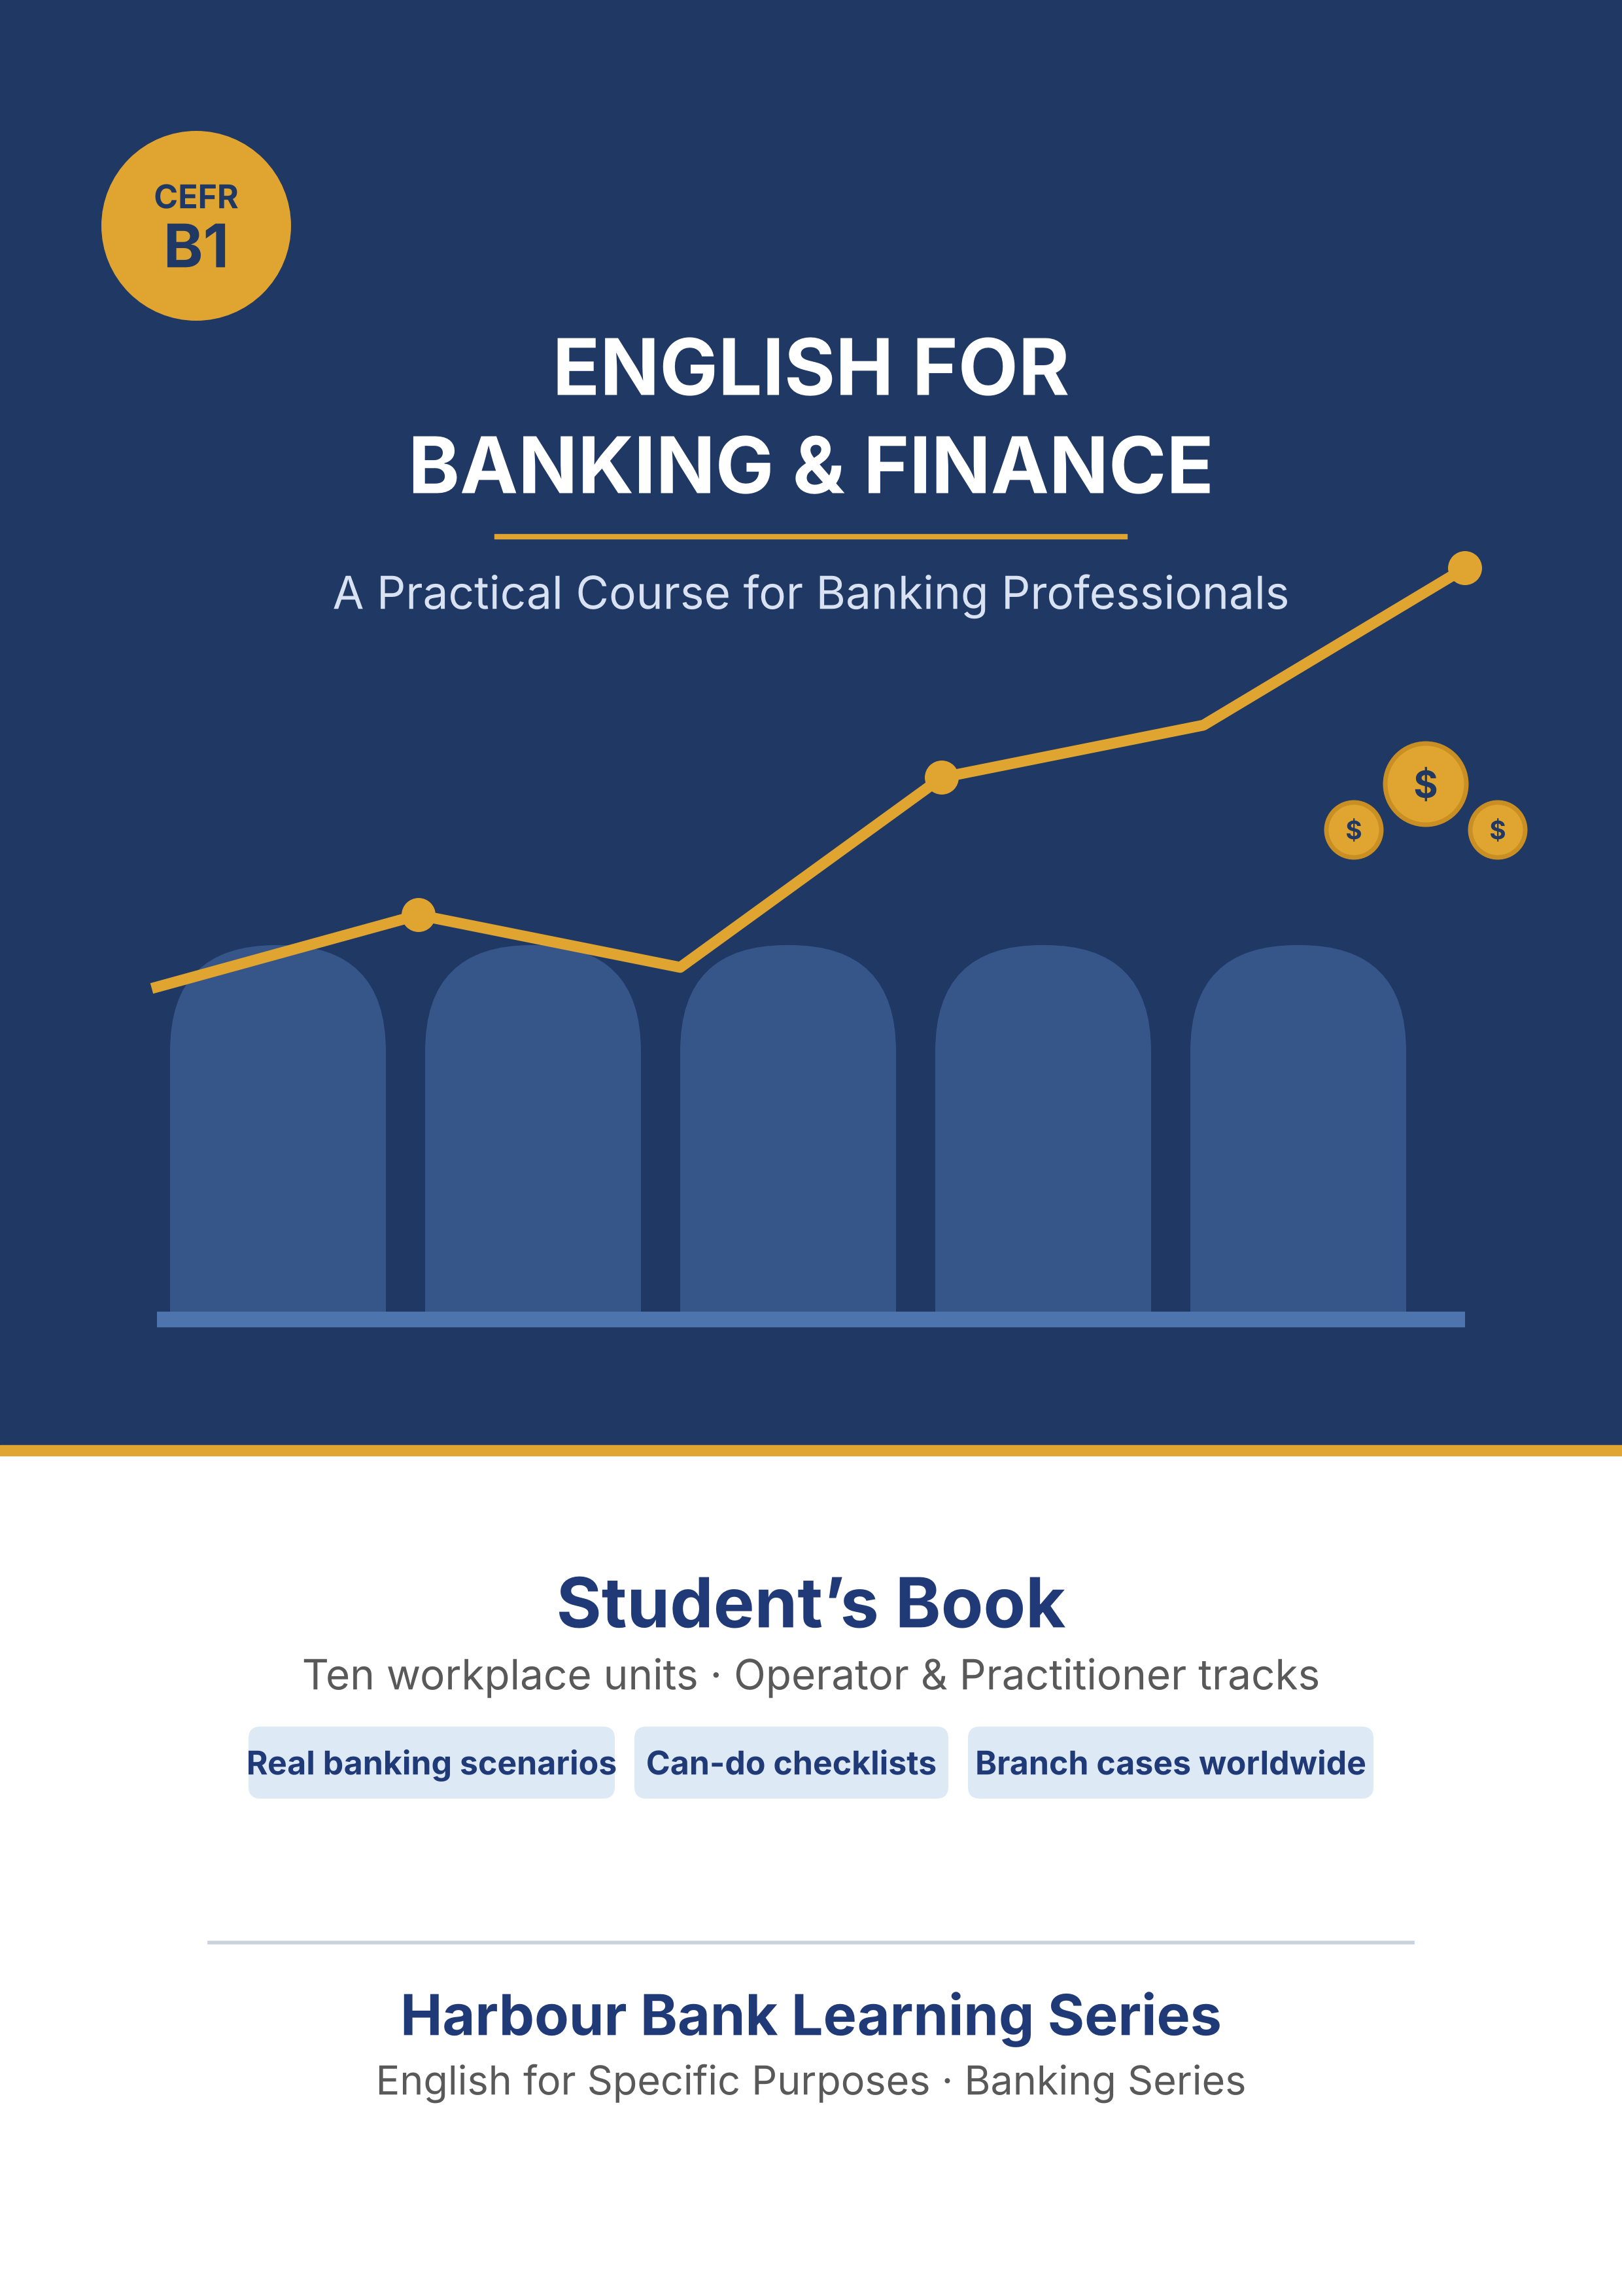

English for Banking & Finance
Professional Student’s Book
Level B1 · Operator & Practitioner tracks
International Edition · Student edition

How to use this book
Every unit has a Warm-Up and ten Parts. Parts 1–6 are the Operator track (lower B1) for staff in their first months. Parts 7–10 are the Practitioner track for staff with a few years’ experience. Both tracks use B1 English — the Practitioner parts add harder decisions and leadership tasks, not harder language. A beginner class can use Parts 1–6 only; a mixed or experienced class adds Parts 7–10.
For a flipped classroom: learners do the ‘Pre-class input’ parts at home (Vocabulary, Grammar, Listening, Reading), then do the ‘in-class output’ parts together (Speaking, Writing, and the Practitioner parts). Every listening script is printed in the unit, so learners can prepare at home even without audio.
Scaffolding: every writing task gives you a model, a plan, useful words, and a check. Every speaking task gives you a model and role cards. Every grammar point has a clear box and a ‘Watch out!’ for common mistakes.
This edition is set in an international bank. Harbour Bank has its head office in Rotterdam and branches in Nairobi, Istanbul, São Paulo, Manila and Warsaw, and it works with partner banks elsewhere. Harbour Bank, its staff, its customers and all its figures are invented for practice; the banking itself — IBAN and BIC, correspondent banking, know-your-customer checks, exchange rates and spreads, letters of credit — is true and general. Part 9 of every unit is a Branch Case Study, and you are asked throughout to compare what you read with banking where you live.

Unit 1 · Getting Started in Finance
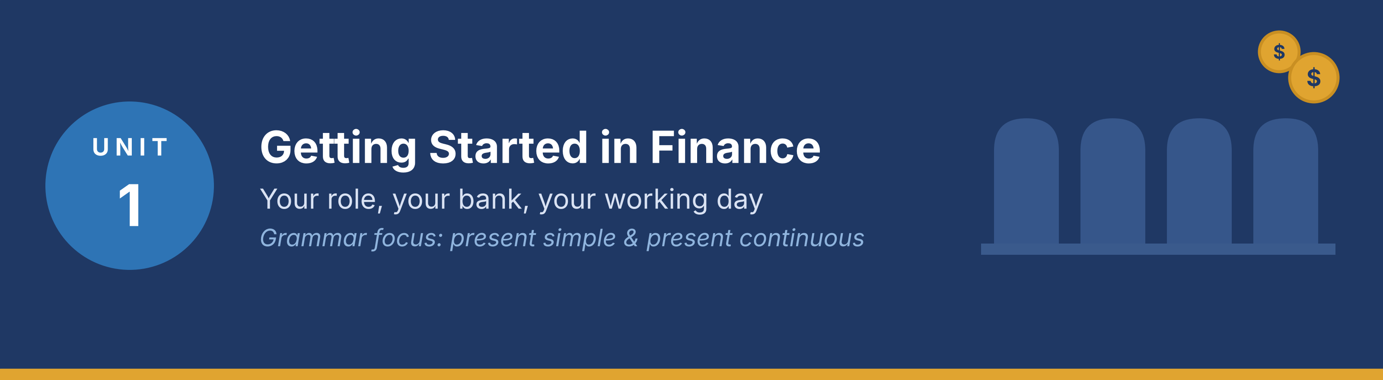
In this unit you learn to introduce yourself and your job, talk about your daily tasks and your current work, understand short workplace conversations, and write a short introduction. Grammar focus: present simple and present continuous.
Part · · Warm-Up
In-class starter · speak before you read

W-A Roles and Services (brainstorm)
With a partner, list job titles and services you find in a bank.
Model — read this first
Job titles: teller, loan officer, branch manager. Services: savings accounts, money transfers, loans.

● Job titles you know: ____
● Services you know: ____
W-B Banking where you live (discussion)
Talk about banking where you live. Useful frame: “In my city there are ___ banks, such as ___.”
● What kinds of banks are there in your country?
● Do you or your family use any banking services? Which ones?
W-C My Banking Experience (pairs)
Share a recent visit to a bank (in person or online).
Model — read this first
Last week I visited my bank to pay a bill. A teller helped me, and it was a good experience.

● Was it a good or bad experience? Why?
● What was the job title of the person who helped you?
Part 1 · Vocabulary
Pre-class input

1A Match the roles to the definitions
Match each banking role (1–7) to the correct definition (a–h). One definition is extra.
Example: 0. Vault → g)
Column A | Column B
1. Teller ____ | a) A senior person who manages the branch.
2. Branch manager ____ | b) A staff member who handles deposits and withdrawals.
3. Loan officer ____ | c) A person who helps customers open or manage services.
4. Customer service rep ____ | d) A machine used for cash withdrawals.
5. Security officer ____ | e) A person who checks loan applications.
6. ATM ____ | f) A person in charge of safety and security.
7. Account ____ | g) A place where money is kept for a customer.
 | h) A written report of all your transactions (extra).

Pronunciation — word stress. Say these words. Mark the strong part: TEL·ler, man·A·ger, of·FI·cer, cus·TO·mer.
1B Vocabulary in context (gap-fill)
Complete the sentences with the correct word.
Word bank
account | interest | teller
branch | ATM | loan
customer | deposit | withdraw

Example: 0. I went to the bank to open a savings account.
1. I opened a new ______________________ at the bank last week.
2. The ______________________ helped me deposit my salary.
3. Our local ______________________ is closed on Sundays.
4. You can ______________________ cash at any time using the ATM.
5. The bank offers 3% ______________________ on savings.
6. I applied for a small business ______________________ to start my shop.
7. A ______________________ service rep helped me reset my online password.
8. Please ______________________ your salary at the counter or the machine.
9. I use the ______________________ near my home to take out cash.
1C Word partners (collocations)
Match the verb to the noun to make a common banking phrase (one noun is extra).
Column A | Column B
1. open / close ____ | a) a loan
2. apply for ____ | b) an account
3. withdraw ____ | c) a password
4. make ____ | d) cash
5. reset ____ | e) a deposit
 | f) a branch (extra)

Now complete the sentences with a phrase from above.
1. I want to ______________________ at this bank. I have my ID.
2. You can ______________________ at the ATM at any time.
3. She went online to ______________________ because she forgot it.
1D Front office or back office?
Put each role in the correct group. Front office = works with customers. Back office = works behind the scenes.
Roles: teller, IT support, loan officer, risk analyst, customer service rep, compliance officer.
● Front office (with customers): ____
● Back office (behind the scenes): ____
Model — read this first
Front office: teller, loan officer, customer service rep. Back office: IT support, risk analyst, compliance officer.

1E Write with the words (40–60 words)
Write a short paragraph about a bank you know. Use at least five words from Part 1.
Model — read this first
My local branch is small but friendly. The tellers are polite, and the customer service rep always helps me. I have a savings account there, and I use the ATM near my home. Last year I took a small loan.

Check before you finish
☐ Did you use five Part-1 words?
☐ Is it 40–60 words?
☐ Are your sentences short and clear?
✎ Write your response here.

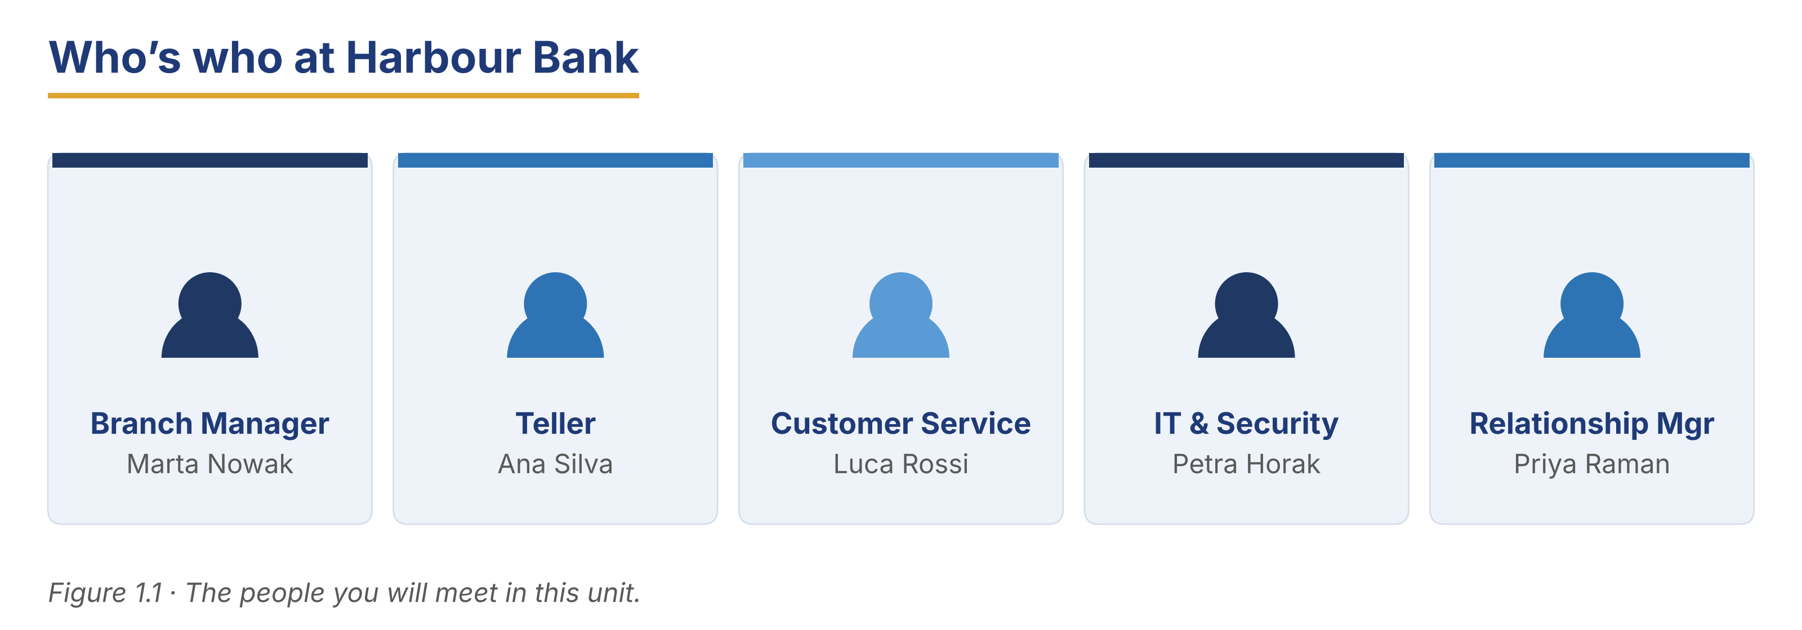
Part 2 · Grammar — Present Simple vs Present Continuous
Pre-class input

2A Notice the grammar
Read the short dialogue. Underline the verbs. Which show a routine, and which show something happening now?
Luca: Hi, I’m Luca. I work in customer service.
Mei: Nice to meet you. I’m training in the loan office this week.
Luca: What do you usually do there?
Mei: I usually help with forms, but now I’m learning to approve small loans.

1. work — routine or now? ____
2. am training — routine or now? ____
3. do / help — routine or now? ____
4. am learning — routine or now? ____
Grammar Focus
 | Form | Use | Example
Present simple | I/you work; he works | routines, facts | I work at the bank every day.
Present continuous | am/is/are + ‑ing | now, this week (temporary) | I am training this week.

Remember: usually, every day, always → present simple. now, this week, at the moment → present continuous.
⚠ Watch out!
✗ He work here. → ✓ He works here. (add ‑s for he/she/it)
✗ I working now. → ✓ I am working now. (don’t drop am/is/are)

2B Controlled practice (choose the tense)
Write the correct form of the verb in brackets.
Word bank
am meeting | are discussing | is checking
offers | arrives | opens

Example: 0. She ____ (work) here every day. → works.
1. The branch manager ______________________ (check) the daily reports at the moment.
2. He usually ______________________ (arrive) at 8:30.
3. I ______________________ (meet) a new client now.
4. Our bank ______________________ (offer) digital banking services.
5. They ______________________ (discuss) loan terms at the moment.
6. The branch ______________________ (open) at nine o’clock every day.
2C Error correction
Find and correct the mistake in each sentence (present simple or continuous).
Example: 0. He work here. → He works here.
1. She work in the loan office.
2. Right now I check the daily reports.
3. They is opening a new branch this month.
4. He usually is arriving at 8:30.
5. We are have a team meeting every Monday.
✎ Write your response here.

2D Write about your day
Write three sentences about your job: two routines (present simple) and one thing you are doing now (present continuous).
Model — read this first
I usually open the branch at nine. I serve customers all morning. This week, I am training a new colleague.

✎ Write your response here.

2E Freer practice (speaking)
In pairs, ask and answer. Use both tenses.
Model — read this first
“I usually serve customers at the counter, but right now I am helping with the audit.”

● What do you do at your job?
● What are you working on now?
● Do you usually deal with customers?
Tip: You will use these two tenses again in the reading in Part 5 (5A and 5B). Look for them there.
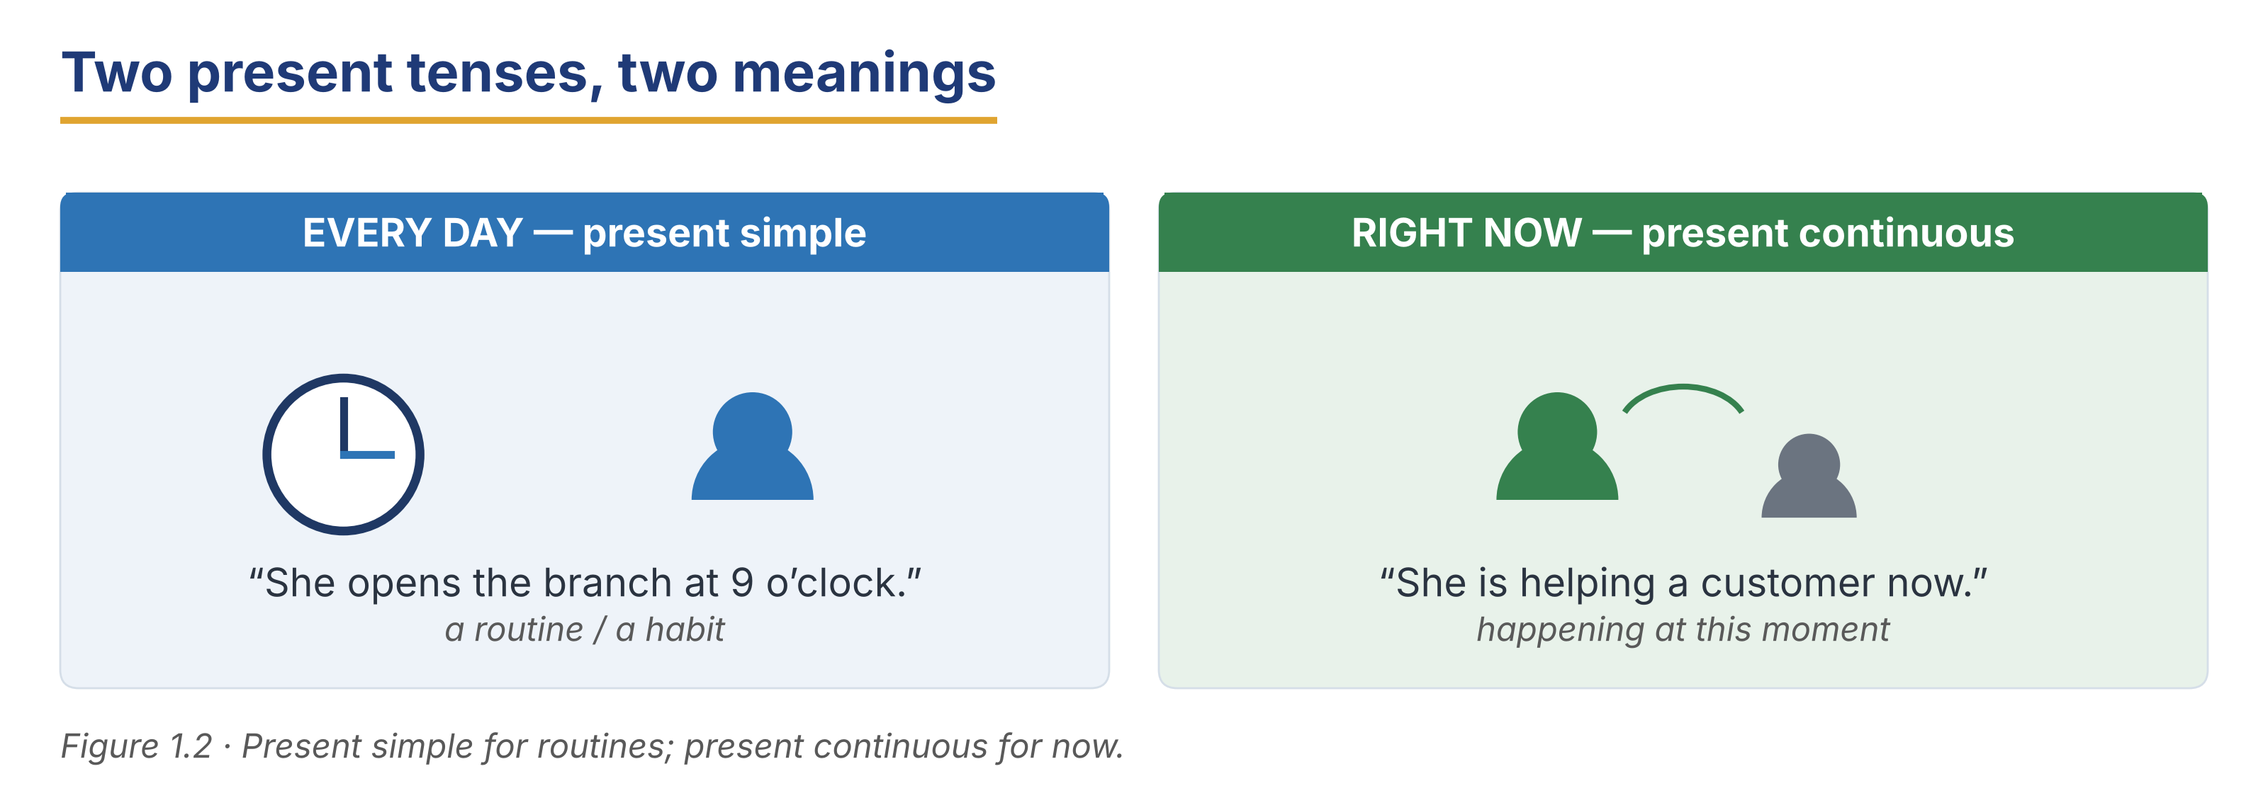
Part 3 · Listening
Pre-class input · scripts printed below

3A Before you listen (predict)
You will hear new staff talking on their first days. What might a new teller say to a manager?
Model — read this first
“I think the new teller will talk about the counter system and her first day.”

3B Dialogue 1 — Meeting the manager
🔊 Audio 1.1 (optional) — or read the script below.
Mr Diallo: Good morning. You must be Ana, our new teller.
Ana: Yes, sir. It’s great to join the Warsaw branch.
Mr Diallo: Welcome. Are you familiar with our teller system?
Ana: I’ve used a similar one in training.
Mr Diallo: Good. Accuracy and service are the most important things here.

Read and decide: True, False, or Not Given.
Example: 0. Ana is a new teller. → True.
1. Ana used the exact same system before.
2. Mr Diallo thinks speed matters most.
3. Ana worked at another branch before.
Useful language: You must be… · Are you familiar with…? · I’ve used a similar one.
3C Dialogue 2 — The IT support visit
🔊 Audio 1.2 (optional) — or read the script below.
Mei: Hi. Are you the new IT support person?
Petra: Yes, I’m Petra. I’m installing the new firewall. It helps with security.
Mei: Great. Our systems were slow last week.
Petra: I’ll look into that. I’m also setting up the online terminals today. They will be faster.

Read and decide: True, False, or Not Given.
1. Petra is installing a firewall to improve security.
2. The terminals are broken and cannot be used.
3. The new setup should make the system faster.
3D A day in the life (longer listening)
🔊 Audio 1.3 (optional) — or read the script below.
Marta: Hello, my name is Marta, and I’m the branch manager here in Warsaw. My days are always busy. I usually arrive at 8 a.m. and check the team’s schedule. Then I open my email and read the messages from head office in Rotterdam. I spend most of my day supporting my staff and making sure everything runs well. I also meet important clients to discuss their needs. But this week is different. I’m not meeting many clients, because I’m training three new tellers. We are reviewing our procedures together, and I am watching them at the counter. It is a very focused week, but I enjoy it.

Read and decide: True, False, or Not Given.
1. Marta usually arrives at 9 a.m.
2. She spends most of a normal day supporting her staff.
3. She is meeting more clients than usual this week.
4. She is training three new tellers this week.
5. She has been the manager for five years.
3E Who is doing what now?
Look back at the three listenings. Match each person to what they are doing at the moment (present continuous). One option is extra.
Column A | Column B
1. Ana ____ | a) is installing a firewall and setting up terminals
2. Petra ____ | b) is training three new tellers
3. Marta ____ | c) is starting her first day and learning the system
 | d) is closing the branch for the day (extra)

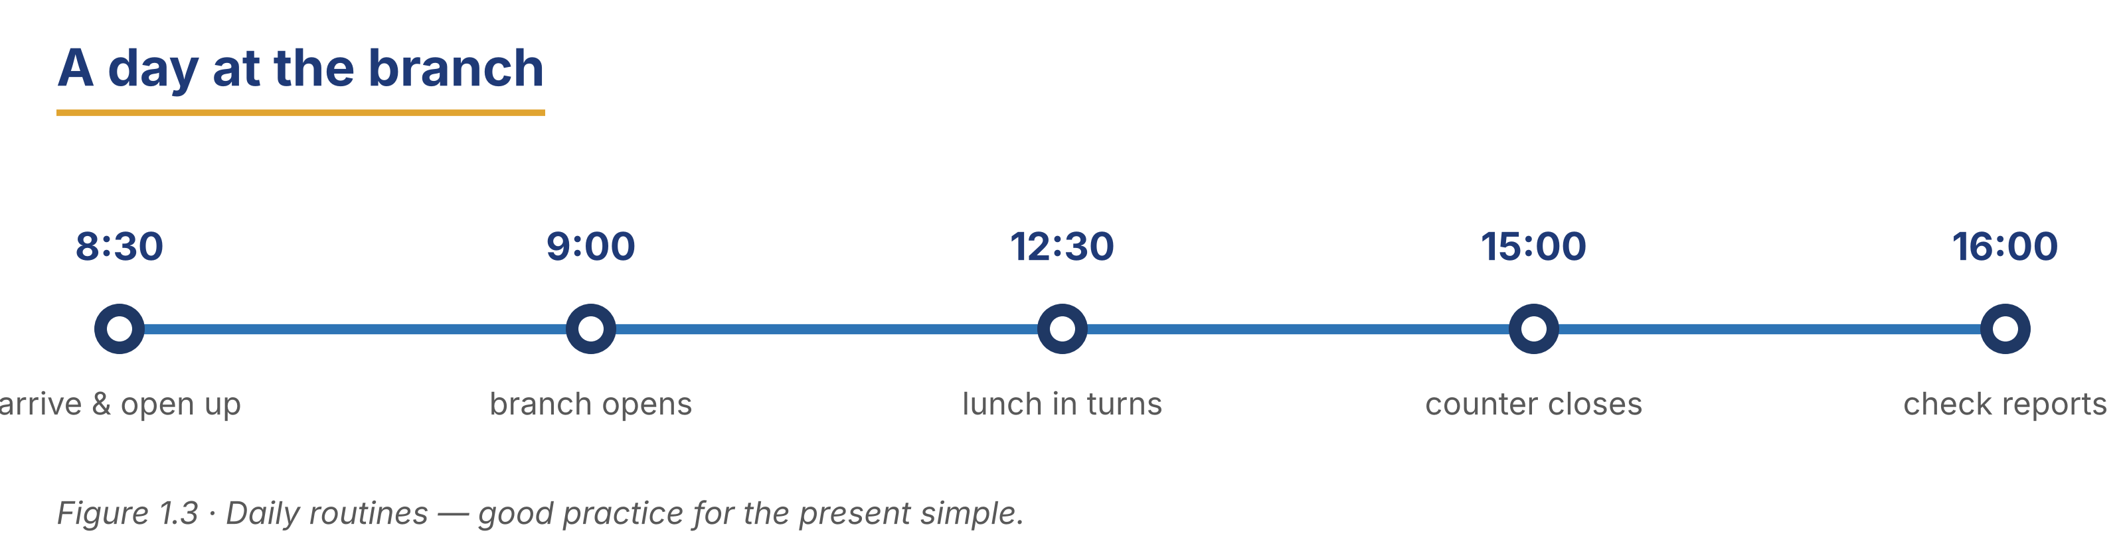
Part 4 · Speaking
In-class output

4A Professional self-introduction
Introduce yourself: name, role, routine duties, and your current task.
Model — read this first
“Hello. My name is Diego. I’m a loan officer at Harbour Bank. I usually check loan applications. Right now, I’m reviewing a housing loan.”

Useful language: My name is… · I’m a… at… · I usually… · Right now, I’m…
Role cards — choose a profile and introduce yourself:
Card A: Luca — Customer Service — usually answers questions — now learning the new app.
Card B: Johanna — Risk Analyst — usually checks reports — now training a colleague.
Card C: Grace — Teller — usually serves customers — now helping with the audit.
4B Role play — professional exchange (pairs)
Model — read this first
A: Hello, I’m Ana. I work as a teller. What do you do?
B: Nice to meet you, Ana. I’m Diego, a loan officer.
A: What are you working on these days?
B: Right now, I’m training on the new software.

Card A: you are a teller; you are helping with the audit this week.
Card B: you are a loan officer; you are training on new software.
4C Find the information (pairwork info-gap)
Student A and Student B have different cards. Ask questions to complete a table about each person.
Card A — you know: Priya: relationship manager; usually checks applications; now training on new software. Ask B about Kofi.
Card B — you know: Kofi: teller; usually serves customers; now helping with the audit. Ask A about Priya.
Useful language: What does he/she do? · What does he/she usually do? · What is he/she doing now?
4D The networking event (mingle)
Stand up and introduce yourself to three classmates. Remember one thing each person is doing now.
Stretch: after each talk, report back — “Diego is a loan officer. He is training this week.”
4E Small talk at work (functional phrases)
Match the small-talk phrase to the right moment (one is extra).
Column A | Column B
1. “How’s your first week going?” ____ | a) meeting a colleague for the first time
2. “Can I help you with anything?” ____ | b) asking a new colleague how they feel
3. “Nice to meet you.” ____ | c) offering help
4. “Have a good weekend.” ____ | d) ending the week politely
 | e) apologising for a mistake (extra)

In pairs, practise a 30-second small-talk chat with a new colleague. Use two phrases above.
Part 5 · Reading
Pre-class input

5A Welcome to Harbour Bank
Read the company profile. Notice the present simple (facts) and present continuous (current plans).
Harbour Bank — Company Profile
About 200 words
Harbour Bank is an international bank for people and small businesses. Its head office is in Rotterdam, and it has branches in Nairobi, Istanbul, São Paulo, Manila and Warsaw. In other countries it works with partner banks. The bank helps individuals and small businesses manage their money safely, at home and across borders. Its services include savings accounts, current accounts, personal and business loans, currency exchange, international transfers, and digital banking. The customer service team gives fast, polite help in several languages. When a client wants to open an account or apply for a loan, the staff are ready to assist. Harbour Bank also supports local economies. Its microfinance programme gives small loans to low-income business owners in every country where the bank works. These loans help them grow their businesses. Right now, the bank is investing in new mobile and online tools. It is building easier and safer ways to send money between countries. The goal is simple: modern, reliable banking for every customer, wherever they are.

Answer the questions.
Example: 0. Where is Harbour Bank’s head office? → In Rotterdam.
1. What financial products does the bank offer?
2. Who are the bank’s main customers?
3. What is the purpose of the microfinance programme?
4. What is the bank doing now to improve its services?
5. In how many cities does the bank have branches?
6. Name one thing the customer service team does.
Vocabulary in context — match the word to its meaning (one is extra).
Column A | Column B
1. SME ____ | a) small and medium enterprises
2. digital banking ____ | b) online and mobile banking services
3. microfinance ____ | c) small loans for low-income business owners
4. branch ____ | d) a local office of the bank
5. entrepreneur ____ | e) a person who starts a business
 | f) money paid on savings (extra)

5B Grammar in context (from 5A)
Look back at the Harbour Bank text. Find and write two present-simple verbs and two present-continuous verbs.
1. Present-simple verbs: ____ , ____
2. Present-continuous verbs: ____ , ____
Now complete these sentences about the bank.
1. Harbour Bank ______________________ (have) branches in five cities.
2. Right now, the bank ______________________ (invest) in new online tools.
5C Meet a team member
Read the short profile. What does Priya do every day, and what is she doing this week?
Priya Raman — Relationship Manager
About 130 words
Meet Priya Raman, a relationship manager at the Manila branch of Harbour Bank. Priya works in a busy department where things change every day. Her main job is to understand the needs of business clients and to suggest the right services. Many of her clients buy or sell abroad, so she also works with the transfers team in Rotterdam. She works with the loan and risk teams too, so clients get fast, correct answers. This week, Priya is training two new colleagues and is updating the bank’s client-service guide. She enjoys her work because she meets many different people.

1. Where does Priya work, and what is her job?
2. What is Priya’s main job with business clients?
3. What two things is Priya doing this week?
5D Discussion — compare banks
In pairs, compare Harbour Bank with a bank you know.
Useful frame: “My bank offers ___, which is similar to / different from Harbour Bank.”
● Does your bank offer similar services?
● What is the benefit of a bank that helps both people and businesses?
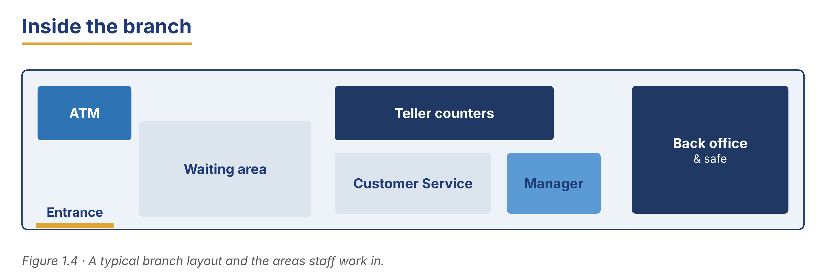
Part 6 · Writing
In-class / homework output

6A The parts of a professional email
Match the part of an email to the example (one is extra).
Column A | Column B
1. Subject line ____ | a) Introduction — New Loan Officer
2. Salutation ____ | b) Dear Mr Diallo,
3. Opening ____ | c) I am writing to introduce myself.
4. Body ____ | d) I usually manage SME accounts, and now I am learning retail.
5. Sign-off ____ | e) Best regards, Diego
 | f) Please find my report attached (extra).

6B Guided writing — complete the email
Complete the email with the words: currently, joined, usually, meeting, name.
Word bank
currently | joined | usually
meeting | name

1. Subject: Introduction — New Analyst. Dear Team, my ______________________ is Johanna Berg.
2. I ______________________ the Risk department last Monday.
3. In my role, I ______________________ check credit limits and prepare reports.
4. ______________________, I am helping the senior manager with the annual audit.
5. I look forward to ______________________ all of you soon.
6C Write your own introduction email (50–70 words)
Write a short email to your new manager. Use one present-simple and one present-continuous sentence.
Model — read this first
Subject: Introduction — New Teller
Dear Ms Nowak, My name is Ana Silva. I am a new teller at the Warsaw branch. I usually help customers with deposits and withdrawals. This week, I am learning the new counter system. I look forward to working with the team. Best regards, Ana

Plan (fill in, then write): Subject: Introduction — ___ · Dear ___, · My name is ___. I am a ___ at ___. · I usually ___. · This week, I am ___. · I look forward to ___. · Best regards, ___
Phrase bank: My name is… · I am a… at… · I usually… · This week, I am… · I look forward to… · Best regards
Check before you finish
☐ A subject line?
☐ One present-simple and one present-continuous sentence?
☐ A polite close?
☐ 50–70 words?
✎ Write your response here.

6D Write a short profile of a colleague (40–60 words)
Use the notes to write a short professional profile.
Notes — Elif Demir: Compliance Officer at Meridian Bank; usually checks that the bank follows the rules in every country it works in; now reviewing customer data; works with the Legal team.
Model — read this first
Elif Demir is a compliance officer at Meridian Bank. She usually checks that the bank follows the rules in every country it works in. At the moment, she is reviewing customer data to improve security. She works closely with the Legal team.

Frame: ___ is a ___ at ___. He/She usually ___. At the moment, he/she is ___. He/She works with ___.
Check before you finish
☐ Present simple for routine tasks?
☐ Present continuous for the current task?
☐ 40–60 words?
✎ Write your response here.

6E Peer check
Swap your email from 6C with a partner. Use the checklist to give one piece of positive feedback and one suggestion.
Checklist: subject line? · two tenses? · polite close? · 50–70 words?
Model — read this first
“Good subject line and a polite close. Next time, try to add one sentence about what you are doing this week.”

6F Improve the email (editing)
This short email has three small mistakes (grammar and politeness). Find them, then rewrite the email correctly.
Subject: hello
hi, I am Petra. I working in IT. I fix computers. bye.
Check before you finish
☐ a clear subject line
☐ correct present continuous (‘I am working’)
☐ a polite greeting and close
✎ Write your response here.

Part 7 · Management File — Welcoming a New Colleague
Practitioner track (optional for beginners) · experienced staff

7A Manager’s phrase bank
Match the onboarding phrase to its purpose (one is extra).
Column A | Column B
1. “Welcome aboard.” ____ | a) offering a tour of the branch
2. “Let me show you around.” ____ | b) greeting a new employee
3. “If you’re unsure, just ask.” ____ | c) giving a buddy for support
4. “I’ll pair you with Grace.” ____ | d) inviting questions
 | e) ending a meeting politely (extra)

7B Listening — Day one for a new colleague
🔊 Audio 1.4 (optional) — or read the script below.
Marta: Welcome aboard, Ana. Let me show you around the branch.
Ana: Thank you. Where do I start?
Marta: First, you shadow a teller today. Watch how she serves customers.
Ana: And after that?
Marta: Tomorrow you try the counter system with support. If you’re unsure, just ask. I’ll pair you with Grace for your first week.
Ana: That sounds good. Thank you, Ms Nowak.

Answer the questions.
Example: 0. Who is the new colleague? → Ana.
1. What does Ana do on her first day?
2. When does she try the counter system?
3. Who supports Ana in her first week?
7C Controlled practice — the induction checklist
Complete the checklist for a new teller. Use the present simple.
Word bank
shadows | meets | reads
signs | learns

1. On day one, the new teller ______________________ an experienced colleague.
2. He or she ______________________ the branch safety rules.
3. The new teller ______________________ the team and the manager.
4. He or she ______________________ the staff handbook.
5. By the end of week one, the new teller ______________________ the counter system.
7D Role play — welcome a new hire
You are a supervisor. Welcome a new team member. Explain three routine duties and one current project.
Model — read this first
“Welcome aboard. In this team, we usually open accounts and answer customer questions. This month, we are moving to a new system, so we are all learning together.”

Card A (supervisor): greet · explain three routine duties · mention one current project · offer help.
Card B (new hire): ask two questions about the job.
Stretch: the new hire is nervous — reassure them politely.
7E Writing — a team-member bio for the noticeboard (60–80 words)
Write a short, friendly bio to introduce a new colleague to the branch.
Model — read this first
Please welcome Ana Silva, our new teller at the Warsaw branch. Ana joined us this week from our training programme in São Paulo. She usually helps customers with deposits and withdrawals. At the moment, she is learning our counter system and shadowing the team. Ana is friendly and hard-working. Please say hello and make her feel welcome.

Plan: Please welcome ___, our new ___. He/She joined us ___. He/She usually ___. At the moment, he/she is ___. Please ___.
Phrase bank: Please welcome… · joined us this week · usually… · at the moment… · make him/her feel welcome
Check before you finish
☐ Name and role?
☐ One present-simple and one present-continuous sentence?
☐ A friendly, welcoming tone?
☐ 60–80 words?
✎ Write your response here.

Part 8 · Global Case Study — Onboarding at a Global Bank
Practitioner track · read then discuss

Before you read: how long should a good “first week” be at a bank? What should a new person learn first?
A Two-Week Start
About 210 words · a made-up example based on real practice
A large international bank believes that a good start helps new staff stay and do well. So the bank gives every new employee a two-week induction, and it uses the same programme in every country where it works. In the first week, new staff do not work at the counter alone. Instead, they shadow an experienced colleague and watch how the work is done. Each new person also gets a “buddy”. A buddy is a friendly colleague who answers small questions and helps the new person feel welcome. New staff say the buddy system makes the first days much easier.
In the second week, new staff take short online lessons about safety, service, and the bank’s rules. Because the bank works in several countries, they also learn which rules are the same everywhere and which ones are local. They practise the computer system with support. Nobody works alone until they are ready. New employees are on “probation” for three months. During this time, the manager gives regular feedback. If a new person needs more help, the manager gives it early. The bank says this careful start is worth the time: staff who feel supported learn faster and give better service.

Glossary help
shadow — watch and follow an experienced colleague to learn
buddy — a friendly colleague who helps a new person
induction — the training period at the start of a job
probation — the first months, when your work is checked

8A Comprehension
Example: 0. How long is the induction? → Two weeks.
1. What do new staff do in the first week?
2. How does a buddy help?
3. What happens during probation?
4. Why does the bank think a careful start is worth the time?
8B Vocabulary in context
Match the word to its meaning (one is extra).
Column A | Column B
1. shadow ____ | a) the training period at the start of a job
2. buddy ____ | b) watch and learn from a colleague
3. induction ____ | c) a helpful colleague for a new person
4. probation ____ | d) the first months, when work is checked
 | e) a written warning (extra)

8C Discussion
Frames: “This is similar to a bank in my country because ___.” “This is different because ___.”
● Would a two-week start work in your bank? Why / why not?
● What is one idea here you would use?
8D Your view (short write, 30–40 words)
Which idea from the global case would help new staff most in your bank, and why?
✎ Write your response here.

Part 9 · Branch Case Study — Nairobi in Focus: A New Branch Opens
Practitioner track · read then decide

Before you read: when a new branch opens, what problems can the manager have on day one?
Opening Day in Nairobi
About 170 words
Harbour Bank is opening a new branch in Nairobi. The branch manager, Amina Yusuf, arrives early. The branch is clean and ready, but the team is very new. Two of the three tellers started only last week, and they are still learning the counter system. By nine o’clock, there is already a small queue outside. Many customers want to open their first account, and several want to receive money from family abroad. One older customer looks worried and asks a lot of questions. The new tellers work slowly and carefully, but the queue is growing. Amina wants two things at once: fast service and correct work. She knows that new tellers make mistakes when they hurry. She also knows that customers do not like waiting. She has one experienced teller, Grace Otieno, and two learners on the counter. She must decide how to organise the morning.

9A Comprehension
Example: 0. Where is the new branch? → In Nairobi.
1. Why do the new tellers work slowly?
2. What two things does Amina want at the same time?
3. Who is the one experienced teller?
9B Decision task
What should Amina do first? Write 40–60 words. Use the frame and the phrase bank.
Model — read this first
I think Amina should put Grace on the busiest window, because she is fast and correct. The two new tellers can serve simple customers with support. Also, Amina can help the worried customer herself. This keeps service polite and reduces mistakes.

Frame: I think Amina should ___, because ___. Also, ___.
Phrase bank: put ___ on the busiest window · serve simple customers first · give support to the new tellers · help the worried customer
✎ Write your response here.

Part 10 · Review & Can-Do
Homework / self-study

10A Spiral review
Complete the sentences. Use the correct tense (present simple or continuous) or the correct word.
Example: 0. She ____ (work) here every day. → works.
1. A ______________________ handles deposits and withdrawals. (role)
2. The manager usually ______________________ (arrive) early.
3. Right now, I ______________________ (learn) the counter system.
4. A loan officer ______________________ (check) loan applications. (routine)
5. This week, we ______________________ (train) two new colleagues.
6. A ______________________ is a machine for cash withdrawals. (word)
7. You can ______________________ for a loan at the counter. (verb + preposition)
8. At the moment, the bank ______________________ (invest) in new online tools.
10B Can-Do checklist
Can-Do checklist — tick what you can do now
☐ I can introduce myself and my job.
☐ I can describe my routine duties (present simple).
☐ I can say what I am doing now (present continuous).
☐ I can understand a short first-day conversation.
☐ I can write a short introduction email.
10C Unit glossary
Glossary help
teller — staff member who handles deposits and withdrawals
branch manager — senior person who manages a branch
loan officer — person who checks loan applications
customer service rep — person who helps customers with services
account — where a customer’s money is kept
ATM — machine for cash withdrawals
SME — small and medium enterprise
microfinance — small loans for low-income business owners
induction — the training period at the start of a job
shadow — watch and learn from a colleague

Unit 2 · Customer Service and Communication
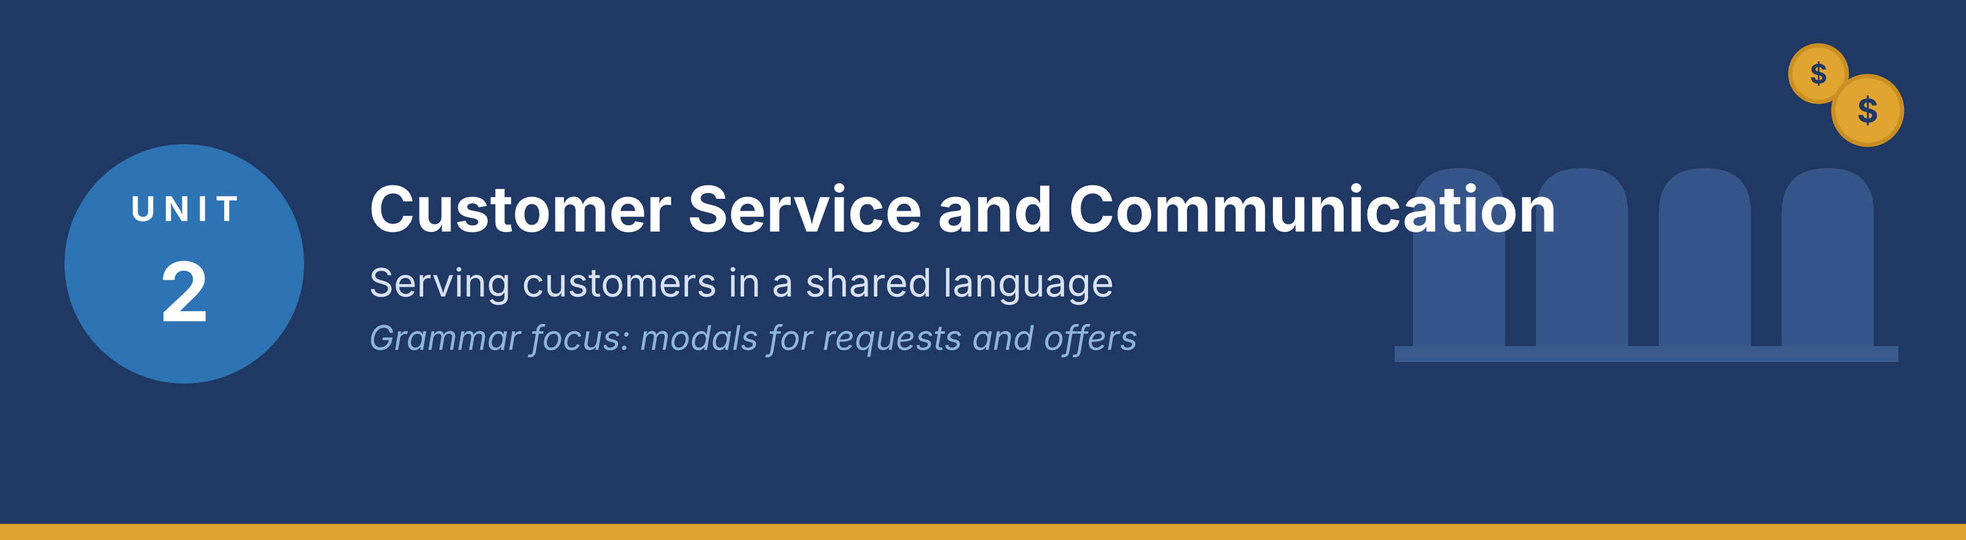
In this unit you learn polite customer-service language, how to make requests and offers, how to handle common situations, and how to write short service emails. Grammar focus: modals for requests and offers (can, could, may).
Part · · Warm-Up
In-class starter · speak before you read

W-A Good and bad service (discussion)
In small groups, talk about customer service you have received.
Model — read this first
“The teller smiled, used my name, and explained each step. It was very good service.”

● Think of good service you received at a bank or shop. What did the person do well?
● Think of poor service. What went wrong?
● What are three things a good bank employee should always do?
W-B Good vs bad service (mini role-play)
In pairs, act out two short scenes (30 seconds each): the same question, first with bad service, then with good service.
Question: “Where do I deposit this cheque?”
Tip: In the good scene, use a greeting, a polite modal (Could / May), and an offer of help.
Part 1 · Vocabulary
Pre-class input

1A Match the phrase to the situation
Match each polite phrase (1–6) to the situation where a banker uses it (a–g). One is extra.
Example: 0. “Have a nice day!” → f) (ending the conversation politely)
Column A | Column B
1. “How can I help you today?” ____ | a) greeting a new customer
2. “May I see your ID, please?” ____ | b) verifying the customer’s identity
3. “You’ll need to fill out this form.” ____ | c) explaining the next step
4. “Would you like a receipt?” ____ | d) offering the customer a choice
5. “Could you confirm your address?” ____ | e) checking that information is correct
6. “I’m sorry, that service is not available.” ____ | f) ending the conversation politely
 | g) asking the customer to wait (extra)

Pronunciation — word stress. Say these words: as·SIST, con·FIRM, VE·ri·fy, in·QUI·ry.
1B Sort the phrases by function
Put each phrase from 1A into the correct group.
● Offering help: ____
● Requesting information: ____
● Explaining a step: ____
Model — read this first
Offering help: “How can I help you today?”, “Would you like a receipt?”
Requesting information: “May I see your ID?”, “Could you confirm your address?”
Explaining a step: “You’ll need to fill out this form.”

1C Complete the bank dialogue
Complete the dialogue with the correct word.
Word bank
account | ID | form
assist | procedure | confirm
transaction | verify

Example: 0. Welcome to our bank. How can I assist you today?
1. Customer: I’d like to open a new ______________________, please.
2. Banker: Certainly. First, may I see your ______________________? I need it to verify your identity.
3. Banker: Thank you. I just need to ______________________ your details.
4. Banker: The ______________________ is simple. Please complete this application ______________________.
5. Banker: Would you like to make your first ______________________, such as a deposit, today?
1D Make it polite (rewrite)
These sentences are too direct. Rewrite each one to be polite and professional.
Example: 0. “Give me your ID.” → “Could I see your ID, please?”
1. “Sign it now.”
2. “Wait.”
3. “What do you want?”
4. “I need your phone number.”
5. “You’re wrong. That’s not the rule.”
✎ Write your response here.

1E Key customer-service terms
Match the term to its meaning (one is extra).
Column A | Column B
1. client / customer ____ | a) a person who uses the bank’s services
2. transaction ____ | b) an action like a deposit, withdrawal or transfer
3. inquiry ____ | c) a question asking for information
4. procedure ____ | d) the official series of steps to do something
5. to verify ____ | e) to check that something is true
6. to authorise ____ | f) to give official permission
 | g) a written complaint (extra)

1F Write with the words (40–60 words)
Describe a good customer-service moment at a bank. Use at least five words from Part 1.
Model — read this first
Yesterday a customer had an inquiry about a transaction. The teller was polite and asked to verify her ID. She explained the procedure clearly and helped her open a new account. The customer left happy.

Check before you finish
☐ Five Part-1 words?
☐ 40–60 words?
☐ Short, clear sentences?
✎ Write your response here.

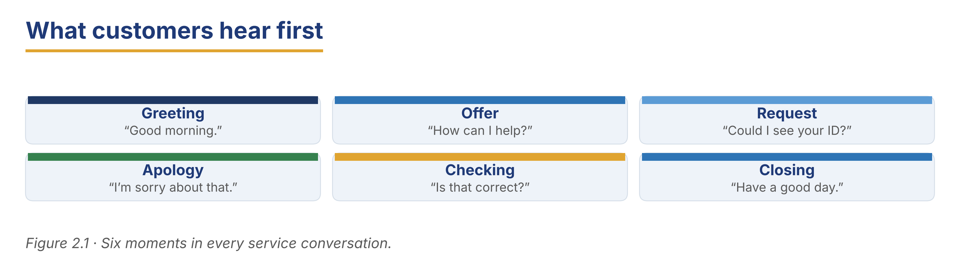
Part 2 · Grammar — Modals for Requests and Offers (can / could / may)
Pre-class input

2A Notice the grammar
Read the short dialogue. Underline can, could and may. Who is more polite?
Banker: Good morning. How can I help you?
Customer: Could you check my balance, please?
Banker: Of course. May I see your card?
Customer: Here you are.

1. can — which speaker? ____
2. could — more or less polite than can? ____
3. may — formal or informal? ____
Grammar Focus
Modal | Use | Example
can | informal offer or request | Can I help you?
could | polite request | Could you sign here, please?
may | formal offer / permission | May I see your ID?

Remember: could and may are more polite than can. Use them with customers.
⚠ Watch out!
✗ Can I to help you? → ✓ Can I help you? (no ‘to’ after a modal)
✗ May you sign here? → ✓ Could you sign here? (for a request to the customer, use could)

2B Controlled practice (choose the modal)
Choose the best modal: can, could, or may. Sometimes more than one is possible.
Word bank
can | could | may

Example: 0. (formal greeting) Good morning. How may I help you?
1. (very formal, senior client) Good morning, sir. How ______________________ I help you?
2. (standard polite request) ______________________ I see some identification, please?
3. (friendly offer) ______________________ I get you a copy of that receipt?
4. (asking permission for a sensitive question) ______________________ I ask the reason for the transfer?
5. (a polite instruction) ______________________ you please fill out this deposit slip?
2C Error correction
Find and correct the mistake in each sentence.
Example: 0. Can I to help you? → Can I help you?
1. You must to fill this form.
2. May you please sign here?
3. Could I seeing your ID?
4. Can you helps me, please?
5. I could to check that for you.
✎ Write your response here.

2D Make the command polite
Change each direct command into a polite request with can, could, or may.
Example: 0. “Sign here.” → “Could you sign here, please?”
1. “Show me your card.”
2. “Type your PIN.”
3. “Come back tomorrow.”
✎ Write your response here.

2E Freer practice (speaking)
In pairs, write and act a short dialogue (4–6 lines) between a banker and a customer. Use at least three polite modals.
Model — read this first
Banker: How may I help you? — Customer: Could I open an account? — Banker: Certainly. May I see your ID?

Tip: You will see these modals again in the reading in Part 5 (5A and 5B). Look for them there.
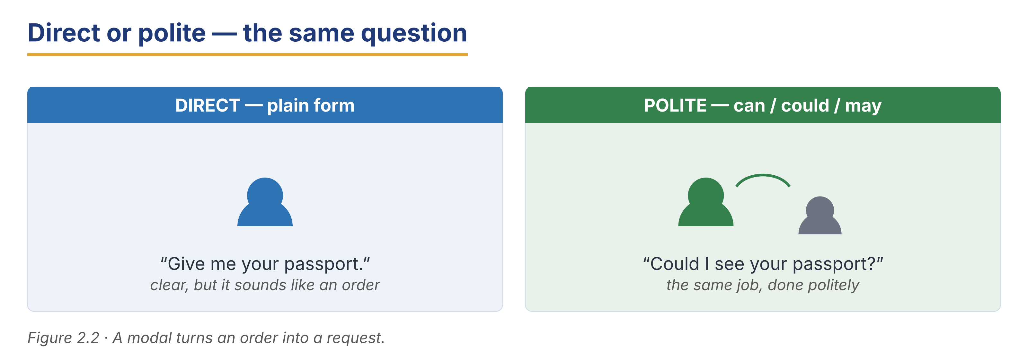
Part 3 · Listening
Pre-class input · scripts printed below

3A Before you listen (predict)
What problems do customers often bring to a bank? What polite phrases might a banker use?
Model — read this first
“A customer might lose a card, forget a PIN, or want to open an account.”

3B Two short conversations — match the purpose
🔊 Audio 2.1 (optional) — or read the script below.
Conversation 1
Customer: Hi. I think I lost my debit card. I’m worried someone might use it.
Banker: I’m sorry to hear that. I can freeze the card right now. May I have your account number?

Conversation 2
Customer: Good morning. I’d like to open a savings account.
Banker: Certainly. I can help you with that. Could I see your ID and proof of address, please?

Match each conversation to its purpose (one is extra).
1. Conversation 1: ____
2. Conversation 2: ____
a) opening an account b) reporting a lost card c) resetting a PIN (extra)
Useful language: I’m sorry to hear that. · I can… right now. · Could I see…?
3C Two more conversations — True or False
🔊 Audio 2.2 (optional) — or read the script below.
Conversation 3
Customer: Hello, I need to apply for a small personal loan.
Banker: No problem. You’ll need to speak with a loan officer. Could you take a seat? Someone will be with you shortly.

Conversation 4
Customer: Excuse me, I can’t remember the PIN for my card. Can you reset it?
Banker: For security, you’ll need to show your ID. Then we can issue a new PIN. Could you go to window 3, please?

Decide: True or False.
1. In Conversation 3, the banker helps with the loan immediately.
2. In Conversation 3, the customer must wait for a loan officer.
3. In Conversation 4, the customer needs to show ID.
4. In Conversation 4, the customer stays at the same window.
3D A customer inquiry about online banking (longer)
🔊 Audio 2.3 (optional) — or read the script below.
Banker: Good afternoon, madam. How may I help you?
Mrs Oyelaran: Good afternoon. I have a current account here, but I don’t have online banking. Can I register for it?
Banker: Of course. It’s a great service, and you can use it from any country.
Banker: Could you show me your ID and your bank card, please?
Mrs Oyelaran: Here you are.
Banker: Thank you. I’ll set up your account now. We will send a security code to your phone. Please enter it to finish.
Mrs Oyelaran: That sounds easy. Thank you very much.

Answer the questions.
Example: 0. What does Mrs Oyelaran want to do? → Register for online banking.
1. What two documents does the banker ask for?
2. What does the bank send to Mrs Oyelaran’s phone?
3. How does Mrs Oyelaran feel about the service?
3E Useful phrases from the conversations
Match each phrase from the listenings to its purpose (one is extra).
Column A | Column B
1. “I’m sorry to hear that.” ____ | a) showing sympathy
2. “I can freeze the card right now.” ____ | b) offering quick action
3. “Could you take a seat?” ____ | c) asking the customer to wait
4. “Could you go to window 3?” ____ | d) directing the customer politely
 | e) ending the call (extra)

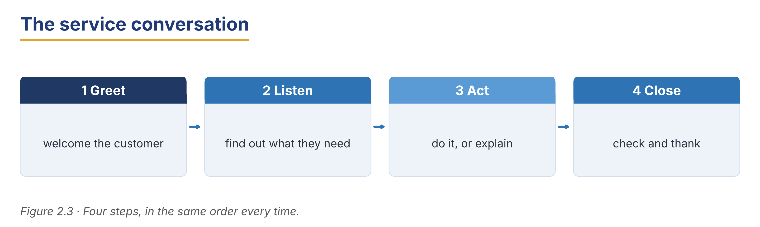
Part 4 · Speaking
In-class output

4A Functional language — offers and requests
Match the function to a phrase (one is extra).
Column A | Column B
1. Offer help ____ | a) “Could you tell me your account number?”
2. Ask for information ____ | b) “How can I help you?”
3. Ask the customer to wait ____ | c) “Could you wait one moment, please?”
4. Apologise ____ | d) “I’m sorry for the wait.”
 | e) “Have a good weekend.” (extra)

4B Bank simulation (pairwork)
Run a short service dialogue, then swap roles.
Model — read this first
A: Good morning. How may I help you? — B: I’d like to open a savings account. — A: Certainly. Could I see your ID, please? — B: Here you are. — A: Thank you. May I confirm your address?

Card A (banker): greet · ask for ID · confirm address · offer a first deposit.
Card B (customer): you want to open an account; you have your ID; your address is in Warsaw.
4C Handle a difficult situation
A customer is upset because they waited a long time. Stay calm and polite. Use the steps.
Model — read this first
“I’m very sorry for the wait. Thank you for your patience. How can I help you now? Let me sort this out for you quickly.”

Steps: 1) apologise · 2) thank them · 3) offer help · 4) act.
Stretch: the customer is still angry — stay calm and offer one clear next step.
4D Find the information (pairwork info-gap)
Student A is a banker; Student B is a customer with a problem. Ask polite questions to solve it.
Card A (banker): you can freeze cards, reset PINs, and open accounts. Ask what the customer needs.
Card B (customer): you lost your card this morning; you want it frozen; your account number is 4471.
Useful language: How can I help? · Could you give me…? · May I have your account number?
4E Closing the conversation politely
Match the closing phrase to the situation (one is extra).
Column A | Column B
1. “Is there anything else I can help with?” ____ | a) checking the customer has no more needs
2. “Thank you for your patience.” ____ | b) thanking a customer who waited
3. “Have a nice day!” ____ | c) a warm goodbye
4. “Please contact us any time.” ____ | d) inviting future contact
 | e) asking for ID (extra)

In pairs, end a short service dialogue politely. Use two phrases above.
Part 5 · Reading
Pre-class input

5A Customer service guidelines
Read the branch guidelines. Notice the polite modals (can, could, may).
Harbour Bank — Customer Service Guidelines
About 200 words
Good service keeps our customers happy and loyal, in every branch and in every language we work in. Every member of staff should follow these simple guidelines. First, greet every customer politely. You can say, “Good morning. How may I help you?” A friendly greeting makes the customer feel welcome. Second, always use polite requests. Instead of “Give me your ID”, say “Could I see your ID, please?” Small words like ‘please’ and ‘thank you’ make a big difference. Third, explain each step clearly. Many customers do not know the procedure, and many are working in their second or third language, so tell them what will happen next. For example, “You’ll need to fill out this form, and then I can open your account.” Fourth, if there is a problem, stay calm. Apologise, thank the customer for waiting, and offer a clear solution. Never argue with a customer. Finally, end the conversation warmly. A simple “Have a nice day” leaves a good final impression.

Decide: True or False.
Example: 0. Staff should greet every customer. → True.
1. Staff should say “Give me your ID.”
2. ‘Please’ and ‘thank you’ are important.
3. Staff should explain the next step to customers.
4. It is fine to argue with an upset customer.
5. Staff should stay calm if there is a problem.
6. A warm goodbye leaves a good impression.
5B Grammar in context (from 5A)
Find in the guidelines two polite requests using could or may. Write them below.
1. Request 1 (could): ____
2. Request 2 (may): ____
Now make these commands polite, like the guidelines.
1. “Give me your card.” → ____
2. “Wait here.” → ____
5C A training dialogue
Read the short training dialogue between a manager and a new teller.
Training at the Counter
About 130 words
Marta: Ana, remember to greet every customer first. A smile helps a lot.
Ana: Of course. And if a customer is angry?
Marta: Stay calm. Apologise, and never argue. You can say, “I’m sorry for the wait. How can I help you now?”
Ana: What if I don’t know the answer?
Marta: That’s fine. Say, “Let me check that for you,” and ask a colleague. It is better to be correct than fast.
Ana: And if the customer’s English is limited?
Marta: Speak slowly, use short sentences, and check that they have understood.
Ana: Thank you. That’s very helpful.
Marta: You’re welcome. Good service is simple: be polite, be clear, and be honest.

1. What should Ana do first with every customer?
2. What should she do if a customer is angry?
3. What can she say if she does not know the answer?
4. What is more important, being correct or being fast?
5D Discussion
In pairs, discuss.
● Which guideline is the most important? Why?
● What is one thing that makes you feel like a valued customer?
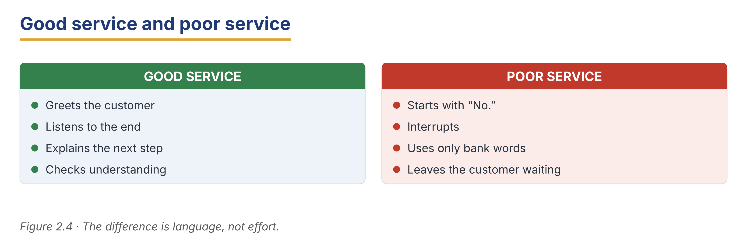
Part 6 · Writing
In-class / homework output

6A Guided writing — complete the service email
Complete the reply email with the words: apologise, confirm, assist, contact, regards.
Word bank
apologise | confirm | assist
contact | regards

1. Dear Mr Okonkwo, thank you for your email. I am happy to ______________________ you.
2. First, I would like to ______________________ for the delay.
3. I can ______________________ that your new card is ready to collect.
4. If you have any questions, please ______________________ us on the number below.
5. Kind ______________________, Customer Service Team.
6B Account inquiry email (50–70 words)
A customer asks how to open a savings account. Write a short, polite reply.
Model — read this first
Subject: Your question about a savings account
Dear Ms Fernandes, Thank you for your email. I am happy to help. To open a savings account, could you please visit our branch with your ID and proof of address? The procedure is quick, and a member of staff can assist you. Please contact us if you have any questions. Kind regards, Customer Service

Plan: Subject: ___ · Dear ___, · Thank you for ___. · To ___, could you please ___? · A member of staff can ___. · Kind regards, ___
Phrase bank: Thank you for your email · I am happy to help · could you please… · a member of staff can assist you · Kind regards
Check before you finish
☐ A clear subject line?
☐ A polite request with could/please?
☐ A warm greeting and close?
☐ 50–70 words?
✎ Write your response here.

6C Lost-card response email (50–70 words)
A customer emails to say they lost their card. Write a calm, helpful reply.
Model — read this first
Subject: Your lost card
Dear Mr Tanaka, Thank you for letting us know. I am sorry to hear about your lost card. For your security, we have frozen it. Could you please visit the branch with your ID so we can issue a new card? If you see any transaction you did not make, please contact us at once. Kind regards, Customer Service

Plan: Subject: ___ · Dear ___, · Thank you for ___. · I am sorry to hear ___. · For your security, we have ___. · Could you please ___? · Kind regards, ___
Check before you finish
☐ A calm, polite tone?
☐ One polite modal request?
☐ A clear next step for the customer?
☐ 50–70 words?
✎ Write your response here.

6D Peer check
Swap your email from 6B or 6C with a partner. Give one piece of positive feedback and one suggestion.
Checklist: subject line? · polite modal? · clear next step? · warm close?
Model — read this first
“Great calm tone and a clear next step. Next time, try to add ‘please’ to your request.”

Part 7 · Management File — Coaching Your Team on Service
Practitioner track (optional for beginners) · experienced staff

7A Feedback phrases — praise or improvement?
Put each phrase into the correct group: Praise or Suggestion for improvement.
● Praise: ____
● Suggestion: ____
Phrases: “You handled that very well.” · “One thing to try next time is…” · “Your greeting was friendly.” · “Let’s work on staying calm with upset customers.”
Model — read this first
Praise: “You handled that very well.”, “Your greeting was friendly.”
Suggestion: “One thing to try next time is…”, “Let’s work on staying calm…”

7B Listening — giving feedback after a hard customer
🔊 Audio 2.4 (optional) — or read the script below.
Marta: Ana, you did well with that difficult customer. You stayed calm.
Ana: Thank you. I was a little nervous.
Marta: That’s normal. Your greeting was friendly, and you apologised nicely.
Ana: Is there anything I should improve?
Marta: One thing to try next time is to explain the next step earlier. That helps the customer feel calm.
Ana: That’s good advice. Thank you, Ms Nowak.

Answer the questions.
Example: 0. Who gives the feedback? → Marta.
1. What did Ana do well?
2. How did Ana feel during the conversation?
3. What should Ana try next time?
7C Turn blunt feedback into supportive feedback
Rewrite each blunt comment so it is supportive and kind.
Example: 0. “You were rude.” → “Let’s work on staying calm and polite with upset customers.”
1. “You were too slow.”
2. “You forgot to greet the customer.”
3. “Your explanation was confusing.”
4. “You didn’t listen to the customer.”
✎ Write your response here.

7D Role play — coach a colleague
You are a supervisor. A new teller’s greeting is too fast and abrupt. Give kind, useful feedback.
Model — read this first
“You’re working hard, and that’s great. One thing to try is a slower, warmer greeting — ‘Good morning, how may I help you?’ Shall we practise it together?”

Card A (supervisor): give one praise + one suggestion + offer to practise.
Card B (teller): listen and respond.
Stretch: the teller feels upset by the feedback — reassure them.
7E Writing — a short feedback note (50–70 words)
Write a friendly feedback note to a team member after a busy day.
Model — read this first
Dear Ana, thank you for your hard work today. You stayed calm with a difficult customer, and your greetings were warm and friendly. One thing to try next time is to explain the next step a little earlier — it helps customers relax. Overall, you did very well. Keep it up! Best, Marta

Plan: Dear ___, thank you for ___. You did well at ___. One thing to try next time is ___. Overall, ___. Best, ___
Phrase bank: thank you for your hard work · you did well at… · one thing to try next time is… · keep it up
Check before you finish
☐ One clear praise?
☐ One kind suggestion?
☐ A warm tone?
☐ 50–70 words?
✎ Write your response here.

Part 8 · Global Case Study — A Service Culture
Practitioner track · read then discuss

Before you read: what makes you go back to the same shop or bank again and again?
Service That Customers Remember
About 210 words · a made-up example based on real practice
A large international bank wanted to keep more of its customers. So it changed how its staff worked, in every country where it has branches. The bank made three simple rules for every employee. The first rule was to greet each customer by name. When staff use a name, customers feel known and valued. The second rule was ‘first-contact resolution’. This means staff try to solve the customer’s problem in one visit, without sending them to another desk. The third rule was to say sorry quickly. If a customer waited too long or had a problem, staff apologised at once and offered a clear solution. They did not argue or blame the customer.
The bank trained every employee, from tellers to managers, and it trained them in the same way in each country. It also asked customers for feedback each month. After one year, complaints fell by almost half, and more customers stayed with the bank. This is called ‘loyalty’. The bank learned an important lesson: good service is not expensive, but it is very valuable.

Glossary help
first-contact resolution — solving a problem in one visit
complaint — when a customer says something is wrong
loyalty — when customers stay with the same bank
feedback — customers’ opinions about the service

8A Comprehension
Example: 0. How many rules did the bank make? → Three.
1. Why does using a customer’s name help?
2. What does ‘first-contact resolution’ mean?
3. What happened to complaints after one year?
4. How did the bank find out customers’ opinions?
5. What lesson did the bank learn?
8B Vocabulary in context
Match the word to its meaning (one is extra).
Column A | Column B
1. loyalty ____ | a) when a customer says something is wrong
2. complaint ____ | b) solving a problem in one visit
3. feedback ____ | c) customers’ opinions about the service
4. first-contact resolution ____ | d) when customers stay with the same bank
 | e) a fee for a service (extra)

8C Discussion
Frames: “This is similar to a bank in my country because ___.” “This is different because ___.”
● Would greeting customers by name work in your bank? Why / why not?
● Which of the three rules is easiest to start today?
8D Your view (short write, 30–40 words)
Which of the three service rules would help most in your bank, and why?
✎ Write your response here.

Part 9 · Branch Case Study — Manila in Focus: The Crowded Branch
Practitioner track · read then decide

Before you read: what happens to service when a branch is very busy?
A Busy Day at the Branch
About 170 words
It is the end of the month, and the Harbour Bank branch in Manila is very busy. Many people come to withdraw their salaries, and several are collecting transfers sent by family working abroad. The queue is long, and the wait is over thirty minutes. Liza Cruz is at the counter. She is polite and careful, but she is also a little slow because she is still new. One customer, an older man, is tired of waiting. When he reaches the counter, he speaks in an angry voice. Liza stays calm. She remembers her training: greet, apologise, and offer help. But the queue behind him is growing, and other customers look unhappy too. Nina Santos, the experienced teller, is fast, but she cannot serve everyone alone. The manager, Carlos Reyes, watches from his office and must decide how to keep service polite and fast. He does not want to lose calm, loyal customers on a difficult day.

9A Comprehension
Example: 0. Why is the branch busy? → It is the end of the month and people withdraw salaries.
1. How long is the wait?
2. Why is Liza a little slow?
3. What does Liza remember from her training?
4. Who is the experienced teller?
9B Decision task
What should Carlos do to keep service polite and fast? Write 40–60 words. Use the frame and phrase bank.
Model — read this first
I think Carlos should open a second counter and help at the busy times. He can move Nina to serve customers quickly, while Liza takes simple transactions. Also, Carlos can apologise to the angry customer and thank everyone for waiting. This keeps service calm and faster.

Frame: I think Carlos should ___, because ___. Also, ___.
Phrase bank: open a second counter · move ___ to the busy window · apologise for the wait · thank customers for waiting
✎ Write your response here.

Part 10 · Review & Can-Do
Homework / self-study

10A Spiral review
Complete the sentences. Use a polite modal (can/could/may) or the correct word. Items 7–8 review Unit 1.
Example: 0. ____ I help you? → May / Can.
1. ______________________ you confirm your address, please? (polite request)
2. ______________________ I see your ID? (formal permission)
3. A customer’s question for information is an ______________________. (word)
4. To check that something is true is to ______________________ it. (word)
5. Please ______________________ for the delay and offer a solution. (verb, service)
6. ______________________ I get you a copy of the receipt? (friendly offer)
7. A ______________________ handles deposits and withdrawals. (Unit 1 role)
8. Right now, the new teller ______________________ (learn) the system. (Unit 1 grammar)
10B Can-Do checklist
Can-Do checklist — tick what you can do now
☐ I can greet a customer politely.
☐ I can make requests and offers with can, could and may.
☐ I can handle a simple problem calmly.
☐ I can understand short service conversations.
☐ I can write a short, polite service email.
10C Unit glossary
Glossary help
assist — to help a customer
verify — to check that something is true
authorise — to give official permission
inquiry — a question asking for information
procedure — the official steps to do something
transaction — a deposit, withdrawal or transfer
complaint — when a customer says something is wrong
loyalty — when customers stay with the same bank
feedback — customers’ opinions about the service
first-contact resolution — solving a problem in one visit

Unit 3 · Everyday Banking Transactions
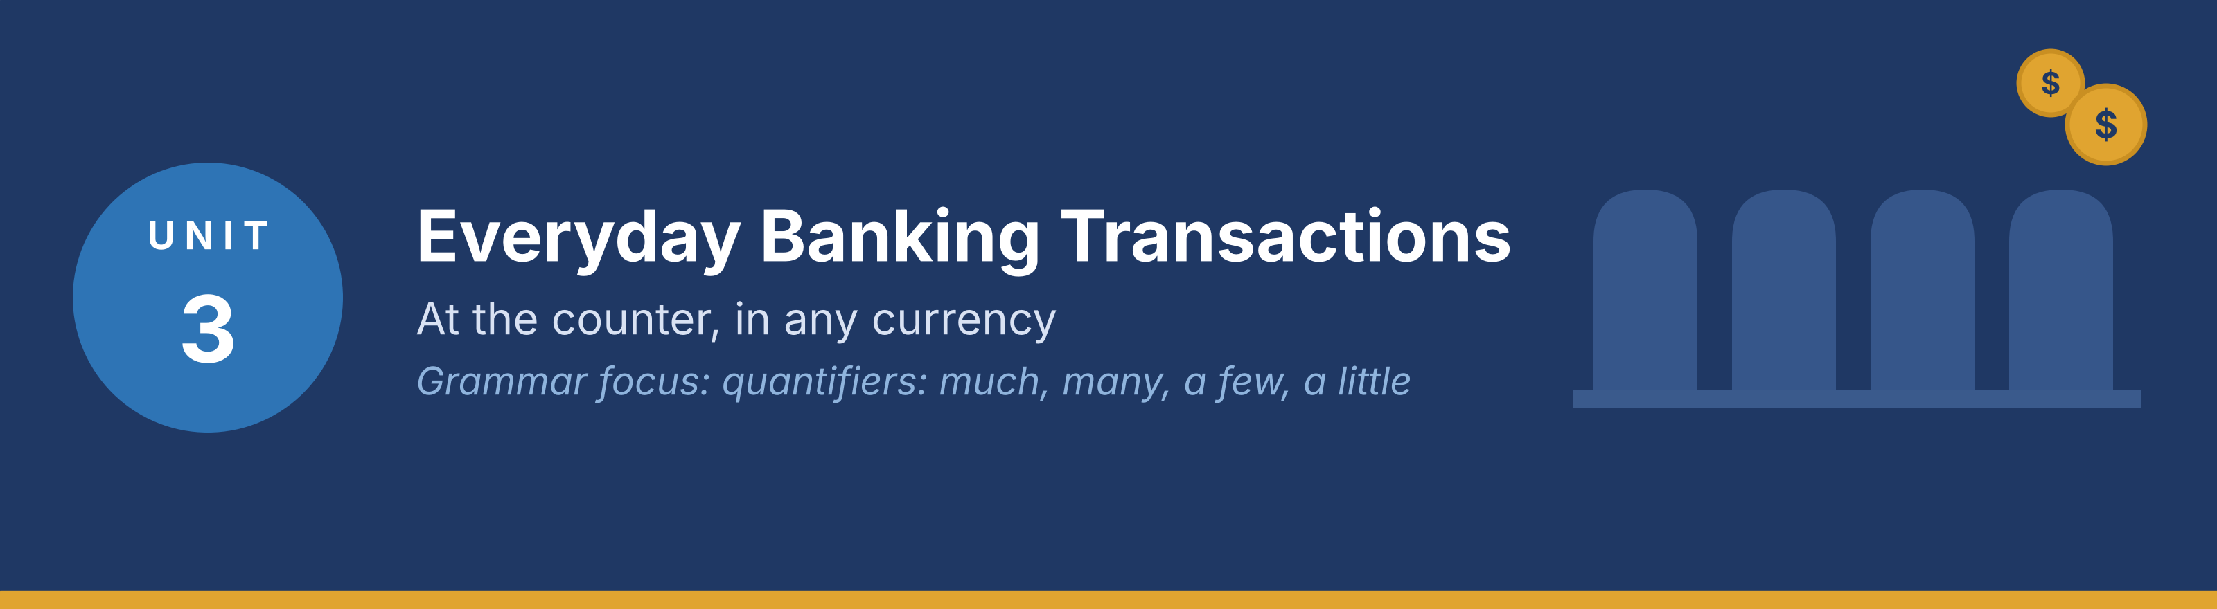
In this unit you learn the language of everyday transactions at the counter, how to talk about amounts, how to follow a conversation with a customer, and how to write a short internal note. Grammar focus: quantifiers (much, many, a few, a little).
Part · · Warm-Up
In-class starter · speak before you read

W-A Daily transactions (brainstorm)
With a partner, list everything a customer can do at a bank counter in one day.
Model — read this first
Deposit cash. Withdraw cash. Pay a bill. Transfer money to another account. Change one currency for another.

● Which of these do you do most often?
● Which one takes the longest? Why?
W-B Teller security checks (think–pair–share)
Think for one minute, then compare with a partner.
● What does a teller check before paying out cash?
● Why does the bank ask for ID for a large amount?
Tip: Use the words amount, limit, ID, receipt and signature in your answer.
Part 1 · Vocabulary
Pre-class input

1A Match the term to the meaning
Match each transaction word (1–7) to the correct meaning (a–h). One meaning is extra.
Example: 0. Receipt → g)
Column A | Column B
1. Deposit ____ | a) money taken out of an account
2. Withdrawal ____ | b) money paid into an account
3. Transfer ____ | c) money moved from one account to another
4. Balance ____ | d) the money in an account at this moment
5. Statement ____ | e) a list of all the transactions on an account
6. Standing order ____ | f) the same payment, sent again and again
7. Direct debit ____ | g) permission for a company to collect a payment
 | h) a fee the bank charges for a service (extra)

Pronunciation — word stress. Say these words: de·PO·sit, with·DRAW·al, TRANS·fer (noun), trans·FER (verb), BA·lance.
1B Sort the transactions
Put each word from 1A into the correct group.
● Money in: ____
● Money out: ____
● Information only: ____
Model — read this first
Money in: deposit. Money out: withdrawal, standing order, direct debit. Information only: balance, statement. (A transfer can be either, depending on the direction.)

1C Complete the sentences
Complete the sentences with the correct word.
Word bank
deposit | withdraw | balance
transfer | statement | receipt
limit | currency | fee

Example: 0. Please sign here and keep your receipt.
1. I would like to ______________________ 200 in cash, please.
2. Could you check the ______________________ on my current account?
3. The daily ______________________ at the machine is 500.
4. I want to ______________________ this money into my savings account.
5. Please send me a ______________________ for the last three months.
6. There is a small ______________________ for an international transfer.
1D Word partners (collocations)
Match the verb to the noun to make a common banking phrase (one noun is extra).
Column A | Column B
1. make ____ | a) cash
2. withdraw ____ | b) a deposit
3. check ____ | c) a transfer
4. send ____ | d) the balance
5. sign ____ | e) the slip
 | f) a queue (extra)

1E Write with the words (40–60 words)
Write about one transaction you made recently. Use at least five words from Part 1.
Model — read this first
Last Friday I went to my branch to deposit my salary. The teller checked my ID and gave me a receipt. Then I asked for my balance and sent a small transfer to my sister. The whole visit took ten minutes.

Check before you finish
☐ Five Part-1 words?
☐ 40–60 words?
☐ Short, clear sentences?
✎ Write your response here.

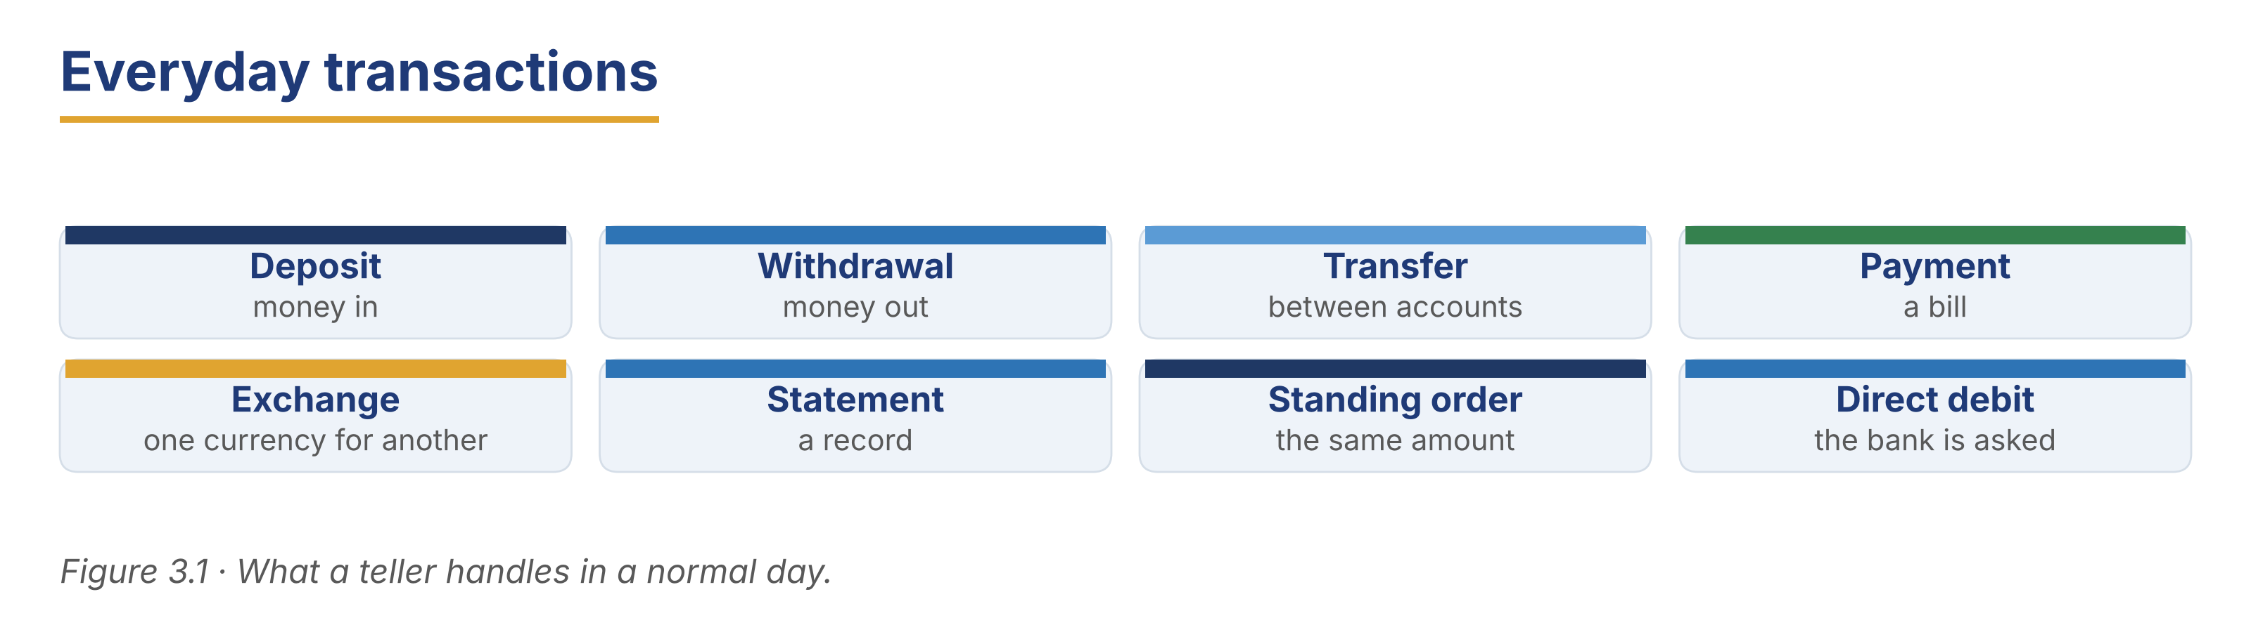
Part 2 · Grammar — Quantifiers (much, many, a few, a little)
Pre-class input

2A Notice the grammar
Read the short dialogue. Underline much, many, a few and a little. Which words go with countable nouns?
Grace: Good morning. How much cash would you like today?
Customer: Three hundred, please. And how many notes can I have?
Grace: As many as you like. There are a few large notes left, and a little change.
Customer: Large notes, please. I don’t have much time.

1. much — countable or uncountable? ____
2. many — countable or uncountable? ____
3. a few / a little — which one goes with notes? ____
Grammar Focus
Quantifier | Use | Example
much | uncountable nouns, mostly in questions and negatives | How much cash do you need?
many | countable nouns | How many notes would you like?
a few / a little | a small amount: a few (countable), a little (uncountable) | a few coins; a little change

Remember: cash, money, time and change are uncountable → much, a little. notes, coins, accounts and forms are countable → many, a few.
⚠ Watch out!
✗ How many money do you need? → ✓ How much money do you need?
✗ I have a little coins. → ✓ I have a few coins.

2B Controlled practice (choose the quantifier)
Choose much, many, a few or a little.
Word bank
much | many | a few
a little | how much | how many

Example: 0. ____ cash do you need? → How much.
1. ______________________ notes would you like, sir?
2. I only have ______________________ change in the drawer.
3. We do not have ______________________ time before the branch closes.
4. ______________________ customers are waiting outside?
5. There are still ______________________ forms on the counter.
6. She put ______________________ money into her savings account.
2C Error correction
Find and correct the mistake in each sentence.
Example: 0. How many cash? → How much cash?
1. How many money would you like to deposit?
2. I have a little notes in my wallet.
3. There aren’t much customers today.
4. He needs a few cash for the weekend.
5. How much forms do I have to sign?
✎ Write your response here.

2D Ask about amounts
Write three questions a teller asks a customer about amounts. Use much, many and a few.
Model — read this first
How much would you like to withdraw? How many notes would you like? Would you like a few coins as well?

✎ Write your response here.

2E Freer practice (speaking at the counter)
In pairs, act a short counter conversation. The teller asks at least three questions about amounts.
Model — read this first
“Good morning. How much would you like to deposit? … And how many of these are large notes?”

Tip: You will see these quantifiers again in the reading in Part 5 (5A and 5B). Look for them there.
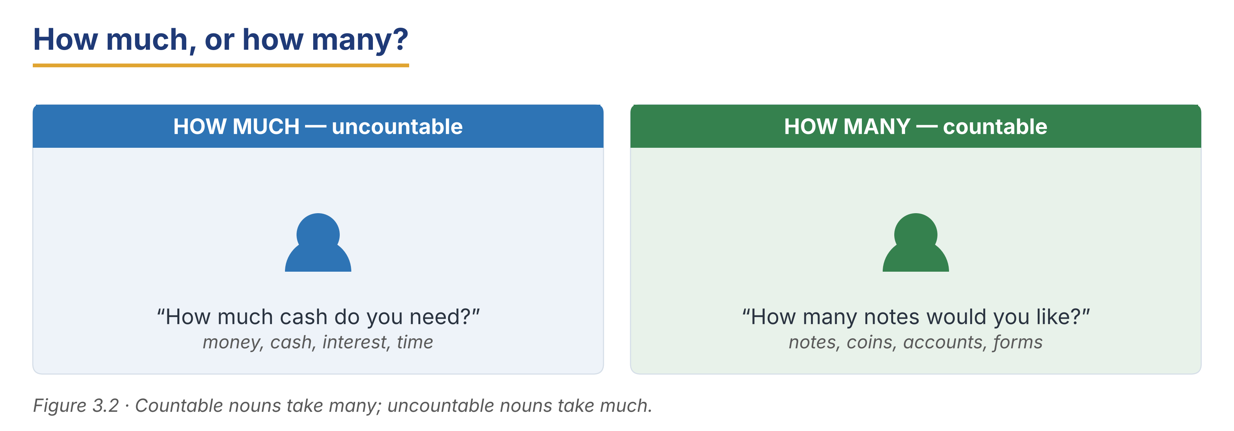
Part 3 · Listening
Pre-class input · scripts printed below

3A Before you listen (predict)
You will hear three counter conversations. What does a teller usually say first?
Model — read this first
“I think the teller will greet the customer and ask how she can help.”

3B A simple withdrawal
🔊 Audio 3.1 (optional) — or read the script below.
Grace: Good morning. How can I help you?
Customer: I’d like to withdraw three hundred, please.
Grace: Certainly. May I see your card and your ID?
Customer: Here you are.
Grace: Thank you. How many large notes would you like?
Customer: All large, please. And a receipt.

Read and decide: True, False, or Not Given.
Example: 0. The customer wants to take out money. → True.
1. The teller asks for one document only.
2. The customer wants small notes.
3. The customer has used this branch before.
Useful language: How can I help you? · May I see your card and your ID? · How many large notes would you like?
3C A cash deposit
🔊 Audio 3.2 (optional) — or read the script below.
Customer: Hello. I’d like to deposit this cash into my current account.
Tomasz: Of course. How much is it?
Customer: Four hundred and fifty. I counted it twice.
Tomasz: Thank you. Could you complete this deposit slip, please? I will count it again in front of you.
Customer: Will the money be in the account today?
Tomasz: Yes. Cash deposits are available at once.

Read and decide: True or False.
1. The customer is paying money into an account.
2. The teller does not count the money again.
3. The customer must complete a slip.
4. Cash deposits take three days.
5. The customer counted the money before coming.
3D A customer with several transactions (longer)
🔊 Audio 3.3 (optional) — or read the script below.
Customer: Good afternoon. I have a few things to do today, I’m afraid.
Grace: That’s no problem. Let’s take them one at a time.
Customer: First, I’d like to withdraw two hundred. Then I want to pay my electricity bill. And I need a statement for the last three months, because my landlord has asked for one.
Grace: Certainly. How much is the bill?
Customer: Eighty-five. I have the paper here.
Grace: Thank you. I’ll do the withdrawal first, then the bill, and I’ll print the statement last. It takes a little time, but not much.
Customer: That’s fine. I’m not in a hurry today.

Read and decide: True, False, or Not Given.
Example: 0. The customer has more than one transaction. → True.
1. The customer wants a statement for six months.
2. The teller does the three transactions in order.
3. The customer is in a hurry.
3E Identify the transaction type
Match each sentence from the listenings to the type of transaction (one is extra).
Column A | Column B
1. “I’d like to withdraw three hundred.” ____ | a) a cash deposit
2. “I’d like to deposit this cash.” ____ | b) a cash withdrawal
3. “I want to pay my electricity bill.” ____ | c) a bill payment
4. “I need a statement for three months.” ____ | d) a request for information
5. “Could you complete this deposit slip?” ____ | e) a form the customer signs
 | f) a currency exchange (extra)

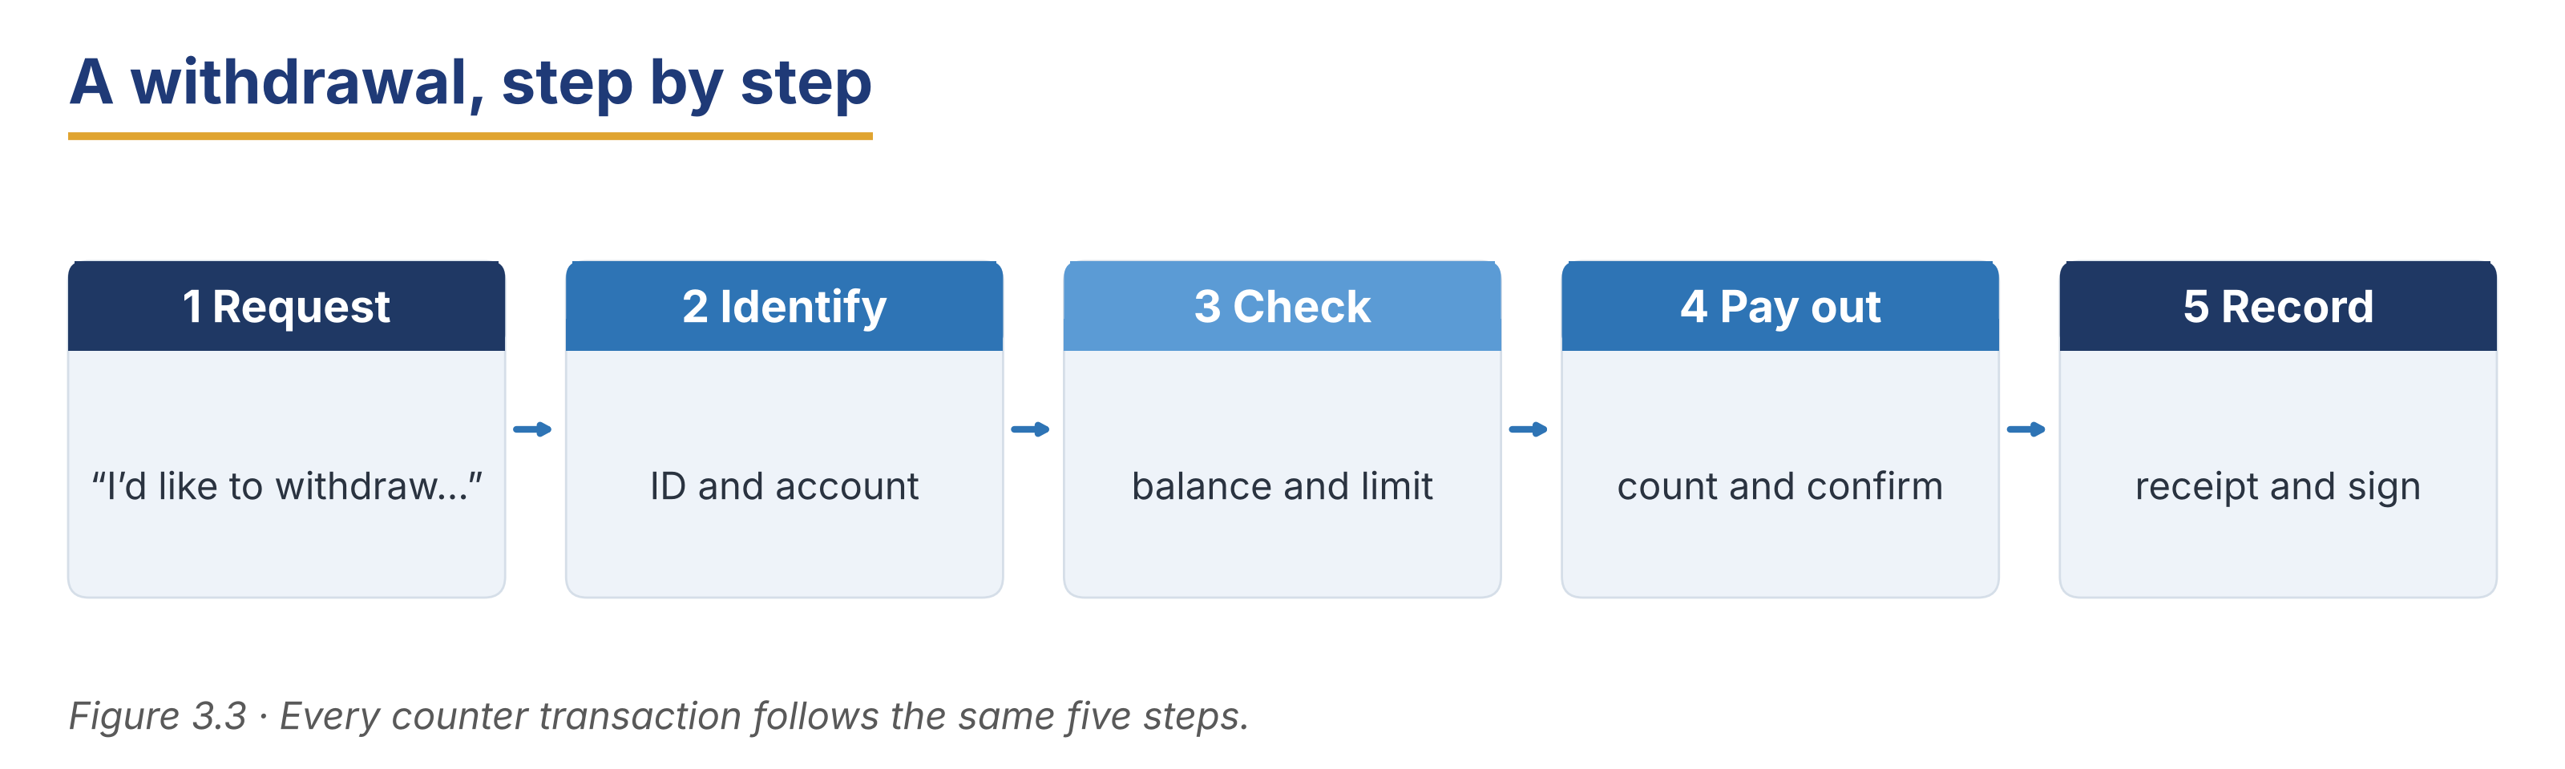
Part 4 · Speaking
In-class output

4A Functional language — at the counter
Match the function to a phrase (one is extra).
Column A | Column B
1. Greet the customer ____ | a) “How much would you like to withdraw?”
2. Ask about an amount ____ | b) “Good morning. How can I help you?”
3. Ask for a document ____ | c) “Could I see your ID, please?”
4. Confirm and close ____ | d) “Here is your receipt. Anything else?”
 | e) “Your card has been blocked.” (extra)

4B Teller role-play (pairwork)
Act a counter transaction, then swap roles.
Model — read this first
A: Good morning. How can I help you? — B: I’d like to deposit four hundred. — A: Certainly. Could you complete this slip? How many notes are there? — B: Eight. — A: Thank you. Here is your receipt.

Card A (teller): greet · ask the amount · ask for ID · give a receipt.
Card B (customer): you want to deposit cash; you have your ID; you also want your balance.
4C Three-step banking task
Your customer has three things to do. Serve them in a clear order and say what you are doing.
Model — read this first
“Let’s take them one at a time. First the withdrawal, then the bill, and I’ll print the statement last.”

Stretch: the customer adds a fourth request at the end — handle it politely.
4D Find the information (pairwork info-gap)
Student A is a teller; Student B is a customer. Ask and answer to complete the transaction.
Card A (teller): you can pay out up to 500 in cash; a statement takes two minutes; a bill payment needs the paper bill.
Card B (customer): you want 600 in cash, a statement for three months, and to pay a bill of 85.
Useful language: How much would you like? · How many notes? · Do you have the bill with you?
4E Closing the transaction
Match the closing phrase to the situation (one is extra).
Column A | Column B
1. “Here is your receipt.” ____ | a) giving the customer the record
2. “Would you like a statement as well?” ____ | b) offering one more service
3. “Please check the amount before you leave.” ____ | c) asking the customer to check
4. “Is there anything else today?” ____ | d) checking there is nothing more
5. “Thank you. Have a good day.” ____ | e) closing warmly
 | f) “Please take a seat.” (extra)

In pairs, close a counter transaction politely. Use two phrases above.
Part 5 · Reading
Pre-class input

5A Teller guidelines
Read the counter guidelines. Notice the quantifiers (much, many, a few, a little).
Harbour Bank — Guidelines for the Counter
About 200 words
These guidelines are the same in every Harbour Bank branch, because every customer should get the same careful service. Before you pay out cash, always check two things: the customer’s ID and the balance on the account. If the amount is large, ask a colleague to check with you. It takes a little time, but it prevents mistakes. Count notes twice. Count them once in the drawer and once in front of the customer. Many customers like to see the money counted, and a few will count it again themselves. That is normal, and you should never hurry them. Ask how many large notes the customer would like. Some people want large notes because they are easier to carry; others want small notes because they are easier to spend. Give a receipt for every transaction, even a small one. Finally, remember that not much goes wrong at a quiet counter; most mistakes happen when there is a queue and too little time. If you feel rushed, slow down and say, “One moment, please.” A short pause is better than a wrong amount.

Answer the questions.
Example: 0. What two things do you check before paying out cash? → ID and balance.
1. What should you do if the amount is large?
2. How many times should you count notes?
3. Why do some customers want large notes?
4. When do most mistakes happen?
5. What should you say if you feel rushed?
6. Who do these guidelines apply to?
5B Grammar in context (from 5A)
Look back at the guidelines. Find one example of each quantifier.
1. much: ____
2. many: ____
3. a few: ____
4. a little: ____
Now complete these sentences about the counter.
1. There isn’t ______________________ time when the queue is long.
5C A customer’s bank statement
Read the short statement note. What does each line show?
Reading a Statement
About 130 words
A statement is a list of everything that has happened on an account. Each line shows the date, a short description, the amount, and the balance after the transaction. Money coming in is usually on the left, and money going out is on the right. A customer called the branch last week because she could not understand one line. It said “DD — CITY POWER — 85.00”. DD means direct debit: the customer gave the electricity company permission to collect the payment every month. Another line said “ATM — 14 MAR — 200.00”. That was a cash withdrawal from a machine. The last line showed the balance: the money left in the account. When you explain a statement, start with the date and read across the line slowly.

1. What four things does each line of a statement show?
2. What does DD mean?
3. Why did the customer call the branch?
4. How should you explain a line to a customer?
5D Discussion
In pairs, compare the guidelines with your own workplace.
Useful frame: “At my bank we also ___, but we do not ___.”
● Which guideline is the most important? Why?
● What does your bank do when there is a long queue?
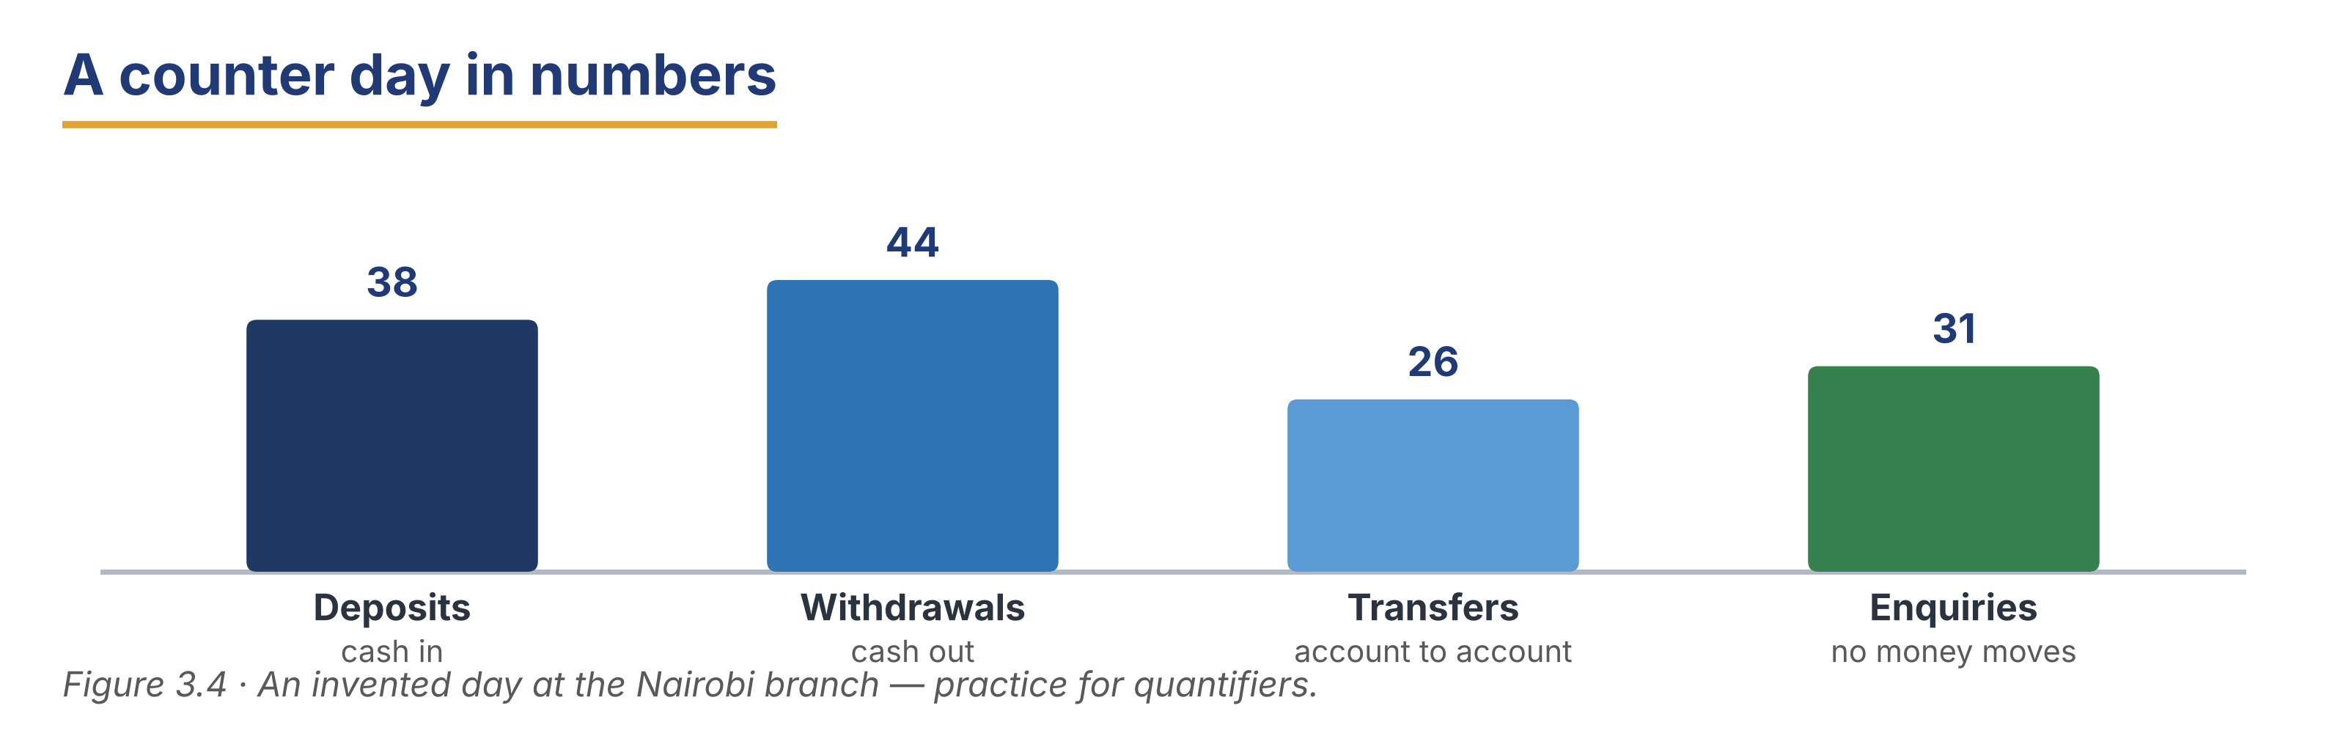
Part 6 · Writing
In-class / homework output

6A Guided writing — complete the transaction note
Complete the internal note with the words: deposited, balance, receipt, verified, slip.
Word bank
deposited | balance | receipt
verified | slip

1. At 10:15 a customer ______________________ 450 in cash into a current account.
2. I ______________________ the customer’s ID before the transaction.
3. The customer completed a deposit ______________________ and signed it.
4. The new ______________________ was shown to the customer on screen.
5. A printed ______________________ was given to the customer.
6B Internal email — process report (50–70 words)
Write a short internal email to your supervisor about a busy hour at the counter.
Model — read this first
Subject: Counter report — Tuesday morning
Dear Ms Nowak, Between nine and eleven we served forty-two customers. Most of them were cash deposits and withdrawals. There were a few bill payments and a little trouble with the note counter, which I have reported to IT. No cash differences at the end of the hour. Best regards, Grace

Plan: Subject: ___ · Dear ___, · Between ___ and ___ we ___. · Most of them were ___. · There were a few ___. · Best regards, ___
Phrase bank: Between ___ and ___ we served… · Most of them were… · There were a few… · No cash differences
Check before you finish
☐ A clear subject line?
☐ One quantifier used correctly?
☐ A short, factual tone?
☐ 50–70 words?
✎ Write your response here.

6C Customer inquiry email (50–70 words)
A customer emails to ask why a payment left her account. Write a short, clear reply.
Model — read this first
Subject: Your question about a payment
Dear Ms Fernandes, Thank you for your email. The payment of 85.00 on 14 March was a direct debit to City Power. A direct debit is a payment you have given a company permission to collect. If you would like to stop it, could you please visit the branch with your ID? Kind regards, Customer Service

Plan: Subject: ___ · Dear ___, · Thank you for ___. · The payment of ___ was ___. · A ___ is ___. · Could you please ___? · Kind regards, ___
Check before you finish
☐ A clear subject line?
☐ A simple explanation of the banking word?
☐ A clear next step?
☐ 50–70 words?
✎ Write your response here.

6D Peer check
Swap your email from 6B or 6C with a partner. Give one piece of positive feedback and one suggestion.
Checklist: subject line? · correct quantifier? · clear next step? · 50–70 words?
Model — read this first
“Clear subject line and a good explanation of ‘direct debit’. Next time, try to give the date as well.”

Part 7 · Management File — Running the Counter
Practitioner track (optional for beginners) · experienced staff

7A Shift and cash-control phrases
Match the phrase to its purpose (one is extra).
Column A | Column B
1. “The drawer balances.” ____ | a) the cash counted matches the record
2. “We are two hundred short.” ____ | b) the cash counted is less than the record
3. “I’m handing over to Tomasz.” ____ | c) passing the counter to a colleague
4. “Please countersign the float.” ____ | d) asking a colleague to check and sign
 | e) closing an account (extra)

7B Listening — the shift handover
🔊 Audio 3.4 (optional) — or read the script below.
Grace: Right, I’m handing over to you now. The drawer balances — I’ve counted it twice.
Tomasz: Thanks. How much is in the float?
Grace: Two thousand, and a little change. There are only a few large notes left, so order more if the queue builds.
Tomasz: Anything else I should know?
Grace: One customer is coming back at three for a statement. Her name is on the pad.

Answer the questions.
Example: 0. Who is taking over the counter? → Tomasz.
1. How much is in the float?
2. Why should Tomasz order more large notes?
3. What is happening at three o’clock?
7C Controlled practice — the handover note
Complete the handover note. Use the correct quantifier or word.
Word bank
balances | float | a few
a little | short | countersigned

1. The drawer ______________________ at the end of my shift.
2. There are only ______________________ large notes left in the drawer.
3. We have ______________________ change, so please order more coins.
4. The ______________________ was counted and ______________________ by a colleague.
5. We are not ______________________ any cash today.
✎ Write your response here.

7D Role play — hand over the counter
You are finishing your shift. Hand over the counter to a colleague clearly and completely.
Model — read this first
“The drawer balances. There is a little change and only a few large notes. One customer is returning at three. Please countersign the float before I go.”

Card A (leaving): say the drawer balances · say what is low · say what is outstanding · ask for a countersignature.
Card B (arriving): ask two questions and repeat back what you heard.
Stretch: the drawer does not balance — explain calmly what you will do next.
7E Writing — an end-of-shift summary (50–70 words)
Write a short end-of-shift summary for the supervisor.
Model — read this first
Subject: End of shift — counter 2
The drawer balances. I served sixty-one customers today, mostly deposits and withdrawals. There were a few bill payments and one statement request. We are low on large notes, so I have ordered more for tomorrow. Nothing outstanding. Countersigned by Tomasz Wójcik at 16:05. Grace Otieno

Plan: Subject: ___ · The drawer ___. · I served ___. · There were a few ___. · We are low on ___. · Countersigned by ___.
Phrase bank: the drawer balances · mostly deposits and withdrawals · we are low on… · nothing outstanding · countersigned by…
Check before you finish
☐ Does it say whether the drawer balances?
☐ One quantifier used correctly?
☐ Anything outstanding named?
☐ 50–70 words?
✎ Write your response here.

Part 8 · Global Case Study — Cutting the Queue
Practitioner track · read then discuss

Before you read: what makes a bank queue move faster — more staff, or something else?
Twenty Minutes Saved
About 200 words · a made-up example based on real practice
A bank with branches in several countries had the same problem everywhere: at the end of the month, customers waited twenty minutes or more. The bank did not want to pay for many extra staff, so it looked at the queue itself. It found that a little over half of the people in the queue did not need a teller at all. They were checking a balance, printing a statement, or paying a routine bill — all things a machine or the app can do. So the bank made three changes. First, it put a member of staff at the door to ask each customer what they needed. This person is called a greeter. If the customer only needed a balance, the greeter showed them the machine. Second, it moved bill payments to a separate, faster desk. Third, it taught customers to use the app, one customer at a time, while they waited. After three months, the average wait fell from twenty minutes to eight. The bank had not added a single teller.

Glossary help
greeter — a member of staff who meets customers at the door
queue — a line of people waiting
average wait — the usual waiting time
routine payment — a payment that happens again and again

8A Comprehension
Example: 0. How long did customers wait at the end of the month? → Twenty minutes or more.
1. What did the bank find about the people in the queue?
2. What does a greeter do?
3. Why did the bank move bill payments to a separate desk?
4. How long was the average wait after three months?
5. How many extra tellers did the bank add?
8B Vocabulary in context
Match the word to its meaning (one is extra).
Column A | Column B
1. greeter ____ | a) a line of people waiting
2. queue ____ | b) a member of staff who meets customers at the door
3. average wait ____ | c) a payment that happens again and again
4. routine payment ____ | d) the usual waiting time
 | e) a charge for a service (extra)

8C Discussion
Frames: “This would work in my branch because ___.” “This would be difficult because ___.”
● Would a greeter work in your branch? Why / why not?
● Which of the three changes is easiest to start tomorrow?
8D Your view (short write, 30–40 words)
Which change would cut the queue most in your bank, and why?
✎ Write your response here.

Part 9 · Branch Case Study — Istanbul in Focus: When the Rate Moves
Practitioner track · read then decide

Before you read: what happens at the counter when an exchange rate changes quickly?
A Morning of Questions
About 175 words
The Harbour Bank branch in Istanbul opens at nine. This morning the exchange rate has moved a long way overnight, and many customers want to change money before it moves again. By half past nine there is a queue of about twenty people. Most of them have only one question: “How much will I get today?” Zeynep Kaya is on the exchange desk. She is careful and polite, but each customer wants to talk about the rate, and a few are angry about the spread between the buy rate and the sell rate. Meanwhile, the ordinary counter has its own queue of deposits and withdrawals. The branch manager, Kerem Aydın, has four staff this morning and two desks. He knows the rate will probably move again at eleven, when the market opens. He must decide how to use his people in the next two hours, and what to tell the customers who are waiting.

9A Comprehension
Example: 0. Where is the branch? → In Istanbul.
1. Why do many customers want to change money this morning?
2. What one question do most of them have?
3. What are a few customers angry about?
4. How many staff and desks does Kerem have?
9B Decision task
What should Kerem do in the next two hours? Write 40–60 words. Use the frame and the phrase bank.
Model — read this first
I think Kerem should open the second desk for exchange only, because most customers have the same question. He can put a board at the door with today’s rate, so people do not have to ask. Also, he can ask Zeynep to explain the spread once, clearly, to everyone waiting.

Frame: I think Kerem should ___, because ___. Also, ___.
Phrase bank: open a second desk for ___ only · put today’s rate on a board · explain the spread once, clearly · ask customers with one question to ___
✎ Write your response here.

Part 10 · Review & Can-Do
Homework / self-study

10A Spiral review
Complete the sentences. Use a quantifier or the correct word. Items 5–6 review Units 1 and 2.
Example: 0. How ____ cash do you need? → much.
1. How ______________________ notes would you like, sir? (quantifier)
2. There isn’t ______________________ time before we close. (quantifier)
3. Money paid into an account is a ______________________. (word)
4. A list of all your transactions is a ______________________. (word)
5. ______________________ you confirm your address, please? (Unit 2 modal)
6. At the moment, the teller ______________________ (count) the drawer. (Unit 1 grammar)
10B Can-Do checklist
Can-Do checklist — tick what you can do now
☐ I can name the everyday transactions at a counter.
☐ I can ask about amounts with much, many, a few and a little.
☐ I can serve a customer with several transactions in order.
☐ I can understand a short counter conversation.
☐ I can write a short internal note about a shift.
10C Unit glossary
Glossary help
deposit — money paid into an account
withdrawal — money taken out of an account
transfer — money moved from one account to another
balance — the money in an account at this moment
statement — a list of all the transactions on an account
standing order — the same payment, sent again and again
direct debit — permission for a company to collect a payment
float — the cash a teller starts the shift with
greeter — a member of staff who meets customers at the door
average wait — the usual waiting time

Unit 4 · Banking Products and Services
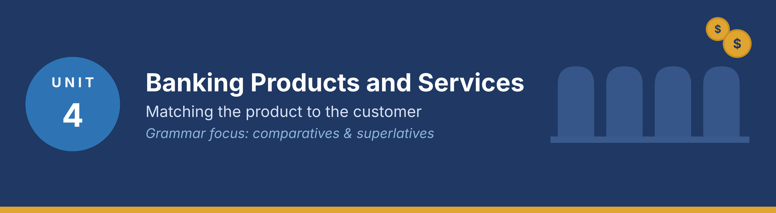
In this unit you learn the names of the bank’s main products, how to compare them, how to recommend the right one to a customer, and how to write a short recommendation email. Grammar focus: comparatives and superlatives.
Part · · Warm-Up
In-class starter · speak before you read

W-A What do customers need? (discussion)
In small groups, think of three different customers and what each one needs from a bank.
Model — read this first
A student needs a simple account with no fees. A shop owner needs a business account and a small loan. A family saving for a house needs a savings account with a good rate.

● Who are the three most common customers at your branch?
● What does each of them ask for first?
W-B Products and uses (quick match)
In pairs, say which product each person needs. One minute only.
● Someone who is paid every month and pays bills: ____
● Someone who wants to keep money for three years: ____
● Someone who needs 5,000 to buy a van for work: ____
Tip: Use the words account, card, loan and deposit in your answers.
Part 1 · Vocabulary
Pre-class input

1A Match the product to the definition
Match each product (1–8) to the correct definition (a–i). One definition is extra.
Example: 0. Overdraft → h)
Column A | Column B
1. Current account ____ | a) money you keep and do not spend every day
2. Savings account ____ | b) an account for everyday payments and bills
3. Fixed deposit ____ | c) money locked away for a fixed time at a fixed rate
4. Debit card ____ | d) a card that spends your own money
5. Credit card ____ | e) a card that spends the bank’s money, repaid later
6. Personal loan ____ | f) money you borrow and repay in monthly amounts
7. Mortgage ____ | g) a long loan to buy a property
8. Overdraft ____ | h) permission to go below zero on a current account
 | i) a charge for sending money abroad (extra)

Pronunciation — word stress. Say these words: MORT·gage, O·ver·draft, de·PO·sit, in·TE·rest, in·STAL·ment.
1B Sort the products
Put each product from 1A into the correct group.
● For keeping money: ____
● For spending money: ____
● For borrowing money: ____
Model — read this first
For keeping money: savings account, fixed deposit. For spending money: current account, debit card. For borrowing money: credit card, personal loan, mortgage, overdraft.

1C Complete the sentences
Complete the sentences with the correct word.
Word bank
interest | rate | fee
instalment | term | limit
apply | repay | balance

Example: 0. The bank pays interest on your savings.
1. Our savings account pays a higher ______________________ than our current account.
2. There is no monthly ______________________ on a student account.
3. You repay a personal loan in equal monthly ______________________.
4. A fixed deposit has a ______________________ of one, two or three years.
5. Your credit card has a ______________________ of 2,000.
6. You can ______________________ for a loan online or at the branch.
1D Word partners (collocations)
Match the verb to the noun to make a common banking phrase (one noun is extra).
Column A | Column B
1. open ____ | a) a loan
2. apply for ____ | b) an account
3. pay ____ | c) interest
4. earn ____ | d) a fee
5. repay ____ | e) the instalments
 | f) a queue (extra)

1E Write with the words (40–60 words)
Write about one banking product you use. Use at least five words from Part 1.
Model — read this first
I have a current account for my salary and a savings account for my holiday. The savings account pays a better rate, but I cannot use the money every day. I do not pay a monthly fee, and my debit card is free.

Check before you finish
☐ Five Part-1 words?
☐ 40–60 words?
☐ Short, clear sentences?
✎ Write your response here.

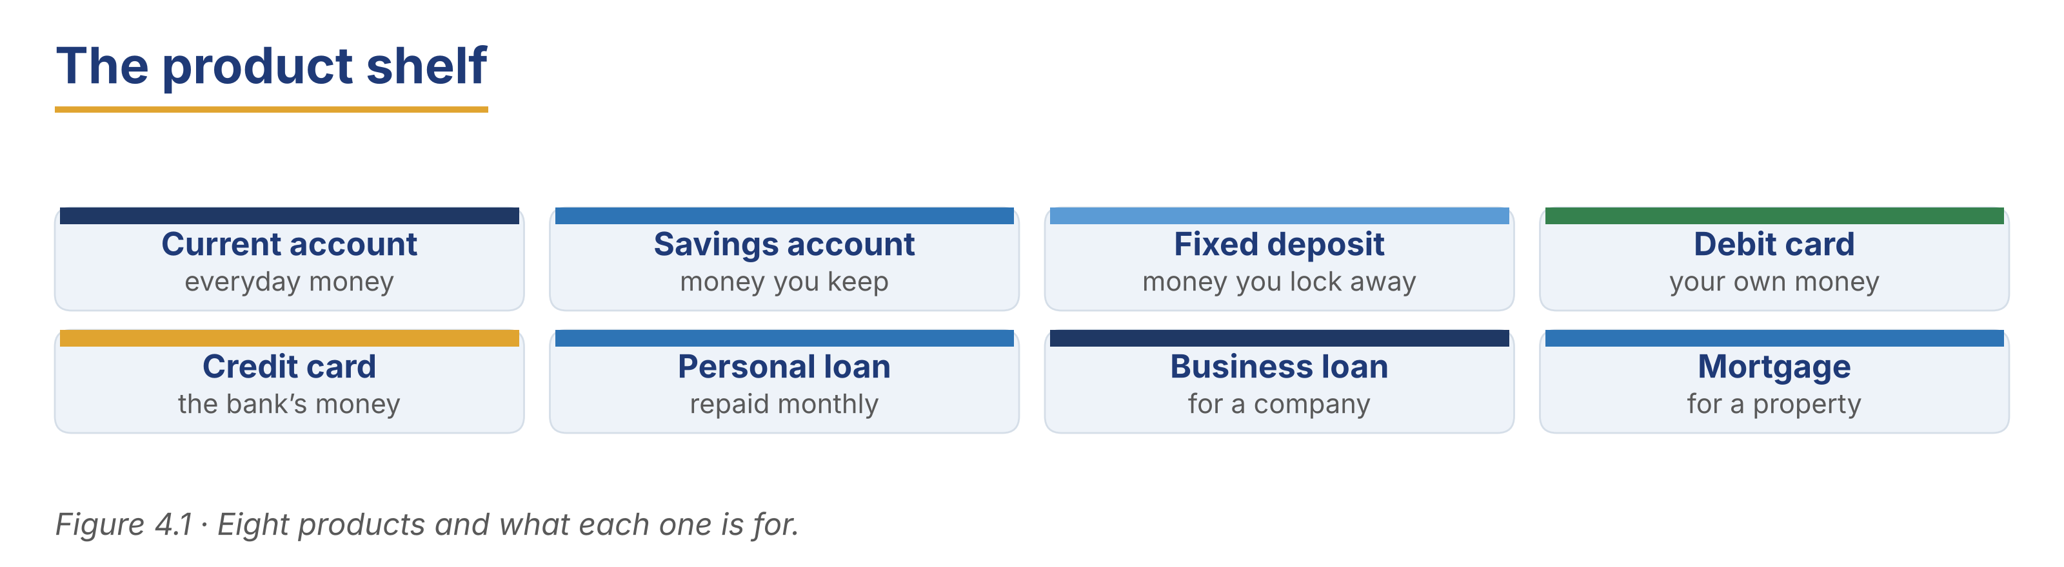
Part 2 · Grammar — Comparatives and Superlatives
Pre-class input

2A Notice the grammar
Read the short dialogue. Underline the comparatives and superlatives. Which compares two things, and which compares all of them?
Diego: The Step Saver pays a higher rate than the Everyday Saver.
Customer: And which is the best for me?
Diego: If you can wait a year, the Fixed 12 is the highest of the three. It is also the least flexible.
Customer: So it is better for money I don’t need?
Diego: Exactly. It is the safest choice for long-term saving.

1. higher — comparative or superlative? ____
2. the best — how many things is it comparing? ____
3. less flexible / the least flexible — which compares two? ____
Grammar Focus
Form | Use | Example
-er / more … than | comparing two things | This card is cheaper than that one.
the -est / the most … | comparing three or more | This is the cheapest card we offer.
less / the least | the opposite direction | the least flexible account

Remember: short words add -er / -est (high → higher → the highest). Long words take more / the most (flexible → more flexible → the most flexible).
⚠ Watch out!
✗ This account is more better. → ✓ This account is better.
✗ It is the most cheap card. → ✓ It is the cheapest card.

2B Controlled practice (comparative or superlative)
Write the correct form of the word in brackets.
Example: 0. The Fixed 12 pays a ____ (high) rate than the Step Saver. → higher.
1. A credit card is ______________________ (expensive) than a debit card.
2. This is the ______________________ (good) account for a student.
3. A mortgage is ______________________ (long) than a personal loan.
4. Our online application is the ______________________ (fast) way to apply.
5. A fixed deposit is ______________________ (safe) than an investment.
6. The Everyday Saver is the ______________________ (flexible) of the three.
2C Error correction
Find and correct the mistake in each sentence.
Example: 0. It is more cheaper. → It is cheaper.
1. This card is more better than the old one.
2. The Fixed 12 is the most high rate we offer.
3. A loan is expensiver than an overdraft.
4. This is the more flexible account of the three.
5. A debit card is cheap than a credit card.
✎ Write your response here.

2D Compare two products
Write three sentences comparing two accounts your bank offers. Use one superlative.
Model — read this first
The Step Saver pays a higher rate than the Everyday Saver. However, the Everyday Saver is more flexible, because you can withdraw any day. For long-term money, the Fixed 12 is the best of the three.

✎ Write your response here.

2E Freer practice (speaking)
In pairs, compare three products and recommend one. Use at least two comparatives and one superlative.
Model — read this first
“The Fixed 12 pays the highest rate, but the Everyday Saver is more flexible. For your situation, I think the Step Saver is better.”

Tip: You will see these forms again in the reading in Part 5 (5A and 5B). Look for them there.
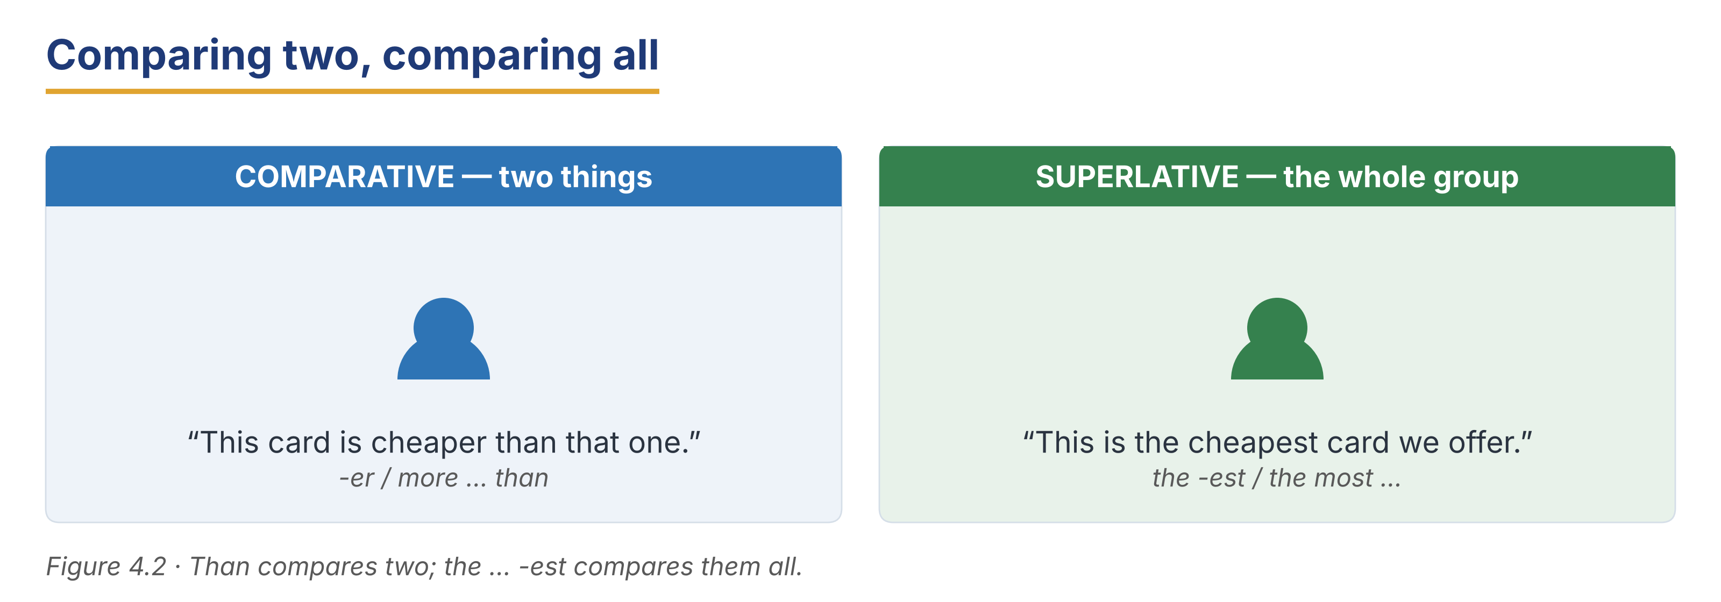
Part 3 · Listening
Pre-class input · scripts printed below

3A Before you listen (predict)
You will hear customers choosing products. What questions do customers ask before they choose?
Model — read this first
“I think they will ask about the rate, the fees, and how soon they can take the money out.”

3B Choosing an account
🔊 Audio 4.1 (optional) — or read the script below.
Customer: I’d like to open a savings account, but I don’t know which one.
Diego: Of course. How soon might you need the money?
Customer: Maybe in a year. Maybe not.
Diego: Then the Step Saver is probably better than the Fixed 12. It pays a little less, but you can take money out twice a year.
Customer: That sounds safer for me.

Read and decide: True, False, or Not Given.
Example: 0. The customer wants a savings account. → True.
1. The Fixed 12 pays less than the Step Saver.
2. The customer may need the money within a year.
3. The customer already has an account at this bank.
Useful language: How soon might you need the money? · It pays a little less, but… · That sounds safer for me.
3C A product recommendation
🔊 Audio 4.2 (optional) — or read the script below.
Customer: My shop is growing. I need to buy a van, about eight thousand.
Priya: Then a business loan is better than an overdraft for that amount. An overdraft is more expensive over a long period.
Customer: How long would I repay it?
Priya: Up to five years. The longer the term, the smaller the monthly instalment — but the more interest you pay in total.
Customer: I see. I’d like the shortest term I can manage.

Read and decide: True or False.
1. An overdraft is cheaper than a loan over a long period.
2. The customer wants to buy a vehicle for the business.
3. A longer term means a smaller monthly payment.
4. The customer prefers a long term.
3D A family chooses a product (longer)
🔊 Audio 4.3 (optional) — or read the script below.
Priya: Good morning. How can I help you both today?
Customer A: We are saving for a deposit on a flat. We have about six thousand, and we can add two hundred a month.
Priya: That is a good start. How long do you think you will save?
Customer B: Three years, maybe four.
Priya: Then let me compare three accounts for you. The Everyday Saver is the most flexible, but it pays the lowest rate. The Step Saver pays more, and you may withdraw twice a year. The Fixed 12 pays the highest rate of the three, but the money is locked for a year at a time.
Customer A: Could we use more than one?
Priya: Yes, and that is often the best answer. Keep some money where you can reach it, and put the rest where it earns more.

Read and decide: True, False, or Not Given.
Example: 0. The customers are saving for a flat. → True.
1. The Everyday Saver pays the highest rate.
2. The customers can save two hundred a month.
3. They decide today which account to open.
3E Match the recommendation
Match each customer to the right product (one is extra).
Column A | Column B
1. A customer who may need the money in a year ____ | a) a business loan over five years
2. A shop owner buying a van ____ | b) the Fixed 12, locked for a year
3. A family saving for three years ____ | c) a mix of two accounts
4. Someone who will not touch the money ____ | d) the Step Saver
5. Someone who needs money every day ____ | e) a current account
 | f) a credit card with a high limit (extra)

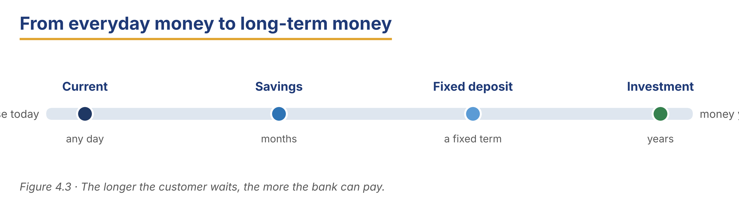
Part 4 · Speaking
In-class output

4A Functional language — comparing and recommending
Match the function to a phrase (one is extra).
Column A | Column B
1. Compare two products ____ | a) “Based on what you’ve told me, I’d suggest…”
2. Recommend one ____ | b) “The Step Saver pays more than the Everyday Saver.”
3. Ask about the customer’s need ____ | c) “How soon might you need the money?”
4. Check the customer agrees ____ | d) “Does that sound right for you?”
 | e) “Your card has been declined.” (extra)

4B Recommend a product (pairwork)
Listen to the customer, compare two products, and recommend one. Then swap roles.
Model — read this first
A: How soon might you need the money? — B: In about a year. — A: Then the Step Saver is better than the Fixed 12, because you can withdraw twice a year. It pays a little less, but it is more flexible.

Card A (adviser): ask one question · compare two products · recommend one · check the customer agrees.
Card B (customer): you have 3,000 to save; you may need it next summer; you do not like risk.
4C Compare and decide
Your customer cannot choose between two cards. Compare them and help them decide.
Model — read this first
“The debit card is cheaper, because there is no annual fee. The credit card costs more, but it is safer for buying online and in another country. For travelling, I think the credit card is better.”

Stretch: the customer says “Which would you choose?” — answer professionally.
4D Find the information (pairwork info-gap)
Student A is an adviser; Student B is a customer. Ask and answer to find the best product.
Card A (adviser): Everyday Saver 1%, withdraw any day · Step Saver 3%, two withdrawals a year · Fixed 12 5%, locked one year.
Card B (customer): you have 10,000; you need 2,000 of it within three months; the rest can wait two years.
Useful language: How much would you like to save? · How soon might you need it? · Would you prefer a higher rate or more flexibility?
4E Close the recommendation
Match the closing phrase to the situation (one is extra).
Column A | Column B
1. “Shall I open that for you now?” ____ | a) moving to action
2. “You can change this later if your plans change.” ____ | b) reassuring the customer
3. “I’ll send you the details in writing.” ____ | c) confirming afterwards
4. “Take your time and come back if you wish.” ____ | d) giving the customer space
5. “Is there anything else I can explain?” ____ | e) checking understanding
 | f) “Please take a seat.” (extra)

In pairs, close a product conversation politely. Use two phrases above.
Part 5 · Reading
Pre-class input

5A Our products, compared
Read the product page. Notice the comparatives and superlatives.
Harbour Bank — Savings Products Compared
About 200 words
Harbour Bank offers three savings accounts, and the right one depends on when you need your money. The Everyday Saver is the most flexible of the three. You can withdraw any day, and there is no fee. However, it pays the lowest rate, because flexibility costs the bank money. The Step Saver pays more than the Everyday Saver, but you may make only two withdrawals a year. It suits customers who are saving for something a year or two away. The Fixed 12 pays the highest rate we offer. The money is locked for twelve months, and you cannot take it out early without losing the interest. It is the best choice for money you are sure you will not need. All three accounts are available in every country where we operate, and the rate is set locally, because interest rates are not the same everywhere. Many customers use more than one account: some money where they can reach it quickly, and the rest where it earns more. If you are not sure, start with the Everyday Saver. It is easier to move money later than to take it out early.

Answer the questions.
Example: 0. How many savings accounts does the bank offer? → Three.
1. Which account is the most flexible, and why does it pay less?
2. How many withdrawals a year does the Step Saver allow?
3. What happens if you take money out of the Fixed 12 early?
4. Why is the rate not the same in every country?
5. What does the page suggest if a customer is not sure?
5B Grammar in context (from 5A)
Look back at the product page. Find two comparatives and two superlatives.
1. Comparatives: ____ , ____
2. Superlatives: ____ , ____
Now complete these sentences about the accounts.
1. The Fixed 12 pays a ______________________ (high) rate than the Step Saver.
2. The Everyday Saver is the ______________________ (flexible) of the three.
3. The Step Saver is ______________________ (good) than the Everyday Saver for two-year savings.
5C Meet a customer
Read the short customer profile. Which account would you recommend?
Meet a Customer — Rafael Lima
About 120 words
Rafael Lima runs a small printing shop in São Paulo. He has about nine thousand saved, and he adds three hundred most months. Next year he wants to buy a second printer, but he is not sure exactly when. He also keeps two thousand for emergencies, because a machine can break at any time. Rafael does not like risk. He says, “I would rather earn a little less and sleep well.” His bank has suggested one account for everything, but Rafael thinks that two accounts might suit him better: one he can reach quickly, and one that pays more.

1. What does Rafael do, and where?
2. Why does he keep two thousand separate?
3. What does Rafael think would suit him better than one account?
5D Discussion
In pairs, compare the products at your own bank.
Useful frame: “At my bank, the ___ pays more than the ___, but it is less ___.”
● Which product do customers ask about most?
● Which is the hardest to explain, and why?
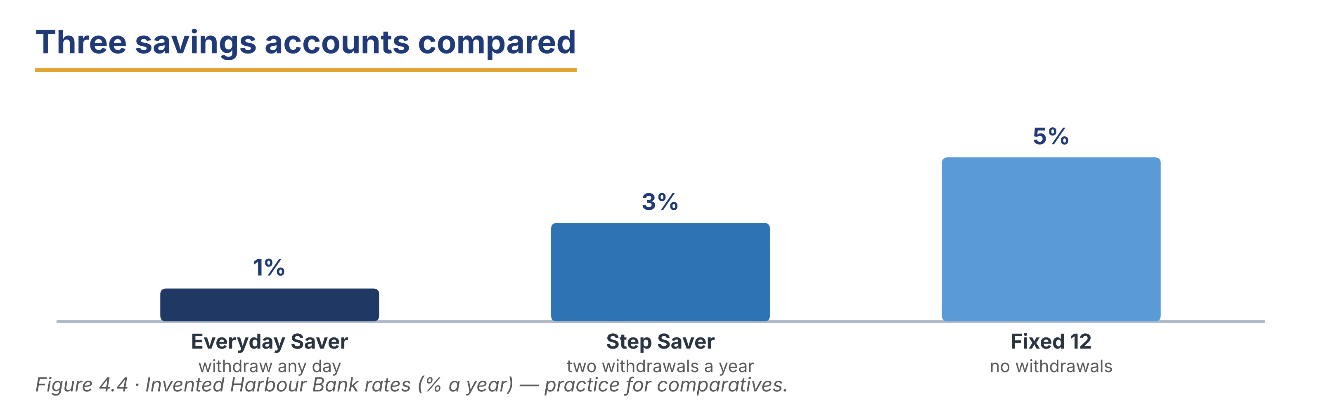
Part 6 · Writing
In-class / homework output

6A Guided writing — complete the recommendation
Complete the email with the words: suggest, flexible, rate, compared, suit.
Word bank
suggest | flexible | rate
compared | suit

1. Dear Mr Okonkwo, thank you for your visit. I have ______________________ our three savings accounts for you.
2. Based on what you told me, I would ______________________ the Step Saver.
3. It pays a better ______________________ than the Everyday Saver.
4. It is less ______________________, but you may still withdraw twice a year.
5. I believe it would ______________________ your plans for next year.
6B Product recommendation email (50–70 words)
Write a short email recommending one product to a customer. Use one comparative and one superlative.
Model — read this first
Subject: Your savings — my recommendation
Dear Mr Lima, Thank you for coming in. Based on your plans, I would suggest the Step Saver. It pays a higher rate than the Everyday Saver, and it still allows two withdrawals a year. The Fixed 12 pays the highest rate, but your money would be locked for twelve months. Kind regards, Diego Moreno

Plan: Subject: ___ · Dear ___, · Thank you for ___. · Based on ___, I would suggest ___. · It pays a ___ rate than ___. · Kind regards, ___
Phrase bank: Based on what you told me… · I would suggest… · It pays a higher rate than… · the highest rate we offer
Check before you finish
☐ A clear subject line?
☐ One comparative and one superlative?
☐ A reason for the recommendation?
☐ 50–70 words?
✎ Write your response here.

6C Compare-two-cards email (50–70 words)
A customer asks which card to take abroad. Write a short, clear reply.
Model — read this first
Subject: Debit card or credit card abroad
Dear Ms Fernandes, Thank you for your question. A debit card is cheaper, because there is no annual fee. However, a credit card is safer abroad, as it is easier to stop a payment if something goes wrong. For a two-week trip, I would suggest taking both and using the credit card for hotels. Kind regards, Customer Service

Plan: Subject: ___ · Dear ___, · Thank you for ___. · A ___ is ___ because ___. · However, a ___ is ___. · I would suggest ___. · Kind regards, ___
Check before you finish
☐ A clear subject line?
☐ Two products compared?
☐ A clear recommendation?
☐ 50–70 words?
✎ Write your response here.

6D Peer check
Swap your email from 6B or 6C with a partner. Give one piece of positive feedback and one suggestion.
Checklist: subject line? · one comparative? · a reason given? · 50–70 words?
Model — read this first
“Clear comparison and a good reason. Next time, try to add one superlative so the customer can see the whole range.”

Part 7 · Management File — Briefing the Team on a New Product
Practitioner track (optional for beginners) · experienced staff

7A Briefing and target phrases
Match the phrase to its purpose (one is extra).
Column A | Column B
1. “From Monday we are offering…” ____ | a) announcing something new
2. “The main difference is…” ____ | b) naming what has changed
3. “Our target is twenty a week.” ____ | c) setting a goal for the team
4. “If a customer asks about fees, say…” ____ | d) giving staff the exact words
 | e) closing a complaint (extra)

7B Listening — briefing the team
🔊 Audio 4.4 (optional) — or read the script below.
Marta: Good morning, everyone. From Monday we are offering a new account, the Step Saver Plus.
Ana: How is it different from the Step Saver?
Marta: The main difference is the rate: it is half a point higher, but you may withdraw only once a year.
Ana: And our target?
Marta: Twenty new accounts a week across the branch. If a customer asks about fees, say there are none, but the withdrawal limit is strict.

Answer the questions.
Example: 0. When does the new account start? → On Monday.
1. What is the main difference from the Step Saver?
2. What is the team’s target?
3. What should staff say if a customer asks about fees?
7C Controlled practice — the product comparison
Complete the briefing note. Use the correct comparative or superlative.
Word bank
higher | strictest | better
the most | less

1. The Step Saver Plus pays a ______________________ rate than the Step Saver.
2. It is ______________________ flexible, because there is only one withdrawal a year.
3. For long-term money it is ______________________ than the Everyday Saver.
4. It has the ______________________ withdrawal rule of all our accounts.
5. The Fixed 12 is still ______________________ generous account we offer.
✎ Write your response here.

7D Role play — brief your team
You are a branch manager. Brief your team on a new product in two minutes.
Model — read this first
“From Monday we are offering the Step Saver Plus. The main difference is the rate — half a point higher — but only one withdrawal a year. Our target is twenty a week. If a customer asks about fees, say there are none.”

Card A (manager): announce · name the main difference · give the target · give the exact words for one likely question.
Card B (team member): ask two questions, one of them difficult.
Stretch: a team member says the target is too high — respond professionally.
7E Writing — an internal product note (50–70 words)
Write a short internal note introducing a new product to the branch.
Model — read this first
Subject: New account from Monday — Step Saver Plus
From Monday we are offering the Step Saver Plus. It pays half a point more than the Step Saver, but customers may withdraw only once a year. It is the best choice for money that will not be touched. There are no fees. Our target is twenty new accounts a week. Marta Nowak

Plan: Subject: ___ · From ___ we are offering ___. · It pays ___ than ___. · It is the best choice for ___. · Our target is ___.
Phrase bank: From Monday we are offering… · the main difference is… · it pays more than… · our target is…
Check before you finish
☐ A clear subject line?
☐ One comparative and one superlative?
☐ The target named?
☐ 50–70 words?
✎ Write your response here.

Part 8 · Global Case Study — Launching a Product Worldwide
Practitioner track · read then discuss

Before you read: why might the same product work in one country and fail in another?
One Account, Six Countries
About 200 words · a made-up example based on real practice
An international bank designed a single savings account and launched it in six countries on the same day. The marketing was the same everywhere: a higher rate than the bank’s other accounts, in exchange for fewer withdrawals. In three countries it sold very well. In the other three it sold almost nothing, and the bank wanted to know why. The answer was not the product. It was the context. In the three successful countries, most customers were paid monthly into a bank account, and they were used to leaving money untouched. In the other three, many customers were paid in cash, or were paid weekly, and they needed to reach their money often. The rate was more attractive, but the rule was impossible. The bank made one change. It kept the same account, but it let each country set its own withdrawal rule: once a year in some markets, four times a year in others. Sales rose in all six countries. The lesson was simple: a product can travel, but the rules around it may have to change at the border.

Glossary help
launch — to start selling a new product
market — the customers in one country or area
withdrawal rule — how often a customer may take money out
context — the situation around the product

8A Comprehension
Example: 0. In how many countries did the bank launch the account? → Six.
1. What did the bank offer in exchange for fewer withdrawals?
2. Why did the account fail in three countries?
3. What one change did the bank make?
4. What is the lesson of the case?
8B Vocabulary in context
Match the word to its meaning (one is extra).
Column A | Column B
1. launch ____ | a) the customers in one country or area
2. market ____ | b) to start selling a new product
3. withdrawal rule ____ | c) the situation around the product
4. context ____ | d) how often a customer may take money out
 | e) a charge for a service (extra)

8C Discussion
Frames: “In my country this would work because ___.” “It would be harder because ___.”
● Are most customers in your country paid into an account, or in cash?
● Which rule would you change for your market?
8D Your view (short write, 30–40 words)
Which rule should be set locally, and which should be the same everywhere? Why?
✎ Write your response here.

Part 9 · Branch Case Study — São Paulo in Focus: A Loan for a Small Shop
Practitioner track · read then decide

Before you read: what does a bank need to know before it lends to a small shop?
The Second Printer
About 185 words
Rafael Lima has banked with the Harbour Bank branch in São Paulo for six years. His printing shop is small but steady, and he has never missed a payment. Now he wants to borrow nine thousand to buy a second printer. He says the new machine will double what the shop can produce, and he already has two customers waiting. The loan officer, Beatriz Costa, looks at his account. The shop’s income is good in most months, but it falls sharply every January, when his business customers are closed. A five-year loan would give him the smallest monthly instalment, but he would pay the most interest in total. A three-year loan costs less overall, but the instalment is larger than his January income can carry. Rafael says he can manage, but Beatriz has seen careful business owners get into difficulty in a quiet month. She must decide what to offer, and how to explain it so that Rafael can make a good decision himself.

9A Comprehension
Example: 0. How long has Rafael banked here? → Six years.
1. What does Rafael want to buy, and why?
2. What does Beatriz notice about the shop’s income?
3. What is the problem with the three-year loan?
9B Decision task
What should Beatriz offer Rafael? Write 40–60 words. Use the frame and the phrase bank.
Model — read this first
I think Beatriz should offer a four-year loan with a smaller instalment in January, because the shop’s income falls in that month. She should explain that a longer term costs more interest in total. Also, she can suggest keeping two thousand in the Everyday Saver for quiet months.

Frame: I think Beatriz should ___, because ___. Also, ___.
Phrase bank: offer a ___-year term · a smaller instalment in ___ · explain that a longer term costs more in total · keep a reserve for quiet months
✎ Write your response here.

Part 10 · Review & Can-Do
Homework / self-study

10A Spiral review
Complete the sentences. Use a comparative, a superlative or the correct word. Items 5–6 review Units 2 and 3.
Example: 0. This card is ____ (cheap) than that one. → cheaper.
1. The Fixed 12 pays the ______________________ (high) rate of the three.
2. A mortgage is ______________________ (long) than a personal loan.
3. Money you borrow and repay monthly is a ______________________. (word)
4. The money in your account right now is your ______________________. (word)
5. ______________________ I see your ID, please? (Unit 2 modal)
6. How ______________________ notes would you like? (Unit 3 quantifier)
10B Can-Do checklist
Can-Do checklist — tick what you can do now
☐ I can name the bank’s main products and say what each is for.
☐ I can compare two products with comparatives.
☐ I can recommend the best product with a superlative.
☐ I can understand a short product conversation.
☐ I can write a short recommendation email.
10C Unit glossary
Glossary help
current account — an account for everyday payments and bills
savings account — an account for money you keep
fixed deposit — money locked away for a fixed time at a fixed rate
overdraft — permission to go below zero on a current account
mortgage — a long loan to buy a property
instalment — one of the equal monthly payments on a loan
term — how long a loan or deposit lasts
interest rate — what the bank pays you, or charges you, each year
launch — to start selling a new product
market — the customers in one country or area

Unit 5 · Digital and Online Banking
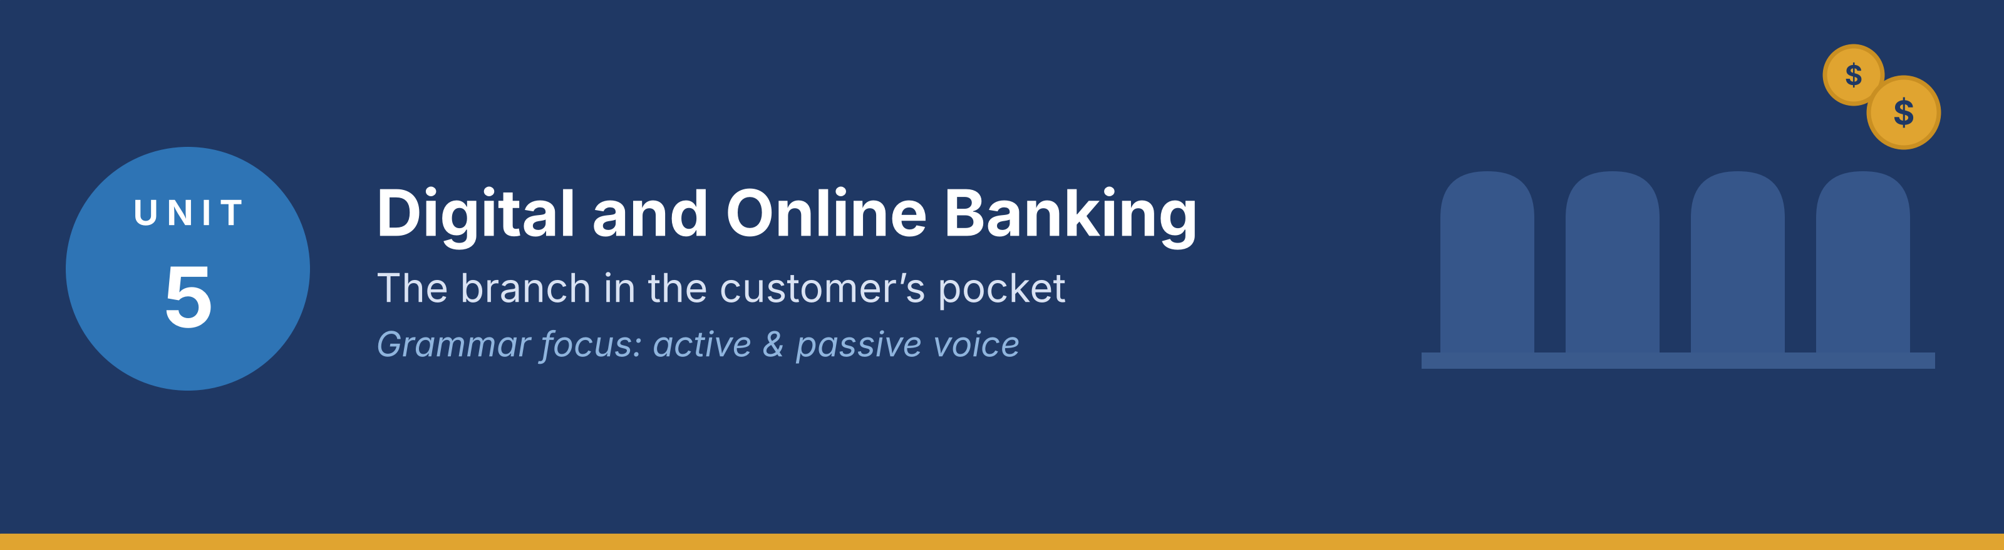
In this unit you learn the language of online and mobile banking, how to explain the app to a customer, how to describe what the system does, and how to write a clear notice. Grammar focus: active and passive voice.
Part · · Warm-Up
In-class starter · speak before you read

W-A Digital banking (discussion)
In small groups, talk about how you use banking on a phone or computer.
Model — read this first
I check my balance on the app every morning. I pay my bills online, but I still go to the branch for cash.

● What do you do on the app, and what do you still do at the branch?
● What do your customers find hardest about the app?
W-B Quick survey
Ask three classmates and note their answers. Two minutes only.
● Do you use the app every day, every week, or rarely?
● What is the one thing you wish the app could do?
Tip: Use the words log in, password, code, app and transfer in your answers.
Part 1 · Vocabulary
Pre-class input

1A Match the term to the meaning
Match each digital banking word (1–8) to the correct meaning (a–i). One meaning is extra.
Example: 0. Username → h)
Column A | Column B
1. Log in ____ | a) a short number sent to your phone for one use only
2. Password ____ | b) the secret word you type to enter your account
3. One-time code ____ | c) to enter your account with your details
4. Two-factor authentication ____ | d) two different checks before you are let in
5. App ____ | e) a program on a phone
6. Online banking ____ | f) using your bank through a browser
7. Notification ____ | g) a short message from the bank on your screen
8. Freeze ____ | h) to stop a card being used, for a short time
 | i) a paper record of a transaction (extra)

Pronunciation — word stress. Say these words: PASS·word, no·ti·fi·CA·tion, au·then·ti·CA·tion, SE·cu·ri·ty.
1B Sort the words
Put each word from 1A into the correct group.
● Getting in: ____
● Staying safe: ____
● Using the service: ____
Model — read this first
Getting in: log in, password, username. Staying safe: one-time code, two-factor authentication, freeze. Using the service: app, online banking, notification.

1C Complete the sentences
Complete the sentences with the correct word.
Word bank
code | password | app
frozen | notification | transfer
screen | updated | login

Example: 0. Please download the app from the official store.
1. A one-time ______________________ is sent to your phone each time you log in.
2. Your card has been ______________________, so no payments can be made.
3. The ______________________ was reset yesterday, so please use the new one.
4. You will receive a ______________________ when the money arrives.
5. The ______________________ has been ______________________, so some buttons have moved.
6. Please confirm the ______________________ on the next screen.
1D Word partners (collocations)
Match the verb to the noun to make a common digital-banking phrase (one noun is extra).
Column A | Column B
1. download ____ | a) your password
2. reset ____ | b) the app
3. enter ____ | c) a card
4. freeze ____ | d) the code
5. receive ____ | e) a notification
 | f) a queue (extra)

1E Write with the words (40–60 words)
Write about how a customer uses the app in one week. Use at least five words from Part 1.
Model — read this first
On Monday she logs in with her password and a one-time code. On Wednesday she makes a transfer and receives a notification. On Friday she loses her card, so she freezes it in the app. She does not visit the branch at all.

Check before you finish
☐ Five Part-1 words?
☐ 40–60 words?
☐ Short, clear sentences?
✎ Write your response here.

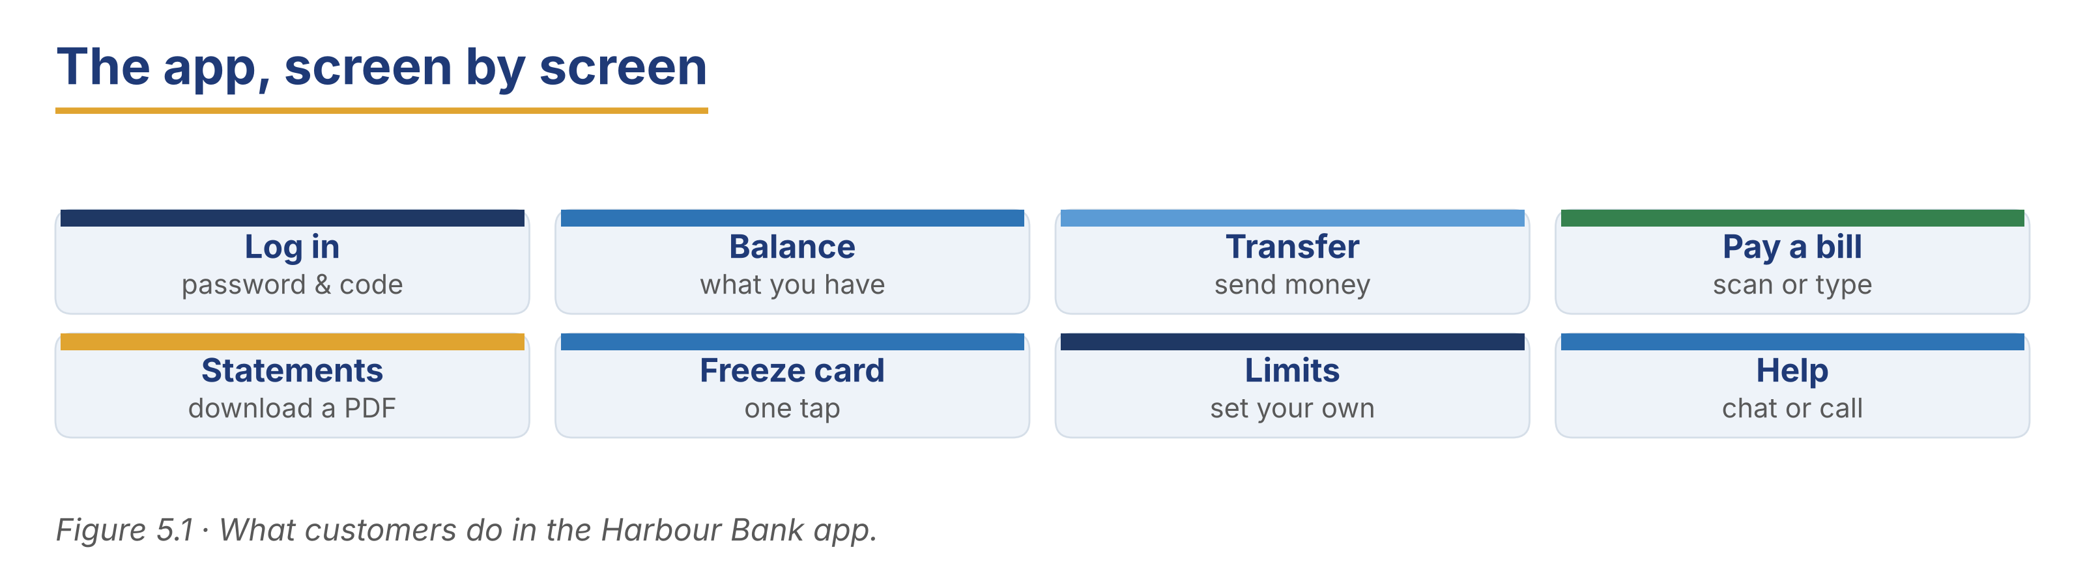
Part 2 · Grammar — Active and Passive Voice
Pre-class input

2A Notice the grammar
Read the short dialogue. Underline the passive verbs. Who or what does the action?
Customer: I didn’t get my code.
Petra: Let me check. The code is sent to the number on your file.
Customer: That number is old.
Petra: Then it must be changed first. Your details are checked by the system, so the new number will be confirmed by a text tomorrow.

1. is sent — active or passive? ____
2. must be changed — who changes it? ____
3. are checked by the system — why does the speaker say ‘by the system’? ____
Grammar Focus
Form | Use | Example
am / is / are + past participle | the present passive, for systems and rules | A code is sent to your phone.
was / were + past participle | the past passive, for what happened | The card was blocked last night.
modal + be + past participle | the passive with can, must, will | The number must be changed first.

Remember: use the passive when the doer is obvious, unknown or not important. Add by + the doer only when it matters.
⚠ Watch out!
✗ The code is send to your phone. → ✓ The code is sent to your phone.
✗ Your card was block. → ✓ Your card was blocked.

2B Controlled practice (make it passive)
Rewrite each sentence in the passive. Leave out the doer where it is obvious.
Example: 0. We send a code to your phone. → A code is sent to your phone.
1. We check every login.
2. The system blocked the card.
3. We will send a notification.
4. Someone reset the password this morning.
5. The bank must verify your identity.
6. We update the app every month.
7. We do not store your password.
2C Error correction
Find and correct the mistake in each sentence.
Example: 0. The code is send now. → The code is sent now.
1. Your account was froze last night.
2. The payment is process in two minutes.
3. The app has update.
4. Your details are check by the system.
5. The card must be block immediately.
✎ Write your response here.

2D Active to passive
Rewrite these three notices in the passive, so they sound official.
Example: 0. We will close the app on Sunday. → The app will be closed on Sunday.
1. We check all transfers over 1,000.
2. We sent your new card yesterday.
3. We do not accept payments after 23:00.
✎ Write your response here.

2E Freer practice (speaking)
In pairs, explain to a customer what happens when they tap “Send”. Use at least three passive verbs.
Model — read this first
“Your details are checked, a code is sent to your phone, and the payment is processed in a few seconds. You will be notified when it arrives.”

Tip: You will see the passive again in the reading in Part 5 (5A and 5B). Look for it there.
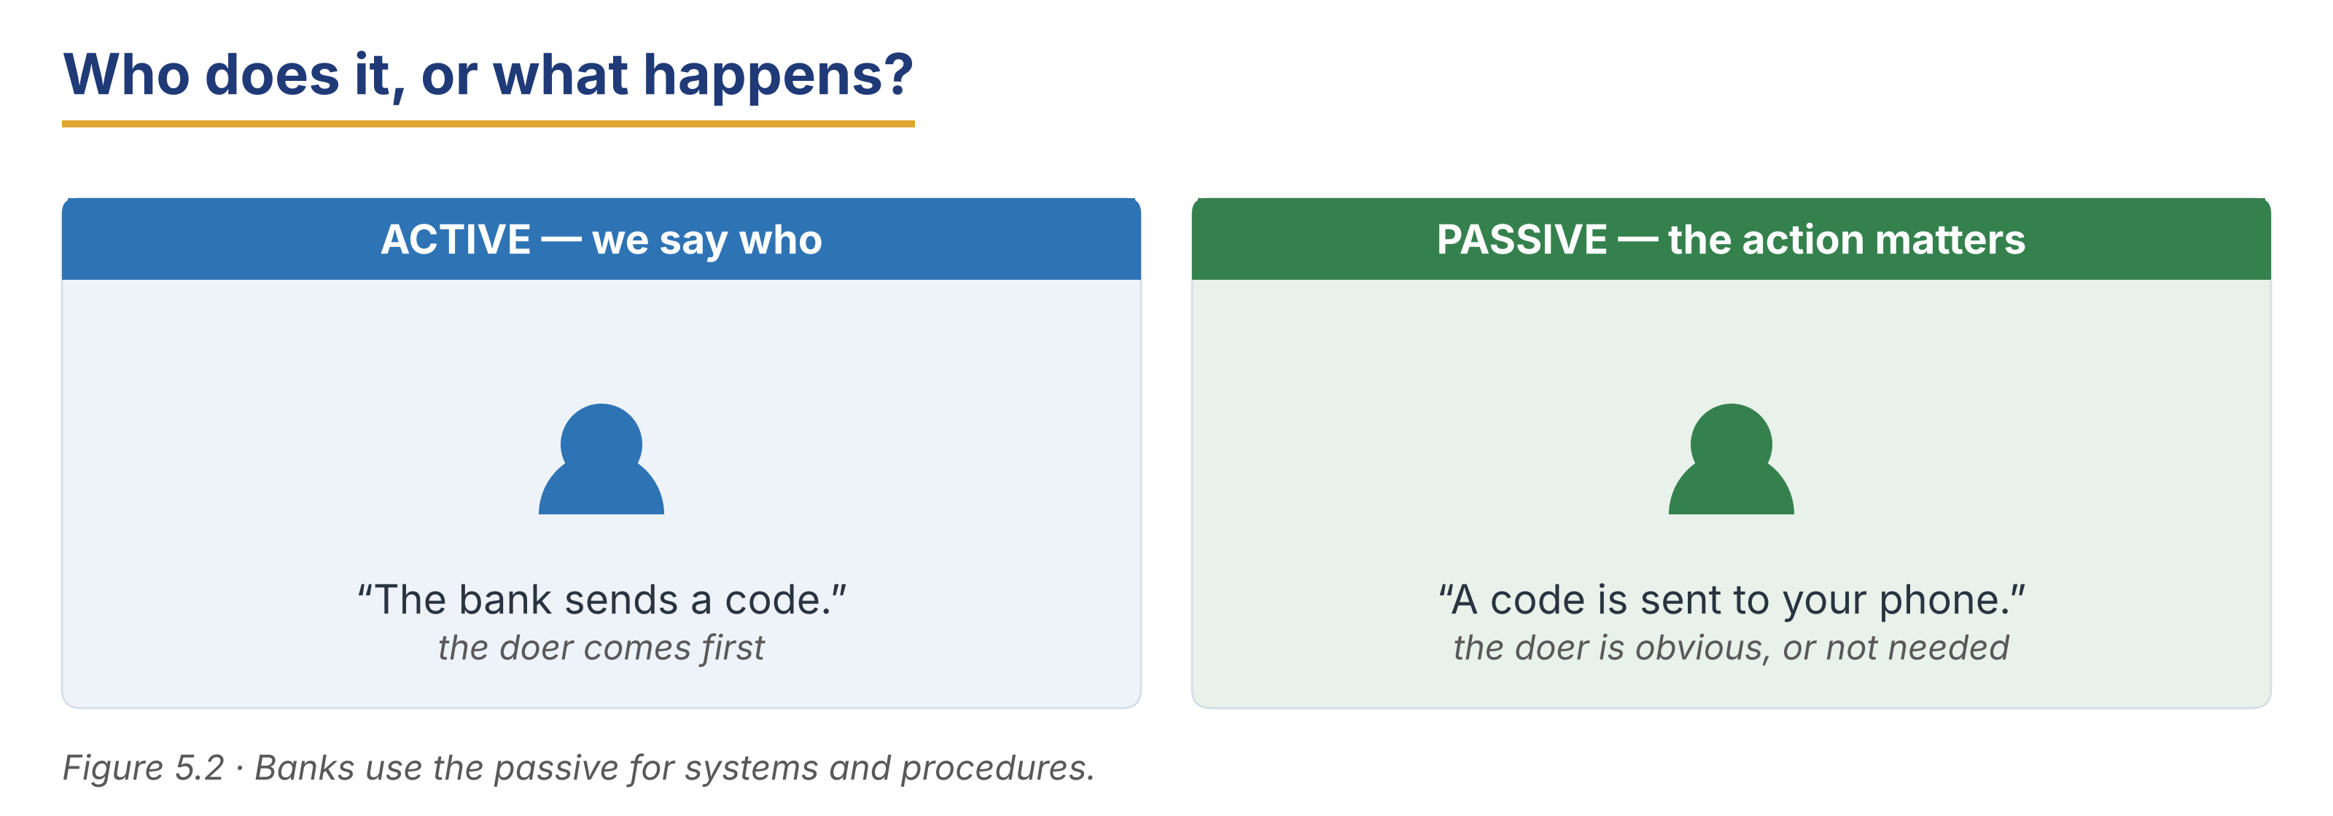
Part 3 · Listening
Pre-class input · scripts printed below

3A Before you listen (predict)
You will hear three app conversations. What goes wrong most often with online banking?
Model — read this first
“I think customers forget their password, or the code does not arrive.”

3B A login problem
🔊 Audio 5.1 (optional) — or read the script below.
Customer: I can’t log in. It says my password is wrong.
Petra: I’m sorry about that. Has the password been changed recently?
Customer: My daughter changed it for me last month.
Petra: That explains it. Your account is not blocked — the old password is simply no longer accepted. A reset link can be sent to your email now.
Customer: Please do that.

Read and decide: True, False, or Not Given.
Example: 0. The customer cannot log in. → True.
1. The customer’s account has been blocked.
2. The password was changed last month.
3. The customer’s email address is out of date.
Useful language: Has the password been changed recently? · Your account is not blocked. · A reset link can be sent to your email.
3C A delayed transfer
🔊 Audio 5.2 (optional) — or read the script below.
Customer: I sent money to my brother yesterday and it hasn’t arrived.
Mei: Let me look. The payment was sent at 18:40.
Customer: So where is it?
Mei: It was received by his bank this morning, and it is being checked now. Transfers over a certain amount are always checked.
Customer: How long does that take?
Mei: Usually a few hours. You will be notified as soon as it is released.

Read and decide: True or False.
1. The payment left this customer’s account.
2. The money has not reached the other bank.
3. Large transfers are always checked.
4. The customer must call again to find out.
3D Learning the app (longer)
🔊 Audio 5.3 (optional) — or read the script below.
Mei: Good morning. I understand you would like some help with the app.
Customer: Yes. My son set it up, but I don’t know what anything does.
Mei: Of course. Let’s start at the first screen. Your balance is shown at the top. Below it, the last ten payments are listed, with the newest first.
Customer: And this button?
Mei: That is for transfers. When you tap it, you choose the person, you type the amount, and then a code is sent to your phone. The payment is not made until the code is entered.
Customer: So nothing can be sent by accident?
Mei: Exactly. And if you are ever worried, your card can be frozen from this screen, and unfrozen later. Nothing is lost.
Customer: That is a relief. Thank you.

Read and decide: True, False, or Not Given.
Example: 0. The customer’s son set up the app. → True.
1. The balance is shown at the bottom of the screen.
2. A payment is made before the code is entered.
3. The customer has used the app before today.
3E Match the passive phrase
Match each phrase from the listenings to what it means (one is extra).
Column A | Column B
1. “Your account is not blocked.” ____ | a) you can still use it
2. “It is being checked now.” ____ | b) the work is happening at this moment
3. “You will be notified.” ____ | c) we will tell you
4. “Your card can be frozen.” ____ | d) you can stop it yourself
5. “The old password is no longer accepted.” ____ | e) it does not work any more
 | f) “Your account has been closed.” (extra)

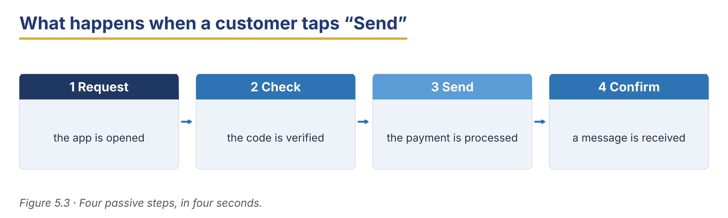
Part 4 · Speaking
In-class output

4A Functional language — explaining the app
Match the function to a phrase (one is extra).
Column A | Column B
1. Start an explanation ____ | a) “Let’s start at the first screen.”
2. Describe what the system does ____ | b) “A code is sent to your phone.”
3. Reassure ____ | c) “Nothing can be sent by accident.”
4. Check understanding ____ | d) “Shall I show you that again?”
 | e) “Your card has been declined.” (extra)

4B Explain the app (pairwork)
Explain one app screen to a customer, step by step. Then swap roles.
Model — read this first
A: Let’s start at the first screen. Your balance is shown at the top. — B: And this button? — A: That is for transfers. A code is sent to your phone before anything is paid.

Card A (staff): start at the first screen · name two things · explain one action · check understanding.
Card B (customer): you are nervous about the app; ask two questions; ask whether you can undo a mistake.
4C Help a nervous customer
A customer is afraid of making a mistake online. Reassure them and explain the safety steps.
Model — read this first
“Nothing is sent until the code is entered, so a payment cannot be made by accident. And if you are ever worried, your card can be frozen from this screen, and unfrozen later.”

Stretch: the customer says “I would rather come to the branch” — respond respectfully.
4D Find the information (pairwork info-gap)
Student A works in digital support; Student B is a customer. Ask and answer to solve the problem.
Card A (support): a reset link can be sent to email; codes go to the number on file; transfers over 1,000 are checked.
Card B (customer): you cannot log in; your phone number changed last year; you sent 1,500 yesterday and it has not arrived.
Useful language: When was it changed? · Has a code been sent to you? · Would you like a reset link sent to your email?
4E Close the explanation
Match the closing phrase to the situation (one is extra).
Column A | Column B
1. “Shall I write the steps down for you?” ____ | a) giving the customer something to keep
2. “You can always freeze the card yourself.” ____ | b) leaving the customer in control
3. “If it happens again, call this number.” ____ | c) giving a clear next step
4. “Would you like to try it once with me?” ____ | d) practising together
5. “Is there anything else on the app?” ____ | e) checking there is nothing more
 | f) “Please take a seat.” (extra)

In pairs, close a digital-support conversation politely. Use two phrases above.
Part 5 · Reading
Pre-class input

5A The new Harbour app (a leaflet)
Read the leaflet. Notice the passive verbs.
Harbour Bank — Your Money, Everywhere
About 200 words
The Harbour app has been rebuilt, and the new version is available in every country where we operate. Your balance is shown as soon as you log in, and your last ten payments are listed below it. Payments are made in three steps: the person is chosen, the amount is typed, and a code is sent to your phone. Nothing is paid until that code is entered, so money cannot be sent by accident. Your details are protected by two-factor authentication. This means two different checks are made before you are let in: something you know, which is your password, and something you have, which is your phone. Transfers to another country are now handled in the app as well. The rate is shown before you confirm, and the fee is shown next to it, so nothing is hidden. Payments are usually received within one working day, and you are notified when the money arrives. If your card is lost, it can be frozen from the main screen in one tap, and unfrozen later if you find it. No data is stored on your phone. If the phone is lost, your money is not at risk.

Answer the questions.
Example: 0. Where is the new version available? → In every country where the bank operates.
1. What three steps are a payment made in?
2. What are the two checks in two-factor authentication?
3. What is shown before you confirm an international transfer?
4. What can be done if a card is lost?
5. Why is your money safe if the phone is lost?
5B Grammar in context (from 5A)
Look back at the leaflet. Find three passive verbs.
1. Passive verb 1: ____
2. Passive verb 2: ____
3. Passive verb 3: ____
Now rewrite these active sentences as the leaflet would write them.
1. We show your balance at once. → ____
2. We send a code to your phone. → ____
3. We do not store any data on your phone. → ____
5C Should you trust the advert?
Read the short note. What is the difference between a bank message and a scam message?
Two Messages, One Difference
About 120 words
A customer received two messages on the same morning. The first said: “Your payment of 240 has been received. No action is needed.” The second said: “Your account has been blocked. Click here within one hour or it will be closed.” Both looked official. The first was from the bank. The second was not. A real message tells you what has happened. A false message tells you to act now, and gives you a link. The bank never asks for a password or a one-time code, and it never gives a deadline of one hour. If a message makes you feel in a hurry, that feeling is the warning.

1. What did the first message say had happened?
2. What two things made the second message false?
3. What does a bank never ask for?
5D Discussion
In pairs, compare the app at your own bank.
Useful frame: “On our app, the ___ is shown before you ___, but the ___ is not.”
● What do customers ask about most often?
● What would you change on the first screen?
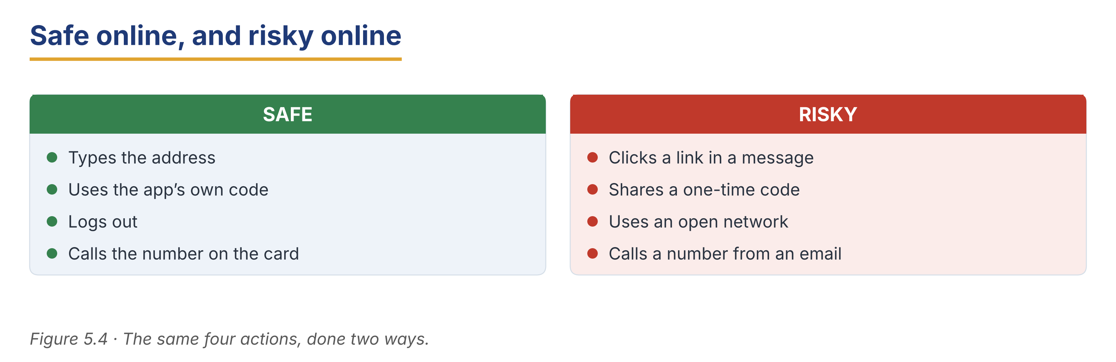
Part 6 · Writing
In-class / homework output

6A Guided writing — complete the notice
Complete the staff notice with the words: updated, shown, sent, entered, notified.
Word bank
updated | shown | sent
entered | notified

1. The app will be ______________________ on Sunday night.
2. From Monday, the balance is ______________________ at the top of the first screen.
3. A one-time code is ______________________ to the customer’s phone for every payment.
4. No payment is made until the code is ______________________.
5. Customers will be ______________________ by a message in the app.
6B Staff notice about a new online service (50–70 words)
Write a short internal notice about a change to the app. Use at least two passive verbs.
Model — read this first
Subject: App update — Sunday night
The Harbour app will be updated on Sunday night between 23:00 and 02:00. During this time, payments cannot be made and balances are not shown. From Monday, international transfers are handled in the app, and the rate and fee are shown before the customer confirms. Please tell customers who ask at the counter. Petra Horak

Plan: Subject: ___ · The ___ will be ___ on ___. · During this time, ___. · From ___, ___ is ___. · Please ___.
Phrase bank: will be updated on… · during this time… · payments cannot be made · please tell customers who ask
Check before you finish
☐ A clear subject line?
☐ Two passive verbs?
☐ The time of the change?
☐ 50–70 words?
✎ Write your response here.

6C Security alert to a customer (50–70 words)
A customer has received a suspicious message. Write a short, calm reply.
Model — read this first
Subject: The message you received
Dear Mrs Oyelaran, Thank you for sending this to us. The message was not sent by the bank. Your account has not been blocked, and no action is needed. The bank never asks for a password or a one-time code, and never gives a deadline. Please delete the message and do not click the link. Kind regards, Customer Service

Plan: Subject: ___ · Dear ___, · Thank you for ___. · The message was not ___. · Your account has not been ___. · Please ___. · Kind regards, ___
Check before you finish
☐ A calm, clear tone?
☐ Two passive verbs?
☐ A clear instruction to the customer?
☐ 50–70 words?
✎ Write your response here.

6D Peer check
Swap your notice or email with a partner. Give one piece of positive feedback and one suggestion.
Checklist: subject line? · two passives? · clear instruction? · 50–70 words?
Model — read this first
“Very calm and clear, and the passive sounds official. Next time, try to say what the customer should do first.”

Part 7 · Management File — Leading a Digital Change
Practitioner track (optional for beginners) · experienced staff

7A Change-management phrases
Match the phrase to its purpose (one is extra).
Column A | Column B
1. “I know this is a big change.” ____ | a) recognising how the team feels
2. “Nothing will be lost.” ____ | b) reassuring about the risk
3. “Training will be provided on Thursday.” ____ | c) saying what support is coming
4. “Please tell me what is not working.” ____ | d) inviting feedback
 | e) closing an account (extra)

7B Listening — reassuring the team
🔊 Audio 5.4 (optional) — or read the script below.
Marta: I know this is a big change, and some of you are worried about the new screens.
Tomasz: The old system was slow, but at least we knew it.
Marta: That is fair. Nothing will be lost — every record has been copied, and the old screens can still be opened for a month.
Tomasz: And if a customer asks something we can’t answer?
Marta: Training will be provided on Thursday. Until then, write the question down and send it to me.

Answer the questions.
Example: 0. What is the team worried about? → The new screens.
1. What has been done with every record?
2. How long can the old screens still be opened?
3. What should staff do with questions before Thursday?
7C Controlled practice — rewrite the customer notice
Rewrite each blunt line so it sounds calm and official. Use the passive.
Example: 0. We are turning the app off on Sunday. → The app will be unavailable on Sunday.
1. We changed your login screen.
2. We blocked your card.
3. We will send you a new card.
4. We are checking your payment.
5. We don’t keep your password.
6. We will tell you when it arrives.
✎ Write your response here.

7D Role play — lead the change
You are a manager. Your team is anxious about a new system. Lead a short team meeting.
Model — read this first
“I know this is a big change. Nothing will be lost — every record has been copied. Training will be provided on Thursday, and until then, please tell me what is not working.”

Card A (manager): recognise the feeling · reassure about the risk · say what support is coming · invite feedback.
Card B (team member): you are experienced and you preferred the old system; ask two hard questions.
Stretch: a team member says customers will leave — answer with evidence, not opinion.
7E Writing — a staff notice about the app (50–70 words)
Write a short notice to your team about the new app, in a calm, official tone.
Model — read this first
Subject: The new app — what changes on Monday
From Monday the new app will be used in all branches. Every record has been copied, and nothing will be lost. The old screens can still be opened until the end of the month. Training will be provided on Thursday at 09:00. Until then, please send any customer question to me. Marta Nowak

Plan: Subject: ___ · From ___ the ___ will be ___. · Every ___ has been ___. · Training will be ___. · Until then, please ___.
Phrase bank: will be used from… · nothing will be lost · training will be provided · please send any question to…
Check before you finish
☐ A clear subject line?
☐ Two passive verbs?
☐ A date for the training?
☐ 50–70 words?
✎ Write your response here.

Part 8 · Global Case Study — The App-Only Bank
Practitioner track · read then discuss

Before you read: could a bank work with no branches at all? Who would it not suit?
A Bank With No Door
About 205 words · a made-up example based on real practice
An app-only bank was launched in four countries at once. It had no branches, no counters and no queues. Accounts were opened in eight minutes from a phone, and identity was confirmed by a short video instead of a visit. Costs were low, so the rates offered were better than those of older banks, and in the first year two million accounts were opened. Then the complaints began. They were not about the technology, which worked well. They were about the moments when something went wrong. A customer whose card was used by a thief wanted to speak to a person, and there was nobody to speak to. An older customer could not pass the video check, because the light in her flat was poor. A small business owner needed to pay in cash, and cash cannot be sent through an app. The bank made two changes. It opened a telephone line answered by people, not machines, twenty-four hours a day. And it agreed with a chain of shops that its customers could pay in cash there. It still has no branches. But it learned that a bank without a door still needs a way in.

Glossary help
app-only bank — a bank with no branches
identity check — proving who you are
complaint — when a customer says something is wrong
cash deposit point — a place where customers can pay in cash

8A Comprehension
Example: 0. How many countries was the bank launched in? → Four.
1. How was a customer’s identity confirmed?
2. Why were the bank’s rates better than those of older banks?
3. What were the complaints about, and what were they not about?
4. What two changes did the bank make?
5. What did the bank learn?
8B Vocabulary in context
Match the word to its meaning (one is extra).
Column A | Column B
1. app-only bank ____ | a) proving who you are
2. identity check ____ | b) a bank with no branches
3. complaint ____ | c) a place where customers can pay in cash
4. cash deposit point ____ | d) when a customer says something is wrong
 | e) a monthly charge (extra)

8C Discussion
Frames: “This would suit customers in my country because ___.” “It would not suit ___ because ___.”
● Which of your customers could not use an app-only bank?
● What is the one thing a branch does that an app cannot?
8D Your view (short write, 30–40 words)
Which customers still need a branch, and why?
✎ Write your response here.

Part 9 · Branch Case Study — Warsaw in Focus: Banking on a Weak Signal
Practitioner track · read then decide

Before you read: what happens to a digital service when the connection is poor?
When the Signal Drops
About 185 words
The Harbour Bank branch in Warsaw serves a wide area, and many of its customers live in villages where the mobile signal is weak. The bank has asked every branch to move routine payments to the app, and in the city this is working well. In the villages it is not. A customer told Marta Nowak last week that her payment had been started but never finished, because the one-time code arrived forty minutes late. Another said that the app had worked at her daughter’s house in town but not at home. Three customers have now gone back to paying at the counter, and two have said they will move to another bank. Marta understands the policy: payments made in the app cost the bank far less than payments made at the counter. But she also knows that a service that fails on a weak signal is not a service. She has one morning with the regional team on Thursday, and she wants to go with a clear proposal.

9A Comprehension
Example: 0. Where is the branch? → In Warsaw.
1. Why is the policy not working in the villages?
2. What happened to the first customer’s payment?
3. Why does the bank want payments made in the app?
9B Decision task
What should Marta propose on Thursday? Write 40–60 words. Use the frame and the phrase bank.
Model — read this first
I think Marta should propose that codes can be sent by email as well as by text, because email arrives even on a weak signal. She should also ask that counter payments stay free for village customers. Also, she can show the regional team how many customers are affected.

Frame: I think Marta should propose ___, because ___. Also, ___.
Phrase bank: send codes by email as well · keep counter payments free for ___ · show how many customers are affected · ask for the policy to be local, not national
✎ Write your response here.

Part 10 · Review & Can-Do
Homework / self-study

10A Spiral review
Complete the sentences. Use the passive or the correct word. Items 5–6 review Units 3 and 4.
Example: 0. A code ____ (send) to your phone. → is sent.
1. Your details ______________________ (check) by the system every time.
2. The card ______________________ (block) last night after three wrong codes.
3. Two different checks before you are let in is called ______________________. (word)
4. A short number sent to your phone for one use is a ______________________. (word)
5. How ______________________ notes would you like? (Unit 3 quantifier)
6. The Fixed 12 pays the ______________________ (high) rate of the three. (Unit 4 grammar)
10B Can-Do checklist
Can-Do checklist — tick what you can do now
☐ I can name the main parts of online and mobile banking.
☐ I can describe what the system does, using the passive.
☐ I can explain an app screen to a nervous customer.
☐ I can understand a short digital-support conversation.
☐ I can write a clear notice about a change.
10C Unit glossary
Glossary help
log in — to enter your account with your details
one-time code — a short number sent to your phone for one use only
two-factor authentication — two different checks before you are let in
notification — a short message from the bank on your screen
freeze — to stop a card being used, for a short time
reset — to set a password again from the beginning
app-only bank — a bank with no branches
identity check — proving who you are
cash deposit point — a place where customers can pay in cash
passive voice — saying what happens, without naming the doer

Unit 6 · Currency Exchange and Money Transfer
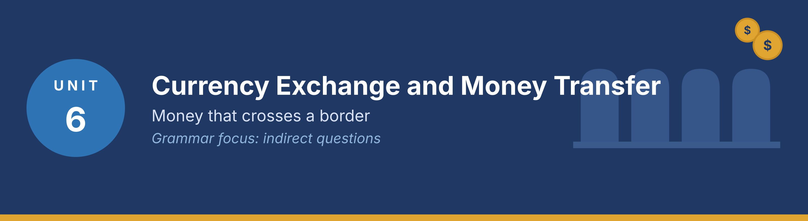
In this unit you learn the language of exchanging money and sending it abroad, how to ask and answer politely, how to follow a transfer conversation, and how to write a short inquiry and reply. Grammar focus: indirect questions.
Part · · Warm-Up
In-class starter · speak before you read

W-A Changing and sending money (discussion)
In small groups, talk about moving money between countries.
Model — read this first
My cousin works abroad and sends money home every month. He uses the bank because it is safer, even though it is a little slower.

● Who in your country receives money from abroad, and why?
● What do people worry about most: the rate, the fee, or the time?
W-B Polite questions (think–pair)
Think for one minute, then compare with a partner.
● Which sounds better to a customer: “What is the rate?” or “Could you tell me what the rate is?”
● Why does a bank use longer, politer questions?
Tip: Use the words rate, fee, transfer and exchange in your answers.
Part 1 · Vocabulary
Pre-class input

1A Match the term to the meaning
Match each word (1–8) to the correct meaning (a–i). One meaning is extra.
Example: 0. Receipt → h)
Column A | Column B
1. Exchange rate ____ | a) what one currency is worth in another
2. Spread ____ | b) the difference between the buy rate and the sell rate
3. IBAN ____ | c) the international number of a bank account
4. BIC / SWIFT ____ | d) the code that says which bank
5. Correspondent bank ____ | e) a bank that passes money between two other banks
6. Remittance ____ | f) money sent home by someone working abroad
7. Beneficiary ____ | g) the person who receives the money
8. Commission ____ | h) what the bank charges for the service
 | i) a card used only inside one country (extra)

Pronunciation — word stress. Say these words: ex·CHANGE, re·MIT·tance, be·ne·FI·ci·a·ry, com·MIS·sion.
1B Sort the words
Put each word from 1A into the correct group.
● About the price: ____
● About the route: ____
● About the people: ____
Model — read this first
About the price: exchange rate, spread, commission. About the route: IBAN, BIC, correspondent bank. About the people: beneficiary, remittance.

1C Complete the sentences
Complete the sentences with the correct word.
Word bank
rate | fee | IBAN
beneficiary | currency | transfer
spread | abroad | working day

Example: 0. Today’s exchange rate is shown on the board.
1. Could you tell me the full name of the ______________________, please?
2. We will need the ______________________ of the account you are sending to.
3. There is a flat ______________________ of twelve for an international transfer.
4. The money should arrive within one ______________________.
5. In which ______________________ would you like the money to arrive?
6. The difference between our buy and sell price is called the ______________________.
1D Word partners (collocations)
Match the verb to the noun to make a common banking phrase (one noun is extra).
Column A | Column B
1. send ____ | a) the rate
2. check ____ | b) a fee
3. charge ____ | c) a transfer
4. convert ____ | d) an amount
5. confirm ____ | e) the beneficiary’s details
 | f) a queue (extra)

1E Write with the words (40–60 words)
Write about one international transfer, from start to finish. Use at least five words from Part 1.
Model — read this first
A customer wanted to send 400 to her son abroad. We checked the rate, confirmed the beneficiary’s IBAN, and charged a flat fee of twelve. The money was converted and sent the same afternoon, and it arrived the next working day.

Check before you finish
☐ Five Part-1 words?
☐ 40–60 words?
☐ Short, clear sentences?
✎ Write your response here.

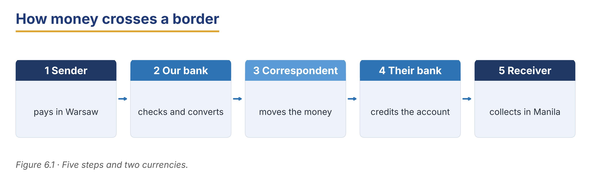
Part 2 · Grammar — Indirect Questions
Pre-class input

2A Notice the grammar
Read the short dialogue. Underline the indirect questions. What happens to the word order?
Customer: Could you tell me what today’s rate is?
Ana: Of course. It is 4.35 to the euro.
Customer: And do you know how long the transfer takes?
Ana: One working day. May I ask whether you have the IBAN with you?
Customer: I do, yes.

1. “what today’s rate is” — where is the verb? ____
2. “how long the transfer takes” — is there do/does? ____
3. whether — what kind of question does it introduce? ____
Grammar Focus
Form | Example
Could you tell me + question word + subject + verb | Could you tell me what the rate is?
Do you know + question word + subject + verb | Do you know how long it takes?
May I ask + whether / if + subject + verb | May I ask whether you have the IBAN?

Remember: in an indirect question the subject comes before the verb, and do / does / did disappears. Use whether or if when there is no question word.
⚠ Watch out!
✗ Could you tell me what is the rate? → ✓ Could you tell me what the rate is?
✗ Do you know how long does it take? → ✓ Do you know how long it takes?

2B Controlled practice (make it indirect)
Rewrite each direct question as an indirect question.
Example: 0. What is the fee? → Could you tell me what the fee is?
1. How much does it cost?
2. Where is the beneficiary’s bank?
3. When will the money arrive?
4. Does the rate change today?
5. What is your account number?
2C Error correction
Find and correct the mistake in each sentence.
Example: 0. Could you tell me what is the rate? → Could you tell me what the rate is?
1. Do you know when does the branch close?
2. Could you tell me how much is the fee?
3. May I ask do you have the IBAN?
4. I would like to know where is the beneficiary’s bank.
5. Can you tell me what time does it arrive?
✎ Write your response here.

2D Ask politely
Write three indirect questions you would ask a customer who is sending money abroad.
Model — read this first
Could you tell me the full name of the beneficiary? May I ask which currency you would like the money to arrive in? Do you know whether the account is held at that branch?

✎ Write your response here.

2E Freer practice (speaking)
In pairs, act a short exchange-desk conversation. Each speaker asks at least two indirect questions.
Model — read this first
“Could you tell me how much you would like to change? … And may I ask whether you have your ID with you?”

Tip: You will see indirect questions again in the reading in Part 5 (5A and 5B). Look for them there.
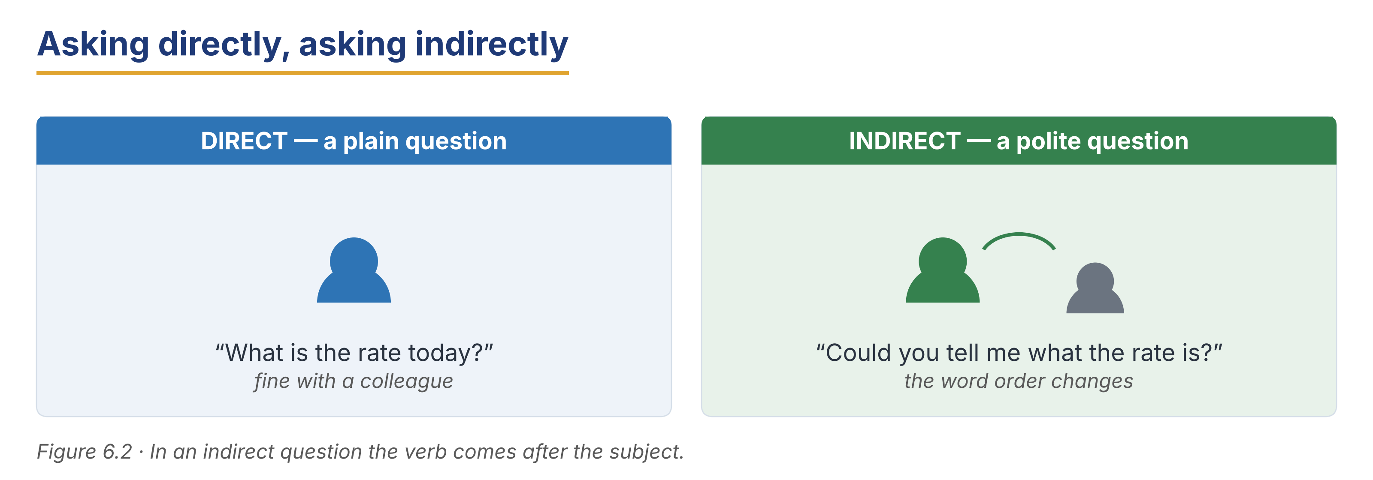
Part 3 · Listening
Pre-class input · scripts printed below

3A Before you listen (predict)
You will hear three conversations about moving money. What does a customer ask first?
Model — read this first
“I think the customer will ask about the rate, and then about the fee.”

3B Asking about the rate
🔊 Audio 6.1 (optional) — or read the script below.
Customer: Good morning. Could you tell me what the rate is today?
Zeynep: Good morning. We are buying at 4.28 and selling at 4.42.
Customer: Why are there two numbers?
Zeynep: The difference is called the spread. It is how the bank is paid for the service. There is no separate commission for cash.
Customer: I see. That is clearer than I expected.

Read and decide: True, False, or Not Given.
Example: 0. The customer asks about the rate. → True.
1. There is a separate commission for changing cash.
2. The bank buys at a lower number than it sells at.
3. The customer changes money today.
Useful language: Could you tell me what the rate is today? · We are buying at… and selling at… · The difference is called the spread.
3C Sending a transfer
🔊 Audio 6.2 (optional) — or read the script below.
Customer: I would like to send three hundred to my daughter.
Luca: Certainly. May I ask whether you have her IBAN?
Customer: Yes, here it is. Do you know how long it will take?
Luca: Usually one working day. Could you tell me the full name on the account, exactly as the bank has it?
Customer: Maria Oliveira. Is the fee the same for any amount?
Luca: Up to a thousand, yes — a flat twelve.

Read and decide: True or False.
1. The customer has the beneficiary’s IBAN.
2. The transfer usually takes one working day.
3. The name on the account does not have to match exactly.
4. The fee is twelve for amounts up to a thousand.
3D Collecting a transfer from abroad (longer)
🔊 Audio 6.3 (optional) — or read the script below.
Customer: Good afternoon. My brother sent me money from abroad last Friday, but nothing has arrived.
Luca: I’m sorry to hear that. Could you tell me the exact date he sent it, and the amount?
Customer: Friday the fourteenth. Five hundred.
Luca: Thank you. May I ask whether he gave the bank your IBAN, or only your account number?
Customer: I’m not sure. He said he gave the number from my card.
Luca: That may be the problem. For money coming from another country, the IBAN is needed, and the BIC of this bank. Without them the payment can sit at a correspondent bank for several days.
Customer: Do you know what I should do now?
Luca: I will write down your IBAN and our BIC for you. Could you send them to your brother today? If the money has not moved by Thursday, come back and we will trace it.

Read and decide: True, False, or Not Given.
Example: 0. The money has not arrived. → True.
1. The customer is certain her brother used her IBAN.
2. A payment can wait at a correspondent bank for several days.
3. The brother lives in Spain.
3E Match the polite question
Match each indirect question from the listenings to what it asks for (one is extra).
Column A | Column B
1. “Could you tell me what the rate is today?” ____ | a) the price of one currency in another
2. “May I ask whether you have her IBAN?” ____ | b) the account number abroad
3. “Do you know how long it will take?” ____ | c) the time the transfer needs
4. “Could you tell me the full name on the account?” ____ | d) the beneficiary’s exact name
5. “Do you know what I should do now?” ____ | e) the next step
 | f) “Could you tell me your address?” (extra)

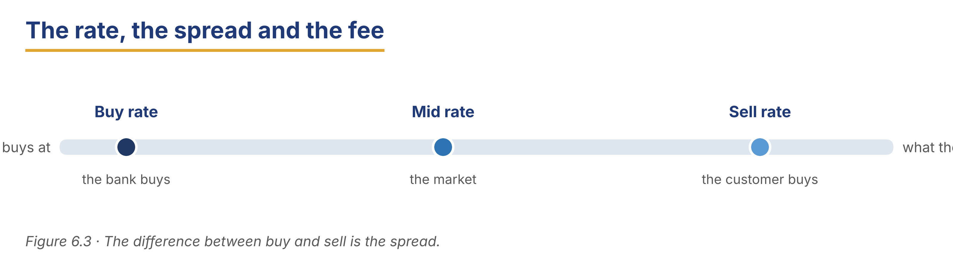
Part 4 · Speaking
In-class output

4A Functional language — polite questions and answers
Match the function to a phrase (one is extra).
Column A | Column B
1. Ask politely for information ____ | a) “Could you tell me the beneficiary’s full name?”
2. Give a price ____ | b) “We are selling at 4.42 today.”
3. Explain a charge ____ | c) “The difference is called the spread.”
4. Give a time ____ | d) “It usually arrives within one working day.”
 | e) “Your card has been declined.” (extra)

4B At the exchange desk (pairwork)
Act a short exchange-desk conversation, then swap roles.
Model — read this first
A: Could you tell me how much you would like to change? — B: Two hundred. What is the rate? — A: We are selling at 4.42. May I ask whether you have your ID with you?

Card A (staff): ask the amount politely · give the rate · explain the spread · ask for ID.
Card B (customer): you want to change 200; you ask why there are two rates; you have your passport.
4C Explain a transfer
A customer does not understand why a transfer takes a day. Explain the route simply.
Model — read this first
“Your money leaves us today, it is passed through a partner bank overnight, and it is credited to your daughter’s account tomorrow morning. Three banks are involved, and each one checks the payment.”

Stretch: the customer asks why a payment within the country is instant but this is not — answer clearly.
4D Find the information (pairwork info-gap)
Student A works at the transfer desk; Student B is a customer. Ask and answer to complete the transfer.
Card A (staff): fee is a flat 12 up to 1,000, then 20 · one working day · you need the IBAN, the BIC and the exact name.
Card B (customer): you are sending 1,400 to Manila; you have the IBAN but not the BIC; you want it to arrive by Friday.
Useful language: Could you tell me how much you would like to send? · May I ask whether you have the BIC? · Do you know when it needs to arrive?
4E Close the conversation
Match the closing phrase to the situation (one is extra).
Column A | Column B
1. “Here is your receipt with the reference number.” ____ | a) giving the customer the record
2. “Please keep this in case you need to trace it.” ____ | b) explaining why the record matters
3. “If it has not arrived by Thursday, come back.” ____ | c) giving a clear next step
4. “Would you like today’s rate written down?” ____ | d) offering something extra
5. “Is there anything else I can check?” ____ | e) checking there is nothing more
 | f) “Please take a seat.” (extra)

In pairs, close a transfer conversation politely. Use two phrases above.
Part 5 · Reading
Pre-class input

5A Common questions about transfers (FAQ)
Read the FAQ page. Notice the indirect questions.
Harbour Bank — Sending Money Abroad
About 195 words
Customers often ask us how an international transfer works, so here are the questions we hear most. Could you tell me what I need before I start? You need three things: the beneficiary’s full name exactly as their bank holds it, their IBAN, and the BIC of their bank. A missing BIC is the most common reason a payment is delayed. Do you know how long it takes? Most transfers arrive within one working day, but a payment sent on Friday afternoon may not move until Monday. May I ask why there are two rates on the board? One is the price at which we buy a currency and one is the price at which we sell it. The difference is called the spread, and it is how the service is paid for. Could you tell me what the fee is? It is a flat twelve up to one thousand, and twenty above that. Do you know where my money is now? Every transfer has a reference number on your receipt. Bring it to any branch and we can see which bank is holding the payment and why.

Answer the questions.
Example: 0. What are the three things you need? → The full name, the IBAN and the BIC.
1. What is the most common reason a payment is delayed?
2. Why might a Friday payment not move until Monday?
3. What is the spread, and what is it for?
4. What is the fee for a transfer of 1,500?
5. What should a customer bring if they want to trace a payment?
5B Grammar in context (from 5A)
Look back at the FAQ. Find three indirect questions.
1. Indirect question 1: ____
2. Indirect question 2: ____
3. Indirect question 3: ____
Now rewrite these direct questions as the FAQ would write them.
1. How much is the fee? → ____
2. Where is my money? → ____
5C How a transfer moves
Read the short note. Which banks touch the money?
Three Banks, One Payment
About 120 words
When money is sent from one country to another, it usually passes through three banks, not two. The sender’s bank takes the money and converts it. A correspondent bank in the middle moves it between the two countries, because the first and last banks may have no direct link. The beneficiary’s bank then credits the account. Each bank checks the payment against its own country’s rules, and each check takes a little time. This is why an international transfer takes a day, while a payment inside one country can be instant. It is also why a missing BIC is serious: without it, the middle bank does not know where to send the money next.

1. How many banks usually touch an international payment?
2. What does the correspondent bank do?
3. Why is a missing BIC serious?
5D Discussion
In pairs, compare transfers at your own bank.
Useful frame: “At my bank, a transfer to ___ takes ___, and the fee is ___.”
● Which country do your customers send money to most?
● What do customers find hardest to understand about the fee?
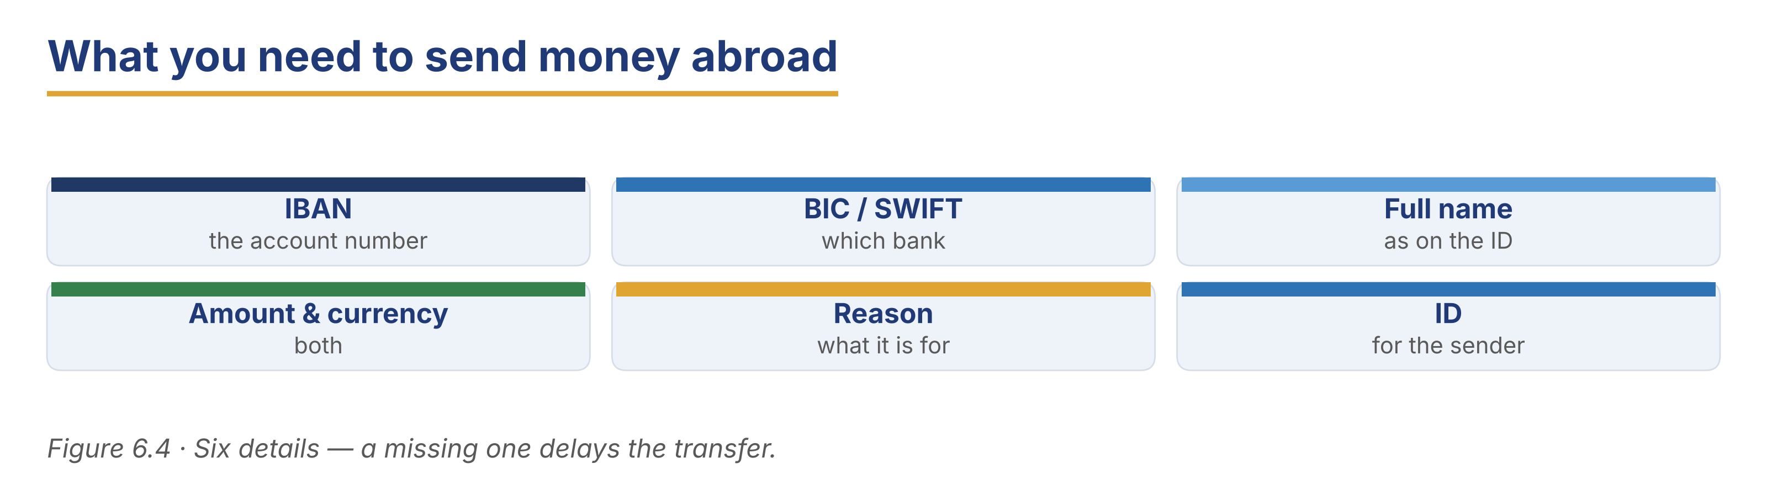
Part 6 · Writing
In-class / homework output

6A Guided writing — complete the inquiry email
Complete the email with the words: confirm, whether, arrive, charged, reference.
Word bank
confirm | whether | arrive
charged | reference

1. Dear Transfers Team, could you please ______________________ the status of the payment below?
2. The ______________________ number is HB-4471-22.
3. I would like to know ______________________ the BIC was included.
4. The customer expected the money to ______________________ on Tuesday.
5. Please also tell me what fee was ______________________.
6B Transfer inquiry email (50–70 words)
Write a short internal email asking about a delayed transfer. Use two indirect questions.
Model — read this first
Subject: Delayed transfer — reference HB-4471-22
Dear Transfers Team, Could you tell me where payment HB-4471-22 is at the moment? It was sent on Friday the fourteenth and has not arrived. May I also ask whether the BIC was included when it left us? The customer is returning on Thursday. Kind regards, Luca Rossi

Plan: Subject: ___ · Dear ___, · Could you tell me ___? · It was sent on ___. · May I also ask whether ___? · Kind regards, ___
Phrase bank: Could you tell me where… · May I ask whether… · It was sent on… · the customer is returning on…
Check before you finish
☐ A clear subject line with the reference?
☐ Two indirect questions?
☐ The date the payment was sent?
☐ 50–70 words?
✎ Write your response here.

6C Reply to a customer (50–70 words)
A customer asks why her transfer has not arrived. Write a short, honest reply.
Model — read this first
Subject: Your transfer of 500
Dear Mrs Oyelaran, Thank you for your patience. The payment left us on Friday and is currently held by the partner bank, because the BIC was missing. We have now supplied it, and the money should arrive within one working day. Could you let us know if it has not arrived by Thursday? Kind regards, Customer Service

Plan: Subject: ___ · Dear ___, · Thank you for ___. · The payment ___. · We have now ___. · Could you let us know ___? · Kind regards, ___
Check before you finish
☐ A clear subject line?
☐ An honest explanation of the delay?
☐ One indirect question?
☐ 50–70 words?
✎ Write your response here.

6D Peer check
Swap your email from 6B or 6C with a partner. Give one piece of positive feedback and one suggestion.
Checklist: subject line? · two indirect questions? · the date given? · 50–70 words?
Model — read this first
“Good polite questions and a clear reference. Next time, try to say what you will do next, not only what went wrong.”

Part 7 · Management File — Handling a Rate Query
Practitioner track (optional for beginners) · experienced staff

7A Explaining rates and fees — phrases
Match the phrase to its purpose (one is extra).
Column A | Column B
1. “The rate on the board is the rate you get.” ____ | a) removing a doubt
2. “The difference is called the spread.” ____ | b) naming the charge
3. “I can write both numbers down for you.” ____ | c) making it checkable
4. “The rate moves during the day.” ____ | d) explaining why it changed
 | e) closing an account (extra)

7B Listening — coaching on a rate query
🔊 Audio 6.4 (optional) — or read the script below.
Kerem: You handled that well, but the customer left still unsure. May I ask what you told him?
Zeynep: I said the rate had changed since the morning.
Kerem: That is true, but it sounds like an excuse. Tell him what the rate is now, write both numbers down, and say that the board is updated when the market moves.
Zeynep: So give him something he can check.
Kerem: Exactly. A customer who can check a number does not need to trust you.

Answer the questions.
Example: 0. Who is giving the coaching? → Kerem.
1. What did Zeynep tell the customer?
2. Why does Kerem say that answer is not enough?
3. What should Zeynep give the customer instead?
7C Controlled practice — make the question polite
Rewrite each blunt question as an indirect question a colleague could use with a customer.
Example: 0. What do you want to send? → Could you tell me how much you would like to send?
1. What is the beneficiary’s name?
2. Where does the money go?
3. Do you have the BIC?
4. When do you need it there?
5. Why are you sending this amount?
✎ Write your response here.

7D Role play — handle a rate complaint
A customer says the rate was better this morning. Handle the complaint professionally.
Model — read this first
“You are right that it has moved. The rate on the board is the rate you get, and it is updated when the market moves. Let me write both numbers down so you can see today’s exactly.”

Card A (staff): accept the fact · explain without excuses · give something checkable · offer a next step.
Card B (customer): you were quoted a better rate at 9 a.m.; you feel the bank changed it on purpose.
Stretch: the customer asks you to give the morning rate — answer honestly and politely.
7E Writing — a short reply about fees (50–70 words)
Write a short reply to a customer who says the fee was too high.
Model — read this first
Dear Mr Tanaka, Thank you for writing. The fee on your transfer was twenty, because the amount was above one thousand; below that it is a flat twelve. The rate you received was the sell rate shown on the board at 14:20. I have attached both figures. Could you tell me whether you would like a copy by post? Kind regards, Zeynep Kaya

Plan: Dear ___, Thank you for ___. · The fee was ___, because ___. · The rate you received was ___. · Could you tell me whether ___? · Kind regards, ___
Phrase bank: the fee was ___ because… · the rate shown at… · I have attached both figures · could you tell me whether…
Check before you finish
☐ Does it give the exact figures?
☐ One indirect question?
☐ No excuses?
☐ 50–70 words?
✎ Write your response here.

Part 8 · Global Case Study — How Money Crosses Borders
Practitioner track · read then discuss

Before you read: why does money sent abroad cost more and take longer than money sent at home?
The Cost of Sending Home
About 205 words · a made-up example based on real practice
Every year, people working away from home send money back to their families. For many countries these payments, called remittances, are larger than all foreign aid together. The people who send them are usually not rich, and the amounts are small — often two or three hundred at a time. That is the problem. A fee of twelve is small on a transfer of five thousand. On a transfer of two hundred, it is six per cent of the money, and the spread on the exchange rate may cost as much again. An international body set a target: the average cost of sending money home should fall below three per cent. One bank tried to reach it. It could not cut the fee, because each payment is checked by three banks and each check costs money. Instead it changed the product. Customers who send money to the same person every month pay one fee for twelve payments, set up once. The checks are done at the start, not twelve times. The cost for those customers fell from six per cent to just under two. The bank did not make the transfer cheaper. It made it fewer transfers.

Glossary help
remittance — money sent home by someone working abroad
spread — the difference between the buy rate and the sell rate
foreign aid — money given by one country to another
standing transfer — the same payment, set up once and repeated

8A Comprehension
Example: 0. What are remittances? → Money sent home by people working abroad.
1. Why is a flat fee a bigger problem on a small transfer?
2. What target did the international body set?
3. Why could the bank not simply cut the fee?
4. What did the bank change instead, and what was the result?
8B Vocabulary in context
Match the word to its meaning (one is extra).
Column A | Column B
1. remittance ____ | a) the difference between the buy rate and the sell rate
2. spread ____ | b) money sent home by someone working abroad
3. foreign aid ____ | c) the same payment, set up once and repeated
4. standing transfer ____ | d) money given by one country to another
 | e) a charge for a lost card (extra)

8C Discussion
Frames: “In my country the cost of sending money is ___.” “This idea would help because ___.”
● Do your customers send the same amount to the same person each month?
● What would make a standing transfer hard to sell?
8D Your view (short write, 30–40 words)
Would a standing transfer help your customers? Why, or why not?
✎ Write your response here.

Part 9 · Branch Case Study — Manila in Focus: Money from Abroad
Practitioner track · read then decide

Before you read: what should a branch do when a payment from abroad goes missing?
The Payment That Stopped
About 185 words
It is the first week of the month at the Harbour Bank branch in Manila, and the counter is busy with people collecting money sent from abroad. Mrs Reyes has been waiting since the branch opened. Her son works overseas and sends two hundred on the same day every month. This month it has not arrived, and she needs it today to pay her rent. Priya Raman checks the system. The payment left her son’s bank eight days ago, but it is sitting at a correspondent bank, because the name on the transfer is “M. Reyes” and the account is held as “Maria Reyes Santos”. The correspondent bank will not release it until the names match. Fixing it will take two more days, and the request must come from the sending bank, not from Manila. Mrs Reyes is calm but close to tears. The branch has a small hardship fund for exactly this kind of case, but it needs the manager’s approval, and the manager is away until tomorrow.

9A Comprehension
Example: 0. Where is the payment now? → At a correspondent bank.
1. Why has the correspondent bank not released the money?
2. Who has to ask for the payment to be fixed?
3. Why can Priya not use the hardship fund straight away?
9B Decision task
What should Priya do today? Write 40–60 words. Use the frame and the phrase bank.
Model — read this first
I think Priya should call the sending bank herself, because only they can correct the name. She should also phone the manager for approval of the hardship fund by telephone. Also, she can give Mrs Reyes a written note of the reference number and the exact name to send her son.

Frame: I think Priya should ___, because ___. Also, ___.
Phrase bank: contact the sending bank directly · ask for approval by telephone · give a written note of the reference · explain exactly what the name must say
✎ Write your response here.

Part 10 · Review & Can-Do
Homework / self-study

10A Spiral review
Complete the sentences. Use an indirect question or the correct word. Items 5–6 review Units 4 and 5.
Example: 0. What is the fee? → Could you tell me what the fee is?
1. Where is the money now? → Could you tell me ______________________?
2. Does he have the IBAN? → May I ask ______________________?
3. The difference between the buy and sell rate is the ______________________. (word)
4. A bank that passes money between two other banks is a ______________________. (word)
5. The Fixed 12 pays the ______________________ (high) rate of the three. (Unit 4 grammar)
6. A code ______________________ (send) to your phone every time. (Unit 5 grammar)
10B Can-Do checklist
Can-Do checklist — tick what you can do now
☐ I can name the parts of an international transfer.
☐ I can ask politely with indirect questions.
☐ I can explain a rate, a spread and a fee to a customer.
☐ I can understand a short transfer conversation.
☐ I can write a short inquiry about a delayed payment.
10C Unit glossary
Glossary help
exchange rate — what one currency is worth in another
spread — the difference between the buy rate and the sell rate
IBAN — the international number of a bank account
BIC — the code that says which bank
correspondent bank — a bank that passes money between two other banks
remittance — money sent home by someone working abroad
beneficiary — the person who receives the money
commission — what the bank charges for the service
working day — a day the banks are open
indirect question — a polite question with the subject before the verb

