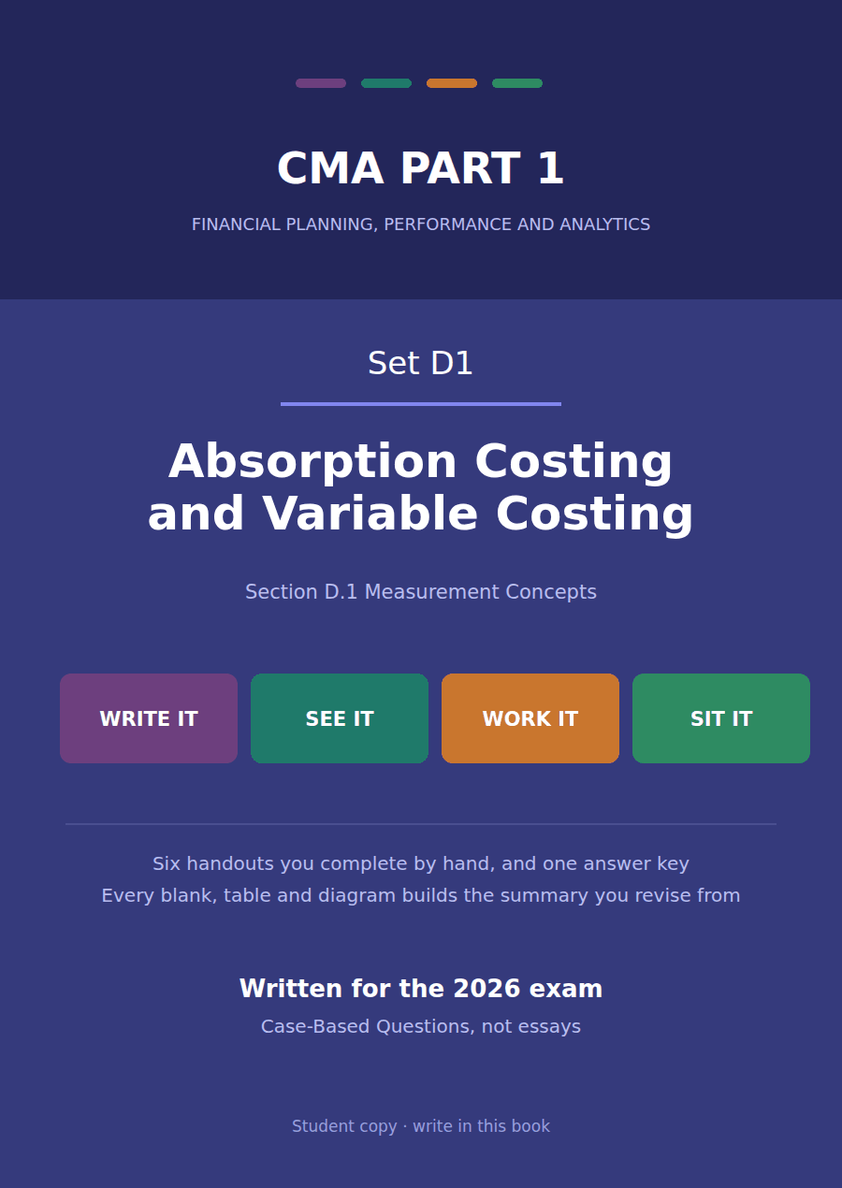

CMA Part 1 · Set D1
Absorption costing and variable costing
Six handouts, one answer key. Section D.1 Measurement Concepts, with the Section C and Section A links the exam actually tests.
These handouts are not notes to read. You write them. The words you supply are the summary, so a finished handout is a page you can revise from, in your own handwriting.
Work in pen. Do not look at the key until the whole handout is done — the key is written to explain the mistake, and you only get that benefit if you have made it first.
The six handouts
# | Handout | What it gives you
1 | The Inventoriable Decision | Every costing question in Part 1 comes back to one choice: which costs go into inventory, and which go straight to the income statement.
2 | Three Methods, One Set of Costs | The same factory, the same costs, three different unit costs — and three different income statement shapes to go with them.
3 | The Two Statements | Build an absorption statement and a variable costing statement from one set of data, then prove the difference between them in a single line.
4 | Deferral and Release Over Time | Sales are flat for three years and reported profit moves anyway. Follow the fixed overhead into the warehouse and back out again.
5 | The Ledger | The same month posted twice. Eleven entries under absorption costing, and the three that change under variable costing.
6 | The Incentive Problem, and the Exam | A manager can raise absorption costing income without selling anything. Here is how much, why it is legal, why it is still wrong, and how the 2026 exam asks about it.

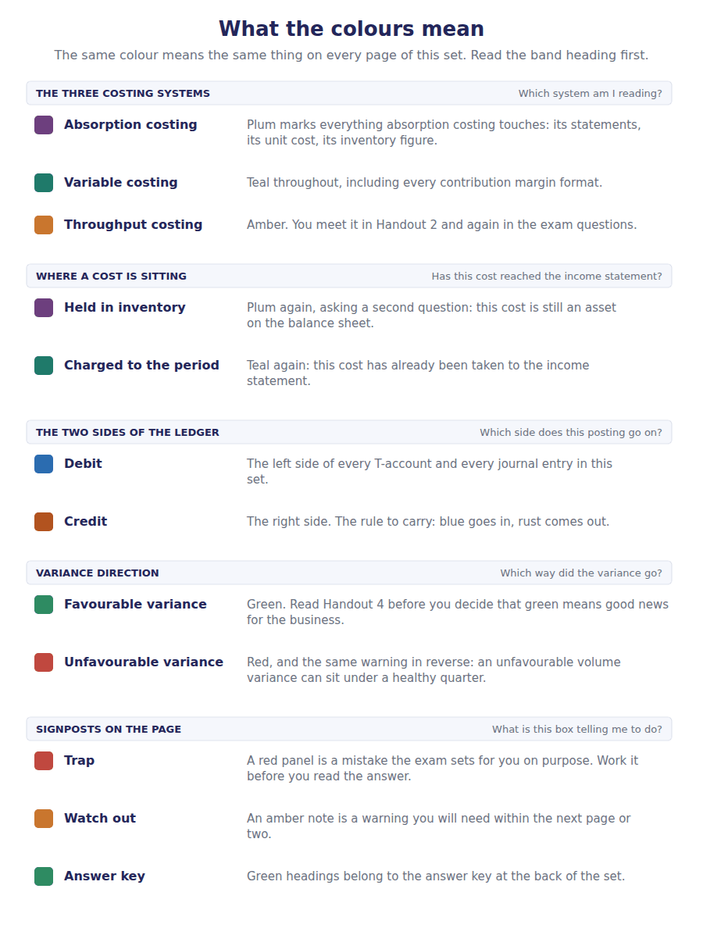
How to read the markers
Marker | Meaning
R1 | Teaching English. Short sentences. This is where a new idea arrives.
R2 | Textbook English. Longer sentences and passive verbs, as a textbook writes them.
R3 | Exam English. Exactly how the CMA exam phrases it, traps included.
Numbered rule | A space you fill in. The number matches the answer key.
Red table | A trap. Read it twice.

Handout 1 · The Inventoriable Decision
Every costing question in Part 1 comes back to one choice: which costs go into inventory, and which go straight to the income statement.
Set D1 · Absorption and Variable Costing · Mostly R1, ending at R2
LANGUAGE FOCUS
Register you are working in | R1 Teaching English. Short sentences, one idea each. Read every sentence aloud once before you write in it.
Say it exactly like this | incur a cost · a cost attaches to the product · flow into inventory · charge a cost to the period · trace a cost · allocate a cost
Words that are not the same | cost / expense / expenditure · direct / variable · indirect / fixed · overhead / expenses
Remember | A cost is not an expense until it is matched against revenue. Direct is about tracing. Variable is about behaviour. Different questions.

What you will be able to do when this handout is finished
- Name the cost object before you classify any cost.
- Say whether a cost is variable or fixed in total, and what it does per unit.
- Separate direct from indirect, and explain why that is not the same question as variable and fixed.
- Decide whether a cost is a product cost or a period cost.
- State the one cost whose treatment separates absorption costing from variable costing.

The plant you will work in all week
Grandview Instruments makes one product: a sealed pressure sensor used in water treatment plants.
One factory. One production line. One selling price. You will meet this company in all six handouts.
In this handout you calculate nothing. You learn to put each cost in the right box, because every calculation later depends on that.
The factory manager has sent you a list of the costs she incurs in a month. She wants to know which belong to the sensors in the warehouse, and which belong to the month that has just finished.

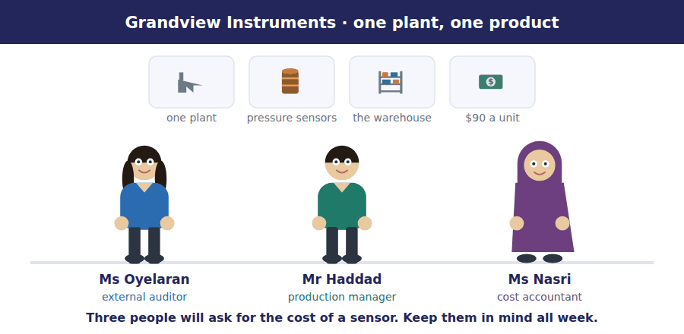
Part 1 · What are you costing? the cost object
Exercise 1A Read and complete. Write one word in each space.
OBJECTIVE | Fix the cost object first, and show that the same cost changes label when the cost object changes.
YOU WILL NEED | Nothing — this is the first exercise in the set.
HOW TO START | • Read the whole paragraph once before writing anything.  • Blank 1 is the technical term the sentence has just defined.  • Blanks 3 and 4 are opposites. Decide which way round they go from the sentence, not from memory.

WORD BANK
centre · direct · driver · indirect · object · sensor · unit · variable
Not every word is used.

R1 A cost is never direct or indirect on its own. It is direct or indirect with respect to something, and that something is called the cost ¹ .
At Grandview the cost object is usually the ² , because the company wants to know the cost of one unit. But the cost object could also be a department, a customer, or a single order.
Change the cost object and the same cost changes its classification. The salary of the factory supervisor cannot be traced to one sensor, so it is ³ with respect to a sensor. With respect to the factory as a whole it is ⁴ , because it belongs to the factory and to nothing else.
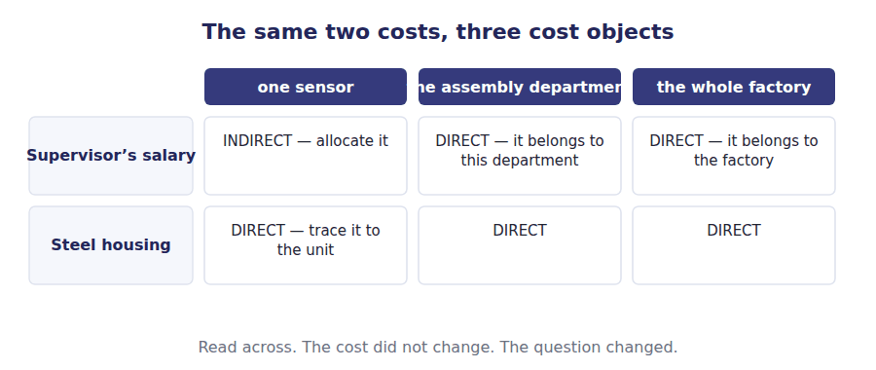
Watch out! Write the cost object at the top of your page before you classify anything. In the exam the stem always tells you — "with respect to the product", "for the department". Underline it.
Part 2 · How does the cost behave? variable, fixed and mixed
Exercise 1B Read and complete.
OBJECTIVE | State what happens to a variable cost and a fixed cost in total and per unit as activity rises.
YOU WILL NEED | Exercise 1A, for the idea of a cost object.
HOW TO START | • The word TOTAL and the words PER UNIT are the two halves of every answer here.  • Blank 8 follows from arithmetic, not from memory: the same total shared by more units.

WORD BANK
always · constant · falls · not · per hour · per unit · rises · total
Not every word is used.

R1 Cost behaviour is about what happens to a cost when activity changes.
A variable cost changes in ⁵ as output changes, but stays constant ⁶ . The direct material in one sensor costs $18 whether Grandview makes one sensor or fifty thousand.
A fixed cost is the opposite. Its total does ⁷ change as output changes, so the amount carried by each unit ⁸ as output rises. Factory rent of $600,000 is $12 per unit at 50,000 units and $20 per unit at 30,000 units. The cost did not change. Only the number of units sharing it changed.
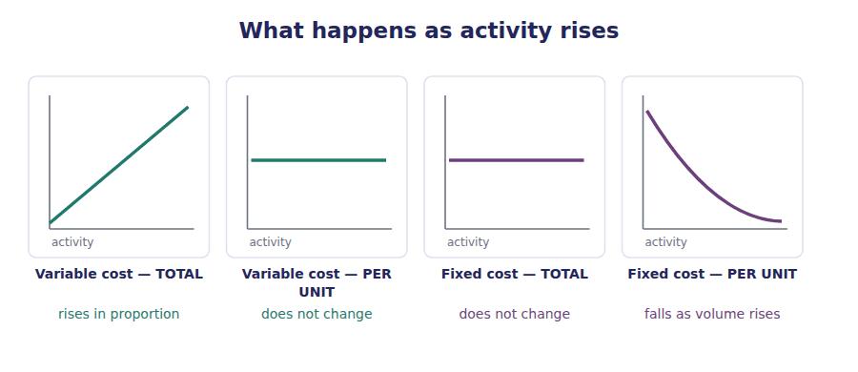
R1 One more word before you classify anything. The activity that makes a cost move is its cost driver: machine hours drive the power bill, units produced drive the material cost, deliveries drive the shipping cost.
A cost driver is not itself a cost. Naming the driver is the fastest way to decide how a cost behaves. A cost with no driver at the level of activity you are looking at is a fixed cost, and a cost with a standing charge plus a driver-related element is a mixed cost.
Exercise 1C Tick one box for each cost. The cost object is the sensor.
OBJECTIVE | Classify ten real costs by behaviour, judging the total rather than the amount per unit.
YOU WILL NEED | Exercise 1B · the four facts in the behaviour chart above
HOW TO START | • For each cost ask one question only: if the plant makes 10% more, does the TOTAL rise?  • If the answer is yes it is variable; if no it is fixed; if partly, it is mixed.  • Number 1 is done for you in the diagram below.

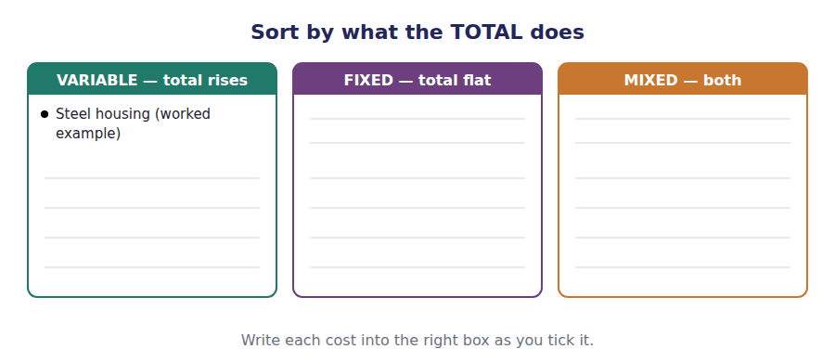
Cost incurred at Grandview this month | Variable | Fixed | Mixed
1. Steel housing for each sensor
2. Monthly rent on the factory building
3. Wages of assembly workers, paid per unit completed
4. Salary of the factory supervisor
5. Electricity: a standing charge plus a rate per machine hour
6. Depreciation on the moulding machine, straight line
7. Shipping cartons, one per sensor
8. Annual licence fee for the calibration software
9. Sales commission at 3% of selling price
10. Quality inspector’s salary

Part 3 · Can you trace it? direct and indirect
Exercise 1D Read and complete.
OBJECTIVE | Separate traceability from behaviour, and show that the two questions are independent.
YOU WILL NEED | Exercise 1A for the cost object · Exercise 1C for behaviour
HOW TO START | • Two different questions are being asked about every cost. Write them both at the top of the page.  • Question one: can I trace it? Question two: does the total move?  • The last blank is the point of the whole exercise.

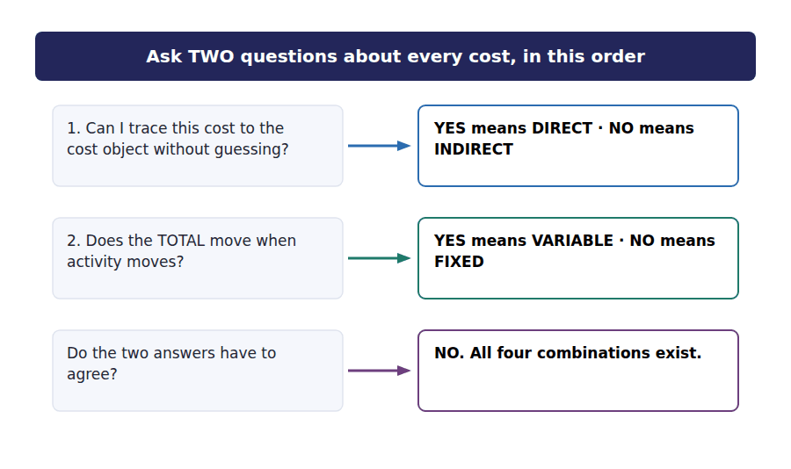
WORD BANK
allocate · arbitrary · behavioural · direct · fixed · independent · indirect · mixed · traceable
Not every word is used. A word may be used more than once.

R1 Direct and indirect is a different question from variable and fixed, and the exam relies on students mixing them up.
A cost is ⁹ if you can trace it to the cost object without guessing. A cost is indirect if you have to ¹⁰ it on some reasonable basis.
Depreciation on a machine that makes only sensors is a ¹¹ cost of sensors, and it is also a ¹² cost. Electricity that runs the whole factory is ¹³ , and most of it is variable. The two classifications are ¹⁴ of each other.
Exercise 1E Write one example from the Grandview list in each box. All four can be filled.
OBJECTIVE | Prove that traceability and behaviour are independent by filling all four combinations.
YOU WILL NEED | Exercise 1C · Exercise 1D
HOW TO START | • Take the costs from Exercise 1C one at a time.  • Ask the two questions and the box chooses itself.  • If a box stays empty, you have classified something wrongly.

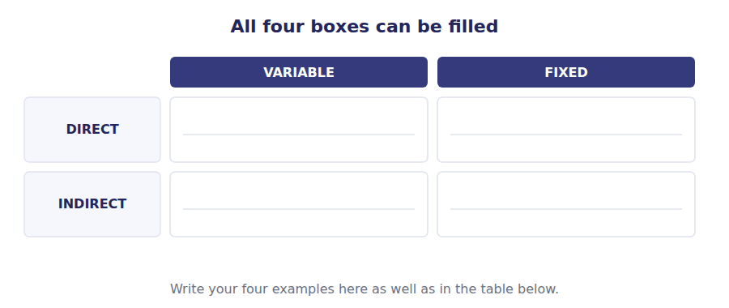
 | Variable | Fixed
Direct
Indirect

Part 4 · Does it go into inventory? product and period costs
Exercise 1F Read and complete. This is the central idea of the whole set.
OBJECTIVE | State the product and period rule, and name the one cost the two methods treat differently.
YOU WILL NEED | Everything above · the cost flow diagram below
HOW TO START | • Follow the diagram first: a product cost travels along the line, a period cost never joins it.  • The last blank is three words long and it is the sentence to memorise.

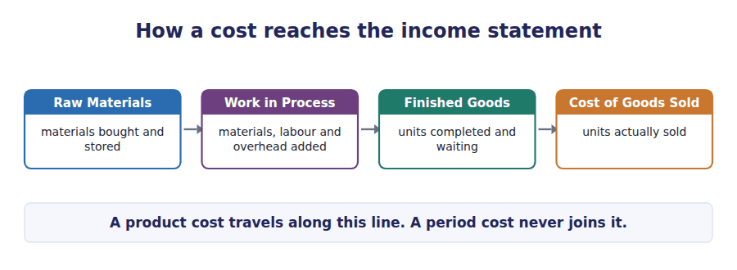
WORD BANK
cash · conversion · expense · fixed manufacturing overhead · incurred · inventory · period · product · sold · variable manufacturing overhead
Not every word is used.

R2 A product cost attaches to the goods. It is recorded as an asset, it sits in ¹⁵ , and it becomes an expense only when the goods are ¹⁶ .
A period cost is charged against income in the period in which it is ¹⁷ , whether or not anything is sold. The timing difference between the two is the whole of this topic.
Under both methods you will study, selling and administrative costs are always ¹⁸ costs, and direct materials, direct labour and variable manufacturing overhead are always ¹⁹ costs.
Exactly one cost is treated differently by the two methods, and that cost is ²⁰ .
Exercise 1G Tick one box for each cost. Use absorption costing.
OBJECTIVE | Apply the product and period rule to twelve costs, including the three that catch almost everybody.
YOU WILL NEED | Exercise 1F · the cost flow diagram
HOW TO START | • Ask: was this cost incurred inside the factory to get the goods ready?  • If yes it is a product cost. Everything after the factory door is a period cost.  • Items 11 and 12 are the two that are designed to catch you.

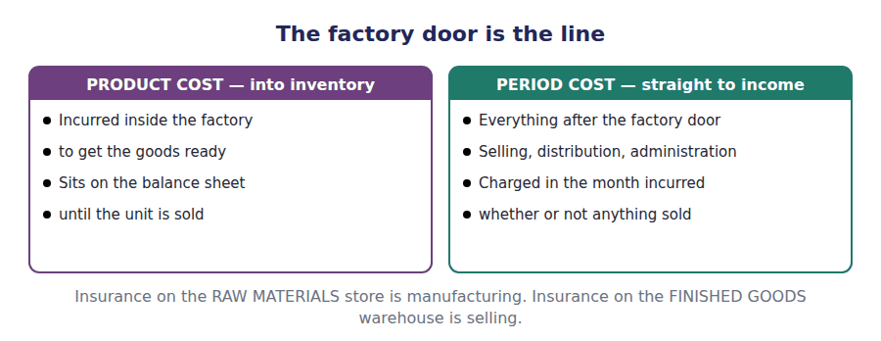
Cost | Product cost | Period cost
1. Steel housing used in production
2. Assembly wages
3. Factory rent
4. Depreciation on factory machinery
5. Depreciation on the delivery vans
6. Factory supervisor’s salary
7. Advertising in a trade magazine
8. Sales commission
9. Salary of the chief financial officer
10. Electricity used in the factory
11. Insurance on the finished goods warehouse
12. Interest on the bank loan

Watch out! Warehouse insurance catches almost everybody. Storing FINISHED goods is a selling and distribution activity, so it is a period cost. Insurance on the RAW MATERIALS store is a manufacturing cost. The exam writes these two a few lines apart.
Part 5 · Language the words that are not the same
Exercise 1H Match each word with the sentence that uses it correctly. Write the letter.
OBJECTIVE | Use cost, expense, expenditure, overhead, allocate and trace in the one sentence each belongs in.
YOU WILL NEED | The Language Focus panel at the front of this handout
HOW TO START | • Follow the timeline below: a cost becomes an expense only at the end of it.  • Two of the six words are verbs. Find them first — that removes two options at once.  • Expenditure is about money leaving, usually for something lasting.

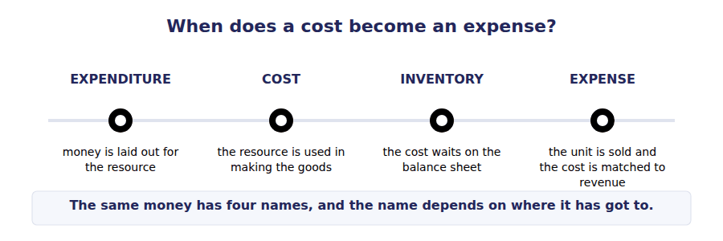
 | Item | Answer |  | Option
1 | cost |  | A | The factory rent of $600,000 is an ______ of the period once it is charged to income.
2 | expense |  | B | We ______ the supervisor’s salary to the two departments on floor area.
3 | expenditure |  | C | The ______ of one sensor is $48 under absorption costing.
4 | overhead |  | D | Total capital ______ on the new moulding line was $2.4 million.
5 | allocate |  | E | Indirect factory costs are collected in a single ______ account.
6 | trace |  | F | We can ______ the steel housing directly to each unit.

Exercise 1I Read across each row. The exam writes the third column.
OBJECTIVE | Recognise the same fact in teaching English, textbook English and exam English.
YOU WILL NEED | Everything in this handout
HOW TO START | • Cover the right-hand column and say what the exam version will be.  • Then uncover it and find your own words inside the exam sentence.  • Do this aloud. It is a listening skill as much as a reading one.

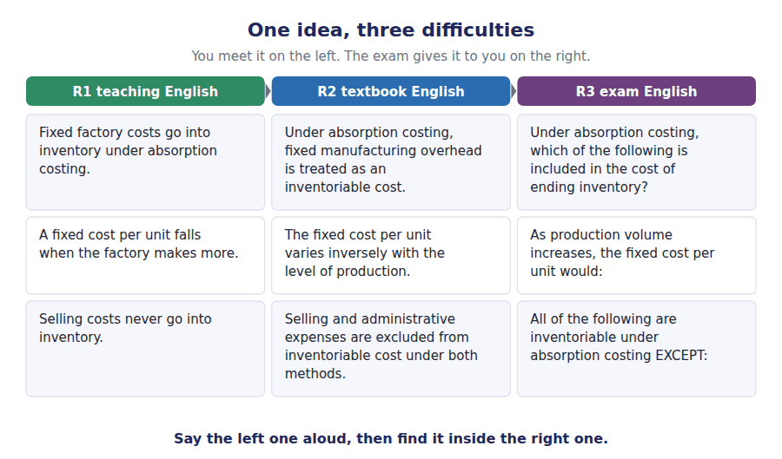
R1 Teaching | R2 Textbook | R3 Exam
Fixed factory costs go into inventory under absorption costing. | Under absorption costing, fixed manufacturing overhead is treated as an inventoriable cost. | Under absorption costing, which of the following is included in the cost of ending inventory?
A fixed cost per unit falls when the factory makes more. | The fixed cost per unit varies inversely with the level of production. | As production volume increases, the fixed cost per unit would:
Selling costs never go into inventory. | Selling and administrative expenses are excluded from inventoriable cost under both methods. | All of the following are inventoriable under absorption costing EXCEPT:

The exam says | Candidates assume | What is actually true
"with respect to the department" | the classification is the same as for the product | A supervisor is indirect to a unit and direct to a department. The cost object decides.
"full costing" | everything the company spends is in the product cost | Full means all MANUFACTURING cost. Selling and administrative cost is still a period cost.
"the variable cost per unit" | it changes when volume changes | The variable cost per unit is constant. It is the fixed cost per unit that moves.
"direct costing" | it means costing with direct costs | Direct costing is an old name for VARIABLE costing. It is about behaviour.
prime cost and conversion cost in the same question | you add them to get total manufacturing cost | Direct labour sits in both. Adding them counts labour twice.

Part 6 · Exam practice Levels A and B
Exercise 1J Decode the stem below, then answer the eight questions.
OBJECTIVE | Take an exam stem apart before answering it, so the trap word cannot do its work.
YOU WILL NEED | The whole handout
HOW TO START | • Find the method named in the stem and underline it.  • Find EXCEPT, NOT or LEAST and circle it.  • Only then read the options. Three of them will be true.

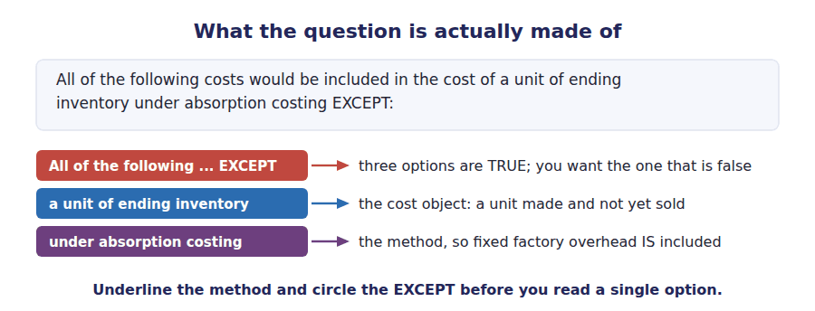
All of the following costs would be included in the cost of a unit of ending inventory under absorption costing EXCEPT:
What am I given? | What is asked? | Which word is the trap?

1. [Level A] All of the following costs would be included in the cost of a unit of ending inventory under absorption costing EXCEPT:
(A) Direct materials used in production.
(B) Depreciation on the factory building.
(C) Depreciation on the delivery vehicles.
(D) Variable manufacturing overhead.
2. [Level A] A company’s production increased from 30,000 to 50,000 units while fixed manufacturing overhead remained at $600,000. With respect to fixed manufacturing overhead, which of the following is correct?
(A) Total cost increased and cost per unit increased.
(B) Total cost was unchanged and cost per unit decreased.
(C) Total cost was unchanged and cost per unit was unchanged.
(D) Total cost decreased and cost per unit decreased.
3. [Level A] Which of the following statements about cost classification is correct?
(A) All variable costs are direct costs.
(B) All fixed costs are indirect costs.
(C) A cost may be both direct and fixed.
(D) Indirect costs are always fixed.
4. [Level B] Grandview incurred the following during the month: direct materials $900,000; direct labour $600,000; manufacturing overhead $900,000. What were prime cost and conversion cost respectively?
(A) $1,500,000 and $1,500,000.
(B) $1,500,000 and $900,000.
(C) $900,000 and $1,500,000.
(D) $2,400,000 and $2,400,000.
5. [Level B] Which cost would be classified as a period cost under absorption costing and as a product cost under no method at all?
(A) Fixed manufacturing overhead.
(B) Variable manufacturing overhead.
(C) The sales manager’s salary.
(D) Indirect materials used in the factory.
6. [Level B] Insurance on a warehouse holding finished goods awaiting shipment is best classified as:
(A) A product cost, because the goods are inventory.
(B) A period cost, because storage of finished goods is a selling and distribution activity.
(C) A product cost, because insurance is manufacturing overhead.
(D) A period cost, because all insurance is a period cost.
7. [Level A] A cost that is $5 per unit at 10,000 units and $5 per unit at 20,000 units, and whose total was $50,000 at the lower volume, is:
(A) A fixed cost.
(B) A variable cost.
(C) A mixed cost.
(D) Indeterminable without the relevant range.
8. [Level B] Which statement correctly distinguishes variable costing from absorption costing?
(A) Variable costing excludes all fixed costs from the income statement.
(B) Variable costing treats fixed manufacturing overhead as a period cost.
(C) Variable costing treats all indirect costs as period costs.
(D) Variable costing treats variable selling expenses as inventoriable.

Handout 2 · Three Methods, One Set of Costs
The same factory, the same costs, three different unit costs — and three different income statement shapes to go with them.
Set D1 · Absorption and Variable Costing · R1 moving to R2
LANGUAGE FOCUS
Register you are working in | R2 Textbook English begins here. Sentences get longer and some verbs become passive: "is treated as", "is excluded from", "is charged to".
Say it exactly like this | absorb overhead · be included in inventoriable cost · be excluded from product cost · arrive at contribution margin · deduct from sales · under each method
Words that are not the same | margin / profit / income · gross margin / contribution margin · cost of goods sold / cost of goods manufactured
Remember | A margin is a subtotal, not a bottom line. Gross margin and contribution margin are never the same number unless there are no fixed manufacturing costs.

What you will be able to do when this handout is finished
- Build the unit product cost under absorption, variable and throughput costing.
- Say which costs each method puts into inventory and which it expenses now.
- Name and write the three margin lines, and say what each one is useful for.
- Value closing inventory under all three methods from the same data.
- Recognise the exam’s wording for each method, including the old names.

One set of costs, three answers
Grandview’s controller has the cost records for the month on her desk. Direct materials $18 a unit, direct labour $12 a unit, variable manufacturing overhead $6 a unit, and fixed manufacturing overhead of $600,000 for the month.
The plant made 50,000 units and sold 42,000. Selling and administrative costs were $4 a unit sold, plus $280,000 of fixed cost.
Three people have asked her for "the cost of a sensor". The auditor needs it for the financial statements. The production manager needs it to decide whether to accept an extra order. The consultant working on the bottleneck needs it for a capacity study. She will give them three different numbers, and all three will be correct.

Part 1 · Where each method draws the line the inventoriable decision
Exercise 2A Read and complete.
OBJECTIVE | State where each of the three methods draws the line between a cost that enters inventory and a cost that is expensed now.
YOU WILL NEED | Handout 1, Exercise 1F
HOW TO START | • Read the ladder diagram below the exercise before you write anything.  • Three of the blanks are the names of cost groups. Two are the names of methods.  • The last blank is the one that makes throughput costing feel wrong the first time.

WORD BANK
factory · fixed · inventoriable · labour · materials · overhead · period · prime · traceable · variable · warehouse
Not every word is used.

R1 All three methods agree about selling and administrative cost: it is never ¹ , under any method, and it is charged to the period in which it is incurred.
They disagree only about costs incurred inside the ² . Absorption costing treats every manufacturing cost as a product cost, both variable and ³ .
Variable costing treats only the ⁴ manufacturing costs as product costs, and charges fixed factory overhead to the period as a capacity cost.
Throughput costing goes further still. It treats only direct ⁵ as a product cost, on the argument that in the short run everything else, including ⁶ , is a cost of keeping the factory open rather than a cost of making one more unit.
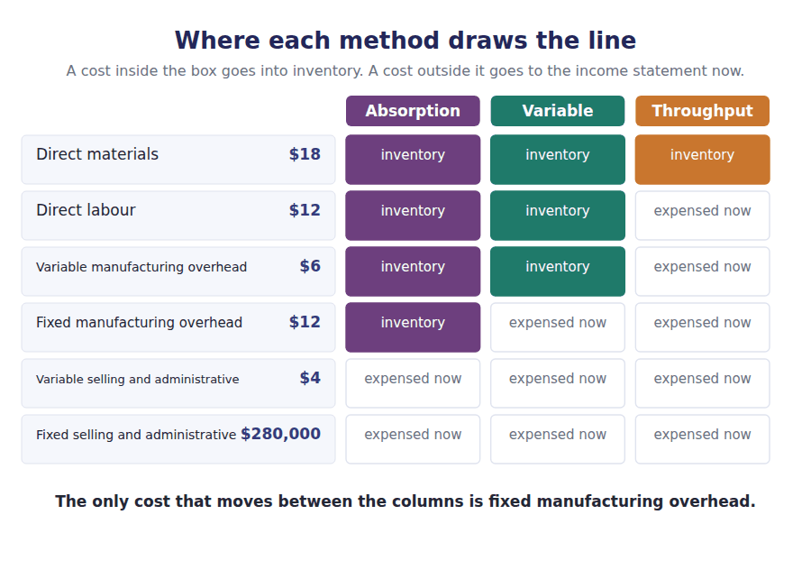
Part 2 · Building the unit cost three columns, one set of data
Exercise 2B Complete the table. The fixed overhead rate is the month’s fixed factory overhead divided by the units produced.
OBJECTIVE | Build the unit product cost under all three methods from one set of data.
YOU WILL NEED | Exercise 2A · the scenario data table above
HOW TO START | • Fill the absorption column downwards first. It has every row.  • The fixed overhead rate is $600,000 divided by the units produced.  • Then cross out the rows the other two methods do not use.

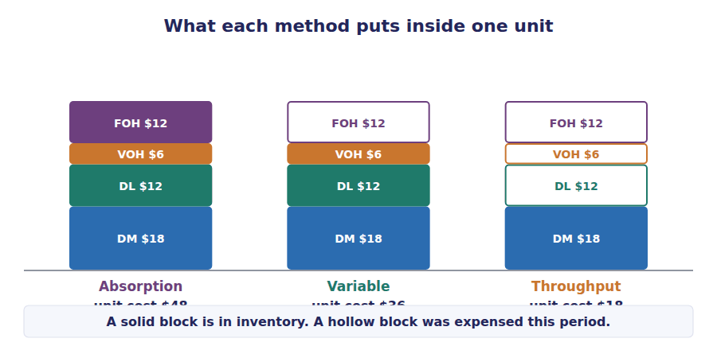
Per unit | Absorption | Variable | Throughput
Direct materials | $18 | $18 | $18
Direct labour |  |  | —
Variable manufacturing overhead |  |  | —
Fixed manufacturing overhead ($600,000 ÷ 50,000 units) |  | — | —
Unit product cost

Exercise 2C Now value the closing inventory. The plant made 50,000 units and sold 42,000.
OBJECTIVE | Value the same closing inventory three ways and see the size of the gap.
YOU WILL NEED | Exercise 2B · units produced and units sold
HOW TO START | • Closing inventory in units is production less sales. Write that number first.  • Then multiply by each of the three unit costs in turn.  • Check: the three answers should be in the order absorption, variable, throughput, largest first.

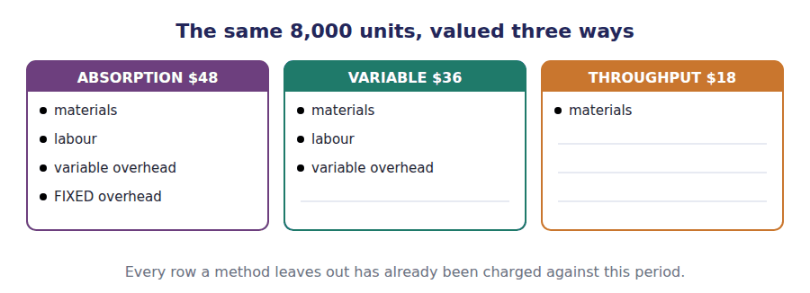
 | Units | × unit cost | = closing inventory
Absorption costing
Variable costing
Throughput costing

Watch out! The three inventory figures differ by $96,000 and $144,000. That money has not disappeared and it has not been earned. It is sitting in a different place on a different statement, and knowing where is the whole skill.
R2 A word about the two cost-of-goods lines, because candidates lose marks by treating them as one. Cost of goods manufactured is the cost of the units FINISHED in the period. Cost of goods sold is the cost of the units SOLD. They are equal only when nothing is added to or taken out of finished goods, which is exactly the case this set is about. In every other period they differ, and the difference is the movement in finished goods inventory.
Part 3 · Three shapes of income statement the margin lines
Exercise 2D Read and complete.
OBJECTIVE | Name the three margin lines and say which costs are above each one.
YOU WILL NEED | Exercise 2A · Exercise 2B
HOW TO START | • Each method has its own subtotal. Learn the subtotal and the format follows.  • The word behaviour in blank 2 is the structural difference, not a style choice.  • The last blank is a condition, not a cost.

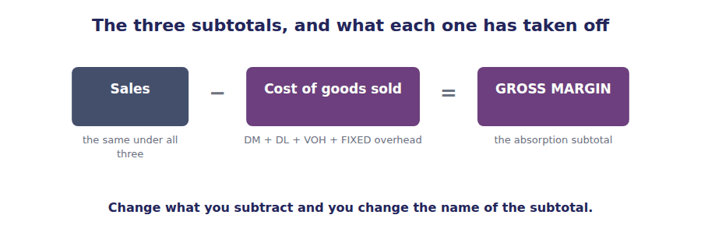
WORD BANK
behaviour · contribution · function · gross · labour · material · net · produced · sold · throughput
Not every word is used.

R2 Each method brings its own income statement format with it, and the exam expects you to produce the right shape without being told.
The absorption statement deducts cost of goods sold from sales to arrive at ⁷ margin, and then deducts all selling and administrative expenses.
The variable costing statement separates costs by ⁸ rather than by function. It deducts every variable cost, including variable selling cost, to arrive at ⁹ margin, and then deducts the fixed costs as a block.
The throughput statement deducts only direct ¹⁰ cost from sales, and treats everything else as an operating expense of the period.
The three statements report three different operating incomes whenever the units produced differ from the units ¹¹ , and exactly the same operating income when they are equal.
The three shapes, side by side
Absorption costing | Variable costing | Throughput costing
Sales | Sales | Sales
less Cost of goods sold  (DM + DL + VMOH + FMOH) | less Variable cost of goods sold  (DM + DL + VMOH) | less Direct materials in units sold
= GROSS MARGIN | less Variable selling and administrative | = THROUGHPUT CONTRIBUTION
less Selling and administrative  (variable and fixed) | = CONTRIBUTION MARGIN | less All other operating costs  (DL, VMOH, FMOH, S&A)
= OPERATING INCOME | less Fixed manufacturing overhead  less Fixed selling and administrative | = OPERATING INCOME
 | = OPERATING INCOME

Exercise 2E Match each subtotal with what it is actually useful for. Write the letter.
OBJECTIVE | Attach each subtotal to the decision it is actually able to answer.
YOU WILL NEED | Exercise 2D
HOW TO START | • Read the four uses first, before the four subtotals.  • Ask which costs each decision can ignore. That names the subtotal.  • Only one of the four is about reporting outside the company.

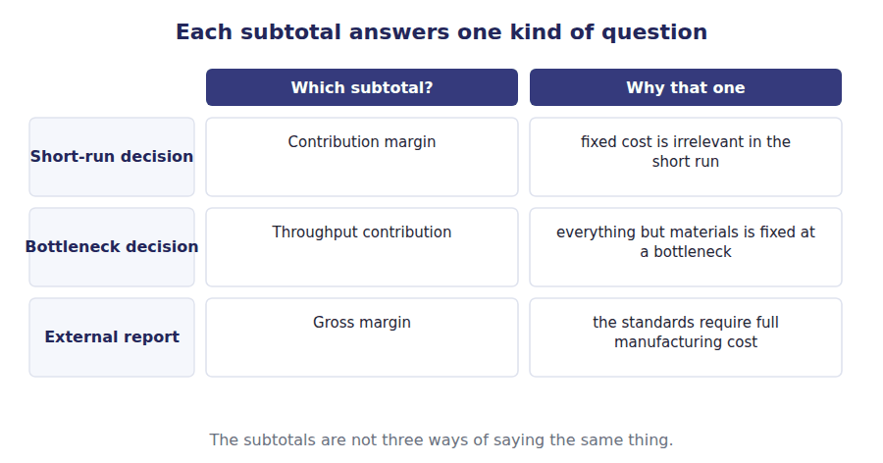
 | Item | Answer |  | Option
1 | Gross margin |  | A | Deciding whether one more unit is worth making when the bottleneck is the constraint.
2 | Contribution margin |  | B | Reporting to shareholders and to the tax authority.
3 | Throughput contribution |  | C | Short-run decisions: special orders, dropping a product, cost-volume-profit analysis.
4 | Operating income |  | D | Comparing the whole result of the period against the budget.

Part 4 · Which method, and who says so the rules behind the choice
Exercise 2F Read and complete.
OBJECTIVE | State which method the accounting standards require, and on what basis fixed overhead must be absorbed.
YOU WILL NEED | Exercise 2A
HOW TO START | • Two of the blanks are about permission and two are about the audience.  • The word in blank 2 is the one the standards actually use. It is not "actual".  • Nothing here says variable costing is improper. Read carefully.

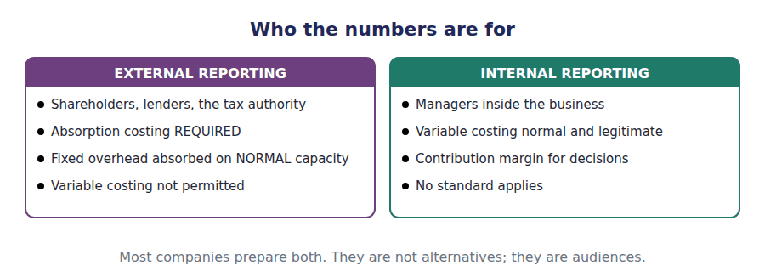
WORD BANK
actual · forbidden · internal reporting · legitimate · normal · optional · required · theoretical
Not every word is used.

R2 The choice between the methods is not free. For external reporting and for tax, absorption costing is ¹² , because the accounting standards treat fixed production overhead as part of the cost of bringing inventory to its present location and condition.
The standards add an important condition. Fixed overhead must be absorbed on the basis of ¹³ capacity rather than actual output, so that a month of unusually low production does not inflate the value of the units that were made.
Variable costing is not permitted for external reporting, but it is entirely ¹⁴ inside the business. Most companies that use absorption costing for external reporting also prepare variable costing figures for ¹⁵ .
Exercise 2G Tick the method each statement describes. One tick per row.
OBJECTIVE | Identify a method from a description of what it does, as the exam states it.
YOU WILL NEED | Everything in this handout
HOW TO START | • Rows 3 and 7 follow from the stack diagram: more cost in, higher inventory value.  • Row 6 is a vocabulary question, not an accounting one.  • Row 8 asks about tax, which follows the external reporting rule.

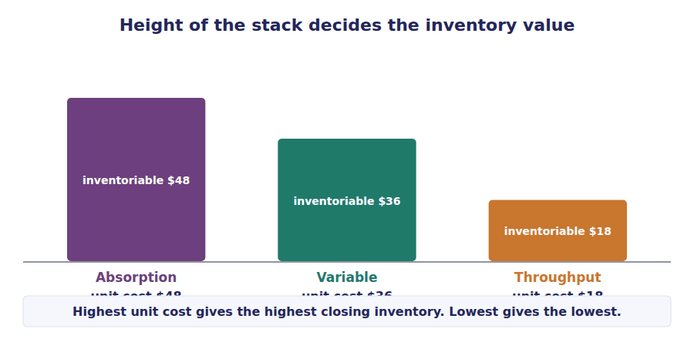
Statement | Absorption | Variable | Throughput
1. Required by GAAP and IFRS for published financial statements
2. Treats fixed factory overhead as a cost of the period
3. Produces the highest closing inventory value of the three
4. Produces a contribution margin figure
5. Treats direct labour as a period cost
6. Was once commonly called "direct costing"
7. Produces the lowest closing inventory value of the three
8. Is the basis on which the tax return is prepared

Exercise 2H The same fact, three registers. Read across.
OBJECTIVE | Recognise the three methods in exam English, including the old names.
YOU WILL NEED | The whole handout
HOW TO START | • Cover the right-hand column and predict the exam wording.  • Then find your own words inside the exam sentence.  • Pay attention to row 3: a question about permitted use is a different question from one about correct method.

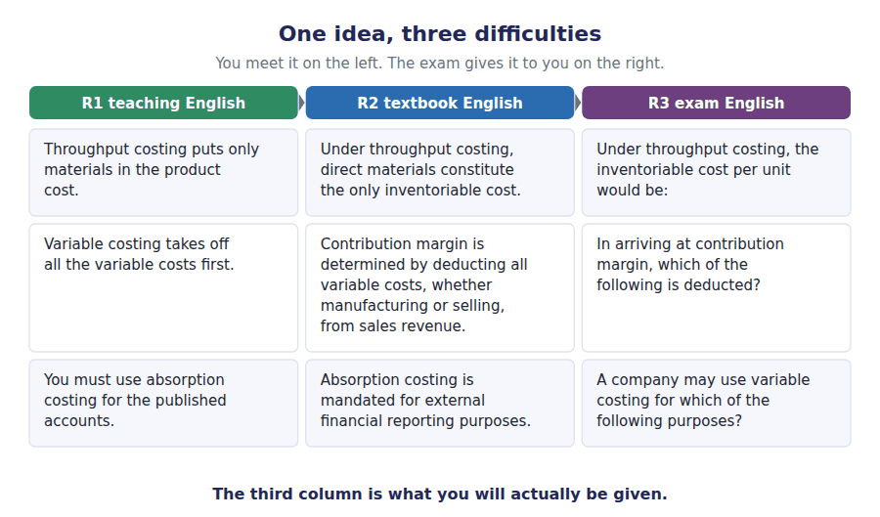
R1 Teaching | R2 Textbook | R3 Exam
Throughput costing puts only materials in the product cost. | Under throughput costing, direct materials constitute the only inventoriable cost. | Under throughput costing, the inventoriable cost per unit would be:
Variable costing takes off all the variable costs first. | Contribution margin is determined by deducting all variable costs, whether manufacturing or selling, from sales revenue. | In arriving at contribution margin, which of the following is deducted?
You must use absorption costing for the published accounts. | Absorption costing is mandated for external financial reporting purposes. | A company may use variable costing for which of the following purposes?

The exam says | Candidates assume | What is actually true
"the unit product cost" | there is one correct unit cost | There are three, and the question always says which method. Underline it.
"variable costing" | all variable costs go into inventory | Only variable MANUFACTURING cost. Variable selling cost is a period cost under every method.
"direct costing" | the product cost is made of direct costs | Direct costing is variable costing. Variable manufacturing overhead is indirect and is still included.
"gross margin" in a variable costing question | gross margin and contribution margin are interchangeable | A variable costing statement has no gross margin line at all.
"based on normal capacity" | the rate uses this period’s actual output | Normal capacity is a budgeted, multi-period figure. This matters enormously in Handout 5.

Part 5 · Exam practice Levels A and B
Which of the following would be included in inventory under variable costing but not under throughput costing?
What am I given? | What is asked? | Which word is the trap?

1. [Level A] Which of the following would be included in inventory under variable costing but NOT under throughput costing?
(A) Direct materials.
(B) Direct labour and variable manufacturing overhead.
(C) Fixed manufacturing overhead.
(D) Variable selling expenses.
2. [Level A] Grandview’s costs per unit are: direct materials $18, direct labour $12, variable manufacturing overhead $6, variable selling $4. Fixed manufacturing overhead is $600,000 and production is 50,000 units. The unit product cost under absorption costing is:
(A) $36.
(B) $40.
(C) $48.
(D) $52.
3. [Level B] Using the data above, the value of 8,000 units of closing inventory under throughput costing would be:
(A) $144,000.
(B) $288,000.
(C) $384,000.
(D) $416,000.
4. [Level B] Which of the following is NOT a valid reason for a company to prepare variable costing statements for internal use?
(A) Contribution margin is more useful for short-run decisions.
(B) Operating income is not affected by changes in inventory levels.
(C) It avoids the need to allocate fixed manufacturing overhead to units.
(D) It is required by accounting standards for segment disclosures.
5. [Level B] A company reports a gross margin of $1,764,000 and a contribution margin of $2,100,000 for the same period. Which of the following best explains the difference?
(A) An arithmetic error, since the two should be equal.
(B) Gross margin is after fixed manufacturing overhead in cost of goods sold, while contribution margin is before all fixed costs and after variable selling costs.
(C) Contribution margin includes fixed manufacturing overhead.
(D) Gross margin is calculated before cost of goods sold.
6. [Level B] Under IFRS and US GAAP, fixed production overhead must be allocated to units of production on the basis of:
(A) Actual production for the period.
(B) The normal capacity of the production facilities.
(C) Maximum theoretical capacity.
(D) Budgeted sales volume.
7. [Level A] In a period in which units produced exactly equal units sold and there is no opening inventory, operating income under absorption costing will be:
(A) Higher than under variable costing.
(B) Lower than under variable costing.
(C) Equal to operating income under variable costing.
(D) Equal to throughput contribution.
8. [Level B] Throughput costing is MOST useful to a manager who wants to:
(A) Value inventory for the annual financial statements.
(B) Evaluate whether to produce one more unit when a bottleneck limits output.
(C) Set a long-run selling price that recovers all costs.
(D) Report segment results to external users.

Handout 3 · The Two Statements
Build an absorption statement and a variable costing statement from one set of data, then prove the difference between them in a single line.
Set D1 · Absorption and Variable Costing · R2 Textbook English
LANGUAGE FOCUS
Register you are working in | R2. You are now reading the sentences a textbook would write. Notice the passive verbs: is deducted, is carried forward, is released.
Say it exactly like this | defer a cost into inventory · release a cost from inventory · carry forward to the next period · reconcile the two figures · account for the difference · exceed sales
Words that are not the same | defer / delay · release / sell · reconcile / agree
Remember | "Defer" does not mean the cost disappears. It means it waits in an asset account. "Reconcile" means explain the gap, not make the gap zero.

What you will be able to do when this handout is finished
- Prepare an absorption costing income statement in the correct format.
- Prepare a variable costing income statement in the correct format.
- Compute the difference between the two operating incomes without preparing either statement.
- State the direction of the difference from the relationship between production and sales.
- Explain, in one sentence, where the money that causes the difference is sitting.

Two statements, one month
It is the first month of production at Grandview’s new line. There was no opening inventory. The plant made 50,000 sensors and sold 42,000, so 8,000 units are still in the warehouse at the end of the month.
The auditor needs an absorption costing statement for the financial statements. The production manager has asked for a variable costing statement so that she can see the contribution each sensor makes.
Both statements are correct. They will report different operating incomes, and by the end of this handout you will be able to say exactly why, and by exactly how much, without preparing either one.

The data for this handout
Item | Amount
Selling price per unit | $90
Direct materials per unit | $18
Direct labour per unit | $12
Variable manufacturing overhead per unit | $6
Fixed manufacturing overhead for the month | $600,000
Variable selling and administrative, per unit sold | $4
Fixed selling and administrative for the month | $280,000
Units produced | 50,000
Units sold | 42,000
Opening inventory | none

Part 1 · The absorption costing statement gross margin format
Exercise 3A Complete the statement. Work down the page and do not skip the inventory section — it is where the whole topic lives.
OBJECTIVE | Prepare an absorption costing income statement in the format the exam marks.
YOU WILL NEED | Handout 2 Exercise 2B for the $48 unit cost · the data table above
HOW TO START | • Sales first: units SOLD times price. Never units produced.  • Then the inventory section: opening plus manufactured gives available; less closing gives cost of goods sold.  • Closing inventory is valued at $48, which carries $12 of fixed overhead per unit.

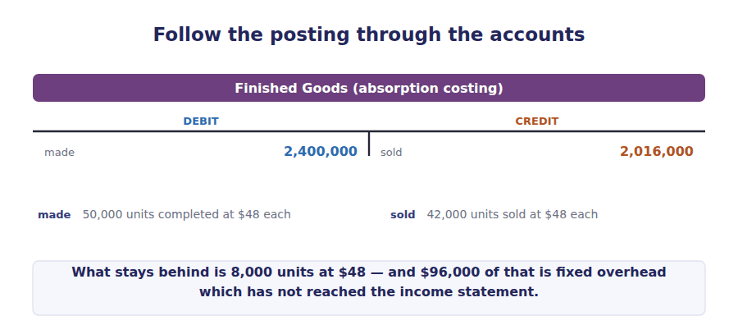
Grandview Instruments · absorption costing · income statement
Sales (42,000 units × $90)
Cost of goods sold
Opening inventory
Cost of goods manufactured (50,000 × $48)
Goods available for sale
less Closing inventory (8,000 × $48)
Cost of goods sold
GROSS MARGIN
Variable selling and administrative (42,000 × $4)
Fixed selling and administrative
Total selling and administrative
OPERATING INCOME

Watch out! Closing inventory is valued at the ABSORPTION unit cost of $48, which includes $12 of fixed overhead per unit. Write that $12 somewhere on this page and circle it. It is the number that makes the two statements differ.
Part 2 · The variable costing statement contribution margin format
Exercise 3B Complete the statement. The order of the lines is not a matter of taste — the exam marks the format.
OBJECTIVE | Prepare a variable costing income statement, with the lines in the order the exam expects.
YOU WILL NEED | Exercise 3A · Handout 2 Exercise 2D for the contribution margin format
HOW TO START | • Deduct EVERY variable cost before the subtotal, including variable selling cost.  • Then deduct the fixed costs as one block below the contribution margin.  • There is no gross margin line on this statement. If you have written one, the format is wrong.

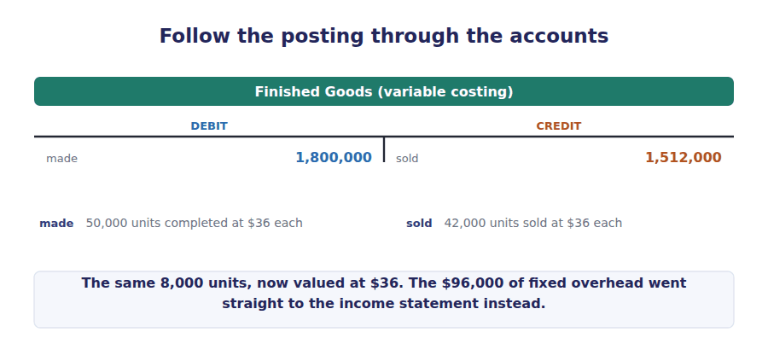
Grandview Instruments · variable costing · income statement
Sales (42,000 units × $90)
Variable costs
Variable cost of goods sold (42,000 × $36)
Variable selling and administrative (42,000 × $4)
Total variable costs
CONTRIBUTION MARGIN
Fixed manufacturing overhead
Fixed selling and administrative
Total fixed costs
OPERATING INCOME

Exercise 3C Read and complete.
OBJECTIVE | Explain in words why the two statements differ, and name the only cost responsible.
YOU WILL NEED | Exercise 3A · Exercise 3B
HOW TO START | • Compare your two statements line by line and mark every line that is the same.  • Only one item will be left. That is the answer to blank 2 and blank 3.

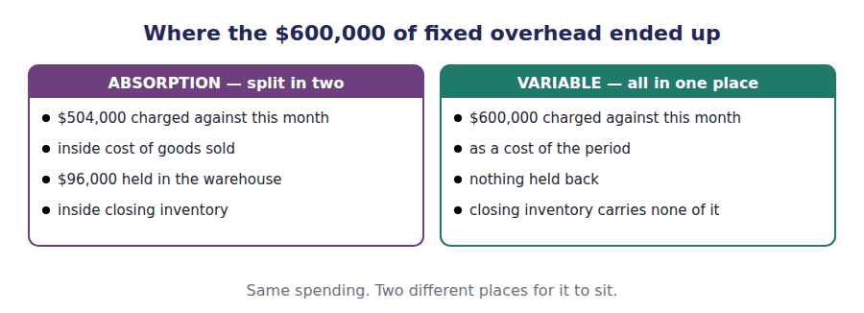
WORD BANK
current · differently · identically · next · partly · period · previous
Not every word is used.

R2 The two statements are built from the same transactions. The difference between them cannot be caused by sales, by variable costs or by selling expenses, all of which are treated ¹ .
The only item treated differently is fixed manufacturing overhead. Under variable costing the whole $600,000 is deducted in the month, because it is a cost of the ² .
Under absorption costing it is attached to the units produced at $12 each, so the 8,000 units still in the warehouse carry $96,000 of it into the ³ period. That amount is the entire difference between the two operating incomes.
R2 Two pieces of vocabulary before the bridge. A period in which production is greater than sales is an inventory build, and the fixed overhead attached to the extra units becomes a deferred cost: real money, spent this month, sitting on the balance sheet. A period in which sales are greater than production is an inventory drawdown, and the overhead that was deferred earlier becomes a released cost, arriving on the income statement of a month that did not spend it. Every deferred cost is eventually a released cost. Nothing is lost on the way.
Part 3 · The bridge proving the difference in one line
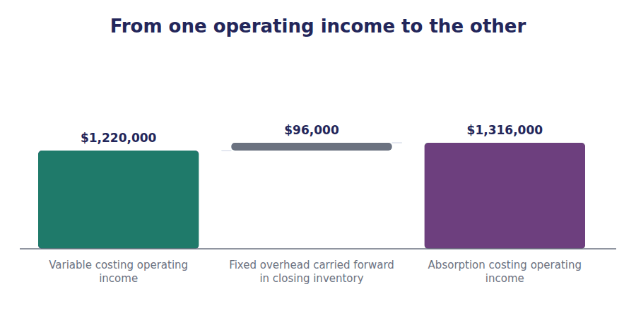
Exercise 3D Complete the reconciliation. This is the calculation the exam actually wants; the two full statements are the long way round.
OBJECTIVE | Produce the difference between the two incomes in one line, without preparing either statement.
YOU WILL NEED | Exercise 3C · the bridge diagram above
HOW TO START | • Start from the variable costing income, because it never moves with inventory.  • Add the fixed overhead in CLOSING inventory, then take off the fixed overhead in OPENING inventory.  • Here opening inventory is nil, so only one line does any work.

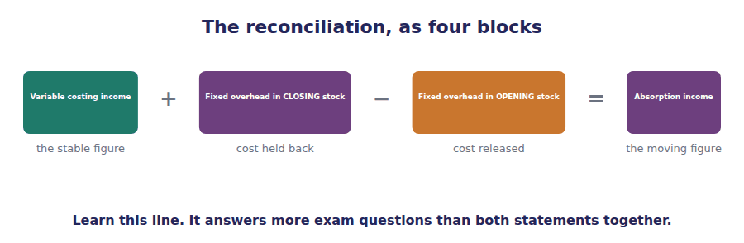
Reconciliation | Units | Rate | Amount
Variable costing operating income
add Fixed overhead in closing inventory
less Fixed overhead in opening inventory
Absorption costing operating income

Exercise 3E Read and complete. Learn this paragraph.
OBJECTIVE | State the direction rule for all three relationships between production and sales, and the cumulative result.
YOU WILL NEED | Exercise 3D
HOW TO START | • The first blank is about the CHANGE in inventory, not its level.  • Blanks 3 and 4 are opposites. Work out one and the other follows.  • The final blank is about timing, and it is the sentence to memorise.

WORD BANK
change · closing balance · deferred · equal · expensed · falls · higher · level · lower · rises · same
Not every word is used.

R2 The difference between the two operating incomes equals the fixed manufacturing overhead rate multiplied by the ⁴ in inventory in units.
When production exceeds sales, inventory ⁵ , fixed overhead is carried forward, and absorption income is ⁶ .
When sales exceed production, inventory falls, fixed overhead deferred in an earlier period is released into cost of goods sold, and absorption income is ⁷ . When production equals sales, no fixed overhead moves and the two incomes are the ⁸ .
Over the life of the business, or over any run of periods that begins and ends with the same inventory, the two methods report exactly the same total income, because every cost is eventually ⁹ .
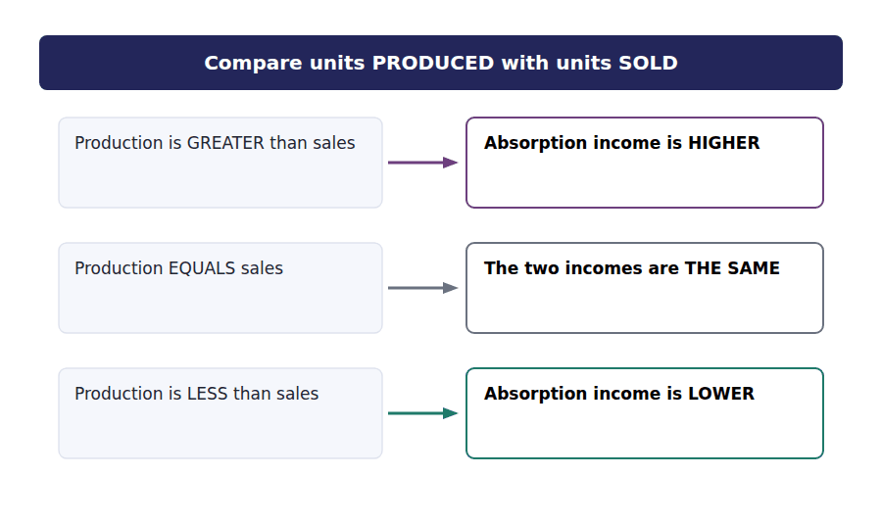
Exercise 3F Three independent cases, each with a fixed overhead rate of $10 per unit. Complete the table.
OBJECTIVE | Apply the direction rule to three independent cases at speed.
YOU WILL NEED | Exercise 3E · the fork diagram above
HOW TO START | • Compute the change in units first for all three cases, before any money.  • Multiply by $10 and the amount is done.  • The sign tells you which method is higher. Write the method name, not a tick.

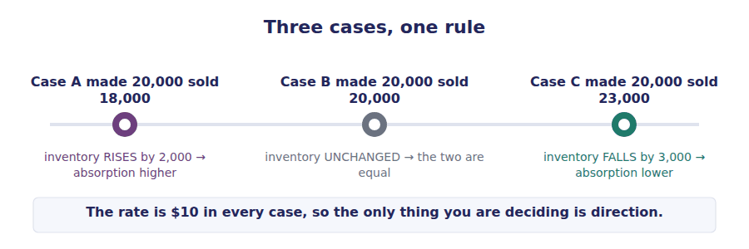
Case | Produced | Sold | Change in units | Difference in operating income | Which is higher?
A | 20,000 | 18,000
B | 20,000 | 20,000
C | 20,000 | 23,000

The exam says | Candidates assume | What is actually true
"units produced exceeded units sold" | variable costing income is higher because it has fewer costs in inventory | ABSORPTION is higher. Cost has been moved OUT of its income statement and into the warehouse.
"there was no change in inventory" | you still need to do the reconciliation | The difference is zero. Answer immediately and move on.
a question giving closing inventory but not opening | the difference is the rate × closing inventory | Only if opening inventory was zero. The formula uses the CHANGE.
"the fixed overhead was $600,000" | that figure appears on both statements | It appears in full on the variable statement. On the absorption statement only the part attached to units SOLD reaches the income statement.
"over the three years combined" | absorption costing reports more profit in total | If opening and closing inventory are the same, total income is identical. Only the pattern differs.

Exercise 3G The same fact, three registers.
OBJECTIVE | Recognise the direction rule and the reconciliation formula in exam English.
YOU WILL NEED | Exercise 3E · Exercise 3D
HOW TO START | • Cover the right-hand column and predict the exam wording.  • Row 3 uses "cumulative", which is the word that signals the three-year question.

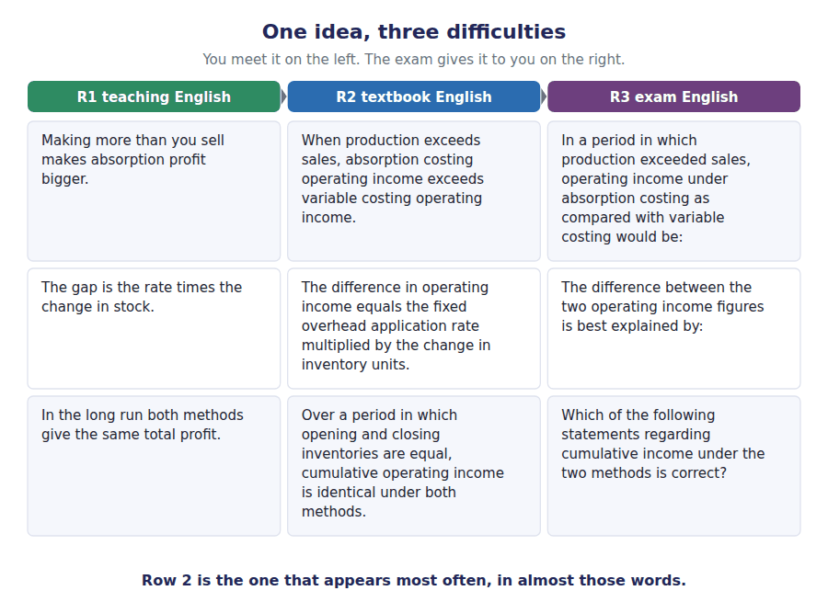
R1 Teaching | R2 Textbook | R3 Exam
Making more than you sell makes absorption profit bigger. | When production exceeds sales, absorption costing operating income exceeds variable costing operating income. | In a period in which production exceeded sales, operating income under absorption costing as compared with variable costing would be:
The gap is the fixed overhead rate times the change in stock. | The difference in operating income is equal to the fixed overhead application rate multiplied by the change in inventory units. | The difference between the two operating income figures is best explained by:
In the long run both methods give the same total profit. | Over a period in which opening and closing inventories are equal, cumulative operating income is identical under both methods. | Which of the following statements regarding cumulative income under the two methods is correct?

Part 4 · Exam practice Levels B and C
A company had operating income of $1,220,000 under variable costing. Production exceeded sales by 8,000 units and the fixed overhead rate was $12 per unit. Operating income under absorption costing was:
What am I given? | What is asked? | Which word is the trap?

1. [Level B] A company had operating income of $1,220,000 under variable costing. Production exceeded sales by 8,000 units and the fixed manufacturing overhead rate was $12 per unit. Operating income under absorption costing was:
(A) $1,124,000.
(B) $1,220,000.
(C) $1,316,000.
(D) $1,412,000.
2. [Level B] Grandview sold 42,000 units at $90. Variable manufacturing cost was $36 per unit, variable selling cost $4 per unit, fixed manufacturing overhead $600,000 and fixed selling and administrative $280,000. Contribution margin was:
(A) $2,268,000
(B) $2,100,000
(C) $1,764,000
(D) $1,500,000
3. [Level A] Which of the following would cause absorption costing operating income to be LOWER than variable costing operating income for a period?
(A) Units produced exceeded units sold.
(B) Units sold exceeded units produced.
(C) Fixed manufacturing overhead increased.
(D) The selling price was reduced.
4. [Level B] A company began the year with 4,000 units in inventory and ended with 9,000 units. The fixed manufacturing overhead rate was $15 per unit. Absorption costing operating income will exceed variable costing operating income by:
(A) $60,000.
(B) $75,000.
(C) $135,000.
(D) $195,000.
5. [Level C] Over three years a company produced 150,000 units and sold 150,000 units, with 10,000 units in inventory at both the beginning and the end of the three years. Cumulative operating income over the three years under absorption costing, compared with variable costing, would be:
(A) Higher, because fixed overhead was inventoried.
(B) Lower, because fixed overhead was released.
(C) The same.
(D) Impossible to determine without the overhead rate.
6. [Level C] A company using absorption costing reported operating income of $940,000. Opening inventory contained $40,000 of fixed manufacturing overhead and closing inventory contained $115,000. Variable costing operating income was:
(A) $865,000.
(B) $900,000.
(C) $980,000.
(D) $1,015,000.
7. [Level B] Which statement about the relationship between the two methods is correct?
(A) Absorption costing always reports higher operating income.
(B) The difference between the two incomes depends on the change in inventory, not on its level.
(C) Variable costing reports higher income whenever fixed overhead is large.
(D) The two methods report the same income whenever sales are constant.
8. [Level B] A manufacturer had no opening inventory, produced 25,000 units and sold 21,000. Fixed manufacturing overhead was $300,000 and fixed selling costs were $90,000. The amount of fixed cost carried in closing inventory under absorption costing was:
(A) $0.
(B) $48,000.
(C) $62,400.
(D) $78,000.

Handout 4 · Deferral and Release Over Time
Sales are flat for three years and reported profit moves anyway. Follow the fixed overhead into the warehouse and back out again.
Set D1 · Absorption and Variable Costing · R2, with R3 practice
LANGUAGE FOCUS
Register you are working in | R2 Textbook English, and the exam questions are now full R3. Watch the conditional verbs: "would be", "would have been".
Say it exactly like this | build up inventory · draw down inventory · carry forward into the next period · over the three years taken together · in aggregate · reverse in a later period
Words that are not the same | build / production · drawdown / sale · cumulative / total
Remember | "Cumulative" means added across the periods, not the biggest one. "Would have been" signals a situation that did not happen. Read it twice.

What you will be able to do when this handout is finished
- Track inventory in units across several periods and compute the change each time.
- Compute the difference in operating income for each period and prove it two ways.
- Explain why absorption income can fall while sales are unchanged.
- Show that cumulative income is the same under both methods once inventory returns to its starting level.
- Recognise the production volume variance as the same fixed overhead seen from the other side.

Three years, one selling price, one problem
Grandview has now been running the sensor line for three years. The selling price has not changed, the cost structure has not changed, and the company has sold exactly 40,000 units in every one of the three years.
Production has not been so steady. In Year 1 the plant ran hard and made 50,000 units. In Year 2 it made exactly what it sold. In Year 3 a long maintenance shutdown cut output to 30,000 units and the warehouse was emptied to meet demand.
The board has the absorption costing results in front of it. Profit rose in Year 1, fell in Year 2 and fell again in Year 3 — on completely flat sales. The chairman wants to know who is responsible. By the end of this handout you will be able to tell him that nobody is, and show him why in four lines.

The data for this handout
Item | Amount
Selling price per unit | $90
Variable manufacturing cost per unit | $36
Variable selling cost per unit sold | $4
Budgeted fixed manufacturing overhead each year | $600,000
Denominator volume (normal capacity) | 40,000 units
Standard fixed overhead rate | $15 per unit
Standard absorption cost per unit | $51
Fixed selling and administrative each year | $280,000
Opening inventory at the start of Year 1 | none

Watch out! The fixed overhead rate is $15 for all three years, because it is set from the DENOMINATOR volume of 40,000 units, not from what the plant actually made. Actual production changes; the rate does not.
Part 1 · Follow the units inventory in units
Exercise 4A Complete the inventory record. Closing inventory in one year is opening inventory in the next — fill the table across, not down.
OBJECTIVE | Track inventory in units across three years, where each year opens where the last one closed.
YOU WILL NEED | Handout 3 Exercise 3E for the direction rule
HOW TO START | • Fill the table ACROSS, not down. Year 2 opens with whatever Year 1 closed with.  • Opening plus produced less sold gives closing. Four rows, one subtraction.  • The last row, the change, is what every later calculation uses.

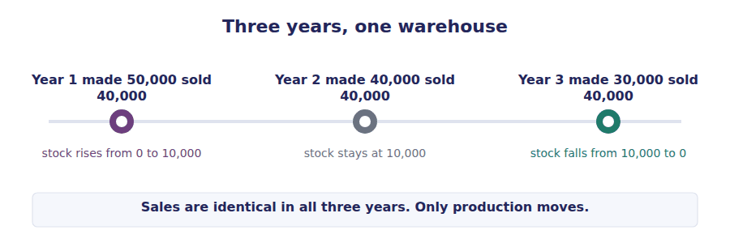
 | Year 1 | Year 2 | Year 3
Opening inventory (units)
add Units produced
less Units sold
Closing inventory (units)
CHANGE in inventory (units)

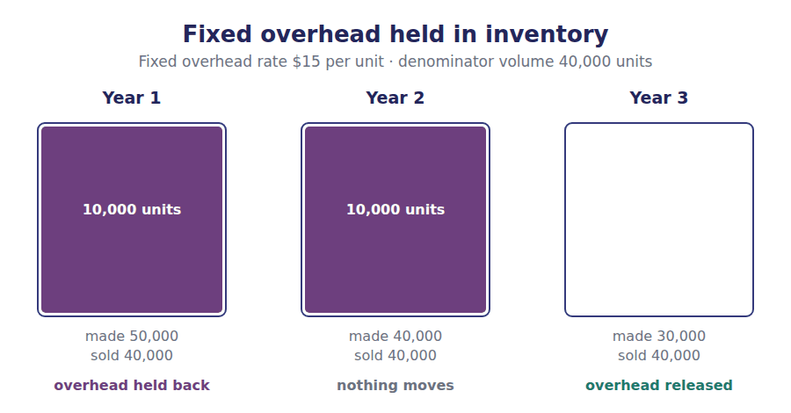
Part 2 · Follow the money the difference, year by year
Exercise 4B Complete the reconciliation for each year. Use the change in units from Exercise 4A and the rate of $15.
OBJECTIVE | Compute the difference between the two incomes for each year and for the three years together.
YOU WILL NEED | Exercise 4A for the change in units · the $15 standard rate
HOW TO START | • Use the reconciliation from Handout 3: start at variable costing income.  • Only one of the middle two rows has a figure in any given year.  • Add the three years across. The total of the middle rows should be nil.

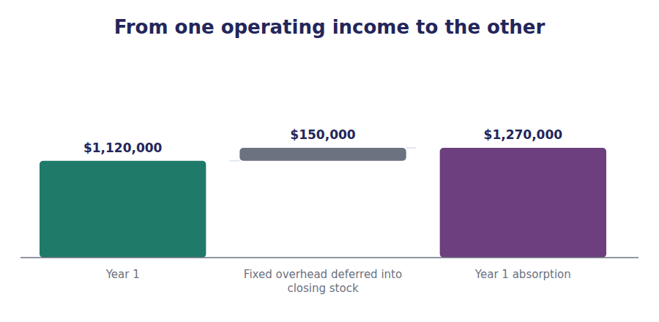
 | Year 1 | Year 2 | Year 3 | Three years
Variable costing operating income
Fixed overhead deferred into closing inventory
Fixed overhead released from opening inventory
Net effect on income
Absorption costing operating income

Exercise 4C Read and complete.
OBJECTIVE | Say in words what happened to the fixed overhead in each of the three years.
YOU WILL NEED | Exercise 4B
HOW TO START | • Blank 1 and blank 3 are opposites and describe the two directions.  • Blank 5 is about the three years taken together, so the answer is about netting off.

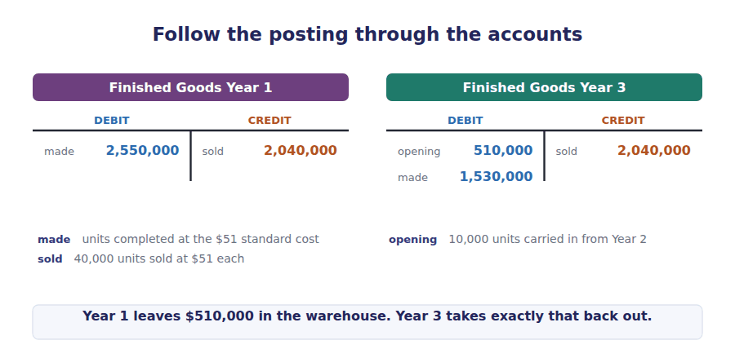
WORD BANK
above · accumulate · avoided · below · cancel · deferred · different · identical · released · written off
Not every word is used.

R2 In Year 1 the plant produced 10,000 units more than it sold. $150,000 of fixed overhead was ¹ into closing inventory, and absorption income exceeded variable costing income by that amount.
In Year 2 production and sales were equal, inventory did not move, and the two incomes were ² .
In Year 3 the plant produced 10,000 units fewer than it sold. The overhead deferred in Year 1 was ³ into cost of goods sold, and absorption income fell ⁴ variable costing income by the same $150,000.
Across the three years taken together, inventory began at zero and ended at zero. The amounts deferred and released ⁵ , and both methods report cumulative income of $3,360,000.
Exercise 4D Complete the summary. This is the table the chairman needs.
OBJECTIVE | Produce the summary table the board actually needs, showing flat sales against moving profit.
YOU WILL NEED | Exercise 4B
HOW TO START | • Copy the two income rows from Exercise 4B.  • Then look at the first two rows and the last two together.  • The point of the table is the contrast between a flat row and a moving one.

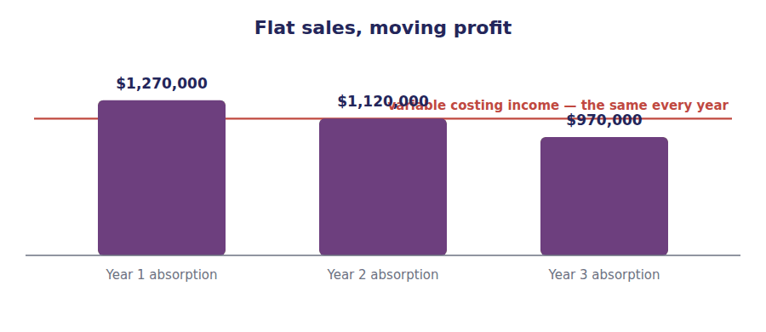
 | Year 1 | Year 2 | Year 3 | Total
Units sold | 40,000 | 40,000 | 40,000 | 120,000
Units produced | 50,000 | 40,000 | 30,000 | 120,000
Variable costing operating income
Absorption costing operating income

Part 3 · The same money, seen from Section C the production volume variance
Exercise 4E Read and complete.
OBJECTIVE | Recognise the production volume variance as the same fixed overhead seen from the performance management side.
YOU WILL NEED | Exercise 4B · the denominator volume of 40,000 units
HOW TO START | • The variance compares production with the DENOMINATOR, never with sales.  • Blank 4 and blank 5 are the two directions. Work out one and the other follows.  • Then compare your two variance figures with the two deferral figures in 4B.

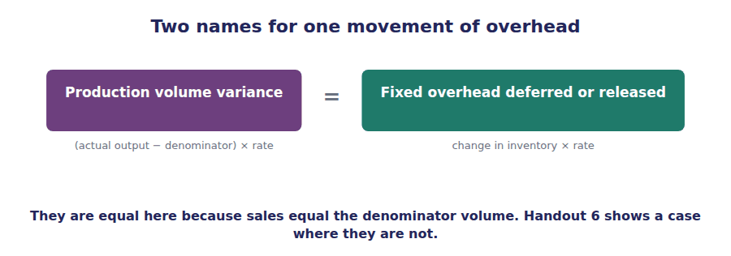
WORD BANK
budget · denominator · favourable · less · more · nil · sales · spending · unfavourable · variance
Not every word is used.

R2 There is a second way to look at exactly the same fixed overhead. The exam tests it in the performance management section rather than in cost management.
Because fixed overhead is applied to units at a standard rate, a plant that produces more than the denominator volume applies ⁶ overhead than was budgeted, and a plant that produces less applies less.
The difference is the production volume ⁷ . It equals the standard rate multiplied by the difference between actual production and the ⁸ volume.
In Year 1 Grandview produced 50,000 units against a denominator of 40,000, so the volume variance was $150,000 ⁹ . In Year 3 it produced 30,000 units and the variance was $150,000 ¹⁰ .
These are the same amounts as the deferral and the release. They are not two separate effects. They are one movement of fixed overhead described in two vocabularies.
R2 An unfavourable volume variance has a plain-language meaning worth holding on to: it is the accounting trace of idle capacity. Grandview paid for the ability to make 40,000 units in Year 3 and used only 30,000 of it, and the $150,000 unfavourable variance is the cost of the capacity that stood still. The favourable variance in Year 1 is the mirror image, and its reversal is the Year 3 release. A deferral in one year and its reversal in a later one are the same money, counted once.
Watch out! A favourable production volume variance is produced by making more units, not by making them more cheaply. In Year 1 Grandview’s $150,000 favourable variance came entirely from building 10,000 units of stock that nobody had ordered. Handout 6 is about what happens when a manager notices this.
Exercise 4F Complete. The two routes must give the same answer — that is the check.
OBJECTIVE | Build absorption income the long way and prove it agrees with the reconciliation.
YOU WILL NEED | Exercise 4B · Exercise 4E
HOW TO START | • Standard gross margin is units SOLD times the $39 margin per unit. It is the same in all three years.  • Add a favourable variance; subtract an unfavourable one.  • Your answer must match Exercise 4B exactly. If it does not, check the sign.

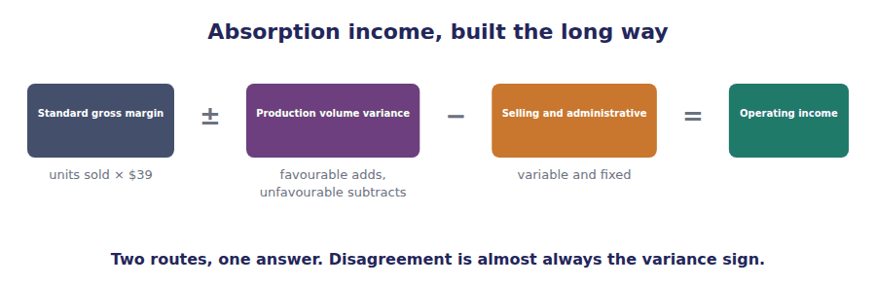
Absorption income, built the long way | Year 1 | Year 2 | Year 3
Standard gross margin (units sold × $39)
add/less Production volume variance
less Selling and administrative
Absorption costing operating income

The exam says | Candidates assume | What is actually true
"sales were constant over the three years" | profit must have been constant too | Under absorption costing, profit follows PRODUCTION as well as sales. That is the whole lesson of this handout.
"the production volume variance was favourable" | the factory performed well | It only means output exceeded the denominator volume. It is often caused by overproduction.
"the fixed overhead rate" | recompute it each year from actual output | The standard rate is set once from the denominator volume. It does not move with actual production.
"over the three-year period" | add up the absorption figures and compare the totals | If inventory starts and ends at the same level, the totals are equal. Answer in one line.
a year with no change in inventory | there is still a volume variance of zero | Not necessarily. Year 2 produced 40,000 against a denominator of 40,000, so the variance is zero here — but a year can have no inventory change and still have a volume variance if production differs from the denominator and sales match production.

Exercise 4G The same fact, three registers.
OBJECTIVE | Recognise the multi-period pattern and the volume variance in exam English.
YOU WILL NEED | Exercise 4C · Exercise 4E
HOW TO START | • Cover the right-hand column and predict the exam wording.  • Row 3 is about what CAUSES a favourable variance, which is a different question from what it means.

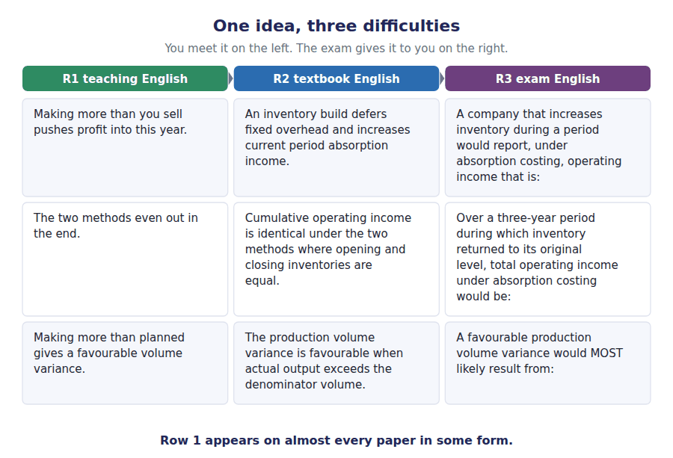
R1 Teaching | R2 Textbook | R3 Exam
Making more than you sell pushes profit into this year. | An inventory build defers fixed overhead and increases current period absorption income. | A company that increases inventory during a period would report, under absorption costing, operating income that is:
The two methods even out in the end. | Cumulative operating income is identical under the two methods where opening and closing inventories are equal. | Over a three-year period during which inventory returned to its original level, total operating income under absorption costing would be:
Making more than planned gives a favourable volume variance. | The production volume variance is favourable when actual output exceeds the denominator volume. | A favourable production volume variance would MOST likely result from:

Part 4 · Exam practice Levels B and C
Sales were unchanged in each of three years. Absorption costing operating income was highest in Year 1 and lowest in Year 3. Which of the following would best explain this pattern?
What am I given? | What is asked? | Which word is the trap?

1. [Level B] Sales were unchanged in each of three years. Absorption costing operating income was highest in Year 1 and lowest in Year 3. Which of the following would best explain this pattern?
(A) Selling prices fell over the period.
(B) Production exceeded sales in Year 1 and was below sales in Year 3.
(C) Fixed manufacturing overhead rose each year.
(D) Variable costs per unit rose each year.
2. [Level B] A plant has a denominator volume of 40,000 units and budgeted fixed overhead of $600,000. It produced 30,000 units and sold 40,000. The production volume variance was:
(A) $150,000 favourable.
(B) $150,000 unfavourable.
(C) $600,000 unfavourable.
(D) Zero, because production equalled the budget.
3. [Level B] Using the data above, the effect of the year’s inventory movement on absorption costing operating income, compared with variable costing, was that absorption income was:
(A) $150,000 higher.
(B) $150,000 lower.
(C) The same.
(D) $600,000 lower.
4. [Level C] A company produced 50,000 units and sold 40,000 in its first year of operations. In its second year it produced 40,000 and sold 50,000. Assuming a constant fixed overhead rate, which of the following is true of the two years taken together?
(A) Absorption costing cumulative income exceeds variable costing cumulative income.
(B) Variable costing cumulative income exceeds absorption costing cumulative income.
(C) Cumulative income is the same under both methods.
(D) Cumulative income cannot be compared without the fixed overhead rate.
5. [Level A] In which of the following situations will absorption costing operating income EQUAL variable costing operating income?
(A) When there is no opening inventory.
(B) When there is no closing inventory.
(C) When units produced equal units sold.
(D) When fixed manufacturing overhead is zero only.
6. [Level B] A manufacturer uses standard absorption costing. During the period it produced 45,000 units against a denominator volume of 36,000 units, with a standard fixed overhead rate of $15 per unit. Fixed overhead applied to production was:
(A) $540,000.
(B) $675,000.
(C) $135,000.
(D) $1,215,000.
7. [Level B] The production volume variance arises because:
(A) Actual fixed overhead differed from budgeted fixed overhead.
(B) Actual production differed from the denominator volume used to set the rate.
(C) Actual sales differed from budgeted sales.
(D) Actual hours differed from standard hours allowed.
8. [Level B] A company reported absorption costing operating income of $970,000 and variable costing operating income of $1,120,000 for the same year. It is MOST likely that during the year the company:
(A) Increased its inventory.
(B) Decreased its inventory.
(C) Held inventory constant.
(D) Sold below cost.
9. [Level C] Which of the following would a manager evaluated on absorption costing operating income have an incentive to do at the end of a weak quarter?
(A) Reduce production below sales.
(B) Increase production above sales.
(C) Reduce the selling price.
(D) Reclassify fixed selling costs as manufacturing costs.
10. [Level A] Over the life of a company, total operating income under absorption costing compared with variable costing will be:
(A) Higher.
(B) Lower.
(C) The same.
(D) Dependent on the pattern of production.

Handout 5 · The Ledger
The same month posted twice. Eleven entries under absorption costing, and the three that change under variable costing.
Set D1 · Absorption and Variable Costing · R2 and R3
LANGUAGE FOCUS
Register you are working in | R2 and R3 together. Journal narratives use a compressed register of their own: "to record", "to close", "being the amount applied".
Say it exactly like this | debit an account · credit an account · post an entry · apply overhead to production · close an account · overhead is over-applied · overhead is under-applied · charge to cost of goods sold
Words that are not the same | charge (verb) / charge (noun) · apply / allocate / absorb · control account / applied account
Remember | To "charge" an account means to DEBIT it. A "charge" is also a fee. Context decides. Overhead is applied TO production and absorbed BY units. Both are correct; "allocated" belongs to service departments.

What you will be able to do when this handout is finished
- Post a complete manufacturing cycle under absorption costing.
- Identify the three entries that change under variable costing, and the one that disappears.
- Compute applied overhead, actual overhead and the amount over- or under-applied.
- Dispose of an over- or under-applied balance and say when proration is required.
- Prove the difference between the two operating incomes from the ledger alone.

Year 1, posted in full
This handout takes Year 1 from Handout 4 — 50,000 units produced, 40,000 sold — and puts it through the accounts. Nothing about the facts changes. Only the bookkeeping does.
Work through the absorption entries first, in order. Then do the variable costing version, which is shorter, and find the one entry that simply does not exist.
At the end you will prove the $150,000 difference in operating income from the ledger, without using the reconciliation formula at all. That is the proof the examiner is really testing when a question mixes costing method with journal entries.

The figures you need
Item | Amount
Units produced | 50,000
Units sold | 40,000
Direct materials, $18 per unit | $900,000
Direct labour, $12 per unit | $600,000
Variable overhead, $6 per unit | $300,000
Fixed manufacturing overhead actually incurred | $600,000
Budgeted fixed manufacturing overhead | $600,000
Denominator volume | 40,000 units
Standard fixed overhead rate | $15 per unit
Standard absorption cost per unit | $51
Standard variable cost per unit | $36
Selling price | $90 per unit

R2 One distinction before you post anything. Under normal costing, direct materials and direct labour go into the accounts at what they actually cost, and only overhead is applied at a predetermined rate. Under standard costing, materials and labour are recorded at standard cost as well, and a variance is recognised wherever the actual amount differs. The entries below use standard costing, which is what the exam assumes whenever it gives you a standard cost per unit and a denominator volume.
Part 1 · Absorption costing, posted in full eleven entries
Exercise 5A Complete every entry. Put each amount in the debit or the credit column — the account name tells you which. Entry J11 has three lines and is the one to think hardest about.
OBJECTIVE | Post a full manufacturing month under absorption costing, including the entry that closes the overhead accounts.
YOU WILL NEED | The figures table above · Handout 4 for the $15 rate and the denominator volume
HOW TO START | • Work in order. Every entry has a debit line first and a credit line indented under it.  • J7 is the entry that only absorption costing makes. Mark it.  • J11 has three lines because two accounts are being closed against each other and the difference has to go somewhere.

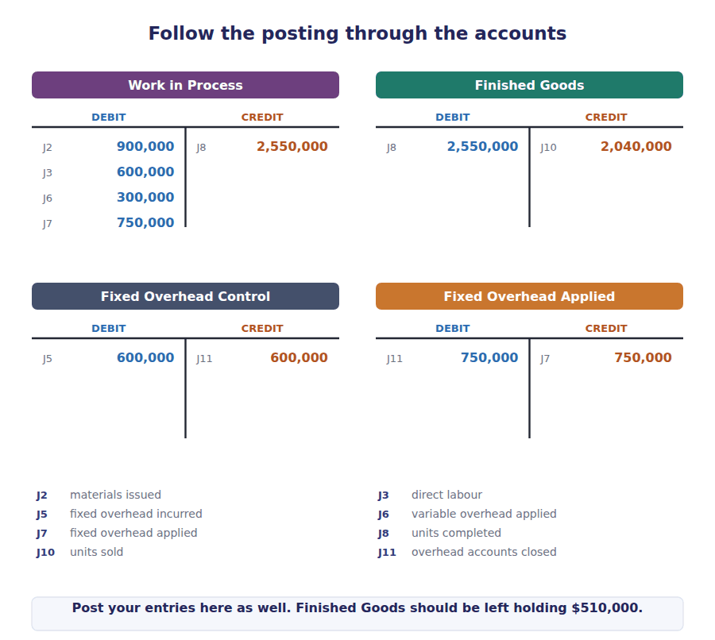
J1 Materials bought on credit.
Account | Debit | Credit
Raw Materials Inventory
Accounts Payable
J2 Materials issued to the production line.
Account | Debit | Credit
Work in Process Inventory
Raw Materials Inventory
J3 Direct labour for the period.
Account | Debit | Credit
Work in Process Inventory
Wages Payable
J4 Variable factory overhead actually incurred.
Account | Debit | Credit
Variable Manufacturing Overhead Control
Accounts Payable / Cash
J5 Fixed factory overhead actually incurred.
Account | Debit | Credit
Fixed Manufacturing Overhead Control
Accumulated Depreciation / Cash / Payables
J6 Variable overhead applied to production, 50,000 units × $6.
Account | Debit | Credit
Work in Process Inventory
Variable Manufacturing Overhead Applied
J7 Fixed overhead applied to production, 50,000 units × $15. This entry exists only under absorption costing.
Account | Debit | Credit
Work in Process Inventory
Fixed Manufacturing Overhead Applied
J8 50,000 units completed and transferred, at $51 each.
Account | Debit | Credit
Finished Goods Inventory
Work in Process Inventory
J9 40,000 units sold on credit.
Account | Debit | Credit
Accounts Receivable
Sales Revenue
J10 Cost of the 40,000 units sold, at $51 each.
Account | Debit | Credit
Cost of Goods Sold
Finished Goods Inventory
J11 Fixed overhead accounts closed. Applied $750,000 exceeds actual $600,000, so overhead was over-applied by $150,000 — the favourable production volume variance.
Account | Debit | Credit
Fixed Manufacturing Overhead Applied
Fixed Manufacturing Overhead Control
Cost of Goods Sold

Exercise 5B Read and complete.
OBJECTIVE | Separate the control account from the applied account, and dispose of the difference between them.
YOU WILL NEED | Exercise 5A, entries J5, J7 and J11
HOW TO START | • Two accounts, two different numbers. One holds what was spent, one holds what was charged to production.  • Applied is the standard rate times units PRODUCED, never units sold.  • The difference between them has a name and a destination. Both are blanks.

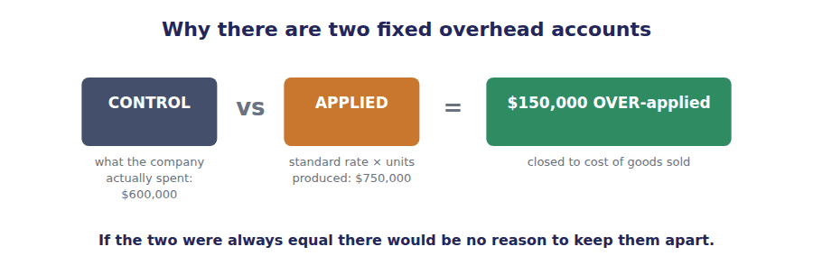
WORD BANK
Applied · Control · Expense · Inventory · over-applied · Payable · produced · Sold · under-applied
Not every word is used.

R2 Two separate things happen to fixed overhead in this ledger, and keeping them apart is what the entries are for.
The actual cost incurred is debited to the Fixed Manufacturing Overhead ¹ account, which records what the company really spent.
A quite different amount is credited to the Fixed Manufacturing Overhead ² account, calculated as the standard rate of $15 multiplied by the 50,000 units actually ³ .
In Year 1 the applied amount of $750,000 exceeded the actual amount of $600,000, so overhead was ⁴ by $150,000.
When the two accounts are closed against each other, that balance is credited to Cost of Goods ⁵ . It reduces the expense and increases reported income by exactly the amount of the favourable production volume variance.
Part 2 · The same month under variable costing three entries change
Exercise 5C Only three entries differ. Complete them, then write in the box below which absorption entry has no variable costing equivalent at all.
OBJECTIVE | Post the same month under variable costing and find the entry that disappears altogether.
YOU WILL NEED | Exercise 5A
HOW TO START | • Only three entries change. J1 to J6 are identical under both methods.  • The transfer to finished goods falls because the unit cost falls from $51 to $36.  • Write the missing entry number on the ruled lines underneath.

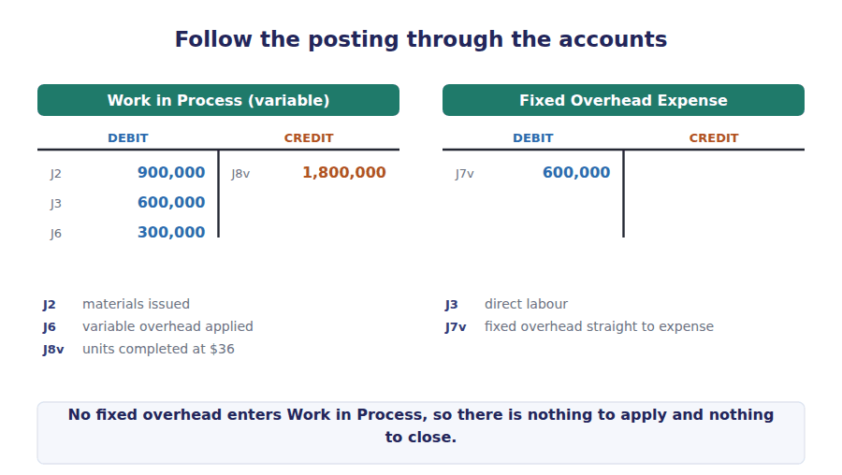
J7v Fixed factory overhead taken straight to expense. Under variable costing there is no application entry at all.
Account | Debit | Credit
Fixed Manufacturing Overhead Expense
Fixed Manufacturing Overhead Control
J8v 50,000 units completed and transferred, at $36 each.
Account | Debit | Credit
Finished Goods Inventory
Work in Process Inventory
J10v Cost of the 40,000 units sold, at $36 each.
Account | Debit | Credit
Cost of Goods Sold
Finished Goods Inventory

Exercise 5D Read and complete.
OBJECTIVE | State what variable costing does NOT have: no application, no balance, no volume variance.
YOU WILL NEED | Exercise 5C
HOW TO START | • Blank 1 is an account name in two words.  • Blank 2 is the thing that cannot exist if nothing is applied.  • Blank 3 is about which entries stay the same, and the answer is most of them.

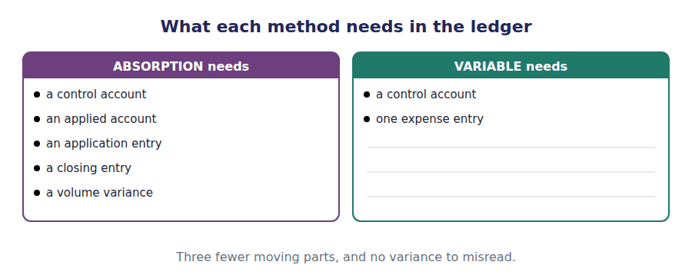
WORD BANK
applied · Finished Goods · identical · Process · produced · spending · unchanged · variance
Not every word is used.

R2 Under variable costing, fixed factory overhead never enters Work in ⁶ . It never reaches Finished Goods and never sits in inventory.
There is therefore no application entry and no over- or under-applied balance for fixed overhead, which also means there is no production volume ⁷ to report. The whole $600,000 is charged to the period in a single entry.
Entries J1 to J6 are ⁸ , because they deal with materials, labour and variable overhead, which both methods treat the same way.
The transfer to finished goods falls from $2,550,000 to $1,800,000, a difference of exactly the fixed overhead applied to the 50,000 units ⁹ .
Part 3 · Proving the difference from the ledger the Section D payoff
Exercise 5E Add up what each method actually charged against this year’s income, and compare.
OBJECTIVE | Prove the difference between the two incomes from the ledger alone, without the reconciliation formula.
YOU WILL NEED | Exercise 5A · Exercise 5C
HOW TO START | • Add up everything each method charged against this year’s income.  • Under absorption that is cost of goods sold LESS the favourable variance closed to it.  • Under variable it is cost of goods sold PLUS the whole fixed overhead.

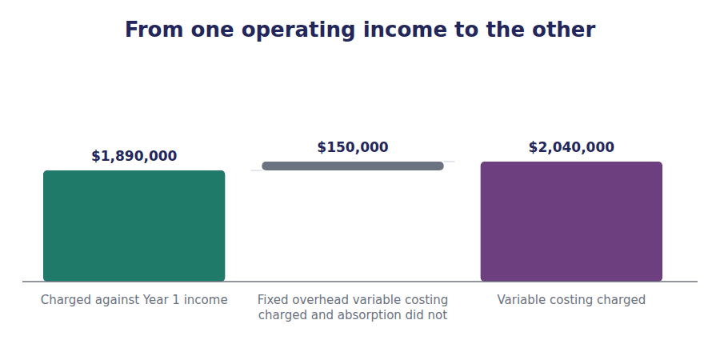
Charged against Year 1 income | Absorption costing | Variable costing
Cost of goods sold
Fixed manufacturing overhead expensed directly
Volume variance closed to cost of goods sold
Total manufacturing cost charged against income
Difference

Watch out! The two totals differ by $150,000, which is 10,000 units still in the warehouse multiplied by the $15 of fixed overhead each one carries. The ledger and the reconciliation formula are two descriptions of the same event.
Part 4 · Disposing of the balance write off or prorate
Exercise 5F Read and complete.
OBJECTIVE | Decide when an over- or under-applied balance may be written off and when it must be spread.
YOU WILL NEED | Exercise 5B
HOW TO START | • The test is materiality, and it is the first blank.  • The second blank is the technical verb for spreading a balance across accounts.  • The third blank is a direction word: which way does inventory go if you write the whole balance off?

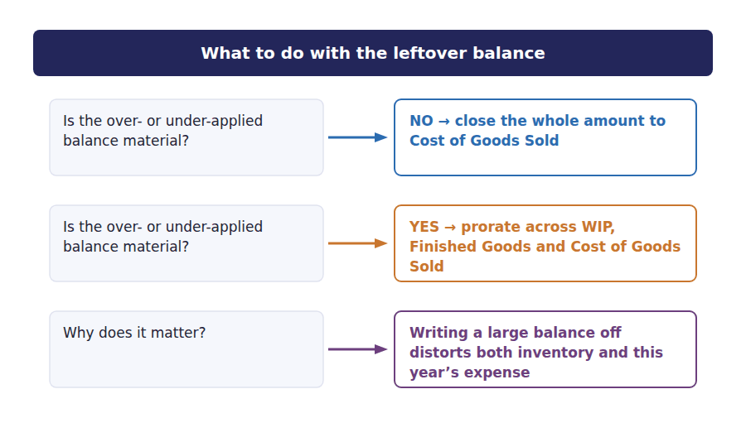
WORD BANK
audited · immaterial · material · overstates · prorated · understates · written off
Not every word is used.

R2 An over- or under-applied balance must be removed at the year end.
If the amount is ¹⁰ , the whole balance may be closed to cost of goods sold, which is what entry J11 did.
If the amount is material, the standards require it to be ¹¹ across the accounts that contain the applied overhead: work in process, finished goods and cost of goods sold, in proportion to the overhead in each.
Proration matters because writing a large under-applied balance off to cost of goods sold ¹² inventory on the balance sheet and overstates the expense for the year.
Exercise 5G An under-applied balance of $90,000 is to be prorated. Complete the table.
OBJECTIVE | Prorate a material under-applied balance across the three accounts that hold applied overhead.
YOU WILL NEED | Exercise 5F
HOW TO START | • Work out each account’s share of the $600,000 of applied overhead first.  • Those three percentages must add to 100.  • Then apply each percentage to the $90,000. Check that your three answers add back to $90,000.

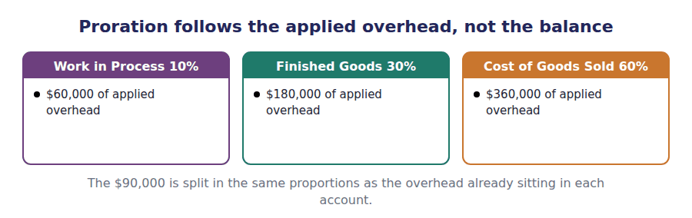
Account | Applied overhead in the account | % | Share of $90,000
Work in Process | $60,000
Finished Goods | $180,000
Cost of Goods Sold | $360,000
Total | $600,000 | 100% | $90,000

The exam says | Candidates assume | What is actually true
"overhead applied was $675,000" | that is the actual overhead cost | Applied is a calculated figure: standard rate × actual production. Actual cost is a separate number given elsewhere in the stem.
"overhead was over-applied" | costs were higher than expected | Over-applied means MORE was charged to production than was spent. Closing it REDUCES cost of goods sold and raises income.
"the fixed overhead variance" | there is only one | There are two: a spending variance (actual vs budget) and a volume variance (applied vs budget). A question saying just "the variance" is usually testing which one you reach for.
a variable costing question asking for the volume variance | compute it as usual | Variable costing does not apply fixed overhead, so no volume variance exists. The answer is zero, or "not applicable".
"close the balance to cost of goods sold" | that is always acceptable | Only if the balance is immaterial. A material balance is prorated.

Exercise 5H The same fact, three registers.
OBJECTIVE | Recognise ledger vocabulary in exam English, where the question names an account rather than a method.
YOU WILL NEED | The whole handout
HOW TO START | • Cover the right-hand column and predict the exam wording.  • Row 2 is about the EFFECT of an entry, which is how the exam usually asks.

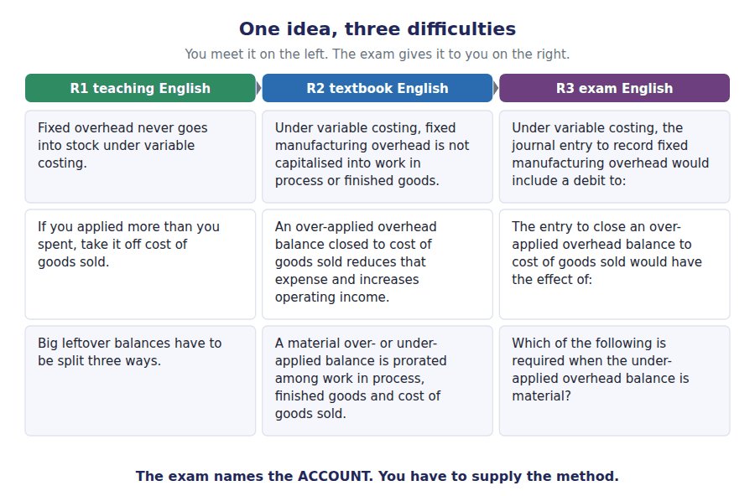
R1 Teaching | R2 Textbook | R3 Exam
Fixed overhead never goes into stock under variable costing. | Under variable costing, fixed manufacturing overhead is not capitalised into work in process or finished goods. | Under variable costing, the journal entry to record fixed manufacturing overhead would include a debit to:
If you applied more than you spent, take it off cost of goods sold. | An over-applied overhead balance closed to cost of goods sold reduces that expense and increases operating income. | The entry to close an over-applied overhead balance to cost of goods sold would have the effect of:
Big leftover balances have to be split three ways. | A material over- or under-applied balance is prorated among work in process, finished goods and cost of goods sold. | Which of the following is required when the under-applied overhead balance is material?

Part 5 · Exam practice Levels B and C
Under variable costing, the journal entry to record fixed manufacturing overhead incurred during the period would include which of the following?
What am I given? | What is asked? | Which word is the trap?

1. [Level B] Under variable costing, the journal entry to record fixed manufacturing overhead incurred during the period would include:
(A) A debit to Work in Process Inventory.
(B) A debit to Finished Goods Inventory.
(C) A debit to an expense account for the full amount incurred.
(D) A credit to Fixed Manufacturing Overhead Applied.
2. [Level B] A plant applied fixed overhead of $675,000 to production and actually incurred $640,000. The balance is:
(A) Under-applied by $35,000, increasing cost of goods sold when closed.
(B) Over-applied by $35,000, decreasing cost of goods sold when closed.
(C) Under-applied by $35,000, decreasing cost of goods sold when closed.
(D) Over-applied by $35,000, increasing cost of goods sold when closed.
3. [Level B] Grandview produced 50,000 units at a standard fixed overhead rate of $15 with a denominator volume of 40,000 units. The amount debited to Work in Process for fixed overhead under absorption costing was:
(A) $600,000
(B) $750,000
(C) $150,000
(D) $0
4. [Level C] Which entry appears under absorption costing but has NO equivalent at all under variable costing?
(A) The entry recording actual fixed overhead incurred.
(B) The entry applying fixed overhead to work in process.
(C) The entry transferring completed units to finished goods.
(D) The entry recording the sale.
5. [Level C] An under-applied overhead balance of $200,000 is considered material. Applied overhead remaining in Work in Process, Finished Goods and Cost of Goods Sold is $100,000, $300,000 and $600,000 respectively. The amount charged to Cost of Goods Sold on proration is:
(A) $60,000.
(B) $100,000.
(C) $120,000.
(D) $200,000.
6. [Level B] A company using standard absorption costing reports a favourable production volume variance. This indicates that:
(A) Actual fixed overhead was less than budgeted fixed overhead.
(B) Actual production exceeded the denominator volume.
(C) Actual sales exceeded budgeted sales.
(D) Variable overhead was efficiently used.
7. [Level A] Under absorption costing, the total debited to Finished Goods Inventory for 50,000 completed units at a standard cost of $51 would be:
(A) $1,800,000
(B) $2,550,000
(C) $2,040,000
(D) $750,000
8. [Level A] Which of the following statements about the two overhead accounts is correct?
(A) Both the control account and the applied account are debited with actual costs.
(B) The control account records actual cost; the applied account records cost charged to production.
(C) The applied account is debited with actual cost and credited with budgeted cost.
(D) Only one account is needed, since the two amounts are always equal.
9. [Level C] A company charged its entire $340,000 under-applied overhead balance to cost of goods sold. If the balance had been prorated, the effect on the financial statements would have been:
(A) Higher inventory and higher operating income.
(B) Higher inventory and lower operating income.
(C) Lower inventory and higher operating income.
(D) No effect, since the total cost is unchanged.

Handout 6 · The Incentive Problem, and the Exam
A manager can raise absorption costing income without selling anything. Here is how much, why it is legal, why it is still wrong, and how the 2026 exam asks about it.
Set D1 · Absorption and Variable Costing · R3 Exam English throughout
LANGUAGE FOCUS
Register you are working in | R3. From here on the English is the exam’s own. Every sentence in Part 4 of this handout is written the way a case-based question writes it.
Say it exactly like this | build inventory for stock · meet the bonus threshold · tie up working capital · at the expense of · act in good faith · raise the matter with · resolve an ethical conflict
Words that are not the same | legal / ethical · earnings management / fraud · incentive / instruction
Remember | Something can be permitted by the accounting standards and still breach the IMA Statement of Ethical Professional Practice. "Would be able to" and "would be required to" are not the same. CBQ items turn on this difference.

What you will be able to do when this handout is finished
- Quantify the effect of overproduction on absorption costing operating income.
- Solve for the production level that reaches a stated income target.
- Explain why variable costing removes the incentive entirely.
- Identify the costs of building unwanted inventory that the income statement does not show.
- Apply the IMA Statement of Ethical Professional Practice to a production decision.
- Work a complete case-based question in the 2026 format.

The Riverside plant, the last week of the fourth quarter
Grandview’s Riverside plant is a separate reporting segment with its own manager, Nadia Hourani. Her annual bonus is paid if the plant reports absorption costing operating income of at least $890,000 for the year.
Demand for the quarter is 30,000 units and that is what the plant has planned to make. The denominator volume used to set the fixed overhead rate is 36,000 units a quarter, and budgeted fixed manufacturing overhead is $540,000.
On Monday Ms Hourani asks the plant accountant to model a second option: run the line at full capacity and make 45,000 units instead of 30,000. The extra 15,000 units would go into the warehouse. There is no customer for them and no order on the books.
Nothing she is proposing breaks a rule. The units would be real, the costs would be real, and the accounting would be correct under every standard that applies.

The data for this handout
Item | Amount
Selling price per unit | $90
Variable manufacturing cost per unit | $36
Variable selling cost per unit sold | $4
Budgeted fixed manufacturing overhead for the quarter | $540,000
Denominator volume for the quarter | 36,000 units
Standard fixed overhead rate | $15 per unit
Standard absorption cost per unit | $51
Fixed selling and administrative for the quarter | $250,000
Units that can be sold this quarter | 30,000
Bonus threshold (absorption operating income) | $890,000

Part 1 · What the two options report the same sales, two incomes
Exercise 6A Complete both columns. Sales are 30,000 units in BOTH cases — only production differs.
OBJECTIVE | Show that absorption income moves and variable costing income does not, when only production changes.
YOU WILL NEED | Handout 4 Exercise 4F for the long-form absorption calculation
HOW TO START | • Fill the two columns in parallel, row by row, not one column at a time.  • Sales are the same in both columns. Only the production volume variance differs.  • Do the last two rows last, and look at them together.

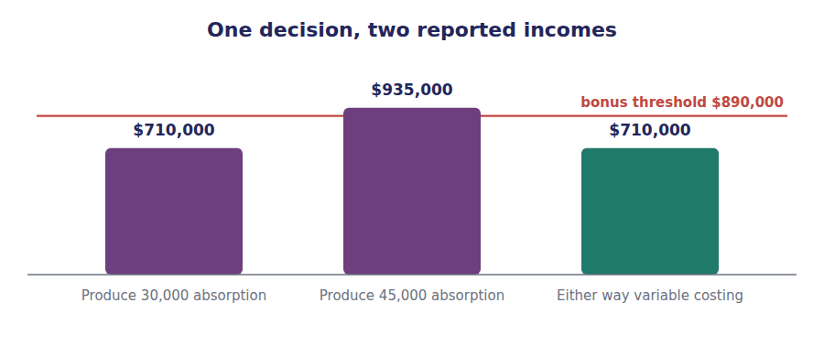
 | Produce 30,000 (to demand) | Produce 45,000 (to capacity)
Units produced
Units sold
Change in inventory (units)
Standard gross margin (units sold × $39)
Production volume variance
less Selling and administrative
ABSORPTION operating income
VARIABLE costing operating income
Bonus earned?

Watch out! Read the two bottom rows again. Absorption income rises by $225,000. Variable costing income does not move at all, because not one extra unit was sold.
Exercise 6B Read and complete.
OBJECTIVE | Describe in words how building stock moves fixed overhead off the income statement.
YOU WILL NEED | Exercise 6A
HOW TO START | • Blank 1 is what did NOT happen, and it is the whole point.  • Blank 2 is a place, not an account name.  • Blank 3 is a direction word and blank 4 is the result.

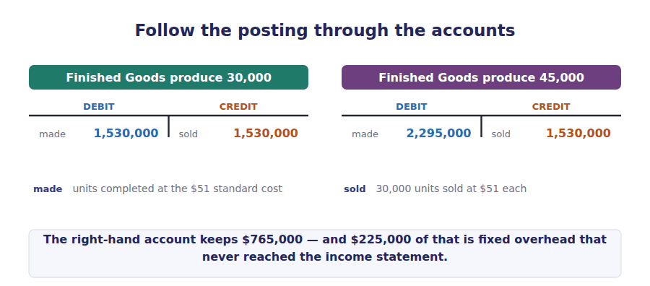
WORD BANK
factory · favourable · ledger · missed · passed · produced · sold · unfavourable · warehouse
Not every word is used.

R2 Making 45,000 units instead of 30,000 changes nothing a customer can see. No extra unit is ¹ , no extra cash comes in, and the variable costing income is unchanged at $710,000.
What changes is where the fixed overhead sits. At the higher output the standard rate of $15 is applied to 15,000 more units, so $225,000 of fixed overhead is attached to goods that stay in the ² instead of being charged against this quarter.
The production volume variance moves from $90,000 unfavourable to $135,000 ³ , a swing of exactly the same $225,000.
Reported absorption income therefore rises to $935,000, and the bonus threshold of $890,000 is ⁴ .
Part 2 · Solving for the target the numerical entry item
Exercise 6C The exam asks this as a numerical entry item, with no options. Find the minimum production in units at which the plant exactly reaches the bonus threshold of $890,000. Show your working in the space.
OBJECTIVE | Solve for the production level that reaches a stated income target, as a numerical entry item.
YOU WILL NEED | Exercise 6A · Handout 4 Exercise 4F
HOW TO START | • Write absorption income as a fixed amount plus the volume variance. Sales are given, so the fixed amount is known.  • Standard gross margin less selling and administrative cost gives that fixed amount.  • Then solve the variance for the output that produces it, and add the denominator volume.

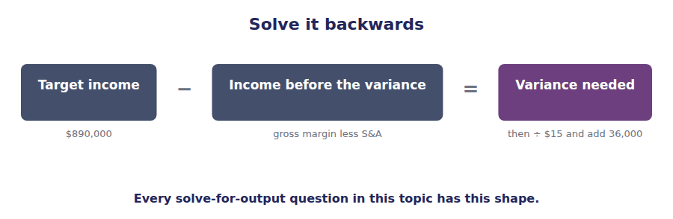

ADAPTIVE TIP Set it up as: income = (a fixed amount) + (the volume variance). The fixed amount is standard gross margin less selling and administrative cost, because sales are given. Then solve the variance for the output that produces it.

Part 3 · What the income statement does not show the real cost
Exercise 6D Read and complete.
OBJECTIVE | Name the costs of building unwanted stock that never appear on the income statement.
YOU WILL NEED | Exercise 6A · Exercise 6C
HOW TO START | • Blank 1 is what the income rise really is, and it is not a gain.  • Blank 2 completes a fixed phrase about cash locked up.  • The last blank explains why the incentive exists at all.

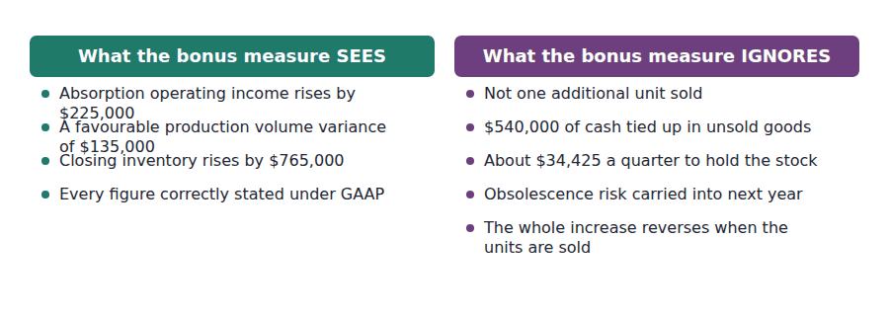
WORD BANK
calculated · fixed · gain · obsolescence · reported · saving · spoilage · transfer · working
Not every word is used.

R2 The $225,000 rise in reported income is not a gain. It is a ⁵ of cost out of this quarter and into a later one, and it reverses the moment those units are sold or written off.
Meanwhile the decision has real costs that appear nowhere on the income statement. Building 15,000 units consumes $540,000 of cash in variable manufacturing cost alone, which is ⁶ capital the company cannot use for anything else.
Holding them costs roughly $34,425 for the quarter in storage, insurance and the capital charge. Every month they sit there they carry a risk of ⁷ if the design changes.
None of these amounts is deducted in arriving at the figure on which the bonus is ⁸ . That is the whole reason the incentive exists.
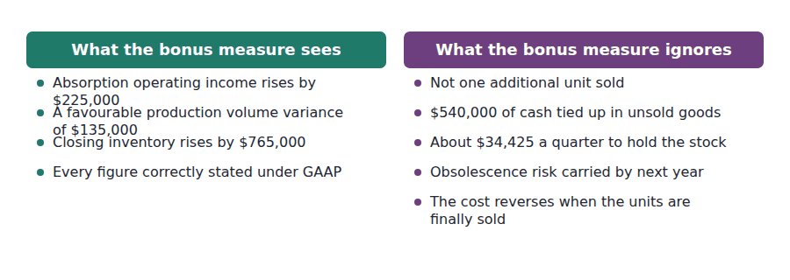
Exercise 6E Tick every statement that is TRUE of the decision to produce 45,000 units. More than one is true — this is how the exam’s multiple-select items work.
OBJECTIVE | Work a multiple-select item, where three statements are true and three are designed to look true.
YOU WILL NEED | Exercise 6A · Exercise 6D
HOW TO START | • Treat each statement as a separate true-or-false question. Do not look for a pattern.  • Statement 3 is about CASH, which the income statement does not show.  • Statement 8 is the one most candidates miss. Think about both halves of the ratio.

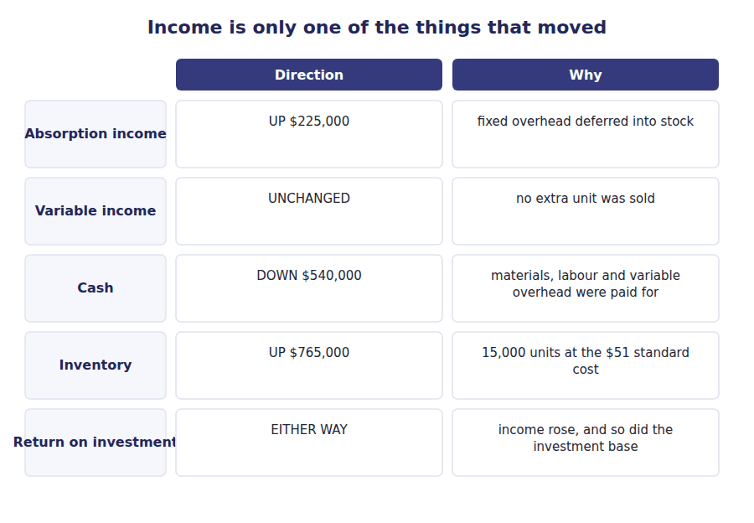
Statement | True | False
1. Absorption costing operating income increases.
2. Variable costing operating income increases.
3. The production volume variance becomes favourable.
4. Cash from operations increases.
5. Closing inventory on the balance sheet increases.
6. The accounting treatment breaches GAAP.
7. The increase in income will reverse in a later period.
8. Return on investment for the segment may fall even though income rises.

R2 What Ms Hourani is proposing has a name in the literature: earnings management. The term covers any use of permitted accounting choices, or of real operating decisions, to move reported income between periods. Building inventory is the production-side version. Channel stuffing — shipping goods to customers earlier than they want them in order to pull sales forward — is the selling-side version, and the exam often puts the two in the same question. Neither is fraud. Both destroy goal congruence, which is the condition in which a manager acting in their own interest is also acting in the company’s. Here the two interests point in opposite directions: the bonus rises while the carrying cost of unsold stock, and the segment margin once that stock is written down, both move against the company.
Part 4 · The ethics the IMA Statement of Ethical Professional Practice
Exercise 6F Read and complete.
OBJECTIVE | Apply the IMA Statement of Ethical Professional Practice to a decision that breaks no accounting rule.
YOU WILL NEED | Exercise 6D
HOW TO START | • Blank 1 is what this is NOT. The accounting is correct throughout.  • Blanks 2 and 3 are two of the four standards. Learn all four by name.  • The last blank is the FIRST step in the resolution process, and it is not an external one.

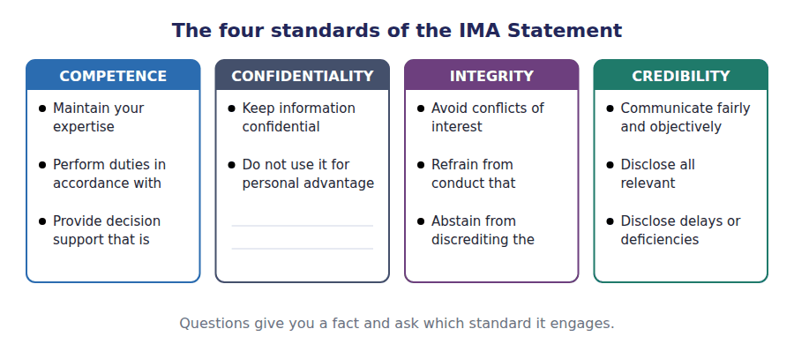
WORD BANK
auditor · Competence · concealed · Confidentiality · Credibility · disclosed · fraud · Integrity · negligence · supervisor
Not every word is used.

R3 Nothing Ms Hourani proposes is unlawful and nothing misstates the accounts, so the question is not one of ⁹ . It is a question about the IMA Statement of Ethical Professional Practice, which binds the plant accountant whatever the plant manager decides.
The standard of ¹⁰ requires a member to refrain from conduct that would prejudice carrying out duties ethically, and to abstain from any activity that might discredit the profession.
The standard of ¹¹ requires that information be communicated fairly and objectively, and that all information reasonably expected to influence an intended user’s understanding be ¹² .
An accountant who prepares the report without drawing attention to the $225,000 of overhead deferred by a production decision taken for its reporting effect has not met that second standard.
The resolution process in the Statement is to discuss the matter first with the immediate ¹³ , except where that person is involved, in which case the matter goes to the next higher level.
Exercise 6G Match each fact with the standard it most directly engages.
OBJECTIVE | Attach a specific fact to the specific ethical standard it engages.
YOU WILL NEED | Exercise 6F
HOW TO START | • Read the four standards first, then the four facts.  • Ask what each fact is really about: knowing, keeping quiet, behaving, or telling.  • Only one of the four is about information leaving the company.

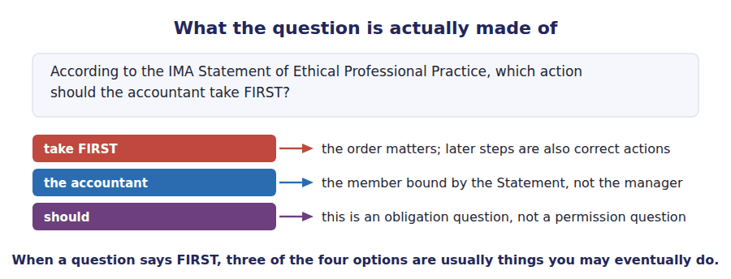
 | Item | Answer |  | Option
1 | Preparing a report that omits the effect of the production decision |  | A | Competence
2 | Accepting the bonus while knowing how the income was produced |  | B | Confidentiality
3 | Not knowing how the volume variance works |  | C | Integrity
4 | Discussing the plant’s unpublished results with a supplier |  | D | Credibility

Part 5 · The cure how companies remove the incentive
Exercise 6H Match each remedy with what it does to the incentive.
OBJECTIVE | Match each remedy for the overproduction incentive to the mechanism by which it works.
YOU WILL NEED | Exercise 6D · Exercise 6E
HOW TO START | • Read the five mechanisms first. Each names what it changes.  • Two of the five remove the incentive completely. Find those two first.  • The exam wants the mechanism, not just the name of the remedy.

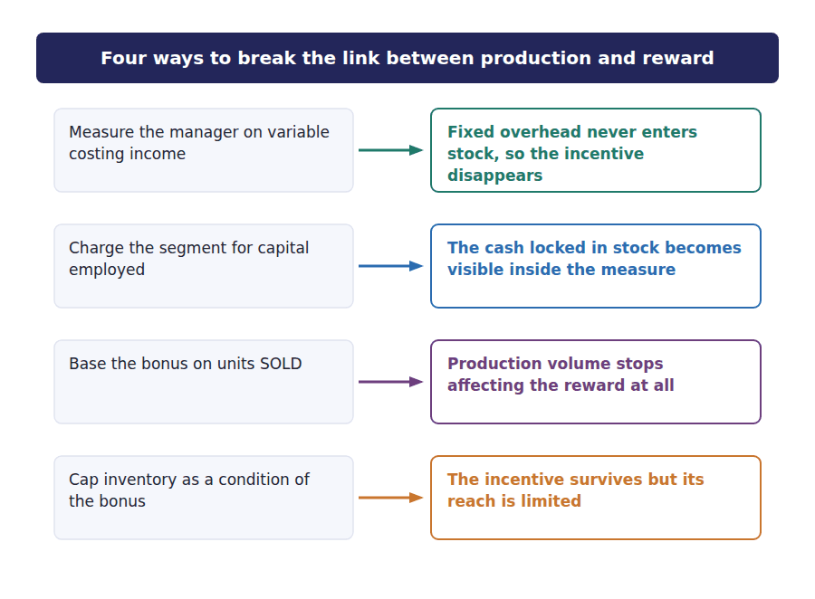
 | Item | Answer |  | Option
1 | Evaluate the manager on variable costing income |  | A | Removes the incentive entirely, because fixed overhead never enters inventory.
2 | Charge the segment for capital employed (residual income) |  | B | Makes the cash tied up in stock visible in the measure itself.
3 | Set a maximum inventory level as a condition of the bonus |  | C | Leaves the incentive in place but caps how far it can be exploited.
4 | Base the bonus on units SOLD rather than produced |  | D | Breaks the link between production volume and the reward altogether.
5 | Use throughput costing for internal reporting |  | E | Removes the incentive and goes further, by treating labour as a period cost too.

The exam says | Candidates assume | What is actually true
"income increased by $225,000" | the company is better off | Nothing was sold. The cost was moved to the balance sheet and will come back.
"the production volume variance was favourable" | the plant performed well | It made more than the denominator volume. Here it did so deliberately, to move cost off the income statement.
"is this permitted under GAAP?" | if the answer is yes, there is no issue | The accounting is correct. The IMA Statement is a separate obligation and it still binds you.
"what should the accountant do first?" | report externally or resign | Discuss with the immediate supervisor, unless that person is involved. External steps come last.
"return on investment will increase" | because operating income increased | Inventory is in the investment base. The denominator rises too, and the ratio can fall.

Part 6 · Case-Based Question the 2026 format, in full
From the September/October 2026 window, the second part of the exam is two case-based questions rather than essays. Each gives a short scenario and then six or seven items in mixed formats: numerical entry, multiple select, fill in the blank, drag and drop, and list selection. There is no credit for explaining your reasoning. The answer is either right or it is not. What follows is one complete case in that shape.
CASE 1 · Riverside Plant · read before answering items 1 to 7
Riverside is one of three plants operated by Grandview Instruments and is treated as an investment centre. Its manager receives an annual bonus if the plant reports absorption costing operating income of at least $890,000.
For the fourth quarter the plant can sell 30,000 units at $90. Variable manufacturing cost is $36 a unit and variable selling cost is $4 a unit sold. Budgeted fixed manufacturing overhead is $540,000 and fixed selling and administrative cost is $250,000. The denominator volume used to set the standard fixed overhead rate is 36,000 units, giving a rate of $15 a unit and a standard absorption cost of $51 a unit. There is no opening inventory.
The original production plan was 30,000 units. In the final week of the quarter the plant manager instructed the line to run to capacity and produce 45,000 units. The additional units were placed in the finished goods warehouse. No customer order exists for them. Group policy requires inventory to be carried at standard absorption cost, and the plant accountant has confirmed that the proposed treatment complies with the group accounting manual and with GAAP in all respects.
The divisional controller has asked you to review the quarter before the results are consolidated.

Item 1 of 7 · Numerical entry
R3 Calculate the production volume variance for the quarter at the ACTUAL production level of 45,000 units. Enter the amount in dollars and state whether it is favourable or unfavourable.

Item 2 of 7 · Numerical entry
R3 Calculate absorption costing operating income for the quarter at the actual production level.

Item 3 of 7 · Numerical entry
R3 Calculate variable costing operating income for the quarter.

Item 4 of 7 · Numerical entry
R3 Calculate the minimum number of units that would have had to be produced for the plant to reach the bonus threshold exactly.

Item 5 of 7 · Multiple select
R3 Select ALL of the statements that are correct with respect to the decision to produce 45,000 units rather than 30,000.
Statement | Select
1. The decision increases absorption costing operating income for the quarter.
2. The decision increases variable costing operating income for the quarter.
3. The decision increases cash generated from operations for the quarter.
4. The additional fixed overhead deferred into inventory is $225,000.
5. The decision will reduce absorption costing operating income in a later period, all else being equal.
6. The accounting treatment of the additional units is contrary to GAAP.

Item 6 of 7 · Fill in the blank
Item 6 Complete the sentence from the word bank. On the real exam each space is a drop-down list.
OBJECTIVE | Complete a fill-in-the-blank case item, where each space is a drop-down list on the real exam.
YOU WILL NEED | The case scenario above · Exercise 6A
HOW TO START | • Four spaces, three possible words. One word is used twice.  • Three of the four follow from the two income figures you have already computed.  • The fourth is about cash, which neither income statement shows.

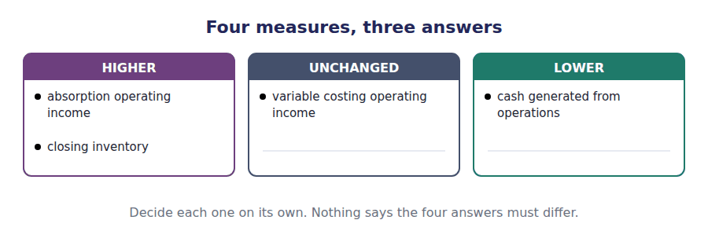
WORD BANK
DEFERRED · HIGHER · LOWER · NEGATIVE · NIL · UNCHANGED
Not every word is used. A word may be used more than once.

R3 Compared with producing to demand, producing to capacity leaves absorption costing operating income ¹⁴ , variable costing operating income ¹⁵ , closing inventory ¹⁶ , and cash generated from operations ¹⁷ .
Item 7 of 7 · List selection
R3 The plant accountant has concluded that the quarterly report, as drafted, does not draw attention to the effect of the production decision. According to the IMA Statement of Ethical Professional Practice, which action should the accountant take FIRST?
1. [Level C] Which action should the accountant take FIRST?
(A) Report the matter to the external auditors.
(B) Discuss the matter with the plant manager’s immediate supervisor.
(C) Decline to prepare the quarterly report.
(D) Add a note to the report and issue it without further discussion.
Part 7 · Mixed exam practice Levels B and C
2. [Level B] A manager whose bonus depends on absorption costing operating income can increase reported income at the end of a period by:
(A) Reducing the selling price to increase volume.
(B) Producing more units than are sold.
(C) Reducing fixed manufacturing overhead spending.
(D) Switching to variable costing for internal reports.
3. [Level B] Which performance measure is LEAST likely to encourage a manager to build unnecessary inventory?
(A) Absorption costing operating income.
(B) Gross margin percentage.
(C) Variable costing operating income.
(D) Return on sales based on absorption costing.
4. [Level C] A segment increased production above sales and reported higher absorption costing operating income. The effect on the segment’s return on investment, where the investment base includes inventory, is:
(A) An increase, because income rose.
(B) A decrease, because the investment base rose.
(C) Indeterminate, because both the numerator and the denominator rose.
(D) No effect, because inventory is excluded from the investment base.
5. [Level B] Residual income is sometimes preferred to absorption operating income for evaluating a plant manager because residual income:
(A) Excludes fixed manufacturing overhead entirely.
(B) Charges the segment for the capital tied up in inventory.
(C) Is required by GAAP for segment reporting.
(D) Is unaffected by changes in selling prices.
6. [Level B] Under the IMA Statement of Ethical Professional Practice, which standard is MOST directly engaged by issuing a report that omits information a user would reasonably need to understand the result?
(A) Competence.
(B) Confidentiality.
(C) Integrity.
(D) Credibility.
7. [Level B] A company produced 45,000 units against a denominator volume of 36,000 and sold 30,000 units. Which of the following is the amount of fixed manufacturing overhead remaining in closing inventory, at a standard rate of $15 per unit?
(A) $135,000.
(B) $225,000.
(C) $540,000.
(D) $675,000.
8. [Level C] Which of the following statements best describes the overproduction incentive created by absorption costing?
(A) It arises because absorption costing overstates total costs.
(B) It arises because fixed overhead attaches to units and therefore leaves the income statement when units are unsold.
(C) It arises because variable costs are understated in inventory.
(D) It arises only when a company is loss-making.
ADAPTIVE TIP This is the end of Set D1. Before you move on, go back to Exercise 3E and read your own completed paragraph aloud. If every blank in it still makes sense to you without the key, you know this topic to the depth the exam tests. If any blank has gone blank again, that is the sentence to rewrite tonight.

Answer Key
Set D1 · Handouts 1 to 6
Every answer carries the reason for it and the mistake it defeats.

Handout 1 · The Inventoriable Decision answers
Completed text and exercises
# | Answer | Why | The trap it defeats
1 | object | Nothing can be classified until you name what you are costing. | Students classify costs with no cost object in mind.
2 | sensor | The company sells one product, so the unit is the natural cost object.
3 | indirect | You cannot trace a supervisor to one unit, so you allocate.
4 | direct | The same cost is direct to a bigger cost object. | Thinking a cost has one fixed classification for ever.
5 | total | Variable costs vary in total, which is the definition.
6 | per unit | The per-unit variable cost is the constant one. | Candidates say "variable cost changes per unit". It does not.
7 | not | Fixed total is flat inside the relevant range.
8 | falls | More units share the same total, so each carries less. | This single sentence causes nearly every absorption costing trap in Part 1.
Grid 1 | 1 Variable 2 Fixed 3 Variable 4 Fixed 5 Mixed 6 Fixed 7 Variable 8 Fixed 9 Variable 10 Fixed | Behaviour is judged by what happens to the TOTAL as volume changes.
9 | direct | Traceable without an arbitrary split.
10 | allocate | Allocation is the technical verb. "Divide" and "distribute" are not used this way in CMA English.
11 | direct | Traceable without an arbitrary split.
12 | fixed | Its total does not move with output.
13 | indirect | It serves the whole factory, so it must be allocated.
14 | independent | All four combinations exist. | Treating "direct" as a synonym for "variable" — the commonest vocabulary error in this topic.
15 | inventory | It is an asset on the balance sheet until the goods leave.
16 | sold | The matching principle: expense it against the revenue it earned.
17 | incurred | No waiting, no inventory.
18 | period | Selling cost never enters inventory under any method, including absorption costing. | Candidates put selling costs into absorption product cost because absorption is called "full" costing. It is not full in that sense.
19 | product | All three are variable manufacturing costs.
20 | fixed manufacturing overhead | The only disputed cost, and the source of every difference in income between the two methods. | If you remember one sentence from Handout 1, make it this one.
Grid 2 | 1 Product cost 2 Product cost 3 Product cost 4 Product cost 5 Period cost 6 Product cost 7 Period cost 8 Period cost 9 Period cost 10 Product cost 11 Period cost 12 Period cost | Inside the factory to get the goods ready: product. After the factory door: period.
Match 1 | 1-C 2-A 3-D 4-E 5-B 6-F | cost = the resource used · expense = a cost now on the income statement · expenditure = money laid out · overhead = indirect factory cost · allocate = spread an indirect cost · trace = follow a direct cost

Exam-pitch questions
# | Answer | Why | The trap it defeats
1 | (C) Depreciation on the delivery vehicles. | Delivery is a selling and distribution cost, so it is a period cost under every method. The trap is reading "full costing" as "all costs". | Level A
2 | (B) Total cost was unchanged and cost per unit decreased. | $600,000 is flat; $20 per unit becomes $12 per unit. Option (C) is chosen by candidates who remember "fixed means it does not change" without asking what does not change. | Level A
3 | (C) A cost may be both direct and fixed. | Depreciation on a machine dedicated to one product is direct to that product and fixed in behaviour. Traceability and behaviour are independent questions. | Level A
4 | (A) $1,500,000 and $1,500,000. | Prime = DM + DL = $1,500,000. Conversion = DL + MOH = $1,500,000. They are equal here by coincidence, which is why the question is written this way. They do not sum to total manufacturing cost of $2,400,000, because direct labour is in both. | Level B
5 | (C) The sales manager’s salary. | Fixed manufacturing overhead is a product cost under absorption costing, so it fails the second condition. A selling salary is a period cost under every method, which is what the question asks for. | Level B
6 | (B) A period cost, because storage of finished goods is a selling and distribution activity. | The test is whether the cost was incurred to GET the goods ready, not whether inventory is nearby. Option (D) is true in conclusion and wrong in reasoning, which the exam uses constantly. | Level B
7 | (B) A variable cost. | Constant per unit and therefore rising in total: $50,000 then $100,000. That is the definition of a variable cost. | Level A
8 | (B) Variable costing treats fixed manufacturing overhead as a period cost. | Only the treatment of FIXED MANUFACTURING overhead differs. (A) is wrong because fixed costs still appear further down the statement. (D) is wrong because selling costs are never inventoriable under any method. | Level B

Exercise 1E · the four combinations
 | Variable | Fixed
Direct | Steel housing; assembly wages paid per unit | Depreciation on the moulding machine, used only for sensors
Indirect | Factory electricity used by the production line | Factory rent; supervisor’s salary

If any box was hard to fill, the difficulty is vocabulary rather than accounting. "Direct" answers can I trace it. "Variable" answers does the total move. Ask the two questions separately and every cost falls into exactly one box.

Handout 2 · Three Methods, One Set of Costs answers
Completed text and exercises
# | Answer | Why | The trap it defeats
1 | inventoriable | No method puts selling cost into stock.
2 | factory | The dispute is entirely about manufacturing cost.
3 | fixed | This is the defining feature of absorption costing.
4 | variable | Variable manufacturing only — not variable selling. | Variable selling cost is a period cost under variable costing too. It is deducted in the contribution margin, not in inventory.
5 | materials | Materials only, which is what makes it "super-variable".
6 | labour | Labour is treated as fixed in the short run. | Candidates assume labour must be a product cost because it is direct. Under throughput costing it is not.
7 | gross | Gross margin is the absorption subtotal.
8 | behaviour | By behaviour, not by function. This is the structural difference. | Writing an absorption statement and calling it variable costing because fixed overhead is shown separately lower down.
9 | contribution | Sales less ALL variable costs.
10 | material | Materials only.
11 | sold | Production equal to sales means no change in inventory, so no fixed overhead moves. | Thinking the methods always differ. They do not.
Match 1 | 1-B 2-C 3-A 4-D | Each margin exists because it answers a question the others cannot.
12 | required | GAAP and IFRS both require it; so does the tax code.
13 | normal | Normal capacity, not actual production. | Candidates assume actual output is always the denominator. Handout 5 shows what happens when it is not.
14 | legitimate | There is nothing improper about variable costing internally. | Students sometimes think variable costing is "not allowed". It is not allowed in PUBLISHED statements. That is all.
15 | internal reporting | Both sets of numbers, for two different audiences.
Grid 1 | 1 Absorption 2 Variable 3 Absorption 4 Variable 5 Throughput 6 Variable 7 Throughput 8 Absorption | Rows 3 and 7 follow from the ladder: the more cost a method puts into inventory, the higher the inventory value.

Exam-pitch questions
# | Answer | Why | The trap it defeats
1 | (B) Direct labour and variable manufacturing overhead. | Variable costing inventories DM + DL + VMOH; throughput inventories DM only. The difference is exactly DL + VMOH. (C) is in neither and (D) is in no method at all. | Level A
2 | (C) $48. | $18 + $12 + $6 + ($600,000 ÷ 50,000 = $12) = $48. Option (D) adds the variable selling cost, which is never inventoriable. Option (B) is the variable product cost plus selling. | Level A
3 | (A) $144,000. | 8,000 × $18 of direct materials = $144,000. (B) is variable costing at $36 and (C) is absorption costing at $48 — both are offered because candidates reach for a familiar number. | Level B
4 | (D) It is required by accounting standards for segment disclosures. | Variable costing is not required by any standard; absorption is the one that is mandated. (A), (B) and (C) are the three standard advantages and the exam expects you to recognise all of them. | Level B
5 | (B) Gross margin is after fixed manufacturing overhead in cost of goods sold, while contribution margin is before all fixed costs and after variable selling costs. | The two subtotals cut the cost structure in different directions — one by function, one by behaviour — so they are different numbers measuring different things. These are Grandview’s actual figures from Handout 3. | Level B
6 | (B) The normal capacity of the production facilities. | Normal capacity prevents a low-production period from loading an abnormal amount of fixed cost onto each unit. Unabsorbed overhead in such a period is expensed rather than inventoried. | Level B
7 | (C) Equal to operating income under variable costing. | No change in inventory means no fixed overhead is carried forward or released, so the two methods report the same income. This is the base case you must know before Handout 4. | Level A
8 | (B) Evaluate whether to produce one more unit when a bottleneck limits output. | Throughput thinking assumes everything except materials is fixed in the short run, which is precisely the assumption that holds at a bottleneck. (C) is the case FOR absorption costing, which is why it is offered. | Level B

Exercise 2B · the completed unit cost table
Per unit | Absorption | Variable | Throughput
Direct materials | $18 | $18 | $18
Direct labour | $12 | $12 | —
Variable manufacturing overhead | $6 | $6 | —
Fixed manufacturing overhead | $12 | — | —
Unit product cost | $48 | $36 | $18

Exercise 2C · closing inventory, 8,000 units
 | Units | × unit cost | = closing inventory
Absorption costing | 8,000 | $48 | $384,000
Variable costing | 8,000 | $36 | $288,000
Throughput costing | 8,000 | $18 | $144,000

The gap between the absorption and variable figures, $96,000, is the fixed factory overhead sitting in the warehouse rather than on the income statement. Handout 3 shows what it does to reported profit.

Handout 3 · The Two Statements answers
Completed text and exercises
# | Answer | Why | The trap it defeats
1 | identically | Every other line is the same in substance. | Candidates hunt for differences in the selling costs. There are none.
2 | period | A capacity cost belongs to the period that bought the capacity.
3 | next | It waits in inventory until those units are sold. | Saying the cost is "saved" or "avoided". It is only postponed.
4 | change | The CHANGE in units, not the level. | Using closing inventory instead of the movement. If opening inventory is not zero, that is wrong.
5 | rises | More units in, than out.
6 | higher | Cost has been moved off this period’s income statement.
7 | lower | Last period’s cost arrives on this period’s statement as well as this period’s.
8 | same | Nothing moves, so nothing differs.
9 | expensed | Timing, not amount. This is the single most important sentence in the topic. | Believing absorption costing "creates" profit. It moves it between periods.

Exam-pitch questions
# | Answer | Why | The trap it defeats
1 | (C) $1,316,000. | $1,220,000 + (8,000 × $12) = $1,316,000. Option (A) subtracts instead of adding and is the single most common wrong answer on this topic. | Level B
2 | (B) $2,100,000 | Sales $3,780,000 less variable production cost $1,512,000 less variable selling cost $168,000 = $2,100,000. Option (A) forgets the variable selling cost, which is the deduction candidates most often miss. | Level B
3 | (B) Units sold exceeded units produced. | Selling more than you make draws inventory down, releasing previously deferred fixed overhead into cost of goods sold. (C) and (D) change both figures equally and so change nothing about the comparison. | Level A
4 | (B) $75,000. | The change is 5,000 units, so 5,000 × $15 = $75,000. (C) uses closing inventory of 9,000 and (A) uses opening inventory of 4,000 — both offered because the question deliberately supplies two inventory figures. | Level B
5 | (C) The same. | Equal opening and closing inventory means no net deferral over the three years taken together. Option (D) is tempting because a rate is usually needed — but the change in units is zero, so the rate is multiplied by nothing. | Level C
6 | (A) $865,000. | Working backwards: $940,000 − ($115,000 − $40,000) = $865,000. The exam often gives the overhead in dollars rather than units, which removes the rate calculation and tests only the direction of the adjustment. | Level C
7 | (B) The difference between the two incomes depends on the change in inventory, not on its level. | Only (B) is always true. (D) is a trap built on Handout 4: sales can be perfectly constant while production swings, and then the incomes differ every year. | Level B
8 | (B) $48,000. | The rate is $300,000 ÷ 25,000 = $12; 4,000 units remain, so $48,000. Option (C) wrongly includes the fixed selling cost in the rate — selling cost is never inventoried. | Level B

Exercise 3A · the completed absorption costing statement
Absorption costing · income statement
Sales (42,000 units × $90) |  | $3,780,000
Cost of goods sold
Opening inventory | $0
Cost of goods manufactured (50,000 × $48) | $2,400,000
Goods available for sale | $2,400,000
less Closing inventory (8,000 × $48) | $384,000
Cost of goods sold |  | $2,016,000
GROSS MARGIN |  | $1,764,000
Variable selling and administrative (42,000 × $4) | $168,000
Fixed selling and administrative | $280,000
Total selling and administrative |  | $448,000
OPERATING INCOME |  | $1,316,000

Exercise 3B · the completed variable costing statement
Variable costing · income statement
Sales (42,000 units × $90) |  | $3,780,000
Variable costs
Variable cost of goods sold (42,000 × $36) | $1,512,000
Variable selling and administrative (42,000 × $4) | $168,000
Total variable costs |  | $1,680,000
CONTRIBUTION MARGIN |  | $2,100,000
Fixed manufacturing overhead | $600,000
Fixed selling and administrative | $280,000
Total fixed costs |  | $880,000
OPERATING INCOME |  | $1,220,000

Exercise 3D · the reconciliation
Reconciliation | Units | Rate | Amount
Variable costing operating income |  |  | $1,220,000
add Fixed overhead in closing inventory | 8,000 | $12 | $96,000
less Fixed overhead in opening inventory | 0 | $12 | —
Absorption costing operating income |  |  | $1,316,000

Exercise 3F · the three cases
Case | Produced | Sold | Change in units | Difference in operating income | Which is higher?
A | 20,000 | 18,000 | +2,000 | $20,000 | Absorption
B | 20,000 | 20,000 | nil | nil | Neither — they are equal
C | 20,000 | 23,000 | −3,000 | $30,000 | Variable

Case C is the one to rehearse. Inventory fell by 3,000 units, so $30,000 of fixed overhead deferred in an earlier period was released into this period’s cost of goods sold on top of this period’s own fixed overhead. Absorption income is lower by exactly that amount.

Handout 4 · Deferral and Release Over Time answers
Completed text and exercises
# | Answer | Why | The trap it defeats
1 | deferred | Held in an asset account instead of being expensed.
2 | identical | No movement in inventory, no difference.
3 | released | The Year 1 cost arrives on the Year 3 income statement. | Candidates think Year 3 is being charged twice. It is being charged for Year 1 as well as Year 3 — which is the point.
4 | below | Absorption income is LOWER in a drawdown year.
5 | cancel | Every deferral eventually reverses. | Believing absorption costing produces more profit in total. It produces a different PATTERN of profit.
6 | more | More overhead is charged to production than was budgeted.
7 | variance | The technical name. Also called the denominator variance or the capacity variance.
8 | denominator | Against the denominator volume, never against sales. | Comparing production with SALES to get the volume variance. The volume variance has nothing to do with sales.
9 | favourable | More overhead applied than budgeted. | "Favourable" here does not mean good. It means over-applied, which happened because the plant built stock nobody ordered.
10 | unfavourable | Less applied than budgeted, because capacity was idle.

Exam-pitch questions
# | Answer | Why | The trap it defeats
1 | (B) Production exceeded sales in Year 1 and was below sales in Year 3. | Only a change in inventory can move absorption income while sales are flat. (A), (C) and (D) would all change variable costing income too, and the question implies it did not move. | Level B
2 | (B) $150,000 unfavourable. | (30,000 − 40,000) × $15 = $150,000 unfavourable. The variance compares production with the DENOMINATOR, not with sales — which is why 40,000 appears twice in the question. | Level B
3 | (B) $150,000 lower. | Inventory fell by 10,000 units, releasing 10,000 × $15 = $150,000 of fixed overhead into cost of goods sold. The same $150,000 as the volume variance, because it is the same movement of overhead. | Level B
4 | (C) Cumulative income is the same under both methods. | Inventory starts at zero and ends at zero, so the Year 1 deferral is exactly reversed in Year 2. The rate is irrelevant precisely because the net change is nil, which is what makes (D) wrong. | Level C
5 | (C) When units produced equal units sold. | Equal production and sales means no change in inventory and therefore no movement of fixed overhead. (A) and (B) are each true only if the OTHER is also true; (D) is a sufficient condition but far from the only one. | Level A
6 | (B) $675,000. | Applied = actual production × standard rate = 45,000 × $15 = $675,000. Option (A) is budgeted fixed overhead (36,000 × $15) and (C) is the volume variance — both correct numbers answering a different question. | Level B
7 | (B) Actual production differed from the denominator volume used to set the rate. | (A) describes a different fixed overhead variance — the one comparing actual spending with the budget. Candidates who have studied variance analysis separately routinely reach for it here. | Level B
8 | (B) Decreased its inventory. | Absorption income is LOWER, so previously deferred overhead was released, so inventory fell. These are Grandview’s Year 3 figures. | Level B
9 | (B) Increase production above sales. | Building inventory defers fixed overhead and raises reported income without a single extra sale. (D) would also raise income but is straightforwardly fraudulent rather than merely an incentive problem. Handout 6 is about exactly this question. | Level C
10 | (C) The same. | Over the whole life, everything produced is eventually sold or written off, so all fixed overhead reaches the income statement under both methods. (D) is true of each individual year and false of the lifetime total. | Level A

Exercise 4A · the inventory record
 | Year 1 | Year 2 | Year 3
Opening inventory (units) | 0 | 10,000 | 10,000
add Units produced | 50,000 | 40,000 | 30,000
less Units sold | 40,000 | 40,000 | 40,000
Closing inventory (units) | 10,000 | 10,000 | 0
CHANGE in inventory (units) | +10,000 | 0 | -10,000

Exercise 4B and 4D · the reconciliation and the summary
 | Year 1 | Year 2 | Year 3 | Three years
Variable costing operating income | $1,120,000 | $1,120,000 | $1,120,000 | $3,360,000
Fixed overhead deferred into closing inventory | $150,000 | — | — | $150,000
Fixed overhead released from opening inventory | — | — | $150,000 | $150,000
Net effect on income | $150,000 | $0 | ($150,000) | $0
Absorption costing operating income | $1,270,000 | $1,120,000 | $970,000 | $3,360,000

Exercise 4F · absorption income built the long way
Absorption income, built the long way | Year 1 | Year 2 | Year 3
Standard gross margin (units sold × $39) | $1,560,000 | $1,560,000 | $1,560,000
add/less Production volume variance | $150,000 F | $0 — | $150,000 U
less Selling and administrative | $440,000 | $440,000 | $440,000
Absorption costing operating income | $1,270,000 | $1,120,000 | $970,000

The two routes to absorption income agree in every year. If yours do not, the error is almost always the volume variance sign: a favourable variance is ADDED, because more overhead was applied to production than was actually budgeted.

Handout 5 · The Ledger answers
Completed text and exercises
# | Answer | Why | The trap it defeats
1 | Control | Actual costs only. | Debiting applied amounts to the control account, which destroys the comparison the two accounts exist to make.
2 | Applied | A credit, built from the standard rate.
3 | produced | Units PRODUCED, not units sold. | Applying overhead to units sold. Overhead attaches at production.
4 | over-applied | Applied is greater than actual.
5 | Sold | Permitted when the amount is immaterial; otherwise prorate. | Forgetting that a material balance must be split between work in process, finished goods and cost of goods sold.
6 | Process | It is never capitalised at all.
7 | variance | No application means no volume variance. | A very common exam point: variable costing systems do not report a production volume variance.
8 | unchanged | The first six entries are identical under both methods.
9 | produced | All 50,000 units carry it, not just those sold.
10 | immaterial | Materiality is the test, not convenience.
11 | prorated | Spread across all three accounts holding applied overhead.
12 | understates | Inventory is left carrying too little cost. | Assuming proration always increases income. It depends entirely on whether the balance is over- or under-applied.

Exam-pitch questions
# | Answer | Why | The trap it defeats
1 | (C) A debit to an expense account for the full amount incurred. | Fixed overhead is a period cost under variable costing, so it is expensed immediately and never enters an inventory account. (D) describes the absorption entry that has no variable costing equivalent. | Level B
2 | (B) Over-applied by $35,000, decreasing cost of goods sold when closed. | Applied exceeds actual, so overhead is over-applied; too much cost was charged to production, and closing the balance takes it back off cost of goods sold. Both the direction AND the effect must be right, which is why all four combinations are offered. | Level B
3 | (B) $750,000 | Applied = actual production × rate = 50,000 × $15 = $750,000. (A) is budgeted overhead and (C) is the volume variance; (D) would be correct only under variable costing. | Level B
4 | (B) The entry applying fixed overhead to work in process. | Actual fixed overhead is still recorded (it is just expensed), units are still transferred (at a lower cost) and sales are identical. Only the APPLICATION of fixed overhead to production disappears entirely. | Level C
5 | (C) $120,000. | $600,000 ÷ $1,000,000 = 60%; 60% × $200,000 = $120,000. Option (D) is the figure you get by writing the whole balance off, which is exactly what materiality forbids here. | Level C
6 | (B) Actual production exceeded the denominator volume. | The volume variance compares applied overhead with budgeted overhead, and applied depends only on output. (A) describes the spending variance. | Level B
7 | (B) $2,550,000 | 50,000 × $51 = $2,550,000. (A) is the variable costing figure at $36 per unit, which is the distractor for candidates who forget which method the question named. | Level A
8 | (B) The control account records actual cost; the applied account records cost charged to production. | The whole point of running two accounts is that the two amounts are NOT equal; their difference is the over- or under-applied balance. | Level A
9 | (A) Higher inventory and higher operating income. | Proration leaves part of the under-applied cost in work in process and finished goods instead of in cost of goods sold. Inventory rises and the expense falls, so income rises. (D) confuses total cost with its allocation between the balance sheet and the income statement. | Level C

Exercise 5A · the completed absorption entries
J1 Materials bought on credit.
Account | Debit | Credit
Raw Materials Inventory | $900,000
Accounts Payable |  | $900,000
J2 Materials issued to the production line.
Account | Debit | Credit
Work in Process Inventory | $900,000
Raw Materials Inventory |  | $900,000
J3 Direct labour for the period.
Account | Debit | Credit
Work in Process Inventory | $600,000
Wages Payable |  | $600,000
J4 Variable factory overhead actually incurred.
Account | Debit | Credit
Variable Manufacturing Overhead Control | $300,000
Accounts Payable / Cash |  | $300,000
J5 Fixed factory overhead actually incurred.
Account | Debit | Credit
Fixed Manufacturing Overhead Control | $600,000
Accumulated Depreciation / Cash / Payables |  | $600,000
J6 Variable overhead applied to production, 50,000 units × $6.
Account | Debit | Credit
Work in Process Inventory | $300,000
Variable Manufacturing Overhead Applied |  | $300,000
J7 Fixed overhead applied to production, 50,000 units × $15. This entry exists only under absorption costing.
Account | Debit | Credit
Work in Process Inventory | $750,000
Fixed Manufacturing Overhead Applied |  | $750,000
J8 50,000 units completed and transferred, at $51 each.
Account | Debit | Credit
Finished Goods Inventory | $2,550,000
Work in Process Inventory |  | $2,550,000
J9 40,000 units sold on credit.
Account | Debit | Credit
Accounts Receivable | $3,600,000
Sales Revenue |  | $3,600,000
J10 Cost of the 40,000 units sold, at $51 each.
Account | Debit | Credit
Cost of Goods Sold | $2,040,000
Finished Goods Inventory |  | $2,040,000
J11 Fixed overhead accounts closed. Applied $750,000 exceeds actual $600,000, so overhead was over-applied by $150,000 — the favourable production volume variance.
Account | Debit | Credit
Fixed Manufacturing Overhead Applied | $750,000
Fixed Manufacturing Overhead Control |  | $600,000
Cost of Goods Sold |  | $150,000

Exercise 5C · the three entries that change under variable costing
J7v Fixed factory overhead taken straight to expense. Under variable costing there is no application entry at all.
Account | Debit | Credit
Fixed Manufacturing Overhead Expense | $600,000
Fixed Manufacturing Overhead Control |  | $600,000
J8v 50,000 units completed and transferred, at $36 each.
Account | Debit | Credit
Finished Goods Inventory | $1,800,000
Work in Process Inventory |  | $1,800,000
J10v Cost of the 40,000 units sold, at $36 each.
Account | Debit | Credit
Cost of Goods Sold | $1,440,000
Finished Goods Inventory |  | $1,440,000

The entry with no variable costing equivalent is J7, the application of fixed overhead to Work in Process. Everything else either stays the same or changes only in amount.
Exercise 5E · what each method charged against Year 1 income
Charged against Year 1 income | Absorption costing | Variable costing
Cost of goods sold | $2,040,000 | $1,440,000
Fixed manufacturing overhead expensed directly | — | $600,000
Volume variance closed to cost of goods sold | ($150,000) | —
Total manufacturing cost charged against income | $1,890,000 | $2,040,000
Difference | $150,000

Variable costing charged $150,000 more against Year 1 income. That is 10,000 units × $15 — the fixed overhead resting in the warehouse under absorption costing, and already expensed under variable costing.
Exercise 5G · proration
Account | Applied overhead in the account | % | Share of $90,000
Work in Process | $60,000 | 10% | $9,000
Finished Goods | $180,000 | 30% | $27,000
Cost of Goods Sold | $360,000 | 60% | $54,000
Total | $600,000 | 100% | $90,000

Handout 6 · The Incentive Problem, and the Exam answers
Completed text and exercises
# | Answer | Why | The trap it defeats
1 | sold | Sales are identical in the two options.
2 | warehouse | The cost moves to the balance sheet.
3 | favourable | Favourable because output exceeded the denominator volume. | Reading "favourable" as "good". Here it is produced by making things nobody wants.
4 | passed | The bonus is earned on a number, and the number moved.
5 | transfer | Timing, not creation.
6 | working | Cash locked in inventory.
7 | obsolescence | Unsold stock can become worthless.
8 | calculated | The measure ignores every cost of the behaviour it rewards. | This sentence is the answer to most Level C questions on this topic.
Grid 1 | 1 True 2 False 3 True 4 False 5 True 6 False 7 True 8 True | Item 8 is the one candidates miss: income is the numerator of return on investment, but inventory is part of the investment base in the denominator, so the ratio can move either way.
9 | fraud | The accounting is correct. That is what makes it hard. | Treating every ethics question as a fraud question. Most CMA ethics items are about disclosure and objectivity, not falsification.
10 | Integrity | One of the four standards. Learn all four by name.
11 | Credibility | Fair and objective communication, and full disclosure.
12 | disclosed | Disclosure is the obligation, not refusal to prepare the report. | Answering "refuse to produce the statements". That is almost never the correct first step.
13 | supervisor | Immediate supervisor first, unless they are involved. | Going outside the organisation first. External disclosure is the last resort, not the first.
Match 1 | 1-D 2-C 3-A 4-B | The four standards are Competence, Confidentiality, Integrity and Credibility. Questions give you a fact and ask which one it engages.
Match 2 | 1-A 2-B 3-C 4-D 5-E | Any of these is a defensible answer to "what would you recommend". The exam wants the mechanism, not just the name.
Grid 2 | 1 Select 2 — 3 — 4 Select 5 Select 6 — | Items 1, 4 and 5 are correct. Item 3 is wrong because producing goods consumes cash; item 6 is wrong because the treatment is explicitly compliant.
14 | HIGHER | Fixed overhead is deferred into inventory.
15 | UNCHANGED | No additional units were sold.
16 | HIGHER | Fixed overhead is deferred into inventory.
17 | LOWER | Cash is spent making units nobody has ordered. | Candidates mark cash UNCHANGED because the income statement did not show the outflow.

Exam-pitch questions
# | Answer | Why | The trap it defeats
1 | (B) Discuss the matter with the plant manager’s immediate supervisor. | The Statement directs a member to raise the matter with the immediate supervisor, and where that person is involved — as the plant manager is here — with the next higher managerial level. External steps and refusal to act are last resorts, not first ones. (D) fails because the matter needs to be discussed, not merely footnoted. | Level C
2 | (B) Producing more units than are sold. | (C) genuinely improves results but is hard and real; (B) requires nothing but an instruction to the production line. (A) would reduce income per unit and (D) would remove the effect the manager wants. | Level B
3 | (C) Variable costing operating income. | Variable costing income is unaffected by production volume because fixed overhead never enters inventory. All three others are built on absorption figures. | Level B
4 | (C) Indeterminate, because both the numerator and the denominator rose. | Both parts of the ratio move upwards, so the direction depends on their relative size. This is the single most common Level C variation on this topic. | Level C
5 | (B) Charges the segment for the capital tied up in inventory. | A capital charge makes the cash locked up in unwanted stock visible inside the measure, which is exactly what the absorption income measure fails to do. | Level B
6 | (D) Credibility. | Credibility covers communicating information fairly and objectively and disclosing all relevant information. Integrity is engaged too, but Credibility is the standard that speaks directly about disclosure. | Level B
7 | (B) $225,000. | 15,000 units unsold × $15 = $225,000. Option (A) is the volume variance (9,000 × $15) and (D) is total applied overhead — both offered because they are computed from the same three numbers. | Level B
8 | (B) It arises because fixed overhead attaches to units and therefore leaves the income statement when units are unsold. | The mechanism is the deferral of fixed overhead into an asset. (A) is wrong because total cost over time is identical under both methods, and (D) is wrong because the incentive exists at any level of profit. | Level C

Exercise 6A · the two options
 | Produce 30,000 (to demand) | Produce 45,000 (to capacity)
Units produced | 30,000 | 45,000
Units sold | 30,000 | 30,000
Change in inventory (units) | nil | +15,000
Standard gross margin (units sold × $39) | $1,170,000 | $1,170,000
Production volume variance | ($90,000) U | $135,000 F
less Selling and administrative | $370,000 | $370,000
ABSORPTION operating income | $710,000 | $935,000
VARIABLE costing operating income | $710,000 | $710,000
Bonus earned? | No | Yes

Note the first column carefully: production equals sales, so absorption and variable income are IDENTICAL at $710,000 — even though there is a $90,000 unfavourable volume variance. A volume variance does not by itself make the two methods differ. Only a change in inventory does.
Exercise 6C and Case Item 4 · the minimum production level
- Standard gross margin on 30,000 units sold = 30,000 units × $39 = $1,170,000
- less selling and administrative = $370,000
- Income before the volume variance = $800,000
- Volume variance needed to reach $890,000 = $90,000
- Units above the denominator = that variance ÷ $15 = 6,000 units
- Minimum production = 36,000 + 6,000 = 42,000 units
Case 1 · items 1 to 4
Item | Answer | Working
1 | $135,000 favourable | (45,000 − 36,000) × $15
2 | $935,000 | Standard gross margin $1,170,000 + variance $135,000 − S&A $370,000
3 | $710,000 | Contribution $1,500,000 − fixed $790,000
4 | 42,000 units | See the working above

Case 1 · item 5, multiple select
- CORRECT: the decision increases absorption costing operating income.
- CORRECT: the additional fixed overhead deferred into inventory is $225,000.
- CORRECT: the increase will reverse in a later period.
- Not correct: variable costing income is unchanged, because no extra unit was sold.
- Not correct: cash FALLS, because producing goods consumes materials, labour and variable overhead.
- Not correct: the stem states the treatment complies with GAAP.
A multiple-select item gives no partial credit on the 2026 exam. Three correct and one wrong scores the same as nothing. Check each statement separately and resist the pull of a plausible fourth.

Glossary
Every term in Set D1, with the Arabic equivalent and the places it misleads
The third column is for recognition only. In the exam room you work in English.

Term | What it means in CMA English | بالعربية | Careful
absorption costing | All manufacturing cost, fixed and variable, is a product cost. | تكلفة الاستيعاب / التكلفة الكلية | Not the same as "total cost". Selling costs stay outside it.
applied overhead | Overhead charged to production using the standard rate. | العبء المحمل | A credit balance. The exam gives you actual and applied and asks for the difference.
capacity cost | A fixed cost incurred to be able to produce at all. | تكلفة الطاقة | This is the argument for variable costing: capacity is bought by the period, so it should be charged to the period.
carrying cost | The cost of holding inventory: capital tied up, storage, insurance, obsolescence. | تكلفة الاحتفاظ بالمخزون | Never appears on the income statement as a line. That is why the incentive works.
channel stuffing | Pushing goods to customers early to pull sales into the current period. | حشو القنوات | The sales-side cousin of overproduction. The exam pairs them.
contribution margin | Sales less all variable costs, including variable selling costs. | هامش المساهمة | Variable SELLING cost is deducted here. Candidates stop at production cost and get the wrong figure.
control account | The account that collects the ACTUAL overhead incurred. | حساب المراقبة | Debited with real costs. Never debited with applied amounts.
conversion cost | Direct labour plus manufacturing overhead. | تكلفة التحويل | Direct labour is in BOTH. The exam asks you to add them and the answer double-counts labour on purpose.
cost driver | The activity that makes a cost change. | مسبب التكلفة | A cost driver is not a cost. Machine hours drive the power bill; the hours themselves cost nothing.
cost object | Anything you want the cost of: a product, a department, a customer, an order. | هدف التكلفة | Always fix this first. "Is rent a direct cost?" has no answer until you say direct to what.
cost of goods manufactured | The cost of the units finished during the period. | تكلفة البضاعة المصنعة | Units FINISHED, not units sold and not units started.
cost of goods sold | The cost of the units actually sold in the period. | تكلفة البضاعة المباعة | Units SOLD. Not units made, and not units available.
cumulative income | Income added across several periods. | الدخل التراكمي | A question about "the three years taken together" is asking about cumulative income, and the answer is usually that the two methods agree.
deferred cost | A cost held in an asset account instead of being expensed now. | تكلفة مؤجلة | Deferred, not avoided. It will be expensed when the units are sold.
denominator volume | The planned activity level used to set the fixed overhead rate. | حجم المقام | Also called the denominator level or normal capacity. It does NOT change when actual production changes.
direct cost | A cost you can trace to the cost object economically. | تكلفة مباشرة | Direct is about traceability, not behaviour. A direct cost can be fixed.
direct costing | An older name for variable costing. | التكلفة المباشرة | A false friend, and the worst one in this topic. It is about cost BEHAVIOUR.
earnings management | Using permitted accounting choices or real decisions to move reported income between periods. | إدارة الأرباح | Not the same as fraud. Most of it is legal, which is exactly what makes it an ethics question rather than a law question.
expense | A cost that has been matched against revenue and now sits on the income statement. | مصروف | Every expense was a cost first. Not every cost has become an expense yet.
external reporting | Financial statements issued outside the company. | التقارير الخارجية | Absorption costing is required here. Variable costing is not permitted.
fixed cost | A cost whose total does not change as activity changes, within the relevant range. | تكلفة ثابتة | Fixed in TOTAL. Per unit it falls as volume rises. This one fact causes most of the errors in this topic.
full costing | Another name for absorption costing. | التكلفة الكلية | "Full" means all MANUFACTURING cost. Not every cost the business incurs.
goal congruence | Managers acting in their own interest also act in the company’s interest. | توافق الأهداف | The technical name for what this handout is about. The absorption bonus destroys it.
goods available for sale | Opening inventory plus cost of goods manufactured. | البضاعة المتاحة للبيع
gross margin | Sales less cost of goods sold, where cost of goods sold is measured on an absorption basis. | مجمل الربح | It mixes fixed and variable cost together, which is why it cannot be used for short-run decisions.
idle capacity | Capacity that was paid for and not used. | الطاقة العاطلة | An unfavourable production volume variance is the accounting trace of idle capacity.
indirect cost | A cost you cannot trace, so you allocate it. | تكلفة غير مباشرة | Indirect is not a synonym for fixed. Factory electricity is indirect and largely variable.
internal reporting | Reports prepared for managers inside the company. | التقارير الداخلية | Variable costing is normal here and entirely legitimate.
inventoriable cost | Another name for a product cost: a cost carried in inventory until the unit is sold. | تكلفة قابلة للتخزين | The exam uses "product cost" and "inventoriable cost" in one question as though you already knew they were the same.
inventory build | A rise in the number of units held. | تراكم المخزون | A build always favours absorption income. Always.
inventory drawdown | A fall in the number of units held. | سحب من المخزون | A drawdown always favours variable costing income.
manufacturing overhead | All factory cost that is not direct materials or direct labour. | التكاليف الصناعية غير المباشرة | Factory only. A sales manager’s salary is never manufacturing overhead.
mixed cost | A cost with a fixed part and a variable part. | تكلفة مختلطة | Also called semi-variable.
normal capacity | The average output expected over several periods, allowing for normal downtime. | الطاقة العادية | The accounting standards require fixed overhead to be absorbed using normal capacity, not actual output.
normal costing | Actual direct costs with overhead applied at a predetermined rate. | التكلفة العادية
obsolescence | Loss of value because goods are superseded or expire. | التقادم
operating income | Income before interest and tax. | الدخل التشغيلي | All three methods arrive at operating income. They differ on the way there, never on what the destination is called.
over-applied overhead | Applied overhead exceeds actual overhead. | تحميل زائد | Credit balance left over. Reduces cost of goods sold when closed.
period cost | A cost charged against income in the period it is incurred. | تكلفة الفترة | A technical label that decides the TIMING of the expense, not a loose phrase.
prime cost | Direct materials plus direct labour. | التكلفة الأولية
product cost | A cost that attaches to the goods and sits in inventory until they are sold. | تكلفة المنتج | Also called an inventoriable cost. Which costs qualify is what this set is about.
production volume variance | The standard fixed overhead rate multiplied by the difference between actual production and the denominator volume. | انحراف حجم الإنتاج | It is caused by the LEVEL OF PRODUCTION only. It says nothing about spending.
proration | Splitting an over- or under-applied balance between work in process, finished goods and cost of goods sold. | التوزيع النسبي | Required when the amount is material. Writing it all off to cost of goods sold is only permitted when it is not.
reconciliation | A short calculation proving why two figures differ. | التسوية / المطابقة | The exam asks you to "reconcile", which means show the bridge, not change either number.
released cost | A cost that was deferred in an earlier period and is expensed now because the units have been sold. | تكلفة محررة
relevant range | The band of activity over which a fixed cost really stays fixed. | المدى الملائم | Outside it a "fixed" cost steps up. The exam uses this for capacity questions.
residual income | Operating income less a charge for the capital employed. | الدخل المتبقي | A capital charge is the standard cure for the overproduction incentive, because inventory is capital.
return on investment | Operating income divided by the investment base. | العائد على الاستثمار | Building inventory raises the numerator AND the denominator. The exam asks which effect wins.
reversal | The later period in which a deferred cost finally reaches the income statement. | عكس القيد | Every deferral reverses. The exam likes to put the deferral in one year and ask about the reversal in another.
segment margin | The margin of a business unit after its own traceable fixed costs. | هامش القطاع
spending variance | Actual fixed overhead less budgeted fixed overhead. | انحراف الإنفاق | This is about PRICE. The volume variance is about OUTPUT. Keep them apart.
standard costing | Standard costs for materials, labour and overhead alike. | التكلفة المعيارية
standard fixed overhead rate | Budgeted fixed overhead divided by the denominator volume. | معدل التحميل المعياري | Fixed for the whole year. Using actual output instead is the commonest setup error in these questions.
Statement of Ethical Professional Practice | The IMA code binding members: the principles of Honesty, Fairness, Objectivity and Responsibility, and the standards of Competence, Confidentiality, Integrity and Credibility. | بيان الممارسة المهنية الأخلاقية | Learn the four STANDARDS by name. Questions ask which one is breached.
throughput contribution | Sales less direct material cost only. | مساهمة الإنتاجية | Also called throughput margin. Labour is NOT deducted, which feels wrong the first time.
throughput costing | Only direct materials are treated as a product cost. | تكلفة الإنتاجية | Also called super-variable costing. It is examinable, and most candidates have never practised it.
under-applied overhead | Actual overhead exceeds applied overhead. | تحميل ناقص | Debit balance. Increases cost of goods sold when closed.
unit product cost | The cost attached to one finished unit under the method in use. | تكلفة الوحدة المنتجة | There is no single "the" unit cost. Always say under which method.
variable cost | A cost whose total rises in proportion to activity. | تكلفة متغيرة | Variable in TOTAL. Per unit it is constant. The exam reverses this to trap you.
variable costing | Only variable manufacturing cost is a product cost. Fixed factory overhead is a period cost. | التكلفة المتغيرة | Sometimes called direct costing, which is a bad old name.

