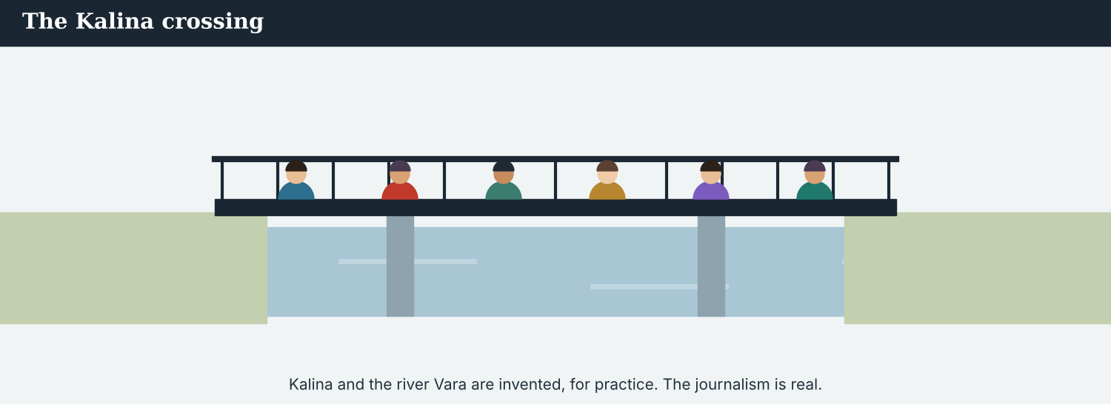
The Kalina crossing — the story this course follows, from the first bulletin to the front page.
English for Journalists
International Edition
Student’s Book
A free press, in plain English.
CEFR A2 → lower B1 · 10 units · the Atlas Wire world desk
A note on real and invented content. The facts about journalism around the world — the press-freedom indexes, the safety figures, the international days, the codes of ethics, the way accreditation and embargoes work — are true, dated and attributed on the page. Atlas Wire, its staff, the town of Kalina, the river Vara, the crossing and the people in the stories are invented, for practice. Real people and real organisations appear only in true, sourced facts — never in an invented quote.

WELCOME About this course
English for Journalists · International Edition is a ten-unit English course for journalists who work across borders. You learn English through the work of Atlas Wire, an invented independent news agency with a world desk in Geneva and correspondents in many countries, and through one continuous story: the reopening of the Kalina crossing — from the morning the barrier went up to the front page that told the year.
The course climbs from CEFR A2 to lower B1. Each unit teaches one new piece of grammar and one part of an international journalist’s work — from the words of the world desk, to interviews through an interpreter, to attribution, to a full front page.
How to use this book
1. Each unit has a Warm-Up and eleven parts: Words, Grammar, a Skill, Listening, Reading, Writing, Speaking, Ethics, Digital, Review, and an Assignment.
2. Every part builds up step by step: you see a model, notice how it works, practise it, and then produce your own.
3. Grammar is taught half as controlled practice and half in your own words. Every part mixes exercises you can check with open tasks to discuss and create.
4. The Ethics part in every unit builds the Code: be accurate, be honest, be fair, be independent, and be kind.
5. The Answer Key at the end of each unit gives the answers to the closed exercises. Open tasks (discussion, role-play, and your own writing) are marked.
The Atlas Wire world desk
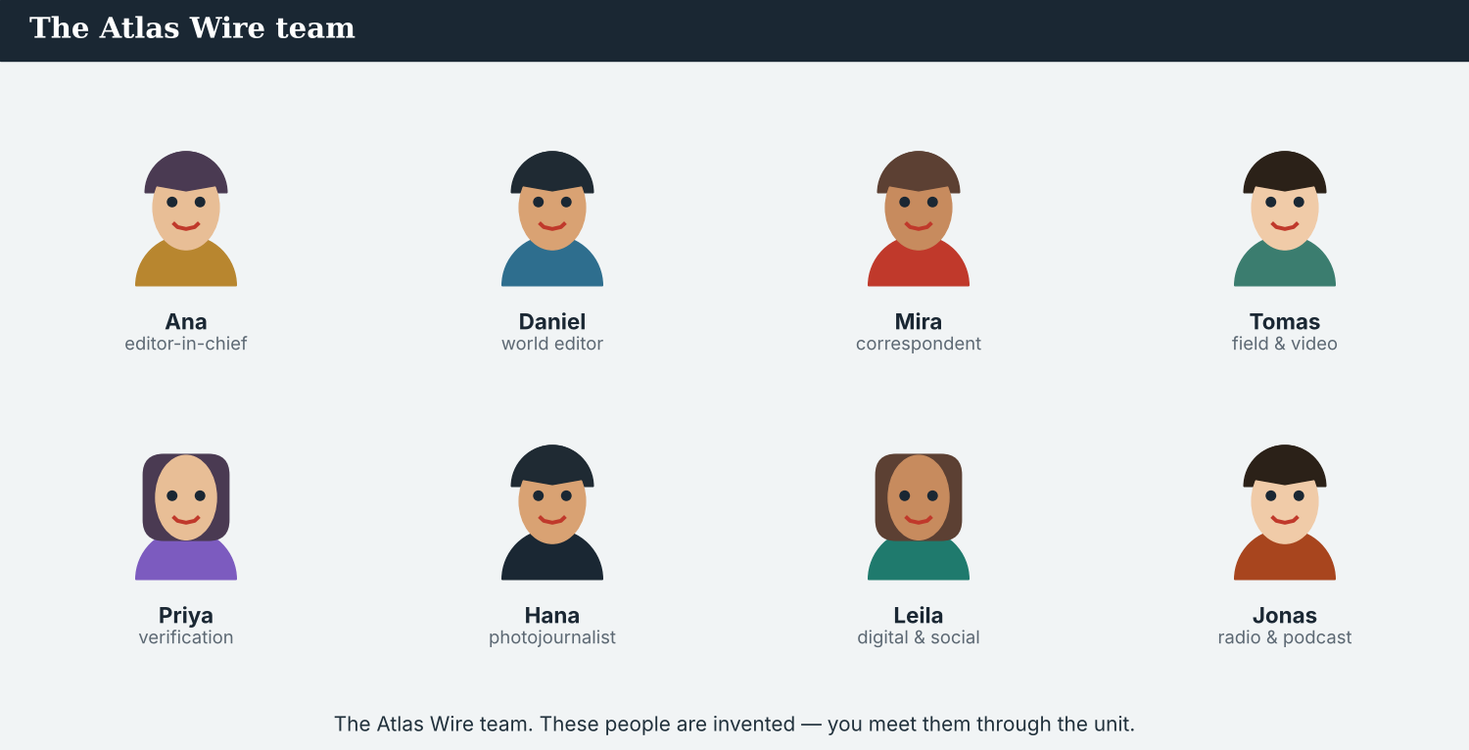
The team you meet in every unit. These people are invented, for practice.

CONTENTS The ten units
Unit 1 The Newsroom  be · present simple · there is/are  Unit 2 What Is News? The Five Ws  wh-questions · adjectives  Unit 3 Live from the Scene  present continuous · going to · prepositions  Unit 4 The Interview  can, could, would · question forms  Unit 5 Getting the Quote Right  reported speech · say/tell · attribution | Unit 6 Telling the Story  past simple · past continuous  Unit 7 What Was Done  the passive  Unit 8 What Has Happened  the present perfect · for/since  Unit 9 What You Should Do  should, must, have to · first conditional  Unit 10 The Front Page  relative clauses · the capstone project
Every unit also has a Warm-Up, eleven parts, ~24 illustrations, and a full Answer Key. The Kalina story runs through all ten.
ENGLISH FOR JOURNALISTS · INTERNATIONAL EDITION · STUDENT’S BOOK
UNIT 1
The Newsroom & the World Media Landscape
Beat · Report & newswriting CEFR A2
In this unit you learn to…
• introduce yourself, your job, and the outlet you work for
• name the people, places, and things of an international newsroom
• use be, the present simple, have got, and there is / there are
• read and talk about press freedom around the world today
• write a short staff bio and an “about our agency” note
Figure 1.1 · The Atlas Wire team. These people are not real. You meet them in every unit.

WARM-UP Mira’s first day
A short story to start the unit. Read it, then answer.
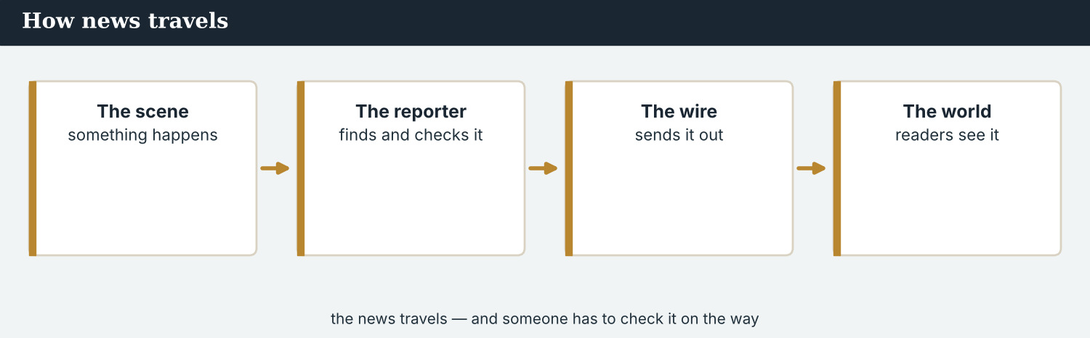
How news reaches people — a journalist finds the news, checks it, and shares it.
W1 Before you read. Talk with a partner.
1. What is a news agency?
2. Do you know a news outlet in another country? Say its name.
Today is Mira’s first day at Atlas Wire. Atlas Wire is a news agency in Geneva. There are eight journalists on the world desk. The editor-in-chief, Ana, welcomes Mira. “Welcome to the desk,” she says.
There is a big story today. The crossing at Kalina is open again, and families are crossing the bridge. “This is your first story, Mira,” says Ana. Mira is happy. She has got a notebook, a press card, and a visa. She is ready.
W2 Read and answer.
1. Where does Mira work?
2. How many journalists are on the world desk?
3. Who is the editor-in-chief?
4. What is the big story today?
W3 Find a word in the text.
1. a company that sends news to many outlets → ______
2. a card that shows you are a journalist → ______
W4 Discuss with a partner.
1. What do you know about the news from other countries? Who reports it?
2. Would you like to work in another country? Why or why not?

PART 1 Newsroom words
The people, places, and things of an international newsroom. Learn these words first.
MODEL The words
Word | Meaning
journalist | a person who finds and reports the news
correspondent | a journalist who reports from another country
stringer | a journalist who sends stories to an outlet, but is not staff
editor | a person who checks and prepares stories
editor-in-chief | the top editor; the head of the newsroom
news agency | a company that sends news to many outlets
wire | the stream of stories an agency sends out
desk | the team that covers one subject (the world desk)
bureau | an agency office in another city or country
dateline | the place and date at the top of a report
beat | the subject a journalist covers
deadline | the time a story must be ready
press card | a card that shows you are a journalist
fixer | a local journalist who helps a visiting team
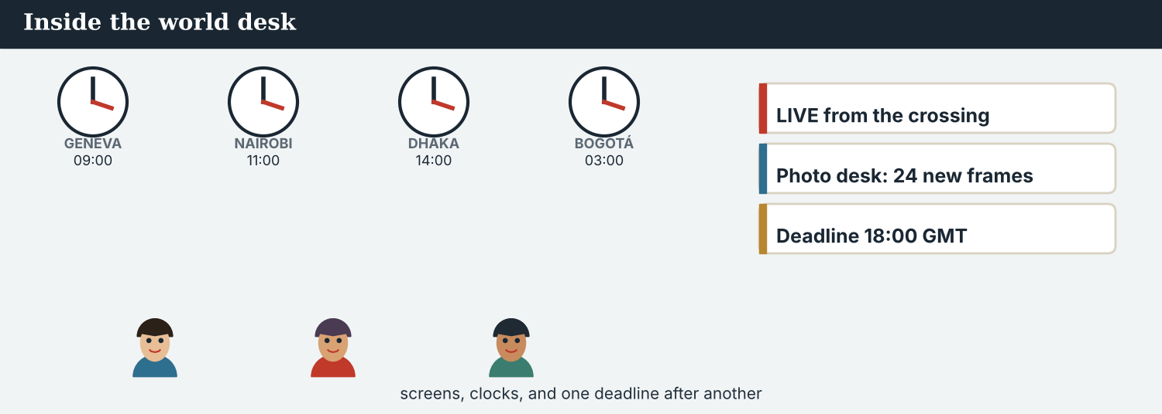
Figure 1.2 · A world desk has screens, a wall of clocks, and one deadline after another.
PRACTISE Controlled practice
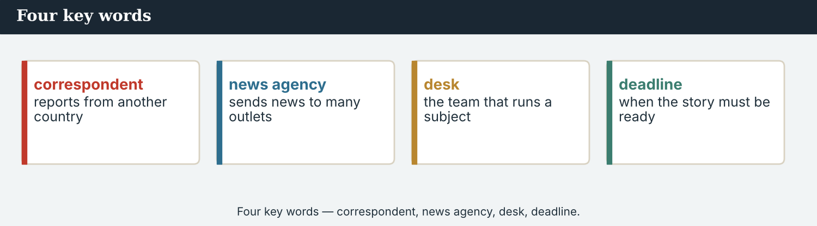
Four key words — correspondent, news agency, desk, deadline.
1A Match the word (1–10) to the meaning (a–j).
1. journalist ______  2. editor-in-chief ______  3. news agency ______  4. dateline ______  5. fixer ______  6. deadline ______  7. bureau ______  8. wire ______  9. correspondent ______  10. beat ______ | a) the place and date at the top of a report  b) a person who reports the news  c) the head of the newsroom  d) a company that sends news to many outlets  e) the time a story must be ready  f) a local journalist who helps a visiting team  g) the stream of stories an agency sends out  h) an agency office in another city or country  i) the subject a journalist covers  j) a journalist who reports from another country
1B Complete the sentences with a word from the box.
WORD BOX
news agency · press card · front page · notebook · editor · camera · visa · media
1. Mira writes an article for a ___________ in Geneva.
2. Hana takes photographs with her ___________.
3. The big story is on the ___________ of the newspaper.
4. A reporter writes notes in a ___________.
5. The ___________ checks the story before it goes out.
6. Your ___________ shows people that you are a journalist.
7. To work in another country you often need a ___________.
8. Newspapers, TV, radio and websites are all part of the ___________.
1C Put the words in the correct group: PEOPLE, PLACES, or THINGS.
WORDS
correspondent · camera · bureau · editor · notebook · press card · fixer · desk · stringer · dateline
People: ________________________ , ________________________ , ________________________ , ________________________
Places: ________________________ , ________________________
Things: ________________________ , ________________________ , ________________________ , ________________________
NOTICE Words that go together
In English, some words go together. We say file a story, take a photo, meet a deadline, check a fact, cover a beat, ask a question. Learn the verb and the noun together.
1D Match the verb to the noun (collocations).
1. file ______  2. take ______  3. meet ______  4. check ______  5. cover ______  6. ask ______ | a) a photo  b) a fact  c) a story  d) a deadline  e) a question  f) a beat
1E Find the word that is different. Circle it.
1. correspondent · editor · camera · stringer
2. bureau · newsroom · desk · deadline
3. dateline · byline · headline · fixer
4. TV · radio · website · notebook
5. visa · camera · notebook · press card
6. wire · bulletin · report · editor
1F Complete the paragraph. Use words from this unit.
Mira is a ___________ at Atlas Wire. She works on the world ___________ with seven other journalists. Every day she files an ___________ about another country. She talks to a ___________ and asks questions. She writes notes in her ___________. The ___________ checks her story. Then it goes out on the ___________. Her ___________ is at six o’clock.
PRODUCE Over to you
1G Answer about you. Write full sentences.
1. Do you read news from other countries every day?
2. What is your favourite news outlet?
3. Do you watch world news on TV, or read it online?
PRODUCE Talk about it
1H Discuss with a partner.
1. Which two words in this unit are new for you? Make a sentence with one of them.
2. Do you know a correspondent or a fixer? What is their job?
1I Creative. Write three sentences about your dream job in an international newsroom. Use I am… , I have got… , and There is… .

PART 2 Grammar in the newsroom
The present. Half the practice is controlled; half is your own words.
MODEL The four structures
1 · the verb be — am / is / are
I am a correspondent. We are journalists.
She is the world editor. They are at the desk.
Negative: She isn’t a photographer. Question: Are you a correspondent?
2 · present simple — daily work and facts
I work for Atlas Wire. He files at six. (he/she/it + -s)
Correspondents report from many countries. She writes the news.
Negative: I don’t work Sundays. Question: Do you work here?
3 · have got — for things you have
I have got a notebook. She has got a press card.
Question: Have you got a visa?
4 · there is / there are
There is a bureau in Nairobi. (one) There are three correspondents. (more than one)
Negative: There isn’t a photographer today. Question: Is there a deadline?
Watch out! With he / she / it, add -s: she files (not she file). Use have got / has got (not haves). Use there is for one, there are for more than one.
Structured practice — half of this part.
NOTICE Which structure is it?
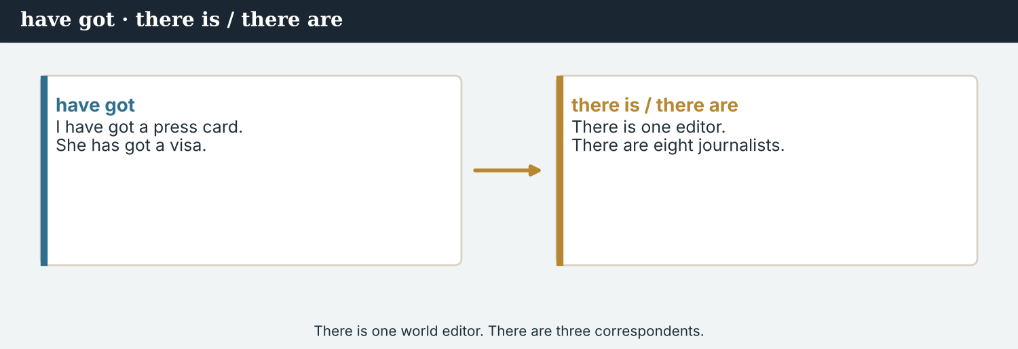
There is one world editor. There are three correspondents.
2A Read each sentence. Write the structure: be / present simple / have got / there is-are.
1. Ana is the editor-in-chief. → ___________
2. Mira files stories from Kalina. → ___________
3. I have got a press card. → ___________
4. There are eight journalists. → ___________
5. We work every day. → ___________
PRACTISE Controlled practice
2B Complete the sentence. Each one uses one of the four structures.
1. Ana ______ the editor-in-chief.
2. Mira ______ (file) stories from abroad.
3. I ______ a press card.
4. ______ three bureaux in the agency.
5. Tomas and Hana ______ in the field.
6. The desk ______ (have) ten computers.
7. ______ a deadline today?
8. We ______ (report) the news every day.
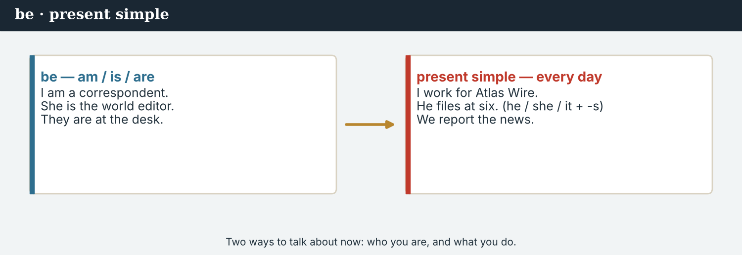
Mira is a correspondent. She works for Atlas Wire. She has got a notebook, a press card, and a visa.
2C Each sentence has one mistake. Write it correctly.
1. She file the story. → ________________________
2. There is three correspondents. → ________________________
3. I has got a visa. → ________________________
4. We is a good team. → ________________________
5. Hana take photographs. → ________________________
Your own words — the other half. Use the grammar to talk and write about you.
PRODUCE Make it true for you
2D Write four true sentences about YOU — one of each structure.
(be) I am ___________ .
(present simple) Every day I ___________ .
(have got) I have got ___________ .
(there is/are) In my city there is / are ___________ .
PRODUCE Ask a partner
2E Ask and answer with a partner. Use full sentences.
1. Are you a student? Are you a journalist?
2. Have you got a phone? What have you got in your bag?
3. Is there a news agency in your country? What is there in your newsroom?
4. Do you read world news? When do you read it?
PRODUCE Write about a newsroom
2F Write 4–5 sentences about a newsroom or an agency (real or invented). Use all four structures. Start like this:
My newsroom is ____ . There is / are ____ . The team has got ____ . Every day the correspondents ____ . I am ____ .

PART 3 Skill focus: who’s who, and the front page
Different jobs, different beats, and one shared front page.
MODEL Who does what
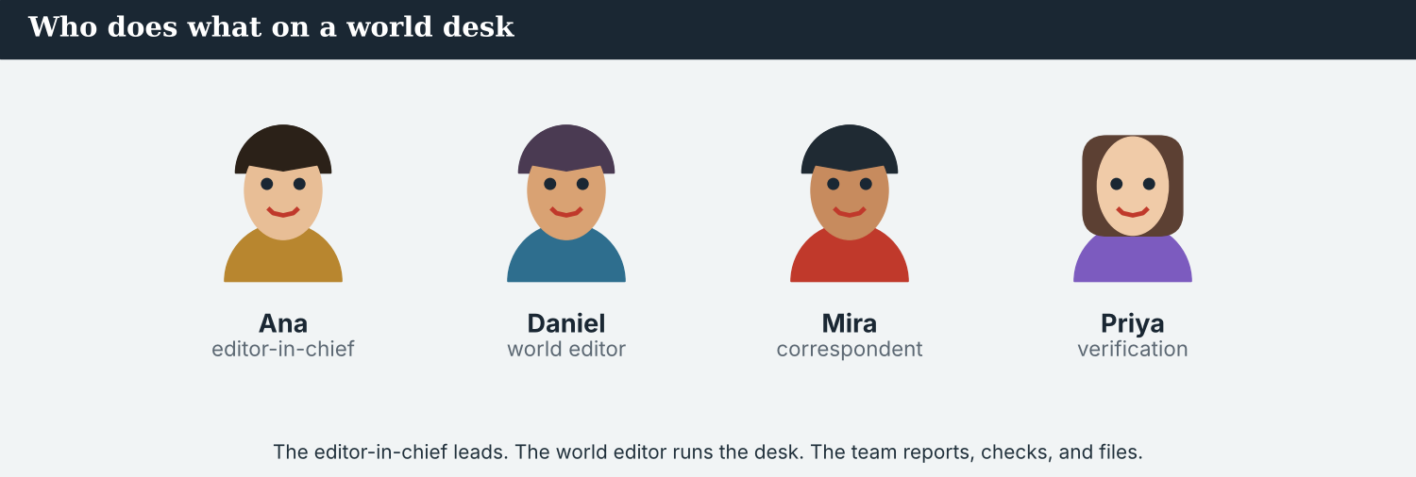
Figure 1.3 · The editor-in-chief leads. The world editor runs the desk. The team reports, checks, and files.
The editor-in-chief leads the agency and makes the big decisions.
The world editor chooses the stories and runs the desk.
A correspondent reports from another country, talks to sources, and writes.
A field reporter goes to the place and reports from there, with video.
A verification journalist checks that every fact and every picture is true.
A photojournalist takes the photographs.
A digital editor puts the news online and on social media.
PRACTISE Controlled practice
3A Match the job (1–7) to what the person does (a–g).
1. editor-in-chief ______  2. world editor ______  3. correspondent ______  4. field reporter ______  5. verification journalist ______  6. photojournalist ______  7. digital editor ______ | a) takes the photographs  b) leads the whole agency  c) checks that the facts and pictures are true  d) chooses the stories and runs the desk  e) puts the news online  f) reports from another country and writes  g) reports from the place of the event, with video
3B Read about the team. Answer with a name.
Ana is the editor-in-chief. Daniel is the world editor; he chooses the stories. Mira is a correspondent and her beat is the region around Kalina. Tomas reports from the field with a camera. Priya checks all the facts. Hana is the photojournalist. Leila puts the news on the website.
1. Who leads the agency? ___________
2. Who checks the facts? ___________
3. Who takes the photographs? ___________
4. Who works online? ___________
5. Who chooses the stories? ___________
6. Whose beat is the region around Kalina? ___________
MODEL The beats — the sections of the news
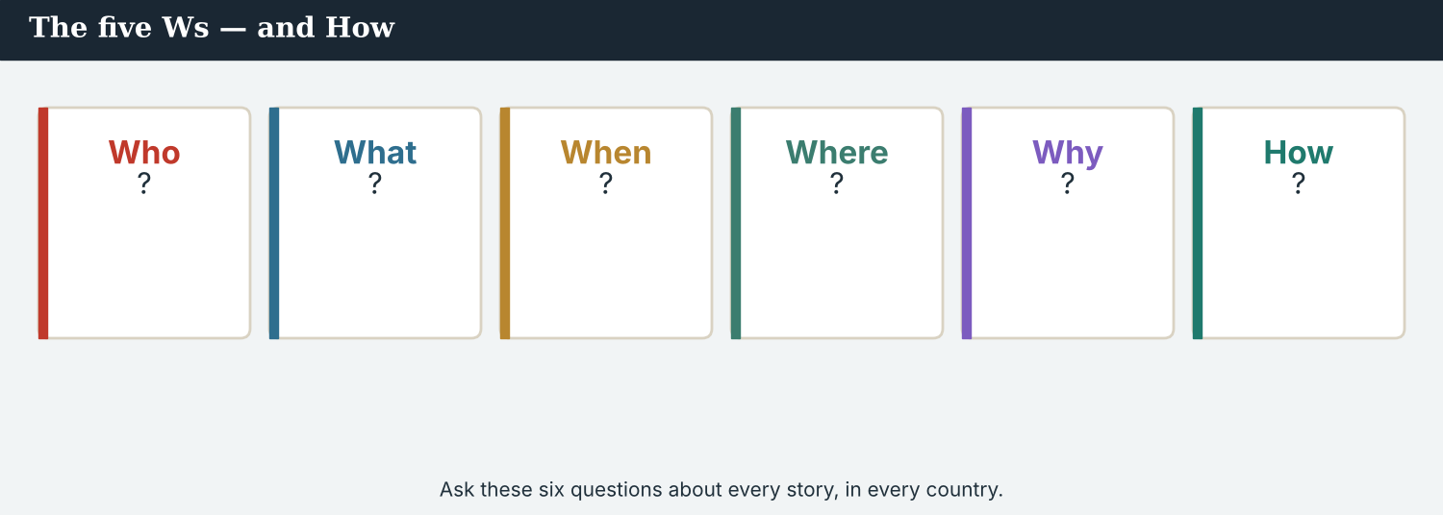
Figure 1.4b · The beats of an international newsroom — politics, economy, climate, health, conflict, culture.
COMMON BEATS
politics · economy · climate · world news · conflict & security · health · culture · technology
3C Which beat is it? Write the beat next to the story.
1. “Two governments sign an agreement on the river” → ___________
2. “Food prices rise in three countries this month” → ___________
3. “A new clinic opens for families at the crossing” → ___________
4. “The summit agrees new targets for 2030” → ___________
5. “A festival of music on both sides of the river” → ___________
6. “A new phone network reaches the valley” → ___________
MODEL The front page
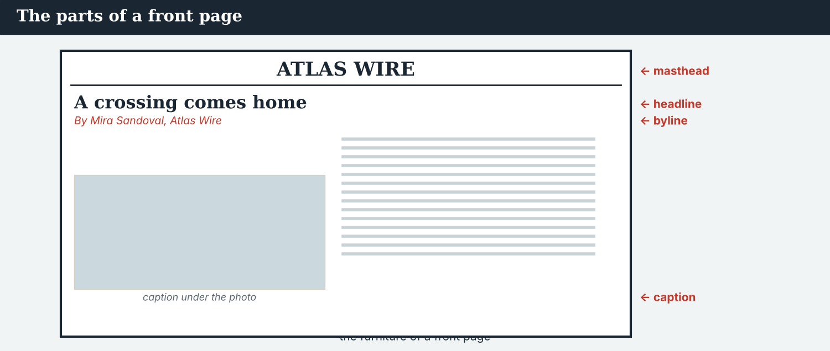
Figure 1.4 · masthead (name) · headline (title) · byline (who wrote it) · dateline (place and date) · caption (under the photo).
PRACTISE Label it
3D Label the front page. Write: masthead · headline · byline · dateline · photo · caption.
1. the name of the newspaper at the top → ___________
2. the big title of the main story → ___________
3. the name of the journalist → ___________
4. the place and date at the start of the report → ___________
5. the picture → ___________
6. the words under the picture → ___________
PRODUCE Apply it
3E Plan a front page for today. Write a headline, a byline and a one-line caption for the Kalina story.
Headline: ________________________
Byline: By ________________________
Caption: ________________________
PRODUCE Discuss
3F Talk with a partner.
1. Which job in an international newsroom is the most interesting for you? Why?
2. Which job is the most difficult? Why?
PRACTISE The sections
3G Which section of the news? Write: climate · politics · health · culture.
1. A summit on rising seas → ___________
2. Two governments sign an agreement → ___________
3. A new clinic opens → ___________
4. A music festival → ___________

PART 4 Listen & view
Two listenings. Do the tasks for each.
Listening A · the morning conference
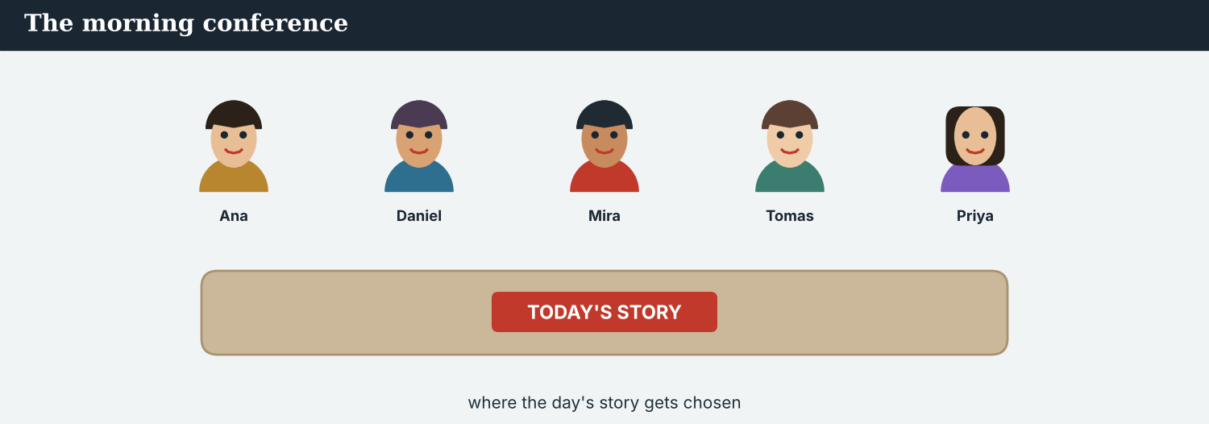
Figure 1.5 · Audio 1.1 — The morning conference at Atlas Wire.
NOTICE Before you listen
4A You will hear the morning conference. Tick who you think speaks: Ana · Daniel · Mira · Tomas · Priya · Hana · Leila · Jonas.
Ana: Good morning, everyone. Welcome to the conference. We have got a lot of news today.
Daniel: Good morning. I am Daniel, the world editor. We have got three big stories.
Ana: What is the main story?
Daniel: The crossing at Kalina. It is open again.
Mira: Hello. I am Mira. My beat is that region. I have got the crossing story. Families are crossing.
Tomas: I am Tomas. I am in the field today. There is a market on the bridge, too.
Priya: I am Priya. I check the facts. Mira, is your story ready?
Mira: Not yet. I have got two sources, but I need one more.
Ana: Good. Hana, have you got the photographs?
Hana: Yes. I have got ten photographs from this morning.
Leila: And I am Leila. I put the top story online at twelve o’clock.
Jonas: I am Jonas. I read the world bulletin on the radio at one o’clock.
Ana: Perfect. We are a good team. Let’s start.
PRACTISE Listen for detail
4B Who says it? Write the name.
1. “I check the facts.” ___________
2. “I am in the field today.” ___________
3. “I put the top story online.” ___________
4. “We have got three big stories.” ___________
5. “I have got ten photographs.” ___________
6. “Welcome to the conference.” ___________
4C True or False? Write T or F.
1. Daniel is the world editor. ______
2. Mira’s beat is sport. ______
3. Tomas is in the newsroom today. ______
4. Mira’s story is ready. ______
5. Hana has got ten photographs. ______
6. Leila works online. ______
7. Priya is a photographer. ______
8. The team has got a lot of news today. ______
4D Complete the notes.
Big stories today: ______
Mira’s beat: ___________
Mira’s sources so far: ______ (needs one more)
Hana’s photographs: ______
Story goes online at: ___________
Listening B · a phone call
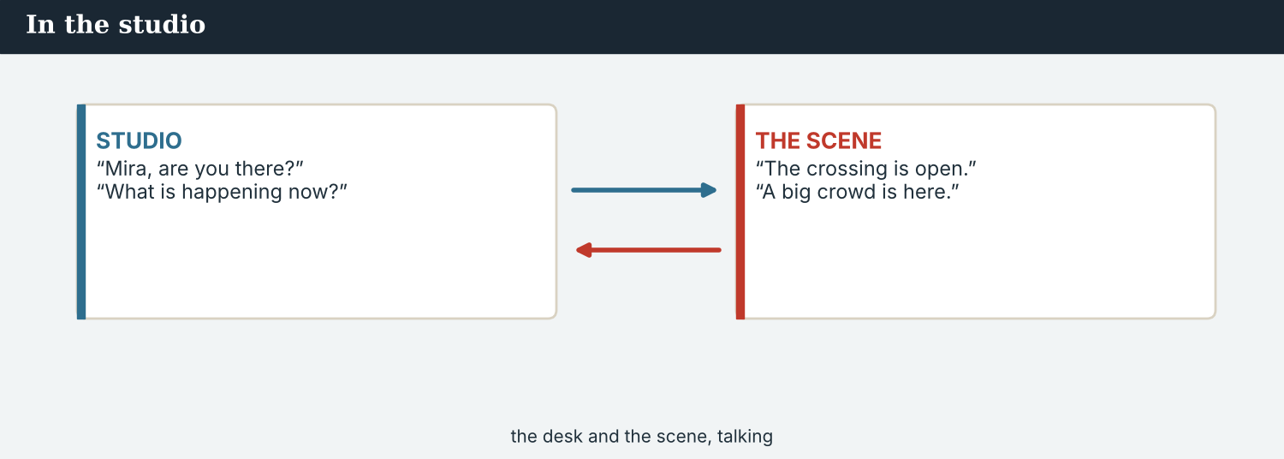
Figure 1.6 · Audio 1.2 — Tomas calls the desk from the Kalina crossing.
NOTICE Before you listen
4E Tomas calls Daniel from the crossing. What do you think he says? Tick: (a) there are many people (b) the crossing is closed (c) he has got photographs.
Tomas: Hello, Daniel. This is Tomas. I am at the crossing at Kalina.
Daniel: Hi, Tomas. What is the news?
Tomas: The crossing is open. There are many people here. Families are crossing.
Daniel: That is great. Have you got photographs?
Tomas: Yes, I have got ten photographs. And I have got a short video.
Daniel: Good. Is Mira there?
Tomas: Yes, she is here. She is with a stall-holder.
Daniel: Who is the stall-holder?
Tomas: His name is Bekim. He sells fruit and vegetables on the bridge.
Daniel: Perfect. Send the photographs now, please. The deadline is at six.
Tomas: OK. I send them now. Thank you, Daniel.
PRACTISE Listen for detail
4F Complete the sentences.
1. Tomas is at the ___________ at Kalina.
2. The crossing is ___________.
3. There are many ___________ there.
4. Tomas has got ten ___________ and a short ___________.
5. Mira is with a ___________.
4G True or False? Write T or F.
1. Tomas is in the newsroom. ______
2. The crossing is open. ______
3. Tomas has got no photographs. ______
4. Mira is at the crossing too. ______
4H Answer.
1. Where is Tomas?
2. What does Daniel ask Tomas to do?
PRODUCE What do you think?
4I Discuss.
1. Is a morning conference a good idea for a world desk? Why?
2. A reporter calls the desk from another country. Why is this important?
PRACTISE Both listenings
4J Complete the summary of the two audios.
In the conference, the team chooses the main ______ : the ______ at Kalina. Mira has the story, but she needs one more ______ . Then Tomas calls from the ______ . He has got ten ______ . The stall-holder, ______ , sells fruit and vegetables.

PART 5 Read the story
Two readings. Reading A is a true report about the world’s press. Reading B is a staff profile.
Reading A · factual · current
NOTICE Before you read
5A Talk with a partner.
1. How do you get news from other countries: TV, radio, or online?
2. Do you know any international news agencies?
3. What makes a good correspondent? Say one thing.
A free press, around the world
Journalism crosses borders. A story that starts in one country is read in fifty. This is big news for journalists, and for everyone.
Every year, Reporters Without Borders publishes the World Press Freedom Index. It ranks 180 countries and territories. Some countries rise; some countries fall. The Index does not say that one country is good and another is bad. It asks a simpler question: can a journalist do the work, and is the journalist safe?
In many places, the answer is still no. Every year on 1 December, the Committee to Protect Journalists counts the journalists who are in prison for their work. In recent years, that number has been more than three hundred. UNESCO reports that when a journalist is killed, nobody is punished in about nine of every ten cases.
There is also good news. In 1991, journalists met in Windhoek and wrote a declaration for a free press. In 1993, the United Nations named 3 May World Press Freedom Day. In 2012, the United Nations agreed a Plan of Action on the Safety of Journalists. And 2 November is now the International Day to End Impunity for Crimes against Journalists.
Journalists also work together. Reporters in many countries share documents and check each other’s facts. One story, forty newsrooms, one deadline: this is normal now.
The work is the same in every language. Find the story. Check the facts. Name the source. Be fair, and be kind. A free press is not a building. It is a habit — and journalists keep it, together.
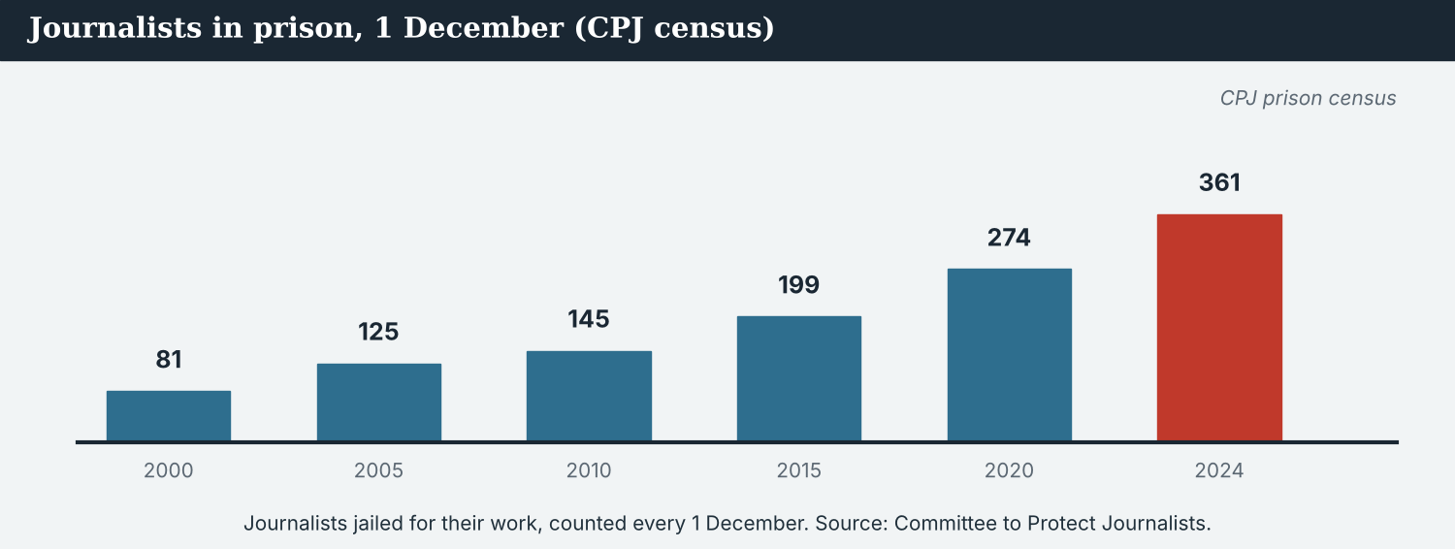
Figure 1.7 · Journalists in prison for their work, counted every 1 December. Source: Committee to Protect Journalists.
PRACTISE Comprehension
5B True or False? Write T or F.
1. The World Press Freedom Index ranks 180 countries and territories. ______
2. Reporters Without Borders publishes the Index. ______
3. The CPJ counts journalists in prison on 1 May. ______
4. World Press Freedom Day is 3 May. ______
5. The UN Plan of Action is from 2012. ______
6. There are no problems for journalists now. ______
5C Answer the questions.
1. Who publishes the World Press Freedom Index?
2. How many countries and territories does it rank?
3. What does the CPJ count every 1 December?
4. What happens on 3 May, and what happens on 2 November?
5. Name two things a journalist must do, in any language.
5D Find a word in the text with the same meaning.
1. not in danger → ___________
2. a line between two countries → ___________
3. a thing you do again and again → ___________
Reading B · a staff profile
NOTICE Before you read
5E This is a profile page from the Atlas Wire website. What information do you think a profile shows?
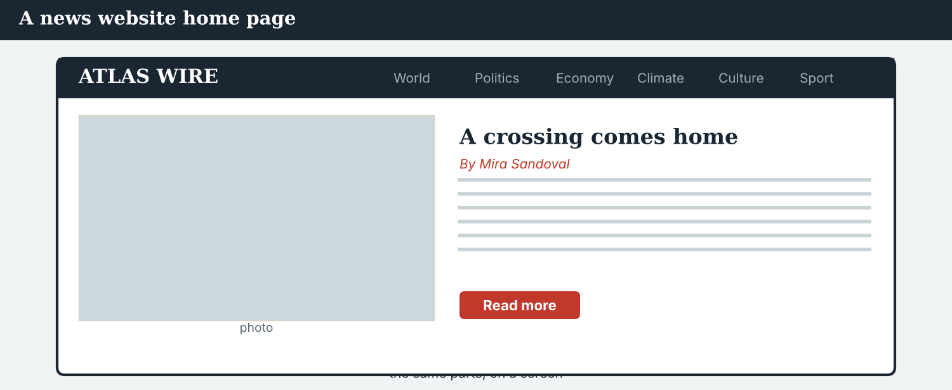
Figure 1.8 · A staff profile page on the Atlas Wire website.
Meet the team: Mira Sandoval
Name: Mira Sandoval · Job: Correspondent · Agency: Atlas Wire, Geneva · Beat: the region around Kalina
About: Mira is a correspondent at Atlas Wire. She is from Montevideo, and she speaks three languages. She writes about the valley at Kalina — the crossing, the market, the families, and daily life. Every morning she reads the wire. Then she goes out to find her own stories. She has got a notebook, a press card, and a small camera. She is not a photographer, but she takes simple photographs for her stories. Her first big story is the reopening of the crossing.
Quick questions
Q: Why are you a journalist? A: Because somebody has to go and look.
Q: What is a good day at work? A: A true story and a happy source.
Q: What is hard about your job? A: The deadline! There is never enough time.
PRACTISE Comprehension
5F Answer about Mira.
1. What is her job? ___________
2. Where is she from? ___________
3. What is her beat? ___________
4. What three things has she got? ___________
5. What is her first big story? ___________
5G Compare the two texts. Answer.
1. Reading A is about the whole world. Reading B is about one ___________ .
2. Which text has a quote (words a person says)?
PRODUCE Talk about it
5H Discuss in small groups.
1. Why is a free press good for a country?
2. The work is “find the story, check the facts, name the source, be fair, be kind”. Which is most important? Why?
PRODUCE Discuss
5I Talk about Reading B.
1. What questions would you ask Mira about her job?
2. What is a good day at work for you? Why?
PRACTISE Words from the readings
5J Find a word in Reading A or Reading B.
1. not in danger → ___________
2. a person who reports from another country → ___________
3. the time a story must be ready → ___________
4. a line between two countries → ___________

PART 6 Write it
Two writing pieces. Each has a model, a plan, and a checklist.
Writing 1 · a staff bio
MODEL Study the model
MODEL · A STAFF BIO
Mira Sandoval is a correspondent at Atlas Wire. She is from Montevideo. Her beat is the region around Kalina. She writes stories about the crossing and the people who use it. She has got a notebook and a press card. She is not a photographer.
NOTICE Notice how it works
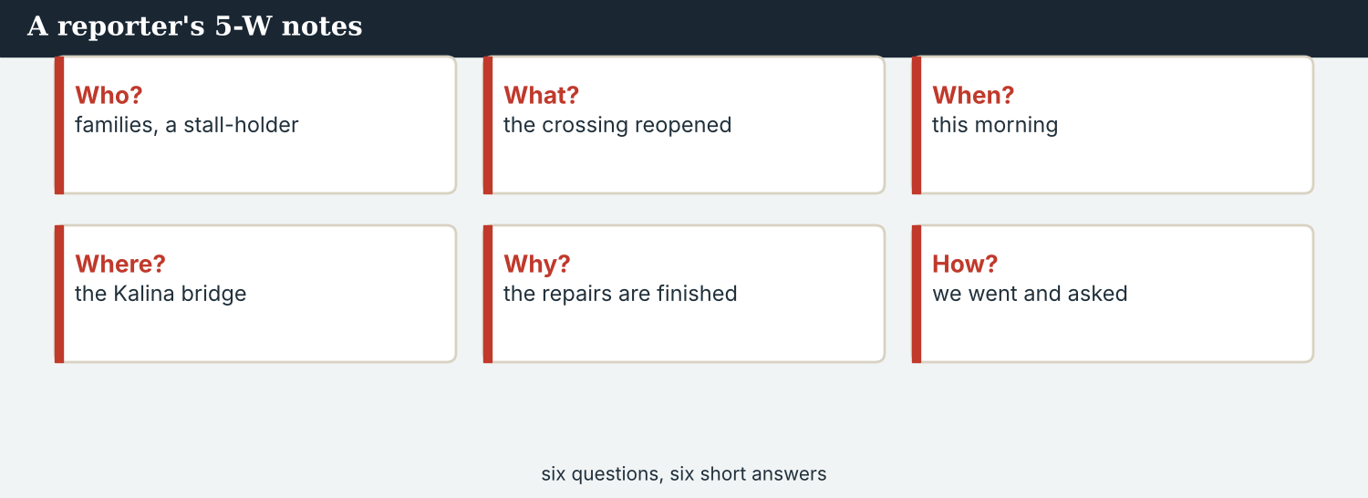
A reporter’s 5-W notes.
6A Answer about the model.
1. What is Mira’s job? ___________
2. What two things has she got? ___________
3. Which sentence uses has got? ________________________
PRACTISE Controlled practice
6B Complete the bio of Tomas. Use: is · from · reports · takes · has got · works.
Tomas Varga ______ a field reporter at Atlas Wire. He is ______ Bratislava. He ______ from the field with a camera. He ______ video and photographs. He ______ a camera and a microphone. He ______ with the world editor, Daniel.
PRODUCE Write your own
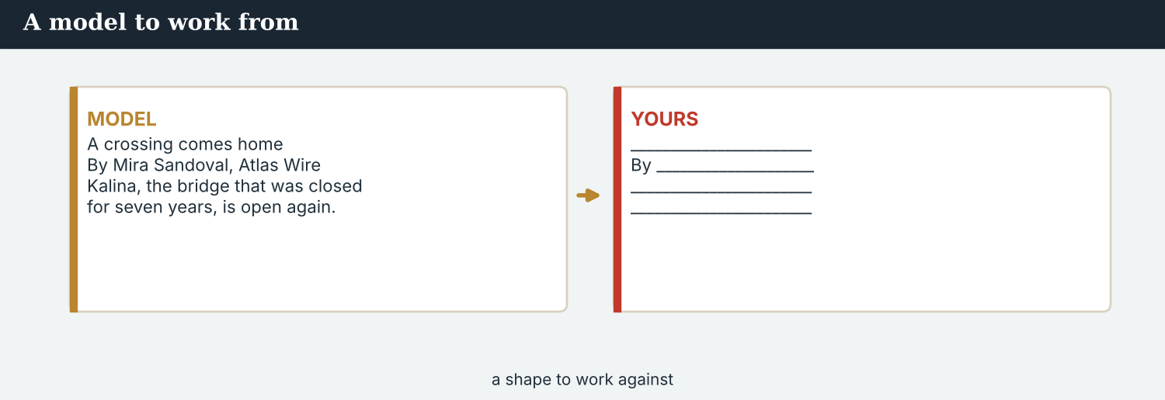
A model staff bio.
6C Write your own bio (4–6 sentences). Plan first, then write.
Plan: name · job (or dream job) · where you are from · your beat · one thing you have got.
Checklist:
☐ I use am / is / are correctly.
☐ I use the present simple (with -s for he/she).
☐ I use have got / has got at least once.
☐ My sentences are true and clear.
Writing 2 · an “about our agency” note
MODEL Study the model
MODEL · AN “ABOUT OUR AGENCY” NOTE
Atlas Wire is a news agency in Geneva. It has got eight journalists on the world desk, and bureaux in four countries. There is a world desk, a photo team, and a digital team. Atlas Wire reports world news for outlets in many countries. Our rules are simple: we are accurate, we are honest, and we are fair.
NOTICE Notice how it works
6D Answer about the model.
1. How many journalists has the agency got on the world desk? ___________
2. Which three teams are there? ________________________
3. What are the three rules? ________________________
PRODUCE Write the note
6E Write an “about our agency” note (5–7 sentences) for a real or an invented outlet.
Sentence starters: ____ is a news outlet in ____ . · It has got ____ journalists. · There is/are ____ . · We report ____ . · Our rules are simple: ____ .
Checklist:
☐ I use there is / there are and has got.
☐ I end with three rules from the Code.
☐ Then swap with a partner and check each other’s note.
PRACTISE Fix the bio
6F This bio has two mistakes. Write it correctly.
“Hana are a photojournalist. She take photographs for Atlas Wire.”
________________________

PART 7 In the field: introduce yourself
Meet people, introduce yourself, and practise from your own role.
MODEL A model dialogue
Mira: Hello. I am Mira, from Atlas Wire.
Omar: Nice to meet you, Mira. I am Omar, from the Meridian Post.
Mira: Are you a correspondent?
Omar: Yes, I am. I cover the economy. And you?
Mira: I am a correspondent, too. My beat is the Kalina valley.
Omar: Have you got a card?
Mira: Yes. Here you are.
The Meridian Post is an invented international outlet. Omar is not a real person.
NOTICE Notice the language
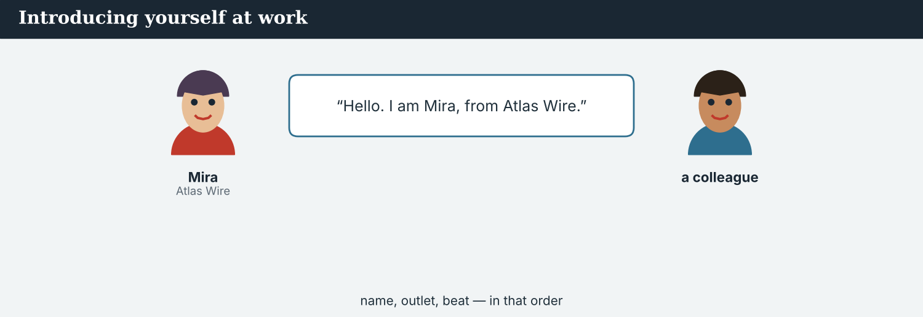
Introducing yourself at work.
7A Read the dialogue. Answer.
1. Where is Omar from? ___________
2. What is Omar’s beat? ___________
3. What is Mira’s beat? ___________
7B Complete the useful phrases.
Hello. I ______ [name], from [outlet].
Nice to ______ you.
I ______ a correspondent. My beat ______ [beat].
______ you got a press card?
PRACTISE Controlled practice
7C Make three new introductions. Swap the name, outlet and beat each time.
1 Sara · Radio Vara · climate 2 Omar · the Meridian Post · politics 3 (you) · (your outlet) · (your beat)
PRODUCE Your role
Everyone learns the same core language. Now practise it from your own job. Choose your role and introduce yourself that way.
Editor-in-Chief | Welcome the team and say the agency’s mission.
World Editor | Introduce the desk and the day’s top stories.
Correspondent | Introduce yourself and the country or region you cover.
Field & Video | Say where you are reporting from and what you have got.
Verification | Explain what you check and how.
Photojournalist | Describe your kit and today’s assignment.
Digital & Social | Describe your platforms and your audience.
Radio / Podcast | Open the world bulletin and introduce a guest.
7D Pair work. You are at a press briefing. Introduce yourself to a partner from your role. Then swap.
7E Find someone who… Ask your classmates. Write a name for each.
1. …reads world news every day. Name: ___________
2. …has got a favourite correspondent. Name: ___________
3. …watches the news on TV. Name: ___________
4. …is interested in climate news. Name: ___________
5. …listens to the radio. Name: ___________
6. …follows a news agency online. Name: ___________
CHECK Check yourself
When I speak, I can… | Yes | Almost | Not yet
say my name, outlet, job and beat | ☐ | ☐ | ☐
ask a simple question (Are you…? Have you got…?) | ☐ | ☐ | ☐
answer about my work | ☐ | ☐ | ☐
A second situation · at a press briefing
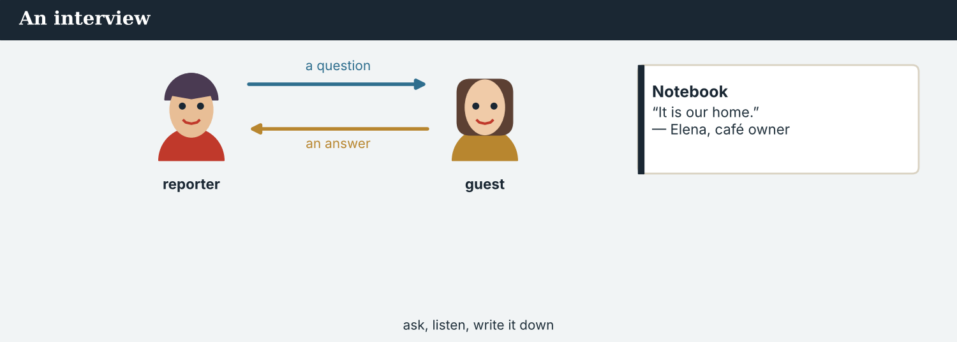
Figure 1.10 · At a press briefing — Ana meets a guest with a story.
MODEL A model dialogue
Ana: Good evening. I am Ana Ferreira, the editor-in-chief of Atlas Wire.
Guest: Nice to meet you. I am from a school near the crossing at Kalina.
Ana: Welcome. What is your news?
Guest: Our school is open again. Two hundred children are back.
Ana: That is a wonderful story. Can my correspondent call you?
Guest: Yes, of course. Here is my card.
PRODUCE Your turn
7F Role-play. One of you is a journalist; one is a guest with news. Introduce yourselves and share one piece of news. Then swap.
7G Discuss. Is it easy or hard to introduce yourself in English? What helps you?

PART 8 Ethics & the Code
Good English is not enough. A good journalist follows the rules of the job.
MODEL A case, and the Code
A case. Mira is at the crossing at Kalina. She writes a good story about the market on the bridge. An official is very happy with the story. “Your story is beautiful,” he says. “Please write only good things about the crossing. Here — we will pay for your flight and your hotel next time.” He puts an envelope in her hand. Mira likes the official, and the agency has little money. But she is a journalist. She knows the Code: a journalist is independent, and does not take money to change a story. What does Mira do? What does she say to the official?
Accuracy — The facts are correct.  Honesty — You tell the truth. | Fairness — You give more than one side.  Respect — You treat people well.
A fifth idea — independence — means no one controls your news. These ideas appear in codes of ethics all over the world, among them the IFJ Global Charter of Ethics for Journalists (2019).
PRACTISE Understand the values
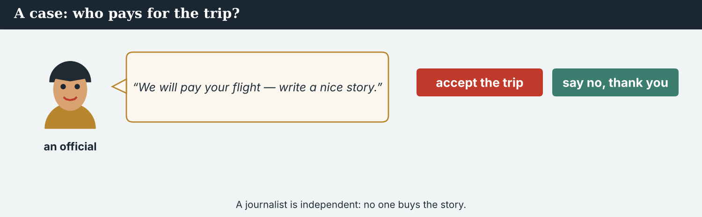
A case — an official offers a paid trip; a journalist stays independent.
8A Match the value (1–5) to its meaning (a–e).
1. Accuracy ______  2. Honesty ______  3. Fairness ______  4. Respect ______  5. Independence ______ | a) you tell the truth  b) the facts are correct  c) you give more than one side  d) you treat people well  e) no one controls your news
8B Good or not good? Write GOOD or NOT GOOD.
1. A journalist checks the facts. ___________
2. A journalist invents a quote. ___________
3. A journalist tells the truth. ___________
4. A journalist takes money to change a story. ___________
5. A journalist respects people. ___________
6. A journalist copies another reporter’s work. ___________
7. A journalist gives two sides of a story. ___________
8. A journalist shares a rumour as news. ___________
NOTICE Decide — what would you do?
8C Read each situation. Choose (a) or (b), and write one reason.
1. An official offers to pay for your flight and hotel. (a) accept it (b) say “no, thank you”. Choice: ______ Because ________________________
2. You are not sure a fact is true. (a) file it now (b) check it first. Choice: ______ Because ________________________
3. A family says “please do not use our photograph”. (a) use it (b) respect the family. Choice: ______ Because ________________________
PRACTISE Apply the Code
8D Complete Atlas Wire’s code. Use: accurate · honest · fair · respect · independent.
1. We are ______. Our facts are correct.
2. We are ______. We tell the truth.
3. We are ______. We give more than one side.
4. We ______ people.
5. We are ______. No one controls our news.
PRODUCE Talk about it
8E Discuss.
1. In the case above, what should Mira say to the official?
2. Why is “independence” important for a free press?
PRODUCE Write it
8F Write what Mira says to the official (2–3 sentences). Be polite, but say no.
A second case · a photograph and a family
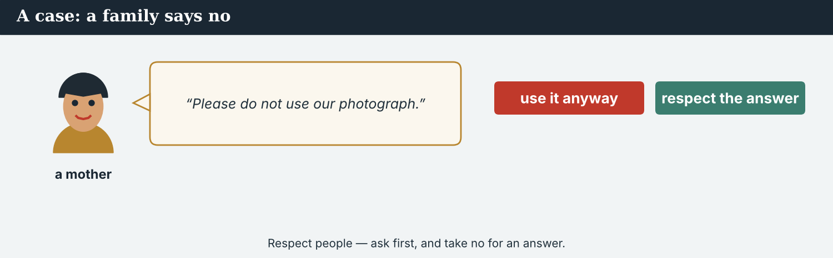
Figure 1.11 · A family asks Tomas not to use their photograph.
A case. Tomas takes a photograph at the crossing. In the photograph there is a family: a mother, a father, and two children. The photograph is very good. But the mother sees Tomas. “Please do not use our photograph,” she says. “We do not want to be in the news.” Tomas needs a picture for the story. The photograph is good, and the deadline is soon. But the family says no. The Code says: respect people. What does Tomas do?
NOTICE What do you do?
8G Choose (a) or (b), and write one reason.
1. (a) use the photograph (b) do not use the photograph. Choice: ______ Because ________________________
2. Next time, what does Tomas do first? (a) take the photograph, then ask (b) ask the family first. Choice: ______
PRODUCE Discuss
8H Discuss. Is it more important to get the story, or to respect people? Why?

PART 9 The digital angle: your profile online
Most news is online. Learn the parts of a news website, then build your own profile.
MODEL A news website
Figure 1.9 · A news website home page. Label the six parts in 9A.
PRACTISE Label it
9A Label the website. Write the number (1–6) next to the word.
1. logo (the name) ______  2. menu (the sections) ______  3. headline ______ | a) byline ______  b) photo ______  c) “Read more” link ______
NOTICE Notice the parts
9B Answer.
1. Which part shows the writer? ___________
2. Which part shows the sections? ___________
3. Which part is the title of the story? ___________
4. Which part opens the full story? ___________
PRACTISE Build and fix
9C Complete your online profile.
Name: ________________________
Role: ________________________
Outlet: ________________________
Beat (country or subject): ________________________
City: ________________________
9D This bio has four mistakes. Write it correctly.
Sara are a correspondent. She have got a camera. She write world news. There is many stories in her region.
________________________ ________________________
PRODUCE Publish
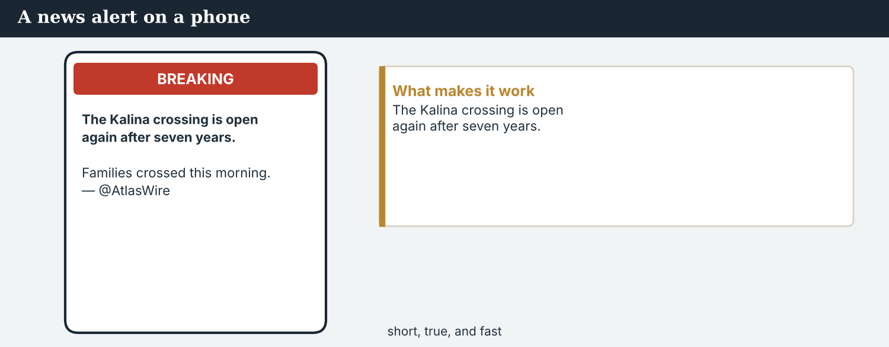
A news alert on a phone — short, true, and fast.
9E Write a one-line bio (10–15 words). Example: “Mira Sandoval is a correspondent at Atlas Wire in Geneva.”
9F Write a short social post (1–2 sentences) about your first day in a newsroom. Use the present simple.
Checklist: a clear sentence · correct present simple · true or clearly invented.
PRODUCE Discuss
9G Talk with a partner.
1. Do you follow any correspondents or agencies online? Which ones?
2. Is online news good or bad for a free press? Say one reason.
9H Creative. Write a short headline (4–6 words) for the Kalina story.

PART 10 Review & Can-Do
Check your new English before you move to Unit 2.
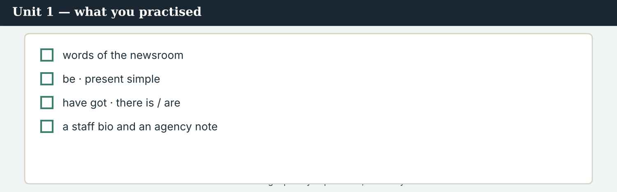
Unit 1 — the eight skills you practised, one story.
10A Vocabulary. Complete with a word from the box.
WORD BOX
headline · fixer · caption · deadline · bureau · beat · wire · editor · press card · byline
1. The ___________ is the big title of a story.
2. A ___________ is a local journalist who helps a visiting team.
3. The words under a photo are the ___________.
4. The ___________ is the time a story must be ready.
5. An agency office in another country is a ___________.
6. The subject you cover is your ___________.
7. The stream of stories an agency sends out is the ___________.
8. The ___________ checks and prepares stories.
9. Your ___________ shows you are a journalist.
10. The name of the writer is the ___________.
10B Grammar. Circle the correct word.
1. She (is / are) a correspondent.
2. They (work / works) at Atlas Wire.
3. He (take / takes) photographs.
4. I (have got / has got) a visa.
5. Priya (have got / has got) a notebook.
6. (There is / There are) three bureaux.
7. (There is / There are) a clock on the wall.
8. We (am / are) a good team.
9. Does she (file / files) the story?
10. (Do / Does) you read world news?
11. The desk (have got / has got) two screens.
12. Tomas (is / are) in the field.
10C Complete the paragraph. Use the words in the box.
WORD BOX
am · work · is · file · has got · There are · take · reports · have got · are
My name is Sara. I ______ (1) a journalist. I ______ (2) at a small agency in Nairobi. My beat ______ (3) climate. I ______ (4) stories about my region. My agency ______ (5) six journalists. ___________ (6) two photographers on the team. They ______ (7) photographs every day. My colleague Tomas ______ (8) from the field. My team and I ______ (9) a lot of news. We ______ (10) a good team.
10D Quick recall. Answer from this unit.
1. How many countries and territories does the World Press Freedom Index rank?
2. Name three of the values in the Code.
3. Say one part of a front page.
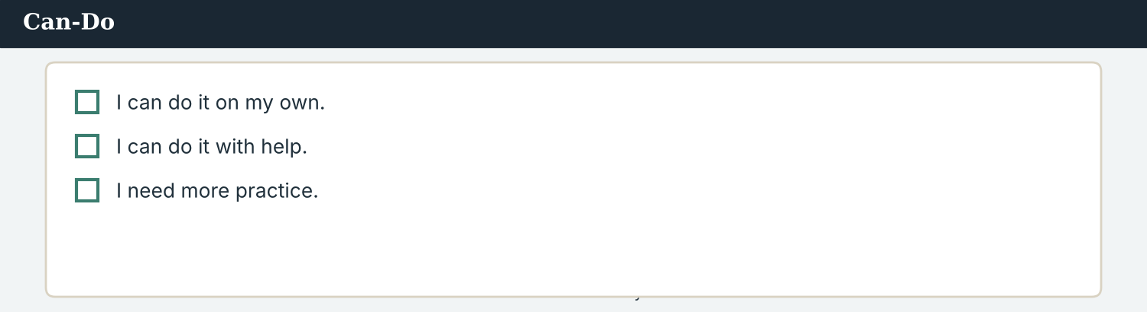
Can-Do — what you can do now.
Can-Do — tick what you can do now
☐ I can introduce myself, my job, and the outlet I work for.
☐ I can name the people, places, and things of an international newsroom.
☐ I can use am / is / are correctly.
☐ I can use the present simple to say what people do.
☐ I can use have got and there is / there are.
☐ I can understand two texts about the world’s press and a newsroom.
☐ I can write a short staff bio and an agency note.
☐ I can name the key ideas of the Code.
10E Reflect. Answer for yourself.
1. What is the most useful word you learned in this unit?
2. What do you want to practise more?
10F Read and answer.
Priya is a verification journalist at Atlas Wire. She has got a computer and a phone. She checks every fact and every picture. There are many stories today, and she is busy.
1. What is Priya’s job? ___________
2. What has she got? ___________
3. What does she check? ___________
10G Grammar review. Write the sentence correctly.
1. There is three correspondents. → ________________________
2. She have got a camera. → ________________________
3. Tomas take photographs. → ________________________
4. We is a team. → ________________________

PART 11 Assignment: an outlet profile
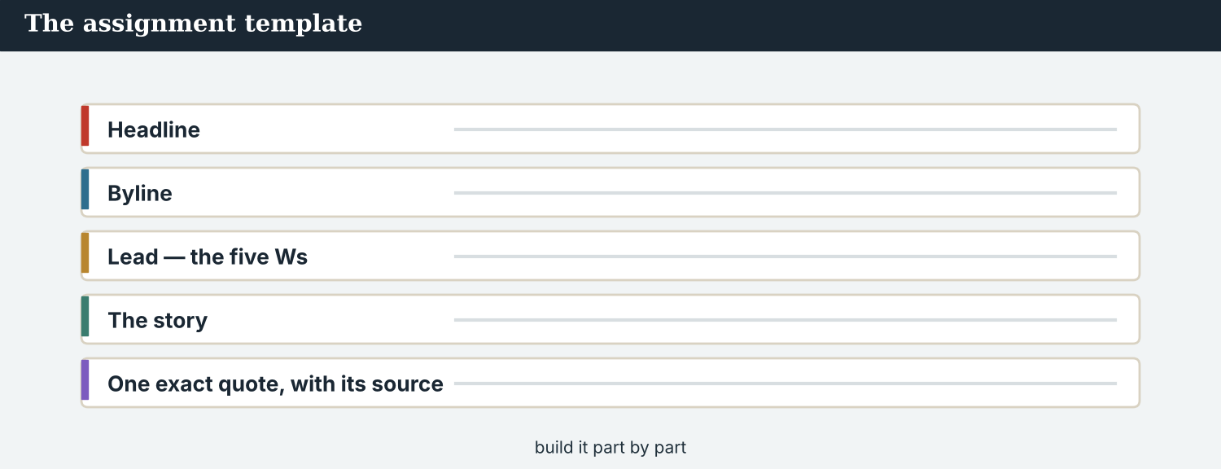
The assignment template — your outlet profile.
Make a one-page profile of a news outlet
Choose a real international news outlet or agency (write only true facts), or invent your own outlet. Make a one-page profile with these parts:
1. the name and the city;
2. the team — how many journalists, and their jobs (use there is/are and has got);
3. the beats or the countries it covers;
4. one rule from the Code;
5. one sentence: why you like it, or why it is important.
Plan: make notes for each of the five parts before you write.
Success criteria | Yes | Almost | Not yet
All five parts are there (name/city, team, beats, one rule, why). | ☐ | ☐ | ☐
Facts are true (real outlet) or clearly invented (my own). | ☐ | ☐ | ☐
I use be, present simple, have got, there is/are. | ☐ | ☐ | ☐
It is neat and easy to read. | ☐ | ☐ | ☐
Keep this profile. In Unit 10, your outlet publishes your final story — the capstone. This is where it begins.

ANSWER KEY Unit 1
Answers for the closed tasks. “Your own answers”, pair work and discussion have no single answer.
W2 1 at Atlas Wire (a news agency in Geneva) · 2 eight · 3 Ana · 4 the crossing at Kalina is open again
W3 1 news agency · 2 press card
1A 1-b, 2-c, 3-d, 4-a, 5-f, 6-e, 7-h, 8-g, 9-j, 10-i
1B 1 news agency · 2 camera · 3 front page · 4 notebook · 5 editor · 6 press card · 7 visa · 8 media
1C People: correspondent, editor, fixer, stringer · Places: bureau, desk · Things: camera, notebook, press card, dateline
1D 1-c (file a story) · 2-a (take a photo) · 3-d (meet a deadline) · 4-b (check a fact) · 5-f (cover a beat) · 6-e (ask a question)
1E 1 camera · 2 deadline · 3 fixer · 4 notebook · 5 visa · 6 editor
1F correspondent · desk · article · source · notebook · editor · wire · deadline
1G Your own answers.
2A 1 be · 2 present simple · 3 have got · 4 there is/are · 5 present simple
2B 1 is · 2 files · 3 have got · 4 There are · 5 are · 6 has got · 7 Is there · 8 report
2C 1 She files the story. · 2 There are three correspondents. · 3 I have got a visa. · 4 We are a good team. · 5 Hana takes photographs.
2D / 2E / 2F Your own answers.
3A 1-b, 2-d, 3-f, 4-g, 5-c, 6-a, 7-e
3B 1 Ana · 2 Priya · 3 Hana · 4 Leila · 5 Daniel · 6 Mira
3C 1 politics · 2 economy · 3 health · 4 climate · 5 culture · 6 technology
3D 1 masthead · 2 headline · 3 byline · 4 dateline · 5 photo · 6 caption
3E / 5A / 5E / 5H / 6C / 6E / 7C / 7D / 7E / 8E / 9C / 9E / 9F / 10E Your own answers.
4A / 4E Your own predictions (in 4A all eight speak; in 4E, a and c).
4B 1 Priya · 2 Tomas · 3 Leila · 4 Daniel · 5 Hana · 6 Ana
4C 1 T · 2 F · 3 F · 4 F · 5 T · 6 T · 7 F · 8 T
4D stories: 3 · beat: the region around Kalina · sources: 2 · photographs: 10 · online at: twelve o’clock
4F 1 crossing · 2 open · 3 people · 4 photographs, video · 5 stall-holder
4G 1 F · 2 T · 3 F · 4 T
4H 1 at the crossing at Kalina · 2 send the photographs now
5B 1 T · 2 T · 3 F (1 December) · 4 T · 5 T · 6 F
5C 1 Reporters Without Borders · 2 180 · 3 the journalists in prison for their work · 4 3 May is World Press Freedom Day; 2 November is the International Day to End Impunity for Crimes against Journalists · 5 (any two) find the story / check the facts / name the source / be fair / be kind
5D 1 safe · 2 border · 3 habit
5F 1 correspondent · 2 Montevideo · 3 the region around Kalina · 4 a notebook, a press card and a small camera · 5 the reopening of the crossing
5G 1 journalist (person) · 2 Reading B
6A 1 a correspondent · 2 a notebook and a press card · 3 “She has got a notebook and a press card.”
6B is · from · reports · takes · has got · works
6D 1 eight · 2 a world desk, a photo team, a digital team · 3 accurate, honest, fair
7A 1 the Meridian Post · 2 the economy · 3 the Kalina valley
7B am · meet · am (is) · Have
8A 1-b, 2-a, 3-c, 4-d, 5-e
8B 1 GOOD · 2 NOT GOOD · 3 GOOD · 4 NOT GOOD · 5 GOOD · 6 NOT GOOD · 7 GOOD · 8 NOT GOOD
8C Suggested: 1 (b) · 2 (b) · 3 (b) — with your own reason.
8D 1 accurate · 2 honest · 3 fair · 4 respect · 5 independent
9A logo 1 · menu 2 · headline 3 · byline 5 · photo 4 · “Read more” 6
9B 1 the byline · 2 the menu · 3 the headline · 4 the “Read more” link
9D Sara is a correspondent. She has got a camera. She writes world news. There are many stories in her region.
10A 1 headline · 2 fixer · 3 caption · 4 deadline · 5 bureau · 6 beat · 7 wire · 8 editor · 9 press card · 10 byline
10B 1 is · 2 work · 3 takes · 4 have got · 5 has got · 6 There are · 7 There is · 8 are · 9 file · 10 Do · 11 has got · 12 is
10C 1 am · 2 work · 3 is · 4 file · 5 has got · 6 There are · 7 take · 8 reports · 9 have got · 10 are
10D 1 180 · 2 (any three) accuracy, honesty, fairness, respect, independence · 3 (any) masthead / headline / byline / dateline / photo / caption
3G 1 climate · 2 politics · 3 health · 4 culture
4J story · crossing · source · crossing (the field) · photographs · Bekim
5J 1 safe · 2 correspondent · 3 deadline · 4 border
8G 1 (b) do not use the photograph — respect the family · 2 (b) ask the family first
6F Hana is a photojournalist. She takes photographs for Atlas Wire.
10F 1 (a) verification journalist · 2 a computer and a phone · 3 every fact and every picture
10G 1 There are three correspondents. · 2 She has got a camera. · 3 Tomas takes photographs. · 4 We are a team.
Open tasks W1, W4, 1H, 1I, 3F, 4I, 5I, 7F, 7G, 8F, 8H, 9G, 9H — your own answers (discussion, role-play, writing).
A note on real and invented content. The facts about the world’s press (the World Press Freedom Index and its 180 countries and territories, the CPJ prison census of 1 December, UNESCO’s finding on impunity, World Press Freedom Day, named by the UN in 1993 and marked on 3 May, the UN Plan of Action of 2012, the International Day to End Impunity on 2 November, the Windhoek Declaration of 1991) are true and attributed. Atlas Wire, its staff, Kalina, the crossing, the Meridian Post and Omar are invented, for practice. In this course, real people are only ever in true, sourced facts — never in an invented quote.
English for Journalists — International Edition · Unit 1 (v5 — 25-page standard). CEFR A2 · two readings · two listenings · two writing pieces · every part scaffolded · grounded in the world’s media reality as of 2026 · fictional agency (Atlas Wire), factual backdrop.
ENGLISH FOR JOURNALISTS · INTERNATIONAL EDITION · STUDENT’S BOOK
UNIT 2
What Is News? The Five Ws
Beat · Report & newswriting CEFR A2
In this unit you learn to…
• ask the five Ws — and How — about a story
• tell hard news from soft news
• describe a story with the right adjectives
• use wh- questions and the present simple for facts
• write 5-W notes and pitch a story idea
The Atlas Wire team — you meet them through this unit.

WARM-UP What’s the story?
A short story to start the unit. Read it, then answer.
The morning conference — the team decides what is news.
W1 Before you read. Talk with a partner.
1. What news from another country is important this week?
2. How do journalists find a story?
At the morning conference, the team talks about Kalina. “What is the story?” asks Ana.
“The crossing is open again,” says Mira. “Families are crossing. That is the story.” Daniel writes it down. “Good angle,” he says. “Now we ask the five Ws: who, what, when, where, why — and how.”
W2 Read and answer.
1. What place is the story about?
2. What is the story? (What is new?)
3. What are “the five Ws” — name three.
W3 Find a word in the text.
1. the main idea of a story → ___________
2. a meeting where the team plans the news → the morning ___________
PRODUCE Talk about it
W4 Discuss with a partner.
1. What is the biggest world story this week? Who told you about it?
2. Where do you get your news — TV, radio, phone, or paper?

PART 1 Newsroom words
The words you need to talk about news and stories. Learn these first.
MODEL The words
Word | Meaning
news | information about new events
story | a report about one event or subject
event | a thing that happens
angle | the main idea of a story; what is new
fact | a thing that is true
detail | a small piece of information
report | a written or spoken news story
source | a person or place that gives information
hard news | important news, now (politics, prices, safety)
soft news | interesting but not urgent news (culture, sport)
important | that matters a lot
local | in your city or area
international | in more than one country
main | the biggest or most important
PRACTISE Controlled practice
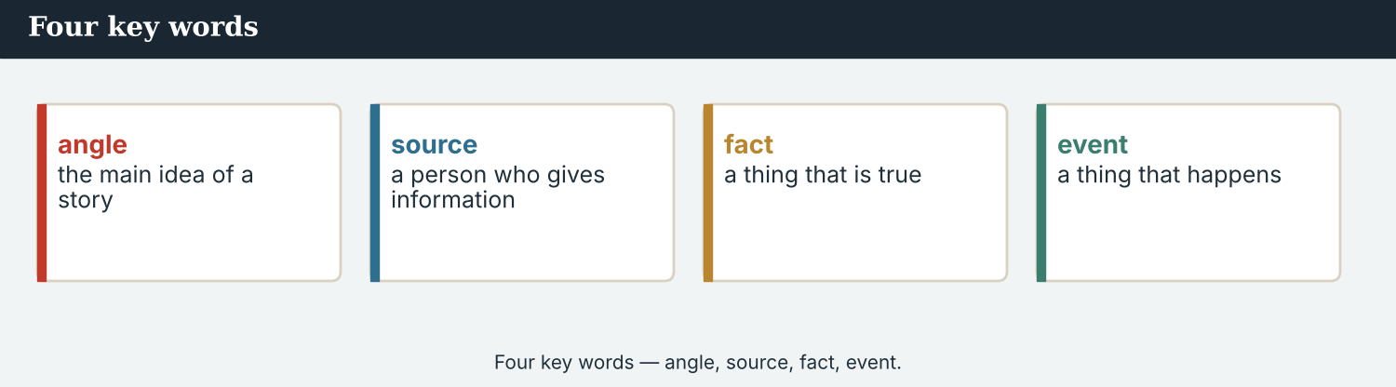
Four key words — angle, source, fact, event.
1A Match the word (1–8) to the meaning (a–h).
1. news ______  2. angle ______  3. source ______  4. event ______  5. fact ______  6. hard news ______  7. international ______  8. main ______ | a) a thing that is true  b) information about new events  c) a thing that happens  d) the main idea of a story  e) important news, now  f) a person who gives information  g) the biggest or most important  h) in more than one country
1B Complete the sentences with a word from the box.
WORD BOX
angle · source · event · report · international · soft news · important · detail
1. The reopening of the crossing is an ___________ .
2. Mira talks to a ___________ to get the facts.
3. A football result is ___________ — interesting, but not urgent.
4. This story is ___________ : it is news in two countries.
5. She files a short ___________ for the wire.
6. The date and the place are one ___________ each.
7. The ___________ of the story is: families are crossing again.
8. Safety news is very ___________ .
NOTICE Words that go together
We say breaking news, the main story, world news, a news report, and check a fact.
1C Match to make word pairs.
1. breaking ______  2. the main ______  3. a news ______  4. check a ______ | a) report  b) news  c) fact  d) story
1D Find the word that is different. Circle it.
1. news · story · report · deadline
2. who · what · when · angle
3. story · article · report · question
4. source · fact · detail · festival
The front page — masthead, headline, byline, photo.
1E Complete the paragraph. Use words from this unit.
Today the main ___________ in the valley is important. A correspondent finds the ___________ and talks to a ___________ . She checks every ___________ . It is ___________ news, for two countries. Then she files a short ___________ .
1F Read the definition. Write the word.
1. important news, now → ___________
2. interesting news, not urgent → ___________
3. the main idea of a story → ___________
4. news in more than one country → ___________
5. a small piece of information → ___________
PRODUCE Over to you
1G Answer about you. Write full sentences.
1. What is one big world story now?
2. Do you prefer hard news or soft news? Why?
3. What is one local story in your city?
1H Complete the paragraph. Use: news · story · source · fact · report.
A journalist finds the ___________ . She looks for a good ___________ . She talks to a ___________ and checks every ___________ . Then she files a short ___________ .
PRODUCE Talk about it
1I Discuss. Which two words in this unit are new for you? Make a sentence with one.

PART 2 Grammar: questions & describing
Ask about a story, and describe it. Half the practice is controlled; half is your own words.
MODEL The grammar
1 · wh- question words — the five Ws + How
Who = people What = the thing / event
When = the time Where = the place
Why = the reason How = the way
2 · asking a question
With be: Wh + is/are + …? What is the news? Where is the crossing?
With other verbs: Wh + do/does + subject + verb? When does the crossing open? Why do families come back?
3 · adjectives — describing a story
Before the noun: a big story · an important event · international news
After be: The story is important. The bridge is busy.
Watch out! In a question, the wh- word comes first: What is the news? (not The news is what?). The adjective does not change: two big storys → two big stories, but big stays big.
Structured practice — half of this part.
NOTICE Which question word?
The question words — who, what, when, where, why, how.
2A Complete with Who, What, When, Where, Why, or How.
1. ___________ is the story? — The crossing is open again.
2. ___________ are the people? — Families and a stall-holder.
3. ___________ is the crossing? — At Kalina, on the river Vara.
4. ___________ does it open? — Every morning at six.
5. ___________ do families come back? — Because their relatives live on the other side.
6. ___________ do you know? — I talk to a source.
PRACTISE Controlled practice
2B Put the words in order to make a question.
1. is / what / the / angle / ? → ________________________
2. the crossing / where / is / ? → ________________________
3. open / does / when / the crossing / ? → ________________________
4. come back / why / families / do / ? → ________________________
5. the source / who / is / ? → ________________________
2C Put the adjective in the right place.
1. It is a story. (big) → ________________________
2. The news is . (important) → ________________________
3. They report news. (international) → ________________________
4. Kalina is a place. (busy) → ________________________
Your own words — the other half. Use the questions and adjectives yourself.
PRODUCE Answer about you
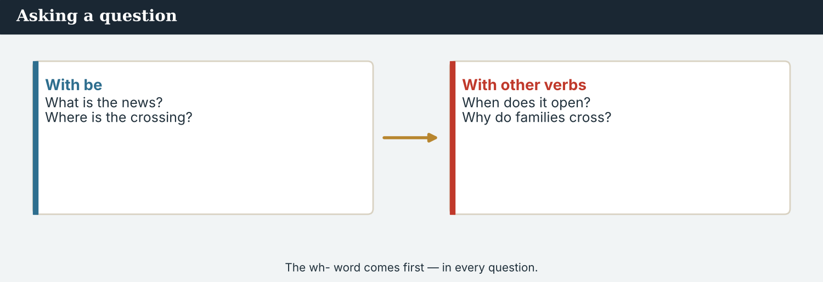
Adjectives describe the news — a big, important, international, true story.
2D Answer these questions about YOU. Write full sentences.
1. What do you read or watch for world news?
2. When do you read the news?
3. Where do you live?
4. Who is a journalist you like?
5. Why do you like (or not like) the news?
PRODUCE Ask a partner
2E Ask a partner four wh- questions about a story they know. Write their answers.
PRODUCE Describe it
2F Write three sentences about a story in the news now. Use an adjective in each (big, important, international, sad, happy…).

PART 3 Skill focus: the Five Ws, and what makes news
Every story answers six questions. And some news is ‘hard’, some is ‘soft’.
MODEL The five Ws + How
Figure 2.2 · Ask these six questions about every story, in every country.
A good reporter asks: Who is in the story? What happens? When? Where? Why does it happen? How do we know? Answer the six questions, and you have your story.
PRACTISE Find the five Ws
3A Read the short news item. Answer the questions.
Today, the crossing at Kalina is open again. Families are crossing the bridge. It is a happy day. The road is safe now. Correspondent Mira Sandoval is there for Atlas Wire.
1. Who is in the story? ___________
2. What is the news? ___________
3. When is it? ___________
4. Where is it? ___________
5. Why is it a happy day? ___________
6. How do we know? (Who reports it?) ___________
MODEL Hard news and soft news
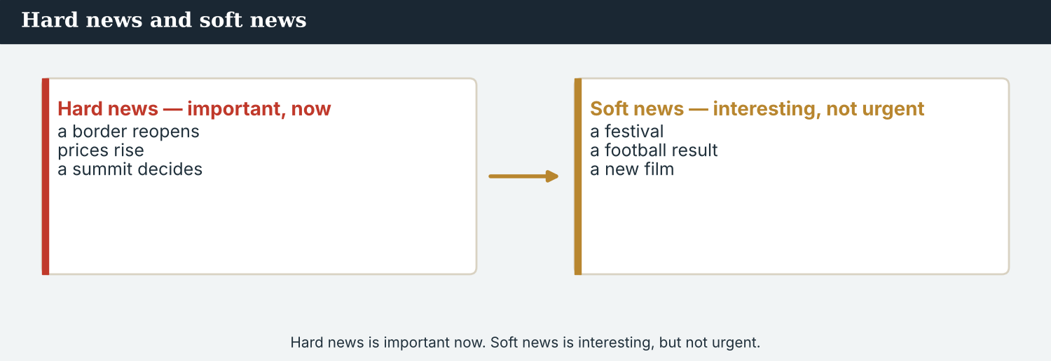
Figure 2.3 · Hard news is important now. Soft news is interesting, but not urgent.
PRACTISE Hard or soft?
3B Write HARD or SOFT for each story.
1. Food prices rise in three countries this month. ___________
2. A new café opens by the bridge. ___________
3. Two governments sign an agreement on the river. ___________
4. The city football team wins. ___________
5. The crossing reopens after seven years. ___________
6. A music festival this weekend. ___________
7. A school opens for 200 children. ___________
8. A famous singer visits the valley. ___________
3C Read a second item. Answer the questions.
There is a music festival on Friday in the park by the river. It is free. Families come from both sides of the bridge. A band called Vara plays.
1. What is the event? ___________
2. When is it? ___________
3. Where is it? ___________
4. Why do many families go? ___________
3D Which question word does each answer give? Write Who, What, When, Where, or Why.
1. In the park by the river. → ___________
2. On Friday. → ___________
3. A band called Vara. → ___________
4. Because it is free. → ___________
5. A music festival. → ___________
PRODUCE Your turn
3E Choose a story from your city or your region (real or invented). Write its five Ws.
Who: ________________________
What: ________________________
When: ________________________
Where: ________________________
Why: ________________________
PRACTISE One more story
3F Read the item. Answer the five Ws.
A new school opens today in the village above Kalina. Two hundred children start class. Families on both sides of the river are very happy.
1. Who? ___________
2. What? ___________
3. When? ___________
4. Where? ___________
5. Why are families happy? ___________
PRODUCE Discuss
3G Talk with a partner. Which is more interesting to you: hard news or soft news? Why?

PART 4 Listen & view
Two listenings. Do the tasks for each.
Listening A · the story conference
NOTICE Before you listen
Inside the world desk — screens, a wall of clocks, and the deadline.
4A The team chooses the main story. What do you think it is?
Ana: What is our main story today?
Daniel: The crossing at Kalina. It is open again.
Mira: Families are crossing. That is the angle.
Ana: Good. Who is the source?
Mira: A stall-holder on the bridge. His name is Bekim.
Daniel: When does the crossing open?
Mira: Every morning at six, now.
Ana: Perfect. That is our main story.
PRACTISE Listen for detail
4B Answer the questions.
1. What is the main story? ___________
2. What is the angle? ___________
3. Who is the source? ___________
4. When does the crossing open? ___________
4C True or False? Write T or F.
1. The main story is about a school. ______
2. Families are crossing. ______
3. The source is an editor. ______
4. The crossing opens every morning. ______
4D Complete the notes from the conference.
Main story: ___________
Angle: ___________
Source: ___________
Crossing opens: ___________
Listening B · an interview on the bridge
Figure 2.4 · Audio 2.2 — Mira interviews a stall-holder on the bridge.
NOTICE Before you listen
4E Mira asks the stall-holder questions. Which wh- words do you think she uses?
Mira: Hello. I am Mira, from Atlas Wire. Are you a stall-holder here?
Bekim: Yes, I am. Welcome.
Mira: What do you sell?
Bekim: Fruit and vegetables.
Mira: When does the market open?
Bekim: Every day at six o’clock.
Mira: Why do families come back?
Bekim: Because their relatives live on the other side. The bridge is open, so they come.
Mira: Thank you.
PRACTISE Listen for detail
4F Complete the answers.
1. Bekim sells ___________ and ___________ .
2. The market opens at ___________ .
3. Families come back because their ___________ live on the other ___________ .
4G Which wh- word does Mira use? Write three.
1. ___________
2. ___________
3. ___________
4H Answer the questions.
1. What does the stall-holder sell?
2. Why do families come back?
PRACTISE Both audios
4I Complete the summary. Use: conference · Ws · bridge · stall-holder.
In the ______ , the team decides the main story and asks the five ______ . Then Mira goes to the ______ and interviews a ______ .
PRODUCE What do you think?
4J Discuss. Why do journalists ask questions? What happens if they do not check?

PART 5 Read the story
Two readings. Reading A is about news around the world. Reading B is ‘news in brief’.
Reading A · factual · current
NOTICE Before you read
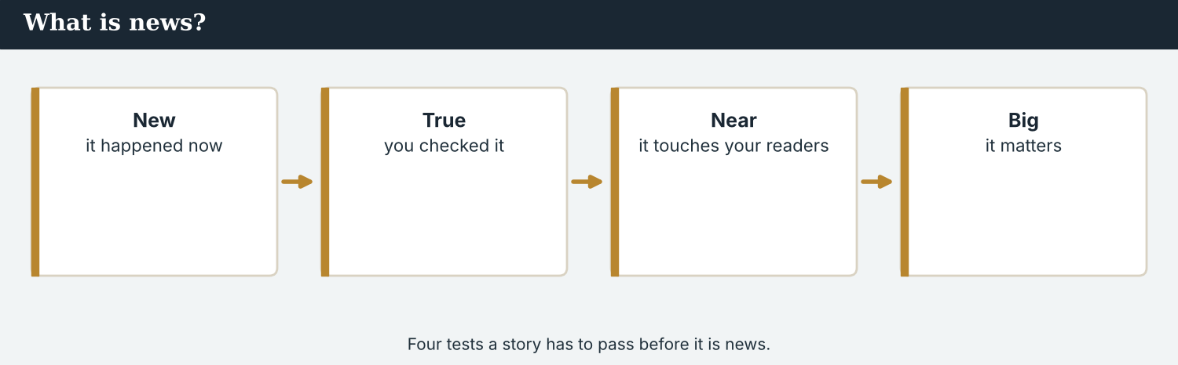
Four tests a story has to pass before it is news.
5A What kinds of stories are in the news in your country? Name two.
What is news around the world today?
Open any international news website, and the stories are not all the same size. Some news is about big change. People move. Borders open and close. Governments meet, and agree, or do not agree. This is important news for many people, in many countries at once.
Other news is about daily life. Prices go up and down. A new clinic opens. A school starts again. A bridge reopens, and a market comes back with it. People want this news, too — and often they want it more.
There is also soft news — sport, music, and culture. A football match, a new song, a festival: these are stories too, and they cross borders easily.
For a journalist, the job is the same in every country. Find the story. Ask the five Ws. Check the facts. Name the source. The subject changes; the work does not.
PRACTISE Comprehension
5B True or False? Write T or F.
1. All international news stories are the same size. ______
2. Prices and clinics are part of daily-life news. ______
3. Sport and music are hard news. ______
4. A journalist must check the facts. ______
5C Answer the questions.
1. Name two kinds of ‘big change’ news.
2. Name one example of soft news.
3. What four things must a journalist do?
5D Find a word in the text.
1. a line between two countries → ___________
2. a party with music → ___________
3. to say yes to the same thing → ___________
Reading B · news in brief
NOTICE Before you read
How news reaches people — a journalist finds the news and shares it.
5E ‘News in brief’ is short news. Each item is 1–2 sentences. Read the three items.
NEWS IN BRIEF
1. Crossing reopens. The crossing at Kalina is open again. Families cross the bridge every morning.
2. New school. A school opens today in the village above Kalina. Two hundred children start class.
3. Music night. There is a music festival on Friday in the park by the river. It is free.
PRACTISE Find the facts
5F Answer for each item.
1. Item 1 — Where is the crossing? ___________
2. Item 1 — When do families cross? ___________
3. Item 2 — How many children start class? ___________
4. Item 2 — Where is the new school? ___________
5. Item 3 — When is the music festival? ___________
6. Item 3 — How much is it? ___________
5G Which item is soft news? Write the number and why.
1. ________________________
PRODUCE Compare
5H Compare Reading A and Reading B. Answer.
1. Which reading is one long text? A or B?
2. Which reading has three short items? A or B?
3. Which reading gives the facts fastest?
PRACTISE Words from the readings
5I Find a word in Reading A or Reading B.
1. important news, now → ___________
2. interesting news, not urgent → ___________
3. a thing that is true → ___________
4. the main idea of a story → ___________
PRODUCE Discuss
5J Talk about it. Which reading is more interesting to you? Why?

PART 6 Write it
Two pieces. First 5-W notes, then three story pitches.
Writing 1 · 5-W notes
MODEL Study the model
MODEL · 5-W notes
Who: families, a stall-holder (Bekim)
What: the crossing at Kalina is open again
When: every morning at six, now
Where: the bridge over the river Vara
Why: the repairs are finished; relatives live on both sides
How: a correspondent went and talked to a source
NOTICE Notice the model
A reporter’s 5-W notes.
6A Answer about the model.
1. How many questions do the notes answer? ___________
2. Are the notes facts or opinions? ___________
3. Who is the source? ___________
PRODUCE Write your notes
6B Choose a story (real or invented). Write 5-W notes. Answer all six questions.
Who: ________________________
What: ________________________
When: ________________________
Where: ________________________
Why: ________________________
How: ________________________
Checklist:
☐ I answer all six questions.
☐ My notes are facts, not opinions.
☐ My notes are short and clear.
Writing 2 · three story pitches
MODEL Study the model
MODEL · a pitch
“The crossing at Kalina is open again. Angle: families are crossing. Hard news, international.”
NOTICE Notice the model
6C Answer about the pitch model.
1. What is the story? ___________
2. What is the angle? ___________
3. Is it hard or soft news? ___________
PRACTISE Complete a pitch
A model news alert — what, where, and who says it.
6D Complete the pitch with: angle · hard · international.
“A new school opens above Kalina. ______ : 200 children start class, from both sides of the river. ______ news, ______ .”
PRODUCE Pitch three stories
6E Write three story ideas. For each: one sentence + the angle + hard or soft.
1. ________________________
2. ________________________
3. ________________________
PRACTISE Fix it
6F This news alert has two mistakes. Write it correctly.
“the crossing are open. familys are crossing.”
________________________

PART 7 In the field: ask the five Ws
Interview a source. Ask the five Ws to get the story.
MODEL A model interview
Reporter: Hello. What is your name?
Source: I am Bekim. I have a stall here on the bridge.
Reporter: What do you sell?
Source: Fruit and vegetables.
Reporter: When does the market open?
Source: Every morning at six.
Reporter: Why is today important?
Source: Families are crossing again. It is a happy day.
NOTICE Notice the questions
An interview — ask the five Ws to get the story.
7A Which wh- words does the reporter use? Write them.
1. ___________ , ___________ , ___________ , ___________
PRACTISE Controlled practice
7B Make a wh- question for each answer.
1. ___________ ? — My name is Mira.
2. ___________ ? — I sell bread.
3. ___________ ? — At six o’clock.
4. ___________ ? — At Kalina, on the river Vara.
7C Put the words in order to make a question.
1. you / what / report / do → ________________________
2. the deadline / when / is → ________________________
3. the photograph / where / is → ________________________
PRODUCE Your role
Everyone asks the five Ws. Ask them from your own job.
Correspondent | Ask a source: What happens? Why?
World Editor | Ask the correspondent: What is the angle? When is the deadline?
Photojournalist | Ask: Where is the photograph? Who is in it?
Verification | Ask: How do you know? Who is the source?
Field & Video | Ask: What is happening now? Where are you?
Digital & Social | Ask: What is the headline? When do we post it?
Introducing yourself before an interview.
7D Choose your role from the table above. Ask your two questions to a partner.
PRODUCE Interview a partner
7E Think of a real event (a match, a festival, an opening). Your partner asks you the five Ws. Then swap.
CHECK Check yourself
When I speak, I can… | Yes | Almost | Not yet
ask the five Ws with correct word order | ☐ | ☐ | ☐
answer a wh- question in a full sentence | ☐ | ☐ | ☐
interview a partner about an event | ☐ | ☐ | ☐
A second dialogue · a phone interview
MODEL Listen and read
Mira: Hello, this is Mira from Atlas Wire. Can I ask you a few questions?
Source: Yes, of course.
Mira: What is your name, and what do you do?
Source: I am Bekim. I have a stall on the bridge.
Mira: When did the crossing open again?
Source: This week. Families come every day now.
Mira: Thank you very much.
PRACTISE Controlled practice
7F Write the wh- question for each answer.
1. _______ ? — I am Bekim.
2. _______ ? — I have a stall.
3. _______ ? — This week.
4. _______ ? — At Kalina.
PRODUCE Role-play
7G Role-play the phone interview with a partner. Then swap roles.

PART 8 Ethics & the Code: get the facts right
A story must be true. Check every fact before you report it.
MODEL A case
A case. A post online says “a thousand people crossed today” at Kalina. But Mira is on the bridge, and she counts about three hundred. Which number does she report?
The Code says: be accurate. A fact is true. A rumour is a story with no proof. An opinion is what someone thinks. Report facts. Check them with a source.
PRACTISE Fact or opinion?
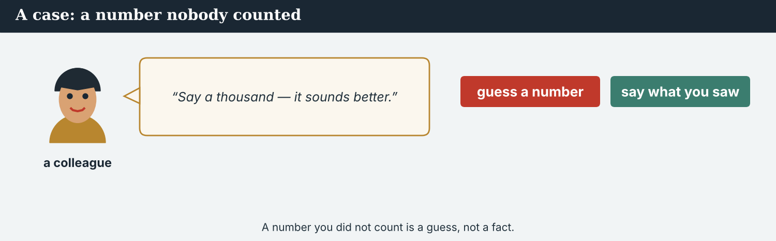
Fact or opinion? A fact is true; an opinion is what someone thinks.
8A Write FACT or OPINION.
1. The crossing is open. ___________
2. The crossing is the best in the region. ___________
3. About three hundred people crossed today. ___________
4. Everyone is very happy. ___________
5. The school opens today. ___________
6. This is the most important news of the year. ___________
8B Fact, rumour, or opinion? Write F, R, or O.
1. “Three hundred people crossed today.” (you counted them) ___________
2. “Maybe a thousand crossed.” (no proof) ___________
3. “This is the best market in the region.” ___________
4. “The market opens at six o’clock.” ___________
NOTICE What do you do?
8C Choose (a) or (b).
1. You read “a thousand crossed” but you are not sure. (a) report a thousand (b) check the number first. ______
2. A person gives you a fact. (a) use it now (b) ask “How do you know?” ______
3. You have one source. (a) file the story (b) find a second source. ______
PRACTISE Complete the rule
8D Complete with: fact · know · source · rumour.
1. Check every ______ .
2. Ask: “How do you ______ ?”
3. Use a ______ .
4. Do not report a ______ .
PRODUCE Talk about it
8E Discuss.
1. In the case above, what number does Mira report? Why?
2. Why is one source sometimes not enough?
A second case · a rumour online
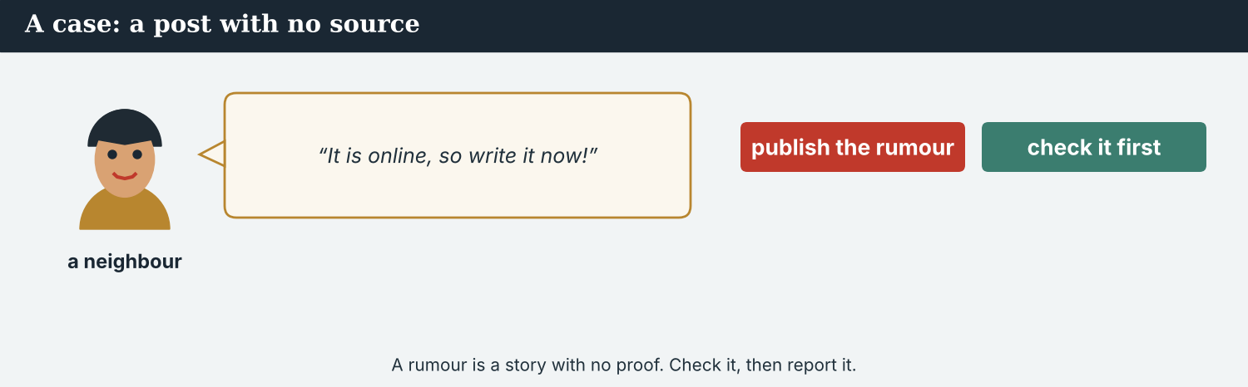
A rumour is not a fact — a journalist checks before reporting.
A case. A neighbour runs to Mira on the bridge. “I read that five hundred stalls are open at the market!” he says. “It is on the internet. Please write it now!” Mira is not sure. She did not see five hundred stalls. Maybe it is true, but maybe it is only a rumour. The deadline is soon, and a big number is good news. But Mira is a journalist. She knows the Code: a journalist checks the facts, and does not report a rumour as news. What does Mira do?
NOTICE What do you do?
8F Choose (a) or (b), and write one reason.
1. (a) file ‘five hundred stalls are open’ now (b) check the number first. Choice: ______ Because ________________________
2. A rumour is (a) a fact (b) a story with no proof. Choice: ______
PRODUCE Discuss
8G Discuss. Why is a rumour dangerous in the news? How can a journalist check it?
PRODUCE Write it
8H Write what Mira says to the neighbour (2–3 sentences). Be kind, but do not report the rumour.

PART 9 The digital angle: a news alert
A news alert is one short line online. It answers the main Ws fast.
MODEL A news alert
BREAKING: The crossing at Kalina is open again. Families are crossing the bridge. — @AtlasWire
NOTICE The parts of an alert
A news alert on a phone — short, true, and fast.
9A Match the part of the alert to what it shows.
1. BREAKING  2. the crossing is open again  3. Kalina  4. @AtlasWire | a) the place  b) the news  c) the outlet  d) it is new / important
PRACTISE Find the Ws
9B Answer about the alert.
1. What is the news? ___________
2. Where is it? ___________
3. Who reports it? ___________
PRACTISE Fix and complete
9C This alert has two mistakes. Write it correctly.
“the crossing are open. familys are crossing.”
________________________
A news website home page.
9D Complete the alert. Answer What and Where.
BREAKING: ___________ (what?) in ___________ (where?). — @AtlasWire
PRODUCE Write your alert
9E Write a one-line news alert for a story you choose. Answer What + Where. Add your outlet’s name.
Checklist: one clear sentence · answers What and Where · a real or invented fact (not a rumour).
9F Write a short headline (5–7 words) for your story. Use the present simple.
9G Creative. Write a short headline (4–6 words) for the crossing story. Use the present simple.
PRODUCE Discuss
9H Discuss. Do you read news alerts on your phone? Are they useful? Why?

PART 10 Review & Can-Do
Check your new English before Unit 3.
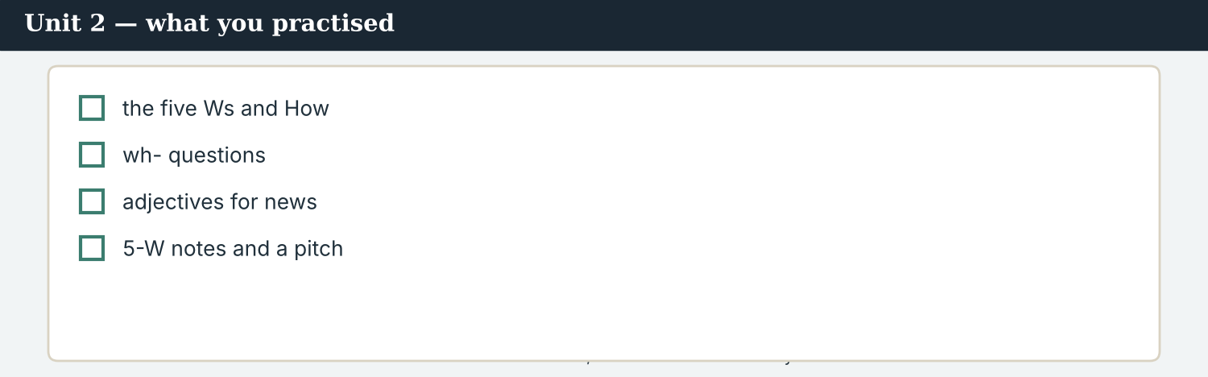
Unit 2 — what is news, and how to find the story.
10A Vocabulary. Complete with a word from the box.
WORD BOX
angle · source · local · event · fact · hard news · news · important
1. The main idea of a story is the ___________ .
2. A person who gives information is a ___________ .
3. News in your city is ___________ news.
4. A thing that happens is an ___________ .
5. A thing that is true is a ___________ .
6. Politics and prices are ___________ .
7. Information about new events is ___________ .
8. Big, serious news is ___________ .
10B Grammar. Complete the question word.
1. ___________ is the story?
2. ___________ are the people?
3. ___________ is it? (place)
4. ___________ does it open? (time)
5. ___________ do they come back? (reason)
6. ___________ do you know? (way)
10C The Five Ws. Answer.
1. Write the five Ws and How (six words).
2. Hard or soft? — a football result: ______ ; food prices rise: ______ .
Can-Do — what you can do now.
10D Hard or soft news? Write HARD or SOFT.
1. A new song from a singer in the valley. ______
2. Food prices rise. ______
3. Two governments sign an agreement. ______
4. A football result. ______
Can-Do — tick what you can do now
☐ I can ask the five Ws (and How) about a story.
☐ I can make correct wh- questions.
☐ I can tell hard news from soft news.
☐ I can describe a story with adjectives.
☐ I can write 5-W notes and pitch a story.
10E Reflect.
1. Which of the five Ws is the hardest to answer? Why?
2. What story would you like to report?
10F Read and answer.
Priya is a verification journalist at Atlas Wire. She reads every story and checks the facts. She asks: who, what, when, where, and why? A good story answers all five.
1. What is Priya’s job? ___________
2. What does she check? ___________
3. How many Ws does a good story answer? ___________
10G Grammar review. Write the wh- question for each answer.
1. _______ ? — Mira is a correspondent.
2. _______ ? — The crossing is at Kalina.
3. _______ ? — It opened this week.
4. _______ ? — Because the road is safe.

PART 11 Assignment: find a story
Find a story and take its 5-W notes
Choose a real story from another country (or invent one). Do these three things:
1. write 5-W notes (Who, What, When, Where, Why, How);
2. say if it is hard or soft news;
3. write a one-line pitch with the angle.
Plan: ask the six questions first; check your facts with a source.
Success criteria | Yes | Almost | Not yet
All six questions are answered. | ☐ | ☐ | ☐
My notes are facts, not rumours or opinions. | ☐ | ☐ | ☐
I say hard or soft, and give a one-line pitch. | ☐ | ☐ | ☐
It is neat and easy to read. | ☐ | ☐ | ☐
Keep this. In Unit 3, you report your story live. This is the first step.
The assignment template — your news story.
A model news story — headline, byline, lead (the 5 Ws), and a quote.

ANSWER KEY Unit 2
Answers for the closed tasks. “Your own answers”, pair work and discussion have no single answer.
W2 1 Kalina (the crossing) · 2 the crossing is open again · 3 (any three) who, what, when, where, why
W3 1 angle · 2 (morning) conference
1A 1-b, 2-d, 3-f, 4-c, 5-a, 6-e, 7-h, 8-g
1B 1 event · 2 source · 3 soft news · 4 international · 5 report · 6 detail · 7 angle · 8 important
1C 1-b (breaking news) · 2-d (the main story) · 3-a (a news report) · 4-c (check a fact)
1D 1 deadline · 2 angle · 3 question · 4 festival
1E 1 story · 2 angle · 3 source · 4 fact · 5 international · 6 report
1F 1 hard news · 2 soft news · 3 angle · 4 international · 5 detail
2A 1 What · 2 Who · 3 Where · 4 When · 5 Why · 6 How
2B 1 What is the angle? · 2 Where is the crossing? · 3 When does the crossing open? · 4 Why do families come back? · 5 Who is the source?
2C 1 It is a big story. · 2 The news is important. · 3 They report international news. · 4 Kalina is a busy place.
3A 1 families / correspondent Mira · 2 the crossing is open again · 3 today · 4 Kalina · 5 the road is safe · 6 Mira Sandoval reports it for Atlas Wire
3B 1 HARD · 2 SOFT · 3 HARD · 4 SOFT · 5 HARD · 6 SOFT · 7 HARD · 8 SOFT
3C 1 a music festival · 2 (on) Friday · 3 the park by the river · 4 because it is free
3D 1 Where · 2 When · 3 Who · 4 Why · 5 What
4B 1 the crossing at Kalina · 2 families are crossing · 3 a stall-holder (Bekim) · 4 every morning at six
4C 1 F · 2 T · 3 F · 4 T
4D Main story: the crossing at Kalina · Angle: families are crossing · Source: a stall-holder (Bekim) · Opens: every morning at six
4F 1 fruit, vegetables · 2 six o’clock · 3 relatives, side
4G (any three) What · When · Why
4H 1 fruit and vegetables · 2 because their relatives live on the other side
5B 1 F · 2 T · 3 F (it is soft news) · 4 T
5C 1 (any two) people move / borders open and close / governments meet · 2 (any) a football match / a new song / a festival · 3 find the story, ask the five Ws, check the facts, name the source
5D 1 border · 2 festival · 3 agree
5F 1 (at) Kalina · 2 every morning · 3 two hundred (200) · 4 the village above Kalina · 5 (on) Friday · 6 free
5G Item 3 (music night) — interesting but not urgent (soft news)
5H 1 Reading A · 2 Reading B · 3 Reading B (news in brief)
6A 1 six · 2 facts · 3 a stall-holder (Bekim)
6C 1 the crossing is open again · 2 families are crossing · 3 hard (international) news
6D angle · hard · international
7A (any) What · When · Why
7B (example) 1 What is your name? · 2 What do you sell? · 3 When does it open? · 4 Where is the crossing?
7C 1 What do you report? · 2 When is the deadline? · 3 Where is the photograph?
8A 1 FACT · 2 OPINION · 3 FACT · 4 OPINION · 5 FACT · 6 OPINION
8B 1 F · 2 R · 3 O · 4 F
8C 1 b · 2 b · 3 b
8D 1 fact · 2 know · 3 source · 4 rumour
9A 1-d (it is new/important) · 2-b (the news) · 3-a (the place) · 4-c (the outlet)
9B 1 the crossing is open again · 2 Kalina · 3 @AtlasWire (Atlas Wire)
9C The crossing is open. Families are crossing.
10A 1 angle · 2 source · 3 local · 4 event · 5 fact · 6 hard news · 7 news · 8 important
10B 1 What · 2 Who · 3 Where · 4 When · 5 Why · 6 How
10C 1 Who, What, When, Where, Why, How · 2 football result = soft; food prices = hard
10D 1 SOFT · 2 HARD · 3 HARD · 4 SOFT
Open tasks W1, 1G, 2D, 2E, 2F, 3E, 4A, 4E, 5A, 5E, 6B, 6E, 7D, 7E, 8E, 9D, 9E, 9F, 10E — your own answers, pair work and discussion.
1H news · story · source · fact · report
3F Who = 200 children / families · What = a new school opens · When = today · Where = the village above Kalina · Why = the children are back at school
4I conference · Ws · bridge · stall-holder
5I 1 hard news · 2 soft news · 3 fact · 4 angle
6F The crossing is open. Families are crossing.
7F 1 What is your name? · 2 What do you do? · 3 When did the crossing open? · 4 Where is the crossing?
8F 1 (b) check the number first · 2 (b) a story with no proof
10F 1 (a) verification journalist · 2 the facts · 3 five
10G 1 Who is Mira? · 2 Where is the crossing? · 3 When did it open? · 4 Why do families come back?
Open tasks (added) W4, 1I, 3G, 4J, 5J, 7G, 8G, 8H, 9G, 9H — your own answers (discussion, role-play, writing).
A note on real and invented content. The facts about journalism around the world are true as of 2026. Atlas Wire, its staff, Kalina, the river Vara and Bekim are invented, for practice. Real people are only ever in true, sourced facts — never in an invented quote.
English for Journalists — International Edition · Unit 2 (v4 standard). CEFR A2 · Beat: Report · two readings · two listenings · two writing pieces · every part scaffolded · English-only vocabulary · 50/50 grammar · featured cast · fictional agency, factual backdrop.
UNIT 3 Live from the Scene: Reporting Now
Beat · Report & live CEFR A2 → lower B1
In this unit you learn to…
1. describe what is happening now (present continuous)
2. talk about plans with going to
3. say where people and things are (prepositions of place)
4. report a short live update from a scene
The Atlas Wire team — Mira reports live in this unit.
The story so far. The crossing at Kalina is open again. Today Mira is at the bridge, reporting live for the wire and for radio. She tells us what is happening now, and what is going to happen next.

WARM-UP What’s happening now?
A short live report to start the unit. Read it, then answer.
The morning conference — the team decides who is going to cover the scene.
Mira is standing on the bridge at Kalina. It is nine o’clock in the morning. Many people are crossing, and the stalls are opening. Mira is holding a microphone. “This is Mira Sandoval, live from the crossing at Kalina,” she says. “The bridge is open again, and families are walking across. In a moment, I am going to talk to a stall-holder.”
W1 Answer the questions.
1. Where is Mira? ___________
2. What time is it? ___________
3. What are the people doing? ___________
W2 True or false? Write T or F.
1. Mira is in the newsroom. ______
2. The bridge is open again. ______
3. Families are walking across. ______
W3 Find three words that end in -ing in the text. Write them.
1. ________________________
PRODUCE Talk about it
W4 Discuss with a partner.
1. What is happening near you right now? Say two things.
2. Have you ever seen a correspondent live on TV? What were they doing?

PART 1 Live: the words of the scene
The words a reporter needs at the scene. Learn these first.
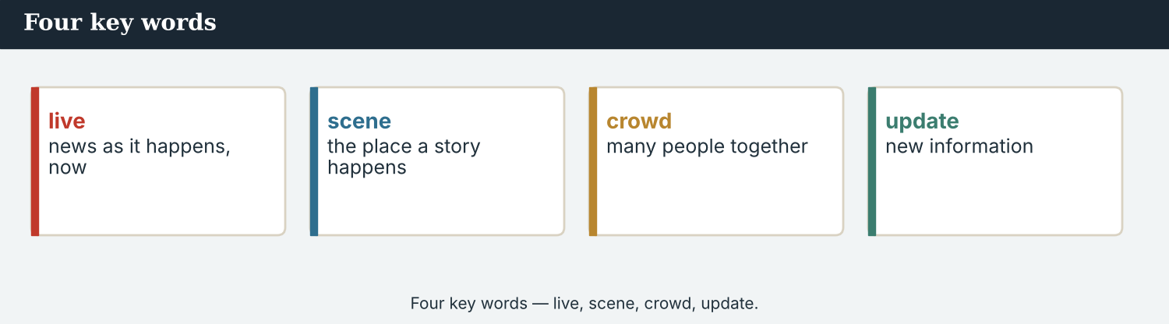
Four key words — live, scene, crowd, update.
The words
Word | Meaning
live | news as it happens, now
scene | the place a story happens
report | a story; to tell the news
microphone | a reporter speaks into it
crowd | many people together
happening | going on now
plan | what you are going to do
cover | to report a story
on air | being shown or heard now
update | new information
breaking | very new and important
event | a thing that happens
moment | a very short time
broadcast | to send news on TV or radio
PRACTISE Controlled practice
1A Match the word (1–10) to the meaning (a–j).
1. live  2. scene  3. crowd  4. cover  5. update  6. microphone  7. broadcast  8. breaking  9. moment  10. event | a) many people together  b) a thing that happens  c) news as it happens  d) to report a story  e) a reporter speaks into it  f) new information  g) a very short time  h) the place a story happens  i) very new and important  j) to send news on TV or radio
1B Complete the sentences with a word from the box.
WORD BOX
live · scene · crowd · microphone · update · report
1. Mira speaks into the ___________ .
2. There is a big ___________ on the bridge today.
3. She is reporting ___________ from the ___________ .
4. Here is a short news ___________ .
5. We have a new ___________ every hour.
1C Match the two halves (collocations).
1. breaking  2. live  3. cover  4. on  5. the | a) news  b) report  c) a story  d) air  e) scene
1D Circle the word that is different.
1. crowd · people · families · microphone
2. report · story · update · deadline
3. scene · place · plan · bridge
4. now · live · later · happening
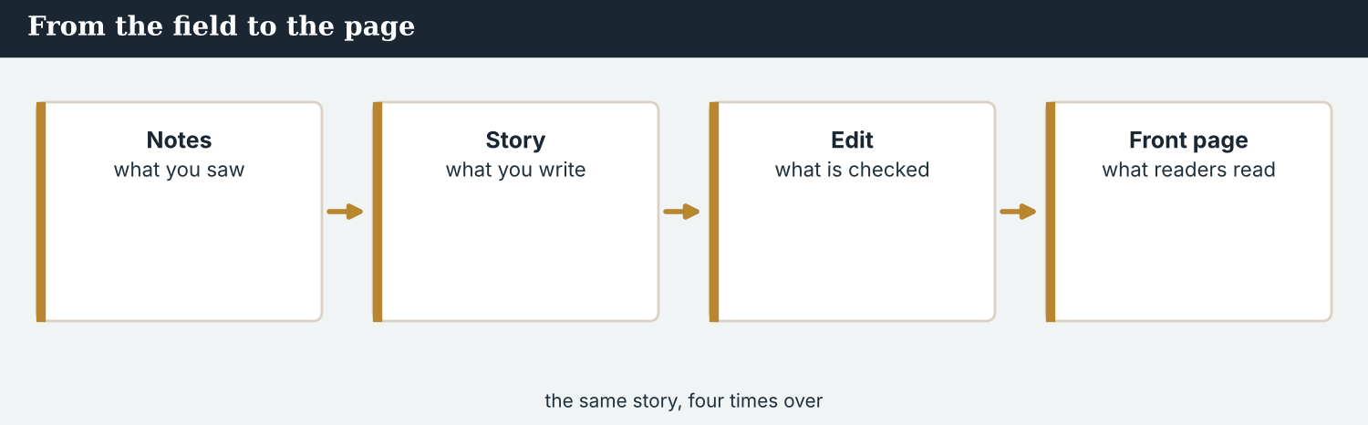
From live report to the front page — the same story, written down.
1E Complete the paragraph. Use: scene · live · microphone · crowd · report.
Mira is at the ___________ . She is on air, ___________ from the bridge. She holds a ___________ and speaks to the camera. Behind her, a big ___________ is crossing. Later, she files a short ___________ for the wire.
1F Read the definition. Write the word.
1. being shown or heard now → ___________
2. news as it happens → ___________
3. new information → ___________
4. a very short time → ___________
PRODUCE Over to you
1G Answer about you. Write full sentences.
1. What is happening in your street or home right now?
2. Would you like to report live from another country? Why or why not?
PRODUCE Talk about it
1H Discuss. Which two words in this unit are new for you? Make a sentence with one.
1I Creative. Write three sentences about a busy place you know. Use: there is / there are / -ing.

PART 2 Grammar: now and next
Present continuous for now, going to for plans, and prepositions for place.
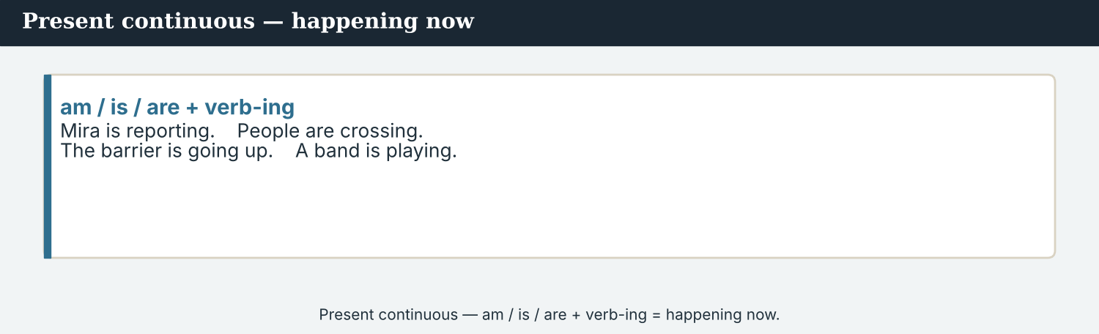
Present continuous — am / is / are + verb-ing = happening now.
1 · Present continuous — happening now
Form: am / is / are + verb-ing.
Mira is reporting. People are crossing. The stalls are opening.
We use it for things that are happening now, at this moment.
2 · going to — plans and the future
Form: am / is / are + going to + verb.
She is going to interview a stall-holder. We are going to cover the story.
We use it for plans and what we think will happen next.
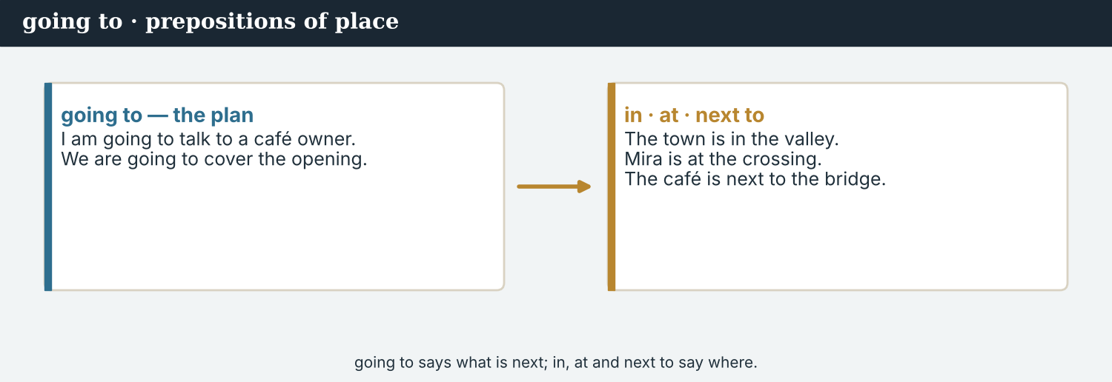
Prepositions of place — in, at, next to, in front of.
3 · Prepositions of place
in a place: The town is in the valley.
at a point: Mira is at the crossing.
next to / in front of / behind: The café is next to the bridge.
PRACTISE Structured practice
2A Write the -ing form of the verb.
1. report → ___________
2. come → ___________
3. open → ___________
4. stand → ___________
5. run → ___________
2B Complete with am / is / are + -ing.
1. Mira ___________ (report) live.
2. The stalls ___________ (open) now.
3. People ___________ (cross) the bridge.
4. I ___________ (write) a report.
2C Write the plan with going to.
1. Mira / interview / a stall-holder → ________________________
2. the team / cover / the opening → ________________________
3. Hana / take / photographs → ________________________
2D Choose the right preposition: in · at · next to.
1. The town is ______ the valley.
2. Mira is ______ the crossing.
3. The café is ______ the bridge.
Your own words
2E Look out of the window (or around the room). Write three things that are happening now.
1. ________________________
2. ________________________
3. ________________________
2F Write two plans for tomorrow with going to.
1. ________________________
2. ________________________

PART 3 At the scene: reporting live
A live report says where you are, and what is happening now.
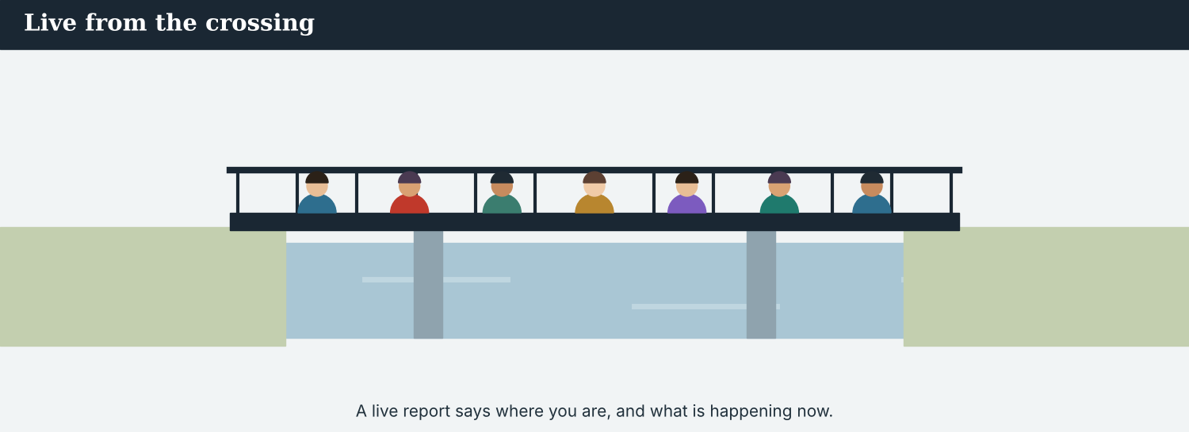
A live report — Mira says what is happening now, from the scene.
MODEL A model live report
“This is Mira Sandoval, live from the crossing at Kalina. It is a busy morning. The barrier is up, the stalls are open, and a big crowd is here. Families are carrying bags across the bridge. In a moment, I am going to talk to a stall-holder. Back to you in the studio.”
NOTICE Notice the report
3A Answer about the model.
1. Where is Mira? ___________
2. What is the crowd doing? ___________
3. What is she going to do next? ___________
3B Underline the three -ing verbs in the report. Write them.
1. ________________________
PRACTISE Say where
A live report still answers the questions — where, what, who, and now.
3C Where is each thing? Write a sentence with a preposition.
1. the reporter / the crossing → ________________________
2. the crowd / the bridge → ________________________
3. the café / the bridge → ________________________
3D Complete the live report. Use the words in brackets.
“This is Tomas, ______ (live) from the village above Kalina. A crowd ______ (gather) here now. People ______ (wait) for the new school to open. In a moment, the head teacher ______ (going to) speak.”
PRODUCE Your turn
3E Choose a busy place. Write a short live report (3–4 sentences). Say where you are and what is happening now.
________________________
________________________
________________________
PRODUCE Discuss
3F Talk with a partner. Why is a live report exciting? What is difficult about it?
3G Which is better for breaking news: a live report or a written report? Say one reason.

PART 4 Listening: on air
Two audios. Listen for what is happening now.
In the studio — the desk listens to the live report.
Listening A · a live broadcast
MODEL Audio 3.1 — Mira goes live
Studio: And now, live from the crossing at Kalina, here is Mira Sandoval.
Mira: Thank you. This is Mira, live from the bridge. It is a busy morning here.
Mira: The barrier is up, and a big crowd is crossing with bags and boxes.
Mira: Right now, a family is opening a small café next to the old gate.
Mira: In a moment, I am going to talk to the owner. Back to you in the studio.
Studio: Thank you, Mira. We will come back to you soon.
PRACTISE Listen for detail
4A Before you listen: what do you think Mira can see? Write two ideas.
1. ________________________
4B Answer the questions.
1. Where is Mira? ___________
2. What is the crowd carrying? ___________
3. What is the family doing? ___________
4. What is Mira going to do next? ___________
4C True or false? Write T or F.
1. Mira is in the studio. ______
2. The barrier is up. ______
3. The café is next to the old gate. ______
4D Complete the notes.
Place: ___________
Now (happening): ___________
Next (plan): ___________
Audio 3.2 — Tomas phones in a live update from the bridge.
Listening B · a live phone-in
MODEL Audio 3.2 — Tomas calls in
Daniel: Tomas, you are on air. What is happening?
Tomas: Hi, Daniel. I am on the bridge, near the old gate. A big crowd is here.
Daniel: What are the people doing?
Tomas: They are watching a small concert. A band is playing now.
Daniel: Is the market still open?
Tomas: Yes, the stalls are open, and children are dancing. It is a happy scene.
Daniel: Thank you, Tomas. We are going to put your photographs on the wire next.
PRACTISE Listen for detail
4E Before you listen: where is Tomas? Guess.
1. ______
4F Complete the answers.
1. Tomas is near the old ___________ .
2. The people are watching a ___________ .
3. The children are ___________ .
4. Daniel is going to put the ___________ on the wire.
4G Which -ing verbs do you hear? Write three.
1. ________________________
4H Answer. Is this hard news or soft news? Why?
1. ________________________
PRACTISE Both audios
4I Complete the summary. Use: live · bridge · crowd · going to.
In both audios, a reporter is ______ from the ______ . A big ______ is there. Each reporter says what is happening now, and what they are ______ do next.
PRODUCE What do you think?
4J Discuss. Why does a studio go ‘live’ to a reporter in another country? What can go wrong?

PART 5 Reading: from the field
Two readings. Read for what is happening, and for the plan.
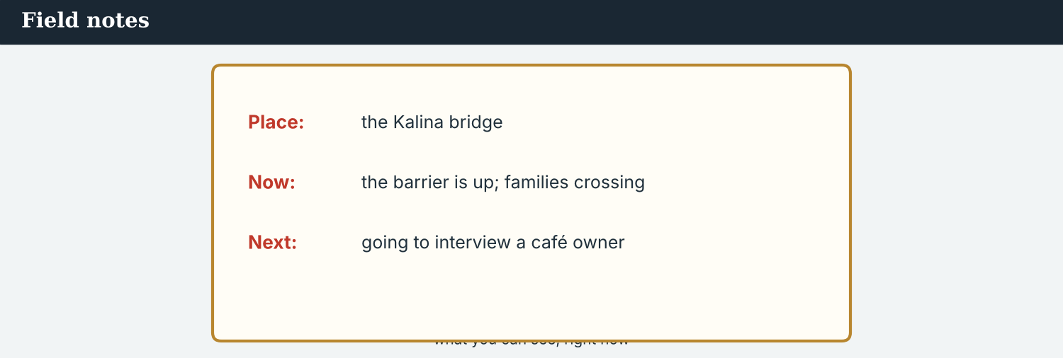
Live updates in brief — short items from the field.
Reading A · a live report, written down
A busy morning at the Kalina crossing
It is nine o’clock, and the crossing at Kalina is waking up. The barrier is up, the stalls are open, and a big crowd is here. Correspondent Mira Sandoval is standing at the old gate with a microphone.
“This is a very busy morning,” Mira says. “People are carrying bags and boxes across the bridge. Families are coming from both sides of the river, and children are running ahead of them. Next to the gate, a young family is opening a small café. This is their first day.”
Behind Mira, a stall-holder is putting fruit on his table. He is smiling. “The people are coming back,” he says. “Every morning, more families cross. It is good for business, and it is good for the valley.”
At the end of the bridge, a group of workers is painting the rail. “We are getting the crossing ready,” one worker says. “Next week, there is going to be a small festival here, on both sides.”
A little further on, two teachers are standing in front of the new school bus. They are waiting for the children. “We are starting again today,” one teacher says. “Forty children are coming this morning, and more are coming next week. It is a very happy day for us.”
Near the barrier, an old man is watching the crowd. He is not shopping; he is just looking. “For seven years, this bridge was closed and quiet,” he says slowly. “Now it is full of people again. I am very happy. I am coming here every morning now, just to see the families.”
Mira looks at the camera. “So the news this morning is simple and happy: Kalina is open. In a moment, I am going to talk to the family at the new café. This is Mira Sandoval, live from the crossing. Back to you in the studio.”
PRACTISE Comprehension
5A Before you read: look at the title. What is the report about? Write one sentence.
1. ______
5B True or false? Write T or F.
1. The barrier is down. ______
2. A family is opening a café. ______
3. Workers are painting the rail. ______
4. There is going to be a festival next week. ______
5C Answer the questions.
1. Where is Mira standing? ___________
2. What are the children doing? ___________
3. What is Mira going to do next? ___________
5D Find a word in the text.
1. many people together → ___________
2. a place to drink coffee → ___________
3. a happy party → ___________
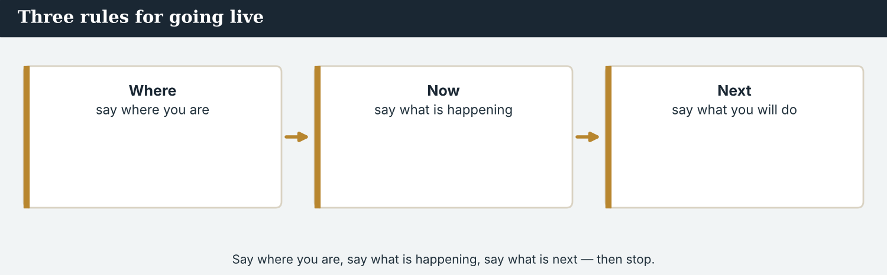
Say where you are, say what is happening, say what is next — then stop.
Reading B · reporting from the field — three tips
Three tips for a live report
1. Say where you are. Start with the place: ‘This is Mira Sandoval, live from the crossing at Kalina.’ The listener is far away and needs to see the scene.
2. Say what is happening now. Use the present continuous: ‘The stalls are opening. A crowd is crossing.’ Talk about this moment, not last week.
3. Say what is next. Use going to for the plan: ‘In a moment, I am going to talk to a stall-holder.’ This keeps the listener with you.
And always: stay calm, speak clearly, and only say what you can see. Do not guess.
PRACTISE Comprehension
5E Before you read: what makes a good live report? Guess one thing.
1. ______
5F Match the tip to the example.
1. Say where you are  2. Say what is happening  3. Say what is next  4. Stay calm | a) ‘The stalls are opening now.’  b) ‘This is Mira, from the crossing.’  c) Speak slowly and clearly.  d) ‘I am going to talk to a stall-holder.’
5G Which tip uses *going to*? Write the number.
1. ______
PRACTISE Words from the readings
5H Find a word in Reading A or Reading B.
1. news as it happens → ___________
2. the place a story happens → ___________
3. a plan for the future → ___________
PRODUCE Discuss
5I Talk about it. Which reading helped you more: the report or the tips? Why?
5J Which of the three tips is the most important? Say why.

PART 6 Writing: notes and a live script
Two short pieces: field notes now, and a live script.
Field notes — what is happening, right now.
Writing 1 · field notes
MODEL A model
Place: the bridge at Kalina
Now: barrier up; crowd crossing with bags; children running
Next: going to interview the café family
NOTICE Notice the model
6A Answer about the model.
1. Are the notes about now or last week? ___________
2. What is the plan (next)? ___________
PRODUCE Write your notes
6B Choose a real or invented scene. Write field notes: Place, Now, Next.
Place: ___________
Now: ___________
Next: ___________
A live script is short — where, what is happening, and what is next.
Writing 2 · a live script
MODEL A model
“This is [name], live from [place]. Right now, [what is happening]. In a moment, I am going to [plan]. Back to you in the studio.”
NOTICE Notice the model
6C Answer. Which tense says what is happening now? Which words say the plan?
1. ___________
PRACTISE Complete a script
6D Complete the live script. Use: live · opening · going to.
“This is Leila, ______ from the school. Right now, the doors are ______ , and children are coming in. In a moment, I am ______ talk to a teacher.”
PRODUCE Write your script
6E Write your own live script (3–4 lines) for a scene you choose.
________________________
________________________
________________________
PRACTISE Fix it
6F This script has two mistakes. Write it correctly.
“the stalls is opening. people is crossing.”
________________________

PART 7 Speaking: to the studio
Report live to a partner. Ask and answer about now.
At the scene — ask what is happening now.
A model dialogue · at the scene
MODEL Listen and read
Mira: Hello. I am Mira, from Atlas Wire. Can I ask you a question?
Person: Yes, of course.
Mira: What are you doing here today?
Person: I am opening my café. It is my first day.
Mira: Why are so many people crossing?
Person: The bridge is open again. Everyone is happy.
Mira: Thank you, and good luck!
NOTICE Notice the questions
7A Which two questions use the present continuous? Write them.
1. ________________________
PRACTISE Controlled practice
7B Make a present-continuous question for each answer.
1. ___________ ? — I am opening my café.
2. ___________ ? — They are carrying bags.
3. ___________ ? — Because the bridge is open.
4. ___________ ? — A band is playing.
Introduce yourself before you ask your questions.
7C Put the words in order to make a question.
1. you / what / doing / are → ________________________
2. crossing / people / why / are → ________________________
3. playing / who / is → ________________________
PRODUCE Your role
Correspondent | Introduce yourself. Ask two present-continuous questions about the scene.
Person at the scene | Answer. Say what you are doing and why you are here.
Studio host | Welcome the reporter, then ask: ‘What is happening now?’
7D Choose a role from the table. Ask your two questions to a partner.
PRODUCE Role-play
7E Role-play a live report: a studio host, a reporter at the scene, and a person. Then swap roles.
A second dialogue · studio and reporter
MODEL Listen and read
Host: Ana here in the studio. Mira, are you there? What is happening?
Mira: Yes, I am here on the bridge. A big crowd is crossing, and the stalls are open.
Host: That is great. What are you going to do next?
Mira: I am going to talk to a stall-holder. Then I am going to send some photographs.
Host: Thank you, Mira. We will come back to you soon.
PRACTISE Controlled practice
7F Write the question the host asks about the plan.
1. ________________________
PRODUCE Self-check
Did I… | Yes | Almost | Not yet
introduce myself clearly? | ☐ | ☐ | ☐
ask about now (present continuous)? | ☐ | ☐ | ☐
say my plan with going to? | ☐ | ☐ | ☐
speak slowly and clearly? | ☐ | ☐ | ☐
7G Role-play the studio-and-reporter call with a partner. Then swap roles.

PART 8 Ethics: live and fair
Live news is fast. A journalist is still accurate and kind.
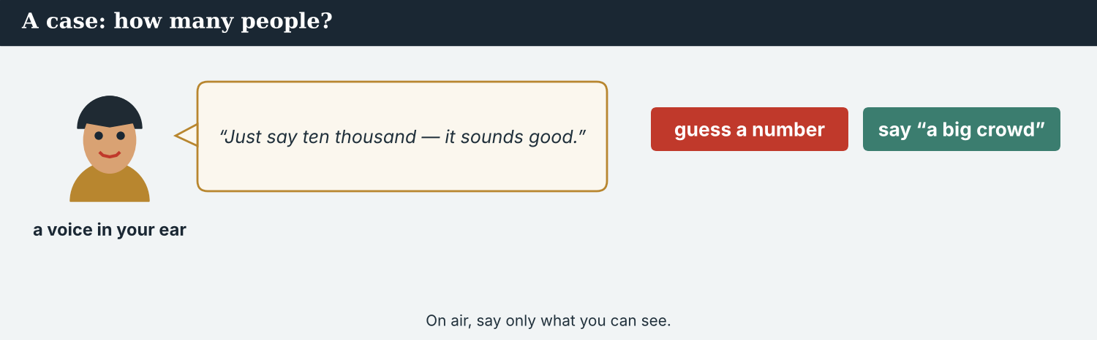
On air, still say only what you can see — a fact, not a guess.
A first case · a number you cannot see
A case. Mira is live at the crossing. The studio asks her: “How many people are there?” Mira can see a big crowd, but she did not count them. A voice in her ear says, “Just say ten thousand — it sounds good.” The report is live, and listeners in many countries are hearing it now. But Mira did not count ten thousand people. She is a journalist, and she knows the Code: report only what you can see, and do not guess a number as a fact. What does Mira say on air?
NOTICE What do you do?
8A Choose (a) or (b), and write one reason.
1. (a) say ‘ten thousand people’ (b) say ‘a big crowd’. Choice: ______ Because ________________________
2. A number you did not count is (a) a fact (b) a guess. Choice: ______
8B Fact or guess? Write F or G.
1. “The stalls are open.” (she can see them) ______
2. “There are exactly 10,000 people.” (she did not count) ______
3. “A band is playing.” (she can hear it) ______
4. “Everyone in the valley is here.” ______
PRACTISE Apply the Code
8C Complete the rule. Use: see · guess · calm · number.
On air, say only what you can ______ . Do not ______ a ______ as a fact. Stay ______ , and speak clearly.
PRODUCE Discuss
8D Discuss. Why is it easy to make a mistake on live news? How can a reporter stay careful?
A second case · filming an upset person
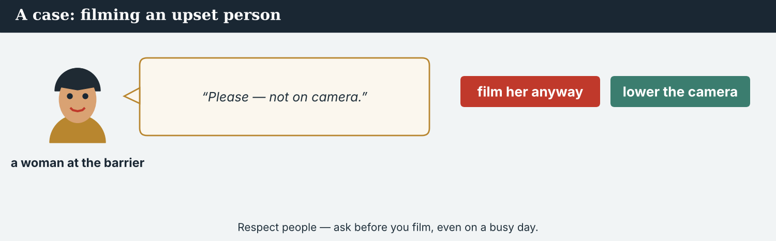
Respect people — ask before you film, even on a busy day.
A case. Tomas is filming the crowd for the live report. He sees a woman at the barrier who is crying. It is a strong picture, and the deadline is now. But the woman does not want to be on camera. She turns away and puts up her hand. Tomas needs pictures for the report, and the pictures will go out in many countries. But the woman said no. The Code says: respect people, and ask before you film. What does Tomas do?
NOTICE What do you do?
8E Choose (a) or (b), and write one reason.
1. (a) film her anyway (b) do not film her. Choice: ______ Because ________________________
2. Next time, Tomas (a) films first, asks later (b) asks first. Choice: ______
8F Complete with: respect · ask · people · no.
1. A journalist must ___________ people.
2. Always ___________ before you film.
3. If a person says ___________ , do not film them.
4. The news is about ___________ , so be kind.
PRODUCE Discuss
8G Discuss. Is it more important to get the picture, or to respect people? Why?
PRODUCE Write it
8H Write what Tomas says to the woman (2–3 sentences). Be kind, and respect her answer.

PART 9 Digital: the live update
Online, a live update is short and fast — but still true.
A live update on a phone — short, now, and true.
MODEL A model live update
LIVE · 9:12 a.m. — The crossing at Kalina is open. A big crowd is here. A family is opening a café next to the old gate. — @AtlasWire
NOTICE The parts of an update
9A Match the part to what it shows.
1. LIVE  2. 9:12 a.m.  3. a big crowd is here  4. @AtlasWire | a) the time, now  b) the outlet  c) it is happening now  d) what you can see
PRACTISE Find and build
9B Find the present-continuous verb in the update. Write it.
1. ______
9C This update has two mistakes. Write it correctly.
“LIVE — the crossing are open. a crowd are crossing.”
________________________
The live update also goes on the website home page.
9D Complete the live update. Answer: where and what is happening.
LIVE · now — ___________ (what is happening?) at ___________ (where?). — @AtlasWire
PRODUCE Write your update
9E Write a one-line live update for a scene you choose. Use the present continuous.
________________________
9F Creative. Write a short headline (4–6 words) for your live story. Use the present continuous.
9G Write a second, later update for the same story (what is happening now).
________________________
PRODUCE Discuss
9H Discuss. Do you follow live updates online? Are they always true? How do you check?

PART 10 Review & Can-Do
Check your new English before Unit 4.
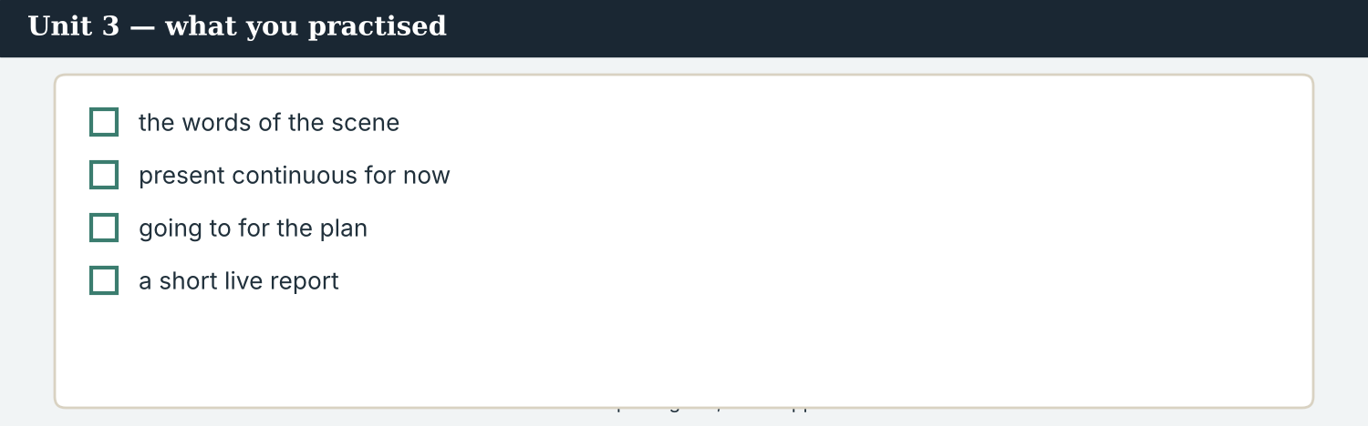
Unit 3 — reporting live, as it happens.
10A Vocabulary. Complete with: live · scene · crowd · update · microphone · report · on air · breaking.
1. Mira speaks into a ___________ .
2. There is a big ___________ on the bridge.
3. She is reporting ___________ from the ___________ .
4. Here is a short news ___________ and a new ___________ .
5. This is ___________ news — it is very new, and she is ___________ now.
10B Grammar. Write am / is / are + -ing.
1. Mira ___________ (report).
2. The stalls ___________ (open).
3. Children ___________ (run).
4. I ___________ (write).
10C Grammar. Write the plan with going to.
1. Mira / interview / the family → ________________________
2. we / cover / the festival → ________________________
Can-Do — tick what you can do now.
10D Prepositions. Choose: in · at · next to.
1. The town is ______ the valley.
2. Mira is ______ the crossing.
3. The café is ______ the old gate.
10E Read and answer.
Tomas is at the scene. He is holding a camera and filming the crowd. People are dancing, and a band is playing. In a moment, he is going to send the photographs to the desk.
1. What is Tomas holding? ___________
2. What are the people doing? ___________
3. What is he going to do next? ___________
Can-Do — tick what you can do now
☐ I can say what is happening now (present continuous).
☐ I can talk about plans with going to.
☐ I can say where things are (prepositions).
☐ I can give a short live update.
10F Reflect. Which part of Unit 3 was the most useful for you? Why?
10G Grammar review. Write the sentence correctly.
1. The stalls is opening. → ________________________
2. People is crossing. → ________________________
3. She go to interview a stall-holder. → ________________________
4. The crossing is on Kalina. → ________________________

PART 11 Assignment: a live report
Put the unit together: plan and write a short live report.
The assignment template — your live report.
Your task. Choose a busy place (real or invented). Write a short live report (5–6 sentences). Say where you are, what is happening now (present continuous), and what is going to happen next (going to). Add one thing you can see, and stay accurate — only what you can see.
A model — use it to check the shape of your report.
Remember: say where you are; use -ing for now; use going to for the plan; report only what you can see.
Success criteria | Yes | Almost | Not yet
I say where I am (a preposition). | ☐ | ☐ | ☐
I use the present continuous for now. | ☐ | ☐ | ☐
I use going to for the plan. | ☐ | ☐ | ☐
I report only what I can see — no guesses. | ☐ | ☐ | ☐
It is neat and easy to read. | ☐ | ☐ | ☐
Keep this. In Unit 4, you learn to run a full interview — asking polite questions with can, could and would.

ANSWER KEY Unit 3
Check your answers. Open tasks (discussion, role-play and your own writing) are marked at the end.
W1 1 on the bridge at Kalina · 2 nine o’clock (in the morning) · 3 crossing; the stalls are opening
W2 1 F · 2 T · 3 T
W3 (any three) standing · crossing · opening · holding · walking
1A 1-c, 2-h, 3-a, 4-d, 5-f, 6-e, 7-j, 8-i, 9-g, 10-b (accept sensible matches)
1B 1 microphone · 2 crowd · 3 live, scene · 4 report · 5 update
1C 1 breaking news · 2 live report · 3 cover a story · 4 on air · 5 the scene
1D 1 microphone · 2 deadline · 3 plan · 4 later
1E 1 scene · 2 live · 3 microphone · 4 crowd · 5 report
1F 1 on air · 2 live · 3 update · 4 moment
2A 1 reporting · 2 coming · 3 opening · 4 standing · 5 running
2B 1 is reporting · 2 are opening · 3 are crossing · 4 am writing
2C 1 Mira is going to interview a stall-holder. · 2 The team is going to cover the opening. · 3 Hana is going to take photographs.
2D 1 in · 2 at · 3 next to
3A 1 at the crossing (the scene), Kalina · 2 carrying bags across the bridge · 3 talk to a stall-holder
3B (any three) is up / are open / is here / are carrying
3C (example) 1 The reporter is at the crossing. · 2 The crowd is on the bridge. · 3 The café is next to the bridge.
3D 1 live · 2 is gathering · 3 are waiting · 4 is going to
4B 1 on the bridge at Kalina · 2 bags and boxes · 3 opening a small café · 4 talk to the owner
4C 1 F · 2 T · 3 T
4D Place = the bridge at Kalina · Now = barrier up, crowd crossing, family opening a café · Next = interview the owner
4F 1 gate · 2 concert (band) · 3 dancing · 4 photographs
4G (any three) watching · playing · dancing
4I live · bridge · crowd · going to
5B 1 F · 2 T · 3 T · 4 T
5C 1 at the old gate · 2 running (ahead of their families) · 3 talk to the family at the new café
5D 1 crowd · 2 café · 3 festival
5F Say where you are → ‘This is Mira, from the crossing.’ · Say what is happening → ‘The stalls are opening now.’ · Say what is next → ‘I am going to talk to a stall-holder.’ · Stay calm → speak slowly and clearly
5G Tip 3
5H 1 live · 2 scene · 3 plan
6A 1 now · 2 interview the café family
6C present continuous (-ing) says now; ‘going to’ says the plan
6D 1 live · 2 opening · 3 going to
6F The stalls are opening. People are crossing.
7A (any two) ‘What are you doing here today?’ · ‘Why are so many people crossing?’
7B (example) 1 What are you doing? · 2 What are they carrying? · 3 Why are people crossing? · 4 Who is playing?
7C 1 What are you doing? · 2 Why are people crossing? · 3 Who is playing?
7F What are you going to do next?
8A 1 (b) say ‘a big crowd’ — she did not count · 2 (b) a guess
8B 1 F · 2 G · 3 F · 4 G
8C see · guess · number · calm
8E 1 (b) do not film her — she said no · 2 (b) asks first
8F 1 respect · 2 ask · 3 no · 4 people
9A LIVE → it is happening now · 9:12 a.m. → the time, now · a big crowd is here → what you can see · @AtlasWire → the outlet
9B is open / is here / is opening (any present-continuous or ‘is’ form)
9C LIVE — the crossing is open. A crowd is crossing.
10A 1 microphone · 2 crowd · 3 live, scene · 4 report, update · 5 breaking, on air
10B 1 is reporting · 2 are opening · 3 are running · 4 am writing
10C 1 Mira is going to interview the family. · 2 We are going to cover the festival.
10D 1 in · 2 at · 3 next to
10E 1 a camera · 2 dancing (and a band is playing) · 3 send the photographs to the desk
10G 1 The stalls are opening. · 2 People are crossing. · 3 She is going to interview a stall-holder. · 4 The crossing is at Kalina.
Open tasks W4, 1G, 1H, 1I, 2E, 2F, 3E, 3F, 3G, 4A, 4E, 4H, 4J, 5A, 5E, 5I, 5J, 6B, 6E, 7D, 7E, 7G, 8D, 8G, 8H, 9D, 9E, 9F, 9G, 9H, 10F — your own answers (discussion, role-play, writing).
A note on real and invented content. The facts about journalism around the world are true as of 2026. Atlas Wire, its staff, Kalina, the river Vara and the people in the scenes are invented, for practice. Real people are only ever in true, sourced facts — never in an invented quote.
English for Journalists — International Edition · Unit 3 (v6 standard). CEFR A2 → lower B1 · Beat: Report & live · two readings · two listenings · two writing pieces · two ethics cases · two speaking dialogues · balanced sections · ~24 figures · featured cast · fictional agency, factual backdrop.
UNIT 4 The Interview: Asking Politely
Beat · Interview CEFR A2 → lower B1
In this unit you learn to…
1. ask polite questions with can, could and would
2. make yes/no and wh- questions correctly
3. set up and run a short interview, with or without an interpreter
4. listen well and get a good quote
The Atlas Wire team — Mira runs her first full interview in this unit.
The story so far. Mira has reported live from the crossing at Kalina. Now a family is opening a café at the end of the bridge, and Mira is going to interview them. First she must ask, politely, if she can — and she must agree how to work with Dren, the local journalist who is helping her.

WARM-UP May I ask a question?
A short scene to start the unit. Read it, then answer.
The morning conference — the team decides who is going to do the interview.
Mira wants to interview a family at the Kalina crossing. She walks up to them and smiles. “Good morning. My name is Mira Sandoval, and I am a correspondent with Atlas Wire,” she says. “Can I ask you a few questions? Could you tell me your names? And would you like to say something about coming back?” The family smile. “Of course,” says the father. “Please, sit with us.”
W1 Answer the questions.
1. Who does Mira want to interview? ___________
2. What does Mira do before she asks? ___________
3. What does the father say? ___________
W2 True or false? Write T or F.
1. Mira is rude to the family. ______
2. Mira says her name and her agency. ______
3. The family say no. ______
W3 Find three polite questions in the text. Write the first word of each.
1. ________________________
PRODUCE Talk about it
W4 Discuss with a partner.
1. How do you ask for something politely in your language?
2. Is it easy or hard to talk to a stranger in another country? Why?

PART 1 The words of the interview
The words a reporter needs for an interview. Learn these first.
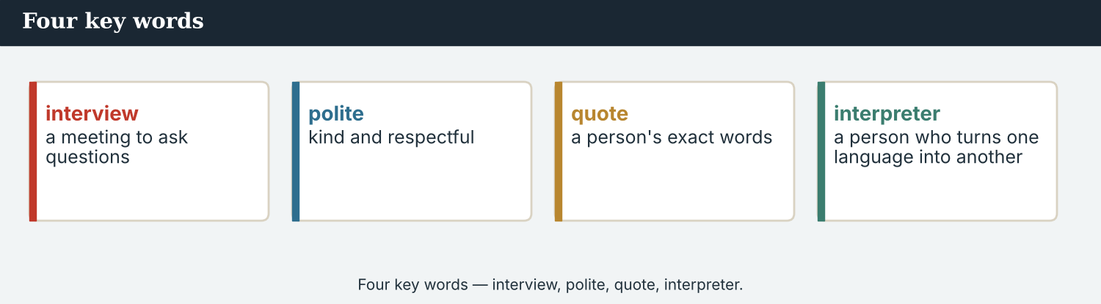
Four key words — interview, polite, quote, interpreter.
The words
Word | Meaning
interview | a meeting to ask questions
question | what you ask
answer | what someone says back
polite | kind and respectful
request | when you ask for something
permission | a yes to do something
appointment | a set time to meet
arrange | to plan a meeting
record | to save sound or video
quote | a person’s exact words
interpreter | a person who turns one language into another
follow-up | a second question about the answer
guest | the person you interview
notes | short words you write down
PRACTISE Controlled practice
1A Match the word (1–10) to the meaning (a–j).
1. interview  2. polite  3. permission  4. arrange  5. record  6. quote  7. interpreter  8. follow-up  9. guest  10. appointment | a) kind and respectful  b) a set time to meet  c) a meeting to ask questions  d) the person you interview  e) to save sound or video  f) a person who turns one language into another  g) a person’s exact words  h) to plan a meeting  i) a yes to do something  j) a second question
1B Complete the sentences with a word from the box.
WORD BOX
interview · polite · quote · record · appointment · interpreter
1. Mira asks for an ___________ to meet the family.
2. She is always ___________ with people.
3. May I ___________ this on my phone?
4. Here is a good ___________ from the café owner.
5. The family do not speak English, so Dren works as the ___________ .
6. A short ___________ is only ten minutes.
1C Match the two halves (collocations).
1. ask a  2. give an  3. take  4. make an  5. get | a) question  b) answer  c) notes  d) appointment  e) permission
1D Circle the word that is different.
1. question · answer · quote · deadline
2. polite · kind · rude · respectful
3. arrange · plan · prepare · shout
4. guest · source · person · microphone
From interview to front page — a good quote makes the story strong.
1E Complete the paragraph. Use: interview · questions · polite · quote · notes.
Mira has an ___________ today. She prepares her ___________ first. She is always ___________ . She listens well and takes ___________ . Then she chooses one good ___________ for her story.
1F Read the definition. Write the word.
1. a set time to meet → ___________
2. a person’s exact words → ___________
3. a second question about the answer → ___________
4. a person who turns one language into another → ___________
PRODUCE Over to you
1G Answer about you. Write full sentences.
1. Who would you like to interview? Why?
2. What is one polite question you could ask them?
PRODUCE Talk about it
1H Discuss. Which two words in this unit are new for you? Make a sentence with one.
1I Creative. Write three questions you would ask a person who is coming home to their town. Be polite.

PART 2 Grammar: asking politely
Can and could for requests, would for offers, and the order of a question.
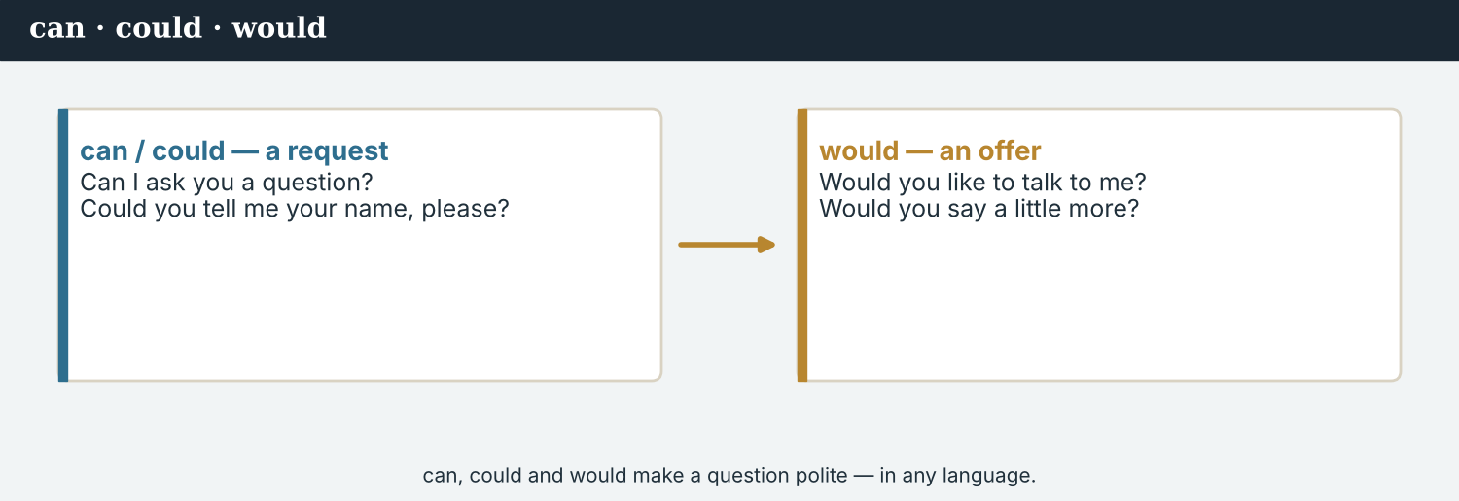
Can, could and would make a question polite.
1 · can / could — requests
can: Can I ask you a question? Can you say that again?
could is more polite: Could you tell me your name, please?
Use them to ask for permission and to make a request.
2 · would — offers and polite requests
Would you like to talk to me? (an offer / a soft request)
Would you say a little more, please?
would is gentle and very polite.
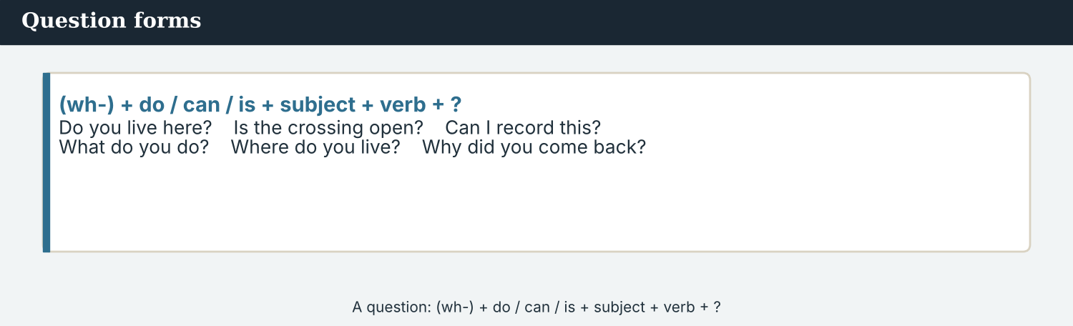
A question: (wh-) + do / can / is + subject + verb + ?
3 · Question forms
Yes / no: Do you live here? Is the crossing open? Can I record this?
Wh-: What do you do? Where do you live? Why did you come back?
Order: (wh-) + do / does / can / is + subject + verb + ?
PRACTISE Structured practice
2A Make the request more polite. Change can to could.
1. Can you tell me your name? → ________________________
2. Can I ask a question? → ________________________
3. Can you say that again? → ________________________
2B Complete with can, could or would.
1. ___________ I ask you a question, please?
2. ___________ you like a cup of coffee?
3. ___________ you tell me the time, please? (very polite)
2C Put the words in order to make a question.
1. you / do / where / live → ________________________
2. the crossing / is / open → ________________________
3. come back / why / did / you → ________________________
2D Write the yes/no question.
1. (you / live / here) → ___________ ?
2. (the café / open / is) → ___________ ?
3. (I / record / can / this) → ___________ ?
Your own words
2E Write two polite requests you could make to a guest. Use could and would.
1. ________________________
2. ________________________
2F Write two wh- questions you would ask a person about their day.
1. ________________________
2. ________________________

PART 3 Running an interview
A good interview: prepare, be polite, listen, and ask a follow-up.
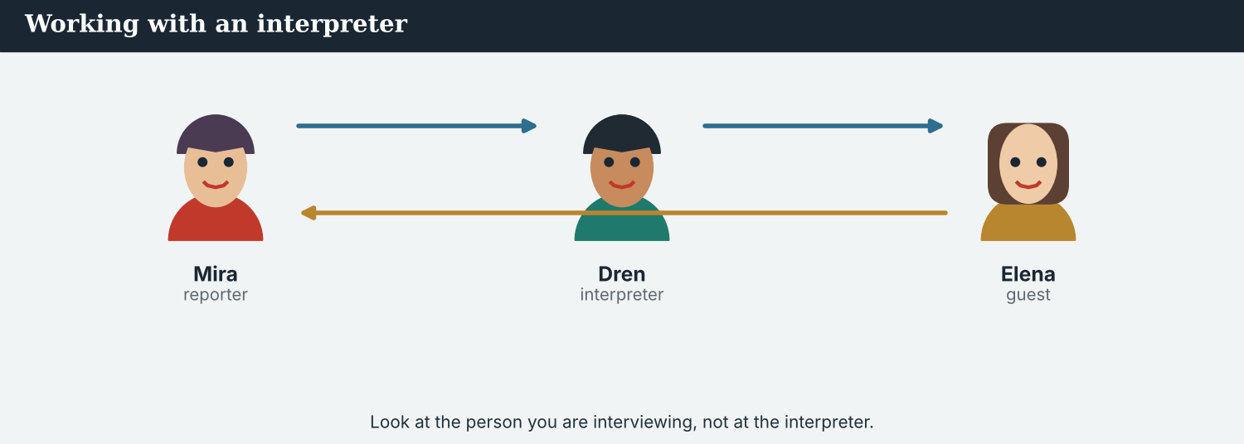
Working with an interpreter — look at your guest, not at the interpreter.
MODEL A model interview
Mira: Good morning. Could you tell me your name, please?
Guest: I am Elena Marku. This is my family.
Mira: Thank you, Elena. Why did you come back to Kalina?
Guest: It is our home. My mother lives on the other side of the river.
Mira: That is lovely. And what are you going to do here now?
Guest: We are going to open a small café at the end of the bridge.
NOTICE Notice the interview
3A Answer about the model.
1. What is the guest’s name? ___________
2. Why did the family come back? ___________
3. What are they going to do? ___________
3B Find the polite opening question. Write it.
1. ________________________
PRACTISE Prepare questions
Prepare a mix of wh- questions and yes/no questions.
3C Write a wh- question to ask the guest.
1. about their home → ________________________
2. about their plan → ________________________
3. about their feelings → ________________________
3D Complete the interview. Use: could · what · would · why.
“______ you tell me your name? ______ did you come back? ______ are you going to do next? And ______ you like to add anything?”
PRODUCE Your turn
3E Choose a person (real or invented). Write four interview questions: a polite opening, two wh- questions, and one follow-up.
________________________
________________________
________________________
________________________
PRODUCE Discuss
3F Talk with a partner. What makes an interview go well? What makes it go badly?
3G Why is a follow-up question useful? Give one example.

PART 4 Listening: setting it up
Two audios. Listen for the polite questions.
In the newsroom — Mira arranges the interview by phone.
Listening A · a phone call to arrange an interview
MODEL Audio 4.1 — Mira makes an appointment
Mira: Hello, this is Mira Sandoval from Atlas Wire. Could I speak to Elena Marku, please?
Elena: Speaking. Good morning.
Mira: Good morning. Can I ask you for a short interview about coming back to Kalina?
Elena: Yes, of course. When would you like to meet?
Mira: Could we meet tomorrow morning, at the café?
Elena: Ten o’clock is good for me.
Mira: Perfect. Thank you very much. See you then.
PRACTISE Listen for detail
4A Before you listen: why is Mira calling? Write one idea.
1. ______
4B Answer the questions.
1. Who does Mira want to speak to? ___________
2. What does she ask for? ___________
3. Where are they going to meet? ___________
4. What time? ___________
4C True or false? Write T or F.
1. Mira is rude on the phone. ______
2. Elena says yes. ______
3. They meet in the evening. ______
4D Complete the notes.
Guest: ___________
Place: ___________
Time: ___________
Audio 4.2 — the interview at the café, the next morning.
Listening B · the interview
MODEL Audio 4.2 — the interview
Mira: Thank you for meeting me. Could you tell me your name?
Elena: I am Elena Marku, and this is my café.
Mira: It is lovely. When did you open?
Elena: We opened last week. It is our first café.
Mira: And why did you choose Kalina?
Elena: Because it is our home. My mother lives on the other side, and now I can see her every day.
Mira: Would you like to say anything to the people of the valley?
Elena: Yes — please come and visit us!
PRACTISE Listen for detail
4E Before you listen: what will Mira ask first? Guess.
1. ______
4F Complete the answers.
1. Elena has a ___________ .
2. They opened it ___________ .
3. She chose Kalina because it is her ___________ .
4. Elena asks people to come and ___________ .
4G Which polite words do you hear? Write two (could / would / please).
1. ________________________
4H Answer. Which answer would make the best quote? Write it.
1. ________________________
PRACTISE Both audios
4I Complete the summary. Use: interview · polite · appointment · café.
First, Mira phones Elena and makes an ______ . She is very ______ . The next morning, she does the ______ at the ______ and gets a good quote.
PRODUCE What do you think?
4J Discuss. Why does Mira call first, before the interview? What could go wrong if she does not?

PART 5 Reading: the interview
Two readings. Read for the questions and the quotes.
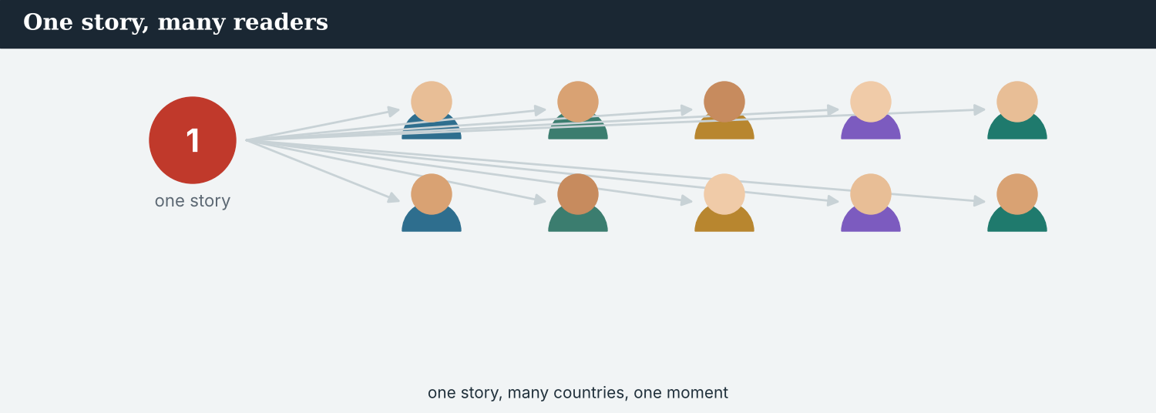
A short interview, written up for the wire.
Reading A · an interview, written up
‘My mother is on the other side’: a family comes back to Kalina
This week, correspondent Mira Sandoval sat down with Elena Marku and her family at their new café, at the end of the bridge at Kalina. The family came back to the town last month, and they are already part of the street.
“Could you tell me why you came back?” Mira asked. Elena smiled. “It is our home,” she said. “We were away for seven years, but we always wanted to come back. When we heard that the crossing was open again, we knew it was time. My mother is on the other side of the river. Now I can see her every day.”
Mira asked what they were going to do. “We are going to run this little café,” Elena said. “My husband makes the coffee, and I make the bread. Our children help after school. Every day, more neighbours come and sit with us.”
The café is small — only six tables — but it is always full. “People do not only come for coffee,” Elena said. “They come to talk, and to see old friends. The valley is waking up, and we are happy to be a part of it.”
Dren, a journalist from the town, sat with them and helped when the English was difficult. “People here want to tell their own story,” he said afterwards. “They only need somebody to ask properly.”
Before she left, Mira asked one more question. “Would you like to say anything to your neighbours?” Elena laughed. “Yes,” she said. “Please come and visit us. The door is always open, and the coffee is always hot.”
PRACTISE Comprehension
5A Before you read: look at the title. Who is the interview with? Write one sentence.
1. ______
5B True or false? Write T or F.
1. The family came back seven years ago. ______
2. Elena makes the bread. ______
3. The café has six tables. ______
4. People come to the café only for coffee. ______
5C Answer the questions.
1. Why did the family come back? ___________
2. What are they going to do at the café? ___________
3. What does Elena say to the neighbours? ___________
5D Find a word in the text.
1. a person’s exact words are a … → ___________
2. kind and respectful → ___________
3. people who live near you → ___________
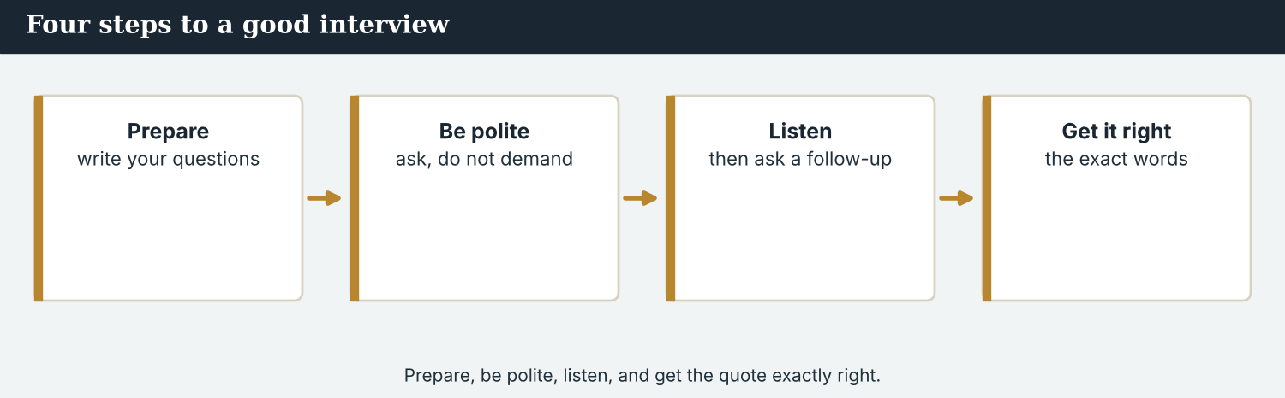
Prepare, be polite, listen, and get the quote exactly right.
Reading B · preparing for an interview — four tips
Four tips for a good interview
1. Prepare your questions. Write three or four questions before you go. Mix wh- questions and yes/no questions.
2. Be polite. Start with a request: ‘Can I ask you a question?’ Use could and would. Say please and thank you.
3. Listen well. Do not only read your questions. Listen to the answer, and ask a follow-up: ‘Could you say more about that?’
4. Get the quote right. Write the person’s exact words. If you work with an interpreter, ask them to translate word for word, and check anything you are not sure of. Do not change what the guest said.
PRACTISE Comprehension
5E Before you read: what should you do before an interview? Guess one thing.
1. ______
5F Match the tip to the example.
1. Prepare your questions  2. Be polite  3. Listen well  4. Get the quote right | a) ‘Could you say more about that?’  b) Write three questions before you go.  c) Write the exact words; check what you are not sure of.  d) ‘Can I ask you a question?’
5G Which tip is about accuracy? Write the number.
1. ______
PRACTISE Words from the readings
5H Find a word in Reading A or Reading B.
1. a meeting to ask questions → ___________
2. a second question → ___________
3. a person’s exact words → ___________
PRODUCE Discuss
5I Talk about it. Which quote from Elena do you like best? Why?
5J Which of the four tips is the most important? Say why.

PART 6 Writing: questions and a quote
Two short pieces: a list of questions, and a short write-up with a quote.
Prepare your questions before the interview.
Writing 1 · interview questions
MODEL A model
Opening: Could you tell me your name?
Wh- 1: Why did you come back?
Wh- 2: What are you going to do here?
Follow-up: Could you say more about that?
NOTICE Notice the model
6A Answer about the model.
1. How many questions are there? ___________
2. Which one is the polite opening? ___________
PRODUCE Write your questions
6B Choose a guest (real or invented). Write four questions: an opening, two wh-, and a follow-up.
________________________
________________________
________________________
________________________
A short write-up ends with one strong quote.
Writing 2 · a short write-up with a quote
MODEL A model
“This week, Mira Sandoval met Elena Marku at her new café at the Kalina crossing. The family came back last month. ‘It is our home,’ Elena said. ‘Please come and visit us.’”
NOTICE Notice the model
6C Answer. Where are the guest’s exact words? What marks them?
1. ___________
PRACTISE Complete a write-up
6D Complete the write-up. Use: interview · said · quote.
In her ______ , Mira asked Elena why she came back. “It is our home,” Elena ______ . Mira chose this as the ______ for her story.
PRODUCE Write your write-up
6E Write a short write-up (3–4 sentences) about an interview. End with one exact quote.
________________________
________________________
________________________
PRACTISE Fix it
6F This is rude. Make it polite. Rewrite the two questions.
“Tell me your name. Say why you came back.”
________________________

PART 7 Speaking: the interview
Set up and run an interview with a partner. Be polite.
Ask politely, listen, and ask a follow-up.
A model dialogue · asking for the interview
MODEL Listen and read
Mira: Excuse me. My name is Mira Sandoval, from Atlas Wire. Could I ask you a few questions?
Guest: Yes, of course.
Mira: Thank you. Can you tell me your name?
Guest: I am Elena.
Mira: Would you like to say why you came back?
Guest: It is our home. My mother is on the other side of the river.
Mira: Thank you very much.
NOTICE Notice the questions
7A Which three questions are polite? Write the first word of each.
1. ________________________
PRACTISE Controlled practice
7B Make the question more polite. Use could or would.
1. Tell me your name. → ________________________
2. Say that again. → ________________________
3. Do you want to add anything? → ________________________
Introduce yourself first, then ask.
7C Put the words in order to make a polite question.
1. I / could / a question / ask → ________________________
2. you / would / to talk / like → ________________________
3. me / could / your name / tell / you → ________________________
PRODUCE Your role
Correspondent | Introduce yourself. Ask three polite questions (an opening, a wh-, and a follow-up).
Guest | Answer politely. Give one good, short quote.
Interpreter | Translate word for word. Do not add anything of your own.
Observer | Listen. Did the reporter say please and thank you? Was every question polite?
7D Choose a role from the table. Ask your questions to a partner.
PRODUCE Role-play
7E Role-play a full interview: a reporter, a guest, an interpreter, and an observer. Then swap roles.
A second dialogue · a follow-up question
MODEL Listen and read
Mira: What are you going to do at the café?
Elena: We are going to make coffee and bread.
Mira: That sounds lovely. Could you say a little more about the bread?
Elena: Yes — they are my grandmother’s recipes, from before the crossing closed.
Mira: How wonderful. Thank you for sharing that.
PRACTISE Controlled practice
7F Write the follow-up question Mira asks.
1. ________________________
PRODUCE Self-check
Did I… | Yes | Almost | Not yet
introduce myself first? | ☐ | ☐ | ☐
ask politely (can / could / would)? | ☐ | ☐ | ☐
listen and ask a follow-up? | ☐ | ☐ | ☐
say please and thank you? | ☐ | ☐ | ☐
7G Role-play the follow-up dialogue with a partner. Then swap roles.

PART 8 Ethics: a fair interview
An interview is a promise: report what the guest really said.
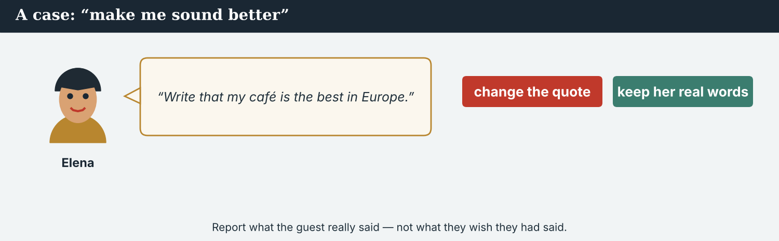
Report the guest’s exact words — do not change them to sound better.
A first case · changing the quote
A case. After the interview, Elena calls Mira. “I have thought about it,” she says. “Can you make my answer sound better? Please write that my café is the best in the region, and that hundreds of people come every day.” But Elena did not say that in the interview, and it is not true. Mira wrote down Elena’s real words: ‘It is our home, and the coffee is always hot.’ Mira likes Elena and wants to help. But she is a journalist, and she knows the Code: report what the guest really said, and do not print things that are not true. What does Mira do?
NOTICE What do you do?
8A Choose (a) or (b), and write one reason.
1. (a) change the quote (b) keep Elena’s real words. Choice: ______ Because ________________________
2. ‘Hundreds come every day’ (nobody counted) is (a) a fact (b) not true. Choice: ______
8B True quote or not? Write T (true, she said it) or N (she did not).
1. “It is our home.” ______
2. “My café is the best in the region.” ______
3. “The coffee is always hot.” ______
4. “Hundreds of people come every day.” ______
PRACTISE Apply the Code
8C Complete the rule. Use: said · change · true · exact.
Report what the guest really ______ . Use their ______ words. Do not ______ a quote, and never print things that are not ______ .
PRODUCE Discuss
8D Discuss. Why is it wrong to change a quote, even to help a friend?
A second case · off the record
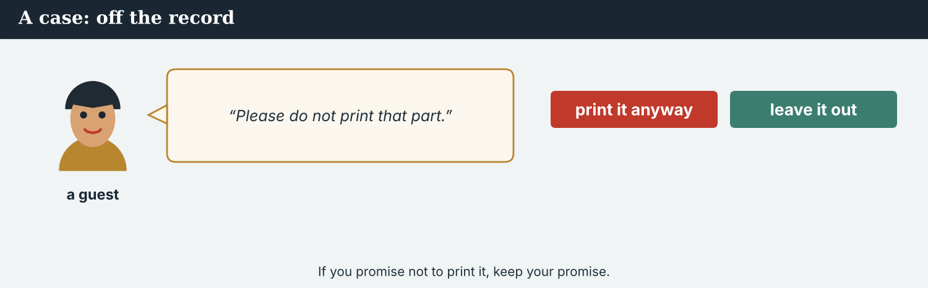
If a guest says ‘please do not print that’, respect their answer.
A case. During the interview, a guest tells Mira something sad about the seven years when the crossing was closed. Then he says, “Please do not put that in the story. I only wanted you to understand. It is private.” It is a strong story, and it would travel far on the wire. But the guest asked Mira not to use it. The Code says: respect people, and keep your promise. What does Mira do?
NOTICE What do you do?
8E Choose (a) or (b), and write one reason.
1. (a) print it anyway (b) leave it out. Choice: ______ Because ________________________
2. When a guest says ‘please do not print that’, a journalist should (a) use it (b) respect it. Choice: ______
8F Complete with: respect · promise · private · trust.
1. A journalist must ___________ people.
2. Some things a guest says are ___________ .
3. If you say you will not print it, keep your ___________ .
4. People ___________ a reporter who keeps their word.
PRODUCE Discuss
8G Discuss. Why is trust so important between a reporter and a guest?
PRODUCE Write it
8H Write what Mira says to the guest (2–3 sentences). Be kind, and keep your promise.

PART 9 Digital: sharing the quote
Online, a good quote travels fast — but it must be exact.
A quote card on a phone — the guest’s exact words.
MODEL A model quote card
“It is our home, and the coffee is always hot.”
— Elena Marku, at her new café at the Kalina crossing · @AtlasWire
NOTICE The parts of a quote card
9A Match the part to what it shows.
1. “ “  2. Elena Marku  3. at her new café  4. @AtlasWire | a) who said it  b) the exact words  c) the outlet  d) where
PRACTISE Find and build
9B In the model card, whose exact words are these? Write the name.
1. ______
9C This quote card has a mistake: it changes the words. Write it correctly.
“It is the best café in the region.” — Elena (she really said: ‘It is our home.’)
________________________
The quote card also goes on the website with the full story.
9D Make a quote card. Write an exact quote and say who said it.
“___________ “ — ___________ (who?), @AtlasWire
PRODUCE Write your post
9E Write a one-line online post to share your interview. Say who you talked to.
________________________
9F Creative. Write a short headline (4–6 words) for your interview story.
9G Write a polite reply to a reader who asks: ‘Can I read the full interview?’
________________________
PRODUCE Discuss
9H Discuss. Why must an online quote be exact? What can go wrong if it is not?

PART 10 Review & Can-Do
Check your new English before Unit 5.
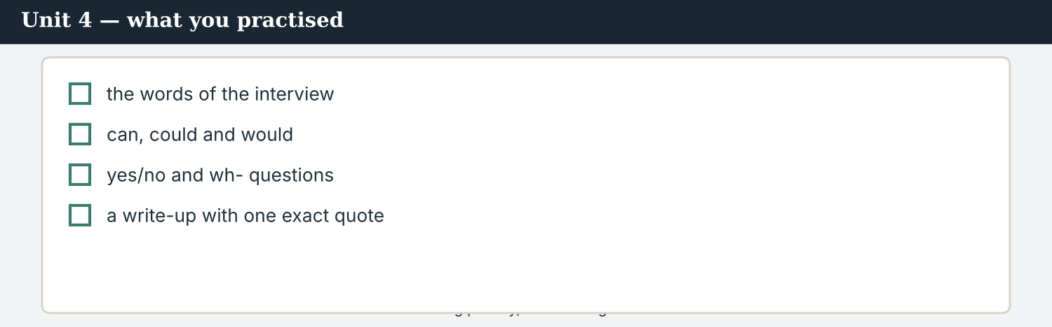
Unit 4 — asking politely, and running an interview.
10A Vocabulary. Complete with: interview · question · polite · quote · appointment · guest · record · follow-up.
1. Mira makes an ___________ to meet the family.
2. She prepares a good ___________ .
3. She is always ___________ .
4. May I ___________ this on my phone?
5. The ___________ sits down and answers.
6. Mira asks a ___________ about the answer.
7. She does the ___________ and gets a good ___________ .
10B Grammar. Make the request polite. Use could or would.
1. Tell me your name. → ________________________
2. Say that again. → ________________________
3. Do you want to add anything? → ________________________
10C Grammar. Write the question in the correct order.
1. you / do / where / live → ________________________
2. come back / did / why / you → ________________________
Can-Do — tick what you can do now.
10D Choose: can · could · would.
1. ______ I ask you a question, please?
2. ______ you like a cup of coffee?
3. ______ you tell me the time, please? (very polite)
10E Read and answer.
Mira is at the café. She introduces herself and asks politely for an interview. The guest says yes. Mira asks three questions, listens well, and writes down one exact quote for her story.
1. What does Mira ask for? ___________
2. How many questions does she ask? ___________
3. What does she write down? ___________
Can-Do — tick what you can do now
☐ I can ask polite questions with can, could and would.
☐ I can make yes/no and wh- questions.
☐ I can set up and run a short interview.
☐ I can write an exact quote.
10F Reflect. Which part of Unit 4 was the most useful for you? Why?
10G Grammar review. Write the sentence correctly.
1. Can you telling me your name? → ________________________
2. Where you live? → ________________________
3. Would you likes a cup of coffee? → ________________________
4. Why you came back? → ________________________

PART 11 Assignment: an interview
Put the unit together: plan and run a short interview.
The assignment template — your interview plan.
Your task. Choose a person (real or invented). Plan four questions: a polite opening (Can I / Could you), two wh- questions, and one follow-up. Run the interview with a partner. Then write a short write-up (4–5 sentences) that ends with one exact quote. Be polite, and report their real words.
A model — use it to check the shape of your write-up.
Remember: introduce yourself; ask politely; listen and ask a follow-up; write the exact quote; do not change what they said.
Success criteria | Yes | Almost | Not yet
I have a polite opening (can / could). | ☐ | ☐ | ☐
I have two wh- questions and one follow-up. | ☐ | ☐ | ☐
My write-up ends with one exact quote. | ☐ | ☐ | ☐
I did not change the guest’s words. | ☐ | ☐ | ☐
It is neat and easy to read. | ☐ | ☐ | ☐
Keep this. In Unit 5, you learn to report what people said — reported speech and attribution (‘she said that…’, ‘according to…’).

ANSWER KEY Unit 4
Check your answers. Open tasks (discussion, role-play and your own writing) are marked at the end.
W1 1 a family at the Kalina crossing · 2 she smiles / says her name and agency · 3 ‘Of course… please sit with us’
W2 1 F · 2 T · 3 F
W3 (any three) Can… · Could… · Would…
1A 1-c, 2-a, 3-i, 4-h, 5-e, 6-g, 7-f, 8-j, 9-d, 10-b (accept sensible matches)
1B 1 appointment · 2 polite · 3 record · 4 quote · 5 interpreter · 6 interview
1C 1 ask a question · 2 give an answer · 3 take notes · 4 make an appointment · 5 get permission
1D 1 deadline · 2 rude · 3 shout · 4 microphone
1E 1 interview · 2 questions · 3 polite · 4 notes · 5 quote
1F 1 appointment · 2 quote · 3 follow-up · 4 interpreter
2A 1 Could you tell me your name? · 2 Could I ask a question? · 3 Could you say that again?
2B 1 Can / Could · 2 Would · 3 Could
2C 1 Where do you live? · 2 Is the crossing open? · 3 Why did you come back?
2D 1 Do you live here? · 2 Is the café open? · 3 Can I record this?
3A 1 Elena Marku · 2 it is their home; her mother lives on the other side · 3 open a small café at the end of the bridge
3B ‘Could you tell me your name, please?’
3C (example) 1 Where do you live? · 2 What are you going to do? · 3 How do you feel?
3D could · Why · What · would
4B 1 Elena Marku · 2 a short interview · 3 at the café · 4 ten o’clock
4C 1 F · 2 T · 3 F
4D Guest = Elena Marku · Place = the café · Time = 10 o’clock (tomorrow morning)
4F 1 café · 2 last week · 3 home · 4 visit
4G (any two) could · would · please
4I appointment · polite · interview · café
5B 1 F · 2 T · 3 T · 4 F
5C 1 it is their home; her mother is on the other side of the river · 2 make coffee and bread / run the café · 3 ‘Please come and visit us.’
5D 1 quote · 2 polite · 3 neighbours
5F Prepare your questions → write three before you go · Be polite → ‘Can I ask you a question?’ · Listen well → ‘Could you say more about that?’ · Get the quote right → write the exact words; check what you are not sure of
5G Tip 4
5H 1 interview · 2 follow-up · 3 quote
6A 1 four · 2 ‘Could you tell me your name?’
6C the guest’s exact words; quotation marks “ “ mark them
6D interview · said · quote
6F (example) ‘Could you tell me your name?’ · ‘Could you say why you came back?’
7A (any three) Could… · Can… · Would…
7B (example) 1 Could you tell me your name? · 2 Could you say that again? · 3 Would you like to add anything?
7C 1 Could I ask a question? · 2 Would you like to talk? · 3 Could you tell me your name?
7F ‘Could you say a little more about the bread?’
8A 1 (b) keep Elena’s real words · 2 (b) not true
8B 1 T · 2 N · 3 T · 4 N
8C said · exact · change · true
8E 1 (b) leave it out · 2 (b) respect it
8F 1 respect · 2 private · 3 promise · 4 trust
9A “ “ → the exact words · Elena Marku → who said it · at her new café → where · @AtlasWire → the outlet
9B Elena Marku
9C “It is our home.” — Elena Marku
10A 1 appointment · 2 question · 3 polite · 4 record · 5 guest · 6 follow-up · 7 interview, quote
10B 1 Could you tell me your name? · 2 Could you say that again? · 3 Would you like to add anything?
10C 1 Where do you live? · 2 Why did you come back?
10D 1 Can / Could · 2 Would · 3 Could
10E 1 (a short) interview · 2 three · 3 one exact quote
10G 1 Can you tell me your name? · 2 Where do you live? · 3 Would you like a cup of coffee? · 4 Why did you come back?
Open tasks W4, 1G, 1H, 1I, 2E, 2F, 3E, 3F, 3G, 4A, 4E, 4H, 4J, 5A, 5E, 5I, 5J, 6B, 6E, 7D, 7E, 7G, 8D, 8G, 8H, 9D, 9E, 9F, 9G, 9H, 10F — your own answers (discussion, role-play, writing).
A note on real and invented content. The facts about journalism around the world are true as of 2026. Atlas Wire, its staff, Elena Marku’s family, Dren, Kalina and the interviews are invented, for practice. Real people are only ever in true, sourced facts — never in an invented quote.
English for Journalists — International Edition · Unit 4 (v6 standard). CEFR A2 → lower B1 · Beat: Interview · two readings · two listenings · two writing pieces · two ethics cases · two speaking dialogues · balanced sections · ~24 figures · featured cast · fictional agency, factual backdrop.
UNIT 5 Getting the Quote Right: Attribution
Beat · Verify & report CEFR A2 → lower B1
In this unit you learn to…
1. report what people said (reported speech)
2. use say and tell correctly
3. say who a fact comes from (attribution: ‘according to…’)
4. keep a quote accurate across languages
The Atlas Wire team — Mira writes up what everyone said.
The story so far. Mira has interviewed the family at the new café. Now she must write the story of the Kalina crossing for the wire — reporting what people said, and always saying who said it. On an international story, the numbers come from an agency, and the agency must be named.

WARM-UP Who said that?
A short scene to start the unit. Read it, then answer.
The morning conference — the team checks who said what.
At the conference, Mira reads from her notebook. “Elena told me that the café is always full,” she says. “And a stall-holder said the market is busy every morning.” Priya, the verification journalist, looks up. “Good,” she says. “But who said the number — that a hundred families have crossed back? We must know the source. According to whom?” Mira checks her notes. “That is from the Crossing Office,” she says. “I will write ‘according to the Crossing Office’.”
W1 Answer the questions.
1. What did Elena tell Mira? ___________
2. What did the stall-holder say? ___________
3. Where does the number come from? ___________
W2 True or false? Write T or F.
1. Priya wants to know the source. ______
2. Mira invented the number. ______
3. Mira will name the source in the story. ______
W3 Find the words Priya uses to ask about the source. Write them.
1. ________________________
PRODUCE Talk about it
W4 Discuss with a partner.
1. When someone tells you news, do you ask who said it? Why?
2. Why is it important to know where a fact comes from?

PART 1 The words of the quote
The words a reporter needs to report what people said. Learn these first.
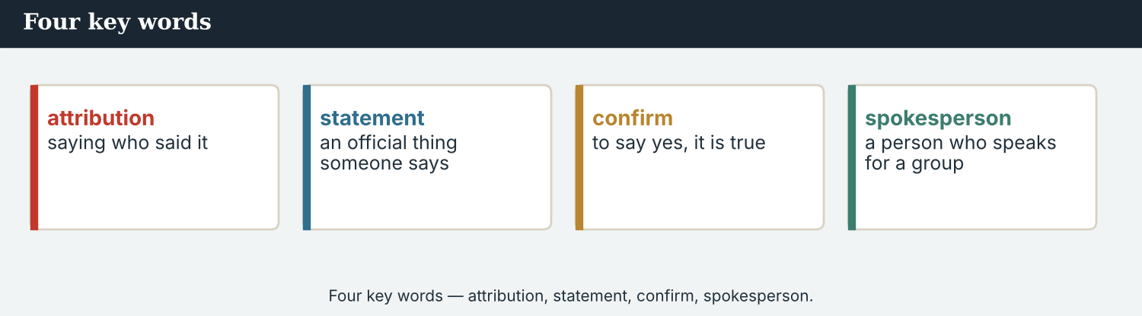
Four key words — attribution, statement, confirm, spokesperson.
The words
Word | Meaning
quote | a person’s exact words
source | a person who gives information
attribution | saying who said it
statement | an official thing someone says
claim | to say something is true (maybe not sure)
confirm | to say yes, it is true
deny | to say no, it is not true
add | to say one more thing
explain | to make something clear
mention | to say something quickly
spokesperson | a person who speaks for a group
agency | an organisation that does official work
accurate | correct, with no mistakes
exact | just right; the same words
PRACTISE Controlled practice
1A Match the word (1–10) to the meaning (a–j).
1. quote  2. source  3. attribution  4. statement  5. confirm  6. deny  7. claim  8. spokesperson  9. accurate  10. exact | a) saying who said it  b) a person who gives information  c) a person’s exact words  d) to say yes, it is true  e) to say no, it is not true  f) an official thing someone says  g) correct, with no mistakes  h) to say something is true  i) a person who speaks for a group  j) the same words
1B Complete the sentences with a word from the box.
WORD BOX
source · quote · statement · confirm · deny · spokesperson
1. Mira always names her ___________ .
2. Here is an exact ___________ from Elena.
3. The Crossing Office made an official ___________ .
4. The ___________ answered the questions.
5. Did the office ___________ the number, or ___________ it?
1C Match the two halves (collocations).
1. name a  2. make a  3. get the  4. according  5. an exact | a) source  b) statement  c) facts right  d) to  e) quote
1D Circle the word that is different.
1. quote · source · statement · deadline
2. confirm · agree · deny · say yes
3. accurate · exact · correct · loud
4. spokesperson · source · person · microphone
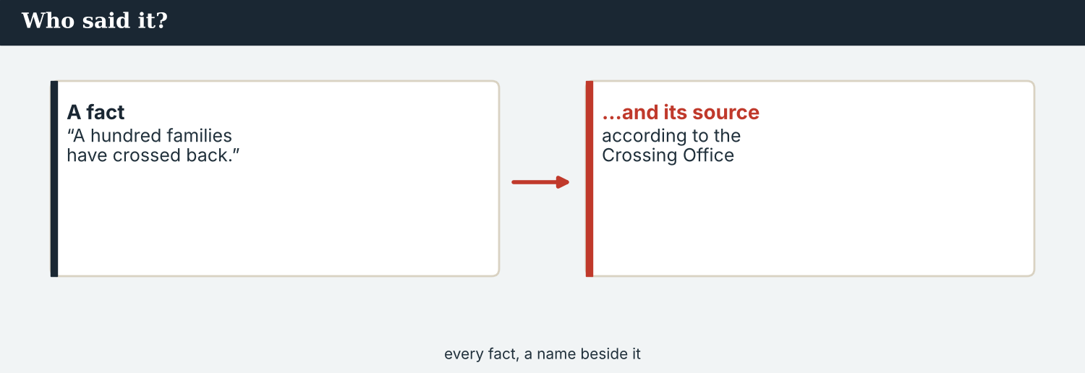
On the wire, every quote and every number needs a source.
1E Complete the paragraph. Use: source · quote · according · confirm · report.
Mira writes her ___________ . For every fact, she names a ___________ . She uses an exact ___________ from Elena, and writes ’___________ to the Crossing Office’ for the number. Priya will ___________ it before it goes out.
1F Read the definition. Write the word.
1. saying who said it → ___________
2. to say yes, it is true → ___________
3. a person who speaks for a group → ___________
4. a person’s exact words → ___________
PRODUCE Over to you
1G Answer about you. Write full sentences.
1. Who is a good source of news in your country? Why?
2. When you hear a big number in the news, do you trust it? Why or why not?
PRODUCE Talk about it
1H Discuss. Which two words in this unit are new for you? Make a sentence with one.
1I Creative. Write two sentences that report what a colleague told you today. Say who said it.

PART 2 Grammar: reporting what people said
say and tell, reported speech, and attribution.
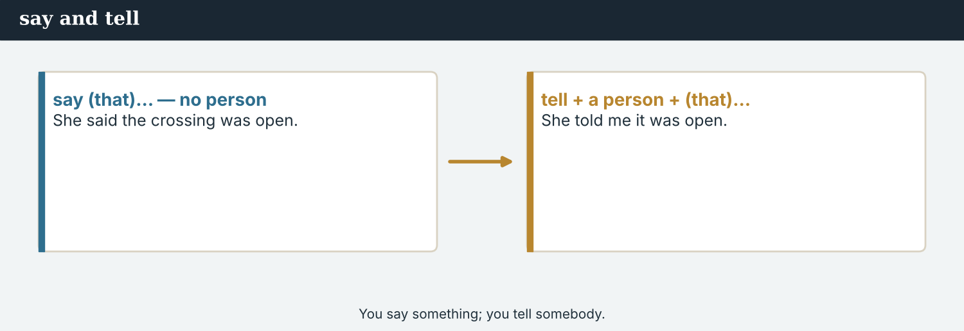
say (that)… / tell + a person + (that)…
1 · say and tell
say (that)… — no person: She said (that) the crossing was open.
tell + a person + (that)…: She told me (that) it was open.
Remember: we tell somebody, but we say something.
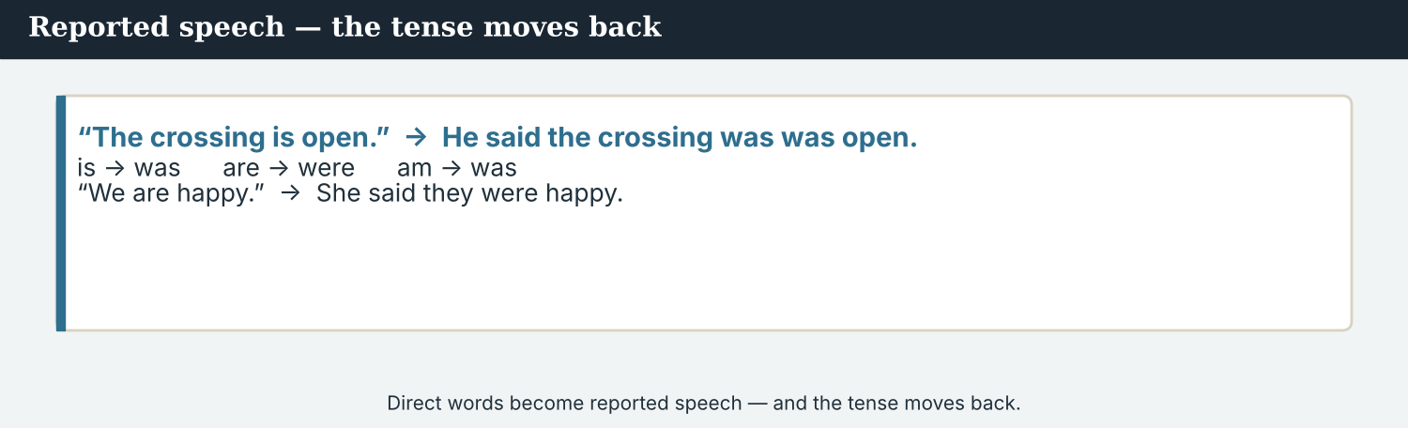
Direct words become reported speech — the tense moves back.
2 · Reported speech
Direct: “The crossing is open.” → Reported: He said the crossing was open.
Direct: “We are happy.” → She said they were happy.
The tense moves back: is → was, are → were, am → was.
3 · Attribution
Always say who a fact comes from.
According to the Crossing Office, a hundred families have crossed back.
The spokesperson said that the bridge was open. A stall-holder told Mira it was busy.
PRACTISE Structured practice
2A Say or tell? Write the correct word.
1. She ___________ that the crossing was open.
2. He ___________ me that he was happy.
3. Elena ___________ Mira about the café.
4. The office ___________ that the number was correct.
2B Change to reported speech (is → was, are → were).
1. “The crossing is open.” → He said the crossing ___________ open.
2. “We are happy.” → They said they ___________ happy.
3. “The café is full.” → She said the café ___________ full.
2C Rewrite with according to.
1. The Crossing Office says a hundred families have come back. → ________________________
2. A stall-holder says the market is busy. → ________________________
2D Choose the correct verb: said / told.
1. Elena ______ that the café was full.
2. She ______ Mira that it was busy.
3. The office ______ a statement.
4. He ______ me the news.
Your own words
2E Report two things a classmate said today. Use said or told.
1. ________________________
2. ________________________
2F Write one fact about your city, and give a source with according to.
1. ________________________

PART 3 Attribution: who said it?
Every quote and every number needs a source.
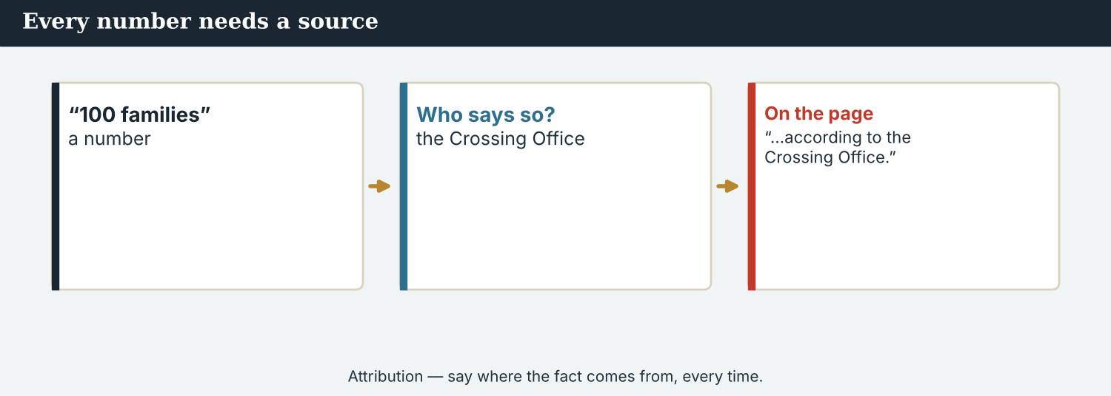
Attribution — say where the fact comes from, every time.
MODEL A model paragraph
According to Elena Marku, the café owner, the crossing is busy every morning. A stall-holder told Mira that families come back every day. The Crossing Office said that a hundred families have returned to the valley. “It is our home,” Elena added.
NOTICE Notice the attribution
3A Answer about the model.
1. Who says the crossing is busy? ___________
2. Who gave the number (a hundred families)? ___________
3. What are Elena’s exact words? ___________
3B Find the three ways the writer names a source. Write them.
1. ________________________
PRACTISE Add the source
For every fact, ask: who said it? Then write it down.
3C Add a source to each fact. Use according to or … said.
1. The crossing is busy. → ________________________
2. A hundred families have come back. → ________________________
3. The café is always full. → ________________________
3D Complete the paragraph. Use: according · told · said · statement.
“______ to the office, the festival is on Friday. A worker ______ Mira that the bridge was ready. The spokesperson ______ that everyone was welcome, and the office made an official ______ .”
PRODUCE Your turn
3E Choose a small story. Write three sentences. Give a source for each (according to… or … said).
________________________
________________________
________________________
PRODUCE Discuss
3F Talk with a partner. Why is a fact with no source a problem? Give one example.
3G Is ‘people say…’ a good source? Why or why not?

PART 4 Listening: statements and sources
Two audios. Listen for who said what.
In the newsroom — the team listens to a statement.
Listening A · a spokesperson’s statement
MODEL Audio 5.1 — the Crossing Office speaks
Spokesperson: Good morning. I am the spokesperson for the Crossing Office.
Spokesperson: I have a short statement about Kalina.
Spokesperson: According to our records, a hundred families have crossed back to the valley.
Spokesperson: The crossing is open every day, and the school opens next week.
Spokesperson: On Friday, there is going to be a small festival on both sides of the river.
Mira: Thank you. Can I quote the number — a hundred families?
Spokesperson: Yes. You can say ‘according to the Crossing Office’.
PRACTISE Listen for detail
4A Before you listen: who is speaking, and about what? Write one idea.
1. ______
4B Answer the questions.
1. Who is speaking? ___________
2. How many families have crossed back? ___________
3. When does the school open? ___________
4. What can Mira say before the number? ___________
4C True or false? Write T or F.
1. The number comes from the Crossing Office. ______
2. There is a festival on Friday. ______
3. Mira must not name the source. ______
4D Complete the notes.
Source: ___________
Fact (number): ___________
Attribution to use: ___________
Audio 5.2 — Mira reports back to the editor what the office said.
Listening B · reporting it back
MODEL Audio 5.2 — Mira and Daniel
Daniel: Mira, what did the office say?
Mira: They said that a hundred families have crossed back to the valley.
Daniel: Good. Did they confirm the number?
Mira: Yes. The spokesperson told me I could quote it.
Daniel: And the festival?
Mira: The office said it is on Friday, and everyone is welcome.
Daniel: Perfect. Write ‘according to the Crossing Office’ for the number.
Mira: I will.
PRACTISE Listen for detail
4E Before you listen: what will Daniel ask about? Guess.
1. ______
4F Complete the answers (reported speech).
1. Mira said that a hundred families ___________ crossed back.
2. The spokesperson ___________ her she could quote it.
3. The office ___________ the festival is on Friday.
4. Daniel says to write ‘according to the ___________ ’.
4G Which reporting verbs do you hear? Write two (said / told).
1. ________________________
4H Answer. Why does Daniel ask ‘did they confirm the number?’
1. ________________________
PRACTISE Both audios
4I Complete the summary. Use: statement · source · confirm · according.
First, the spokesperson makes a ______ . Then Mira reports it to Daniel. She names the ______ and they ______ the number. In the story, Mira writes ’______ to the Crossing Office’.
PRODUCE What do you think?
4J Discuss. Why does a good reporter always report the source, not just the fact?

PART 5 Reading: what people said
Two readings. Read for the quotes and the sources.
A report is built from what people said — with their names.
Reading A · a report with quotes
Voices from the Kalina crossing
This week, correspondent Mira Sandoval spoke to many people at the crossing at Kalina. They all had something to say about the bridge that is open again.
Elena Marku, who owns the new café at the end of the bridge, told Mira that business was good. “The café is always full,” she said. “People do not only come for coffee. They come to talk, and to see old friends.”
A stall-holder on the bridge said that families crossed every morning. According to him, the market was busy from early until late. “Every day, I see new faces,” he added.
The Crossing Office made a short statement. According to the office, a hundred families have now returned to the valley, and the school will open next week. The office also said that a small festival is planned for Friday.
Not everyone agreed on the numbers. One worker told Mira that he thought there were more than a hundred families. Another said there were fewer. Mira wrote down both, and she used the office’s figure, with attribution, for the story.
Priya Nair, the verification journalist at Atlas Wire, said that this was the right thing to do. “We report what people say,” she explained, “but we always name the source. If two people say different things, we say so. We do not choose one and hide the other. On an international story that goes out in six languages, that matters even more: a number with no name behind it travels a very long way.”
PRACTISE Comprehension
5A Before you read: look at the title. What is the report about? Write one sentence.
1. ______
5B True or false? Write T or F.
1. Elena said the café is always empty. ______
2. The number of families comes from the office. ______
3. Everyone agreed on the numbers. ______
4. Mira used the office number with a source. ______
5C Answer the questions.
1. What did Elena say about the café? ___________
2. Where does the number ‘a hundred families’ come from? ___________
3. What did Priya say a reporter must always do? ___________
5D Find a word in the text.
1. saying who said it → ___________
2. a person who gives information → ___________
3. to make something clear → ___________
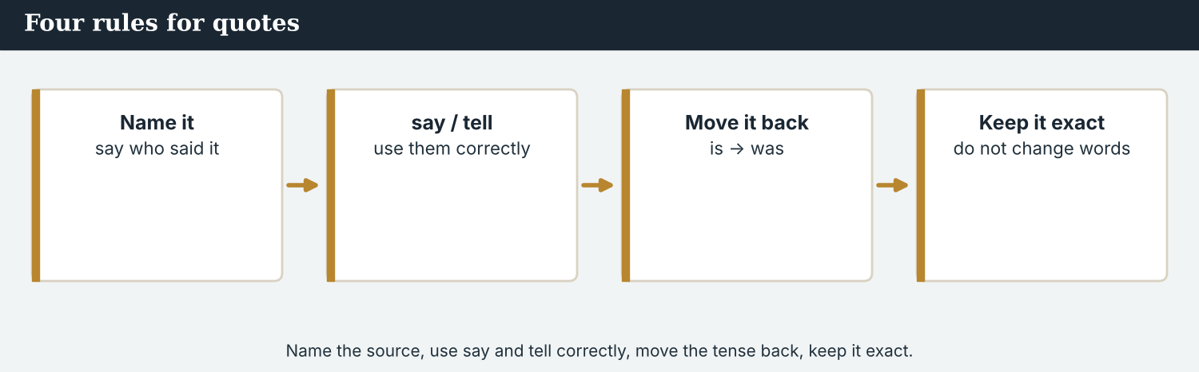
Name the source, use say and tell correctly, move the tense back, keep it exact.
Reading B · say it right — four rules for quotes
Four rules for quotes
1. Name your source. For every fact and every number, say who said it: ‘according to…’ or ’… said’.
2. Use say and tell correctly. You say something; you tell somebody. ‘She said that…’ or ‘She told me that…’.
3. Change the tense. In reported speech, the tense moves back: ‘is’ becomes ‘was’, ‘are’ becomes ‘were’.
4. Keep it accurate. Use the person’s exact words in a quote. Do not change what they said. If the interview was in another language, keep the translation close and say that it is a translation. If two sources disagree, report both.
PRACTISE Comprehension
5E Before you read: what must you do with every number in a story? Guess.
1. ______
5F Match the rule to the example.
1. Name your source  2. Use say and tell  3. Change the tense  4. Keep it accurate | a) ‘is’ becomes ‘was’  b) ‘According to the office…’  c) If two sources disagree, report both  d) ‘She told me that…’
5G Which rule is about attribution? Write the number.
1. ______
PRACTISE Words from the readings
5H Find a word in Reading A or Reading B.
1. a person’s exact words → ___________
2. saying who said it → ___________
3. correct, with no mistakes → ___________
PRODUCE Discuss
5I Talk about it. Which quote in Reading A do you like best? Why?
5J Which of the four rules is the most important? Say why.

PART 6 Writing: reporting the words
Two short pieces: reported-speech notes, and a short report with sources.
Notes: what each source said, and their name.
Writing 1 · source notes
MODEL A model
Elena Marku: ‘the café is always full’ (exact quote)
Stall-holder: said families cross every morning
Crossing Office: 100 families back — according to the office
NOTICE Notice the model
6A Answer about the model.
1. Which note is an exact quote? ___________
2. Where does the number come from? ___________
PRODUCE Write your notes
6B Choose a small story. Write three source notes: one exact quote, and two facts with a source.
Source 1: ___________
Source 2: ___________
Source 3: ___________
A short report uses reported speech and names its sources.
Writing 2 · a short report
MODEL A model
According to the Crossing Office, a hundred families have come back to the valley at Kalina. Elena Marku, the café owner, told Mira that business was good. “The café is always full,” she said.
NOTICE Notice the model
6C Answer. How many sources are named? Where are the exact words?
1. ___________
PRACTISE Complete a report
6D Complete the report. Use: according · said · told.
______ to the office, the school opens next week. A teacher ______ Mira that forty children were coming. “We are very happy,” she ______ .
PRODUCE Write your report
6E Write a short report (3–4 sentences). Name at least two sources and use one exact quote.
________________________
________________________
________________________
PRACTISE Fix it
6F This report has no source. Add one, and fix the tense.
“A hundred families are back. Someone said it is true.”
________________________

PART 7 Speaking: reporting back
Tell a partner what someone said. Use reported speech.
Report what your source said — and check the exact words.
A model dialogue · reporting to the editor
MODEL Listen and read
Daniel: What did Elena say?
Mira: She said that the café was always full.
Daniel: Did she say why?
Mira: Yes. She told me that people came to see old friends.
Daniel: And the number of families?
Mira: According to the Crossing Office, a hundred families have come back.
Daniel: Good. Name the office in the story.
NOTICE Notice the reporting
7A Find two examples of reported speech. Write them.
1. ________________________
PRACTISE Controlled practice
7B Report what the person said. Use said or told.
1. Elena: ‘The café is full.’ → She ___________ that the café was full.
2. Stall-holder: ‘Families cross every day.’ → He ___________ me that families crossed every day.
3. Office: ‘The school opens next week.’ → The office ___________ that the school opened next week.
Before you report a quote, check you have the exact words.
7C Change to reported speech.
1. “The crossing is open.” → He said the crossing ___________ open.
2. “We are happy.” → They said they ___________ happy.
3. “The café is busy.” → She said the café ___________ busy.
PRODUCE Your role
Correspondent | Report to the editor what two sources said. Use ‘said’ / ‘told’ and name each source.
World Editor | Listen. Ask: ‘Who said that?’ and ‘Did they confirm the number?’
Verification | Check that every fact has a named source.
7D Choose a role from the table. Report your two sources to a partner.
PRODUCE Role-play
7E Role-play the newsroom: a correspondent, an editor, and a verification journalist. Then swap roles.
A second dialogue · checking the quote
MODEL Listen and read
Mira: I want to check your words. You said, ‘It is our home.’ Is that right?
Elena: Yes, that is exactly right.
Mira: And can I write ‘according to Elena Marku, the café is always full’?
Elena: Yes, you can.
Mira: Thank you. I want to get your words exactly right.
PRACTISE Controlled practice
7F Write the question Mira asks to check the quote.
1. ________________________
PRODUCE Self-check
Did I… | Yes | Almost | Not yet
report what the source really said? | ☐ | ☐ | ☐
use said / told correctly? | ☐ | ☐ | ☐
name every source? | ☐ | ☐ | ☐
check the exact words of the quote? | ☐ | ☐ | ☐
7G Role-play checking a quote with a partner. Then swap roles.

PART 8 Ethics: fair and sourced
Report what people said — all of it, and always with a source.
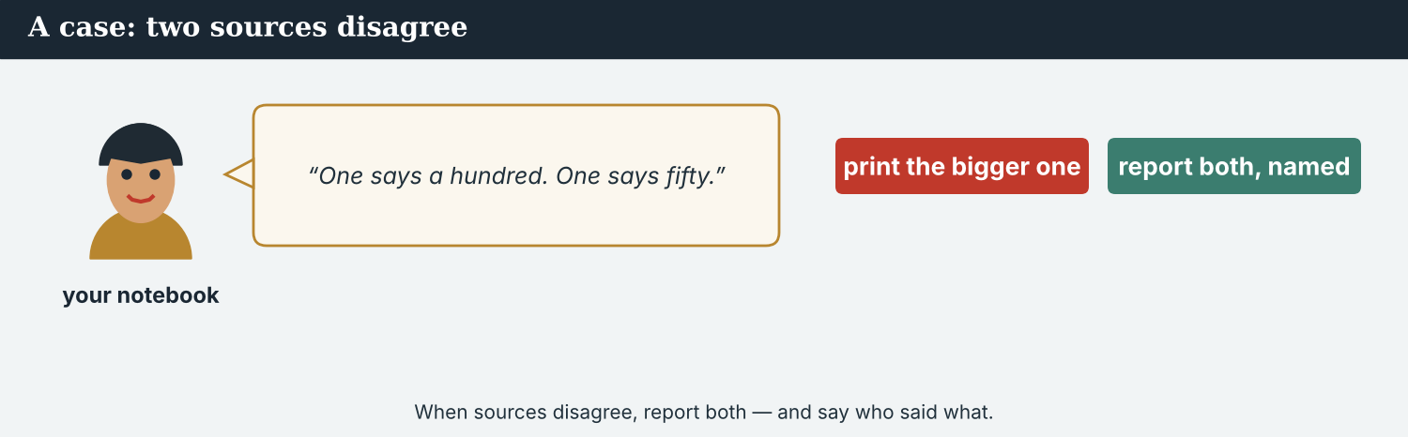
When two sources disagree, report both — do not choose one and hide the other.
A first case · two sources disagree
A case. Mira asks about the number of families. A stall-holder tells her that a hundred families have come back. But a worker says there are only fifty. The two sources do not agree. The story is due soon, and a bigger number sounds better on an international wire. Mira could just write ‘a hundred families’ and leave out the worker. But two people said different things. The Code says: be accurate and fair — report what each source said, and name them. What does Mira do?
NOTICE What do you do?
8A Choose (a) or (b), and write one reason.
1. (a) write only the bigger number (b) report both, with the office’s figure and attribution. Choice: ______ Because ________________________
2. When two sources disagree, a reporter should (a) hide one (b) report both. Choice: ______
8B Fair or not fair? Write F (fair) or U (unfair).
1. Report both numbers, and name the sources. ______
2. Print only the number you like. ______
3. Use the official figure, with attribution. ______
4. Hide the source that disagrees. ______
PRACTISE Apply the Code
8C Complete the rule. Use: both · source · accurate · hide.
Be ______ and fair. Give a ______ for every fact. If two people disagree, report ______ — do not ______ one of them.
PRODUCE Discuss
8D Discuss. Why is it unfair to report only one side? Who does it hurt?
A second case · ‘do not use my name’
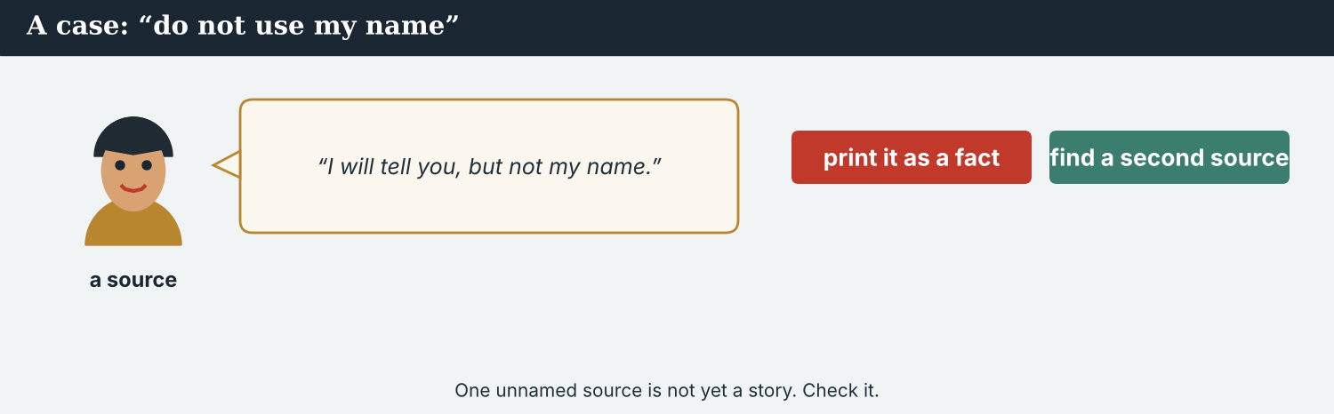
A claim with no name needs a second source before you report it.
A case. A person tells Mira something important about the crossing, but says, “Do not use my name.” It is a big claim, and it could be a strong story on the wire. But Mira has only one source, and that source will not be named. She cannot write ‘according to…’ because she cannot say who. The Code says: check a claim with a second source before you report it, and be careful with information you cannot attribute. What does Mira do?
NOTICE What do you do?
8E Choose (a) or (b), and write one reason.
1. (a) report the claim as a fact now (b) check it with a second source first. Choice: ______ Because ________________________
2. A big claim from one unnamed source is (a) ready to file (b) not yet confirmed. Choice: ______
8F Complete with: check · source · confirm · claim.
1. A ___________ is not yet a fact.
2. Always name a ___________ if you can.
3. If you cannot name it, ___________ the claim with a second source.
4. Do not file it until you ___________ it.
PRODUCE Discuss
8G Discuss. Why is one unnamed source not enough for a big story?
PRODUCE Write it
8H Write what Mira says to the source (2–3 sentences). Be kind, and explain why she must check first.

PART 9 Digital: quotes online
Online, a quote travels fast — so the source must travel with it.
A quote online — the exact words, and the source.
MODEL A model online post
“The café is always full.”
— Elena Marku, café owner, Kalina. 100 families back, according to the Crossing Office. · @AtlasWire
NOTICE The parts of the post
9A Match the part to what it shows.
1. “ “  2. Elena Marku, café owner  3. according to the Crossing Office  4. @AtlasWire | a) the exact words  b) the source of the number  c) who said it  d) the outlet
PRACTISE Find and build
9B In the model post, who is the source of the number? Write it.
1. ______
9C This post has no source for the number. Add one.
“100 families are back in the valley.” — @AtlasWire
________________________
The post links to the full story, with all its sources.
9D Make an online post. Add an exact quote and name the source.
“___________ “ — ___________ (who?), @AtlasWire
PRODUCE Write your post
9E Write a one-line online post that reports a fact and its source. Use according to.
________________________
9F Creative. Write a short headline (4–6 words) for your report. Keep it accurate.
9G A reader comments: ‘Who said that?’ Write a short, polite reply that names your source.
________________________
PRODUCE Discuss
9H Discuss. Online, quotes are shared across borders in minutes. Why must the source be shared too?

PART 10 Review & Can-Do
Check your new English before Unit 6.
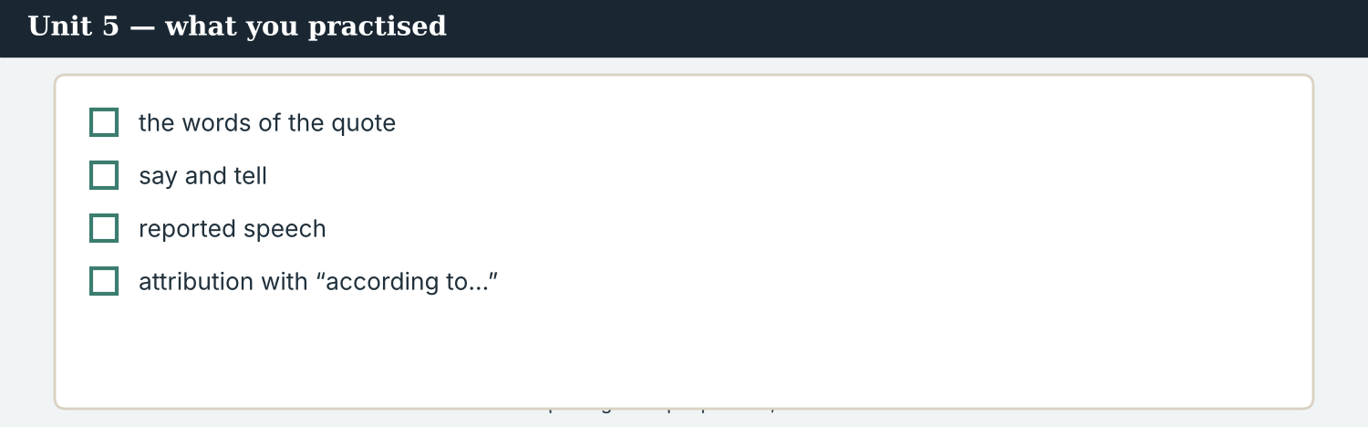
Unit 5 — reporting what people said, with attribution.
10A Vocabulary. Complete with: quote · source · attribution · statement · confirm · deny · spokesperson · accurate.
1. Mira names her ___________ for every fact.
2. Here is an exact ___________ from Elena.
3. The office made an official ___________ .
4. Did they ___________ the number, or ___________ it?
5. The ___________ answered the questions.
6. Good ___________ means saying who said it, and being ___________ .
10B Grammar. Say or tell?
1. She ___________ that the crossing was open.
2. He ___________ me the news.
3. The spokesperson ___________ a statement.
4. Elena ___________ Mira about the café.
10C Grammar. Change to reported speech.
1. “The café is full.” → She said the café ___________ full.
2. “We are happy.” → They said they ___________ happy.
Can-Do — tick what you can do now.
10D Attribution. Rewrite with according to.
1. The office says a hundred families have come back. → ________________________
2. A stall-holder says the market is busy. → ________________________
10E Read and answer.
Mira writes her report. She names a source for every fact. She uses one exact quote from Elena, and ‘according to the office’ for the number. Priya will confirm it before it goes out on the wire.
1. What does Mira give for every fact? ___________
2. Whose exact words does she use? ___________
3. Who will confirm the report? ___________
Can-Do — tick what you can do now
☐ I can report what people said (reported speech).
☐ I can use say and tell correctly.
☐ I can say who a fact comes from (according to…).
☐ I can keep a quote accurate.
10F Reflect. Which part of Unit 5 was the most useful for you? Why?
10G Grammar review. Write the sentence correctly.
1. She told that the crossing was open. → ________________________
2. He said me the news. → ________________________
3. They said they are happy. → ________________________
4. The office say the school opens next week. → ________________________

PART 11 Assignment: a sourced report
Put the unit together: write a short report with named sources.
The assignment template — your report, with sources.
Your task. Choose a small story (real or invented). Talk to two ‘sources’ (classmates can help). Write a short report (5–6 sentences). Name both sources, use reported speech (said / told) and at least one exact quote, and attribute any number with ‘according to…’. Keep every quote accurate.
A model — use it to check the shape of your report.
Remember: name every source; use said / told correctly; move the tense back in reported speech; keep the quote exact; if sources disagree, report both.
Success criteria | Yes | Almost | Not yet
I name both sources. | ☐ | ☐ | ☐
I use reported speech (said / told) correctly. | ☐ | ☐ | ☐
I use at least one exact quote. | ☐ | ☐ | ☐
I attribute the number with ‘according to…’. | ☐ | ☐ | ☐
It is accurate, fair, and easy to read. | ☐ | ☐ | ☐
Keep this. In Unit 6, you learn to tell the story of what happened — the past simple and the past continuous.

ANSWER KEY Unit 5
Check your answers. Open tasks (discussion, role-play and your own writing) are marked at the end.
W1 1 that the café is always full · 2 the market is busy every morning · 3 the Crossing Office
W2 1 T · 2 F · 3 T
W3 ‘According to whom?’
1A 1-c, 2-b, 3-a, 4-f, 5-d, 6-e, 7-h, 8-i, 9-g, 10-j (accept sensible matches)
1B 1 source · 2 quote · 3 statement · 4 spokesperson · 5 confirm, deny
1C 1 name a source · 2 make a statement · 3 get the facts right · 4 according to · 5 an exact quote
1D 1 deadline · 2 deny · 3 loud · 4 microphone
1E 1 report · 2 source · 3 quote · 4 according · 5 confirm
1F 1 attribution · 2 confirm · 3 spokesperson · 4 quote
2A 1 said · 2 told · 3 told · 4 said
2B 1 was · 2 were · 3 was
2C 1 According to the Crossing Office, a hundred families have come back. · 2 According to a stall-holder, the market is busy.
2D 1 said · 2 told · 3 made / said · 4 told
3A 1 Elena Marku (the café owner) · 2 the Crossing Office · 3 ‘It is our home.’
3B (any three) ‘According to Elena Marku…’ · ’… a stall-holder told Mira…’ · ‘The Crossing Office said…’
3C (example) 1 According to a stall-holder, the crossing is busy. · 2 According to the office, a hundred families have come back. · 3 Elena said the café is always full.
3D According · told · said · statement
4B 1 the spokesperson (Crossing Office) · 2 a hundred · 3 next week · 4 ‘according to the Crossing Office’
4C 1 T · 2 T · 3 F
4D Source = the Crossing Office · Fact = 100 families back · Attribution = ‘according to the Crossing Office’
4F 1 had · 2 told · 3 said · 4 Crossing Office
4G (any two) said · told
4H to be sure the number is true / has a source before it goes out
4I statement · source · confirm · according
5B 1 F · 2 T · 3 F · 4 T
5C 1 it is always full (people come to see old friends) · 2 the Crossing Office · 3 name the source (and report both sides)
5D 1 attribution · 2 source · 3 explain
5F Name your source → ‘According to the office…’ · Use say and tell → ‘She told me that…’ · Change the tense → ‘is’ becomes ‘was’ · Keep it accurate → if two sources disagree, report both
5G Rule 1
5H 1 quote · 2 attribution · 3 accurate
6A 1 ‘the café is always full’ · 2 the Crossing Office
6C two sources; the exact words are in the quotation marks “ “
6D According · told · said
6F (example) ‘According to the Crossing Office, a hundred families have come back.’
7A (any two) ‘She said that the café was always full.’ · ‘She told me that people came to see old friends.’
7B 1 said · 2 told · 3 said
7C 1 was · 2 were · 3 was
7F (example) ‘You said, “It is our home.” Is that right?’
8A 1 (b) report both, with the office’s figure and attribution · 2 (b) report both
8B 1 F · 2 U · 3 F · 4 U
8C accurate · source · both · hide
8E 1 (b) check it with a second source first · 2 (b) not yet confirmed
8F 1 claim · 2 source · 3 check · 4 confirm
9A “ “ → the exact words · Elena Marku, café owner → who said it · according to the Crossing Office → the source of the number · @AtlasWire → the outlet
9B the Crossing Office
9C (example) ‘100 families are back, according to the Crossing Office.’ — @AtlasWire
10A 1 source · 2 quote · 3 statement · 4 confirm, deny · 5 spokesperson · 6 attribution, accurate
10B 1 said · 2 told · 3 made / said · 4 told
10C 1 was · 2 were
10D 1 According to the office, a hundred families have come back. · 2 According to a stall-holder, the market is busy.
10E 1 a source · 2 Elena’s · 3 Priya (the verification journalist)
10G 1 She said that the crossing was open. · 2 He told me the news. · 3 They said they were happy. · 4 The office says the school opens next week.
Open tasks W4, 1G, 1H, 1I, 2E, 2F, 3E, 3F, 3G, 4A, 4E, 4J, 5A, 5E, 5I, 5J, 6B, 6E, 7D, 7E, 7G, 8D, 8G, 8H, 9D, 9E, 9F, 9G, 9H, 10F — your own answers (discussion, role-play, writing).
A note on real and invented content. The facts about journalism around the world are true as of 2026. Atlas Wire, its staff, Elena Marku, the Crossing Office, Kalina and the quotes are invented, for practice. Real people are only ever in true, sourced facts — never in an invented quote.
English for Journalists — International Edition · Unit 5 (v6 standard). CEFR A2 → lower B1 · Beat: Verify & report · two readings · two listenings · two writing pieces · two ethics cases · two speaking dialogues · balanced sections · ~24 figures · featured cast · fictional agency, factual backdrop.
UNIT 6 Telling the Story: What Happened
Beat · Report & feature CEFR A2 → lower B1
In this unit you learn to…
1. tell what happened (past simple)
2. describe what was happening (past continuous)
3. use time words (ago, last, when, while)
4. write a short news story about a past event
The Atlas Wire team — Mira writes the story of the past year.
The story so far. The crossing is open, the interviews are done. Now Mira writes a feature for the wire: the story of the seven years when the bridge at Kalina was closed, and of the spring when the families came back.

WARM-UP What happened?
A short story to start the unit. Read it, then answer.
The morning conference — the team plans a feature about the past year.
For seven years, the bridge at Kalina was closed. The road was empty, and the stalls were gone. Then, last spring, things changed. Workers repaired the bridge, and the barrier went up. Families started to cross again. When Mira first visited, people were carrying bags across the river and children were running ahead of them. “It was a happy day,” one stall-holder said. “After seven quiet years, the valley came back.”
W1 Answer the questions.
1. How was the bridge for seven years? ___________
2. What did the workers do? ___________
3. What were the children doing when Mira visited? ___________
W2 True or false? Write T or F.
1. For seven years, the bridge was open. ______
2. Families started to cross again last spring. ______
3. The stall-holder was sad. ______
W3 Find three past verbs in the text (e.g. was, changed). Write them.
1. ________________________
PRODUCE Talk about it
W4 Discuss with a partner.
1. What happened in your city last year? Say two things.
2. What were you doing this time last year?

PART 1 The words of the story
The words for telling a past story. Learn these first.
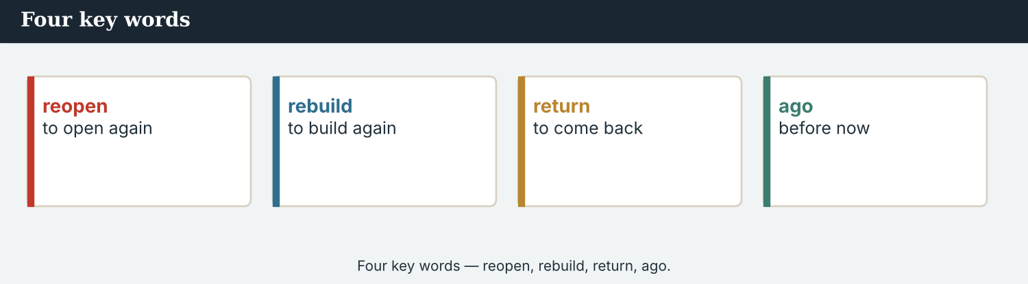
Four key words — reopen, rebuild, return, ago.
The words
Word | Meaning
event | a thing that happened
happen | to take place
return | to come back
reopen | to open again
rebuild | to build again
change | to become different
start | to begin
finish | to end
ago | before now (two years ago)
last | the one before this (last week)
yesterday | the day before today
then | after that
before | earlier
after | later
PRACTISE Controlled practice
1A Match the word (1–10) to the meaning (a–j).
1. event  2. return  3. rebuild  4. reopen  5. change  6. ago  7. last  8. then  9. before  10. after | a) to build again  b) to come back  c) a thing that happened  d) to open again  e) the one before this  f) to become different  g) before now  h) earlier  i) after that  j) later
1B Complete the sentences with a word from the box.
WORD BOX
event · returned · rebuilt · reopened · changed · ago
1. Seven years ___________ , the bridge closed.
2. Then everything ___________ .
3. Families ___________ to the valley.
4. Workers ___________ the old road.
5. The crossing ___________ last spring.
6. The festival was a happy ___________ .
1C Match the two halves.
1. last  2. seven years  3. the crossing  4. children  5. a happy | a) week  b) ago  c) reopened  d) returned to school  e) event
1D Circle the word that is different.
1. yesterday · last week · tomorrow · two years ago
2. started · began · finished · opened
3. returned · came back · left · went home
4. event · story · report · deadline
A feature tells the story behind the headline.
1E Complete the paragraph. Use: closed · returned · rebuilt · reopened · happened.
For seven years, the bridge was ___________ . Then something good ___________ . Families ___________ to the valley. Workers ___________ the road, and the crossing ___________ .
1F Read the definition. Write the word.
1. a thing that happened → ___________
2. to open again → ___________
3. before now → ___________
4. after that → ___________
PRODUCE Over to you
1G Answer about you. Write full sentences.
1. What is one thing that changed in your city in the last year?
2. What did you do last weekend?
PRODUCE Talk about it
1H Discuss. Which two words in this unit are new for you? Make a sentence with one.
1I Creative. Write two sentences about a place that changed. Use returned, rebuilt or reopened.

PART 2 Grammar: the past
Past simple for the events, past continuous for the background.
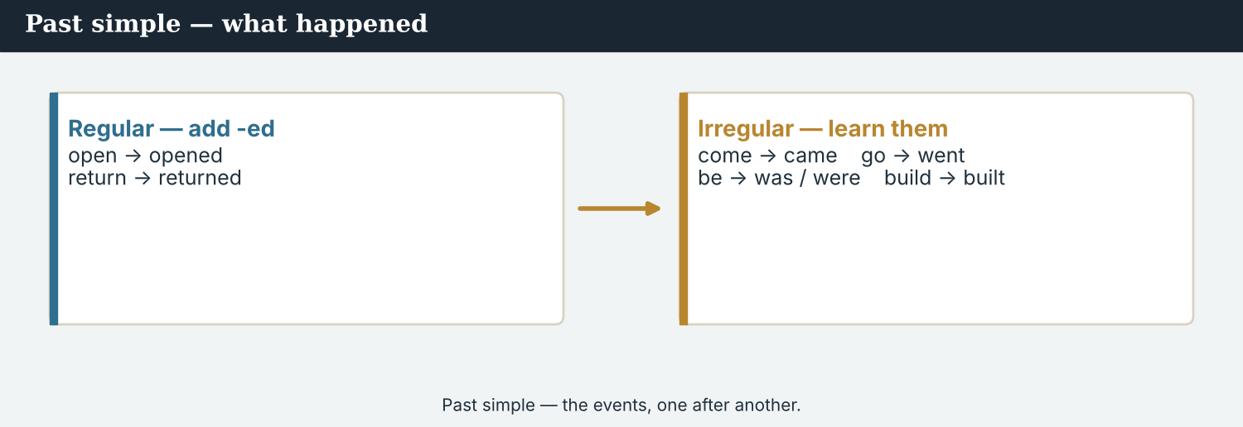
Past simple — the events, one after another.
1 · Past simple — what happened
Regular: add -ed: open → opened, return → returned, start → started.
Irregular: come → came, go → went, be → was / were, say → said, build → built.
The crossing opened last spring. Families came back. It was a happy day.
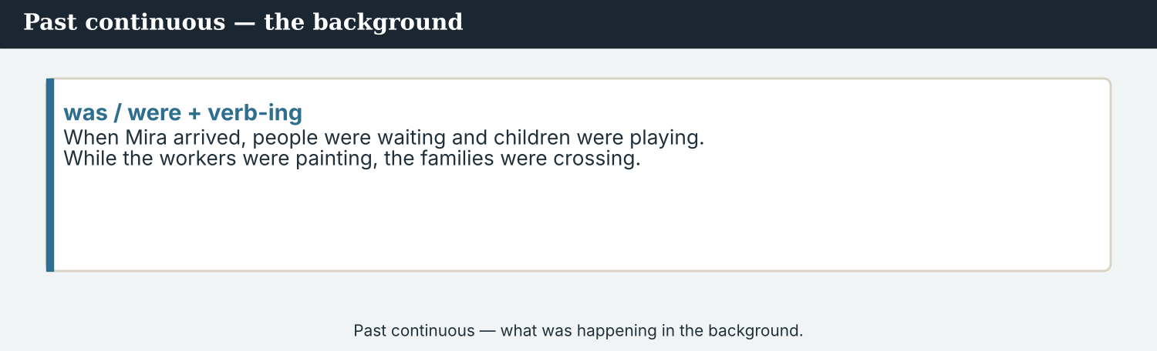
Past continuous — what was happening in the background.
2 · Past continuous — what was happening
Form: was / were + verb-ing.
When Mira arrived, people were crossing and children were running.
Use it for the background — a longer action that was going on.
3 · Time words
ago: seven years ago. last: last week / last spring. yesterday.
when + past simple: When the barrier went up, people were waiting.
while = at the same time: While the workers repaired the road, families returned.
PRACTISE Structured practice
2A Write the past simple of the verb.
1. open → ___________
2. return → ___________
3. come → ___________
4. go → ___________
5. be (he) → ___________
6. build → ___________
2B Complete with the past simple.
1. The crossing ___________ (open) last spring.
2. Families ___________ (come) back.
3. Workers ___________ (build) a new road.
4. It ___________ (be) a happy day.
2C Complete with the past continuous (was/were + -ing).
1. When Mira arrived, children ___________ (run).
2. People ___________ (carry) bags across the bridge.
3. A family ___________ (open) a café.
2D Choose: ago · last · when.
1. Seven years ______ , the bridge closed.
2. The crossing reopened ______ spring.
3. ______ the barrier went up, people were waiting.
Your own words
2E Write two things you did last week. Use the past simple.
1. ________________________
2. ________________________
2F Write one sentence about what you were doing yesterday evening. Use the past continuous.
1. ________________________

PART 3 Telling it in order
A good story has an order: before, then, and after.
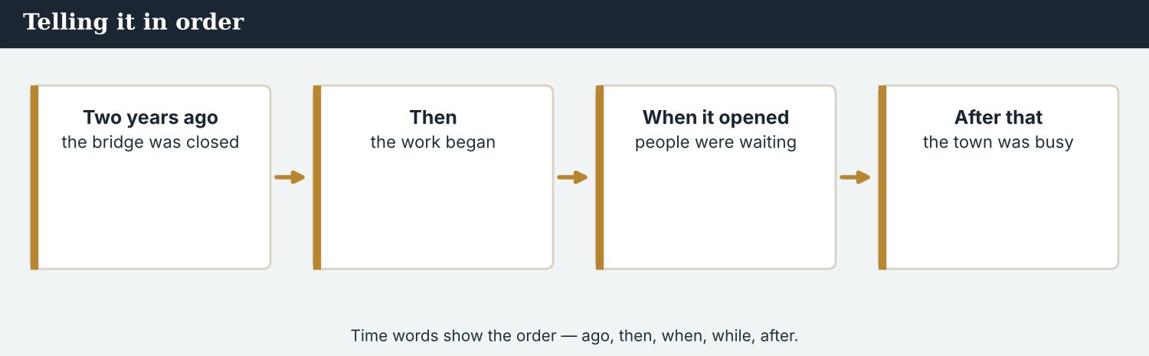
Time words show the order — ago, last, when, while, then.
MODEL A model paragraph
Seven years ago, the bridge closed. Then, last spring, workers started the repairs. While the workers repaired the road, the stall-holders cleaned the market. When the barrier went up, hundreds of people were waiting on both sides. After that morning, Kalina was busy again.
NOTICE Notice the order
3A Answer about the model.
1. What happened seven years ago? ___________
2. What were the workers doing? ___________
3. What happened when the barrier went up? ___________
3B Find three time words in the model (e.g. ago, then). Write them.
1. ________________________
PRACTISE Put it in order
A story answers: what happened, when, and in what order?
3C Put the events in order (1–4).
1. The crossing reopened. ______
2. The bridge was closed. ______
3. Workers started the repairs. ______
4. Kalina was busy again. ______
3D Complete the story. Use: ago · then · when · after.
Two years ______ , the school was closed. ______ , last month, the workers finished. ______ the doors opened, children were waiting. ______ that, the school was full again.
PRODUCE Your turn
3E Choose a place that changed. Write four sentences in order (before, then, while, after). Use past tenses.
________________________
________________________
________________________
________________________
PRODUCE Discuss
3F Talk with a partner. Why do time words help the reader? Give one example.
3G Which is more interesting to read: a list of facts, or a story with an order? Why?

PART 4 Listening: eyewitnesses
Two audios. Listen for what happened, and when.
In the newsroom — the team listens to an eyewitness.
Listening A · an eyewitness remembers
MODEL Audio 6.1 — a stall-holder remembers
Mira: Could you tell me about the day the crossing reopened?
Bekim: Of course. It was last spring, on a Friday morning.
Bekim: I arrived early, and I opened my stall for the first time in seven years.
Bekim: While I was setting up, families started to arrive on both sides.
Bekim: When the barrier went up, everyone was smiling.
Bekim: It was a wonderful day. The valley came back.
Mira: Thank you. That is a lovely memory.
PRACTISE Listen for detail
4A Before you listen: what day is Bekim going to describe? Write one idea.
1. ______
4B Answer the questions.
1. When did the crossing reopen? ___________
2. What was Bekim doing when the families arrived? ___________
3. How did people feel? ___________
4. How long was his stall closed? ___________
4C True or false? Write T or F.
1. The crossing reopened in the winter. ______
2. Bekim arrived early. ______
3. People were sad. ______
4D Complete the notes.
Event: ___________
When: ___________
Background (while): ___________
Audio 6.2 — Mira tells the editor what the eyewitness said.
Listening B · reporting the story
MODEL Audio 6.2 — Mira and Daniel
Daniel: What did Bekim tell you?
Mira: He said that the crossing reopened last spring, on a Friday.
Daniel: What was happening that morning?
Mira: While he was setting up, families were arriving. Everyone was smiling.
Daniel: That is a great story. Did he give a quote?
Mira: Yes. He said, ‘The valley came back.’
Daniel: Perfect. Use that quote at the end.
PRACTISE Listen for detail
4E Before you listen: what will Daniel ask about? Guess.
1. ______
4F Complete the answers.
1. The crossing reopened ___________ spring.
2. While Bekim was setting up, families were ___________ .
3. Everyone was ___________ .
4. Bekim’s quote was: ‘The valley ___________ back.’
4G Which past continuous verbs do you hear? Write two (was/were + -ing).
1. ________________________
4H Answer. Which sentence would make the best ending quote? Write it.
1. ________________________
PRACTISE Both audios
4I Complete the summary. Use: reopened · setting · arriving · quote.
The crossing ______ last spring. While Bekim was ______ up, families were ______ . Mira reported his story to Daniel, and kept his ______ for the end.
PRODUCE What do you think?
4J Discuss. Why is an eyewitness a good source for a past story? What must a reporter still check?

PART 5 Reading: the feature
Two readings. Read for the events and the order.
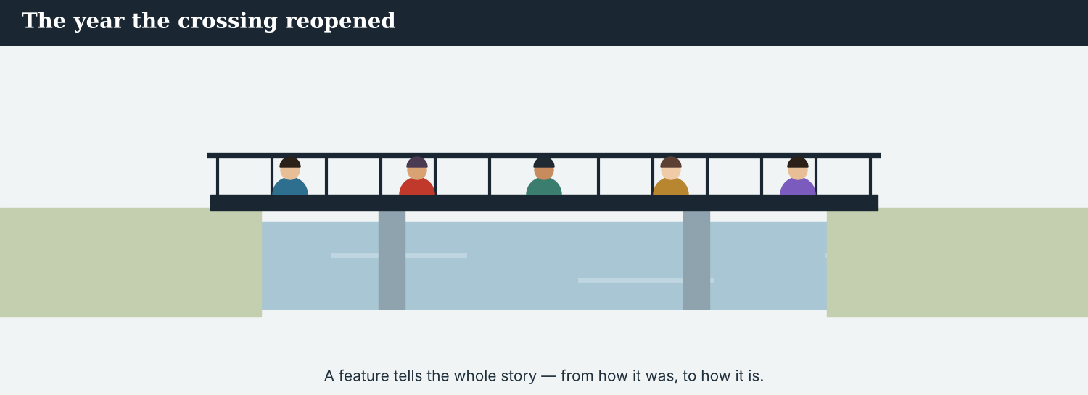
A feature tells the whole story — from how it was, to how it is.
Reading A · a feature about the seven years
The year the crossing came back
Seven years ago, the bridge at Kalina closed. The barrier came down one evening, and it stayed down. The road was empty. The stalls disappeared. The old gate at the end of the bridge rusted in the rain, and for a long time the only sound on the river was the water.
Then, last spring, things began to change. First, a small team of workers arrived and looked at the bridge. While they were measuring the rail, people on both sides watched them from their windows. Nobody said very much, but everybody understood.
The repairs took four months. Workers rebuilt the road surface and painted the rail. In April, the barrier went up. “I opened my stall for the first time in seven years,” one stall-holder remembered. “While I was setting up, families started to arrive. Everyone was smiling.”
When the school bus crossed the bridge in the autumn, forty children returned to class on the other side. Their teacher said that it was the happiest day of the year. After that, more stalls opened, and a young family started a small café at the end of the bridge.
Today, the crossing is busy again. According to the Crossing Office, a hundred families have now returned to the valley. “For seven years, we were waiting,” Elena Marku, the café owner, said. “Now the door is open, and the coffee is hot. The valley came back.”
PRACTISE Comprehension
5A Before you read: look at the title. What is the feature about? Write one sentence.
1. ______
5B True or false? Write T or F.
1. Seven years ago, the bridge was busy. ______
2. The barrier went up in April. ______
3. Forty children returned to class. ______
4. The crossing is still empty today. ______
5C Answer the questions.
1. How was the road for seven years? ___________
2. What were people doing while the workers measured the rail? ___________
3. How many families have returned today? ___________
5D Find a word in the text.
1. to build again → ___________
2. to go away and not be seen → ___________
3. the season after winter → ___________
A good feature helps readers far away understand how a place changed.
Reading B · writing a story about the past — four tips
Four tips for a past story
1. Use the past simple for the events. What happened, one thing after another: ‘The crossing opened. Families came back.’
2. Use the past continuous for the background. What was going on at the time: ‘While the workers were painting, families were arriving.’
3. Use time words to show the order. ‘Seven years ago… Then… When… After that…’ The reader follows the story.
4. Keep it accurate. Check the dates and the numbers. Name a source. Use the eyewitness’s exact words in a quote.
PRACTISE Comprehension
5E Before you read: which tense tells the main events? Guess.
1. ______
5F Match the tip to the example.
1. Past simple for events  2. Past continuous for background  3. Time words for order  4. Keep it accurate | a) ‘While they were painting…’  b) ‘The crossing opened.’  c) Check the dates and name a source  d) ‘Seven years ago… Then… After that…’
5G Which tip is about accuracy? Write the number.
1. ______
PRACTISE Words from the readings
5H Find a word in Reading A or Reading B.
1. to come back → ___________
2. to build again → ___________
3. a thing that happened → ___________
PRODUCE Discuss
5I Talk about it. Which part of the feature did you like best? Why?
5J Which of the four tips is the most important? Say why.

PART 6 Writing: a past story
Two short pieces: a timeline of notes, and a short story.
Notes: the events, in order.
Writing 1 · a timeline of notes
MODEL A model
Seven years ago: the bridge closed
Last spring: workers arrived; repairs began
April: the barrier went up
Now: the crossing is busy again
NOTICE Notice the model
6A Answer about the model.
1. Which tense do the notes use? ___________
2. What happened in April? ___________
PRODUCE Write your notes
6B Choose a place that changed. Write a timeline of notes: before, then, and now.
Before: ___________
Then: ___________
Now: ___________
A short story uses past tenses and one good quote.
Writing 2 · a short story
MODEL A model
Last spring, the crossing at Kalina reopened. While the stall-holders were setting up, families were arriving on both sides. “It was a happy day,” one stall-holder said. “The valley came back.”
NOTICE Notice the model
6C Answer. Which verbs are past simple? Which are past continuous?
1. ___________
PRACTISE Complete a story
6D Complete the story. Use: reopened · were waiting · said.
Last month, the school ______ . When the doors opened, forty children ______ outside. “It was the happiest day of the year,” the teacher ______ .
PRODUCE Write your story
6E Write a short story (3–4 sentences) about a past event. Use past simple and past continuous, and one quote.
________________________
________________________
________________________
PRACTISE Fix it
6F This has the wrong tense. Write it in the past.
“Last year, the crossing is closed. Then families come back.”
________________________

PART 7 Speaking: what happened
Interview an eyewitness, and tell the story.
Ask an eyewitness what happened, and what they were doing.
A model dialogue · interviewing an eyewitness
MODEL Listen and read
Mira: Could you tell me what happened on the day the crossing reopened?
Guest: Yes. I arrived early and opened my stall.
Mira: What were you doing when the families arrived?
Guest: I was setting up. Then I saw them, and I was very happy.
Mira: How did you feel?
Guest: It was a wonderful day. The valley came back.
Mira: Thank you for sharing that.
NOTICE Notice the questions
7A Find the past simple question and the past continuous question. Write them.
1. ________________________
PRACTISE Controlled practice
7B Make a past question for each answer.
1. ___________ ? — I opened my stall.
2. ___________ ? — I was setting up.
3. ___________ ? — Last spring.
4. ___________ ? — I was very happy.
Introduce yourself, then ask about the past.
7C Change to the past simple.
1. The crossing opens. → The crossing ___________ .
2. Families come back. → Families ___________ back.
3. It is a happy day. → It ___________ a happy day.
PRODUCE Your role
Correspondent | Ask an eyewitness: ‘What happened?’ and ‘What were you doing when…?’
Eyewitness | Answer in the past. Give one good quote about the day.
Observer | Listen. Did the reporter use past simple and past continuous?
7D Choose a role from the table. Ask your questions to a partner.
PRODUCE Role-play
7E Role-play an eyewitness interview: a reporter, an eyewitness, and an observer. Then swap roles.
A second dialogue · telling the story
MODEL Listen and read
Mira: I spoke to a stall-holder today. He told me a lovely story.
Priya: What did he say?
Mira: He said that the crossing reopened last spring. While he was setting up, families were arriving.
Priya: How did people feel?
Mira: Everyone was smiling. He said, ‘The valley came back.’
Priya: That is a great quote. Use it.
PRACTISE Controlled practice
7F Write the past continuous sentence Mira uses (While he was …).
1. ________________________
PRODUCE Self-check
Did I… | Yes | Almost | Not yet
use the past simple for the events? | ☐ | ☐ | ☐
use the past continuous for the background? | ☐ | ☐ | ☐
use time words (ago, when, while)? | ☐ | ☐ | ☐
keep the quote exact? | ☐ | ☐ | ☐
7G Role-play telling a colleague what happened. Then swap roles.

PART 8 Ethics: a true story
A story about the past must still be accurate and kind.
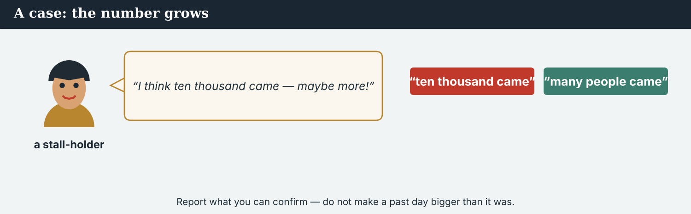
Report what you can confirm — not what sounds bigger.
A first case · the number grows
A case. Mira is writing the story of the day the crossing reopened. One stall-holder tells her, “I think ten thousand people crossed that day — maybe more!” It makes a great line, and the story is due soon. But nobody counted, and the Crossing Office says the real number was much smaller. Mira cannot confirm ten thousand. She is a journalist, and she knows the Code: report what you can confirm, and do not make a past event bigger than it was. What does Mira write?
NOTICE What do you do?
8A Choose (a) or (b), and write one reason.
1. (a) write ‘ten thousand people crossed’ (b) write ‘many people crossed’ (what she can confirm). Choice: ______ Because ________________________
2. A number nobody counted is (a) a fact (b) not confirmed. Choice: ______
8B Can you confirm it? Write Y (yes) or N (no).
1. The crossing reopened last spring (the office confirms it). ______
2. Exactly ten thousand people crossed (nobody counted). ______
3. Families were arriving all morning (many saw it). ______
4. It was the biggest day in the valley’s history. ______
PRACTISE Apply the Code
8C Complete the rule. Use: confirm · bigger · true · check.
Tell a ______ story. Only write what you can ______ . ______ the dates and numbers, and do not make a past event ______ than it was.
PRODUCE Discuss
8D Discuss. Why is it tempting to make a story bigger? Why is it wrong?
A second case · a hard memory
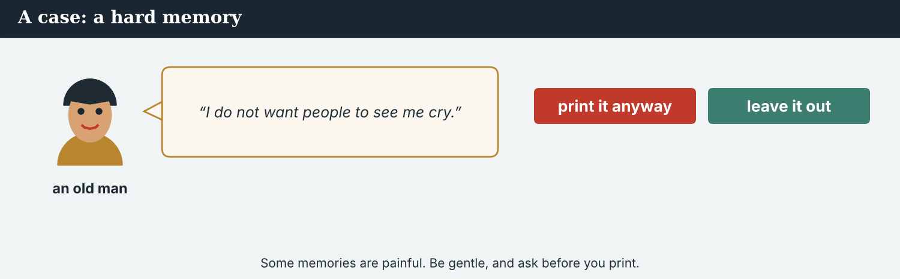
Some memories are painful — be gentle, and ask before you print.
A case. An old man tells Mira about the seven quiet years — how the road was empty, and how much he missed his family on the other side. He becomes sad, and his eyes fill with tears. Then he says, “Please, I do not want people to see me cry. Do not put that part in the story.” It is a strong, human moment, and it would travel far on the wire. But the man asked Mira not to use it. The Code says: respect people, and be gentle with a hard memory. What does Mira do?
NOTICE What do you do?
8E Choose (a) or (b), and write one reason.
1. (a) print the moment anyway (b) leave it out, as he asked. Choice: ______ Because ________________________
2. When a person shares a painful memory and says ‘do not print that’, a reporter should (a) use it (b) respect it. Choice: ______
8F Complete with: respect · gentle · private · kind.
1. A journalist must ___________ people.
2. Some memories are ___________ .
3. Be ___________ with a hard story.
4. Being first is not more important than being ___________ .
PRODUCE Discuss
8G Discuss. How can a reporter tell a sad story with kindness?
PRODUCE Write it
8H Write what Mira says to the old man (2–3 sentences). Be gentle, and keep your promise.

PART 9 Digital: a look back
Online, a ‘then and now’ post tells a past story fast.
A ‘then and now’ post — what happened, in a line.
MODEL A model post
THEN AND NOW · Seven years ago, the bridge at Kalina closed. Last spring, it reopened. Today, a hundred families are back. — @AtlasWire
NOTICE The parts of the post
9A Match the part to the time.
1. Seven years ago, the bridge closed  2. Last spring, it reopened  3. Today, a hundred families are back  4. @AtlasWire | a) the past event  b) now  c) before  d) the outlet
PRACTISE Find and build
9B Find the past simple verb in the post. Write it.
1. ______
9C This post has the wrong tense. Put it in the past.
“Last year, the crossing is closed. Then it reopens.”
________________________
The post links to the full feature on the website.
9D Write a ‘then and now’ post. Say how a place changed.
THEN: ___________ (before). NOW: ___________ (today). — @AtlasWire
PRODUCE Write your post
9E Write a one-line post about a past event in your city. Use the past simple.
________________________
9F Creative. Write a short headline (4–6 words) for your ‘then and now’ story.
9G A reader asks: ‘When did that happen?’ Write a short reply with a time word.
________________________
PRODUCE Discuss
9H Discuss. Why do people like ‘then and now’ stories? What must the reporter still get right?

PART 10 Review & Can-Do
Check your new English before Unit 7.
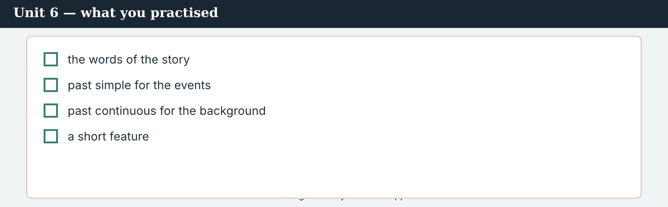
Unit 6 — telling the story of what happened.
10A Vocabulary. Complete with: event · returned · rebuilt · reopened · changed · ago · then · after.
1. Seven years ___________ , the bridge closed.
2. Everything ___________ .
3. Families ___________ home.
4. Workers ___________ the road.
5. The crossing ___________ .
6. First it was quiet; ___________ it was busy.
7. The festival was a happy ___________ .
8. ___________ that day, the valley was busy.
10B Grammar. Write the past simple.
1. open → ___________
2. come → ___________
3. be (they) → ___________
4. build → ___________
10C Grammar. Complete with the past continuous.
1. When Mira arrived, children ___________ (run).
2. While the workers ___________ (paint), families arrived.
Can-Do — tick what you can do now.
10D Choose: ago · last · when.
1. Seven years ______ , the bridge closed.
2. The crossing reopened ______ spring.
3. ______ the barrier went up, people were waiting.
10E Read and answer.
Last spring, the crossing reopened. While the stall-holders were setting up, families were arriving. “It was a happy day,” one stall-holder said. After that, the valley was busy again.
1. When did the crossing reopen? ___________
2. What were the stall-holders doing? ___________
3. What did the stall-holder say? ___________
Can-Do — tick what you can do now
☐ I can tell what happened (past simple).
☐ I can describe what was happening (past continuous).
☐ I can use time words (ago, last, when, while).
☐ I can write a short story about a past event.
10F Reflect. Which part of Unit 6 was the most useful for you? Why?
10G Grammar review. Write the sentence in the past.
1. The crossing opens last week. → ________________________
2. Families comes back. → ________________________
3. When Mira arrives, children play. → ________________________
4. It is a happy day. → ________________________

PART 11 Assignment: a short feature
Put the unit together: write the story of a place that changed.
The assignment template — your past story.
Your task. Choose a place that changed (real or invented). Write a short feature (5–6 sentences). Say how it was before, tell what happened (past simple), describe the background (past continuous), and use time words for the order. Name a source, and end with one exact quote. Keep it accurate and kind.
A model — use it to check the shape of your feature.
Remember: past simple for events; past continuous for background; time words for order; name a source; keep the quote exact; report only what you can confirm.
Success criteria | Yes | Almost | Not yet
I say how the place was before. | ☐ | ☐ | ☐
I use past simple for the events. | ☐ | ☐ | ☐
I use past continuous for the background. | ☐ | ☐ | ☐
I use time words (ago, when, while, after). | ☐ | ☐ | ☐
I name a source and end with one exact quote. | ☐ | ☐ | ☐
Keep this. In Unit 7, you learn the passive — to say what was done (‘the bridge was rebuilt’, ‘the road was repaired’).

ANSWER KEY Unit 6
Check your answers. Open tasks (discussion, role-play and your own writing) are marked at the end.
W1 1 closed (the road was empty, the stalls were gone) · 2 repaired the bridge · 3 (they were) running
W2 1 F · 2 T · 3 F
W3 (any three) was · were · changed · repaired · went · started · came · said
1A 1-c, 2-b, 3-a, 4-d, 5-f, 6-g, 7-e, 8-i, 9-h, 10-j (accept sensible matches)
1B 1 ago · 2 changed · 3 returned · 4 rebuilt · 5 reopened · 6 event
1C 1 last week · 2 seven years ago · 3 the crossing reopened · 4 children returned to school · 5 a happy event
1D 1 tomorrow · 2 finished · 3 left · 4 deadline
1E 1 closed · 2 happened · 3 returned · 4 rebuilt · 5 reopened
1F 1 event · 2 reopen · 3 ago · 4 then
2A 1 opened · 2 returned · 3 came · 4 went · 5 was · 6 built
2B 1 opened · 2 came · 3 built · 4 was
2C 1 were running · 2 were carrying · 3 was opening
2D 1 ago · 2 last · 3 When
3A 1 the bridge closed · 2 repairing the road / measuring the rail · 3 hundreds of people were waiting on both sides
3B (any three) ago · Then · last · While · When · After that
3C 1 the crossing reopened = 3 · 2 the bridge was closed = 1 · 3 workers started the repairs = 2 · 4 busy again = 4
3D ago · Then · When · After
4B 1 last spring (Friday morning) · 2 setting up (his stall) · 3 (they were) smiling / happy · 4 seven years
4C 1 F · 2 T · 3 F
4D Event = the crossing reopened · When = last spring, Friday · Background = families were arriving while he was setting up
4F 1 last · 2 arriving · 3 smiling · 4 came
4G (any two) was setting up · were arriving · were smiling
4H ‘The valley came back.’
4I reopened · setting · arriving · quote
5B 1 F · 2 T · 3 T · 4 F
5C 1 empty (the stalls disappeared) · 2 watching the workers from their windows · 3 a hundred
5D 1 rebuild · 2 disappear · 3 spring
5F Past simple for events → ‘The crossing opened.’ · Past continuous for background → ‘While they were painting…’ · Time words → ‘Seven years ago… Then… After that…’ · Keep it accurate → check the dates and name a source
5G Tip 4
5H 1 return · 2 rebuild · 3 event
6A 1 past simple · 2 the barrier went up
6C past simple: reopened, said, came; past continuous: were setting up, were arriving
6D reopened · were waiting · said
6F (example) ‘Last year, the crossing was closed. Then families came back.’
7A past simple: ‘what happened…?’; past continuous: ‘What were you doing when the families arrived?’
7B (example) 1 What did you do? · 2 What were you doing? · 3 When did it reopen? · 4 How did you feel?
7C 1 opened · 2 came · 3 was
7F ‘While he was setting up, families were arriving.’
8A 1 (b) write ‘many people crossed’ · 2 (b) not confirmed
8B 1 Y · 2 N · 3 Y · 4 N
8C true · confirm · Check · bigger
8E 1 (b) leave it out · 2 (b) respect it
8F 1 respect · 2 private · 3 gentle · 4 kind
9A ’…the bridge closed’ → before · ’…it reopened’ → the past event · ’…families are back’ → now · @AtlasWire → the outlet
9B closed (also: reopened)
9C ‘Last year, the crossing was closed. Then it reopened.’
10A 1 ago · 2 changed · 3 returned · 4 rebuilt · 5 reopened · 6 then · 7 event · 8 After
10B 1 opened · 2 came · 3 were · 4 built
10C 1 were running · 2 were painting
10D 1 ago · 2 last · 3 When
10E 1 last spring · 2 setting up · 3 ‘It was a happy day.’
10G 1 The crossing opened last week. · 2 Families came back. · 3 When Mira arrived, children were playing. · 4 It was a happy day.
Open tasks W4, 1G, 1H, 1I, 2E, 2F, 3E, 3F, 3G, 4A, 4E, 4H, 4J, 5A, 5E, 5I, 5J, 6B, 6E, 7D, 7E, 7G, 8D, 8G, 8H, 9D, 9E, 9F, 9G, 9H, 10F — your own answers (discussion, role-play, writing).
A note on real and invented content. The facts about journalism around the world are true as of 2026. Atlas Wire, its staff, Elena Marku, Bekim, Kalina and the story of the crossing are invented, for practice. Real people are only ever in true, sourced facts — never in an invented quote.
English for Journalists — International Edition · Unit 6 (v6 standard). CEFR A2 → lower B1 · Beat: Report & feature · two readings · two listenings · two writing pieces · two ethics cases · two speaking dialogues · balanced sections · ~24 figures · featured cast · fictional agency, factual backdrop.
UNIT 7 What Was Done: The Passive
Beat · Report CEFR A2 → lower B1
In this unit you learn to…
1. say what was done (past passive: was/were + done)
2. say what is done (present passive: is/are + done)
3. choose between active and passive
4. write a short report using the passive
The Atlas Wire team — Mira reports on the work at the crossing.
The story so far. The families are back and the story of the seven years is told. Now Mira reports on the work itself: what was done to the bridge at Kalina, and who did it. In a report, the passive puts the result first — ‘the bridge was rebuilt’.

WARM-UP What was done here?
A short report to start the unit. Read it, then answer.
The morning conference — the team plans a report on the rebuilding.
A lot of work was done at Kalina this year. The bridge was rebuilt, and the road was repaired. The rail was painted, and the old gate was replaced. New lamps were fitted along the river. Most of the work was done by local volunteers, with help from two councils. “Every week, something new is finished,” one worker said. “The crossing is being brought back to life.”
W1 Answer the questions.
1. What was done to the bridge? ___________
2. What was done to the old gate? ___________
3. Who did most of the work? ___________
W2 True or false? Write T or F.
1. The bridge was closed again. ______
2. New lamps were fitted. ______
3. The work was done by volunteers. ______
W3 Find three passive verbs in the text (e.g. was done). Write them.
1. ________________________
PRODUCE Talk about it
W4 Discuss with a partner.
1. What was built or repaired in your city recently? Say two things.
2. Who does this kind of work — the city, or volunteers?

PART 1 The words of the project
The words for reporting a project. Learn these first.
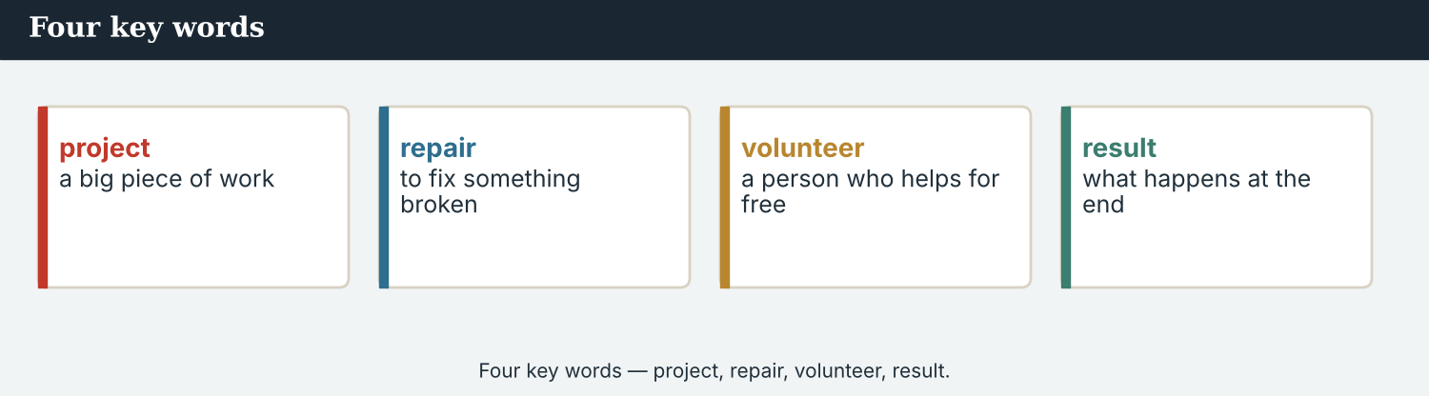
Four key words — project, repair, volunteer, result.
The words
Word | Meaning
project | a big piece of work
result | what happens at the end
complete | finished
repair | to fix something broken
rebuild | to build again
replace | to put a new one in place of an old one
paint | to put colour on
fit | to put a thing in place
fix | to repair
build | to make a building or a road
damage | harm to a thing
restore | to make like before
volunteer | a person who helps for free
finish | to end / complete
PRACTISE Controlled practice
1A Match the word (1–10) to the meaning (a–j).
1. project  2. repair  3. volunteer  4. result  5. restore  6. rebuild  7. damage  8. complete  9. replace  10. fit | a) to fix something broken  b) a person who helps for free  c) a big piece of work  d) what happens at the end  e) to build again  f) harm to a thing  g) to make like before  h) finished  i) to put a new one in place of an old one  j) to put a thing in place
1B Complete the sentences with a word from the box.
WORD BOX
project · repaired · volunteers · complete · fitted · rebuilt
1. The rebuilding was a big ___________ .
2. The old road was ___________ .
3. Most of the work was done by ___________ .
4. Now the project is nearly ___________ .
5. New lamps were ___________ along the river.
6. The bridge was ___________ .
1C Match the two halves.
1. a big  2. local  3. the  4. rebuild  5. paint | a) project  b) volunteers  c) result  d) the bridge  e) the rail
1D Circle the word that is different.
1. repair · fix · restore · break
2. project · work · result · deadline
3. volunteer · helper · worker · microphone
4. fitted · painted · repaired · yesterday
A report on a project tells readers what was done, and the result.
1E Complete the paragraph. Use: project · rebuilt · repaired · volunteers · complete.
The rebuilding of the crossing was a big ___________ . The bridge was ___________ , and the road was ___________ . Most of the work was done by ___________ . Now the project is nearly ___________ .
1F Read the definition. Write the word.
1. a big piece of work → ___________
2. to make like before → ___________
3. a person who helps for free → ___________
4. what happens at the end → ___________
PRODUCE Over to you
1G Answer about you. Write full sentences.
1. What is one thing that was repaired or built near you?
2. Have you ever been a volunteer? What did you do?
PRODUCE Talk about it
1H Discuss. Which two words in this unit are new for you? Make a sentence with one.
1I Creative. Write two sentences about a project in your town. Say what was done.

PART 2 Grammar: the passive
Was/were + done for the past, is/are + done for now.
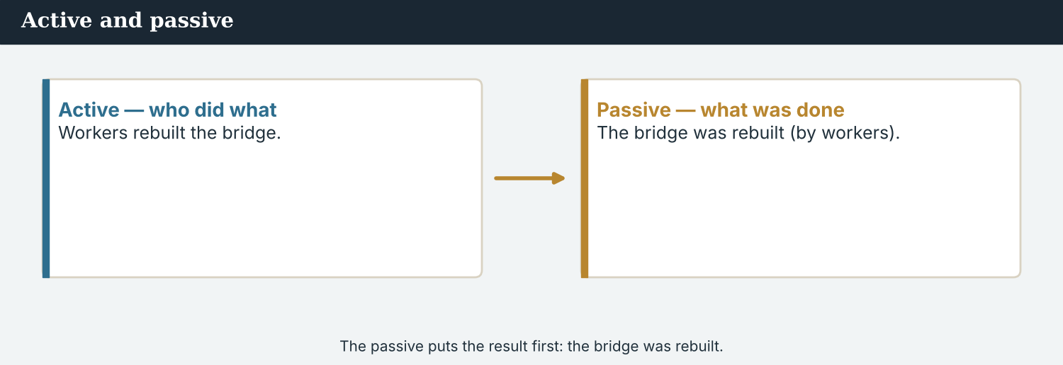
Active → passive: the result comes first.
1 · Past passive — what was done
Form: was / were + past participle.
The bridge was rebuilt. The road was repaired. New lamps were fitted.
We use it to say what was done, when the result matters more than who did it.
2 · Active and passive
Active: Workers rebuilt the bridge. (who + did + what)
Passive: The bridge was rebuilt (by workers). (what + was done)
Add by… only if the doer matters. Often, we do not need it.
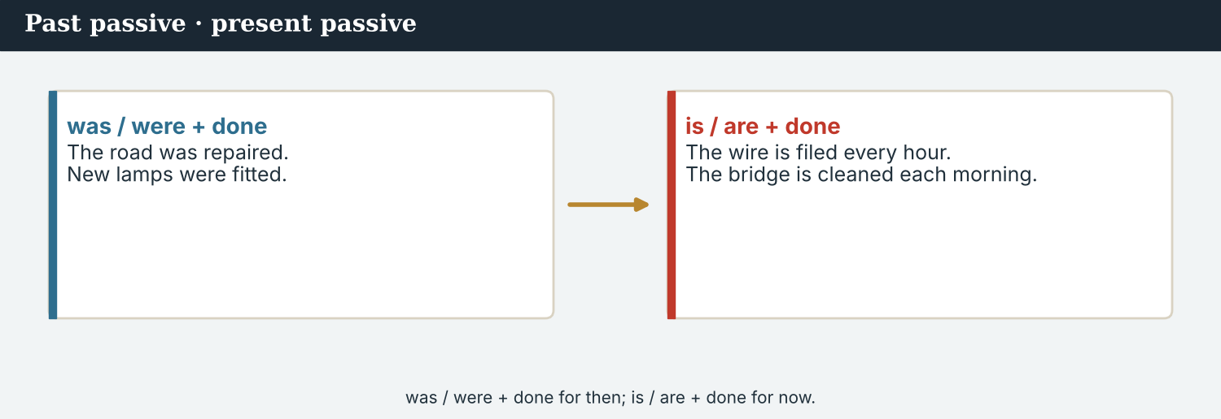
Present passive — for what is done again and again.
3 · Present passive — what is done
Form: is / are + past participle.
The wire is filed every hour. The stalls are cleaned each morning.
We use it for things that happen again and again.
PRACTISE Structured practice
2A Write the past participle.
1. rebuild → ___________
2. repair → ___________
3. paint → ___________
4. replace → ___________
5. do → ___________
6. write → ___________
2B Complete with the past passive (was / were + done).
1. The bridge ___________ (rebuild).
2. The road ___________ (repair).
3. New lamps ___________ (fit).
4. The work ___________ (do) by volunteers.
2C Change from active to passive.
1. Workers rebuilt the bridge. → The bridge ___________ .
2. Volunteers painted the rail. → The rail ___________ .
3. The council repaired the road. → The road ___________ .
2D Complete with the present passive (is / are + done).
1. The wire ___________ (file) every hour.
2. The stalls ___________ (clean) each morning.
3. The news ___________ (report) by Atlas Wire.
Your own words
2E Write two things that were done in your school or street. Use the past passive.
1. ________________________
2. ________________________
2F Write one thing that is done in your city every day. Use the present passive.
1. ________________________

PART 3 Reporting the work
A report often uses the passive: the result comes first.
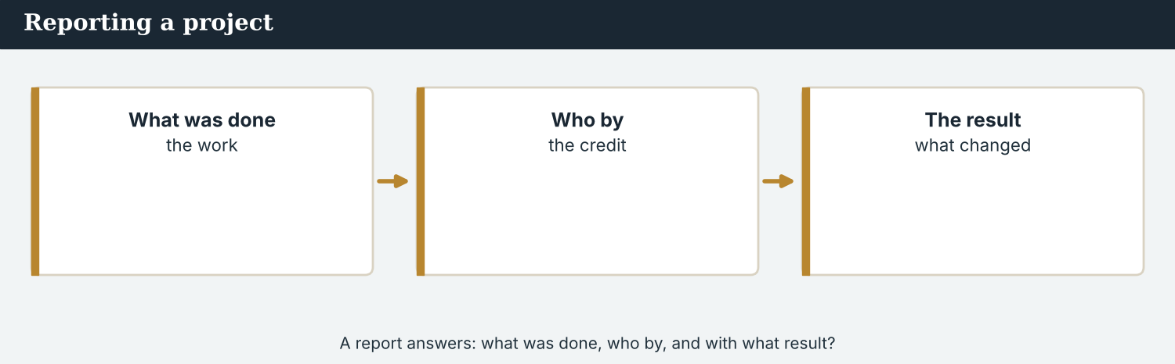
A report answers: what was done, who by, and with what result?
MODEL A model paragraph
A lot of work was done at Kalina this year. The bridge was rebuilt, and the road was repaired. The rail was painted, and new lamps were fitted. Most of the work was done by local volunteers. Every week, something new is finished.
NOTICE Notice the passive
3A Answer about the model.
1. What was done to the bridge? ___________
2. What was done to the rail? ___________
3. Who was the work done by? ___________
3B Find three past-passive verbs in the model. Write them.
1. ________________________
PRACTISE Turn it around
A report still answers the five Ws — and adds ‘who by?’.
3C Change to the passive (put the result first).
1. Workers rebuilt the school. → ________________________
2. Volunteers cleaned the market. → ________________________
3. The council fitted new lamps. → ________________________
3D Complete the report. Use: were · was · are · by.
Last month, the school ______ reopened. The classrooms ______ painted ______ volunteers. Now the rooms ______ cleaned every morning.
PRODUCE Your turn
3E Choose a project (real or invented). Write four sentences about what was done. Use the past passive.
________________________
________________________
________________________
________________________
PRODUCE Discuss
3F Talk with a partner. Why does a report often use the passive? Give one example.
3G When is it important to say who did the work (‘by…’)? When is it not?

PART 4 Listening: the project
Two audios. Listen for what was done.
In the newsroom — the team hears about the project.
Listening A · a report on the project
MODEL Audio 7.1 — the Crossing Office reports
Spokesperson: Good morning. I can tell you what was done at the crossing this year.
Spokesperson: The bridge was rebuilt, and the road was repaired in April.
Spokesperson: The rail was painted, and new lamps were fitted along the river.
Mira: Who was the work done by?
Spokesperson: Most of it was done by local volunteers, with help from two councils.
Mira: And is anything still being done?
Spokesperson: Yes. The school is being painted this week, and the riverside path is being cleaned.
PRACTISE Listen for detail
4A Before you listen: what kind of work do you think was done? Write one idea.
1. ______
4B Answer the questions.
1. What was done to the bridge? ___________
2. When was the road repaired? ___________
3. Who was most of the work done by? ___________
4. What is being done this week? ___________
4C True or false? Write T or F.
1. The road was repaired in April. ______
2. The work was done by volunteers. ______
3. Nothing is being done now. ______
4D Complete the notes.
Bridge: ___________
Road: ___________
Done by: ___________
Audio 7.2 — Mira reports to the editor what was done.
Listening B · reporting it back
MODEL Audio 7.2 — Mira and Daniel
Daniel: What did the office say was done?
Mira: The bridge was rebuilt, and the road was repaired in April.
Daniel: Good. Who was it done by?
Mira: It was done by local volunteers, with help from two councils.
Daniel: And now?
Mira: The school is being painted, and the riverside path is being cleaned.
Daniel: Perfect. Put the volunteers in the story — they should be named.
PRACTISE Listen for detail
4E Before you listen: what will Daniel want to know? Guess.
1. ______
4F Complete the answers.
1. The bridge ___________ rebuilt.
2. The road ___________ repaired in April.
3. The work was done ___________ volunteers.
4. The school ___________ being painted now.
4G Which passive forms do you hear? Write two (was/were + done).
1. ________________________
4H Answer. Why does Daniel want to name the volunteers?
1. ________________________
PRACTISE Both audios
4I Complete the summary. Use: rebuilt · repaired · volunteers · painted.
This year, the bridge was ______ and the road was ______ . Most of the work was done by local ______ . Now the school is being ______ .
PRODUCE What do you think?
4J Discuss. When a reporter uses the passive, what important information can be lost? Why does Daniel ask ‘who by?’

PART 5 Reading: the report
Two readings. Read for what was done, and by whom.
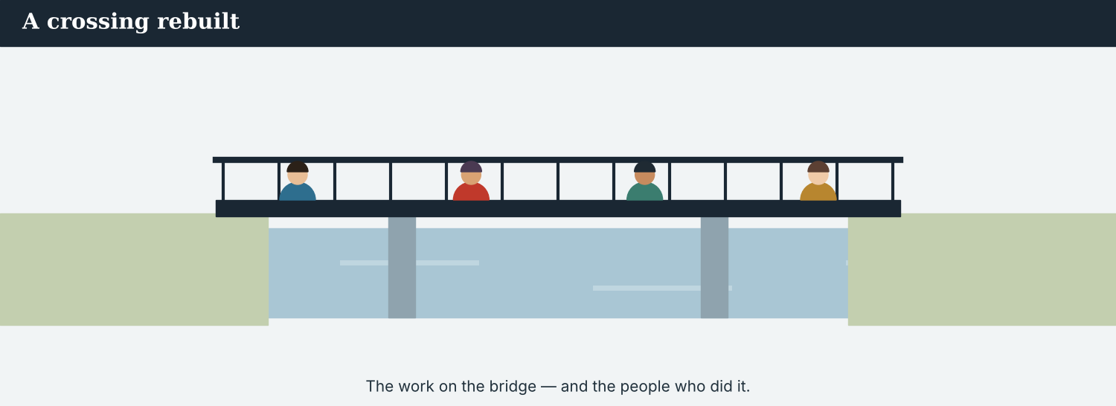
The work on the bridge — and the people who did it.
Reading A · a report on the rebuilding
A crossing rebuilt: the work at Kalina
A great deal of work was done at the Kalina crossing this year. According to the Crossing Office, the bridge was rebuilt and the road was repaired last April.
The rail was painted, and the old gate was replaced. New lamps were fitted along the river, and the riverside path was cleared after seven years. Most of this work was done by local volunteers, with help from the councils on both sides.
“Every week, something new is finished,” said one volunteer, who worked on the bridge. “The gate was the hardest job. It was rusted shut for years, but now it opens every morning. Children walk through it on their way to school.”
Some work is still being done. This week, the school is being painted, and the riverside path is being cleaned. “The project is not complete,” the office said, “but most of it is finished, and the crossing looks like a crossing again.”
The office asked to thank the volunteers by name. “The bridge was rebuilt by our neighbours — from both sides of the river,” one worker said. “This was done by us, together. That is why it means so much.”
PRACTISE Comprehension
5A Before you read: look at the title. What is the report about? Write one sentence.
1. ______
5B True or false? Write T or F.
1. The bridge was rebuilt. ______
2. The gate was easy to replace. ______
3. The school is being painted this week. ______
4. The project is completely finished. ______
5C Answer the questions.
1. What was done to the old gate? ___________
2. Who was most of the work done by? ___________
3. What is being done this week? ___________
5D Find a word in the text.
1. a person who helps for free → ___________
2. to fix something broken → ___________
3. finished → ___________
A report reaches readers who want to know what was done — and by whom.
Reading B · active or passive? — four tips
Four tips for the passive
1. Use the passive for the result. When the work matters more than the worker: ‘The bridge was rebuilt.’
2. Use ‘by…’ when the doer matters. ‘The bridge was rebuilt by local volunteers.’ Name people who should get credit.
3. Do not hide who did it. ‘Mistakes were made’ hides the person. If readers should know who, say who.
4. Keep it clear. The active voice is often shorter and clearer. Use the passive when it helps — not everywhere.
PRACTISE Comprehension
5E Before you read: when is the passive a good choice? Guess.
1. ______
5F Match the tip to the example.
1. Use the passive for the result  2. Use ‘by…’ when the doer matters  3. Do not hide who did it  4. Keep it clear | a) ‘Mistakes were made’ hides the person  b) ‘The bridge was rebuilt.’  c) The active is often shorter  d) ’…rebuilt by local volunteers.’
5G Which tip is about credit for the work? Write the number.
1. ______
PRACTISE Words from the readings
5H Find a word in Reading A or Reading B.
1. a big piece of work → ___________
2. to put a new one in place of an old one → ___________
3. finished → ___________
PRODUCE Discuss
5I Talk about it. Which part of the report did you like best? Why?
5J Which of the four tips is the most important? Say why.

PART 6 Writing: a report
Two short pieces: a list of what was done, and a short report.
Notes: what was done, item by item.
Writing 1 · a ‘what was done’ list
MODEL A model
Bridge: was rebuilt (by volunteers)
Road: was repaired in April
Gate: was replaced
Lamps: were fitted along the river
NOTICE Notice the model
6A Answer about the model.
1. Which tense are the notes in? ___________
2. Which item names who did the work? ___________
PRODUCE Write your notes
6B Choose a project. Write four ‘what was done’ notes. Use the past passive.
1: ___________
2: ___________
3: ___________
4: ___________
A short report uses the passive and names the people who deserve credit.
Writing 2 · a short report
MODEL A model
This year, the bridge at Kalina was rebuilt and the road was repaired. Most of the work was done by local volunteers. “The bridge was rebuilt by our neighbours,” one worker said.
NOTICE Notice the model
6C Answer. Which verbs are passive? Where does the report name who did the work?
1. ___________
PRACTISE Complete a report
6D Complete the report. Use: was · were · by.
The school ______ reopened last month. The classrooms ______ painted ______ volunteers, and new books were given to every child.
PRODUCE Write your report
6E Write a short report (3–4 sentences) about a project. Use the passive, and name who did the work.
________________________
________________________
________________________
PRACTISE Fix it
6F Change this to the passive (put the result first).
“Volunteers rebuilt the bridge. Workers repaired the road.”
________________________

PART 7 Speaking: about the work
Ask and answer about a project. Use the passive.
Ask about a project: what was done, and who by.
A model dialogue · asking about the project
MODEL Listen and read
Mira: Could you tell me what was done here?
Guest: Yes. The bridge was rebuilt, and the gate was replaced.
Mira: Who was the work done by?
Guest: It was done by local volunteers, from both sides of the river.
Mira: And is anything still being done?
Guest: Yes, the school is being painted this week.
Mira: Thank you very much.
NOTICE Notice the questions
7A Find the two passive questions. Write them.
1. ________________________
PRACTISE Controlled practice
7B Make a passive question for each answer.
1. ___________ ? — The bridge was rebuilt.
2. ___________ ? — By local volunteers.
3. ___________ ? — The gate was replaced.
4. ___________ ? — The school is being painted.
Introduce yourself, then ask what was done.
7C Change the question to the passive.
1. Who rebuilt the bridge? → What ___________ done to the bridge?
2. Who cleaned the path? → How ___________ the path cleaned?
3. Who repaired the road? → When ___________ the road repaired?
PRODUCE Your role
Correspondent | Ask about the project: ‘What was done?’ and ‘Who was it done by?’
Worker / volunteer | Answer with the passive. Name who did the work.
Observer | Listen. Did the reporter ask who the work was done by?
7D Choose a role from the table. Ask your questions to a partner.
PRODUCE Role-play
7E Role-play a report on a project: a reporter, a worker, and an observer. Then swap roles.
A second dialogue · reporting the work
MODEL Listen and read
Mira: I visited the school today. A lot was done there.
Priya: What was done?
Mira: The classrooms were painted, and new books were given to the children.
Priya: Who was it done by?
Mira: It was done by volunteers, and the councils paid for the books.
Priya: Good. Name the volunteers in the story.
PRACTISE Controlled practice
7F Write the passive sentence Mira uses about the classrooms.
1. ________________________
PRODUCE Self-check
Did I… | Yes | Almost | Not yet
use the past passive (was/were + done)? | ☐ | ☐ | ☐
ask who the work was done by? | ☐ | ☐ | ☐
name the people who did the work? | ☐ | ☐ | ☐
keep my report clear? | ☐ | ☐ | ☐
7G Role-play reporting a project to a colleague. Then swap roles.

PART 8 Ethics: who did it?
The passive can hide the doer. A fair report says who — when it matters.
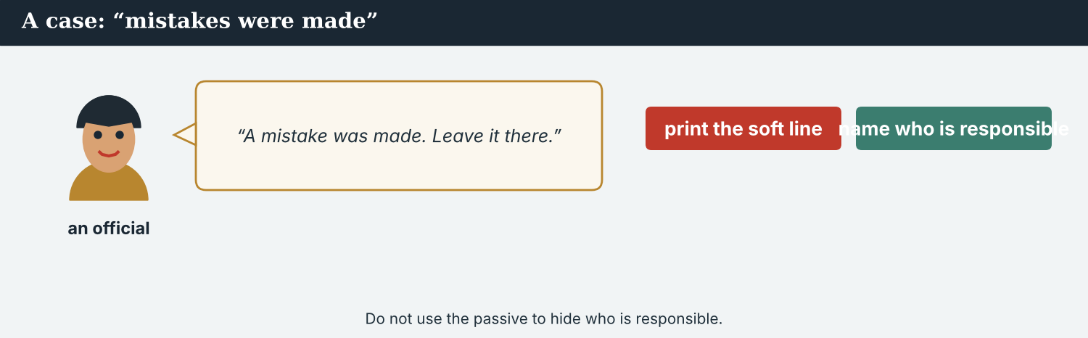
‘Mistakes were made’ hides the person. If readers should know who, say who.
A first case · hiding the doer
A case. A part of the new river wall fell down a month after it was built. The building company sends Mira a line for the story: “A mistake was made, and the wall will be repaired.” But the passive hides who made the mistake. Readers — and the families who live beside the wall — have a right to know which company built it. Mira can file the company’s soft line, or she can find out who did the work and name them. The Code says: be accountable — do not use the passive to hide who is responsible. What does Mira do?
NOTICE What do you do?
8A Choose (a) or (b), and write one reason.
1. (a) file ‘a mistake was made’ (b) find out who built the wall and name them. Choice: ______ Because ________________________
2. ‘A mistake was made’ (no name) tells readers (a) who is responsible (b) nothing about who. Choice: ______
8B Does it name who? Write Y (yes) or N (no).
1. “The wall was built by the Vara Company.” ______
2. “A mistake was made.” ______
3. “The office says the company will repair it.” ______
4. “The wall fell down.” ______
PRACTISE Apply the Code
8C Complete the rule. Use: hide · who · responsible · name.
Do not use the passive to ______ the doer. When readers should know ______ is ______ , ______ them.
PRODUCE Discuss
8D Discuss. Why is ‘mistakes were made’ a problem in the news? Who does it protect?
A second case · who gets the credit
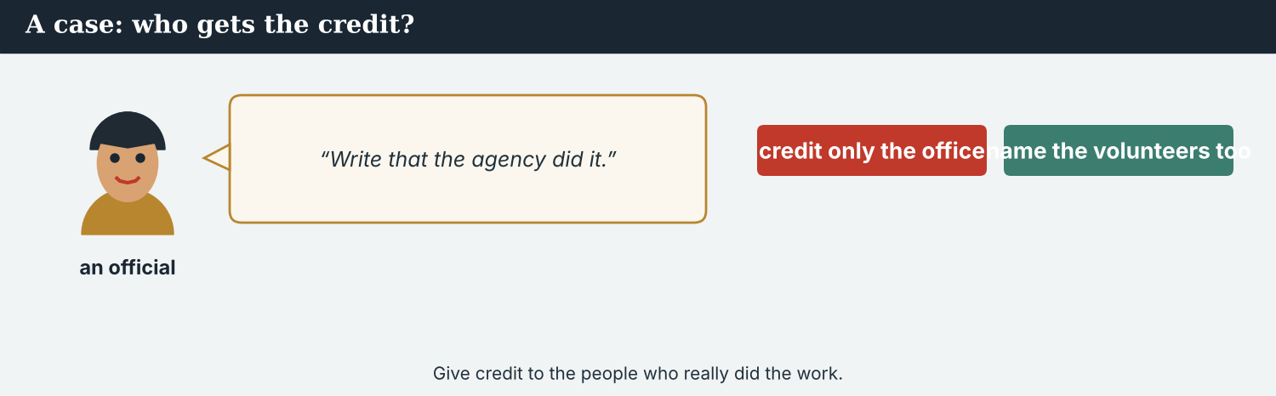
Give credit fairly — to the people who did the work, not only the officials.
A case. The bridge was rebuilt mostly by local volunteers, who worked for four months. But an official asks Mira to write only that “the bridge was rebuilt by the councils.” The councils helped and paid for materials, but the volunteers did most of the work. If Mira writes only ‘by the councils’, the volunteers get no credit — and the story goes out in six languages. The Code says: be fair and accurate — give credit to the people who really did the work. What does Mira do?
NOTICE What do you do?
8E Choose (a) or (b), and write one reason.
1. (a) write only ‘by the councils’ (b) name the volunteers and the councils. Choice: ______ Because ________________________
2. Giving credit only to officials, not the workers, is (a) fair (b) unfair. Choice: ______
8F Complete with: credit · fair · workers · true.
1. Give ___________ to the people who did the work.
2. A report must be ___________ .
3. Do not forget the ___________ .
4. Write what is ___________ , not only what an official wants.
PRODUCE Discuss
8G Discuss. Why does it matter who gets the credit in a story?
PRODUCE Write it
8H Write two sentences for Mira’s report that give fair credit for the rebuilding. Use the passive.

PART 9 Digital: the results post
Online, a ‘what was done’ post shares the results fast.
A results post — what was done, in a line.
MODEL A model post
DONE · The bridge was rebuilt, the road was repaired, and the old gate was replaced at Kalina — by local volunteers. — @AtlasWire
NOTICE The parts of the post
9A Match the part to what it shows.
1. The bridge was rebuilt  2. the road was repaired  3. by local volunteers  4. @AtlasWire | a) the doer (credit)  b) what was done (1)  c) what was done (2)  d) the outlet
PRACTISE Find and build
9B Find one past-passive verb in the post. Write it.
1. ______
9C This post hides who did the work. Add the doer with ‘by…’.
“The bridge was rebuilt. The road was repaired.”
________________________
The post links to the full report on the website.
9D Write a results post. Say what was done, and by whom.
DONE · ___________ (what was done) — by ___________ (who). — @AtlasWire
PRODUCE Write your post
9E Write a one-line results post about a project in your city. Use the passive.
________________________
9F Creative. Write a short headline (4–6 words) for your results story. Use the passive.
9G A reader asks: ‘Who did the work?’ Write a short reply that names the doer.
________________________
PRODUCE Discuss
9H Discuss. A short post often drops the ‘by…’. When is that a problem?

PART 10 Review & Can-Do
Check your new English before Unit 8.
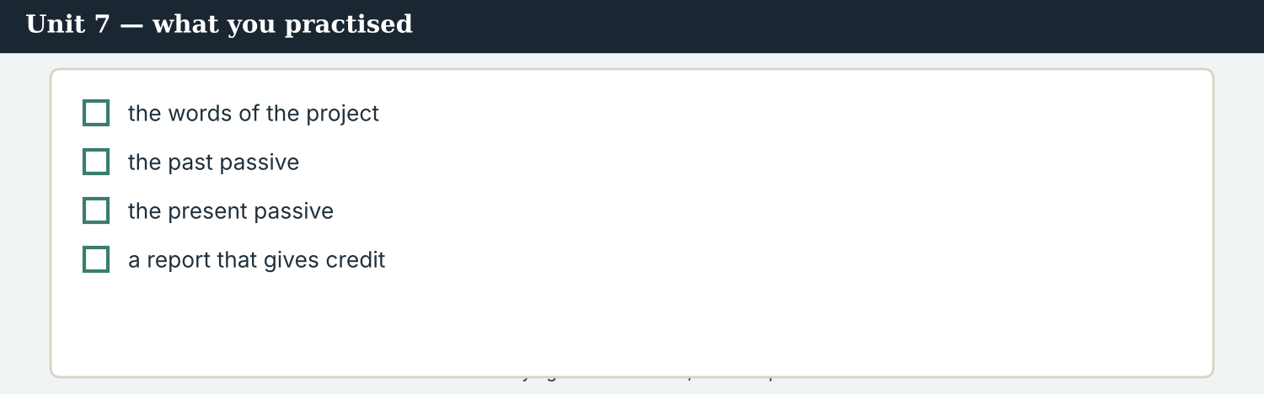
Unit 7 — saying what was done, with the passive.
10A Vocabulary. Complete with: project · repaired · volunteers · complete · rebuilt · fitted · result · restored.
1. The rebuilding was a big ___________ .
2. The old road was ___________ .
3. Most of the work was done by ___________ .
4. Now the project is nearly ___________ .
5. The bridge was ___________ .
6. New lamps were ___________ .
7. The old gate was ___________ to its first colour.
8. A busy crossing is the ___________ .
10B Grammar. Write the past passive (was/were + done).
1. the bridge / rebuild → ___________
2. the road / repair → ___________
3. the lamps / fit → ___________
4. the work / do → ___________
10C Grammar. Change from active to passive.
1. Volunteers painted the rail. → ________________________
2. The council repaired the road. → ________________________
Can-Do — tick what you can do now.
10D Present passive. Complete with is / are.
1. The wire ______ filed every hour.
2. The stalls ______ cleaned each morning.
3. The news ______ reported by Atlas Wire.
10E Read and answer.
This year, the bridge was rebuilt and the road was repaired. The old gate was replaced by local volunteers. Now the school is being painted, and new books are given to every child.
1. What was done to the bridge? ___________
2. Who replaced the gate? ___________
3. What is being done to the school now? ___________
Can-Do — tick what you can do now
☐ I can say what was done (past passive).
☐ I can say what is done (present passive).
☐ I can change active to passive.
☐ I can write a short report using the passive.
10F Reflect. Which part of Unit 7 was the most useful for you? Why?
10G Grammar review. Write the sentence in the passive.
1. Workers rebuilt the bridge. → ________________________
2. Volunteers cleaned the path. → ________________________
3. The council repairs the roads. → ________________________
4. Atlas Wire reports the news. → ________________________

PART 11 Assignment: a project report
Put the unit together: report what was done on a project.
The assignment template — your project report.
Your task. Choose a project (real or invented). Write a short report (5–6 sentences). Say what was done (past passive), say what is done now (present passive) if it helps, and name who did the work with ‘by…’ where the doer should get credit. End with one exact quote. Be accurate, and do not use the passive to hide who is responsible.
A model — use it to check the shape of your report.
Remember: past passive for what was done; present passive for what is done; add ‘by…’ for credit; do not hide the doer; end with an exact quote.
Success criteria | Yes | Almost | Not yet
I use the past passive for what was done. | ☐ | ☐ | ☐
I use ‘by…’ to give credit where it matters. | ☐ | ☐ | ☐
I do not hide who is responsible. | ☐ | ☐ | ☐
I end with one exact quote. | ☐ | ☐ | ☐
It is accurate and easy to read. | ☐ | ☐ | ☐
Keep this. In Unit 8, you learn the present perfect — to say what has happened and what has changed (‘the crossing has reopened’, ‘the valley has changed’).

ANSWER KEY Unit 7
Check your answers. Open tasks (discussion, role-play and your own writing) are marked at the end.
W1 1 it was rebuilt · 2 it was replaced · 3 (by) local volunteers, with help from two councils
W2 1 F · 2 T · 3 T
W3 (any three) was done · was rebuilt · was repaired · was painted · was replaced · were fitted
1A 1-c, 2-a, 3-b, 4-d, 5-g, 6-e, 7-f, 8-h, 9-i, 10-j (accept sensible matches)
1B 1 project · 2 repaired · 3 volunteers · 4 complete · 5 fitted · 6 rebuilt
1C 1 a big project · 2 local volunteers · 3 the result · 4 rebuild the bridge · 5 paint the rail
1D 1 break · 2 deadline · 3 microphone · 4 yesterday
1E 1 project · 2 rebuilt · 3 repaired · 4 volunteers · 5 complete
1F 1 project · 2 restore · 3 volunteer · 4 result
2A 1 rebuilt · 2 repaired · 3 painted · 4 replaced · 5 done · 6 written
2B 1 was rebuilt · 2 was repaired · 3 were fitted · 4 was done
2C 1 was rebuilt · 2 was painted · 3 was repaired
2D 1 is filed · 2 are cleaned · 3 is reported
3A 1 it was rebuilt · 2 it was painted · 3 (by) local volunteers
3B (any three) was done · was rebuilt · was repaired · was painted · were fitted
3C 1 The school was rebuilt (by workers). · 2 The market was cleaned (by volunteers). · 3 New lamps were fitted (by the council).
3D was · were, by · are
4B 1 it was rebuilt · 2 in April · 3 (by) local volunteers (and two councils) · 4 the school is being painted (and the path cleaned)
4C 1 T · 2 T · 3 F
4D Bridge = rebuilt · Road = repaired in April · Done by = local volunteers (+ two councils)
4F 1 was · 2 was · 3 by · 4 is
4G (any two) was rebuilt · was repaired · were fitted · is being painted
4H because the volunteers did the work and should get credit
4I rebuilt · repaired · volunteers · painted
5B 1 T · 2 F · 3 T · 4 F
5C 1 it was replaced · 2 (by) local volunteers, with help from the councils · 3 the school is being painted / the path cleaned
5D 1 volunteer · 2 repair · 3 complete
5F result → ‘The bridge was rebuilt.’ · ‘by…’ → ’…rebuilt by local volunteers.’ · do not hide → ‘Mistakes were made’ hides the person · keep it clear → the active is often shorter
5G Tip 2
5H 1 project · 2 replace · 3 complete
6A 1 past passive · 2 the bridge (by volunteers)
6C passive: was rebuilt, was repaired, was done; it names the doer with ‘by local volunteers’ / ‘by our neighbours’
6D was · were · by
6F The bridge was rebuilt (by volunteers). The road was repaired (by workers).
7A ’…what was done here?’ · ‘Who was the work done by?’
7B (example) 1 What was done? · 2 Who was it done by? · 3 What was replaced? · 4 What is being painted?
7C 1 was · 2 was · 3 was
7F ‘The classrooms were painted (by volunteers).’
8A 1 (b) find out who built the wall and name them · 2 (b) nothing about who
8B 1 Y · 2 N · 3 Y · 4 N
8C hide · who · responsible · name
8E 1 (b) name the volunteers and the councils · 2 (b) unfair
8F 1 credit · 2 fair · 3 workers · 4 true
9A ‘The bridge was rebuilt’ → what was done (1) · ‘the road was repaired’ → what was done (2) · ‘by local volunteers’ → the doer (credit) · @AtlasWire → the outlet
9B (any) was rebuilt · was repaired · was replaced
9C (example) ‘The bridge was rebuilt by local volunteers. The road was repaired by workers.’
10A 1 project · 2 repaired · 3 volunteers · 4 complete · 5 rebuilt · 6 fitted · 7 restored · 8 result
10B 1 was rebuilt · 2 was repaired · 3 were fitted · 4 was done
10C 1 The rail was painted (by volunteers). · 2 The road was repaired (by the council).
10D 1 is · 2 are · 3 is
10E 1 it was rebuilt · 2 (by) local volunteers · 3 it is being painted
10G 1 The bridge was rebuilt (by workers). · 2 The path was cleaned (by volunteers). · 3 The roads are repaired (by the council). · 4 The news is reported by Atlas Wire.
Open tasks W4, 1G, 1H, 1I, 2E, 2F, 3E, 3F, 3G, 4A, 4E, 4J, 5A, 5E, 5I, 5J, 6B, 6E, 7D, 7E, 7G, 8D, 8G, 8H, 9D, 9E, 9F, 9G, 9H, 10F — your own answers (discussion, role-play, writing).
A note on real and invented content. The facts about journalism around the world are true as of 2026. Atlas Wire, its staff, the volunteers, the Vara Company, Kalina and the project are invented, for practice. Real people are only ever in true, sourced facts — never in an invented quote.
English for Journalists — International Edition · Unit 7 (v6 standard). CEFR A2 → lower B1 · Beat: Report · two readings · two listenings · two writing pieces · two ethics cases · two speaking dialogues · balanced sections · ~24 figures · featured cast · fictional agency, factual backdrop.
UNIT 8 What Has Happened: The Present Perfect
Beat · Report & feature CEFR A2 → lower B1
In this unit you learn to…
1. say what has happened (present perfect: has/have + done)
2. talk about a change with a result now
3. use for and since
4. use just, already, yet, ever and never
The Atlas Wire team — Mira reports on how the valley has changed.
The story so far. The work is done and reported. Now Mira writes about the change itself: what has happened at Kalina, and how the valley has become a place where people live again. The present perfect links the past to the result we can see now.

WARM-UP What has changed?
A short piece to start the unit. Read it, then answer.
The morning conference — the team looks at how much has changed.
Kalina has changed a lot this year. The crossing has reopened, and many families have returned. The school has just started again, and the old gate has been replaced. “The valley has become a home again,” one stall-holder said. “I have had my stall here since the spring, and every week is better than the last.” But some things have not changed yet: the clinic is still closed, and the bus does not cross the bridge yet.
W1 Answer the questions.
1. What has happened to the crossing? ___________
2. Since when has the stall-holder had his stall? ___________
3. What has not changed yet? ___________
W2 True or false? Write T or F.
1. Many families have returned. ______
2. The school has just started again. ______
3. The clinic has reopened. ______
W3 Find three present-perfect verbs in the text (e.g. has changed). Write them.
1. ________________________
PRODUCE Talk about it
W4 Discuss with a partner.
1. What has changed in your city this year? Say two things.
2. What has not changed yet, but should?

PART 1 The words of change
The words for talking about change. Learn these first.
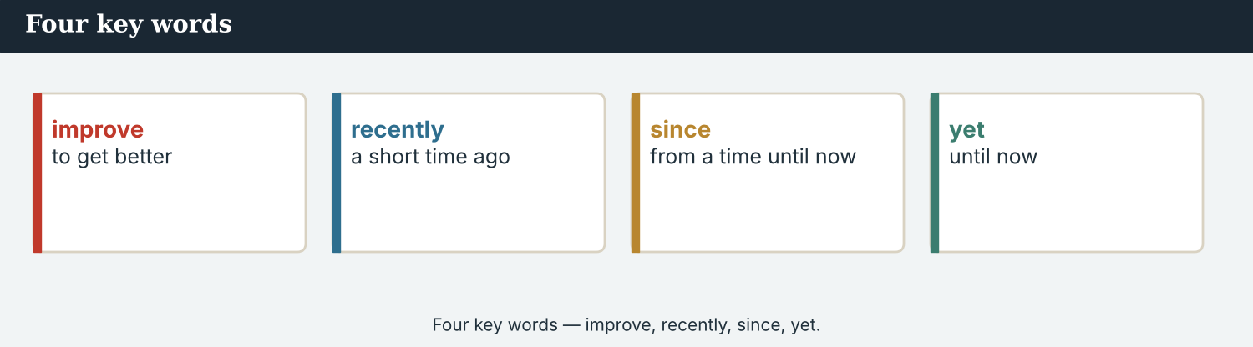
Four key words — improve, recently, since, yet.
The words
Word | Meaning
change | to become different
improve | to get better
grow | to get bigger
become | to start to be
progress | moving forward; getting better
development | a new thing that happens
recently | a short time ago
since | from a time until now
for | for a length of time
already | before now
yet | until now (in questions and negatives)
just | a very short time ago
ever | at any time
never | at no time
PRACTISE Controlled practice
1A Match the word (1–10) to the meaning (a–j).
1. change  2. improve  3. grow  4. become  5. progress  6. recently  7. already  8. yet  9. ever  10. never | a) to get better  b) to become different  c) to get bigger  d) a short time ago  e) to start to be  f) getting better  g) before now  h) until now  i) at any time  j) at no time
1B Complete the sentences with a word from the box.
WORD BOX
changed · improved · grown · recently · already · yet
1. The valley has ___________ a lot.
2. Life has ___________ for many families.
3. The market has ___________ bigger.
4. ___________ , a new café opened.
5. Many families have ___________ returned.
6. But the clinic has not reopened ___________ .
1C Match the two halves.
1. since  2. for  3. just  4. not  5. have | a) the spring  b) six months  c) reopened  d) yet  e) changed
1D Circle the word that is different.
1. change · improve · grow · deadline
2. since · for · already · microphone
3. ever · never · recently · loud
4. development · progress · change · rumour
A ‘what has changed’ story helps readers see the whole year at once.
1E Complete the paragraph. Use: changed · reopened · returned · improved · since.
Kalina has ___________ a lot. The crossing has ___________ , and many families have ___________ . Life has ___________ for everyone ___________ the spring.
1F Read the definition. Write the word.
1. to become different → ___________
2. to get better → ___________
3. from a time until now → ___________
4. a very short time ago → ___________
PRODUCE Over to you
1G Answer about you. Write full sentences.
1. What has changed in your life this year?
2. What have you learned recently?
PRODUCE Talk about it
1H Discuss. Which two words in this unit are new for you? Make a sentence with one.
1I Creative. Write two sentences about how your school or street has changed. Use has/have + a verb.

PART 2 Grammar: the present perfect
Has/have + done for a past action with a result now.
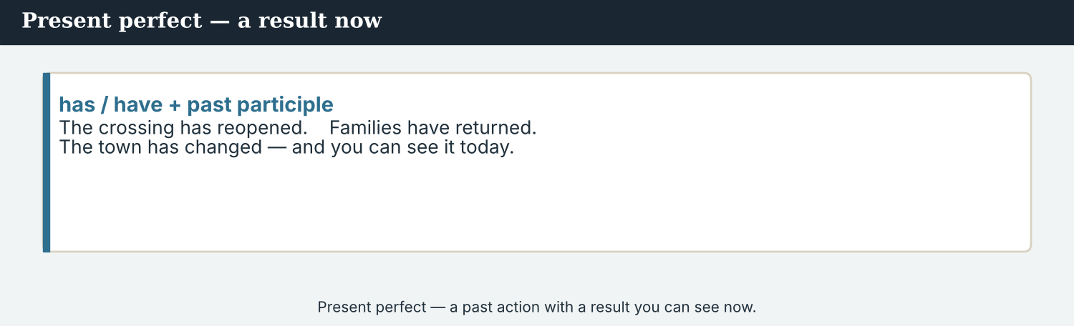
Present perfect — a past action with a result now.
1 · Present perfect — what has happened
Form: has / have + past participle.
The crossing has reopened. Families have returned. The valley has changed.
We use it for a past action with a result now — the crossing is open now.
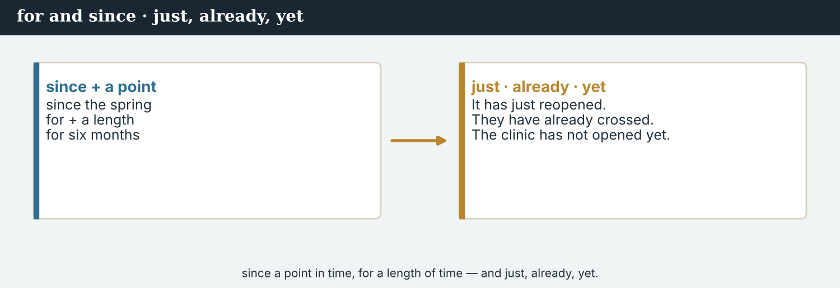
since + a point in time · for + a length of time.
2 · for and since
since + a point in time: The valley has changed since the spring.
for + a length of time: Families have been back for six months.
Both go with the present perfect — from the past until now.
3 · just, already, yet, ever, never
just: The school has just reopened. already: Families have already returned.
yet (– / ?): The clinic has not reopened yet.
ever / never: Have you ever visited? I have never seen it so busy.
PRACTISE Structured practice
2A Write the past participle.
1. reopen → ___________
2. return → ___________
3. change → ___________
4. be → ___________
5. become → ___________
6. grow → ___________
2B Complete with the present perfect (has/have + done).
1. The crossing ___________ (reopen).
2. Families ___________ (return).
3. The valley ___________ (change).
4. Life ___________ (improve).
2C Choose: for or since.
1. The valley has changed ______ the spring.
2. Families have been back ______ six months.
3. The café has been open ______ April.
4. I have lived here ______ two years.
2D Complete with just, already or yet.
1. The school has ______ reopened. (a moment ago)
2. Many families have ______ returned. (before now)
3. The clinic has not reopened ______ .
Your own words
2E Write two things that have changed in your town. Use the present perfect.
1. ________________________
2. ________________________
2F Write one thing you have never done, and one thing you have already done today.
1. ________________________
2. ________________________

PART 3 Telling what has changed
The present perfect links the change to the result we see now.
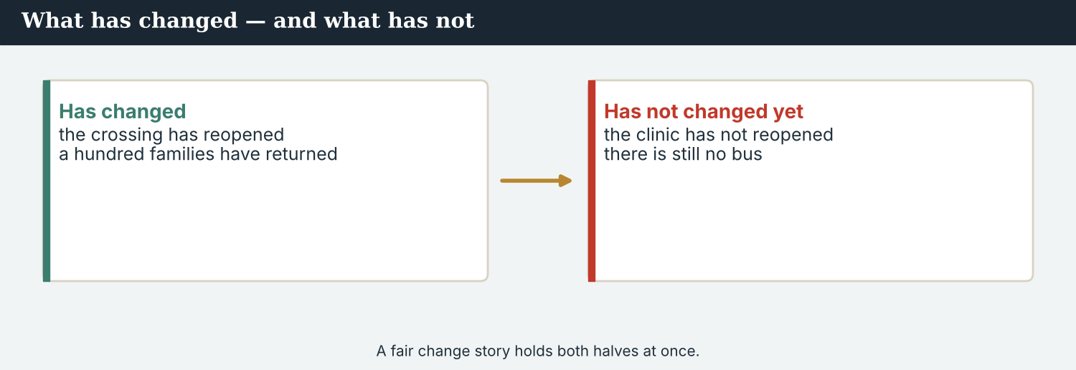
A fair change story holds both halves at once.
MODEL A model paragraph
Kalina has changed a lot since the spring. The crossing has reopened, and many families have already returned. The school has just started again. Life has improved for everyone. But the clinic has not reopened yet, and there is still work to do.
NOTICE Notice the tense
3A Answer about the model.
1. What has happened to the crossing? ___________
2. Since when has the valley changed? ___________
3. What has not happened yet? ___________
3B Find three present-perfect verbs in the model. Write them.
1. ________________________
PRACTISE Now and result
Ask: what has happened, and what is the result now?
3C Write the present perfect, then the result now.
1. The crossing (reopen) → ___________ . Result: it is ___________ now.
2. Families (return) → ___________ . Result: the valley is ___________ .
3. The gate (be replaced) → ___________ . Result: it ___________ every morning.
3D Complete the paragraph. Use: has · have · since · yet.
The school ______ reopened, and forty children ______ come back. Life has improved ______ the spring. But the bus does not cross the bridge ______ .
PRODUCE Your turn
3E Choose a place that has changed. Write four sentences about what has happened, with results now. Use the present perfect.
________________________
________________________
________________________
________________________
PRODUCE Discuss
3F Talk with a partner. Why does a ‘what has changed’ story feel close to now? Give one example.
3G Is it fair to write only what has improved? What else should a reporter say?

PART 4 Listening: what has changed
Two audios. Listen for what has happened, and the result now.
In the newsroom — the team hears how much has changed.
Listening A · a resident describes the change
MODEL Audio 8.1 — a resident speaks
Mira: Could you tell me how the valley has changed?
Resident: Of course. It has changed a lot since the spring.
Resident: The crossing has reopened, and many families have come back.
Resident: My children have just started school again — it reopened last week.
Mira: Has everything improved?
Resident: Not everything. The clinic has not reopened yet, and the bus does not cross yet.
Resident: But I have never been so happy to live here.
PRACTISE Listen for detail
4A Before you listen: what changes do you think the resident will mention? Write one idea.
1. ______
4B Answer the questions.
1. Since when has the valley changed? ___________
2. What has just happened for the children? ___________
3. What has not reopened yet? ___________
4. How does the resident feel? ___________
4C True or false? Write T or F.
1. The crossing has reopened. ______
2. Everything has improved. ______
3. The children have started school again. ______
4D Complete the notes.
Has changed since: ___________
Just happened: ___________
Not yet: ___________
Audio 8.2 — Mira reports to the editor what has changed.
Listening B · reporting it back
MODEL Audio 8.2 — Mira and Daniel
Daniel: So, how has the valley changed?
Mira: It has changed a lot. The crossing has reopened and families have returned.
Daniel: Anything just now?
Mira: Yes — the school has just reopened. The children have already gone back.
Daniel: And the problems?
Mira: The clinic has not reopened yet, and there is no bus yet.
Daniel: Good. Put the good news and the problems both in the story.
PRACTISE Listen for detail
4E Before you listen: what will Daniel ask about? Guess.
1. ______
4F Complete the answers.
1. The crossing ___________ reopened.
2. The school has ___________ reopened.
3. The children have ___________ gone back.
4. The clinic has not reopened ___________ .
4G Which present-perfect forms do you hear? Write two (has/have + done).
1. ________________________
4H Answer. Why does Daniel want both the good news and the problems?
1. ________________________
PRACTISE Both audios
4I Complete the summary. Use: changed · reopened · returned · yet.
The valley has ______ a lot. The crossing has ______ and families have ______ . But the clinic has not reopened ______ .
PRODUCE What do you think?
4J Discuss. Why is it important to report the problems, not only the good changes?

PART 5 Reading: a year of change
Two readings. Read for what has changed, and what has not.
A ‘what has changed’ feature — good news, and the work still to do.
Reading A · how the valley has changed
How Kalina has changed
Kalina has changed a great deal since the spring. A year ago, the bridge was closed and the road was empty; today, people cross it from six in the morning. The market has reopened, and, according to the Crossing Office, a hundred families have returned to the valley.
Life has improved in many small ways. The road has been repaired, the old gate has been replaced, and new lamps have been fitted along the river. The school itself has just reopened, and forty children have already gone back to class on the other side.
“I have had my stall here since the spring,” said Bekim, who sells fruit and vegetables on the bridge. “Every week is better than the last. The valley has become a home again. I have never been so busy.”
But not everything has changed yet. The clinic is still closed, and the bus does not cross the bridge yet. “We have done a lot,” the Crossing Office said, “but we have not finished. There is still work to do.”
For the people of Kalina, the change is easy to see. In one year, a quiet, empty crossing has become a busy road again — and, they say, the best is still to come.
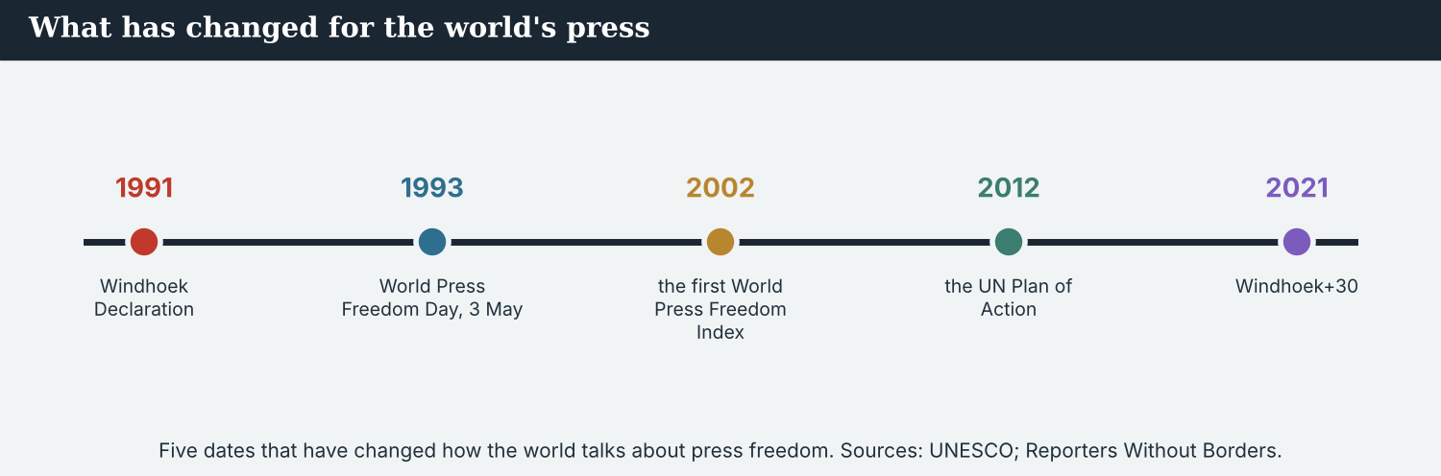
Five dates that have changed how the world talks about press freedom. Sources: UNESCO; Reporters Without Borders.
PRACTISE Comprehension
5A Before you read: look at the title. What is the feature about? Write one sentence.
1. ______
5B True or false? Write T or F.
1. A hundred families have returned. ______
2. The school has just reopened. ______
3. The clinic has reopened. ______
4. The bus crosses the bridge now. ______
5C Answer the questions.
1. Since when has the valley changed? ___________
2. What has just happened at the school? ___________
3. What has not changed yet? ___________
5D Find a word in the text.
1. to get better → ___________
2. to become different → ___________
3. to start to be → ___________
A change story feels close to readers, because the result is now.
Reading B · present perfect or past simple? — four tips
Four tips for the present perfect
1. Use the present perfect for a result now. ‘The crossing has reopened.’ (and it is open now).
2. Use the past simple for a finished time. ‘The crossing reopened last April.’ (a finished time — last April).
3. Use since and for. ‘since the spring’ (a point) / ‘for six months’ (a length). Both link to now.
4. Report both sides. Say what has improved — and what has not changed yet. That is fair and accurate.
PRACTISE Comprehension
5E Before you read: which tense shows a result now? Guess.
1. ______
5F Match the tip to the example.
1. Present perfect for a result now  2. Past simple for a finished time  3. Use since and for  4. Report both sides | a) ‘The crossing reopened last April.’  b) say what has and has not changed  c) ‘The crossing has reopened.’  d) ‘since the spring’ / ‘for six months’
5G Which tip is about fairness? Write the number.
1. ______
PRACTISE Words from the readings
5H Find a word in Reading A or Reading B.
1. to become different → ___________
2. to get better → ___________
3. a short time ago → ___________
PRODUCE Discuss
5I Talk about it. Which change in the feature is the most important? Why?
5J Which of the four tips is the most important? Say why.

PART 6 Writing: a change story
Two short pieces: a ‘then and now’ note, and a short change story.
Notes: what has changed, and what has not.
Writing 1 · then-and-now notes
MODEL A model
Crossing: has reopened (open now)
Families: have returned — a hundred, since the spring
School: has just reopened
Not yet: the clinic has not reopened; no bus yet
NOTICE Notice the model
6A Answer about the model.
1. Which tense do the notes use? ___________
2. What has NOT changed yet? ___________
PRODUCE Write your notes
6B Choose a place that has changed. Write four notes: three things that have changed, and one that has not yet.
Changed 1: ___________
Changed 2: ___________
Changed 3: ___________
Not yet: ___________
A short change story ends with one hopeful, honest quote.
Writing 2 · a short change story
MODEL A model
Kalina has changed a lot since the spring. The crossing has reopened, and many families have returned. “The valley has become a home again,” Bekim said. But the clinic has not reopened yet.
NOTICE Notice the model
6C Answer. Which verbs are present perfect? Where does the story say what has NOT changed?
1. ___________
PRACTISE Complete a story
6D Complete the story. Use: has · have · since · yet.
The school ______ reopened, and the children ______ gone back. Life has improved ______ the spring. But the bus does not cross ______ .
PRODUCE Write your story
6E Write a short change story (3–4 sentences). Use the present perfect, and say one thing that has not changed yet.
________________________
________________________
________________________
PRACTISE Fix it
6F This uses the wrong tense. Change it to the present perfect.
“The crossing reopened, and it is open now. Families returned since the spring.”
________________________

PART 7 Speaking: has it changed?
Ask and answer about changes. Use the present perfect.
Ask what has changed, and what has not.
A model dialogue · asking about changes
MODEL Listen and read
Mira: How has the valley changed since the spring?
Guest: It has changed a lot. The crossing has reopened.
Mira: Have the families returned?
Guest: Yes, many have already come back.
Mira: Has everything improved?
Guest: Not yet. The clinic has not reopened yet.
Mira: Thank you very much.
NOTICE Notice the questions
7A Find the two present-perfect questions. Write them.
1. ________________________
PRACTISE Controlled practice
7B Make a present-perfect question for each answer.
1. ___________ ? — The crossing has reopened.
2. ___________ ? — Yes, many have returned.
3. ___________ ? — No, the clinic has not reopened yet.
4. ___________ ? — Since the spring.
Introduce yourself, then ask what has changed.
7C Make an ‘ever’ or ‘never’ sentence.
1. you / ever / visit → ________________________
2. I / never / see / it so busy → ________________________
3. they / already / return → ________________________
PRODUCE Your role
Correspondent | Ask a resident: ‘How has it changed?’ and ‘What has not changed yet?’
Resident | Answer with the present perfect. Say what has improved and what has not.
Observer | Listen. Did the reporter ask about both the good news and the problems?
7D Choose a role from the table. Ask your questions to a partner.
PRODUCE Role-play
7E Role-play a ‘what has changed’ interview: a reporter, a resident, and an observer. Then swap roles.
A second dialogue · reporting the change
MODEL Listen and read
Mira: I have spoken to a resident. The valley has really changed.
Priya: What has happened?
Mira: The crossing has reopened, and the families have come back.
Priya: Has everything improved?
Mira: Not yet. The clinic has not reopened, and there is no bus yet.
Priya: Good. Report both — the good news and the problems.
PRACTISE Controlled practice
7F Write the sentence Mira uses about what has NOT changed.
1. ________________________
PRODUCE Self-check
Did I… | Yes | Almost | Not yet
use the present perfect (has/have + done)? | ☐ | ☐ | ☐
talk about a result now? | ☐ | ☐ | ☐
report what has not changed yet? | ☐ | ☐ | ☐
use since or for? | ☐ | ☐ | ☐
7G Role-play reporting the change to a colleague. Then swap roles.

PART 8 Ethics: the whole picture
Good news is real — but so are the problems. Report both.
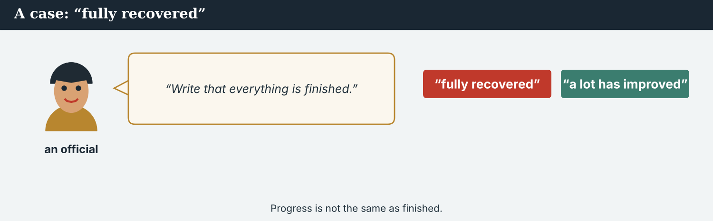
‘It has fully recovered’ is a claim — not a fact until it is true.
A first case · ‘fully recovered’
A case. An official gives Mira a happy line: “Write that Kalina has fully recovered, and everything is finished.” It would be a bright, positive headline on an international wire. But it is not accurate. The clinic has not reopened yet, there is no bus, and some families have not returned. A lot has improved — but the valley has not ‘fully recovered’. Mira knows the Code: be accurate. Progress is not the same as ‘finished’. What does Mira write?
NOTICE What do you do?
8A Choose (a) or (b), and write one reason.
1. (a) write ‘fully recovered, everything finished’ (b) write ‘a lot has improved, but work remains’. Choice: ______ Because ________________________
2. ‘Fully recovered’, when things are not finished, is (a) accurate (b) not accurate. Choice: ______
8B Has it happened yet? Write Y (yes) or N (not yet).
1. The crossing has reopened. ______
2. The clinic has reopened. ______
3. Many families have returned. ______
4. The valley has fully recovered. ______
PRACTISE Apply the Code
8C Complete the rule. Use: accurate · progress · finished · both.
Be ______ . ______ is not the same as ’______ ’. Report ______ what has changed and what has not.
PRODUCE Discuss
8D Discuss. Why is a ‘too positive’ story a problem? Who could it hurt?
A second case · only the good news
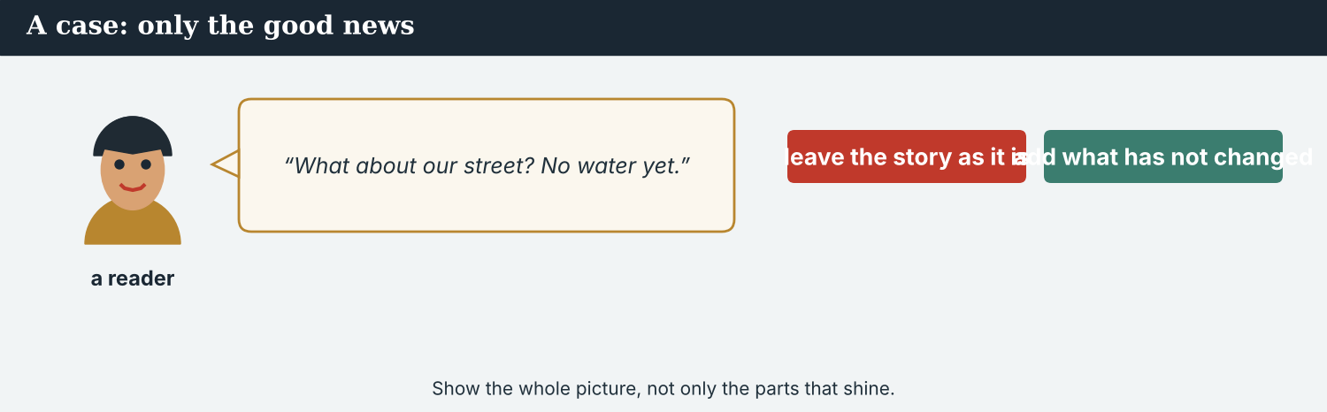
A fair story shows the whole picture — not only the parts that shine.
A case. Mira’s story is full of good news: the crossing has reopened, the school has restarted, families have come back. It is all true. But a reader writes: “What about us? Our street still has no water, and the bus has not returned.” Mira checks, and the reader is right — some problems have not changed yet, and she left them out. The Code says: be complete and fair — show the whole picture, not only the good parts. What does Mira do?
NOTICE What do you do?
8E Choose (a) or (b), and write one reason.
1. (a) leave the story as only good news (b) add the problems that have not changed. Choice: ______ Because ________________________
2. A story with only the good parts is (a) complete (b) not the whole picture. Choice: ______
8F Complete with: whole · fair · problems · both.
1. Show the ___________ picture.
2. A report must be ___________ .
3. Do not leave out the ___________ .
4. Report the good news and the problems — ___________ .
PRODUCE Discuss
8G Discuss. Why do readers trust a story that shows both sides?
PRODUCE Write it
8H Write two sentences that add the problems to Mira’s story. Use the present perfect (has not … yet).

PART 9 Digital: the update post
Online, a ‘what has changed’ post shares the news of the year fast.
A ‘what has changed’ post — good news, honestly.
MODEL A model post
ONE YEAR ON · The crossing has reopened, 100 families have returned, and the school has just restarted. The clinic has not reopened yet. — @AtlasWire
NOTICE The parts of the post
9A Match the part to what it shows.
1. The crossing has reopened  2. 100 families have returned  3. the school has just restarted  4. The clinic has not reopened yet | a) a recent change  b) what has not changed  c) good news (1)  d) good news (2)
PRACTISE Find and build
9B Find one present-perfect verb in the post. Write it.
1. ______
9C This post is only good news. Add one honest line about what has not changed yet.
“The crossing has reopened and families have returned.”
________________________
The post links to the full ‘what has changed’ feature.
9D Write a ‘what has changed’ post. Say one thing that has changed, and one that has not yet.
CHANGED: ___________ . NOT YET: ___________ . — @AtlasWire
PRODUCE Write your post
9E Write a one-line post about how your city has changed this year. Use the present perfect.
________________________
9F Creative. Write a short headline (4–6 words) for your ‘one year on’ story.
9G A reader asks: ‘Has the clinic reopened?’ Write a short, honest reply.
________________________
PRODUCE Discuss
9H Discuss. Online, good news is shared fast. Why must a reporter still add what has not changed?

PART 10 Review & Can-Do
Check your new English before Unit 9.
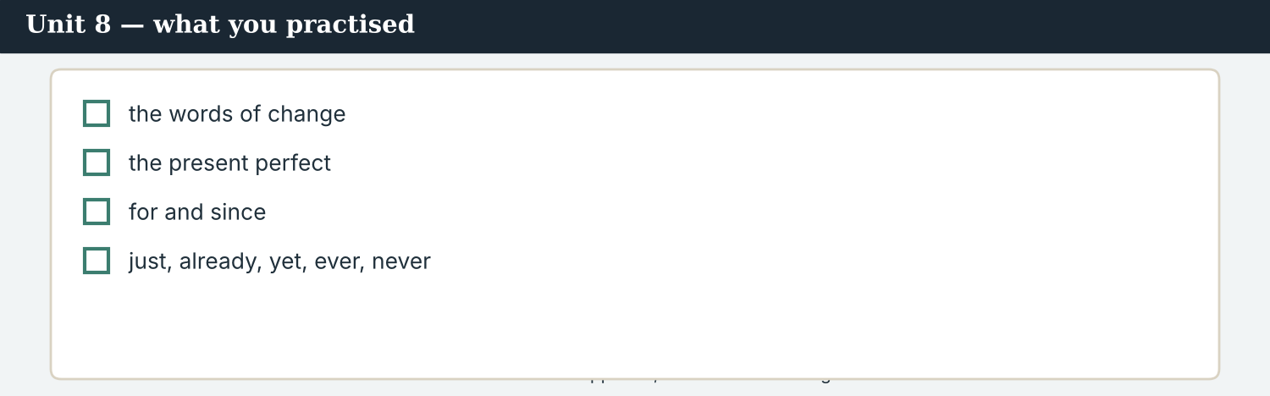
Unit 8 — what has happened, and what has changed.
10A Vocabulary. Complete with: changed · improved · grown · recently · already · yet · since · become.
1. The valley has ___________ a lot.
2. Life has ___________ for families.
3. The market has ___________ bigger.
4. ___________ , a new café opened.
5. Many families have ___________ returned.
6. But the clinic has not reopened ___________ .
7. Everything is better ___________ the spring.
8. The valley has ___________ a home again.
10B Grammar. Write the present perfect (has/have + done).
1. the crossing / reopen → ___________
2. families / return → ___________
3. the valley / change → ___________
4. life / improve → ___________
10C Grammar. Choose: for or since.
1. The valley has changed ______ the spring.
2. Families have been back ______ six months.
Can-Do — tick what you can do now.
10D Complete with just, already or yet.
1. The school has ______ reopened. (a moment ago)
2. Families have ______ returned. (before now)
3. The clinic has not reopened ______ .
10E Read and answer.
Kalina has changed a lot since the spring. The crossing has reopened, and families have returned. The school has just restarted. But the clinic has not reopened yet.
1. Since when has the valley changed? ___________
2. What has just restarted? ___________
3. What has not reopened yet? ___________
Can-Do — tick what you can do now
☐ I can say what has happened (present perfect).
☐ I can talk about a change with a result now.
☐ I can use for and since.
☐ I can use just, already, yet, ever and never.
10F Reflect. Which part of Unit 8 was the most useful for you? Why?
10G Grammar review. Write the sentence in the present perfect.
1. The crossing reopens. → ________________________
2. Families return. → ________________________
3. The valley changes a lot. → ________________________
4. The school just restarts. → ________________________

PART 11 Assignment: a year in review
Put the unit together: write about how a place has changed.
The assignment template — your ‘what has changed’ story.
Your task. Choose a place that has changed (real or invented). Write a short ‘year in review’ (5–6 sentences). Say what has happened (present perfect), with the result now. Use for or since. Include at least one thing that has not changed yet. End with one exact quote. Be accurate, and show the whole picture.
A model — use it to check the shape of your review.
Remember: present perfect for what has happened; for/since for the time; add what has NOT changed yet; do not say ‘finished’ unless it is true; end with an exact quote.
Success criteria | Yes | Almost | Not yet
I use the present perfect for what has changed. | ☐ | ☐ | ☐
I use for or since. | ☐ | ☐ | ☐
I include one thing that has not changed yet. | ☐ | ☐ | ☐
I do not say ‘finished’ unless it is true. | ☐ | ☐ | ☐
It is accurate, fair, and easy to read. | ☐ | ☐ | ☐
Keep this. In Unit 9, you learn should, must and have to, and the first conditional — to give advice and talk about what will happen if…

ANSWER KEY Unit 8
Check your answers. Open tasks (discussion, role-play and your own writing) are marked at the end.
W1 1 it has reopened · 2 since the spring · 3 the clinic is still closed; no bus yet
W2 1 T · 2 T · 3 F
W3 (any three) has changed · has reopened · have returned · has started · has been replaced · has become · have not changed
1A 1-b, 2-a, 3-c, 4-e, 5-f, 6-d, 7-g, 8-h, 9-i, 10-j (accept sensible matches)
1B 1 changed · 2 improved · 3 grown · 4 Recently · 5 already · 6 yet
1C 1 since the spring · 2 for six months · 3 just reopened · 4 not yet · 5 have changed
1D 1 deadline · 2 microphone · 3 loud · 4 rumour
1E 1 changed · 2 reopened · 3 returned · 4 improved · 5 since
1F 1 change · 2 improve · 3 since · 4 just
2A 1 reopened · 2 returned · 3 changed · 4 been · 5 become · 6 grown
2B 1 has reopened · 2 have returned · 3 has changed · 4 has improved
2C 1 since · 2 for · 3 since · 4 for
2D 1 just · 2 already · 3 yet
3A 1 it has reopened · 2 since the spring · 3 the clinic has not reopened (yet)
3B (any three) has changed · has reopened · have returned · has started · has improved
3C 1 has reopened; open · 2 have returned; busy/full · 3 has been replaced; opens
3D has · have · since · yet
4B 1 since the spring · 2 the children have started school (it reopened) · 3 the clinic (and the bus does not cross) · 4 very happy / never so happy
4C 1 T · 2 F · 3 T
4D Since = the spring · Just = children started school again · Not yet = clinic reopened / bus crosses
4F 1 has · 2 just · 3 already · 4 yet
4G (any two) has reopened · have returned · has (just) reopened · have (already) gone back
4H so the story is fair and shows the whole picture
4I changed · reopened · returned · yet
5B 1 T · 2 T · 3 F · 4 F
5C 1 since the spring · 2 it has just reopened · 3 the clinic (closed); no bus yet
5D 1 improve · 2 change · 3 become
5F present perfect for a result now → ‘The crossing has reopened.’ · past simple for a finished time → ‘The crossing reopened last April.’ · since and for → ‘since the spring’ / ‘for six months’ · report both sides → say what has and has not changed
5G Tip 4
5H 1 change · 2 improve · 3 recently
6A 1 present perfect · 2 the clinic has not reopened; no bus yet
6C present perfect: has changed, has reopened, have returned, has become; ‘But the clinic has not reopened yet.’
6D has · have · since · yet
6F ‘The crossing has reopened, and it is open now. Families have returned since the spring.’
7A ‘How has the valley changed…?’ · ‘Have the families returned?’
7B (example) 1 What has happened to the crossing? · 2 Have the families returned? · 3 Has the clinic reopened? · 4 Since when has it changed?
7C 1 Have you ever visited? · 2 I have never seen it so busy. · 3 They have already returned.
7F ‘The clinic has not reopened (yet), and there is no bus yet.’
8A 1 (b) write ‘a lot has improved, but work remains’ · 2 (b) not accurate
8B 1 Y · 2 N · 3 Y · 4 N
8C accurate · Progress · finished · both
8E 1 (b) add the problems that have not changed · 2 (b) not the whole picture
8F 1 whole · 2 fair · 3 problems · 4 both
9A ‘The crossing has reopened’ → good news (1) · ‘100 families have returned’ → good news (2) · ‘the school has just restarted’ → a recent change · ‘The clinic has not reopened yet’ → what has not changed
9B (any) has reopened · have returned · has (just) restarted · has (not) reopened
9C (example) ‘But the clinic has not reopened yet.’
10A 1 changed · 2 improved · 3 grown · 4 Recently · 5 already · 6 yet · 7 since · 8 become
10B 1 has reopened · 2 have returned · 3 has changed · 4 has improved
10C 1 since · 2 for
10D 1 just · 2 already · 3 yet
10E 1 since the spring · 2 the school · 3 the clinic
10G 1 The crossing has reopened. · 2 Families have returned. · 3 The valley has changed a lot. · 4 The school has just restarted.
Open tasks W4, 1G, 1H, 1I, 2E, 2F, 3E, 3F, 3G, 4A, 4E, 4J, 5A, 5E, 5I, 5J, 6B, 6E, 7D, 7E, 7G, 8D, 8G, 8H, 9D, 9E, 9F, 9G, 9H, 10F — your own answers (discussion, role-play, writing).
A note on real and invented content. The facts about journalism around the world are true as of 2026. Atlas Wire, its staff, Bekim, the Crossing Office, Kalina and the story of the valley’s change are invented, for practice. Real people are only ever in true, sourced facts — never in an invented quote.
English for Journalists — International Edition · Unit 8 (v6 standard). CEFR A2 → lower B1 · Beat: Report & feature · two readings · two listenings · two writing pieces · two ethics cases · two speaking dialogues · balanced sections · ~24 figures · featured cast · fictional agency, factual backdrop.
UNIT 9 What You Should Do: Advice and Rules
Beat · Verify & ethics CEFR A2 → lower B1
In this unit you learn to…
1. give advice with should
2. talk about rules with must and have to
3. say what will happen if… (first conditional)
4. write advice for a new correspondent
The Atlas Wire team — they welcome a new trainee, Sofia.
The story so far. A new trainee correspondent, Sofia Mendes, has started at Atlas Wire, and her first assignment is Kalina. The team gives her advice and rules: what she should do, what she must do, and what will happen if she checks her facts — or if she does not. (Sofia is invented, for practice.)

WARM-UP What should I do?
A short scene to start the unit. Read it, then answer.
The morning conference — the team gives the new trainee some advice.
It is Sofia’s first day at Atlas Wire. “Welcome,” says Mira. “I will give you some advice. You should check every fact before you file it. You shouldn’t guess. And there are rules: you must protect your source, and you have to meet the deadline.” Sofia asks, “What will happen if I make a mistake?” Mira smiles. “If you check your work, you will not make many. And if you do make a mistake, you must say sorry and correct it. That is the rule.”
W1 Answer the questions.
1. What advice does Mira give about facts? ___________
2. What must Sofia protect? ___________
3. What must Sofia do if she makes a mistake? ___________
W2 True or false? Write T or F.
1. Sofia should guess. ______
2. Sofia must protect her source. ______
3. Sofia has to meet the deadline. ______
W3 Find one sentence with should, one with must, and one with if. Write the first word of each.
1. ________________________
PRODUCE Talk about it
W4 Discuss with a partner.
1. What advice would you give a new colleague on their first day?
2. What is one rule at your school or work? Why is it important?

PART 1 The words of advice
The words for advice and rules. Learn these first.
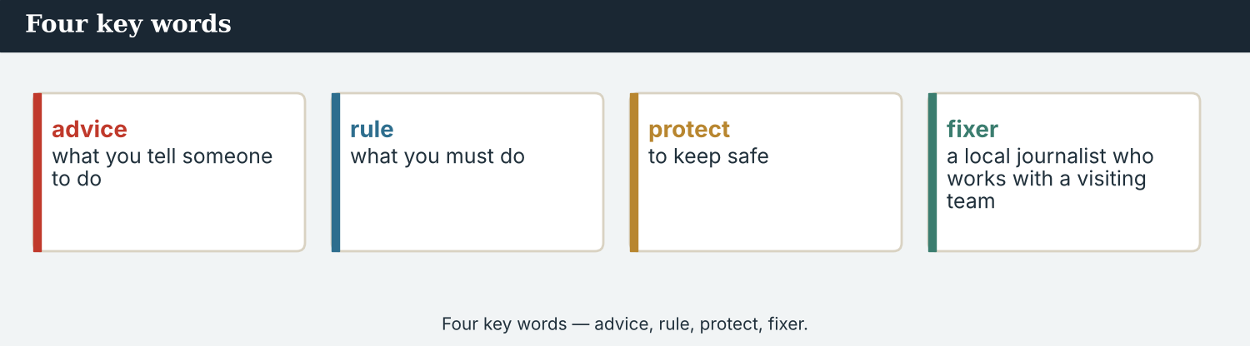
Four key words — advice, rule, protect, fixer.
The words
Word | Meaning
advice | what you tell someone to do
rule | what you must do
mistake | a wrong thing
careful | giving attention; not making mistakes
protect | to keep safe
safe | not in danger
honest | telling the truth
fair | treating everyone the same
trust | to believe someone
responsible | you must answer for it
warn | to tell of a danger
accreditation | official permission to work as a journalist at an event
credit | to name the person who did the work
tip | a small piece of advice
PRACTISE Controlled practice
1A Match the word (1–10) to the meaning (a–j).
1. advice  2. rule  3. mistake  4. careful  5. protect  6. honest  7. fair  8. warn  9. responsible  10. credit | a) what you must do  b) a wrong thing  c) what you tell someone to do  d) to keep safe  e) giving attention  f) treating everyone the same  g) telling the truth  h) to tell of a danger  i) you must answer for it  j) to name the person who did the work
1B Complete the sentences with a word from the box.
WORD BOX
advice · rule · mistake · careful · protect · honest
1. Mira gives Sofia good ___________ .
2. There is a ___________ : always check the facts.
3. If you rush, you may make a ___________ .
4. A good reporter is ___________ with every word.
5. A journalist must ___________ a source.
6. You must be ___________ — tell the truth.
1C Match the two halves.
1. give  2. break  3. make a  4. protect a  5. be | a) advice  b) a rule  c) mistake  d) source  e) honest
1D Circle the word that is different.
1. advice · tip · rule · deadline
2. careful · honest · fair · loud
3. protect · keep safe · warn · shout
4. responsible · trusted · fair · rumour
Good advice makes a stronger story on the page.
1E Complete the paragraph. Use: advice · rules · check · careful · honest.
On her first day, Sofia gets good ___________ . There are ___________ : she must ___________ every fact, and she must be ___________ with every word. Above all, she must be ___________ .
1F Read the definition. Write the word.
1. what you must do → ___________
2. to keep safe → ___________
3. telling the truth → ___________
4. official permission to work as a journalist at an event → ___________
PRODUCE Over to you
1G Answer about you. Write full sentences.
1. What is one rule you always follow? Why?
2. Who gives you good advice? What do they say?
PRODUCE Talk about it
1H Discuss. Which two words in this unit are new for you? Make a sentence with one.
1I Creative. Write two pieces of advice for a new colleague. Use ‘You should…’.

PART 2 Grammar: advice and rules
Should for advice, must and have to for rules.
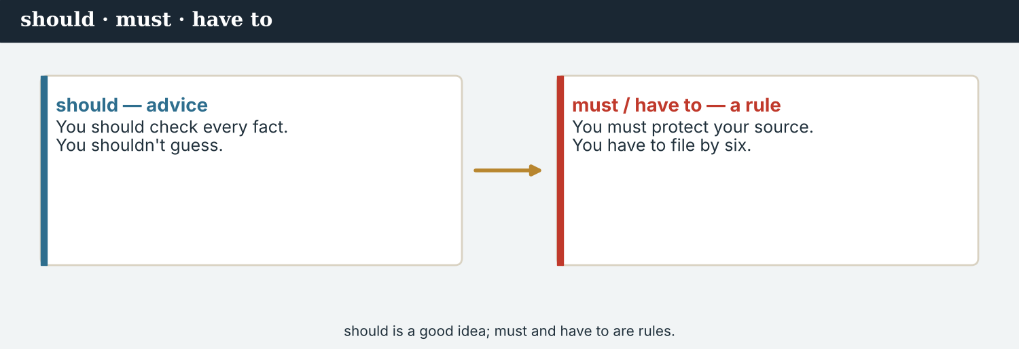
should / shouldn’t — for advice.
1 · should — advice
You should + verb: You should check every fact.
You shouldn’t + verb: You shouldn’t guess.
We use should to give advice — a good idea, not a strong rule.
2 · must / have to — rules
must = a strong rule: You must protect your source.
have to = it is necessary: You have to meet the deadline.
must not = it is forbidden: You must not file a rumour.
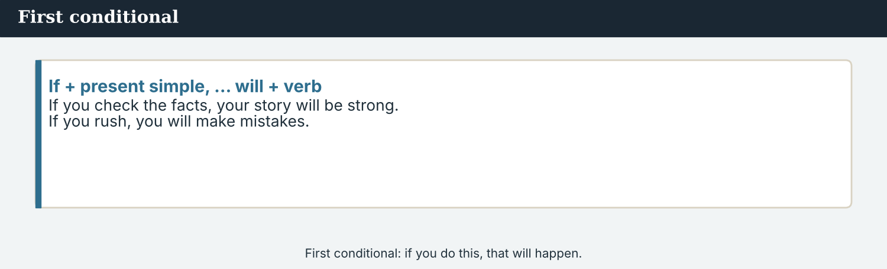
must = a strong rule · have to = it is necessary.
3 · Which one?
Advice (a good idea): You should ask a follow-up question.
A rule (you have no choice): You must name your source.
Not necessary: You don’t have to file it today, but you can.
PRACTISE Structured practice
2A Give advice. Complete with should or shouldn’t.
1. You ___________ check the facts.
2. You ___________ guess a number.
3. You ___________ listen to the answer.
4. You ___________ file a rumour.
2B Complete with must or have to.
1. You ___________ protect your source. (a strong rule)
2. You ___________ meet the deadline. (it is necessary)
3. You ___________ not file a rumour.
2C Advice or rule? Write S (should) or M (must).
1. Name your source. ______
2. Ask a follow-up question. ______
3. Check every fact. ______
4. Get to the briefing early. ______
2D Rewrite as advice with should.
1. Check the facts. → You ___________ .
2. Be honest. → You ___________ .
3. Listen to the source. → You ___________ .
Your own words
2E Write two rules for your school or work. Use must or have to.
1. ________________________
2. ________________________
2F Write two pieces of advice for a new correspondent. Use should.
1. ________________________
2. ________________________

PART 3 If… will… (what happens next)
The first conditional: if you do this, that will happen.
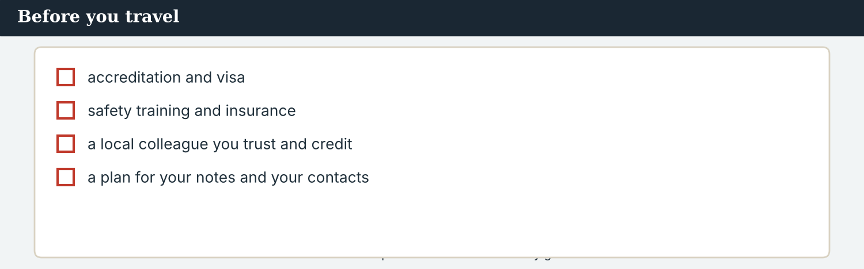
What a correspondent checks before they go.
MODEL A model
“If you check the facts, your story will be strong. If you rush, you will make mistakes. If you protect your source, people will talk to you. And if you credit your local colleague, they will work with you again.”
NOTICE Notice the pattern
3A Answer about the model.
1. What will happen if you check the facts? ___________
2. What will happen if you rush? ___________
3. What will happen if you credit your local colleague? ___________
3B In the model, which part has the present simple, and which has ‘will’? Write one example of each.
1. ________________________
PRACTISE Make the sentence
If you do the right thing, a good result will follow.
3C Join the two halves with if.
1. you check the facts / your story will be strong → ________________________
2. you guess / you will make a mistake → ________________________
3. you protect your source / people will trust you → ________________________
3D Complete the first conditional. Use: check · will · rush · trust.
If you ______ the facts, your story ______ be strong. If you ______ , you will make mistakes. If you are honest, people will ______ you.
PRODUCE Your turn
3E Write four first-conditional sentences of advice for a new correspondent. Use If… will… .
________________________
________________________
________________________
________________________
PRODUCE Discuss
3F Talk with a partner. Which piece of advice is the most important? Why?
3G Why is ‘If you rush, you will make mistakes’ good advice for a journalist?

PART 4 Listening: first-week advice
Two audios. Listen for the advice and the rules.
In the newsroom — Mira gives Sofia her first-week advice.
Listening A · advice on the first day
MODEL Audio 9.1 — Mira and Sofia
Mira: Welcome, Sofia. Let me give you some advice.
Mira: You should check every fact, and you shouldn’t guess.
Sofia: And the rules?
Mira: You must protect your source, and you have to meet the deadline.
Sofia: What will happen if I make a mistake?
Mira: If you check your work, you will not make many. And if you do, you must correct it.
Sofia: Thank you. I will be careful.
PRACTISE Listen for detail
4A Before you listen: what advice do you think Mira will give? Write one idea.
1. ______
4B Answer the questions.
1. What should Sofia do with every fact? ___________
2. What must she protect? ___________
3. What does she have to meet? ___________
4. What must she do if she makes a mistake? ___________
4C Advice or rule? Write S (should) or M (must).
1. Check every fact. ______
2. Protect your source. ______
3. Meet the deadline. ______
4D Complete the notes.
Advice (should): ___________
Rule (must): ___________
If you make a mistake: ___________
Audio 9.2 — the editor warns about what will happen if…
Listening B · a warning
MODEL Audio 9.2 — Daniel and Sofia
Daniel: Sofia, one more thing. If you file a rumour, you will lose the reader’s trust.
Sofia: So I have to check everything?
Daniel: Yes. If you check, your work will be strong.
Sofia: And if I am not sure?
Daniel: If you are not sure, you should ask, or leave it out. Do not guess.
Sofia: I understand. I will always check first.
Daniel: Good. Then you will be a fine correspondent.
PRACTISE Listen for detail
4E Before you listen: what will Daniel warn Sofia about? Guess.
1. ______
4F Complete the first-conditional sentences.
1. If you file a rumour, you ___________ the reader’s trust.
2. If you check, your work ___________ strong.
3. If you are not sure, you ___________ ask.
4. If you always check, you ___________ a fine correspondent.
4G Which modal verbs do you hear? Write two (should / must / have to).
1. ________________________
4H Answer. Why does Daniel warn Sofia about rumours?
1. ________________________
PRACTISE Both audios
4I Complete the summary. Use: should · must · check · trust.
Mira and Daniel give Sofia advice. She ______ check every fact, and she ______ protect her source. If she ______ everything, readers will ______ her.
PRODUCE What do you think?
4J Discuss. Why is ‘if you are not sure, ask or leave it out’ good advice for any job?

PART 5 Reading: the rules
Two readings. Read for the advice and the rules.
Advice for a new correspondent — what to do, and what will follow.
Reading A · advice for a new correspondent
Ten minutes of advice: a note for a new correspondent
On Sofia’s first day at Atlas Wire, Mira gave her a short note of advice. “I have been a correspondent for many years,” she wrote, “and this is what I have learned.”
“First, you should check every fact. If you check, your story will be strong. If you rush and guess, you will make mistakes, and readers will not trust you. So take your time — it is better to be right than to be first.”
“Second, there are rules you must follow. You must protect your source. You have to be honest, and you must not file a rumour as a fact. If you break these rules, you will lose the one thing a journalist really has: trust.”
“Third, when you work in a country that is not your own, you should listen before you write. Learn how the place works. Get your accreditation early. And remember that the local journalist beside you knows more than you do — you should ask them, and you must credit them.”
“And last: if you make a mistake, you must say sorry and correct it. Everyone makes mistakes. A good reporter is not the one who never fails, but the one who always tells the truth about it.”
PRACTISE Comprehension
5A Before you read: look at the title. Who is the note for? Write one sentence.
1. ______
5B True or false? Write T or F.
1. A correspondent should check every fact. ______
2. It is fine to file a rumour as a fact. ______
3. A visiting reporter should listen before they write. ______
4. If you make a mistake, you should hide it. ______
5C Answer the questions.
1. What will happen if you check the facts? ___________
2. What must a correspondent protect? ___________
3. What must you do if you make a mistake? ___________
5D Find a word in the text.
1. to keep safe → ___________
2. to name the person who did the work → ___________
3. official permission to work as a journalist → ___________
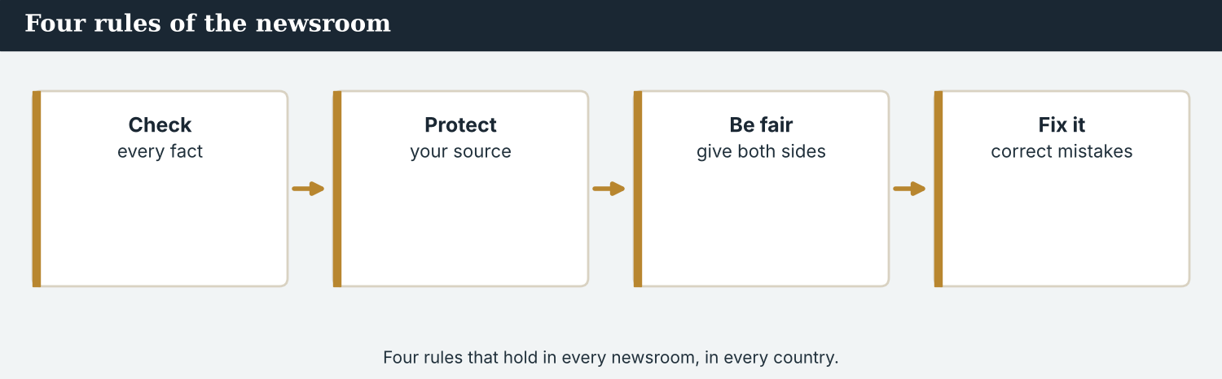
Four rules that hold in every newsroom, in every country.
Reading B · four things you must do
The rules of the newsroom
1. You must check every fact. If you are not sure, ask, or leave it out. Do not guess.
2. You must protect your source. If a source is not safe, you must keep their name out of the story.
3. You have to be fair. Give both sides. If you only give one side, the story is not fair.
4. You should fix your mistakes. If you make a mistake, say sorry and correct it. Readers will trust you more, not less.
PRACTISE Comprehension
5E Before you read: which is a strong rule — should or must? Guess.
1. ______
5F Match the rule to the reason.
1. Check every fact  2. Protect your source  3. Be fair  4. Fix your mistakes | a) give both sides of the story  b) readers will trust you more  c) do not guess; ask or leave it out  d) keep an unsafe name out of the story
5G Which rule uses should (advice), not must? Write the number.
1. ______
PRACTISE Words from the readings
5H Find a word in Reading A or Reading B.
1. to keep safe → ___________
2. treating everyone the same → ___________
3. a wrong thing → ___________
PRODUCE Discuss
5I Talk about it. Which piece of advice in the note is the most important? Why?
5J Which of the four rules is the hardest to follow? Why?

PART 6 Writing: advice
Two short pieces: a list of tips, and a note of advice.
Notes: your advice and your rules.
Writing 1 · a list of tips
MODEL A model
Advice: You should check every fact.
Rule: You must protect your source.
Rule: You have to meet the deadline.
If…: If you rush, you will make mistakes.
NOTICE Notice the model
6A Answer about the model.
1. Which line is advice (should)? ___________
2. Which line uses if… will…? ___________
PRODUCE Write your tips
6B Write four tips for a new correspondent: one with should, two with must/have to, and one with if… will… .
1 (should): ___________
2 (must): ___________
3 (have to): ___________
4 (if… will…): ___________
A note of advice is short, kind, and clear.
Writing 2 · a note of advice
MODEL A model
Welcome to Atlas Wire. You should check every fact, and you must protect your source. If you are honest and fair, readers will trust you. And if you make a mistake, say sorry and correct it. Good luck!
NOTICE Notice the model
6C Answer. Find one ‘should’, one ‘must’, and one ‘if… will…’ in the note.
1. ___________
PRACTISE Complete the note
6D Complete the note. Use: should · must · will.
You ______ listen to your source. You ______ not file a rumour. If you are fair, people ______ talk to you.
PRODUCE Write your note
6E Write a short note of advice (3–4 sentences) for a new correspondent. Use should, must, and one if… will… .
________________________
________________________
________________________
PRACTISE Fix it
6F This advice is too strong for a ‘good idea’. Change must to should where it is only advice.
“You must ask a follow-up question. You must be kind to people.”
________________________

PART 7 Speaking: giving advice
Give advice and rules to a partner. Use should, must, and if… will… .
Give advice: what a new correspondent should and must do.
A model dialogue · advice for the first week
MODEL Listen and read
Sofia: What should I do first?
Mira: You should read the wire every morning.
Sofia: And the rules?
Mira: You must check every fact, and you must protect your source.
Sofia: What will happen if I make a mistake?
Mira: If you correct it and say sorry, people will still trust you.
Sofia: Thank you. That is good advice.
NOTICE Notice the advice
7A Find one ‘should’ sentence and one ‘must’ sentence. Write them.
1. ________________________
PRACTISE Controlled practice
7B Give advice with should for each situation.
1. A new correspondent is not sure of a fact. → You ___________ .
2. A reporter has a rumour, not a fact. → You ___________ not .
3. A reporter forgets to credit a local colleague. → You ___________ .
Introduce yourself, then give your advice.
7C Make a first-conditional sentence of advice.
1. you / check / your story / be strong → ________________________
2. you / rush / you / make mistakes → ________________________
3. you / be honest / readers / trust you → ________________________
PRODUCE Your role
Mentor | Give a new correspondent three pieces of advice: one ‘should’, one ‘must’, and one ‘if… will…’.
New correspondent | Ask: ‘What should I do?’ and ‘What will happen if…?’
Observer | Listen. Did the mentor use should, must, and a first conditional?
7D Choose a role from the table. Give your advice to a partner.
PRODUCE Role-play
7E Role-play the first week: a mentor, a new correspondent, and an observer. Then swap roles.
A second dialogue · a rule and a reason
MODEL Listen and read
Sofia: Why must I protect my source?
Priya: Because if the source is not safe, they will not talk to us again.
Sofia: So the rule protects them and us?
Priya: Yes. If you protect your source, people will trust the whole newsroom.
Sofia: I understand. I will always protect them.
PRACTISE Controlled practice
7F Write the first-conditional reason Priya gives (If the source is not safe, …).
1. ________________________
PRODUCE Self-check
Did I… | Yes | Almost | Not yet
give advice with should? | ☐ | ☐ | ☐
state a rule with must or have to? | ☐ | ☐ | ☐
use a first conditional (if… will…)? | ☐ | ☐ | ☐
give a reason for the rule? | ☐ | ☐ | ☐
7G Role-play explaining a rule and its reason. Then swap roles.

PART 8 Ethics: the rules that matter
Some rules are not just advice — they protect people. You must follow them.
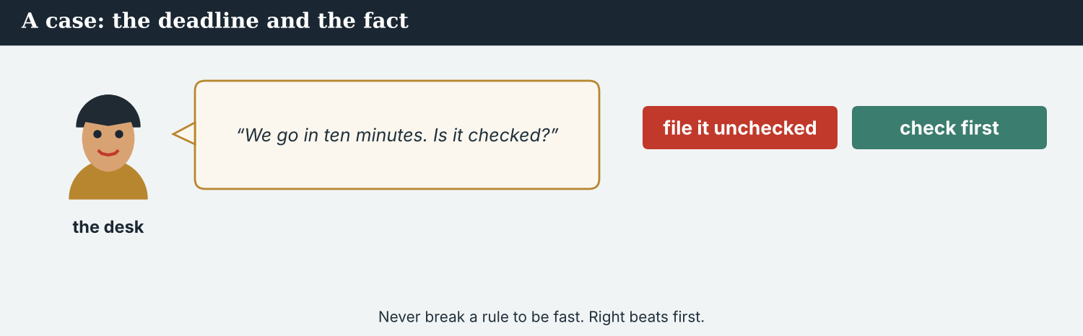
A deadline is not a reason to break a rule.
A first case · the deadline and the fact
A case. It is Sofia’s first big story, and the wire goes in ten minutes. She has a strong line, but she has not checked one number. Her editor is waiting. She thinks: “If I check, I will miss the deadline. If I don’t check, maybe it is fine.” But the rule is clear: you must check every fact. If she files a wrong number, it will go out to outlets in many countries, readers will be misled, and the agency will lose trust. Sofia knows the Code: you should never break a rule to be fast. What should Sofia do?
NOTICE What do you do?
8A Choose (a) or (b), and write one reason.
1. (a) file it now, unchecked (b) check first, even if the story is a little late. Choice: ______ Because ________________________
2. If she files a wrong number, readers will be (a) helped (b) misled. Choice: ______
8B Should or must? Write S or M.
1. Check every fact. ______
2. Ask a follow-up question. ______
3. Protect your source. ______
4. Read the wire every morning. ______
PRACTISE Apply the Code
8C Complete the rule. Use: check · fast · rule · trust.
You must ______ every fact. Do not break a ______ to be ______ . If you are always careful, readers will ______ you.
PRODUCE Discuss
8D Discuss. Why is ‘right’ more important than ‘first’ in the news?
A second case · your local colleague
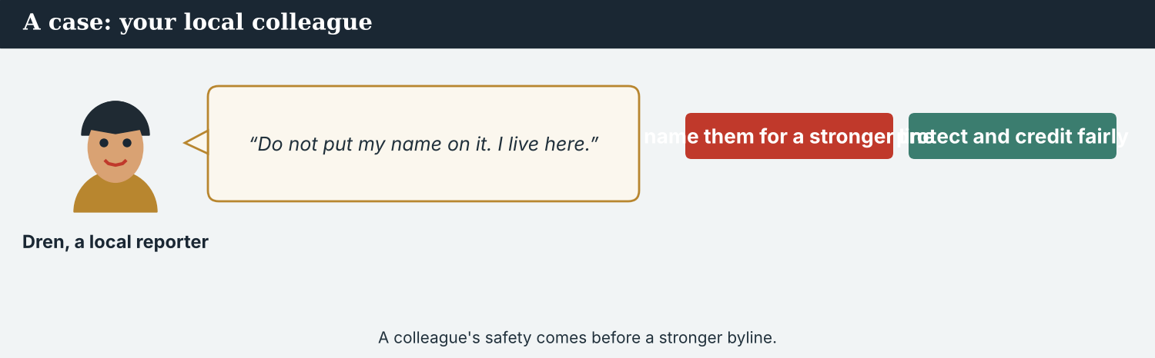
A colleague’s safety comes before a stronger byline.
A case. Dren, a journalist who lives at Kalina, has found most of Sofia’s story. He knows everyone, he arranged the interviews, and he translated them. Now the desk wants a byline. Dren says, “Please do not put my name on it. I live here, and I will still be here when you go home.” Another reporter says, “Use his name — it makes the story stronger, and it is his work.” Sofia knows the Code: credit the people who did the work, but a colleague’s safety comes first, and it is their decision, not yours. What should Sofia do?
NOTICE What do you do?
8E Choose (a) or (b), and write one reason.
1. (a) put Dren’s name on it anyway (b) ask Dren what he wants, and do that. Choice: ______ Because ________________________
2. If Sofia respects Dren’s answer, he will (a) stop working with the agency (b) trust it more. Choice: ______
8F Complete with: protect · safe · credit · decide.
1. You must ___________ your colleague.
2. A colleague’s ___________ comes first.
3. Where it is safe, always give ___________ for the work.
4. The person at risk must ___________ , not you.
PRODUCE Discuss
8G Discuss. Why is it unfair when a visiting reporter takes all the credit for a local colleague’s work?
PRODUCE Write it
8H Write two sentences of advice for Sofia about working with a local colleague. Use must and if… will… .

PART 9 Digital: a tips thread
Online, a short ‘tips’ post shares advice fast.
A tips post — short advice, one line each.
MODEL A model tips post
TIPS FOR NEW CORRESPONDENTS · You should check every fact. You must protect your source. If you credit your local colleague, they will work with you again. — @AtlasWire
NOTICE The parts of the post
9A Match the line to the type.
1. You should check every fact  2. You must protect your source  3. If you credit your local colleague, they will work with you again  4. @AtlasWire | a) a rule (must)  b) advice (should)  c) the outlet  d) a first conditional (if… will…)
PRACTISE Find and build
9B Find the first-conditional sentence in the post. Write it.
1. ________________________
9C This tip is too strong for a ‘good idea’. Change must to should.
“You must ask a follow-up question.”
________________________
The tips post links to the full advice on the website.
9D Write a tips post. Add one ‘should’, one ‘must’, and one ‘if… will…’.
TIPS · You should ___________ . You must ___________ . If you ___________ , … will … . — @AtlasWire
PRODUCE Write your post
9E Write a one-line tip for a new correspondent. Use should or must.
________________________
9F Creative. Write a short headline (4–6 words) for a ‘tips for correspondents’ story.
9G A reader asks: ‘What is your best tip?’ Write a short reply with should or if… will… .
________________________
PRODUCE Discuss
9H Discuss. Online, advice is shared fast. Why must a ‘rule’ be clear and not just a ‘tip’?

PART 10 Review & Can-Do
Check your new English before Unit 10.
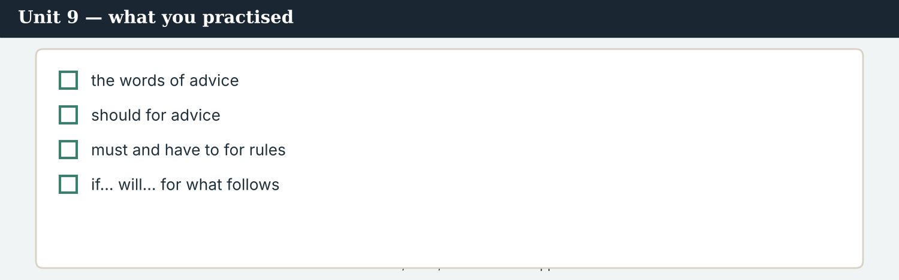
Unit 9 — advice, rules, and what will happen if…
10A Vocabulary. Complete with: advice · rule · mistake · careful · protect · honest · fair · trust.
1. Mira gives Sofia good ___________ .
2. There is a ___________ : always check.
3. If you rush, you make a ___________ .
4. Be ___________ with every word.
5. You must ___________ your source.
6. You must be ___________ — tell the truth.
7. Give both sides; be ___________ .
8. If you are honest, readers will ___________ you.
10B Grammar. Complete with should or shouldn’t.
1. You ___________ check the facts.
2. You ___________ guess.
3. You ___________ listen to the answer.
4. You ___________ file a rumour.
10C Grammar. Complete with must or have to.
1. You ___________ protect your source.
2. You ___________ meet the deadline.
Can-Do — tick what you can do now.
10D First conditional. Complete with will.
1. If you check the facts, your story ___________ be strong.
2. If you rush, you ___________ make mistakes.
3. If you are honest, readers ___________ trust you.
10E Read and answer.
On her first day, Sofia learns the rules. She should check every fact, and she must protect her source. If she is honest and fair, readers will trust her. If she makes a mistake, she must correct it.
1. What should Sofia do with every fact? ___________
2. What must she protect? ___________
3. What will happen if she is honest and fair? ___________
Can-Do — tick what you can do now
☐ I can give advice with should.
☐ I can talk about rules with must and have to.
☐ I can say what will happen if… (first conditional).
☐ I can write advice for a new correspondent.
10F Reflect. Which part of Unit 9 was the most useful for you? Why?
10G Grammar review. Write the sentence correctly.
1. You should to check the facts. → ________________________
2. You must protecting your source. → ________________________
3. If you will rush, you will make mistakes. → ________________________
4. You have meet the deadline. → ________________________

PART 11 Assignment: a note of advice
Put the unit together: write advice for a new correspondent.
The assignment template — your advice for a new correspondent.
Your task. Write a short note of advice (5–6 sentences) for a new correspondent on their first week in a country that is not their own. Give at least one piece of advice with should, at least one rule with must or have to, and at least one first conditional (If…, … will…). Be clear, kind, and honest.
A model — use it to check the shape of your note.
Remember: should for advice; must / have to for rules; if… will… for what happens next; a rule protects people, so make it clear.
Success criteria | Yes | Almost | Not yet
I give advice with should. | ☐ | ☐ | ☐
I give a rule with must or have to. | ☐ | ☐ | ☐
I use at least one first conditional (if… will…). | ☐ | ☐ | ☐
My advice is kind and clear. | ☐ | ☐ | ☐
It is easy to read. | ☐ | ☐ | ☐
Keep this. In Unit 10, you bring it all together — relative clauses (the reporter who…, the story that…) and your final project: a full front page.

ANSWER KEY Unit 9
Check your answers. Open tasks (discussion, role-play and your own writing) are marked at the end.
W1 1 you should check every fact; you shouldn’t guess · 2 her source · 3 say sorry and correct it
W2 1 F · 2 T · 3 T
W3 You should… · You must… · If…
1A 1-c, 2-a, 3-b, 4-e, 5-d, 6-g, 7-f, 8-h, 9-i, 10-j (accept sensible matches)
1B 1 advice · 2 rule · 3 mistake · 4 careful · 5 protect · 6 honest
1C 1 give advice · 2 break a rule · 3 make a mistake · 4 protect a source · 5 be honest
1D 1 deadline · 2 loud · 3 shout · 4 rumour
1E 1 advice · 2 rules · 3 check · 4 careful · 5 honest
1F 1 rule · 2 protect · 3 honest · 4 accreditation
2A 1 should · 2 shouldn’t · 3 should · 4 shouldn’t
2B 1 must · 2 have to · 3 must
2C 1 M · 2 S · 3 M · 4 S
2D 1 You should check the facts. · 2 You should be honest. · 3 You should listen to the source.
3A 1 your story will be strong · 2 you will make mistakes · 3 they will work with you again
3B present simple: ‘If you check the facts…’; will: ’…your story will be strong.’
3C 1 If you check the facts, your story will be strong. · 2 If you guess, you will make a mistake. · 3 If you protect your source, people will trust you.
3D check · will · rush · trust
4B 1 check it · 2 her source · 3 the deadline · 4 correct it (say sorry)
4C 1 S · 2 M · 3 M
4D Advice = check every fact (don’t guess) · Rule = protect your source / meet the deadline · If mistake = correct it
4F 1 will lose · 2 will be · 3 should · 4 will be
4G (any two) should · must · have to
4H because a rumour is not a fact, and it loses the reader’s trust
4I should · must · check · trust
5B 1 T · 2 F · 3 T · 4 F
5C 1 your story will be strong · 2 the source · 3 say sorry and correct it
5D 1 protect · 2 credit · 3 accreditation
5F Check every fact → do not guess; ask or leave it out · Protect your source → keep an unsafe name out · Be fair → give both sides · Fix your mistakes → readers will trust you more
5G Rule 4 (should fix your mistakes)
5H 1 protect · 2 fair · 3 mistake
6A 1 ‘You should check every fact.’ · 2 ‘If you rush, you will make mistakes.’
6C should: ‘You should check…’; must: ‘you must protect…’; if…will…: ‘If you are honest and fair, readers will trust you.’
6D should · must · will
6F ‘You should ask a follow-up question. You should be kind to people.’
7A should: ‘You should read the wire every morning.’; must: ‘You must check every fact / protect your source.’
7B 1 You should ask (or check) · 2 shouldn’t file it · 3 You should credit them
7C 1 If you check, your story will be strong. · 2 If you rush, you will make mistakes. · 3 If you are honest, readers will trust you.
7F ‘If the source is not safe, they will not talk to us again.’
8A 1 (b) check first, even if a little late · 2 (b) misled
8B 1 M · 2 S · 3 M · 4 S
8C check · rule · fast · trust
8E 1 (b) ask Dren what he wants, and do that · 2 (b) trust it more
8F 1 protect · 2 safe · 3 credit · 4 decide
9A ‘You should check every fact’ → advice (should) · ‘You must protect your source’ → a rule (must) · ‘If you credit your local colleague, they will work with you again’ → a first conditional · @AtlasWire → the outlet
9B ‘If you credit your local colleague, they will work with you again.’
9C ‘You should ask a follow-up question.’
10A 1 advice · 2 rule · 3 mistake · 4 careful · 5 protect · 6 honest · 7 fair · 8 trust
10B 1 should · 2 shouldn’t · 3 should · 4 shouldn’t
10C 1 must · 2 have to
10D 1 will · 2 will · 3 will
10E 1 check it · 2 her source · 3 readers will trust her
10G 1 You should check the facts. · 2 You must protect your source. · 3 If you rush, you will make mistakes. · 4 You have to meet the deadline.
Open tasks W4, 1G, 1H, 1I, 2E, 2F, 3E, 3F, 3G, 4A, 4E, 4J, 5A, 5E, 5I, 5J, 6B, 6E, 7D, 7E, 7G, 8D, 8G, 8H, 9D, 9E, 9F, 9G, 9H, 10F — your own answers (discussion, role-play, writing).
A note on real and invented content. The facts about journalism around the world are true as of 2026. Atlas Wire, its staff, Sofia Mendes, Dren, Kalina and the advice are invented, for practice. Real people are only ever in true, sourced facts — never in an invented quote.
English for Journalists — International Edition · Unit 9 (v6 standard). CEFR A2 → lower B1 · Beat: Verify & ethics · two readings · two listenings · two writing pieces · two ethics cases · two speaking dialogues · balanced sections · ~24 figures · featured cast · fictional agency, factual backdrop.
UNIT 10 The Front Page: Bringing It Together
Beat · Capstone CEFR A2 → lower B1
In this unit you learn to…
1. join two ideas with a relative clause (who, which, that, where)
2. describe people, things, and places
3. edit and finish a news story
4. make a full front page — using everything you have learned
The Atlas Wire team — together, they make a special front page.
The story so far, and the end. It has been a full year. The crossing has reopened, the families have returned, and the valley has come back. Now the team makes one special front page that tells the whole story — the correspondent who followed it, the people who came back, and the town where it all happened.

WARM-UP The story that…
A short piece to start the unit. Read it, then answer.
The morning conference — the team plans the special front page.
Today the team is making a special front page. “This is the story that everyone has waited for,” says Ana. “Mira, who has followed Kalina all year, will write the lead. Hana, who takes the best photographs, will choose the picture. And we need a headline that people will remember.” Sofia, the new correspondent, asks, “Is this the town where the crossing reopened?” “Yes,” says Mira. “The town that was quiet is a home again — and this is the page that will tell everyone.”
W1 Answer the questions.
1. Who will write the lead? ___________
2. What will Hana, who takes the best photographs, choose? ___________
3. Which town is the story about? ___________
W2 True or false? Write T or F.
1. Mira has followed the story all year. ______
2. Hana will write the headline. ______
3. The town was always busy. ______
W3 Find three words that join two ideas (who, which, that, where). Write them.
1. ________________________
PRODUCE Talk about it
W4 Discuss with a partner.
1. Think of a person who you admire. Say one thing about them, using ‘who’.
2. Think of a place where something happened to you. Tell your partner about it.

PART 1 The words of the page
The words for making a front page. Learn these first.
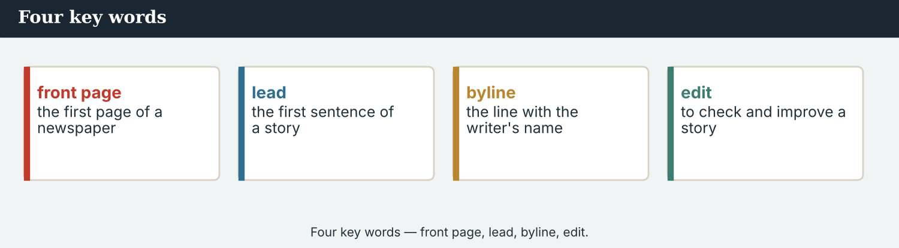
Four key words — front page, lead, byline, edit.
The words
Word | Meaning
front page | the first page of a newspaper
masthead | the newspaper’s name at the top
headline | the big title
byline | the line with the writer’s name
dateline | the place and date at the start of a report
lead | the first sentence of a story
caption | the words under a photo
layout | how a page is arranged
edit | to check and improve a story
publish | to make public; to print
column | a tall block of text
describe | to say what someone or something is like
connect | to join two ideas
final | the last
PRACTISE Controlled practice
1A Match the word (1–10) to the meaning (a–j).
1. front page  2. masthead  3. headline  4. byline  5. lead  6. caption  7. layout  8. edit  9. publish  10. dateline | a) the newspaper’s name at the top  b) the big title  c) the first page of a newspaper  d) the line with the writer’s name  e) the words under a photo  f) the first sentence of a story  g) to make public  h) how a page is arranged  i) to check and improve a story  j) the place and date at the start of a report
1B Complete the sentences with a word from the box.
WORD BOX
headline · byline · lead · caption · edit · publish
1. The ___________ is the big title at the top.
2. The ___________ says who wrote the story.
3. The ___________ is the first sentence.
4. The words under the photo are the ___________ .
5. Priya will ___________ the story and fix any mistakes.
6. Then the team will ___________ the page.
1C Match the two halves.
1. write the  2. choose the  3. edit the  4. design the  5. publish the | a) headline  b) photograph  c) story  d) layout  e) page
1D Circle the word that is different.
1. headline · byline · lead · deadline
2. edit · check · improve · shout
3. column · caption · masthead · rumour
4. publish · print · describe · page
The parts of a front page — masthead, headline, byline, photo.
1E Complete the paragraph. Use: front page · headline · byline · lead · photograph.
The team makes the ___________ . At the top is a big ___________ . Under it, the ___________ says who wrote the story, and the ___________ gives the news in one sentence. A ___________ fills the middle of the page.
1F Read the definition. Write the word.
1. the newspaper’s name at the top → ___________
2. the first sentence of a story → ___________
3. to check and improve a story → ___________
4. a tall block of text → ___________
PRODUCE Over to you
1G Answer about you. Write full sentences.
1. What story would you put on the front page of an international newspaper today?
2. What headline would you give it?
PRODUCE Talk about it
1H Discuss. Which two words in this unit are new for you? Make a sentence with one.
1I Creative. Write a headline (5–7 words) and a byline for a story about your town.

PART 2 Grammar: relative clauses
who for people, which/that for things, where for places.
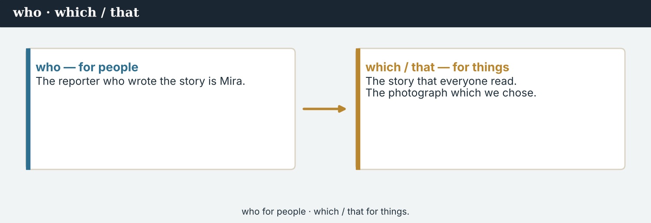
who = people · which / that = things.
1 · who / which / that
who for people: The correspondent who wrote the story is Mira.
which / that for things: The story that everyone read. The photograph which we chose.
We use them to say which person or thing we mean.
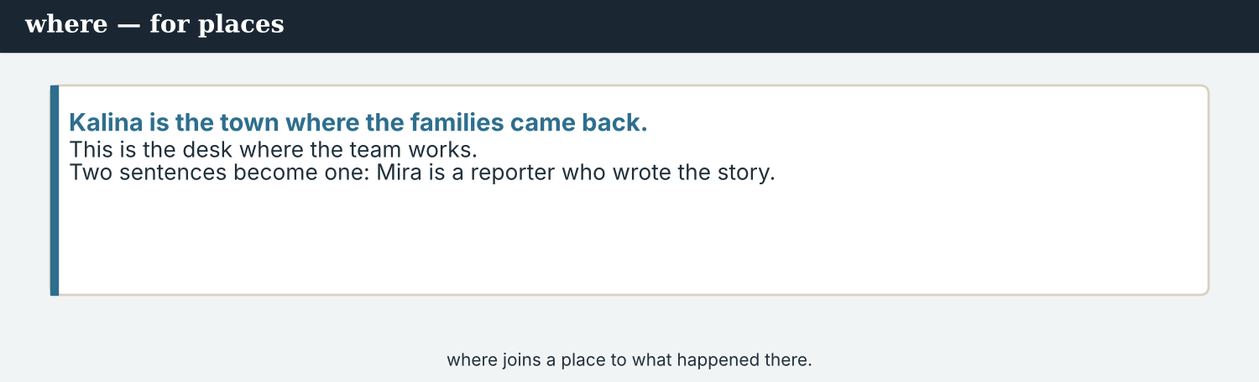
where — for places.
2 · where
where for places: Kalina is the town where the families came back.
This is the desk where the team works.
Use where to join a place to what happened there.
3 · Joining two ideas
Two sentences: Mira is a correspondent. She wrote the story.
One sentence: Mira is a correspondent who wrote the story.
Joining ideas makes your writing flow, and is better to read.
PRACTISE Structured practice
2A Choose: who, which/that, or where.
1. The correspondent ___________ wrote the story is Mira.
2. The story ___________ everyone read was on the front page.
3. Kalina is the town ___________ the families came back.
4. The photograph ___________ Hana took is beautiful.
2B Complete with who or which/that.
1. Elena is the woman ___________ owns the café.
2. The crossing ___________ reopened is busy again.
3. Priya is the person ___________ checks the facts.
4. This is the page ___________ tells the whole story.
2C Join the two sentences with who, which/that, or where.
1. Mira is a correspondent. She wrote the story. → ________________________
2. This is the bridge. It reopened in April. → ________________________
3. That is the town. The families came back there. → ________________________
2D Add where or who.
1. This is the desk ___________ the team works.
2. Hana is the photographer ___________ took the picture.
3. Kalina is the town ___________ the story happened.
Your own words
2E Write two sentences about people you know. Use who.
1. ________________________
2. ________________________
2F Write one sentence about a place, using where.
1. ________________________

PART 3 Editing: making it flow
A good editor joins short sentences to make the writing flow.
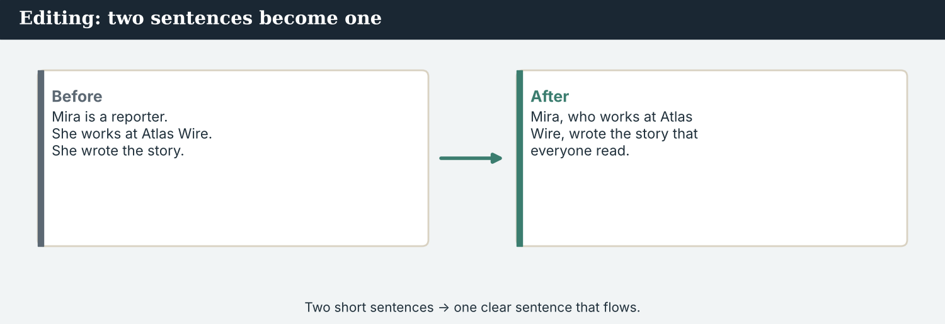
Two short sentences → one clear sentence.
MODEL Before and after
Before: Mira is a correspondent. She works at Atlas Wire. She wrote the story. Everyone read the story.
After: Mira, who works at Atlas Wire, wrote the story that everyone read.
NOTICE Notice the change
3A Answer about the model.
1. How many sentences are there ‘before’? ___________
2. How many ‘after’? ___________
3. Which words join the ideas? ___________
3B In the ‘after’ sentence, underline the two relative clauses. Write the joining words.
1. ________________________
PRACTISE Join them
Editing makes a story clearer, without changing the facts.
3C Join each pair into one sentence.
1. The crossing reopened. It is at Kalina. → ________________________
2. Elena owns the café. The café is always full. → ________________________
3. Priya checks the facts. She is the verification journalist. → ________________________
3D Complete the edited paragraph. Use: who · which · where · that.
Kalina is the town ______ the crossing reopened. Elena, ______ owns the café, is happy. The story, ______ Mira wrote, is on the page ______ everyone will read.
PRODUCE Your turn
3E Write four short sentences about a person and a place. Then join them into two flowing sentences with who / which / where.
________________________
________________________
________________________
________________________
PRODUCE Discuss
3F Talk with a partner. Why is a joined sentence often better to read than three short ones?
3G When you edit, you must not change the facts. Why is that a rule?

PART 4 Listening: planning the page
Two audios. Listen for who does what.
In the newsroom — the team plans the special front page.
Listening A · planning the front page
MODEL Audio 10.1 — the team plans
Ana: This is the front page that will tell the whole story. Let us plan it.
Ana: Mira, who has followed the valley all year, will write the lead.
Mira: Thank you. I will write the story that people have waited for.
Ana: Hana, who takes the best photographs, will choose the picture.
Hana: I have a photograph which shows the busy bridge.
Ana: And Priya, who checks the facts, will edit the page.
Priya: I will make sure every fact is right before we publish.
PRACTISE Listen for detail
4A Before you listen: who do you think will do each job? Write one idea.
1. ______
4B Answer the questions.
1. Who will write the lead? ___________
2. Who will choose the photograph? ___________
3. What does Hana’s photograph show? ___________
4. Who will edit the page? ___________
4C Match the person to the job.
1. Mira  2. Hana  3. Priya  4. Ana | a) chooses the photograph  b) leads the conference  c) writes the lead  d) checks the facts
4D Complete the notes.
Lead (who?): ___________
Photograph (who?): ___________
Edit (who?): ___________
Audio 10.2 — Mira presents the finished front page.
Listening B · presenting the page
MODEL Audio 10.2 — Mira presents
Mira: Here is the front page. The headline, which is short and strong, says: ‘A crossing comes home’.
Daniel: And the lead?
Mira: The lead gives the five Ws in one sentence, with the number that the office confirmed.
Daniel: The photograph?
Mira: It is the picture that Hana took — the bridge where the families came back.
Daniel: And the quote?
Mira: At the end: ‘It is our home,’ which are Elena’s exact words.
Daniel: It is perfect. We will publish it tonight.
PRACTISE Listen for detail
4E Before you listen: what parts of the page will Mira describe? Guess.
1. ______
4F Complete the answers.
1. The headline, ___________ is short and strong, says ‘A crossing comes home’.
2. The lead gives the five ___________ .
3. The photograph is the picture ___________ Hana took.
4. The quote is Elena’s exact ___________ .
4G Which relative words do you hear? Write two (who / which / that / where).
1. ________________________
4H Answer. Why does the lead use ‘the number that the office confirmed’?
1. ________________________
PRACTISE Both audios
4I Complete the summary. Use: who · which · lead · photograph.
The team plans the page: Mira, ______ followed the story, writes the ______ ; Hana chooses the ______ ; and Priya edits it. Then Mira presents the page, ______ is ready to publish.
PRODUCE What do you think?
4J Discuss. Why does a good front page need many people, each with a different job?

PART 5 Reading: the front page
Two readings. Read for the story, and for the parts of the page.
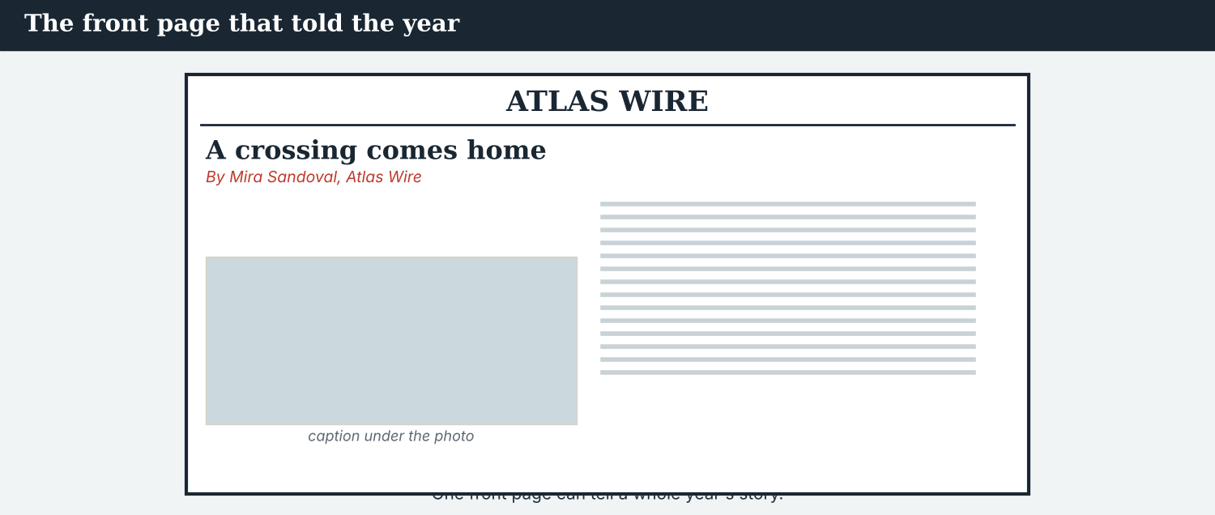
The front page that told the whole story.
Reading A · the story that brought a town home
A crossing comes home
By Mira Sandoval, Atlas Wire · KALINA
Kalina, the town that was quiet for seven years, is a home again. The bridge, which reopened last April, is busy every morning, and the families who left have come back.
The correspondent who followed the story all year is Mira Sandoval. “I have watched this valley change,” she said. “The road that was empty is full of children, and the stalls that disappeared have come back.”
Much of the work was done by the volunteers who live here, on both sides of the river. Elena Marku, who owns the café at the end of the bridge, is one of them. “It is our home,” she said — words that many people in the valley now repeat.
According to the Crossing Office, a hundred families have returned. There is still work to do: the clinic, which is closed, has not reopened yet. But the change is easy to see.
This is the front page that tells the story — a story about a place where, after seven quiet years, the people came home. As Elena said, and as the headline now reads: the crossing has come home.
PRACTISE Comprehension
5A Before you read: look at the headline, the byline and the dateline. What is the story about, who wrote it, and where is it from?
1. ______
5B True or false? Write T or F.
1. The bridge reopened last April. ______
2. Elena owns the café. ______
3. A hundred families have returned. ______
4. The clinic has reopened. ______
5C Answer the questions.
1. Who is the correspondent who followed the story? ___________
2. Who did much of the work? ___________
3. What has not reopened yet? ___________
5D Find a relative clause in the text (e.g. ‘who owns the café’). Write one.
1. ________________________
One front page can tell a whole year’s story, in many countries at once.
Reading B · making a front page — the parts
The parts of a front page
1. Masthead and headline. The masthead is the paper’s name at the top. The headline is the big title that people read first.
2. Byline and dateline. The byline names the writer. The dateline says where the report comes from — on an international page, it is the first thing a reader looks for.
3. Lead, photograph and caption. The lead is the first sentence, which gives the five Ws. A strong photograph, and a caption which says what the photograph shows.
4. Edit and check. Before you publish, edit the page: check every fact, every name, and every quote. A front page that has a mistake loses trust.
PRACTISE Comprehension
5E Before you read: which part do people read first? Guess.
1. ______
5F Match the part to what it does.
1. masthead  2. headline  3. byline  4. dateline | a) the big title people read first  b) says where the report comes from  c) the paper’s name at the top  d) names the writer
5G Which step is about checking before you publish? Write the number.
1. ______
PRACTISE Words from the readings
5H Find a word in Reading A or Reading B.
1. the big title → ___________
2. the first sentence → ___________
3. the line with the writer’s name → ___________
PRODUCE Discuss
5I Talk about it. Reading A uses many relative clauses. Do they make it easier or harder to read? Why?
5J Which part of a front page is the most important? Say why.

PART 6 Writing: headline and lead
Two short pieces: a headline, and a lead with the five Ws.
The lead answers the five Ws in one sentence.
Writing 1 · a headline, byline and dateline
MODEL A model
Headline: A crossing comes home
Byline: By Mira Sandoval, Atlas Wire
Dateline: KALINA
NOTICE Notice the model
6A Answer about the model.
1. How many words is the headline? ___________
2. What do the byline and the dateline tell us? ___________
PRODUCE Write your headline
6B Choose a story. Write a headline (5–7 words), a byline and a dateline.
Headline: ___________
Byline: ___________
Dateline: ___________
The lead gives the five Ws — and names a source for the number.
Writing 2 · a lead sentence
MODEL A model
Kalina, the town that was quiet for seven years, is a home again: a hundred families have returned since the spring, according to the Crossing Office.
NOTICE Notice the model
6C Answer. Which of the five Ws are in the lead? Where is the source?
1. ___________
PRACTISE Complete a lead
6D Complete the lead. Use: who · which · according.
The bridge, ______ reopened last April, is busy again, and the families ______ left have come back — ______ to the Crossing Office.
PRODUCE Write your lead
6E Write a lead sentence for your story. Give the five Ws, use one relative clause, and name a source.
________________________
________________________
________________________
PRACTISE Fix it
6F Join these three short sentences into one flowing lead. Use who and which.
“Mira is a correspondent. She works at Atlas Wire. She wrote the story that is on the front page.”
________________________

PART 7 Speaking: presenting the page
Describe your front page to a partner. Use relative clauses.
Present your page: the story, the photograph, and the people.
A model dialogue · presenting the front page
MODEL Listen and read
Mira: This is our front page. The headline, which is short, says ‘A crossing comes home’.
Ana: Who wrote the lead?
Mira: I did. It gives the five Ws, with the number that the office confirmed.
Ana: And the photograph?
Mira: It is the picture that Hana took — the bridge where the families came back.
Ana: It is a page that everyone will want to read.
NOTICE Notice the description
7A Find two relative clauses Mira uses. Write them.
1. ________________________
PRACTISE Controlled practice
7B Describe each part. Use a relative clause.
1. the headline / people read first → The headline is the part ___________ .
2. the correspondent / wrote the story → Mira is the correspondent ___________ .
3. the bridge / the families came back → It is the bridge ___________ .
Introduce your page, then describe each part.
7C Join the two sentences to describe your page.
1. This is the photograph. Hana took it. → ________________________
2. This is the town. The story happened there. → ________________________
3. This is the quote. Elena said it. → ________________________
PRODUCE Your role
Presenter | Present your front page. Describe the headline, the lead, and the photograph, using relative clauses.
Editor | Ask: ‘Who wrote it?’ ‘Where did it happen?’ ‘What does the photograph show?’
Observer | Listen. Did the presenter use who, which/that, and where?
7D Choose a role from the table. Present your page to a partner.
PRODUCE Role-play
7E Role-play the final conference: a presenter, an editor, and an observer. Then swap roles.
A second dialogue · the last check
MODEL Listen and read
Priya: Before we publish, I have checked the page which you gave me.
Mira: Is everything right?
Priya: Yes. Every fact is checked, and the quote, which is Elena’s, is exact.
Mira: And the number?
Priya: The number that the office confirmed is correct. The page is ready.
Mira: Then let us publish it.
PRACTISE Controlled practice
7F Write the relative clause Priya uses about the quote (the quote, which…).
1. ________________________
PRODUCE Self-check
Did I… | Yes | Almost | Not yet
use who for people and which/that for things? | ☐ | ☐ | ☐
use where for a place? | ☐ | ☐ | ☐
join short sentences to make them flow? | ☐ | ☐ | ☐
describe each part of my page? | ☐ | ☐ | ☐
7G Role-play the last check before publishing. Then swap roles.

PART 8 Ethics: the whole Code
The front page brings the whole Code together: accurate, fair, and kind.
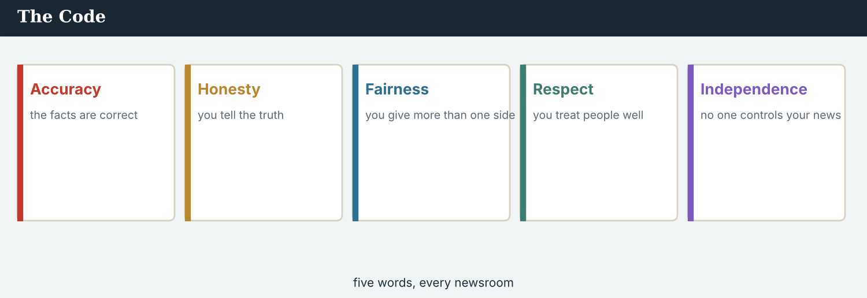
Five words that have held this course together, and now hold one page together.
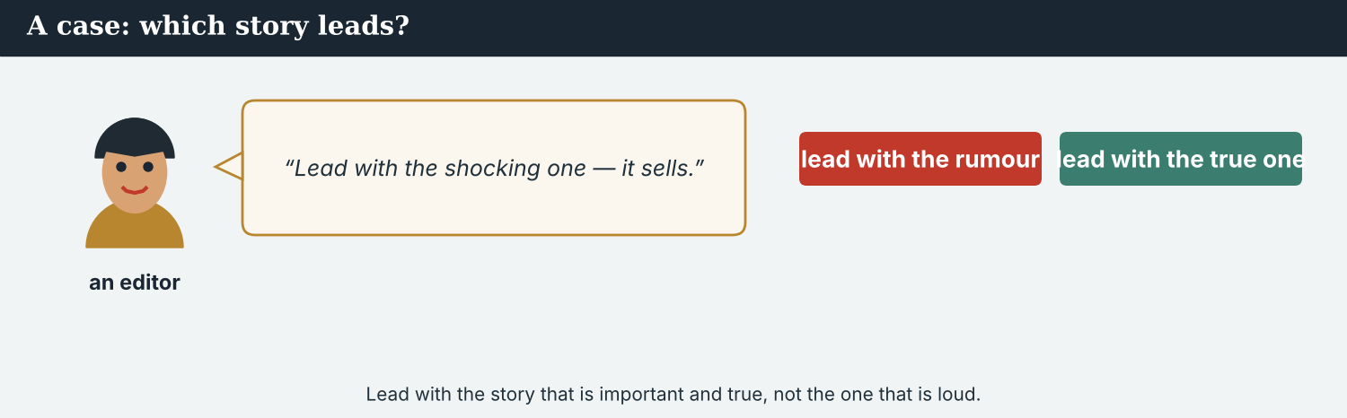
The lead story is the important one — not the loudest one.
A first case · which story leads?
A case. The team has two stories. One is the town that has come home — an important, true story that helps readers in many countries understand the year. The other is a small, shocking claim that would be shared more widely, but that nobody has checked. An editor says, “Put the shocking one on the front — it will travel further.” But it is a rumour, and it is not the story that matters most. The Code says: choose the story that is important and true, not the one that is loud. Which story does the team put on the front page?
NOTICE What do you do?
8A Choose (a) or (b), and write one reason.
1. (a) the shocking, unchecked claim (b) the important, true story. Choice: ______ Because ________________________
2. A front page should carry the story that is (a) loudest (b) most important and true. Choice: ______
8B Front page or not? Write Y (yes) or N (no).
1. An important, checked, true story. ______
2. A shocking claim nobody has checked. ______
3. A story that helps readers understand. ______
4. A story chosen only because it will be shared. ______
PRACTISE Apply the Code
8C Complete the rule. Use: important · true · loud · checked.
Lead with the story that is ______ and ______ . Do not lead with a story only because it is ______ . Everything on the page must be ______ .
PRODUCE Discuss
8D Discuss. Why should a newspaper not choose its front page only to be shared more widely?
A second case · a correction on the front
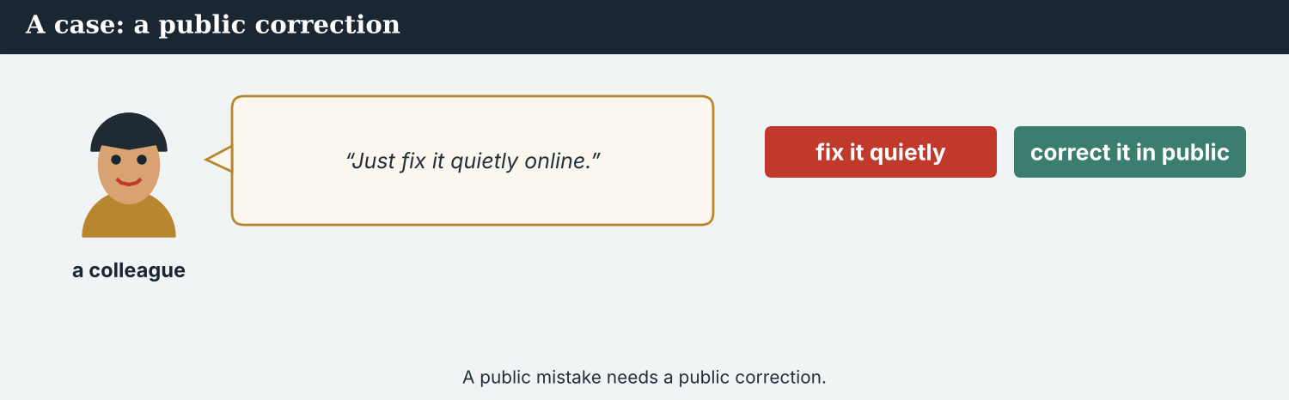
If the front page had a mistake, correct it — in public.
A case. Yesterday’s front page had a small mistake: it gave the wrong number of families. A reader found it, and the reader is right. The story went out on the wire, so outlets in six countries printed the wrong number too. Someone says, “It was small. Just fix it quietly online, and say nothing.” But the mistake was on the front page, where everyone saw it. The Code says: be honest — if you make a public mistake, you correct it in public, and you tell everyone who used it. What does the team do?
NOTICE What do you do?
8E Choose (a) or (b), and write one reason.
1. (a) fix it quietly and say nothing (b) print a correction, in public, and send it on the wire. Choice: ______ Because ________________________
2. Correcting a public mistake in public makes readers trust the paper (a) less (b) more. Choice: ______
8F Complete with: honest · public · correct · trust.
1. A journalist must be ___________ .
2. A ___________ mistake needs a public correction.
3. Say sorry and ___________ it.
4. Readers ___________ a paper that owns its mistakes.
PRODUCE Discuss
8G Discuss. Why does correcting a mistake in public build trust, not lose it?
PRODUCE Write it
8H Write a short, honest correction (2–3 sentences) for the wrong number. Say sorry, and give the right fact.

PART 9 Digital: the online front page
Online, the front page is the home page — the same rules apply.
The online front page — the lead story, on every phone.
MODEL A model home-page post
TOP STORY · A crossing comes home: Kalina, where the bridge reopened, is busy again. 100 families have returned, according to the Crossing Office. — @AtlasWire
NOTICE The parts of the post
9A Match the part to what it shows.
1. A crossing comes home  2. where the bridge reopened  3. 100 families have returned  4. according to the Crossing Office | a) a relative clause (where)  b) the headline  c) the source  d) the fact
PRACTISE Find and build
9B Find the relative clause in the post. Write it.
1. ________________________
9C Join these two into one home-page line, using where.
“The bridge is busy again. The families came back there.”
________________________
The online front page links to the full story.
9D Write a top-story post. Use one relative clause and name a source.
TOP STORY · ___________ (headline), ___________ (a relative clause). — @AtlasWire
PRODUCE Write your post
9E Write a one-line top-story post for your front page. Use a relative clause.
________________________
9F Creative. Write the headline (5–7 words) for your online front page.
9G A reader comments: ‘Who wrote this?’ Write a short reply. Use a byline and a relative clause.
________________________
PRODUCE Discuss
9H Discuss. Online or on paper, the front page has the same rules. What are two of them?

PART 10 Review & Can-Do
Check your English — and everything you have learned this course.
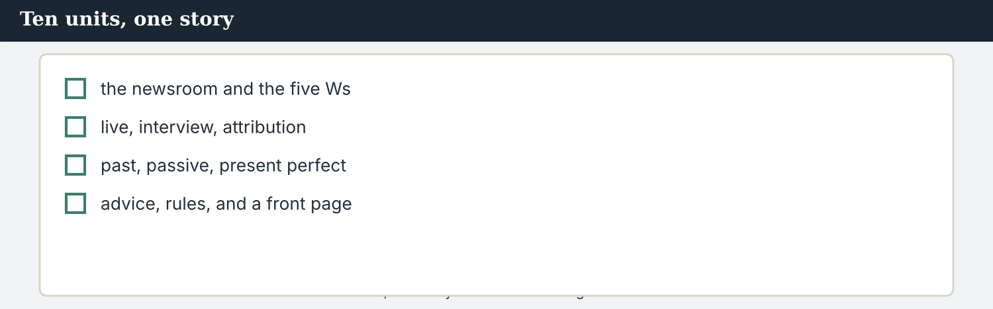
Ten units, one story: the Kalina crossing came home.
10A Vocabulary. Complete with: front page · masthead · headline · byline · lead · caption · edit · publish.
1. The team makes the ___________ .
2. The ___________ is the paper’s name at the top.
3. The big title is the ___________ .
4. The ___________ names the writer.
5. The ___________ is the first sentence.
6. The words under a photo are the ___________ .
7. Priya will ___________ the story.
8. Then the team will ___________ it.
10B Grammar. Choose: who, which/that, or where.
1. The correspondent ___________ wrote the story is Mira.
2. The story ___________ everyone read was on the front page.
3. Kalina is the town ___________ the families came back.
4. Elena is the woman ___________ owns the café.
10C Grammar. Join the two sentences.
1. Mira is a correspondent. She wrote the story. → ________________________
2. This is the bridge. It reopened in April. → ________________________
Can-Do — tick what you can do now.
10D Course review. Match the unit skill to the example.
1. the 5 Ws (U2)  2. reported speech (U5)  3. the passive (U7)  4. present perfect (U8) | a) ‘The bridge was rebuilt.’  b) ‘Who, what, when, where, why?’  c) ‘The crossing has reopened.’  d) ‘She said the crossing was open.’
10E Read and answer.
Mira, who has followed the story all year, wrote the front page that everyone read. It is about Kalina, the town where the families came back. Priya, who checks the facts, edited it before the team published it.
1. Who wrote the front page? ___________
2. Which town is the story about? ___________
3. Who edited it? ___________
Can-Do — tick what you can do now
☐ I can join two ideas with who, which, that, and where.
☐ I can describe people, things, and places.
☐ I can edit short sentences to make writing flow.
☐ I can plan and make a front page.
10F Reflect. Look back at all ten units. Which unit helped you the most? Why?
10G Grammar review. Write the sentence correctly.
1. Mira is the correspondent which wrote the story. → ________________________
2. This is the bridge who reopened. → ________________________
3. Kalina is the town which the families came back. → ________________________
4. The story that Mira wrote it is on the front page. → ________________________

PART 11 Final project: your front page
Bring the whole course together. Make a complete front page.
The template — build your front page part by part.
Your task. Make a full front page for a story of your choice (real or invented). Use everything you have learned this course. Work alone or in a small team — a correspondent, a photographer, and an editor.
Every part of the page, and what it is for.
Your front page must have:
1. a masthead (your outlet’s name) and a strong headline (5–7 words) — Units 1 & 10;
2. a byline (By…) and a dateline (the place you are reporting from) — Units 1 & 10;
3. a lead sentence that gives the five Ws — Units 2 & 6;
4. a short story that reports what happened and what has changed — Units 6, 7 & 8;
5. at least one exact quote, with attribution (’… said’ / ‘according to…’) — Units 4 & 5;
6. a photo box and a caption — Unit 10;
7. at least two relative clauses (who / which / that / where) — Unit 10.
A model — use it, and Reading A, to check the shape of your page.
Before you publish, edit it. Check every fact, every name, and every quote. Be accurate, fair, and kind. Lead with the story that is important and true — not the one that is loud. That is the whole Code, on one page.
Success criteria — the whole course | Yes | Almost | Not yet
It has a masthead, a headline, a byline and a dateline. | ☐ | ☐ | ☐
The lead gives the five Ws. | ☐ | ☐ | ☐
It has one exact quote, with a named source. | ☐ | ☐ | ☐
It uses the past, the passive, or the present perfect correctly. | ☐ | ☐ | ☐
It uses at least two relative clauses. | ☐ | ☐ | ☐
It is edited: every fact, name, and quote is checked. | ☐ | ☐ | ☐
It is accurate, fair, and kind. | ☐ | ☐ | ☐
Congratulations. You have finished English for Journalists. You started by learning the words of the newsroom; now you can plan, write, edit, and publish a front page — in English, in any country, and with a journalist’s care for the truth. A free press, in plain English.

ANSWER KEY Unit 10
Check your answers. Open tasks (discussion, role-play, your own writing, and the final project) are marked at the end.
W1 1 Mira · 2 the picture (the photograph) · 3 Kalina
W2 1 T · 2 F · 3 F
W3 (any three) that · who · where · that
1A 1-c, 2-a, 3-b, 4-d, 5-f, 6-e, 7-h, 8-i, 9-g, 10-j (accept sensible matches)
1B 1 headline · 2 byline · 3 lead · 4 caption · 5 edit · 6 publish
1C 1 write the headline · 2 choose the photograph · 3 edit the story · 4 design the layout · 5 publish the page
1D 1 deadline · 2 shout · 3 rumour · 4 describe
1E 1 front page · 2 headline · 3 byline · 4 lead · 5 photograph
1F 1 masthead · 2 lead · 3 edit · 4 column
2A 1 who · 2 that/which · 3 where · 4 that/which
2B 1 who · 2 that/which · 3 who · 4 that/which
2C 1 Mira is a correspondent who wrote the story. · 2 This is the bridge that/which reopened in April. · 3 That is the town where the families came back.
2D 1 where · 2 who · 3 where
3A 1 four · 2 one · 3 who / that
3B who (works at Atlas Wire) · that (everyone read)
3C 1 The crossing that/which reopened is at Kalina. · 2 Elena owns the café, which is always full. · 3 Priya, who is the verification journalist, checks the facts.
3D where · who · which/that · that/which
4B 1 Mira · 2 Hana · 3 the busy bridge · 4 Priya
4C Mira → writes the lead · Hana → chooses the photograph · Priya → checks the facts · Ana → leads the conference
4D Lead = Mira · Photograph = Hana · Edit = Priya
4F 1 which · 2 Ws · 3 that · 4 words
4G (any two) who · which · that · where
4H so the number has a source and is confirmed / accurate
4I who · lead · photograph · which
5B 1 T · 2 T · 3 T · 4 F
5C 1 Mira Sandoval · 2 the volunteers (who live there, on both sides) · 3 the clinic
5D (any) ‘that was quiet’ · ‘which reopened last April’ · ‘who left’ · ‘who owns the café’ · ‘where the people came home’
5F masthead → the paper’s name at the top · headline → the big title people read first · byline → names the writer · dateline → says where the report comes from
5G Step 4 (edit and check)
5H 1 headline · 2 lead · 3 byline
6A 1 four · 2 the writer and the outlet (By Mira Sandoval, Atlas Wire), and the place the report comes from (KALINA)
6C who/what/when/where (and why); the source is ‘according to the Crossing Office’
6D which · who · according
6F ‘Mira, who works at Atlas Wire, wrote the story which/that is on the front page.’
7A (any two) ‘which is short’ · ‘that Hana took’ · ‘where the families came back’
7B 1 (that) people read first · 2 who wrote the story · 3 where the families came back
7C 1 This is the photograph that/which Hana took. · 2 This is the town where the story happened. · 3 This is the quote that/which Elena said.
7F ‘the quote, which is Elena’s, is exact’
8A 1 (b) the important, true story · 2 (b) most important and true
8B 1 Y · 2 N · 3 Y · 4 N
8C important · true · loud · checked
8E 1 (b) print a correction, in public, and send it on the wire · 2 (b) more
8F 1 honest · 2 public · 3 correct · 4 trust
9A ‘A crossing comes home’ → the headline · ‘where the bridge reopened’ → a relative clause (where) · ‘100 families have returned’ → the fact · ‘according to the Crossing Office’ → the source
9B ‘where the bridge reopened’
9C ‘The bridge where the families came back is busy again.’
10A 1 front page · 2 masthead · 3 headline · 4 byline · 5 lead · 6 caption · 7 edit · 8 publish
10B 1 who · 2 that/which · 3 where · 4 who
10C 1 Mira is a correspondent who wrote the story. · 2 This is the bridge that/which reopened in April.
10D the 5 Ws → ‘Who, what, when, where, why?’ · reported speech → ‘She said the crossing was open.’ · the passive → ‘The bridge was rebuilt.’ · present perfect → ‘The crossing has reopened.’
10E 1 Mira · 2 Kalina · 3 Priya
10G 1 Mira is the correspondent who wrote the story. · 2 This is the bridge that/which reopened. · 3 Kalina is the town where the families came back. · 4 The story that Mira wrote is on the front page.
Open tasks W4, 1G, 1H, 1I, 2E, 2F, 3E, 3F, 3G, 4A, 4E, 4J, 5A, 5E, 5I, 5J, 6B, 6E, 7D, 7E, 7G, 8D, 8G, 8H, 9D, 9E, 9F, 9G, 9H, 10F, and the Final Project — your own answers (discussion, role-play, writing, and your front page).
A note on real and invented content. The facts about journalism around the world are true as of 2026. Atlas Wire, its staff, Elena Marku, Dren, Sofia Mendes, Kalina, the river Vara and the front-page story are invented, for practice. Real people are only ever in true, sourced facts — never in an invented quote.
English for Journalists — International Edition · Unit 10 (v6 standard) · the capstone. CEFR A2 → lower B1 · Beat: Capstone · two readings · two listenings · two writing pieces · two ethics cases · two speaking dialogues · balanced sections · ~24 figures · featured cast · fictional agency, factual backdrop. A free press, in plain English.

