Before you start
Read all three before you write anything: together they are the whole session. Then fill the gaps, guessing where you have to.

What this handout settles, cycle by cycle
In this handout | What you will read | How you check it
Who uses financial statements, and why? | a diagram · a table to complete · a rule to complete | Which group is a primary user of general-purpose financial statements?
The words this section uses precisely | a diagram · Verb · The English this sheet uses, and its Arabic | Which words complete this? “The four main statements are the balance sheet, the income statement, the ...... and the statement of cash flows.”

1. Where the section starts — Fill every gap. One word in the list is not used.
choose from: cost of goods sold · statement of changes in equity · Financial statements · conceptual framework · general-purpose financial statements · statement of cash flows · income statement
A company collects thousands of facts every day: sales, purchases, salaries and loans. summarize these facts in a standard form for people outside the company. The four main statements are the balance sheet, the , the and the . Most companies prepare . These are reports for many readers at the same time, not for one special reader. The U.S. names the most important readers. The primary users are existing and potential investors, lenders and other creditors.
2. What it settles in the middle — Fill every gap. One word in the list is not used.
choose from: statement of cash flows · Relevance · income statement · conceptual framework · balance sheet · materiality · cost of goods sold
What does the company have, and what does it owe? The answers this. How did the company perform in the period? The answers this. Where did cash come from, and where did it go? The answers this. The lists the qualities of useful information. There are two fundamental qualities. means the information can make a difference to a decision. It helps users predict the future (predictive value) or check their past predictions (confirmatory value). Relevance includes : an item is material if leaving it out or stating it wrongly could change users' decisions.
3. Where it ends — Fill every gap. One word in the list is not used.
choose from: faithful representation · income statement · relevance · cost of goods sold · primary users · revenue
Managers are users, but not of general-purpose statements. Also remember: and are the two fundamental qualities. Comparability, verifiability, timeliness and understandability are only enhancing qualities. These verbs have exact meanings in exam questions. Example: Orontes recognizes when it delivers the goods. It measures the revenue at the invoice price. It presents revenue in the , and it discloses its revenue policy in the notes.
What this sheet settles
Word | what it means here
financial statements
expense
accrual basis
faithful representation | the information shows what it claims to show
net income
journal entry
accounts receivable

CYCLE A | Who uses financial statements, and why?

FIRST THOUGHT One claim. Decide now; you will check it in a moment.

4. Decide before you look at anything else: the decision of Managers (internal) is “Plan and control operations”. TRUE / FALSE
FILL IT IN

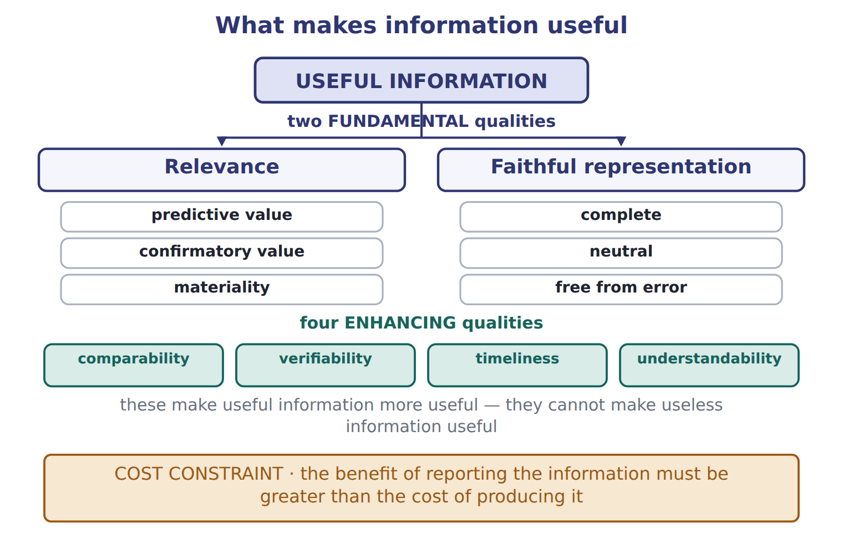
Complete the empty cells. One entry in the list is not used.
User | Decision | Key question | Statements used most
Investors (shareholders) — PRIMARY | Buy, hold or sell shares | Will the company create future cash flows and returns?
Lenders (banks, bondholders) — PRIMARY | Lend, renew or stop a loan | Can the company pay interest and repay the principal on time? | Cash flows, balance sheet
Other creditors (suppliers) — PRIMARY | Sell on credit, set credit terms | Will the company pay its bills when due?
Employees and unions | Stay, negotiate pay |  | Income statement
Customers |  | Will the company continue to supply us? | Balance sheet, income statement
Governments and regulators | Tax, oversight, statistics | Does the company follow the rules and pay its taxes?
Managers (internal) | Plan and control operations |  | Internal management reports

USE IT Use the table you have just completed.

11. What is the decision of Investors (shareholders) — PRIMARY?
A. Sign long-term contracts | C. Buy, hold or sell shares
B. Lend, renew or stop a loan | D. Tax, oversight, statistics
12. The statements used most of Lenders (banks, bondholders) — PRIMARY is “Cash flows, balance sheet”. TRUE / FALSE
STATE THE RULE

13. Complete the sentence.
use every one of these words: journal entry · statement of changes in equity · statement of cash flows · income statement
The four main statements are the balance sheet, the , the and the .

Two cases, side by side
Lenders (banks, bondholders) — PRIMARY | Employees and unions
Decision: Lend, renew or stop a loan | Decision: Stay, negotiate pay
Key question: Can the company pay interest and repay the principal on time? | Key question: Is the company stable and profitable?
Only the facts above differ. What is the statements used most of Lenders (banks, bondholders) — PRIMARY?
14. Choose one:
A. Balance sheet, income statement | C. All statements and notes
B. Cash flows, balance sheet | D. Income statement
APPLY No help on this move.

15. Under the U.S. conceptual framework, the objective of general-purpose financial reporting is to provide useful information mainly to:
A. the board of directors and senior management.
B. government statisticians and tax authorities.
C. existing and potential investors, lenders and other creditors.
D. the company's employees and trade unions.
16. A bank is deciding whether to renew a five-year loan to Orontes. Which information will the bank find MOST useful?
A. The highest and lowest share price during the year
B. The company's ability to generate cash to pay interest and repay principal
C. The number of products the company sells
D. The names of the company's major shareholders
17. Two companies use the same accounting methods, so an analyst can compare their results. This quality is called:
A. relevance | C. faithful representation
B. verifiability | D. comparability
WORK IN PAIRS | Compare every answer on this page with your partner before you read any key.
If you disagree: go back to the model and find the row that settles it. The row decides, not the louder voice.
CHECKPOINT 18. Which group is a primary user of general-purpose financial statements?
A. The company's managers
B. The company's internal auditors
C. The company's board of directors
D. Existing and potential lenders
If you got it wrong: redo the USE IT questions of cycle A with the model in front of you.

CYCLE B | The words this section uses precisely

FIRST THOUGHT

19. Decide before you look at anything else: which verb goes with “explain the item in the notes to the statements”?
A. disclose | C. record
B. measure | D. recognize
FILL IT IN

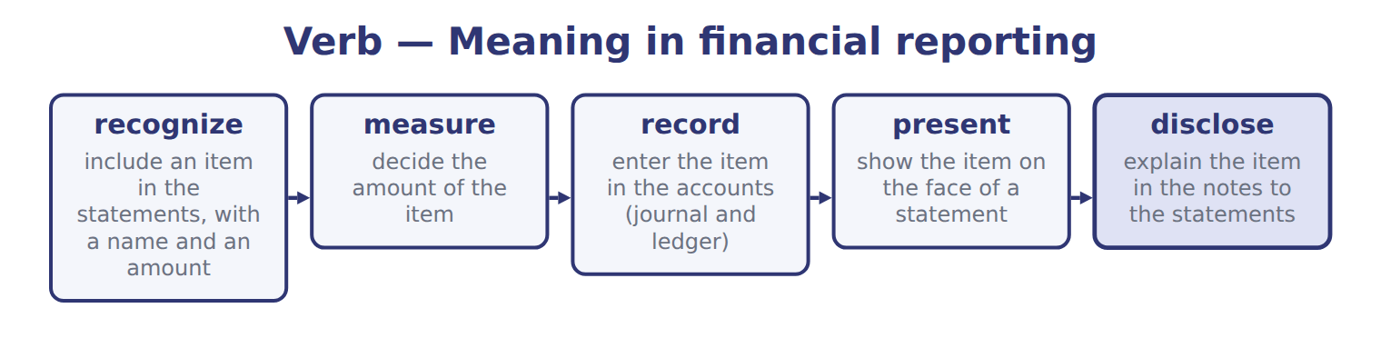
Verb — Meaning in financial reporting
Verb | Meaning in financial reporting
recognize | include an item in the statements, with a name and an amount
measure | decide the amount of the item
record | enter the item in the accounts (journal and ledger)
present | show the item on the face of a statement
disclose | explain the item in the notes to the statements

The English this sheet uses, and its Arabic
English (exam term) | Arabic
financial statements | القوائم المالية
expense | مصروف (مصروفات)
accrual basis | أساس الاستحقاق
faithful representation | التمثيل الصادق
net income | صافي الدخل
journal entry | قيد اليومية
accounts receivable | الذمم المدينة (المدينون)
prepaid expense | مصروف مدفوع مقدماً
conceptual framework | الإطار المفاهيمي

USE IT

Write the letter of its meaning beside each term.
A decide the amount of the item
B show the item on the face of a statement
C investors, lenders and other creditors
D explain the item in the notes to the statements
E include an item in the statements, with a name and an amount
F the information can make a difference to a decision

20. measure
21. Relevance
22. recognize
23. Primary users
24. present
25. disclose

Write the letter of the Arabic term beside each English term. Every term is used once.
A مصروف مدفوع مقدماً | D القوائم المالية
B أساس الاستحقاق | E الإطار المفاهيمي
C صافي الدخل | F مصروف (مصروفات)

26. prepaid expense
27. expense
28. conceptual framework
29. net income
30. accrual basis
31. financial statements

32. Which verb goes with “include an item in the statements, with a name and an amount”?
A. measure | C. disclose
B. present | D. recognize
33. Which verb goes with “decide the amount of the item”?
A. measure | C. disclose
B. record | D. present
APPLY

34. Information helps an investor forecast next year's cash flows. This information has:
A. predictive value | C. comparability
B. verifiability | D. timeliness
35. Which words complete this? “How did the company perform in the period? The …… answers this.”
A. prepaid expense | C. accounts payable
B. income statement | D. retained earnings
36. Which words complete this? “Relevance includes ……: an item is material if leaving it out or stating it wrongly could change users' decisions.”
A. net income | C. cash basis
B. materiality | D. common stock

CHECKPOINT 37. Which words complete this? “The four main statements are the balance sheet, the income statement, the …… and the statement of cash flows.”
A. allowance for credit losses
B. statement of financial position
C. additional paid-in capital
D. statement of changes in equity
If you got it wrong: redo the USE IT questions of round B.

FROM MEMORY | Close the earlier pages first.
38. Rebuild the figure from this handout. Label every part and fill in every box.
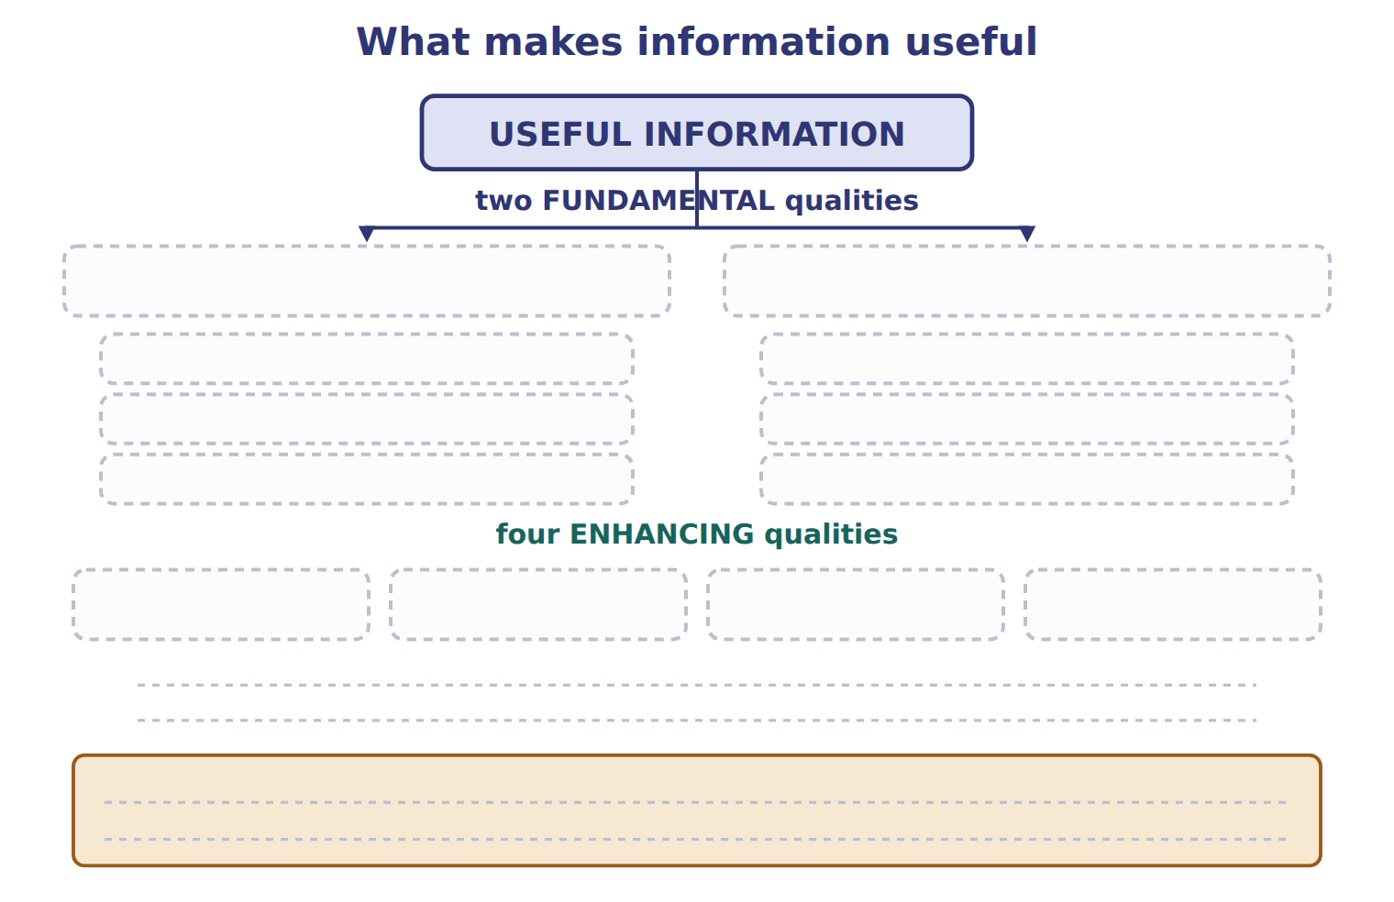
TEACH IT BACK | Write it for a classmate who missed this session — not for the marker.
39. In three or four sentences, write what this section settles and the one rule a reader has to take away.
every one of these words must appear: financial statements · expense · accrual basis · faithful representation

Answer key · Handout 1.1 · Who uses financial statements, and why?

1 Financial statements · income statement · statement of changes in equity · statement of cash flows · general-purpose financial statements · conceptual framework | 14 B | 27 F
2 balance sheet · income statement · statement of cash flows · conceptual framework · Relevance · materiality | 15 C | 28 E
3 primary users · relevance · faithful representation · revenue · income statement | 16 B | 29 C
4 T | 17 D | 30 B
5 Investors (shareholders) — PRIMARY — statements used most: Income statement, cash flows, balance sheet | 18 D | 31 D
6 Other creditors (suppliers) — PRIMARY — statements used most: Balance sheet (short-term items), cash flows | 19 A | 32 D
7 Employees and unions — key question: Is the company stable and profitable? | 20 A | 33 A
8 Customers — decision: Sign long-term contracts | 21 F | 34 A
9 Governments and regulators — statements used most: All statements and notes | 22 E | 35 B
10 Managers (internal) — key question: Not a primary user: can use internal reports | 23 C | 36 B
11 C | 24 B | 37 D
12 T | 25 D | 38 Compare with the model earlier in this handout.
13 income statement · statement of changes in equity · statement of cash flows | 26 A | 39 A company collects thousands of facts every day: sales, purchases, salaries and loans. Financial statements summarize these facts in a standard form for people outside the company. The four main statements are the balance sheet, the income statement, the statement of changes in equity and the statement of cash flows.

13 what the book says
The four main statements are the balance sheet, the income statement, the statement of changes in equity and the statement of cash flows.

why
1 In full: “A company collects thousands of facts every day: sales, purchases, salaries and loans. Financial statements summarize these facts in a standard form for people outside the company. The four main statements are the balance sheet, the income statement, the statement of changes in equity and the statement of cash flows. Most companies prepare general-purpose financial statements. These are reports for many readers at the same time, not for one special reader. The U.S. conceptual framework names the most important readers. The primary users are existing and potential investors, lenders and other creditors.”
2 In full: “What does the company have, and what does it owe? The balance sheet answers this. How did the company perform in the period? The income statement answers this. Where did cash come from, and where did it go? The statement of cash flows answers this. The conceptual framework lists the qualities of useful information. There are two fundamental qualities. Relevance means the information can make a difference to a decision. It helps users predict the future (predictive value) or check their past predictions (confirmatory value). Relevance includes materiality: an item is material if leaving it out or stating it wrongly could change users' decisions.”
3 In full: “Managers are users, but not primary users of general-purpose statements. Also remember: relevance and faithful representation are the two fundamental qualities. Comparability, verifiability, timeliness and understandability are only enhancing qualities. These verbs have exact meanings in exam questions. Example: Orontes recognizes revenue when it delivers the goods. It measures the revenue at the invoice price. It presents revenue in the income statement, and it discloses its revenue policy in the notes.”
4 Managers (internal): Plan and control operations.
11 The Buy, hold or sell shares of decision is Investors (shareholders) — PRIMARY.
12 Lenders (banks, bondholders) — PRIMARY: Cash flows, balance sheet.
14 The statements used most of Lenders (banks, bondholders) — PRIMARY is Cash flows, balance sheet.
15 These are the primary users. They provide resources and cannot demand special reports. A is wrong: Management can obtain internal information, so it is not a primary user. B is wrong: Governments use the statements, but they are not the primary users named by the framework.
16 A lender's main question is repayment: can the borrower pay interest and principal on time? A is wrong: Share prices interest investors more than lenders and do not show repayment ability. C is wrong: The product count does not show whether the company can repay the loan.
17 Comparability lets users identify similarities and differences between companies or periods. A is wrong: Relevance means the information can make a difference to a decision. B is wrong: Verifiability means independent observers could reach the same result.
18 The primary users are existing and potential investors, lenders and other creditors. A is wrong: Managers can get internal information, so they are not primary users. B is wrong: Internal auditors work inside the company and use internal records.
19 disclose goes with “explain the item in the notes to the statements”.
32 recognize goes with “include an item in the statements, with a name and an amount”.
33 measure goes with “decide the amount of the item”.
34 Predictive value is part of relevance: the information helps users predict the future. B is wrong: Verifiability means independent people could agree on the amount. C is wrong: Comparability means users can compare companies or periods.
35 The sentence reads: “How did the company perform in the period? The income statement answers this.”
36 The sentence reads: “Relevance includes materiality: an item is material if leaving it out or stating it wrongly could change users' decisions.”
37 The sentence reads: “The four main statements are the balance sheet, the income statement, the statement of changes in equity and the statement of cash flows.”

