1.1 Who uses financial statements, and why?
Chapter 1 · section 1.1

Fill every gap. Each word list holds one word more than there are gaps.
Chapter 1, section by section
Each stage leads to the next.
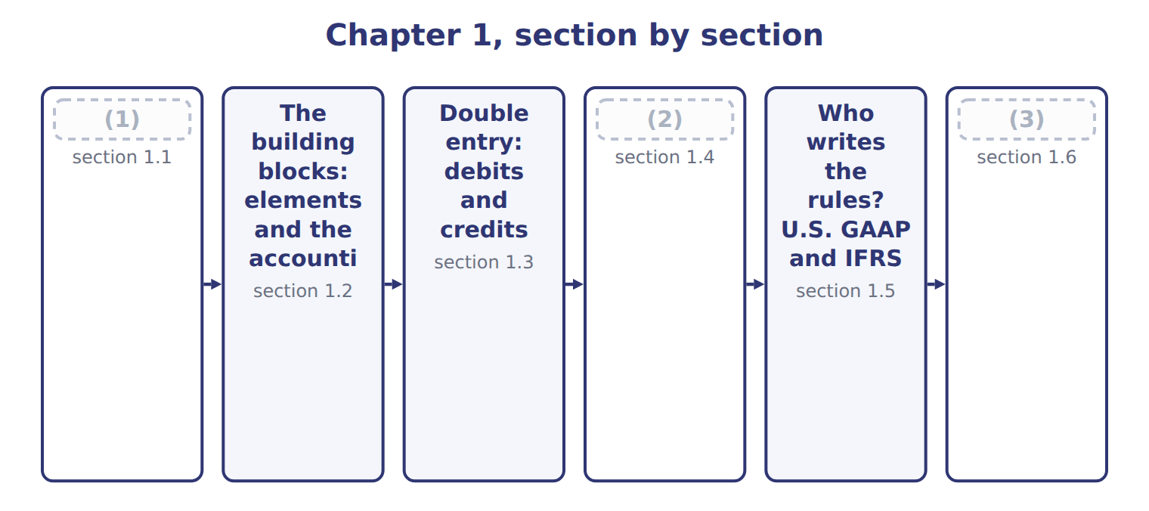
word list
Who uses financial statements, and why? · A first look at the four statements · The building blocks: elements and the accounti · The accrual basis and the matching principle

Summary 1 gaps 4–14
A company collects (4) of facts every day: sales, (5) , salaries and loans. Financial statements (6) these facts in a (7) form for people outside the company. The four main statements are the (8) sheet, the income statement, the statement of changes in (9) and the statement of cash flows. Most companies prepare (10) financial statements. These are reports for many readers at the same time, not for one special (11) . The U.S. (12) framework names the most (13) readers. The primary users are existing and (14) investors, lenders and other creditors. They give resources (money, goods or credit) to the company. They usually cannot ask the company for special reports, so they depend on the published statements. Each user makes a different decision, so each user looks for different information.
word list
general-purpose · standard · summarize · purchases · wrongly · important · reader · equity · balance · conceptual · thousands · potential

Users of financial statements and what they need
User | Decision | Key question | Statements used most
Investors (shareholders) — PRIMARY | (15) | Will the company create future cash flows and returns? | Income statement, cash flows, balance sheet
Lenders (banks, bondholders) — PRIMARY | Lend, renew or stop a loan | Can the company pay interest and repay the (16) on time? | Cash flows, balance sheet
Other creditors (suppliers) — PRIMARY | Sell on credit, set credit terms | (17) | Balance sheet (short-term items), cash flows
Employees and unions | Stay, negotiate pay | (18) | Income statement
Customers | Sign long-term contracts | (19) | Balance sheet, income statement
Governments and regulators | (20) | Does the company follow the rules and pay its taxes? | All statements and notes
Managers (internal) | Plan and control operations | (21) | Internal management reports

word list
Tax, oversight, statistics · principal · Is the company stable and profitable? · Buy, hold or sell shares · Will the company pay its bills when due? · Will the company continue to supply us? · Not a primary user: can use internal reports · equity

Summary 2 gaps 22–32
Other groups also read (22) statements: employees, customers, (23) , tax authorities and the public. Managers read them too. However, managers are not primary users of (24) statements, because they can get any internal (25) they need. (26) for managers is (27) accounting, the subject of most of the CMA exam. What do all these users need? In (28) terms, they ask three (29) . What does the company have, and what does it owe? The (30) sheet answers this. How did the company (31) in the period? The (32) statement answers this. Where did cash come from, and where did it go? The statement of cash flows answers this. Users also want to judge stewardship: how well the managers used the owners' resources.
word list
income · financial · perform · information · management · governments · simple · balance · Reporting · material · questions · general-purpose

What makes information useful?

Summary 3 gaps 33–41
The (33) framework lists the qualities of useful information. There are two (34) qualities. Relevance means the information can make a (35) to a decision. It helps users predict the future (predictive value) or check their past predictions ( (36) value). Relevance includes (37) : an item is material if leaving it out or stating it wrongly could change users' decisions. Faithful (38) means the information shows what it claims to show. It is (39) , neutral and free from error. Four enhancing qualities make information even more useful: comparability, verifiability, timeliness and (40) . Finally, there is a cost (41) : the benefit of reporting information should be greater than its cost.
word list
representation · benefit · conceptual · confirmatory · materiality · complete · fundamental · constraint · understandability · difference

Who is a primary user?

Summary 4 gaps 42–44
Primary users are (42) , lenders and other creditors. Managers are users, but not primary users of (43) statements. Also remember: (44) and faithful representation are the two fundamental qualities. Comparability, verifiability, timeliness and understandability are only enhancing qualities.
word list
investors · relevance · general-purpose · T-account

Five accounting verbs

These verbs have exact meanings in exam questions.
Five accounting verbs
Each stage leads to the next.
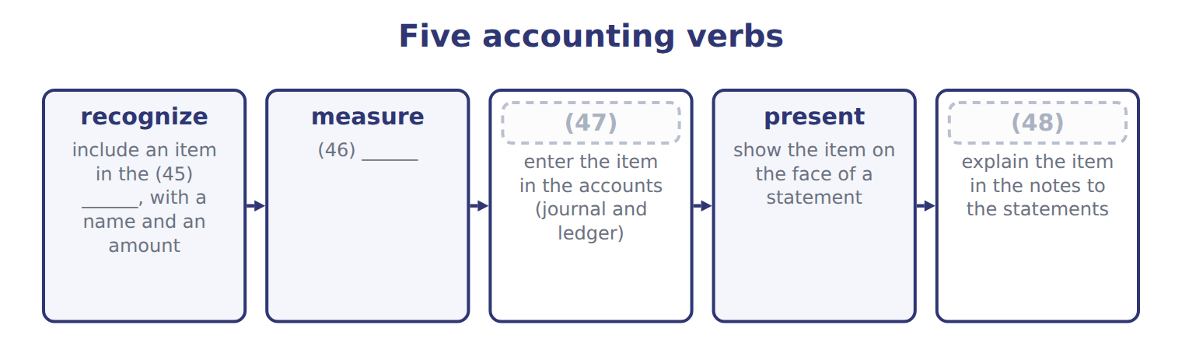
word list
decide the amount of the item · statements · disclose · record · U.S. GAAP

Summary 5 gaps 49–51
Example: Orontes (49) revenue when it delivers the goods. It (50) the revenue at the invoice price. It presents revenue in the income (51) , and it discloses its revenue policy in the notes.
word list
relevance · statement · measures · recognizes

The words this section uses
Each term sits against what it means.
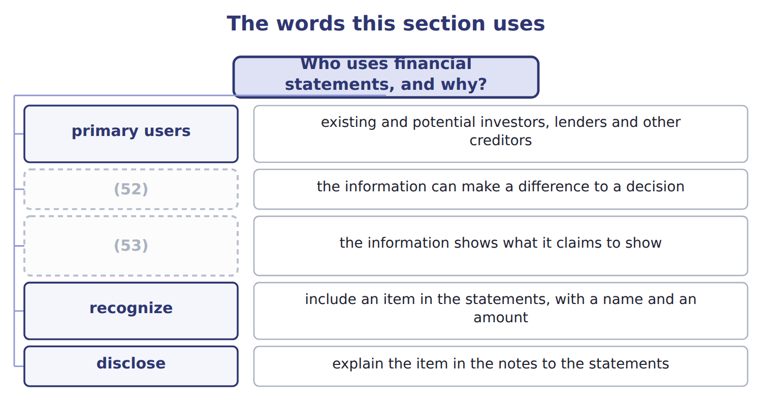
word list
faithful representation · relevance · materiality

The English this sheet uses, and its Arabic
English (exam term) | Arabic
financial statements | القوائم المالية
general-purpose financial statements | القوائم المالية ذات الغرض العام
primary users | المستخدمون الرئيسيون
relevance | الملاءمة
faithful representation | التمثيل الصادق
materiality | الأهمية النسبية
recognize | يعترف (الاعتراف)
disclose | يُفصح (الإفصاح)

Answer key · 1.1 Who uses financial statements, and why?

1 Who uses financial statements, and why? | 28 simple
2 The accrual basis and the matching principle | 29 questions
3 A first look at the four statements | 30 balance
4 thousands | 31 perform
5 purchases | 32 income
6 summarize | 33 conceptual
7 standard | 34 fundamental
8 balance | 35 difference
9 equity | 36 confirmatory
10 general-purpose | 37 materiality
11 reader | 38 representation
12 conceptual | 39 complete
13 important | 40 understandability
14 potential | 41 constraint
15 Buy, hold or sell shares | 42 investors
16 principal | 43 general-purpose
17 Will the company pay its bills when due? | 44 relevance
18 Is the company stable and profitable? | 45 statements
19 Will the company continue to supply us? | 46 decide the amount of the item
20 Tax, oversight, statistics | 47 record
21 Not a primary user: can use internal reports | 48 disclose
22 financial | 49 recognizes
23 governments | 50 measures
24 general-purpose | 51 statement
25 information | 52 relevance
26 Reporting | 53 faithful representation
27 management

the summaries in full
Summary 1 A company collects thousands of facts every day: sales, purchases, salaries and loans. Financial statements summarize these facts in a standard form for people outside the company. The four main statements are the balance sheet, the income statement, the statement of changes in equity and the statement of cash flows. Most companies prepare general-purpose financial statements. These are reports for many readers at the same time, not for one special reader. The U.S. conceptual framework names the most important readers. The primary users are existing and potential investors, lenders and other creditors. They give resources (money, goods or credit) to the company. They usually cannot ask the company for special reports, so they depend on the published statements. Each user makes a different decision, so each user looks for different information.
Summary 2 Other groups also read financial statements: employees, customers, governments, tax authorities and the public. Managers read them too. However, managers are not primary users of general-purpose statements, because they can get any internal information they need. Reporting for managers is management accounting, the subject of most of the CMA exam. What do all these users need? In simple terms, they ask three questions. What does the company have, and what does it owe? The balance sheet answers this. How did the company perform in the period? The income statement answers this. Where did cash come from, and where did it go? The statement of cash flows answers this. Users also want to judge stewardship: how well the managers used the owners' resources.
Summary 3 The conceptual framework lists the qualities of useful information. There are two fundamental qualities. Relevance means the information can make a difference to a decision. It helps users predict the future (predictive value) or check their past predictions (confirmatory value). Relevance includes materiality: an item is material if leaving it out or stating it wrongly could change users' decisions. Faithful representation means the information shows what it claims to show. It is complete, neutral and free from error. Four enhancing qualities make information even more useful: comparability, verifiability, timeliness and understandability. Finally, there is a cost constraint: the benefit of reporting information should be greater than its cost.
Summary 4 Primary users are investors, lenders and other creditors. Managers are users, but not primary users of general-purpose statements. Also remember: relevance and faithful representation are the two fundamental qualities. Comparability, verifiability, timeliness and understandability are only enhancing qualities.
Summary 5 Example: Orontes recognizes revenue when it delivers the goods. It measures the revenue at the invoice price. It presents revenue in the income statement, and it discloses its revenue policy in the notes.

1.2 The building blocks: elements and the accounting equation
Chapter 1 · section 1.2

Fill every gap. Each word list holds one word more than there are gaps.
Summary 1 gaps 1–12
Every amount in the financial (1) belongs to an element. The (2) conceptual framework defines ten elements. Three of them describe the (3) sheet at one date. An (4) is a present right of an entity to an economic benefit. Examples: cash, accounts receivable, (5) and equipment. A (6) is a present obligation of an entity to transfer an economic benefit. Examples: accounts payable, notes payable and wages payable. (7) is the residual interest in the assets after the liabilities are deducted. It is the (8) ' claim. The other elements describe (9) during a period. Revenues and expenses come from the company's central, ongoing (10) . When Orontes sells olive oil, it earns (11) . When it pays plant workers, it has an (12) . Gains and losses come from peripheral or incidental events. If Orontes sells an old delivery truck for more than its carrying amount, it has a gain.
word list
asset · inventory · balance · expense · accounts · Equity · revenue · statements · operations · FASB · liability · owners · changes

Summary 2 gaps 13–24
Investments by owners, such as (13) new shares, increase equity. (14) to owners, such as dividends, decrease equity. (15) income is the total change in equity from (16) other than owners. The equation always holds, because creditors ( (17) ) or owners (equity) finance every asset. Equity has two main parts. (18) capital is what owners paid: common stock at its par value, plus additional paid-in capital (APIC). Retained earnings (RE) are the past net income that the company kept (19) of paying it out as dividends. Look at the lower part. (20) and gains increase retained earnings. (21) and losses decrease it. Dividends also decrease it, but a (22) is not an expense. It is a distribution to owners, so it never appears in the income (23) . The (24) Conceptual Framework (2018) defines an asset as a present economic resource controlled by the entity as a result of past events.
word list
balance · buying · Contributed · dividend · Comprehensive · statement · sources · IFRS · instead · Expenses · Revenues · liabilities · Distributions

Summary 3 gaps 25–29
The idea is the same as in U.S. GAAP; only the wording is (25) . IFRS also uses the word income for both (26) and gains, while U.S. GAAP keeps revenues and gains apart. You may also know these IFRS names: (27) of financial (28) (balance sheet), share capital (common stock) and share premium ( (29) paid-in capital).
word list
additional · obligation · different · statement · position · revenue

Words that look familiar

Summary 4 gaps 30–32
In a CMA question, inventory is (30) inventory. Revenue is the gross (31) from sales. Net income is what remains after (32) . Do not use income when the question means revenue. In English, charges usually means fees.
word list
amount · always · Orontes · expenses

The words this section uses
Each term sits against what it means.
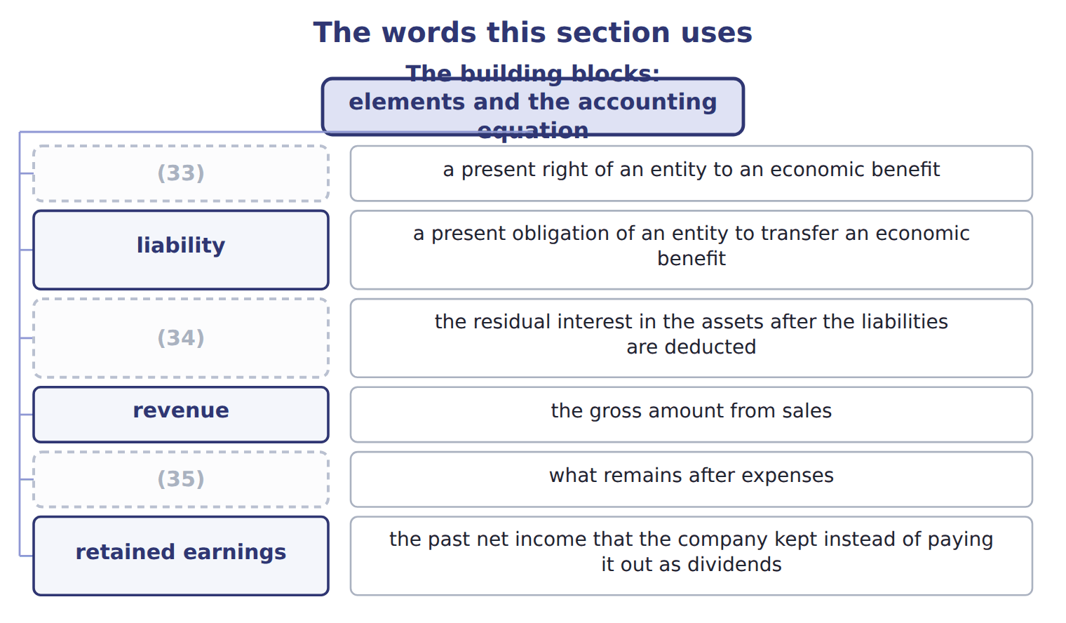
word list
income statement · asset · net income · equity

The English this sheet uses, and its Arabic
English (exam term) | Arabic
asset | أصل (أصول)
liability | التزام (التزامات)
equity | حقوق الملكية
revenue | إيراد (إيرادات)
expense | مصروف (مصروفات)
gain | مكسب (مكاسب)
loss | خسارة
net income | صافي الدخل
retained earnings | الأرباح المحتجزة
common stock | الأسهم العادية
additional paid-in capital | علاوة إصدار الأسهم (رأس المال الإضافي المدفوع)
par value | القيمة الاسمية
dividend | توزيعات الأرباح
accounting equation | المعادلة المحاسبية

Answer key · 1.2 The building blocks: elements and the accounting equation

1 statements | 19 instead
2 FASB | 20 Revenues
3 balance | 21 Expenses
4 asset | 22 dividend
5 inventory | 23 statement
6 liability | 24 IFRS
7 Equity | 25 different
8 owners | 26 revenue
9 changes | 27 statement
10 operations | 28 position
11 revenue | 29 additional
12 expense | 30 always
13 buying | 31 amount
14 Distributions | 32 expenses
15 Comprehensive | 33 asset
16 sources | 34 equity
17 liabilities | 35 net income
18 Contributed

the summaries in full
Summary 1 Every amount in the financial statements belongs to an element. The FASB conceptual framework defines ten elements. Three of them describe the balance sheet at one date. An asset is a present right of an entity to an economic benefit. Examples: cash, accounts receivable, inventory and equipment. A liability is a present obligation of an entity to transfer an economic benefit. Examples: accounts payable, notes payable and wages payable. Equity is the residual interest in the assets after the liabilities are deducted. It is the owners' claim. The other elements describe changes during a period. Revenues and expenses come from the company's central, ongoing operations. When Orontes sells olive oil, it earns revenue. When it pays plant workers, it has an expense. Gains and losses come from peripheral or incidental events. If Orontes sells an old delivery truck for more than its carrying amount, it has a gain.
Summary 2 Investments by owners, such as buying new shares, increase equity. Distributions to owners, such as dividends, decrease equity. Comprehensive income is the total change in equity from sources other than owners. The equation always holds, because creditors (liabilities) or owners (equity) finance every asset. Equity has two main parts. Contributed capital is what owners paid: common stock at its par value, plus additional paid-in capital (APIC). Retained earnings (RE) are the past net income that the company kept instead of paying it out as dividends. Look at the lower part. Revenues and gains increase retained earnings. Expenses and losses decrease it. Dividends also decrease it, but a dividend is not an expense. It is a distribution to owners, so it never appears in the income statement. The IFRS Conceptual Framework (2018) defines an asset as a present economic resource controlled by the entity as a result of past events.
Summary 3 The idea is the same as in U.S. GAAP; only the wording is different. IFRS also uses the word income for both revenue and gains, while U.S. GAAP keeps revenues and gains apart. You may also know these IFRS names: statement of financial position (balance sheet), share capital (common stock) and share premium (additional paid-in capital).
Summary 4 In a CMA question, inventory is always inventory. Revenue is the gross amount from sales. Net income is what remains after expenses. Do not use income when the question means revenue. In English, charges usually means fees.

1.3 Double entry: debits and credits
Chapter 1 · section 1.3

Fill every gap. Each word list holds one word more than there are gaps.
Summary 1 gaps 1–12
Accountants record every transaction with the (1) system. Each transaction (2) at least two accounts, and total debits always equal total credits. This is why the (3) equation always balances. Debit (4) means the left side of an account, and credit means the right side. Neither word means good or bad, and neither word always means increase. (5) a debit increases an account depends on the type of account. Each account has a normal balance: the side that increases it. The (6) equation at the bottom is a useful memory aid. Accounts on the left side of the equation (assets, expenses and (7) ) increase with a debit. Accounts on the right side (liabilities, (8) and revenues) increase with a credit. A contra account reduces a related account, so it has the (9) normal balance. For example, accumulated (10) reduces equipment. It has a credit balance, but it (11) with the assets. The allowance for credit losses reduces accounts (12) in the same way.
word list
expanded · receivable · Whether · dividends · equity · depreciation · opposite · double-entry · affects · simply · accounting · balances · belongs

Orontes Foods in January

Summary 2 gaps 13–16
Orontes Foods, Inc. makes olive oil and tahini in Amman, Jordan, and frozen (13) in Dubai. Its shares are listed on a U.S. stock (14) , and it reports under U.S. GAAP. Here are its journal entries for six (15) in January 2025. (16) are in USD 000.
word list
transactions · exchange · pastries · expense · Amounts

Orontes Foods in January
# | Date | Account and explanation | Debit | Credit
1 | Jan 2 | Cash | 1,500
 |  | Common stock |  | 100
 |  | Additional paid-in capital |  | 1,400
 |  | Issued 100,000 new shares of $1 par common stock for $15 per share, in cash.
2 | (17) | Cash | 800
 |  | Notes payable (long-term) |  | 800
 |  | (18) cash from Levant Commerce Bank on a 5-year note at 6% interest.
3 | Jan 10 | (19) | 1,200
 |  | (20) |  | 1,200
 |  | Bought a new (21) line for the Amman plant and paid cash.
4 | Jan 18 | (22) | 300
 |  | (23) |  | 300
 |  | Cost of goods sold | 180
 |  | Inventory |  | 180
 |  | Sold olive oil to GreenBasket Supermarkets on credit. The goods had cost Orontes less than the selling price.
5 | (24) | (25) | 40
 |  | Cash |  | 40
 |  | Paid January wages to plant workers in cash.
6 | Jan 31 | Retained earnings (dividends declared) | 50
 |  | Dividends payable |  | 50
 |  | The board declared a cash dividend, payable on February 15.
 |  | (26) | 4,070 | 4,070

word list
Totals · Jan 5 · Jan 31 · bottling · Wages expense · Borrowed · Equipment · Sales revenue · Accounts receivable · Cash · Dividends payable

Summary 3 gaps 27–35
Check each entry: the debits equal the (27) . Read the grid row by row. Three (28) matter for the exam. Rows 1 and 2 bring in cash of 2,300 in total, but no revenue. Money from (29) and lenders is (30) . Row 4 creates revenue of 300 but no cash. Orontes records revenue when it (31) the goods, not when the customer pays. Row 6 reduces retained earnings by 50 and creates a (32) . No cash moves until (33) , and net income does not change. The totals prove the (34) . Assets rose by 2,380, liabilities rose by 850 and (35) rose by 1,530.
word list
equity · owners · February · delivers · points · liability · equation · credits · advance · financing

Three classic mistakes

Summary 4 gaps 36–39
A (36) is not an expense. It reduces (37) earnings, not net income. Cash from borrowing or from issuing shares is not (38) . (39) equipment for cash is not an expense today. One asset (cash) becomes another asset (equipment). The cost becomes an expense later, through depreciation.
word list
Buying · equation · retained · revenue · dividend

Orontes Foods in February

Summary 5 gaps 40–48
Here are six (40) from February (USD 000). Feb 3: Paid a supplier for olives bought on (41) in January. Feb 8: Collected part of the January receivable from GreenBasket (42) . Feb 10: Paid 12 months of (43) rent in advance. Feb 12: A Dubai hotel group paid cash in advance for (44) that Orontes will deliver in March. Feb 15: Paid the (45) declared on January 31. Feb 28: (46) one month of interest on the bank note. Orontes has not paid it yet. Rows 1 to 3 are done for you. (47) rows 4 to 6. Then write the (48) entries for rows 4 to 6.
word list
Complete · warehouse · pastries · equation · credit · journal · transactions · Supermarkets · dividend · Recorded

Describing the effect of a transaction

Summary 6 gaps 49–54
X is debited (or (49) ) for an amount: Cash is debited for 1,500. Exam stems often say: The effect of this (50) is to increase... In English, always say (51) . An allowance (for example, the allowance for credit losses) reduces an (52) . A provision is a (53) . Never say (54) for bad debts in a U.S. GAAP answer. That is the bank's view. Do not use banking habits to guess the accounting side.
word list
transaction · belongs · reserve · credited · liability · depreciation · asset

The English this section uses, and its Arabic
Each term sits against what it means.
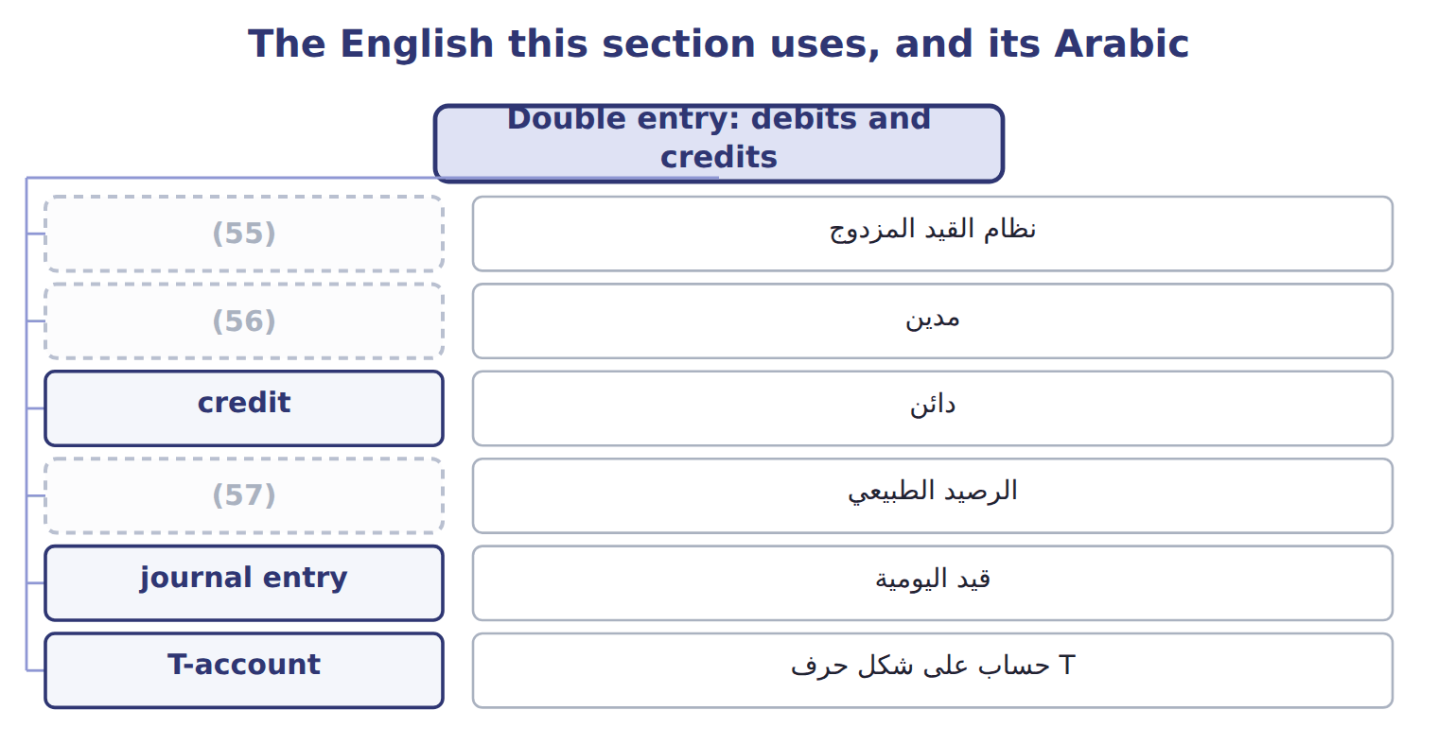
word list
par value · normal balance · double-entry system · debit

The English this sheet uses, and its Arabic
English (exam term) | Arabic
double-entry system | نظام القيد المزدوج
debit | مدين
credit | دائن
normal balance | الرصيد الطبيعي
journal entry | قيد اليومية
T-account | حساب على شكل حرف T
trial balance | ميزان المراجعة
contra account | حساب مقابل (حساب عكسي)
accumulated depreciation | مجمع الإهلاك (مجمع الاستهلاك / الاهتلاك)
allowance for credit losses | مخصص الخسائر الائتمانية
accounts receivable | الذمم المدينة (المدينون)
accounts payable | الذمم الدائنة (الدائنون)
inventory | المخزون
cost of goods sold | تكلفة البضاعة المباعة
notes payable | أوراق الدفع

Answer key · 1.3 Double entry: debits and credits

1 double-entry | 30 financing
2 affects | 31 delivers
3 accounting | 32 liability
4 simply | 33 February
5 Whether | 34 equation
6 expanded | 35 equity
7 dividends | 36 dividend
8 equity | 37 retained
9 opposite | 38 revenue
10 depreciation | 39 Buying
11 belongs | 40 transactions
12 receivable | 41 credit
13 pastries | 42 Supermarkets
14 exchange | 43 warehouse
15 transactions | 44 pastries
16 Amounts | 45 dividend
17 Jan 5 | 46 Recorded
18 Borrowed | 47 Complete
19 Equipment | 48 journal
20 Cash | 49 credited
21 bottling | 50 transaction
22 Accounts receivable | 51 depreciation
23 Sales revenue | 52 asset
24 Jan 31 | 53 liability
25 Wages expense | 54 reserve
26 Totals | 55 double-entry system
27 credits | 56 debit
28 points | 57 normal balance
29 owners

the summaries in full
Summary 1 Accountants record every transaction with the double-entry system. Each transaction affects at least two accounts, and total debits always equal total credits. This is why the accounting equation always balances. Debit simply means the left side of an account, and credit means the right side. Neither word means good or bad, and neither word always means increase. Whether a debit increases an account depends on the type of account. Each account has a normal balance: the side that increases it. The expanded equation at the bottom is a useful memory aid. Accounts on the left side of the equation (assets, expenses and dividends) increase with a debit. Accounts on the right side (liabilities, equity and revenues) increase with a credit. A contra account reduces a related account, so it has the opposite normal balance. For example, accumulated depreciation reduces equipment. It has a credit balance, but it belongs with the assets. The allowance for credit losses reduces accounts receivable in the same way.
Summary 2 Orontes Foods, Inc. makes olive oil and tahini in Amman, Jordan, and frozen pastries in Dubai. Its shares are listed on a U.S. stock exchange, and it reports under U.S. GAAP. Here are its journal entries for six transactions in January 2025. Amounts are in USD 000.
Summary 3 Check each entry: the debits equal the credits. Read the grid row by row. Three points matter for the exam. Rows 1 and 2 bring in cash of 2,300 in total, but no revenue. Money from owners and lenders is financing. Row 4 creates revenue of 300 but no cash. Orontes records revenue when it delivers the goods, not when the customer pays. Row 6 reduces retained earnings by 50 and creates a liability. No cash moves until February, and net income does not change. The totals prove the equation. Assets rose by 2,380, liabilities rose by 850 and equity rose by 1,530.
Summary 4 A dividend is not an expense. It reduces retained earnings, not net income. Cash from borrowing or from issuing shares is not revenue. Buying equipment for cash is not an expense today. One asset (cash) becomes another asset (equipment). The cost becomes an expense later, through depreciation.
Summary 5 Here are six transactions from February (USD 000). Feb 3: Paid a supplier for olives bought on credit in January. Feb 8: Collected part of the January receivable from GreenBasket Supermarkets. Feb 10: Paid 12 months of warehouse rent in advance. Feb 12: A Dubai hotel group paid cash in advance for pastries that Orontes will deliver in March. Feb 15: Paid the dividend declared on January 31. Feb 28: Recorded one month of interest on the bank note. Orontes has not paid it yet. Rows 1 to 3 are done for you. Complete rows 4 to 6. Then write the journal entries for rows 4 to 6.
Summary 6 X is debited (or credited) for an amount: Cash is debited for 1,500. Exam stems often say: The effect of this transaction is to increase... In English, always say depreciation. An allowance (for example, the allowance for credit losses) reduces an asset. A provision is a liability. Never say reserve for bad debts in a U.S. GAAP answer. That is the bank's view. Do not use banking habits to guess the accounting side.

1.4 The accrual basis and the matching principle
Chapter 1 · section 1.4

Fill every gap. Each word list holds one word more than there are gaps.
Summary 1 gaps 1–12
When should a company record (1) and expenses? U.S. GAAP financial (2) use the accrual basis. Under the accrual basis, a company records revenue when it earns it, that is, when it (3) the goods or (4) . It records expenses when it (5) them. The (6) of the cash does not (7) the period. The cash basis records items only when cash is (8) or paid. The cash basis is (9) , but it is not (10) under U.S. GAAP. On (11) 20, 2025, Orontes ships olive oil to GreenBasket (12) and sends an invoice for 90. The goods cost Orontes 54. GreenBasket pays on January 15, 2026. Under the accrual basis, Orontes records the revenue and the cost of goods sold in fiscal 2025, the year it delivered the goods. The gross profit of 36 belongs to 2025.
word list
incurs · delivers · simple · services · acceptable · December · decide · belongs · revenues · received · statements · Supermarkets · timing

Summary 2 gaps 13–24
In (13) , the cash receipt only changes one asset (the (14) ) into another asset (cash). Under the cash basis, the revenue would fall in 2026, which is the wrong period. The matching (15) says: record expenses in the same period as the revenues they help to produce. There are three ways to apply it. Some costs link (16) to a sale. Cost of goods sold is the (17) example: Orontes records it at the same time as the sales revenue. (18) and rational allocation. Some costs help many periods, such as a (19) line. (20) spreads the cost over the years of use. Some costs have no clear link to future revenue, such as most (21) and office salaries. They are expenses in the period in which they are (22) . The accrual basis creates four common types of (23) . You met three of them in the February (24) .
word list
advertising · bottling · transactions · classic · T-account · principle · receivable · Depreciation · incurred · Systematic · directly · January · adjustment

Timeline of a December sale collected in January: accrual basis versus cash basis
Every item belongs to exactly one group.
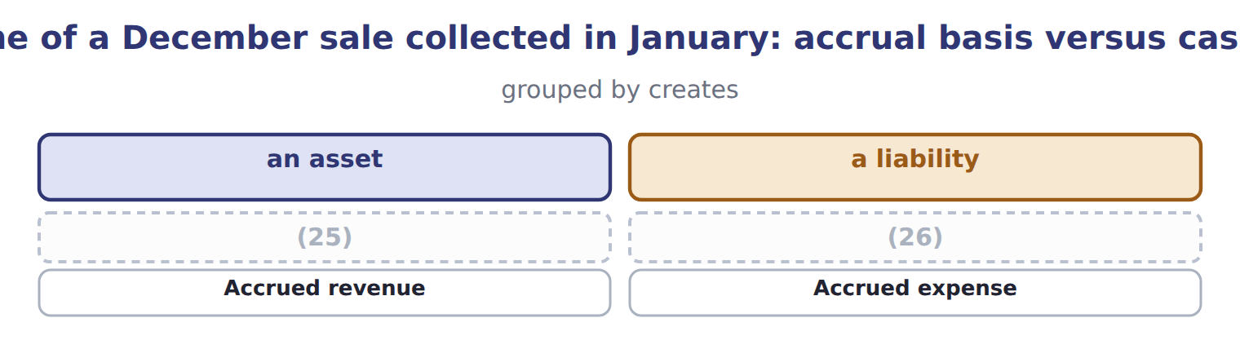
word list
allowance for credit losses · Contract liability, or unearned revenue (deferral) · Prepaid expense (deferral)

Summary 3 gaps 27–29
Two of these names are (27) for the exam. A prepaid (28) is an asset: the company has paid for a future benefit. A contract liability (unearned (29) ) is a liability: the company must still deliver the goods or services.
word list
advertising · expense · important · revenue

Cash is not the trigger

Summary 4 gaps 30–31
Cash received in advance is a (30) , not revenue. Cash paid in advance is an asset, not an (31) . Matching means matching expenses to revenues, not to cash payments.
word list
Depreciation · expense · liability

The words this section uses
Each term sits against what it means.
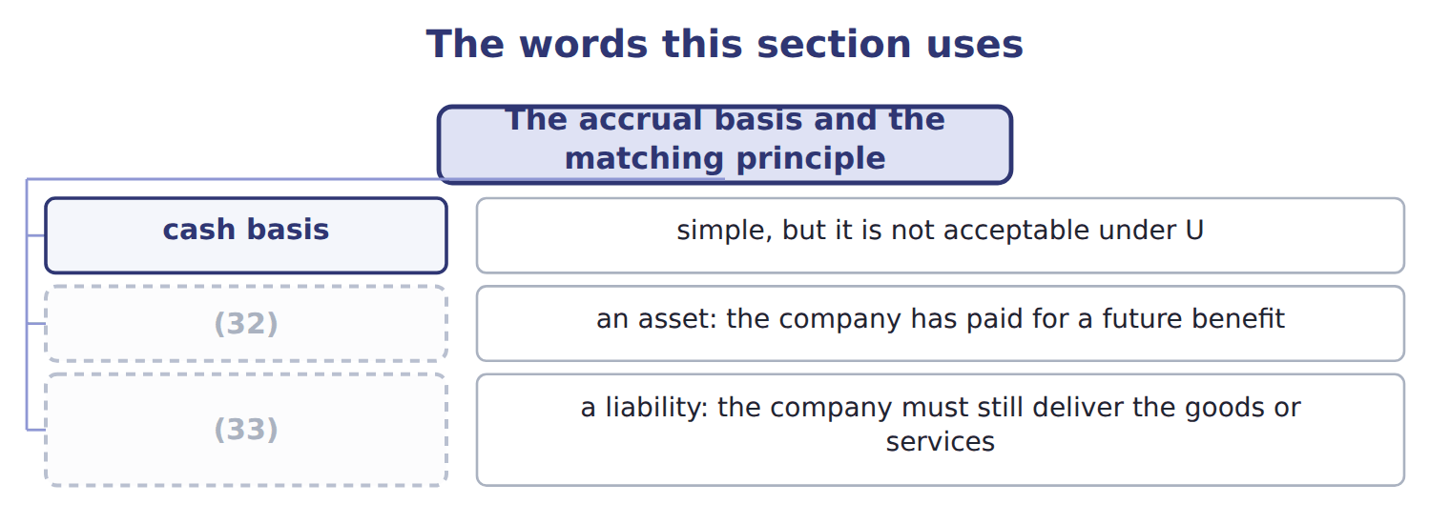
word list
faithful representation · prepaid expense · contract liability (unearned revenue)

The English this sheet uses, and its Arabic
English (exam term) | Arabic
accrual basis | أساس الاستحقاق
cash basis | الأساس النقدي
matching principle | مبدأ مقابلة الإيرادات بالمصروفات
prepaid expense | مصروف مدفوع مقدماً
contract liability (unearned revenue) | التزام العقد (إيراد مقبوض مقدماً)

Answer key · 1.4 The accrual basis and the matching principle

1 revenues | 18 Systematic
2 statements | 19 bottling
3 delivers | 20 Depreciation
4 services | 21 advertising
5 incurs | 22 incurred
6 timing | 23 adjustment
7 decide | 24 transactions
8 received | 25 Prepaid expense (deferral)
9 simple | 26 Contract liability, or unearned revenue (deferral)
10 acceptable | 27 important
11 December | 28 expense
12 Supermarkets | 29 revenue
13 January | 30 liability
14 receivable | 31 expense
15 principle | 32 prepaid expense
16 directly | 33 contract liability (unearned revenue)
17 classic

the summaries in full
Summary 1 When should a company record revenues and expenses? U.S. GAAP financial statements use the accrual basis. Under the accrual basis, a company records revenue when it earns it, that is, when it delivers the goods or services. It records expenses when it incurs them. The timing of the cash does not decide the period. The cash basis records items only when cash is received or paid. The cash basis is simple, but it is not acceptable under U.S. GAAP. On December 20, 2025, Orontes ships olive oil to GreenBasket Supermarkets and sends an invoice for 90. The goods cost Orontes 54. GreenBasket pays on January 15, 2026. Under the accrual basis, Orontes records the revenue and the cost of goods sold in fiscal 2025, the year it delivered the goods. The gross profit of 36 belongs to 2025.
Summary 2 In January, the cash receipt only changes one asset (the receivable) into another asset (cash). Under the cash basis, the revenue would fall in 2026, which is the wrong period. The matching principle says: record expenses in the same period as the revenues they help to produce. There are three ways to apply it. Some costs link directly to a sale. Cost of goods sold is the classic example: Orontes records it at the same time as the sales revenue. Systematic and rational allocation. Some costs help many periods, such as a bottling line. Depreciation spreads the cost over the years of use. Some costs have no clear link to future revenue, such as most advertising and office salaries. They are expenses in the period in which they are incurred. The accrual basis creates four common types of adjustment. You met three of them in the February transactions.
Summary 3 Two of these names are important for the exam. A prepaid expense is an asset: the company has paid for a future benefit. A contract liability (unearned revenue) is a liability: the company must still deliver the goods or services.
Summary 4 Cash received in advance is a liability, not revenue. Cash paid in advance is an asset, not an expense. Matching means matching expenses to revenues, not to cash payments.

1.5 Who writes the rules? U.S. GAAP and IFRS
Chapter 1 · section 1.5

Fill every gap. Each word list holds one word more than there are gaps.
Summary 1 gaps 1–12
In the United States, the accounting rules are called U.S. GAAP ( (1) accepted accounting (2) ). The FASB (Financial Accounting Standards Board) (3) them. The FASB is a private, independent (4) . It keeps all U.S. GAAP in one place: the Accounting Standards Codification (ASC). The ASC is the single source of authoritative (5) U.S. GAAP. It is (6) by topic numbers. For example, ASC 606 covers (7) and ASC 842 covers leases. When the FASB (8) a rule, it issues an Accounting Standards Update (ASU), which amends the Codification. The SEC ( (9) and Exchange Commission) is a U.S. government agency. It has legal authority over the financial reporting of public companies, and it (10) the FASB as the standard setter. For companies that (11) to the SEC, SEC rules are also part of authoritative GAAP. Do not confuse these bodies with the PCAOB, which (12) the audits of public companies.
word list
generally · recognizes · changes · oversees · nongovernmental · report · principles · Securities · writes · organization · authoritative · revenue · organized

Summary 2 gaps 13–24
The PCAOB sets (13) standards, not accounting standards. (14) the United States, many countries use IFRS (International (15) Reporting Standards). The (16) (International Accounting Standards Board) issues them, under the IFRS (17) . Many countries in the (18) East and North Africa, for example Jordan and the United Arab (19) , require IFRS for listed companies. The CMA exam tests U.S. GAAP. (20) , Section A also asks about the main (21) between U.S. GAAP and IFRS. If you (22) accounting under IFRS, this is good news: most (23) are the same. Every chapter has an IFRS (24) box, so. Both systems rest on a conceptual framework: the basic ideas behind the standards, such as the users, the elements and the qualities of useful information. You studied the U.S. version in Sections 1.1 and 1.2.
word list
expense · Emirates · auditing · Financial · Outside · learned · Middle · However · Foundation · differences · Contrast · concepts · IASB

U.S. GAAP (used on the exam) — IFRS
The two sides differ only where the rows say.
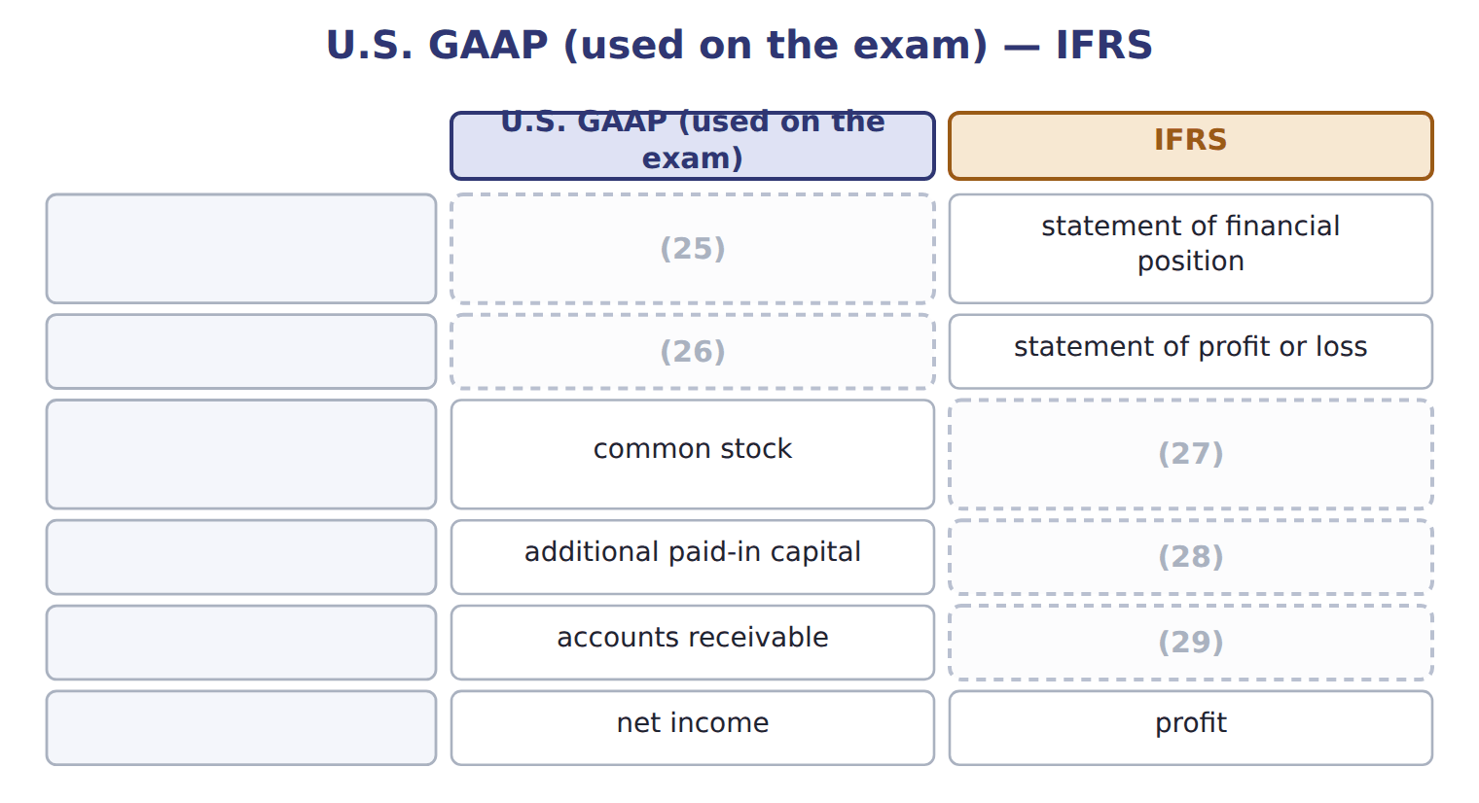
word list
balance sheet · income statement · share capital (ordinary shares) · trade receivables · share premium · primary users

Four bodies, four jobs

Summary 3 gaps 30–31
FASB: (30) U.S. GAAP (the ASC). SEC: U.S. (31) agency with legal authority over public company reporting. PCAOB: sets auditing standards for audits of public companies.
word list
between · writes · government

The English this section uses, and its Arabic
Each term sits against what it means.
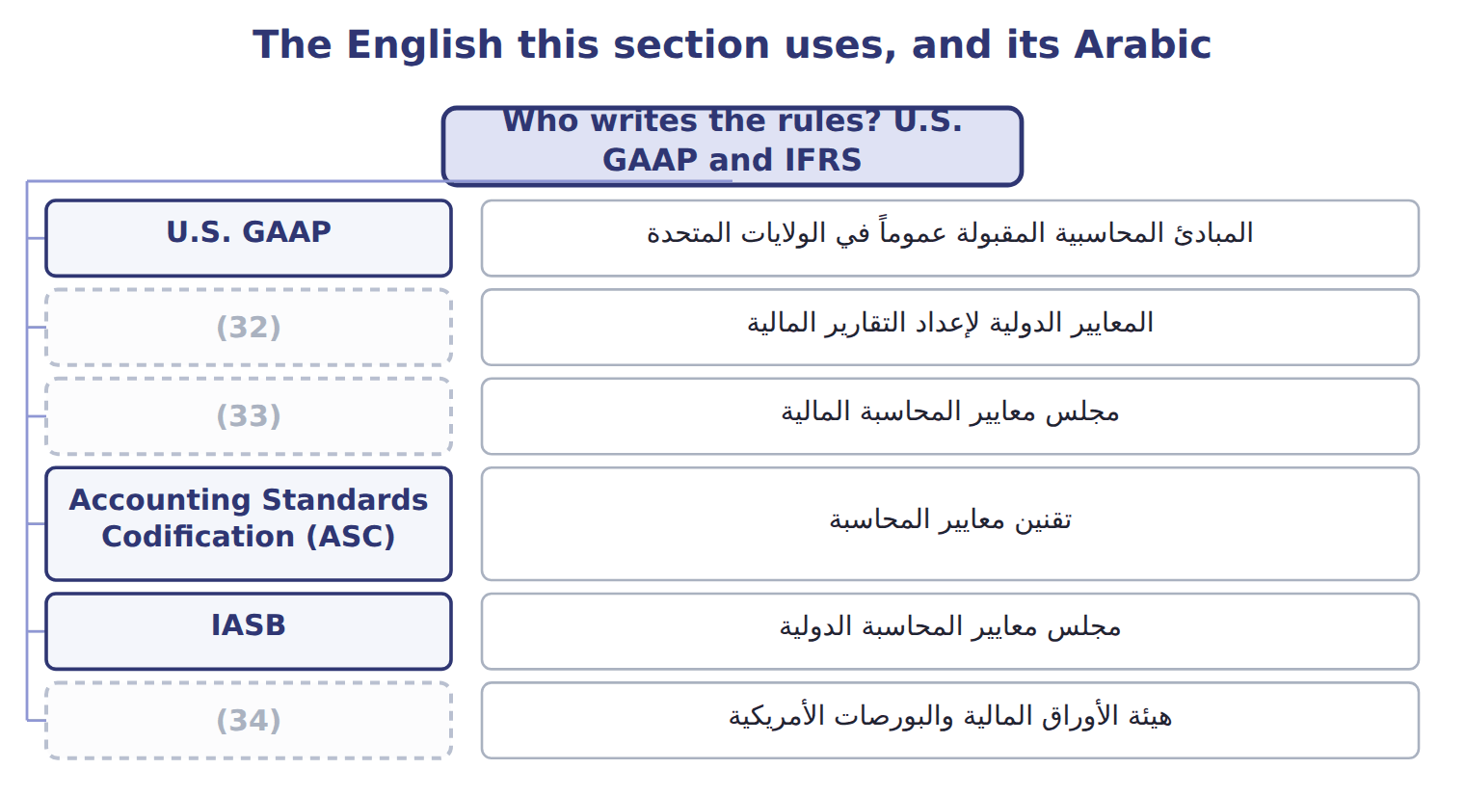
word list
FASB · IFRS · SEC · expense

The English this sheet uses, and its Arabic
English (exam term) | Arabic
U.S. GAAP | المبادئ المحاسبية المقبولة عموماً في الولايات المتحدة
IFRS | المعايير الدولية لإعداد التقارير المالية
FASB | مجلس معايير المحاسبة المالية
Accounting Standards Codification (ASC) | تقنين معايير المحاسبة
IASB | مجلس معايير المحاسبة الدولية
SEC | هيئة الأوراق المالية والبورصات الأمريكية
conceptual framework | الإطار المفاهيمي

Answer key · 1.5 Who writes the rules? U.S. GAAP and IFRS

1 generally | 18 Middle
2 principles | 19 Emirates
3 writes | 20 However
4 organization | 21 differences
5 nongovernmental | 22 learned
6 organized | 23 concepts
7 revenue | 24 Contrast
8 changes | 25 balance sheet
9 Securities | 26 income statement
10 recognizes | 27 share capital (ordinary shares)
11 report | 28 share premium
12 oversees | 29 trade receivables
13 auditing | 30 writes
14 Outside | 31 government
15 Financial | 32 IFRS
16 IASB | 33 FASB
17 Foundation | 34 SEC

the summaries in full
Summary 1 In the United States, the accounting rules are called U.S. GAAP (generally accepted accounting principles). The FASB (Financial Accounting Standards Board) writes them. The FASB is a private, independent organization. It keeps all U.S. GAAP in one place: the Accounting Standards Codification (ASC). The ASC is the single source of authoritative nongovernmental U.S. GAAP. It is organized by topic numbers. For example, ASC 606 covers revenue and ASC 842 covers leases. When the FASB changes a rule, it issues an Accounting Standards Update (ASU), which amends the Codification. The SEC (Securities and Exchange Commission) is a U.S. government agency. It has legal authority over the financial reporting of public companies, and it recognizes the FASB as the standard setter. For companies that report to the SEC, SEC rules are also part of authoritative GAAP. Do not confuse these bodies with the PCAOB, which oversees the audits of public companies.
Summary 2 The PCAOB sets auditing standards, not accounting standards. Outside the United States, many countries use IFRS (International Financial Reporting Standards). The IASB (International Accounting Standards Board) issues them, under the IFRS Foundation. Many countries in the Middle East and North Africa, for example Jordan and the United Arab Emirates, require IFRS for listed companies. The CMA exam tests U.S. GAAP. However, Section A also asks about the main differences between U.S. GAAP and IFRS. If you learned accounting under IFRS, this is good news: most concepts are the same. Every chapter has an IFRS Contrast box, so. Both systems rest on a conceptual framework: the basic ideas behind the standards, such as the users, the elements and the qualities of useful information. You studied the U.S. version in Sections 1.1 and 1.2.
Summary 3 FASB: writes U.S. GAAP (the ASC). SEC: U.S. government agency with legal authority over public company reporting. PCAOB: sets auditing standards for audits of public companies.

1.6 A first look at the four statements
Chapter 1 · section 1.6

Fill every gap. Each word list holds one word more than there are gaps.
Each statement answers a different question for users. Here is the overview.
Statement — Question it answers
Every item belongs to exactly one group.
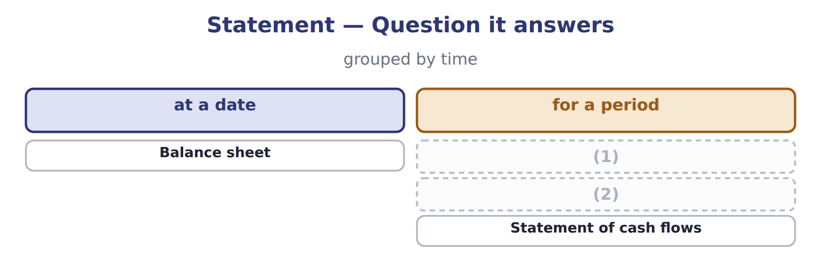
word list
Income statement · Statement of changes in equity · double-entry system

Summary 1 gaps 3–12
The four (3) are linked. Net income flows into retained earnings, and the net change in cash (4) the cash balance on the balance sheet. You can see both links in the January (5) of Orontes. The (6) declared was 50, so retained earnings rose by 30. Cash rose by 1,060: an (7) outflow of 40, an (8) outflow of 1,200 and a financing inflow of 2,300. (9) that net income and the change in cash are very (10) numbers. This is the (11) basis at work. A trial balance lists every (12) balance and checks that total debits equal total credits. You will use it in the section check below and in the practice set.
word list
operating · transactions · accrual · account · statements · Notice · dividend · investing · explains · describes · different

Barada Wholesale, Inc. — trial balance, December 31, 2025 (USD 000)
Account | Debit | Credit
(13) | 1,050
Accounts receivable | 300
(14) |  | 20
(15) | 420
(16) | 24
(17) | 936
Equipment | 4,200
(18) |  | 900
Accounts payable |  | 380
Dividends payable |  | 50
Notes payable (long-term) |  | 1,800
(19) |  | 600
(20) |  | 1,900
(21) |  | 1,000
Dividends declared | 50
Sales revenue |  | 3,100
Cost of goods sold | 1,860
Wages expense | 520
(22) | 300
Interest expense | 90
Totals | 9,750 | 9,750

word list
Cash · Depreciation expense · Additional paid-in capital · Accumulated depreciation · Retained earnings, January 1 · statement of financial position · Allowance for credit losses · Prepaid rent · Land · Common stock · Inventory

Reading exam questions

Net income, and how it is reached
The parts add up to the total; the bars are to scale.
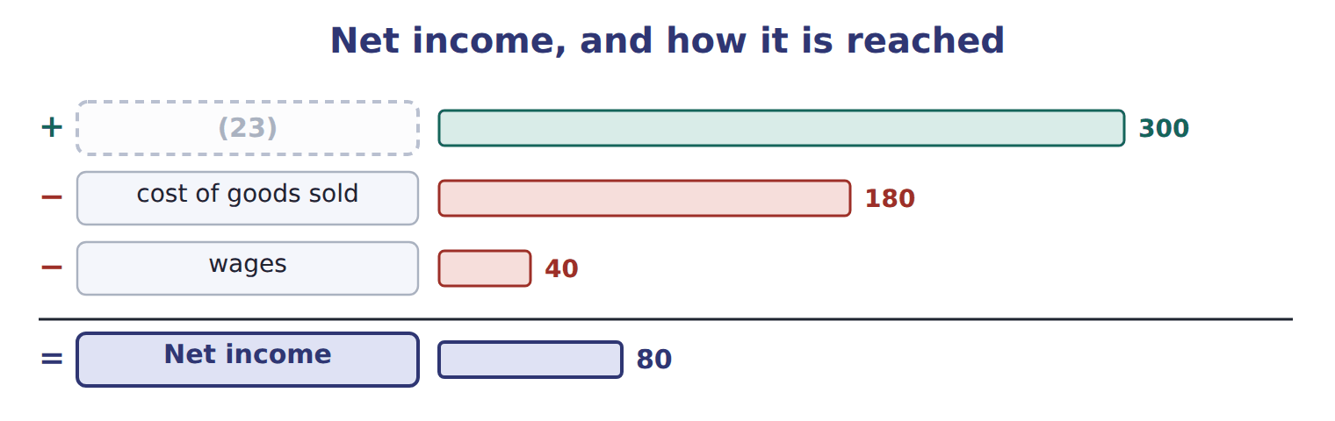
word list
revenue · disclose

Summary 2 gaps 24–25
MOST likely or BEST (24) : more than one option may be partly true. (25) the best one. NOT or EXCEPT: three options are true. Find the one that is false.
word list
retained · describes · Choose

Reading exam questions
Each stage leads to the next.
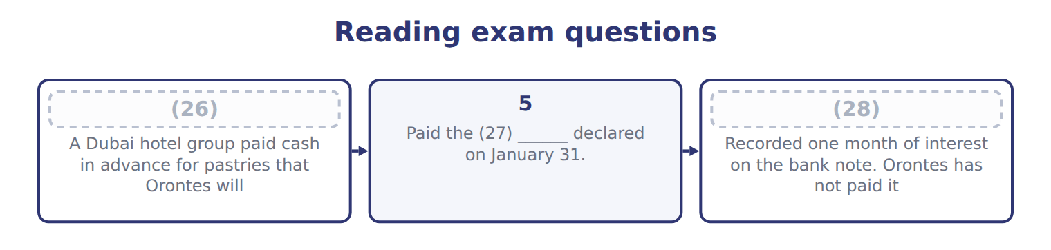
word list
credit · 6 · dividend · 4

Account — Category
Account | Category
Prepaid rent | Asset
Land | (29)
Dividends payable | Liability
Additional paid-in capital | (30)
Sales revenue | Revenue
Interest expense | Expense
Allowance for credit losses | (31)
Accumulated depreciation | Contra-asset

word list
Contra-asset · Asset · Equity · Transaction

The English this section uses, and its Arabic
Each term sits against what it means.
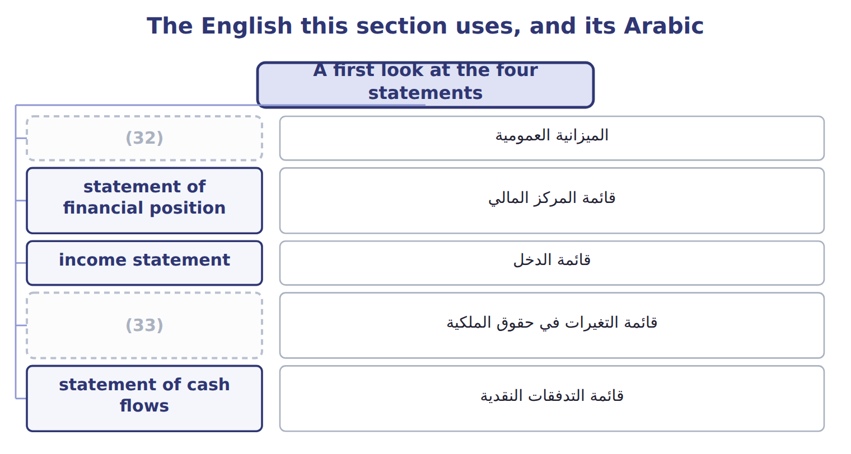
word list
statement of changes in equity · balance sheet · matching principle

The English this sheet uses, and its Arabic
English (exam term) | Arabic
balance sheet | الميزانية العمومية
statement of financial position | قائمة المركز المالي
income statement | قائمة الدخل
statement of changes in equity | قائمة التغيرات في حقوق الملكية
statement of cash flows | قائمة التدفقات النقدية

Answer key · 1.6 A first look at the four statements

1 Income statement | 18 Accumulated depreciation
2 Statement of changes in equity | 19 Common stock
3 statements | 20 Additional paid-in capital
4 explains | 21 Retained earnings, January 1
5 transactions | 22 Depreciation expense
6 dividend | 23 revenue
7 operating | 24 describes
8 investing | 25 Choose
9 Notice | 26 4
10 different | 27 dividend
11 accrual | 28 6
12 account | 29 Asset
13 Cash | 30 Equity
14 Allowance for credit losses | 31 Contra-asset
15 Inventory | 32 balance sheet
16 Prepaid rent | 33 statement of changes in equity
17 Land

the summaries in full
Summary 1 The four statements are linked. Net income flows into retained earnings, and the net change in cash explains the cash balance on the balance sheet. You can see both links in the January transactions of Orontes. The dividend declared was 50, so retained earnings rose by 30. Cash rose by 1,060: an operating outflow of 40, an investing outflow of 1,200 and a financing inflow of 2,300. Notice that net income and the change in cash are very different numbers. This is the accrual basis at work. A trial balance lists every account balance and checks that total debits equal total credits. You will use it in the section check below and in the practice set.
Summary 2 MOST likely or BEST describes: more than one option may be partly true. Choose the best one. NOT or EXCEPT: three options are true. Find the one that is false.

