12.1 What makes a liability current
Chapter 12 · section 12.1

Fill every gap. Each word list holds one word more than there are gaps.
Chapter 12, section by section
Each stage leads to the next.
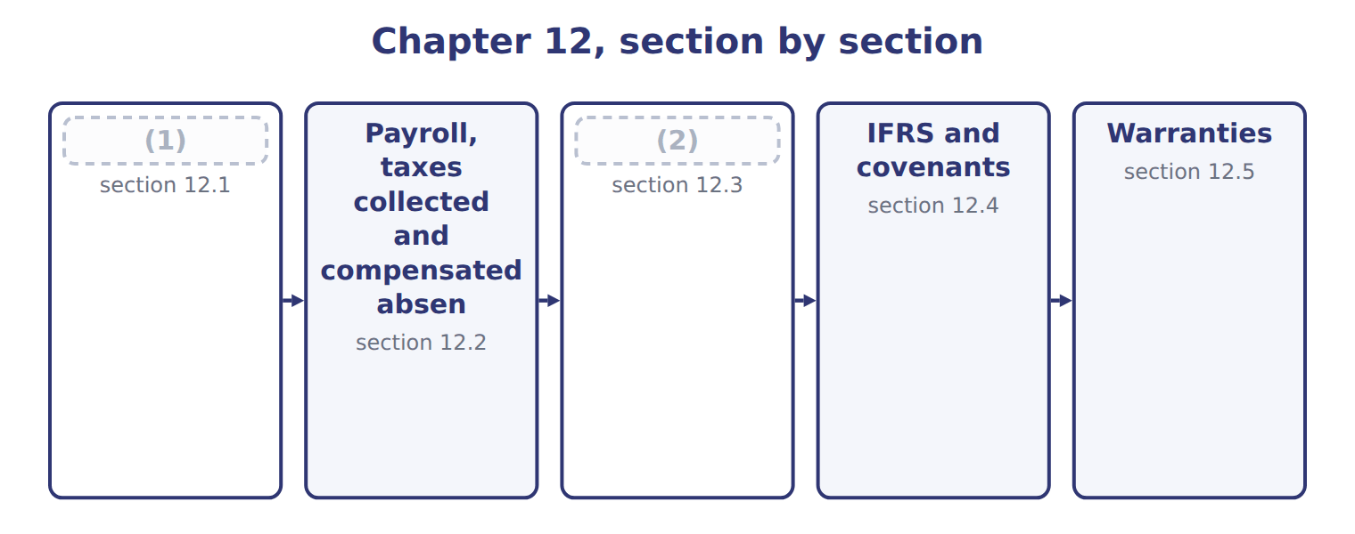
word list
Short-term debt expected to be refinanced · Payroll, taxes collected and compensated absen · What makes a liability current

Summary 1 gaps 3–7
Current liabilities are (3) that a company expects to settle by using current assets or by (4) other current liabilities, normally within one year. They are (5) at the amount to be paid. (6) the time is short, they are not (7) to present value. Accounts payable and accruals arise from operations; dividends payable and the current portion of long-term debt arise from financing.
word list
obligations · measured · delivers · discounted · Because · creating

Orontes's current liabilities at December 31, 2025
The parts add up to the total; the bars are to scale.
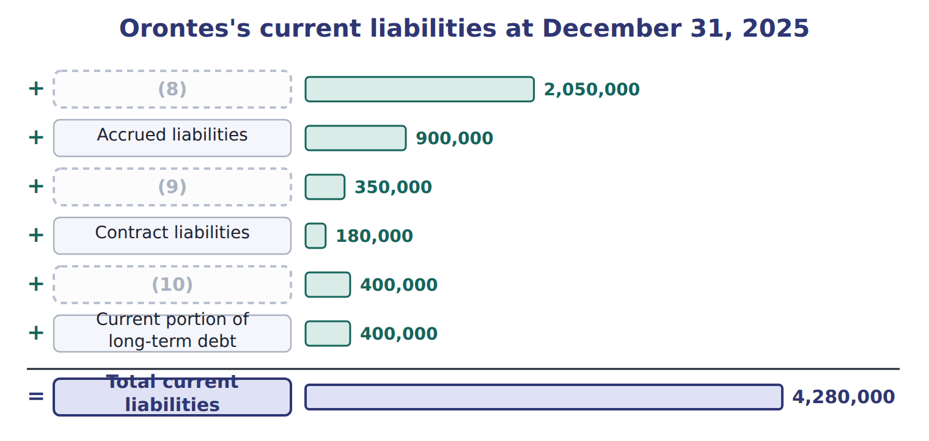
word list
Accounts payable · warranty liability · Income taxes payable · Dividends payable

Summary 2 gaps 11–13
Customer deposits are contract (11) : they become revenue when Orontes delivers. Cash dividends become a liability on the (12) date. A stock dividend (13) is not a liability, because no assets will be paid.
word list
liabilities · distributable · declaration · accruals

The words this section uses
Each term sits against what it means.
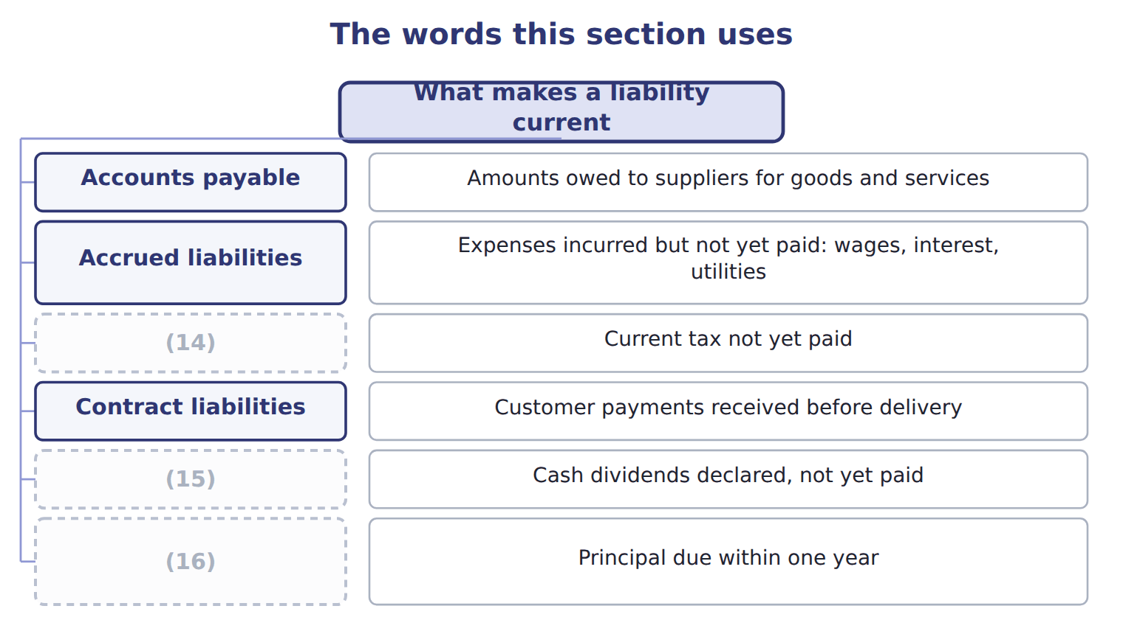
word list
Income taxes payable · Current portion of long-term debt · warranty liability · Dividends payable

Answer key · 12.1 What makes a liability current

1 What makes a liability current | 9 Income taxes payable
2 Short-term debt expected to be refinanced | 10 Dividends payable
3 obligations | 11 liabilities
4 creating | 12 declaration
5 measured | 13 distributable
6 Because | 14 Income taxes payable
7 discounted | 15 Dividends payable
8 Accounts payable | 16 Current portion of long-term debt

the summaries in full
Summary 1 Current liabilities are obligations that a company expects to settle by using current assets or by creating other current liabilities, normally within one year. They are measured at the amount to be paid. Because the time is short, they are not discounted to present value. Accounts payable and accruals arise from operations; dividends payable and the current portion of long-term debt arise from financing.
Summary 2 Customer deposits are contract liabilities: they become revenue when Orontes delivers. Cash dividends become a liability on the declaration date. A stock dividend distributable is not a liability, because no assets will be paid.

12.2 Payroll, taxes collected and compensated absences
Chapter 12 · section 12.2

Fill every gap. Each word list holds one word more than there are gaps.
Summary 1 gaps 1–12
Payroll (1) several liabilities. The employer deducts (2) , such as income tax and the employees' share of social security, from gross wages. These (3) belong to the government, so they are liabilities, not (4) . The (5) own payroll taxes, such as its share of social security, are an (6) expense. (7) Barada's gross wages for a month are $40,000. It withholds $4,000 of income tax and $2,800 of social security, so employees (8) $33,200. Barada's total payroll cost is the gross wages plus its own social security. Sales tax and VAT (9) from customers are also owed to the government. They are (10) as sales tax (11) , not as revenue. (12) absences, such as earned vacation, are accrued when employees have already worked for them, the rights vest or accumulate, and payment is probable.
word list
withholding · additional · revenue · Compensated · employer's · amounts · Suppose · creates · payable · recorded · receive · collected · expenses

Barada's payroll and sales tax

The first four rows are done. Complete the four blanks.
Suppose: Barada's payroll and sales tax for one month (complete the blanks)
Suppose: Barada, one month in 2027 | Whole USD
(13) | 40,000
(14) | 4,000
Employees' social security withheld (7%) | 2,800
(15) | 33,200
Employer's social security (payroll tax expense, 7%) | ________
Total owed to the tax authorities | ________
Cash register total, including 5% sales tax: 21,000. Sales revenue | ________
(16) | ________

word list
Gross wages for the month · Sales tax payable · qualifying financing agreement · Net pay to employees · Income tax withheld from employees

The English this section uses, and its Arabic
Each term sits against what it means.
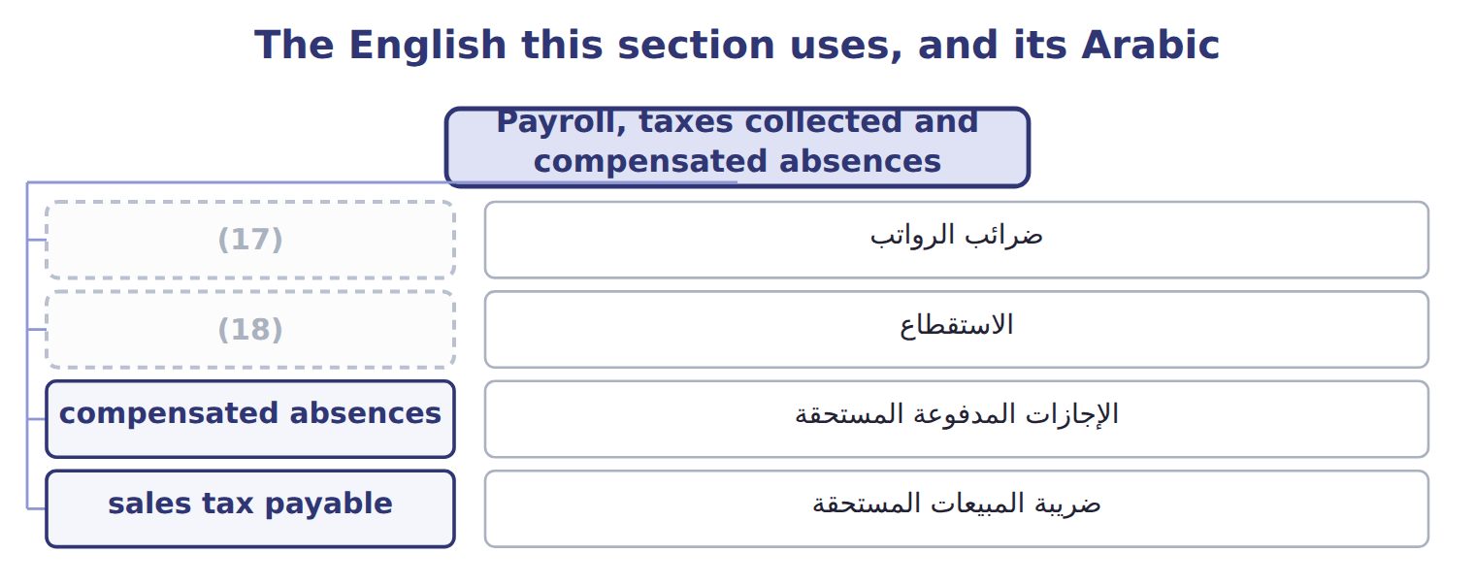
word list
withholding · compensated absences · payroll taxes

The English this sheet uses, and its Arabic
English (exam term) | Arabic
payroll taxes | ضرائب الرواتب
withholding | الاستقطاع
compensated absences | الإجازات المدفوعة المستحقة
sales tax payable | ضريبة المبيعات المستحقة

Answer key · 12.2 Payroll, taxes collected and compensated absences

1 creates | 10 recorded
2 withholding | 11 payable
3 amounts | 12 Compensated
4 expenses | 13 Gross wages for the month
5 employer's | 14 Income tax withheld from employees
6 additional | 15 Net pay to employees
7 Suppose | 16 Sales tax payable
8 receive | 17 payroll taxes
9 collected | 18 withholding

the summaries in full
Summary 1 Payroll creates several liabilities. The employer deducts withholding, such as income tax and the employees' share of social security, from gross wages. These amounts belong to the government, so they are liabilities, not expenses. The employer's own payroll taxes, such as its share of social security, are an additional expense. Suppose Barada's gross wages for a month are $40,000. It withholds $4,000 of income tax and $2,800 of social security, so employees receive $33,200. Barada's total payroll cost is the gross wages plus its own social security. Sales tax and VAT collected from customers are also owed to the government. They are recorded as sales tax payable, not as revenue. Compensated absences, such as earned vacation, are accrued when employees have already worked for them, the rights vest or accumulate, and payment is probable.

12.3 Short-term debt expected to be refinanced
Chapter 12 · section 12.3

Fill every gap. Each word list holds one word more than there are gaps.
Summary 1 gaps 1–10
A (1) obligation is (2) current. It may be shown as noncurrent only if the company intends to (3) it on a long-term basis and shows that it can. A (4) agreement does not expire within one year, cannot be (5) except for an objective violation, has no violation, and the lender can pay. An agreement that the lender may cancel for a ' (6) adverse change' does not qualify, because that clause is (7) . The noncurrent amount cannot (8) the amount refinanced or (9) . Debt repaid with current assets before the new (10) is obtained stays current. Refinanced debt moves to noncurrent liabilities, never to equity, even when shares are issued.
word list
subjective · exceed · qualifying · cancelled · financing · normally · proceeds · available · refinance · short-term · material

Worked example: Orontes's commercial paper

The set, member by member
The rows are a set, not a sequence.
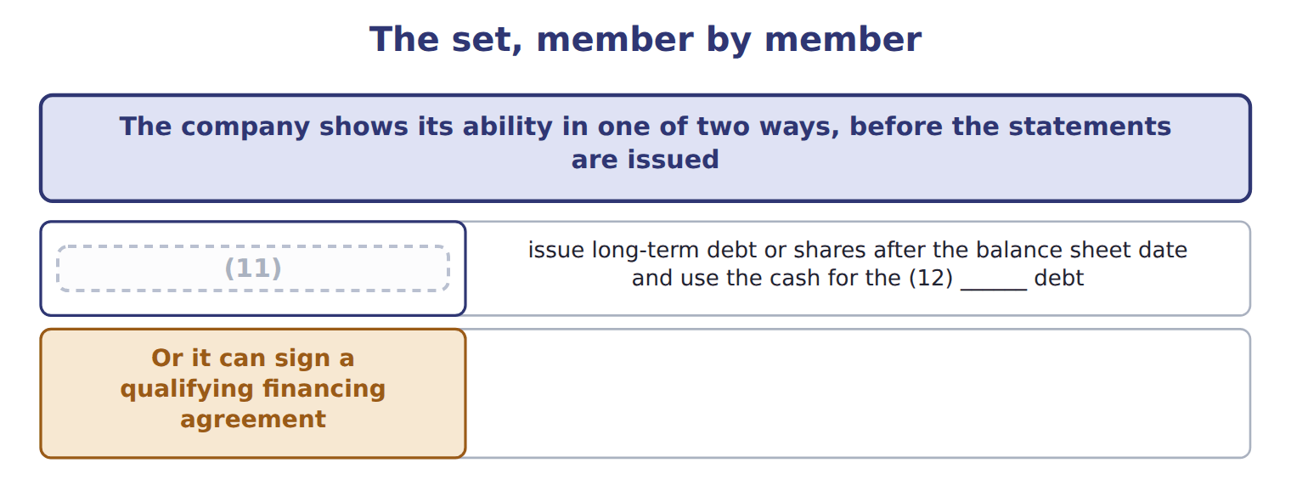
word list
It can actually refinance · short-term · warranty liability

Summary 2 gaps 13–18
Suppose Orontes has (13) paper of $3,000,000 due March 31, 2027, and intends to refinance it. Its 2026 (14) are issued on March 1, 2027. Scenario A. Bonds issued on (15) 10 replace the paper: the whole $3,000,000 is noncurrent. Scenario C. (16) issued for $2,400,000: that amount is noncurrent and $600,000 stays current. (17) moves to equity. Scenario D. A (18) agreement for 80% of inventory of at least $3,125,000: $2,500,000 noncurrent, $500,000 current.
word list
commercial · Shares · February · refinance · Nothing · qualifying · statements

Refinancing traps

Summary 3 gaps 19–20
Repaid first, refinanced later: still (19) . Refinanced with shares: noncurrent (20) up to the proceeds, not equity. A 'material adverse change' clause makes the agreement fail.
word list
current · February · liability

Suppose: five refinancing scenarios for Orontes's commercial paper
Suppose: Orontes, commercial paper of 3,000,000 | Noncurrent (U.S. GAAP) | Current (U.S. GAAP)
A. Issues 5-year bonds on February 10 and uses the cash to repay the paper at maturity | 3,000,000 | 0
B. Repays the paper with cash on January 15, then issues bonds on (21) 10 | 0 | 3,000,000
C. Issues shares on February 10 for 2,400,000 to repay the paper | 2,400,000 | 600,000
D. Signs a (22) agreement on February 1 to borrow 80% of inventory; inventory will not fall below 3,125,000 | 2,500,000 | 500,000
E. Same as D, but the lender may cancel if it sees a ' (23) adverse change' | 0 | 3,000,000

word list
qualifying · February · material · withholding

The English this section uses, and its Arabic
Each term sits against what it means.
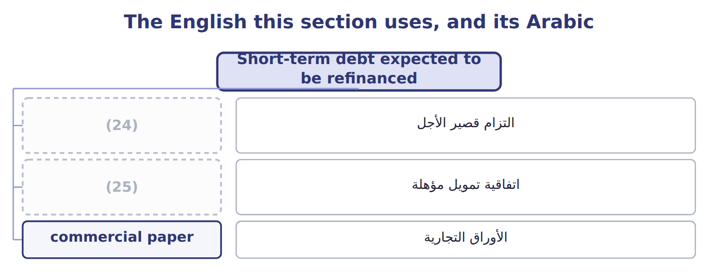
word list
qualifying financing agreement · اتفاقية تمويل مؤهلة · short-term obligation

The English this sheet uses, and its Arabic
English (exam term) | Arabic
short-term obligation | التزام قصير الأجل
qualifying financing agreement | اتفاقية تمويل مؤهلة
commercial paper | الأوراق التجارية

Answer key · 12.3 Short-term debt expected to be refinanced

1 short-term | 14 statements
2 normally | 15 February
3 refinance | 16 Shares
4 qualifying | 17 Nothing
5 cancelled | 18 qualifying
6 material | 19 current
7 subjective | 20 liability
8 exceed | 21 February
9 available | 22 qualifying
10 financing | 23 material
11 It can actually refinance | 24 short-term obligation
12 short-term | 25 qualifying financing agreement
13 commercial

the summaries in full
Summary 1 A short-term obligation is normally current. It may be shown as noncurrent only if the company intends to refinance it on a long-term basis and shows that it can. A qualifying agreement does not expire within one year, cannot be cancelled except for an objective violation, has no violation, and the lender can pay. An agreement that the lender may cancel for a 'material adverse change' does not qualify, because that clause is subjective. The noncurrent amount cannot exceed the amount refinanced or available. Debt repaid with current assets before the new financing is obtained stays current. Refinanced debt moves to noncurrent liabilities, never to equity, even when shares are issued.
Summary 2 Suppose Orontes has commercial paper of $3,000,000 due March 31, 2027, and intends to refinance it. Its 2026 statements are issued on March 1, 2027. Scenario A. Bonds issued on February 10 replace the paper: the whole $3,000,000 is noncurrent. Scenario C. Shares issued for $2,400,000: that amount is noncurrent and $600,000 stays current. Nothing moves to equity. Scenario D. A qualifying agreement for 80% of inventory of at least $3,125,000: $2,500,000 noncurrent, $500,000 current.
Summary 3 Repaid first, refinanced later: still current. Refinanced with shares: noncurrent liability up to the proceeds, not equity. A 'material adverse change' clause makes the agreement fail.

12.4 IFRS and covenants
Chapter 12 · section 12.4

Fill every gap. Each word list holds one word more than there are gaps.
Summary 1 gaps 1–7
IAS 1 asks only one question: at the reporting date, does the company have a right to defer (1) for at least twelve months? (2) agreed after the reporting date does not change the classification, even if it happens before the statements are issued. In (3) A, C and D above, an IFRS company would show the whole (4) paper as current. Covenants (5) the same logic. Under IFRS, only covenants that must be met on or before the reporting date (6) classification; future covenants are (7) .
word list
settlement · affect · Refinancing · scenarios · commercial · disclosed · follow · January

Classification, covenants and warranty costs: U.S. GAAP and IFRS
The two sides differ only where the rows say.
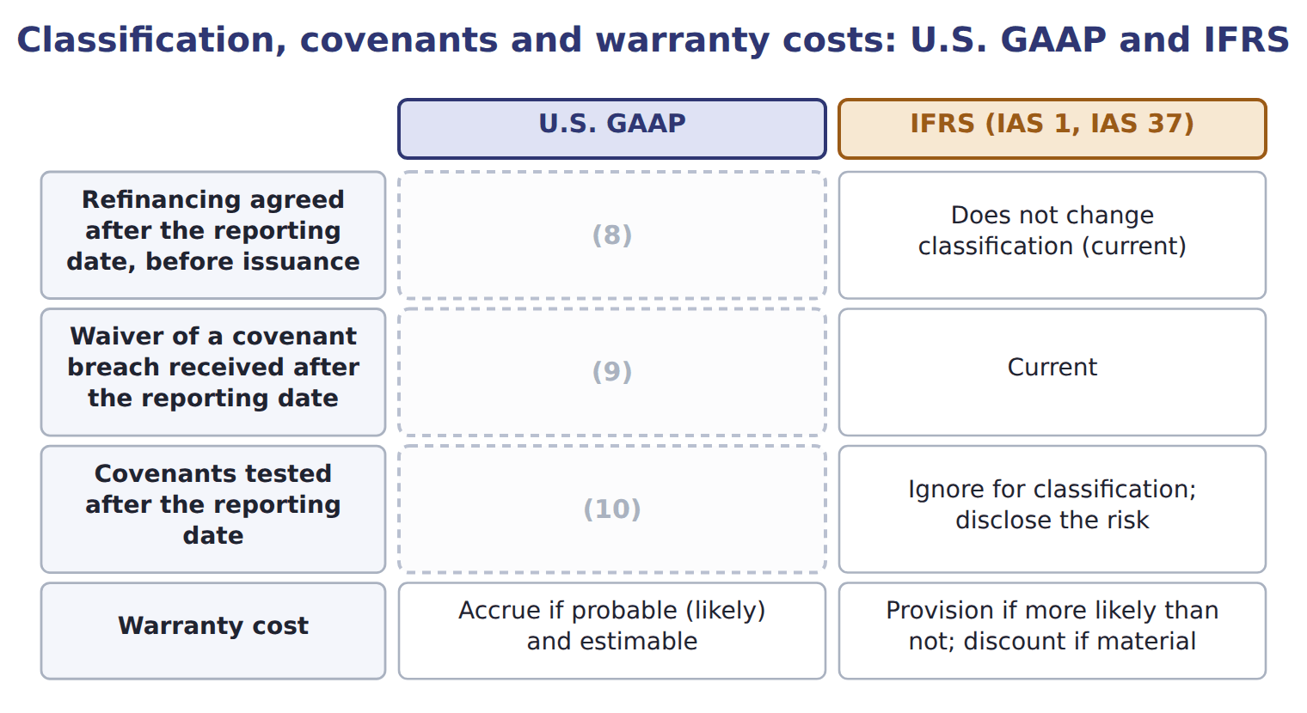
word list
Consider only violations at the balance sheet date · Noncurrent if the waiver lasts more than one year · Can make the debt noncurrent · Accrue if probable (likely) and estimable

Summary 2 gaps 11–13
The IAS 1 amendments on (11) and covenants apply from January 1, 2024, and are testable now as IFRS (12) . They confirm that (13) intention to refinance does not matter; only rights at the reporting date do.
word list
contrasts · Covenants · classification · management's

Answer key · 12.4 IFRS and covenants

1 settlement | 8 Can make the debt noncurrent
2 Refinancing | 9 Noncurrent if the waiver lasts more than one year
3 scenarios | 10 Consider only violations at the balance sheet date
4 commercial | 11 classification
5 follow | 12 contrasts
6 affect | 13 management's
7 disclosed

the summaries in full
Summary 1 IAS 1 asks only one question: at the reporting date, does the company have a right to defer settlement for at least twelve months? Refinancing agreed after the reporting date does not change the classification, even if it happens before the statements are issued. In scenarios A, C and D above, an IFRS company would show the whole commercial paper as current. Covenants follow the same logic. Under IFRS, only covenants that must be met on or before the reporting date affect classification; future covenants are disclosed.
Summary 2 The IAS 1 amendments on classification and covenants apply from January 1, 2024, and are testable now as IFRS contrasts. They confirm that management's intention to refinance does not matter; only rights at the reporting date do.

12.5 Warranties
Chapter 12 · section 12.5

Fill every gap. Each word list holds one word more than there are gaps.
Summary 1 gaps 1–11
An (1) warranty only (2) that a product will work as agreed. It is not a separate performance obligation. The company (3) the repair cost at the time of sale, (4) warranty expense and a warranty liability, and reduces the liability as repairs are made. A service-type warranty gives the (5) an extra service, such as (6) cover. It is a separate performance obligation: part of the price is recorded as a (7) liability and (8) as revenue over the coverage period. A warranty that customers can buy (9) is always service-type. Suppose Orontes sells 2,000 beverage (10) in 2026 for $3,000,000, with a (11) assurance warranty. It expects repairs to cost 2% of sales. It also sells 400 three-year service plans for $120 each.
word list
contract · estimates · dispensers · customer · recognized · assurance-type · beverage · separately · promises · extended · records · one-year

Suppose: Orontes's warranty entries for 2026
The bars are drawn to scale.
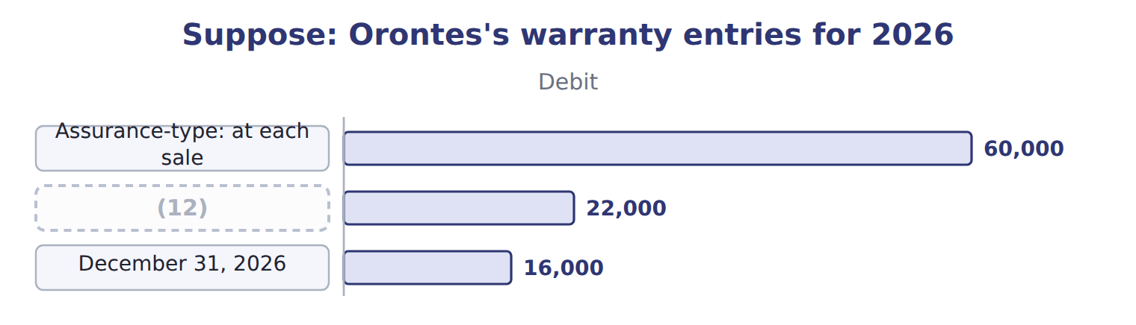
word list
Assurance-type: at each sale · Repairs made in 2026

Summary 2 gaps 13–15
The (13) liability is the (14) of $60,000 minus repairs of $22,000: $38,000. The service plans are a (15) liability of $32,000, of which the part to be earned in 2027 is current.
word list
warranty · contract · service · accrual

Warranty traps

Summary 3 gaps 16–18
Standard warranty: accrue the cost at the sale; do not defer revenue. Extended plan sold (16) : defer revenue; do not accrue a cost. (17) warranty costs in the year of the sale, not when (18) are paid.
word list
separately · Expense · Suppose · repairs

Warranty traps
Barada Wholesale, selected liabilities, December | Amount / details
Accounts payable | 450
Bank loan due April 30, 2028 | 400
Note payable due in 2029 (from the Chapter 2 case) | 1,500
Dividends payable | 60
Customer deposits for orders to be delivered in 2028 | 40
Wages payable / income tax withheld / employer payroll taxes | 25 / 5 / 3
M1 | On February 15, 2028, before the statements were issued on March 1, 2028, Barada signed a (19) three-year agreement. The bank will
M2 | In 2027 Barada began selling kitchen (20) with a one-year warranty that the product works as agreed. Sales were 1000; expected repairs
M3 | Barada also sold (21) priced three-year service plans for 36, all starting on January 1, 2027.
M4 | Deferred tax balances are not shown here; Chapter 13 covers them.

word list
separately · non-cancelable · equipment · Debit

Item — Answer
Item | Answer
Employer's social security | (22)
Total owed to the tax authorities | 4,000 + 2,800 + 2,800 = 9,600
Sales revenue | (23)
Sales tax payable | 21,000 − 20,000 = 1,000

word list
7% × 40,000 = 2,800 (payroll tax expense) · Split between current and noncurrent · 21,000 ÷ 1.05 = 20,000

Item — Category
Item | Category
Bank loan | (24)
Note payable due 2029 | (25)
Warranty liability (M2) | Current liability
Service plans (M3) | Split between current and noncurrent
Customer deposits | (26)

word list
Noncurrent liability · Current liability · Split between current and noncurrent · 25 / 5 / 3

The English this section uses, and its Arabic
Each term sits against what it means.
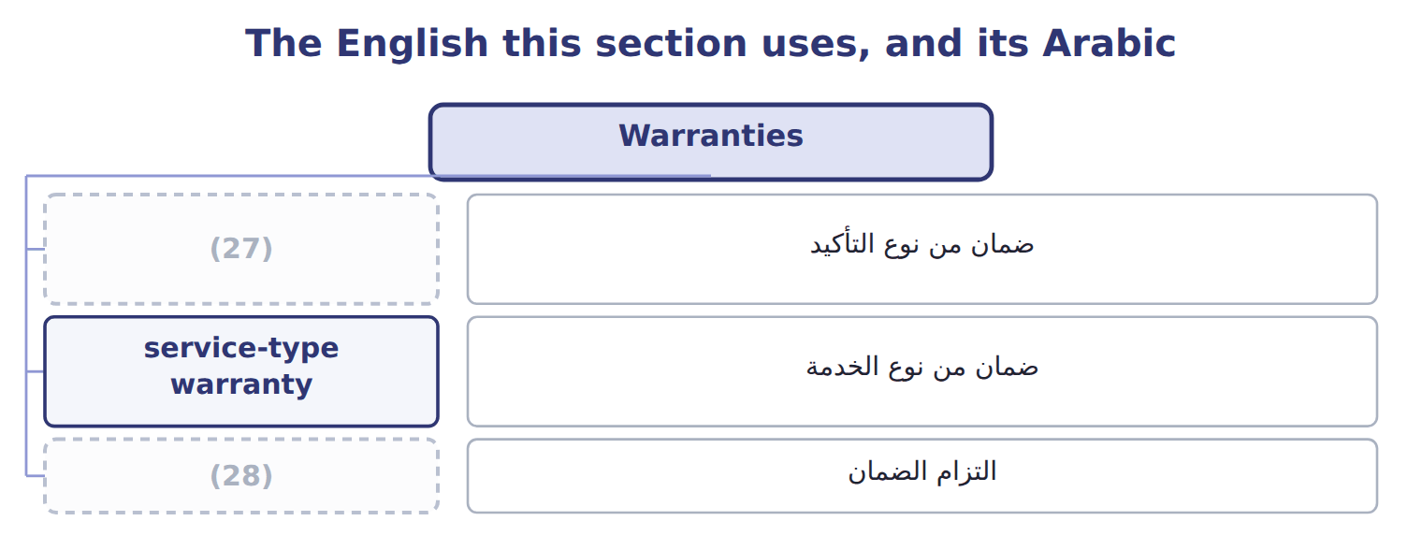
word list
warranty liability · assurance-type warranty · service-type warranty

The English this sheet uses, and its Arabic
English (exam term) | Arabic
assurance-type warranty | ضمان من نوع التأكيد
service-type warranty | ضمان من نوع الخدمة
warranty liability | التزام الضمان

Answer key · 12.5 Warranties

1 assurance-type | 15 contract
2 promises | 16 separately
3 estimates | 17 Expense
4 records | 18 repairs
5 customer | 19 non-cancelable
6 extended | 20 equipment
7 contract | 21 separately
8 recognized | 22 7% × 40,000 = 2,800 (payroll tax expense)
9 separately | 23 21,000 ÷ 1.05 = 20,000
10 dispensers | 24 Split between current and noncurrent
11 one-year | 25 Noncurrent liability
12 Repairs made in 2026 | 26 Current liability
13 warranty | 27 assurance-type warranty
14 accrual | 28 warranty liability

the summaries in full
Summary 1 An assurance-type warranty only promises that a product will work as agreed. It is not a separate performance obligation. The company estimates the repair cost at the time of sale, records warranty expense and a warranty liability, and reduces the liability as repairs are made. A service-type warranty gives the customer an extra service, such as extended cover. It is a separate performance obligation: part of the price is recorded as a contract liability and recognized as revenue over the coverage period. A warranty that customers can buy separately is always service-type. Suppose Orontes sells 2,000 beverage dispensers in 2026 for $3,000,000, with a one-year assurance warranty. It expects repairs to cost 2% of sales. It also sells 400 three-year service plans for $120 each.
Summary 2 The warranty liability is the accrual of $60,000 minus repairs of $22,000: $38,000. The service plans are a contract liability of $32,000, of which the part to be earned in 2027 is current.
Summary 3 Standard warranty: accrue the cost at the sale; do not defer revenue. Extended plan sold separately: defer revenue; do not accrue a cost. Expense warranty costs in the year of the sale, not when repairs are paid.

