2.1 Four cost behaviors
Chapter 2 · section 2.1

Fill every gap. Each word list holds one word more than there are gaps.
Chapter 2, section by section
Each stage leads to the next.
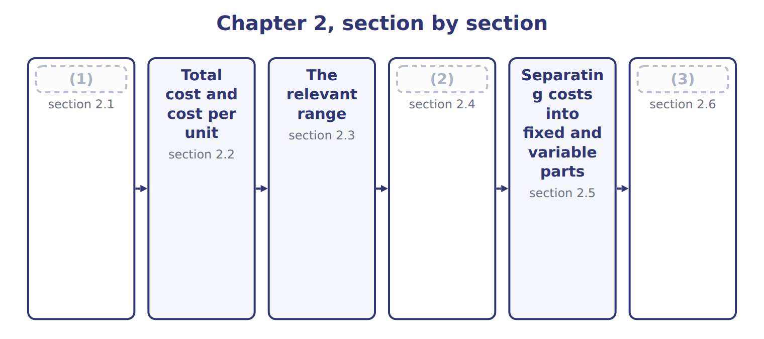
word list
Four cost behaviors · The time frame: short run and long run · Extended Example 2A: the Oils overhead budget, · Total cost and cost per unit

Summary 1 gaps 4–12
A (4) cost changes in total in (5) to activity. Power for the crushers costs $5 for every machine hour, so twice the hours means twice the power bill. A fixed cost stays the same in total when activity changes. Factory (6) costs $420,000 a year (7) the crushers run a (8) or a lot. A mixed cost has both parts: (9) and utilities cost $216,000 a year plus $12 per machine hour. A step cost is fixed over a band of activity and then jumps. Above the (10) range, Oils needs a (11) shift, which adds a (12) costing $180,000.
word list
supervision · variable · relevant · proportion · supervisor · whether · maintenance · machine · little · second

The English this section uses, and its Arabic
Each term sits against what it means.
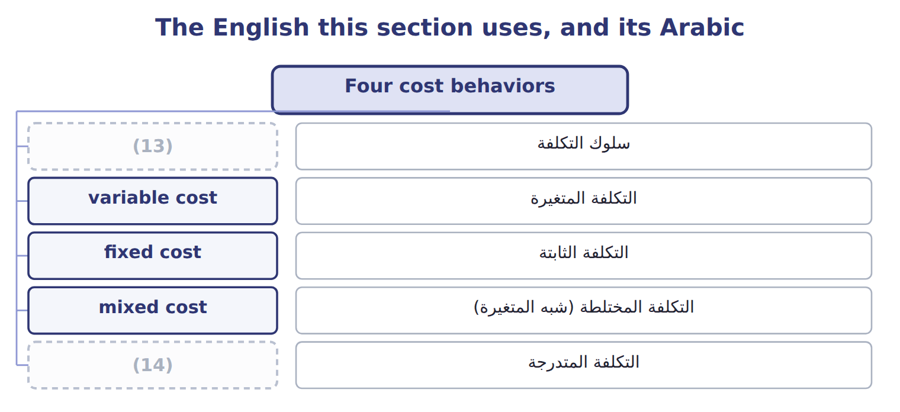
word list
mixed cost · step cost · cost behavior

The English this sheet uses, and its Arabic
English (exam term) | Arabic
cost behavior | سلوك التكلفة
variable cost | التكلفة المتغيرة
fixed cost | التكلفة الثابتة
mixed cost | التكلفة المختلطة (شبه المتغيرة)
step cost | التكلفة المتدرجة

Answer key · 2.1 Four cost behaviors

1 Four cost behaviors | 8 little
2 The time frame: short run and long run | 9 maintenance
3 Extended Example 2A: the Oils overhead budget, | 10 relevant
4 variable | 11 second
5 proportion | 12 supervisor
6 supervision | 13 cost behavior
7 whether | 14 step cost

the summaries in full
Summary 1 A variable cost changes in total in proportion to activity. Power for the crushers costs $5 for every machine hour, so twice the hours means twice the power bill. A fixed cost stays the same in total when activity changes. Factory supervision costs $420,000 a year whether the crushers run a little or a lot. A mixed cost has both parts: maintenance and utilities cost $216,000 a year plus $12 per machine hour. A step cost is fixed over a band of activity and then jumps. Above the relevant range, Oils needs a second shift, which adds a supervisor costing $180,000.

2.2 Total cost and cost per unit
Chapter 2 · section 2.2

Fill every gap. Each word list holds one word more than there are gaps.
Summary 1 gaps 1–3
The two basic (1) look opposite when you divide by (2) . Variable cost is constant per unit but changes in total. Fixed cost is constant in total but changes per unit: the more hours, the lower the fixed cost per hour. Total fixed overhead stays at $2,100,569, but fixed overhead per (3) hour falls from $70.02 to $43.76. Variable overhead stays at $20 per hour.
word list
behaviors · machine · activity · constant

Oils overhead in total and per machine hour at three volumes
Oils overhead, FY2027 (whole USD) | Low | Budget | High
(4) | 30,000 | 38,400 | 48,000
Total fixed overhead | 2,100,569 | 2,100,569 | 2,100,569
(5) | $70.02 | $54.70 | $43.76
(6) | 600,000 | 768,000 | 960,000
Variable overhead per MH | $20.00 | $20.00 | $20.00
Total overhead | 2,700,569 | 2,868,569 | 3,060,569
Total overhead per MH | $90.02 | $74.70 | $63.76

word list
Fixed overhead per MH · Machine hours · Total variable overhead ($20 per MH) · relevant range

Fixed cost per unit is not fixed

Summary 2 gaps 7–9
Do not (7) a fixed cost per unit by a new volume. Fixed cost per unit was (8) at one volume only. (9) the total fixed cost, then divide by the new volume if you need a unit figure.
word list
Budget · overhead · computed · multiply

The English this section uses, and its Arabic
Each term sits against what it means.
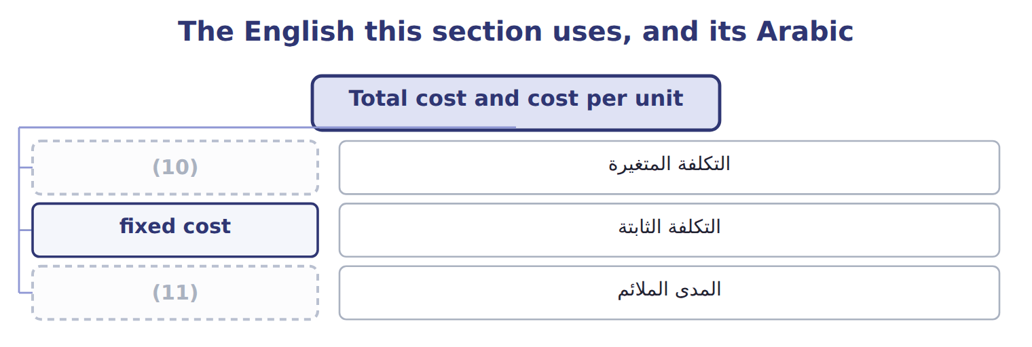
word list
cost behavior · relevant range · variable cost

Answer key · 2.2 Total cost and cost per unit

1 behaviors | 7 multiply
2 activity | 8 computed
3 machine | 9 Budget
4 Machine hours | 10 variable cost
5 Fixed overhead per MH | 11 relevant range
6 Total variable overhead ($20 per MH)

the summaries in full
Summary 1 The two basic behaviors look opposite when you divide by activity. Variable cost is constant per unit but changes in total. Fixed cost is constant in total but changes per unit: the more hours, the lower the fixed cost per hour. Total fixed overhead stays at $2,100,569, but fixed overhead per machine hour falls from $70.02 to $43.76. Variable overhead stays at $20 per hour.
Summary 2 Do not multiply a fixed cost per unit by a new volume. Fixed cost per unit was computed at one volume only. Budget the total fixed cost, then divide by the new volume if you need a unit figure.

2.3 The relevant range
Chapter 2 · section 2.3

Fill every gap. Each word list holds one word more than there are gaps.
Summary 1 gaps 1–10
The (1) range is the band of (2) in which the cost behavior assumptions hold. Oils has data from 2,000 to 4,300 (3) hours a month. (4) that range, maintenance and (5) follow $18,000 plus $12 per hour. Outside the range the (6) may fail. Above 4,300 hours a month Oils must run a (7) shift, so the fixed part jumps. Below the range, the $18,000 (8) is only an (9) : nobody has seen the plant at zero hours. A change in assumptions (10) the cost. If a new contract turns the maintenance charge into a fixed fee, the cost becomes fixed. If volume moves outside the range, a new cost function is needed.
word list
Inside · formula · changes · relevant · behavior · machine · second · activity · utilities · extrapolation · intercept

The English this sheet uses, and its Arabic
English (exam term) | Arabic
relevant range | المدى الملائم

Answer key · 2.3 The relevant range

1 relevant | 6 formula
2 activity | 7 second
3 machine | 8 intercept
4 Inside | 9 extrapolation
5 utilities | 10 changes

the summaries in full
Summary 1 The relevant range is the band of activity in which the cost behavior assumptions hold. Oils has data from 2,000 to 4,300 machine hours a month. Inside that range, maintenance and utilities follow $18,000 plus $12 per hour. Outside the range the formula may fail. Above 4,300 hours a month Oils must run a second shift, so the fixed part jumps. Below the range, the $18,000 intercept is only an extrapolation: nobody has seen the plant at zero hours. A change in assumptions changes the cost. If a new contract turns the maintenance charge into a fixed fee, the cost becomes fixed. If volume moves outside the range, a new cost function is needed.

2.4 The time frame: short run and long run
Chapter 2 · section 2.4

Fill every gap. Each word list holds one word more than there are gaps.
Summary 1 gaps 1–7
Whether a cost is fixed (1) on the time frame. In the short run, such as one (2) year, the press lease and (3) salaries cannot easily change. In the long run, (4) can end the lease, change the staff or buy new (5) , so every cost can change. Some fixed costs come from (6) decisions, such as leases and (7) : these are committed fixed costs. Others, such as training or advertising, are set each year by managers: these are discretionary fixed costs.
word list
machines · supervision · long-term · depends · depreciation · budget · training · Orontes

Short run and long run: four Oils costs
Oils cost | Behavior this year | Short run (why) | Long run
Olive-press lease (ROU amortization) | Fixed: 216,569 a year | Committed until the lease ends in 2029 | (8)
Factory supervision | Fixed: 420,000 a year | Salaries are set for the year | (9)
Maintenance & utilities | Mixed: 216,000 + $12 per MH | Fixed part is the service contract | (10)
Power for the crushers | Variable: $5 per MH | (11) | Rate can change with new machines

word list
Committed until the lease ends in 2029 · Changes only when the lease is renewed or ended · Staff can be added or removed · Contract can be resized · Moves with machine hours

Summary 2 gaps 12–13
For overhead rates and budgets, Orontes (12) overhead for one year at a time. That is the time frame the CMA exam usually assumes, unless a question says (13) .
word list
classifies · discretionary · otherwise

Charges fixes

Summary 3 gaps 14–15
In cost (14) , fixed means only 'does not change with (15) in this range and period'.
word list
activity · accounting · Whether

The English this section uses, and its Arabic
Each term sits against what it means.
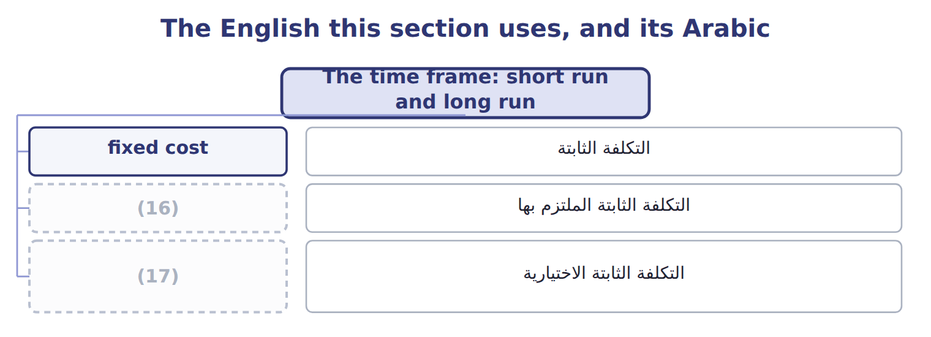
word list
التكلفة الثابتة الاختيارية · discretionary fixed cost · committed fixed cost

The English this sheet uses, and its Arabic
English (exam term) | Arabic
committed fixed cost | التكلفة الثابتة الملتزم بها
discretionary fixed cost | التكلفة الثابتة الاختيارية

Answer key · 2.4 The time frame: short run and long run

1 depends | 10 Contract can be resized
2 budget | 11 Moves with machine hours
3 supervision | 12 classifies
4 Orontes | 13 otherwise
5 machines | 14 accounting
6 long-term | 15 activity
7 depreciation | 16 committed fixed cost
8 Changes only when the lease is renewed or ended | 17 discretionary fixed cost
9 Staff can be added or removed

the summaries in full
Summary 1 Whether a cost is fixed depends on the time frame. In the short run, such as one budget year, the press lease and supervision salaries cannot easily change. In the long run, Orontes can end the lease, change the staff or buy new machines, so every cost can change. Some fixed costs come from long-term decisions, such as leases and depreciation: these are committed fixed costs. Others, such as training or advertising, are set each year by managers: these are discretionary fixed costs.
Summary 2 For overhead rates and budgets, Orontes classifies overhead for one year at a time. That is the time frame the CMA exam usually assumes, unless a question says otherwise.
Summary 3 In cost accounting, fixed means only 'does not change with activity in this range and period'.

2.5 Separating costs into fixed and variable parts
Chapter 2 · section 2.5

Fill every gap. Each word list holds one word more than there are gaps.
Summary 1 gaps 1–6
Budgets need a cost (1) : total cost = fixed cost + variable rate × (2) . To build it, each cost must be (3) into its fixed and variable parts. The simplest method is account analysis: an (4) reviews each account and (5) it by judgment. Mixed (6) need a second step. For maintenance and utilities, Oils uses the fixed monthly contract and the rate per machine hour estimated from its records.
word list
classifies · separated · accounts · accountant · Classify · activity · function

Worked example: the Oils overhead cost function

Adding the columns gives the cost function: $2,100,569 a year plus $20 per machine hour.
Worked example: account analysis of Oils overhead
Every item belongs to exactly one group.
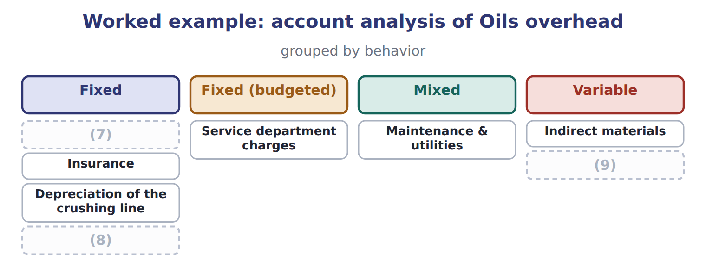
word list
Factory supervision · Olive-press ROU amortization · Insurance · Power

Classify Tahini & Spreads costs

The first two are done. Classify the rest as variable, fixed, mixed or step.

Your turn: classify Tahini & Spreads costs (complete the blanks)
Every item belongs to exactly one group.
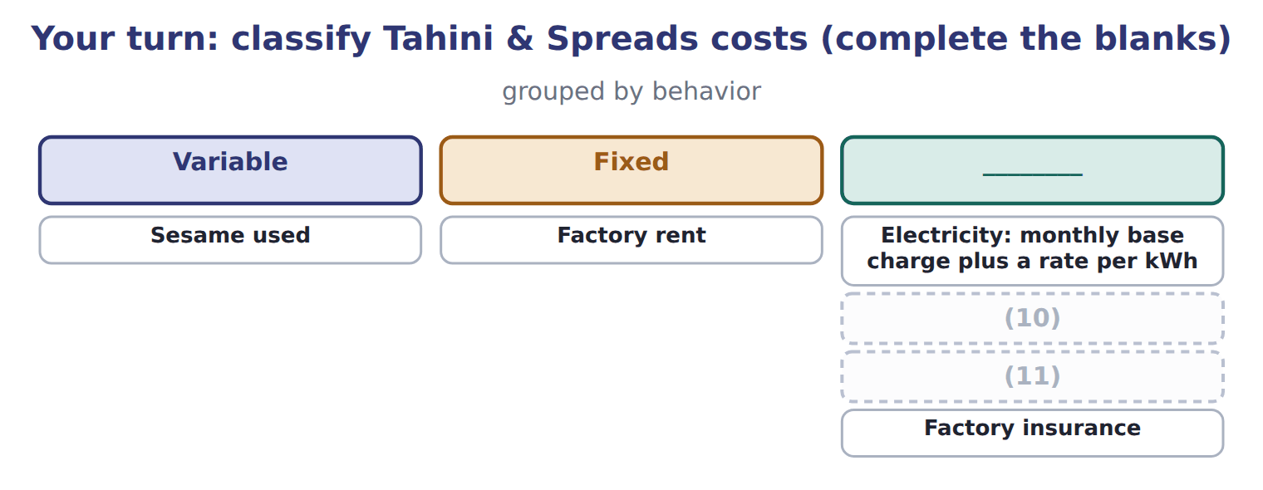
word list
Labels, one per jar · Electricity: monthly base charge plus a rate per kWh · One extra supervisor for every 20,000 jars a month

The English this section uses, and its Arabic
Each term sits against what it means.
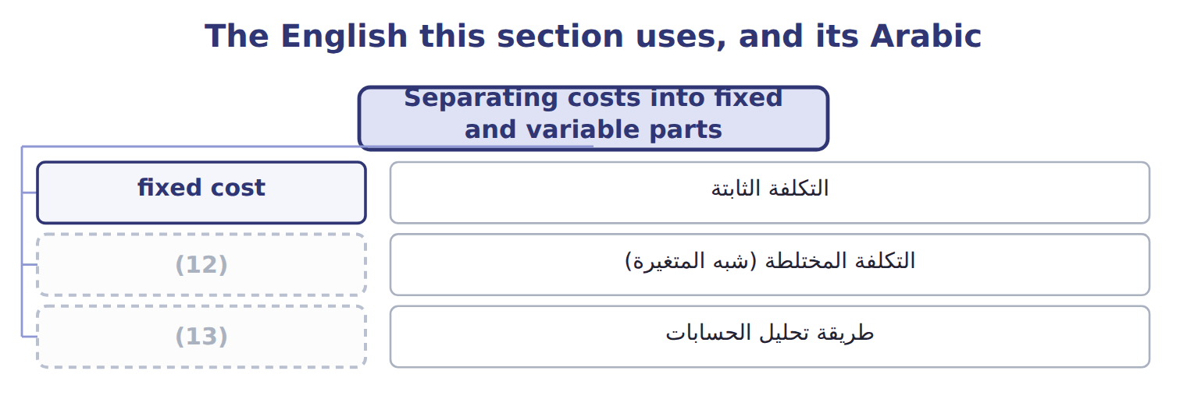
word list
mixed cost · cost behavior · account analysis

The English this sheet uses, and its Arabic
English (exam term) | Arabic
account analysis | طريقة تحليل الحسابات

Answer key · 2.5 Separating costs into fixed and variable parts

1 function | 8 Olive-press ROU amortization
2 activity | 9 Power
3 separated | 10 One extra supervisor for every 20,000 jars a month
4 accountant | 11 Labels, one per jar
5 classifies | 12 mixed cost
6 accounts | 13 account analysis
7 Factory supervision

the summaries in full
Summary 1 Budgets need a cost function: total cost = fixed cost + variable rate × activity. To build it, each cost must be separated into its fixed and variable parts. The simplest method is account analysis: an accountant reviews each account and classifies it by judgment. Mixed accounts need a second step. For maintenance and utilities, Oils uses the fixed monthly contract and the rate per machine hour estimated from its records.

2.6 Extended Example 2A: the Oils overhead budget, 2027
Chapter 2 · section 2.6

Fill every gap. Each word list holds one word more than there are gaps.
Summary 1 gaps 1–12
This example builds a (1) overhead budget from the cost function, tests it at (2) volumes and (3) one month's (4) by behavior. The budget (5) are exam-core; the (6) are for depth. Oils plans 38,400 machine hours for 2027, but the (7) could give (8) from 30,000 to 48,000. Above 51,600 hours a year, a second shift adds $72,000 of (9) and $180,000 of (10) . Use the cost function from Section 2.5. (11) total overhead at each volume, check which volumes are inside the (12) range, and see what happens to cost per machine hour. Budget volume: $2,100,569 + $20 × 38,400 = $2,868,569, or $74.70 per machine hour. Low volume: $2,100,569 + $20 × 30,000 = $2,700,569, or $90.02 per hour. High volume: $2,100,569 + $20 × 48,000 = $3,060,569, or $63.76 per hour.
word list
anything · Compute · calculations · records · several · relevant · invoices · supervision · flexible · entries · volumes · maintenance · harvest

Summary 2 gaps 13–15
Above the range (55,000 hours): $2,100,569 + $252,000 + $20 × 55,000 = $3,452,569. Fixed (13) is the same in the first three columns; only the (14) part moves. The last column needs a new cost (15) because it lies outside the range.
word list
machine · overhead · function · variable

Extended Example: flexible overhead budget for Oils
The bars are drawn to scale.
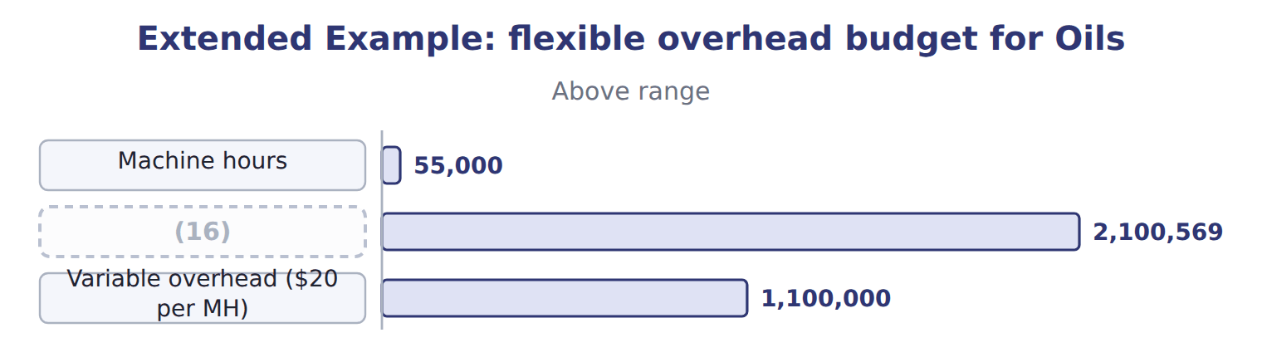
word list
Fixed overhead · Machine hours

Summary 3 gaps 17–20
Variable cost per hour is flat, fixed cost per hour falls, and so total cost per hour falls as (17) rises. The (18) ledger records costs by nature, but Orontes tags each (19) line as fixed or variable. In March the (20) ran 3,200 machine hours.
word list
crushers · relevant · volume · overhead · general

Extended Example: March overhead journal by behavior
No. | Account (detail) | Debit | Credit
1 | MOH Control - Fixed | 18,000
 | (21) | 38,400
 | (22) |  | 56,400
2 | MOH Control - Variable | 16,000
 | Accounts Payable |  | 16,000
3 | MOH Control - Variable | 9,600
 | (23) |  | 9,600
 | (24) | 82,000 | 82,000

word list
MOH Control - Variable · Raw Materials Inventory · Totals · mixed cost · Accounts Payable

Everything ties

Summary 4 gaps 25–27
Maintenance invoice: $18,000 fixed + $38,400 variable = $56,400, the (25) estimate for 3,200 hours. March variable (26) : $20 × 3,200 = $64,000. Fixed maintenance for the year: $216,000, (27) months at $18,000. Journal total: $82,000 on both sides.
word list
twelve · regression · overhead · behavior

Exam view

Summary 5 gaps 28–30
Expect a cost at two (28) and a request for the cost at a third volume. Split the cost first, check that the new volume is inside the (29) range, then rebuild the total. Never scale a total cost that (30) fixed costs.
word list
columns · volumes · relevant · includes

Exam view
The bars are drawn to scale.
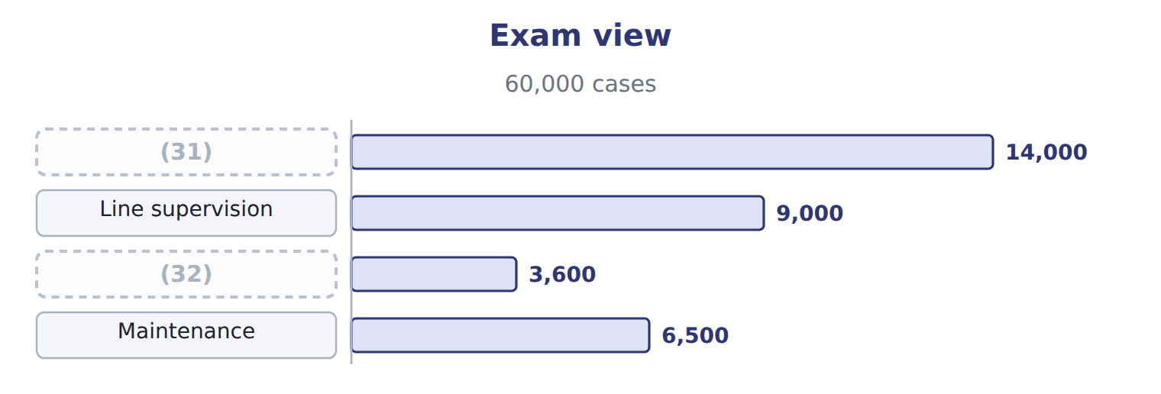
word list
Maintenance · Shrink film · Electricity

Item — Answer
Item | Answer
Electricity: monthly base charge plus a rate per kWh | Mixed
One extra supervisor for every 20,000 jars a month | Step
Labels, one per jar | (33)
Factory insurance | (34)

word list
Fixed · Variable · High

Cost — Category
Cost | Category
Electricity | Mixed
Line supervision | Fixed
Shrink film | (35)
Forklift rental | (36)
Maintenance | (37)

word list
Mixed · Step · Variable · Fixed

The English this section uses, and its Arabic
Each term sits against what it means.
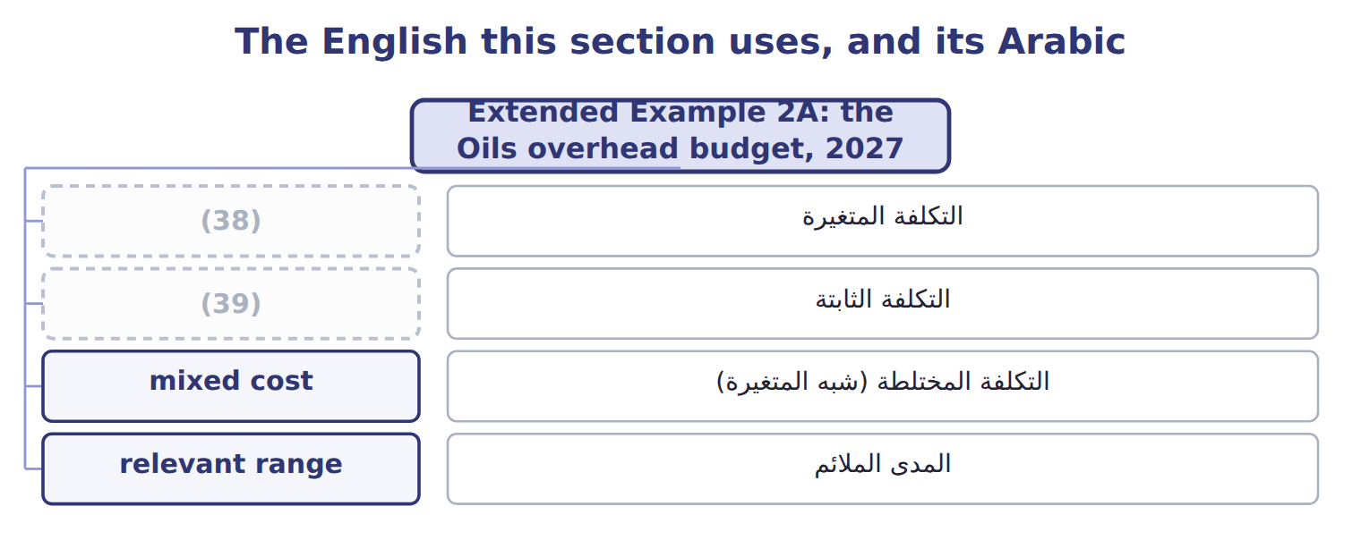
word list
variable cost · التكلفة المتغيرة · fixed cost

The English this sheet uses, and its Arabic
English (exam term) | Arabic
variable cost | التكلفة المتغيرة
fixed cost | التكلفة الثابتة
mixed cost | التكلفة المختلطة (شبه المتغيرة)
relevant range | المدى الملائم

Answer key · 2.6 Extended Example 2A: the Oils overhead budget, 2027

1 flexible | 21 MOH Control - Variable
2 several | 22 Accounts Payable
3 records | 23 Raw Materials Inventory
4 invoices | 24 Totals
5 calculations | 25 regression
6 entries | 26 overhead
7 harvest | 27 twelve
8 anything | 28 volumes
9 maintenance | 29 relevant
10 supervision | 30 includes
11 Compute | 31 Electricity
12 relevant | 32 Shrink film
13 overhead | 33 Variable
14 variable | 34 Fixed
15 function | 35 Variable
16 Fixed overhead | 36 Step
17 volume | 37 Mixed
18 general | 38 variable cost
19 overhead | 39 fixed cost
20 crushers

the summaries in full
Summary 1 This example builds a flexible overhead budget from the cost function, tests it at several volumes and records one month's invoices by behavior. The budget calculations are exam-core; the entries are for depth. Oils plans 38,400 machine hours for 2027, but the harvest could give anything from 30,000 to 48,000. Above 51,600 hours a year, a second shift adds $72,000 of maintenance and $180,000 of supervision. Use the cost function from Section 2.5. Compute total overhead at each volume, check which volumes are inside the relevant range, and see what happens to cost per machine hour. Budget volume: $2,100,569 + $20 × 38,400 = $2,868,569, or $74.70 per machine hour. Low volume: $2,100,569 + $20 × 30,000 = $2,700,569, or $90.02 per hour. High volume: $2,100,569 + $20 × 48,000 = $3,060,569, or $63.76 per hour.
Summary 2 Above the range (55,000 hours): $2,100,569 + $252,000 + $20 × 55,000 = $3,452,569. Fixed overhead is the same in the first three columns; only the variable part moves. The last column needs a new cost function because it lies outside the range.
Summary 3 Variable cost per hour is flat, fixed cost per hour falls, and so total cost per hour falls as volume rises. The general ledger records costs by nature, but Orontes tags each overhead line as fixed or variable. In March the crushers ran 3,200 machine hours.
Summary 4 Maintenance invoice: $18,000 fixed + $38,400 variable = $56,400, the regression estimate for 3,200 hours. March variable overhead: $20 × 3,200 = $64,000. Fixed maintenance for the year: $216,000, twelve months at $18,000. Journal total: $82,000 on both sides.
Summary 5 Expect a cost at two volumes and a request for the cost at a third volume. Split the cost first, check that the new volume is inside the relevant range, then rebuild the total. Never scale a total cost that includes fixed costs.

