4.1 What learning is
Chapter 4 · section 4.1

Fill every gap. Each word list holds one word more than there are gaps.
Chapter 4, section by section
Each stage leads to the next.
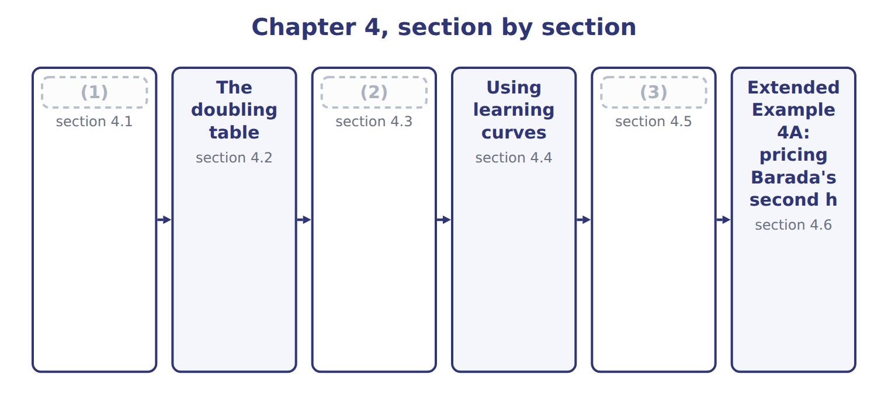
word list
The doubling table · The learning curve formula · Benefits and shortcomings · What learning is

Summary 1 gaps 4–11
Workers who (4) a task become (5) . They find better methods, make fewer (6) and need less (7) . A learning curve shows how labor time per unit falls as cumulative output grows. Learning is (8) each time cumulative output doubles. On an 80% curve, the average time per unit after a (9) is 80% of the average before it. The learning rate is 80%; the time saved is 20%. Learning (10) labor and the costs that follow labor hours. It does not affect (11) : each halva batch still needs the same sesame and sugar.
word list
materials · mistakes · supervision · measured · Workers · repeat · affects · doubling · faster

The rate is what remains, not what falls

Summary 2 gaps 12–13
An 80% (12) curve does not cut time by 80%. After each (13) , the new average is 80% of the old average, a fall of 20%.
word list
supervision · learning · doubling

The English this section uses, and its Arabic
Each term sits against what it means.
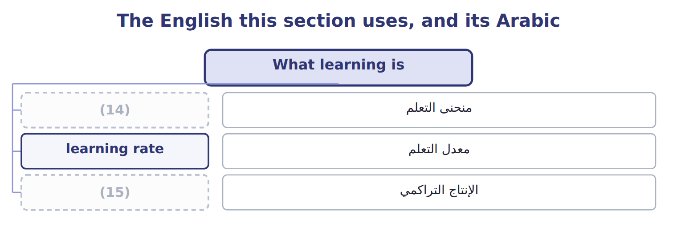
word list
learning curve · cumulative output · معدل التعلم

The English this sheet uses, and its Arabic
English (exam term) | Arabic
learning curve | منحنى التعلم
learning rate | معدل التعلم
cumulative output | الإنتاج التراكمي

Answer key · 4.1 What learning is

1 What learning is | 9 doubling
2 The learning curve formula | 10 affects
3 Benefits and shortcomings | 11 materials
4 repeat | 12 learning
5 faster | 13 doubling
6 mistakes | 14 learning curve
7 supervision | 15 cumulative output
8 measured

the summaries in full
Summary 1 Workers who repeat a task become faster. They find better methods, make fewer mistakes and need less supervision. A learning curve shows how labor time per unit falls as cumulative output grows. Learning is measured each time cumulative output doubles. On an 80% curve, the average time per unit after a doubling is 80% of the average before it. The learning rate is 80%; the time saved is 20%. Learning affects labor and the costs that follow labor hours. It does not affect materials: each halva batch still needs the same sesame and sugar.
Summary 2 An 80% learning curve does not cut time by 80%. After each doubling, the new average is 80% of the old average, a fall of 20%.

4.2 The doubling table
Chapter 4 · section 4.2

Fill every gap. Each word list holds one word more than there are gaps.
Summary 1 gaps 1–6
At each doubling of (1) output, the average time for all units so far is the (2) rate times the previous average. Total time is the average times the (3) of units. The table works only at (4) : one, two, four, eight, (5) units and so on. To find the time for a group of later units, (6) the totals: batches 5 to 8 need the total for 8 minus the total for 4.
word list
sixteen · previous · learning · cumulative · subtract · doublings · number

Worked example: the halva doubling table

The average falls from 1,000 to 800, 640 and 512 hours. The total for eight batches is 4,096 hours, so batches 5 to 8 need 4,096 − 2,560 = 1,536 hours.
Worked example: the halva doubling table
Name each point on the scale from where it sits.
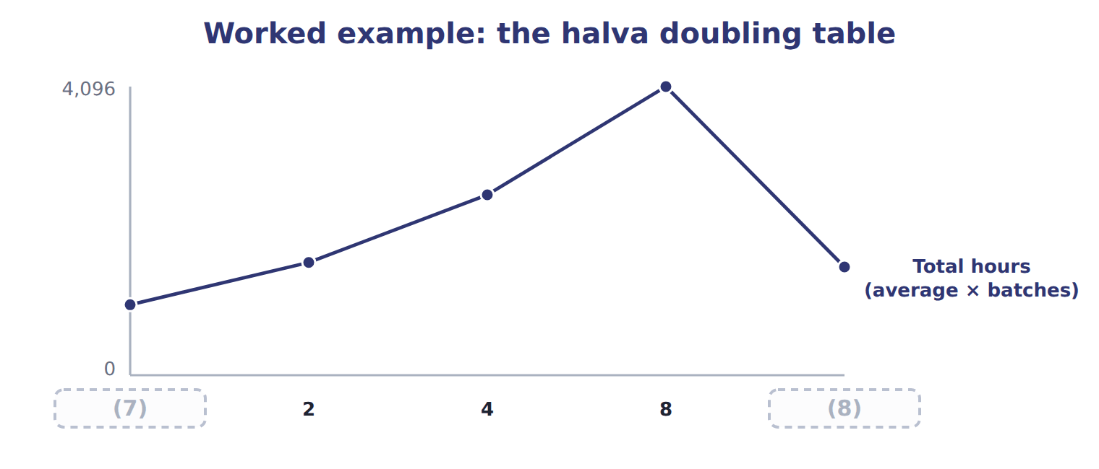
word list
1 · learning rate · Batches 5–8

The English this section uses, and its Arabic
Each term sits against what it means.
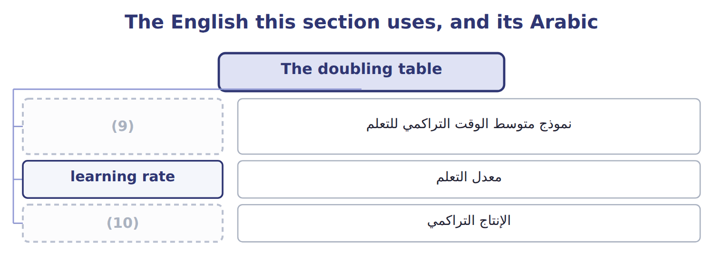
word list
معدل التعلم · cumulative output · cumulative average-time learning model

The English this sheet uses, and its Arabic
English (exam term) | Arabic
cumulative average-time learning model | نموذج متوسط الوقت التراكمي للتعلم

Answer key · 4.2 The doubling table

1 cumulative | 6 subtract
2 learning | 7 1
3 number | 8 Batches 5–8
4 doublings | 9 cumulative average-time learning model
5 sixteen | 10 cumulative output

the summaries in full
Summary 1 At each doubling of cumulative output, the average time for all units so far is the learning rate times the previous average. Total time is the average times the number of units. The table works only at doublings: one, two, four, eight, sixteen units and so on. To find the time for a group of later units, subtract the totals: batches 5 to 8 need the total for 8 minus the total for 4.

4.3 The learning curve formula
Chapter 4 · section 4.3

Fill every gap. Each word list holds one word more than there are gaps.
Summary 1 gaps 1–4
For (1) that are not (2) , use the formula Y = a X^b. Y is the cumulative average time per unit, a is the time for the first unit, X is cumulative units, and b = log( (3) rate) ÷ log(two). For an 80% curve, b = -0.3219. Three halva (4) average 702.1 hours, a total of about 2,106 hours.
word list
average-time · learning · doublings · batches · quantities

The learning curve formula for three and six batches
The bars are drawn to scale.
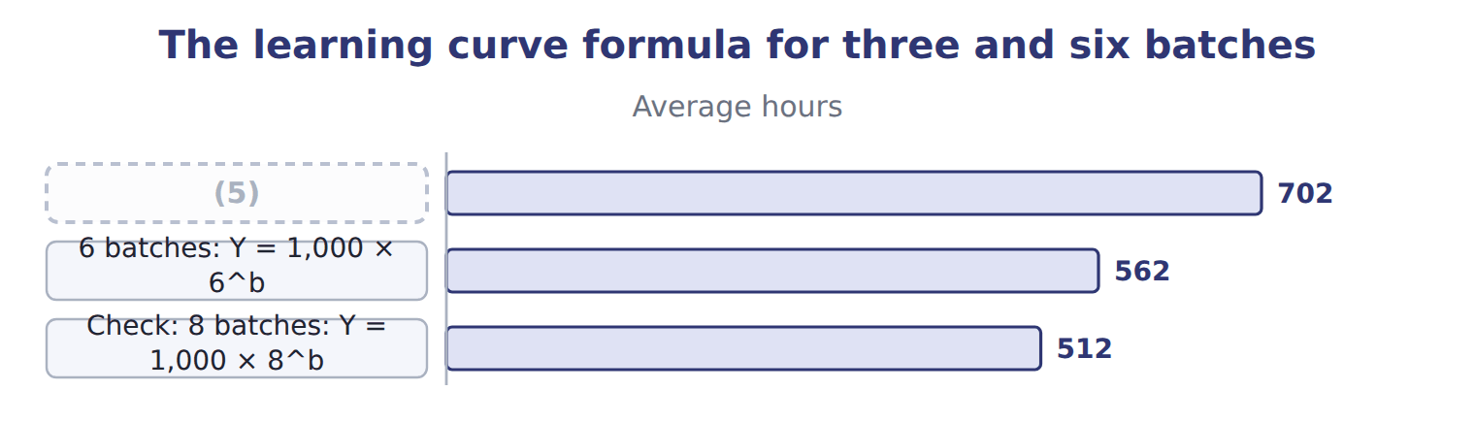
word list
3 batches: Y = 1,000 × 3^b · 6 batches: Y = 1,000 × 6^b

Summary 2 gaps 6–9
The learning rate (6) a great deal. A lower (7) means faster learning. Some texts use an (8) unit-time model, in which the time for the last unit falls by the rate at each doubling. It gives (9) totals. The CMA LOS name the cumulative average-time model; use it unless a question says otherwise.
word list
higher · otherwise · incremental · matters · percentage

The English this section uses, and its Arabic
Each term sits against what it means.
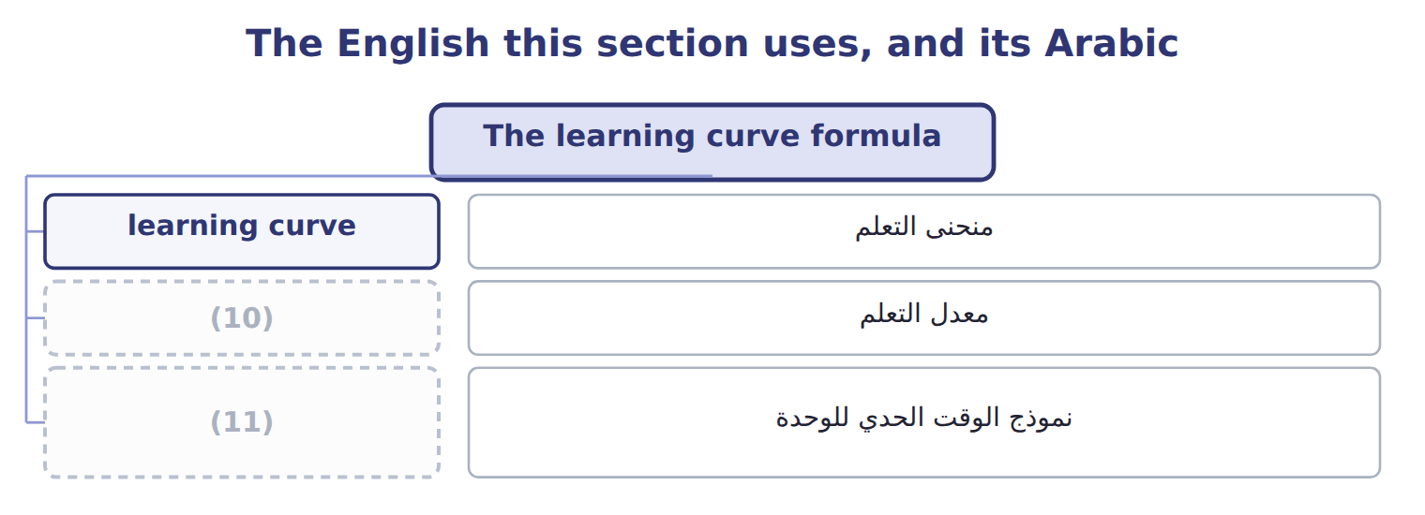
word list
معدل التعلم · incremental unit-time learning model · learning rate

The English this sheet uses, and its Arabic
English (exam term) | Arabic
incremental unit-time learning model | نموذج الوقت الحدي للوحدة

Answer key · 4.3 The learning curve formula

1 quantities | 7 percentage
2 doublings | 8 incremental
3 learning | 9 higher
4 batches | 10 learning rate
5 3 batches: Y = 1,000 × 3^b | 11 incremental unit-time learning model
6 matters

the summaries in full
Summary 1 For quantities that are not doublings, use the formula Y = a X^b. Y is the cumulative average time per unit, a is the time for the first unit, X is cumulative units, and b = log(learning rate) ÷ log(two). For an 80% curve, b = -0.3219. Three halva batches average 702.1 hours, a total of about 2,106 hours.
Summary 2 The learning rate matters a great deal. A lower percentage means faster learning. Some texts use an incremental unit-time model, in which the time for the last unit falls by the rate at each doubling. It gives higher totals. The CMA LOS name the cumulative average-time model; use it unless a question says otherwise.

4.4 Using learning curves
Chapter 4 · section 4.4

Fill every gap. Each word list holds one word more than there are gaps.
Summary 1 gaps 1–7
Learning (1) improve three (2) . In (3) , a later order costs less than the first, so a lower price may still cover cost. In (4) , labor hours fall over the year. In setting (5) , a standard based on one early batch is too loose, and one based on later batches is too tight for new staff. (6) cost an order with its own (7) hours. The average for the whole run mixes the slow early batches with the fast later ones.
word list
curves · pricing · standards · Complete · budgeting · decisions · Always · incremental

Complete the doubling table

Complete it, then find the hours for batches 5 to 8.
Your turn: complete the halva doubling table
Each stage leads to the next.
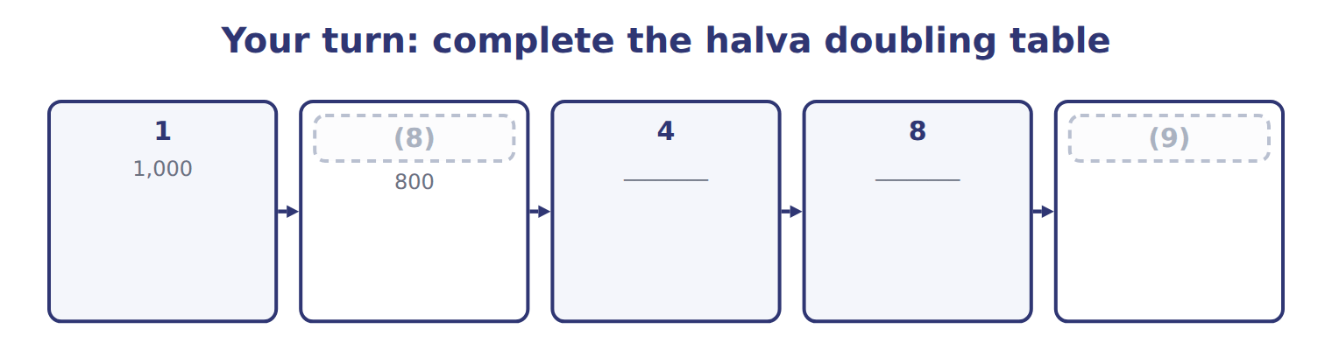
word list
Batches 5–8 · 2 · learning rate

Answer key · 4.4 Using learning curves

1 curves | 6 Always
2 decisions | 7 incremental
3 pricing | 8 2
4 budgeting | 9 Batches 5–8
5 standards

the summaries in full
Summary 1 Learning curves improve three decisions. In pricing, a later order costs less than the first, so a lower price may still cover cost. In budgeting, labor hours fall over the year. In setting standards, a standard based on one early batch is too loose, and one based on later batches is too tight for new staff. Always cost an order with its own incremental hours. The average for the whole run mixes the slow early batches with the fast later ones.

4.5 Benefits and shortcomings
Chapter 4 · section 4.5

Fill every gap. Each word list holds one word more than there are gaps.
Summary 1 gaps 1–7
Both regression and learning curves turn past data into better (1) . Regression gives a fixed cost and a (2) rate, with tests of (3) . Learning curves (4) the labor estimate when the task is new. Regression needs (5) past data and holds only inside the (6) range; a good fit does not prove a causal link. A learning rate is itself an estimate, learning may stop once the task is routine, and it does not apply to (7) work or materials.
word list
relevant · regression · estimates · enough · variable · correct · machine-paced · reliability

Benefits and shortcomings of learning curves and regression
Method | Benefits | Shortcomings
Learning curve | More accurate labor (8) for new products; better prices, budgets and standards | The rate must be estimated; learning may stop; it does not apply to materials or machine-paced work
Regression | Uses all data; reports R2, t and standard error; separates fixed and variable cost | Needs enough past data; valid only inside the (9) range; a good fit does not prove cause

word list
separates · estimates · relevant

The learning curve here covers only labor time on one task.

Answer key · 4.5 Benefits and shortcomings

1 estimates | 6 relevant
2 variable | 7 machine-paced
3 reliability | 8 estimates
4 correct | 9 relevant
5 enough

the summaries in full
Summary 1 Both regression and learning curves turn past data into better estimates. Regression gives a fixed cost and a variable rate, with tests of reliability. Learning curves correct the labor estimate when the task is new. Regression needs enough past data and holds only inside the relevant range; a good fit does not prove a causal link. A learning rate is itself an estimate, learning may stop once the task is routine, and it does not apply to machine-paced work or materials.

4.6 Extended Example 4A: pricing Barada's second halva order
Chapter 4 · section 4.6

Fill every gap. Each word list holds one word more than there are gaps.
Summary 1 gaps 1–12
This example uses the (1) curve to cost two orders, sets a price floor for the (2) one and shows what the curve means for a labor standard. There are no (3) entries: the (4) is a quote and a standard. Barada (5) 4 batches of halva, which (6) has made. Barada now asks for 4 more. Direct labor costs $12 an hour and (7) overhead $6 per labor hour, (8) the manual line uses little (9) . Materials cost $3,000 a batch and do not learn. Use the (10) table to find the hours for each order. Apply the labor and overhead rates to the hours, and add materials at a flat (11) per batch. (12) the two orders and think about the standard. Order 1 hours = total for 4 batches = 2,560. Order 2 hours = total for 8 batches − total for 4 = 4,096 − 2,560 = 1,536.
word list
doubling · learning · efficiency · second · Compare · amount · because · ordered · output · journal · machinery · variable · Orontes

Summary 2 gaps 13–16
Order 2 cost = 1,536 × ($12 + $6) + 4 × $3,000 = $39,648. The (13) order costs $39,648, or $9,912 a batch, (14) $14,520 for the first. Any price above $39,648 covers the (15) cost; fixed costs and (16) come on top.
word list
incremental · against · Orontes · profit · second

Extended Example: incremental cost of the two Barada orders
Halva orders for Barada (whole USD) | Order 1 | Order 2
(17) | 1–4 | 5–8
(18) | 2,560 | 1,536
Direct labor at $12 per hour | 30,720 | 18,432
(19) | 15,360 | 9,216
(20) | 12,000 | 12,000
Incremental cost of the order | 58,080 | 39,648
Cost per batch | 14,520 | 9,912

word list
Labor hours (from the doubling table) · Direct materials at 3,000 per batch (no learning) · Incremental · Batches · Variable overhead at $6 per labor hour

Summary 3 gaps 21–23
Order 2 needs only the rise in (21) hours from 2,560 to 4,096. Suppose Orontes sets one labor (22) for all eight batches at their average of 512 hours. Book 3 calls these labor (23) variances; here they come only from learning.
word list
machinery · cumulative · efficiency · standard

Extended Example: a labor standard at the eight-batch average
Setting a labor standard for halva | Batches 1–4 | Batches 5–8 | All 8
Actual labor hours (learning curve) | 2,560 | 1,536 | 4,096
(24) | 2,048 | 2,048 | 4,096
(25) | 512 | (512) | 0

word list
4,096 − 2,560 = 1,536 hours · Standard hours at the 8-batch average (512 per batch) · Actual − standard hours

Everything ties

Summary 4 gaps 26–27
Hours: 2,560 + 1,536 = 4,096, the total for eight batches. Order 2 labor: 1,536 × $12 = $18,432. (26) check: overrun 512 + (27) (512) = 0 over the eight batches.
word list
Suppose · Standard · saving

Exam view

Summary 5 gaps 28–30
Expect the (28) time, a learning rate and a question about a later group of units. Build the (29) table to the needed total, then subtract the earlier total. Apply learning to labor and (30) costs only.
word list
labor-driven · doubling · entries · first-unit

Exam view
Beverages · new juice-blend crew | Data
First lot of 1,000 cases | (31)
Learning rate | 90% (cumulative average-time model)
Direct labor rate | (32)
Planned lots this year | 8 (lots 1–4 are (33) in quarter 1; lots 5–8 in quarter 2)
Materials per lot | Standard; no learning expected

word list
Batches 1–4 · 500 direct labor hours · $12 per hour · budgeted

Item — Answer
Item | Answer
4 batches | (34)
8 batches | Average 512 hours; total 4,096 hours
Batches 5–8 | (35)

word list
Average 640 hours; total 2,560 hours · Variable overhead driven by labor hours · 4,096 − 2,560 = 1,536 hours

Cost — Category
Every item belongs to exactly one group.
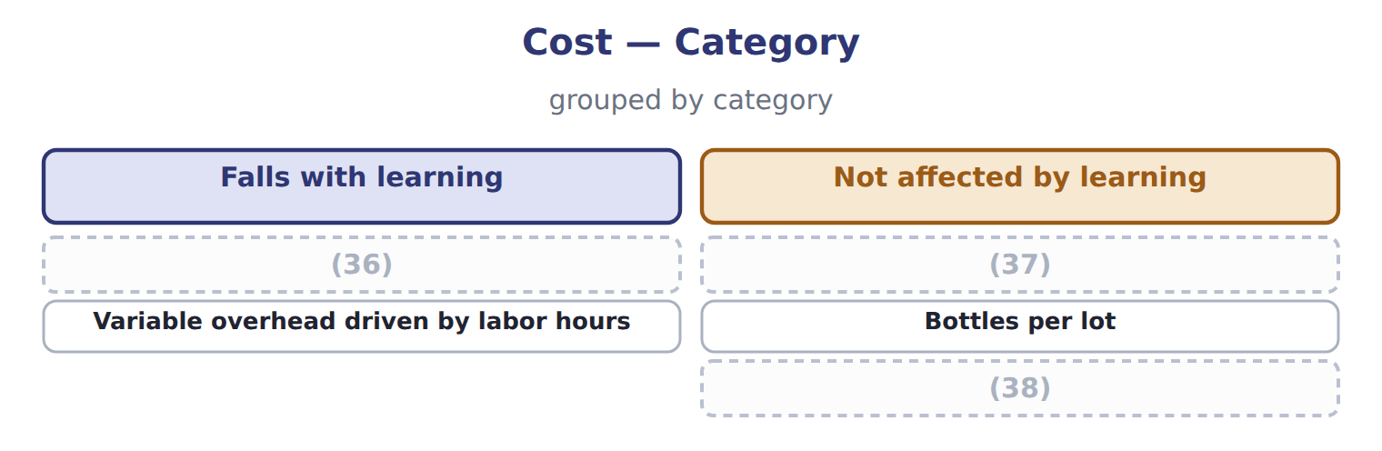
word list
Juice concentrate per lot · Direct labor per lot · Not affected by learning · Straight-line depreciation of the line

The English this section uses, and its Arabic
Each term sits against what it means.
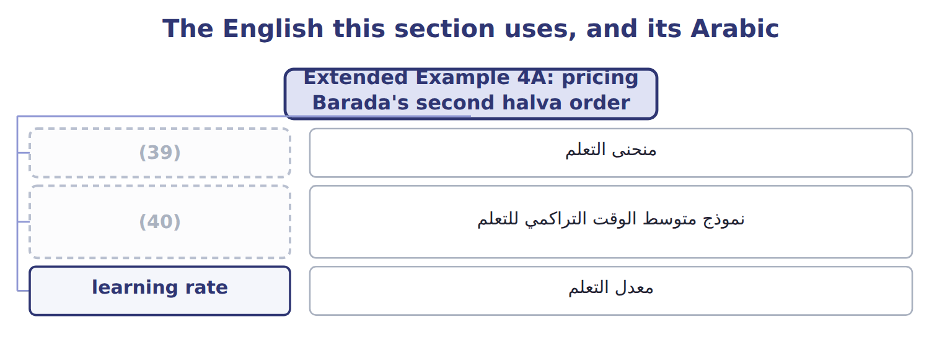
word list
learning rate · cumulative average-time learning model · learning curve

The English this sheet uses, and its Arabic
English (exam term) | Arabic
learning curve | منحنى التعلم
cumulative average-time learning model | نموذج متوسط الوقت التراكمي للتعلم
learning rate | معدل التعلم

Answer key · 4.6 Extended Example 4A: pricing Barada's second halva order

1 learning | 21 cumulative
2 second | 22 standard
3 journal | 23 efficiency
4 output | 24 Standard hours at the 8-batch average (512 per batch)
5 ordered | 25 Actual − standard hours
6 Orontes | 26 Standard
7 variable | 27 saving
8 because | 28 first-unit
9 machinery | 29 doubling
10 doubling | 30 labor-driven
11 amount | 31 500 direct labor hours
12 Compare | 32 $12 per hour
13 second | 33 budgeted
14 against | 34 Average 640 hours; total 2,560 hours
15 incremental | 35 4,096 − 2,560 = 1,536 hours
16 profit | 36 Direct labor per lot
17 Batches | 37 Juice concentrate per lot
18 Labor hours (from the doubling table) | 38 Straight-line depreciation of the line
19 Variable overhead at $6 per labor hour | 39 learning curve
20 Direct materials at 3,000 per batch (no learning) | 40 cumulative average-time learning model

the summaries in full
Summary 1 This example uses the learning curve to cost two orders, sets a price floor for the second one and shows what the curve means for a labor standard. There are no journal entries: the output is a quote and a standard. Barada ordered 4 batches of halva, which Orontes has made. Barada now asks for 4 more. Direct labor costs $12 an hour and variable overhead $6 per labor hour, because the manual line uses little machinery. Materials cost $3,000 a batch and do not learn. Use the doubling table to find the hours for each order. Apply the labor and overhead rates to the hours, and add materials at a flat amount per batch. Compare the two orders and think about the standard. Order 1 hours = total for 4 batches = 2,560. Order 2 hours = total for 8 batches − total for 4 = 4,096 − 2,560 = 1,536.
Summary 2 Order 2 cost = 1,536 × ($12 + $6) + 4 × $3,000 = $39,648. The second order costs $39,648, or $9,912 a batch, against $14,520 for the first. Any price above $39,648 covers the incremental cost; fixed costs and profit come on top.
Summary 3 Order 2 needs only the rise in cumulative hours from 2,560 to 4,096. Suppose Orontes sets one labor standard for all eight batches at their average of 512 hours. Book 3 calls these labor efficiency variances; here they come only from learning.
Summary 4 Hours: 2,560 + 1,536 = 4,096, the total for eight batches. Order 2 labor: 1,536 × $12 = $18,432. Standard check: overrun 512 + saving (512) = 0 over the eight batches.
Summary 5 Expect the first-unit time, a learning rate and a question about a later group of units. Build the doubling table to the needed total, then subtract the earlier total. Apply learning to labor and labor-driven costs only.

