5.1 Three measurement techniques
Chapter 5 · section 5.1

Fill every gap. Each word list holds one word more than there are gaps.
Chapter 5, section by section
Each stage leads to the next.
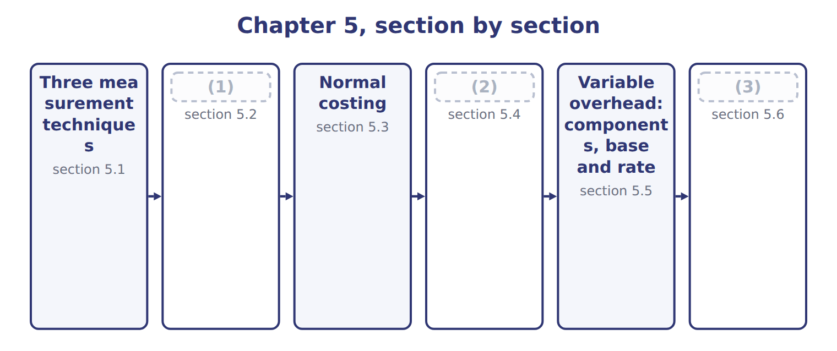
word list
Standard costing · Actual costing · Extended Example 5A: one month, three costs · section 5.5

Summary 1 gaps 4–12
A product cost has three parts: direct (4) , direct labor and overhead. The three techniques (5) in how they measure each part. Actual costing uses actual (6) for all three. Normal costing uses actual direct costs but applies overhead with a (7) rate. Standard costing uses standard (8) and prices for everything. Each (9) suits a different need. Actual costing is exact but late; normal costing is timely; standard costing also sets targets that (10) can compare with results. The techniques measure cost; they do not (11) it. Any of them can be used with job costing, process costing or (12) costing.
word list
quantities · managers · differ · compare · activity-based · materials · collect · amounts · technique · predetermined

Actual, normal and standard costing compared
 | Actual costing | Normal costing | Standard costing
Direct materials | Actual quantity × actual price | Actual quantity × actual price | (13)
Direct labor | Actual hours × actual rate | Actual hours × actual rate | (14)
Overhead | Actual overhead | (15) | Standard base allowed × standard rate
Unit cost known | After the period ends | When the work is done | (16)
Best use | Small firms; audit of results | (17) | Repetitive production; control through variances

word list
Standard quantity allowed × standard price · Standard hours allowed × standard rate · Actual base × predetermined rate · When the work is done · Job shops; pricing during the year · Before production starts

The English this section uses, and its Arabic
Each term sits against what it means.
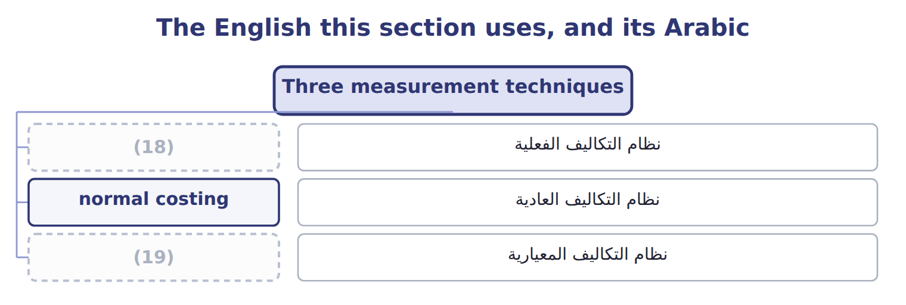
word list
standard costing · normal costing · actual costing

The English this sheet uses, and its Arabic
English (exam term) | Arabic
actual costing | نظام التكاليف الفعلية
normal costing | نظام التكاليف العادية
standard costing | نظام التكاليف المعيارية

Answer key · 5.1 Three measurement techniques

1 Actual costing | 11 collect
2 Standard costing | 12 activity-based
3 Extended Example 5A: one month, three costs | 13 Standard quantity allowed × standard price
4 materials | 14 Standard hours allowed × standard rate
5 differ | 15 Actual base × predetermined rate
6 amounts | 16 Before production starts
7 predetermined | 17 Job shops; pricing during the year
8 quantities | 18 actual costing
9 technique | 19 standard costing
10 managers

the summaries in full
Summary 1 A product cost has three parts: direct materials, direct labor and overhead. The three techniques differ in how they measure each part. Actual costing uses actual amounts for all three. Normal costing uses actual direct costs but applies overhead with a predetermined rate. Standard costing uses standard quantities and prices for everything. Each technique suits a different need. Actual costing is exact but late; normal costing is timely; standard costing also sets targets that managers can compare with results. The techniques measure cost; they do not collect it. Any of them can be used with job costing, process costing or activity-based costing.

5.2 Actual costing
Chapter 5 · section 5.2

Fill every gap. Each word list holds one word more than there are gaps.
Summary 1 gaps 1–7
Under actual costing, overhead is (1) only when the period ends and the actual overhead is known. In May (2) spent $222,600 on overhead, so the full cost was $903,000, or $12.90 a case. Actual costing has two (3) . The cost (4) too late for (5) and control during the month. And unit cost jumps with volume, (6) fixed overhead is spread over (7) the month produces. Actual costing suits small firms with stable volume, and it is the basis for checking results after the period.
word list
limits · whatever · pricing · arrives · Beverages · because · assigned · overhead

The English this section uses, and its Arabic
Each term sits against what it means.
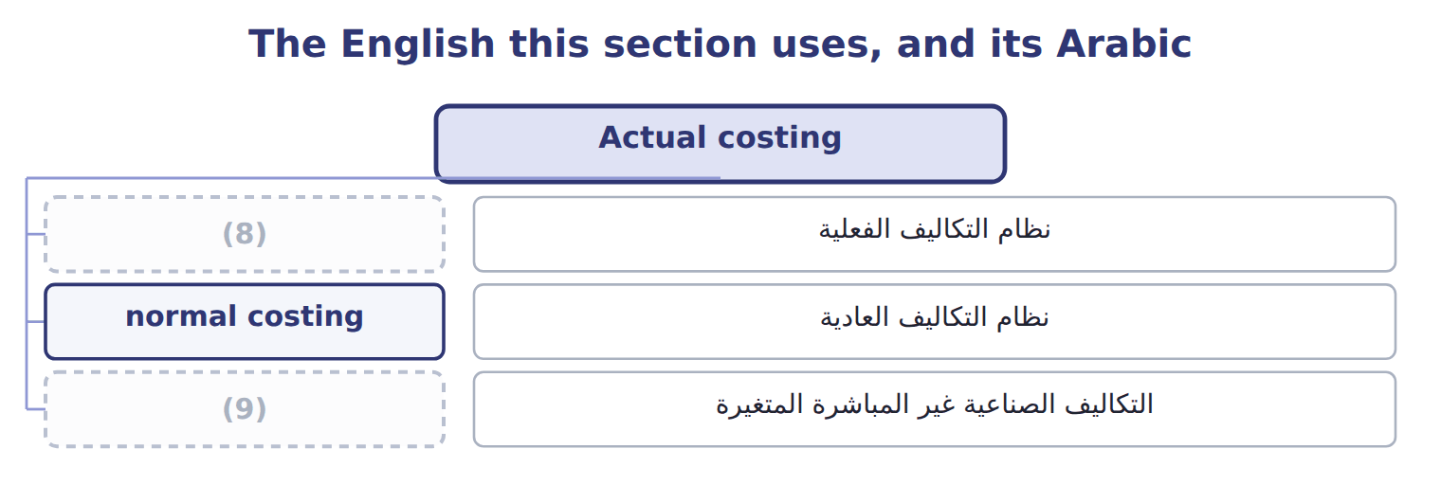
word list
normal costing · variable overhead · actual costing

Answer key · 5.2 Actual costing

1 assigned | 6 because
2 Beverages | 7 whatever
3 limits | 8 actual costing
4 arrives | 9 variable overhead
5 pricing

the summaries in full
Summary 1 Under actual costing, overhead is assigned only when the period ends and the actual overhead is known. In May Beverages spent $222,600 on overhead, so the full cost was $903,000, or $12.90 a case. Actual costing has two limits. The cost arrives too late for pricing and control during the month. And unit cost jumps with volume, because fixed overhead is spread over whatever the month produces. Actual costing suits small firms with stable volume, and it is the basis for checking results after the period.

5.3 Normal costing
Chapter 5 · section 5.3

Fill every gap. Each word list holds one word more than there are gaps.
Summary 1 gaps 1–8
Normal costing keeps actual direct (1) and direct labor, but applies overhead with a (2) overhead rate: budgeted overhead divided by the budgeted (3) base, set before the year starts. (4) uses $150 per machine hour. Applied overhead (5) the actual base times the rate. In May the line ran 1,414 machine hours, so applied overhead was $212,100. Normal costing gives a cost as soon as the work is done, and the rate smooths out (6) swings in fixed overhead. Its limit is that the rate is only an (7) , so applied and actual overhead (8) .
word list
differ · smooths · equals · Beverages · predetermined · seasonal · allocation · materials · estimate

Normal costing is not normal capacity

Summary 2 gaps 9–10
Normal (9) means 'actual direct costs plus applied overhead'. Normal capacity is a (10) level used to set a fixed overhead rate.
word list
costing · overhead · denominator

The English this section uses, and its Arabic
Each term sits against what it means.
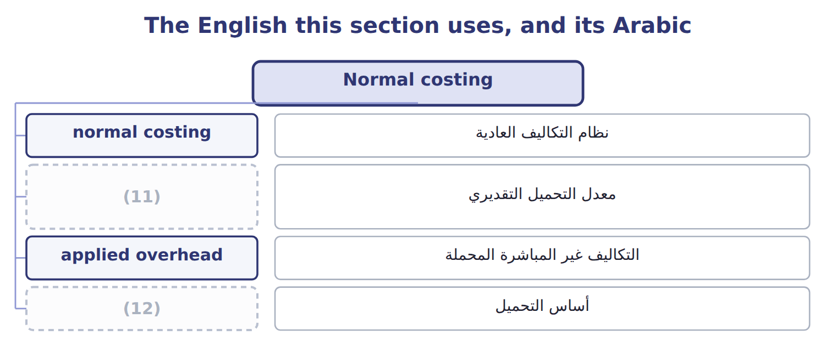
word list
normal costing · allocation base · predetermined overhead rate

The English this sheet uses, and its Arabic
English (exam term) | Arabic
predetermined overhead rate | معدل التحميل التقديري
applied overhead | التكاليف غير المباشرة المحملة

Answer key · 5.3 Normal costing

1 materials | 7 estimate
2 predetermined | 8 differ
3 allocation | 9 costing
4 Beverages | 10 denominator
5 equals | 11 predetermined overhead rate
6 seasonal | 12 allocation base

the summaries in full
Summary 1 Normal costing keeps actual direct materials and direct labor, but applies overhead with a predetermined overhead rate: budgeted overhead divided by the budgeted allocation base, set before the year starts. Beverages uses $150 per machine hour. Applied overhead equals the actual base times the rate. In May the line ran 1,414 machine hours, so applied overhead was $212,100. Normal costing gives a cost as soon as the work is done, and the rate smooths out seasonal swings in fixed overhead. Its limit is that the rate is only an estimate, so applied and actual overhead differ.
Summary 2 Normal costing means 'actual direct costs plus applied overhead'. Normal capacity is a denominator level used to set a fixed overhead rate.

5.4 Standard costing
Chapter 5 · section 5.4

Fill every gap. Each word list holds one word more than there are gaps.
Summary 1 gaps 1–6
Standard costing values every input at what it should cost for the output (1) . Each part equals the standard (2) allowed for the actual output times the standard price. The (3) standard cost card gives $12.60 a case. The (4) between actual cost and standard cost is recorded as variances. (5) study them to control costs, and Book 3 analyzes them in detail. Standard costing suits (6) production such as bottling.
word list
repetitive · difference · Beverages · allowed · achieved · Managers · quantity

Worked example: May output at standard

Summary 2 gaps 7–8
Overhead uses the 1,400 standard (7) hours allowed for 70,000 cases, not the 1,414 hours (8) used. The standard cost is $882,000.
word list
allowed · machine · actually

Worked example: May output valued at standard
The bars are drawn to scale.
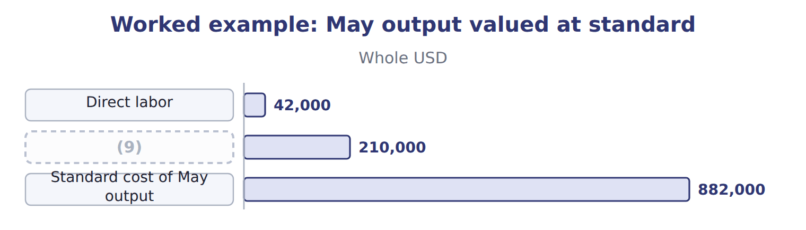
word list
Overhead: 1,400 standard MH × $150 · Standard cost of May output

Standard hours allowed, not actual hours

Summary 3 gaps 10–13
In standard costing, (10) is applied on the standard hours allowed for the actual output. Using actual hours turns standard costing back into (11) costing. Both ASC 330 and IAS 2 accept standard costs for inventory only if they (12) actual cost. (13) must be reviewed and updated regularly.
word list
Standards · approximate · overhead · normal · allowed

The English this section uses, and its Arabic
Each term sits against what it means.
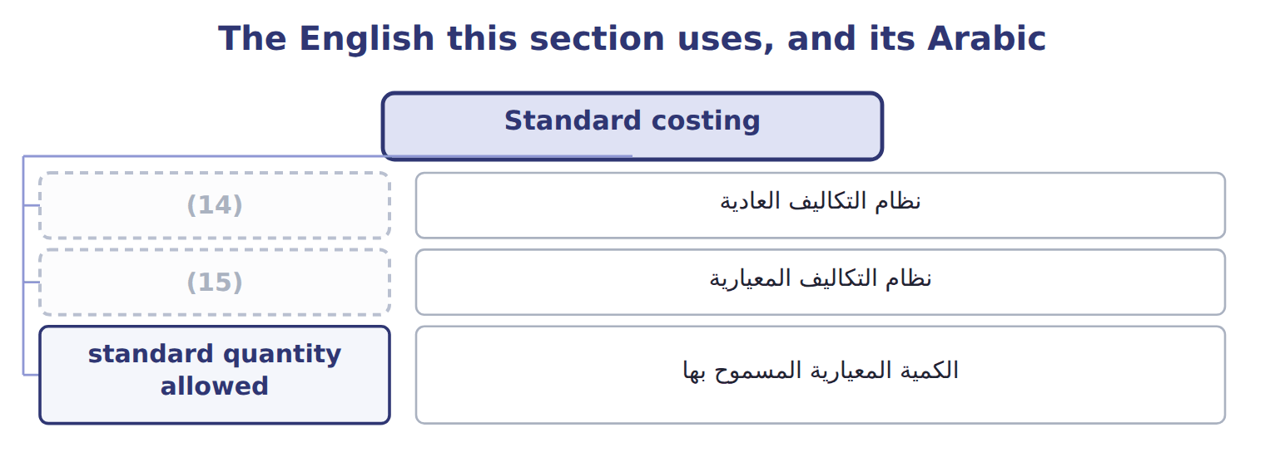
word list
variable overhead · normal costing · standard costing

The English this sheet uses, and its Arabic
English (exam term) | Arabic
standard costing | نظام التكاليف المعيارية
standard quantity allowed | الكمية المعيارية المسموح بها

Answer key · 5.4 Standard costing

1 achieved | 9 Overhead: 1,400 standard MH × $150
2 quantity | 10 overhead
3 Beverages | 11 normal
4 difference | 12 approximate
5 Managers | 13 Standards
6 repetitive | 14 normal costing
7 machine | 15 standard costing
8 actually

the summaries in full
Summary 1 Standard costing values every input at what it should cost for the output achieved. Each part equals the standard quantity allowed for the actual output times the standard price. The Beverages standard cost card gives $12.60 a case. The difference between actual cost and standard cost is recorded as variances. Managers study them to control costs, and Book 3 analyzes them in detail. Standard costing suits repetitive production such as bottling.
Summary 2 Overhead uses the 1,400 standard machine hours allowed for 70,000 cases, not the 1,414 hours actually used. The standard cost is $882,000.
Summary 3 In standard costing, overhead is applied on the standard hours allowed for the actual output. Using actual hours turns standard costing back into normal costing. Both ASC 330 and IAS 2 accept standard costs for inventory only if they approximate actual cost. Standards must be reviewed and updated regularly.

5.5 Variable overhead: components, base and rate
Chapter 5 · section 5.5

Fill every gap. Each word list holds one word more than there are gaps.
Summary 1 gaps 1–12
Variable overhead is indirect (1) cost that changes with (2) . On the bottling line it has four (3) : power for the machines, cleaning chemicals, (4) supplies, and water and steam. (5) , insurance and (6) are fixed overhead. The (7) base for variable overhead (8) be what drives it. The bottling line is (9) , so power and supplies (10) machine hours, not labor hours. On a (11) line, such as halva (12) , labor hours may be the better base. Variable overhead per unit = rate per base unit × base units per product. Each case needs 0.02 machine hours, so variable overhead is $1.00 a case. Keep variable and fixed overhead apart when you need a variable cost. The full predetermined rate of $150 per machine hour mixes both: it gives $1.00 of variable and $2.00 of fixed overhead per case.
word list
allocation · production · manual · Supervision · components · should · activity · finishing · follow · standard · maintenance · depreciation · automated

Summary 2 gaps 13–18
A special order that uses spare (13) adds only the variable part. Test the base (14) you use it. Plot monthly variable overhead against each (15) base, as in, and keep the one with a clear causal link and the better fit. For the (16) line, machine hours pass both tests. The (17) figure travels far. It goes on the standard cost card, into the (18) margin and into the flexible overhead budget in Book 3.
word list
capacity · bottling · contribution · possible · before · per-unit · overhead

Variable overhead per unit

The first two are done. Calculate variable overhead per unit for the others.
Your turn: variable overhead per unit (complete the blanks)
The bars are drawn to scale.
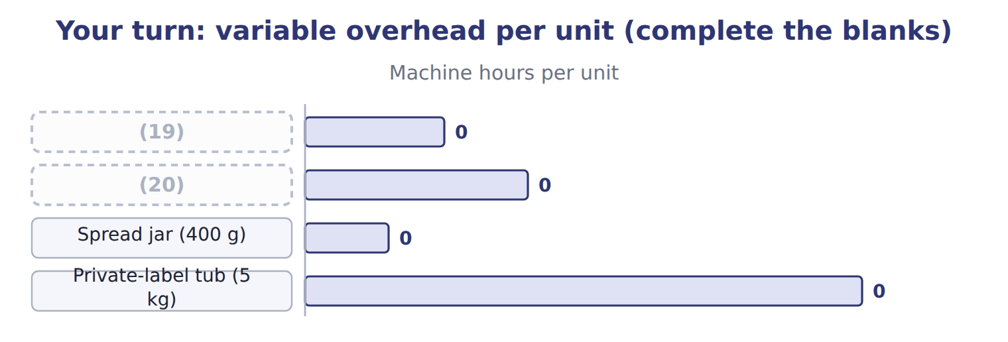
word list
normal costing · Halva tray · Tahini jar (1 kg)

Variable overhead on the bottling line
Beverages bottling line · variable overhead (bas | Per machine hour
(21) | $20
Cleaning chemicals | $12
(22) | $10
Water and steam | $8
Variable overhead rate per machine hour | $50
(23) | 0.02
(24) | $1.00

word list
Maintenance supplies · Variable overhead per case · Standard machine hours per case · Private-label tub (5 kg) · Power

The English this sheet uses, and its Arabic
English (exam term) | Arabic
variable overhead | التكاليف الصناعية غير المباشرة المتغيرة
allocation base | أساس التحميل

Answer key · 5.5 Variable overhead: components, base and rate

1 production | 13 capacity
2 activity | 14 before
3 components | 15 possible
4 maintenance | 16 bottling
5 Supervision | 17 per-unit
6 depreciation | 18 contribution
7 allocation | 19 Tahini jar (1 kg)
8 should | 20 Halva tray
9 automated | 21 Power
10 follow | 22 Maintenance supplies
11 manual | 23 Standard machine hours per case
12 finishing | 24 Variable overhead per case

the summaries in full
Summary 1 Variable overhead is indirect production cost that changes with activity. On the bottling line it has four components: power for the machines, cleaning chemicals, maintenance supplies, and water and steam. Supervision, insurance and depreciation are fixed overhead. The allocation base for variable overhead should be what drives it. The bottling line is automated, so power and supplies follow machine hours, not labor hours. On a manual line, such as halva finishing, labor hours may be the better base. Variable overhead per unit = rate per base unit × base units per product. Each case needs 0.02 machine hours, so variable overhead is $1.00 a case. Keep variable and fixed overhead apart when you need a variable cost. The full predetermined rate of $150 per machine hour mixes both: it gives $1.00 of variable and $2.00 of fixed overhead per case.
Summary 2 A special order that uses spare capacity adds only the variable part. Test the base before you use it. Plot monthly variable overhead against each possible base, as in, and keep the one with a clear causal link and the better fit. For the bottling line, machine hours pass both tests. The per-unit figure travels far. It goes on the standard cost card, into the contribution margin and into the flexible overhead budget in Book 3.

5.6 Extended Example 5A: one month, three costs
Chapter 5 · section 5.6

Fill every gap. Each word list holds one word more than there are gaps.
Summary 1 gaps 1–12
This example costs the same May output three ways and (1) each in the (2) . The costs per case are (3) ; the entries show where the (4) go. Output: 70,000 cases, all (5) in May. Actual costs: direct (6) $637,000; direct labor $43,400; (7) overhead $70,700; fixed overhead $151,900. Machine hours: 1,414 actual; 1,400 standard hours (8) for the output. Rates: (9) overhead $150 per machine hour; standard cost $12.60 a case. (10) each cost part under each (11) , record the entries, and see where the difference between actual and product cost goes. Actual: $637,000 + $43,400 + $222,600 = $903,000. Normal: $637,000 + $43,400 + 1,414 × $150 = $892,500. Standard: 70,000 × $12.60 = $882,000. The last row shows the actual cost that did not enter product cost: nothing under actual costing, $10,500 of (12) overhead under normal costing, and $21,000 of variances under standard costing.
word list
allowed · exam-core · differences · overhead · Measure · predetermined · finished · materials · accounts · variable · records · technique · underapplied

Extended Example: May output under three techniques
Beverages · May 2027 · 70,000 cases | Actual | Normal | Standard
Direct materials | 637,000 | 637,000 | 630,000
Direct labor | 43,400 | 43,400 | 42,000
(13) | 222,600 | 212,100 | 210,000
(14) | 903,000 | 892,500 | 882,000
Cost per case | $12.90 | $12.75 | $12.60
(15) | 0 | 10,500 | 21,000

word list
Jars in the job · Overhead in product cost · Cost moved to finished goods · Actual cost not in product cost

Summary 2 gaps 16–17
Only the (16) entry differs for normal costing, while standard costing also records (17) and labor at standard.
word list
technique · materials · overhead

Extended Example: standard costing journal for May
No. | Account (detail) | Debit | Credit
1 | (18) | 630,000
 | Direct Materials Variances | 7,000
 | (19) |  | 637,000
2 | Work-in-Process Inventory | 42,000
 | Direct Labor Variances | 1,400
 | Wages Payable |  | 43,400
3 | (20) | 222,600
 | Accounts Payable |  | 70,700
 | (21) |  | 34,500
 | Accumulated Depreciation |  | 75,000
 | (22) |  | 42,400
4 | Work-in-Process Inventory | 210,000
 | (23) |  | 210,000
5 | (24) | 882,000
 | Work-in-Process Inventory |  | 882,000
 | (25) | 1,995,000 | 1,995,000

word list
Totals · Work-in-Process Inventory · Raw Materials Inventory · Wages Payable · Manufacturing Overhead Control · Service Department Charges · normal costing · Finished Goods Inventory · Manufacturing Overhead Applied

Summary 3 gaps 26–27
Standard is lowest (26) the month used more (27) , labor and machine time than the standard allows.
word list
because · accounts · materials

Everything ties

Summary 4 gaps 28–30
Normal: actual overhead $222,600 − applied $212,100 = (28) $10,500. Standard: (29) variance $7,000 + labor variance $1,400 + overhead (30) $12,600 = $21,000. Actual − standard = $903,000 − $882,000 = $21,000.
word list
underapplied · quantities · variances · materials

Exam view

Summary 5 gaps 31–32
Expect one set of data and a (31) about one technique. Check which quantities and which rate the technique uses: actual or standard quantities, and an actual or (32) overhead rate.
word list
question · costing · predetermined

Exam view
Tahini & Spreads · job T-0306 · June 2027 (whole | Amount
Direct materials used on job T-0306 | 50,000
Direct labor on job T-0306 | 20,000
Machine hours on job T-0306 | 1,200
Jars in the job | 20,000
Tahini & Spreads actual overhead for June (all jobs) | 250,000
Tahini & Spreads actual machine hours for June | 8,000
Predetermined overhead rate (fixed + variable) | (33)
Variable overhead rate | (34)
Standards for the job's output | DM 48,000; DL 18,000; 1,100 MH

word list
Plant manager's salary · $30 per MH · $6 per MH

Item — Answer
Item | Answer
Spread jar (400 g) | (35)
Private-label tub (5 kg) | 0.20 × $6 = $1.20

word list
0.03 × $6 = $0.18 · Direct labor on job T-0306

Cost — Category
Every item belongs to exactly one group.
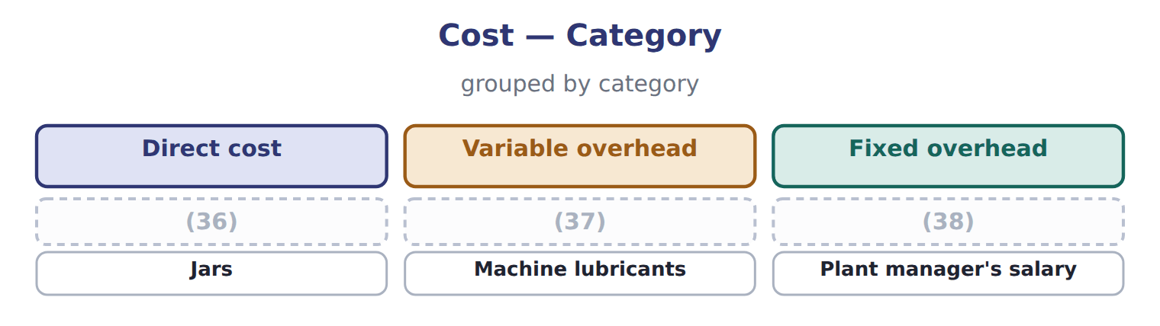
word list
actual costing · Sesame · Power for the grinders · Factory insurance

The English this section uses, and its Arabic
Each term sits against what it means.
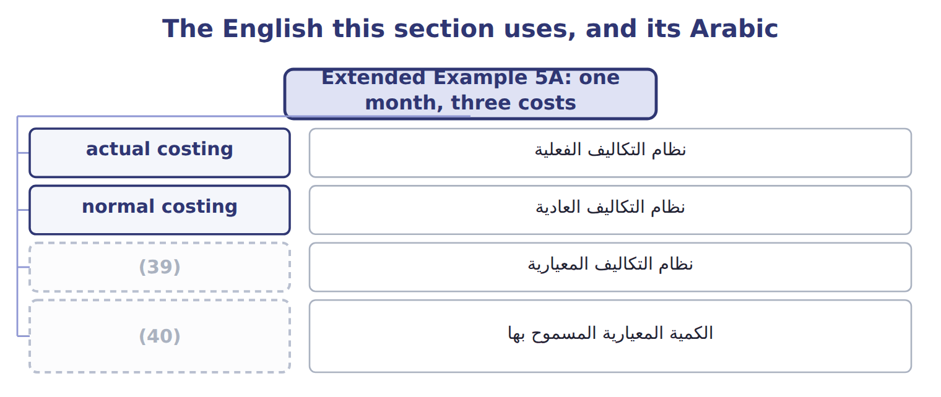
word list
standard costing · standard quantity allowed · نظام التكاليف الفعلية

The English this sheet uses, and its Arabic
English (exam term) | Arabic
actual costing | نظام التكاليف الفعلية
normal costing | نظام التكاليف العادية
standard costing | نظام التكاليف المعيارية
standard quantity allowed | الكمية المعيارية المسموح بها

Answer key · 5.6 Extended Example 5A: one month, three costs

1 records | 21 Service Department Charges
2 accounts | 22 Wages Payable
3 exam-core | 23 Manufacturing Overhead Applied
4 differences | 24 Finished Goods Inventory
5 finished | 25 Totals
6 materials | 26 because
7 variable | 27 materials
8 allowed | 28 underapplied
9 predetermined | 29 materials
10 Measure | 30 variances
11 technique | 31 question
12 underapplied | 32 predetermined
13 Overhead in product cost | 33 $30 per MH
14 Cost moved to finished goods | 34 $6 per MH
15 Actual cost not in product cost | 35 0.03 × $6 = $0.18
16 overhead | 36 Sesame
17 materials | 37 Power for the grinders
18 Work-in-Process Inventory | 38 Factory insurance
19 Raw Materials Inventory | 39 standard costing
20 Manufacturing Overhead Control | 40 standard quantity allowed

the summaries in full
Summary 1 This example costs the same May output three ways and records each in the accounts. The costs per case are exam-core; the entries show where the differences go. Output: 70,000 cases, all finished in May. Actual costs: direct materials $637,000; direct labor $43,400; variable overhead $70,700; fixed overhead $151,900. Machine hours: 1,414 actual; 1,400 standard hours allowed for the output. Rates: predetermined overhead $150 per machine hour; standard cost $12.60 a case. Measure each cost part under each technique, record the entries, and see where the difference between actual and product cost goes. Actual: $637,000 + $43,400 + $222,600 = $903,000. Normal: $637,000 + $43,400 + 1,414 × $150 = $892,500. Standard: 70,000 × $12.60 = $882,000. The last row shows the actual cost that did not enter product cost: nothing under actual costing, $10,500 of underapplied overhead under normal costing, and $21,000 of variances under standard costing.
Summary 2 Only the overhead entry differs for normal costing, while standard costing also records materials and labor at standard.
Summary 3 Standard is lowest because the month used more materials, labor and machine time than the standard allows.
Summary 4 Normal: actual overhead $222,600 − applied $212,100 = underapplied $10,500. Standard: materials variance $7,000 + labor variance $1,400 + overhead variances $12,600 = $21,000. Actual − standard = $903,000 − $882,000 = $21,000.
Summary 5 Expect one set of data and a question about one technique. Check which quantities and which rate the technique uses: actual or standard quantities, and an actual or predetermined overhead rate.

