7.1 Process costing and departments
Chapter 7 · section 7.1

Fill every gap. Each word list holds one word more than there are gaps.
Chapter 7, section by section
Each stage leads to the next.
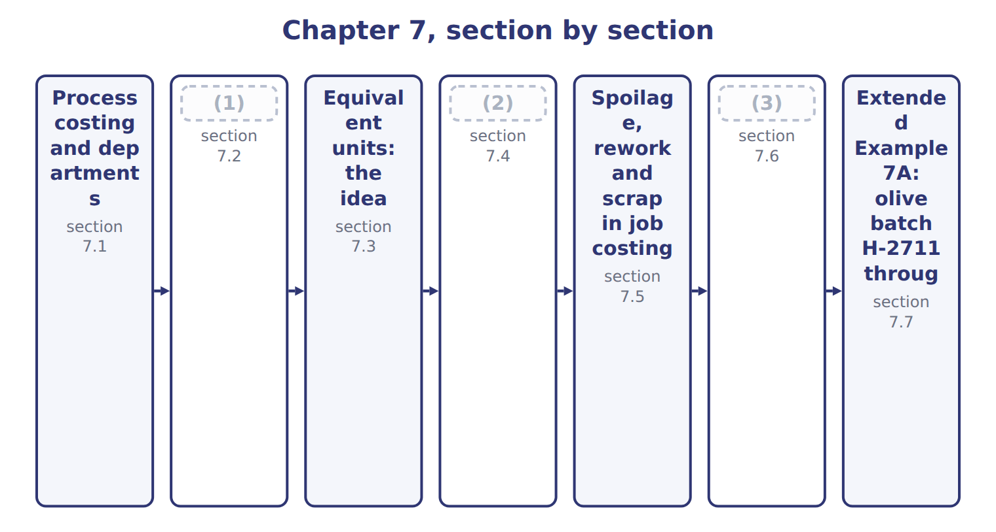
word list
The strategic value of cost information · Transferred-in costs · Spoilage: the ideas, shown in a process · production cost report

Summary 1 gaps 4–10
Process costing collects costs by department when identical units move through a (4) flow. It suits oil, juice, cement and (5) . Each department has its own (6) account. The Oils division has two (7) . (8) turns olives into extra-virgin oil, virgin oil and pomace. (9) fills extra-virgin oil into bottles. Unit cost in process costing is an (10) : department cost divided by the units it worked on. Every liter carries the same cost, which is fair when every liter is the same.
word list
Work-in-Process · average · Bottling · continuous · rework · chemicals · Crushing · departments

Exam scope: process costing is concept only

Summary 2 gaps 11–12
The exam asks you to (11) process costing and equivalent units, not to calculate them (LOS D.2.f). It tests (12) calculations in job order and activity-based costing settings.
word list
spoilage · through · understand

The English this section uses, and its Arabic
Each term sits against what it means.
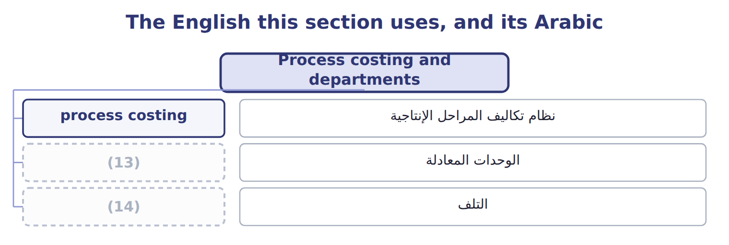
word list
scrap · spoilage · equivalent units

The English this sheet uses, and its Arabic
English (exam term) | Arabic
process costing | نظام تكاليف المراحل الإنتاجية

Answer key · 7.1 Process costing and departments

1 Transferred-in costs | 8 Crushing
2 Spoilage: the ideas, shown in a process | 9 Bottling
3 The strategic value of cost information | 10 average
4 continuous | 11 understand
5 chemicals | 12 spoilage
6 Work-in-Process | 13 equivalent units
7 departments | 14 spoilage

the summaries in full
Summary 1 Process costing collects costs by department when identical units move through a continuous flow. It suits oil, juice, cement and chemicals. Each department has its own Work-in-Process account. The Oils division has two departments. Crushing turns olives into extra-virgin oil, virgin oil and pomace. Bottling fills extra-virgin oil into bottles. Unit cost in process costing is an average: department cost divided by the units it worked on. Every liter carries the same cost, which is fair when every liter is the same.
Summary 2 The exam asks you to understand process costing and equivalent units, not to calculate them (LOS D.2.f). It tests spoilage calculations in job order and activity-based costing settings.

7.2 Transferred-in costs
Chapter 7 · section 7.2

Fill every gap. Each word list holds one word more than there are gaps.
Summary 1 gaps 1–8
When units leave a department, their cost goes with them. The entry is: debit Work in Process of the next department, (1) Work in Process of the (2) one. The next department (3) these as transferred-in costs. For the next department, transferred-in cost behaves like a (4) added at the start. Bottling received (5) oil at $8.06 a liter, the cost set by the joint cost allocation. It then added bottles and (6) . (7) transferred-in cost is a common error. The bottling cost of $11.66 a liter (8) the oil itself, not only the bottle and the work.
word list
previous · extra-virgin · material · conversion · allocation · Forgetting · includes · records · credit

The English this sheet uses, and its Arabic
English (exam term) | Arabic
transferred-in costs | التكاليف المحولة من المرحلة السابقة

Answer key · 7.2 Transferred-in costs

1 credit | 5 extra-virgin
2 previous | 6 conversion
3 records | 7 Forgetting
4 material | 8 includes

the summaries in full
Summary 1 When units leave a department, their cost goes with them. The entry is: debit Work in Process of the next department, credit Work in Process of the previous one. The next department records these as transferred-in costs. For the next department, transferred-in cost behaves like a material added at the start. Bottling received extra-virgin oil at $8.06 a liter, the cost set by the joint cost allocation. It then added bottles and conversion. Forgetting transferred-in cost is a common error. The bottling cost of $11.66 a liter includes the oil itself, not only the bottle and the work.

7.3 Equivalent units: the idea
Chapter 7 · section 7.3

Fill every gap. Each word list holds one word more than there are gaps.
Summary 1 gaps 1–7
At the end of a month some units are only partly finished. To share costs (1) , process costing (2) partly finished work as a number of whole units: equivalent units. Each cost (3) has its own count. (4) added at the start are complete for every unit; (5) added evenly may be only partly done. The CMA LOS ask you to (6) the concept, not to (7) equivalent units. The Oils example avoids the issue: the batch was complete when it was inspected.
word list
understand · calculate · inspected · expresses · fairly · conversion · element · Materials

No equivalent-unit arithmetic

Summary 2 gaps 8–9
LOS D.2.f says 'no (8) required'. Know what equivalent units mean and why they exist; do not spend exam time on (9) or FIFO schedules.
word list
calculations · spoilage · weighted-average

The English this sheet uses, and its Arabic
English (exam term) | Arabic
equivalent units | الوحدات المعادلة

Answer key · 7.3 Equivalent units: the idea

1 fairly | 6 understand
2 expresses | 7 calculate
3 element | 8 calculations
4 Materials | 9 weighted-average
5 conversion

the summaries in full
Summary 1 At the end of a month some units are only partly finished. To share costs fairly, process costing expresses partly finished work as a number of whole units: equivalent units. Each cost element has its own count. Materials added at the start are complete for every unit; conversion added evenly may be only partly done. The CMA LOS ask you to understand the concept, not to calculate equivalent units. The Oils example avoids the issue: the batch was complete when it was inspected.
Summary 2 LOS D.2.f says 'no calculations required'. Know what equivalent units mean and why they exist; do not spend exam time on weighted-average or FIFO schedules.

7.4 Spoilage: the ideas, shown in a process
Chapter 7 · section 7.4

Fill every gap. Each word list holds one word more than there are gaps.
Summary 1 gaps 1–8
Spoilage is units that fail (1) and are thrown away or sold (2) . Normal spoilage is expected even when (3) are efficient. Abnormal spoilage is not expected and could be (4) , for example after a (5) failure. In (6) costing, the cost of normal spoilage (7) part of the cost of good units. The cost of abnormal spoilage is taken out and (8) as a loss in the period. Measure the normal rate on good output, not on input. If the policy allows 2% of good units, the normal amount is 2% × good units.
word list
becomes · recorded · operations · process · machine · inspection · controlled · spoiled · cheaply

Concept illustration: normal or abnormal?

Summary 2 gaps 9–10
A process finishes 10,000 good units and finds 350 spoiled units at the final (9) . Normal (10) is 200 units, so 150 units are abnormal.
word list
charged · spoilage · inspection

Worked example: splitting spoilage and costing it
Spoilage worked example | Amount
(11) | 10,000
(12) | 350
Normal spoilage: 2% of good units | 200
Abnormal spoilage: spoiled − normal | 150
Total cost: 10,350 units × $4.00 | 41,400
Loss from abnormal spoilage: 150 × $4.00 | 600
Cost of good units (normal spoilage included) | 40,800
(13) | $4.08

word list
Good units completed · Cost per good unit · Spoiled units found at inspection · Abnormal spoilage: spoiled − normal

Summary 3 gaps 14–15
ASC 330 says abnormal amounts of wasted (14) (spoilage) are charged to the period, not to inventory. IAS 2 has the same rule. (15) spoilage stays in inventory cost.
word list
Spoilage · materials · Normal

The English this section uses, and its Arabic
Each term sits against what it means.
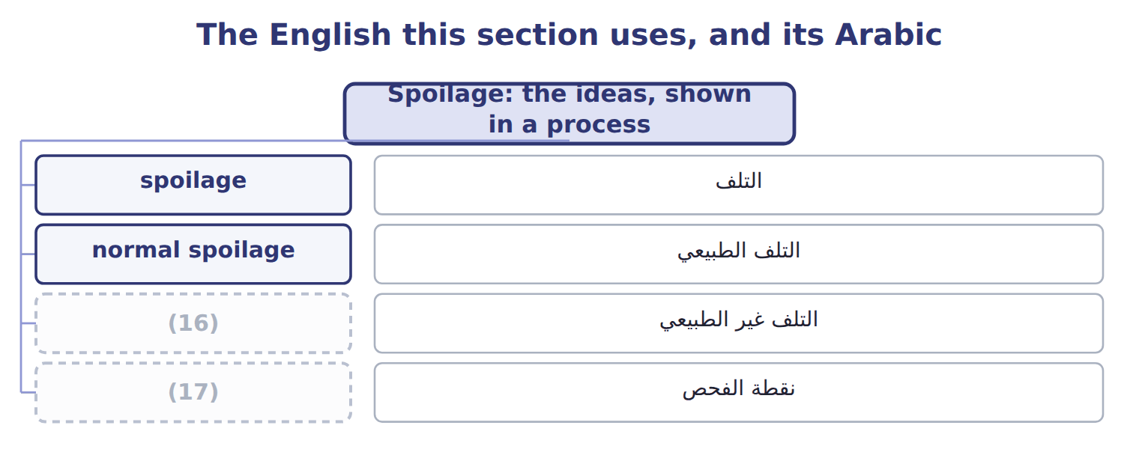
word list
التلف الطبيعي · inspection point · abnormal spoilage

The English this sheet uses, and its Arabic
English (exam term) | Arabic
spoilage | التلف
normal spoilage | التلف الطبيعي
abnormal spoilage | التلف غير الطبيعي
inspection point | نقطة الفحص

Answer key · 7.4 Spoilage: the ideas, shown in a process

1 inspection | 10 spoilage
2 cheaply | 11 Good units completed
3 operations | 12 Spoiled units found at inspection
4 controlled | 13 Cost per good unit
5 machine | 14 materials
6 process | 15 Normal
7 becomes | 16 abnormal spoilage
8 recorded | 17 inspection point
9 inspection

the summaries in full
Summary 1 Spoilage is units that fail inspection and are thrown away or sold cheaply. Normal spoilage is expected even when operations are efficient. Abnormal spoilage is not expected and could be controlled, for example after a machine failure. In process costing, the cost of normal spoilage becomes part of the cost of good units. The cost of abnormal spoilage is taken out and recorded as a loss in the period. Measure the normal rate on good output, not on input. If the policy allows 2% of good units, the normal amount is 2% × good units.
Summary 2 A process finishes 10,000 good units and finds 350 spoiled units at the final inspection. Normal spoilage is 200 units, so 150 units are abnormal.
Summary 3 ASC 330 says abnormal amounts of wasted materials (spoilage) are charged to the period, not to inventory. IAS 2 has the same rule. Normal spoilage stays in inventory cost.

7.5 Spoilage, rework and scrap in job costing
Chapter 7 · section 7.5

Fill every gap. Each word list holds one word more than there are gaps.
Summary 1 gaps 1–9
Job costing has three cases. Normal spoilage caused by one job's (1) needs stays in that job. Normal spoilage common to all jobs goes to (2) Overhead Control and is spread (3) the overhead rate. (4) spoilage is a loss. In every case, the (5) value of the spoiled units is (6) first. (7) , fixing units so they can be sold, (8) the same three cases. (9) , leftover material with a small value, reduces overhead or the job that caused it. This is the setting in which the exam asks for spoilage calculations: the official statement on spoilage (D.2.c) covers job order and activity-based costing.
word list
Control · Manufacturing · Rework · Abnormal · Scrap · through · disposal · follows · recorded · special

Normal or abnormal?

Split its spoilage into normal and abnormal.
Your turn: normal or abnormal spoilage (complete the blanks)
Every item belongs to exactly one group.
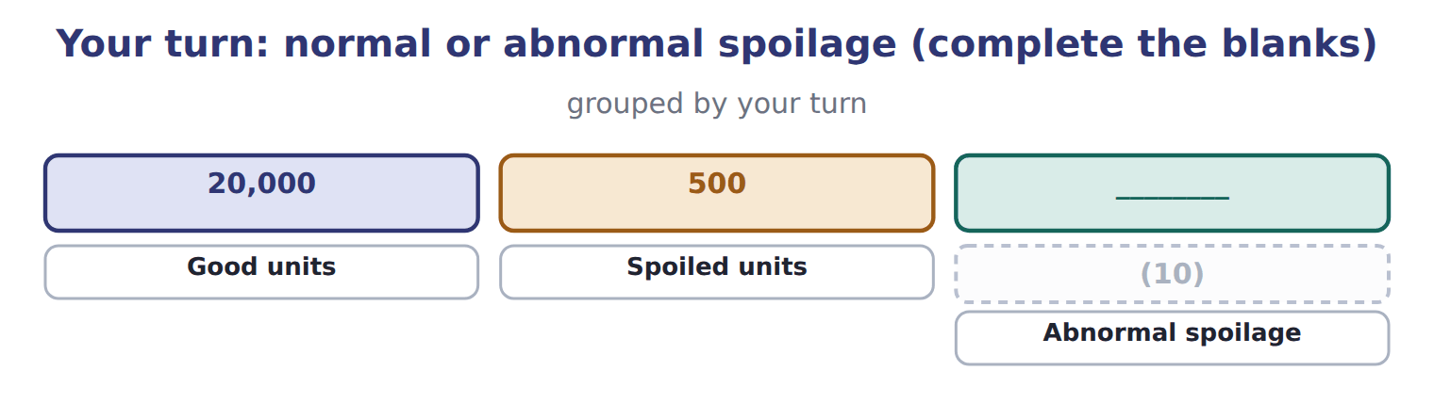
word list
Normal spoilage (2% of good) · production cost report

The two are accounted for differently, so do not mix them.
Spoilage and scrap in job costing: three cases
Job T-0305: spoiled units cost 4,000; disposal v | Entry | Effect
Normal, caused by this job's specifications | (11) | The job keeps the net cost of 3,500
Normal, common to all jobs | Dr Spoiled Goods Inventory 500; Dr MOH Control 3,500; Cr WIP (job) 4,000 | Spread to all jobs through the overhead rate
Abnormal | Dr Spoiled Goods Inventory 500; Dr Loss from Abnormal Spoilage 3,500; Cr WIP (job) 4,000 | (12)
Scrap sold (common to all jobs) | (13) | Reduces overhead (if specific to a job: Cr WIP of that job)

word list
Dr Spoiled Goods Inventory 500; Cr WIP (job) 500 · Dr Cash 600; Cr MOH Control 600 · Spread to all jobs through the overhead rate · Period loss in the income statement

The English this section uses, and its Arabic
Each term sits against what it means.
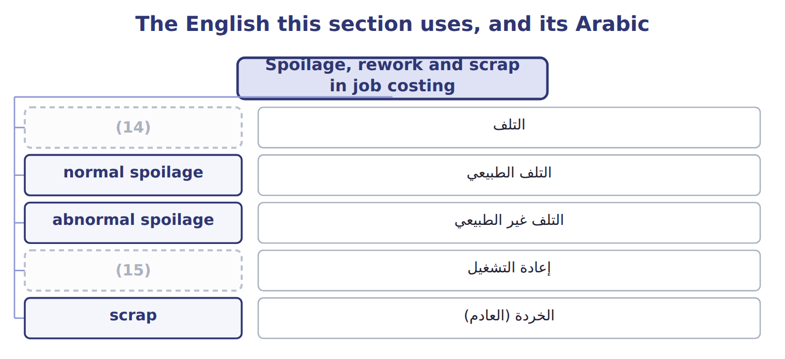
word list
التلف · rework · spoilage

The English this sheet uses, and its Arabic
English (exam term) | Arabic
rework | إعادة التشغيل
scrap | الخردة (العادم)

Answer key · 7.5 Spoilage, rework and scrap in job costing

1 special | 9 Scrap
2 Manufacturing | 10 Normal spoilage (2% of good)
3 through | 11 Dr Spoiled Goods Inventory 500; Cr WIP (job) 500
4 Abnormal | 12 Period loss in the income statement
5 disposal | 13 Dr Cash 600; Cr MOH Control 600
6 recorded | 14 spoilage
7 Rework | 15 rework
8 follows

the summaries in full
Summary 1 Job costing has three cases. Normal spoilage caused by one job's special needs stays in that job. Normal spoilage common to all jobs goes to Manufacturing Overhead Control and is spread through the overhead rate. Abnormal spoilage is a loss. In every case, the disposal value of the spoiled units is recorded first. Rework, fixing units so they can be sold, follows the same three cases. Scrap, leftover material with a small value, reduces overhead or the job that caused it. This is the setting in which the exam asks for spoilage calculations: the official statement on spoilage (D.2.c) covers job order and activity-based costing.

7.6 The strategic value of cost information
Chapter 7 · section 7.6

Fill every gap. Each word list holds one word more than there are gaps.
Summary 1 gaps 1–11
Product costs are not only for the (1) sheet. (2) use them to set prices, choose the product mix and decide where to (3) . A good bottle of (4) oil costs $11.75; any price must cover that and the (5) costs. Job (6) gives the same kind of information for each order. (7) job T-0303 cost $346,000 in March. When Barada asks for a repeat order, that job cost sheet is the (8) point for the quote, and it shows which cost items to (9) . Cost information also shows where value is lost. Each batch with (10) spoilage like this one loses $11,660. (11) spoilage by cause lets the Oils manager fix the line rather than accept the loss. Poor overhead allocation can mislead every one of these decisions.
word list
starting · negotiate · extra-virgin · decisions · abnormal · selling · Tahini · costing · Tracking · Managers · balance · improve

How the Oils division uses cost information
Decision | How Oils uses the cost information
Pricing | A good bottle of EVOO costs $11.75; prices must cover it plus (12) costs
Product mix | Compare margins of EVOO, VOO and pomace before (13) the mix
Quality and spoilage | Each 1,000 liters of abnormal spoilage costs 11,660; target the causes
Overhead allocation | A poor base distorts product costs (Chapters 8 and 12)
Make or buy; process or sell | (14) the extra cost of a further process with the extra revenue (Chapter 11)

word list
changing · Compare · spoilage · selling

Answer key · 7.6 The strategic value of cost information

1 balance | 8 starting
2 Managers | 9 negotiate
3 improve | 10 abnormal
4 extra-virgin | 11 Tracking
5 selling | 12 selling
6 costing | 13 changing
7 Tahini | 14 Compare

the summaries in full
Summary 1 Product costs are not only for the balance sheet. Managers use them to set prices, choose the product mix and decide where to improve. A good bottle of extra-virgin oil costs $11.75; any price must cover that and the selling costs. Job costing gives the same kind of information for each order. Tahini job T-0303 cost $346,000 in March. When Barada asks for a repeat order, that job cost sheet is the starting point for the quote, and it shows which cost items to negotiate. Cost information also shows where value is lost. Each batch with abnormal spoilage like this one loses $11,660. Tracking spoilage by cause lets the Oils manager fix the line rather than accept the loss. Poor overhead allocation can mislead every one of these decisions.

7.7 Extended Example 7A: olive batch H-2711 through two departments
Chapter 7 · section 7.7

Fill every gap. Each word list holds one word more than there are gaps.
Summary 1 gaps 1–11
This example (1) one batch from the olives to the finished bottles, (2) every entry by (3) and handles spoilage at the final inspection. It is for depth: the exam does not test process (4) , but the same spoilage rules are tested in job (5) (Section 7.5 and the case set). Crushing: olives $1,000,000, labor $120,000, overhead applied $280,000; total $1,400,000. Split-off: pomace (6) $100,000; virgin oil $252,200, sold in bulk; (7) oil $1,047,800 to bottling. Bottling: bottles $312,000; labor $52,000; overhead applied $104,000. Inspection: 130,000 liters; 128,000 good; 1,000 normal and 1,000 abnormal spoilage; no (8) value. Record crushing, split the joint cost, record bottling, (9) the cost per liter, and move good (10) and abnormal spoilage out of Work in Process – Bottling. Bottling cost: $1,047,800 + $312,000 + $156,000 = $1,515,800; ÷ 130,000 liters = $11.66 per liter. Abnormal loss: 1,000 liters × $11.66 = $11,660. Finished goods: $1,515,800 − $11,660 = $1,504,140, which (11) the normal spoilage; ÷ 128,000 good liters = $11.75 per liter.
word list
disposal · by-product · calculations · follows · abnormal · settings · extra-virgin · compute · records · includes · department · output

Extended Example: journal for batch H-2711
No. | Account (detail) | Debit | Credit
1 | WIP - Crushing | 1,000,000
 | Raw Materials Inventory |  | 1,000,000
2 | (12) | 120,000
 | Wages Payable |  | 120,000
3 | WIP - Crushing | 280,000
 | Manufacturing Overhead Applied |  | 280,000
4 | (13) | 100,000
 | WIP - Bottling | 1,047,800
 | (14) | 252,200
 | WIP - Crushing |  | 1,400,000
5 | WIP - Bottling | 312,000
 | (15) |  | 312,000
6 | (16) | 52,000
 | (17) |  | 52,000
7 | WIP - Bottling | 104,000
 | (18) |  | 104,000
8 | (19) | 1,504,140
 | Loss from Abnormal Spoilage | 11,660
 | WIP - Bottling |  | 1,515,800
 | (20) | 4,783,800 | 4,783,800

word list
Pomace (By-product) Inventory · Totals · Finished Goods - EVOO · Raw Materials Inventory · Manufacturing Overhead Applied · Finished Goods - VOO · Costs to account for · WIP - Bottling · Wages Payable · WIP - Crushing

Summary 2 gaps 21–22
Both (21) accounts close to zero: every cost has moved on to inventory or to the loss. A production cost report summarizes a (22) units and costs.
word list
department's · inspection · Work-in-Process

Everything ties

Summary 3 gaps 23–24
Crushing: $1,000,000 + $120,000 + $280,000 = $100,000 + $1,047,800 + $252,200. (23) : $1,515,800 = finished goods $1,504,140 + loss $11,660. (24) : 128,000 + 1,000 + 1,000 = 130,000.
word list
Crushing · Bottling · Liters

Exam view

Summary 4 gaps 25–27
Expect (25) units, a normal rate and a unit cost. Base the normal rate on good output, value (26) units at the full cost per unit, and report them as a loss. Normal (27) stays in the good units.
word list
abnormal · spoiled · by-product · spoilage

Extended Example: bottling production cost report
Bottling department · production cost report · b | Amount
Units (liters)
Transferred in from crushing | 130,000
Good liters to finished goods | 128,000
(28) | 1,000
Abnormal spoilage | 1,000
(29)
(30) | 1,047,800
Bottles | 312,000
(31) | 156,000
(32) | 1,515,800
(33) | $11.66
Costs accounted for
Finished goods: good liters + normal spoilage | 1,504,140
Loss: 1,000 liters × $11.66 | 11,660
Total | 1,515,800
(34) | $11.75

word list
Costs to account for · Normal spoilage · Cost per good liter · Cost per liter started · Conversion (labor + overhead) · process costing · Total · Transferred-in cost

Tahini & Spreads · May 2027 (whole USD) — Cost
Tahini & Spreads · May 2027 (whole USD) | Cost | Disposal value / proceeds
(35) : Barada's special tolerance) | 6,000 | 1,000
Normal spoiled jars common to all jobs | 9,000 | 1,500
Jars ruined in the power failure (abnormal) | 4,800 | 800
(36) | 2,500 | —
(37) | — | 700

word list
Spoiled jars on job T-0412 (normal · Spoiled jars on T-0412 (Barada's special tolerance) · Rework on routine jobs (common to all jobs) · Scrap sold (common to all jobs): proceeds

Item — Answer
Item | Answer
Normal spoilage (your turn) | (38)
Abnormal spoilage (your turn) | 500 − 400 = 100 units

word list
Jars ruined in the power failure · 2% × 20,000 = 400 units

May event — Category
Every item belongs to exactly one group.
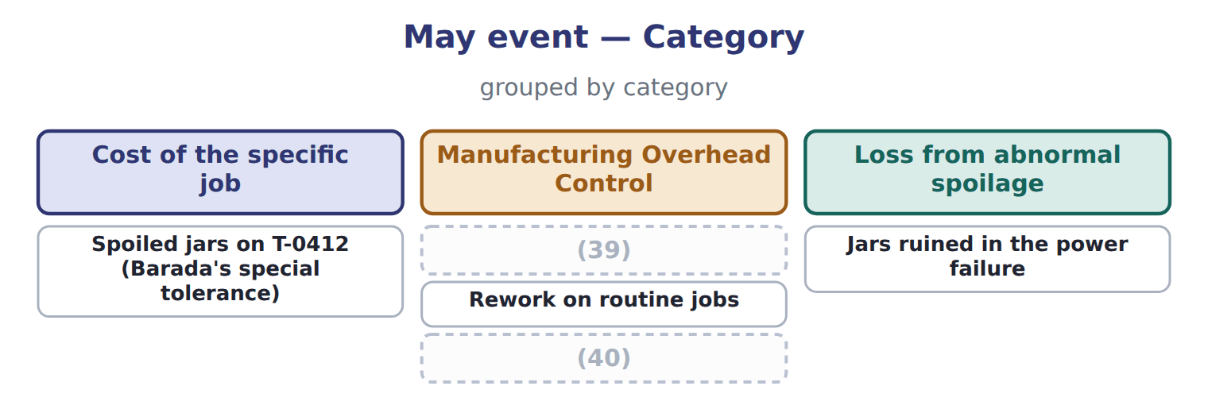
word list
Normal spoiled jars common to all jobs · Proceeds from scrap sold · Spoiled jars on T-0412 (Barada's special tolerance)

The English this section uses, and its Arabic
Each term sits against what it means.
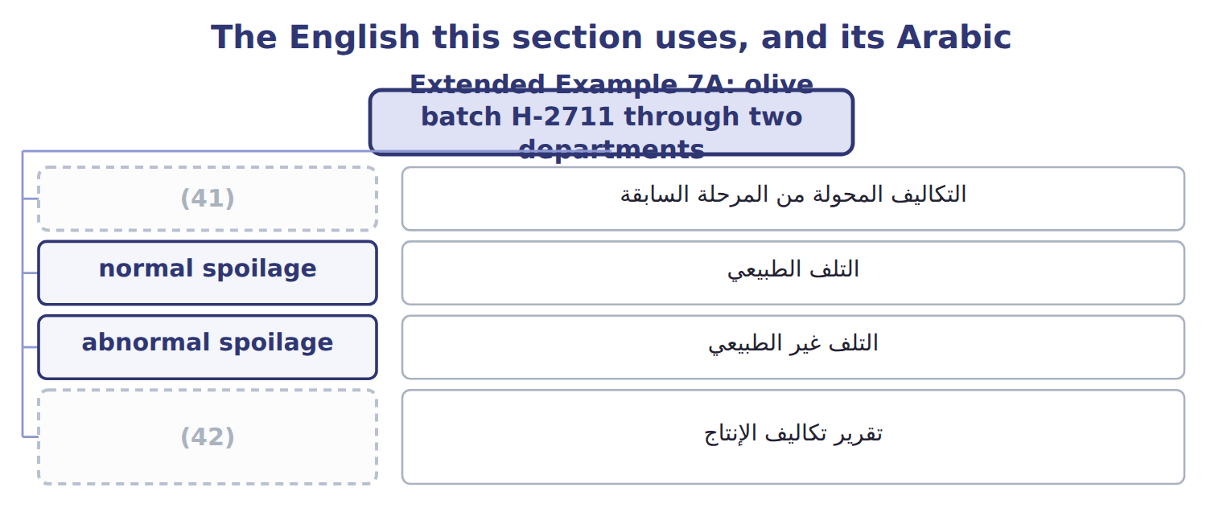
word list
transferred-in costs · inspection point · production cost report

The English this sheet uses, and its Arabic
English (exam term) | Arabic
transferred-in costs | التكاليف المحولة من المرحلة السابقة
normal spoilage | التلف الطبيعي
abnormal spoilage | التلف غير الطبيعي
production cost report | تقرير تكاليف الإنتاج

Answer key · 7.7 Extended Example 7A: olive batch H-2711 through two departments

1 follows | 22 department's
2 records | 23 Bottling
3 department | 24 Liters
4 calculations | 25 spoiled
5 settings | 26 abnormal
6 by-product | 27 spoilage
7 extra-virgin | 28 Normal spoilage
8 disposal | 29 Costs to account for
9 compute | 30 Transferred-in cost
10 output | 31 Conversion (labor + overhead)
11 includes | 32 Total
12 WIP - Crushing | 33 Cost per liter started
13 Pomace (By-product) Inventory | 34 Cost per good liter
14 Finished Goods - VOO | 35 Spoiled jars on job T-0412 (normal
15 Raw Materials Inventory | 36 Rework on routine jobs (common to all jobs)
16 WIP - Bottling | 37 Scrap sold (common to all jobs): proceeds
17 Wages Payable | 38 2% × 20,000 = 400 units
18 Manufacturing Overhead Applied | 39 Normal spoiled jars common to all jobs
19 Finished Goods - EVOO | 40 Proceeds from scrap sold
20 Totals | 41 transferred-in costs
21 Work-in-Process | 42 production cost report

the summaries in full
Summary 1 This example follows one batch from the olives to the finished bottles, records every entry by department and handles spoilage at the final inspection. It is for depth: the exam does not test process calculations, but the same spoilage rules are tested in job settings (Section 7.5 and the case set). Crushing: olives $1,000,000, labor $120,000, overhead applied $280,000; total $1,400,000. Split-off: pomace by-product $100,000; virgin oil $252,200, sold in bulk; extra-virgin oil $1,047,800 to bottling. Bottling: bottles $312,000; labor $52,000; overhead applied $104,000. Inspection: 130,000 liters; 128,000 good; 1,000 normal and 1,000 abnormal spoilage; no disposal value. Record crushing, split the joint cost, record bottling, compute the cost per liter, and move good output and abnormal spoilage out of Work in Process – Bottling. Bottling cost: $1,047,800 + $312,000 + $156,000 = $1,515,800; ÷ 130,000 liters = $11.66 per liter. Abnormal loss: 1,000 liters × $11.66 = $11,660. Finished goods: $1,515,800 − $11,660 = $1,504,140, which includes the normal spoilage; ÷ 128,000 good liters = $11.75 per liter.
Summary 2 Both Work-in-Process accounts close to zero: every cost has moved on to inventory or to the loss. A production cost report summarizes a department's units and costs.
Summary 3 Crushing: $1,000,000 + $120,000 + $280,000 = $100,000 + $1,047,800 + $252,200. Bottling: $1,515,800 = finished goods $1,504,140 + loss $11,660. Liters: 128,000 + 1,000 + 1,000 = 130,000.
Summary 4 Expect spoiled units, a normal rate and a unit cost. Base the normal rate on good output, value abnormal units at the full cost per unit, and report them as a loss. Normal spoilage stays in the good units.

