15.1 Process analysis
Chapter 15 · section 15.1

Fill every gap. Each word list holds one word more than there are gaps.
Chapter 15, section by section
Each stage leads to the next.
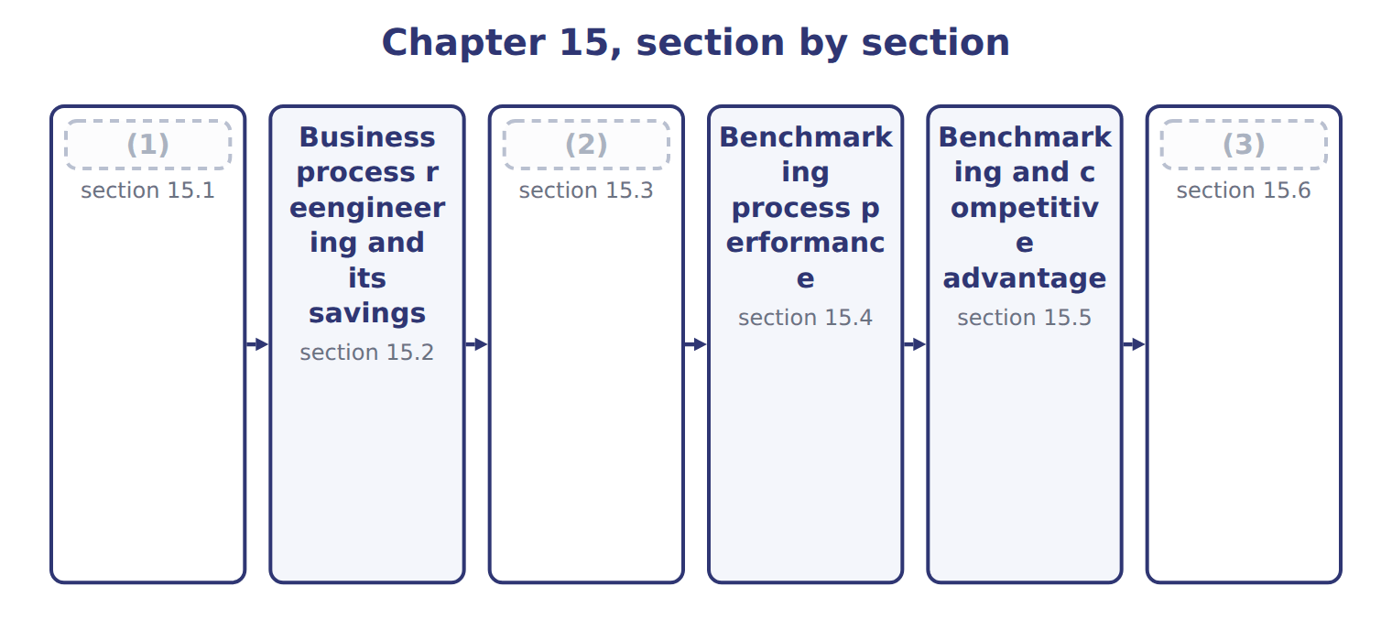
word list
Process analysis · section 15.1 · Extended Example 15A: the business case for th · Best practice analysis

Summary 1 gaps 4–11
A (4) process is a chain of steps that turns an input into a (5) for a customer, such as an order into cash. Process (6) studies each step: what it does, who does it, how long it takes, what it costs and (7) it adds value. The first tool is a process map, a (8) of the steps in order. Only two of its eight steps, picking and (9) , are steps the customer (10) . The second tool (11) each step. The cycle time from order to cash is 9 days, and the staff time is 2.10 hours per order.
word list
measures · values · analysis · shipping · process · business · diagram · whether · result

Worked example: the cost of one order

Staff cost $20 an hour.

Worked example: staff time and cost of each step, per order
The parts add up to the total; the bars are to scale.
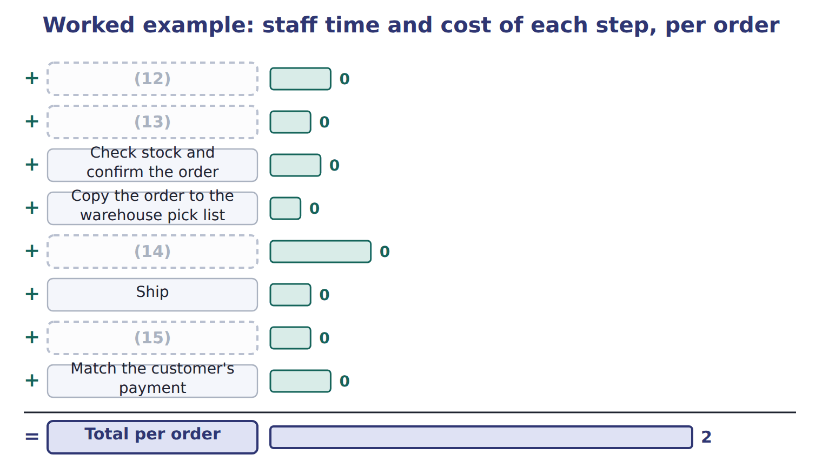
word list
Prepare the invoice by hand · Copy the order to the warehouse pick list · Take the order by phone and type it in · Pick and pack · Check the customer's credit

The English this section uses, and its Arabic
Each term sits against what it means.
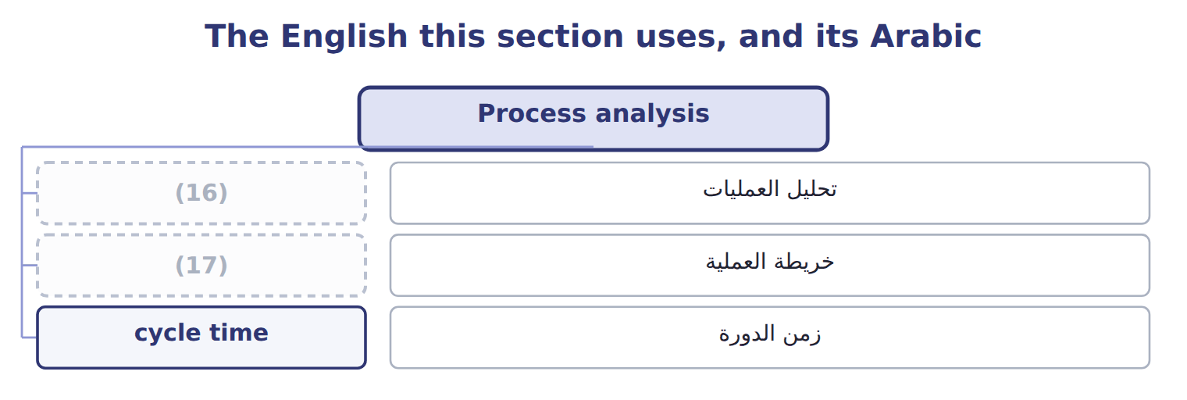
word list
process map · process analysis · competitive benchmarking

The English this sheet uses, and its Arabic
English (exam term) | Arabic
process analysis | تحليل العمليات
process map | خريطة العملية
cycle time | زمن الدورة

Answer key · 15.1 Process analysis

1 Process analysis | 10 values
2 Best practice analysis | 11 measures
3 Extended Example 15A: the business case for th | 12 Take the order by phone and type it in
4 business | 13 Check the customer's credit
5 result | 14 Pick and pack
6 analysis | 15 Prepare the invoice by hand
7 whether | 16 process analysis
8 diagram | 17 process map
9 shipping

the summaries in full
Summary 1 A business process is a chain of steps that turns an input into a result for a customer, such as an order into cash. Process analysis studies each step: what it does, who does it, how long it takes, what it costs and whether it adds value. The first tool is a process map, a diagram of the steps in order. Only two of its eight steps, picking and shipping, are steps the customer values. The second tool measures each step. The cycle time from order to cash is 9 days, and the staff time is 2.10 hours per order.

15.2 Business process reengineering and its savings
Chapter 15 · section 15.2

Fill every gap. Each word list holds one word more than there are gaps.
Summary 1 gaps 1–6
Business process (1) is a radical redesign of a process, not a small improvement. Instead of typing orders faster, Tahini lets (2) order online; instead of preparing invoices by hand, the invoice is created from the shipment record. Two steps (3) , four are shortened, and staff time falls to 0.87 hours per order. Cycle time falls to 4 days, so cash (4) sooner. The (5) must be net. The net (6) saving is $200,000.
word list
customers · process · reengineering · savings · disappear · yearly · arrives

Yearly cost of the old and new processes
The bars are drawn to scale.
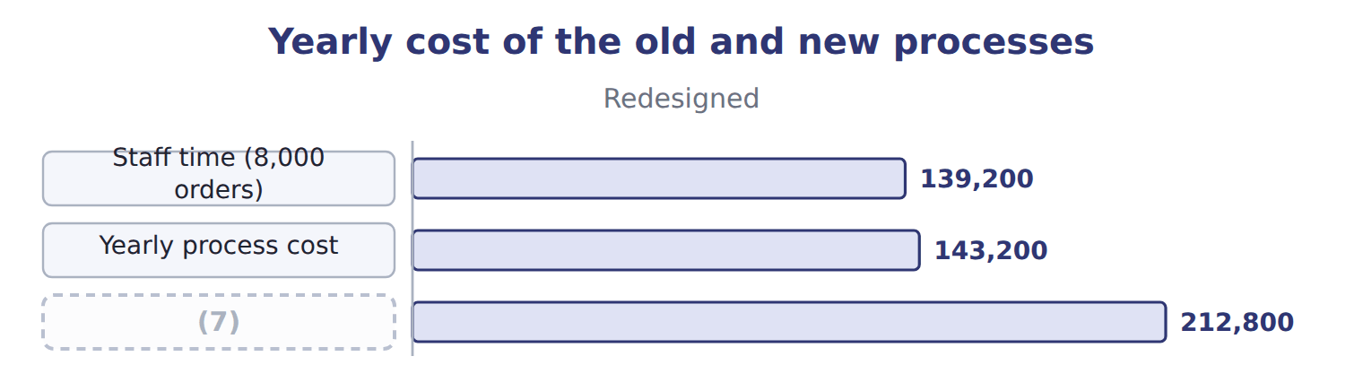
word list
business process reengineering · Gross yearly saving

The saving over three years

The change also has a one-off cost of $150,000.
Your turn: the net saving over three years (complete the blanks)
Three-year view (whole USD) | Amount
Net yearly saving × 3 years | ________
(8) | (150,000)
Net saving over three years | ________

word list
One-off cost of the change · Net saving over three years

Gross is not net

Summary 2 gaps 9–10
Exam (9) often show the gross saving. The (10) answer deducts the running cost of the new process every year and the one-off cost of the change once.
word list
options · Business · correct

The English this section uses, and its Arabic
Each term sits against what it means.
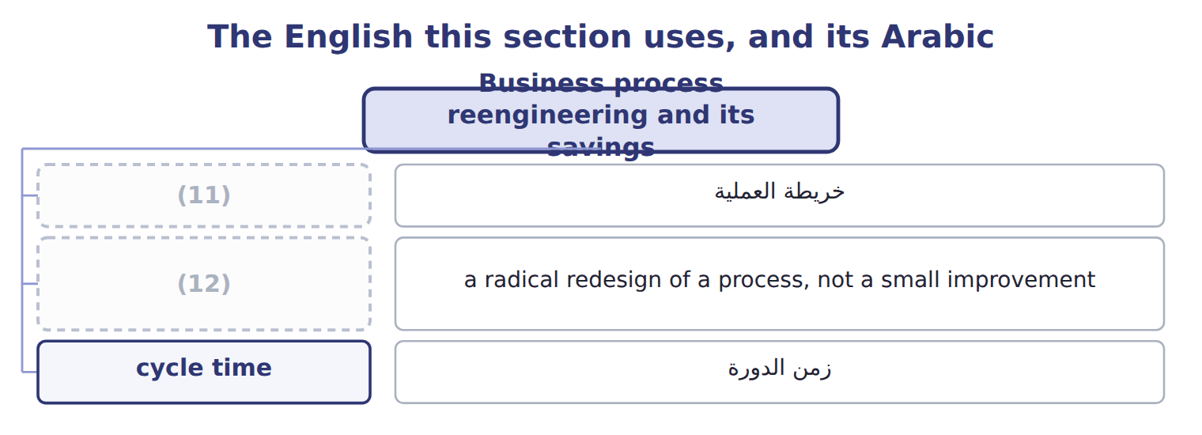
word list
business process reengineering · process map · cycle time

The English this sheet uses, and its Arabic
English (exam term) | Arabic
business process reengineering | إعادة هندسة العمليات

Answer key · 15.2 Business process reengineering and its savings

1 reengineering | 7 Gross yearly saving
2 customers | 8 One-off cost of the change
3 disappear | 9 options
4 arrives | 10 correct
5 savings | 11 process map
6 yearly | 12 business process reengineering

the summaries in full
Summary 1 Business process reengineering is a radical redesign of a process, not a small improvement. Instead of typing orders faster, Tahini lets customers order online; instead of preparing invoices by hand, the invoice is created from the shipment record. Two steps disappear, four are shortened, and staff time falls to 0.87 hours per order. Cycle time falls to 4 days, so cash arrives sooner. The savings must be net. The net yearly saving is $200,000.
Summary 2 Exam options often show the gross saving. The correct answer deducts the running cost of the new process every year and the one-off cost of the change once.

15.3 Best practice analysis
Chapter 15 · section 15.3

Fill every gap. Each word list holds one word more than there are gaps.
Summary 1 gaps 1–3
Best practice analysis finds the practices that make the best performers better and adapts them to one's own (1) . The aim is not to copy the result, but to (2) how it is achieved. Every one of them removes a (3) step.
word list
organization · non-value-added · channel · understand

Best practices found among leading food distributors
Best practice | Why it works | Tahini step it affects
Customers order online | (4) | Order taking, credit check
Invoice created from the shipment | (5) | Invoicing
Payments matched automatically by reference | Faster cash, fewer queries | (6)
Suppliers deliver to the line | (7) | Receiving (Chapter 17)

word list
No separate invoicing step · Less storage and handling · competitive benchmarking · Cash collection · Removes typing and copying errors

Summary 2 gaps 8–9
A practice must fit the (8) . Online ordering works for Barada and the (9) ; many small shops still order by phone, so Tahini keeps a simple phone channel for them.
word list
supermarkets · organization · benchmarking

The English this sheet uses, and its Arabic
English (exam term) | Arabic
best practice analysis | تحليل أفضل الممارسات

Answer key · 15.3 Best practice analysis

1 organization | 6 Cash collection
2 understand | 7 Less storage and handling
3 non-value-added | 8 organization
4 Removes typing and copying errors | 9 supermarkets
5 No separate invoicing step

the summaries in full
Summary 1 Best practice analysis finds the practices that make the best performers better and adapts them to one's own organization. The aim is not to copy the result, but to understand how it is achieved. Every one of them removes a non-value-added step.
Summary 2 A practice must fit the organization. Online ordering works for Barada and the supermarkets; many small shops still order by phone, so Tahini keeps a simple phone channel for them.

15.4 Benchmarking process performance
Chapter 15 · section 15.4

Fill every gap. Each word list holds one word more than there are gaps.
Summary 1 gaps 1–2
Benchmarking compares a process and its results with those of the best (1) . There are four common types: internal benchmarking, (2) benchmarking, functional benchmarking and generic benchmarking.
word list
correction · performers · competitive

The four types of benchmarking
Type | Compare with | Orontes example
Internal | (3) | Tahini vs Oils order handling
Competitive | Direct competitors | (4)
Functional | (5) | Order handling at a pharmaceutical distributor
Generic | A basic process at the best organizations anywhere | (6)

word list
Order handling at a pharmaceutical distributor · Units of the same organization · Invoice-to-cash at a global retailer · Another Jordanian tahini maker · The same function in other industries

Summary 2 gaps 7–9
Benchmarking follows a cycle: plan, find partners, collect (7) data, analyse the gap and the (8) behind it, act, and monitor. The (9) closes most of the gap, but best practice is still $16.00 an order and 3 days.
word list
practices · redesign · results · comparable

Tahini's order-to-cash process against best practice
Measure | Tahini before | Tahini after | Best practice
Cost per order (all-in) | $44.50 | $19.50 | $16.00
(10) | 9 | 4 | 3
(11) | 5 | 1 | 0.5

word list
Another Jordanian tahini maker · Cycle time, order to cash (days) · Faulty orders (%)

Summary 3 gaps 12–14
Measures must be (12) the same way on both sides. Tahini's all-in cost per order includes error (13) and the running cost of the portal; the survey figure must include the same items, or the (14) misleads.
word list
compares · correction · comparison · defined

The English this section uses, and its Arabic
Each term sits against what it means.
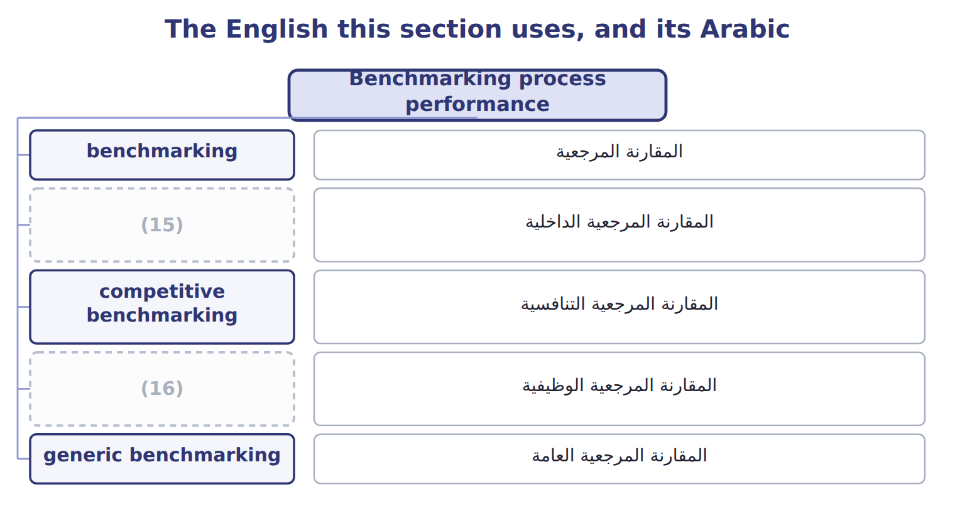
word list
competitive benchmarking · functional benchmarking · internal benchmarking

The English this sheet uses, and its Arabic
English (exam term) | Arabic
benchmarking | المقارنة المرجعية
internal benchmarking | المقارنة المرجعية الداخلية
competitive benchmarking | المقارنة المرجعية التنافسية
functional benchmarking | المقارنة المرجعية الوظيفية
generic benchmarking | المقارنة المرجعية العامة

Answer key · 15.4 Benchmarking process performance

1 performers | 9 redesign
2 competitive | 10 Cycle time, order to cash (days)
3 Units of the same organization | 11 Faulty orders (%)
4 Another Jordanian tahini maker | 12 defined
5 The same function in other industries | 13 correction
6 Invoice-to-cash at a global retailer | 14 comparison
7 comparable | 15 internal benchmarking
8 practices | 16 functional benchmarking

the summaries in full
Summary 1 Benchmarking compares a process and its results with those of the best performers. There are four common types: internal benchmarking, competitive benchmarking, functional benchmarking and generic benchmarking.
Summary 2 Benchmarking follows a cycle: plan, find partners, collect comparable data, analyse the gap and the practices behind it, act, and monitor. The redesign closes most of the gap, but best practice is still $16.00 an order and 3 days.
Summary 3 Measures must be defined the same way on both sides. Tahini's all-in cost per order includes error correction and the running cost of the portal; the survey figure must include the same items, or the comparison misleads.

15.5 Benchmarking and competitive advantage
Chapter 15 · section 15.5

Fill every gap. Each word list holds one word more than there are gaps.
Summary 1 gaps 1–2
Benchmarking helps create an (1) in four ways. It sets targets that others already achieve, brings in ideas from outside, focuses on measures (2) feel, and builds a habit of improving.
word list
customers · advantage · tomorrow's

Benefits of benchmarking for competitive advantage
Benefit | What it gives the company
Realistic targets | Targets based on what others already achieve
New ideas | (3)
Customer focus | (4)
Lasting advantage | A habit of improving faster than rivals

word list
A habit of improving faster than rivals · Measures such as cycle time that customers feel · Practices the company would not have thought of

Summary 2 gaps 5–8
For Tahini, a four-day cycle time is now a selling point: Barada receives its orders faster than from other suppliers, and fewer invoices need (5) . The (6) lasts only if benchmarking continues. (7) improve too, so today's best practice becomes tomorrow's normal practice. In (8) it means benchmarking.
word list
Competitors · advantage · improve · management · correcting

The words this section uses
Each term sits against what it means.
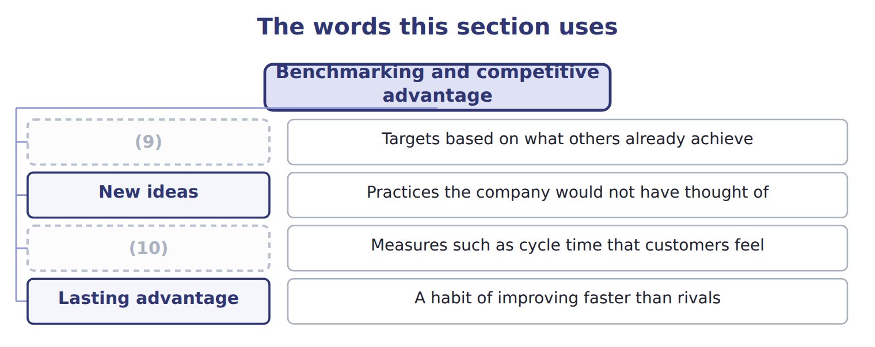
word list
Lasting advantage · Customer focus · Realistic targets

Answer key · 15.5 Benchmarking and competitive advantage

1 advantage | 6 advantage
2 customers | 7 Competitors
3 Practices the company would not have thought of | 8 management
4 Measures such as cycle time that customers feel | 9 Realistic targets
5 correcting | 10 Customer focus

the summaries in full
Summary 1 Benchmarking helps create an advantage in four ways. It sets targets that others already achieve, brings in ideas from outside, focuses on measures customers feel, and builds a habit of improving.
Summary 2 For Tahini, a four-day cycle time is now a selling point: Barada receives its orders faster than from other suppliers, and fewer invoices need correcting. The advantage lasts only if benchmarking continues. Competitors improve too, so today's best practice becomes tomorrow's normal practice. In management it means benchmarking.

15.6 Extended Example 15A: the business case for the new order-to-cash process
Chapter 15 · section 15.6

Fill every gap. Each word list holds one word more than there are gaps.
Summary 1 gaps 1–7
This example builds the (1) business case the (2) manager signed. (3) : 8,000 orders a year; staff cost $20 an hour; (4) a faulty order costs $50. Change: one-off cost $150,000; (5) cost $12,800 a year. Old process: staff $336,000 + corrections $20,000 = $356,000 a year. New process: staff $139,200 + corrections $4,000 = $143,200 a year. Net (6) saving: $212,800 − $12,800 = $200,000. The one-off cost is (7) in 0.75 years, and the net saving over three years is $450,000.
word list
business · recovered · division · yearly · three-year · Volume · correcting · running

Extended Example: the three-year business case
Every item belongs to exactly one group.
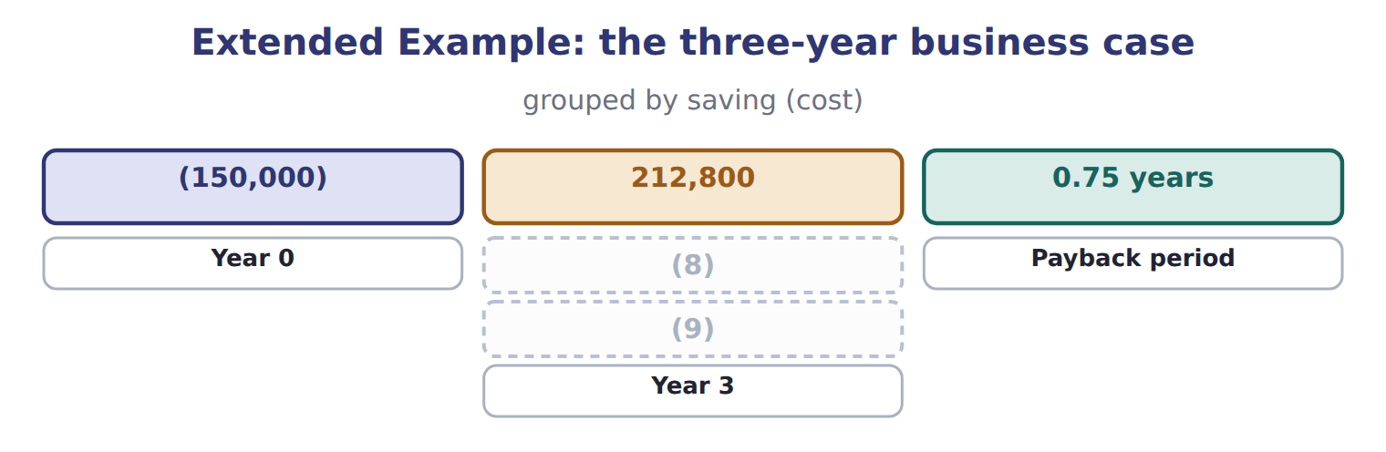
word list
Year 2 · cycle time · Year 1

Everything ties

Summary 2 gaps 10–11
Three net yearly savings of $200,000 minus the one-off $150,000 = $450,000, the last (10) figure. (11) cost per order after the change: ($143,200 + $12,800) ÷ 8,000 = $19.50.
word list
corrections · All-in · cumulative

Exam view

Summary 3 gaps 12–14
Expect hours or costs per step (12) and after a (13) , a volume, and the costs of the change. (14) the yearly cost of each process, deduct the running cost, then deduct the one-off cost once over the period asked.
word list
redesign · Compute · before · three-year

Exam view
Levant receiving, 2027 | Now | Redesigned
(15) | 1.0 | 1.0
(16) | 1.2 | 0.1
(17) | 0.5 | 0.3
Type the receipt into the records | 0.8 | 0.0
Put away | 0.5 | 0.5
Hours per truck | 4.0 | 1.9
Trucks received per year | 2,000 | 2,000
(18) | $18 | $18
One-off cost of the change |  | 60,000
Yearly running cost (scanners, advance notices) |  | 5,600
(19) |  | 1.5

word list
Staff cost per hour · Best-practice distributor, hours per truck · Internal · Inspect · Count every carton · Unload

Item — Answer
Item | Answer
Net yearly saving × 3 years | $200,000 × 3 = $600,000
Net saving over three years | (20)

word list
One-off cost of the change · $600,000 − $150,000 = $450,000

Comparison — Category
Comparison | Category
Levant's two warehouses | (21)
The Oils division's receiving dock | Internal
Another juice distributor in Amman | (22)
Receiving at a pharmaceutical distributor | (23)
The best receiving process in any industry | Generic

word list
Internal · Functional · Competitive · Generic

The English this section uses, and its Arabic
Each term sits against what it means.
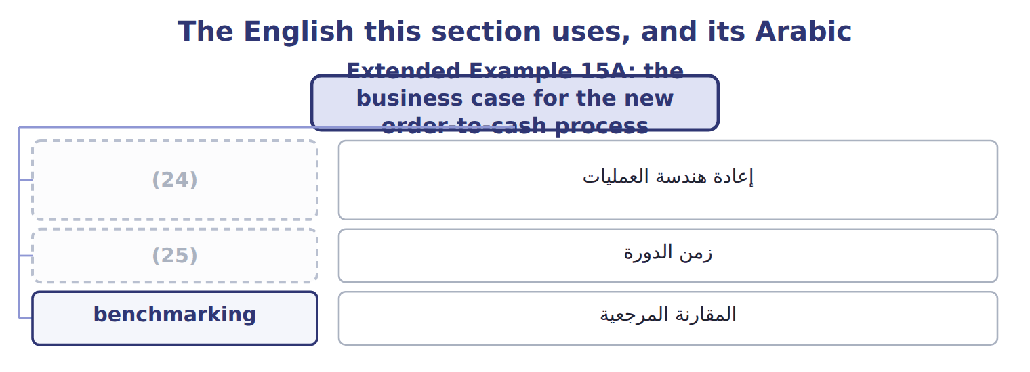
word list
business process reengineering · internal benchmarking · cycle time

The English this sheet uses, and its Arabic
English (exam term) | Arabic
business process reengineering | إعادة هندسة العمليات
cycle time | زمن الدورة
benchmarking | المقارنة المرجعية

Answer key · 15.6 Extended Example 15A: the business case for the new order-to-cash process

1 three-year | 14 Compute
2 division | 15 Unload
3 Volume | 16 Count every carton
4 correcting | 17 Inspect
5 running | 18 Staff cost per hour
6 yearly | 19 Best-practice distributor, hours per truck
7 recovered | 20 $600,000 − $150,000 = $450,000
8 Year 1 | 21 Internal
9 Year 2 | 22 Competitive
10 cumulative | 23 Functional
11 All-in | 24 business process reengineering
12 before | 25 cycle time
13 redesign

the summaries in full
Summary 1 This example builds the three-year business case the division manager signed. Volume: 8,000 orders a year; staff cost $20 an hour; correcting a faulty order costs $50. Change: one-off cost $150,000; running cost $12,800 a year. Old process: staff $336,000 + corrections $20,000 = $356,000 a year. New process: staff $139,200 + corrections $4,000 = $143,200 a year. Net yearly saving: $212,800 − $12,800 = $200,000. The one-off cost is recovered in 0.75 years, and the net saving over three years is $450,000.
Summary 2 Three net yearly savings of $200,000 minus the one-off $150,000 = $450,000, the last cumulative figure. All-in cost per order after the change: ($143,200 + $12,800) ÷ 8,000 = $19.50.
Summary 3 Expect hours or costs per step before and after a redesign, a volume, and the costs of the change. Compute the yearly cost of each process, deduct the running cost, then deduct the one-off cost once over the period asked.

