1.1 What strategic planning does
Chapter 1 · section 1.1

Fill every gap. Each word list holds one word more than there are gaps.
Chapter 1, section by section
Each stage leads to the next.
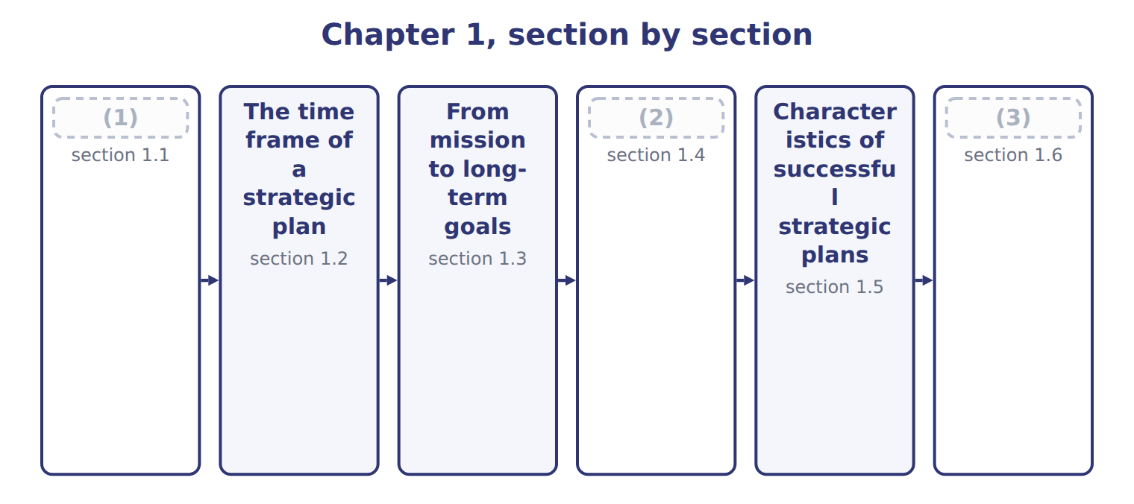
word list
What strategic planning does · Extended Example 1A: from the Orontes goals to · From mission to long-term goals · Congruence: objectives, tactics, plans and bud

Summary 1 gaps 4–10
Strategic planning decides where an (4) wants to be in the long term and how it will get there. It chooses the markets, products and ways of (5) that will lead to the (6) goals. The (7) is a strategic plan. (8) it comes first, strategic planning sets the path for (9) else. A company that plans to grow exports will budget for export staff and (10) ; a company that plans to cut costs will budget for new equipment and fewer products.
word list
competing · tactics · result · certification · long-term · Because · everything · organization

The budget is not the strategy

Summary 2 gaps 11–12
An exam (11) that says the budget sets the strategy has the order (12) . The strategy comes first; the budget puts the first year of it into money.
word list
backwards · option · tactics

The English this section uses, and its Arabic
Each term sits against what it means.
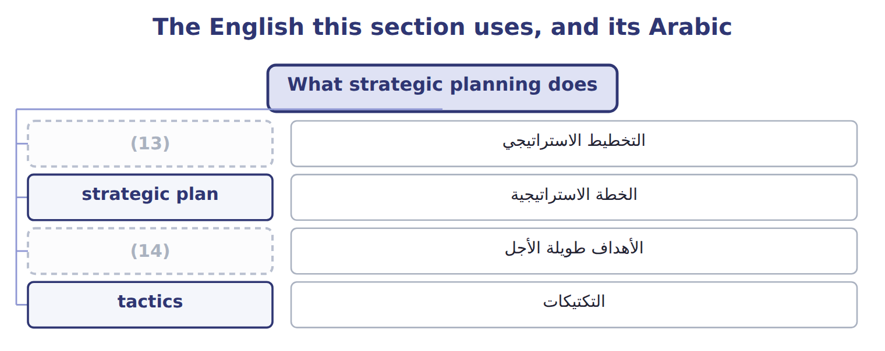
word list
long-term goals · strategic planning · vision statement

The English this sheet uses, and its Arabic
English (exam term) | Arabic
strategic planning | التخطيط الاستراتيجي
strategic plan | الخطة الاستراتيجية

Answer key · 1.1 What strategic planning does

1 What strategic planning does | 8 Because
2 Congruence: objectives, tactics, plans and bud | 9 everything
3 Extended Example 1A: from the Orontes goals to | 10 certification
4 organization | 11 option
5 competing | 12 backwards
6 long-term | 13 strategic planning
7 result | 14 long-term goals

the summaries in full
Summary 1 Strategic planning decides where an organization wants to be in the long term and how it will get there. It chooses the markets, products and ways of competing that will lead to the long-term goals. The result is a strategic plan. Because it comes first, strategic planning sets the path for everything else. A company that plans to grow exports will budget for export staff and certification; a company that plans to cut costs will budget for new equipment and fewer products.
Summary 2 An exam option that says the budget sets the strategy has the order backwards. The strategy comes first; the budget puts the first year of it into money.

1.2 The time frame of a strategic plan
Chapter 1 · section 1.2

Fill every gap. Each word list holds one word more than there are gaps.
Summary 1 gaps 1–2
A (1) plan usually looks three to five years ahead, and sometimes longer. Tactical plans cover one to three years, and (2) plans and budgets cover one year or less.
word list
strategic · operational · Orontes

Time frames of strategic, tactical and operational plans
Plan | Typical time frame | Content | Example
Strategic plan | 3–5 years or more | Mission, vision, long-term goals, main strategies | (3) : 2028–2032
Tactical plan | 1–3 years | (4) | Beverages export launch
Operational plan and budget | 1 year or less | Activities, people, resources, money | (5)
Industry pace | Shorter for fast-changing industries; longer for heavy investment |  | (6) : 5 years is common

word list
The 2028 budget · Orontes · Food production · long-term goals · How each division carries out the strategy

Summary 2 gaps 7–11
The right time frame depends on the (7) . A (8) company may plan only two or three years ahead because its market changes fast. A food (9) that builds plants and brands can plan five years or more. (10) uses a plan for 2028 to 2032. Each year the plan is (11) and rolled forward one year, so there is always a full view ahead.
word list
reviewed · budgets · industry · producer · Orontes · software

The English this section uses, and its Arabic
Each term sits against what it means.
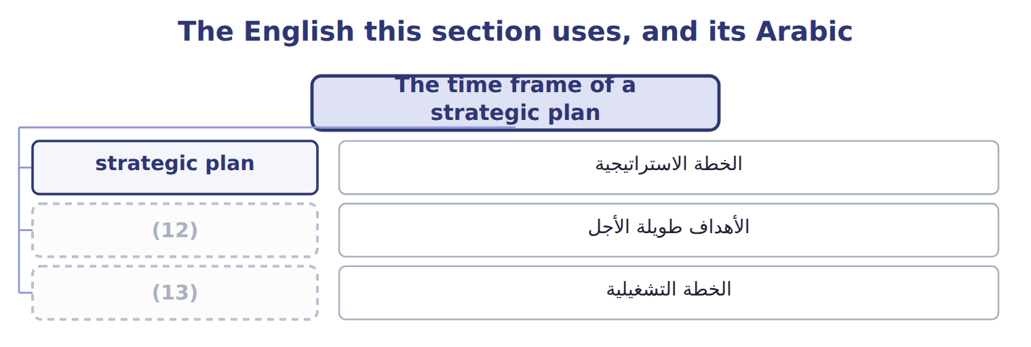
word list
operational plan · strategic plan · long-term goals

Answer key · 1.2 The time frame of a strategic plan

1 strategic | 8 software
2 operational | 9 producer
3 Orontes | 10 Orontes
4 How each division carries out the strategy | 11 reviewed
5 The 2028 budget | 12 long-term goals
6 Food production | 13 operational plan
7 industry

the summaries in full
Summary 1 A strategic plan usually looks three to five years ahead, and sometimes longer. Tactical plans cover one to three years, and operational plans and budgets cover one year or less.
Summary 2 The right time frame depends on the industry. A software company may plan only two or three years ahead because its market changes fast. A food producer that builds plants and brands can plan five years or more. Orontes uses a plan for 2028 to 2032. Each year the plan is reviewed and rolled forward one year, so there is always a full view ahead.

1.3 From mission to long-term goals
Chapter 1 · section 1.3

Fill every gap. Each word list holds one word more than there are gaps.
Summary 1 gaps 1–5
The mission statement says why the (1) exists, what it does and for whom. The (2) statement says what it wants to (3) . The mission leads to (4) goals: results the company aims to reach by the end of the plan. Good goals turn the mission into numbers and dates, so that (5) can be measured.
word list
long-term · organization · become · progress · vision · tactics

Worked example: the Orontes long-term goals

Summary 2 gaps 6–7
The (6) speaks of trusted Levant foods across the region. The board turns it into five goals for 2032. For example, (7) rise from 18.0% to 30.0% of revenue.
word list
mission · strategic · exports

Worked example: the Orontes long-term goals
Long-term goal | 2027 (actual) | 2032 (goal)
Export sales as a share of revenue | 18.0% | 30.0%
Revenue from products launched in the last three years | 6.0% | 15.0%
(8) | 11.0% | 15.0%
(9) | 0.50 kWh | 0.40 kWh
(10) | 12 h | 24 h

word list
Return on investment · Training hours per employee a year · What do we want to become? · Energy per case of juice (kWh)

Mission, mission

In strategic planning it means the organization's lasting purpose.
Mission, vision and goals at Orontes Foods
 | Question it answers | Orontes Foods
Mission | (11) | To make trusted, traditional Levant foods and drinks for families and businesses across the region.
Vision | (12) | To be the first-choice Levant food brand in the Gulf and Europe by 2032.
Long-term goals | What results, by when? | (13)

word list
Why do we exist? What do we do, and for whom? · Export sales as a share of revenue · For example: exports 30.0% of revenue by 2032. · What do we want to become?

The English this section uses, and its Arabic
Each term sits against what it means.
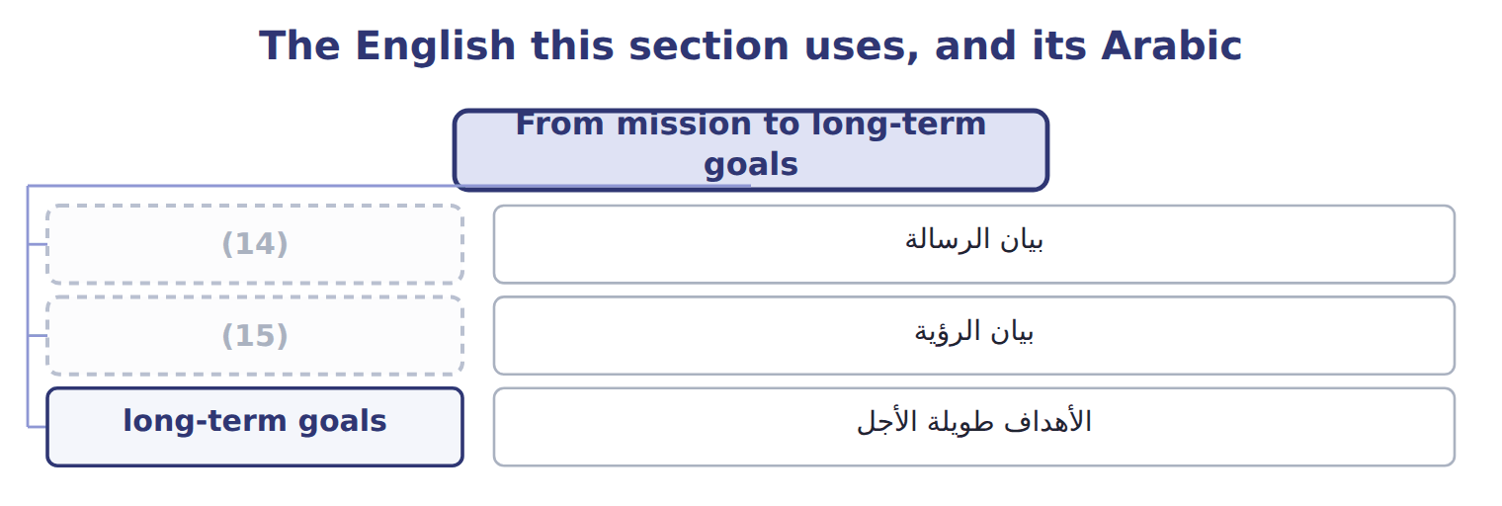
word list
vision statement · long-term goals · mission statement

The English this sheet uses, and its Arabic
English (exam term) | Arabic
mission statement | بيان الرسالة
vision statement | بيان الرؤية
long-term goals | الأهداف طويلة الأجل

Answer key · 1.3 From mission to long-term goals

1 organization | 9 Energy per case of juice (kWh)
2 vision | 10 Training hours per employee a year
3 become | 11 Why do we exist? What do we do, and for whom?
4 long-term | 12 What do we want to become?
5 progress | 13 For example: exports 30.0% of revenue by 2032.
6 mission | 14 mission statement
7 exports | 15 vision statement
8 Return on investment

the summaries in full
Summary 1 The mission statement says why the organization exists, what it does and for whom. The vision statement says what it wants to become. The mission leads to long-term goals: results the company aims to reach by the end of the plan. Good goals turn the mission into numbers and dates, so that progress can be measured.
Summary 2 The mission speaks of trusted Levant foods across the region. The board turns it into five goals for 2032. For example, exports rise from 18.0% to 30.0% of revenue.

1.4 Congruence: objectives, tactics, plans and budgets
Chapter 1 · section 1.4

Fill every gap. Each word list holds one word more than there are gaps.
Summary 1 gaps 1–11
Short-term objectives are (1) results for the (2) year that move the company toward its goals. (3) are the specific actions used to reach them, and the (4) plan sets out the people, activities and resources. The budget puts all of this into money. Each level must fit the level above it. This fit is called (5) . If the budget cuts export (6) while the plan calls for export growth, the company will miss its goal even if every (7) meets the budget. A (8) way to set objectives is to (9) the change needed over the plan into equal yearly steps. (10) must rise by 12.0 points over 5 years, or 2.40 points a year, so the 2028 (11) is 20.4%.
word list
congruence · Tactics · divide · operational · Exports · objective · manager · actions · measurable · simple · coming · marketing

The 2028 objectives

Complete the two blank objectives.
Your turn: the 2028 objectives (complete the blanks)
Goal | 2027 | Change a year | 2028 objective
Export sales as a share of revenue | 18.0% | (12) | 20.4%
Revenue from products launched in the last three years | 6.0% | +1.80 points | 7.8%
Return on investment | 11.0% | (13) | ________
Energy per case of juice (kWh) | 0.50 kWh | (14) | ________
Training hours per employee a year | (15) | +2.4 h | 14.4 h

word list
+2.40 points · −0.02 kWh · short-term objectives · 12 h · +0.80 points

The English this section uses, and its Arabic
Each term sits against what it means.
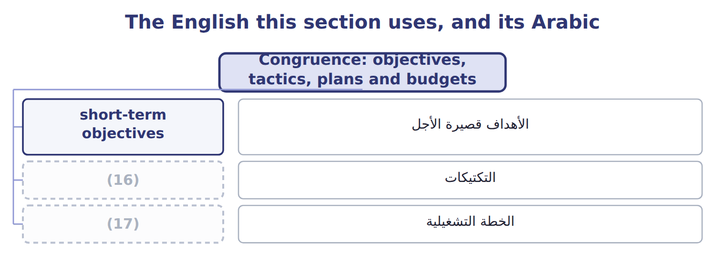
word list
mission statement · tactics · operational plan

The English this sheet uses, and its Arabic
English (exam term) | Arabic
short-term objectives | الأهداف قصيرة الأجل
tactics | التكتيكات
operational plan | الخطة التشغيلية

Answer key · 1.4 Congruence: objectives, tactics, plans and budgets

1 measurable | 10 Exports
2 coming | 11 objective
3 Tactics | 12 +2.40 points
4 operational | 13 +0.80 points
5 congruence | 14 −0.02 kWh
6 marketing | 15 12 h
7 manager | 16 tactics
8 simple | 17 operational plan
9 divide

the summaries in full
Summary 1 Short-term objectives are measurable results for the coming year that move the company toward its goals. Tactics are the specific actions used to reach them, and the operational plan sets out the people, activities and resources. The budget puts all of this into money. Each level must fit the level above it. This fit is called congruence. If the budget cuts export marketing while the plan calls for export growth, the company will miss its goal even if every manager meets the budget. A simple way to set objectives is to divide the change needed over the plan into equal yearly steps. Exports must rise by 12.0 points over 5 years, or 2.40 points a year, so the 2028 objective is 20.4%.

1.5 Characteristics of successful strategic plans
Chapter 1 · section 1.5

Fill every gap. Each word list holds one word more than there are gaps.
Summary 1 gaps 1–6
A (1) strategic plan gives a clear (2) that follows from the mission. Its goals are (3) and realistic, based on a careful study of the company and its (4) . It is also shared: managers help set their own (5) and understand how they (6) . It is linked to resources, so that people and money are available, and it is reviewed regularly, with contingency plans for the main risks.
word list
contribute · objectives · successful · direction · understand · environment · measurable

Characteristics of successful strategic plans
Characteristic | What it means
Clear direction | (7)
Measurable goals | Numbers and dates, not wishes
Realistic | Based on the analysis of internal and external factors (Chapter 2)
Shared | (8) to managers, who help set their own objectives
Resourced | (9)
Flexible | Reviewed each year; contingency plans for major risks

word list
Follows from the mission and vision · Communicated · Linked to budgets, people and investment · tactics

Measurable objectives are the most common weakness in practice.
Weak and strong objectives
Weak objective | Strong objective | Why it is better
“Grow exports.” | (10) | Measurable and dated
“Use less energy.” | (11) | A number the plant can track
“Train people more.” | “14.4 training hours per employee in 2028.” | (12)

word list
“Exports 20.4% of revenue in 2028.” · Reviewed each year; contingency plans for major risks · “0.48 kWh per case of juice in 2028.” · Owned by HR, easy to check

The words this section uses
Each term sits against what it means.
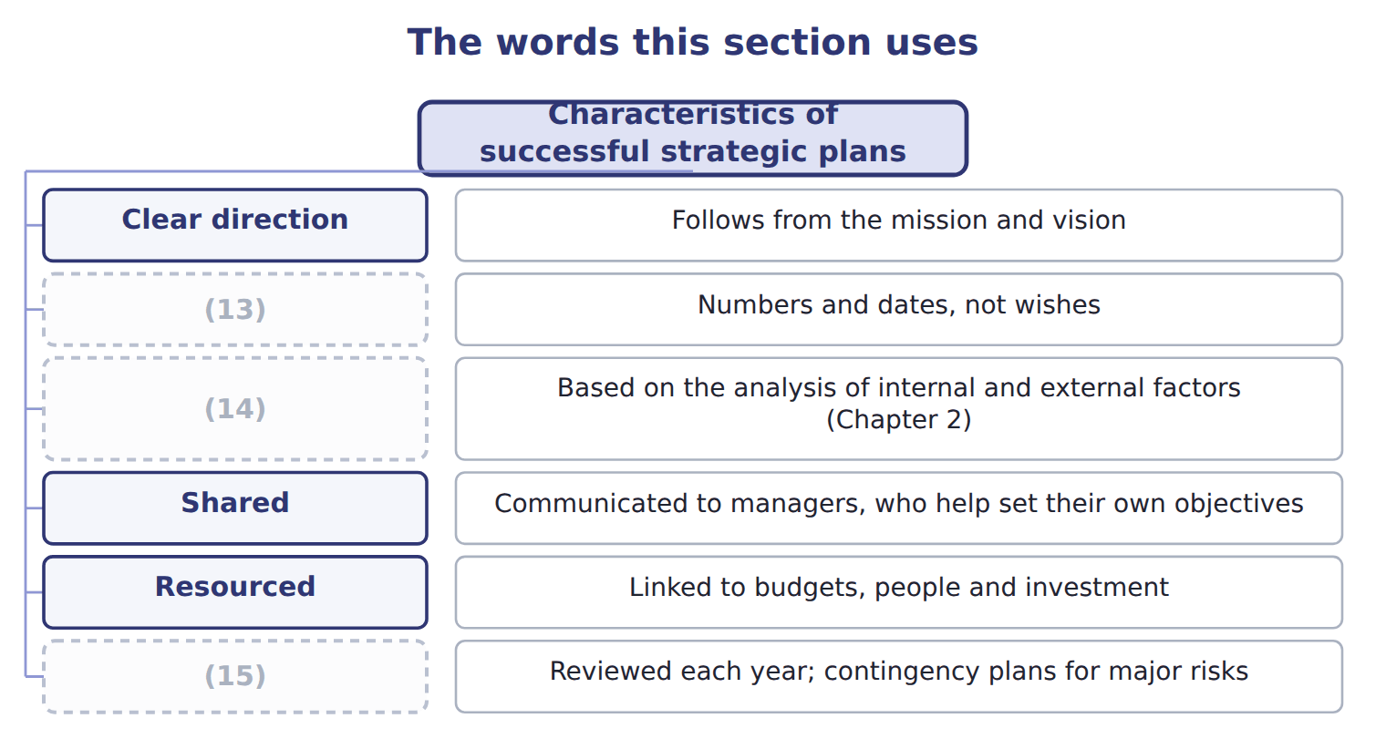
word list
Realistic · Measurable goals · Flexible · strategic plan

Answer key · 1.5 Characteristics of successful strategic plans

1 successful | 9 Linked to budgets, people and investment
2 direction | 10 “Exports 20.4% of revenue in 2028.”
3 measurable | 11 “0.48 kWh per case of juice in 2028.”
4 environment | 12 Owned by HR, easy to check
5 objectives | 13 Measurable goals
6 contribute | 14 Realistic
7 Follows from the mission and vision | 15 Flexible
8 Communicated

the summaries in full
Summary 1 A successful strategic plan gives a clear direction that follows from the mission. Its goals are measurable and realistic, based on a careful study of the company and its environment. It is also shared: managers help set their own objectives and understand how they contribute. It is linked to resources, so that people and money are available, and it is reviewed regularly, with contingency plans for the main risks.

1.6 Extended Example 1A: from the Orontes goals to the 2028 plan
Chapter 1 · section 1.6

Fill every gap. Each word list holds one word more than there are gaps.
Summary 1 gaps 1–5
This example (1) all five goals from the 2032 targets to the 2028 (2) and the main tactic for each. Plan (3) : 2028 to 2032, 5 years; baseline year 2027. (4) : equal yearly steps from the baseline to each goal. Return on (5) must rise from 11.0% to 15.0%, so the first-year objective is 11.8%.
word list
Method · period · operational · follows · objectives · investment

Extended Example: the plan on one page
Goal | 2032 goal | 2028 objective | Main tactic
Export sales as a share of revenue | 30.0% | 20.4% | (6)
Revenue from products launched in the last three years | 15.0% | 7.8% | (7)
Return on investment | 15.0% | 11.8% | (8)
Energy per case of juice (kWh) | (9) | 0.48 kWh | New filling-line motors; kaizen on changeovers
Training hours per employee a year | 24 h | 14.4 h | (10)

word list
Sell unused equipment; tighter stock control · Gulf retail chains; private-label tahini · Launch sugar-free halva and juice · Supervisor and quality courses · 0.40 kWh · Plan period

Each tactic now needs an owner, an operational plan and a budget line.
Everything ties

The first step gives the 2028 objective of 20.4%.
Exam view

Summary 2 gaps 11–13
Expect (11) to classify as mission, vision, goal, objective or tactic, and questions on time frames and on the fit between the budget and the (12) . Some questions give a goal and a period and ask for the (13) objective.
word list
first-year · strategy · statements · follows

Exam view
Levant Distribution | 2027 (actual) | 2030 (goal)
Deliveries on time | 88.0% | 97.0%
Cost per delivery stop (USD) | 42.0 | 36.0
Plan period | 2028–2030 | (14)

word list
0.40 kWh · 3 years

Item — Answer
Item | Answer
Return on investment, 2028 | 11.0% + (15.0% − 11.0%) ÷ 5 = 11.8%
Energy per case, 2028 | (15)

word list
0.50 − (0.50 − 0.40) ÷ 5 = 0.48 kWh · To be the most reliable food distributor in the Levant

Statement — Category
Statement | Category
We deliver Orontes products to every shop in Jordan, fresh and on time | (16)
To be the most reliable food distributor in the Levant | (17)
97% of deliveries on time by 2030 | Long-term goal
91% of deliveries on time in 2028 | Short-term objective
Plan delivery routes each night with new software | (18)

word list
Tactic · Vision · Mission · Long-term

The English this section uses, and its Arabic
Each term sits against what it means.
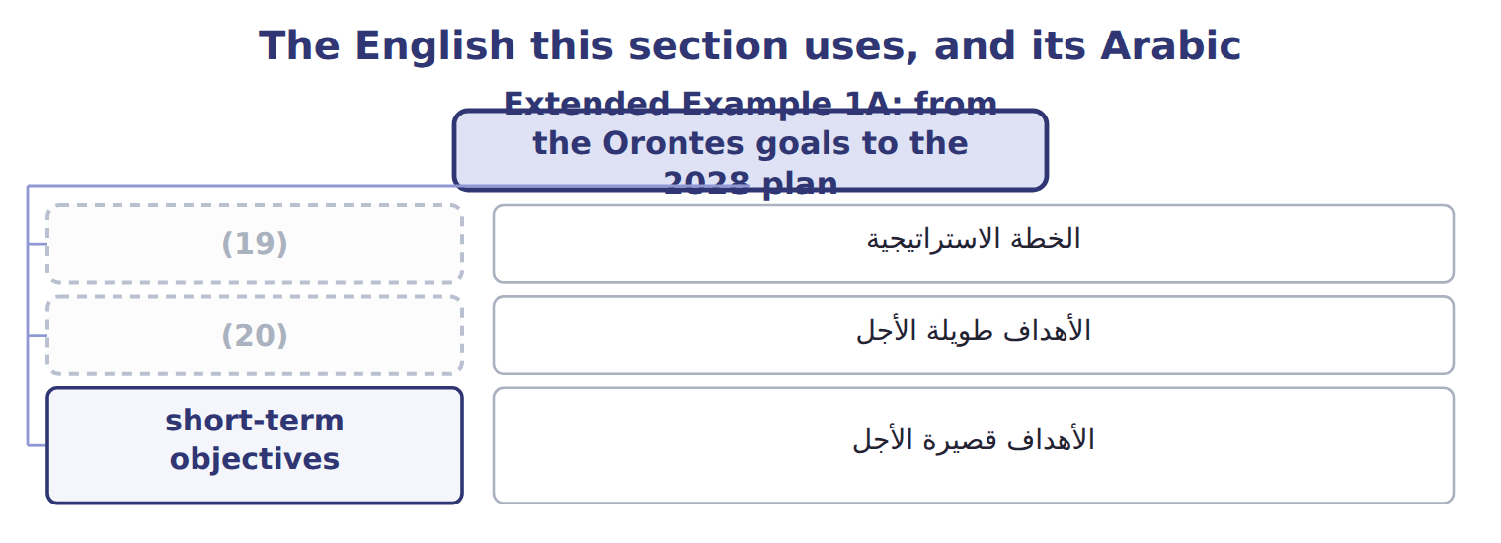
word list
long-term goals · strategic plan · vision statement

The English this sheet uses, and its Arabic
English (exam term) | Arabic
strategic plan | الخطة الاستراتيجية
long-term goals | الأهداف طويلة الأجل
short-term objectives | الأهداف قصيرة الأجل

Answer key · 1.6 Extended Example 1A: from the Orontes goals to the 2028 plan

1 follows | 11 statements
2 objectives | 12 strategy
3 period | 13 first-year
4 Method | 14 3 years
5 investment | 15 0.50 − (0.50 − 0.40) ÷ 5 = 0.48 kWh
6 Gulf retail chains; private-label tahini | 16 Mission
7 Launch sugar-free halva and juice | 17 Vision
8 Sell unused equipment; tighter stock control | 18 Tactic
9 0.40 kWh | 19 strategic plan
10 Supervisor and quality courses | 20 long-term goals

the summaries in full
Summary 1 This example follows all five goals from the 2032 targets to the 2028 objectives and the main tactic for each. Plan period: 2028 to 2032, 5 years; baseline year 2027. Method: equal yearly steps from the baseline to each goal. Return on investment must rise from 11.0% to 15.0%, so the first-year objective is 11.8%.
Summary 2 Expect statements to classify as mission, vision, goal, objective or tactic, and questions on time frames and on the fit between the budget and the strategy. Some questions give a goal and a period and ask for the first-year objective.

