2.1 Analysing the external environment
Chapter 2 · section 2.1

Fill every gap. Each word list holds one word more than there are gaps.
Chapter 2, section by section
Each stage leads to the next.
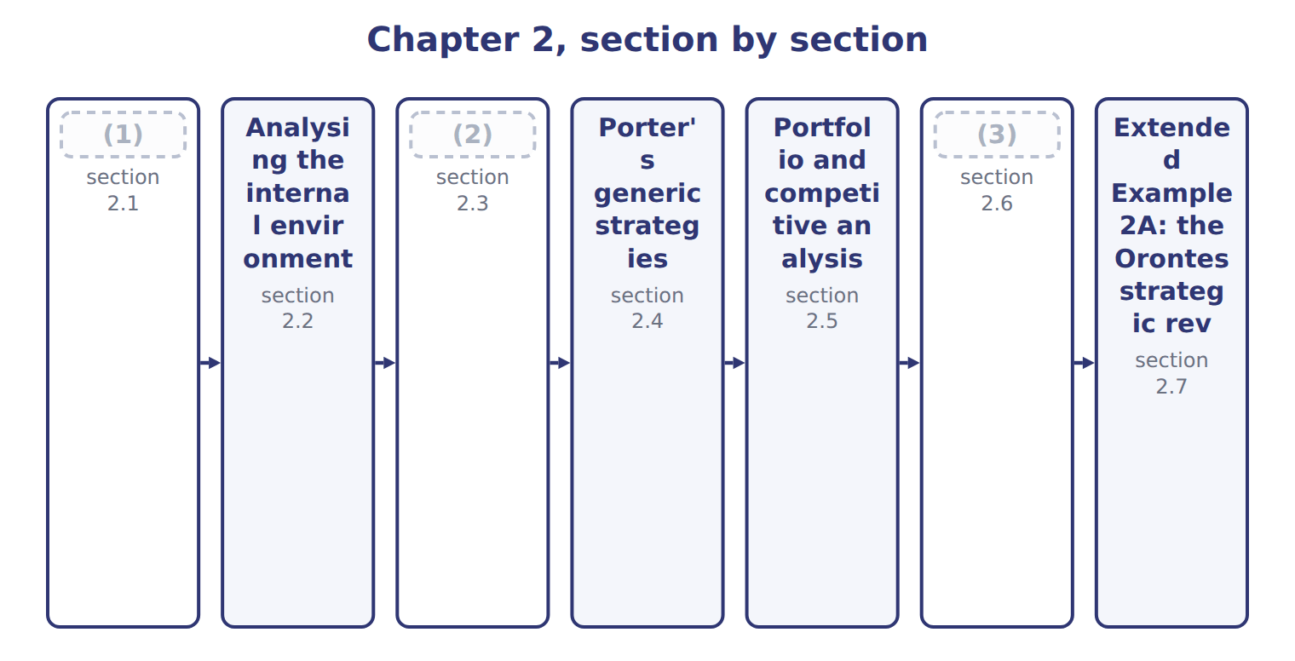
word list
Analysing the external environment · SWOT and situational analysis · Scenario planning and contingency planning · Analysing the internal environment

Summary 1 gaps 4–12
External factors are outside the (4) control. They create (5) to use and (6) to defend against. A PEST analysis reviews four groups of them: (7) , economic, social and (8) factors. (9) five forces describe the industry itself: new entrants, (10) , buyers, substitutes and rivalry. The (11) the forces, the (12) it is to earn a good profit. In the juice market, rivalry is the strongest force and supplier power the weakest, partly because Jordan Glass, which supplies the bottles, is a company Orontes partly owns. The external analysis therefore points to a threat from rivals and substitutes, and an opportunity in stable supply.
word list
threats · company's · suppliers · opportunities · harder · political · Porter's · weakest · technological · stronger

Strong forces, weak industry

Summary 2 gaps 13–14
A (13) force is bad news for profit. An answer that calls a market with powerful buyers and many (14) 'attractive' has read the forces backwards.
word list
substitutes · strong · reviews

The English this sheet uses, and its Arabic
English (exam term) | Arabic
PEST analysis | تحليل PEST (السياسي والاقتصادي والاجتماعي والتقني)
five forces | القوى الخمس

Answer key · 2.1 Analysing the external environment

1 Analysing the external environment | 8 technological
2 SWOT and situational analysis | 9 Porter's
3 Scenario planning and contingency planning | 10 suppliers
4 company's | 11 stronger
5 opportunities | 12 harder
6 threats | 13 strong
7 political | 14 substitutes

the summaries in full
Summary 1 External factors are outside the company's control. They create opportunities to use and threats to defend against. A PEST analysis reviews four groups of them: political, economic, social and technological factors. Porter's five forces describe the industry itself: new entrants, suppliers, buyers, substitutes and rivalry. The stronger the forces, the harder it is to earn a good profit. In the juice market, rivalry is the strongest force and supplier power the weakest, partly because Jordan Glass, which supplies the bottles, is a company Orontes partly owns. The external analysis therefore points to a threat from rivals and substitutes, and an opportunity in stable supply.
Summary 2 A strong force is bad news for profit. An answer that calls a market with powerful buyers and many substitutes 'attractive' has read the forces backwards.

2.2 Analysing the internal environment
Chapter 2 · section 2.2

Fill every gap. Each word list holds one word more than there are gaps.
Summary 1 gaps 1–2
Internal factors are the company's own resources and (1) : its brands, people, equipment, systems and the things it does well. They show strengths to build on and (2) to fix.
word list
capabilities · machine · weaknesses

Internal factors at Orontes
Every item belongs to exactly one group.
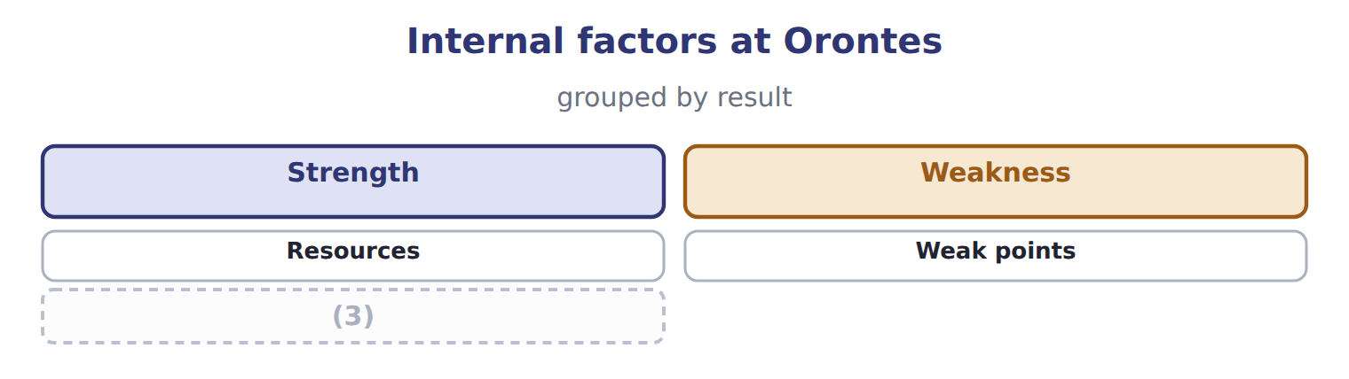
word list
Capabilities · Strength

Summary 2 gaps 4–8
A strength becomes a (4) advantage only if (5) value it, few rivals have it, and it is hard to copy. The (6) tahini recipes and brand pass this test; a new (7) machine that any rival can buy does not. The value chain of Book 2: it shows which (8) create the advantage and which only add cost.
word list
Internal · filling · activities · customers · Orontes · competitive

The English this sheet uses, and its Arabic
English (exam term) | Arabic
competitive advantage | الميزة التنافسية

Answer key · 2.2 Analysing the internal environment

1 capabilities | 5 customers
2 weaknesses | 6 Orontes
3 Capabilities | 7 filling
4 competitive | 8 activities

the summaries in full
Summary 1 Internal factors are the company's own resources and capabilities: its brands, people, equipment, systems and the things it does well. They show strengths to build on and weaknesses to fix.
Summary 2 A strength becomes a competitive advantage only if customers value it, few rivals have it, and it is hard to copy. The Orontes tahini recipes and brand pass this test; a new filling machine that any rival can buy does not. The value chain of Book 2: it shows which activities create the advantage and which only add cost.

2.3 SWOT and situational analysis
Chapter 2 · section 2.3

Fill every gap. Each word list holds one word more than there are gaps.
Summary 1 gaps 1–6
A SWOT analysis brings the two views (1) : strengths and weaknesses from inside, opportunities and threats from (2) . A (3) analysis is the wider study of the (4) current position that feeds the SWOT. The (5) step is the next one: match strengths to opportunities, for example the (6) brand to Gulf demand, and plan how to fix the weaknesses that expose the company to threats.
word list
outside · together · opportunities · situational · useful · company's · tahini

The English this section uses, and its Arabic
Each term sits against what it means.
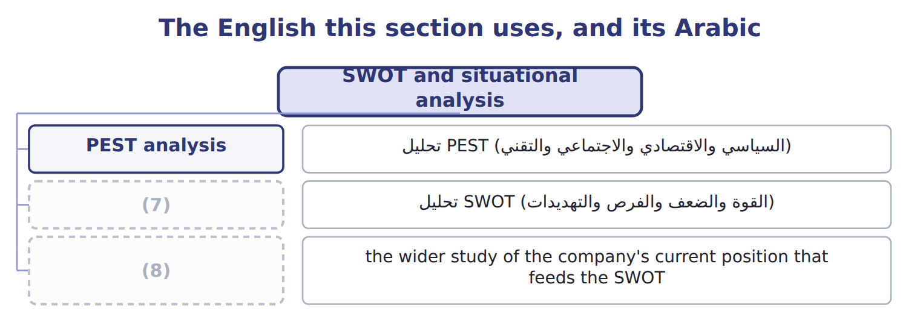
word list
PEST analysis · SWOT analysis · situational analysis

The English this sheet uses, and its Arabic
English (exam term) | Arabic
SWOT analysis | تحليل SWOT (القوة والضعف والفرص والتهديدات)
situational analysis | تحليل الموقف

Answer key · 2.3 SWOT and situational analysis

1 together | 5 useful
2 outside | 6 tahini
3 situational | 7 SWOT analysis
4 company's | 8 situational analysis

the summaries in full
Summary 1 A SWOT analysis brings the two views together: strengths and weaknesses from inside, opportunities and threats from outside. A situational analysis is the wider study of the company's current position that feeds the SWOT. The useful step is the next one: match strengths to opportunities, for example the tahini brand to Gulf demand, and plan how to fix the weaknesses that expose the company to threats.

2.4 Porter's generic strategies
Chapter 2 · section 2.4

Fill every gap. Each word list holds one word more than there are gaps.
Summary 1 gaps 1–6
Porter (1) three ways to win. Cost (2) sells at or near the market price with the (3) costs. (4) offers something (5) value and will pay more for. A focus strategy serves a narrow segment, either at low cost or with a (6) . Beverages competes on cost in the mass juice market; Oils differentiates with traced, cold-pressed oil; Tahini & Spreads focuses on premium Gulf buyers and private label for Barada.
word list
lowest · described · customers · Beverages · Differentiation · leadership · difference

The generic strategy of each Orontes unit
Unit | Generic strategy | How it competes
Oils | (7) | premium price for traced oil
Tahini & Spreads | Focus | (8)
Beverages | Cost leadership | (9)
Pulses & Spices line | Review | (10)

word list
competitive advantage · Differentiation · niche buyers: Gulf and private label · lowest cost per case · decide to fix or leave

Summary 2 gaps 11–12
A company that tries to be (11) and most special at the same time, (12) a clear choice, risks being 'stuck in the middle' and losing to rivals that chose.
word list
cheapest · middle' · without

The English this section uses, and its Arabic
Each term sits against what it means.
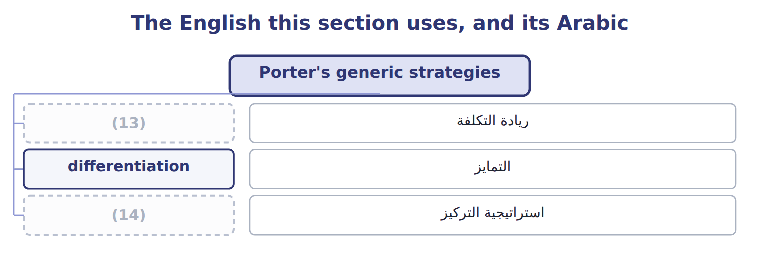
word list
استراتيجية التركيز · focus strategy · cost leadership

The English this sheet uses, and its Arabic
English (exam term) | Arabic
cost leadership | ريادة التكلفة
differentiation | التمايز
focus strategy | استراتيجية التركيز

Answer key · 2.4 Porter's generic strategies

1 described | 8 niche buyers: Gulf and private label
2 leadership | 9 lowest cost per case
3 lowest | 10 decide to fix or leave
4 Differentiation | 11 cheapest
5 customers | 12 without
6 difference | 13 cost leadership
7 Differentiation | 14 focus strategy

the summaries in full
Summary 1 Porter described three ways to win. Cost leadership sells at or near the market price with the lowest costs. Differentiation offers something customers value and will pay more for. A focus strategy serves a narrow segment, either at low cost or with a difference. Beverages competes on cost in the mass juice market; Oils differentiates with traced, cold-pressed oil; Tahini & Spreads focuses on premium Gulf buyers and private label for Barada.
Summary 2 A company that tries to be cheapest and most special at the same time, without a clear choice, risks being 'stuck in the middle' and losing to rivals that chose.

2.5 Portfolio and competitive analysis
Chapter 2 · section 2.5

Fill every gap. Each word list holds one word more than there are gaps.
Summary 1 gaps 1–3
The BCG (1) matrix places each business unit by market growth and relative market share: the unit's share divided by the share of its largest (2) . Growth above 10.0% and relative share above 1.0 mark the (3) lines.
word list
competitor · dividing · withdraw · growth-share

Worked example: placing Oils

Summary 2 gaps 4–6
Oils holds 22.0% of its market; the (4) rival holds 15.0%. (5) share = 22.0 ÷ 15.0 = 1.47. The market grows 3.0% a year, below the line, so Oils is in the Cash cow (6) .
word list
Relative · quadrant · rival's · largest

Worked example: BCG data for the Orontes portfolio
The bars are drawn to scale.
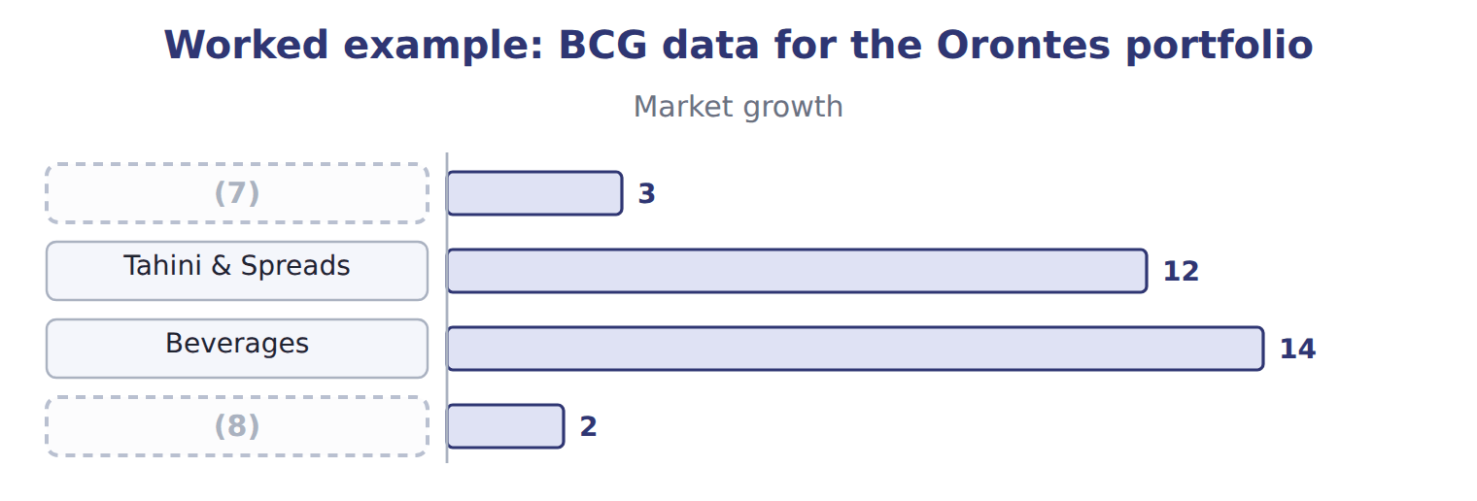
word list
Oils · situational analysis · Pulses & Spices line

Placing Beverages and Pulses & Spices

Summary 3 gaps 9–11
Complete the blank cells. Stars need (9) to hold their lead, cash cows fund the others, (10) marks need a decision to invest or withdraw, and dogs are fixed or sold. A (11) analysis looks closely at the main rivals.
word list
question · investment · competitive · Complete

Competitive analysis: Orontes Beverages and the largest juice producer
Juice market | Orontes Beverages | Largest rival
Market share in Jordan | 8.0% | 25.0%
Strategy | Cost leadership | (12)
Strength | (13) | Advertising budget; shelf space
Weakness | Small brand; few flavours | (14)

word list
Low cost per case; Levant's distribution · Higher costs · Relative share · Brand and wide range

Relative, not own, share

Summary 4 gaps 15–16
Beverages holds 8.0% of its market, but its (15) share is 0.32, not 0.08. Always divide by the (16) rival's share.
word list
growth-share · largest · relative

The English this section uses, and its Arabic
Each term sits against what it means.
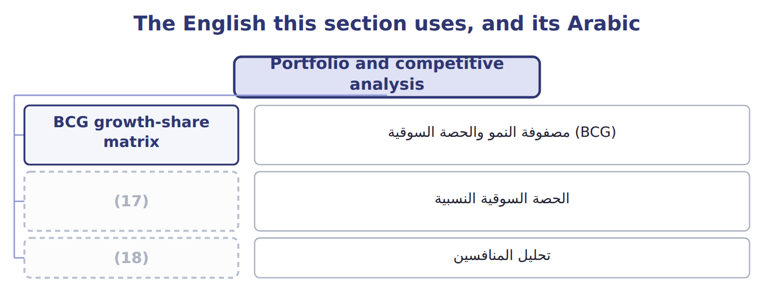
word list
relative market share · الحصة السوقية النسبية · competitive analysis

The English this sheet uses, and its Arabic
English (exam term) | Arabic
BCG growth-share matrix | مصفوفة النمو والحصة السوقية (BCG)
relative market share | الحصة السوقية النسبية
competitive analysis | تحليل المنافسين

Answer key · 2.5 Portfolio and competitive analysis

1 growth-share | 10 question
2 competitor | 11 competitive
3 dividing | 12 Brand and wide range
4 largest | 13 Low cost per case; Levant's distribution
5 Relative | 14 Higher costs
6 quadrant | 15 relative
7 Oils | 16 largest
8 Pulses & Spices line | 17 relative market share
9 investment | 18 competitive analysis

the summaries in full
Summary 1 The BCG growth-share matrix places each business unit by market growth and relative market share: the unit's share divided by the share of its largest competitor. Growth above 10.0% and relative share above 1.0 mark the dividing lines.
Summary 2 Oils holds 22.0% of its market; the largest rival holds 15.0%. Relative share = 22.0 ÷ 15.0 = 1.47. The market grows 3.0% a year, below the line, so Oils is in the Cash cow quadrant.
Summary 3 Complete the blank cells. Stars need investment to hold their lead, cash cows fund the others, question marks need a decision to invest or withdraw, and dogs are fixed or sold. A competitive analysis looks closely at the main rivals.
Summary 4 Beverages holds 8.0% of its market, but its relative share is 0.32, not 0.08. Always divide by the largest rival's share.

2.6 Scenario planning and contingency planning
Chapter 2 · section 2.6

Fill every gap. Each word list holds one word more than there are gaps.
Summary 1 gaps 1–3
Scenario (1) prepares for several (2) futures instead of one forecast. For tahini exports in 2032, the board (3) three scenarios, from open Gulf and EU markets to a new EU import tariff.
word list
planning · possible · considers · Contingency

Tahini export scenarios for 2030 and the contingency trigger
Scenario for tahini exports, 2030 | Operating income (USD) | Response
Open Gulf and EU markets | 2,400,000 | no action
Gulf growth as planned | 1,800,000 | (4)
New EU import tariff | 900,000 | (5)
Contingency trigger | (6) | shift export sales to Gulf buyers; delay the EU warehouse

word list
below 1,200,000 · relative market share · no action · start the contingency plan

Summary 2 gaps 7–11
Contingency (7) prepares a (8) in advance and names the trigger that starts it. If the export (9) falls below $1,200,000, as it would in the tariff scenario, Orontes will shift sales to Gulf buyers and delay its EU (10) . The two tools work together: (11) show what could happen; the contingency plan says what the company will do.
word list
forecast · scenarios · response · planning · warehouse · futures

The English this section uses, and its Arabic
Each term sits against what it means.
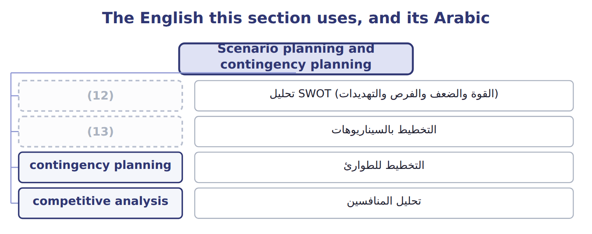
word list
SWOT analysis · competitive analysis · scenario planning

The English this sheet uses, and its Arabic
English (exam term) | Arabic
scenario planning | التخطيط بالسيناريوهات
contingency planning | التخطيط للطوارئ

Answer key · 2.6 Scenario planning and contingency planning

1 planning | 8 response
2 possible | 9 forecast
3 considers | 10 warehouse
4 no action | 11 scenarios
5 start the contingency plan | 12 SWOT analysis
6 below 1,200,000 | 13 scenario planning
7 planning

the summaries in full
Summary 1 Scenario planning prepares for several possible futures instead of one forecast. For tahini exports in 2032, the board considers three scenarios, from open Gulf and EU markets to a new EU import tariff.
Summary 2 Contingency planning prepares a response in advance and names the trigger that starts it. If the export forecast falls below $1,200,000, as it would in the tariff scenario, Orontes will shift sales to Gulf buyers and delay its EU warehouse. The two tools work together: scenarios show what could happen; the contingency plan says what the company will do.

2.7 Extended Example 2A: the Orontes strategic review
Chapter 2 · section 2.7

Fill every gap. Each word list holds one word more than there are gaps.
Summary 1 gaps 1–4
This example brings the tools (1) for the board meeting that (2) the 2028 to 2032 plan. (3) : strong rivalry and (4) in juice; growing Gulf demand for tahini; a possible EU tariff. Internal: a strong tahini brand and low-cost juice filling; a small juice share and an old bottling line in Oils.
word list
approves · together · strategy · External · substitutes

Extended Example: the strategic review of each unit
The bars are drawn to scale.
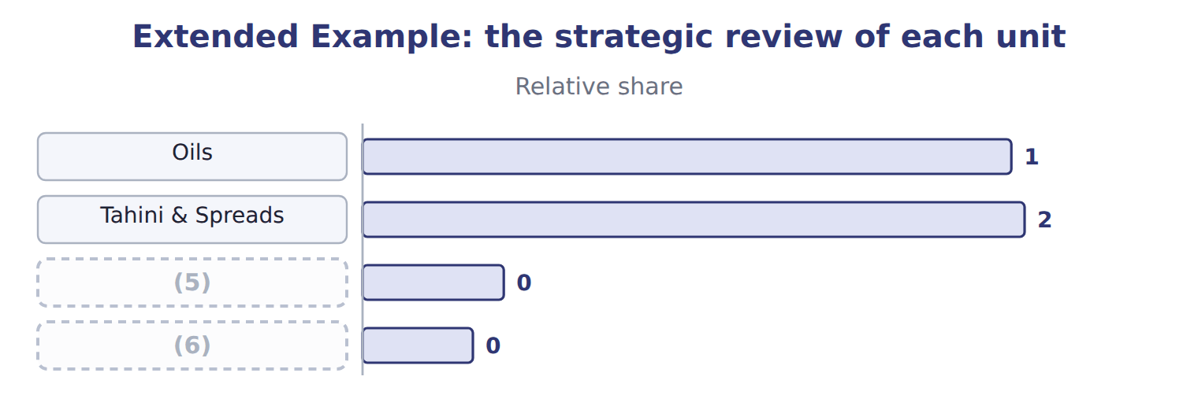
word list
Beverages · competitive advantage · Pulses & Spices line

Summary 2 gaps 7–8
The (7) range from $900,000 to $2,400,000 of export operating income, a spread of $1,500,000. The (8) plan starts if the forecast falls below $1,200,000.
word list
contingency · scenarios · strengths

Everything ties

Summary 3 gaps 9–10
Every (9) share equals the unit's share divided by the largest rival's share. (10) spread: $2,400,000 − $900,000 = $1,500,000.
word list
planning · Scenario · relative

Exam view

Summary 4 gaps 11–13
Expect to classify factors as strengths, weaknesses, (11) or threats; to compute a relative share and place a unit in the BCG matrix; to name a generic strategy from a (12) ; and to tell scenario planning from (13) planning.
word list
contingency · opportunities · growing · description

Exam view
Name each point on the scale from where it sits.
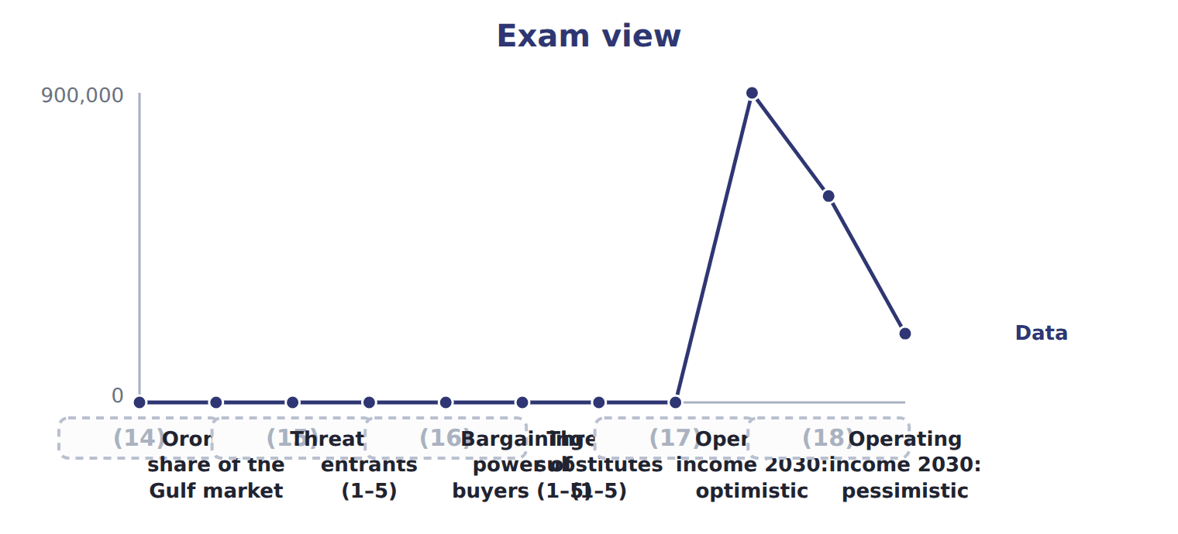
word list
Gulf tahini market growth a year · Bargaining power of suppliers (1–5) · Largest rival's share · Orontes's share of the Gulf market · Operating income 2030: base · Rivalry among competitors (1–5)

Item — Answer
Item | Answer
Beverages | (19)
Pulses & Spices | 5.0 ÷ 20.0 = 0.25; growth 2.0% → Dog

word list
An EU tariff may push more exporters to the Gulf · 8.0 ÷ 25.0 = 0.32; growth 14.0% → Question mark

Factor — Category
Factor | Category
The Orontes tahini brand is well known in Jordan | Strength
The Gulf sales team has only three people | (20)
Gulf demand for healthy traditional foods is growing | (21)
The market leader is cutting prices | (22)
An EU tariff may push more exporters to the Gulf | Threat

word list
Weakness · Threat · Opportunity · Beverages

The English this section uses, and its Arabic
Each term sits against what it means.
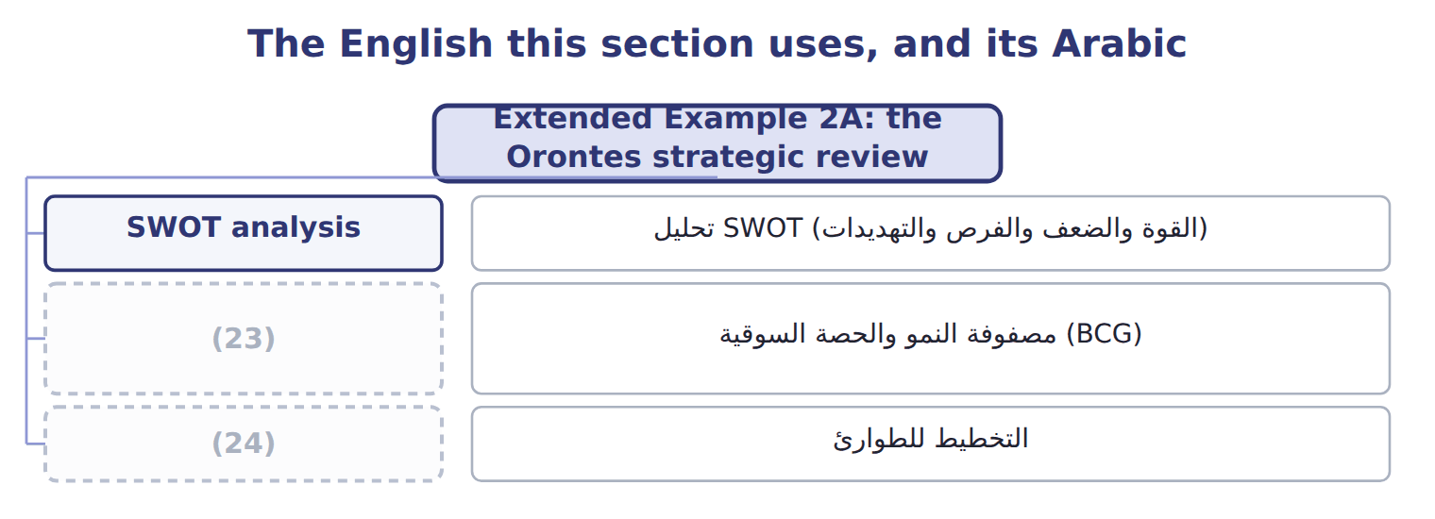
word list
BCG growth-share matrix · contingency planning · PEST analysis

The English this sheet uses, and its Arabic
English (exam term) | Arabic
SWOT analysis | تحليل SWOT (القوة والضعف والفرص والتهديدات)
BCG growth-share matrix | مصفوفة النمو والحصة السوقية (BCG)
contingency planning | التخطيط للطوارئ

Answer key · 2.7 Extended Example 2A: the Orontes strategic review

1 together | 13 contingency
2 approves | 14 Gulf tahini market growth a year
3 External | 15 Largest rival's share
4 substitutes | 16 Bargaining power of suppliers (1–5)
5 Beverages | 17 Rivalry among competitors (1–5)
6 Pulses & Spices line | 18 Operating income 2030: base
7 scenarios | 19 8.0 ÷ 25.0 = 0.32; growth 14.0% → Question mark
8 contingency | 20 Weakness
9 relative | 21 Opportunity
10 Scenario | 22 Threat
11 opportunities | 23 BCG growth-share matrix
12 description | 24 contingency planning

the summaries in full
Summary 1 This example brings the tools together for the board meeting that approves the 2028 to 2032 plan. External: strong rivalry and substitutes in juice; growing Gulf demand for tahini; a possible EU tariff. Internal: a strong tahini brand and low-cost juice filling; a small juice share and an old bottling line in Oils.
Summary 2 The scenarios range from $900,000 to $2,400,000 of export operating income, a spread of $1,500,000. The contingency plan starts if the forecast falls below $1,200,000.
Summary 3 Every relative share equals the unit's share divided by the largest rival's share. Scenario spread: $2,400,000 − $900,000 = $1,500,000.
Summary 4 Expect to classify factors as strengths, weaknesses, opportunities or threats; to compute a relative share and place a unit in the BCG matrix; to name a generic strategy from a description; and to tell scenario planning from contingency planning.

