4.1 The master budget
Chapter 4 · section 4.1

Fill every gap. Each word list holds one word more than there are gaps.
Chapter 4, section by section
Each stage leads to the next.
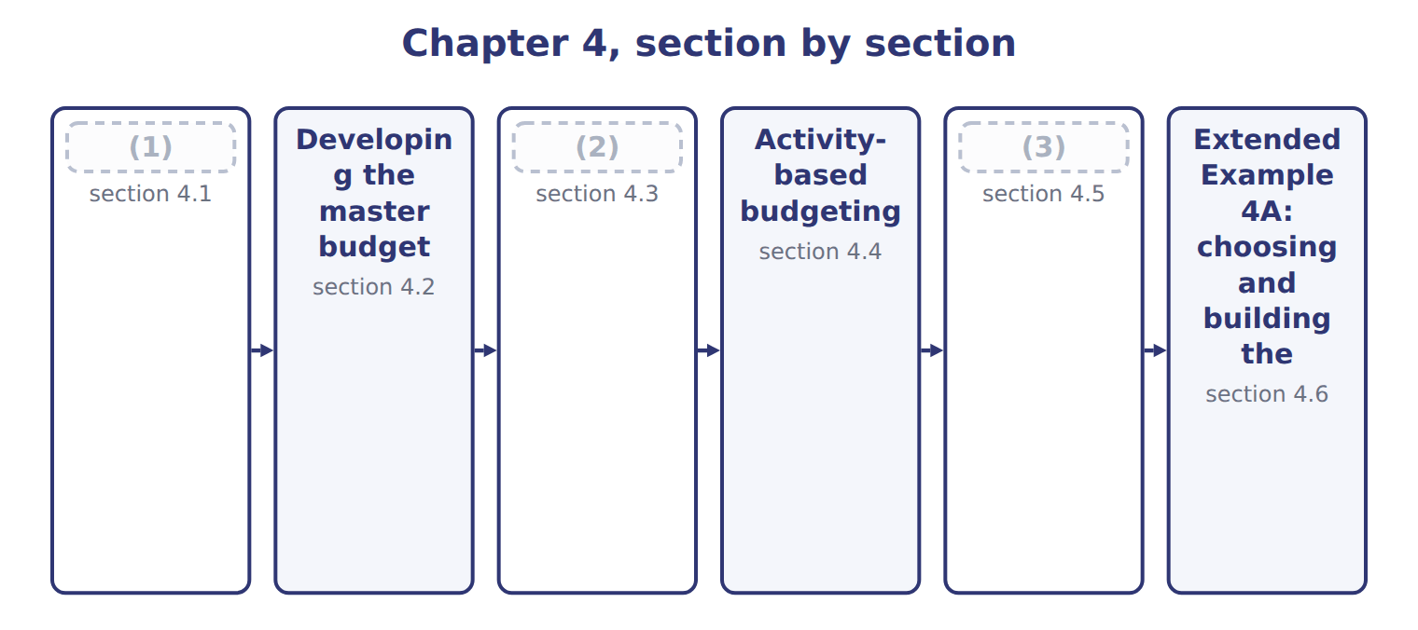
word list
section 4.2 · Project budgets · Benefits and limitations · The master budget

Summary 1 gaps 4–12
The (4) budget is the (5) annual budget of the organization. Its purpose is to plan and (6) every unit for one year, usually split into (7) and months. Every organization (8) one. It has two groups of (9) . The (10) budget plans sales, production and costs, and ends in the budgeted income (11) . The (12) budget plans capital spending and cash, and ends in the budgeted balance sheet. The sales budget sets production; production sets materials, labor and overhead; these set the cost of goods sold. Sales also drive cash collections, so an error in the sales budget spreads to every other budget.
word list
statement · coordinate · quarters · prepares · financial · master · operating · components · complete · production

Purpose, use and time frame of the three budget systems
B.4.a | Master (annual) budget | Project budget | Activity-based budget
Purpose | Plan and coordinate the whole company for a year | (13) | Plan overhead from the activities the output needs
Appropriate use | Every organization, every year | Construction, new lines, systems, launches | (14)
Time frame | (15) | The life of the project | Usually the budget year

word list
One year, by quarter or month · The life of the project · Many products using overhead differently · Plan and control one project

The English this section uses, and its Arabic
Each term sits against what it means.
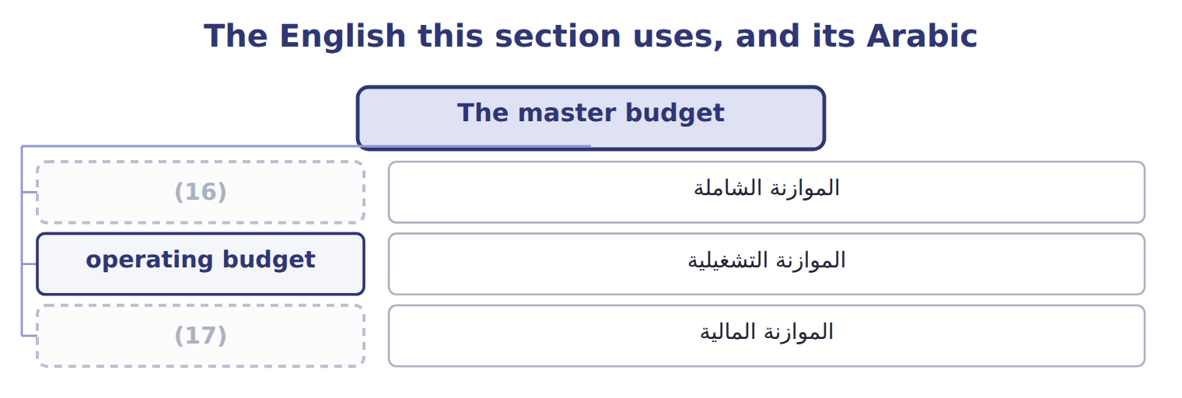
word list
master budget · financial budget · activity-based budgeting

The English this sheet uses, and its Arabic
English (exam term) | Arabic
master budget | الموازنة الشاملة
operating budget | الموازنة التشغيلية
financial budget | الموازنة المالية

Answer key · 4.1 The master budget

1 The master budget | 10 operating
2 Project budgets | 11 statement
3 Benefits and limitations | 12 financial
4 master | 13 Plan and control one project
5 complete | 14 Many products using overhead differently
6 coordinate | 15 One year, by quarter or month
7 quarters | 16 master budget
8 prepares | 17 financial budget
9 components

the summaries in full
Summary 1 The master budget is the complete annual budget of the organization. Its purpose is to plan and coordinate every unit for one year, usually split into quarters and months. Every organization prepares one. It has two groups of components. The operating budget plans sales, production and costs, and ends in the budgeted income statement. The financial budget plans capital spending and cash, and ends in the budgeted balance sheet. The sales budget sets production; production sets materials, labor and overhead; these set the cost of goods sold. Sales also drive cash collections, so an error in the sales budget spreads to every other budget.

4.2 Developing the master budget
Chapter 4 · section 4.2

Fill every gap. Each word list holds one word more than there are gaps.
Summary 1 gaps 1–2
The master budget is (1) in a fixed order, (2) with sales, because every other figure depends on how much the company expects to sell.
word list
developed · reviewed · starting

Steps in developing the Beverages master budget
Each stage leads to the next.
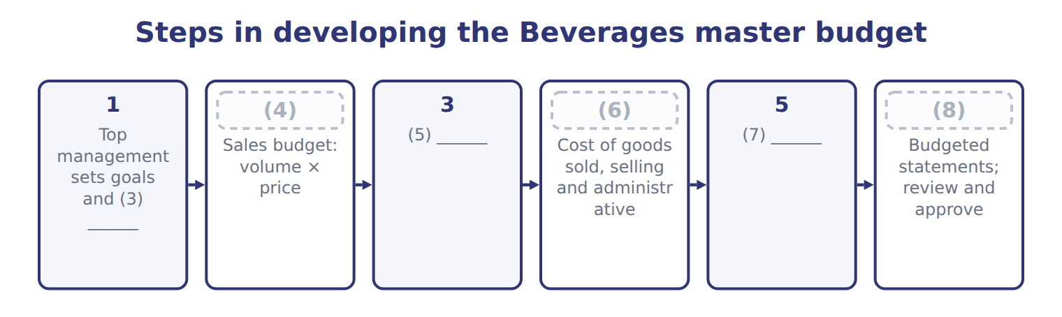
word list
4 · Production and input budgets · 6 · 2 · operating budget · assumptions · Capital and cash budgets

Summary 2 gaps 9–12
The (9) sales budget is 900,000 cases × $20.00 = $18,000,000. The process is not a (10) pass. Draft budgets are (11) , and a shortage of cash or capacity found late in the process may send the planners back to change the sales or (12) plan.
word list
depends · single · reviewed · Beverages · production

Sales first

Summary 3 gaps 13–14
An (13) that starts the master budget with (14) , purchases or cash has the order wrong. The sales budget comes first.
word list
process · answer · production

Answer key · 4.2 Developing the master budget

1 developed | 8 6
2 starting | 9 Beverages
3 assumptions | 10 single
4 2 | 11 reviewed
5 Production and input budgets | 12 production
6 4 | 13 answer
7 Capital and cash budgets | 14 production

the summaries in full
Summary 1 The master budget is developed in a fixed order, starting with sales, because every other figure depends on how much the company expects to sell.
Summary 2 The Beverages sales budget is 900,000 cases × $20.00 = $18,000,000. The process is not a single pass. Draft budgets are reviewed, and a shortage of cash or capacity found late in the process may send the planners back to change the sales or production plan.
Summary 3 An answer that starts the master budget with production, purchases or cash has the order wrong. The sales budget comes first.

4.3 Project budgets
Chapter 4 · section 4.3

Fill every gap. Each word list holds one word more than there are gaps.
Summary 1 gaps 1–3
A project (1) plans the costs of one project over its whole life, which may be (2) or longer than a year. It is used for building a plant, (3) a new line, launching a product or putting in a new system.
word list
capital · installing · shorter · budget

Worked example: the new juice filling line

Summary 2 gaps 4–5
The filling line funded: equipment, (4) , training, testing and start-up, plus a (5) for costs that cannot be predicted in detail.
word list
start-up · contingency · installation

Worked example: the filling-line project budget
The bars are drawn to scale.
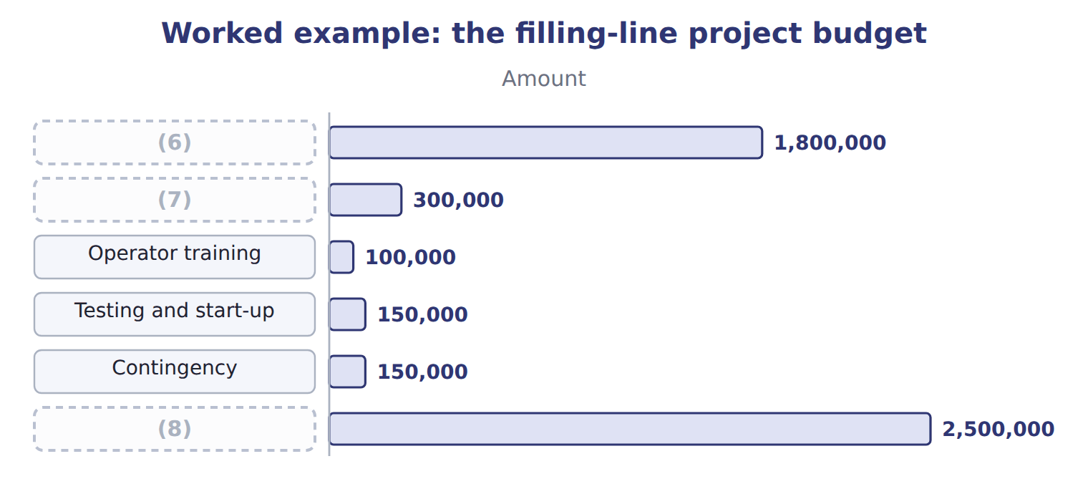
word list
Operator training · Project budget (9 months) · Installation · Filling equipment

Summary 3 gaps 9–11
A project budget also has a (9) . The project budget links to the master budget through the capital (10) budget and the cash budget. When the line starts working, its costs move into the (11) budgets.
word list
operating · expenditure · timeline · installing

The English this section uses, and its Arabic
Each term sits against what it means.
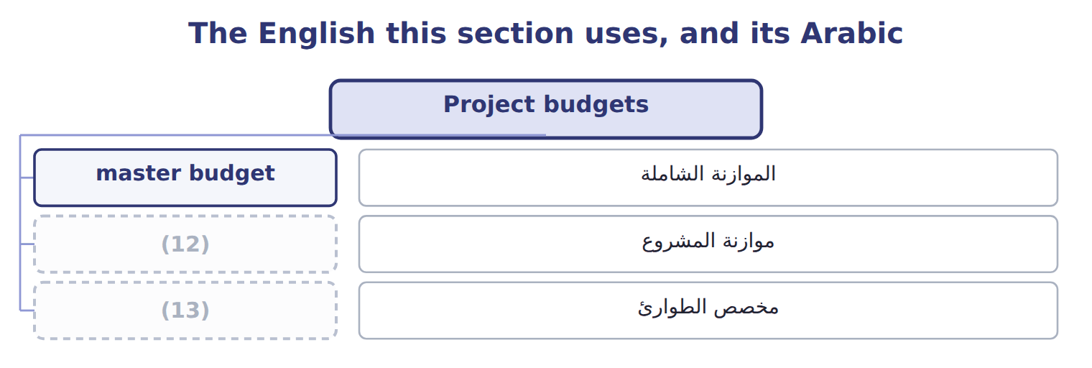
word list
master budget · contingency · project budget

The English this sheet uses, and its Arabic
English (exam term) | Arabic
project budget | موازنة المشروع
contingency | مخصص الطوارئ

Answer key · 4.3 Project budgets

1 budget | 8 Project budget (9 months)
2 shorter | 9 timeline
3 installing | 10 expenditure
4 installation | 11 operating
5 contingency | 12 project budget
6 Filling equipment | 13 contingency
7 Installation

the summaries in full
Summary 1 A project budget plans the costs of one project over its whole life, which may be shorter or longer than a year. It is used for building a plant, installing a new line, launching a product or putting in a new system.
Summary 2 The filling line funded: equipment, installation, training, testing and start-up, plus a contingency for costs that cannot be predicted in detail.
Summary 3 A project budget also has a timeline. The project budget links to the master budget through the capital expenditure budget and the cash budget. When the line starts working, its costs move into the operating budgets.

4.4 Activity-based budgeting
Chapter 4 · section 4.4

Fill every gap. Each word list holds one word more than there are gaps.
Summary 1 gaps 1–6
Activity-based (1) plans overhead from the (2) that planned output will require. It is most useful when (3) use overhead very (4) , as lentils and za'atar do in the Pulses & Spices line. Planned output sets the demand for each activity; each demand is (5) by the activity rate from Book 2. (6) costs do not change with output and are budgeted as a fixed amount.
word list
products · multiplied · budgeting · contingency · activities · Facility · differently

Worked example: Pulses & Spices overhead for 2028

Summary 2 gaps 7–8
The 2028 plan is 220,000 packs of (7) , up from 200,000, and 40,000 packs of za'atar, down from 50,000. (8) , for example: 540 planned × $300 = $162,000.
word list
Receipts · lentils · Facility

Worked example: activity-based budget for Pulses & Spices, 2028
The bars are drawn to scale.
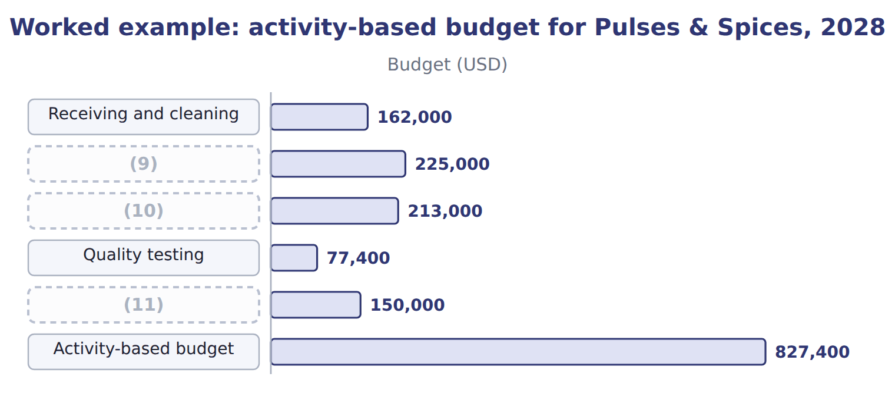
word list
Facility (capacity cost) · Packaging · master budget · Blending setups

Budgeting packaging and testing

Summary 3 gaps 12–13
Complete the blank cells. A (12) budget would take last year's (13) of $900,000 and add 3%, giving $927,000.
word list
budgeted · traditional · overhead

The English this sheet uses, and its Arabic
English (exam term) | Arabic
activity-based budgeting | الموازنة على أساس الأنشطة

Answer key · 4.4 Activity-based budgeting

1 budgeting | 8 Receipts
2 activities | 9 Blending setups
3 products | 10 Packaging
4 differently | 11 Facility (capacity cost)
5 multiplied | 12 traditional
6 Facility | 13 overhead
7 lentils

the summaries in full
Summary 1 Activity-based budgeting plans overhead from the activities that planned output will require. It is most useful when products use overhead very differently, as lentils and za'atar do in the Pulses & Spices line. Planned output sets the demand for each activity; each demand is multiplied by the activity rate from Book 2. Facility costs do not change with output and are budgeted as a fixed amount.
Summary 2 The 2028 plan is 220,000 packs of lentils, up from 200,000, and 40,000 packs of za'atar, down from 50,000. Receipts, for example: 540 planned × $300 = $162,000.
Summary 3 Complete the blank cells. A traditional budget would take last year's overhead of $900,000 and add 3%, giving $927,000.

4.5 Benefits and limitations
Chapter 4 · section 4.5

Fill every gap. Each word list holds one word more than there are gaps.
No system suits every purpose.
Benefits and limitations of the three budget systems
System | Benefits (B.4.d) | Limitations
Master budget | Coordinates every unit; links to strategy | (1)
Project budget | Controls a project over its whole life | (2)
Activity-based budget | (3) | Needs activity data; costly to set up and maintain

word list
Hard to estimate new work; shared costs may be missed · Takes time; can become fixed and out of date · Controls a project over its whole life · Shows why overhead changes; finds waste

Summary 1 gaps 4–9
The master budget (4) everything but can (5) a fixed ritual. The project budget (6) a project well but may miss costs shared with the rest of the (7) . The activity-based budget (8) overhead but needs (9) data that many companies do not have. Companies usually combine the systems: a master budget for the whole company, project budgets for major investments, and activity-based budgets where overhead is large and varied.
word list
activity · business · controls · coordinates · become · usually · explains

The English this section uses, and its Arabic
Each term sits against what it means.
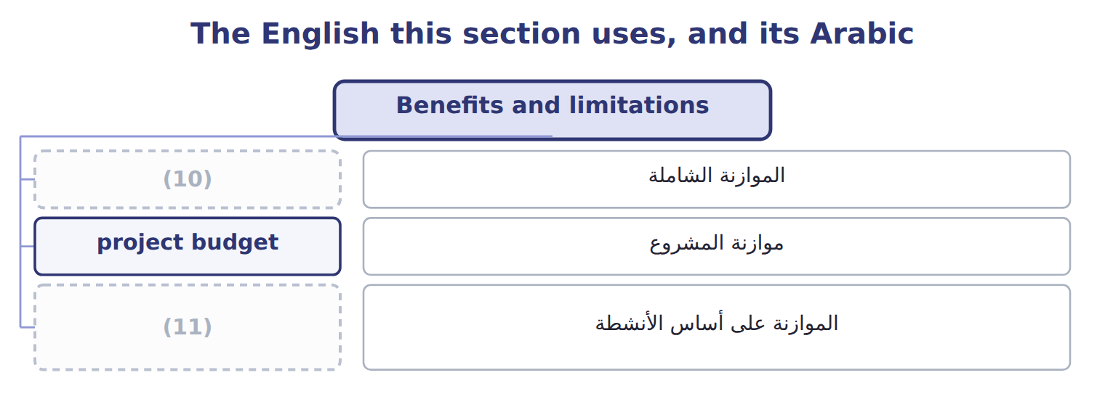
word list
activity-based budgeting · project budget · master budget

Answer key · 4.5 Benefits and limitations

1 Takes time; can become fixed and out of date | 7 business
2 Hard to estimate new work; shared costs may be missed | 8 explains
3 Shows why overhead changes; finds waste | 9 activity
4 coordinates | 10 master budget
5 become | 11 activity-based budgeting
6 controls

the summaries in full
Summary 1 The master budget coordinates everything but can become a fixed ritual. The project budget controls a project well but may miss costs shared with the rest of the business. The activity-based budget explains overhead but needs activity data that many companies do not have. Companies usually combine the systems: a master budget for the whole company, project budgets for major investments, and activity-based budgets where overhead is large and varied.

4.6 Extended Example 4A: choosing and building the 2028 budgets
Chapter 4 · section 4.6

Fill every gap. Each word list holds one word more than there are gaps.
Summary 1 gaps 1–4
This example shows how the (1) combines the three systems for 2028. (2) as a whole: master budget, one year by month. The new (3) line: project budget, 9 months. Pulses & Spices overhead: (4) budget, because lentils and za'atar use overhead very differently.
word list
Beverages · controller · packing · activity-based · filling

Extended Example: the Beverages 2028 component map
Every item belongs to exactly one group.
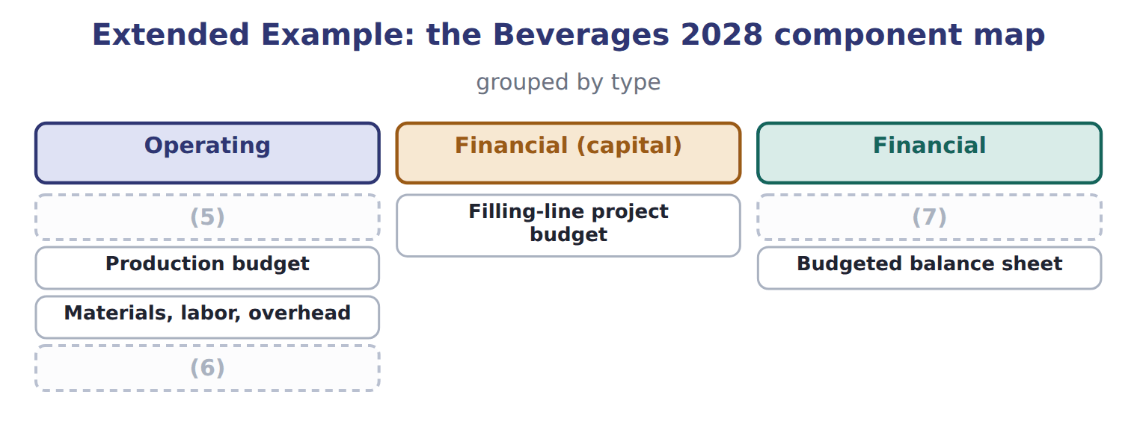
word list
Sales budget · Production budget · Budgeted income statement · Cash budget

Summary 2 gaps 8–9
The fall in (8) volume cuts setups and tests; the rise in lentils adds packing hours; (9) costs stay the same.
word list
za'atar · differently · facility

Extended Example: activity-based and incremental budgets compared
The parts add up to the total; the bars are to scale.
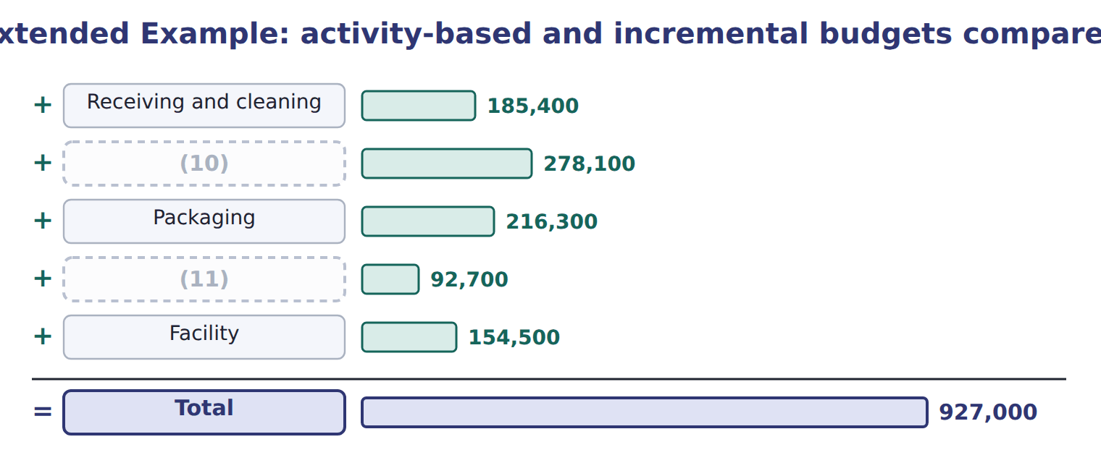
word list
operating budget · Quality testing · Blending setups

Everything ties

Project budget $2,500,000 = capital granted to Beverages.
Exam view

Summary 3 gaps 12–14
Expect to order the (12) of a master budget, to classify budgets as (13) or financial, to total a project budget, to build an (14) budget from drivers and rates, and to match each system with a situation.
word list
operating · activity-based · components · Beverages

Exam view
The bars are drawn to scale.
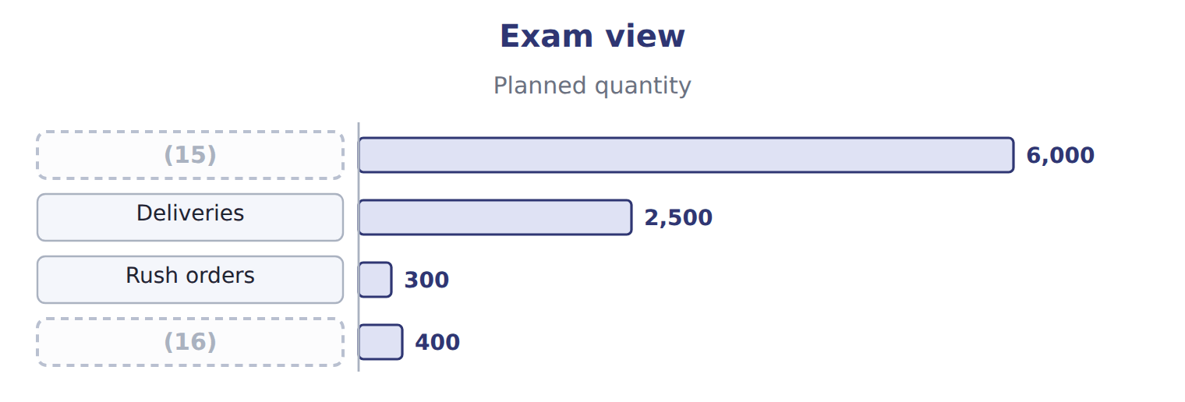
word list
Returns · operating budget · Customer orders

Item — Answer
Item | Answer
Packaging | 7,100 hours × $30 = $213,000
Quality testing | (17)
Total | $827,400

word list
1,290 tests × $60 = $77,400 · 7,100 hours × $30 = $213,000

Budget — Category
Every item belongs to exactly one group.
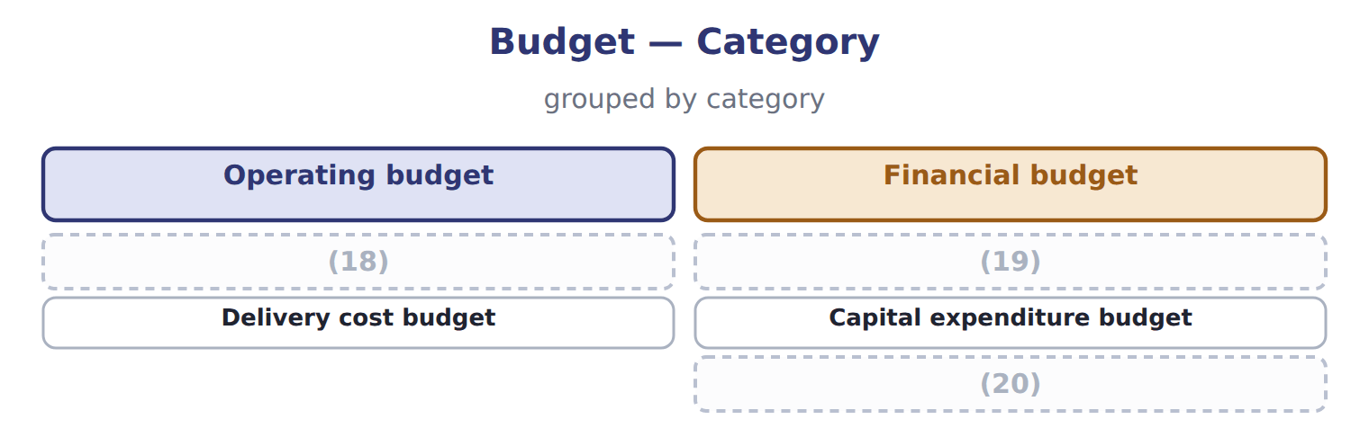
word list
Budgeted balance sheet · Sales budget · Cash budget · activity-based budgeting

The English this section uses, and its Arabic
Each term sits against what it means.
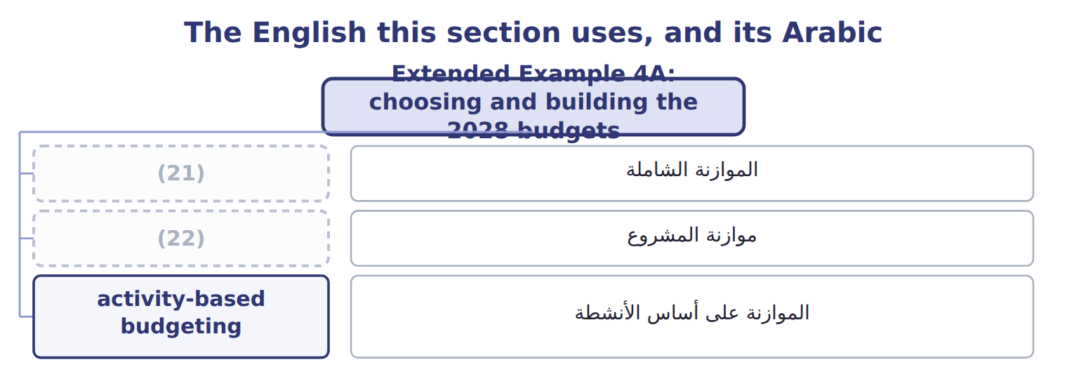
word list
financial budget · project budget · master budget

The English this sheet uses, and its Arabic
English (exam term) | Arabic
master budget | الموازنة الشاملة
project budget | موازنة المشروع
activity-based budgeting | الموازنة على أساس الأنشطة

Answer key · 4.6 Extended Example 4A: choosing and building the 2028 budgets

1 controller | 12 components
2 Beverages | 13 operating
3 filling | 14 activity-based
4 activity-based | 15 Customer orders
5 Sales budget | 16 Returns
6 Budgeted income statement | 17 1,290 tests × $60 = $77,400
7 Cash budget | 18 Sales budget
8 za'atar | 19 Cash budget
9 facility | 20 Budgeted balance sheet
10 Blending setups | 21 master budget
11 Quality testing | 22 project budget

the summaries in full
Summary 1 This example shows how the controller combines the three systems for 2028. Beverages as a whole: master budget, one year by month. The new filling line: project budget, 9 months. Pulses & Spices overhead: activity-based budget, because lentils and za'atar use overhead very differently.
Summary 2 The fall in za'atar volume cuts setups and tests; the rise in lentils adds packing hours; facility costs stay the same.
Summary 3 Expect to order the components of a master budget, to classify budgets as operating or financial, to total a project budget, to build an activity-based budget from drivers and rates, and to match each system with a situation.

