11.1 Measuring performance against the plan
Chapter 11 · section 11.1

Fill every gap. Each word list holds one word more than there are gaps.
Chapter 11, section by section
Each stage leads to the next.
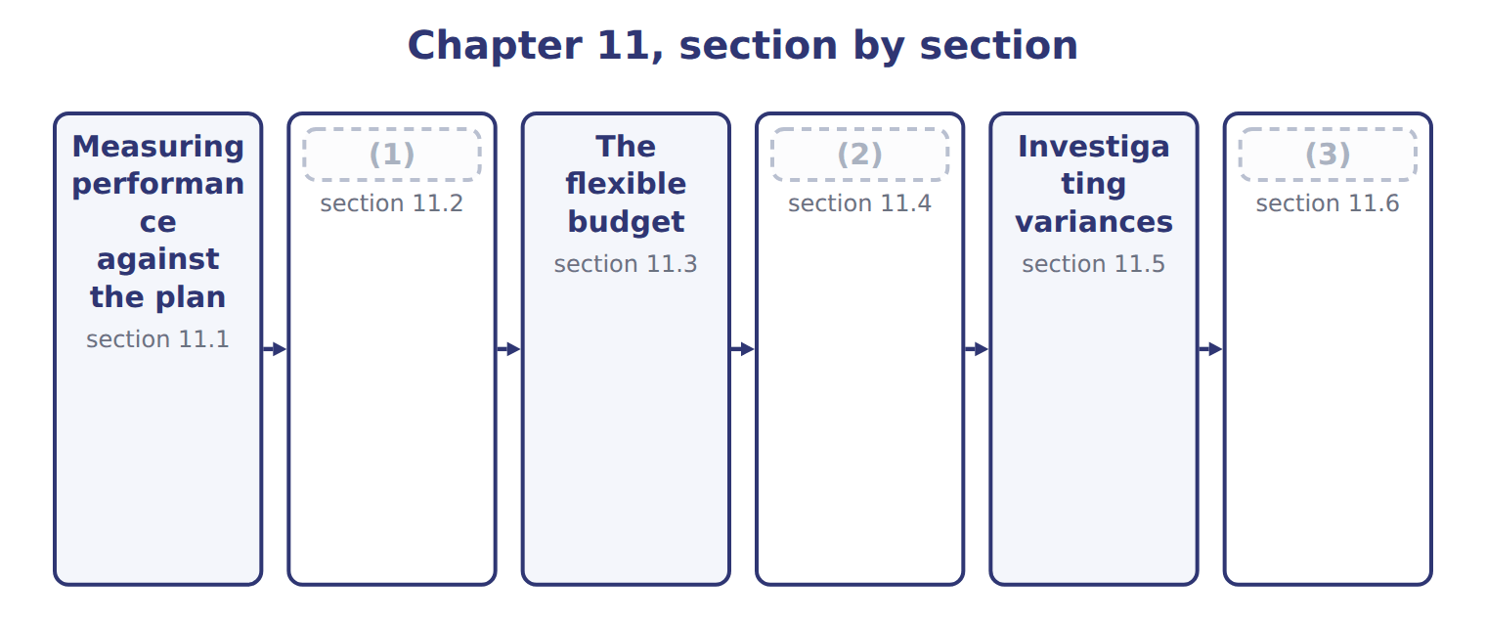
word list
The flexible budget · Sales-volume, sales-price and flexible-budget · The master-budget variance · Extended Example 11A: the June review meeting

Summary 1 gaps 4–5
Performance is measured against the (4) goals set in the budget: revenue, manufacturing costs, (5) costs and profit.
word list
describe · operational · non-manufacturing

Measures of performance against operational goals
Measure (C.1.a) | June 2028 | What it reflects
Revenue | Sales of $1,468,800 against $1,500,000 planned | (6)
Manufacturing costs | (7) | Input prices and quantities
Non-manufacturing costs | (8) | Rates and spending decisions
Profitability | Operating income of $247,632 against $265,000 planned | (9)

word list
Input prices and quantities · Variable selling, fixed selling and administrative · Volume and price · Concentrate, bottles, labor and overhead per case · All of the above together

Summary 2 gaps 10–13
A (10) between an actual result and a (11) figure is a variance. It is a favorable variance when it raises (12) income above the budget and an (13) variance when it lowers it. The words describe the effect on income, not whether the news is good.
word list
difference · Performance · operating · budgeted · unfavorable

Favorable is not always good

Summary 3 gaps 14–15
A favorable material price variance may come from buying (14) concentrate that later causes spillage. Always ask what caused the variance before judging (15) .
word list
non-manufacturing · poor-quality · performance

The English this sheet uses, and its Arabic
English (exam term) | Arabic
favorable variance | انحراف ملائم
unfavorable variance | انحراف غير ملائم

Answer key · 11.1 Measuring performance against the plan

1 The master-budget variance | 9 All of the above together
2 Sales-volume, sales-price and flexible-budget | 10 difference
3 Extended Example 11A: the June review meeting | 11 budgeted
4 operational | 12 operating
5 non-manufacturing | 13 unfavorable
6 Volume and price | 14 poor-quality
7 Concentrate, bottles, labor and overhead per case | 15 performance
8 Variable selling, fixed selling and administrative

the summaries in full
Summary 1 Performance is measured against the operational goals set in the budget: revenue, manufacturing costs, non-manufacturing costs and profit.
Summary 2 A difference between an actual result and a budgeted figure is a variance. It is a favorable variance when it raises operating income above the budget and an unfavorable variance when it lowers it. The words describe the effect on income, not whether the news is good.
Summary 3 A favorable material price variance may come from buying poor-quality concentrate that later causes spillage. Always ask what caused the variance before judging performance.

11.2 The master-budget variance
Chapter 11 · section 11.2

Fill every gap. Each word list holds one word more than there are gaps.
Summary 1 gaps 1–2
The (1) (static-budget) variance is the difference between the actual result and the master budget. For June, (2) income was $17,368 below the plan.
word list
master-budget · operating · constant

Worked example: June against the master budget

Sales were $1,468,800 against $1,500,000 planned, and operating income $247,632 against $265,000.
Worked example: June actual results against the master budget
The bars are drawn to scale.
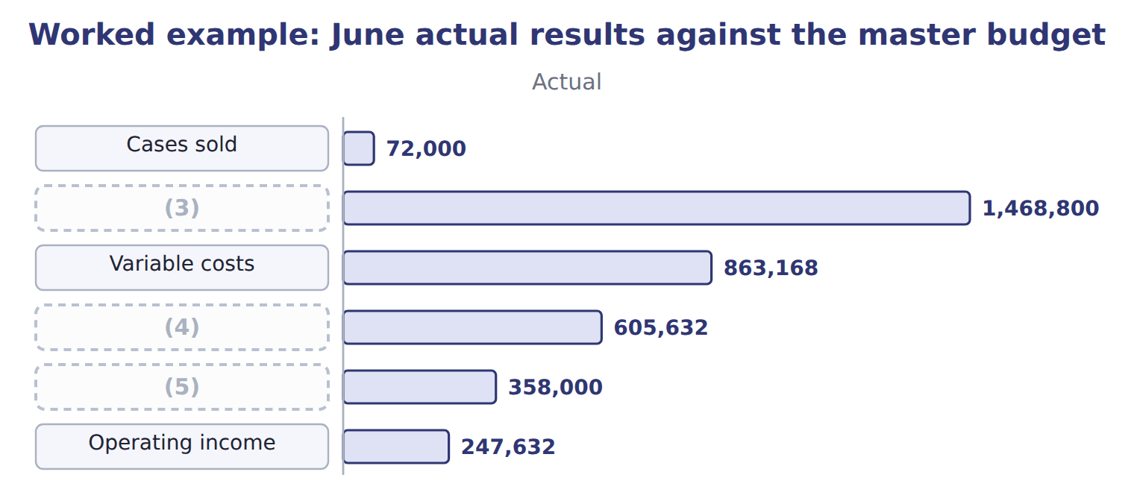
word list
Variable costs · Contribution margin · Sales · Fixed costs

Summary 2 gaps 6–13
The total is not very useful on its own, because the (6) sold 3,000 fewer cases than (7) . Lower volume reduces both revenue and (8) costs, so the comparison mixes two (9) stories. It shows the full gap from the plan, which the board wants to know, but it is not a fair (10) of cost control when volume (11) . The comparison is (12) kept for the board and for the sales team, who are (13) for volume. The plant manager is judged on the flexible budget of the next section, which holds volume constant.
word list
different · responsible · differs · variable · planned · measure · because · therefore · division

Benefits and limitations of comparing with the master budget
Benefits of comparing with the master budget (C. | Limitations
Shows the total gap from the plan, including volume | (14)
Simple and well understood | Can blame a manager for a volume (15) caused by the market
Useful for the board, which approved the plan | Not a fair measure of cost control when volume differs

word list
shortfall · Variance · Mixes volume with prices and efficiency

The English this section uses, and its Arabic
Each term sits against what it means.
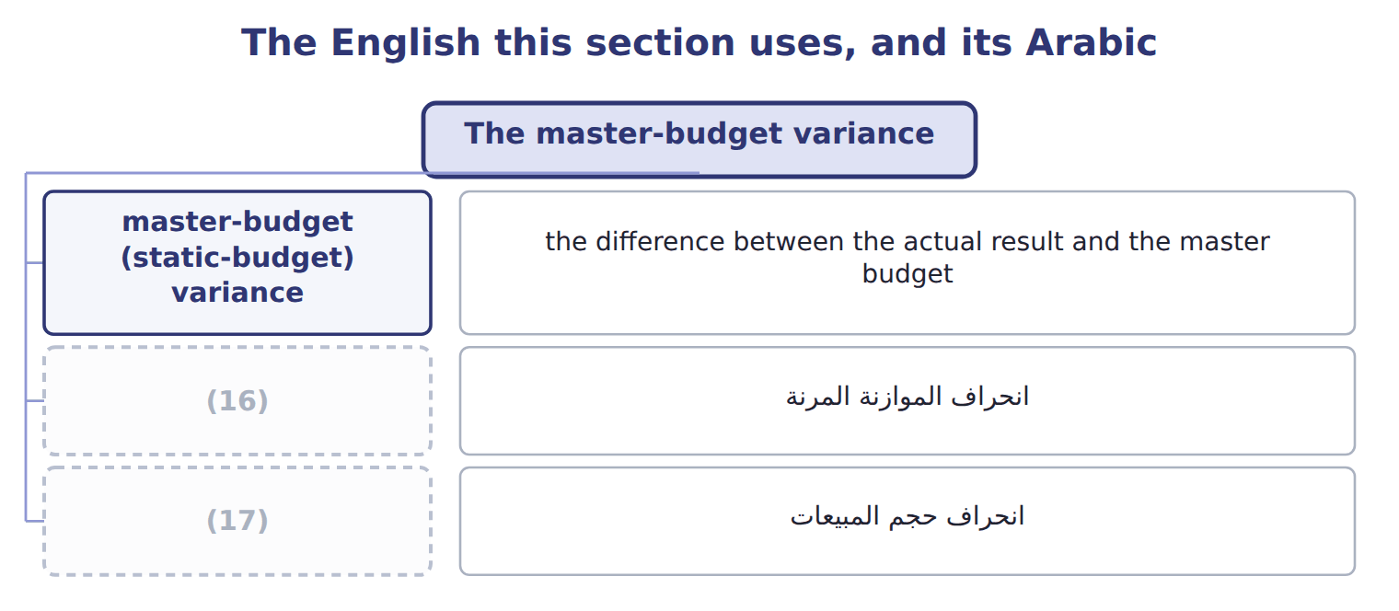
word list
unfavorable variance · flexible-budget variance · sales-volume variance

The English this sheet uses, and its Arabic
English (exam term) | Arabic
master-budget (static-budget) variance | انحراف الموازنة الشاملة (الثابتة)

Answer key · 11.2 The master-budget variance

1 master-budget | 10 measure
2 operating | 11 differs
3 Sales | 12 therefore
4 Contribution margin | 13 responsible
5 Fixed costs | 14 Mixes volume with prices and efficiency
6 division | 15 shortfall
7 planned | 16 flexible-budget variance
8 variable | 17 sales-volume variance
9 different

the summaries in full
Summary 1 The master-budget (static-budget) variance is the difference between the actual result and the master budget. For June, operating income was $17,368 below the plan.
Summary 2 The total is not very useful on its own, because the division sold 3,000 fewer cases than planned. Lower volume reduces both revenue and variable costs, so the comparison mixes two different stories. It shows the full gap from the plan, which the board wants to know, but it is not a fair measure of cost control when volume differs. The comparison is therefore kept for the board and for the sales team, who are responsible for volume. The plant manager is judged on the flexible budget of the next section, which holds volume constant.

11.3 The flexible budget
Chapter 11 · section 11.3

Fill every gap. Each word list holds one word more than there are gaps.
Summary 1 gaps 1–3
The (1) budget answers the (2) : what should the results have been at the volume actually sold? It uses the actual volume with budgeted prices and budgeted costs. Fixed costs do not change, (3) they do not depend on volume.
word list
question · flexible · because · overspending

Worked example: the flexible budget for June

Summary 2 gaps 4–5
At 72,000 cases: sales 72,000 × $20.00 = $1,440,000; (4) costs × $11.80 = $849,600; fixed costs stay at $350,000. (5) income is $240,400.
word list
variable · Operating · results

Worked example: the three-column analysis for June
The bars are drawn to scale.
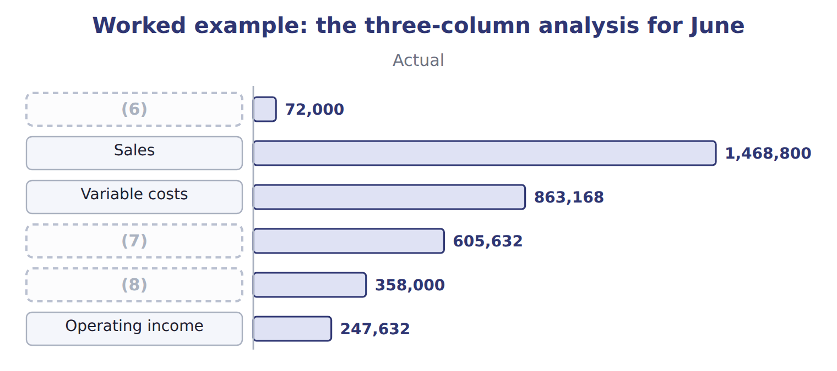
word list
favorable variance · Fixed costs · Contribution margin · Cases

The flexible-budget column

Complete the blank cells.
Fixed costs do not flex

Summary 3 gaps 9–10
The (9) budget changes only the variable items. Scaling fixed costs down to 72,000 cases would hide the real fixed-cost (10) and give the wrong flexible-budget variance.
word list
overspending · flexible · answers

The English this sheet uses, and its Arabic
English (exam term) | Arabic
flexible-budget variance | انحراف الموازنة المرنة

Answer key · 11.3 The flexible budget

1 flexible | 6 Cases
2 question | 7 Contribution margin
3 because | 8 Fixed costs
4 variable | 9 flexible
5 Operating | 10 overspending

the summaries in full
Summary 1 The flexible budget answers the question: what should the results have been at the volume actually sold? It uses the actual volume with budgeted prices and budgeted costs. Fixed costs do not change, because they do not depend on volume.
Summary 2 At 72,000 cases: sales 72,000 × $20.00 = $1,440,000; variable costs × $11.80 = $849,600; fixed costs stay at $350,000. Operating income is $240,400.
Summary 3 The flexible budget changes only the variable items. Scaling fixed costs down to 72,000 cases would hide the real fixed-cost overspending and give the wrong flexible-budget variance.

11.4 Sales-volume, sales-price and flexible-budget variances
Chapter 11 · section 11.4

Fill every gap. Each word list holds one word more than there are gaps.
Summary 1 gaps 1–8
The (1) variance is the difference between the flexible budget and the (2) budget. It equals the change in units multiplied by the budgeted (3) margin per unit: (72,000 − 75,000) × $8.20 = $24,600, (4) . The (5) variance compares the actual price with the budgeted price on the units (6) sold: ($20.40 − $20.00) × 72,000 = $28,800, favorable. Note the (7) bases: the volume variance uses the budgeted margin, the price variance uses actual units. The (8) variance is the difference between the actual result and the flexible budget: $7,232, favorable.
word list
contribution · selling · flexible-budget · actually · different · sales-price · master · unfavorable · sales-volume

Worked example: the June variances and how they add up
Variance | Calculation | Effect on operating income
Sales-volume variance | (9) | 24,600 U
Sales-price variance | ($20.40 − $20.00) × 72,000 | (10)
Variable cost variance | actual − flexible budget | (11)
Fixed cost variance | actual − budget | (12)
Flexible-budget variance | price + cost variances | (13)
Master-budget variance | flexible-budget + sales-volume | (14)

word list
price + cost variances · 17,368 U · 8,000 U · 28,800 F · 13,568 U · 7,232 F · (72,000 − 75,000) × $8.20

Concentrate is $13,240 over budget, and the fixed costs are $8,000 over.

The cost side of the flexible-budget variance
The bars are drawn to scale.
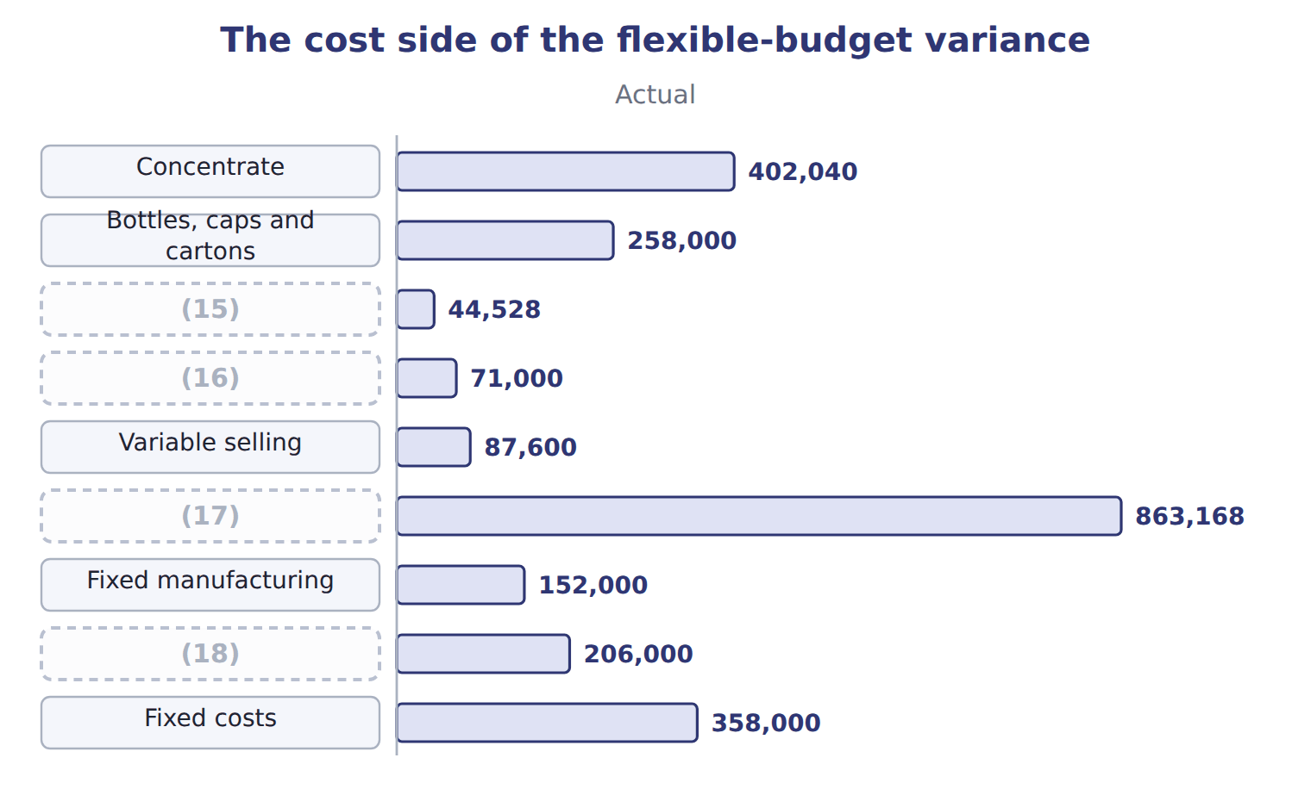
word list
Fixed selling and administrative · Variable overhead · Fixed costs · Variable costs · Direct labor

Volume at margin, price at actual units

Summary 2 gaps 19–21
Valuing the volume variance at the (19) price, or the price variance at budgeted units, are the two most (20) errors. The volume variance uses the budgeted (21) margin; the price variance uses the units actually sold.
word list
selling · sales-volume · common · contribution

The English this section uses, and its Arabic
Each term sits against what it means.
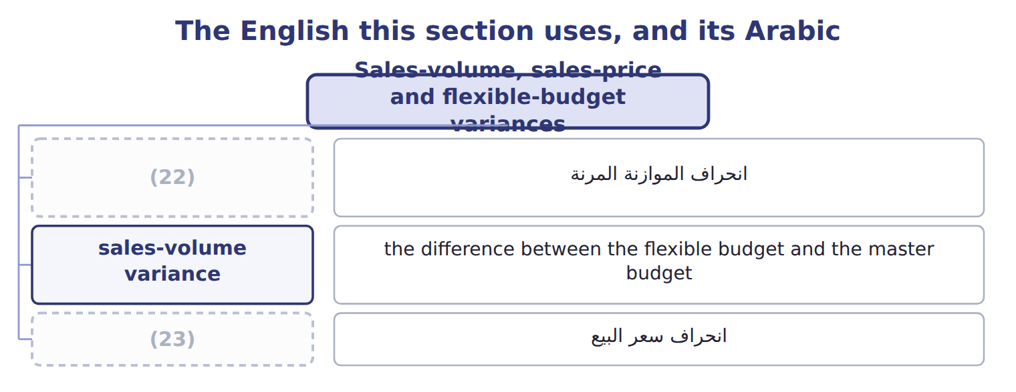
word list
unfavorable variance · sales-price variance · flexible-budget variance

The English this sheet uses, and its Arabic
English (exam term) | Arabic
sales-volume variance | انحراف حجم المبيعات
sales-price variance | انحراف سعر البيع

Answer key · 11.4 Sales-volume, sales-price and flexible-budget variances

1 sales-volume | 13 7,232 F
2 master | 14 17,368 U
3 contribution | 15 Direct labor
4 unfavorable | 16 Variable overhead
5 sales-price | 17 Variable costs
6 actually | 18 Fixed selling and administrative
7 different | 19 selling
8 flexible-budget | 20 common
9 (72,000 − 75,000) × $8.20 | 21 contribution
10 28,800 F | 22 flexible-budget variance
11 13,568 U | 23 sales-price variance
12 8,000 U

the summaries in full
Summary 1 The sales-volume variance is the difference between the flexible budget and the master budget. It equals the change in units multiplied by the budgeted contribution margin per unit: (72,000 − 75,000) × $8.20 = $24,600, unfavorable. The sales-price variance compares the actual price with the budgeted price on the units actually sold: ($20.40 − $20.00) × 72,000 = $28,800, favorable. Note the different bases: the volume variance uses the budgeted margin, the price variance uses actual units. The flexible-budget variance is the difference between the actual result and the flexible budget: $7,232, favorable.
Summary 2 Valuing the volume variance at the selling price, or the price variance at budgeted units, are the two most common errors. The volume variance uses the budgeted contribution margin; the price variance uses the units actually sold.

11.5 Investigating variances
Chapter 11 · section 11.5

Fill every gap. Each word list holds one word more than there are gaps.
Summary 1 gaps 1–2
A cost (1) still mixes two causes: the price paid for an input and the (2) used.
word list
changes · variance · quantity

Investigating the concentrate and labor differences
Difference | Calculation | Amount | Likely reason
Concentrate price | ($0.92 − $0.90) × 437,000 liters | (3) | A world price rise; not controllable by the plant
Concentrate usage | (4) | 4,500 U | Spillage on the line during a changeover
Labor rate | ($12.10 − $12.00) × 3,680 hours | 368 U | (5)
Labor efficiency | (3,680 − 3,600) hours × $12.00 | (6) | The same changeover

word list
960 U · Overtime for the summer season · 8,740 U · master-budget (static-budget) variance · (437,000 − 432,000) liters × $0.90

Summary 2 gaps 7–12
The (7) price variance of $8,740 came from a world price rise, which the plant cannot control; the usage variance of $4,500 and the labor (8) variance of $960 came from one long (9) . Common reasons for (10) include changes in input prices, the quality of (11) , the skill or mix of workers, machine problems, the volume produced, and errors in the budget itself. A variance is a (12) , not an answer.
word list
quality · variances · changeover · efficiency · question · materials · concentrate

The English this section uses, and its Arabic
Each term sits against what it means.
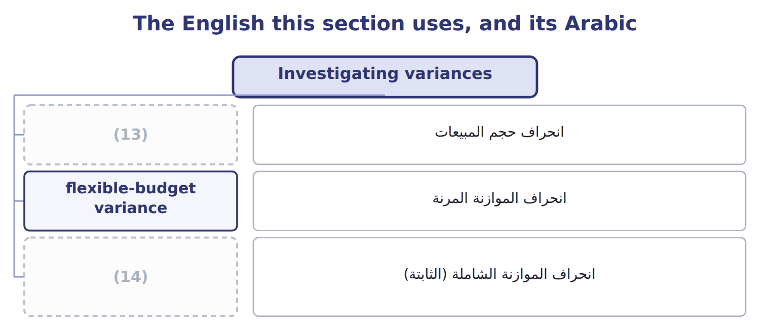
word list
favorable variance · master-budget (static-budget) variance · sales-volume variance

The English this sheet uses, and its Arabic
English (exam term) | Arabic
sales-volume variance | انحراف حجم المبيعات
flexible-budget variance | انحراف الموازنة المرنة
master-budget (static-budget) variance | انحراف الموازنة الشاملة (الثابتة)

Answer key · 11.5 Investigating variances

1 variance | 8 efficiency
2 quantity | 9 changeover
3 8,740 U | 10 variances
4 (437,000 − 432,000) liters × $0.90 | 11 materials
5 Overtime for the summer season | 12 question
6 960 U | 13 sales-volume variance
7 concentrate | 14 master-budget (static-budget) variance

the summaries in full
Summary 1 A cost variance still mixes two causes: the price paid for an input and the quantity used.
Summary 2 The concentrate price variance of $8,740 came from a world price rise, which the plant cannot control; the usage variance of $4,500 and the labor efficiency variance of $960 came from one long changeover. Common reasons for variances include changes in input prices, the quality of materials, the skill or mix of workers, machine problems, the volume produced, and errors in the budget itself. A variance is a question, not an answer.

11.6 Extended Example 11A: the June review meeting
Chapter 11 · section 11.6

Fill every gap. Each word list holds one word more than there are gaps.
Summary 1 gaps 1–3
This example follows the monthly review, where the (1) decides which variances to (2) . Orontes follows (3) by exception: a variance is investigated if it is above 5% of the budgeted figure for that item.
word list
management · whether · investigate · division

Extended Example: which variances to investigate
Item | Variance | Share of its budget | Action under the 5% rule
Sales price | (4) | 10.9% | Follow up: can the higher price be kept?
Sales volume | (5) | 9.3% | Follow up: why were cases lost?
Concentrate | 13,240 U | 5.0% | (6) : price rise and spillage
Direct labor | (7) | 3.1% | Below the 5% rule: no action
Variable overhead | (8) | 1.4% | Below the 5% rule: no action

word list
Variable costs · 28,800 F · Follow up · 1,328 U · 24,600 U · 1,000 F

Variance — Category
Every item belongs to exactly one group.
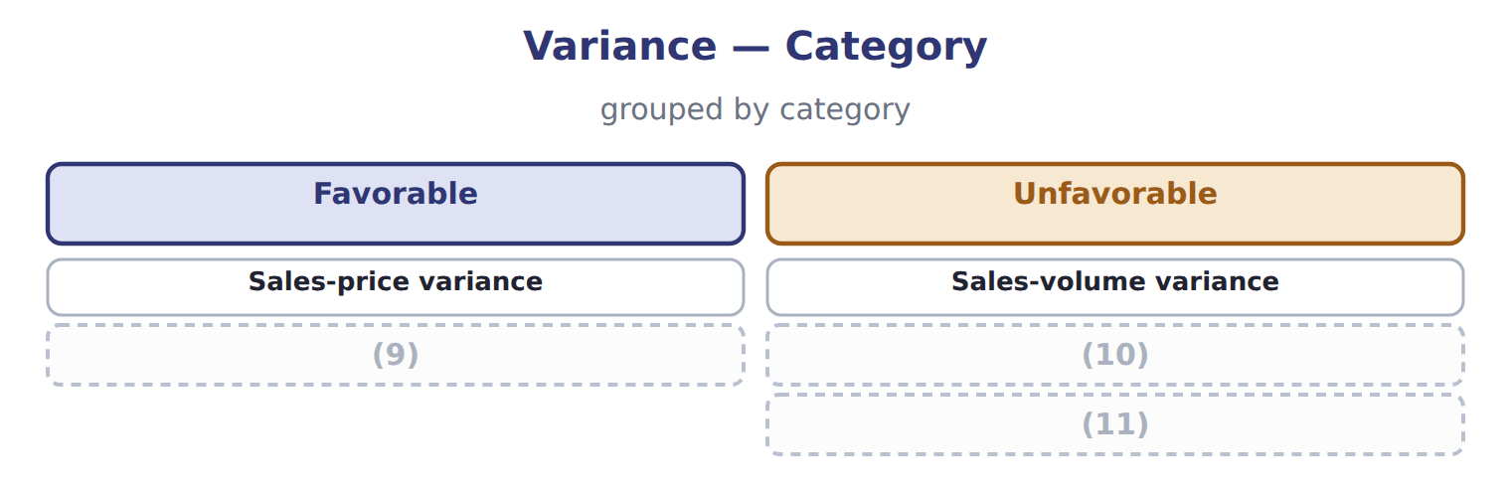
word list
sales-price variance · Flexible-budget variance · Variable cost variance · Fixed cost variance

Summary 2 gaps 12–18
Three items pass the rule. The favorable price variance is (12) as well as the (13) ones, because the division wants to know whether the higher price can be kept. Labor and (14) overhead are below the rule and are left alone. Volume was lost to a (15) promotion, not to poor (16) . The higher price held because the promotion did not reach the hotel (17) . The plant's problems came from one (18) , which the lean work of Book 2.
word list
changeover · competitor's · selling · investigated · unfavorable · customers · variable · Together

Everything ties

Together: $17,368 unfavorable, the master-budget variance.
Exam view

Summary 3 gaps 19–21
Expect a master budget, actual (19) and the actual volume. Build the flexible-budget column first, then the (20) and sales-price variances, then the flexible-budget variance. Label each as favorable or (21) by its effect on operating income.
word list
unfavorable · results · sales-volume · decides

Exam view
Tahini & Spreads, one month | Data
(22) | 125,000
Jars actually sold | 118,000
Budgeted selling price | $3.50
(23) | $3.60
Budgeted contribution margin per jar | $1.50
(24) | 240,000
(25) | 120,000
Actual fixed costs | 123,000

word list
Actual selling price · Jars in the static budget · Below the 5% rule: no action · Actual variable costs · Budgeted fixed costs for the month

Item — Answer
Item | Answer
Variable costs | (26)
Contribution margin | 72,000 × $8.20 = $590,400
Operating income | (27)

word list
72,000 × $8.20 = $590,400 · 72,000 × $11.80 = $849,600 · $590,400 − $350,000 = $240,400

The English this section uses, and its Arabic
Each term sits against what it means.
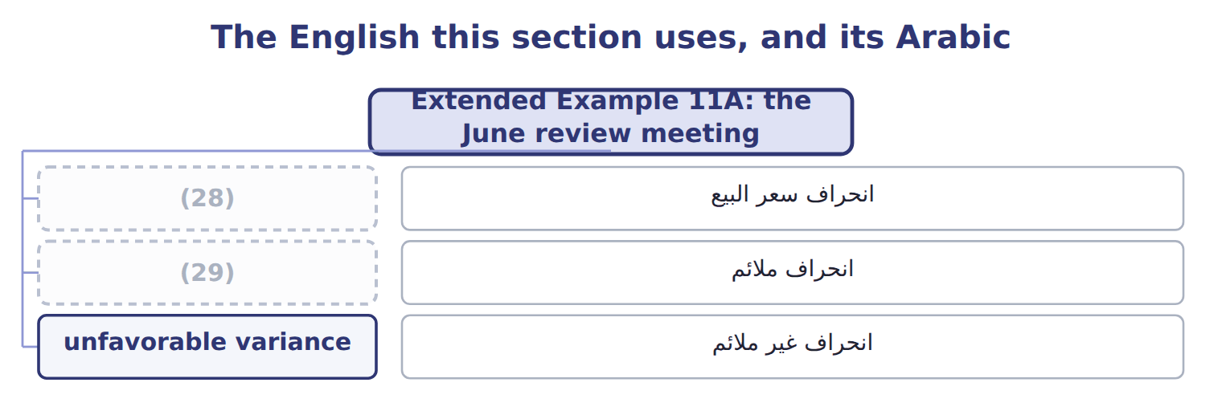
word list
favorable variance · sales-price variance · flexible-budget variance

The English this sheet uses, and its Arabic
English (exam term) | Arabic
sales-price variance | انحراف سعر البيع
favorable variance | انحراف ملائم
unfavorable variance | انحراف غير ملائم

Answer key · 11.6 Extended Example 11A: the June review meeting

1 division | 16 selling
2 investigate | 17 customers
3 management | 18 changeover
4 28,800 F | 19 results
5 24,600 U | 20 sales-volume
6 Follow up | 21 unfavorable
7 1,328 U | 22 Jars in the static budget
8 1,000 F | 23 Actual selling price
9 Flexible-budget variance | 24 Actual variable costs
10 Variable cost variance | 25 Budgeted fixed costs for the month
11 Fixed cost variance | 26 72,000 × $11.80 = $849,600
12 investigated | 27 $590,400 − $350,000 = $240,400
13 unfavorable | 28 sales-price variance
14 variable | 29 favorable variance
15 competitor's

the summaries in full
Summary 1 This example follows the monthly review, where the division decides which variances to investigate. Orontes follows management by exception: a variance is investigated if it is above 5% of the budgeted figure for that item.
Summary 2 Three items pass the rule. The favorable price variance is investigated as well as the unfavorable ones, because the division wants to know whether the higher price can be kept. Labor and variable overhead are below the rule and are left alone. Volume was lost to a competitor's promotion, not to poor selling. The higher price held because the promotion did not reach the hotel customers. The plant's problems came from one changeover, which the lean work of Book 2.
Summary 3 Expect a master budget, actual results and the actual volume. Build the flexible-budget column first, then the sales-volume and sales-price variances, then the flexible-budget variance. Label each as favorable or unfavorable by its effect on operating income.

