15.1 The four responsibility centers
Chapter 15 · section 15.1

Fill every gap. Each word list holds one word more than there are gaps.
Chapter 15, section by section
Each stage leads to the next.
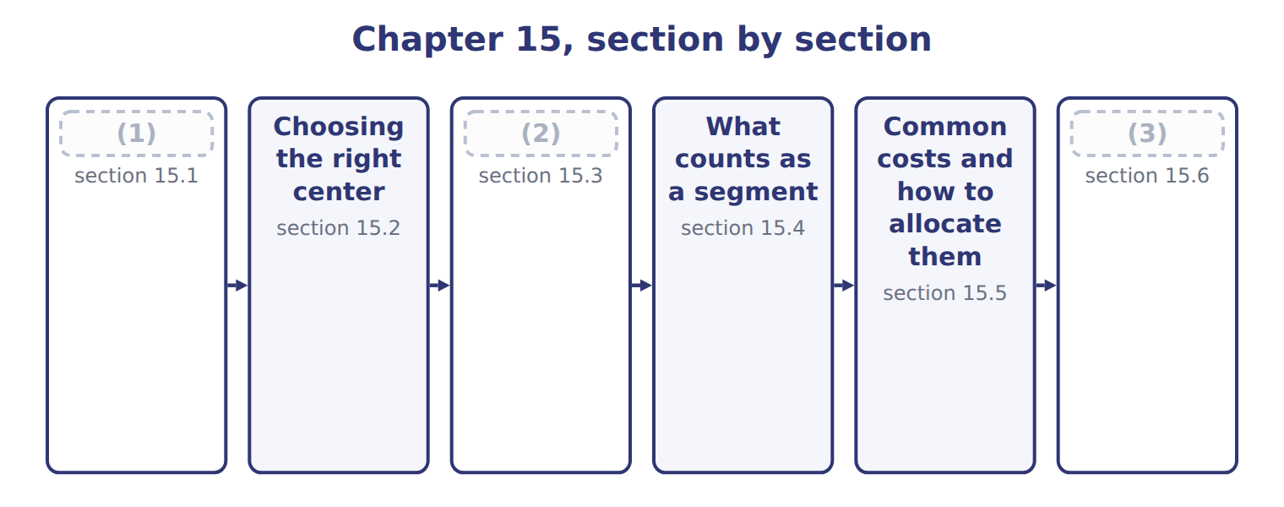
word list
The four responsibility centers · What counts as a segment · Extended Example 15A: evaluating the three div · The contribution margin report

Summary 1 gaps 4–12
A (4) center is a unit whose manager answers for a (5) set of results. There are four kinds, and they (6) only in how much the manager (7) . A cost center answers for costs, and a revenue center for revenue and the (8) costs of earning it. A profit center answers for both, and an (9) center also for the (10) used. The four form a (11) . Each center carries the (12) of the one before it and adds another, so a manager promoted from a cost center to a profit center is answering for revenue for the first time.
word list
ladder · assets · differ · investment · manager · responsibility · selling · controls · responsibilities · defined

The English this section uses, and its Arabic
Each term sits against what it means.
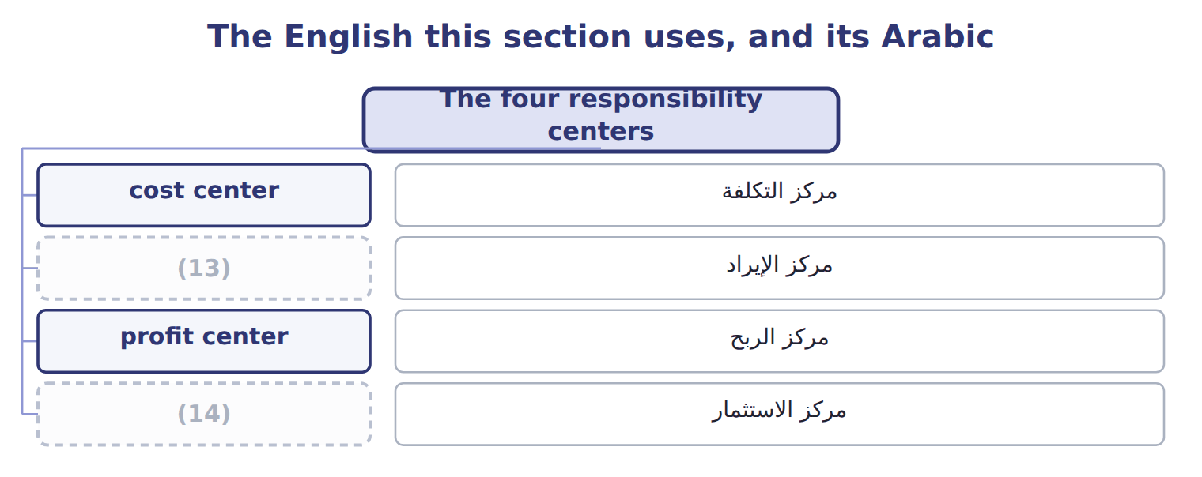
word list
investment center · revenue center · profit center

The English this sheet uses, and its Arabic
English (exam term) | Arabic
cost center | مركز التكلفة
revenue center | مركز الإيراد
profit center | مركز الربح
investment center | مركز الاستثمار

Answer key · 15.1 The four responsibility centers

1 The four responsibility centers | 8 selling
2 The contribution margin report | 9 investment
3 Extended Example 15A: evaluating the three div | 10 assets
4 responsibility | 11 ladder
5 defined | 12 responsibilities
6 differ | 13 revenue center
7 controls | 14 investment center

the summaries in full
Summary 1 A responsibility center is a unit whose manager answers for a defined set of results. There are four kinds, and they differ only in how much the manager controls. A cost center answers for costs, and a revenue center for revenue and the selling costs of earning it. A profit center answers for both, and an investment center also for the assets used. The four form a ladder. Each center carries the responsibilities of the one before it and adds another, so a manager promoted from a cost center to a profit center is answering for revenue for the first time.

15.2 Choosing the right center
Chapter 15 · section 15.2

Fill every gap. Each word list holds one word more than there are gaps.
Summary 1 gaps 1–2
The rule is simple to state and easy to break: give a manager only the (1) that matches the (2) .
word list
responsibility · revenue · authority

Choosing a responsibility center for a situation
What the manager controls (C.2.b) | Recommended center | Orontes example
The manager sets prices and controls costs, but not investment | Profit center | (3)
The manager controls costs only; another unit decides output | (4) | Tahini plant
The manager controls selling effort but not production costs | (5) | Regional sales team
The manager decides on new plant and working capital | (6) | Beverages division
The manager controls nothing but is charged a share of head office | (7) | Any division's allocated head-office cost

word list
Investment center · Levant Distribution · Any division's allocated head-office cost · Revenue center · No center: the charge is not controllable · Cost center

Summary 2 gaps 8–11
At (8) the tahini plant is a cost center, because the sales team decides what to sell and at what price. Levant (9) is a profit center, because its manager sets (10) prices and controls its costs. The Beverages division is an (11) center, because its manager decides on new equipment.
word list
authority · Distribution · delivery · investment · Orontes

Authority first, label second

Summary 3 gaps 12–17
Calling a unit a profit center does not give its (12) control over (13) . If the (14) says that another unit sets the price or the volume, the center is a cost center (15) the company labels it. The (16) also shapes (17) . A unit made a profit center will look for ways to raise revenue, which is useful when it can really influence customers, and misleading when it cannot.
word list
division · manager · however · question · behavior · choice · prices

The English this section uses, and its Arabic
Each term sits against what it means.
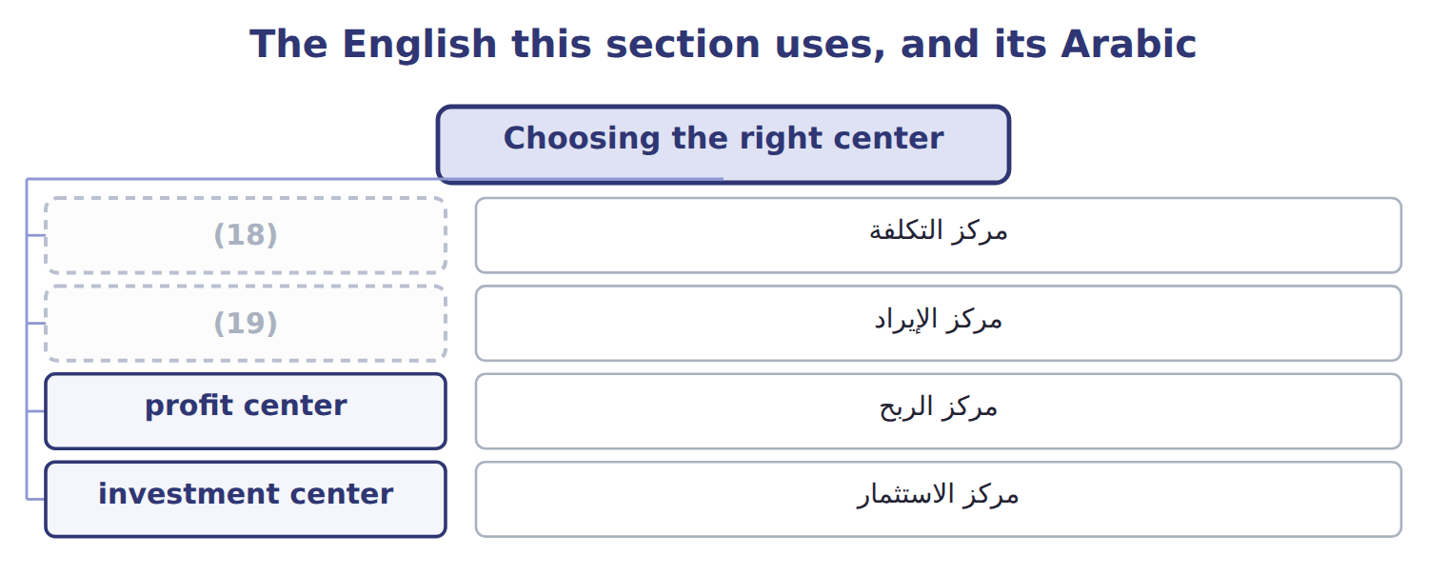
word list
revenue center · cost center · common cost

Answer key · 15.2 Choosing the right center

1 responsibility | 11 investment
2 authority | 12 manager
3 Levant Distribution | 13 prices
4 Cost center | 14 question
5 Revenue center | 15 however
6 Investment center | 16 choice
7 No center: the charge is not controllable | 17 behavior
8 Orontes | 18 cost center
9 Distribution | 19 revenue center
10 delivery

the summaries in full
Summary 1 The rule is simple to state and easy to break: give a manager only the responsibility that matches the authority.
Summary 2 At Orontes the tahini plant is a cost center, because the sales team decides what to sell and at what price. Levant Distribution is a profit center, because its manager sets delivery prices and controls its costs. The Beverages division is an investment center, because its manager decides on new equipment.
Summary 3 Calling a unit a profit center does not give its manager control over prices. If the question says that another unit sets the price or the volume, the center is a cost center however the company labels it. The choice also shapes behavior. A unit made a profit center will look for ways to raise revenue, which is useful when it can really influence customers, and misleading when it cannot.

15.3 The contribution margin report
Chapter 15 · section 15.3

Fill every gap. Each word list holds one word more than there are gaps.
Summary 1 gaps 1–8
A segment report in contribution format has three margins, each (1) a different (2) . The contribution margin is revenue less all (3) costs: $18,000,000 − $10,620,000 = $7,380,000. It shows what each extra case adds, and it is the figure used (4) . The (5) margin then deducts the fixed costs the manager can change, such as marketing and (6) . The segment margin deducts the other fixed costs (7) to the division, such as (8) of its plant. Judge the manager on the first; judge the segment on the second.
word list
traceable · depreciation · throughout · question · answering · Complete · controllable · supervision · variable

Worked example: the Orontes segment report

Beverages earns a segment margin of $3,180,000, the figure, and the three together earn $5,020,000.
Worked example: the Orontes segment report for 2028
The bars are drawn to scale.
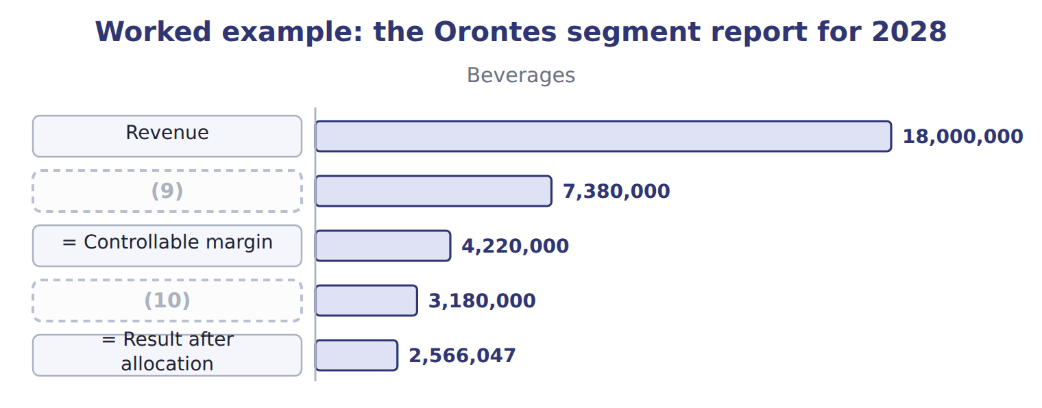
word list
= Segment margin · = Contribution margin · = Controllable margin

The Tahini & Spreads column

Complete the blank cells.
Contribution margin deducts only variable costs

Summary 2 gaps 11–12
Deducting any fixed cost before the (11) margin gives a figure that no longer measures what an extra unit adds. The (12) work of Book 2 then no longer applies to it.
word list
cost-volume-profit · division · contribution

The English this sheet uses, and its Arabic
English (exam term) | Arabic
controllable margin | الهامش القابل للرقابة
segment margin | هامش القطاع

Answer key · 15.3 The contribution margin report

1 answering | 7 traceable
2 question | 8 depreciation
3 variable | 9 = Contribution margin
4 throughout | 10 = Segment margin
5 controllable | 11 contribution
6 supervision | 12 cost-volume-profit

the summaries in full
Summary 1 A segment report in contribution format has three margins, each answering a different question. The contribution margin is revenue less all variable costs: $18,000,000 − $10,620,000 = $7,380,000. It shows what each extra case adds, and it is the figure used throughout. The controllable margin then deducts the fixed costs the manager can change, such as marketing and supervision. The segment margin deducts the other fixed costs traceable to the division, such as depreciation of its plant. Judge the manager on the first; judge the segment on the second.
Summary 2 Deducting any fixed cost before the contribution margin gives a figure that no longer measures what an extra unit adds. The cost-volume-profit work of Book 2 then no longer applies to it.

15.4 What counts as a segment
Chapter 15 · section 15.4

Fill every gap. Each word list holds one word more than there are gaps.
Summary 1 gaps 1–2
A segment is any part of a (1) for which a manager is (2) and separate figures are useful.
word list
separate · business · responsible

Segments that Orontes evaluates
Segment type (C.2.e) | At Orontes | Why it is evaluated
Divisions | Beverages, Oils, Tahini & Spreads | (3)
Product lines | Juice flavours; tahini jars and halva | (4)
Geographical areas | (5) | Shows where growth and risk lie
Customers or channels | Supermarkets, hotels, Barada | (6)
Reportable segments under ASC 280 | The (7) , as reported to the chief operating decision maker | External reporting follows internal reporting

word list
divisions · Each has a manager responsible for results · Book 2, Chapter 13 measured customer profitability · cost center · Shows which products earn their keep (Chapter 13) · Jordan, the Gulf, export markets

Summary 2 gaps 8–13
Segments can overlap: the Gulf is a (8) segment that cuts across all three (9) . What (10) is that someone is (11) for the result and that the revenue and costs can be traced. External (12) follows the same logic. Under U.S. GAAP a company reports the segments its chief (13) decision maker uses, so the internal report and the published one usually share a structure.
word list
divisions · reporting · matters · accountable · operating · External · geographical

Answer key · 15.4 What counts as a segment

1 business | 8 geographical
2 responsible | 9 divisions
3 Each has a manager responsible for results | 10 matters
4 Shows which products earn their keep (Chapter 13) | 11 accountable
5 Jordan, the Gulf, export markets | 12 reporting
6 Book 2, Chapter 13 measured customer profitability | 13 operating
7 divisions

the summaries in full
Summary 1 A segment is any part of a business for which a manager is responsible and separate figures are useful.
Summary 2 Segments can overlap: the Gulf is a geographical segment that cuts across all three divisions. What matters is that someone is accountable for the result and that the revenue and costs can be traced. External reporting follows the same logic. Under U.S. GAAP a company reports the segments its chief operating decision maker uses, so the internal report and the published one usually share a structure.

15.5 Common costs and how to allocate them
Chapter 15 · section 15.5

Fill every gap. Each word list holds one word more than there are gaps.
Summary 1 gaps 1–6
A (1) cost serves more than one (2) and cannot be traced to any of them. Head office costs $1,100,000 a year, the (3) budget of, and every (4) is charged a share. Stand-alone cost allocation (5) the cost in (6) to what each would have paid alone. Incremental cost allocation charges a primary user its stand-alone cost and the other user only the extra cost it adds.
word list
common · shares · division · decision · zero-based · segment · proportion

Worked example: sharing the cold store

Summary 2 gaps 7–8
Alone, the two (7) would pay $240,000 and $120,000, a total of $360,000; (8) they pay $300,000.
word list
divisions · decision · together

Worked example: three ways of sharing the cold store
Every item belongs to exactly one group.
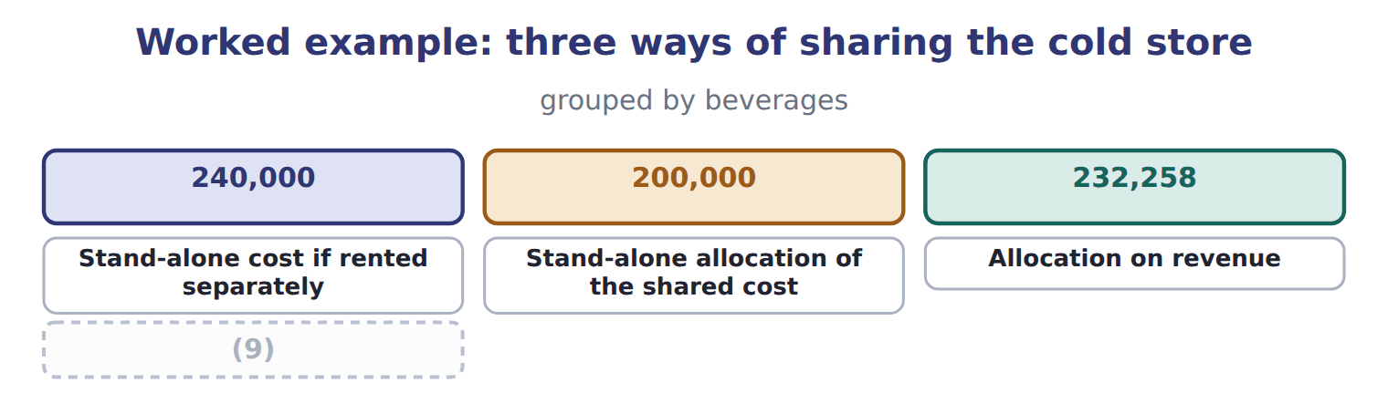
word list
incremental cost allocation · Incremental allocation (Beverages primary)

Summary 3 gaps 10–13
Each method gives a (10) answer from the same facts, and none of them is wrong. The (11) method shares the saving between the users, while the (12) method gives all of it to the second user. The choice of primary user is (13) itself a decision.
word list
different · therefore · stand-alone · incremental · charged

Why allocating common costs is a problem
Issue with allocating common costs (C.2.f) | Why it matters | What to do
The charge is not controllable | A manager cannot change head-office cost by working harder | (14)
The base may be arbitrary | Revenue, floor space and (15) give different answers | Choose a base that reflects the use of the service
It can make a good segment look bad | A segment with a positive segment margin can show a loss after allocation | (16)
It can hide the cost of the service | (17) | Charge a rate per use where possible

word list
Users have no reason to economise on a free service · Report it below the segment margin · headcount · incremental cost allocation · Never close a segment on the allocated figure alone

Never close a segment on the allocated figure

Summary 4 gaps 18–19
A segment with a positive segment margin is covering its own costs and (18) to common costs. Closing it does not remove those common costs; they are simply shared among fewer (19) .
word list
contributing · segments · different

The English this section uses, and its Arabic
Each term sits against what it means.
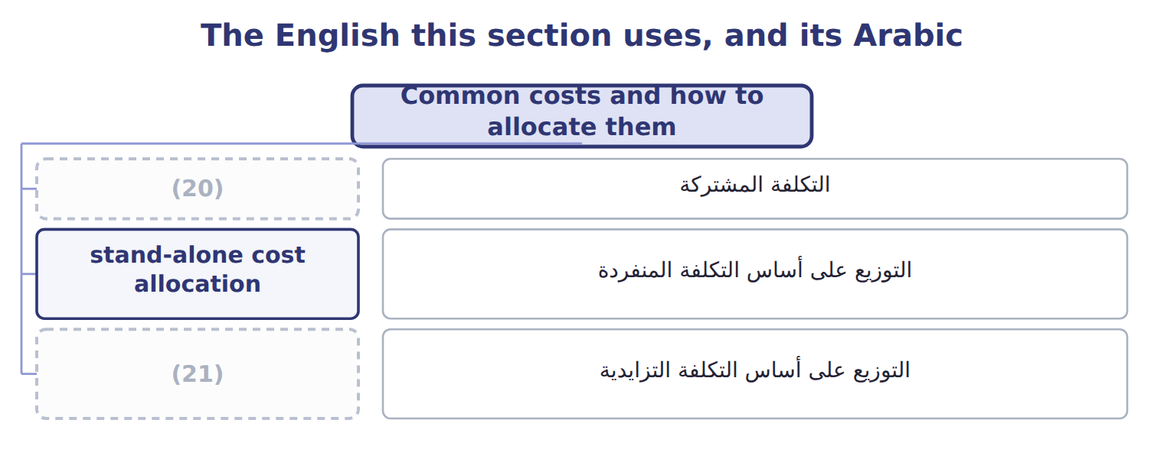
word list
stand-alone cost allocation · incremental cost allocation · common cost

The English this sheet uses, and its Arabic
English (exam term) | Arabic
common cost | التكلفة المشتركة
stand-alone cost allocation | التوزيع على أساس التكلفة المنفردة
incremental cost allocation | التوزيع على أساس التكلفة التزايدية

Answer key · 15.5 Common costs and how to allocate them

1 common | 12 incremental
2 segment | 13 therefore
3 zero-based | 14 Report it below the segment margin
4 division | 15 headcount
5 shares | 16 Never close a segment on the allocated figure alone
6 proportion | 17 Users have no reason to economise on a free service
7 divisions | 18 contributing
8 together | 19 segments
9 Incremental allocation (Beverages primary) | 20 common cost
10 different | 21 incremental cost allocation
11 stand-alone

the summaries in full
Summary 1 A common cost serves more than one segment and cannot be traced to any of them. Head office costs $1,100,000 a year, the zero-based budget of, and every division is charged a share. Stand-alone cost allocation shares the cost in proportion to what each would have paid alone. Incremental cost allocation charges a primary user its stand-alone cost and the other user only the extra cost it adds.
Summary 2 Alone, the two divisions would pay $240,000 and $120,000, a total of $360,000; together they pay $300,000.
Summary 3 Each method gives a different answer from the same facts, and none of them is wrong. The stand-alone method shares the saving between the users, while the incremental method gives all of it to the second user. The choice of primary user is therefore itself a decision.
Summary 4 A segment with a positive segment margin is covering its own costs and contributing to common costs. Closing it does not remove those common costs; they are simply shared among fewer segments.

15.6 Extended Example 15A: evaluating the three divisions
Chapter 15 · section 15.6

Fill every gap. Each word list holds one word more than there are gaps.
This example reads the segment report the way the Orontes board does.
Extended Example: the three divisions compared
The bars are drawn to scale.
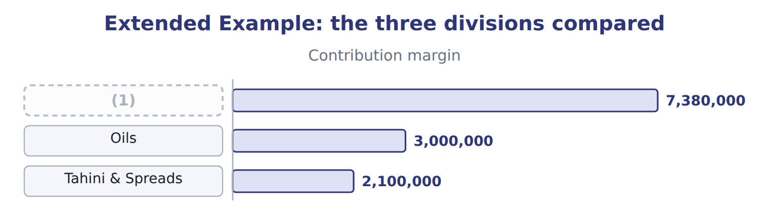
word list
segment margin · Beverages

Summary 1 gaps 2–11
Beverages earns the (2) margin in dollars and the highest (3) , which is why it (4) the capital. Tahini & Spreads earns $840,000 on a much (5) revenue, and the board has asked it to grow. Head office (6) each division a share of $1,100,000 on revenue. Tahini & Spreads is charged $179,070 and is left with $660,930. Its manager (7) that head office does no more work for his division than before, and that the charge rises whenever the other (8) grow. The board judges each manager on the (9) margin and each division on the segment margin, and treats the allocation as a (10) figure. No division is (11) on the figure after allocation.
word list
closed · smaller · charges · received · remember · memorandum · percentage · argues · controllable · divisions · largest

Everything ties

Summary 2 gaps 12–13
Beverages segment margin $3,180,000 = the (12) operating income. Segment (13) $5,020,000 − common costs $1,100,000 = company operating income $3,920,000.
word list
Spreads · contribution-format · margins

Exam view

Summary 3 gaps 14–16
Expect a list of costs to classify as variable, (14) fixed, traceable fixed or common, and then a margin to (15) . Read (16) which margin is asked for, and remember that allocated common costs come last.
word list
controllable · carefully · Spreads · calculate

Exam view
The bars are drawn to scale.
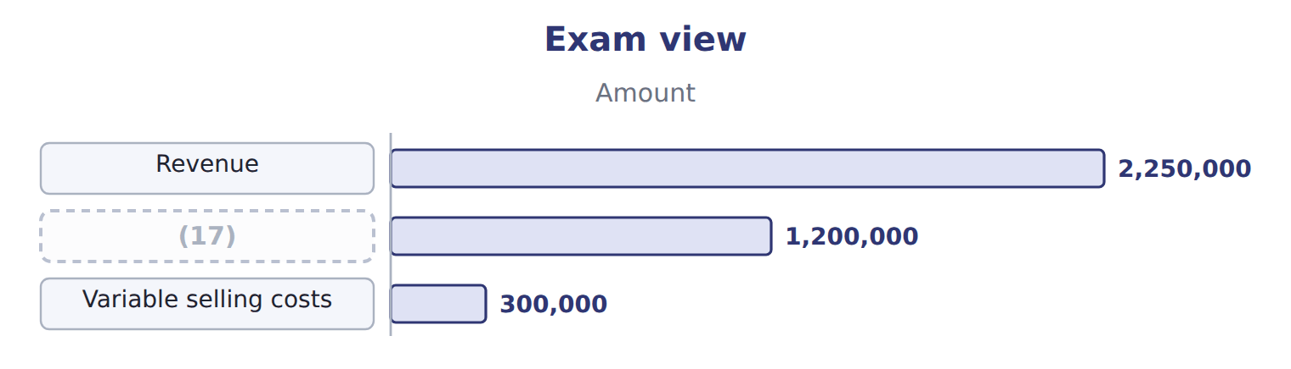
word list
stand-alone cost allocation · Variable manufacturing costs

Item — Answer
Item | Answer
Contribution margin | $5,250,000 − $3,150,000 = $2,100,000
Controllable margin | (18)
Segment margin | (19)

word list
$2,100,000 − $900,000 = $1,200,000 · $5,250,000 − $3,150,000 = $2,100,000 · $1,200,000 − $360,000 = $840,000

Cost — Category
Cost | Category
Olive oil and bottles | (20)
Marketing the manager approved | (21)
Depreciation of the bottling plant | (22)
Share of head-office costs | Common cost
Freight to customers per case | Variable cost

word list
Fixed cost the manager controls · $2,100,000 − $900,000 = $1,200,000 · Traceable fixed cost the manager does not control · Variable cost

The English this section uses, and its Arabic
Each term sits against what it means.
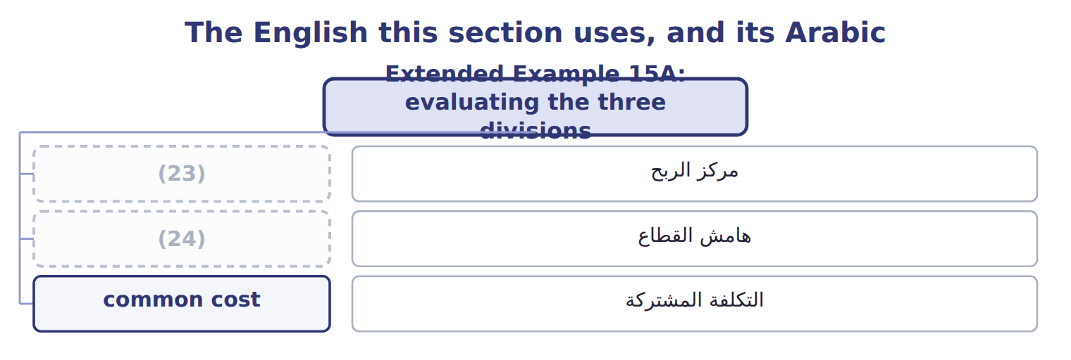
word list
profit center · investment center · segment margin

The English this sheet uses, and its Arabic
English (exam term) | Arabic
profit center | مركز الربح
segment margin | هامش القطاع
common cost | التكلفة المشتركة

Answer key · 15.6 Extended Example 15A: evaluating the three divisions

1 Beverages | 13 margins
2 largest | 14 controllable
3 percentage | 15 calculate
4 received | 16 carefully
5 smaller | 17 Variable manufacturing costs
6 charges | 18 $2,100,000 − $900,000 = $1,200,000
7 argues | 19 $1,200,000 − $360,000 = $840,000
8 divisions | 20 Variable cost
9 controllable | 21 Fixed cost the manager controls
10 memorandum | 22 Traceable fixed cost the manager does not control
11 closed | 23 profit center
12 contribution-format | 24 segment margin

the summaries in full
Summary 1 Beverages earns the largest margin in dollars and the highest percentage, which is why it received the capital. Tahini & Spreads earns $840,000 on a much smaller revenue, and the board has asked it to grow. Head office charges each division a share of $1,100,000 on revenue. Tahini & Spreads is charged $179,070 and is left with $660,930. Its manager argues that head office does no more work for his division than before, and that the charge rises whenever the other divisions grow. The board judges each manager on the controllable margin and each division on the segment margin, and treats the allocation as a memorandum figure. No division is closed on the figure after allocation.
Summary 2 Beverages segment margin $3,180,000 = the contribution-format operating income. Segment margins $5,020,000 − common costs $1,100,000 = company operating income $3,920,000.
Summary 3 Expect a list of costs to classify as variable, controllable fixed, traceable fixed or common, and then a margin to calculate. Read carefully which margin is asked for, and remember that allocated common costs come last.

