2.1 What corporate governance is
Chapter 2 · section 2.1

Fill every gap. Each word list holds one word more than there are gaps.
Chapter 2, section by section
Each stage leads to the next.
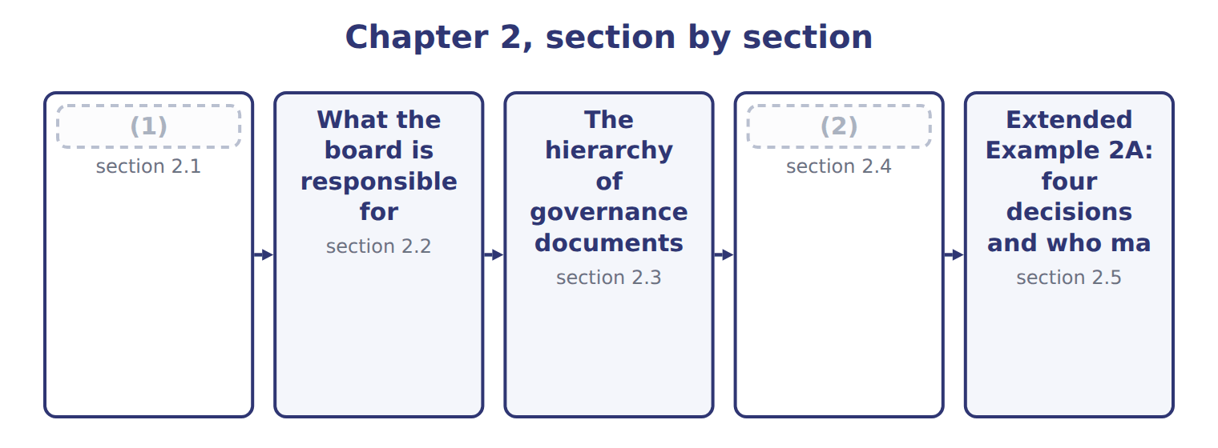
word list
What corporate governance is · The hierarchy of governance documents · Why personnel policy is a control

Summary 1 gaps 3–13
Corporate (3) is the system by which a company is (4) and held to account. It exists (5) the people who own a company are (6) not the people who run it. The (7) need some way to be sure their money is used in their (8) . Read it from the top: (9) elect the board, the board appoints and (10) the officers, and the board, through its audit committee, appoints the external auditor. One line in that (11) does the most work. The external auditor is (12) by, and reports to, the audit committee rather than the (13) whose statements are being audited. An auditor hired and paid by the chief financial officer could not credibly give an opinion on that officer's accounts.
word list
shareholders · because · governance · interest · usually · directed · appointed · diagram · audited · owners · assesses · management

The English this sheet uses, and its Arabic
English (exam term) | Arabic
corporate governance | حوكمة الشركات
audit committee | لجنة التدقيق

Answer key · 2.1 What corporate governance is

1 What corporate governance is | 8 interest
2 Why personnel policy is a control | 9 shareholders
3 governance | 10 assesses
4 directed | 11 diagram
5 because | 12 appointed
6 usually | 13 management
7 owners

the summaries in full
Summary 1 Corporate governance is the system by which a company is directed and held to account. It exists because the people who own a company are usually not the people who run it. The owners need some way to be sure their money is used in their interest. Read it from the top: shareholders elect the board, the board appoints and assesses the officers, and the board, through its audit committee, appoints the external auditor. One line in that diagram does the most work. The external auditor is appointed by, and reports to, the audit committee rather than the management whose statements are being audited. An auditor hired and paid by the chief financial officer could not credibly give an opinion on that officer's accounts.

2.2 What the board is responsible for
Chapter 2 · section 2.2

Fill every gap. Each word list holds one word more than there are gaps.
Summary 1 gaps 1–2
Directors owe the company a duty of care: they must inform (1) before deciding. They also owe a duty of loyalty: the (2) interest comes before their own.
word list
themselves · deciding · company's

What the board is responsible for
Board responsibility (E.1.d) | What it means | At Orontes
Set the tone | Integrity and ethical values start at the board | (3)
Oversee strategy | Challenge and approve the plan, not write it | (4)
Oversee risk and control | (5) | Receives the control testing of Chapter 5
Appoint and assess the CEO | (6) | Sets the incentives that shape behaviour
Oversee reporting | Through the audit committee, oversee the accounts and the auditor | (7)
Act for shareholders | (8) | Declines a contract with a director's own company

word list
Challenge and approve the plan, not write it · Satisfy itself that controls exist and work · Approves the code of conduct and acts on breaches · Duties of care and loyalty; no self-dealing · Approved the Gulf expansion of Book 3 · Hire, pay, evaluate and if necessary replace · Approves the annual report

Summary 2 gaps 9–13
The (9) the exam tests most often is between oversight and (10) . A board (11) and approves a (12) ; it does not write it. It (13) itself that controls exist and work; it does not operate them. A board that starts managing has stopped overseeing, because it can no longer review its own work independently.
word list
project · strategy · satisfies · management · challenges · distinction

Oversight is not management

Summary 3 gaps 14–16
If a question describes a board (14) a capital project, that is oversight. If it describes a board (15) the contract, something has gone wrong. Look for who (16) and who reviews: they should not be the same people.
word list
negotiating · decides · approving · contract

The words this section uses
Each term sits against what it means.
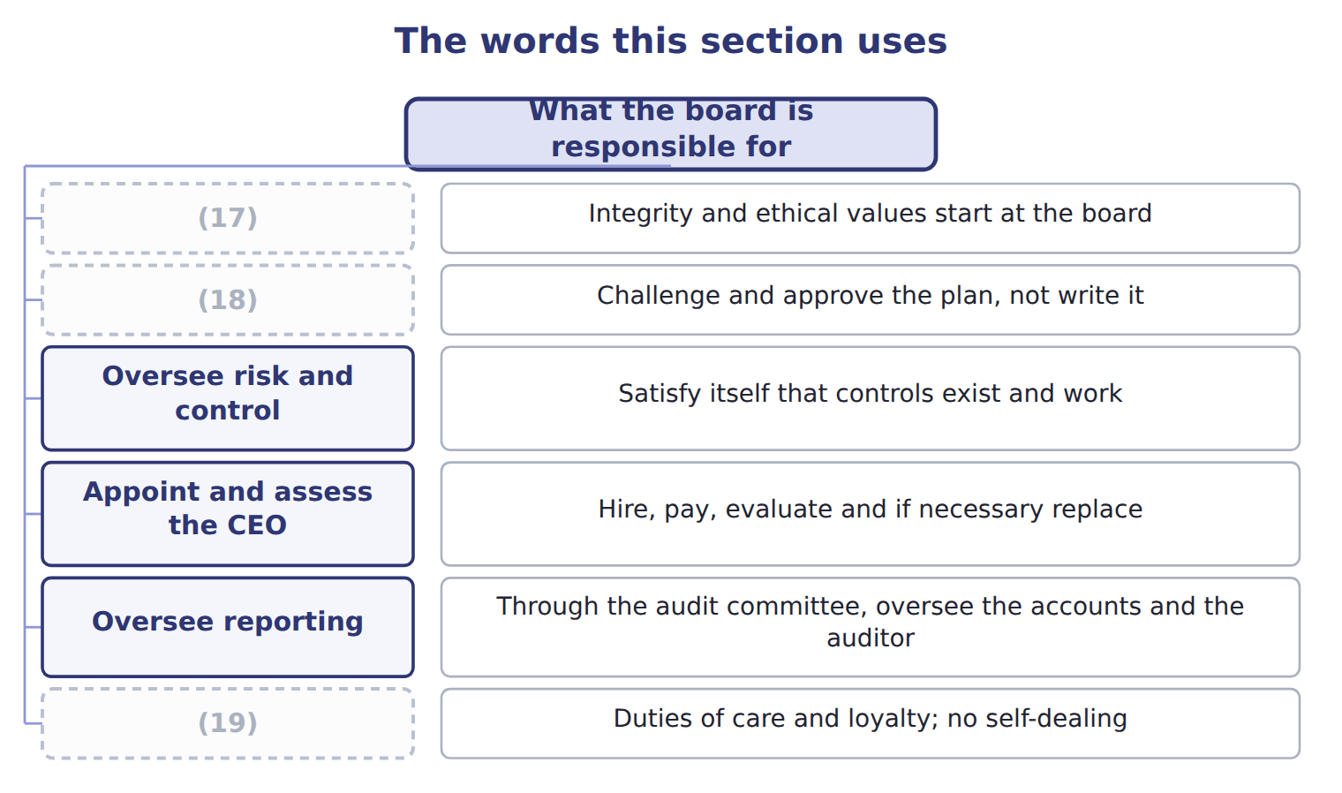
word list
articles of incorporation · Act for shareholders · Oversee strategy · Set the tone

The English this sheet uses, and its Arabic
English (exam term) | Arabic
duty of care | واجب العناية
duty of loyalty | واجب الولاء

Answer key · 2.2 What the board is responsible for

1 themselves | 11 challenges
2 company's | 12 strategy
3 Approves the code of conduct and acts on breaches | 13 satisfies
4 Approved the Gulf expansion of Book 3 | 14 approving
5 Satisfy itself that controls exist and work | 15 negotiating
6 Hire, pay, evaluate and if necessary replace | 16 decides
7 Approves the annual report | 17 Set the tone
8 Duties of care and loyalty; no self-dealing | 18 Oversee strategy
9 distinction | 19 Act for shareholders
10 management

the summaries in full
Summary 1 Directors owe the company a duty of care: they must inform themselves before deciding. They also owe a duty of loyalty: the company's interest comes before their own.
Summary 2 The distinction the exam tests most often is between oversight and management. A board challenges and approves a strategy; it does not write it. It satisfies itself that controls exist and work; it does not operate them. A board that starts managing has stopped overseeing, because it can no longer review its own work independently.
Summary 3 If a question describes a board approving a capital project, that is oversight. If it describes a board negotiating the contract, something has gone wrong. Look for who decides and who reviews: they should not be the same people.

2.3 The hierarchy of governance documents
Chapter 2 · section 2.3

Fill every gap. Each word list holds one word more than there are gaps.
Summary 1 gaps 1–11
A company is (1) by a stack of (2) , each one operating within the limits of the one above it. The articles of (3) are filed with the state and create the company: its name, purpose and (4) shares. The (5) are the company's internal rulebook on how the board meets and how officers are (6) . (7) state what the company intends, and (8) say step by step how to do it. First, a lower document can never (9) a higher one: a procedure breaching a policy is void, and so is a bylaw breaching the articles. Second, the (10) of changing them rises as you go up. Management rewrites a procedure, the board approves a policy, and the (11) must vote to change the articles.
word list
authorized · appointed · difficulty · governed · shareholders · incorporation · Policies · documents · bylaws · contradict · procedures · financial

Rights and responsibilities along the chain
Who | Rights and responsibilities (E.1.f) | In one line
Shareholders | Elect and remove directors; vote on the articles, mergers and pay; inspect books; receive declared dividends | (12)
Board of directors | Oversight of strategy, risk, control and reporting; duties of care and loyalty | (13)
Audit committee | Appoint, pay and oversee the external auditor; handle complaints; every member (14) | Oversee reporting and the auditor
CEO | Runs operations and carries out strategy; signs the certifications | (15)
CFO | Financial reporting and the design of internal control over it; signs the (16) | Own the numbers

word list
Manage the company · SEC Rule 10D-1; policies due 1 Dec 2023 · certifications · Vote; they do not manage · independent · Direct and monitor; they do not run operations

Summary 2 gaps 17–28
The audit committee deserves (17) attention. Every member must be (18) . That means taking no (19) or advisory fee from the company, and not being an (20) person. The committee appoints, pays and oversees the external auditor, and must provide a route for (21) , including (22) ones. Many (23) say this. The (24) is to disclose whether at least one audit committee (25) expert serves, and if none does, to say why not. A company may (26) have none, (27) it explains itself. Exchange rules (28) require members to be financially literate, which is a lower bar. Two are worth noting now: the clawback rules took effect at the end of 2023, and Nasdaq's board diversity rules were struck down by the courts in December 2024 and are no longer in force.
word list
consulting · independent · lawfully · December · separately · affiliated · provided · requirement · particular · financial · anonymous · guides · complaints

Governance requirements and their current status
Every item belongs to exactly one group.
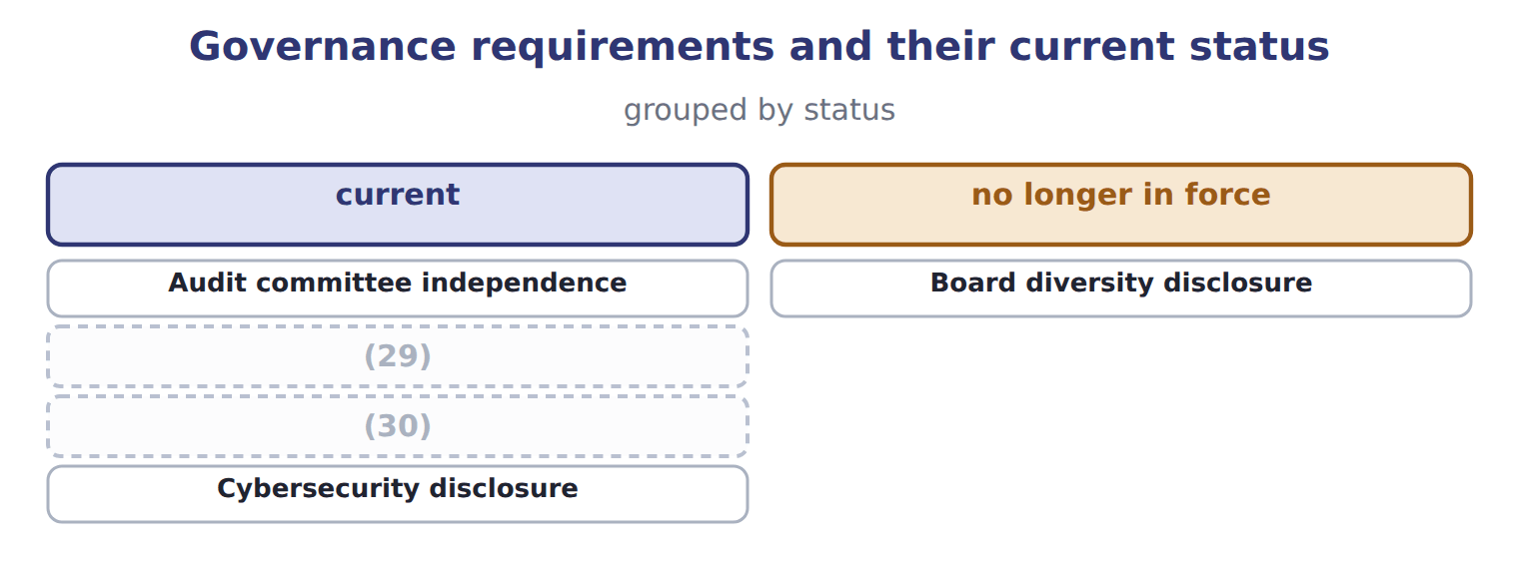
word list
Clawback of incentive pay · no longer in force · Audit committee financial expert

Summary 3 gaps 31–32
Governance (31) change more often than accounting standards. Check the position before relying on any of them in practice, and expect the exam to test the (32) rather than the date.
word list
appointed · principle · requirements

The words this section uses
Each term sits against what it means.
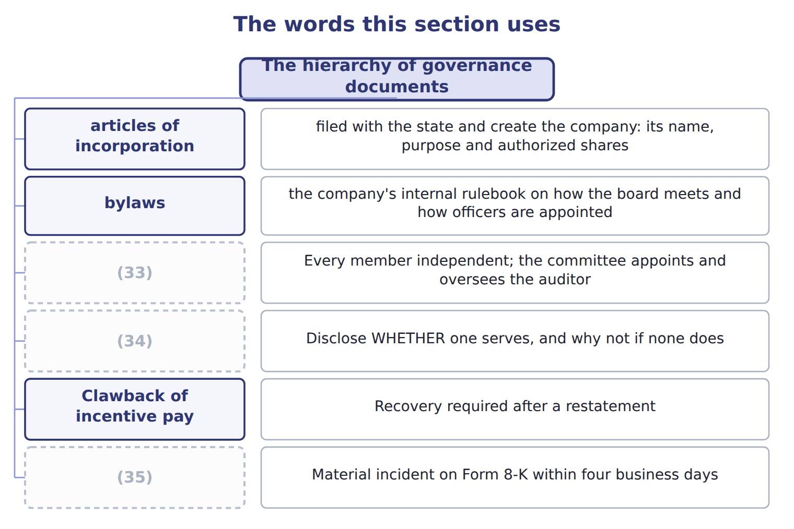
word list
articles of incorporation · Audit committee financial expert · Audit committee independence · Cybersecurity disclosure

The English this sheet uses, and its Arabic
English (exam term) | Arabic
articles of incorporation | عقد التأسيس
bylaws | النظام الداخلي

Answer key · 2.3 The hierarchy of governance documents

1 governed | 19 consulting
2 documents | 20 affiliated
3 incorporation | 21 complaints
4 authorized | 22 anonymous
5 bylaws | 23 guides
6 appointed | 24 requirement
7 Policies | 25 financial
8 procedures | 26 lawfully
9 contradict | 27 provided
10 difficulty | 28 separately
11 shareholders | 29 Audit committee financial expert
12 Vote; they do not manage | 30 Clawback of incentive pay
13 Direct and monitor; they do not run operations | 31 requirements
14 independent | 32 principle
15 Manage the company | 33 Audit committee independence
16 certifications | 34 Audit committee financial expert
17 particular | 35 Cybersecurity disclosure
18 independent

the summaries in full
Summary 1 A company is governed by a stack of documents, each one operating within the limits of the one above it. The articles of incorporation are filed with the state and create the company: its name, purpose and authorized shares. The bylaws are the company's internal rulebook on how the board meets and how officers are appointed. Policies state what the company intends, and procedures say step by step how to do it. First, a lower document can never contradict a higher one: a procedure breaching a policy is void, and so is a bylaw breaching the articles. Second, the difficulty of changing them rises as you go up. Management rewrites a procedure, the board approves a policy, and the shareholders must vote to change the articles.
Summary 2 The audit committee deserves particular attention. Every member must be independent. That means taking no consulting or advisory fee from the company, and not being an affiliated person. The committee appoints, pays and oversees the external auditor, and must provide a route for complaints, including anonymous ones. Many guides say this. The requirement is to disclose whether at least one audit committee financial expert serves, and if none does, to say why not. A company may lawfully have none, provided it explains itself. Exchange rules separately require members to be financially literate, which is a lower bar. Two are worth noting now: the clawback rules took effect at the end of 2023, and Nasdaq's board diversity rules were struck down by the courts in December 2024 and are no longer in force.
Summary 3 Governance requirements change more often than accounting standards. Check the position before relying on any of them in practice, and expect the exam to test the principle rather than the date.

2.4 Why personnel policy is a control
Chapter 2 · section 2.4

Fill every gap. Each word list holds one word more than there are gaps.
Summary 1 gaps 1–2
Controls are (1) out by people. That single fact makes hiring, training, (2) and dismissal part of internal control rather than a separate human resources matter.
word list
supervision · carried · purpose

Personnel practices as controls
Personnel practice (E.1.h) | Why it is a control | What it looks like
Hiring | A control is only as good as the person performing it | (3)
Training | Someone who does not understand a reconciliation cannot review one | (4)
Supervision | Work that is never reviewed drifts | (5)
Rotation and mandatory leave | A fraud that needs daily (6) is exposed when its author is away | Two consecutive weeks away each year
Clear job descriptions | Nobody can be held to account for a duty they were never given | Supplier approval named in the role, not (7) verbally
Exit procedures | (8) | System access removed on the last day

word list
Train on the control, not only on the system · Check references and qualifications before appointment · job rotation · Access that outlives employment is an open door · A second person checks a sample of the clerk's work · delegated · attention

Summary 2 gaps 9–15
Mandatory leave and job (9) deserve a word, because their (10) is not obvious. A fraud that must be tended daily, such as moving money (11) accounts to hide a (12) , is exposed when someone else sits at the desk. Two (13) weeks is the usual (14) , because one week can be survived. The (15) manager delegated supplier approval verbally and never took it back. The duty appeared in nobody's job description, so nobody could be held to account for it.
word list
purchasing · consecutive · purpose · rotation · shortfall · between · appeared · requirement

The English this sheet uses, and its Arabic
English (exam term) | Arabic
mandatory leave | الإجازة الإلزامية
job rotation | تدوير الوظائف

Answer key · 2.4 Why personnel policy is a control

1 carried | 9 rotation
2 supervision | 10 purpose
3 Check references and qualifications before appointment | 11 between
4 Train on the control, not only on the system | 12 shortfall
5 A second person checks a sample of the clerk's work | 13 consecutive
6 attention | 14 requirement
7 delegated | 15 purchasing
8 Access that outlives employment is an open door

the summaries in full
Summary 1 Controls are carried out by people. That single fact makes hiring, training, supervision and dismissal part of internal control rather than a separate human resources matter.
Summary 2 Mandatory leave and job rotation deserve a word, because their purpose is not obvious. A fraud that must be tended daily, such as moving money between accounts to hide a shortfall, is exposed when someone else sits at the desk. Two consecutive weeks is the usual requirement, because one week can be survived. The purchasing manager delegated supplier approval verbally and never took it back. The duty appeared in nobody's job description, so nobody could be held to account for it.

2.5 Extended Example 2A: four decisions and who makes them
Chapter 2 · section 2.5

Fill every gap. Each word list holds one word more than there are gaps.
Summary 1 gaps 1–12
This example takes four (1) facing Orontes and asks, for each one, which (2) governs it and who must act. It is (3) : questions in this area are nearly always of (4) this shape. Orontes wants to issue new shares to fund the Gulf (5) , but has already issued all the shares its articles (6) . The articles of (7) must be amended, which requires a (8) vote. The board (9) do this alone, however clear the (10) case. The board wants to (11) the quorum from five (12) to four. This is a bylaw matter, and the board can amend its own bylaws, provided the amendment does not conflict with the articles or with state law. After the supplier fraud, the board wants every payment above a threshold to carry two signatures. This is a policy: the board approves it, and management writes the procedure that puts it into effect, naming the systems, the limits and the authorised signatories.
word list
directors · document · incorporation · reduce · exam-core · commercial · expansion · cannot · authorize · shareholder · conflict · exactly · decisions

Summary 2 gaps 13–16
The chief (13) officer is unhappy with the (14) questions and wants a different firm. He cannot make that (15) . The external auditor is appointed, paid and overseen by the audit committee, precisely so that the officers whose (16) are audited cannot remove an auditor who challenges them.
word list
statements · authorised · decision · auditor's · financial

Four more decisions

Complete the blank cells.
Your turn: which document governs the decision? (complete the blanks)
Every item belongs to exactly one group.
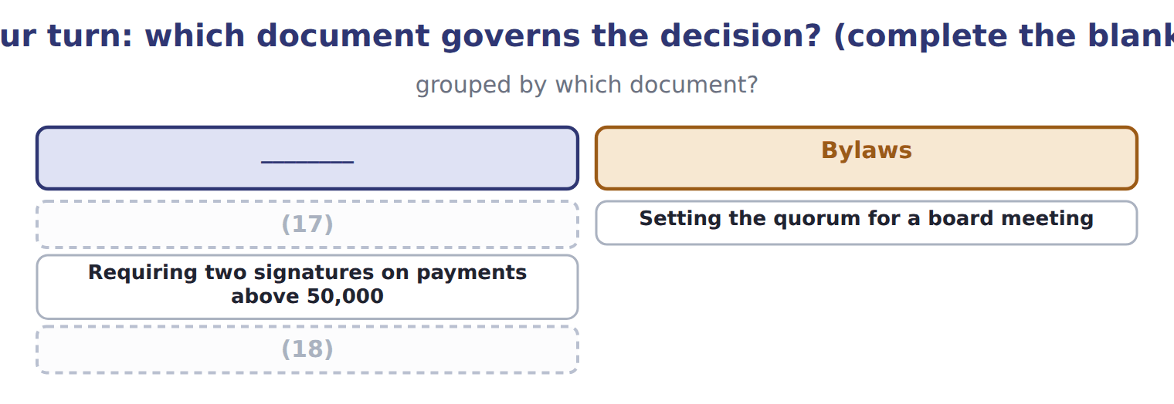
word list
Changing the number of authorized shares · The exact screens a clerk uses to raise a payment · Setting the quorum for a board meeting

The pattern behind all four

Summary 3 gaps 19–23
Ask first which document (19) the decision, (20) that decides who may act. The (21) the document, the harder it is to change: management, then board, then (22) . Where a decision would let someone review their own work, the (23) moves it elsewhere. The audit committee exists to hold one such line: the auditor answers to it, not to management.
word list
higher · governs · officers · because · structure · shareholders

Exam view

Summary 4 gaps 24–27
Expect a decision and four candidate (24) , or a decision and four candidate (25) . Work out which level of the (26) the matter sits at. If the decision affects the company's existence or its share capital, it is the articles and therefore the (27) .
word list
shareholders · conflict · decision-makers · hierarchy · documents

Exam view
Item | Answer
Changing the number of authorized shares | (28) — share capital is created by the articles, so the shareholders must vote
Setting the quorum for a board meeting | Why: the (29) govern how the board meets, and the board may amend them within the articles and the law
Requiring two signatures on payments above 50,000 | A board policy — management then writes the procedure that carries it out
The exact screens a clerk uses to raise a payment | A procedure — written and amended by management, within the policy above it

word list
management · bylaws · Articles of incorporation

Element of the proposal — Category
Element of the proposal | Category
Whether the chairman may also be chief executive | Governed by the bylaws
How often the audit committee meets | (30)
To whom the external auditor reports | Governed by the audit committee
Whether combining the roles is wise for Orontes | (31)

word list
Written and amended by management · A board judgement, not a document · Governed by the audit committee

The English this section uses, and its Arabic
Each term sits against what it means.
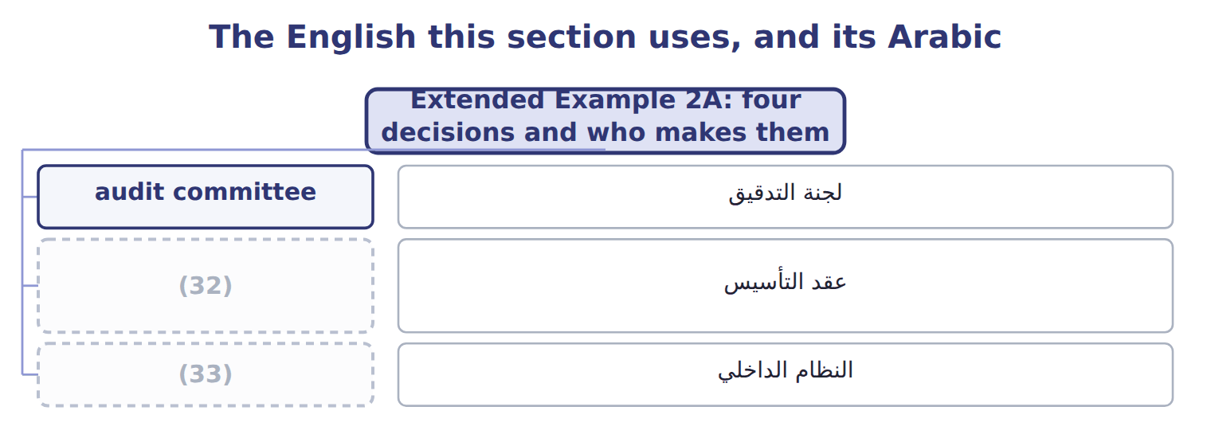
word list
articles of incorporation · mandatory leave · bylaws

Answer key · 2.5 Extended Example 2A: four decisions and who makes them

1 decisions | 18 The exact screens a clerk uses to raise a payment
2 document | 19 governs
3 exam-core | 20 because
4 exactly | 21 higher
5 expansion | 22 shareholders
6 authorize | 23 structure
7 incorporation | 24 documents
8 shareholder | 25 decision-makers
9 cannot | 26 hierarchy
10 commercial | 27 shareholders
11 reduce | 28 Articles of incorporation
12 directors | 29 bylaws
13 financial | 30 Governed by the audit committee
14 auditor's | 31 A board judgement, not a document
15 decision | 32 articles of incorporation
16 statements | 33 bylaws
17 Changing the number of authorized shares

the summaries in full
Summary 1 This example takes four decisions facing Orontes and asks, for each one, which document governs it and who must act. It is exam-core: questions in this area are nearly always of exactly this shape. Orontes wants to issue new shares to fund the Gulf expansion, but has already issued all the shares its articles authorize. The articles of incorporation must be amended, which requires a shareholder vote. The board cannot do this alone, however clear the commercial case. The board wants to reduce the quorum from five directors to four. This is a bylaw matter, and the board can amend its own bylaws, provided the amendment does not conflict with the articles or with state law. After the supplier fraud, the board wants every payment above a threshold to carry two signatures. This is a policy: the board approves it, and management writes the procedure that puts it into effect, naming the systems, the limits and the authorised signatories.
Summary 2 The chief financial officer is unhappy with the auditor's questions and wants a different firm. He cannot make that decision. The external auditor is appointed, paid and overseen by the audit committee, precisely so that the officers whose statements are audited cannot remove an auditor who challenges them.
Summary 3 Ask first which document governs the decision, because that decides who may act. The higher the document, the harder it is to change: management, then board, then shareholders. Where a decision would let someone review their own work, the structure moves it elsewhere. The audit committee exists to hold one such line: the auditor answers to it, not to management.
Summary 4 Expect a decision and four candidate documents, or a decision and four candidate decision-makers. Work out which level of the hierarchy the matter sits at. If the decision affects the company's existence or its share capital, it is the articles and therefore the shareholders.

