3.1 What segregation of duties means
Chapter 3 · section 3.1

Fill every gap. Each word list holds one word more than there are gaps.
Chapter 3, section by section
Each stage leads to the next.
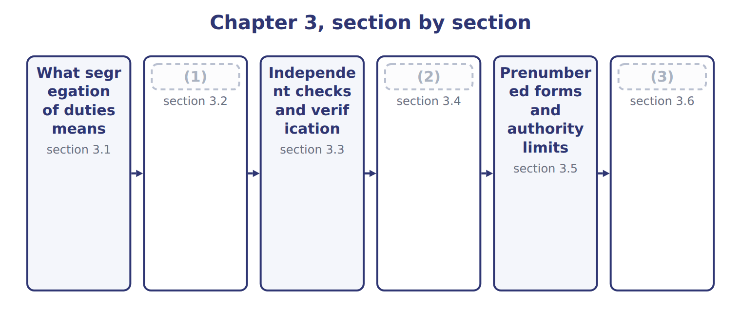
word list
Safeguarding assets · Extended Example 3A: redesigning the Orontes p · The four functional responsibilities · section 3.3

Summary 1 gaps 4–6
Segregation of duties means splitting a (4) so that no one person can both carry it out and (5) it. It is the most powerful control activity available, and usually the cheapest, because it costs an (6) decision rather than money.
word list
transaction · conceal · decision · organizing

Segregation of duties across five areas
Area | What separation looks like | Which duties are split
Cash receipts | The cashier who receives cash does not post the ledger or do the bank reconciliation | (7)
Purchasing | The buyer who approves a supplier does not release the payment | (8)
Payroll | The person who adds a new employee does not approve the payroll run | (9)
Inventory | The (10) does not maintain the stock records or perform the count | Custody separated from recording and verification
Systems | The (11) does not have access to live data or production programs | Development separated from operations

word list
storekeeper · Authorization separated from custody of cash · Custody separated from recording and reconciliation · control activity · Authorization separated from recording · programmer

Summary 2 gaps 12–14
Notice what the (12) have in common. In each case the person who can take or (13) something is not the person who records it, and (14) of them is the person who later checks that records and reality agree.
word list
misdirect · activity · examples · neither

The English this section uses, and its Arabic
Each term sits against what it means.
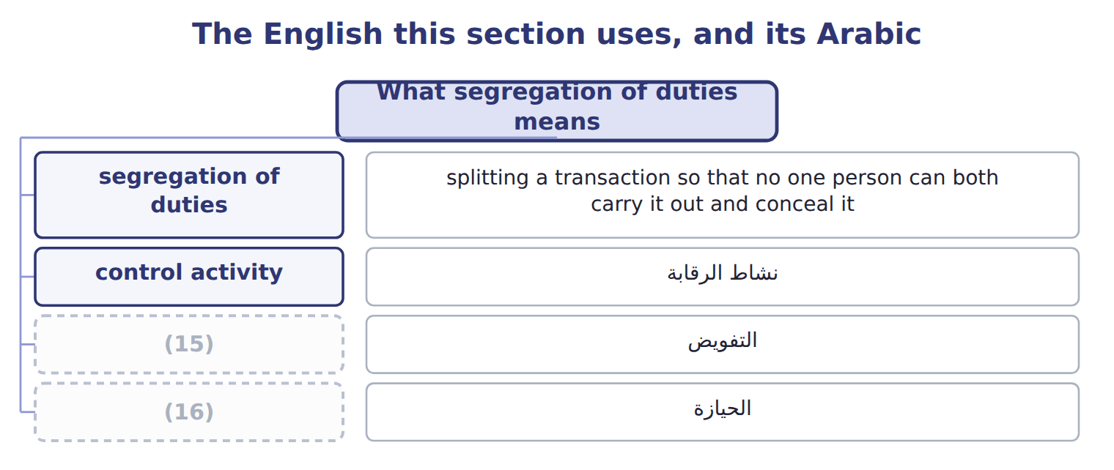
word list
التفويض · custody · authorization

The English this sheet uses, and its Arabic
English (exam term) | Arabic
segregation of duties | الفصل بين المهام
control activity | نشاط الرقابة

Answer key · 3.1 What segregation of duties means

1 The four functional responsibilities | 9 Authorization separated from recording
2 Safeguarding assets | 10 storekeeper
3 Extended Example 3A: redesigning the Orontes p | 11 programmer
4 transaction | 12 examples
5 conceal | 13 misdirect
6 organizing | 14 neither
7 Custody separated from recording and reconciliation | 15 authorization
8 Authorization separated from custody of cash | 16 custody

the summaries in full
Summary 1 Segregation of duties means splitting a transaction so that no one person can both carry it out and conceal it. It is the most powerful control activity available, and usually the cheapest, because it costs an organizing decision rather than money.
Summary 2 Notice what the examples have in common. In each case the person who can take or misdirect something is not the person who records it, and neither of them is the person who later checks that records and reality agree.

3.2 The four functional responsibilities
Chapter 3 · section 3.2

Fill every gap. Each word list holds one word more than there are gaps.
Summary 1 gaps 1–2
The exam names four (1) that should be held by different people, or at least by different (2) .
word list
departments · someone · responsibilities

The four functional responsibilities
Functional responsibility (E.1.j) | What it means | At Orontes
Authority to execute transactions | (3) | The purchasing manager approves a new supplier
Recording transactions | (4) | The accounts clerk posts the invoice
Custody of assets | (5) | The cashier holds the cash; the storekeeper holds the stock
Periodic reconciliation | Comparing the records with the assets actually there | (6)

word list
Entering it in the accounting records · Holding or controlling the asset itself · A third person reconciles the bank statement · Deciding that the transaction should happen at all · The accounts clerk posts the invoice

Summary 2 gaps 7–10
The logic is (7) the same. A person who holds only one of the four can make a (8) or commit a fraud, but (9) else will see it. A person who holds two can make the entry and remove the evidence, which is why the pairs matter more than the (10) duties.
word list
individual · always · mistake · performing · someone

Two duties, not one, create the risk

Summary 3 gaps 11–12
A question that describes someone (11) one of the four duties describes a normal job. Look for the (12) duty. The answer is almost always the pair, not the person.
word list
performing · custody · second

The words this section uses
Each term sits against what it means.
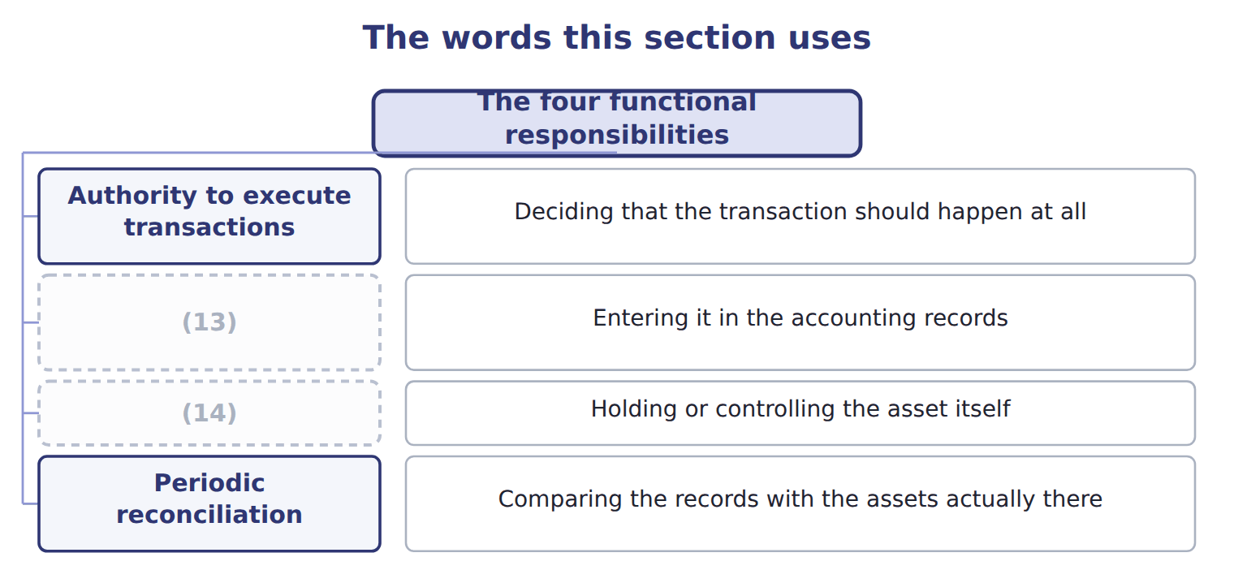
word list
independent check · Recording transactions · Custody of assets

The English this sheet uses, and its Arabic
English (exam term) | Arabic
authorization | التفويض
custody | الحيازة

Answer key · 3.2 The four functional responsibilities

1 responsibilities | 8 mistake
2 departments | 9 someone
3 Deciding that the transaction should happen at all | 10 individual
4 Entering it in the accounting records | 11 performing
5 Holding or controlling the asset itself | 12 second
6 A third person reconciles the bank statement | 13 Recording transactions
7 always | 14 Custody of assets

the summaries in full
Summary 1 The exam names four responsibilities that should be held by different people, or at least by different departments.
Summary 2 The logic is always the same. A person who holds only one of the four can make a mistake or commit a fraud, but someone else will see it. A person who holds two can make the entry and remove the evidence, which is why the pairs matter more than the individual duties.
Summary 3 A question that describes someone performing one of the four duties describes a normal job. Look for the second duty. The answer is almost always the pair, not the person.

3.3 Independent checks and verification
Chapter 3 · section 3.3

Fill every gap. Each word list holds one word more than there are gaps.
Summary 1 gaps 1–4
An independent check is a (1) performed by (2) who did not do the work being checked. The word independent is the whole of the control: a (3) performed by the person who made the entries proves nothing, because the same (4) or the same intent produced both.
word list
comparison · someone · reconciliation · alongside · misunderstanding

Independent checks and who must perform them
Independent check | Who must perform it | What it would catch
Bank reconciliation | (5) | Cash recorded but never banked
Stock count | (6) | Stock recorded but not present
Supplier statement reconciliation | Accounts payable, not the buyer | (7)
Review of exception reports | A supervisor, not the clerk who caused the exception | (8)
Internal audit | A function (9) to the audit committee, not to the manager audited | Weaknesses the line would not report on itself

word list
Invoices paid twice or paid to the wrong party · recorded · reporting · A team that does not include the storekeeper · Overrides and unusual amounts · Someone who neither handles cash nor posts the ledger

Summary 2 gaps 10–12
Independent checks are detective rather than (10) . They do not stop the error; they find it (11) . That is why they sit alongside (12) rather than replacing it, and why their value depends entirely on someone acting when a difference appears.
word list
preventive · replacing · afterwards · segregation

The English this section uses, and its Arabic
Each term sits against what it means.
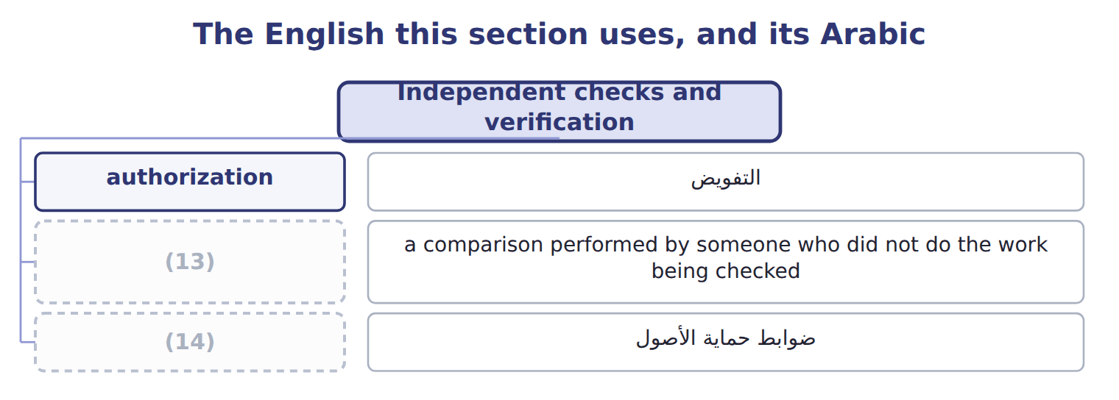
word list
independent check · control activity · safeguarding control

The English this sheet uses, and its Arabic
English (exam term) | Arabic
independent check | التحقق المستقل

Answer key · 3.3 Independent checks and verification

1 comparison | 8 Overrides and unusual amounts
2 someone | 9 reporting
3 reconciliation | 10 preventive
4 misunderstanding | 11 afterwards
5 Someone who neither handles cash nor posts the ledger | 12 segregation
6 A team that does not include the storekeeper | 13 independent check
7 Invoices paid twice or paid to the wrong party | 14 safeguarding control

the summaries in full
Summary 1 An independent check is a comparison performed by someone who did not do the work being checked. The word independent is the whole of the control: a reconciliation performed by the person who made the entries proves nothing, because the same misunderstanding or the same intent produced both.
Summary 2 Independent checks are detective rather than preventive. They do not stop the error; they find it afterwards. That is why they sit alongside segregation rather than replacing it, and why their value depends entirely on someone acting when a difference appears.

3.4 Safeguarding assets
Chapter 3 · section 3.4

Fill every gap. Each word list holds one word more than there are gaps.
Summary 1 gaps 1–3
A (1) control limits who can physically reach an asset and (2) who is answerable for it. These matter most where assets are (3) and valuable, which at Orontes means cash, saffron and the spice store rather than the bottling line.
word list
keyholders · safeguarding · portable · establishes

Safeguarding controls
Safeguarding control (E.1.l) | Examples | What it achieves
Physical barriers | (4) | Stops the simple taking of an asset
Access control | Badges, keys, biometrics, visitor logs | (5)
Environmental protection | (6) | Protects assets from loss as well as theft
Custodial accountability | (7) | Makes a shortage someone's responsibility
Periodic counts | (8) | Detects loss that prevention missed
Insurance and bonding | Cover for losses, and (9) bonds on staff handling cash | Limits the damage once a loss occurs

word list
One named custodian per store or cash float · Independent counts compared with records · Records who was able to reach the asset · Fire suppression, cold-chain alarms, backup power · Locked stores, fenced yards, safes, restricted areas · fidelity · Limits the damage once a loss occurs

Summary 2 gaps 10–12
Custodial (10) deserves attention because it is often forgotten. A store with three (11) and no named custodian has no one to ask when stock is short. (12) one custodian turns a general loss into a specific question.
word list
valuable · Assigning · accountability · keyholders

The English this sheet uses, and its Arabic
English (exam term) | Arabic
custodial accountability | المساءلة عن العهدة
safeguarding control | ضوابط حماية الأصول

Answer key · 3.4 Safeguarding assets

1 safeguarding | 7 One named custodian per store or cash float
2 establishes | 8 Independent counts compared with records
3 portable | 9 fidelity
4 Locked stores, fenced yards, safes, restricted areas | 10 accountability
5 Records who was able to reach the asset | 11 keyholders
6 Fire suppression, cold-chain alarms, backup power | 12 Assigning

the summaries in full
Summary 1 A safeguarding control limits who can physically reach an asset and establishes who is answerable for it. These matter most where assets are portable and valuable, which at Orontes means cash, saffron and the spice store rather than the bottling line.
Summary 2 Custodial accountability deserves attention because it is often forgotten. A store with three keyholders and no named custodian has no one to ask when stock is short. Assigning one custodian turns a general loss into a specific question.

3.5 Prenumbered forms and authority limits
Chapter 3 · section 3.5

Fill every gap. Each word list holds one word more than there are gaps.
Summary 1 gaps 1–8
A (1) form carries a (2) number printed before use. The sequence makes (3) testable. Anyone can (4) for the numbers used, and a gap is a (5) that somebody must answer. (6) it, a document that was (7) , or never raised at all, leaves no trace. (8) limits work the same way from the other direction. If the policy names who may receive goods and who may approve a payment, and up to what amount, then an unapproved transaction has nobody who could legitimately have made it. The limit converts a vague expectation into a testable rule.
word list
question · sequential · destroyed · Without · printed · prenumbered · Authority · account · completeness

The English this section uses, and its Arabic
Each term sits against what it means.
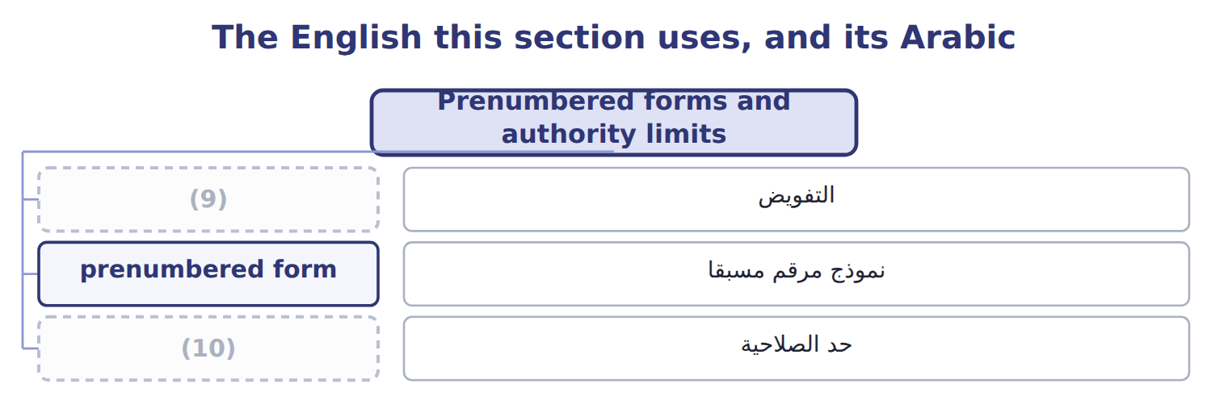
word list
authorization · authority limit · prenumbered form

The English this sheet uses, and its Arabic
English (exam term) | Arabic
prenumbered form | نموذج مرقم مسبقا
authority limit | حد الصلاحية

Answer key · 3.5 Prenumbered forms and authority limits

1 prenumbered | 6 Without
2 sequential | 7 destroyed
3 completeness | 8 Authority
4 account | 9 authorization
5 question | 10 authority limit

the summaries in full
Summary 1 A prenumbered form carries a sequential number printed before use. The sequence makes completeness testable. Anyone can account for the numbers used, and a gap is a question that somebody must answer. Without it, a document that was destroyed, or never raised at all, leaves no trace. Authority limits work the same way from the other direction. If the policy names who may receive goods and who may approve a payment, and up to what amount, then an unapproved transaction has nobody who could legitimately have made it. The limit converts a vague expectation into a testable rule.

3.6 Extended Example 3A: redesigning the Orontes purchasing cycle
Chapter 3 · section 3.6

Fill every gap. Each word list holds one word more than there are gaps.
Summary 1 gaps 1–12
This example takes the (1) . It is (2) : questions give a flawed (3) and ask which duty to move. One purchasing clerk could add a supplier to the (4) list, raise the order, (5) that goods had arrived and release the payment. Of the four (6) , he held authorization, recording and (7) custody of the cash leaving the company. Only (8) sat elsewhere, and nobody (9) it. Supplier approval moves to the purchasing manager, named in the job (10) rather than (11) verbally. That single change breaks the authorization and custody pair, which is the (12) that let money leave the company. Authorization sits with the purchasing manager, who approves suppliers and orders above a stated limit. Recording sits with the accounts clerk, who posts invoices. Custody sits with the storekeeper, who receives goods, and with the cashier, who releases payment.
word list
approved · failure · reconciliation · delegated · confirm · effective · pairing · description · printed · performed · responsibilities · exam-core · arrangement

Summary 2 gaps 13–20
Reconciliation sits with a fourth person, who (13) the supplier (14) with the ledger each month. Goods received notes are (15) , so a delivery that was never (16) leaves a gap. A (17) above the limit needs two (18) . The supplier master file is printed and reviewed quarterly by someone outside purchasing, which is an (19) check on the (20) itself. If the purchasing manager and the cashier agree together, the design fails. The redesign buys reasonable assurance against one person acting alone, which is what segregation is for.
word list
signatures · prenumbered · authorization · recorded · payment · statement · received · compares · independent

Four arrangements to diagnose

Complete the blank cells.
Your turn: diagnose four arrangements (complete the blanks)
Situation | Which duties are combined? | Why it matters
The storekeeper also keeps the stock records | ________ | (21)
The cashier performs the bank reconciliation | Custody and reconciliation | ________
The buyer approves suppliers and releases payment | ________ | He can approve a payment to himself and collect it
The clerk who posts an error also reviews the exception report | ________ | (22)

word list
He can remove stock and adjust the record to match · He can approve a payment to himself and collect it · She can certify that her own mistake is acceptable

The pattern behind the redesign

Summary 3 gaps 23–26
Name the four (23) in the cycle, then ask who holds each one. Any person holding two is the weakness; move (24) is easiest to move. Add an (25) check on the duty that remains most powerful. Prenumber the documents, so that (26) can be tested afterwards.
word list
duties · invoices · completeness · independent · whichever

Exam view

Summary 4 gaps 27–30
A case (27) a cycle and asks for the weakness, or for the (28) that would fix it. Map each person to the four duties before (29) . The weakness is the person with two, and the fix is the cheapest move that (30) them.
word list
separates · control · describes · easiest · answering

Exam view
Item | Answer
The storekeeper also keeps the stock records | (31) and recording — he can remove stock and adjust the record to match
The cashier performs the bank reconciliation | Why: the person holding the cash certifies that the records agree with it, so a shortage can be hidden
The buyer approves suppliers and releases payment | Authorization and custody — he can approve a payment to himself and collect it
The clerk who posts an error also reviews the exception report | Recording and (32) — she can certify that her own mistake is acceptable

word list
Authorization · reconciliation · Custody

Person and duty — Category
Person and duty | Category
Samir holds the keys to the store | Custody
Samir maintains the stock records | (33)
Nadia approves customers for collection without prepayment | Authorization
Khalid performs the monthly stock count | (34)

word list
Recording · custody · Reconciliation

The English this section uses, and its Arabic
Each term sits against what it means.
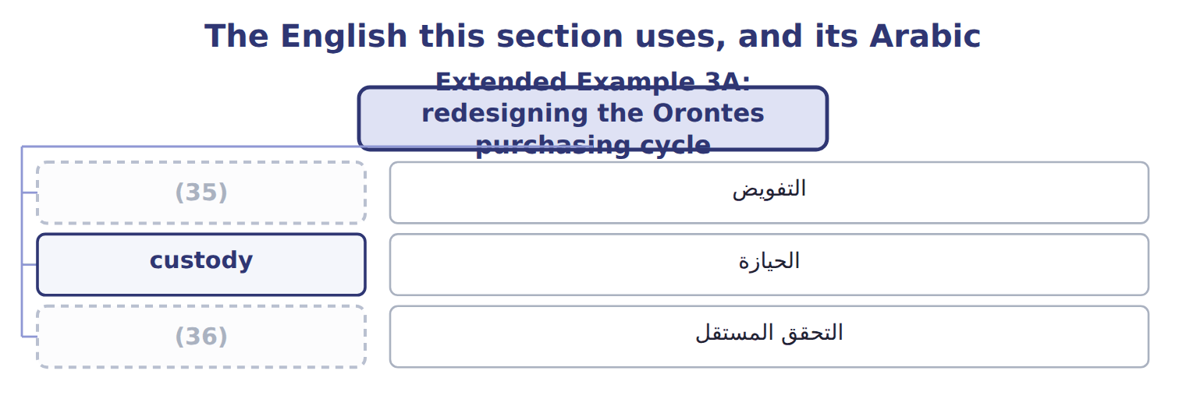
word list
authorization · independent check · safeguarding control

Answer key · 3.6 Extended Example 3A: redesigning the Orontes purchasing cycle

1 failure | 19 independent
2 exam-core | 20 authorization
3 arrangement | 21 He can remove stock and adjust the record to match
4 approved | 22 She can certify that her own mistake is acceptable
5 confirm | 23 duties
6 responsibilities | 24 whichever
7 effective | 25 independent
8 reconciliation | 26 completeness
9 performed | 27 describes
10 description | 28 control
11 delegated | 29 answering
12 pairing | 30 separates
13 compares | 31 Custody
14 statement | 32 reconciliation
15 prenumbered | 33 Recording
16 recorded | 34 Reconciliation
17 payment | 35 authorization
18 signatures | 36 independent check

the summaries in full
Summary 1 This example takes the failure. It is exam-core: questions give a flawed arrangement and ask which duty to move. One purchasing clerk could add a supplier to the approved list, raise the order, confirm that goods had arrived and release the payment. Of the four responsibilities, he held authorization, recording and effective custody of the cash leaving the company. Only reconciliation sat elsewhere, and nobody performed it. Supplier approval moves to the purchasing manager, named in the job description rather than delegated verbally. That single change breaks the authorization and custody pair, which is the pairing that let money leave the company. Authorization sits with the purchasing manager, who approves suppliers and orders above a stated limit. Recording sits with the accounts clerk, who posts invoices. Custody sits with the storekeeper, who receives goods, and with the cashier, who releases payment.
Summary 2 Reconciliation sits with a fourth person, who compares the supplier statement with the ledger each month. Goods received notes are prenumbered, so a delivery that was never recorded leaves a gap. A payment above the limit needs two signatures. The supplier master file is printed and reviewed quarterly by someone outside purchasing, which is an independent check on the authorization itself. If the purchasing manager and the cashier agree together, the design fails. The redesign buys reasonable assurance against one person acting alone, which is what segregation is for.
Summary 3 Name the four duties in the cycle, then ask who holds each one. Any person holding two is the weakness; move whichever is easiest to move. Add an independent check on the duty that remains most powerful. Prenumber the documents, so that completeness can be tested afterwards.
Summary 4 A case describes a cycle and asks for the weakness, or for the control that would fix it. Map each person to the four duties before answering. The weakness is the person with two, and the fix is the cheapest move that separates them.

