4.1 The Sarbanes-Oxley sections that matter
Chapter 4 · section 4.1

Fill every gap. Each word list holds one word more than there are gaps.
Chapter 4, section by section
Each stage leads to the next.
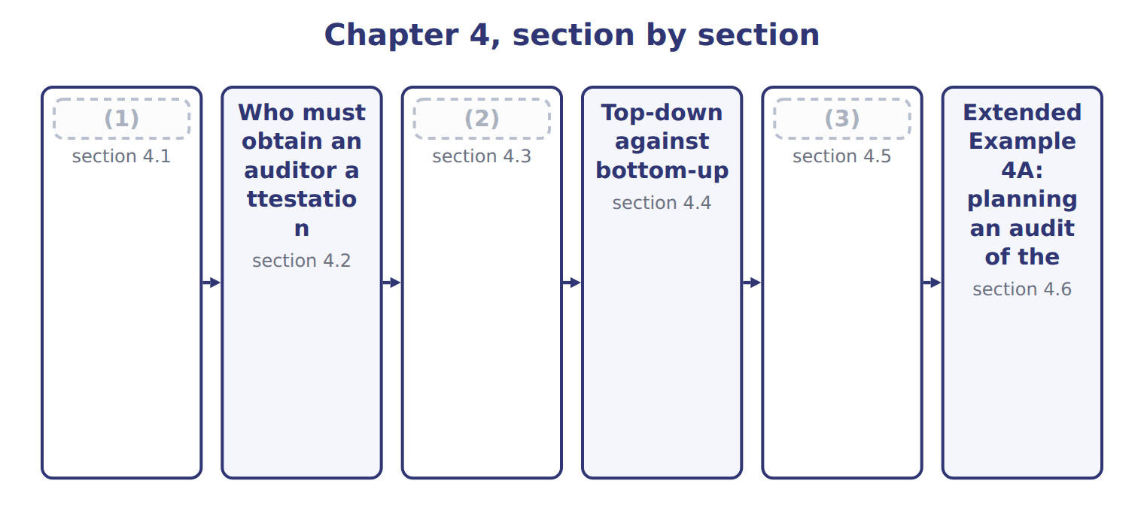
word list
internal accounting controls · What the PCAOB does · The Foreign Corrupt Practices Act · The Sarbanes-Oxley sections that matter

The Sarbanes-Oxley Act of 2002 followed a run of accounting failures.
The Sarbanes-Oxley sections that concern internal control
Each stage leads to the next.
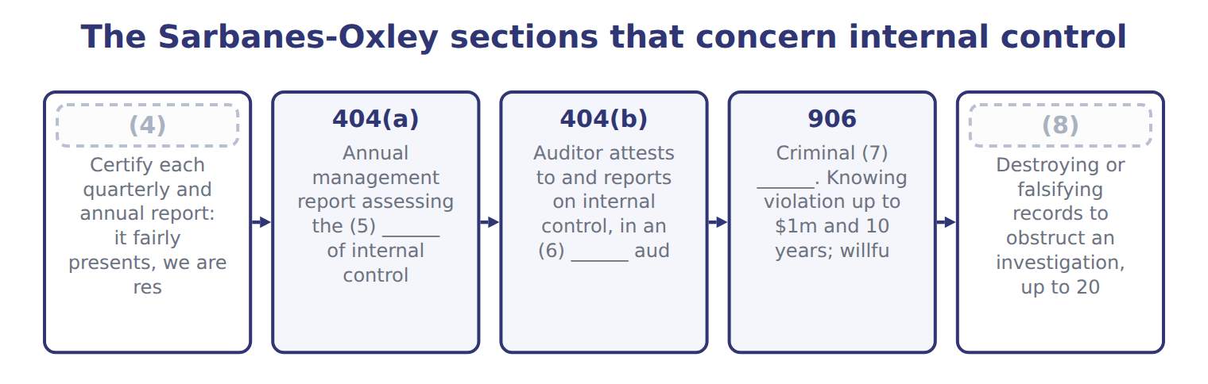
word list
integrated · 802 · 404(a) · effectiveness · certification · 302

Summary 1 gaps 9–20
Section 302 and Section 906 both require the CEO and CFO to certify, and (9) often ask why there are two. Section 302 is the civil (10) about the content of the report and the (11) behind it. Section 906 is the (12) one, carrying up to twenty years for a willful (13) . Section 404 has two (14) that are often (15) . Part (a) requires (16) to assess internal control over (17) reporting each year. Part (b) requires the (18) auditor to (19) to it, and that half does not apply to every company. The (20) , Section 802 says five years. The SEC's own rule and the PCAOB's standard then require seven. Both numbers are correct in their place, and a question may test either. Say five if asked about the Act, and seven if asked about the SEC or PCAOB requirement.
word list
external · statute · candidates · confused · violation · financial · controls · attest · certification · management · accounting · halves · criminal

The words this section uses
Each term sits against what it means.
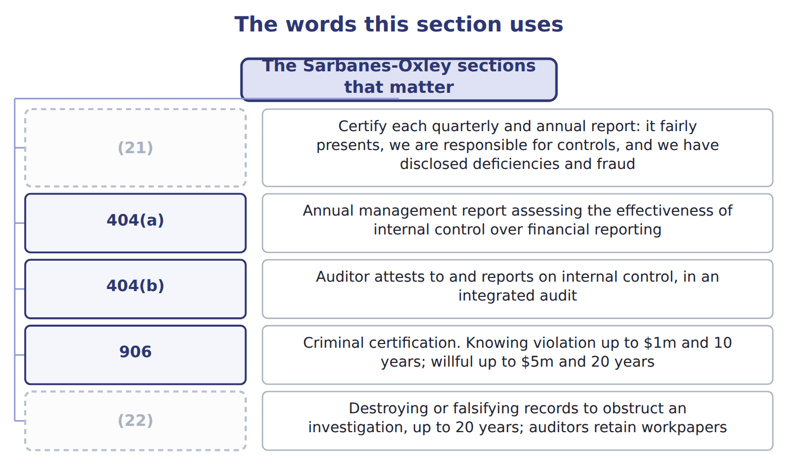
word list
302 · 802 · 404(b)

The English this sheet uses, and its Arabic
English (exam term) | Arabic
Sarbanes-Oxley Act | قانون ساربينز-أوكسلي
internal control over financial reporting (ICFR) | الرقابة الداخلية على التقارير المالية

Answer key · 4.1 The Sarbanes-Oxley sections that matter

1 The Sarbanes-Oxley sections that matter | 12 criminal
2 What the PCAOB does | 13 violation
3 The Foreign Corrupt Practices Act | 14 halves
4 302 | 15 confused
5 effectiveness | 16 management
6 integrated | 17 financial
7 certification | 18 external
8 802 | 19 attest
9 candidates | 20 statute
10 certification | 21 302
11 controls | 22 802

the summaries in full
Summary 1 Section 302 and Section 906 both require the CEO and CFO to certify, and candidates often ask why there are two. Section 302 is the civil certification about the content of the report and the controls behind it. Section 906 is the criminal one, carrying up to twenty years for a willful violation. Section 404 has two halves that are often confused. Part (a) requires management to assess internal control over financial reporting each year. Part (b) requires the external auditor to attest to it, and that half does not apply to every company. The statute, Section 802 says five years. The SEC's own rule and the PCAOB's standard then require seven. Both numbers are correct in their place, and a question may test either. Say five if asked about the Act, and seven if asked about the SEC or PCAOB requirement.

4.2 Who must obtain an auditor attestation
Chapter 4 · section 4.2

Fill every gap. Each word list holds one word more than there are gaps.
Summary 1 gaps 1–11
Section 404(b) binds accelerated filers and large accelerated filers. Non-accelerated filers were (1) exempted by the (2) Act in 2010. Only if they are also non-accelerated. Since the SEC's 2020 (3) the two labels (4) but are not the same. A smaller reporting company with a float of $75 million or more, and (5) of $100 million or more, is still an accelerated filer and still needs the attestation. In May 2026 the SEC (6) raising the large accelerated threshold to $2 (7) . It would also (8) the accelerated filer and smaller reporting company (9) , leaving about 81% of companies exempt from the Section 404 attestation. Learn the (10) rules, and expect the exam to test the (11) rather than the threshold.
word list
current · amendments · remove · categories · threshold · Dodd-Frank · overlap · revenue · permanently · principle · billion · proposed

Answer key · 4.2 Who must obtain an auditor attestation

1 permanently | 7 billion
2 Dodd-Frank | 8 remove
3 amendments | 9 categories
4 overlap | 10 current
5 revenue | 11 principle
6 proposed

the summaries in full
Summary 1 Section 404(b) binds accelerated filers and large accelerated filers. Non-accelerated filers were permanently exempted by the Dodd-Frank Act in 2010. Only if they are also non-accelerated. Since the SEC's 2020 amendments the two labels overlap but are not the same. A smaller reporting company with a float of $75 million or more, and revenue of $100 million or more, is still an accelerated filer and still needs the attestation. In May 2026 the SEC proposed raising the large accelerated threshold to $2 billion. It would also remove the accelerated filer and smaller reporting company categories, leaving about 81% of companies exempt from the Section 404 attestation. Learn the current rules, and expect the exam to test the principle rather than the threshold.

4.3 What the PCAOB does
Chapter 4 · section 4.3

Fill every gap. Each word list holds one word more than there are gaps.
Summary 1 gaps 1–2
The Public Company (1) Oversight Board was created by the Act itself. Before 2002 the audit profession set its own standards and inspected itself; the PCAOB replaced that (2) .
word list
attestation · arrangement · Accounting

What the PCAOB does
PCAOB role (E.1.q) | What it does | Why it matters
Registration | (3) | No registration, no audit of a public company
Standard setting | (4) | AS 2201 governs the audit of internal control
Inspection | (5) | Findings drive firm-wide remediation
Enforcement | Investigates and disciplines firms and individuals | (6)

word list
AS 2201 governs the audit of internal control · Audit firms of issuers must register with the PCAOB · Issues auditing standards, subject to SEC approval · Inspects registered firms' audit work · Sanctions up to barring an auditor

Summary 2 gaps 7–15
The PCAOB issues the auditing standards, subject to approval by the SEC, and the standard (7) an audit of internal control over (8) reporting is AS 2201. Many study (9) still call it AS No. 5. The PCAOB (10) its standards in 2016 and it is now AS 2201. The (11) did not change, but the old name (12) a book that has not been updated. A (13) point is worth knowing because (14) mix it up. The SEC gives guidance to management on its own 404(a) assessment; the PCAOB gives guidance to auditors on the 404(b) (15) . Different bodies, different audiences, same subject.
word list
governing · candidates · content · arrangement · attestation · renumbered · signals · second · financial · guides

The words this section uses
Each term sits against what it means.
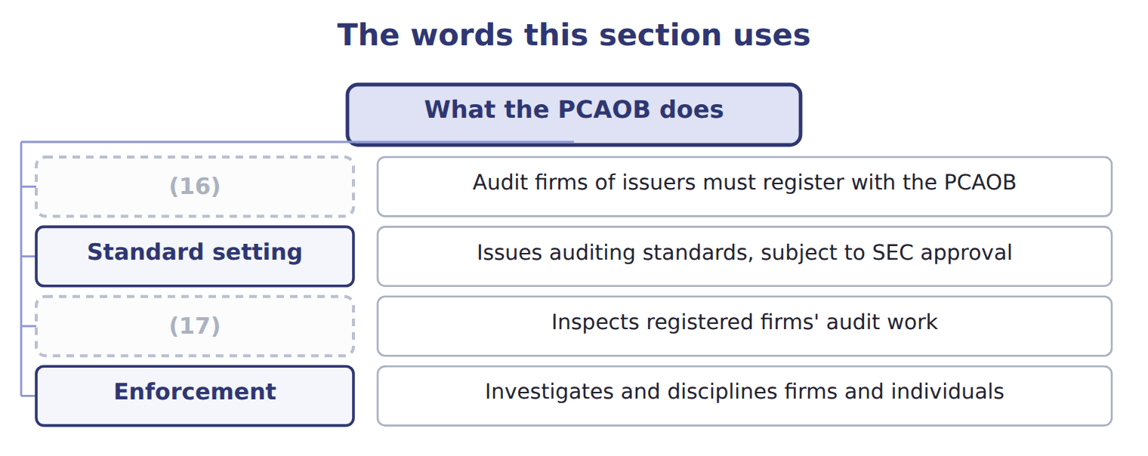
word list
Enforcement · Inspection · Registration

The English this sheet uses, and its Arabic
English (exam term) | Arabic
Public Company Accounting Oversight Board (PCAOB) | مجلس الرقابة على محاسبة الشركات العامة
accelerated filer | الجهة المصدرة المعجلة

Answer key · 4.3 What the PCAOB does

1 Accounting | 10 renumbered
2 arrangement | 11 content
3 Audit firms of issuers must register with the PCAOB | 12 signals
4 Issues auditing standards, subject to SEC approval | 13 second
5 Inspects registered firms' audit work | 14 candidates
6 Sanctions up to barring an auditor | 15 attestation
7 governing | 16 Registration
8 financial | 17 Inspection
9 guides

the summaries in full
Summary 1 The Public Company Accounting Oversight Board was created by the Act itself. Before 2002 the audit profession set its own standards and inspected itself; the PCAOB replaced that arrangement.
Summary 2 The PCAOB issues the auditing standards, subject to approval by the SEC, and the standard governing an audit of internal control over financial reporting is AS 2201. Many study guides still call it AS No. 5. The PCAOB renumbered its standards in 2016 and it is now AS 2201. The content did not change, but the old name signals a book that has not been updated. A second point is worth knowing because candidates mix it up. The SEC gives guidance to management on its own 404(a) assessment; the PCAOB gives guidance to auditors on the 404(b) attestation. Different bodies, different audiences, same subject.

4.4 Top-down against bottom-up
Chapter 4 · section 4.4

Fill every gap. Each word list holds one word more than there are gaps.
Summary 1 gaps 1–12
AS 2201 (1) the auditor to use a top-down approach to (2) the controls to test. This is the (3) required and (4) approach, and the exam asks for it by name. The auditor starts at the financial (5) and the risk of (6) misstatement. From there the path runs to (7) controls, then to (8) accounts and their assertions, then to the likely sources of misstatement. Only then are the controls selected. A bottom-up approach does the (9) . It starts with a list of controls and tests them, hoping that the (10) turns out to be (11) . The (12) is not merely efficiency, though a top-down audit does cost less. It is about evidence. A bottom-up audit can test a hundred controls and still miss the one that matters, because nothing in the method connects the testing to the risk.
word list
requires · difference · statements · select · material · opposite · coverage · significant · preferred · nothing · PCAOB's · adequate · entity-level

Top-down against bottom-up
 | Top-down, risk-based | Bottom-up
Starting point | The financial statements and the risk of material misstatement | (13)
Direction | From risk down to the controls that address it | (14)
Scope | (15) | Potentially every control in the company
Entity-level controls | (16) | Often tested last or not at all
Cost and evidence | (17) | More testing, much of it irrelevant
PCAOB position | Required by AS 2201.21 | (18)

word list
Less testing, better targeted · More testing, much of it irrelevant · Only controls that address an identified risk · From the controls up to whatever they happen to cover · Tested first, and may reduce testing below · Individual process-level controls · Not the standard

The English this sheet uses, and its Arabic
English (exam term) | Arabic
top-down approach | النهج من الأعلى إلى الأسفل
bottom-up approach | النهج من الأسفل إلى الأعلى

Answer key · 4.4 Top-down against bottom-up

1 requires | 10 coverage
2 select | 11 adequate
3 PCAOB's | 12 difference
4 preferred | 13 Individual process-level controls
5 statements | 14 From the controls up to whatever they happen to cover
6 material | 15 Only controls that address an identified risk
7 entity-level | 16 Tested first, and may reduce testing below
8 significant | 17 Less testing, better targeted
9 opposite | 18 Not the standard

the summaries in full
Summary 1 AS 2201 requires the auditor to use a top-down approach to select the controls to test. This is the PCAOB's required and preferred approach, and the exam asks for it by name. The auditor starts at the financial statements and the risk of material misstatement. From there the path runs to entity-level controls, then to significant accounts and their assertions, then to the likely sources of misstatement. Only then are the controls selected. A bottom-up approach does the opposite. It starts with a list of controls and tests them, hoping that the coverage turns out to be adequate. The difference is not merely efficiency, though a top-down audit does cost less. It is about evidence. A bottom-up audit can test a hundred controls and still miss the one that matters, because nothing in the method connects the testing to the risk.

4.5 The Foreign Corrupt Practices Act
Chapter 4 · section 4.5

Fill every gap. Each word list holds one word more than there are gaps.
Summary 1 gaps 1–2
The Foreign Corrupt (1) Act of 1977 has two sets of (2) , and only one of them is about bribery.
word list
provisions · Practices · posture

The two sets of FCPA provisions
FCPA provision (E.1.t) | What it says | Who it binds
Anti-bribery | Prohibits corruptly offering anything of value to a foreign official to obtain or keep business | Issuers, domestic concerns, and others acting in U.S. (3)
Books and records | Keep books in reasonable detail that accurately and fairly reflect transactions and dispositions of assets | (4)
Internal accounting controls | Maintain a system giving reasonable assurance over (5) , recording, access and periodic comparison | Issuers only
Exception | (6) payments for routine governmental action, such as processing a visa | Narrowly read
Defenses | The payment was lawful under written local law; or a reasonable bona fide expenditure | (7)

word list
accelerated filer · Two affirmative defenses · Issuers only · Facilitating · territory · authorization

Summary 2 gaps 8–17
The accounting provisions are the ones this exam cares about. They require an issuer to keep books in reasonable detail that (8) and fairly (9) its transactions. They also require a system of internal accounting controls giving reasonable (10) over four things: that transactions are authorized; that they are recorded so that (11) can be prepared; that access to assets is authorized; and that recorded assets are compared with actual assets at reasonable (12) . Two (13) follow that are easy to miss. The accounting provisions bind (14) only, while the (15) provisions reach much wider. And a company can breach the accounting provisions with no bribe (16) in the picture, because poor records and weak controls are (17) the offence.
word list
require · statements · reflect · issuers · anti-bribery · intervals · points · accurately · assurance · anywhere · themselves

The FCPA does not require COSO

Summary 3 gaps 18–26
The Act requires a system of internal (18) controls giving (19) assurance over the four matters listed above. It names no (20) . Most companies use COSO because it is the (21) one, not because the FCPA says so. The statute has not (22) . It was paused in February 2025 and restarted in June 2025 under (23) of Justice (24) setting four priorities, with a further policy in March 2026. (25) , the Foreign Extortion (26) Act of December 2023 made it a crime for a foreign official to demand a bribe. Expect the exam to test the statute rather than the enforcement posture.
word list
because · changed · Prevention · reasonable · Department · Separately · framework · recognised · guidelines · accounting

The words this section uses
Each term sits against what it means.
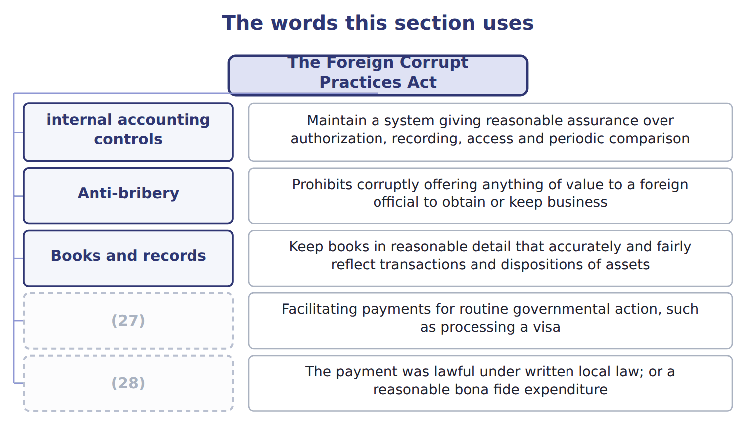
word list
Defenses · Anti-bribery · Exception

The English this sheet uses, and its Arabic
English (exam term) | Arabic
Foreign Corrupt Practices Act (FCPA) | قانون الممارسات الأجنبية الفاسدة
internal accounting controls | ضوابط المحاسبة الداخلية

Answer key · 4.5 The Foreign Corrupt Practices Act

1 Practices | 15 anti-bribery
2 provisions | 16 anywhere
3 territory | 17 themselves
4 Issuers only | 18 accounting
5 authorization | 19 reasonable
6 Facilitating | 20 framework
7 Two affirmative defenses | 21 recognised
8 accurately | 22 changed
9 reflect | 23 Department
10 assurance | 24 guidelines
11 statements | 25 Separately
12 intervals | 26 Prevention
13 points | 27 Exception
14 issuers | 28 Defenses

the summaries in full
Summary 1 The Foreign Corrupt Practices Act of 1977 has two sets of provisions, and only one of them is about bribery.
Summary 2 The accounting provisions are the ones this exam cares about. They require an issuer to keep books in reasonable detail that accurately and fairly reflect its transactions. They also require a system of internal accounting controls giving reasonable assurance over four things: that transactions are authorized; that they are recorded so that statements can be prepared; that access to assets is authorized; and that recorded assets are compared with actual assets at reasonable intervals. Two points follow that are easy to miss. The accounting provisions bind issuers only, while the anti-bribery provisions reach much wider. And a company can breach the accounting provisions with no bribe anywhere in the picture, because poor records and weak controls are themselves the offence.
Summary 3 The Act requires a system of internal accounting controls giving reasonable assurance over the four matters listed above. It names no framework. Most companies use COSO because it is the recognised one, not because the FCPA says so. The statute has not changed. It was paused in February 2025 and restarted in June 2025 under Department of Justice guidelines setting four priorities, with a further policy in March 2026. Separately, the Foreign Extortion Prevention Act of December 2023 made it a crime for a foreign official to demand a bribe. Expect the exam to test the statute rather than the enforcement posture.

4.6 Extended Example 4A: planning an audit of the Orontes controls
Chapter 4 · section 4.6

Fill every gap. Each word list holds one word more than there are gaps.
Summary 1 gaps 1–12
This example walks the (1) approach through one Orontes audit and shows what a (2) auditor would have done instead. It is (3) , so expect to be asked to judge (4) than recall. The auditor starts by asking where a material (5) could appear in the Orontes (6) . Inventory is large and includes spices that are (7) and portable. (8) includes Gulf export sales with (9) terms. Those two attract (10) ; the small items do not. Next the auditor tests the controls that run across (11) : the control (12) described in, the period-end reporting process, and the controls over management override. Strong entity-level controls can reduce the testing needed below, which is why they come second and not last. Inventory is a significant account, but not every assertion about it matters equally. Existence is the assertion at risk for portable spices; valuation matters for slow-moving stock.
word list
attention · top-down · Nothing · bottom-up · environment · everything · Revenue · misstatement · rather · exam-core · unusual · valuable · statements

Summary 2 gaps 13–23
The auditor names the (13) , not just the (14) . How could (15) existence actually go wrong at Orontes? Stock could be removed from the spice store and the record (16) , which is the pairing. That is a (17) , testable route, not a (18) worry. Only now does the auditor choose: the separation of the (19) from the stock records, the independent count, and the (20) of depot records to plant dispatches. Three controls, each tied to an (21) risk. A (22) auditor would have asked for the list of controls and (23) testing. Many hours would go on purchase order approvals and payroll authorisations, which are real controls over immaterial risks. The spice store might be reached eventually, and might not. Nothing in the method would reveal the gap.
word list
assertion · specific · Orontes · general · identified · inventory · started · storekeeper · adjusted · reconciliation · bottom-up · account

Match each requirement to its SOX section

Complete the blank cells.

Your turn: match the requirement to the section (complete the blanks)
Every item belongs to exactly one group.
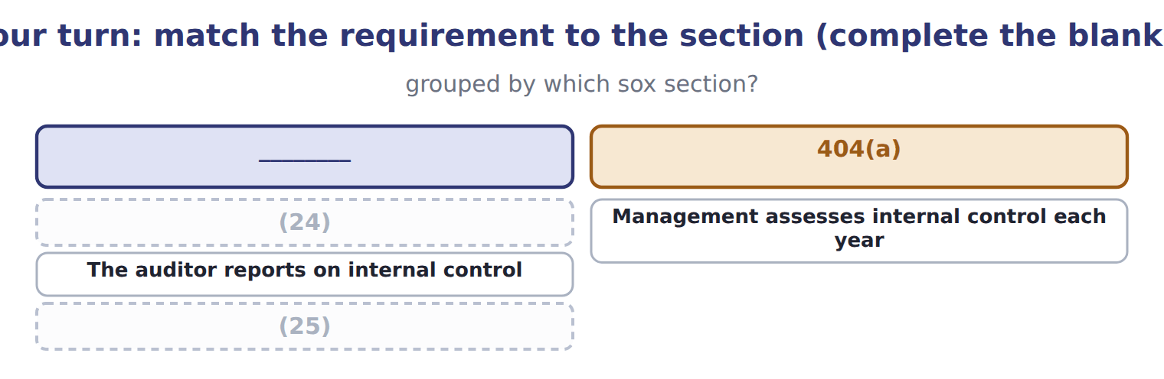
word list
Management assesses internal control each year · Destroying records to obstruct an investigation · The CEO and CFO certify the annual report

Summary 3 gaps 26–27
The (26) matters for an exam (27) : answer on current law unless a question says otherwise.
word list
attract · distinction · candidate

What is current law and what is only proposed
Item | What it says | Source | Status
404(b) exemption | Non-accelerated filers exempt; an SRC qualifies only if also non-accelerated | (28) | current law
Filer thresholds | Would raise large accelerated to $2bn and remove the SRC category | (29) | PROPOSED only
PCAOB QC 1000 | A firm's system of quality control | Adopted May 2024, postponed to 15 Dec 2026 | (30)
Technology-assisted analysis | Amendments to AS 1105 and AS 2301 | (31) | effective for years from 15 Dec 2025
FCPA enforcement | Paused Feb 2025; restarted under DOJ Guidelines of June 2025 with four priorities | DOJ | (32)

word list
SEC amendments, April 2020 · SEC Release 33-11419, 19 May 2026 · Management assesses internal control each year · statute unchanged · Adopted June 2024 · not yet effective

The pattern behind the approach

Summary 4 gaps 33–35
Start at the statements, because that is where (33) is decided. Test (34) controls early, because they can reduce work below. Name the (35) at risk, not just the account. Select controls last, and only those addressing an identified risk.
word list
assertion · entity-level · equally · materiality

Exam view

Summary 5 gaps 36–39
A (36) may describe an audit plan and ask whether it is top-down. Look at where it (37) . If the first step is a list of controls, it is (38) , whatever it is called. If the first step is the risk of material (39) , it is top-down.
word list
misstatement · starts · question · bottom-up · approach

Exam view
Item | Answer
The CEO and CFO certify the annual report | Section 302 — the civil (40) covering the report and the controls behind it
Management assesses internal control each year | Why: 404(a) places the assessment on management of every issuer, whatever its filer status
The auditor reports on internal control | Section 404(b) — and only for accelerated and large accelerated filers
Destroying records to obstruct an investigation | (41)

word list
certification · SEC amendments, April 2020 · Section 802 — up to twenty years

Requirement — Category
Every item belongs to exactly one group.
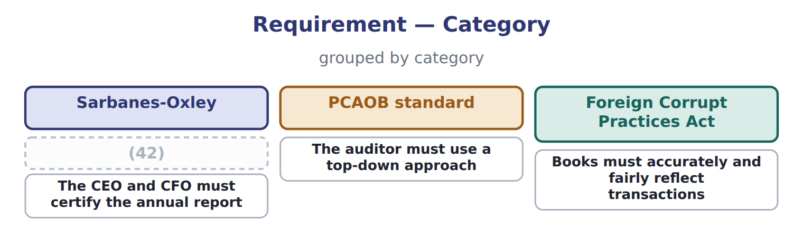
word list
Management must assess internal control annually · Books must accurately and fairly reflect transactions

The words this section uses
Each term sits against what it means.
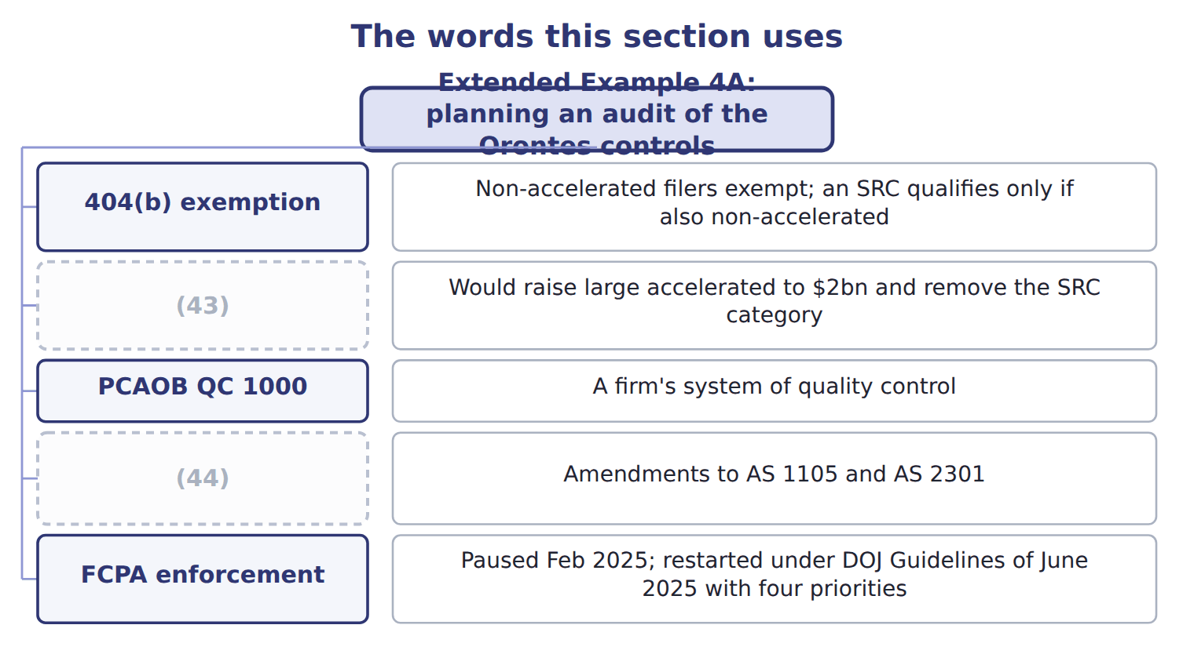
word list
bottom-up approach · Technology-assisted analysis · Filer thresholds

Answer key · 4.6 Extended Example 4A: planning an audit of the Orontes controls

1 top-down | 23 started
2 bottom-up | 24 The CEO and CFO certify the annual report
3 exam-core | 25 Destroying records to obstruct an investigation
4 rather | 26 distinction
5 misstatement | 27 candidate
6 statements | 28 SEC amendments, April 2020
7 valuable | 29 SEC Release 33-11419, 19 May 2026
8 Revenue | 30 not yet effective
9 unusual | 31 Adopted June 2024
10 attention | 32 statute unchanged
11 everything | 33 materiality
12 environment | 34 entity-level
13 assertion | 35 assertion
14 account | 36 question
15 inventory | 37 starts
16 adjusted | 38 bottom-up
17 specific | 39 misstatement
18 general | 40 certification
19 storekeeper | 41 Section 802 — up to twenty years
20 reconciliation | 42 Management must assess internal control annually
21 identified | 43 Filer thresholds
22 bottom-up | 44 Technology-assisted analysis

the summaries in full
Summary 1 This example walks the top-down approach through one Orontes audit and shows what a bottom-up auditor would have done instead. It is exam-core, so expect to be asked to judge rather than recall. The auditor starts by asking where a material misstatement could appear in the Orontes statements. Inventory is large and includes spices that are valuable and portable. Revenue includes Gulf export sales with unusual terms. Those two attract attention; the small items do not. Next the auditor tests the controls that run across everything: the control environment described in, the period-end reporting process, and the controls over management override. Strong entity-level controls can reduce the testing needed below, which is why they come second and not last. Inventory is a significant account, but not every assertion about it matters equally. Existence is the assertion at risk for portable spices; valuation matters for slow-moving stock.
Summary 2 The auditor names the assertion, not just the account. How could inventory existence actually go wrong at Orontes? Stock could be removed from the spice store and the record adjusted, which is the pairing. That is a specific, testable route, not a general worry. Only now does the auditor choose: the separation of the storekeeper from the stock records, the independent count, and the reconciliation of depot records to plant dispatches. Three controls, each tied to an identified risk. A bottom-up auditor would have asked for the list of controls and started testing. Many hours would go on purchase order approvals and payroll authorisations, which are real controls over immaterial risks. The spice store might be reached eventually, and might not. Nothing in the method would reveal the gap.
Summary 3 The distinction matters for an exam candidate: answer on current law unless a question says otherwise.
Summary 4 Start at the statements, because that is where materiality is decided. Test entity-level controls early, because they can reduce work below. Name the assertion at risk, not just the account. Select controls last, and only those addressing an identified risk.
Summary 5 A question may describe an audit plan and ask whether it is top-down. Look at where it starts. If the first step is a list of controls, it is bottom-up, whatever it is called. If the first step is the risk of material misstatement, it is top-down.

