7.1 System development controls
Chapter 7 · section 7.1

Fill every gap. Each word list holds one word more than there are gaps.
Chapter 7, section by section
Each stage leads to the next.
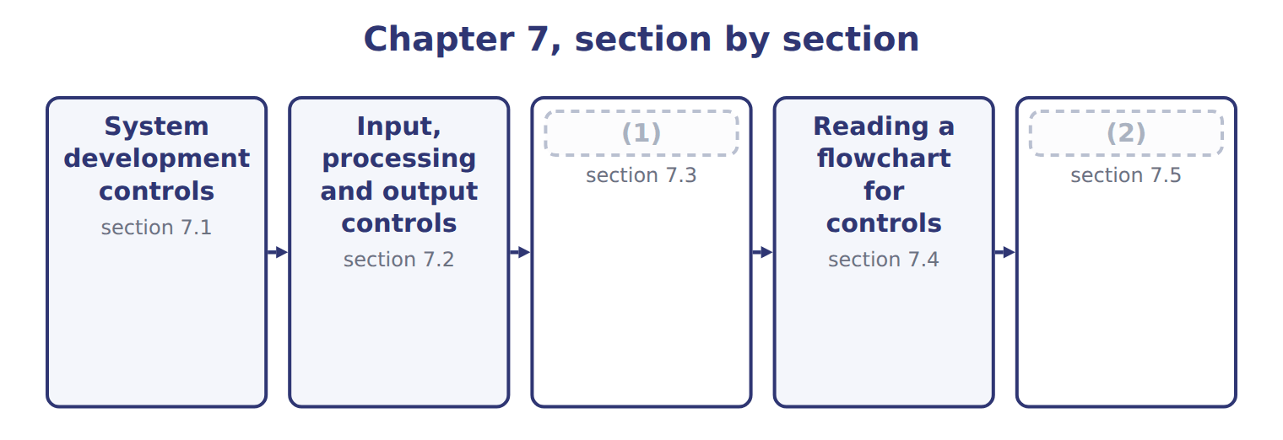
word list
Storage controls · Extended Example 7A: a batch of invoices, and · section 7.5

Summary 1 gaps 3–4
Controls are cheapest when they are designed into a system and most (3) when they are added (4) .
word list
afterwards · expensive · Controls

What system development controls protect
What development controls protect (E.2.c) | What it means | How it is achieved
Accuracy | (5) | Test with known data and compare the result
Validity | Only genuine, authorized transactions are processed | (6)
Safety | (7) | Recovery routines and transaction rollback
Security | (8) | Access rights built in, not added afterwards
Adaptability | The system can be changed as the business changes | (9)
Over all of them | Users involved, stages approved, testing in a separate environment, changes controlled | (10)

word list
Only genuine, authorized transactions are processed · Data is not lost or corrupted when something fails · The system development controls of Chapter 12 · Authorization checks designed into the program · Documentation and modular design · Only the right people can reach the system · The system computes what it is supposed to compute

Summary 2 gaps 11–16
Adaptability is the one (11) overlook. A system that cannot be changed safely will be changed (12) , because the business will not stop to (13) it. (14) and modular design are control matters, not merely technical (15) . Across all five sits a familiar (16) . Users are involved from the start, each stage is formally approved, testing is carried out in an environment separate from the live one, and every later change is controlled.
word list
requirement · business · unsafely · accommodate · housekeeping · candidates · Documentation

The words this section uses
Each term sits against what it means.
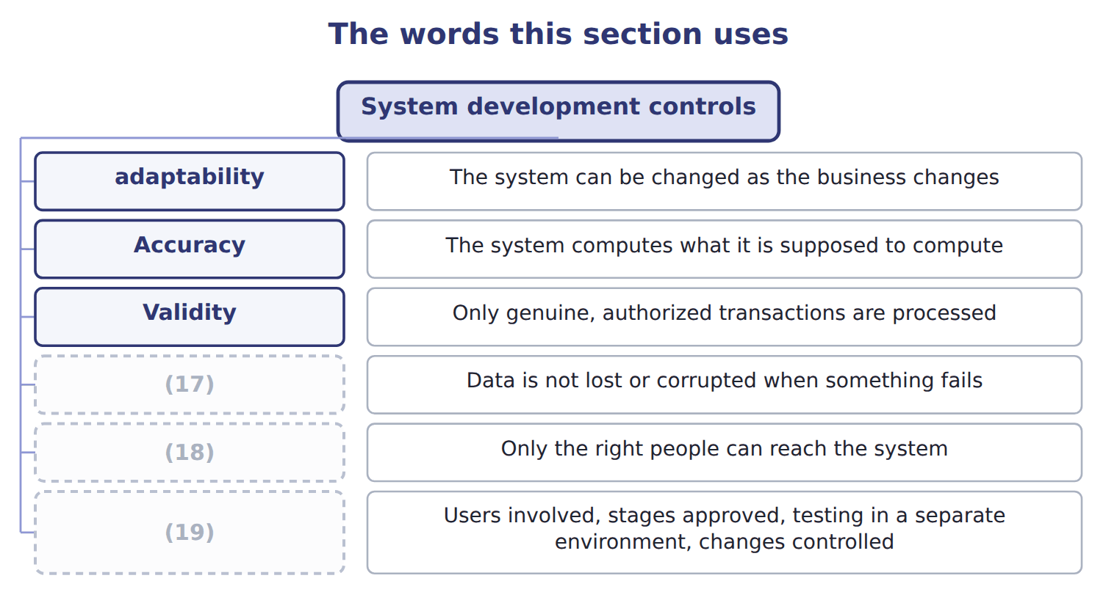
word list
Safety · Accuracy · Over all of them · Security

The English this sheet uses, and its Arabic
English (exam term) | Arabic
system development control | ضوابط تطوير النظم
adaptability | القابلية للتكيف

Answer key · 7.1 System development controls

1 Storage controls | 11 candidates
2 Extended Example 7A: a batch of invoices, and | 12 unsafely
3 expensive | 13 accommodate
4 afterwards | 14 Documentation
5 The system computes what it is supposed to compute | 15 housekeeping
6 Authorization checks designed into the program | 16 requirement
7 Data is not lost or corrupted when something fails | 17 Safety
8 Only the right people can reach the system | 18 Security
9 Documentation and modular design | 19 Over all of them
10 The system development controls of Chapter 12

the summaries in full
Summary 1 Controls are cheapest when they are designed into a system and most expensive when they are added afterwards.
Summary 2 Adaptability is the one candidates overlook. A system that cannot be changed safely will be changed unsafely, because the business will not stop to accommodate it. Documentation and modular design are control matters, not merely technical housekeeping. Across all five sits a familiar requirement. Users are involved from the start, each stage is formally approved, testing is carried out in an environment separate from the live one, and every later change is controlled.

7.2 Input, processing and output controls
Chapter 7 · section 7.2

Fill every gap. Each word list holds one word more than there are gaps.
Summary 1 gaps 1–4
The (1) are the whole (2) for input controls. An error (3) as it is keyed costs a (4) . The same error found in the output has already passed through every calculation in between, and tracing it back through them costs far more than preventing it would have.
word list
controls · caught · moment · argument · economics

Input controls and what each one tests
Input control (E.2.f) | What it tests | Example
Field check | The data is the right type | (5)
Format check | The data has the right shape | (6)
Range or limit check | (7) | An hourly rate above 500 is queried
Reasonableness check | The value makes sense beside another field | (8)
Validity check | The code exists on the master file | (9)
Check digit | (10) | A mistyped account number fails the arithmetic
Batch totals | (11) , hash or record count compared before and after | Twenty invoices entered; twenty posted
Closed-loop verification | (12) | The supplier name appears for confirmation

word list
The value falls between sensible bounds · An extra digit computed from the rest · A date entered as 2026-13-45 is rejected · Financial · The supplier name appears for confirmation · Letters rejected in a quantity field · The system displays what the code means · A 900-case order from a customer who buys 20 · An unknown supplier number is rejected

Summary 2 gaps 13–21
Batch totals come in three kinds and the (13) is tested. A (14) total adds amounts; a record count counts documents; a hash total adds something (15) , such as supplier numbers, purely so that a change shows up. The hash total has no (16) meaning at all, which is (17) why it works. (18) controls keep the data right while it is being handled: (19) totals carry a figure from one stage to the next, sequence checks confirm nothing is skipped, and error logs capture what was rejected. Output controls then (20) what left against what entered, send reports only to named (21) , and dispose of them securely.
word list
recipients · exactly · skipped · accounting · distinction · financial · meaningless · Processing · reconcile · run-to-run

The words this section uses
Each term sits against what it means.
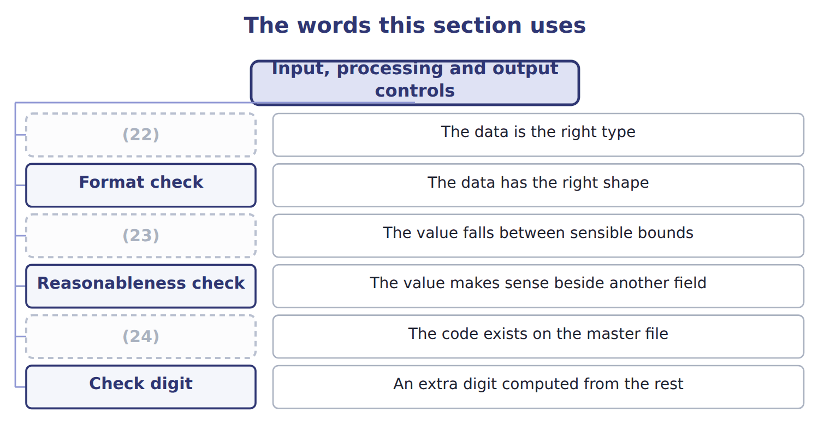
word list
Validity check · Range or limit check · Field check · Check digit

The English this sheet uses, and its Arabic
English (exam term) | Arabic
input control | ضوابط المدخلات
batch total | الإجمالي الدفعي
hash total | الإجمالي الرقابي

Answer key · 7.2 Input, processing and output controls

1 economics | 13 distinction
2 argument | 14 financial
3 caught | 15 meaningless
4 moment | 16 accounting
5 Letters rejected in a quantity field | 17 exactly
6 A date entered as 2026-13-45 is rejected | 18 Processing
7 The value falls between sensible bounds | 19 run-to-run
8 A 900-case order from a customer who buys 20 | 20 reconcile
9 An unknown supplier number is rejected | 21 recipients
10 An extra digit computed from the rest | 22 Field check
11 Financial | 23 Range or limit check
12 The system displays what the code means | 24 Validity check

the summaries in full
Summary 1 The economics are the whole argument for input controls. An error caught as it is keyed costs a moment. The same error found in the output has already passed through every calculation in between, and tracing it back through them costs far more than preventing it would have.
Summary 2 Batch totals come in three kinds and the distinction is tested. A financial total adds amounts; a record count counts documents; a hash total adds something meaningless, such as supplier numbers, purely so that a change shows up. The hash total has no accounting meaning at all, which is exactly why it works. Processing controls keep the data right while it is being handled: run-to-run totals carry a figure from one stage to the next, sequence checks confirm nothing is skipped, and error logs capture what was rejected. Output controls then reconcile what left against what entered, send reports only to named recipients, and dispose of them securely.

7.3 Storage controls
Chapter 7 · section 7.3

Fill every gap. Each word list holds one word more than there are gaps.
Storage controls and their trade-offs
Storage control (E.2.g) | What it does | Trade-off | Typical
Full backup | Copies everything | Slowest to take, fastest to restore | (1)
Incremental backup | (2) | Fastest to take, slowest to restore | Nightly
Differential backup | (3) | Between the two on both counts | Nightly, where restore speed matters
Mirroring or replication | (4) | Protects against hardware failure, not against error | Continuous
Off-site or cloud copy | (5) | The only protection against fire or flood | At least one copy, always
Immutable or air-gapped copy | (6) | The protection against ransomware | At least one copy

word list
A copy held away from the site · Copies changes since the last FULL backup · Copies changes since the last backup of ANY type · Nightly · A continuously maintained second copy · Weekly · A copy that cannot be altered or reached online

Summary 1 gaps 7–17
The (7) between incremental and differential backups is the one the exam tests. An incremental copies what has changed since the last backup of any kind. It is quick to take and slow to (8) , because every incremental since the last full backup must be (9) in order. A differential copies what has changed since the last full backup. It grows (10) each night but needs only two restores. Two (11) points are worth (12) . (13) protects against a disk (14) but not against a mistake, because the error is copied (15) to the mirror. And a copy that cannot be altered or reached online is now the standard (16) against ransomware, which otherwise encrypts the backups along with (17) else.
word list
applied · faithfully · restore · failing · knowing · distinction · everything · protection · adaptability · larger · further · Mirroring

RAID is not a backup

Summary 2 gaps 18–20
Mirroring and RAID give (18) against hardware failure. They do not protect against deletion, corruption or encryption, because whatever happens to the original happens (19) to the copy. A (20) offering RAID as the answer to data loss is offering the wrong answer.
word list
question · encryption · immediately · resilience

The words this section uses
Each term sits against what it means.
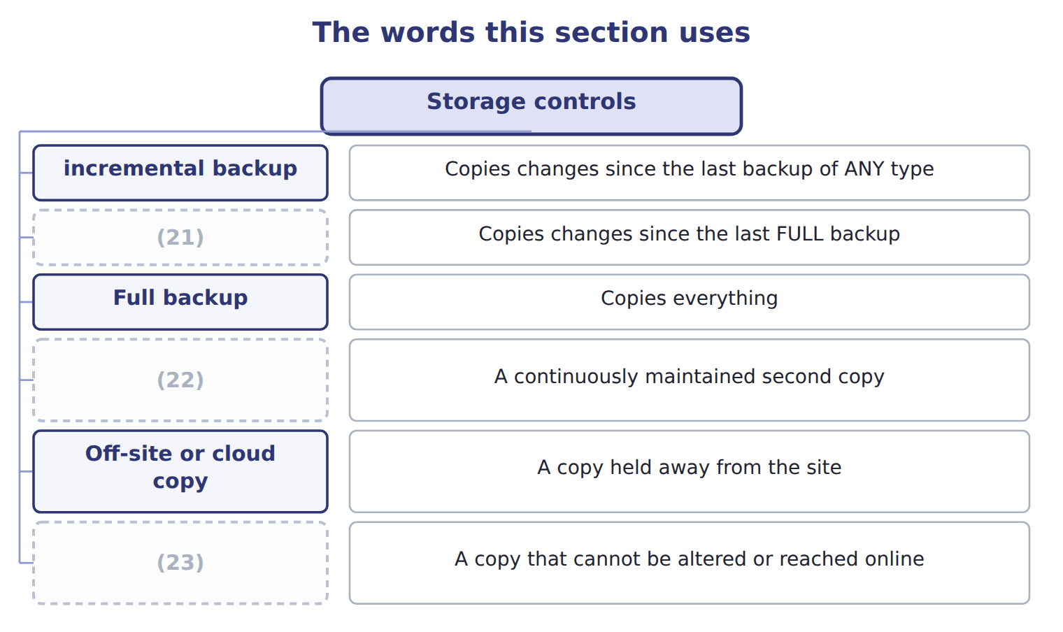
word list
differential backup · Immutable or air-gapped copy · incremental backup · Mirroring or replication

The English this sheet uses, and its Arabic
English (exam term) | Arabic
incremental backup | النسخ الاحتياطي التزايدي
differential backup | النسخ الاحتياطي التفاضلي

Answer key · 7.3 Storage controls

1 Weekly | 13 Mirroring
2 Copies changes since the last backup of ANY type | 14 failing
3 Copies changes since the last FULL backup | 15 faithfully
4 A continuously maintained second copy | 16 protection
5 A copy held away from the site | 17 everything
6 A copy that cannot be altered or reached online | 18 resilience
7 distinction | 19 immediately
8 restore | 20 question
9 applied | 21 differential backup
10 larger | 22 Mirroring or replication
11 further | 23 Immutable or air-gapped copy
12 knowing

the summaries in full
Summary 1 The distinction between incremental and differential backups is the one the exam tests. An incremental copies what has changed since the last backup of any kind. It is quick to take and slow to restore, because every incremental since the last full backup must be applied in order. A differential copies what has changed since the last full backup. It grows larger each night but needs only two restores. Two further points are worth knowing. Mirroring protects against a disk failing but not against a mistake, because the error is copied faithfully to the mirror. And a copy that cannot be altered or reached online is now the standard protection against ransomware, which otherwise encrypts the backups along with everything else.
Summary 2 Mirroring and RAID give resilience against hardware failure. They do not protect against deletion, corruption or encryption, because whatever happens to the original happens immediately to the copy. A question offering RAID as the answer to data loss is offering the wrong answer.

7.4 Reading a flowchart for controls
Chapter 7 · section 7.4

Fill every gap. Each word list holds one word more than there are gaps.
Summary 1 gaps 1–8
A (1) draws a process as a sequence of steps, (2) and documents. For a control reviewer it does (3) no written (4) does: it shows, in one picture, who holds which duty and where a document is created or lost. Four (5) answer most of what a reviewer needs. Applied here, the chart shows four (6) people, a decision point (7) by a stated limit, and a document at every step. The weakness the chart would have revealed before the redesign was a single name (8) in four boxes.
word list
governed · appearing · something · different · questions · flowchart · procedure · redesign · decisions

The English this sheet uses, and its Arabic
English (exam term) | Arabic
flowchart | مخطط التدفق

Answer key · 7.4 Reading a flowchart for controls

1 flowchart | 5 questions
2 decisions | 6 different
3 something | 7 governed
4 procedure | 8 appearing

the summaries in full
Summary 1 A flowchart draws a process as a sequence of steps, decisions and documents. For a control reviewer it does something no written procedure does: it shows, in one picture, who holds which duty and where a document is created or lost. Four questions answer most of what a reviewer needs. Applied here, the chart shows four different people, a decision point governed by a stated limit, and a document at every step. The weakness the chart would have revealed before the redesign was a single name appearing in four boxes.

7.5 Extended Example 7A: a batch of invoices, and where each control catches it
Chapter 7 · section 7.5

Fill every gap. Each word list holds one word more than there are gaps.
Summary 1 gaps 1–12
This example (1) one batch of twenty supplier invoices (2) the Orontes system and shows which control catches which error. It is (3) : questions give an error and ask which control would find it. (4) payable keys twenty invoices as one batch. Before keying, the clerk (5) three batch totals: twenty (6) , a financial total of the invoice amounts, and a hash total of the supplier numbers. One invoice is keyed with the (7) in the rate field. One (8) a supplier number that does not exist. And one is for a supplier that exists, but with a (9) number that happens to belong to a (10) real supplier. The field or (11) check rejects the first as it is keyed. The (12) check rejects the second, because the code is not on the master file.
word list
exam-core · through · Orontes · different · format · Accounts · quantity · records · validity · mistyped · carries · documents · follows

Summary 2 gaps 13–21
The record count catches the third: (13) documents posted (14) twenty counted. The fourth error passes the (15) check, because the (16) number is a real supplier. It passes the record count and the (17) total, because the (18) is right. Only the hash total of supplier numbers catches it, or closed-loop (19) showing the supplier name on screen before the clerk (20) . This is the case that justifies the hash total, which otherwise looks like (21) for its own sake. A total with no accounting meaning catches an error that every meaningful total misses, because the error substitutes one valid value for another.
word list
twenty-one · control · financial · validity · amount · mistyped · confirms · against · arithmetic · verification

Match four errors to their controls

Complete the blank cells.

Your turn: match four errors to their controls (complete the blanks)
Every item belongs to exactly one group.
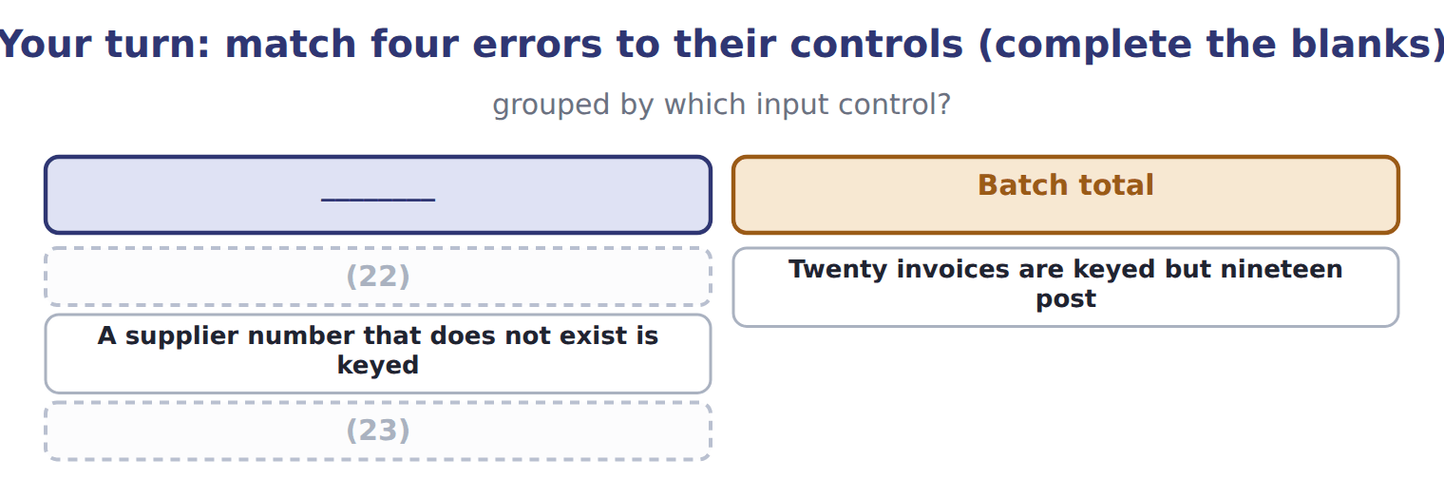
word list
Twenty invoices are keyed but nineteen post · An hourly rate of 5,000 is entered · A mistyped account number is caught by arithmetic

The pattern behind the example

Summary 3 gaps 24–27
Field, (24) and range checks catch data that is the wrong shape. (25) checks catch codes that do not exist. Record counts and (26) totals catch things missing or added. Only a hash total or closed-loop (27) catches one valid code substituted for another.
word list
questions · verification · format · financial · Validity

Exam view

Summary 4 gaps 28–30
Ask what kind of error it is before (28) a control. Wrong shape, absent code, wrong count, or one valid value (29) for another. The last of these is the one most (30) get wrong, and it has only two answers.
word list
candidates · swapped · validity · choosing

Exam view
Item | Answer
An hourly rate of 5,000 is entered | Range or limit check — the value falls (31) the bounds set for that field
Twenty invoices are keyed but nineteen post | Why: the record count taken before entry no longer agrees with the number posted, so one (32) is missing
A supplier number that does not exist is keyed | Validity check — the code is tested against the supplier master file and is not found
A mistyped account number is caught by arithmetic | Check digit — an extra digit computed from the rest of the number no longer agrees

word list
document · outside · Validity

Control figure or practice — Category
Every item belongs to exactly one group.
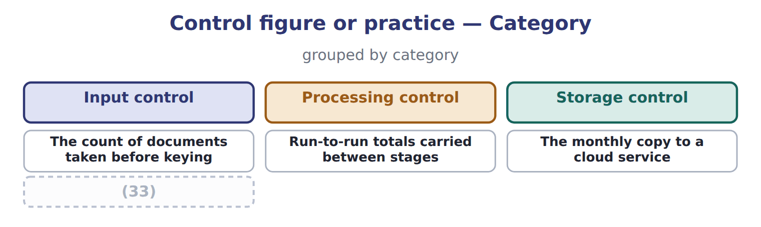
word list
The monthly copy to a cloud service · The total of supplier numbers with no accounting meaning

The English this section uses, and its Arabic
Each term sits against what it means.
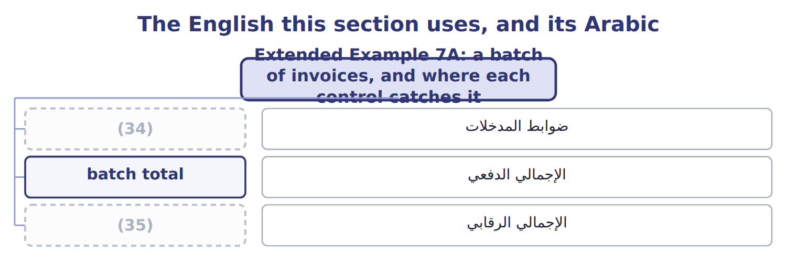
word list
batch total · hash total · input control

Answer key · 7.5 Extended Example 7A: a batch of invoices, and where each control catches it

1 follows | 19 verification
2 through | 20 confirms
3 exam-core | 21 arithmetic
4 Accounts | 22 An hourly rate of 5,000 is entered
5 records | 23 A mistyped account number is caught by arithmetic
6 documents | 24 format
7 quantity | 25 Validity
8 carries | 26 financial
9 mistyped | 27 verification
10 different | 28 choosing
11 format | 29 swapped
12 validity | 30 candidates
13 twenty-one | 31 outside
14 against | 32 document
15 validity | 33 The total of supplier numbers with no accounting meaning
16 mistyped | 34 input control
17 financial | 35 hash total
18 amount

the summaries in full
Summary 1 This example follows one batch of twenty supplier invoices through the Orontes system and shows which control catches which error. It is exam-core: questions give an error and ask which control would find it. Accounts payable keys twenty invoices as one batch. Before keying, the clerk records three batch totals: twenty documents, a financial total of the invoice amounts, and a hash total of the supplier numbers. One invoice is keyed with the quantity in the rate field. One carries a supplier number that does not exist. And one is for a supplier that exists, but with a mistyped number that happens to belong to a different real supplier. The field or format check rejects the first as it is keyed. The validity check rejects the second, because the code is not on the master file.
Summary 2 The record count catches the third: twenty-one documents posted against twenty counted. The fourth error passes the validity check, because the mistyped number is a real supplier. It passes the record count and the financial total, because the amount is right. Only the hash total of supplier numbers catches it, or closed-loop verification showing the supplier name on screen before the clerk confirms. This is the case that justifies the hash total, which otherwise looks like arithmetic for its own sake. A total with no accounting meaning catches an error that every meaningful total misses, because the error substitutes one valid value for another.
Summary 3 Field, format and range checks catch data that is the wrong shape. Validity checks catch codes that do not exist. Record counts and financial totals catch things missing or added. Only a hash total or closed-loop verification catches one valid code substituted for another.
Summary 4 Ask what kind of error it is before choosing a control. Wrong shape, absent code, wrong count, or one valid value swapped for another. The last of these is the one most candidates get wrong, and it has only two answers.

