8.1 Why the internet is riskier
Chapter 8 · section 8.1

Fill every gap. Each word list holds one word more than there are gaps.
Chapter 8, section by section
Each stage leads to the next.
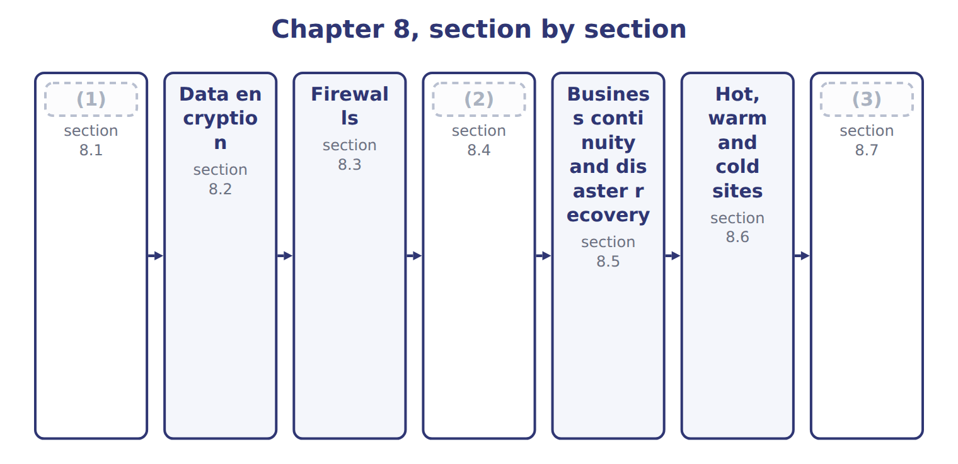
word list
Why the internet is riskier · Extended Example 8A: choosing a recovery arran · Business continuity and disaster recovery · Why the backup must leave the building

Summary 1 gaps 4–7
A leased line is a (4) the company pays for and (5) else uses. The (6) is a shared road. The traffic crosses (7) owned by strangers, by a route chosen at the time, and anything on that route can in principle read or alter what passes.
word list
crosses · nobody · equipment · connection · internet

The risks of the internet compared with a private line
Internet risk (E.2.h) | Why it arises | What it looks like | Main defence
Interception | (8) | Reading data in transit | Encryption
Man in the middle | An attacker relays and may alter the conversation | (9) | Encryption with authentication
Spoofing | A false identity for a site, sender or address | (10) | Certificates, authentication
Tampering | (11) | An invoice amount altered on the way | Integrity checks, hashing
Denial of service | The service is flooded until it fails | (12) | Filtering, capacity, provider defences
Malware delivery | (13) | Ransomware from an attachment | Filtering, patching, training

word list
Traffic crosses networks nobody controls · Reading data in transit · An order site unavailable for a day · A convincing but fake supplier portal · Altering a payment instruction · Data changed in transit · Hostile software carried over the connection

Summary 2 gaps 14–21
The (14) is one of exposure (15) than of kind. A (16) line can be tapped, and an (17) can read either one. But the internet (18) the traffic within reach of far more people, none of whom the company has any (19) with. That is also why the internet is used (20) . A leased line to every Gulf (21) would cost more than the business they bring. The practical answer is not to avoid the shared road but to make the traffic unreadable while it is on it.
word list
places · relationship · difference · customer · private · rather · internet · anyway · insider

The English this section uses, and its Arabic
Each term sits against what it means.
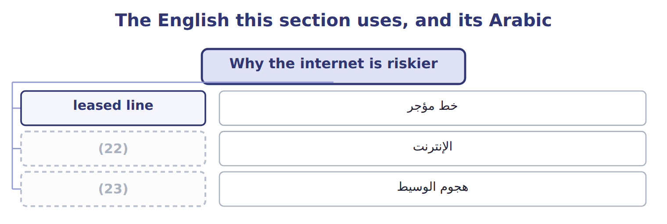
word list
man in the middle · firewall · internet

The English this sheet uses, and its Arabic
English (exam term) | Arabic
leased line | خط مؤجر
internet | الإنترنت
man in the middle | هجوم الوسيط

Answer key · 8.1 Why the internet is riskier

1 Why the internet is riskier | 13 Hostile software carried over the connection
2 Why the backup must leave the building | 14 difference
3 Extended Example 8A: choosing a recovery arran | 15 rather
4 connection | 16 private
5 nobody | 17 insider
6 internet | 18 places
7 equipment | 19 relationship
8 Traffic crosses networks nobody controls | 20 anyway
9 Altering a payment instruction | 21 customer
10 A convincing but fake supplier portal | 22 internet
11 Data changed in transit | 23 man in the middle
12 An order site unavailable for a day

the summaries in full
Summary 1 A leased line is a connection the company pays for and nobody else uses. The internet is a shared road. The traffic crosses equipment owned by strangers, by a route chosen at the time, and anything on that route can in principle read or alter what passes.
Summary 2 The difference is one of exposure rather than of kind. A private line can be tapped, and an insider can read either one. But the internet places the traffic within reach of far more people, none of whom the company has any relationship with. That is also why the internet is used anyway. A leased line to every Gulf customer would cost more than the business they bring. The practical answer is not to avoid the shared road but to make the traffic unreadable while it is on it.

8.2 Data encryption
Chapter 8 · section 8.2

Fill every gap. Each word list holds one word more than there are gaps.
Summary 1 gaps 1–12
Data encryption (1) readable data into a form that cannot be (2) without a key. Symmetric encryption uses one key for both (3) . It is fast and suits bulk data, but it leaves a (4) . The key itself must reach the other party (5) , and sending it over the same (6) network defeats the purpose. Each party has a pair of keys, and what one (7) only the other can (8) . Anyone may hold the public key, so (9) secret has to be (10) first. (11) the pair gives a digital (12) : encrypting with the private key proves who sent the message, since only that person holds it. In practice the two are combined. A secure web connection uses asymmetric methods to agree a symmetric key, then uses that faster key for the conversation itself.
word list
asymmetric · somehow · Reversing · problem · signature · decrypt · exchanged · untrusted · encrypts · converts · nothing · directions · understood

Summary 2 gaps 13–16
The current (13) for traffic in transit is TLS, with version 1.2 the minimum (14) . Separately, the United States standards body published its first (15) encryption standards in August 2024, (16) machines that could break today's asymmetric methods. Neither detail is likely to be examined; the principles above are.
word list
standard · accepted · untrusted · post-quantum · anticipating

The English this section uses, and its Arabic
Each term sits against what it means.
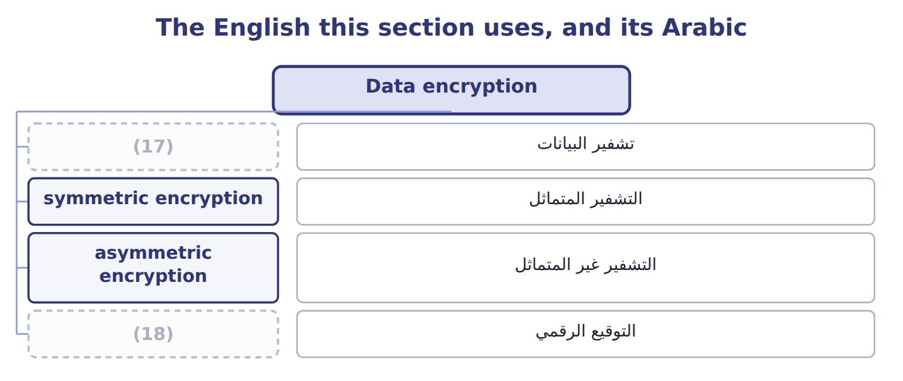
word list
التشفير المتماثل · data encryption · digital signature

The English this sheet uses, and its Arabic
English (exam term) | Arabic
data encryption | تشفير البيانات
symmetric encryption | التشفير المتماثل
asymmetric encryption | التشفير غير المتماثل
digital signature | التوقيع الرقمي

Answer key · 8.2 Data encryption

1 converts | 10 exchanged
2 understood | 11 Reversing
3 directions | 12 signature
4 problem | 13 standard
5 somehow | 14 accepted
6 untrusted | 15 post-quantum
7 encrypts | 16 anticipating
8 decrypt | 17 data encryption
9 nothing | 18 digital signature

the summaries in full
Summary 1 Data encryption converts readable data into a form that cannot be understood without a key. Symmetric encryption uses one key for both directions. It is fast and suits bulk data, but it leaves a problem. The key itself must reach the other party somehow, and sending it over the same untrusted network defeats the purpose. Each party has a pair of keys, and what one encrypts only the other can decrypt. Anyone may hold the public key, so nothing secret has to be exchanged first. Reversing the pair gives a digital signature: encrypting with the private key proves who sent the message, since only that person holds it. In practice the two are combined. A secure web connection uses asymmetric methods to agree a symmetric key, then uses that faster key for the conversation itself.
Summary 2 The current standard for traffic in transit is TLS, with version 1.2 the minimum accepted. Separately, the United States standards body published its first post-quantum encryption standards in August 2024, anticipating machines that could break today's asymmetric methods. Neither detail is likely to be examined; the principles above are.

8.3 Firewalls
Chapter 8 · section 8.3

Fill every gap. Each word list holds one word more than there are gaps.
Summary 1 gaps 1–3
A (1) sits between two networks and allows or blocks traffic (2) to rules. It is a border post: (3) crossing is examined against a list of what is permitted, and whatever is not permitted is refused.
word list
granted · everything · according · firewall

Types of firewall
Type of firewall (E.2.j) | What it does | Note
Packet filtering | (4) | Cheap and fast; blind to content
Stateful inspection | Tracks whole conversations, not single packets | (5)
Proxy or application gateway | Stands between the two sides and inspects content | (6)
Next-generation | (7) | The common corporate standard
Web application firewall | (8) | Used in front of a public website

word list
Protects one application from hostile requests · Slower; sees what the traffic actually contains · Application-aware, with intrusion prevention built in · Blocks traffic that does not belong to a session · Allows or blocks by address and port · Tracks whole conversations, not single packets

Summary 2 gaps 9–12
Firewalls have three (9) uses. They guard the boundary between the company and the (10) . They divide the internal network so a (11) in one part does not reach another. And they create a (12) zone for servers that must be reachable from outside.
word list
internet · protected · compromise · traffic · common

What a firewall does not do

Summary 3 gaps 13–21
A firewall does not stop (13) , because the user (14) the traffic. It does not stop an (15) , who is already inside. And it does not stop (16) carried on a device brought into the (17) . A (18) offering a firewall as the answer to any of these is offering the wrong answer. A firewall is a rule set, and a rule set ages. Ports opened for a project that ended, addresses permitted for a supplier no longer used, and (19) granted in an emergency all (20) exactly as system access does. The rules need the same (21) review.
word list
reachable · periodic · malware · building · insider · accumulate · question · exceptions · invites · phishing

The words this section uses
Each term sits against what it means.
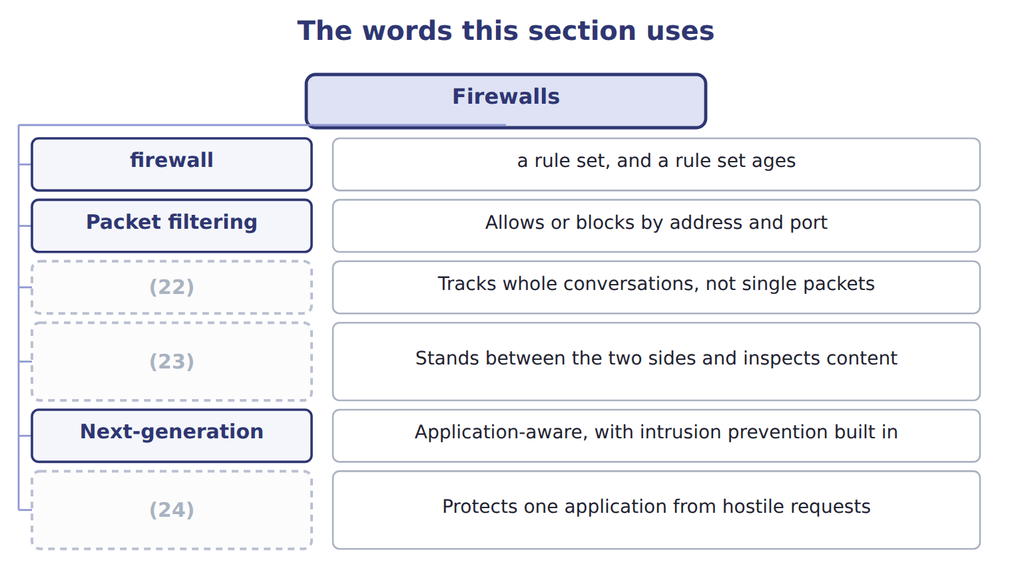
word list
Stateful inspection · remote site · Proxy or application gateway · Web application firewall

The English this sheet uses, and its Arabic
English (exam term) | Arabic
firewall | جدار الحماية

Answer key · 8.3 Firewalls

1 firewall | 13 phishing
2 according | 14 invites
3 everything | 15 insider
4 Allows or blocks by address and port | 16 malware
5 Blocks traffic that does not belong to a session | 17 building
6 Slower; sees what the traffic actually contains | 18 question
7 Application-aware, with intrusion prevention built in | 19 exceptions
8 Protects one application from hostile requests | 20 accumulate
9 common | 21 periodic
10 internet | 22 Stateful inspection
11 compromise | 23 Proxy or application gateway
12 protected | 24 Web application firewall

the summaries in full
Summary 1 A firewall sits between two networks and allows or blocks traffic according to rules. It is a border post: everything crossing is examined against a list of what is permitted, and whatever is not permitted is refused.
Summary 2 Firewalls have three common uses. They guard the boundary between the company and the internet. They divide the internal network so a compromise in one part does not reach another. And they create a protected zone for servers that must be reachable from outside.
Summary 3 A firewall does not stop phishing, because the user invites the traffic. It does not stop an insider, who is already inside. And it does not stop malware carried on a device brought into the building. A question offering a firewall as the answer to any of these is offering the wrong answer. A firewall is a rule set, and a rule set ages. Ports opened for a project that ended, addresses permitted for a supplier no longer used, and exceptions granted in an emergency all accumulate exactly as system access does. The rules need the same periodic review.

8.4 Why the backup must leave the building
Chapter 8 · section 8.4

Fill every gap. Each word list holds one word more than there are gaps.
Summary 1 gaps 1–12
The (1) here is simpler and more often got wrong: where the copies are kept. Every copy in one (2) shares one fate. A fire, a flood or a burst pipe (3) the live system and the backup (4) . The company then (5) it had been taking backups (6) for years to no purpose. That is the whole (7) for a remote site. The (8) rule of thumb is three copies, on two kinds of media, with one of them off site. (9) matters as much as location: a copy taken monthly means losing up to a month of work, which for most (10) is the same as losing everything. And (11) must be copied as well as data, because (12) records into a system nobody can rebuild is only half a recovery.
word list
question · building · Regularity · common · internet · together · programs · discovers · businesses · restoring · destroys · argument · faithfully

The English this sheet uses, and its Arabic
English (exam term) | Arabic
remote site | الموقع البعيد

Answer key · 8.4 Why the backup must leave the building

1 question | 7 argument
2 building | 8 common
3 destroys | 9 Regularity
4 together | 10 businesses
5 discovers | 11 programs
6 faithfully | 12 restoring

the summaries in full
Summary 1 The question here is simpler and more often got wrong: where the copies are kept. Every copy in one building shares one fate. A fire, a flood or a burst pipe destroys the live system and the backup together. The company then discovers it had been taking backups faithfully for years to no purpose. That is the whole argument for a remote site. The common rule of thumb is three copies, on two kinds of media, with one of them off site. Regularity matters as much as location: a copy taken monthly means losing up to a month of work, which for most businesses is the same as losing everything. And programs must be copied as well as data, because restoring records into a system nobody can rebuild is only half a recovery.

8.5 Business continuity and disaster recovery
Chapter 8 · section 8.5

Fill every gap. Each word list holds one word more than there are gaps.
Summary 1 gaps 1–7
Business (1) planning is the work of making sure the critical functions of the business can keep running during and after a (2) . (3) recovery planning is the part of it that (4) the systems and the data. Both start from the business (5) analysis, which asks what must not stop, for how long it could stop without (6) harm, and what it would cost per day. Without that analysis every system looks critical and the plan protects nothing in (7) .
word list
Disaster · restores · disruption · impact · particular · suppliers · continuity · serious

The components of a disaster recovery plan
Component of a disaster recovery plan | What it covers | Note
Roles and a recovery team | (8) | Named people, with deputies
Critical application ranking | (9) | From the business impact analysis
Communication plan | (10) | Contact details held off site as well
Recovery procedures | The steps, in order, to bring systems back | (11)
Testing and updating | Proof that the plan works, and maintenance of it | (12)

word list
Keep critical business functions running during and after a disruption · Which systems are restored first · Who decides to invoke the plan, and who does what · A plan never tested is an assumption · Written to be followed under pressure · How staff, customers and suppliers are told

Summary 2 gaps 13–20
The last (13) carries the most (14) . A plan that has never been (15) is a set of (16) . The assumption that fails is (17) a small one: a (18) list held only on the system that is down, or a backup nobody has ever tried to restore. (19) planning covers more than systems. It asks where staff would work, how (20) and suppliers would be told, which premises could be used, and who may authorise spending in the first hours. A company whose systems recover into an unusable building has recovered nothing.
word list
contact · weight · Continuity · component · tested · assumptions · nothing · customers · usually

Business continuity planning against disaster recovery planning
 | Business continuity plan (E.2.m) | Disaster recovery plan (E.2.n)
Purpose | Keep critical business functions running during and after a disruption | (21)
Scope | (22) : people, premises, suppliers, communications | Systems, data, networks
Starts from | (23) : what must not stop, and for how long | The criticality ranking the analysis produced
Key measures | (24) | Recovery time objective and recovery point objective
Relationship | The wider plan | (25)

word list
Maximum tolerable outage for each function · A plan never tested is an assumption · The business impact analysis · The whole business · Restore the IT systems and the data · The IT part of the wider plan

The words this section uses
Each term sits against what it means.
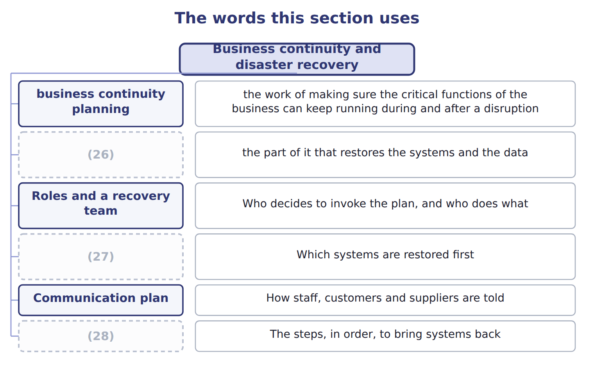
word list
Recovery procedures · disaster recovery planning · remote site · Critical application ranking

The English this sheet uses, and its Arabic
English (exam term) | Arabic
business continuity planning | تخطيط استمرارية الأعمال
disaster recovery planning | تخطيط التعافي من الكوارث
business impact analysis | تحليل الأثر على الأعمال

Answer key · 8.5 Business continuity and disaster recovery

1 continuity | 15 tested
2 disruption | 16 assumptions
3 Disaster | 17 usually
4 restores | 18 contact
5 impact | 19 Continuity
6 serious | 20 customers
7 particular | 21 Restore the IT systems and the data
8 Who decides to invoke the plan, and who does what | 22 The whole business
9 Which systems are restored first | 23 The business impact analysis
10 How staff, customers and suppliers are told | 24 Maximum tolerable outage for each function
11 Written to be followed under pressure | 25 The IT part of the wider plan
12 A plan never tested is an assumption | 26 disaster recovery planning
13 component | 27 Critical application ranking
14 weight | 28 Recovery procedures

the summaries in full
Summary 1 Business continuity planning is the work of making sure the critical functions of the business can keep running during and after a disruption. Disaster recovery planning is the part of it that restores the systems and the data. Both start from the business impact analysis, which asks what must not stop, for how long it could stop without serious harm, and what it would cost per day. Without that analysis every system looks critical and the plan protects nothing in particular.
Summary 2 The last component carries the most weight. A plan that has never been tested is a set of assumptions. The assumption that fails is usually a small one: a contact list held only on the system that is down, or a backup nobody has ever tried to restore. Continuity planning covers more than systems. It asks where staff would work, how customers and suppliers would be told, which premises could be used, and who may authorise spending in the first hours. A company whose systems recover into an unusable building has recovered nothing.

8.6 Hot, warm and cold sites
Chapter 8 · section 8.6

Fill every gap. Each word list holds one word more than there are gaps.
Summary 1 gaps 1–10
An (1) site is where (2) resumes when the main site cannot be used. The choice is an (3) one, and two (4) decide it. The recovery time objective is the longest the (5) can be without the (6) . The recovery point objective is the most data it can (7) to lose, measured in time, which (8) how often backups must run. A (9) recovery time objective needs a hot site, (10) it costs. A tolerance of two weeks makes a cold site perfectly rational. Paying for a hot site where a cold one would do is as much a failure of judgement as the reverse, because the money has to come from somewhere.
word list
economic · processing · afford · whatever · measures · business · decides · system · four-hour · alternate · because

The English this sheet uses, and its Arabic
English (exam term) | Arabic
recovery time objective | هدف وقت الاستعادة
recovery point objective | هدف نقطة الاستعادة

Answer key · 8.6 Hot, warm and cold sites

1 alternate | 6 system
2 processing | 7 afford
3 economic | 8 decides
4 measures | 9 four-hour
5 business | 10 whatever

the summaries in full
Summary 1 An alternate site is where processing resumes when the main site cannot be used. The choice is an economic one, and two measures decide it. The recovery time objective is the longest the business can be without the system. The recovery point objective is the most data it can afford to lose, measured in time, which decides how often backups must run. A four-hour recovery time objective needs a hot site, whatever it costs. A tolerance of two weeks makes a cold site perfectly rational. Paying for a hot site where a cold one would do is as much a failure of judgement as the reverse, because the money has to come from somewhere.

8.7 Extended Example 8A: choosing a recovery arrangement for Orontes
Chapter 8 · section 8.7

Fill every gap. Each word list holds one word more than there are gaps.
Summary 1 gaps 1–12
This example works (1) the choice for three (2) systems and shows why one answer does not fit them all. It is (3) : questions give a (4) and ask for the site. The plant control system runs the (5) lines and stops (6) within minutes of failing. The payables and receivables system can wait a (7) day without (8) harm. The management reporting system can wait two weeks, because the (9) pack can be (10) . Plant control is given a recovery time objective of four hours and a recovery point objective of (11) minutes. Payables and receivables get one day and four hours. Management reporting gets two weeks and one day. Plant control needs a hot site with (12) replication, because four hours allows no time to configure anything. Payables and receivables can use a warm site: the hardware waits, and a day is enough to restore and configure.
word list
through · fifteen · near-continuous · production · bottling · technology · Orontes · exam-core · serious · rebuilt · working · tolerance · month-end

Summary 2 gaps 13–21
Management (13) can use a cold site, since two weeks is time to bring (14) . The recovery point (15) sets the backup frequency, and this is the (16) candidates miss. Fifteen minutes of (17) loss means (18) rather than nightly backups. Four hours means copies (19) times a day. One day means the nightly backup is (20) . Orontes (21) holds every copy in the server room beside the live machines. Moving one copy off site costs very little and removes the single risk that would otherwise defeat all three plans at once, which is a fire in that room.
word list
restore · equipment · tolerable · replication · objective · enough · several · reporting · connection · currently

Match four requirements

Complete the blank cells.

Your turn: match four requirements (complete the blanks)
Every item belongs to exactly one group.
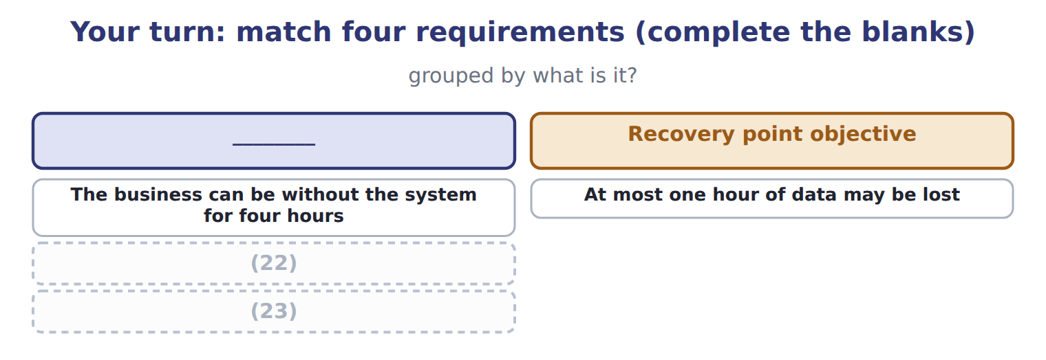
word list
A site fully equipped with current data · At most one hour of data may be lost · A site with space and power but no equipment

The pattern behind the choice

Summary 3 gaps 24–27
Start from the (24) impact analysis, not from the (25) . The recovery time objective chooses the site: hours means hot, days means warm, weeks means cold. The recovery point objective chooses the backup (26) . One copy off site (27) every plan against the loss of the building.
word list
backups · frequency · technology · business · protects

Exam view

Summary 4 gaps 28–31
A (28) gives a tolerance and four site (29) . Match the time: (30) or hours is hot, hours to days is warm, days to weeks is cold. If it gives a data loss tolerance instead, it is asking about backup (31) , not about the site.
word list
analysis · minutes · question · options · frequency

Exam view
Item | Answer
The business can be without the system for four hours | Recovery time objective — it measures acceptable downtime, and four hours points to a hot site
At most one hour of data may be lost | Why: the (32) is measured in time but describes data, so it sets how often backups must run
A site with space and power but no equipment | Cold site — equipment must be brought in and installed, so recovery takes days to weeks
A site fully equipped with current data | Hot site — it can take over in (33) to hours, and costs the most

word list
minutes · equipment · recovery point objective

System — Category
System | Category
Plant control, four hours | Hot site
Payables, one working day | (34)
Management reporting, two weeks | (35)

word list
Warm site · remote site · Cold site

The English this section uses, and its Arabic
Each term sits against what it means.
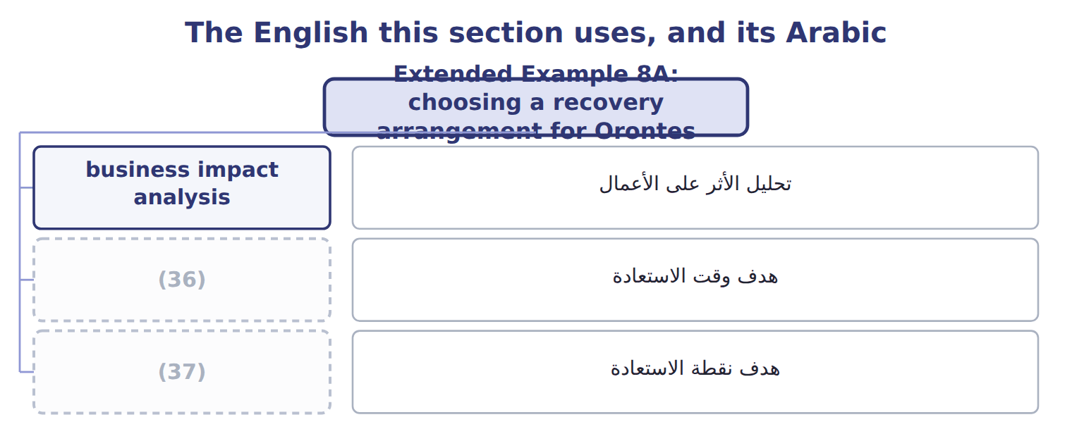
word list
disaster recovery planning · recovery time objective · recovery point objective

Answer key · 8.7 Extended Example 8A: choosing a recovery arrangement for Orontes

1 through | 20 enough
2 Orontes | 21 currently
3 exam-core | 22 A site with space and power but no equipment
4 tolerance | 23 A site fully equipped with current data
5 bottling | 24 business
6 production | 25 technology
7 working | 26 frequency
8 serious | 27 protects
9 month-end | 28 question
10 rebuilt | 29 options
11 fifteen | 30 minutes
12 near-continuous | 31 frequency
13 reporting | 32 recovery point objective
14 equipment | 33 minutes
15 objective | 34 Warm site
16 connection | 35 Cold site
17 tolerable | 36 recovery time objective
18 replication | 37 recovery point objective
19 several

the summaries in full
Summary 1 This example works through the choice for three Orontes systems and shows why one answer does not fit them all. It is exam-core: questions give a tolerance and ask for the site. The plant control system runs the bottling lines and stops production within minutes of failing. The payables and receivables system can wait a working day without serious harm. The management reporting system can wait two weeks, because the month-end pack can be rebuilt. Plant control is given a recovery time objective of four hours and a recovery point objective of fifteen minutes. Payables and receivables get one day and four hours. Management reporting gets two weeks and one day. Plant control needs a hot site with near-continuous replication, because four hours allows no time to configure anything. Payables and receivables can use a warm site: the hardware waits, and a day is enough to restore and configure.
Summary 2 Management reporting can use a cold site, since two weeks is time to bring equipment. The recovery point objective sets the backup frequency, and this is the connection candidates miss. Fifteen minutes of tolerable loss means replication rather than nightly backups. Four hours means copies several times a day. One day means the nightly backup is enough. Orontes currently holds every copy in the server room beside the live machines. Moving one copy off site costs very little and removes the single risk that would otherwise defeat all three plans at once, which is a fire in that room.
Summary 3 Start from the business impact analysis, not from the technology. The recovery time objective chooses the site: hours means hot, days means warm, weeks means cold. The recovery point objective chooses the backup frequency. One copy off site protects every plan against the loss of the building.
Summary 4 A question gives a tolerance and four site options. Match the time: minutes or hours is hot, hours to days is warm, days to weeks is cold. If it gives a data loss tolerance instead, it is asking about backup frequency, not about the site.

