9.1 What an accounting information system does
Chapter 9 · section 9.1

Fill every gap. Each word list holds one word more than there are gaps.
Chapter 9, section by section
Each stage leads to the next.
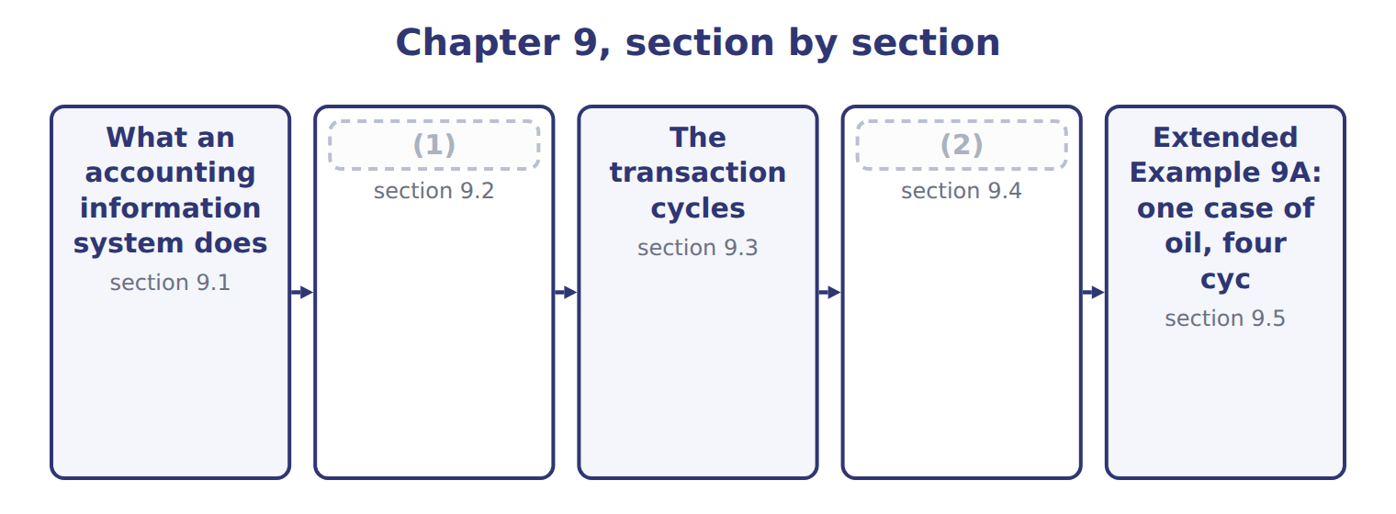
word list
The cost of separate systems · What an accounting information system does · The system within the value chain

An accounting information system captures, processes, stores and reports the economic events of a business.
What an accounting information system does
What an AIS does | Meaning | At Orontes
Capture | Record each economic event as it happens | (3)
Process | Classify, value and summarise the events | (4)
Store | Keep the record so it can be found again | (5)
Report | (6) | The payables ageing of Book 1, Chapter 6
Control | Ensure what is captured is complete and authorized | (7)

word list
The payables ageing of Book 1, Chapter 6 · The invoice matched and posted to payables · The supplier account and the audit trail · The input controls of Chapter 7 · Present the result to whoever must decide · A goods received note raised at the gate

Summary 1 gaps 8–12
A system that captures and (8) but does not control what it captures (9) numbers nobody should rely on, which is why. Notice what the (10) does not say. It does not (11) the system to (12) data. The cases produced, the hours worked and the energy used are all economic events, and a modern system captures them alongside the amounts.
word list
confine · financial · reports · definition · produces · economic

The words this section uses
Each term sits against what it means.
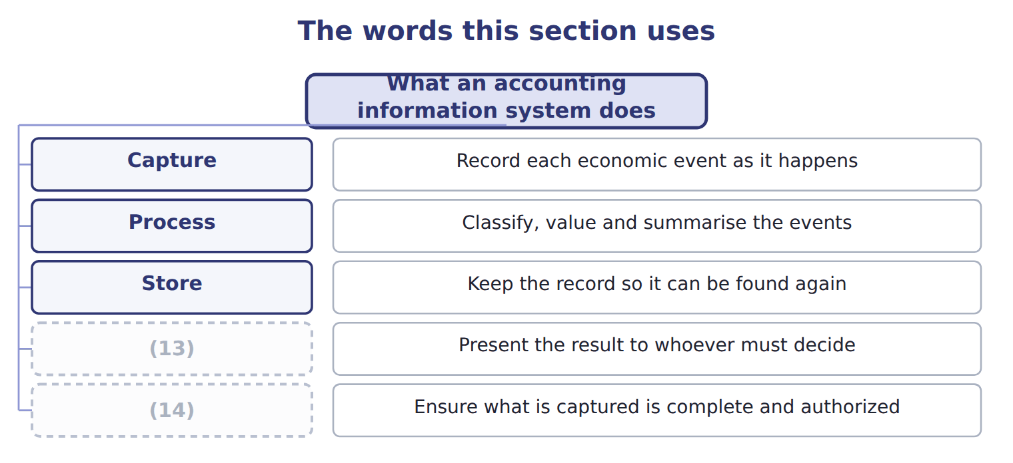
word list
Control · Store · Report

The English this sheet uses, and its Arabic
English (exam term) | Arabic
accounting information system | نظام المعلومات المحاسبية
value chain | سلسلة القيمة

Answer key · 9.1 What an accounting information system does

1 The system within the value chain | 8 reports
2 The cost of separate systems | 9 produces
3 A goods received note raised at the gate | 10 definition
4 The invoice matched and posted to payables | 11 confine
5 The supplier account and the audit trail | 12 financial
6 Present the result to whoever must decide | 13 Report
7 The input controls of Chapter 7 | 14 Control

the summaries in full
Summary 1 A system that captures and reports but does not control what it captures produces numbers nobody should rely on, which is why. Notice what the definition does not say. It does not confine the system to financial data. The cases produced, the hours worked and the energy used are all economic events, and a modern system captures them alongside the amounts.

9.2 The system within the value chain
Chapter 9 · section 9.2

Fill every gap. Each word list holds one word more than there are gaps.
Summary 1 gaps 1–9
The value chain (1) a business into the primary activities that create the product and the support activities that make them (2) . It is a support activity, and it is (3) among them (4) it touches every primary activity rather than one. Inbound (5) generates receipts, (6) generates production records, sales generates invoices, and service generates warranty claims. Each (7) an entry. The practical (8) is that the system is the only place where the whole business can be seen at once. That is why its design decides what (9) can ask. A system organised only around the ledger cannot answer a question about a product or a customer.
word list
operations · unusual · because · consequence · becomes · divides · product · logistics · possible · management

Answer key · 9.2 The system within the value chain

1 divides | 6 operations
2 possible | 7 becomes
3 unusual | 8 consequence
4 because | 9 management
5 logistics

the summaries in full
Summary 1 The value chain divides a business into the primary activities that create the product and the support activities that make them possible. It is a support activity, and it is unusual among them because it touches every primary activity rather than one. Inbound logistics generates receipts, operations generates production records, sales generates invoices, and service generates warranty claims. Each becomes an entry. The practical consequence is that the system is the only place where the whole business can be seen at once. That is why its design decides what management can ask. A system organised only around the ledger cannot answer a question about a product or a customer.

9.3 The transaction cycles
Chapter 9 · section 9.3

Fill every gap. Each word list holds one word more than there are gaps.
Summary 1 gaps 1–12
Transactions are (1) into cycles, each (2) a sequence of related events. The revenue cycle, often called revenue to cash, runs from the (3) order to the (4) of cash. The expenditure cycle, or expenditure to (5) , runs from the (6) request to the payment. The (7) cycle converts (8) into finished goods, and the payroll cycle turns hours into wages. The (9) ledger and (10) cycle is the fifth, and it differs from the others. It (11) few transactions of its own: its work is to receive the (12) results of the other four, close the period, produce the statements, and hold the audit trail that leads back from any total to the entries behind it. Each cycle has its own documents, master files and controls. A weakness in one cycle rarely stays there, because the ledger receives whatever the cycle sends it.
word list
collection · covering · summarised · grouped · reporting · disbursement · whatever · materials · originates · purchase · general · production · customer

The English this section uses, and its Arabic
Each term sits against what it means.
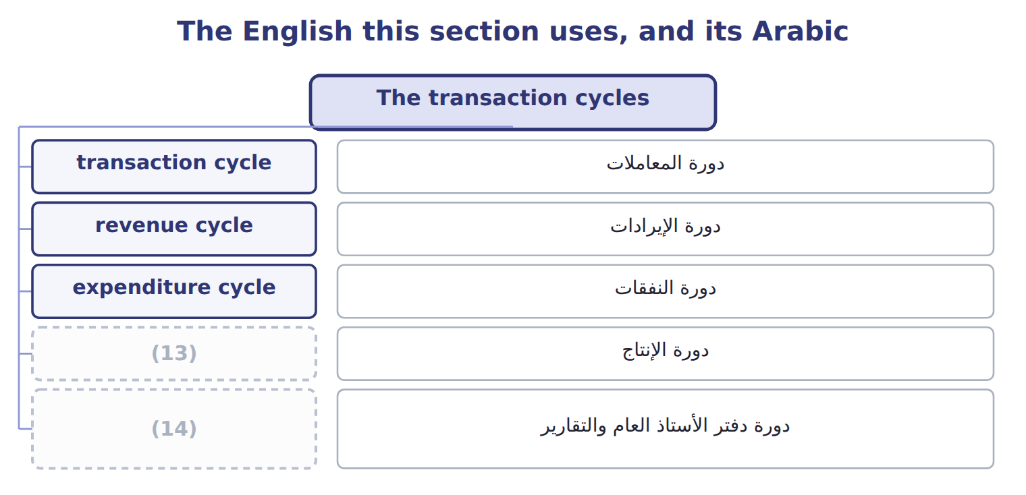
word list
production cycle · value chain · general ledger and reporting cycle

The English this sheet uses, and its Arabic
English (exam term) | Arabic
transaction cycle | دورة المعاملات
revenue cycle | دورة الإيرادات
expenditure cycle | دورة النفقات
production cycle | دورة الإنتاج
general ledger and reporting cycle | دورة دفتر الأستاذ العام والتقارير

Answer key · 9.3 The transaction cycles

1 grouped | 8 materials
2 covering | 9 general
3 customer | 10 reporting
4 collection | 11 originates
5 disbursement | 12 summarised
6 purchase | 13 production cycle
7 production | 14 general ledger and reporting cycle

the summaries in full
Summary 1 Transactions are grouped into cycles, each covering a sequence of related events. The revenue cycle, often called revenue to cash, runs from the customer order to the collection of cash. The expenditure cycle, or expenditure to disbursement, runs from the purchase request to the payment. The production cycle converts materials into finished goods, and the payroll cycle turns hours into wages. The general ledger and reporting cycle is the fifth, and it differs from the others. It originates few transactions of its own: its work is to receive the summarised results of the other four, close the period, produce the statements, and hold the audit trail that leads back from any total to the entries behind it. Each cycle has its own documents, master files and controls. A weakness in one cycle rarely stays there, because the ledger receives whatever the cycle sends it.

9.4 The cost of separate systems
Chapter 9 · section 9.4

Fill every gap. Each word list holds one word more than there are gaps.
Summary 1 gaps 1–2
Most companies arrive at several systems rather than (1) them. A plant buys software to schedule (2) , sales buys something to track customers, and finance keeps the ledger it has always had.
word list
production · choosing · transfer

The challenges of separate financial and nonfinancial systems
Challenge (F.1.c) | What it means | At Orontes
Duplicate data entry | The same fact is keyed into two systems | (3) enters output; accounting enters it again for costing
Data that disagrees | Two systems hold different versions of the same figure | (4)
Reconciliation effort | Staff spend time (5) the difference, not analysing it | Two days a month closing the gap
Delay | Information waits for a transfer or a monthly extract | (6)
No single view | (7) | Profit by product needs three systems and a spreadsheet
Weak control | The transfer between systems is where errors hide | (8)

word list
explaining · A manual upload nobody reconciles · Nobody can see one customer or product end to end · Production · Two days a month closing the gap · Managers see last month's margin in the third week · The plant says 240,000 cases; the ledger says 238,500

Summary 2 gaps 9–15
The first two (9) are the ones (10) name, and the fifth is the one that matters most. When no system holds the whole picture, a (11) as ordinary as which (12) earns the most becomes a project rather than a query. By the time it is (13) the month has moved on. There is a control (14) too. The (15) between two systems is where errors hide, because it belongs to neither. A monthly upload that nobody reconciles is exactly the kind of gap.
word list
candidates · product · transfer · answered · question · choosing · challenges · dimension

The words this section uses
Each term sits against what it means.
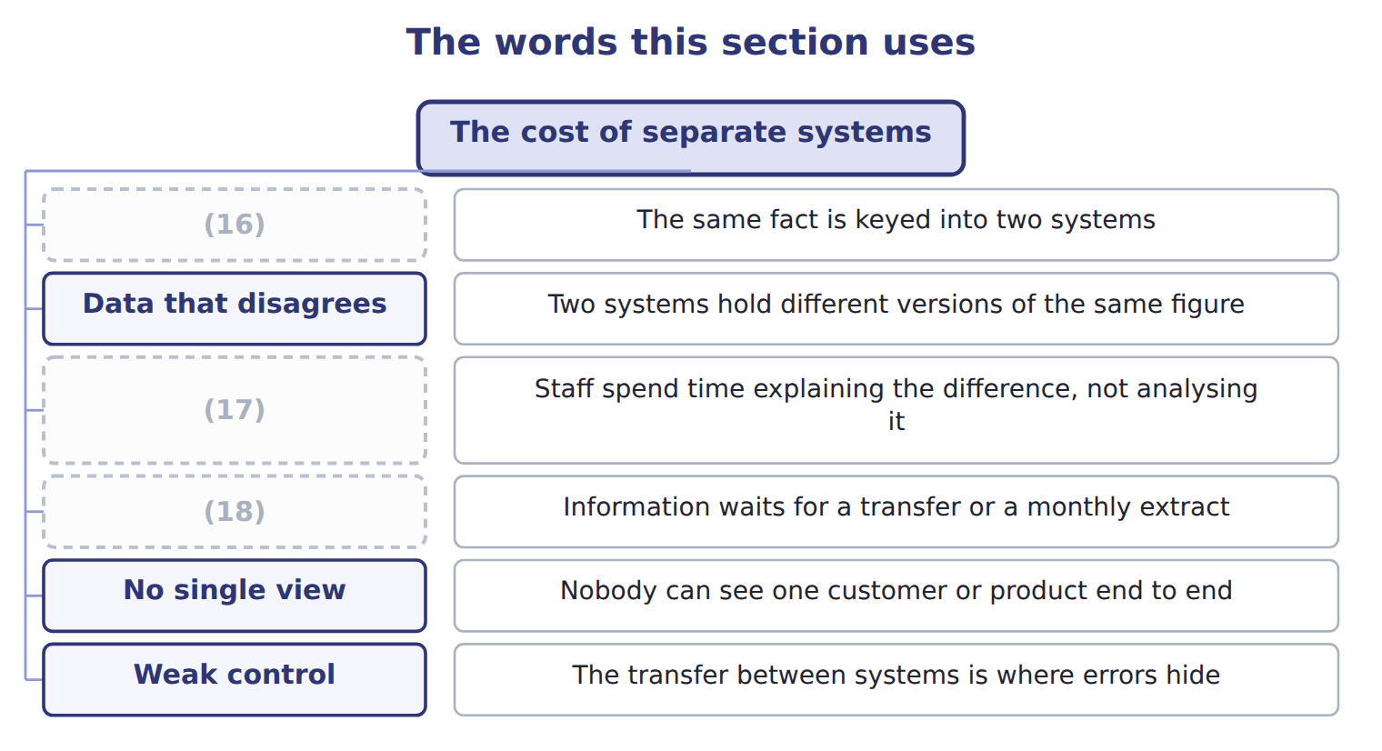
word list
Reconciliation effort · Delay · Duplicate data entry · nonfinancial system

The English this sheet uses, and its Arabic
English (exam term) | Arabic
nonfinancial system | النظام غير المالي
single view | الرؤية الموحدة

Answer key · 9.4 The cost of separate systems

1 choosing | 10 candidates
2 production | 11 question
3 Production | 12 product
4 The plant says 240,000 cases; the ledger says 238,500 | 13 answered
5 explaining | 14 dimension
6 Managers see last month's margin in the third week | 15 transfer
7 Nobody can see one customer or product end to end | 16 Duplicate data entry
8 A manual upload nobody reconciles | 17 Reconciliation effort
9 challenges | 18 Delay

the summaries in full
Summary 1 Most companies arrive at several systems rather than choosing them. A plant buys software to schedule production, sales buys something to track customers, and finance keeps the ledger it has always had.
Summary 2 The first two challenges are the ones candidates name, and the fifth is the one that matters most. When no system holds the whole picture, a question as ordinary as which product earns the most becomes a project rather than a query. By the time it is answered the month has moved on. There is a control dimension too. The transfer between two systems is where errors hide, because it belongs to neither. A monthly upload that nobody reconciles is exactly the kind of gap.

9.5 Extended Example 9A: one case of oil, four cycles
Chapter 9 · section 9.5

Fill every gap. Each word list holds one word more than there are gaps.
Summary 1 gaps 1–12
This example follows a single case of olive oil from the (1) of the olives to the (2) of cash, naming the cycle at each step. It is (3) : questions give an event and ask which cycle it (4) to. The (5) department raises a request, the manager approves it, the (6) receives the delivery and accounts payable pays the farmer. That is the (7) cycle from end to end, and it (8) a payable and then removes it. Materials are issued to the (9) line, labour is recorded against the batch and overhead is applied at the rate Book 2 (10) . The (11) cycle moves the cost from raw materials through work in process to (12) goods. The hours recorded against that batch also flow through the payroll cycle, which calculates gross pay, deducts what must be deducted and pays the net amount.
word list
production · purchase · because · purchasing · belongs · established · expenditure · finished · storekeeper · exam-core · pressing · collection · creates

Summary 2 gaps 13–24
The same hours (13) appear in two cycles, for two (14) purposes. A Gulf (15) orders, the (16) ships, the system invoices and the cash arrives sixty days later. That is the (17) cycle, and it creates a (18) and then removes it. At Orontes the (19) system holds the batch and its hours, (20) holds the same hours, and the ledger holds the cost. (21) joins them (22) . To ask what that case of oil (23) cost, somebody must export from three (24) and match them by hand. The ledger receives four summarised postings and knows the margin on the case. It cannot say whether the margin came from a good price, a cheap harvest or an efficient shift, because the detail that would answer that stayed behind in the cycles.
word list
systems · Nothing · receivable · distributor · different · efficient · production · payroll · revenue · therefore · actually · warehouse · automatically

Name four cycles

Complete the blank cells.

Your turn: name four cycles (complete the blanks)
Every item belongs to exactly one group.
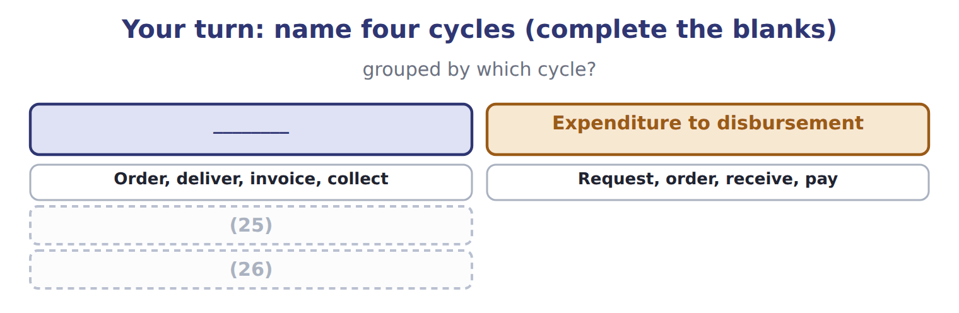
word list
Request, order, receive, pay · Hire, record time, pay · Issue materials, apply labour and overhead

The pattern behind the example

Summary 3 gaps 27–30
Name the cycle by where the (27) ends: cash in, cash out, finished goods, or wages. One event may belong to two cycles, as hours belong to (28) and payroll. The ledger receives (29) , not detail. Separate systems mean the detail cannot be (30) without manual work.
word list
receivable · summaries · sequence · reassembled · production

Exam view

Summary 4 gaps 31–33
A (31) names an activity and asks for the cycle. (32) it to its end. Issuing materials ends in finished goods, so it is (33) ; recording the hours of the same worker ends in a wage payment, so it is payroll.
word list
production · request · Follow · question

Exam view
Item | Answer
Order, deliver, invoice, collect | Revenue to cash — it ends with cash coming in from the customer
Request, order, receive, pay | Why: the sequence ends with cash going out to the supplier, which is what defines the (34)
Issue materials, apply labour and overhead | Production — it ends with finished goods ready to sell
Hire, record time, pay | Human resources and payroll — it ends with wages paid and (35) accounted for

word list
deductions · Category · expenditure cycle

Event or record — Category
Event or record | Category
Invoicing a Gulf distributor | Revenue to cash
Paying the olive farmer | Expenditure to disbursement
Issuing materials to the pressing line | (36)
Calculating deductions from a worker's gross pay | (37)

word list
Production · Answer · Human resources and payroll

The English this section uses, and its Arabic
Each term sits against what it means.
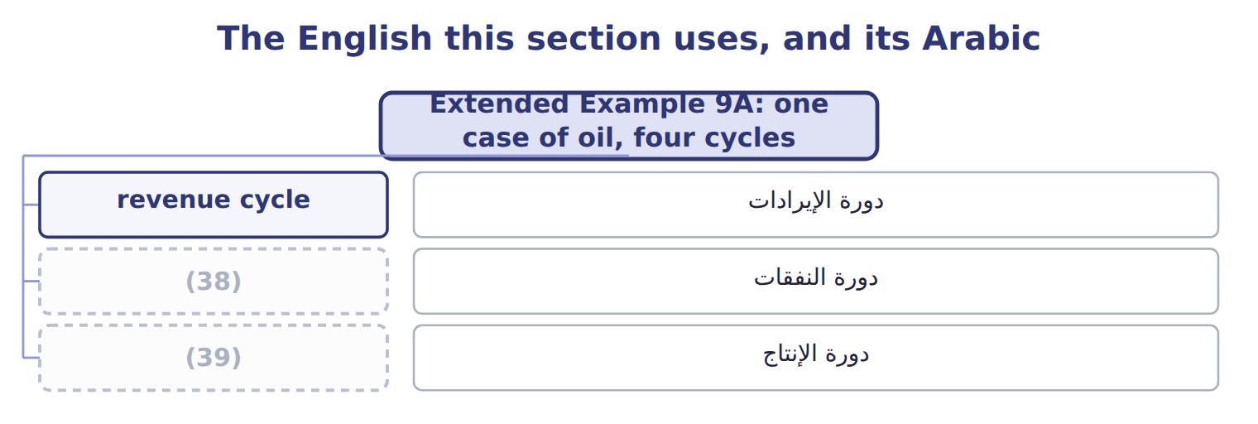
word list
expenditure cycle · production cycle · دورة الإيرادات

Answer key · 9.5 Extended Example 9A: one case of oil, four cycles

1 purchase | 21 Nothing
2 collection | 22 automatically
3 exam-core | 23 actually
4 belongs | 24 systems
5 purchasing | 25 Issue materials, apply labour and overhead
6 storekeeper | 26 Hire, record time, pay
7 expenditure | 27 sequence
8 creates | 28 production
9 pressing | 29 summaries
10 established | 30 reassembled
11 production | 31 question
12 finished | 32 Follow
13 therefore | 33 production
14 different | 34 expenditure cycle
15 distributor | 35 deductions
16 warehouse | 36 Production
17 revenue | 37 Human resources and payroll
18 receivable | 38 expenditure cycle
19 production | 39 production cycle
20 payroll

the summaries in full
Summary 1 This example follows a single case of olive oil from the purchase of the olives to the collection of cash, naming the cycle at each step. It is exam-core: questions give an event and ask which cycle it belongs to. The purchasing department raises a request, the manager approves it, the storekeeper receives the delivery and accounts payable pays the farmer. That is the expenditure cycle from end to end, and it creates a payable and then removes it. Materials are issued to the pressing line, labour is recorded against the batch and overhead is applied at the rate Book 2 established. The production cycle moves the cost from raw materials through work in process to finished goods. The hours recorded against that batch also flow through the payroll cycle, which calculates gross pay, deducts what must be deducted and pays the net amount.
Summary 2 The same hours therefore appear in two cycles, for two different purposes. A Gulf distributor orders, the warehouse ships, the system invoices and the cash arrives sixty days later. That is the revenue cycle, and it creates a receivable and then removes it. At Orontes the production system holds the batch and its hours, payroll holds the same hours, and the ledger holds the cost. Nothing joins them automatically. To ask what that case of oil actually cost, somebody must export from three systems and match them by hand. The ledger receives four summarised postings and knows the margin on the case. It cannot say whether the margin came from a good price, a cheap harvest or an efficient shift, because the detail that would answer that stayed behind in the cycles.
Summary 3 Name the cycle by where the sequence ends: cash in, cash out, finished goods, or wages. One event may belong to two cycles, as hours belong to production and payroll. The ledger receives summaries, not detail. Separate systems mean the detail cannot be reassembled without manual work.
Summary 4 A question names an activity and asks for the cycle. Follow it to its end. Issuing materials ends in finished goods, so it is production; recording the hours of the same worker ends in a wage payment, so it is payroll.

