11.1 Governance and management
Chapter 11 · section 11.1

Fill every gap. Each word list holds one word more than there are gaps.
Chapter 11, section by section
Each stage leads to the next.
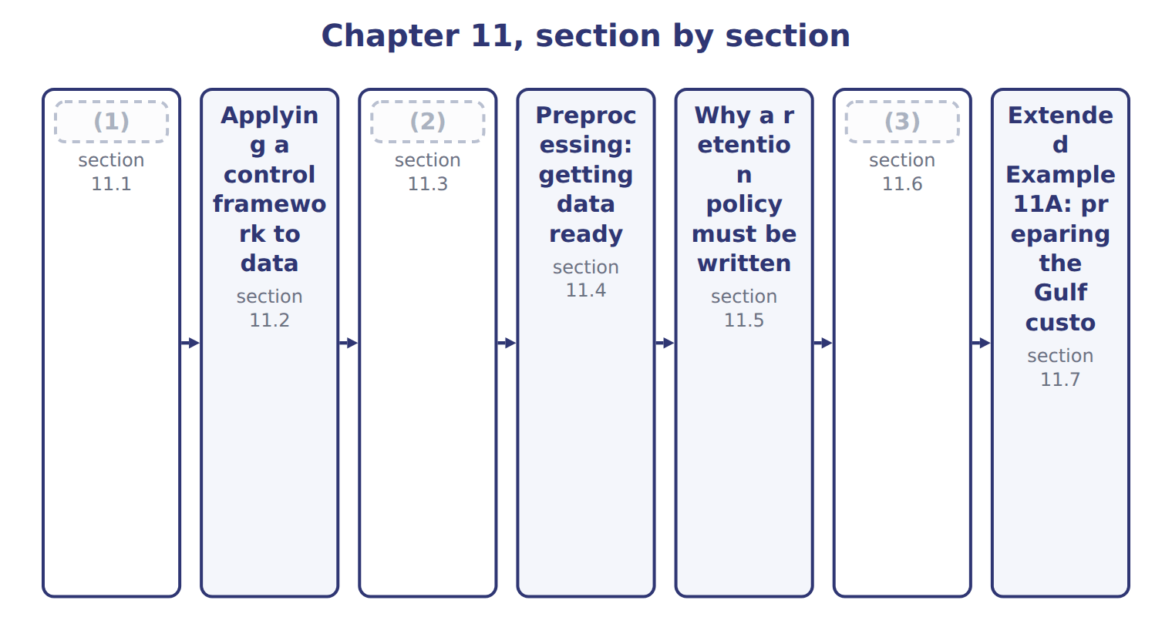
word list
record retention policy · The data life cycle · Governance and management · Controls and tools against cyberattack

Summary 1 gaps 4–14
Data governance is the exercise of (4) and decision rights over data: who owns it, what may be done with it, and to what (5) it is held. Data management is the work of carrying those (6) out. The (7) is worth holding firmly, because the exam tests it (8) and because companies confuse it in (9) . Governance (10) ; management does. A company with a (11) excellent data team and no decision rights has management without governance, and nobody can say who is allowed to change a (12) . The practical (13) of governance is the data owner: a named person, usually in the business rather than in the (14) function, who answers for the quality and the use of one domain of data.
word list
excellent · distinction · definition · technology · decisions · practice · decides · authority · expression · directly · standard · technically

Data governance against data management
 | Data governance | Data management
Question it answers | (15) | How is it actually done?
Typical outputs | Policies, ownership, decision rights, standards | (16)
Who does it | (17) | Technical and operational teams
Example at Orontes | Deciding that the plant owns production data | (18)
In one line | (19) | Management does

word list
Governance decides · A council or committee, with named data owners · Who decides, and by what authority? · Architecture, loading, quality work, storage · Loading it nightly and fixing bad records · Technical and operational teams

The English this section uses, and its Arabic
Each term sits against what it means.
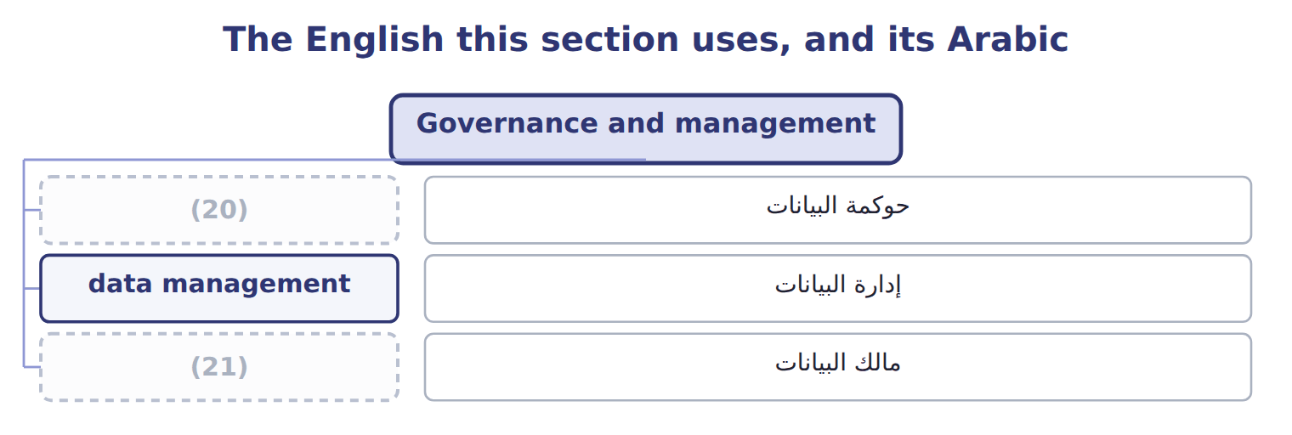
word list
data governance · data owner · data management

The English this sheet uses, and its Arabic
English (exam term) | Arabic
data governance | حوكمة البيانات
data management | إدارة البيانات
data owner | مالك البيانات

Answer key · 11.1 Governance and management

1 Governance and management | 12 definition
2 The data life cycle | 13 expression
3 Controls and tools against cyberattack | 14 technology
4 authority | 15 Who decides, and by what authority?
5 standard | 16 Architecture, loading, quality work, storage
6 decisions | 17 A council or committee, with named data owners
7 distinction | 18 Loading it nightly and fixing bad records
8 directly | 19 Governance decides
9 practice | 20 data governance
10 decides | 21 data owner
11 technically

the summaries in full
Summary 1 Data governance is the exercise of authority and decision rights over data: who owns it, what may be done with it, and to what standard it is held. Data management is the work of carrying those decisions out. The distinction is worth holding firmly, because the exam tests it directly and because companies confuse it in practice. Governance decides; management does. A company with a technically excellent data team and no decision rights has management without governance, and nobody can say who is allowed to change a definition. The practical expression of governance is the data owner: a named person, usually in the business rather than in the technology function, who answers for the quality and the use of one domain of data.

11.2 Applying a control framework to data
Chapter 11 · section 11.2

Fill every gap. Each word list holds one word more than there are gaps.
Summary 1 gaps 1–9
The exam asks specifically how COSO's (1) Control framework (2) to data governance. The (3) is that it is not (4) at all: the same five components. Two components do most of the work here. Information and (5) becomes the question of whether anyone knows what data exists and what it means, which is why a data (6) matters. (7) becomes the question of whether data quality is (8) at all. Other frameworks exist and are worth (9) by name. COBIT addresses the governance of information and technology more broadly, and the NIST Cybersecurity Framework addresses security specifically. None of them replaces COSO; they apply it to narrower subjects.
word list
Internal · communication · Monitoring · recognising · answer · changed · measured · applies · dictionary · quality

Answer key · 11.2 Applying a control framework to data

1 Internal | 6 dictionary
2 applies | 7 Monitoring
3 answer | 8 measured
4 changed | 9 recognising
5 communication

the summaries in full
Summary 1 The exam asks specifically how COSO's Internal Control framework applies to data governance. The answer is that it is not changed at all: the same five components. Two components do most of the work here. Information and communication becomes the question of whether anyone knows what data exists and what it means, which is why a data dictionary matters. Monitoring becomes the question of whether data quality is measured at all. Other frameworks exist and are worth recognising by name. COBIT addresses the governance of information and technology more broadly, and the NIST Cybersecurity Framework addresses security specifically. None of them replaces COSO; they apply it to narrower subjects.

11.3 The data life cycle
Chapter 11 · section 11.3

Fill every gap. Each word list holds one word more than there are gaps.
Summary 1 gaps 1–10
Data has a life, and the exam names eight (1) of it. The order (2) less than the two (3) inside it. (4) creates new values from existing ones, such as a cost per case derived from hours and output, and those derived values need (5) exactly as captured ones do. (6) examines data for (7) , which is the subject of Part IV. The pair most often (8) is the last two. (9) removes data from the live system but does not destroy it: the data still exists, still has to be protected, and is still (10) in a dispute. A company that believes archiving has discharged its obligations has misunderstood both.
word list
governing · Analytics · stages · confused · creates · matters · distinctions · Archival · Synthesis · discoverable · patterns

The English this section uses, and its Arabic
Each term sits against what it means.
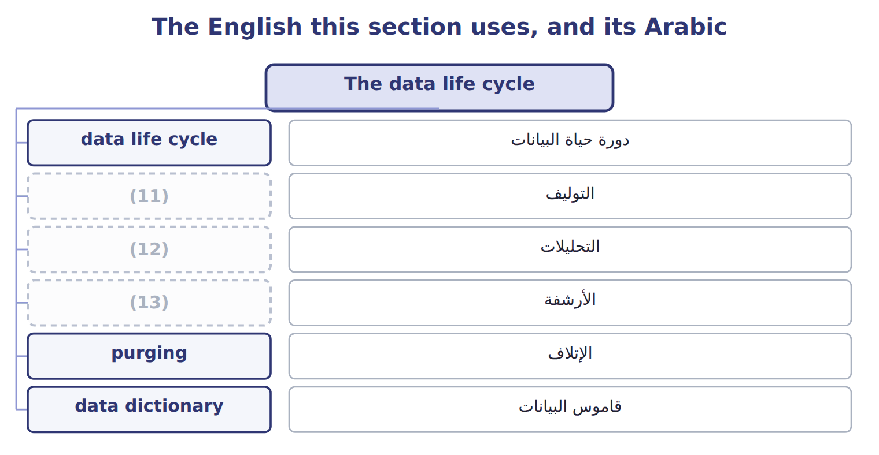
word list
synthesis · archival · analytics · التحليلات

The English this sheet uses, and its Arabic
English (exam term) | Arabic
data life cycle | دورة حياة البيانات
synthesis | التوليف
analytics | التحليلات
archival | الأرشفة
purging | الإتلاف
data dictionary | قاموس البيانات

Answer key · 11.3 The data life cycle

1 stages | 8 confused
2 matters | 9 Archival
3 distinctions | 10 discoverable
4 Synthesis | 11 synthesis
5 governing | 12 analytics
6 Analytics | 13 archival
7 patterns

the summaries in full
Summary 1 Data has a life, and the exam names eight stages of it. The order matters less than the two distinctions inside it. Synthesis creates new values from existing ones, such as a cost per case derived from hours and output, and those derived values need governing exactly as captured ones do. Analytics examines data for patterns, which is the subject of Part IV. The pair most often confused is the last two. Archival removes data from the live system but does not destroy it: the data still exists, still has to be protected, and is still discoverable in a dispute. A company that believes archiving has discharged its obligations has misunderstood both.

11.4 Preprocessing: getting data ready
Chapter 11 · section 11.4

Fill every gap. Each word list holds one word more than there are gaps.
Summary 1 gaps 1–2
Raw data is rarely fit for (1) . (2) is the work of making it so, and the exam names four steps.
word list
Preprocessing · analysis · outliers

The four steps of preprocessing
Preprocessing step (F.2.d) | What it does | At Orontes
Consolidation | (3) | Plant output, payroll hours and ledger cost in one table
Cleaning (cleansing) | Remove duplicates, fix errors, handle missing values and outliers | Two (4) of one supplier merged; a blank rate filled or flagged
Transformation | Put the data into the form the analysis needs | Dates to quarters, amounts to a single currency, (5) coded
Reduction | (6) | Twelve monthly columns replaced by four quarterly ones

word list
spellings · Remove duplicates, fix errors, handle missing values and outliers · Cut the data to what the analysis actually needs · categories · Bring the sources together into one set

Summary 2 gaps 7–13
It covers (7) , plain errors, missing values and outliers, and each of those raises a (8) rather than a rule. A missing rate can be deleted, (9) or flagged, and the three choices give three different answers (10) . It does not mean throwing data away (11) ; it means cutting the data to what the analysis needs, so that the result is readable and the (12) is manageable. Twelve monthly columns become four (13) ones because the question is about seasons, not months.
word list
carelessly · estimated · downstream · judgement · flagged · duplicates · computation · quarterly

Preprocessing is not analysis

Summary 3 gaps 14–16
Every one of these four steps happens before the (14) begins. A question describing the fitting of a model or the search for a pattern has left (15) behind. The test is whether the data is being prepared or (16) .
word list
interrogated · analysis · readable · preprocessing

The words this section uses
Each term sits against what it means.
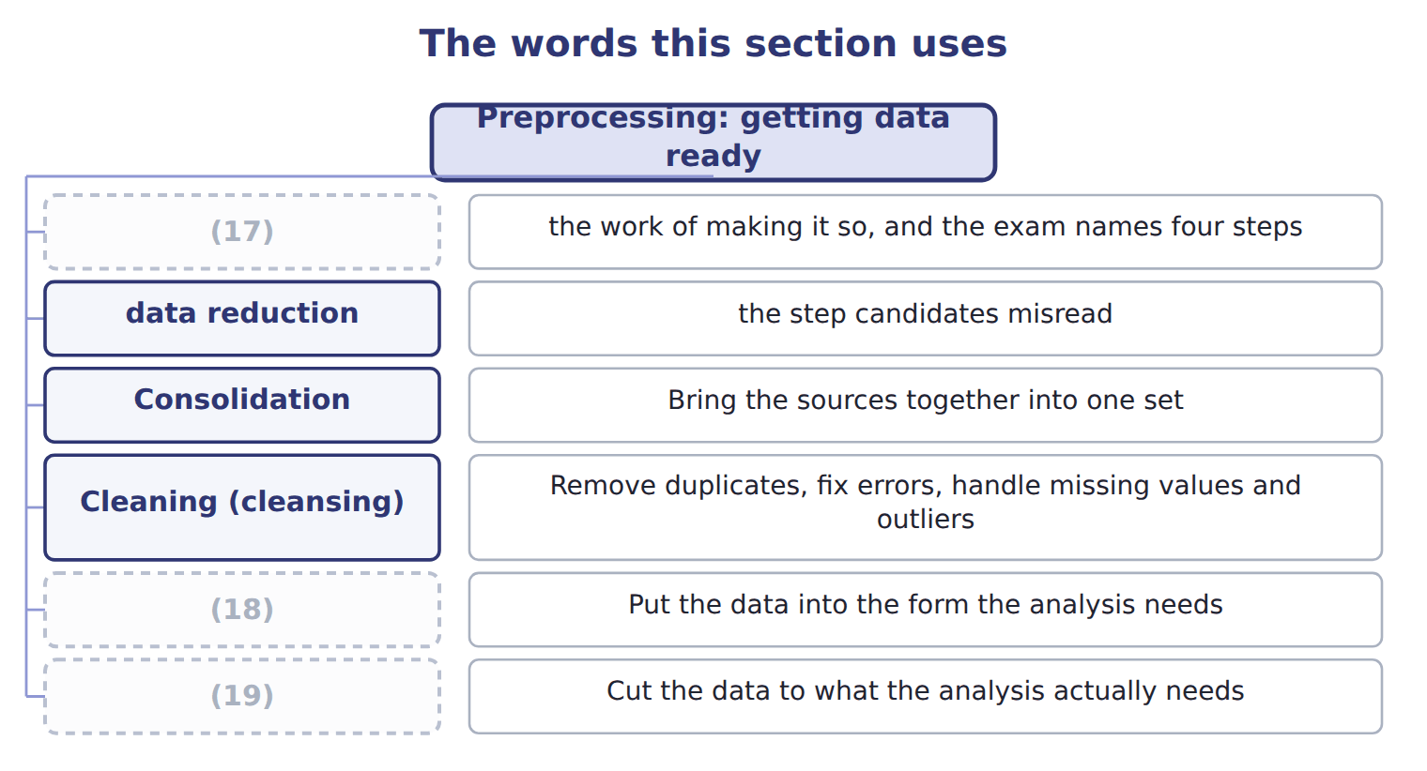
word list
preprocessing · purging · Reduction · Transformation

The English this sheet uses, and its Arabic
English (exam term) | Arabic
preprocessing | المعالجة الأولية
data cleaning | تنظيف البيانات
data reduction | تقليص البيانات

Answer key · 11.4 Preprocessing: getting data ready

1 analysis | 11 carelessly
2 Preprocessing | 12 computation
3 Bring the sources together into one set | 13 quarterly
4 spellings | 14 analysis
5 categories | 15 preprocessing
6 Cut the data to what the analysis actually needs | 16 interrogated
7 duplicates | 17 preprocessing
8 judgement | 18 Transformation
9 estimated | 19 Reduction
10 downstream

the summaries in full
Summary 1 Raw data is rarely fit for analysis. Preprocessing is the work of making it so, and the exam names four steps.
Summary 2 It covers duplicates, plain errors, missing values and outliers, and each of those raises a judgement rather than a rule. A missing rate can be deleted, estimated or flagged, and the three choices give three different answers downstream. It does not mean throwing data away carelessly; it means cutting the data to what the analysis needs, so that the result is readable and the computation is manageable. Twelve monthly columns become four quarterly ones because the question is about seasons, not months.
Summary 3 Every one of these four steps happens before the analysis begins. A question describing the fitting of a model or the search for a pattern has left preprocessing behind. The test is whether the data is being prepared or interrogated.

11.5 Why a retention policy must be written
Chapter 11 · section 11.5

Fill every gap. Each word list holds one word more than there are gaps.
Summary 1 gaps 1–2
A record (1) policy states how long each kind of record is kept and when it is (2) .
word list
purpose · retention · destroyed

Why a written retention policy matters
Why a written policy matters (F.2.e) | The reason | At Orontes
Legal and tax requirements | Records must exist for as long as a law or authority may ask | (3)
Audit and contract needs | (4) must survive long enough to support a claim or an audit | Supplier contracts and the records behind them
Privacy obligations | (5) | Jordan's Personal Data Protection Law, in force since 2024
Cost and risk of keeping | Data held beyond its purpose costs money and can still be stolen | (6)
Consistency | Everyone destroys to the same rule, or destruction looks selective | One schedule, applied by everyone
Litigation hold | (7) | Deleting on schedule during a dispute looks deliberate

word list
Twelve years of customer records nobody uses · Jordanian tax and company law periods · Personal data must be deleted once its purpose has ended · Routine destruction stops once a dispute is foreseeable · authority · Evidence

Summary 2 gaps 8–19
Two of those reasons deserve (8) . (9) protects the company: when everyone destroys to the same (10) schedule, destruction is routine. When destruction is decided case by case, every (11) invites the (12) of why that record and not another. A (13) hold is the other. Once a dispute or an (14) is foreseeable, routine destruction must stop for the records (15) . (16) to delete on schedule during a dispute is how an innocent company acquires the (17) of a guilty one. Keeping (18) forever is not the safe (19) , which is the point candidates miss. Data held past its purpose costs money, can still be stolen, and under Jordan's data protection law, in force since 2024, personal data must be deleted once the purpose has ended. The policy exists to answer both directions.
word list
published · emphasis · litigation · personal · alternative · investigation · everything · concerned · question · deletion · Continuing · appearance · Consistency

The English this sheet uses, and its Arabic
English (exam term) | Arabic
record retention policy | سياسة الاحتفاظ بالسجلات
litigation hold | تعليق الإتلاف للتقاضي

Answer key · 11.5 Why a retention policy must be written

1 retention | 11 deletion
2 destroyed | 12 question
3 Jordanian tax and company law periods | 13 litigation
4 Evidence | 14 investigation
5 Personal data must be deleted once its purpose has ended | 15 concerned
6 Twelve years of customer records nobody uses | 16 Continuing
7 Routine destruction stops once a dispute is foreseeable | 17 appearance
8 emphasis | 18 everything
9 Consistency | 19 alternative
10 published

the summaries in full
Summary 1 A record retention policy states how long each kind of record is kept and when it is destroyed.
Summary 2 Two of those reasons deserve emphasis. Consistency protects the company: when everyone destroys to the same published schedule, destruction is routine. When destruction is decided case by case, every deletion invites the question of why that record and not another. A litigation hold is the other. Once a dispute or an investigation is foreseeable, routine destruction must stop for the records concerned. Continuing to delete on schedule during a dispute is how an innocent company acquires the appearance of a guilty one. Keeping everything forever is not the safe alternative, which is the point candidates miss. Data held past its purpose costs money, can still be stolen, and under Jordan's data protection law, in force since 2024, personal data must be deleted once the purpose has ended. The policy exists to answer both directions.

11.6 Controls and tools against cyberattack
Chapter 11 · section 11.6

Fill every gap. Each word list holds one word more than there are gaps.
Controls and tools against cyberattack
Every item belongs to exactly one group.
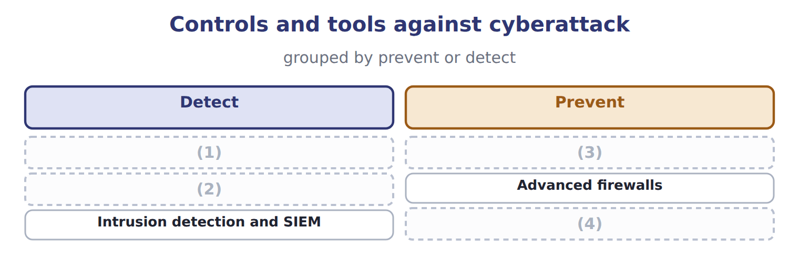
word list
data owner · Access controls · Biometrics · Penetration testing · Vulnerability scanning

Summary 1 gaps 5–15
The pair most often (5) is the first two. (6) scanning is automated and looks for known (7) across everything, which makes it broad, cheap and shallow. (8) testing is a skilled person (9) an authorized attack, which makes it narrow, expensive and deep. A scan finds the (10) door; a test finds out what (11) could do once through it. (12) authenticates by a physical (13) rather than something known or carried, which removes the sharing and theft that defeat passwords. It is a stronger (14) , not a different kind of (15) : the access rules. The NIST Cybersecurity Framework was revised to version 2.0 in February 2024, adding a sixth function, Govern, to the existing Identify, Protect, Detect, Respond and Recover.
word list
characteristic · Penetration · sharing · someone · attempting · Biometrics · authentication · confused · unlocked · weaknesses · Vulnerability · control

The words this section uses
Each term sits against what it means.
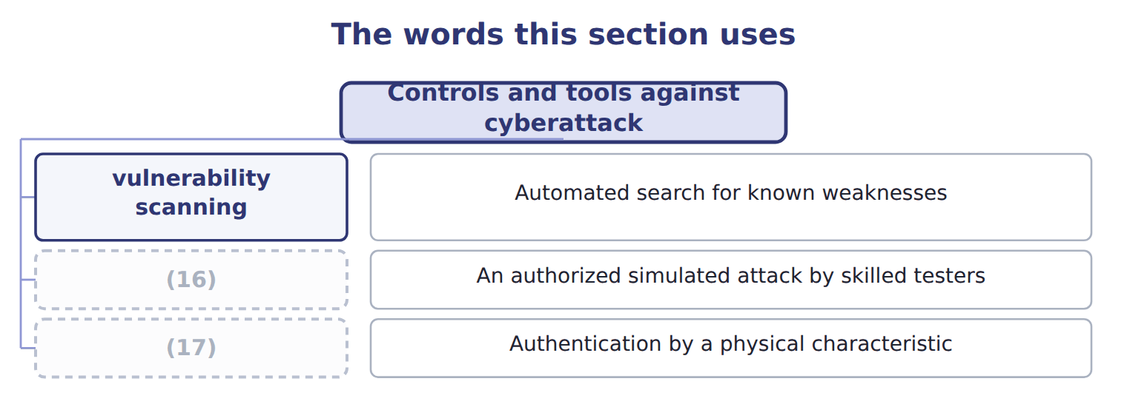
word list
biometrics · penetration testing · vulnerability scanning

The English this sheet uses, and its Arabic
English (exam term) | Arabic
vulnerability scanning | فحص الثغرات
penetration testing | اختبار الاختراق
biometrics | القياسات الحيوية

Answer key · 11.6 Controls and tools against cyberattack

1 Vulnerability scanning | 10 unlocked
2 Penetration testing | 11 someone
3 Biometrics | 12 Biometrics
4 Access controls | 13 characteristic
5 confused | 14 authentication
6 Vulnerability | 15 control
7 weaknesses | 16 penetration testing
8 Penetration | 17 biometrics
9 attempting

the summaries in full
Summary 1 The pair most often confused is the first two. Vulnerability scanning is automated and looks for known weaknesses across everything, which makes it broad, cheap and shallow. Penetration testing is a skilled person attempting an authorized attack, which makes it narrow, expensive and deep. A scan finds the unlocked door; a test finds out what someone could do once through it. Biometrics authenticates by a physical characteristic rather than something known or carried, which removes the sharing and theft that defeat passwords. It is a stronger authentication, not a different kind of control: the access rules. The NIST Cybersecurity Framework was revised to version 2.0 in February 2024, adding a sixth function, Govern, to the existing Identify, Protect, Detect, Respond and Recover.

11.7 Extended Example 11A: preparing the Gulf customer data
Chapter 11 · section 11.7

Fill every gap. Each word list holds one word more than there are gaps.
Summary 1 gaps 1–12
This example (1) one real dataset for (2) and then asks how long any of it should be kept. F.2.e is a Level C (3) , so the second half asks for a (4) . (5) wants to analyse three years of Gulf orders. The data sits in the new ERP, but the first two years were (6) from the old system, and the loading was (7) . Orders, (8) and customer (9) come from three tables and must be joined. The join is possible because each carries the customer key of, which is the first (10) dividend of a (11) design. The old system allowed free text, so one (12) appears as three spellings and must be merged to one. Fourteen orders have no delivery date. Two orders show a quantity a hundred times the usual, which is either a decimal error or a genuine bulk order, and the analyst must find out which rather than guess.
word list
imperfect · distributor · practical · loaded · relational · deliveries · Orontes · judgement · prepares · outcome · records · consolidation · analysis

Summary 2 gaps 13–24
Amounts are held in three (13) and must be (14) to one. Dates become (15) , because the question is about (16) . (17) size becomes a category rather than a number, so that small and large (18) can be compared. (19) monthly columns become twelve quarterly ones, and forty (20) codes become six families. (21) true is lost, because the question (22) seasons and families, not months and codes. The dataset contains the names, (23) numbers and addresses of (24) buyers at each distributor. That is personal data, and it falls under Jordan's law for Orontes and under Saudi law for Saudi residents. The analysis needs the orders; it does not need the buyers' names. The right answer is to remove the personal identifiers during preprocessing, which serves the analysis and the obligation at once. Where identifiers are genuinely needed, the retention policy must state how long and the data must be purged, not merely archived, when that period ends.
word list
product · Nothing · telephone · Thirty-six · individual · distributors · Customer · Consolidate · currencies · concerns · quarters · seasonality · converted

Name four preprocessing steps

Complete the blank cells.

Your turn: name four preprocessing steps (complete the blanks)
Every item belongs to exactly one group.
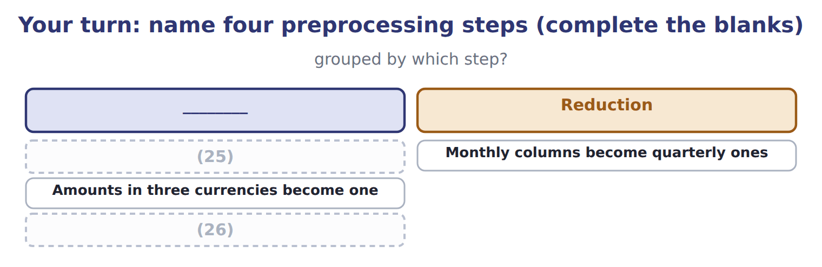
word list
Amounts in three currencies become one · Plant, payroll and ledger data are brought together · Two spellings of one supplier are merged

The pattern behind the example

Summary 3 gaps 27–30
Consolidate, clean, (27) , reduce: in that order, and all before any analysis. An outlier is (28) , not deleted, until its cause is known. Removing personal (29) can serve the analysis and the law at the same time. When a (30) period ends, the data is purged, not archived.
word list
deleted · retention · transform · identifiers · investigated

Exam view

Summary 4 gaps 31–33
A question (31) something done to data and asks which step it is. Ask what the step achieves: bringing sources together is (32) , fixing what is wrong is cleaning, changing the form is (33) , and cutting the volume is reduction.
word list
consolidation · describes · transformation · seasonality

Exam view
Item | Answer
Two spellings of one supplier are merged | Cleaning — it removes duplicates and fixes errors before any analysis begins
Monthly columns become quarterly ones | Why: the data is cut to what the (34) actually needs, since the question concerns seasons rather than months
Amounts in three currencies become one | Transformation — the data is put into the form the analysis requires
Plant, payroll and ledger data are brought together | (35) — separate sources are combined into one set

word list
analysis · Consolidation · Transformation

Action required — Category
Action required | Category
Joining the three tables into one set | Consolidation
Merging the three spellings of one distributor | (36)
Converting three currencies into one | Transformation
Replacing monthly columns with quarterly ones | (37)

word list
Cleaning · biometrics · Reduction

Answer key · 11.7 Extended Example 11A: preparing the Gulf customer data

1 prepares | 20 product
2 analysis | 21 Nothing
3 outcome | 22 concerns
4 judgement | 23 telephone
5 Orontes | 24 individual
6 loaded | 25 Two spellings of one supplier are merged
7 imperfect | 26 Plant, payroll and ledger data are brought together
8 deliveries | 27 transform
9 records | 28 investigated
10 practical | 29 identifiers
11 relational | 30 retention
12 distributor | 31 describes
13 currencies | 32 consolidation
14 converted | 33 transformation
15 quarters | 34 analysis
16 seasonality | 35 Consolidation
17 Customer | 36 Cleaning
18 distributors | 37 Reduction
19 Thirty-six

the summaries in full
Summary 1 This example prepares one real dataset for analysis and then asks how long any of it should be kept. F.2.e is a Level C outcome, so the second half asks for a judgement. Orontes wants to analyse three years of Gulf orders. The data sits in the new ERP, but the first two years were loaded from the old system, and the loading was imperfect. Orders, deliveries and customer records come from three tables and must be joined. The join is possible because each carries the customer key of, which is the first practical dividend of a relational design. The old system allowed free text, so one distributor appears as three spellings and must be merged to one. Fourteen orders have no delivery date. Two orders show a quantity a hundred times the usual, which is either a decimal error or a genuine bulk order, and the analyst must find out which rather than guess.
Summary 2 Amounts are held in three currencies and must be converted to one. Dates become quarters, because the question is about seasonality. Customer size becomes a category rather than a number, so that small and large distributors can be compared. Thirty-six monthly columns become twelve quarterly ones, and forty product codes become six families. Nothing true is lost, because the question concerns seasons and families, not months and codes. The dataset contains the names, telephone numbers and addresses of individual buyers at each distributor. That is personal data, and it falls under Jordan's law for Orontes and under Saudi law for Saudi residents. The analysis needs the orders; it does not need the buyers' names. The right answer is to remove the personal identifiers during preprocessing, which serves the analysis and the obligation at once. Where identifiers are genuinely needed, the retention policy must state how long and the data must be purged, not merely archived, when that period ends.
Summary 3 Consolidate, clean, transform, reduce: in that order, and all before any analysis. An outlier is investigated, not deleted, until its cause is known. Removing personal identifiers can serve the analysis and the law at the same time. When a retention period ends, the data is purged, not archived.
Summary 4 A question describes something done to data and asks which step it is. Ask what the step achieves: bringing sources together is consolidation, fixing what is wrong is cleaning, changing the form is transformation, and cutting the volume is reduction.

