12.1 The system development life cycle
Chapter 12 · section 12.1

Fill every gap. Each word list holds one word more than there are gaps.
Chapter 12, section by section
Each stage leads to the next.
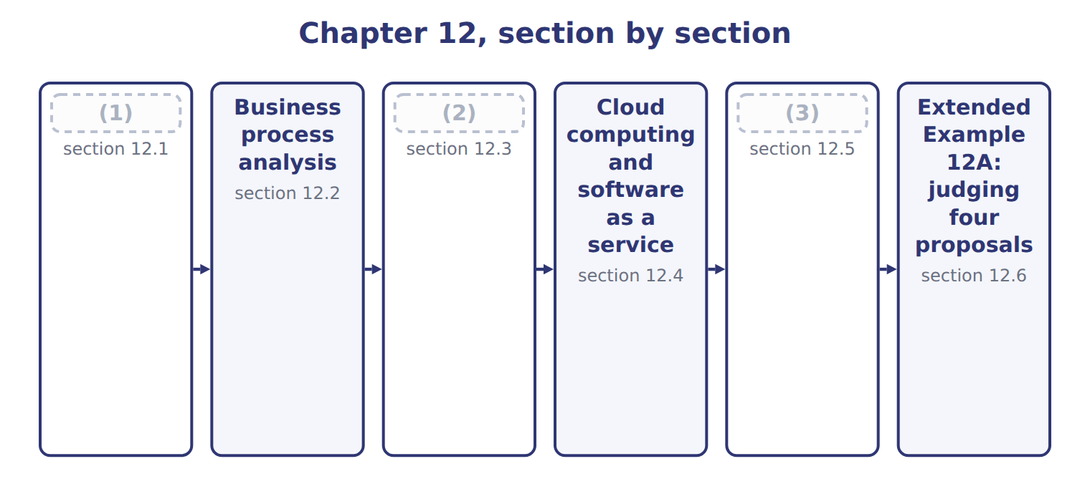
word list
Robotic process automation · software as a service (SaaS) · Blockchain, distributed ledgers and smart cont · The system development life cycle

Summary 1 gaps 4–14
The system (4) life cycle (SDLC) is the ordered (5) by which a system is planned, built and run. The two design (6) are the pair (7) confuse. (8) design answers what the system should do, in the (9) of the business. (10) design answers how it will do it: the files, the (11) , the screens and the controls. One is a (12) about purpose, the other about (13) . (14) deserves a word of its own. Moving from the old system to the new can be done directly, in parallel, as a pilot in one site, or in phases. Running both systems in parallel is the safest and the most expensive, and the choice is a judgement about what a failure would cost.
word list
Conceptual · development · candidates · sequence · Physical · confuse · construction · decision · language · Conversion · programs · stages

The English this section uses, and its Arabic
Each term sits against what it means.
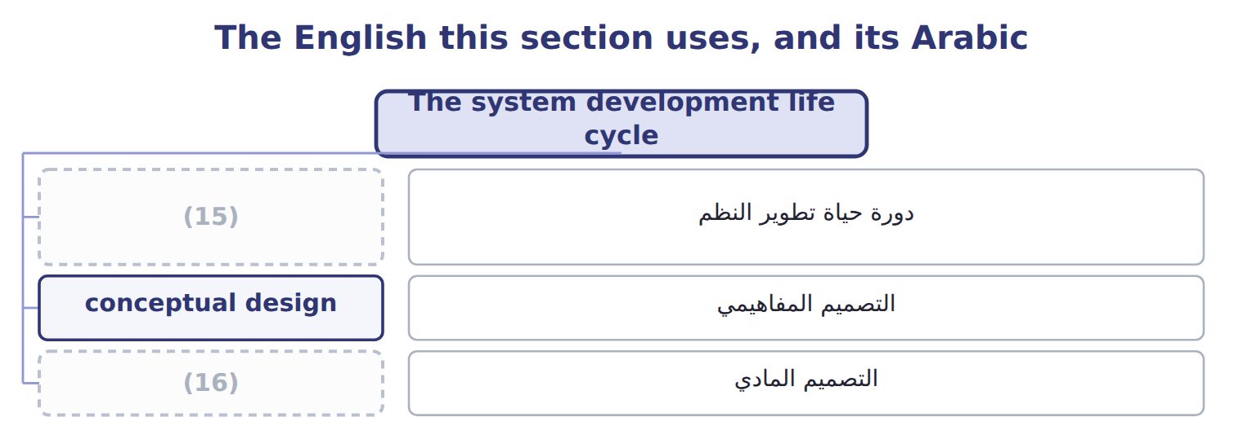
word list
physical design · system development life cycle (SDLC) · distributed ledger

The English this sheet uses, and its Arabic
English (exam term) | Arabic
system development life cycle (SDLC) | دورة حياة تطوير النظم
conceptual design | التصميم المفاهيمي
physical design | التصميم المادي

Answer key · 12.1 The system development life cycle

1 The system development life cycle | 9 language
2 Robotic process automation | 10 Physical
3 Blockchain, distributed ledgers and smart cont | 11 programs
4 development | 12 decision
5 sequence | 13 construction
6 stages | 14 Conversion
7 candidates | 15 system development life cycle (SDLC)
8 Conceptual | 16 physical design

the summaries in full
Summary 1 The system development life cycle (SDLC) is the ordered sequence by which a system is planned, built and run. The two design stages are the pair candidates confuse. Conceptual design answers what the system should do, in the language of the business. Physical design answers how it will do it: the files, the programs, the screens and the controls. One is a decision about purpose, the other about construction. Conversion deserves a word of its own. Moving from the old system to the new can be done directly, in parallel, as a pilot in one site, or in phases. Running both systems in parallel is the safest and the most expensive, and the choice is a judgement about what a failure would cost.

12.2 Business process analysis
Chapter 12 · section 12.2

Fill every gap. Each word list holds one word more than there are gaps.
Business process analysis examines how work is actually done, in order to improve it.
The steps of business process analysis
Each stage leads to the next.
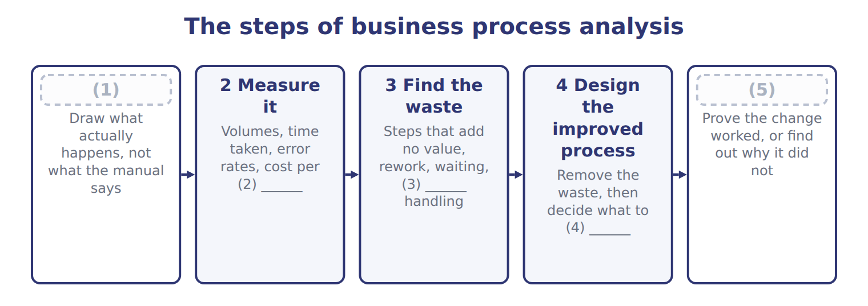
word list
transaction · 1 Map the current process · automate · 5 Implement and measure again · duplicate · blockchain

Summary 1 gaps 6–11
Its role in system (6) rests on a single (7) . (8) a bad process does not fix it: it makes the same errors faster and at greater volume, and makes them harder to see because nobody is (9) them any more. The first step is where the work is. Mapping what (10) happens, rather than what the manual says, (11) reveals steps that exist only because someone once needed them.
word list
principle · handling · routinely · Automating · performance · examines · actually

The words this section uses
Each term sits against what it means.
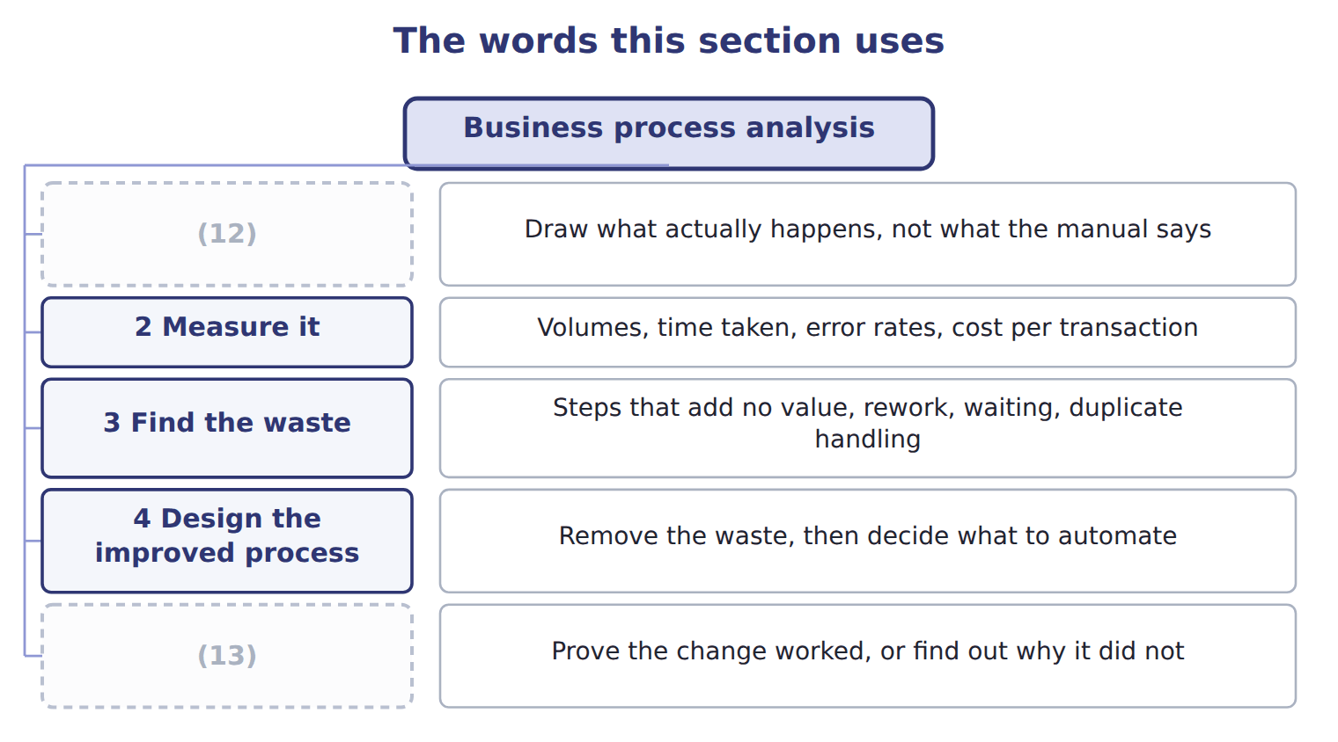
word list
5 Implement and measure again · 4 Design the improved process · 1 Map the current process

The English this sheet uses, and its Arabic
English (exam term) | Arabic
business process analysis | تحليل عمليات الأعمال

Answer key · 12.2 Business process analysis

1 1 Map the current process | 8 Automating
2 transaction | 9 handling
3 duplicate | 10 actually
4 automate | 11 routinely
5 5 Implement and measure again | 12 1 Map the current process
6 performance | 13 5 Implement and measure again
7 principle

the summaries in full
Summary 1 Its role in system performance rests on a single principle. Automating a bad process does not fix it: it makes the same errors faster and at greater volume, and makes them harder to see because nobody is handling them any more. The first step is where the work is. Mapping what actually happens, rather than what the manual says, routinely reveals steps that exist only because someone once needed them.

12.3 Robotic process automation
Chapter 12 · section 12.3

Fill every gap. Each word list holds one word more than there are gaps.
What robotic process automation does, and where it stops
Robotic process automation (F.3.c) | What it means | At Orontes
What it does | Software robots copy rule-based keyboard and mouse steps on structured data | (1)
Benefits | Speed, accuracy, operation outside working hours, a complete log of every action | (2)
No change to systems | It works through existing screens, so no integration project is needed | (3)
Limitation: brittleness | (4) | A vendor update breaks the invoice matching
Limitation: scope | Only stable, (5) , structured work; judgement defeats it | Deciding whether an unusual order is genuine
Control requirement | A robot needs its own identity, access rights and segregation | A robot that can both post and (6) is one person with two duties

word list
A three-hour reconciliation finished overnight · rule-based · Useful where an ERP cannot yet reach · Deciding whether an unusual order is genuine · Matching invoices to orders and flagging exceptions · A changed screen or report layout stops the robot · approve

Summary 1 gaps 7–14
Its (7) is that it needs no (8) project. Where an ERP cannot yet reach, or where two (9) must be joined and neither can be changed, a robot can do the keying that a person was doing, (10) and without error. The (11) point is the one most often (12) . A robot is a user: it needs its own (13) , its own access rights and its own place in the (14) of duties. A robot that can both post a transaction and approve it is one person holding two duties.
word list
appeal · identity · control · segregation · integration · description · missed · overnight · systems

A robot is not judgement

Summary 2 gaps 15–17
Robotic process (15) handles stable, rule-based work on structured data. If the task requires deciding whether something is (16) , it is outside the technique, however it is described. Adding artificial (17) to the description does not change what the robot itself does.
word list
intelligence · automation · reasonable · technique

The words this section uses
Each term sits against what it means.
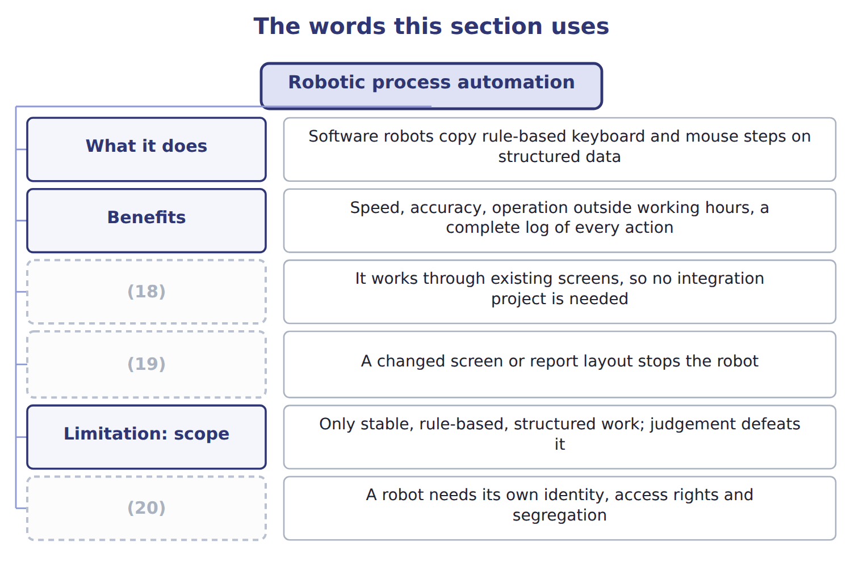
word list
business process analysis · Control requirement · No change to systems · Limitation: brittleness

The English this sheet uses, and its Arabic
English (exam term) | Arabic
robotic process automation (RPA) | الأتمتة الآلية للعمليات

Answer key · 12.3 Robotic process automation

1 Matching invoices to orders and flagging exceptions | 11 control
2 A three-hour reconciliation finished overnight | 12 missed
3 Useful where an ERP cannot yet reach | 13 identity
4 A changed screen or report layout stops the robot | 14 segregation
5 rule-based | 15 automation
6 approve | 16 reasonable
7 appeal | 17 intelligence
8 integration | 18 No change to systems
9 systems | 19 Limitation: brittleness
10 overnight | 20 Control requirement

the summaries in full
Summary 1 Its appeal is that it needs no integration project. Where an ERP cannot yet reach, or where two systems must be joined and neither can be changed, a robot can do the keying that a person was doing, overnight and without error. The control point is the one most often missed. A robot is a user: it needs its own identity, its own access rights and its own place in the segregation of duties. A robot that can both post a transaction and approve it is one person holding two duties.
Summary 2 Robotic process automation handles stable, rule-based work on structured data. If the task requires deciding whether something is reasonable, it is outside the technique, however it is described. Adding artificial intelligence to the description does not change what the robot itself does.

12.4 Cloud computing and software as a service
Chapter 12 · section 12.4

Fill every gap. Each word list holds one word more than there are gaps.
Summary 1 gaps 1–12
Cloud computing is (1) access to a shared pool of computing resources over a network. The (2) definition gives it five characteristics: self-service on demand, broad network access, resources pooled across (3) , rapid elasticity, and metered use. (4) comes from three of those characteristics. Metered use turns a capital purchase into an (5) cost paid only for what is (6) . Elasticity means (7) can rise for a peak and fall again. And self-service means a server is (8) in minutes rather than after a (9) cycle. Four deployment models cut across the three service models. A private cloud serves one (10) , a community cloud a group with shared (11) , a public cloud anyone who pays, and a hybrid combines them. The (12) the exam tests is simply that service models and deployment models are different questions.
word list
capacity · on-demand · concerns · recognised · customers · consumed · Efficiency · distinction · operating · resources · organization · procurement · available

Summary 2 gaps 13–15
Two (13) deserve weight. The company relies on the (14) controls rather than its own, which is why a report on those controls is normally obtained and read. And data (15) can matter legally:.
word list
community · provider's · residency · disadvantages

The advantages and disadvantages of software as a service
 | Advantage of SaaS | Disadvantage
Cost | No large purchase; pay as you use | (16)
Updates | The provider updates everything for everyone | (17)
Access | Reachable from anywhere with a connection | (18)
Scale | Add users or capacity on demand | (19)
Maintenance | (20) | You rely on the provider's controls, not your own
Data | (21) | Residency may breach local law; exit is costly

word list
Residency may breach local law; exit is costly · Costs scale up as readily as down · Stored and protected by the provider · You cannot refuse or defer an update you dislike · Recurring cost forever, which may exceed a purchase · The provider handles servers, patching and backup · Useless without the connection

The English this sheet uses, and its Arabic
English (exam term) | Arabic
cloud computing | الحوسبة السحابية
software as a service (SaaS) | البرمجيات كخدمة

Answer key · 12.4 Cloud computing and software as a service

1 on-demand | 12 distinction
2 recognised | 13 disadvantages
3 customers | 14 provider's
4 Efficiency | 15 residency
5 operating | 16 Recurring cost forever, which may exceed a purchase
6 consumed | 17 You cannot refuse or defer an update you dislike
7 capacity | 18 Useless without the connection
8 available | 19 Costs scale up as readily as down
9 procurement | 20 The provider handles servers, patching and backup
10 organization | 21 Stored and protected by the provider
11 concerns

the summaries in full
Summary 1 Cloud computing is on-demand access to a shared pool of computing resources over a network. The recognised definition gives it five characteristics: self-service on demand, broad network access, resources pooled across customers, rapid elasticity, and metered use. Efficiency comes from three of those characteristics. Metered use turns a capital purchase into an operating cost paid only for what is consumed. Elasticity means capacity can rise for a peak and fall again. And self-service means a server is available in minutes rather than after a procurement cycle. Four deployment models cut across the three service models. A private cloud serves one organization, a community cloud a group with shared concerns, a public cloud anyone who pays, and a hybrid combines them. The distinction the exam tests is simply that service models and deployment models are different questions.
Summary 2 Two disadvantages deserve weight. The company relies on the provider's controls rather than its own, which is why a report on those controls is normally obtained and read. And data residency can matter legally:.

12.5 Blockchain, distributed ledgers and smart contracts
Chapter 12 · section 12.5

Fill every gap. Each word list holds one word more than there are gaps.
Summary 1 gaps 1–4
A (1) is a distributed, append-only ledger of (2) linked blocks, agreed between participants by consensus rather than by a central authority. A distributed ledger is the wider class, and a smart (3) is code held on such a ledger that executes itself when its (4) are met.
word list
central · conditions · blockchain · contract · cryptographically

Blockchain terms and their status
Term (F.3.g) | What it means | Status as at October 2026
Blockchain | A distributed, append-only ledger of (5) linked blocks, agreed by consensus | Real, and narrow in use
Distributed ledger | The wider class, including ledgers where (6) is controlled | The form enterprises actually use
Smart contract | Code on a ledger that executes itself when (7) are met | Real, but only as reliable as its code
What did materialise | (8) and audit of crypto assets, tokenised funds, stablecoin payments, some trade finance and provenance | Narrower than predicted
What did not | Replacing accounting systems. The Australian exchange cancelled its blockchain settlement replacement in 2022 | A large and public failure
Triple-entry accounting | A proposal that a shared ledger entry replaces two sets of books | (9)

word list
conditions · Recognised by no standard-setter · Accounting · membership · business process analysis · cryptographically

Summary 2 gaps 10–20
Between 2018 and 2022 it was widely (10) that blockchain would (11) accounting systems. That did not (12) . The Australian securities exchange cancelled its blockchain settlement replacement in 2022 after large write-offs, and no (13) recognises (14) accounting. What did (15) is narrower: accounting and audit of crypto assets, tokenised funds, (16) payments, and some trade finance and provenance work. A candidate who can say what the (17) is and where it genuinely applies is better prepared than one who repeats the (18) . The exam asks you to recognise potential (19) , so know the (20) ones. Where several parties must share one record and do not fully trust each other, a distributed ledger has something to offer. Where one company keeps its own books, a database is simpler, faster and cheaper.
word list
replace · predicted · happen · securities · stablecoin · realistic · predictions · technology · materialise · applications · triple-entry · standard-setter

The words this section uses
Each term sits against what it means.
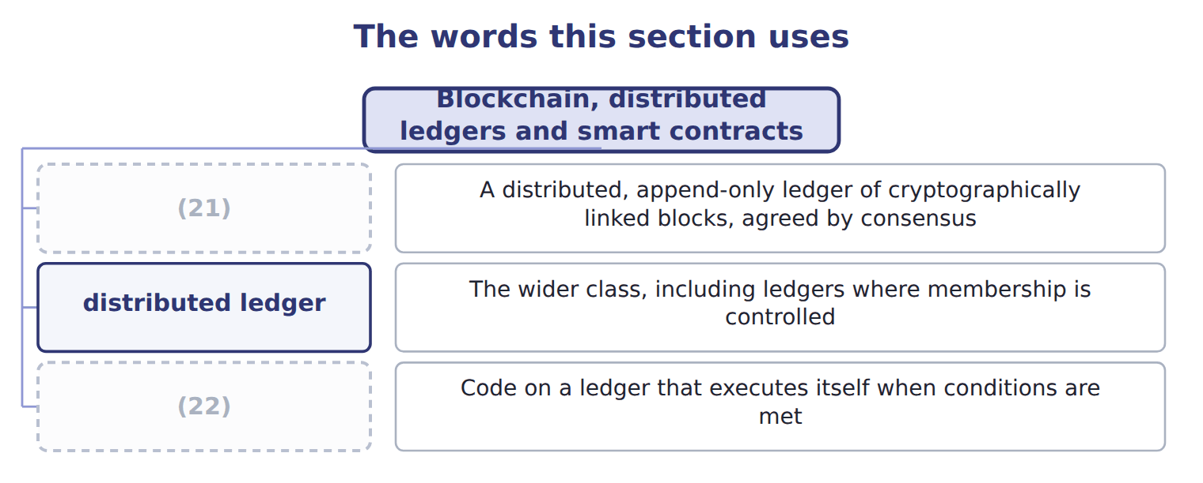
word list
smart contract · blockchain · conceptual design

The English this sheet uses, and its Arabic
English (exam term) | Arabic
blockchain | سلسلة الكتل
distributed ledger | السجل الموزع
smart contract | العقد الذكي

Answer key · 12.5 Blockchain, distributed ledgers and smart contracts

1 blockchain | 12 happen
2 cryptographically | 13 standard-setter
3 contract | 14 triple-entry
4 conditions | 15 materialise
5 cryptographically | 16 stablecoin
6 membership | 17 technology
7 conditions | 18 predictions
8 Accounting | 19 applications
9 Recognised by no standard-setter | 20 realistic
10 predicted | 21 blockchain
11 replace | 22 smart contract

the summaries in full
Summary 1 A blockchain is a distributed, append-only ledger of cryptographically linked blocks, agreed between participants by consensus rather than by a central authority. A distributed ledger is the wider class, and a smart contract is code held on such a ledger that executes itself when its conditions are met.
Summary 2 Between 2018 and 2022 it was widely predicted that blockchain would replace accounting systems. That did not happen. The Australian securities exchange cancelled its blockchain settlement replacement in 2022 after large write-offs, and no standard-setter recognises triple-entry accounting. What did materialise is narrower: accounting and audit of crypto assets, tokenised funds, stablecoin payments, and some trade finance and provenance work. A candidate who can say what the technology is and where it genuinely applies is better prepared than one who repeats the predictions. The exam asks you to recognise potential applications, so know the realistic ones. Where several parties must share one record and do not fully trust each other, a distributed ledger has something to offer. Where one company keeps its own books, a database is simpler, faster and cheaper.

12.6 Extended Example 12A: judging four proposals
Chapter 12 · section 12.6

Fill every gap. Each word list holds one word more than there are gaps.
Summary 1 gaps 1–12
F.3.d asks you to evaluate where a (1) would improve the (2) of accounting data. This example (3) four proposals put to the Orontes board, (4) two and refusing two. Three (5) settle most proposals. (6) payable spends three hours a day (7) invoices to orders and goods received notes. The work is (8) and the data is (9) , so a robot fits. It (10) speed and accuracy, and it creates one new (11) : the robot needs its own identity and must not also approve payment. The expenses system is small, standard and not a (12) advantage. A hosted service removes the maintenance and the upgrades. The risks are dependence on the provider and the location of the data, both manageable for expenses. Accept, after reading the provider's controls report and confirming where the data sits.
word list
improves · processing · technology · Accounts · accepting · matching · competitive · questions · structured · requirement · rule-based · judges · blockchain

Summary 2 gaps 13–21
A consultant proposes recording supplier balances on a (13) , to make them (14) . But Orontes keeps its own books, there is no group of mutually (15) parties needing one shared record, and the ERP database with proper access controls already prevents (16) alteration. Refuse: it (17) a problem the company does not have. The close takes (18) days, and the (19) is to automate it as it stands. The first (20) defeats it: the process includes two days (21) systems that the ERP has now merged, and a manual upload that no longer exists. Refuse for now, analyse the process, and automate what survives.
word list
tamper-evident · reconciling · undetected · answers · matching · distrustful · blockchain · proposal · question · eleven

Name four stages

Complete the blank cells.

Your turn: name four stages (complete the blanks)
Every item belongs to exactly one group.
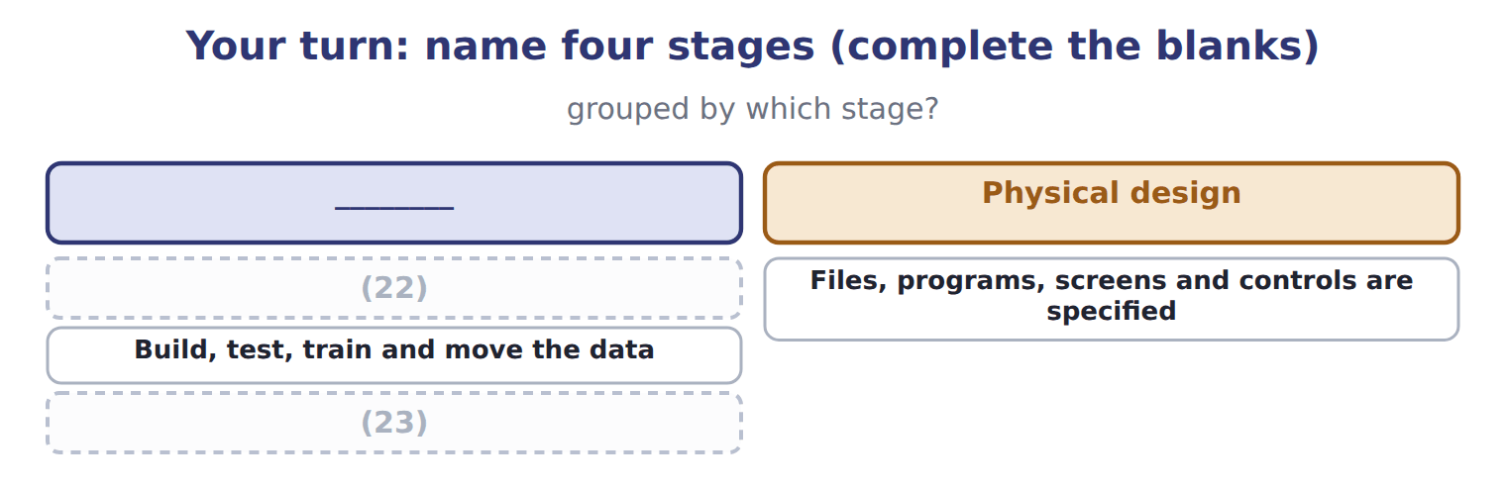
word list
Run it and change it as the business changes · What does the business need, and what happens now? · Build, test, train and move the data

The pattern behind the judgements

Summary 3 gaps 24–27
Ask what process changes before asking what technology is (24) . A technology that (25) a problem the company does not have is refused, however capable. (26) a process nobody has examined preserves its waste. Every acceptance carries a new control (27) ; name it at the time.
word list
Automating · requirement · proposed · automate · answers

Exam view

Summary 4 gaps 28–30
A Level C question gives a technology and a (28) and asks whether it helps. Name the process, the (29) gain and the new risk. An answer that (30) the technology in general, without naming the process it changes, earns nothing.
word list
praises · specific · situation · location

Exam view
Item | Answer
What does the business need, and what happens now? | Systems analysis — it establishes the need and the current position before any design begins
Files, programs, screens and controls are specified | Why: physical design settles how the system will do what (31) decided it should do
Build, test, train and move the data | Implementation and conversion — the point at which the system goes live
Run it and change it as the business changes | Operations and (32) — and what it reveals feeds the next systems analysis

word list
maintenance · Refuse · conceptual design

Proposal — Category
Every item belongs to exactly one group.
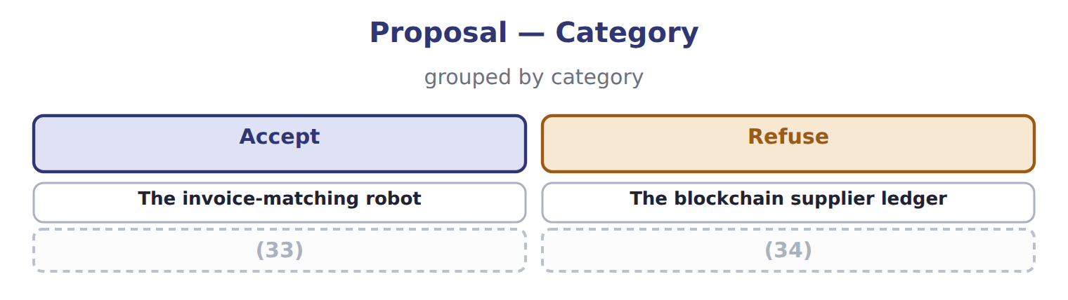
word list
The hosted expenses service · robotic process automation (RPA) · Automating the close as it stands

Answer key · 12.6 Extended Example 12A: judging four proposals

1 technology | 18 eleven
2 processing | 19 proposal
3 judges | 20 question
4 accepting | 21 reconciling
5 questions | 22 What does the business need, and what happens now?
6 Accounts | 23 Run it and change it as the business changes
7 matching | 24 proposed
8 rule-based | 25 answers
9 structured | 26 Automating
10 improves | 27 requirement
11 requirement | 28 situation
12 competitive | 29 specific
13 blockchain | 30 praises
14 tamper-evident | 31 conceptual design
15 distrustful | 32 maintenance
16 undetected | 33 The hosted expenses service
17 answers | 34 Automating the close as it stands

the summaries in full
Summary 1 F.3.d asks you to evaluate where a technology would improve the processing of accounting data. This example judges four proposals put to the Orontes board, accepting two and refusing two. Three questions settle most proposals. Accounts payable spends three hours a day matching invoices to orders and goods received notes. The work is rule-based and the data is structured, so a robot fits. It improves speed and accuracy, and it creates one new requirement: the robot needs its own identity and must not also approve payment. The expenses system is small, standard and not a competitive advantage. A hosted service removes the maintenance and the upgrades. The risks are dependence on the provider and the location of the data, both manageable for expenses. Accept, after reading the provider's controls report and confirming where the data sits.
Summary 2 A consultant proposes recording supplier balances on a blockchain, to make them tamper-evident. But Orontes keeps its own books, there is no group of mutually distrustful parties needing one shared record, and the ERP database with proper access controls already prevents undetected alteration. Refuse: it answers a problem the company does not have. The close takes eleven days, and the proposal is to automate it as it stands. The first question defeats it: the process includes two days reconciling systems that the ERP has now merged, and a manual upload that no longer exists. Refuse for now, analyse the process, and automate what survives.
Summary 3 Ask what process changes before asking what technology is proposed. A technology that answers a problem the company does not have is refused, however capable. Automating a process nobody has examined preserves its waste. Every acceptance carries a new control requirement; name it at the time.
Summary 4 A Level C question gives a technology and a situation and asks whether it helps. Name the process, the specific gain and the new risk. An answer that praises the technology in general, without naming the process it changes, earns nothing.

