16.1 The four components of a time series
Chapter 16 · section 16.1

Fill every gap. Each word list holds one word more than there are gaps.
Chapter 16, section by section
Each stage leads to the next.
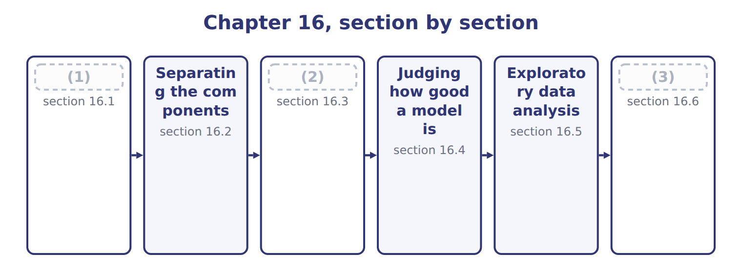
word list
What both techniques can and cannot do · Extended Example 16A: decomposing the Beverage · The four components of a time series · Judging how good a model is

Any series measured over time can be thought of as four things added together.
The four components of a time series
Component (F.4.r) | What it is | At Orontes | In this data
Trend | The long-run direction, over years | (4) | Rising across the two years
Cyclical | Swings longer than a year, tied to the economy | (5) | Not visible in only two years of data
Seasonal | A pattern that repeats within the year | (6) | The third quarter peaks in both years
Irregular | What is left: random, unrepeatable | A port strike delaying one shipment | (7)

word list
A regional downturn lasting several years · The third quarter peaks in both years · The small residual after the other three · Hot quarters sell more · Underlying growth as the Gulf market opens

Summary 1 gaps 8–11
Those two are (8) the visible ones. It needs many years of data before it can be told apart from (9) at all. It is (10) by definition, which is why no model should try to explain it. A model that fits the irregular component is the (11) .
word list
overfitting · usually · unrepeatable · trend · component

The words this section uses
Each term sits against what it means.
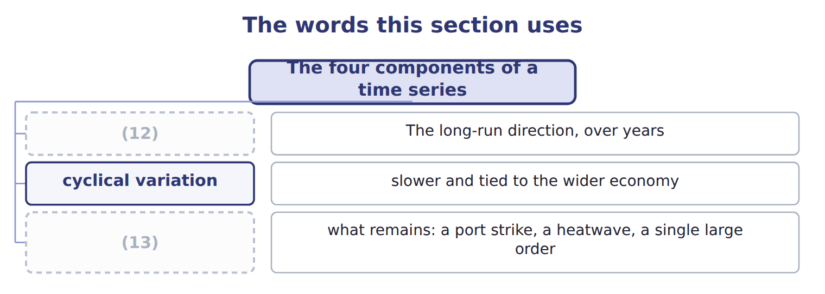
word list
seasonal variation · trend · irregular variation

The English this sheet uses, and its Arabic
English (exam term) | Arabic
trend | الاتجاه العام
cyclical variation | التغير الدوري
seasonal variation | التغير الموسمي
irregular variation | التغير العشوائي

Answer key · 16.1 The four components of a time series

1 The four components of a time series | 8 usually
2 What both techniques can and cannot do | 9 trend
3 Extended Example 16A: decomposing the Beverage | 10 unrepeatable
4 Underlying growth as the Gulf market opens | 11 overfitting
5 A regional downturn lasting several years | 12 trend
6 Hot quarters sell more | 13 irregular variation
7 The small residual after the other three

the summaries in full
Summary 1 Those two are usually the visible ones. It needs many years of data before it can be told apart from trend at all. It is unrepeatable by definition, which is why no model should try to explain it. A model that fits the irregular component is the overfitting.

16.2 Separating the components
Chapter 16 · section 16.2

Fill every gap. Each word list holds one word more than there are gaps.
Summary 1 gaps 1–12
The (1) method is a moving average. Averaging four (2) quarters removes the seasonal (3) , because every average (4) one of each quarter. Most of the (5) variation cancels as well. What is left is close to the trend. The first panel is the series as (6) , with its clear peak in the third quarter of each year. The second is the (7) centred moving average, which rises from 219,750 to 223,662 cases and is far (8) . The third shows what is left once the trend is taken out. Those (9) are the seasonal (10) : 20,003 cases in the third quarter and (13,022) in the first, a swing of 33,025 cases between the best quarter and the worst. They are (11) so that the four sum to zero, because a season (12) the year's demand rather than adding to it.
word list
pattern · recorded · contains · adjusted · four-quarter · remainders · consecutive · smoother · redistributes · centred · factors · irregular · standard

The English this section uses, and its Arabic
Each term sits against what it means.
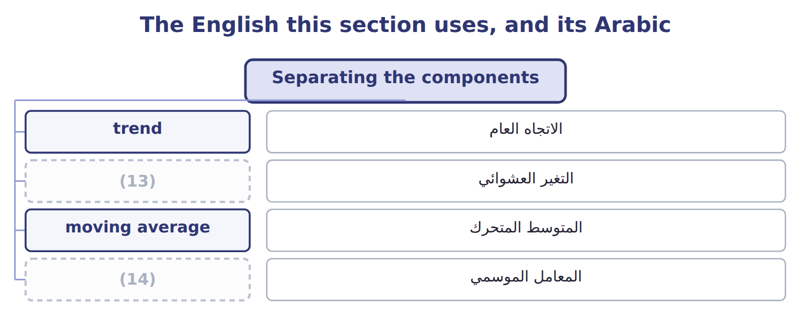
word list
التغير العشوائي · irregular variation · seasonal factor

The English this sheet uses, and its Arabic
English (exam term) | Arabic
moving average | المتوسط المتحرك
seasonal factor | المعامل الموسمي

Answer key · 16.2 Separating the components

1 standard | 8 smoother
2 consecutive | 9 remainders
3 pattern | 10 factors
4 contains | 11 adjusted
5 irregular | 12 redistributes
6 recorded | 13 irregular variation
7 four-quarter | 14 seasonal factor

the summaries in full
Summary 1 The standard method is a moving average. Averaging four consecutive quarters removes the seasonal pattern, because every average contains one of each quarter. Most of the irregular variation cancels as well. What is left is close to the trend. The first panel is the series as recorded, with its clear peak in the third quarter of each year. The second is the four-quarter centred moving average, which rises from 219,750 to 223,662 cases and is far smoother. The third shows what is left once the trend is taken out. Those remainders are the seasonal factors: 20,003 cases in the third quarter and (13,022) in the first, a swing of 33,025 cases between the best quarter and the worst. They are adjusted so that the four sum to zero, because a season redistributes the year's demand rather than adding to it.

16.3 What both techniques can and cannot do
Chapter 16 · section 16.3

Fill every gap. Each word list holds one word more than there are gaps.
Benefits and limitations of regression and time series analysis
Every item belongs to exactly one group.
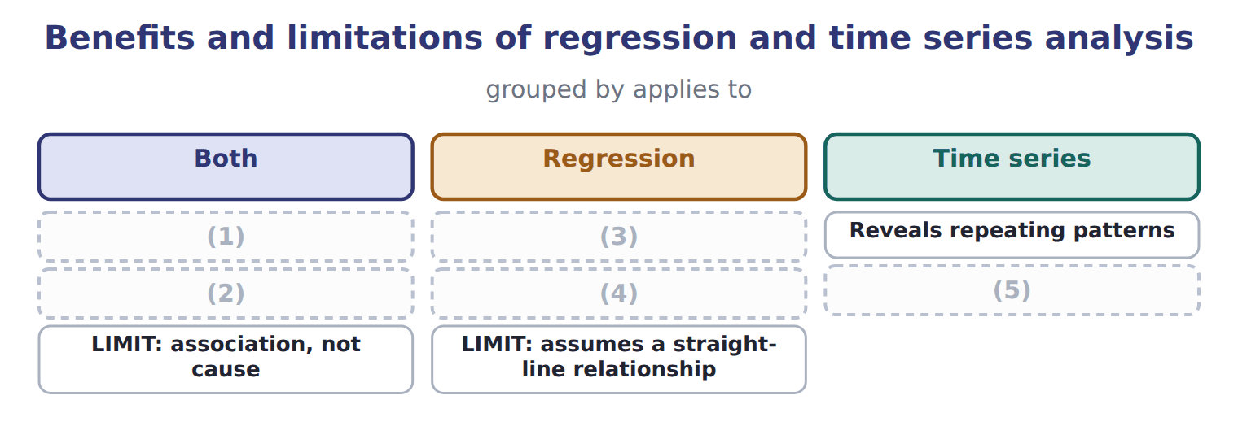
word list
Uses every observation · Separates mixed effects · Quantifies the relationship · LIMIT: needs enough history · LIMIT: assumes the past continues · standard error of the estimate

Summary 1 gaps 6–13
The (6) that matters most applies to both, and it is simply stated: each (7) assumes that the pattern in the past will continue. A (8) fitted before a (9) entered the Gulf market will keep predicting the old volumes. A (10) factor from two normal years will not (11) a year in which the pattern breaks. The (12) that matters most also applies to both. Each uses every (13) rather than a chosen few. That is why Book 2's high-low method, resting on two points, was described there as a rough approximation.
word list
limitation · competitor · technique · benefit · survive · observation · seasonal · regression · approximation

The words this section uses
Each term sits against what it means.
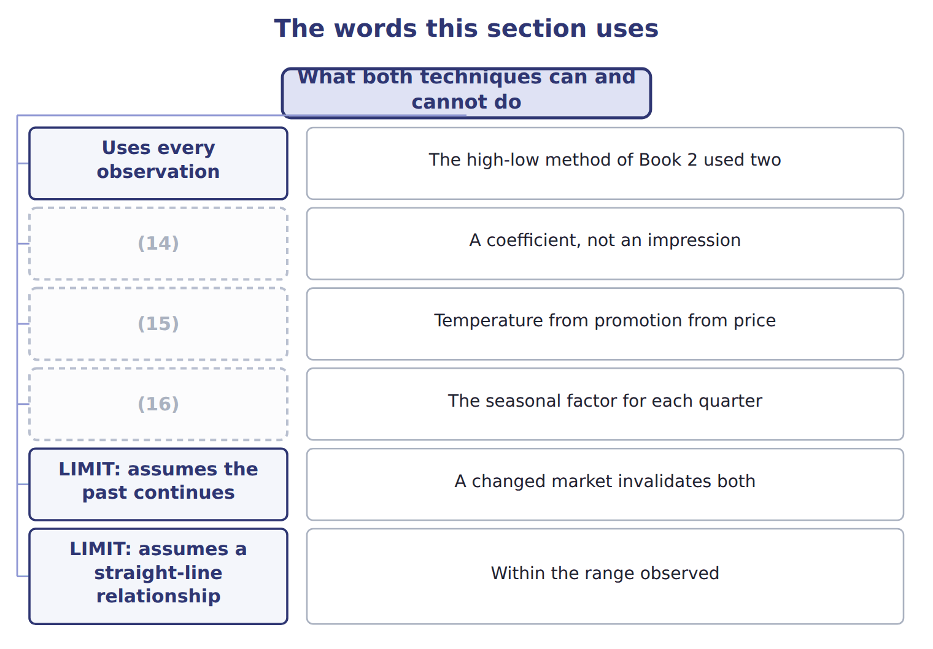
word list
Quantifies the relationship · Reveals repeating patterns · Separates mixed effects · Uses every observation

Answer key · 16.3 What both techniques can and cannot do

1 Uses every observation | 9 competitor
2 LIMIT: assumes the past continues | 10 seasonal
3 Quantifies the relationship | 11 survive
4 Separates mixed effects | 12 benefit
5 LIMIT: needs enough history | 13 observation
6 limitation | 14 Quantifies the relationship
7 technique | 15 Separates mixed effects
8 regression | 16 Reveals repeating patterns

the summaries in full
Summary 1 The limitation that matters most applies to both, and it is simply stated: each technique assumes that the pattern in the past will continue. A regression fitted before a competitor entered the Gulf market will keep predicting the old volumes. A seasonal factor from two normal years will not survive a year in which the pattern breaks. The benefit that matters most also applies to both. Each uses every observation rather than a chosen few. That is why Book 2's high-low method, resting on two points, was described there as a rough approximation.

16.4 Judging how good a model is
Chapter 16 · section 16.4

Fill every gap. Each word list holds one word more than there are gaps.
Standard error, goodness of fit and confidence interval
Measure (F.4.t) | What it is | In this model | Note
Standard error of the estimate | The typical distance of an observation from the fitted line | In the units of the result, so 555 cases here | (1)
Goodness of fit | How closely the model matches the observed data | R squared is the usual measure, 0.9989 here | (2)
Confidence interval | A range around the estimate, with a stated level of confidence | The estimate plus or minus a multiple of the standard error | A wider interval is a more honest one

word list
Smaller is better · standard error of the estimate · High fit with few observations invites caution

Summary 1 gaps 3–9
The standard error of the estimate is the typical distance of an (3) from the fitted line, (4) in the units of the thing being predicted. For the (5) model it is 555 cases, which is readable directly: a (6) is typically wrong by about that much. A (7) interval turns a single estimate into a range, by adding and (8) a multiple of the standard error. It also states how (9) one is that the true value lies inside it.
word list
Beverages · confident · expressed · subtracting · confidence · interval · observation · prediction

A narrow interval is not a better one

Summary 2 gaps 10–12
A (10) interval is honest about (11) , not a measure of skill. An interval that is narrow because the model (12) a small sample is worse than a wide one that reflects what the data can actually support.
word list
actually · confidence · overfits · uncertainty

The words this section uses
Each term sits against what it means.
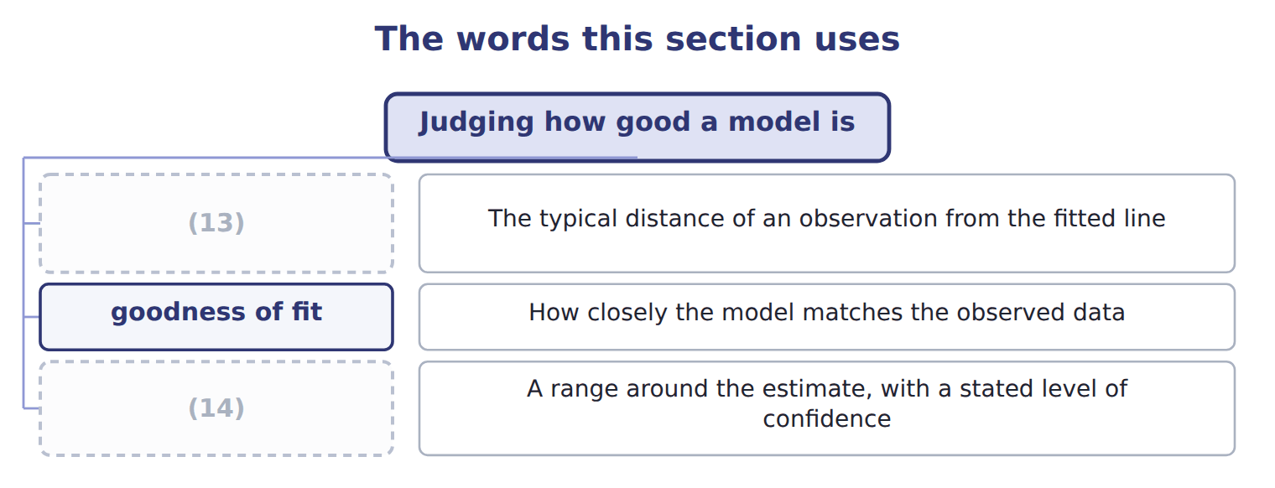
word list
confidence interval · moving average · standard error of the estimate

The English this sheet uses, and its Arabic
English (exam term) | Arabic
standard error of the estimate | الخطأ المعياري للتقدير
goodness of fit | جودة المطابقة
confidence interval | فترة الثقة

Answer key · 16.4 Judging how good a model is

1 Smaller is better | 8 subtracting
2 High fit with few observations invites caution | 9 confident
3 observation | 10 confidence
4 expressed | 11 uncertainty
5 Beverages | 12 overfits
6 prediction | 13 standard error of the estimate
7 confidence | 14 confidence interval

the summaries in full
Summary 1 The standard error of the estimate is the typical distance of an observation from the fitted line, expressed in the units of the thing being predicted. For the Beverages model it is 555 cases, which is readable directly: a prediction is typically wrong by about that much. A confidence interval turns a single estimate into a range, by adding and subtracting a multiple of the standard error. It also states how confident one is that the true value lies inside it.
Summary 2 A confidence interval is honest about uncertainty, not a measure of skill. An interval that is narrow because the model overfits a small sample is worse than a wide one that reflects what the data can actually support.

16.5 Exploratory data analysis
Chapter 16 · section 16.5

Fill every gap. Each word list holds one word more than there are gaps.
What exploratory data analysis involves
Exploratory step (F.4.v) | What it does | At Orontes
Plot the series | See the shape before assuming one | (1)
Look at the spread | Find outliers and impossible values | (2)
Compare the periods | See whether the pattern repeats | (3)
Ask what is missing | Absent data shapes the answer too | (4)
Then model | (5) | Chapter 15's regression

word list
Chapter 11's two orders a hundred times the usual · Two years both peak in the third quarter · The third-quarter peak is visible without any model · The model tests what the eye suggested · Absent data shapes the answer too · Fourteen orders with no delivery date

Summary 1 gaps 6–11
Its value is that the eye finds (6) no summary (7) reports. The (8) peak is visible (9) , before any moving average is computed, and so are the outliers and the gaps. It also (10) against the (11) error. A model fitted without looking can produce a respectable R squared on data that contains an obvious impossibility, and nobody will notice until someone acts on the answer.
word list
protects · immediately · opposite · someone · third-quarter · things · statistic

The words this section uses
Each term sits against what it means.
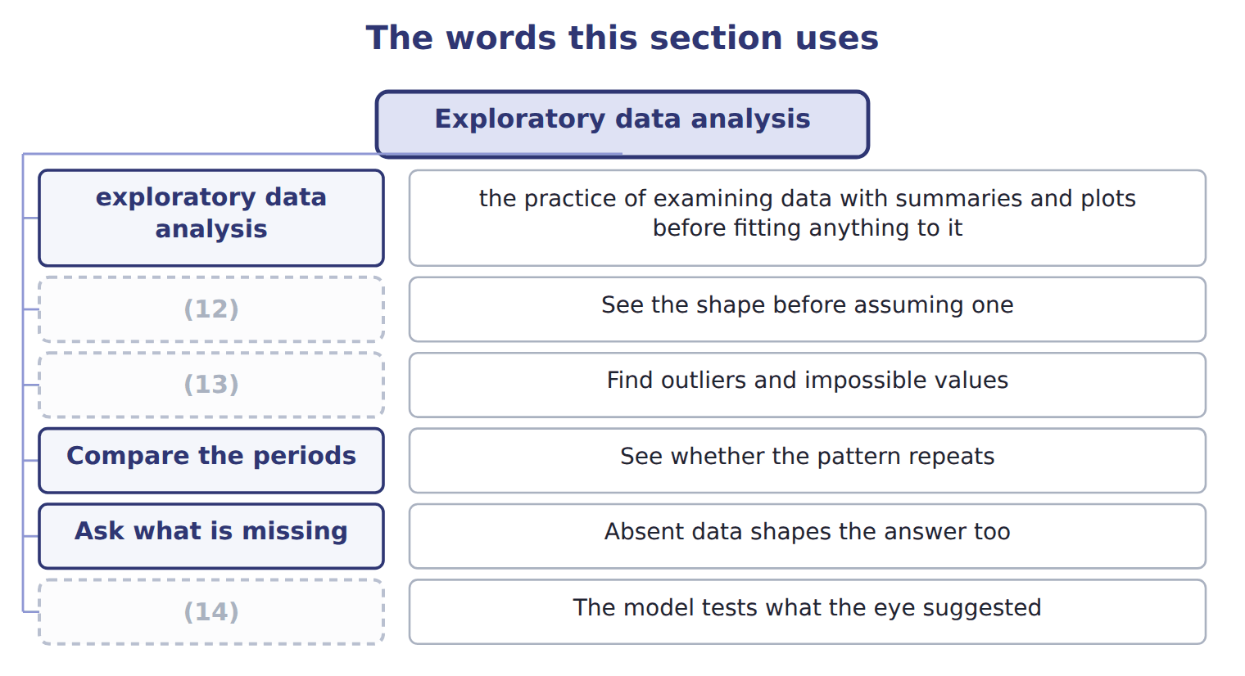
word list
Plot the series · Then model · Look at the spread · irregular variation

The English this sheet uses, and its Arabic
English (exam term) | Arabic
exploratory data analysis | التحليل الاستكشافي للبيانات

Answer key · 16.5 Exploratory data analysis

1 The third-quarter peak is visible without any model | 8 third-quarter
2 Chapter 11's two orders a hundred times the usual | 9 immediately
3 Two years both peak in the third quarter | 10 protects
4 Fourteen orders with no delivery date | 11 opposite
5 The model tests what the eye suggested | 12 Plot the series
6 things | 13 Look at the spread
7 statistic | 14 Then model

the summaries in full
Summary 1 Its value is that the eye finds things no summary statistic reports. The third-quarter peak is visible immediately, before any moving average is computed, and so are the outliers and the gaps. It also protects against the opposite error. A model fitted without looking can produce a respectable R squared on data that contains an obvious impossibility, and nobody will notice until someone acts on the answer.

16.6 Extended Example 16A: decomposing the Beverages series
Chapter 16 · section 16.6

Fill every gap. Each word list holds one word more than there are gaps.
Summary 1 gaps 1–12
This example performs the (1) and then says what it is and is not good for. A (2) moving average is taken, then (3) so that it lines up with an actual quarter. With 8 (4) this gives 4 trend (5) , from 2027 Q3 to 2028 Q2. The two (6) at each end have no trend value, which is a real cost of the (7) . (8) the trend from the actual leaves the seasonal and irregular (9) together. In 2027 Q3, actual demand was 240,400 cases (10) a trend of 219,750, (11) 20,650. Where a quarter appears more than once, averaging its (12) cancels most of the irregular part and leaves the seasonal factor. Adjusting the four so they sum to zero gives (13,022), 691, 20,003 and (7,672) for the first to the fourth quarter.
word list
four-quarter · against · decomposition · Subtracting · remainders · average · values · components · leaving · quarters · method · observations · centred

Summary 2 gaps 13–20
The (13) say how much of the (14) peak is simply the season. A manager who congratulates the sales team on a 20,003-case rise in the third quarter is (15) them on the (16) . The same manager (17) not treat the (18) fall as a failure. Two years is very (19) . Each seasonal factor here rests on two observations, so a single unusual quarter moves it (20) . The cyclical component cannot be seen at all. The honest statement is a direction and a rough size, not a precise forecast.
word list
congratulating · third-quarter · first-quarter · should · weather · factors · substantially · little · components

Name four components

Complete the blank cells.
Your turn: name four components (complete the blanks)
Every item belongs to exactly one group.
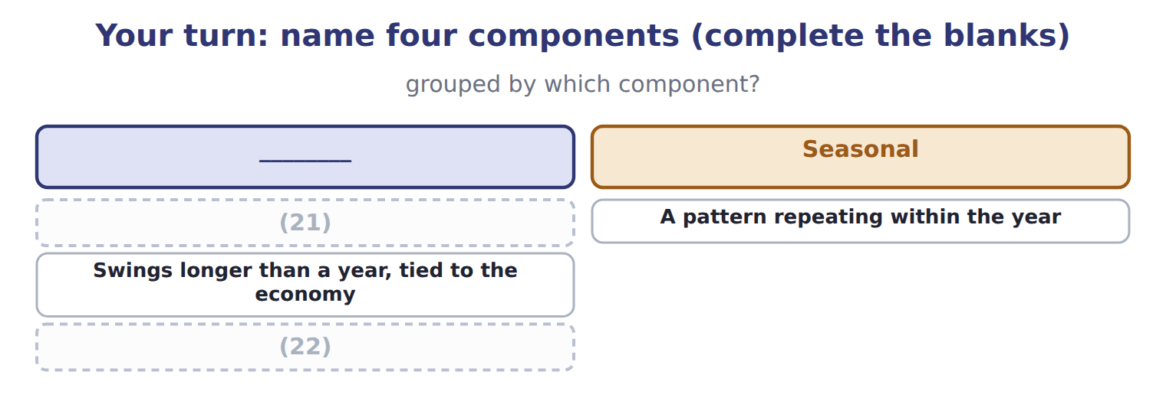
word list
What is left after the other three · The long-run direction over years · A pattern repeating within the year

Everything ties

Summary 3 gaps 23–24
Trend rises from 219,750 to 223,662 cases across the 4 (23) quarters. (24) factors (13,022), 691, 20,003, (7,672) sum to zero. The swing from worst quarter to best is 33,025 cases.
word list
computed · statement · Seasonal

Exam view

Summary 4 gaps 25–27
A (25) names a movement and asks which (26) it is. Ask how long it lasts: within a year is seasonal, over years is (27) , several years and tied to the economy is cyclical, and once only is irregular.
word list
component · question · together · trend

Exam view
Item | Answer
The long-run direction over years | (28) — it is the underlying growth or decline, visible only across years
A pattern repeating within the year | Why: seasonal variation returns at the same point each year, so the third quarter peaks in both years here
Swings longer than a year, tied to the economy | (29) — and two years of data cannot show it
What is left after the other three | Irregular variation — random and unrepeatable, which is why no model should try to fit it

word list
Trend · Cyclical variation · moving average

Movement described — Category
Movement described | Category
Steadily rising demand as the Gulf market opens | (30)
The third quarter peaking every year | Seasonal
A multi-year regional downturn | Cyclical
A port strike delaying one shipment | (31)

word list
Trend · Irregular · Cyclical

The English this section uses, and its Arabic
Each term sits against what it means.
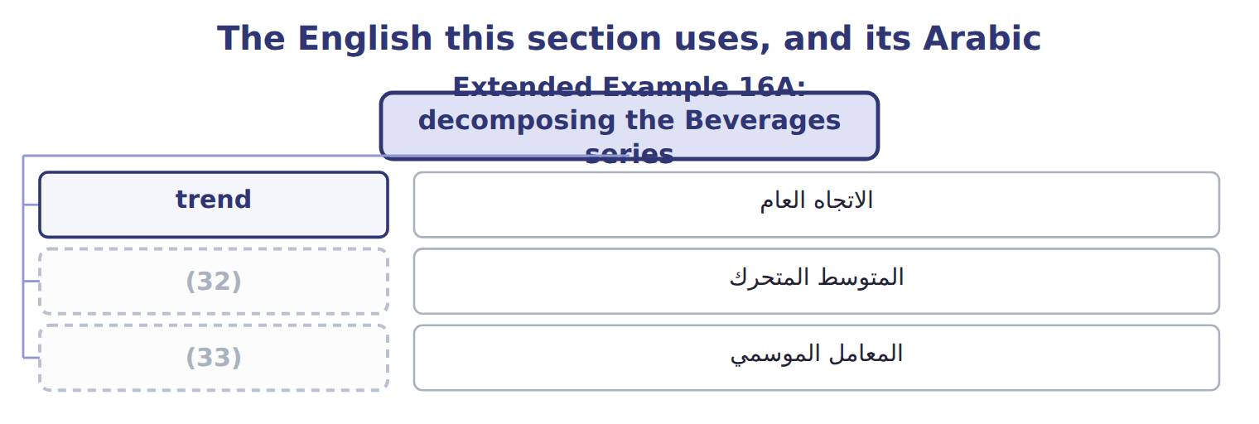
word list
moving average · seasonal factor · confidence interval

Answer key · 16.6 Extended Example 16A: decomposing the Beverages series

1 decomposition | 18 first-quarter
2 four-quarter | 19 little
3 centred | 20 substantially
4 observations | 21 The long-run direction over years
5 values | 22 What is left after the other three
6 quarters | 23 computed
7 method | 24 Seasonal
8 Subtracting | 25 question
9 components | 26 component
10 against | 27 trend
11 leaving | 28 Trend
12 remainders | 29 Cyclical variation
13 factors | 30 Trend
14 third-quarter | 31 Irregular
15 congratulating | 32 moving average
16 weather | 33 seasonal factor
17 should

the summaries in full
Summary 1 This example performs the decomposition and then says what it is and is not good for. A four-quarter moving average is taken, then centred so that it lines up with an actual quarter. With 8 observations this gives 4 trend values, from 2027 Q3 to 2028 Q2. The two quarters at each end have no trend value, which is a real cost of the method. Subtracting the trend from the actual leaves the seasonal and irregular components together. In 2027 Q3, actual demand was 240,400 cases against a trend of 219,750, leaving 20,650. Where a quarter appears more than once, averaging its remainders cancels most of the irregular part and leaves the seasonal factor. Adjusting the four so they sum to zero gives (13,022), 691, 20,003 and (7,672) for the first to the fourth quarter.
Summary 2 The factors say how much of the third-quarter peak is simply the season. A manager who congratulates the sales team on a 20,003-case rise in the third quarter is congratulating them on the weather. The same manager should not treat the first-quarter fall as a failure. Two years is very little. Each seasonal factor here rests on two observations, so a single unusual quarter moves it substantially. The cyclical component cannot be seen at all. The honest statement is a direction and a rough size, not a precise forecast.
Summary 3 Trend rises from 219,750 to 223,662 cases across the 4 computed quarters. Seasonal factors (13,022), 691, 20,003, (7,672) sum to zero. The swing from worst quarter to best is 33,025 cases.
Summary 4 A question names a movement and asks which component it is. Ask how long it lasts: within a year is seasonal, over years is trend, several years and tied to the economy is cyclical, and once only is irregular.

