1.1 Cost objects
Chapter 1 · section 1.1

Fill every gap. Each word list holds one word more than there are gaps.
Chapter 1, section by section
Each stage leads to the next.
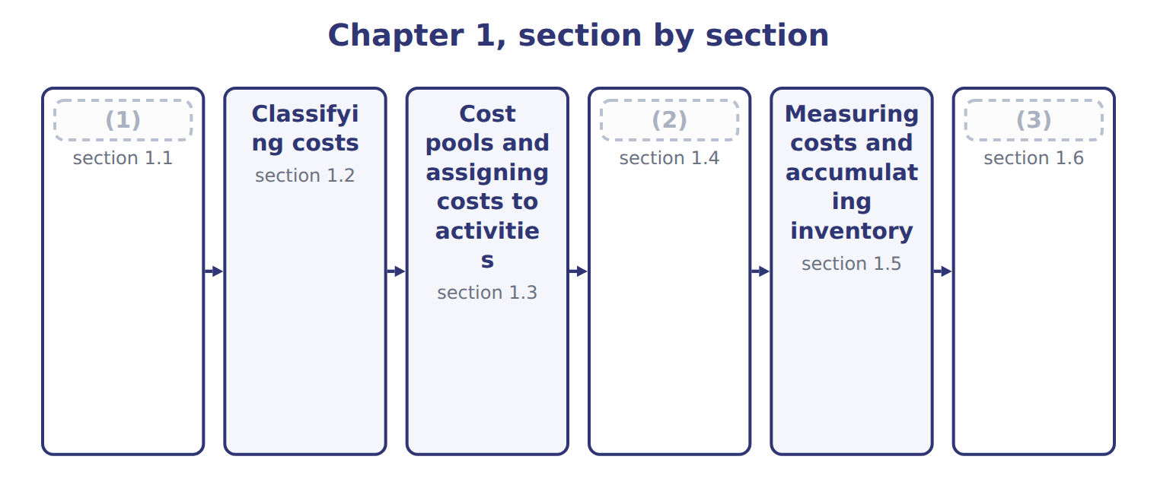
word list
Cost objects · Extended Example 1A: Tahini & Spreads, full ye · cost pool · Cost drivers

Summary 1 gaps 4–10
A cost object is (4) for which a (5) cost is measured. At Orontes it can be a division, a product line, one (6) job, a customer such as Barada (7) , or an activity such as machine setups. (8) choose cost objects to answer (9) . What does job T-0303 cost? Is the halva line (10) ? How much does it cost to serve Barada? Each question needs a different cost object. The same cost can be treated differently for different cost objects.
word list
separate · product · Wholesale · profitable · private-label · Managers · questions · anything

Answer key · 1.1 Cost objects

1 Cost objects | 6 private-label
2 Cost drivers | 7 Wholesale
3 Extended Example 1A: Tahini & Spreads, full ye | 8 Managers
4 anything | 9 questions
5 separate | 10 profitable

the summaries in full
Summary 1 A cost object is anything for which a separate cost is measured. At Orontes it can be a division, a product line, one private-label job, a customer such as Barada Wholesale, or an activity such as machine setups. Managers choose cost objects to answer questions. What does job T-0303 cost? Is the halva line profitable? How much does it cost to serve Barada? Each question needs a different cost object. The same cost can be treated differently for different cost objects.

1.2 Classifying costs
Chapter 1 · section 1.2

Fill every gap. Each word list holds one word more than there are gaps.
Summary 1 gaps 1–9
A direct cost can be (1) to a cost object in an (2) way. An indirect cost cannot, so it must be (3) . The (4) of the tahini line is indirect for one job, but direct for the Tahini & Spreads division. A second (5) matters for the statements. Product costs are direct materials, direct labor and manufacturing overhead; they go to (6) first. Period costs are selling and (7) costs; they are expensed when incurred. Two totals appear often in exam (8) . Prime cost is direct materials plus direct labor. (9) cost is direct labor plus manufacturing overhead: the cost of turning materials into products.
word list
economical · supervisor · allocated · classification · administrative · through · traced · inventory · questions · Conversion

Worked example: classifying Tahini & Spreads costs

Summary 2 gaps 10–12
Notice that supervision, (10) and the Quality Lab charge are product costs but (11) : they reach the job only through overhead. (12) to Barada is a period cost, even though it relates to a sale.
word list
manufacturing · Delivery · indirect · depreciation

Worked example: classifying ten Tahini & Spreads costs
Every item belongs to exactly one group.
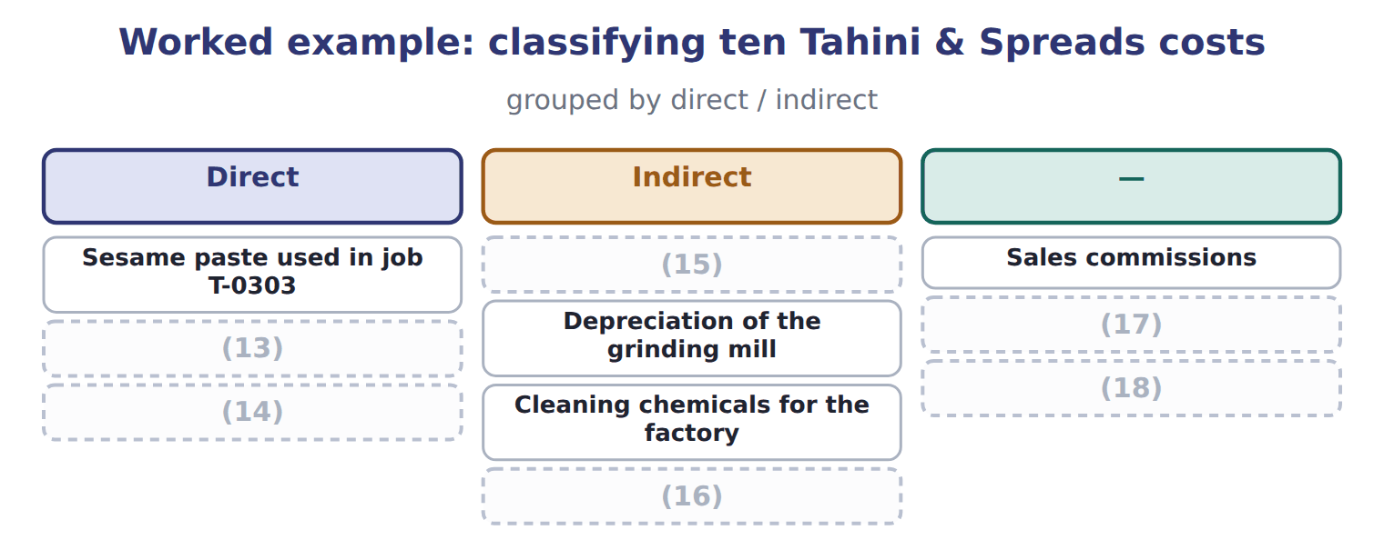
word list
Head-office salaries · Quality Lab charge to the division · Wages of operators working on job T-0303 · Delivery of goods to Barada · Cleaning chemicals for the factory · Jars and labels for job T-0303 · Factory supervisor's salary

It is not the U.S. product cost used for inventory.

The English this section uses, and its Arabic
Each term sits against what it means.
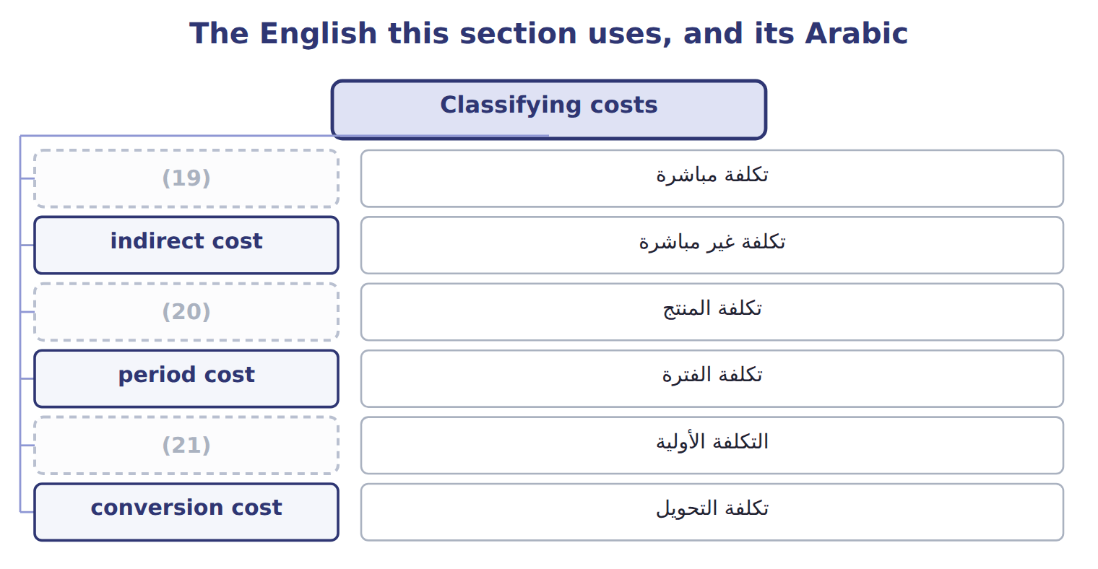
word list
conversion cost · direct cost · prime cost · product cost

The English this sheet uses, and its Arabic
English (exam term) | Arabic
direct cost | تكلفة مباشرة
indirect cost | تكلفة غير مباشرة
product cost | تكلفة المنتج
period cost | تكلفة الفترة
prime cost | التكلفة الأولية
conversion cost | تكلفة التحويل

Answer key · 1.2 Classifying costs

1 traced | 12 Delivery
2 economical | 13 Jars and labels for job T-0303
3 allocated | 14 Wages of operators working on job T-0303
4 supervisor | 15 Factory supervisor's salary
5 classification | 16 Quality Lab charge to the division
6 inventory | 17 Head-office salaries
7 administrative | 18 Delivery of goods to Barada
8 questions | 19 direct cost
9 Conversion | 20 product cost
10 depreciation | 21 prime cost
11 indirect

the summaries in full
Summary 1 A direct cost can be traced to a cost object in an economical way. An indirect cost cannot, so it must be allocated. The supervisor of the tahini line is indirect for one job, but direct for the Tahini & Spreads division. A second classification matters for the statements. Product costs are direct materials, direct labor and manufacturing overhead; they go to inventory first. Period costs are selling and administrative costs; they are expensed when incurred. Two totals appear often in exam questions. Prime cost is direct materials plus direct labor. Conversion cost is direct labor plus manufacturing overhead: the cost of turning materials into products.
Summary 2 Notice that supervision, depreciation and the Quality Lab charge are product costs but indirect: they reach the job only through overhead. Delivery to Barada is a period cost, even though it relates to a sale.

1.3 Cost pools and assigning costs to activities
Chapter 1 · section 1.3

Fill every gap. Each word list holds one word more than there are gaps.
Summary 1 gaps 1–5
A cost pool is a group of (1) costs that are (2) together. Instead of assigning every (3) bill and every (4) salary one by one, Orontes groups indirect costs into pools, such as machine operations, batch setups, quality testing and facility costs. Tahini & Spreads uses one (5) pool today: all its overhead is applied with machine hours.
word list
supervisor's · individual · electricity · plantwide · assigned · salaries

Summary 2 gaps 6–8
Assignment then (6) in two stages. First, resources such as salaries and power are assigned to the (7) that use them. Second, each pool is assigned to jobs and (8) with its own base.
word list
happens · products · conversion cost · activities

The English this sheet uses, and its Arabic
English (exam term) | Arabic
cost object | هدف التكلفة
cost pool | مجمع التكلفة

Answer key · 1.3 Cost pools and assigning costs to activities

1 individual | 5 plantwide
2 assigned | 6 happens
3 electricity | 7 activities
4 supervisor's | 8 products

the summaries in full
Summary 1 A cost pool is a group of individual costs that are assigned together. Instead of assigning every electricity bill and every supervisor's salary one by one, Orontes groups indirect costs into pools, such as machine operations, batch setups, quality testing and facility costs. Tahini & Spreads uses one plantwide pool today: all its overhead is applied with machine hours.
Summary 2 Assignment then happens in two stages. First, resources such as salaries and power are assigned to the activities that use them. Second, each pool is assigned to jobs and products with its own base.

1.4 Cost drivers
Chapter 1 · section 1.4

Fill every gap. Each word list holds one word more than there are gaps.
Summary 1 gaps 1–10
A cost driver is a (1) that causes a cost to change. Grinding (2) takes machine time, so machine hours drive grinding power and (3) . A new (4) needs a setup, so the number of (5) drives setup costs. The link must be (6) . Sales (7) may move with factory power costs, but (8) more at higher prices does not cause more power use. A driver chosen only (9) it moves with the cost can give wrong product costs when (10) change. Drivers work at different levels. A volume-based cost driver rises with each unit or hour. Other drivers rise with batches, with the number of products, or not at all, as with facility costs.
word list
revenue · because · recipe · setups · conditions · maintenance · products · factor · selling · sesame · causal

Types of cost drivers at Orontes
Driver type | Cost moves with | Orontes example | Causal link
Volume-based (unit level) | Rises with each unit or hour | Machine hours in grinding; direct labor hours | (11)
Batch level | (12) | Number of setups for a new recipe | Strong for setup and cleaning costs
Product-sustaining | (13) | Number of private-label recipes | Strong for design and label costs
Facility level | Does not move with activity | (14) | Weak: an allocation, not a cause

word list
Strong for machine and energy costs · Strong for design and label costs · Rises with the number of products · Rises with each batch or order · Square meters of factory space

Correlation is not causation

Summary 2 gaps 15–16
A (15) may offer a base that moves closely with the cost but does not cause it, such as sales revenue for factory power. (16) the base that causes the cost.
word list
Choose · question · volume-based

The English this section uses, and its Arabic
Each term sits against what it means.
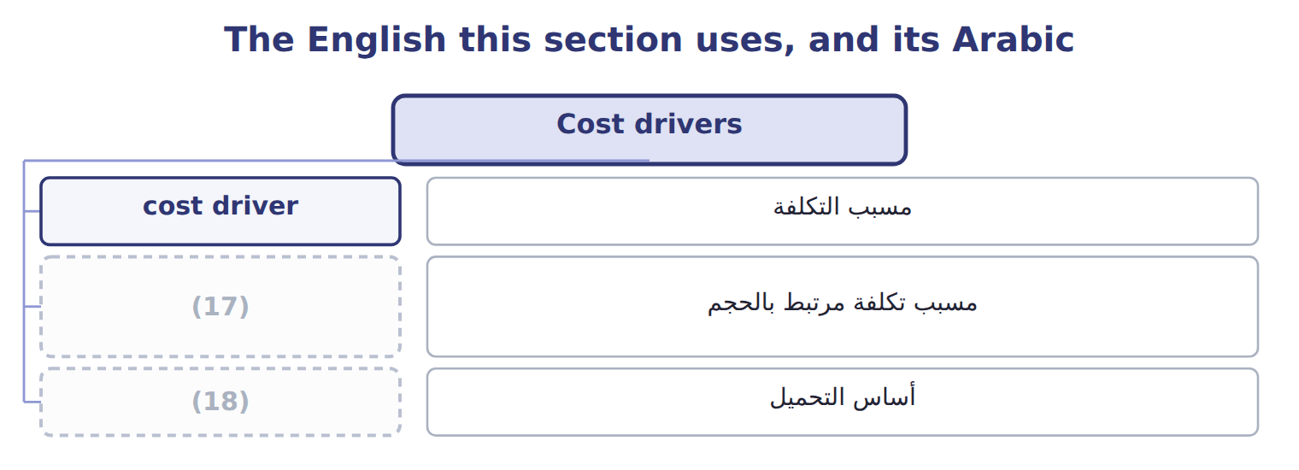
word list
indirect cost · volume-based cost driver · allocation base

The English this sheet uses, and its Arabic
English (exam term) | Arabic
cost driver | مسبب التكلفة
volume-based cost driver | مسبب تكلفة مرتبط بالحجم
allocation base | أساس التحميل

Answer key · 1.4 Cost drivers

1 factor | 10 conditions
2 sesame | 11 Strong for machine and energy costs
3 maintenance | 12 Rises with each batch or order
4 recipe | 13 Rises with the number of products
5 setups | 14 Square meters of factory space
6 causal | 15 question
7 revenue | 16 Choose
8 selling | 17 volume-based cost driver
9 because | 18 allocation base

the summaries in full
Summary 1 A cost driver is a factor that causes a cost to change. Grinding sesame takes machine time, so machine hours drive grinding power and maintenance. A new recipe needs a setup, so the number of setups drives setup costs. The link must be causal. Sales revenue may move with factory power costs, but selling more at higher prices does not cause more power use. A driver chosen only because it moves with the cost can give wrong product costs when conditions change. Drivers work at different levels. A volume-based cost driver rises with each unit or hour. Other drivers rise with batches, with the number of products, or not at all, as with facility costs.
Summary 2 A question may offer a base that moves closely with the cost but does not cause it, such as sales revenue for factory power. Choose the base that causes the cost.

1.5 Measuring costs and accumulating inventory
Chapter 1 · section 1.5

Fill every gap. Each word list holds one word more than there are gaps.
Summary 1 gaps 1–2
A cost system answers two (1) . How is cost measured: at actual amounts, with a (2) overhead rate, or at standard? And how is cost collected: by job, by process, by activity.
word list
questions · measured · predetermined

Cost measurement and accumulation methods
Question | Method | What it does | Taught in
Measurement | (3) | Actual DM, DL and actual overhead | Chapter 5
 | (4) | Actual DM and DL + applied overhead | Chapters 5, 6
 | Standard costing | (5) | Chapters 5, 18
Accumulation | Job order costing | (6) | Chapter 6
 | Process costing | (7) | Chapter 7
 | Activity-based costing | (8) | Chapter 12
 | (9) | Costs recorded at trigger points | Chapter 17

word list
Chapter 6 · Normal costing · Actual costing · Standard quantities and prices · Costs collected by department · Costs collected by job · Costs collected by activity · Backflush costing

Summary 2 gaps 10–16
Whatever the method, a (10) product costs move (11) three inventory (12) . Raw materials inventory holds materials not yet used. Work in process holds (13) finished goods. Finished goods inventory holds (14) goods not yet sold. Sold goods move to cost of goods sold. The cost of goods manufactured is the cost of the goods finished in the period: beginning work in process plus (15) costs added, less ending work in process. The (16) Example shows the whole flow for one year.
word list
overhead · partly · Extended · through · manufacturing · manufacturer's · accounts · completed

Classify halva costs

The first two are done. Classify the rest, with one batch as the cost object.

Your turn: classify halva line costs (complete the blanks)
Every item belongs to exactly one group.
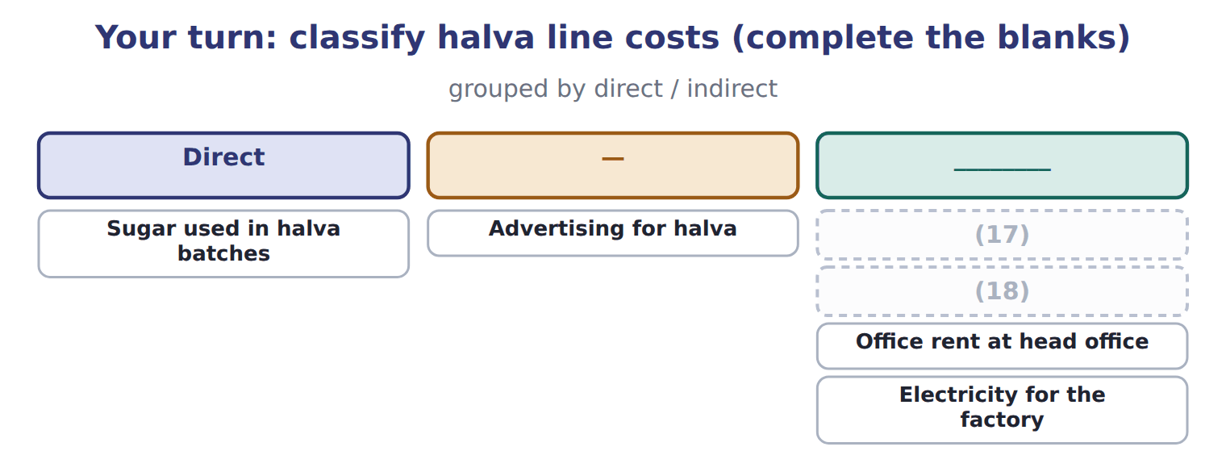
word list
Wages of halva line operators · Maintenance of the halva mixer · Office rent at head office

The English this section uses, and its Arabic
Each term sits against what it means.
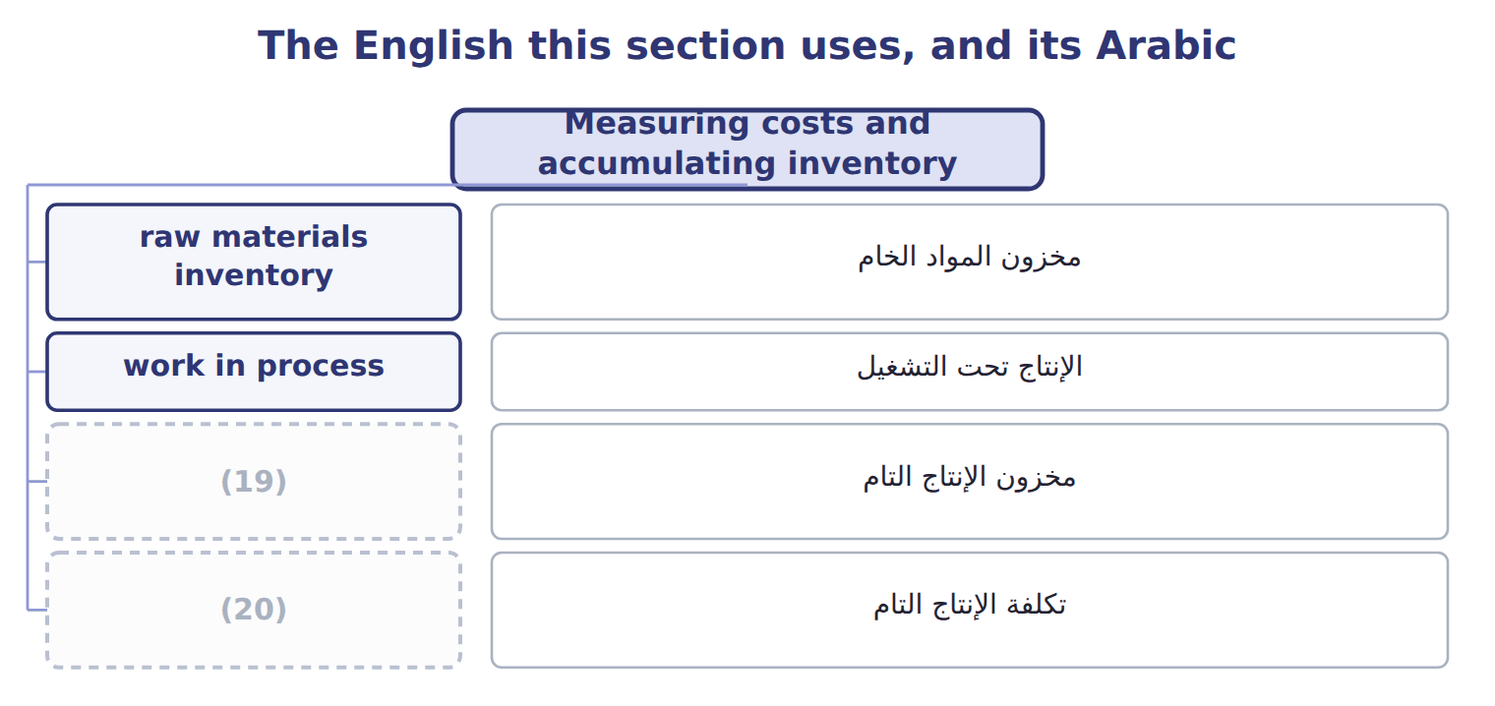
word list
finished goods inventory · cost of goods manufactured · مخزون المواد الخام

The English this sheet uses, and its Arabic
English (exam term) | Arabic
raw materials inventory | مخزون المواد الخام
work in process | الإنتاج تحت التشغيل
finished goods inventory | مخزون الإنتاج التام
cost of goods manufactured | تكلفة الإنتاج التام

Answer key · 1.5 Measuring costs and accumulating inventory

1 questions | 11 through
2 predetermined | 12 accounts
3 Actual costing | 13 partly
4 Normal costing | 14 completed
5 Standard quantities and prices | 15 manufacturing
6 Costs collected by job | 16 Extended
7 Costs collected by department | 17 Maintenance of the halva mixer
8 Costs collected by activity | 18 Wages of halva line operators
9 Backflush costing | 19 finished goods inventory
10 manufacturer's | 20 cost of goods manufactured

the summaries in full
Summary 1 A cost system answers two questions. How is cost measured: at actual amounts, with a predetermined overhead rate, or at standard? And how is cost collected: by job, by process, by activity.
Summary 2 Whatever the method, a manufacturer's product costs move through three inventory accounts. Raw materials inventory holds materials not yet used. Work in process holds partly finished goods. Finished goods inventory holds completed goods not yet sold. Sold goods move to cost of goods sold. The cost of goods manufactured is the cost of the goods finished in the period: beginning work in process plus manufacturing costs added, less ending work in process. The Extended Example shows the whole flow for one year.

1.6 Extended Example 1A: Tahini & Spreads, full year 2027
Chapter 1 · section 1.6

Fill every gap. Each word list holds one word more than there are gaps.
Summary 1 gaps 1–12
This example (1) one full year of costs through the (2) and into the (3) income statement. The (4) are exam-core: questions often ask for cost of goods manufactured or cost of goods sold. The entries are for depth. On (5) 1, 2027 Tahini & Spreads held raw materials of $130,000, work in process of $180,000 and finished goods of $420,000. Materials: (6) $3,260,000; direct materials used $3,000,000; indirect materials $240,000. Labor: direct labor $1,800,000; indirect labor $480,000. Other factory overhead: service department charges $690,000; (7) $840,000; utilities and other costs $740,000. Overhead (8) : 92,000 machine hours × $30 = $2,760,000. (9) balances: work in process $690,000; finished goods $1,380,000. Sales and period costs: sales $8,700,000; selling expense $610,000; (10) expense $390,000. (11) product costs from period costs. Record the entries, post them, (12) the schedule of cost of goods manufactured and the income statement, and check that the balances tie.
word list
prepare · applied · entries · January · follows · Separate · schedules · depreciation · administrative · purchases · accounts · division's · Year-end

Summary 2 gaps 13–18
Total (13) costs = $3,000,000 + $1,800,000 + $2,760,000 = $7,560,000. Cost of goods manufactured = $180,000 + $7,560,000 − $690,000 = $7,050,000. Cost of goods sold = $420,000 + $7,050,000 − $1,380,000 = $6,090,000. (14) overhead = $240,000 + $480,000 + $2,270,000 = $2,990,000, so overhead is (15) by $230,000. (16) 1 to 8 are product costs; entry 9 records the period costs, which never touch (17) . The (18) totals $36,650,000 on both sides.
word list
journal · materials · underapplied · inventory · Actual · Entries · manufacturing

Extended Example: general journal, FY2027
No. | Account (detail) | Debit | Credit
1 | (19) | 3,260,000
 | (20) |  | 3,260,000
2 | (21) | 3,000,000
 | Manufacturing Overhead Control | 240,000
 | Raw Materials Inventory |  | 3,240,000
3 | Work-in-Process Inventory | 1,800,000
 | Manufacturing Overhead Control | 480,000
 | (22) |  | 2,280,000
4 | (23) | 2,270,000
 | Service Department Charges |  | 690,000
 | (24) |  | 840,000
 | Accounts Payable |  | 740,000
5 | Work-in-Process Inventory | 2,760,000
 | Manufacturing Overhead Applied |  | 2,760,000
6 | (25) | 7,050,000
 | Work-in-Process Inventory |  | 7,050,000
7 | (26) | 8,700,000
 | Sales Revenue |  | 8,700,000
8 | Cost of Goods Sold | 6,090,000
 | Finished Goods Inventory |  | 6,090,000
9 | (27) | 610,000
 | (28) | 390,000
 | Cash and Payables |  | 1,000,000
 | Totals | 36,650,000 | 36,650,000

word list
Wages Payable · Accounts Payable · Accumulated Depreciation · Raw Materials Inventory · Finished Goods Inventory · Work-in-Process Inventory · Direct materials · Manufacturing Overhead Control · Administrative Expense · Accounts Receivable · Selling Expense

Raw materials close at $150,000, work in process at $690,000 and finished goods at $1,380,000.

Extended Example: cost of goods manufactured, cost of goods sold and operating income
The bars are drawn to scale.
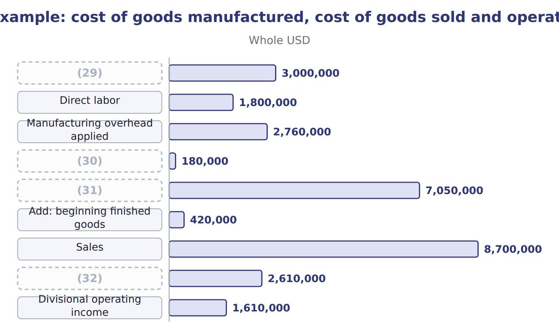
word list
Cost of goods manufactured · Add: beginning WIP · cost pool · Gross margin · Direct materials used

Everything ties

Summary 3 gaps 33–36
Total debits = total (33) = $36,650,000. Raw materials: $130,000 + $3,260,000 − $3,240,000 = $150,000. Work in process: $180,000 + $7,560,000 − $7,050,000 = $690,000. (34) goods: $420,000 + $7,050,000 − $6,090,000 = $1,380,000. (35) work in process = direct materials $300,000 + direct labor $114,000 + applied (36) $276,000.
word list
manufactured · Ending · credits · overhead · Finished

Exam view

Summary 4 gaps 37–39
Expect a list of costs and (37) balances, and a request for cost of goods (38) or cost of goods sold. Sort product from period costs first; then apply the two (39) formulas.
word list
inventory · schedule · utilities · manufactured

Exam view
Halva line · April–June 2027 (actual costs, whol | Amount
Sesame | 180,000
(40) | 60,000
(41) | 40,000
Line operators' wages | 120,000
(42) | 30,000
Depreciation of halva equipment | 45,000
(43) | 25,000
Indirect materials | 10,000
Sales commissions | 35,000
Advertising | 20,000
Head-office salaries | 50,000
Delivery to customers | 15,000
(44) | 25,000 / 40,000
(45) | 30,000 / 45,000
Sales | 700,000

word list
Sugar and flavors · Factory supervision · Finished goods: beginning / ending · Jars · Factory utilities · Work-in-Process Inventory · WIP: beginning / ending

Item — Answer
Item | Answer
Maintenance of the halva mixer | Indirect; product cost
Wages of halva line operators | (46)
Office rent at head office | (47)
Electricity for the factory | Indirect; product cost

word list
Tahini & Spreads · FY2027 · Not a production cost; period cost · Direct; product cost

Cost — Category
Every item belongs to exactly one group.
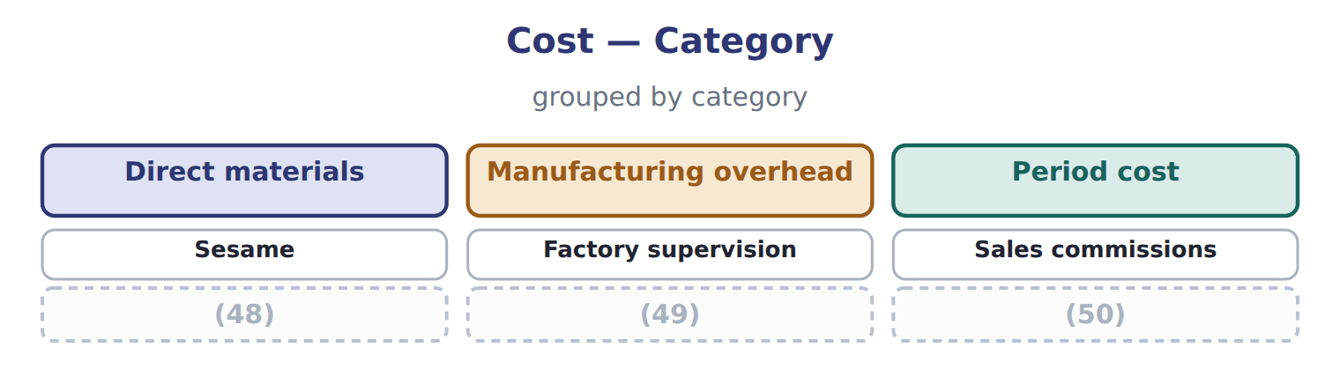
word list
Factory utilities · Jars · cost driver · Head-office salaries

The English this section uses, and its Arabic
Each term sits against what it means.
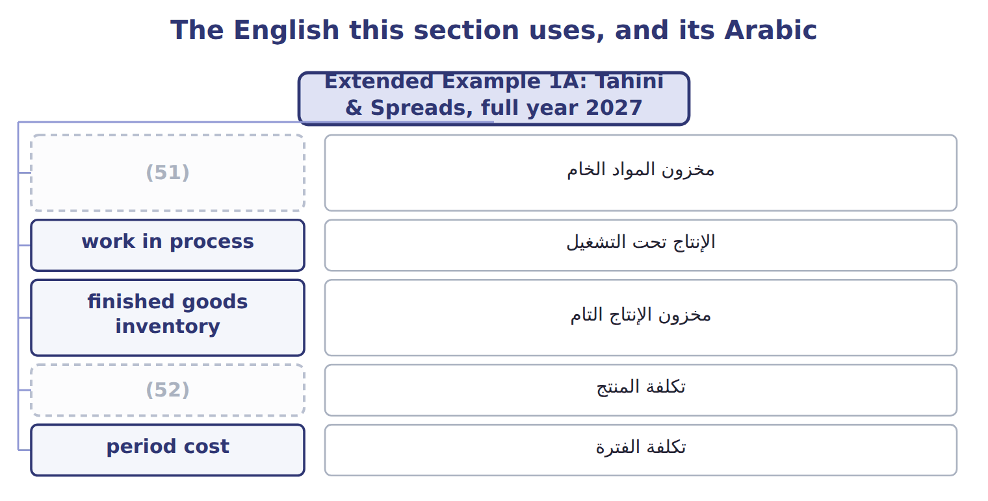
word list
product cost · raw materials inventory · مخزون الإنتاج التام

The English this sheet uses, and its Arabic
English (exam term) | Arabic
raw materials inventory | مخزون المواد الخام
work in process | الإنتاج تحت التشغيل
finished goods inventory | مخزون الإنتاج التام
product cost | تكلفة المنتج
period cost | تكلفة الفترة

Answer key · 1.6 Extended Example 1A: Tahini & Spreads, full year 2027

1 follows | 27 Selling Expense
2 accounts | 28 Administrative Expense
3 division's | 29 Direct materials used
4 schedules | 30 Add: beginning WIP
5 January | 31 Cost of goods manufactured
6 purchases | 32 Gross margin
7 depreciation | 33 credits
8 applied | 34 Finished
9 Year-end | 35 Ending
10 administrative | 36 overhead
11 Separate | 37 inventory
12 prepare | 38 manufactured
13 manufacturing | 39 schedule
14 Actual | 40 Sugar and flavors
15 underapplied | 41 Jars
16 Entries | 42 Factory supervision
17 inventory | 43 Factory utilities
18 journal | 44 WIP: beginning / ending
19 Raw Materials Inventory | 45 Finished goods: beginning / ending
20 Accounts Payable | 46 Direct; product cost
21 Work-in-Process Inventory | 47 Not a production cost; period cost
22 Wages Payable | 48 Jars
23 Manufacturing Overhead Control | 49 Factory utilities
24 Accumulated Depreciation | 50 Head-office salaries
25 Finished Goods Inventory | 51 raw materials inventory
26 Accounts Receivable | 52 product cost

the summaries in full
Summary 1 This example follows one full year of costs through the accounts and into the division's income statement. The schedules are exam-core: questions often ask for cost of goods manufactured or cost of goods sold. The entries are for depth. On January 1, 2027 Tahini & Spreads held raw materials of $130,000, work in process of $180,000 and finished goods of $420,000. Materials: purchases $3,260,000; direct materials used $3,000,000; indirect materials $240,000. Labor: direct labor $1,800,000; indirect labor $480,000. Other factory overhead: service department charges $690,000; depreciation $840,000; utilities and other costs $740,000. Overhead applied: 92,000 machine hours × $30 = $2,760,000. Year-end balances: work in process $690,000; finished goods $1,380,000. Sales and period costs: sales $8,700,000; selling expense $610,000; administrative expense $390,000. Separate product costs from period costs. Record the entries, post them, prepare the schedule of cost of goods manufactured and the income statement, and check that the balances tie.
Summary 2 Total manufacturing costs = $3,000,000 + $1,800,000 + $2,760,000 = $7,560,000. Cost of goods manufactured = $180,000 + $7,560,000 − $690,000 = $7,050,000. Cost of goods sold = $420,000 + $7,050,000 − $1,380,000 = $6,090,000. Actual overhead = $240,000 + $480,000 + $2,270,000 = $2,990,000, so overhead is underapplied by $230,000. Entries 1 to 8 are product costs; entry 9 records the period costs, which never touch inventory. The journal totals $36,650,000 on both sides.
Summary 3 Total debits = total credits = $36,650,000. Raw materials: $130,000 + $3,260,000 − $3,240,000 = $150,000. Work in process: $180,000 + $7,560,000 − $7,050,000 = $690,000. Finished goods: $420,000 + $7,050,000 − $6,090,000 = $1,380,000. Ending work in process = direct materials $300,000 + direct labor $114,000 + applied overhead $276,000.
Summary 4 Expect a list of costs and inventory balances, and a request for cost of goods manufactured or cost of goods sold. Sort product from period costs first; then apply the two schedule formulas.

2.1 Four cost behaviors
Chapter 2 · section 2.1

Fill every gap. Each word list holds one word more than there are gaps.
Chapter 2, section by section
Each stage leads to the next.
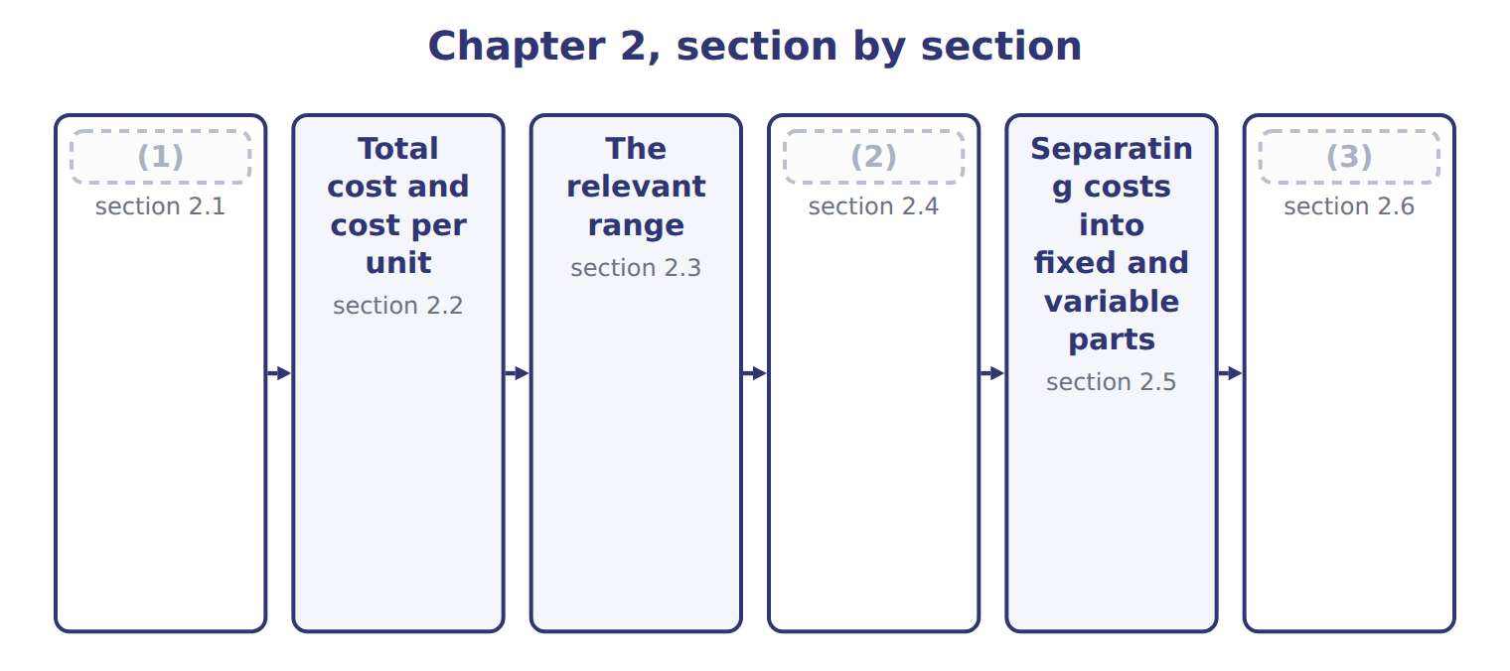
word list
Four cost behaviors · The time frame: short run and long run · Extended Example 2A: the Oils overhead budget, · Total cost and cost per unit

Summary 1 gaps 4–12
A (4) cost changes in total in (5) to activity. Power for the crushers costs $5 for every machine hour, so twice the hours means twice the power bill. A fixed cost stays the same in total when activity changes. Factory (6) costs $420,000 a year (7) the crushers run a (8) or a lot. A mixed cost has both parts: (9) and utilities cost $216,000 a year plus $12 per machine hour. A step cost is fixed over a band of activity and then jumps. Above the (10) range, Oils needs a (11) shift, which adds a (12) costing $180,000.
word list
supervision · variable · relevant · proportion · supervisor · whether · maintenance · machine · little · second

The English this section uses, and its Arabic
Each term sits against what it means.
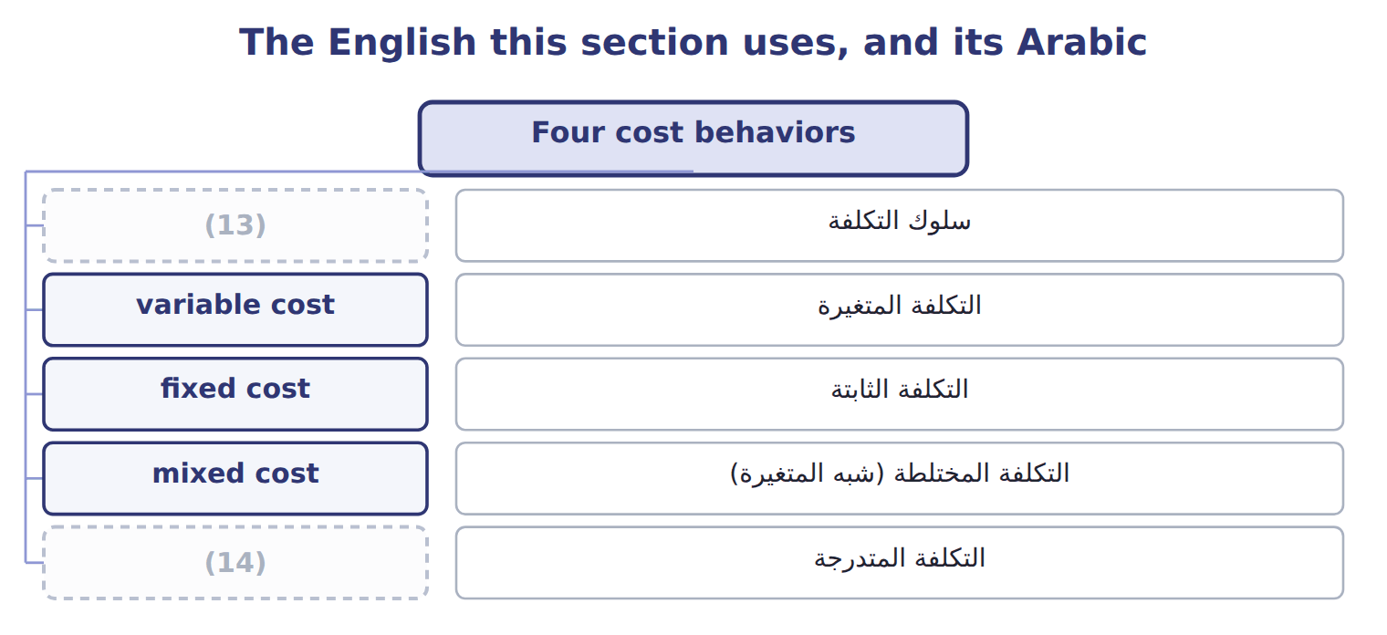
word list
mixed cost · step cost · cost behavior

The English this sheet uses, and its Arabic
English (exam term) | Arabic
cost behavior | سلوك التكلفة
variable cost | التكلفة المتغيرة
fixed cost | التكلفة الثابتة
mixed cost | التكلفة المختلطة (شبه المتغيرة)
step cost | التكلفة المتدرجة

Answer key · 2.1 Four cost behaviors

1 Four cost behaviors | 8 little
2 The time frame: short run and long run | 9 maintenance
3 Extended Example 2A: the Oils overhead budget, | 10 relevant
4 variable | 11 second
5 proportion | 12 supervisor
6 supervision | 13 cost behavior
7 whether | 14 step cost

the summaries in full
Summary 1 A variable cost changes in total in proportion to activity. Power for the crushers costs $5 for every machine hour, so twice the hours means twice the power bill. A fixed cost stays the same in total when activity changes. Factory supervision costs $420,000 a year whether the crushers run a little or a lot. A mixed cost has both parts: maintenance and utilities cost $216,000 a year plus $12 per machine hour. A step cost is fixed over a band of activity and then jumps. Above the relevant range, Oils needs a second shift, which adds a supervisor costing $180,000.

2.2 Total cost and cost per unit
Chapter 2 · section 2.2

Fill every gap. Each word list holds one word more than there are gaps.
Summary 1 gaps 1–3
The two basic (1) look opposite when you divide by (2) . Variable cost is constant per unit but changes in total. Fixed cost is constant in total but changes per unit: the more hours, the lower the fixed cost per hour. Total fixed overhead stays at $2,100,569, but fixed overhead per (3) hour falls from $70.02 to $43.76. Variable overhead stays at $20 per hour.
word list
behaviors · machine · activity · constant

Oils overhead in total and per machine hour at three volumes
Oils overhead, FY2027 (whole USD) | Low | Budget | High
(4) | 30,000 | 38,400 | 48,000
Total fixed overhead | 2,100,569 | 2,100,569 | 2,100,569
(5) | $70.02 | $54.70 | $43.76
(6) | 600,000 | 768,000 | 960,000
Variable overhead per MH | $20.00 | $20.00 | $20.00
Total overhead | 2,700,569 | 2,868,569 | 3,060,569
Total overhead per MH | $90.02 | $74.70 | $63.76

word list
Fixed overhead per MH · Machine hours · Total variable overhead ($20 per MH) · relevant range

Fixed cost per unit is not fixed

Summary 2 gaps 7–9
Do not (7) a fixed cost per unit by a new volume. Fixed cost per unit was (8) at one volume only. (9) the total fixed cost, then divide by the new volume if you need a unit figure.
word list
Budget · overhead · computed · multiply

The English this section uses, and its Arabic
Each term sits against what it means.
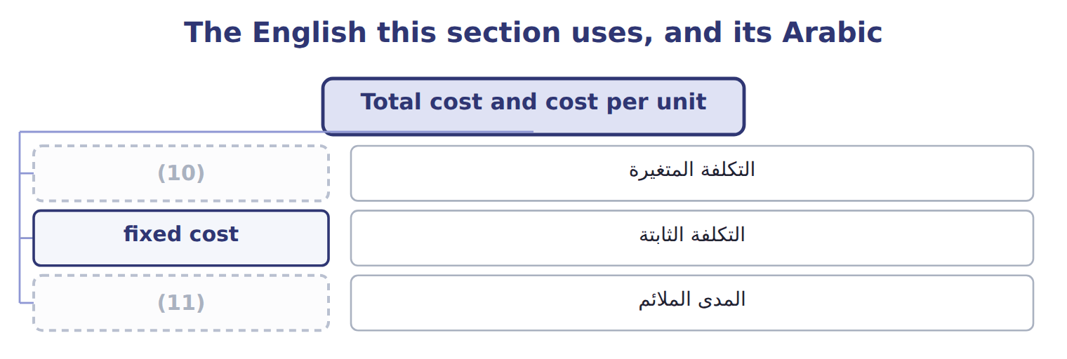
word list
cost behavior · relevant range · variable cost

Answer key · 2.2 Total cost and cost per unit

1 behaviors | 7 multiply
2 activity | 8 computed
3 machine | 9 Budget
4 Machine hours | 10 variable cost
5 Fixed overhead per MH | 11 relevant range
6 Total variable overhead ($20 per MH)

the summaries in full
Summary 1 The two basic behaviors look opposite when you divide by activity. Variable cost is constant per unit but changes in total. Fixed cost is constant in total but changes per unit: the more hours, the lower the fixed cost per hour. Total fixed overhead stays at $2,100,569, but fixed overhead per machine hour falls from $70.02 to $43.76. Variable overhead stays at $20 per hour.
Summary 2 Do not multiply a fixed cost per unit by a new volume. Fixed cost per unit was computed at one volume only. Budget the total fixed cost, then divide by the new volume if you need a unit figure.

2.3 The relevant range
Chapter 2 · section 2.3

Fill every gap. Each word list holds one word more than there are gaps.
Summary 1 gaps 1–10
The (1) range is the band of (2) in which the cost behavior assumptions hold. Oils has data from 2,000 to 4,300 (3) hours a month. (4) that range, maintenance and (5) follow $18,000 plus $12 per hour. Outside the range the (6) may fail. Above 4,300 hours a month Oils must run a (7) shift, so the fixed part jumps. Below the range, the $18,000 (8) is only an (9) : nobody has seen the plant at zero hours. A change in assumptions (10) the cost. If a new contract turns the maintenance charge into a fixed fee, the cost becomes fixed. If volume moves outside the range, a new cost function is needed.
word list
Inside · formula · changes · relevant · behavior · machine · second · activity · utilities · extrapolation · intercept

The English this sheet uses, and its Arabic
English (exam term) | Arabic
relevant range | المدى الملائم

Answer key · 2.3 The relevant range

1 relevant | 6 formula
2 activity | 7 second
3 machine | 8 intercept
4 Inside | 9 extrapolation
5 utilities | 10 changes

the summaries in full
Summary 1 The relevant range is the band of activity in which the cost behavior assumptions hold. Oils has data from 2,000 to 4,300 machine hours a month. Inside that range, maintenance and utilities follow $18,000 plus $12 per hour. Outside the range the formula may fail. Above 4,300 hours a month Oils must run a second shift, so the fixed part jumps. Below the range, the $18,000 intercept is only an extrapolation: nobody has seen the plant at zero hours. A change in assumptions changes the cost. If a new contract turns the maintenance charge into a fixed fee, the cost becomes fixed. If volume moves outside the range, a new cost function is needed.

2.4 The time frame: short run and long run
Chapter 2 · section 2.4

Fill every gap. Each word list holds one word more than there are gaps.
Summary 1 gaps 1–7
Whether a cost is fixed (1) on the time frame. In the short run, such as one (2) year, the press lease and (3) salaries cannot easily change. In the long run, (4) can end the lease, change the staff or buy new (5) , so every cost can change. Some fixed costs come from (6) decisions, such as leases and (7) : these are committed fixed costs. Others, such as training or advertising, are set each year by managers: these are discretionary fixed costs.
word list
machines · supervision · long-term · depends · depreciation · budget · training · Orontes

Short run and long run: four Oils costs
Oils cost | Behavior this year | Short run (why) | Long run
Olive-press lease (ROU amortization) | Fixed: 216,569 a year | Committed until the lease ends in 2029 | (8)
Factory supervision | Fixed: 420,000 a year | Salaries are set for the year | (9)
Maintenance & utilities | Mixed: 216,000 + $12 per MH | Fixed part is the service contract | (10)
Power for the crushers | Variable: $5 per MH | (11) | Rate can change with new machines

word list
Committed until the lease ends in 2029 · Changes only when the lease is renewed or ended · Staff can be added or removed · Contract can be resized · Moves with machine hours

Summary 2 gaps 12–13
For overhead rates and budgets, Orontes (12) overhead for one year at a time. That is the time frame the CMA exam usually assumes, unless a question says (13) .
word list
classifies · discretionary · otherwise

Charges fixes

Summary 3 gaps 14–15
In cost (14) , fixed means only 'does not change with (15) in this range and period'.
word list
activity · accounting · Whether

The English this section uses, and its Arabic
Each term sits against what it means.
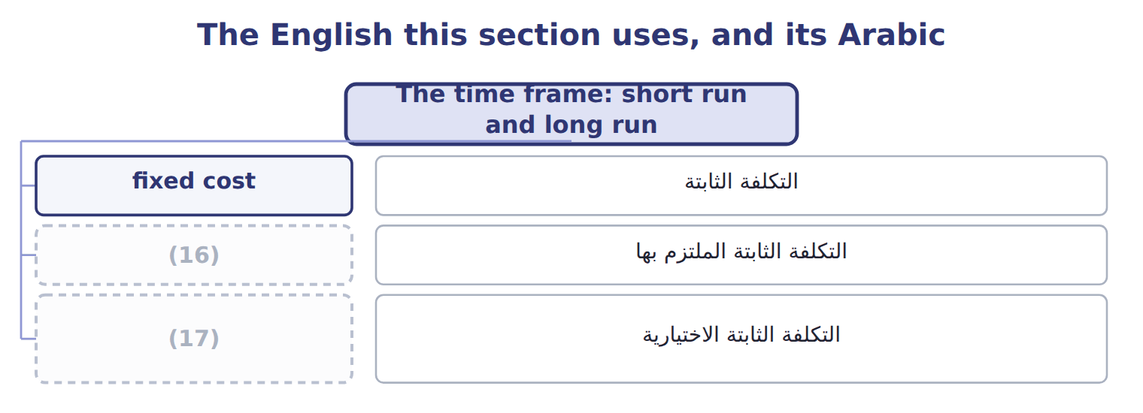
word list
التكلفة الثابتة الاختيارية · discretionary fixed cost · committed fixed cost

The English this sheet uses, and its Arabic
English (exam term) | Arabic
committed fixed cost | التكلفة الثابتة الملتزم بها
discretionary fixed cost | التكلفة الثابتة الاختيارية

Answer key · 2.4 The time frame: short run and long run

1 depends | 10 Contract can be resized
2 budget | 11 Moves with machine hours
3 supervision | 12 classifies
4 Orontes | 13 otherwise
5 machines | 14 accounting
6 long-term | 15 activity
7 depreciation | 16 committed fixed cost
8 Changes only when the lease is renewed or ended | 17 discretionary fixed cost
9 Staff can be added or removed

the summaries in full
Summary 1 Whether a cost is fixed depends on the time frame. In the short run, such as one budget year, the press lease and supervision salaries cannot easily change. In the long run, Orontes can end the lease, change the staff or buy new machines, so every cost can change. Some fixed costs come from long-term decisions, such as leases and depreciation: these are committed fixed costs. Others, such as training or advertising, are set each year by managers: these are discretionary fixed costs.
Summary 2 For overhead rates and budgets, Orontes classifies overhead for one year at a time. That is the time frame the CMA exam usually assumes, unless a question says otherwise.
Summary 3 In cost accounting, fixed means only 'does not change with activity in this range and period'.

2.5 Separating costs into fixed and variable parts
Chapter 2 · section 2.5

Fill every gap. Each word list holds one word more than there are gaps.
Summary 1 gaps 1–6
Budgets need a cost (1) : total cost = fixed cost + variable rate × (2) . To build it, each cost must be (3) into its fixed and variable parts. The simplest method is account analysis: an (4) reviews each account and (5) it by judgment. Mixed (6) need a second step. For maintenance and utilities, Oils uses the fixed monthly contract and the rate per machine hour estimated from its records.
word list
classifies · separated · accounts · accountant · Classify · activity · function

Worked example: the Oils overhead cost function

Adding the columns gives the cost function: $2,100,569 a year plus $20 per machine hour.
Worked example: account analysis of Oils overhead
Every item belongs to exactly one group.
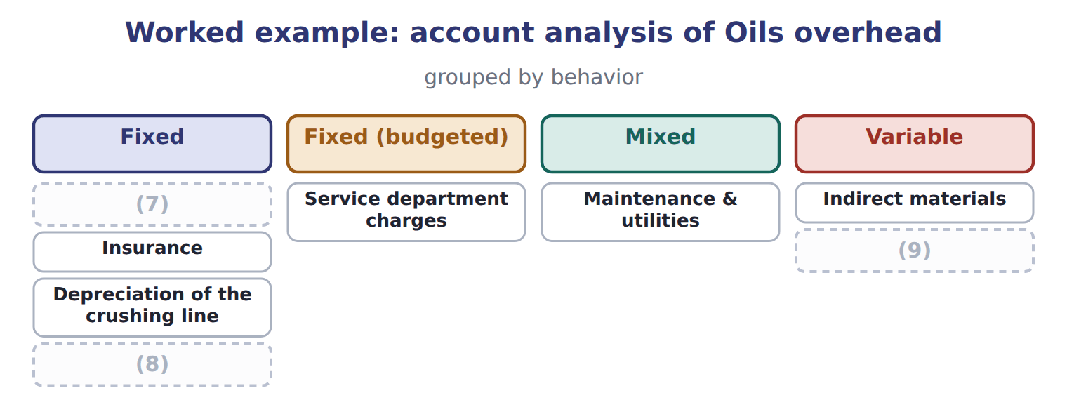
word list
Factory supervision · Olive-press ROU amortization · Insurance · Power

Classify Tahini & Spreads costs

The first two are done. Classify the rest as variable, fixed, mixed or step.

Your turn: classify Tahini & Spreads costs (complete the blanks)
Every item belongs to exactly one group.
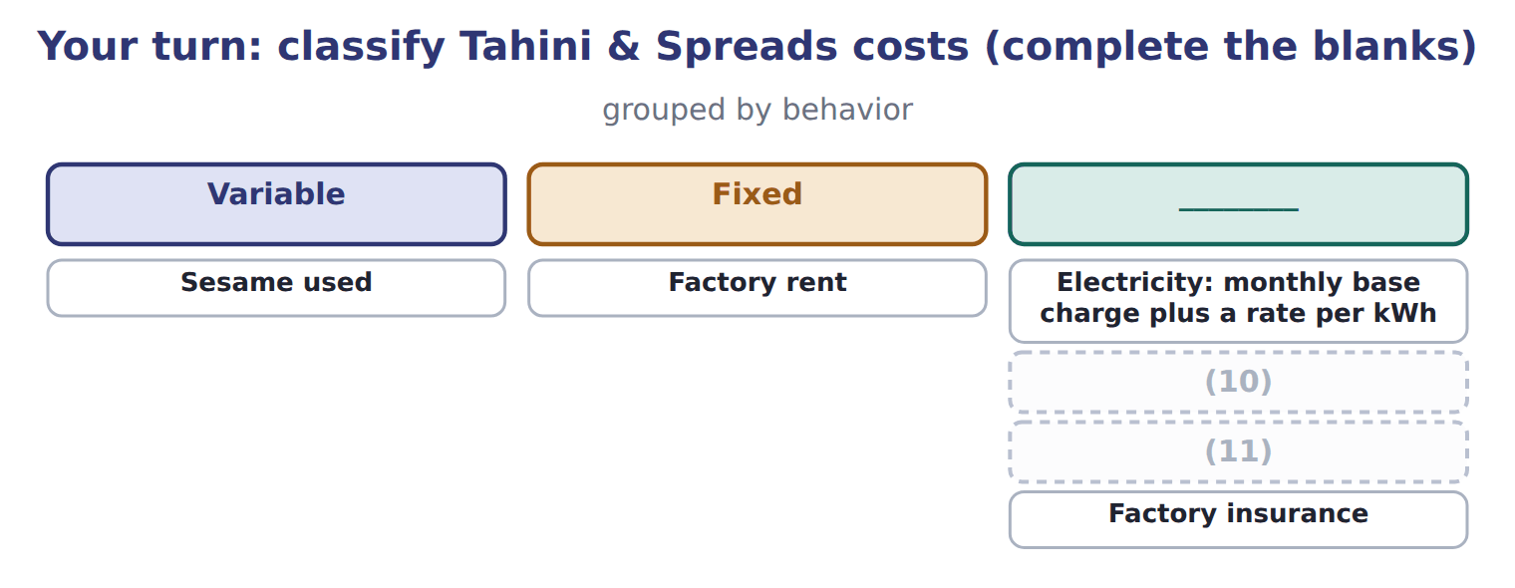
word list
Labels, one per jar · Electricity: monthly base charge plus a rate per kWh · One extra supervisor for every 20,000 jars a month

The English this section uses, and its Arabic
Each term sits against what it means.
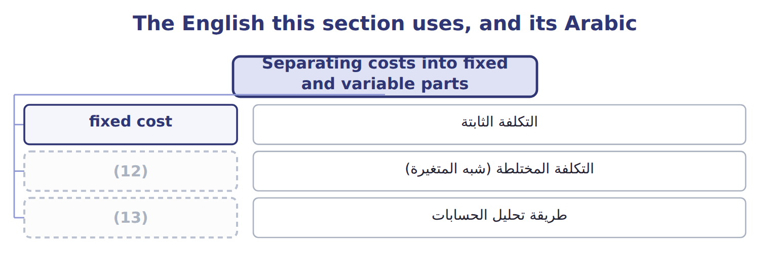
word list
mixed cost · cost behavior · account analysis

The English this sheet uses, and its Arabic
English (exam term) | Arabic
account analysis | طريقة تحليل الحسابات

Answer key · 2.5 Separating costs into fixed and variable parts

1 function | 8 Olive-press ROU amortization
2 activity | 9 Power
3 separated | 10 One extra supervisor for every 20,000 jars a month
4 accountant | 11 Labels, one per jar
5 classifies | 12 mixed cost
6 accounts | 13 account analysis
7 Factory supervision

the summaries in full
Summary 1 Budgets need a cost function: total cost = fixed cost + variable rate × activity. To build it, each cost must be separated into its fixed and variable parts. The simplest method is account analysis: an accountant reviews each account and classifies it by judgment. Mixed accounts need a second step. For maintenance and utilities, Oils uses the fixed monthly contract and the rate per machine hour estimated from its records.

2.6 Extended Example 2A: the Oils overhead budget, 2027
Chapter 2 · section 2.6

Fill every gap. Each word list holds one word more than there are gaps.
Summary 1 gaps 1–12
This example builds a (1) overhead budget from the cost function, tests it at (2) volumes and (3) one month's (4) by behavior. The budget (5) are exam-core; the (6) are for depth. Oils plans 38,400 machine hours for 2027, but the (7) could give (8) from 30,000 to 48,000. Above 51,600 hours a year, a second shift adds $72,000 of (9) and $180,000 of (10) . Use the cost function from Section 2.5. (11) total overhead at each volume, check which volumes are inside the (12) range, and see what happens to cost per machine hour. Budget volume: $2,100,569 + $20 × 38,400 = $2,868,569, or $74.70 per machine hour. Low volume: $2,100,569 + $20 × 30,000 = $2,700,569, or $90.02 per hour. High volume: $2,100,569 + $20 × 48,000 = $3,060,569, or $63.76 per hour.
word list
anything · Compute · calculations · records · several · relevant · invoices · supervision · flexible · entries · volumes · maintenance · harvest

Summary 2 gaps 13–15
Above the range (55,000 hours): $2,100,569 + $252,000 + $20 × 55,000 = $3,452,569. Fixed (13) is the same in the first three columns; only the (14) part moves. The last column needs a new cost (15) because it lies outside the range.
word list
machine · overhead · function · variable

Extended Example: flexible overhead budget for Oils
The bars are drawn to scale.
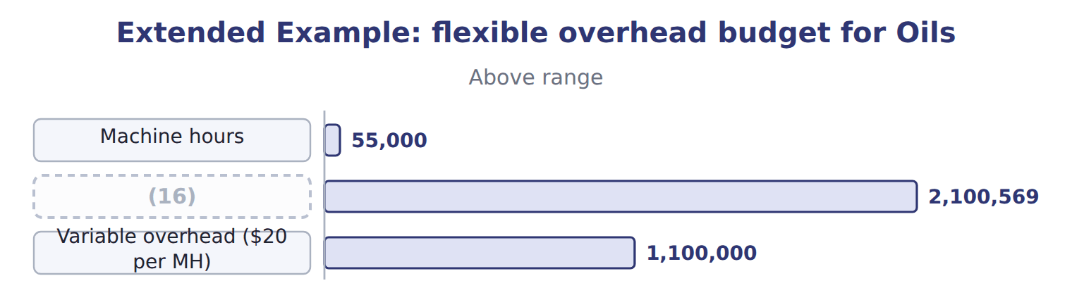
word list
Fixed overhead · Machine hours

Summary 3 gaps 17–20
Variable cost per hour is flat, fixed cost per hour falls, and so total cost per hour falls as (17) rises. The (18) ledger records costs by nature, but Orontes tags each (19) line as fixed or variable. In March the (20) ran 3,200 machine hours.
word list
crushers · relevant · volume · overhead · general

Extended Example: March overhead journal by behavior
No. | Account (detail) | Debit | Credit
1 | MOH Control - Fixed | 18,000
 | (21) | 38,400
 | (22) |  | 56,400
2 | MOH Control - Variable | 16,000
 | Accounts Payable |  | 16,000
3 | MOH Control - Variable | 9,600
 | (23) |  | 9,600
 | (24) | 82,000 | 82,000

word list
MOH Control - Variable · Raw Materials Inventory · Totals · mixed cost · Accounts Payable

Everything ties

Summary 4 gaps 25–27
Maintenance invoice: $18,000 fixed + $38,400 variable = $56,400, the (25) estimate for 3,200 hours. March variable (26) : $20 × 3,200 = $64,000. Fixed maintenance for the year: $216,000, (27) months at $18,000. Journal total: $82,000 on both sides.
word list
twelve · regression · overhead · behavior

Exam view

Summary 5 gaps 28–30
Expect a cost at two (28) and a request for the cost at a third volume. Split the cost first, check that the new volume is inside the (29) range, then rebuild the total. Never scale a total cost that (30) fixed costs.
word list
columns · volumes · relevant · includes

Exam view
The bars are drawn to scale.
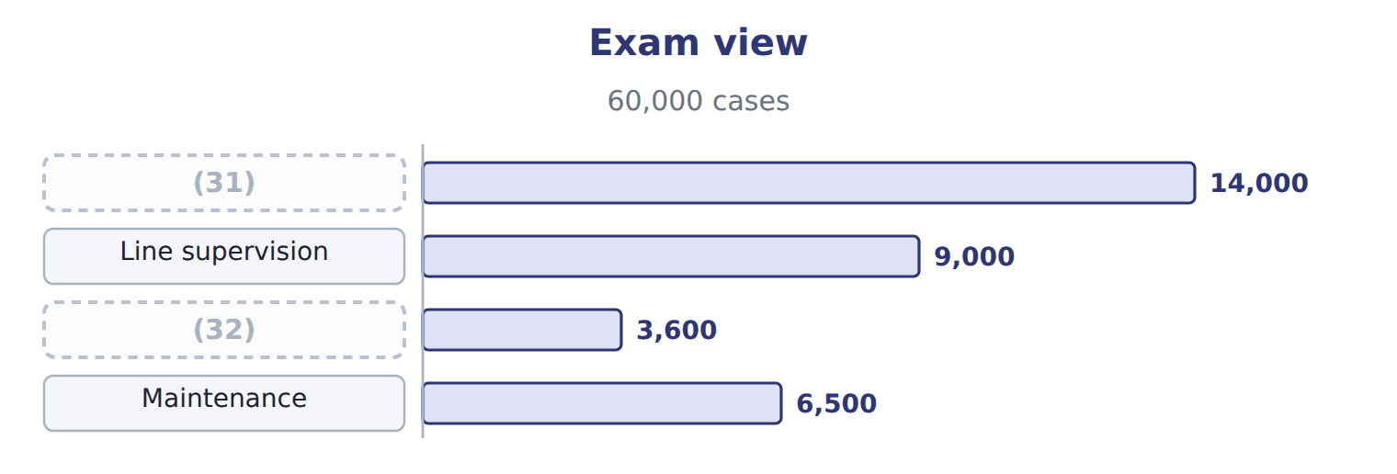
word list
Maintenance · Shrink film · Electricity

Item — Answer
Item | Answer
Electricity: monthly base charge plus a rate per kWh | Mixed
One extra supervisor for every 20,000 jars a month | Step
Labels, one per jar | (33)
Factory insurance | (34)

word list
Fixed · Variable · High

Cost — Category
Cost | Category
Electricity | Mixed
Line supervision | Fixed
Shrink film | (35)
Forklift rental | (36)
Maintenance | (37)

word list
Mixed · Step · Variable · Fixed

The English this section uses, and its Arabic
Each term sits against what it means.
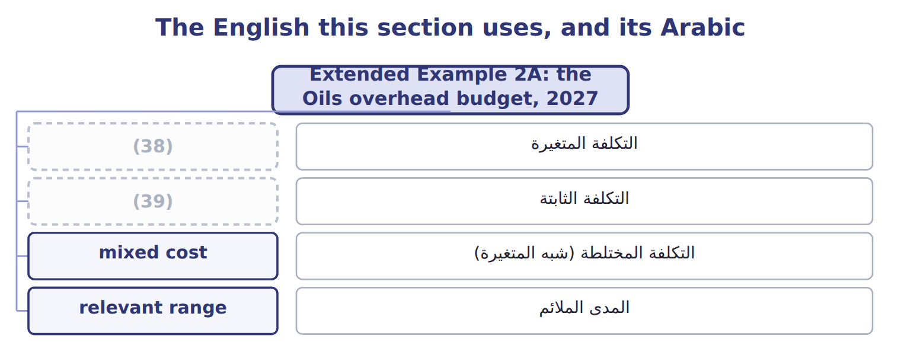
word list
variable cost · التكلفة المتغيرة · fixed cost

The English this sheet uses, and its Arabic
English (exam term) | Arabic
variable cost | التكلفة المتغيرة
fixed cost | التكلفة الثابتة
mixed cost | التكلفة المختلطة (شبه المتغيرة)
relevant range | المدى الملائم

Answer key · 2.6 Extended Example 2A: the Oils overhead budget, 2027

1 flexible | 21 MOH Control - Variable
2 several | 22 Accounts Payable
3 records | 23 Raw Materials Inventory
4 invoices | 24 Totals
5 calculations | 25 regression
6 entries | 26 overhead
7 harvest | 27 twelve
8 anything | 28 volumes
9 maintenance | 29 relevant
10 supervision | 30 includes
11 Compute | 31 Electricity
12 relevant | 32 Shrink film
13 overhead | 33 Variable
14 variable | 34 Fixed
15 function | 35 Variable
16 Fixed overhead | 36 Step
17 volume | 37 Mixed
18 general | 38 variable cost
19 overhead | 39 fixed cost
20 crushers

the summaries in full
Summary 1 This example builds a flexible overhead budget from the cost function, tests it at several volumes and records one month's invoices by behavior. The budget calculations are exam-core; the entries are for depth. Oils plans 38,400 machine hours for 2027, but the harvest could give anything from 30,000 to 48,000. Above 51,600 hours a year, a second shift adds $72,000 of maintenance and $180,000 of supervision. Use the cost function from Section 2.5. Compute total overhead at each volume, check which volumes are inside the relevant range, and see what happens to cost per machine hour. Budget volume: $2,100,569 + $20 × 38,400 = $2,868,569, or $74.70 per machine hour. Low volume: $2,100,569 + $20 × 30,000 = $2,700,569, or $90.02 per hour. High volume: $2,100,569 + $20 × 48,000 = $3,060,569, or $63.76 per hour.
Summary 2 Above the range (55,000 hours): $2,100,569 + $252,000 + $20 × 55,000 = $3,452,569. Fixed overhead is the same in the first three columns; only the variable part moves. The last column needs a new cost function because it lies outside the range.
Summary 3 Variable cost per hour is flat, fixed cost per hour falls, and so total cost per hour falls as volume rises. The general ledger records costs by nature, but Orontes tags each overhead line as fixed or variable. In March the crushers ran 3,200 machine hours.
Summary 4 Maintenance invoice: $18,000 fixed + $38,400 variable = $56,400, the regression estimate for 3,200 hours. March variable overhead: $20 × 3,200 = $64,000. Fixed maintenance for the year: $216,000, twelve months at $18,000. Journal total: $82,000 on both sides.
Summary 5 Expect a cost at two volumes and a request for the cost at a third volume. Split the cost first, check that the new volume is inside the relevant range, then rebuild the total. Never scale a total cost that includes fixed costs.

3.1 Why estimate cost functions
Chapter 3 · section 3.1

Fill every gap. Each word list holds one word more than there are gaps.
Chapter 3, section by section
Each stage leads to the next.
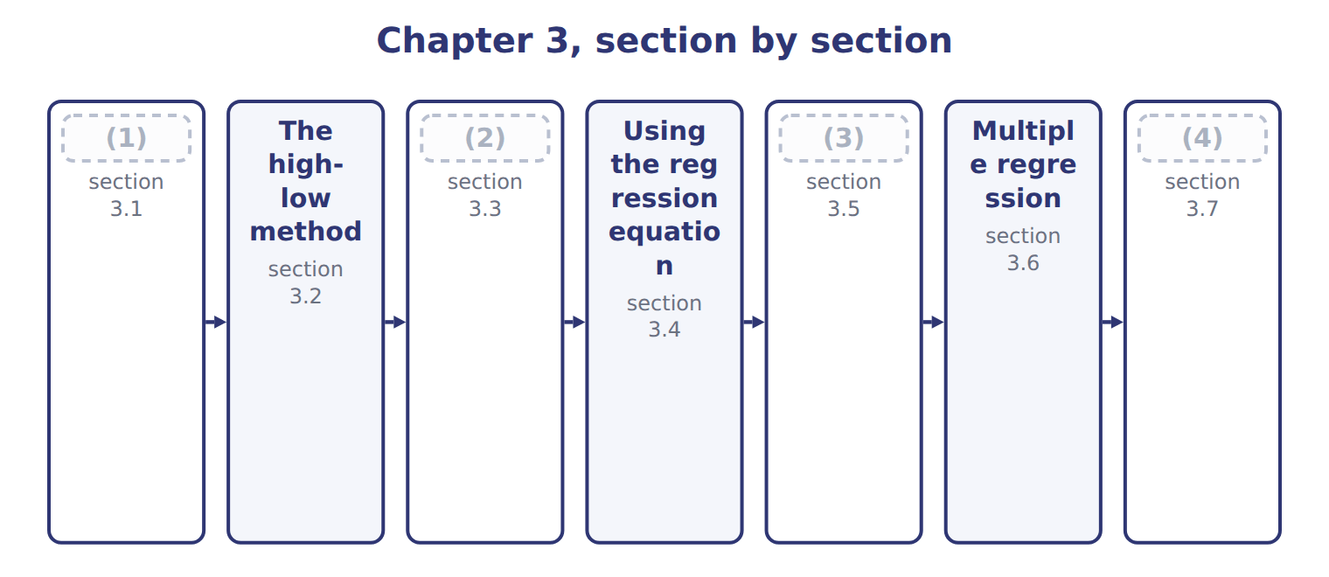
word list
Simple regression · Using regression to estimate fixed costs · scatter plot · Why estimate cost functions · Extended Example 3A: the Oils maintenance and

Summary 1 gaps 5–6
Budgets, prices and (5) budgets all need a cost function: total cost = fixed cost + variable rate × activity. (6) have four main ways to estimate it.
word list
flexible · vertical · Managers

Four ways to estimate a cost function
Method | How it works | Strength | Weakness
Account analysis | (7) | Quick; uses knowledge of the costs | Subjective
High-low | Line through the highest and lowest activity | (8) | Ignores all other data; outliers distort it
Simple regression | Best-fit line through all points | (9) | Needs data and care in use
Engineering (industrial) analysis | Studies inputs needed per unit | (10) | Costly and slow

word list
Works for new products with no history · Judgment on each account · Simple; needs two points · Uses all data; gives R2, t and standard error · Studies inputs needed per unit

Summary 2 gaps 11–14
The first step in every method is to draw a scatter plot: one point for each month, with activity on the (11) axis and cost on the (12) axis. The plot shows whether a (13) line makes sense and whether any month looks (14) .
word list
scatter · unusual · horizontal · vertical · straight

The English this section uses, and its Arabic
Each term sits against what it means.
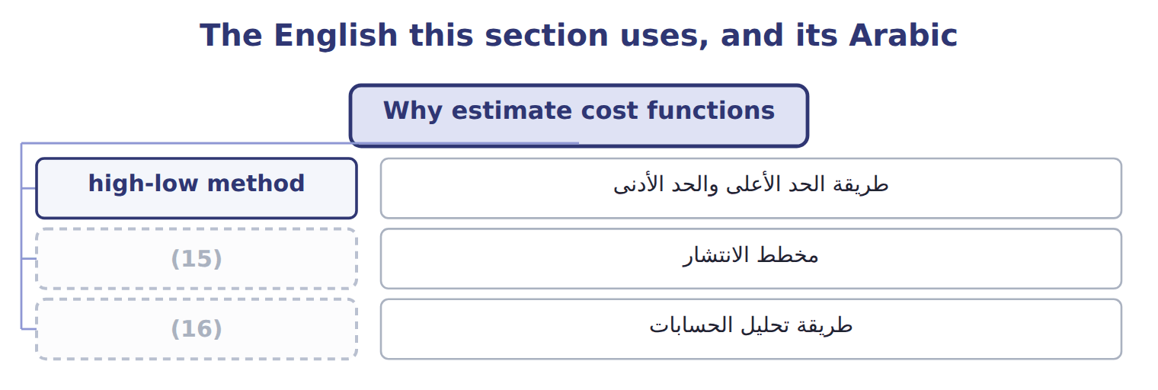
word list
multiple regression · account analysis · scatter plot

The English this sheet uses, and its Arabic
English (exam term) | Arabic
scatter plot | مخطط الانتشار
account analysis | طريقة تحليل الحسابات

Answer key · 3.1 Why estimate cost functions

1 Why estimate cost functions | 9 Uses all data; gives R2, t and standard error
2 Simple regression | 10 Works for new products with no history
3 Using regression to estimate fixed costs | 11 horizontal
4 Extended Example 3A: the Oils maintenance and | 12 vertical
5 flexible | 13 straight
6 Managers | 14 unusual
7 Judgment on each account | 15 scatter plot
8 Simple; needs two points | 16 account analysis

the summaries in full
Summary 1 Budgets, prices and flexible budgets all need a cost function: total cost = fixed cost + variable rate × activity. Managers have four main ways to estimate it.
Summary 2 The first step in every method is to draw a scatter plot: one point for each month, with activity on the horizontal axis and cost on the vertical axis. The plot shows whether a straight line makes sense and whether any month looks unusual.

3.2 The high-low method
Chapter 3 · section 3.2

Fill every gap. Each word list holds one word more than there are gaps.
Summary 1 gaps 1–8
The (1) method draws a line (2) two points: the (3) with the highest and the (4) activity. The variable rate is the change in cost (5) by the change in activity. The fixed cost is what is left at (6) point. (7) the points by activity, not by cost. In the Oils data the highest cost, $69,400, came in a month with 4,200 machine hours, not in the busiest month. The busiest month had 4,300 machine hours and cost $68,600; the (8) had 2,000 hours and cost $43,300. The variable rate is $11 per hour and the fixed cost is $21,300 a month.
word list
divided · through · either · quietest · Choose · high-low · lowest · highest · months

Worked example: high-low for Oils maintenance and utilities
Oils M&U, high-low method | Activity | Cost (whole USD)
Highest activity | (9) | 68,600
Lowest activity | 2,000 MH | 43,300
Change | (10) | 25,300
Variable rate = change in cost ÷ change in MH |  | (11)
Fixed cost = 68,600 − $11 × 4,300 |  | 21,300
High-low cost function |  | 21,300 + $11 × MH

word list
2,300 MH · $11 per MH · account analysis · 4,300 MH

High activity, not high cost

Summary 2 gaps 12–13
Exam (12) often put the highest cost in a month that is not the busiest. Always find the highest and lowest (13) first, then take the costs of those two months.
word list
questions · intercept · activity

The English this sheet uses, and its Arabic
English (exam term) | Arabic
high-low method | طريقة الحد الأعلى والحد الأدنى

Answer key · 3.2 The high-low method

1 high-low | 8 quietest
2 through | 9 4,300 MH
3 months | 10 2,300 MH
4 lowest | 11 $11 per MH
5 divided | 12 questions
6 either | 13 activity
7 Choose

the summaries in full
Summary 1 The high-low method draws a line through two points: the months with the highest and the lowest activity. The variable rate is the change in cost divided by the change in activity. The fixed cost is what is left at either point. Choose the points by activity, not by cost. In the Oils data the highest cost, $69,400, came in a month with 4,200 machine hours, not in the busiest month. The busiest month had 4,300 machine hours and cost $68,600; the quietest had 2,000 hours and cost $43,300. The variable rate is $11 per hour and the fixed cost is $21,300 a month.
Summary 2 Exam questions often put the highest cost in a month that is not the busiest. Always find the highest and lowest activity first, then take the costs of those two months.

3.3 Simple regression
Chapter 3 · section 3.3

Fill every gap. Each word list holds one word more than there are gaps.
Summary 1 gaps 1–10
Regression (1) fits the line that best explains cost using all the data (2) . In (3) regression there is one (4) variable x, the activity, and one dependent variable y, the cost. The (5) is y = a + b x. The (6) a is the estimated fixed cost for the (7) . The slope b is the variable cost for each extra unit of activity. (8) prints more than a and b. The coefficient of (9) R2 shows how much of the cost (10) the activity explains. Each coefficient has a t-statistic: above about 2 means it is reliably different from zero. The standard error of the estimate shows how far actual costs typically lie from the line.
word list
simple · points · t-statistic · variation · independent · equation · analysis · intercept · determination · period · Software

Annotated regression output for Oils maintenance and utilities
Regression output | Coefficient / value | Std. error | t-stat | What it means
Intercept | 18,000 | 951 | 18.93 | Estimated fixed cost per month
Machine hours | 12.00 | 0.295 | 40.7 | (11)
R2 | 0.987 |  |  | Share of cost variation explained by machine hours
Standard error of the estimate | 1,000 |  |  | (12)
Observations | 24 |  |  | (13)

word list
Months of data · Share of cost variation explained by machine hours · Typical distance of actual cost from the line · Variable cost per machine hour

The English this section uses, and its Arabic
Each term sits against what it means.
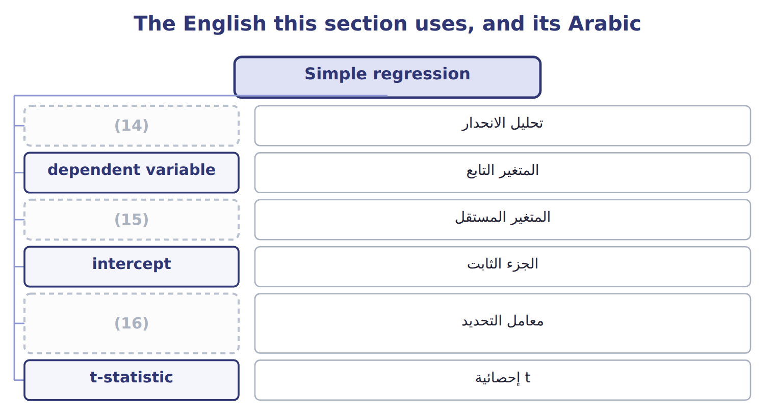
word list
regression analysis · independent variable · coefficient of determination · account analysis

The English this sheet uses, and its Arabic
English (exam term) | Arabic
regression analysis | تحليل الانحدار
dependent variable | المتغير التابع
independent variable | المتغير المستقل
intercept | الجزء الثابت
coefficient of determination | معامل التحديد
t-statistic | إحصائية t
standard error of the estimate | الخطأ المعياري للتقدير

Answer key · 3.3 Simple regression

1 analysis | 9 determination
2 points | 10 variation
3 simple | 11 Variable cost per machine hour
4 independent | 12 Typical distance of actual cost from the line
5 equation | 13 Months of data
6 intercept | 14 regression analysis
7 period | 15 independent variable
8 Software | 16 coefficient of determination

the summaries in full
Summary 1 Regression analysis fits the line that best explains cost using all the data points. In simple regression there is one independent variable x, the activity, and one dependent variable y, the cost. The equation is y = a + b x. The intercept a is the estimated fixed cost for the period. The slope b is the variable cost for each extra unit of activity. Software prints more than a and b. The coefficient of determination R2 shows how much of the cost variation the activity explains. Each coefficient has a t-statistic: above about 2 means it is reliably different from zero. The standard error of the estimate shows how far actual costs typically lie from the line.

3.4 Using the regression equation
Chapter 3 · section 3.4

Fill every gap. Each word list holds one word more than there are gaps.
Summary 1 gaps 1–5
To forecast, put the planned (1) into x. At 3,200 machine hours, Oils (2) and utilities (3) cost $18,000 + $12 × 3,200 = $56,400. A forecast is only as good as the range of the data. The Oils data run from 2,000 to 4,300 machine hours a month. A forecast inside that range is (4) ; a forecast far (5) it is a guess.
word list
reasonable · outside · Complete · should · activity · maintenance

Forecast with the equation

Summary 2 gaps 6–7
The first two (6) are done. Complete the rest, and think (7) about the last one.
word list
forecasts · carefully · maintenance

Your turn: forecasts with the regression equation (complete the blanks)
Each stage leads to the next.
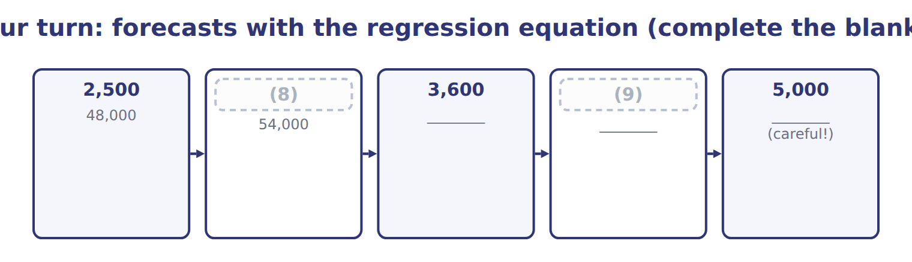
word list
4,000 · 5,000 · 3,000

Answer key · 3.4 Using the regression equation

1 activity | 6 forecasts
2 maintenance | 7 carefully
3 should | 8 3,000
4 reasonable | 9 4,000
5 outside

the summaries in full
Summary 1 To forecast, put the planned activity into x. At 3,200 machine hours, Oils maintenance and utilities should cost $18,000 + $12 × 3,200 = $56,400. A forecast is only as good as the range of the data. The Oils data run from 2,000 to 4,300 machine hours a month. A forecast inside that range is reasonable; a forecast far outside it is a guess.
Summary 2 The first two forecasts are done. Complete the rest, and think carefully about the last one.

3.5 Using regression to estimate fixed costs
Chapter 3 · section 3.5

Fill every gap. Each word list holds one word more than there are gaps.
Summary 1 gaps 1–8
The intercept is (1) estimate of fixed cost: $18,000 a month for Oils (2) and utilities, or $216,000 a year. Use the intercept with care. It is the cost the line (3) at zero activity, and zero lies far (4) the data. It is a sound estimate of fixed cost inside the (5) range, not a (6) of what the plant would cost if it (7) . The t-statistic of the intercept helps. For Oils it is 18.93, well above 2, so the fixed part is (8) greater than zero. A small t-statistic would mean the fixed estimate is weak.
word list
relevant · maintenance · stopped · promise · intercept · regression's · clearly · outside · predicts

Constante

Summary 2 gaps 9–10
The word ' (9) ' suggests a fact, but the (10) is only an estimate from the data.
word list
constant · intercept · promise

Answer key · 3.5 Using regression to estimate fixed costs

1 regression's | 6 promise
2 maintenance | 7 stopped
3 predicts | 8 clearly
4 outside | 9 constant
5 relevant | 10 intercept

the summaries in full
Summary 1 The intercept is regression's estimate of fixed cost: $18,000 a month for Oils maintenance and utilities, or $216,000 a year. Use the intercept with care. It is the cost the line predicts at zero activity, and zero lies far outside the data. It is a sound estimate of fixed cost inside the relevant range, not a promise of what the plant would cost if it stopped. The t-statistic of the intercept helps. For Oils it is 18.93, well above 2, so the fixed part is clearly greater than zero. A small t-statistic would mean the fixed estimate is weak.
Summary 2 The word 'constant' suggests a fact, but the intercept is only an estimate from the data.

3.6 Multiple regression
Chapter 3 · section 3.6

Fill every gap. Each word list holds one word more than there are gaps.
Summary 1 gaps 1–6
Multiple regression uses two or more (1) variables: y = a + b1x1 + b2x2. Each (2) is the cost per unit of its own (3) , with the other variables held constant. (4) Oils also records the (5) of setups each month. A multiple regression might give $15,000 a month, plus $11.5 per (6) hour, plus $150 per setup. Book 4 shows how such equations are estimated and tested.
word list
Suppose · machine · number · equations · variable · independent · coefficient

Suppose: reading a multiple regression equation
Suppose: Oils M&U, two drivers | Coefficient | Meaning
Intercept | 15,000 | (7)
Machine hours | $11.5 | Variable cost per machine hour, holding setups constant
Number of setups | $150 | Cost per setup, holding machine hours constant
R2 | 0.992 | (8)
Forecast: 3,200 MH and 20 setups | 54,800 | (9)

word list
Share of variation explained by both drivers · Variable cost per machine hour, holding setups constant · 15,000 + 11.5 × 3,200 + 150 × 20 · Fixed cost per month (with both drivers in the model)

Summary 2 gaps 10–13
Add a (10) driver only when it has a causal link to the cost and (11) the fit. In the example, R2 rises from 0.987 to 0.992, and each (12) should still pass its (13) . Adding drivers that do not cause the cost only makes the equation harder to use.
word list
coefficient · intercept · second · improves · t-test

The English this section uses, and its Arabic
Each term sits against what it means.
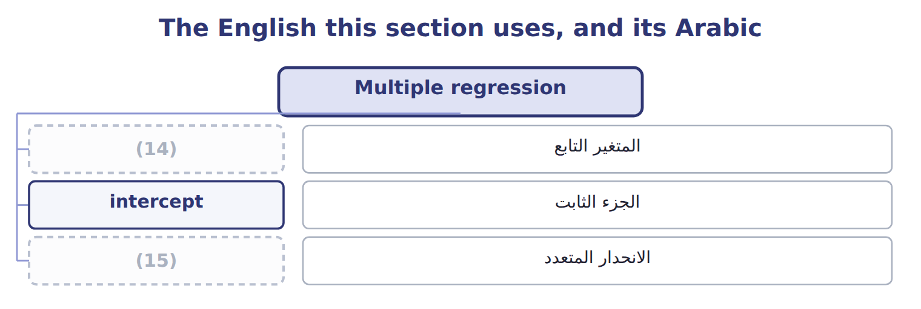
word list
dependent variable · multiple regression · regression analysis

The English this sheet uses, and its Arabic
English (exam term) | Arabic
multiple regression | الانحدار المتعدد

Answer key · 3.6 Multiple regression

1 independent | 9 15,000 + 11.5 × 3,200 + 150 × 20
2 coefficient | 10 second
3 variable | 11 improves
4 Suppose | 12 coefficient
5 number | 13 t-test
6 machine | 14 dependent variable
7 Fixed cost per month (with both drivers in the model) | 15 multiple regression
8 Share of variation explained by both drivers

the summaries in full
Summary 1 Multiple regression uses two or more independent variables: y = a + b1x1 + b2x2. Each coefficient is the cost per unit of its own variable, with the other variables held constant. Suppose Oils also records the number of setups each month. A multiple regression might give $15,000 a month, plus $11.5 per machine hour, plus $150 per setup. Book 4 shows how such equations are estimated and tested.
Summary 2 Add a second driver only when it has a causal link to the cost and improves the fit. In the example, R2 rises from 0.987 to 0.992, and each coefficient should still pass its t-test. Adding drivers that do not cause the cost only makes the equation harder to use.

3.7 Extended Example 3A: the Oils maintenance and utilities cost function
Chapter 3 · section 3.7

Fill every gap. Each word list holds one word more than there are gaps.
Summary 1 gaps 1–9
This example runs both methods on the full 24 (1) of Oils data and turns the result into the 2027 budget. There are no (2) entries here: the output is a forecast that feeds the budget. Oils has monthly (3) and utilities costs for January 2025 to (4) 2026, with machine hours from 2,000 to 4,300. For 2027 it plans 3,200 machine hours a month, or 38,400 for the year. (5) the cost function with (6) and with regression. Read the regression output. Forecast the month and the year, (7) the two methods, and pass the result to the budget. (8) does this work, but (9) it once shows what b and a mean.
word list
compare · Estimate · seeing · months · maintenance · December · high-low · methods · journal · Software

Extended Example: regression by hand for the 24 Oils months
Regression by hand: the 24 Oils months | Value
Number of months (n) | 24
(10) | 75,600
(11) | 1,339,200
(12) | 3,150
Mean cost (ȳ) | 55,800
(13) | 11,500,000
Sxy = Σ(x − x̄)(y − ȳ) | 138,000,000
Slope b = Sxy ÷ Sxx | $12
Intercept a = ȳ − b × x̄ = 55,800 − 12 × 3,150 | 18,000
(14) | 22,000,000
(15) | 1,678,000,000
R2 = 1 − SSE ÷ SST | 0.987

word list
Sxx = Σ(x − x̄)2 · Total variation SST = Σ(y − ȳ)2 · Sum of machine hours (Σx) · Unexplained variation SSE = Σ(y − ŷ)2 · Oils M&U forecast (whole USD) · Mean machine hours (x̄) · Sum of costs (Σy)

Summary 2 gaps 16–21
The high-low line (16) on two months only; the regression line passes (17) the middle of all 24. The bar at 3,200 hours shows the (18) plus or minus two (19) errors: $54,400 to $58,400. For 2027 regression gives $676,800 and high-low gives $678,000. (20) uses the regression figure, because it uses all the data and passes the (21) tests. That is the maintenance line in the.
word list
through · forecast · reliability · standard · printed · depends · Orontes

Extended Example: regression and high-low forecasts for 2027
The bars are drawn to scale.
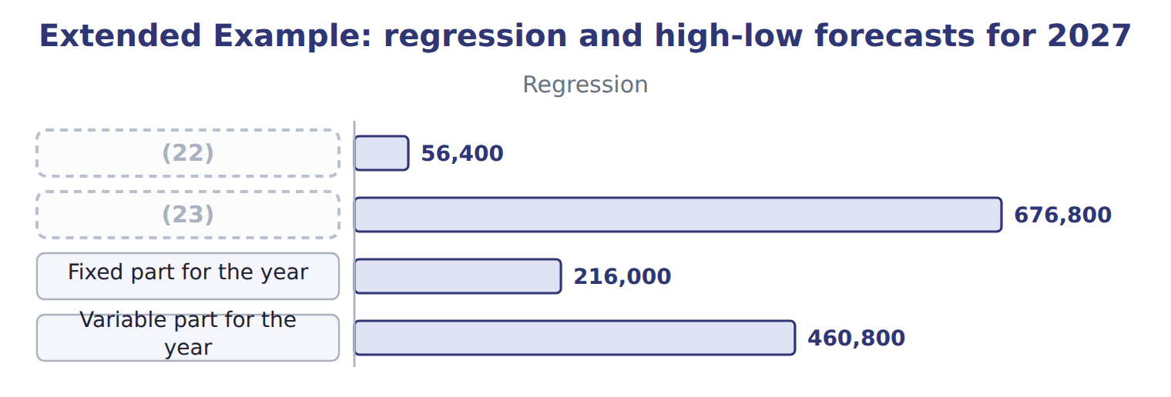
word list
Variable part for the year · Monthly forecast at 3,200 MH · FY2027 forecast at 38,400 MH

Everything ties

Summary 3 gaps 24–25
Slope: Sxy ÷ Sxx = 138,000,000 ÷ 11,500,000 = $12. (24) : 55,800 − 12 × 3,150 = $18,000. (25) : twelve months × $18,000 + $12 × 38,400 = $676,800, the.
word list
printed · Budget · Intercept

Exam view

Summary 4 gaps 26–29
Expect either a small data set with a high-low question, or a (26) regression output with a (27) question. For high-low, find the activity (28) first. For regression, take a and b from the (29) column, put the activity in x, and ignore R2 in the arithmetic.
word list
printed · coefficient · extremes · forecast · compare

Exam view
Barada Wholesale · deliveries in the month | Delivery cost (whole USD)
280 | 16,200
320 | 16,600
380 | 18,900
420 | 19,100
460 | 20,900
480 | 20,800
Regression output
Intercept | 9,000
(30) | 25
(31) | 0.964
(32) | 10.4
Standard error of the estimate | 424

word list
R2 · Coefficient on deliveries · Regression output · t-statistic on deliveries

Item — Answer
Each stage leads to the next.
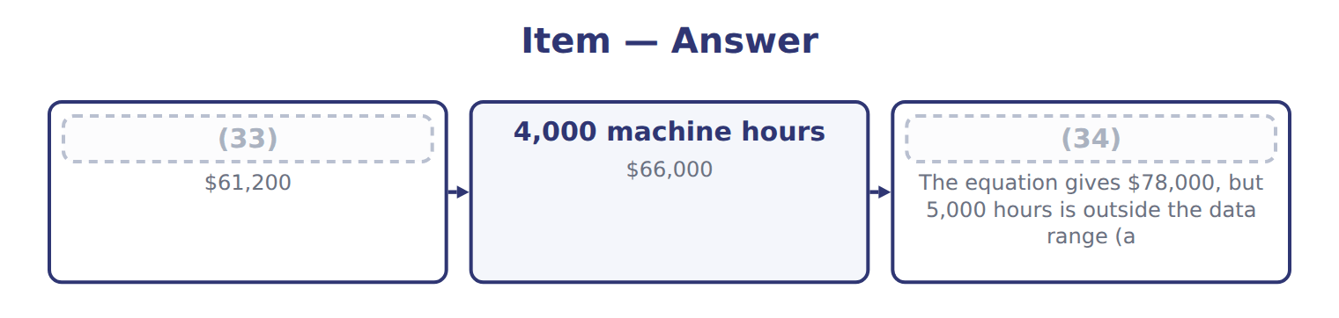
word list
3,600 machine hours · 4,000 machine hours · 5,000 machine hours

Output item — Category
Every item belongs to exactly one group.
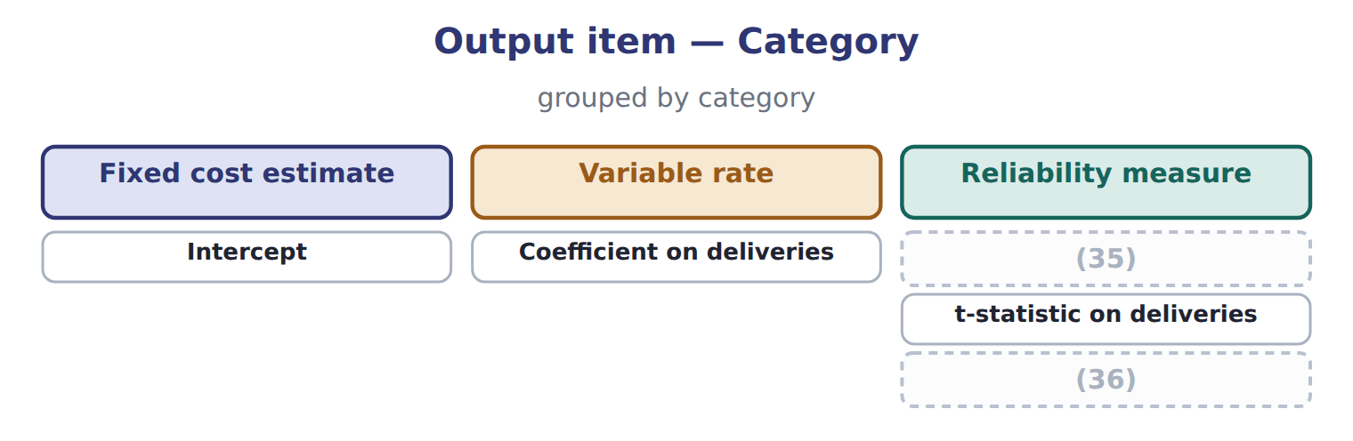
word list
R2 · Standard error of the estimate · t-statistic on deliveries

The English this section uses, and its Arabic
Each term sits against what it means.
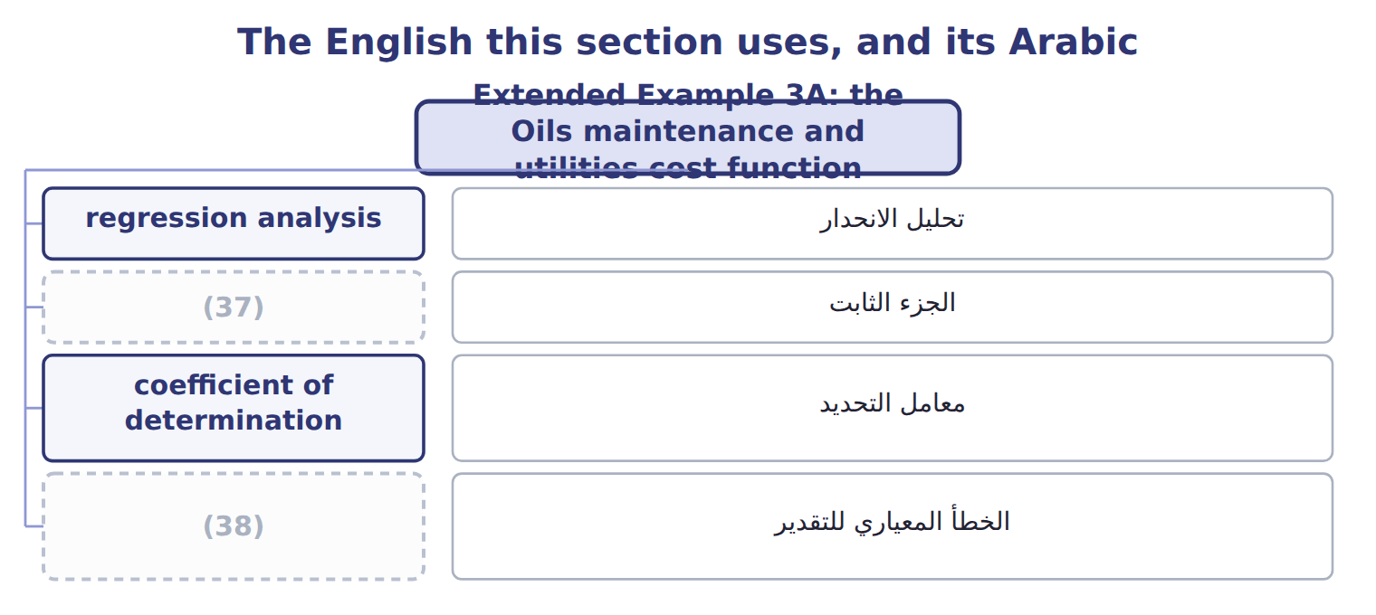
word list
coefficient of determination · standard error of the estimate · intercept

The English this sheet uses, and its Arabic
English (exam term) | Arabic
regression analysis | تحليل الانحدار
intercept | الجزء الثابت
coefficient of determination | معامل التحديد
standard error of the estimate | الخطأ المعياري للتقدير

Answer key · 3.7 Extended Example 3A: the Oils maintenance and utilities cost function

1 months | 20 Orontes
2 journal | 21 reliability
3 maintenance | 22 Monthly forecast at 3,200 MH
4 December | 23 FY2027 forecast at 38,400 MH
5 Estimate | 24 Intercept
6 high-low | 25 Budget
7 compare | 26 printed
8 Software | 27 forecast
9 seeing | 28 extremes
10 Sum of machine hours (Σx) | 29 coefficient
11 Sum of costs (Σy) | 30 Coefficient on deliveries
12 Mean machine hours (x̄) | 31 R2
13 Sxx = Σ(x − x̄)2 | 32 t-statistic on deliveries
14 Unexplained variation SSE = Σ(y − ŷ)2 | 33 3,600 machine hours
15 Total variation SST = Σ(y − ȳ)2 | 34 5,000 machine hours
16 depends | 35 R2
17 through | 36 Standard error of the estimate
18 forecast | 37 intercept
19 standard | 38 standard error of the estimate

the summaries in full
Summary 1 This example runs both methods on the full 24 months of Oils data and turns the result into the 2027 budget. There are no journal entries here: the output is a forecast that feeds the budget. Oils has monthly maintenance and utilities costs for January 2025 to December 2026, with machine hours from 2,000 to 4,300. For 2027 it plans 3,200 machine hours a month, or 38,400 for the year. Estimate the cost function with high-low and with regression. Read the regression output. Forecast the month and the year, compare the two methods, and pass the result to the budget. Software does this work, but seeing it once shows what b and a mean.
Summary 2 The high-low line depends on two months only; the regression line passes through the middle of all 24. The bar at 3,200 hours shows the forecast plus or minus two standard errors: $54,400 to $58,400. For 2027 regression gives $676,800 and high-low gives $678,000. Orontes uses the regression figure, because it uses all the data and passes the reliability tests. That is the maintenance line in the.
Summary 3 Slope: Sxy ÷ Sxx = 138,000,000 ÷ 11,500,000 = $12. Intercept: 55,800 − 12 × 3,150 = $18,000. Budget: twelve months × $18,000 + $12 × 38,400 = $676,800, the.
Summary 4 Expect either a small data set with a high-low question, or a printed regression output with a forecast question. For high-low, find the activity extremes first. For regression, take a and b from the coefficient column, put the activity in x, and ignore R2 in the arithmetic.

4.1 What learning is
Chapter 4 · section 4.1

Fill every gap. Each word list holds one word more than there are gaps.
Chapter 4, section by section
Each stage leads to the next.
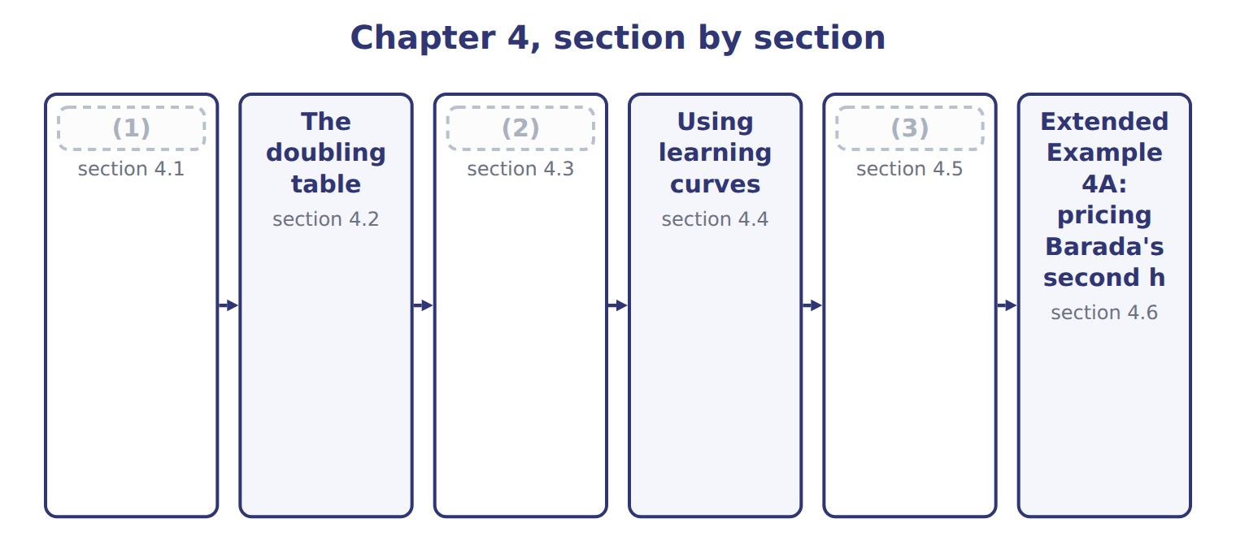
word list
The doubling table · The learning curve formula · Benefits and shortcomings · What learning is

Summary 1 gaps 4–11
Workers who (4) a task become (5) . They find better methods, make fewer (6) and need less (7) . A learning curve shows how labor time per unit falls as cumulative output grows. Learning is (8) each time cumulative output doubles. On an 80% curve, the average time per unit after a (9) is 80% of the average before it. The learning rate is 80%; the time saved is 20%. Learning (10) labor and the costs that follow labor hours. It does not affect (11) : each halva batch still needs the same sesame and sugar.
word list
materials · mistakes · supervision · measured · Workers · repeat · affects · doubling · faster

The rate is what remains, not what falls

Summary 2 gaps 12–13
An 80% (12) curve does not cut time by 80%. After each (13) , the new average is 80% of the old average, a fall of 20%.
word list
supervision · learning · doubling

The English this section uses, and its Arabic
Each term sits against what it means.
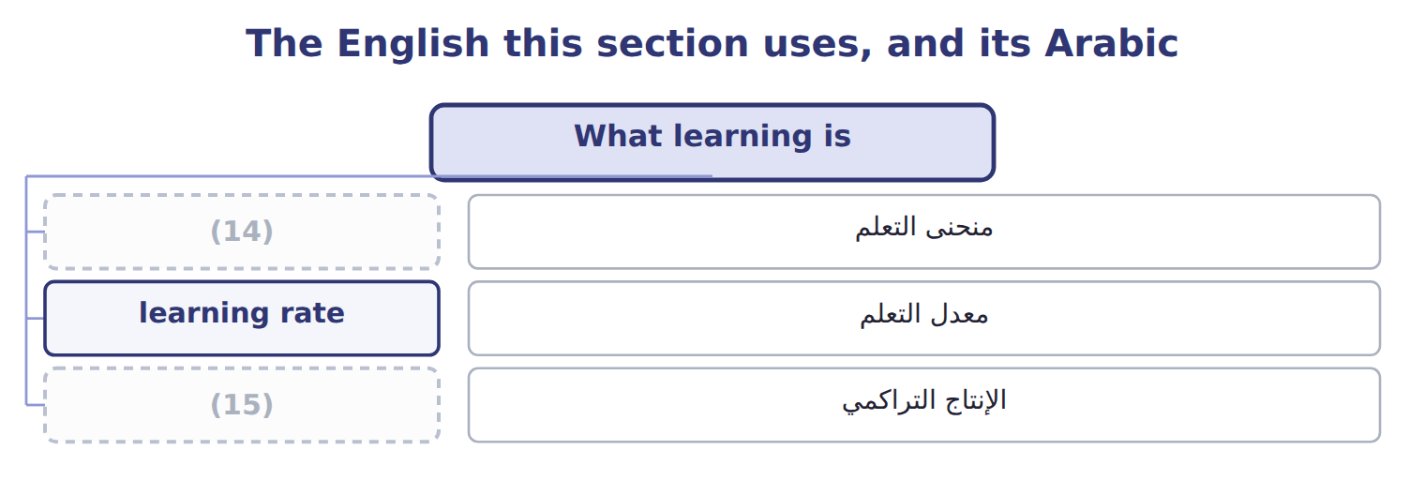
word list
learning curve · cumulative output · معدل التعلم

The English this sheet uses, and its Arabic
English (exam term) | Arabic
learning curve | منحنى التعلم
learning rate | معدل التعلم
cumulative output | الإنتاج التراكمي

Answer key · 4.1 What learning is

1 What learning is | 9 doubling
2 The learning curve formula | 10 affects
3 Benefits and shortcomings | 11 materials
4 repeat | 12 learning
5 faster | 13 doubling
6 mistakes | 14 learning curve
7 supervision | 15 cumulative output
8 measured

the summaries in full
Summary 1 Workers who repeat a task become faster. They find better methods, make fewer mistakes and need less supervision. A learning curve shows how labor time per unit falls as cumulative output grows. Learning is measured each time cumulative output doubles. On an 80% curve, the average time per unit after a doubling is 80% of the average before it. The learning rate is 80%; the time saved is 20%. Learning affects labor and the costs that follow labor hours. It does not affect materials: each halva batch still needs the same sesame and sugar.
Summary 2 An 80% learning curve does not cut time by 80%. After each doubling, the new average is 80% of the old average, a fall of 20%.

4.2 The doubling table
Chapter 4 · section 4.2

Fill every gap. Each word list holds one word more than there are gaps.
Summary 1 gaps 1–6
At each doubling of (1) output, the average time for all units so far is the (2) rate times the previous average. Total time is the average times the (3) of units. The table works only at (4) : one, two, four, eight, (5) units and so on. To find the time for a group of later units, (6) the totals: batches 5 to 8 need the total for 8 minus the total for 4.
word list
sixteen · previous · learning · cumulative · subtract · doublings · number

Worked example: the halva doubling table

The average falls from 1,000 to 800, 640 and 512 hours. The total for eight batches is 4,096 hours, so batches 5 to 8 need 4,096 − 2,560 = 1,536 hours.
Worked example: the halva doubling table
Name each point on the scale from where it sits.
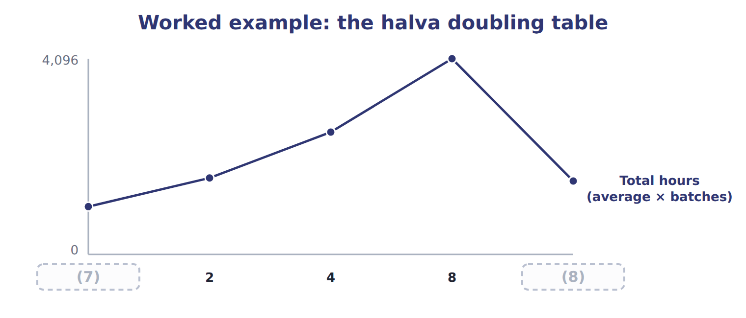
word list
1 · learning rate · Batches 5–8

The English this section uses, and its Arabic
Each term sits against what it means.
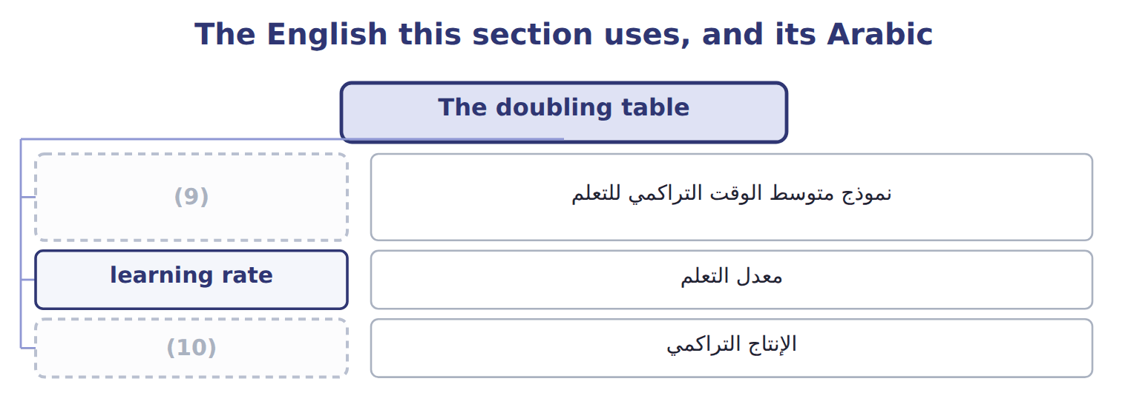
word list
معدل التعلم · cumulative output · cumulative average-time learning model

The English this sheet uses, and its Arabic
English (exam term) | Arabic
cumulative average-time learning model | نموذج متوسط الوقت التراكمي للتعلم

Answer key · 4.2 The doubling table

1 cumulative | 6 subtract
2 learning | 7 1
3 number | 8 Batches 5–8
4 doublings | 9 cumulative average-time learning model
5 sixteen | 10 cumulative output

the summaries in full
Summary 1 At each doubling of cumulative output, the average time for all units so far is the learning rate times the previous average. Total time is the average times the number of units. The table works only at doublings: one, two, four, eight, sixteen units and so on. To find the time for a group of later units, subtract the totals: batches 5 to 8 need the total for 8 minus the total for 4.

4.3 The learning curve formula
Chapter 4 · section 4.3

Fill every gap. Each word list holds one word more than there are gaps.
Summary 1 gaps 1–4
For (1) that are not (2) , use the formula Y = a X^b. Y is the cumulative average time per unit, a is the time for the first unit, X is cumulative units, and b = log( (3) rate) ÷ log(two). For an 80% curve, b = -0.3219. Three halva (4) average 702.1 hours, a total of about 2,106 hours.
word list
average-time · learning · doublings · batches · quantities

The learning curve formula for three and six batches
The bars are drawn to scale.
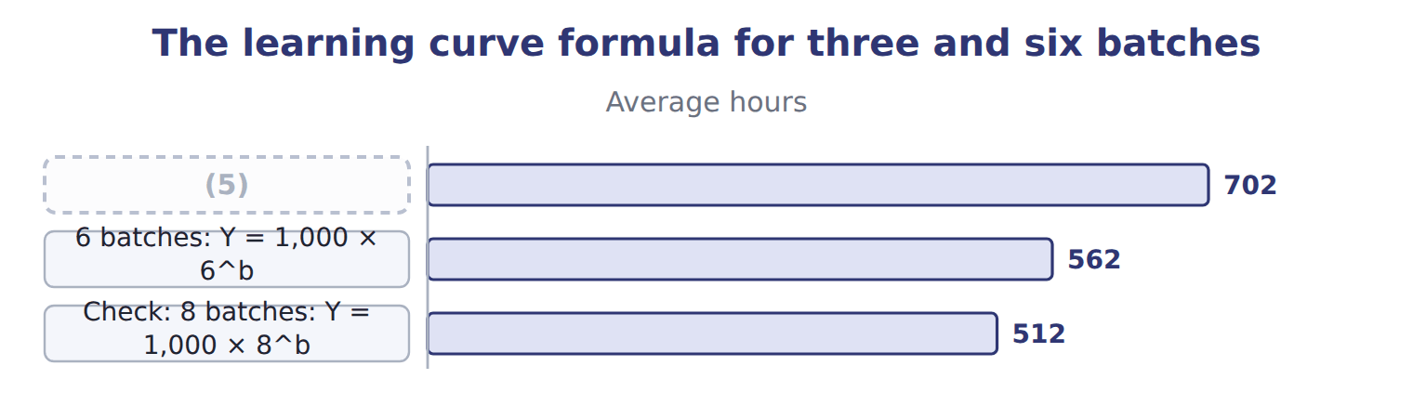
word list
3 batches: Y = 1,000 × 3^b · 6 batches: Y = 1,000 × 6^b

Summary 2 gaps 6–9
The learning rate (6) a great deal. A lower (7) means faster learning. Some texts use an (8) unit-time model, in which the time for the last unit falls by the rate at each doubling. It gives (9) totals. The CMA LOS name the cumulative average-time model; use it unless a question says otherwise.
word list
higher · otherwise · incremental · matters · percentage

The English this section uses, and its Arabic
Each term sits against what it means.
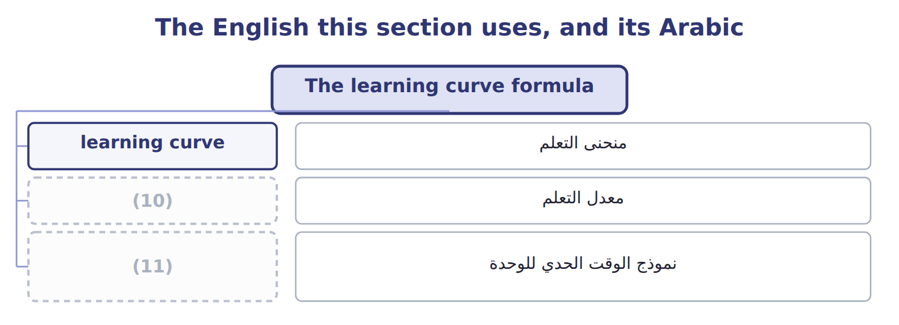
word list
معدل التعلم · incremental unit-time learning model · learning rate

The English this sheet uses, and its Arabic
English (exam term) | Arabic
incremental unit-time learning model | نموذج الوقت الحدي للوحدة

Answer key · 4.3 The learning curve formula

1 quantities | 7 percentage
2 doublings | 8 incremental
3 learning | 9 higher
4 batches | 10 learning rate
5 3 batches: Y = 1,000 × 3^b | 11 incremental unit-time learning model
6 matters

the summaries in full
Summary 1 For quantities that are not doublings, use the formula Y = a X^b. Y is the cumulative average time per unit, a is the time for the first unit, X is cumulative units, and b = log(learning rate) ÷ log(two). For an 80% curve, b = -0.3219. Three halva batches average 702.1 hours, a total of about 2,106 hours.
Summary 2 The learning rate matters a great deal. A lower percentage means faster learning. Some texts use an incremental unit-time model, in which the time for the last unit falls by the rate at each doubling. It gives higher totals. The CMA LOS name the cumulative average-time model; use it unless a question says otherwise.

4.4 Using learning curves
Chapter 4 · section 4.4

Fill every gap. Each word list holds one word more than there are gaps.
Summary 1 gaps 1–7
Learning (1) improve three (2) . In (3) , a later order costs less than the first, so a lower price may still cover cost. In (4) , labor hours fall over the year. In setting (5) , a standard based on one early batch is too loose, and one based on later batches is too tight for new staff. (6) cost an order with its own (7) hours. The average for the whole run mixes the slow early batches with the fast later ones.
word list
curves · pricing · standards · Complete · budgeting · decisions · Always · incremental

Complete the doubling table

Complete it, then find the hours for batches 5 to 8.
Your turn: complete the halva doubling table
Each stage leads to the next.
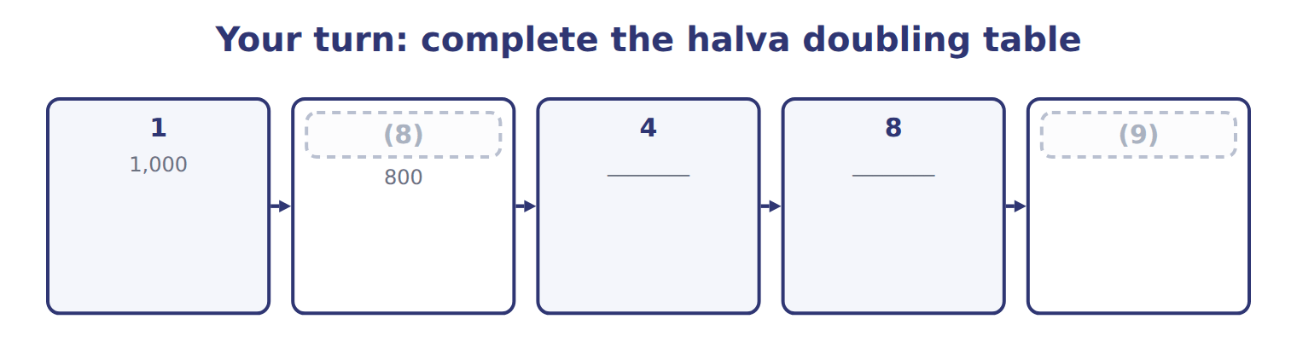
word list
Batches 5–8 · 2 · learning rate

Answer key · 4.4 Using learning curves

1 curves | 6 Always
2 decisions | 7 incremental
3 pricing | 8 2
4 budgeting | 9 Batches 5–8
5 standards

the summaries in full
Summary 1 Learning curves improve three decisions. In pricing, a later order costs less than the first, so a lower price may still cover cost. In budgeting, labor hours fall over the year. In setting standards, a standard based on one early batch is too loose, and one based on later batches is too tight for new staff. Always cost an order with its own incremental hours. The average for the whole run mixes the slow early batches with the fast later ones.

4.5 Benefits and shortcomings
Chapter 4 · section 4.5

Fill every gap. Each word list holds one word more than there are gaps.
Summary 1 gaps 1–7
Both regression and learning curves turn past data into better (1) . Regression gives a fixed cost and a (2) rate, with tests of (3) . Learning curves (4) the labor estimate when the task is new. Regression needs (5) past data and holds only inside the (6) range; a good fit does not prove a causal link. A learning rate is itself an estimate, learning may stop once the task is routine, and it does not apply to (7) work or materials.
word list
relevant · regression · estimates · enough · variable · correct · machine-paced · reliability

Benefits and shortcomings of learning curves and regression
Method | Benefits | Shortcomings
Learning curve | More accurate labor (8) for new products; better prices, budgets and standards | The rate must be estimated; learning may stop; it does not apply to materials or machine-paced work
Regression | Uses all data; reports R2, t and standard error; separates fixed and variable cost | Needs enough past data; valid only inside the (9) range; a good fit does not prove cause

word list
separates · estimates · relevant

The learning curve here covers only labor time on one task.

Answer key · 4.5 Benefits and shortcomings

1 estimates | 6 relevant
2 variable | 7 machine-paced
3 reliability | 8 estimates
4 correct | 9 relevant
5 enough

the summaries in full
Summary 1 Both regression and learning curves turn past data into better estimates. Regression gives a fixed cost and a variable rate, with tests of reliability. Learning curves correct the labor estimate when the task is new. Regression needs enough past data and holds only inside the relevant range; a good fit does not prove a causal link. A learning rate is itself an estimate, learning may stop once the task is routine, and it does not apply to machine-paced work or materials.

4.6 Extended Example 4A: pricing Barada's second halva order
Chapter 4 · section 4.6

Fill every gap. Each word list holds one word more than there are gaps.
Summary 1 gaps 1–12
This example uses the (1) curve to cost two orders, sets a price floor for the (2) one and shows what the curve means for a labor standard. There are no (3) entries: the (4) is a quote and a standard. Barada (5) 4 batches of halva, which (6) has made. Barada now asks for 4 more. Direct labor costs $12 an hour and (7) overhead $6 per labor hour, (8) the manual line uses little (9) . Materials cost $3,000 a batch and do not learn. Use the (10) table to find the hours for each order. Apply the labor and overhead rates to the hours, and add materials at a flat (11) per batch. (12) the two orders and think about the standard. Order 1 hours = total for 4 batches = 2,560. Order 2 hours = total for 8 batches − total for 4 = 4,096 − 2,560 = 1,536.
word list
doubling · learning · efficiency · second · Compare · amount · because · ordered · output · journal · machinery · variable · Orontes

Summary 2 gaps 13–16
Order 2 cost = 1,536 × ($12 + $6) + 4 × $3,000 = $39,648. The (13) order costs $39,648, or $9,912 a batch, (14) $14,520 for the first. Any price above $39,648 covers the (15) cost; fixed costs and (16) come on top.
word list
incremental · against · Orontes · profit · second

Extended Example: incremental cost of the two Barada orders
Halva orders for Barada (whole USD) | Order 1 | Order 2
(17) | 1–4 | 5–8
(18) | 2,560 | 1,536
Direct labor at $12 per hour | 30,720 | 18,432
(19) | 15,360 | 9,216
(20) | 12,000 | 12,000
Incremental cost of the order | 58,080 | 39,648
Cost per batch | 14,520 | 9,912

word list
Labor hours (from the doubling table) · Direct materials at 3,000 per batch (no learning) · Incremental · Batches · Variable overhead at $6 per labor hour

Summary 3 gaps 21–23
Order 2 needs only the rise in (21) hours from 2,560 to 4,096. Suppose Orontes sets one labor (22) for all eight batches at their average of 512 hours. Book 3 calls these labor (23) variances; here they come only from learning.
word list
machinery · cumulative · efficiency · standard

Extended Example: a labor standard at the eight-batch average
Setting a labor standard for halva | Batches 1–4 | Batches 5–8 | All 8
Actual labor hours (learning curve) | 2,560 | 1,536 | 4,096
(24) | 2,048 | 2,048 | 4,096
(25) | 512 | (512) | 0

word list
4,096 − 2,560 = 1,536 hours · Standard hours at the 8-batch average (512 per batch) · Actual − standard hours

Everything ties

Summary 4 gaps 26–27
Hours: 2,560 + 1,536 = 4,096, the total for eight batches. Order 2 labor: 1,536 × $12 = $18,432. (26) check: overrun 512 + (27) (512) = 0 over the eight batches.
word list
Suppose · Standard · saving

Exam view

Summary 5 gaps 28–30
Expect the (28) time, a learning rate and a question about a later group of units. Build the (29) table to the needed total, then subtract the earlier total. Apply learning to labor and (30) costs only.
word list
labor-driven · doubling · entries · first-unit

Exam view
Beverages · new juice-blend crew | Data
First lot of 1,000 cases | (31)
Learning rate | 90% (cumulative average-time model)
Direct labor rate | (32)
Planned lots this year | 8 (lots 1–4 are (33) in quarter 1; lots 5–8 in quarter 2)
Materials per lot | Standard; no learning expected

word list
Batches 1–4 · 500 direct labor hours · $12 per hour · budgeted

Item — Answer
Item | Answer
4 batches | (34)
8 batches | Average 512 hours; total 4,096 hours
Batches 5–8 | (35)

word list
Average 640 hours; total 2,560 hours · Variable overhead driven by labor hours · 4,096 − 2,560 = 1,536 hours

Cost — Category
Every item belongs to exactly one group.
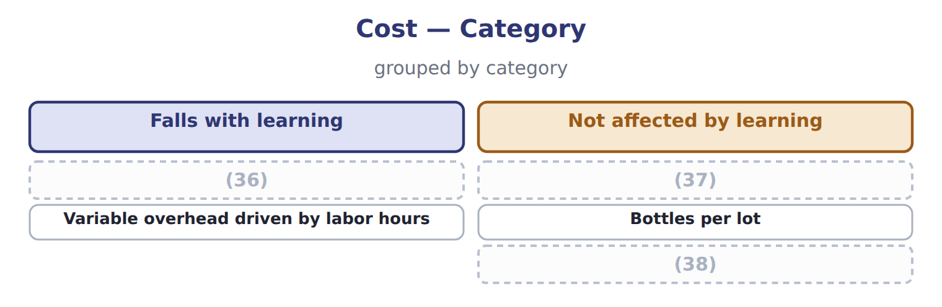
word list
Juice concentrate per lot · Direct labor per lot · Not affected by learning · Straight-line depreciation of the line

The English this section uses, and its Arabic
Each term sits against what it means.
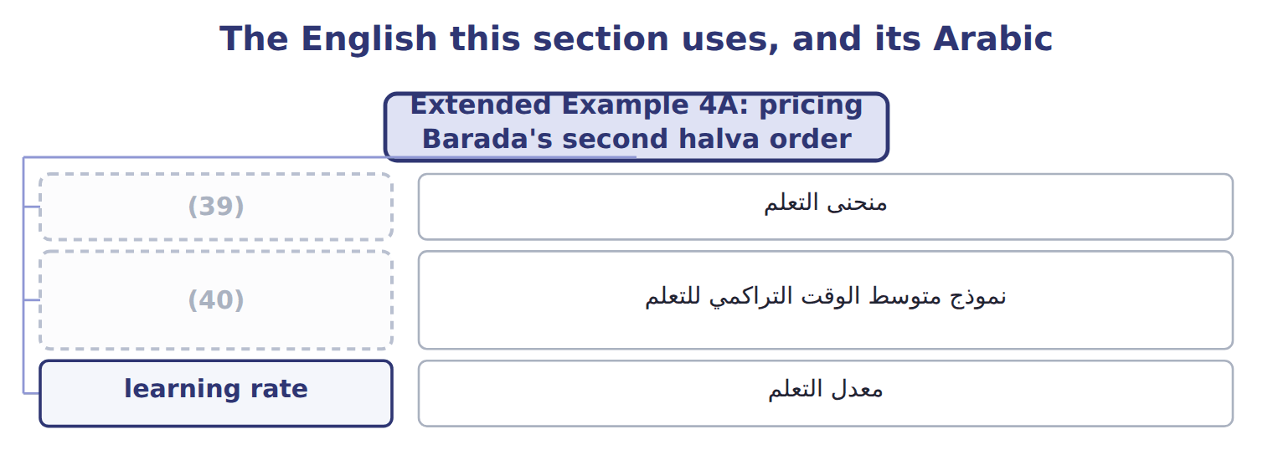
word list
learning rate · cumulative average-time learning model · learning curve

The English this sheet uses, and its Arabic
English (exam term) | Arabic
learning curve | منحنى التعلم
cumulative average-time learning model | نموذج متوسط الوقت التراكمي للتعلم
learning rate | معدل التعلم

Answer key · 4.6 Extended Example 4A: pricing Barada's second halva order

1 learning | 21 cumulative
2 second | 22 standard
3 journal | 23 efficiency
4 output | 24 Standard hours at the 8-batch average (512 per batch)
5 ordered | 25 Actual − standard hours
6 Orontes | 26 Standard
7 variable | 27 saving
8 because | 28 first-unit
9 machinery | 29 doubling
10 doubling | 30 labor-driven
11 amount | 31 500 direct labor hours
12 Compare | 32 $12 per hour
13 second | 33 budgeted
14 against | 34 Average 640 hours; total 2,560 hours
15 incremental | 35 4,096 − 2,560 = 1,536 hours
16 profit | 36 Direct labor per lot
17 Batches | 37 Juice concentrate per lot
18 Labor hours (from the doubling table) | 38 Straight-line depreciation of the line
19 Variable overhead at $6 per labor hour | 39 learning curve
20 Direct materials at 3,000 per batch (no learning) | 40 cumulative average-time learning model

the summaries in full
Summary 1 This example uses the learning curve to cost two orders, sets a price floor for the second one and shows what the curve means for a labor standard. There are no journal entries: the output is a quote and a standard. Barada ordered 4 batches of halva, which Orontes has made. Barada now asks for 4 more. Direct labor costs $12 an hour and variable overhead $6 per labor hour, because the manual line uses little machinery. Materials cost $3,000 a batch and do not learn. Use the doubling table to find the hours for each order. Apply the labor and overhead rates to the hours, and add materials at a flat amount per batch. Compare the two orders and think about the standard. Order 1 hours = total for 4 batches = 2,560. Order 2 hours = total for 8 batches − total for 4 = 4,096 − 2,560 = 1,536.
Summary 2 Order 2 cost = 1,536 × ($12 + $6) + 4 × $3,000 = $39,648. The second order costs $39,648, or $9,912 a batch, against $14,520 for the first. Any price above $39,648 covers the incremental cost; fixed costs and profit come on top.
Summary 3 Order 2 needs only the rise in cumulative hours from 2,560 to 4,096. Suppose Orontes sets one labor standard for all eight batches at their average of 512 hours. Book 3 calls these labor efficiency variances; here they come only from learning.
Summary 4 Hours: 2,560 + 1,536 = 4,096, the total for eight batches. Order 2 labor: 1,536 × $12 = $18,432. Standard check: overrun 512 + saving (512) = 0 over the eight batches.
Summary 5 Expect the first-unit time, a learning rate and a question about a later group of units. Build the doubling table to the needed total, then subtract the earlier total. Apply learning to labor and labor-driven costs only.

5.1 Three measurement techniques
Chapter 5 · section 5.1

Fill every gap. Each word list holds one word more than there are gaps.
Chapter 5, section by section
Each stage leads to the next.
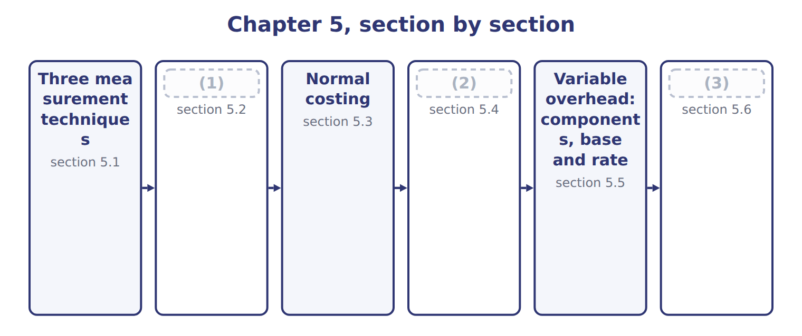
word list
Standard costing · Actual costing · Extended Example 5A: one month, three costs · section 5.5

Summary 1 gaps 4–12
A product cost has three parts: direct (4) , direct labor and overhead. The three techniques (5) in how they measure each part. Actual costing uses actual (6) for all three. Normal costing uses actual direct costs but applies overhead with a (7) rate. Standard costing uses standard (8) and prices for everything. Each (9) suits a different need. Actual costing is exact but late; normal costing is timely; standard costing also sets targets that (10) can compare with results. The techniques measure cost; they do not (11) it. Any of them can be used with job costing, process costing or (12) costing.
word list
quantities · managers · differ · compare · activity-based · materials · collect · amounts · technique · predetermined

Actual, normal and standard costing compared
 | Actual costing | Normal costing | Standard costing
Direct materials | Actual quantity × actual price | Actual quantity × actual price | (13)
Direct labor | Actual hours × actual rate | Actual hours × actual rate | (14)
Overhead | Actual overhead | (15) | Standard base allowed × standard rate
Unit cost known | After the period ends | When the work is done | (16)
Best use | Small firms; audit of results | (17) | Repetitive production; control through variances

word list
Standard quantity allowed × standard price · Standard hours allowed × standard rate · Actual base × predetermined rate · When the work is done · Job shops; pricing during the year · Before production starts

The English this section uses, and its Arabic
Each term sits against what it means.
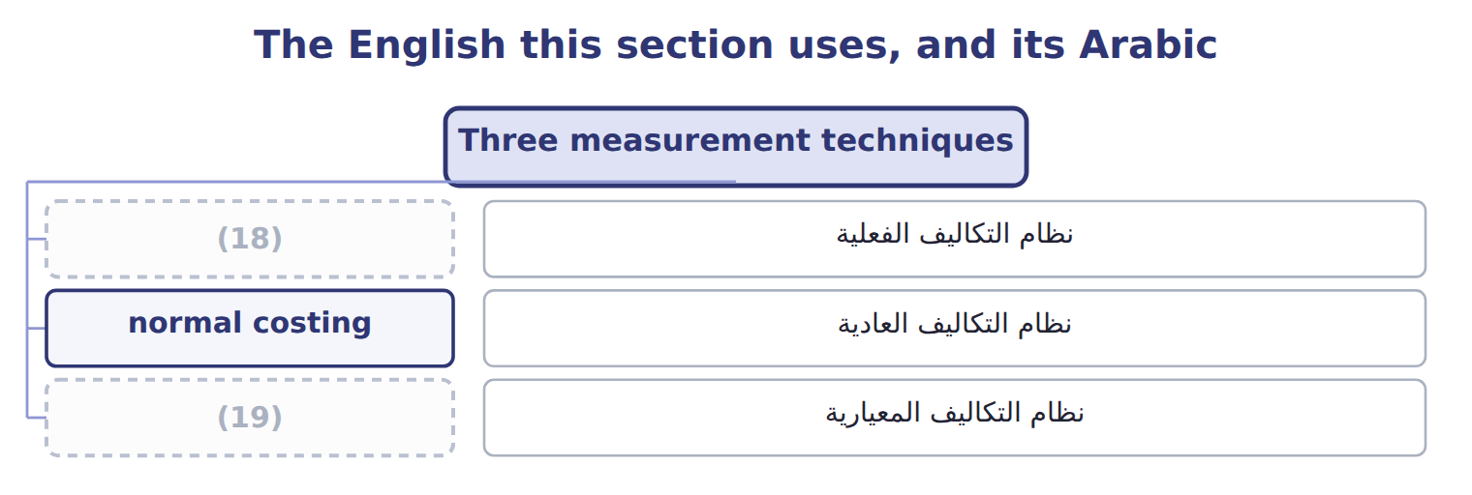
word list
standard costing · normal costing · actual costing

The English this sheet uses, and its Arabic
English (exam term) | Arabic
actual costing | نظام التكاليف الفعلية
normal costing | نظام التكاليف العادية
standard costing | نظام التكاليف المعيارية

Answer key · 5.1 Three measurement techniques

1 Actual costing | 11 collect
2 Standard costing | 12 activity-based
3 Extended Example 5A: one month, three costs | 13 Standard quantity allowed × standard price
4 materials | 14 Standard hours allowed × standard rate
5 differ | 15 Actual base × predetermined rate
6 amounts | 16 Before production starts
7 predetermined | 17 Job shops; pricing during the year
8 quantities | 18 actual costing
9 technique | 19 standard costing
10 managers

the summaries in full
Summary 1 A product cost has three parts: direct materials, direct labor and overhead. The three techniques differ in how they measure each part. Actual costing uses actual amounts for all three. Normal costing uses actual direct costs but applies overhead with a predetermined rate. Standard costing uses standard quantities and prices for everything. Each technique suits a different need. Actual costing is exact but late; normal costing is timely; standard costing also sets targets that managers can compare with results. The techniques measure cost; they do not collect it. Any of them can be used with job costing, process costing or activity-based costing.

5.2 Actual costing
Chapter 5 · section 5.2

Fill every gap. Each word list holds one word more than there are gaps.
Summary 1 gaps 1–7
Under actual costing, overhead is (1) only when the period ends and the actual overhead is known. In May (2) spent $222,600 on overhead, so the full cost was $903,000, or $12.90 a case. Actual costing has two (3) . The cost (4) too late for (5) and control during the month. And unit cost jumps with volume, (6) fixed overhead is spread over (7) the month produces. Actual costing suits small firms with stable volume, and it is the basis for checking results after the period.
word list
limits · whatever · pricing · arrives · Beverages · because · assigned · overhead

The English this section uses, and its Arabic
Each term sits against what it means.
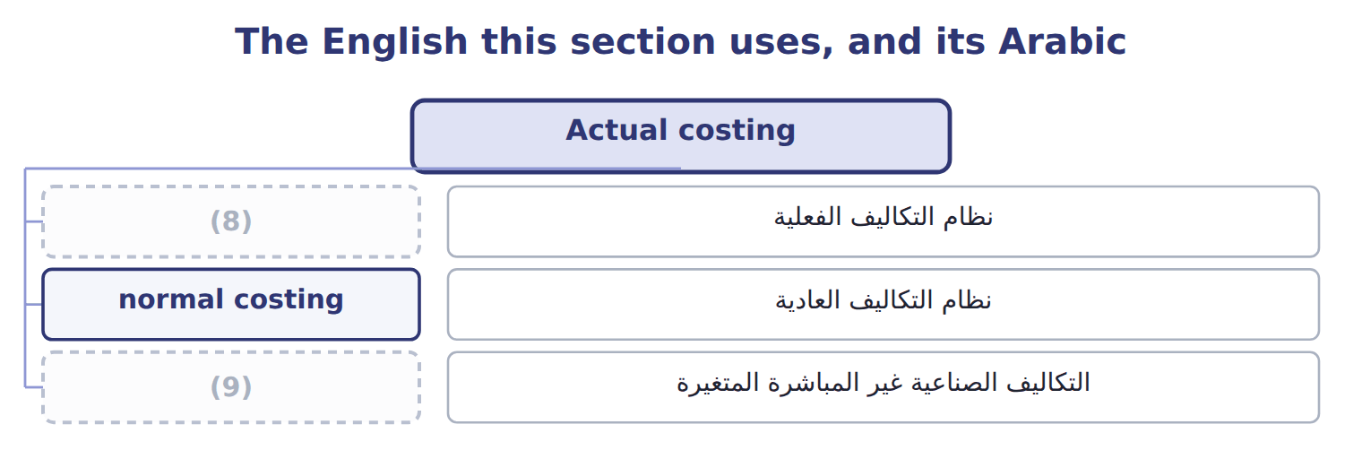
word list
normal costing · variable overhead · actual costing

Answer key · 5.2 Actual costing

1 assigned | 6 because
2 Beverages | 7 whatever
3 limits | 8 actual costing
4 arrives | 9 variable overhead
5 pricing

the summaries in full
Summary 1 Under actual costing, overhead is assigned only when the period ends and the actual overhead is known. In May Beverages spent $222,600 on overhead, so the full cost was $903,000, or $12.90 a case. Actual costing has two limits. The cost arrives too late for pricing and control during the month. And unit cost jumps with volume, because fixed overhead is spread over whatever the month produces. Actual costing suits small firms with stable volume, and it is the basis for checking results after the period.

5.3 Normal costing
Chapter 5 · section 5.3

Fill every gap. Each word list holds one word more than there are gaps.
Summary 1 gaps 1–8
Normal costing keeps actual direct (1) and direct labor, but applies overhead with a (2) overhead rate: budgeted overhead divided by the budgeted (3) base, set before the year starts. (4) uses $150 per machine hour. Applied overhead (5) the actual base times the rate. In May the line ran 1,414 machine hours, so applied overhead was $212,100. Normal costing gives a cost as soon as the work is done, and the rate smooths out (6) swings in fixed overhead. Its limit is that the rate is only an (7) , so applied and actual overhead (8) .
word list
differ · smooths · equals · Beverages · predetermined · seasonal · allocation · materials · estimate

Normal costing is not normal capacity

Summary 2 gaps 9–10
Normal (9) means 'actual direct costs plus applied overhead'. Normal capacity is a (10) level used to set a fixed overhead rate.
word list
costing · overhead · denominator

The English this section uses, and its Arabic
Each term sits against what it means.
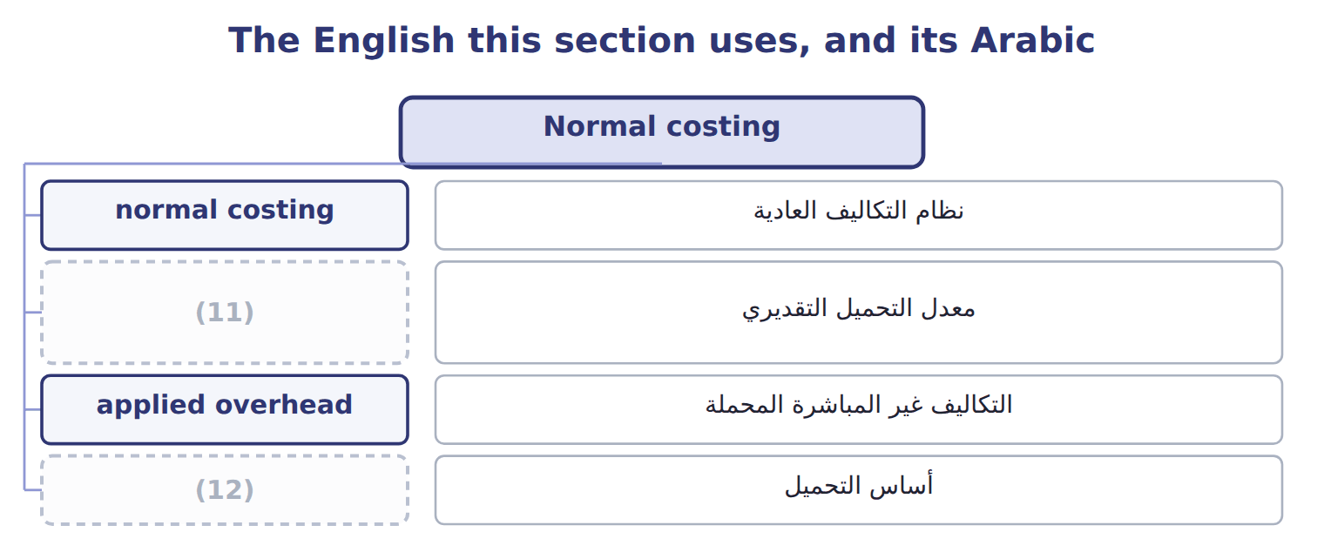
word list
normal costing · allocation base · predetermined overhead rate

The English this sheet uses, and its Arabic
English (exam term) | Arabic
predetermined overhead rate | معدل التحميل التقديري
applied overhead | التكاليف غير المباشرة المحملة

Answer key · 5.3 Normal costing

1 materials | 7 estimate
2 predetermined | 8 differ
3 allocation | 9 costing
4 Beverages | 10 denominator
5 equals | 11 predetermined overhead rate
6 seasonal | 12 allocation base

the summaries in full
Summary 1 Normal costing keeps actual direct materials and direct labor, but applies overhead with a predetermined overhead rate: budgeted overhead divided by the budgeted allocation base, set before the year starts. Beverages uses $150 per machine hour. Applied overhead equals the actual base times the rate. In May the line ran 1,414 machine hours, so applied overhead was $212,100. Normal costing gives a cost as soon as the work is done, and the rate smooths out seasonal swings in fixed overhead. Its limit is that the rate is only an estimate, so applied and actual overhead differ.
Summary 2 Normal costing means 'actual direct costs plus applied overhead'. Normal capacity is a denominator level used to set a fixed overhead rate.

5.4 Standard costing
Chapter 5 · section 5.4

Fill every gap. Each word list holds one word more than there are gaps.
Summary 1 gaps 1–6
Standard costing values every input at what it should cost for the output (1) . Each part equals the standard (2) allowed for the actual output times the standard price. The (3) standard cost card gives $12.60 a case. The (4) between actual cost and standard cost is recorded as variances. (5) study them to control costs, and Book 3 analyzes them in detail. Standard costing suits (6) production such as bottling.
word list
repetitive · difference · Beverages · allowed · achieved · Managers · quantity

Worked example: May output at standard

Summary 2 gaps 7–8
Overhead uses the 1,400 standard (7) hours allowed for 70,000 cases, not the 1,414 hours (8) used. The standard cost is $882,000.
word list
allowed · machine · actually

Worked example: May output valued at standard
The bars are drawn to scale.
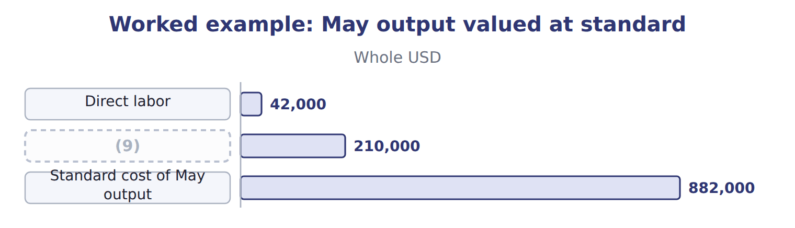
word list
Overhead: 1,400 standard MH × $150 · Standard cost of May output

Standard hours allowed, not actual hours

Summary 3 gaps 10–13
In standard costing, (10) is applied on the standard hours allowed for the actual output. Using actual hours turns standard costing back into (11) costing. Both ASC 330 and IAS 2 accept standard costs for inventory only if they (12) actual cost. (13) must be reviewed and updated regularly.
word list
Standards · approximate · overhead · normal · allowed

The English this section uses, and its Arabic
Each term sits against what it means.
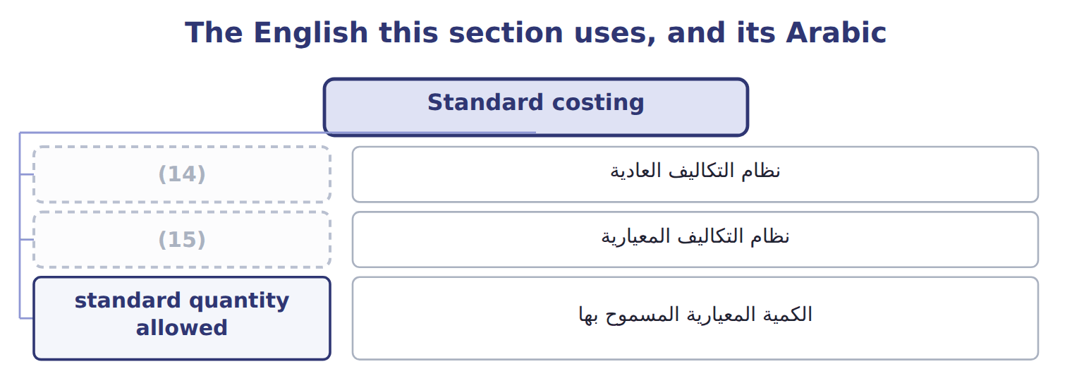
word list
variable overhead · normal costing · standard costing

The English this sheet uses, and its Arabic
English (exam term) | Arabic
standard costing | نظام التكاليف المعيارية
standard quantity allowed | الكمية المعيارية المسموح بها

Answer key · 5.4 Standard costing

1 achieved | 9 Overhead: 1,400 standard MH × $150
2 quantity | 10 overhead
3 Beverages | 11 normal
4 difference | 12 approximate
5 Managers | 13 Standards
6 repetitive | 14 normal costing
7 machine | 15 standard costing
8 actually

the summaries in full
Summary 1 Standard costing values every input at what it should cost for the output achieved. Each part equals the standard quantity allowed for the actual output times the standard price. The Beverages standard cost card gives $12.60 a case. The difference between actual cost and standard cost is recorded as variances. Managers study them to control costs, and Book 3 analyzes them in detail. Standard costing suits repetitive production such as bottling.
Summary 2 Overhead uses the 1,400 standard machine hours allowed for 70,000 cases, not the 1,414 hours actually used. The standard cost is $882,000.
Summary 3 In standard costing, overhead is applied on the standard hours allowed for the actual output. Using actual hours turns standard costing back into normal costing. Both ASC 330 and IAS 2 accept standard costs for inventory only if they approximate actual cost. Standards must be reviewed and updated regularly.

5.5 Variable overhead: components, base and rate
Chapter 5 · section 5.5

Fill every gap. Each word list holds one word more than there are gaps.
Summary 1 gaps 1–12
Variable overhead is indirect (1) cost that changes with (2) . On the bottling line it has four (3) : power for the machines, cleaning chemicals, (4) supplies, and water and steam. (5) , insurance and (6) are fixed overhead. The (7) base for variable overhead (8) be what drives it. The bottling line is (9) , so power and supplies (10) machine hours, not labor hours. On a (11) line, such as halva (12) , labor hours may be the better base. Variable overhead per unit = rate per base unit × base units per product. Each case needs 0.02 machine hours, so variable overhead is $1.00 a case. Keep variable and fixed overhead apart when you need a variable cost. The full predetermined rate of $150 per machine hour mixes both: it gives $1.00 of variable and $2.00 of fixed overhead per case.
word list
allocation · production · manual · Supervision · components · should · activity · finishing · follow · standard · maintenance · depreciation · automated

Summary 2 gaps 13–18
A special order that uses spare (13) adds only the variable part. Test the base (14) you use it. Plot monthly variable overhead against each (15) base, as in, and keep the one with a clear causal link and the better fit. For the (16) line, machine hours pass both tests. The (17) figure travels far. It goes on the standard cost card, into the (18) margin and into the flexible overhead budget in Book 3.
word list
capacity · bottling · contribution · possible · before · per-unit · overhead

Variable overhead per unit

The first two are done. Calculate variable overhead per unit for the others.
Your turn: variable overhead per unit (complete the blanks)
The bars are drawn to scale.
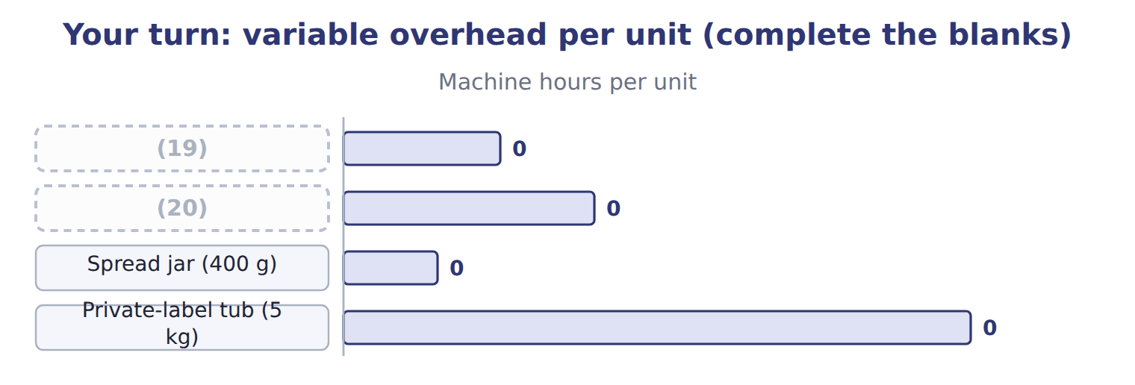
word list
normal costing · Halva tray · Tahini jar (1 kg)

Variable overhead on the bottling line
Beverages bottling line · variable overhead (bas | Per machine hour
(21) | $20
Cleaning chemicals | $12
(22) | $10
Water and steam | $8
Variable overhead rate per machine hour | $50
(23) | 0.02
(24) | $1.00

word list
Maintenance supplies · Variable overhead per case · Standard machine hours per case · Private-label tub (5 kg) · Power

The English this sheet uses, and its Arabic
English (exam term) | Arabic
variable overhead | التكاليف الصناعية غير المباشرة المتغيرة
allocation base | أساس التحميل

Answer key · 5.5 Variable overhead: components, base and rate

1 production | 13 capacity
2 activity | 14 before
3 components | 15 possible
4 maintenance | 16 bottling
5 Supervision | 17 per-unit
6 depreciation | 18 contribution
7 allocation | 19 Tahini jar (1 kg)
8 should | 20 Halva tray
9 automated | 21 Power
10 follow | 22 Maintenance supplies
11 manual | 23 Standard machine hours per case
12 finishing | 24 Variable overhead per case

the summaries in full
Summary 1 Variable overhead is indirect production cost that changes with activity. On the bottling line it has four components: power for the machines, cleaning chemicals, maintenance supplies, and water and steam. Supervision, insurance and depreciation are fixed overhead. The allocation base for variable overhead should be what drives it. The bottling line is automated, so power and supplies follow machine hours, not labor hours. On a manual line, such as halva finishing, labor hours may be the better base. Variable overhead per unit = rate per base unit × base units per product. Each case needs 0.02 machine hours, so variable overhead is $1.00 a case. Keep variable and fixed overhead apart when you need a variable cost. The full predetermined rate of $150 per machine hour mixes both: it gives $1.00 of variable and $2.00 of fixed overhead per case.
Summary 2 A special order that uses spare capacity adds only the variable part. Test the base before you use it. Plot monthly variable overhead against each possible base, as in, and keep the one with a clear causal link and the better fit. For the bottling line, machine hours pass both tests. The per-unit figure travels far. It goes on the standard cost card, into the contribution margin and into the flexible overhead budget in Book 3.

5.6 Extended Example 5A: one month, three costs
Chapter 5 · section 5.6

Fill every gap. Each word list holds one word more than there are gaps.
Summary 1 gaps 1–12
This example costs the same May output three ways and (1) each in the (2) . The costs per case are (3) ; the entries show where the (4) go. Output: 70,000 cases, all (5) in May. Actual costs: direct (6) $637,000; direct labor $43,400; (7) overhead $70,700; fixed overhead $151,900. Machine hours: 1,414 actual; 1,400 standard hours (8) for the output. Rates: (9) overhead $150 per machine hour; standard cost $12.60 a case. (10) each cost part under each (11) , record the entries, and see where the difference between actual and product cost goes. Actual: $637,000 + $43,400 + $222,600 = $903,000. Normal: $637,000 + $43,400 + 1,414 × $150 = $892,500. Standard: 70,000 × $12.60 = $882,000. The last row shows the actual cost that did not enter product cost: nothing under actual costing, $10,500 of (12) overhead under normal costing, and $21,000 of variances under standard costing.
word list
allowed · exam-core · differences · overhead · Measure · predetermined · finished · materials · accounts · variable · records · technique · underapplied

Extended Example: May output under three techniques
Beverages · May 2027 · 70,000 cases | Actual | Normal | Standard
Direct materials | 637,000 | 637,000 | 630,000
Direct labor | 43,400 | 43,400 | 42,000
(13) | 222,600 | 212,100 | 210,000
(14) | 903,000 | 892,500 | 882,000
Cost per case | $12.90 | $12.75 | $12.60
(15) | 0 | 10,500 | 21,000

word list
Jars in the job · Overhead in product cost · Cost moved to finished goods · Actual cost not in product cost

Summary 2 gaps 16–17
Only the (16) entry differs for normal costing, while standard costing also records (17) and labor at standard.
word list
technique · materials · overhead

Extended Example: standard costing journal for May
No. | Account (detail) | Debit | Credit
1 | (18) | 630,000
 | Direct Materials Variances | 7,000
 | (19) |  | 637,000
2 | Work-in-Process Inventory | 42,000
 | Direct Labor Variances | 1,400
 | Wages Payable |  | 43,400
3 | (20) | 222,600
 | Accounts Payable |  | 70,700
 | (21) |  | 34,500
 | Accumulated Depreciation |  | 75,000
 | (22) |  | 42,400
4 | Work-in-Process Inventory | 210,000
 | (23) |  | 210,000
5 | (24) | 882,000
 | Work-in-Process Inventory |  | 882,000
 | (25) | 1,995,000 | 1,995,000

word list
Totals · Work-in-Process Inventory · Raw Materials Inventory · Wages Payable · Manufacturing Overhead Control · Service Department Charges · normal costing · Finished Goods Inventory · Manufacturing Overhead Applied

Summary 3 gaps 26–27
Standard is lowest (26) the month used more (27) , labor and machine time than the standard allows.
word list
because · accounts · materials

Everything ties

Summary 4 gaps 28–30
Normal: actual overhead $222,600 − applied $212,100 = (28) $10,500. Standard: (29) variance $7,000 + labor variance $1,400 + overhead (30) $12,600 = $21,000. Actual − standard = $903,000 − $882,000 = $21,000.
word list
underapplied · quantities · variances · materials

Exam view

Summary 5 gaps 31–32
Expect one set of data and a (31) about one technique. Check which quantities and which rate the technique uses: actual or standard quantities, and an actual or (32) overhead rate.
word list
question · costing · predetermined

Exam view
Tahini & Spreads · job T-0306 · June 2027 (whole | Amount
Direct materials used on job T-0306 | 50,000
Direct labor on job T-0306 | 20,000
Machine hours on job T-0306 | 1,200
Jars in the job | 20,000
Tahini & Spreads actual overhead for June (all jobs) | 250,000
Tahini & Spreads actual machine hours for June | 8,000
Predetermined overhead rate (fixed + variable) | (33)
Variable overhead rate | (34)
Standards for the job's output | DM 48,000; DL 18,000; 1,100 MH

word list
Plant manager's salary · $30 per MH · $6 per MH

Item — Answer
Item | Answer
Spread jar (400 g) | (35)
Private-label tub (5 kg) | 0.20 × $6 = $1.20

word list
0.03 × $6 = $0.18 · Direct labor on job T-0306

Cost — Category
Every item belongs to exactly one group.
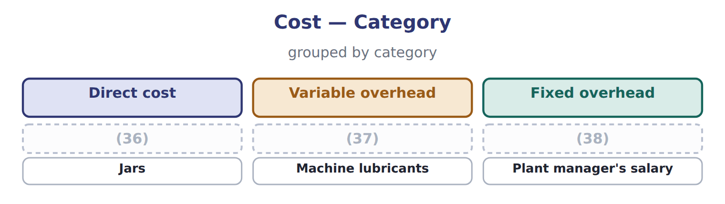
word list
actual costing · Sesame · Power for the grinders · Factory insurance

The English this section uses, and its Arabic
Each term sits against what it means.
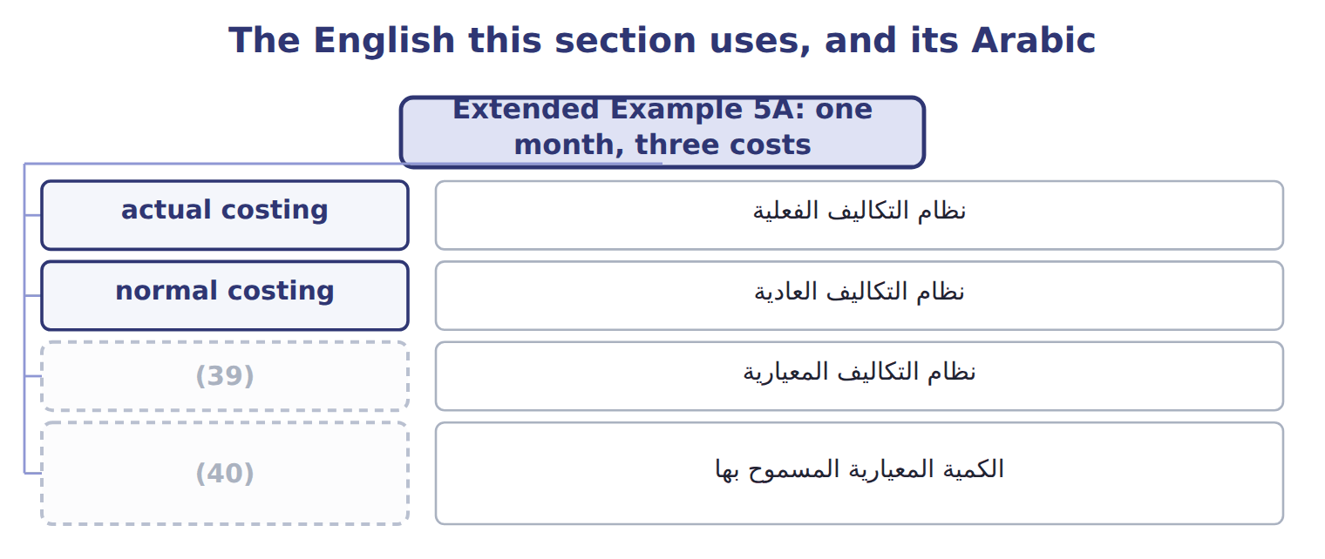
word list
standard costing · standard quantity allowed · نظام التكاليف الفعلية

The English this sheet uses, and its Arabic
English (exam term) | Arabic
actual costing | نظام التكاليف الفعلية
normal costing | نظام التكاليف العادية
standard costing | نظام التكاليف المعيارية
standard quantity allowed | الكمية المعيارية المسموح بها

Answer key · 5.6 Extended Example 5A: one month, three costs

1 records | 21 Service Department Charges
2 accounts | 22 Wages Payable
3 exam-core | 23 Manufacturing Overhead Applied
4 differences | 24 Finished Goods Inventory
5 finished | 25 Totals
6 materials | 26 because
7 variable | 27 materials
8 allowed | 28 underapplied
9 predetermined | 29 materials
10 Measure | 30 variances
11 technique | 31 question
12 underapplied | 32 predetermined
13 Overhead in product cost | 33 $30 per MH
14 Cost moved to finished goods | 34 $6 per MH
15 Actual cost not in product cost | 35 0.03 × $6 = $0.18
16 overhead | 36 Sesame
17 materials | 37 Power for the grinders
18 Work-in-Process Inventory | 38 Factory insurance
19 Raw Materials Inventory | 39 standard costing
20 Manufacturing Overhead Control | 40 standard quantity allowed

the summaries in full
Summary 1 This example costs the same May output three ways and records each in the accounts. The costs per case are exam-core; the entries show where the differences go. Output: 70,000 cases, all finished in May. Actual costs: direct materials $637,000; direct labor $43,400; variable overhead $70,700; fixed overhead $151,900. Machine hours: 1,414 actual; 1,400 standard hours allowed for the output. Rates: predetermined overhead $150 per machine hour; standard cost $12.60 a case. Measure each cost part under each technique, record the entries, and see where the difference between actual and product cost goes. Actual: $637,000 + $43,400 + $222,600 = $903,000. Normal: $637,000 + $43,400 + 1,414 × $150 = $892,500. Standard: 70,000 × $12.60 = $882,000. The last row shows the actual cost that did not enter product cost: nothing under actual costing, $10,500 of underapplied overhead under normal costing, and $21,000 of variances under standard costing.
Summary 2 Only the overhead entry differs for normal costing, while standard costing also records materials and labor at standard.
Summary 3 Standard is lowest because the month used more materials, labor and machine time than the standard allows.
Summary 4 Normal: actual overhead $222,600 − applied $212,100 = underapplied $10,500. Standard: materials variance $7,000 + labor variance $1,400 + overhead variances $12,600 = $21,000. Actual − standard = $903,000 − $882,000 = $21,000.
Summary 5 Expect one set of data and a question about one technique. Check which quantities and which rate the technique uses: actual or standard quantities, and an actual or predetermined overhead rate.

6.1 When job order costing fits
Chapter 6 · section 6.1

Fill every gap. Each word list holds one word more than there are gaps.
Chapter 6, section by section
Each stage leads to the next.
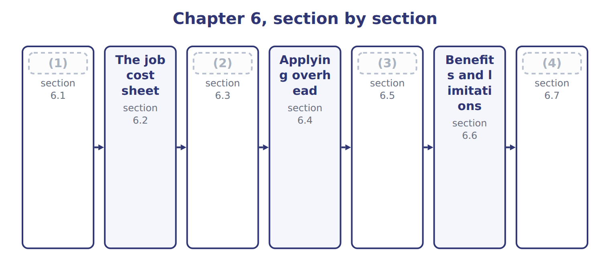
word list
Extended Example 6A: Tahini & Spreads, March 2 · The job cost sheet · Recording materials and labor · When job order costing fits · Inventory values and cost of goods sold

Summary 1 gaps 5–13
Job order costing (5) costs for each (6) job, batch or customer order. It fits when the (7) are different from each other and each order can be (8) from start to finish. (9) tahini fits well. One job may be a Barada order in (10) tubs, and the next a Gulf (11) order in glass jars with a different sesame blend. (12) firms, builders, law firms and (13) also use job costing. Orontes's Oils division does not use it. Olive oil flows through crushing and bottling as identical liters, so costs are collected by department instead. That is process costing, the topic.
word list
separate · plastic · identified · retailer's · Private-label · Printing · products · hospitals · collects · bottling

Answer key · 6.1 When job order costing fits

1 When job order costing fits | 8 identified
2 Recording materials and labor | 9 Private-label
3 Inventory values and cost of goods sold | 10 plastic
4 Extended Example 6A: Tahini & Spreads, March 2 | 11 retailer's
5 collects | 12 Printing
6 separate | 13 hospitals
7 products

the summaries in full
Summary 1 Job order costing collects costs for each separate job, batch or customer order. It fits when the products are different from each other and each order can be identified from start to finish. Private-label tahini fits well. One job may be a Barada order in plastic tubs, and the next a Gulf retailer's order in glass jars with a different sesame blend. Printing firms, builders, law firms and hospitals also use job costing. Orontes's Oils division does not use it. Olive oil flows through crushing and bottling as identical liters, so costs are collected by department instead. That is process costing, the topic.

6.2 The job cost sheet
Chapter 6 · section 6.2

Fill every gap. Each word list holds one word more than there are gaps.
Summary 1 gaps 1–6
A job cost sheet is the (1) of one job. It collects three costs: direct materials from materials (2) , direct labor from labor time tickets, and overhead applied at the (3) rate. The job cost sheets form a (4) ledger. The total of all open sheets must equal the balance of the (5) Inventory control (6) in the general ledger. When a job is finished, its sheet moves to the finished goods file.
word list
account · predetermined · record · balance · Work-in-Process · requisitions · subsidiary

Worked example: the cost of job T-0303

Summary 2 gaps 7–8
In March 2027 job T-0303, a Barada (7) order, used direct (8) of $140,000 and direct labor of $80,000. It used 4,200 machine hours. Overhead is applied at $30 per machine hour, so applied overhead is $126,000.
word list
general · private-label · materials

Worked example: job cost sheet for T-0303
The parts add up to the total; the bars are to scale.
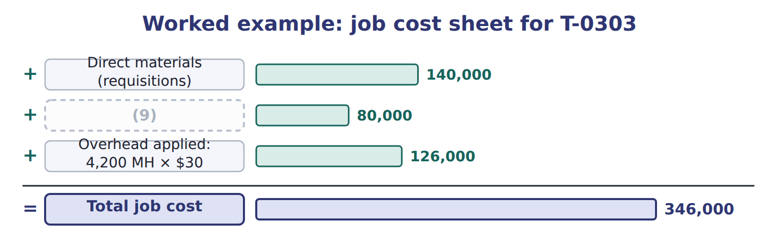
word list
Direct labor (time tickets) · cost of goods manufactured

The English this section uses, and its Arabic
Each term sits against what it means.
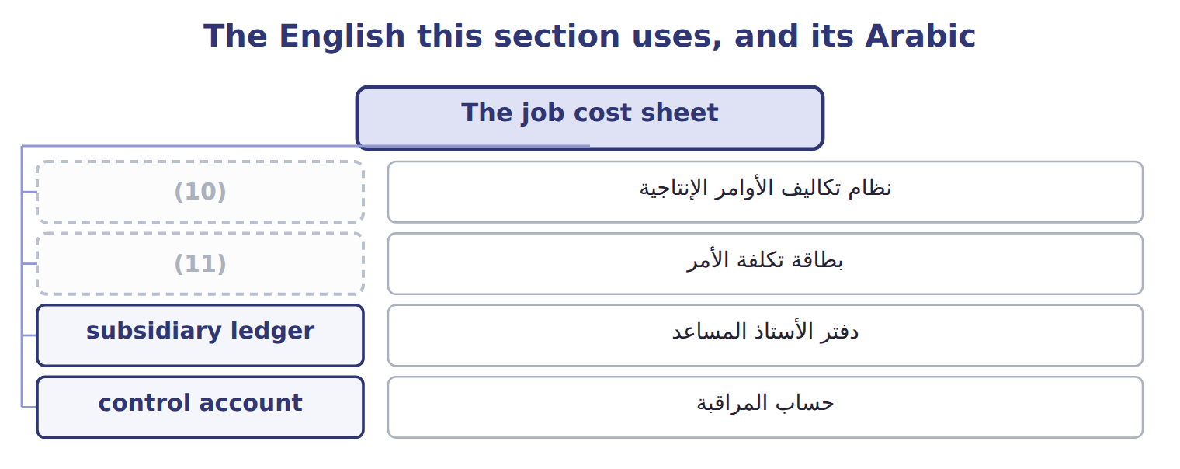
word list
job order costing · job cost sheet · بطاقة تكلفة الأمر

The English this sheet uses, and its Arabic
English (exam term) | Arabic
job order costing | نظام تكاليف الأوامر الإنتاجية
job cost sheet | بطاقة تكلفة الأمر
subsidiary ledger | دفتر الأستاذ المساعد
control account | حساب المراقبة

Answer key · 6.2 The job cost sheet

1 record | 7 private-label
2 requisitions | 8 materials
3 predetermined | 9 Direct labor (time tickets)
4 subsidiary | 10 job order costing
5 Work-in-Process | 11 job cost sheet
6 account

the summaries in full
Summary 1 A job cost sheet is the record of one job. It collects three costs: direct materials from materials requisitions, direct labor from labor time tickets, and overhead applied at the predetermined rate. The job cost sheets form a subsidiary ledger. The total of all open sheets must equal the balance of the Work-in-Process Inventory control account in the general ledger. When a job is finished, its sheet moves to the finished goods file.
Summary 2 In March 2027 job T-0303, a Barada private-label order, used direct materials of $140,000 and direct labor of $80,000. It used 4,200 machine hours. Overhead is applied at $30 per machine hour, so applied overhead is $126,000.

6.3 Recording materials and labor
Chapter 6 · section 6.3

Fill every gap. Each word list holds one word more than there are gaps.
Summary 1 gaps 1–10
A materials (1) moves materials out of Raw Materials Inventory. If the materials are (2) to a job, the debit goes to Work-in-Process Inventory and the job cost sheet. If they are indirect materials, such as cleaning (3) or machine oil, the debit goes to Manufacturing Overhead Control. Labor time (4) work the same way. Hours on a job are direct labor, debited to Work-in-Process Inventory. (5) , idle time and (6) labor are indirect labor, debited to Manufacturing Overhead Control. The credit is Wages (7) . In March, Tahini & (8) issued direct materials of $250,000 and indirect materials of $20,000. Direct labor was $150,000 and indirect labor was $40,000. Only the direct (9) reach the job cost (10) .
word list
Payable · sheets · Spreads · Work-in-Process · requisition · chemicals · Supervision · maintenance · traced · tickets · amounts

Indirect costs do not go to WIP

Summary 2 gaps 11–12
A common wrong answer debits (11) Inventory with indirect materials or indirect labor. They reach the jobs only through the (12) rate.
word list
predetermined · tickets · Work-in-Process

The English this section uses, and its Arabic
Each term sits against what it means.
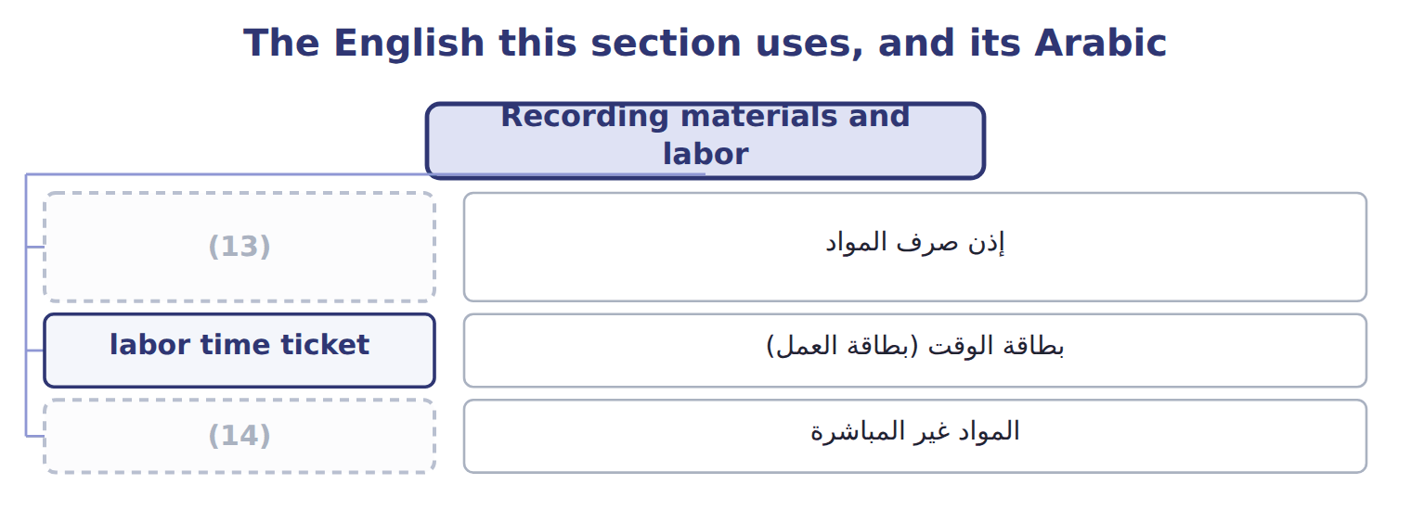
word list
materials requisition · indirect materials · control account

The English this sheet uses, and its Arabic
English (exam term) | Arabic
materials requisition | إذن صرف المواد
labor time ticket | بطاقة الوقت (بطاقة العمل)
indirect materials | المواد غير المباشرة

Answer key · 6.3 Recording materials and labor

1 requisition | 8 Spreads
2 traced | 9 amounts
3 chemicals | 10 sheets
4 tickets | 11 Work-in-Process
5 Supervision | 12 predetermined
6 maintenance | 13 materials requisition
7 Payable | 14 indirect materials

the summaries in full
Summary 1 A materials requisition moves materials out of Raw Materials Inventory. If the materials are traced to a job, the debit goes to Work-in-Process Inventory and the job cost sheet. If they are indirect materials, such as cleaning chemicals or machine oil, the debit goes to Manufacturing Overhead Control. Labor time tickets work the same way. Hours on a job are direct labor, debited to Work-in-Process Inventory. Supervision, idle time and maintenance labor are indirect labor, debited to Manufacturing Overhead Control. The credit is Wages Payable. In March, Tahini & Spreads issued direct materials of $250,000 and indirect materials of $20,000. Direct labor was $150,000 and indirect labor was $40,000. Only the direct amounts reach the job cost sheets.
Summary 2 A common wrong answer debits Work-in-Process Inventory with indirect materials or indirect labor. They reach the jobs only through the predetermined rate.

6.4 Applying overhead
Chapter 6 · section 6.4

Fill every gap. Each word list holds one word more than there are gaps.
Summary 1 gaps 1–10
Actual overhead is not known until the end of the year, but a job needs a cost when it is (1) . So job costing uses (2) costing: overhead is applied with a predetermined rate. For 2027 Tahini & (3) uses $30 per machine hour: $24 fixed plus $6 (4) . Applied overhead (5) the actual machine hours used by the job times the predetermined rate. The debit is (6) Inventory and the (7) is Manufacturing Overhead Applied. Actual overhead costs, such as (8) and utilities, are (9) to Manufacturing Overhead Control. The two overhead (10) rarely match during the year. The difference is under- or over-applied overhead. It stays open until year-end.
word list
Work-in-Process · debited · finished · Spreads · variable · depreciation · credit · normal · equals · difference · accounts

Imputation

In U.S. terms the accounts are Manufacturing Overhead Control and Manufacturing Overhead Applied.
The English this section uses, and its Arabic
Each term sits against what it means.
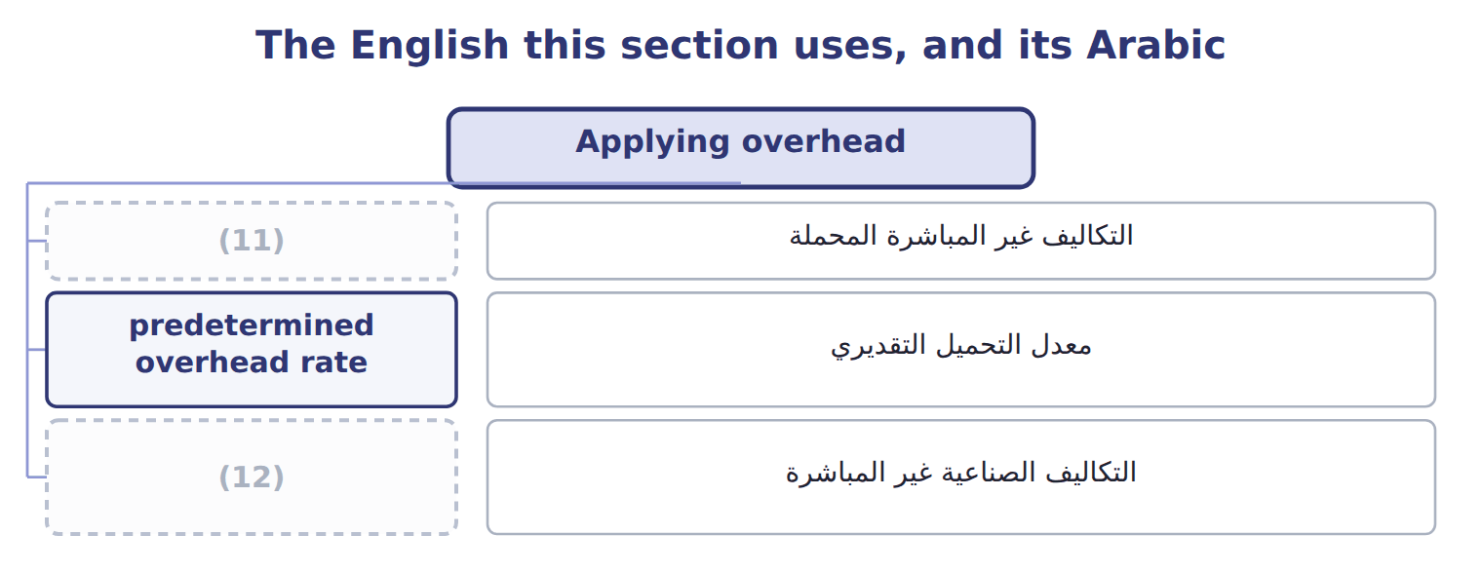
word list
control account · applied overhead · manufacturing overhead

The English this sheet uses, and its Arabic
English (exam term) | Arabic
applied overhead | التكاليف غير المباشرة المحملة
predetermined overhead rate | معدل التحميل التقديري
manufacturing overhead | التكاليف الصناعية غير المباشرة

Answer key · 6.4 Applying overhead

1 finished | 7 credit
2 normal | 8 depreciation
3 Spreads | 9 debited
4 variable | 10 accounts
5 equals | 11 applied overhead
6 Work-in-Process | 12 manufacturing overhead

the summaries in full
Summary 1 Actual overhead is not known until the end of the year, but a job needs a cost when it is finished. So job costing uses normal costing: overhead is applied with a predetermined rate. For 2027 Tahini & Spreads uses $30 per machine hour: $24 fixed plus $6 variable. Applied overhead equals the actual machine hours used by the job times the predetermined rate. The debit is Work-in-Process Inventory and the credit is Manufacturing Overhead Applied. Actual overhead costs, such as depreciation and utilities, are debited to Manufacturing Overhead Control. The two overhead accounts rarely match during the year. The difference is under- or over-applied overhead. It stays open until year-end.

6.5 Inventory values and cost of goods sold
Chapter 6 · section 6.5

Fill every gap. Each word list holds one word more than there are gaps.
Summary 1 gaps 1–7
When a job is finished, its total cost moves from (1) Inventory to Finished Goods Inventory. The total of the jobs finished in a (2) is the cost of goods (3) . When the goods are sold, the job cost moves from Finished Goods Inventory to Cost of Goods Sold. At any date, the inventory values come (4) from the job cost (5) . Open jobs make up work in process. Finished jobs not yet sold make up finished goods. The sale price never enters these (6) ; it goes to Sales (7) .
word list
finished · sheets · Work-in-Process · straight · Revenue · accounts · manufactured · period

Complete a job cost sheet

Your turn: job cost sheet for T-0304 (complete the blanks)
Every item belongs to exactly one group.
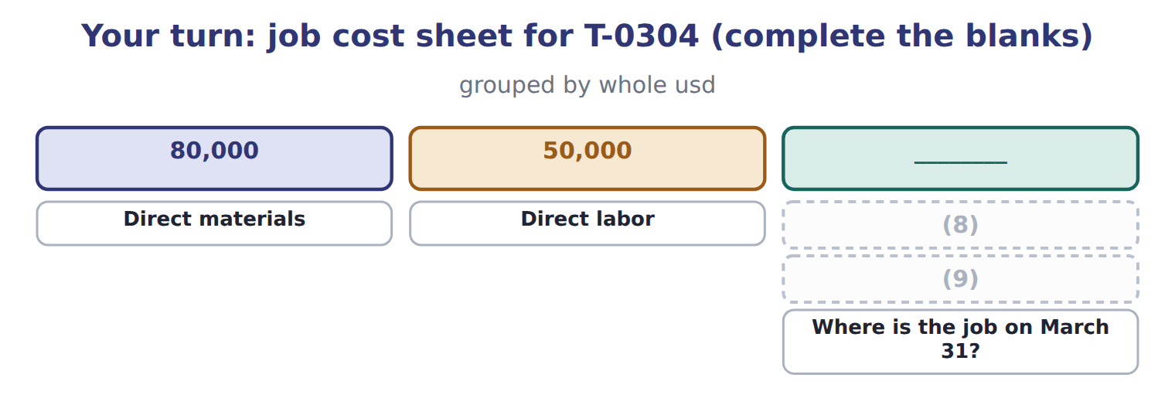
word list
Job cost at March 31 · Overhead applied: 2,500 MH × $30 · Where is the job on March 31?

The English this section uses, and its Arabic
Each term sits against what it means.
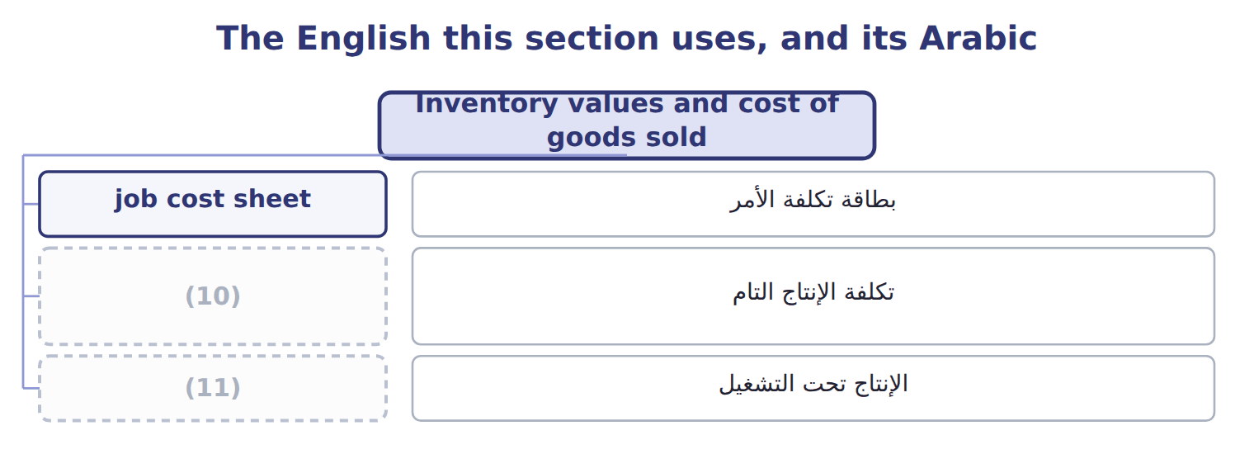
word list
work in process · cost of goods manufactured · job order costing

The English this sheet uses, and its Arabic
English (exam term) | Arabic
cost of goods manufactured | تكلفة الإنتاج التام

Answer key · 6.5 Inventory values and cost of goods sold

1 Work-in-Process | 7 Revenue
2 period | 8 Overhead applied: 2,500 MH × $30
3 manufactured | 9 Job cost at March 31
4 straight | 10 cost of goods manufactured
5 sheets | 11 work in process
6 accounts

the summaries in full
Summary 1 When a job is finished, its total cost moves from Work-in-Process Inventory to Finished Goods Inventory. The total of the jobs finished in a period is the cost of goods manufactured. When the goods are sold, the job cost moves from Finished Goods Inventory to Cost of Goods Sold. At any date, the inventory values come straight from the job cost sheets. Open jobs make up work in process. Finished jobs not yet sold make up finished goods. The sale price never enters these accounts; it goes to Sales Revenue.

6.6 Benefits and limitations
Chapter 6 · section 6.6

Fill every gap. Each word list holds one word more than there are gaps.
Summary 1 gaps 1–10
Job costing gives an (1) cost for each order. (2) use it to price new orders, compare the estimate with the actual cost and find (3) customers. It also gives the inventory (4) that the financial (5) need. It needs many (6) and careful (7) for every job. Overhead is still an allocation, so a poor allocation base can (8) job costs; (9) costing is one answer. It also does not suit identical units in a (10) flow. Both ASC 330 and IAS 2 accept job costs as inventory cost when they include a proper share of production overhead. Both require abnormal costs, such as abnormal spoilage or idle capacity, to be expensed rather than added to a job.
word list
Managers · activity-based · statements · unprofitable · records · compare · accurate · values · continuous · documents · distort

Job order costing and process costing
 | Job order costing | Process costing (Chapter 7)
Product | (11) | Identical units in a continuous flow (olive oil)
Cost object | The job | (12)
WIP records | One job cost sheet per job | One WIP account per department
Unit cost | (13) | Department cost ÷ equivalent units
Main benefit | Accurate cost and price for each order | (14)
Main limitation | (15) | Averages hide differences between units

word list
Job cost ÷ units in the job · Department cost ÷ equivalent units · Unique orders (private-label tahini, halva batches) · Simple records for mass production · More records; overhead is still an allocation · The process or department

Answer key · 6.6 Benefits and limitations

1 accurate | 9 activity-based
2 Managers | 10 continuous
3 unprofitable | 11 Unique orders (private-label tahini, halva batches)
4 values | 12 The process or department
5 statements | 13 Job cost ÷ units in the job
6 documents | 14 Simple records for mass production
7 records | 15 More records; overhead is still an allocation
8 distort

the summaries in full
Summary 1 Job costing gives an accurate cost for each order. Managers use it to price new orders, compare the estimate with the actual cost and find unprofitable customers. It also gives the inventory values that the financial statements need. It needs many documents and careful records for every job. Overhead is still an allocation, so a poor allocation base can distort job costs; activity-based costing is one answer. It also does not suit identical units in a continuous flow. Both ASC 330 and IAS 2 accept job costs as inventory cost when they include a proper share of production overhead. Both require abnormal costs, such as abnormal spoilage or idle capacity, to be expensed rather than added to a job.

6.7 Extended Example 6A: Tahini & Spreads, March 2027
Chapter 6 · section 6.7

Fill every gap. Each word list holds one word more than there are gaps.
Summary 1 gaps 1–12
This example (1) every cost of one month from the source (2) to the income (3) . The (4) are exam-core: the exam asks for job costs, inventory (5) and cost of goods sold. The (6) entries and (7) are for depth: they show why the (8) move. On March 1, 2027 Raw Materials Inventory was $120,000. Job T-0302 was in process at $64,000, and job T-0215 was in finished goods at $90,000. During March the (9) worked on three jobs. T-0302 (halva): direct materials $30,000, direct labor $20,000, 1,000 machine hours. T-0303 (Barada (10) tahini): direct materials $140,000, direct labor $80,000, 4,200 machine hours. Finished, not yet sold. T-0304: direct materials $80,000, direct labor $50,000, 2,500 machine hours. Still in process on March 31. Other events: materials purchased $300,000; indirect materials $20,000; indirect labor $40,000; service (11) charges $57,500; (12) $70,000; utilities $62,500; jobs T-0215 and T-0302 sold on account for $330,000.
word list
follows · calculations · statement · journal · numbers · questions · depreciation · private-label · department · T-accounts · division · documents · values

Summary 2 gaps 13–21
Classify each cost as direct or (13) . Apply overhead at the (14) rate. Record the entries, post them, prepare the (15) and check that (16) ties. Overhead (17) : 7,700 machine hours × $30 = $231,000. Job costs: T-0302 = $64,000 (18) + $30,000 + $20,000 + $30,000 = $144,000; T-0303 = $346,000; T-0304 = $205,000. Cost of goods (19) (T-0302 + T-0303) = $490,000. Cost of goods sold (T-0215 + T-0302) = $90,000 + $144,000 = $234,000. (20) overhead = $20,000 + $40,000 + $190,000 = $250,000; underapplied = $19,000. Each entry has equal debits and (21) , and the journal totals $2,235,000 on both sides.
word list
manufactured · Actual · opening · predetermined · schedules · applied · indirect · credits · everything · process

Extended Example: general journal, March 2027
No. | Account (detail) | Debit | Credit
1 | (22) | 300,000
 | (23) |  | 300,000
2 | Work-in-Process Inventory (T-0302 30,000; T-0303 140,000; T-0304 80,000) | 250,000
 | Manufacturing Overhead Control | 20,000
 | Raw Materials Inventory |  | 270,000
3 | Work-in-Process Inventory (T-0302 20,000; T-0303 80,000; T-0304 50,000) | 150,000
 | Manufacturing Overhead Control | 40,000
 | Wages Payable |  | 190,000
4 | (24) | 190,000
 | (25) |  | 57,500
 | Accumulated Depreciation |  | 70,000
 | Accounts Payable |  | 62,500
5 | Work-in-Process Inventory | 231,000
 | (26) |  | 231,000
6 | Finished Goods Inventory | 490,000
 | Work-in-Process Inventory |  | 490,000
7 | (27) | 330,000
 | (28) |  | 330,000
8 | Cost of Goods Sold | 234,000
 | (29) |  | 234,000
 | Totals | 2,235,000 | 2,235,000

word list
Factory supervisor's wages · Raw Materials Inventory · Manufacturing Overhead Applied · Finished Goods Inventory · Accounts Payable · Manufacturing Overhead Control · Service Department Charges · Sales Revenue · Accounts Receivable

Summary 3 gaps 30–31
Raw (30) closes at $150,000, Work in Process at $205,000 and Finished Goods at $346,000. Gross margin for March is $96,000 before the year-end overhead (31) .
word list
department · adjustment · Materials

Extended Example: schedule of cost of goods manufactured and cost of goods sold
The bars are drawn to scale.
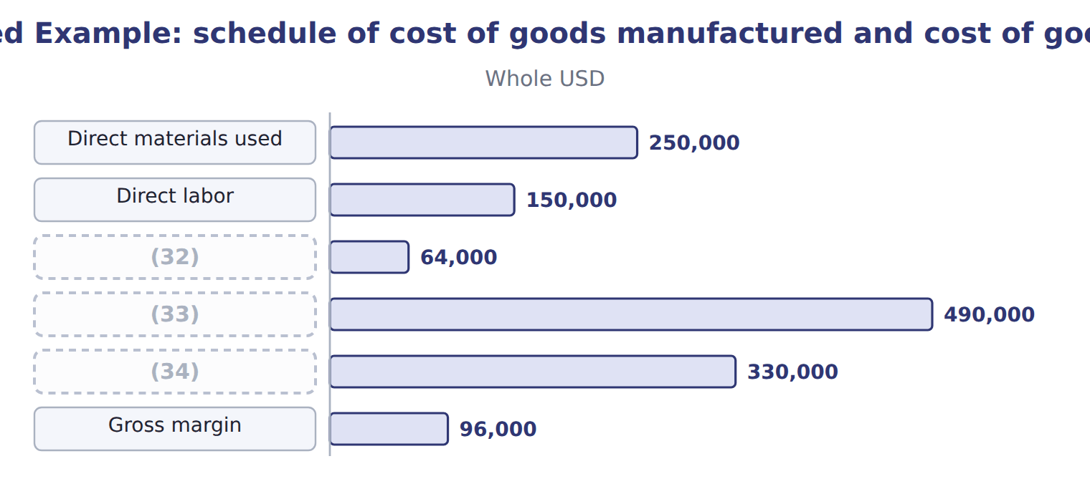
word list
labor time ticket · Cost of goods manufactured · Sales (T-0215 and T-0302) · Add: beginning WIP (T-0302)

Everything ties

Summary 4 gaps 35–37
Total debits = total (35) = $2,235,000. Raw (36) : $120,000 + $300,000 − $270,000 = $150,000. Work in (37) : $64,000 + $631,000 − $490,000 = $205,000 = job T-0304. Finished goods: $90,000 + $490,000 − $234,000 = $346,000 = job T-0303.
word list
process · credits · materials · prepare

Extended Example: job cost sheets agree with the control accounts
The bars are drawn to scale.
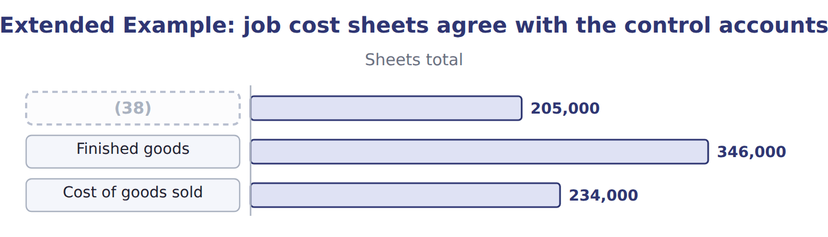
word list
Work in process · predetermined overhead rate

Exam view

Summary 5 gaps 39–41
CMA (39) rarely ask for the entries. They give job data and ask for ending work in process, cost of goods (40) or cost of goods sold. Build the job costs first; the (41) follow from the job sheets.
word list
adjustment · manufactured · questions · balances

Exam view
Tahini & Spreads · April 2027 (whole USD) | Amount
(42) : job T-0304 (from March) | 205,000
(43) : job T-0303 (from March) | 346,000
(44) : DM 20,000, DL 30,000, 1,500 MH — completed
Job T-0305 (new) in April: DM 160,000, DL 90,000, 5,000 MH — still in process
(45) | 470,000
Actual manufacturing overhead in April | 245,000
M1 | Tahini & Spreads applies overhead at $30 per machine hour. Differences are closed at year-end.

word list
Opening WIP · Job T-0304 in April · Where is the job on March 31? · Job T-0303 sold to Barada Wholesale on account · Opening finished goods

Item — Answer
Item | Answer
Overhead applied | 75,000
Job cost at March 31 | 205,000
Where is the job on March 31? | (46)

word list
Tahini & Spreads · April 2027 (whole USD) · Work in process (the job is still open)

April item — Category
Every item belongs to exactly one group.
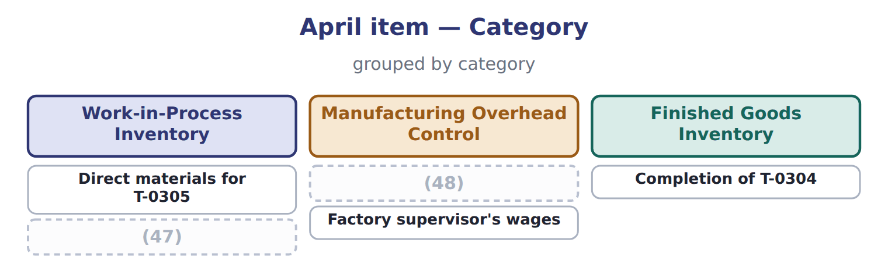
word list
Indirect materials · predetermined overhead rate · Overhead applied to T-0305

The English this section uses, and its Arabic
Each term sits against what it means.
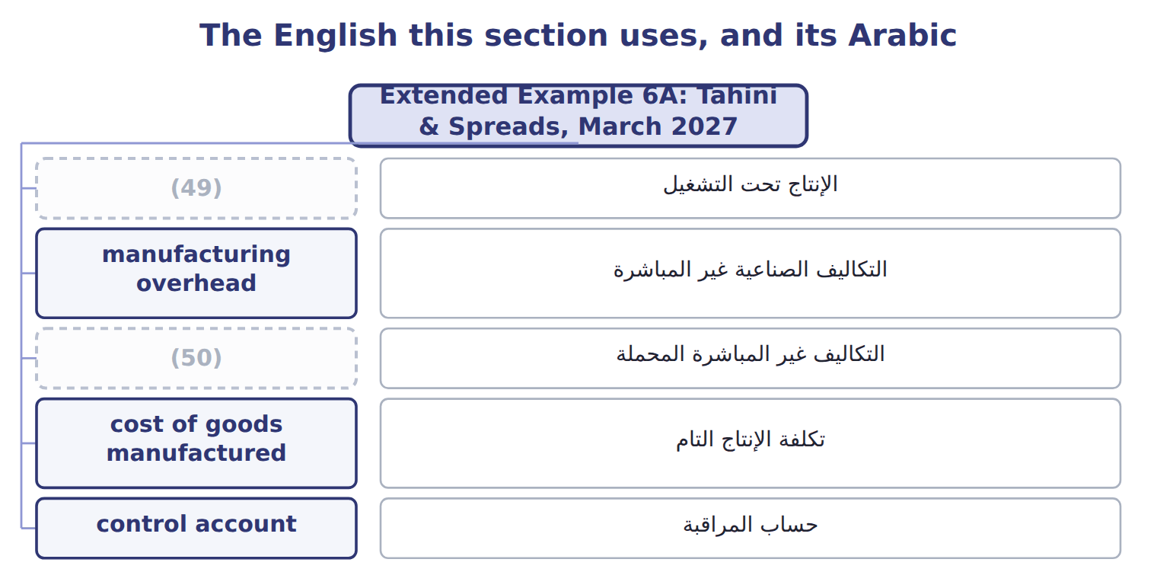
word list
applied overhead · work in process · control account

The English this sheet uses, and its Arabic
English (exam term) | Arabic
work in process | الإنتاج تحت التشغيل
manufacturing overhead | التكاليف الصناعية غير المباشرة
applied overhead | التكاليف غير المباشرة المحملة
cost of goods manufactured | تكلفة الإنتاج التام
control account | حساب المراقبة

Answer key · 6.7 Extended Example 6A: Tahini & Spreads, March 2027

1 follows | 26 Manufacturing Overhead Applied
2 documents | 27 Accounts Receivable
3 statement | 28 Sales Revenue
4 calculations | 29 Finished Goods Inventory
5 values | 30 Materials
6 journal | 31 adjustment
7 T-accounts | 32 Add: beginning WIP (T-0302)
8 numbers | 33 Cost of goods manufactured
9 division | 34 Sales (T-0215 and T-0302)
10 private-label | 35 credits
11 department | 36 materials
12 depreciation | 37 process
13 indirect | 38 Work in process
14 predetermined | 39 questions
15 schedules | 40 manufactured
16 everything | 41 balances
17 applied | 42 Opening WIP
18 opening | 43 Opening finished goods
19 manufactured | 44 Job T-0304 in April
20 Actual | 45 Job T-0303 sold to Barada Wholesale on account
21 credits | 46 Work in process (the job is still open)
22 Raw Materials Inventory | 47 Overhead applied to T-0305
23 Accounts Payable | 48 Indirect materials
24 Manufacturing Overhead Control | 49 work in process
25 Service Department Charges | 50 applied overhead

the summaries in full
Summary 1 This example follows every cost of one month from the source documents to the income statement. The calculations are exam-core: the exam asks for job costs, inventory values and cost of goods sold. The journal entries and T-accounts are for depth: they show why the numbers move. On March 1, 2027 Raw Materials Inventory was $120,000. Job T-0302 was in process at $64,000, and job T-0215 was in finished goods at $90,000. During March the division worked on three jobs. T-0302 (halva): direct materials $30,000, direct labor $20,000, 1,000 machine hours. T-0303 (Barada private-label tahini): direct materials $140,000, direct labor $80,000, 4,200 machine hours. Finished, not yet sold. T-0304: direct materials $80,000, direct labor $50,000, 2,500 machine hours. Still in process on March 31. Other events: materials purchased $300,000; indirect materials $20,000; indirect labor $40,000; service department charges $57,500; depreciation $70,000; utilities $62,500; jobs T-0215 and T-0302 sold on account for $330,000.
Summary 2 Classify each cost as direct or indirect. Apply overhead at the predetermined rate. Record the entries, post them, prepare the schedules and check that everything ties. Overhead applied: 7,700 machine hours × $30 = $231,000. Job costs: T-0302 = $64,000 opening + $30,000 + $20,000 + $30,000 = $144,000; T-0303 = $346,000; T-0304 = $205,000. Cost of goods manufactured (T-0302 + T-0303) = $490,000. Cost of goods sold (T-0215 + T-0302) = $90,000 + $144,000 = $234,000. Actual overhead = $20,000 + $40,000 + $190,000 = $250,000; underapplied = $19,000. Each entry has equal debits and credits, and the journal totals $2,235,000 on both sides.
Summary 3 Raw Materials closes at $150,000, Work in Process at $205,000 and Finished Goods at $346,000. Gross margin for March is $96,000 before the year-end overhead adjustment.
Summary 4 Total debits = total credits = $2,235,000. Raw materials: $120,000 + $300,000 − $270,000 = $150,000. Work in process: $64,000 + $631,000 − $490,000 = $205,000 = job T-0304. Finished goods: $90,000 + $490,000 − $234,000 = $346,000 = job T-0303.
Summary 5 CMA questions rarely ask for the entries. They give job data and ask for ending work in process, cost of goods manufactured or cost of goods sold. Build the job costs first; the balances follow from the job sheets.

7.1 Process costing and departments
Chapter 7 · section 7.1

Fill every gap. Each word list holds one word more than there are gaps.
Chapter 7, section by section
Each stage leads to the next.
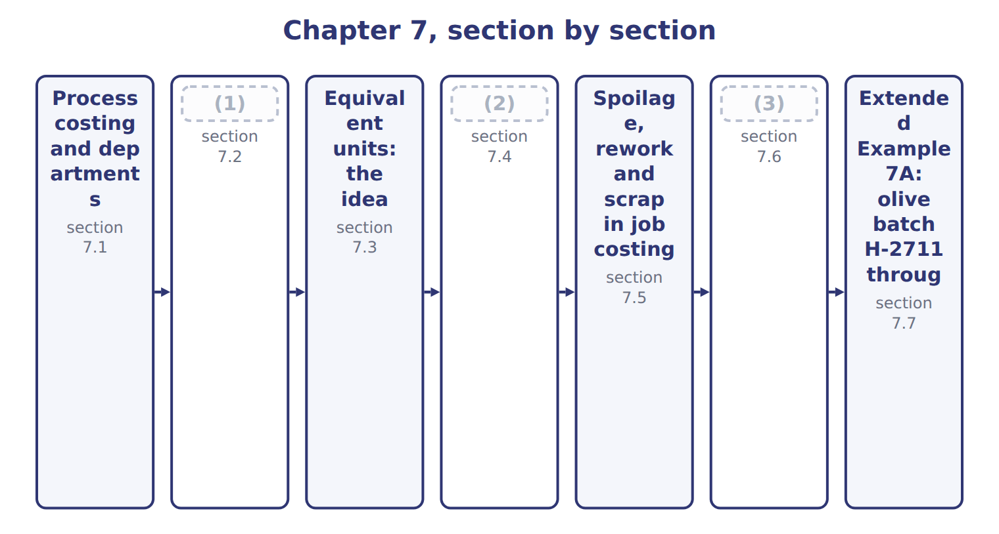
word list
The strategic value of cost information · Transferred-in costs · Spoilage: the ideas, shown in a process · production cost report

Summary 1 gaps 4–10
Process costing collects costs by department when identical units move through a (4) flow. It suits oil, juice, cement and (5) . Each department has its own (6) account. The Oils division has two (7) . (8) turns olives into extra-virgin oil, virgin oil and pomace. (9) fills extra-virgin oil into bottles. Unit cost in process costing is an (10) : department cost divided by the units it worked on. Every liter carries the same cost, which is fair when every liter is the same.
word list
Work-in-Process · average · Bottling · continuous · rework · chemicals · Crushing · departments

Exam scope: process costing is concept only

Summary 2 gaps 11–12
The exam asks you to (11) process costing and equivalent units, not to calculate them (LOS D.2.f). It tests (12) calculations in job order and activity-based costing settings.
word list
spoilage · through · understand

The English this section uses, and its Arabic
Each term sits against what it means.
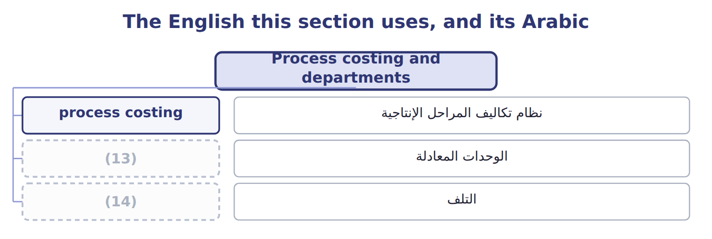
word list
scrap · spoilage · equivalent units

The English this sheet uses, and its Arabic
English (exam term) | Arabic
process costing | نظام تكاليف المراحل الإنتاجية

Answer key · 7.1 Process costing and departments

1 Transferred-in costs | 8 Crushing
2 Spoilage: the ideas, shown in a process | 9 Bottling
3 The strategic value of cost information | 10 average
4 continuous | 11 understand
5 chemicals | 12 spoilage
6 Work-in-Process | 13 equivalent units
7 departments | 14 spoilage

the summaries in full
Summary 1 Process costing collects costs by department when identical units move through a continuous flow. It suits oil, juice, cement and chemicals. Each department has its own Work-in-Process account. The Oils division has two departments. Crushing turns olives into extra-virgin oil, virgin oil and pomace. Bottling fills extra-virgin oil into bottles. Unit cost in process costing is an average: department cost divided by the units it worked on. Every liter carries the same cost, which is fair when every liter is the same.
Summary 2 The exam asks you to understand process costing and equivalent units, not to calculate them (LOS D.2.f). It tests spoilage calculations in job order and activity-based costing settings.

7.2 Transferred-in costs
Chapter 7 · section 7.2

Fill every gap. Each word list holds one word more than there are gaps.
Summary 1 gaps 1–8
When units leave a department, their cost goes with them. The entry is: debit Work in Process of the next department, (1) Work in Process of the (2) one. The next department (3) these as transferred-in costs. For the next department, transferred-in cost behaves like a (4) added at the start. Bottling received (5) oil at $8.06 a liter, the cost set by the joint cost allocation. It then added bottles and (6) . (7) transferred-in cost is a common error. The bottling cost of $11.66 a liter (8) the oil itself, not only the bottle and the work.
word list
previous · extra-virgin · material · conversion · allocation · Forgetting · includes · records · credit

The English this sheet uses, and its Arabic
English (exam term) | Arabic
transferred-in costs | التكاليف المحولة من المرحلة السابقة

Answer key · 7.2 Transferred-in costs

1 credit | 5 extra-virgin
2 previous | 6 conversion
3 records | 7 Forgetting
4 material | 8 includes

the summaries in full
Summary 1 When units leave a department, their cost goes with them. The entry is: debit Work in Process of the next department, credit Work in Process of the previous one. The next department records these as transferred-in costs. For the next department, transferred-in cost behaves like a material added at the start. Bottling received extra-virgin oil at $8.06 a liter, the cost set by the joint cost allocation. It then added bottles and conversion. Forgetting transferred-in cost is a common error. The bottling cost of $11.66 a liter includes the oil itself, not only the bottle and the work.

7.3 Equivalent units: the idea
Chapter 7 · section 7.3

Fill every gap. Each word list holds one word more than there are gaps.
Summary 1 gaps 1–7
At the end of a month some units are only partly finished. To share costs (1) , process costing (2) partly finished work as a number of whole units: equivalent units. Each cost (3) has its own count. (4) added at the start are complete for every unit; (5) added evenly may be only partly done. The CMA LOS ask you to (6) the concept, not to (7) equivalent units. The Oils example avoids the issue: the batch was complete when it was inspected.
word list
understand · calculate · inspected · expresses · fairly · conversion · element · Materials

No equivalent-unit arithmetic

Summary 2 gaps 8–9
LOS D.2.f says 'no (8) required'. Know what equivalent units mean and why they exist; do not spend exam time on (9) or FIFO schedules.
word list
calculations · spoilage · weighted-average

The English this sheet uses, and its Arabic
English (exam term) | Arabic
equivalent units | الوحدات المعادلة

Answer key · 7.3 Equivalent units: the idea

1 fairly | 6 understand
2 expresses | 7 calculate
3 element | 8 calculations
4 Materials | 9 weighted-average
5 conversion

the summaries in full
Summary 1 At the end of a month some units are only partly finished. To share costs fairly, process costing expresses partly finished work as a number of whole units: equivalent units. Each cost element has its own count. Materials added at the start are complete for every unit; conversion added evenly may be only partly done. The CMA LOS ask you to understand the concept, not to calculate equivalent units. The Oils example avoids the issue: the batch was complete when it was inspected.
Summary 2 LOS D.2.f says 'no calculations required'. Know what equivalent units mean and why they exist; do not spend exam time on weighted-average or FIFO schedules.

7.4 Spoilage: the ideas, shown in a process
Chapter 7 · section 7.4

Fill every gap. Each word list holds one word more than there are gaps.
Summary 1 gaps 1–8
Spoilage is units that fail (1) and are thrown away or sold (2) . Normal spoilage is expected even when (3) are efficient. Abnormal spoilage is not expected and could be (4) , for example after a (5) failure. In (6) costing, the cost of normal spoilage (7) part of the cost of good units. The cost of abnormal spoilage is taken out and (8) as a loss in the period. Measure the normal rate on good output, not on input. If the policy allows 2% of good units, the normal amount is 2% × good units.
word list
becomes · recorded · operations · process · machine · inspection · controlled · spoiled · cheaply

Concept illustration: normal or abnormal?

Summary 2 gaps 9–10
A process finishes 10,000 good units and finds 350 spoiled units at the final (9) . Normal (10) is 200 units, so 150 units are abnormal.
word list
charged · spoilage · inspection

Worked example: splitting spoilage and costing it
Spoilage worked example | Amount
(11) | 10,000
(12) | 350
Normal spoilage: 2% of good units | 200
Abnormal spoilage: spoiled − normal | 150
Total cost: 10,350 units × $4.00 | 41,400
Loss from abnormal spoilage: 150 × $4.00 | 600
Cost of good units (normal spoilage included) | 40,800
(13) | $4.08

word list
Good units completed · Cost per good unit · Spoiled units found at inspection · Abnormal spoilage: spoiled − normal

Summary 3 gaps 14–15
ASC 330 says abnormal amounts of wasted (14) (spoilage) are charged to the period, not to inventory. IAS 2 has the same rule. (15) spoilage stays in inventory cost.
word list
Spoilage · materials · Normal

The English this section uses, and its Arabic
Each term sits against what it means.
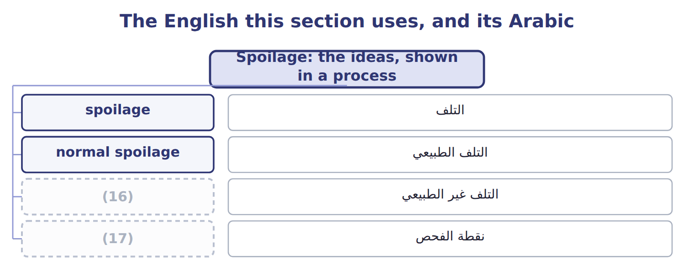
word list
التلف الطبيعي · inspection point · abnormal spoilage

The English this sheet uses, and its Arabic
English (exam term) | Arabic
spoilage | التلف
normal spoilage | التلف الطبيعي
abnormal spoilage | التلف غير الطبيعي
inspection point | نقطة الفحص

Answer key · 7.4 Spoilage: the ideas, shown in a process

1 inspection | 10 spoilage
2 cheaply | 11 Good units completed
3 operations | 12 Spoiled units found at inspection
4 controlled | 13 Cost per good unit
5 machine | 14 materials
6 process | 15 Normal
7 becomes | 16 abnormal spoilage
8 recorded | 17 inspection point
9 inspection

the summaries in full
Summary 1 Spoilage is units that fail inspection and are thrown away or sold cheaply. Normal spoilage is expected even when operations are efficient. Abnormal spoilage is not expected and could be controlled, for example after a machine failure. In process costing, the cost of normal spoilage becomes part of the cost of good units. The cost of abnormal spoilage is taken out and recorded as a loss in the period. Measure the normal rate on good output, not on input. If the policy allows 2% of good units, the normal amount is 2% × good units.
Summary 2 A process finishes 10,000 good units and finds 350 spoiled units at the final inspection. Normal spoilage is 200 units, so 150 units are abnormal.
Summary 3 ASC 330 says abnormal amounts of wasted materials (spoilage) are charged to the period, not to inventory. IAS 2 has the same rule. Normal spoilage stays in inventory cost.

7.5 Spoilage, rework and scrap in job costing
Chapter 7 · section 7.5

Fill every gap. Each word list holds one word more than there are gaps.
Summary 1 gaps 1–9
Job costing has three cases. Normal spoilage caused by one job's (1) needs stays in that job. Normal spoilage common to all jobs goes to (2) Overhead Control and is spread (3) the overhead rate. (4) spoilage is a loss. In every case, the (5) value of the spoiled units is (6) first. (7) , fixing units so they can be sold, (8) the same three cases. (9) , leftover material with a small value, reduces overhead or the job that caused it. This is the setting in which the exam asks for spoilage calculations: the official statement on spoilage (D.2.c) covers job order and activity-based costing.
word list
Control · Manufacturing · Rework · Abnormal · Scrap · through · disposal · follows · recorded · special

Normal or abnormal?

Split its spoilage into normal and abnormal.
Your turn: normal or abnormal spoilage (complete the blanks)
Every item belongs to exactly one group.
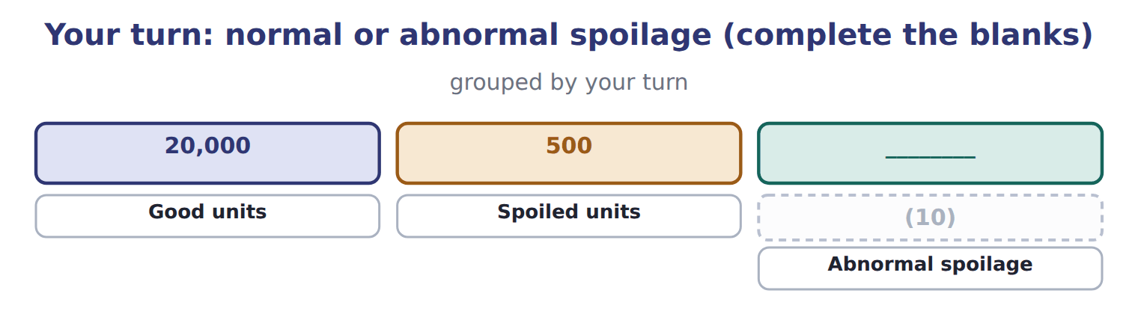
word list
Normal spoilage (2% of good) · production cost report

The two are accounted for differently, so do not mix them.
Spoilage and scrap in job costing: three cases
Job T-0305: spoiled units cost 4,000; disposal v | Entry | Effect
Normal, caused by this job's specifications | (11) | The job keeps the net cost of 3,500
Normal, common to all jobs | Dr Spoiled Goods Inventory 500; Dr MOH Control 3,500; Cr WIP (job) 4,000 | Spread to all jobs through the overhead rate
Abnormal | Dr Spoiled Goods Inventory 500; Dr Loss from Abnormal Spoilage 3,500; Cr WIP (job) 4,000 | (12)
Scrap sold (common to all jobs) | (13) | Reduces overhead (if specific to a job: Cr WIP of that job)

word list
Dr Spoiled Goods Inventory 500; Cr WIP (job) 500 · Dr Cash 600; Cr MOH Control 600 · Spread to all jobs through the overhead rate · Period loss in the income statement

The English this section uses, and its Arabic
Each term sits against what it means.
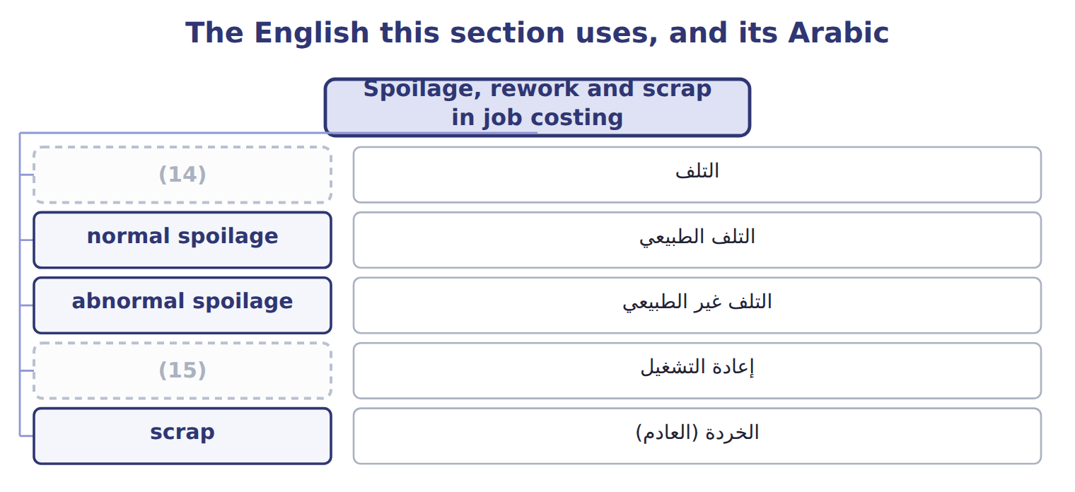
word list
التلف · rework · spoilage

The English this sheet uses, and its Arabic
English (exam term) | Arabic
rework | إعادة التشغيل
scrap | الخردة (العادم)

Answer key · 7.5 Spoilage, rework and scrap in job costing

1 special | 9 Scrap
2 Manufacturing | 10 Normal spoilage (2% of good)
3 through | 11 Dr Spoiled Goods Inventory 500; Cr WIP (job) 500
4 Abnormal | 12 Period loss in the income statement
5 disposal | 13 Dr Cash 600; Cr MOH Control 600
6 recorded | 14 spoilage
7 Rework | 15 rework
8 follows

the summaries in full
Summary 1 Job costing has three cases. Normal spoilage caused by one job's special needs stays in that job. Normal spoilage common to all jobs goes to Manufacturing Overhead Control and is spread through the overhead rate. Abnormal spoilage is a loss. In every case, the disposal value of the spoiled units is recorded first. Rework, fixing units so they can be sold, follows the same three cases. Scrap, leftover material with a small value, reduces overhead or the job that caused it. This is the setting in which the exam asks for spoilage calculations: the official statement on spoilage (D.2.c) covers job order and activity-based costing.

7.6 The strategic value of cost information
Chapter 7 · section 7.6

Fill every gap. Each word list holds one word more than there are gaps.
Summary 1 gaps 1–11
Product costs are not only for the (1) sheet. (2) use them to set prices, choose the product mix and decide where to (3) . A good bottle of (4) oil costs $11.75; any price must cover that and the (5) costs. Job (6) gives the same kind of information for each order. (7) job T-0303 cost $346,000 in March. When Barada asks for a repeat order, that job cost sheet is the (8) point for the quote, and it shows which cost items to (9) . Cost information also shows where value is lost. Each batch with (10) spoilage like this one loses $11,660. (11) spoilage by cause lets the Oils manager fix the line rather than accept the loss. Poor overhead allocation can mislead every one of these decisions.
word list
starting · negotiate · extra-virgin · decisions · abnormal · selling · Tahini · costing · Tracking · Managers · balance · improve

How the Oils division uses cost information
Decision | How Oils uses the cost information
Pricing | A good bottle of EVOO costs $11.75; prices must cover it plus (12) costs
Product mix | Compare margins of EVOO, VOO and pomace before (13) the mix
Quality and spoilage | Each 1,000 liters of abnormal spoilage costs 11,660; target the causes
Overhead allocation | A poor base distorts product costs (Chapters 8 and 12)
Make or buy; process or sell | (14) the extra cost of a further process with the extra revenue (Chapter 11)

word list
changing · Compare · spoilage · selling

Answer key · 7.6 The strategic value of cost information

1 balance | 8 starting
2 Managers | 9 negotiate
3 improve | 10 abnormal
4 extra-virgin | 11 Tracking
5 selling | 12 selling
6 costing | 13 changing
7 Tahini | 14 Compare

the summaries in full
Summary 1 Product costs are not only for the balance sheet. Managers use them to set prices, choose the product mix and decide where to improve. A good bottle of extra-virgin oil costs $11.75; any price must cover that and the selling costs. Job costing gives the same kind of information for each order. Tahini job T-0303 cost $346,000 in March. When Barada asks for a repeat order, that job cost sheet is the starting point for the quote, and it shows which cost items to negotiate. Cost information also shows where value is lost. Each batch with abnormal spoilage like this one loses $11,660. Tracking spoilage by cause lets the Oils manager fix the line rather than accept the loss. Poor overhead allocation can mislead every one of these decisions.

7.7 Extended Example 7A: olive batch H-2711 through two departments
Chapter 7 · section 7.7

Fill every gap. Each word list holds one word more than there are gaps.
Summary 1 gaps 1–11
This example (1) one batch from the olives to the finished bottles, (2) every entry by (3) and handles spoilage at the final inspection. It is for depth: the exam does not test process (4) , but the same spoilage rules are tested in job (5) (Section 7.5 and the case set). Crushing: olives $1,000,000, labor $120,000, overhead applied $280,000; total $1,400,000. Split-off: pomace (6) $100,000; virgin oil $252,200, sold in bulk; (7) oil $1,047,800 to bottling. Bottling: bottles $312,000; labor $52,000; overhead applied $104,000. Inspection: 130,000 liters; 128,000 good; 1,000 normal and 1,000 abnormal spoilage; no (8) value. Record crushing, split the joint cost, record bottling, (9) the cost per liter, and move good (10) and abnormal spoilage out of Work in Process – Bottling. Bottling cost: $1,047,800 + $312,000 + $156,000 = $1,515,800; ÷ 130,000 liters = $11.66 per liter. Abnormal loss: 1,000 liters × $11.66 = $11,660. Finished goods: $1,515,800 − $11,660 = $1,504,140, which (11) the normal spoilage; ÷ 128,000 good liters = $11.75 per liter.
word list
disposal · by-product · calculations · follows · abnormal · settings · extra-virgin · compute · records · includes · department · output

Extended Example: journal for batch H-2711
No. | Account (detail) | Debit | Credit
1 | WIP - Crushing | 1,000,000
 | Raw Materials Inventory |  | 1,000,000
2 | (12) | 120,000
 | Wages Payable |  | 120,000
3 | WIP - Crushing | 280,000
 | Manufacturing Overhead Applied |  | 280,000
4 | (13) | 100,000
 | WIP - Bottling | 1,047,800
 | (14) | 252,200
 | WIP - Crushing |  | 1,400,000
5 | WIP - Bottling | 312,000
 | (15) |  | 312,000
6 | (16) | 52,000
 | (17) |  | 52,000
7 | WIP - Bottling | 104,000
 | (18) |  | 104,000
8 | (19) | 1,504,140
 | Loss from Abnormal Spoilage | 11,660
 | WIP - Bottling |  | 1,515,800
 | (20) | 4,783,800 | 4,783,800

word list
Pomace (By-product) Inventory · Totals · Finished Goods - EVOO · Raw Materials Inventory · Manufacturing Overhead Applied · Finished Goods - VOO · Costs to account for · WIP - Bottling · Wages Payable · WIP - Crushing

Summary 2 gaps 21–22
Both (21) accounts close to zero: every cost has moved on to inventory or to the loss. A production cost report summarizes a (22) units and costs.
word list
department's · inspection · Work-in-Process

Everything ties

Summary 3 gaps 23–24
Crushing: $1,000,000 + $120,000 + $280,000 = $100,000 + $1,047,800 + $252,200. (23) : $1,515,800 = finished goods $1,504,140 + loss $11,660. (24) : 128,000 + 1,000 + 1,000 = 130,000.
word list
Crushing · Bottling · Liters

Exam view

Summary 4 gaps 25–27
Expect (25) units, a normal rate and a unit cost. Base the normal rate on good output, value (26) units at the full cost per unit, and report them as a loss. Normal (27) stays in the good units.
word list
abnormal · spoiled · by-product · spoilage

Extended Example: bottling production cost report
Bottling department · production cost report · b | Amount
Units (liters)
Transferred in from crushing | 130,000
Good liters to finished goods | 128,000
(28) | 1,000
Abnormal spoilage | 1,000
(29)
(30) | 1,047,800
Bottles | 312,000
(31) | 156,000
(32) | 1,515,800
(33) | $11.66
Costs accounted for
Finished goods: good liters + normal spoilage | 1,504,140
Loss: 1,000 liters × $11.66 | 11,660
Total | 1,515,800
(34) | $11.75

word list
Costs to account for · Normal spoilage · Cost per good liter · Cost per liter started · Conversion (labor + overhead) · process costing · Total · Transferred-in cost

Tahini & Spreads · May 2027 (whole USD) — Cost
Tahini & Spreads · May 2027 (whole USD) | Cost | Disposal value / proceeds
(35) : Barada's special tolerance) | 6,000 | 1,000
Normal spoiled jars common to all jobs | 9,000 | 1,500
Jars ruined in the power failure (abnormal) | 4,800 | 800
(36) | 2,500 | —
(37) | — | 700

word list
Spoiled jars on job T-0412 (normal · Spoiled jars on T-0412 (Barada's special tolerance) · Rework on routine jobs (common to all jobs) · Scrap sold (common to all jobs): proceeds

Item — Answer
Item | Answer
Normal spoilage (your turn) | (38)
Abnormal spoilage (your turn) | 500 − 400 = 100 units

word list
Jars ruined in the power failure · 2% × 20,000 = 400 units

May event — Category
Every item belongs to exactly one group.
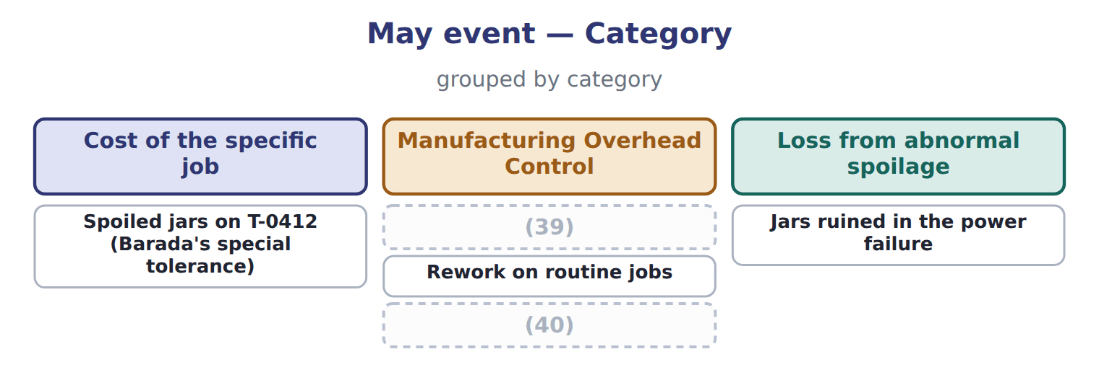
word list
Normal spoiled jars common to all jobs · Proceeds from scrap sold · Spoiled jars on T-0412 (Barada's special tolerance)

The English this section uses, and its Arabic
Each term sits against what it means.
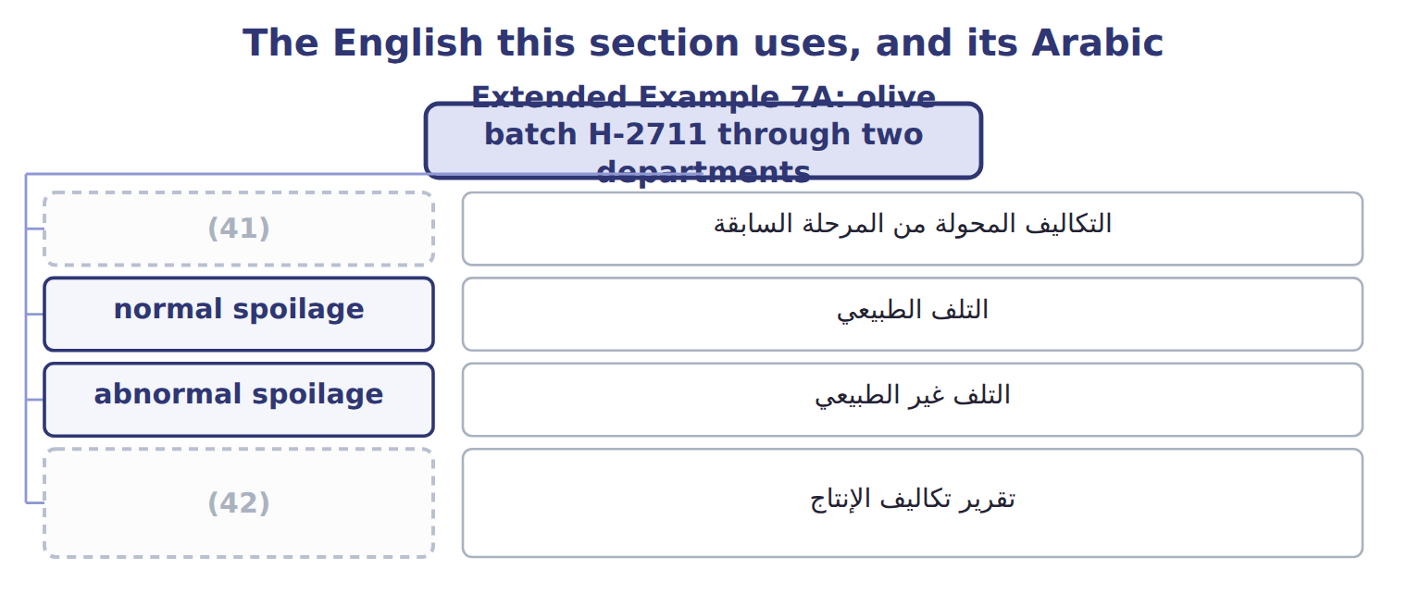
word list
transferred-in costs · inspection point · production cost report

The English this sheet uses, and its Arabic
English (exam term) | Arabic
transferred-in costs | التكاليف المحولة من المرحلة السابقة
normal spoilage | التلف الطبيعي
abnormal spoilage | التلف غير الطبيعي
production cost report | تقرير تكاليف الإنتاج

Answer key · 7.7 Extended Example 7A: olive batch H-2711 through two departments

1 follows | 22 department's
2 records | 23 Bottling
3 department | 24 Liters
4 calculations | 25 spoiled
5 settings | 26 abnormal
6 by-product | 27 spoilage
7 extra-virgin | 28 Normal spoilage
8 disposal | 29 Costs to account for
9 compute | 30 Transferred-in cost
10 output | 31 Conversion (labor + overhead)
11 includes | 32 Total
12 WIP - Crushing | 33 Cost per liter started
13 Pomace (By-product) Inventory | 34 Cost per good liter
14 Finished Goods - VOO | 35 Spoiled jars on job T-0412 (normal
15 Raw Materials Inventory | 36 Rework on routine jobs (common to all jobs)
16 WIP - Bottling | 37 Scrap sold (common to all jobs): proceeds
17 Wages Payable | 38 2% × 20,000 = 400 units
18 Manufacturing Overhead Applied | 39 Normal spoiled jars common to all jobs
19 Finished Goods - EVOO | 40 Proceeds from scrap sold
20 Totals | 41 transferred-in costs
21 Work-in-Process | 42 production cost report

the summaries in full
Summary 1 This example follows one batch from the olives to the finished bottles, records every entry by department and handles spoilage at the final inspection. It is for depth: the exam does not test process calculations, but the same spoilage rules are tested in job settings (Section 7.5 and the case set). Crushing: olives $1,000,000, labor $120,000, overhead applied $280,000; total $1,400,000. Split-off: pomace by-product $100,000; virgin oil $252,200, sold in bulk; extra-virgin oil $1,047,800 to bottling. Bottling: bottles $312,000; labor $52,000; overhead applied $104,000. Inspection: 130,000 liters; 128,000 good; 1,000 normal and 1,000 abnormal spoilage; no disposal value. Record crushing, split the joint cost, record bottling, compute the cost per liter, and move good output and abnormal spoilage out of Work in Process – Bottling. Bottling cost: $1,047,800 + $312,000 + $156,000 = $1,515,800; ÷ 130,000 liters = $11.66 per liter. Abnormal loss: 1,000 liters × $11.66 = $11,660. Finished goods: $1,515,800 − $11,660 = $1,504,140, which includes the normal spoilage; ÷ 128,000 good liters = $11.75 per liter.
Summary 2 Both Work-in-Process accounts close to zero: every cost has moved on to inventory or to the loss. A production cost report summarizes a department's units and costs.
Summary 3 Crushing: $1,000,000 + $120,000 + $280,000 = $100,000 + $1,047,800 + $252,200. Bottling: $1,515,800 = finished goods $1,504,140 + loss $11,660. Liters: 128,000 + 1,000 + 1,000 = 130,000.
Summary 4 Expect spoiled units, a normal rate and a unit cost. Base the normal rate on good output, value abnormal units at the full cost per unit, and report them as a loss. Normal spoilage stays in the good units.

8.1 Plantwide, departmental and cost-driver rates
Chapter 8 · section 8.1

Fill every gap. Each word list holds one word more than there are gaps.
Chapter 8, section by section
Each stage leads to the next.
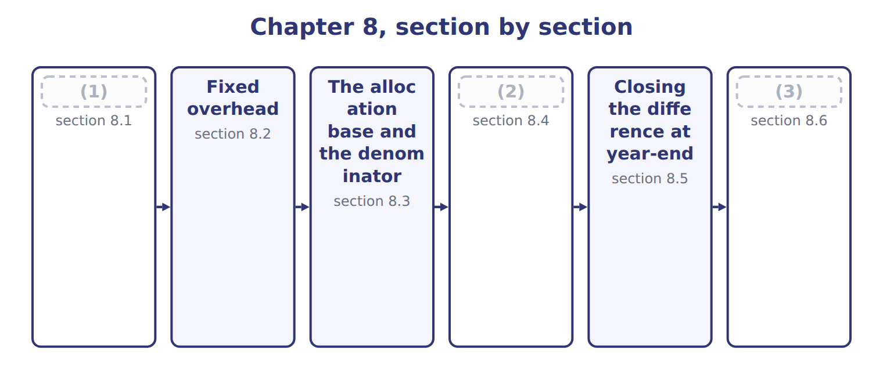
word list
Plantwide, departmental and cost-driver rates · Extended Example 8A: Tahini & Spreads closes 2 · Closing the difference at year-end · Why overhead is over- or under-applied

Summary 1 gaps 4–9
A plantwide overhead rate, also called a (4) rate, uses one rate and one base for all overhead. A (5) overhead rate gives each department its own rate and base. Individual cost-driver rates go further, with a rate for each activity; that is (6) costing. Tahini & Spreads has two (7) . Grinding is (8) and packing is labor-heavy. Its plantwide rate of $30 per machine hour ignores that (9) .
word list
difference · plantwide · departments · departmental · corporate-wide · machine-heavy · activity-based

Plantwide, departmental and cost-driver rates
Method | How | Benefit | Limitation
Plantwide (corporate-wide) rate | One rate, one base for all overhead | (10) | Distorts cost when departments use different drivers
Departmental rates | A rate and base for each department | Better when departments differ | (11)
Individual cost-driver rates | (12) | Most accurate | Costly to design and maintain

word list
A rate for each activity (ABC, Chapter 12) · More records · Simple, cheap · Plantwide: MH × $30

Worked example: one rate or two?

Summary 2 gaps 13–14
Grinding overhead is $2,200,000 over 80,000 (13) hours: $27.50 per hour. (14) overhead is $800,000 over 50,000 labor hours: $16 per hour.
word list
Packing · machine · ignores

Worked example: plantwide and departmental overhead on two jobs
The bars are drawn to scale.
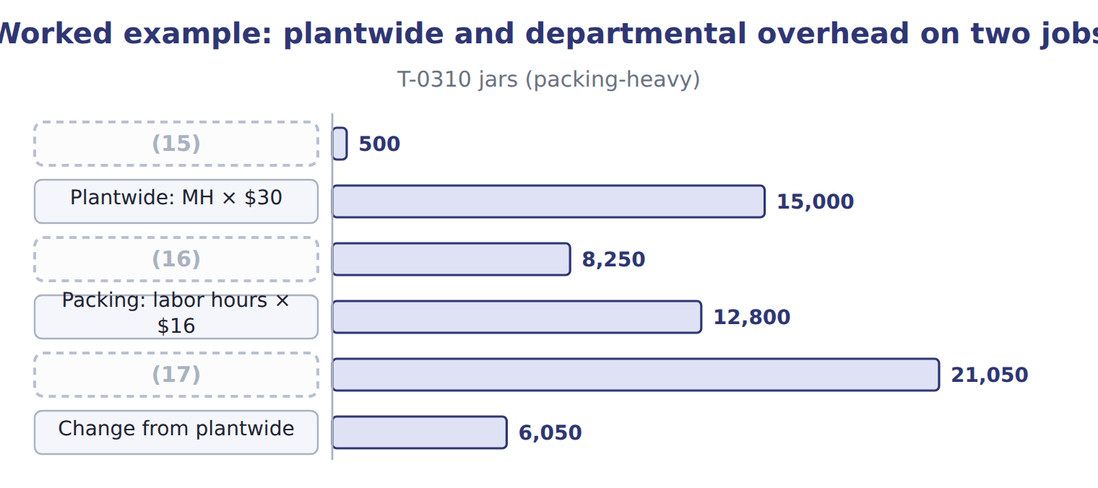
word list
Grinding: MH × $27.50 · Machine hours (grinding + packing) · underapplied overhead · Departmental total

Summary 3 gaps 18–23
The plantwide rate undercosts the (18) jar order by $6,050 and overcosts the (19) drum order. Departmental rates follow the real (20) , so they give more (21) job costs and better prices. More rates cost more to run: more bases to (22) and more records to keep. Use a plantwide rate when (23) consume overhead in similar ways; use departmental or driver rates when they do not.
word list
measure · undercosts · accurate · packing-heavy · departments · drivers · grinding-heavy

The English this sheet uses, and its Arabic
English (exam term) | Arabic
plantwide overhead rate | معدل التحميل الموحد للمصنع
departmental overhead rate | معدل التحميل على مستوى القسم

Answer key · 8.1 Plantwide, departmental and cost-driver rates

1 Plantwide, departmental and cost-driver rates | 13 machine
2 Why overhead is over- or under-applied | 14 Packing
3 Extended Example 8A: Tahini & Spreads closes 2 | 15 Machine hours (grinding + packing)
4 corporate-wide | 16 Grinding: MH × $27.50
5 departmental | 17 Departmental total
6 activity-based | 18 packing-heavy
7 departments | 19 grinding-heavy
8 machine-heavy | 20 drivers
9 difference | 21 accurate
10 Simple, cheap | 22 measure
11 More records | 23 departments
12 A rate for each activity (ABC, Chapter 12)

the summaries in full
Summary 1 A plantwide overhead rate, also called a corporate-wide rate, uses one rate and one base for all overhead. A departmental overhead rate gives each department its own rate and base. Individual cost-driver rates go further, with a rate for each activity; that is activity-based costing. Tahini & Spreads has two departments. Grinding is machine-heavy and packing is labor-heavy. Its plantwide rate of $30 per machine hour ignores that difference.
Summary 2 Grinding overhead is $2,200,000 over 80,000 machine hours: $27.50 per hour. Packing overhead is $800,000 over 50,000 labor hours: $16 per hour.
Summary 3 The plantwide rate undercosts the packing-heavy jar order by $6,050 and overcosts the grinding-heavy drum order. Departmental rates follow the real drivers, so they give more accurate job costs and better prices. More rates cost more to run: more bases to measure and more records to keep. Use a plantwide rate when departments consume overhead in similar ways; use departmental or driver rates when they do not.

8.2 Fixed overhead
Chapter 8 · section 8.2

Fill every gap. Each word list holds one word more than there are gaps.
Summary 1 gaps 1–3
Fixed (1) is the cost of having (2) : it does not change with activity in the relevant range. Typical components are (3) , supervision, insurance, property tax, rent or lease costs, and the fixed charges of service departments.
word list
capacity · depreciation · components · overhead

Tahini & Spreads fixed overhead, 2027
The bars are drawn to scale.
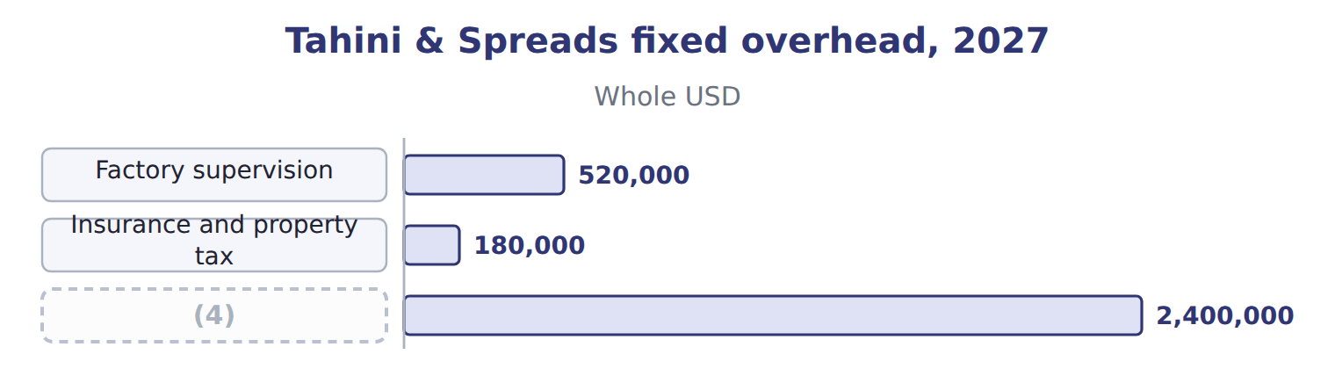
word list
Budgeted fixed overhead · plantwide overhead rate

Summary 2 gaps 5–6
Keep variable items out of the fixed pool. Power for the (5) and cleaning (6) rise with machine hours, so they belong in variable overhead at $6 per machine hour.
word list
supplies · Typical · grinders

The English this sheet uses, and its Arabic
English (exam term) | Arabic
fixed overhead | التكاليف الصناعية غير المباشرة الثابتة

Answer key · 8.2 Fixed overhead

1 overhead | 4 Budgeted fixed overhead
2 capacity | 5 grinders
3 depreciation | 6 supplies

the summaries in full
Summary 1 Fixed overhead is the cost of having capacity: it does not change with activity in the relevant range. Typical components are depreciation, supervision, insurance, property tax, rent or lease costs, and the fixed charges of service departments.
Summary 2 Keep variable items out of the fixed pool. Power for the grinders and cleaning supplies rise with machine hours, so they belong in variable overhead at $6 per machine hour.

8.3 The allocation base and the denominator
Chapter 8 · section 8.3

Fill every gap. Each word list holds one word more than there are gaps.
Summary 1 gaps 1–12
The base for fixed overhead (1) measure how (2) use capacity. In an (3) grinding plant that is machine hours. The base must also be (4) for every job. The fixed overhead rate is (5) fixed overhead divided by a (6) level of the base. The choice matters: the same $2,400,000 gives $16 per hour at (7) capacity, $20 at practical capacity, $24 at normal capacity and $25 at (8) capacity. (9) uses normal capacity: 100,000 machine hours, inside a normal range of 90,000 to 110,000 hours a year, which gives $24 per hour and keeps (10) in line with U.S. GAAP. U.S. GAAP and IAS 2 (11) fixed production overhead on normal capacity. Fixed overhead per unit is not increased when production is (12) low; the unallocated amount is expensed in that period.
word list
abnormally · should · master-budget · measurable · budgeted · automated · Orontes · denominator · theoretical · products · allocate · inventory · increased

The English this section uses, and its Arabic
Each term sits against what it means.
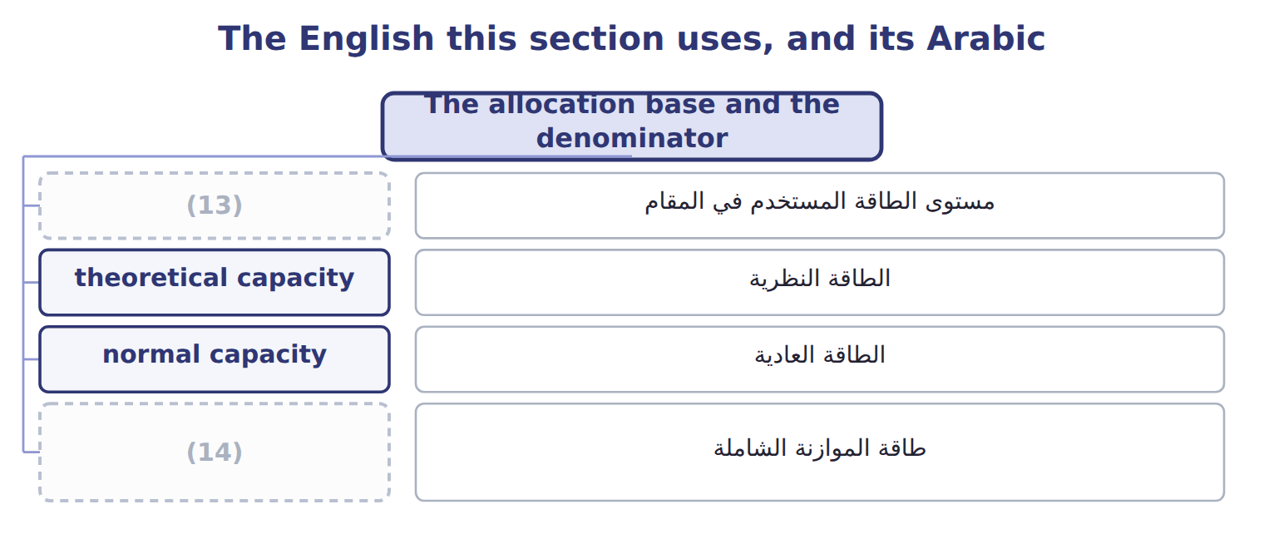
word list
denominator level · theoretical capacity · master-budget capacity

The English this sheet uses, and its Arabic
English (exam term) | Arabic
denominator level | مستوى الطاقة المستخدم في المقام
theoretical capacity | الطاقة النظرية
normal capacity | الطاقة العادية
master-budget capacity | طاقة الموازنة الشاملة

Answer key · 8.3 The allocation base and the denominator

1 should | 8 master-budget
2 products | 9 Orontes
3 automated | 10 inventory
4 measurable | 11 allocate
5 budgeted | 12 abnormally
6 denominator | 13 denominator level
7 theoretical | 14 master-budget capacity

the summaries in full
Summary 1 The base for fixed overhead should measure how products use capacity. In an automated grinding plant that is machine hours. The base must also be measurable for every job. The fixed overhead rate is budgeted fixed overhead divided by a denominator level of the base. The choice matters: the same $2,400,000 gives $16 per hour at theoretical capacity, $20 at practical capacity, $24 at normal capacity and $25 at master-budget capacity. Orontes uses normal capacity: 100,000 machine hours, inside a normal range of 90,000 to 110,000 hours a year, which gives $24 per hour and keeps inventory in line with U.S. GAAP. U.S. GAAP and IAS 2 allocate fixed production overhead on normal capacity. Fixed overhead per unit is not increased when production is abnormally low; the unallocated amount is expensed in that period.

8.4 Why overhead is over- or under-applied
Chapter 8 · section 8.4

Fill every gap. Each word list holds one word more than there are gaps.
Summary 1 gaps 1–9
Actual overhead collects in Manufacturing Overhead (1) ; applied overhead collects in Manufacturing Overhead Applied. When actual is more than applied, the difference is (2) overhead and product costs are too low. When applied is more, the difference is (3) overhead. There are three (4) . Spending can differ from the (5) . Actual (6) can differ from the denominator, so fixed overhead is applied to more or fewer hours than planned. And the base can be used more or less (7) . In 2027 Tahini & Spreads worked 92,000 machine hours, below the (8) denominator of 100,000. So applied fixed overhead fell short even before spending is (9) .
word list
Control · machine · underapplied · budget · normal-capacity · considered · causes · overapplied · efficiently · activity

The English this section uses, and its Arabic
Each term sits against what it means.
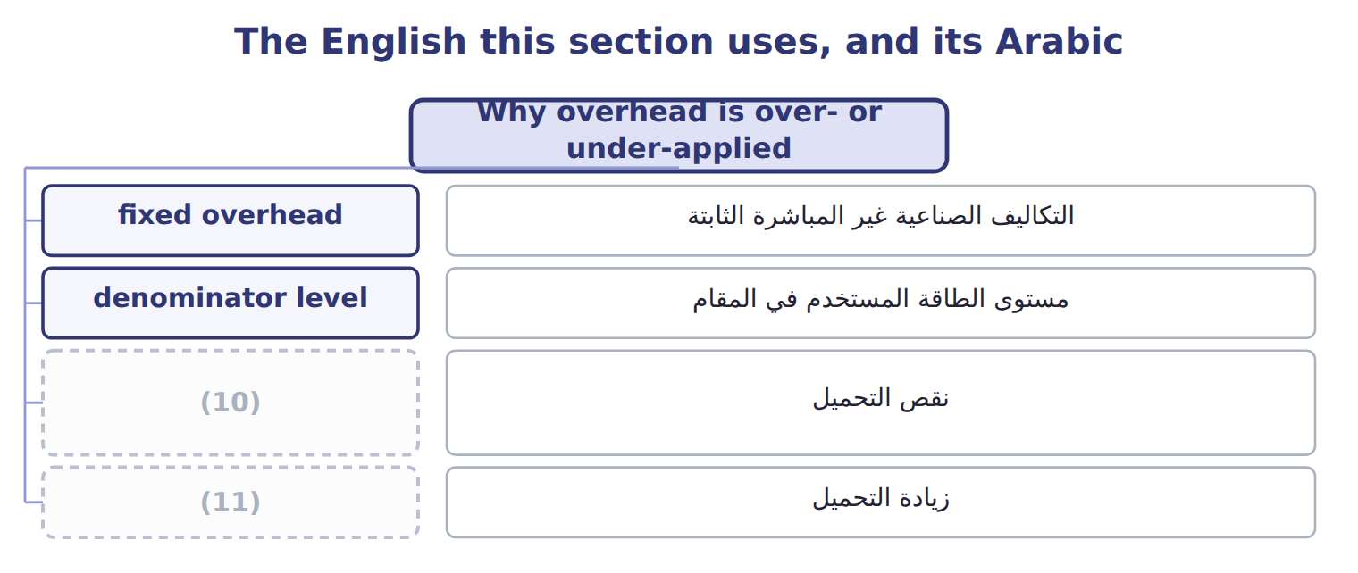
word list
overapplied overhead · underapplied overhead · نقص التحميل

The English this sheet uses, and its Arabic
English (exam term) | Arabic
underapplied overhead | نقص التحميل
overapplied overhead | زيادة التحميل

Answer key · 8.4 Why overhead is over- or under-applied

1 Control | 7 efficiently
2 underapplied | 8 normal-capacity
3 overapplied | 9 considered
4 causes | 10 underapplied overhead
5 budget | 11 overapplied overhead
6 activity

the summaries in full
Summary 1 Actual overhead collects in Manufacturing Overhead Control; applied overhead collects in Manufacturing Overhead Applied. When actual is more than applied, the difference is underapplied overhead and product costs are too low. When applied is more, the difference is overapplied overhead. There are three causes. Spending can differ from the budget. Actual activity can differ from the denominator, so fixed overhead is applied to more or fewer hours than planned. And the base can be used more or less efficiently. In 2027 Tahini & Spreads worked 92,000 machine hours, below the normal-capacity denominator of 100,000. So applied fixed overhead fell short even before spending is considered.

8.5 Closing the difference at year-end
Chapter 8 · section 8.5

Fill every gap. Each word list holds one word more than there are gaps.
Summary 1 gaps 1–8
During the year the difference stays open, because monthly (1) often cancel out. At (2) it must be closed so that both overhead (3) return to zero. If the difference is (4) , it is closed to cost of goods sold. If it is material, it is spread by (5) over ending work in process, ending (6) goods and cost of goods sold. The (7) come from the overhead applied in each balance this year, not from the total (8) . Orontes treats a difference above 2% of applied overhead as material.
word list
accounts · immaterial · year-end · proration · balances · shares · include · differences · finished

Prorate on applied overhead

Summary 2 gaps 9–10
Use the (9) applied in each balance during the current year. Do not use total ending balances, and do not include (10) inventory.
word list
balance · beginning · overhead

Share the underapplied overhead

The first share is done.
Your turn: share the underapplied overhead (complete the blanks)
The parts add up to the total; the bars are to scale.
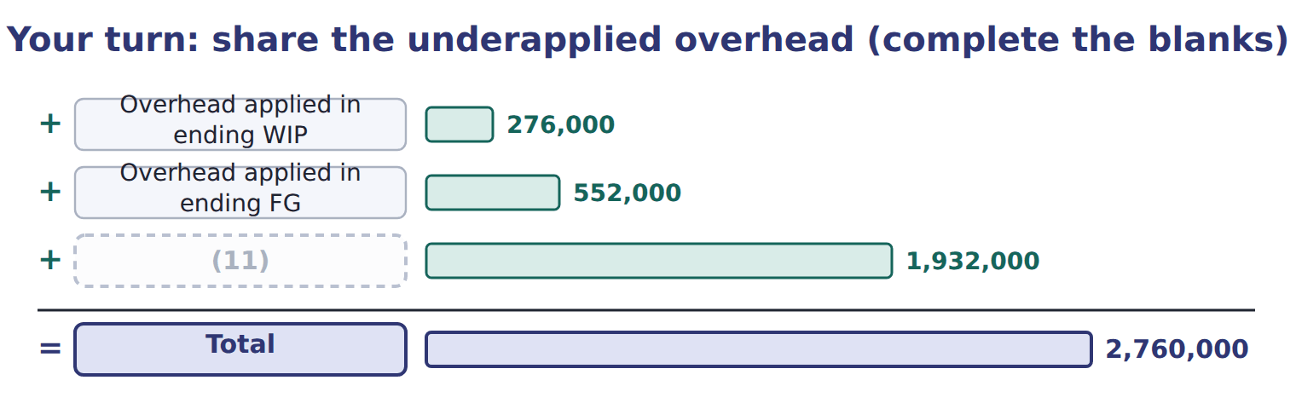
word list
plantwide overhead rate · Overhead applied in COGS

Closing the difference: write-off or proration
 | Write off to COGS | Prorate
When | Difference is immaterial | (12)
Entry | (13) | Dr MOH Applied, Dr WIP, Dr FG, Dr COGS; Cr MOH Control
Basis | (14) | Current-period overhead applied in ending WIP, FG and COGS
Effect | Simple; COGS absorbs all | (15)
GAAP note | Fine if immaterial | (16) idle capacity is expensed, never prorated (ASC 330)

word list
fixed overhead · Inventories show nearer-actual cost · Dr MOH Applied, Dr (or Cr) COGS; Cr MOH Control · Abnormal · All to COGS · Difference is material

The English this sheet uses, and its Arabic
English (exam term) | Arabic
proration | التوزيع النسبي

Answer key · 8.5 Closing the difference at year-end

1 differences | 9 overhead
2 year-end | 10 beginning
3 accounts | 11 Overhead applied in COGS
4 immaterial | 12 Difference is material
5 proration | 13 Dr MOH Applied, Dr (or Cr) COGS; Cr MOH Control
6 finished | 14 All to COGS
7 shares | 15 Inventories show nearer-actual cost
8 balances | 16 Abnormal

the summaries in full
Summary 1 During the year the difference stays open, because monthly differences often cancel out. At year-end it must be closed so that both overhead accounts return to zero. If the difference is immaterial, it is closed to cost of goods sold. If it is material, it is spread by proration over ending work in process, ending finished goods and cost of goods sold. The shares come from the overhead applied in each balance this year, not from the total balances. Orontes treats a difference above 2% of applied overhead as material.
Summary 2 Use the overhead applied in each balance during the current year. Do not use total ending balances, and do not include beginning inventory.

8.6 Extended Example 8A: Tahini & Spreads closes 2027
Chapter 8 · section 8.6

Fill every gap. Each word list holds one word more than there are gaps.
Summary 1 gaps 1–12
This example (1) the year's underapplied overhead, prorates it, records the closing entry and compares the result with a (2) . The (3) and its effect on income are (4) ; the variance split previews Book 3. Rate: $30 per machine hour, set at normal (5) of 100,000 hours. (6) : 92,000 machine hours; fixed overhead $30,000 above budget; variable overhead $8,000 above the (7) budget. (8) before closing: work in process $690,000, (9) goods $1,380,000, cost of goods sold $6,090,000. Find the underapplied amount and its causes, test materiality, (10) on applied overhead, record the entry and (11) the income effect of the two methods. Fixed rate: $2,400,000 ÷ 100,000 hours = $24; plus $6 variable = $30 per machine hour. Applied: 92,000 × $30 = $2,760,000. Materiality: 230,000 ÷ 2,760,000 = 8.3%, above the 2% policy, so the (12) is prorated.
word list
write-off · proration · capacity · prorate · methods · exam-core · Balances · difference · flexible · Actual · finished · analyzes · compare

Summary 2 gaps 13–15
Most of it, $192,000, is the (13) effect: fixed overhead was budgeted for normal capacity but applied to only 92,000 hours. (14) adds $30,000 and variable overhead $8,000. Book 3 calls these (15) .
word list
variances · Spending · production-volume · proration

Extended Example: proration of the 2027 underapplied overhead
The parts add up to the total; the bars are to scale.
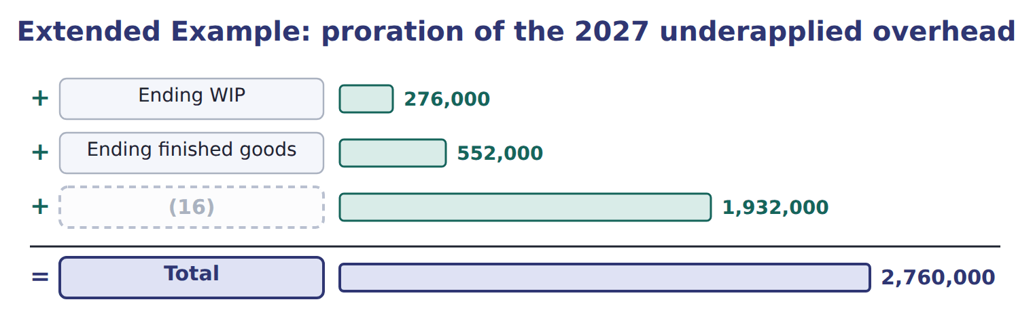
word list
Cost of goods sold · departmental overhead rate

Extended Example: year-end closing entry (proration)
No. | Account (detail) | Debit | Credit
1 | (17) | 2,760,000
 | Work-in-Process Inventory | 23,000
 | Finished Goods Inventory | 46,000
 | (18) | 161,000
 | (19) |  | 2,990,000
 | Totals | 2,990,000 | 2,990,000

word list
Manufacturing Overhead Control · Cost of Goods Sold · plantwide overhead rate · Manufacturing Overhead Applied

6. Write-off or proration?

Summary 3 gaps 20–21
Proration leaves $69,000 of the (20) overhead in inventory, so operating income is $69,000 higher than with a write-off. The cost reaches the income (21) later, when the inventory is sold.
word list
Compute · statement · underapplied

Extended Example: operating income under the two methods
The bars are drawn to scale.
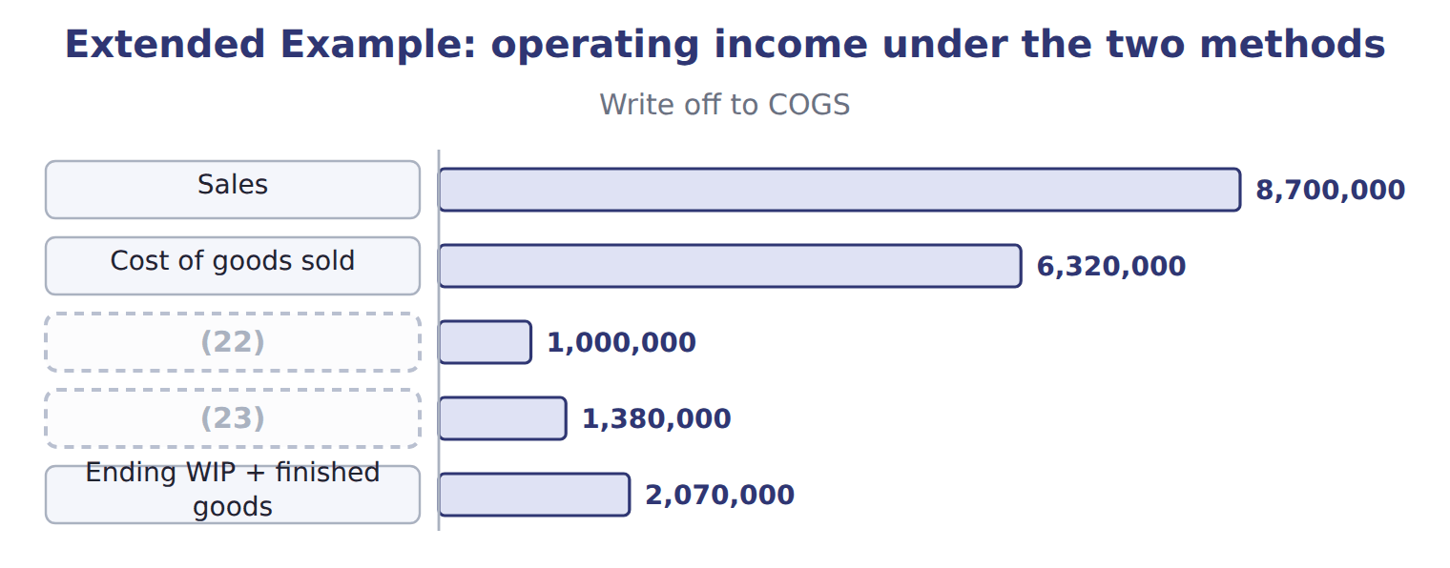
word list
Operating income · master-budget capacity · Selling and administrative

Everything ties

Summary 4 gaps 24–26
Parts of the (24) : $30,000 + $192,000 + $8,000 = $230,000. (25) : $23,000 + $46,000 + $161,000 = $230,000. Income effect: $23,000 + $46,000 = $69,000 kept in (26) . After closing: MOH Control and MOH Applied are both zero.
word list
compare · Proration · inventory · difference

Exam view

Summary 5 gaps 27–29
Expect the applied overhead in ending WIP, (27) goods and COGS, and an under- or (28) amount. Compute each share from applied overhead, then say whether income rises or falls compared with a (29) .
word list
write-off · finished · methods · overapplied

Exam view
Beverages · FY2026 (normal costing, whole USD) | Data
Budgeted fixed overhead | 1,650,000
Normal capacity (Orontes policy) | 16,500 machine hours
Practical capacity | 20,000 machine hours
Variable overhead rate | (30)
Actual machine hours | 16,000
Actual fixed overhead / actual variable overhead | (31)
Machine hours in ending WIP / ending FG / COGS | 800 / 2,400 / 12,800
Unadjusted balances: WIP / FG / COGS | (32)
Materiality policy | (33)

word list
400,000 / 900,000 / 9,000,000 · 1,660,000 / 820,000 · $50 per machine hour · 2% of applied overhead · 20,000 machine hours

Item — Answer
Item | Answer
Finished goods share | (34)
COGS share | 70% × 230,000 = 161,000

word list
20% × 230,000 = 46,000 · 70% × 230,000 = 161,000

Beverages cost — Category
Every item belongs to exactly one group.
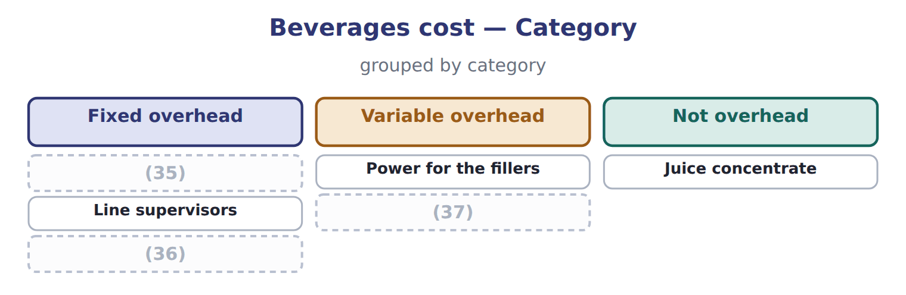
word list
overapplied overhead · Depreciation of the bottling line · Cleaning chemicals · Service department charges

The English this section uses, and its Arabic
Each term sits against what it means.
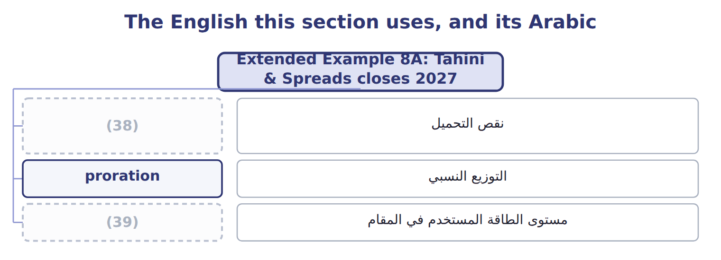
word list
underapplied overhead · denominator level · التوزيع النسبي

The English this sheet uses, and its Arabic
English (exam term) | Arabic
underapplied overhead | نقص التحميل
proration | التوزيع النسبي
denominator level | مستوى الطاقة المستخدم في المقام

Answer key · 8.6 Extended Example 8A: Tahini & Spreads closes 2027

1 analyzes | 21 statement
2 write-off | 22 Selling and administrative
3 proration | 23 Operating income
4 exam-core | 24 difference
5 capacity | 25 Proration
6 Actual | 26 inventory
7 flexible | 27 finished
8 Balances | 28 overapplied
9 finished | 29 write-off
10 prorate | 30 $50 per machine hour
11 compare | 31 1,660,000 / 820,000
12 difference | 32 400,000 / 900,000 / 9,000,000
13 production-volume | 33 2% of applied overhead
14 Spending | 34 20% × 230,000 = 46,000
15 variances | 35 Depreciation of the bottling line
16 Cost of goods sold | 36 Service department charges
17 Manufacturing Overhead Applied | 37 Cleaning chemicals
18 Cost of Goods Sold | 38 underapplied overhead
19 Manufacturing Overhead Control | 39 denominator level
20 underapplied

the summaries in full
Summary 1 This example analyzes the year's underapplied overhead, prorates it, records the closing entry and compares the result with a write-off. The proration and its effect on income are exam-core; the variance split previews Book 3. Rate: $30 per machine hour, set at normal capacity of 100,000 hours. Actual: 92,000 machine hours; fixed overhead $30,000 above budget; variable overhead $8,000 above the flexible budget. Balances before closing: work in process $690,000, finished goods $1,380,000, cost of goods sold $6,090,000. Find the underapplied amount and its causes, test materiality, prorate on applied overhead, record the entry and compare the income effect of the two methods. Fixed rate: $2,400,000 ÷ 100,000 hours = $24; plus $6 variable = $30 per machine hour. Applied: 92,000 × $30 = $2,760,000. Materiality: 230,000 ÷ 2,760,000 = 8.3%, above the 2% policy, so the difference is prorated.
Summary 2 Most of it, $192,000, is the production-volume effect: fixed overhead was budgeted for normal capacity but applied to only 92,000 hours. Spending adds $30,000 and variable overhead $8,000. Book 3 calls these variances.
Summary 3 Proration leaves $69,000 of the underapplied overhead in inventory, so operating income is $69,000 higher than with a write-off. The cost reaches the income statement later, when the inventory is sold.
Summary 4 Parts of the difference: $30,000 + $192,000 + $8,000 = $230,000. Proration: $23,000 + $46,000 + $161,000 = $230,000. Income effect: $23,000 + $46,000 = $69,000 kept in inventory. After closing: MOH Control and MOH Applied are both zero.
Summary 5 Expect the applied overhead in ending WIP, finished goods and COGS, and an under- or overapplied amount. Compute each share from applied overhead, then say whether income rises or falls compared with a write-off.

9.1 Two ways to cost inventory
Chapter 9 · section 9.1

Fill every gap. Each word list holds one word more than there are gaps.
Chapter 9, section by section
Each stage leads to the next.
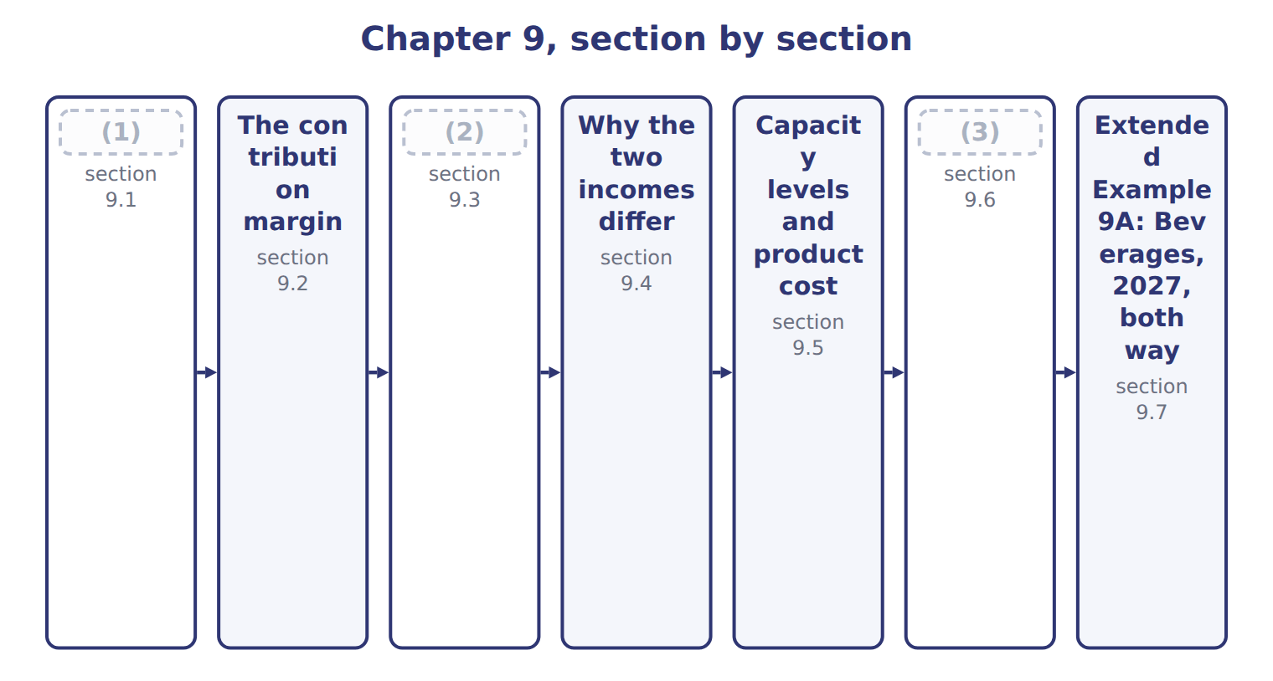
word list
Two income statements for the same year · Practical capacity and capacity management · Why the two incomes differ · Two ways to cost inventory

Summary 1 gaps 4–9
Absorption costing, also called full costing, treats all manufacturing costs as product costs, (4) fixed manufacturing overhead. Variable costing, also called (5) costing, treats only variable manufacturing costs as product costs; fixed manufacturing overhead is a (6) cost. That is the only difference. Both methods treat (7) , labor and variable overhead as product costs, and both (8) all selling and (9) costs. So a case costs $12.60 under absorption costing and $10.60 under variable costing. The difference is the fixed overhead rate of $2.00 a case.
word list
including · expense · administrative · materials · selling · period · direct

Product cost per case under the two methods
Beverages juice case | Absorption | Variable costing
(10) | $9.00 | $9.00
(11) | $0.60 | $0.60
Variable MOH | $1.00 | $1.00
Fixed MOH | $2.00 | — (period cost)
Product cost per case | $12.60 | $10.60

word list
production-volume variance · Direct labor · Direct materials

Summary 2 gaps 12–13
U.S. GAAP and IFRS require (12) costing for external reporting and tax. Variable costing is an internal tool: it is not allowed in the published (13) .
word list
statements · absorption · published

The English this sheet uses, and its Arabic
English (exam term) | Arabic
absorption costing | التكاليف الكلية
variable costing | التكاليف المتغيرة

Answer key · 9.1 Two ways to cost inventory

1 Two ways to cost inventory | 8 expense
2 Two income statements for the same year | 9 administrative
3 Practical capacity and capacity management | 10 Direct materials
4 including | 11 Direct labor
5 direct | 12 absorption
6 period | 13 statements
7 materials

the summaries in full
Summary 1 Absorption costing, also called full costing, treats all manufacturing costs as product costs, including fixed manufacturing overhead. Variable costing, also called direct costing, treats only variable manufacturing costs as product costs; fixed manufacturing overhead is a period cost. That is the only difference. Both methods treat materials, labor and variable overhead as product costs, and both expense all selling and administrative costs. So a case costs $12.60 under absorption costing and $10.60 under variable costing. The difference is the fixed overhead rate of $2.00 a case.
Summary 2 U.S. GAAP and IFRS require absorption costing for external reporting and tax. Variable costing is an internal tool: it is not allowed in the published statements.

9.2 The contribution margin
Chapter 9 · section 9.2

Fill every gap. Each word list holds one word more than there are gaps.
Summary 1 gaps 1–4
The contribution margin is sales minus all variable costs, both (1) and selling. It is the (2) left to cover fixed costs and then (3) profit. Per unit, it is price minus variable cost per unit. A case of juice sells for $20.00. Variable costs are $10.60 to make it and $1.20 to sell it, so each case (4) $8.20. The contribution margin ratio is $8.20 ÷ $20.00 = 41%.
word list
contributes · amount · provide · manufacturing · variable

Worked example: Beverages contribution margin, 2027

On 830,000 cases sold, the total is $6,806,000.
Worked example: Beverages contribution margin, 2027
Beverages · FY2027 · 830,000 cases sold | Per case | Total
Price | $20.00 | 16,600,000
(5) | ($10.60) | (8,798,000)
(6) | ($1.20) | (996,000)
Contribution margin | $8.20 | 6,806,000
Contribution margin ratio | 41% | 41%

word list
downward demand spiral · Variable manufacturing cost · Variable selling cost

Summary 2 gaps 7–10
Do not (7) it with gross margin. Gross margin deducts full product cost, (8) fixed overhead, but not variable selling costs. Contribution margin is the basis of (9) analysis and short-run decisions such as special orders (Book 3). The exam uses both terms in the same (10) .
word list
including · cost-volume-profit · analysis · question · confuse

The English this sheet uses, and its Arabic
English (exam term) | Arabic
contribution margin | هامش المساهمة
contribution margin ratio | نسبة هامش المساهمة

Answer key · 9.2 The contribution margin

1 manufacturing | 6 Variable selling cost
2 amount | 7 confuse
3 provide | 8 including
4 contributes | 9 cost-volume-profit
5 Variable manufacturing cost | 10 question

the summaries in full
Summary 1 The contribution margin is sales minus all variable costs, both manufacturing and selling. It is the amount left to cover fixed costs and then provide profit. Per unit, it is price minus variable cost per unit. A case of juice sells for $20.00. Variable costs are $10.60 to make it and $1.20 to sell it, so each case contributes $8.20. The contribution margin ratio is $8.20 ÷ $20.00 = 41%.
Summary 2 Do not confuse it with gross margin. Gross margin deducts full product cost, including fixed overhead, but not variable selling costs. Contribution margin is the basis of cost-volume-profit analysis and short-run decisions such as special orders (Book 3). The exam uses both terms in the same question.

9.3 Two income statements for the same year
Chapter 9 · section 9.3

Fill every gap. Each word list holds one word more than there are gaps.
Summary 1 gaps 1–11
The absorption statement uses the gross margin format. Cost of goods sold is at full cost, and the (1) variance is added when production falls short of the (2) . Selling and (3) costs follow. The variable costing statement uses the contribution format. Variable costs come first, then the contribution margin, then all fixed costs, (4) the full $1,800,000 of fixed (5) overhead. Use absorption costing for the published (6) and for pricing that must cover all costs. Use variable costing for internal (7) : it shows how (8) moves with sales volume. Variable costing has another benefit: (9) cannot raise income by (10) for inventory. Its limits are that it is not allowed (11) , and it can make fixed costs look less important than they are.
word list
including · denominator · externally · production-volume · producing · manufacturing · costing · profit · statements · managers · decisions · administrative

The English this section uses, and its Arabic
Each term sits against what it means.
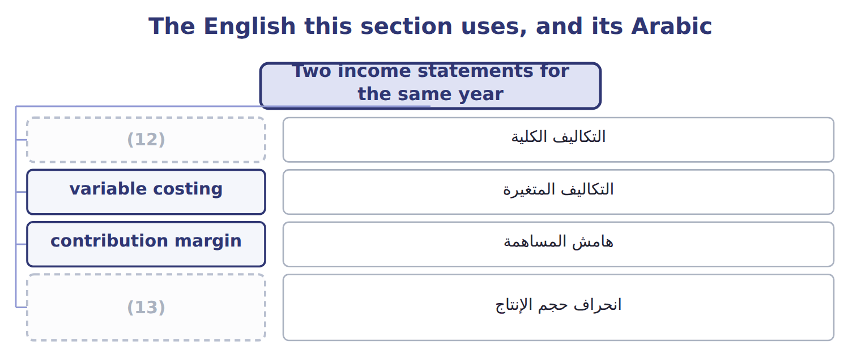
word list
absorption costing · normal capacity · production-volume variance

The English this sheet uses, and its Arabic
English (exam term) | Arabic
production-volume variance | انحراف حجم الإنتاج

Answer key · 9.3 Two income statements for the same year

1 production-volume | 8 profit
2 denominator | 9 managers
3 administrative | 10 producing
4 including | 11 externally
5 manufacturing | 12 absorption costing
6 statements | 13 production-volume variance
7 decisions

the summaries in full
Summary 1 The absorption statement uses the gross margin format. Cost of goods sold is at full cost, and the production-volume variance is added when production falls short of the denominator. Selling and administrative costs follow. The variable costing statement uses the contribution format. Variable costs come first, then the contribution margin, then all fixed costs, including the full $1,800,000 of fixed manufacturing overhead. Use absorption costing for the published statements and for pricing that must cover all costs. Use variable costing for internal decisions: it shows how profit moves with sales volume. Variable costing has another benefit: managers cannot raise income by producing for inventory. Its limits are that it is not allowed externally, and it can make fixed costs look less important than they are.

9.4 Why the two incomes differ
Chapter 9 · section 9.4

Fill every gap. Each word list holds one word more than there are gaps.
Summary 1 gaps 1–8
The difference comes only from fixed overhead held in inventory. When inventory rises, absorption costing (1) some fixed overhead to next year, so its income is (2) . When inventory falls, it (3) fixed overhead from (4) years, so its income is lower. In 2027 Beverages' inventory rose from 40,000 to 60,000 cases. The difference in income is the (5) in inventory times the fixed rate: $40,000, the extra fixed overhead left in (6) inventory. (7) that in 2028 Beverages (8) 800,000 cases and sells 840,000. Inventory falls, and absorption income is $80,000 lower than variable costing income.
word list
higher · produces · releases · costing · Suppose · change · ending · earlier · defers

Inventory change and the two incomes
Inventory change | Operating income | Beverages
Production > sales (inventory rises) | (9) | 2027: +20,000 cases → +40,000
Production < sales (inventory falls) | Absorption < variable | (10) : (40,000) cases → (80,000)
Production = sales | Equal | (11)

word list
No fixed MOH enters or leaves inventory · Absorption > variable · Which method shows higher income? · Suppose 2028

Difference = change in units × fixed rate

Summary 2 gaps 12–14
Absorption income − variable income = (ending − (12) inventory units) × fixed (13) overhead per unit, when the rate is the same in both years. Do not use variable costs or (14) costs in this formula.
word list
inventory · manufacturing · beginning · selling

Reconcile 2028

Find the income difference and say which method shows higher income.
Your turn: reconcile the two incomes for 2028 (complete the blanks)
Suppose: Beverages FY2028 | Value
Cases produced / sold | (15)
Change in inventory (cases) | (40,000)
Fixed MOH per case | $2.00
Absorption − variable operating income | ________
Which method shows higher income? | ________

word list
Absorption > variable · 800,000 / 840,000

Answer key · 9.4 Why the two incomes differ

1 defers | 9 Absorption > variable
2 higher | 10 Suppose 2028
3 releases | 11 No fixed MOH enters or leaves inventory
4 earlier | 12 beginning
5 change | 13 manufacturing
6 ending | 14 selling
7 Suppose | 15 800,000 / 840,000
8 produces

the summaries in full
Summary 1 The difference comes only from fixed overhead held in inventory. When inventory rises, absorption costing defers some fixed overhead to next year, so its income is higher. When inventory falls, it releases fixed overhead from earlier years, so its income is lower. In 2027 Beverages' inventory rose from 40,000 to 60,000 cases. The difference in income is the change in inventory times the fixed rate: $40,000, the extra fixed overhead left in ending inventory. Suppose that in 2028 Beverages produces 800,000 cases and sells 840,000. Inventory falls, and absorption income is $80,000 lower than variable costing income.
Summary 2 Absorption income − variable income = (ending − beginning inventory units) × fixed manufacturing overhead per unit, when the rate is the same in both years. Do not use variable costs or selling costs in this formula.

9.5 Capacity levels and product cost
Chapter 9 · section 9.5

Fill every gap. Each word list holds one word more than there are gaps.
Summary 1 gaps 1–9
The fixed overhead rate (1) on the capacity level in the denominator. Theoretical capacity (2) the plant never stops. Practical capacity allows for normal breaks and (3) . Normal capacity is (4) use over several years. Master-budget capacity is this (5) plan. The (6) the denominator, the higher the product cost. For a case of juice, full cost (7) from $12.10 at theoretical capacity to $12.85 at master-budget capacity. The choice also (8) the statements. A larger denominator applies less fixed overhead per case, which gives a larger (9) variance and lower inventory values. For the published statements Orontes uses normal capacity, as ASC 330 requires.
word list
smaller · year's · production-volume · average · ranges · depends · several · maintenance · assumes · changes

The English this section uses, and its Arabic
Each term sits against what it means.
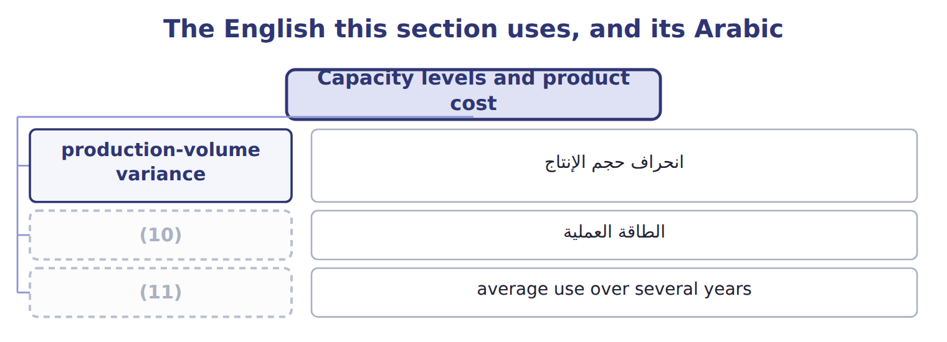
word list
practical capacity · normal capacity · unused capacity

The English this sheet uses, and its Arabic
English (exam term) | Arabic
practical capacity | الطاقة العملية
normal capacity | الطاقة العادية

Answer key · 9.5 Capacity levels and product cost

1 depends | 7 ranges
2 assumes | 8 changes
3 maintenance | 9 production-volume
4 average | 10 practical capacity
5 year's | 11 normal capacity
6 smaller

the summaries in full
Summary 1 The fixed overhead rate depends on the capacity level in the denominator. Theoretical capacity assumes the plant never stops. Practical capacity allows for normal breaks and maintenance. Normal capacity is average use over several years. Master-budget capacity is this year's plan. The smaller the denominator, the higher the product cost. For a case of juice, full cost ranges from $12.10 at theoretical capacity to $12.85 at master-budget capacity. The choice also changes the statements. A larger denominator applies less fixed overhead per case, which gives a larger production-volume variance and lower inventory values. For the published statements Orontes uses normal capacity, as ASC 330 requires.

9.6 Practical capacity and capacity management
Chapter 9 · section 9.6

Fill every gap. Each word list holds one word more than there are gaps.
Summary 1 gaps 1–12
Many managers use practical capacity for (1) reports. The (2) carries only the cost of the capacity it uses, and the cost of idle capacity is shown on its own as (3) capacity. In 2027 the (4) line could fill 1,000,000 cases but (5) 850,000. At $1.80 of fixed (6) per case of practical capacity, 150,000 idle cases cost $270,000. That figure tells managers what the spare capacity costs, so they can seek more sales or (7) capacity. Practical capacity also (8) pricing. If prices follow full cost at a (9) budget volume, unit cost rises, prices rise and demand falls again: a (10) demand spiral. Practical capacity has (11) . It must be (12) , and the published statements still need normal capacity. So Orontes keeps practical capacity for management reports and adjusts to normal capacity for the statements.
word list
estimated · reduce · bottling · internal · limits · published · filled · unused · protects · downward · product · overhead · falling

The English this section uses, and its Arabic
Each term sits against what it means.
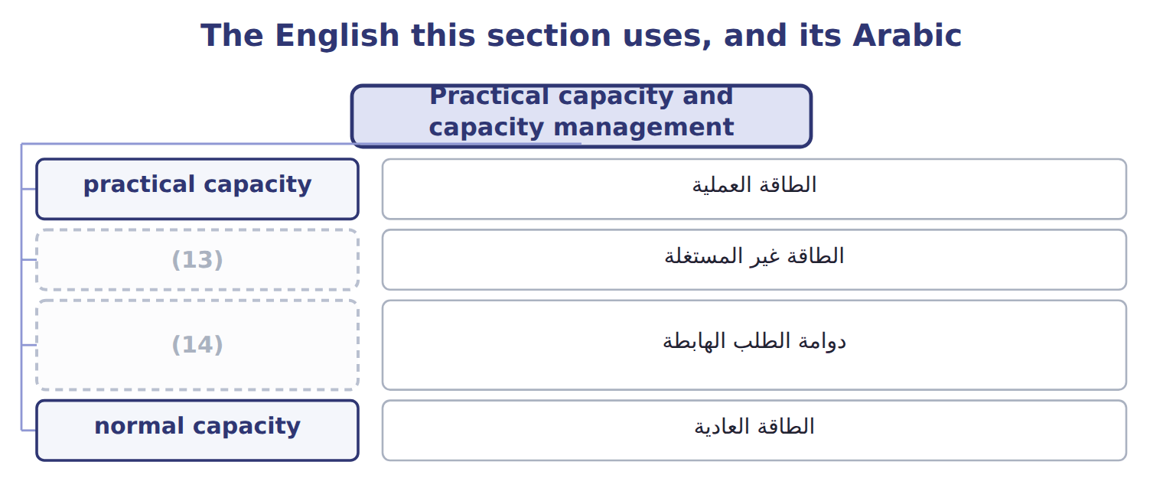
word list
unused capacity · الطاقة غير المستغلة · downward demand spiral

The English this sheet uses, and its Arabic
English (exam term) | Arabic
unused capacity | الطاقة غير المستغلة
downward demand spiral | دوامة الطلب الهابطة

Answer key · 9.6 Practical capacity and capacity management

1 internal | 8 protects
2 product | 9 falling
3 unused | 10 downward
4 bottling | 11 limits
5 filled | 12 estimated
6 overhead | 13 unused capacity
7 reduce | 14 downward demand spiral

the summaries in full
Summary 1 Many managers use practical capacity for internal reports. The product carries only the cost of the capacity it uses, and the cost of idle capacity is shown on its own as unused capacity. In 2027 the bottling line could fill 1,000,000 cases but filled 850,000. At $1.80 of fixed overhead per case of practical capacity, 150,000 idle cases cost $270,000. That figure tells managers what the spare capacity costs, so they can seek more sales or reduce capacity. Practical capacity also protects pricing. If prices follow full cost at a falling budget volume, unit cost rises, prices rise and demand falls again: a downward demand spiral. Practical capacity has limits. It must be estimated, and the published statements still need normal capacity. So Orontes keeps practical capacity for management reports and adjusts to normal capacity for the statements.

9.7 Extended Example 9A: Beverages, 2027, both ways
Chapter 9 · section 9.7

Fill every gap. Each word list holds one word more than there are gaps.
Summary 1 gaps 1–12
This example (1) the year under both methods, follows finished goods and cost of goods sold, and shows how income (2) to production. The statements and the reconciliation are (3) ; the entries are for depth. Units: opening (4) 40,000 cases; (5) 850,000; sold 830,000; closing 60,000. Costs per case: variable manufacturing $10.60; fixed overhead $2.00 at normal (6) ; variable selling $1.20; price $20.00. Fixed costs: manufacturing overhead $1,800,000; selling and (7) $2,100,000. Record production and sales under each method, (8) finished goods and cost of goods sold, prepare both statements and (9) the incomes. (10) : fixed overhead applied 850,000 × $2.00 = $1,700,000; (11) variance $100,000; operating income $2,946,000. Variable costing: (12) margin $6,806,000 − fixed costs $3,900,000 = $2,906,000. Reconciliation: (60,000 − 40,000) × $2.00 = $40,000. Only the treatment of fixed overhead differs.
word list
compare · responds · inventory · administrative · closing · contribution · capacity · records · Absorption · reconcile · exam-core · produced · production-volume

Extended Example: absorption costing journal, 2027
No. | Account (detail) | Debit | Credit
1 | (13) | 1,800,000
 | Various accounts |  | 1,800,000
2 | Finished Goods Inventory | 10,710,000
 | (14) |  | 9,010,000
 | Fixed MOH Applied |  | 1,700,000
3 | Cost of Goods Sold | 10,458,000
 | (15) |  | 10,458,000
4 | Fixed MOH Applied | 1,700,000
 | (16) | 100,000
 | Fixed MOH Control |  | 1,800,000
 | (17) | 24,768,000 | 24,768,000

word list
Finished Goods Inventory · Various accounts · Cost of Goods Sold · Fixed MOH Control · Variable manufacturing costs · Totals

Extended Example: variable costing journal, 2027
No. | Account (detail) | Debit | Credit
1 | (18) | 1,800,000
 | Various accounts |  | 1,800,000
2 | (19) | 9,010,000
 | (20) |  | 9,010,000
3 | Cost of Goods Sold | 8,798,000
 | Finished Goods Inventory |  | 8,798,000
 | (21) | 19,608,000 | 19,608,000

word list
Fixed MOH Applied · Fixed MOH Expense · Finished Goods Inventory · Totals · Variable manufacturing costs

Summary 2 gaps 22–24
Ending (22) goods are $756,000 under absorption and $636,000 under variable costing. Variable costing income does not move. Absorption income rises by $2.00 for each extra case (23) , which is why absorption income alone can reward (24) .
word list
statements · finished · produced · overproduction

Everything ties

Summary 3 gaps 25–27
Finished goods difference: $756,000 − $636,000 = 60,000 × $2.00. (25) difference: $504,000 − $424,000 = 40,000 × $2.00. (26) difference: $2,946,000 − $2,906,000 = $40,000 = the change in fixed overhead held in (27) .
word list
Income · operating · Opening · inventory

Exam view

Summary 4 gaps 28–30
Expect (28) , sales and cost data, and a request for income under one method or the (29) between them. Find the change in (30) units first; multiply by the fixed overhead rate to reconcile.
word list
production · difference · reconcile · inventory

Exam view
Halva line · FY2027 (whole USD) | Data
Selling price per tray | $6.00
Variable manufacturing cost per tray | $2.40
(31) | $0.30
(32) | 360,000
(33) | 400,000 trays
Fixed selling and administrative | 150,000
(34) | 380,000 / 350,000

word list
Fixed manufacturing overhead (budget = actual) · Variable selling cost per tray · Trays produced / sold (no opening inventory) · Normal capacity (denominator) · Selling price per tray

Item — Answer
Item | Answer
Absorption − variable operating income (2028) | (35)
Which method shows higher income? | Variable costing, because inventory falls and absorption costing releases fixed overhead from earlier years.

word list
Product cost under both methods · (40,000) × $2.00 = (80,000)

Halva cost — Category
Halva cost | Category
Sesame and sugar | Product cost under both methods
Depreciation of the halva line | Product cost under absorption only
Variable selling cost | (36)
Variable manufacturing overhead | (37)
Fixed administrative salaries | Period cost under both methods
Halva line supervisor | (38)

word list
Product cost under both methods · Product cost under absorption only · Period cost under both methods · (40,000) × $2.00 = (80,000)

The English this section uses, and its Arabic
Each term sits against what it means.
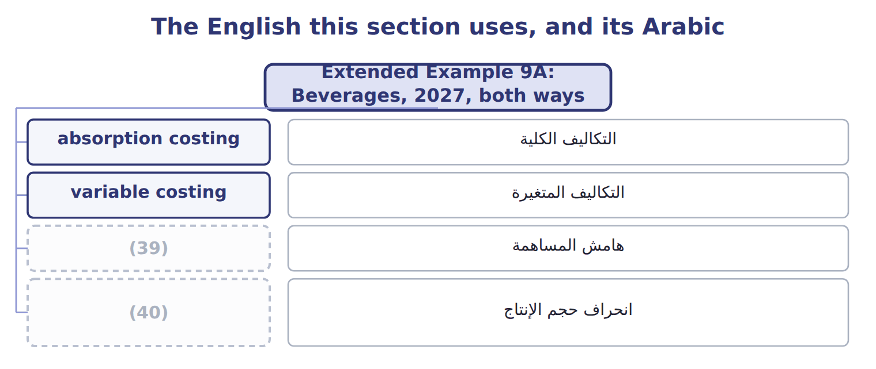
word list
التكاليف المتغيرة · contribution margin · production-volume variance

The English this sheet uses, and its Arabic
English (exam term) | Arabic
absorption costing | التكاليف الكلية
variable costing | التكاليف المتغيرة
contribution margin | هامش المساهمة
production-volume variance | انحراف حجم الإنتاج

Answer key · 9.7 Extended Example 9A: Beverages, 2027, both ways

1 records | 21 Totals
2 responds | 22 finished
3 exam-core | 23 produced
4 inventory | 24 overproduction
5 produced | 25 Opening
6 capacity | 26 Income
7 administrative | 27 inventory
8 compare | 28 production
9 reconcile | 29 difference
10 Absorption | 30 inventory
11 production-volume | 31 Variable selling cost per tray
12 contribution | 32 Fixed manufacturing overhead (budget = actual)
13 Fixed MOH Control | 33 Normal capacity (denominator)
14 Variable manufacturing costs | 34 Trays produced / sold (no opening inventory)
15 Finished Goods Inventory | 35 (40,000) × $2.00 = (80,000)
16 Cost of Goods Sold | 36 Period cost under both methods
17 Totals | 37 Product cost under both methods
18 Fixed MOH Expense | 38 Product cost under absorption only
19 Finished Goods Inventory | 39 contribution margin
20 Variable manufacturing costs | 40 production-volume variance

the summaries in full
Summary 1 This example records the year under both methods, follows finished goods and cost of goods sold, and shows how income responds to production. The statements and the reconciliation are exam-core; the entries are for depth. Units: opening inventory 40,000 cases; produced 850,000; sold 830,000; closing 60,000. Costs per case: variable manufacturing $10.60; fixed overhead $2.00 at normal capacity; variable selling $1.20; price $20.00. Fixed costs: manufacturing overhead $1,800,000; selling and administrative $2,100,000. Record production and sales under each method, compare finished goods and cost of goods sold, prepare both statements and reconcile the incomes. Absorption: fixed overhead applied 850,000 × $2.00 = $1,700,000; production-volume variance $100,000; operating income $2,946,000. Variable costing: contribution margin $6,806,000 − fixed costs $3,900,000 = $2,906,000. Reconciliation: (60,000 − 40,000) × $2.00 = $40,000. Only the treatment of fixed overhead differs.
Summary 2 Ending finished goods are $756,000 under absorption and $636,000 under variable costing. Variable costing income does not move. Absorption income rises by $2.00 for each extra case produced, which is why absorption income alone can reward overproduction.
Summary 3 Finished goods difference: $756,000 − $636,000 = 60,000 × $2.00. Opening difference: $504,000 − $424,000 = 40,000 × $2.00. Income difference: $2,946,000 − $2,906,000 = $40,000 = the change in fixed overhead held in inventory.
Summary 4 Expect production, sales and cost data, and a request for income under one method or the difference between them. Find the change in inventory units first; multiply by the fixed overhead rate to reconcile.

10.1 Why allocate service department costs
Chapter 10 · section 10.1

Fill every gap. Each word list holds one word more than there are gaps.
Chapter 10, section by section
Each stage leads to the next.
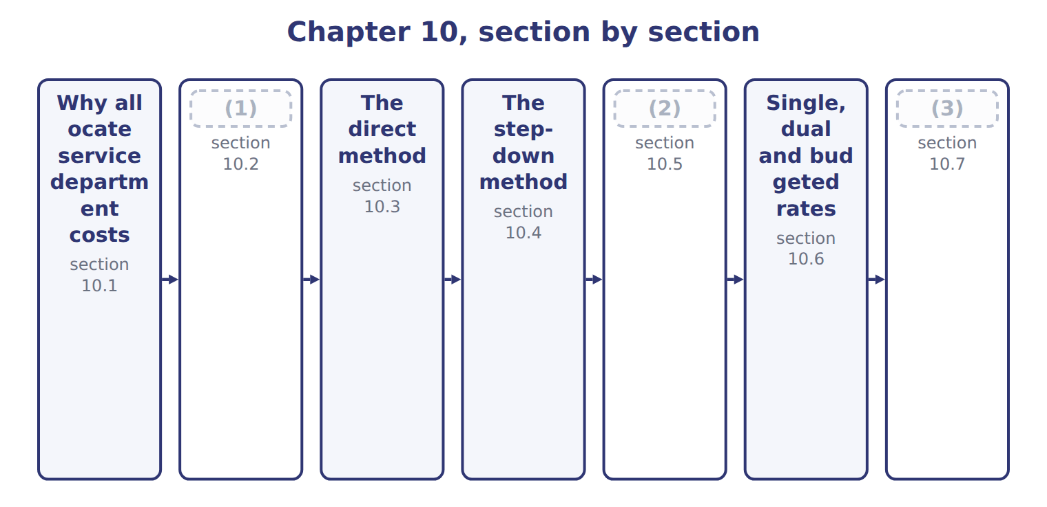
word list
The reciprocal method · Why allocate service department costs · Extended Example 10A: Orontes allocates 2027 s · Choosing allocation bases

Summary 1 gaps 4–10
A service department (4) other departments but does not make products: at Orontes these are (5) , IT, the Quality Lab and HR. A (6) department works on the products: the Oils, Tahini & Spreads and Beverages divisions. Service costs are (7) for three reasons. Products must carry their full cost for (8) and pricing. Users become (9) when a service has a price. And (10) can compare an internal service with an outside supplier. Service departments also serve each other.
word list
careful · production · managers · Beverages · allocated · inventory · Maintenance · supports

The English this sheet uses, and its Arabic
English (exam term) | Arabic
service department | مركز الخدمات
production department | مركز الإنتاج

Answer key · 10.1 Why allocate service department costs

1 Choosing allocation bases | 6 production
2 The reciprocal method | 7 allocated
3 Extended Example 10A: Orontes allocates 2027 s | 8 inventory
4 supports | 9 careful
5 Maintenance | 10 managers

the summaries in full
Summary 1 A service department supports other departments but does not make products: at Orontes these are Maintenance, IT, the Quality Lab and HR. A production department works on the products: the Oils, Tahini & Spreads and Beverages divisions. Service costs are allocated for three reasons. Products must carry their full cost for inventory and pricing. Users become careful when a service has a price. And managers can compare an internal service with an outside supplier. Service departments also serve each other.

10.2 Choosing allocation bases
Chapter 10 · section 10.2

Fill every gap. Each word list holds one word more than there are gaps.
Summary 1 gaps 1–4
The base should follow cause and effect: the (1) that makes the service (2) spend money. Maintenance is (3) on maintenance hours, the Quality Lab on test hours and HR on (4) . Where no causal base exists, managers use benefit received or ability to bear, but these are weaker.
word list
allocated · department · headcount · divisions · activity

Allocation bases for the four service departments
Service department | Allocation base | Why
Maintenance | (5) | Hours of work cause the cost
IT | Share of systems use | (6)
Quality Lab | (7) | Each test uses lab time
HR | Headcount at $200 a person | (8)

word list
Share of maintenance hours (long-run plan) · Hours of work cause the cost · Test hours at $40 an hour · Users, devices and tickets drive the cost · Hiring, payroll and training follow people

Summary 2 gaps 9–11
Quality Lab and HR serve only the (9) , so their costs go (10) to them: $400,000 at $40 a test hour and $312,000 at $200 a person. The methods below deal with (11) and IT, which serve each other.
word list
divisions · Maintenance · Quality · straight

Answer key · 10.2 Choosing allocation bases

1 activity | 7 Test hours at $40 an hour
2 department | 8 Hiring, payroll and training follow people
3 allocated | 9 divisions
4 headcount | 10 straight
5 Share of maintenance hours (long-run plan) | 11 Maintenance
6 Users, devices and tickets drive the cost

the summaries in full
Summary 1 The base should follow cause and effect: the activity that makes the service department spend money. Maintenance is allocated on maintenance hours, the Quality Lab on test hours and HR on headcount. Where no causal base exists, managers use benefit received or ability to bear, but these are weaker.
Summary 2 Quality Lab and HR serve only the divisions, so their costs go straight to them: $400,000 at $40 a test hour and $312,000 at $200 a person. The methods below deal with Maintenance and IT, which serve each other.

10.3 The direct method
Chapter 10 · section 10.3

Fill every gap. Each word list holds one word more than there are gaps.
Summary 1 gaps 1–4
The (1) method ignores the (2) that service departments give each other. Each service (3) cost is shared among the (4) departments only, in proportion to their use. It is simple and common, but it is least accurate when service departments serve each other a lot.
word list
production · direct · services · original · department's

Worked example: the direct method

Summary 2 gaps 5–6
Maintenance's shares to the (5) are 50, 20 and 10, a total of 80, so Oils (6) 50/80 of $880,000.
word list
receives · divisions · unallocated

Worked example: the direct method
The parts add up to the total; the bars are to scale.
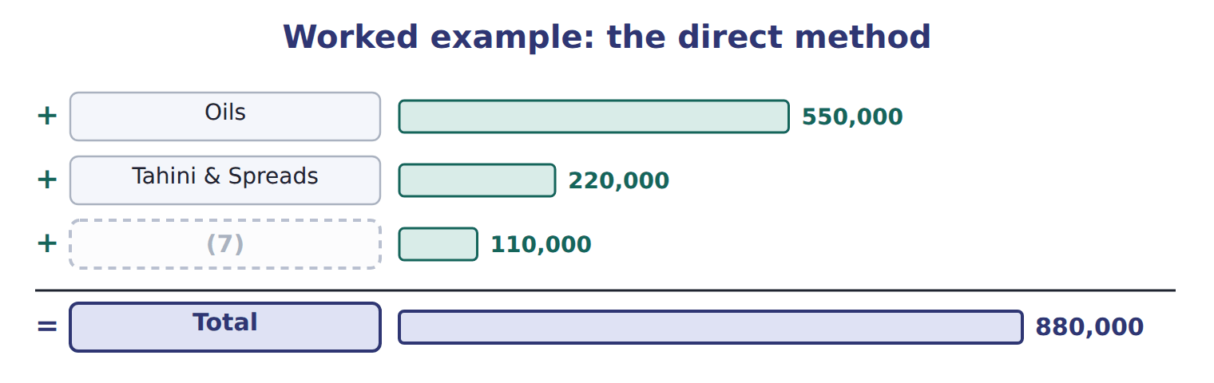
word list
budgeted rate · Beverages

Summary 3 gaps 8–9
The shares are rescaled to the production (8) only. Using the original (9) would leave part of the cost unallocated.
word list
percentages · rescaled · departments

The English this sheet uses, and its Arabic
English (exam term) | Arabic
direct method | الطريقة المباشرة

Answer key · 10.3 The direct method

1 direct | 6 receives
2 services | 7 Beverages
3 department's | 8 departments
4 production | 9 percentages
5 divisions

the summaries in full
Summary 1 The direct method ignores the services that service departments give each other. Each service department's cost is shared among the production departments only, in proportion to their use. It is simple and common, but it is least accurate when service departments serve each other a lot.
Summary 2 Maintenance's shares to the divisions are 50, 20 and 10, a total of 80, so Oils receives 50/80 of $880,000.
Summary 3 The shares are rescaled to the production departments only. Using the original percentages would leave part of the cost unallocated.

10.4 The step-down method
Chapter 10 · section 10.4

Fill every gap. Each word list holds one word more than there are gaps.
Summary 1 gaps 1–5
The step-down method recognizes some (1) links. Service departments are allocated one at a time. A department that has been allocated (2) nothing back. Start with the department that (3) other service departments the most. Orontes starts with (4) : $176,000 goes to IT, so IT's pool becomes $576,000. IT is then shared among the (5) only.
word list
receives · serves · service-to-service · Maintenance · Orontes's · divisions

The step-down method: Maintenance first, then IT
The parts add up to the total; the bars are to scale.
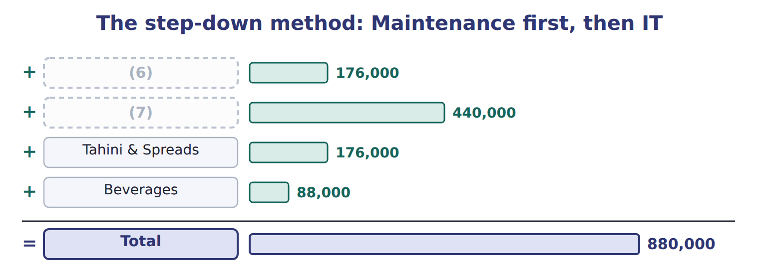
word list
IT (first receives from Maintenance) · Oils · direct method

Summary 2 gaps 8–9
Step-down is (8) policy method. It is more accurate than the direct method, but the order matters and the link from IT back to (9) is still ignored.
word list
allocates · Maintenance · Orontes's

Use the new pool

Summary 3 gaps 10–11
The second (10) allocates its own cost plus what it (11) in step 1: $576,000, not $400,000.
word list
department · received · step-down

The English this sheet uses, and its Arabic
English (exam term) | Arabic
step-down method | طريقة التوزيع التنازلي

Answer key · 10.4 The step-down method

1 service-to-service | 7 Oils
2 receives | 8 Orontes's
3 serves | 9 Maintenance
4 Maintenance | 10 department
5 divisions | 11 received
6 IT (first receives from Maintenance)

the summaries in full
Summary 1 The step-down method recognizes some service-to-service links. Service departments are allocated one at a time. A department that has been allocated receives nothing back. Start with the department that serves other service departments the most. Orontes starts with Maintenance: $176,000 goes to IT, so IT's pool becomes $576,000. IT is then shared among the divisions only.
Summary 2 Step-down is Orontes's policy method. It is more accurate than the direct method, but the order matters and the link from IT back to Maintenance is still ignored.
Summary 3 The second department allocates its own cost plus what it received in step 1: $576,000, not $400,000.

10.5 The reciprocal method
Chapter 10 · section 10.5

Fill every gap. Each word list holds one word more than there are gaps.
Summary 1 gaps 1–5
The reciprocal method recognizes all (1) links. Write one equation for each service (2) : its total cost is its own cost plus its share of the other's total. Solving the two equations gives (3) a total of $1,000,000 and IT $600,000. These totals are larger than the original costs because they include the services (4) . Each (5) then takes its share of both totals.
word list
service-to-service · exchanged · original · division · Maintenance · department

The reciprocal method: equations and allocation
Reciprocal method | Result
Maintenance equation | (6)
IT equation | I = 400,000 + 0.20 M
Substitute and solve | (7)
Oils: 50% of M + 20% of I | 620,000
Tahini & Spreads: 20% of M + 40% of I | 440,000
Beverages: 10% of M + 20% of I | 220,000
Total to divisions | 1,280,000

word list
I = 400,000 + 0.20 M · M = 880,000 + 0.20 I · M = 1,000,000; I = 600,000

It is the most accurate method but needs algebra, or matrix methods for many departments.
The English this sheet uses, and its Arabic
English (exam term) | Arabic
reciprocal method | طريقة التوزيع التبادلي

Answer key · 10.5 The reciprocal method

1 service-to-service | 5 division
2 department | 6 M = 880,000 + 0.20 I
3 Maintenance | 7 M = 1,000,000; I = 600,000
4 exchanged

the summaries in full
Summary 1 The reciprocal method recognizes all service-to-service links. Write one equation for each service department: its total cost is its own cost plus its share of the other's total. Solving the two equations gives Maintenance a total of $1,000,000 and IT $600,000. These totals are larger than the original costs because they include the services exchanged. Each division then takes its share of both totals.

10.6 Single, dual and budgeted rates
Chapter 10 · section 10.6

Fill every gap. Each word list holds one word more than there are gaps.
Summary 1 gaps 1–10
A (1) method charges one rate per hour for fixed and variable service costs (2) . When users need fewer hours than planned, the fixed cost is (3) over fewer hours, and one (4) change moves cost to the (5) . A (6) method charges variable cost on (7) use and fixed cost on the capacity each user planned for. Orontes charges Maintenance at a (8) rate of $40 per hour plus fixed shares of $560,000, so users do not pay for (9) overspending. The dual rate (10) $860,000 and left only the $12,000 spending difference in Maintenance. The single rate left $47,000, which mixes that spending difference with $35,000 of idle capacity.
word list
others · single-rate · user's · charged · difference · spread · together · dual-rate · Maintenance's · budgeted · actual

Maintenance charges: dual rate compared with single rate
Maintenance: actual cost 872,000 | Dual rate (budgeted) | Single rate ($110 per hour)
Fixed Maintenance cost | (11) | with variable cost at one rate on actual hours
Variable Maintenance cost | (12) | included in the single rate
Amount charged to users | 860,000 | 825,000
Left in Maintenance | 12,000 (spending only) | (13)

word list
actual hours × budgeted $40 · included in the single rate · on long-run capacity shares: 560,000 · 47,000 (spending 12,000 + unused capacity 35,000)

Complete the dual-rate charges

Complete the other two.
Your turn: dual-rate Maintenance charges (complete the blanks)
The bars are drawn to scale.
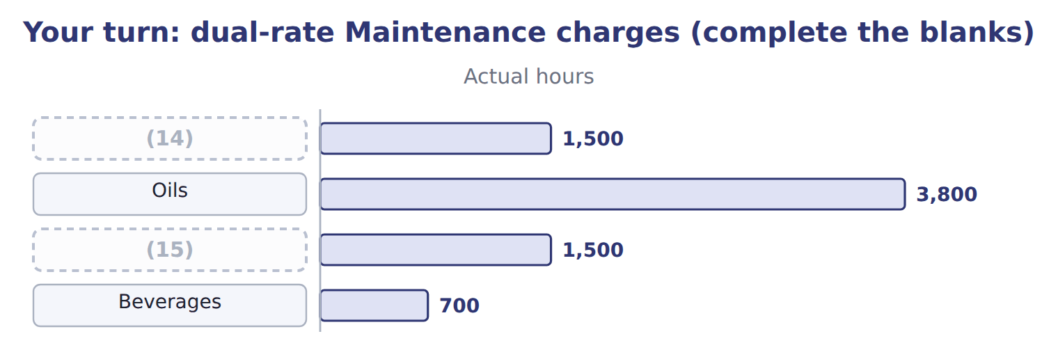
word list
IT · Tahini & Spreads · step-down method

The English this section uses, and its Arabic
Each term sits against what it means.
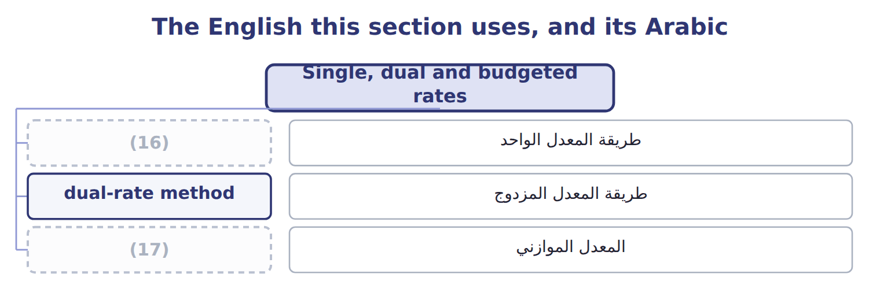
word list
step-down method · single-rate method · budgeted rate

The English this sheet uses, and its Arabic
English (exam term) | Arabic
single-rate method | طريقة المعدل الواحد
dual-rate method | طريقة المعدل المزدوج
budgeted rate | المعدل الموازني

Answer key · 10.6 Single, dual and budgeted rates

1 single-rate | 10 charged
2 together | 11 on long-run capacity shares: 560,000
3 spread | 12 actual hours × budgeted $40
4 user's | 13 47,000 (spending 12,000 + unused capacity 35,000)
5 others | 14 IT
6 dual-rate | 15 Tahini & Spreads
7 actual | 16 single-rate method
8 budgeted | 17 budgeted rate
9 Maintenance's

the summaries in full
Summary 1 A single-rate method charges one rate per hour for fixed and variable service costs together. When users need fewer hours than planned, the fixed cost is spread over fewer hours, and one user's change moves cost to the others. A dual-rate method charges variable cost on actual use and fixed cost on the capacity each user planned for. Orontes charges Maintenance at a budgeted rate of $40 per hour plus fixed shares of $560,000, so users do not pay for Maintenance's overspending. The dual rate charged $860,000 and left only the $12,000 spending difference in Maintenance. The single rate left $47,000, which mixes that spending difference with $35,000 of idle capacity.

10.7 Extended Example 10A: Orontes allocates 2027 service costs
Chapter 10 · section 10.7

Fill every gap. Each word list holds one word more than there are gaps.
Summary 1 gaps 1–10
This example (1) all four service (2) with the policy methods, records the entries and ties the result to the charges used in earlier chapters. The (3) table is exam-core; the entries are for depth. Service costs: Maintenance $880,000; IT $400,000; Quality Lab $400,000; HR $312,000; total $1,992,000. Policy: (4) for Maintenance then IT; Quality Lab on test hours; HR on (5) . Allocate Maintenance, then the (6) IT pool, then Quality Lab and HR. Record each step, check that every service (7) closes, and compare each (8) total with its monthly charge. Oils (9) $888,000, Tahini & Spreads $690,000 and (10) $414,000. Divided by twelve, these are the monthly service charges used in, 6 and 8.
word list
headcount · Beverages · allocation · departments · division's · enlarged · allocates · entries · account · step-down · receives

Extended Example: 2027 service allocation by division
The parts add up to the total; the bars are to scale.
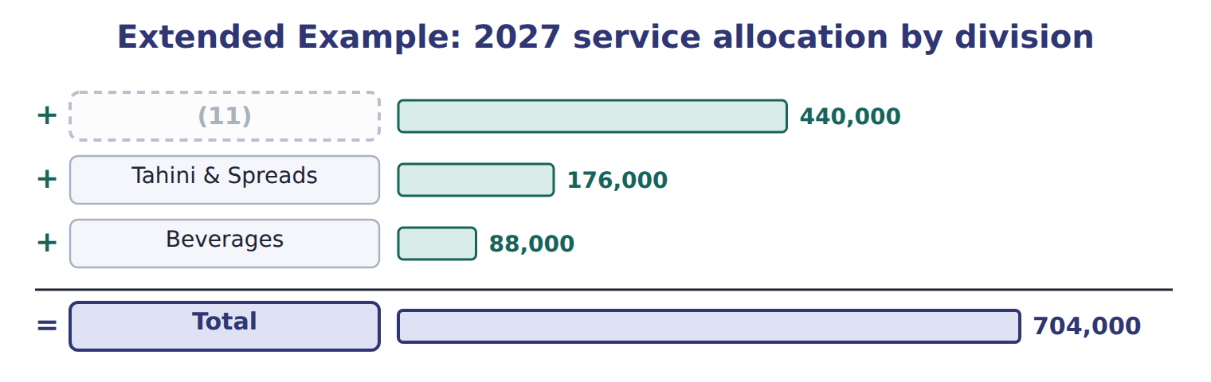
word list
Beverages · Oils

The journal totals $4,160,000 on each side.

Extended Example: service allocation journal, 2027
No. | Account (detail) | Debit | Credit
1 | (12) | 880,000
 | (13) | 400,000
 | Quality Lab | 400,000
 | (14) | 312,000
 | (15) |  | 1,992,000
2 | IT Department | 176,000
 | MOH Control - Oils | 440,000
 | MOH Control - Tahini | 176,000
 | MOH Control - Beverages | 88,000
 | Maintenance Department |  | 880,000
3 | MOH Control - Oils | 144,000
 | (16) | 288,000
 | MOH Control - Beverages | 144,000
 | IT Department |  | 576,000
4 | MOH Control - Oils | 200,000
 | MOH Control - Tahini | 104,000
 | MOH Control - Beverages | 96,000
 | (17) |  | 400,000
5 | (18) | 104,000
 | MOH Control - Tahini | 122,000
 | (19) | 86,000
 | HR Department |  | 312,000
 | (20) | 4,160,000 | 4,160,000

word list
Quality Lab · Various accounts · MOH Control - Beverages · MOH Control - Tahini · HR Department · step-down method · Totals · Maintenance Department · IT Department · MOH Control - Oils

Every service department account closes to zero, and each division's overhead account holds its share.
Everything ties

Summary 2 gaps 21–22
Allocated: $888,000 + $690,000 + $414,000 = $1,992,000, all (21) cost. IT pool: $400,000 + $176,000 from (22) = $576,000. Tahini: $690,000 is twelve months of the charge in the.
word list
Divided · Maintenance · service

Exam view

Summary 3 gaps 23–25
Expect two service and two production departments with (23) . For the direct method, (24) to production departments. For (25) , use the enlarged pool. For the reciprocal method, write the two equations and solve before allocating.
word list
percentages · rescale · step-down · Quality

Exam view
Levant Distribution · FY2027 | Cost | To IT | To Fleet | To Warehouse | To Delivery
Fleet Maintenance (S1) | 216,000 | 20% | — | 40% | 40%
(26) | 120,000 | — | 20% | 50% | 30%

word list
IT (S2) · step-down method

Item — Answer
Item | Answer
Tahini & Spreads | (27)
Beverages | Variable 28,000; total 84,000

word list
Levant Distribution · FY2027 · Variable 60,000; total 172,000

Department — Category
Every item belongs to exactly one group.
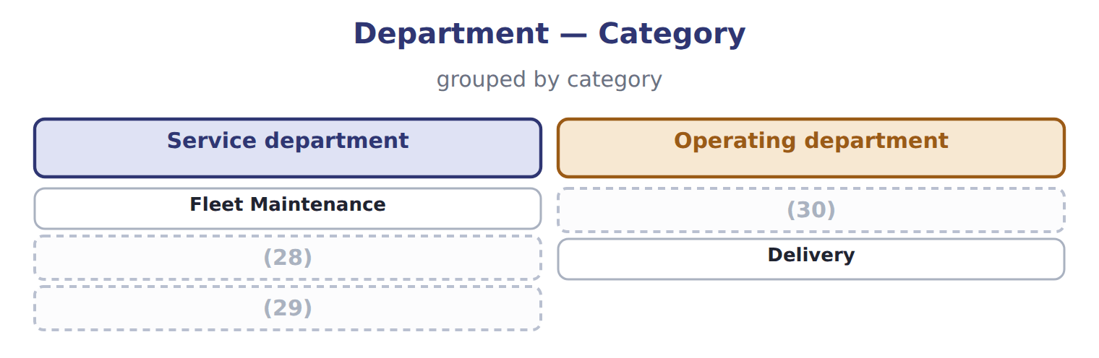
word list
Warehouse · Payroll office · IT · dual-rate method

The English this section uses, and its Arabic
Each term sits against what it means.
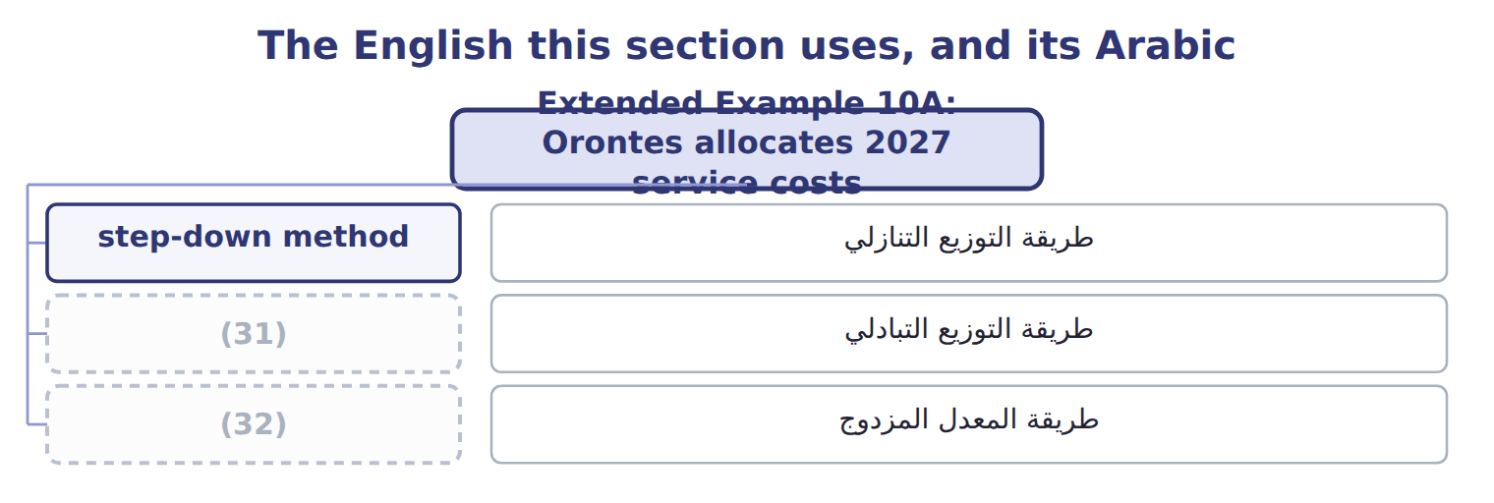
word list
dual-rate method · direct method · reciprocal method

The English this sheet uses, and its Arabic
English (exam term) | Arabic
step-down method | طريقة التوزيع التنازلي
reciprocal method | طريقة التوزيع التبادلي
dual-rate method | طريقة المعدل المزدوج

Answer key · 10.7 Extended Example 10A: Orontes allocates 2027 service costs

1 allocates | 17 Quality Lab
2 departments | 18 MOH Control - Oils
3 allocation | 19 MOH Control - Beverages
4 step-down | 20 Totals
5 headcount | 21 service
6 enlarged | 22 Maintenance
7 account | 23 percentages
8 division's | 24 rescale
9 receives | 25 step-down
10 Beverages | 26 IT (S2)
11 Oils | 27 Variable 60,000; total 172,000
12 Maintenance Department | 28 IT
13 IT Department | 29 Payroll office
14 HR Department | 30 Warehouse
15 Various accounts | 31 reciprocal method
16 MOH Control - Tahini | 32 dual-rate method

the summaries in full
Summary 1 This example allocates all four service departments with the policy methods, records the entries and ties the result to the charges used in earlier chapters. The allocation table is exam-core; the entries are for depth. Service costs: Maintenance $880,000; IT $400,000; Quality Lab $400,000; HR $312,000; total $1,992,000. Policy: step-down for Maintenance then IT; Quality Lab on test hours; HR on headcount. Allocate Maintenance, then the enlarged IT pool, then Quality Lab and HR. Record each step, check that every service account closes, and compare each division's total with its monthly charge. Oils receives $888,000, Tahini & Spreads $690,000 and Beverages $414,000. Divided by twelve, these are the monthly service charges used in, 6 and 8.
Summary 2 Allocated: $888,000 + $690,000 + $414,000 = $1,992,000, all service cost. IT pool: $400,000 + $176,000 from Maintenance = $576,000. Tahini: $690,000 is twelve months of the charge in the.
Summary 3 Expect two service and two production departments with percentages. For the direct method, rescale to production departments. For step-down, use the enlarged pool. For the reciprocal method, write the two equations and solve before allocating.

11.1 Joint products, by-products and scrap
Chapter 11 · section 11.1

Fill every gap. Each word list holds one word more than there are gaps.
Chapter 11, section by section
Each stage leads to the next.
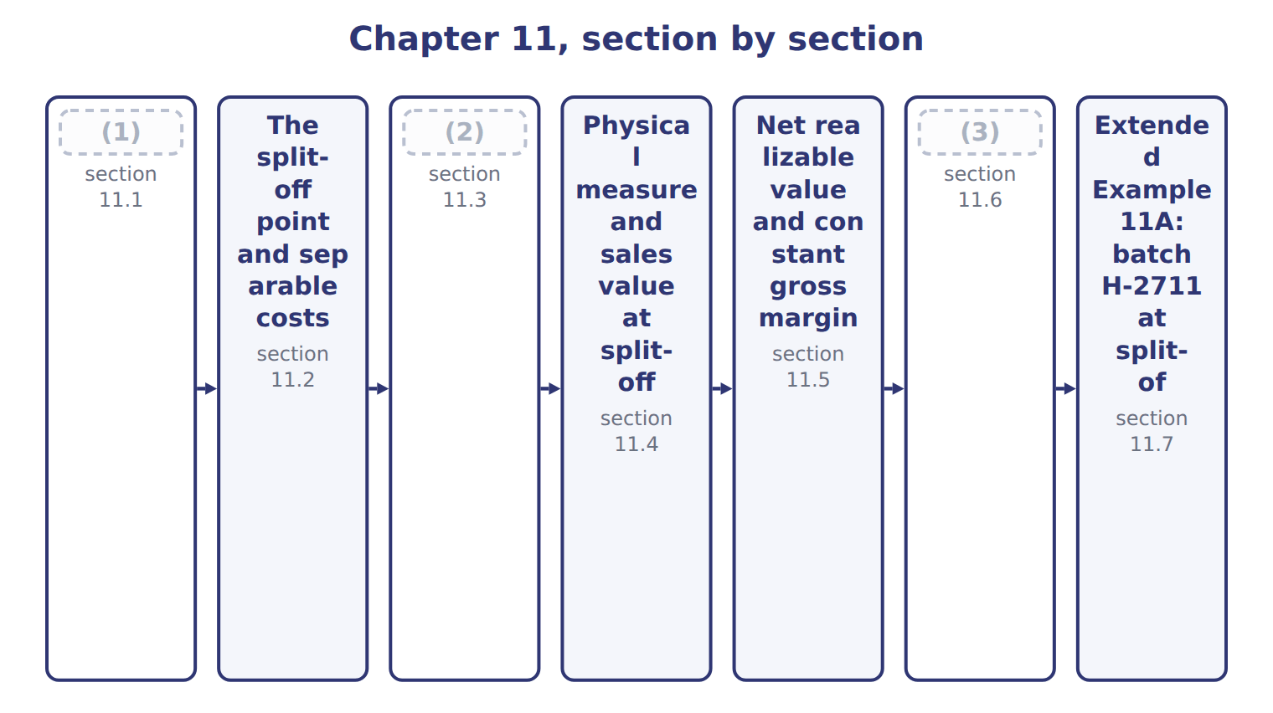
word list
sales method (by-products) · Accounting for by-products · Joint products, by-products and scrap · Benefits, limitations and further processing

Summary 1 gaps 4–8
Joint products are two or more products from the same process, each with (4) sales value. (5) oil (EVOO) and virgin oil (VOO) are joint products: the press runs to make both. A by-product comes from the same process but has a small sales value (6) with the joint products. (7) , the olive cake left after (8) , is a by-product. Scrap has even less value.
word list
sharply · pressing · Extra-virgin · compared · significant · Pomace

Joint products, by-products and scrap
Output | Test | Oils example | Accounting
Joint product | Significant sales value; a main reason to run the process | EVOO and VOO | (9)
By-product | (10) | Pomace (olive cake) | NRV reduces joint cost, or income when sold
Scrap | Very small value; often sold for a token amount | (11) | Credit to overhead or income

word list
Small sales value compared with the joint products · Share of joint cost · Filter residue · split-off point

Summary 2 gaps 12–13
The test is (12) value, and it can change. If pomace prices rose (13) , Orontes might treat it as a joint product and give it a share of joint cost.
word list
by-product · relative · sharply

The English this sheet uses, and its Arabic
English (exam term) | Arabic
joint products | المنتجات المشتركة
by-product | المنتج العرضي

Answer key · 11.1 Joint products, by-products and scrap

1 Joint products, by-products and scrap | 8 pressing
2 Accounting for by-products | 9 Share of joint cost
3 Benefits, limitations and further processing | 10 Small sales value compared with the joint products
4 significant | 11 Filter residue
5 Extra-virgin | 12 relative
6 compared | 13 sharply
7 Pomace

the summaries in full
Summary 1 Joint products are two or more products from the same process, each with significant sales value. Extra-virgin oil (EVOO) and virgin oil (VOO) are joint products: the press runs to make both. A by-product comes from the same process but has a small sales value compared with the joint products. Pomace, the olive cake left after pressing, is a by-product. Scrap has even less value.
Summary 2 The test is relative value, and it can change. If pomace prices rose sharply, Orontes might treat it as a joint product and give it a share of joint cost.

11.2 The split-off point and separable costs
Chapter 11 · section 11.2

Fill every gap. Each word list holds one word more than there are gaps.
Summary 1 gaps 1–7
The split-off point is where the joint products become separately (1) . All costs before it are joint costs: olives, crushing labor and crushing (2) , $1,400,000 for the batch. Costs after split-off that (3) to one product are separable costs. Bottling adds $468,000 to EVOO and (4) adds $32,000 to VOO. Joint costs cannot be traced to one product, however hard (5) try. Any split is an (6) . Separable costs can be traced, and they matter for every later (7) .
word list
by-product · belong · managers · filtering · overhead · identifiable · decision · allocation

The English this section uses, and its Arabic
Each term sits against what it means.
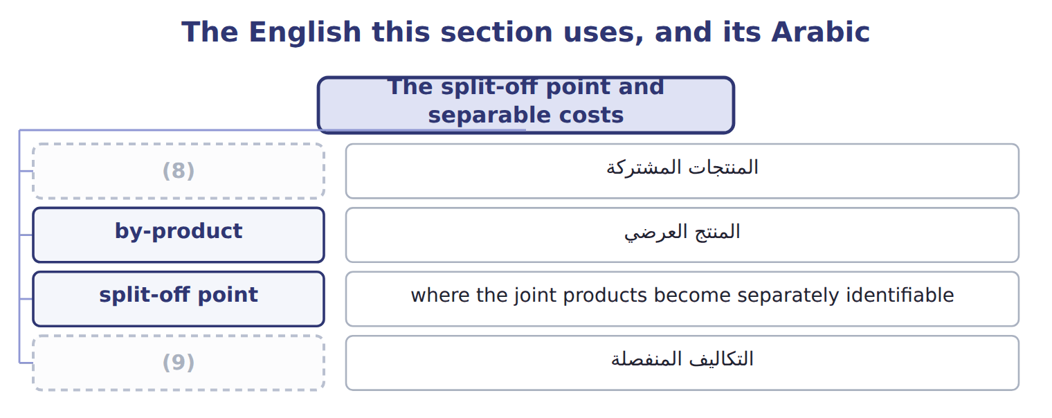
word list
sell-or-process-further decision · joint products · separable costs

The English this sheet uses, and its Arabic
English (exam term) | Arabic
split-off point | نقطة الانفصال
separable costs | التكاليف المنفصلة

Answer key · 11.2 The split-off point and separable costs

1 identifiable | 6 allocation
2 overhead | 7 decision
3 belong | 8 joint products
4 filtering | 9 separable costs
5 managers

the summaries in full
Summary 1 The split-off point is where the joint products become separately identifiable. All costs before it are joint costs: olives, crushing labor and crushing overhead, $1,400,000 for the batch. Costs after split-off that belong to one product are separable costs. Bottling adds $468,000 to EVOO and filtering adds $32,000 to VOO. Joint costs cannot be traced to one product, however hard managers try. Any split is an allocation. Separable costs can be traced, and they matter for every later decision.

11.3 Accounting for by-products
Chapter 11 · section 11.3

Fill every gap. Each word list holds one word more than there are gaps.
Summary 1 gaps 1–8
Under the production method, the by-product's net (1) value is recorded as (2) at split-off and deducted from joint cost. (3) sells for $120,000 with $20,000 of (4) costs, so its NRV is $100,000 and the joint products share $1,300,000. Under the sales method, (5) is recorded at split-off. The joint products share the full $1,400,000, and the by-product's net (6) is other income when it is sold. Over time both (7) give the same total income. The production method (8) the by-product's value with the batch; the sales method is simpler. Orontes uses the production method.
word list
matches · realizable · nothing · revenue · recorded · Pomace · inventory · disposal · methods

Sous-produit

Do not translate 'by-product' as 'secondary product' in an exam answer: the accounting is different.
By-products: production method and sales method
 | Production method | Sales method
When is value recorded? | (9) | When the by-product is sold
Joint cost to allocate | (10) | 1,400,000
Where does the value go? | (11) | Other income in the period of sale
Main benefit | Matches the by-product's value to the batch | (12)

word list
Lower cost of the joint products · sales value at split-off method · 1,400,000 − 100,000 = 1,300,000 · Simple; no inventory to track · At split-off, as inventory at NRV

The English this sheet uses, and its Arabic
English (exam term) | Arabic
production method (by-products) | طريقة الإنتاج للمنتجات العرضية
sales method (by-products) | طريقة المبيعات للمنتجات العرضية

Answer key · 11.3 Accounting for by-products

1 realizable | 7 methods
2 inventory | 8 matches
3 Pomace | 9 At split-off, as inventory at NRV
4 disposal | 10 1,400,000 − 100,000 = 1,300,000
5 nothing | 11 Lower cost of the joint products
6 revenue | 12 Simple; no inventory to track

the summaries in full
Summary 1 Under the production method, the by-product's net realizable value is recorded as inventory at split-off and deducted from joint cost. Pomace sells for $120,000 with $20,000 of disposal costs, so its NRV is $100,000 and the joint products share $1,300,000. Under the sales method, nothing is recorded at split-off. The joint products share the full $1,400,000, and the by-product's net revenue is other income when it is sold. Over time both methods give the same total income. The production method matches the by-product's value with the batch; the sales method is simpler. Orontes uses the production method.

11.4 Physical measure and sales value at split-off
Chapter 11 · section 11.4

Fill every gap. Each word list holds one word more than there are gaps.
Summary 1 gaps 1–4
The physical measure method shares joint cost in (1) to a physical (2) , such as liters. It is (3) and needs no (4) . But it ignores value: a liter of VOO takes the same share as a liter of EVOO, which sells for much more.
word list
quantity · prices · simple · proportion · follows

Worked example: physical measure

EVOO is 130,000 of the 200,000 liters, or 65%.
Worked example: physical measure method
Physical measure method | Liters | Share | Joint cost allocated
EVOO | 130,000 | 65% | 845,000
(5) | 70,000 | 35% | 455,000
(6) | 200,000 | 100% | 1,300,000

word list
Calculation · Total · VOO

Summary 2 gaps 7–9
The sales value at split-off (7) shares joint cost in (8) to each product's market value at split-off. It (9) the idea that costs are shared by ability to bear them. It needs a market price at split-off, which not every product has.
word list
follows · method · ability · proportion

Sales value at split-off

Share the net joint cost of $1,300,000.
Your turn: sales value at split-off (complete the blanks)
Sales value at split-off | Calculation | Sales value | Joint cost allocated
EVOO | (10) | 1,352,000 | ________
VOO | 70,000 × $3.90 | 273,000 | ________
Total |  | 1,625,000 | 1,300,000

word list
Joint cost allocated · 130,000 × $10.40

The English this sheet uses, and its Arabic
English (exam term) | Arabic
physical measure method | طريقة المقياس المادي
sales value at split-off method | طريقة القيمة البيعية عند نقطة الانفصال

Answer key · 11.4 Physical measure and sales value at split-off

1 proportion | 6 Total
2 quantity | 7 method
3 simple | 8 proportion
4 prices | 9 follows
5 VOO | 10 130,000 × $10.40

the summaries in full
Summary 1 The physical measure method shares joint cost in proportion to a physical quantity, such as liters. It is simple and needs no prices. But it ignores value: a liter of VOO takes the same share as a liter of EVOO, which sells for much more.
Summary 2 The sales value at split-off method shares joint cost in proportion to each product's market value at split-off. It follows the idea that costs are shared by ability to bear them. It needs a market price at split-off, which not every product has.

11.5 Net realizable value and constant gross margin
Chapter 11 · section 11.5

Fill every gap. Each word list holds one word more than there are gaps.
Summary 1 gaps 1–5
The net (1) value method uses each (2) final sales value minus its separable costs. It works when there is no market price at (3) . It is (4) policy method. The constant (5) percentage method first finds the gross margin of the whole batch, 28%. It then gives each product the joint cost that makes its own margin the same 28%.
word list
split-off · product's · gross-margin · constant · realizable · Orontes's

NRV and constant gross-margin methods, step by step
The bars are drawn to scale.
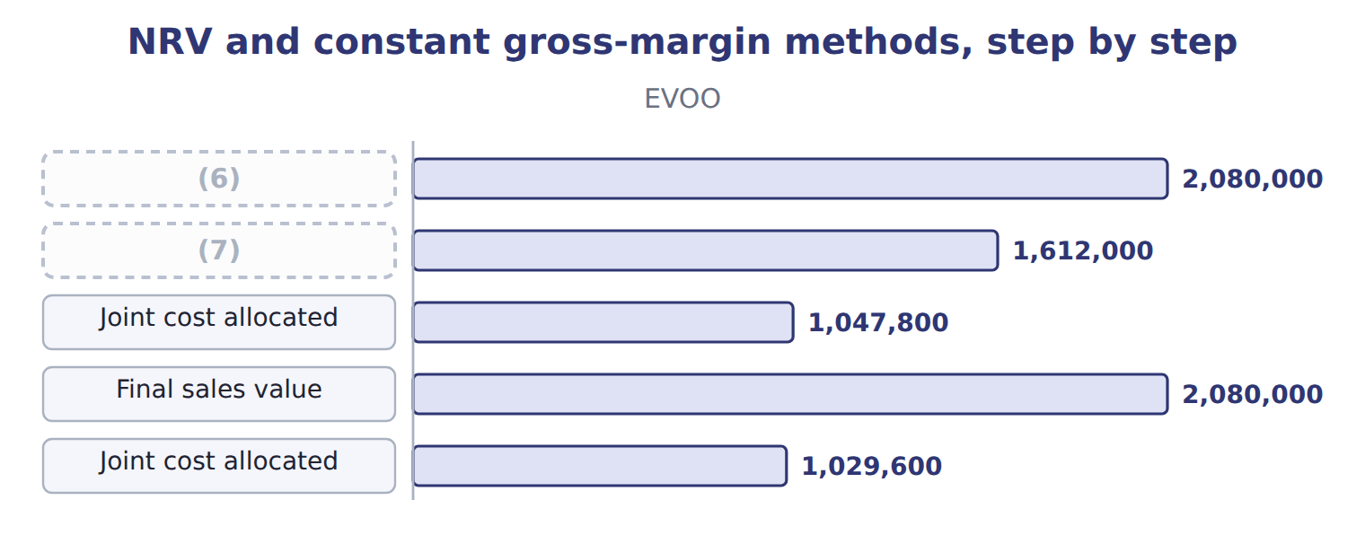
word list
NRV at split-off · sales method (by-products) · Final sales value

Each shares the same $1,300,000; they differ only in how much each product carries.
Final sales value, not NRV

Summary 2 gaps 8–9
In the constant (8) method, apply the margin to final sales value, then deduct separable costs. (9) it to NRV gives the wrong joint cost.
word list
gross-margin · Applying · product's

The English this section uses, and its Arabic
Each term sits against what it means.
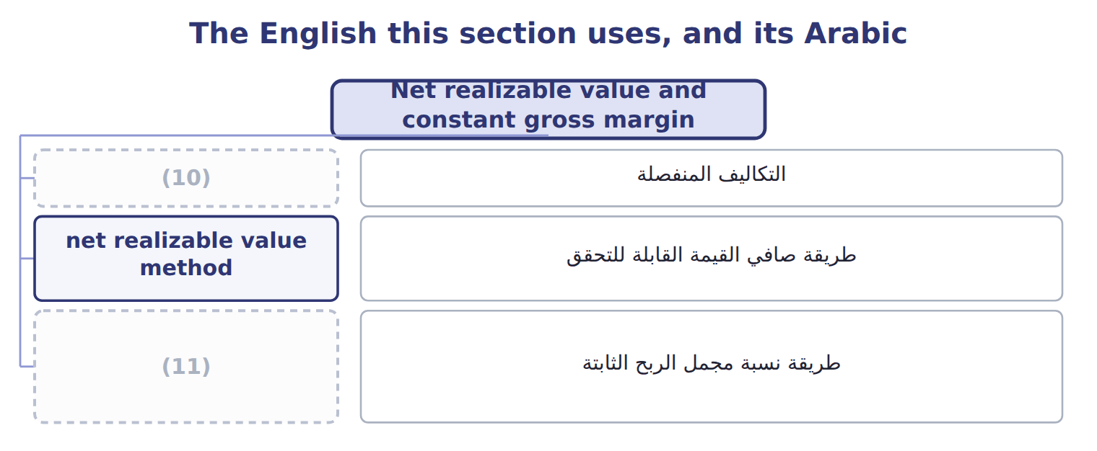
word list
physical measure method · constant gross-margin percentage method · separable costs

The English this sheet uses, and its Arabic
English (exam term) | Arabic
net realizable value method | طريقة صافي القيمة القابلة للتحقق
constant gross-margin percentage method | طريقة نسبة مجمل الربح الثابتة

Answer key · 11.5 Net realizable value and constant gross margin

1 realizable | 7 NRV at split-off
2 product's | 8 gross-margin
3 split-off | 9 Applying
4 Orontes's | 10 separable costs
5 gross-margin | 11 constant gross-margin percentage method
6 Final sales value

the summaries in full
Summary 1 The net realizable value method uses each product's final sales value minus its separable costs. It works when there is no market price at split-off. It is Orontes's policy method. The constant gross-margin percentage method first finds the gross margin of the whole batch, 28%. It then gives each product the joint cost that makes its own margin the same 28%.
Summary 2 In the constant gross-margin method, apply the margin to final sales value, then deduct separable costs. Applying it to NRV gives the wrong joint cost.

11.6 Benefits, limitations and further processing
Chapter 11 · section 11.6

Fill every gap. Each word list holds one word more than there are gaps.
Each method changes reported product margins.
Product gross margins under each method
The bars are drawn to scale.
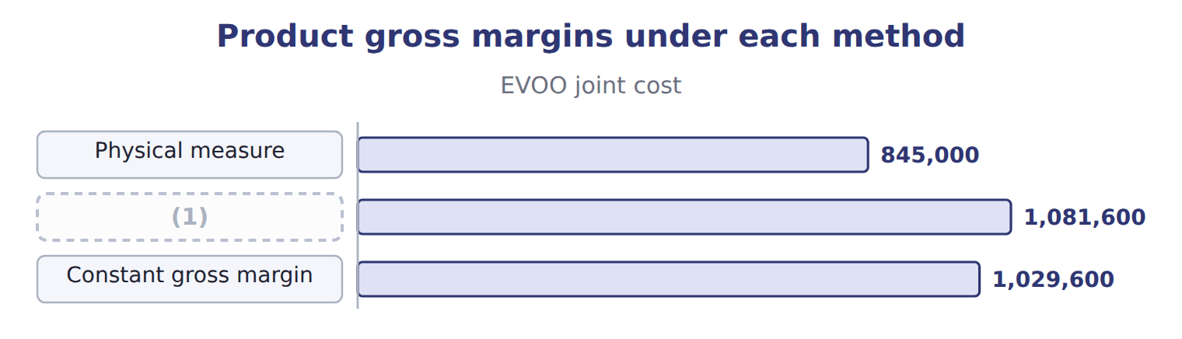
word list
net realizable value method · Sales value at split-off

Summary 1 gaps 2–8
The (2) measure method is simple but (3) value. Sales value at split-off is fair and simple but needs split-off prices. NRV works (4) split-off prices but depends on (5) of separable costs. (6) gross margin gives every product the same margin, which may hide real (7) . No (8) should drive a decision to sell at split-off or process further. That decision compares the extra revenue with the separable cost only; the joint cost is the same either way.
word list
estimates · without · Constant · allocation · separable · ignores · differences · physical

Sell at split-off or process further?
Sell at split-off or process further? | EVOO: bottle | VOO: filter
Sales value if processed further | 2,080,000 | 420,000
(9) | (1,352,000) | (273,000)
Incremental revenue | 728,000 | 147,000
(10) | (468,000) | (32,000)
(11) | 260,000 | 115,000
Joint cost | irrelevant | irrelevant

word list
Separable (incremental) cost · Sales value at split-off · physical measure method · Gain from processing further

The English this section uses, and its Arabic
Each term sits against what it means.
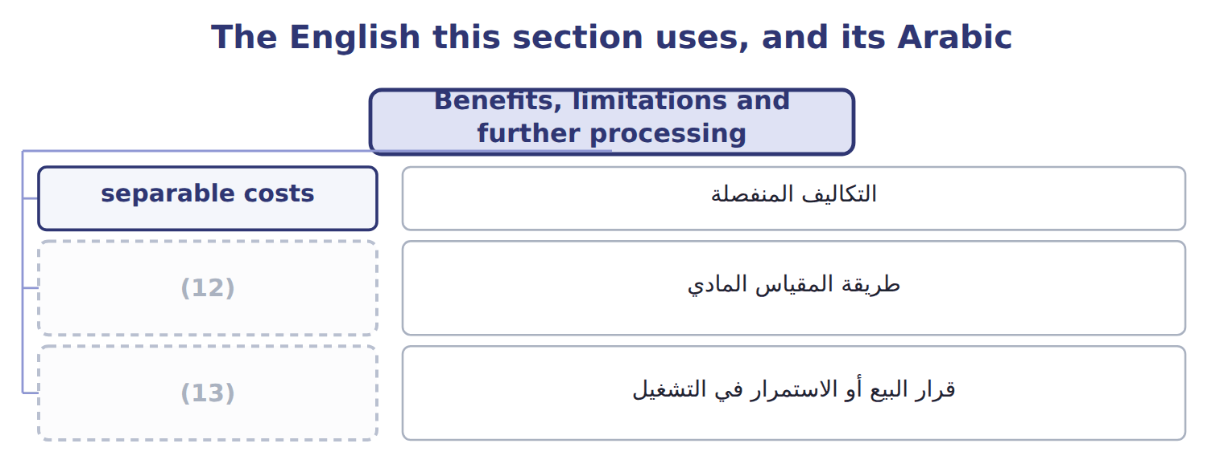
word list
sell-or-process-further decision · physical measure method · طريقة المقياس المادي

The English this sheet uses, and its Arabic
English (exam term) | Arabic
sell-or-process-further decision | قرار البيع أو الاستمرار في التشغيل

Answer key · 11.6 Benefits, limitations and further processing

1 Sales value at split-off | 8 allocation
2 physical | 9 Sales value at split-off
3 ignores | 10 Separable (incremental) cost
4 without | 11 Gain from processing further
5 estimates | 12 physical measure method
6 Constant | 13 sell-or-process-further decision
7 differences

the summaries in full
Summary 1 The physical measure method is simple but ignores value. Sales value at split-off is fair and simple but needs split-off prices. NRV works without split-off prices but depends on estimates of separable costs. Constant gross margin gives every product the same margin, which may hide real differences. No allocation should drive a decision to sell at split-off or process further. That decision compares the extra revenue with the separable cost only; the joint cost is the same either way.

11.7 Extended Example 11A: batch H-2711 at split-off
Chapter 11 · section 11.7

Fill every gap. Each word list holds one word more than there are gaps.
Summary 1 gaps 1–10
This example records the split-off of batch H-2711 twice, once for each (1) method, and (2) the results. The (3) are exam-core; the (4) are for depth. (5) : EVOO 130,000 liters; VOO 70,000 liters; pomace 400,000 kg at $0.30, with $20,000 of (6) costs. (7) : NRV method for the joint (8) ; production method for pomace. Record the joint cost, split it at split-off under the production method, record the pomace sale, then (9) with the sales method and compare. Production method: net joint cost $1,300,000; EVOO $1,047,800; VOO $252,200. EVOO per liter: $1,047,800 ÷ 130,000 = $8.06, the (10) cost used. Sales method: joint cost $1,400,000 on the same NRVs; EVOO $1,128,400; VOO $271,600.
word list
disposal · entries · products · transferred-in · Outputs · by-product · Policy · allocations · repeat · results · compares

Extended Example: production method journal
No. | Account (detail) | Debit | Credit
1 | WIP - Crushing | 1,400,000
 | (11) |  | 1,000,000
 | (12) |  | 120,000
 | Manufacturing Overhead Applied |  | 280,000
2 | (13) | 100,000
 | WIP - Bottling | 1,047,800
 | Finished Goods - VOO | 252,200
 | (14) |  | 1,400,000
3 | (15) | 120,000
 | Pomace (By-product) Inventory |  | 100,000
 | Cash |  | 20,000
 | (16) | 2,920,000 | 2,920,000

word list
Accounts Receivable · Cash · Pomace (By-product) Inventory · Totals · Raw Materials Inventory · WIP - Crushing · Wages Payable

Extended Example: sales method journal
No. | Account (detail) | Debit | Credit
1 | WIP - Crushing | 1,400,000
 | (17) |  | 1,000,000
 | Wages Payable |  | 120,000
 | (18) |  | 280,000
2 | (19) | 1,128,400
 | Finished Goods - VOO | 271,600
 | WIP - Crushing |  | 1,400,000
3 | Accounts Receivable | 120,000
 | (20) |  | 20,000
 | (21) |  | 100,000
 | Totals | 2,920,000 | 2,920,000

word list
Raw Materials Inventory · WIP - Bottling · Other Income - By-product · physical measure method · Manufacturing Overhead Applied · Cash

Summary 2 gaps 22–23
The joint (22) carry $100,000 more cost under the sales (23) , and pomace adds the same $100,000 to other income. Total income over time is the same.
word list
volumes · products · method

Extended Example: the two by-product methods compared
Batch H-2711, NRV method | Production method | Sales method
Joint cost allocated to EVOO | 1,047,800 | 1,128,400
(24) | 252,200 | 271,600
Pomace inventory at split-off | 100,000 | none
(25) | none | 100,000
(26) | the same | the same

word list
Total effect on income over time · Joint cost allocated to VOO · Other income when pomace is sold · Joint cost allocated to EVOO

Everything ties

Production method: $100,000 + $1,047,800 + $252,200 = $1,400,000. Sales method: $1,128,400 + $271,600 = $1,400,000. Batch margin: sales $2,500,000 − costs $1,800,000 = $700,000, or 28%.
Exam view

Summary 3 gaps 27–30
Expect a joint cost, two or three (27) with volumes and prices, and (28) a by-product. (29) the by-product NRV first if the (30) method is used. Then build the base for the method asked, and never include joint costs in a process-further decision.
word list
sometimes · Deduct · production · products · disposal

Exam view
Tahini & Spreads · sesame processing · FY2027 | Data
Joint cost of sesame processing | 500,000
Tahini base: 60,000 kg | $6.00/kg at split-off; $8.00/kg as jarred tahini after 60,000 of further cost
Sesame oil: 20,000 liters | (31)
Sesame hulls: 50,000 kg | $0.20/kg; no disposal cost; production method

word list
$7.00/liter at split-off; sold at split-off · Other income when pomace is sold

Item — Answer
Item | Answer
EVOO | (32)
VOO | 273,000 ÷ 1,625,000 × 1,300,000 = 218,400

word list
Floor sweepings sold for a few dollars · 1,352,000 ÷ 1,625,000 × 1,300,000 = 1,081,600

Output — Category
Every item belongs to exactly one group.
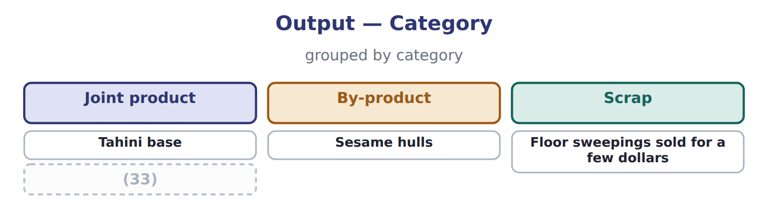
word list
Sesame oil · sell-or-process-further decision

The English this section uses, and its Arabic
Each term sits against what it means.
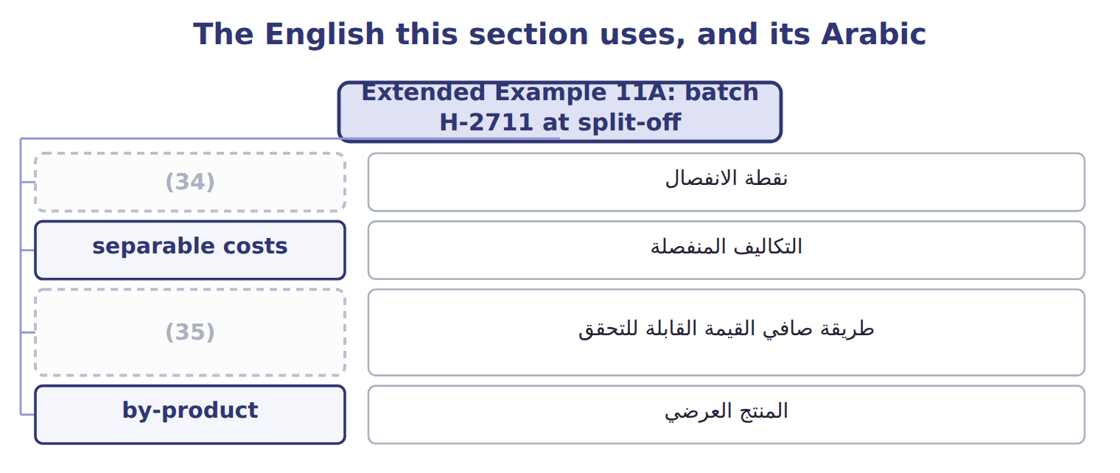
word list
sales method (by-products) · split-off point · net realizable value method

The English this sheet uses, and its Arabic
English (exam term) | Arabic
split-off point | نقطة الانفصال
separable costs | التكاليف المنفصلة
net realizable value method | طريقة صافي القيمة القابلة للتحقق
by-product | المنتج العرضي

Answer key · 11.7 Extended Example 11A: batch H-2711 at split-off

1 by-product | 19 WIP - Bottling
2 compares | 20 Cash
3 allocations | 21 Other Income - By-product
4 entries | 22 products
5 Outputs | 23 method
6 disposal | 24 Joint cost allocated to VOO
7 Policy | 25 Other income when pomace is sold
8 products | 26 Total effect on income over time
9 repeat | 27 products
10 transferred-in | 28 sometimes
11 Raw Materials Inventory | 29 Deduct
12 Wages Payable | 30 production
13 Pomace (By-product) Inventory | 31 $7.00/liter at split-off; sold at split-off
14 WIP - Crushing | 32 1,352,000 ÷ 1,625,000 × 1,300,000 = 1,081,600
15 Accounts Receivable | 33 Sesame oil
16 Totals | 34 split-off point
17 Raw Materials Inventory | 35 net realizable value method
18 Manufacturing Overhead Applied

the summaries in full
Summary 1 This example records the split-off of batch H-2711 twice, once for each by-product method, and compares the results. The allocations are exam-core; the entries are for depth. Outputs: EVOO 130,000 liters; VOO 70,000 liters; pomace 400,000 kg at $0.30, with $20,000 of disposal costs. Policy: NRV method for the joint products; production method for pomace. Record the joint cost, split it at split-off under the production method, record the pomace sale, then repeat with the sales method and compare. Production method: net joint cost $1,300,000; EVOO $1,047,800; VOO $252,200. EVOO per liter: $1,047,800 ÷ 130,000 = $8.06, the transferred-in cost used. Sales method: joint cost $1,400,000 on the same NRVs; EVOO $1,128,400; VOO $271,600.
Summary 2 The joint products carry $100,000 more cost under the sales method, and pomace adds the same $100,000 to other income. Total income over time is the same.
Summary 3 Expect a joint cost, two or three products with volumes and prices, and sometimes a by-product. Deduct the by-product NRV first if the production method is used. Then build the base for the method asked, and never include joint costs in a process-further decision.

12.1 Why one overhead rate can mislead
Chapter 12 · section 12.1

Fill every gap. Each word list holds one word more than there are gaps.
Chapter 12, section by section
Each stage leads to the next.
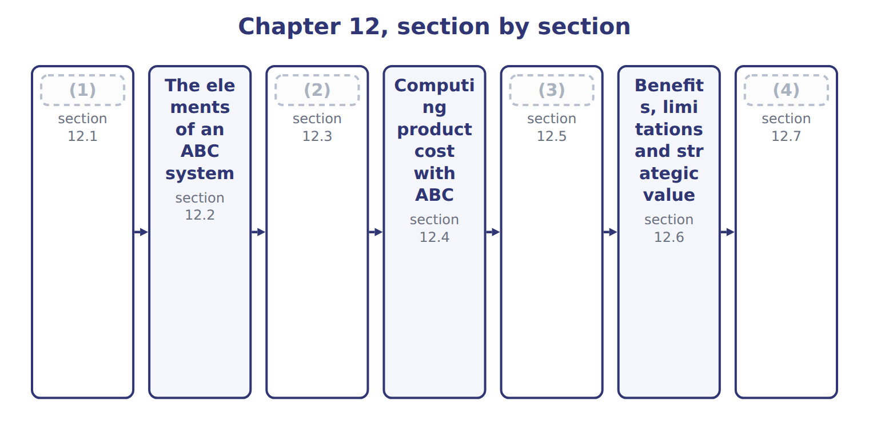
word list
Extended Example 12A: Pulses & Spices in 2027 · ABC as a cost accumulation system · The cost hierarchy · Benefits, limitations and strategic value · Why one overhead rate can mislead

Summary 1 gaps 5–13
A (5) system collects overhead in one pool and (6) it with one volume measure, such as direct labor hours. That works when every product uses overhead in the same way as it uses labor. (7) & Spices has $900,000 of overhead. At $36 a labor hour, (8) receive $720,000 (9) they use most of the labor. Za'atar (10) $180,000, although its many small batches need most of the setups, tests and (11) . The result is cost (12) . (13) , simple products are overcosted, and low-volume, complex products are undercosted. Prices and product decisions based on these costs go wrong.
word list
traditional · spreads · lentils · receipts · receives · because · whether · High-volume · distortion · Pulses

Volume drivers for batch costs

Summary 2 gaps 14–15
A setup costs the same (14) the batch is large or small. If an exam (15) spreads setup costs by units or labor hours, the answer will overcost the large batches.
word list
whether · question · High-volume

Answer key · 12.1 Why one overhead rate can mislead

1 Why one overhead rate can mislead | 9 because
2 The cost hierarchy | 10 receives
3 ABC as a cost accumulation system | 11 receipts
4 Extended Example 12A: Pulses & Spices in 2027 | 12 distortion
5 traditional | 13 High-volume
6 spreads | 14 whether
7 Pulses | 15 question
8 lentils

the summaries in full
Summary 1 A traditional system collects overhead in one pool and spreads it with one volume measure, such as direct labor hours. That works when every product uses overhead in the same way as it uses labor. Pulses & Spices has $900,000 of overhead. At $36 a labor hour, lentils receive $720,000 because they use most of the labor. Za'atar receives $180,000, although its many small batches need most of the setups, tests and receipts. The result is cost distortion. High-volume, simple products are overcosted, and low-volume, complex products are undercosted. Prices and product decisions based on these costs go wrong.
Summary 2 A setup costs the same whether the batch is large or small. If an exam question spreads setup costs by units or labor hours, the answer will overcost the large batches.

12.2 The elements of an ABC system
Chapter 12 · section 12.2

Fill every gap. Each word list holds one word more than there are gaps.
Summary 1 gaps 1–9
An activity is a task that uses (1) , such as a setup or a (2) test. Each activity has an activity cost pool: the total cost of doing it. (3) costing assigns (4) to these pools first and then to products. The first stage uses resource drivers, such as the share of staff time spent on each activity. The (5) stage uses activity drivers, such as the number of setups each (6) needs. Both are cost drivers: they (7) what causes the cost. (8) labor of $360,000 is split by time studies; the $100,000 (9) lease from Book 1 goes to the facility pool.
word list
quality · measure · product · Activity-based · resources · studies · second · Indirect · warehouse · overhead

Resource drivers: filling the five activity pools
The parts add up to the total; the bars are to scale.
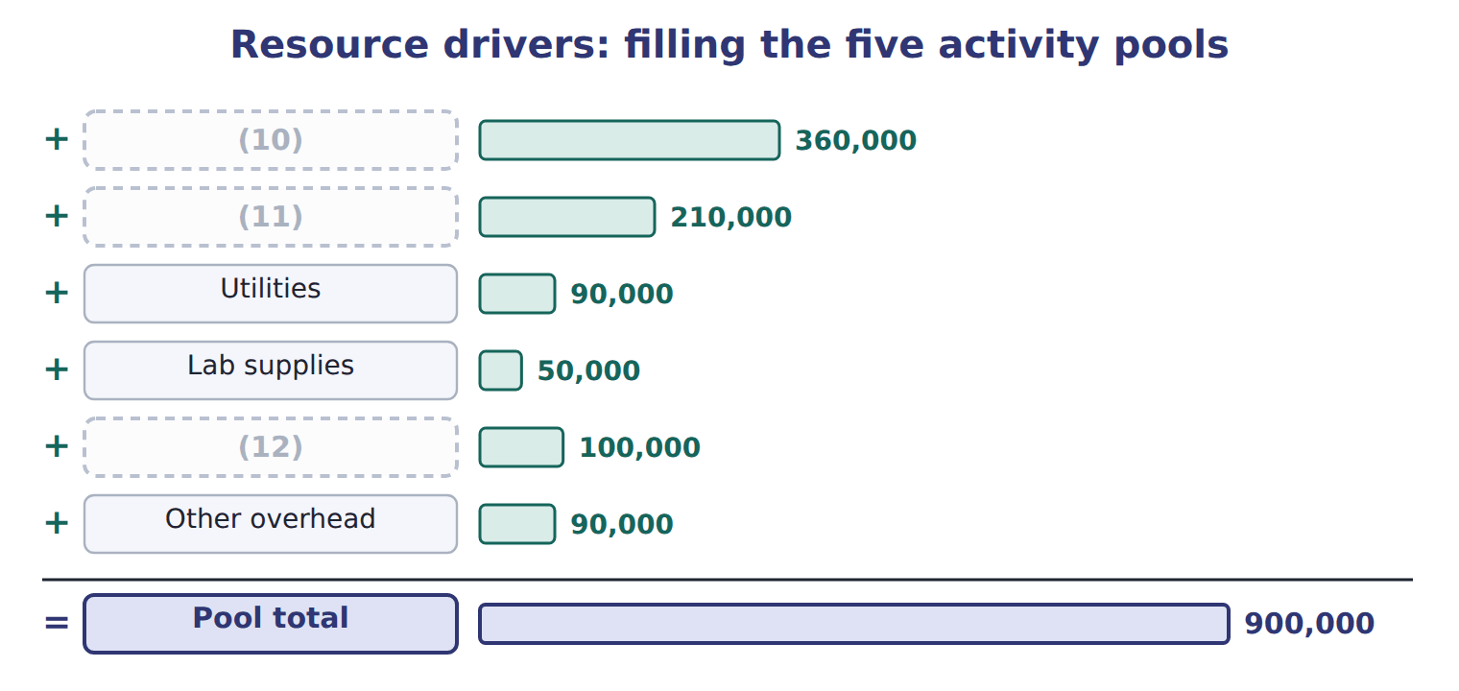
word list
product-sustaining cost · Indirect labor · Equipment depreciation · Warehouse lease

Summary 2 gaps 13–16
A value-added activity is one that customers would pay for, such as (13) . (14) , moving and (15) add cost but not value; ABC makes them visible so managers can reduce them. Here, a value-added activity means an activity customers are (16) to pay for.
word list
re-testing · willing · Receiving · blending · value-added

The English this section uses, and its Arabic
Each term sits against what it means.
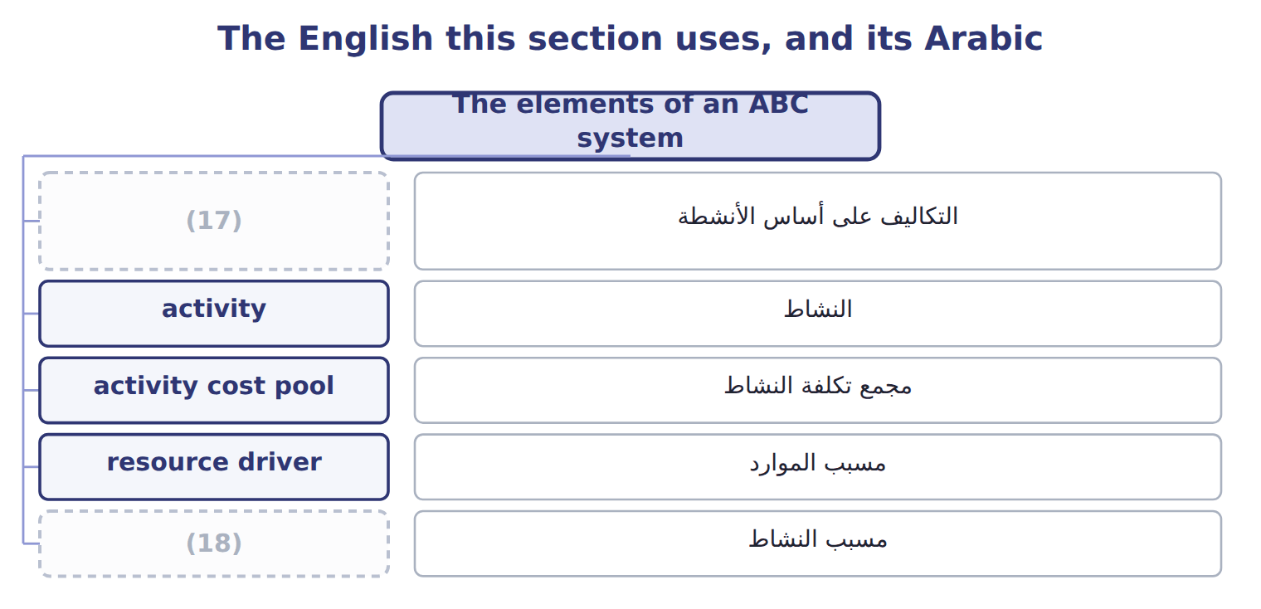
word list
activity driver · batch-level cost · activity-based costing

The English this sheet uses, and its Arabic
English (exam term) | Arabic
activity-based costing | التكاليف على أساس الأنشطة
activity | النشاط
activity cost pool | مجمع تكلفة النشاط
resource driver | مسبب الموارد
activity driver | مسبب النشاط

Answer key · 12.2 The elements of an ABC system

1 resources | 10 Indirect labor
2 quality | 11 Equipment depreciation
3 Activity-based | 12 Warehouse lease
4 overhead | 13 blending
5 second | 14 Receiving
6 product | 15 re-testing
7 measure | 16 willing
8 Indirect | 17 activity-based costing
9 warehouse | 18 activity driver

the summaries in full
Summary 1 An activity is a task that uses resources, such as a setup or a quality test. Each activity has an activity cost pool: the total cost of doing it. Activity-based costing assigns overhead to these pools first and then to products. The first stage uses resource drivers, such as the share of staff time spent on each activity. The second stage uses activity drivers, such as the number of setups each product needs. Both are cost drivers: they measure what causes the cost. Indirect labor of $360,000 is split by time studies; the $100,000 warehouse lease from Book 1 goes to the facility pool.
Summary 2 A value-added activity is one that customers would pay for, such as blending. Receiving, moving and re-testing add cost but not value; ABC makes them visible so managers can reduce them. Here, a value-added activity means an activity customers are willing to pay for.

12.3 The cost hierarchy
Chapter 12 · section 12.3

Fill every gap. Each word list holds one word more than there are gaps.
Summary 1 gaps 1–8
ABC groups (1) by what causes them. (2) costs rise with every unit, like (3) hours. (4) costs rise with each batch, like setups, (5) the batch size. (6) costs support one product line, such as its (7) design. Facility-sustaining costs keep the whole site (8) , such as rent. Facility-sustaining costs have no causal driver. Many companies leave them out of product cost for decisions; if they are allocated, as Pulses & Spices does with pallet positions, managers should remember that they will not disappear if one product is dropped.
word list
whatever · packing · Batch-level · running · disappear · recipe · Unit-level · activities · Product-sustaining

The English this section uses, and its Arabic
Each term sits against what it means.
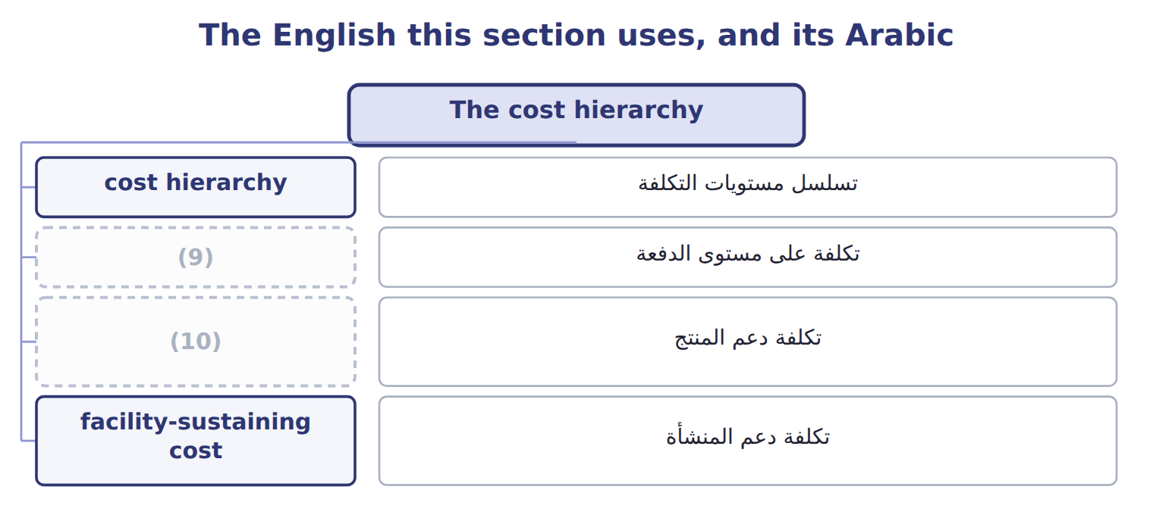
word list
product-sustaining cost · resource driver · batch-level cost

The English this sheet uses, and its Arabic
English (exam term) | Arabic
cost hierarchy | تسلسل مستويات التكلفة
batch-level cost | تكلفة على مستوى الدفعة
product-sustaining cost | تكلفة دعم المنتج
facility-sustaining cost | تكلفة دعم المنشأة

Answer key · 12.3 The cost hierarchy

1 activities | 6 Product-sustaining
2 Unit-level | 7 recipe
3 packing | 8 running
4 Batch-level | 9 batch-level cost
5 whatever | 10 product-sustaining cost

the summaries in full
Summary 1 ABC groups activities by what causes them. Unit-level costs rise with every unit, like packing hours. Batch-level costs rise with each batch, like setups, whatever the batch size. Product-sustaining costs support one product line, such as its recipe design. Facility-sustaining costs keep the whole site running, such as rent. Facility-sustaining costs have no causal driver. Many companies leave them out of product cost for decisions; if they are allocated, as Pulses & Spices does with pallet positions, managers should remember that they will not disappear if one product is dropped.

12.4 Computing product cost with ABC
Chapter 12 · section 12.4

Fill every gap. Each word list holds one word more than there are gaps.
Summary 1 gaps 1–2
For each pool, the (1) rate is the pool cost divided by the total driver quantity. A (2) overhead is the rate times the driver quantity it uses, added over all pools.
word list
activity · Lentils · product's

Worked example: ABC overhead for lentils

Summary 2 gaps 3–4
Blending setups cost $270,000 for 900 setups, a rate of $300. (3) need 100 setups, so they (4) $30,000.
word list
Blending · receive · Lentils

Worked example: activity rates and ABC overhead for lentils
The parts add up to the total; the bars are to scale.
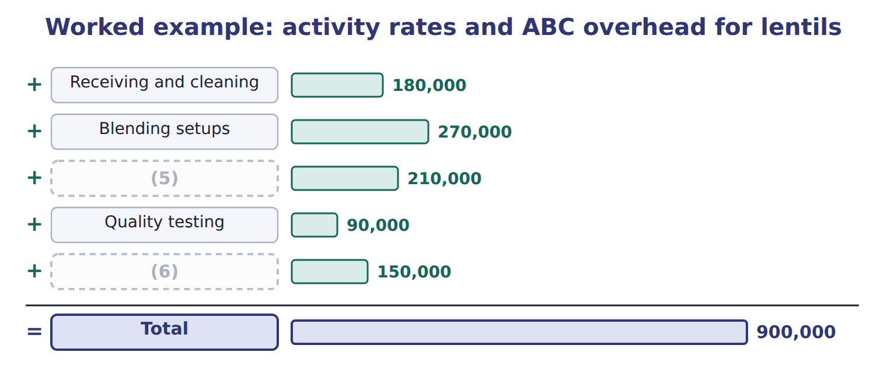
word list
activity · Packaging · Facility

ABC overhead for za'atar

Complete the two blank rows.

Your turn: ABC overhead for za'atar (complete the blanks)
Za'atar | Use | Rate | Overhead
Receiving and cleaning | 400 receipts | $300 | 120,000
Blending setups | (7) | $300 | 240,000
Packaging | (8) | $30 | ________
Quality testing | 1,200 tests | $60 | 72,000
Facility | (9) | $100 | ________
Total |  |  | 542,000

word list
800 setups · 2,000 packing hours · Blending setups · 500 pallet positions

Summary 3 gaps 10–12
Per pack, (10) for lentils falls from $3.60 to $1.79, and for za'atar it rises from $3.60 to $10.84. Under the old rate, lentils cost $6.30 and (11) to lose money at a price of $6.00. With ABC they cost $4.49 and earn a (12) . Za'atar costs $15.04, more than its price of $11.00.
word list
seemed · margin · Complete · overhead

Unit cost and margin per pack: traditional compared with ABC
Per pack | Price | DM + DL | OH trad. | Cost trad. | Margin trad. | OH ABC | Cost ABC | Margin ABC
Lentils | $6.00 | (13) | $3.60 | $6.30 | ($0.30) | $1.79 | $4.49 | $1.51
Za'atar | $11.00 | $3.00 + $1.20 | $3.60 | $7.80 | $3.20 | $10.84 | $15.04 | (14)

word list
$1.50 + $1.20 · ($4.04) · Receiving and cleaning

Answer key · 12.4 Computing product cost with ABC

1 activity | 8 2,000 packing hours
2 product's | 9 500 pallet positions
3 Lentils | 10 overhead
4 receive | 11 seemed
5 Packaging | 12 margin
6 Facility | 13 $1.50 + $1.20
7 800 setups | 14 ($4.04)

the summaries in full
Summary 1 For each pool, the activity rate is the pool cost divided by the total driver quantity. A product's overhead is the rate times the driver quantity it uses, added over all pools.
Summary 2 Blending setups cost $270,000 for 900 setups, a rate of $300. Lentils need 100 setups, so they receive $30,000.
Summary 3 Per pack, overhead for lentils falls from $3.60 to $1.79, and for za'atar it rises from $3.60 to $10.84. Under the old rate, lentils cost $6.30 and seemed to lose money at a price of $6.00. With ABC they cost $4.49 and earn a margin. Za'atar costs $15.04, more than its price of $11.00.

12.5 ABC as a cost accumulation system
Chapter 12 · section 12.5

Fill every gap. Each word list holds one word more than there are gaps.
Summary 1 gaps 1–6
ABC does not need new ledger (1) . (2) and labor go to work in process as before; overhead is applied at the (3) rates instead of one rate. (4) units move to (5) goods and then to cost of goods sold, as in job costing. Because unit costs change, (6) values change too. At the end of 2027 the unsold packs are worth $142,550 with ABC and $133,500 with the old rate.
word list
instead · Completed · finished · accounts · activity · Materials · inventory

Ending finished goods under the two methods
The bars are drawn to scale.
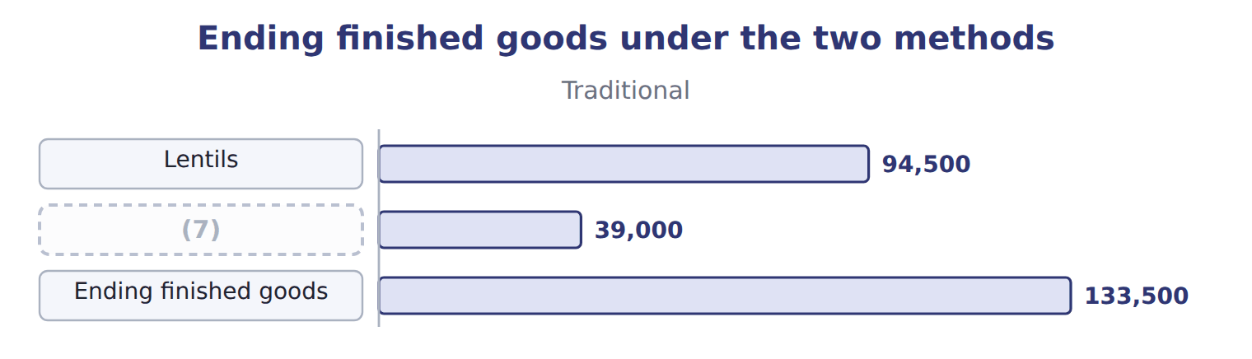
word list
activity · Za'atar

Summary 2 gaps 8–16
Normal spoilage is built into the rates of the activities that cause it, such as (8) testing. Abnormal spoilage is (9) from product cost and (10) as a loss. For example, if a (11) batch fails its test for a normal reason and is thrown away, its cost stays in the (12) and testing pools and reaches the good packs through the rates. A batch (13) by a power cut is abnormal and is (14) off as a loss. ABC suits companies with many (15) that use activities in (16) ways. With one simple product, one rate gives almost the same answer at a lower cost.
word list
removed · quality · expensed · written · testing · different · products · ruined · blending · za'atar

Answer key · 12.5 ABC as a cost accumulation system

1 accounts | 9 removed
2 Materials | 10 expensed
3 activity | 11 za'atar
4 Completed | 12 blending
5 finished | 13 ruined
6 inventory | 14 written
7 Za'atar | 15 products
8 quality | 16 different

the summaries in full
Summary 1 ABC does not need new ledger accounts. Materials and labor go to work in process as before; overhead is applied at the activity rates instead of one rate. Completed units move to finished goods and then to cost of goods sold, as in job costing. Because unit costs change, inventory values change too. At the end of 2027 the unsold packs are worth $142,550 with ABC and $133,500 with the old rate.
Summary 2 Normal spoilage is built into the rates of the activities that cause it, such as quality testing. Abnormal spoilage is removed from product cost and expensed as a loss. For example, if a za'atar batch fails its test for a normal reason and is thrown away, its cost stays in the blending and testing pools and reaches the good packs through the rates. A batch ruined by a power cut is abnormal and is written off as a loss. ABC suits companies with many products that use activities in different ways. With one simple product, one rate gives almost the same answer at a lower cost.

12.6 Benefits, limitations and strategic value
Chapter 12 · section 12.6

Fill every gap. Each word list holds one word more than there are gaps.
Summary 1 gaps 1–5
Activity-based (1) gives more accurate product costs where products differ in complexity. It shows batch-level and (2) costs that a volume rate hides. It also links cost to (3) that managers can change. It needs data on many drivers, (4) to design the pools, and regular updates. Facility costs are still (5) without a true driver.
word list
allocation · accurate · activities · allocated · judgment · product-sustaining

Benefits and limitations of ABC
Benefits | Limitations
More accurate product costs where products use activities differently | (6)
Shows batch-level and product-sustaining costs that volume rates hide | Needs judgment to choose pools and drivers
Better pricing, product-mix and customer decisions | (7) costs are still allocated arbitrarily
Links cost to activities that managers can change | Must still be adjusted for external reporting rules

word list
cost hierarchy · Costly to design and keep up to date · Facility-sustaining

Summary 2 gaps 8–10
The (8) value is in the decisions. With ABC costs, the (9) may raise the za'atar price, make larger za'atar batches to cut setups, or stop pushing lentils away. ABC (10) these choices; it does not make them.
word list
updates · informs · division · strategic

Beyond the exam

Summary 3 gaps 11–13
Time-driven ABC estimates the time each (11) takes instead of surveying staff. Activity-based (12) uses ABC to improve activities. Both are useful in (13) , but they are not in the 2024 Part 1 outcomes.
word list
Facility · practice · activity · management

Answer key · 12.6 Benefits, limitations and strategic value

1 allocation | 8 strategic
2 product-sustaining | 9 division
3 activities | 10 informs
4 judgment | 11 activity
5 allocated | 12 management
6 Costly to design and keep up to date | 13 practice
7 Facility-sustaining

the summaries in full
Summary 1 Activity-based allocation gives more accurate product costs where products differ in complexity. It shows batch-level and product-sustaining costs that a volume rate hides. It also links cost to activities that managers can change. It needs data on many drivers, judgment to design the pools, and regular updates. Facility costs are still allocated without a true driver.
Summary 2 The strategic value is in the decisions. With ABC costs, the division may raise the za'atar price, make larger za'atar batches to cut setups, or stop pushing lentils away. ABC informs these choices; it does not make them.
Summary 3 Time-driven ABC estimates the time each activity takes instead of surveying staff. Activity-based management uses ABC to improve activities. Both are useful in practice, but they are not in the 2024 Part 1 outcomes.

12.7 Extended Example 12A: Pulses & Spices in 2027
Chapter 12 · section 12.7

Fill every gap. Each word list holds one word more than there are gaps.
Summary 1 gaps 1–10
This example (1) a full year of the (2) & Spices line with ABC, from overhead to cost of goods sold. The product costs are (3) ; the entries are for depth. (4) : 200,000 packs of lentils and 50,000 packs of za'atar; 185,000 and 45,000 sold. Direct costs per pack: lentils $1.50 (5) and $1.20 labor; za'atar $3.00 and $1.20. Overhead: $900,000 in five activity pools. Record overhead, direct costs and the (6) at activity rates. Move completed packs to finished goods, record the sales, close the overhead (7) and check every (8) . Overhead applied: lentils $358,000; za'atar $542,000. Cost completed: lentils $898,000; za'atar $752,000; total $1,650,000. Cost of goods sold: $1,507,450; (9) finished goods $142,550. Entry 4 is where ABC (10) : overhead is applied at the five activity rates.
word list
Output · balance · differs · ending · application · accounts · Pulses · materials · exam-core · lentils · records

Extended Example: ABC journal, 2027
No. | Account (detail) | Debit | Credit
1 | (11) | 900,000
 | (12) |  | 900,000
2 | WIP - Pulses & Spices | 450,000
 | Raw Materials Inventory |  | 450,000
3 | WIP - Pulses & Spices | 300,000
 | (13) |  | 300,000
4 | (14) | 900,000
 | MOH Applied |  | 900,000
5 | (15) | 1,650,000
 | WIP - Pulses & Spices |  | 1,650,000
6 | (16) | 1,507,450
 | Finished Goods |  | 1,507,450
7 | (17) | 900,000
 | MOH Control |  | 900,000
 | Totals | 6,607,450 | 6,607,450

word list
Cost of Goods Sold · MOH Control · Various accounts · Finished Goods · WIP - Pulses & Spices · Quality tests · Wages Payable · MOH Applied

Work in process and both overhead accounts close; finished goods end at $142,550.
Everything ties

Summary 2 gaps 18–19
Overhead: $358,000 + $542,000 = $900,000, the same total as the old rate. (18) goods: $1,650,000 in = $1,507,450 sold + $142,550 left. Only the split between the (19) changes.
word list
Finished · products · za'atar

Exam view

Summary 3 gaps 20–21
Expect pool costs, driver (20) and each product's use. Compute each rate from the total driver (21) , multiply by each product's use, and compare with the single rate given in the question.
word list
za'atar · quantities · quantity

Exam view
The bars are drawn to scale.
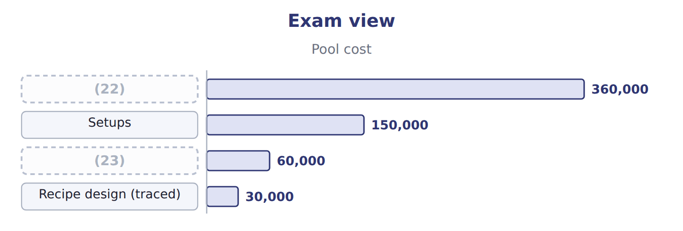
word list
Machine operations · activity driver · Quality tests

Item — Answer
Item | Answer
Packaging (za'atar) | (24)
Facility (za'atar) | 500 pallet positions × $100 = $50,000

word list
2,000 packing hours × $30 = $60,000 · 500 pallet positions × $100 = $50,000

Overhead item — Category
Overhead item | Category
Machine operations | (25)
Setups | (26)
Quality tests | Batch-level
Recipe design | (27)
Plant manager's salary | Facility-sustaining

word list
Product-sustaining · Batch-level · Unit-level · Credit

The English this section uses, and its Arabic
Each term sits against what it means.
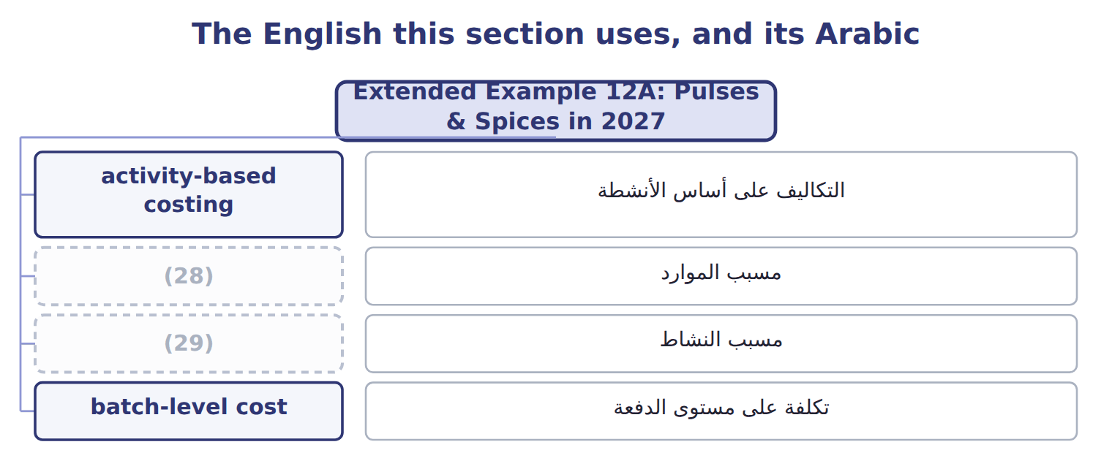
word list
activity driver · value-added activity · resource driver

The English this sheet uses, and its Arabic
English (exam term) | Arabic
activity-based costing | التكاليف على أساس الأنشطة
resource driver | مسبب الموارد
activity driver | مسبب النشاط
batch-level cost | تكلفة على مستوى الدفعة

Answer key · 12.7 Extended Example 12A: Pulses & Spices in 2027

1 records | 16 Cost of Goods Sold
2 Pulses | 17 MOH Applied
3 exam-core | 18 Finished
4 Output | 19 products
5 materials | 20 quantities
6 application | 21 quantity
7 accounts | 22 Machine operations
8 balance | 23 Quality tests
9 ending | 24 2,000 packing hours × $30 = $60,000
10 differs | 25 Unit-level
11 MOH Control | 26 Batch-level
12 Various accounts | 27 Product-sustaining
13 Wages Payable | 28 resource driver
14 WIP - Pulses & Spices | 29 activity driver
15 Finished Goods

the summaries in full
Summary 1 This example records a full year of the Pulses & Spices line with ABC, from overhead to cost of goods sold. The product costs are exam-core; the entries are for depth. Output: 200,000 packs of lentils and 50,000 packs of za'atar; 185,000 and 45,000 sold. Direct costs per pack: lentils $1.50 materials and $1.20 labor; za'atar $3.00 and $1.20. Overhead: $900,000 in five activity pools. Record overhead, direct costs and the application at activity rates. Move completed packs to finished goods, record the sales, close the overhead accounts and check every balance. Overhead applied: lentils $358,000; za'atar $542,000. Cost completed: lentils $898,000; za'atar $752,000; total $1,650,000. Cost of goods sold: $1,507,450; ending finished goods $142,550. Entry 4 is where ABC differs: overhead is applied at the five activity rates.
Summary 2 Overhead: $358,000 + $542,000 = $900,000, the same total as the old rate. Finished goods: $1,650,000 in = $1,507,450 sold + $142,550 left. Only the split between the products changes.
Summary 3 Expect pool costs, driver quantities and each product's use. Compute each rate from the total driver quantity, multiply by each product's use, and compare with the single rate given in the question.

13.1 ABC in service companies
Chapter 13 · section 13.1

Fill every gap. Each word list holds one word more than there are gaps.
Chapter 13, section by section
Each stage leads to the next.
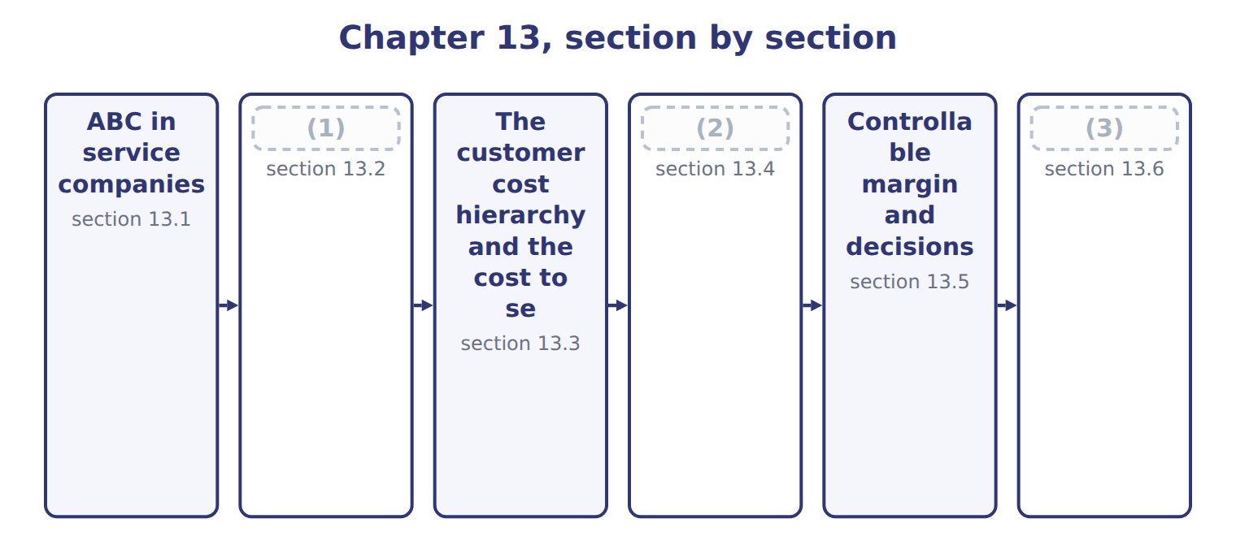
word list
Controllable margin and decisions · Measuring profitability: the issues · Customer, product-line and business-unit profi · Extended Example 13A: Al-Salam's revenue under

Summary 1 gaps 4–11
A service company has no (4) of products, but it still (5) activities: it takes orders, moves goods, answers calls and sends invoices. Most of its costs are (6) , so one volume rate can (7) cost even more than in a factory. Levant (8) , the Orontes subsidiary that (9) juices, is a good example. Its main activities are picking order lines, (10) to stops and (11) . The steps are the same as: build activity pools, choose a driver for each, compute a rate and assign cost by use. The cost objects are services or customers instead of products.
word list
performs · invoicing · overhead · inventory · distributes · delivering · activity · distort · Distribution

ABC is not only for factories

Summary 2 gaps 12–13
Banks, hospitals, airlines and (12) all use ABC. If an answer option says ABC applies only to (13) , it is wrong.
word list
distributors · Distribution · manufacturing

Answer key · 13.1 ABC in service companies

1 Measuring profitability: the issues | 8 Distribution
2 Customer, product-line and business-unit profi | 9 distributes
3 Extended Example 13A: Al-Salam's revenue under | 10 delivering
4 inventory | 11 invoicing
5 performs | 12 distributors
6 overhead | 13 manufacturing
7 distort

the summaries in full
Summary 1 A service company has no inventory of products, but it still performs activities: it takes orders, moves goods, answers calls and sends invoices. Most of its costs are overhead, so one volume rate can distort cost even more than in a factory. Levant Distribution, the Orontes subsidiary that distributes juices, is a good example. Its main activities are picking order lines, delivering to stops and invoicing. The steps are the same as: build activity pools, choose a driver for each, compute a rate and assign cost by use. The cost objects are services or customers instead of products.
Summary 2 Banks, hospitals, airlines and distributors all use ABC. If an answer option says ABC applies only to manufacturing, it is wrong.

13.2 Measuring profitability: the issues
Chapter 13 · section 13.2

Fill every gap. Each word list holds one word more than there are gaps.
Summary 1 gaps 1–3
Profit can be (1) for a product, a (2) or a business unit. Each measure raises the same (3) : which revenue, which costs, how to allocate shared costs, and which assets and values to use.
word list
therefore · questions · customer · measured

The issues in measuring profitability
Issue | Question to answer
Cost measurement | (4) : product cost only, or also the cost to serve each customer
Cost allocation | How to assign shared costs: by activity drivers, not by revenue
Revenue measurement | Revenue net of rebates, listing fees and other payments to (5) (ASC 606)
Investment measurement | Which assets each (6) uses, for return measures
Valuation | Historical cost or current value of those assets; transfer prices between units

word list
cost to serve · business unit · customers · Which costs to include

Summary 2 gaps 7–12
Under ASC 606, (7) and fees paid to a customer for shelf space reduce revenue; they are not selling (8) . A (9) revenue is (10) its net revenue. (11) cost alone hides the cost to serve, and (12) selling costs by revenue hides it again. For a business unit, the investment base and its valuation also matter, because they decide the return. A 'marge client' is a customer margin, measured after the cost to serve.
word list
therefore · expenses · Product · rebates · measure · customer's · allocating

The English this section uses, and its Arabic
Each term sits against what it means.
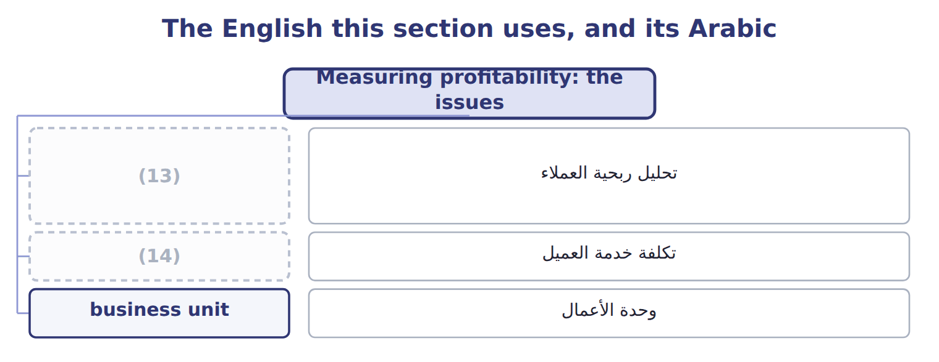
word list
تكلفة خدمة العميل · cost to serve · customer profitability analysis

The English this sheet uses, and its Arabic
English (exam term) | Arabic
customer profitability analysis | تحليل ربحية العملاء
business unit | وحدة الأعمال

Answer key · 13.2 Measuring profitability: the issues

1 measured | 8 expenses
2 customer | 9 customer's
3 questions | 10 therefore
4 Which costs to include | 11 Product
5 customers | 12 allocating
6 business unit | 13 customer profitability analysis
7 rebates | 14 cost to serve

the summaries in full
Summary 1 Profit can be measured for a product, a customer or a business unit. Each measure raises the same questions: which revenue, which costs, how to allocate shared costs, and which assets and values to use.
Summary 2 Under ASC 606, rebates and fees paid to a customer for shelf space reduce revenue; they are not selling expenses. A customer's revenue is therefore its net revenue. Product cost alone hides the cost to serve, and allocating selling costs by revenue hides it again. For a business unit, the investment base and its valuation also matter, because they decide the return. A 'marge client' is a customer margin, measured after the cost to serve.

13.3 The customer cost hierarchy and the cost to serve
Chapter 13 · section 13.3

Fill every gap. Each word list holds one word more than there are gaps.
Summary 1 gaps 1–6
Customer-related costs sit at (1) levels. Some are caused by each order or delivery; some by (2) one customer, such as a key (3) manager; some by a whole channel; and some by the company as a whole. The cost to serve is the cost of the (4) a customer (5) . Tahini & Spreads uses four (6) rates: $50 an order, $120 a delivery, $200 a rush order and $80 a return.
word list
activities · account · causes · different · delivery · activity · keeping

Worked example: the cost to serve Barada

Summary 2 gaps 7–8
Barada (7) 240 orders and took 120 (8) . At the four rates, its cost to serve is $31,200.
word list
deliveries · placed · activities

Worked example: the cost to serve Barada Wholesale
The bars are drawn to scale.
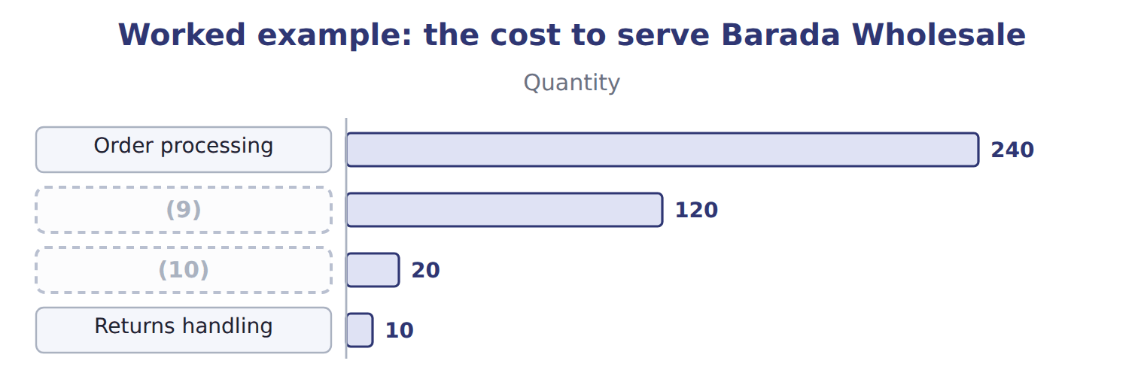
word list
Rush orders · Deliveries · whale curve

The cost to serve Qasr Hotels

Complete the two blank rows.

Your turn: the cost to serve Qasr Hotels (complete the blanks)
The bars are drawn to scale.
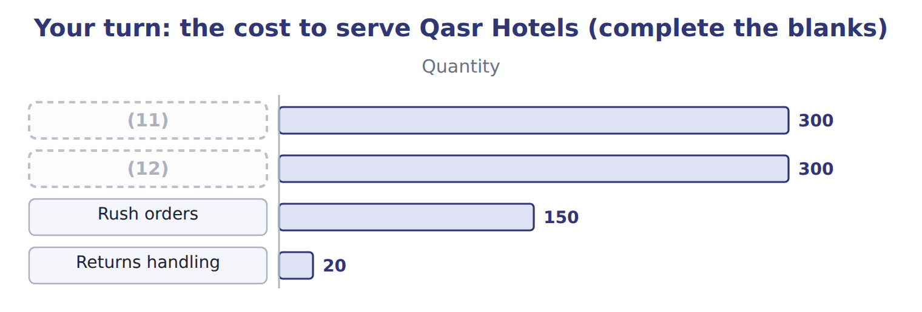
word list
controllable margin · Order processing · Deliveries

Summary 3 gaps 13–15
Qasr (13) often and asks for many rush (14) , so its cost to serve is high for its size. A (15) cost, such as Qasr's key account manager, is added after the activity costs.
word list
delivery · orders · deliveries · customer-sustaining

The English this section uses, and its Arabic
Each term sits against what it means.
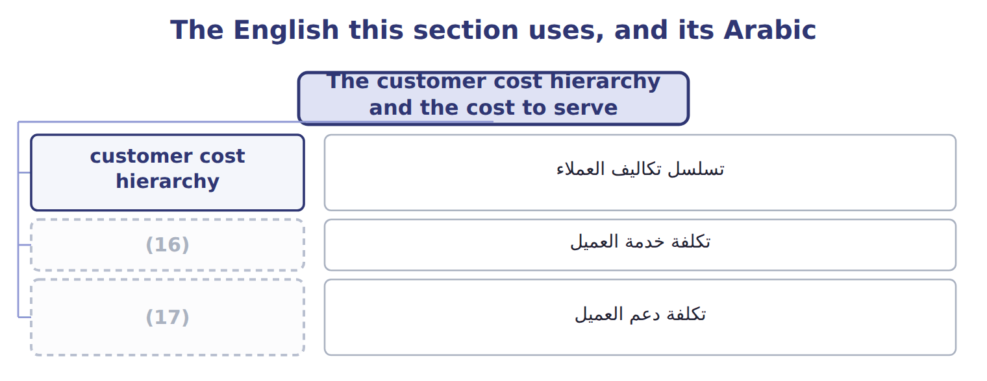
word list
customer-sustaining cost · whale curve · cost to serve

The English this sheet uses, and its Arabic
English (exam term) | Arabic
customer cost hierarchy | تسلسل تكاليف العملاء
cost to serve | تكلفة خدمة العميل
customer-sustaining cost | تكلفة دعم العميل

Answer key · 13.3 The customer cost hierarchy and the cost to serve

1 different | 10 Rush orders
2 keeping | 11 Order processing
3 account | 12 Deliveries
4 activities | 13 orders
5 causes | 14 deliveries
6 activity | 15 customer-sustaining
7 placed | 16 cost to serve
8 deliveries | 17 customer-sustaining cost
9 Deliveries

the summaries in full
Summary 1 Customer-related costs sit at different levels. Some are caused by each order or delivery; some by keeping one customer, such as a key account manager; some by a whole channel; and some by the company as a whole. The cost to serve is the cost of the activities a customer causes. Tahini & Spreads uses four activity rates: $50 an order, $120 a delivery, $200 a rush order and $80 a return.
Summary 2 Barada placed 240 orders and took 120 deliveries. At the four rates, its cost to serve is $31,200.
Summary 3 Qasr orders often and asks for many rush deliveries, so its cost to serve is high for its size. A customer-sustaining cost, such as Qasr's key account manager, is added after the activity costs.

13.4 Customer, product-line and business-unit profitability
Chapter 13 · section 13.4

Fill every gap. Each word list holds one word more than there are gaps.
The small shops lose $73,000 and the hotel supply agent loses $58,800.
Customer profitability, Tahini & Spreads, 2027
The bars are drawn to scale.
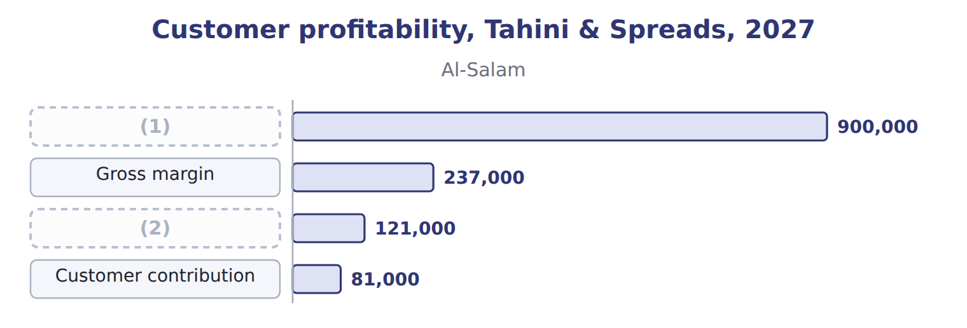
word list
Customer contribution · Customer margin · Gross sales

Summary 1 gaps 3–6
The line reaches $560,300, or 131% of the total, before the (3) customers bring it down to $428,500. This shape is (4) the whale curve. Product-line (5) uses the same logic by product. With the ABC costs of, the Pulses & Spices (6) earn a gross margin of $279,350, while za'atar loses $181,800.
word list
profitability · called · customers · lentils · loss-making

Product-line profitability: the Pulses & Spices line
The bars are drawn to scale.
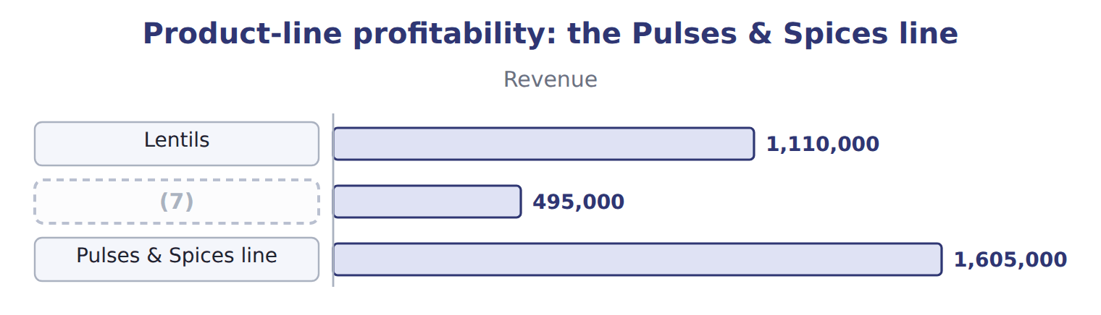
word list
Lentils · Za'atar

Summary 2 gaps 8–10
A (8) unit's profit adds all its (9) and then deducts the costs that no single customer causes. For the Tahini & Spreads sales unit, $200,000 of rent and sales (10) leaves $228,500.
word list
customers · administration · business · Spreads

Business-unit profit: the Tahini & Spreads sales unit
Tahini & Spreads sales unit, 2027 | Whole USD
(11) | 428,500
Distribution-centre rent and sales administration | (200,000)
(12) | 228,500

word list
Business-unit profit before corporate costs · Customer contribution (six customers) · Cost of goods sold

The English this section uses, and its Arabic
Each term sits against what it means.
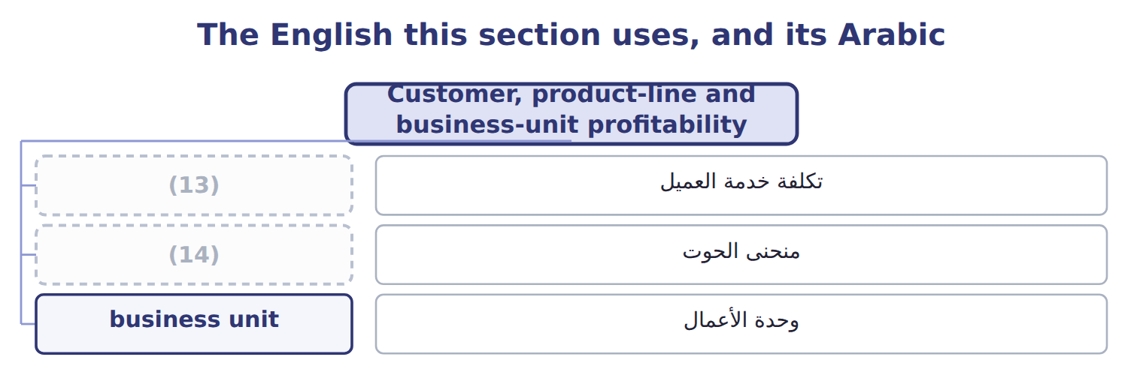
word list
customer-sustaining cost · whale curve · cost to serve

The English this sheet uses, and its Arabic
English (exam term) | Arabic
whale curve | منحنى الحوت

Answer key · 13.4 Customer, product-line and business-unit profitability

1 Gross sales | 8 business
2 Customer margin | 9 customers
3 loss-making | 10 administration
4 called | 11 Customer contribution (six customers)
5 profitability | 12 Business-unit profit before corporate costs
6 lentils | 13 cost to serve
7 Za'atar | 14 whale curve

the summaries in full
Summary 1 The line reaches $560,300, or 131% of the total, before the loss-making customers bring it down to $428,500. This shape is called the whale curve. Product-line profitability uses the same logic by product. With the ABC costs of, the Pulses & Spices lentils earn a gross margin of $279,350, while za'atar loses $181,800.
Summary 2 A business unit's profit adds all its customers and then deducts the costs that no single customer causes. For the Tahini & Spreads sales unit, $200,000 of rent and sales administration leaves $228,500.

13.5 Controllable margin and decisions
Chapter 13 · section 13.5

Fill every gap. Each word list holds one word more than there are gaps.
Summary 1 gaps 1–2
A manager should be judged only on what the manager can (1) . The (2) margin is revenue minus the costs the manager controls.
word list
influence · listing · controllable

The sales manager's report: controllable margin
Sales manager's report, 2027 | Whole USD | Controllable by the sales manager?
Net revenue | 3,266,000 | (3)
Variable cost of goods sold | (2,170,000) | (4)
Cost to serve | (507,500) | Yes (order size, delivery terms)
Key account managers | (160,000) | Yes (staffing)
Controllable margin | 428,500 | (5)
Rent and sales administration | (200,000) | No (decided centrally)
Business-unit profit | 228,500

word list
Cost of goods sold avoided · Yes (prices, discounts, rebates) · The basis for judging the sales manager · Mostly no (set by production)

Summary 2 gaps 6–8
Before (6) a customer, ask which costs would (7) go away. If the small shops were dropped, Tahini & Spreads would lose their revenue but avoid their product cost and, if the (8) shrink, their cost to serve.
word list
activities · dropping · customer · really

What changes if the small shops are dropped
If the small shops are dropped | Whole USD
(9) | (300,000)
Cost of goods sold avoided | 186,000
Cost to serve avoided (if activities shrink) | 187,000
(10) | 73,000
(11) | unchanged

word list
Rent and sales administration · Cost to serve · Change in profit · Net revenue lost

Summary 3 gaps 12–14
Dropping is the last (12) . The division can first set a minimum order size, charge for rush deliveries, or serve the shops through Levant (13) . For the hotel supply agent, (14) listing fees and rush orders may restore a profit.
word list
Distribution · cutting · revenue · option

The English this sheet uses, and its Arabic
English (exam term) | Arabic
controllable margin | الهامش القابل للرقابة

Answer key · 13.5 Controllable margin and decisions

1 influence | 8 activities
2 controllable | 9 Net revenue lost
3 Yes (prices, discounts, rebates) | 10 Change in profit
4 Mostly no (set by production) | 11 Rent and sales administration
5 The basis for judging the sales manager | 12 option
6 dropping | 13 Distribution
7 really | 14 cutting

the summaries in full
Summary 1 A manager should be judged only on what the manager can influence. The controllable margin is revenue minus the costs the manager controls.
Summary 2 Before dropping a customer, ask which costs would really go away. If the small shops were dropped, Tahini & Spreads would lose their revenue but avoid their product cost and, if the activities shrink, their cost to serve.
Summary 3 Dropping is the last option. The division can first set a minimum order size, charge for rush deliveries, or serve the shops through Levant Distribution. For the hotel supply agent, cutting listing fees and rush orders may restore a profit.

13.6 Extended Example 13A: Al-Salam's revenue under ASC 606
Chapter 13 · section 13.6

Fill every gap. Each word list holds one word more than there are gaps.
Summary 1 gaps 1–8
This example (1) the revenue from Al-Salam (2) , whose rebates and listing fees make its gross sales look larger than its real revenue. The net revenue and customer margin are (3) ; the entries are for depth. Gross sales: $900,000; rebates expected $45,000; listing fees paid $60,000. (4) : 600 orders, 500 (5) , 50 rush orders and 200 returns. Record the sales net of expected rebates, treat the listing fee as a (6) of revenue, pay the rebates, and then build (7) customer margin. The revenue (8) ends at $795,000: gross sales minus rebates and the listing fee.
word list
exam-core · business · deliveries · Supermarkets · Al-Salam's · account · Activities · records · reduction

Extended Example: Al-Salam revenue journal
No. | Account (detail) | Debit | Credit
1 | (9) | 900,000
 | Sales Revenue |  | 855,000
 | (10) |  | 45,000
2 | Sales Revenue | 60,000
 | (11) |  | 60,000
3 | Refund Liability | 45,000
 | Cash |  | 45,000
 | (12) | 1,005,000 | 1,005,000

word list
Refund Liability · Totals · Cash · Invoices · Accounts Receivable

Summary 2 gaps 13–14
Net (13) $795,000 minus cost of goods sold $558,000 = gross margin $237,000. Cost to serve $116,000; customer margin $121,000; key account manager $40,000; (14) $81,000.
word list
revenue · Supermarkets · contribution

Everything ties

Summary 3 gaps 15–16
Six (15) add to $428,500; minus $200,000 gives the business unit's $228,500. (16) revenue in the ledger equals its net revenue.
word list
Al-Salam's · contributions · expected

Exam view

Summary 4 gaps 17–19
Expect revenue, (17) , fees, product costs and activity data for two or three (18) . Start from net revenue, deduct the cost to serve at the activity rates, and keep (19) costs out of each customer's margin.
word list
entries · customers · company-level · rebates

Exam view
Levant Distribution · 2027 | Supermarket chain | Small shops | Activity rate
Service fees (revenue) | 600,000 | 400,000
Order lines picked | 60,000 | 90,000 | (20)
Delivery stops | 2,000 | 8,000 | $40 per stop
Invoices | 500 | 6,000 | (21)

word list
$15 per invoice · $2 per line · Supermarket channel promotions

Item — Answer
Item | Answer
Deliveries (Qasr) | 300 × $120 = $36,000
Rush orders (Qasr) | (22)

word list
150 × $200 = $30,000 · 300 × $120 = $36,000

Cost — Category
Cost | Category
Picking order lines | (23)
Delivery stops | Order or delivery level
Invoices | Order or delivery level
Key account manager for the chain | (24)
Supermarket channel promotions | Channel level
Warehouse rent | (25)

word list
Customer level · Company level · customer profitability analysis · Order or delivery level

The English this section uses, and its Arabic
Each term sits against what it means.
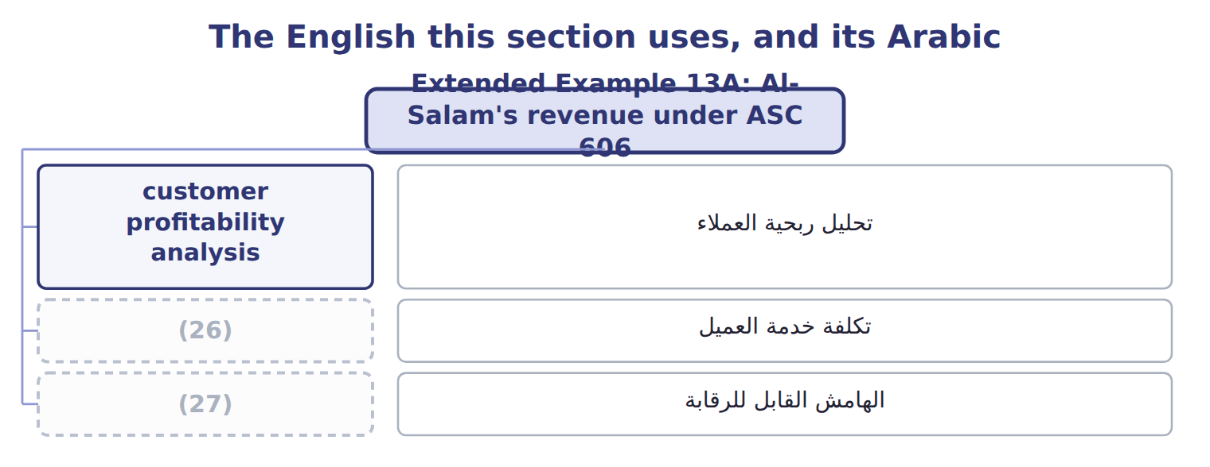
word list
cost to serve · controllable margin · تحليل ربحية العملاء

The English this sheet uses, and its Arabic
English (exam term) | Arabic
customer profitability analysis | تحليل ربحية العملاء
cost to serve | تكلفة خدمة العميل
controllable margin | الهامش القابل للرقابة

Answer key · 13.6 Extended Example 13A: Al-Salam's revenue under ASC 606

1 records | 15 contributions
2 Supermarkets | 16 Al-Salam's
3 exam-core | 17 rebates
4 Activities | 18 customers
5 deliveries | 19 company-level
6 reduction | 20 $2 per line
7 Al-Salam's | 21 $15 per invoice
8 account | 22 150 × $200 = $30,000
9 Accounts Receivable | 23 Order or delivery level
10 Refund Liability | 24 Customer level
11 Cash | 25 Company level
12 Totals | 26 cost to serve
13 revenue | 27 controllable margin
14 contribution

the summaries in full
Summary 1 This example records the revenue from Al-Salam Supermarkets, whose rebates and listing fees make its gross sales look larger than its real revenue. The net revenue and customer margin are exam-core; the entries are for depth. Gross sales: $900,000; rebates expected $45,000; listing fees paid $60,000. Activities: 600 orders, 500 deliveries, 50 rush orders and 200 returns. Record the sales net of expected rebates, treat the listing fee as a reduction of revenue, pay the rebates, and then build Al-Salam's customer margin. The revenue account ends at $795,000: gross sales minus rebates and the listing fee.
Summary 2 Net revenue $795,000 minus cost of goods sold $558,000 = gross margin $237,000. Cost to serve $116,000; customer margin $121,000; key account manager $40,000; contribution $81,000.
Summary 3 Six contributions add to $428,500; minus $200,000 gives the business unit's $228,500. Al-Salam's revenue in the ledger equals its net revenue.
Summary 4 Expect revenue, rebates, fees, product costs and activity data for two or three customers. Start from net revenue, deduct the cost to serve at the activity rates, and keep company-level costs out of each customer's margin.

14.1 Life-cycle costing
Chapter 14 · section 14.1

Fill every gap. Each word list holds one word more than there are gaps.
Chapter 14, section by section
Each stage leads to the next.
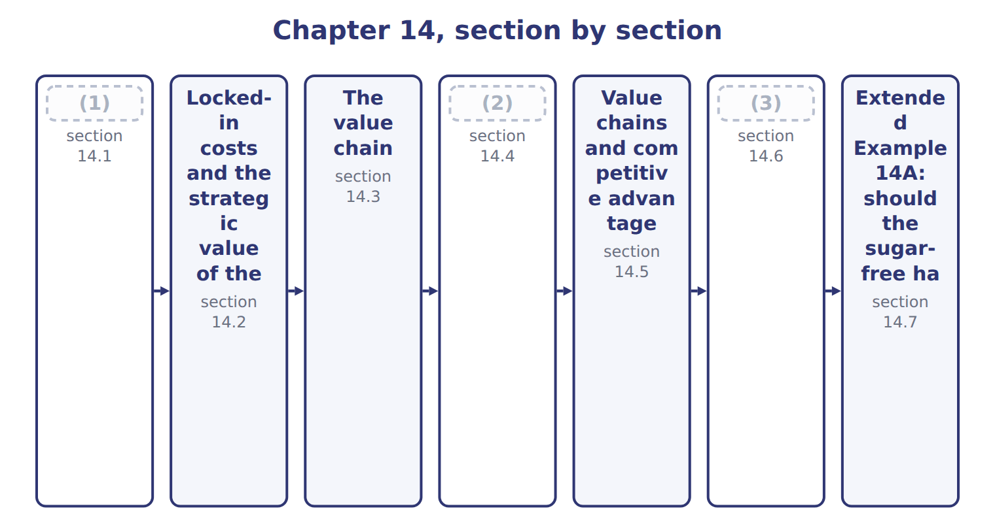
word list
Value-added and non-value-added activities · Life-cycle costing · The steps in value chain analysis · upstream costs

Summary 1 gaps 4–7
Life-cycle costing plans and tracks every cost of a product from research to (4) . It groups costs into three stages: upstream costs before production, (5) costs, and downstream costs after production. Upstream costs include research, design and (6) . Downstream costs include marketing, (7) , customer service and the costs of leaving the market.
word list
manufacturing · withdrawal · testing · service · distribution

Worked example: the halva's life-cycle budget

The division expects to sell 510,000 trays over five years at $7.00.

Worked example: the sugar-free halva's life-cycle budget
The bars are drawn to scale.
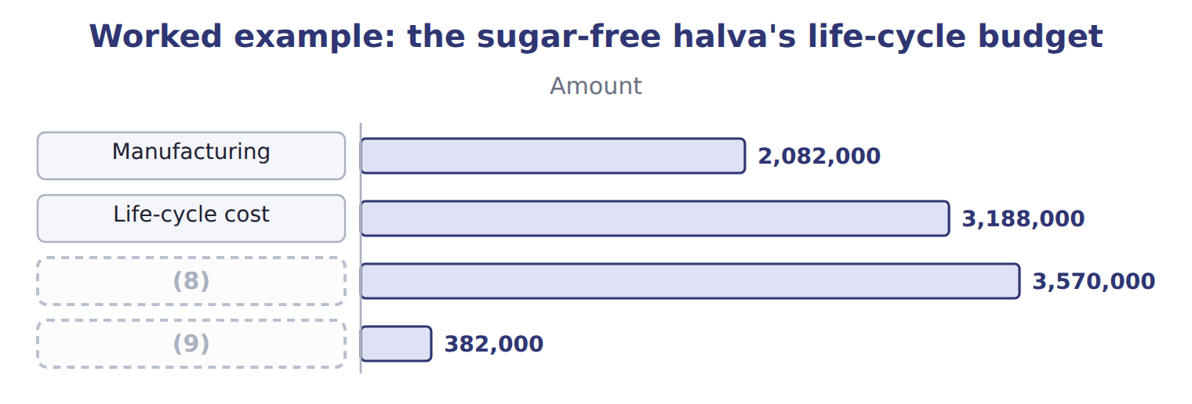
word list
Life-cycle profit · downstream costs · Revenue

The halva's downstream costs

Complete the two blank rows.
Your turn: the halva's downstream costs (complete the blanks)
Downstream costs, 510,000 trays | Whole USD
Marketing (5 years) | 520,000
Distribution at $0.50 a tray | ________
(10) | ________
(11) | 30,000
Downstream costs | 856,000

word list
Customer service at $0.10 a tray · Exit costs (2032) · Upstream: research, design, testing

Summary 2 gaps 12–13
A yearly product report would miss the (12) costs, because they were spent before the product had sales. (13) costing puts them back, so the product is judged on everything it costs.
word list
upstream · differentiation · Life-cycle

The English this section uses, and its Arabic
Each term sits against what it means.
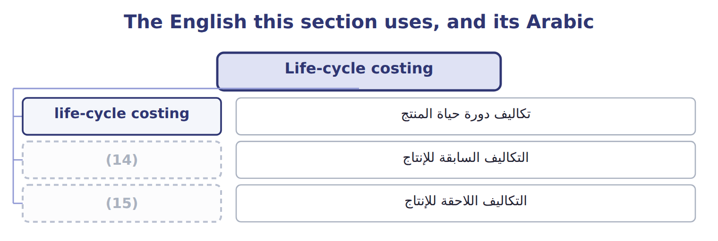
word list
upstream costs · support activities · downstream costs

The English this sheet uses, and its Arabic
English (exam term) | Arabic
life-cycle costing | تكاليف دورة حياة المنتج
upstream costs | التكاليف السابقة للإنتاج
downstream costs | التكاليف اللاحقة للإنتاج

Answer key · 14.1 Life-cycle costing

1 Life-cycle costing | 9 Life-cycle profit
2 The steps in value chain analysis | 10 Customer service at $0.10 a tray
3 Value-added and non-value-added activities | 11 Exit costs (2032)
4 withdrawal | 12 upstream
5 manufacturing | 13 Life-cycle
6 testing | 14 upstream costs
7 distribution | 15 downstream costs
8 Revenue

the summaries in full
Summary 1 Life-cycle costing plans and tracks every cost of a product from research to withdrawal. It groups costs into three stages: upstream costs before production, manufacturing costs, and downstream costs after production. Upstream costs include research, design and testing. Downstream costs include marketing, distribution, customer service and the costs of leaving the market.
Summary 2 A yearly product report would miss the upstream costs, because they were spent before the product had sales. Life-cycle costing puts them back, so the product is judged on everything it costs.

14.2 Locked-in costs and the strategic value of the design stage
Chapter 14 · section 14.2

Fill every gap. Each word list holds one word more than there are gaps.
Summary 1 gaps 1–8
A cost is (1) when the money is spent. It is committed, or (2) in, when a decision makes it (3) later. The (4) , the tray and the choice of (5) fix most future costs long before they are paid. At the end of design, the halva team (6) that 80% of the life-cycle cost is (7) committed, while only 7.8% has been spent. This is the (8) value of life-cycle costing: the cheapest time to reduce cost is the design stage. Once production starts, managers can only control the small share of cost that is still open.
word list
channels · recipe · differentiation · estimates · incurred · unavoidable · locked · already · strategic

Committed is not incurred

Summary 2 gaps 9–10
An exam (9) that most costs are incurred at the design stage is false. Most costs are committed at design and incurred later, during (10) and sales.
word list
statement · production · estimates

The English this section uses, and its Arabic
Each term sits against what it means.
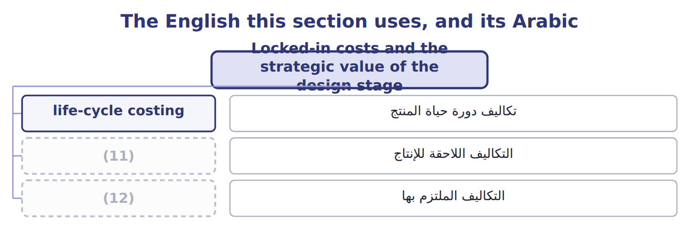
word list
non-value-added activity · locked-in costs · downstream costs

The English this sheet uses, and its Arabic
English (exam term) | Arabic
locked-in costs | التكاليف الملتزم بها

Answer key · 14.2 Locked-in costs and the strategic value of the design stage

1 incurred | 7 already
2 locked | 8 strategic
3 unavoidable | 9 statement
4 recipe | 10 production
5 channels | 11 downstream costs
6 estimates | 12 locked-in costs

the summaries in full
Summary 1 A cost is incurred when the money is spent. It is committed, or locked in, when a decision makes it unavoidable later. The recipe, the tray and the choice of channels fix most future costs long before they are paid. At the end of design, the halva team estimates that 80% of the life-cycle cost is already committed, while only 7.8% has been spent. This is the strategic value of life-cycle costing: the cheapest time to reduce cost is the design stage. Once production starts, managers can only control the small share of cost that is still open.
Summary 2 An exam statement that most costs are incurred at the design stage is false. Most costs are committed at design and incurred later, during production and sales.

14.3 The value chain
Chapter 14 · section 14.3

Fill every gap. Each word list holds one word more than there are gaps.
Summary 1 gaps 1–11
The value chain is the chain of activities a company (1) to design, make, sell, deliver and support its (2) . Value chain (3) studies each activity to find where the company can lower cost or add value for (4) . (5) Porter divided the chain into two (6) . Primary activities make and deliver the product: inbound logistics, (7) , outbound logistics, (8) and sales, and service. Support activities help all of them: firm (9) , human resource management, technology (10) and procurement. The chain does not stop at the (11) walls. The olive growers before Orontes and the distributors after it are part of a wider value system, and many savings come from the links between them. The supply chain links several companies; the value chain is inside one.
word list
marketing · Michael · customers · groups · Orontes · company's · development · analysis · performs · infrastructure · products · operations

The English this section uses, and its Arabic
Each term sits against what it means.
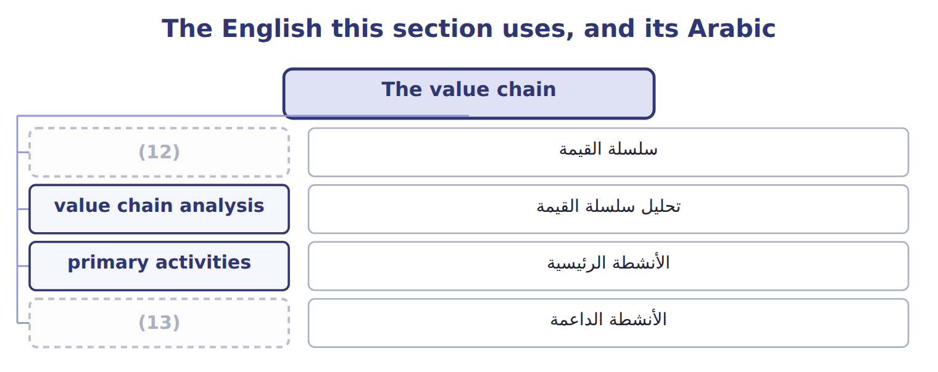
word list
primary activities · support activities · value chain

The English this sheet uses, and its Arabic
English (exam term) | Arabic
value chain | سلسلة القيمة
value chain analysis | تحليل سلسلة القيمة
primary activities | الأنشطة الرئيسية
support activities | الأنشطة الداعمة

Answer key · 14.3 The value chain

1 performs | 8 marketing
2 products | 9 infrastructure
3 analysis | 10 development
4 customers | 11 company's
5 Michael | 12 value chain
6 groups | 13 support activities
7 operations

the summaries in full
Summary 1 The value chain is the chain of activities a company performs to design, make, sell, deliver and support its products. Value chain analysis studies each activity to find where the company can lower cost or add value for customers. Michael Porter divided the chain into two groups. Primary activities make and deliver the product: inbound logistics, operations, outbound logistics, marketing and sales, and service. Support activities help all of them: firm infrastructure, human resource management, technology development and procurement. The chain does not stop at the company's walls. The olive growers before Orontes and the distributors after it are part of a wider value system, and many savings come from the links between them. The supply chain links several companies; the value chain is inside one.

14.4 The steps in value chain analysis
Chapter 14 · section 14.4

Fill every gap. Each word list holds one word more than there are gaps.
Summary 1 gaps 1–2
Value chain analysis has five steps: identify the (1) , assign costs and assets to them, find what drives each cost, study the links inside and outside the company, and look for (2) .
word list
Inbound · opportunities · activities

The five steps of value chain analysis in the Oils division
Each stage leads to the next.
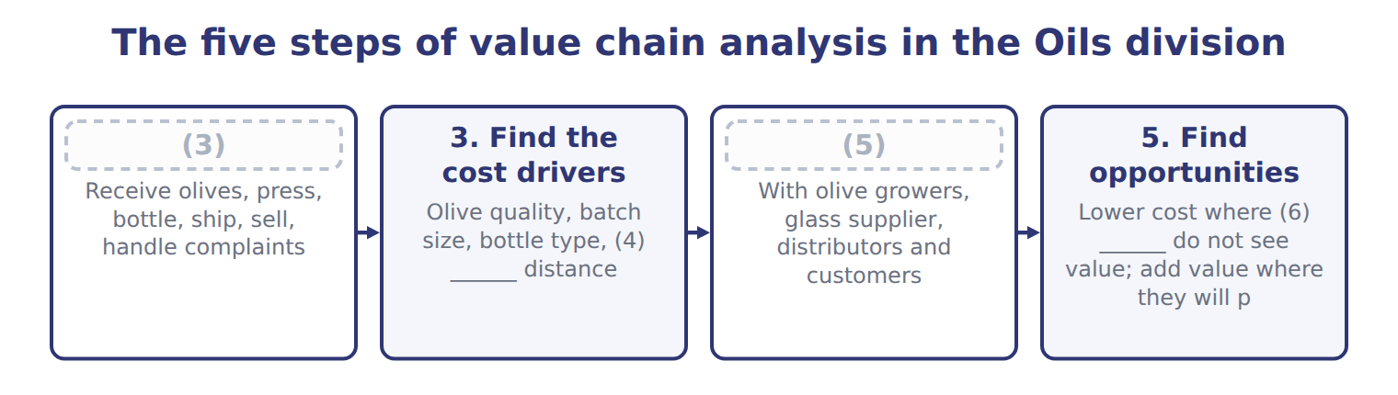
word list
4. Study the links · 1. Identify the activities · life-cycle costing · customers · delivery

Summary 2 gaps 7–8
Inbound logistics and (7) together cost $11.75, the production cost. The chain adds outbound, (8) , service and support costs to reach $14.65.
word list
operations · marketing · support

Cost per liter of bottled EVOO by activity: Orontes and a bulk competitor
Bottled EVOO, 2027 | Orontes | Bulk competitor
Inbound logistics | $0.45 | $0.30
(9) | $11.30 | $9.10
Outbound logistics | $0.70 | $0.60
(10) | $1.10 | $0.40
(11) | $0.20 | $0.05
(12) | $0.90 | $0.55
Total cost per liter | $14.65 | $11.00
(13) | $16.00 | $11.50
Margin per liter | $1.35 | $0.50

word list
Price per liter · Support activities · Operations · Step · Service · Marketing and sales

Summary 3 gaps 14–15
Placing the (14) costs beside Orontes's shows where the two companies spend differently. Orontes spends more on (15) and marketing; the competitor spends less almost everywhere.
word list
competitor's · operations · outside

The English this section uses, and its Arabic
Each term sits against what it means.
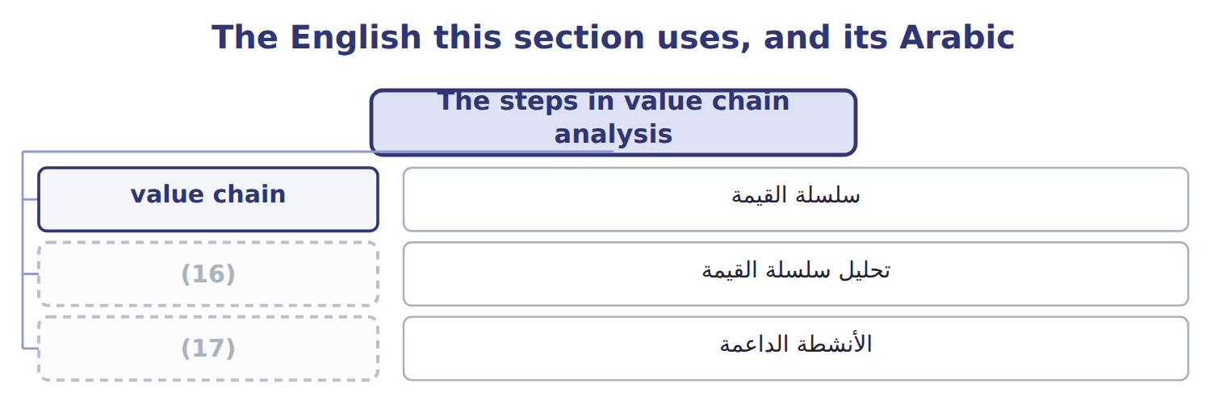
word list
support activities · value chain analysis · cost leadership

Answer key · 14.4 The steps in value chain analysis

1 activities | 10 Marketing and sales
2 opportunities | 11 Service
3 1. Identify the activities | 12 Support activities
4 delivery | 13 Price per liter
5 4. Study the links | 14 competitor's
6 customers | 15 operations
7 operations | 16 value chain analysis
8 marketing | 17 support activities
9 Operations

the summaries in full
Summary 1 Value chain analysis has five steps: identify the activities, assign costs and assets to them, find what drives each cost, study the links inside and outside the company, and look for opportunities.
Summary 2 Inbound logistics and operations together cost $11.75, the production cost. The chain adds outbound, marketing, service and support costs to reach $14.65.
Summary 3 Placing the competitor's costs beside Orontes's shows where the two companies spend differently. Orontes spends more on operations and marketing; the competitor spends less almost everywhere.

14.5 Value chains and competitive advantage
Chapter 14 · section 14.5

Fill every gap. Each word list holds one word more than there are gaps.
Summary 1 gaps 1–8
A company gains an (1) in one of two ways. Cost leadership means doing the activities more (2) than rivals. Differentiation means doing some activities in a way customers value and will pay more for. The bulk (3) follows cost leadership: its cost per liter is $11.00. Orontes follows differentiation: (4) , traced oil costs more, but customers pay $4.50 more per liter. Value chain (5) shows whether a (6) is working. (7) margin of $1.35 a liter survives only while the premium exceeds the extra cost of its (8) and marketing.
word list
Orontes's · competitor · strategy · marketing · operations · cold-pressed · cheaply · analysis · advantage

Cost leadership and differentiation compared
 | Cost leadership | Differentiation
Aim | (9) | Something customers value and pay more for
Where to spend | (10) | More in the activities customers value
Oils example | Bulk competitor: low operations and marketing costs | Orontes: (11) , traced EVOO; price premium of $4.50 a liter
Risk | (12) | Customers stop paying the premium

word list
cold-pressed · Lowest cost in the industry · A rival with even lower cost · Something customers value and pay more for · As little as possible in every activity

The English this section uses, and its Arabic
Each term sits against what it means.
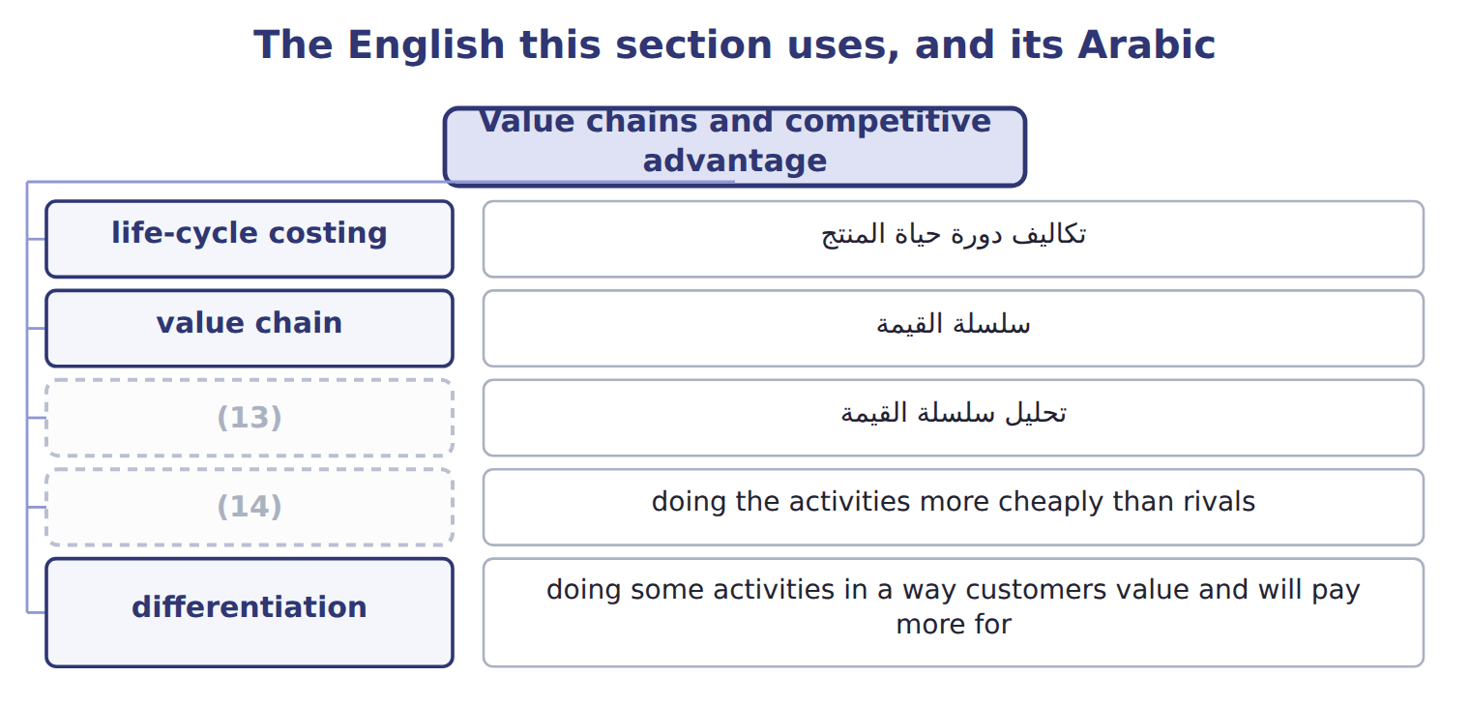
word list
life-cycle costing · value chain analysis · cost leadership

The English this sheet uses, and its Arabic
English (exam term) | Arabic
cost leadership | ريادة التكلفة
differentiation | التمايز

Answer key · 14.5 Value chains and competitive advantage

1 advantage | 8 operations
2 cheaply | 9 Lowest cost in the industry
3 competitor | 10 As little as possible in every activity
4 cold-pressed | 11 cold-pressed
5 analysis | 12 A rival with even lower cost
6 strategy | 13 value chain analysis
7 Orontes's | 14 cost leadership

the summaries in full
Summary 1 A company gains an advantage in one of two ways. Cost leadership means doing the activities more cheaply than rivals. Differentiation means doing some activities in a way customers value and will pay more for. The bulk competitor follows cost leadership: its cost per liter is $11.00. Orontes follows differentiation: cold-pressed, traced oil costs more, but customers pay $4.50 more per liter. Value chain analysis shows whether a strategy is working. Orontes's margin of $1.35 a liter survives only while the premium exceeds the extra cost of its operations and marketing.

14.6 Value-added and non-value-added activities
Chapter 14 · section 14.6

Fill every gap. Each word list holds one word more than there are gaps.
Summary 1 gaps 1–4
A (1) activity is one (2) would pay for, such as filling and labeling bottles. A non-value-added activity adds cost but no value, such as moving pallets or (3) errors. Some (4) , such as final inspection, add no value but are necessary for now. Of its $800,000 cost, $140,000 is non-value-added.
word list
reworking · value-added · customers · labeling · activities

Bottling-line activities classified
The parts add up to the total; the bars are to scale.
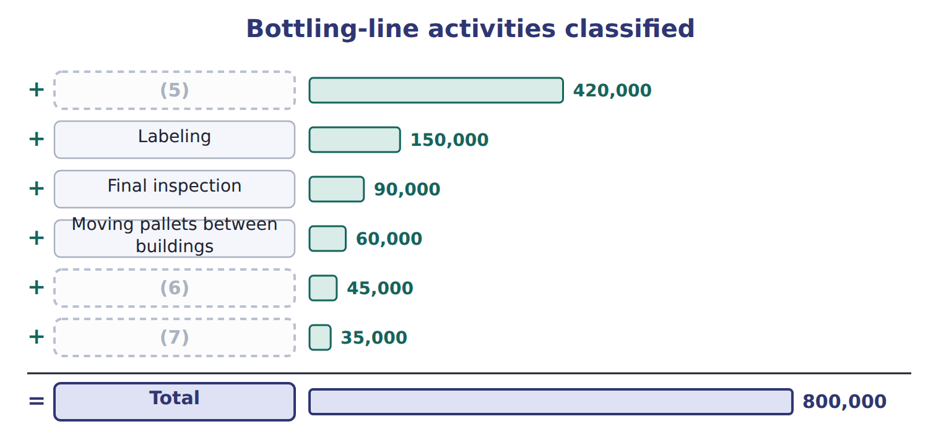
word list
Waiting and storage before filling · Filling and capping · value chain analysis · Reworking mislabeled bottles

Removing non-value-added activities improves performance without making customers worse off.
Removing non-value-added activities
The bars are drawn to scale.
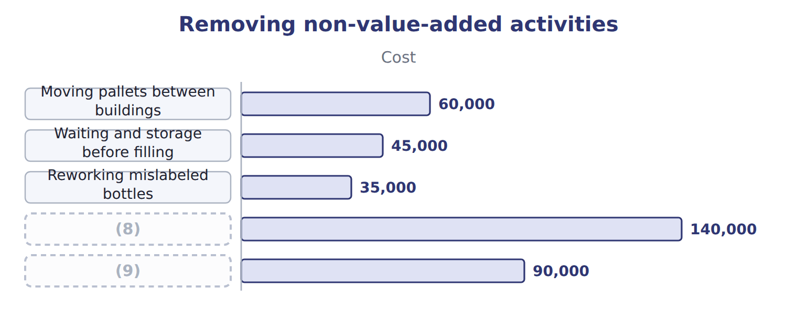
word list
Final inspection (kept: necessary) · Annual cost removed · value chain analysis

The English this sheet uses, and its Arabic
English (exam term) | Arabic
non-value-added activity | نشاط غير مضيف للقيمة

Answer key · 14.6 Value-added and non-value-added activities

1 value-added | 6 Waiting and storage before filling
2 customers | 7 Reworking mislabeled bottles
3 reworking | 8 Annual cost removed
4 activities | 9 Final inspection (kept: necessary)
5 Filling and capping

the summaries in full
Summary 1 A value-added activity is one customers would pay for, such as filling and labeling bottles. A non-value-added activity adds cost but no value, such as moving pallets or reworking errors. Some activities, such as final inspection, add no value but are necessary for now. Of its $800,000 cost, $140,000 is non-value-added.

14.7 Extended Example 14A: should the sugar-free halva be launched?
Chapter 14 · section 14.7

Fill every gap. Each word list holds one word more than there are gaps.
Summary 1 gaps 1–6
This example sets out the halva's budget year by year and (1) the yearly view with the (2) view. Upstream (2027): research $150,000; design and (3) $60,000; testing and (4) $40,000. (5) : $3.20 a tray plus $90,000 a year; (6) $0.50 and service $0.10 a tray; exit costs $30,000 in 2032. The launch year, 2028, loses $98,000 because of heavy marketing, and 2032 loses $8,000 because of exit costs.
word list
Production · distribution · volumes · approvals · life-cycle · packaging · compares

Extended Example: the halva budget year by year
Name each line from how it moves.
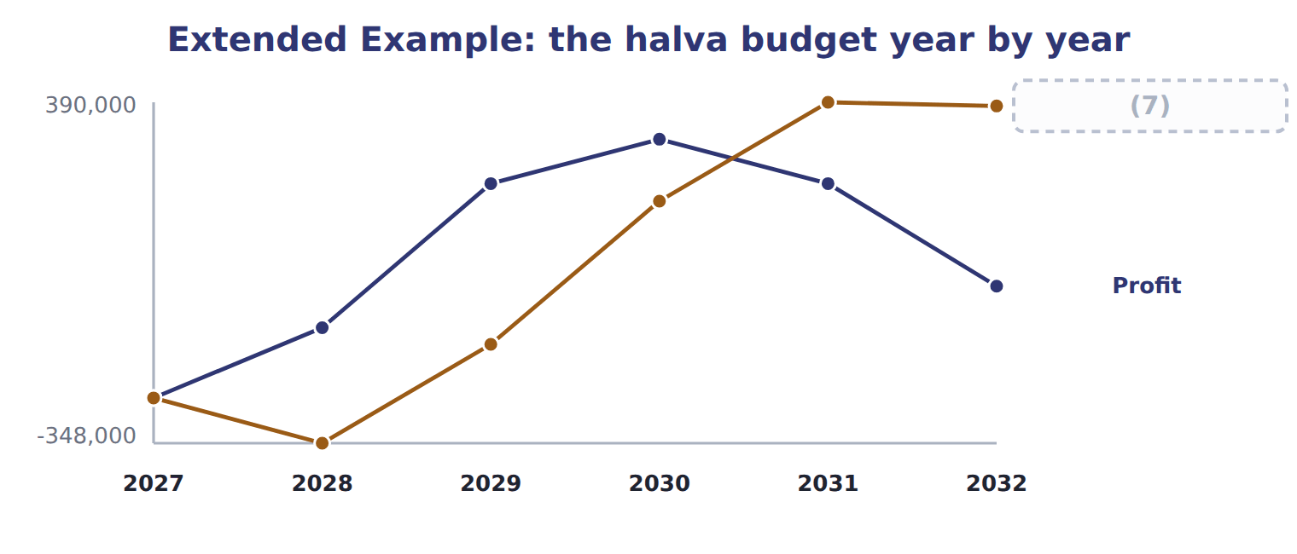
word list
Cumulative · differentiation

Summary 2 gaps 8–11
Cumulative profit is (8) until 2030, then (9) $382,000 over the whole life. On a (10) view, the first report after launch would suggest (11) the product. On a life-cycle view, the halva earns $382,000, so the division launches it and watches whether volumes follow the plan.
word list
dropping · product · yearly · reaches · negative

Everything ties

Summary 3 gaps 12–13
Upstream $250,000 + (12) $2,082,000 + downstream $856,000 = $3,188,000. Revenue $3,570,000 − (13) cost $3,188,000 = $382,000, the last point on the cumulative line.
word list
classify · life-cycle · manufacturing

Exam view

Summary 4 gaps 14–16
Expect costs by stage and year. Add all three stages for the (14) cost, and do not judge a new (15) on its first year. For value chains, expect to classify activities as primary or support, and as (16) or not.
word list
value-added · product · research · life-cycle

Exam view
Name each line from how it moves.
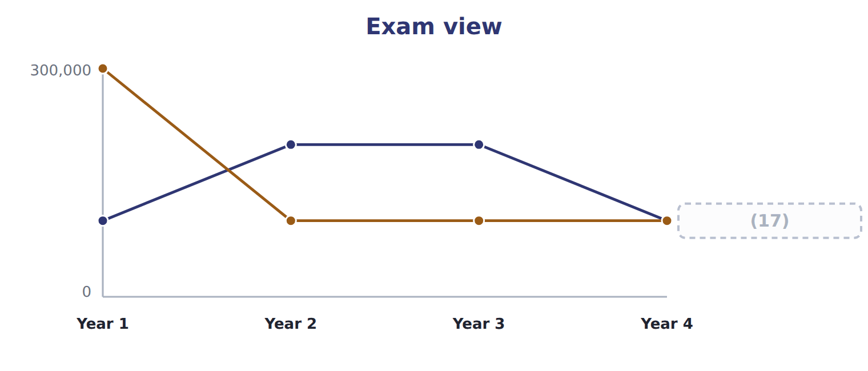
word list
differentiation · Marketing

Item — Answer
Item | Answer
Distribution | 510,000 trays × $0.50 = $255,000
Customer service | (18)

word list
510,000 trays × $0.50 = $255,000 · 510,000 trays × $0.10 = $51,000

Cost — Category
Every item belongs to exactly one group.
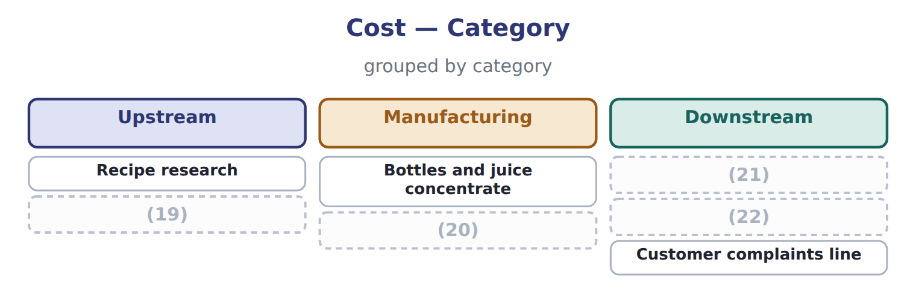
word list
Taste testing before launch · Launch advertising · locked-in costs · Depreciation of the filling line · Delivery to hotels

The English this section uses, and its Arabic
Each term sits against what it means.
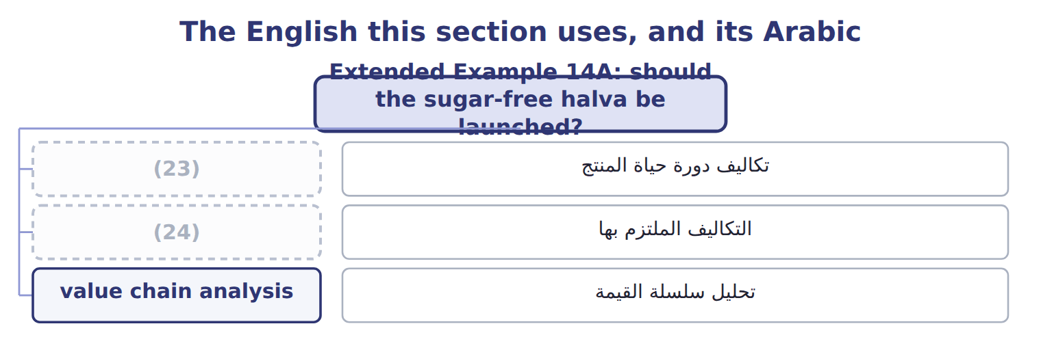
word list
life-cycle costing · upstream costs · locked-in costs

The English this sheet uses, and its Arabic
English (exam term) | Arabic
life-cycle costing | تكاليف دورة حياة المنتج
locked-in costs | التكاليف الملتزم بها
value chain analysis | تحليل سلسلة القيمة

Answer key · 14.7 Extended Example 14A: should the sugar-free halva be launched?

1 compares | 13 life-cycle
2 life-cycle | 14 life-cycle
3 packaging | 15 product
4 approvals | 16 value-added
5 Production | 17 Marketing
6 distribution | 18 510,000 trays × $0.10 = $51,000
7 Cumulative | 19 Taste testing before launch
8 negative | 20 Depreciation of the filling line
9 reaches | 21 Launch advertising
10 yearly | 22 Delivery to hotels
11 dropping | 23 life-cycle costing
12 manufacturing | 24 locked-in costs

the summaries in full
Summary 1 This example sets out the halva's budget year by year and compares the yearly view with the life-cycle view. Upstream (2027): research $150,000; design and packaging $60,000; testing and approvals $40,000. Production: $3.20 a tray plus $90,000 a year; distribution $0.50 and service $0.10 a tray; exit costs $30,000 in 2032. The launch year, 2028, loses $98,000 because of heavy marketing, and 2032 loses $8,000 because of exit costs.
Summary 2 Cumulative profit is negative until 2030, then reaches $382,000 over the whole life. On a yearly view, the first report after launch would suggest dropping the product. On a life-cycle view, the halva earns $382,000, so the division launches it and watches whether volumes follow the plan.
Summary 3 Upstream $250,000 + manufacturing $2,082,000 + downstream $856,000 = $3,188,000. Revenue $3,570,000 − life-cycle cost $3,188,000 = $382,000, the last point on the cumulative line.
Summary 4 Expect costs by stage and year. Add all three stages for the life-cycle cost, and do not judge a new product on its first year. For value chains, expect to classify activities as primary or support, and as value-added or not.

15.1 Process analysis
Chapter 15 · section 15.1

Fill every gap. Each word list holds one word more than there are gaps.
Chapter 15, section by section
Each stage leads to the next.
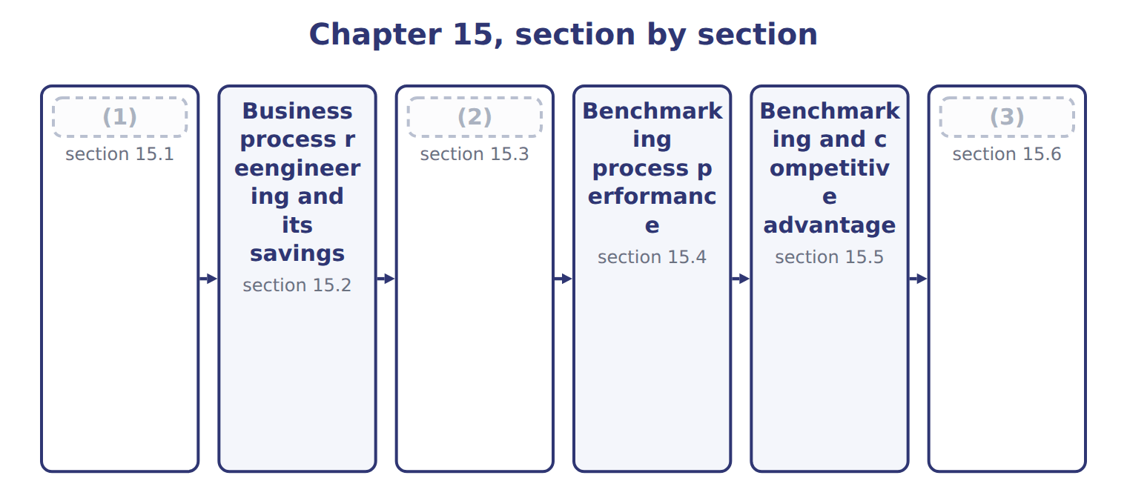
word list
Process analysis · section 15.1 · Extended Example 15A: the business case for th · Best practice analysis

Summary 1 gaps 4–11
A (4) process is a chain of steps that turns an input into a (5) for a customer, such as an order into cash. Process (6) studies each step: what it does, who does it, how long it takes, what it costs and (7) it adds value. The first tool is a process map, a (8) of the steps in order. Only two of its eight steps, picking and (9) , are steps the customer (10) . The second tool (11) each step. The cycle time from order to cash is 9 days, and the staff time is 2.10 hours per order.
word list
measures · values · analysis · shipping · process · business · diagram · whether · result

Worked example: the cost of one order

Staff cost $20 an hour.

Worked example: staff time and cost of each step, per order
The parts add up to the total; the bars are to scale.
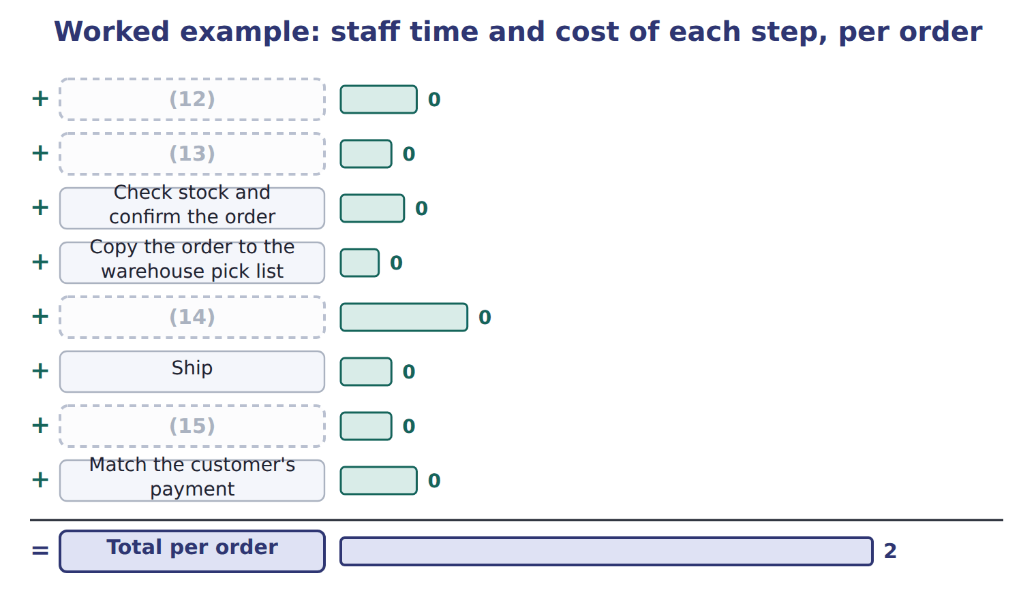
word list
Prepare the invoice by hand · Copy the order to the warehouse pick list · Take the order by phone and type it in · Pick and pack · Check the customer's credit

The English this section uses, and its Arabic
Each term sits against what it means.
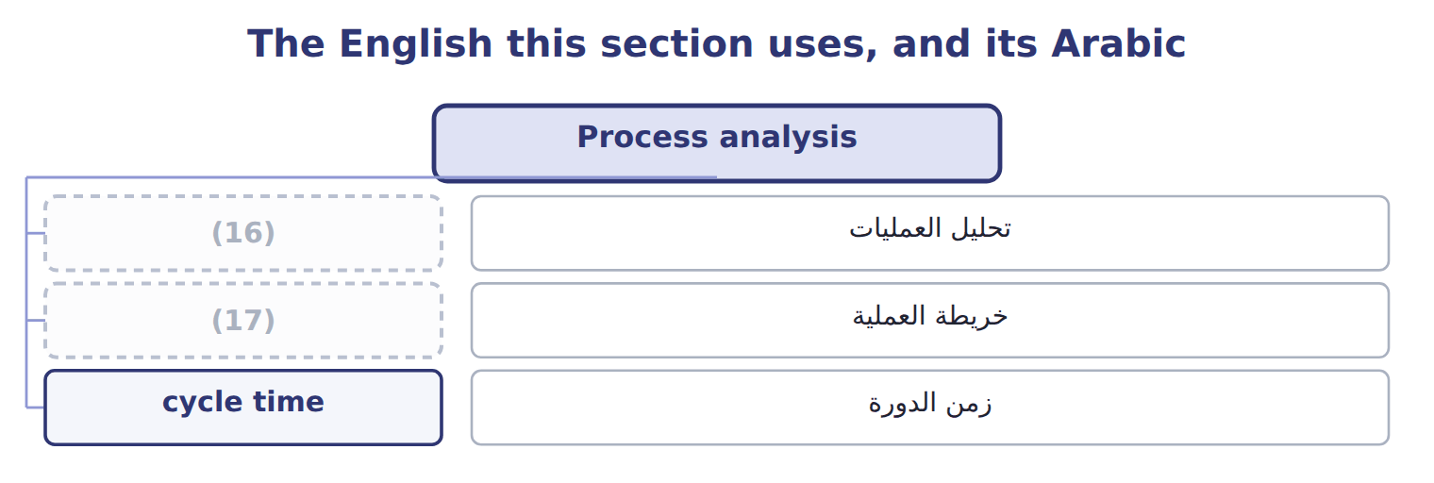
word list
process map · process analysis · competitive benchmarking

The English this sheet uses, and its Arabic
English (exam term) | Arabic
process analysis | تحليل العمليات
process map | خريطة العملية
cycle time | زمن الدورة

Answer key · 15.1 Process analysis

1 Process analysis | 10 values
2 Best practice analysis | 11 measures
3 Extended Example 15A: the business case for th | 12 Take the order by phone and type it in
4 business | 13 Check the customer's credit
5 result | 14 Pick and pack
6 analysis | 15 Prepare the invoice by hand
7 whether | 16 process analysis
8 diagram | 17 process map
9 shipping

the summaries in full
Summary 1 A business process is a chain of steps that turns an input into a result for a customer, such as an order into cash. Process analysis studies each step: what it does, who does it, how long it takes, what it costs and whether it adds value. The first tool is a process map, a diagram of the steps in order. Only two of its eight steps, picking and shipping, are steps the customer values. The second tool measures each step. The cycle time from order to cash is 9 days, and the staff time is 2.10 hours per order.

15.2 Business process reengineering and its savings
Chapter 15 · section 15.2

Fill every gap. Each word list holds one word more than there are gaps.
Summary 1 gaps 1–6
Business process (1) is a radical redesign of a process, not a small improvement. Instead of typing orders faster, Tahini lets (2) order online; instead of preparing invoices by hand, the invoice is created from the shipment record. Two steps (3) , four are shortened, and staff time falls to 0.87 hours per order. Cycle time falls to 4 days, so cash (4) sooner. The (5) must be net. The net (6) saving is $200,000.
word list
customers · process · reengineering · savings · disappear · yearly · arrives

Yearly cost of the old and new processes
The bars are drawn to scale.
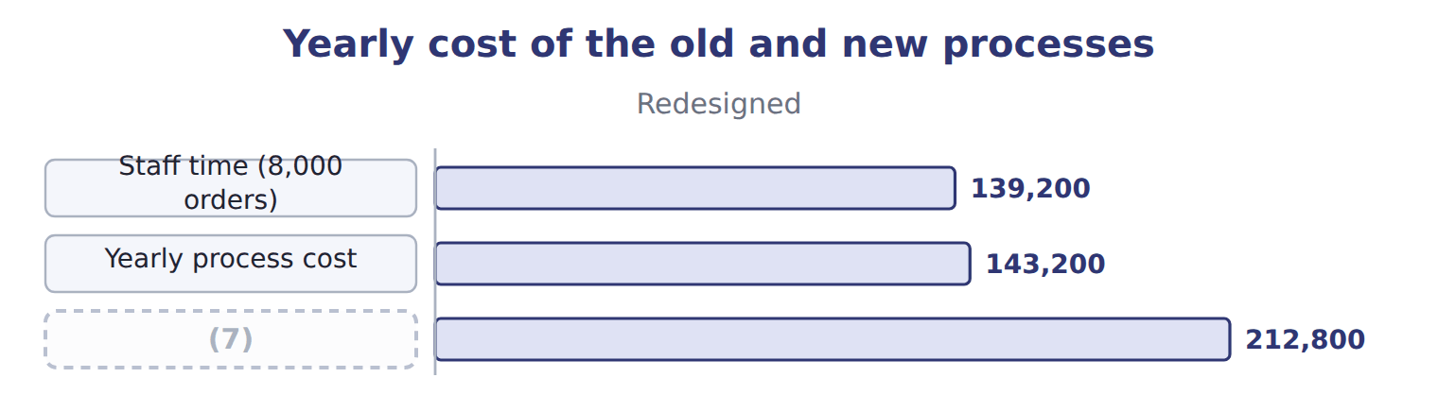
word list
business process reengineering · Gross yearly saving

The saving over three years

The change also has a one-off cost of $150,000.
Your turn: the net saving over three years (complete the blanks)
Three-year view (whole USD) | Amount
Net yearly saving × 3 years | ________
(8) | (150,000)
Net saving over three years | ________

word list
One-off cost of the change · Net saving over three years

Gross is not net

Summary 2 gaps 9–10
Exam (9) often show the gross saving. The (10) answer deducts the running cost of the new process every year and the one-off cost of the change once.
word list
options · Business · correct

The English this section uses, and its Arabic
Each term sits against what it means.
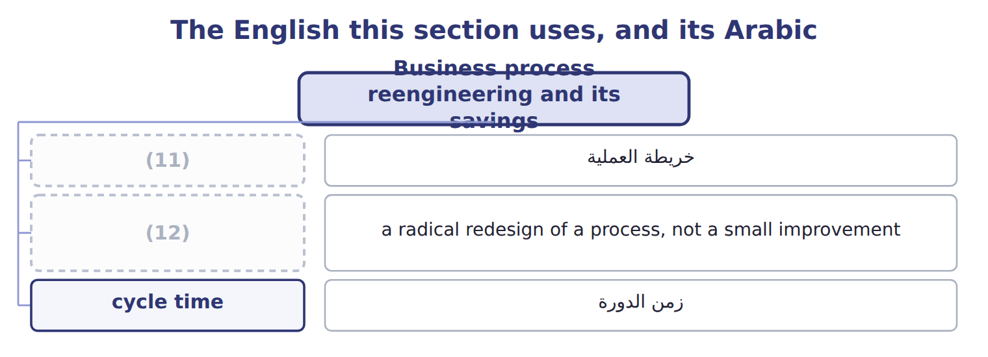
word list
business process reengineering · process map · cycle time

The English this sheet uses, and its Arabic
English (exam term) | Arabic
business process reengineering | إعادة هندسة العمليات

Answer key · 15.2 Business process reengineering and its savings

1 reengineering | 7 Gross yearly saving
2 customers | 8 One-off cost of the change
3 disappear | 9 options
4 arrives | 10 correct
5 savings | 11 process map
6 yearly | 12 business process reengineering

the summaries in full
Summary 1 Business process reengineering is a radical redesign of a process, not a small improvement. Instead of typing orders faster, Tahini lets customers order online; instead of preparing invoices by hand, the invoice is created from the shipment record. Two steps disappear, four are shortened, and staff time falls to 0.87 hours per order. Cycle time falls to 4 days, so cash arrives sooner. The savings must be net. The net yearly saving is $200,000.
Summary 2 Exam options often show the gross saving. The correct answer deducts the running cost of the new process every year and the one-off cost of the change once.

15.3 Best practice analysis
Chapter 15 · section 15.3

Fill every gap. Each word list holds one word more than there are gaps.
Summary 1 gaps 1–3
Best practice analysis finds the practices that make the best performers better and adapts them to one's own (1) . The aim is not to copy the result, but to (2) how it is achieved. Every one of them removes a (3) step.
word list
organization · non-value-added · channel · understand

Best practices found among leading food distributors
Best practice | Why it works | Tahini step it affects
Customers order online | (4) | Order taking, credit check
Invoice created from the shipment | (5) | Invoicing
Payments matched automatically by reference | Faster cash, fewer queries | (6)
Suppliers deliver to the line | (7) | Receiving (Chapter 17)

word list
No separate invoicing step · Less storage and handling · competitive benchmarking · Cash collection · Removes typing and copying errors

Summary 2 gaps 8–9
A practice must fit the (8) . Online ordering works for Barada and the (9) ; many small shops still order by phone, so Tahini keeps a simple phone channel for them.
word list
supermarkets · organization · benchmarking

The English this sheet uses, and its Arabic
English (exam term) | Arabic
best practice analysis | تحليل أفضل الممارسات

Answer key · 15.3 Best practice analysis

1 organization | 6 Cash collection
2 understand | 7 Less storage and handling
3 non-value-added | 8 organization
4 Removes typing and copying errors | 9 supermarkets
5 No separate invoicing step

the summaries in full
Summary 1 Best practice analysis finds the practices that make the best performers better and adapts them to one's own organization. The aim is not to copy the result, but to understand how it is achieved. Every one of them removes a non-value-added step.
Summary 2 A practice must fit the organization. Online ordering works for Barada and the supermarkets; many small shops still order by phone, so Tahini keeps a simple phone channel for them.

15.4 Benchmarking process performance
Chapter 15 · section 15.4

Fill every gap. Each word list holds one word more than there are gaps.
Summary 1 gaps 1–2
Benchmarking compares a process and its results with those of the best (1) . There are four common types: internal benchmarking, (2) benchmarking, functional benchmarking and generic benchmarking.
word list
correction · performers · competitive

The four types of benchmarking
Type | Compare with | Orontes example
Internal | (3) | Tahini vs Oils order handling
Competitive | Direct competitors | (4)
Functional | (5) | Order handling at a pharmaceutical distributor
Generic | A basic process at the best organizations anywhere | (6)

word list
Order handling at a pharmaceutical distributor · Units of the same organization · Invoice-to-cash at a global retailer · Another Jordanian tahini maker · The same function in other industries

Summary 2 gaps 7–9
Benchmarking follows a cycle: plan, find partners, collect (7) data, analyse the gap and the (8) behind it, act, and monitor. The (9) closes most of the gap, but best practice is still $16.00 an order and 3 days.
word list
practices · redesign · results · comparable

Tahini's order-to-cash process against best practice
Measure | Tahini before | Tahini after | Best practice
Cost per order (all-in) | $44.50 | $19.50 | $16.00
(10) | 9 | 4 | 3
(11) | 5 | 1 | 0.5

word list
Another Jordanian tahini maker · Cycle time, order to cash (days) · Faulty orders (%)

Summary 3 gaps 12–14
Measures must be (12) the same way on both sides. Tahini's all-in cost per order includes error (13) and the running cost of the portal; the survey figure must include the same items, or the (14) misleads.
word list
compares · correction · comparison · defined

The English this section uses, and its Arabic
Each term sits against what it means.
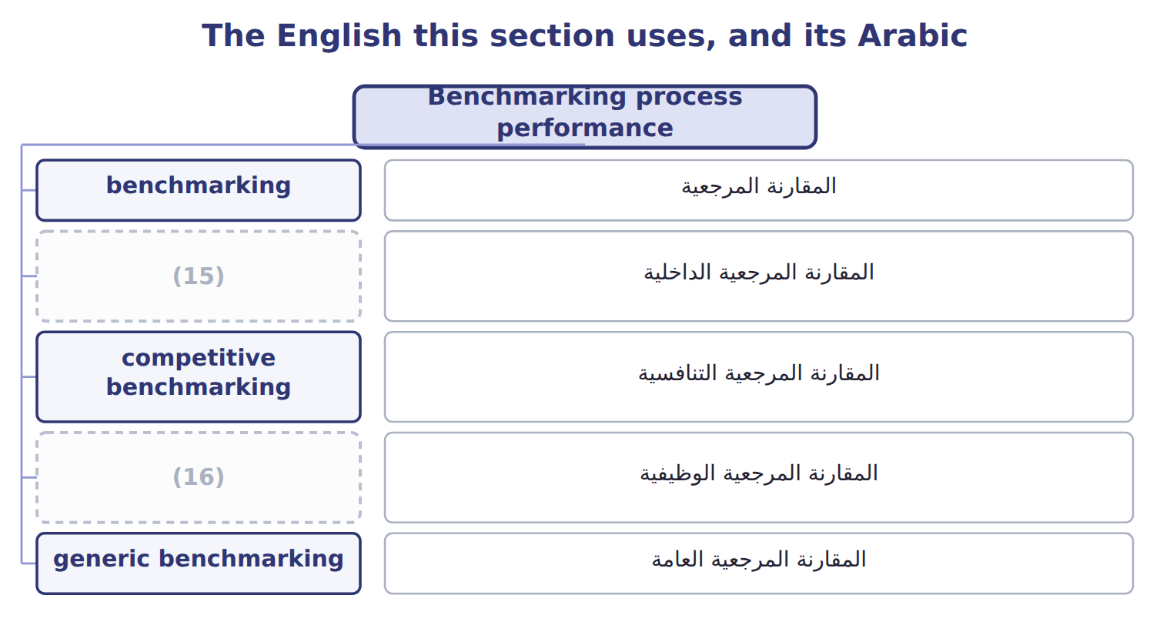
word list
competitive benchmarking · functional benchmarking · internal benchmarking

The English this sheet uses, and its Arabic
English (exam term) | Arabic
benchmarking | المقارنة المرجعية
internal benchmarking | المقارنة المرجعية الداخلية
competitive benchmarking | المقارنة المرجعية التنافسية
functional benchmarking | المقارنة المرجعية الوظيفية
generic benchmarking | المقارنة المرجعية العامة

Answer key · 15.4 Benchmarking process performance

1 performers | 9 redesign
2 competitive | 10 Cycle time, order to cash (days)
3 Units of the same organization | 11 Faulty orders (%)
4 Another Jordanian tahini maker | 12 defined
5 The same function in other industries | 13 correction
6 Invoice-to-cash at a global retailer | 14 comparison
7 comparable | 15 internal benchmarking
8 practices | 16 functional benchmarking

the summaries in full
Summary 1 Benchmarking compares a process and its results with those of the best performers. There are four common types: internal benchmarking, competitive benchmarking, functional benchmarking and generic benchmarking.
Summary 2 Benchmarking follows a cycle: plan, find partners, collect comparable data, analyse the gap and the practices behind it, act, and monitor. The redesign closes most of the gap, but best practice is still $16.00 an order and 3 days.
Summary 3 Measures must be defined the same way on both sides. Tahini's all-in cost per order includes error correction and the running cost of the portal; the survey figure must include the same items, or the comparison misleads.

15.5 Benchmarking and competitive advantage
Chapter 15 · section 15.5

Fill every gap. Each word list holds one word more than there are gaps.
Summary 1 gaps 1–2
Benchmarking helps create an (1) in four ways. It sets targets that others already achieve, brings in ideas from outside, focuses on measures (2) feel, and builds a habit of improving.
word list
customers · advantage · tomorrow's

Benefits of benchmarking for competitive advantage
Benefit | What it gives the company
Realistic targets | Targets based on what others already achieve
New ideas | (3)
Customer focus | (4)
Lasting advantage | A habit of improving faster than rivals

word list
A habit of improving faster than rivals · Measures such as cycle time that customers feel · Practices the company would not have thought of

Summary 2 gaps 5–8
For Tahini, a four-day cycle time is now a selling point: Barada receives its orders faster than from other suppliers, and fewer invoices need (5) . The (6) lasts only if benchmarking continues. (7) improve too, so today's best practice becomes tomorrow's normal practice. In (8) it means benchmarking.
word list
Competitors · advantage · improve · management · correcting

The words this section uses
Each term sits against what it means.
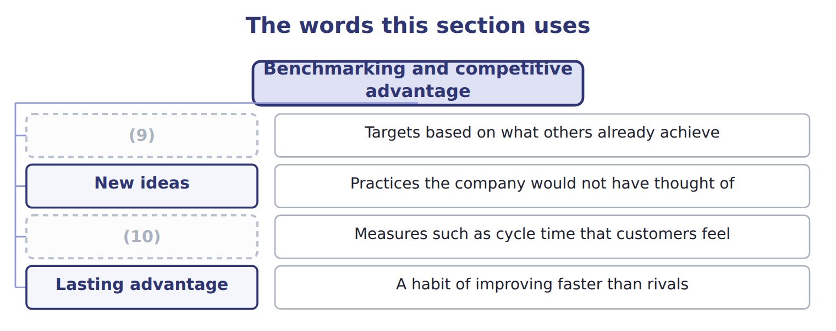
word list
Lasting advantage · Customer focus · Realistic targets

Answer key · 15.5 Benchmarking and competitive advantage

1 advantage | 6 advantage
2 customers | 7 Competitors
3 Practices the company would not have thought of | 8 management
4 Measures such as cycle time that customers feel | 9 Realistic targets
5 correcting | 10 Customer focus

the summaries in full
Summary 1 Benchmarking helps create an advantage in four ways. It sets targets that others already achieve, brings in ideas from outside, focuses on measures customers feel, and builds a habit of improving.
Summary 2 For Tahini, a four-day cycle time is now a selling point: Barada receives its orders faster than from other suppliers, and fewer invoices need correcting. The advantage lasts only if benchmarking continues. Competitors improve too, so today's best practice becomes tomorrow's normal practice. In management it means benchmarking.

15.6 Extended Example 15A: the business case for the new order-to-cash process
Chapter 15 · section 15.6

Fill every gap. Each word list holds one word more than there are gaps.
Summary 1 gaps 1–7
This example builds the (1) business case the (2) manager signed. (3) : 8,000 orders a year; staff cost $20 an hour; (4) a faulty order costs $50. Change: one-off cost $150,000; (5) cost $12,800 a year. Old process: staff $336,000 + corrections $20,000 = $356,000 a year. New process: staff $139,200 + corrections $4,000 = $143,200 a year. Net (6) saving: $212,800 − $12,800 = $200,000. The one-off cost is (7) in 0.75 years, and the net saving over three years is $450,000.
word list
business · recovered · division · yearly · three-year · Volume · correcting · running

Extended Example: the three-year business case
Every item belongs to exactly one group.
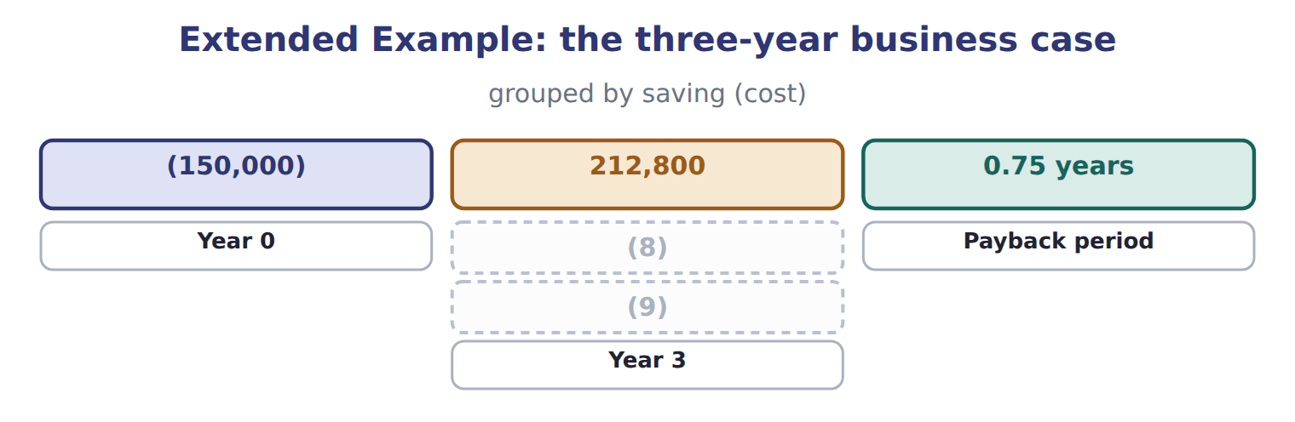
word list
Year 2 · cycle time · Year 1

Everything ties

Summary 2 gaps 10–11
Three net yearly savings of $200,000 minus the one-off $150,000 = $450,000, the last (10) figure. (11) cost per order after the change: ($143,200 + $12,800) ÷ 8,000 = $19.50.
word list
corrections · All-in · cumulative

Exam view

Summary 3 gaps 12–14
Expect hours or costs per step (12) and after a (13) , a volume, and the costs of the change. (14) the yearly cost of each process, deduct the running cost, then deduct the one-off cost once over the period asked.
word list
redesign · Compute · before · three-year

Exam view
Levant receiving, 2027 | Now | Redesigned
(15) | 1.0 | 1.0
(16) | 1.2 | 0.1
(17) | 0.5 | 0.3
Type the receipt into the records | 0.8 | 0.0
Put away | 0.5 | 0.5
Hours per truck | 4.0 | 1.9
Trucks received per year | 2,000 | 2,000
(18) | $18 | $18
One-off cost of the change |  | 60,000
Yearly running cost (scanners, advance notices) |  | 5,600
(19) |  | 1.5

word list
Staff cost per hour · Best-practice distributor, hours per truck · Internal · Inspect · Count every carton · Unload

Item — Answer
Item | Answer
Net yearly saving × 3 years | $200,000 × 3 = $600,000
Net saving over three years | (20)

word list
One-off cost of the change · $600,000 − $150,000 = $450,000

Comparison — Category
Comparison | Category
Levant's two warehouses | (21)
The Oils division's receiving dock | Internal
Another juice distributor in Amman | (22)
Receiving at a pharmaceutical distributor | (23)
The best receiving process in any industry | Generic

word list
Internal · Functional · Competitive · Generic

The English this section uses, and its Arabic
Each term sits against what it means.
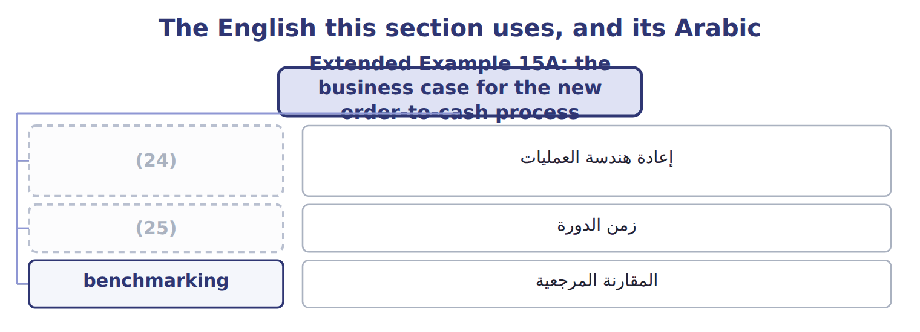
word list
business process reengineering · internal benchmarking · cycle time

The English this sheet uses, and its Arabic
English (exam term) | Arabic
business process reengineering | إعادة هندسة العمليات
cycle time | زمن الدورة
benchmarking | المقارنة المرجعية

Answer key · 15.6 Extended Example 15A: the business case for the new order-to-cash process

1 three-year | 14 Compute
2 division | 15 Unload
3 Volume | 16 Count every carton
4 correcting | 17 Inspect
5 running | 18 Staff cost per hour
6 yearly | 19 Best-practice distributor, hours per truck
7 recovered | 20 $600,000 − $150,000 = $450,000
8 Year 1 | 21 Internal
9 Year 2 | 22 Competitive
10 cumulative | 23 Functional
11 All-in | 24 business process reengineering
12 before | 25 cycle time
13 redesign

the summaries in full
Summary 1 This example builds the three-year business case the division manager signed. Volume: 8,000 orders a year; staff cost $20 an hour; correcting a faulty order costs $50. Change: one-off cost $150,000; running cost $12,800 a year. Old process: staff $336,000 + corrections $20,000 = $356,000 a year. New process: staff $139,200 + corrections $4,000 = $143,200 a year. Net yearly saving: $212,800 − $12,800 = $200,000. The one-off cost is recovered in 0.75 years, and the net saving over three years is $450,000.
Summary 2 Three net yearly savings of $200,000 minus the one-off $150,000 = $450,000, the last cumulative figure. All-in cost per order after the change: ($143,200 + $12,800) ÷ 8,000 = $19.50.
Summary 3 Expect hours or costs per step before and after a redesign, a volume, and the costs of the change. Compute the yearly cost of each process, deduct the running cost, then deduct the one-off cost once over the period asked.

16.1 Continuous improvement techniques and quality
Chapter 16 · section 16.1

Fill every gap. Each word list holds one word more than there are gaps.
Chapter 16, section by section
Each stage leads to the next.
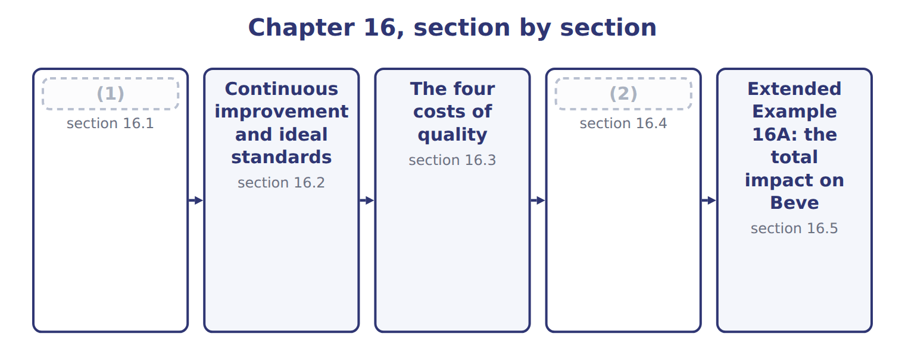
word list
Continuous improvement techniques and quality · The financial impact of quality improvement · Continuous improvement and ideal standards

Summary 1 gaps 3–10
Continuous (3) means improving (4) in many small, regular steps instead of one big change. Each step (5) a little waste or a cause of defects, and quality rises over time. The (6) approach is (7) , in which the people who do the work suggest the improvements. Each change is (8) with the PDCA cycle: plan, do, check, act. Two wider (9) support it. Total quality (10) makes quality everyone's job and lets the customer define it. Six Sigma uses data and statistics to cut defects to very low levels.
word list
removes · best-known · approaches · tested · kaizen · processes · improvement · management · Continuous

Continuous improvement techniques compared
Technique | Idea | Beverages example
Kaizen | Many small (11) , suggested by the people who do the work | Shorter changeovers on the filling line
PDCA cycle | Plan, do, check, act: test a change before adopting it | (12)
Total quality management | (13) | Drivers report damaged cases at delivery
Six Sigma | (14) | Measuring fill-volume variation per bottle

word list
Trying a new cleaning routine on one line first · ideal standard · Data and statistics to cut defects to very low levels · Quality is everyone's job; the customer defines quality · improvements

Worked example: a kaizen event on the filling line

The line team cut each changeover from 60 to 35 minutes.

Worked example: the kaizen changeover saving
Kaizen event on the filling line | Amount
(15) | 400
Minutes per changeover: before → after | 60 → 35
Hours of line time freed a year | 167
(16) | $600
(17) | 100,000

word list
prevention costs · Yearly saving · Changeovers a year · Cost of one hour of line time

The English this section uses, and its Arabic
Each term sits against what it means.
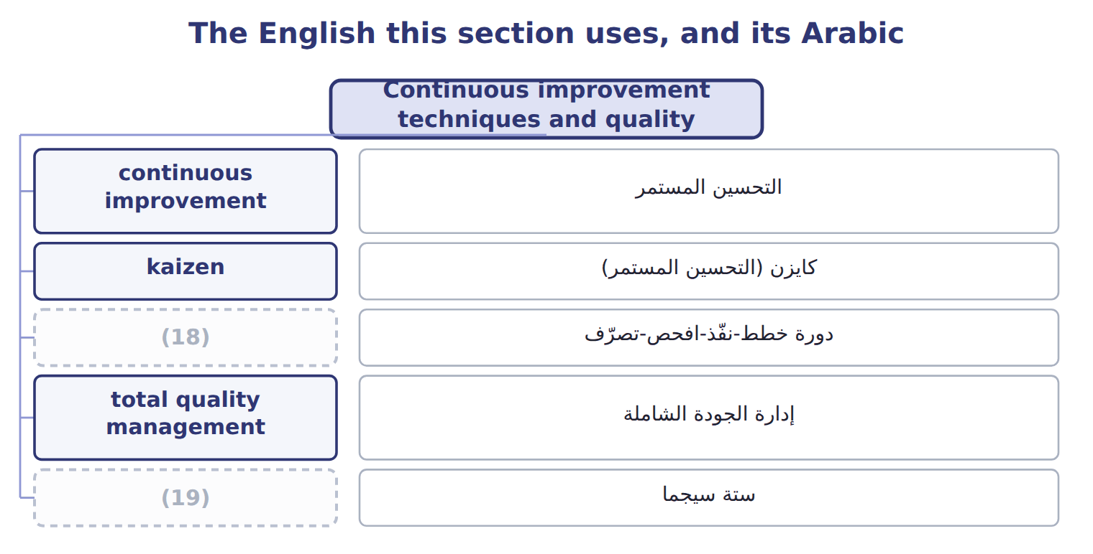
word list
ستة سيجما · PDCA cycle · Six Sigma

The English this sheet uses, and its Arabic
English (exam term) | Arabic
continuous improvement | التحسين المستمر
kaizen | كايزن (التحسين المستمر)
PDCA cycle | دورة خطط-نفّذ-افحص-تصرّف
total quality management | إدارة الجودة الشاملة
Six Sigma | ستة سيجما

Answer key · 16.1 Continuous improvement techniques and quality

1 Continuous improvement techniques and quality | 11 improvements
2 The financial impact of quality improvement | 12 Trying a new cleaning routine on one line first
3 improvement | 13 Quality is everyone's job; the customer defines quality
4 processes | 14 Data and statistics to cut defects to very low levels
5 removes | 15 Changeovers a year
6 best-known | 16 Cost of one hour of line time
7 kaizen | 17 Yearly saving
8 tested | 18 PDCA cycle
9 approaches | 19 Six Sigma
10 management

the summaries in full
Summary 1 Continuous improvement means improving processes in many small, regular steps instead of one big change. Each step removes a little waste or a cause of defects, and quality rises over time. The best-known approach is kaizen, in which the people who do the work suggest the improvements. Each change is tested with the PDCA cycle: plan, do, check, act. Two wider approaches support it. Total quality management makes quality everyone's job and lets the customer define it. Six Sigma uses data and statistics to cut defects to very low levels.

16.2 Continuous improvement and ideal standards
Chapter 16 · section 16.2

Fill every gap. Each word list holds one word more than there are gaps.
Summary 1 gaps 1–8
An ideal standard assumes perfect (1) : no waste, no (2) , no idle time. A (3) attainable standard allows for normal waste and is hard but (4) . The ideal shows the (5) and the size of the waste still in the (6) . Each year the attainable standard moves (7) to it. Beverages allows 2.0% normal spoilage this year, aims for 1.2% after its (8) program, and treats 0.0% as the ideal. Judging people against the ideal standard can demotivate them, because it is never met; using it to show the remaining waste motivates improvement.
word list
breakdowns · closer · process · possible · currently · attainable · kaizen · direction · conditions

Ideal and currently attainable standards
 | Ideal standard | Currently attainable standard
Assumes | Perfect conditions: no waste, no breakdowns | (9)
Use in continuous improvement | (10) | Sets this year's target and judges performance
Effect on people | (11) | Motivates: hard but possible
Beverages spoilage allowance | 0.0% | (12)

word list
Can demotivate if used to judge them · Shows the direction and the size of the remaining waste · Efficient work with normal waste and breaks · 2.0% this year; 1.2% after kaizen · Perfect conditions: no waste, no breakdowns

The English this section uses, and its Arabic
Each term sits against what it means.
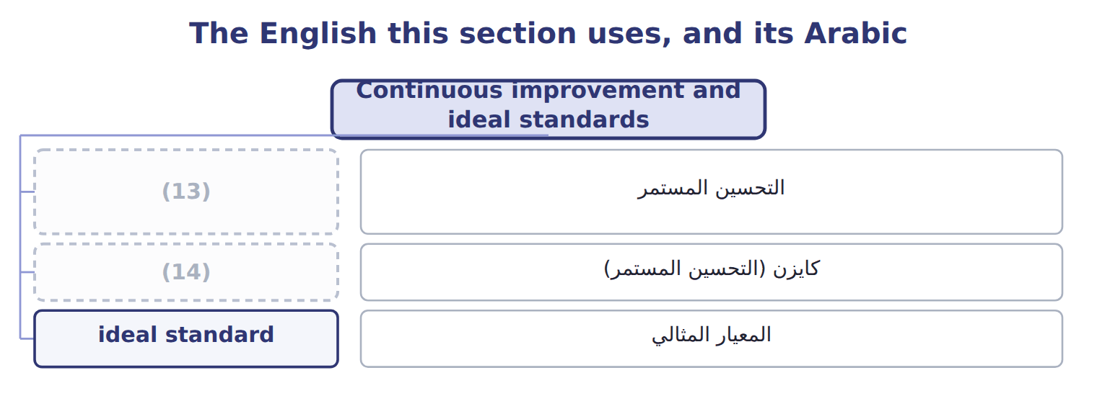
word list
Six Sigma · continuous improvement · kaizen

The English this sheet uses, and its Arabic
English (exam term) | Arabic
ideal standard | المعيار المثالي

Answer key · 16.2 Continuous improvement and ideal standards

1 conditions | 8 kaizen
2 breakdowns | 9 Efficient work with normal waste and breaks
3 currently | 10 Shows the direction and the size of the remaining waste
4 possible | 11 Can demotivate if used to judge them
5 direction | 12 2.0% this year; 1.2% after kaizen
6 process | 13 continuous improvement
7 closer | 14 kaizen

the summaries in full
Summary 1 An ideal standard assumes perfect conditions: no waste, no breakdowns, no idle time. A currently attainable standard allows for normal waste and is hard but possible. The ideal shows the direction and the size of the waste still in the process. Each year the attainable standard moves closer to it. Beverages allows 2.0% normal spoilage this year, aims for 1.2% after its kaizen program, and treats 0.0% as the ideal. Judging people against the ideal standard can demotivate them, because it is never met; using it to show the remaining waste motivates improvement.

16.3 The four costs of quality
Chapter 16 · section 16.3

Fill every gap. Each word list holds one word more than there are gaps.
Summary 1 gaps 1–7
The cost of (1) has four parts. (2) costs stop defects before they happen. Appraisal costs find defects by (3) and testing. Together they are the costs of (4) . (5) failure costs arise from defects found before the product reaches the customer, such as scrap and rework. External failure costs arise from defects the customer finds, such as returns, (6) and lost sales. Failure costs are 68% of the total $950,000, and the largest (7) is external failure.
word list
Prevention · complaints · kaizen · Internal · inspection · quality · category · conformance

Beverages cost-of-quality report, 2027
Beverages cost-of-quality report, 2027 | Item | Category
(8) | 30,000
Quality training for staff | 40,000
(9) | 50,000
(10) |  | 120,000 (13%)
(11) | 45,000
(12) | 80,000
Lab tests of finished juice | 55,000
Appraisal costs |  | 180,000 (19%)
(13) | 150,000
Re-filtering (rework) | 60,000
(14) | 40,000
Internal failure costs |  | 250,000 (26%)
(15) | 200,000
Handling complaints | 50,000
Lost contribution from lost customers (estimate) | 150,000
External failure costs |  | 400,000 (42%)
Total cost of quality |  | 950,000

word list
Line stops after failures · Prevention costs · Supplier audits · Testing incoming concentrate · Lab tests of finished juice · Preventive maintenance of the fillers · Spoiled batches · In-line checks of fill and seal · Returns and replacements

Hidden external failure costs

Summary 2 gaps 16–18
Lost sales and lost (16) do not appear in the ledger, but they are external failure costs. An exam answer that leaves them out (17) the cost of quality. Both mean the four categories, not the price of a (18) product.
word list
customers · Prevention · understates · high-quality

The English this section uses, and its Arabic
Each term sits against what it means.
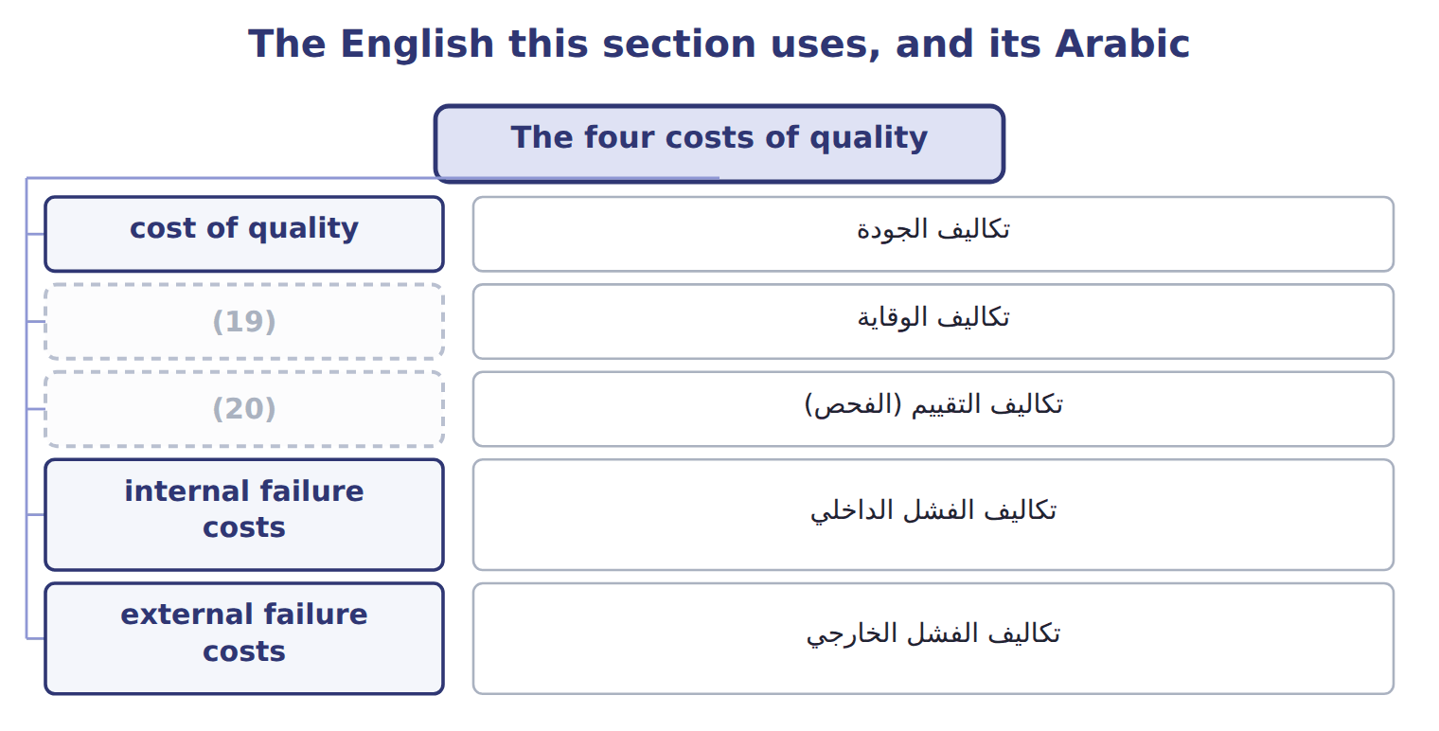
word list
prevention costs · PDCA cycle · appraisal costs

The English this sheet uses, and its Arabic
English (exam term) | Arabic
cost of quality | تكاليف الجودة
prevention costs | تكاليف الوقاية
appraisal costs | تكاليف التقييم (الفحص)
internal failure costs | تكاليف الفشل الداخلي
external failure costs | تكاليف الفشل الخارجي

Answer key · 16.3 The four costs of quality

1 quality | 11 Testing incoming concentrate
2 Prevention | 12 In-line checks of fill and seal
3 inspection | 13 Spoiled batches
4 conformance | 14 Line stops after failures
5 Internal | 15 Returns and replacements
6 complaints | 16 customers
7 category | 17 understates
8 Supplier audits | 18 high-quality
9 Preventive maintenance of the fillers | 19 prevention costs
10 Prevention costs | 20 appraisal costs

the summaries in full
Summary 1 The cost of quality has four parts. Prevention costs stop defects before they happen. Appraisal costs find defects by inspection and testing. Together they are the costs of conformance. Internal failure costs arise from defects found before the product reaches the customer, such as scrap and rework. External failure costs arise from defects the customer finds, such as returns, complaints and lost sales. Failure costs are 68% of the total $950,000, and the largest category is external failure.
Summary 2 Lost sales and lost customers do not appear in the ledger, but they are external failure costs. An exam answer that leaves them out understates the cost of quality. Both mean the four categories, not the price of a high-quality product.

16.4 The financial impact of quality improvement
Chapter 16 · section 16.4

Fill every gap. Each word list holds one word more than there are gaps.
Summary 1 gaps 1–2
Beverages plans a (1) and process-control program. It adds $110,000 a year of (2) , cuts appraisal by $40,000, and is expected to cut internal failure by 45% and external failure by 60%.
word list
supplier-certification · quality · prevention

Worked example: the program's effect

Summary 2 gaps 3–4
The total cost of (3) falls from $950,000 to $667,500, a net (4) of $282,500 a year.
word list
saving · quality · failure

Worked example: the quality program's effect on each category
The parts add up to the total; the bars are to scale.
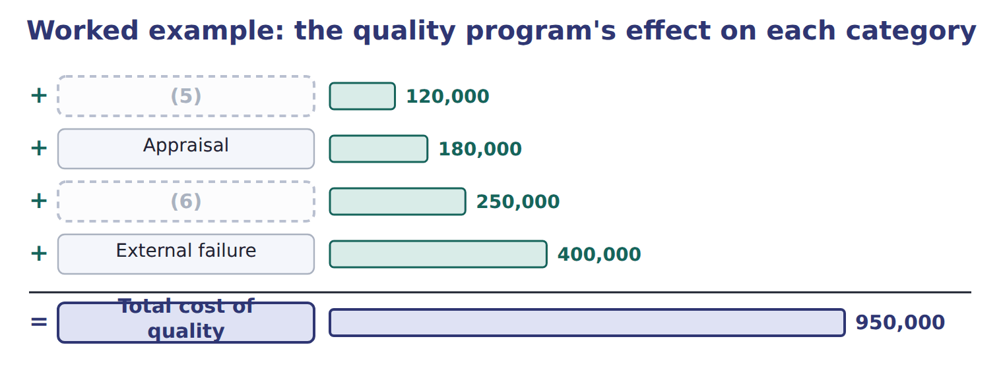
word list
continuous improvement · Prevention · Internal failure

The failure costs after the program

Complete the two blank rows.
Your turn: the cost of quality after the program (complete the blanks)
Cost of quality after the program | Whole USD
(7) | 230,000
(8) | 140,000
Internal failure (cut by 45%) | ________
(9) | ________
Total after the program | 667,500

word list
continuous improvement · Appraisal · Prevention · External failure (cut by 60%)

Summary 3 gaps 10–11
Prevention rises, and (10) else falls by more. The net saving already deducts the extra prevention (11) .
word list
everything · process-control · spending

Answer key · 16.4 The financial impact of quality improvement

1 supplier-certification | 7 Prevention
2 prevention | 8 Appraisal
3 quality | 9 External failure (cut by 60%)
4 saving | 10 everything
5 Prevention | 11 spending
6 Internal failure

the summaries in full
Summary 1 Beverages plans a supplier-certification and process-control program. It adds $110,000 a year of prevention, cuts appraisal by $40,000, and is expected to cut internal failure by 45% and external failure by 60%.
Summary 2 The total cost of quality falls from $950,000 to $667,500, a net saving of $282,500 a year.
Summary 3 Prevention rises, and everything else falls by more. The net saving already deducts the extra prevention spending.

16.5 Extended Example 16A: the total impact on Beverages
Chapter 16 · section 16.5

Fill every gap. Each word list holds one word more than there are gaps.
Summary 1 gaps 1–6
This example adds the quality program and the kaizen event (1) , as the division manager (2) them to the board. Cost of quality 2027: prevention $120,000, appraisal $180,000, (3) failure $250,000, (4) failure $400,000. (5) : the quality program (Section 16.4) and the (6) kaizen (Section 16.1). Failure costs fall by $352,500 and appraisal by $40,000, against $110,000 of extra prevention. With the kaizen saving, the total yearly impact is shown on the last line.
word list
presented · internal · changeover · together · external · Improvements · compute

Extended Example: the total yearly financial impact
The bars are drawn to scale.
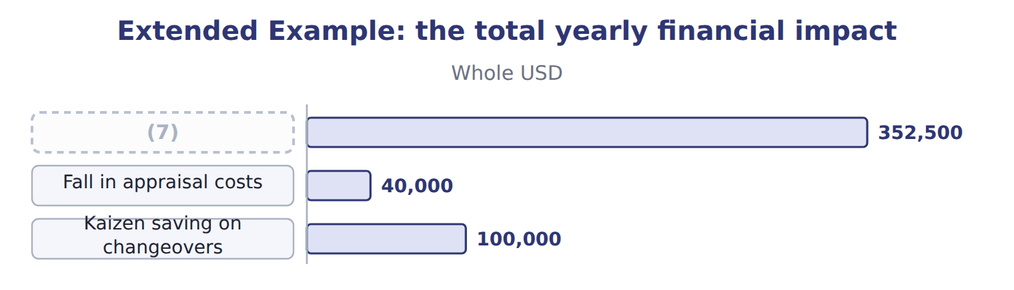
word list
Kaizen saving on changeovers · Fall in failure costs

Summary 2 gaps 8–9
Failure costs fall from 68% to 45% of the total: the (8) now spends its (9) money earlier in the process.
word list
quality · process · division

Everything ties

Summary 3 gaps 10–11
Fall in failure costs $352,500 + fall in (10) $40,000 − extra (11) $110,000 = $282,500.
word list
prevention · appraisal · process

Exam view

Summary 4 gaps 12–14
Expect a list of quality costs to classify, then a (12) that raises (13) or appraisal and lowers failure costs. Classify first, then compute the new total; the answer is the net change, after the extra (14) .
word list
spending · proposal · together · prevention

Exam view
The bars are drawn to scale.
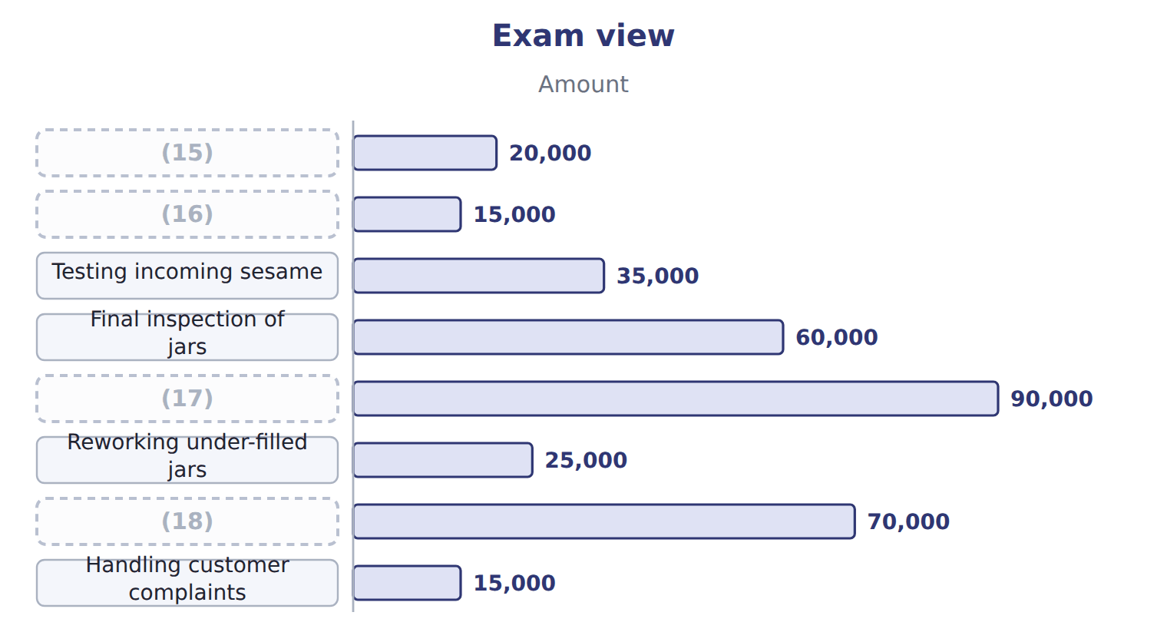
word list
Supplier audits · Staff training in hygiene · Returns from Barada · Reworking under-filled jars · Scrapped batches

Item — Answer
Item | Answer
Internal failure after the program | (19)
External failure after the program | $400,000 × (100% − 60%) = $160,000

word list
$400,000 × (100% − 60%) = $160,000 · $250,000 × (100% − 45%) = $137,500

Quality cost — Category
Every item belongs to exactly one group.
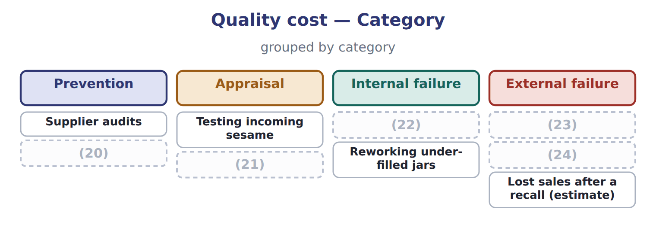
word list
Scrapped batches · Testing incoming sesame · Handling customer complaints · Staff training in hygiene · Returns from Barada · Final inspection of jars

The English this section uses, and its Arabic
Each term sits against what it means.
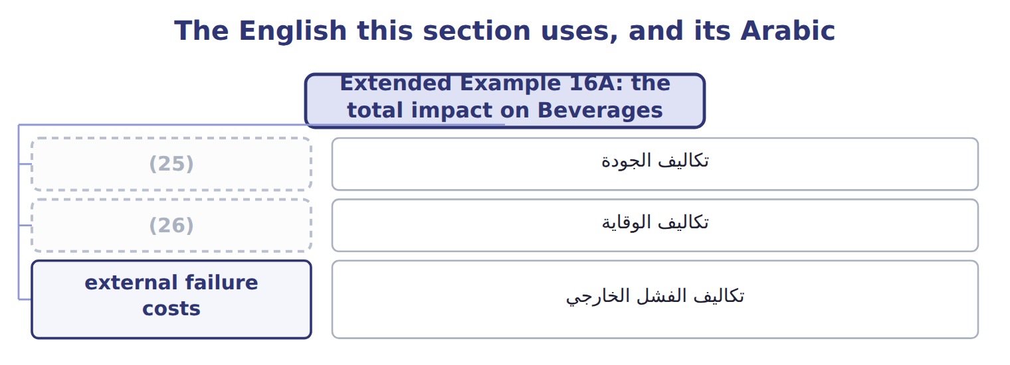
word list
cost of quality · continuous improvement · prevention costs

The English this sheet uses, and its Arabic
English (exam term) | Arabic
cost of quality | تكاليف الجودة
prevention costs | تكاليف الوقاية
external failure costs | تكاليف الفشل الخارجي

Answer key · 16.5 Extended Example 16A: the total impact on Beverages

1 together | 14 spending
2 presented | 15 Supplier audits
3 internal | 16 Staff training in hygiene
4 external | 17 Scrapped batches
5 Improvements | 18 Returns from Barada
6 changeover | 19 $250,000 × (100% − 45%) = $137,500
7 Fall in failure costs | 20 Staff training in hygiene
8 division | 21 Final inspection of jars
9 quality | 22 Scrapped batches
10 appraisal | 23 Returns from Barada
11 prevention | 24 Handling customer complaints
12 proposal | 25 cost of quality
13 prevention | 26 prevention costs

the summaries in full
Summary 1 This example adds the quality program and the kaizen event together, as the division manager presented them to the board. Cost of quality 2027: prevention $120,000, appraisal $180,000, internal failure $250,000, external failure $400,000. Improvements: the quality program (Section 16.4) and the changeover kaizen (Section 16.1). Failure costs fall by $352,500 and appraisal by $40,000, against $110,000 of extra prevention. With the kaizen saving, the total yearly impact is shown on the last line.
Summary 2 Failure costs fall from 68% to 45% of the total: the division now spends its quality money earlier in the process.
Summary 3 Fall in failure costs $352,500 + fall in appraisal $40,000 − extra prevention $110,000 = $282,500.
Summary 4 Expect a list of quality costs to classify, then a proposal that raises prevention or appraisal and lowers failure costs. Classify first, then compute the new total; the answer is the net change, after the extra spending.

17.1 Supply chain management
Chapter 17 · section 17.1

Fill every gap. Each word list holds one word more than there are gaps.
Chapter 17, section by section
Each stage leads to the next.
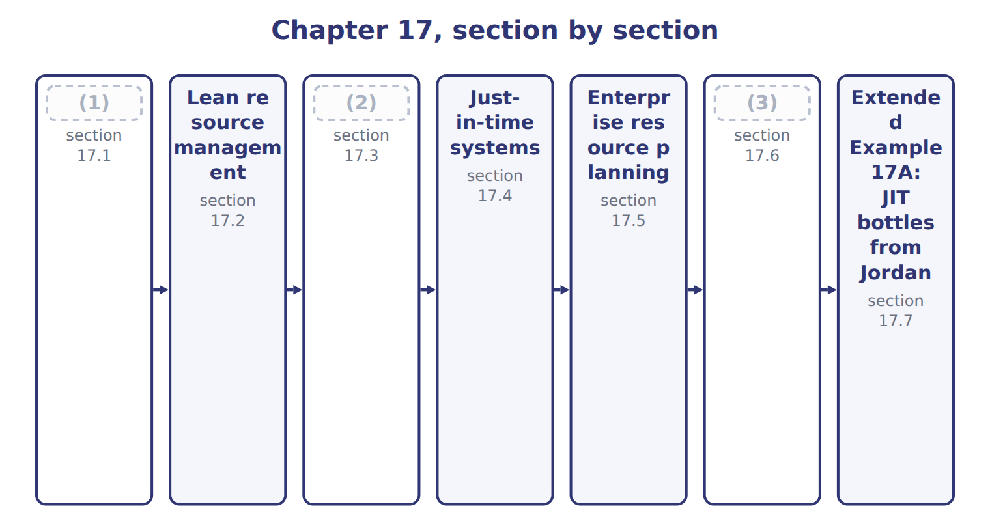
word list
Material requirements planning · Supply chain management · just-in-time (JIT) · Outsourcing

Summary 1 gaps 4–12
A supply chain links every company that helps a product reach the final consumer: suppliers, (4) , distributors, (5) and customers. Supply chain management (6) the flows of goods, (7) and money along the whole chain. Goods move toward (8) ; orders, forecasts and (9) move back. The aim is the right product, in the right place, at the right time and the (10) total cost. Supply chain management is more than (11) . When (12) share sales data, small changes in consumer demand no longer grow into large swings in orders further up the chain, and every partner needs less stock.
word list
coordinates · kanban · manufacturers · information · retailers · lowest · partners · consumers · payments · purchasing

The English this sheet uses, and its Arabic
English (exam term) | Arabic
supply chain management | إدارة سلسلة الإمداد

Answer key · 17.1 Supply chain management

1 Supply chain management | 7 information
2 Material requirements planning | 8 consumers
3 Outsourcing | 9 payments
4 manufacturers | 10 lowest
5 retailers | 11 purchasing
6 coordinates | 12 partners

the summaries in full
Summary 1 A supply chain links every company that helps a product reach the final consumer: suppliers, manufacturers, distributors, retailers and customers. Supply chain management coordinates the flows of goods, information and money along the whole chain. Goods move toward consumers; orders, forecasts and payments move back. The aim is the right product, in the right place, at the right time and the lowest total cost. Supply chain management is more than purchasing. When partners share sales data, small changes in consumer demand no longer grow into large swings in orders further up the chain, and every partner needs less stock.

17.2 Lean resource management
Chapter 17 · section 17.2

Fill every gap. Each word list holds one word more than there are gaps.
Summary 1 gaps 1–2
Lean resource (1) delivers value to customers with the least waste of time, materials, space and effort. It (2) by seeing waste.
word list
kanban · starts · management

The eight wastes of lean, with Orontes examples
Waste | Orontes example
Overproduction | Making juice before orders exist
Waiting | (3)
Transport | Moving pallets between two buildings
Over-processing | (4)
Inventory | (5)
Motion | Staff walking to fetch caps
Defects | Under-filled jars, re-filtering
Unused skills | (6)

word list
Filling line idle during long changeovers · Making juice before orders exist · A month of bottles in a rented store · Ignoring line workers' improvement ideas · Checking every invoice twice

Summary 2 gaps 7–8
Lean uses simple techniques to remove waste: tidy work areas, (7) signals that pull materials only when needed, quick changeovers, (8) and maps of each value stream.
word list
kanban · removes · error-proofing

Lean techniques and their operational benefits
Lean technique | What it does | Operational benefit
5S (sort, set, shine, standardize, sustain) | Tidy, organized work areas | (9)
Kanban | (10) | Less inventory
Quick changeover | Shorter setups (Chapter 16) | (11)
Error-proofing | (12) | Fewer defects
Value stream mapping | Map of every step and wait | (13)

word list
Staff walking to fetch caps · Smaller batches, less waiting · Shows where waste is · Devices that stop mistakes · Signals pull materials when needed · Less searching and motion

Summary 3 gaps 14–20
The (14) benefits follow: less (15) and space, shorter lead times, fewer defects and more capacity from the same line. Lean is not simple cost cutting; it removes (16) customers do not value while (17) those they do. At (18) , lean started with a value stream map of the (19) line. It showed that a bottle spent weeks in storage and minutes in (20) . Kanban signals from the filling line to the store, and later to Jordan Glass, cut that waiting time and the space it needed.
word list
activities · Orontes · signals · protecting · Beverages · inventory · production · operational

The words this section uses
Each term sits against what it means.
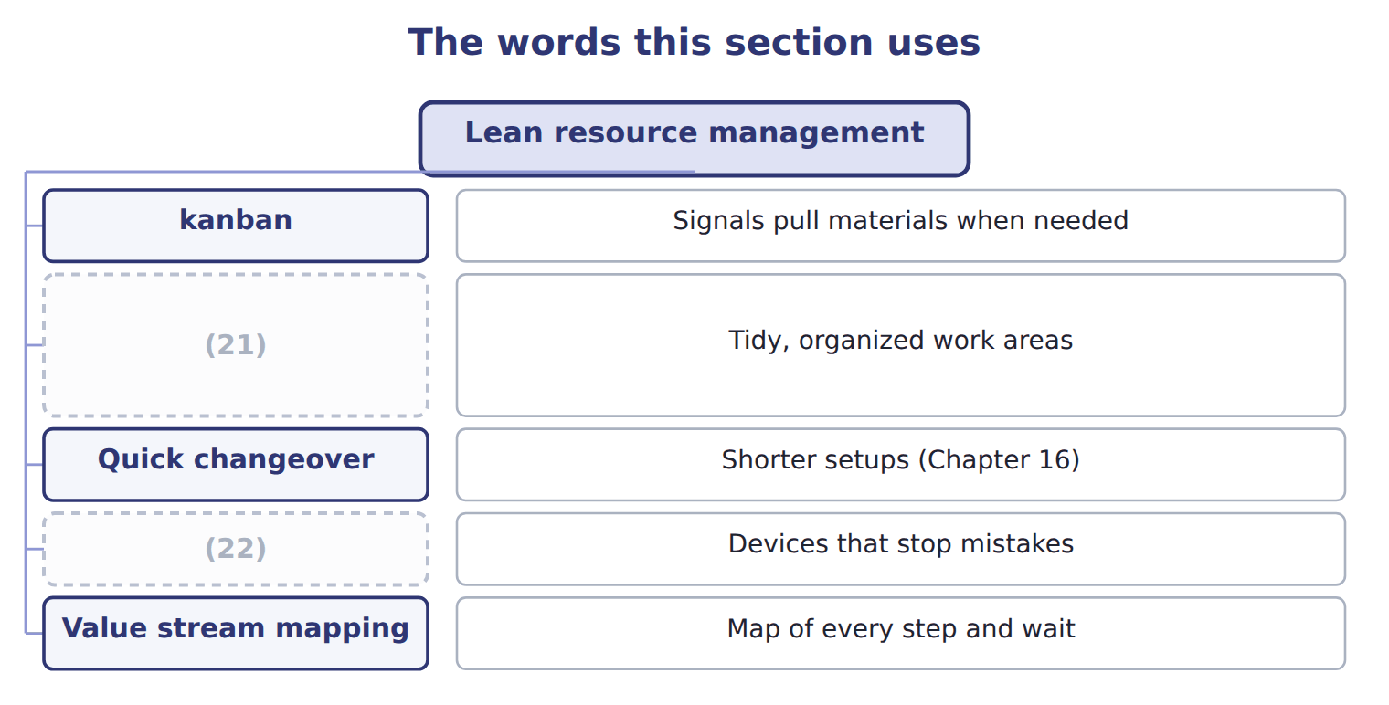
word list
lean resource management · 5S (sort, set, shine, standardize, sustain) · Error-proofing

The English this sheet uses, and its Arabic
English (exam term) | Arabic
lean resource management | الإدارة الرشيقة للموارد
kanban | كانبان

Answer key · 17.2 Lean resource management

1 management | 12 Devices that stop mistakes
2 starts | 13 Shows where waste is
3 Filling line idle during long changeovers | 14 operational
4 Checking every invoice twice | 15 inventory
5 A month of bottles in a rented store | 16 activities
6 Ignoring line workers' improvement ideas | 17 protecting
7 kanban | 18 Orontes
8 error-proofing | 19 Beverages
9 Less searching and motion | 20 production
10 Signals pull materials when needed | 21 5S (sort, set, shine, standardize, sustain)
11 Smaller batches, less waiting | 22 Error-proofing

the summaries in full
Summary 1 Lean resource management delivers value to customers with the least waste of time, materials, space and effort. It starts by seeing waste.
Summary 2 Lean uses simple techniques to remove waste: tidy work areas, kanban signals that pull materials only when needed, quick changeovers, error-proofing and maps of each value stream.
Summary 3 The operational benefits follow: less inventory and space, shorter lead times, fewer defects and more capacity from the same line. Lean is not simple cost cutting; it removes activities customers do not value while protecting those they do. At Orontes, lean started with a value stream map of the Beverages line. It showed that a bottle spent weeks in storage and minutes in production. Kanban signals from the filling line to the store, and later to Jordan Glass, cut that waiting time and the space it needed.

17.3 Material requirements planning
Chapter 17 · section 17.3

Fill every gap. Each word list holds one word more than there are gaps.
Summary 1 gaps 1–2
Material (1) planning (MRP) calculates which materials are needed, how many, and when to order them. It uses three inputs: the master (2) schedule, the bill of materials, and the stock records.
word list
production · requirements · calculates

Worked example: bottles for week 1

Summary 2 gaps 3–5
Beverages plans 18,000 cases in week 1, or 216,000 bottles. It has 60,000 bottles, must keep 20,000 as (3) stock, and (4) 150,000 from an open order. Net need: 216,000 − 150,000 − 40,000 = 26,000 bottles, (5) one week ahead.
word list
expects · safety · ordered · planning

Bottles for weeks 3 and 4

No stock or receipts remain after week 1. Complete the two blank cells.
Your turn: net bottle requirements (complete the blanks)
Name each point on the scale from where it sits.
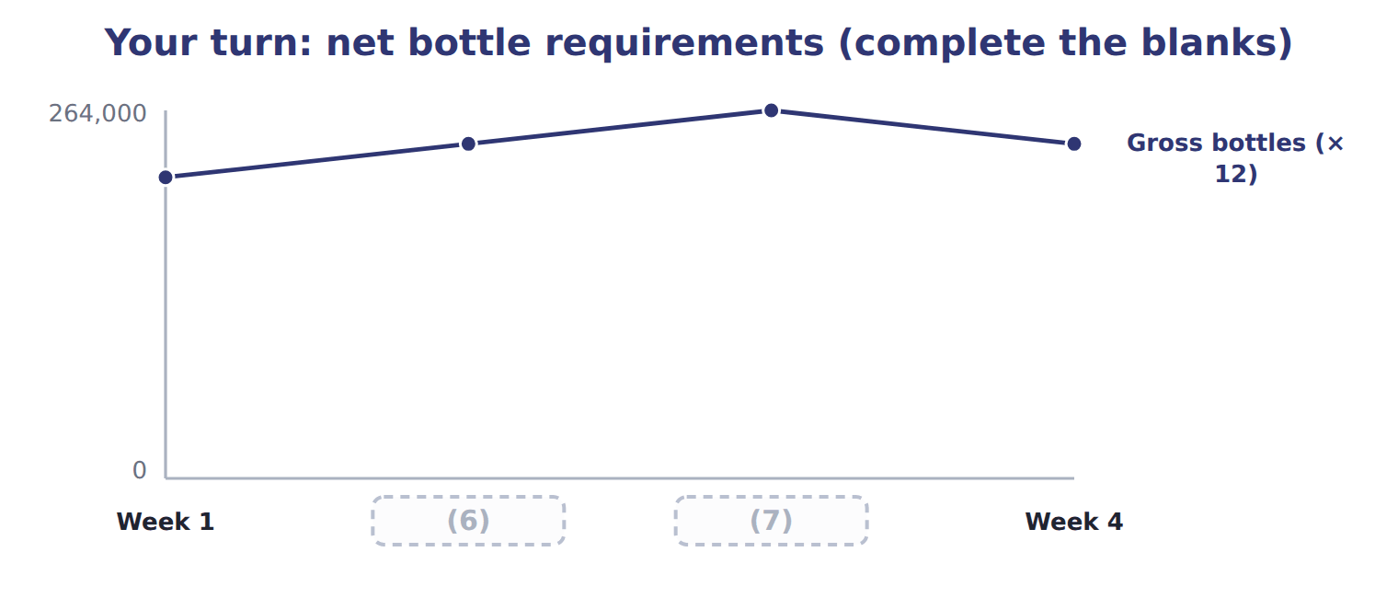
word list
Week 2 · Week 3 · Week 1

Summary 3 gaps 8–10
MRP is a push system: it plans (8) from a forecast schedule and pushes (9) into production. It works well for (10) production, but a wrong forecast leaves the company with too much or too little stock.
word list
purchases · planned · Complete · materials

The English this section uses, and its Arabic
Each term sits against what it means.
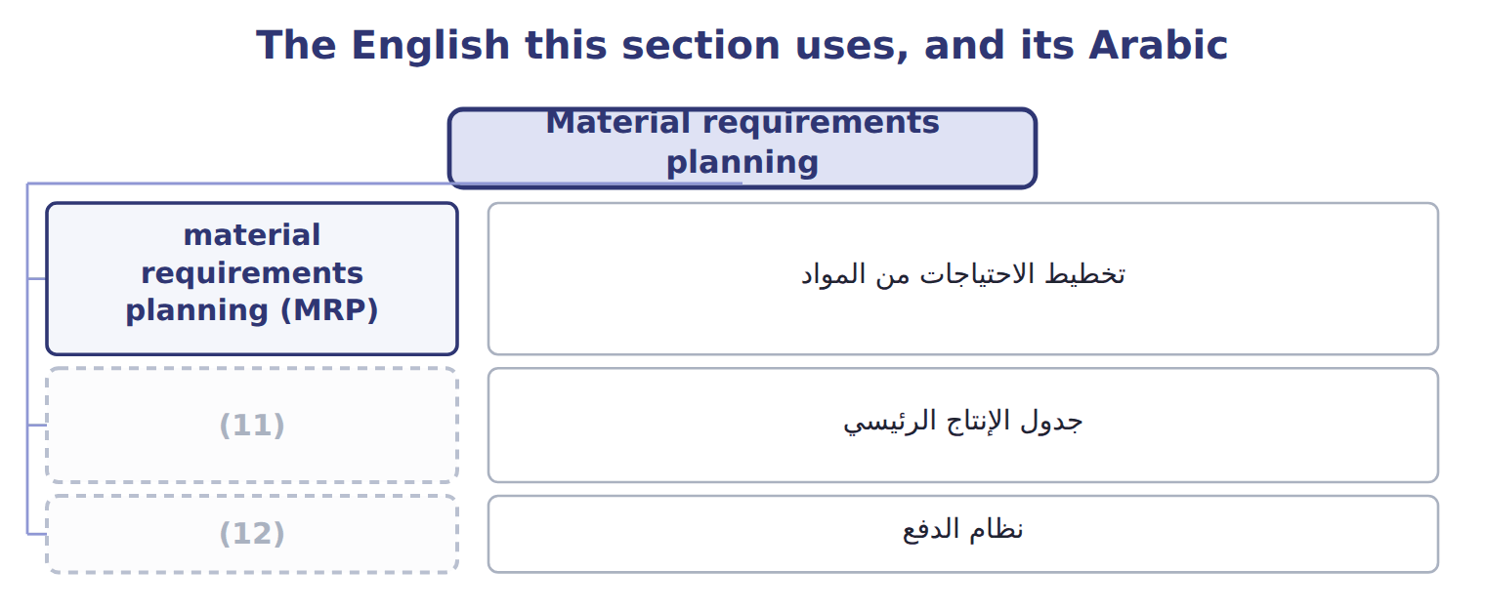
word list
جدول الإنتاج الرئيسي · push system · master production schedule

The English this sheet uses, and its Arabic
English (exam term) | Arabic
material requirements planning (MRP) | تخطيط الاحتياجات من المواد
master production schedule | جدول الإنتاج الرئيسي
push system | نظام الدفع

Answer key · 17.3 Material requirements planning

1 requirements | 7 Week 3
2 production | 8 purchases
3 safety | 9 materials
4 expects | 10 planned
5 ordered | 11 master production schedule
6 Week 2 | 12 push system

the summaries in full
Summary 1 Material requirements planning (MRP) calculates which materials are needed, how many, and when to order them. It uses three inputs: the master production schedule, the bill of materials, and the stock records.
Summary 2 Beverages plans 18,000 cases in week 1, or 216,000 bottles. It has 60,000 bottles, must keep 20,000 as safety stock, and expects 150,000 from an open order. Net need: 216,000 − 150,000 − 40,000 = 26,000 bottles, ordered one week ahead.
Summary 3 MRP is a push system: it plans purchases from a forecast schedule and pushes materials into production. It works well for planned production, but a wrong forecast leaves the company with too much or too little stock.

17.4 Just-in-time systems
Chapter 17 · section 17.4

Fill every gap. Each word list holds one word more than there are gaps.
Summary 1 gaps 1–3
Just-in-time (JIT) is a pull (1) . (2) arrive and products are made only when the next step, or the customer, asks for them. JIT needs reliable (3) , short setups and good quality, because there is almost no stock to hide problems.
word list
system · Materials · because · suppliers

Operational benefits of JIT for the Beverages division
JIT benefit | Beverages example
Lower inventory | (4)
Less space | (5)
Faster response | Production follows actual orders
Higher quality | (6)
Closer suppliers | Daily deliveries need a reliable partner (Jordan Glass)

word list
Bottle stock falls from a month to a day · Problems show quickly, before large stocks are made · Daily deliveries need a reliable partner (Jordan Glass) · The rented bottle store is given up

Backflush costing

Summary 2 gaps 7–10
With JIT, work in process is small, so some companies use (7) costing: they record costs only at a few trigger points, such as (8) or sale. Under U.S. GAAP this is (9) only when the (10) is close to what full costing would give (ASC 330).
word list
outsourcing · backflush · result · completion · acceptable

The English this section uses, and its Arabic
Each term sits against what it means.
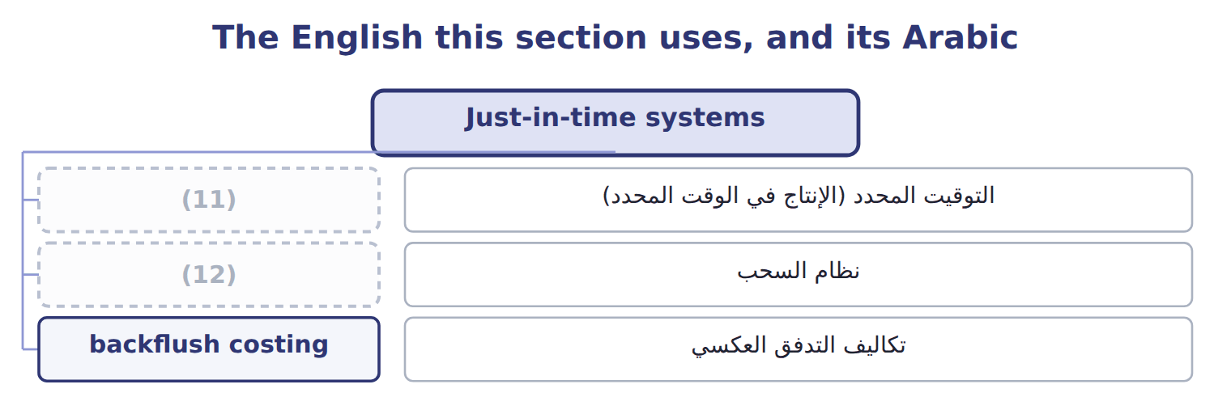
word list
pull system · just-in-time (JIT) · نظام السحب

The English this sheet uses, and its Arabic
English (exam term) | Arabic
just-in-time (JIT) | التوقيت المحدد (الإنتاج في الوقت المحدد)
pull system | نظام السحب
backflush costing | تكاليف التدفق العكسي

Answer key · 17.4 Just-in-time systems

1 system | 7 backflush
2 Materials | 8 completion
3 suppliers | 9 acceptable
4 Bottle stock falls from a month to a day | 10 result
5 The rented bottle store is given up | 11 just-in-time (JIT)
6 Problems show quickly, before large stocks are made | 12 pull system

the summaries in full
Summary 1 Just-in-time (JIT) is a pull system. Materials arrive and products are made only when the next step, or the customer, asks for them. JIT needs reliable suppliers, short setups and good quality, because there is almost no stock to hide problems.
Summary 2 With JIT, work in process is small, so some companies use backflush costing: they record costs only at a few trigger points, such as completion or sale. Under U.S. GAAP this is acceptable only when the result is close to what full costing would give (ASC 330).

17.5 Enterprise resource planning
Chapter 17 · section 17.5

Fill every gap. Each word list holds one word more than there are gaps.
Summary 1 gaps 1–6
Enterprise resource planning (ERP) is an (1) system in which sales, (2) , production, inventory, accounting and human resources all work from one shared database. (3) data is entered once, the copying and (4) removed. (5) see stock, orders and costs as they change, and MRP runs on live data (6) of last month's reports. ERP is not only an accounting system: its value comes from linking every function through the same processes and data.
word list
Managers · purchasing · re-typing · Enterprise · Because · integrated · instead

Operational benefits of ERP
Operational benefit of ERP | Example
Data entered once | No copying of orders (Chapter 15)
Real-time information | (7)
Integrated planning | MRP uses live sales and stock data
Faster period-end close | (8)
Better control | (9)

word list
Managers see stock, orders and costs as they change · Standard processes and a full record of who did what · Fewer reconciliations between departments · enterprise resource planning (ERP)

The English this sheet uses, and its Arabic
English (exam term) | Arabic
enterprise resource planning (ERP) | تخطيط موارد المؤسسة

Answer key · 17.5 Enterprise resource planning

1 integrated | 6 instead
2 purchasing | 7 Managers see stock, orders and costs as they change
3 Because | 8 Fewer reconciliations between departments
4 re-typing | 9 Standard processes and a full record of who did what
5 Managers

the summaries in full
Summary 1 Enterprise resource planning (ERP) is an integrated system in which sales, purchasing, production, inventory, accounting and human resources all work from one shared database. Because data is entered once, the copying and re-typing removed. Managers see stock, orders and costs as they change, and MRP runs on live data instead of last month's reports. ERP is not only an accounting system: its value comes from linking every function through the same processes and data.

17.6 Outsourcing
Chapter 17 · section 17.6

Fill every gap. Each word list holds one word more than there are gaps.
Outsourcing means buying from an outside supplier something the company used to do itself.
Benefits and limitations of outsourcing
Benefits | Limitations
Lower cost when the supplier has scale | Loss of control over quality and timing
Focus on core activities | (1)
Access to skills and technology | Confidential know-how may leak
Fixed costs become variable | (2)

word list
Dependence on one supplier · Hidden costs: contracts, monitoring, transport · Printer lease (can be cancelled)

Summary 1 gaps 3–5
The (3) test compares the (4) price with the costs that would really disappear, not with the full cost. Allocated plant overhead and (5) on equipment that cannot be sold stay whether or not the work is outsourced.
word list
supplier's · financial · outsourcing · depreciation

Worked example: printing labels

Summary 2 gaps 6–7
Beverages prints its own labels at a full cost of $265,000, of which $225,000 is (6) . A (7) offers the labels for $200,000, and the freed room can be rented for $12,000.
word list
printer · Beverages · avoidable

Worked example: print labels in-house or buy them?
The bars are drawn to scale.
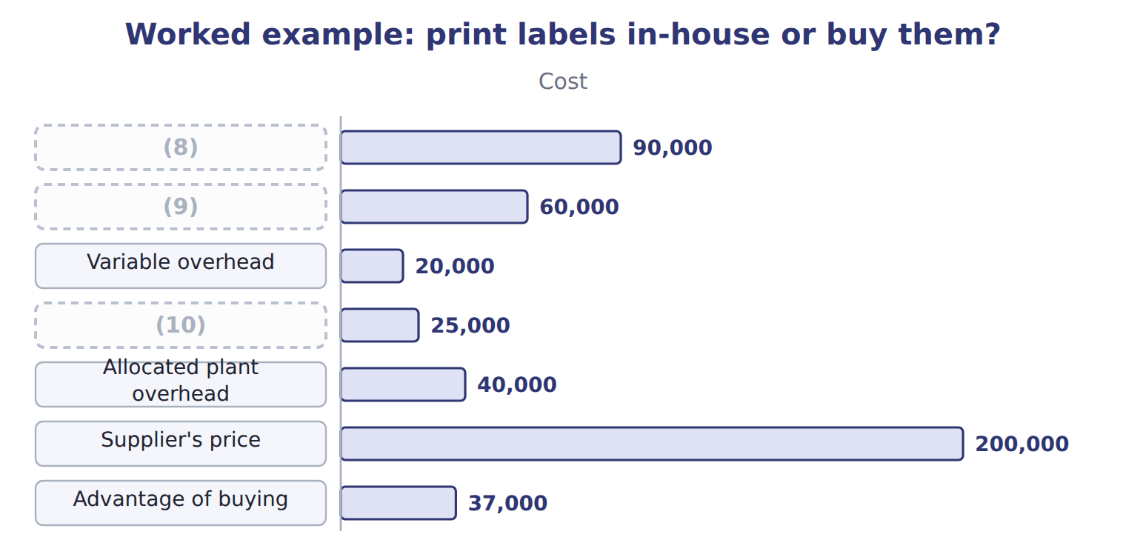
word list
Printing staff · Variable overhead · Label stock and ink · Printer lease (can be cancelled)

Summary 3 gaps 11–14
The (11) are only half of the (12) . (13) are not a core skill, and several (14) can supply them, so the risks are small. For a core activity with one possible supplier, the same saving might not be worth the loss of control.
word list
numbers · Labels · depreciation · decision · printers

Full cost is not avoidable cost

Summary 4 gaps 15–16
If an exam answer compares the (15) price with the full cost, it counts costs that will not disappear. Compare with the (16) cost, and add any income from freed resources.
word list
supplier's · Beverages · avoidable

The English this sheet uses, and its Arabic
English (exam term) | Arabic
outsourcing | الاستعانة بمصادر خارجية

Answer key · 17.6 Outsourcing

1 Dependence on one supplier | 9 Printing staff
2 Hidden costs: contracts, monitoring, transport | 10 Printer lease (can be cancelled)
3 financial | 11 numbers
4 supplier's | 12 decision
5 depreciation | 13 Labels
6 avoidable | 14 printers
7 printer | 15 supplier's
8 Label stock and ink | 16 avoidable

the summaries in full
Summary 1 The financial test compares the supplier's price with the costs that would really disappear, not with the full cost. Allocated plant overhead and depreciation on equipment that cannot be sold stay whether or not the work is outsourced.
Summary 2 Beverages prints its own labels at a full cost of $265,000, of which $225,000 is avoidable. A printer offers the labels for $200,000, and the freed room can be rented for $12,000.
Summary 3 The numbers are only half of the decision. Labels are not a core skill, and several printers can supply them, so the risks are small. For a core activity with one possible supplier, the same saving might not be worth the loss of control.
Summary 4 If an exam answer compares the supplier's price with the full cost, it counts costs that will not disappear. Compare with the avoidable cost, and add any income from freed resources.

17.7 Extended Example 17A: JIT bottles from Jordan Glass
Chapter 17 · section 17.7

Fill every gap. Each word list holds one word more than there are gaps.
Summary 1 gaps 1–7
This example measures the (1) impact of moving bottle (2) from monthly to daily deliveries. Now: monthly deliveries; average bottle inventory $120,000; a (3) store at $30,000 a year. JIT: daily deliveries; average inventory $10,000; an extra delivery (4) of $24,000 and extra handling of $6,000 a year. (5) cost: 20% of the average inventory a year. The (6) cost falls from $62,000 to $33,000, a (7) of $29,000 after the extra delivery and handling costs. The lower inventory also releases $110,000 of cash once.
word list
financial · Carrying · supply · rented · saving · yearly · charge · handling

Extended Example: the financial impact of JIT bottle deliveries
Beverages bottles (whole USD) | Monthly deliveries | JIT daily deliveries
Average bottle inventory | 120,000 | 10,000
Carrying cost (20% of average inventory) | 24,000 | 2,000
(8) | 30,000 | —
Damage and breakage | 8,000 | 1,000
Extra delivery charge | — | 24,000
(9) | — | 6,000
(10) | 62,000 | 33,000
(11) |  | 29,000
(12) |  | 110,000

word list
supply chain management · Yearly saving · Yearly cost · Extra receiving and handling · Rent of the bottle store · Cash released once from lower inventory

Summary 2 gaps 13–15
The saving is real but (13) on Jordan Glass (14) every day. Orontes owns part of Jordan Glass, which makes the link closer, but the division still keeps a small safety stock for (15) .
word list
delivery · delivering · depends · breakdowns

Everything ties

Summary 3 gaps 16–17
Carrying cost now: $120,000 × 20% = $24,000; under JIT: $2,000. (16) saving $29,000 = $62,000 − $33,000; cash (17) $110,000 = $120,000 − $10,000.
word list
handling · Yearly · released

Exam view

Summary 4 gaps 18–20
Expect inventory levels, a (18) rate and the extra costs of the new (19) . Compute each yearly cost, take the (20) , and treat the fall in inventory as a one-time release of cash, not a yearly saving.
word list
system · breakdowns · difference · carrying-cost

Exam view
Oils: bottling EVOO, 2027 | Per liter
Bottles and caps | $1.50
Bottling labor | $0.90
(21) | $0.40
(22) | $0.50
(23) | $0.30
Bottling cost per liter (Chapter 11) | $3.60
Bottler's quote per liter | $3.20
(24) | 150,000

word list
Allocated plant overhead · Variable overhead · Liters bottled per year · Extra receiving and handling · Depreciation of the bottling line (no resale value)

Item — Answer
Item | Answer
Week 3 net bottles | 22,000 cases × 12 = 264,000
Week 4 net bottles | (25)

word list
20,000 cases × 12 = 240,000 · Carrying cost (20% of average inventory)

Bottling cost — Category
Every item belongs to exactly one group.
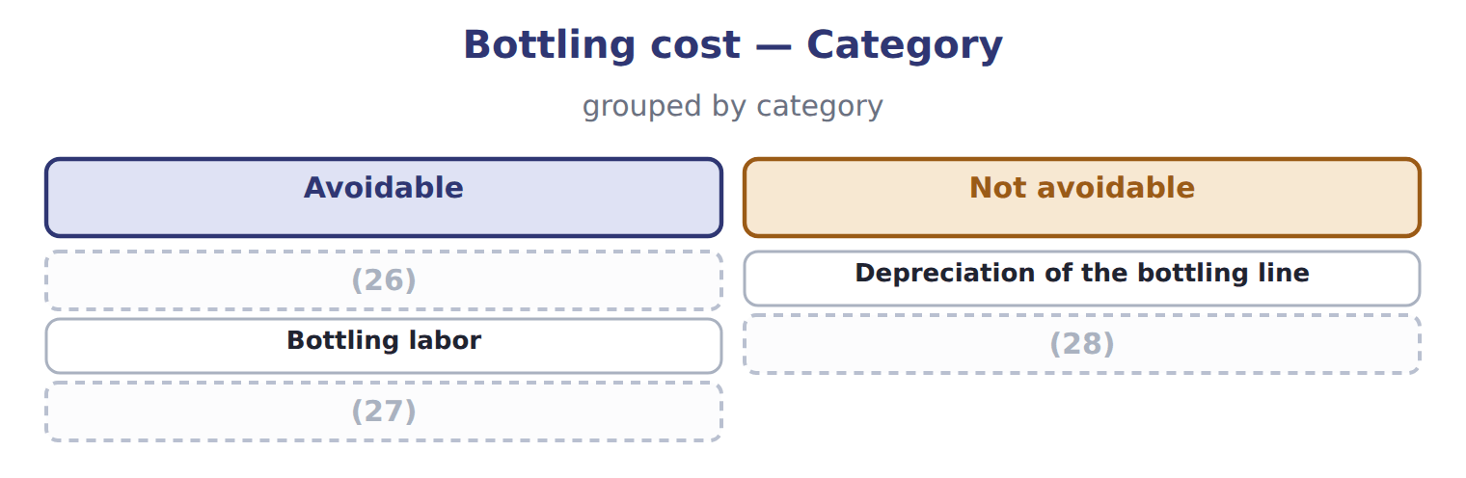
word list
Bottles and caps · Allocated plant overhead · supply chain management · Variable overhead

The English this section uses, and its Arabic
Each term sits against what it means.
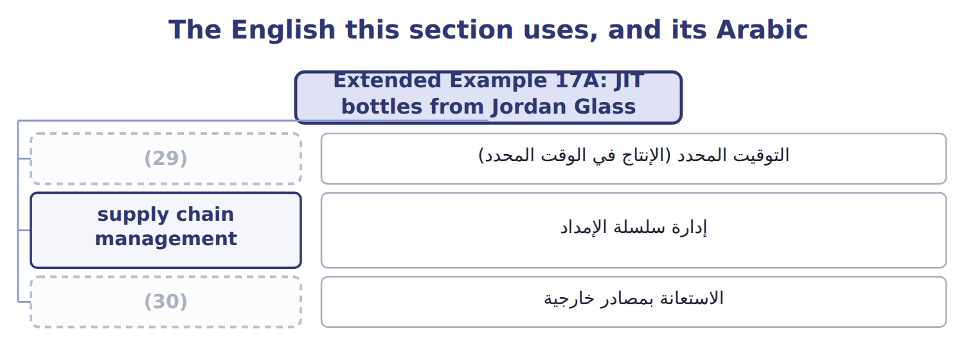
word list
kanban · just-in-time (JIT) · outsourcing

The English this sheet uses, and its Arabic
English (exam term) | Arabic
just-in-time (JIT) | التوقيت المحدد (الإنتاج في الوقت المحدد)
supply chain management | إدارة سلسلة الإمداد
outsourcing | الاستعانة بمصادر خارجية

Answer key · 17.7 Extended Example 17A: JIT bottles from Jordan Glass

1 financial | 16 Yearly
2 supply | 17 released
3 rented | 18 carrying-cost
4 charge | 19 system
5 Carrying | 20 difference
6 yearly | 21 Variable overhead
7 saving | 22 Depreciation of the bottling line (no resale value)
8 Rent of the bottle store | 23 Allocated plant overhead
9 Extra receiving and handling | 24 Liters bottled per year
10 Yearly cost | 25 20,000 cases × 12 = 240,000
11 Yearly saving | 26 Bottles and caps
12 Cash released once from lower inventory | 27 Variable overhead
13 depends | 28 Allocated plant overhead
14 delivering | 29 just-in-time (JIT)
15 breakdowns | 30 outsourcing

the summaries in full
Summary 1 This example measures the financial impact of moving bottle supply from monthly to daily deliveries. Now: monthly deliveries; average bottle inventory $120,000; a rented store at $30,000 a year. JIT: daily deliveries; average inventory $10,000; an extra delivery charge of $24,000 and extra handling of $6,000 a year. Carrying cost: 20% of the average inventory a year. The yearly cost falls from $62,000 to $33,000, a saving of $29,000 after the extra delivery and handling costs. The lower inventory also releases $110,000 of cash once.
Summary 2 The saving is real but depends on Jordan Glass delivering every day. Orontes owns part of Jordan Glass, which makes the link closer, but the division still keeps a small safety stock for breakdowns.
Summary 3 Carrying cost now: $120,000 × 20% = $24,000; under JIT: $2,000. Yearly saving $29,000 = $62,000 − $33,000; cash released $110,000 = $120,000 − $10,000.
Summary 4 Expect inventory levels, a carrying-cost rate and the extra costs of the new system. Compute each yearly cost, take the difference, and treat the fall in inventory as a one-time release of cash, not a yearly saving.

18.1 Cost standards in budgeting
Chapter 18 · section 18.1

Fill every gap. Each word list holds one word more than there are gaps.
Chapter 18, section by section
Each stage leads to the next.
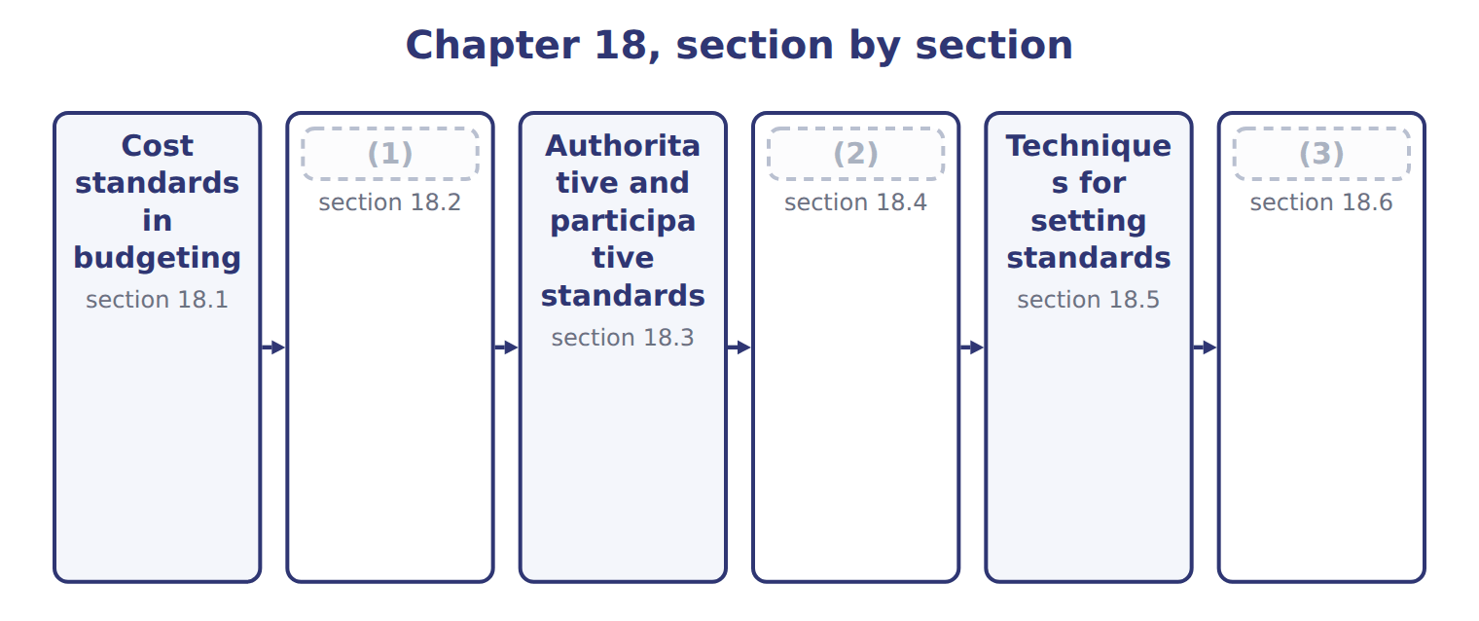
word list
Extended Example 18A: the juice standard cost · Techniques for setting standards · Steps in setting direct material and direct la · Ideal and currently attainable standards

Summary 1 gaps 4–7
A standard is the (4) cost of one unit of output under efficient (5) . The standard cost card lists, for one unit, the standard (6) and the standard price of every input. (7) are built from the card: standard cost per unit times planned units.
word list
quantity · efficient · Budgets · conditions · expected

Worked example: the June production budget

Each input's standard quantity and price are multiplied by the planned cases.

Worked example: the June 2028 production budget from standards
The bars are drawn to scale.
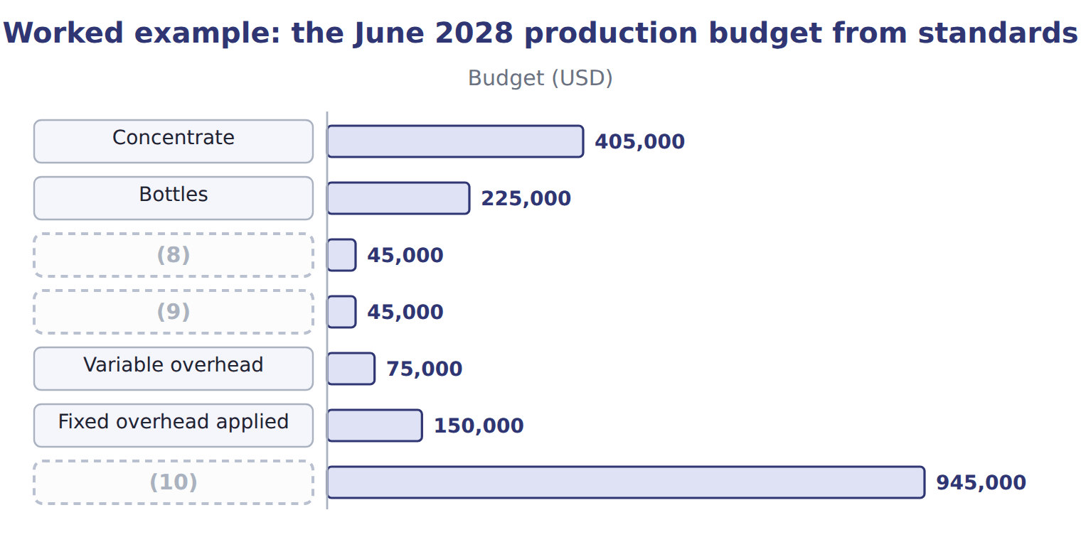
word list
normal loss · Caps and carton · Standard cost of June production · Direct labor

Summary 2 gaps 11–13
The same standards later measure (11) . When June ends, actual costs are compared with the standard cost of the actual output; the (12) are variances, the subject of Book 3. Standards must (13) be reviewed each year, as prices and methods change.
word list
therefore · performance · quantity · differences

The English this sheet uses, and its Arabic
English (exam term) | Arabic
standard cost card | بطاقة التكلفة المعيارية

Answer key · 18.1 Cost standards in budgeting

1 Ideal and currently attainable standards | 8 Caps and carton
2 Steps in setting direct material and direct la | 9 Direct labor
3 Extended Example 18A: the juice standard cost | 10 Standard cost of June production
4 expected | 11 performance
5 conditions | 12 differences
6 quantity | 13 therefore
7 Budgets

the summaries in full
Summary 1 A standard is the expected cost of one unit of output under efficient conditions. The standard cost card lists, for one unit, the standard quantity and the standard price of every input. Budgets are built from the card: standard cost per unit times planned units.
Summary 2 The same standards later measure performance. When June ends, actual costs are compared with the standard cost of the actual output; the differences are variances, the subject of Book 3. Standards must therefore be reviewed each year, as prices and methods change.

18.2 Ideal and currently attainable standards
Chapter 18 · section 18.2

Fill every gap. Each word list holds one word more than there are gaps.
Summary 1 gaps 1–6
An ideal standard assumes perfect (1) : no waste, no rest, no (2) . A (3) attainable standard allows for normal loss, rest, setups and normal (4) . It is hard but (5) for a trained team working (6) . For juice labor, the ideal is 0.040 hours a case; the standard set is 0.050 hours. Budgets and product costs use attainable standards; the ideal shows how much waste is still left to remove.
word list
downtime · conditions · breakdowns · possible · perfect · currently · efficiently

Ideal and currently attainable standards for juice labor
 | Ideal (theoretical) | Currently attainable (practical)
Allowances | None: perfect conditions | (7)
Juice labor per case | 0.040 hours | (8)
Labor cost per case | $0.48 | $0.60
Best use | (9) | Budgets, product costs and judging performance

word list
Shows the direction of improvement (Chapter 16) · 0.040 hours · 0.050 hours · Normal loss, rest, setups, normal downtime

The English this sheet uses, and its Arabic
English (exam term) | Arabic
currently attainable standard | المعيار الممكن التحقيق حاليًا

Answer key · 18.2 Ideal and currently attainable standards

1 conditions | 6 efficiently
2 breakdowns | 7 Normal loss, rest, setups, normal downtime
3 currently | 8 0.050 hours
4 downtime | 9 Shows the direction of improvement (Chapter 16)
5 possible

the summaries in full
Summary 1 An ideal standard assumes perfect conditions: no waste, no rest, no breakdowns. A currently attainable standard allows for normal loss, rest, setups and normal downtime. It is hard but possible for a trained team working efficiently. For juice labor, the ideal is 0.040 hours a case; the standard set is 0.050 hours. Budgets and product costs use attainable standards; the ideal shows how much waste is still left to remove.

18.3 Authoritative and participative standards
Chapter 18 · section 18.3

Fill every gap. Each word list holds one word more than there are gaps.
Summary 1 gaps 1–8
An (1) standard is set by management or engineers alone. A (2) standard is set with the people who must meet it. The juice labor standard (3) as an engineers' proposal of 0.045 hours a case. The line (4) pointed out that the proposal had no time for cleaning between runs. After the (5) , the division set 0.050 hours. (6) builds acceptance, because people help set the target. The risk is padding: people may ask for easy (7) . Management keeps the final (8) and checks the result against activity studies and history.
word list
Participation · supervisors · standards · authoritative · against · decision · participative · started · discussion

Authoritative and participative standards
 | Authoritative (imposed) | Participative
Who sets it | (9) | Managers with the people who must meet it
Juice labor example | (10) | Line supervisors added cleaning time: 0.050 hours
Strength | Fast; uses expert knowledge | (11)
Risk | (12) | Loose standards if people pad them; slower

word list
Management or engineers · Realistic; people accept and own the standard · Engineers proposed 0.045 hours · Loose standards if people pad them; slower · Resistance if people see it as unfair

The English this sheet uses, and its Arabic
English (exam term) | Arabic
authoritative standard | المعيار المفروض (السلطوي)
participative standard | المعيار التشاركي

Answer key · 18.3 Authoritative and participative standards

1 authoritative | 7 standards
2 participative | 8 decision
3 started | 9 Management or engineers
4 supervisors | 10 Engineers proposed 0.045 hours
5 discussion | 11 Realistic; people accept and own the standard
6 Participation | 12 Resistance if people see it as unfair

the summaries in full
Summary 1 An authoritative standard is set by management or engineers alone. A participative standard is set with the people who must meet it. The juice labor standard started as an engineers' proposal of 0.045 hours a case. The line supervisors pointed out that the proposal had no time for cleaning between runs. After the discussion, the division set 0.050 hours. Participation builds acceptance, because people help set the target. The risk is padding: people may ask for easy standards. Management keeps the final decision and checks the result against activity studies and history.

18.4 Steps in setting direct material and direct labor standards
Chapter 18 · section 18.4

Fill every gap. Each word list holds one word more than there are gaps.
Summary 1 gaps 1–2
Each input needs two (1) : a quantity standard and a price standard. For labor they are (2) the time standard and the rate standard.
word list
residue · standards · called

Worked example: the concentrate price standard

Summary 2 gaps 3–4
The (3) list price is $0.88 a liter. The division deducts the quantity discount and adds freight and the cost of (4) and testing.
word list
without · receiving · supplier's

Worked example: the concentrate price standard
Concentrate | Per liter
List price per liter | $0.88
(5) | $(0.04)
(6) | $0.05
Add: receiving and testing | $0.01
(7) | $0.90

word list
Add: freight to Amman · Add: receiving and testing · Price standard per liter · Less: quantity discount

Summary 3 gaps 8–10
The (8) standard starts from the net (9) in one case and allows for normal loss, such as tank residue and spillage on the line. (10) waste is not included; it will show as a variance.
word list
quantity · follows · Abnormal · concentrate

The concentrate quantity standard

Complete the two blank rows.

Your turn: the concentrate quantity standard (complete the blanks)
Every item belongs to exactly one group.
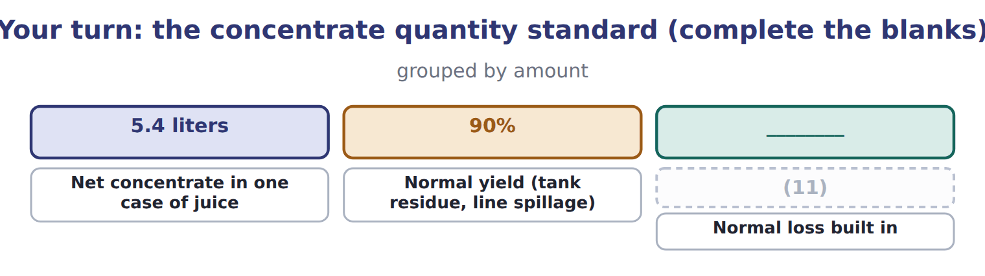
word list
Normal yield (tank residue, line spillage) · Quantity standard (net ÷ yield)

The labor standard follows the same logic. The result is $0.60 a case.
The direct labor standard for juice
Juice direct labor | Amount
Basic time per case (time study) | (12)
Rest and personal allowance | (13)
Setup and cleaning allowance | 0.004 h
Normal downtime allowance | (14)
Time standard per case | 0.050 h
Wage per hour | $10.00
Payroll taxes and benefits per hour | $2.00
Rate standard per hour | $12.00
Direct labor standard per case | $0.60

word list
0.040 h · 0.004 h · 0.002 h · activity analysis

Complete price and quantity standards

Summary 4 gaps 15–17
Exam options often use the list price, or the net (15) without normal loss, or the wage without (16) . The correct (17) includes all normal costs of getting the input ready for use.
word list
quantity · standard · supplier's · benefits

The English this section uses, and its Arabic
Each term sits against what it means.
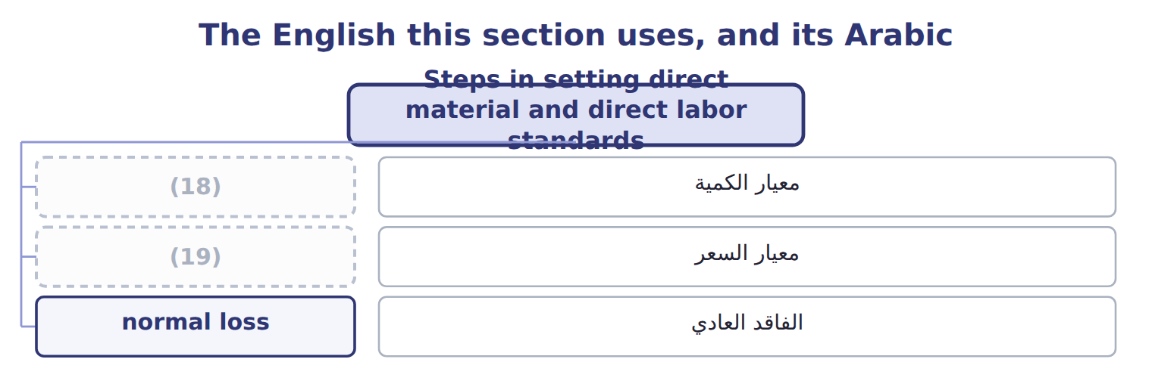
word list
activity analysis · price standard · quantity standard

The English this sheet uses, and its Arabic
English (exam term) | Arabic
quantity standard | معيار الكمية
price standard | معيار السعر
normal loss | الفاقد العادي

Answer key · 18.4 Steps in setting direct material and direct labor standards

1 standards | 11 Quantity standard (net ÷ yield)
2 called | 12 0.040 h
3 supplier's | 13 0.004 h
4 receiving | 14 0.002 h
5 Less: quantity discount | 15 quantity
6 Add: freight to Amman | 16 benefits
7 Price standard per liter | 17 standard
8 quantity | 18 quantity standard
9 concentrate | 19 price standard
10 Abnormal

the summaries in full
Summary 1 Each input needs two standards: a quantity standard and a price standard. For labor they are called the time standard and the rate standard.
Summary 2 The supplier's list price is $0.88 a liter. The division deducts the quantity discount and adds freight and the cost of receiving and testing.
Summary 3 The quantity standard starts from the net concentrate in one case and allows for normal loss, such as tank residue and spillage on the line. Abnormal waste is not included; it will show as a variance.
Summary 4 Exam options often use the list price, or the net quantity without normal loss, or the wage without benefits. The correct standard includes all normal costs of getting the input ready for use.

18.5 Techniques for setting standards
Chapter 18 · section 18.5

Fill every gap. Each word list holds one word more than there are gaps.
Summary 1 gaps 1–6
Activity (1) sets a standard by studying how the work should be done: time and motion studies, recipes and (2) tests. The juice time study found a basic time of 0.040 hours a case. (3) data uses past results. Over the last twelve months, labor (4) 0.056 hours a case, and the best month reached 0.052. (5) is quick and real, but it copies past waste. Good practice combines both (6) .
word list
Historical · techniques · engineering · practice · averaged · analysis · History

Activity analysis and historical data compared
 | Activity analysis | Historical data
How | (7) : time and motion studies, recipes, engineering tests | Average past results, adjusted for known changes
Strength | (8) | Quick and cheap; based on real results
Weakness | (9) | Copies past waste and inefficiency
Juice example | Time study: 0.040 h + allowances | (10)

word list
Takes time and expertise · Builds the standard from how the work should be done · Study each step · Average past results, adjusted for known changes · 12-month average 0.056 h; best month 0.052 h

The English this sheet uses, and its Arabic
English (exam term) | Arabic
activity analysis | تحليل الأنشطة

Answer key · 18.5 Techniques for setting standards

1 analysis | 6 techniques
2 engineering | 7 Study each step
3 Historical | 8 Builds the standard from how the work should be done
4 averaged | 9 Takes time and expertise
5 History | 10 12-month average 0.056 h; best month 0.052 h

the summaries in full
Summary 1 Activity analysis sets a standard by studying how the work should be done: time and motion studies, recipes and engineering tests. The juice time study found a basic time of 0.040 hours a case. Historical data uses past results. Over the last twelve months, labor averaged 0.056 hours a case, and the best month reached 0.052. History is quick and real, but it copies past waste. Good practice combines both techniques.

18.6 Extended Example 18A: the juice standard cost card
Chapter 18 · section 18.6

Fill every gap. Each word list holds one word more than there are gaps.
Summary 1 gaps 1–6
This example puts every standard on one card and shows where each (1) came. (2) : 5.4 liters net ÷ 90% yield = 6.0 liters, at $0.90 a liter. Bottles, caps and carton: from the Jordan Glass and supplier (3) . (4) labor: 0.050 hours at $12.00 an hour. (5) : 0.02 machine hours at the variable and fixed rates from the. The total is $12.60 a case, the standard used (6) Book 2.
word list
contracts · Direct · throughout · Concentrate · Bottles · Overhead · number

Extended Example: the juice standard cost card
Input | Quantity | Price | Cost | Source
Concentrate | 6.0 liters | $0.90 | $5.40 | (7)
Bottles | 12 | $0.25 | $3.00 | Jordan Glass contract
Caps and carton | 1 | $0.60 | $0.60 | (8)
Direct labor | 0.050 h | $12.00 | $0.60 | (9)
Variable overhead | (10) | $50.00 | $1.00 | (11)
Fixed overhead | 0.02 MH | $100.00 | $2.00 | Overhead budget (Chapter 8)
Standard cost per case |  |  | $12.60

word list
0.02 MH · Supplier quote + yield study · Supplier contract · Time study + payroll · Overhead budget (Chapter 8) · standard cost card

Everything ties

Exam view

Summary 2 gaps 12–14
Expect a list price, (12) , freight, a net quantity, a yield, a basic time with (13) and a wage with benefits. Build each price and quantity standard in full, (14) , and add the lines to get the standard cost per unit.
word list
discounts · allowances · supplier · multiply

Exam view
Tahini jar standard: data | Amount
Sesame paste list price per kg | $2.40
Quantity discount per kg | $(0.10)
Freight per kg | $0.15
Receiving and testing per kg | $0.05
Net sesame in one 500 g jar | (15)
Normal yield | 96%
Jar and lid | $0.35
Basic filling time per jar | (16)
Rest and personal allowance | 0.001 h
Cleaning allowance | 0.001 h
Wage per hour | $12.50
Payroll taxes and benefits per hour | $2.50

word list
0.48 kg · 0.010 h · 0.001 h

Item — Answer
Item | Answer
Quantity standard | (17)
Normal loss built in | 6.0 − 5.4 = 0.6 liters

word list
5.4 ÷ 90% = 6.0 liters · Assumes no waste, breaks or downtime

Statement — Category
Statement | Category
Assumes no waste, breaks or downtime | (18)
Allows for normal loss and rest breaks | (19)
Set by the engineers without asking the filling team | Authoritative
Set together with the filling team | (20)
Shows the direction for kaizen | Ideal

word list
Participative · Currently attainable · Ideal · Fixed overhead

The English this section uses, and its Arabic
Each term sits against what it means.
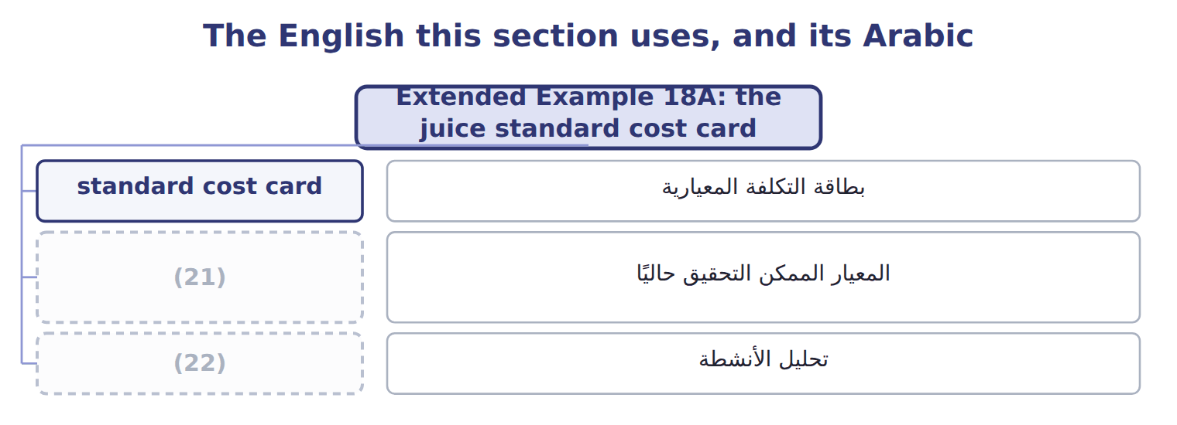
word list
activity analysis · standard cost card · currently attainable standard

The English this sheet uses, and its Arabic
English (exam term) | Arabic
standard cost card | بطاقة التكلفة المعيارية
currently attainable standard | المعيار الممكن التحقيق حاليًا
activity analysis | تحليل الأنشطة

Answer key · 18.6 Extended Example 18A: the juice standard cost card

1 number | 12 discounts
2 Concentrate | 13 allowances
3 contracts | 14 multiply
4 Direct | 15 0.48 kg
5 Overhead | 16 0.010 h
6 throughout | 17 5.4 ÷ 90% = 6.0 liters
7 Supplier quote + yield study | 18 Ideal
8 Supplier contract | 19 Currently attainable
9 Time study + payroll | 20 Participative
10 0.02 MH | 21 currently attainable standard
11 Overhead budget (Chapter 8) | 22 activity analysis

the summaries in full
Summary 1 This example puts every standard on one card and shows where each number came. Concentrate: 5.4 liters net ÷ 90% yield = 6.0 liters, at $0.90 a liter. Bottles, caps and carton: from the Jordan Glass and supplier contracts. Direct labor: 0.050 hours at $12.00 an hour. Overhead: 0.02 machine hours at the variable and fixed rates from the. The total is $12.60 a case, the standard used throughout Book 2.
Summary 2 Expect a list price, discounts, freight, a net quantity, a yield, a basic time with allowances and a wage with benefits. Build each price and quantity standard in full, multiply, and add the lines to get the standard cost per unit.

