1.1 Internal control risk and how it is managed
Chapter 1 · section 1.1

Fill every gap. Each word list holds one word more than there are gaps.
Chapter 1, section by section
Each stage leads to the next.
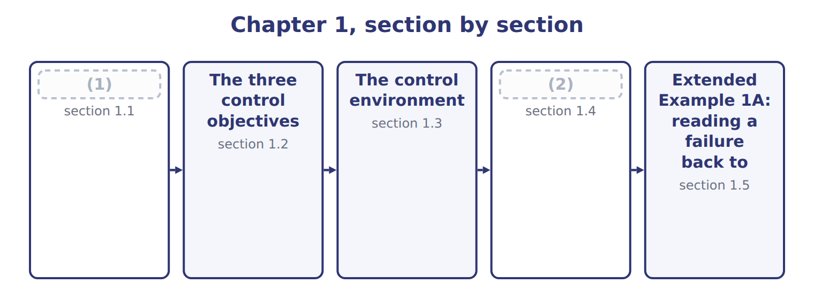
word list
Extended Example 1A: reading a failure back to · Reasonable, not absolute, assurance · Internal control risk and how it is managed

Summary 1 gaps 3–10
Internal control is a process, carried out by the board, (3) and other staff, designed to give reasonable assurance that the (4) objectives will be achieved. It is a process, not a (5) : a written (6) that nobody follows is not a control. Control risk is the risk that internal control will not (7) or detect a material (8) in time. It sits (9) two others. Inherent risk is how exposed something is before any control is (10) , and detection risk is the risk that the auditor's own work misses the problem.
word list
organization's · procedure · beside · designed · considered · misstatement · document · prevent · management

The three risks, and the one the auditor controls
Risk | What it means | At Orontes
Inherent risk | How open an assertion is to material misstatement BEFORE considering any control | (11)
Control risk | The risk that (12) will not prevent or detect that misstatement in time | One storekeeper both receives and records stock
Detection risk | (13) | The auditor samples only large issues and misses many small ones
Audit risk | inherent x control x detection | (14)

word list
internal control · control risk · Spices are small, valuable and easy to carry out · The risk that the auditor's own procedures miss it · The only one the auditor can change is detection risk

Summary 2 gaps 15–19
The three (15) to give audit risk. (16) can reduce inherent risk by changing what the business does, and control risk by designing better controls, but only the auditor can change detection risk, by testing more or (17) . (18) control risk is a cycle: (19) what could go wrong, design a control, operate it, monitor whether it works, and fix it when it does not.
word list
multiply · differently · identify · controls · Managing · Management

The words this section uses
Each term sits against what it means.
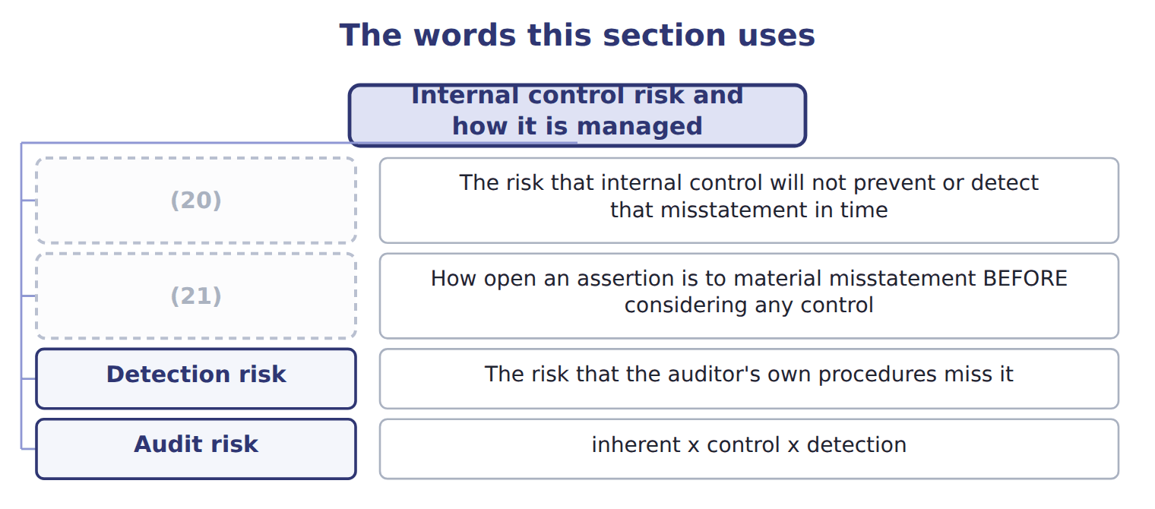
word list
inherent risk · control risk · Detection risk

The English this sheet uses, and its Arabic
English (exam term) | Arabic
internal control | الرقابة الداخلية
control risk | مخاطر الرقابة
inherent risk | المخاطر الملازمة

Answer key · 1.1 Internal control risk and how it is managed

1 Internal control risk and how it is managed | 12 internal control
2 Reasonable, not absolute, assurance | 13 The risk that the auditor's own procedures miss it
3 management | 14 The only one the auditor can change is detection risk
4 organization's | 15 multiply
5 document | 16 Management
6 procedure | 17 differently
7 prevent | 18 Managing
8 misstatement | 19 identify
9 beside | 20 control risk
10 considered | 21 inherent risk
11 Spices are small, valuable and easy to carry out

the summaries in full
Summary 1 Internal control is a process, carried out by the board, management and other staff, designed to give reasonable assurance that the organization's objectives will be achieved. It is a process, not a document: a written procedure that nobody follows is not a control. Control risk is the risk that internal control will not prevent or detect a material misstatement in time. It sits beside two others. Inherent risk is how exposed something is before any control is considered, and detection risk is the risk that the auditor's own work misses the problem.
Summary 2 The three multiply to give audit risk. Management can reduce inherent risk by changing what the business does, and control risk by designing better controls, but only the auditor can change detection risk, by testing more or differently. Managing control risk is a cycle: identify what could go wrong, design a control, operate it, monitor whether it works, and fix it when it does not.

1.2 The three control objectives
Chapter 1 · section 1.2

Fill every gap. Each word list holds one word more than there are gaps.
Summary 1 gaps 1–2
Internal control serves three (1) of objective. (2) a control does falls into one of them.
word list
categories · Everything · usually

The three categories of control objective
Objective category | What it covers | At Orontes
Operations | Effectiveness and efficiency, including safeguarding assets | (3)
Reporting | (4) | The monthly management pack; the audited accounts; the energy figures of Book 3
Compliance | (5) | Food safety rules; Jordan's data protection law

word list
With applicable laws and regulations · Effectiveness and efficiency, including safeguarding assets · Spoilage below target; stock not stolen · Internal AND external, financial AND non-financial

Summary 2 gaps 6–15
The second category is the one most often (6) . It is reporting, not financial reporting: it covers internal (7) as well as external ones, and non-financial (8) as well as financial. The energy and water (9) of Book 3. Many study (10) still say the second objective is (11) of financial reporting (their wording). That was the wording of the 1992 framework. The 2013 framework (12) it to reporting, (13) internal and external, financial and non-financial. A (14) that offers both (15) is testing exactly this. Safeguarding of assets is not a fourth category. It sits inside operations, because losing an asset is an operating failure, though it usually shows up in reporting too.
word list
question · meaning · Internal · misremembered · guides · figures · wordings · reports · reliability · widened · information

The words this section uses
Each term sits against what it means.
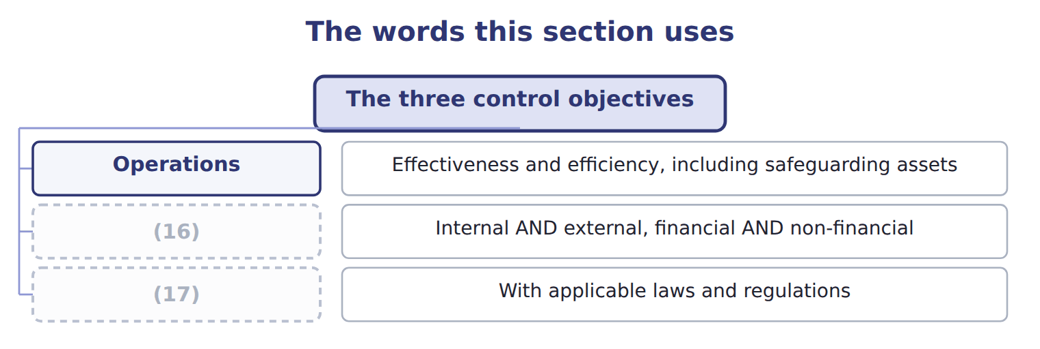
word list
Compliance · Operations · Reporting

The English this sheet uses, and its Arabic
English (exam term) | Arabic
detection risk | مخاطر الاكتشاف

Answer key · 1.2 The three control objectives

1 categories | 10 guides
2 Everything | 11 reliability
3 Spoilage below target; stock not stolen | 12 widened
4 Internal AND external, financial AND non-financial | 13 meaning
5 With applicable laws and regulations | 14 question
6 misremembered | 15 wordings
7 reports | 16 Reporting
8 information | 17 Compliance
9 figures

the summaries in full
Summary 1 Internal control serves three categories of objective. Everything a control does falls into one of them.
Summary 2 The second category is the one most often misremembered. It is reporting, not financial reporting: it covers internal reports as well as external ones, and non-financial information as well as financial. The energy and water figures of Book 3. Many study guides still say the second objective is reliability of financial reporting (their wording). That was the wording of the 1992 framework. The 2013 framework widened it to reporting, meaning internal and external, financial and non-financial. A question that offers both wordings is testing exactly this. Safeguarding of assets is not a fourth category. It sits inside operations, because losing an asset is an operating failure, though it usually shows up in reporting too.

1.3 The control environment
Chapter 1 · section 1.3

Fill every gap. Each word list holds one word more than there are gaps.
Summary 1 gaps 1–4
The control (1) is the set of standards, processes and structures that provide the basis for carrying out internal control across the (2) . It is the first of the five (3) and it is first for a reason: it (4) whether the other four work.
word list
decides · environment · components · manager · organization

What shapes the control environment
Element of the control environment | What it decides | Why it matters
Management philosophy and style | Whether targets are pursued at any cost, or within limits | A plant manager rewarded only on output will cut inspection
Organizational structure | Who reports to whom, and where authority stops | Levant (5) reports to the group, not to the division it serves
Policies, objectives and goals | What the company says it wants and will not do | (6)
Competence | Whether people can do the job they are given | A clerk asked to review a (7) he does not understand
Accountability | Whether anyone answers for a failure | (8)

word list
inherent risk · reconciliation · A missed control that nobody is asked about · The code of conduct; the Chapter 1 objectives of Book 3 · Distribution

Summary 2 gaps 9–15
Management (9) and style matter more than any single (10) . If a plant manager is (11) only on output, (12) will be cut, whatever the manual says. This is what is meant by the tone at the top: not a slogan, but what people (13) from watching what management rewards and (14) . (15) matters in the same practical way. Levant Distribution reports to the group rather than to the division it serves, so the manager who negotiates its prices is not the manager who approves its results.
word list
philosophy · conclude · inspection · procedure · Structure · whatever · rewarded · tolerates

The words this section uses
Each term sits against what it means.
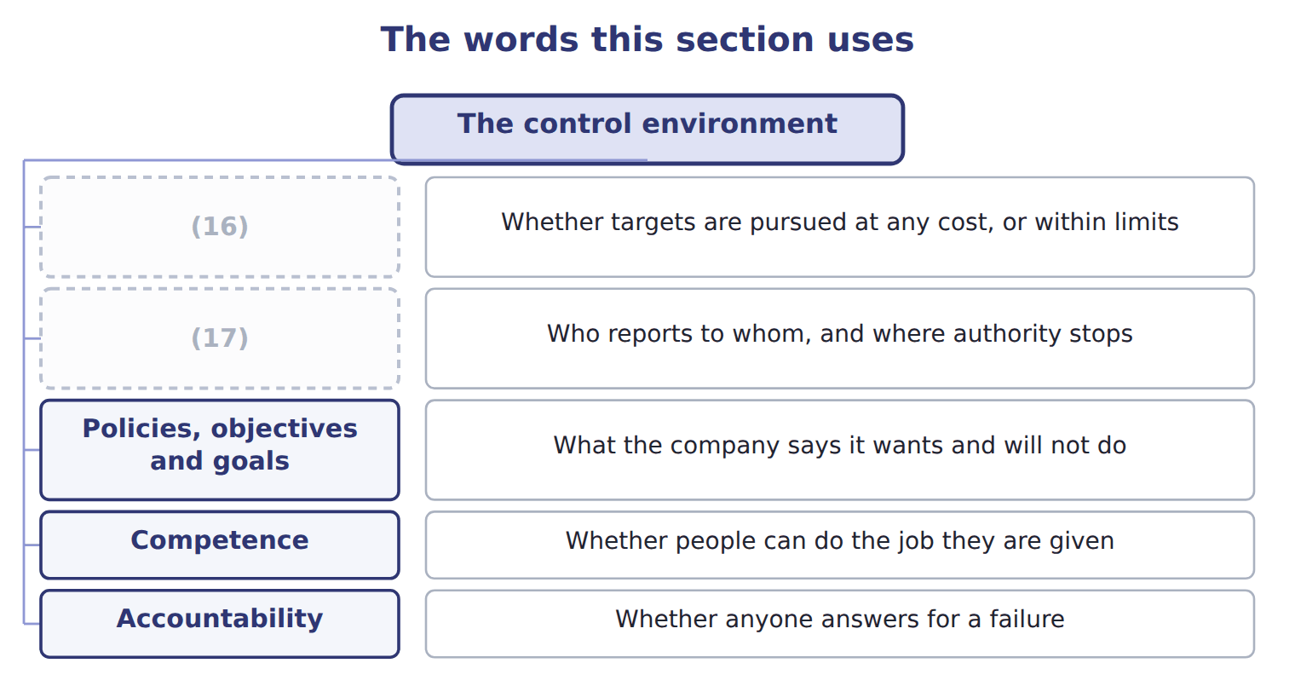
word list
Organizational structure · Policies, objectives and goals · Management philosophy and style

The English this sheet uses, and its Arabic
English (exam term) | Arabic
control environment | بيئة الرقابة
tone at the top | النهج الذي تحدده الإدارة العليا

Answer key · 1.3 The control environment

1 environment | 10 procedure
2 organization | 11 rewarded
3 components | 12 inspection
4 decides | 13 conclude
5 Distribution | 14 tolerates
6 The code of conduct; the Chapter 1 objectives of Book 3 | 15 Structure
7 reconciliation | 16 Management philosophy and style
8 A missed control that nobody is asked about | 17 Organizational structure
9 philosophy

the summaries in full
Summary 1 The control environment is the set of standards, processes and structures that provide the basis for carrying out internal control across the organization. It is the first of the five components and it is first for a reason: it decides whether the other four work.
Summary 2 Management philosophy and style matter more than any single procedure. If a plant manager is rewarded only on output, inspection will be cut, whatever the manual says. This is what is meant by the tone at the top: not a slogan, but what people conclude from watching what management rewards and tolerates. Structure matters in the same practical way. Levant Distribution reports to the group rather than to the division it serves, so the manager who negotiates its prices is not the manager who approves its results.

1.4 Reasonable, not absolute, assurance
Chapter 1 · section 1.4

Fill every gap. Each word list holds one word more than there are gaps.
Summary 1 gaps 1–11
No system of (1) control can give (2) assurance. The standard is (3) assurance: a high level of (4) , not a guarantee. Two of them deserve (5) because the exam (6) to them. Collusion defeats a (7) of duties designed for one person acting alone: the clerk who raises an invoice and the (8) who approves it can agree together. (9) override is the harder one, because the people who design and enforce the (10) are the people best placed to step around them. The (11) limit is not an excuse but a design principle. A control that costs more than the loss it prevents makes the company worse off, so the question is always whether the control is worth its cost, not whether it is perfect.
word list
attention · reasonable · Management · confidence · controls · cost-benefit · separation · assurance · internal · supervisor · absolute · returns

Reasonable means high, not weak

Summary 2 gaps 12–14
Reasonable assurance is a high level of assurance. A (12) that treats it as 'some (13) ' or 'better than nothing' has the sense wrong. The word (14) the six limits, not a low standard.
word list
acknowledges · comfort · because · question

The English this section uses, and its Arabic
Each term sits against what it means.
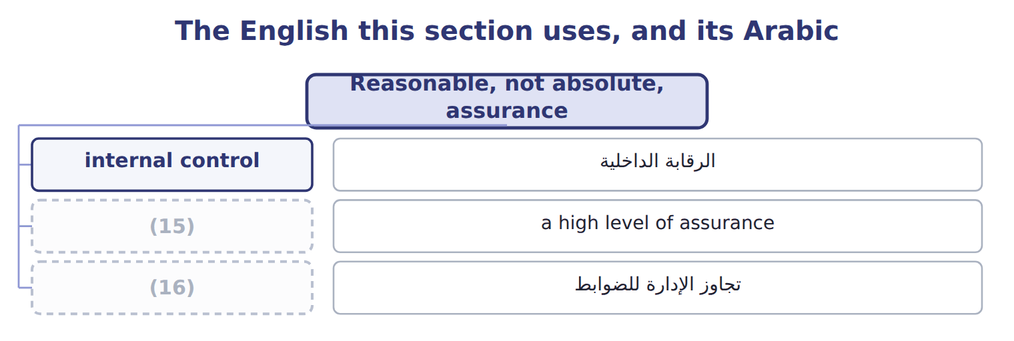
word list
detection risk · reasonable assurance · management override

The English this sheet uses, and its Arabic
English (exam term) | Arabic
reasonable assurance | التأكيد المعقول
management override | تجاوز الإدارة للضوابط

Answer key · 1.4 Reasonable, not absolute, assurance

1 internal | 9 Management
2 absolute | 10 controls
3 reasonable | 11 cost-benefit
4 confidence | 12 question
5 attention | 13 comfort
6 returns | 14 acknowledges
7 separation | 15 reasonable assurance
8 supervisor | 16 management override

the summaries in full
Summary 1 No system of internal control can give absolute assurance. The standard is reasonable assurance: a high level of confidence, not a guarantee. Two of them deserve attention because the exam returns to them. Collusion defeats a separation of duties designed for one person acting alone: the clerk who raises an invoice and the supervisor who approves it can agree together. Management override is the harder one, because the people who design and enforce the controls are the people best placed to step around them. The cost-benefit limit is not an excuse but a design principle. A control that costs more than the loss it prevents makes the company worse off, so the question is always whether the control is worth its cost, not whether it is perfect.
Summary 2 Reasonable assurance is a high level of assurance. A question that treats it as 'some comfort' or 'better than nothing' has the sense wrong. The word acknowledges the six limits, not a low standard.

1.5 Extended Example 1A: reading a failure back to its cause
Chapter 1 · section 1.5

Fill every gap. Each word list holds one word more than there are gaps.
Summary 1 gaps 1–7
This example takes a real failure at (1) and traces it back through the (2) . It is (3) : questions give you the failure and ask which component or which (4) explains it. A (5) clerk at the Amman plant was able to add a supplier to the (6) list and to release payments to it. Over fourteen months, payments went to a supplier that (7) nothing. The loss was found when a new controller reconciled supplier records against goods received.
word list
payment · purchasing · Orontes · framework · exam-core · limitation · delivered · approved

2. Which risk was this?

Summary 2 gaps 8–11
Inherent risk was high: (8) to new suppliers are easy to (9) and hard to verify. (10) risk was also high, because one person held two duties that should have been (11) . Detection risk was high too, since nobody reconciled suppliers to receipts until the new controller arrived.
word list
separated · payments · arrived · Control · disguise

3. Which component failed?

Summary 3 gaps 12–14
Control activities failed first: the duties were not (12) . But (13) activities failed as well, because fourteen months passed before anyone looked. And the control (14) was weak underneath both: nobody owned supplier approval, so no one was accountable when it went wrong.
word list
payment · separated · monitoring · environment

4. Which objective was missed?

Summary 4 gaps 15–16
Operations, because cash left the company for (15) . (16) , because purchases and payables were misstated for more than a year. Compliance, because the payments breached the company's own procurement policy.
word list
procurement · nothing · Reporting

5. Could a control have stopped it?

Summary 5 gaps 17–21
Separating (17) approval from payment release would have stopped this (18) fraud, and it costs almost nothing. But it would not stop two people agreeing together, which is collusion, and it would not stop a director (19) the clerk, which is (20) override. (21) assurance is the honest claim; absolute assurance is not available at any price.
word list
particular · Reasonable · supplier · instructing · management · approved

Everything connects

Summary 6 gaps 22–25
High inherent risk plus high control risk plus high (22) risk gave a high audit risk. Control activities failed, monitoring failed, and the control (23) allowed both. All three (24) were missed: operations, reporting and compliance. The fix is cheap, but it buys (25) assurance, not certainty.
word list
reasonable · objectives · environment · approval · detection

Classify four more failures

Complete the blank cells.
Your turn: classify four failures (complete the blanks)
Every item belongs to exactly one group.
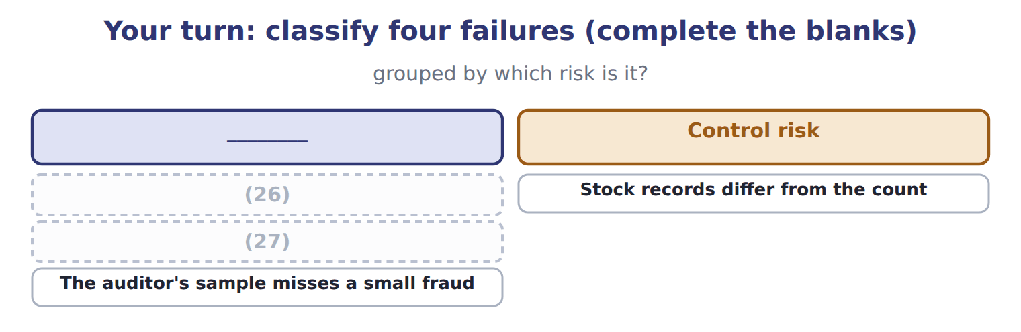
word list
Stock records differ from the count · A new food safety rule is missed · A supplier invoice is paid twice

Exam view

Summary 7 gaps 28–31
A case gives a failure and asks which (28) , which objective or which limitation it (29) . Work (30) : what was supposed to stop this, why did it not, and was there anything that could have? If the answer is that two people agreed together, the answer is (31) , not a missing control.
word list
illustrates · component · backwards · collusion · breached

Exam view
Item | Answer
A supplier invoice is paid twice | (32) — one clerk can both approve and release payment, so nothing stops the duplicate
Stock records differ from the count | Why: the (33) and the custody of stock are not separated, so an error or theft is not detected
A new food safety rule is missed | Control risk — no control exists to track regulatory change, which is a compliance objective
The auditor's sample misses a small fraud | Detection risk — sampling cannot examine every transaction, which is the auditor's own limitation

word list
Control risk · Detection risk · recording

Fact from the case — Category
Fact from the case | Category
Payments to new suppliers are easy to disguise | (34)
One clerk both approved suppliers and released payments | Control risk
Nobody reconciled suppliers to goods received for fourteen months | Detection risk
The approved supplier list was never reviewed | (35)

word list
Inherent risk · Control risk · Detection risk

The English this section uses, and its Arabic
Each term sits against what it means.
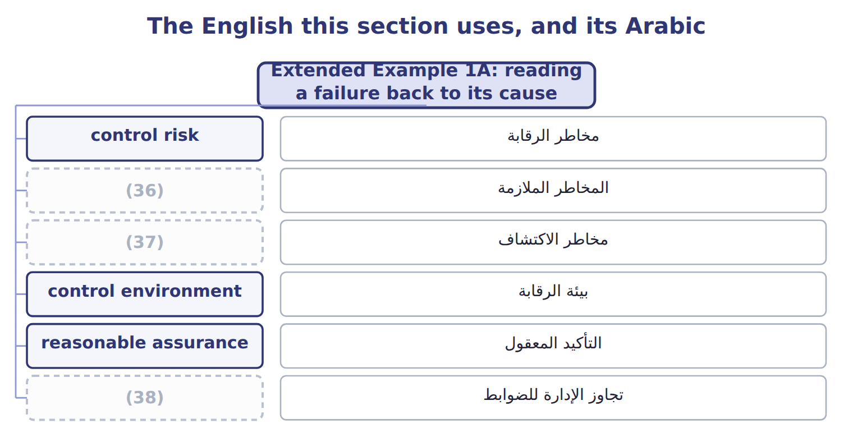
word list
detection risk · inherent risk · management override · control risk

Answer key · 1.5 Extended Example 1A: reading a failure back to its cause

1 Orontes | 20 management
2 framework | 21 Reasonable
3 exam-core | 22 detection
4 limitation | 23 environment
5 purchasing | 24 objectives
6 approved | 25 reasonable
7 delivered | 26 A supplier invoice is paid twice
8 payments | 27 A new food safety rule is missed
9 disguise | 28 component
10 Control | 29 illustrates
11 separated | 30 backwards
12 separated | 31 collusion
13 monitoring | 32 Control risk
14 environment | 33 recording
15 nothing | 34 Inherent risk
16 Reporting | 35 Control risk
17 supplier | 36 inherent risk
18 particular | 37 detection risk
19 instructing | 38 management override

the summaries in full
Summary 1 This example takes a real failure at Orontes and traces it back through the framework. It is exam-core: questions give you the failure and ask which component or which limitation explains it. A purchasing clerk at the Amman plant was able to add a supplier to the approved list and to release payments to it. Over fourteen months, payments went to a supplier that delivered nothing. The loss was found when a new controller reconciled supplier records against goods received.
Summary 2 Inherent risk was high: payments to new suppliers are easy to disguise and hard to verify. Control risk was also high, because one person held two duties that should have been separated. Detection risk was high too, since nobody reconciled suppliers to receipts until the new controller arrived.
Summary 3 Control activities failed first: the duties were not separated. But monitoring activities failed as well, because fourteen months passed before anyone looked. And the control environment was weak underneath both: nobody owned supplier approval, so no one was accountable when it went wrong.
Summary 4 Operations, because cash left the company for nothing. Reporting, because purchases and payables were misstated for more than a year. Compliance, because the payments breached the company's own procurement policy.
Summary 5 Separating supplier approval from payment release would have stopped this particular fraud, and it costs almost nothing. But it would not stop two people agreeing together, which is collusion, and it would not stop a director instructing the clerk, which is management override. Reasonable assurance is the honest claim; absolute assurance is not available at any price.
Summary 6 High inherent risk plus high control risk plus high detection risk gave a high audit risk. Control activities failed, monitoring failed, and the control environment allowed both. All three objectives were missed: operations, reporting and compliance. The fix is cheap, but it buys reasonable assurance, not certainty.
Summary 7 A case gives a failure and asks which component, which objective or which limitation it illustrates. Work backwards: what was supposed to stop this, why did it not, and was there anything that could have? If the answer is that two people agreed together, the answer is collusion, not a missing control.

2.1 What corporate governance is
Chapter 2 · section 2.1

Fill every gap. Each word list holds one word more than there are gaps.
Chapter 2, section by section
Each stage leads to the next.
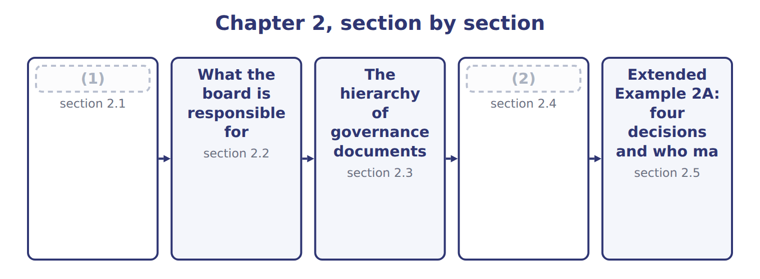
word list
What corporate governance is · The hierarchy of governance documents · Why personnel policy is a control

Summary 1 gaps 3–13
Corporate (3) is the system by which a company is (4) and held to account. It exists (5) the people who own a company are (6) not the people who run it. The (7) need some way to be sure their money is used in their (8) . Read it from the top: (9) elect the board, the board appoints and (10) the officers, and the board, through its audit committee, appoints the external auditor. One line in that (11) does the most work. The external auditor is (12) by, and reports to, the audit committee rather than the (13) whose statements are being audited. An auditor hired and paid by the chief financial officer could not credibly give an opinion on that officer's accounts.
word list
shareholders · because · governance · interest · usually · directed · appointed · diagram · audited · owners · assesses · management

The English this sheet uses, and its Arabic
English (exam term) | Arabic
corporate governance | حوكمة الشركات
audit committee | لجنة التدقيق

Answer key · 2.1 What corporate governance is

1 What corporate governance is | 8 interest
2 Why personnel policy is a control | 9 shareholders
3 governance | 10 assesses
4 directed | 11 diagram
5 because | 12 appointed
6 usually | 13 management
7 owners

the summaries in full
Summary 1 Corporate governance is the system by which a company is directed and held to account. It exists because the people who own a company are usually not the people who run it. The owners need some way to be sure their money is used in their interest. Read it from the top: shareholders elect the board, the board appoints and assesses the officers, and the board, through its audit committee, appoints the external auditor. One line in that diagram does the most work. The external auditor is appointed by, and reports to, the audit committee rather than the management whose statements are being audited. An auditor hired and paid by the chief financial officer could not credibly give an opinion on that officer's accounts.

2.2 What the board is responsible for
Chapter 2 · section 2.2

Fill every gap. Each word list holds one word more than there are gaps.
Summary 1 gaps 1–2
Directors owe the company a duty of care: they must inform (1) before deciding. They also owe a duty of loyalty: the (2) interest comes before their own.
word list
themselves · deciding · company's

What the board is responsible for
Board responsibility (E.1.d) | What it means | At Orontes
Set the tone | Integrity and ethical values start at the board | (3)
Oversee strategy | Challenge and approve the plan, not write it | (4)
Oversee risk and control | (5) | Receives the control testing of Chapter 5
Appoint and assess the CEO | (6) | Sets the incentives that shape behaviour
Oversee reporting | Through the audit committee, oversee the accounts and the auditor | (7)
Act for shareholders | (8) | Declines a contract with a director's own company

word list
Challenge and approve the plan, not write it · Satisfy itself that controls exist and work · Approves the code of conduct and acts on breaches · Duties of care and loyalty; no self-dealing · Approved the Gulf expansion of Book 3 · Hire, pay, evaluate and if necessary replace · Approves the annual report

Summary 2 gaps 9–13
The (9) the exam tests most often is between oversight and (10) . A board (11) and approves a (12) ; it does not write it. It (13) itself that controls exist and work; it does not operate them. A board that starts managing has stopped overseeing, because it can no longer review its own work independently.
word list
project · strategy · satisfies · management · challenges · distinction

Oversight is not management

Summary 3 gaps 14–16
If a question describes a board (14) a capital project, that is oversight. If it describes a board (15) the contract, something has gone wrong. Look for who (16) and who reviews: they should not be the same people.
word list
negotiating · decides · approving · contract

The words this section uses
Each term sits against what it means.
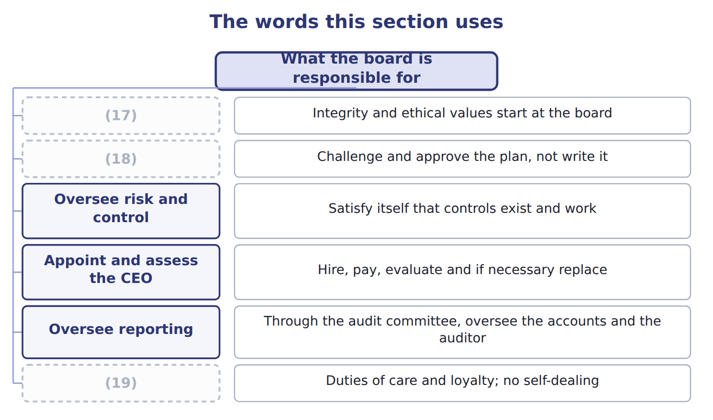
word list
articles of incorporation · Act for shareholders · Oversee strategy · Set the tone

The English this sheet uses, and its Arabic
English (exam term) | Arabic
duty of care | واجب العناية
duty of loyalty | واجب الولاء

Answer key · 2.2 What the board is responsible for

1 themselves | 11 challenges
2 company's | 12 strategy
3 Approves the code of conduct and acts on breaches | 13 satisfies
4 Approved the Gulf expansion of Book 3 | 14 approving
5 Satisfy itself that controls exist and work | 15 negotiating
6 Hire, pay, evaluate and if necessary replace | 16 decides
7 Approves the annual report | 17 Set the tone
8 Duties of care and loyalty; no self-dealing | 18 Oversee strategy
9 distinction | 19 Act for shareholders
10 management

the summaries in full
Summary 1 Directors owe the company a duty of care: they must inform themselves before deciding. They also owe a duty of loyalty: the company's interest comes before their own.
Summary 2 The distinction the exam tests most often is between oversight and management. A board challenges and approves a strategy; it does not write it. It satisfies itself that controls exist and work; it does not operate them. A board that starts managing has stopped overseeing, because it can no longer review its own work independently.
Summary 3 If a question describes a board approving a capital project, that is oversight. If it describes a board negotiating the contract, something has gone wrong. Look for who decides and who reviews: they should not be the same people.

2.3 The hierarchy of governance documents
Chapter 2 · section 2.3

Fill every gap. Each word list holds one word more than there are gaps.
Summary 1 gaps 1–11
A company is (1) by a stack of (2) , each one operating within the limits of the one above it. The articles of (3) are filed with the state and create the company: its name, purpose and (4) shares. The (5) are the company's internal rulebook on how the board meets and how officers are (6) . (7) state what the company intends, and (8) say step by step how to do it. First, a lower document can never (9) a higher one: a procedure breaching a policy is void, and so is a bylaw breaching the articles. Second, the (10) of changing them rises as you go up. Management rewrites a procedure, the board approves a policy, and the (11) must vote to change the articles.
word list
authorized · appointed · difficulty · governed · shareholders · incorporation · Policies · documents · bylaws · contradict · procedures · financial

Rights and responsibilities along the chain
Who | Rights and responsibilities (E.1.f) | In one line
Shareholders | Elect and remove directors; vote on the articles, mergers and pay; inspect books; receive declared dividends | (12)
Board of directors | Oversight of strategy, risk, control and reporting; duties of care and loyalty | (13)
Audit committee | Appoint, pay and oversee the external auditor; handle complaints; every member (14) | Oversee reporting and the auditor
CEO | Runs operations and carries out strategy; signs the certifications | (15)
CFO | Financial reporting and the design of internal control over it; signs the (16) | Own the numbers

word list
Manage the company · SEC Rule 10D-1; policies due 1 Dec 2023 · certifications · Vote; they do not manage · independent · Direct and monitor; they do not run operations

Summary 2 gaps 17–28
The audit committee deserves (17) attention. Every member must be (18) . That means taking no (19) or advisory fee from the company, and not being an (20) person. The committee appoints, pays and oversees the external auditor, and must provide a route for (21) , including (22) ones. Many (23) say this. The (24) is to disclose whether at least one audit committee (25) expert serves, and if none does, to say why not. A company may (26) have none, (27) it explains itself. Exchange rules (28) require members to be financially literate, which is a lower bar. Two are worth noting now: the clawback rules took effect at the end of 2023, and Nasdaq's board diversity rules were struck down by the courts in December 2024 and are no longer in force.
word list
consulting · independent · lawfully · December · separately · affiliated · provided · requirement · particular · financial · anonymous · guides · complaints

Governance requirements and their current status
Every item belongs to exactly one group.
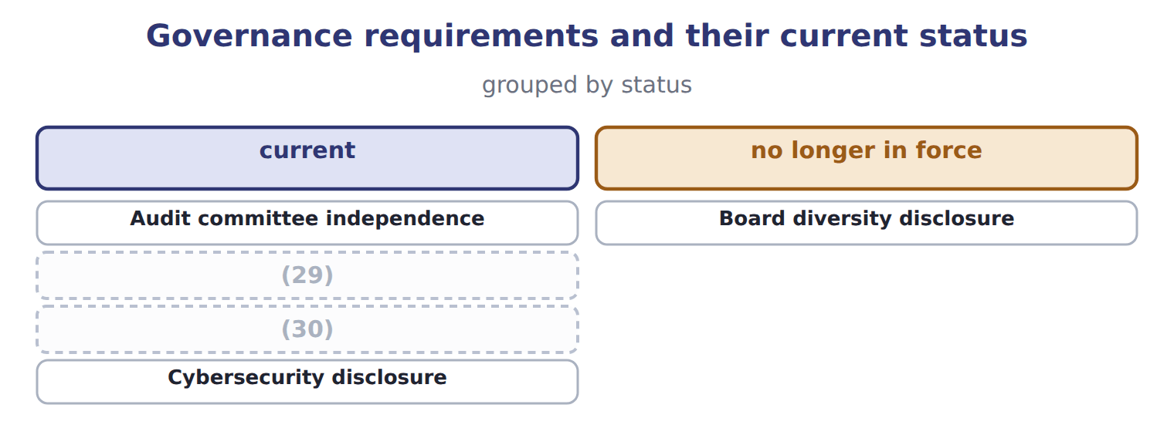
word list
Clawback of incentive pay · no longer in force · Audit committee financial expert

Summary 3 gaps 31–32
Governance (31) change more often than accounting standards. Check the position before relying on any of them in practice, and expect the exam to test the (32) rather than the date.
word list
appointed · principle · requirements

The words this section uses
Each term sits against what it means.
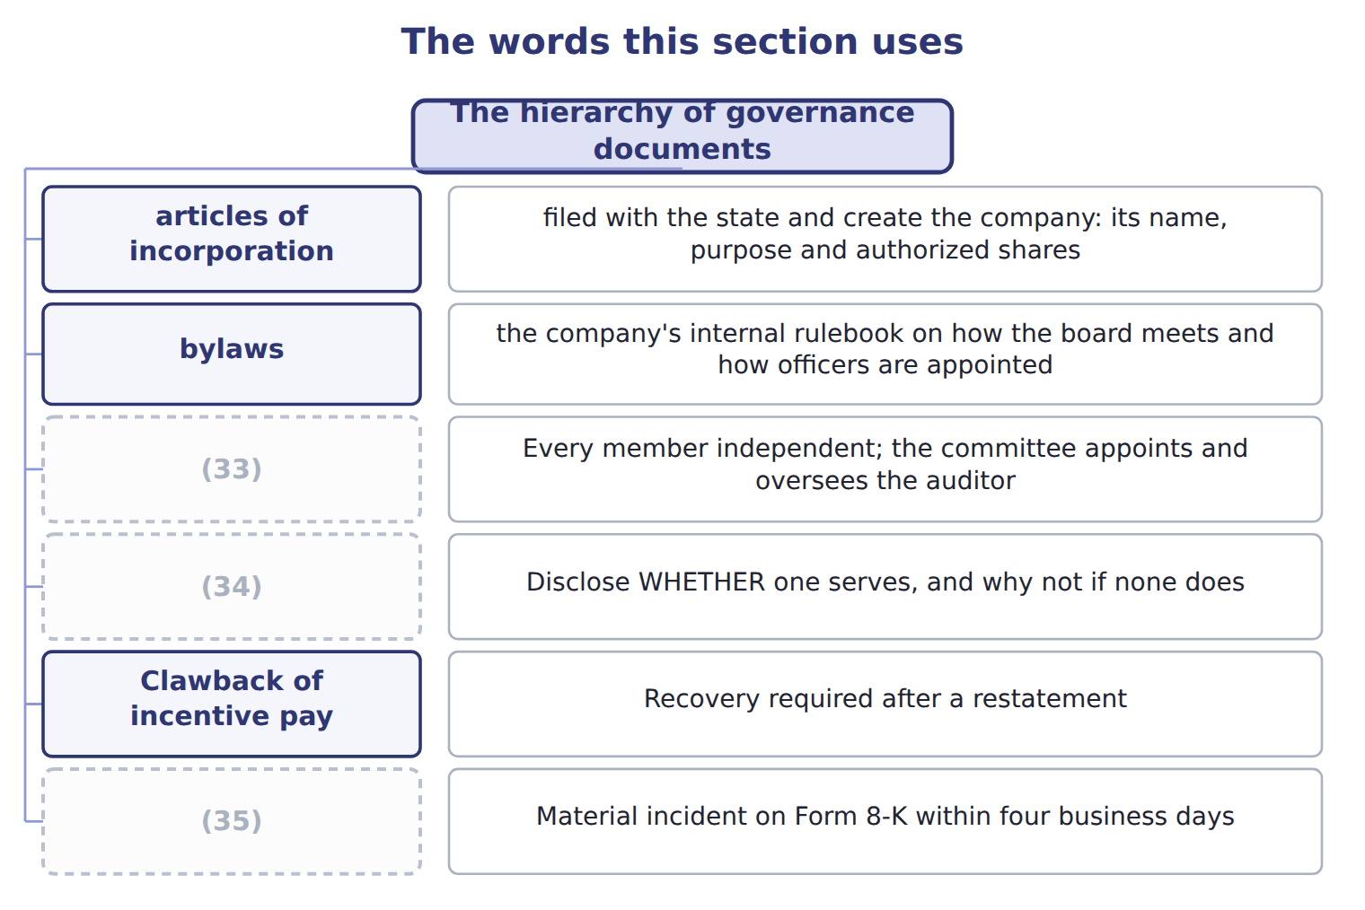
word list
articles of incorporation · Audit committee financial expert · Audit committee independence · Cybersecurity disclosure

The English this sheet uses, and its Arabic
English (exam term) | Arabic
articles of incorporation | عقد التأسيس
bylaws | النظام الداخلي

Answer key · 2.3 The hierarchy of governance documents

1 governed | 19 consulting
2 documents | 20 affiliated
3 incorporation | 21 complaints
4 authorized | 22 anonymous
5 bylaws | 23 guides
6 appointed | 24 requirement
7 Policies | 25 financial
8 procedures | 26 lawfully
9 contradict | 27 provided
10 difficulty | 28 separately
11 shareholders | 29 Audit committee financial expert
12 Vote; they do not manage | 30 Clawback of incentive pay
13 Direct and monitor; they do not run operations | 31 requirements
14 independent | 32 principle
15 Manage the company | 33 Audit committee independence
16 certifications | 34 Audit committee financial expert
17 particular | 35 Cybersecurity disclosure
18 independent

the summaries in full
Summary 1 A company is governed by a stack of documents, each one operating within the limits of the one above it. The articles of incorporation are filed with the state and create the company: its name, purpose and authorized shares. The bylaws are the company's internal rulebook on how the board meets and how officers are appointed. Policies state what the company intends, and procedures say step by step how to do it. First, a lower document can never contradict a higher one: a procedure breaching a policy is void, and so is a bylaw breaching the articles. Second, the difficulty of changing them rises as you go up. Management rewrites a procedure, the board approves a policy, and the shareholders must vote to change the articles.
Summary 2 The audit committee deserves particular attention. Every member must be independent. That means taking no consulting or advisory fee from the company, and not being an affiliated person. The committee appoints, pays and oversees the external auditor, and must provide a route for complaints, including anonymous ones. Many guides say this. The requirement is to disclose whether at least one audit committee financial expert serves, and if none does, to say why not. A company may lawfully have none, provided it explains itself. Exchange rules separately require members to be financially literate, which is a lower bar. Two are worth noting now: the clawback rules took effect at the end of 2023, and Nasdaq's board diversity rules were struck down by the courts in December 2024 and are no longer in force.
Summary 3 Governance requirements change more often than accounting standards. Check the position before relying on any of them in practice, and expect the exam to test the principle rather than the date.

2.4 Why personnel policy is a control
Chapter 2 · section 2.4

Fill every gap. Each word list holds one word more than there are gaps.
Summary 1 gaps 1–2
Controls are (1) out by people. That single fact makes hiring, training, (2) and dismissal part of internal control rather than a separate human resources matter.
word list
supervision · carried · purpose

Personnel practices as controls
Personnel practice (E.1.h) | Why it is a control | What it looks like
Hiring | A control is only as good as the person performing it | (3)
Training | Someone who does not understand a reconciliation cannot review one | (4)
Supervision | Work that is never reviewed drifts | (5)
Rotation and mandatory leave | A fraud that needs daily (6) is exposed when its author is away | Two consecutive weeks away each year
Clear job descriptions | Nobody can be held to account for a duty they were never given | Supplier approval named in the role, not (7) verbally
Exit procedures | (8) | System access removed on the last day

word list
Train on the control, not only on the system · Check references and qualifications before appointment · job rotation · Access that outlives employment is an open door · A second person checks a sample of the clerk's work · delegated · attention

Summary 2 gaps 9–15
Mandatory leave and job (9) deserve a word, because their (10) is not obvious. A fraud that must be tended daily, such as moving money (11) accounts to hide a (12) , is exposed when someone else sits at the desk. Two (13) weeks is the usual (14) , because one week can be survived. The (15) manager delegated supplier approval verbally and never took it back. The duty appeared in nobody's job description, so nobody could be held to account for it.
word list
purchasing · consecutive · purpose · rotation · shortfall · between · appeared · requirement

The English this sheet uses, and its Arabic
English (exam term) | Arabic
mandatory leave | الإجازة الإلزامية
job rotation | تدوير الوظائف

Answer key · 2.4 Why personnel policy is a control

1 carried | 9 rotation
2 supervision | 10 purpose
3 Check references and qualifications before appointment | 11 between
4 Train on the control, not only on the system | 12 shortfall
5 A second person checks a sample of the clerk's work | 13 consecutive
6 attention | 14 requirement
7 delegated | 15 purchasing
8 Access that outlives employment is an open door

the summaries in full
Summary 1 Controls are carried out by people. That single fact makes hiring, training, supervision and dismissal part of internal control rather than a separate human resources matter.
Summary 2 Mandatory leave and job rotation deserve a word, because their purpose is not obvious. A fraud that must be tended daily, such as moving money between accounts to hide a shortfall, is exposed when someone else sits at the desk. Two consecutive weeks is the usual requirement, because one week can be survived. The purchasing manager delegated supplier approval verbally and never took it back. The duty appeared in nobody's job description, so nobody could be held to account for it.

2.5 Extended Example 2A: four decisions and who makes them
Chapter 2 · section 2.5

Fill every gap. Each word list holds one word more than there are gaps.
Summary 1 gaps 1–12
This example takes four (1) facing Orontes and asks, for each one, which (2) governs it and who must act. It is (3) : questions in this area are nearly always of (4) this shape. Orontes wants to issue new shares to fund the Gulf (5) , but has already issued all the shares its articles (6) . The articles of (7) must be amended, which requires a (8) vote. The board (9) do this alone, however clear the (10) case. The board wants to (11) the quorum from five (12) to four. This is a bylaw matter, and the board can amend its own bylaws, provided the amendment does not conflict with the articles or with state law. After the supplier fraud, the board wants every payment above a threshold to carry two signatures. This is a policy: the board approves it, and management writes the procedure that puts it into effect, naming the systems, the limits and the authorised signatories.
word list
directors · document · incorporation · reduce · exam-core · commercial · expansion · cannot · authorize · shareholder · conflict · exactly · decisions

Summary 2 gaps 13–16
The chief (13) officer is unhappy with the (14) questions and wants a different firm. He cannot make that (15) . The external auditor is appointed, paid and overseen by the audit committee, precisely so that the officers whose (16) are audited cannot remove an auditor who challenges them.
word list
statements · authorised · decision · auditor's · financial

Four more decisions

Complete the blank cells.
Your turn: which document governs the decision? (complete the blanks)
Every item belongs to exactly one group.
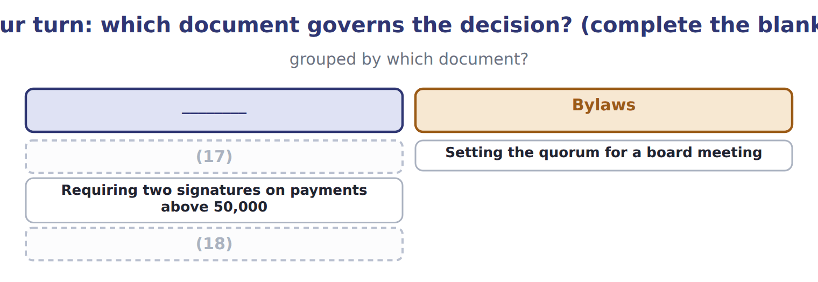
word list
Changing the number of authorized shares · The exact screens a clerk uses to raise a payment · Setting the quorum for a board meeting

The pattern behind all four

Summary 3 gaps 19–23
Ask first which document (19) the decision, (20) that decides who may act. The (21) the document, the harder it is to change: management, then board, then (22) . Where a decision would let someone review their own work, the (23) moves it elsewhere. The audit committee exists to hold one such line: the auditor answers to it, not to management.
word list
higher · governs · officers · because · structure · shareholders

Exam view

Summary 4 gaps 24–27
Expect a decision and four candidate (24) , or a decision and four candidate (25) . Work out which level of the (26) the matter sits at. If the decision affects the company's existence or its share capital, it is the articles and therefore the (27) .
word list
shareholders · conflict · decision-makers · hierarchy · documents

Exam view
Item | Answer
Changing the number of authorized shares | (28) — share capital is created by the articles, so the shareholders must vote
Setting the quorum for a board meeting | Why: the (29) govern how the board meets, and the board may amend them within the articles and the law
Requiring two signatures on payments above 50,000 | A board policy — management then writes the procedure that carries it out
The exact screens a clerk uses to raise a payment | A procedure — written and amended by management, within the policy above it

word list
management · bylaws · Articles of incorporation

Element of the proposal — Category
Element of the proposal | Category
Whether the chairman may also be chief executive | Governed by the bylaws
How often the audit committee meets | (30)
To whom the external auditor reports | Governed by the audit committee
Whether combining the roles is wise for Orontes | (31)

word list
Written and amended by management · A board judgement, not a document · Governed by the audit committee

The English this section uses, and its Arabic
Each term sits against what it means.
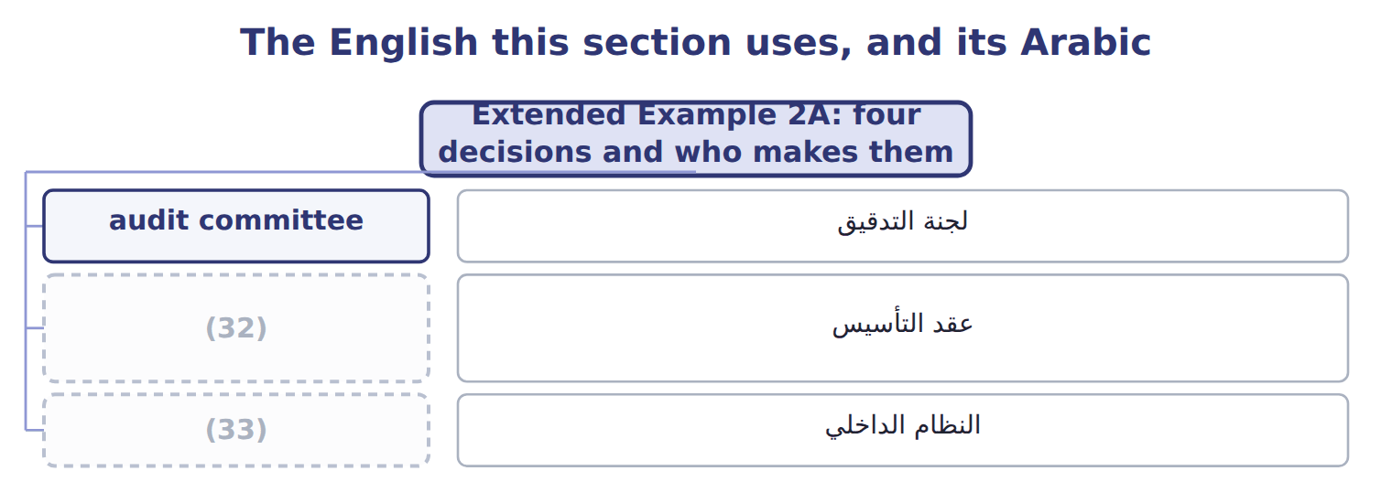
word list
articles of incorporation · mandatory leave · bylaws

Answer key · 2.5 Extended Example 2A: four decisions and who makes them

1 decisions | 18 The exact screens a clerk uses to raise a payment
2 document | 19 governs
3 exam-core | 20 because
4 exactly | 21 higher
5 expansion | 22 shareholders
6 authorize | 23 structure
7 incorporation | 24 documents
8 shareholder | 25 decision-makers
9 cannot | 26 hierarchy
10 commercial | 27 shareholders
11 reduce | 28 Articles of incorporation
12 directors | 29 bylaws
13 financial | 30 Governed by the audit committee
14 auditor's | 31 A board judgement, not a document
15 decision | 32 articles of incorporation
16 statements | 33 bylaws
17 Changing the number of authorized shares

the summaries in full
Summary 1 This example takes four decisions facing Orontes and asks, for each one, which document governs it and who must act. It is exam-core: questions in this area are nearly always of exactly this shape. Orontes wants to issue new shares to fund the Gulf expansion, but has already issued all the shares its articles authorize. The articles of incorporation must be amended, which requires a shareholder vote. The board cannot do this alone, however clear the commercial case. The board wants to reduce the quorum from five directors to four. This is a bylaw matter, and the board can amend its own bylaws, provided the amendment does not conflict with the articles or with state law. After the supplier fraud, the board wants every payment above a threshold to carry two signatures. This is a policy: the board approves it, and management writes the procedure that puts it into effect, naming the systems, the limits and the authorised signatories.
Summary 2 The chief financial officer is unhappy with the auditor's questions and wants a different firm. He cannot make that decision. The external auditor is appointed, paid and overseen by the audit committee, precisely so that the officers whose statements are audited cannot remove an auditor who challenges them.
Summary 3 Ask first which document governs the decision, because that decides who may act. The higher the document, the harder it is to change: management, then board, then shareholders. Where a decision would let someone review their own work, the structure moves it elsewhere. The audit committee exists to hold one such line: the auditor answers to it, not to management.
Summary 4 Expect a decision and four candidate documents, or a decision and four candidate decision-makers. Work out which level of the hierarchy the matter sits at. If the decision affects the company's existence or its share capital, it is the articles and therefore the shareholders.

3.1 What segregation of duties means
Chapter 3 · section 3.1

Fill every gap. Each word list holds one word more than there are gaps.
Chapter 3, section by section
Each stage leads to the next.
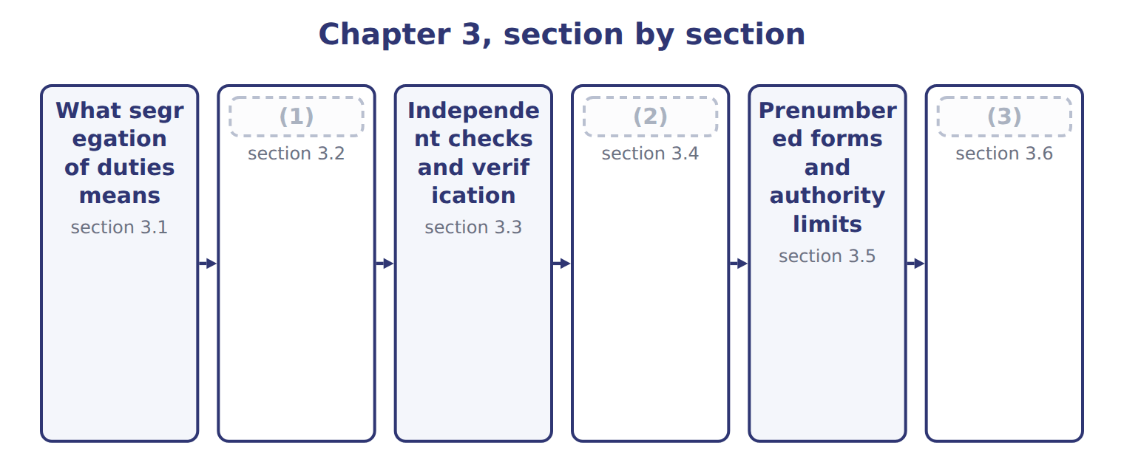
word list
Safeguarding assets · Extended Example 3A: redesigning the Orontes p · The four functional responsibilities · section 3.3

Summary 1 gaps 4–6
Segregation of duties means splitting a (4) so that no one person can both carry it out and (5) it. It is the most powerful control activity available, and usually the cheapest, because it costs an (6) decision rather than money.
word list
transaction · conceal · decision · organizing

Segregation of duties across five areas
Area | What separation looks like | Which duties are split
Cash receipts | The cashier who receives cash does not post the ledger or do the bank reconciliation | (7)
Purchasing | The buyer who approves a supplier does not release the payment | (8)
Payroll | The person who adds a new employee does not approve the payroll run | (9)
Inventory | The (10) does not maintain the stock records or perform the count | Custody separated from recording and verification
Systems | The (11) does not have access to live data or production programs | Development separated from operations

word list
storekeeper · Authorization separated from custody of cash · Custody separated from recording and reconciliation · control activity · Authorization separated from recording · programmer

Summary 2 gaps 12–14
Notice what the (12) have in common. In each case the person who can take or (13) something is not the person who records it, and (14) of them is the person who later checks that records and reality agree.
word list
misdirect · activity · examples · neither

The English this section uses, and its Arabic
Each term sits against what it means.
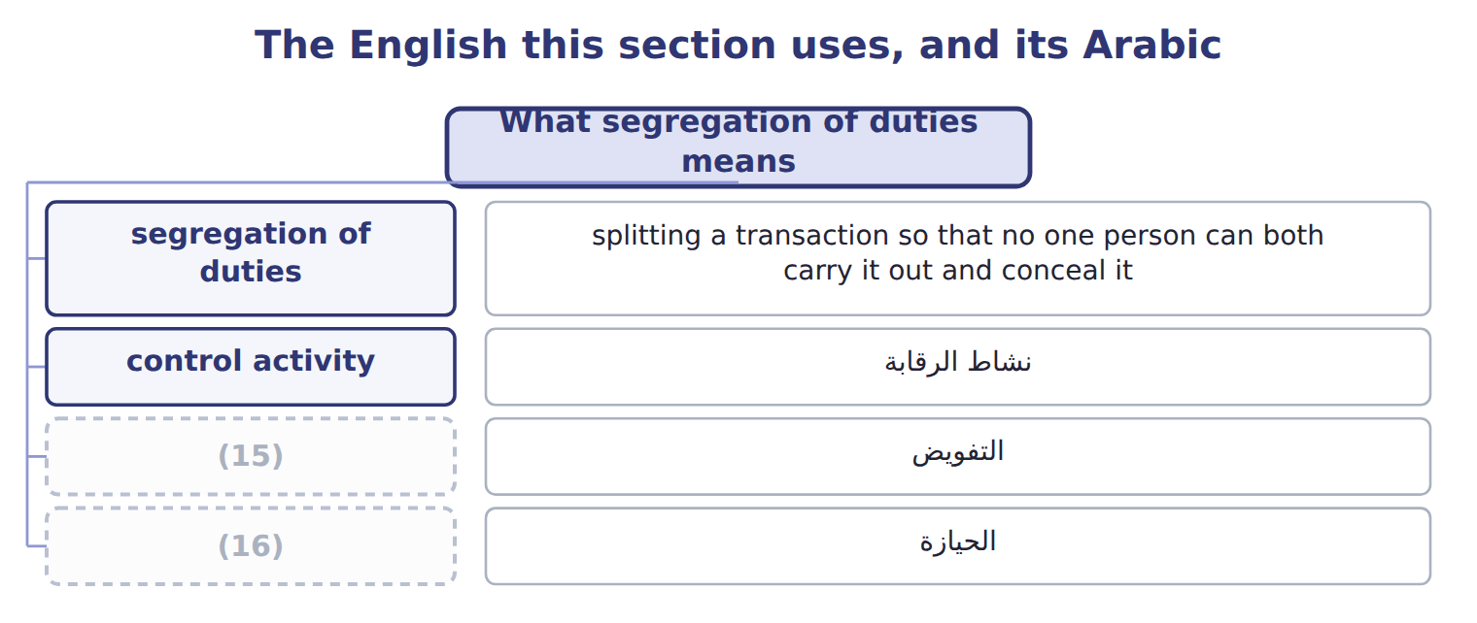
word list
التفويض · custody · authorization

The English this sheet uses, and its Arabic
English (exam term) | Arabic
segregation of duties | الفصل بين المهام
control activity | نشاط الرقابة

Answer key · 3.1 What segregation of duties means

1 The four functional responsibilities | 9 Authorization separated from recording
2 Safeguarding assets | 10 storekeeper
3 Extended Example 3A: redesigning the Orontes p | 11 programmer
4 transaction | 12 examples
5 conceal | 13 misdirect
6 organizing | 14 neither
7 Custody separated from recording and reconciliation | 15 authorization
8 Authorization separated from custody of cash | 16 custody

the summaries in full
Summary 1 Segregation of duties means splitting a transaction so that no one person can both carry it out and conceal it. It is the most powerful control activity available, and usually the cheapest, because it costs an organizing decision rather than money.
Summary 2 Notice what the examples have in common. In each case the person who can take or misdirect something is not the person who records it, and neither of them is the person who later checks that records and reality agree.

3.2 The four functional responsibilities
Chapter 3 · section 3.2

Fill every gap. Each word list holds one word more than there are gaps.
Summary 1 gaps 1–2
The exam names four (1) that should be held by different people, or at least by different (2) .
word list
departments · someone · responsibilities

The four functional responsibilities
Functional responsibility (E.1.j) | What it means | At Orontes
Authority to execute transactions | (3) | The purchasing manager approves a new supplier
Recording transactions | (4) | The accounts clerk posts the invoice
Custody of assets | (5) | The cashier holds the cash; the storekeeper holds the stock
Periodic reconciliation | Comparing the records with the assets actually there | (6)

word list
Entering it in the accounting records · Holding or controlling the asset itself · A third person reconciles the bank statement · Deciding that the transaction should happen at all · The accounts clerk posts the invoice

Summary 2 gaps 7–10
The logic is (7) the same. A person who holds only one of the four can make a (8) or commit a fraud, but (9) else will see it. A person who holds two can make the entry and remove the evidence, which is why the pairs matter more than the (10) duties.
word list
individual · always · mistake · performing · someone

Two duties, not one, create the risk

Summary 3 gaps 11–12
A question that describes someone (11) one of the four duties describes a normal job. Look for the (12) duty. The answer is almost always the pair, not the person.
word list
performing · custody · second

The words this section uses
Each term sits against what it means.
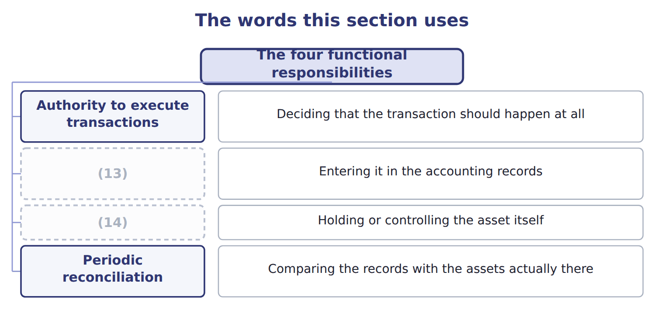
word list
independent check · Recording transactions · Custody of assets

The English this sheet uses, and its Arabic
English (exam term) | Arabic
authorization | التفويض
custody | الحيازة

Answer key · 3.2 The four functional responsibilities

1 responsibilities | 8 mistake
2 departments | 9 someone
3 Deciding that the transaction should happen at all | 10 individual
4 Entering it in the accounting records | 11 performing
5 Holding or controlling the asset itself | 12 second
6 A third person reconciles the bank statement | 13 Recording transactions
7 always | 14 Custody of assets

the summaries in full
Summary 1 The exam names four responsibilities that should be held by different people, or at least by different departments.
Summary 2 The logic is always the same. A person who holds only one of the four can make a mistake or commit a fraud, but someone else will see it. A person who holds two can make the entry and remove the evidence, which is why the pairs matter more than the individual duties.
Summary 3 A question that describes someone performing one of the four duties describes a normal job. Look for the second duty. The answer is almost always the pair, not the person.

3.3 Independent checks and verification
Chapter 3 · section 3.3

Fill every gap. Each word list holds one word more than there are gaps.
Summary 1 gaps 1–4
An independent check is a (1) performed by (2) who did not do the work being checked. The word independent is the whole of the control: a (3) performed by the person who made the entries proves nothing, because the same (4) or the same intent produced both.
word list
comparison · someone · reconciliation · alongside · misunderstanding

Independent checks and who must perform them
Independent check | Who must perform it | What it would catch
Bank reconciliation | (5) | Cash recorded but never banked
Stock count | (6) | Stock recorded but not present
Supplier statement reconciliation | Accounts payable, not the buyer | (7)
Review of exception reports | A supervisor, not the clerk who caused the exception | (8)
Internal audit | A function (9) to the audit committee, not to the manager audited | Weaknesses the line would not report on itself

word list
Invoices paid twice or paid to the wrong party · recorded · reporting · A team that does not include the storekeeper · Overrides and unusual amounts · Someone who neither handles cash nor posts the ledger

Summary 2 gaps 10–12
Independent checks are detective rather than (10) . They do not stop the error; they find it (11) . That is why they sit alongside (12) rather than replacing it, and why their value depends entirely on someone acting when a difference appears.
word list
preventive · replacing · afterwards · segregation

The English this section uses, and its Arabic
Each term sits against what it means.
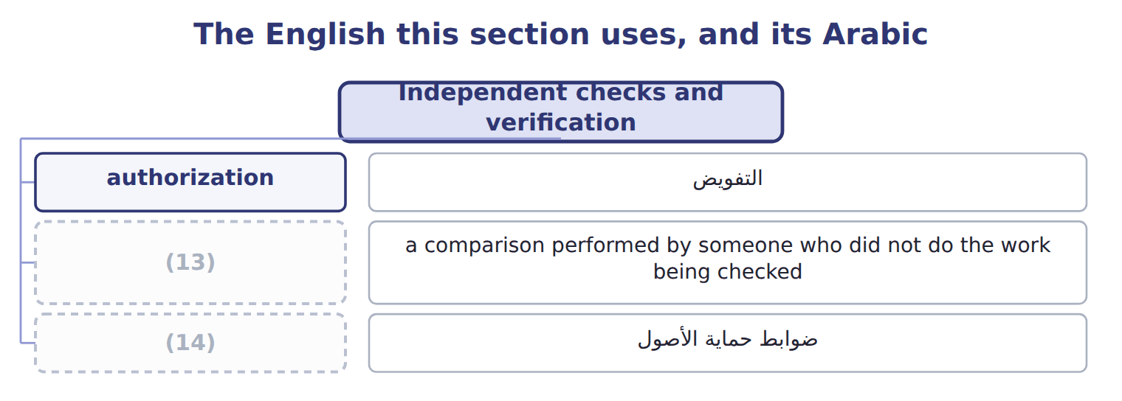
word list
independent check · control activity · safeguarding control

The English this sheet uses, and its Arabic
English (exam term) | Arabic
independent check | التحقق المستقل

Answer key · 3.3 Independent checks and verification

1 comparison | 8 Overrides and unusual amounts
2 someone | 9 reporting
3 reconciliation | 10 preventive
4 misunderstanding | 11 afterwards
5 Someone who neither handles cash nor posts the ledger | 12 segregation
6 A team that does not include the storekeeper | 13 independent check
7 Invoices paid twice or paid to the wrong party | 14 safeguarding control

the summaries in full
Summary 1 An independent check is a comparison performed by someone who did not do the work being checked. The word independent is the whole of the control: a reconciliation performed by the person who made the entries proves nothing, because the same misunderstanding or the same intent produced both.
Summary 2 Independent checks are detective rather than preventive. They do not stop the error; they find it afterwards. That is why they sit alongside segregation rather than replacing it, and why their value depends entirely on someone acting when a difference appears.

3.4 Safeguarding assets
Chapter 3 · section 3.4

Fill every gap. Each word list holds one word more than there are gaps.
Summary 1 gaps 1–3
A (1) control limits who can physically reach an asset and (2) who is answerable for it. These matter most where assets are (3) and valuable, which at Orontes means cash, saffron and the spice store rather than the bottling line.
word list
keyholders · safeguarding · portable · establishes

Safeguarding controls
Safeguarding control (E.1.l) | Examples | What it achieves
Physical barriers | (4) | Stops the simple taking of an asset
Access control | Badges, keys, biometrics, visitor logs | (5)
Environmental protection | (6) | Protects assets from loss as well as theft
Custodial accountability | (7) | Makes a shortage someone's responsibility
Periodic counts | (8) | Detects loss that prevention missed
Insurance and bonding | Cover for losses, and (9) bonds on staff handling cash | Limits the damage once a loss occurs

word list
One named custodian per store or cash float · Independent counts compared with records · Records who was able to reach the asset · Fire suppression, cold-chain alarms, backup power · Locked stores, fenced yards, safes, restricted areas · fidelity · Limits the damage once a loss occurs

Summary 2 gaps 10–12
Custodial (10) deserves attention because it is often forgotten. A store with three (11) and no named custodian has no one to ask when stock is short. (12) one custodian turns a general loss into a specific question.
word list
valuable · Assigning · accountability · keyholders

The English this sheet uses, and its Arabic
English (exam term) | Arabic
custodial accountability | المساءلة عن العهدة
safeguarding control | ضوابط حماية الأصول

Answer key · 3.4 Safeguarding assets

1 safeguarding | 7 One named custodian per store or cash float
2 establishes | 8 Independent counts compared with records
3 portable | 9 fidelity
4 Locked stores, fenced yards, safes, restricted areas | 10 accountability
5 Records who was able to reach the asset | 11 keyholders
6 Fire suppression, cold-chain alarms, backup power | 12 Assigning

the summaries in full
Summary 1 A safeguarding control limits who can physically reach an asset and establishes who is answerable for it. These matter most where assets are portable and valuable, which at Orontes means cash, saffron and the spice store rather than the bottling line.
Summary 2 Custodial accountability deserves attention because it is often forgotten. A store with three keyholders and no named custodian has no one to ask when stock is short. Assigning one custodian turns a general loss into a specific question.

3.5 Prenumbered forms and authority limits
Chapter 3 · section 3.5

Fill every gap. Each word list holds one word more than there are gaps.
Summary 1 gaps 1–8
A (1) form carries a (2) number printed before use. The sequence makes (3) testable. Anyone can (4) for the numbers used, and a gap is a (5) that somebody must answer. (6) it, a document that was (7) , or never raised at all, leaves no trace. (8) limits work the same way from the other direction. If the policy names who may receive goods and who may approve a payment, and up to what amount, then an unapproved transaction has nobody who could legitimately have made it. The limit converts a vague expectation into a testable rule.
word list
question · sequential · destroyed · Without · printed · prenumbered · Authority · account · completeness

The English this section uses, and its Arabic
Each term sits against what it means.
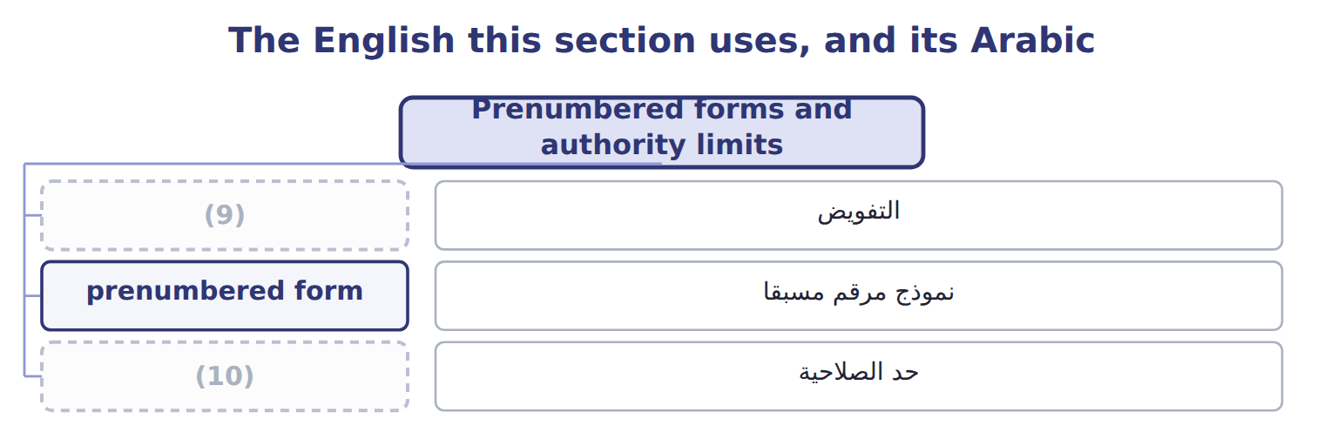
word list
authorization · authority limit · prenumbered form

The English this sheet uses, and its Arabic
English (exam term) | Arabic
prenumbered form | نموذج مرقم مسبقا
authority limit | حد الصلاحية

Answer key · 3.5 Prenumbered forms and authority limits

1 prenumbered | 6 Without
2 sequential | 7 destroyed
3 completeness | 8 Authority
4 account | 9 authorization
5 question | 10 authority limit

the summaries in full
Summary 1 A prenumbered form carries a sequential number printed before use. The sequence makes completeness testable. Anyone can account for the numbers used, and a gap is a question that somebody must answer. Without it, a document that was destroyed, or never raised at all, leaves no trace. Authority limits work the same way from the other direction. If the policy names who may receive goods and who may approve a payment, and up to what amount, then an unapproved transaction has nobody who could legitimately have made it. The limit converts a vague expectation into a testable rule.

3.6 Extended Example 3A: redesigning the Orontes purchasing cycle
Chapter 3 · section 3.6

Fill every gap. Each word list holds one word more than there are gaps.
Summary 1 gaps 1–12
This example takes the (1) . It is (2) : questions give a flawed (3) and ask which duty to move. One purchasing clerk could add a supplier to the (4) list, raise the order, (5) that goods had arrived and release the payment. Of the four (6) , he held authorization, recording and (7) custody of the cash leaving the company. Only (8) sat elsewhere, and nobody (9) it. Supplier approval moves to the purchasing manager, named in the job (10) rather than (11) verbally. That single change breaks the authorization and custody pair, which is the (12) that let money leave the company. Authorization sits with the purchasing manager, who approves suppliers and orders above a stated limit. Recording sits with the accounts clerk, who posts invoices. Custody sits with the storekeeper, who receives goods, and with the cashier, who releases payment.
word list
approved · failure · reconciliation · delegated · confirm · effective · pairing · description · printed · performed · responsibilities · exam-core · arrangement

Summary 2 gaps 13–20
Reconciliation sits with a fourth person, who (13) the supplier (14) with the ledger each month. Goods received notes are (15) , so a delivery that was never (16) leaves a gap. A (17) above the limit needs two (18) . The supplier master file is printed and reviewed quarterly by someone outside purchasing, which is an (19) check on the (20) itself. If the purchasing manager and the cashier agree together, the design fails. The redesign buys reasonable assurance against one person acting alone, which is what segregation is for.
word list
signatures · prenumbered · authorization · recorded · payment · statement · received · compares · independent

Four arrangements to diagnose

Complete the blank cells.
Your turn: diagnose four arrangements (complete the blanks)
Situation | Which duties are combined? | Why it matters
The storekeeper also keeps the stock records | ________ | (21)
The cashier performs the bank reconciliation | Custody and reconciliation | ________
The buyer approves suppliers and releases payment | ________ | He can approve a payment to himself and collect it
The clerk who posts an error also reviews the exception report | ________ | (22)

word list
He can remove stock and adjust the record to match · He can approve a payment to himself and collect it · She can certify that her own mistake is acceptable

The pattern behind the redesign

Summary 3 gaps 23–26
Name the four (23) in the cycle, then ask who holds each one. Any person holding two is the weakness; move (24) is easiest to move. Add an (25) check on the duty that remains most powerful. Prenumber the documents, so that (26) can be tested afterwards.
word list
duties · invoices · completeness · independent · whichever

Exam view

Summary 4 gaps 27–30
A case (27) a cycle and asks for the weakness, or for the (28) that would fix it. Map each person to the four duties before (29) . The weakness is the person with two, and the fix is the cheapest move that (30) them.
word list
separates · control · describes · easiest · answering

Exam view
Item | Answer
The storekeeper also keeps the stock records | (31) and recording — he can remove stock and adjust the record to match
The cashier performs the bank reconciliation | Why: the person holding the cash certifies that the records agree with it, so a shortage can be hidden
The buyer approves suppliers and releases payment | Authorization and custody — he can approve a payment to himself and collect it
The clerk who posts an error also reviews the exception report | Recording and (32) — she can certify that her own mistake is acceptable

word list
Authorization · reconciliation · Custody

Person and duty — Category
Person and duty | Category
Samir holds the keys to the store | Custody
Samir maintains the stock records | (33)
Nadia approves customers for collection without prepayment | Authorization
Khalid performs the monthly stock count | (34)

word list
Recording · custody · Reconciliation

The English this section uses, and its Arabic
Each term sits against what it means.
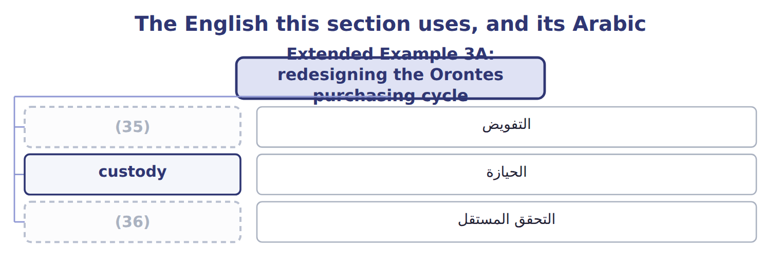
word list
authorization · independent check · safeguarding control

Answer key · 3.6 Extended Example 3A: redesigning the Orontes purchasing cycle

1 failure | 19 independent
2 exam-core | 20 authorization
3 arrangement | 21 He can remove stock and adjust the record to match
4 approved | 22 She can certify that her own mistake is acceptable
5 confirm | 23 duties
6 responsibilities | 24 whichever
7 effective | 25 independent
8 reconciliation | 26 completeness
9 performed | 27 describes
10 description | 28 control
11 delegated | 29 answering
12 pairing | 30 separates
13 compares | 31 Custody
14 statement | 32 reconciliation
15 prenumbered | 33 Recording
16 recorded | 34 Reconciliation
17 payment | 35 authorization
18 signatures | 36 independent check

the summaries in full
Summary 1 This example takes the failure. It is exam-core: questions give a flawed arrangement and ask which duty to move. One purchasing clerk could add a supplier to the approved list, raise the order, confirm that goods had arrived and release the payment. Of the four responsibilities, he held authorization, recording and effective custody of the cash leaving the company. Only reconciliation sat elsewhere, and nobody performed it. Supplier approval moves to the purchasing manager, named in the job description rather than delegated verbally. That single change breaks the authorization and custody pair, which is the pairing that let money leave the company. Authorization sits with the purchasing manager, who approves suppliers and orders above a stated limit. Recording sits with the accounts clerk, who posts invoices. Custody sits with the storekeeper, who receives goods, and with the cashier, who releases payment.
Summary 2 Reconciliation sits with a fourth person, who compares the supplier statement with the ledger each month. Goods received notes are prenumbered, so a delivery that was never recorded leaves a gap. A payment above the limit needs two signatures. The supplier master file is printed and reviewed quarterly by someone outside purchasing, which is an independent check on the authorization itself. If the purchasing manager and the cashier agree together, the design fails. The redesign buys reasonable assurance against one person acting alone, which is what segregation is for.
Summary 3 Name the four duties in the cycle, then ask who holds each one. Any person holding two is the weakness; move whichever is easiest to move. Add an independent check on the duty that remains most powerful. Prenumber the documents, so that completeness can be tested afterwards.
Summary 4 A case describes a cycle and asks for the weakness, or for the control that would fix it. Map each person to the four duties before answering. The weakness is the person with two, and the fix is the cheapest move that separates them.

4.1 The Sarbanes-Oxley sections that matter
Chapter 4 · section 4.1

Fill every gap. Each word list holds one word more than there are gaps.
Chapter 4, section by section
Each stage leads to the next.
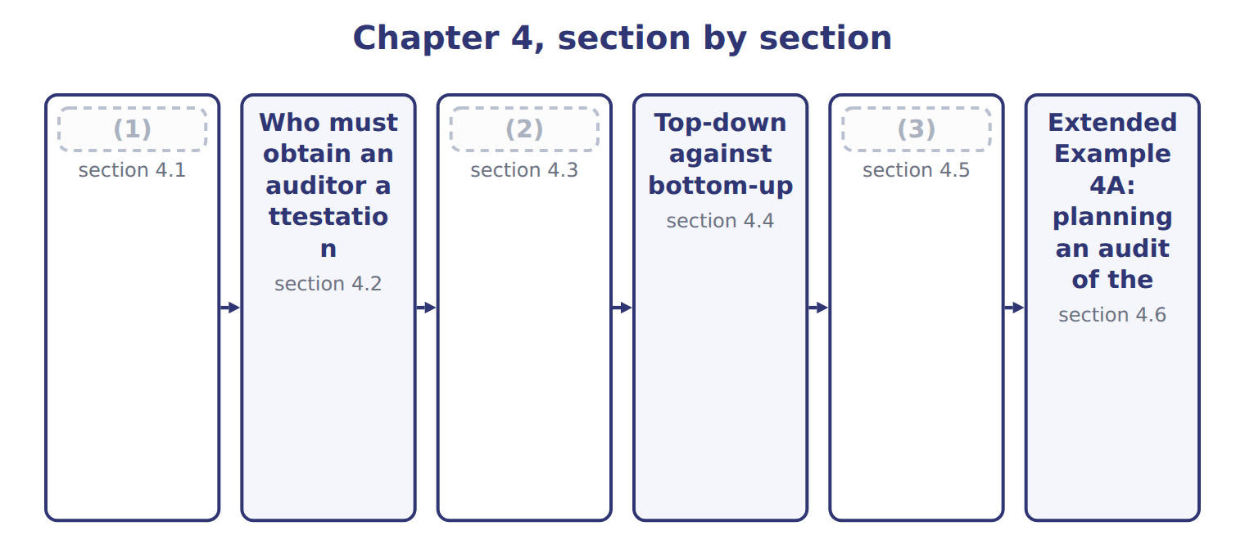
word list
internal accounting controls · What the PCAOB does · The Foreign Corrupt Practices Act · The Sarbanes-Oxley sections that matter

The Sarbanes-Oxley Act of 2002 followed a run of accounting failures.
The Sarbanes-Oxley sections that concern internal control
Each stage leads to the next.
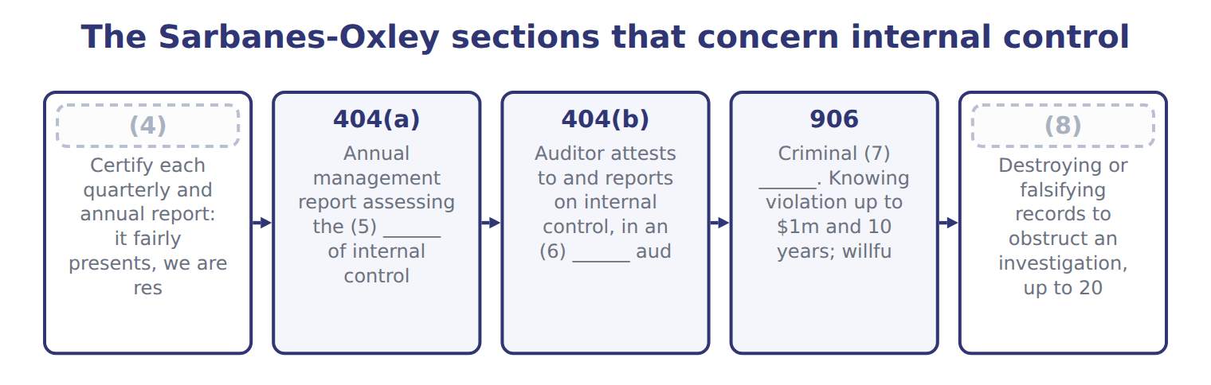
word list
integrated · 802 · 404(a) · effectiveness · certification · 302

Summary 1 gaps 9–20
Section 302 and Section 906 both require the CEO and CFO to certify, and (9) often ask why there are two. Section 302 is the civil (10) about the content of the report and the (11) behind it. Section 906 is the (12) one, carrying up to twenty years for a willful (13) . Section 404 has two (14) that are often (15) . Part (a) requires (16) to assess internal control over (17) reporting each year. Part (b) requires the (18) auditor to (19) to it, and that half does not apply to every company. The (20) , Section 802 says five years. The SEC's own rule and the PCAOB's standard then require seven. Both numbers are correct in their place, and a question may test either. Say five if asked about the Act, and seven if asked about the SEC or PCAOB requirement.
word list
external · statute · candidates · confused · violation · financial · controls · attest · certification · management · accounting · halves · criminal

The words this section uses
Each term sits against what it means.
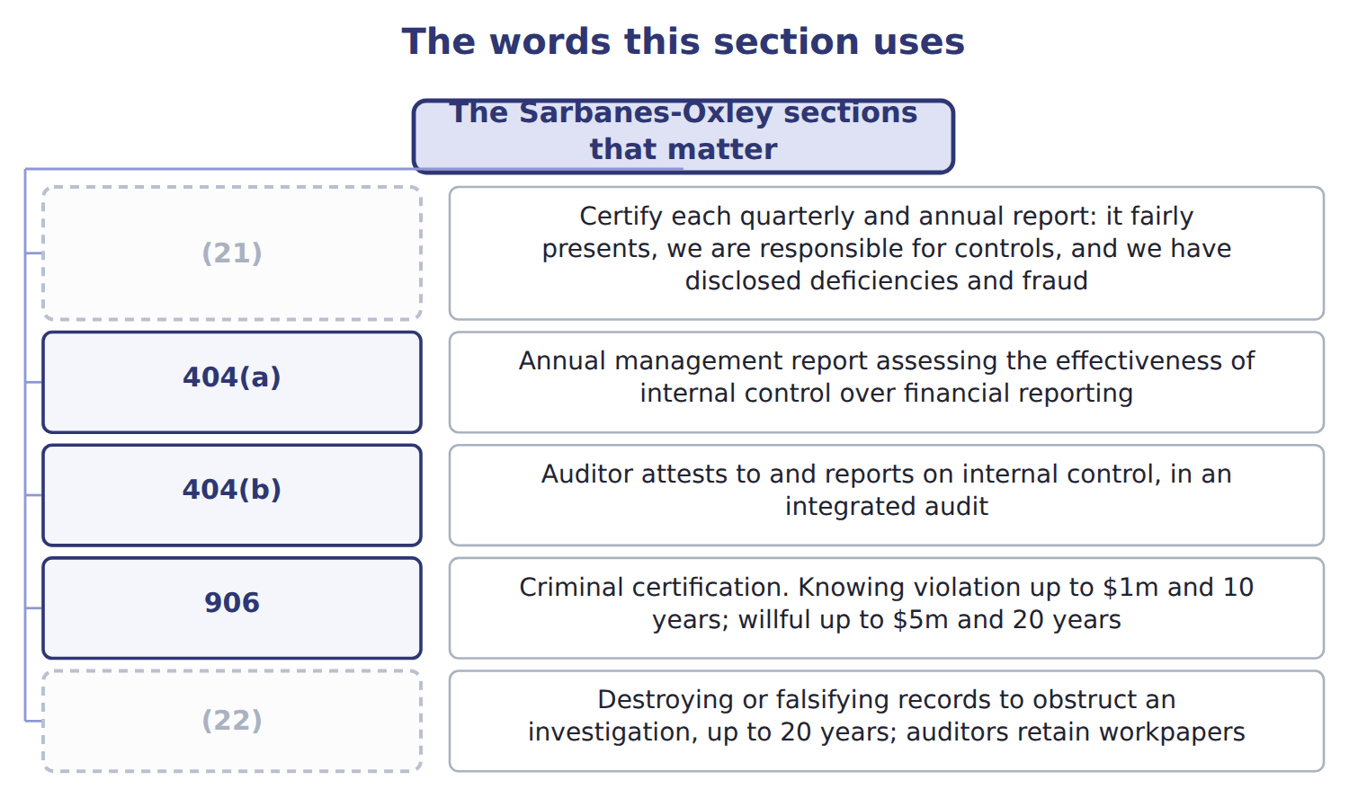
word list
302 · 802 · 404(b)

The English this sheet uses, and its Arabic
English (exam term) | Arabic
Sarbanes-Oxley Act | قانون ساربينز-أوكسلي
internal control over financial reporting (ICFR) | الرقابة الداخلية على التقارير المالية

Answer key · 4.1 The Sarbanes-Oxley sections that matter

1 The Sarbanes-Oxley sections that matter | 12 criminal
2 What the PCAOB does | 13 violation
3 The Foreign Corrupt Practices Act | 14 halves
4 302 | 15 confused
5 effectiveness | 16 management
6 integrated | 17 financial
7 certification | 18 external
8 802 | 19 attest
9 candidates | 20 statute
10 certification | 21 302
11 controls | 22 802

the summaries in full
Summary 1 Section 302 and Section 906 both require the CEO and CFO to certify, and candidates often ask why there are two. Section 302 is the civil certification about the content of the report and the controls behind it. Section 906 is the criminal one, carrying up to twenty years for a willful violation. Section 404 has two halves that are often confused. Part (a) requires management to assess internal control over financial reporting each year. Part (b) requires the external auditor to attest to it, and that half does not apply to every company. The statute, Section 802 says five years. The SEC's own rule and the PCAOB's standard then require seven. Both numbers are correct in their place, and a question may test either. Say five if asked about the Act, and seven if asked about the SEC or PCAOB requirement.

4.2 Who must obtain an auditor attestation
Chapter 4 · section 4.2

Fill every gap. Each word list holds one word more than there are gaps.
Summary 1 gaps 1–11
Section 404(b) binds accelerated filers and large accelerated filers. Non-accelerated filers were (1) exempted by the (2) Act in 2010. Only if they are also non-accelerated. Since the SEC's 2020 (3) the two labels (4) but are not the same. A smaller reporting company with a float of $75 million or more, and (5) of $100 million or more, is still an accelerated filer and still needs the attestation. In May 2026 the SEC (6) raising the large accelerated threshold to $2 (7) . It would also (8) the accelerated filer and smaller reporting company (9) , leaving about 81% of companies exempt from the Section 404 attestation. Learn the (10) rules, and expect the exam to test the (11) rather than the threshold.
word list
current · amendments · remove · categories · threshold · Dodd-Frank · overlap · revenue · permanently · principle · billion · proposed

Answer key · 4.2 Who must obtain an auditor attestation

1 permanently | 7 billion
2 Dodd-Frank | 8 remove
3 amendments | 9 categories
4 overlap | 10 current
5 revenue | 11 principle
6 proposed

the summaries in full
Summary 1 Section 404(b) binds accelerated filers and large accelerated filers. Non-accelerated filers were permanently exempted by the Dodd-Frank Act in 2010. Only if they are also non-accelerated. Since the SEC's 2020 amendments the two labels overlap but are not the same. A smaller reporting company with a float of $75 million or more, and revenue of $100 million or more, is still an accelerated filer and still needs the attestation. In May 2026 the SEC proposed raising the large accelerated threshold to $2 billion. It would also remove the accelerated filer and smaller reporting company categories, leaving about 81% of companies exempt from the Section 404 attestation. Learn the current rules, and expect the exam to test the principle rather than the threshold.

4.3 What the PCAOB does
Chapter 4 · section 4.3

Fill every gap. Each word list holds one word more than there are gaps.
Summary 1 gaps 1–2
The Public Company (1) Oversight Board was created by the Act itself. Before 2002 the audit profession set its own standards and inspected itself; the PCAOB replaced that (2) .
word list
attestation · arrangement · Accounting

What the PCAOB does
PCAOB role (E.1.q) | What it does | Why it matters
Registration | (3) | No registration, no audit of a public company
Standard setting | (4) | AS 2201 governs the audit of internal control
Inspection | (5) | Findings drive firm-wide remediation
Enforcement | Investigates and disciplines firms and individuals | (6)

word list
AS 2201 governs the audit of internal control · Audit firms of issuers must register with the PCAOB · Issues auditing standards, subject to SEC approval · Inspects registered firms' audit work · Sanctions up to barring an auditor

Summary 2 gaps 7–15
The PCAOB issues the auditing standards, subject to approval by the SEC, and the standard (7) an audit of internal control over (8) reporting is AS 2201. Many study (9) still call it AS No. 5. The PCAOB (10) its standards in 2016 and it is now AS 2201. The (11) did not change, but the old name (12) a book that has not been updated. A (13) point is worth knowing because (14) mix it up. The SEC gives guidance to management on its own 404(a) assessment; the PCAOB gives guidance to auditors on the 404(b) (15) . Different bodies, different audiences, same subject.
word list
governing · candidates · content · arrangement · attestation · renumbered · signals · second · financial · guides

The words this section uses
Each term sits against what it means.
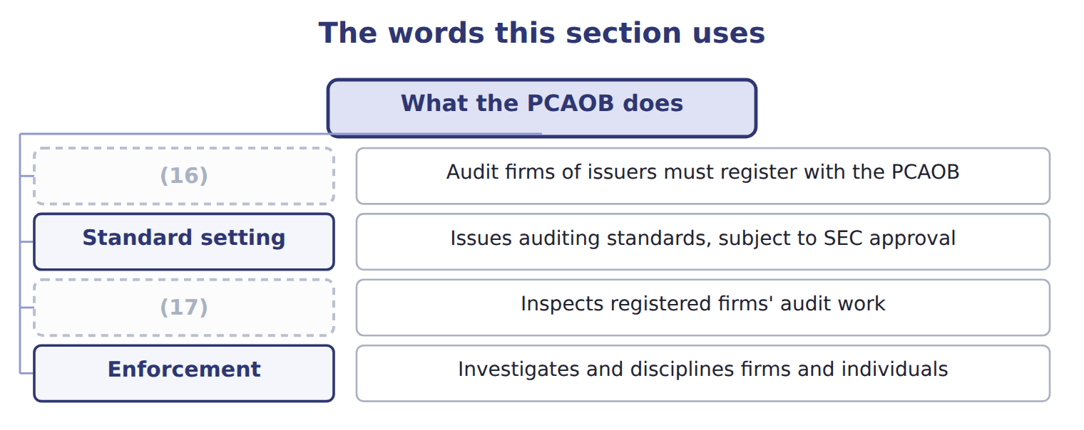
word list
Enforcement · Inspection · Registration

The English this sheet uses, and its Arabic
English (exam term) | Arabic
Public Company Accounting Oversight Board (PCAOB) | مجلس الرقابة على محاسبة الشركات العامة
accelerated filer | الجهة المصدرة المعجلة

Answer key · 4.3 What the PCAOB does

1 Accounting | 10 renumbered
2 arrangement | 11 content
3 Audit firms of issuers must register with the PCAOB | 12 signals
4 Issues auditing standards, subject to SEC approval | 13 second
5 Inspects registered firms' audit work | 14 candidates
6 Sanctions up to barring an auditor | 15 attestation
7 governing | 16 Registration
8 financial | 17 Inspection
9 guides

the summaries in full
Summary 1 The Public Company Accounting Oversight Board was created by the Act itself. Before 2002 the audit profession set its own standards and inspected itself; the PCAOB replaced that arrangement.
Summary 2 The PCAOB issues the auditing standards, subject to approval by the SEC, and the standard governing an audit of internal control over financial reporting is AS 2201. Many study guides still call it AS No. 5. The PCAOB renumbered its standards in 2016 and it is now AS 2201. The content did not change, but the old name signals a book that has not been updated. A second point is worth knowing because candidates mix it up. The SEC gives guidance to management on its own 404(a) assessment; the PCAOB gives guidance to auditors on the 404(b) attestation. Different bodies, different audiences, same subject.

4.4 Top-down against bottom-up
Chapter 4 · section 4.4

Fill every gap. Each word list holds one word more than there are gaps.
Summary 1 gaps 1–12
AS 2201 (1) the auditor to use a top-down approach to (2) the controls to test. This is the (3) required and (4) approach, and the exam asks for it by name. The auditor starts at the financial (5) and the risk of (6) misstatement. From there the path runs to (7) controls, then to (8) accounts and their assertions, then to the likely sources of misstatement. Only then are the controls selected. A bottom-up approach does the (9) . It starts with a list of controls and tests them, hoping that the (10) turns out to be (11) . The (12) is not merely efficiency, though a top-down audit does cost less. It is about evidence. A bottom-up audit can test a hundred controls and still miss the one that matters, because nothing in the method connects the testing to the risk.
word list
requires · difference · statements · select · material · opposite · coverage · significant · preferred · nothing · PCAOB's · adequate · entity-level

Top-down against bottom-up
 | Top-down, risk-based | Bottom-up
Starting point | The financial statements and the risk of material misstatement | (13)
Direction | From risk down to the controls that address it | (14)
Scope | (15) | Potentially every control in the company
Entity-level controls | (16) | Often tested last or not at all
Cost and evidence | (17) | More testing, much of it irrelevant
PCAOB position | Required by AS 2201.21 | (18)

word list
Less testing, better targeted · More testing, much of it irrelevant · Only controls that address an identified risk · From the controls up to whatever they happen to cover · Tested first, and may reduce testing below · Individual process-level controls · Not the standard

The English this sheet uses, and its Arabic
English (exam term) | Arabic
top-down approach | النهج من الأعلى إلى الأسفل
bottom-up approach | النهج من الأسفل إلى الأعلى

Answer key · 4.4 Top-down against bottom-up

1 requires | 10 coverage
2 select | 11 adequate
3 PCAOB's | 12 difference
4 preferred | 13 Individual process-level controls
5 statements | 14 From the controls up to whatever they happen to cover
6 material | 15 Only controls that address an identified risk
7 entity-level | 16 Tested first, and may reduce testing below
8 significant | 17 Less testing, better targeted
9 opposite | 18 Not the standard

the summaries in full
Summary 1 AS 2201 requires the auditor to use a top-down approach to select the controls to test. This is the PCAOB's required and preferred approach, and the exam asks for it by name. The auditor starts at the financial statements and the risk of material misstatement. From there the path runs to entity-level controls, then to significant accounts and their assertions, then to the likely sources of misstatement. Only then are the controls selected. A bottom-up approach does the opposite. It starts with a list of controls and tests them, hoping that the coverage turns out to be adequate. The difference is not merely efficiency, though a top-down audit does cost less. It is about evidence. A bottom-up audit can test a hundred controls and still miss the one that matters, because nothing in the method connects the testing to the risk.

4.5 The Foreign Corrupt Practices Act
Chapter 4 · section 4.5

Fill every gap. Each word list holds one word more than there are gaps.
Summary 1 gaps 1–2
The Foreign Corrupt (1) Act of 1977 has two sets of (2) , and only one of them is about bribery.
word list
provisions · Practices · posture

The two sets of FCPA provisions
FCPA provision (E.1.t) | What it says | Who it binds
Anti-bribery | Prohibits corruptly offering anything of value to a foreign official to obtain or keep business | Issuers, domestic concerns, and others acting in U.S. (3)
Books and records | Keep books in reasonable detail that accurately and fairly reflect transactions and dispositions of assets | (4)
Internal accounting controls | Maintain a system giving reasonable assurance over (5) , recording, access and periodic comparison | Issuers only
Exception | (6) payments for routine governmental action, such as processing a visa | Narrowly read
Defenses | The payment was lawful under written local law; or a reasonable bona fide expenditure | (7)

word list
accelerated filer · Two affirmative defenses · Issuers only · Facilitating · territory · authorization

Summary 2 gaps 8–17
The accounting provisions are the ones this exam cares about. They require an issuer to keep books in reasonable detail that (8) and fairly (9) its transactions. They also require a system of internal accounting controls giving reasonable (10) over four things: that transactions are authorized; that they are recorded so that (11) can be prepared; that access to assets is authorized; and that recorded assets are compared with actual assets at reasonable (12) . Two (13) follow that are easy to miss. The accounting provisions bind (14) only, while the (15) provisions reach much wider. And a company can breach the accounting provisions with no bribe (16) in the picture, because poor records and weak controls are (17) the offence.
word list
require · statements · reflect · issuers · anti-bribery · intervals · points · accurately · assurance · anywhere · themselves

The FCPA does not require COSO

Summary 3 gaps 18–26
The Act requires a system of internal (18) controls giving (19) assurance over the four matters listed above. It names no (20) . Most companies use COSO because it is the (21) one, not because the FCPA says so. The statute has not (22) . It was paused in February 2025 and restarted in June 2025 under (23) of Justice (24) setting four priorities, with a further policy in March 2026. (25) , the Foreign Extortion (26) Act of December 2023 made it a crime for a foreign official to demand a bribe. Expect the exam to test the statute rather than the enforcement posture.
word list
because · changed · Prevention · reasonable · Department · Separately · framework · recognised · guidelines · accounting

The words this section uses
Each term sits against what it means.
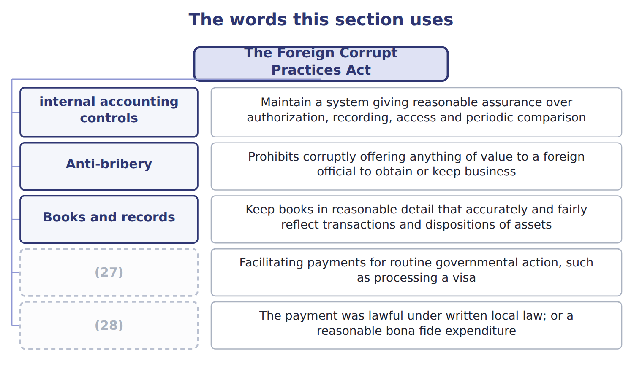
word list
Defenses · Anti-bribery · Exception

The English this sheet uses, and its Arabic
English (exam term) | Arabic
Foreign Corrupt Practices Act (FCPA) | قانون الممارسات الأجنبية الفاسدة
internal accounting controls | ضوابط المحاسبة الداخلية

Answer key · 4.5 The Foreign Corrupt Practices Act

1 Practices | 15 anti-bribery
2 provisions | 16 anywhere
3 territory | 17 themselves
4 Issuers only | 18 accounting
5 authorization | 19 reasonable
6 Facilitating | 20 framework
7 Two affirmative defenses | 21 recognised
8 accurately | 22 changed
9 reflect | 23 Department
10 assurance | 24 guidelines
11 statements | 25 Separately
12 intervals | 26 Prevention
13 points | 27 Exception
14 issuers | 28 Defenses

the summaries in full
Summary 1 The Foreign Corrupt Practices Act of 1977 has two sets of provisions, and only one of them is about bribery.
Summary 2 The accounting provisions are the ones this exam cares about. They require an issuer to keep books in reasonable detail that accurately and fairly reflect its transactions. They also require a system of internal accounting controls giving reasonable assurance over four things: that transactions are authorized; that they are recorded so that statements can be prepared; that access to assets is authorized; and that recorded assets are compared with actual assets at reasonable intervals. Two points follow that are easy to miss. The accounting provisions bind issuers only, while the anti-bribery provisions reach much wider. And a company can breach the accounting provisions with no bribe anywhere in the picture, because poor records and weak controls are themselves the offence.
Summary 3 The Act requires a system of internal accounting controls giving reasonable assurance over the four matters listed above. It names no framework. Most companies use COSO because it is the recognised one, not because the FCPA says so. The statute has not changed. It was paused in February 2025 and restarted in June 2025 under Department of Justice guidelines setting four priorities, with a further policy in March 2026. Separately, the Foreign Extortion Prevention Act of December 2023 made it a crime for a foreign official to demand a bribe. Expect the exam to test the statute rather than the enforcement posture.

4.6 Extended Example 4A: planning an audit of the Orontes controls
Chapter 4 · section 4.6

Fill every gap. Each word list holds one word more than there are gaps.
Summary 1 gaps 1–12
This example walks the (1) approach through one Orontes audit and shows what a (2) auditor would have done instead. It is (3) , so expect to be asked to judge (4) than recall. The auditor starts by asking where a material (5) could appear in the Orontes (6) . Inventory is large and includes spices that are (7) and portable. (8) includes Gulf export sales with (9) terms. Those two attract (10) ; the small items do not. Next the auditor tests the controls that run across (11) : the control (12) described in, the period-end reporting process, and the controls over management override. Strong entity-level controls can reduce the testing needed below, which is why they come second and not last. Inventory is a significant account, but not every assertion about it matters equally. Existence is the assertion at risk for portable spices; valuation matters for slow-moving stock.
word list
attention · top-down · Nothing · bottom-up · environment · everything · Revenue · misstatement · rather · exam-core · unusual · valuable · statements

Summary 2 gaps 13–23
The auditor names the (13) , not just the (14) . How could (15) existence actually go wrong at Orontes? Stock could be removed from the spice store and the record (16) , which is the pairing. That is a (17) , testable route, not a (18) worry. Only now does the auditor choose: the separation of the (19) from the stock records, the independent count, and the (20) of depot records to plant dispatches. Three controls, each tied to an (21) risk. A (22) auditor would have asked for the list of controls and (23) testing. Many hours would go on purchase order approvals and payroll authorisations, which are real controls over immaterial risks. The spice store might be reached eventually, and might not. Nothing in the method would reveal the gap.
word list
assertion · specific · Orontes · general · identified · inventory · started · storekeeper · adjusted · reconciliation · bottom-up · account

Match each requirement to its SOX section

Complete the blank cells.

Your turn: match the requirement to the section (complete the blanks)
Every item belongs to exactly one group.
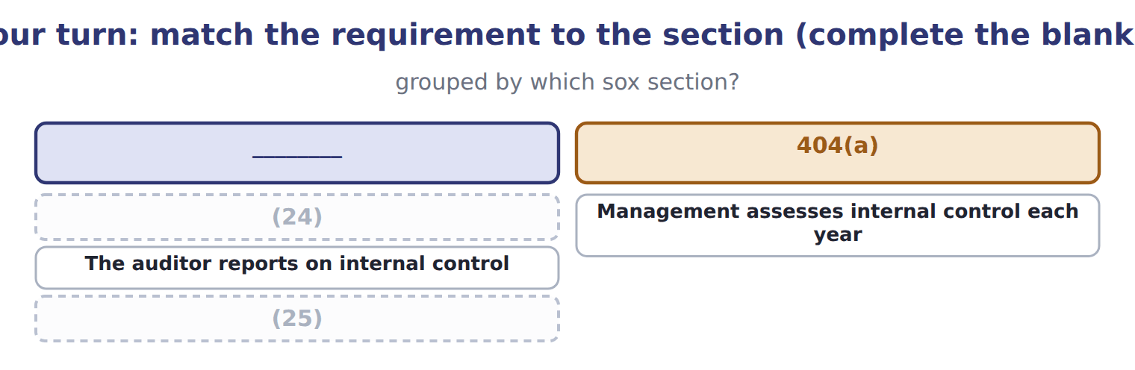
word list
Management assesses internal control each year · Destroying records to obstruct an investigation · The CEO and CFO certify the annual report

Summary 3 gaps 26–27
The (26) matters for an exam (27) : answer on current law unless a question says otherwise.
word list
attract · distinction · candidate

What is current law and what is only proposed
Item | What it says | Source | Status
404(b) exemption | Non-accelerated filers exempt; an SRC qualifies only if also non-accelerated | (28) | current law
Filer thresholds | Would raise large accelerated to $2bn and remove the SRC category | (29) | PROPOSED only
PCAOB QC 1000 | A firm's system of quality control | Adopted May 2024, postponed to 15 Dec 2026 | (30)
Technology-assisted analysis | Amendments to AS 1105 and AS 2301 | (31) | effective for years from 15 Dec 2025
FCPA enforcement | Paused Feb 2025; restarted under DOJ Guidelines of June 2025 with four priorities | DOJ | (32)

word list
SEC amendments, April 2020 · SEC Release 33-11419, 19 May 2026 · Management assesses internal control each year · statute unchanged · Adopted June 2024 · not yet effective

The pattern behind the approach

Summary 4 gaps 33–35
Start at the statements, because that is where (33) is decided. Test (34) controls early, because they can reduce work below. Name the (35) at risk, not just the account. Select controls last, and only those addressing an identified risk.
word list
assertion · entity-level · equally · materiality

Exam view

Summary 5 gaps 36–39
A (36) may describe an audit plan and ask whether it is top-down. Look at where it (37) . If the first step is a list of controls, it is (38) , whatever it is called. If the first step is the risk of material (39) , it is top-down.
word list
misstatement · starts · question · bottom-up · approach

Exam view
Item | Answer
The CEO and CFO certify the annual report | Section 302 — the civil (40) covering the report and the controls behind it
Management assesses internal control each year | Why: 404(a) places the assessment on management of every issuer, whatever its filer status
The auditor reports on internal control | Section 404(b) — and only for accelerated and large accelerated filers
Destroying records to obstruct an investigation | (41)

word list
certification · SEC amendments, April 2020 · Section 802 — up to twenty years

Requirement — Category
Every item belongs to exactly one group.
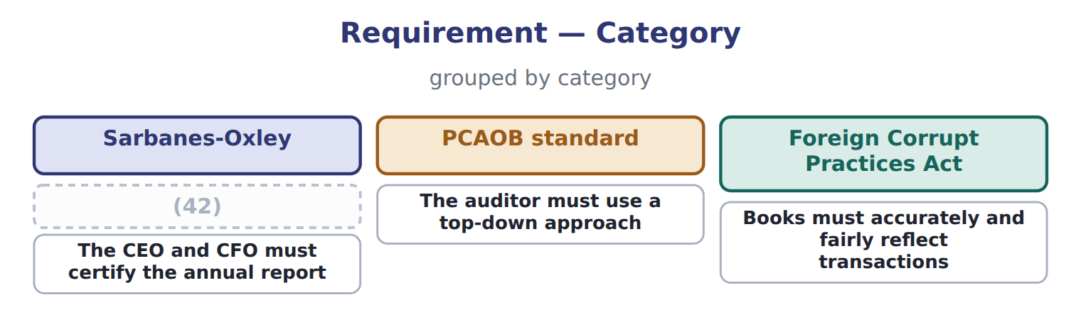
word list
Management must assess internal control annually · Books must accurately and fairly reflect transactions

The words this section uses
Each term sits against what it means.
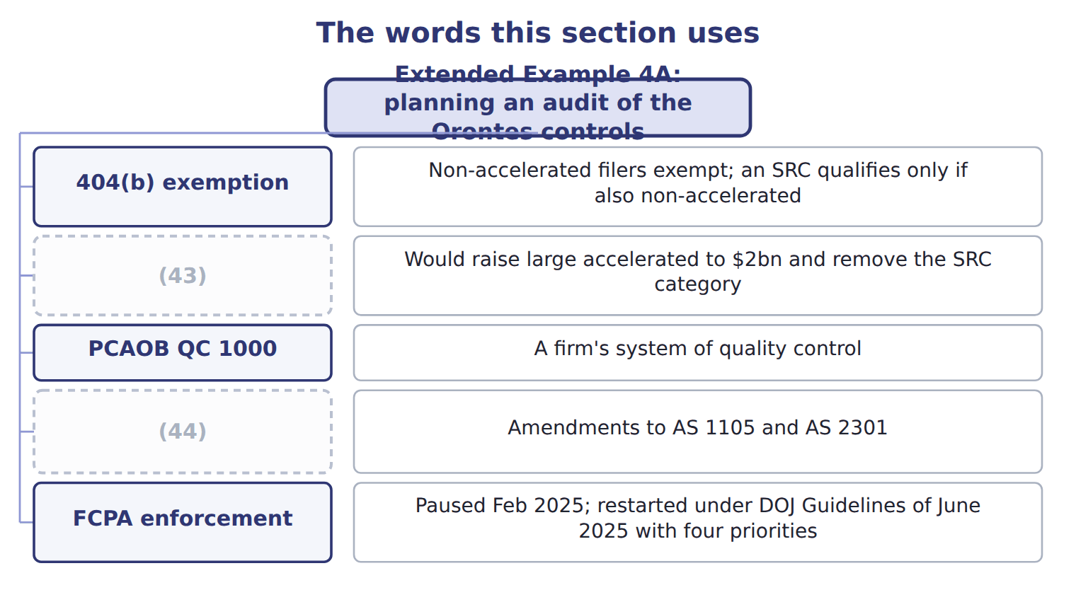
word list
bottom-up approach · Technology-assisted analysis · Filer thresholds

Answer key · 4.6 Extended Example 4A: planning an audit of the Orontes controls

1 top-down | 23 started
2 bottom-up | 24 The CEO and CFO certify the annual report
3 exam-core | 25 Destroying records to obstruct an investigation
4 rather | 26 distinction
5 misstatement | 27 candidate
6 statements | 28 SEC amendments, April 2020
7 valuable | 29 SEC Release 33-11419, 19 May 2026
8 Revenue | 30 not yet effective
9 unusual | 31 Adopted June 2024
10 attention | 32 statute unchanged
11 everything | 33 materiality
12 environment | 34 entity-level
13 assertion | 35 assertion
14 account | 36 question
15 inventory | 37 starts
16 adjusted | 38 bottom-up
17 specific | 39 misstatement
18 general | 40 certification
19 storekeeper | 41 Section 802 — up to twenty years
20 reconciliation | 42 Management must assess internal control annually
21 identified | 43 Filer thresholds
22 bottom-up | 44 Technology-assisted analysis

the summaries in full
Summary 1 This example walks the top-down approach through one Orontes audit and shows what a bottom-up auditor would have done instead. It is exam-core, so expect to be asked to judge rather than recall. The auditor starts by asking where a material misstatement could appear in the Orontes statements. Inventory is large and includes spices that are valuable and portable. Revenue includes Gulf export sales with unusual terms. Those two attract attention; the small items do not. Next the auditor tests the controls that run across everything: the control environment described in, the period-end reporting process, and the controls over management override. Strong entity-level controls can reduce the testing needed below, which is why they come second and not last. Inventory is a significant account, but not every assertion about it matters equally. Existence is the assertion at risk for portable spices; valuation matters for slow-moving stock.
Summary 2 The auditor names the assertion, not just the account. How could inventory existence actually go wrong at Orontes? Stock could be removed from the spice store and the record adjusted, which is the pairing. That is a specific, testable route, not a general worry. Only now does the auditor choose: the separation of the storekeeper from the stock records, the independent count, and the reconciliation of depot records to plant dispatches. Three controls, each tied to an identified risk. A bottom-up auditor would have asked for the list of controls and started testing. Many hours would go on purchase order approvals and payroll authorisations, which are real controls over immaterial risks. The spice store might be reached eventually, and might not. Nothing in the method would reveal the gap.
Summary 3 The distinction matters for an exam candidate: answer on current law unless a question says otherwise.
Summary 4 Start at the statements, because that is where materiality is decided. Test entity-level controls early, because they can reduce work below. Name the assertion at risk, not just the account. Select controls last, and only those addressing an identified risk.
Summary 5 A question may describe an audit plan and ask whether it is top-down. Look at where it starts. If the first step is a list of controls, it is bottom-up, whatever it is called. If the first step is the risk of material misstatement, it is top-down.

5.1 The three risks, defined
Chapter 5 · section 5.1

Fill every gap. Each word list holds one word more than there are gaps.
Chapter 5, section by section
Each stage leads to the next.
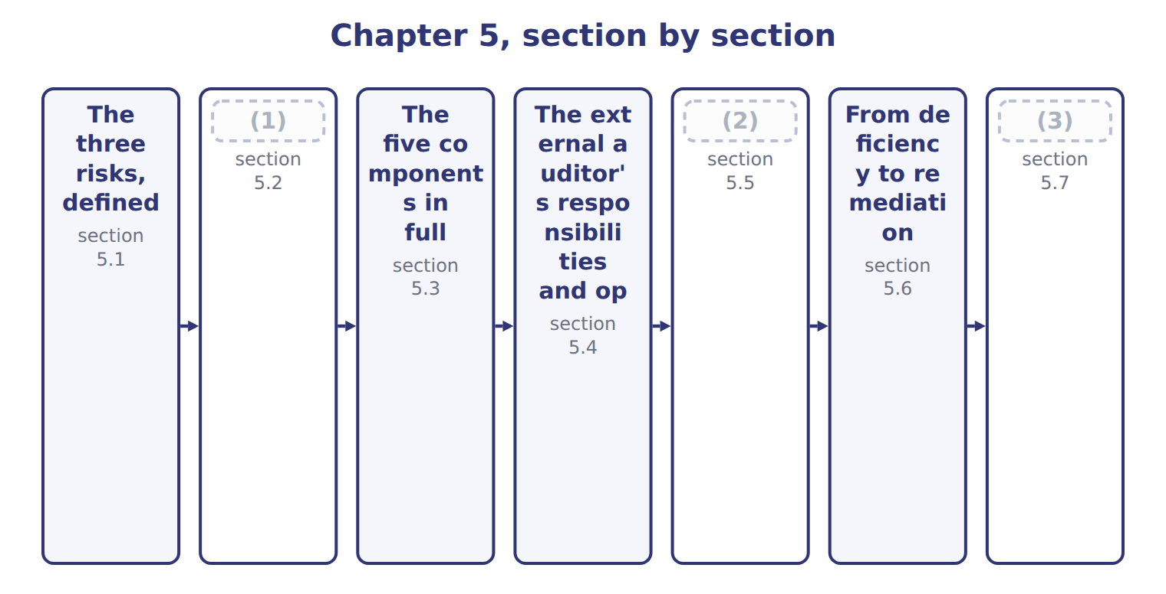
word list
Testing the adequacy of controls · Preventive and detective controls · Extended Example 5A: assessing and mitigating · The external auditor's responsibilities and op

The three risks and who can change each
Risk | Definition | Who can change it
Inherent risk | Susceptibility to (4) BEFORE considering any control | Management, by changing what the business does
Control risk | The risk that (5) control will not prevent or detect it in time | Management, by designing and operating better controls
Detection risk | (6) | The auditor, by changing the nature, timing and extent of testing
Audit risk | inherent x control x detection | (7)

word list
internal · material misstatement · The risk of giving a wrong opinion · preventive control · The risk that the auditor's procedures fail to find it

Summary 1 gaps 8–15
Inherent risk is (8) before any control is (9) . Control risk is the risk that the system fails to (10) or detect the (11) in time. Detection risk is the risk that the auditor's own (12) miss it. Together they give audit risk, the risk of an (13) opinion on (14) that are materially misstated. The (15) point is who holds each lever. Management acts on inherent risk by changing the business and on control risk by changing the system. The auditor acts only on detection risk, by testing more, differently, or closer to the year end.
word list
statements · prevent · considered · misstatement · practical · unmodified · susceptibility · procedures · materially

The words this section uses
Each term sits against what it means.
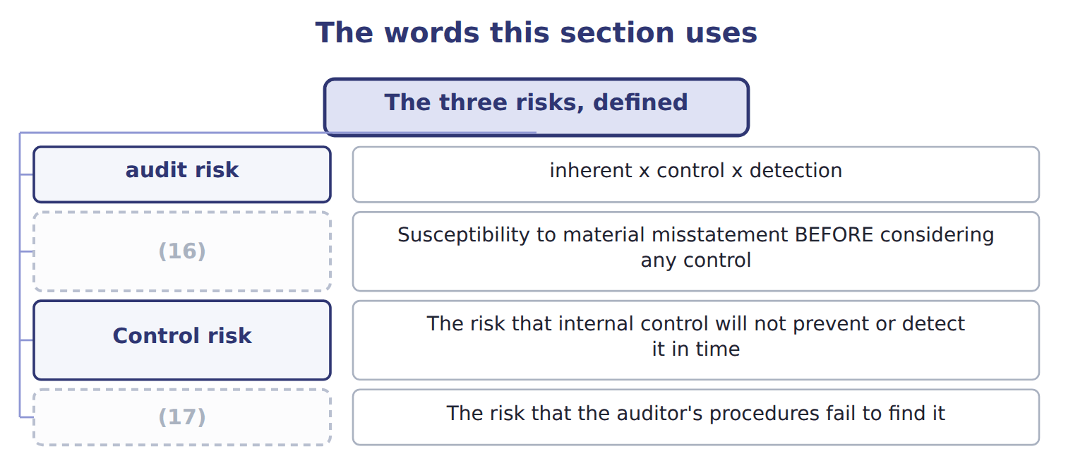
word list
Detection risk · material weakness · Inherent risk

The English this sheet uses, and its Arabic
English (exam term) | Arabic
audit risk | مخاطر التدقيق
material misstatement | التحريف الجوهري

Answer key · 5.1 The three risks, defined

1 Preventive and detective controls | 10 prevent
2 Testing the adequacy of controls | 11 misstatement
3 Extended Example 5A: assessing and mitigating | 12 procedures
4 material misstatement | 13 unmodified
5 internal | 14 statements
6 The risk that the auditor's procedures fail to find it | 15 practical
7 The risk of giving a wrong opinion | 16 Inherent risk
8 susceptibility | 17 Detection risk
9 considered

the summaries in full
Summary 1 Inherent risk is susceptibility before any control is considered. Control risk is the risk that the system fails to prevent or detect the misstatement in time. Detection risk is the risk that the auditor's own procedures miss it. Together they give audit risk, the risk of an unmodified opinion on statements that are materially misstated. The practical point is who holds each lever. Management acts on inherent risk by changing the business and on control risk by changing the system. The auditor acts only on detection risk, by testing more, differently, or closer to the year end.

5.2 Preventive and detective controls
Chapter 5 · section 5.2

Fill every gap. Each word list holds one word more than there are gaps.
Summary 1 gaps 1–4
A (1) control acts before an error or fraud can occur. A detective control finds it (2) . Both are needed, and for (3) reasons. Prevention is (4) , because the loss never happens. Detection is what proves prevention is working: without a reconciliation nobody knows whether the authorization limits are being respected.
word list
afterwards · because · different · preventive · cheaper

Classify by when, not by how important

Summary 2 gaps 5–11
A control is (5) or detective (6) to when it acts, not how valuable it is. A stock count is detective even (7) it may be the single most useful control in the (8) . Some (9) do both. A (10) who reviews a payment before it is released is (11) an error, and the same review across a month's payments detects the ones that slipped through. The exam asks when the control acts in the case described, not what it could do in principle.
word list
through · according · though · preventive · controls · supervisor · preventing · warehouse

Preventive against detective controls
 | Preventive | Detective
When it acts | Before the error or fraud occurs | (12)
What it does | (13) | Finds it so it can be corrected
Examples | (14) limits, segregation of duties, input validation, locked stores | Reconciliations, exception reports, stock counts, supervisory review
Cost of failure | The loss never happens | (15)
Why both | Prevention is cheaper but cannot catch everything | (16)

word list
Stops it happening · After it has occurred · Prevention is cheaper but cannot catch everything · Authorization · Detection proves prevention is working · The loss happens but is recovered or corrected

The English this sheet uses, and its Arabic
English (exam term) | Arabic
preventive control | الرقابة الوقائية
detective control | الرقابة الكاشفة

Answer key · 5.2 Preventive and detective controls

1 preventive | 9 controls
2 afterwards | 10 supervisor
3 different | 11 preventing
4 cheaper | 12 After it has occurred
5 preventive | 13 Stops it happening
6 according | 14 Authorization
7 though | 15 The loss happens but is recovered or corrected
8 warehouse | 16 Detection proves prevention is working

the summaries in full
Summary 1 A preventive control acts before an error or fraud can occur. A detective control finds it afterwards. Both are needed, and for different reasons. Prevention is cheaper, because the loss never happens. Detection is what proves prevention is working: without a reconciliation nobody knows whether the authorization limits are being respected.
Summary 2 A control is preventive or detective according to when it acts, not how valuable it is. A stock count is detective even though it may be the single most useful control in the warehouse. Some controls do both. A supervisor who reviews a payment before it is released is preventing an error, and the same review across a month's payments detects the ones that slipped through. The exam asks when the control acts in the case described, not what it could do in principle.

5.3 The five components in full
Chapter 5 · section 5.3

Fill every gap. Each word list holds one word more than there are gaps.
Summary 1 gaps 1–11
The framework sets a demanding test for (1) . All five (2) must be present and (3) , and they must be operating together in an integrated manner. A company with excellent control (4) and no monitoring does not have effective internal control; it has four (5) of a system. COSO's 2023 (6) concerns internal control over (7) reporting, not financial reporting. A separate (8) on generative AI (9) in 2026. The 2013 framework (10) has not been (11) . The order of the five is not arbitrary. The control environment comes first because it decides whether the rest function at all, and monitoring comes last because it looks back at everything above it. A question that asks which component a failure belongs to is usually asking where in that order the breakdown began.
word list
integrated · itself · components · revised · supplement · followed · activities · publication · functioning · fifths · effectiveness · sustainability

The English this sheet uses, and its Arabic
English (exam term) | Arabic
present and functioning | قائم ويعمل

Answer key · 5.3 The five components in full

1 effectiveness | 7 sustainability
2 components | 8 publication
3 functioning | 9 followed
4 activities | 10 itself
5 fifths | 11 revised
6 supplement

the summaries in full
Summary 1 The framework sets a demanding test for effectiveness. All five components must be present and functioning, and they must be operating together in an integrated manner. A company with excellent control activities and no monitoring does not have effective internal control; it has four fifths of a system. COSO's 2023 supplement concerns internal control over sustainability reporting, not financial reporting. A separate publication on generative AI followed in 2026. The 2013 framework itself has not been revised. The order of the five is not arbitrary. The control environment comes first because it decides whether the rest function at all, and monitoring comes last because it looks back at everything above it. A question that asks which component a failure belongs to is usually asking where in that order the breakdown began.

5.4 The external auditor's responsibilities and opinions
Chapter 5 · section 5.4

Fill every gap. Each word list holds one word more than there are gaps.
Summary 1 gaps 1–2
The external auditor expresses an opinion on whether the financial (1) are fairly presented. For an (2) filer the auditor also expresses an opinion on internal control over financial reporting.
word list
accelerated · assurance · statements

The opinions available on the statements and on internal control
Opinion | When it is given | On the statements | On internal control
Unqualified (unmodified) | The statements are fairly presented in all material respects | Available | Available: control is effective
Qualified | A material but not pervasive misstatement or scope limitation | Available | (3)
Adverse | A material and pervasive misstatement | Available | (4)
Disclaimer | (5) | Available | Issued for a scope limitation

word list
NOT available on internal control · Issued for a scope limitation · Insufficient evidence, with a pervasive effect · Issued if ANY material weakness exists

Summary 2 gaps 6–17
On internal control the opinion is unqualified or adverse only. There is no (6) opinion: internal control either is (7) or it is not, and a single material (8) makes it adverse. A scope (9) leads to a (10) or to withdrawal. The two opinions are (11) of each other. A company can receive an adverse opinion on internal control and an unqualified opinion on its (12) statements in the same report, because the auditor may have done enough extra (13) work to be satisfied about the numbers despite the weak controls. The auditor is (14) for obtaining reasonable assurance that the statements are free from material (15) , whether caused by error or fraud. That (16) does not transfer to the auditor what management owes: preparing the statements and maintaining the controls behind them remain (17) work.
word list
responsible · effective · weakness · disclaimer · financial · responsibility · misstatement · qualified · substantive · independent · accelerated · management's · limitation

The English this section uses, and its Arabic
Each term sits against what it means.
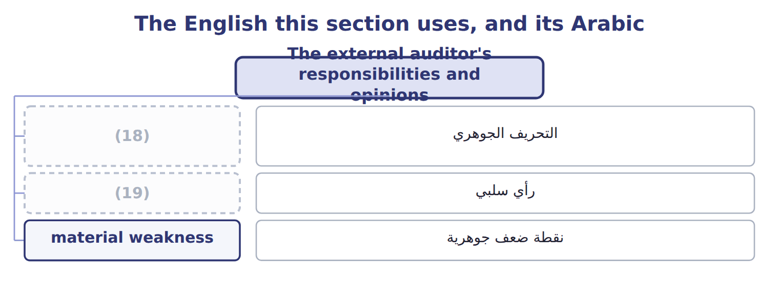
word list
رأي سلبي · material misstatement · adverse opinion

The English this sheet uses, and its Arabic
English (exam term) | Arabic
adverse opinion | رأي سلبي

Answer key · 5.4 The external auditor's responsibilities and opinions

1 statements | 11 independent
2 accelerated | 12 financial
3 NOT available on internal control | 13 substantive
4 Issued if ANY material weakness exists | 14 responsible
5 Insufficient evidence, with a pervasive effect | 15 misstatement
6 qualified | 16 responsibility
7 effective | 17 management's
8 weakness | 18 material misstatement
9 limitation | 19 adverse opinion
10 disclaimer

the summaries in full
Summary 1 The external auditor expresses an opinion on whether the financial statements are fairly presented. For an accelerated filer the auditor also expresses an opinion on internal control over financial reporting.
Summary 2 On internal control the opinion is unqualified or adverse only. There is no qualified opinion: internal control either is effective or it is not, and a single material weakness makes it adverse. A scope limitation leads to a disclaimer or to withdrawal. The two opinions are independent of each other. A company can receive an adverse opinion on internal control and an unqualified opinion on its financial statements in the same report, because the auditor may have done enough extra substantive work to be satisfied about the numbers despite the weak controls. The auditor is responsible for obtaining reasonable assurance that the statements are free from material misstatement, whether caused by error or fraud. That responsibility does not transfer to the auditor what management owes: preparing the statements and maintaining the controls behind them remain management's work.

5.5 Testing the adequacy of controls
Chapter 5 · section 5.5

Fill every gap. Each word list holds one word more than there are gaps.
Summary 1 gaps 1–9
Four methods are (1) , and the standard ranks them by the strength of the evidence they give. Inquiry asks (2) whether the control is performed. (3) watches it being performed. (4) examines the document the control produced. (5) does the control again and compares the result. Each gives more evidence than the one (6) . Inquiry alone is never (7) . The person asked may be mistaken, may be describing what should happen rather than what does, or may be the person (8) for the failure. A (9) follows a single transaction from start to finish and typically uses all four methods at once.
word list
responsible · someone · available · Observation · sufficient · Re-performance · transaction · Inspection · before · walkthrough

The English this sheet uses, and its Arabic
English (exam term) | Arabic
re-performance | إعادة الأداء

Answer key · 5.5 Testing the adequacy of controls

1 available | 6 before
2 someone | 7 sufficient
3 Observation | 8 responsible
4 Inspection | 9 walkthrough
5 Re-performance

the summaries in full
Summary 1 Four methods are available, and the standard ranks them by the strength of the evidence they give. Inquiry asks someone whether the control is performed. Observation watches it being performed. Inspection examines the document the control produced. Re-performance does the control again and compares the result. Each gives more evidence than the one before. Inquiry alone is never sufficient. The person asked may be mistaken, may be describing what should happen rather than what does, or may be the person responsible for the failure. A walkthrough follows a single transaction from start to finish and typically uses all four methods at once.

5.6 From deficiency to remediation
Chapter 5 · section 5.6

Fill every gap. Each word list holds one word more than there are gaps.
Not every failure is equally serious.
Three levels of deficiency
Severity | Definition | Consequence
Control deficiency | The control does not allow staff, in the normal course of their work, to prevent or detect (1) on a timely basis | Management decides whether to fix it
Significant deficiency | Less severe than a material weakness, but important enough to merit the attention of those overseeing reporting | (2)
Material weakness | A reasonable possibility that a material misstatement will not be prevented or detected on a timely basis | (3)

word list
3. Implement · misstatements · Reported to the audit committee · Internal control cannot be called effective; disclosed

Summary 1 gaps 4–10
A material weakness is the one that matters most, because its existence prevents (4) from concluding that internal control is (5) . The test combines (6) and magnitude: a reasonable possibility that a material misstatement would not be (7) or detected on a timely basis. There is no numeric (8) . The test is (9) there is a reasonable possibility that a material misstatement would go (10) . A weakness can exist where no misstatement has yet occurred at all.
word list
whether · threshold · undetected · management · effective · failure · prevented · likelihood

The six steps of remediation
Each stage leads to the next.
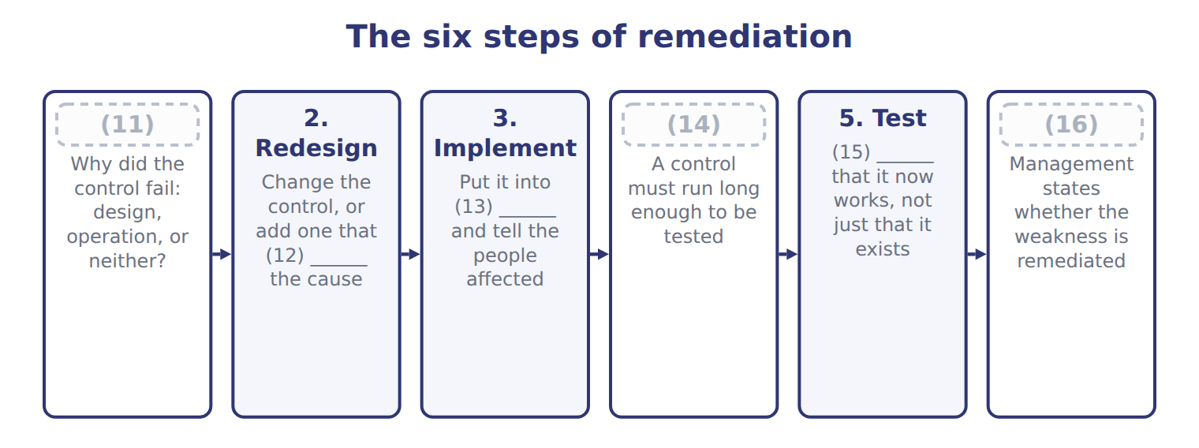
word list
1. Find the root cause · 6. Conclude and disclose · addresses · material weakness · 4. Operate for a period · operation · Evidence

Summary 2 gaps 17–19
Step four is the one companies try to skip. A (17) must operate for long enough to be tested before anyone can say it works, which in (18) means at least a quarter. Announcing a fix is not (19) a weakness.
word list
control · remediating · practice · misstatement

The words this section uses
Each term sits against what it means.
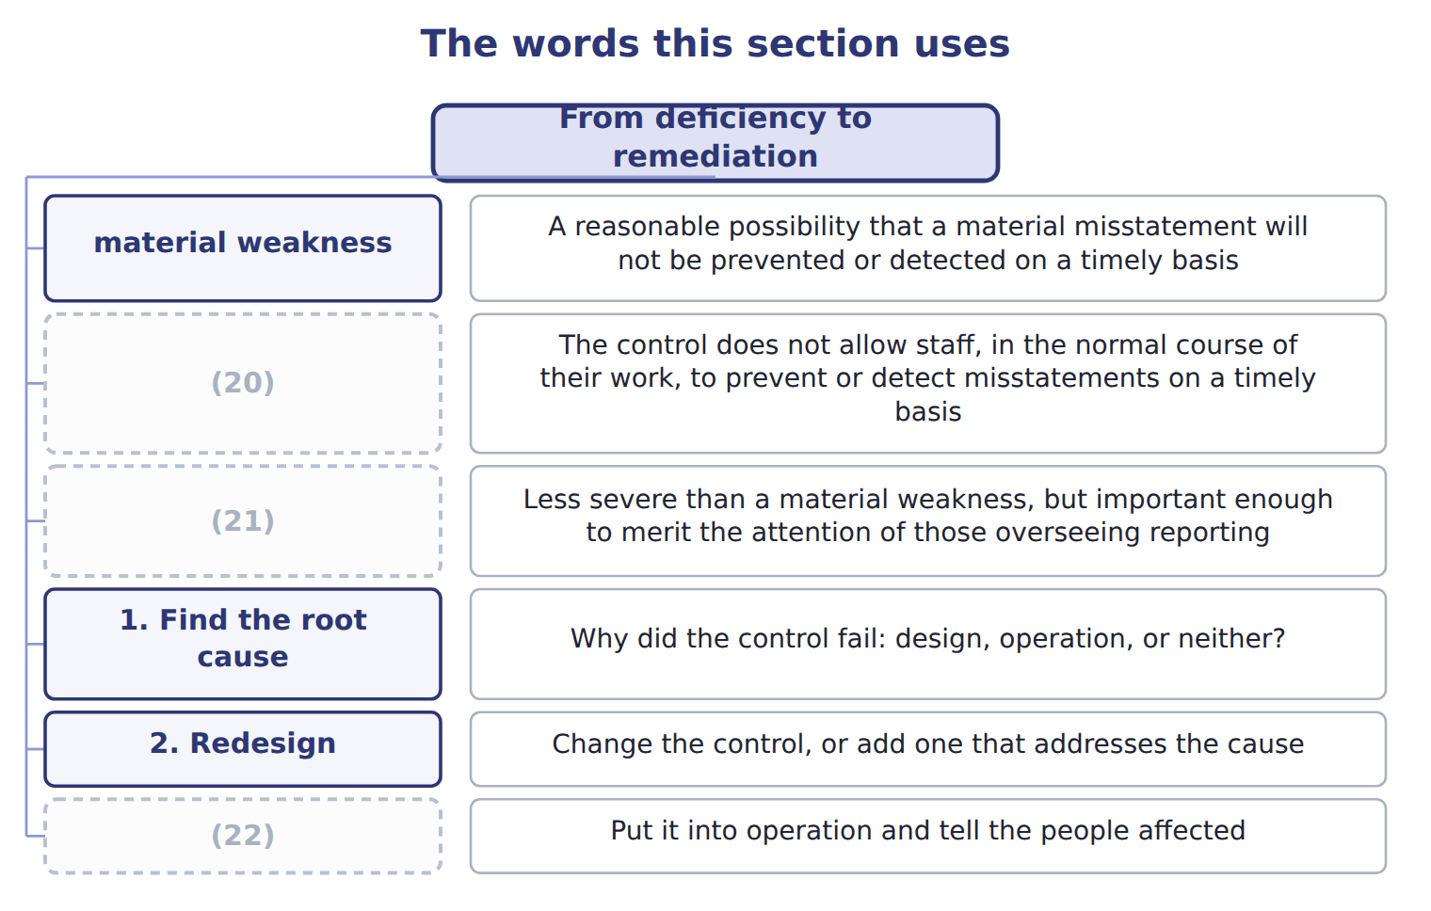
word list
Control deficiency · 3. Implement · Significant deficiency · preventive control

The English this sheet uses, and its Arabic
English (exam term) | Arabic
material weakness | نقطة ضعف جوهرية

Answer key · 5.6 From deficiency to remediation

1 misstatements | 12 addresses
2 Reported to the audit committee | 13 operation
3 Internal control cannot be called effective; disclosed | 14 4. Operate for a period
4 management | 15 Evidence
5 effective | 16 6. Conclude and disclose
6 likelihood | 17 control
7 prevented | 18 practice
8 threshold | 19 remediating
9 whether | 20 Control deficiency
10 undetected | 21 Significant deficiency
11 1. Find the root cause | 22 3. Implement

the summaries in full
Summary 1 A material weakness is the one that matters most, because its existence prevents management from concluding that internal control is effective. The test combines likelihood and magnitude: a reasonable possibility that a material misstatement would not be prevented or detected on a timely basis. There is no numeric threshold. The test is whether there is a reasonable possibility that a material misstatement would go undetected. A weakness can exist where no misstatement has yet occurred at all.
Summary 2 Step four is the one companies try to skip. A control must operate for long enough to be tested before anyone can say it works, which in practice means at least a quarter. Announcing a fix is not remediating a weakness.

5.7 Extended Example 5A: assessing and mitigating the Orontes control risk
Chapter 5 · section 5.7

Fill every gap. Each word list holds one word more than there are gaps.
Summary 1 gaps 1–6
This example (1) the level of control risk across Orontes and (2) what to do about it. E.1.v is a Level C outcome, so the exam will ask for a judgement and a (3) rather than a definition. Three areas stand out. (4) , because of the failure. The Levant depot, where one person holds (5) and the records. And the Gulf export channel, where terms are unusual and (6) is distant.
word list
quarter · assesses · recommends · oversight · Purchasing · custody · recommendation

Extended Example 5A: control risk assessed area by area
Area | Control risk | Why | Recommended mitigation
Purchasing | Moderate | Duties now segregated and reviewed (7) ; collusion remains possible | Keep the design and test it each quarter
Levant depot | High | One person holds custody of the stock and (8) the records; nothing has changed | Move the records to another person and reconcile depot records to plant dispatches
Gulf export channel | (9) | Unusual terms and distant oversight, but amounts pass through the group's systems | Require a second approval on non-standard terms; review the customer master file quarterly

word list
independently · maintains · Moderate · Item

Summary 2 gaps 10–21
Purchasing now has segregated duties and an (10) review, so control risk has fallen from high to moderate, limited mainly by the (11) of collusion. The depot (12) high: nothing has (13) there yet. The Gulf channel is moderate, because the risk is real but the (14) pass through the (15) own systems. For the depot, move the stock records away from the (16) and have group finance reconcile depot records to plant (17) . For the Gulf channel, require a second approval on (18) terms and review the customer master file (19) . For purchasing, keep what is in place and test it. The depot weakness is a material weakness if the stock held there is material to the group, because one (20) can remove stock and adjust the record without anyone (21) the two. If the depot is small, it is a significant deficiency: still reported to the audit committee, but not fatal to the assessment. The root cause is not dishonesty but design: nobody separated the duties when the depot was set up. Redesign moves the records; implementation means telling both people and updating the procedure; the control then runs for a quarter before anyone tests it; and only after testing can management say the weakness is remediated.
word list
quarterly · changed · amounts · non-standard · possibility · group's · remains · independent · person · custodian · dispatches · deficiency · comparing

Judge four situations

Complete the blank cells.
Your turn: judge four situations (complete the blanks)
Situation | How severe? | Why
A reconciliation that nobody performs | ________ | Design is sound; operation failed
Approval limits that were never set | Design deficiency | ________
One person approves and pays, and the amounts are material | ________ | (22)
A minor posting error found and corrected monthly | ________ | (23)

word list
The revised procedure was circulated to staff · A reasonable possibility of material misstatement · Below the threshold for audit committee attention

The pattern behind the assessment

Summary 3 gaps 24–27
Assess control risk area by area, not for the company as a whole. Rate it against what the (24) actually do, not what the (25) says. Judge severity by (26) and magnitude together, with no percentage rule. (27) is not complete until the new control has run and been tested.
word list
manual · Complete · controls · likelihood · Remediation

Exam view

Summary 4 gaps 28–30
A Level C question gives a (28) and asks you to assess and recommend. Name the risk, rate it high, moderate or low with a reason, then give a specific (29) . A general answer such as improve (30) earns nothing.
word list
situation · mitigation · controls · custodian

Exam view
Item | Answer
A reconciliation that nobody performs | Control deficiency at least — the design is sound but the control does not operate, so it prevents or detects nothing
Approval limits that were never set | Why: there is no control to operate, so the (31) is in the design rather than in how it is carried out
One person approves and pays, and the amounts are material | Material weakness — a reasonable possibility that a (32) would not be prevented or detected
A minor posting error found and corrected monthly | Control deficiency — the detective control works, and the amounts are below the threshold for audit committee attention

word list
material misstatement · deficiency · detective control

Step taken or still outstanding — Category
Step taken or still outstanding | Category
The control was redesigned and the duty named in a job description | Already done
The revised procedure was circulated to staff | (33)
The new control has operated for a sufficient period | Still outstanding
Someone independent has tested that the control works | Still outstanding

word list
Control risk · Already done

Answer key · 5.7 Extended Example 5A: assessing and mitigating the Orontes control risk

1 assesses | 18 non-standard
2 recommends | 19 quarterly
3 recommendation | 20 person
4 Purchasing | 21 comparing
5 custody | 22 A reasonable possibility of material misstatement
6 oversight | 23 Below the threshold for audit committee attention
7 independently | 24 controls
8 maintains | 25 manual
9 Moderate | 26 likelihood
10 independent | 27 Remediation
11 possibility | 28 situation
12 remains | 29 mitigation
13 changed | 30 controls
14 amounts | 31 deficiency
15 group's | 32 material misstatement
16 custodian | 33 Already done
17 dispatches

the summaries in full
Summary 1 This example assesses the level of control risk across Orontes and recommends what to do about it. E.1.v is a Level C outcome, so the exam will ask for a judgement and a recommendation rather than a definition. Three areas stand out. Purchasing, because of the failure. The Levant depot, where one person holds custody and the records. And the Gulf export channel, where terms are unusual and oversight is distant.
Summary 2 Purchasing now has segregated duties and an independent review, so control risk has fallen from high to moderate, limited mainly by the possibility of collusion. The depot remains high: nothing has changed there yet. The Gulf channel is moderate, because the risk is real but the amounts pass through the group's own systems. For the depot, move the stock records away from the custodian and have group finance reconcile depot records to plant dispatches. For the Gulf channel, require a second approval on non-standard terms and review the customer master file quarterly. For purchasing, keep what is in place and test it. The depot weakness is a material weakness if the stock held there is material to the group, because one person can remove stock and adjust the record without anyone comparing the two. If the depot is small, it is a significant deficiency: still reported to the audit committee, but not fatal to the assessment. The root cause is not dishonesty but design: nobody separated the duties when the depot was set up. Redesign moves the records; implementation means telling both people and updating the procedure; the control then runs for a quarter before anyone tests it; and only after testing can management say the weakness is remediated.
Summary 3 Assess control risk area by area, not for the company as a whole. Rate it against what the controls actually do, not what the manual says. Judge severity by likelihood and magnitude together, with no percentage rule. Remediation is not complete until the new control has run and been tested.
Summary 4 A Level C question gives a situation and asks you to assess and recommend. Name the risk, rate it high, moderate or low with a reason, then give a specific mitigation. A general answer such as improve controls earns nothing.

6.1 Segregation inside the systems function
Chapter 6 · section 6.1

Fill every gap. Each word list holds one word more than there are gaps.
Chapter 6, section by section
Each stage leads to the next.
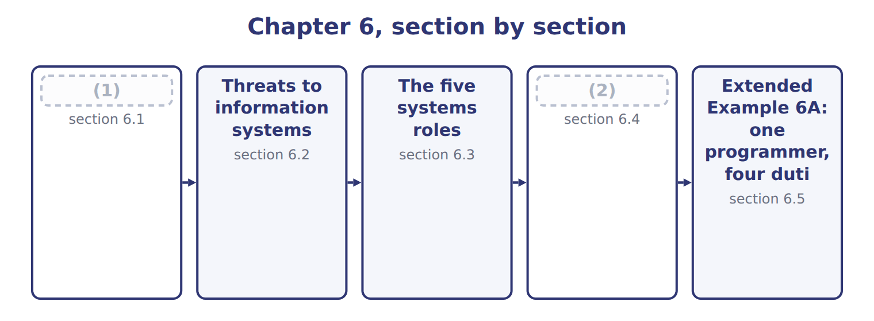
word list
Threats to information systems · Segregation inside the systems function · Physical and logical access

Summary 1 gaps 3–5
A computer (3) power. A clerk who alters one invoice affects one transaction; a (4) who alters one routine affects every transaction it touches, silently, until someone notices. That is why the systems function has its own (5) rules.
word list
segregation · programmer · invoice · concentrates

Combinations of systems access to avoid
Combination to avoid | What it would allow | The control
Programmer with access to live data | Can write code that benefits him and run it on real records | (6)
Operator who can change programs | Can alter a program, run it, and restore the original | (7)
Librarian who also programs | Controls the versions and writes them | (8)
Analyst with production access | (9) | Design and operation stay apart
One person holding all system passwords | Every separation above becomes theoretical | (10)

word list
Designs the control and can bypass it · Split administrative access and log its use · Separate development from operations · Keep version control independent · Design and operation stay apart · Program changes go through the librarian

Summary 2 gaps 11–13
The last row (11) most in a small company. Every separation above becomes theoretical if one (12) holds all the passwords, which is why (13) access is split where possible and logged where it is not.
word list
transaction · administrative · matters · administrator

The words this section uses
Each term sits against what it means.
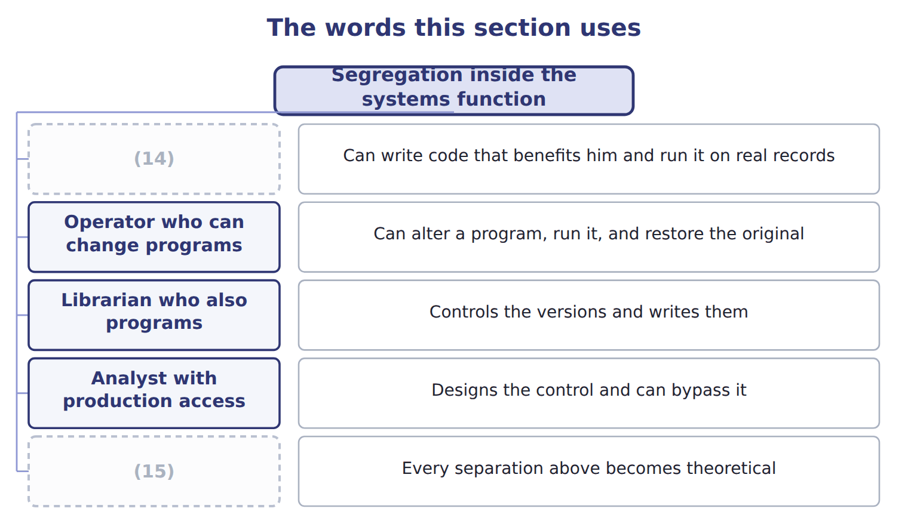
word list
One person holding all system passwords · Controls the versions and writes them · Programmer with access to live data

The English this sheet uses, and its Arabic
English (exam term) | Arabic
systems analyst | محلل النظم
librarian | أمين المكتبة

Answer key · 6.1 Segregation inside the systems function

1 Segregation inside the systems function | 9 Designs the control and can bypass it
2 Physical and logical access | 10 Split administrative access and log its use
3 concentrates | 11 matters
4 programmer | 12 administrator
5 segregation | 13 administrative
6 Separate development from operations | 14 Programmer with access to live data
7 Program changes go through the librarian | 15 One person holding all system passwords
8 Keep version control independent

the summaries in full
Summary 1 A computer concentrates power. A clerk who alters one invoice affects one transaction; a programmer who alters one routine affects every transaction it touches, silently, until someone notices. That is why the systems function has its own segregation rules.
Summary 2 The last row matters most in a small company. Every separation above becomes theoretical if one administrator holds all the passwords, which is why administrative access is split where possible and logged where it is not.

6.2 Threats to information systems
Chapter 6 · section 6.2

Fill every gap. Each word list holds one word more than there are gaps.
Six threats to information systems
Threat (E.2.b) | What it is | Why it matters | Example
Input manipulation | Entering false or altered data | (1) | A fictitious supplier invoice keyed in
Program alteration | Changing the code itself | (2) | A routine that rounds pennies into one account
Direct file alteration | (3) | Leaves no application audit trail | A balance changed in the database directly
Data theft | Copying data out | Often an insider, often undetected | (4)
Sabotage | (5) | May be a disgruntled employee | Records deleted after a dismissal
Malware and ransomware | Hostile software that spreads or encrypts | (6) | Files encrypted and a payment demanded

word list
A customer list taken on a leaving day · Editing the data file, bypassing the application · Arrives by phishing far more often than by attack · The commonest of all, and needs no technical skill · Destroying data or equipment · Hard to detect without change control · Records deleted after a dismissal

Summary 1 gaps 7–16
Input (7) is the commonest by a wide margin, and it is worth (8) why. It needs no technical skill at all: the person simply enters (9) false into a system working exactly as (10) . Direct file (11) deserves attention for the (12) reason. It (13) the application, so the (14) own audit trail shows nothing. Detecting it needs controls at the database level: (15) access, and logging that the database (16) cannot quietly switch off. Malware and ransomware attract the most attention, but the route in is usually mundane. Most arrive through a person opening an attachment or entering a password on a false page, which makes them a training and access problem as much as a technical one.
word list
manipulation · administrator · noticing · technical · opposite · something · restricted · alteration · bypasses · designed · application's

The words this section uses
Each term sits against what it means.
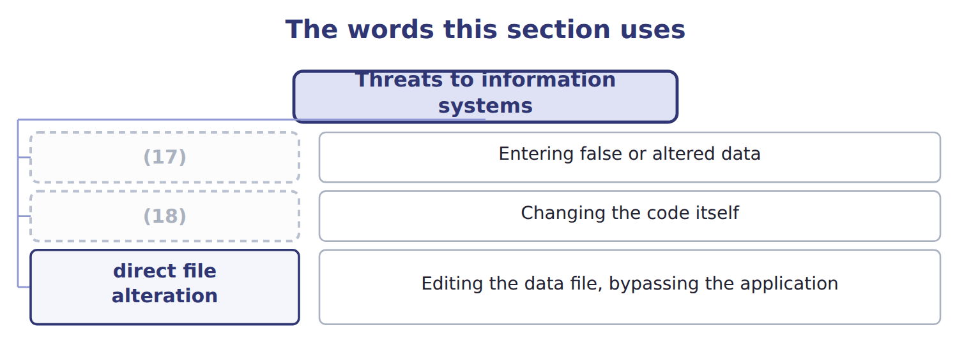
word list
input manipulation · program alteration · systems analyst

The English this sheet uses, and its Arabic
English (exam term) | Arabic
input manipulation | التلاعب بالمدخلات
program alteration | تعديل البرامج
direct file alteration | التعديل المباشر للملفات

Answer key · 6.2 Threats to information systems

1 The commonest of all, and needs no technical skill | 10 designed
2 Hard to detect without change control | 11 alteration
3 Editing the data file, bypassing the application | 12 opposite
4 A customer list taken on a leaving day | 13 bypasses
5 Destroying data or equipment | 14 application's
6 Arrives by phishing far more often than by attack | 15 restricted
7 manipulation | 16 administrator
8 noticing | 17 input manipulation
9 something | 18 program alteration

the summaries in full
Summary 1 Input manipulation is the commonest by a wide margin, and it is worth noticing why. It needs no technical skill at all: the person simply enters something false into a system working exactly as designed. Direct file alteration deserves attention for the opposite reason. It bypasses the application, so the application's own audit trail shows nothing. Detecting it needs controls at the database level: restricted access, and logging that the database administrator cannot quietly switch off. Malware and ransomware attract the most attention, but the route in is usually mundane. Most arrive through a person opening an attachment or entering a password on a false page, which makes them a training and access problem as much as a technical one.

6.3 The five systems roles
Chapter 6 · section 6.3

Fill every gap. Each word list holds one word more than there are gaps.
Summary 1 gaps 1–4
Read the (1) column as the whole point of the (2) . The systems analyst designs, the (3) writes, the computer operator runs, the (4) controls the versions, and data control checks what went in and what came out. No one of them can both change the system and use it unobserved.
word list
programmer · librarian · right-hand · arrangement · versions

Answer key · 6.3 The five systems roles

1 right-hand | 3 programmer
2 arrangement | 4 librarian

the summaries in full
Summary 1 Read the right-hand column as the whole point of the arrangement. The systems analyst designs, the programmer writes, the computer operator runs, the librarian controls the versions, and data control checks what went in and what came out. No one of them can both change the system and use it unobserved.

6.4 Physical and logical access
Chapter 6 · section 6.4

Fill every gap. Each word list holds one word more than there are gaps.
Summary 1 gaps 1–10
Access (1) has two halves. Physical access controls decide who can reach the (2) . Logical access controls decide who can reach the (3) and the data. Physical controls are the older idea and still (4) . A server room needs a lock, a record of who (5) , and a procedure for (6) old drives. A disk carried out of the (7) defeats every (8) on it. The physical controls also cover (9) that leaves the room. (10) and portable drives carry the same data outside every lock the company owns. Disposal, encryption of portable media and a register of what has been issued therefore belong here rather than with the logical controls.
word list
destroying · equipment · control · programs · necessary · password · building · machine · entered · therefore · Laptops

Logical access controls
Logical access control (E.2.e) | What it does | Note
Unique user identification | (11) | Shared logins make accountability impossible
Authentication | Proves the person is who the ID claims | (12)
Authorization and least privilege | (13) | Access tends to accumulate as people change roles
Access reviews | (14) | Catches the accumulation above
Logging and monitoring | (15) | A log nobody reads is not a control
Removal on exit | Access ends when employment ends | (16)

word list
Each person has the minimum access the job needs · A record of who did what, reviewed by someone · Chapter 2 treated this as a personnel control too · Every action can be traced to one person · Multi-factor is now the normal standard · Someone checks periodically who holds what · Proves the person is who the ID claims

Summary 2 gaps 17–19
Least (17) is the one that decays fastest. Access (18) as people change roles, because granting is easy and revoking is forgotten. The access (19) exists to find the clerk who still holds the rights of a job she left two years ago.
word list
accumulates · librarian · review · privilege

A log nobody reads is not a control

Summary 3 gaps 20–22
Logging (20) in almost every list of access (21) , and it earns its place only if someone reviews it. A question describing (22) logging with no review is describing a detective control that detects nothing.
word list
granting · controls · appears · extensive

The words this section uses
Each term sits against what it means.
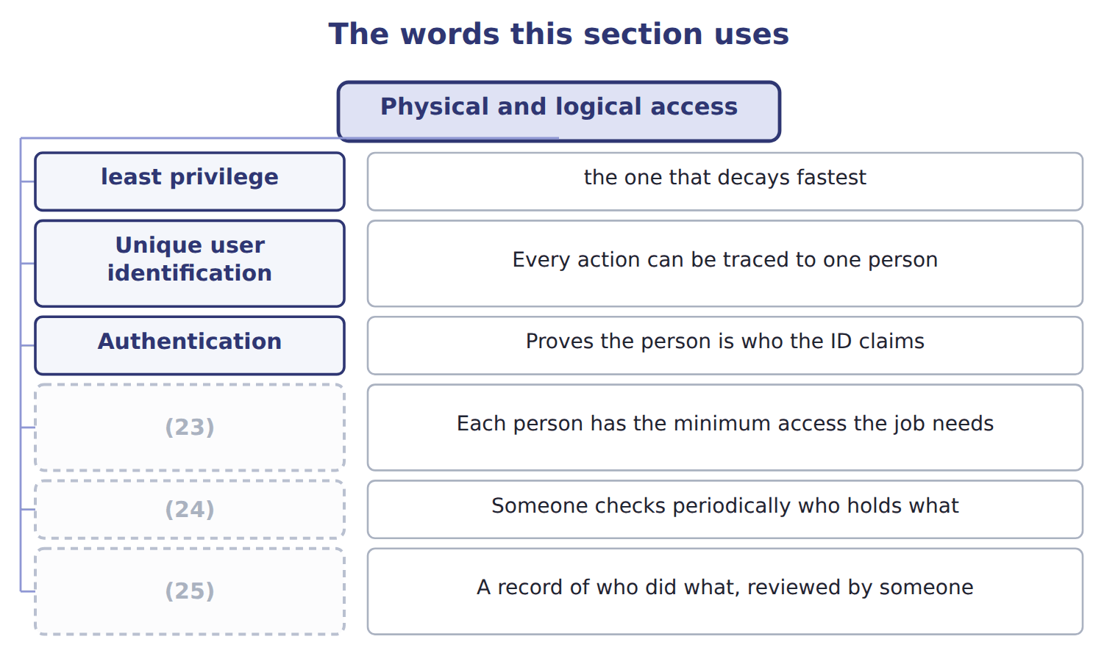
word list
direct file alteration · Access reviews · Authorization and least privilege · Logging and monitoring

The English this sheet uses, and its Arabic
English (exam term) | Arabic
physical access control | الرقابة على الوصول المادي
logical access control | الرقابة على الوصول المنطقي
least privilege | أقل الصلاحيات

Answer key · 6.4 Physical and logical access

1 control | 14 Someone checks periodically who holds what
2 machine | 15 A record of who did what, reviewed by someone
3 programs | 16 Chapter 2 treated this as a personnel control too
4 necessary | 17 privilege
5 entered | 18 accumulates
6 destroying | 19 review
7 building | 20 appears
8 password | 21 controls
9 equipment | 22 extensive
10 Laptops | 23 Authorization and least privilege
11 Every action can be traced to one person | 24 Access reviews
12 Multi-factor is now the normal standard | 25 Logging and monitoring
13 Each person has the minimum access the job needs

the summaries in full
Summary 1 Access control has two halves. Physical access controls decide who can reach the machine. Logical access controls decide who can reach the programs and the data. Physical controls are the older idea and still necessary. A server room needs a lock, a record of who entered, and a procedure for destroying old drives. A disk carried out of the building defeats every password on it. The physical controls also cover equipment that leaves the room. Laptops and portable drives carry the same data outside every lock the company owns. Disposal, encryption of portable media and a register of what has been issued therefore belong here rather than with the logical controls.
Summary 2 Least privilege is the one that decays fastest. Access accumulates as people change roles, because granting is easy and revoking is forgotten. The access review exists to find the clerk who still holds the rights of a job she left two years ago.
Summary 3 Logging appears in almost every list of access controls, and it earns its place only if someone reviews it. A question describing extensive logging with no review is describing a detective control that detects nothing.

6.5 Extended Example 6A: one programmer, four duties
Chapter 6 · section 6.5

Fill every gap. Each word list holds one word more than there are gaps.
Summary 1 gaps 1–12
This example takes a single (1) at Orontes and shows how one person's access (2) the four duties. When Orontes (3) its payables system, one (4) built it and stayed on to support it. He writes the code, moves his own changes into (5) , holds the database (6) password, and is the person who investigates when a payment query arises. He can create a supplier record (7) in the database, which is (8) . He can alter the (9) routine, which is (10) . (11) a payment run gives him (12) custody. And he investigates the queries that would reveal any of it, which is reconciliation. One person, four duties. Program alteration, because he changes code with no independent review. Direct file alteration, because he holds the database password and can edit records outside the application. Data theft, because he can extract the supplier and payment history.
word list
authorization · arrangement · directly · effective · developer · installed · administrator · production · collapsed · Releasing · recording · inconvenient · posting

Summary 2 gaps 13–21
In the second case the (13) audit trail would show nothing. Separate (14) from production: he may write code, but (15) else moves it into live use. Take the (16) password away and give it to a separate (17) , logged and reviewed. Move (18) release to the (19) . Move query (20) to accounts (21) . Almost nothing in money, and something real in convenience: a change that took him an afternoon now needs another person. That is the trade the chapter is about, and the answer at Orontes is clear, because the alternative is one person able to move cash without trace.
word list
administrator · payment · investigation · someone · development · cashier · application's · extract · payable · database

Identify four threats

Complete the blank cells.

Your turn: identify four threats (complete the blanks)
Every item belongs to exactly one group.
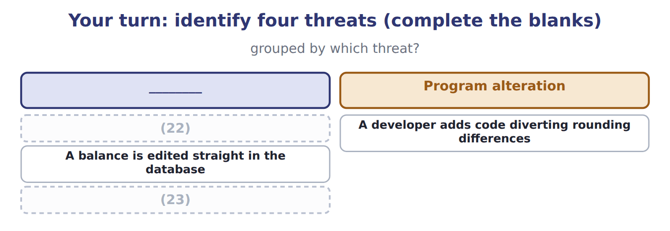
word list
A developer adds code diverting rounding differences · Files are encrypted and a payment demanded · A clerk keys an invoice for goods never received

The pattern behind the example

Summary 3 gaps 24–27
Map the (24) ACCESS to the four duties, not their job title. (25) and production must be separate, whatever the company's size. (26) passwords are a duty in themselves, and must be held and logged separately. A control that is (27) is not therefore wrong.
word list
inconvenient · Development · Administrative · person's · authorization

Exam view

Summary 4 gaps 28–30
A case (28) who has which system access and asks for the (29) . Translate access into duties before answering: the ability to edit a database record is (30) and recording at once, whatever the person is called.
word list
describes · production · weakness · authorization

Exam view
Item | Answer
A clerk keys an invoice for goods never received | (31) — false data entered into a system working exactly as designed
A developer adds code diverting rounding differences | Why: the code itself was changed, so every transaction it touches is affected until someone notices
A balance is edited straight in the database | Direct file alteration — the application was bypassed, so its audit trail shows nothing
Files are encrypted and a payment demanded | Malware, (32) ransomware — usually arriving through a person rather than a technical attack

word list
librarian · specifically · Input manipulation

Fadi's access — Category
Fadi's access | Category
Creating a supplier record directly in the database | (33)
Altering the posting routine in the code | Recording
Releasing a payment run | (34)
Investigating supplier payment queries | Reconciliation

word list
Reconciliation · Authorization · Custody

Answer key · 6.5 Extended Example 6A: one programmer, four duties

1 arrangement | 18 payment
2 collapsed | 19 cashier
3 installed | 20 investigation
4 developer | 21 payable
5 production | 22 A clerk keys an invoice for goods never received
6 administrator | 23 Files are encrypted and a payment demanded
7 directly | 24 person's
8 authorization | 25 Development
9 posting | 26 Administrative
10 recording | 27 inconvenient
11 Releasing | 28 describes
12 effective | 29 weakness
13 application's | 30 authorization
14 development | 31 Input manipulation
15 someone | 32 specifically
16 database | 33 Authorization
17 administrator | 34 Custody

the summaries in full
Summary 1 This example takes a single arrangement at Orontes and shows how one person's access collapsed the four duties. When Orontes installed its payables system, one developer built it and stayed on to support it. He writes the code, moves his own changes into production, holds the database administrator password, and is the person who investigates when a payment query arises. He can create a supplier record directly in the database, which is authorization. He can alter the posting routine, which is recording. Releasing a payment run gives him effective custody. And he investigates the queries that would reveal any of it, which is reconciliation. One person, four duties. Program alteration, because he changes code with no independent review. Direct file alteration, because he holds the database password and can edit records outside the application. Data theft, because he can extract the supplier and payment history.
Summary 2 In the second case the application's audit trail would show nothing. Separate development from production: he may write code, but someone else moves it into live use. Take the database password away and give it to a separate administrator, logged and reviewed. Move payment release to the cashier. Move query investigation to accounts payable. Almost nothing in money, and something real in convenience: a change that took him an afternoon now needs another person. That is the trade the chapter is about, and the answer at Orontes is clear, because the alternative is one person able to move cash without trace.
Summary 3 Map the person's ACCESS to the four duties, not their job title. Development and production must be separate, whatever the company's size. Administrative passwords are a duty in themselves, and must be held and logged separately. A control that is inconvenient is not therefore wrong.
Summary 4 A case describes who has which system access and asks for the weakness. Translate access into duties before answering: the ability to edit a database record is authorization and recording at once, whatever the person is called.

7.1 System development controls
Chapter 7 · section 7.1

Fill every gap. Each word list holds one word more than there are gaps.
Chapter 7, section by section
Each stage leads to the next.
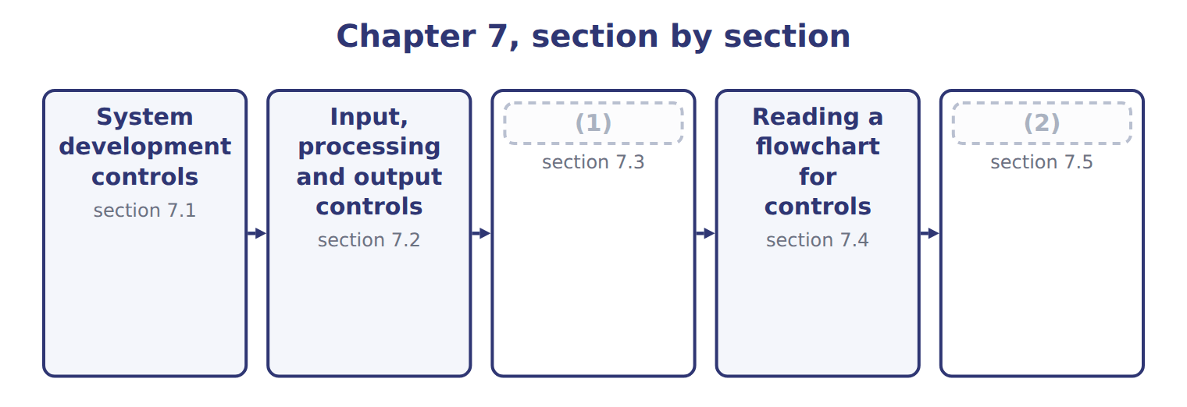
word list
Storage controls · Extended Example 7A: a batch of invoices, and · section 7.5

Summary 1 gaps 3–4
Controls are cheapest when they are designed into a system and most (3) when they are added (4) .
word list
afterwards · expensive · Controls

What system development controls protect
What development controls protect (E.2.c) | What it means | How it is achieved
Accuracy | (5) | Test with known data and compare the result
Validity | Only genuine, authorized transactions are processed | (6)
Safety | (7) | Recovery routines and transaction rollback
Security | (8) | Access rights built in, not added afterwards
Adaptability | The system can be changed as the business changes | (9)
Over all of them | Users involved, stages approved, testing in a separate environment, changes controlled | (10)

word list
Only genuine, authorized transactions are processed · Data is not lost or corrupted when something fails · The system development controls of Chapter 12 · Authorization checks designed into the program · Documentation and modular design · Only the right people can reach the system · The system computes what it is supposed to compute

Summary 2 gaps 11–16
Adaptability is the one (11) overlook. A system that cannot be changed safely will be changed (12) , because the business will not stop to (13) it. (14) and modular design are control matters, not merely technical (15) . Across all five sits a familiar (16) . Users are involved from the start, each stage is formally approved, testing is carried out in an environment separate from the live one, and every later change is controlled.
word list
requirement · business · unsafely · accommodate · housekeeping · candidates · Documentation

The words this section uses
Each term sits against what it means.
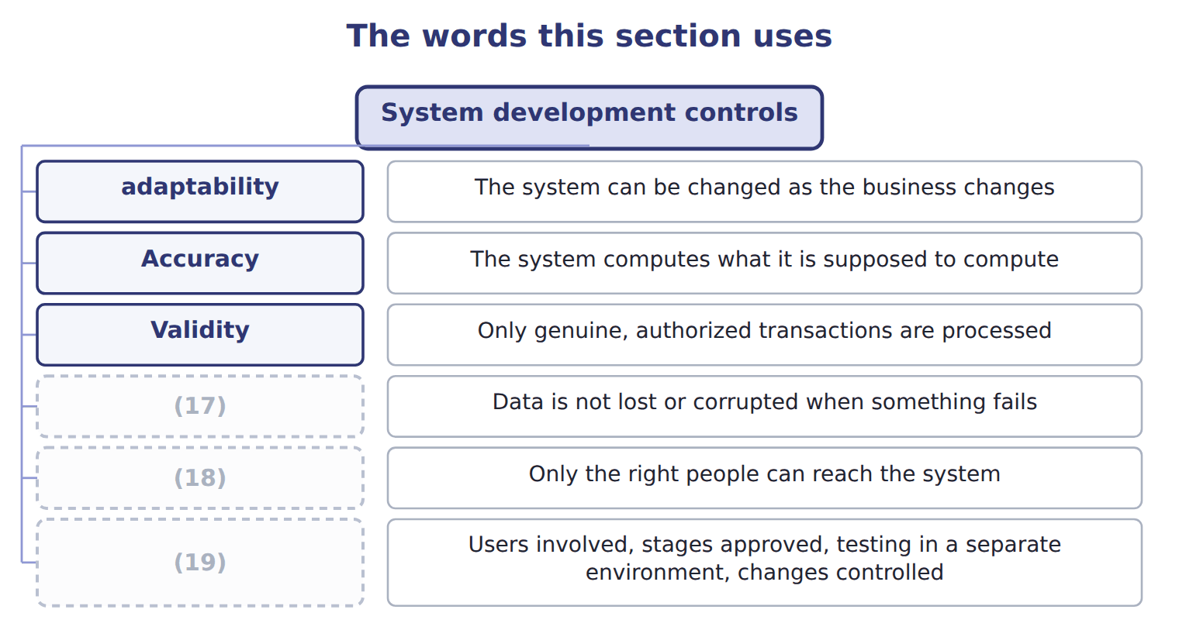
word list
Safety · Accuracy · Over all of them · Security

The English this sheet uses, and its Arabic
English (exam term) | Arabic
system development control | ضوابط تطوير النظم
adaptability | القابلية للتكيف

Answer key · 7.1 System development controls

1 Storage controls | 11 candidates
2 Extended Example 7A: a batch of invoices, and | 12 unsafely
3 expensive | 13 accommodate
4 afterwards | 14 Documentation
5 The system computes what it is supposed to compute | 15 housekeeping
6 Authorization checks designed into the program | 16 requirement
7 Data is not lost or corrupted when something fails | 17 Safety
8 Only the right people can reach the system | 18 Security
9 Documentation and modular design | 19 Over all of them
10 The system development controls of Chapter 12

the summaries in full
Summary 1 Controls are cheapest when they are designed into a system and most expensive when they are added afterwards.
Summary 2 Adaptability is the one candidates overlook. A system that cannot be changed safely will be changed unsafely, because the business will not stop to accommodate it. Documentation and modular design are control matters, not merely technical housekeeping. Across all five sits a familiar requirement. Users are involved from the start, each stage is formally approved, testing is carried out in an environment separate from the live one, and every later change is controlled.

7.2 Input, processing and output controls
Chapter 7 · section 7.2

Fill every gap. Each word list holds one word more than there are gaps.
Summary 1 gaps 1–4
The (1) are the whole (2) for input controls. An error (3) as it is keyed costs a (4) . The same error found in the output has already passed through every calculation in between, and tracing it back through them costs far more than preventing it would have.
word list
controls · caught · moment · argument · economics

Input controls and what each one tests
Input control (E.2.f) | What it tests | Example
Field check | The data is the right type | (5)
Format check | The data has the right shape | (6)
Range or limit check | (7) | An hourly rate above 500 is queried
Reasonableness check | The value makes sense beside another field | (8)
Validity check | The code exists on the master file | (9)
Check digit | (10) | A mistyped account number fails the arithmetic
Batch totals | (11) , hash or record count compared before and after | Twenty invoices entered; twenty posted
Closed-loop verification | (12) | The supplier name appears for confirmation

word list
The value falls between sensible bounds · An extra digit computed from the rest · A date entered as 2026-13-45 is rejected · Financial · The supplier name appears for confirmation · Letters rejected in a quantity field · The system displays what the code means · A 900-case order from a customer who buys 20 · An unknown supplier number is rejected

Summary 2 gaps 13–21
Batch totals come in three kinds and the (13) is tested. A (14) total adds amounts; a record count counts documents; a hash total adds something (15) , such as supplier numbers, purely so that a change shows up. The hash total has no (16) meaning at all, which is (17) why it works. (18) controls keep the data right while it is being handled: (19) totals carry a figure from one stage to the next, sequence checks confirm nothing is skipped, and error logs capture what was rejected. Output controls then (20) what left against what entered, send reports only to named (21) , and dispose of them securely.
word list
recipients · exactly · skipped · accounting · distinction · financial · meaningless · Processing · reconcile · run-to-run

The words this section uses
Each term sits against what it means.
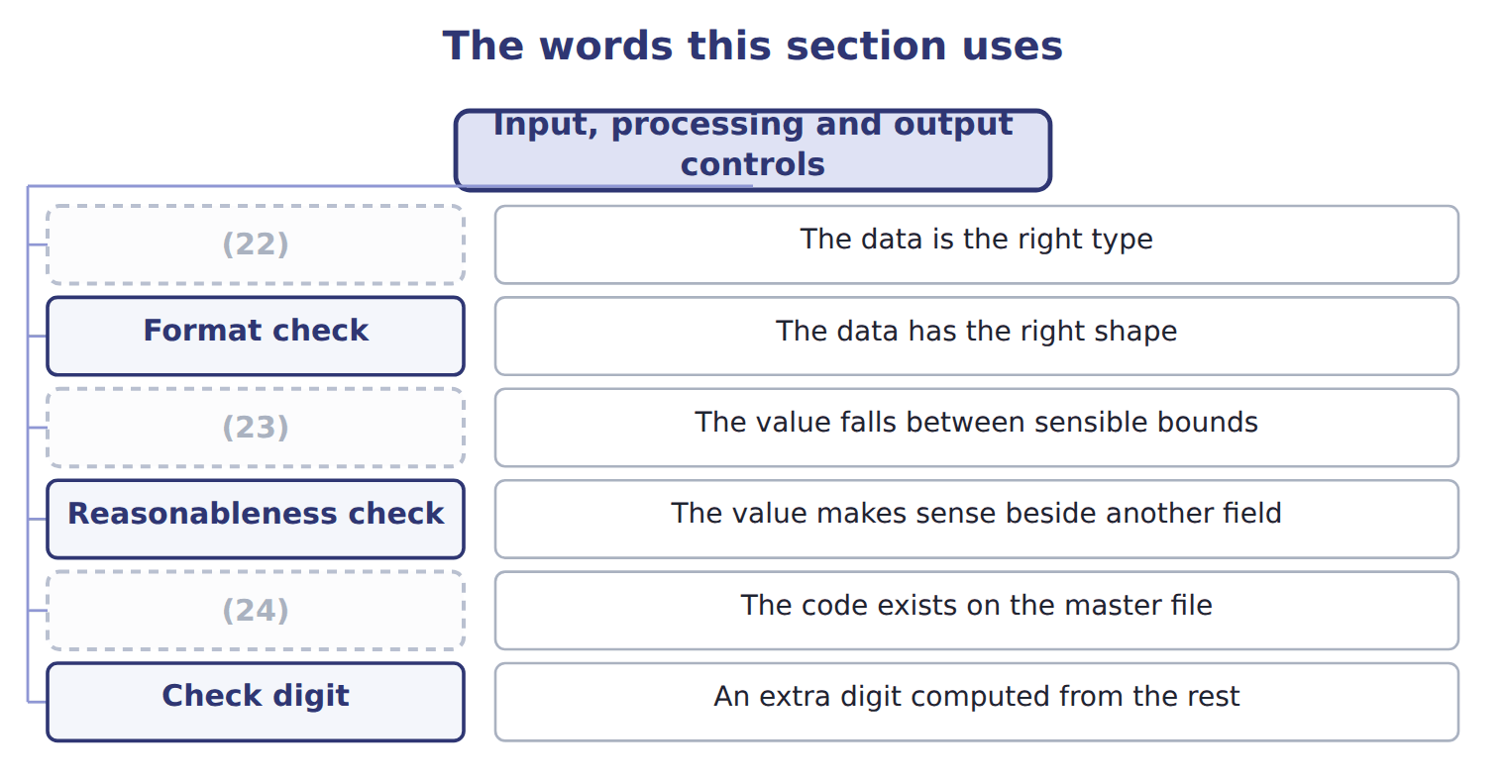
word list
Validity check · Range or limit check · Field check · Check digit

The English this sheet uses, and its Arabic
English (exam term) | Arabic
input control | ضوابط المدخلات
batch total | الإجمالي الدفعي
hash total | الإجمالي الرقابي

Answer key · 7.2 Input, processing and output controls

1 economics | 13 distinction
2 argument | 14 financial
3 caught | 15 meaningless
4 moment | 16 accounting
5 Letters rejected in a quantity field | 17 exactly
6 A date entered as 2026-13-45 is rejected | 18 Processing
7 The value falls between sensible bounds | 19 run-to-run
8 A 900-case order from a customer who buys 20 | 20 reconcile
9 An unknown supplier number is rejected | 21 recipients
10 An extra digit computed from the rest | 22 Field check
11 Financial | 23 Range or limit check
12 The system displays what the code means | 24 Validity check

the summaries in full
Summary 1 The economics are the whole argument for input controls. An error caught as it is keyed costs a moment. The same error found in the output has already passed through every calculation in between, and tracing it back through them costs far more than preventing it would have.
Summary 2 Batch totals come in three kinds and the distinction is tested. A financial total adds amounts; a record count counts documents; a hash total adds something meaningless, such as supplier numbers, purely so that a change shows up. The hash total has no accounting meaning at all, which is exactly why it works. Processing controls keep the data right while it is being handled: run-to-run totals carry a figure from one stage to the next, sequence checks confirm nothing is skipped, and error logs capture what was rejected. Output controls then reconcile what left against what entered, send reports only to named recipients, and dispose of them securely.

7.3 Storage controls
Chapter 7 · section 7.3

Fill every gap. Each word list holds one word more than there are gaps.
Storage controls and their trade-offs
Storage control (E.2.g) | What it does | Trade-off | Typical
Full backup | Copies everything | Slowest to take, fastest to restore | (1)
Incremental backup | (2) | Fastest to take, slowest to restore | Nightly
Differential backup | (3) | Between the two on both counts | Nightly, where restore speed matters
Mirroring or replication | (4) | Protects against hardware failure, not against error | Continuous
Off-site or cloud copy | (5) | The only protection against fire or flood | At least one copy, always
Immutable or air-gapped copy | (6) | The protection against ransomware | At least one copy

word list
A copy held away from the site · Copies changes since the last FULL backup · Copies changes since the last backup of ANY type · Nightly · A continuously maintained second copy · Weekly · A copy that cannot be altered or reached online

Summary 1 gaps 7–17
The (7) between incremental and differential backups is the one the exam tests. An incremental copies what has changed since the last backup of any kind. It is quick to take and slow to (8) , because every incremental since the last full backup must be (9) in order. A differential copies what has changed since the last full backup. It grows (10) each night but needs only two restores. Two (11) points are worth (12) . (13) protects against a disk (14) but not against a mistake, because the error is copied (15) to the mirror. And a copy that cannot be altered or reached online is now the standard (16) against ransomware, which otherwise encrypts the backups along with (17) else.
word list
applied · faithfully · restore · failing · knowing · distinction · everything · protection · adaptability · larger · further · Mirroring

RAID is not a backup

Summary 2 gaps 18–20
Mirroring and RAID give (18) against hardware failure. They do not protect against deletion, corruption or encryption, because whatever happens to the original happens (19) to the copy. A (20) offering RAID as the answer to data loss is offering the wrong answer.
word list
question · encryption · immediately · resilience

The words this section uses
Each term sits against what it means.
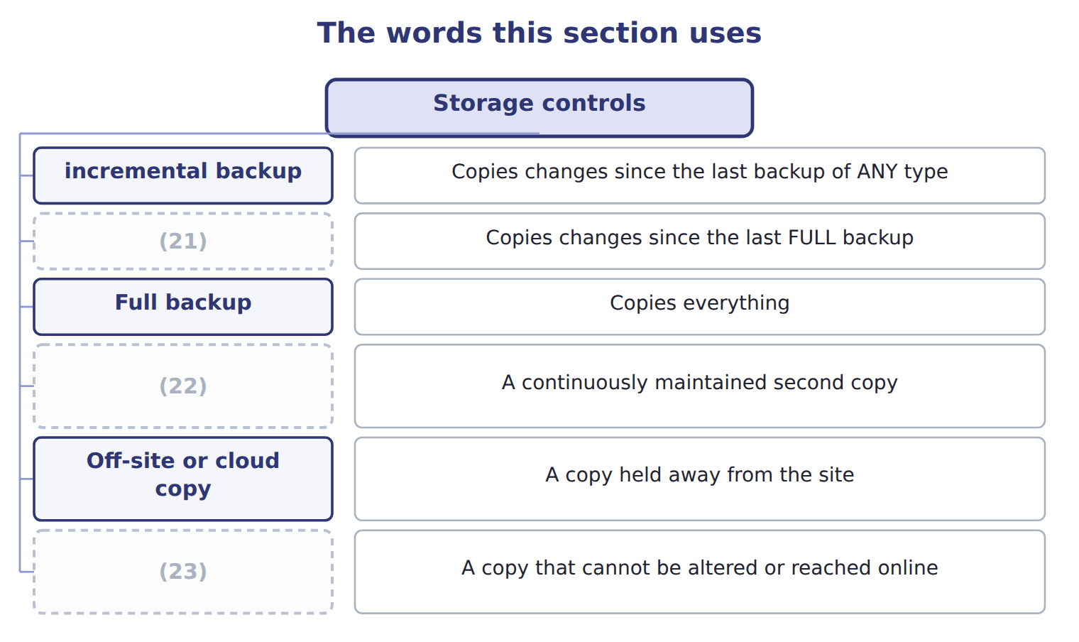
word list
differential backup · Immutable or air-gapped copy · incremental backup · Mirroring or replication

The English this sheet uses, and its Arabic
English (exam term) | Arabic
incremental backup | النسخ الاحتياطي التزايدي
differential backup | النسخ الاحتياطي التفاضلي

Answer key · 7.3 Storage controls

1 Weekly | 13 Mirroring
2 Copies changes since the last backup of ANY type | 14 failing
3 Copies changes since the last FULL backup | 15 faithfully
4 A continuously maintained second copy | 16 protection
5 A copy held away from the site | 17 everything
6 A copy that cannot be altered or reached online | 18 resilience
7 distinction | 19 immediately
8 restore | 20 question
9 applied | 21 differential backup
10 larger | 22 Mirroring or replication
11 further | 23 Immutable or air-gapped copy
12 knowing

the summaries in full
Summary 1 The distinction between incremental and differential backups is the one the exam tests. An incremental copies what has changed since the last backup of any kind. It is quick to take and slow to restore, because every incremental since the last full backup must be applied in order. A differential copies what has changed since the last full backup. It grows larger each night but needs only two restores. Two further points are worth knowing. Mirroring protects against a disk failing but not against a mistake, because the error is copied faithfully to the mirror. And a copy that cannot be altered or reached online is now the standard protection against ransomware, which otherwise encrypts the backups along with everything else.
Summary 2 Mirroring and RAID give resilience against hardware failure. They do not protect against deletion, corruption or encryption, because whatever happens to the original happens immediately to the copy. A question offering RAID as the answer to data loss is offering the wrong answer.

7.4 Reading a flowchart for controls
Chapter 7 · section 7.4

Fill every gap. Each word list holds one word more than there are gaps.
Summary 1 gaps 1–8
A (1) draws a process as a sequence of steps, (2) and documents. For a control reviewer it does (3) no written (4) does: it shows, in one picture, who holds which duty and where a document is created or lost. Four (5) answer most of what a reviewer needs. Applied here, the chart shows four (6) people, a decision point (7) by a stated limit, and a document at every step. The weakness the chart would have revealed before the redesign was a single name (8) in four boxes.
word list
governed · appearing · something · different · questions · flowchart · procedure · redesign · decisions

The English this sheet uses, and its Arabic
English (exam term) | Arabic
flowchart | مخطط التدفق

Answer key · 7.4 Reading a flowchart for controls

1 flowchart | 5 questions
2 decisions | 6 different
3 something | 7 governed
4 procedure | 8 appearing

the summaries in full
Summary 1 A flowchart draws a process as a sequence of steps, decisions and documents. For a control reviewer it does something no written procedure does: it shows, in one picture, who holds which duty and where a document is created or lost. Four questions answer most of what a reviewer needs. Applied here, the chart shows four different people, a decision point governed by a stated limit, and a document at every step. The weakness the chart would have revealed before the redesign was a single name appearing in four boxes.

7.5 Extended Example 7A: a batch of invoices, and where each control catches it
Chapter 7 · section 7.5

Fill every gap. Each word list holds one word more than there are gaps.
Summary 1 gaps 1–12
This example (1) one batch of twenty supplier invoices (2) the Orontes system and shows which control catches which error. It is (3) : questions give an error and ask which control would find it. (4) payable keys twenty invoices as one batch. Before keying, the clerk (5) three batch totals: twenty (6) , a financial total of the invoice amounts, and a hash total of the supplier numbers. One invoice is keyed with the (7) in the rate field. One (8) a supplier number that does not exist. And one is for a supplier that exists, but with a (9) number that happens to belong to a (10) real supplier. The field or (11) check rejects the first as it is keyed. The (12) check rejects the second, because the code is not on the master file.
word list
exam-core · through · Orontes · different · format · Accounts · quantity · records · validity · mistyped · carries · documents · follows

Summary 2 gaps 13–21
The record count catches the third: (13) documents posted (14) twenty counted. The fourth error passes the (15) check, because the (16) number is a real supplier. It passes the record count and the (17) total, because the (18) is right. Only the hash total of supplier numbers catches it, or closed-loop (19) showing the supplier name on screen before the clerk (20) . This is the case that justifies the hash total, which otherwise looks like (21) for its own sake. A total with no accounting meaning catches an error that every meaningful total misses, because the error substitutes one valid value for another.
word list
twenty-one · control · financial · validity · amount · mistyped · confirms · against · arithmetic · verification

Match four errors to their controls

Complete the blank cells.

Your turn: match four errors to their controls (complete the blanks)
Every item belongs to exactly one group.
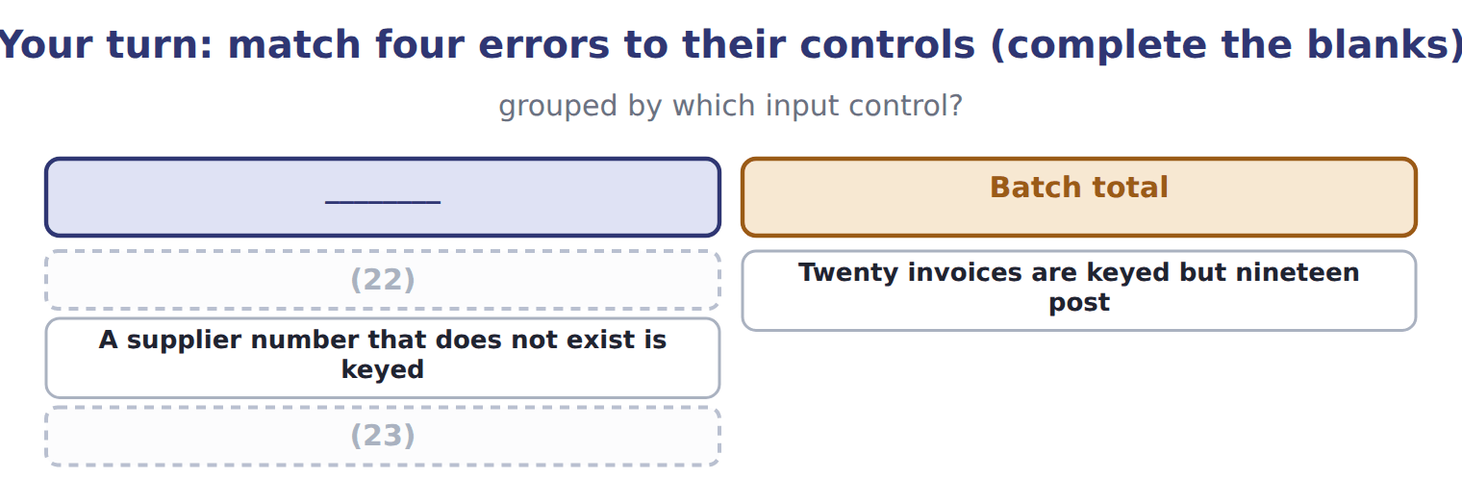
word list
Twenty invoices are keyed but nineteen post · An hourly rate of 5,000 is entered · A mistyped account number is caught by arithmetic

The pattern behind the example

Summary 3 gaps 24–27
Field, (24) and range checks catch data that is the wrong shape. (25) checks catch codes that do not exist. Record counts and (26) totals catch things missing or added. Only a hash total or closed-loop (27) catches one valid code substituted for another.
word list
questions · verification · format · financial · Validity

Exam view

Summary 4 gaps 28–30
Ask what kind of error it is before (28) a control. Wrong shape, absent code, wrong count, or one valid value (29) for another. The last of these is the one most (30) get wrong, and it has only two answers.
word list
candidates · swapped · validity · choosing

Exam view
Item | Answer
An hourly rate of 5,000 is entered | Range or limit check — the value falls (31) the bounds set for that field
Twenty invoices are keyed but nineteen post | Why: the record count taken before entry no longer agrees with the number posted, so one (32) is missing
A supplier number that does not exist is keyed | Validity check — the code is tested against the supplier master file and is not found
A mistyped account number is caught by arithmetic | Check digit — an extra digit computed from the rest of the number no longer agrees

word list
document · outside · Validity

Control figure or practice — Category
Every item belongs to exactly one group.
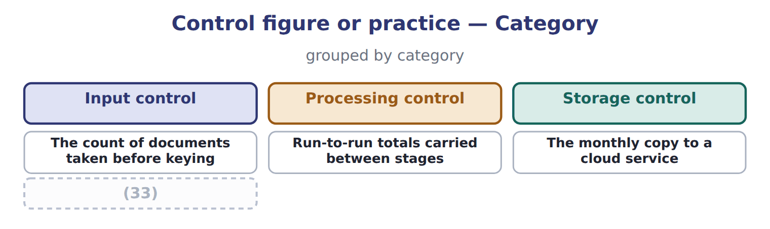
word list
The monthly copy to a cloud service · The total of supplier numbers with no accounting meaning

The English this section uses, and its Arabic
Each term sits against what it means.
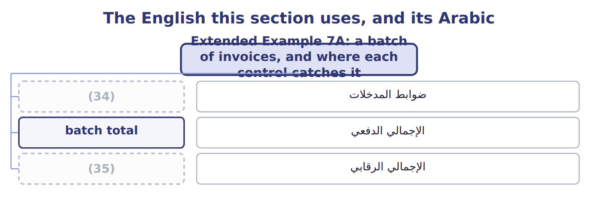
word list
batch total · hash total · input control

Answer key · 7.5 Extended Example 7A: a batch of invoices, and where each control catches it

1 follows | 19 verification
2 through | 20 confirms
3 exam-core | 21 arithmetic
4 Accounts | 22 An hourly rate of 5,000 is entered
5 records | 23 A mistyped account number is caught by arithmetic
6 documents | 24 format
7 quantity | 25 Validity
8 carries | 26 financial
9 mistyped | 27 verification
10 different | 28 choosing
11 format | 29 swapped
12 validity | 30 candidates
13 twenty-one | 31 outside
14 against | 32 document
15 validity | 33 The total of supplier numbers with no accounting meaning
16 mistyped | 34 input control
17 financial | 35 hash total
18 amount

the summaries in full
Summary 1 This example follows one batch of twenty supplier invoices through the Orontes system and shows which control catches which error. It is exam-core: questions give an error and ask which control would find it. Accounts payable keys twenty invoices as one batch. Before keying, the clerk records three batch totals: twenty documents, a financial total of the invoice amounts, and a hash total of the supplier numbers. One invoice is keyed with the quantity in the rate field. One carries a supplier number that does not exist. And one is for a supplier that exists, but with a mistyped number that happens to belong to a different real supplier. The field or format check rejects the first as it is keyed. The validity check rejects the second, because the code is not on the master file.
Summary 2 The record count catches the third: twenty-one documents posted against twenty counted. The fourth error passes the validity check, because the mistyped number is a real supplier. It passes the record count and the financial total, because the amount is right. Only the hash total of supplier numbers catches it, or closed-loop verification showing the supplier name on screen before the clerk confirms. This is the case that justifies the hash total, which otherwise looks like arithmetic for its own sake. A total with no accounting meaning catches an error that every meaningful total misses, because the error substitutes one valid value for another.
Summary 3 Field, format and range checks catch data that is the wrong shape. Validity checks catch codes that do not exist. Record counts and financial totals catch things missing or added. Only a hash total or closed-loop verification catches one valid code substituted for another.
Summary 4 Ask what kind of error it is before choosing a control. Wrong shape, absent code, wrong count, or one valid value swapped for another. The last of these is the one most candidates get wrong, and it has only two answers.

8.1 Why the internet is riskier
Chapter 8 · section 8.1

Fill every gap. Each word list holds one word more than there are gaps.
Chapter 8, section by section
Each stage leads to the next.
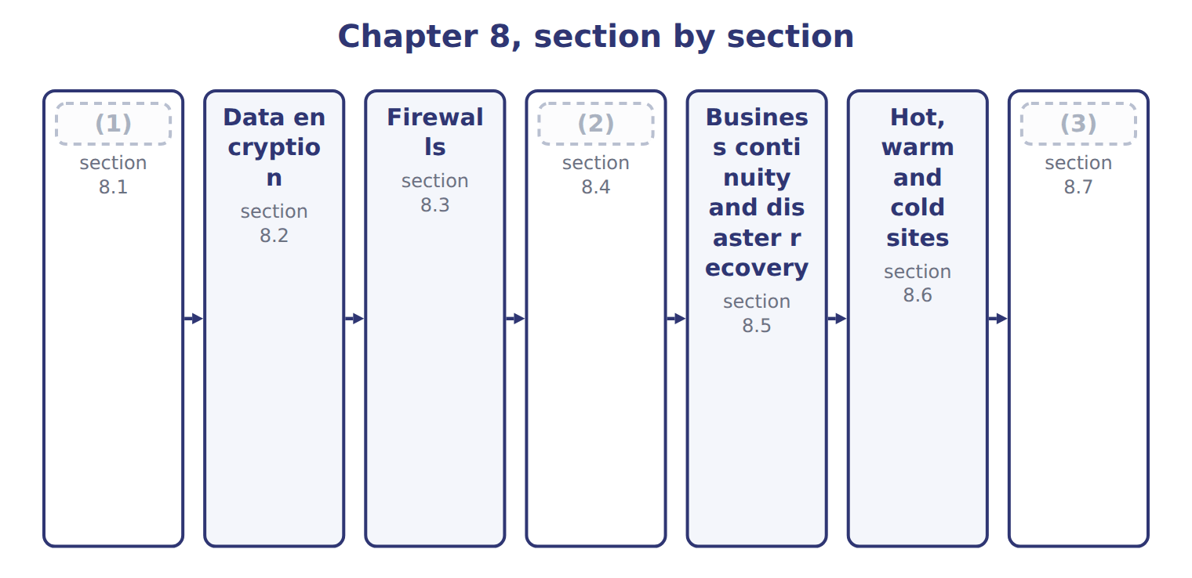
word list
Why the internet is riskier · Extended Example 8A: choosing a recovery arran · Business continuity and disaster recovery · Why the backup must leave the building

Summary 1 gaps 4–7
A leased line is a (4) the company pays for and (5) else uses. The (6) is a shared road. The traffic crosses (7) owned by strangers, by a route chosen at the time, and anything on that route can in principle read or alter what passes.
word list
crosses · nobody · equipment · connection · internet

The risks of the internet compared with a private line
Internet risk (E.2.h) | Why it arises | What it looks like | Main defence
Interception | (8) | Reading data in transit | Encryption
Man in the middle | An attacker relays and may alter the conversation | (9) | Encryption with authentication
Spoofing | A false identity for a site, sender or address | (10) | Certificates, authentication
Tampering | (11) | An invoice amount altered on the way | Integrity checks, hashing
Denial of service | The service is flooded until it fails | (12) | Filtering, capacity, provider defences
Malware delivery | (13) | Ransomware from an attachment | Filtering, patching, training

word list
Traffic crosses networks nobody controls · Reading data in transit · An order site unavailable for a day · A convincing but fake supplier portal · Altering a payment instruction · Data changed in transit · Hostile software carried over the connection

Summary 2 gaps 14–21
The (14) is one of exposure (15) than of kind. A (16) line can be tapped, and an (17) can read either one. But the internet (18) the traffic within reach of far more people, none of whom the company has any (19) with. That is also why the internet is used (20) . A leased line to every Gulf (21) would cost more than the business they bring. The practical answer is not to avoid the shared road but to make the traffic unreadable while it is on it.
word list
places · relationship · difference · customer · private · rather · internet · anyway · insider

The English this section uses, and its Arabic
Each term sits against what it means.
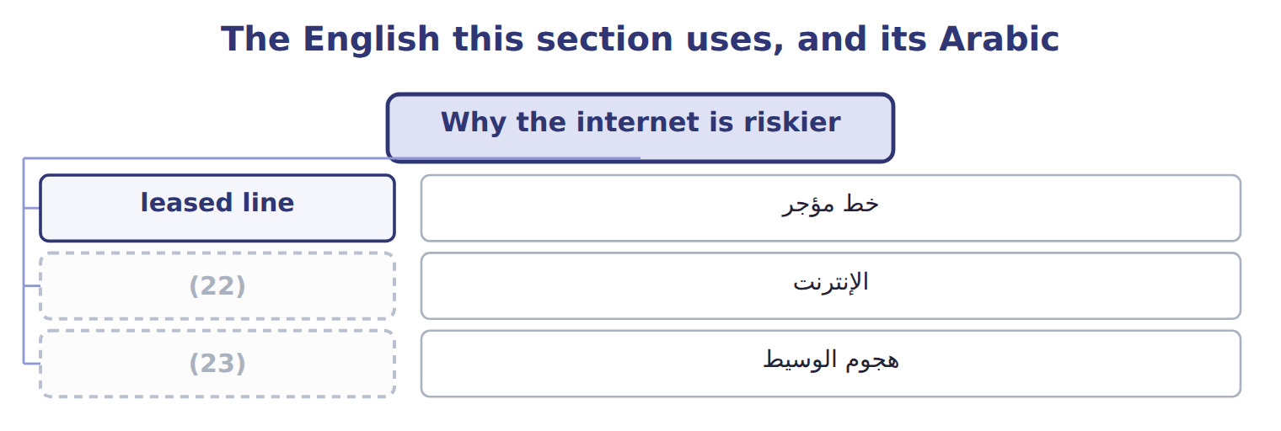
word list
man in the middle · firewall · internet

The English this sheet uses, and its Arabic
English (exam term) | Arabic
leased line | خط مؤجر
internet | الإنترنت
man in the middle | هجوم الوسيط

Answer key · 8.1 Why the internet is riskier

1 Why the internet is riskier | 13 Hostile software carried over the connection
2 Why the backup must leave the building | 14 difference
3 Extended Example 8A: choosing a recovery arran | 15 rather
4 connection | 16 private
5 nobody | 17 insider
6 internet | 18 places
7 equipment | 19 relationship
8 Traffic crosses networks nobody controls | 20 anyway
9 Altering a payment instruction | 21 customer
10 A convincing but fake supplier portal | 22 internet
11 Data changed in transit | 23 man in the middle
12 An order site unavailable for a day

the summaries in full
Summary 1 A leased line is a connection the company pays for and nobody else uses. The internet is a shared road. The traffic crosses equipment owned by strangers, by a route chosen at the time, and anything on that route can in principle read or alter what passes.
Summary 2 The difference is one of exposure rather than of kind. A private line can be tapped, and an insider can read either one. But the internet places the traffic within reach of far more people, none of whom the company has any relationship with. That is also why the internet is used anyway. A leased line to every Gulf customer would cost more than the business they bring. The practical answer is not to avoid the shared road but to make the traffic unreadable while it is on it.

8.2 Data encryption
Chapter 8 · section 8.2

Fill every gap. Each word list holds one word more than there are gaps.
Summary 1 gaps 1–12
Data encryption (1) readable data into a form that cannot be (2) without a key. Symmetric encryption uses one key for both (3) . It is fast and suits bulk data, but it leaves a (4) . The key itself must reach the other party (5) , and sending it over the same (6) network defeats the purpose. Each party has a pair of keys, and what one (7) only the other can (8) . Anyone may hold the public key, so (9) secret has to be (10) first. (11) the pair gives a digital (12) : encrypting with the private key proves who sent the message, since only that person holds it. In practice the two are combined. A secure web connection uses asymmetric methods to agree a symmetric key, then uses that faster key for the conversation itself.
word list
asymmetric · somehow · Reversing · problem · signature · decrypt · exchanged · untrusted · encrypts · converts · nothing · directions · understood

Summary 2 gaps 13–16
The current (13) for traffic in transit is TLS, with version 1.2 the minimum (14) . Separately, the United States standards body published its first (15) encryption standards in August 2024, (16) machines that could break today's asymmetric methods. Neither detail is likely to be examined; the principles above are.
word list
standard · accepted · untrusted · post-quantum · anticipating

The English this section uses, and its Arabic
Each term sits against what it means.
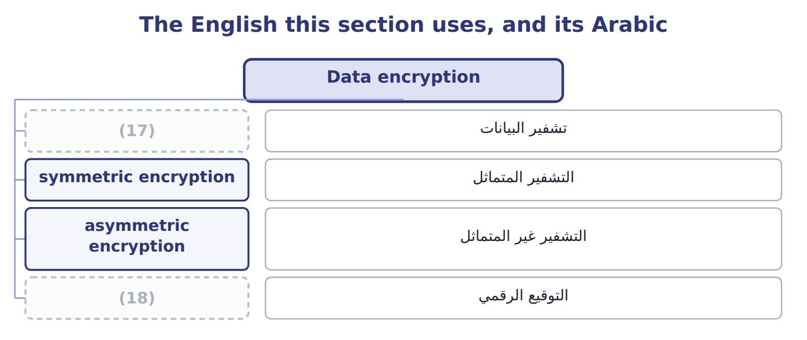
word list
التشفير المتماثل · data encryption · digital signature

The English this sheet uses, and its Arabic
English (exam term) | Arabic
data encryption | تشفير البيانات
symmetric encryption | التشفير المتماثل
asymmetric encryption | التشفير غير المتماثل
digital signature | التوقيع الرقمي

Answer key · 8.2 Data encryption

1 converts | 10 exchanged
2 understood | 11 Reversing
3 directions | 12 signature
4 problem | 13 standard
5 somehow | 14 accepted
6 untrusted | 15 post-quantum
7 encrypts | 16 anticipating
8 decrypt | 17 data encryption
9 nothing | 18 digital signature

the summaries in full
Summary 1 Data encryption converts readable data into a form that cannot be understood without a key. Symmetric encryption uses one key for both directions. It is fast and suits bulk data, but it leaves a problem. The key itself must reach the other party somehow, and sending it over the same untrusted network defeats the purpose. Each party has a pair of keys, and what one encrypts only the other can decrypt. Anyone may hold the public key, so nothing secret has to be exchanged first. Reversing the pair gives a digital signature: encrypting with the private key proves who sent the message, since only that person holds it. In practice the two are combined. A secure web connection uses asymmetric methods to agree a symmetric key, then uses that faster key for the conversation itself.
Summary 2 The current standard for traffic in transit is TLS, with version 1.2 the minimum accepted. Separately, the United States standards body published its first post-quantum encryption standards in August 2024, anticipating machines that could break today's asymmetric methods. Neither detail is likely to be examined; the principles above are.

8.3 Firewalls
Chapter 8 · section 8.3

Fill every gap. Each word list holds one word more than there are gaps.
Summary 1 gaps 1–3
A (1) sits between two networks and allows or blocks traffic (2) to rules. It is a border post: (3) crossing is examined against a list of what is permitted, and whatever is not permitted is refused.
word list
granted · everything · according · firewall

Types of firewall
Type of firewall (E.2.j) | What it does | Note
Packet filtering | (4) | Cheap and fast; blind to content
Stateful inspection | Tracks whole conversations, not single packets | (5)
Proxy or application gateway | Stands between the two sides and inspects content | (6)
Next-generation | (7) | The common corporate standard
Web application firewall | (8) | Used in front of a public website

word list
Protects one application from hostile requests · Slower; sees what the traffic actually contains · Application-aware, with intrusion prevention built in · Blocks traffic that does not belong to a session · Allows or blocks by address and port · Tracks whole conversations, not single packets

Summary 2 gaps 9–12
Firewalls have three (9) uses. They guard the boundary between the company and the (10) . They divide the internal network so a (11) in one part does not reach another. And they create a (12) zone for servers that must be reachable from outside.
word list
internet · protected · compromise · traffic · common

What a firewall does not do

Summary 3 gaps 13–21
A firewall does not stop (13) , because the user (14) the traffic. It does not stop an (15) , who is already inside. And it does not stop (16) carried on a device brought into the (17) . A (18) offering a firewall as the answer to any of these is offering the wrong answer. A firewall is a rule set, and a rule set ages. Ports opened for a project that ended, addresses permitted for a supplier no longer used, and (19) granted in an emergency all (20) exactly as system access does. The rules need the same (21) review.
word list
reachable · periodic · malware · building · insider · accumulate · question · exceptions · invites · phishing

The words this section uses
Each term sits against what it means.
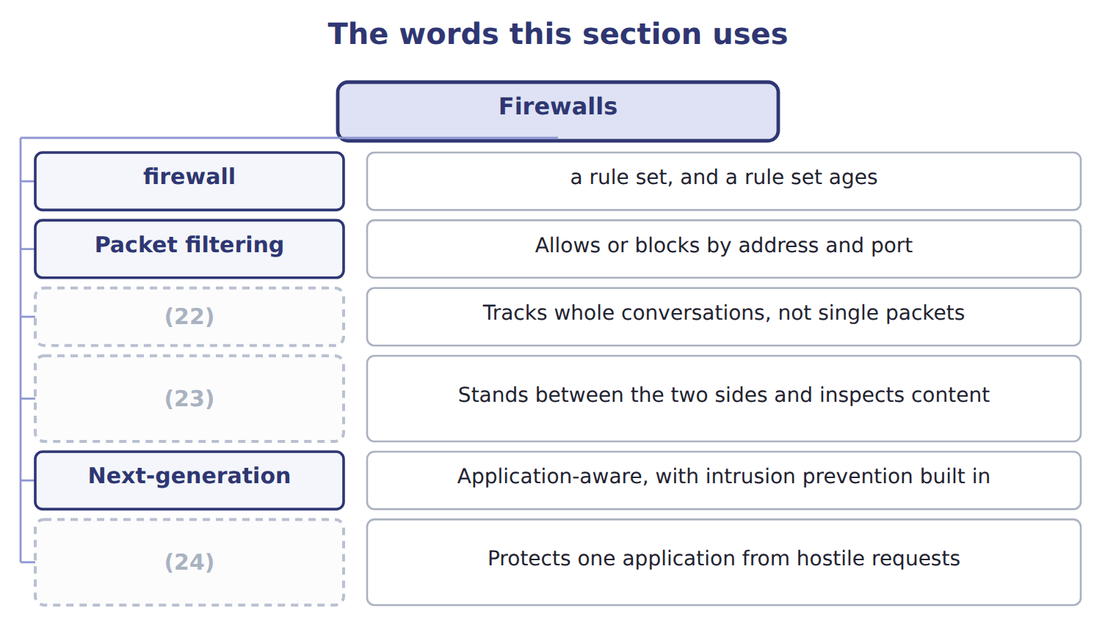
word list
Stateful inspection · remote site · Proxy or application gateway · Web application firewall

The English this sheet uses, and its Arabic
English (exam term) | Arabic
firewall | جدار الحماية

Answer key · 8.3 Firewalls

1 firewall | 13 phishing
2 according | 14 invites
3 everything | 15 insider
4 Allows or blocks by address and port | 16 malware
5 Blocks traffic that does not belong to a session | 17 building
6 Slower; sees what the traffic actually contains | 18 question
7 Application-aware, with intrusion prevention built in | 19 exceptions
8 Protects one application from hostile requests | 20 accumulate
9 common | 21 periodic
10 internet | 22 Stateful inspection
11 compromise | 23 Proxy or application gateway
12 protected | 24 Web application firewall

the summaries in full
Summary 1 A firewall sits between two networks and allows or blocks traffic according to rules. It is a border post: everything crossing is examined against a list of what is permitted, and whatever is not permitted is refused.
Summary 2 Firewalls have three common uses. They guard the boundary between the company and the internet. They divide the internal network so a compromise in one part does not reach another. And they create a protected zone for servers that must be reachable from outside.
Summary 3 A firewall does not stop phishing, because the user invites the traffic. It does not stop an insider, who is already inside. And it does not stop malware carried on a device brought into the building. A question offering a firewall as the answer to any of these is offering the wrong answer. A firewall is a rule set, and a rule set ages. Ports opened for a project that ended, addresses permitted for a supplier no longer used, and exceptions granted in an emergency all accumulate exactly as system access does. The rules need the same periodic review.

8.4 Why the backup must leave the building
Chapter 8 · section 8.4

Fill every gap. Each word list holds one word more than there are gaps.
Summary 1 gaps 1–12
The (1) here is simpler and more often got wrong: where the copies are kept. Every copy in one (2) shares one fate. A fire, a flood or a burst pipe (3) the live system and the backup (4) . The company then (5) it had been taking backups (6) for years to no purpose. That is the whole (7) for a remote site. The (8) rule of thumb is three copies, on two kinds of media, with one of them off site. (9) matters as much as location: a copy taken monthly means losing up to a month of work, which for most (10) is the same as losing everything. And (11) must be copied as well as data, because (12) records into a system nobody can rebuild is only half a recovery.
word list
question · building · Regularity · common · internet · together · programs · discovers · businesses · restoring · destroys · argument · faithfully

The English this sheet uses, and its Arabic
English (exam term) | Arabic
remote site | الموقع البعيد

Answer key · 8.4 Why the backup must leave the building

1 question | 7 argument
2 building | 8 common
3 destroys | 9 Regularity
4 together | 10 businesses
5 discovers | 11 programs
6 faithfully | 12 restoring

the summaries in full
Summary 1 The question here is simpler and more often got wrong: where the copies are kept. Every copy in one building shares one fate. A fire, a flood or a burst pipe destroys the live system and the backup together. The company then discovers it had been taking backups faithfully for years to no purpose. That is the whole argument for a remote site. The common rule of thumb is three copies, on two kinds of media, with one of them off site. Regularity matters as much as location: a copy taken monthly means losing up to a month of work, which for most businesses is the same as losing everything. And programs must be copied as well as data, because restoring records into a system nobody can rebuild is only half a recovery.

8.5 Business continuity and disaster recovery
Chapter 8 · section 8.5

Fill every gap. Each word list holds one word more than there are gaps.
Summary 1 gaps 1–7
Business (1) planning is the work of making sure the critical functions of the business can keep running during and after a (2) . (3) recovery planning is the part of it that (4) the systems and the data. Both start from the business (5) analysis, which asks what must not stop, for how long it could stop without (6) harm, and what it would cost per day. Without that analysis every system looks critical and the plan protects nothing in (7) .
word list
Disaster · restores · disruption · impact · particular · suppliers · continuity · serious

The components of a disaster recovery plan
Component of a disaster recovery plan | What it covers | Note
Roles and a recovery team | (8) | Named people, with deputies
Critical application ranking | (9) | From the business impact analysis
Communication plan | (10) | Contact details held off site as well
Recovery procedures | The steps, in order, to bring systems back | (11)
Testing and updating | Proof that the plan works, and maintenance of it | (12)

word list
Keep critical business functions running during and after a disruption · Which systems are restored first · Who decides to invoke the plan, and who does what · A plan never tested is an assumption · Written to be followed under pressure · How staff, customers and suppliers are told

Summary 2 gaps 13–20
The last (13) carries the most (14) . A plan that has never been (15) is a set of (16) . The assumption that fails is (17) a small one: a (18) list held only on the system that is down, or a backup nobody has ever tried to restore. (19) planning covers more than systems. It asks where staff would work, how (20) and suppliers would be told, which premises could be used, and who may authorise spending in the first hours. A company whose systems recover into an unusable building has recovered nothing.
word list
contact · weight · Continuity · component · tested · assumptions · nothing · customers · usually

Business continuity planning against disaster recovery planning
 | Business continuity plan (E.2.m) | Disaster recovery plan (E.2.n)
Purpose | Keep critical business functions running during and after a disruption | (21)
Scope | (22) : people, premises, suppliers, communications | Systems, data, networks
Starts from | (23) : what must not stop, and for how long | The criticality ranking the analysis produced
Key measures | (24) | Recovery time objective and recovery point objective
Relationship | The wider plan | (25)

word list
Maximum tolerable outage for each function · A plan never tested is an assumption · The business impact analysis · The whole business · Restore the IT systems and the data · The IT part of the wider plan

The words this section uses
Each term sits against what it means.
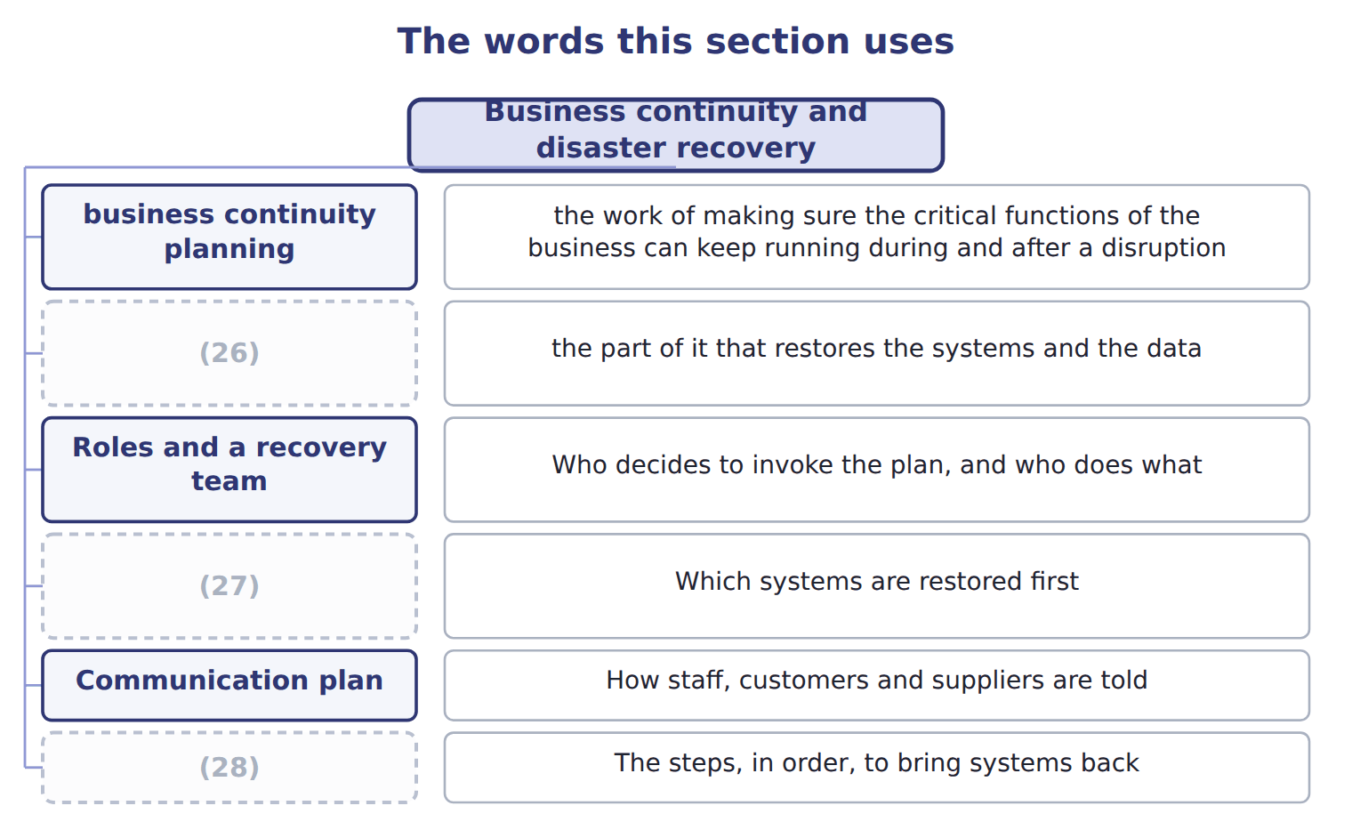
word list
Recovery procedures · disaster recovery planning · remote site · Critical application ranking

The English this sheet uses, and its Arabic
English (exam term) | Arabic
business continuity planning | تخطيط استمرارية الأعمال
disaster recovery planning | تخطيط التعافي من الكوارث
business impact analysis | تحليل الأثر على الأعمال

Answer key · 8.5 Business continuity and disaster recovery

1 continuity | 15 tested
2 disruption | 16 assumptions
3 Disaster | 17 usually
4 restores | 18 contact
5 impact | 19 Continuity
6 serious | 20 customers
7 particular | 21 Restore the IT systems and the data
8 Who decides to invoke the plan, and who does what | 22 The whole business
9 Which systems are restored first | 23 The business impact analysis
10 How staff, customers and suppliers are told | 24 Maximum tolerable outage for each function
11 Written to be followed under pressure | 25 The IT part of the wider plan
12 A plan never tested is an assumption | 26 disaster recovery planning
13 component | 27 Critical application ranking
14 weight | 28 Recovery procedures

the summaries in full
Summary 1 Business continuity planning is the work of making sure the critical functions of the business can keep running during and after a disruption. Disaster recovery planning is the part of it that restores the systems and the data. Both start from the business impact analysis, which asks what must not stop, for how long it could stop without serious harm, and what it would cost per day. Without that analysis every system looks critical and the plan protects nothing in particular.
Summary 2 The last component carries the most weight. A plan that has never been tested is a set of assumptions. The assumption that fails is usually a small one: a contact list held only on the system that is down, or a backup nobody has ever tried to restore. Continuity planning covers more than systems. It asks where staff would work, how customers and suppliers would be told, which premises could be used, and who may authorise spending in the first hours. A company whose systems recover into an unusable building has recovered nothing.

8.6 Hot, warm and cold sites
Chapter 8 · section 8.6

Fill every gap. Each word list holds one word more than there are gaps.
Summary 1 gaps 1–10
An (1) site is where (2) resumes when the main site cannot be used. The choice is an (3) one, and two (4) decide it. The recovery time objective is the longest the (5) can be without the (6) . The recovery point objective is the most data it can (7) to lose, measured in time, which (8) how often backups must run. A (9) recovery time objective needs a hot site, (10) it costs. A tolerance of two weeks makes a cold site perfectly rational. Paying for a hot site where a cold one would do is as much a failure of judgement as the reverse, because the money has to come from somewhere.
word list
economic · processing · afford · whatever · measures · business · decides · system · four-hour · alternate · because

The English this sheet uses, and its Arabic
English (exam term) | Arabic
recovery time objective | هدف وقت الاستعادة
recovery point objective | هدف نقطة الاستعادة

Answer key · 8.6 Hot, warm and cold sites

1 alternate | 6 system
2 processing | 7 afford
3 economic | 8 decides
4 measures | 9 four-hour
5 business | 10 whatever

the summaries in full
Summary 1 An alternate site is where processing resumes when the main site cannot be used. The choice is an economic one, and two measures decide it. The recovery time objective is the longest the business can be without the system. The recovery point objective is the most data it can afford to lose, measured in time, which decides how often backups must run. A four-hour recovery time objective needs a hot site, whatever it costs. A tolerance of two weeks makes a cold site perfectly rational. Paying for a hot site where a cold one would do is as much a failure of judgement as the reverse, because the money has to come from somewhere.

8.7 Extended Example 8A: choosing a recovery arrangement for Orontes
Chapter 8 · section 8.7

Fill every gap. Each word list holds one word more than there are gaps.
Summary 1 gaps 1–12
This example works (1) the choice for three (2) systems and shows why one answer does not fit them all. It is (3) : questions give a (4) and ask for the site. The plant control system runs the (5) lines and stops (6) within minutes of failing. The payables and receivables system can wait a (7) day without (8) harm. The management reporting system can wait two weeks, because the (9) pack can be (10) . Plant control is given a recovery time objective of four hours and a recovery point objective of (11) minutes. Payables and receivables get one day and four hours. Management reporting gets two weeks and one day. Plant control needs a hot site with (12) replication, because four hours allows no time to configure anything. Payables and receivables can use a warm site: the hardware waits, and a day is enough to restore and configure.
word list
through · fifteen · near-continuous · production · bottling · technology · Orontes · exam-core · serious · rebuilt · working · tolerance · month-end

Summary 2 gaps 13–21
Management (13) can use a cold site, since two weeks is time to bring (14) . The recovery point (15) sets the backup frequency, and this is the (16) candidates miss. Fifteen minutes of (17) loss means (18) rather than nightly backups. Four hours means copies (19) times a day. One day means the nightly backup is (20) . Orontes (21) holds every copy in the server room beside the live machines. Moving one copy off site costs very little and removes the single risk that would otherwise defeat all three plans at once, which is a fire in that room.
word list
restore · equipment · tolerable · replication · objective · enough · several · reporting · connection · currently

Match four requirements

Complete the blank cells.

Your turn: match four requirements (complete the blanks)
Every item belongs to exactly one group.
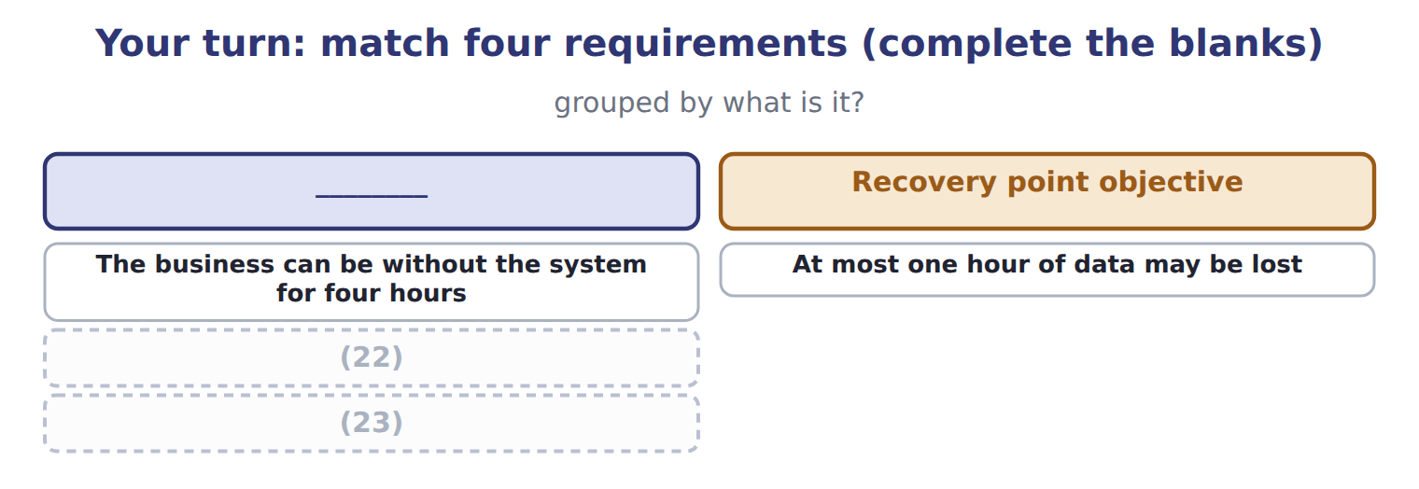
word list
A site fully equipped with current data · At most one hour of data may be lost · A site with space and power but no equipment

The pattern behind the choice

Summary 3 gaps 24–27
Start from the (24) impact analysis, not from the (25) . The recovery time objective chooses the site: hours means hot, days means warm, weeks means cold. The recovery point objective chooses the backup (26) . One copy off site (27) every plan against the loss of the building.
word list
backups · frequency · technology · business · protects

Exam view

Summary 4 gaps 28–31
A (28) gives a tolerance and four site (29) . Match the time: (30) or hours is hot, hours to days is warm, days to weeks is cold. If it gives a data loss tolerance instead, it is asking about backup (31) , not about the site.
word list
analysis · minutes · question · options · frequency

Exam view
Item | Answer
The business can be without the system for four hours | Recovery time objective — it measures acceptable downtime, and four hours points to a hot site
At most one hour of data may be lost | Why: the (32) is measured in time but describes data, so it sets how often backups must run
A site with space and power but no equipment | Cold site — equipment must be brought in and installed, so recovery takes days to weeks
A site fully equipped with current data | Hot site — it can take over in (33) to hours, and costs the most

word list
minutes · equipment · recovery point objective

System — Category
System | Category
Plant control, four hours | Hot site
Payables, one working day | (34)
Management reporting, two weeks | (35)

word list
Warm site · remote site · Cold site

The English this section uses, and its Arabic
Each term sits against what it means.
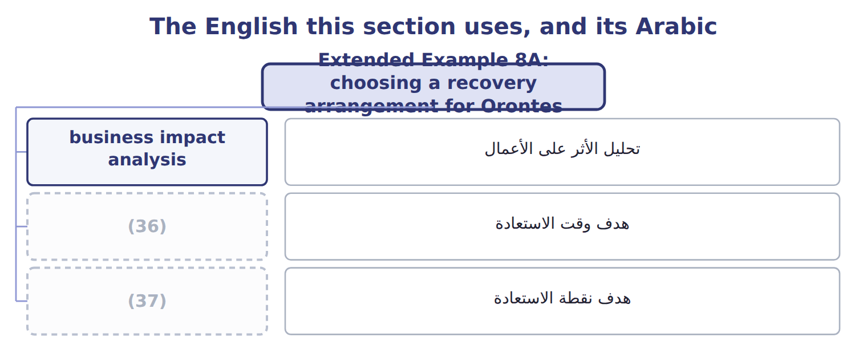
word list
disaster recovery planning · recovery time objective · recovery point objective

Answer key · 8.7 Extended Example 8A: choosing a recovery arrangement for Orontes

1 through | 20 enough
2 Orontes | 21 currently
3 exam-core | 22 A site with space and power but no equipment
4 tolerance | 23 A site fully equipped with current data
5 bottling | 24 business
6 production | 25 technology
7 working | 26 frequency
8 serious | 27 protects
9 month-end | 28 question
10 rebuilt | 29 options
11 fifteen | 30 minutes
12 near-continuous | 31 frequency
13 reporting | 32 recovery point objective
14 equipment | 33 minutes
15 objective | 34 Warm site
16 connection | 35 Cold site
17 tolerable | 36 recovery time objective
18 replication | 37 recovery point objective
19 several

the summaries in full
Summary 1 This example works through the choice for three Orontes systems and shows why one answer does not fit them all. It is exam-core: questions give a tolerance and ask for the site. The plant control system runs the bottling lines and stops production within minutes of failing. The payables and receivables system can wait a working day without serious harm. The management reporting system can wait two weeks, because the month-end pack can be rebuilt. Plant control is given a recovery time objective of four hours and a recovery point objective of fifteen minutes. Payables and receivables get one day and four hours. Management reporting gets two weeks and one day. Plant control needs a hot site with near-continuous replication, because four hours allows no time to configure anything. Payables and receivables can use a warm site: the hardware waits, and a day is enough to restore and configure.
Summary 2 Management reporting can use a cold site, since two weeks is time to bring equipment. The recovery point objective sets the backup frequency, and this is the connection candidates miss. Fifteen minutes of tolerable loss means replication rather than nightly backups. Four hours means copies several times a day. One day means the nightly backup is enough. Orontes currently holds every copy in the server room beside the live machines. Moving one copy off site costs very little and removes the single risk that would otherwise defeat all three plans at once, which is a fire in that room.
Summary 3 Start from the business impact analysis, not from the technology. The recovery time objective chooses the site: hours means hot, days means warm, weeks means cold. The recovery point objective chooses the backup frequency. One copy off site protects every plan against the loss of the building.
Summary 4 A question gives a tolerance and four site options. Match the time: minutes or hours is hot, hours to days is warm, days to weeks is cold. If it gives a data loss tolerance instead, it is asking about backup frequency, not about the site.

9.1 What an accounting information system does
Chapter 9 · section 9.1

Fill every gap. Each word list holds one word more than there are gaps.
Chapter 9, section by section
Each stage leads to the next.
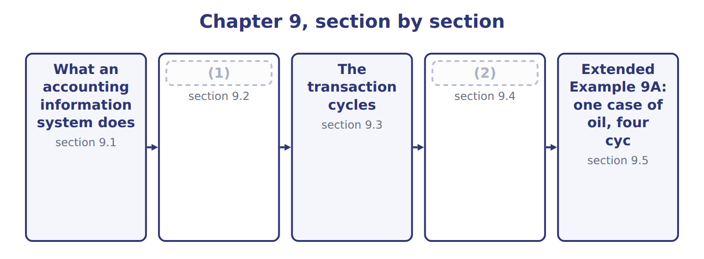
word list
The cost of separate systems · What an accounting information system does · The system within the value chain

An accounting information system captures, processes, stores and reports the economic events of a business.
What an accounting information system does
What an AIS does | Meaning | At Orontes
Capture | Record each economic event as it happens | (3)
Process | Classify, value and summarise the events | (4)
Store | Keep the record so it can be found again | (5)
Report | (6) | The payables ageing of Book 1, Chapter 6
Control | Ensure what is captured is complete and authorized | (7)

word list
The payables ageing of Book 1, Chapter 6 · The invoice matched and posted to payables · The supplier account and the audit trail · The input controls of Chapter 7 · Present the result to whoever must decide · A goods received note raised at the gate

Summary 1 gaps 8–12
A system that captures and (8) but does not control what it captures (9) numbers nobody should rely on, which is why. Notice what the (10) does not say. It does not (11) the system to (12) data. The cases produced, the hours worked and the energy used are all economic events, and a modern system captures them alongside the amounts.
word list
confine · financial · reports · definition · produces · economic

The words this section uses
Each term sits against what it means.
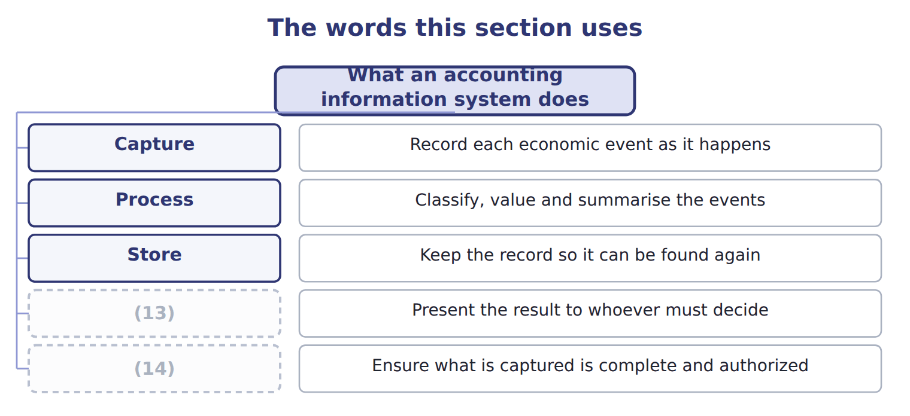
word list
Control · Store · Report

The English this sheet uses, and its Arabic
English (exam term) | Arabic
accounting information system | نظام المعلومات المحاسبية
value chain | سلسلة القيمة

Answer key · 9.1 What an accounting information system does

1 The system within the value chain | 8 reports
2 The cost of separate systems | 9 produces
3 A goods received note raised at the gate | 10 definition
4 The invoice matched and posted to payables | 11 confine
5 The supplier account and the audit trail | 12 financial
6 Present the result to whoever must decide | 13 Report
7 The input controls of Chapter 7 | 14 Control

the summaries in full
Summary 1 A system that captures and reports but does not control what it captures produces numbers nobody should rely on, which is why. Notice what the definition does not say. It does not confine the system to financial data. The cases produced, the hours worked and the energy used are all economic events, and a modern system captures them alongside the amounts.

9.2 The system within the value chain
Chapter 9 · section 9.2

Fill every gap. Each word list holds one word more than there are gaps.
Summary 1 gaps 1–9
The value chain (1) a business into the primary activities that create the product and the support activities that make them (2) . It is a support activity, and it is (3) among them (4) it touches every primary activity rather than one. Inbound (5) generates receipts, (6) generates production records, sales generates invoices, and service generates warranty claims. Each (7) an entry. The practical (8) is that the system is the only place where the whole business can be seen at once. That is why its design decides what (9) can ask. A system organised only around the ledger cannot answer a question about a product or a customer.
word list
operations · unusual · because · consequence · becomes · divides · product · logistics · possible · management

Answer key · 9.2 The system within the value chain

1 divides | 6 operations
2 possible | 7 becomes
3 unusual | 8 consequence
4 because | 9 management
5 logistics

the summaries in full
Summary 1 The value chain divides a business into the primary activities that create the product and the support activities that make them possible. It is a support activity, and it is unusual among them because it touches every primary activity rather than one. Inbound logistics generates receipts, operations generates production records, sales generates invoices, and service generates warranty claims. Each becomes an entry. The practical consequence is that the system is the only place where the whole business can be seen at once. That is why its design decides what management can ask. A system organised only around the ledger cannot answer a question about a product or a customer.

9.3 The transaction cycles
Chapter 9 · section 9.3

Fill every gap. Each word list holds one word more than there are gaps.
Summary 1 gaps 1–12
Transactions are (1) into cycles, each (2) a sequence of related events. The revenue cycle, often called revenue to cash, runs from the (3) order to the (4) of cash. The expenditure cycle, or expenditure to (5) , runs from the (6) request to the payment. The (7) cycle converts (8) into finished goods, and the payroll cycle turns hours into wages. The (9) ledger and (10) cycle is the fifth, and it differs from the others. It (11) few transactions of its own: its work is to receive the (12) results of the other four, close the period, produce the statements, and hold the audit trail that leads back from any total to the entries behind it. Each cycle has its own documents, master files and controls. A weakness in one cycle rarely stays there, because the ledger receives whatever the cycle sends it.
word list
collection · covering · summarised · grouped · reporting · disbursement · whatever · materials · originates · purchase · general · production · customer

The English this section uses, and its Arabic
Each term sits against what it means.
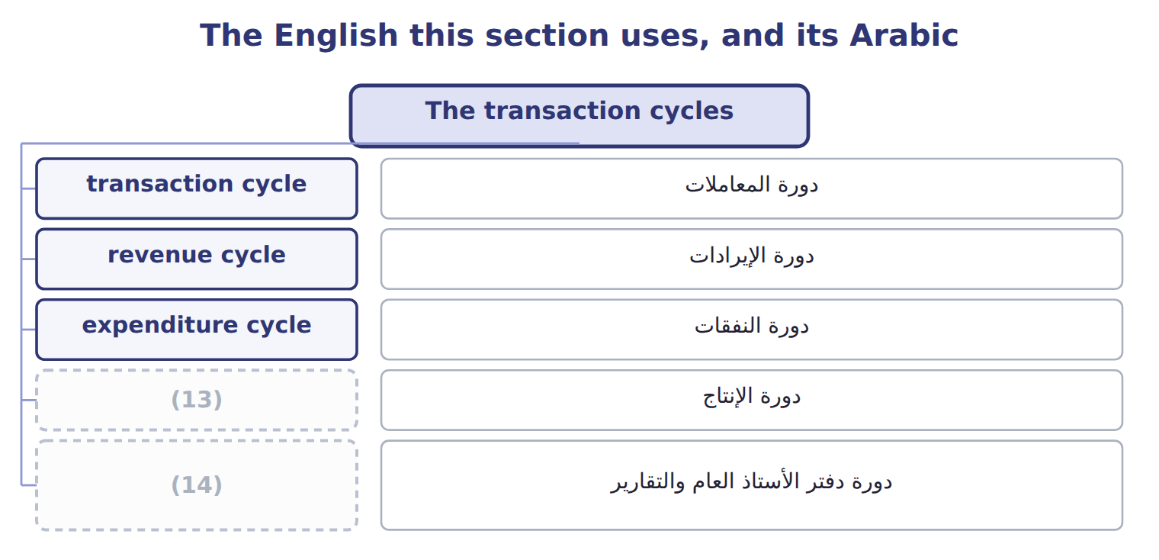
word list
production cycle · value chain · general ledger and reporting cycle

The English this sheet uses, and its Arabic
English (exam term) | Arabic
transaction cycle | دورة المعاملات
revenue cycle | دورة الإيرادات
expenditure cycle | دورة النفقات
production cycle | دورة الإنتاج
general ledger and reporting cycle | دورة دفتر الأستاذ العام والتقارير

Answer key · 9.3 The transaction cycles

1 grouped | 8 materials
2 covering | 9 general
3 customer | 10 reporting
4 collection | 11 originates
5 disbursement | 12 summarised
6 purchase | 13 production cycle
7 production | 14 general ledger and reporting cycle

the summaries in full
Summary 1 Transactions are grouped into cycles, each covering a sequence of related events. The revenue cycle, often called revenue to cash, runs from the customer order to the collection of cash. The expenditure cycle, or expenditure to disbursement, runs from the purchase request to the payment. The production cycle converts materials into finished goods, and the payroll cycle turns hours into wages. The general ledger and reporting cycle is the fifth, and it differs from the others. It originates few transactions of its own: its work is to receive the summarised results of the other four, close the period, produce the statements, and hold the audit trail that leads back from any total to the entries behind it. Each cycle has its own documents, master files and controls. A weakness in one cycle rarely stays there, because the ledger receives whatever the cycle sends it.

9.4 The cost of separate systems
Chapter 9 · section 9.4

Fill every gap. Each word list holds one word more than there are gaps.
Summary 1 gaps 1–2
Most companies arrive at several systems rather than (1) them. A plant buys software to schedule (2) , sales buys something to track customers, and finance keeps the ledger it has always had.
word list
production · choosing · transfer

The challenges of separate financial and nonfinancial systems
Challenge (F.1.c) | What it means | At Orontes
Duplicate data entry | The same fact is keyed into two systems | (3) enters output; accounting enters it again for costing
Data that disagrees | Two systems hold different versions of the same figure | (4)
Reconciliation effort | Staff spend time (5) the difference, not analysing it | Two days a month closing the gap
Delay | Information waits for a transfer or a monthly extract | (6)
No single view | (7) | Profit by product needs three systems and a spreadsheet
Weak control | The transfer between systems is where errors hide | (8)

word list
explaining · A manual upload nobody reconciles · Nobody can see one customer or product end to end · Production · Two days a month closing the gap · Managers see last month's margin in the third week · The plant says 240,000 cases; the ledger says 238,500

Summary 2 gaps 9–15
The first two (9) are the ones (10) name, and the fifth is the one that matters most. When no system holds the whole picture, a (11) as ordinary as which (12) earns the most becomes a project rather than a query. By the time it is (13) the month has moved on. There is a control (14) too. The (15) between two systems is where errors hide, because it belongs to neither. A monthly upload that nobody reconciles is exactly the kind of gap.
word list
candidates · product · transfer · answered · question · choosing · challenges · dimension

The words this section uses
Each term sits against what it means.
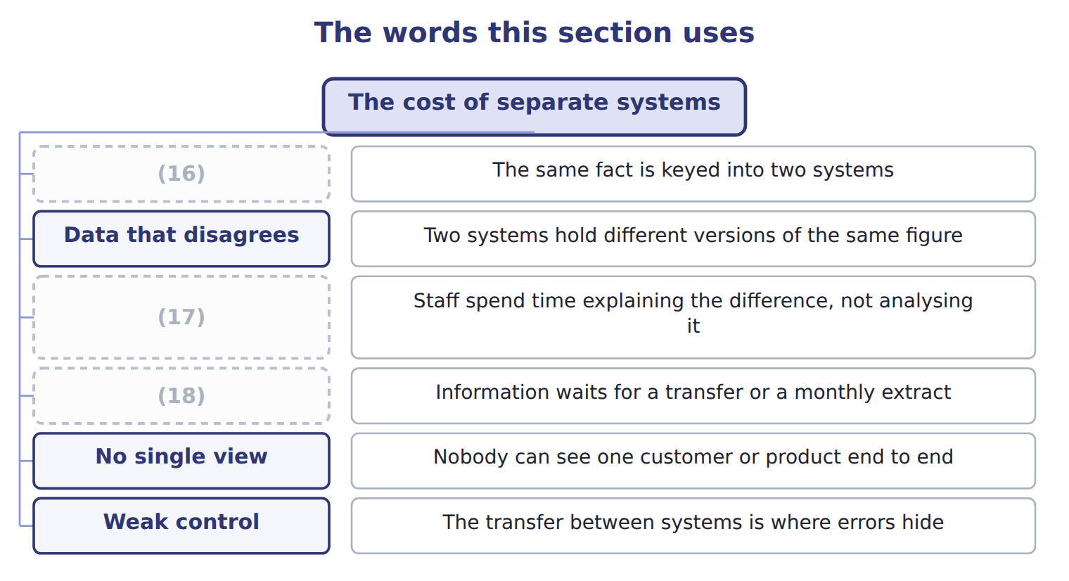
word list
Reconciliation effort · Delay · Duplicate data entry · nonfinancial system

The English this sheet uses, and its Arabic
English (exam term) | Arabic
nonfinancial system | النظام غير المالي
single view | الرؤية الموحدة

Answer key · 9.4 The cost of separate systems

1 choosing | 10 candidates
2 production | 11 question
3 Production | 12 product
4 The plant says 240,000 cases; the ledger says 238,500 | 13 answered
5 explaining | 14 dimension
6 Managers see last month's margin in the third week | 15 transfer
7 Nobody can see one customer or product end to end | 16 Duplicate data entry
8 A manual upload nobody reconciles | 17 Reconciliation effort
9 challenges | 18 Delay

the summaries in full
Summary 1 Most companies arrive at several systems rather than choosing them. A plant buys software to schedule production, sales buys something to track customers, and finance keeps the ledger it has always had.
Summary 2 The first two challenges are the ones candidates name, and the fifth is the one that matters most. When no system holds the whole picture, a question as ordinary as which product earns the most becomes a project rather than a query. By the time it is answered the month has moved on. There is a control dimension too. The transfer between two systems is where errors hide, because it belongs to neither. A monthly upload that nobody reconciles is exactly the kind of gap.

9.5 Extended Example 9A: one case of oil, four cycles
Chapter 9 · section 9.5

Fill every gap. Each word list holds one word more than there are gaps.
Summary 1 gaps 1–12
This example follows a single case of olive oil from the (1) of the olives to the (2) of cash, naming the cycle at each step. It is (3) : questions give an event and ask which cycle it (4) to. The (5) department raises a request, the manager approves it, the (6) receives the delivery and accounts payable pays the farmer. That is the (7) cycle from end to end, and it (8) a payable and then removes it. Materials are issued to the (9) line, labour is recorded against the batch and overhead is applied at the rate Book 2 (10) . The (11) cycle moves the cost from raw materials through work in process to (12) goods. The hours recorded against that batch also flow through the payroll cycle, which calculates gross pay, deducts what must be deducted and pays the net amount.
word list
production · purchase · because · purchasing · belongs · established · expenditure · finished · storekeeper · exam-core · pressing · collection · creates

Summary 2 gaps 13–24
The same hours (13) appear in two cycles, for two (14) purposes. A Gulf (15) orders, the (16) ships, the system invoices and the cash arrives sixty days later. That is the (17) cycle, and it creates a (18) and then removes it. At Orontes the (19) system holds the batch and its hours, (20) holds the same hours, and the ledger holds the cost. (21) joins them (22) . To ask what that case of oil (23) cost, somebody must export from three (24) and match them by hand. The ledger receives four summarised postings and knows the margin on the case. It cannot say whether the margin came from a good price, a cheap harvest or an efficient shift, because the detail that would answer that stayed behind in the cycles.
word list
systems · Nothing · receivable · distributor · different · efficient · production · payroll · revenue · therefore · actually · warehouse · automatically

Name four cycles

Complete the blank cells.

Your turn: name four cycles (complete the blanks)
Every item belongs to exactly one group.
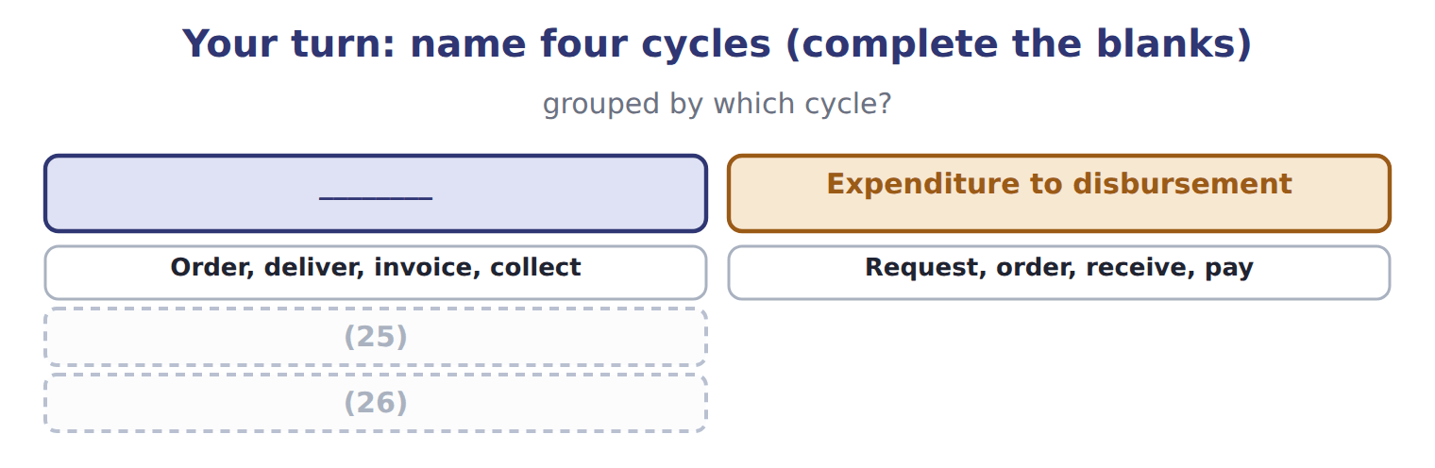
word list
Request, order, receive, pay · Hire, record time, pay · Issue materials, apply labour and overhead

The pattern behind the example

Summary 3 gaps 27–30
Name the cycle by where the (27) ends: cash in, cash out, finished goods, or wages. One event may belong to two cycles, as hours belong to (28) and payroll. The ledger receives (29) , not detail. Separate systems mean the detail cannot be (30) without manual work.
word list
receivable · summaries · sequence · reassembled · production

Exam view

Summary 4 gaps 31–33
A (31) names an activity and asks for the cycle. (32) it to its end. Issuing materials ends in finished goods, so it is (33) ; recording the hours of the same worker ends in a wage payment, so it is payroll.
word list
production · request · Follow · question

Exam view
Item | Answer
Order, deliver, invoice, collect | Revenue to cash — it ends with cash coming in from the customer
Request, order, receive, pay | Why: the sequence ends with cash going out to the supplier, which is what defines the (34)
Issue materials, apply labour and overhead | Production — it ends with finished goods ready to sell
Hire, record time, pay | Human resources and payroll — it ends with wages paid and (35) accounted for

word list
deductions · Category · expenditure cycle

Event or record — Category
Event or record | Category
Invoicing a Gulf distributor | Revenue to cash
Paying the olive farmer | Expenditure to disbursement
Issuing materials to the pressing line | (36)
Calculating deductions from a worker's gross pay | (37)

word list
Production · Answer · Human resources and payroll

The English this section uses, and its Arabic
Each term sits against what it means.
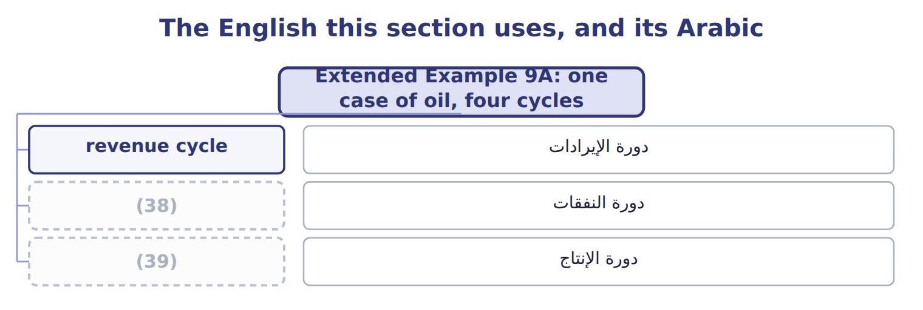
word list
expenditure cycle · production cycle · دورة الإيرادات

Answer key · 9.5 Extended Example 9A: one case of oil, four cycles

1 purchase | 21 Nothing
2 collection | 22 automatically
3 exam-core | 23 actually
4 belongs | 24 systems
5 purchasing | 25 Issue materials, apply labour and overhead
6 storekeeper | 26 Hire, record time, pay
7 expenditure | 27 sequence
8 creates | 28 production
9 pressing | 29 summaries
10 established | 30 reassembled
11 production | 31 question
12 finished | 32 Follow
13 therefore | 33 production
14 different | 34 expenditure cycle
15 distributor | 35 deductions
16 warehouse | 36 Production
17 revenue | 37 Human resources and payroll
18 receivable | 38 expenditure cycle
19 production | 39 production cycle
20 payroll

the summaries in full
Summary 1 This example follows a single case of olive oil from the purchase of the olives to the collection of cash, naming the cycle at each step. It is exam-core: questions give an event and ask which cycle it belongs to. The purchasing department raises a request, the manager approves it, the storekeeper receives the delivery and accounts payable pays the farmer. That is the expenditure cycle from end to end, and it creates a payable and then removes it. Materials are issued to the pressing line, labour is recorded against the batch and overhead is applied at the rate Book 2 established. The production cycle moves the cost from raw materials through work in process to finished goods. The hours recorded against that batch also flow through the payroll cycle, which calculates gross pay, deducts what must be deducted and pays the net amount.
Summary 2 The same hours therefore appear in two cycles, for two different purposes. A Gulf distributor orders, the warehouse ships, the system invoices and the cash arrives sixty days later. That is the revenue cycle, and it creates a receivable and then removes it. At Orontes the production system holds the batch and its hours, payroll holds the same hours, and the ledger holds the cost. Nothing joins them automatically. To ask what that case of oil actually cost, somebody must export from three systems and match them by hand. The ledger receives four summarised postings and knows the margin on the case. It cannot say whether the margin came from a good price, a cheap harvest or an efficient shift, because the detail that would answer that stayed behind in the cycles.
Summary 3 Name the cycle by where the sequence ends: cash in, cash out, finished goods, or wages. One event may belong to two cycles, as hours belong to production and payroll. The ledger receives summaries, not detail. Separate systems mean the detail cannot be reassembled without manual work.
Summary 4 A question names an activity and asks for the cycle. Follow it to its end. Issuing materials ends in finished goods, so it is production; recording the hours of the same worker ends in a wage payment, so it is payroll.

10.1 What enterprise resource planning is
Chapter 10 · section 10.1

Fill every gap. Each word list holds one word more than there are gaps.
Chapter 10, section by section
Each stage leads to the next.
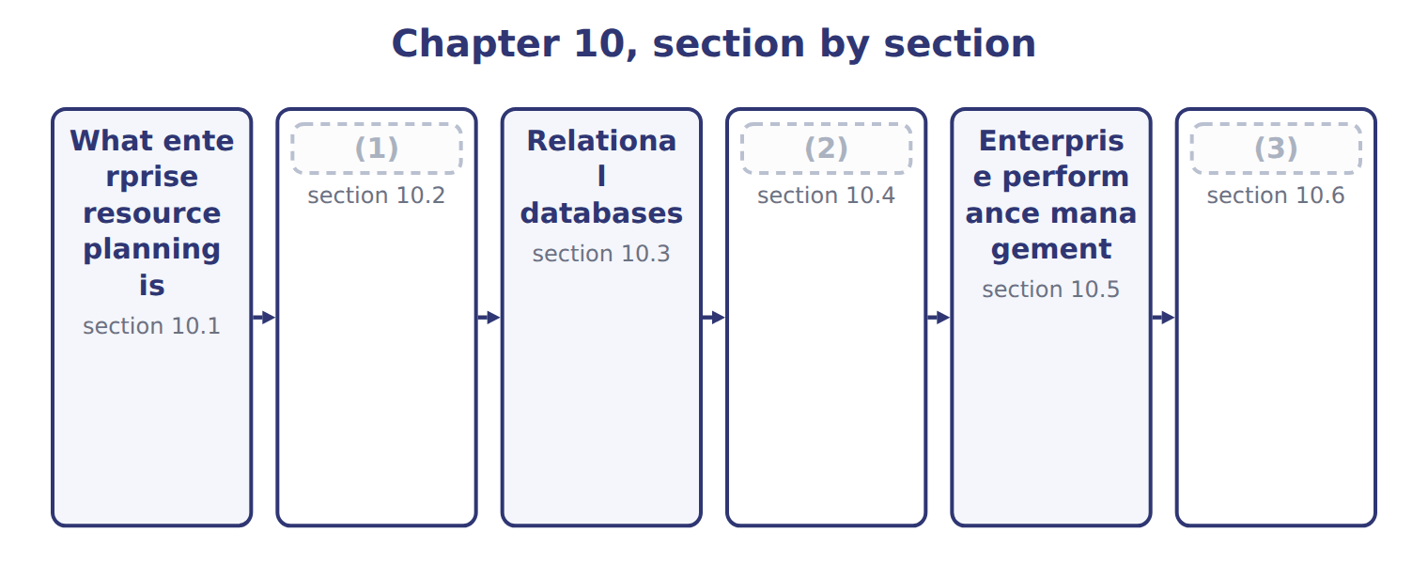
word list
Data warehouses and data marts · What enterprise resource planning is · Extended Example 10A: what Orontes gains, and · How ERP answers the six challenges

Summary 1 gaps 4–7
The (4) feature is the shared database, not the breadth of the modules. Several (5) systems that exchange files are still several systems. One system means one stored value for each fact, which is where every (6) below comes. Those advantages come at a price, and the exam (7) both sides.
word list
implementations · expects · advantage · separate · defining

The advantages and disadvantages of ERP
ERP characteristic | Advantage | Disadvantage
Integration | (8) | A long and costly implementation
One version of the data | Everyone works from the same figure | Processes must change to fit the software, or (9) costs rise
Real-time information | A manager sees today, not last month | (10)
Standard processes | The same method across divisions and countries | (11)
Stronger control and audit trail | (12) | A single point of failure if it stops
Scalability | (13) | Dependence on one vendor, and the cost of leaving

word list
Everyone · customisation · Less flexibility for a division that genuinely differs · New sites and companies are added to the same system · One entry serves every module that needs it · Heavy demands on training and change management · One set of access rules and one trail

Summary 2 gaps 14–17
The (14) row is the one that sinks (15) . An ERP (16) a way of working, so a company either changes its (17) to match the software or pays to change the software. Companies that assume a third option exists are the ones whose projects run years late.
word list
embodies · advantage · implementations · processes · second

The English this section uses, and its Arabic
Each term sits against what it means.
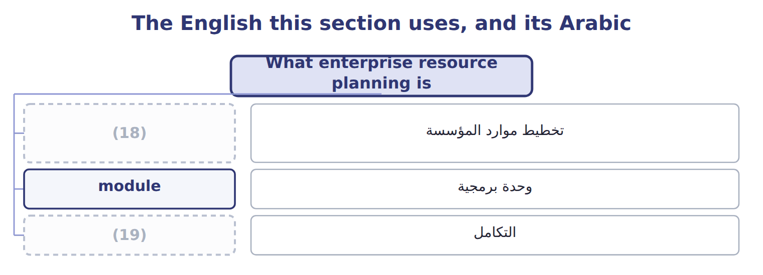
word list
data warehouse · integration · enterprise resource planning (ERP)

The English this sheet uses, and its Arabic
English (exam term) | Arabic
enterprise resource planning (ERP) | تخطيط موارد المؤسسة
module | وحدة برمجية
integration | التكامل

Answer key · 10.1 What enterprise resource planning is

1 How ERP answers the six challenges | 11 Less flexibility for a division that genuinely differs
2 Data warehouses and data marts | 12 One set of access rules and one trail
3 Extended Example 10A: what Orontes gains, and | 13 New sites and companies are added to the same system
4 defining | 14 second
5 separate | 15 implementations
6 advantage | 16 embodies
7 expects | 17 processes
8 One entry serves every module that needs it | 18 enterprise resource planning (ERP)
9 customisation | 19 integration
10 Heavy demands on training and change management

the summaries in full
Summary 1 The defining feature is the shared database, not the breadth of the modules. Several separate systems that exchange files are still several systems. One system means one stored value for each fact, which is where every advantage below comes. Those advantages come at a price, and the exam expects both sides.
Summary 2 The second row is the one that sinks implementations. An ERP embodies a way of working, so a company either changes its processes to match the software or pays to change the software. Companies that assume a third option exists are the ones whose projects run years late.

10.2 How ERP answers the six challenges
Chapter 10 · section 10.2

Fill every gap. Each word list holds one word more than there are gaps.
How ERP answers the six challenges of Chapter 9
Challenge from Chapter 9 | How ERP answers it | At Orontes
Duplicate data entry | The fact is entered once, in the module where it arises | Production output is keyed at the line and is (1) available for costing
Data that disagrees | There is only one stored value, so disagreement is impossible | (2)
Reconciliation effort | Nothing to reconcile between modules | (3)
Delay | (4) | Margin visible the next morning, not in the third week
No single view | One database holds the customer, product and order together | (5)
Weak transfer control | No transfer exists to fail | (6)

word list
Profit by product is a query, not a project · The two days a month are released for analysis · The unreconciled upload disappears with the interface · immediately · Posting is immediate, not monthly · disagreement · The 1,500-case difference of Chapter 9 cannot arise

Summary 1 gaps 7–14
One (7) produces all six (8) : the fact is stored once. Because (9) output is a row in the same database the ledger reads, it cannot be keyed twice, cannot disagree with itself, needs no (10) , arrives without delay and can be joined to a customer or a product. The sixth answer is the one (11) overlook. The (12) monthly upload; it ceases to exist, because there is nothing to (13) between. Removing a control weakness by removing the thing that needed (14) is the strongest form of the remedy.
word list
answers · database · mechanism · transfer · production · unreconciled · candidates · reconciliation · controlling

Integration is not the same as interfacing

Summary 2 gaps 15–17
Two systems that send each other files are interfaced. One system (15) one copy of the data is (16) . A question describing nightly file (17) between modules is describing interfaced systems, whatever the vendor calls the product.
word list
holding · transfers · describing · integrated

Answer key · 10.2 How ERP answers the six challenges

1 immediately | 10 reconciliation
2 The 1,500-case difference of Chapter 9 cannot arise | 11 candidates
3 The two days a month are released for analysis | 12 unreconciled
4 Posting is immediate, not monthly | 13 transfer
5 Profit by product is a query, not a project | 14 controlling
6 The unreconciled upload disappears with the interface | 15 holding
7 mechanism | 16 integrated
8 answers | 17 transfers
9 production

the summaries in full
Summary 1 One mechanism produces all six answers: the fact is stored once. Because production output is a row in the same database the ledger reads, it cannot be keyed twice, cannot disagree with itself, needs no reconciliation, arrives without delay and can be joined to a customer or a product. The sixth answer is the one candidates overlook. The unreconciled monthly upload; it ceases to exist, because there is nothing to transfer between. Removing a control weakness by removing the thing that needed controlling is the strongest form of the remedy.
Summary 2 Two systems that send each other files are interfaced. One system holding one copy of the data is integrated. A question describing nightly file transfers between modules is describing interfaced systems, whatever the vendor calls the product.

10.3 Relational databases
Chapter 10 · section 10.3

Fill every gap. Each word list holds one word more than there are gaps.
Summary 1 gaps 1–12
A (1) database stores data in tables of rows and columns, with tables linked by shared values rather than by (2) . A primary key uniquely (3) each row: no two (4) may share a supplier number, and none may be left blank. A foreign key is a column in one table (5) the primary key of (6) , which is how the invoice knows which supplier it belongs to. Two control (7) follow directly. The supplier name is stored once, so (8) it corrects every invoice at the same (9) . And an invoice cannot (10) a supplier that does not exist, because the database refuses a foreign key with no (11) primary key. That is (12) integrity, and it is the validity check. A database management system (DBMS) is the software that holds the tables, enforces the keys, decides who may read or change what, and answers queries. The distinction the exam tests is simple: the tables are the data, and the management system is what guards and serves them.
word list
reference · matching · moment · identifies · columns · relational · position · correcting · suppliers · consequences · another · referential · holding

The English this section uses, and its Arabic
Each term sits against what it means.
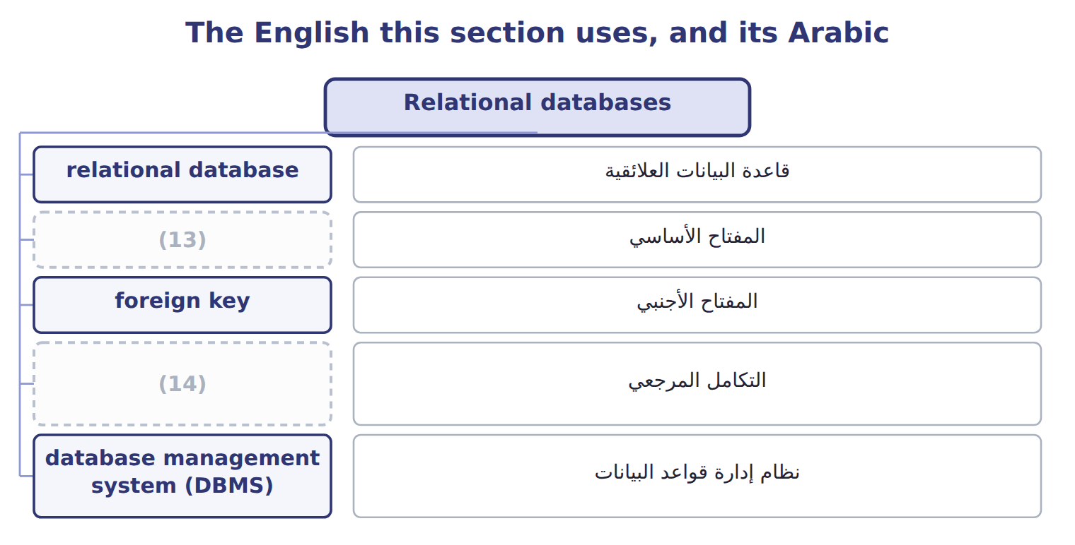
word list
التكامل المرجعي · primary key · referential integrity

The English this sheet uses, and its Arabic
English (exam term) | Arabic
relational database | قاعدة البيانات العلائقية
primary key | المفتاح الأساسي
foreign key | المفتاح الأجنبي
referential integrity | التكامل المرجعي
database management system (DBMS) | نظام إدارة قواعد البيانات

Answer key · 10.3 Relational databases

1 relational | 8 correcting
2 position | 9 moment
3 identifies | 10 reference
4 suppliers | 11 matching
5 holding | 12 referential
6 another | 13 primary key
7 consequences | 14 referential integrity

the summaries in full
Summary 1 A relational database stores data in tables of rows and columns, with tables linked by shared values rather than by position. A primary key uniquely identifies each row: no two suppliers may share a supplier number, and none may be left blank. A foreign key is a column in one table holding the primary key of another, which is how the invoice knows which supplier it belongs to. Two control consequences follow directly. The supplier name is stored once, so correcting it corrects every invoice at the same moment. And an invoice cannot reference a supplier that does not exist, because the database refuses a foreign key with no matching primary key. That is referential integrity, and it is the validity check. A database management system (DBMS) is the software that holds the tables, enforces the keys, decides who may read or change what, and answers queries. The distinction the exam tests is simple: the tables are the data, and the management system is what guards and serves them.

10.4 Data warehouses and data marts
Chapter 10 · section 10.4

Fill every gap. Each word list holds one word more than there are gaps.
Summary 1 gaps 1–11
An operational system is built to process one (1) quickly. Analysis asks the (2) question, reading (3) of rows at once, and running that against the live system would slow down the people working in it. That is why analysis happens (4) else. A data warehouse is a (5) store holding (6) across every subject, loaded from the operational systems, read but never updated by transactions. A data mart is a (7) store serving one (8) or subject, usually drawn from the warehouse. The (9) is one of scope, not of (10) . A mart is not a lesser warehouse; it is a (11) worth of structure applied to one subject, so that the sales team can answer its own questions without waiting for, or disturbing, anyone else.
word list
relationship · somewhere · warehouse's · millions · separate · department · history · opposite · transaction · smaller · process · quality

Data warehouse against data mart
 | Data warehouse | Data mart
Purpose | Supports analysis and decisions across the enterprise | Supports one department or subject
Scope | (12) | One subject, such as sales or production
Source | Loaded from the operational systems, often overnight | (13)
Time span | History, kept for years so trends can be seen | (14)
Changed by users? | No. It is read, not updated by transactions | (15)
Why not just query the live system? | Heavy analysis would slow the system people are working in | (16)

word list
All subjects: customers, products, suppliers, plants · No, for the same reason · Usually drawn from the warehouse · The period that department needs · Supports one department or subject · Same reason, on a smaller scale

The English this sheet uses, and its Arabic
English (exam term) | Arabic
data warehouse | مستودع البيانات
data mart | سوق البيانات

Answer key · 10.4 Data warehouses and data marts

1 transaction | 9 relationship
2 opposite | 10 quality
3 millions | 11 warehouse's
4 somewhere | 12 All subjects: customers, products, suppliers, plants
5 separate | 13 Usually drawn from the warehouse
6 history | 14 The period that department needs
7 smaller | 15 No, for the same reason
8 department | 16 Same reason, on a smaller scale

the summaries in full
Summary 1 An operational system is built to process one transaction quickly. Analysis asks the opposite question, reading millions of rows at once, and running that against the live system would slow down the people working in it. That is why analysis happens somewhere else. A data warehouse is a separate store holding history across every subject, loaded from the operational systems, read but never updated by transactions. A data mart is a smaller store serving one department or subject, usually drawn from the warehouse. The relationship is one of scope, not of quality. A mart is not a lesser warehouse; it is a warehouse's worth of structure applied to one subject, so that the sales team can answer its own questions without waiting for, or disturbing, anyone else.

10.5 Enterprise performance management
Chapter 10 · section 10.5

Fill every gap. Each word list holds one word more than there are gaps.
What enterprise performance management covers
EPM activity | What it does | At Orontes
Strategy | Turn objectives into measurable targets | (1)
Planning and budgeting | Build the plan from drivers, not last year plus a (2) | Cases times price, with named assumptions
Forecasting | Re-forecast as conditions change, not once a year | (3)
Consolidation and reporting | Combine divisions and report one result | (4)
Monitoring | (5) | The variance analysis of Book 2
Review and act | (6) | The balanced scorecard of Book 3, Chapter 18

word list
variance · Three divisions and Levant into one group figure · The Gulf expansion becomes a volume and margin target · Decide what to change, and feed it back into the plan · Compare actual with plan and show the gap · percentage · A rolling forecast updated monthly

Summary 1 gaps 7–18
It is not a (7) for ERP, and the (8) is worth stating plainly. An ERP records what (9) ; enterprise (10) management decides what should happen, measures whether it did, and feeds the answer back into the next plan. One is the system of (11) , the other the system of management. Four (12) follow for planning, and they are what a Level C (13) asks about. Planning becomes (14) rather than (15) : the budget is built from cases and prices and rates, so a change in any assumption flows through without rebuilding the model. (16) becomes continuous rather than (17) . Reporting becomes comparison rather than (18) , because plan and actual sit in the same place. And review becomes connected to the next plan, which is the loop Book 3 described in the balanced scorecard: a measure that nobody acts on is only a number.
word list
things · spreadsheet · difference · record · driver-based · performance · happened · question · description · incremental · annual · synonym · Forecasting

Summary 2 gaps 19–22
The (19) matters less than the (20) . A company can manage (21) well with a (22) and badly with an expensive suite, because what the term describes is a set of linked processes rather than a product. The suite makes the processes cheaper to run, not more likely to exist.
word list
software · spreadsheet · performance · stating · discipline

The words this section uses
Each term sits against what it means.
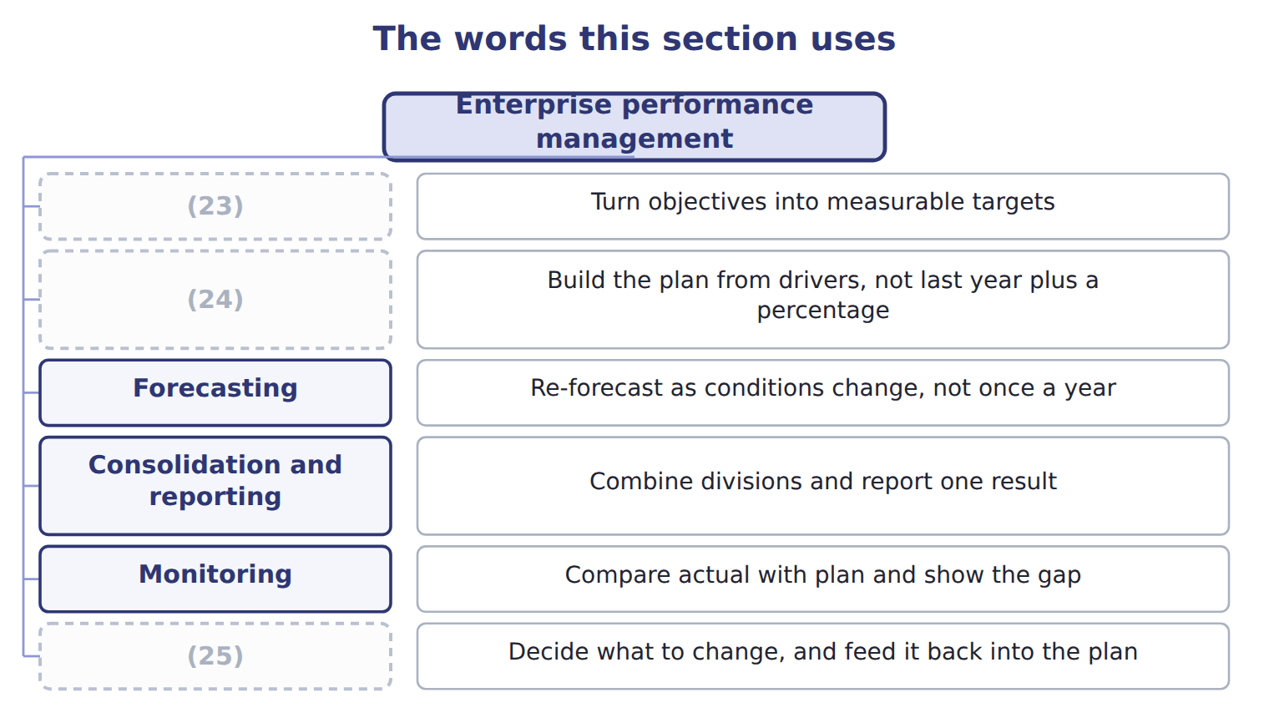
word list
Strategy · primary key · Review and act · Planning and budgeting

The English this sheet uses, and its Arabic
English (exam term) | Arabic
enterprise performance management (EPM) | إدارة أداء المؤسسة

Answer key · 10.5 Enterprise performance management

1 The Gulf expansion becomes a volume and margin target | 14 driver-based
2 percentage | 15 incremental
3 A rolling forecast updated monthly | 16 Forecasting
4 Three divisions and Levant into one group figure | 17 annual
5 Compare actual with plan and show the gap | 18 description
6 Decide what to change, and feed it back into the plan | 19 software
7 synonym | 20 discipline
8 difference | 21 performance
9 happened | 22 spreadsheet
10 performance | 23 Strategy
11 record | 24 Planning and budgeting
12 things | 25 Review and act
13 question

the summaries in full
Summary 1 It is not a synonym for ERP, and the difference is worth stating plainly. An ERP records what happened; enterprise performance management decides what should happen, measures whether it did, and feeds the answer back into the next plan. One is the system of record, the other the system of management. Four things follow for planning, and they are what a Level C question asks about. Planning becomes driver-based rather than incremental: the budget is built from cases and prices and rates, so a change in any assumption flows through without rebuilding the model. Forecasting becomes continuous rather than annual. Reporting becomes comparison rather than description, because plan and actual sit in the same place. And review becomes connected to the next plan, which is the loop Book 3 described in the balanced scorecard: a measure that nobody acts on is only a number.
Summary 2 The software matters less than the discipline. A company can manage performance well with a spreadsheet and badly with an expensive suite, because what the term describes is a set of linked processes rather than a product. The suite makes the processes cheaper to run, not more likely to exist.

10.6 Extended Example 10A: what Orontes gains, and what it gives up
Chapter 10 · section 10.6

Fill every gap. Each word list holds one word more than there are gaps.
Summary 1 gaps 1–12
This example judges the Orontes ERP (1) rather than (2) it. F.1.i is a Level C outcome, so the exam will ask what (3) management makes (4) and whether it is worth having. The sales (5) asked what one case of (6) oil cost and how much was labour. Under the present (7) the answer took two days and arrived (8) . On an (9) system it is a query: the batch, its hours, its (10) and its output all sit in one database. Once cost per case is (11) on demand, the budget can be built from (12) rather than from last year. Volume times price gives revenue; volume times cost per case gives cost; and a change in the olive price flows through to margin without anyone rebuilding the model. The variance analysis of Book 2 could already explain a difference after the month closed.
word list
proposal · possible · materials · drivers · expanding · available · describing · director · performance · premium · integrated · unverifiable · arrangement

Summary 2 gaps 13–24
With plan and actual in one place, the same analysis becomes available while the month is still running, which is the (13) between explaining a loss and (14) one. Three (15) , and none of them (16) . A long (17) during which (18) goes to the project rather than the business. (19) changed to match the software, (20) some that the plant believes are better than the standard. And (21) on one vendor, with the cost of (22) rising each year. For a company (23) into the Gulf the case is strong, because the (24) it will need to answer are exactly the ones separate systems cannot answer: which products earn most in which market, and what a change in volume does to cost. A company not growing might rationally defer. Implementations fail when a company tries to keep every existing process, customises heavily to do so, and then cannot upgrade. The discipline that makes integration work is accepting a standard process unless there is a real reason not to.
word list
trivial · dependence · things · Processes · preventing · implementation · expanding · questions · including · leaving · revenue · attention · difference

Name four things

Complete the blank cells.

Your turn: name four things (complete the blanks)
Description | What is it? | Why
One store of history, covering every subject, loaded overnight | ________ | (25)
A subset for the sales department only | Data mart | ________
Uniquely identifies each row of a table | ________ | (26)
Points from one table back to another | ________ | It prevents an orphan record

word list
It serves the whole enterprise · No two rows may share it · It prevents an orphan record

The pattern behind the judgement

Summary 3 gaps 27–31
Integration is worth most to a company whose (27) span its systems. The gain is not the (28) but the ability to plan from (29) and review in time to act. The cost is paid in (30) change and vendor (31) , not only in licence fees. Heavy customisation destroys the benefit it was bought to protect.
word list
questions · drivers · process · software · dependence · rationally

Exam view

Summary 4 gaps 32–34
A Level C question asks whether (32) management helps, or what it makes possible. Name the mechanism, not the benefit: (33) planning, continuous forecasting, plan and actual together, and review feeding the next plan. (34) that it improves decisions earns nothing.
word list
performance · arrived · Answering · driver-based

Exam view
Item | Answer
One store of history, covering every subject, loaded overnight | A (35) — it serves the whole enterprise and is read rather than updated
A subset for the sales department only | Why: a mart applies the same structure to one subject, so that department can answer its own questions without disturbing anyone
Uniquely identifies each row of a table | A primary key — no two rows may share it and none may be blank
Points from one table back to another | A foreign key — it must match an existing (36) , which prevents an orphan record

word list
primary key · data warehouse · Data mart

Feature or request — Category
Every item belongs to exactly one group.
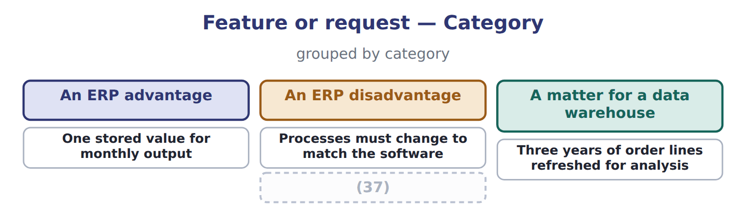
word list
Reapplying modifications at every upgrade · A matter for a data warehouse

The English this section uses, and its Arabic
Each term sits against what it means.
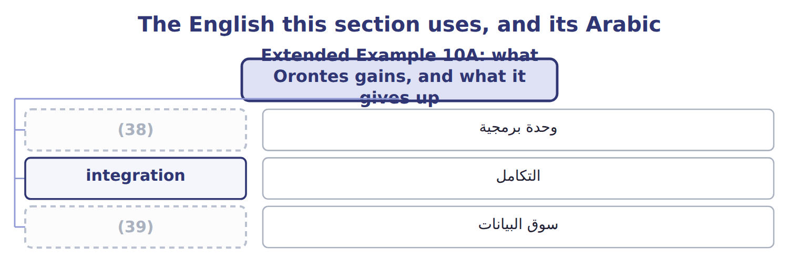
word list
relational database · module · data mart

Answer key · 10.6 Extended Example 10A: what Orontes gains, and what it gives up

1 proposal | 21 dependence
2 describing | 22 leaving
3 performance | 23 expanding
4 possible | 24 questions
5 director | 25 It serves the whole enterprise
6 premium | 26 No two rows may share it
7 arrangement | 27 questions
8 unverifiable | 28 software
9 integrated | 29 drivers
10 materials | 30 process
11 available | 31 dependence
12 drivers | 32 performance
13 difference | 33 driver-based
14 preventing | 34 Answering
15 things | 35 data warehouse
16 trivial | 36 primary key
17 implementation | 37 Reapplying modifications at every upgrade
18 attention | 38 module
19 Processes | 39 data mart
20 including

the summaries in full
Summary 1 This example judges the Orontes ERP proposal rather than describing it. F.1.i is a Level C outcome, so the exam will ask what performance management makes possible and whether it is worth having. The sales director asked what one case of premium oil cost and how much was labour. Under the present arrangement the answer took two days and arrived unverifiable. On an integrated system it is a query: the batch, its hours, its materials and its output all sit in one database. Once cost per case is available on demand, the budget can be built from drivers rather than from last year. Volume times price gives revenue; volume times cost per case gives cost; and a change in the olive price flows through to margin without anyone rebuilding the model. The variance analysis of Book 2 could already explain a difference after the month closed.
Summary 2 With plan and actual in one place, the same analysis becomes available while the month is still running, which is the difference between explaining a loss and preventing one. Three things, and none of them trivial. A long implementation during which attention goes to the project rather than the business. Processes changed to match the software, including some that the plant believes are better than the standard. And dependence on one vendor, with the cost of leaving rising each year. For a company expanding into the Gulf the case is strong, because the questions it will need to answer are exactly the ones separate systems cannot answer: which products earn most in which market, and what a change in volume does to cost. A company not growing might rationally defer. Implementations fail when a company tries to keep every existing process, customises heavily to do so, and then cannot upgrade. The discipline that makes integration work is accepting a standard process unless there is a real reason not to.
Summary 3 Integration is worth most to a company whose questions span its systems. The gain is not the software but the ability to plan from drivers and review in time to act. The cost is paid in process change and vendor dependence, not only in licence fees. Heavy customisation destroys the benefit it was bought to protect.
Summary 4 A Level C question asks whether performance management helps, or what it makes possible. Name the mechanism, not the benefit: driver-based planning, continuous forecasting, plan and actual together, and review feeding the next plan. Answering that it improves decisions earns nothing.

11.1 Governance and management
Chapter 11 · section 11.1

Fill every gap. Each word list holds one word more than there are gaps.
Chapter 11, section by section
Each stage leads to the next.
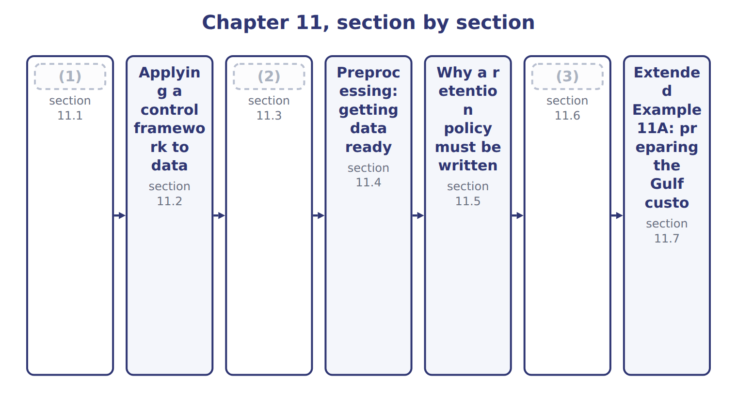
word list
record retention policy · The data life cycle · Governance and management · Controls and tools against cyberattack

Summary 1 gaps 4–14
Data governance is the exercise of (4) and decision rights over data: who owns it, what may be done with it, and to what (5) it is held. Data management is the work of carrying those (6) out. The (7) is worth holding firmly, because the exam tests it (8) and because companies confuse it in (9) . Governance (10) ; management does. A company with a (11) excellent data team and no decision rights has management without governance, and nobody can say who is allowed to change a (12) . The practical (13) of governance is the data owner: a named person, usually in the business rather than in the (14) function, who answers for the quality and the use of one domain of data.
word list
excellent · distinction · definition · technology · decisions · practice · decides · authority · expression · directly · standard · technically

Data governance against data management
 | Data governance | Data management
Question it answers | (15) | How is it actually done?
Typical outputs | Policies, ownership, decision rights, standards | (16)
Who does it | (17) | Technical and operational teams
Example at Orontes | Deciding that the plant owns production data | (18)
In one line | (19) | Management does

word list
Governance decides · A council or committee, with named data owners · Who decides, and by what authority? · Architecture, loading, quality work, storage · Loading it nightly and fixing bad records · Technical and operational teams

The English this section uses, and its Arabic
Each term sits against what it means.
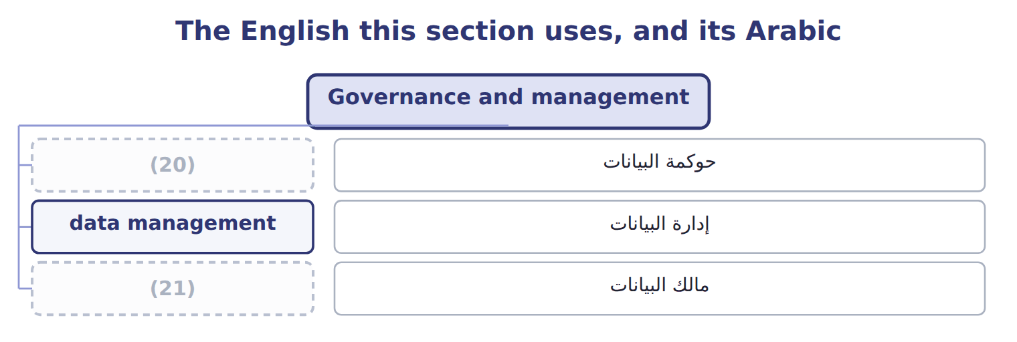
word list
data governance · data owner · data management

The English this sheet uses, and its Arabic
English (exam term) | Arabic
data governance | حوكمة البيانات
data management | إدارة البيانات
data owner | مالك البيانات

Answer key · 11.1 Governance and management

1 Governance and management | 12 definition
2 The data life cycle | 13 expression
3 Controls and tools against cyberattack | 14 technology
4 authority | 15 Who decides, and by what authority?
5 standard | 16 Architecture, loading, quality work, storage
6 decisions | 17 A council or committee, with named data owners
7 distinction | 18 Loading it nightly and fixing bad records
8 directly | 19 Governance decides
9 practice | 20 data governance
10 decides | 21 data owner
11 technically

the summaries in full
Summary 1 Data governance is the exercise of authority and decision rights over data: who owns it, what may be done with it, and to what standard it is held. Data management is the work of carrying those decisions out. The distinction is worth holding firmly, because the exam tests it directly and because companies confuse it in practice. Governance decides; management does. A company with a technically excellent data team and no decision rights has management without governance, and nobody can say who is allowed to change a definition. The practical expression of governance is the data owner: a named person, usually in the business rather than in the technology function, who answers for the quality and the use of one domain of data.

11.2 Applying a control framework to data
Chapter 11 · section 11.2

Fill every gap. Each word list holds one word more than there are gaps.
Summary 1 gaps 1–9
The exam asks specifically how COSO's (1) Control framework (2) to data governance. The (3) is that it is not (4) at all: the same five components. Two components do most of the work here. Information and (5) becomes the question of whether anyone knows what data exists and what it means, which is why a data (6) matters. (7) becomes the question of whether data quality is (8) at all. Other frameworks exist and are worth (9) by name. COBIT addresses the governance of information and technology more broadly, and the NIST Cybersecurity Framework addresses security specifically. None of them replaces COSO; they apply it to narrower subjects.
word list
Internal · communication · Monitoring · recognising · answer · changed · measured · applies · dictionary · quality

Answer key · 11.2 Applying a control framework to data

1 Internal | 6 dictionary
2 applies | 7 Monitoring
3 answer | 8 measured
4 changed | 9 recognising
5 communication

the summaries in full
Summary 1 The exam asks specifically how COSO's Internal Control framework applies to data governance. The answer is that it is not changed at all: the same five components. Two components do most of the work here. Information and communication becomes the question of whether anyone knows what data exists and what it means, which is why a data dictionary matters. Monitoring becomes the question of whether data quality is measured at all. Other frameworks exist and are worth recognising by name. COBIT addresses the governance of information and technology more broadly, and the NIST Cybersecurity Framework addresses security specifically. None of them replaces COSO; they apply it to narrower subjects.

11.3 The data life cycle
Chapter 11 · section 11.3

Fill every gap. Each word list holds one word more than there are gaps.
Summary 1 gaps 1–10
Data has a life, and the exam names eight (1) of it. The order (2) less than the two (3) inside it. (4) creates new values from existing ones, such as a cost per case derived from hours and output, and those derived values need (5) exactly as captured ones do. (6) examines data for (7) , which is the subject of Part IV. The pair most often (8) is the last two. (9) removes data from the live system but does not destroy it: the data still exists, still has to be protected, and is still (10) in a dispute. A company that believes archiving has discharged its obligations has misunderstood both.
word list
governing · Analytics · stages · confused · creates · matters · distinctions · Archival · Synthesis · discoverable · patterns

The English this section uses, and its Arabic
Each term sits against what it means.
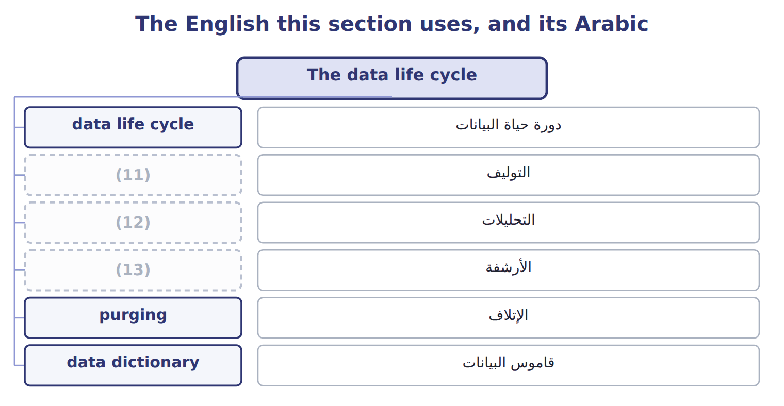
word list
synthesis · archival · analytics · التحليلات

The English this sheet uses, and its Arabic
English (exam term) | Arabic
data life cycle | دورة حياة البيانات
synthesis | التوليف
analytics | التحليلات
archival | الأرشفة
purging | الإتلاف
data dictionary | قاموس البيانات

Answer key · 11.3 The data life cycle

1 stages | 8 confused
2 matters | 9 Archival
3 distinctions | 10 discoverable
4 Synthesis | 11 synthesis
5 governing | 12 analytics
6 Analytics | 13 archival
7 patterns

the summaries in full
Summary 1 Data has a life, and the exam names eight stages of it. The order matters less than the two distinctions inside it. Synthesis creates new values from existing ones, such as a cost per case derived from hours and output, and those derived values need governing exactly as captured ones do. Analytics examines data for patterns, which is the subject of Part IV. The pair most often confused is the last two. Archival removes data from the live system but does not destroy it: the data still exists, still has to be protected, and is still discoverable in a dispute. A company that believes archiving has discharged its obligations has misunderstood both.

11.4 Preprocessing: getting data ready
Chapter 11 · section 11.4

Fill every gap. Each word list holds one word more than there are gaps.
Summary 1 gaps 1–2
Raw data is rarely fit for (1) . (2) is the work of making it so, and the exam names four steps.
word list
Preprocessing · analysis · outliers

The four steps of preprocessing
Preprocessing step (F.2.d) | What it does | At Orontes
Consolidation | (3) | Plant output, payroll hours and ledger cost in one table
Cleaning (cleansing) | Remove duplicates, fix errors, handle missing values and outliers | Two (4) of one supplier merged; a blank rate filled or flagged
Transformation | Put the data into the form the analysis needs | Dates to quarters, amounts to a single currency, (5) coded
Reduction | (6) | Twelve monthly columns replaced by four quarterly ones

word list
spellings · Remove duplicates, fix errors, handle missing values and outliers · Cut the data to what the analysis actually needs · categories · Bring the sources together into one set

Summary 2 gaps 7–13
It covers (7) , plain errors, missing values and outliers, and each of those raises a (8) rather than a rule. A missing rate can be deleted, (9) or flagged, and the three choices give three different answers (10) . It does not mean throwing data away (11) ; it means cutting the data to what the analysis needs, so that the result is readable and the (12) is manageable. Twelve monthly columns become four (13) ones because the question is about seasons, not months.
word list
carelessly · estimated · downstream · judgement · flagged · duplicates · computation · quarterly

Preprocessing is not analysis

Summary 3 gaps 14–16
Every one of these four steps happens before the (14) begins. A question describing the fitting of a model or the search for a pattern has left (15) behind. The test is whether the data is being prepared or (16) .
word list
interrogated · analysis · readable · preprocessing

The words this section uses
Each term sits against what it means.
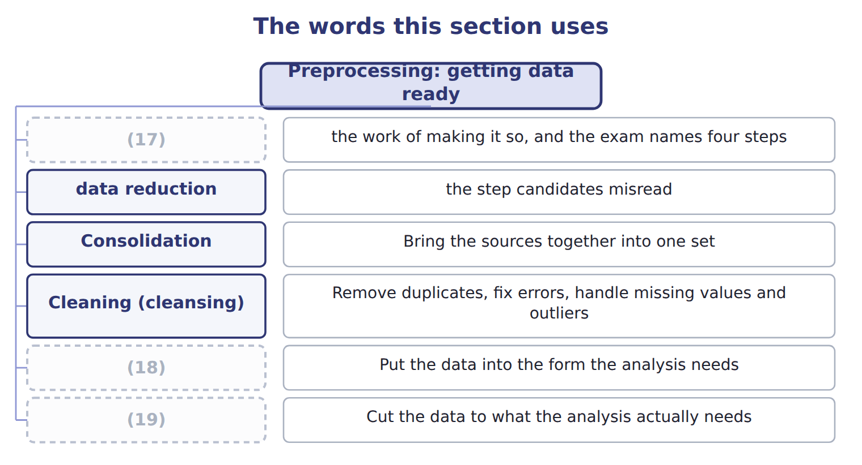
word list
preprocessing · purging · Reduction · Transformation

The English this sheet uses, and its Arabic
English (exam term) | Arabic
preprocessing | المعالجة الأولية
data cleaning | تنظيف البيانات
data reduction | تقليص البيانات

Answer key · 11.4 Preprocessing: getting data ready

1 analysis | 11 carelessly
2 Preprocessing | 12 computation
3 Bring the sources together into one set | 13 quarterly
4 spellings | 14 analysis
5 categories | 15 preprocessing
6 Cut the data to what the analysis actually needs | 16 interrogated
7 duplicates | 17 preprocessing
8 judgement | 18 Transformation
9 estimated | 19 Reduction
10 downstream

the summaries in full
Summary 1 Raw data is rarely fit for analysis. Preprocessing is the work of making it so, and the exam names four steps.
Summary 2 It covers duplicates, plain errors, missing values and outliers, and each of those raises a judgement rather than a rule. A missing rate can be deleted, estimated or flagged, and the three choices give three different answers downstream. It does not mean throwing data away carelessly; it means cutting the data to what the analysis needs, so that the result is readable and the computation is manageable. Twelve monthly columns become four quarterly ones because the question is about seasons, not months.
Summary 3 Every one of these four steps happens before the analysis begins. A question describing the fitting of a model or the search for a pattern has left preprocessing behind. The test is whether the data is being prepared or interrogated.

11.5 Why a retention policy must be written
Chapter 11 · section 11.5

Fill every gap. Each word list holds one word more than there are gaps.
Summary 1 gaps 1–2
A record (1) policy states how long each kind of record is kept and when it is (2) .
word list
purpose · retention · destroyed

Why a written retention policy matters
Why a written policy matters (F.2.e) | The reason | At Orontes
Legal and tax requirements | Records must exist for as long as a law or authority may ask | (3)
Audit and contract needs | (4) must survive long enough to support a claim or an audit | Supplier contracts and the records behind them
Privacy obligations | (5) | Jordan's Personal Data Protection Law, in force since 2024
Cost and risk of keeping | Data held beyond its purpose costs money and can still be stolen | (6)
Consistency | Everyone destroys to the same rule, or destruction looks selective | One schedule, applied by everyone
Litigation hold | (7) | Deleting on schedule during a dispute looks deliberate

word list
Twelve years of customer records nobody uses · Jordanian tax and company law periods · Personal data must be deleted once its purpose has ended · Routine destruction stops once a dispute is foreseeable · authority · Evidence

Summary 2 gaps 8–19
Two of those reasons deserve (8) . (9) protects the company: when everyone destroys to the same (10) schedule, destruction is routine. When destruction is decided case by case, every (11) invites the (12) of why that record and not another. A (13) hold is the other. Once a dispute or an (14) is foreseeable, routine destruction must stop for the records (15) . (16) to delete on schedule during a dispute is how an innocent company acquires the (17) of a guilty one. Keeping (18) forever is not the safe (19) , which is the point candidates miss. Data held past its purpose costs money, can still be stolen, and under Jordan's data protection law, in force since 2024, personal data must be deleted once the purpose has ended. The policy exists to answer both directions.
word list
published · emphasis · litigation · personal · alternative · investigation · everything · concerned · question · deletion · Continuing · appearance · Consistency

The English this sheet uses, and its Arabic
English (exam term) | Arabic
record retention policy | سياسة الاحتفاظ بالسجلات
litigation hold | تعليق الإتلاف للتقاضي

Answer key · 11.5 Why a retention policy must be written

1 retention | 11 deletion
2 destroyed | 12 question
3 Jordanian tax and company law periods | 13 litigation
4 Evidence | 14 investigation
5 Personal data must be deleted once its purpose has ended | 15 concerned
6 Twelve years of customer records nobody uses | 16 Continuing
7 Routine destruction stops once a dispute is foreseeable | 17 appearance
8 emphasis | 18 everything
9 Consistency | 19 alternative
10 published

the summaries in full
Summary 1 A record retention policy states how long each kind of record is kept and when it is destroyed.
Summary 2 Two of those reasons deserve emphasis. Consistency protects the company: when everyone destroys to the same published schedule, destruction is routine. When destruction is decided case by case, every deletion invites the question of why that record and not another. A litigation hold is the other. Once a dispute or an investigation is foreseeable, routine destruction must stop for the records concerned. Continuing to delete on schedule during a dispute is how an innocent company acquires the appearance of a guilty one. Keeping everything forever is not the safe alternative, which is the point candidates miss. Data held past its purpose costs money, can still be stolen, and under Jordan's data protection law, in force since 2024, personal data must be deleted once the purpose has ended. The policy exists to answer both directions.

11.6 Controls and tools against cyberattack
Chapter 11 · section 11.6

Fill every gap. Each word list holds one word more than there are gaps.
Controls and tools against cyberattack
Every item belongs to exactly one group.
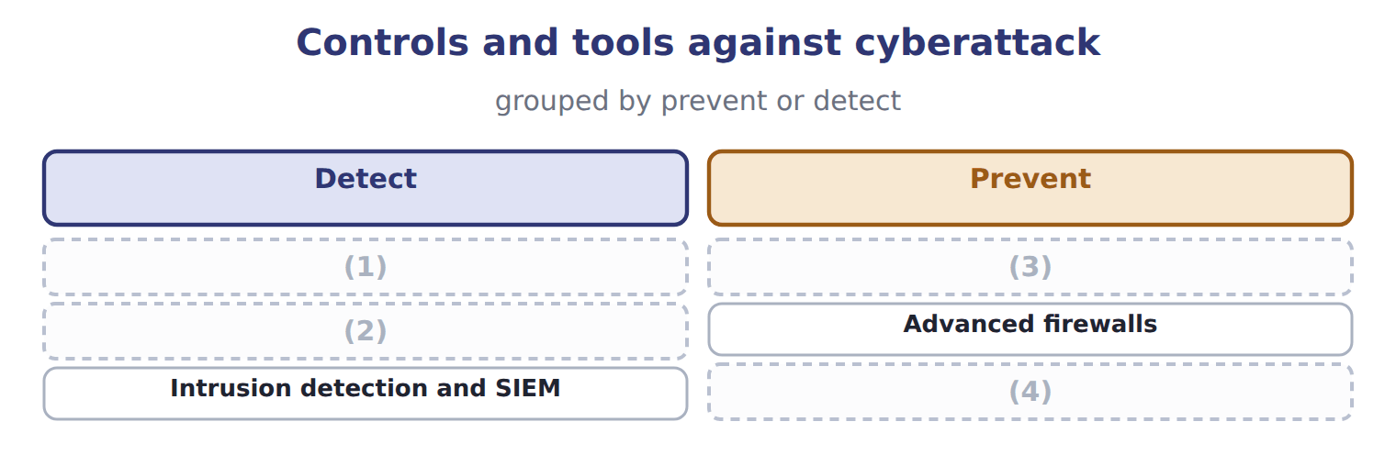
word list
data owner · Access controls · Biometrics · Penetration testing · Vulnerability scanning

Summary 1 gaps 5–15
The pair most often (5) is the first two. (6) scanning is automated and looks for known (7) across everything, which makes it broad, cheap and shallow. (8) testing is a skilled person (9) an authorized attack, which makes it narrow, expensive and deep. A scan finds the (10) door; a test finds out what (11) could do once through it. (12) authenticates by a physical (13) rather than something known or carried, which removes the sharing and theft that defeat passwords. It is a stronger (14) , not a different kind of (15) : the access rules. The NIST Cybersecurity Framework was revised to version 2.0 in February 2024, adding a sixth function, Govern, to the existing Identify, Protect, Detect, Respond and Recover.
word list
characteristic · Penetration · sharing · someone · attempting · Biometrics · authentication · confused · unlocked · weaknesses · Vulnerability · control

The words this section uses
Each term sits against what it means.
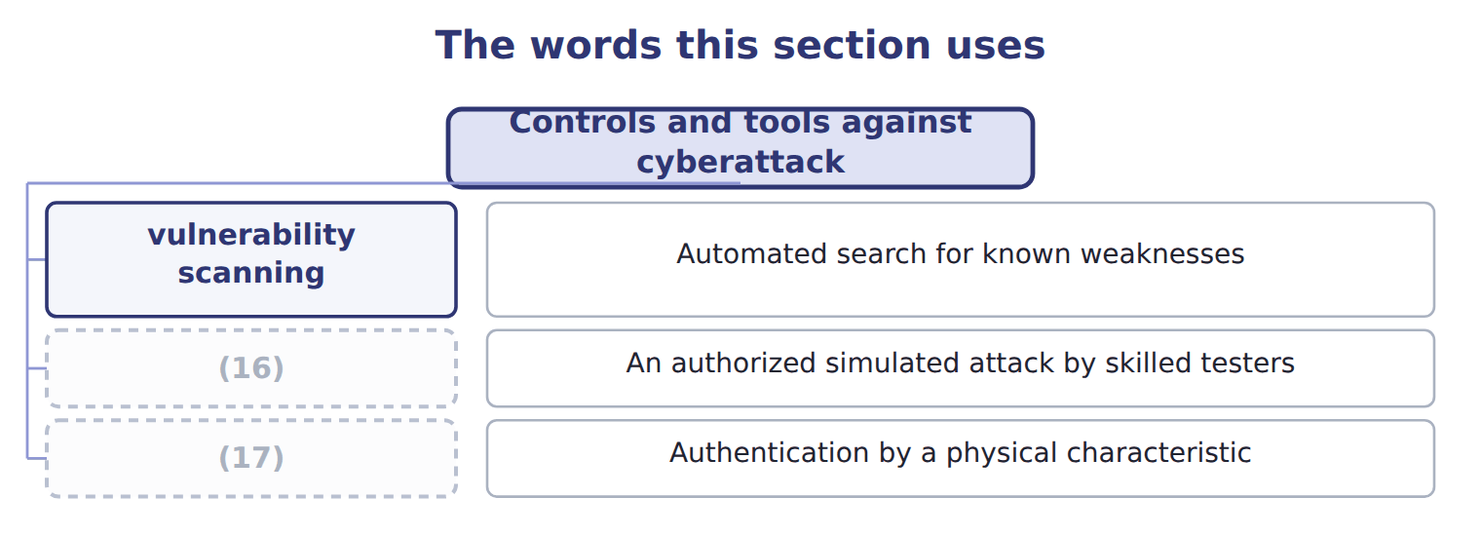
word list
biometrics · penetration testing · vulnerability scanning

The English this sheet uses, and its Arabic
English (exam term) | Arabic
vulnerability scanning | فحص الثغرات
penetration testing | اختبار الاختراق
biometrics | القياسات الحيوية

Answer key · 11.6 Controls and tools against cyberattack

1 Vulnerability scanning | 10 unlocked
2 Penetration testing | 11 someone
3 Biometrics | 12 Biometrics
4 Access controls | 13 characteristic
5 confused | 14 authentication
6 Vulnerability | 15 control
7 weaknesses | 16 penetration testing
8 Penetration | 17 biometrics
9 attempting

the summaries in full
Summary 1 The pair most often confused is the first two. Vulnerability scanning is automated and looks for known weaknesses across everything, which makes it broad, cheap and shallow. Penetration testing is a skilled person attempting an authorized attack, which makes it narrow, expensive and deep. A scan finds the unlocked door; a test finds out what someone could do once through it. Biometrics authenticates by a physical characteristic rather than something known or carried, which removes the sharing and theft that defeat passwords. It is a stronger authentication, not a different kind of control: the access rules. The NIST Cybersecurity Framework was revised to version 2.0 in February 2024, adding a sixth function, Govern, to the existing Identify, Protect, Detect, Respond and Recover.

11.7 Extended Example 11A: preparing the Gulf customer data
Chapter 11 · section 11.7

Fill every gap. Each word list holds one word more than there are gaps.
Summary 1 gaps 1–12
This example (1) one real dataset for (2) and then asks how long any of it should be kept. F.2.e is a Level C (3) , so the second half asks for a (4) . (5) wants to analyse three years of Gulf orders. The data sits in the new ERP, but the first two years were (6) from the old system, and the loading was (7) . Orders, (8) and customer (9) come from three tables and must be joined. The join is possible because each carries the customer key of, which is the first (10) dividend of a (11) design. The old system allowed free text, so one (12) appears as three spellings and must be merged to one. Fourteen orders have no delivery date. Two orders show a quantity a hundred times the usual, which is either a decimal error or a genuine bulk order, and the analyst must find out which rather than guess.
word list
imperfect · distributor · practical · loaded · relational · deliveries · Orontes · judgement · prepares · outcome · records · consolidation · analysis

Summary 2 gaps 13–24
Amounts are held in three (13) and must be (14) to one. Dates become (15) , because the question is about (16) . (17) size becomes a category rather than a number, so that small and large (18) can be compared. (19) monthly columns become twelve quarterly ones, and forty (20) codes become six families. (21) true is lost, because the question (22) seasons and families, not months and codes. The dataset contains the names, (23) numbers and addresses of (24) buyers at each distributor. That is personal data, and it falls under Jordan's law for Orontes and under Saudi law for Saudi residents. The analysis needs the orders; it does not need the buyers' names. The right answer is to remove the personal identifiers during preprocessing, which serves the analysis and the obligation at once. Where identifiers are genuinely needed, the retention policy must state how long and the data must be purged, not merely archived, when that period ends.
word list
product · Nothing · telephone · Thirty-six · individual · distributors · Customer · Consolidate · currencies · concerns · quarters · seasonality · converted

Name four preprocessing steps

Complete the blank cells.

Your turn: name four preprocessing steps (complete the blanks)
Every item belongs to exactly one group.
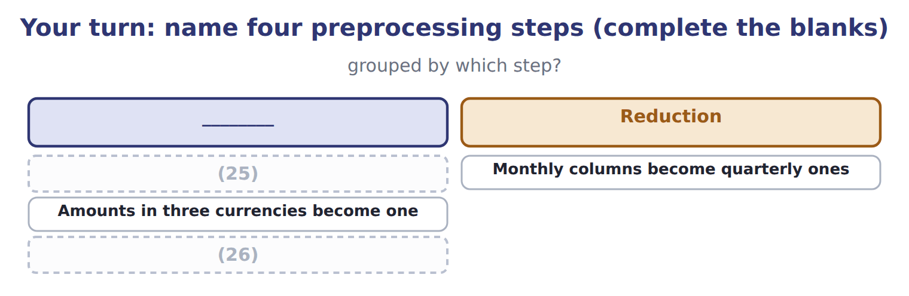
word list
Amounts in three currencies become one · Plant, payroll and ledger data are brought together · Two spellings of one supplier are merged

The pattern behind the example

Summary 3 gaps 27–30
Consolidate, clean, (27) , reduce: in that order, and all before any analysis. An outlier is (28) , not deleted, until its cause is known. Removing personal (29) can serve the analysis and the law at the same time. When a (30) period ends, the data is purged, not archived.
word list
deleted · retention · transform · identifiers · investigated

Exam view

Summary 4 gaps 31–33
A question (31) something done to data and asks which step it is. Ask what the step achieves: bringing sources together is (32) , fixing what is wrong is cleaning, changing the form is (33) , and cutting the volume is reduction.
word list
consolidation · describes · transformation · seasonality

Exam view
Item | Answer
Two spellings of one supplier are merged | Cleaning — it removes duplicates and fixes errors before any analysis begins
Monthly columns become quarterly ones | Why: the data is cut to what the (34) actually needs, since the question concerns seasons rather than months
Amounts in three currencies become one | Transformation — the data is put into the form the analysis requires
Plant, payroll and ledger data are brought together | (35) — separate sources are combined into one set

word list
analysis · Consolidation · Transformation

Action required — Category
Action required | Category
Joining the three tables into one set | Consolidation
Merging the three spellings of one distributor | (36)
Converting three currencies into one | Transformation
Replacing monthly columns with quarterly ones | (37)

word list
Cleaning · biometrics · Reduction

Answer key · 11.7 Extended Example 11A: preparing the Gulf customer data

1 prepares | 20 product
2 analysis | 21 Nothing
3 outcome | 22 concerns
4 judgement | 23 telephone
5 Orontes | 24 individual
6 loaded | 25 Two spellings of one supplier are merged
7 imperfect | 26 Plant, payroll and ledger data are brought together
8 deliveries | 27 transform
9 records | 28 investigated
10 practical | 29 identifiers
11 relational | 30 retention
12 distributor | 31 describes
13 currencies | 32 consolidation
14 converted | 33 transformation
15 quarters | 34 analysis
16 seasonality | 35 Consolidation
17 Customer | 36 Cleaning
18 distributors | 37 Reduction
19 Thirty-six

the summaries in full
Summary 1 This example prepares one real dataset for analysis and then asks how long any of it should be kept. F.2.e is a Level C outcome, so the second half asks for a judgement. Orontes wants to analyse three years of Gulf orders. The data sits in the new ERP, but the first two years were loaded from the old system, and the loading was imperfect. Orders, deliveries and customer records come from three tables and must be joined. The join is possible because each carries the customer key of, which is the first practical dividend of a relational design. The old system allowed free text, so one distributor appears as three spellings and must be merged to one. Fourteen orders have no delivery date. Two orders show a quantity a hundred times the usual, which is either a decimal error or a genuine bulk order, and the analyst must find out which rather than guess.
Summary 2 Amounts are held in three currencies and must be converted to one. Dates become quarters, because the question is about seasonality. Customer size becomes a category rather than a number, so that small and large distributors can be compared. Thirty-six monthly columns become twelve quarterly ones, and forty product codes become six families. Nothing true is lost, because the question concerns seasons and families, not months and codes. The dataset contains the names, telephone numbers and addresses of individual buyers at each distributor. That is personal data, and it falls under Jordan's law for Orontes and under Saudi law for Saudi residents. The analysis needs the orders; it does not need the buyers' names. The right answer is to remove the personal identifiers during preprocessing, which serves the analysis and the obligation at once. Where identifiers are genuinely needed, the retention policy must state how long and the data must be purged, not merely archived, when that period ends.
Summary 3 Consolidate, clean, transform, reduce: in that order, and all before any analysis. An outlier is investigated, not deleted, until its cause is known. Removing personal identifiers can serve the analysis and the law at the same time. When a retention period ends, the data is purged, not archived.
Summary 4 A question describes something done to data and asks which step it is. Ask what the step achieves: bringing sources together is consolidation, fixing what is wrong is cleaning, changing the form is transformation, and cutting the volume is reduction.

12.1 The system development life cycle
Chapter 12 · section 12.1

Fill every gap. Each word list holds one word more than there are gaps.
Chapter 12, section by section
Each stage leads to the next.
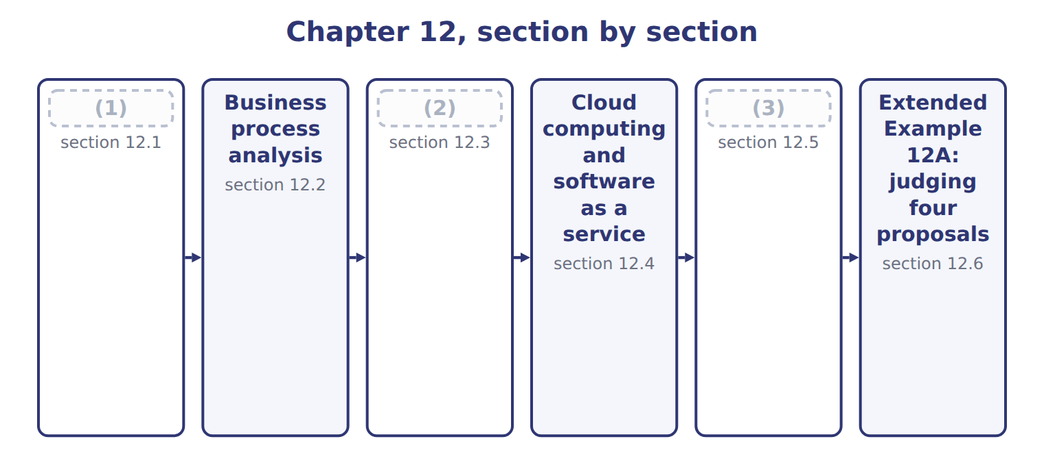
word list
Robotic process automation · software as a service (SaaS) · Blockchain, distributed ledgers and smart cont · The system development life cycle

Summary 1 gaps 4–14
The system (4) life cycle (SDLC) is the ordered (5) by which a system is planned, built and run. The two design (6) are the pair (7) confuse. (8) design answers what the system should do, in the (9) of the business. (10) design answers how it will do it: the files, the (11) , the screens and the controls. One is a (12) about purpose, the other about (13) . (14) deserves a word of its own. Moving from the old system to the new can be done directly, in parallel, as a pilot in one site, or in phases. Running both systems in parallel is the safest and the most expensive, and the choice is a judgement about what a failure would cost.
word list
Conceptual · development · candidates · sequence · Physical · confuse · construction · decision · language · Conversion · programs · stages

The English this section uses, and its Arabic
Each term sits against what it means.
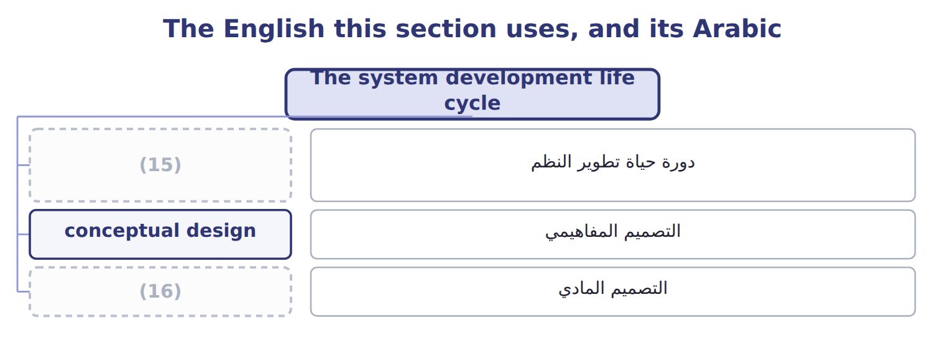
word list
physical design · system development life cycle (SDLC) · distributed ledger

The English this sheet uses, and its Arabic
English (exam term) | Arabic
system development life cycle (SDLC) | دورة حياة تطوير النظم
conceptual design | التصميم المفاهيمي
physical design | التصميم المادي

Answer key · 12.1 The system development life cycle

1 The system development life cycle | 9 language
2 Robotic process automation | 10 Physical
3 Blockchain, distributed ledgers and smart cont | 11 programs
4 development | 12 decision
5 sequence | 13 construction
6 stages | 14 Conversion
7 candidates | 15 system development life cycle (SDLC)
8 Conceptual | 16 physical design

the summaries in full
Summary 1 The system development life cycle (SDLC) is the ordered sequence by which a system is planned, built and run. The two design stages are the pair candidates confuse. Conceptual design answers what the system should do, in the language of the business. Physical design answers how it will do it: the files, the programs, the screens and the controls. One is a decision about purpose, the other about construction. Conversion deserves a word of its own. Moving from the old system to the new can be done directly, in parallel, as a pilot in one site, or in phases. Running both systems in parallel is the safest and the most expensive, and the choice is a judgement about what a failure would cost.

12.2 Business process analysis
Chapter 12 · section 12.2

Fill every gap. Each word list holds one word more than there are gaps.
Business process analysis examines how work is actually done, in order to improve it.
The steps of business process analysis
Each stage leads to the next.
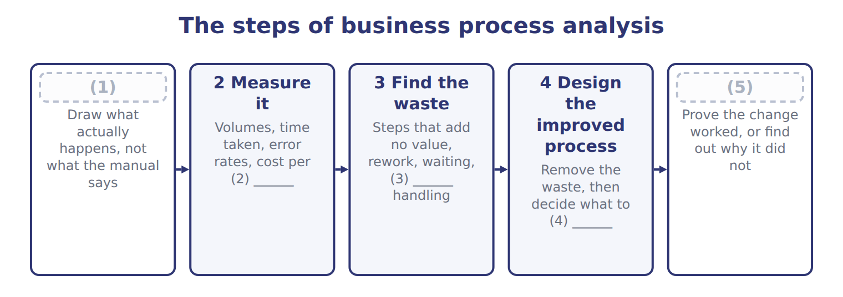
word list
transaction · 1 Map the current process · automate · 5 Implement and measure again · duplicate · blockchain

Summary 1 gaps 6–11
Its role in system (6) rests on a single (7) . (8) a bad process does not fix it: it makes the same errors faster and at greater volume, and makes them harder to see because nobody is (9) them any more. The first step is where the work is. Mapping what (10) happens, rather than what the manual says, (11) reveals steps that exist only because someone once needed them.
word list
principle · handling · routinely · Automating · performance · examines · actually

The words this section uses
Each term sits against what it means.
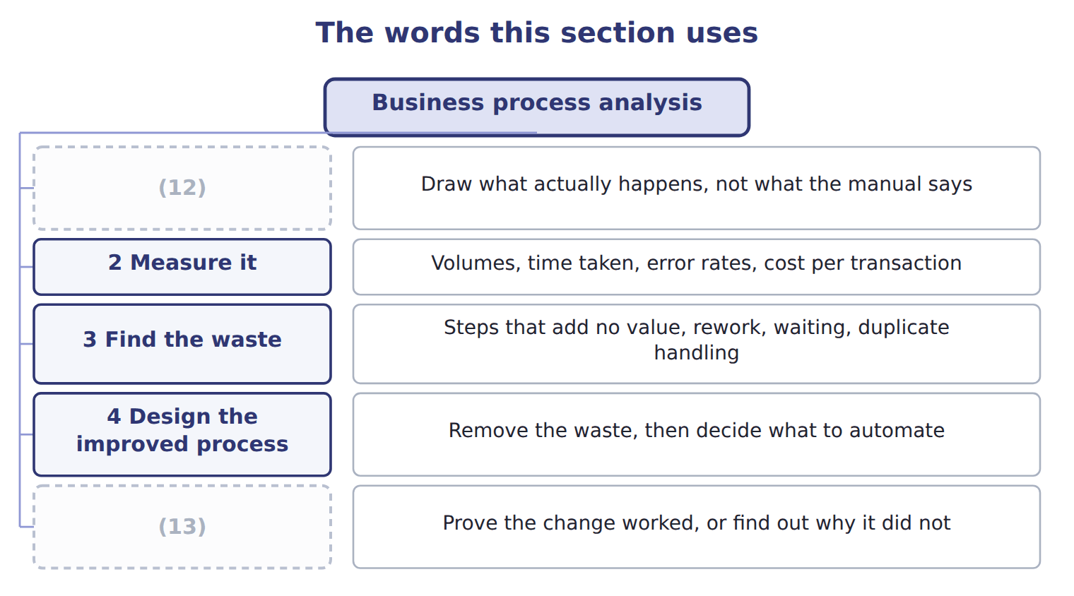
word list
5 Implement and measure again · 4 Design the improved process · 1 Map the current process

The English this sheet uses, and its Arabic
English (exam term) | Arabic
business process analysis | تحليل عمليات الأعمال

Answer key · 12.2 Business process analysis

1 1 Map the current process | 8 Automating
2 transaction | 9 handling
3 duplicate | 10 actually
4 automate | 11 routinely
5 5 Implement and measure again | 12 1 Map the current process
6 performance | 13 5 Implement and measure again
7 principle

the summaries in full
Summary 1 Its role in system performance rests on a single principle. Automating a bad process does not fix it: it makes the same errors faster and at greater volume, and makes them harder to see because nobody is handling them any more. The first step is where the work is. Mapping what actually happens, rather than what the manual says, routinely reveals steps that exist only because someone once needed them.

12.3 Robotic process automation
Chapter 12 · section 12.3

Fill every gap. Each word list holds one word more than there are gaps.
What robotic process automation does, and where it stops
Robotic process automation (F.3.c) | What it means | At Orontes
What it does | Software robots copy rule-based keyboard and mouse steps on structured data | (1)
Benefits | Speed, accuracy, operation outside working hours, a complete log of every action | (2)
No change to systems | It works through existing screens, so no integration project is needed | (3)
Limitation: brittleness | (4) | A vendor update breaks the invoice matching
Limitation: scope | Only stable, (5) , structured work; judgement defeats it | Deciding whether an unusual order is genuine
Control requirement | A robot needs its own identity, access rights and segregation | A robot that can both post and (6) is one person with two duties

word list
A three-hour reconciliation finished overnight · rule-based · Useful where an ERP cannot yet reach · Deciding whether an unusual order is genuine · Matching invoices to orders and flagging exceptions · A changed screen or report layout stops the robot · approve

Summary 1 gaps 7–14
Its (7) is that it needs no (8) project. Where an ERP cannot yet reach, or where two (9) must be joined and neither can be changed, a robot can do the keying that a person was doing, (10) and without error. The (11) point is the one most often (12) . A robot is a user: it needs its own (13) , its own access rights and its own place in the (14) of duties. A robot that can both post a transaction and approve it is one person holding two duties.
word list
appeal · identity · control · segregation · integration · description · missed · overnight · systems

A robot is not judgement

Summary 2 gaps 15–17
Robotic process (15) handles stable, rule-based work on structured data. If the task requires deciding whether something is (16) , it is outside the technique, however it is described. Adding artificial (17) to the description does not change what the robot itself does.
word list
intelligence · automation · reasonable · technique

The words this section uses
Each term sits against what it means.
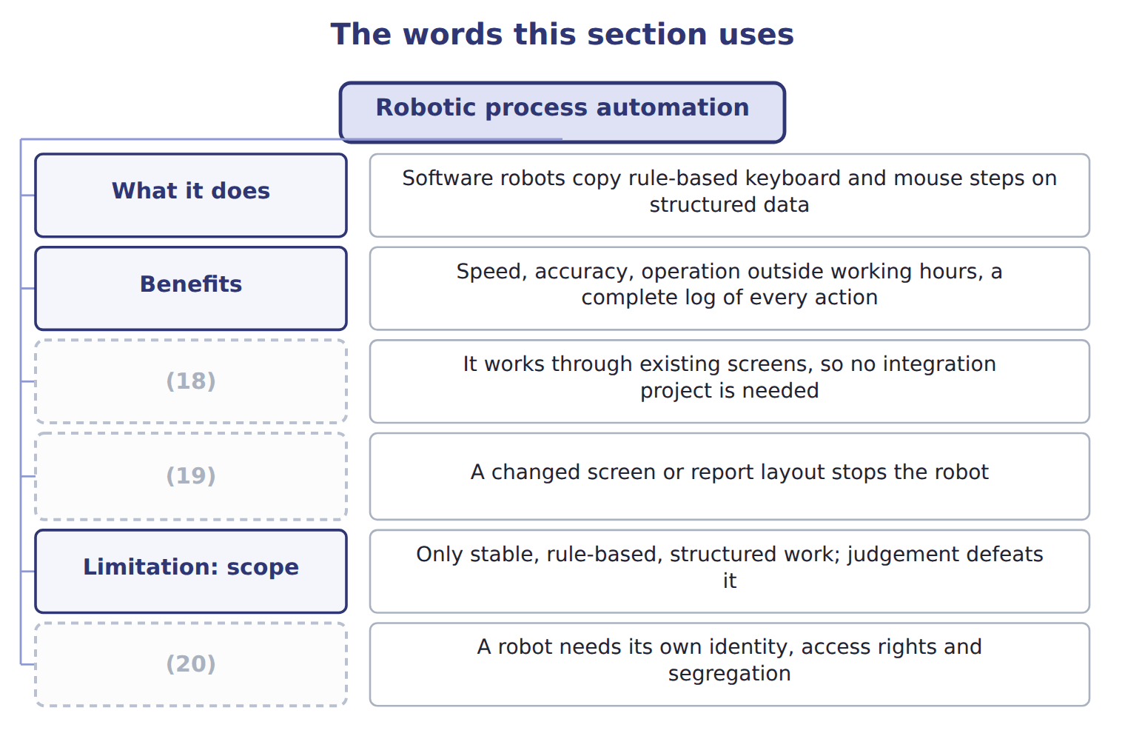
word list
business process analysis · Control requirement · No change to systems · Limitation: brittleness

The English this sheet uses, and its Arabic
English (exam term) | Arabic
robotic process automation (RPA) | الأتمتة الآلية للعمليات

Answer key · 12.3 Robotic process automation

1 Matching invoices to orders and flagging exceptions | 11 control
2 A three-hour reconciliation finished overnight | 12 missed
3 Useful where an ERP cannot yet reach | 13 identity
4 A changed screen or report layout stops the robot | 14 segregation
5 rule-based | 15 automation
6 approve | 16 reasonable
7 appeal | 17 intelligence
8 integration | 18 No change to systems
9 systems | 19 Limitation: brittleness
10 overnight | 20 Control requirement

the summaries in full
Summary 1 Its appeal is that it needs no integration project. Where an ERP cannot yet reach, or where two systems must be joined and neither can be changed, a robot can do the keying that a person was doing, overnight and without error. The control point is the one most often missed. A robot is a user: it needs its own identity, its own access rights and its own place in the segregation of duties. A robot that can both post a transaction and approve it is one person holding two duties.
Summary 2 Robotic process automation handles stable, rule-based work on structured data. If the task requires deciding whether something is reasonable, it is outside the technique, however it is described. Adding artificial intelligence to the description does not change what the robot itself does.

12.4 Cloud computing and software as a service
Chapter 12 · section 12.4

Fill every gap. Each word list holds one word more than there are gaps.
Summary 1 gaps 1–12
Cloud computing is (1) access to a shared pool of computing resources over a network. The (2) definition gives it five characteristics: self-service on demand, broad network access, resources pooled across (3) , rapid elasticity, and metered use. (4) comes from three of those characteristics. Metered use turns a capital purchase into an (5) cost paid only for what is (6) . Elasticity means (7) can rise for a peak and fall again. And self-service means a server is (8) in minutes rather than after a (9) cycle. Four deployment models cut across the three service models. A private cloud serves one (10) , a community cloud a group with shared (11) , a public cloud anyone who pays, and a hybrid combines them. The (12) the exam tests is simply that service models and deployment models are different questions.
word list
capacity · on-demand · concerns · recognised · customers · consumed · Efficiency · distinction · operating · resources · organization · procurement · available

Summary 2 gaps 13–15
Two (13) deserve weight. The company relies on the (14) controls rather than its own, which is why a report on those controls is normally obtained and read. And data (15) can matter legally:.
word list
community · provider's · residency · disadvantages

The advantages and disadvantages of software as a service
 | Advantage of SaaS | Disadvantage
Cost | No large purchase; pay as you use | (16)
Updates | The provider updates everything for everyone | (17)
Access | Reachable from anywhere with a connection | (18)
Scale | Add users or capacity on demand | (19)
Maintenance | (20) | You rely on the provider's controls, not your own
Data | (21) | Residency may breach local law; exit is costly

word list
Residency may breach local law; exit is costly · Costs scale up as readily as down · Stored and protected by the provider · You cannot refuse or defer an update you dislike · Recurring cost forever, which may exceed a purchase · The provider handles servers, patching and backup · Useless without the connection

The English this sheet uses, and its Arabic
English (exam term) | Arabic
cloud computing | الحوسبة السحابية
software as a service (SaaS) | البرمجيات كخدمة

Answer key · 12.4 Cloud computing and software as a service

1 on-demand | 12 distinction
2 recognised | 13 disadvantages
3 customers | 14 provider's
4 Efficiency | 15 residency
5 operating | 16 Recurring cost forever, which may exceed a purchase
6 consumed | 17 You cannot refuse or defer an update you dislike
7 capacity | 18 Useless without the connection
8 available | 19 Costs scale up as readily as down
9 procurement | 20 The provider handles servers, patching and backup
10 organization | 21 Stored and protected by the provider
11 concerns

the summaries in full
Summary 1 Cloud computing is on-demand access to a shared pool of computing resources over a network. The recognised definition gives it five characteristics: self-service on demand, broad network access, resources pooled across customers, rapid elasticity, and metered use. Efficiency comes from three of those characteristics. Metered use turns a capital purchase into an operating cost paid only for what is consumed. Elasticity means capacity can rise for a peak and fall again. And self-service means a server is available in minutes rather than after a procurement cycle. Four deployment models cut across the three service models. A private cloud serves one organization, a community cloud a group with shared concerns, a public cloud anyone who pays, and a hybrid combines them. The distinction the exam tests is simply that service models and deployment models are different questions.
Summary 2 Two disadvantages deserve weight. The company relies on the provider's controls rather than its own, which is why a report on those controls is normally obtained and read. And data residency can matter legally:.

12.5 Blockchain, distributed ledgers and smart contracts
Chapter 12 · section 12.5

Fill every gap. Each word list holds one word more than there are gaps.
Summary 1 gaps 1–4
A (1) is a distributed, append-only ledger of (2) linked blocks, agreed between participants by consensus rather than by a central authority. A distributed ledger is the wider class, and a smart (3) is code held on such a ledger that executes itself when its (4) are met.
word list
central · conditions · blockchain · contract · cryptographically

Blockchain terms and their status
Term (F.3.g) | What it means | Status as at October 2026
Blockchain | A distributed, append-only ledger of (5) linked blocks, agreed by consensus | Real, and narrow in use
Distributed ledger | The wider class, including ledgers where (6) is controlled | The form enterprises actually use
Smart contract | Code on a ledger that executes itself when (7) are met | Real, but only as reliable as its code
What did materialise | (8) and audit of crypto assets, tokenised funds, stablecoin payments, some trade finance and provenance | Narrower than predicted
What did not | Replacing accounting systems. The Australian exchange cancelled its blockchain settlement replacement in 2022 | A large and public failure
Triple-entry accounting | A proposal that a shared ledger entry replaces two sets of books | (9)

word list
conditions · Recognised by no standard-setter · Accounting · membership · business process analysis · cryptographically

Summary 2 gaps 10–20
Between 2018 and 2022 it was widely (10) that blockchain would (11) accounting systems. That did not (12) . The Australian securities exchange cancelled its blockchain settlement replacement in 2022 after large write-offs, and no (13) recognises (14) accounting. What did (15) is narrower: accounting and audit of crypto assets, tokenised funds, (16) payments, and some trade finance and provenance work. A candidate who can say what the (17) is and where it genuinely applies is better prepared than one who repeats the (18) . The exam asks you to recognise potential (19) , so know the (20) ones. Where several parties must share one record and do not fully trust each other, a distributed ledger has something to offer. Where one company keeps its own books, a database is simpler, faster and cheaper.
word list
replace · predicted · happen · securities · stablecoin · realistic · predictions · technology · materialise · applications · triple-entry · standard-setter

The words this section uses
Each term sits against what it means.
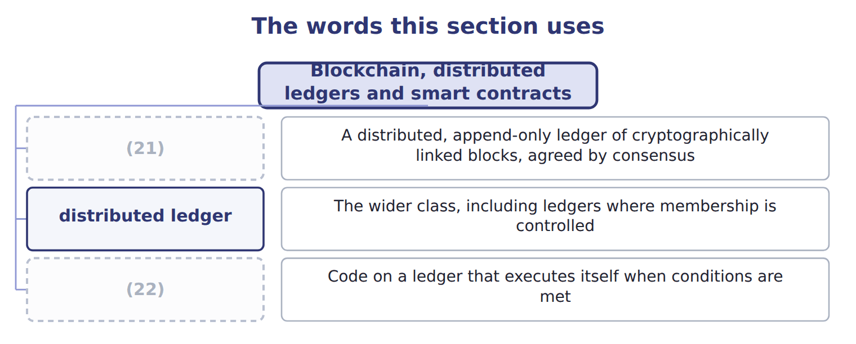
word list
smart contract · blockchain · conceptual design

The English this sheet uses, and its Arabic
English (exam term) | Arabic
blockchain | سلسلة الكتل
distributed ledger | السجل الموزع
smart contract | العقد الذكي

Answer key · 12.5 Blockchain, distributed ledgers and smart contracts

1 blockchain | 12 happen
2 cryptographically | 13 standard-setter
3 contract | 14 triple-entry
4 conditions | 15 materialise
5 cryptographically | 16 stablecoin
6 membership | 17 technology
7 conditions | 18 predictions
8 Accounting | 19 applications
9 Recognised by no standard-setter | 20 realistic
10 predicted | 21 blockchain
11 replace | 22 smart contract

the summaries in full
Summary 1 A blockchain is a distributed, append-only ledger of cryptographically linked blocks, agreed between participants by consensus rather than by a central authority. A distributed ledger is the wider class, and a smart contract is code held on such a ledger that executes itself when its conditions are met.
Summary 2 Between 2018 and 2022 it was widely predicted that blockchain would replace accounting systems. That did not happen. The Australian securities exchange cancelled its blockchain settlement replacement in 2022 after large write-offs, and no standard-setter recognises triple-entry accounting. What did materialise is narrower: accounting and audit of crypto assets, tokenised funds, stablecoin payments, and some trade finance and provenance work. A candidate who can say what the technology is and where it genuinely applies is better prepared than one who repeats the predictions. The exam asks you to recognise potential applications, so know the realistic ones. Where several parties must share one record and do not fully trust each other, a distributed ledger has something to offer. Where one company keeps its own books, a database is simpler, faster and cheaper.

12.6 Extended Example 12A: judging four proposals
Chapter 12 · section 12.6

Fill every gap. Each word list holds one word more than there are gaps.
Summary 1 gaps 1–12
F.3.d asks you to evaluate where a (1) would improve the (2) of accounting data. This example (3) four proposals put to the Orontes board, (4) two and refusing two. Three (5) settle most proposals. (6) payable spends three hours a day (7) invoices to orders and goods received notes. The work is (8) and the data is (9) , so a robot fits. It (10) speed and accuracy, and it creates one new (11) : the robot needs its own identity and must not also approve payment. The expenses system is small, standard and not a (12) advantage. A hosted service removes the maintenance and the upgrades. The risks are dependence on the provider and the location of the data, both manageable for expenses. Accept, after reading the provider's controls report and confirming where the data sits.
word list
improves · processing · technology · Accounts · accepting · matching · competitive · questions · structured · requirement · rule-based · judges · blockchain

Summary 2 gaps 13–21
A consultant proposes recording supplier balances on a (13) , to make them (14) . But Orontes keeps its own books, there is no group of mutually (15) parties needing one shared record, and the ERP database with proper access controls already prevents (16) alteration. Refuse: it (17) a problem the company does not have. The close takes (18) days, and the (19) is to automate it as it stands. The first (20) defeats it: the process includes two days (21) systems that the ERP has now merged, and a manual upload that no longer exists. Refuse for now, analyse the process, and automate what survives.
word list
tamper-evident · reconciling · undetected · answers · matching · distrustful · blockchain · proposal · question · eleven

Name four stages

Complete the blank cells.

Your turn: name four stages (complete the blanks)
Every item belongs to exactly one group.
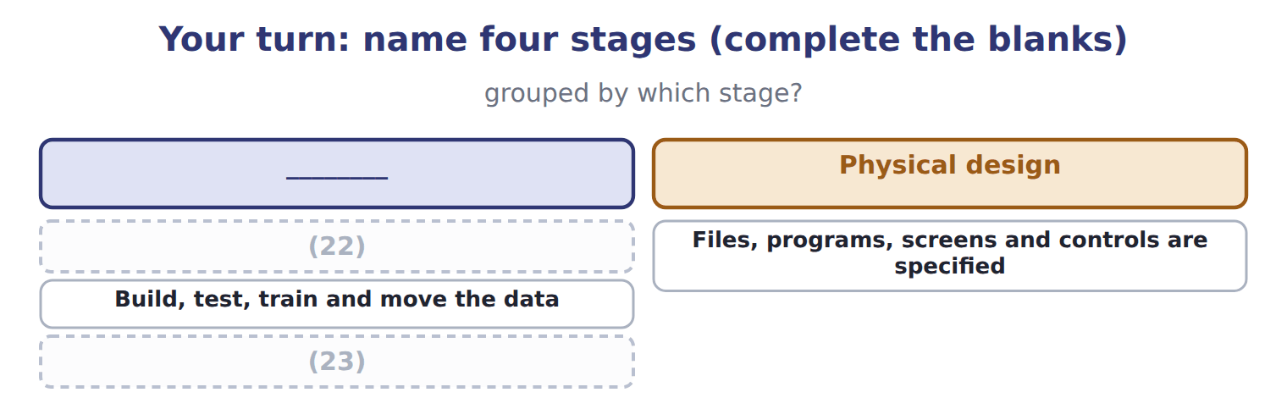
word list
Run it and change it as the business changes · What does the business need, and what happens now? · Build, test, train and move the data

The pattern behind the judgements

Summary 3 gaps 24–27
Ask what process changes before asking what technology is (24) . A technology that (25) a problem the company does not have is refused, however capable. (26) a process nobody has examined preserves its waste. Every acceptance carries a new control (27) ; name it at the time.
word list
Automating · requirement · proposed · automate · answers

Exam view

Summary 4 gaps 28–30
A Level C question gives a technology and a (28) and asks whether it helps. Name the process, the (29) gain and the new risk. An answer that (30) the technology in general, without naming the process it changes, earns nothing.
word list
praises · specific · situation · location

Exam view
Item | Answer
What does the business need, and what happens now? | Systems analysis — it establishes the need and the current position before any design begins
Files, programs, screens and controls are specified | Why: physical design settles how the system will do what (31) decided it should do
Build, test, train and move the data | Implementation and conversion — the point at which the system goes live
Run it and change it as the business changes | Operations and (32) — and what it reveals feeds the next systems analysis

word list
maintenance · Refuse · conceptual design

Proposal — Category
Every item belongs to exactly one group.
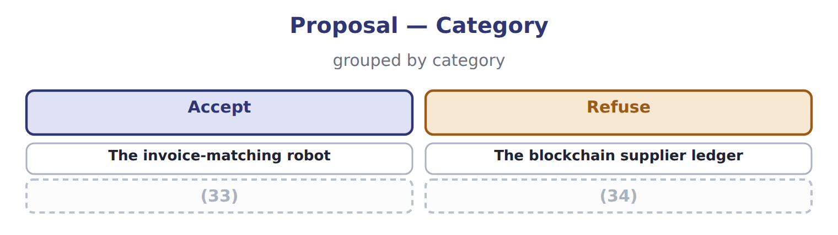
word list
The hosted expenses service · robotic process automation (RPA) · Automating the close as it stands

Answer key · 12.6 Extended Example 12A: judging four proposals

1 technology | 18 eleven
2 processing | 19 proposal
3 judges | 20 question
4 accepting | 21 reconciling
5 questions | 22 What does the business need, and what happens now?
6 Accounts | 23 Run it and change it as the business changes
7 matching | 24 proposed
8 rule-based | 25 answers
9 structured | 26 Automating
10 improves | 27 requirement
11 requirement | 28 situation
12 competitive | 29 specific
13 blockchain | 30 praises
14 tamper-evident | 31 conceptual design
15 distrustful | 32 maintenance
16 undetected | 33 The hosted expenses service
17 answers | 34 Automating the close as it stands

the summaries in full
Summary 1 F.3.d asks you to evaluate where a technology would improve the processing of accounting data. This example judges four proposals put to the Orontes board, accepting two and refusing two. Three questions settle most proposals. Accounts payable spends three hours a day matching invoices to orders and goods received notes. The work is rule-based and the data is structured, so a robot fits. It improves speed and accuracy, and it creates one new requirement: the robot needs its own identity and must not also approve payment. The expenses system is small, standard and not a competitive advantage. A hosted service removes the maintenance and the upgrades. The risks are dependence on the provider and the location of the data, both manageable for expenses. Accept, after reading the provider's controls report and confirming where the data sits.
Summary 2 A consultant proposes recording supplier balances on a blockchain, to make them tamper-evident. But Orontes keeps its own books, there is no group of mutually distrustful parties needing one shared record, and the ERP database with proper access controls already prevents undetected alteration. Refuse: it answers a problem the company does not have. The close takes eleven days, and the proposal is to automate it as it stands. The first question defeats it: the process includes two days reconciling systems that the ERP has now merged, and a manual upload that no longer exists. Refuse for now, analyse the process, and automate what survives.
Summary 3 Ask what process changes before asking what technology is proposed. A technology that answers a problem the company does not have is refused, however capable. Automating a process nobody has examined preserves its waste. Every acceptance carries a new control requirement; name it at the time.
Summary 4 A Level C question gives a technology and a situation and asks whether it helps. Name the process, the specific gain and the new risk. An answer that praises the technology in general, without naming the process it changes, earns nothing.

13.1 What makes data Big
Chapter 13 · section 13.1

Fill every gap. Each word list holds one word more than there are gaps.
Chapter 13, section by section
Each stage leads to the next.
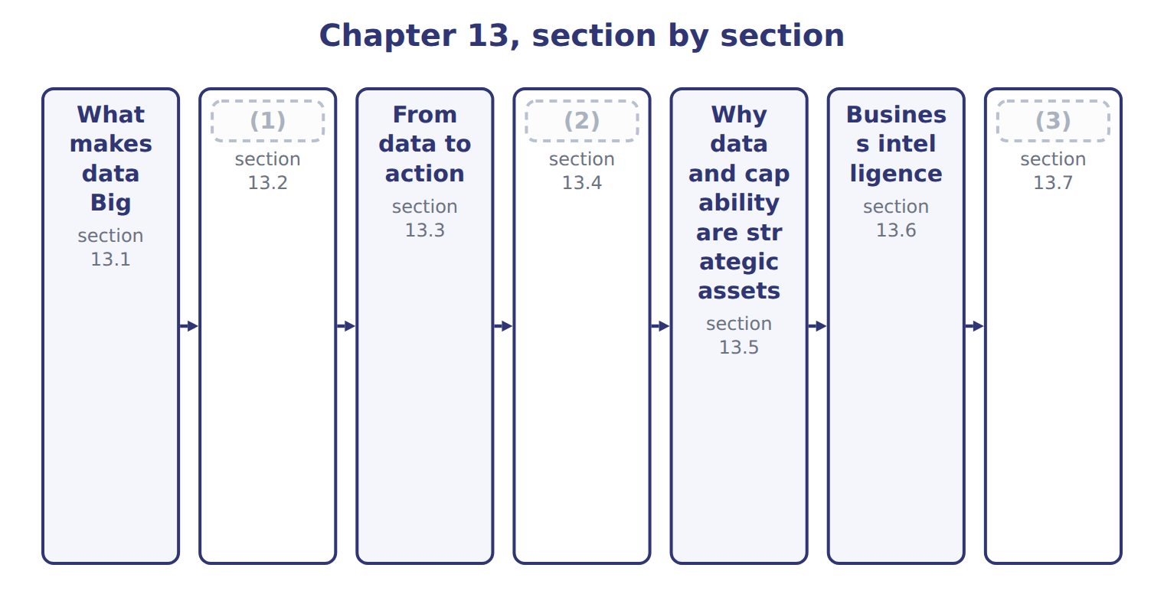
word list
business intelligence (BI) · Structured, semi-structured and unstructured d · Opportunities and challenges · Extended Example 13A: one number becomes a dec

Summary 1 gaps 4–12
Big Data is data whose volume, speed or variety puts it beyond what (4) tools were built to (5) . Many (6) add a fifth V, value, and some add (7) . The (8) outcome names four: volume, (9) , variety and veracity. Answer with four unless a (10) gives you a (11) list to work. Veracity is the one that matters most to an (12) , and the one most often skipped. It asks whether the data can be trusted, and: one distributor recorded under three spellings, fourteen orders with no delivery date. Volume without veracity produces confident answers that are wrong.
word list
different · accountant · guides · question · velocity · traditional · produces · handle · others · official

The English this sheet uses, and its Arabic
English (exam term) | Arabic
Big Data | البيانات الضخمة
veracity | الموثوقية

Answer key · 13.1 What makes data Big

1 Structured, semi-structured and unstructured d | 7 others
2 Opportunities and challenges | 8 official
3 Extended Example 13A: one number becomes a dec | 9 velocity
4 traditional | 10 question
5 handle | 11 different
6 guides | 12 accountant

the summaries in full
Summary 1 Big Data is data whose volume, speed or variety puts it beyond what traditional tools were built to handle. Many guides add a fifth V, value, and some add others. The official outcome names four: volume, velocity, variety and veracity. Answer with four unless a question gives you a different list to work. Veracity is the one that matters most to an accountant, and the one most often skipped. It asks whether the data can be trusted, and: one distributor recorded under three spellings, fourteen orders with no delivery date. Volume without veracity produces confident answers that are wrong.

13.2 Structured, semi-structured and unstructured data
Chapter 13 · section 13.2

Fill every gap. Each word list holds one word more than there are gaps.
Variety is easier to grasp once the three kinds are named.
Structured, semi-structured and unstructured data
Kind of data (F.4.b) | What it means | At Orontes | How it is used
Structured | Fits rows and columns with a fixed meaning | (1) | Queried directly; the easiest to analyse
Semi-structured | Carries tags or keys but no rigid table | A supplier's electronic invoice file | (2)
Unstructured | (3) | Customer emails, photographs of damaged pallets, call recordings | The largest share, and the hardest to use

word list
A supplier's electronic invoice file · No predefined form at all · Readable by machine once the tags are understood · The order table of Chapter 10

Summary 1 gaps 4–11
Structured data is what: rows and (4) with a fixed meaning, which a query can read (5) . It is the (6) of what a company holds and the (7) majority of what it analyses, for the simple reason that it is the easiest to use. (8) data is the opposite and the larger share: emails, (9) , recordings, free text. A photograph of a damaged pallet contains (10) no table holds, and (11) it has until recently needed a person. That is what has changed, and it is why variety now appears beside volume.
word list
minority · directly · photographs · overwhelming · columns · information · extracting · majority · Unstructured

The words this section uses
Each term sits against what it means.
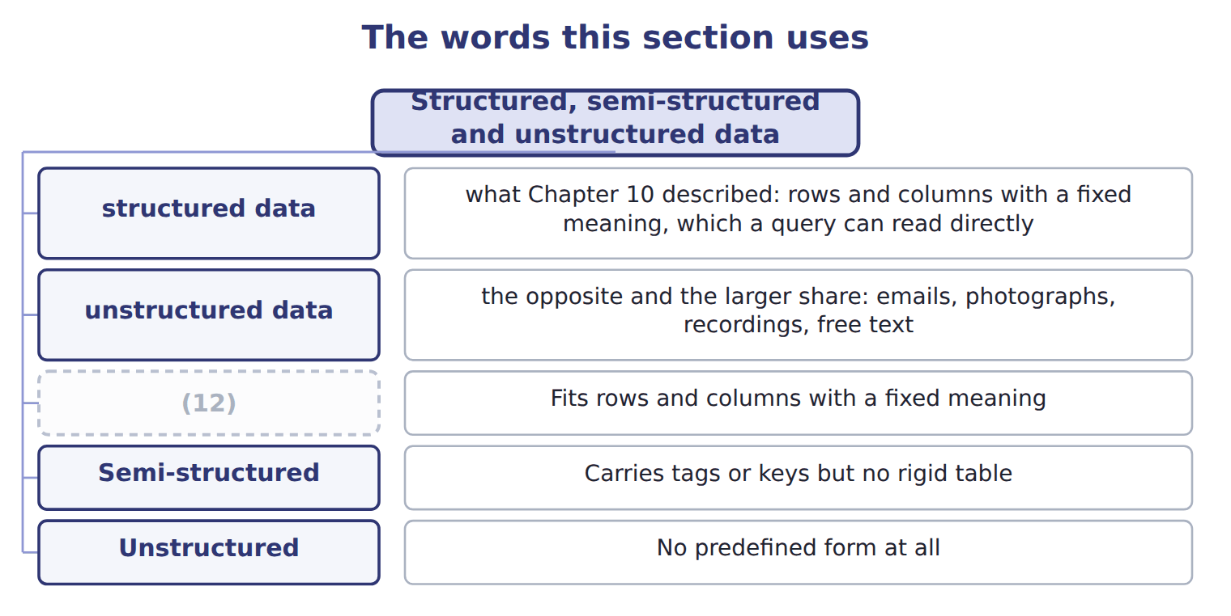
word list
veracity · Structured

The English this sheet uses, and its Arabic
English (exam term) | Arabic
structured data | البيانات المهيكلة
semi-structured data | البيانات شبه المهيكلة
unstructured data | البيانات غير المهيكلة

Answer key · 13.2 Structured, semi-structured and unstructured data

1 The order table of Chapter 10 | 7 overwhelming
2 Readable by machine once the tags are understood | 8 Unstructured
3 No predefined form at all | 9 photographs
4 columns | 10 information
5 directly | 11 extracting
6 minority | 12 Structured

the summaries in full
Summary 1 Structured data is what: rows and columns with a fixed meaning, which a query can read directly. It is the minority of what a company holds and the overwhelming majority of what it analyses, for the simple reason that it is the easiest to use. Unstructured data is the opposite and the larger share: emails, photographs, recordings, free text. A photograph of a damaged pallet contains information no table holds, and extracting it has until recently needed a person. That is what has changed, and it is why variety now appears beside volume.

13.3 From data to action
Chapter 13 · section 13.3

Fill every gap. Each word list holds one word more than there are gaps.
Summary 1 gaps 1–8
Data by itself (1) nothing. Read it upward and the (2) are clear. (3) needs insight into why a pattern holds; insight needs the knowledge that a pattern (4) ; knowledge needs enough information to see across cases; and information is a fact placed in (5) . Each step is worth more than the one below it, and none can be (6) . The step companies stop at is knowledge. Knowing that the third quarter is always the peak is useful, but it does not say whether to (7) the extra shift to the (8) or to the weather.
word list
skipped · schedule · context · dependencies · exists · calendar · decides · pattern · Action

The English this sheet uses, and its Arabic
English (exam term) | Arabic
insight | البصيرة التحليلية

Answer key · 13.3 From data to action

1 decides | 5 context
2 dependencies | 6 skipped
3 Action | 7 schedule
4 exists | 8 calendar

the summaries in full
Summary 1 Data by itself decides nothing. Read it upward and the dependencies are clear. Action needs insight into why a pattern holds; insight needs the knowledge that a pattern exists; knowledge needs enough information to see across cases; and information is a fact placed in context. Each step is worth more than the one below it, and none can be skipped. The step companies stop at is knowledge. Knowing that the third quarter is always the peak is useful, but it does not say whether to schedule the extra shift to the calendar or to the weather.

13.4 Opportunities and challenges
Chapter 13 · section 13.4

Fill every gap. Each word list holds one word more than there are gaps.
Summary 1 gaps 1–8
The last row deserves (1) because it (2) as data grows. With enough (3) , patterns appear by chance alone: two series that happen to move together, with no (4) between them. More data finds more such patterns, not fewer, and only (5) about what could (6) cause what separates them from real findings. The (7) that defeats most (8) , though, is the ordinary one in the fifth row. An insight that reaches nobody with the authority to act changes nothing, and the cost of producing it has been spent.
word list
variables · judgement · attention · challenge · worsens · plausibly · projects · connection · producing

Opportunities and their matching challenges
 | Opportunity (F.4.a, F.4.d) | Matching challenge
Better decisions | Patterns too large or too fast for a person to see | (9) : an answer from poor data is still poor
Speed | Answers while there is still time to act | (10) : the people who can do this are scarce and expensive
New questions | Questions nobody could previously afford to ask | (11) : storage, tools and time add up before any benefit
Customer understanding | Behaviour across every channel, not just sales | (12) : Chapter 11's obligations still apply
Operational insight | (13) | Acting on it: an insight nobody acts on changes nothing
Competitive position | Capability competitors cannot quickly copy | (14) : more data means more false findings

word list
Skills · Capability competitors cannot quickly copy · Spurious patterns · Privacy and law · Sensor and process data alongside financial data · Cost · Data quality

Answer key · 13.4 Opportunities and challenges

1 attention | 8 projects
2 worsens | 9 Data quality
3 variables | 10 Skills
4 connection | 11 Cost
5 judgement | 12 Privacy and law
6 plausibly | 13 Sensor and process data alongside financial data
7 challenge | 14 Spurious patterns

the summaries in full
Summary 1 The last row deserves attention because it worsens as data grows. With enough variables, patterns appear by chance alone: two series that happen to move together, with no connection between them. More data finds more such patterns, not fewer, and only judgement about what could plausibly cause what separates them from real findings. The challenge that defeats most projects, though, is the ordinary one in the fifth row. An insight that reaches nobody with the authority to act changes nothing, and the cost of producing it has been spent.

13.5 Why data and capability are strategic assets
Chapter 13 · section 13.5

Fill every gap. Each word list holds one word more than there are gaps.
Why data and capability are strategic assets
Why data is a strategic asset (F.4.e) | What it means | At Orontes
It is hard to copy | A competitor can buy the same software but not your history | (1)
It compounds | (2) | Seasonality is clearer with three years than with one
It is specific to you | Your data describes your customers and your processes | (3)
The capability matters more | Data without people who can use it earns nothing | (4)
It enables, not decides | It improves the odds; management still chooses | (5)

word list
The Gulf decision of Book 3 remains a judgement · Each year of data makes the next analysis better · Three years of Gulf order patterns · The analyst who knows which question to ask · Data without people who can use it earns nothing · Nobody else holds the Orontes plant records

Summary 1 gaps 6–13
The (6) row carries the (7) . A (8) can buy the same software tomorrow, and could in (9) buy similar data. What cannot be bought quickly is the data science (10) : people who know which (11) is worth asking, which answer is suspect, and how to say so to a board. The last row is the honest (12) . Data (13) the odds of a good decision; it does not make the decision. Book 3's Gulf expansion rested on figures but remained a judgement about risk and ambition, and no quantity of data would have removed.
word list
argument · question · principle · improves · fourth · capability · qualification · similar · competitor

The words this section uses
Each term sits against what it means.
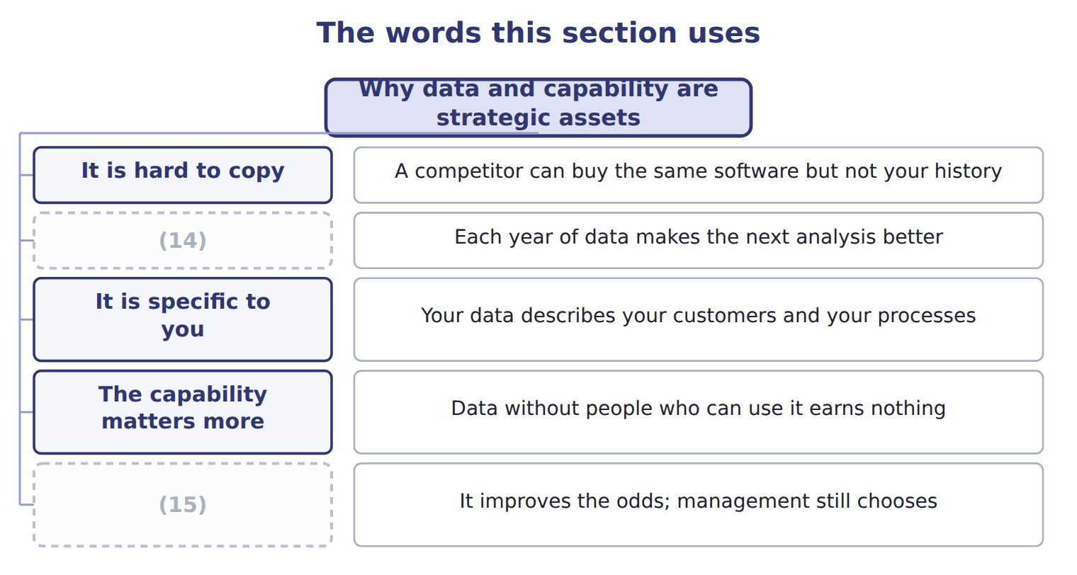
word list
unstructured data · It enables, not decides · It compounds

The English this sheet uses, and its Arabic
English (exam term) | Arabic
data science capability | القدرة على علم البيانات

Answer key · 13.5 Why data and capability are strategic assets

1 Three years of Gulf order patterns | 9 principle
2 Each year of data makes the next analysis better | 10 capability
3 Nobody else holds the Orontes plant records | 11 question
4 The analyst who knows which question to ask | 12 qualification
5 The Gulf decision of Book 3 remains a judgement | 13 improves
6 fourth | 14 It compounds
7 argument | 15 It enables, not decides
8 competitor

the summaries in full
Summary 1 The fourth row carries the argument. A competitor can buy the same software tomorrow, and could in principle buy similar data. What cannot be bought quickly is the data science capability: people who know which question is worth asking, which answer is suspect, and how to say so to a board. The last row is the honest qualification. Data improves the odds of a good decision; it does not make the decision. Book 3's Gulf expansion rested on figures but remained a judgement about risk and ambition, and no quantity of data would have removed.

13.6 Business intelligence
Chapter 13 · section 13.6

Fill every gap. Each word list holds one word more than there are gaps.
What business intelligence covers
Business intelligence (F.4.f) | What it covers | At Orontes
Applications | The software people actually use to ask questions | (1)
Tools | (2) | The warehouse and loading of Chapter 10
Best practices | (3) | Agreed definitions, one version of each measure
Purpose | Turning data into information that can be acted on | (4)
What it is not | (5) | Analytics is a technique; BI is the whole arrangement

word list
How the work is organised so answers can be trusted · What moves and prepares the data behind them · A synonym for analytics or for a dashboard · Not a report, but a decision · Dashboards and reporting tools · Agreed definitions, one version of each measure

Summary 1 gaps 6–9
The third (6) is the one that is (7) missing. (8) and tools can be bought; agreed (9) cannot. If two dashboards show different figures for the same measure because nobody settled what it means, the arrangement has failed however good the software is.
word list
usually · veracity · Applications · definitions · element

Business intelligence is not a dashboard

Summary 2 gaps 10–15
A dashboard is one (10) within business intelligence. The term covers the whole (11) : the applications, the tools that feed them, and the practices that make the numbers (12) . A (13) equating the two has (14) it too far. Business intelligence looks (15) and sideways: what happened, where, and compared with. Part IV goes further, into what will happen and what should be done, which is the distinction between the four types of analytics.
word list
between · backward · arrangement · application · narrowed · trustworthy · question

The words this section uses
Each term sits against what it means.
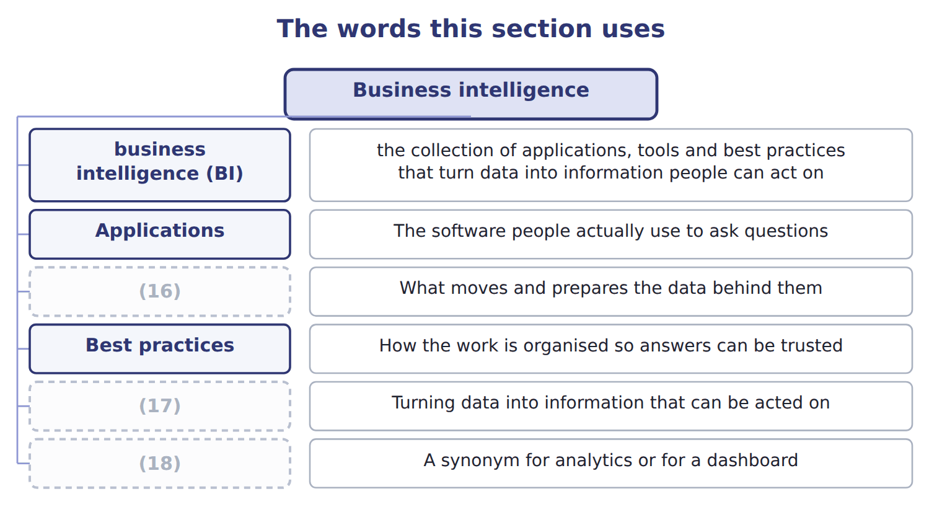
word list
Purpose · Big Data · Tools · What it is not

The English this sheet uses, and its Arabic
English (exam term) | Arabic
business intelligence (BI) | ذكاء الأعمال

Answer key · 13.6 Business intelligence

1 Dashboards and reporting tools | 10 application
2 What moves and prepares the data behind them | 11 arrangement
3 How the work is organised so answers can be trusted | 12 trustworthy
4 Not a report, but a decision | 13 question
5 A synonym for analytics or for a dashboard | 14 narrowed
6 element | 15 backward
7 usually | 16 Tools
8 Applications | 17 Purpose
9 definitions | 18 What it is not

the summaries in full
Summary 1 The third element is the one that is usually missing. Applications and tools can be bought; agreed definitions cannot. If two dashboards show different figures for the same measure because nobody settled what it means, the arrangement has failed however good the software is.
Summary 2 A dashboard is one application within business intelligence. The term covers the whole arrangement: the applications, the tools that feed them, and the practices that make the numbers trustworthy. A question equating the two has narrowed it too far. Business intelligence looks backward and sideways: what happened, where, and compared with. Part IV goes further, into what will happen and what should be done, which is the distinction between the four types of analytics.

13.7 Extended Example 13A: one number becomes a decision
Chapter 13 · section 13.7

Fill every gap. Each word list holds one word more than there are gaps.
Summary 1 gaps 1–12
This example takes a single (1) figure and walks it up the (2) to an action. It is (3) , because the exam gives a statement and asks which step it (4) . The (5) is 240,000. On its own it means (6) at all: it could be cases, dinars, (7) or an account code. Place it in context and it becomes (8) : 240,000 cases sold in 2028 Q3. Now it can be compared with (9) , which is the whole (10) of context. Set it beside the other (11) and a pattern (12) . The third quarter is the peak in both years, at 240,400 cases in 2027 and 240,000 in 2028. That is knowledge: a regularity across cases rather than a single fact. Knowledge says what happens; insight says why. The third quarter is also the hottest, at 34 degrees against 15 in the first.
word list
something · decision · kilometres · progression · appears · Beverages · purpose · represents · quarters · exam-core · number · information · nothing

Summary 2 gaps 13–20
The (13) follows from the insight, not from the pattern. If the peak follows the weather rather than the promotion calendar, the extra shift should be (14) to forecast (15) , and promotion spending in the hottest weeks may be buying demand that would have arrived anyway. (16) up to insight is analysis and can be (17) . The action requires somebody with the (18) to change the shift pattern, and willing to accept an analyst's finding over a (19) assumption. That is the (20) the fourth row describes, and it is not bought with software.
word list
long-standing · delegated · scheduled · capability · becomes · temperature · decision · Everything · authority

Name four characteristics

Complete the blank cells.

Your turn: name four characteristics (complete the blanks)
Every item belongs to exactly one group.
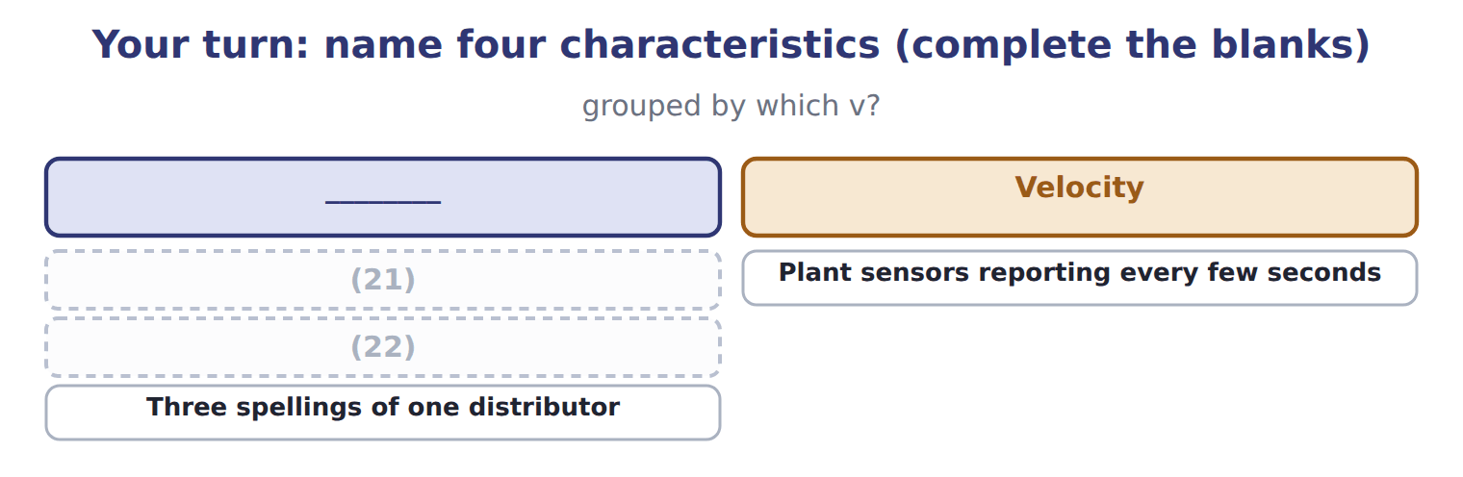
word list
Numbers, emails and photographs together · Plant sensors reporting every few seconds · Millions of order lines held over three years

The pattern behind the progression

Summary 3 gaps 23–26
A fact alone is data; a fact in context is (23) . A regularity across cases is knowledge; an (24) of it is insight. Only insight (25) an action, because only insight says why. Most (26) stop at knowledge and act on the calendar instead.
word list
information · appears · supports · explanation · organizations

Exam view

Summary 4 gaps 27–29
A question gives a (27) and asks which step it is. Test it: is it a bare fact, a fact with context, a pattern, an (28) , or a decision? The commonest error is calling a pattern an (29) .
word list
explanation · willing · statement · insight

Exam view
Item | Answer
Millions of order lines held over three years | Volume — it describes how much data there is
Plant sensors reporting every few seconds | Why: velocity describes how fast data arrives, and sensor data arrives far faster than monthly reporting
Numbers, emails and photographs together | Variety — it describes how many different kinds of data are involved
Three spellings of one distributor | (30)

word list
Veracity — it describes how far the data can be trusted · Variety — it describes how many different kinds of data are involved

Statement from the case — Category
Statement from the case | Category
240,000 | (31)
240,000 cases in the third quarter | (32)
The third quarter is the peak every year | Knowledge
The peak follows temperature rather than the promotion calendar | Insight

word list
Knowledge · Information · Data

Answer key · 13.7 Extended Example 13A: one number becomes a decision

1 Beverages | 17 delegated
2 progression | 18 authority
3 exam-core | 19 long-standing
4 represents | 20 capability
5 number | 21 Millions of order lines held over three years
6 nothing | 22 Numbers, emails and photographs together
7 kilometres | 23 information
8 information | 24 explanation
9 something | 25 supports
10 purpose | 26 organizations
11 quarters | 27 statement
12 appears | 28 explanation
13 decision | 29 insight
14 scheduled | 30 Veracity — it describes how far the data can be trusted
15 temperature | 31 Data
16 Everything | 32 Information

the summaries in full
Summary 1 This example takes a single Beverages figure and walks it up the progression to an action. It is exam-core, because the exam gives a statement and asks which step it represents. The number is 240,000. On its own it means nothing at all: it could be cases, dinars, kilometres or an account code. Place it in context and it becomes information: 240,000 cases sold in 2028 Q3. Now it can be compared with something, which is the whole purpose of context. Set it beside the other quarters and a pattern appears. The third quarter is the peak in both years, at 240,400 cases in 2027 and 240,000 in 2028. That is knowledge: a regularity across cases rather than a single fact. Knowledge says what happens; insight says why. The third quarter is also the hottest, at 34 degrees against 15 in the first.
Summary 2 The decision follows from the insight, not from the pattern. If the peak follows the weather rather than the promotion calendar, the extra shift should be scheduled to forecast temperature, and promotion spending in the hottest weeks may be buying demand that would have arrived anyway. Everything up to insight is analysis and can be delegated. The action requires somebody with the authority to change the shift pattern, and willing to accept an analyst's finding over a long-standing assumption. That is the capability the fourth row describes, and it is not bought with software.
Summary 3 A fact alone is data; a fact in context is information. A regularity across cases is knowledge; an explanation of it is insight. Only insight supports an action, because only insight says why. Most organizations stop at knowledge and act on the calendar instead.
Summary 4 A question gives a statement and asks which step it is. Test it: is it a bare fact, a fact with context, a pattern, an explanation, or a decision? The commonest error is calling a pattern an insight.

14.1 What data mining is
Chapter 14 · section 14.1

Fill every gap. Each word list holds one word more than there are gaps.
Chapter 14, section by section
Each stage leads to the next.
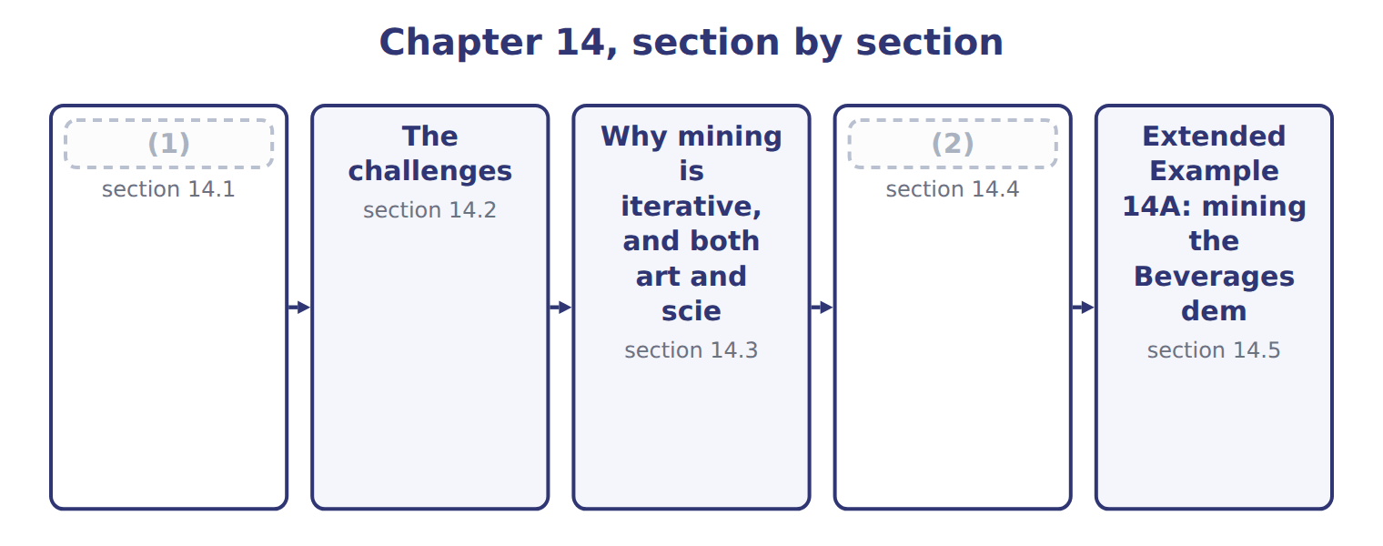
word list
What data mining is · section 14.1 · Structured Query Language

Summary 1 gaps 3–6
Data mining is the search (3) data for patterns, (4) and anomalies that were not known in advance. The last part of that definition (5) it from reporting. A report answers a (6) somebody already had; mining looks for what nobody thought to ask.
word list
relationships · through · distinguishes · technique · question

What data mining looks for, and what it does not deliver
What data mining looks for (F.4.g) | What it means | At Orontes
Patterns | Regularities that repeat across cases | (7)
Relationships | (8) | Cases sold against mean temperature
Anomalies | (9) | Two orders a hundred times the usual size
Groupings | (10) | Distributors that order like each other
Not: proof of cause | Mining finds association, not causation | (11)

word list
Natural clusters within the data · Heat and demand move together; the data cannot say why · Variables that move together · Two orders a hundred times the usual size · Cases that do not fit the pattern · Third-quarter demand rises every year

Summary 2 gaps 12–15
Mining finds (12) , meaning that two things occur together. It cannot by itself (13) that one causes the other. That (14) is not a weakness of the technique but of the data. Causation is established by reasoning about mechanism, or by an (15) , and a dataset of past orders contains neither.
word list
limitation · association · establish · answers · experiment

The words this section uses
Each term sits against what it means.
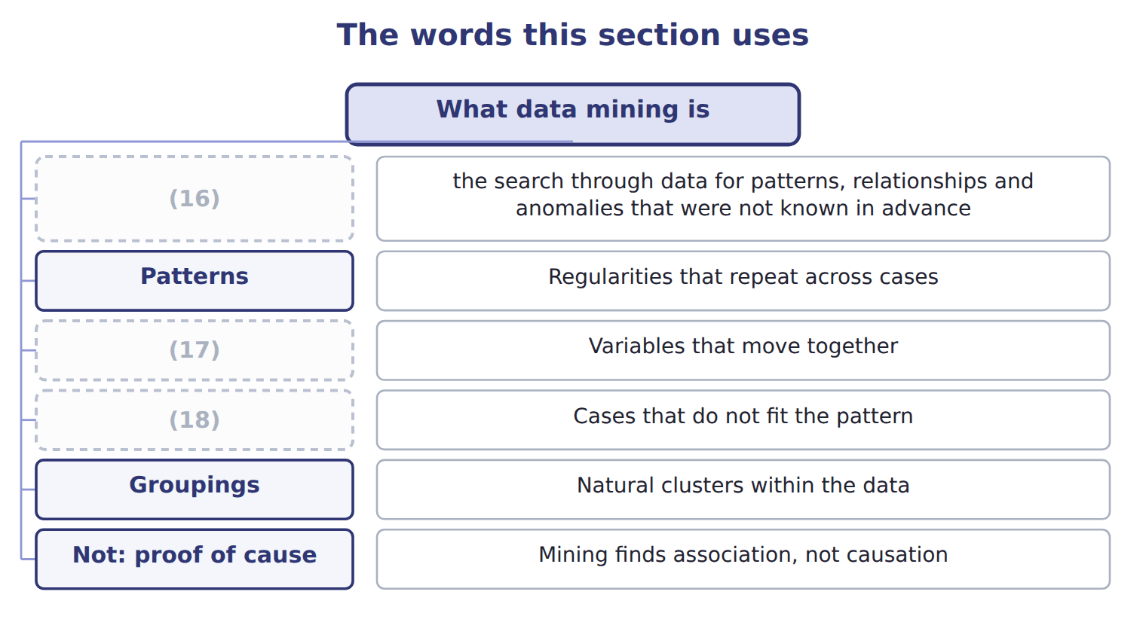
word list
Patterns · data mining · Relationships · Anomalies

The English this sheet uses, and its Arabic
English (exam term) | Arabic
data mining | التنقيب في البيانات
association | الارتباط

Answer key · 14.1 What data mining is

1 What data mining is | 10 Natural clusters within the data
2 Structured Query Language | 11 Heat and demand move together; the data cannot say why
3 through | 12 association
4 relationships | 13 establish
5 distinguishes | 14 limitation
6 question | 15 experiment
7 Third-quarter demand rises every year | 16 data mining
8 Variables that move together | 17 Relationships
9 Cases that do not fit the pattern | 18 Anomalies

the summaries in full
Summary 1 Data mining is the search through data for patterns, relationships and anomalies that were not known in advance. The last part of that definition distinguishes it from reporting. A report answers a question somebody already had; mining looks for what nobody thought to ask.
Summary 2 Mining finds association, meaning that two things occur together. It cannot by itself establish that one causes the other. That limitation is not a weakness of the technique but of the data. Causation is established by reasoning about mechanism, or by an experiment, and a dataset of past orders contains neither.

14.2 The challenges
Chapter 14 · section 14.2

Fill every gap. Each word list holds one word more than there are gaps.
The challenges of data mining
Challenge (F.4.h) | Why it is hard | At Orontes
Data quality | Poor data yields a confident wrong answer | (1)
Size and cost | (2) | Three years of order lines across three systems
Privacy and law | (3) | Jordan's law, applied since 2025
Spurious findings | (4) | Cases against staff birthdays
Overfitting | A model that fits this data (5) may predict nothing | Chapter 16 returns to this
Knowing when to stop | (6) | Two weeks of analysis for a decision due Friday

word list
perfectly · Chapter 11's three spellings and missing dates · There is always another cut of the data · Large datasets need storage, tools and time · More variables mean more coincidences · Three years of order lines across three systems · Personal data constrains what may be held and used

Summary 1 gaps 7–12
The first (7) the largest. (8) routinely consumes most of the effort in a mining project. The last is the one (9) warns about. There is always another cut of the data, another (10) to add, another period to extend. An analysis still (11) when the decision is taken has failed as surely as one that was wrong. (12) when the answer is good enough is a skill rather than a rule.
word list
Preparation · remains · routinely · improving · variable · nobody · Knowing

Answer key · 14.2 The challenges

1 Chapter 11's three spellings and missing dates | 7 remains
2 Large datasets need storage, tools and time | 8 Preparation
3 Personal data constrains what may be held and used | 9 nobody
4 More variables mean more coincidences | 10 variable
5 perfectly | 11 improving
6 There is always another cut of the data | 12 Knowing

the summaries in full
Summary 1 The first remains the largest. Preparation routinely consumes most of the effort in a mining project. The last is the one nobody warns about. There is always another cut of the data, another variable to add, another period to extend. An analysis still improving when the decision is taken has failed as surely as one that was wrong. Knowing when the answer is good enough is a skill rather than a rule.

14.3 Why mining is iterative, and both art and science
Chapter 14 · section 14.3

Fill every gap. Each word list holds one word more than there are gaps.
Summary 1 gaps 1–6
It is drawn with return arrows (1) it is never a (2) line. A failed (3) sends the analyst back to the model, to the (4) , or to the question itself. That (5) more than once in any real (6) . A first model that disappoints is the normal case, not a failure of competence. The phrase art and science describes the same cycle from a different angle.
word list
straight · evaluation · disappoints · project · happens · because · preparation

Which parts of the work are art and which are science
Every item belongs to exactly one group.
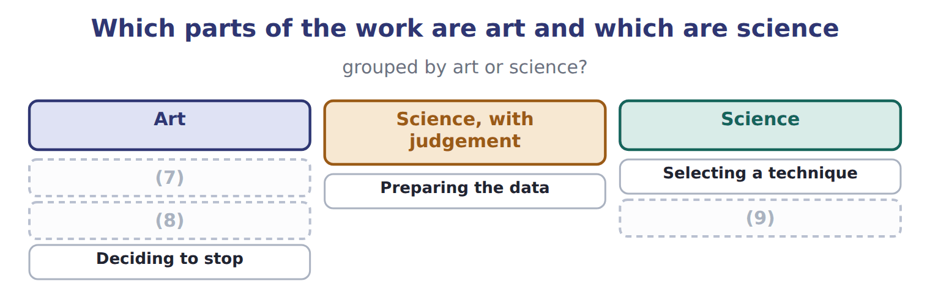
word list
Reading the result · Choosing the question · Testing the result · Preparing the data

Summary 2 gaps 10–14
The (10) is the part that can be (11) down. It covers how to (12) data, which (13) suits which question, and how to test a result. The art is (14) the method cannot settle, and the two that matter most sit at the ends. Choosing a question that would actually change a decision is judgement, and so is deciding that the work is finished.
word list
science · because · everything · written · prepare · technique

The English this sheet uses, and its Arabic
English (exam term) | Arabic
iterative process | العملية التكرارية

Answer key · 14.3 Why mining is iterative, and both art and science

1 because | 8 Reading the result
2 straight | 9 Testing the result
3 evaluation | 10 science
4 preparation | 11 written
5 happens | 12 prepare
6 project | 13 technique
7 Choosing the question | 14 everything

the summaries in full
Summary 1 It is drawn with return arrows because it is never a straight line. A failed evaluation sends the analyst back to the model, to the preparation, or to the question itself. That happens more than once in any real project. A first model that disappoints is the normal case, not a failure of competence. The phrase art and science describes the same cycle from a different angle.
Summary 2 The science is the part that can be written down. It covers how to prepare data, which technique suits which question, and how to test a result. The art is everything the method cannot settle, and the two that matter most sit at the ends. Choosing a question that would actually change a decision is judgement, and so is deciding that the work is finished.

14.4 Structured Query Language
Chapter 14 · section 14.4

Fill every gap. Each word list holds one word more than there are gaps.
Summary 1 gaps 1–10
Structured Query Language (SQL), usually called SQL, is the (1) language for asking a relational (2) for data and for changing what it holds. Read it as six (3) in order. Which (4) do I want, from which table, linked to what, keeping which rows, (5) how, and sorted how. A (6) is the clause that earns the relational design: without the shared key, the orders and the (7) could not be read together at all. A (8) accountant is not expected to write (9) queries. The (10) is to know what SQL is for and to read a simple query. It also includes seeing why an answer depends on which rows were kept and which were not.
word list
customers · database · management · questions · summarised · expectation · production · join · querying · standard · columns

The filter decides the answer

Summary 2 gaps 11–13
Two analysts querying the same table can report (11) totals if one keeps (12) orders and the other does not. When a figure is (13) , the first question is what the query filtered out, not whether the data is wrong.
word list
columns · disputed · different · cancelled

The English this sheet uses, and its Arabic
English (exam term) | Arabic
Structured Query Language (SQL) | لغة الاستعلام الهيكلية
join | الربط

Answer key · 14.4 Structured Query Language

1 standard | 8 management
2 database | 9 production
3 questions | 10 expectation
4 columns | 11 different
5 summarised | 12 cancelled
6 join | 13 disputed
7 customers

the summaries in full
Summary 1 Structured Query Language (SQL), usually called SQL, is the standard language for asking a relational database for data and for changing what it holds. Read it as six questions in order. Which columns do I want, from which table, linked to what, keeping which rows, summarised how, and sorted how. A join is the clause that earns the relational design: without the shared key, the orders and the customers could not be read together at all. A management accountant is not expected to write production queries. The expectation is to know what SQL is for and to read a simple query. It also includes seeing why an answer depends on which rows were kept and which were not.
Summary 2 Two analysts querying the same table can report different totals if one keeps cancelled orders and the other does not. When a figure is disputed, the first question is what the query filtered out, not whether the data is wrong.

14.5 Extended Example 14A: mining the Beverages demand data
Chapter 14 · section 14.5

Fill every gap. Each word list holds one word more than there are gaps.
Summary 1 gaps 1–12
F.4.k asks how an analyst would (1) mine a dataset. This example does it, on the (2) data. The cycle is the (3) this example (4) , step by step. The question is whether the extra (5) shift should be (6) to the promotion calendar, as now, or to something else. That is a question worth asking, (7) the answer would change a (8) taken every quarter. There are 8 quarters of (9) : cases sold, average price, mean (10) and promotion weeks. Eight (11) is few, and the analyst should say so now rather than (12) it later. The preparation is: consolidate the sources, clean what is wrong, transform dates into quarters, and reduce to the columns the question needs. Nothing here is new, and it is where most of the time goes. A first query ranks the quarters by cases.
word list
scheduled · history · temperature · follows · decision · observations · Beverages · promotion · because · structure · production · actually · discover

Summary 2 gaps 13–24
The peak quarters are the third of each year, at 240,400 cases in 2027 and 240,000 in 2028. The same quarters carry the highest (13) , 33 and 34 (14) . Promotion weeks in those quarters were 6 and 5, which is not the highest in the (15) . The pattern (16) demand follows temperature more (17) than promotion. That is a hypothesis, not a (18) , and it is (19) the point at which an analyst is most likely to stop too early and report it as a result. The hypothesis (20) , but the promotion effect is real as well, which the eyeball analysis had (21) . That last sentence is the (22) . The first look suggested promotion barely (23) ; the model says it matters, just less than temperature. Had the analyst reported after step four, the (24) would have been to cut promotion spending, and it would have been wrong.
word list
recommendation · survives · closely · mattered · degrees · finding · dataset · suggests · iteration · understated · whether · exactly · temperatures

Name four SQL clauses

Complete the blank cells.

Your turn: name four SQL clauses (complete the blanks)
Every item belongs to exactly one group.
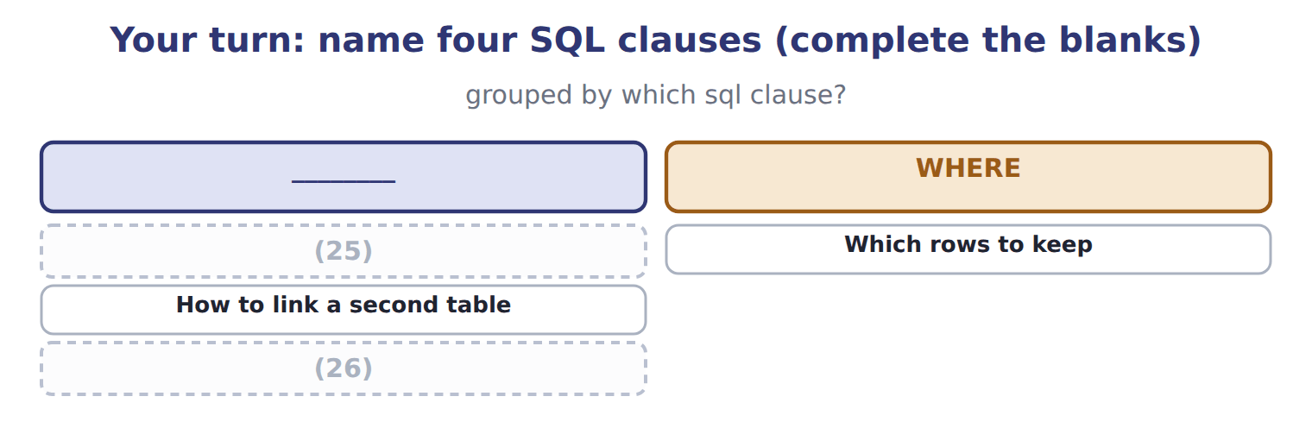
word list
How to summarise by customer · Which rows to keep · Which columns to show

The pattern behind the example

Summary 3 gaps 27–30
Start from the (27) , not from the data. Look at the data before (28) it, and say how much of it there is. Treat what the first look (29) as a hypothesis, never as a finding. The model exists to test the hypothesis, and may (30) it rather than confirm it.
word list
qualify · suggests · whether · modelling · decision

Exam view

Summary 4 gaps 31–33
A question (31) an analyst at some point in the work and asks what should happen next. Follow the cycle: (32) , prepare, model, evaluate, deploy. If the (33) has not been done, the answer is not yet a finding.
word list
describes · columns · understand · evaluation

Exam view
Item | Answer
Which columns to show | SELECT — it names the output of the query
Which rows to keep | Why: WHERE filters the rows before anything is (34) , so it determines what the answer covers
How to link a second table | JOIN ... ON — it matches the two tables on the shared key of Chapter 10
How to summarise by customer | (35)

word list
summarised · matches · GROUP BY — it collapses many rows into one per group

Stage of the work — Category
Stage of the work | Category
Asking whether the shift schedule should change | (36)
Transforming dates into quarters | (37)
Fitting the regression | Model
Asking whether the relationship has been tested | Evaluate

word list
Which SQL clause? · Prepare the data · Understand the business

Answer key · 14.5 Extended Example 14A: mining the Beverages demand data

1 actually | 20 survives
2 Beverages | 21 understated
3 structure | 22 iteration
4 follows | 23 mattered
5 production | 24 recommendation
6 scheduled | 25 Which columns to show
7 because | 26 How to summarise by customer
8 decision | 27 decision
9 history | 28 modelling
10 temperature | 29 suggests
11 observations | 30 qualify
12 discover | 31 describes
13 temperatures | 32 understand
14 degrees | 33 evaluation
15 dataset | 34 summarised
16 suggests | 35 GROUP BY — it collapses many rows into one per group
17 closely | 36 Understand the business
18 finding | 37 Prepare the data
19 exactly

the summaries in full
Summary 1 F.4.k asks how an analyst would actually mine a dataset. This example does it, on the Beverages data. The cycle is the structure this example follows, step by step. The question is whether the extra production shift should be scheduled to the promotion calendar, as now, or to something else. That is a question worth asking, because the answer would change a decision taken every quarter. There are 8 quarters of history: cases sold, average price, mean temperature and promotion weeks. Eight observations is few, and the analyst should say so now rather than discover it later. The preparation is: consolidate the sources, clean what is wrong, transform dates into quarters, and reduce to the columns the question needs. Nothing here is new, and it is where most of the time goes. A first query ranks the quarters by cases.
Summary 2 The peak quarters are the third of each year, at 240,400 cases in 2027 and 240,000 in 2028. The same quarters carry the highest temperatures, 33 and 34 degrees. Promotion weeks in those quarters were 6 and 5, which is not the highest in the dataset. The pattern suggests demand follows temperature more closely than promotion. That is a hypothesis, not a finding, and it is exactly the point at which an analyst is most likely to stop too early and report it as a result. The hypothesis survives, but the promotion effect is real as well, which the eyeball analysis had understated. That last sentence is the iteration. The first look suggested promotion barely mattered; the model says it matters, just less than temperature. Had the analyst reported after step four, the recommendation would have been to cut promotion spending, and it would have been wrong.
Summary 3 Start from the decision, not from the data. Look at the data before modelling it, and say how much of it there is. Treat what the first look suggests as a hypothesis, never as a finding. The model exists to test the hypothesis, and may qualify it rather than confirm it.
Summary 4 A question describes an analyst at some point in the work and asks what should happen next. Follow the cycle: understand, prepare, model, evaluate, deploy. If the evaluation has not been done, the answer is not yet a finding.

15.1 The four types of analytics
Chapter 15 · section 15.1

Fill every gap. Each word list holds one word more than there are gaps.
Chapter 15, section by section
Each stage leads to the next.
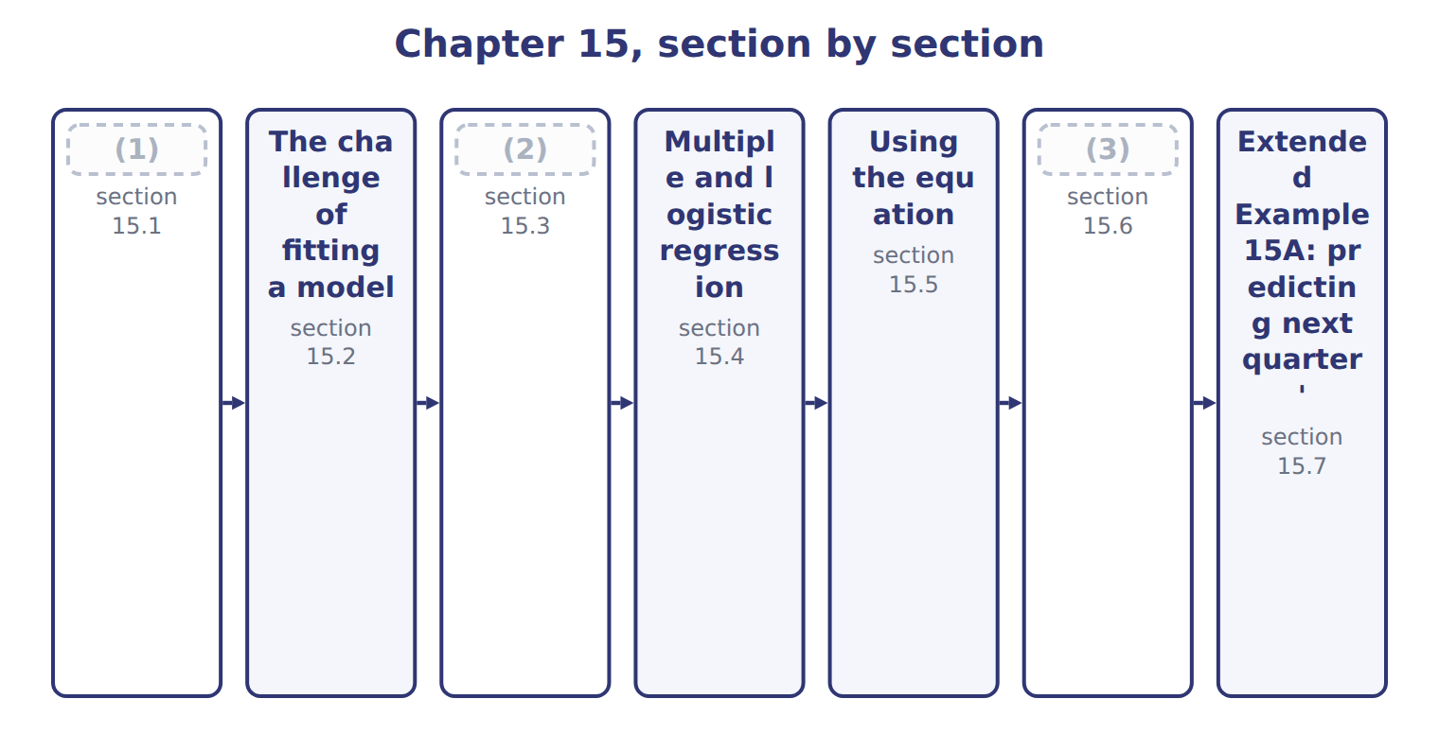
word list
The four types of analytics · The challenge of fitting a model · How well does the model fit? · Clustering and classification

Analytics is usually divided into four types by the question each answers.
The four types of analytics
Type (F.4.m) | Question | What it does | At Orontes
Descriptive | What happened? | (4) | Cases sold by quarter
Diagnostic | Why did it happen? | (5) | The third quarter peak follows temperature
Predictive | What will happen? | Modelling to forecast | (6)
Prescriptive | (7) | Optimising a decision under constraints | How many shifts to schedule, given capacity

word list
Reporting and summarising past data · Drilling into causes and relationships · standard error of the estimate · Next summer's expected demand · What should we do?

Summary 1 gaps 8–9
The order is one of (8) value and difficulty. That is where Book 2's linear (9) would sit if a company joined the two.
word list
clustering · increasing · programming

The English this section uses, and its Arabic
Each term sits against what it means.
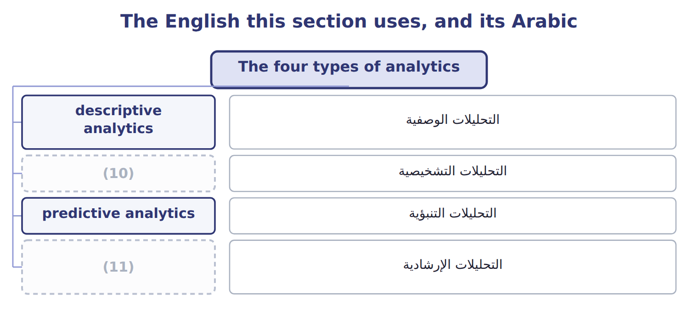
word list
prescriptive analytics · diagnostic analytics · descriptive analytics

The English this sheet uses, and its Arabic
English (exam term) | Arabic
descriptive analytics | التحليلات الوصفية
diagnostic analytics | التحليلات التشخيصية
predictive analytics | التحليلات التنبؤية
prescriptive analytics | التحليلات الإرشادية

Answer key · 15.1 The four types of analytics

1 The four types of analytics | 7 What should we do?
2 Clustering and classification | 8 increasing
3 How well does the model fit? | 9 programming
4 Reporting and summarising past data | 10 diagnostic analytics
5 Drilling into causes and relationships | 11 prescriptive analytics
6 Next summer's expected demand

the summaries in full
Summary 1 The order is one of increasing value and difficulty. That is where Book 2's linear programming would sit if a company joined the two.

15.2 The challenge of fitting a model
Chapter 15 · section 15.2

Fill every gap. Each word list holds one word more than there are gaps.
Summary 1 gaps 1–9
A model is a (1) of reality (2) to be useful. The central (3) is that the data (4) both the pattern you want and noise you do not, and no model can separate them perfectly. A (5) model can be made to pass through every (6) point. It then fits the past perfectly and (7) the future worse than a (8) line would. The reason is that it has (9) the noise as well as the signal, and the noise will not repeat. The defence is to test a model against data it has never seen, and to prefer the simplest model that does the job.
word list
difficulty · contains · straight · clustering · complicated · chosen · simplification · learned · observed · predicts

The English this sheet uses, and its Arabic
English (exam term) | Arabic
underfitting | القصور في المطابقة
overfitting | الإفراط في المطابقة

Answer key · 15.2 The challenge of fitting a model

1 simplification | 6 observed
2 chosen | 7 predicts
3 difficulty | 8 straight
4 contains | 9 learned
5 complicated

the summaries in full
Summary 1 A model is a simplification of reality chosen to be useful. The central difficulty is that the data contains both the pattern you want and noise you do not, and no model can separate them perfectly. A complicated model can be made to pass through every observed point. It then fits the past perfectly and predicts the future worse than a straight line would. The reason is that it has learned the noise as well as the signal, and the noise will not repeat. The defence is to test a model against data it has never seen, and to prefer the simplest model that does the job.

15.3 Clustering and classification
Chapter 15 · section 15.3

Fill every gap. Each word list holds one word more than there are gaps.
Both techniques put cases into groups, and the exam asks which is appropriate.
Clustering against classification
Technique (F.4.n) | What it assumes | What it does | At Orontes
Clustering | (1) : no labels exist | Finds natural groups by similarity | Which distributors behave alike, when nobody has said
Classification | Supervised: labels exist | (2) | Is this order likely to be returned, given past returns
How to choose | (3) | If they are, classify; if not, cluster | Return or not is known; distributor types are not

word list
standard error of the estimate · Assigns a case to a known category · Ask whether the categories are already known · Unsupervised

Summary 1 gaps 4–8
The test is a single question: are the (4) already known? classification needs (5) history. It (6) from cases whose answer is known, and then (7) new ones. At Orontes, whether an order was returned is recorded, so (8) returns is classification. Which distributors behave alike has never been recorded by anyone, so finding that out is clustering.
word list
assigns · predicting · labelled · learns · categories · question

The words this section uses
Each term sits against what it means.
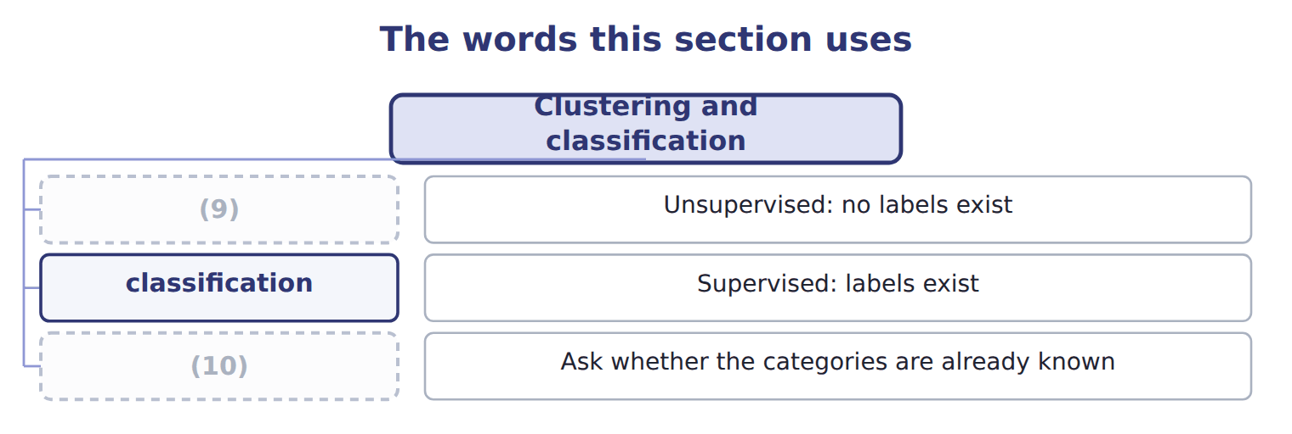
word list
How to choose · intercept · clustering

The English this sheet uses, and its Arabic
English (exam term) | Arabic
clustering | التجميع العنقودي
classification | التصنيف

Answer key · 15.3 Clustering and classification

1 Unsupervised | 6 learns
2 Assigns a case to a known category | 7 assigns
3 Ask whether the categories are already known | 8 predicting
4 categories | 9 clustering
5 labelled | 10 How to choose

the summaries in full
Summary 1 The test is a single question: are the categories already known? classification needs labelled history. It learns from cases whose answer is known, and then assigns new ones. At Orontes, whether an order was returned is recorded, so predicting returns is classification. Which distributors behave alike has never been recorded by anyone, so finding that out is clustering.

15.4 Multiple and logistic regression
Chapter 15 · section 15.4

Fill every gap. Each word list holds one word more than there are gaps.
Multiple against logistic regression
Technique (F.4.o) | Predicts | The output is | The question it answers
Multiple regression | A quantity | (1) | How many cases will we sell?
Logistic regression | A yes or no | (2) | Will this customer pay late?
Choosing | (3) | A number or a category | If the answer is a quantity, use multiple regression

word list
Cases, revenue, cost, hours · A yes or no · Look at what is being predicted · Probability between 0 and 1

Summary 1 gaps 4–12
The choice follows (4) from what is being (5) . A (6) , such as cases or cost or hours, calls for multiple regression. A (7) , such as whether a customer will pay late, calls for logistic regression, whose output is a (8) between zero and one rather than a number of cases. A multiple regression equation takes the form of an (9) plus a coefficient for each variable (10) by that variable's value. Each coefficient says how much the result (11) when that variable rises by one, holding the others (12) . That last clause is what makes it more useful than looking at one variable alone.
word list
intercept · equation · predicted · constant · multiplied · entirely · category · quantity · probability · changes

The English this section uses, and its Arabic
Each term sits against what it means.
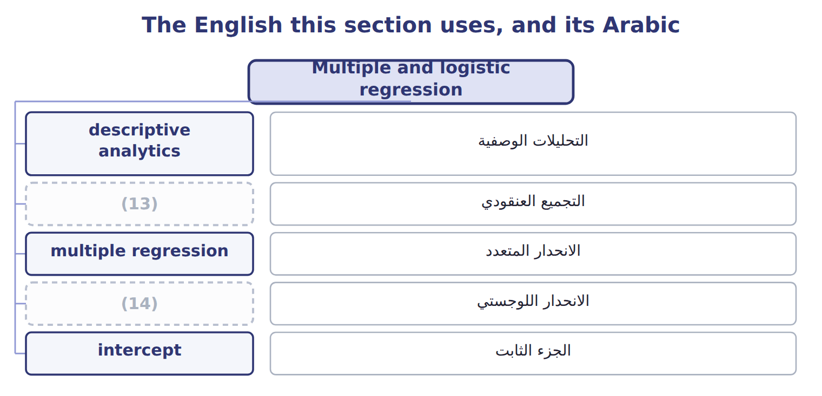
word list
prescriptive analytics · logistic regression · clustering

The English this sheet uses, and its Arabic
English (exam term) | Arabic
multiple regression | الانحدار المتعدد
logistic regression | الانحدار اللوجستي

Answer key · 15.4 Multiple and logistic regression

1 Cases, revenue, cost, hours | 8 probability
2 Probability between 0 and 1 | 9 intercept
3 Look at what is being predicted | 10 multiplied
4 entirely | 11 changes
5 predicted | 12 constant
6 quantity | 13 clustering
7 category | 14 logistic regression

the summaries in full
Summary 1 The choice follows entirely from what is being predicted. A quantity, such as cases or cost or hours, calls for multiple regression. A category, such as whether a customer will pay late, calls for logistic regression, whose output is a probability between zero and one rather than a number of cases. A multiple regression equation takes the form of an intercept plus a coefficient for each variable multiplied by that variable's value. Each coefficient says how much the result changes when that variable rises by one, holding the others constant. That last clause is what makes it more useful than looking at one variable alone.

15.5 Using the equation
Chapter 15 · section 15.5

Fill every gap. Each word list holds one word more than there are gaps.
Summary 1 gaps 1–3
Fitting the eight quarters of (1) data to price, mean (2) and promotion weeks gives the equation below. Only this (3) is examinable in this part of the syllabus, so it is worth being able to do it without hesitation.
word list
calculation · Beverages · overfitting · temperature

The fitted equation

Summary 2 gaps 4–11
Price carries a (4) coefficient: raise the price and sell fewer cases. (5) and promotion carry positive (6) : both raise demand. Every sign is what a (7) would expect, and that is worth checking in any (8) before trusting it. A coefficient with the wrong sign usually means the (9) are entangled with each other rather than that the world has (10) . The points do not sit exactly on the line because price and promotion also move, and the line holds those at the values used for the (11) .
word list
regression · coefficients · Temperature · negative · variables · reader · overfitting · prediction · changed

The English this sheet uses, and its Arabic
English (exam term) | Arabic
intercept | الجزء الثابت

Answer key · 15.5 Using the equation

1 Beverages | 7 reader
2 temperature | 8 regression
3 calculation | 9 variables
4 negative | 10 changed
5 Temperature | 11 prediction
6 coefficients

the summaries in full
Summary 1 Fitting the eight quarters of Beverages data to price, mean temperature and promotion weeks gives the equation below. Only this calculation is examinable in this part of the syllabus, so it is worth being able to do it without hesitation.
Summary 2 Price carries a negative coefficient: raise the price and sell fewer cases. Temperature and promotion carry positive coefficients: both raise demand. Every sign is what a reader would expect, and that is worth checking in any regression before trusting it. A coefficient with the wrong sign usually means the variables are entangled with each other rather than that the world has changed. The points do not sit exactly on the line because price and promotion also move, and the line holds those at the values used for the prediction.

15.6 How well does the model fit?
Chapter 15 · section 15.6

Fill every gap. Each word list holds one word more than there are gaps.
Measures of fit
Measure (F.4.q) | Range | What it tells you | Note
Correlation coefficient, R | (1) | Direction and strength of a straight-line relationship | Negative means they move oppositely
Coefficient of determination, R squared | Between 0 and 1 | The share of (2) in the result that the model explains | 0.90 means 90 per cent explained
The link | R squared is R multiplied by itself, in simple regression | So R of -0.8 gives R squared of 0.64 | (3)
Adjusted R squared | (4) | Penalises adding variables that do not help | Use it to compare models of different sizes
Standard error of the estimate | (5) | The typical distance of a point from the line | Smaller is better
What none of them prove | Not cause | A high R squared on unrelated series is still a (6) | Chapter 14's warning applies

word list
The sign disappears when squared · coincidence · Between -1 and +1 · variation · In the units of the result · underfitting · Always at or below R squared

Summary 1 gaps 7–14
The correlation coefficient runs from minus one to plus one and describes a (7) relationship: its sign gives the (8) , its size the strength. The coefficient of (9) is that number squared, so it runs from zero to one and gives the share of the (10) in the result that the model explains. (11) destroys the sign, which is the point (12) most often miss. A correlation of -0.8 and one of plus 0.8 both give an R squared of 0.64. Both (13) an equally strong relationship, running in (14) directions.
word list
variation · direction · determination · straight-line · opposite · destroys · Squaring · candidates · describe

A high R squared is not proof

Summary 2 gaps 15–16
R squared measures how much variation the model accounts for, not whether the (15) is real. (16) about plausible cause comes first, and the statistic second.
word list
plausible · Judgement · relationship

The English this section uses, and its Arabic
Each term sits against what it means.
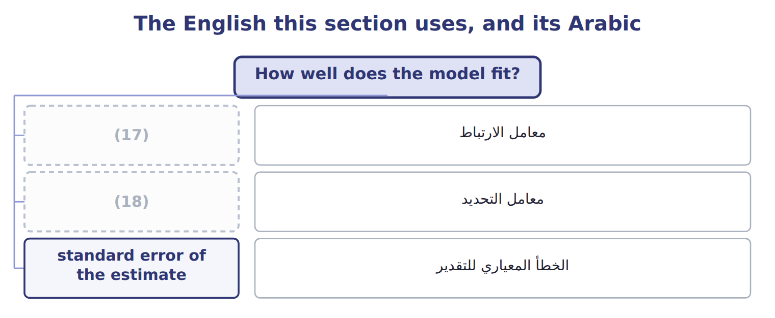
word list
correlation coefficient · معامل الارتباط · coefficient of determination

The English this sheet uses, and its Arabic
English (exam term) | Arabic
correlation coefficient | معامل الارتباط
coefficient of determination | معامل التحديد
standard error of the estimate | الخطأ المعياري للتقدير

Answer key · 15.6 How well does the model fit?

1 Between -1 and +1 | 10 variation
2 variation | 11 Squaring
3 The sign disappears when squared | 12 candidates
4 Always at or below R squared | 13 describe
5 In the units of the result | 14 opposite
6 coincidence | 15 relationship
7 straight-line | 16 Judgement
8 direction | 17 correlation coefficient
9 determination | 18 coefficient of determination

the summaries in full
Summary 1 The correlation coefficient runs from minus one to plus one and describes a straight-line relationship: its sign gives the direction, its size the strength. The coefficient of determination is that number squared, so it runs from zero to one and gives the share of the variation in the result that the model explains. Squaring destroys the sign, which is the point candidates most often miss. A correlation of -0.8 and one of plus 0.8 both give an R squared of 0.64. Both describe an equally strong relationship, running in opposite directions.
Summary 2 R squared measures how much variation the model accounts for, not whether the relationship is real. Judgement about plausible cause comes first, and the statistic second.

15.7 Extended Example 15A: predicting next quarter's demand
Chapter 15 · section 15.7

Fill every gap. Each word list holds one word more than there are gaps.
Summary 1 gaps 1–4
This example performs the one (1) this part of the (2) examines, and then asks how far the answer can be trusted. (3) expects to hold the price at $20.00 next quarter, the forecast mean (4) is 26 degrees, and 4 promotion weeks are planned.
word list
temperature · penalises · Beverages · calculation · syllabus

Applying the equation

Summary 2 gaps 5–7
Treating the price coefficient as (5) gives 549,673 cases, which is far too high. The sign is part of the coefficient, and (6) it is the mistake the exam most often tests in this (7) .
word list
positive · dropping · temperature · calculation

4. How good is the fit?

Summary 3 gaps 8–19
The model's R squared is 0.9989, so it (8) for almost all the (9) in quarterly cases. The (10) figure is 0.9982, slightly lower because it (11) the three variables used. The (12) error is 555 cases, which is the typical distance of an (13) from the line. An R squared this high on 8 observations should make a reader (14) rather than (15) . With few observations and three variables, a model can fit the past closely without (16) well, which is the (17) of section 15.2. The honest (18) is that the (19) looks strong and needs more quarters to confirm. The temperature coefficient of 1,457 cases a degree, applied to a seasonal swing of some twenty degrees, moves demand far more than the promotion coefficient of 2,706 applied to a few weeks. But promotion is positive and material, so the.
word list
variation · overfitting · statement · confident · cautious · observation · standard · adjusted · calculation · penalises · relationship · predicting · accounts

Name four types of analytics

Complete the blank cells.

Your turn: name four types of analytics (complete the blanks)
Every item belongs to exactly one group.
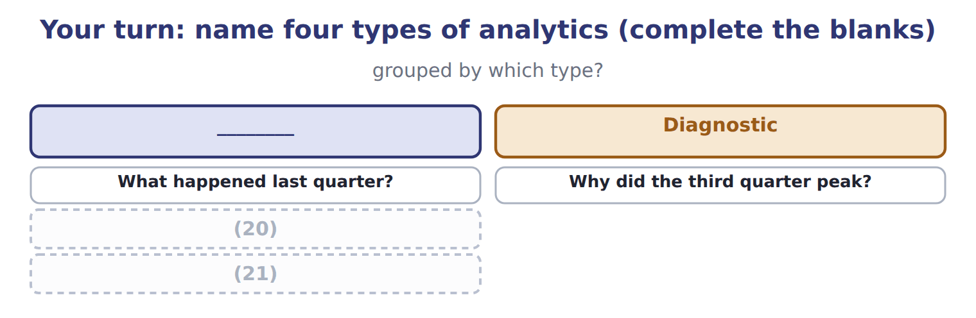
word list
How many shifts should we schedule? · How many cases next summer? · standard error of the estimate

Everything ties

Summary 4 gaps 22–23
Each (22) carries the sign a reader would expect. R squared 0.9989, (23) 0.9982, standard error 555 cases.
word list
syllabus · coefficient · adjusted

Exam view

Summary 5 gaps 24–26
The (24) is always the same shape: multiply each coefficient by its value, add the (25) , and watch the signs. If the question gives an R squared, it is usually asking what share of (26) is explained, not whether the model is right.
word list
usually · variation · intercept · calculation

Exam view
Item | Answer
What happened last quarter? | (27)
Why did the third quarter peak? | Why: (28) drills into the causes and relationships behind what the reporting showed
How many cases next summer? | Predictive — it forecasts a future value
How many shifts should we schedule? | Prescriptive — it recommends a course of action given the constraints

word list
Question asked · diagnostic analytics · Descriptive — it summarises what has already occurred

Question asked — Category
Question asked | Category
What were cases sold last quarter? | (29)
Why did the third quarter peak? | Diagnostic
How many cases next summer? | (30)
How many shifts should we run? | Prescriptive

word list
Descriptive · Predictive · clustering

Answer key · 15.7 Extended Example 15A: predicting next quarter's demand

1 calculation | 16 predicting
2 syllabus | 17 overfitting
3 Beverages | 18 statement
4 temperature | 19 relationship
5 positive | 20 How many cases next summer?
6 dropping | 21 How many shifts should we schedule?
7 calculation | 22 coefficient
8 accounts | 23 adjusted
9 variation | 24 calculation
10 adjusted | 25 intercept
11 penalises | 26 variation
12 standard | 27 Descriptive — it summarises what has already occurred
13 observation | 28 diagnostic analytics
14 cautious | 29 Descriptive
15 confident | 30 Predictive

the summaries in full
Summary 1 This example performs the one calculation this part of the syllabus examines, and then asks how far the answer can be trusted. Beverages expects to hold the price at $20.00 next quarter, the forecast mean temperature is 26 degrees, and 4 promotion weeks are planned.
Summary 2 Treating the price coefficient as positive gives 549,673 cases, which is far too high. The sign is part of the coefficient, and dropping it is the mistake the exam most often tests in this calculation.
Summary 3 The model's R squared is 0.9989, so it accounts for almost all the variation in quarterly cases. The adjusted figure is 0.9982, slightly lower because it penalises the three variables used. The standard error is 555 cases, which is the typical distance of an observation from the line. An R squared this high on 8 observations should make a reader cautious rather than confident. With few observations and three variables, a model can fit the past closely without predicting well, which is the overfitting of section 15.2. The honest statement is that the relationship looks strong and needs more quarters to confirm. The temperature coefficient of 1,457 cases a degree, applied to a seasonal swing of some twenty degrees, moves demand far more than the promotion coefficient of 2,706 applied to a few weeks. But promotion is positive and material, so the.
Summary 4 Each coefficient carries the sign a reader would expect. R squared 0.9989, adjusted 0.9982, standard error 555 cases.
Summary 5 The calculation is always the same shape: multiply each coefficient by its value, add the intercept, and watch the signs. If the question gives an R squared, it is usually asking what share of variation is explained, not whether the model is right.

16.1 The four components of a time series
Chapter 16 · section 16.1

Fill every gap. Each word list holds one word more than there are gaps.
Chapter 16, section by section
Each stage leads to the next.
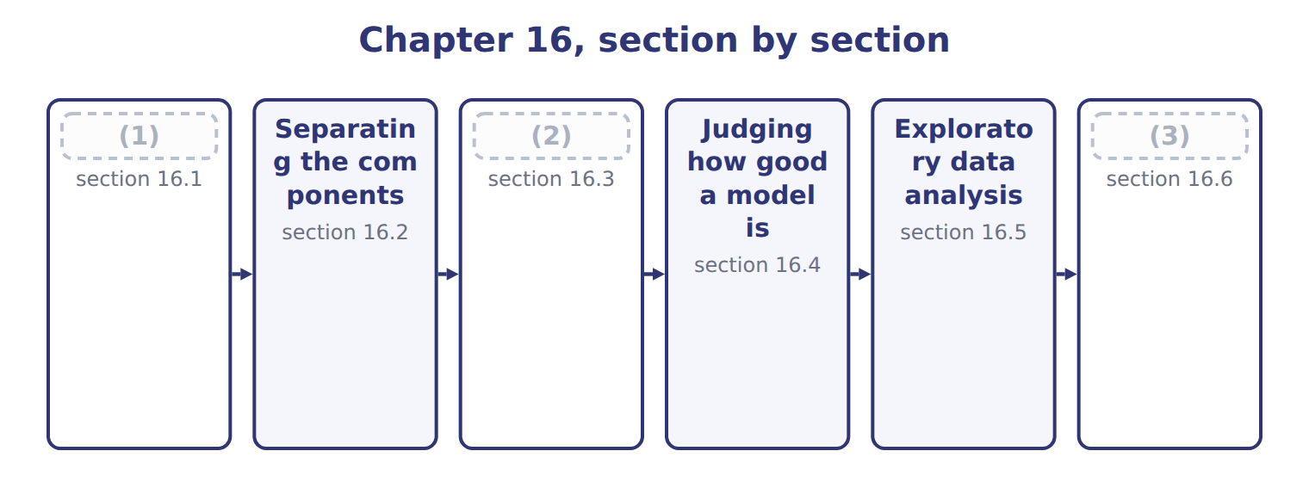
word list
What both techniques can and cannot do · Extended Example 16A: decomposing the Beverage · The four components of a time series · Judging how good a model is

Any series measured over time can be thought of as four things added together.
The four components of a time series
Component (F.4.r) | What it is | At Orontes | In this data
Trend | The long-run direction, over years | (4) | Rising across the two years
Cyclical | Swings longer than a year, tied to the economy | (5) | Not visible in only two years of data
Seasonal | A pattern that repeats within the year | (6) | The third quarter peaks in both years
Irregular | What is left: random, unrepeatable | A port strike delaying one shipment | (7)

word list
A regional downturn lasting several years · The third quarter peaks in both years · The small residual after the other three · Hot quarters sell more · Underlying growth as the Gulf market opens

Summary 1 gaps 8–11
Those two are (8) the visible ones. It needs many years of data before it can be told apart from (9) at all. It is (10) by definition, which is why no model should try to explain it. A model that fits the irregular component is the (11) .
word list
overfitting · usually · unrepeatable · trend · component

The words this section uses
Each term sits against what it means.
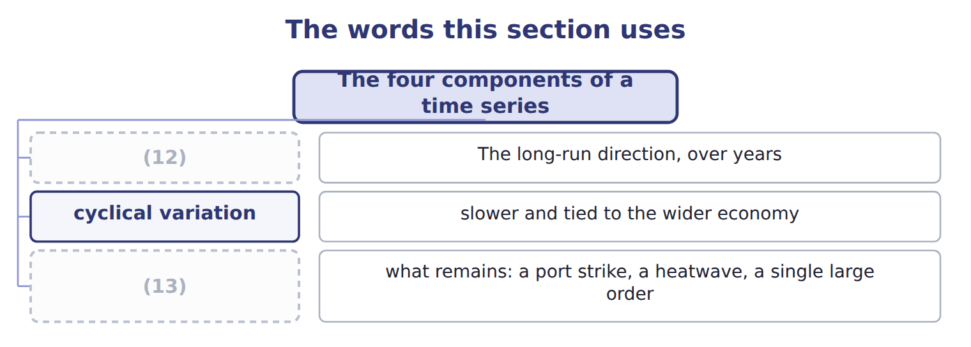
word list
seasonal variation · trend · irregular variation

The English this sheet uses, and its Arabic
English (exam term) | Arabic
trend | الاتجاه العام
cyclical variation | التغير الدوري
seasonal variation | التغير الموسمي
irregular variation | التغير العشوائي

Answer key · 16.1 The four components of a time series

1 The four components of a time series | 8 usually
2 What both techniques can and cannot do | 9 trend
3 Extended Example 16A: decomposing the Beverage | 10 unrepeatable
4 Underlying growth as the Gulf market opens | 11 overfitting
5 A regional downturn lasting several years | 12 trend
6 Hot quarters sell more | 13 irregular variation
7 The small residual after the other three

the summaries in full
Summary 1 Those two are usually the visible ones. It needs many years of data before it can be told apart from trend at all. It is unrepeatable by definition, which is why no model should try to explain it. A model that fits the irregular component is the overfitting.

16.2 Separating the components
Chapter 16 · section 16.2

Fill every gap. Each word list holds one word more than there are gaps.
Summary 1 gaps 1–12
The (1) method is a moving average. Averaging four (2) quarters removes the seasonal (3) , because every average (4) one of each quarter. Most of the (5) variation cancels as well. What is left is close to the trend. The first panel is the series as (6) , with its clear peak in the third quarter of each year. The second is the (7) centred moving average, which rises from 219,750 to 223,662 cases and is far (8) . The third shows what is left once the trend is taken out. Those (9) are the seasonal (10) : 20,003 cases in the third quarter and (13,022) in the first, a swing of 33,025 cases between the best quarter and the worst. They are (11) so that the four sum to zero, because a season (12) the year's demand rather than adding to it.
word list
pattern · recorded · contains · adjusted · four-quarter · remainders · consecutive · smoother · redistributes · centred · factors · irregular · standard

The English this section uses, and its Arabic
Each term sits against what it means.
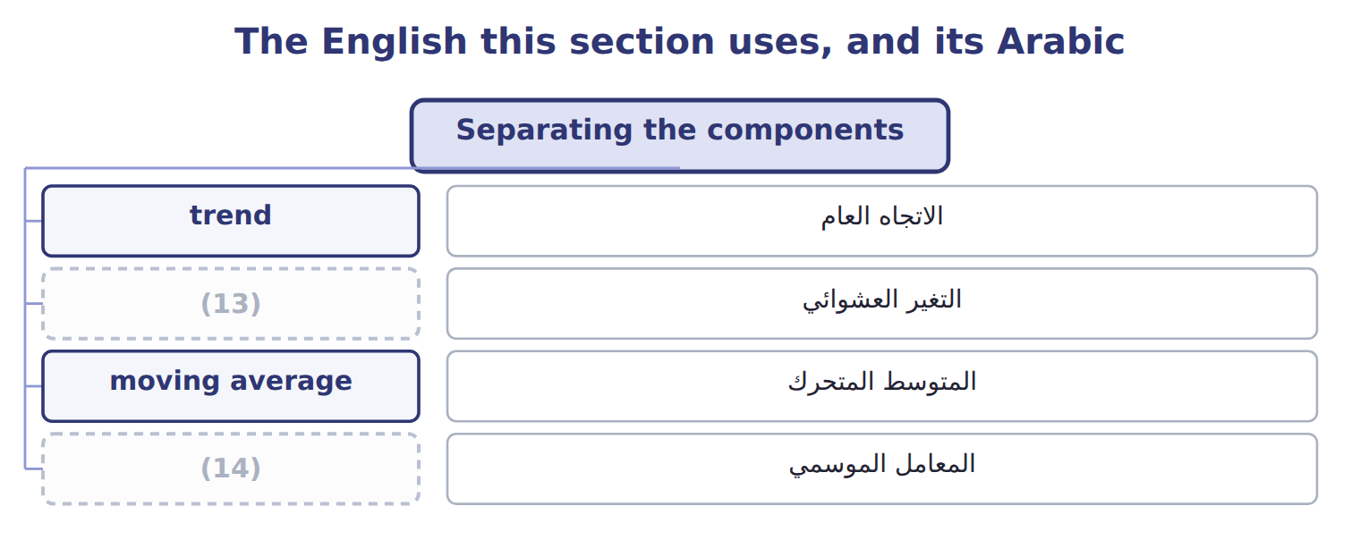
word list
التغير العشوائي · irregular variation · seasonal factor

The English this sheet uses, and its Arabic
English (exam term) | Arabic
moving average | المتوسط المتحرك
seasonal factor | المعامل الموسمي

Answer key · 16.2 Separating the components

1 standard | 8 smoother
2 consecutive | 9 remainders
3 pattern | 10 factors
4 contains | 11 adjusted
5 irregular | 12 redistributes
6 recorded | 13 irregular variation
7 four-quarter | 14 seasonal factor

the summaries in full
Summary 1 The standard method is a moving average. Averaging four consecutive quarters removes the seasonal pattern, because every average contains one of each quarter. Most of the irregular variation cancels as well. What is left is close to the trend. The first panel is the series as recorded, with its clear peak in the third quarter of each year. The second is the four-quarter centred moving average, which rises from 219,750 to 223,662 cases and is far smoother. The third shows what is left once the trend is taken out. Those remainders are the seasonal factors: 20,003 cases in the third quarter and (13,022) in the first, a swing of 33,025 cases between the best quarter and the worst. They are adjusted so that the four sum to zero, because a season redistributes the year's demand rather than adding to it.

16.3 What both techniques can and cannot do
Chapter 16 · section 16.3

Fill every gap. Each word list holds one word more than there are gaps.
Benefits and limitations of regression and time series analysis
Every item belongs to exactly one group.
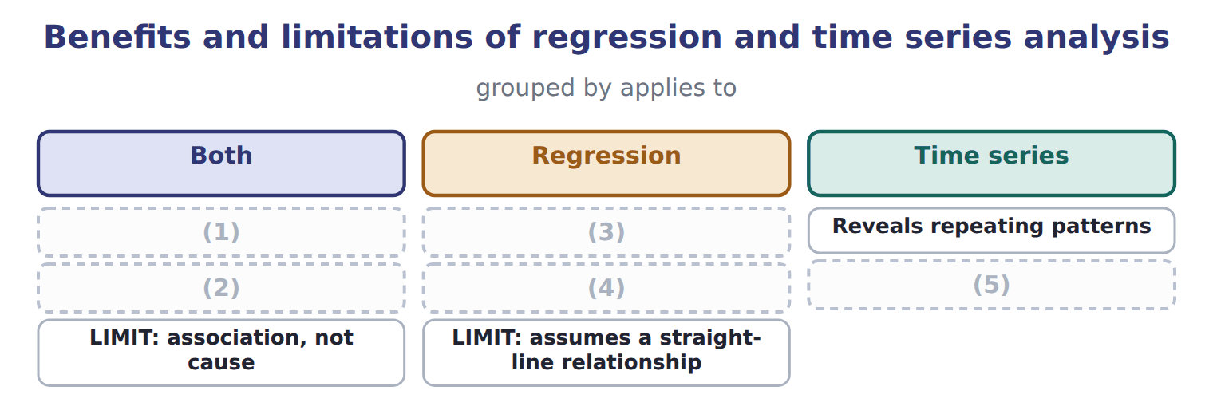
word list
Uses every observation · Separates mixed effects · Quantifies the relationship · LIMIT: needs enough history · LIMIT: assumes the past continues · standard error of the estimate

Summary 1 gaps 6–13
The (6) that matters most applies to both, and it is simply stated: each (7) assumes that the pattern in the past will continue. A (8) fitted before a (9) entered the Gulf market will keep predicting the old volumes. A (10) factor from two normal years will not (11) a year in which the pattern breaks. The (12) that matters most also applies to both. Each uses every (13) rather than a chosen few. That is why Book 2's high-low method, resting on two points, was described there as a rough approximation.
word list
limitation · competitor · technique · benefit · survive · observation · seasonal · regression · approximation

The words this section uses
Each term sits against what it means.
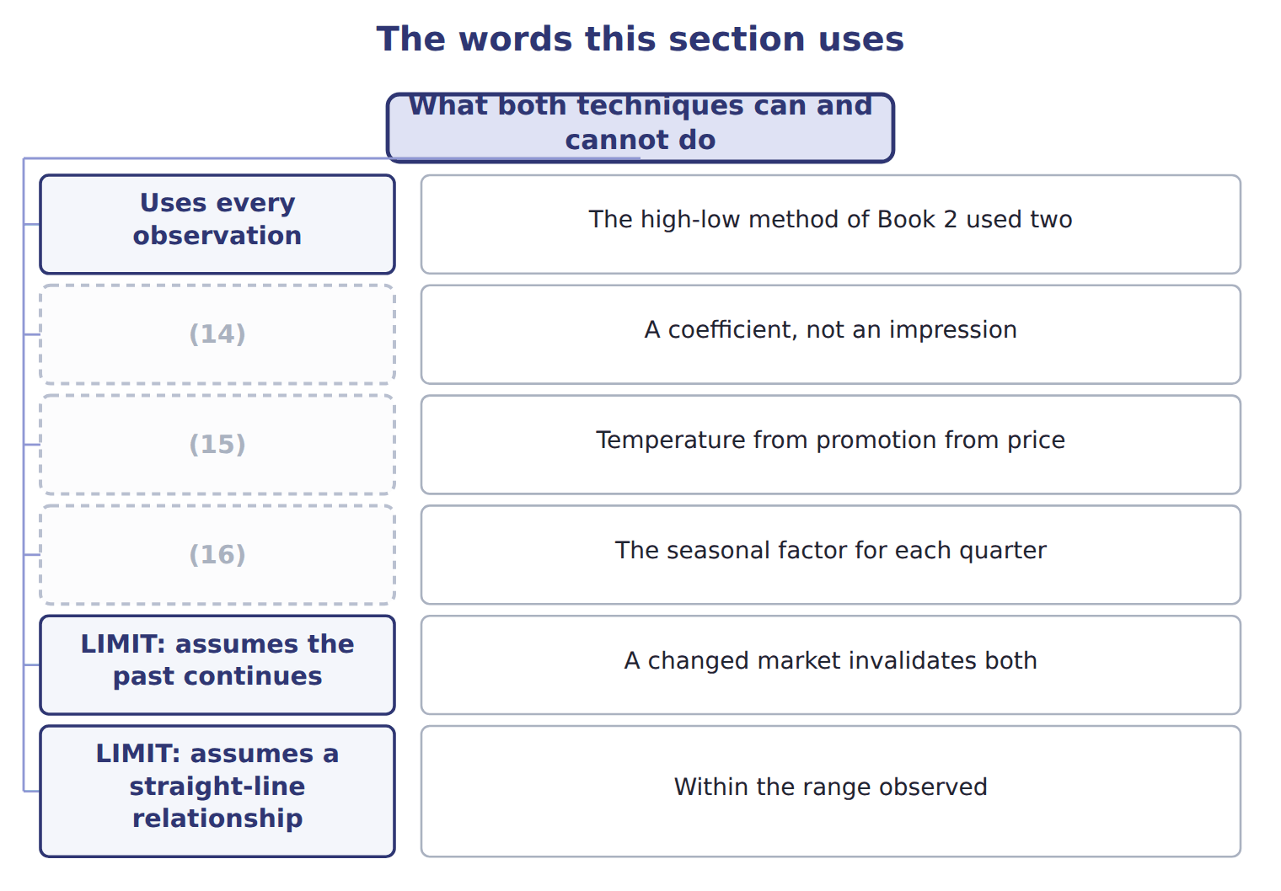
word list
Quantifies the relationship · Reveals repeating patterns · Separates mixed effects · Uses every observation

Answer key · 16.3 What both techniques can and cannot do

1 Uses every observation | 9 competitor
2 LIMIT: assumes the past continues | 10 seasonal
3 Quantifies the relationship | 11 survive
4 Separates mixed effects | 12 benefit
5 LIMIT: needs enough history | 13 observation
6 limitation | 14 Quantifies the relationship
7 technique | 15 Separates mixed effects
8 regression | 16 Reveals repeating patterns

the summaries in full
Summary 1 The limitation that matters most applies to both, and it is simply stated: each technique assumes that the pattern in the past will continue. A regression fitted before a competitor entered the Gulf market will keep predicting the old volumes. A seasonal factor from two normal years will not survive a year in which the pattern breaks. The benefit that matters most also applies to both. Each uses every observation rather than a chosen few. That is why Book 2's high-low method, resting on two points, was described there as a rough approximation.

16.4 Judging how good a model is
Chapter 16 · section 16.4

Fill every gap. Each word list holds one word more than there are gaps.
Standard error, goodness of fit and confidence interval
Measure (F.4.t) | What it is | In this model | Note
Standard error of the estimate | The typical distance of an observation from the fitted line | In the units of the result, so 555 cases here | (1)
Goodness of fit | How closely the model matches the observed data | R squared is the usual measure, 0.9989 here | (2)
Confidence interval | A range around the estimate, with a stated level of confidence | The estimate plus or minus a multiple of the standard error | A wider interval is a more honest one

word list
Smaller is better · standard error of the estimate · High fit with few observations invites caution

Summary 1 gaps 3–9
The standard error of the estimate is the typical distance of an (3) from the fitted line, (4) in the units of the thing being predicted. For the (5) model it is 555 cases, which is readable directly: a (6) is typically wrong by about that much. A (7) interval turns a single estimate into a range, by adding and (8) a multiple of the standard error. It also states how (9) one is that the true value lies inside it.
word list
Beverages · confident · expressed · subtracting · confidence · interval · observation · prediction

A narrow interval is not a better one

Summary 2 gaps 10–12
A (10) interval is honest about (11) , not a measure of skill. An interval that is narrow because the model (12) a small sample is worse than a wide one that reflects what the data can actually support.
word list
actually · confidence · overfits · uncertainty

The words this section uses
Each term sits against what it means.
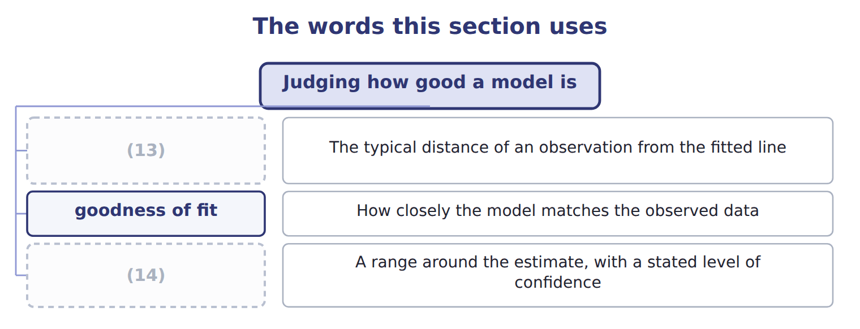
word list
confidence interval · moving average · standard error of the estimate

The English this sheet uses, and its Arabic
English (exam term) | Arabic
standard error of the estimate | الخطأ المعياري للتقدير
goodness of fit | جودة المطابقة
confidence interval | فترة الثقة

Answer key · 16.4 Judging how good a model is

1 Smaller is better | 8 subtracting
2 High fit with few observations invites caution | 9 confident
3 observation | 10 confidence
4 expressed | 11 uncertainty
5 Beverages | 12 overfits
6 prediction | 13 standard error of the estimate
7 confidence | 14 confidence interval

the summaries in full
Summary 1 The standard error of the estimate is the typical distance of an observation from the fitted line, expressed in the units of the thing being predicted. For the Beverages model it is 555 cases, which is readable directly: a prediction is typically wrong by about that much. A confidence interval turns a single estimate into a range, by adding and subtracting a multiple of the standard error. It also states how confident one is that the true value lies inside it.
Summary 2 A confidence interval is honest about uncertainty, not a measure of skill. An interval that is narrow because the model overfits a small sample is worse than a wide one that reflects what the data can actually support.

16.5 Exploratory data analysis
Chapter 16 · section 16.5

Fill every gap. Each word list holds one word more than there are gaps.
What exploratory data analysis involves
Exploratory step (F.4.v) | What it does | At Orontes
Plot the series | See the shape before assuming one | (1)
Look at the spread | Find outliers and impossible values | (2)
Compare the periods | See whether the pattern repeats | (3)
Ask what is missing | Absent data shapes the answer too | (4)
Then model | (5) | Chapter 15's regression

word list
Chapter 11's two orders a hundred times the usual · Two years both peak in the third quarter · The third-quarter peak is visible without any model · The model tests what the eye suggested · Absent data shapes the answer too · Fourteen orders with no delivery date

Summary 1 gaps 6–11
Its value is that the eye finds (6) no summary (7) reports. The (8) peak is visible (9) , before any moving average is computed, and so are the outliers and the gaps. It also (10) against the (11) error. A model fitted without looking can produce a respectable R squared on data that contains an obvious impossibility, and nobody will notice until someone acts on the answer.
word list
protects · immediately · opposite · someone · third-quarter · things · statistic

The words this section uses
Each term sits against what it means.
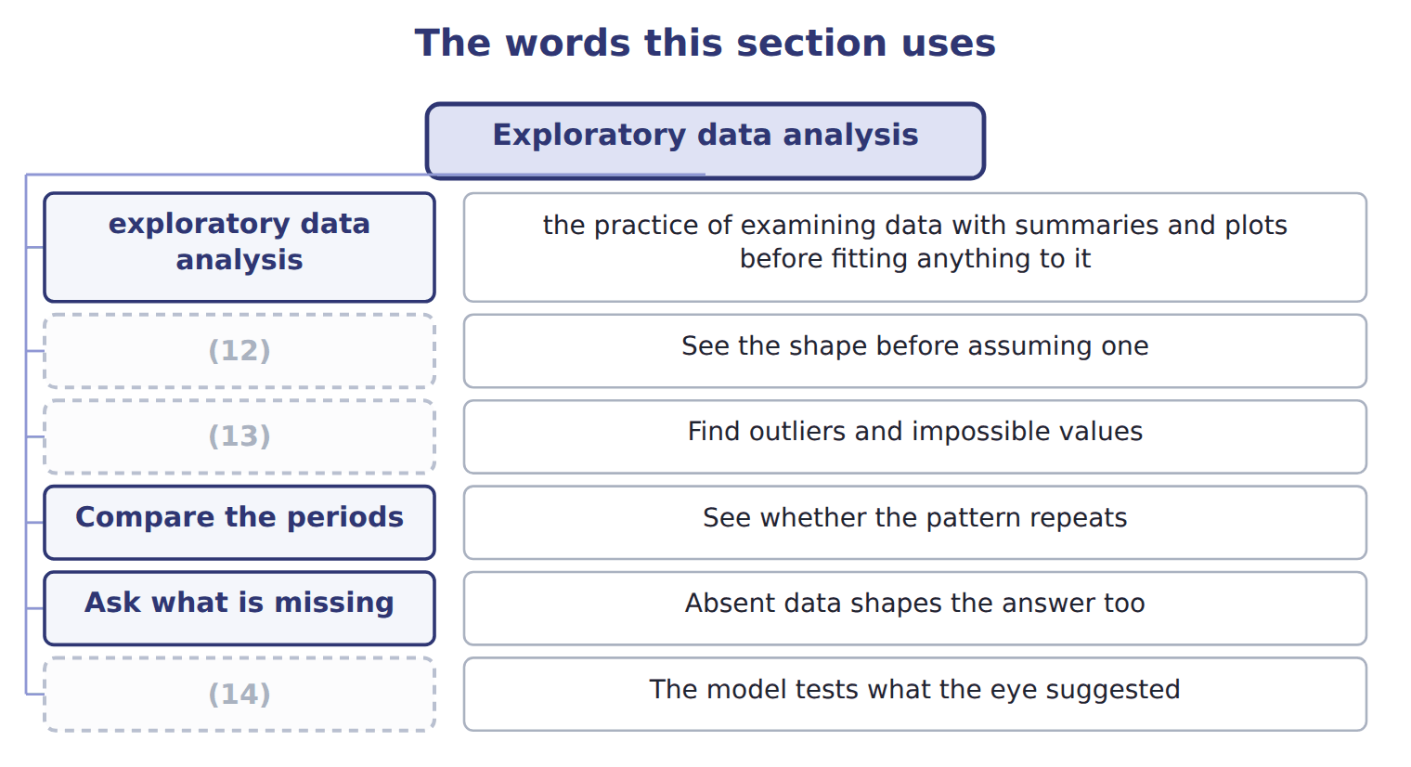
word list
Plot the series · Then model · Look at the spread · irregular variation

The English this sheet uses, and its Arabic
English (exam term) | Arabic
exploratory data analysis | التحليل الاستكشافي للبيانات

Answer key · 16.5 Exploratory data analysis

1 The third-quarter peak is visible without any model | 8 third-quarter
2 Chapter 11's two orders a hundred times the usual | 9 immediately
3 Two years both peak in the third quarter | 10 protects
4 Fourteen orders with no delivery date | 11 opposite
5 The model tests what the eye suggested | 12 Plot the series
6 things | 13 Look at the spread
7 statistic | 14 Then model

the summaries in full
Summary 1 Its value is that the eye finds things no summary statistic reports. The third-quarter peak is visible immediately, before any moving average is computed, and so are the outliers and the gaps. It also protects against the opposite error. A model fitted without looking can produce a respectable R squared on data that contains an obvious impossibility, and nobody will notice until someone acts on the answer.

16.6 Extended Example 16A: decomposing the Beverages series
Chapter 16 · section 16.6

Fill every gap. Each word list holds one word more than there are gaps.
Summary 1 gaps 1–12
This example performs the (1) and then says what it is and is not good for. A (2) moving average is taken, then (3) so that it lines up with an actual quarter. With 8 (4) this gives 4 trend (5) , from 2027 Q3 to 2028 Q2. The two (6) at each end have no trend value, which is a real cost of the (7) . (8) the trend from the actual leaves the seasonal and irregular (9) together. In 2027 Q3, actual demand was 240,400 cases (10) a trend of 219,750, (11) 20,650. Where a quarter appears more than once, averaging its (12) cancels most of the irregular part and leaves the seasonal factor. Adjusting the four so they sum to zero gives (13,022), 691, 20,003 and (7,672) for the first to the fourth quarter.
word list
four-quarter · against · decomposition · Subtracting · remainders · average · values · components · leaving · quarters · method · observations · centred

Summary 2 gaps 13–20
The (13) say how much of the (14) peak is simply the season. A manager who congratulates the sales team on a 20,003-case rise in the third quarter is (15) them on the (16) . The same manager (17) not treat the (18) fall as a failure. Two years is very (19) . Each seasonal factor here rests on two observations, so a single unusual quarter moves it (20) . The cyclical component cannot be seen at all. The honest statement is a direction and a rough size, not a precise forecast.
word list
congratulating · third-quarter · first-quarter · should · weather · factors · substantially · little · components

Name four components

Complete the blank cells.
Your turn: name four components (complete the blanks)
Every item belongs to exactly one group.
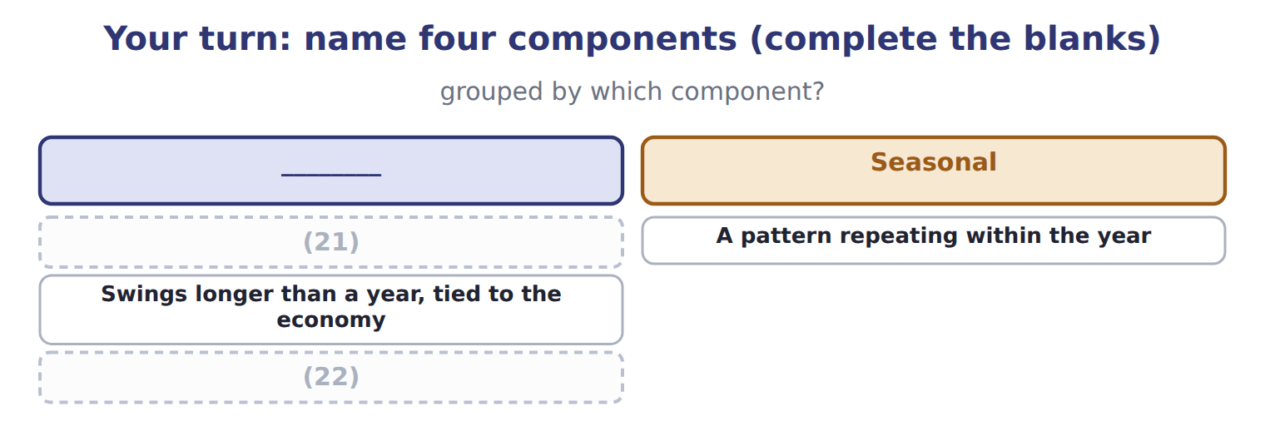
word list
What is left after the other three · The long-run direction over years · A pattern repeating within the year

Everything ties

Summary 3 gaps 23–24
Trend rises from 219,750 to 223,662 cases across the 4 (23) quarters. (24) factors (13,022), 691, 20,003, (7,672) sum to zero. The swing from worst quarter to best is 33,025 cases.
word list
computed · statement · Seasonal

Exam view

Summary 4 gaps 25–27
A (25) names a movement and asks which (26) it is. Ask how long it lasts: within a year is seasonal, over years is (27) , several years and tied to the economy is cyclical, and once only is irregular.
word list
component · question · together · trend

Exam view
Item | Answer
The long-run direction over years | (28) — it is the underlying growth or decline, visible only across years
A pattern repeating within the year | Why: seasonal variation returns at the same point each year, so the third quarter peaks in both years here
Swings longer than a year, tied to the economy | (29) — and two years of data cannot show it
What is left after the other three | Irregular variation — random and unrepeatable, which is why no model should try to fit it

word list
Trend · Cyclical variation · moving average

Movement described — Category
Movement described | Category
Steadily rising demand as the Gulf market opens | (30)
The third quarter peaking every year | Seasonal
A multi-year regional downturn | Cyclical
A port strike delaying one shipment | (31)

word list
Trend · Irregular · Cyclical

The English this section uses, and its Arabic
Each term sits against what it means.
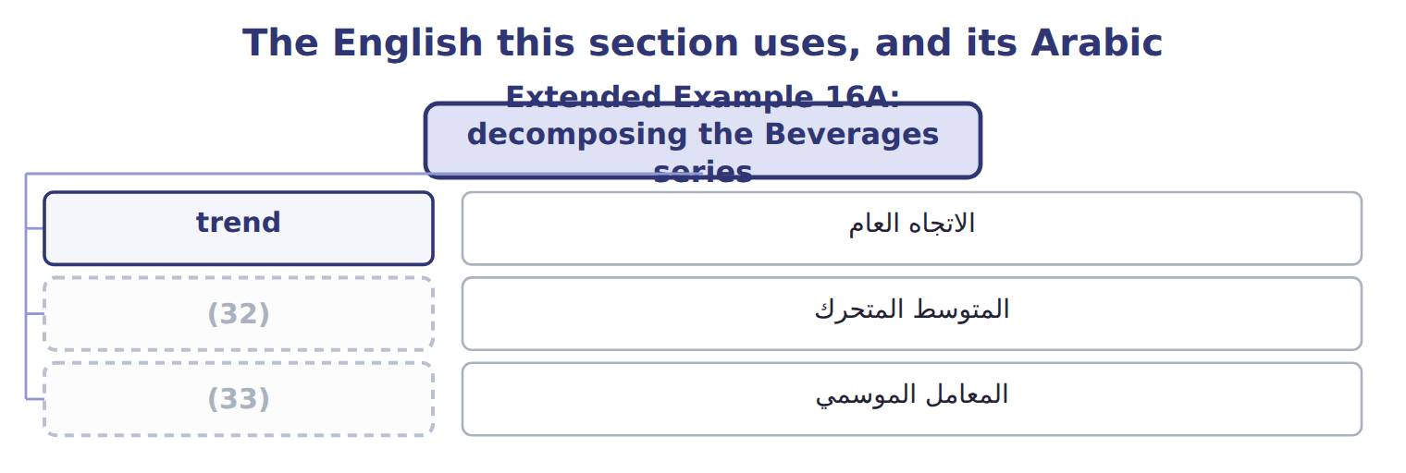
word list
moving average · seasonal factor · confidence interval

Answer key · 16.6 Extended Example 16A: decomposing the Beverages series

1 decomposition | 18 first-quarter
2 four-quarter | 19 little
3 centred | 20 substantially
4 observations | 21 The long-run direction over years
5 values | 22 What is left after the other three
6 quarters | 23 computed
7 method | 24 Seasonal
8 Subtracting | 25 question
9 components | 26 component
10 against | 27 trend
11 leaving | 28 Trend
12 remainders | 29 Cyclical variation
13 factors | 30 Trend
14 third-quarter | 31 Irregular
15 congratulating | 32 moving average
16 weather | 33 seasonal factor
17 should

the summaries in full
Summary 1 This example performs the decomposition and then says what it is and is not good for. A four-quarter moving average is taken, then centred so that it lines up with an actual quarter. With 8 observations this gives 4 trend values, from 2027 Q3 to 2028 Q2. The two quarters at each end have no trend value, which is a real cost of the method. Subtracting the trend from the actual leaves the seasonal and irregular components together. In 2027 Q3, actual demand was 240,400 cases against a trend of 219,750, leaving 20,650. Where a quarter appears more than once, averaging its remainders cancels most of the irregular part and leaves the seasonal factor. Adjusting the four so they sum to zero gives (13,022), 691, 20,003 and (7,672) for the first to the fourth quarter.
Summary 2 The factors say how much of the third-quarter peak is simply the season. A manager who congratulates the sales team on a 20,003-case rise in the third quarter is congratulating them on the weather. The same manager should not treat the first-quarter fall as a failure. Two years is very little. Each seasonal factor here rests on two observations, so a single unusual quarter moves it substantially. The cyclical component cannot be seen at all. The honest statement is a direction and a rough size, not a precise forecast.
Summary 3 Trend rises from 219,750 to 223,662 cases across the 4 computed quarters. Seasonal factors (13,022), 691, 20,003, (7,672) sum to zero. The swing from worst quarter to best is 33,025 cases.
Summary 4 A question names a movement and asks which component it is. Ask how long it lasts: within a year is seasonal, over years is trend, several years and tied to the economy is cyclical, and once only is irregular.

17.1 Expected value
Chapter 17 · section 17.1

Fill every gap. Each word list holds one word more than there are gaps.
Chapter 17, section by section
Each stage leads to the next.
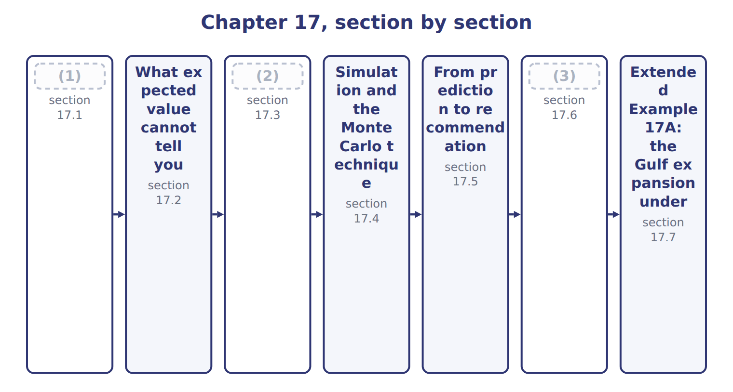
word list
Sensitivity, what-if and goal seeking · Expected value · simulation model · The limitations of data analytics

Summary 1 gaps 4–5
The expected value of an (4) quantity is each possible outcome multiplied by its (5) , and the results added together.
word list
uncertain · percentile · probability

Expected value of the Gulf expansion
The bars are drawn to scale.
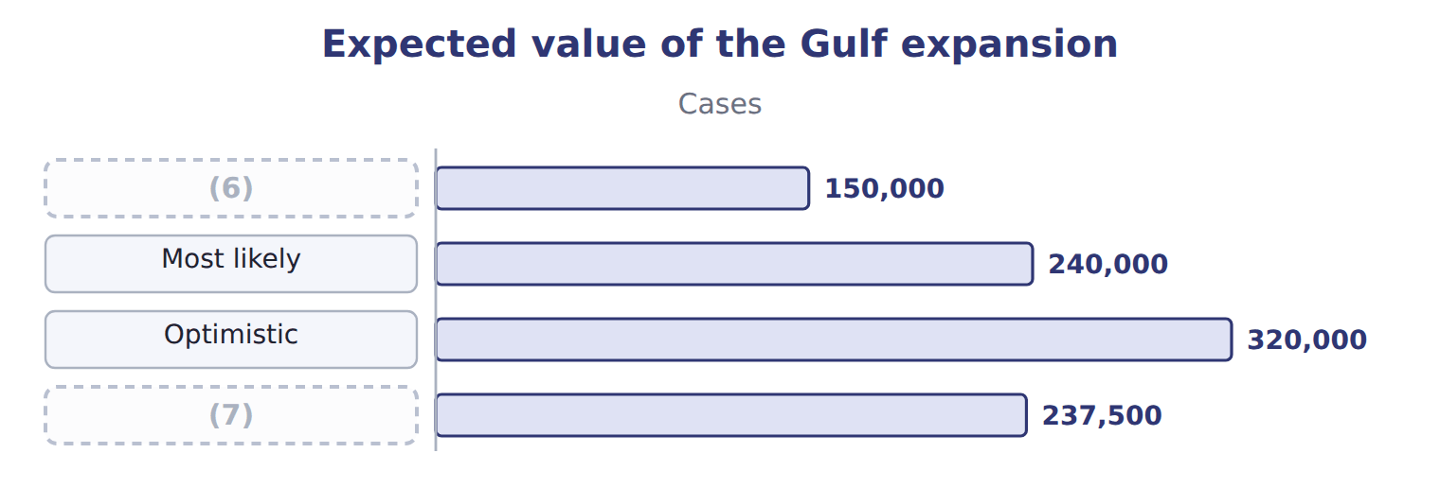
word list
Pessimistic · Expected value · Optimistic

Summary 2 gaps 8–16
The expected (8) of 237,500 cases is not the middle scenario and not the simple (9) of the three, which would be 236,667. The (10) do the work: the most likely case carries half the weight, and the two (11) a quarter each. The same (12) estimates a (13) cash flow. At a (14) of 8.20 a case and fixed costs of 900,000, the expected contribution is 1,047,500. Each (15) own contribution is shown (16) it, and they range from 330,000 to 1,724,000. Where cash flows fall in different years, each year's expected flow is computed this way and then discounted. The two steps must not be combined.
word list
probabilities · volume · scenario's · arithmetic · margin · future · beside · carries · extremes · average

The English this sheet uses, and its Arabic
English (exam term) | Arabic
expected value | القيمة المتوقعة

Answer key · 17.1 Expected value

1 Expected value | 9 average
2 Sensitivity, what-if and goal seeking | 10 probabilities
3 The limitations of data analytics | 11 extremes
4 uncertain | 12 arithmetic
5 probability | 13 future
6 Pessimistic | 14 margin
7 Expected value | 15 scenario's
8 volume | 16 beside

the summaries in full
Summary 1 The expected value of an uncertain quantity is each possible outcome multiplied by its probability, and the results added together.
Summary 2 The expected volume of 237,500 cases is not the middle scenario and not the simple average of the three, which would be 236,667. The probabilities do the work: the most likely case carries half the weight, and the two extremes a quarter each. The same arithmetic estimates a future cash flow. At a margin of 8.20 a case and fixed costs of 900,000, the expected contribution is 1,047,500. Each scenario's own contribution is shown beside it, and they range from 330,000 to 1,724,000. Where cash flows fall in different years, each year's expected flow is computed this way and then discounted. The two steps must not be combined.

17.2 What expected value cannot tell you
Chapter 17 · section 17.2

Fill every gap. Each word list holds one word more than there are gaps.
The benefits and shortcomings of expected value
Expected value (B.3.h) | Benefit | Shortcoming
Uses all the information | Every outcome and its likelihood enter the figure | (1)
Comparable across options | One number per option, so options can be ranked | (2)
Correct over many repetitions | The long-run average of a repeated decision | (3)
Simple to compute and explain | Multiply and add | (4)
 |  | It ignores the decision-maker's attitude to risk

word list
The probabilities are usually estimates, not facts · It hides the spread entirely · Nobody actually receives the expected value · A once-only decision is not a long run · The long-run average of a repeated decision

Summary 1 gaps 5–12
Two of those (5) decide real cases. The first is that nobody (6) the expected value: the outcomes here are 330,000, 1,068,000 and 1,724,000, and 1,047,500 is not among them. It is a (7) average, not a (8) of what will happen. The (9) is that it is correct over many (10) . A company (11) between two (12) every week is in a long run; a company deciding once whether to enter the Gulf is not. For a single large decision, the spread of outcomes matters as much as their average.
word list
choosing · receives · shortcomings · weighted · repetitions · decision · second · suppliers · forecast

Answer key · 17.2 What expected value cannot tell you

1 Nobody actually receives the expected value | 7 weighted
2 It hides the spread entirely | 8 forecast
3 A once-only decision is not a long run | 9 second
4 The probabilities are usually estimates, not facts | 10 repetitions
5 shortcomings | 11 choosing
6 receives | 12 suppliers

the summaries in full
Summary 1 Two of those shortcomings decide real cases. The first is that nobody receives the expected value: the outcomes here are 330,000, 1,068,000 and 1,724,000, and 1,047,500 is not among them. It is a weighted average, not a forecast of what will happen. The second is that it is correct over many repetitions. A company choosing between two suppliers every week is in a long run; a company deciding once whether to enter the Gulf is not. For a single large decision, the spread of outcomes matters as much as their average.

17.3 Sensitivity, what-if and goal seeking
Chapter 17 · section 17.3

Fill every gap. Each word list holds one word more than there are gaps.
Three related techniques vary the assumptions deliberately.
Sensitivity, what-if, goal seeking and simulation
Technique | What it does | The question it answers | Varies
Sensitivity analysis | (1) | Which assumption deserves the most work? | One at a time
What-if analysis | (2) | What happens if volume falls by a fifth? | Any number of inputs
Goal seeking | Set the answer you need and solve for the input | (3) | Works backwards
Simulation | Vary every assumption together, thousands of times | What is the whole range of outcomes? | (4)

word list
Which assumption deserves the most work? · All at once, with probabilities · Change ONE assumption and see how far the answer moves · Change an input and read the new answer · What volume is needed to break even?

Summary 1 gaps 5–16
Its purpose is not to forecast but to rank: it tells you which (5) deserves the most effort in (6) , and which can be left rough. A ten per cent change in margin or in volume moves (7) by +18.6%, while the same change in fixed cost moves it by +8.6%. Margin and volume (8) deserve the careful estimate, and the fixed cost can be (9) . It sets the answer (10) and solves for the input that would produce it, which is how a (11) volume is found. Both are everyday (12) work rather than (13) techniques, and that is their value. A (14) who can ask the model a question and get an answer in a minute will ask more (15) . The assumptions then get (16) far more often than any formal review would test them.
word list
spreadsheet · related · contribution · specialist · manager · questions · required · break-even · tested · approximate · therefore · assumption · estimating

The words this section uses
Each term sits against what it means.
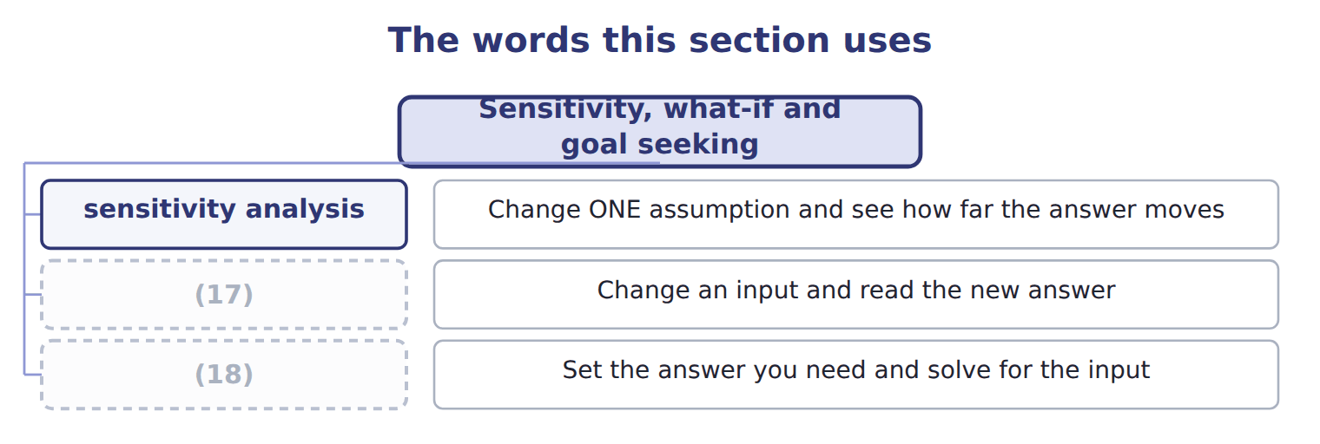
word list
expected value · goal seeking · what-if analysis

The English this sheet uses, and its Arabic
English (exam term) | Arabic
sensitivity analysis | تحليل الحساسية
what-if analysis | تحليل ماذا لو
goal seeking | البحث عن الهدف

Answer key · 17.3 Sensitivity, what-if and goal seeking

1 Change ONE assumption and see how far the answer moves | 10 required
2 Change an input and read the new answer | 11 break-even
3 What volume is needed to break even? | 12 spreadsheet
4 All at once, with probabilities | 13 specialist
5 assumption | 14 manager
6 estimating | 15 questions
7 contribution | 16 tested
8 therefore | 17 what-if analysis
9 approximate | 18 goal seeking

the summaries in full
Summary 1 Its purpose is not to forecast but to rank: it tells you which assumption deserves the most effort in estimating, and which can be left rough. A ten per cent change in margin or in volume moves contribution by +18.6%, while the same change in fixed cost moves it by +8.6%. Margin and volume therefore deserve the careful estimate, and the fixed cost can be approximate. It sets the answer required and solves for the input that would produce it, which is how a break-even volume is found. Both are everyday spreadsheet work rather than specialist techniques, and that is their value. A manager who can ask the model a question and get an answer in a minute will ask more questions. The assumptions then get tested far more often than any formal review would test them.

17.4 Simulation and the Monte Carlo technique
Chapter 17 · section 17.4

Fill every gap. Each word list holds one word more than there are gaps.
Summary 1 gaps 1–12
Sensitivity moves one (1) at a time, which is its (2) : in reality they all move at once, and sometimes together. A (3) model varies them all, (4) , each draw taken from a distribution rather than a single value. The Monte Carlo (5) is the standard (6) . Each trial draws a volume, a margin and a fixed cost at random from their ranges, (7) the outcome, and (8) it. Doing that (9) of times builds up the distribution of (10) rather than a single number. The mean of the trials is 1,027,152, close to the single expected value of 1,047,500, which is (11) rather than (12) . The information the expected value could not give is the spread: 539,260 to 1,503,517 covers nine trials in ten. That range is what a board needs. It converts a decision from a single number into a question about whether the worst plausible outcome is survivable. That is the question that ought to be asked.
word list
outcomes · reassuring · technique · computes · method · records · limitation · decision · assumption · simulation · surprising · thousands · repeatedly

Summary 2 gaps 13–16
Simulation has costs of its own. It needs a (13) for every assumption rather than a single figure, which is more work and more (14) . It is harder to (15) to a board than one number. And its apparent (16) can lend unearned authority to inputs that were guessed.
word list
sophistication · reassuring · judgement · distribution · explain

The English this section uses, and its Arabic
Each term sits against what it means.
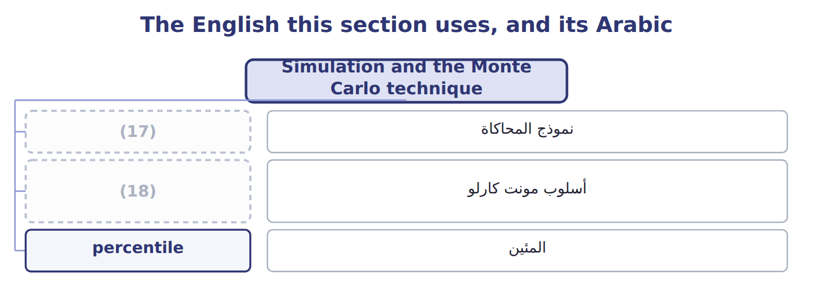
word list
Monte Carlo technique · simulation model · أسلوب مونت كارلو

The English this sheet uses, and its Arabic
English (exam term) | Arabic
simulation model | نموذج المحاكاة
Monte Carlo technique | أسلوب مونت كارلو
percentile | المئين

Answer key · 17.4 Simulation and the Monte Carlo technique

1 assumption | 10 outcomes
2 limitation | 11 reassuring
3 simulation | 12 surprising
4 repeatedly | 13 distribution
5 technique | 14 judgement
6 method | 15 explain
7 computes | 16 sophistication
8 records | 17 simulation model
9 thousands | 18 Monte Carlo technique

the summaries in full
Summary 1 Sensitivity moves one assumption at a time, which is its limitation: in reality they all move at once, and sometimes together. A simulation model varies them all, repeatedly, each draw taken from a distribution rather than a single value. The Monte Carlo technique is the standard method. Each trial draws a volume, a margin and a fixed cost at random from their ranges, computes the outcome, and records it. Doing that thousands of times builds up the distribution of outcomes rather than a single number. The mean of the trials is 1,027,152, close to the single expected value of 1,047,500, which is reassuring rather than surprising. The information the expected value could not give is the spread: 539,260 to 1,503,517 covers nine trials in ten. That range is what a board needs. It converts a decision from a single number into a question about whether the worst plausible outcome is survivable. That is the question that ought to be asked.
Summary 2 Simulation has costs of its own. It needs a distribution for every assumption rather than a single figure, which is more work and more judgement. It is harder to explain to a board than one number. And its apparent sophistication can lend unearned authority to inputs that were guessed.

17.5 From prediction to recommendation
Chapter 17 · section 17.5

Fill every gap. Each word list holds one word more than there are gaps.
Summary 1 gaps 1–11
The syllabus asks how (1) techniques are used to draw insights and make (2) , and the answer is a sequence rather than a technique. Predict the outcome, test which (3) it depends on, (4) the range, and then state what should be done and under what conditions. A recommendation that names no (5) is weaker than one that does. (6) it with the. Saying demand will be about 226,273 cases is a (7) ; saying the plant should schedule to forecast (8) is a recommendation. The (9) form adds the conditions under which the recommendation would change. Here that is a volume below the fifth (10) , a margin materially below 8.20, or a change in the Gulf market that breaks the (11) the model was fitted to.
word list
simulate · recommendations · condition · prediction · percentile · honest · temperature · assumptions · forecast · Compare · predictive · pattern

Answer key · 17.5 From prediction to recommendation

1 predictive | 7 prediction
2 recommendations | 8 temperature
3 assumptions | 9 honest
4 simulate | 10 percentile
5 condition | 11 pattern
6 Compare

the summaries in full
Summary 1 The syllabus asks how predictive techniques are used to draw insights and make recommendations, and the answer is a sequence rather than a technique. Predict the outcome, test which assumptions it depends on, simulate the range, and then state what should be done and under what conditions. A recommendation that names no condition is weaker than one that does. Compare it with the. Saying demand will be about 226,273 cases is a prediction; saying the plant should schedule to forecast temperature is a recommendation. The honest form adds the conditions under which the recommendation would change. Here that is a volume below the fifth percentile, a margin materially below 8.20, or a change in the Gulf market that breaks the pattern the model was fitted to.

17.6 The limitations of data analytics
Chapter 17 · section 17.6

Fill every gap. Each word list holds one word more than there are gaps.
Summary 1 gaps 1–2
This is the last (1) of Part IV and the one that keeps the rest in (2) .
word list
proportion · outcome · percentile

The limitations of data analytics
Limitation of data analytics (F.4.aa) | What it means
Data quality | (3)
Association, not cause | Correlation never establishes causation
The past may not continue | Every model assumes it does
What is not measured | Reputation, morale and (4) rarely appear in the data
Probabilities are estimates | (5)
Privacy and ethics | (6)
It informs, it does not decide | Management remains accountable for the choice

word list
A model built on guesses inherits them · An answer is only as good as what went in · relationships · What can be analysed is not always what should be · Management remains accountable for the choice

Summary 2 gaps 7–8
The (7) of 0.25, 0.50 and 0.25 were not measured; somebody estimated them. Every figure computed from them inherits that judgement, however many decimal places the (8) reports.
word list
accurate · probabilities · simulation

Precision is not accuracy

Summary 3 gaps 9–15
A (9) reporting a fifth (10) to the nearest pound looks precise, and is only as accurate as the ranges it was given. A question offering a very exact figure from very rough (11) is testing whether the (12) notices. The last row is the one to carry out of Part IV. (13) informs a decision; it does not make one. The board still votes on the Gulf (14) , and remains (15) for the vote whatever the model said.
word list
simulation · expansion · accountable · Analytics · judgement · assumptions · percentile · candidate

The words this section uses
Each term sits against what it means.
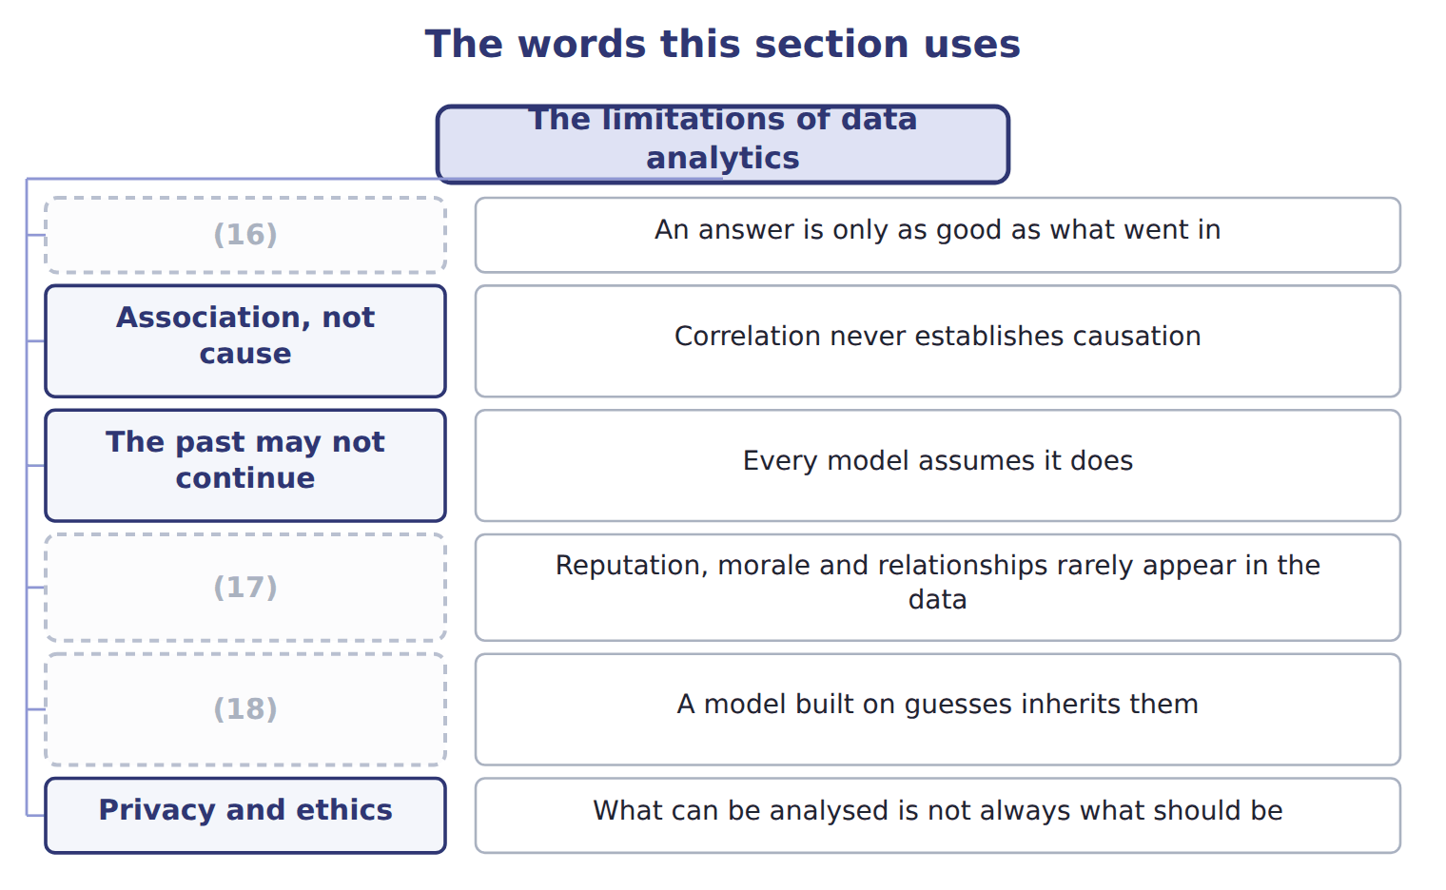
word list
Privacy and ethics · Probabilities are estimates · Data quality · What is not measured

Answer key · 17.6 The limitations of data analytics

1 outcome | 10 percentile
2 proportion | 11 assumptions
3 An answer is only as good as what went in | 12 candidate
4 relationships | 13 Analytics
5 A model built on guesses inherits them | 14 expansion
6 What can be analysed is not always what should be | 15 accountable
7 probabilities | 16 Data quality
8 simulation | 17 What is not measured
9 simulation | 18 Probabilities are estimates

the summaries in full
Summary 1 This is the last outcome of Part IV and the one that keeps the rest in proportion.
Summary 2 The probabilities of 0.25, 0.50 and 0.25 were not measured; somebody estimated them. Every figure computed from them inherits that judgement, however many decimal places the simulation reports.
Summary 3 A simulation reporting a fifth percentile to the nearest pound looks precise, and is only as accurate as the ranges it was given. A question offering a very exact figure from very rough assumptions is testing whether the candidate notices. The last row is the one to carry out of Part IV. Analytics informs a decision; it does not make one. The board still votes on the Gulf expansion, and remains accountable for the vote whatever the model said.

17.7 Extended Example 17A: the Gulf expansion under uncertainty
Chapter 17 · section 17.7

Fill every gap. Each word list holds one word more than there are gaps.
Summary 1 gaps 1–2
This example works the (1) the exam sets and then shows what the single figure (2) .
word list
calculation · conceals · materially

Weighting the three scenarios

Summary 2 gaps 3–14
At 8.20 a case the expected (3) before fixed cost is 1,947,500. (4) fixed costs of 900,000 gives 1,047,500, against an (5) of 2,500,000. (6) the three volumes (7) their probabilities gives 236,667 cases rather than 237,500. The (8) is small here because the probabilities are nearly (9) , and it would not be if they were not. (10) analysis says margin and volume (11) , at +18.6% for a ten per cent change, and fixed cost half as much at +8.6%. (12) effort should follow that (13) . No trial in this run produced a loss, which is itself worth (14) . Proceed, because even the fifth percentile of 539,260 covers the fixed cost comfortably. Review if the margin falls materially below 8.20, because margin is one of the two assumptions the answer depends on most.
word list
investment · contribution · Deducting · materially · ranking · Averaging · symmetrical · equally · difference · reporting · without · Estimating · Sensitivity

Name four techniques

Complete the blank cells.
Your turn: name four techniques (complete the blanks)
Every item belongs to exactly one group.
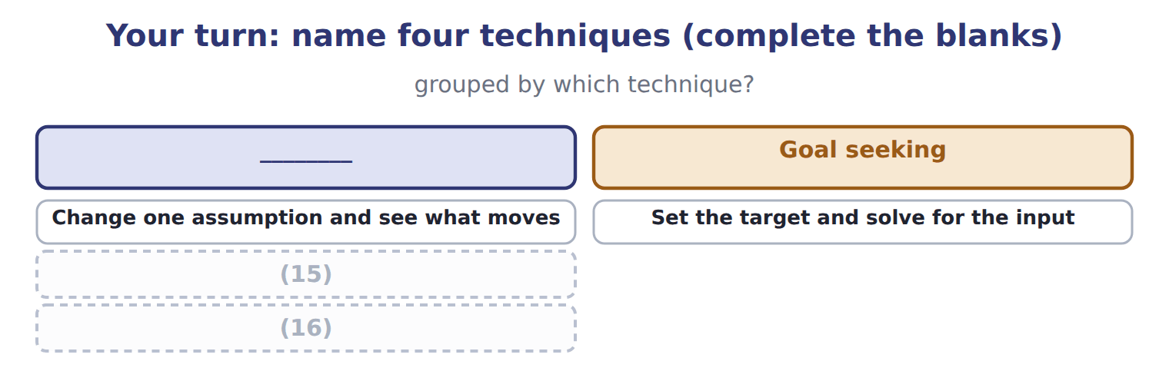
word list
Change one assumption and see what moves · Vary everything together, many times · Each outcome times its probability, summed

Everything ties

Summary 3 gaps 17–19
Expected volume 237,500 cases; expected (17) 1,047,500. Simple average 236,667 cases, which is the (18) . (19) mean 1,027,152, within a few per cent of the expected value. Fifth to ninety-fifth percentile: 539,260 to 1,503,517.
word list
distractor · produced · Simulation · contribution

Exam view

Summary 4 gaps 20–22
The (20) is always outcome times probability, summed. The trap is the (21) average. Where a question asks what simulation adds over expected value, the answer is the (22) , not a better single number.
word list
distribution · calculation · unweighted · equally

Exam view
Item | Answer
Change one assumption and see what moves | Sensitivity analysis — it finds which input the answer depends on most
Set the target and solve for the input | Why: goal seeking works backwards from a required answer, which is how a break-even volume is found
Vary everything together, many times | Simulation, usually by the (23) — it gives the whole distribution of outcomes
Each outcome times its probability, summed | (24) — it gives one number, which is both its convenience and its weakness

word list
Monte Carlo technique · goal seeking · Expected value

Question from the board — Category
Question from the board | Category
What is the single probability-weighted outcome? | (25)
Which assumption moves the answer most? | Sensitivity analysis
What volume is needed to break even? | Goal seeking
What is the whole range of possible outcomes? | (26)

word list
Simulation · Expected value · Goal seeking

The English this section uses, and its Arabic
Each term sits against what it means.
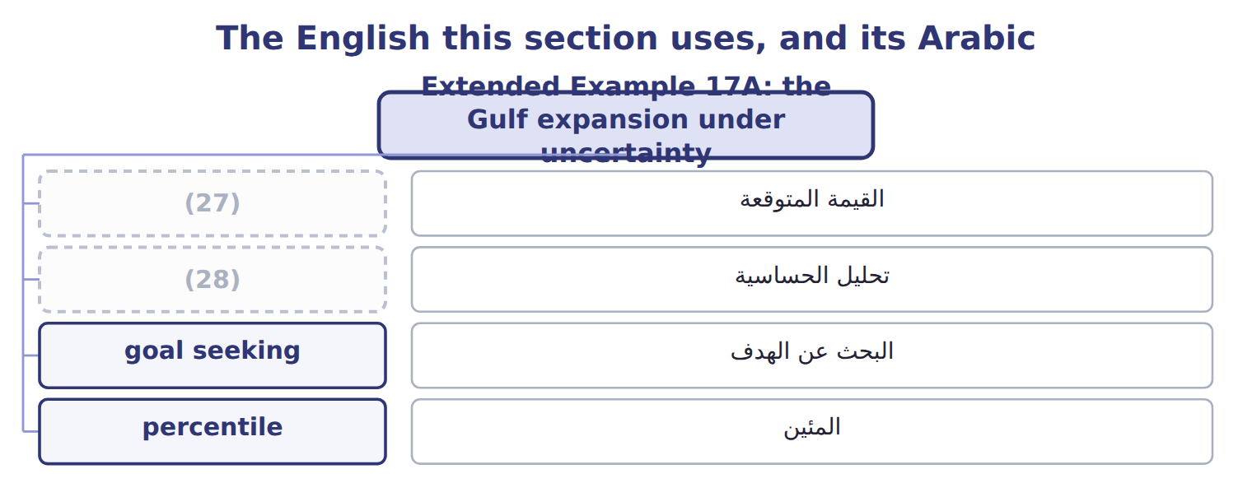
word list
goal seeking · expected value · sensitivity analysis

Answer key · 17.7 Extended Example 17A: the Gulf expansion under uncertainty

1 calculation | 15 Vary everything together, many times
2 conceals | 16 Each outcome times its probability, summed
3 contribution | 17 contribution
4 Deducting | 18 distractor
5 investment | 19 Simulation
6 Averaging | 20 calculation
7 without | 21 unweighted
8 difference | 22 distribution
9 symmetrical | 23 Monte Carlo technique
10 Sensitivity | 24 Expected value
11 equally | 25 Expected value
12 Estimating | 26 Simulation
13 ranking | 27 expected value
14 reporting | 28 sensitivity analysis

the summaries in full
Summary 1 This example works the calculation the exam sets and then shows what the single figure conceals.
Summary 2 At 8.20 a case the expected contribution before fixed cost is 1,947,500. Deducting fixed costs of 900,000 gives 1,047,500, against an investment of 2,500,000. Averaging the three volumes without their probabilities gives 236,667 cases rather than 237,500. The difference is small here because the probabilities are nearly symmetrical, and it would not be if they were not. Sensitivity analysis says margin and volume equally, at +18.6% for a ten per cent change, and fixed cost half as much at +8.6%. Estimating effort should follow that ranking. No trial in this run produced a loss, which is itself worth reporting. Proceed, because even the fifth percentile of 539,260 covers the fixed cost comfortably. Review if the margin falls materially below 8.20, because margin is one of the two assumptions the answer depends on most.
Summary 3 Expected volume 237,500 cases; expected contribution 1,047,500. Simple average 236,667 cases, which is the distractor. Simulation mean 1,027,152, within a few per cent of the expected value. Fifth to ninety-fifth percentile: 539,260 to 1,503,517.
Summary 4 The calculation is always outcome times probability, summed. The trap is the unweighted average. Where a question asks what simulation adds over expected value, the answer is the distribution, not a better single number.

18.1 Choosing the form
Chapter 18 · section 18.1

Fill every gap. Each word list holds one word more than there are gaps.
Chapter 18, section by section
Each stage leads to the next.
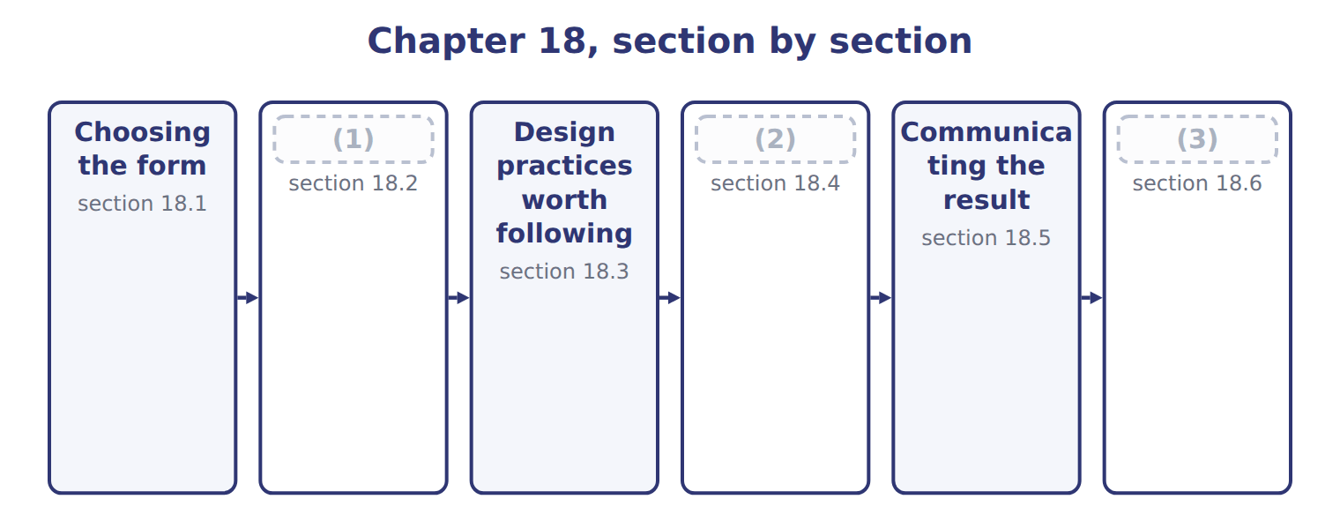
word list
Extended Example 18A: presenting the Gulf deci · Design practices worth following · What a picture can and cannot do · How a true chart misleads

Summary 1 gaps 4–5
The choice of chart (4) from what the reader must see, not from what is (5) in the software.
word list
available · follows · measures

Choosing the form of a visualization
What the reader must see (F.4.cc) | Best form
A comparison across categories | Bar chart
A trend over time | (6)
A relationship between two variables | (7)
A distribution of many values | Histogram or box plot
Composition of a whole | (8)
Exact values that will be read off | Table
Several measures watched over time | (9)

word list
Dashboard · Stacked bar, or a table · Line chart · Scatter plot · Histogram or box plot

Summary 2 gaps 10–17
Three of those have been used (10) . A scatter plot showed cases against (11) because the question was whether two (12) move together. A (13) showed the simulated outcomes because the question was about the shape of a (14) . A line chart showed the eight (15) because the question was about (16) over time. The last two rows (17) a note. A dashboard suits several measures watched repeatedly. And a table is the right answer more often than people expect: where exact values will be read off and compared, a table beats any chart.
word list
movement · deserve · question · quarters · already · temperature · histogram · variables · distribution

The English this section uses, and its Arabic
Each term sits against what it means.
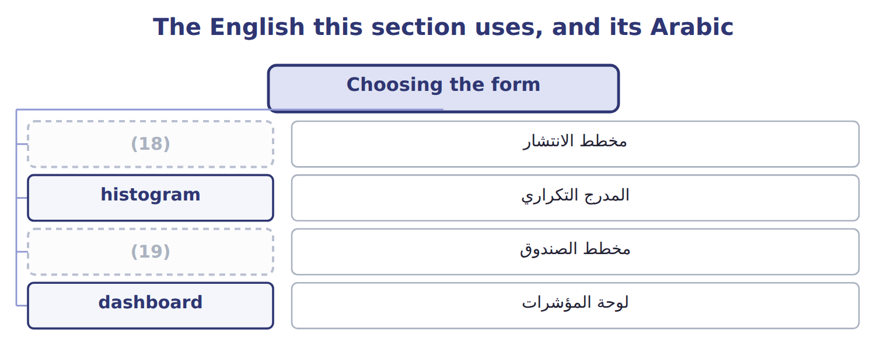
word list
box plot · scatter plot · مخطط الصندوق

The English this sheet uses, and its Arabic
English (exam term) | Arabic
scatter plot | مخطط الانتشار
histogram | المدرج التكراري
box plot | مخطط الصندوق
dashboard | لوحة المؤشرات

Answer key · 18.1 Choosing the form

1 How a true chart misleads | 11 temperature
2 What a picture can and cannot do | 12 variables
3 Extended Example 18A: presenting the Gulf deci | 13 histogram
4 follows | 14 distribution
5 available | 15 quarters
6 Line chart | 16 movement
7 Scatter plot | 17 deserve
8 Stacked bar, or a table | 18 scatter plot
9 Dashboard | 19 box plot
10 already

the summaries in full
Summary 1 The choice of chart follows from what the reader must see, not from what is available in the software.
Summary 2 Three of those have been used already. A scatter plot showed cases against temperature because the question was whether two variables move together. A histogram showed the simulated outcomes because the question was about the shape of a distribution. A line chart showed the eight quarters because the question was about movement over time. The last two rows deserve a note. A dashboard suits several measures watched repeatedly. And a table is the right answer more often than people expect: where exact values will be read off and compared, a table beats any chart.

18.2 How a true chart misleads
Chapter 18 · section 18.2

Fill every gap. Each word list holds one word more than there are gaps.
Summary 1 gaps 1–12
Distortion rarely (1) a false number. On the left the axis begins at 205,000, and the (2) bar towers over the first. On the right it begins at zero, and the four (3) are visibly (4) . The third quarter (5) the first by 14 per cent, which the (6) chart conveys and the left-hand chart does not. Every figure in the left-hand chart is (7) . Nothing has been (8) , nothing omitted, and the axis is (9) labelled. It misleads because a bar's length is read as its value, and truncating the axis breaks that (10) while leaving the chart (11) defensible. A label does not undo the distortion, because (12) take the message from the shape before reading the axis. For a bar chart the rule is simple and worth keeping: start at zero. A line chart may begin elsewhere, because a line's message is its slope rather than its length, but the choice should still be stated.
word list
quarters · honestly · relationship · involves · similar · invented · elsewhere · third-quarter · correct · right-hand · readers · exceeds · technically

The English this sheet uses, and its Arabic
English (exam term) | Arabic
truncated axis | المحور المقطوع

Answer key · 18.2 How a true chart misleads

1 involves | 7 correct
2 third-quarter | 8 invented
3 quarters | 9 honestly
4 similar | 10 relationship
5 exceeds | 11 technically
6 right-hand | 12 readers

the summaries in full
Summary 1 Distortion rarely involves a false number. On the left the axis begins at 205,000, and the third-quarter bar towers over the first. On the right it begins at zero, and the four quarters are visibly similar. The third quarter exceeds the first by 14 per cent, which the right-hand chart conveys and the left-hand chart does not. Every figure in the left-hand chart is correct. Nothing has been invented, nothing omitted, and the axis is honestly labelled. It misleads because a bar's length is read as its value, and truncating the axis breaks that relationship while leaving the chart technically defensible. A label does not undo the distortion, because readers take the message from the shape before reading the axis. For a bar chart the rule is simple and worth keeping: start at zero. A line chart may begin elsewhere, because a line's message is its slope rather than its length, but the choice should still be stated.

18.3 Design practices worth following
Chapter 18 · section 18.3

Fill every gap. Each word list holds one word more than there are gaps.
Design practices and the reason for each
Practice (F.4.bb) | Why | Note
Start a bar chart's axis at zero | A bar's length is the message; truncating it lies about the ratio | (1)
Keep the aspect ratio honest | Stretching a chart vertically steepens every trend | (2)
Label directly where you can | (3) | Put the series name at the end of the line
Order categories meaningfully | By size, or by time; not by the alphabet | (4)
Remove what does not inform | (5) | Every mark should carry meaning
One message per exhibit | (6) | Draw the second chart
Show the caveat | (7) | Chapter 17's probabilities were estimates

word list
Sample size, excluded rows, estimated inputs · Stretching a chart vertically steepens every trend · A line chart may start elsewhere, if labelled · Choose it before seeing the result · A chart saying three things usually says none · A legend makes the eye travel; a label does not · Unless the reader will look a category up · Gridlines, borders and effects compete with the data

Summary 1 gaps 8–14
The aspect ratio (8) more attention than it (9) gets. (10) a chart vertically steepens every trend in it, and the stretch is invisible to a reader who never sees the (11) . Choosing the (12) before seeing the result removes the (13) . (14) what does not inform is the rule that improves most charts. Gridlines, borders, shadows and three-dimensional effects compete with the data for the reader's attention, and the data always loses something in the contest.
word list
temptation · Removing · usually · deserves · Stretching · proportions · attention · alternative

Answer key · 18.3 Design practices worth following

1 A line chart may start elsewhere, if labelled | 8 deserves
2 Choose it before seeing the result | 9 usually
3 A legend makes the eye travel; a label does not | 10 Stretching
4 Unless the reader will look a category up | 11 alternative
5 Gridlines, borders and effects compete with the data | 12 proportions
6 A chart saying three things usually says none | 13 temptation
7 Sample size, excluded rows, estimated inputs | 14 Removing

the summaries in full
Summary 1 The aspect ratio deserves more attention than it usually gets. Stretching a chart vertically steepens every trend in it, and the stretch is invisible to a reader who never sees the alternative. Choosing the proportions before seeing the result removes the temptation. Removing what does not inform is the rule that improves most charts. Gridlines, borders, shadows and three-dimensional effects compete with the data for the reader's attention, and the data always loses something in the contest.

18.4 What a picture can and cannot do
Chapter 18 · section 18.4

Fill every gap. Each word list holds one word more than there are gaps.
The benefits of visualization and their matching limitations
Visualization (F.4.dd) | Benefit | Matching limitation
The eye is fast | A (1) visible in a second would take minutes in a table | The same speed makes a distorted chart persuasive
It reaches non-specialists | (2) | It can imply precision the data lacks
It reveals the unexpected | Outliers and gaps show themselves | (3)
It compresses volume | (4) | Compression hides the individual case
It aids memory | A reader recalls a shape, not a number | (5)
It supports the argument | The claim and its evidence sit together | (6)

word list
It never establishes cause · pattern · A wrong shape is remembered just as well · Thousands of trials in one picture · It can suggest patterns that are coincidence · A board reads a chart it would not read as output · scatter plot

Summary 1 gaps 7–12
The first pair carries the (7) . The eye reads a (8) in a second that a table would take minutes to yield. That same speed is why a (9) chart persuades before anybody has checked the axis. Speed is the (10) and the danger together. The last (11) is the one Part IV has repeated. A chart showing two series moving together is a picture of an (12) .
word list
benefit · limitation · argument · association · showing · distorted · pattern

Answer key · 18.4 What a picture can and cannot do

1 pattern | 7 argument
2 A board reads a chart it would not read as output | 8 pattern
3 It can suggest patterns that are coincidence | 9 distorted
4 Thousands of trials in one picture | 10 benefit
5 A wrong shape is remembered just as well | 11 limitation
6 It never establishes cause | 12 association

the summaries in full
Summary 1 The first pair carries the argument. The eye reads a pattern in a second that a table would take minutes to yield. That same speed is why a distorted chart persuades before anybody has checked the axis. Speed is the benefit and the danger together. The last limitation is the one Part IV has repeated. A chart showing two series moving together is a picture of an association.

18.5 Communicating the result
Chapter 18 · section 18.5

Fill every gap. Each word list holds one word more than there are gaps.
Summary 1 gaps 1–11
An exhibit has to carry its meaning to someone who did not do the (1) and will not ask (2) . The (3) single change is in the title. A title (4) the axes leaves the reader to work out what (5) , and some will not. A title (6) the finding tells them what to look for, and the chart then has one job: to show that the claim is true. The other three rules (7) from it. One (8) per exhibit, because a chart saying three things (9) says none. The chart (10) the title, by (11) the part that carries the claim. And the caveat is shown rather than hidden, because an audience that discovers an omission later distrusts everything else.
word list
naming · because · analysis · strongest · matters · highlighting · supports · stating · follow · message · questions · usually

The English this sheet uses, and its Arabic
English (exam term) | Arabic
data visualization | العرض المرئي للبيانات

Answer key · 18.5 Communicating the result

1 analysis | 7 follow
2 questions | 8 message
3 strongest | 9 usually
4 naming | 10 supports
5 matters | 11 highlighting
6 stating

the summaries in full
Summary 1 An exhibit has to carry its meaning to someone who did not do the analysis and will not ask questions. The strongest single change is in the title. A title naming the axes leaves the reader to work out what matters, and some will not. A title stating the finding tells them what to look for, and the chart then has one job: to show that the claim is true. The other three rules follow from it. One message per exhibit, because a chart saying three things usually says none. The chart supports the title, by highlighting the part that carries the claim. And the caveat is shown rather than hidden, because an audience that discovers an omission later distrusts everything else.

18.6 Extended Example 18A: presenting the Gulf decision to the board
Chapter 18 · section 18.6

Fill every gap. Each word list holds one word more than there are gaps.
Summary 1 gaps 1–12
F.4.cc is a Level C (1) , so the exam asks you to choose between (2) options and defend the choice. This example does that for the decision. The board must see three things: that the (3) is expected to (4) 1,047,500, that the realistic range runs from 539,260 to 1,503,517, and that even the low end covers the fixed cost. Three facts, and the decision (5) from them. A table of 1,000 trial (6) shows everything and (7) nothing. A single number is what the finance (8) already tried, and it (9) the question about the worst case. A pie chart has no role here, (10) nothing is a share of a whole. A (11) of the simulated outcomes, as, with the fifth and (12) percentiles marked and the fixed-cost line drawn across it. The shape answers the worst-case question visually, and the marked percentiles answer it numerically.
word list
results · director · ninety-fifth · started · contribute · communicates · histogram · follows · because · expansion · visualization · provoked · outcome

Summary 2 gaps 13–20
Not ' (13) of simulated (14) '. (15) closer to: even the (16) tenth of outcomes covers the fixed cost. That is the (17) , and the chart (18) to show that it is true. A line under the chart recording that the (19) were estimated by (20) rather than measured. Truncating the horizontal axis to begin at the fifth percentile, which would make every outcome look comfortable. Or drawing only the mean, which is what started the argument. Both would be defensible in the sense that no number would be false.
word list
management · Something · Distribution · exists · contribution · finding · visualization · pessimistic · probabilities

Choose four forms

Complete the blank cells.
Your turn: choose four forms (complete the blanks)
Every item belongs to exactly one group.
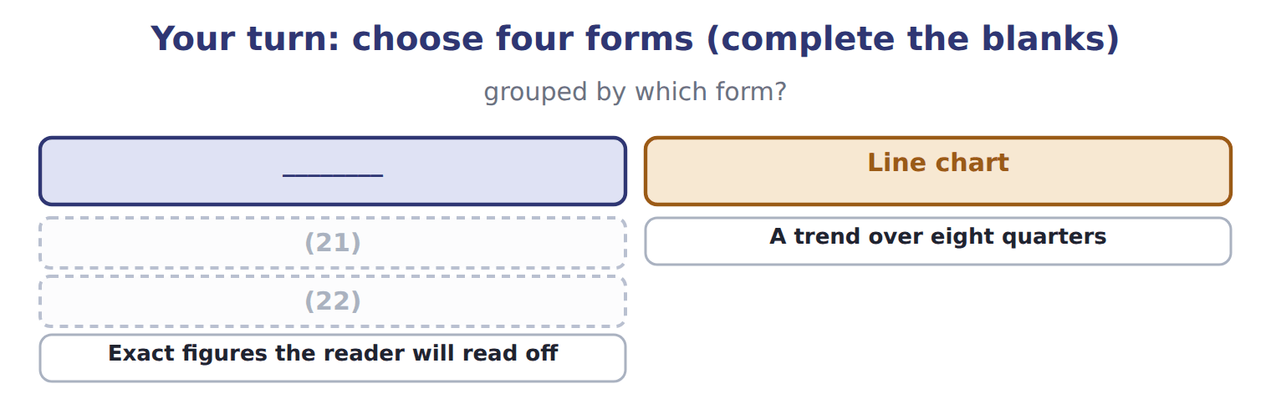
word list
A relationship between two variables · The distribution of 1,000 simulated outcomes · A trend over eight quarters

The pattern behind the choice

Summary 3 gaps 23–26
Start from what the reader must see, not from what the (23) produced. Reject the options that show (24) or show too little, and say why. Title the exhibit with the (25) , not with the axes. Put the (26) on the exhibit, where it will be read.
word list
caveat · argument · everything · finding · analysis

Exam view

Summary 4 gaps 27–30
A Level C question gives a (27) and several chart options. Name what the (28) must see, choose the form that shows it, and say what the (29) options would have failed to convey. Choosing (30) without the reason earns less than the reason deserves.
word list
rejected · situation · reader · Choosing · correctly

Exam view
Item | Answer
A relationship between two variables | A scatter plot — each point is one observation placed against both variables
A trend over eight quarters | Why: a line chart shows (31) over time, and the slope between points carries the message
The distribution of 1,000 simulated outcomes | A (32) — it shows the shape of the distribution and the spread around its centre
Exact figures the reader will read off | A table — where precision matters more than shape, a table beats any chart

word list
movement · Defect · histogram

Feature of the slide — Category
Every item belongs to exactly one group.
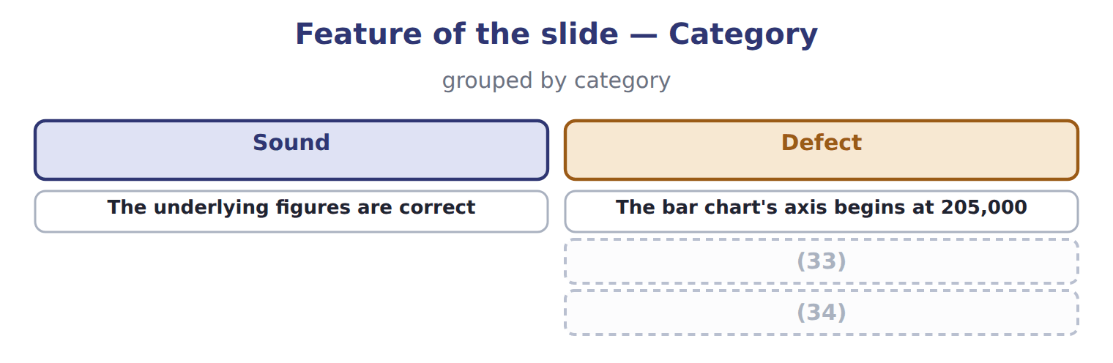
word list
Two charts and two messages on one slide · The title names the axes rather than the finding · The bar chart's axis begins at 205,000

Answer key · 18.6 Extended Example 18A: presenting the Gulf decision to the board

1 outcome | 18 exists
2 visualization | 19 probabilities
3 expansion | 20 management
4 contribute | 21 A relationship between two variables
5 follows | 22 The distribution of 1,000 simulated outcomes
6 results | 23 analysis
7 communicates | 24 everything
8 director | 25 finding
9 provoked | 26 caveat
10 because | 27 situation
11 histogram | 28 reader
12 ninety-fifth | 29 rejected
13 Distribution | 30 correctly
14 contribution | 31 movement
15 Something | 32 histogram
16 pessimistic | 33 Two charts and two messages on one slide
17 finding | 34 The title names the axes rather than the finding

the summaries in full
Summary 1 F.4.cc is a Level C outcome, so the exam asks you to choose between visualization options and defend the choice. This example does that for the decision. The board must see three things: that the expansion is expected to contribute 1,047,500, that the realistic range runs from 539,260 to 1,503,517, and that even the low end covers the fixed cost. Three facts, and the decision follows from them. A table of 1,000 trial results shows everything and communicates nothing. A single number is what the finance director already tried, and it provoked the question about the worst case. A pie chart has no role here, because nothing is a share of a whole. A histogram of the simulated outcomes, as, with the fifth and ninety-fifth percentiles marked and the fixed-cost line drawn across it. The shape answers the worst-case question visually, and the marked percentiles answer it numerically.
Summary 2 Not 'Distribution of simulated contribution'. Something closer to: even the pessimistic tenth of outcomes covers the fixed cost. That is the finding, and the chart exists to show that it is true. A line under the chart recording that the probabilities were estimated by management rather than measured. Truncating the horizontal axis to begin at the fifth percentile, which would make every outcome look comfortable. Or drawing only the mean, which is what started the argument. Both would be defensible in the sense that no number would be false.
Summary 3 Start from what the reader must see, not from what the analysis produced. Reject the options that show everything or show too little, and say why. Title the exhibit with the finding, not with the axes. Put the caveat on the exhibit, where it will be read.
Summary 4 A Level C question gives a situation and several chart options. Name what the reader must see, choose the form that shows it, and say what the rejected options would have failed to convey. Choosing correctly without the reason earns less than the reason deserves.

