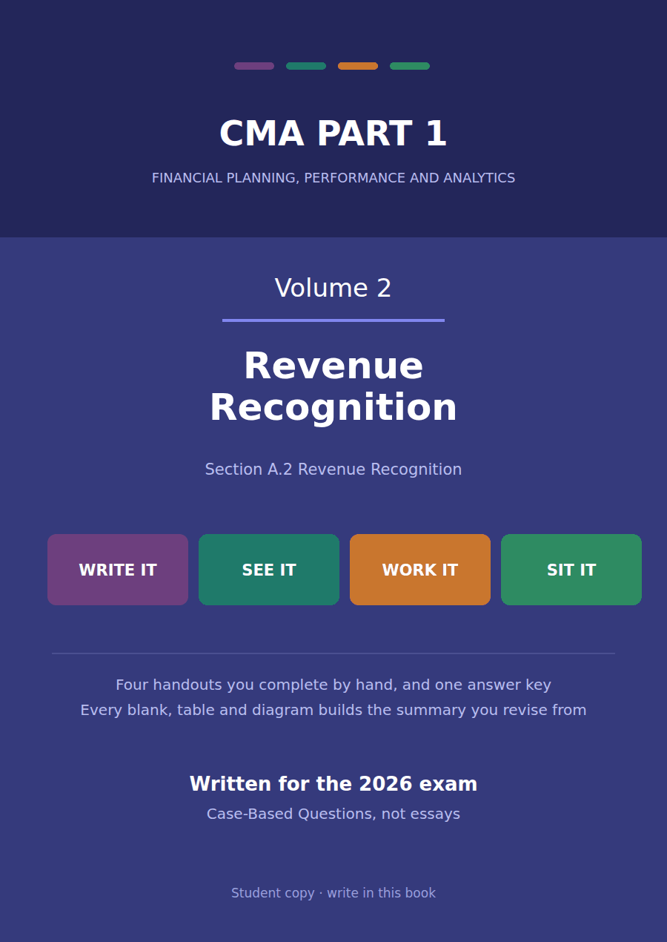

CMA Part 1 · Volume 2
Revenue Recognition
Four handouts, one answer key. The five steps, worked on contracts the exam actually sets, and the matching principle underneath them.
These handouts are not notes to read. You write them. The words you supply are the summary, so a finished handout is a page you can revise from, in your own handwriting.
Work in pen. Do not look at the key until the whole handout is done — the key is written to explain the mistake, and you only get that benefit if you have made it first.
The four handouts
# | Handout | What it gives you
1 | When Has a Company Earned It? | Cash arriving is not revenue, and an invoice sent is not revenue. One test decides, and it has nothing to do with either of them.
2 | The Contract, the Obligations, the Price | Three steps before a single dollar is allocated: is there a contract, how many promises, and how much will we actually be entitled to?
3 | Allocating the Price, and When to Recognise | The discount is spread, not dropped. Then each piece waits for its own moment, and two of the three do not wait long.
4 | Matching: Revenue and the Costs That Earned It | Revenue decides the year. The costs that produced it follow it there, and the ones that did not produce it do not.

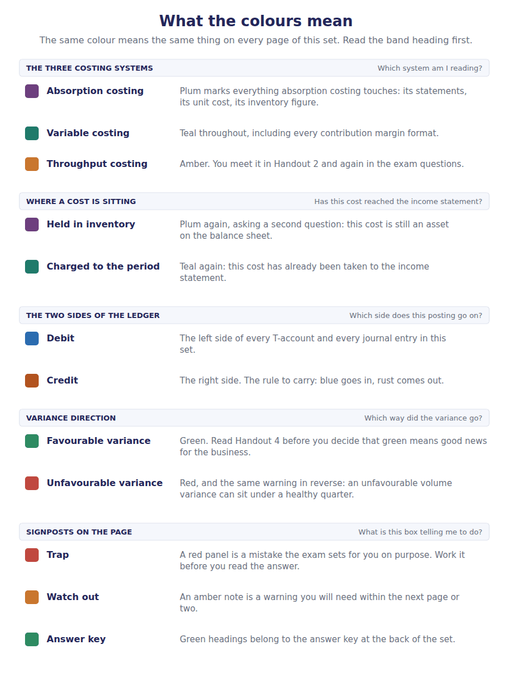
How to read the markers
Marker | Meaning
R1 | Teaching English. Short sentences. This is where a new idea arrives.
R2 | Textbook English. Longer sentences and passive verbs, as a textbook writes them.
R3 | Exam English. Exactly how the CMA exam phrases it, traps included.
Numbered rule | A space you fill in. The number matches the answer key.
Red table | A trap. Read it twice.

Handout 1 · When Has a Company Earned It?
Cash arriving is not revenue, and an invoice sent is not revenue. One test decides, and it has nothing to do with either of them.
Volume 2 · Revenue Recognition · R1 throughout, ending at R2
LANGUAGE FOCUS
Register you are working in | R1 Teaching English. Short sentences, one idea each. The vocabulary of this volume is introduced here.
Say it exactly like this | recognise revenue · transfer control of a good · satisfy a performance obligation · enter into a contract with a customer · enforceable rights and obligations · the customer obtains control
Words that are not the same | receive cash / recognise revenue · deliver / invoice · customer / counterparty · risk and reward / control
Remember | Receiving cash is not earning it. A deposit is a liability until the company does something for it. Sending an invoice is not earning it either. An invoice is a request for payment, not evidence of performance.

What you will be able to do when this handout is finished
- State the single event that triggers revenue recognition.
- Say why cash received in advance is a liability rather than revenue.
- Identify who the customer is in a transaction, and why it matters.
- Apply the control test to goods, to services, and to a combination of both.
- Name the five steps and say what each one decides.

One contract, worked for four handouts
In October 20X4 Northwind signed its largest contract of the year with Meridian Water Systems, a company that builds municipal water treatment plants.
Northwind promised three things: 1,200 flow controllers, the installation of those controllers on site, and twenty-four months of technical support afterwards. The stated price of the whole package is $560,000.
That one contract will occupy this entire volume. By the end of Handout 3 you will know exactly how much of it belongs to 20X4, and the answer is nothing like the whole.
This handout asks the question underneath all of it: what has Northwind actually earned?

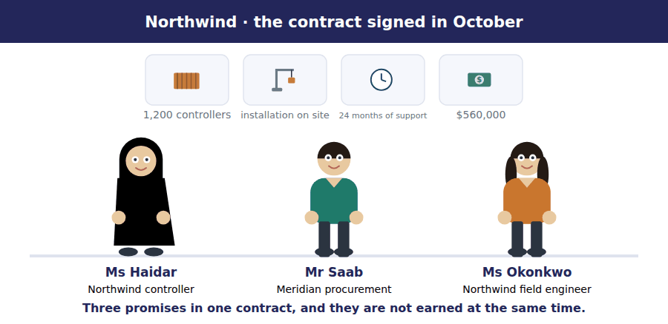
Part 1 · Not cash, not an invoice what actually triggers it
Exercise 1A Read and complete. Write one word in each space.
OBJECTIVE | State what triggers revenue recognition, and rule out the two things that do not.
YOU WILL NEED | Nothing — this is the first exercise in the volume.
HOW TO START | • Two of these blanks are things students wrongly believe trigger revenue. The sentences tell you they do not.  • Blank 3 is the single word that does trigger it.  • Blank 5 is what cash received in advance becomes instead.

WORD BANK
asset · cash · control · delivered · invoice · liability · order · profit
Not every word is used.

R1 Revenue is not recognised when the money arrives. A customer who pays a deposit in advance has given Northwind ¹ , but Northwind has not yet done anything for it.
Revenue is not recognised when the invoice is sent either. An ² is a request for payment. The company can send one early, late, or not at all, and none of that changes what it has earned.
Revenue is recognised when the customer obtains ³ of what was promised. Control means the customer can direct the use of the thing and take substantially all of the benefit from it.
For the controllers, that happens when they are ⁴ and Meridian can do what it likes with them. For the support, it happens month by month as the service is provided.
Until then, anything Meridian has paid sits on Northwind’s balance sheet as a contract ⁵ : a promise the company still owes.
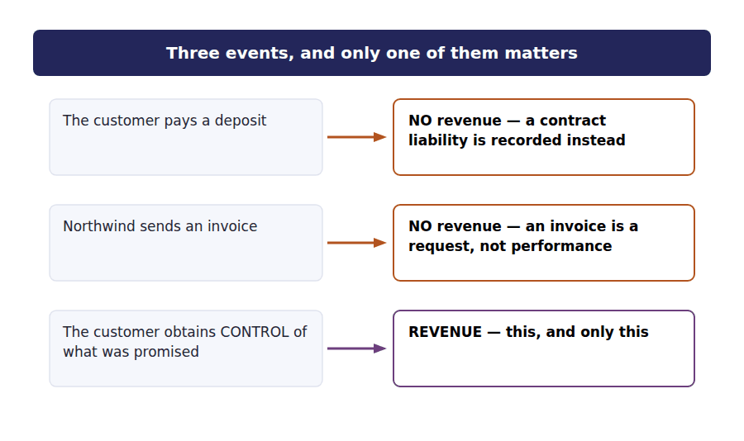
Part 2 · Control, not risks and rewards the test and the one it replaced
R2 The older rule asked whether the risks and rewards of ownership had passed. The current rule asks whether control has passed. Most of the time the two give the same answer, which is why the difference is easy to overlook and worth being careful about.
R2 Control is about what the customer can do: direct the use of the asset, and obtain substantially all of its remaining benefits. A customer who has taken delivery, can sell the goods on, and bears the loss if they are damaged has control, even if a small warranty obligation remains with the seller.
Exercise 1B Sort each situation into the column that says whether control has passed.
OBJECTIVE | Apply the control test to five situations, including two where it is contested.
YOU WILL NEED | Exercise 1A, and the two paragraphs above.
HOW TO START | • Ask what the customer can actually do with the goods, not where the goods are sitting.  • Physical possession is evidence of control, not proof of it. Two of these turn on exactly that.  • The consignment case is the one most students get wrong. Who can direct the use of the goods while they sit in the shop?

Situation at 31 December 20X4 | CONTROL HAS PASSED | CONTROL HAS NOT PASSED
1. Controllers delivered to Meridian’s site and accepted
2. Goods sent to a distributor on consignment, unsold
3. Goods shipped, in transit, title passing on despatch
4. A deposit received for controllers not yet made
5. Goods held in Northwind’s warehouse at the customer’s request, invoiced and separately identified
6. Installation work half finished on site

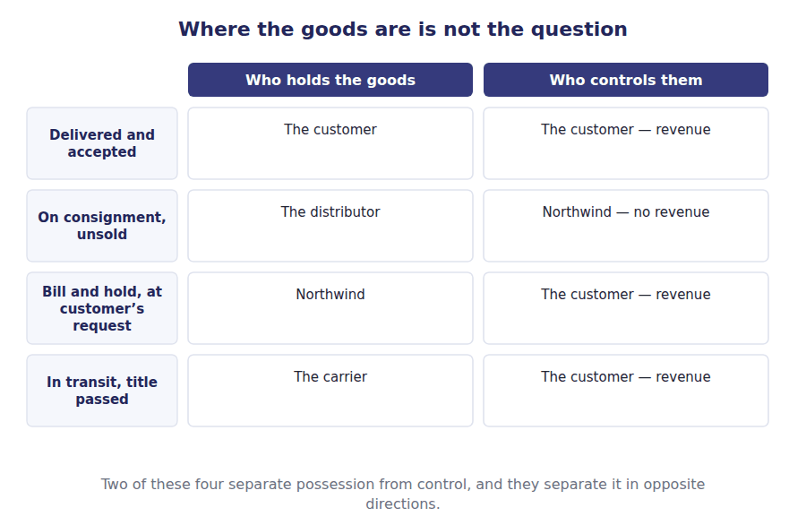
Part 3 · Who is the customer? the question asked before any of the others
Exercise 1C Read and complete.
OBJECTIVE | Identify the customer, and say why some counterparties are not customers.
YOU WILL NEED | Exercise 1B
HOW TO START | • Blank 1 is the phrase that defines what a customer is contracting to obtain.  • Blank 2 is the kind of arrangement where the other party shares the risk instead of buying an output.  • The last blank is what the company is doing when it merely arranges a sale for somebody else.

WORD BANK
agent · collaboration · input · output · principal · supplier
Not every word is used.

R2 A customer is a party that has contracted to obtain goods or services that are an ⁶ of the entity’s ordinary activities. Meridian is plainly a customer: it is buying exactly what Northwind is in business to sell.
Not every counterparty is. If Northwind entered a ⁷ with another manufacturer to develop a new controller, sharing the costs and the risks of the project, that party would not be a customer, and the revenue standard would not apply to the arrangement at all.
A third case changes the amount rather than the existence of revenue. Where Northwind merely arranges for another company’s goods to reach a buyer, it is acting as an ⁸ , and it recognises only the commission it keeps rather than the whole amount the buyer pays.
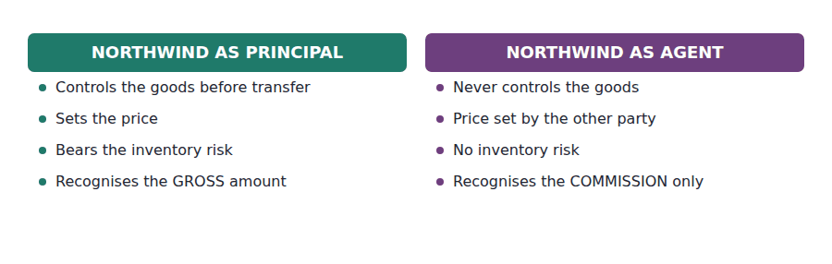
Part 4 · The five steps the map for the rest of the volume
Exercise 1D Match each step to the question it answers.
OBJECTIVE | Name the five steps and say what each one decides.
YOU WILL NEED | Exercises 1A to 1C
HOW TO START | • The steps are in order, and the order matters: each one needs the answer from the one before it.  • Two of the five are about the amount. Two are about the units. One is about timing.  • Step 5 is the one this handout has been about.

 | Item | Answer |  | Option
1 | Step 1 · Identify the contract |  | A | Is there an enforceable agreement with a customer at all?
2 | Step 2 · Identify the performance obligations |  | B | How many separate promises did we make?
3 | Step 3 · Determine the transaction price |  | C | How much do we expect to be entitled to, including estimates?
4 | Step 4 · Allocate the price to the obligations |  | D | How much of that total belongs to each promise?
5 | Step 5 · Recognise revenue as each obligation is satisfied |  | E | When has the customer obtained control of each one?

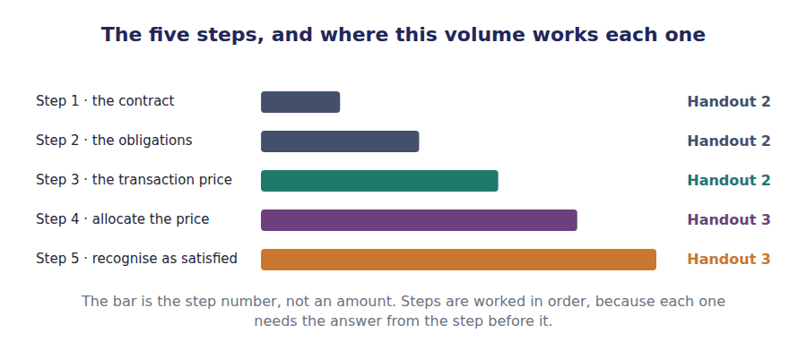
Watch out! The whole of this contract is $560,000, and Northwind will recognise $465,750 of it in 20X4. Everything in Handouts 2 and 3 exists to get from the first figure to the second.
Part 5 · Exam pitch the questions as the CMA sets them
1. [Level A] A customer pays a $50,000 deposit in November for equipment to be manufactured and delivered the following March. At 31 December the seller should report:
(A) Revenue of $50,000
(B) A contract liability of $50,000
(C) A receivable of $50,000
(D) Neither revenue nor a liability, because the equipment does not exist yet
2. [Level A] Under the current revenue standard, revenue from the sale of goods is recognised when:
(A) The risks and rewards of ownership have transferred to the buyer
(B) The customer obtains control of the goods
(C) The invoice is issued to the customer
(D) Payment is received from the customer
3. [Level B] Northwind ships goods to a distributor on consignment. The distributor may return any unsold goods at any time. On shipment, Northwind should:
(A) Recognise revenue, because the goods have left its warehouse
(B) Recognise revenue, because the distributor has physical possession
(C) Recognise no revenue, because control has not passed to the distributor
(D) Recognise half the revenue, reflecting expected sell-through
4. [Level C] A travel website arranges hotel rooms for travellers. It never controls the rooms, the hotel sets the price, and the website keeps 12% of each booking. The website should recognise revenue equal to:
(A) The full amount paid by the traveller
(B) 12% of the amount paid by the traveller
(C) The amount paid by the traveller less the cost of the room, presented as cost of sales
(D) Nothing until the traveller completes the stay
5. [Level B] Which of the following is NOT a customer for the purposes of the revenue standard?
(A) A buyer of goods the entity routinely sells
(B) A party sharing the costs and risks of a joint development project with the entity
(C) A government department buying the entity’s standard product
(D) A distributor purchasing goods for resale
6. [Level C] Goods are held in the seller’s warehouse at the customer’s written request, invoiced, separately identified and ready to ship. Control:
(A) Has not passed, because the seller still has physical possession
(B) Has passed, provided the arrangement is substantive and the goods are identified as the customer’s
(C) Has passed only when the goods are collected
(D) Cannot pass while the seller holds the goods
7. [Level A] Which step of the five-step model determines how much of a contract’s total price belongs to each promise?
(A) Step 2 · identify the performance obligations
(B) Step 3 · determine the transaction price
(C) Step 4 · allocate the transaction price
(D) Step 5 · recognise revenue when an obligation is satisfied
ADAPTIVE TIP Whenever a question describes a payment, stop and ask what the seller has actually done for the customer so far. The answer to that question, not the movement of the money, decides how much revenue there is.

Handout 2 · The Contract, the Obligations, the Price
Three steps before a single dollar is allocated: is there a contract, how many promises, and how much will we actually be entitled to?
Volume 2 · Revenue Recognition · R2 throughout, with R3 on variable consideration
LANGUAGE FOCUS
Register you are working in | R2 textbook English. The sentences carry conditions, so they are longer than in Handout 1. Read each one twice.
Say it exactly like this | identify a performance obligation · a good or service is distinct · estimate variable consideration · constrain an estimate of revenue · combine two contracts · the most likely amount
Words that are not the same | distinct / separately identifiable · expected value / most likely amount · discount / rebate · stated price / transaction price
Remember | A promise is not automatically a performance obligation. It has to be distinct, and that is two tests rather than one. The stated price is not the transaction price. Anything variable has to be estimated and brought into the total.

What you will be able to do when this handout is finished
- State the criteria that make an agreement a contract for this purpose.
- Apply both limbs of the distinct test and say how many performance obligations a contract contains.
- Estimate variable consideration using the right one of the two methods.
- Apply the constraint and say what it is protecting against.
- Produce the transaction price for the Meridian contract.

Three steps before any allocation
The Meridian contract has a stated price of $560,000. By the end of this handout you will know that the figure Northwind actually works with is $540,000, and why.
Step 1 asks whether there is a contract at all. Step 2 asks how many separate promises it contains. Step 3 asks how much Northwind expects to be entitled to, which is not the same as what the paperwork says.
None of these three steps allocates anything. Allocation is step 4, and it cannot begin until all three of these are settled.

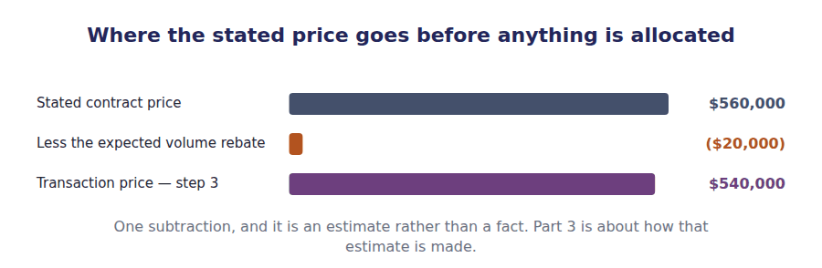
Part 1 · Step 1 is there a contract?
Exercise 2A Read and complete. Write one word in each space.
OBJECTIVE | State the criteria that make an agreement a contract for this purpose.
YOU WILL NEED | Handout 1, for who counts as a customer.
HOW TO START | • Blank 1 is the quality that makes an agreement a contract in law, and it does not depend on paperwork.  • Blank 3 is about the customer rather than about the agreement.  • The last blank is what a company does with cash received under an arrangement that fails the test.

WORD BANK
collect · enforceable · liability · profit · revenue · substance · written
Not every word is used.

R2 A contract exists when the parties have approved the arrangement, the rights and the payment terms can be identified, and the agreement is ¹ . It need not be written: an oral order accepted and acted upon is a contract.
Two further conditions matter. The arrangement must have commercial ² , so that the risk or timing of the entity’s cash flows is genuinely expected to change. And it must be probable that the entity will ³ what it is entitled to, which is a judgement about this customer rather than about the agreement.
Where an arrangement fails the test, revenue is not recognised at all. Any cash already received is held as a ⁴ until either the criteria are met or the money becomes non-refundable with nothing left to deliver.
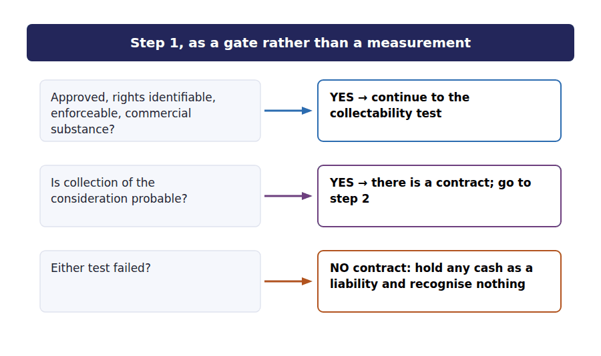
Part 2 · Step 2 how many promises?
R2 A contract may contain one promise or twenty. The unit that matters is the performance obligation, and a promise becomes one only if it is distinct. Distinct has two limbs, and both have to hold.
R2 The first limb looks at the item: can the customer benefit from it on its own, or together with resources it already has? The second looks at the contract: is the promise separately identifiable, or has the seller in substance promised a single combined output that the individual items are merely inputs to?
Exercise 2B Complete the table. Write yes or no in the last column, and be ready to say which limb decided it.
OBJECTIVE | Apply both limbs of the distinct test to the three Meridian promises.
YOU WILL NEED | Exercise 2A, and the two paragraphs above.
HOW TO START | • Ask the first limb first: could Meridian get a benefit from this on its own?  • Then ask the second: is Northwind selling three things, or one combined thing that these are inputs to?  • All three promises here are distinct. The exercise after this one shows a contract where they are not.

Promise in the contract | Standalone selling price | Distinct?
1,200 flow controllers | $420,000 | ______________
Installation on site | $90,000 | ______________
24 months of technical support | $90,000 | ______________
Total of the standalone selling prices | $600,000

1 | 2 | 3

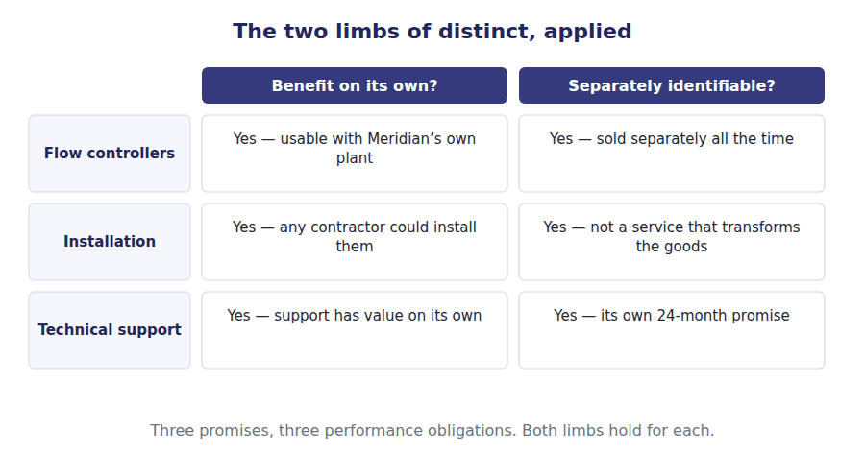
Exercise 2C Sort each contract by how many performance obligations it contains.
OBJECTIVE | Decide how many performance obligations a contract contains when the second limb fails.
YOU WILL NEED | Exercise 2B
HOW TO START | • The second limb is the one that fails in a construction case: the parts are inputs to one combined output.  • A good sold with a warranty that only assures it works is not two promises. A warranty that provides an extra service is.  • Count the promises the customer could sensibly have bought separately.

The contract | ONE OBLIGATION | TWO OR MORE OBLIGATIONS
1. Bricks, labour and design, to build one wall
2. Controllers, installation and 24 months of support
3. A laptop sold with a one-year assurance warranty
4. A laptop sold with a three-year extended service plan
5. Software, plus significant customisation that transforms it
6. A machine, plus a separate annual maintenance contract

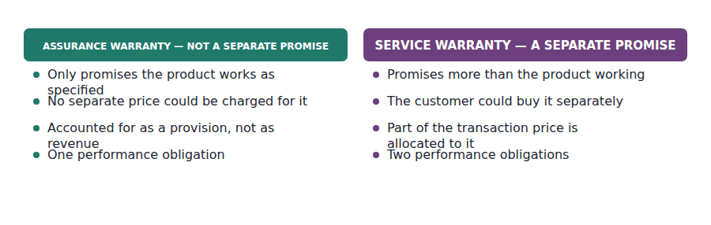
Part 3 · Step 3 what we expect to be entitled to
Exercise 2D Read and complete. This passage is written at exam pitch.
OBJECTIVE | Estimate variable consideration using the right method, and apply the constraint.
YOU WILL NEED | Exercises 2B and 2C
HOW TO START | • Two methods exist and they are not interchangeable. The number of possible outcomes decides which.  • Blank 3 is the rule that limits how much of an estimate may be included.  • The last blank is the transaction price for the Meridian contract, and it is a figure you can compute.

WORD BANK
$540,000 · $560,000 · constraint · expected · fixed · likely · probable
Not every word is used.

R3 The stated price of the Meridian contract is $560,000, but Northwind has offered a rebate of $20,000 if Meridian places a further order next year. Either the rebate is earned or it is not, so with only two possible outcomes the estimate uses the most ⁵ amount rather than a probability-weighted average.
Where instead there were hundreds of possible outcomes — a volume rebate across a whole customer base, say — the appropriate method would be the ⁶ value, which weights each outcome by its probability.
Whichever method is used, the amount included is limited by the ⁷ : variable consideration is brought into the transaction price only to the extent that a significant reversal of cumulative revenue is not probable. It is a deliberate brake on optimism.
Northwind judges the further order probable, so it expects to pay the rebate. The transaction price for step 4 is therefore $560,000 less $20,000, which is ⁸ .
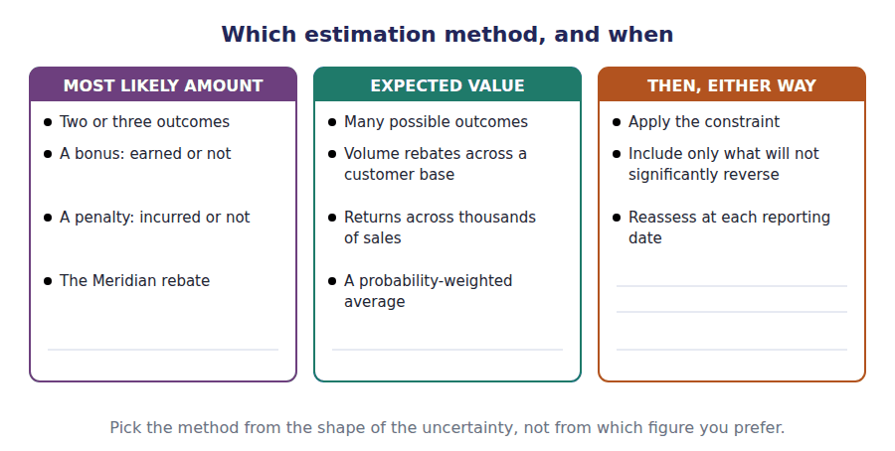
Exercise 2E Read and complete.
OBJECTIVE | Produce the transaction price and say what has and has not been settled so far.
YOU WILL NEED | Exercise 2D
HOW TO START | • Blank 1 is the number of performance obligations identified in Part 2.  • Blank 3 names the step that has still not been done.  • The last blank is the thing that cannot be done until step 4 is complete.

WORD BANK
4 · 5 · discount · premium · recognise · three · two
Not every word is used.

R2 Three steps are now settled. There is a contract, it contains ⁹ performance obligations, and the transaction price is $540,000 after the expected rebate has been deducted.
Notice what has not happened. The $600,000 of standalone selling prices exceeds the transaction price by $60,000, and that ¹⁰ has not yet been attributed to anything.
Attributing it is step ¹¹ , and until it is done Northwind cannot say how much of the contract belongs to the controllers, how much to the installation, and how much to the support.
And until that is known, step 5 cannot be done either, because there is nothing to ¹² when each obligation is satisfied. Handout 3 does both.
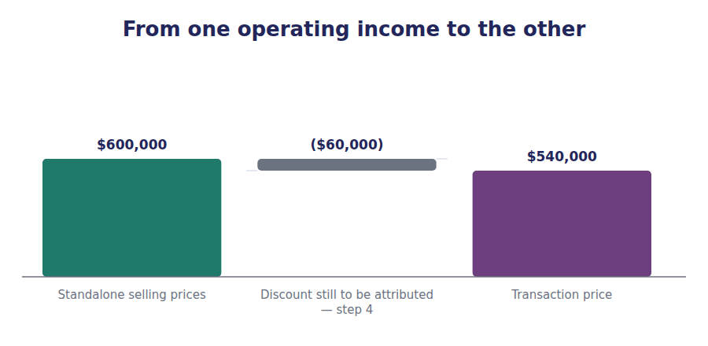
Watch out! The discount of $60,000 is spread across the obligations in proportion to their standalone selling prices. It is not applied to whichever promise is delivered last, and it is not ignored. Handout 3 does the arithmetic.
Part 4 · Exam pitch the questions as the CMA sets them
1. [Level B] A contract promises a machine and a three-year extended service plan that the customer could have bought separately. The number of performance obligations is:
(A) One, because both relate to the same machine
(B) Two, because each is distinct
(C) Three, one for each year of the service plan
(D) One, because the service plan is a warranty
2. [Level C] A contractor agrees to build a single warehouse, supplying design, materials and labour. The number of performance obligations is:
(A) Three, because design, materials and labour are each capable of benefiting the customer
(B) One, because the individual items are inputs to one combined output
(C) Two, separating design from construction
(D) One, because construction contracts always contain a single obligation
3. [Level C] A seller will receive a $100,000 bonus if a project finishes early and nothing if it does not. It judges early completion 80% likely. The amount of variable consideration estimated using the appropriate method is:
(A) $80,000, the expected value
(B) $100,000, the most likely amount
(C) $0, until the bonus is certain
(D) $50,000, the midpoint
4. [Level B] The constraint on variable consideration requires that such amounts be included in the transaction price only to the extent that:
(A) The amount has been received in cash
(B) A significant reversal of cumulative revenue recognised is not probable
(C) The customer has confirmed the amount in writing
(D) The amount can be measured to within 5%
5. [Level C] An arrangement fails the collectability criterion in step 1. The seller has received a $30,000 non-refundable deposit. It should:
(A) Recognise $30,000 of revenue immediately
(B) Recognise no revenue and present the $30,000 as a liability until the criteria are met or the obligations are discharged
(C) Recognise $30,000 as a gain
(D) Recognise revenue as the goods are delivered, ignoring step 1
6. [Level A] The Meridian contract has a stated price of $560,000 and an expected rebate of $20,000 judged probable. The transaction price is:
(A) $560,000
(B) $540,000
(C) $600,000
(D) $580,000
7. [Level B] Which of the following is true of a significant financing component in a contract?
(A) It is recognised in every contract where payment is not immediate
(B) It may be ignored where the period between transfer and payment is one year or less
(C) It increases revenue by the amount of interest implied
(D) It applies only to contracts with government customers
ADAPTIVE TIP Work the steps in order and write the step number beside each figure you produce. Most wrong answers in this topic come from allocating before the transaction price has been settled, or from recognising before the allocation has been done.

Handout 3 · Allocating the Price, and When to Recognise
The discount is spread, not dropped. Then each piece waits for its own moment, and two of the three do not wait long.
Volume 2 · Revenue Recognition · R2 throughout, closing at R3
LANGUAGE FOCUS
Register you are working in | R2 textbook English, rising to R3 for the final passage, where the figures are produced the way an exam would ask for them.
Say it exactly like this | allocate on a relative basis · spread a discount across obligations · satisfy an obligation over time · transfer control at a point in time · recognise revenue as the service is provided · present a contract liability
Words that are not the same | over time / at a point in time · relative / absolute · earned / billed · contract asset / receivable
Remember | A discount is not applied to one promise because it is convenient. It is spread in proportion to standalone selling prices. Over time does not mean evenly. It means measured by progress, and progress is not always a straight line.

What you will be able to do when this handout is finished
- Allocate a transaction price across performance obligations on a relative standalone selling price basis.
- Say what happens to a discount, and why it is not attributed to one promise.
- Apply the three tests that make an obligation satisfied over time.
- Produce the revenue recognised in the period and the contract liability left at the year end.
- Distinguish a contract asset from a receivable.

Two steps, and the contract is finished
Handout 2 settled three things. There is a contract with Meridian Water Systems, it contains three performance obligations, and the transaction price is $540,000.
What remains is to split that $540,000 between the three promises, and then to decide when each share is earned.
The answer will surprise you if you have only looked at the contract value. Of a $560,000 contract signed in October, $465,750 belongs to 20X4, and the rest belongs to the two years that follow.

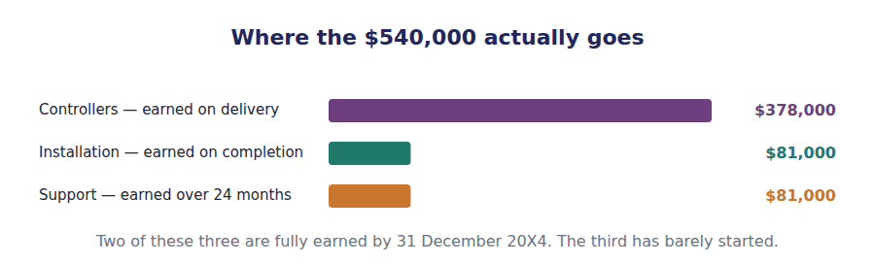
Part 1 · Step 4 spreading the price, and the discount
Exercise 3A Complete the table. Work out each promise’s share of the total standalone price, then apply it.
OBJECTIVE | Allocate the transaction price on a relative standalone selling price basis.
YOU WILL NEED | Handout 2, for the transaction price and the three obligations.
HOW TO START | • Work out the percentages first, from the standalone prices. They are round figures.  • Then apply each percentage to the transaction price of $540,000, not to the standalone total.  • Your three allocated amounts must add back to the transaction price exactly.

Performance obligation | Standalone price | Share of total | Allocated amount
1,200 flow controllers | $420,000
Installation on site | $90,000
24 months of technical support | $90,000
Total | $600,000

1 | 2 | 3 | 4 | 5 | 6
7 | 8

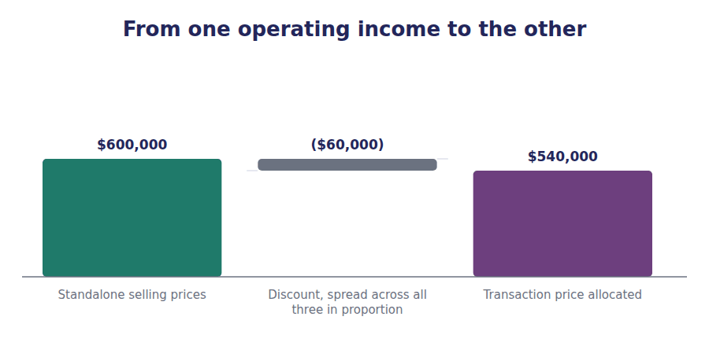
Exercise 3B Read and complete. Write one word in each space.
OBJECTIVE | Say what happens to the discount, and why it is not attributed to one promise.
YOU WILL NEED | Exercise 3A
HOW TO START | • Blank 1 is the amount by which the standalone prices exceed what the customer will pay.  • Blank 3 is the basis on which the discount is spread.  • The last blank is the one circumstance in which a discount may be attributed to fewer than all the promises.

WORD BANK
discount · evidence · guess · percentage · premium · proportion · spread · total
Not every word is used.

R2 The standalone selling prices add to $600,000, and Meridian is paying $540,000. The difference of $60,000 is a ¹ , and it has to go somewhere.
It goes everywhere. The allocation is made on a relative standalone selling price basis, which means each obligation takes the same ² of the transaction price as its standalone price bears to the standalone total. The discount is therefore spread across all three promises automatically, without being calculated separately at all.
The controllers take 70% of the standalone total, so they take 70% of the transaction price: $378,000. The same ³ is applied to each of the other two.
There is one exception, and it is narrow. A discount may be allocated to one or more specific obligations rather than to all of them only where there is observable ⁴ that the discount relates to those obligations alone. Absent that evidence, it is ⁵ .
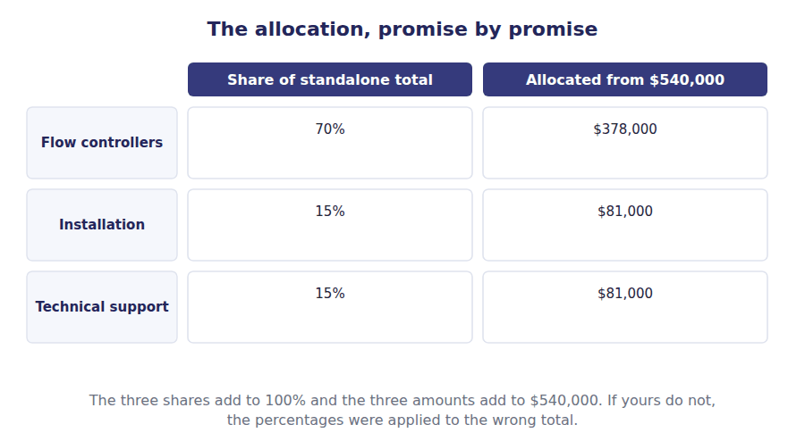
Part 2 · Step 5 over time, or at a point in time?
R2 Each allocated amount now waits for its own moment. The default is that an obligation is satisfied at a point in time, when control passes. An obligation is satisfied over time instead only if one of three tests is met, and any one of them is enough.
R2 The first test covers most services: the customer receives and consumes the benefit as the entity performs. The second covers work on an asset the customer already controls. The third covers an asset with no alternative use to the seller, where the seller has an enforceable right to payment for work done to date.
Exercise 3C Sort each obligation into the column that says when it is satisfied.
OBJECTIVE | Apply the three over-time tests to each of the Meridian obligations.
YOU WILL NEED | Exercise 3B, and the two paragraphs above.
HOW TO START | • Start with the default. An obligation is at a point in time unless a test pulls it the other way.  • The support contract meets the first test, and it is worth saying out loud why.  • Two of the extra examples are there to show that construction is not automatically over time: the third test has two limbs.

The obligation | OVER TIME | AT A POINT IN TIME
1. 1,200 flow controllers delivered to site
2. Installation, completed in two days on site
3. 24 months of technical support
4. A cleaning contract for an office building
5. A machine built to a customer’s unique specification, with an enforceable right to payment for work done
6. A machine built to a standard specification, held in stock

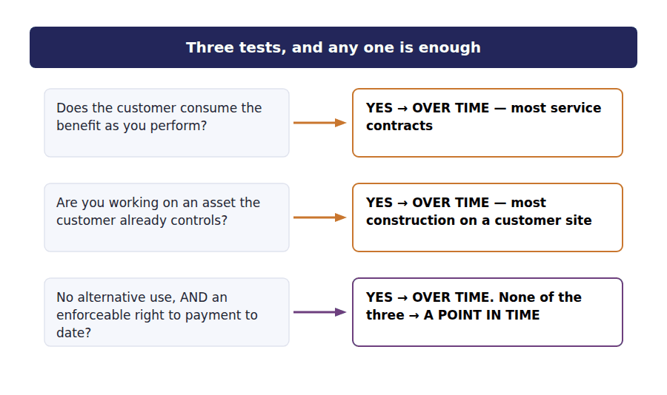
Part 3 · Measuring progress input and output methods
Exercise 3D Match each situation to the method that fits it.
OBJECTIVE | Choose a method of measuring progress and say what each one measures.
YOU WILL NEED | Exercise 3C
HOW TO START | • One family of methods measures what has gone in. The other measures what has come out.  • A straight-line spread over time is an output method: each month delivers the same thing.  • The last one is a trap. Materials delivered to site but not yet installed have gone in without producing anything.

 | Item | Answer |  | Option
1 | 24 months of support, provided evenly |  | A | Output method — time elapsed, because each month is the same
2 | A building contract, 40% of expected costs incurred |  | B | Input method — costs incurred against total expected costs
3 | A contract to deliver 500 units, 300 delivered |  | C | Output method — units delivered
4 | Surveys of work performed by an independent engineer |  | D | Output method — an appraisal of what has been produced
5 | Uninstalled materials delivered to the site |  | E | Excluded from an input measure — effort in, nothing produced

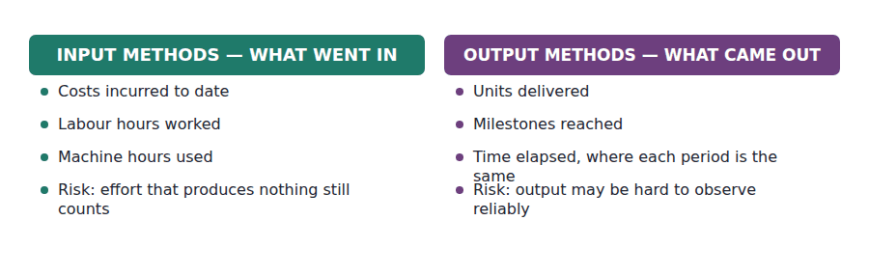
Part 4 · The answer what Northwind recognises, and what it still owes
Exercise 3E Complete the table, then read the passage underneath and complete that too.
OBJECTIVE | Produce the revenue recognised in 20X4 and the contract liability at the year end.
YOU WILL NEED | Exercises 3A to 3D
HOW TO START | • Two obligations are fully satisfied, so their whole allocated amount is recognised.  • The support contract ran for 2 of its 24 months by 31 December. Apply that fraction.  • What is left of the support allocation is what Northwind still owes, and it goes on the balance sheet.

Performance obligation | Allocated | Satisfied | Revenue in 20X4
1,200 flow controllers | $378,000
Installation on site | $81,000
24 months of technical support | $81,000
Total | $540,000

1 | 2 | 3 | 4 | 5 | 6
7

WORD BANK
$465,750 · $540,000 · $6,750 · $81,000 · asset · liability
Not every word is used.

R3 Both point-in-time obligations were satisfied before the year end, so their full allocations of $378,000 and $81,000 are recognised.
The support obligation is satisfied over time, measured by months elapsed. Two of its twenty-four months had run by 31 December, so Northwind recognises two twenty-fourths of the $81,000 allocated, which is ⁶ .
Total revenue recognised on the contract in 20X4 is therefore ⁷ , against a stated contract price of $560,000. The difference is not a loss and it is not a deferral of profit: it is revenue that belongs to the two years that follow.
The $74,250 of support that has been paid for and not yet delivered is reported on the balance sheet as a contract ⁸ , and it will be released to revenue month by month across 20X5 and the year after.
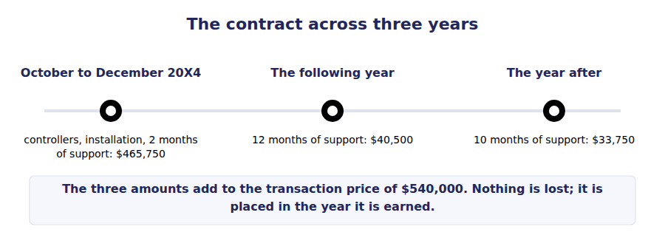
Watch out! A contract liability and a receivable are different things, and so is a contract asset. A contract liability is cash held for work not yet done. A contract asset is work done whose billing still depends on something other than time passing. A receivable is work done where only time stands between the company and the cash.
Part 5 · Exam pitch the questions as the CMA sets them
1. [Level B] A contract has a transaction price of $540,000. The standalone selling prices of its three obligations are $420,000, $90,000 and $90,000. The amount allocated to the first obligation is:
(A) $420,000
(B) $378,000
(C) $360,000
(D) $480,000
2. [Level B] A contract’s standalone selling prices exceed its transaction price. In the absence of observable evidence that the discount relates to specific obligations, the discount is:
(A) Allocated entirely to the obligation satisfied last
(B) Allocated proportionately to all performance obligations
(C) Recognised as a selling expense when the contract is signed
(D) Ignored, and each obligation is recognised at its standalone price
3. [Level A] An entity provides 24 months of support, satisfied over time and measured by months elapsed. $81,000 was allocated to the support and 2 months have elapsed at the year end. Revenue recognised on this obligation is:
(A) $81,000
(B) $6,750
(C) $40,500
(D) Nothing until the 24 months end
4. [Level B] Which of the following obligations is satisfied OVER TIME?
(A) A machine built to a standard specification and held in inventory
(B) Flow controllers delivered to a customer’s site
(C) A two-year cleaning contract for a customer’s building
(D) A laptop sold with an assurance warranty
5. [Level C] A contractor builds an asset to a customer’s unique specification and has an enforceable right to payment for work completed to date. The obligation is satisfied:
(A) At a point in time, on completion
(B) Over time, because the asset has no alternative use to the contractor and payment for work to date is enforceable
(C) Over time, because construction contracts are always over time
(D) At a point in time, because the customer does not yet control the asset
6. [Level C] An entity has completed work worth $50,000 but cannot invoice it until a separate milestone is certified. At the reporting date this is:
(A) A receivable of $50,000
(B) A contract asset of $50,000
(C) A contract liability of $50,000
(D) Not recognised at all
7. [Level C] An input method measures progress by costs incurred. Materials costing $200,000 have been delivered to the site but not yet installed. These costs should:
(A) Be included, because they have been incurred
(B) Be excluded from the measure of progress, because they have not produced any transfer to the customer
(C) Be included at half their value
(D) Cause the entity to switch to an output method
ADAPTIVE TIP Set out four columns before you compute anything: obligation, standalone price, share, allocated amount. Then add a fifth for the fraction satisfied. Nearly every revenue question in Section A is that table with some cells left blank.

Handout 4 · Matching: Revenue and the Costs That Earned It
Revenue decides the year. The costs that produced it follow it there, and the ones that did not produce it do not.
Volume 2 · Revenue Recognition · R2 throughout, closing at R3
LANGUAGE FOCUS
Register you are working in | R2 textbook English, rising to R3 at the end, where the costs of the Meridian contract are placed in the years they belong to.
Say it exactly like this | match an expense against revenue · capitalise a cost and release it · expense a cost as incurred · an incremental cost of obtaining a contract · charge a cost to the period · carry a cost forward
Words that are not the same | product cost / period cost · incremental cost / cost that would have been incurred anyway · capitalise / expense · cause and effect / systematic allocation
Remember | Matching does not mean every cost waits for revenue. Most costs of running a business are charged to the period they fall in. A cost of winning a contract is not the same as a cost of performing it, and they are not charged on the same basis.

What you will be able to do when this handout is finished
- State what the matching principle requires, and what it does not.
- Classify a cost by the basis on which it reaches the income statement.
- Decide whether a cost of obtaining a contract is capitalised or expensed.
- Place the costs of the Meridian contract in the years they belong to.
- Explain why a company that recognises revenue late must also hold its costs back.

The other half of the Meridian contract
Handout 3 settled the revenue. Of the $540,000 transaction price, $465,750 belongs to 20X4 and $74,250 is a contract liability carried forward.
Costs were incurred too. The controllers cost $226,800 to buy, the installation cost $54,000 in labour and travel, and the twenty-four months of support are expected to cost $48,000 in total. A commission of $27,000 was paid to the salesperson who won the contract.
If all of those costs were charged in 20X4 while most of the support revenue waited for the following years, the contract would look far worse this year and far better later than it really is. This handout is about not letting that happen.

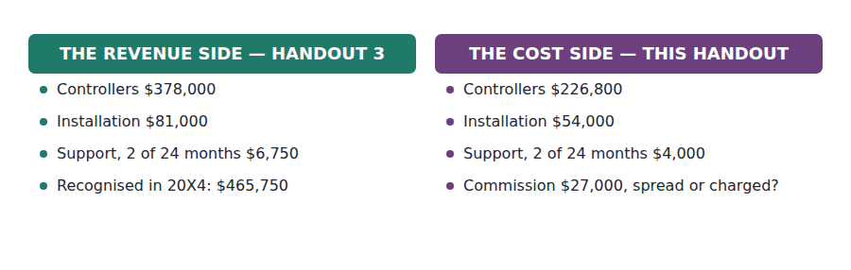
Part 1 · What matching actually requires and the much larger class it does not cover
Exercise 4A Read and complete. Write one word in each space.
OBJECTIVE | State what the matching principle requires and name the two other bases on which costs reach the income statement.
YOU WILL NEED | Handout 3, for the revenue side of the contract.
HOW TO START | • Three bases are described, one per paragraph. The blank names the basis or its consequence.  • Blank 2 is the relationship that has to exist before matching can be applied at all.  • The last blank is the basis depreciation uses, where no single sale can be pointed at.

WORD BANK
cause · guess · immediate · period · product · revenue · systematic
Not every word is used.

R2 The matching principle says that a cost incurred to produce revenue is charged in the same period as that ¹ . The cost of the controllers waits in inventory until they are delivered, and then both sides of the transaction appear in the same year.
Matching applies only where a direct ² and effect relationship can be identified between the cost and particular revenue. That is a much narrower class of cost than students assume.
Most costs of running a company cannot be tied to any particular sale. The rent of the warehouse, the salary of the controller, the cost of the accounting system: these are ³ costs, charged to the period in which they are incurred and matched against nothing.
A third group sits between the two. A cost that benefits several periods, with no single sale to point at, is spread across them by ⁴ allocation. Depreciation is the standing example.
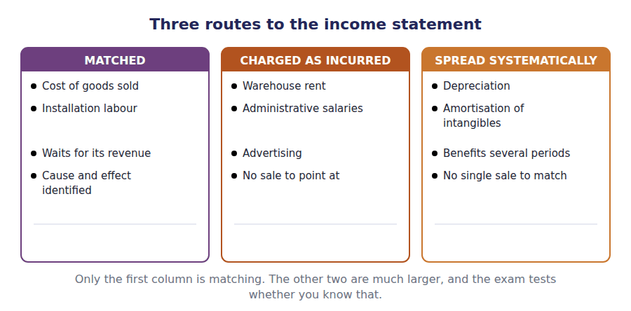
Exercise 4B Sort each cost into its column.
OBJECTIVE | Classify costs by the basis on which they reach the income statement.
YOU WILL NEED | Exercise 4A
HOW TO START | • Ask whether you can point at the specific revenue this cost helped to produce. If you cannot, it is not matched.  • Two of these benefit several periods with no single sale attached.  • The commission is deliberately left out of this exercise. Part 2 deals with it.

The cost | MATCHED TO REVENUE | CHARGED AS INCURRED | SPREAD SYSTEMATICALLY
1. The $226,800 cost of the controllers shipped
2. Rent of the warehouse for the year
3. Depreciation of the delivery vans
4. Installation labour and travel of $54,000
5. The financial controller’s salary
6. Amortisation of purchased software

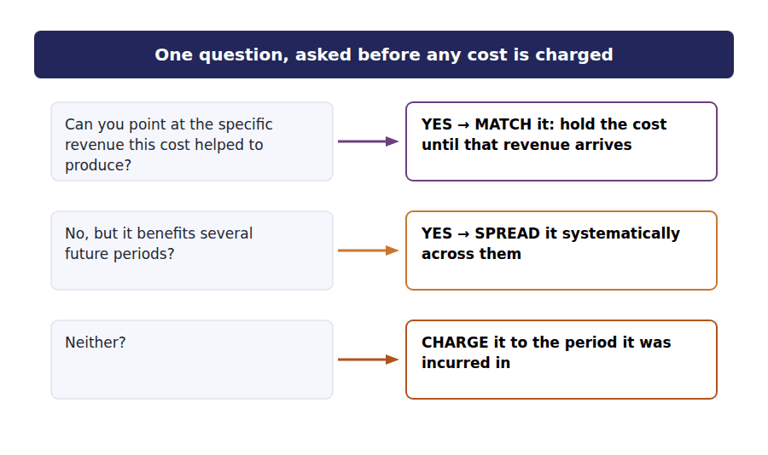
Part 2 · The cost of winning the contract commissions, and what happens to them
R2 A sales commission is not a cost of performing a contract. It is a cost of obtaining one, and the two are treated differently. The question is whether the company would have incurred the cost if it had not won the work.
R2 Where the cost is incremental in that sense, and the company expects to recover it, it is capitalised as an asset and released to the income statement over the period the contract benefits. Where it would have been incurred regardless — a bid team’s salaries, say — it is charged as incurred.
Exercise 4C Match each cost to its treatment.
OBJECTIVE | Decide whether a cost of obtaining a contract is capitalised or expensed.
YOU WILL NEED | Exercise 4B, and the two paragraphs above.
HOW TO START | • Ask the counterfactual: would this cost have been incurred if the contract had been lost?  • One of these is incremental but still charged immediately, because of the length of the contract.  • The last one is a cost of performing, not of obtaining. It belongs in Part 1’s framework, not this one.

 | Item | Answer |  | Option
1 | A $27,000 commission payable only on winning the contract |  | A | Capitalised — incremental and expected to be recovered
2 | Salaries of the bid team, payable whether or not the bid succeeds |  | B | Expensed as incurred — not incremental to winning
3 | A small commission on a contract lasting eight months |  | C | Expensed as incurred — the practical expedient for short contracts
4 | Legal fees payable only if the contract is signed |  | D | Capitalised — incremental and conditional on the contract
5 | Installation labour incurred performing the contract |  | E | Matched to revenue — a cost of performing, not of obtaining

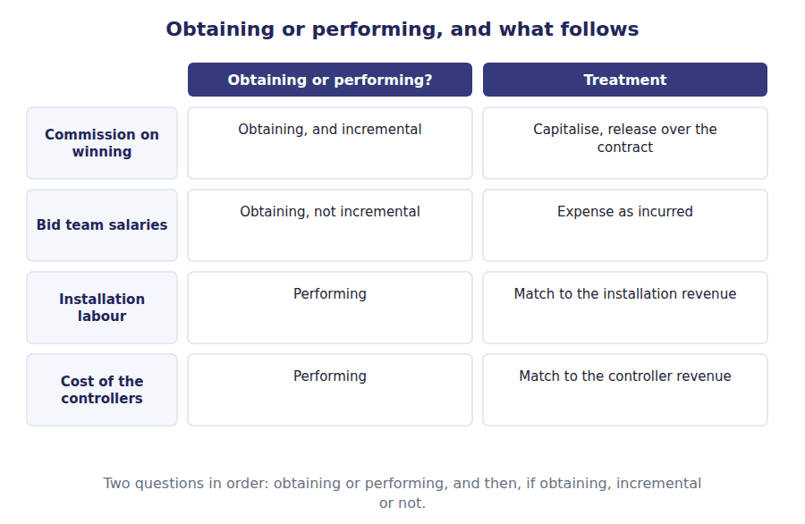
Part 3 · Putting the contract together revenue and cost in the same years
Exercise 4D Complete the table. Each cost follows its own revenue.
OBJECTIVE | Charge the costs of the Meridian contract to the years they belong to.
YOU WILL NEED | Exercises 4A to 4C · Handout 3, for the revenue side.
HOW TO START | • The first two rows are straightforward: both revenue and cost fall wholly in 20X4.  • The support row uses the same fraction on both sides. Two of twenty-four months.  • Compute the margin column last, and check that it is positive on every row.

Promise | Revenue in 20X4 | Cost charged in 20X4 | Margin
Flow controllers | $378,000
Installation | $81,000
Technical support, 2 of 24 months | $6,750
Total | $465,750

1 | 2 | 3 | 4 | 5 | 6
7 | 8

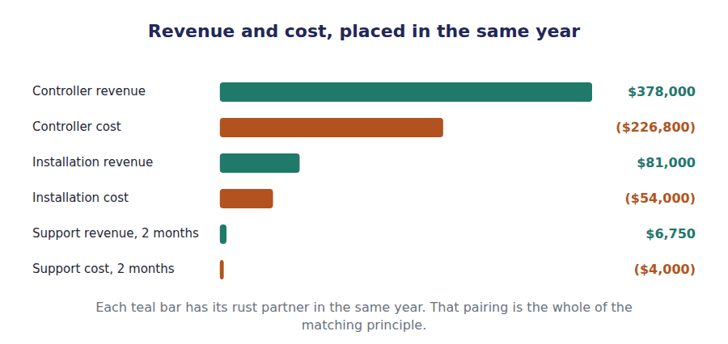
Exercise 4E Read and complete. This passage is written at exam pitch.
OBJECTIVE | Explain why holding revenue back forces the related costs back with it.
YOU WILL NEED | Exercise 4D
HOW TO START | • Blank 1 is what the first year would show if the costs were charged but the revenue were deferred.  • Blank 3 is the balance sheet line the deferred support costs sit in until they are released.  • The last blank is what the two sides moving together protects.

WORD BANK
$540,000 · asset · carried · expense · loss · margin · revenue
Not every word is used.

R3 Suppose Northwind charged the whole $48,000 expected cost of support in 20X4 while recognising only $6,750 of support revenue. The contract would show a ⁵ in its first year and an unnaturally high margin in the two years that follow, although nothing about the economics had changed.
The costs are therefore held back with the revenue. Only $4,000 of support cost is charged in 20X4, matching the $6,750 of support revenue, and the remainder is ⁶ forward.
Where a cost of fulfilling a contract is deferred in this way it sits on the balance sheet as an ⁷ , released to the income statement as the related revenue is recognised — the mirror image of the contract liability carried on the revenue side.
What the two sides moving together protects is the ⁸ . A reader comparing 20X4 with the following year sees the same percentage on this contract in both, which is the truth about it.
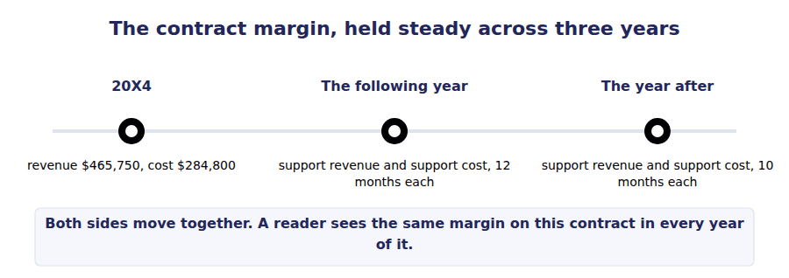
Watch out! A contract liability holds revenue that has been paid for and not yet earned. A fulfilment cost asset holds cost that has been incurred and not yet charged. They are mirror images, and a question that gives you one is usually testing whether you remember the other.
Part 4 · Exam pitch the questions as the CMA sets them
1. [Level A] The matching principle requires that:
(A) Every cost incurred in a period be charged in that period
(B) A cost be charged in the same period as the revenue it helped to produce, where a cause and effect relationship can be identified
(C) Revenue be recognised only when the related cash is received
(D) All costs be spread evenly over the periods they benefit
2. [Level A] Which of the following is a period cost?
(A) The cost of inventory sold during the year
(B) Installation labour on a customer contract
(C) The salary of the financial controller
(D) The purchase cost of goods still in the warehouse
3. [Level B] An entity pays a $27,000 commission that was payable only because a three-year contract was won, and expects to recover it. The commission should be:
(A) Expensed immediately, because it relates to a past event
(B) Capitalised and released to the income statement over the contract
(C) Deducted from revenue when the contract revenue is recognised
(D) Capitalised and never released
4. [Level C] A bid team is paid salaries of $80,000 whether or not the bid succeeds. The bid succeeds. The $80,000 should be:
(A) Capitalised as a cost of obtaining the contract
(B) Expensed as incurred, because it is not incremental to winning the contract
(C) Matched against the contract revenue over its life
(D) Added to the cost of the goods delivered
5. [Level C] An entity defers revenue on a service contract but charges all the expected costs of the service immediately. The effect is:
(A) A loss in the first year and overstated margins later
(B) A profit in the first year and understated margins later
(C) No effect on reported margins in any year
(D) Higher total profit over the life of the contract
6. [Level B] A cost of fulfilling a contract has been incurred but relates to revenue that will be recognised in later periods. It is reported as:
(A) An expense of the current period
(B) An asset, released as the related revenue is recognised
(C) A contract liability
(D) A reduction of the contract’s transaction price
7. [Level B] Depreciation of delivery vans is charged on the basis of:
(A) Matching, against the specific sales each delivery produced
(B) Systematic allocation over the periods expected to benefit
(C) The period in which the vans were purchased
(D) The period in which the vans are eventually sold
ADAPTIVE TIP When a question defers revenue, immediately ask what happened to the related costs. The examiner is usually testing the pair, and the wrong answers are built from treating one side correctly and the other side as though nothing had changed.

Answer Key
Volume 2 · Handouts 1 to 4
Every answer carries the reason for it and the mistake it defeats.

Handout 1 · When Has a Company Earned It? answers
Completed text and exercises
# | Answer | Why | The trap it defeats
1 | cash | Money in the bank is not performance.
2 | invoice | A request for payment, not evidence of earning.
3 | control | The one test. Everything else follows from it. | Students answer with risks and rewards, which was the old rule. The exam keeps that phrase alive in wrong answers.
4 | delivered | Control passes on delivery for ordinary goods.
5 | liability | Paid for, not yet delivered: an obligation.
Grid 1 | 1 CONTROL HAS PASSED 2 CONTROL HAS NOT PASSED 3 CONTROL HAS PASSED 4 CONTROL HAS NOT PASSED 5 CONTROL HAS PASSED 6 CONTROL HAS NOT PASSED | Consignment goods are still the seller’s: the distributor can send them back. The bill-and-hold case is the reverse — the customer controls goods it has not collected.
6 | output | An output of ordinary activities, which is the test.
7 | collaboration | Sharing risk, not buying an output.
8 | agent | Commission only, not the gross amount. | Students recognise the gross amount for an agent, which can multiply reported revenue several times over without changing profit at all.
Match 1 | 1-A 2-B 3-C 4-D 5-E | Handout 2 works steps 1 to 3. Handout 3 works steps 4 and 5. This handout has been about the idea underneath step 5.

Exam-pitch questions
# | Answer | Why | The trap it defeats
1 | (B) A contract liability of $50,000 | Cash has been received for a promise not yet performed, so an obligation is recognised. (A) recognises revenue before anything has been earned. (C) reverses the position — the seller owes goods, not the other way round. (D) ignores the cash that has actually changed hands. | Level A
2 | (B) The customer obtains control of the goods | Control is the test. (A) is the superseded rule and the most frequently chosen wrong answer, because it is still taught in older texts. (C) and (D) are administrative events the seller can largely choose the timing of. | Level A
3 | (C) Recognise no revenue, because control has not passed to the distributor | The distributor cannot direct the use of the goods and can hand them back, so control has not passed. (A) and (B) both mistake possession for control. (D) is not a treatment the standard permits. | Level B
4 | (B) 12% of the amount paid by the traveller | It is acting as an agent, so revenue is the commission. (A) and (C) present the gross amount, which can multiply reported revenue many times over without changing profit by a cent — which is exactly why the distinction is examined. | Level C
5 | (B) A party sharing the costs and risks of a joint development project with the entity | A collaborator sharing risk is not obtaining an output of the entity’s ordinary activities, so the revenue standard does not apply to the arrangement. The other three are all buying what the entity is in business to sell. | Level B
6 | (B) Has passed, provided the arrangement is substantive and the goods are identified as the customer’s | This is a bill-and-hold arrangement, and control can pass although the seller holds the goods. (A) and (D) treat possession as decisive, which the consignment case in this handout already disproved in the opposite direction. | Level C
7 | (C) Step 4 · allocate the transaction price | Step 4 does the allocation. Step 2 decides how many promises there are, step 3 decides the total, and step 5 decides when each allocated amount is recognised. The order matters, and allocation cannot be done before the total is known. | Level A

The five steps, and what each one decides
Step | Question it answers | Worked in
1 · Identify the contract | Is there an enforceable agreement with a customer? | Handout 2
2 · Identify the performance obligations | How many separate promises were made? | Handout 2
3 · Determine the transaction price | How much do we expect to be entitled to? | Handout 2
4 · Allocate the transaction price | How much belongs to each promise? | Handout 3
5 · Recognise revenue | When has control of each promise passed? | Handout 3

Handout 2 · The Contract, the Obligations, the Price answers
Completed text and exercises
# | Answer | Why | The trap it defeats
1 | enforceable | Enforceability, not paperwork, is the test.
2 | substance | A circular arrangement that changes nothing fails here.
3 | collect | A judgement about the customer’s ability to pay. | Students read collectability as a measurement problem. At step 1 it is a gate: fail it and there is no contract.
4 | liability | Held, not recognised.
Grid 1 | 1 ONE OBLIGATION 2 TWO OR MORE OBLIGATIONS 3 ONE OBLIGATION 4 TWO OR MORE OBLIGATIONS 5 ONE OBLIGATION 6 TWO OR MORE OBLIGATIONS | The wall and the customised software both fail the second limb: the items are inputs to one combined output, not separable promises.
5 | likely | Two outcomes, so the most likely amount.
6 | expected | Many outcomes, so a probability-weighted average. | Students use expected value for a binary bonus, which produces a figure that cannot actually occur.
7 | constraint | A brake on optimism, applied after the estimate.
8 | $540,000 | $560,000 − $20,000.
9 | three | Controllers, installation, support.
10 | discount | $600,000 of standalone prices against a $540,000 price.
11 | 4 | Allocation is step 4.
12 | recognise | No allocated amount, nothing to recognise. | Students jump to recognising the whole contract price on delivery, which brings two years of support revenue into the wrong year.

Exam-pitch questions
# | Answer | Why | The trap it defeats
1 | (B) Two, because each is distinct | Both limbs of the distinct test hold for each promise, so there are two obligations. (C) confuses the number of obligations with the pattern of satisfying one of them. (D) would be right for an assurance warranty, which only promises the machine works. | Level B
2 | (B) One, because the individual items are inputs to one combined output | The first limb may well be satisfied, but the second is not: the items are inputs to a combined output the customer contracted for. (A) applies only the first limb. (D) states a rule that does not exist — the test is applied to the facts each time. | Level C
3 | (B) $100,000, the most likely amount | With two outcomes, the most likely amount is the appropriate method, and that is $100,000. (A) applies expected value to a binary outcome and produces a figure that cannot occur. (C) ignores the requirement to estimate. The constraint is then applied separately to test whether the estimate may be included. | Level C
4 | (B) A significant reversal of cumulative revenue recognised is not probable | That is the rule as written. (A) would defeat the purpose of estimating at all. (C) and (D) invent thresholds the standard does not contain. The constraint is deliberately asymmetric: it brakes optimism and not caution. | Level B
5 | (B) Recognise no revenue and present the $30,000 as a liability until the criteria are met or the obligations are discharged | Failing step 1 means there is no contract for accounting purposes, so nothing may be recognised; cash received is held. (D) is the tempting answer because the goods are real, but the model is sequential and step 1 is a gate. | Level C
6 | (B) $540,000 | $560,000 − $20,000 = $540,000. (A) ignores the variable consideration entirely. (C) is the sum of standalone selling prices, which is a different figure used in step 4. (D) adds the rebate instead of deducting it. | Level A
7 | (B) It may be ignored where the period between transfer and payment is one year or less | The practical expedient removes the question for gaps of a year or less, which covers most contracts an exam will set. (C) is backwards: the financing element is separated out of revenue and presented as interest. (D) is invented. | Level B

Exercise 2B · the completed table
Promise in the contract | Standalone selling price | Distinct?
1,200 flow controllers | $420,000 | Yes — both limbs hold
Installation on site | $90,000 | Yes — any contractor could do it
24 months of technical support | $90,000 | Yes — its own 24-month promise
Total of the standalone selling prices | $600,000 | Three performance obligations

- Step 1: there is a contract — approved, enforceable, with commercial substance, and collection is probable.
- Step 2: three performance obligations.
- Step 3: the transaction price is $540,000, after deducting the $20,000 rebate estimated by the most likely amount.
- Still undone: the $60,000 discount has not been attributed to anything. That is step 4, in Handout 3.

Handout 3 · Allocating the Price, and When to Recognise answers
Completed text and exercises
# | Answer | Why | The trap it defeats
1 | discount | $600,000 against $540,000.
2 | proportion | Relative, not absolute.
3 | percentage | One percentage per obligation, applied to the transaction price. | Students apply the discount to the last promise delivered, which defers revenue that has been earned.
4 | evidence | Observable evidence, which is rare in an exam stem.
5 | spread | Spread, in proportion, across every obligation.
Grid 1 | 1 AT A POINT IN TIME 2 AT A POINT IN TIME 3 OVER TIME 4 OVER TIME 5 OVER TIME 6 AT A POINT IN TIME | The last two differ only in whether the asset has an alternative use to the seller. That is the third test, and the exam uses exactly this contrast.
Match 1 | 1-A 2-B 3-C 4-D 5-E | The support contract uses time elapsed: 2 of 24 months by 31 December.
6 | $6,750 | $81,000 × 2 ÷ 24.
7 | $465,750 | $378,000 + $81,000 + $6,750.
8 | liability | Paid for, not yet delivered. | Students recognise the whole contract on delivery, which pulls two years of support revenue into one year.

Exam-pitch questions
# | Answer | Why | The trap it defeats
1 | (B) $378,000 | The first obligation is 70% of the $600,000 standalone total, so it takes 70% of the $540,000 transaction price: $378,000. (A) uses the standalone price and ignores the discount. (C) and (D) misapply the proportion. | Level B
2 | (B) Allocated proportionately to all performance obligations | Relative allocation spreads the discount automatically. (A) is the common error and it defers revenue that has been earned. (C) and (D) would both cause the allocated amounts to exceed the transaction price. | Level B
3 | (B) $6,750 | $81,000 × 2 ÷ 24 = $6,750. (A) recognises the whole thing on signature. (C) halves it for no reason. (D) defers everything, which is the opposite error and equally wrong. | Level A
4 | (C) A two-year cleaning contract for a customer’s building | The customer consumes the benefit of cleaning as it is performed, which is the first over-time test. (A) and (B) transfer control at a moment. (D) is a single obligation satisfied at a point in time, with the warranty treated as a provision. | Level B
5 | (B) Over time, because the asset has no alternative use to the contractor and payment for work to date is enforceable | That is the third over-time test, and it has two limbs that both hold here. (C) states a rule that does not exist: a standard-specification machine built for stock is at a point in time, which is exactly the contrast the exam draws. | Level C
6 | (B) A contract asset of $50,000 | The right to consideration depends on something other than the passage of time, so it is a contract asset rather than a receivable. (A) would be right once only time stands in the way. (C) reverses the direction — the customer owes the entity, not the other way round. | Level C
7 | (B) Be excluded from the measure of progress, because they have not produced any transfer to the customer | Uninstalled materials have gone in without producing progress, so including them would overstate completion and pull revenue forward. (A) is the mechanical answer the question is testing. (D) overreacts: the method is adjusted, not abandoned. | Level C

Exercise 3A · the completed allocation
Performance obligation | Standalone price | Share of total | Allocated amount
1,200 flow controllers | $420,000 | 70% | $378,000
Installation on site | $90,000 | 15% | $81,000
24 months of technical support | $90,000 | 15% | $81,000
Total | $600,000 | 100% | $540,000

Exercise 3E · the completed timing table
Performance obligation | Allocated | Satisfied | Revenue in 20X4
1,200 flow controllers | $378,000 | At a point in time — delivered October | $378,000
Installation on site | $81,000 | At a point in time — completed November | $81,000
24 months of technical support | $81,000 | Over time — 2 of 24 months elapsed | $6,750
Total | $540,000 |  | $465,750

- Revenue recognised on the contract in 20X4: $465,750.
- Contract liability at 31 December 20X4: $74,250, being the support paid for and not yet delivered.
- The two figures add to $540,000, which is the transaction price. Nothing is lost between them.

Handout 4 · Matching: Revenue and the Costs That Earned It answers
Completed text and exercises
# | Answer | Why | The trap it defeats
1 | revenue | Same period as the revenue it produced.
2 | cause | Cause and effect, identified — not assumed.
3 | period | Charged as they fall, matched against nothing. | Students try to match every cost against revenue. Most costs cannot be matched and are not meant to be.
4 | systematic | Spread over the periods that benefit.
Grid 1 | 1 MATCHED TO REVENUE 2 CHARGED AS INCURRED 3 SPREAD SYSTEMATICALLY 4 MATCHED TO REVENUE 5 CHARGED AS INCURRED 6 SPREAD SYSTEMATICALLY | Only two of these six are matched. That proportion is closer to the truth than most students expect.
Match 1 | 1-A 2-B 3-C 4-D 5-E | The counterfactual test does most of the work: would this cost have been incurred if the contract had been lost?
5 | loss | Costs in, revenue deferred: the first year looks wrong.
6 | carried | Held back with the revenue it will earn.
7 | asset | A fulfilment cost asset, the mirror of the contract liability.
8 | margin | The same percentage in every year of the contract. | Students defer the revenue and charge the costs at once, which makes a profitable contract look like a loss-maker in year one.

Exam-pitch questions
# | Answer | Why | The trap it defeats
1 | (B) A cost be charged in the same period as the revenue it helped to produce, where a cause and effect relationship can be identified | Matching applies where cause and effect can be identified, which is a narrower class than students assume. (A) describes period costs, which are a separate basis. (C) is cash accounting. (D) describes systematic allocation, which is the third basis. | Level A
2 | (C) The salary of the financial controller | No particular revenue can be pointed at, so it is charged as incurred. (A) and (B) are matched to specific revenue. (D) is a product cost still sitting in inventory, waiting for its revenue. | Level A
3 | (B) Capitalised and released to the income statement over the contract | It is an incremental cost of obtaining a contract and recovery is expected, so it is capitalised and amortised over the period it benefits. (A) ignores the rule. (C) would understate both revenue and expense. (D) would leave a permanent asset for a cost that is being consumed. | Level B
4 | (B) Expensed as incurred, because it is not incremental to winning the contract | The counterfactual test fails: the cost would have been incurred anyway. (A) is the trap, because the contract was in fact won — but the test is whether the cost depended on winning, not whether winning happened. | Level C
5 | (A) A loss in the first year and overstated margins later | Costs in and revenue deferred produces a first-year loss and inflated margins afterwards, although the economics never changed. (D) is the reassuring wrong answer: total profit over the life is identical; only its distribution between years is distorted. | Level C
6 | (B) An asset, released as the related revenue is recognised | It is held as an asset and released alongside the revenue. (C) reverses the direction: a contract liability holds revenue, not cost. (D) would reduce the top line for something that is not a price concession at all. | Level B
7 | (B) Systematic allocation over the periods expected to benefit | No single sale can be pointed at, so the cost is spread over the periods that benefit. (A) would require a cause and effect link that does not exist at the level of individual deliveries. (C) is cash accounting and (D) defers the whole cost to a single later year. | Level B

Exercise 4D · the completed table
Promise | Revenue in 20X4 | Cost charged in 20X4 | Margin
Flow controllers | $378,000 | $226,800 | $151,200
Installation | $81,000 | $54,000 | $27,000
Technical support, 2 of 24 months | $6,750 | $4,000 | $2,750
Total | $465,750 | $284,800 | $180,950

- Each promise carries its own cost into the same year as its revenue.
- The support contract charges 2 of 24 months of cost against 2 of 24 months of revenue.
- The $27,000 commission is an incremental cost of obtaining the contract: capitalised, and released across the contract rather than charged in 20X4.
- Over the whole contract, total revenue of $540,000 meets total cost of $355,800. Matching changes which year each lands in, never the total.

Glossary
Every term in Volume 2, with the Arabic equivalent and the places it misleads
The third column is for recognition only. In the exam room you work in English.

Term | What it means in CMA English | بالعربية | Careful
at a point in time | Recognition at one moment, because control transfers at one moment. | في نقطة زمنية | The default. An obligation is satisfied at a point in time unless one of the three over-time tests is met.
capitalise | To record a cost as an asset rather than charging it immediately. | الرسملة | The cost is then released to the income statement over the period it benefits.
constraint | The rule that variable consideration is included only to the extent a significant reversal is not probable. | القيد على الإيرادات | It is a brake on optimism, and it is asymmetric on purpose.
contract | An agreement between two or more parties that creates enforceable rights and obligations. | العقد | It need not be written. What it must be is enforceable, and that is a question of law rather than of paperwork.
contract asset | A right to consideration that depends on something other than the passage of time. | أصل العقد | Earned but not yet unconditionally billable. It becomes a receivable once only time stands between the entity and the cash.
contract liability | An obligation to transfer goods or services for which the entity has already been paid. | التزام العقد | The modern name for deferred revenue or unearned revenue. All three mean the same thing.
control | The ability to direct the use of an asset and obtain substantially all of its remaining benefits. | السيطرة | Control is the test. The older rule asked about risks and rewards, and the exam still writes that phrase into wrong answers.
customer | A party that has contracted to obtain goods or services that are an output of the entity’s ordinary activities. | العميل | Not every counterparty is a customer. A partner sharing the risk of a joint activity is not one, and the standard does not apply to them.
distinct | Capable of benefiting the customer on its own, and separately identifiable from the other promises in the contract. | متمايز | Two limbs, and both must hold. Most exam questions turn on the second one, which is about the contract rather than about the item.
expected value | The probability-weighted average of the possible outcomes. | القيمة المتوقعة | The right method when there are many possible outcomes, such as a volume rebate across hundreds of customers.
incremental cost of obtaining a contract | A cost that would not have been incurred if the contract had not been won. | التكلفة الإضافية للحصول على العقد | A sales commission is the standard example. It is capitalised if recovery is expected.
input method | Measuring progress by the effort or cost put in. | طريقة المدخلات | Costs incurred to date against total expected costs is the common one.
matching principle | Charging an expense in the same period as the revenue it helped to produce. | مبدأ المقابلة | It applies only where a cost can be tied to specific revenue. Most costs cannot be, and they are handled differently.
most likely amount | The single most probable outcome. | المبلغ الأكثر احتمالاً | The right method when there are only two or three outcomes, such as a bonus that is either earned or not.
output method | Measuring progress by the value of what has been delivered. | طريقة المخرجات | Units delivered, milestones reached, surveys of work performed.
over time | Recognition spread across a period, because control transfers continuously. | على مدى الزمن | Three tests, any one of which is enough. Most service contracts meet the first of them.
performance obligation | A promise in a contract to transfer a good or service that stands on its own. | التزام الأداء | The unit of account for the whole model. Everything in Handout 2 depends on identifying these correctly.
period cost | A cost charged to the period in which it is incurred. | تكلفة الفترة | Rent, salaries, most administration. There is no revenue to tie them to, so they are charged as they fall.
product cost | A cost that attaches to goods and waits in inventory until they are sold. | تكلفة المنتج | The cleanest case of matching: the cost sits on the balance sheet until the revenue arrives.
relative standalone selling price | Allocating a total in proportion to the separate prices of its parts. | الأساس النسبي لأسعار البيع المستقلة | The default allocation method, and the one an exam expects unless it tells you otherwise.
revenue | Income arising from the activities an entity is in business to carry on. | الإيرادات | Only from ordinary activities. Selling an old van produces a gain, not revenue, however large it is.
significant financing component | An interest element hidden inside a contract price because payment is well before or after delivery. | عنصر تمويلي جوهري | Ignored where the gap is a year or less, which covers most contracts a question will give you.
standalone selling price | The price at which an entity would sell a promised good or service separately. | سعر البيع المستقل | Observable where the item is actually sold separately; estimated where it is not. It is the basis of the whole allocation.
systematic allocation | Spreading a cost over the periods expected to benefit from it, where no direct link to revenue exists. | التوزيع المنتظم | Depreciation is the standing example. There is no single sale to match it against.
variable consideration | An amount in a contract that is not fixed: a rebate, a bonus, a penalty, a right of return. | المقابل المتغير | It must be estimated and included, not ignored until it is known.

