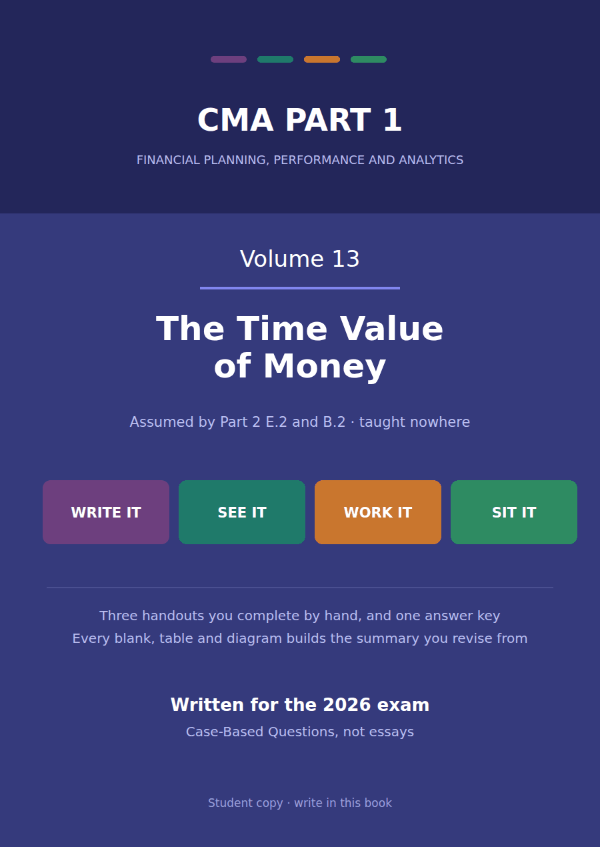

CMA Part 1 · Volume 13
The Time Value of Money
Three handouts, one answer key. Read this before Volume 7: that volume builds a lease schedule from a present value this one teaches you to compute.
These handouts are not notes to read. You write them. The words you supply are the summary, so a finished handout is a page you can revise from, in your own handwriting.
Work in pen. Do not look at the key until the whole handout is done — the key is written to explain the mistake, and you only get that benefit if you have made it first.
The three handouts
# | Handout | What it gives you
1 | Why a Dollar Moves: Present Value and Future Value | Volume 7 discounted five lease payments and never said how. This volume says how, and you should read it before that one.
2 | Annuities: Ordinary, Due, and the Factor a Table Gives You | Five payments of $60,000 at 8% come to $239,563 today. That figure has been in Volume 7 since the day it was written.
3 | Solving for the Missing One: Rate, Term, Payment | Volume 7 told you the lease rate was 8%. This handout recovers it from the schedule, which is what the exam actually asks.

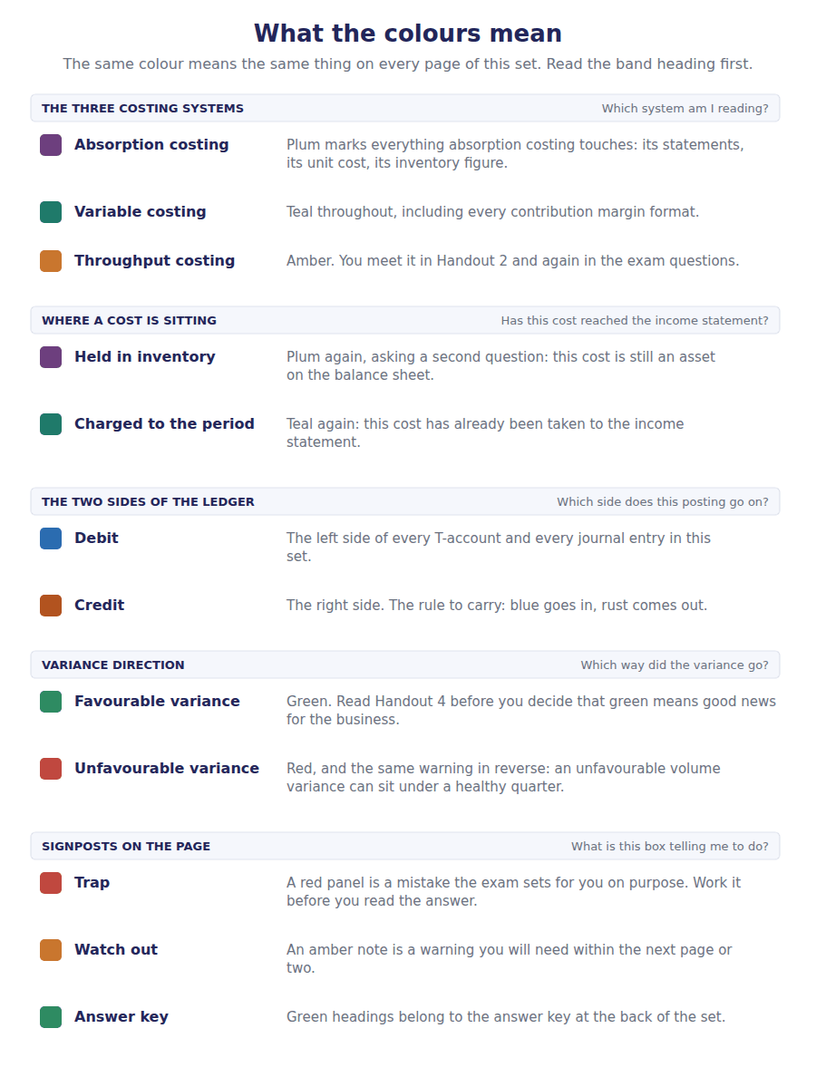
How to read the markers
Marker | Meaning
R1 | Teaching English. Short sentences. This is where a new idea arrives.
R2 | Textbook English. Longer sentences and passive verbs, as a textbook writes them.
R3 | Exam English. Exactly how the CMA exam phrases it, traps included.
Numbered rule | A space you fill in. The number matches the answer key.
Red table | A trap. Read it twice.

Handout 1 · Why a Dollar Moves: Present Value and Future Value
Volume 7 discounted five lease payments and never said how. This volume says how, and you should read it before that one.
Volume 13 · The Time Value of Money · R1 moving to R2
LANGUAGE FOCUS
Register you are working in | R1 while the idea is being established, R2 once the factors are being applied.
Say it exactly like this | discount a future amount · compound a present amount forward · apply a discount rate · read a factor from a table · state an amount in today’s money · accumulate interest on interest
Words that are not the same | present value / future value · discount / compound · rate / period · simple interest / compound interest
Remember | Discounting is not a judgement that the money is less certain. It is arithmetic about when, not about whether. A present value is not an opinion. Given a rate and a date, there is one right answer.

What you will be able to do when this handout is finished
- Say why an amount due later is worth less than the same amount now.
- Compound a present amount forward to a future value.
- Discount a future amount back to a present value.
- Read and use a present value factor.
- Say what the rate and the number of periods each do to a factor.

A gap in your own course
Volume 7 Handout 6 built a lease liability schedule. It opened at $239,563, which it said was the present value of five payments of $60,000.
Where that $239,563 came from was never explained. Five payments of $60,000 come to $300,000, and the schedule used a figure $60,437 smaller.
That gap is this volume. By the end of Handout 2 you will compute $239,563 yourself, and by the end of Handout 3 you will be able to recover the 8% rate from the schedule alone.
Everything here is arithmetic. None of it is a matter of judgement.

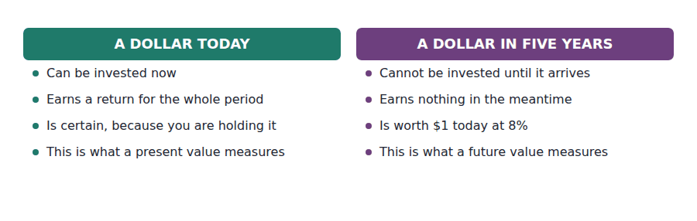
Part 1 · Forward: compounding interest on interest
Exercise 1A Read and complete. Write one word in each space.
OBJECTIVE | Say why an amount grows faster than the rate alone suggests.
YOU WILL NEED | Volume 7 Handout 6, where interest was charged on a falling balance.
HOW TO START | • Northwind deposits $68,058 at 8%. Work out the first year’s interest before you read on.  • In the second year the interest is charged on a larger amount than in the first. Ask what that larger amount contains.  • The last blank is what makes the factor a power rather than a multiplication.

WORD BANK
interest · original · power · principal · product · sum
Not every word is used.

R1 Northwind puts $68,058 into an account paying 8% a year. In the first year it earns $5,445 of interest, so the balance becomes $73,503.
In the second year the 8% is charged on that larger balance, not on the original deposit. The company is now earning interest on its ¹ , and that is what compounding means.
Over 5 years the deposit grows to $100,000. Simple interest at the same rate would have given only $95,282, so $4,718 of the growth is interest the ² deposit never earned.
So the growth factor is 1.08 multiplied by itself 5 times rather than 8% multiplied by 5. It is a ³ , and that one fact shapes every table in this volume.
Year | Opening | Interest at 8% | Closing
1 | $68,058
2 | $73,503
3 | $79,383
4 | $85,734
5 | $92,593

1 | 2 | 3 | 4 | 5 | 6
7 | 8 | 9 | 10

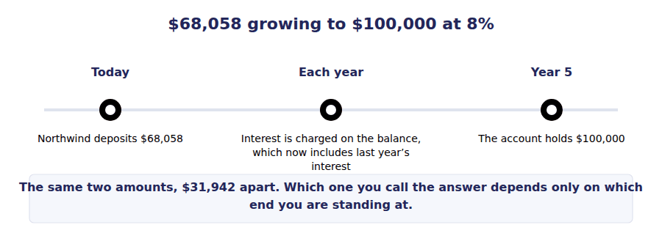
Part 2 · Backward: discounting the same relationship, reversed
R2 Discounting is compounding read from the other end. If $68,058 grows to $100,000 over 5 years at 8%, then $100,000 due in 5 years is worth $68,058 today at that rate. One statement, two directions.
Exercise 1B Read and complete. Write one word or figure in each space.
OBJECTIVE | Discount a single future amount back to its present value.
YOU WILL NEED | Exercise 1A, and the paragraph above.
HOW TO START | • If multiplying by 1.08 moves money forward one year, ask what moves it back one year.  • Dividing by a number greater than one makes the result smaller, which is the direction a present value should go.  • The last blank is what happens to a present value when the rate rises and the date stays the same.

WORD BANK
$68,058 · divides · multiplies · near · off · period · rate · when
Not every word is used.

R2 Compounding multiplies by 1.08 once for each year. Discounting therefore ⁴ by 1.08 once for each year, and the result is always smaller than the amount you started with.
So $100,000 due in 5 years is worth $100,000 divided by 1.08 to the power of 5, which is ⁵ . That is its present value at 8%.
Two things make a present value smaller. A longer wait divides by 1.08 more times, and a higher ⁶ divides by a bigger number each time.
Both effects run the same way, which is why a present value is most sensitive to a change in the rate when the amount is a long way ⁷ .
Note what is not here. Nothing has been said about whether the money will actually arrive. Discounting is about ⁸ , and a doubt about whether belongs in the cash flows or in the rate, not in the factor.
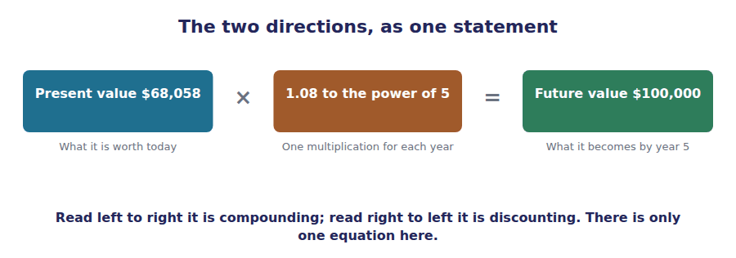
Part 3 · The factors what a table actually holds
Exercise 1C Complete the table to five decimal places.
OBJECTIVE | Build the present value and future value factors for 8%.
YOU WILL NEED | Exercises 1A and 1B.
HOW TO START | • A factor is what one dollar does. Multiply it by the amount you actually have.  • The present value factor for one period is 1 divided by 1.08. Each later row divides by 1.08 again.  • Check your work across each row: the two factors in a row multiply to exactly 1.

Periods | Present value of $1 | Future value of $1
1
2
3
4
5
6

1 | 2 | 3 | 4 | 5 | 6
7 | 8 | 9 | 10 | 11 | 12

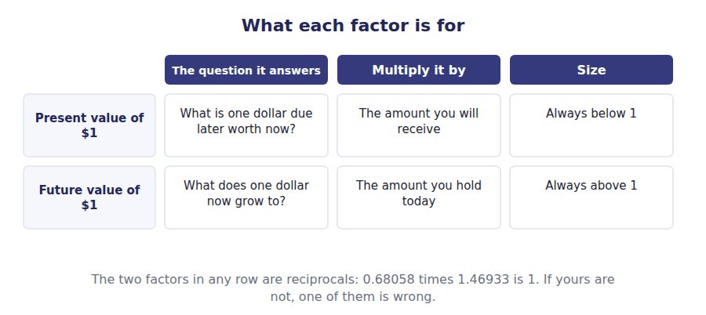
Part 4 · What moves a factor rate and time, pulling the same way
Exercise 1D Sort each statement into the column that says whether it is true.
OBJECTIVE | Say what a higher rate and a longer wait each do to a present value.
YOU WILL NEED | Exercise 1C.
HOW TO START | • Work from the factor table rather than from intuition: compare the row for one period with the row for 6.  • A present value factor can never be above 1 when the rate is positive, because waiting cannot make money worth more.  • One of the statements is about a rate of zero, which is the only case where time costs nothing.

Statement about a present value | TRUE | FALSE
1. A higher discount rate gives a smaller present value
2. A longer wait gives a smaller present value
3. A present value factor is always below 1 when the rate is positive
4. Doubling the rate halves the present value
5. At a rate of zero, the present value equals the future amount
6. A present value can exceed the future amount it came from

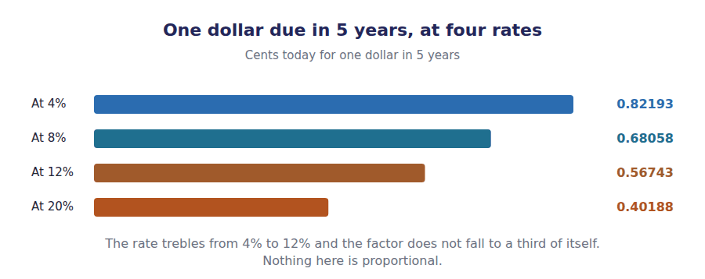
Watch out! Every figure in this volume depends on two things the question must give you: a rate and a number of periods. If a stem gives you an annual rate and semi-annual periods, halve the rate and double the periods before you touch a table. That single step is the commonest lost mark in Part 2 Section E.
Part 5 · Exam pitch the questions as the CMA sets them
1. [Level A] The present value of an amount due in the future is:
(A) Greater than the future amount
(B) Less than the future amount when the discount rate is positive
(C) Equal to the future amount
(D) Not determinable without knowing the risk
2. [Level A] An amount of $100,000 is due in 5 years. At 8% the present value is:
(A) $60,000
(B) $68,058
(C) $92,593
(D) $92,593
3. [Level A] If the discount rate rises and everything else is unchanged, the present value of a future amount:
(A) Rises
(B) Falls
(C) Is unchanged
(D) Rises then falls
4. [Level B] The present value factor and the future value factor for the same rate and period:
(A) Are equal
(B) Are reciprocals, multiplying to 1
(C) Sum to 1
(D) Are unrelated
5. [Level B] A sum earns 8% a year, compounded annually, for 5 years. Compared with simple interest at the same rate, the final balance is:
(A) The same
(B) Higher, by the interest earned on interest
(C) Lower
(D) Higher, by exactly double
6. [Level C] An annual rate of 8% is quoted on a loan that compounds semi-annually over 5 years. The factor should be built using:
(A) 8% for 5 periods
(B) 4% for 10 periods
(C) 16% for 5 periods
(D) 8% for 10 periods
7. [Level C] Two amounts are each due in the future, one in two years and one in ten. A rise in the discount rate reduces:
(A) Both by the same amount
(B) The ten-year amount by proportionately more
(C) The two-year amount by proportionately more
(D) Neither, if both are certain
ADAPTIVE TIP Write the rate and the number of periods at the top of the page before anything else, and adjust them for the compounding frequency immediately. Every factor in this volume follows from those two numbers, and almost every lost mark comes from using the annual rate with monthly periods.

Handout 2 · Annuities: Ordinary, Due, and the Factor a Table Gives You
Five payments of $60,000 at 8% come to $239,563 today. That figure has been in Volume 7 since the day it was written.
Volume 13 · The Time Value of Money · R2
LANGUAGE FOCUS
Register you are working in | R2 for the mechanics, R3 once the exam’s own wording for the two kinds of annuity arrives.
Say it exactly like this | discount a stream of equal payments · sum the individual present values · read an annuity factor · adjust an ordinary annuity to an annuity due · value a payment made in advance · capitalise a perpetual stream
Words that are not the same | single sum / annuity · ordinary annuity / annuity due · in arrears / in advance · annuity / perpetuity
Remember | An annuity factor is not a shortcut that loses accuracy. It is the exact sum of the single-sum factors. An annuity due is not a different kind of contract. It is the same payments, each one period earlier.

What you will be able to do when this handout is finished
- Define an annuity and say what makes a stream of payments one.
- Value an annuity by discounting each payment separately.
- Read and use an annuity factor instead.
- Distinguish an ordinary annuity from an annuity due.
- Convert between the two factors.

Five payments, one figure
Northwind’s machine lease requires $60,000 at the end of each of five years. Handout 1 can value any one of those payments.
Valuing all five is the same work five times: discount each one by the number of years until it arrives, then add the results.
Because the payments are equal and equally spaced, the five factors can be added once and used for every payment. That sum is an annuity factor, and at 8% over five years it is 3.99271.
$60,000 times 3.99271 is $239,563, which is where Volume 7 began.

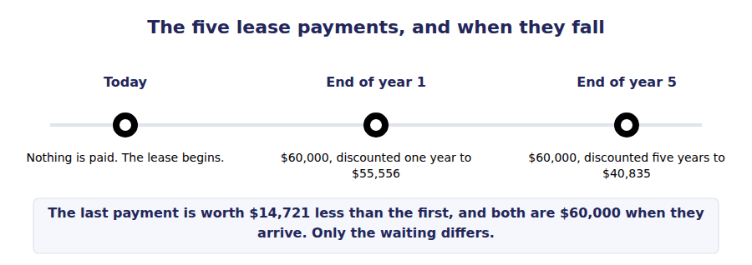
Part 1 · The long way five payments, five factors
Exercise 2A Complete the table. The payments are identical; the factors are not.
OBJECTIVE | Value the lease payments by discounting each one separately.
YOU WILL NEED | Handout 1 Exercise 1C, for the 8% present value factors.
HOW TO START | • Each row is the same $60,000 discounted by a different number of years.  • Take the factors from Handout 1’s table. Row 1 uses 0.92593 and row 5 uses 0.68058.  • The total of the five present values should come to $239,563, and the total of the five factors to 3.99271.

Payment | Due in | Factor at 8% | Present value
$60,000 | 1 year
$60,000 | 2 years
$60,000 | 3 years
$60,000 | 4 years
$60,000 | 5 years
Total

1 | 2 | 3 | 4 | 5 | 6
7 | 8 | 9 | 10 | 11 | 12

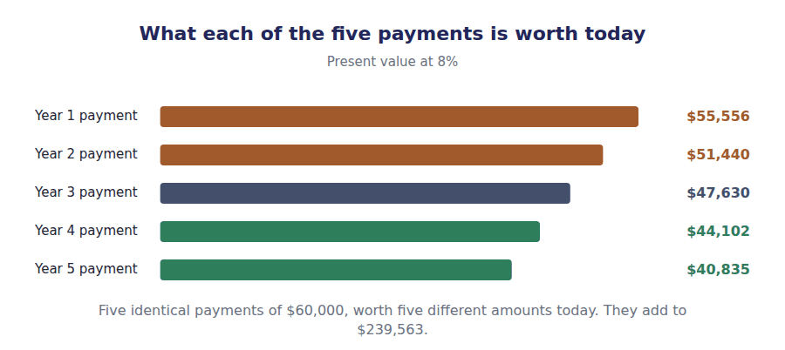
Part 2 · The short way one factor, used once
R2 Because the payments are equal, the arithmetic can be done once instead of five times. Adding the five single-sum factors gives one annuity factor, and multiplying the payment by it gives the same answer exactly. Nothing is lost by the shortcut.
Exercise 2B Read and complete. Write one word or figure in each space.
OBJECTIVE | Say what an annuity factor is and when it may be used.
YOU WILL NEED | Exercise 2A, and the paragraph above.
HOW TO START | • Add your five factors from Exercise 2A before you start, and keep the total to five decimals.  • The shortcut needs two conditions to hold. One is about the amount of each payment, the other about the spacing.  • The last blank is the lease Volume 7 called the warehouse floor, which needs a different factor for the same reason.

WORD BANK
0.68058 · 3.99271 · approximation · equal · exact · floor · machine
Not every word is used.

R2 Adding the five present value factors gives ¹ . That one number is the present value of one dollar a year for five years at 8%, and it is called an annuity factor.
Multiplying it by the $60,000 payment gives $239,563, which is exactly the total of the five rows in Exercise 2A. The shortcut is not an ² ; it is the same sum, computed once.
Two conditions have to hold. The payments must be ³ in amount, and they must fall at equal intervals. A stream that fails either is valued payment by payment, the long way.
Volume 7’s other lease has three payments of $40,000 rather than five of $60,000, so it needs the three-year factor of 2.57710. That gives $103,084, which is the figure that volume used for the warehouse ⁴ .
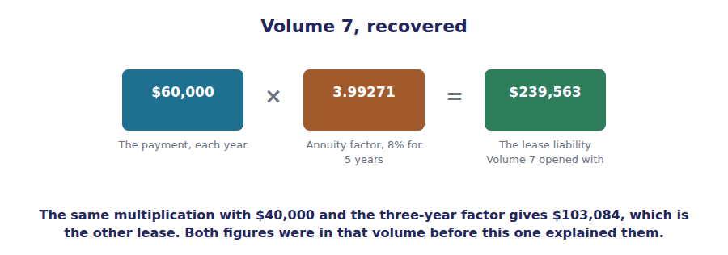
Part 3 · Paid at the end, or at the start the one distinction the exam tests
Exercise 2C Read and complete. Write one word or figure in each space.
OBJECTIVE | Distinguish an ordinary annuity from an annuity due and convert between them.
YOU WILL NEED | Exercise 2B.
HOW TO START | • Northwind’s lease pays at the end of each year. Ask what changes if the landlord demands payment in advance instead.  • If every payment arrives one year earlier, each one escapes exactly one year of discounting.  • The last blank is the single multiplication that converts one factor into the other.

WORD BANK
$258,728 · due · less · more · ordinary · period · rate
Not every word is used.

R3 An annuity whose payments fall at the end of each period is an ⁵ annuity, and it is what an exam question means unless it says otherwise.
If the same payments fall at the beginning of each period instead, the annuity is said to be due. Every payment then escapes one period of discounting, so an annuity due is worth ⁶ than the ordinary kind, never less.
The conversion is one step. Multiply the ordinary factor by one plus the ⁷ : 3.99271 times 1.08 gives 4.31213, which is the five-year annuity due factor at 8%.
On Northwind’s lease that is the difference between $239,563 and ⁸ , which is $19,165 of value for paying each instalment twelve months sooner.
Periods | Ordinary annuity | Annuity due
1
2
3
4
5
6

1 | 2 | 3 | 4 | 5 | 6
7 | 8 | 9 | 10 | 11 | 12

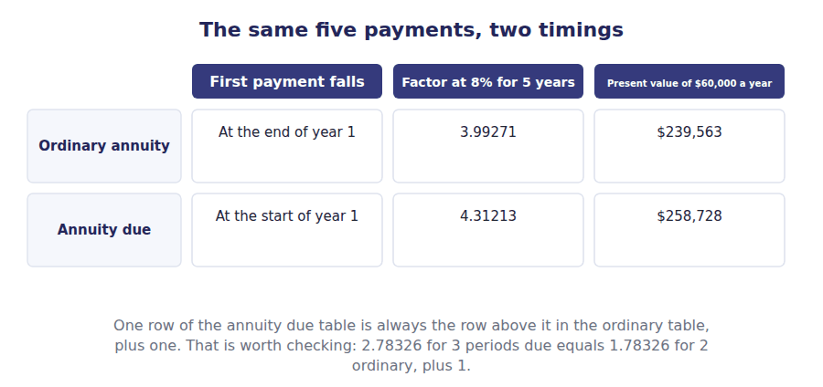
Part 4 · The stream that never ends a factor you can compute in your head
Exercise 2D Sort each statement into the column that says whether it is true.
OBJECTIVE | Value a perpetual stream and say why its factor is so small.
YOU WILL NEED | Exercise 2C, and the factor table above.
HOW TO START | • Look down the ordinary annuity column. Ask what it is heading towards as the periods increase.  • At 8% a perpetuity factor is 1 divided by 0.08, which is 12.50000.  • A perpetual stream is worth only a little more than a 6-year one, and the statements ask you to say why.

Statement about a perpetuity | TRUE | FALSE
1. Its factor is the payment divided by the rate
2. Its present value is infinite, because the payments never stop
3. At 8% the factor is 12.50000
4. A higher rate gives a smaller perpetuity factor
5. An annuity factor can never exceed the perpetuity factor for the same rate
6. Doubling the rate doubles the perpetuity factor

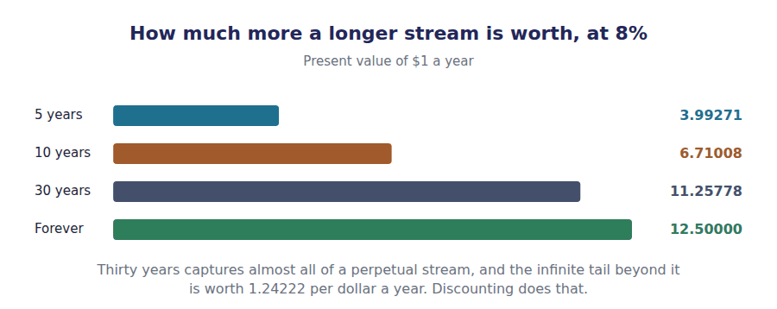
Watch out! Read the timing before you read the numbers. "Payments at the end of each year" is an ordinary annuity and "the first payment is due immediately" is an annuity due, and the two differ by a full multiplication of 1.08. A question that mentions a lease payable in advance is testing exactly that.
Part 5 · Exam pitch the questions as the CMA sets them
1. [Level A] An annuity is a series of payments that are:
(A) Increasing at a constant rate
(B) Equal in amount and equally spaced in time
(C) Made at the start of each period
(D) Guaranteed by a third party
2. [Level A] The present value of $60,000 a year for 5 years at 8% is:
(A) $300,000
(B) $239,563
(C) $40,835
(D) $258,728
3. [Level B] Compared with an ordinary annuity of the same payments, the present value of an annuity due is:
(A) Lower
(B) Higher by a factor of one plus the rate
(C) The same
(D) Higher by the rate itself
4. [Level B] A lease requires $60,000 at the beginning of each of 5 years. At 8% the present value is:
(A) $239,563
(B) $258,728
(C) $300,000
(D) $198,728
5. [Level B] An annuity factor at a given rate and term is:
(A) An approximation of the sum of the single-sum factors
(B) Exactly the sum of the single-sum factors
(C) The average of the single-sum factors
(D) Unrelated to the single-sum factors
6. [Level C] A perpetuity pays $1,000 a year forever. At 8% its present value is:
(A) Infinite
(B) $12,500
(C) $11,258
(D) Not determinable
7. [Level C] A stream of five payments rises by 3% each year. Its present value should be computed by:
(A) The ordinary annuity factor for five years
(B) Discounting each payment separately
(C) The annuity due factor for five years
(D) The perpetuity formula
ADAPTIVE TIP Three questions, in order, before any annuity calculation: are the payments equal, are they equally spaced, and do they fall at the end or the beginning? The first two decide whether you may use a factor at all, and the third decides which factor.

Handout 3 · Solving for the Missing One: Rate, Term, Payment
Volume 7 told you the lease rate was 8%. This handout recovers it from the schedule, which is what the exam actually asks.
Volume 13 · The Time Value of Money · R2 moving to R3
LANGUAGE FOCUS
Register you are working in | R2 for the mechanics, R3 for the exam’s own way of hiding which variable is missing.
Say it exactly like this | solve for the implicit rate · read a factor off the table · interpolate between two rates · determine the required payment · convert a nominal rate to an effective rate · accumulate a sinking fund
Words that are not the same | given / missing · nominal rate / effective annual rate · present value / payment · interpolate / read directly
Remember | A factor table is not only for finding present values. Read backwards it finds the rate and the term as well. A nominal rate is not an effective rate. Quoting 8% compounded semi-annually is quoting 8.16% a year.

What you will be able to do when this handout is finished
- Say which variable is missing in a given question.
- Solve for the payment when the present value is known.
- Solve for the rate implicit in a stream of payments.
- Solve for the number of periods.
- Convert a nominal rate to an effective annual rate.

The question from the other side
Handouts 1 and 2 were given a payment, a rate and a term, and asked for a present value. Almost no exam question is set that way.
A lease contract states the payments and the amount financed and leaves the rate unstated. A capital project states the investment and the annual saving and asks whether the return clears a hurdle.
In both the relationship is the one you already have. What changes is which of the four variables is the unknown.
By the end of this handout you will recover 8% from Volume 7’s own figures, with no information that volume did not print.

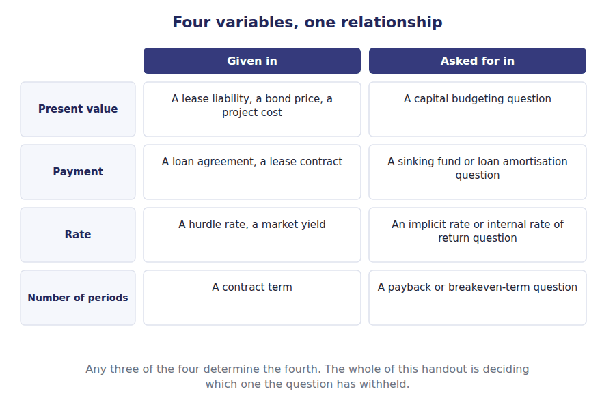
Part 1 · Which one is missing reading the question first
Exercise 3A Complete the right-hand column. One short phrase in each cell.
OBJECTIVE | Say which variable each kind of question withholds, and how to find it.
YOU WILL NEED | Handout 2 Exercise 2B, on the annuity factor.
HOW TO START | • Two of the four rows are a multiplication or a division by the annuity factor, and nothing more.  • The other two need the factor first, and then a search through the table for the row or the column that produced it.  • Row 1 is the only one Handouts 1 and 2 covered.

What you are given | What is missing | How to find it
Payment, rate, number of periods | Present value
Present value, rate, number of periods | Payment
Present value, payment, number of periods | Rate
Present value, payment, rate | Number of periods

1 | 2 | 3 | 4

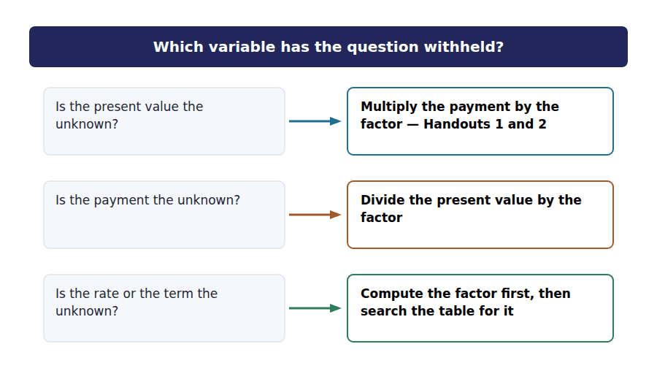
Part 2 · Solving for the payment one division
Exercise 3B Read and complete. Write one word or figure in each space.
OBJECTIVE | Compute the payment a known present value supports.
YOU WILL NEED | Exercise 3A, and Handout 2 for the 8% annuity factors.
HOW TO START | • Volume 7 financed $239,563 over 5 years at 8%. Work out what annual payment that supports.  • If multiplying the payment by the factor gives the present value, the reverse is a single division.  • Your answer should be the $60,000 Volume 7 printed, which is the check that the method is right.

WORD BANK
$60,000 · divide · factor · future · multiply · present · rate
Not every word is used.

R2 Northwind financed $239,563 over 5 years at 8%. To find the payment, ¹ the present value by the annuity factor rather than multiplying by it.
$239,563 divided by 3.99271 gives ² a year, which is exactly the payment Volume 7 used. Nothing new has been introduced; the same equation has been read in a different direction.
A sinking fund is the same question with a ³ value in place of a present one. A company that must repay $1,000,000 in 5 years divides that amount by the future value annuity factor of 5.86660 to find the annual deposit.
In both cases the unknown is a payment and the arithmetic is one division. What changes is which ⁴ you divide by.
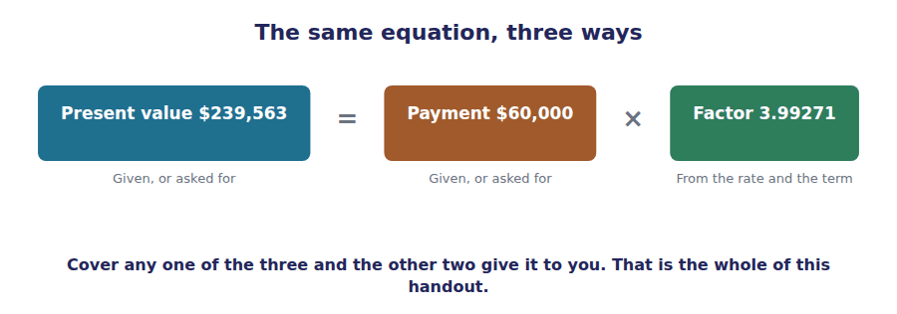
Part 3 · Solving for the rate the one Volume 7 withheld
R2 When the rate is the unknown there is no formula. The factor is computed from the figures given, and then the table is searched along the row for the term until that factor is found. The rate at the top of the column is the answer.
Exercise 3C Complete the table, then say which row matches the lease.
OBJECTIVE | Recover the rate implicit in Volume 7’s lease.
YOU WILL NEED | Exercise 3B, and Volume 7 Handout 6 for the lease figures.
HOW TO START | • Volume 7 financed $239,563 with five payments of $60,000. Divide the first by the second to get the factor the lease implies.  • That factor is 3.99271. Now compute the five-year annuity factor at each rate in the table until you find it.  • The row that matches is the rate implicit in the lease, and Volume 7 stated it without ever showing this step.

Rate | Five-year annuity factor | Value of $60,000 a year
6%
7%
8%
9%
10%

1 | 2 | 3 | 4 | 5 | 6
7 | 8 | 9 | 10

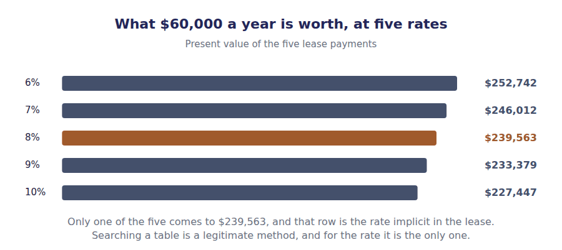
Part 4 · When the answer is between two rows interpolation
Exercise 3D Read and complete. Write one word or figure in each space.
OBJECTIVE | Estimate a rate that falls between two tabulated figures.
YOU WILL NEED | Exercise 3C.
HOW TO START | • Suppose a lease of $248,000 supported five payments of $60,000 instead. Work out the factor that implies.  • That factor falls between the 7% row and the 8% row of your table, so the rate is somewhere between them.  • The last blank is why the answer is an estimate rather than an exact figure.

WORD BANK
above · accuracy · between · curved · interpolation · precision · straight
Not every word is used.

R3 A lease of $248,000 supporting five payments of $60,000 implies a factor of 4.13333. That falls between the 7% and 8% rows, so the rate lies ⁵ them.
The estimate takes a proportion of the gap. The factor is -31% of the way from the 7% figure to the 8% figure, so the rate is about 6.7%. The method is called ⁶ .
The result is close and not exact, because the relationship between a rate and its factor is a curve rather than a ⁷ line. Interpolation treats a small piece of that curve as if it were straight.
For an exam that is enough. A question whose answers are a percentage point apart does not need more ⁸ than this method gives.
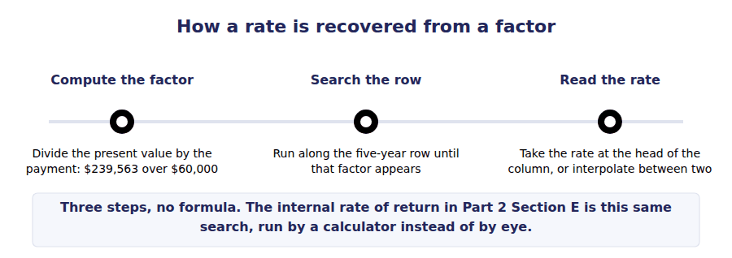
Part 5 · Nominal against effective the rate the contract does not quote
Exercise 3E Sort each statement into the column that says whether it is true.
OBJECTIVE | Convert a nominal rate to an effective annual rate.
YOU WILL NEED | Handout 1 Exercise 1A, on compounding.
HOW TO START | • A rate of 8% compounded twice a year charges 4% every six months, and the second charge falls on a balance that already includes the first.  • Work out what one dollar becomes after two half-years at 4% before you answer.  • One of the statements is about annual compounding, which is the only case where the two rates agree.

Statement about nominal and effective rates | TRUE | FALSE
1. 8% compounded semi-annually is an effective 8.16% a year
2. The effective rate is never below the nominal rate
3. More frequent compounding raises the effective rate
4. 8% compounded annually has an effective rate of 8%
5. The effective rate rises without limit as compounding gets more frequent
6. A factor table should be built on the periodic rate, not the annual one

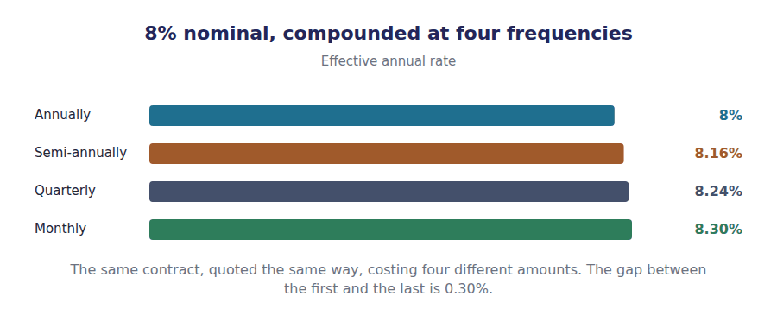
Watch out! The exam hides which variable is missing inside the story. "A machine costing $400,000 saves $95,000 a year for six years — does it clear a 10% hurdle?" is a question about the rate, and it reads like a question about a machine. Identify the unknown before you reach for anything.
Part 6 · Exam pitch the questions as the CMA sets them
1. [Level A] A present value of $239,563 supports 5 equal annual payments at 8%. The payment is found by:
(A) Multiplying $239,563 by the annuity factor
(B) Dividing $239,563 by the annuity factor
(C) Dividing $239,563 by the number of periods
(D) Multiplying $239,563 by the rate
2. [Level B] A lease of $239,563 requires 5 payments of $60,000. The rate implicit in the lease is found by:
(A) Dividing the total payments by the lease amount
(B) Computing the annuity factor and finding it in the table
(C) Dividing the lease amount by the number of periods
(D) Applying the effective annual rate formula
3. [Level B] An annuity factor of 3.99271 for five years implies a rate of:
(A) 6%
(B) 8%
(C) 10%
(D) Not determinable from a factor
4. [Level C] A company must repay $1,000,000 in 5 years and will make equal annual deposits earning 8%. The deposit is found by dividing $1,000,000 by:
(A) The present value annuity factor
(B) The future value annuity factor
(C) The number of periods
(D) The present value factor
5. [Level B] A nominal rate of 8% compounded semi-annually has an effective annual rate of:
(A) 8%
(B) 8.16%
(C) 4%
(D) 16%
6. [Level C] An interpolated rate is:
(A) Exact, because the table is exact
(B) An estimate, because the relationship between rate and factor is not linear
(C) Always too high
(D) Only valid for annuities
7. [Level C] A project costs $400,000 and saves $95,000 a year for six years. The question "does it clear a 10% hurdle?" is asking you to find:
(A) The present value
(B) The implicit rate, and compare it with 10%
(C) The payment
(D) The number of periods
ADAPTIVE TIP Before any time value question, write the four variables down and tick the three you have been given. The one without a tick is the answer, and which one it is decides whether you multiply, divide, or search the table.

Answer Key
Volume 13 · Handouts 1 to 3
Every answer carries the reason for it and the mistake it defeats.

Handout 1 · Why a Dollar Moves: Present Value and Future Value answers
Completed text and exercises
# | Answer | Why | The trap it defeats
1 | interest | The balance now includes last year’s interest.
2 | original | Interest the first deposit alone could not earn.
3 | power | Repeated multiplication, not repeated addition. | Students multiply the rate by the years. That is simple interest, and no exam question in either part uses it.
4 | divides | The inverse of multiplying.
5 | $68,058 | $100,000 over 1.08 to the fifth.
6 | rate | A bigger divisor, every period. | Students expect a higher rate to raise a present value, by analogy with earning more. It lowers it.
7 | off | Many periods, each one compounding the effect.
8 | when | Timing, not certainty. | Students read a present value as a risk adjustment. The factor knows only the rate and the number of periods.
Grid 1 | 1 TRUE 2 TRUE 3 TRUE 4 FALSE 5 TRUE 6 FALSE | The fourth is the trap. The relationship is a power, so nothing in this topic scales in proportion to anything.

Exam-pitch questions
# | Answer | Why | The trap it defeats
1 | (B) Less than the future amount when the discount rate is positive | Discounting at a positive rate always reduces the amount. (D) confuses the choice of rate, which may involve judgement, with the arithmetic, which does not. | Level A
2 | (B) $68,058 | $100,000 times the 8% factor of 0.68058 is $68,058. (A) applies the rate as simple interest for five years, which ignores compounding entirely. | Level A
3 | (B) Falls | A higher rate divides by a larger number each period. (A) is the instinct that a higher rate means more money, which is true of an investment you hold and false of an amount you are waiting for. | Level A
4 | (B) Are reciprocals, multiplying to 1 | 0.68058 times 1.46933 is 1. (C) is the most common wrong answer and would make both factors less than 1, which is impossible for a future value factor. | Level B
5 | (B) Higher, by the interest earned on interest | Compounding charges each year’s rate on a balance that already includes earlier interest. On Northwind’s deposit the difference is $4,718. (D) assumes a proportionality the arithmetic does not have. | Level B
6 | (B) 4% for 10 periods | Halve the rate and double the periods. (D) doubles the periods and leaves the rate alone, which charges a full year’s interest twice a year and is the error the exam is looking for. | Level C
7 | (B) The ten-year amount by proportionately more | The rate compounds over more periods, so a distant amount is far more sensitive. That sensitivity is what Volume 14 calls duration, and it is why a long bond’s price moves most. | Level C

Exercise 1A · the deposit, year by year
Year | Opening | Interest at 8% | Closing
1 | $68,058 | $5,445 | $73,503
2 | $73,503 | $5,880 | $79,383
3 | $79,383 | $6,351 | $85,734
4 | $85,734 | $6,859 | $92,593
5 | $92,593 | $7,407 | $100,000

Exercise 1C · the 8% factors
Periods | Present value of $1 | Future value of $1
1 | 0.92593 | 1.08000
2 | 0.85734 | 1.16640
3 | 0.79383 | 1.25971
4 | 0.73503 | 1.36049
5 | 0.68058 | 1.46933
6 | 0.63017 | 1.58687

R2 Check the factor table across the rows rather than down the columns: 0.68058 times 1.46933 is 1, and so is every other pair. A reciprocal check catches an arithmetic slip that reading the column never will.
R2 The deposit table and the factor table are the same arithmetic twice. $68,058 times the year 5 future value factor of 1.46933 is $100,000, which is the last line of the first table.

Handout 2 · Annuities: Ordinary, Due, and the Factor a Table Gives You answers
Completed text and exercises
# | Answer | Why | The trap it defeats
1 | 3.99271 | The five factors of Exercise 2A, added.
2 | approximation | The same arithmetic, done once. | Students treat the factor as a rounding convenience and discount separately when accuracy matters. The two give the same answer.
3 | equal | In amount, and equally spaced.
4 | floor | Three payments, so the three-year factor.
5 | ordinary | End of period, and the exam’s default.
6 | more | Each payment is discounted one period less. | Students expect paying earlier to be worth less because more cash leaves sooner. The question asks what the stream is worth, not what it costs the payer.
7 | rate | One multiplication, and the direction is up.
8 | $258,728 | $60,000 times 4.31213.
Grid 1 | 1 TRUE 2 FALSE 3 TRUE 4 TRUE 5 TRUE 6 FALSE | The second is the one worth arguing about. The payments never stop and the sum converges anyway, because the distant ones are worth almost nothing.

Exam-pitch questions
# | Answer | Why | The trap it defeats
1 | (B) Equal in amount and equally spaced in time | Both conditions, and nothing about timing within the period or about certainty. (C) describes an annuity due, which is one kind of annuity rather than the definition of all of them. | Level A
2 | (B) $239,563 | $60,000 times the annuity factor of 3.99271. (A) is the undiscounted total and (C) discounts a single payment rather than five. | Level A
3 | (B) Higher by a factor of one plus the rate | Every payment escapes one period of discounting, so the whole factor is multiplied by 1.08. (D) adds the rate rather than multiplying by one plus it, which understates the difference. | Level B
4 | (B) $258,728 | Payments in advance make this an annuity due: $60,000 times 4.31213. (A) is the ordinary annuity answer and is what a candidate gets for not reading the word beginning. | Level B
5 | (B) Exactly the sum of the single-sum factors | It is the sum, exactly: the five 8% factors add to 3.99271. (C) is the commonest misunderstanding and would make the annuity factor smaller than 1, which it is not beyond the first period. | Level B
6 | (B) $12,500 | Payment divided by rate: $1,000 over 0.08. (A) is the intuition the word forever creates, and the sum converges because the distant payments are worth almost nothing. | Level C
7 | (B) Discounting each payment separately | The payments are not equal, so no annuity factor applies and the long way of Exercise 2A is the only way. (A) is the error of reaching for the shortcut without checking the condition that licenses it. | Level C

Exercise 2A · the long way, payment by payment
Payment | Due in | Factor at 8% | Present value
$60,000 | 1 year | 0.92593 | $55,556
$60,000 | 2 years | 0.85734 | $51,440
$60,000 | 3 years | 0.79383 | $47,630
$60,000 | 4 years | 0.73503 | $44,102
$60,000 | 5 years | 0.68058 | $40,835
Total |  | 3.99271 | $239,563

Exercise 2C · the two annuity factors at 8%
Periods | Ordinary annuity | Annuity due
1 | 0.92593 | 1.00000
2 | 1.78326 | 1.92593
3 | 2.57710 | 2.78326
4 | 3.31213 | 3.57710
5 | 3.99271 | 4.31213
6 | 4.62288 | 4.99271

R2 The last row of the first table is the point of the handout. Five separate present values add to $239,563, and $60,000 multiplied by the single factor 3.99271 gives the same figure. Volume 7 used that figure without ever deriving it.
R2 The second table has a check built into it. Each annuity due factor equals the ordinary factor one row above, plus 1, because an annuity due is an immediate payment followed by an ordinary annuity one period shorter.

Handout 3 · Solving for the Missing One: Rate, Term, Payment answers
Completed text and exercises
# | Answer | Why | The trap it defeats
1 | divide | The inverse of the multiplication in Handout 2.
2 | $60,000 | $239,563 over 3.99271.
3 | future | The obligation falls at the end, not the start.
4 | factor | Present value annuity, or future value annuity. | Students use the present value factor for a sinking fund. The money is being accumulated forward, not discounted back.
5 | between | A bigger factor means a smaller rate.
6 | interpolation | A proportion of the gap between two rows.
7 | straight | A curve, so the estimate is approximate. | Students treat an interpolated rate as exact and then build a schedule on it that will not close. Use it to pick an answer, not to start a computation.
8 | precision | Enough to choose between the options offered.
Grid 1 | 1 TRUE 2 TRUE 3 TRUE 4 TRUE 5 FALSE 6 TRUE | The fifth is the trap: more frequent compounding raises the effective rate towards a ceiling, not past every bound.

Exam-pitch questions
# | Answer | Why | The trap it defeats
1 | (B) Dividing $239,563 by the annuity factor | The present value is the payment times the factor, so the payment is the present value over the factor: $60,000. (C) ignores the rate entirely. | Level A
2 | (B) Computing the annuity factor and finding it in the table | $239,563 over $60,000 is 3.99271, and that factor appears in the five-year row at 8%. (A) gives a ratio with no interest meaning at all. | Level B
3 | (B) 8% | Reading along the five-year row, 3.99271 sits in the 8% column. (D) is the answer of a candidate who has not realised the table works in both directions. | Level B
4 | (B) The future value annuity factor | A sinking fund accumulates forward, so the future value annuity factor of 5.86660 applies. (A) is the error of reaching for the familiar factor: it would give a deposit far too large. | Level C
5 | (B) 8.16% | Two half-years at 4% give 8.16% a year, because the second half-year charges on a balance that includes the first. (A) assumes the quoted rate is already effective, which it is only under annual compounding. | Level B
6 | (B) An estimate, because the relationship between rate and factor is not linear | Interpolation treats a curve as a straight line over a short stretch. (C) states a direction the method does not reliably have, which is exactly why it is only an estimate. | Level C
7 | (B) The implicit rate, and compare it with 10% | Three variables are given and the rate is withheld, which makes this an internal rate of return question in the language of Part 2 Section E. (A) is a legitimate alternative route to the same decision and is not what the stem asked for. | Level C

Exercise 3A · which variable each question withholds
What you are given | What is missing | How to find it
Payment, rate, number of periods | Present value | Multiply the payment by the annuity factor
Present value, rate, number of periods | Payment | Divide the present value by the annuity factor
Present value, payment, number of periods | Rate | Find the factor, then read the rate off the table
Present value, payment, rate | Number of periods | Find the factor, then read the periods off the table

Exercise 3C · the rate recovered from Volume 7
Rate | Five-year annuity factor | Value of $60,000 a year
6% | 4.21236 | $252,742
7% | 4.10020 | $246,012
8% | 3.99271 | $239,563
9% | 3.88965 | $233,379
10% | 3.79079 | $227,447

R2 The 8% row is the lease. $239,563 divided by $60,000 is 3.99271, that factor appears in the 8% column, and the $60,000 a year value of $239,563 matches the liability Volume 7 opened with. The volume that used the rate has now been checked by the volume that teaches it.
R2 The same search run on Volume 7’s other lease gives the same answer: $103,084 divided by $40,000 is 2.57710, which is the three-year factor at 8%. Two leases, one rate, and neither figure was invented for this handout.

Glossary
Every term in Volume 13, with the Arabic equivalent and the places it misleads
The third column is for recognition only. In the exam room you work in English.

Term | What it means in CMA English | بالعربية | Careful
annuity | A series of equal payments made at equal intervals. | دفعة سنوية منتظمة | Equal in amount and equal in spacing. A stream that fails either test is valued payment by payment.
annuity due | An annuity whose first payment falls at the beginning of the first period. | دفعة معجلة | Worth more than the ordinary kind, because every payment escapes one period of discounting.
annuity factor | The present value of one dollar per period for a given number of periods at a given rate. | معامل الدفعة | The sum of the single-sum factors for those periods. Nothing is approximated.
compounding | Earning interest on interest already earned, so growth accelerates. | التركيب | The reason the factors are powers rather than multiples. Simple interest has no compounding and is rarely examined.
discount rate | The rate used to bring a future amount back to the present. | معدل الخصم | In a lease it is the rate implicit in the contract; in a capital project it is the hurdle rate. The arithmetic does not care which.
effective annual rate | The rate that, compounded once a year, gives the same result as the nominal rate at its stated frequency. | المعدل الفعلي السنوي | Always at or above the nominal rate, and equal to it only when compounding is annual.
future value | What an amount invested today will grow to by a later date. | القيمة المستقبلية | The same relationship read the other way. One factor is the reciprocal of the other.
implicit rate | The rate that discounts a stream of payments back to a known present value. | المعدل الضمني | The figure Volume 7 called the rate implicit in the lease. It is found by searching a table, not by a formula.
interpolation | Estimating a value that falls between two tabulated figures, by taking a proportion of the gap. | الاستيفاء | Accurate enough for an exam and never exact, because the relationship between rate and factor is not a straight line.
nominal rate | An annual rate quoted without regard to how often it is compounded. | المعدل الاسمي | What a contract states. It is not what the borrower actually pays unless compounding is annual.
ordinary annuity | An annuity whose first payment falls at the end of the first period. | دفعة عادية | The default in every exam question that does not say otherwise, and the one a lease uses unless the contract says in advance.
perpetuity | An annuity with no end, valued by dividing the payment by the rate. | دفعة دائمة | The factor converges because the later payments are worth almost nothing. At 8% it is only 12.50000.
present value | What an amount due at a later date is worth today, at a given rate. | القيمة الحالية | Always smaller than the future amount when the rate is positive. The exam gives you the rate; you do not choose it.
principal | The amount on which interest is computed. | أصل المبلغ | Under compounding the principal grows each period, which is exactly what makes the arithmetic non-linear.
sinking fund | A series of deposits accumulated to meet a known future obligation. | صندوق الاستهلاك | The one common case where the unknown is a payment and the known figure is a future value rather than a present one.

