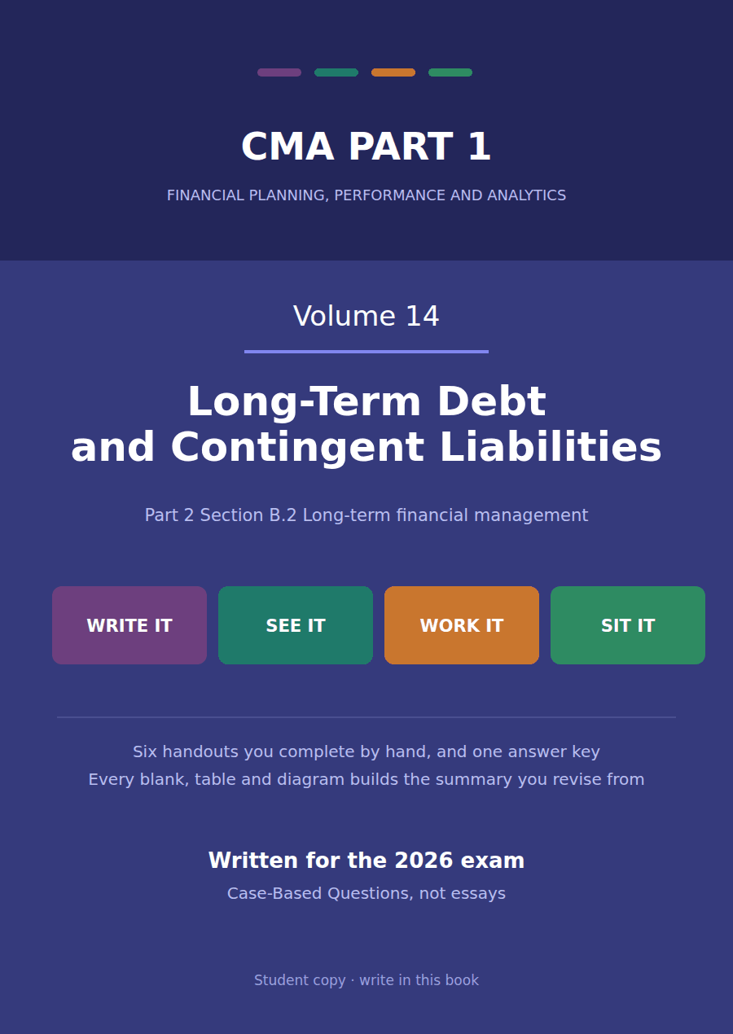

CMA Part 1 · Volume 14
Long-Term Debt and Contingent Liabilities
Six handouts, one answer key. The CMA wants a bond valued; intermediate accounting wants it accounted for. This volume does both, and says which is which.
These handouts are not notes to read. You write them. The words you supply are the summary, so a finished handout is a page you can revise from, in your own handwriting.
Work in pen. Do not look at the key until the whole handout is done — the key is written to explain the mistake, and you only get that benefit if you have made it first.
The six handouts
# | Handout | What it gives you
1 | What a Bond Promises: Par, Coupon, Indenture, Covenants | Northwind has had a $1,500,000 bond on its balance sheet since Volume 1. This handout reads the contract behind it.
2 | Issued at a Discount, at a Premium, at Par | The same $1,000,000 bond raises $920,146 with one coupon and $1,079,854 with another. Nothing about the company changed.
3 | The Effective Interest Method, Period by Period | The 6% bond pays $60,000 in cash and costs $73,612 in its first year. The gap is the discount, arriving one year at a time.
4 | Valuing a Bond, and What Moves Its Price | The CMA asks for this half of the topic and not for Handout 3. One bond, five market rates, and five different prices.
5 | Retirement, Refinancing, Convertibles and Warrants | Northwind buys its bond back three years in, at 102 of face, and records a $55,664 loss on a deal it chose to do.
6 | Contingencies: Probable, Reasonably Possible, Remote | A lawsuit that might cost between $200,000 and $600,000. One framework accrues $200,000 and the other accrues $400,000.

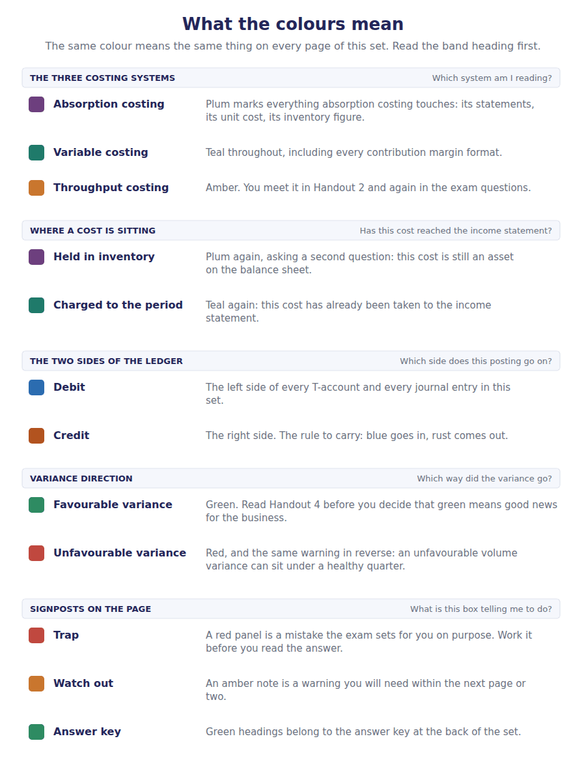
How to read the markers
Marker | Meaning
R1 | Teaching English. Short sentences. This is where a new idea arrives.
R2 | Textbook English. Longer sentences and passive verbs, as a textbook writes them.
R3 | Exam English. Exactly how the CMA exam phrases it, traps included.
Numbered rule | A space you fill in. The number matches the answer key.
Red table | A trap. Read it twice.

Handout 1 · What a Bond Promises: Par, Coupon, Indenture, Covenants
Northwind has had a $1,500,000 bond on its balance sheet since Volume 1. This handout reads the contract behind it.
Volume 14 · Long-Term Debt and Contingent Liabilities · R1 moving to R2
LANGUAGE FOCUS
Register you are working in | R1 while the features are being named, R2 once the contract is being read.
Say it exactly like this | issue a bond to the public · pay a coupon semi-annually · redeem a bond at maturity · breach a covenant · call a bond before maturity · retire an instalment of a serial bond
Words that are not the same | face value / market price · coupon rate / market rate · secured / unsecured · term bond / serial bond
Remember | A coupon rate is not a yield. It is a rate on the face value and it never changes; the yield moves every day. A covenant is not a guarantee of repayment. It is a promise about conduct, and breaching it usually makes the debt fall due at once.

What you will be able to do when this handout is finished
- Name the features of a bond that the indenture fixes.
- Distinguish the coupon rate from the market rate.
- Say what a covenant does and what breaching one costs.
- Distinguish a term bond from a serial bond.
- Read Northwind’s own debt as the bond it is.

The debt you have been looking at all along
Volume 1’s balance sheet carries $1,200,000 of long-term debt and $150,000 due within twelve months, and its income statement charges $90,000 of interest.
Those three figures describe one instrument completely. $90,000 of interest on $1,500,000 outstanding at the start of the year is a coupon of 6%.
And $150,000 was repaid during the year, which is why the total fell from $1,500,000 to $1,350,000.
It is a serial bond at par. This handout reads its contract; Handouts 2 and 3 take two bonds that were not issued at par.

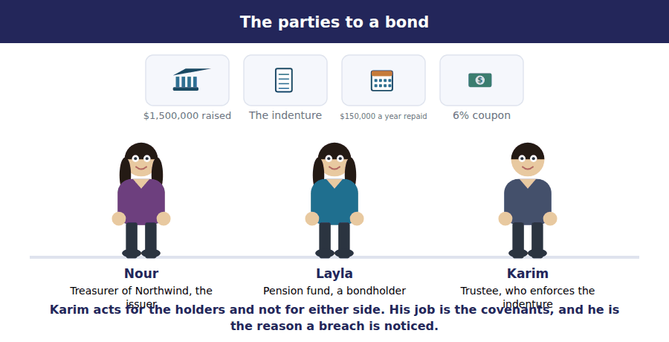
Part 1 · What the indenture fixes six features, all of them in the contract
Exercise 1A Complete both right-hand columns.
OBJECTIVE | Name each feature of a bond and say what it fixes.
YOU WILL NEED | Volume 1 Handout 4, for the debt on the balance sheet.
HOW TO START | • Two of the six are amounts, two are dates or schedules, and two are promises about conduct.  • Northwind’s coupon is $90,000 of interest on $1,500,000 outstanding.  • The last row is a right the issuer may or may not have reserved, and Northwind did not.

Feature | What it fixes | Northwind’s serial bond
Face value |  | $1,500,000
Coupon rate
Maturity
Indenture
Covenants
Call provision

1 | 2 | 3 | 4 | 5 | 6
7 | 8 | 9 | 10 | 11

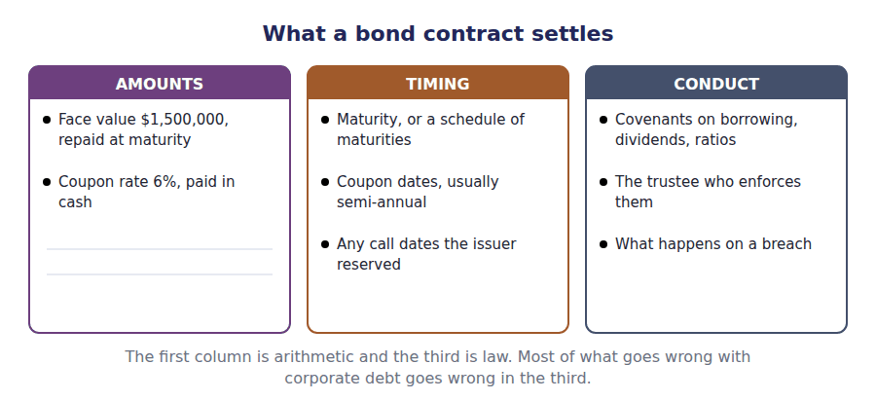
Part 2 · The coupon and the market one is fixed, the other is not
Exercise 1B Read and complete. Write one word in each space.
OBJECTIVE | Distinguish the coupon rate from the market rate.
YOU WILL NEED | Exercise 1A, and Volume 13 Handout 1 on discount rates.
HOW TO START | • The coupon is printed on the contract. Ask whether anything printed on a contract can respond to tomorrow’s news.  • If a bond pays 6% and investors can get 8% elsewhere, ask what has to happen to the price for anyone to buy it.  • The last blank is the only one of the two rates that changes after the bond is issued.

WORD BANK
coincidence · design · face · price · received · yield
Not every word is used.

R2 The coupon rate is written into the indenture and never changes. A 6% coupon on $1,000,000 of face pays $60,000 in cash every year of the bond’s life, whatever happens to interest rates or to the company.
The market rate is what investors require today for a bond of this risk and this term. It moves daily and the issuer has no control over it, so the two rates agree only by ¹ .
When they differ, the cash is fixed, so the only thing that can adjust is the ² . A bond paying less than the market demands sells below its face value, and one paying more sells above it.
That is the whole of Handout 2. For now note which figure the balance sheet carries: not the face value and not the market price, but the amount actually ³ , adjusted thereafter.
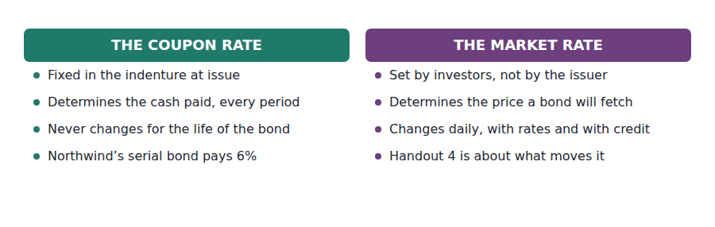
Part 3 · Covenants the promises that are not about money
R2 A lender who cannot control what a borrower does after the money has gone protects itself by contract. Covenants are those protections: promises to maintain a ratio, to limit further borrowing, to restrict dividends, or to keep an asset insured.
Exercise 1C Read and complete, then sort each item into the column it belongs in.
OBJECTIVE | Say what covenants do and what breaching one costs.
YOU WILL NEED | The paragraph above.
HOW TO START | • An affirmative covenant is something the issuer promises to do; a negative covenant is something it promises not to do.  • Ask which kind "maintain a current ratio above 1.5" is before you answer.  • Two of the items are not covenants at all, and one of those two is about what happens after a breach.

WORD BANK
affirmative · cash · default · do · negative · once · promise · waive
Not every word is used.

R2 A lender hands over the money first and watches afterwards. Covenants are how it keeps some control: promises in the indenture about what the issuer will and will not ⁴ .
A promise to do something, such as deliver audited statements or hold a ratio above a stated level, is an ⁵ covenant. A promise to refrain, such as not to borrow further or not to pay dividends above a share of earnings, is a negative one.
Breaching either is serious because of what usually follows. The lender may demand immediate repayment, and a balance that was due in five years becomes payable at ⁶ .
That is why a breach moves the whole debt into current liabilities. Northwind’s $1,200,000 would join the $150,000 already there, and every liquidity ratio Part 2 computes would change on a day when no ⁷ moved at all.
A lender may instead ⁸ the breach for at least twelve months, and where it has done so by the reporting date the debt stays long-term and the waiver is disclosed.
Item | AFFIRMATIVE | NEGATIVE | NOT A COVENANT
1. Maintain a current ratio of at least 1.5
2. Do not incur additional debt beyond a stated limit
3. Deliver audited statements within 90 days of the year end
4. Do not pay dividends exceeding a stated share of earnings
5. Repay the face value at maturity
6. The whole debt becomes due on breach

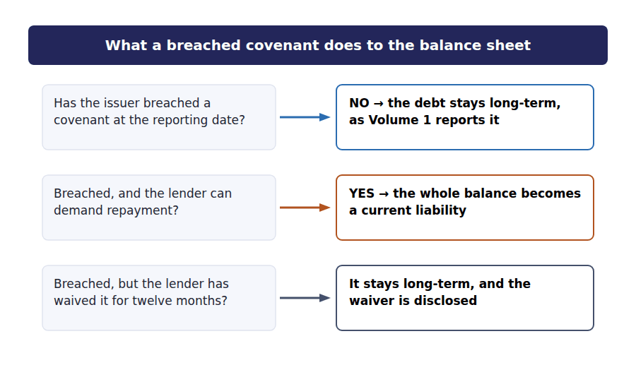
Part 4 · Term bonds and serial bonds and why Volume 1 split the balance
Exercise 1D Complete the schedule. Two figures are given from Volume 1.
OBJECTIVE | Roll Northwind’s serial bond forward and split the closing balance.
YOU WILL NEED | Exercise 1A, and Volume 1 Handout 4 for the balance sheet split.
HOW TO START | • The coupon is 6% on the $1,500,000 outstanding at the start of the year.  • One instalment of $150,000 was repaid, so the closing balance is the opening less that.  • The last two rows split that closing balance the way Volume 1 splits it, and they must add back to it.

Northwind’s debt in 20X4 | Amount
Outstanding at 1 January 20X4 | $1,500,000
Coupon at 6% on the opening balance
Instalment repaid during the year | ($150,000)
Outstanding at 31 December 20X4
of which due within twelve months | $150,000
of which due after twelve months | $1,200,000

1 | 2 | 3

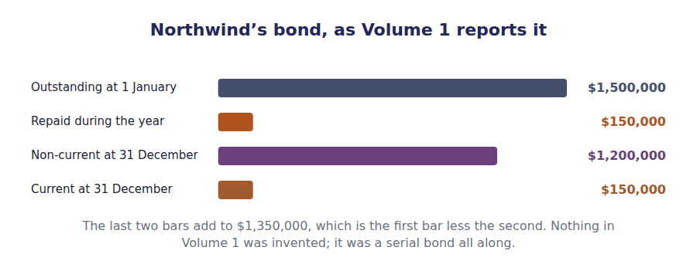
Watch out! A term bond repays everything on one date and a serial bond repays in instalments. Only the serial kind produces a current portion every year, which is why Northwind’s $150,000 sits among current liabilities while the other $1,200,000 does not.
Part 5 · Exam pitch the questions as the CMA sets them
1. [Level A] The coupon rate on a bond:
(A) Changes with market interest rates
(B) Is fixed in the indenture and determines the cash interest paid
(C) Equals the rate investors require at all times
(D) Is set by the trustee
2. [Level A] A bond backed by the issuer’s general credit rather than by specific collateral is a:
(A) Mortgage bond
(B) Debenture
(C) Serial bond
(D) Callable bond
3. [Level B] An indenture is:
(A) The accounting standard governing bonds
(B) The contract between the issuer and the bondholders
(C) The certificate held by each investor
(D) The registration filed with a regulator
4. [Level B] A company breaches a debt covenant before its year end and the lender has not waived it. The debt should be reported as:
(A) Long-term, because the maturity has not changed
(B) A current liability
(C) Off balance sheet until the lender acts
(D) Equity
5. [Level A] Northwind’s bond repays $150,000 each year rather than the whole $1,500,000 at one date. It is a:
(A) Term bond
(B) Serial bond
(C) Callable bond
(D) Secured bond
6. [Level C] A call provision in an indenture benefits:
(A) The bondholders, who may demand early repayment
(B) The issuer, who may repay early if rates fall
(C) The trustee
(D) Neither party
7. [Level B] Northwind reports $90,000 of interest expense on $1,500,000 of debt outstanding at the start of the year. The coupon rate is:
(A) 8%
(B) 6%
(C) 8%
(D) Not determinable
ADAPTIVE TIP Separate the three rates before you answer anything on this topic: the coupon rate fixes the cash, the market rate at issue fixes the price, and the market rate today fixes what the bond would fetch now. Most distractors are the right arithmetic on the wrong one of the three.

Handout 2 · Issued at a Discount, at a Premium, at Par
The same $1,000,000 bond raises $920,146 with one coupon and $1,079,854 with another. Nothing about the company changed.
Volume 14 · Long-Term Debt and Contingent Liabilities · R2
LANGUAGE FOCUS
Register you are working in | R2 throughout. The exam register waits for Handout 4, where the CMA’s own wording arrives.
Say it exactly like this | issue a bond below par · discount the coupons and the principal · record a discount on bonds payable · carry a bond at its issue price · present a discount as a contra account · raise less than the face value
Words that are not the same | discount / premium · coupon rate / market rate · face value / issue price · contra liability / addition
Remember | A discount is not a loss and a premium is not a gain. Both are interest, and Handout 3 spreads them over the bond’s life. A discount on bonds payable is not an asset. It is a deduction from the liability it belongs to.

What you will be able to do when this handout is finished
- Say why a bond sells above or below its face value.
- Price a bond as an annuity plus a single sum.
- Compute the discount or premium at issue.
- Record the issue and present the bond on the balance sheet.
- Say what the discount and the premium actually represent.

Two bonds, one company, one week
Northwind proposes to raise money with a $1,000,000 bond repayable in 5 years. The market requires 8% from a company of its credit.
If the board sets the coupon at 6%, the bond pays less than investors want and will not sell at face value. If it sets 10%, it pays more than they want and will sell for more.
The first raises $920,146 and the second raises $1,079,854. The company, the term and the amount repaid at maturity are identical.
This handout prices both and records them. The arithmetic is Volume 13’s, with nothing added.

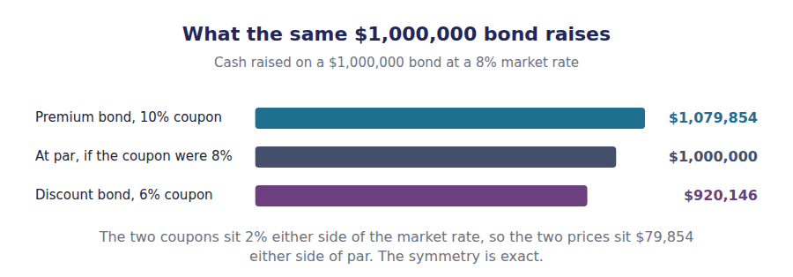
Part 1 · Why a bond sells away from par the cash is fixed, so the price moves
Exercise 2A Read and complete. Write one word in each space.
OBJECTIVE | Say why a bond sells below or above its face value.
YOU WILL NEED | Handout 1 Exercise 1B, on the coupon against the market rate.
HOW TO START | • An investor can get 8% elsewhere. Ask what they would pay for a promise of $60,000 a year.  • The coupon cannot be changed, and the amount repaid at maturity cannot be changed either. Only one number is left free.  • The last blank is what the shortfall in the price really is, and it is not a loss.

WORD BANK
discount · gain · interest · loss · pay · premium · receive
Not every word is used.

R2 An investor who can earn 8% elsewhere will not pay $1,000,000 for a bond paying a 6% coupon. The cash the bond offers is fixed by the indenture, so the only thing that can adjust is what the investor is willing to ¹ .
The price falls until the bond yields 8% on the money actually laid out. At $920,146 it does, and the $79,854 shortfall against face value is called a ² .
That shortfall is not a loss to the issuer. Northwind receives $920,146 and repays $1,000,000, and the extra $79,854 it hands back at maturity is additional ³ it did not pay in cash along the way.
A 10% coupon runs the other way. Investors pay $1,079,854 for it, the $79,854 excess is a ⁴ , and the issuer’s real cost is below the coupon because part of what it collected is never repaid as interest.
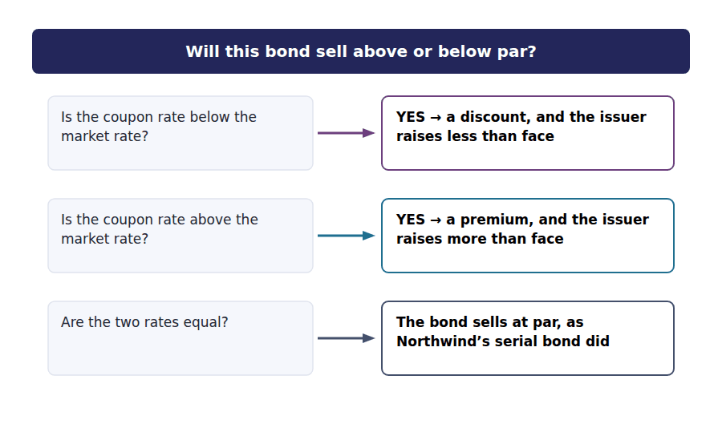
Part 2 · Pricing it an annuity plus a single sum
R2 A bond is two promises: a stream of equal coupons, and one repayment of the face value at the end. Volume 13 can value both. The coupons are an ordinary annuity and the repayment is a single sum, and the price is their total.
Exercise 2B Complete the grid. The present value of the repayment is given.
OBJECTIVE | Price both bonds as an annuity plus a single sum.
YOU WILL NEED | Volume 13 Handout 2, for the five-year annuity factor at 8%. · Volume 13 Handout 1, for the single-sum factor.
HOW TO START | • The coupon row is the rate in row 1 applied to the $1,000,000 face value.  • The annuity factor at 8% for 5 years is 3.99271, and you computed it in Volume 13.  • Look hard at the discount bond’s coupon row before you move on: you have met that figure twice already.

Pricing the $1,000,000 bond | Discount bond | Premium bond
Coupon rate written in the indenture | 6% | 10%
Cash coupon, each year
Present value of the coupons at 8%
Present value of the $1,000,000 repaid at maturity | $680,583 | $680,583
Issue price
Discount or premium

1 | 2 | 3 | 4 | 5 | 6
7 | 8 | 9 | 10

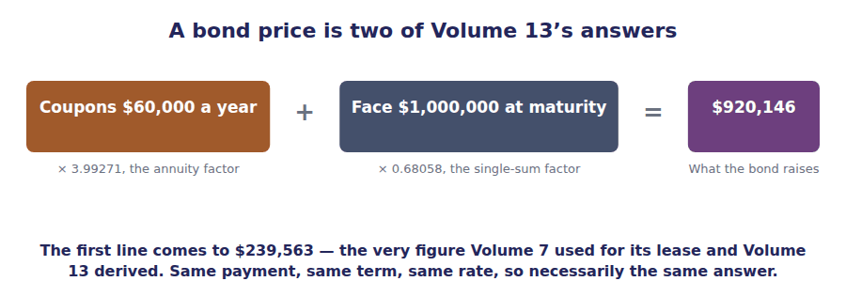
Part 3 · Recording the issue and where the difference sits
Exercise 2C Read and complete, then fill the grid and record the two entries underneath.
OBJECTIVE | Record both issues and present each bond on the balance sheet.
YOU WILL NEED | Exercise 2B.
HOW TO START | • Bonds payable is always credited with the face value, whatever the cash received.  • The difference between the cash and the face goes to a separate account, and its sign decides which of the two rows it uses.  • The carrying amount must come back to the issue price you computed in Exercise 2B.

WORD BANK
added · carrying · credited · debited · face · issue · market · stated
Not every word is used.

R2 Whatever the cash, bonds payable is credited with the ⁵ value of $1,000,000. That account records what will be repaid, and what will be repaid does not depend on what the bond fetched.
The difference goes to an account of its own. On the 6% bond the company received $79,854 less than face, so $79,854 is ⁶ to discount on bonds payable.
That account is a contra liability. It is deducted from bonds payable rather than shown separately, so the balance sheet reports one ⁷ amount of $920,146.
The premium bond runs the other way. The $79,854 excess is credited to premium on bonds payable and ⁸ to the face value, giving a carrying amount of $1,079,854.
Note which rate did all the work. The stated rate decided the cash coupons; the ⁹ rate decided the price and therefore the discount and the premium.
On the balance sheet at issue | Discount bond | Premium bond
Bonds payable, at face value | $1,000,000 | $1,000,000
Less discount on bonds payable
Plus premium on bonds payable
Carrying amount

1 | 2 | 3 | 4 | 5 | 6

J1 The 6% bond issued at $920,146, raising $920,146. Three lines, and the discount is a debit.
Account | Debit | Credit
Cash
Discount on Bonds Payable
Bonds Payable
J2 The 10% bond issued at $1,079,854 instead. The same three accounts, with the premium on the other side.
Account | Debit | Credit
Cash
Bonds Payable
Premium on Bonds Payable

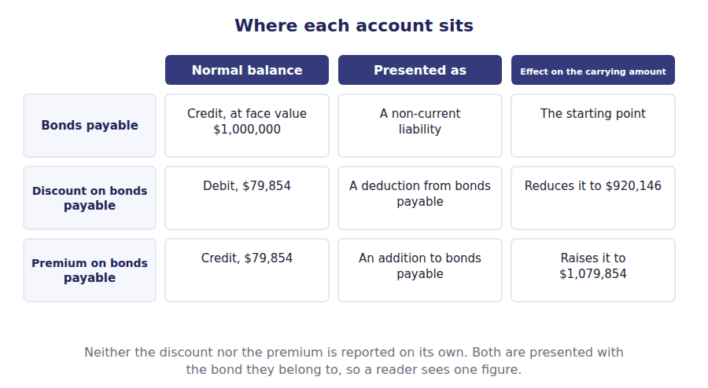
Part 4 · What the difference really is interest, and nothing else
Exercise 2D Sort each statement into the column that says whether it is true.
OBJECTIVE | Say what the discount and the premium represent over the bond’s life.
YOU WILL NEED | Exercise 2C.
HOW TO START | • Northwind receives $920,146 on the discount bond and repays $1,000,000. Add up what it pays in total and compare.  • Five coupons of $60,000 plus $1,000,000 of principal is $1,300,000, against $920,146 received.  • One of the statements is about the premium bond, where the total cost runs the other way.

Statement about the discount bond | TRUE | FALSE
1. The total cash cost is $379,854
2. The discount is a loss recognised at issue
3. The real cost of borrowing is above the 6% coupon
4. The discount will be charged to interest expense over the term
5. The premium bond costs more in total than the discount bond
6. Both bonds repay $1,000,000 at maturity

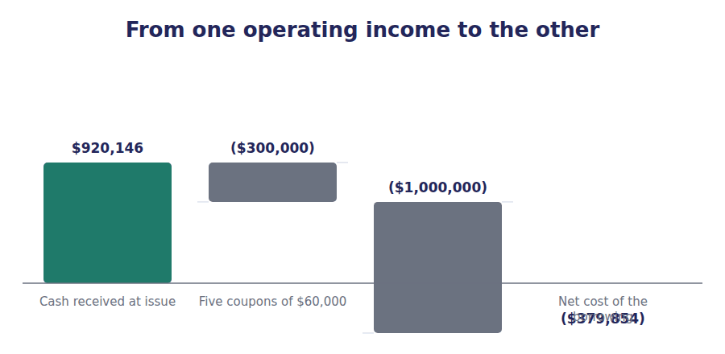
Watch out! Bonds payable is credited with the face value every time, whatever the cash. A question that asks for the credit to bonds payable on a bond issued at $920,146 is asking for $1,000,000, and the $79,854 goes to a separate account.
Part 5 · Exam pitch the questions as the CMA sets them
1. [Level A] A bond sells at a discount when:
(A) The issuer is in financial difficulty
(B) The coupon rate is below the market rate
(C) The coupon rate is above the market rate
(D) The bond is unsecured
2. [Level B] A $1,000,000 bond with a 6% coupon is issued when the market rate is 8%. The issue price is the present value of:
(A) The face value only
(B) The coupons and the face value, both at 8%
(C) The coupons and the face value, both at 6%
(D) The total cash the bond will pay
3. [Level A] On the issue of a bond at a discount, bonds payable is credited with:
(A) $920,146
(B) $1,000,000
(C) $79,854
(D) $1,079,854
4. [Level B] Discount on bonds payable is reported as:
(A) An asset
(B) A deduction from bonds payable
(C) An expense of the period of issue
(D) An addition to equity
5. [Level C] The same issuer offers a 6% coupon and a 10% coupon on otherwise identical $1,000,000 bonds. Compared with the discount bond, the premium bond:
(A) Repays more at maturity
(B) Raises more at issue and pays more in coupons
(C) Costs the issuer less in total cash
(D) Costs the issuer a higher rate on the money raised
6. [Level A] A bond is issued at exactly par. This tells you that:
(A) The issuer has no covenants
(B) The coupon rate equals the market rate at issue
(C) The bond is secured
(D) The bond matures in one year
7. [Level C] The present value of the coupons on the 6% bond comes to $239,563. That figure also appears in this course as:
(A) The premium on the other bond
(B) The present value of Volume 7’s finance lease
(C) The face value of the serial bond
(D) A coincidence with no meaning
ADAPTIVE TIP Price every bond in two pieces and label them. Coupons times the annuity factor, face times the single-sum factor, both at the market rate. Then compare the total with the face value: below is a discount, above is a premium, and you never have to remember which way round it goes.

Handout 3 · The Effective Interest Method, Period by Period
The 6% bond pays $60,000 in cash and costs $73,612 in its first year. The gap is the discount, arriving one year at a time.
Volume 14 · Long-Term Debt and Contingent Liabilities · R2
LANGUAGE FOCUS
Register you are working in | R2 throughout, with the exam’s own contrast between the two methods at R3.
Say it exactly like this | amortise a discount to interest expense · apply the effective rate to the carrying amount · accrete a carrying amount toward par · spread a premium over the term · reduce interest expense below the coupon · close a schedule on the face value
Words that are not the same | cash coupon / interest expense · effective interest / straight-line · accretion / amortisation · discount bond / premium bond
Remember | Amortising a discount is not repaying it. No cash moves, and the carrying amount rises. The effective interest method is not an approximation of the straight-line one. It is the exact method, and straight-line is the shortcut.

What you will be able to do when this handout is finished
- Build an effective interest schedule for a bond issued at a discount.
- Build the same schedule for a bond issued at a premium.
- Say why interest expense differs from the cash coupon.
- Record a year’s interest on each bond.
- Compare the effective interest method with straight-line.

The cash and the cost are not the same number
Handout 2 issued a $1,000,000 bond with a 6% coupon for $920,146, because the market wanted 8%.
In cash that bond pays $60,000 a year. But Northwind borrowed $920,146 and owes $1,000,000, so $79,854 of interest is being paid at the end rather than along the way.
The accounts charge what the borrowing really costs: 8% of the carrying amount each year, which in year one is $73,612.
That is the effective interest method, and it is the schedule Volume 7 built for a lease liability. The same arithmetic, on a different contract.

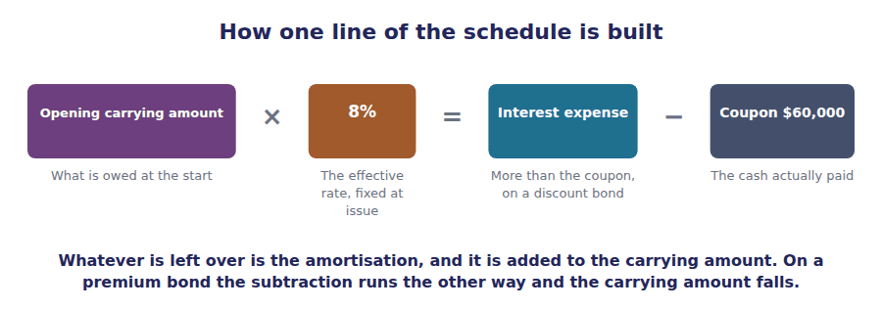
Part 1 · Why the two figures differ borrowed less, owe more
Exercise 3A Read and complete. Write one word or figure in each space.
OBJECTIVE | Say why interest expense differs from the cash coupon.
YOU WILL NEED | Handout 2 Exercise 2A, on what a discount represents. · Volume 7 Handout 6, on how a lease liability unwinds.
HOW TO START | • Northwind received $920,146 and will repay $1,000,000. Ask which of those two figures the interest should be charged on.  • The coupon is 6% of the face value. The effective charge is 8% of something smaller.  • The last blank is the direction the carrying amount moves on a discount bond, and it is not down.

WORD BANK
$1,000,000 · carrying · face · falls · incurred · paid · rises
Not every word is used.

R2 Northwind received $920,146, not $1,000,000. Interest should therefore be charged on the $920,146 it actually has the use of, which is the ¹ amount.
8% of $920,146 is $73,612, and the cash coupon is only $60,000. The $13,612 difference is interest the company has incurred and not yet ² .
It is not paid because it is not due until maturity, when $1,000,000 rather than $920,146 is handed back. So the unpaid part is added to the liability, and the carrying amount ³ .
Each year it rises a little further, and by the end of year five it has reached exactly ⁴ . That is the check on the whole schedule.
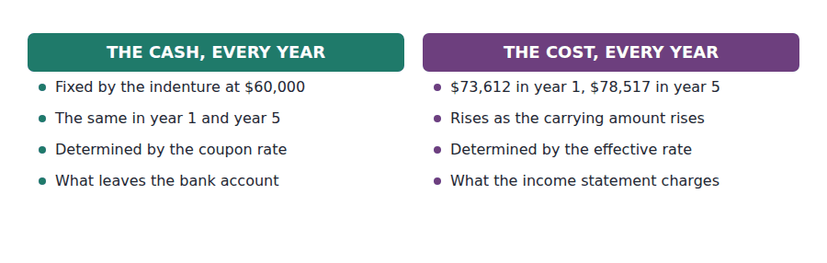
Part 2 · The discount bond, year by year the schedule, built
Exercise 3B Complete the table. Each closing balance is the next opening balance.
OBJECTIVE | Build the effective interest schedule for the discount bond.
YOU WILL NEED | Exercise 3A, and Handout 2 for the $920,146 issue price.
HOW TO START | • Interest is 8% of the opening carrying amount, not of the $1,000,000 face value.  • The coupon column is $60,000 in every year. Only the interest column moves.  • The amortisation is the interest less the coupon, and it is added to the carrying amount. Year five must close on $1,000,000.

Year | Opening | Interest at 8% | Coupon paid | Amortised | Closing
1 | $920,146 | $73,612 | $60,000 | $13,612 | $933,758
2 |  |  | $60,000
3 |  |  | $60,000
4 |  |  | $60,000
5 |  |  | $60,000

1 | 2 | 3 | 4 | 5 | 6
7 | 8 | 9 | 10 | 11 | 12
13 | 14 | 15 | 16

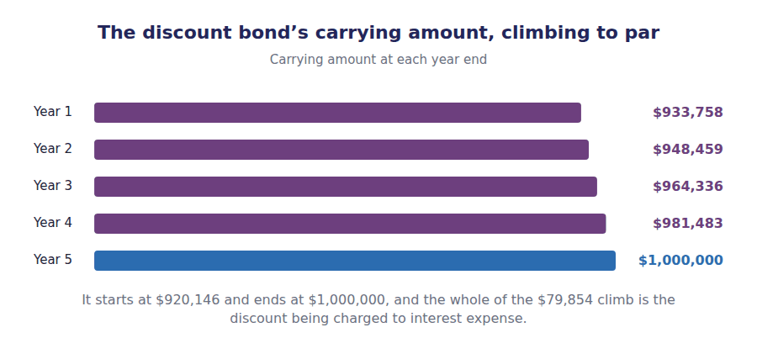
Part 3 · The premium bond, the other way the same method, mirrored
Exercise 3C Complete the table, then record the two entries underneath.
OBJECTIVE | Build the schedule for the premium bond and record a year of each.
YOU WILL NEED | Exercise 3B.
HOW TO START | • The method does not change. Interest is still 8% of the opening carrying amount.  • Here the coupon of $100,000 exceeds the interest, so the difference is subtracted from the carrying amount rather than added.  • Compare your amortisation column with Exercise 3B’s: the figures should be identical with the opposite sign.

Year | Opening | Interest at 8% | Coupon paid | Amortised | Closing
1 | $1,079,854 | $86,388 | $100,000 | ($13,612) | $1,066,242
2 |  |  | $100,000
3 |  |  | $100,000
4 |  |  | $100,000
5 |  |  | $100,000

1 | 2 | 3 | 4 | 5 | 6
7 | 8 | 9 | 10 | 11 | 12
13 | 14 | 15 | 16

J1 Year one interest on the discount bond: $73,612 charged, $60,000 paid in cash. Three lines, and the third moves no cash at all.
Account | Debit | Credit
Interest Expense
Discount on Bonds Payable
Cash
J2 Year one interest on the premium bond: $86,388 charged, $100,000 paid in cash. Here the premium account is debited, and the expense is below the cash.
Account | Debit | Credit
Interest Expense
Premium on Bonds Payable
Cash

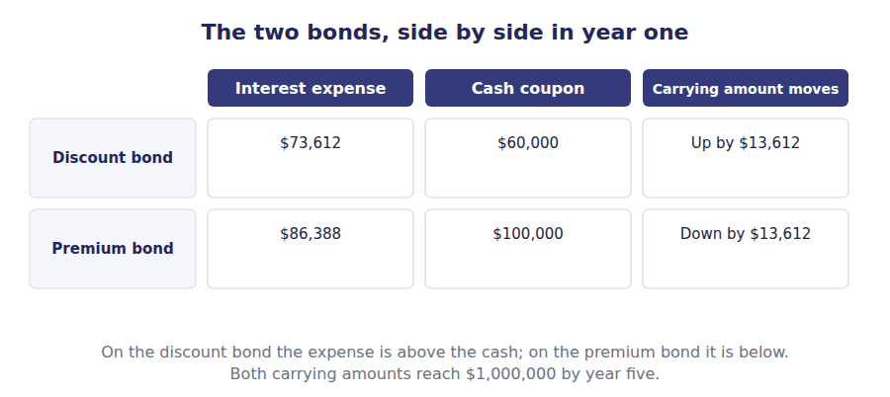
Part 4 · The shortcut, and when it is allowed straight-line against effective interest
Exercise 3D Complete the grid. The totals row is the one that agrees.
OBJECTIVE | Compare the effective interest method with straight-line amortisation.
YOU WILL NEED | Exercises 3B and 3C.
HOW TO START | • Straight-line divides the $79,854 discount by the 5 years, giving the same figure every year.  • The effective interest figures are in your Exercise 3B table: look up years 1 and 5.  • The last row is about permission rather than arithmetic, and the two frameworks do not agree on it.

WORD BANK
$15,971 · all · amounts · bears · coupon · move · rise · years
Not every word is used.

R3 The rate used throughout the schedule is the effective interest rate: the 8% the market demanded at issue. It is fixed for the life of the bond and does not move when market rates ⁵ afterwards.
Read from the investor’s side the same number is the yield to maturity, because what the issuer ⁶ is what the holder earns. One rate, two names, two sets of books.
Straight-line amortisation ignores the carrying amount and divides the $79,854 discount by the 5 years, charging ⁷ in every one of them. The amortisation of a discount is then flat rather than rising.
US GAAP permits that only where the answer is not materially different from the effective interest method, and IFRS does not permit it at ⁸ .
Both methods charge the same total over five years, because both amortise the whole $79,854. What differs is which ⁹ carry it.
 | Effective interest method | Straight-line
Year 1 amortisation
Year 5 amortisation
Year 1 interest expense
Total over five years
Permitted under US GAAP

1 | 2 | 3 | 4 | 5 | 6
7 | 8

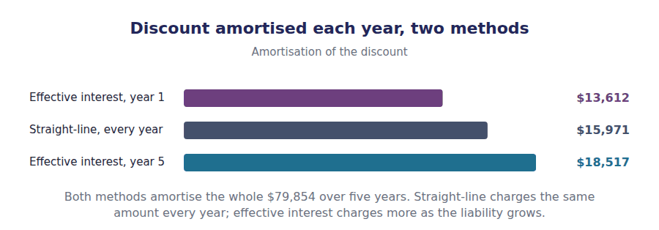
Watch out! Interest expense is the effective rate on the carrying amount, never the coupon rate on the face value. A stem that gives you a 6% coupon on $1,000,000 of face and asks for interest expense is offering $60,000 as a distractor, and the answer is $73,612.
Part 5 · Exam pitch the questions as the CMA sets them
1. [Level A] Under the effective interest method, interest expense for a period is:
(A) The coupon rate times the face value
(B) The effective rate times the opening carrying amount
(C) The effective rate times the face value
(D) The coupon rate times the carrying amount
2. [Level A] A bond issued at a discount has, in each period, interest expense that is:
(A) Equal to the cash coupon
(B) Greater than the cash coupon
(C) Less than the cash coupon
(D) Zero
3. [Level B] Amortising a discount on bonds payable:
(A) Reduces the carrying amount
(B) Increases the carrying amount
(C) Has no effect on the carrying amount
(D) Requires a cash payment
4. [Level B] A $1,000,000 bond with a 6% coupon was issued for $920,146 to yield 8%. Interest expense in year one is:
(A) $60,000
(B) $73,612
(C) $80,000
(D) $15,971
5. [Level C] Over the whole term, total interest expense under the effective interest method compared with straight-line is:
(A) Higher
(B) The same
(C) Lower
(D) Not comparable
6. [Level B] Straight-line amortisation of a bond discount is:
(A) Required under IFRS
(B) Permitted under US GAAP only where the result is not materially different from the effective interest method
(C) Required under US GAAP for all bonds
(D) Prohibited under both frameworks
7. [Level C] On a bond issued at a premium, the carrying amount over the term:
(A) Rises to the face value
(B) Falls to the face value
(C) Stays at the issue price
(D) Falls to zero
ADAPTIVE TIP Build the first line of any bond schedule before answering anything: opening carrying amount, times the effective rate, less the cash coupon. Almost every distractor on this topic is one of those three numbers offered in place of the answer.

Handout 4 · Valuing a Bond, and What Moves Its Price
The CMA asks for this half of the topic and not for Handout 3. One bond, five market rates, and five different prices.
Volume 14 · Long-Term Debt and Contingent Liabilities · R2 moving to R3
LANGUAGE FOCUS
Register you are working in | R2 for the valuation, R3 for duration, which Part 2 states in its own words.
Say it exactly like this | value a bond by discounted cash flow · price a bond off the market rate · measure interest rate sensitivity · widen a credit spread · read the term structure · compute the current yield
Words that are not the same | price / yield · coupon rate / current yield · duration / maturity · interest rate risk / credit risk
Remember | A bond’s price is not its carrying amount. Handout 3’s schedule ignores the market entirely once the bond is issued. Duration is not maturity. Two bonds maturing on the same day can have very different durations.

What you will be able to do when this handout is finished
- Value a bond at any market rate by discounted cash flow.
- Say what moves a bond’s price after issue.
- Distinguish the coupon rate, the current yield and the yield to maturity.
- Say what duration measures and what raises it.
- Say why the carrying amount does not follow the market price.

The price, after the issue
Handout 2 priced Northwind’s 6% bond at $920,146, because the market wanted 8% on the day it was issued.
The market does not stay still. A year later rates may be 6% or 10%, and the bond will trade at a different price even though not one term of the contract has changed.
This is the half of the topic the CMA actually asks for. Part 2 B.2(e) wants the bond valued; it never asks for Handout 3’s schedule.
The valuation is Volume 13’s arithmetic with a different rate in it. What is new is why the rate moves, and how much the price moves with it.

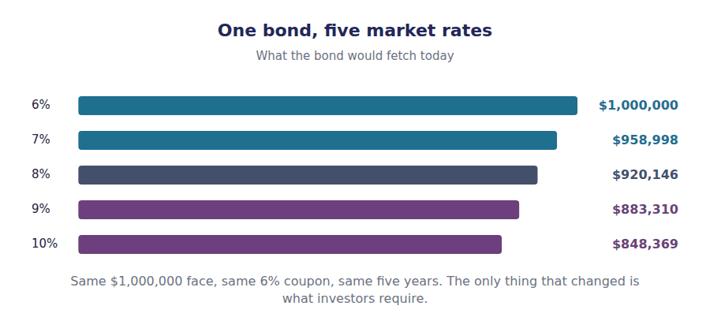
Part 1 · Valuing it at any rate the same two pieces, a different rate
Exercise 4A Complete both right-hand columns.
OBJECTIVE | Value the bond at five different market rates.
YOU WILL NEED | Handout 2 Exercise 2B, for the two-piece method. · Volume 13 Handout 2, for the annuity factors.
HOW TO START | • Each row is the same calculation as Handout 2 with a different rate: $60,000 a year for five years, plus $1,000,000 at the end.  • One row should come out at exactly $1,000,000. Work out which before you compute it.  • The last column asks for the gap against face value, and its sign tells you whether the bond is at a discount or a premium.

Market rate today | Price of the 6% bond | Against face value
6%
7%
8%
9%
10%

1 | 2 | 3 | 4 | 5 | 6
7 | 8 | 9 | 10

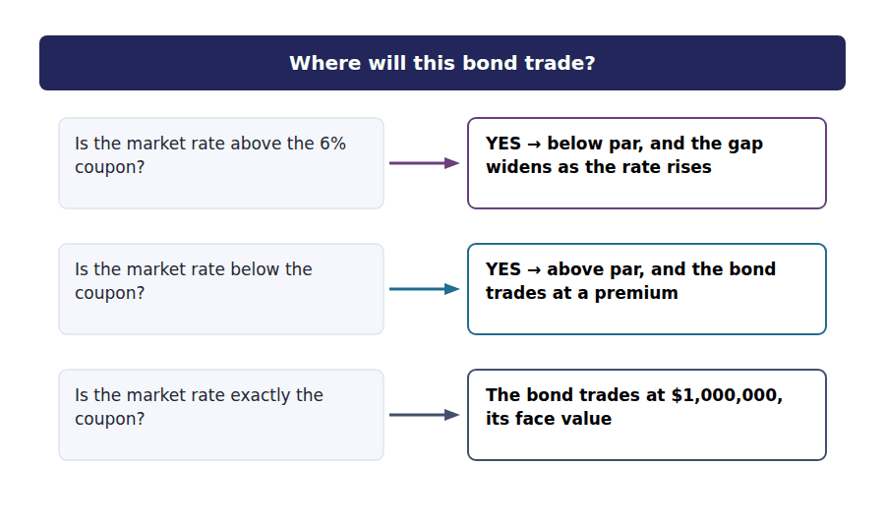
Part 2 · What makes the rate move two forces, not one
Exercise 4B Read and complete. Write one word in each space.
OBJECTIVE | Say what moves the rate a bond is discounted at.
YOU WILL NEED | Exercise 4A.
HOW TO START | • A government bond of the same term is the benchmark. Ask what makes that benchmark move.  • Then ask what makes investors demand more from Northwind than from a government, and what makes that gap widen.  • The last blank is why a ten-year rate and a two-year rate are not the same number on the same day.

WORD BANK
bank · coupon · issuer · premium · risky · spread · structure
Not every word is used.

R2 The rate used to value a bond has two parts. The first is the risk-free rate for that term, which moves with inflation expectations and with what the central ¹ is doing.
The second is the extra return investors require for lending to this particular company rather than to a government. That is the credit ² , and it widens when the issuer’s prospects worsen.
Either can move on its own. Northwind’s bond can fall in price on a day when interest rates do not move at all, if the market decides the company has become more ³ .
And the risk-free rate itself is not one number. It differs by term, which is what the term ⁴ of interest rates describes, so a ten-year bond and a two-year bond are discounted differently on the same day. Reading the term structure of interest rates off a yield curve is how a treasurer decides which maturity to issue.
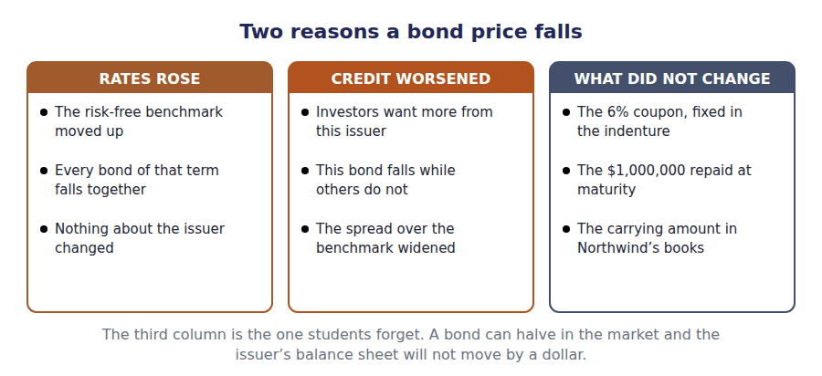
Part 3 · Three rates with similar names and only one of them is the yield
Exercise 4C Sort each statement into the column it belongs in.
OBJECTIVE | Distinguish the coupon rate, the current yield and the yield to maturity.
YOU WILL NEED | Exercise 4B, and Handout 3 on the effective rate.
HOW TO START | • The coupon rate is on the face value; the current yield is on the price. They differ whenever the bond is not at par.  • With the bond at $920,146, a 6% coupon of $60,000 is a current yield of 6.52%.  • Only one of the three accounts for the $79,854 that will be received at maturity.

Statement | COUPON RATE | CURRENT YIELD | YIELD TO MATURITY
1. Fixed in the indenture and never changes
2. The annual coupon divided by the current market price
3. The rate that discounts all the cash flows back to the price
4. Ignores the discount that will be received at maturity
5. Equals the effective rate Handout 3 used
6. Is 6% on Northwind’s discount bond

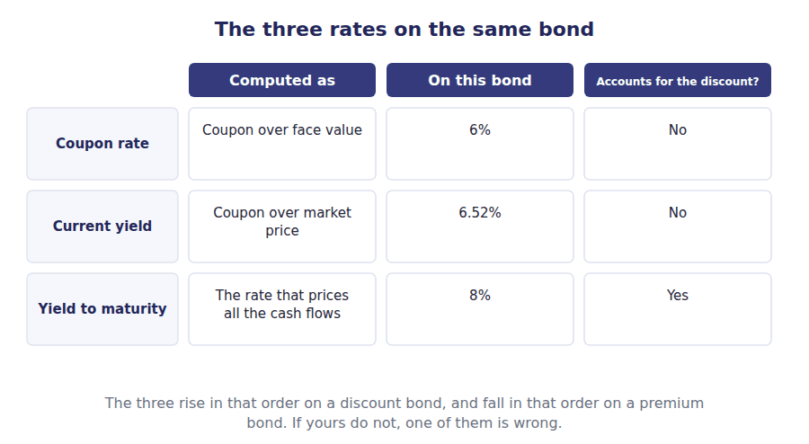
Part 4 · How far the price moves duration
R3 Two bonds from the same issuer do not move by the same amount when rates change. The one whose cash flows arrive later moves more, because every one of its payments is discounted over more periods. Duration measures that, and it is quoted in years.
Exercise 4D Complete the grid, then say which bond is most sensitive.
OBJECTIVE | Measure how far three bonds move when the market rate rises by one point.
YOU WILL NEED | Exercise 4A, and the paragraph above.
HOW TO START | • Each row is the same 6% coupon bond with a different term. Price each one at 8% and again at 9%.  • The last column is the change as a percentage of the starting price, not in dollars.  • The three answers should get larger as you go down the table, and the question is why.

Bond | Price at 8% | Price at 9% | Change
2-year, 6% coupon
5-year, 6% coupon
10-year, 6% coupon

1 | 2 | 3 | 4 | 5 | 6
7 | 8 | 9

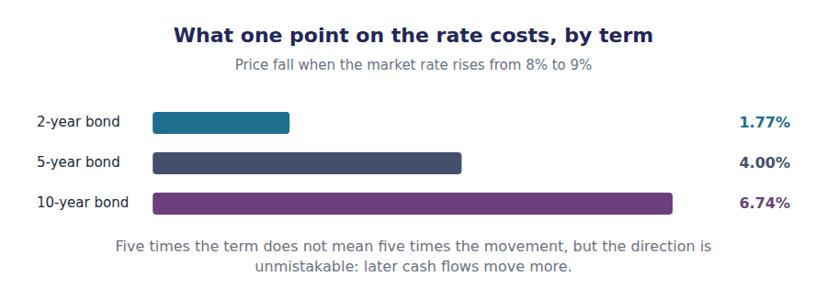
Part 5 · What the market price does not touch the books
Exercise 4E Read and complete. Write one word or figure in each space.
OBJECTIVE | Say why the carrying amount does not follow the market price.
YOU WILL NEED | Exercise 4D, and Handout 3 Exercise 3B.
HOW TO START | • Handout 3 built a schedule that reached $933,758 in year one. Ask what rate that schedule used.  • The effective rate was fixed at issue. Nothing in Exercise 4A changed it.  • The last blank is who bears the loss when rates rise, and it is not the company that issued the bond.

WORD BANK
asset · coupon · issue · liability · maturity · repurchase · risk
Not every word is used.

R2 Suppose rates rise to 10% and the bond falls to $848,369 in the market. Handout 3’s schedule still shows a carrying amount of $933,758 at the end of year one, because that schedule uses the rate fixed at ⁵ .
Northwind still owes $1,000,000 at maturity and still pays $60,000 a year. Nothing the market does changes either, so nothing about its ⁶ changes.
The fall is borne by whoever holds the bond. Interest rate risk is the holder’s ⁷ and not the issuer’s, and Volume 6 showed how a holder reports it depending on the classification.
The one case where the issuer is affected is a ⁸ . If Northwind buys its own bond back at $848,369 it settles a $933,758 liability for less, and Handout 5 works that entry.
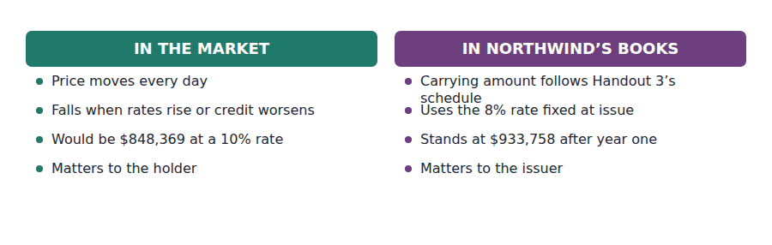
Watch out! Price and yield move in opposite directions, always. If a question says rates rose and offers you a higher price, it is offering a distractor; and the longer the bond, the bigger the move, which is what duration is for.
Part 6 · Exam pitch the questions as the CMA sets them
1. [Level A] A bond is valued by discounting:
(A) The face value only, at the coupon rate
(B) The coupons and the face value, at the market rate
(C) The coupons only, at the market rate
(D) The total cash the bond will pay, at the coupon rate
2. [Level A] If market interest rates rise, the price of an existing bond:
(A) Rises
(B) Falls
(C) Is unchanged
(D) Rises if it was issued at a discount
3. [Level B] A $1,000,000 bond with a 6% coupon trades at $920,146. Its current yield is:
(A) 6%
(B) 6.52%
(C) 8%
(D) 7.99%
4. [Level B] Duration measures:
(A) The number of years to maturity
(B) How much a bond’s price moves when interest rates change
(C) The credit risk of the issuer
(D) The total interest a bond will pay
5. [Level C] Of two bonds from the same issuer with the same coupon, the one with the longer maturity has:
(A) Lower duration and a smaller price movement
(B) Higher duration and a larger price movement
(C) The same duration
(D) Higher duration but a smaller price movement
6. [Level C] A bond falls in price on a day when risk-free rates are unchanged. The most likely cause is:
(A) An error in the quotation
(B) A widening of the issuer’s credit spread
(C) A change in the coupon rate
(D) Amortisation of the discount
7. [Level C] Market rates rise sharply after Northwind issues its bond. The carrying amount of the liability in Northwind’s balance sheet:
(A) Falls to the new market price
(B) Continues to follow the schedule built at the issue rate
(C) Is written down with a gain in profit
(D) Is disclosed at fair value on the face of the balance sheet
ADAPTIVE TIP Ask which side of the contract the question is on. The issuer’s books use the rate fixed at issue and never move; the holder’s price uses today’s rate and moves daily. Most distractors here are the right answer for the other party.

Handout 5 · Retirement, Refinancing, Convertibles and Warrants
Northwind buys its bond back three years in, at 102 of face, and records a $55,664 loss on a deal it chose to do.
Volume 14 · Long-Term Debt and Contingent Liabilities · R2 moving to R3
LANGUAGE FOCUS
Register you are working in | R2 for the entries, R3 for the financing comparison, which Part 2 sets as a strategy question.
Say it exactly like this | extinguish a debt before maturity · call a bond at a stated premium · refinance at a lower rate · convert a bond into shares · detach a warrant and sell it · recognise a loss on extinguishment
Words that are not the same | retirement / maturity · carrying amount / cash paid · convertible / warrant · debt finance / equity finance
Remember | A loss on extinguishment is not evidence of a bad decision. Refinancing at a lower rate usually produces one. A convertible bond is not equity until it is converted. Until then it is debt, and it pays interest.

What you will be able to do when this handout is finished
- Compute the gain or loss on retiring a bond early.
- Record an extinguishment.
- Say when refinancing makes sense despite the loss it records.
- Distinguish a convertible bond from a bond with warrants.
- Compare the sources of long-term finance.

Rates fall, and Northwind acts
Three years into the 6% bond, market rates have fallen. Northwind can borrow at 6% and is paying an effective 8%.
It buys the bond back in the market at 102 of face, paying $1,020,000 for debt standing in its books at $964,336.
The entry records a $55,664 loss. The decision was still the right one, and this handout explains why those two statements are not in conflict.
Then the instruments that are not straight debt: convertibles, warrants, and what each costs.

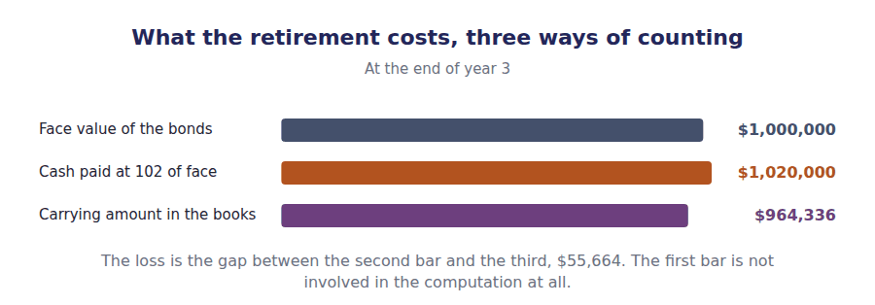
Part 1 · Retiring a bond early carrying amount against cash
Exercise 5A Complete the schedule, then record the entry underneath.
OBJECTIVE | Compute the loss on retiring the bond and record the entry.
YOU WILL NEED | Handout 3 Exercise 3B, for the carrying amount after 3 years.
HOW TO START | • Take the carrying amount from your Handout 3 schedule. At the end of year 3 it is $964,336.  • The unamortised discount is the gap between that figure and the $1,000,000 face value.  • The loss is the cash paid less the carrying amount, and the face value plays no part in it.

Retiring the discount bond after 3 years | Amount
Face value of the bonds retired | $1,000,000
Less unamortised discount at that date
Carrying amount
Cash paid at 102 of face | ($1,020,000)
Loss on extinguishment

1 | 2 | 3 | 4

J1 The bond repurchased at 102 of face after 3 years, against a carrying amount of $964,336. Four lines: the face value out, the discount out, the cash out, and the difference to profit.
Account | Debit | Credit
Bonds Payable
Loss on Extinguishment
Discount on Bonds Payable
Cash

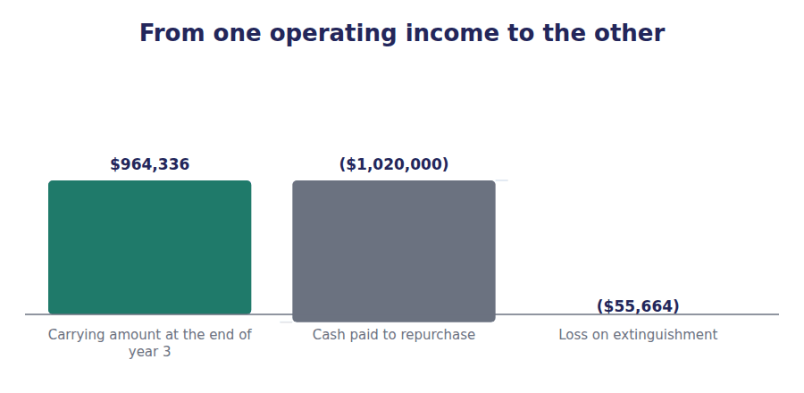
Part 2 · Why a loss can be the right answer the accounting and the decision
Exercise 5B Read and complete. Write one word in each space.
OBJECTIVE | Say why refinancing can make sense despite the loss it records.
YOU WILL NEED | Exercise 5A, and Handout 4 on what moves a bond price.
HOW TO START | • Rates fell, which is why the bond costs more than its carrying amount to buy back. Ask what else falling rates make possible.  • The $55,664 loss is recognised once. The saving on a new borrowing recurs every year until maturity.  • The last blank is the comparison a treasurer actually makes, and it is not between two accounting figures.

WORD BANK
arithmetic · fallen · recurs · reverses · right · risen · wrong
Not every word is used.

R2 The bond costs $1,020,000 to retire because rates have ¹ : a 6% coupon is attractive when the market pays 6%, so holders want more than par for it.
The same fall is why Northwind wants out. It can borrow at 6% instead of the 8% it is effectively paying, and that saving ² in every remaining year.
So the $55,664 loss is a one-off charge and the saving is an annuity. Comparing them means discounting the saving back, which is Volume 13’s ³ and the whole of a refinancing decision.
The accounting records the charge in the year of the repurchase and says nothing about the saving at all, which is why a company can report a loss on a decision that was plainly ⁴ .
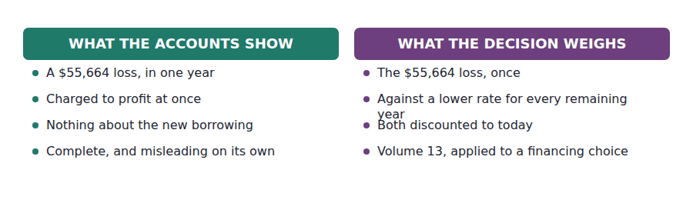
Part 3 · Convertibles and warrants debt with something attached
R2 An issuer can lower its coupon by attaching a right to buy shares. Where the right is embedded and inseparable the instrument is a convertible bond; where it is a separately tradable certificate it is a detachable warrant, and the two are accounted for differently.
Exercise 5C Read and complete. Write one word in each space.
OBJECTIVE | Distinguish a convertible bond from a bond with detachable warrants.
YOU WILL NEED | The paragraph above.
HOW TO START | • Ask whether the holder can sell the share right on its own while keeping the bond.  • If it can be sold separately it has an observable value of its own, which is what makes the allocation possible.  • The last blank is what happens to the existing shareholders if either right is eventually used.

WORD BANK
allocated · conversion · dilution · equity · higher · liability · lower
Not every word is used.

R2 Both instruments give the holder a right to the issuer’s shares, and both let the issuer pay a ⁵ coupon than straight debt would require.
A convertible bond is one instrument. The right cannot be sold apart from the bond, so under US GAAP the whole of the proceeds is usually recorded as a ⁶ and no part of it reaches equity at issue.
A detachable warrant can be traded on its own, so it has a value that can be observed. The proceeds are ⁷ between the bond and the warrants, and the warrant portion is credited to paid-in capital.
Either way, exercise or conversion issues new shares, so the existing holders own a smaller fraction of the same company. That is ⁸ , and Volume 15 measures it.
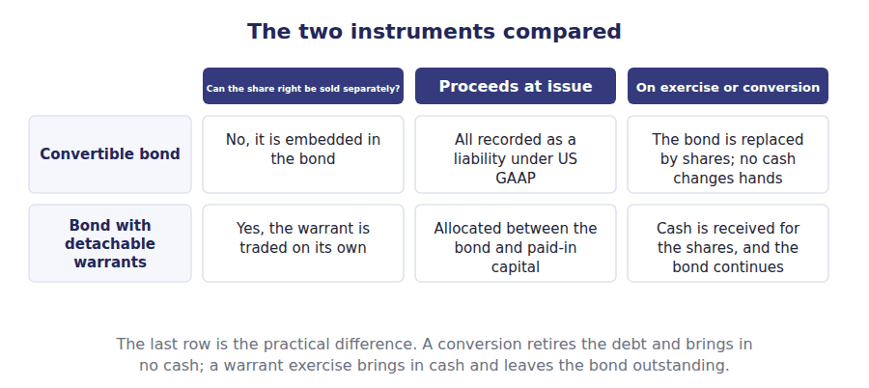
Part 4 · Choosing a source what each one really costs
Exercise 5D Complete both right-hand columns.
OBJECTIVE | Compare the sources of long-term finance available to Northwind.
YOU WILL NEED | Exercise 5C, and Volume 7 Handout 5 on leases as financing.
HOW TO START | • The second column is what the provider receives, and the third is what the company gives up.  • Two of the five lower the coupon by attaching a right to shares, and both therefore risk dilution.  • The last row is the only one with no fixed charge at all, and that is both its advantage and its cost.

Source of long-term finance | What the holder gets | What it costs the issuer
A straight bond
A convertible bond
A bond with detachable warrants
A lease
Ordinary shares

1 | 2 | 3 | 4 | 5 | 6
7 | 8

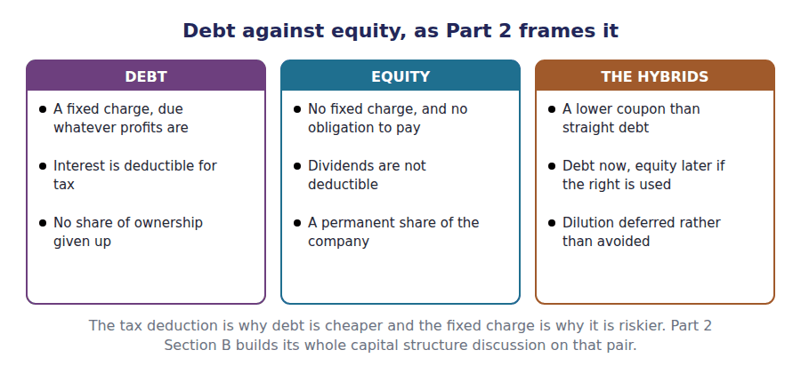
Watch out! The gain or loss on extinguishment is carrying amount less cash paid, and the face value never enters it. A stem that gives you $1,000,000 of face, a call at 102 and an unamortised discount is giving you three numbers and asking for a subtraction between two of them.
Part 5 · Exam pitch the questions as the CMA sets them
1. [Level A] A gain or loss on the early extinguishment of debt is measured as:
(A) Face value less cash paid
(B) Carrying amount less cash paid
(C) Cash paid less the unamortised discount
(D) The call premium alone
2. [Level A] A bond with a $964,336 carrying amount is retired for $1,020,000. The result is:
(A) A gain of $55,664
(B) A loss of $55,664
(C) No gain or loss
(D) A loss of $35,664
3. [Level B] A loss on extinguishment is reported:
(A) As an extraordinary item
(B) In profit for the period of the extinguishment
(C) As an adjustment to retained earnings
(D) Spread over the remaining original term
4. [Level C] A company refinances expensive debt at a lower rate and records a loss. The decision was:
(A) Clearly wrong, because it produced a loss
(B) Possibly right, if the discounted saving exceeds the loss
(C) Right only if the loss is immaterial
(D) Not assessable from accounting information
5. [Level B] Proceeds from a bond issued with detachable warrants are:
(A) Recorded entirely as a liability
(B) Allocated between the bond and paid-in capital
(C) Recorded entirely in equity
(D) Deferred until the warrants are exercised
6. [Level B] When a convertible bond is converted into shares:
(A) The company receives cash for the new shares
(B) The liability is replaced by equity and no cash moves
(C) A gain is recognised in profit
(D) The bond remains outstanding
7. [Level C] The principal advantage of debt finance over equity finance is that:
(A) It carries no obligation to pay
(B) Interest is deductible for tax, while dividends are not
(C) It never dilutes existing shareholders
(D) It improves the debt-to-equity ratio
ADAPTIVE TIP For any extinguishment, write three numbers: the carrying amount from the schedule, the cash paid, and the difference. The face value is in the stem to be used in the entry, not in the computation of the gain or loss.

Handout 6 · Contingencies: Probable, Reasonably Possible, Remote
A lawsuit that might cost between $200,000 and $600,000. One framework accrues $200,000 and the other accrues $400,000.
Volume 14 · Long-Term Debt and Contingent Liabilities · R2 moving to R3
LANGUAGE FOCUS
Register you are working in | R2 for the ladder, R3 for the classification, which uses the standard’s own three words.
Say it exactly like this | accrue a loss contingency · disclose a possible obligation · estimate a range of outcomes · assess the likelihood of an outflow · recognise a provision · confirm a contingency by a future event
Words that are not the same | probable / reasonably possible / remote · accrue / disclose · loss contingency / gain contingency · range / best estimate
Remember | A contingency is not an estimate that happens to be uncertain. Its existence depends on a future event, not just its amount. A gain contingency is never accrued. The asymmetry is deliberate and the exam tests it.

What you will be able to do when this handout is finished
- Define a contingency and say what makes one.
- State the three likelihood thresholds.
- Decide whether to accrue, disclose, or do neither.
- Account for a range of possible losses.
- Say why a gain contingency is treated differently.

Four claims and a counterclaim
At 31 December 20X4 Northwind faces three claims and has brought one of its own.
The first is probable and will cost between $200,000 and $600,000, with no point in that range more likely than any other. The second is reasonably possible at about $300,000. The third is remote.
The counterclaim is one Northwind expects to win, for $250,000.
Four situations, four different answers, and the warranty provision of Volume 7 is a fifth that you have already accrued.

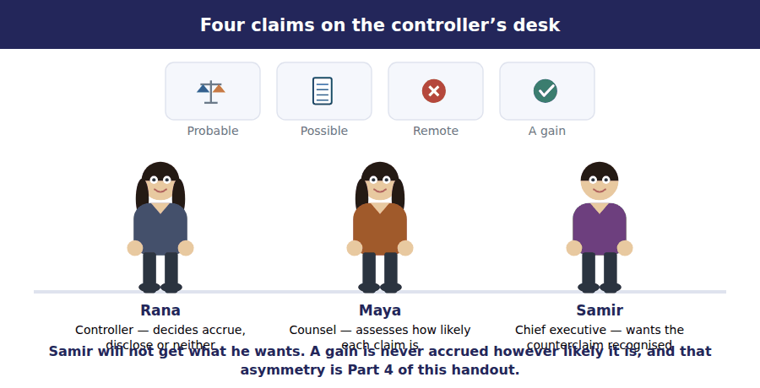
Part 1 · What makes a contingency uncertain existence, not uncertain amount
Exercise 6A Read and complete. Write one word in each space.
OBJECTIVE | Define a contingency and distinguish it from an ordinary estimate.
YOU WILL NEED | Volume 7 Handout 1, where the warranty provision was accrued. · Volume 3 Handout 2, on estimating credit losses.
HOW TO START | • Northwind’s depreciation charge is uncertain in amount and nobody calls it a contingency. Ask what is different about the lawsuit.  • The lawsuit may cost nothing at all. The machine will certainly wear out.  • The last blank is the event that will settle the matter, and it is not in the company’s hands.

WORD BANK
amount · arise · event · exist · likely · much · timing
Not every word is used.

R2 Almost every figure in these volumes is an estimate. Depreciation, the allowance for credit losses and the warranty provision are all uncertain in ¹ , and none of them is a contingency.
A contingency is different because the obligation may not ² at all. Northwind may lose the lawsuit and owe $600,000, or win it and owe nothing.
What settles the question is a future ³ outside the company’s control: a judgment, a settlement, a regulator’s decision. Until it happens the position cannot be resolved by better information alone.
So the accounting asks a question it asks nowhere else. Not how much, but how ⁴ , and the answer decides whether anything is recorded.
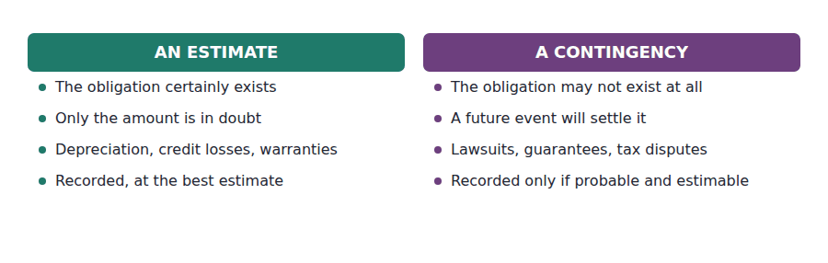
Part 2 · The three rungs and what each one requires
Exercise 6B Complete both right-hand columns.
OBJECTIVE | State what each likelihood threshold requires.
YOU WILL NEED | Exercise 6A.
HOW TO START | • Two conditions must both hold before anything is accrued, and the columns separate them.  • The middle row is the same in both columns, which is worth noticing before you fill it in.  • The bottom row is the only one where a company may say nothing at all.

Likelihood of the loss | If the amount can be estimated | If it cannot
Probable
Reasonably possible
Remote

1 | 2 | 3 | 4 | 5 | 6

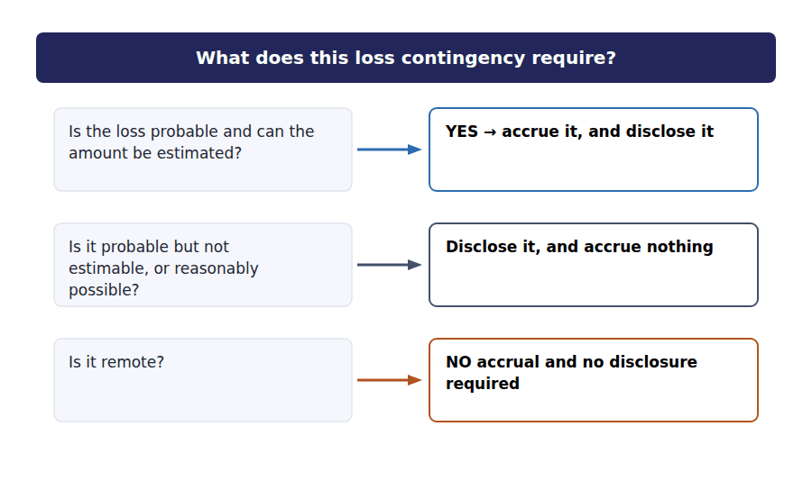
Part 3 · A range with no best estimate where the frameworks part
R2 Northwind’s first lawsuit is probable and will cost somewhere between $200,000 and $600,000, with no point in the range better supported than any other. Both frameworks accrue something, and they do not accrue the same amount.
Exercise 6C Read and complete, then record the entry underneath.
OBJECTIVE | Account for a probable loss stated as a range.
YOU WILL NEED | Exercise 6B, and Volume 12 for the US GAAP and IFRS pattern.
HOW TO START | • US GAAP takes the lowest amount in the range when no point in it is a better estimate than the others.  • IFRS takes the midpoint of a continuous range, which here is $400,000.  • The last blank is what both frameworks require about the rest of the range, whichever figure is accrued.

WORD BANK
average · disclosed · highest · ignored · lowest · met · midpoint
Not every word is used.

R2 The loss is probable and the range is $200,000 to $600,000, with no point better supported than any other. Something must be accrued, because both conditions for accrual are ⁵ .
US GAAP accrues the ⁶ amount in the range, $200,000, on the ground that no greater amount has been shown to be probable.
IFRS accrues the ⁷ of a continuous range instead, $400,000, on the ground that it is the best single representation of the expected outflow.
Both frameworks then require the range itself to be ⁸ , so a reader who wants the worst case can find the $600,000 whichever number is on the balance sheet.
J1 The probable lawsuit accrued at the low end of the range, under US GAAP. An expense now, and a liability that may never be paid.
Account | Debit | Credit
Loss from Litigation
Estimated Liability

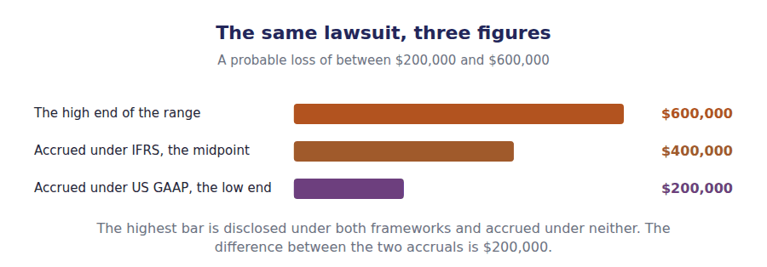
Part 4 · The asymmetry why a likely gain is not recorded
Exercise 6D Sort each item into the column it belongs in.
OBJECTIVE | Say why a gain contingency is treated differently from a loss.
YOU WILL NEED | Exercise 6C, and Volume 1 Handout 1 on the qualities of useful information.
HOW TO START | • Northwind expects to win its counterclaim for $250,000. Ask whether it may record the receivable.  • A company that records likely gains and likely losses alike would report a result that is right on average and never cautious.  • Two of the six items are about the warranty provision, which is not a contingency at all once it is probable and estimable.

Item | ACCRUE | DISCLOSE ONLY | NEITHER
1. A probable, estimable loss of $200,000
2. A reasonably possible loss of $300,000
3. A remote loss
4. A probable gain of $250,000 on a counterclaim
5. Warranty claims expected on this year’s sales
6. A gain that is virtually certain and already realised

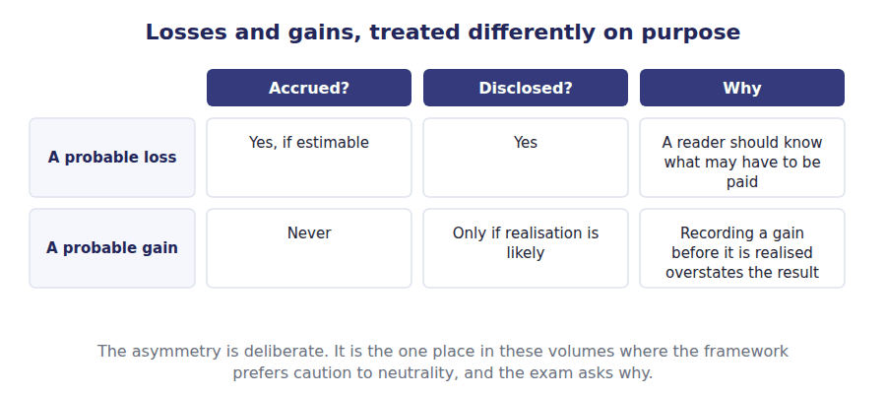
Part 5 · Northwind’s five situations the ladder applied
Exercise 6E Complete the right-hand column.
OBJECTIVE | Decide the treatment of each of Northwind’s five situations.
YOU WILL NEED | Exercises 6B, 6C and 6D.
HOW TO START | • One of the five is not a contingency at all once it has been measured, and Volume 7 already accrued it.  • Two of the five reach the notes and not the balance sheet.  • One of the five reaches neither, and one is the counterclaim.

Northwind’s 20X4 year | Treatment
Warranty claims on $4,800,000 of sales, probable and estimable at $96,000
A lawsuit, probable, with losses between $200,000 and $600,000 and no better estimate
A second lawsuit, reasonably possible, estimated at $300,000
A third claim, remote
A counterclaim Northwind expects to win, $250,000

1 | 2 | 3 | 4 | 5

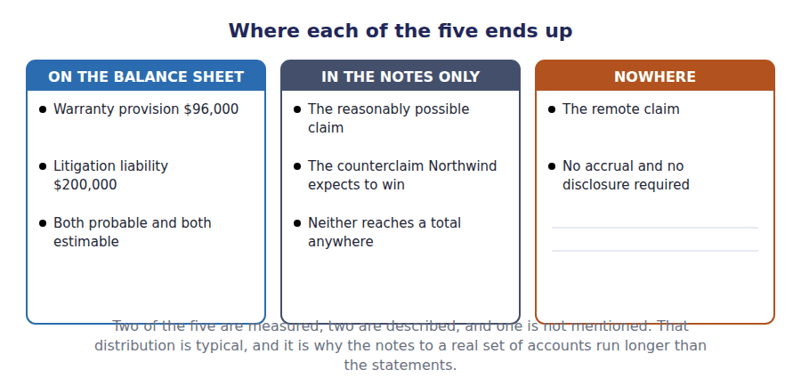
Watch out! A gain contingency is never accrued, however probable. If a question offers you a likely recovery and an accrual, it is offering the symmetric answer, and the asymmetry is the whole point of the topic.
Part 6 · Exam pitch the questions as the CMA sets them
1. [Level A] A loss contingency is accrued when it is:
(A) Reasonably possible and estimable
(B) Probable and the amount can be reasonably estimated
(C) Probable, whether or not it can be estimated
(D) Disclosed in the notes
2. [Level A] A loss that is reasonably possible and can be estimated is:
(A) Accrued
(B) Disclosed in the notes
(C) Ignored
(D) Charged to retained earnings
3. [Level B] A probable loss is estimated at between $200,000 and $600,000, with no amount in the range a better estimate than any other. Under US GAAP the company accrues:
(A) $600,000
(B) $200,000
(C) $400,000
(D) Nothing
4. [Level B] Under IFRS, the same range would be accrued at:
(A) $200,000
(B) $400,000
(C) $600,000
(D) Nothing
5. [Level C] A company expects to win a lawsuit it has brought, for a probable $250,000. It should:
(A) Accrue a $250,000 receivable
(B) Disclose the gain contingency without accruing it
(C) Accrue half of it
(D) Do nothing at all
6. [Level A] A remote loss contingency requires:
(A) Accrual only
(B) Disclosure only
(C) Accrual and disclosure
(D) Neither accrual nor disclosure
7. [Level C] Northwind’s warranty provision of $96,000 differs from its lawsuit accrual in that:
(A) It is larger
(B) The obligation certainly exists and only its amount is estimated
(C) It is disclosed rather than accrued
(D) It is a gain contingency
ADAPTIVE TIP Ask the two questions in order and in the right order: how likely, then how much. Likelihood decides whether anything is recorded at all, and only then does measurement matter. Reversing them produces an accrual for a possible loss, which is the error the ladder exists to prevent.

Answer Key
Volume 14 · Handouts 1 to 6
Every answer carries the reason for it and the mistake it defeats.

Handout 1 · What a Bond Promises: Par, Coupon, Indenture, Covenants answers
Completed text and exercises
# | Answer | Why | The trap it defeats
1 | coincidence | Nothing makes them agree after issue.
2 | price | The cash cannot move, so the price must. | Students expect the coupon to adjust. It is a term of a signed contract and cannot.
3 | received | What the issuer got, which Handout 2 computes.
4 | do | Conduct, not amounts.
5 | affirmative | A promise to act.
6 | once | Acceleration, and it is immediate.
7 | cash | A reclassification, not a payment. | Students look for a transaction. A covenant breach moves a liability between categories without anything being paid.
8 | waive | Granted by the lender, before the year end.
Grid 1 | 1 AFFIRMATIVE 2 NEGATIVE 3 AFFIRMATIVE 4 NEGATIVE 5 NOT A COVENANT 6 NOT A COVENANT | Repaying is the promise the bond is; a covenant is a promise about everything else. Acceleration is the consequence of breach, not a covenant itself.

Exam-pitch questions
# | Answer | Why | The trap it defeats
1 | (B) Is fixed in the indenture and determines the cash interest paid | The coupon is a contractual term and cannot move. (C) is true only on the day a bond is issued at par, which is the one case where the two rates agree. | Level A
2 | (B) Debenture | A debenture is unsecured, which is why it carries a higher coupon than a secured bond from the same issuer. (C) and (D) describe maturity and redemption, not security. | Level A
3 | (B) The contract between the issuer and the bondholders | A contract, administered by a trustee. (A) is the distinction worth holding: a question that says "the indenture requires" is quoting the parties’ own agreement, which can require things no standard does. | Level B
4 | (B) A current liability | Breach makes the balance callable, so it is current whatever the stated maturity. (A) reads the maturity date and ignores the acceleration clause, which is exactly the trap. | Level B
5 | (B) Serial bond | Instalment maturities make it serial, which is why part of it is a current liability every year. A term bond would show no current portion until its final year. | Level A
6 | (B) The issuer, who may repay early if rates fall | The call is the issuer’s option, exercised when replacing the debt is cheaper. (A) describes a put provision, and because the call is valuable to the issuer a callable bond carries a higher coupon. | Level C
7 | (B) 6% | $90,000 over $1,500,000 is 6%. The computation works here because the bond was issued at par; Handout 3 shows why it would not work on a bond issued at a discount. | Level B

Exercise 1A · the features, completed
Feature | What it fixes | Northwind’s serial bond
Face value | What is repaid at maturity, per bond | $1,500,000
Coupon rate | The cash interest, as a rate on face | 6%
Maturity | When the face value falls due | In instalments of $150,000 a year
Indenture | The contract between issuer and holders | Names the trustee and the covenants
Covenants | What the issuer promises to do, or not do | A limit on further borrowing
Call provision | The issuer’s right to repay early | None

Exercise 1D · the serial bond, rolled forward
Northwind’s debt in 20X4 | Amount
Outstanding at 1 January 20X4 | $1,500,000
Coupon at 6% on the opening balance | $90,000
Instalment repaid during the year | ($150,000)
Outstanding at 31 December 20X4 | $1,350,000
of which due within twelve months | $150,000
of which due after twelve months | $1,200,000

R2 Nothing in the second table is new. $90,000 of interest, $150,000 repaid and a closing balance split $150,000 current and $1,200,000 non-current are all figures Volume 1 reported, and the coupon of 6% is the only thing this handout had to solve for.
R2 The serial bond is a useful first case precisely because it was issued at par: the carrying amount is the face value, and the interest expense is the cash paid. Handouts 2 and 3 remove both of those conveniences.

Handout 2 · Issued at a Discount, at a Premium, at Par answers
Completed text and exercises
# | Answer | Why | The trap it defeats
1 | pay | The price, which is the only free variable.
2 | discount | Below par, because the coupon is below the market.
3 | interest | Paid at the end rather than along the way. | Students read a discount as a loss on issue. The company borrowed less and will repay more; the difference is interest.
4 | premium | Above par, for a coupon above the market.
5 | face | What will be repaid, not what was raised.
6 | debited | A contra liability has a debit balance.
7 | carrying | One figure, not two. | Students report the discount as a separate line or, worse, as an asset. It belongs with the bond.
8 | added | The premium raises the carrying amount.
9 | market | The rate investors required, not the one printed.
Grid 1 | 1 TRUE 2 FALSE 3 TRUE 4 TRUE 5 TRUE 6 TRUE | The fifth surprises people. The premium bond pays $100,000 a year rather than $60,000, so it costs more in cash even though it raised more at issue.

Exam-pitch questions
# | Answer | Why | The trap it defeats
1 | (B) The coupon rate is below the market rate | The price adjusts until the bond yields the market rate. (A) affects the market rate the bond is priced at, and a bond from a sound issuer sells at a discount whenever its coupon is below that rate. | Level A
2 | (B) The coupons and the face value, both at 8% | Both promises, discounted at the rate investors require. (C) uses the coupon rate and would price every bond at par, which is the commonest error on this topic. | Level B
3 | (B) $1,000,000 | Always the face value. The $920,146 of cash and the $79,854 of discount are the two debits that balance it. | Level A
4 | (B) A deduction from bonds payable | A contra liability, so the balance sheet shows one net figure of $920,146. (C) is the error the sortgrid was built to prevent: the discount is interest, and it belongs to the whole term. | Level B
5 | (B) Raises more at issue and pays more in coupons | Both repay $1,000,000; the premium bond raises $159,708 more and pays $40,000 more each year. (D) is the trap: both bonds were priced to yield exactly 8%, so the effective rates are identical. | Level C
6 | (B) The coupon rate equals the market rate at issue | Par is the one case where the two rates agree, which is why Northwind’s serial bond in Handout 1 needed no discount account at all. | Level A
7 | (B) The present value of Volume 7’s finance lease | Five payments of $60,000 at 8% is one calculation, whether the payments are lease instalments or bond coupons. Recognising that a bond is an annuity plus a single sum is most of what Part 2 B.2(e) asks for. | Level C

Exercise 2B · both bonds, priced
Pricing the $1,000,000 bond | Discount bond | Premium bond
Coupon rate written in the indenture | 6% | 10%
Cash coupon, each year | $60,000 | $100,000
Present value of the coupons at 8% | $239,563 | $399,271
Present value of the $1,000,000 repaid at maturity | $680,583 | $680,583
Issue price | $920,146 | $1,079,854
Discount or premium | ($79,854) | $79,854

Exercise 2C · the balance sheet at issue
On the balance sheet at issue | Discount bond | Premium bond
Bonds payable, at face value | $1,000,000 | $1,000,000
Less discount on bonds payable | ($79,854) | —
Plus premium on bonds payable | — | $79,854
Carrying amount | $920,146 | $1,079,854

The two issue entries, completed
J1 The 6% bond issued at a discount.
Account | Debit | Credit
Cash | $920,146
Discount on Bonds Payable | $79,854
Bonds Payable |  | $1,000,000
J2 The 10% bond issued at a premium.
Account | Debit | Credit
Cash | $1,079,854
Bonds Payable |  | $1,000,000
Premium on Bonds Payable |  | $79,854

R2 The discount and the premium are equal at $79,854, and that is not a coincidence. Both coupons sit 2% away from the 8% market rate, so each is $20,000 of face a year for 5 years, discounted at 8% — the same annuity in both directions.
R2 Note where the $239,563 of coupons on the discount bond came from. It is $60,000 a year for five years at 8%, which is the figure Volume 7 opened its lease schedule with and Volume 13 derived. A lease and a bond are the same arithmetic wearing different contracts.

Handout 3 · The Effective Interest Method, Period by Period answers
Completed text and exercises
# | Answer | Why | The trap it defeats
1 | carrying | What the company actually has the use of.
2 | paid | Incurred now, settled at maturity.
3 | rises | Toward par, because the discount is unwinding. | Students expect a liability to fall as it is serviced. A discount bond is being serviced at less than its cost, so it grows.
4 | $1,000,000 | The face value, exactly.
5 | move | Fixed at issue, whatever happens later.
6 | bears | The issuer’s cost is the investor’s return.
7 | $15,971 | $79,854 over 5 years.
8 | all | Prohibited, not merely discouraged.
9 | years | The pattern, not the total. | Students expect the two methods to differ in total. They differ only in timing, and the exam asks about that.

Exam-pitch questions
# | Answer | Why | The trap it defeats
1 | (B) The effective rate times the opening carrying amount | The rate the borrowing really costs, applied to what is really owed. (A) is the cash coupon, which is the figure the question usually offers first. | Level A
2 | (B) Greater than the cash coupon | The company borrowed less than it will repay, so the cost exceeds the cash. (C) is true of a premium bond, and the pair is the distinction being tested. | Level A
3 | (B) Increases the carrying amount | The unpaid part of the cost is added to the liability, which climbs toward par. (D) is the misreading the word amortisation invites: no cash moves on that line at all. | Level B
4 | (B) $73,612 | 8% of $920,146 is $73,612. (C) applies the effective rate to the face value, which is the one combination the method never uses. | Level B
5 | (B) The same | Both methods charge the coupons plus the whole $79,854 discount; only the pattern differs. (A) is the answer the rising schedule suggests and confuses timing with amount. | Level C
6 | (B) Permitted under US GAAP only where the result is not materially different from the effective interest method | A materiality accommodation under US GAAP, and not available under IFRS at all. (A) inverts the position, and IFRS requires the effective interest method without exception. | Level B
7 | (B) Falls to the face value | The coupon exceeds the cost, so the excess reduces the liability until it reaches $1,000,000 at maturity. (D) confuses the carrying amount with the balance after repayment. | Level C

Exercise 3B · the discount bond schedule
Year | Opening | Interest at 8% | Coupon paid | Amortised | Closing
1 | $920,146 | $73,612 | $60,000 | $13,612 | $933,758
2 | $933,758 | $74,701 | $60,000 | $14,701 | $948,459
3 | $948,459 | $75,877 | $60,000 | $15,877 | $964,336
4 | $964,336 | $77,147 | $60,000 | $17,147 | $981,483
5 | $981,483 | $78,517 | $60,000 | $18,517 | $1,000,000

Exercise 3C · the premium bond schedule
Year | Opening | Interest at 8% | Coupon paid | Amortised | Closing
1 | $1,079,854 | $86,388 | $100,000 | ($13,612) | $1,066,242
2 | $1,066,242 | $85,299 | $100,000 | ($14,701) | $1,051,541
3 | $1,051,541 | $84,123 | $100,000 | ($15,877) | $1,035,664
4 | $1,035,664 | $82,853 | $100,000 | ($17,147) | $1,018,517
5 | $1,018,517 | $81,483 | $100,000 | ($18,517) | $1,000,000

Exercise 3D · the two methods compared
 | Effective interest method | Straight-line
Year 1 amortisation | $13,612 | $15,971
Year 5 amortisation | $18,517 | $15,971
Year 1 interest expense | $73,612 | $75,971
Total over five years | $79,854 | $79,854
Permitted under US GAAP | Yes | Only if not materially different

The two interest entries, completed
J1 Year one interest on the discount bond.
Account | Debit | Credit
Interest Expense | $73,612
Discount on Bonds Payable |  | $13,612
Cash |  | $60,000
J2 Year one interest on the premium bond.
Account | Debit | Credit
Interest Expense | $86,388
Premium on Bonds Payable | $13,612
Cash |  | $100,000

R2 The two amortisation columns are exact mirrors: $13,612 and ($13,612) in year one, $18,517 and ($18,517) in year five. Both coupons sit the same distance from the 8% market rate, so the schedules differ only in sign.
R2 Both schedules close on $1,000,000 exactly, which is the check worth running before anything else. A schedule that misses par has an arithmetic error in it, and the same test caught a real one in Volume 7’s lease.

Handout 4 · Valuing a Bond, and What Moves Its Price answers
Completed text and exercises
# | Answer | Why | The trap it defeats
1 | bank | Policy and inflation, mostly.
2 | spread | The price of this borrower’s credit.
3 | risky | Credit can move when rates do not. | Students treat a bond price as a pure interest rate story. Half the movement in corporate bonds is credit.
4 | structure | A curve, not a point.
Grid 1 | 1 COUPON RATE 2 CURRENT YIELD 3 YIELD TO MATURITY 4 CURRENT YIELD 5 YIELD TO MATURITY 6 COUPON RATE | Only the yield to maturity accounts for everything the investor will receive, which is why it is the one the exam means by yield.
5 | issue | Fixed then, and not revisited.
6 | liability | The contract did not change. | Students mark the liability to market. A bond payable is carried at amortised cost, not at fair value.
7 | risk | Borne by the holder.
8 | repurchase | Buying the debt back realises the difference.

Exam-pitch questions
# | Answer | Why | The trap it defeats
1 | (B) The coupons and the face value, at the market rate | Both cash flows, at the rate investors require. (D) discounts at the coupon rate, which would price every bond at par whatever the market was doing. | Level A
2 | (B) Falls | The cash flows are fixed, so a higher required return can only come from a lower price. (D) invents a dependence on the issue price that does not exist. | Level A
3 | (B) 6.52% | $60,000 of coupon over the $920,146 price. (C) is the yield to maturity, which is higher because it also counts the $79,854 received at maturity. | Level B
4 | (B) How much a bond’s price moves when interest rates change | Interest rate sensitivity, quoted in years. (A) is the confusion the unit invites: two bonds maturing on the same day have different durations if their coupons differ. | Level B
5 | (B) Higher duration and a larger price movement | Later cash flows are discounted over more periods, so they move more: 6.74% against 1.77% for a one-point rise on Northwind’s figures. (D) states the measure and then contradicts what it measures. | Level C
6 | (B) A widening of the issuer’s credit spread | Credit and rates move independently, and corporate bond prices respond to both. (C) is impossible: the coupon is a term of the indenture, and (D) affects the issuer’s books rather than the market. | Level C
7 | (B) Continues to follow the schedule built at the issue rate | A bond payable is carried at amortised cost using the rate fixed at issue. (A) and (C) would let a company report a gain because its own credit worsened, which is exactly what amortised cost avoids. | Level C

Exercise 4A · the bond at five market rates
Market rate today | Price of the 6% bond | Against face value
6% | $1,000,000 | At par
7% | $958,998 | $41,002 discount
8% | $920,146 | $79,854 discount
9% | $883,310 | $116,690 discount
10% | $848,369 | $151,631 discount

Exercise 4D · what one point costs, by term
Bond | Price at 8% | Price at 9% | Change
2-year, 6% coupon | $964,335 | $947,227 | -1.77%
5-year, 6% coupon | $920,146 | $883,310 | -4.00%
10-year, 6% coupon | $865,798 | $807,470 | -6.74%

R2 The 6% row of the first table is the one to notice. When the market rate equals the 6% coupon the bond trades at exactly $1,000,000, which is the definition of par and the only case where price, face value and carrying amount all agree.
R2 The second table is duration without the formula. The two-year bond loses 1.77% and the ten-year bond loses 6.74% on the same one-point rise, from the same issuer at the same coupon. Nothing but the timing of the cash flows differs.

Handout 5 · Retirement, Refinancing, Convertibles and Warrants answers
Completed text and exercises
# | Answer | Why | The trap it defeats
1 | fallen | A low-rate world makes old bonds expensive.
2 | recurs | Every year, not once.
3 | arithmetic | A one-off against an annuity, discounted.
4 | right | The books record one side of it. | Students read a loss on extinguishment as a mistake. It is the price of ending an expensive contract early.
5 | lower | The share right is worth something, so the coupon can be less.
6 | liability | One instrument, one classification, under US GAAP.
7 | allocated | Split, because the warrant has its own price. | Students split a convertible too. The test is whether the right can be sold on its own.
8 | dilution | More shares over the same earnings.

Exam-pitch questions
# | Answer | Why | The trap it defeats
1 | (B) Carrying amount less cash paid | The books give up the carrying amount and part with the cash. (A) uses the face value, which ignores every year of amortisation already recorded. | Level A
2 | (B) A loss of $55,664 | More cash went out than the liability stood at, so it is a loss. (D) is the unamortised discount, which is an input to the carrying amount rather than the answer. | Level A
3 | (B) In profit for the period of the extinguishment | In profit, at once. (A) is the category US GAAP abolished and (D) would keep amortising a bond that no longer exists. | Level B
4 | (B) Possibly right, if the discounted saving exceeds the loss | A one-off charge against a recurring saving is a discounting question, which is why Part 2 treats refinancing as a capital decision. (A) reads the accounts as if they were the decision. | Level C
5 | (B) Allocated between the bond and paid-in capital | The warrants trade separately and so have an observable value. (A) is the treatment of a convertible bond, and separability is exactly what distinguishes the two. | Level B
6 | (B) The liability is replaced by equity and no cash moves | Conversion exchanges one claim for another. (A) describes a warrant exercise, where the holder pays for the shares and the bond continues. | Level B
7 | (B) Interest is deductible for tax, while dividends are not | The tax shield is why debt is the cheaper source. (C) is true of straight debt and false of the hybrids in this handout, and (D) is backwards. | Level C

Exercise 5A · the retirement, computed
Retiring the discount bond after 3 years | Amount
Face value of the bonds retired | $1,000,000
Less unamortised discount at that date | ($35,664)
Carrying amount | $964,336
Cash paid at 102 of face | ($1,020,000)
Loss on extinguishment | ($55,664)

Exercise 5D · the sources compared
Source of long-term finance | What the holder gets | What it costs the issuer
A straight bond | Interest and repayment of face | The coupon, and the discount or premium
A convertible bond | The same, plus the right to convert into shares | A lower coupon, and dilution if conversion happens
A bond with detachable warrants | The bond, plus a separately tradable right to buy shares | A lower coupon, and dilution if the warrants are exercised
A lease | Rentals, and the asset back at the end | Interest inside the rentals, as Volume 7 showed
Ordinary shares | A residual claim, and any dividend declared | No fixed charge, and a permanent share of the company

The extinguishment entry, completed
J1 The bond repurchased at 102 of face after 3 years.
Account | Debit | Credit
Bonds Payable | $1,000,000
Loss on Extinguishment | $55,664
Discount on Bonds Payable |  | $35,664
Cash |  | $1,020,000

R2 The entry clears the $1,000,000 of face and the $35,664 of discount that were still on the books, which together are the $964,336 carrying amount, and pays out $1,020,000. The $55,664 difference is the loss, and it is the only line of the four that reaches profit.
R2 Note that the loss arose because rates fell. A bond bought back after rates have risen produces a gain, and a company that reports one has usually been in trouble rather than in luck: its own credit spread is what made its debt cheap.

Handout 6 · Contingencies: Probable, Reasonably Possible, Remote answers
Completed text and exercises
# | Answer | Why | The trap it defeats
1 | amount | Uncertain size, certain existence.
2 | exist | It may turn out there was never an obligation. | Students treat any uncertain figure as a contingency. Depreciation is uncertain in amount and certain in existence.
3 | event | Outside the company’s control.
4 | likely | Likelihood first, measurement second.
5 | met | Probable, and a range is an estimate.
6 | lowest | The low end, under US GAAP.
7 | midpoint | The middle of the range, under IFRS. | Students apply one rule to both frameworks. The difference is small in principle and $200,000 here.
8 | disclosed | The range, whatever was accrued.
Grid 1 | 1 ACCRUE 2 DISCLOSE ONLY 3 NEITHER 4 DISCLOSE ONLY 5 ACCRUE 6 ACCRUE | The last row is the escape: once a gain is realised it is no longer contingent, and ordinary revenue recognition applies.

Exam-pitch questions
# | Answer | Why | The trap it defeats
1 | (B) Probable and the amount can be reasonably estimated | Both conditions, together. (C) drops the measurement condition, and a probable loss that cannot be estimated is disclosed rather than accrued. | Level A
2 | (B) Disclosed in the notes | The middle rung requires disclosure and no accrual. (A) is the commonest error and would put an amount on the balance sheet that the threshold does not support. | Level A
3 | (B) $200,000 | The low end, with the range disclosed. (C) is the IFRS answer, and the $200,000 gap between them is one of the differences Volume 12 would have listed had the CMA asked for it. | Level B
4 | (B) $400,000 | IFRS takes the midpoint of a continuous range as the best single representation of the expected outflow. (A) is the US GAAP answer, and the pairing is what makes this examinable. | Level B
5 | (B) Disclose the gain contingency without accruing it | Gain contingencies are never accrued; disclosure is permitted where realisation is likely, worded so as not to imply it is assured. (A) applies the loss rule symmetrically, which is exactly what the standard refuses to do. | Level C
6 | (B) Disclosure only | The bottom rung is the one case where nothing is required. Remote is also the rung most often argued over, because it is the only one that keeps a claim out of the notes entirely. | Level A
7 | (B) The obligation certainly exists and only its amount is estimated | Goods have been sold and some will fail, so the obligation exists; only the amount is in doubt. That is an estimate rather than a contingency, which is why Volume 7 accrued it without ever using the ladder in this handout. | Level C

Exercise 6B · the ladder, completed
Likelihood of the loss | If the amount can be estimated | If it cannot
Probable | Accrue it, and disclose | Disclose only
Reasonably possible | Disclose only | Disclose only
Remote | Neither accrue nor disclose | Neither accrue nor disclose

Exercise 6E · Northwind’s five situations
Northwind’s 20X4 year | Treatment
Warranty claims on $4,800,000 of sales, probable and estimable at $96,000 | Accrue $96,000
A lawsuit, probable, with losses between $200,000 and $600,000 and no better estimate | Accrue $200,000 under US GAAP
A second lawsuit, reasonably possible, estimated at $300,000 | Disclose only
A third claim, remote | Neither accrue nor disclose
A counterclaim Northwind expects to win, $250,000 | Disclose at most; never accrue

Exercise 6C · the accrual entry
J1 The probable lawsuit accrued at the low end, under US GAAP.
Account | Debit | Credit
Loss from Litigation | $200,000
Estimated Liability |  | $200,000

R2 The middle column of the ladder is the one to memorise, because it is the same in both of its cells: a loss that is probable but not estimable gets exactly the same treatment as one that is only reasonably possible. Disclosure, and nothing on the face of anything.
R2 This handout is outside the CMA. No section of either part asks for the ladder, the range rule or the gain asymmetry. It is here because a reader who has accrued Volume 7’s warranty provision without ever being told why some obligations are accrued and others are not has learned a procedure rather than a principle.

Glossary
Every term in Volume 14, with the Arabic equivalent and the places it misleads
The third column is for recognition only. In the exam room you work in English.

Term | What it means in CMA English | بالعربية | Careful
amortisation of a discount | Charging part of a discount to interest expense each period, which raises the carrying amount toward the face value. | إطفاء الخصم | No cash moves. The entry is a debit to interest expense and a credit to the discount account.
call premium | The excess over face value an issuer must pay to redeem a bond under a call provision. | علاوة الاستدعاء | The price of the option the issuer reserved. It is what makes most early retirements show a loss.
carrying amount | The amount at which a liability stands in the books, which for a bond is the issue price adjusted for amortisation to date. | المبلغ المدرج | Neither the face value nor the market price. On a bond issued at par it happens to equal the face, which is why this volume starts there.
contingency | An existing condition whose outcome will be confirmed only by a future event outside the company’s control. | الالتزام المحتمل | The uncertainty is about whether an obligation exists at all, not merely about its amount.
convertible bond | A bond the holder may exchange for a fixed number of the issuer’s shares. | سند قابل للتحويل | One instrument, and under US GAAP usually one liability. The conversion right is not separated.
coupon rate | The fixed rate, stated in the indenture, that determines the cash interest paid. | سعر الكوبون | Fixed for the life of the bond. Everything that moves — the price, the yield, the carrying amount — moves around it.
covenant | A promise in the indenture about what the issuer will or will not do. | تعهد | Breach usually accelerates the debt, which is how a long-term liability becomes current overnight.
credit spread | The amount by which the rate required from a borrower exceeds the rate on a risk-free bond of the same term. | هامش الائتمان | The second thing that moves a bond price. Rates can be flat and a bond still fall, if the issuer’s credit worsens.
current yield | The annual coupon divided by the bond’s current market price. | العائد الجاري | A crude measure that ignores the discount or premium entirely. The exam offers it as a distractor for yield to maturity.
debenture | A bond backed by the issuer’s general credit rather than by specific collateral. | سند غير مضمون | Unsecured, so it carries a higher coupon than a secured bond of the same issuer.
detachable warrant | A right to buy shares at a stated price, issued with a bond and tradable separately from it. | أمر اكتتاب قابل للفصل | Detachable is the word that matters. Because it can be sold on its own it has its own value, and part of the proceeds is allocated to equity.
discount on bonds payable | The excess of a bond’s face value over its issue price. | خصم إصدار السندات | A contra account, deducted from bonds payable. It is additional interest the issuer pays at maturity.
duration | A measure of how much a bond’s price moves when interest rates change, expressed in years. | المدة | Longer duration means a larger price swing. It is driven by the timing of the cash flows, not by the maturity date alone.
effective interest rate | The rate that, applied to the carrying amount each period, produces the interest the borrowing really costs. | سعر الفائدة الفعلي | The market rate at issue, and it does not change afterwards even though market rates do.
extinguishment | The settlement of a debt before its maturity date, by repurchase or by call. | إطفاء الدين | The gain or loss is the difference between the carrying amount and the cash paid, and it goes to profit at once.
face value | The amount a bond repays at maturity, on which the coupon is computed. | القيمة الاسمية للسند | Also called par. It is what is repaid and almost never what the bond was sold for.
gain contingency | A contingency whose resolution would create a gain. | مكسب محتمل | Never accrued, however likely. Disclosed only where realisation is likely, and with care not to imply it is assured.
indenture | The contract between the issuer and the bondholders, administered by a trustee. | عقد إصدار السندات | Where every term in this handout is actually written down. An exam question that says "the indenture provides" is quoting a contract, not a standard.
interest rate risk | The risk that a bond’s price falls because market rates rise. | مخاطر سعر الفائدة | Borne by the holder, not the issuer. Northwind’s liability is unaffected by what happens to its bond in the market.
issue price | The cash a bond actually raises, which is the present value of its coupons and its face value at the market rate. | سعر الإصدار | The figure the liability starts at. Neither the face value nor anything in the indenture fixes it.
loss contingency | A contingency whose resolution would create a liability or reduce an asset. | خسارة محتملة | Accrued when probable and estimable. Disclosed in most other cases, which is why the notes are longer than the balance sheet.
premium on bonds payable | The excess of a bond’s issue price over its face value. | علاوة إصدار السندات | Added to bonds payable, and it reduces the interest the issuer really bears below the coupon.
probable | Likely to occur, and the threshold for accruing a loss contingency under US GAAP. | مرجّح | A high bar in US GAAP and a lower one under IFRS, where probable is read as more likely than not. The same facts can give different answers.
reasonably possible | More than remote but less than probable: the middle rung, which requires disclosure and no accrual. | محتمل بدرجة معقولة | The rung most exam questions land on, because it is the one where nothing reaches the face of the statements.
refinancing | Replacing an existing borrowing with a new one, usually at a lower rate or a longer term. | إعادة التمويل | A financing decision, not an accounting one. The accounting loss and the economic gain routinely point in opposite directions.
remote | So unlikely that neither accrual nor disclosure is required. | بعيد الاحتمال | The only rung on which a company may say nothing at all, which is why management and auditors argue about it.
serial bond | A bond that matures in instalments across several dates rather than all at once. | سند متسلسل | Northwind’s is one. The part maturing within a year is a current liability, which is why Volume 1 split it.
stated rate | Another name for the coupon rate, used where it must be contrasted with the market rate. | السعر المعلن | Also called the nominal or face rate. The exam uses all four names for the same number.
straight-line amortisation | Spreading a discount or premium in equal amounts across the term. | الإطفاء بالقسط الثابت | Permitted under US GAAP only where the result is not materially different, and prohibited under IFRS.
term structure of interest rates | The relationship between the rate required and the term to maturity, usually drawn as a yield curve. | هيكل أسعار الفائدة الزمني | Why a ten-year bond and a two-year bond from one issuer are discounted at different rates in practice.
yield to maturity | The return an investor earns by holding a bond to maturity, including the discount or premium. | العائد حتى الاستحقاق | The same rate from the other side of the contract. The issuer’s effective rate is the investor’s yield.

