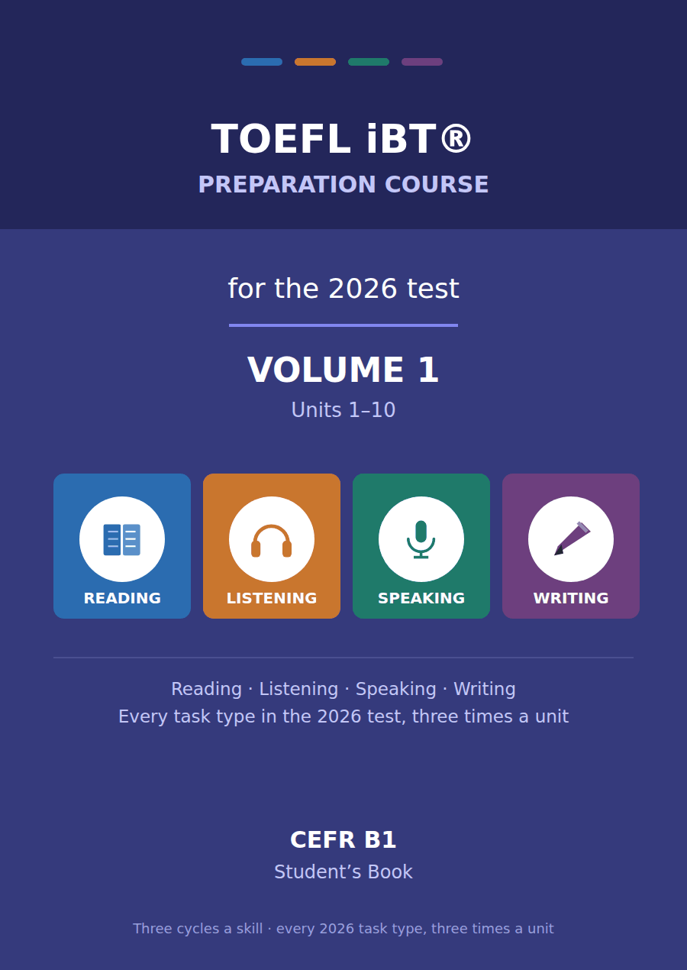

TOEFL iBT® Preparation Course 2026
Volume 1 · Units 1–10 · CEFR B1
Student’s Book with Practice Test 1

This course prepares B1 learners for the TOEFL iBT® test as it has been since 21 January 2026. Every task name, item count and timing in this book follows the official ETS practice test for that form.
Twenty units, ten in each volume. Each unit takes one topic from the test — American History, Astronomy, Public Health — and runs it through all four skills, three times, on three different sub-topics.

Series TOEFL iBT® Preparation Course 2026
Level CEFR B1 (targeting a steady 3.0–4.0 band)
Components Student’s Book · Audio · Interview video
This volume Units 1–10, Practice Test 1, answer key, audio scripts, glossary

TOEFL and TOEFL iBT are registered trademarks of ETS. This publication is not endorsed by or affiliated with ETS. Format details are taken from ETS’s own published practice material for the January 2026 form.

Map of the book Volume 1
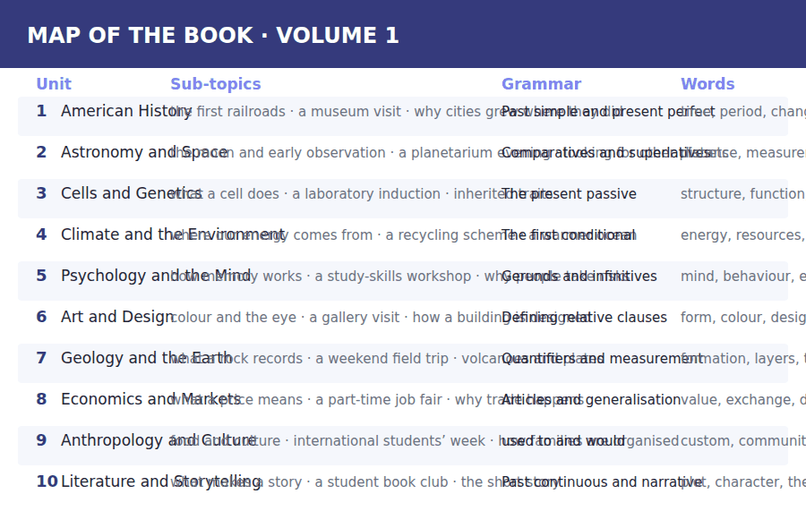

How to use this book Three cycles, four skills
Every unit is sixteen pages and every unit is built the same way, so once you have worked through Unit 1 you know where everything is.
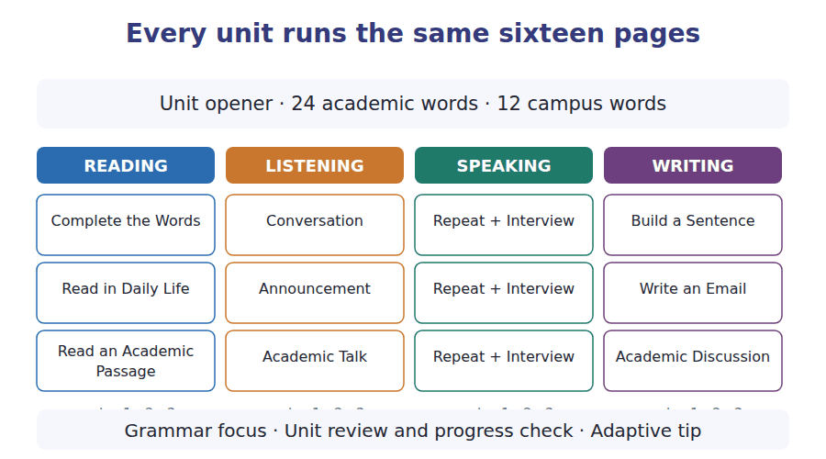
What a cycle is
A cycle is one sub-topic taken through one skill. Cycle 1 of Reading, Listening, Speaking and Writing all deal with sub-topic A; cycle 2 with sub-topic B; cycle 3 with sub-topic C. That is why the email you write in Writing cycle 2 answers the announcement you heard in Listening cycle 2.
Teach, guide, test
Inside every cycle the order is the same. A skill box tells you what to do. A guided exercise does it with help. An exam exercise does it the way the test will.

The 2026 test at a glance What you are preparing for
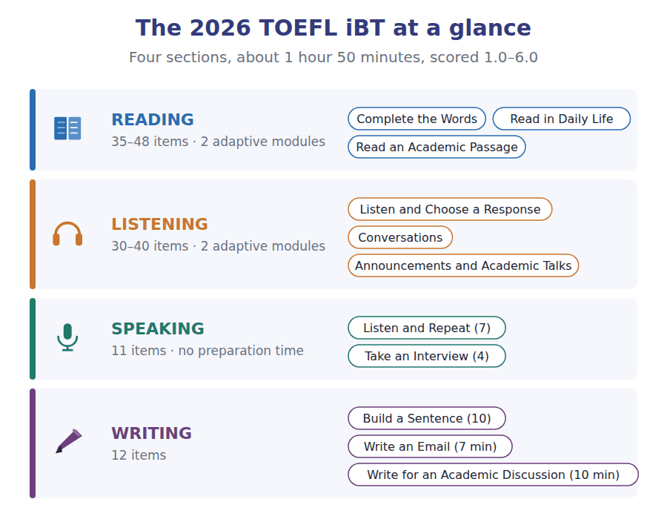
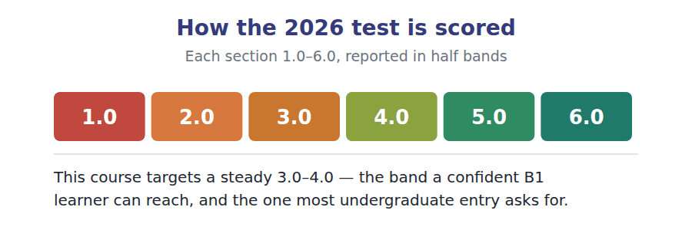

What an adaptive test does to you Modules, and why you cannot go back
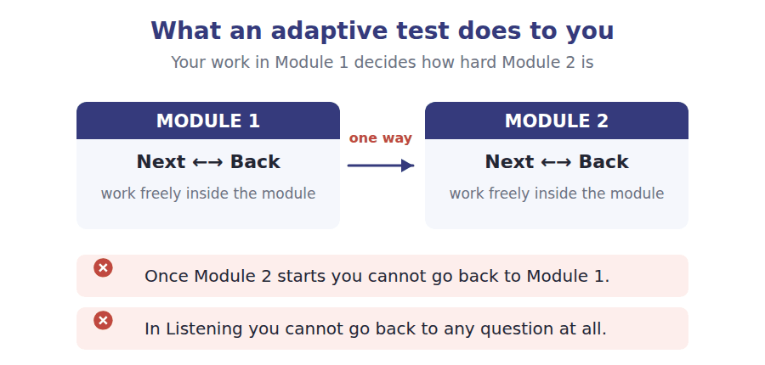
Reading and Listening are adaptive. Each is split into two modules, and how you do in Module 1 decides how hard Module 2 is. Two rules follow, and they are not the same rule.
- In Reading you can move Next and Back freely inside a module. Only the jump to Module 2 is one-way.
- In Listening you cannot go back to a previous question at all. The audio plays once.
- The early questions in a module carry the most weight, because they place you. Never rush them to buy time later.
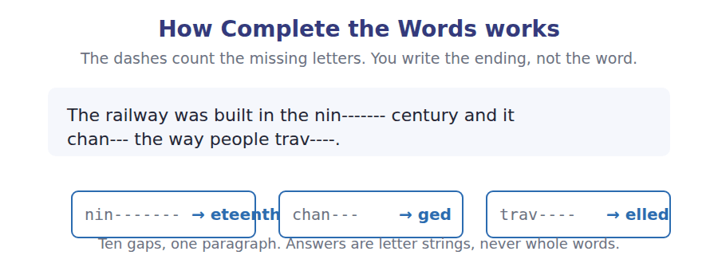

Study planner Twelve weeks, two units a week
When | What | Focus
Week 1 | Unit 1 · American History | Vocabulary, Reading, Listening
Week 2 | Unit 2 · Astronomy and Space | Speaking, Writing, grammar, review
Week 3 | Unit 3 · Cells and Genetics | Vocabulary, Reading, Listening
Week 4 | Unit 4 · Climate and the Environment | Speaking, Writing, grammar, review
Week 5 | Unit 5 · Psychology and the Mind | Vocabulary, Reading, Listening
Week 6 | Unit 6 · Art and Design | Speaking, Writing, grammar, review
Week 7 | Unit 7 · Geology and the Earth | Vocabulary, Reading, Listening
Week 8 | Unit 8 · Economics and Markets | Speaking, Writing, grammar, review
Week 9 | Unit 9 · Anthropology and Culture | Vocabulary, Reading, Listening
Week 10 | Unit 10 · Literature and Storytelling | Speaking, Writing, grammar, review
Week 11 | Review units 1–10 | Glossary and grammar reference
Week 12 | Practice Test 1 | Sit it in one sitting, then mark it

Unit 1 · American History
TOEFL iBT® Preparation Course 2026 · Volume 1
CEFR B1 · Grammar: Past simple and present perfect · direct question forms · Word field: time, period, change
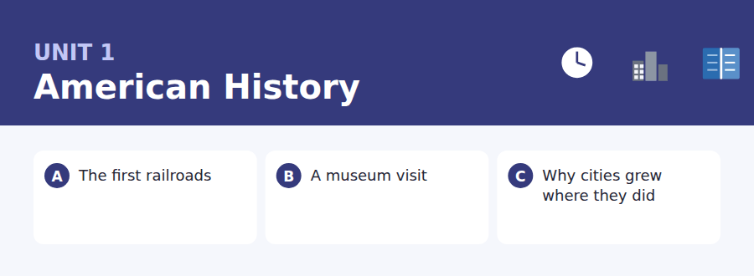
By the end of this unit I can…
- complete missing word endings in a paragraph about the past
- find one fact quickly in a notice, a web page or an email
- understand the main idea of a short academic passage about history
- follow a conversation in which one speaker has got something wrong
- ask and answer questions about the past without preparing
- write an email asking for something, and a discussion post with a reason

Three sub-topics, three cycles in every skill. Everything in this unit comes back in the review on page 29, and again in Practice Test 1.

Vocabulary 1 · Academic 24 words from the Academic Word List
These twenty-four words come back through the whole unit, and again in the review. Cover the right-hand column and test yourself.
period a length of time | significant important enough to notice
previous coming before this one | major very large or very important
prior before something else | federal belonging to the whole country, not one state
subsequent coming after | document a piece of writing that gives information
decade ten years | evident easy to see or understand
establish to start something that will last | region a large area of a country
expand to get bigger | construct to build
found to start a town, company or school | transport to carry people or goods from place to place
revolution a complete change in the way something is done | route the way from one place to another
transform to change something completely | migrate to move to another place to live
emerge to appear for the first time | initial first
decline to become smaller or weaker | eventual happening in the end, after a long time

Exercise A Work in pairs. Ask and answer.
1. Which decade of your life do you remember best, and why?
2. Name one thing in your town that has been transformed in the last ten years.
3. Has the population of your region expanded or declined? How do you know?
4. What was the initial reason your family came to live where they live now?
Vocabulary 2 · Campus and everyday 12 words for the daily-life tasks
The exam does not only test academic English. Notices, emails, conversations and announcements use the everyday words below.
museum a building where old or important things are shown | lecture hall a large room where a professor teaches
exhibition a collection of things shown to the public | field trip a visit away from the school as part of a course
guided tour a walk round a place with someone who explains it | coach a large bus for a long journey
ticket desk the place where you buy or collect tickets | deadline the last time something can be done
opening hours the times a place is open | timetable a list of times when things happen
gift shop a small shop selling presents and souvenirs | noticeboard a board where announcements are put up

Words you will meet again: period | establish | transform | route | migrate | significant | decade | revolution


SKILL · Use the sentence around the gap
- Read the whole sentence before you touch the gap. The grammar of the sentence usually tells you the ending.
- Count the dashes. Each one is one missing letter, so -ed, -ing and -ly are easy to spot.
- Say the first part out loud in your head. You usually already know the word.
- Never write a whole word. You are completing one, not replacing it.

Exercise A Guided practice. Five words are not complete. Write the missing letters.
Before 1830 there were no railroads in the United States. Travel was slow and expen----. The first line opened in Baltimore and carried only coal and pass------. Within twenty ye--- the network reached the Mississippi. Engineers lear--- quickly, and each new line was built fas--- than the one before it.

The first one is done for you: 1 expen---- → sive (expensive)
Exercise B Exam practice. One paragraph, ten gaps — the real task.
In the early 1800s most people in North America travelled by horse or by boat. A journey from New York to Chicago could take three we---. The first rail----- changed that completely. By 1860 more than thirty thou---- miles of track had been laid, and the same journey took two da--. Towns on a line grew quic---, while towns a few miles away stayed sm---. The railroad also carried letters, newspapers and fresh fo-- for the first time. People beg-- to measure distance in hours instead of days, and after 1869 a traveller could cross the whole cont----- without leaving the train. The country suddenly felt sma----.

Check your answers in the key at the back of the book.


SKILL · Read for one fact, not for the whole text
- Read the question first. You are looking for one piece of information.
- Find the heading that would hold it, then read only under that heading.
- The answer is always printed on the page. Never reason beyond the text.
- Numbers, times and prices are the most common answers — check them twice.

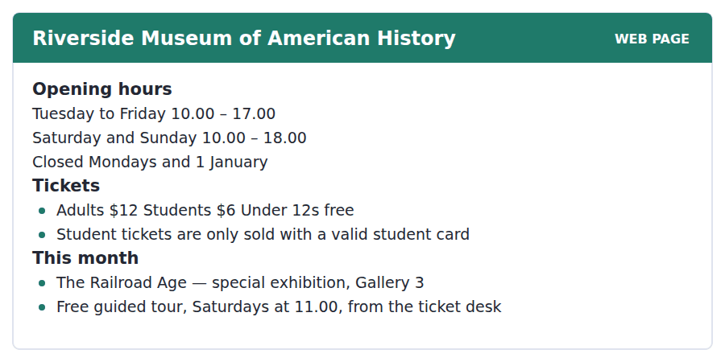
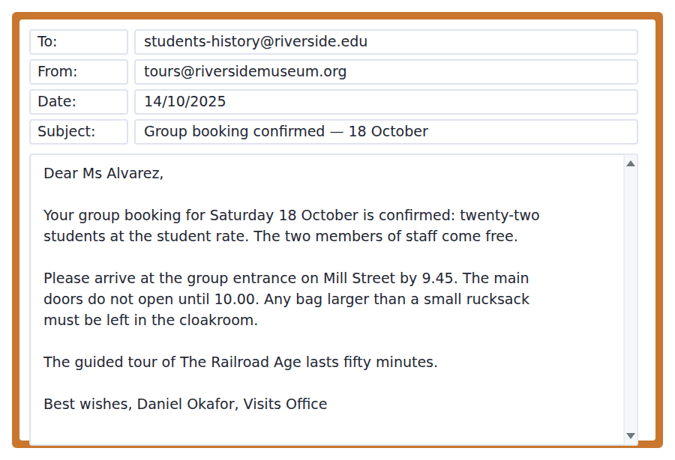
Exercise A Guided practice. The answer is on the page — find it.
1. On which day is the museum closed?
(A) Tuesday
(B) Sunday
(C) Saturday
(D) Monday
2. How much does a student pay?
(A) $6
(B) Nothing
(C) $12
(D) $18
3. What must a student bring to get the cheaper ticket?
(A) A passport
(B) A printed email
(C) A student card
(D) Cash
4. Where does the free guided tour start?
(A) In Gallery 3
(B) At the ticket desk
(C) At the group entrance
(D) On Mill Street
Exercise B Exam practice.
5. What is the main purpose of the email?
(A) To cancel a visit
(B) To ask for payment
(C) To change a date
(D) To confirm a booking
6. How many people has the school been charged for?
(A) 2
(B) 22
(C) 20
(D) 24
7. Why must the group arrive at 9.45?
(A) The tour starts then
(B) The cloakroom closes at 10.00
(C) The main doors open later
(D) The ticket desk is busy
8. What can be inferred about Ms Alvarez?
(A) She is bringing the students
(B) She works at the museum
(C) She is a student
(D) She has visited before
9. What should a student with a large bag do?
(A) Leave it in the cloakroom
(B) Leave it at school
(C) Carry it in the gallery
(D) Give it to a member of staff
10. The group visits on Saturday 18 October. Which of these is true that day?
(A) The museum is closed
(B) A free guided tour is offered
(C) The museum shuts at 17.00
(D) Student tickets are not sold


SKILL · Find the topic sentence first
- In an academic passage the first sentence of a paragraph usually carries its point. Read those three sentences before anything else.
- A main-idea question is answered by what all three paragraphs share, never by one interesting detail.
- A vocabulary question gives you the sentence. Replace the word with each option and see which one still makes sense.
- A "why does the author mention X" question asks for the purpose of the example, not for the example itself.

Why Cities Grew Where They Did
Look at a map of the United States in 1800 and almost every large town sits on water. New York, Boston, Philadelphia and Charleston were ports. Further inland, St Louis and Cincinnati stood on great rivers. This was not an accident. Before the railroad, moving a ton of goods thirty miles over land cost about as much as shipping it across the Atlantic. A town without water transport could feed itself, but it could not trade, and a town that could not trade did not grow.
The railroad broke that rule. After 1840 a line could be laid almost anywhere, and towns began to appear in places with no river at all. Chicago is the clearest example. It had a small harbour and a great deal of swamp, and in 1840 fewer than five thousand people lived there. Thirty years later it was the meeting point of eleven railroad companies and the fourth largest city in the country. What had changed was not the land but the cost of crossing it.
Geography still mattered, though. Railroads were cheapest to build on flat ground, so lines followed valleys and plains, and towns followed the lines. Where a line crossed a river, or where two companies met, a city grew. Historians call these places break-in-bulk points: somewhere goods have to be moved from one kind of transport to another. Wherever goods stop, people stay. The pattern is very old. Only the reason for stopping had changed.
[265 words]

Exercise A Guided practice.
1. What is the passage mainly about?
(A) The building of the first railroads
(B) The history of Chicago
(C) Transport costs in 1800
(D) Why towns grew where they did
2. The word "accident" in paragraph 1 is closest in meaning to
(A) crash
(B) mistake
(C) chance
(D) plan
3. According to paragraph 1, why did a town need water transport?
(A) To get drinking water
(B) To defend itself
(C) To grow food
(D) To trade
4. Why does the author mention Chicago?
(A) To compare it with New York
(B) To explain why swamps are useful
(C) To give an example of a city that grew without a river
(D) To describe its harbour
Exercise B Exam practice.
5. According to paragraph 2, what became possible after 1840?
(A) Rivers became deeper
(B) Lines could be built away from water
(C) Towns stopped growing
(D) Harbours were closed
6. In 1840 Chicago had
(A) fewer than five thousand people
(B) eleven railroad companies
(C) the fourth largest population
(D) no harbour at all
7. All of the following are true about railroads EXCEPT:
(A) They were cheapest to build on flat ground
(B) They could only be built beside rivers
(C) They followed valleys and plains
(D) They changed the cost of moving goods
8. The word "pattern" in paragraph 3 refers to
(A) the shape of a railway line
(B) the design of a harbour
(C) the map of 1800
(D) cities growing where goods have to stop
9. What can be inferred about break-in-bulk points?
(A) They are always on rivers
(B) They were built by one company
(C) They existed before the railroad
(D) They are no longer important
10. What does the author suggest about geography?
(A) It decided where lines could cheaply go
(B) It stopped mattering after 1840
(C) It explains why Chicago failed
(D) It only affected ports
11. Which sentence best states the main idea of paragraph 3?
(A) Railroads were expensive to build
(B) Valleys are flatter than hills
(C) Two companies met in Chicago
(D) Cities grew where transport had to change


Exercise A Listen and choose a response. You hear one line. Choose the best reply.
1. Woman: Are you going to the museum on Saturday?
(A) I think so, if I finish my essay.
(B) Yes, it’s on Mill Street.
(C) No, it was very interesting.
(D) It costs six dollars.
2. Man: How long does the tour last?
(A) At eleven o’clock.
(B) In Gallery 3.
(C) About fifty minutes.
(D) Twenty-two students.
3. Woman: I thought the trip was next week.
(A) Yes, I enjoyed it.
(B) No, it’s this Saturday.
(C) The tickets are free.
(D) It’s near the station.
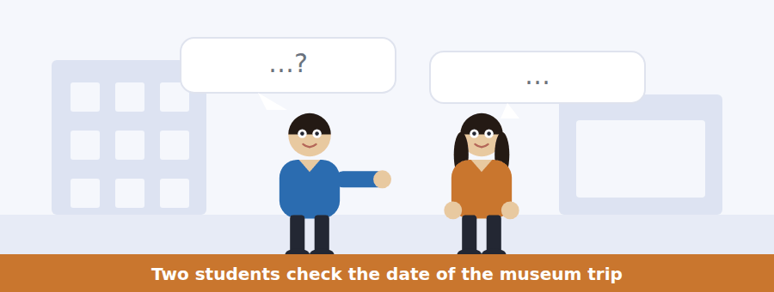
SKILL · Listen for the problem
- A TOEFL conversation almost always contains one problem. Find it and half the questions answer themselves.
- Listen for words that correct: actually, no, that’s the thing, I thought.
- An idiom question asks what the speaker means, not what the words mean.
- The audio plays once, so write while you listen, not afterwards.

Exercise B Listen and answer. The audio plays once.
4. What is the man’s main point?
(A) The trip has been cancelled
(B) The exhibition is closed
(C) The email was never sent
(D) The woman has the wrong date
5. Why was the date changed?
(A) The students asked for it
(B) The gallery changed its dates
(C) The tour was too long
(D) The group was too large
6. What does the woman mean when she says "I’m not missing it twice"?
(A) She has missed the exhibition before
(B) She has already seen it twice
(C) She will go on both days
(D) She does not want to go
7. What will the woman probably do next?
(A) Write to the Visits Office
(B) Buy a ticket online
(C) Ask a colleague to work for her
(D) Cancel her shift without asking
8. Why does the man mention the main doors?
(A) They are on Mill Street
(B) They open later than the group entrance
(C) They are closed on Saturdays
(D) They lead to Gallery 3
9. What can be inferred about the woman?
(A) She has never been to the museum
(B) She does not read her email
(C) She is not interested in history
(D) She has a part-time job
Audio script: see the back of the book. Do not read it before you listen.


Exercise A Listen and choose a response. You hear one line. Choose the best reply.
1. Man: Where does the coach leave from?
(A) At nine fifteen.
(B) It takes an hour.
(C) From the library car park.
(D) Yes, it does.
2. Woman: Do I need to bring anything?
(A) Your student card.
(B) It’s on Saturday.
(C) About forty people.
(D) No, it’s not included.
3. Man: Is lunch included?
(A) In the café.
(B) At one o’clock.
(C) No, but there’s a café in the museum.
(D) Yes, the coach leaves at nine.

SKILL · Catch time, place and change
- An announcement exists because something has changed. Listen for the change and for what it replaces.
- Write the old detail and the new one side by side. Questions test the pair.
- Reasons follow the word because, so, or due to — they are almost always tested.
- A final instruction (email us, bring this) is a question in waiting.

Exercise B Listen and answer. The audio plays once.
4. What is the main purpose of the announcement?
(A) To cancel the trip
(B) To describe the exhibition
(C) To sell tickets
(D) To announce two changes
5. Why has the departure point changed?
(A) The main gate is closed for building work
(B) The car park is bigger
(C) The library is nearer
(D) The coach is too long
6. Why does the coach leave earlier?
(A) The museum opens early
(B) There are roadworks
(C) More students are coming
(D) The tour is longer
7. What happens to a student who forgets a student card?
(A) They cannot come
(B) They pay the adult price
(C) They get a refund later
(D) They wait outside
8. What should a student do who can no longer come?
(A) Tell a friend
(B) Go to the car park anyway
(C) Pay for the place
(D) Email the Visits Office today
Audio script: see the back of the book. Do not read it before you listen.


Exercise A Listen and choose a response. You hear one line. Choose the best reply.
1. Woman: Did you understand the part about the canal?
(A) It was built in 1825.
(B) Yes, it’s on the board.
(C) Not really — can you explain it?
(D) The lecture is on Tuesday.
2. Man: What was the Homestead Act?
(A) A law that gave away farmland.
(B) In 1862.
(C) Yes, it was important.
(D) The professor mentioned it.
3. Woman: I missed the last point.
(A) It starts at two.
(B) I can lend you my notes.
(C) No, I don’t think so.
(D) The board is behind you.
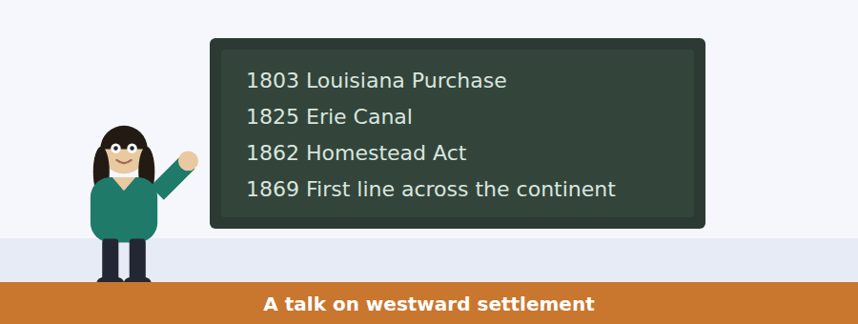
SKILL · Follow the signposts to the main idea
- A talk tells you its plan. Today I want to…, What I want you to notice is… — the main idea lives in those sentences.
- Dates on a board are a list, and a list is almost always in an order the speaker will explain.
- The last thirty seconds usually carry the point. Do not stop listening.
- A "why does the speaker mention" question wants the purpose of an example.

Exercise B Listen and answer. The audio plays once.
4. What is the main idea of the talk?
(A) The United States doubled in size in 1803
(B) The Erie Canal was the most important change
(C) People moved west when the cost of moving fell
(D) Farmers in Ohio grew wheat for New York
5. Why does the speaker mention the Louisiana Purchase?
(A) To show that more land alone did not move people
(B) To explain how canals were paid for
(C) To give the date the railroad began
(D) To describe the size of Ohio
6. According to the speaker, what did the Erie Canal change?
(A) The price of land in New York
(B) The law about free farmland
(C) The route of the first railroad
(D) What a farmer could sell and where
7. Which of the dates on the board is a change in law, not transport?
(A) 1803
(B) 1862
(C) 1825
(D) 1869
8. What does the speaker want students to notice?
(A) The order of the four changes
(B) The size of the country
(C) The number of farmers
(D) The cost of a canal boat
9. What will the speaker most likely discuss next?
(A) How canals were built
(B) The population of New York in 1800
(C) Why the Louisiana Purchase was cheap
(D) What people expected to earn in the west
Audio script: see the back of the book. Do not read it before you listen.


Part 1 · Listen and Repeat
You hear a sentence and repeat it once. There is no preparation time, and the sentences get longer. Focus: past -ed endings (/t/, /d/ and /ɪd/)
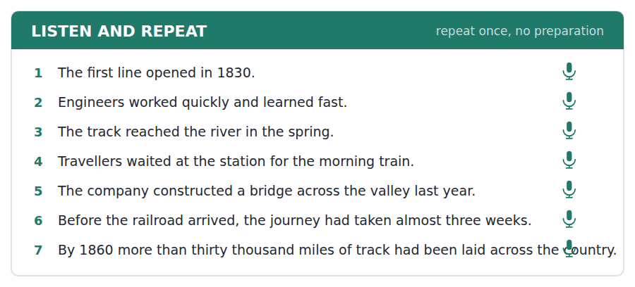
SKILL · Say the whole sentence
- Half a sentence scores lower than a slow, complete one. Finish it.
- There is no preparation time, so start speaking as the beep ends.
- -ed has three sounds: worked /t/, opened /d/, started /ɪd/.
- If you lose a word, say the sentence again from the beginning.

Part 2 · Take an Interview
An interviewer asks you four questions on one theme: a place you have visited. Answer each one fully. There is no preparation time.
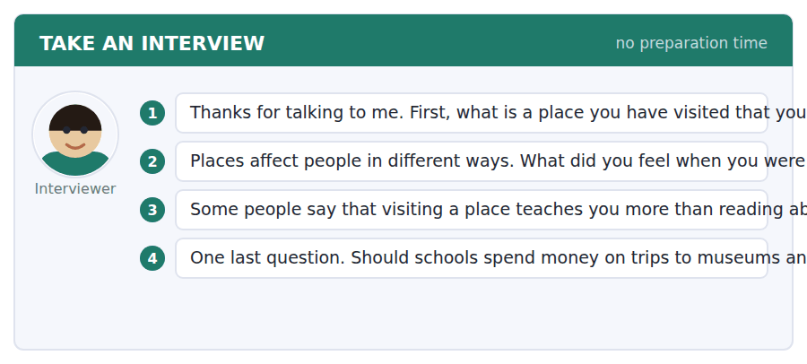
A good answer sounds like this
Question 1 — I visited the old castle in my city last summer. I remember it because I had walked past it for years and I had never been inside.
Question 3 — I agree, mostly. When I read about the castle I only learned dates, but when I stood in the kitchen I understood how small it really was.
I can… | Not yet | Yes
I started speaking straight away, with no long pause | □ | □
I finished every sentence I began | □ | □
I gave a reason after my opinion | □ | □


Part 1 · Listen and Repeat
You hear a sentence and repeat it once. There is no preparation time, and the sentences get longer. Focus: keeping going without preparation
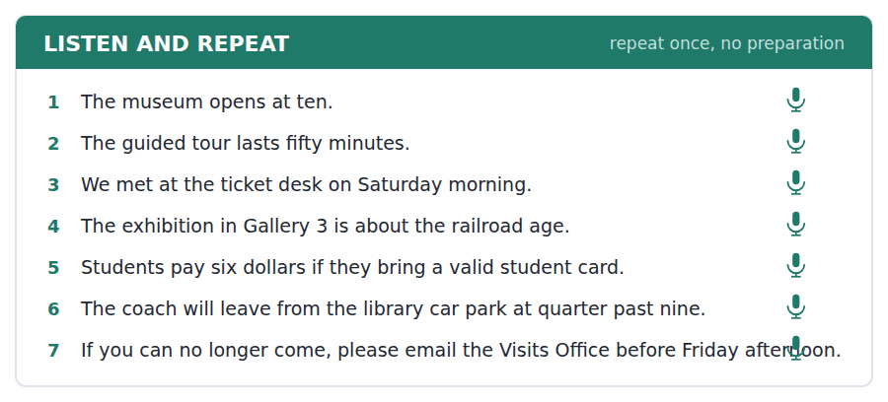
SKILL · Buy yourself half a second, not five
- Short fillers are fine: Well, I think… / That’s a good question.
- Never stop in the middle. Finish the sentence even if it is not the one you planned.
- Say your opinion first, then because. The reason is what earns the band.
- Thirty seconds of clear B1 beats ten seconds of hesitant C1.

Part 2 · Take an Interview
An interviewer asks you four questions on one theme: the past in your country. Answer each one fully. There is no preparation time.
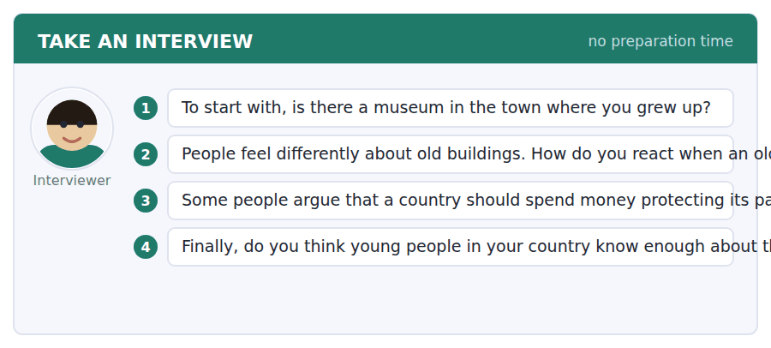
A good answer sounds like this
Question 2 — Honestly, it makes me sad, because once a building is gone you cannot get it back. A new one can always be built somewhere else.
Question 4 — I don’t think they do, no. We studied dates at school but nobody explained why any of it mattered to us.
I can… | Not yet | Yes
I used a short filler, not a long silence | □ | □
I answered the actual question, not a similar one | □ | □
I gave an example in at least two answers | □ | □


Part 1 · Listen and Repeat
You hear a sentence and repeat it once. There is no preparation time, and the sentences get longer. Focus: academic register
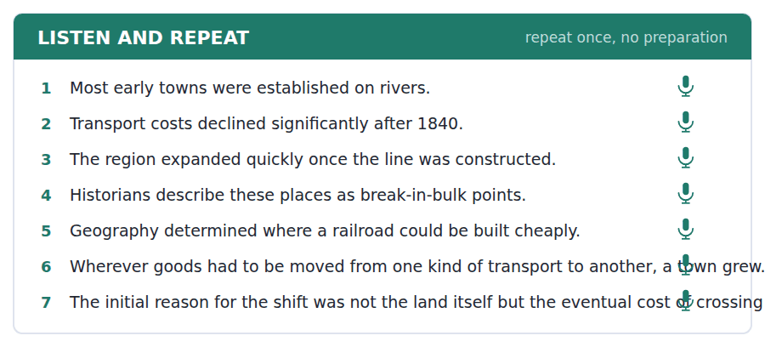
SKILL · Sound like the reading passage
- Use the unit’s academic words when you speak: significant, expand, decline, establish.
- Signal your structure: One reason is… / On the other hand… / That is why…
- The fourth question is always the most abstract. Answer it with a reason and one example.
- Mark yourself with the band descriptors below before you listen back.

Part 2 · Take an Interview
An interviewer asks you four questions on one theme: what students should learn about history. Answer each one fully. There is no preparation time.
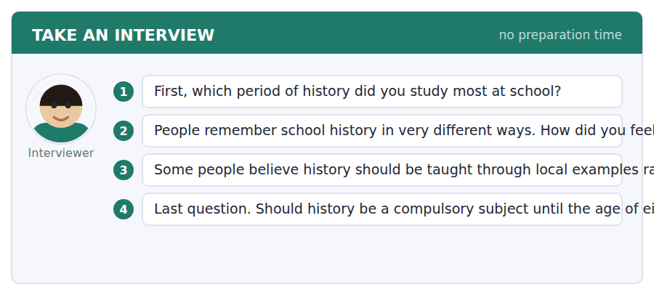
A good answer sounds like this
Question 3 — I agree with that. One reason is that local history is visible: you can walk to it. When something is in front of you, you remember it.
Question 4 — I don’t think it should be compulsory that long. On the other hand, every student should finish school knowing how to check a source.
I can… | Not yet | Yes
I used at least three academic words from this unit | □ | □
I signalled my structure (one reason is…, on the other hand…) | □ | □
My fourth answer gave an opinion and a reason, not just an opinion | □ | □


You see a sentence, then a set of words in boxes. Put the words in order to make one grammatical sentence. Almost every item in the real test makes a question or a question inside another sentence.
SKILL · Read the prompt sentence first
- The sentence above the boxes fixes the tense and the person. Match it.
- Almost every item makes a question. Find the question word first.
- A direct question inverts: did you see…? An indirect one does not: do you know whether you saw…
- Use every tile exactly once. If one is left over, the order is wrong.

Exercise A Guided practice. The first three are worked through.
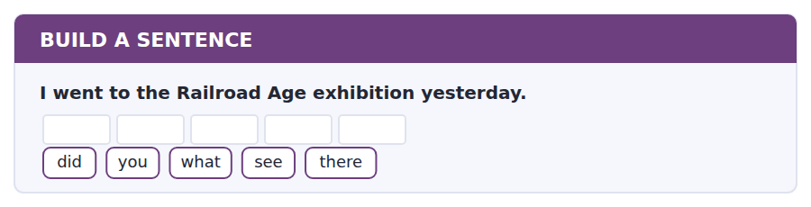
1. What did you see there?
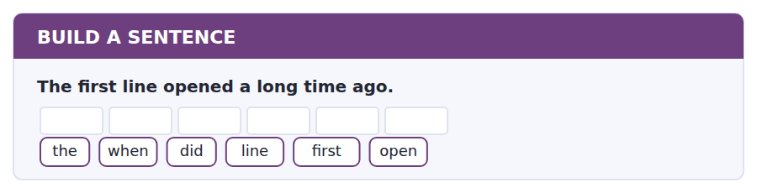
2. When did the first line open?
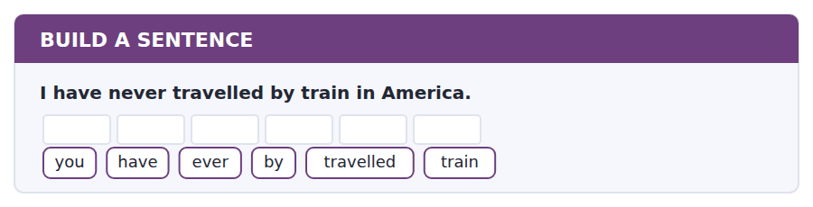
3. Have you ever travelled by train?
Exercise B Exam practice. Write the sentence.
4. The museum changed its opening hours last month.
they / why / did / the / change / hours
__________________________________________________________
5. Thirty thousand miles of track were laid by 1860.
how / much / was / track / laid
__________________________________________________________
6. Chicago grew faster than any other city.
city / which / grew / fastest
__________________________________________________________
7. I have already booked the tickets.
you / have / the / booked / tickets / already
__________________________________________________________
8. The engineers who built the bridge came from Scotland.
the / engineers / who / the / built / bridge / came / from / Scotland
__________________________________________________________
9. We arrived at the group entrance at quarter to ten.
time / what / did / arrive / you
__________________________________________________________
10. The exhibition has been open since September.
long / how / has / been / it / open
__________________________________________________________


You read a short situation and write an email. You have 7 minutes. The three bullet points are the mark scheme: answer all three.
Your history professor, Dr Whitfield, mentioned in class that she would like to see The Railroad Age exhibition. Your group has two free places on the coach for Saturday 18 October.
Write an email to Dr Whitfield inviting her to come with the group.
- Tell her why you think she would enjoy the exhibition.
- Give her the practical details she needs.
- Ask whether she would like one of the free places.
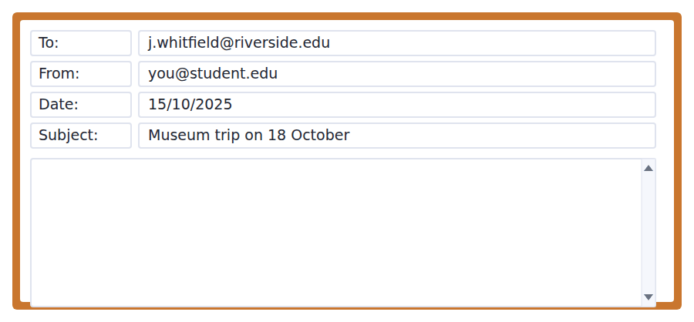
SKILL · Answer all three bullet points
- The three bullets are the mark scheme. One short paragraph each is enough.
- Open and close properly: Dear Dr Whitfield … Best wishes, + your name.
- Seven minutes is about 110–140 words. Do not plan for longer.
- Ask your question as a real question, with a question mark.

Model email
Dear Dr Whitfield,
You said in Tuesday’s lecture that you wanted to see The Railroad Age exhibition at the Riverside Museum. Our group is going on Saturday 18 October, and I thought of you at once, because the exhibition covers exactly the period we have been studying.
The coach leaves from the library car park at 9.15 and we have to be at the group entrance on Mill Street by 9.45. There is a free guided tour at eleven which lasts fifty minutes, and we are free in the galleries afterwards. Lunch is not included.
We have two free places for staff. Would you like one of them? If you let me know by Thursday, I can add your name to the list.
Best wishes,
Leyla Haddad
Why it works
- Each of the three bullets gets its own paragraph — the reader can see all three at a glance.
- The reason is specific (the period we have been studying), not general (it is interesting).
- The practical paragraph gives time, place and length, which is what an invitation actually needs.
- The question is a real question, and it has a deadline attached to it.
Now write your own. 7 minutes.
__________________________________________________________
__________________________________________________________
__________________________________________________________
__________________________________________________________
__________________________________________________________
__________________________________________________________
__________________________________________________________
__________________________________________________________


A professor asks a question and two students answer. You add your own post. You have 10 minutes and an effective answer is at least 100 words.
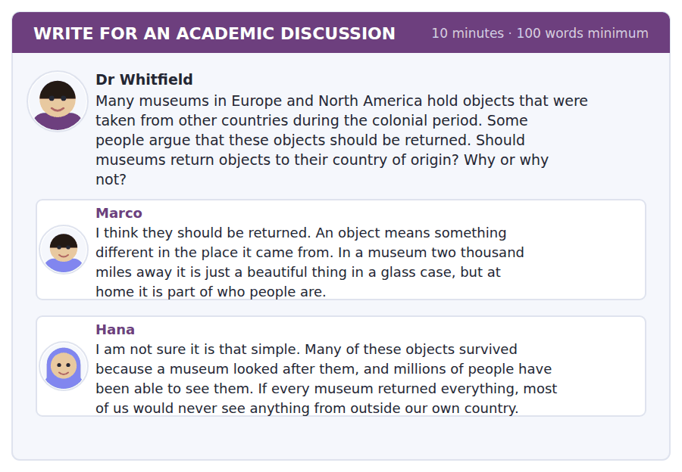
SKILL · Name a classmate, then add something new
- Start from one of the two posts by name. It shows you read the discussion.
- Then add a point neither of them made. Agreeing twice earns nothing.
- At least 100 words, which is about six sentences at this level.
- Ten minutes: two to think, seven to write, one to read it back.

Sentence starters
- I agree with Marco that…, but I would add that…
- Hana makes a fair point about… However,…
- Both posts assume that… In my country, though,…
- The strongest reason for me is…, because…
Model post
Hana makes a fair point about who has looked after these objects, but I think she is answering a different question. The question is not who kept them safe; it is who they belong to.
I agree with Marco, and I would add one thing. We talked in class about break-in-bulk points — places where things stop and people stay. A museum is the same kind of place. Objects stopped there for reasons that had nothing to do with the people who made them, and nobody asked those people.
I would not return everything immediately, because some countries do say they are not ready. But the decision should be theirs, not ours. Museums could lend objects back and share them, so that Hana’s millions of visitors still see something.
[146 words]
Now write your own. 10 minutes, at least 100 words.
__________________________________________________________
__________________________________________________________
__________________________________________________________
__________________________________________________________
__________________________________________________________
__________________________________________________________
__________________________________________________________
__________________________________________________________
__________________________________________________________
__________________________________________________________

Grammar focus Past simple and present perfect · direct question forms
Form | Example
Past simple — finished time | The line opened in 1830.
Present perfect — no finished time | The museum has changed its hours.
Past simple question | When did the line open?
Present perfect question | How long has it been open?
Ever / never | Have you ever travelled by train?
Wh- + auxiliary + subject + verb | Why did they change the hours?
Subject question (no auxiliary) | Which city grew fastest?

The rule that matters for this test is not the tense but the word order. A direct question puts the auxiliary in front of the subject: did you see, has it opened.
There is one exception, and Build a Sentence uses it. When the question word is the subject, there is no auxiliary at all: Which city grew fastest? — not Which city did grow fastest?
A time expression decides the tense. In 1830, last month and yesterday force the past simple. Since, for, already, yet and ever force the present perfect.
Watch out! Never say *When have you gone to the museum?* A question with when is about finished time, so it takes the past simple: When did you go?
Exercise 1 Put the verb in the past simple or the present perfect.
1. The first line __________ (open) in Baltimore in 1830.
2. I __________ (never / be) to the United States.
3. The museum __________ (change) its opening hours last month.
4. How long __________ (the exhibition / be) in Gallery 3?
5. Chicago __________ (grow) very quickly between 1840 and 1870.
6. We __________ (already / book) the coach.
Exercise 2 Write the question for each answer.
1. __________________? — It opened in 1830.
2. __________________? — Because the gallery changed the dates.
3. __________________? — Chicago did.
4. __________________? — For about three months.
Exercise 3 One sentence in each pair is wrong. Correct it.
1. a) When have you visited the museum? b) When did you visit the museum?
2. a) Which company built the bridge? b) Which company did build the bridge?
3. a) I have seen the exhibition last week. b) I saw the exhibition last week.
How this is tested in Build a Sentence
Seven of the ten Build a Sentence items in a real test make a question. Three of them use the shape you have just practised: wh- word, auxiliary, subject, verb. Get that order automatic now and three marks are already safe.

Unit review and progress check Unit 1
Exercise A Vocabulary. Write the word.
1. a length of ten years
2. to change something completely
3. to move to another place to live
4. important enough to notice
5. to start something that will last
6. the way from one place to another
7. a large area of a country
8. to become smaller or weaker
9. first
10. belonging to the whole country
11. a visit away from school as part of a course
12. the times a place is open
Exercise B Grammar. Complete the sentence.
1. The railroad __________ (reach) the Mississippi in 1850.
2. __________ you ever __________ (be) on a guided tour?
3. How long __________ the museum __________ (be) open today?
4. Which engineer __________ (design) the bridge?
5. We __________ (not / receive) the email yet.
6. What time __________ the coach __________ (leave) yesterday?
7. The population of the region __________ (decline) since 1980.
8. Why __________ they __________ (move) the date?
Exercise C One timed mini-section. 6 minutes.
1. In the passage on page 18, the author argues that cities appeared where
(A) rivers were deepest
(B) land was cheapest
(C) goods had to change transport
(D) the weather was best
2. The coach on Saturday leaves at
(A) 9.00
(B) 9.30
(C) 9.15
(D) 9.45
3. Which question is correctly formed?
(A) When have you gone to the museum?
(B) Which city did grow fastest?
(C) What time did the coach left?
(D) How long has it been open?
4. In Complete the Words, the dashes tell you
(A) how many words are missing
(B) how many letters are missing
(C) which tense to use
(D) where the sentence ends
5. In the Listening section you can go back to a previous question
(A) never
(B) always
(C) inside one module only
(D) in Module 1 only
6. A student with no student card at the museum will
(A) be turned away
(B) get a refund later
(C) pay the adult price
(D) pay nothing
Can you do these now?
I can… | Not yet | Yes
complete missing word endings in a paragraph about the past | □ | □
find one fact quickly in a notice, a web page or an email | □ | □
understand the main idea of a short academic passage about history | □ | □
follow a conversation in which one speaker has got something wrong | □ | □
ask and answer questions about the past without preparing | □ | □
write an email asking for something, and a discussion post with a reason | □ | □

ADAPTIVE TIP Back works inside a Reading module and nowhere in Listening. In Reading, answer the easy items first and return to the hard ones. In Listening there is no returning: decide, mark, move on. A question you leave open is a question you lose.

Unit 2 · Astronomy and Space
TOEFL iBT® Preparation Course 2026 · Volume 1
CEFR B1 · Grammar: Comparatives and superlatives · Word field: distance, measurement, discovery
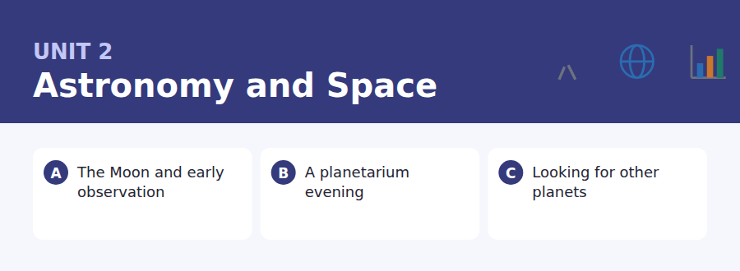
By the end of this unit I can…
- complete word endings in a short text about observation and measurement
- find times, prices and changes in a programme listing and a booking email
- follow an academic passage that explains a method, not just a fact
- understand a conversation in which two people compare two options
- compare two things out loud without preparing what to say
- write an email asking about a group booking, and a post weighing costs against benefits

Everything in this unit is about size and distance, so the grammar is the grammar of comparison. You will need it again in Unit 16.

Vocabulary 1 · Academic 24 words from the Academic Word List
These twenty-four words come back through the whole unit, and again in the review. Cover the right-hand column and test yourself.
estimate to say about how much or how many | enormous extremely large
approximate almost exact, but not completely | sphere a perfectly round object, like a ball
precise exact and correct in every detail | orient to find which way you are facing
accurate correct, with no mistakes | locate to find exactly where something is
detect to notice something that is hard to see | identify to say what or who something is
reveal to show something that was hidden | confirm to show that something is true
visible able to be seen | hypothesis an idea you test to see if it is true
dimension a measurement such as length, width or height | predict to say what will happen before it happens
ratio the relation between two numbers | phenomenon something that happens that people notice and study
proportion a part of a whole | device a tool or machine made for one job
minimum the smallest possible amount | survey a careful look at a whole area
maximise to make as large as possible | interval the time between two events

Exercise A Work in pairs. Ask and answer.
1. Can you see any stars from where you live? What do you think that reveals about the place?
2. Which is the most enormous thing you have ever seen in real life?
3. Make a prediction about space travel in the next decade. How accurate do you think it is?
4. How would you estimate the distance from your home to your school, without measuring it?
Vocabulary 2 · Campus and everyday 12 words for the daily-life tasks
The exam does not only test academic English. Notices, emails, conversations and announcements use the everyday words below.
planetarium a building where the night sky is shown on a dome | screening a showing of a film
show a performance or programme for an audience | refund money given back to you
booking an arrangement to keep a place for you | seat a place to sit
group rate a lower price for several people together | queue a line of people waiting
telescope an instrument for looking at distant things | voucher a paper or code you exchange for something
observatory a building with telescopes for studying the sky | latecomer someone who arrives after the start

Words you will meet again: period | significant | region | construct | transform | estimate | detect | visible


SKILL · Let the grammar finish the word
- A gap after the subject is usually a verb ending. A gap after an article is usually a noun ending.
- Comparative and superlative endings are common here: -er, -est, -ier.
- Count the dashes before you write: -er is two, -est is three, -ier is three.
- If two endings fit the letters, the sentence decides, not the word.

Exercise A Guided practice. Five words are not complete. Write the missing letters.
People watched the Moon long before anyone built a telescope. They noticed that it was bri----- at some times than at others, and that it always showed the sa-- face to the Earth. Farmers used it to coun- the months. The Moon was the first clock, and for thousands of ye--- it was the only one that everybody could s--.

The first one is done for you: 1 bri------ → ghter (brighter)
Exercise B Exam practice. One paragraph, ten gaps — the real task.
The Moon is the clo---- object in space, and for most of history it was the only one anyone could study in any detail. Early observers had no instru-----, so they measured what they could: how long the cycle lasted and how high the Moon ro-- above the horizon. Their numbers were surprisingly accu----. By 200 BC, Greek astronomers had estim---- the distance to the Moon to within ten per cent of the mod--- figure, using nothing but shadows and geometry. They were also the fir-- to argue that the Moon shines by reflected lig--, not by its own. The telescope, when it fin---- arrived in 1609, did not begin astronomy. It confirmed what careful people had already work-- out.

Check your answers in the key at the back of the book.


SKILL · Match the question word to the column
- A listing is a table in disguise. When the question says how much, look at the price column only.
- Read the small print under a listing. Changes and conditions live there.
- In an email, the subject line often answers the main-purpose question.
- If two shows or two prices look similar, the question is probably testing which one — read the names carefully.

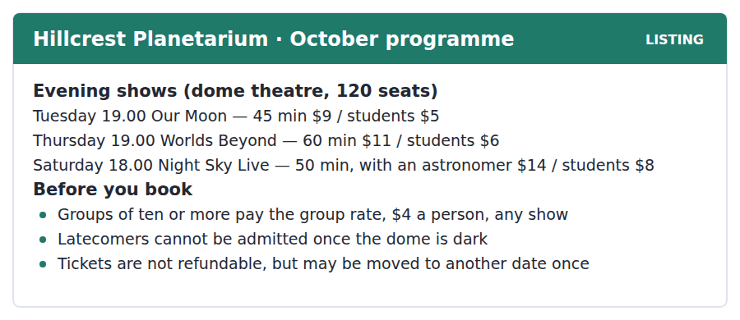
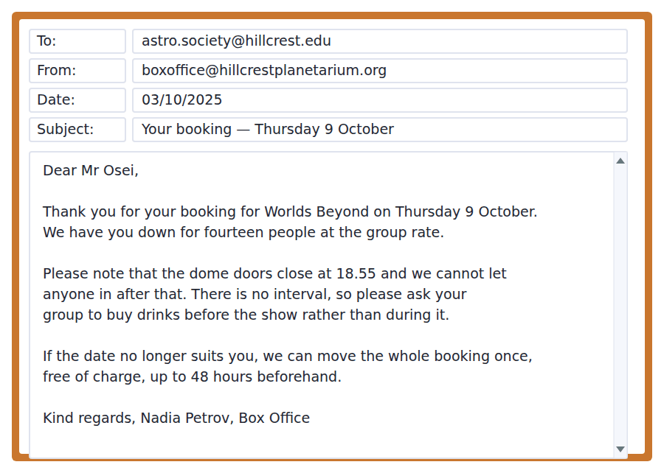
Exercise A Guided practice. The answer is on the page — find it.
1. Which show lasts the longest?
(A) Our Moon
(B) Night Sky Live
(C) They are all the same length
(D) Worlds Beyond
2. How much does a student pay for Night Sky Live?
(A) $5
(B) $8
(C) $6
(D) $14
3. Which show includes a person as well as the film?
(A) Night Sky Live
(B) Our Moon
(C) Worlds Beyond
(D) None of them
4. What happens if you arrive after the show has started?
(A) You get a refund
(B) You wait at the back
(C) You cannot go in
(D) You move to another date
Exercise B Exam practice.
5. How much will Mr Osei’s group pay per person?
(A) $6
(B) $11
(C) $14
(D) $4
6. Why does the email mention 18.55?
(A) The doors close then
(B) The show starts then
(C) The box office closes then
(D) The drinks are served then
7. Why should the group buy drinks before the show?
(A) They are cheaper then
(B) There is no interval
(C) The bar closes at seven
(D) Drinks are not allowed in the dome
8. What can Mr Osei do if the date becomes impossible?
(A) Get his money back
(B) Send different people
(C) Move the booking once, free of charge
(D) Book a second show at half price
9. By when must a change of date be requested?
(A) On the day
(B) 48 hours before
(C) 24 hours before
(D) One week before
10. What can be inferred about Mr Osei?
(A) He works at the planetarium
(B) He is studying astronomy
(C) He organises a student society
(D) He has booked before


SKILL · Follow a method, not a story
- A passage that explains a method usually has one problem and two solutions. Mark them as you read.
- Comparisons carry the meaning: brighter, slower, fainter, simpler. Note what is being compared with what.
- Numbers in this kind of passage are almost always tested. Note the unit as well as the number.
- The final sentence often states the limitation. Inference questions live there.

Looking for Other Planets
For most of the twentieth century nobody knew whether any star other than the Sun had planets. The problem was not that such planets were far away. It was that they were invisible. A planet gives out no light of its own, and the star beside it is perhaps a billion times brighter. Looking for a planet directly is like trying to see a moth beside a searchlight.
The solution was to stop looking for the planet and start watching the star. A planet pulls on the star it circles, and that pull moves the star very slightly towards us and away from us. The movement is tiny — a few metres a second, slower than a person running — but it changes the colour of the starlight by a measurable amount. The first planet around an ordinary star was found this way in 1995.
A second method is simpler still. If a planet passes in front of its star, the star gets slightly fainter for a few hours. The drop is often less than one per cent, so it takes an accurate instrument and a great deal of patience, and it only works when the planet’s path happens to lie between us and the star. Even so, this method has found the great majority of the five thousand planets now known. Neither method shows us a planet. Both of them show us a star behaving as though something is there.
[270 words]

Exercise A Guided practice.
1. What is the passage mainly about?
(A) Why stars are brighter than planets
(B) The discovery of 1995
(C) Why telescopes are not accurate enough
(D) How planets around other stars are found
2. The word "invisible" in paragraph 1 is closest in meaning to
(A) impossible to see
(B) very small
(C) moving quickly
(D) far away
3. Why does the author mention a moth and a searchlight?
(A) To show how small planets are
(B) To describe a type of telescope
(C) To explain why direct looking fails
(D) To compare two kinds of star
4. According to paragraph 2, what does a planet do to its star?
(A) It makes it brighter
(B) It moves it slightly
(C) It changes its temperature
(D) It slows it down
Exercise B Exam practice.
5. How fast does the star’s movement described in paragraph 2 appear to be?
(A) About the speed of a running person
(B) Faster than light
(C) A few kilometres a second
(D) Too slow to measure
6. What makes the second method work?
(A) The planet reflects more light
(B) The star changes colour
(C) The planet moves faster
(D) The star gets slightly fainter
7. All of the following are true of the second method EXCEPT:
(A) It needs an accurate instrument
(B) It needs patience
(C) It works for every planet
(D) It has found most known planets
8. The word "drop" in paragraph 3 refers to
(A) a fall in temperature
(B) a change of colour
(C) a change of speed
(D) a fall in brightness
9. What can be inferred about planets found before 1995?
(A) There were none
(B) Only planets around the Sun were known
(C) They were found by the second method
(D) They were larger than Jupiter
10. What does the author suggest in the last two sentences?
(A) Neither method observes a planet directly
(B) Both methods are unreliable
(C) The two methods contradict each other
(D) A third method will be needed
11. Which best states the main idea of paragraph 3?
(A) Instruments are now very accurate
(B) Five thousand planets have been counted
(C) Patience matters more than equipment
(D) A simpler method works, but only sometimes


Exercise A Listen and choose a response. You hear one line. Choose the best reply.
1. Man: Which show did you book?
(A) At seven o’clock.
(B) The Thursday one.
(C) It was very good.
(D) Fourteen people.
2. Woman: Is the Saturday show more expensive?
(A) It lasts fifty minutes.
(B) At the planetarium.
(C) Yes, but there’s a real astronomer.
(D) No, I haven’t booked.
3. Man: We should get there early.
(A) I agree — the doors close at five to.
(B) It was dark inside.
(C) The tickets were nine dollars.
(D) No, I didn’t see it.
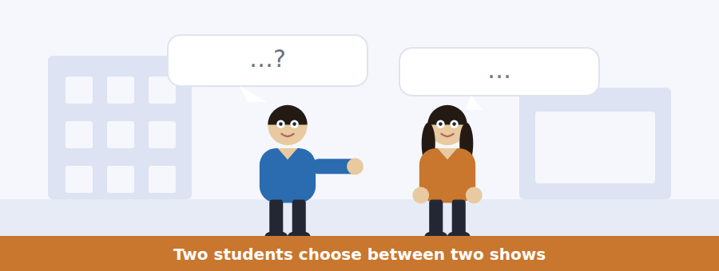
SKILL · Listen for the comparison
- When two speakers compare two things, the question will ask which one and why.
- Note the reason, not only the choice. Reasons are what get tested.
- Words like but, though, actually and the thing is signal the turning point.
- Decide and mark as you listen. In Listening there is no going back.

Exercise B Listen and answer. The audio plays once.
4. What are the speakers mainly discussing?
(A) Which show to book
(B) Which planetarium to visit
(C) How much student tickets cost
(D) When the astronomer is available
5. Why does the man prefer Saturday at first?
(A) It is cheaper
(B) It is shorter
(C) More of the group is free
(D) An astronomer is there
6. What does the woman say about the price?
(A) Saturday is too expensive for students
(B) The group rate makes price irrelevant
(C) Thursday is the cheapest show
(D) Student cards are not accepted
7. What is the real reason they choose Thursday?
(A) It is longer
(B) It is cheaper
(C) Half the group works at weekends
(D) The astronomer is busy
8. What does the woman mean when she says "Honestly, they answer"?
(A) The staff reply to emails
(B) The show answers his question
(C) The astronomer is honest
(D) He should ask in person
9. What will the man probably do about the telescope?
(A) Go on Saturday instead
(B) Ask during the show
(C) Nothing
(D) Write to the planetarium
Audio script: see the back of the book. Do not read it before you listen.


Exercise A Listen and choose a response. You hear one line. Choose the best reply.
1. Woman: What time does it start now?
(A) At the Mill Street entrance.
(B) It lasts an hour.
(C) Half past seven.
(D) Because of the roadworks.
2. Man: Do we still get the group rate?
(A) Fourteen of us.
(B) Yes, four dollars each.
(C) At the box office.
(D) It was confirmed last week.
3. Woman: Should I bring my student card?
(A) No need — you’re on the group list.
(B) It’s cheaper for students.
(C) I left mine at home.
(D) The card costs five dollars.
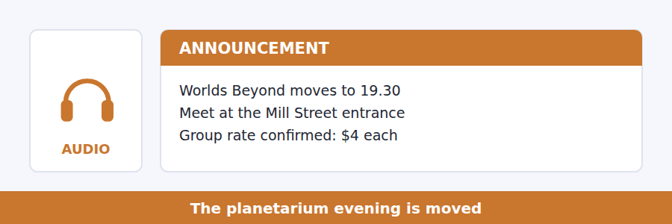
SKILL · Write the old detail beside the new one
- An announcement is usually a correction. Note what it replaces.
- Time, place, price, and what to bring — these four are tested almost every time.
- Listen past the change for the reason. Because and due to carry marks.
- The final instruction is nearly always a question.

Exercise B Listen and answer. The audio plays once.
4. What is the main purpose of the announcement?
(A) To cancel the visit
(B) To sell tickets
(C) To describe the show
(D) To give a new time and meeting point
5. Why has the start time changed?
(A) The group is larger
(B) The earlier screening ran over
(C) There are roadworks
(D) The astronomer is late
6. What time should the group meet?
(A) 6.45
(B) 7.00
(C) 7.15
(D) 7.30
7. Why is a student card not needed?
(A) The show is free
(B) The box office is closed
(C) Cards are not accepted
(D) Everyone is on one group list
8. Why must students say if they cannot come?
(A) The seats cost the society money
(B) The box office needs names
(C) The doors close early
(D) The group rate needs ten people
Audio script: see the back of the book. Do not read it before you listen.


Exercise A Listen and choose a response. You hear one line. Choose the best reply.
1. Man: Did you follow the part about parallax?
(A) It’s on the board.
(B) Not entirely — did you?
(C) At three o’clock.
(D) Yes, the lecture was long.
2. Woman: How far away is the nearest star?
(A) With a telescope.
(B) In 1995.
(C) About four light years.
(D) Yes, it’s very far.
3. Man: Can I borrow your notes?
(A) I took them in the lecture.
(B) They were about parallax.
(C) Of course — I’ll send a photo.
(D) The lecture is on Thursday.
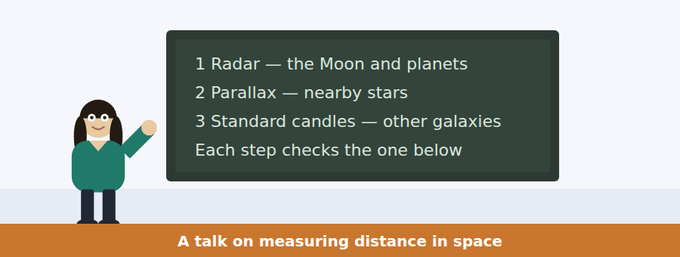
SKILL · Hear the structure before the detail
- A talk with numbered points on a board will follow those numbers. Use them as a frame.
- Each point usually gets a definition, an example and a limitation. Expect all three.
- The limitation of one method is almost always the reason for the next one.
- What the speaker says last is what the talk was for.

Exercise B Listen and answer. The audio plays once.
4. What is the main idea of the talk?
(A) Radar is the most accurate method
(B) Distance is measured by a ladder of methods that check each other
(C) Parallax was discovered before radar
(D) Astronomers disagree about distances
5. Why does the speaker ask students to hold up a thumb?
(A) To demonstrate parallax
(B) To show how small a star is
(C) To explain how radar works
(D) To compare two eyes
6. Why can radar not be used for stars?
(A) Stars are too bright
(B) Stars move too quickly
(C) Radar is not accurate enough
(D) The signal would be too weak when it returned
7. What is the limitation of parallax?
(A) It only works in summer
(B) It needs two telescopes
(C) It cannot be checked
(D) The shift becomes too small beyond a few thousand light years
8. What is a standard candle?
(A) A very bright star
(B) An object whose real brightness is known
(C) A unit of distance
(D) A type of telescope
9. What does the speaker mean by "the bottom rung"?
(A) The nearest galaxies
(B) The method used for the greatest distances
(C) The radar measurements everything else is checked against
(D) The oldest method in astronomy
Audio script: see the back of the book. Do not read it before you listen.


Part 1 · Listen and Repeat
You hear a sentence and repeat it once. There is no preparation time, and the sentences get longer. Focus: long numbers and units
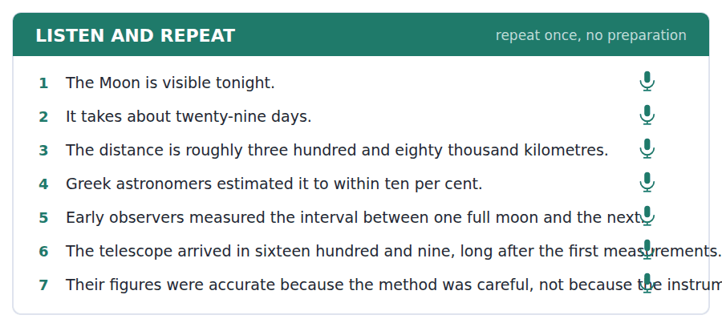
SKILL · Say the number, not the digits
- Practise groups: three hundred and eighty thousand, not three-eight-zero.
- Units matter. Kilometres, light years and per cent are all tested.
- Keep a steady speed. A number said slowly and correctly scores better than one rushed.
- If you misread a number, correct it and carry on — do not restart.

Part 2 · Take an Interview
An interviewer asks you four questions on one theme: the night sky where you live. Answer each one fully. There is no preparation time.
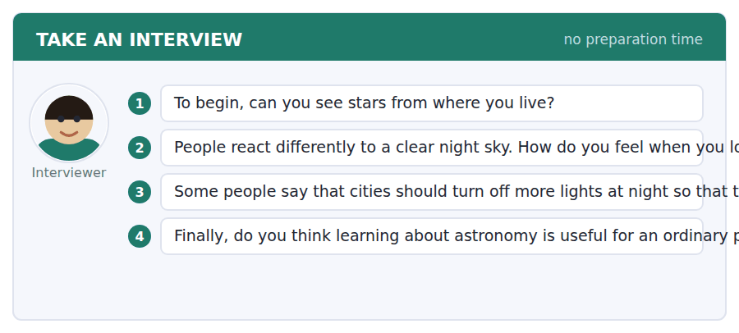
A good answer sounds like this
Question 1 — Not many. I live near the centre of the city, so I can usually see the Moon and maybe three or four stars, and that is all.
Question 3 — I do agree, partly. It would save energy as well as showing the sky, so there are two reasons rather than one.
I can… | Not yet | Yes
I said long numbers in groups, not digit by digit | □ | □
I began speaking without a long pause | □ | □
I gave a reason after every opinion | □ | □


Part 1 · Listen and Repeat
You hear a sentence and repeat it once. There is no preparation time, and the sentences get longer. Focus: comparing two options out loud
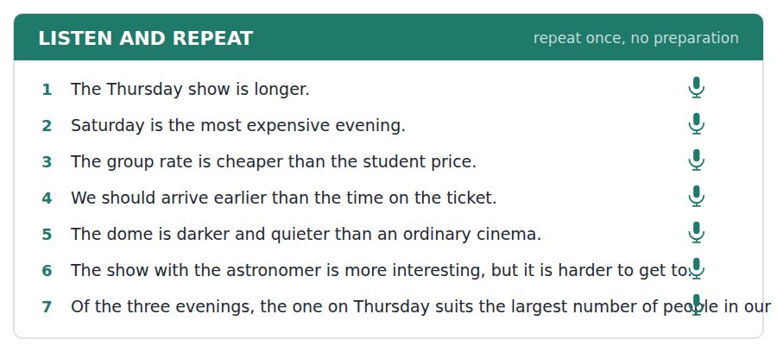
SKILL · Compare, then choose
- Say both sides before you choose: one is cheaper, but the other is longer.
- Use the comparative forms from this unit: more expensive, the most useful.
- Then commit: In the end I would choose… because…
- Do not list three reasons badly. Give one reason well.

Part 2 · Take an Interview
An interviewer asks you four questions on one theme: whether space travel interests you. Answer each one fully. There is no preparation time.
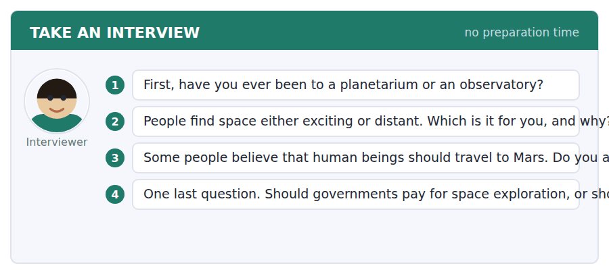
A good answer sounds like this
Question 2 — Exciting, definitely. I know it is far away, but that is exactly what I like about it — it makes ordinary problems feel smaller.
Question 4 — I think governments should, because a private company has to make money and some research will never make any.
I can… | Not yet | Yes
I gave both sides before I chose | □ | □
I used at least two comparative or superlative forms | □ | □
I finished every sentence I started | □ | □


Part 1 · Listen and Repeat
You hear a sentence and repeat it once. There is no preparation time, and the sentences get longer. Focus: academic register
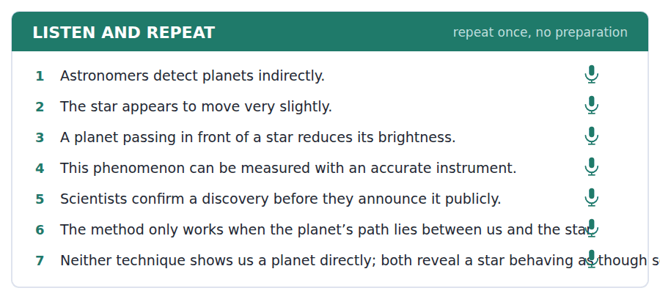
SKILL · Borrow the passage’s own words
- Use this unit’s academic set: estimate, detect, confirm, approximate, phenomenon.
- Explain a method in steps: first…, then…, which means that…
- The fourth question is the most abstract. Give an opinion, a reason and one example.
- Mark yourself against the three statements below.

Part 2 · Take an Interview
An interviewer asks you four questions on one theme: whether governments should fund science. Answer each one fully. There is no preparation time.
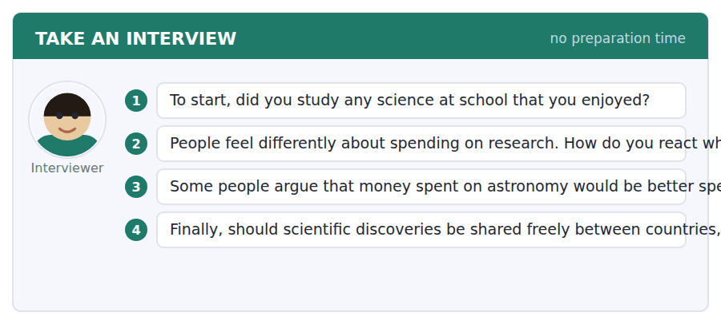
A good answer sounds like this
Question 3 — I understand the argument, but I do not agree. One reason is that the instruments built for astronomy end up being used in hospitals.
Question 4 — They should be shared. A discovery that is kept secret is only useful once, and a discovery that is shared is useful everywhere.
I can… | Not yet | Yes
I used at least three academic words from this unit | □ | □
I explained one idea in steps (first…, then…) | □ | □
My last answer had an opinion, a reason and an example | □ | □


You see a sentence, then a set of words in boxes. Put the words in order to make one grammatical sentence. Almost every item in the real test makes a question or a question inside another sentence.
SKILL · Find the comparison word first
- If a tile says more, less, -er or the most, the sentence is a comparison. Build around it.
- How far, how long, how much and which are the question words this unit uses.
- Than always follows a comparative. The most and the -est take the before them.
- Use every tile once. A leftover tile means a wrong order.

Exercise A Guided practice. The first three are worked through.
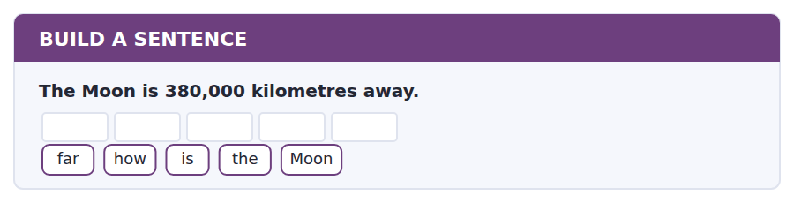
1. How far is the Moon?
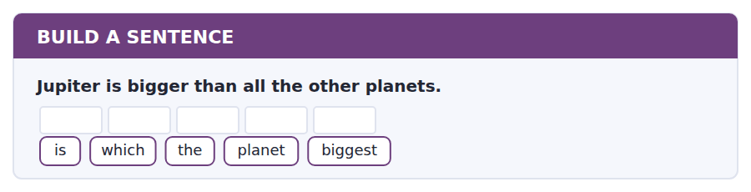
2. Which is the biggest planet?
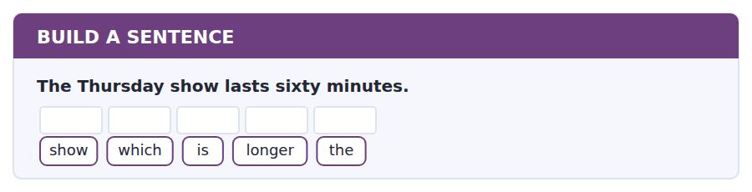
3. Which is the longer show?
Exercise B Exam practice. Write the sentence.
4. Saturday costs fourteen dollars.
much / how / does / cost / Saturday
__________________________________________________________
5. Parallax stops working after a few thousand light years.
does / how / far / parallax / work
__________________________________________________________
6. Radar is more accurate than parallax.
which / is / more / method / accurate
__________________________________________________________
7. The first planet was found in 1995.
the / when / was / first / found / planet
__________________________________________________________
8. The star that moves is the one with a planet.
the / star / that / moves / has / a / planet
__________________________________________________________
9. The drop in brightness is less than one per cent.
is / how / big / the / drop
__________________________________________________________
10. Five thousand planets are known today.
planets / how / many / are / known
__________________________________________________________


You read a short situation and write an email. You have 7 minutes. The three bullet points are the mark scheme: answer all three.
You are the secretary of your university astronomy society. Fourteen members want to see Worlds Beyond on Thursday 9 October, and the programme says that groups of ten or more pay a group rate.
Write an email to the box office to make the booking.
- Say who you are and what you want to book.
- Give the numbers the box office needs.
- Ask about one thing the programme does not tell you.
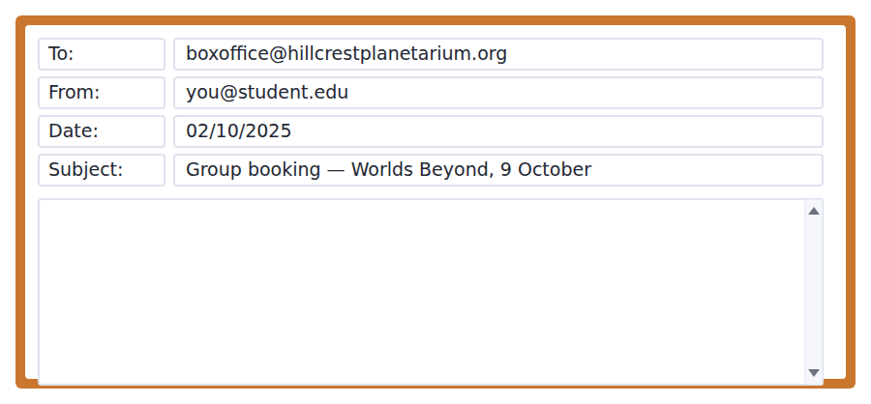
SKILL · Put the facts where they can be seen
- A booking email is read quickly. Put the date, the show and the number on their own line or in their own sentence.
- Do not apologise or explain at length. Say what you want.
- One question only, and make it a question the reader can answer in one line.
- Seven minutes is 110–140 words. Count once, in practice, so you know the feel.

Model email
Dear Box Office,
I am writing on behalf of the Hillcrest University Astronomy Society. We would like to book Worlds Beyond on Thursday 9 October at seven o’clock.
There will be fourteen of us: twelve students and two members of staff. As this is more than ten, I believe we qualify for the group rate of four dollars each, which would come to fifty-six dollars in total. Please tell me if that is not correct.
One thing the programme does not say: is there anywhere inside the building where a group can leave bags during the show? Several of us will be coming straight from a laboratory session.
I look forward to hearing from you.
Kind regards,
Kwame Osei, Secretary
Why it works
- The show, the day and the time are all in the first short paragraph, where a busy reader will find them.
- The numbers paragraph does the arithmetic for the reader and invites a correction.
- The question is specific and answerable in one line, and the reason for asking is given.
- The register is polite but not elaborate — which is exactly what seven minutes allows.
Now write your own. 7 minutes.
__________________________________________________________
__________________________________________________________
__________________________________________________________
__________________________________________________________
__________________________________________________________
__________________________________________________________
__________________________________________________________
__________________________________________________________


A professor asks a question and two students answer. You add your own post. You have 10 minutes and an effective answer is at least 100 words.
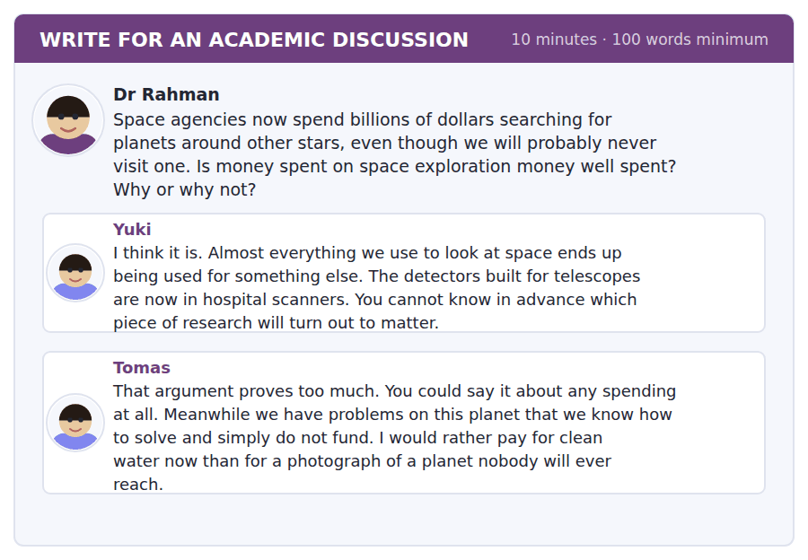
SKILL · Answer the strongest post, not the easiest one
- Take on whichever post you find hardest to argue with. That is where the marks are.
- Name the student. It shows the rater you read the thread.
- Add one idea neither post contains — agreeing twice earns nothing.
- At least 100 words. Six or seven sentences at this level.

Sentence starters
- Tomas is right that…, but I think he underestimates…
- Yuki’s point about… is the strongest one here, because…
- Both posts assume that… In fact,…
- I would put it differently:…
Model post
Tomas makes the stronger argument, and I want to answer it directly rather than repeat what Yuki said.
He is right that the research argument proves too much on its own. But there is a difference between spending we could redirect and spending we actually would. Clean water is not short of money because of telescopes; it is short of money because of politics. Cancelling the telescope would not build a single well.
I would add something neither post mentions. The search for other planets has already changed how people think about this one. Before 1995 we had no idea whether our system was ordinary or rare. Knowing that planets are everywhere, and that none of the nearby ones look habitable, makes the argument for looking after this planet stronger, not weaker.
[152 words]
Now write your own. 10 minutes, at least 100 words.
__________________________________________________________
__________________________________________________________
__________________________________________________________
__________________________________________________________
__________________________________________________________
__________________________________________________________
__________________________________________________________
__________________________________________________________
__________________________________________________________
__________________________________________________________

Grammar focus Comparatives and superlatives
Form | Example
Short adjective + -er / -est | bright → brighter → the brightest
-y → -ier / -iest | heavy → heavier → the heaviest
Long adjective: more / the most | accurate → more accurate → the most accurate
Irregular | good → better → the best; bad → worse → the worst
than after a comparative | Radar is more accurate than parallax.
the before a superlative | Saturday is the most expensive evening.
Comparing amounts | more light · less light · fewer planets

One syllable takes -er. Three syllables take more. Two-syllable adjectives go both ways, but if it ends in -y it takes -ier.
Less goes with things you cannot count (less light, less time). Fewer goes with things you can (fewer planets, fewer seats). The test does check this.
A comparative needs something to compare with, even when it is not spoken: Thursday is longer [than Saturday].
Watch out! Never write *more brighter* or *the most brightest*. Use one form or the other, never both.
Exercise 1 Write the comparative and the superlative.
1. far → __________ → __________
2. accurate → __________ → __________
3. heavy → __________ → __________
4. good → __________ → __________
5. visible → __________ → __________
6. large → __________ → __________
Exercise 2 Complete with less or fewer.
1. There are __________ stars visible from the city.
2. The dome lets in __________ light than a cinema.
3. __________ people came on Thursday than on Saturday.
4. The second method needs __________ patience, not more.
Exercise 3 Correct the mistake in each sentence.
1. Saturday is the most expensivest evening.
2. Radar is more accurate that parallax.
3. This telescope is more big than that one.
How this is tested in Build a Sentence
Build a Sentence uses comparison inside questions: Which is the biggest planet? How much does Saturday cost? Notice that a which question about the subject needs no auxiliary at all.

Unit review and progress check Unit 2
Exercise A Vocabulary. Write the word.
1. to say about how much or how many
2. exact in every detail
3. to notice something hard to see
4. able to be seen
5. the smallest possible amount
6. extremely large
7. to show that something is true
8. an idea you test to see if it is true
9. something people notice and study
10. the time between two events
11. a lower price for several people together
12. money given back to you
Exercise B Grammar. Complete the sentence.
1. Radar is __________ (accurate) than parallax.
2. Saturday is __________ (expensive) evening of the three.
3. There are __________ (few) stars visible in the city.
4. The dome is __________ (dark) than a cinema.
5. Which method is __________ (good) for nearby stars?
6. That was __________ (bad) show I have ever seen.
7. This instrument needs __________ (little) patience, not more.
8. The Moon is __________ (close) object in space.
Exercise C One timed mini-section. 6 minutes.
1. According to the passage on page 34, the first planet around an ordinary star was found by
(A) watching the star move
(B) photographing it directly
(C) measuring the star’s temperature
(D) radar
2. In the talk, radar cannot be used for stars because
(A) the signal would come back too weak
(B) stars are too bright
(C) stars move too fast
(D) radar is not accurate
3. Which sentence is correct?
(A) Saturday is more expensiver.
(B) There are less seats on Thursday.
(C) It is the most brightest star.
(D) Radar is more accurate than parallax.
4. The group rate at the planetarium applies to groups of
(A) five or more
(B) eight or more
(C) ten or more
(D) fifteen or more
5. In Complete the Words, an ending of three dashes after a verb stem is most likely
(A) -ed
(B) -ing
(C) -est
(D) -er
6. The first questions in an adaptive module matter most because
(A) they are the easiest
(B) they are worth more marks
(C) they decide the level of what comes next
(D) they cannot be changed
Can you do these now?
I can… | Not yet | Yes
complete word endings in a short text about observation and measurement | □ | □
find times, prices and changes in a programme listing and a booking email | □ | □
follow an academic passage that explains a method, not just a fact | □ | □
understand a conversation in which two people compare two options | □ | □
compare two things out loud without preparing what to say | □ | □
write an email asking about a group booking, and a post weighing costs against benefits | □ | □

ADAPTIVE TIP The first questions in a module carry the most weight, because they are what places you. Never rush them to save time for later ones — the later ones are chosen on the strength of how you answered the early ones.

Unit 3 · Cells and Genetics
TOEFL iBT® Preparation Course 2026 · Volume 1
CEFR B1 · Grammar: The present passive · Word field: structure, function, inheritance
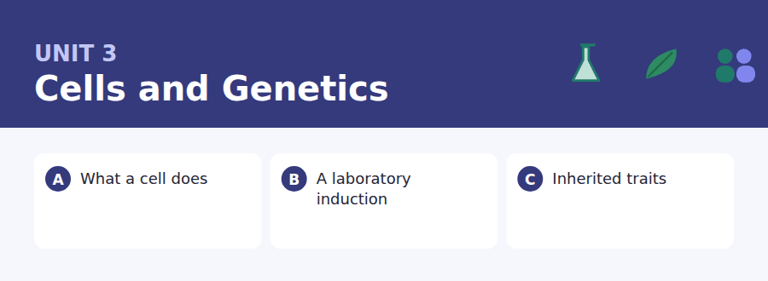
By the end of this unit I can…
- complete word endings in a text that describes how something works
- read a safety notice and an induction email for the one rule that applies to me
- follow an academic passage that explains why something happens
- understand two students sorting out a timetable problem
- describe a process out loud using the passive
- write an email asking to rearrange something, and a post that answers an objection

Science writing uses the passive constantly, because what matters is what is done, not who does it. That is why the passive is this unit’s grammar.

Vocabulary 1 · Academic 24 words from the Academic Word List
These twenty-four words come back through the whole unit, and again in the review. Cover the right-hand column and test yourself.
structure the way the parts of something are arranged | derive to come from, or to get from
function the job that something does | distinct clearly different from other things
component one part of a larger thing | identical exactly the same
element one of the basic parts of something | vary to be different in different cases
complex made of many connected parts | similar almost the same
process a series of actions that produce a result | consist to be made of (consist of)
generate to produce or make | comprise to be made up of
generation all the people born at about the same time | feature a noticeable part or quality
inherent existing as a natural part of something | mechanism the way a thing works, part by part
chemical connected with substances and how they react | specify to say exactly which or what
react to change when mixed with another substance | isolate to separate one thing from the rest
transmit to pass something from one place or person to another | trace to follow something back to where it began

Exercise A Work in pairs. Ask and answer.
1. Name two things in your body that have a clear function. What are they?
2. Are you more similar to one parent than the other? In what way?
3. Think of a complex machine you use. What are its main components?
4. What is one feature of your home town that visitors always notice?
Vocabulary 2 · Campus and everyday 12 words for the daily-life tasks
The exam does not only test academic English. Notices, emails, conversations and announcements use the everyday words below.
laboratory a room for scientific work | safety rules instructions that keep people from being hurt
induction a first meeting that teaches you the rules | technician a person who looks after equipment
goggles glasses that protect the eyes | slot a short period of time set aside for something
lab coat a white coat worn in a laboratory | swap to exchange one thing for another
bench a long work table in a laboratory | hand in to give work to a teacher
sample a small amount taken for testing | make-up session a replacement class for one you missed

Words you will meet again: structure | process | significant | estimate | detect | vary | identify | confirm


SKILL · Watch for passive endings
- In a science text the gap is often -ed on a passive verb: is used, are carried.
- A gap right after is, are, was or were is almost certainly a past participle.
- Noun endings are common too: -ion, -ment, -ance. Count the dashes.
- Read on past the gap. The rest of the sentence often names the ending for you.

Exercise A Guided practice. Five words are not complete. Write the missing letters.
A cell is the small--- living thing there is. Everything a body does is done inside cells: food is brok-- down, energy is relea---, and waste is carr--- away. A single drop of blood holds about five mill--- of them.

The first one is done for you: 1 small--- → est (smallest)
Exercise B Exam practice. One paragraph, ten gaps — the real task.
Every living thing is built from cells, and almost everything that keeps it alive hap---- inside them. A cell is not a simple bag. It cont---- dozens of separate structures, each with its own funct---. Energy is gener---- in one place, proteins are assem---- in another, and waste is bro--- down in a third. Instructions for all of this are st---- in the nucleus and are cop--- every time the cell divides. The remark---- thing is the scale. A human body contains roughly thirty trillion cells, and in a healthy adult about two million of them are repl---- every second.

Check your answers in the key at the back of the book.


SKILL · Find the rule that applies to you
- A safety notice has many rules but a question asks about one person. Match the person to the rule.
- Words like must, must not, may and only mark the testable sentences.
- An exception (except, unless, other than) is almost always the answer to something.
- In an email, a deadline and a consequence usually come as a pair.

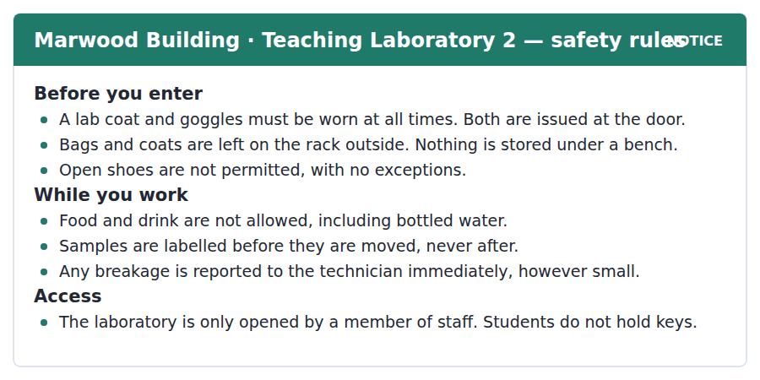
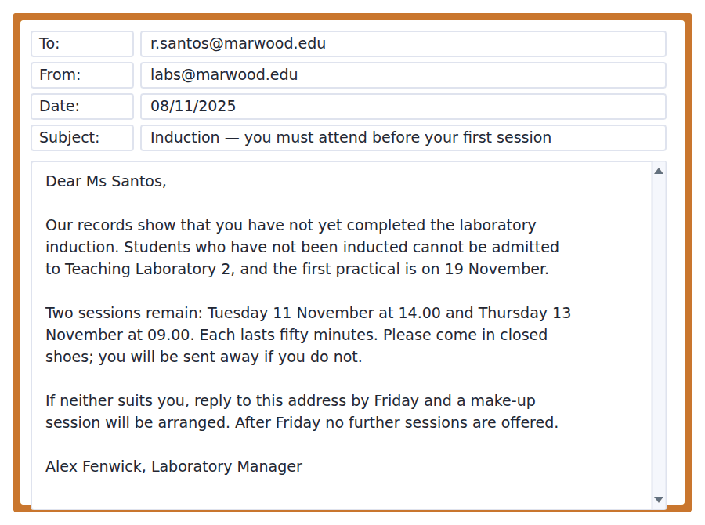
Exercise A Guided practice. The answer is on the page — find it.
1. Where are bags left?
(A) Under the bench
(B) At the technician’s desk
(C) In the corridor cupboard
(D) On the rack outside
2. What is issued at the door?
(A) Keys
(B) Samples
(C) A lab coat and goggles
(D) A safety sheet
3. When must a sample be labelled?
(A) After it is moved
(B) Before it is moved
(C) At the end of the session
(D) Only if it is dangerous
4. Who can open the laboratory?
(A) A member of staff
(B) Any student
(C) The first person to arrive
(D) A student with a key
Exercise B Exam practice.
5. What is the main purpose of the email?
(A) To cancel a practical
(B) To offer a new course
(C) To change a laboratory
(D) To warn that an induction is still needed
6. What will happen if Ms Santos attends no induction?
(A) She cannot attend the practical on 19 November
(B) She will be fined
(C) She must repeat the module
(D) She will be given a key
7. How long does an induction session last?
(A) Thirty minutes
(B) One hour
(C) Fifty minutes
(D) Two hours
8. Why does the email mention closed shoes?
(A) They are more comfortable
(B) Students in open shoes are sent away
(C) They are issued at the door
(D) They are cheaper
9. What should Ms Santos do if neither date is possible?
(A) Go to the laboratory anyway
(B) Ask another student to go
(C) Reply by Friday
(D) Wait for the next term
10. Which of these is allowed in the laboratory?
(A) A labelled sample
(B) A bottle of water
(C) A bag under the bench
(D) Open shoes


SKILL · Spot the wrong idea and the right one
- Many academic passages open with a belief that turns out to be wrong. Mark it.
- The paragraph that follows usually gives the evidence that replaced it.
- An EXCEPT question wants the one statement the passage does not support. Tick off the three it does.
- Dates in the final paragraph are often tested as a sequence, not as facts.

Why Children Resemble Their Parents
Everybody notices family resemblance, and for most of history nobody could explain it. The common belief was that the qualities of the two parents were simply mixed, like two colours of paint. That idea has an obvious problem. If characteristics were blended, every generation would be more similar than the one before it, and after a few hundred years everyone would be alike. Plainly that does not happen.
The answer came from a monastery garden. In the 1860s Gregor Mendel grew thousands of pea plants and counted what he got. He found that a trait which disappeared in one generation could return, unchanged, in the next. A tall plant crossed with a short one did not give a medium plant; it gave a tall one. But when those plants were crossed with each other, short plants reappeared, in a predictable proportion. Characteristics, in other words, are not blended. They are passed on as separate units, and some of them are simply hidden when a stronger version is present.
Mendel’s work was ignored for thirty-four years. When it was rediscovered in 1900, biologists already had microscopes good enough to see what he had only inferred: structures inside the cell that are copied and divided in exactly the pattern his numbers predicted. It is a rare case in science of a theory waiting, fully formed, for the instrument that would confirm it.
[275 words]

Exercise A Guided practice.
1. What is the passage mainly about?
(A) How Mendel grew pea plants
(B) Why microscopes were invented
(C) The history of monasteries
(D) How characteristics are actually passed on
2. According to paragraph 1, what was the problem with the blending idea?
(A) It could not be tested
(B) It would make everyone alike over time
(C) It was invented by Mendel
(D) It only applied to plants
3. The word "blended" in paragraph 2 is closest in meaning to
(A) passed on
(B) counted
(C) hidden
(D) mixed together
4. Why does the author mention a tall plant and a short one?
(A) To show that height is unimportant
(B) To show that traits are not blended
(C) To explain how peas grow
(D) To describe Mendel’s garden
Exercise B Exam practice.
5. According to paragraph 2, what happened when the tall plants were crossed with each other?
(A) Short plants reappeared
(B) All the offspring were tall
(C) Medium plants appeared
(D) The plants did not grow
6. All of the following are true about Mendel EXCEPT:
(A) He worked with pea plants
(B) He counted his results
(C) He used a microscope to see the structures
(D) His work was ignored for years
7. The word "inferred" in paragraph 3 is closest in meaning to
(A) measured exactly
(B) worked out without seeing
(C) described in writing
(D) disagreed with
8. How long was Mendel’s work ignored?
(A) Thirty-four years
(B) Thirty years
(C) Forty years
(D) A hundred years
9. What can be inferred about biology in 1900?
(A) It had rejected Mendel
(B) It no longer used microscopes
(C) It had better instruments than in the 1860s
(D) It had proved the blending theory
10. What does the author find unusual about this case?
(A) A monk made a scientific discovery
(B) Peas were used instead of animals
(C) The results were counted
(D) A theory existed before the instrument that could confirm it
11. Which best states the main idea of paragraph 2?
(A) Peas are easy to grow
(B) Tall plants are more common
(C) Traits are passed on as separate units
(D) Mendel worked in a garden


Exercise A Listen and choose a response. You hear one line. Choose the best reply.
1. Woman: Have you done your lab induction yet?
(A) It’s in Marwood Building.
(B) Fifty minutes.
(C) Yes, it was a good practical.
(D) Not yet — I keep missing it.
2. Man: Which session are you going to?
(A) The Thursday one.
(B) At nine o’clock in the morning.
(C) Because I have a lecture.
(D) With Alex Fenwick.
3. Woman: I’ve got a seminar at the same time.
(A) It lasts fifty minutes.
(B) Can’t you swap?
(C) Yes, I’ve done mine.
(D) The seminar is interesting.
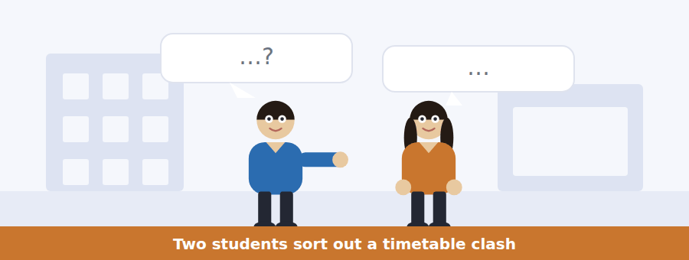
SKILL · Follow who does what
- A conversation about arrangements is full of names and times. Keep them straight.
- Listen for the obstacle. There is usually one thing that makes the plan hard.
- A suggestion often comes as a question: why don’t you…? couldn’t you…?
- The last two lines usually settle it. Do not stop listening early.

Exercise B Listen and answer. The audio plays once.
4. What is the woman’s problem?
(A) She did not receive the email
(B) She has lost her lab coat
(C) Neither session fits her timetable
(D) The practical has been cancelled
5. Why did the woman think she had already been inducted?
(A) She read the wrong email
(B) A friend told her
(C) She has a key to the laboratory
(D) She attended the chemistry induction
6. Why can the woman not attend on Thursday?
(A) She arrives on a later train
(B) She has a seminar
(C) She is away that week
(D) The session is full
7. What does the man advise her to do?
(A) Go to Tuesday’s session anyway
(B) Ask for a make-up session
(C) Speak to her seminar tutor
(D) Wait until next term
8. What happens if she does not reply by Friday?
(A) She pays a fee
(B) She misses the practical on the nineteenth
(C) She joins a later group
(D) She repeats the module
9. What does the woman mean when she says "before I forget again"?
(A) She has a bad memory for dates
(B) She will write it in her diary
(C) She does not want to go
(D) She has forgotten this before
Audio script: see the back of the book. Do not read it before you listen.


Exercise A Listen and choose a response. You hear one line. Choose the best reply.
1. Man: Where do we get the goggles now?
(A) Everyone must wear them.
(B) Because of the new rule.
(C) They’re issued at the door.
(D) Yes, they’re compulsory.
2. Woman: Can I take a small bag in?
(A) No bags at all, I’m afraid.
(B) It’s on the rack.
(C) Mine is quite small.
(D) The lab opens at nine.
3. Man: What do I do if I break something?
(A) It was an accident.
(B) The glass is expensive.
(C) Nothing is stored under a bench.
(D) Tell the technician straight away.
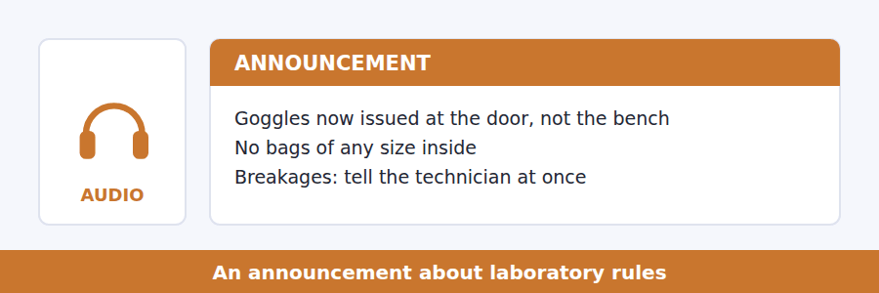
SKILL · Hear the rule and its exception
- Rules in announcements almost always have one exception. Listen for except, unless, other than.
- A rule that changes is more testable than a rule that stays. Note both versions.
- Numbers attached to rules (sizes, times, amounts) are nearly always asked about.
- The reason for a rule is often given once, quickly. Catch it the first time.

Exercise B Listen and answer. The audio plays once.
4. What is the main purpose of the announcement?
(A) To cancel a practical
(B) To introduce the technician
(C) To explain three changes to the rules
(D) To describe the equipment
5. Why are goggles now issued at the door?
(A) Students reached their bench without them
(B) The benches are full
(C) They are cheaper to store there
(D) The technician asked for it
6. What is said about the lockers?
(A) They cost a small fee
(B) They need a coin, which is given back
(C) They are only for large bags
(D) They are inside the laboratory
7. Why must even a small breakage be reported?
(A) To replace the equipment
(B) Because glass you cannot see is more dangerous
(C) To record who caused it
(D) Because the technician must clean it
8. What is the one exception to the no-drink rule?
(A) Water needed for medication
(B) Water during a long session
(C) Hot drinks before the session
(D) There is no exception
Audio script: see the back of the book. Do not read it before you listen.


Exercise A Listen and choose a response. You hear one line. Choose the best reply.
1. Woman: How long does the whole process take?
(A) In the nucleus.
(B) Four stages.
(C) About twenty-four hours.
(D) Yes, it’s complicated.
2. Man: Is the copy always perfect?
(A) It is copied every time.
(B) In the second stage.
(C) Thirty trillion cells.
(D) Almost, but not quite.
3. Woman: I didn’t catch the third stage.
(A) It’s on the board.
(B) Neither did I.
(C) They are pulled apart.
(D) Yes, four stages.
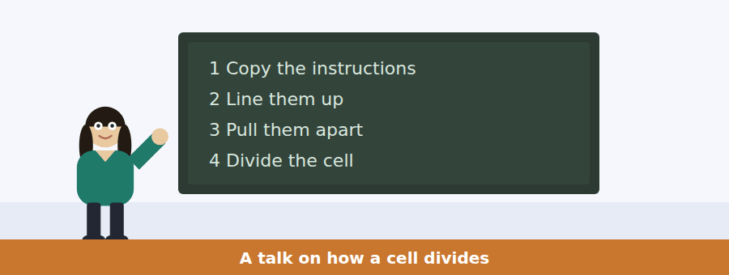
SKILL · Use the stages on the board
- When a talk numbers its stages, each number will get one chunk of the audio.
- Listen for what can go wrong at each stage. That is where the questions are.
- A speaker who says the important thing is or what I want you to notice is handing you the main idea.
- The final sentence often points forward to the next lecture.

Exercise B Listen and answer. The audio plays once.
4. What is the main idea of the talk?
(A) Cells divide in four stages
(B) Checking between stages is what makes copying accurate
(C) Two million cells are replaced every second
(D) Mistakes in copying are common
5. Which stage takes the longest?
(A) Copying the instructions
(B) Lining them up
(C) Pulling them apart
(D) Dividing the cell
6. What happens if one set is not properly attached?
(A) The cell divides anyway
(B) The copy is discarded
(C) The cell starts again from stage one
(D) The process stops and waits
7. Why does the speaker mention two million cells a second?
(A) To show how fast cells move
(B) To explain how long division takes
(C) To compare humans with plants
(D) To show how much copying a body does
8. How often does a mistake get through?
(A) Never
(B) About one in a billion
(C) About one in a million
(D) Every second
9. What will the speaker most likely discuss next week?
(A) The four stages again
(B) How microscopes work
(C) What happens when a mistake gets through
(D) How plants divide
Audio script: see the back of the book. Do not read it before you listen.


Part 1 · Listen and Repeat
You hear a sentence and repeat it once. There is no preparation time, and the sentences get longer. Focus: consonant clusters in science words
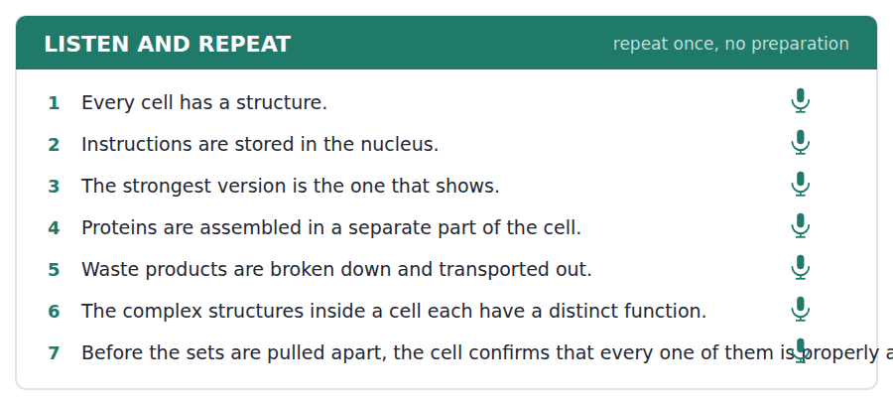
SKILL · Slow the cluster, not the sentence
- Words like structure, instructions and strongest have three consonants together. Say each one.
- Do not add a vowel: it is structure, not sut-ructure.
- Keep the sentence rhythm normal. Only the cluster slows.
- Finish the sentence even if one word comes out wrong.

Part 2 · Take an Interview
An interviewer asks you four questions on one theme: science at your school. Answer each one fully. There is no preparation time.
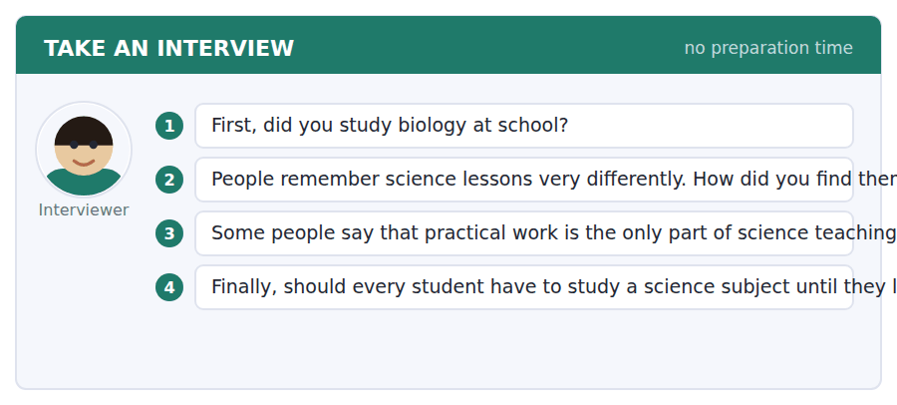
A good answer sounds like this
Question 2 — I enjoyed the practicals and disliked everything else, which is probably because I only understood things once I had done them.
Question 4 — I think they should. Not to make scientists, but so that everyone can read a news story about health and know what a study is.
I can… | Not yet | Yes
I said consonant clusters without adding an extra vowel | □ | □
I kept a normal sentence rhythm | □ | □
I answered the question that was asked | □ | □


Part 1 · Listen and Repeat
You hear a sentence and repeat it once. There is no preparation time, and the sentences get longer. Focus: the passive in speech
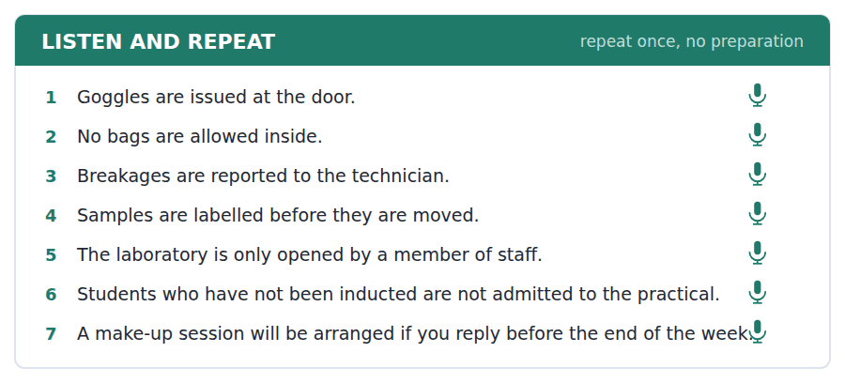
SKILL · Use the passive to describe a system
- Rules and procedures are described in the passive: coats are issued, samples are labelled.
- This is not formal English for its own sake — it is shorter, because you leave out who.
- Mix it with the active, or you will sound like a notice.
- Say what is done first, then who does it, only if it matters.

Part 2 · Take an Interview
An interviewer asks you four questions on one theme: rules where you study or work. Answer each one fully. There is no preparation time.
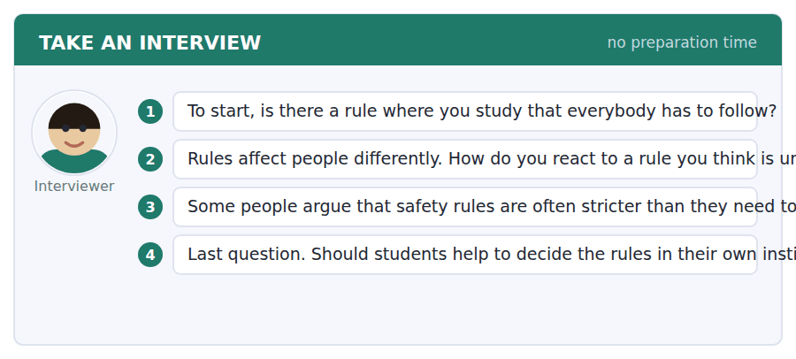
A good answer sounds like this
Question 2 — I usually follow it and complain afterwards, because arguing at the door never works. But I do think somebody should ask why it exists.
Question 3 — Not in a laboratory, no. One reason is that the person who writes the rule has usually seen the accident that caused it.
I can… | Not yet | Yes
I used at least three passive forms | □ | □
I also used some active sentences | □ | □
I gave one clear reason, not three weak ones | □ | □


Part 1 · Listen and Repeat
You hear a sentence and repeat it once. There is no preparation time, and the sentences get longer. Focus: academic register
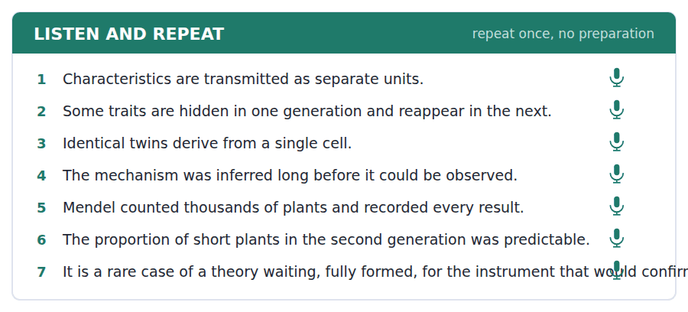
SKILL · Explain a finding, not an opinion
- Use this unit’s words: derive, vary, identical, transmit, mechanism.
- Say what was found, then what it means: Mendel found that…, which shows that…
- Hedge where you should: it seems that, the evidence suggests.
- Use the self-check below before you listen to your recording.

Part 2 · Take an Interview
An interviewer asks you four questions on one theme: whether science should be compulsory. Answer each one fully. There is no preparation time.
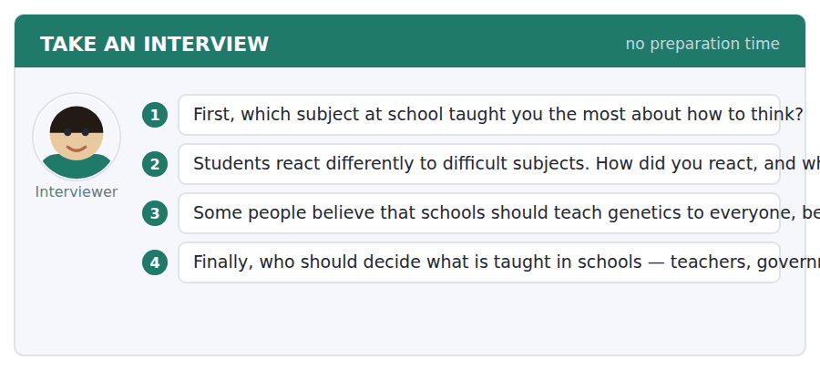
A good answer sounds like this
Question 3 — I agree with that. The evidence suggests people will be offered genetic tests in ordinary medicine, and you cannot consent to something you do not understand.
Question 4 — Teachers, mainly. One reason is that they are the only group that sees what actually works in a classroom.
I can… | Not yet | Yes
I used at least three academic words from this unit | □ | □
I separated the finding from my opinion about it | □ | □
I hedged where I was not certain | □ | □


You see a sentence, then a set of words in boxes. Put the words in order to make one grammatical sentence. Almost every item in the real test makes a question or a question inside another sentence.
SKILL · Build the passive question
- A passive question needs is or are in front of the subject: How is it done?
- If a tile says is, are, was or were, look for a past participle to pair with it.
- An indirect question keeps the normal order: Do you know how it is done?
- Use every tile. A tile left over means the order is wrong.

Exercise A Guided practice. The first three are worked through.
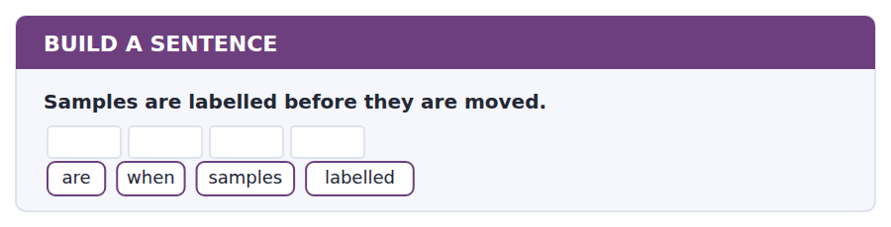
1. When are samples labelled?
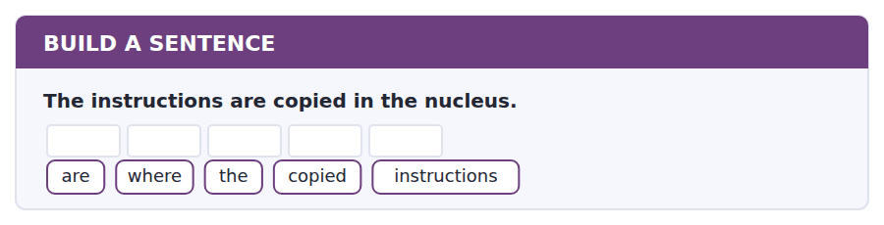
2. Where are the instructions copied?
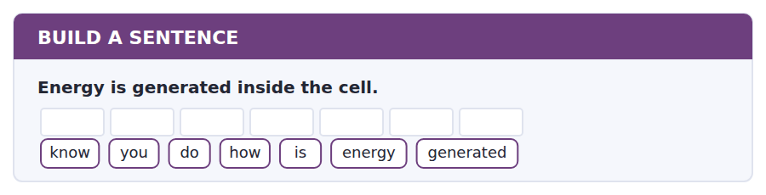
3. Do you know how energy is generated?
Exercise B Exam practice. Write the sentence.
4. Goggles are issued at the door.
are / where / goggles / issued
__________________________________________________________
5. The laboratory is opened by a member of staff.
the / who / is / laboratory / opened / by
__________________________________________________________
6. Two million cells are replaced every second.
many / how / cells / are / replaced
__________________________________________________________
7. A make-up session will be arranged if you reply.
tell / can / you / me / whether / a / session / will / be / arranged
__________________________________________________________
8. The work that Mendel did was ignored for years.
the / work / that / Mendel / did / was / ignored / for / years
__________________________________________________________
9. Breakages are reported to the technician.
are / to / whom / breakages / reported
__________________________________________________________
10. The process stops when something is not attached.
know / do / you / why / the / process / stops
__________________________________________________________


You read a short situation and write an email. You have 7 minutes. The three bullet points are the mark scheme: answer all three.
You have been told that you must attend a laboratory induction before your first practical on 19 November. Neither of the two remaining sessions is possible for you: Tuesday at 14.00 clashes with a seminar, and you cannot reach the campus before 9.30 on a Thursday.
Write an email to the Laboratory Manager, Alex Fenwick.
- Explain which sessions you cannot attend and why.
- Ask for a make-up session.
- Say what you can do to make it easy to arrange.
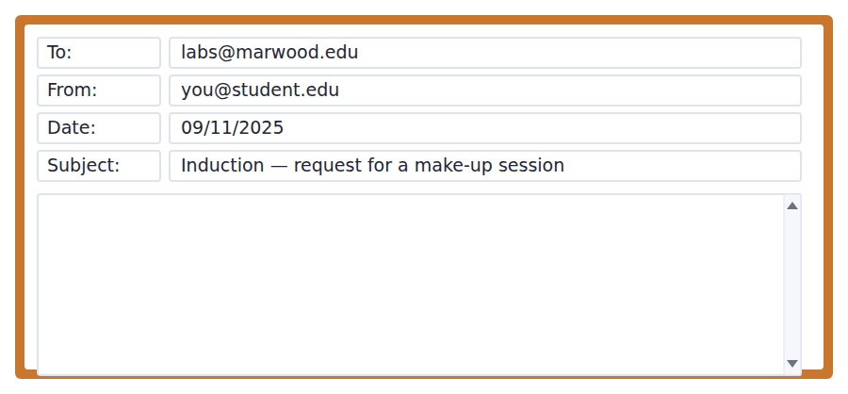
SKILL · Give the reason before the request
- A reader says yes more readily when the reason comes first.
- Be exact about times. Tuesday at 14.00, not Tuesday afternoon.
- Offer something: your free times, a willingness to come early.
- Keep it to three short paragraphs — one per bullet.

Model email
Dear Mr Fenwick,
Thank you for your email about the laboratory induction. Unfortunately neither of the remaining sessions is possible for me. Tuesday at 14.00 is my statistics seminar, which is compulsory, and on Thursdays I travel in by train and do not reach the campus until 9.30, half an hour after the session begins.
I am writing before Friday, as you asked, to request a make-up session. I am keen not to miss the practical on 19 November.
To make this as easy as possible, I am free all day on Monday and Wednesday, and after 11.00 on any other day. I am happy to join another group rather than have a session arranged for me alone.
Thank you for your help.
Kind regards,
Rosa Santos
Why it works
- The two clashes are given with exact times and exact reasons, so there is nothing left to ask.
- The request names the deadline the manager set, which shows the email was read.
- The third paragraph removes work from the reader — free times offered, and a willingness to join an existing group.
- Nothing is apologised for twice. One unfortunately is enough.
Now write your own. 7 minutes.
__________________________________________________________
__________________________________________________________
__________________________________________________________
__________________________________________________________
__________________________________________________________
__________________________________________________________
__________________________________________________________
__________________________________________________________


A professor asks a question and two students answer. You add your own post. You have 10 minutes and an effective answer is at least 100 words.
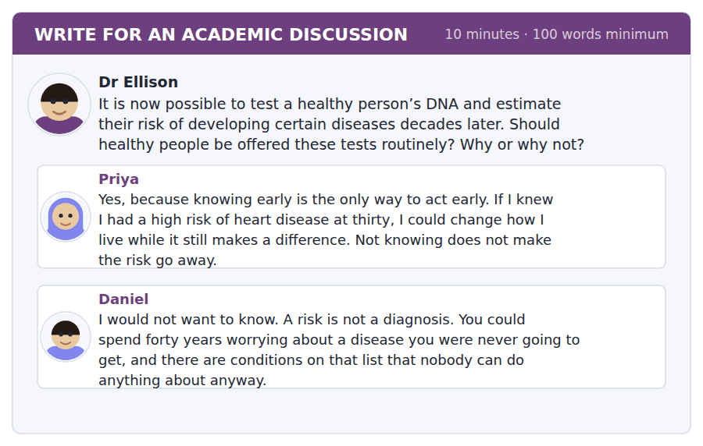
SKILL · Find the distinction nobody has made
- The best posts separate two things the others have treated as one.
- Here, for example: tests you can act on and tests you cannot.
- Name a classmate, make the distinction, then say what follows from it.
- At least 100 words, in ten minutes. Leave one minute to read it back.

Sentence starters
- Priya and Daniel are arguing about different cases:…
- Daniel is right that…, but that only applies to…
- The distinction I would draw is between… and…
- For that reason I would…
Model post
Priya and Daniel are arguing about two different kinds of test, and once you separate them the disagreement gets much smaller.
Daniel is right about conditions nobody can treat. Telling a healthy twenty-year-old that they may develop something untreatable at sixty gives them forty years of worry and nothing to do with it. But Priya is right about heart disease, because that risk responds to how you live. The difference is not how serious the disease is. It is whether the person can act.
So I would offer the tests, but not all of them routinely, and not without someone to explain what a risk actually means. A number on a page is not information until somebody tells you what it is a number of.
[148 words]
Now write your own. 10 minutes, at least 100 words.
__________________________________________________________
__________________________________________________________
__________________________________________________________
__________________________________________________________
__________________________________________________________
__________________________________________________________
__________________________________________________________
__________________________________________________________
__________________________________________________________
__________________________________________________________

Grammar focus The present passive
Form | Example
am / is / are + past participle | Goggles are issued at the door.
Negative | Bags are not allowed inside.
Question | Where are goggles issued?
With by (only if it matters) | The lab is opened by a member of staff.
Modal passive | Breakages must be reported at once.
In an indirect question | Do you know how energy is generated?
Common in science writing | Samples are labelled before they are moved.

Use the passive when who does the action is obvious, unknown or unimportant. In a laboratory notice everyone knows who issues the goggles, so nobody says it.
Add by only when the agent is news: opened by a member of staff tells you that students cannot.
The passive question puts is or are before the subject, exactly like any other question: Where are the samples kept?
Watch out! The passive needs the past participle, not the past simple. It is are issued, never *are issue*, and was broken, never *was broke*.
Exercise 1 Rewrite the sentence in the present passive.
1. A technician checks the equipment. → The equipment __________.
2. Students do not hold keys. → Keys __________ by students.
3. They label every sample. → Every sample __________.
4. Someone copies the instructions. → The instructions __________.
5. The university issues lab coats. → Lab coats __________.
6. Nobody allows food in the laboratory. → Food __________ in the laboratory.
Exercise 2 Write a passive question for each answer.
1. __________________? — At the door.
2. __________________? — By a member of staff.
3. __________________? — Before they are moved.
4. __________________? — About two million every second.
Exercise 3 One sentence in each pair is wrong. Correct it.
1. a) The samples are keep in the fridge. b) The samples are kept in the fridge.
2. a) Where are the goggles issued? b) Where the goggles are issued?
3. a) Breakages must reported at once. b) Breakages must be reported at once.
How this is tested in Build a Sentence
Build a Sentence often hides a passive inside an indirect question: Do you know how it is done? Keep the normal word order after know — it is done, not is it done.

Unit review and progress check Unit 3
Exercise A Vocabulary. Write the word.
1. the job that something does
2. one part of a larger thing
3. made of many connected parts
4. exactly the same
5. to be different in different cases
6. to pass from one place to another
7. the way a thing works, part by part
8. to separate one thing from the rest
9. to follow something back to its beginning
10. clearly different from other things
11. a first meeting that teaches you the rules
12. a replacement class for one you missed
Exercise B Grammar. Complete the sentence.
1. Goggles __________ (issue) at the door.
2. Bags __________ (not / allow) inside the building.
3. Where __________ the samples __________ (keep)?
4. Every breakage __________ (must / report) at once.
5. The instructions __________ (copy) before the cell divides.
6. Do you know how energy __________ (generate)?
7. The laboratory __________ (only / open) by a member of staff.
8. Short plants __________ (produce) in the second generation.
Exercise C One timed mini-section. 6 minutes.
1. According to the passage on page 50, the blending theory failed because
(A) it predicted everyone would become alike
(B) Mendel disproved it with peas
(C) it could not be tested
(D) microscopes showed something different
2. In the talk, the cell pauses before
(A) copying the instructions
(B) pulling the sets apart
(C) lining the sets up
(D) dividing in two
3. Which sentence is correct?
(A) The samples are keep in the fridge.
(B) Where the goggles are issued?
(C) The lab is open by a technician.
(D) Breakages must be reported at once.
4. A student who has not been inducted
(A) pays a fee
(B) works with a partner
(C) cannot attend the practical
(D) is given a key
5. In a Complete the Words paragraph, a gap directly after "are" is most likely
(A) a past participle
(B) a noun
(C) an adjective
(D) an adverb
6. In Reading you can use Back
(A) at any point in the section
(B) only in Module 2
(C) never
(D) inside one module only
Can you do these now?
I can… | Not yet | Yes
complete word endings in a text that describes how something works | □ | □
read a safety notice and an induction email for the one rule that applies to me | □ | □
follow an academic passage that explains why something happens | □ | □
understand two students sorting out a timetable problem | □ | □
describe a process out loud using the passive | □ | □
write an email asking to rearrange something, and a post that answers an objection | □ | □

ADAPTIVE TIP An easy question late in a module is not a trick. In an adaptive test the questions are chosen to match the level you have shown, so an easy one means the test has placed you — answer it carefully and move on rather than looking for a hidden catch.

Unit 4 · Climate and the Environment
TOEFL iBT® Preparation Course 2026 · Volume 1
CEFR B1 · Grammar: The first conditional · Word field: energy, resources, impact
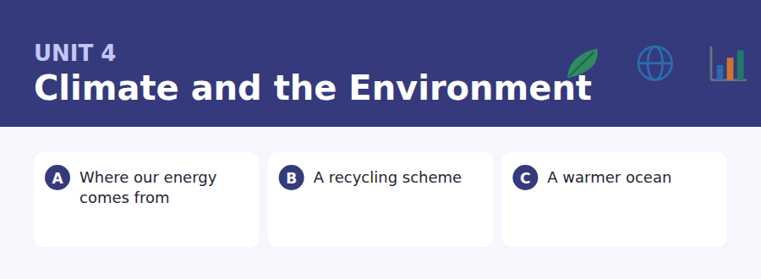
By the end of this unit I can…
- complete word endings in a text about energy and resources
- read a notice and a social media post for a rule and a consequence
- follow an academic passage that explains a delay, not just a change
- understand two people disagreeing about a practical arrangement
- talk about causes and consequences without preparing
- write an email asking for clarification, and a post that proposes something

Every text in this unit is about what follows from what. That is why the grammar is the conditional, and why the discussion asks you to predict.

Vocabulary 1 · Academic 24 words from the Academic Word List
These twenty-four words come back through the whole unit, and again in the review. Cover the right-hand column and test yourself.
resource something useful that a country or person has | restrict to keep something within limits
impact a strong effect on something | regulate to control something with rules
consume to use up fuel, energy or food | policy a plan of action agreed by a government or group
sustain to keep something going over time | scheme an organised plan to do something
environment the natural world around us | alternative another choice that could be used instead
available able to be used or obtained | sufficient enough
convert to change something into another form | considerable large enough to matter
release to let something out | eliminate to get rid of completely
output the amount a system produces | minimise to make as small as possible
cycle a set of events that repeat in the same order | stable not changing or moving
globe the whole world | fluctuate to go up and down irregularly
widespread found in many places | offset to balance one thing against another

Exercise A Work in pairs. Ask and answer.
1. Which resource does your country have most of? What impact does that have?
2. Name one thing you could eliminate from your week to consume less energy.
3. Has recycling in your area become more widespread in the last five years?
4. What would be a realistic alternative to the way you travel to school?
Vocabulary 2 · Campus and everyday 12 words for the daily-life tasks
The exam does not only test academic English. Notices, emails, conversations and announcements use the everyday words below.
bin a container for rubbish | tap water water from a tap, not a bottle
recycling treating used things so they can be used again | heating the system that keeps a building warm
compost rotted plant waste used on soil | light switch the switch that turns a light on and off
litter rubbish left in a public place | leaflet a small printed sheet of information
clean-up an organised event to clear rubbish | pledge a serious promise to do something
volunteer someone who works without being paid | drop-off point a place where you leave something

Words you will meet again: process | significant | estimate | vary | generate | transmit | component | confirm


SKILL · Use the word you already half-know
- You usually recognise the word before you can spell the ending. Trust that.
- Nouns made from verbs are common here: -ment, -tion, -ure.
- If the gap follows the or a, the missing letters finish a noun.
- Two endings that fit the dashes? The sentence decides, not the word.

Exercise A Guided practice. Five words are not complete. Write the missing letters.
Most of the electricity in the world is still made by burning something. Coal, gas and oil are bur--- to heat water, the steam turns a turb---, and the turbine gener---- electricity. The method is more than a hun---- years old and it wa---- about two thirds of the energy as heat.

The first one is done for you: 1 bur--- → ned (burned)
Exercise B Exam practice. One paragraph, ten gaps — the real task.
Ask most people where their electricity comes from and they will say the wall. The real answer is a long ch---. In a coal station, the fuel is bur--- to boil water; the steam drives a turbine; the turbine turns a gener----; and the current then travels through hun----- of kilometres of cable before it reaches a house. At every st--- some energy is lost as heat, so only about a third of the energy in the coal arri--- as electricity. Wind and solar skip most of the ch---: there is no fuel and no boiling, so there is nothing to wa---. Their real diffic---- is different. The wind does not always bl--, and the sun sets every night, so the output fluctuates in a way that a coal station does not.

Check your answers in the key at the back of the book.


SKILL · Find the rule, then find the consequence
- Notices about schemes always pair a rule with what happens if you break it.
- A question may ask for either half, so note both.
- In a social media post, the writer’s purpose is usually in the first or last line.
- Dates and places in a post are as testable as those in a notice.

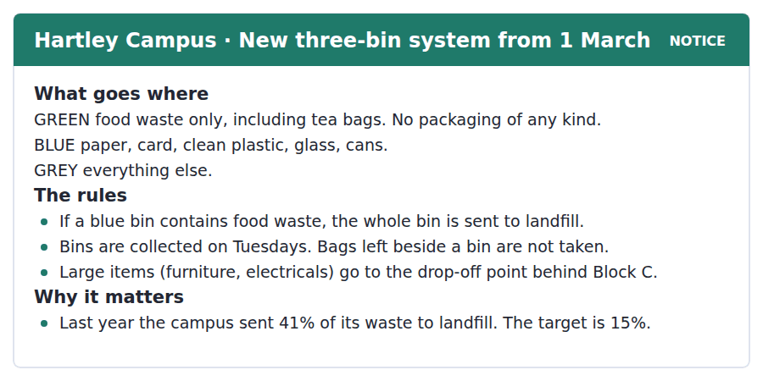
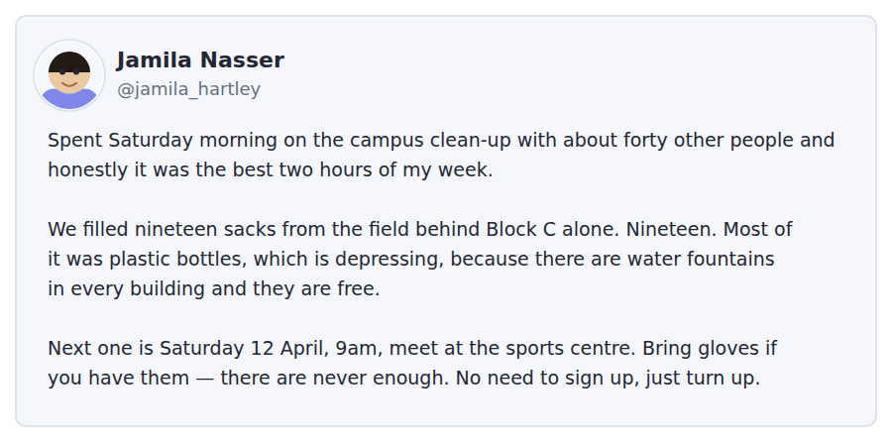
Exercise A Guided practice. The answer is on the page — find it.
1. What goes in the green bin?
(A) Paper and card
(B) Everything else
(C) Food waste only
(D) Glass and cans
2. What happens if food waste is put in a blue bin?
(A) It is sorted by hand
(B) The bin is not collected
(C) The department is charged
(D) The whole bin goes to landfill
3. What should be done with an old chair?
(A) Take it to the drop-off point behind Block C
(B) Put it beside a bin
(C) Put it in the grey bin
(D) Wait for a special collection
4. When are the bins collected?
(A) Every day
(B) On Tuesdays
(C) On Saturdays
(D) Once a month
Exercise B Exam practice.
5. Why did Jamila write the post?
(A) To complain about litter
(B) To ask for money
(C) To tell people about the next clean-up
(D) To thank the university
6. How many people took part in the clean-up?
(A) Nineteen
(B) About forty
(C) Twelve
(D) Over a hundred
7. Why does Jamila find the plastic bottles depressing?
(A) They are difficult to recycle
(B) They were left by visitors
(C) They cannot go in the blue bin
(D) There is free water in every building
8. What does Jamila ask people to bring?
(A) Gloves
(B) Sacks
(C) Water
(D) Nothing
9. What is the campus trying to achieve?
(A) To cut landfill from 41% to 15%
(B) To collect bins more often
(C) To remove all grey bins
(D) To open a second drop-off point
10. What can be inferred about the clean-up events?
(A) They are compulsory for students
(B) They are organised by the university
(C) They are always in the same place
(D) They happen regularly


SKILL · Read the comparison, not the number
- Numbers in this kind of passage exist to make a comparison. Ask what is being compared with what.
- A word like however, but or in fact marks the sentence the paragraph was written for.
- An image (a flywheel, a ladder) is always explained in the next sentence. Read on.
- Inference questions usually ask what follows from the facts, not what is in them.

Why the Ocean Warms So Slowly
The air above the land has warmed considerably in the last century, and anyone over fifty can tell you so. The ocean has warmed too, but by a much smaller number, and that difference is often misread. It does not mean that the sea is less affected. It means that water is extremely difficult to heat.
The reason is a property called heat capacity. It takes roughly four times as much energy to raise the temperature of a kilogram of water by one degree as it does for a kilogram of air, and the ocean contains about 1,300 times as much mass as the atmosphere. Put those two numbers together and the ocean can absorb an enormous amount of energy while its thermometer barely moves. In fact more than nine tenths of the extra heat trapped by the atmosphere since 1970 has gone into the sea, not into the air.
That is why the ocean is sometimes described as a flywheel. A flywheel is hard to speed up and equally hard to slow down, and it keeps turning long after the engine has stopped. The sea has been storing heat for decades, and it will go on releasing it for centuries, whatever happens to emissions. The consequences follow from that single fact: sea level will keep rising for a long time after the air stops warming, because water expands as it warms, and because the heat already in the ocean has not yet finished doing its work.
[275 words]

Exercise A Guided practice.
1. What is the passage mainly about?
(A) Why air temperature has risen
(B) How sea level is measured
(C) Why the ocean warms slowly and what follows
(D) The history of flywheels
2. According to paragraph 1, what does the small rise in ocean temperature mean?
(A) The sea is less affected
(B) Water is hard to heat
(C) The measurements are unreliable
(D) The air has not really warmed
3. The word "absorb" in paragraph 2 is closest in meaning to
(A) give out
(B) measure
(C) reflect
(D) take in
4. Why does the author mention a flywheel?
(A) To describe how a ship engine works
(B) To show that the ocean keeps going after the cause stops
(C) To show that the ocean is heavy
(D) To explain how heat capacity is measured
Exercise B Exam practice.
5. How much more energy does water need than air, per kilogram and degree?
(A) About four times
(B) About twice
(C) About ten times
(D) About 1,300 times
6. Where has most of the extra heat since 1970 gone?
(A) Into the air
(B) Into the land
(C) Into the sea
(D) Into the ice
7. All of the following are stated about the ocean EXCEPT:
(A) It has warmed more than the air
(B) It is slow to warm
(C) It is slow to cool
(D) It stores most of the extra heat
8. Why will sea level keep rising after the air stops warming?
(A) Because ice melts slowly
(B) Because emissions continue
(C) Because water expands as it warms and the stored heat is still working
(D) Because rivers add more water
9. The word "it" in the phrase "releasing it for centuries" refers to
(A) the sea level
(B) the emissions
(C) the flywheel
(D) the heat
10. What can be inferred about efforts to cut emissions?
(A) They will have no effect
(B) They will not stop sea level rising soon
(C) They will cool the ocean quickly
(D) They are already working
11. Which best states the main idea of paragraph 2?
(A) The ocean is very large
(B) Thermometers are not accurate at sea
(C) Two numbers together explain the ocean’s slow warming
(D) Air warms faster than land


Exercise A Listen and choose a response. You hear one line. Choose the best reply.
1. Man: Have you seen the new bins?
(A) They’re collected on Tuesdays.
(B) Three of them.
(C) Behind Block C.
(D) Seen them? I’ve already used the wrong one.
2. Woman: Why are there three now?
(A) In every building.
(B) Because food waste ruins the recycling.
(C) Yes, three colours.
(D) Since the first of March.
3. Man: I never know which one to use.
(A) There’s a leaflet — I’ll send it to you.
(B) They’re outside Block C.
(C) No, I don’t either.
(D) It started in March.
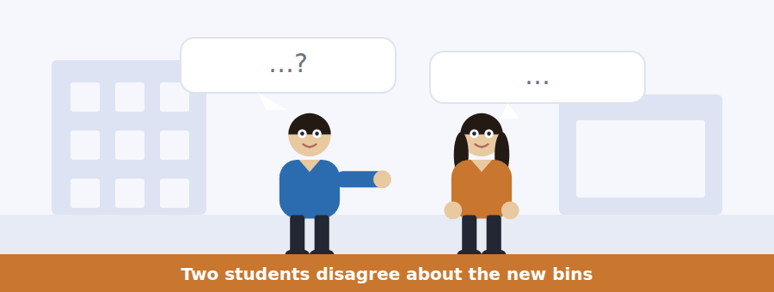
SKILL · Separate the complaint from the fact
- When two speakers disagree, note what each one actually claims.
- One of them is usually wrong about something, and that is a question.
- Attitude questions ask how a speaker feels, not what they say. Listen to tone words: honestly, frankly, to be fair.
- The agreement at the end is often the answer to what will they do next.

Exercise B Listen and answer. The audio plays once.
4. What are the speakers mainly discussing?
(A) Whether the new bin system works
(B) Where the bins are kept
(C) How often bins are collected
(D) What a sandwich box is made of
5. What mistake did the man make?
(A) He left a bag beside a bin
(B) He used the grey bin for paper
(C) He missed the collection day
(D) He put packaging in the food bin
6. What does the woman say is the one rule that matters?
(A) Rinse everything first
(B) No food in the blue bin
(C) Use the grey bin for packaging
(D) Put bins out on Tuesday
7. Why does one sandwich matter so much?
(A) It smells
(B) It cannot be composted
(C) It sends a whole bin to landfill
(D) It blocks the collection lorry
8. What does the woman think the real problem is?
(A) Students do not care
(B) Nobody explained the consequence
(C) The system is too complicated
(D) There are not enough bins
9. What will the man probably do?
(A) Stop using the blue bin
(B) Write to the university
(C) Ask for a leaflet
(D) Take his idea to the sustainability group
Audio script: see the back of the book. Do not read it before you listen.


Exercise A Listen and choose a response. You hear one line. Choose the best reply.
1. Woman: When does it start?
(A) On Monday.
(B) Three bins.
(C) Because of the target.
(D) In every building.
2. Man: What if I put the wrong thing in?
(A) It’s a green bin.
(B) On Tuesdays.
(C) Nothing happens to you, but the bin may be wasted.
(D) There are three.
3. Woman: Where do old chairs go?
(A) To the drop-off point behind Block C.
(B) On Monday morning.
(C) In the grey bin, usually.
(D) Yes, they’re collected.
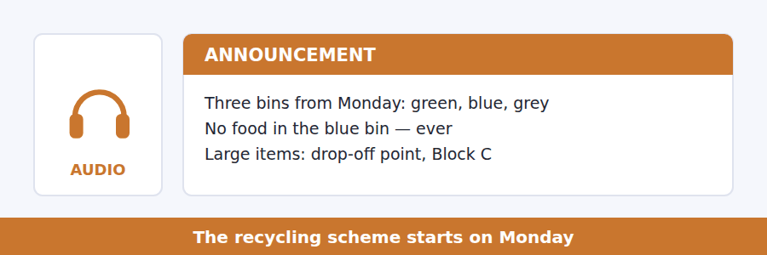
SKILL · Catch the condition
- Announcements about new schemes are full of if-sentences. The if-half and the result-half are often tested separately.
- Listen for a deadline and for what happens after it.
- An exception is nearly always worth a question. Note it the first time.
- The closing instruction tells you what the speaker wants. Expect to be asked.

Exercise B Listen and answer. The audio plays once.
4. What is the main purpose of the announcement?
(A) To report last year’s figures
(B) To ask for volunteers
(C) To change the collection day
(D) To explain a new bin system
5. What may be put in the green bin?
(A) Clean plastic
(B) Packaging
(C) Tea bags
(D) Glass
6. Why is the blue-bin rule the most important?
(A) Blue bins are collected first
(B) One sandwich can waste a whole bin
(C) Blue bins cost more
(D) Paper is the heaviest waste
7. What should you do if your bin is full?
(A) Leave a bag beside it
(B) Wait until Tuesday
(C) Take it to Block C
(D) Use another bin
8. By when must a department ask for a talk?
(A) By Monday
(B) By Tuesday
(C) Before the end of term
(D) Before September
Audio script: see the back of the book. Do not read it before you listen.


Exercise A Listen and choose a response. You hear one line. Choose the best reply.
1. Man: Did she say nine tenths or nine per cent?
(A) Nine tenths.
(B) Since 1970.
(C) Into the ocean.
(D) Yes, she did.
2. Woman: What does heat capacity actually mean?
(A) It’s on the board.
(B) How much energy it takes to warm something.
(C) Four times more.
(D) The ocean has a lot of it.
3. Man: Could you repeat the last point?
(A) It was about sea level.
(B) Of course — which part?
(C) Yes, I agree.
(D) The lecture ends at four.
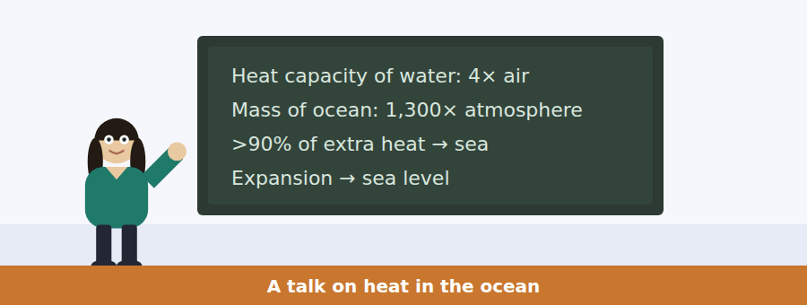
SKILL · Link the numbers to the conclusion
- A talk that puts numbers on a board will use them to reach one conclusion. Find it.
- Listen for so, which means, that is why — the conclusion follows those words.
- A speaker who says people get this wrong is telling you the misconception question in advance.
- The last sentence is nearly always the point of the whole talk.

Exercise B Listen and answer. The audio plays once.
4. What is the main idea of the talk?
(A) Sea temperature measurements are unreliable
(B) The atmosphere is heavier than people think
(C) A small temperature rise in the ocean represents a huge amount of energy
(D) Emissions must stop immediately
5. Why does the speaker say "people get this one wrong"?
(A) To criticise other scientists
(B) To explain a measurement error
(C) To describe an old theory
(D) To introduce a common misunderstanding
6. What two figures does the speaker multiply together?
(A) Heat capacity and mass
(B) Temperature and depth
(C) Emissions and years
(D) Volume and sea level
7. According to the speaker, the yearly air temperature figure is
(A) the most important measurement
(B) impossible to measure accurately
(C) only a small part of the story
(D) rising faster than expected
8. Why is sea level rise already committed?
(A) Emissions cannot be reduced
(B) Ice is melting too quickly
(C) Rivers are adding water
(D) The stored heat expands the water
9. What does the speaker mean by "the flywheel"?
(A) The ocean drives the whole system and is slow to change
(B) The ocean follows the atmosphere
(C) The ocean is circular
(D) The ocean mixes slowly
Audio script: see the back of the book. Do not read it before you listen.


Part 1 · Listen and Repeat
You hear a sentence and repeat it once. There is no preparation time, and the sentences get longer. Focus: sentence stress in if-sentences
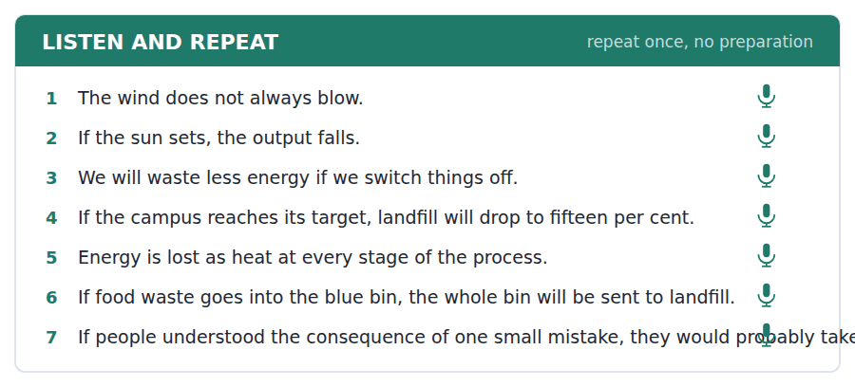
SKILL · Stress the new information
- In an if-sentence the stress falls on the condition and on the result, not on if or then.
- Pause very slightly at the comma. It tells the listener a result is coming.
- Say the whole sentence. An unfinished conditional scores badly.
- If you start the result first (I will… if…), there is no comma and no pause.

Part 2 · Take an Interview
An interviewer asks you four questions on one theme: recycling where you live. Answer each one fully. There is no preparation time.
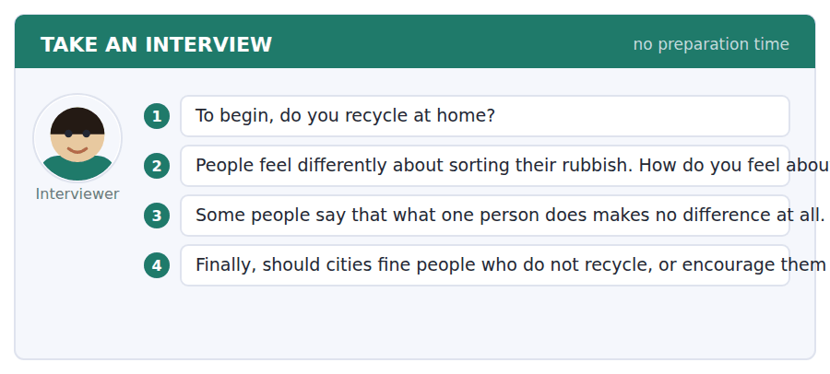
A good answer sounds like this
Question 1 — We do, yes. We have two bins at home, one for paper and plastic and one for everything else, and the city collects them on Thursdays.
Question 3 — I disagree, although I understand the feeling. One person changes nothing, but no single person ever does — that is how any change works.
I can… | Not yet | Yes
I paused at the comma in if-sentences | □ | □
I finished every conditional I started | □ | □
I gave a reason, not just an opinion | □ | □


Part 1 · Listen and Repeat
You hear a sentence and repeat it once. There is no preparation time, and the sentences get longer. Focus: explaining a consequence
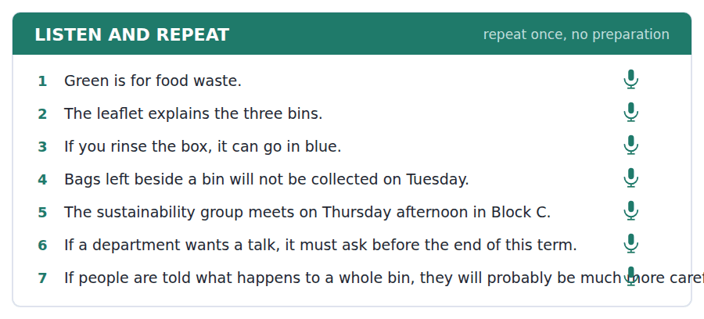
SKILL · Say what follows, then why
- Use the pattern: if X, then Y — because Z. Three short clauses beat one long one.
- Signal the consequence: so, which means, that is why.
- Give one example. A concrete example is worth more than a second reason.
- Keep the tense right: if + present, will + infinitive.

Part 2 · Take an Interview
An interviewer asks you four questions on one theme: how your town handles waste. Answer each one fully. There is no preparation time.
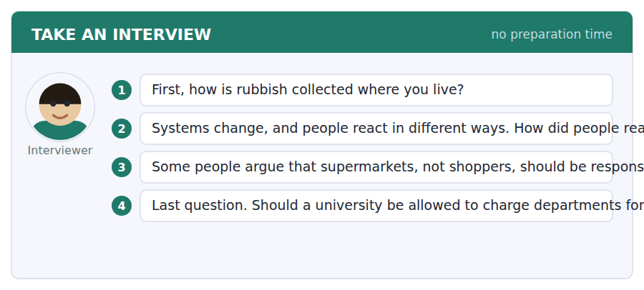
A good answer sounds like this
Question 2 — Badly at first, honestly. People complained for about a month and then it became normal, which is what usually happens.
Question 3 — I agree with that. The shopper cannot choose packaging that is not on the shelf, so the decision is made before they arrive.
I can… | Not yet | Yes
I used if + present, will + infinitive correctly | □ | □
I signalled the consequence (so, which means) | □ | □
I gave one concrete example | □ | □


Part 1 · Listen and Repeat
You hear a sentence and repeat it once. There is no preparation time, and the sentences get longer. Focus: academic register
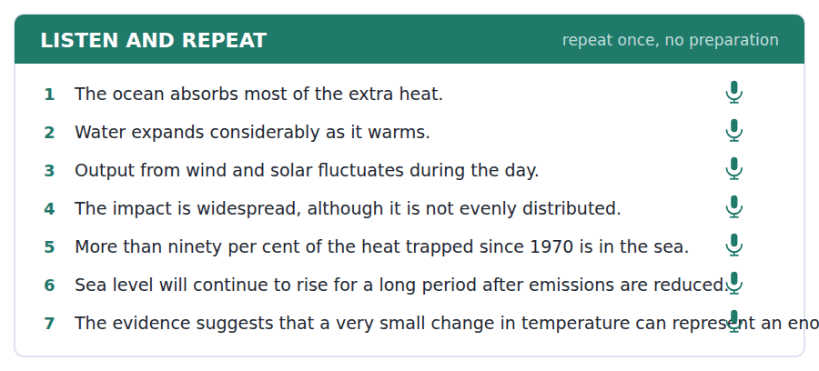
SKILL · Quantify, then conclude
- Use the unit’s words: considerable, fluctuate, sustain, impact, offset.
- Give a figure, then say what it means. A number without a conclusion is not an answer.
- Hedge properly: the evidence suggests, it appears that, broadly speaking.
- Check yourself against the three statements below.

Part 2 · Take an Interview
An interviewer asks you four questions on one theme: whether individual action matters. Answer each one fully. There is no preparation time.
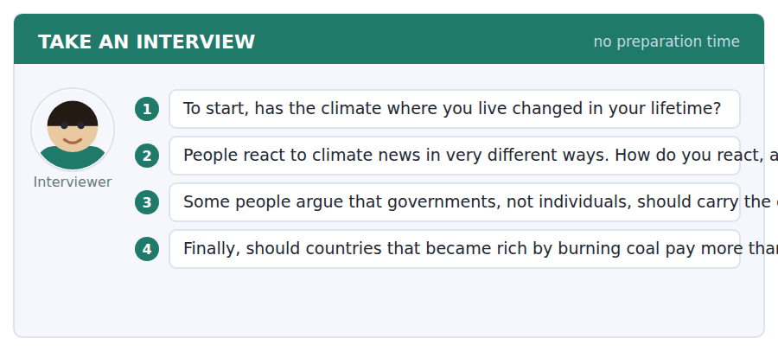
A good answer sounds like this
Question 2 — Honestly, I switch off. I think that is because the numbers are so large that nothing I do seems to touch them.
Question 4 — Broadly speaking, yes. The evidence suggests most of the heat now in the ocean was put there by a small number of countries over a long period.
I can… | Not yet | Yes
I used at least three academic words from this unit | □ | □
I gave a figure and said what it meant | □ | □
I hedged where I was not certain | □ | □


You see a sentence, then a set of words in boxes. Put the words in order to make one grammatical sentence. Almost every item in the real test makes a question or a question inside another sentence.
SKILL · Build the if-half first
- Find if among the tiles. Everything before the comma belongs to it.
- If + present simple, then will + infinitive. Never will twice.
- A question with if is usually an indirect question: do you know if…
- Use every tile exactly once.

Exercise A Guided practice. The first three are worked through.
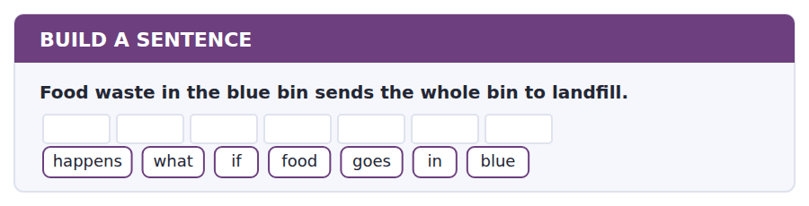
1. What happens if food goes in blue?
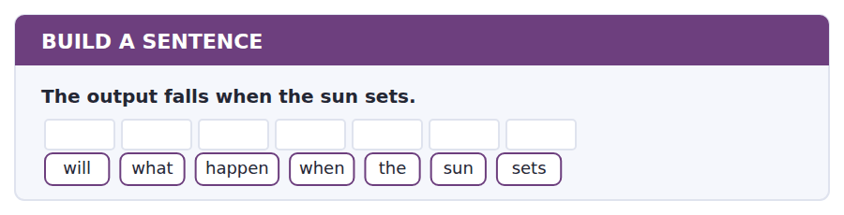
2. What will happen when the sun sets?
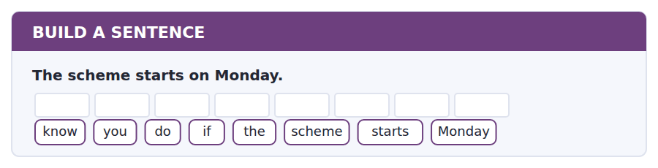
3. Do you know if the scheme starts Monday?
Exercise B Exam practice. Write the sentence.
4. Bags left beside a bin are not collected.
happens / what / if / I / leave / a / bag
__________________________________________________________
5. The campus wants to cut landfill to fifteen per cent.
will / much / how / landfill / fall
__________________________________________________________
6. A department must ask before the end of term.
tell / can / you / me / whether / we / can / still / ask
__________________________________________________________
7. Sea level will go on rising for centuries.
long / how / will / sea / level / rise
__________________________________________________________
8. The bin that contains food goes to landfill.
the / bin / that / contains / food / goes / to / landfill
__________________________________________________________
9. Collections are on Tuesdays.
day / which / are / the / bins / collected
__________________________________________________________
10. If nobody explains the rule, people will ignore it.
know / do / you / why / people / ignore / it
__________________________________________________________


You read a short situation and write an email. You have 7 minutes. The three bullet points are the mark scheme: answer all three.
The new three-bin system starts on Monday. You live in Block D, where there is no green bin on your floor, and the leaflet does not say what to do with coffee cups, which are paper on the outside and plastic on the inside.
Write an email to the sustainability group.
- Say where you live and why you are writing.
- Ask your two questions clearly.
- Offer to help in some way.
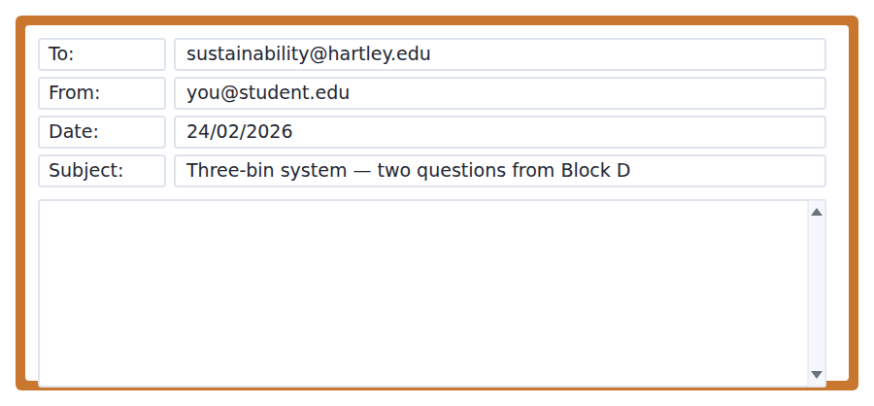
SKILL · Number your questions
- Two questions in one paragraph get one answer. Two numbered questions get two.
- Say what you have already checked. It stops the reader repeating it.
- Offer something small and specific, not vague help.
- Seven minutes. Three short paragraphs, 110–140 words.

Model email
Dear Sustainability Group,
I live on the third floor of Block D and I am writing about the new three-bin system, which starts on Monday. I have read the leaflet and the notice by the lift, but two things are still not clear to me.
First, there is no green bin anywhere in Block D. Should we take food waste down to the bins outside, or will green bins be installed on each floor? Second, what should we do with coffee cups? They are paper outside and plastic inside, so I cannot tell whether they belong in blue or in grey.
If it would help, I am happy to put a short notice in our kitchen once I know the answers. There are about forty of us on this floor and most people have the same two questions.
Many thanks,
Daniel Mwangi
Why it works
- The first paragraph says who and where before it says what, so the reader can route the email immediately.
- I have read the leaflet and the notice removes the most likely unhelpful reply.
- First… Second… makes two questions impossible to answer as one.
- The offer is specific (a notice in one kitchen, forty people) rather than a vague let me know if I can help.
Now write your own. 7 minutes.
__________________________________________________________
__________________________________________________________
__________________________________________________________
__________________________________________________________
__________________________________________________________
__________________________________________________________
__________________________________________________________
__________________________________________________________


A professor asks a question and two students answer. You add your own post. You have 10 minutes and an effective answer is at least 100 words.
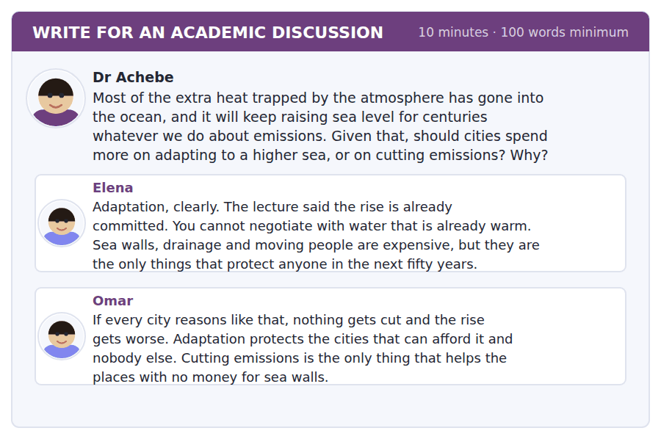
SKILL · Reject the either/or if it is false
- Many discussion questions offer two choices. Sometimes the best answer is that the choice is wrong.
- But you must show why, with a reason from the material.
- Name a classmate and take their strongest point seriously before you move past it.
- At least 100 words in ten minutes.

Sentence starters
- Elena and Omar are answering different questions:…
- The choice in the question is a false one, because…
- Omar’s point about… is the one that decides it for me, because…
- What neither post mentions is…
Model post
Elena is right about the physics and Omar is right about the politics, and I do not think the question has to be answered as an either/or.
The lecture made one thing clear: the heat already in the ocean is committed, so some rise is coming no matter what any city decides this year. That settles the case for adaptation. But it settles nothing about how much rise, which is still open, and that is Omar’s point.
What neither post mentions is that the two compete for the same money in the same budget year, and sea walls are visible while emissions cuts are not. A mayor who builds a wall gets re-elected; a mayor who cuts emissions gets a smaller rise in forty years. That is why I would fund adaptation locally and emissions nationally, so they stop competing.
[155 words]
Now write your own. 10 minutes, at least 100 words.
__________________________________________________________
__________________________________________________________
__________________________________________________________
__________________________________________________________
__________________________________________________________
__________________________________________________________
__________________________________________________________
__________________________________________________________
__________________________________________________________
__________________________________________________________

Grammar focus The first conditional
Form | Example
If + present simple, will + infinitive | If food goes in blue, the bin will be wasted.
Result first (no comma) | The bin will be wasted if food goes in blue.
Negative in either half | If you do not rinse it, it will not be recycled.
when = it is certain | When the sun sets, the output will fall.
unless = if not | Unless you rinse it, it will go to landfill.
may / might instead of will | If we do nothing, the target might be missed.
Question form | What will happen if I leave a bag?

The if-half uses the present simple even though it is about the future. English does not say *if it will rain*.
Use when, not if, when the thing is certain to happen. The sun will set; the wind may or may not blow.
Unless already contains not, so never write *unless you do not*.
Watch out! Never put will in both halves. It is If it rains, we will cancel — never *If it will rain, we will cancel*.
Exercise 1 Put the verb in the right form.
1. If the wind __________ (not / blow), the output __________ (fall).
2. The bin __________ (go) to landfill if you __________ (put) food in it.
3. If we __________ (reach) the target, the university __________ (save) money.
4. Unless you __________ (rinse) the box, it __________ (not / be) recycled.
5. When the scheme __________ (start), there __________ (be) three bins.
6. If nobody __________ (explain) the rule, people __________ (ignore) it.
Exercise 2 Rewrite with unless.
1. If you do not rinse it, it will go in grey.
2. If we do not act now, the target will be missed.
3. If they do not explain the consequence, nobody will care.
4. If the department does not email before Friday, no talk will be arranged.
Exercise 3 Correct the mistake in each sentence.
1. If it will rain, the clean-up will be cancelled.
2. Unless you do not rinse it, it will go to landfill.
3. If the sun sets, the output falls — that is certain every day.
How this is tested in Build a Sentence
Build a Sentence uses conditionals inside questions: What happens if food goes in blue? Notice that what happens stays in the present, because the whole thing is a general rule rather than one future event.

Unit review and progress check Unit 4
Exercise A Vocabulary. Write the word.
1. a strong effect on something
2. to use up fuel or energy
3. to keep something going over time
4. another choice that could be used instead
5. large enough to matter
6. to get rid of completely
7. to go up and down irregularly
8. an organised plan to do something
9. found in many places
10. to control something with rules
11. an organised event to clear rubbish
12. a place where you leave something
Exercise B Grammar. Complete the sentence.
1. If the wind __________ (not / blow), the output falls.
2. The bin __________ (go) to landfill if you put food in it.
3. __________ you rinse the box, it will not be recycled.
4. __________ (when / if) the sun sets, the output will fall.
5. If we reach the target, the university __________ (save) money.
6. What __________ (happen) if I leave a bag beside the bin?
7. If nobody explains the rule, people __________ (ignore) it.
8. If we do nothing, the target __________ (might / miss).
Exercise C One timed mini-section. 6 minutes.
1. According to the passage on page 66, the ocean has warmed less than the air because
(A) it is further from the sun
(B) water is much harder to heat
(C) the measurements are older
(D) ice absorbs the heat
2. In the talk, more than ninety per cent of the extra heat since 1970 has gone
(A) into the air
(B) into the sea
(C) into the land
(D) into the ice
3. Which sentence is correct?
(A) If it will rain, we will cancel.
(B) Unless you do not rinse it, it goes to landfill.
(C) When the wind blows, the output might falls.
(D) If food goes in blue, the bin will be wasted.
4. A bag left beside a full bin will be
(A) left where it is
(B) collected on Tuesday
(C) taken to Block C
(D) put in the green bin
5. In Complete the Words, a gap after "the" is most likely the end of
(A) a verb
(B) an adverb
(C) a noun
(D) a conjunction
6. In Listening, the audio plays
(A) as often as you like
(B) twice
(C) once
(D) once for talks only
Can you do these now?
I can… | Not yet | Yes
complete word endings in a text about energy and resources | □ | □
read a notice and a social media post for a rule and a consequence | □ | □
follow an academic passage that explains a delay, not just a change | □ | □
understand two people disagreeing about a practical arrangement | □ | □
talk about causes and consequences without preparing | □ | □
write an email asking for clarification, and a post that proposes something | □ | □

ADAPTIVE TIP In Listening the audio plays once and there is no Back. Write while you listen, not afterwards — two words on the page beat a whole sentence in your head, because the next question is already starting.

Unit 5 · Psychology and the Mind
TOEFL iBT® Preparation Course 2026 · Volume 1
CEFR B1 · Grammar: Gerunds and infinitives · Word field: mind, behaviour, evidence
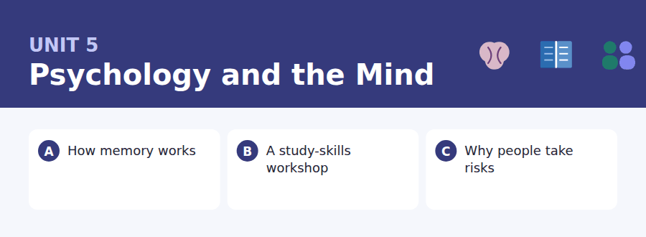
By the end of this unit I can…
- complete word endings in a text about how the mind behaves
- read a workshop poster and a confirmation email for the detail I need
- follow a passage that explains an experiment and what it showed
- understand two students comparing how they work
- describe a habit and a preference out loud without preparing
- write an email asking to change an arrangement, and a post that uses evidence

Psychology talks constantly about doing things: avoid revising, decide to change, stop worrying. That is why this unit’s grammar is the -ing form and the infinitive.

Vocabulary 1 · Academic 24 words from the Academic Word List
These twenty-four words come back through the whole unit, and again in the review. Cover the right-hand column and test yourself.
psychology the study of the mind and behaviour | evaluate to judge how good or useful something is
mental connected with the mind | conceive to form an idea in the mind
perceive to notice or understand something | intense very strong
perspective a particular way of seeing something | retain to keep something
aware knowing that something exists | recover to get back something lost
focus to give all your attention to one thing | distort to change something so it is no longer accurate
concentrate to keep your attention on one thing | induce to cause something to happen
respond to react or answer | random without any pattern or plan
motive the reason someone does something | task a piece of work to be done
attitude the way you think and feel about something | monitor to watch something over time
assume to think something is true without checking | insight a clear understanding of something
interpret to decide what something means | rational based on reason rather than feeling

Exercise A Work in pairs. Ask and answer.
1. What is the first thing you do when you need to concentrate?
2. Describe a time when your memory distorted something. What really happened?
3. What motive do people usually give for leaving work until the last day?
4. How do you evaluate whether a study method is working for you?
Vocabulary 2 · Campus and everyday 12 words for the daily-life tasks
The exam does not only test academic English. Notices, emails, conversations and announcements use the everyday words below.
revision studying again before an exam | break a short rest between periods of work
flashcard a small card with a question on one side | concentration the ability to keep your attention on something
past paper an exam paper from an earlier year | timetable clash two things arranged at the same time
study group a small group that studies together | distraction something that takes your attention away
workshop a short practical class | wellbeing the state of being healthy and comfortable
sign-up sheet a list you add your name to | handout a printed sheet given out in a class

Words you will meet again: process | significant | vary | impact | consume | evident | identify | random


SKILL · Find the part of speech first
- Decide whether the gap ends a noun, a verb or an adjective. The ending follows.
- Verb after to? Then the word is in its base form and any gap is part of the stem, not an ending.
- Adjectives often end -ful, -ive, -able. Count the dashes before you choose.
- Reread the sentence with your answer in it. If it sounds wrong, it is wrong.

Exercise A Guided practice. Five words are not complete. Write the missing letters.
Memory is not a recording. When you remember something, you rebu--- it, and each time you rebuild it you change it a lit---. That is why two people who were at the same event will often disa---- about what happe---. Neither of them is ly---.

The first one is done for you: 1 rebu--- → ild (rebuild)
Exercise B Exam practice. One paragraph, ten gaps — the real task.
Most people think of memory as a box. You put something in, it stays there, and later you take it out unch-----. Psychologists stopped belie---- that a long time ago. Remembering is an act of rebuil----, not of retrieval, and every act of rebuilding changes what is st----. In one famous study, volunteers watched a film of a car accident and were then as--- how fast the cars were going when they hit each other. A second group was as--- the same question, but with the word smashed instead of hit. The second group estim---- a higher sp---, and a week later many of them remem----- broken glass that was never in the film at all. One word, asked once, had quietly rewr----- what they saw.

Check your answers in the key at the back of the book.


SKILL · Scan for the one word the question uses
- The question usually repeats a word from the text. Find that word and read the sentence it sits in.
- If the question asks about a person, the answer is usually in the sentence with their name.
- Posters use short lines. The condition is often the last line, not the first.
- A time and a place in a poster will be tested against a time and a place in the email.

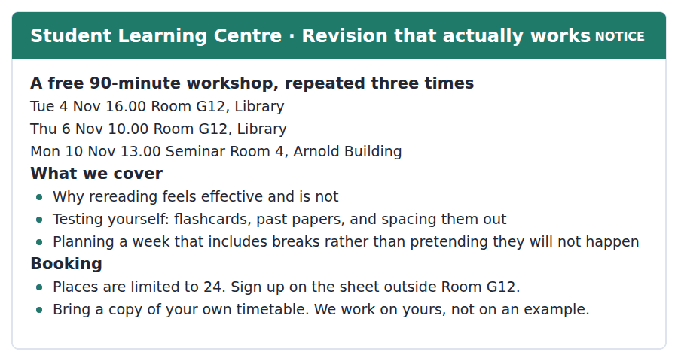
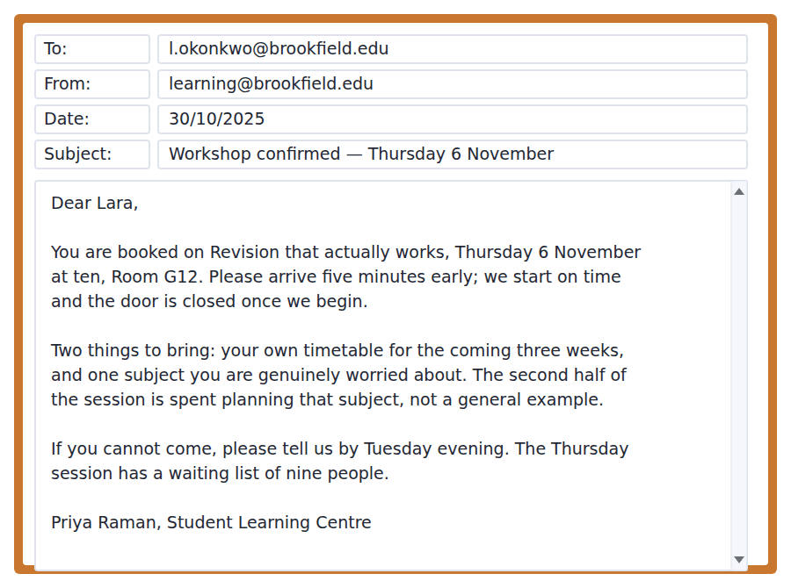
Exercise A Guided practice. The answer is on the page — find it.
1. How long does the workshop last?
(A) One hour
(B) Two hours
(C) Ninety minutes
(D) Half a day
2. Which session is not in the Library?
(A) Tuesday 4 November
(B) Monday 10 November
(C) Thursday 6 November
(D) They are all in the Library
3. What must students bring?
(A) A past paper
(B) A laptop
(C) Flashcards
(D) Their own timetable
4. How many places are there?
(A) Twenty-four
(B) Nine
(C) Twelve
(D) Unlimited
Exercise B Exam practice.
5. Why does the email ask Lara to arrive early?
(A) Because the door is closed at the start
(B) To find the room
(C) To sign the sheet
(D) Because the session may start early
6. What is the second thing Lara must bring?
(A) A past paper
(B) A handout
(C) A subject she is worried about
(D) Her student card
7. What happens in the second half of the session?
(A) A general example is worked through
(B) Flashcards are handed out
(C) Students take a test
(D) Students plan their own subject
8. Why should Lara tell the centre if she cannot come?
(A) She will be charged
(B) Nine people are waiting for a place
(C) The session will be cancelled
(D) She cannot book again
9. According to the poster, what is the problem with rereading?
(A) It takes too long
(B) It cannot be done alone
(C) It feels effective but is not
(D) It only works for some subjects
10. What can be inferred about the three sessions?
(A) They cover different material
(B) They are the same workshop repeated
(C) They are all fully booked
(D) Only students may attend


SKILL · Follow the experiment to the conclusion
- A psychology passage usually runs: old belief, experiment, what it shows, everyday example. Expect that order.
- When two versions of the same choice are described, the question will ask what changed. Usually the wording, not the amounts.
- Examples in the last paragraph exist to illustrate the finding. Inference questions live there.
- Mark the sentence containing because — it is the one the paragraph was written for.

Why People Take Risks They Know Are Risks
Economists once assumed that people weigh a gain against a loss in the same way, and choose whichever is larger. Psychologists have shown that we do not. A loss of a hundred pounds hurts noticeably more than a gain of a hundred pounds pleases, and the difference is large: roughly twice as much. That single asymmetry explains a great deal of behaviour that otherwise looks irrational.
Consider a simple choice. You are offered a certain gain of fifty pounds, or a coin toss for a hundred. Most people take the fifty, even though the two are worth the same on average. Now change the wording. You will certainly lose fifty pounds, or you can toss a coin and lose either nothing or a hundred. Now most people toss the coin. Nothing about the amounts has changed. What has changed is whether the choice is described as winning or as avoiding a loss, and people will take a real risk to avoid a certain loss.
This is not a laboratory curiosity. A student who has already spent three days on an essay that is not working will often spend a fourth day on it rather than start again, because starting again makes the three days a definite loss. A driver who is late will overtake dangerously to recover time that is already gone. In each case the risk is not taken because the person misjudges the danger. It is taken because the alternative is admitting a loss, and admitting a loss costs more than it should.
[275 words]

Exercise A Guided practice.
1. What is the passage mainly about?
(A) How economists calculate value
(B) Why students write bad essays
(C) How coin tosses work
(D) Why losses feel worse than gains, and what follows
2. According to paragraph 1, a loss of a hundred pounds feels
(A) about twice as strong as the gain
(B) the same as a gain of a hundred
(C) half as strong as the gain
(D) impossible to measure
3. In the first version of the choice, what do most people do?
(A) Take the certain fifty
(B) Toss the coin
(C) Refuse both
(D) Ask for more
4. What changes between the two versions?
(A) The amounts
(B) The number of people
(C) The wording
(D) Whether a coin is used
Exercise B Exam practice.
5. Why does the student spend a fourth day on the essay?
(A) They enjoy the subject
(B) Starting again would make the first three days a loss
(C) They have no other work
(D) The deadline has moved
6. The word "asymmetry" in paragraph 1 is closest in meaning to
(A) exact measurement
(B) repeated pattern
(C) sudden change
(D) uneven balance
7. All of the following are given as examples EXCEPT:
(A) a shopper choosing between brands
(B) a student and an essay
(C) a driver who is late
(D) a coin toss
8. What does the author say about the driver?
(A) They do not understand the danger
(B) They are in a hurry for no reason
(C) They have had an accident before
(D) They are trying to recover lost time
9. What can be inferred about the economists mentioned in paragraph 1?
(A) They were right about small amounts
(B) Their assumption was too simple
(C) They never tested their ideas
(D) They studied only students
10. Which best states the main idea of paragraph 3?
(A) People often misjudge danger
(B) Essays should be started early
(C) Risk-taking comes from refusing to accept a loss
(D) Driving is more dangerous than it looks
11. The phrase "a laboratory curiosity" in paragraph 3 suggests the finding
(A) is only true in experiments
(B) has not been repeated
(C) was discovered by accident
(D) applies to real life as well


Exercise A Listen and choose a response. You hear one line. Choose the best reply.
1. Woman: How do you revise?
(A) In the library, usually.
(B) For about three hours.
(C) I reread my notes, mostly.
(D) Yes, I do.
2. Man: Do flashcards actually work?
(A) I made forty of them.
(B) Apparently they do, if you space them out.
(C) They’re small cards.
(D) In the workshop.
3. Woman: I can never concentrate after an hour.
(A) Then take a break — that’s the point.
(B) It starts at ten.
(C) I concentrate very well.
(D) The room is G12.
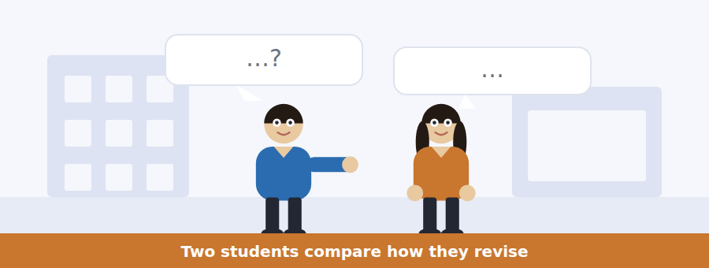
SKILL · Note who does what, and who is right
- When two people describe different habits, expect a question on each habit.
- One speaker usually learns something. Listen for oh, really? or I didn’t know that.
- A number said once is a question waiting to happen.
- The last exchange usually contains the decision.

Exercise B Listen and answer. The audio plays once.
4. What is the woman doing to revise?
(A) Testing herself
(B) Using flashcards
(C) Rereading her notes
(D) Working with a study group
5. What did the workshop say about rereading?
(A) It is the best method
(B) It only works for some subjects
(C) It should be done once only
(D) It feels effective but is not
6. What does the man recommend instead?
(A) Reading aloud
(B) Covering the page and writing what you remember
(C) Working in a group
(D) Making a timetable
7. What was the difference between the two groups in the study?
(A) One scored about fifty per cent higher
(B) One studied for twice as long
(C) One used flashcards
(D) One took the test immediately
8. What does the man mean when he says "It feels much worse and it works much better"?
(A) The method is easy but useless
(B) He dislikes the workshop
(C) The study was badly designed
(D) The method is unpleasant but effective
9. What will the woman probably do next?
(A) Reread her notes a fourth time
(B) Email the learning centre
(C) Look for the sign-up sheet
(D) Join a study group
Audio script: see the back of the book. Do not read it before you listen.


Exercise A Listen and choose a response. You hear one line. Choose the best reply.
1. Man: Has the time changed as well?
(A) No, still ten o’clock.
(B) In Seminar Room 4.
(C) Because the room is being painted.
(D) Yes, on Thursday.
2. Woman: Which building is that in?
(A) At ten in the morning.
(B) The Arnold Building.
(C) Ninety minutes.
(D) Twenty-four people.
3. Man: Do I still need to bring anything?
(A) Yes — your timetable, as before.
(B) The room has changed.
(C) It’s free.
(D) There’s a waiting list.
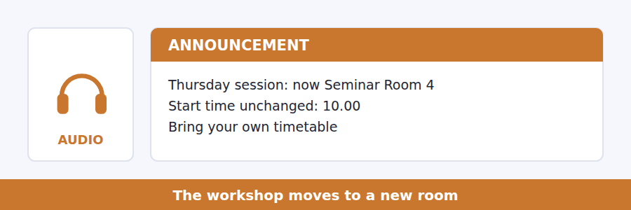
SKILL · Hold two versions of the same detail
- When something moves, you must remember the old place and the new one.
- Listen for not — it usually separates the wrong version from the right one.
- What stays the same is as testable as what changes.
- An instruction repeated twice is certain to be tested.

Exercise B Listen and answer. The audio plays once.
4. What is the main purpose of the announcement?
(A) To cancel the workshop
(B) To change the time
(C) To open a waiting list
(D) To announce a change of room
5. Why is Room G12 unavailable?
(A) It is too small
(B) It is being used for an exam
(C) It is being painted
(D) It is closed on Thursdays
6. What has not changed?
(A) The room
(B) The building
(C) The day and the time
(D) The waiting list
7. Why does the speaker mention a four-minute walk?
(A) To say the workshop is longer
(B) To explain why people should still arrive early
(C) To describe the Arnold Building
(D) To warn about the weather
8. When should a student say they cannot come?
(A) Today
(B) Tomorrow
(C) By Thursday morning
(D) Within a week
Audio script: see the back of the book. Do not read it before you listen.


Exercise A Listen and choose a response. You hear one line. Choose the best reply.
1. Woman: Did she define the second term?
(A) It’s on the board.
(B) Two types.
(C) At the end of the lecture.
(D) Yes, soft fascination.
2. Man: What causes mental fatigue?
(A) Watching a film.
(B) It makes you irritable.
(C) Intense, effortless focus for too long.
(D) Yes, it does.
3. Woman: So should I stop watching films?
(A) They’re hard fascination.
(B) I watch one most evenings.
(C) It was about attention.
(D) No — just not before you need to concentrate.
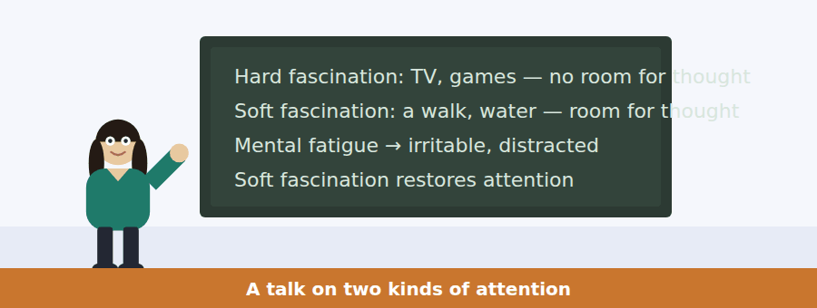
SKILL · Hear the two-way contrast
- A talk built on two contrasting terms will define each one, then compare them.
- The second term is usually the one the speaker cares about. Listen harder there.
- Everyday examples are given for each. Expect a question that asks which is which.
- The advice at the end follows from the contrast, and is often the main idea.

Exercise B Listen and answer. The audio plays once.
4. What is the main idea of the talk?
(A) Screens are bad for students
(B) Two kinds of attention have opposite effects on concentration
(C) Walking is the best form of exercise
(D) Mental fatigue cannot be measured
5. Why does the speaker mention the question asked last week?
(A) To introduce the topic
(B) To correct a mistake
(C) To praise the student
(D) To change the subject
6. What do hard and soft fascination have in common?
(A) Both require effort
(B) Both cause fatigue
(C) Both take no effort
(D) Both involve screens
7. What is the difference between them?
(A) One is outdoors
(B) One leaves room for other thoughts
(C) One lasts longer
(D) One is more enjoyable
8. What does soft fascination do?
(A) It restores the ability to concentrate
(B) It causes irritability
(C) It makes time pass quickly
(D) It has no measurable effect
9. What advice does the speaker give?
(A) Stop watching films
(B) Study immediately after a film
(C) Walk before studying rather than use a screen
(D) Avoid all screens in the evening
Audio script: see the back of the book. Do not read it before you listen.


Part 1 · Listen and Repeat
You hear a sentence and repeat it once. There is no preparation time, and the sentences get longer. Focus: weak forms of to
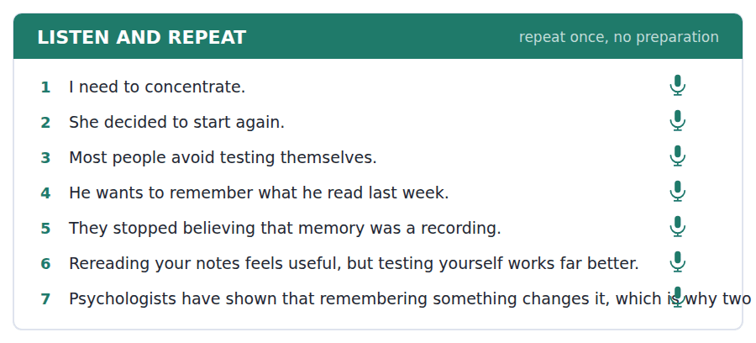
SKILL · Say to as /tə/, not /tuː/
- In I want to go the to is almost swallowed. Full /tuː/ sounds unnatural.
- The -ing form keeps its full sound: avoid revising, not avoid revisin.
- Keep the sentence moving. Weak forms are what makes speech sound fluent.
- Say the whole sentence even if one word slips.

Part 2 · Take an Interview
An interviewer asks you four questions on one theme: how you study. Answer each one fully. There is no preparation time.
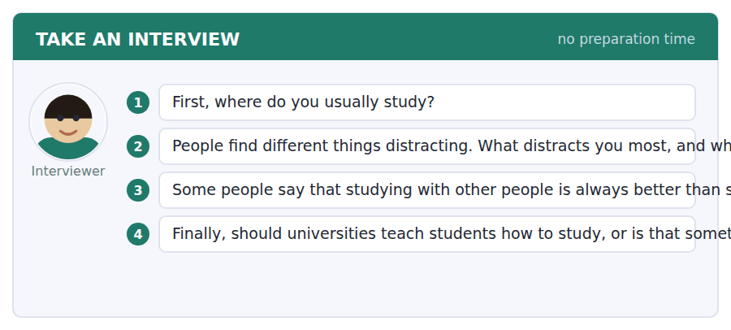
A good answer sounds like this
Question 2 — My phone, obviously, but really it is other people talking. I can work in complete noise or in silence, and not in between.
Question 4 — I think they should teach it. I spent two years rereading notes because nobody had ever told me it does not work.
I can… | Not yet | Yes
I used weak to rather than full /tuː/ | □ | □
I spoke in complete sentences | □ | □
I gave a reason after every opinion | □ | □


Part 1 · Listen and Repeat
You hear a sentence and repeat it once. There is no preparation time, and the sentences get longer. Focus: habits and preferences
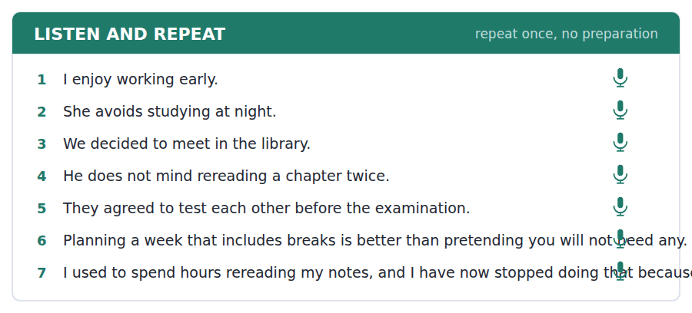
SKILL · Use the -ing form for habits
- I enjoy working, I avoid starting late, I don’t mind rereading.
- Use the infinitive after want, decide, need, hope, plan, agree.
- A few verbs take both with different meanings: I stopped reading / I stopped to read.
- One habit, one example, one reason. That is a full answer at this level.

Part 2 · Take an Interview
An interviewer asks you four questions on one theme: time and how you organise it. Answer each one fully. There is no preparation time.
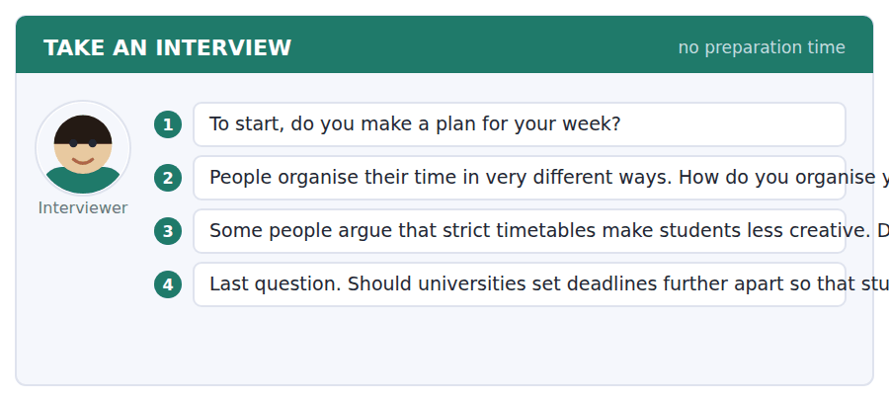
A good answer sounds like this
Question 2 — Not really a plan — more a list. I like crossing things off, which sounds silly but it keeps me going.
Question 3 — I disagree with that. A timetable does not tell you what to think; it just stops you worrying about when.
I can… | Not yet | Yes
I used -ing after enjoy, avoid or mind | □ | □
I used the infinitive after want, decide or need | □ | □
I gave one example in each answer | □ | □


Part 1 · Listen and Repeat
You hear a sentence and repeat it once. There is no preparation time, and the sentences get longer. Focus: academic register
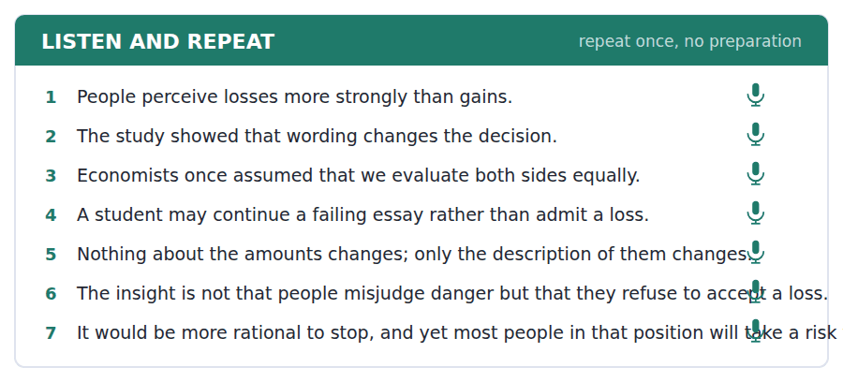
SKILL · Report a finding, then apply it
- Use the unit’s words: perceive, assume, evaluate, insight, rational.
- Say what was found, then what follows: the study showed…, which suggests…
- Separate the evidence from your opinion about it.
- Mark yourself against the three statements below.

Part 2 · Take an Interview
An interviewer asks you four questions on one theme: decisions and how people make them. Answer each one fully. There is no preparation time.
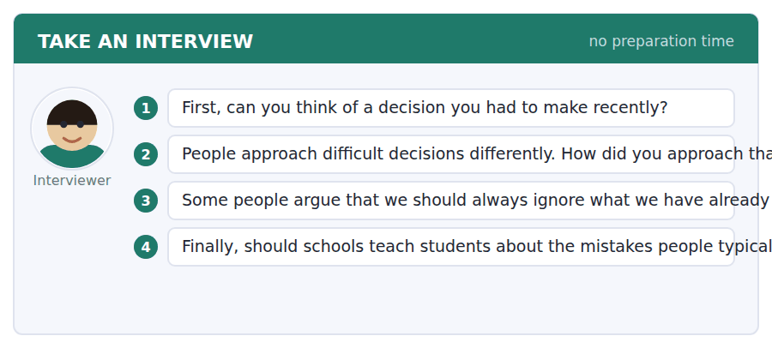
A good answer sounds like this
Question 3 — In principle I agree, because the money is gone either way. In practice it is very hard, and the study we read suggests that is normal rather than weak.
Question 4 — Yes. The insight costs nothing to teach and it changes how you read advertising, politics and your own excuses.
I can… | Not yet | Yes
I used at least three academic words from this unit | □ | □
I separated the finding from my own view | □ | □
My last answer had an opinion, a reason and an example | □ | □


You see a sentence, then a set of words in boxes. Put the words in order to make one grammatical sentence. Almost every item in the real test makes a question or a question inside another sentence.
SKILL · Decide -ing or to before you order the tiles
- Find the first verb. It decides whether the next one takes -ing or to.
- enjoy, avoid, mind, finish, suggest → -ing. want, need, decide, hope, agree → to.
- In a question the auxiliary still comes before the subject: Do you enjoy…?
- An indirect question keeps statement order: Do you know why she decided to…

Exercise A Guided practice. The first three are worked through.
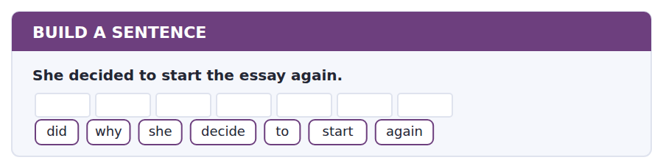
1. Why did she decide to start again?
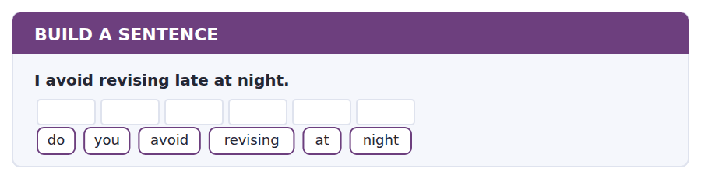
2. Do you avoid revising at night?
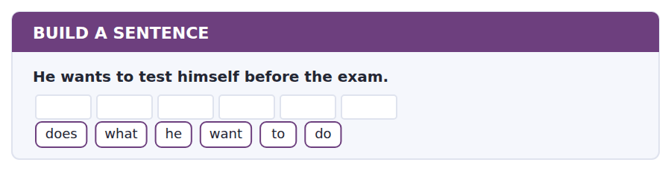
3. What does he want to do?
Exercise B Exam practice. Write the sentence.
4. They stopped believing that memory was a recording.
did / when / they / stop / believing / that
__________________________________________________________
5. The workshop is worth going to.
know / you / do / whether / it / is / worth / going / to
__________________________________________________________
6. She needs to bring her own timetable.
need / does / she / to / bring / what
__________________________________________________________
7. Most people avoid testing themselves because it feels worse.
do / why / people / avoid / testing / themselves
__________________________________________________________
8. The student who tested herself scored higher.
the / student / who / tested / herself / scored / higher
__________________________________________________________
9. The session she wanted to attend was full.
tell / can / you / me / which / session / she / wanted
__________________________________________________________
10. He hopes to finish by Friday.
hope / does / he / to / finish / when
__________________________________________________________


You read a short situation and write an email. You have 7 minutes. The three bullet points are the mark scheme: answer all three.
You are booked on the study-skills workshop on Thursday 6 November at ten. Your department has just scheduled a compulsory laboratory session at the same time. The same workshop runs again on Monday 10 November at one.
Write an email to the Student Learning Centre.
- Explain the clash.
- Ask to move to the Monday session.
- Say that you know there is a waiting list, and what you will do about it.
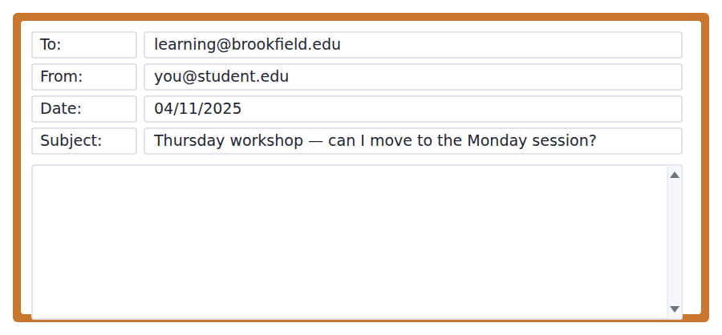
SKILL · Make it easy to say yes
- Give the reason first, then the request. A reader agrees more readily that way.
- Name both sessions exactly — date, day and time — so nothing has to be looked up.
- Show you know the cost of your request. Here, that means the waiting list.
- Seven minutes. Three paragraphs, 110–140 words.

Model email
Dear Ms Raman,
Thank you for confirming my place on Thursday 6 November at ten. Unfortunately my department has now scheduled a compulsory laboratory session at exactly that time, and I cannot miss it.
I can see that the same workshop runs on Monday 10 November at one, in the Arnold Building, and that time is completely free for me. Would it be possible to move my booking to the Monday session?
I know from your email that nine people are waiting for a Thursday place, so I am writing now rather than on Wednesday. If the Monday session is already full, please release my Thursday place to the waiting list anyway and I will sign up for the next workshop instead.
Thank you very much for your help.
Best wishes,
Lara Okonkwo
Why it works
- The reason comes before the request, and it is a reason the reader cannot argue with: compulsory.
- Both sessions are named in full, so the person answering does not have to open the programme.
- Mentioning the waiting list shows the writer read the original email and understands the cost of a late change.
- The last sentence offers a solution even if the answer is no, which removes a second email.
Now write your own. 7 minutes.
__________________________________________________________
__________________________________________________________
__________________________________________________________
__________________________________________________________
__________________________________________________________
__________________________________________________________
__________________________________________________________
__________________________________________________________


A professor asks a question and two students answer. You add your own post. You have 10 minutes and an effective answer is at least 100 words.
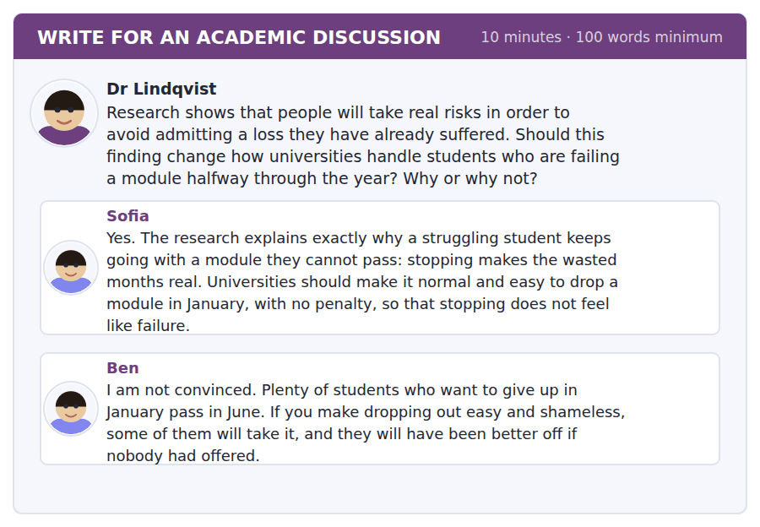
SKILL · Use the evidence, do not just mention it
- Quote the mechanism, not the conclusion: the finding is about avoiding a certain loss.
- Apply it to the specific case in the question, not to life in general.
- Name a classmate and engage with the strongest version of what they said.
- At least 100 words in ten minutes.

Sentence starters
- Ben’s objection is the serious one, because…
- The research says something narrower than Sofia suggests:…
- What follows from the finding is not… but…
- I would therefore…
Model post
Ben’s objection is the serious one, and I think it survives the research rather than being answered by it.
The finding is narrower than Sofia suggests. It does not say that students who want to stop are right to stop. It says that the feeling of having wasted four months distorts the decision, in either direction. A student who should drop the module will stay in it to avoid admitting the loss — that is Sofia’s case. But a student who could pass may also take whatever exit is offered, because quitting now feels cheaper than failing in June.
So what follows is not an easy exit, and not a hard one. It is that the January decision should not be made by the student alone, at the moment the loss feels largest. Give them the January mark, a realistic estimate of the June one, and an hour with somebody who has seen a hundred of these.
[161 words]
Now write your own. 10 minutes, at least 100 words.
__________________________________________________________
__________________________________________________________
__________________________________________________________
__________________________________________________________
__________________________________________________________
__________________________________________________________
__________________________________________________________
__________________________________________________________
__________________________________________________________
__________________________________________________________

Grammar focus Gerunds and infinitives
Pattern | Example
enjoy / avoid / mind / finish + -ing | I avoid revising late.
want / need / decide / hope / agree + to | She decided to start again.
preposition + -ing | He is good at remembering names.
-ing as a subject | Rereading feels useful.
stop + -ing / stop + to | He stopped reading. / He stopped to read.
worth + -ing | It is worth going.
make / let + bare infinitive | It makes you concentrate.

The verb before decides the form. There is no rule of meaning that predicts it, so these are learned as pairs.
After a preposition the verb is always -ing: good at remembering, instead of starting, before leaving.
Stop + -ing means end the activity. Stop + to means pause in order to do something else. The test does use this pair.
Watch out! Never write *I enjoy to read*. Enjoy always takes -ing, however natural the infinitive sounds in your language.
Exercise 1 Put the verb in the -ing form or the infinitive.
1. She avoids __________ (test) herself.
2. He decided __________ (start) the essay again.
3. Do you enjoy __________ (work) in the library?
4. They need __________ (bring) their own timetable.
5. __________ (reread) your notes feels useful.
6. It is worth __________ (go) to the workshop.
Exercise 2 Complete with the right preposition and form.
1. She is good __________ (remember) names.
2. He left __________ (say) goodbye. (without)
3. They talked __________ (change) the room. (about)
4. I am tired __________ (reread) the same page. (of)
Exercise 3 Explain the difference in meaning.
1. a) He stopped reading. b) He stopped to read.
2. a) I remember locking the door. b) I remembered to lock the door.
3. a) She tried studying at night. b) She tried to study at night.
How this is tested in Build a Sentence
Build a Sentence hides these patterns inside questions: Why did she decide to start again? Do you avoid revising at night? Get the verb pattern right and the word order follows.

Unit review and progress check Unit 5
Exercise A Vocabulary. Write the word.
1. to notice or understand something
2. to think something is true without checking
3. to decide what something means
4. to judge how good or useful something is
5. the reason someone does something
6. to change something so it is no longer accurate
7. a clear understanding of something
8. based on reason rather than feeling
9. to keep something
10. without any pattern or plan
11. something that takes your attention away
12. two things arranged at the same time
Exercise B Grammar. Complete the sentence.
1. She avoids __________ (test) herself.
2. He decided __________ (start) again.
3. Do you enjoy __________ (work) in the library?
4. It is worth __________ (go) to the workshop.
5. They need __________ (bring) a timetable.
6. She is good at __________ (remember) names.
7. __________ (reread) notes feels useful but is not.
8. He stopped __________ (read) and went home.
Exercise C One timed mini-section. 6 minutes.
1. According to the passage on page 82, people take risks mainly because
(A) they misjudge the danger
(B) they enjoy excitement
(C) they cannot do the arithmetic
(D) they refuse to accept a certain loss
2. In the talk, soft fascination
(A) causes mental fatigue
(B) restores the ability to concentrate
(C) requires effort
(D) only happens indoors
3. Which sentence is correct?
(A) I enjoy to read before bed.
(B) She avoids to test herself.
(C) He is good at remember names.
(D) It is worth going to the workshop.
4. The study-skills workshop asks students to bring
(A) a past paper
(B) a laptop
(C) their own timetable
(D) a handout
5. In Complete the Words, a gap after "to" at the start of a verb is
(A) part of the base form
(B) a past participle ending
(C) an -ing ending
(D) a plural ending
6. A question that asks what a speaker means by a phrase is testing
(A) vocabulary
(B) the main idea
(C) a specific number
(D) the speaker’s purpose or implication
Can you do these now?
I can… | Not yet | Yes
complete word endings in a text about how the mind behaves | □ | □
read a workshop poster and a confirmation email for the detail I need | □ | □
follow a passage that explains an experiment and what it showed | □ | □
understand two students comparing how they work | □ | □
describe a habit and a preference out loud without preparing | □ | □
write an email asking to change an arrangement, and a post that uses evidence | □ | □

ADAPTIVE TIP A question you cannot answer costs one mark. A question you sit on costs the two after it as well, because the clock does not stop. Choose the best option you have, mark it and move — an adaptive test is scored on the whole module, not on any one item.

Unit 6 · Art and Design
TOEFL iBT® Preparation Course 2026 · Volume 1
CEFR B1 · Grammar: Defining relative clauses · embedded questions with if and whether · Word field: form, colour, design
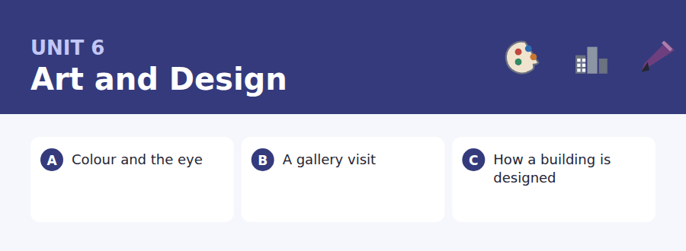
By the end of this unit I can…
- complete word endings in a text about how we see
- find one fact in a gallery plan and an email about an exhibition
- follow a passage that explains how a decision is made before anything is built
- understand two people disagreeing about something they are looking at
- describe an object out loud and say what I think of it
- write a polite enquiry, and a discussion post that makes a distinction

This is the unit the whole Writing section turns on. Eight of the ten Build a Sentence items in a real test make a question or a question inside another sentence, and the other two make relative clauses. Both are taught here.

Vocabulary 1 · Academic 24 words from the Academic Word List
These twenty-four words come back through the whole unit, and again in the review. Cover the right-hand column and test yourself.
design to plan how something will look and work | innovate to introduce something new
image a picture or a mental picture | create to make something that did not exist
visual connected with seeing | format the shape and size in which something is presented
style a particular way of doing or making something | layer one thickness lying over another
symbol a thing that stands for something else | medium the material or method an artist uses
display to put something where it can be seen | virtual existing on a computer rather than in reality
exhibit to show something publicly | illustrate to show the meaning of something with a picture or example
contrast a clear difference between two things | diverse of many different kinds
parallel similar and happening at the same time | edit to change a text or image before it is finished
uniform the same everywhere | unique the only one of its kind
classic of lasting quality and widely admired | intrinsic belonging naturally to something
contemporary belonging to the present time | highlight to draw attention to something

Exercise A Work in pairs. Ask and answer.
1. Describe something you own that you would call well designed. What makes it so?
2. Which colour would you never paint a room, and why?
3. Is there a building in your town that people argue about? What is the contrast of opinion?
4. What is one thing you create, in any medium at all?
Vocabulary 2 · Campus and everyday 12 words for the daily-life tasks
The exam does not only test academic English. Notices, emails, conversations and announcements use the everyday words below.
gallery a room or building where art is shown | caption the words printed beside a picture
frame the border around a picture | floor plan a drawing of a building seen from above
sketch a quick rough drawing | cloakroom a place to leave coats and bags
studio a room where an artist works | entry fee the money you pay to go in
portfolio a collection of work you show to others | submission work you hand in to be considered
private view an opening evening for invited guests | easel a stand that holds a canvas while you paint

Words you will meet again: structure | perceive | interpret | significant | contrast | identify | vary | alternative


SKILL · Finish the word your eye already finished
- You recognised the word before you reached the dashes. Write what you recognised.
- Adjective endings to expect here: -ful, -ive, -ous, -able.
- If the gap follows a comparative word (more, less), the gap is not a comparative.
- Read your answer back inside the sentence before you move on.

Exercise A Guided practice. Five words are not complete. Write the missing letters.
Colour does not exist in the world. Light has a wavel-----, and the eye has three kinds of cell that resp--- to it, but the colour itself is made in the brain. That is why the same gr-- square can look blue on one backgr---- and yellow on anot---.

The first one is done for you: 1 wavel----- → ength (wavelength)
Exercise B Exam practice. One paragraph, ten gaps — the real task.
Ask somebody to name a colour and they will point at an obj---. But colour is not a property of objects. A ripe tomato is not red; it reflects light of a certain wavelength, and your brain does the r---. The proof is easy to arrange. Put the same grey patch on a dark backgr---- and on a light one and it will look obvi----- lighter on the dark. Nothing about the pa--- has changed. What has changed is what surr----- it, and the brain judges brightness by compar---- rather than by measuring. Designers have known this for cent-----. A pale wall looks pal-- beside a dark floor; a small room painted in one uni---- colour looks larger than the same room painted in two.

Check your answers in the key at the back of the book.


SKILL · Use the plan as a map, not as a text
- A floor plan answers where questions. Find the room, then read its line.
- Captions are short and dense: every word in them can be tested.
- In an email about a deadline, note both the date and what happens after it.
- When a plan and an email disagree, the email is usually the newer one.

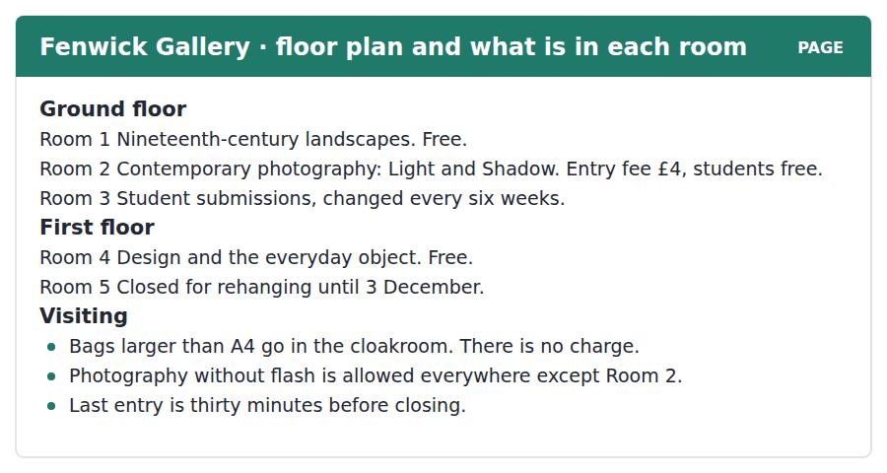
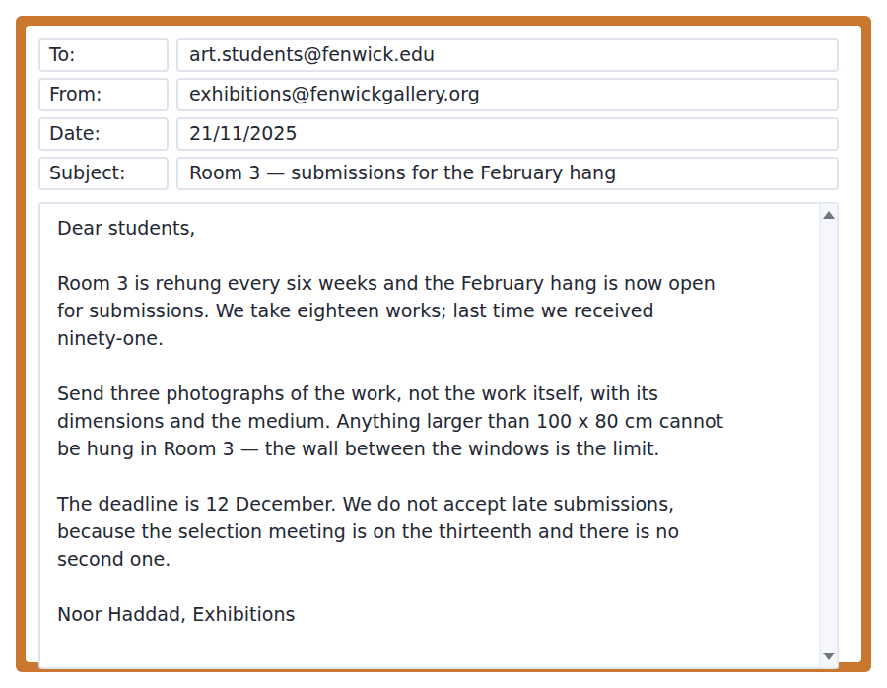
Exercise A Guided practice. The answer is on the page — find it.
1. Which room costs money to enter?
(A) Room 2
(B) Room 1
(C) Room 3
(D) Room 4
2. Where can you not take photographs?
(A) Room 1
(B) Room 2
(C) Room 3
(D) The cloakroom
3. Which room is on the first floor and open?
(A) Room 2
(B) Room 3
(C) Room 4
(D) Room 5
4. How much does the cloakroom cost?
(A) £4
(B) £1
(C) It depends on the bag
(D) Nothing
Exercise B Exam practice.
5. What is the main purpose of the email?
(A) To announce a closure
(B) To change the entry fee
(C) To report last year’s figures
(D) To invite submissions for February
6. What should students send?
(A) The work itself
(B) A sketch
(C) Three photographs of the work
(D) A portfolio
7. What is the largest work Room 3 can take?
(A) 100 x 80 cm
(B) 80 x 80 cm
(C) 100 x 100 cm
(D) There is no limit
8. Why are late submissions refused?
(A) There is no storage
(B) The selection meeting is the next day and there is no second one
(C) The gallery closes in December
(D) Too many were received last time
9. What can be inferred about getting work into Room 3?
(A) It is easy
(B) It costs money
(C) It is competitive
(D) It is only for first-year students
10. A student with a large rucksack visiting on 1 December should
(A) carry it in Room 2
(B) take it to Room 5
(C) pay £4
(D) leave it in the cloakroom


SKILL · Follow the order of the process
- A passage about a process tells you the stages in order. Number them as you read.
- A stage that reverses an earlier one is always tested. Mark it.
- Rhetorical questions in a passage are the author’s examples, not the author’s doubts.
- The main idea usually contradicts the belief stated in the first sentence.

How a Building Is Designed Before Anyone Builds It
People imagine that an architect begins with a shape. In practice the shape is nearly the last thing decided. The first weeks of a project are spent on a document called the brief, which contains no drawings at all. It lists what the building must do: how many people, doing what, at which times of day, and what must never happen. A concert hall and a hospital may end up looking entirely different, but the reason is in the brief, not in the architect’s taste.
Only then does drawing begin, and it begins small. The first sketches are often no larger than a hand, because at that size you cannot draw a detail and are forced to decide the things that matter: where the entrance is, which way the building faces, how daylight gets in. An architect who starts with a beautiful window has usually made those decisions by accident.
The last stage reverses the first. Having decided what the building does and roughly what shape it takes, the team tests the shape back against the brief. Will four hundred people leave this room in ninety seconds? Does the afternoon sun fall on the screens? Is the kitchen on the same floor as the dining room, or has a corridor quietly been added to every meal for the next fifty years? Most of what makes a building pleasant to use is settled by questions of this kind, asked before any material is ordered.
[270 words]

Exercise A Guided practice.
1. What is the passage mainly about?
(A) How architects learn to draw
(B) The order in which a building is designed
(C) Why concert halls differ from hospitals
(D) How daylight affects a room
2. According to paragraph 1, what does the brief contain?
(A) A list of what the building must do
(B) Drawings of the building
(C) A budget
(D) A list of materials
3. Why are the first sketches very small?
(A) To save paper
(B) Because the architect is in a hurry
(C) To fit in a notebook
(D) Because detail is impossible at that size
4. The word "brief" in paragraph 1 refers to
(A) a document setting out requirements
(B) a short period of time
(C) a type of drawing
(D) a meeting
Exercise B Exam practice.
5. What does the author say about an architect who starts with a beautiful window?
(A) They are unusually talented
(B) They have decided the important things by accident
(C) They work faster
(D) They ignore the brief deliberately
6. What happens at the last stage?
(A) The brief is rewritten
(B) Materials are ordered
(C) The shape is tested against the brief
(D) The sketches are enlarged
7. Why does the author mention a corridor between kitchen and dining room?
(A) To show how long buildings last
(B) To explain how kitchens are designed
(C) To compare two floors
(D) To illustrate a cost hidden in a plan
8. All of the following are described as part of the process EXCEPT:
(A) writing a brief
(B) choosing the colour of the walls
(C) drawing small sketches
(D) testing the shape against the brief
9. What can be inferred about the architect’s taste?
(A) It matters less than the brief
(B) It explains most of a building’s shape
(C) It is decided at the last stage
(D) It is the same for every architect
10. The word "settled" in paragraph 3 is closest in meaning to
(A) paid for
(B) written down
(C) decided
(D) moved
11. Which best states the main idea of paragraph 2?
(A) Beautiful windows are a mistake
(B) Architects should draw more
(C) Small drawings force the big decisions
(D) Daylight is the most important factor


Exercise A Listen and choose a response. You hear one line. Choose the best reply.
1. Man: Have you been to Room 3 yet?
(A) It’s on the ground floor.
(B) Not yet — is it worth it?
(C) Eighteen works.
(D) Yes, it was rehung.
2. Woman: Why is Room 5 closed?
(A) Until the third of December.
(B) On the first floor.
(C) Yes, it is.
(D) They’re rehanging it.
3. Man: Do you know if we have to pay?
(A) Students go in free.
(B) It’s Room 2.
(C) I went last week.
(D) The cloakroom is free.
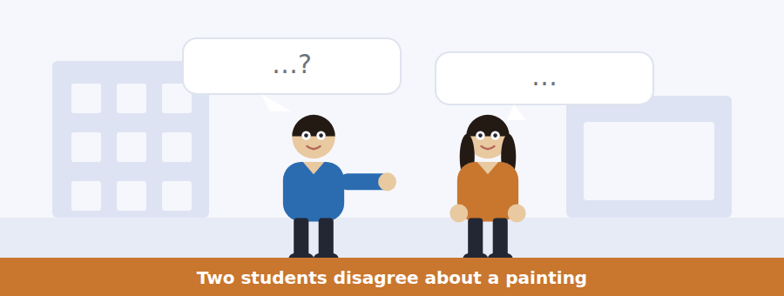
SKILL · Separate what is seen from what is claimed
- In a discussion about art, one speaker describes and the other interprets. Keep them apart.
- An opinion question asks what a speaker thinks; a detail question asks what they said.
- Listen for concession: all right, fair enough, I suppose. It marks a change of position.
- The ending usually says what they will do, not what they believe.

Exercise B Listen and answer. The audio plays once.
4. What are the speakers looking at?
(A) Two photographs
(B) A building plan
(C) Two grey squares on different backgrounds
(D) A student submission
5. What does the man say about the two greys?
(A) They are identical
(B) One is darker
(C) They were painted at different times
(D) The caption is wrong
6. What is the point of the piece, according to the man?
(A) That grey is hard to paint
(B) That the eye judges brightness by comparison
(C) That captions should be shorter
(D) That galleries light rooms badly
7. What does the woman mean by "half a painting"?
(A) It is unfinished
(B) It is only half the usual size
(C) It was painted by two people
(D) It depends too much on its explanation
8. What does the woman concede?
(A) That she was wrong about the greys
(B) That the piece is quite clever
(C) That captions are useful
(D) That she would have noticed anyway
9. What does the man suggest she do?
(A) Read the caption again
(B) Look at the next room first
(C) Write her comment in the visitors’ book
(D) Ask a member of staff
Audio script: see the back of the book. Do not read it before you listen.


Exercise A Listen and choose a response. You hear one line. Choose the best reply.
1. Woman: When is the deadline?
(A) Eighteen works.
(B) Three photographs.
(C) In Room 3.
(D) The twelfth of December.
2. Man: Can I hand it in late?
(A) No — the meeting is the next day.
(B) It’s in Room 3.
(C) Three photographs.
(D) Yes, it’s open now.
3. Woman: What size can they take?
(A) Up to a hundred by eighty.
(B) Eighteen of them.
(C) In December.
(D) On the first floor.
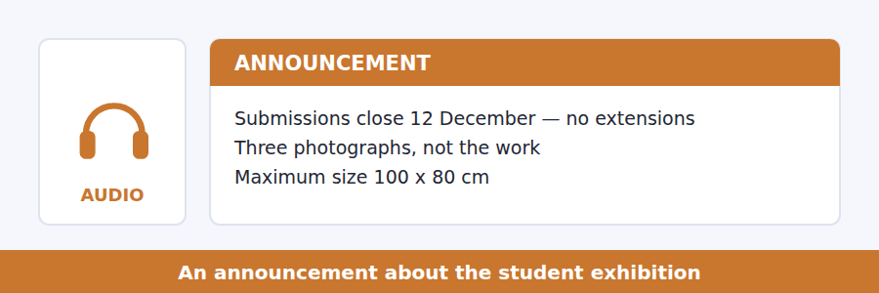
SKILL · Catch what is refused as well as what is asked
- Announcements about deadlines usually say what will not be accepted. That is a question.
- A reason given with because is nearly always tested.
- A number repeated twice is being emphasised for you. Write it down.
- The final sentence often tells you where to go for help.

Exercise B Listen and answer. The audio plays once.
4. What is the main purpose of the announcement?
(A) To open a new gallery
(B) To announce the selected works
(C) To change a deadline
(D) To explain how to submit work
5. Why is a late submission pointless?
(A) The gallery closes
(B) Nobody will see it
(C) It costs extra
(D) The wall is full
6. What must be written under the photographs?
(A) The artist’s name
(B) The price
(C) The dimensions and the medium
(D) The date of the work
7. What should a student with an oversized work do?
(A) Not submit
(B) Cut it down
(C) Submit and say so
(D) Wait six weeks
8. Why does the speaker give the numbers eighteen and ninety-one?
(A) To show the gallery is small
(B) To show that not being selected means little
(C) To explain the deadline
(D) To compare two years
Audio script: see the back of the book. Do not read it before you listen.


Exercise A Listen and choose a response. You hear one line. Choose the best reply.
1. Woman: Who said form follows function?
(A) In 1896.
(B) It’s on the board.
(C) Yes, it’s famous.
(D) An American architect called Sullivan.
2. Man: Does that mean beauty doesn’t matter?
(A) No — it means beauty comes from fitness for purpose.
(B) It was said in 1896.
(C) Form and function.
(D) Yes, it does.
3. Woman: Could you say the last bit again?
(A) It’s on the board.
(B) Of course — the part about the staircase?
(C) The lecture ends at four.
(D) Yes, I agree.
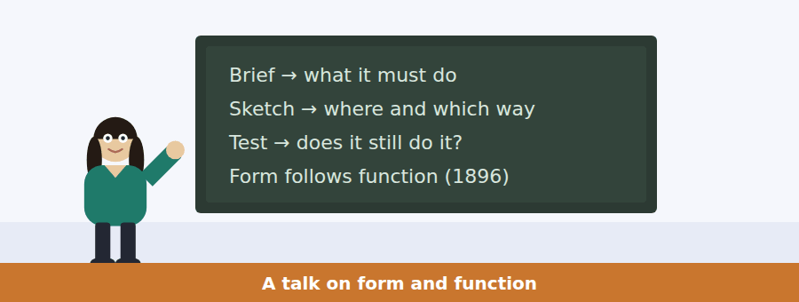
SKILL · Trace a phrase to its meaning
- When a talk quotes a famous phrase, it will go on to say what the phrase does and does not mean.
- Listen for the correction: what he actually meant, that is not what it says.
- A date on the board will be used, not just mentioned.
- The final example usually carries the main idea.

Exercise B Listen and answer. The audio plays once.
4. What is the main idea of the talk?
(A) Buildings should be plain
(B) Fire regulations are too strict
(C) Sullivan’s phrase is usually misunderstood
(D) Staircases are the hardest part to design
5. According to the speaker, what did Sullivan mean?
(A) That decoration should be banned
(B) That buildings should be cheap
(C) That function is more important than people
(D) That shape should grow out of purpose
6. Why does the speaker mention four hundred people and ninety seconds?
(A) To show that a plain box can fail to be functional
(B) To describe a fire
(C) To explain how halls are measured
(D) To compare two buildings
7. What sets the width of the staircase?
(A) The number who must leave in an emergency
(B) The architect’s taste
(C) The height of the building
(D) The size of the facade
8. What does the chain in the talk end with?
(A) The cost of the building
(B) The proportion of the facade
(C) The choice of material
(D) The position of the entrance
9. What does the speaker say about buildings we call beautiful?
(A) They ignore regulations
(B) They are usually old
(C) Their architects let function shape them
(D) They are designed by famous people
Audio script: see the back of the book. Do not read it before you listen.


Part 1 · Listen and Repeat
You hear a sentence and repeat it once. There is no preparation time, and the sentences get longer. Focus: linking inside relative clauses
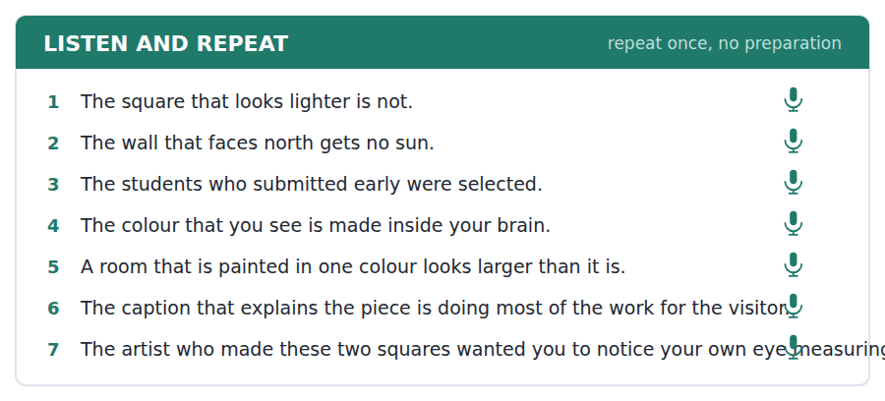
SKILL · Do not stop before who or that
- A relative clause belongs to the noun before it. Say them as one phrase: the_painting_that…
- A pause before that makes the sentence sound like two broken ones.
- Keep the voice up until the end of the clause, then let it fall.
- Finish the sentence. An abandoned relative clause scores badly.

Part 2 · Take an Interview
An interviewer asks you four questions on one theme: art you like. Answer each one fully. There is no preparation time.
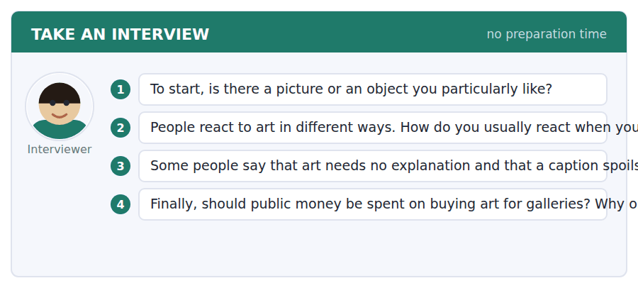
A good answer sounds like this
Question 2 — I usually read the caption first, which some people think is cheating. Without it I just walk past, so for me it is the opposite of spoiling it.
Question 4 — I think it should, but on living artists rather than famous dead ones. One reason is that the money then does two things at once.
I can… | Not yet | Yes
I said each relative clause without pausing before who or that | □ | □
I finished every sentence | □ | □
I gave a reason after each opinion | □ | □


Part 1 · Listen and Repeat
You hear a sentence and repeat it once. There is no preparation time, and the sentences get longer. Focus: asking politely with embedded questions
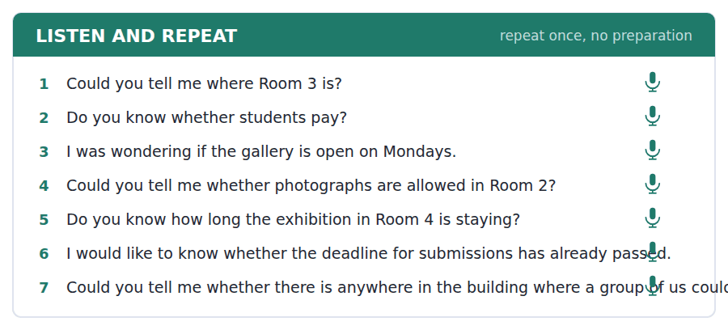
SKILL · Ask the long way round
- Could you tell me whether… is politer than Is it…? and the test rewards it.
- After tell me / know / wonder the word order is a statement: …whether it is free.
- Never invert twice: not *do you know is it free*.
- One question, asked well, is worth more than three asked quickly.

Part 2 · Take an Interview
An interviewer asks you four questions on one theme: places you visit. Answer each one fully. There is no preparation time.
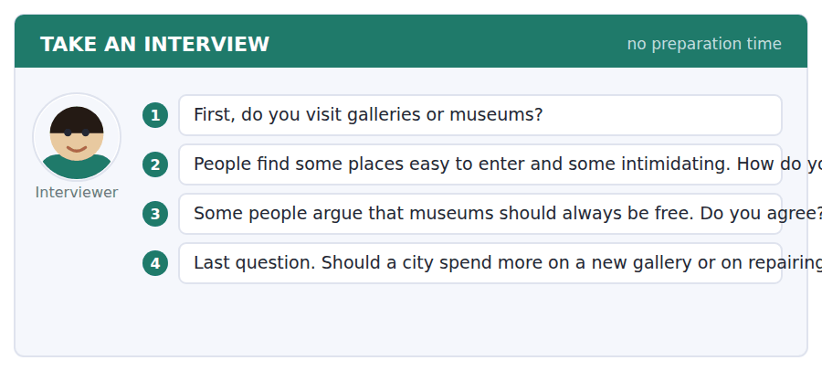
A good answer sounds like this
Question 2 — A little intimidated, honestly, mostly because everyone else looks as though they know what they are doing.
Question 3 — I agree, and the reason is practical rather than moral: a free museum is somewhere you drop into for twenty minutes, and that is how people learn to like them.
I can… | Not yet | Yes
I used statement order after tell me and know | □ | □
I did not invert twice in one question | □ | □
I asked at least two full indirect questions | □ | □


Part 1 · Listen and Repeat
You hear a sentence and repeat it once. There is no preparation time, and the sentences get longer. Focus: academic register
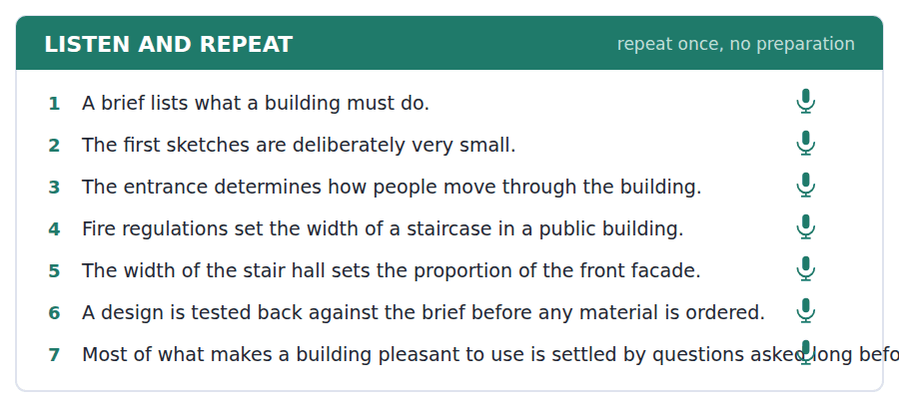
SKILL · Explain a consequence chain
- Use the unit’s words: design, format, contrast, intrinsic, illustrate.
- Say which sets which: the number sets the width, which sets the depth.
- One chain, said clearly, is a complete answer at this level.
- Mark yourself against the three statements below.

Part 2 · Take an Interview
An interviewer asks you four questions on one theme: buildings in your town. Answer each one fully. There is no preparation time.
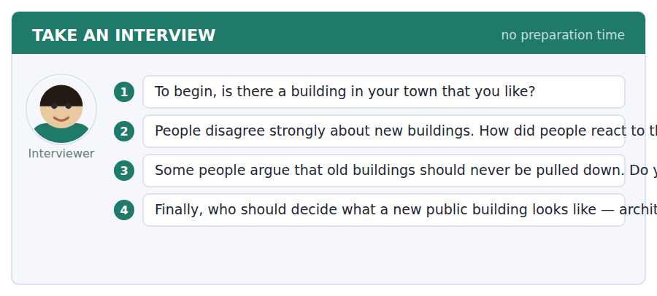
A good answer sounds like this
Question 3 — Not never, no. I would keep any building that still does its job, because the alternative is a town that is only ever as old as its last decision.
Question 4 — The people who use it should set the brief, and the architect should decide the form. That way each group decides what it actually knows about.
I can… | Not yet | Yes
I used at least three academic words from this unit | □ | □
I explained one chain of consequences | □ | □
My last answer gave an opinion, a reason and an example | □ | □


You see a sentence, then a set of words in boxes. Put the words in order to make one grammatical sentence. Almost every item in the real test makes a question or a question inside another sentence.
SKILL · The two shapes the real test uses
- Eight of ten real items make a question. Two make a relative clause. This exercise is built in that ratio.
- Direct question: auxiliary before the subject — Is it free?
- Embedded question: statement order after the reporting phrase — Do you know whether it is free?
- Relative clause: the noun, then who or that, then the verb — no second subject.

Exercise A Guided practice. The first three are worked through.
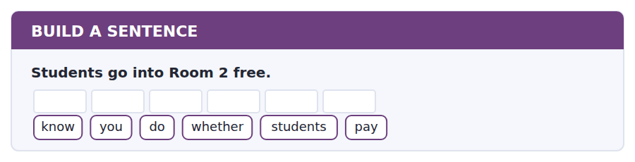
1. Do you know whether students pay?
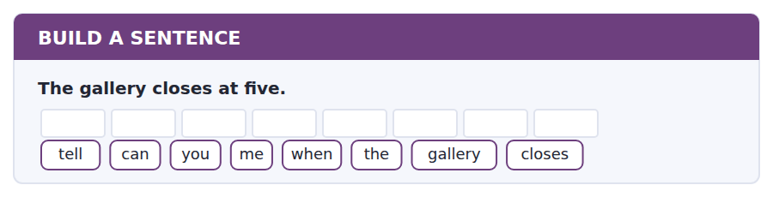
2. Can you tell me when the gallery closes?
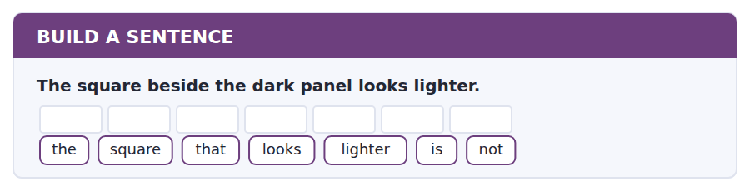
3. The square that looks lighter is not.
Exercise B Exam practice. Write the sentence.
4. Photography is not allowed in Room 2.
know / you / do / if / photography / is / allowed
__________________________________________________________
5. The deadline is the twelfth of December.
tell / could / you / me / whether / the / deadline / has / passed
__________________________________________________________
6. Room 5 is closed until 3 December.
Room / why / is / 5 / closed
__________________________________________________________
7. Eighteen works are chosen each time.
works / how / many / are / chosen
__________________________________________________________
8. The architect who designed the hall also designed the library.
the / architect / who / designed / the / hall / designed / the / library
__________________________________________________________
9. Students may leave bags in the cloakroom at no charge.
wondering / I / was / if / the / cloakroom / is / free
__________________________________________________________
10. The sketches are small so that detail is impossible.
know / do / you / why / the / sketches / are / small
__________________________________________________________


You read a short situation and write an email. You have 7 minutes. The three bullet points are the mark scheme: answer all three.
You want to submit a piece to Room 3 for the February hang. Your work is 110 x 70 cm, which is wider than the stated limit of 100 x 80 cm, and it is made of three separate panels that could be hung slightly apart or close together.
Write an email to the Exhibitions office.
- Say what you want to submit and give its dimensions.
- Ask whether the size rule can be met in your case.
- Ask one other question about how the work should be hung.
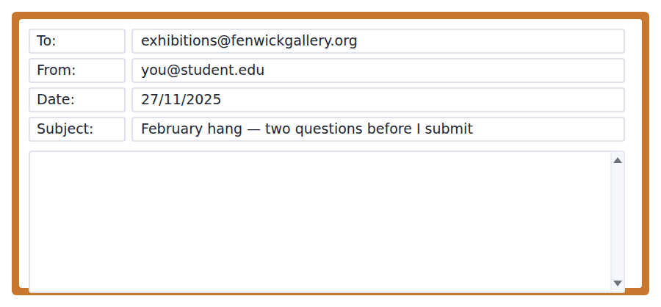
SKILL · Ask indirect questions in writing too
- Could you tell me whether… reads better on the page than a bare question.
- Give the measurement before you ask about it, so the reader can answer in one line.
- Two questions, clearly separated. Do not bury the second one.
- Seven minutes. 110–140 words.

Model email
Dear Ms Haddad,
I would like to submit a piece to Room 3 for the February hang. It is a work in three panels, 110 x 70 cm in total, in oil on board.
I can see that the limit is 100 x 80 cm, so mine is ten centimetres too wide. However, the three panels are separate, and the work reads equally well with a small gap between them or with none. Could you tell me whether the limit applies to the overall width, or to each panel? If it is the overall width, I could hang the panels touching and bring the total to 102 cm.
I would also like to know whether a three-part work has to be hung on a single wall, or whether panels may turn a corner.
Many thanks,
Tomás Oliveira
Why it works
- The dimensions come before the question, so the reader can answer without asking for them.
- The writer has read the rule and says so, which stops the reply being a restatement of it.
- A solution is offered (102 cm, panels touching), which makes a yes easy.
- Both questions use the indirect form, which is the register this unit teaches and the test rewards.
Now write your own. 7 minutes.
__________________________________________________________
__________________________________________________________
__________________________________________________________
__________________________________________________________
__________________________________________________________
__________________________________________________________
__________________________________________________________
__________________________________________________________


A professor asks a question and two students answer. You add your own post. You have 10 minutes and an effective answer is at least 100 words.
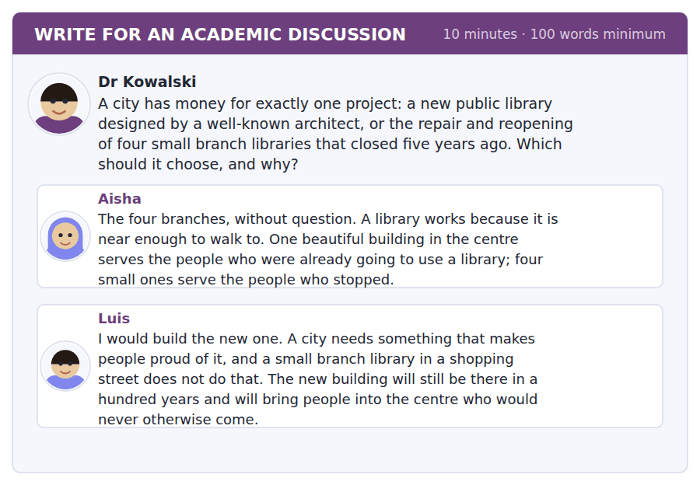
SKILL · Make a distinction, then decide
- The two posts usually measure different things. Name what each is measuring.
- Then say which measure the question is actually about.
- Use something from the unit — here, the idea of a brief.
- At least 100 words in ten minutes.

Sentence starters
- Aisha and Luis are measuring different things:…
- The question is really about what the building is for, which is…
- Luis is right that…, but that is an argument for…, not for…
- On the brief as I would write it,…
Model post
Aisha and Luis are measuring different things, and the disagreement disappears once you say which one the city is buying.
Luis is measuring civic pride and permanence. Those are real, and he is right that a branch library in a shopping street will never provide them. Aisha is measuring use — how many people actually open a door. Her point about walking distance is the stronger one, because a library that is a bus ride away is a library most people will visit twice a year.
We spent this unit on the brief: the document that says what a building must do before anyone draws it. If the brief says make the city proud, Luis wins. If it says get more people reading, Aisha does. For a city that has had four libraries shut for five years, the honest brief is the second one, so I would reopen the four.
[163 words]
Now write your own. 10 minutes, at least 100 words.
__________________________________________________________
__________________________________________________________
__________________________________________________________
__________________________________________________________
__________________________________________________________
__________________________________________________________
__________________________________________________________
__________________________________________________________
__________________________________________________________
__________________________________________________________

Grammar focus Defining relative clauses · embedded questions
Form | Example
who for people | The architect who designed the hall.
that / which for things | The square that looks lighter.
where for places | The room where the work is hung.
No second subject | The square that it looks lighter. ✗
Embedded: if / whether | Do you know whether students pay?
Embedded: wh- word | Could you tell me when it closes?
Statement order after the reporting phrase | Do you know where it is? (not *where is it*)

A defining relative clause says which one. It takes no commas: the square that looks lighter, not the square, that looks lighter.
The relative pronoun replaces the subject or object, so you never repeat it. Never *the man who he came*.
In an embedded question the inversion disappears. Where is it? becomes Do you know where it is?
Use whether, not if, after a preposition and before to: the question of whether to go.
Watch out! Do not invert twice. *Do you know where is it?* is the single most common mistake in this part of the test. After know, tell me and wonder, use statement order.
Exercise 1 Join the two sentences with who, that or where.
1. The architect designed the hall. She also designed the library.
2. This is the square. It looks lighter.
3. That is the room. The work is hung there.
4. The students submitted early. They were selected.
5. This is the wall. It limits the size.
6. That is the gallery. I told you about it.
Exercise 2 Make the direct question indirect.
1. Is the cloakroom free? → Do you know __________?
2. When does the gallery close? → Could you tell me __________?
3. Why is Room 5 closed? → I was wondering __________.
4. Has the deadline passed? → Could you tell me __________?
Exercise 3 Correct the mistake in each sentence.
1. Do you know where is the cloakroom?
2. The man who he designed it is Spanish.
3. Could you tell me does the gallery open on Monday?
How this is tested in Build a Sentence
This is the anchor unit for Build a Sentence. In the official practice test, Can you tell me whether the cabins will be available? and The tour guides who showed us around were fantastic are two of the ten items. Both shapes are here.

Unit review and progress check Unit 6
Exercise A Vocabulary. Write the word.
1. a clear difference between two things
2. belonging to the present time
3. the material or method an artist uses
4. the only one of its kind
5. of many different kinds
6. to draw attention to something
7. belonging naturally to something
8. the same everywhere
9. to introduce something new
10. one thickness lying over another
11. the words printed beside a picture
12. a drawing of a building seen from above
Exercise B Grammar. Complete the sentence.
1. The architect __________ designed the hall is Spanish.
2. This is the square __________ looks lighter.
3. That is the room __________ the work is hung.
4. Do you know __________ (be) the cloakroom?
5. Could you tell me __________ students pay?
6. I was wondering __________ Room 5 is closed.
7. The students __________ submitted early were selected.
8. Could you tell me when the gallery __________ (close)?
Exercise C One timed mini-section. 6 minutes.
1. According to the passage on page 98, the first thing an architect produces is
(A) a sketch
(B) a model
(C) a facade
(D) a brief
2. In the talk, what sets the width of a public staircase?
(A) the architect’s taste
(B) the number who must leave in an emergency
(C) the height of the building
(D) the width of the facade
3. Which sentence is correct?
(A) Do you know where is the gallery?
(B) The man who he designed it is Spanish.
(C) This is the square what looks lighter.
(D) Could you tell me whether the cloakroom is free?
4. A work larger than the Room 3 limit should be
(A) submitted with a note about its size
(B) not submitted
(C) cut down
(D) hung in Room 2
5. In Build a Sentence, the prompt sentence above the gaps
(A) is one of the answers
(B) is always a question
(C) fixes the tense and the person
(D) can be ignored
6. In a Reading module you can use Back
(A) freely inside the module
(B) never
(C) only on the first question
(D) only after finishing
Can you do these now?
I can… | Not yet | Yes
complete word endings in a text about how we see | □ | □
find one fact in a gallery plan and an email about an exhibition | □ | □
follow a passage that explains how a decision is made before anything is built | □ | □
understand two people disagreeing about something they are looking at | □ | □
describe an object out loud and say what I think of it | □ | □
write a polite enquiry, and a discussion post that makes a distinction | □ | □

ADAPTIVE TIP In Build a Sentence, read the prompt sentence above the gaps before you touch the tiles. It fixes the tense and the person, and most wrong answers in this task are grammatical sentences that simply do not follow from the prompt.

Unit 7 · Geology and the Earth
TOEFL iBT® Preparation Course 2026 · Volume 1
CEFR B1 · Grammar: Quantifiers and measurement · Word field: formation, layers, time
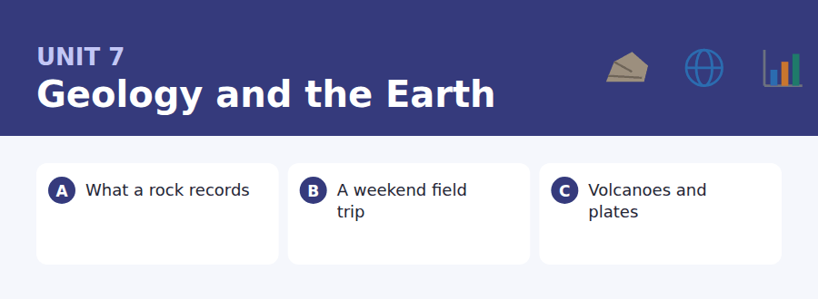
By the end of this unit I can…
- complete word endings in a text about how rock is formed
- read a kit list and a practical email and find the one detail I need
- follow a passage that explains why something happens where it does
- understand two people working out what to take somewhere
- talk about amounts and measurements without preparing
- write an email asking to join something late, and a post about priorities

Geology is a subject of quantities: how much, how many, how long, how deep. That is the grammar of this unit and the question words of its Build a Sentence page.

Vocabulary 1 · Academic 24 words from the Academic Word List
These twenty-four words come back through the whole unit, and again in the review. Cover the right-hand column and test yourself.
core the central part of something | undergo to experience a process or change
compound a substance made of two or more elements | collapse to fall down suddenly
erode to wear away slowly | trigger to make something start
accumulate to collect over time | volume the amount of space something fills
sequence a set of things in a particular order | aggregate a total formed from many parts
duration the length of time something lasts | deviate to move away from an expected course
phase one stage in a longer process | persist to continue for a long time
rigid stiff and not easily bent | precede to come before
adjacent next to something | ongoing still continuing
overlap to cover part of something else | site a place where something is or happens
exceed to be greater than | domain an area of knowledge or activity
expose to uncover something | scope how far something reaches

Exercise A Work in pairs. Ask and answer.
1. What is the longest duration you have ever spent travelling in one go?
2. Name something near you that is slowly eroding. What is wearing it away?
3. Describe a sequence of events that led to a decision you made.
4. Which domain of study interests you most, and what is its scope?
Vocabulary 2 · Campus and everyday 12 words for the daily-life tasks
The exam does not only test academic English. Notices, emails, conversations and announcements use the everyday words below.
boots strong shoes that cover the ankle | sample bag a bag for carrying specimens
waterproof a coat that keeps rain out | hammer a tool for breaking rock
rucksack a bag carried on the back | risk form a form about safety that must be signed
packed lunch food you bring with you | headcount a count of how many people are present
meeting point the place where a group gathers | minibus a small bus for about fifteen people
map a drawing of an area | shelter a place that protects you from weather

Words you will meet again: structure | process | estimate | vary | significant | convert | stable | impact


SKILL · Trust the first half of the word
- The letters before the dashes are the stem. Your brain finishes it faster than your pen.
- Noun endings in this field: -ion, -ure, -ment, -ness.
- A gap after a number is almost always a plural: layers, years, metres.
- Count the dashes before you commit — -ies and -ed look alike in a hurry.

Exercise A Guided practice. Five words are not complete. Write the missing letters.
A cliff is a calendar. Each band of rock is one layer of sediment that sett--- on the sea floor, and the bands below are always ol--- than the bands above. Count the layers and you can count the ye---. Where a layer is miss---, something has eroded it aw--.

The first one is done for you: 1 sett--- → led (settled)
Exercise B Exam practice. One paragraph, ten gaps — the real task.
Hold a piece of sandstone and you are holding a sum of time. The grains in it were once a be--- somewhere, and they settled grain by grain over a period that may have exce---- a million years. The layers above press down, water carries dissolved minerals between the grains, and gradually the sediment bec---- rock. Geologists read these layers like p----, from the bottom upwards. A thick layer means a long qu--- period; a thin one means a short one, or a slow sup--- of material. A sudden coarse layer in the middle of fine ones usually means a st---: a river in flood dumped its load in a single week and then went quiet again. Nothing in the rock is wri---- down, and yet the sequ---- is unambiguous, because the bottom was always there fi---.

Check your answers in the key at the back of the book.


SKILL · Match the item to the rule
- A kit list is a set of short rules. A question names one item; find its line.
- Essential and optional are different categories. Note which is which.
- Times in an email override times on a list. Read both.
- A warning (you will be sent back, you cannot join) is almost always a question.

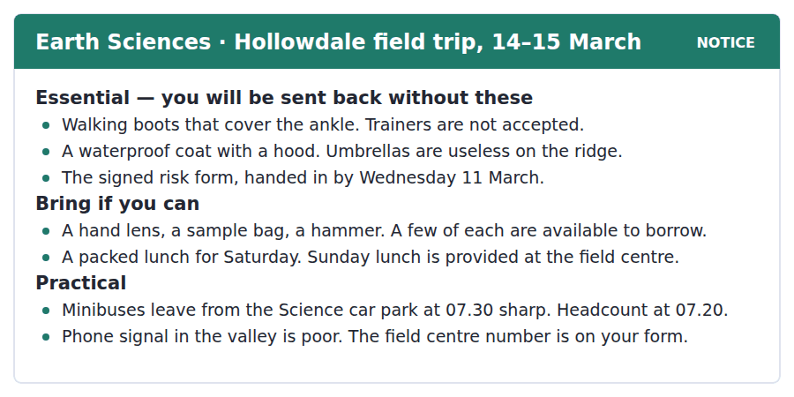
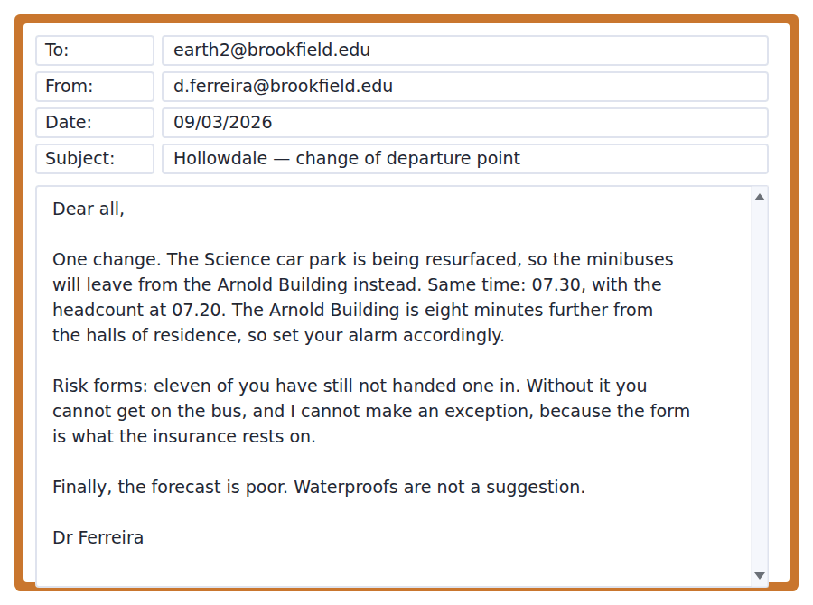
Exercise A Guided practice. The answer is on the page — find it.
1. What kind of shoes must students wear?
(A) Trainers
(B) Walking boots that cover the ankle
(C) Any strong shoe
(D) Waterproof shoes
2. Which item must be handed in before the trip?
(A) The signed risk form
(B) The kit list
(C) A sample bag
(D) A map
3. Which lunch do students have to bring?
(A) Sunday’s
(B) Both
(C) Saturday’s
(D) Neither
4. What time is the headcount?
(A) 07.00
(B) 07.30
(C) 08.00
(D) 07.20
Exercise B Exam practice.
5. What is the main purpose of the email?
(A) To cancel the trip
(B) To change the date
(C) To ask for volunteers
(D) To announce a new departure point
6. Why has the departure point changed?
(A) The car park is being resurfaced
(B) The car park is full
(C) The Arnold Building is closer
(D) There are more students
7. What has not changed?
(A) The departure place
(B) The departure time
(C) The lunch arrangements
(D) The weather forecast
8. Why can Dr Ferreira not make an exception about the risk form?
(A) The forms are already sent
(B) There is no time to sign one
(C) The insurance depends on it
(D) The field centre requires it
9. What does "Waterproofs are not a suggestion" mean?
(A) Waterproofs are optional
(B) Waterproofs are compulsory
(C) Waterproofs will be provided
(D) Umbrellas are better
10. A student who lives in the halls should
(A) leave eight minutes earlier than before
(B) go to the Science car park
(C) arrive at 07.30
(D) wait for a text message


SKILL · Hold two categories apart
- When a passage describes two types, make two columns in your head and fill both.
- The question will usually ask which type does what, so the labels matter.
- A comparison of behaviour (often/rarely, quietly/violently) is always tested.
- The final sentence of a passage like this is usually the one worth remembering.

Why Volcanoes Sit Where They Do
Mark every volcano on a world map and you do not get a scatter. You get lines. Almost all of them fall along a few narrow bands, and one of those bands runs nearly all the way round the Pacific Ocean. For most of the nineteenth century nobody could say why. The pattern was obvious and the explanation was missing, which is an uncomfortable position for a science.
The answer, agreed only in the 1960s, is that the surface of the Earth is broken into rigid plates that move a few centimetres a year — about the speed at which a fingernail grows. Where two plates pull apart, hot material rises to fill the gap and a line of volcanoes forms along the join. Where one plate is pushed beneath another, the descending plate carries water down with it, and water lowers the melting point of the rock above. Melted rock is lighter than solid rock, so it rises, and a second kind of volcano appears, parallel to the edge but a hundred kilometres inland.
The two kinds behave very differently, and the difference matters to anyone living near one. Volcanoes at a spreading join erupt often and quietly; their lava is runny and flows away. Volcanoes above a descending plate erupt rarely and violently, because their magma is thick and traps gas until the pressure exceeds the strength of the rock above it. The dangerous ones, in other words, are the ones that have been quiet for a long time.
[275 words]

Exercise A Guided practice.
1. What is the passage mainly about?
(A) How plates were discovered
(B) How lava flows
(C) Why the Pacific is large
(D) Why volcanoes form in lines, and in two kinds
2. According to paragraph 1, what did nineteenth-century scientists lack?
(A) Accurate maps
(B) A way to measure eruptions
(C) An explanation for an obvious pattern
(D) Agreement about the Pacific
3. How fast do the plates move?
(A) A few metres a year
(B) A few centimetres a year
(C) A few kilometres a year
(D) Too slowly to measure
4. Why does melted rock rise?
(A) It is hotter
(B) It contains water
(C) It is lighter than solid rock
(D) It is pushed by the plate
Exercise B Exam practice.
5. What does the descending plate carry down with it?
(A) Lava
(B) Gas
(C) Sediment
(D) Water
6. Where does the second kind of volcano appear?
(A) About a hundred kilometres inland
(B) At the plate edge
(C) In the middle of an ocean
(D) Only in the Pacific
7. All of the following are true of volcanoes at a spreading join EXCEPT:
(A) They erupt often
(B) They erupt quietly
(C) Their lava is runny
(D) Their magma traps gas
8. Why are the violent volcanoes dangerous?
(A) They are taller
(B) Their magma is thick and traps gas
(C) They are closer to cities
(D) They erupt without warning signs
9. What can be inferred from the last sentence?
(A) A long quiet period is a warning sign
(B) A long quiet period is reassuring
(C) Quiet volcanoes are extinct
(D) All volcanoes erupt eventually
10. The word "exceeds" in paragraph 3 is closest in meaning to
(A) falls below
(B) matches exactly
(C) becomes greater than
(D) destroys
11. Which best states the main idea of paragraph 2?
(A) Plates move very slowly
(B) Water is found deep underground
(C) Two plate movements produce two kinds of volcano
(D) The 1960s were important for science


Exercise A Listen and choose a response. You hear one line. Choose the best reply.
1. Man: Have you got boots?
(A) I’ve got some, but they’re trainers.
(B) They cover the ankle.
(C) In the Science car park.
(D) Yes, it’s cold.
2. Woman: How many of us are going?
(A) Two minibuses.
(B) Twenty-six, I think.
(C) On Saturday morning.
(D) From the Arnold Building.
3. Man: Do we need to bring lunch?
(A) At the field centre.
(B) It’s a packed lunch.
(C) Twelve o’clock.
(D) For Saturday, yes.
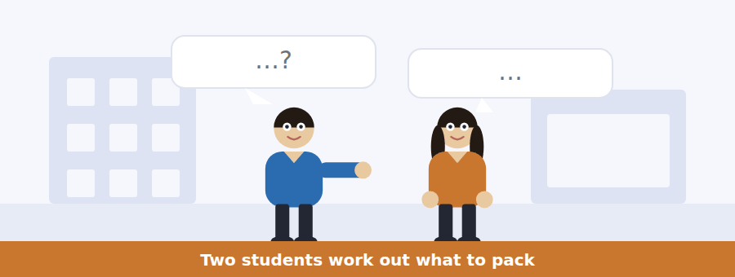
SKILL · Count what is said
- Conversations about packing are full of numbers and items. Note both.
- Listen for what is borrowed, shared or already owned — that is usually the question.
- A correction (actually, no, I thought so too) marks the testable fact.
- The last line often contains the plan.

Exercise B Listen and answer. The audio plays once.
4. What are the speakers mainly doing?
(A) Choosing a field trip
(B) Complaining about the weather
(C) Working out what to take
(D) Arranging transport
5. How many hammers are available to borrow?
(A) Three
(B) Six
(C) Eleven
(D) Twenty-six
6. What will the woman do about a hammer?
(A) Buy one
(B) Borrow one from the department
(C) Go without
(D) Share with the man
7. What is the man’s problem?
(A) He has not handed in the risk form
(B) He has no boots
(C) He missed the email
(D) He cannot get to the car park
8. Why can the form not be handed in on the day?
(A) The office is closed at weekends
(B) There are too many students
(C) It must be signed by a doctor
(D) The insurance depends on it
9. What will the man do next?
(A) Email Dr Ferreira
(B) Go to the office before four
(C) Borrow a hammer
(D) Buy walking boots
Audio script: see the back of the book. Do not read it before you listen.


Exercise A Listen and choose a response. You hear one line. Choose the best reply.
1. Woman: Where do we meet now?
(A) At twenty past seven.
(B) Because of the resurfacing.
(C) Outside the Arnold Building.
(D) Two minibuses.
2. Man: What happens if I’m late?
(A) The bus leaves without you.
(B) At half past seven.
(C) It’s eight minutes away.
(D) Yes, you can.
3. Woman: Is there phone signal there?
(A) Not really, no.
(B) The field centre number is on the form.
(C) In the valley.
(D) Yes, bring your phone.
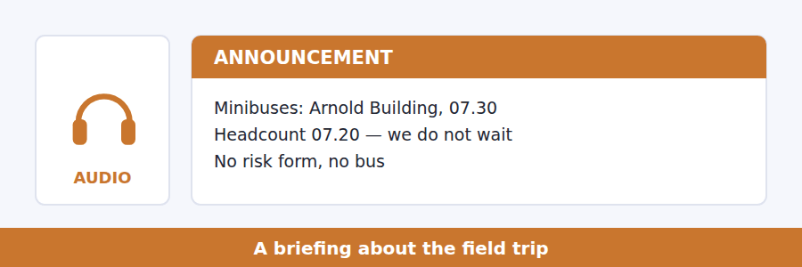
SKILL · Note what is non-negotiable
- A briefing separates advice from rules. Only the rules get tested as rules.
- Listen for we cannot, there is no, you will not be able to.
- A time repeated twice is a time you will be asked about.
- A safety instruction at the end is the speaker’s real priority.

Exercise B Listen and answer. The audio plays once.
4. What is the main purpose of the briefing?
(A) To describe the geology of Hollowdale
(B) To cancel part of the trip
(C) To give the arrangements and the rules
(D) To collect risk forms
5. Why does the speaker mention last year?
(A) To praise the group
(B) To describe the quarry
(C) To compare the weather
(D) To explain why the buses will not wait
6. Why is the risk form compulsory?
(A) The field centre asks for it
(B) The insurance is written against it
(C) It records allergies
(D) It confirms numbers
7. What does the speaker say about the ridge?
(A) It is slippery
(B) It has no shelter
(C) It is closed in bad weather
(D) It has good phone signal
8. What should a separated student do?
(A) Walk on to find the group
(B) Phone the field centre
(C) Stay where they are
(D) Return to the minibus
Audio script: see the back of the book. Do not read it before you listen.


Exercise A Listen and choose a response. You hear one line. Choose the best reply.
1. Man: What is an index fossil?
(A) About five hundred million years.
(B) In the lower layers.
(C) Yes, we saw one.
(D) A species that lived briefly and spread widely.
2. Woman: Can you date every rock that way?
(A) No — only ones with the right minerals.
(B) It takes a long time.
(C) They are on the board.
(D) Yes, every rock.
3. Man: Which method is older?
(A) About two hundred years.
(B) Relative dating, by a long way.
(C) Both are useful.
(D) Yes, it is.
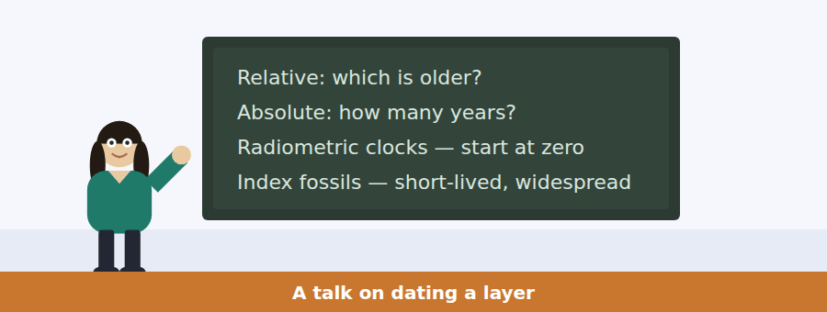
SKILL · Separate two questions the talk answers
- A talk that contrasts two methods will define both and then say when each is used.
- Listen for the limitation of each. That is almost always a question.
- An example given twice is the one the speaker thinks is important.
- The conclusion usually says how the two methods work together.

Exercise B Listen and answer. The audio plays once.
4. What is the main idea of the talk?
(A) Radiometric dating is the most accurate method
(B) Sandstone is difficult to study
(C) Two different dating questions need two different methods that support each other
(D) Fossils are more useful than minerals
5. What is relative dating?
(A) Deciding which layer is older
(B) Measuring how many years old a rock is
(C) Identifying a fossil species
(D) Counting radioactive minerals
6. Why can radiometric dating not be used on all rocks?
(A) It is too expensive
(B) It damages the sample
(C) It only works on young rocks
(D) Only some rocks contain the right minerals
7. What makes a good index fossil?
(A) It lived briefly and spread widely
(B) It is large and rare
(C) It is found only in sandstone
(D) It is beautiful
8. Why does the speaker mention sandstone?
(A) It is the oldest rock
(B) It contains the most fossils
(C) It is easy to break
(D) It is the rock they will see on Saturday and it cannot be dated radiometrically
9. How do the two methods work together?
(A) Fossils check the radiometric clocks
(B) Radiometric dates are carried everywhere by fossils
(C) Both are used on the same rock
(D) Neither is used alone
Audio script: see the back of the book. Do not read it before you listen.


Part 1 · Listen and Repeat
You hear a sentence and repeat it once. There is no preparation time, and the sentences get longer. Focus: numbers, fractions and units
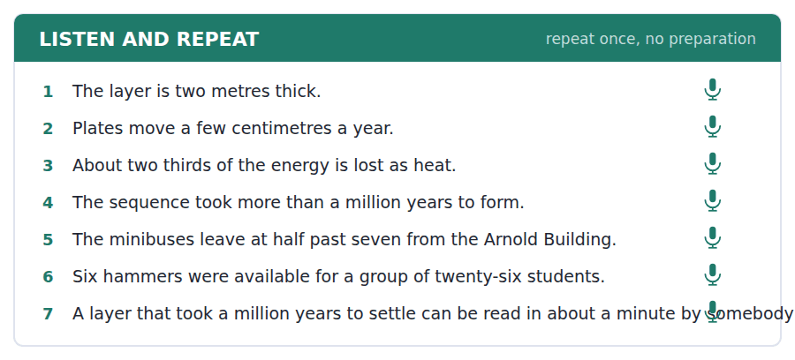
SKILL · Say the unit, every time
- A number without a unit is not an answer. Say centimetres, million years, per cent.
- Fractions: two thirds, three quarters, a half — practise them as whole phrases.
- Large numbers in groups: a hundred and sixty, not one six zero.
- If you misread a number, correct it in one word and keep going.

Part 2 · Take an Interview
An interviewer asks you four questions on one theme: the landscape where you grew up. Answer each one fully. There is no preparation time.
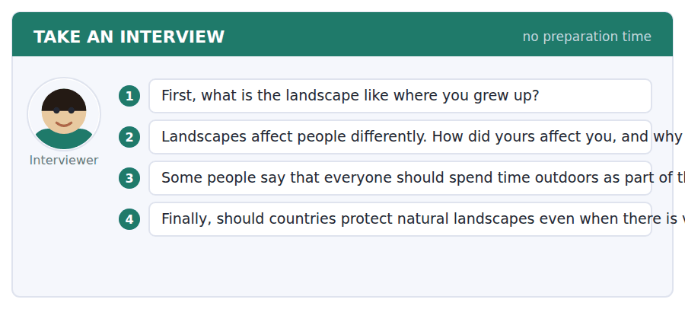
A good answer sounds like this
Question 1 — Very flat, actually. Fields in every direction and one hill that everybody called a mountain, which it was not.
Question 3 — I agree. One reason is that you cannot understand a map until you have walked across something it describes.
I can… | Not yet | Yes
I said the unit after every number | □ | □
I said fractions as whole phrases | □ | □
I kept going after any mistake | □ | □


Part 1 · Listen and Repeat
You hear a sentence and repeat it once. There is no preparation time, and the sentences get longer. Focus: talking about quantity
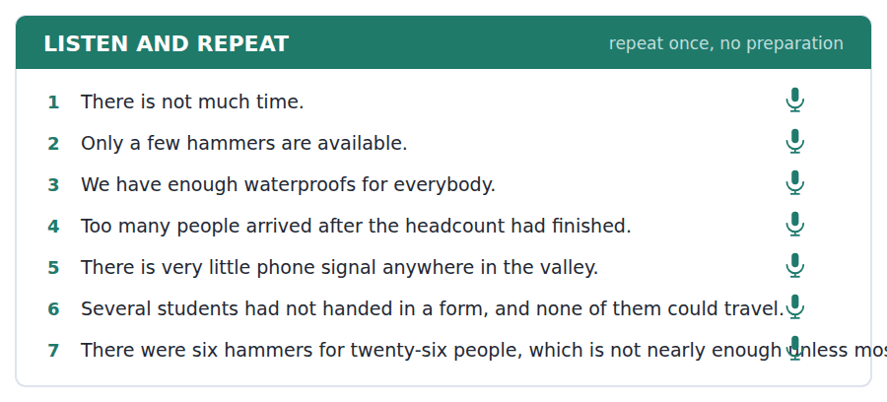
SKILL · Choose the right quantifier out loud
- Countable: many, a few, several, fewer. Uncountable: much, a little, less.
- Enough goes after an adjective (warm enough) and before a noun (enough time).
- Too many and too much both mean a problem. Say which.
- One quantity, one example. That is a complete answer here.

Part 2 · Take an Interview
An interviewer asks you four questions on one theme: trips and how they are organised. Answer each one fully. There is no preparation time.
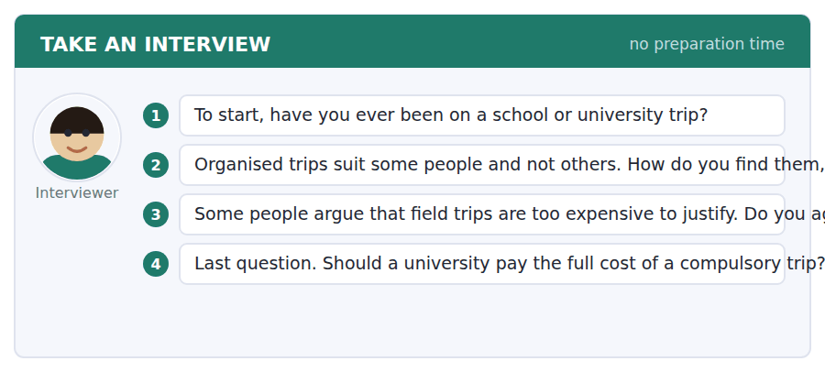
A good answer sounds like this
Question 2 — I like them more than I expect to. The organisation annoys me and then the day itself is always the part I remember.
Question 4 — Yes, if it is compulsory. If a student cannot pay, the trip stops being compulsory for them and starts being a filter.
I can… | Not yet | Yes
I used many and much correctly | □ | □
I gave a quantity with an example | □ | □
I finished every sentence | □ | □


Part 1 · Listen and Repeat
You hear a sentence and repeat it once. There is no preparation time, and the sentences get longer. Focus: academic register
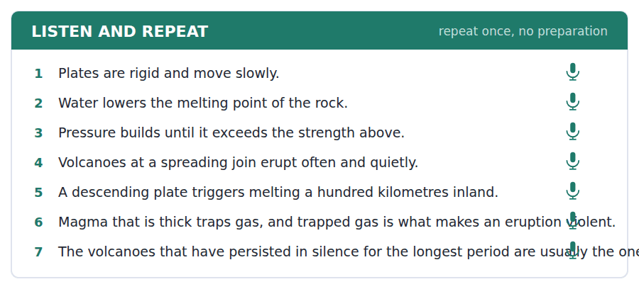
SKILL · State a mechanism, then its consequence
- Use the unit’s words: trigger, exceed, persist, rigid, undergo.
- Say what causes what: water lowers the melting point, so rock melts, so it rises.
- Three short clauses in a chain beat one long sentence.
- Mark yourself against the three statements below.

Part 2 · Take an Interview
An interviewer asks you four questions on one theme: living with natural risk. Answer each one fully. There is no preparation time.
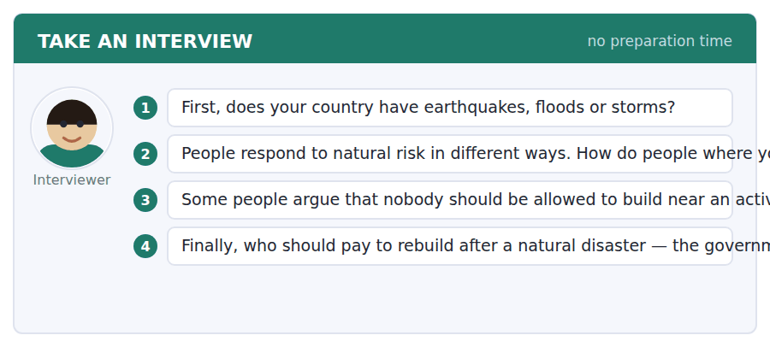
A good answer sounds like this
Question 3 — I disagree, mostly. The soil near volcanoes is the best farmland there is, which is exactly why people are there, and a rule that ignores that will simply be broken.
Question 4 — The government, with insurance behind it. One reason is that nobody chooses where they are born.
I can… | Not yet | Yes
I used at least three academic words from this unit | □ | □
I stated a mechanism and then its consequence | □ | □
I gave an example in my last answer | □ | □


You see a sentence, then a set of words in boxes. Put the words in order to make one grammatical sentence. Almost every item in the real test makes a question or a question inside another sentence.
SKILL · Find the measurement word
- How much, how many, how long, how deep, how old — these open most items here.
- How much goes with uncountables, how many with countables.
- In an embedded question, how many keeps statement order: do you know how many there are.
- Use every tile exactly once.

Exercise A Guided practice. The first three are worked through.
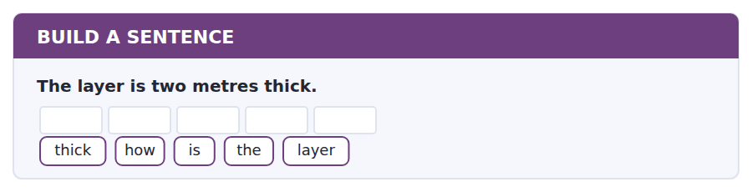
1. How thick is the layer?
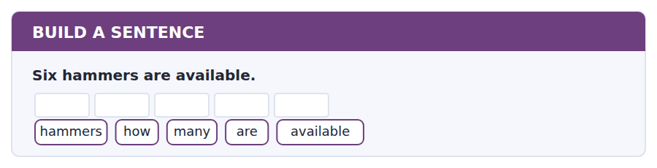
2. How many hammers are available?
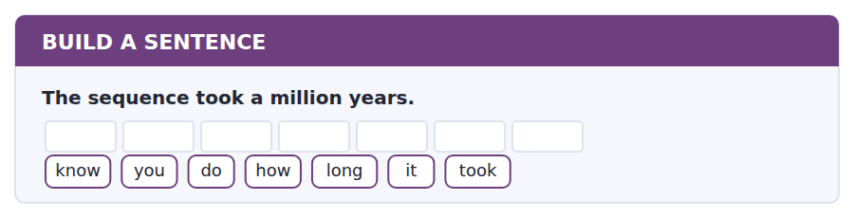
3. Do you know how long it took?
Exercise B Exam practice. Write the sentence.
4. Plates move a few centimetres a year.
fast / how / do / the / plates / move
__________________________________________________________
5. Twenty-six students are going on the trip.
tell / can / you / me / how / many / students / are / going
__________________________________________________________
6. The minibuses leave at half past seven.
time / what / do / the / minibuses / leave
__________________________________________________________
7. There is very little phone signal in the valley.
much / how / signal / is / there
__________________________________________________________
8. The fossil that spread widely is the useful one.
the / fossil / that / spread / widely / is / the / useful / one
__________________________________________________________
9. Students without a form cannot travel.
know / do / you / whether / I / can / travel
__________________________________________________________
10. The rock is about five hundred million years old.
old / how / is / the / rock
__________________________________________________________


You read a short situation and write an email. You have 7 minutes. The three bullet points are the mark scheme: answer all three.
You have not handed in your risk form for the Hollowdale trip and the deadline is tomorrow afternoon. You also own walking boots that come to just below the ankle, and the kit list says boots must cover the ankle.
Write an email to Dr Ferreira.
- Say when you will hand in the form.
- Ask about the boots, giving enough detail to be answered.
- Say what you will do if the answer is no.
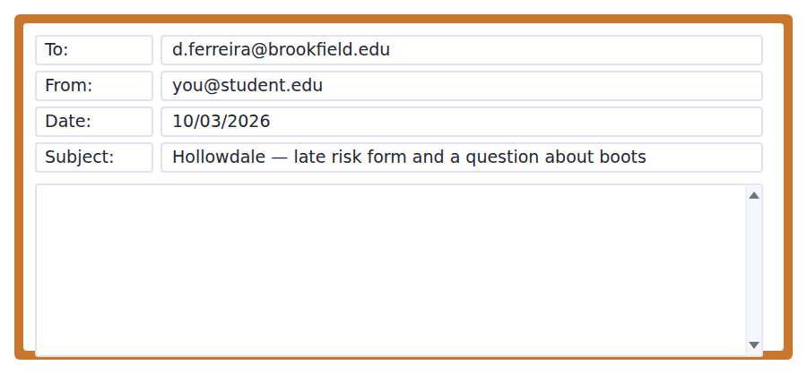
SKILL · Do not ask a question that cannot be answered
- Are my boots all right? cannot be answered. Describe them and the answer becomes possible.
- Say what you will do in either case. It saves a second email.
- Keep the apology to one clause. Then move on to the practical part.
- Seven minutes. 110–140 words.

Model email
Dear Dr Ferreira,
Apologies — I am one of the eleven. I will bring my risk form to the office tomorrow morning, well before four, and I understand that I cannot travel without it.
I also have a question about boots. Mine are walking boots with a stiff sole, but they stop about two centimetres below the ankle bone rather than above it. Would those be acceptable for the ridge, or do you want boots that cover the ankle completely?
If they are not acceptable, I can borrow a pair from my housemate, who takes the same size. I would rather know tomorrow than find out at the headcount, which is why I am asking now.
Thank you,
Hana Takeda
Why it works
- The apology is one clause and the commitment is specific: tomorrow morning, before four.
- The boots are described in enough detail (stiff sole, two centimetres below the ankle) for a yes or a no.
- The writer gives the fallback, so the reply can be one word.
- I would rather know tomorrow than at the headcount shows the reader why the question is worth answering now.
Now write your own. 7 minutes.
__________________________________________________________
__________________________________________________________
__________________________________________________________
__________________________________________________________
__________________________________________________________
__________________________________________________________
__________________________________________________________
__________________________________________________________


A professor asks a question and two students answer. You add your own post. You have 10 minutes and an effective answer is at least 100 words.
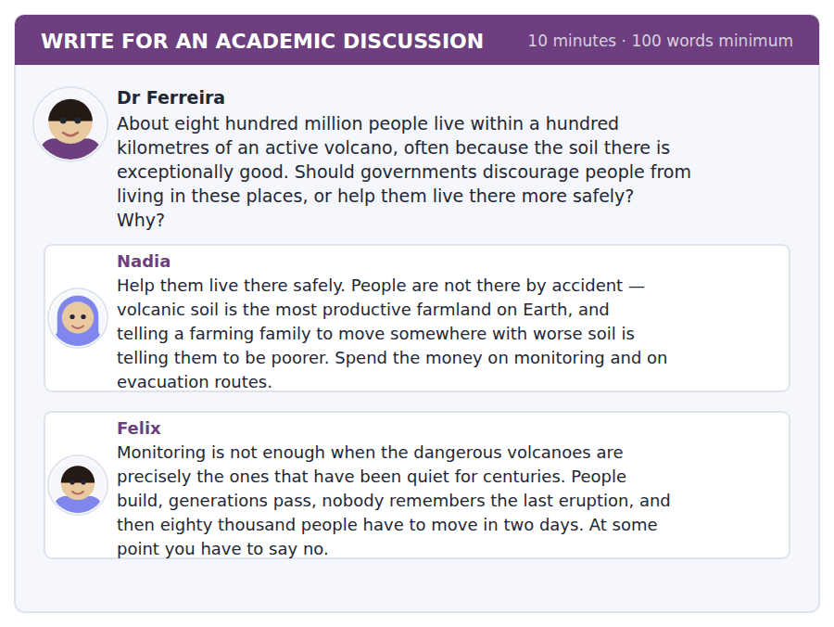
SKILL · Use the science in the question
- The passage gave you a fact that bears on this: the quiet ones are the dangerous ones.
- A post that uses that fact beats one that only has an opinion.
- Name a classmate and take their best point seriously.
- At least 100 words in ten minutes.

Sentence starters
- Felix’s point about forgetting is the one that worries me, because…
- Nadia is right about the soil, but that is an argument for…
- The passage gives a reason neither post uses:…
- I would therefore…
Model post
Felix has found the real difficulty, and it is not geological. It is that memory is shorter than the gap between eruptions.
Nadia is right about the soil, and I do not think anyone will move away from the best farmland in the world because of a warning. But the passage gives a reason that neither post uses. The volcanoes that erupt often are the quiet, runny ones; the violent ones are quiet for centuries first. So the places that feel safest are exactly the ones where nobody alive has seen an eruption, and that is where discouragement would be hardest to sell and most needed.
What I would fund, then, is neither moving people nor monitoring alone. It is keeping the memory. Mark the old flow lines in the streets. Teach the last eruption in every local school. A town that remembers evacuates in hours.
[167 words]
Now write your own. 10 minutes, at least 100 words.
__________________________________________________________
__________________________________________________________
__________________________________________________________
__________________________________________________________
__________________________________________________________
__________________________________________________________
__________________________________________________________
__________________________________________________________
__________________________________________________________
__________________________________________________________

Grammar focus Quantifiers and measurement
Form | Example
many / few / fewer (countable) | few hammers, fewer students
much / little / less (uncountable) | little signal, less time
a few = some; few = not many | A few came. Few came.
enough + noun / adjective + enough | enough time; warm enough
too many / too much | too many people; too much rain
How much / How many questions | How much signal is there?
Measurement as an adjective | a two-metre layer; two metres thick

Countable nouns have a plural: hammers, students, layers. Uncountable nouns do not: signal, time, rain, information.
A few is positive (some, enough to matter). Few is negative (hardly any). The same applies to a little and little.
When a measurement comes before a noun it loses its plural: a two-metre layer, a ten-minute walk, a five-year study.
Watch out! Never write *less students* or *many informations*. It is fewer students, and information has no plural at all.
Exercise 1 Complete with much, many, few, little, fewer or less.
1. There were very __________ hammers for the group.
2. There is not __________ phone signal in the valley.
3. __________ students handed in the form late this year than last.
4. How __________ people are going on the trip?
5. We have __________ time than we thought.
6. Only a __________ of them had the right boots.
Exercise 2 Rewrite using a measurement before the noun.
1. a layer of two metres → __________
2. a walk of ten minutes → __________
3. a study lasting five years → __________
4. a delay of eleven minutes → __________
Exercise 3 Correct the mistake in each sentence.
1. There were less students than last year.
2. We did not have many time.
3. It is a two-metres layer.
How this is tested in Build a Sentence
Build a Sentence uses measurement questions constantly: How much track was laid? How many works are chosen? Choose much or many from the noun that follows, not from the size of the answer.

Unit review and progress check Unit 7
Exercise A Vocabulary. Write the word.
1. to wear away slowly
2. to collect over time
3. a set of things in a particular order
4. the length of time something lasts
5. to be greater than
6. to make something start
7. to continue for a long time
8. to come before
9. still continuing
10. next to something
11. a form about safety that must be signed
12. the place where a group gathers
Exercise B Grammar. Complete the sentence.
1. There were very __________ hammers for the group.
2. There is not __________ phone signal in the valley.
3. __________ students handed in the form than last year.
4. How __________ people are travelling?
5. We have __________ time than we thought.
6. It is a __________ (two metres) layer.
7. Only a __________ of them had the right boots.
8. There was __________ (too much / too many) rain on the ridge.
Exercise C One timed mini-section. 6 minutes.
1. According to the passage on page 114, the dangerous volcanoes are the ones that
(A) erupt most often
(B) sit on a spreading join
(C) have been quiet for a long time
(D) have runny lava
2. In the talk, sandstone usually cannot be dated radiometrically because
(A) it lacks the right minerals
(B) it is too young
(C) it contains too many fossils
(D) it erodes too quickly
3. Which sentence is correct?
(A) There were less students this year.
(B) We did not have many time.
(C) How much people are coming?
(D) It is a two-metre layer.
4. A student who has not handed in a risk form
(A) pays a fee
(B) cannot travel
(C) travels in a separate bus
(D) signs one on the day
5. In Complete the Words, a gap after a number is most likely
(A) a past tense ending
(B) an adverb ending
(C) a plural ending
(D) a comparative ending
6. A question beginning "All of the following are true EXCEPT" wants
(A) the one statement the text supports
(B) the main idea
(C) the one statement the text does not support
(D) a vocabulary meaning
Can you do these now?
I can… | Not yet | Yes
complete word endings in a text about how rock is formed | □ | □
read a kit list and a practical email and find the one detail I need | □ | □
follow a passage that explains why something happens where it does | □ | □
understand two people working out what to take somewhere | □ | □
talk about amounts and measurements without preparing | □ | □
write an email asking to join something late, and a post about priorities | □ | □

ADAPTIVE TIP Skim the whole Reading passage once before you look at the questions. At this level it is only about 250 words, so a first pass costs you under a minute and it tells you where everything is — which is most of what the detail questions are asking.

Unit 8 · Economics and Markets
TOEFL iBT® Preparation Course 2026 · Volume 1
CEFR B1 · Grammar: Articles and generalisation · Word field: value, exchange, demand
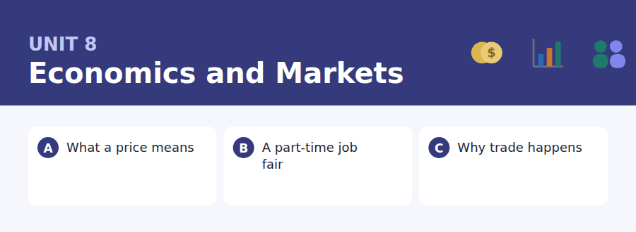
By the end of this unit I can…
- complete word endings in a text about prices and value
- read a job advertisement and an interview email for the conditions
- follow a passage that explains why two countries both gain from trade
- understand two people comparing two jobs
- talk about money and work without preparing
- write an email asking about conditions, and a post that questions an assumption

Economics generalises constantly: a price tells you…, buyers respond to… Getting a, the and no article right is what makes a generalisation sound like one.

Vocabulary 1 · Academic 24 words from the Academic Word List
These twenty-four words come back through the whole unit, and again in the review. Cover the right-hand column and test yourself.
economy the system by which a country makes and uses money | sector one part of a country’s economy
finance the management of money | labour work, especially physical work
income money that you receive regularly | export to sell goods to another country
invest to put money into something to gain more later | contract a written agreement
purchase to buy | sum a total amount of money
revenue money a business receives | percent one part in a hundred
currency the money used in a country | statistic a number that describes a group
commodity a raw material that is bought and sold | index a number showing how something has changed
credit an arrangement to pay later | allocate to give out for a particular purpose
fund to provide money for something | distribute to share out among many
margin the difference between cost and selling price | transfer to move from one place or person to another
incentive something that encourages you to act | equate to treat two things as equal

Exercise A Work in pairs. Ask and answer.
1. What is the main sector of the economy where you live?
2. Name one thing whose price has changed a lot recently. What do you think caused it?
3. If you had a sum of money to invest, what would you put it into and why?
4. What incentive would actually make students use less electricity?
Vocabulary 2 · Campus and everyday 12 words for the daily-life tasks
The exam does not only test academic English. Notices, emails, conversations and announcements use the everyday words below.
job fair an event where employers meet possible staff | application a formal request for a job or place
part-time working fewer than full hours | employer a person or company that pays people to work
shift a period of work | contract hours the number of hours you have agreed to work
wage money paid for work, usually by the hour | payslip a paper showing what you were paid
interview a formal meeting to decide if someone is suitable | overtime hours worked beyond the agreed number
CV a short written record of your education and jobs | reference a statement about you from someone who knows your work

Words you will meet again: significant | estimate | impact | vary | alternative | evaluate | exceed | proportion


SKILL · Let the collocation finish the word
- Words travel in pairs. After supply you expect and demand; after make you expect a profit.
- Endings to expect here: -ers, -ing, -ment, -ity.
- If the gap follows a number or a quantity word, think plural.
- Read the finished sentence back. Economics texts repeat their key words.

Exercise A Guided practice. Five words are not complete. Write the missing letters.
A price is a message. When something becomes scarce, its price ri---, and the rise tells every buy-- to use less of it and every sell-- to make more. Nobody has to be t---. The price does the tell--- by itself.

The first one is done for you: 1 ri--- → ses (rises)
Exercise B Exam practice. One paragraph, ten gaps — the real task.
Ask what a price is and most people say it is what something co---. That is what it is to you. What it is to an economy is a sig---. A price carries information from people you will never meet to people who will never meet you. When a harvest fails somewhere, the price of that comm----- rises everywhere, and millions of buy--- quietly use a little less of it without ever hear--- about the harvest. At the same time the higher margin gives produ---- an incentive to grow more. No committee decides any of this and no government annou---- it. The difficulty is that a price only carries the information that somebody actually pa--. If a factory can pour waste into a river at no co--, the price of what it makes says noth--- about the river, and everyone downstream pays a bill that never appears on anybody’s receipt.

Check your answers in the key at the back of the book.


SKILL · Read the conditions, not the headline
- A job advertisement sells. The testable information is in the small print.
- Pay, hours, start date and requirements are the four things usually asked about.
- An email offering an interview will contain a time, a place and a thing to bring.
- If two documents give different numbers, one of them is a condition on the other.

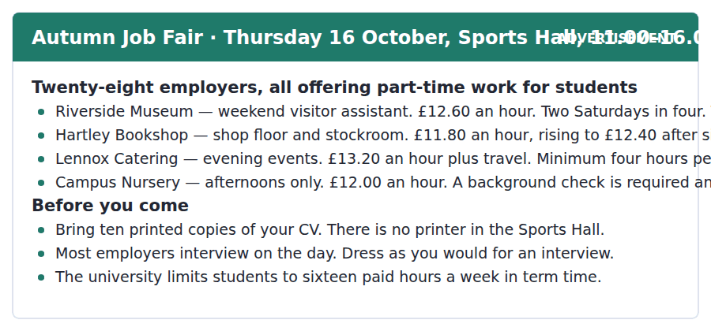
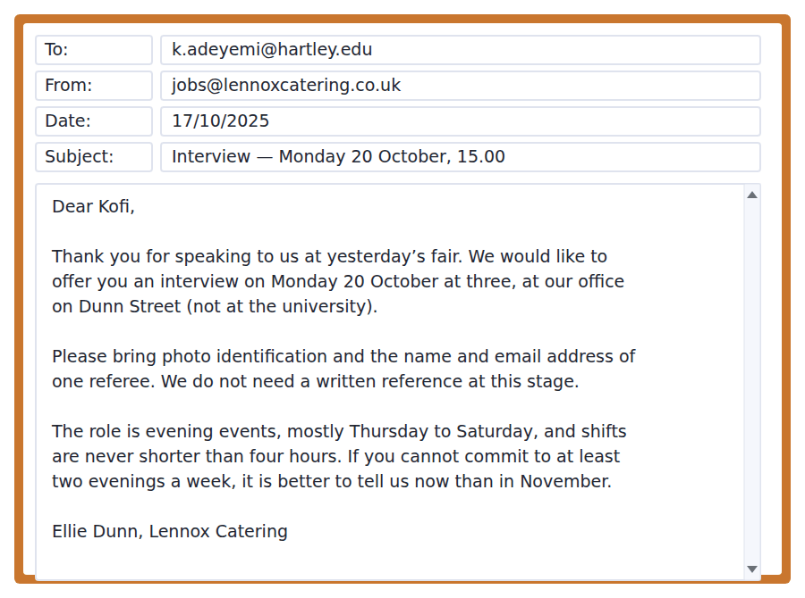
Exercise A Guided practice. The answer is on the page — find it.
1. Which employer pays the most per hour at the start?
(A) Riverside Museum
(B) Hartley Bookshop
(C) Lennox Catering
(D) Campus Nursery
2. Which job requires a background check?
(A) Riverside Museum
(B) Campus Nursery
(C) Hartley Bookshop
(D) Lennox Catering
3. What must students bring to the fair?
(A) A payslip
(B) A reference
(C) Photo identification
(D) Ten printed copies of a CV
4. How many paid hours a week may a student work in term time?
(A) Sixteen
(B) Four
(C) Twelve
(D) Twenty
Exercise B Exam practice.
5. Where will Kofi’s interview take place?
(A) At the Sports Hall
(B) At an office on Dunn Street
(C) At the university
(D) At an evening event
6. What does Kofi need to bring?
(A) A written reference
(B) Ten copies of his CV
(C) Photo identification and a referee’s details
(D) A payslip
7. What is the shortest shift Lennox offers?
(A) Four hours
(B) Two hours
(C) Three hours
(D) Six hours
8. Why does Ellie mention November?
(A) The job starts then
(B) Interviews continue until then
(C) Pay rises then
(D) It is better to withdraw now than later
9. A student working two Lennox shifts a week would earn about
(A) £50
(B) £160
(C) £210
(D) £105
10. What can be inferred about the job fair?
(A) Only final-year students may attend
(B) Employers may offer a job the same day
(C) All the jobs are on campus
(D) Applications close in November


SKILL · Follow an argument, not a description
- An argument passage sets up a belief, gives a counter-argument, and then qualifies it. Expect all three.
- Imagine two countries signals a worked example. Follow it number by number.
- The last paragraph often concedes something. That concession is usually tested.
- Main-idea questions want the whole argument, not the example inside it.

Why Two Countries Both Gain from Trade
The oldest argument against trade is the simplest: if we buy from them, the money leaves. It sounds obviously true, and economists have spent two centuries explaining why it is not. The explanation is counter-intuitive enough that it is worth doing slowly.
Imagine two countries. One is better than the other at making absolutely everything — better at growing wheat and better at making cloth. The intuition says the efficient country should make both and the other should make nothing. But think about what the efficient country gives up. Every hour it spends making cloth is an hour it does not spend growing wheat, and it is very good at wheat. The other country is worse at both, but it is less bad at cloth, and an hour it spends on cloth costs it very little wheat. So both countries end up with more of everything if each concentrates on what it gives up least to produce, and then they exchange.
This is why trade is not a competition with a winner. It is also why the argument is so often lost in public. The gains are spread thinly across millions of buyers who never notice them, while the losses are concentrated on the few thousand people whose industry closes, and who notice very sharply indeed. Both effects are real. An economist who says only the first thing is answering a different question from the one being asked.
[275 words]

Exercise A Guided practice.
1. What is the passage mainly about?
(A) How wheat and cloth are made
(B) Why some countries are more efficient
(C) Why trade can benefit both sides, and why that is hard to see
(D) The history of economics
2. What is "the oldest argument against trade"?
(A) That money leaves the country
(B) That it costs jobs
(C) That it is inefficient
(D) That it favours large countries
3. In the example, what is true of the second country?
(A) It is better at cloth
(B) It is better at wheat
(C) It makes nothing
(D) It is worse at both but less bad at cloth
4. The phrase "gives up" in paragraph 2 refers to
(A) what is not produced instead
(B) money spent
(C) goods exported
(D) hours worked
Exercise B Exam practice.
5. According to the passage, what should each country concentrate on?
(A) What it makes best
(B) What it can sell most of
(C) What it gives up least to produce
(D) What its neighbours cannot make
6. Why does the author say trade is "not a competition with a winner"?
(A) Because governments regulate it
(B) Because both sides end up with more
(C) Because prices are fixed
(D) Because money does not actually move
7. All of the following are stated in the passage EXCEPT:
(A) The gains from trade are spread thinly
(B) The losses are concentrated
(C) The losses are smaller than people think
(D) Both effects are real
8. Why is the argument "so often lost in public"?
(A) It is too technical to explain
(B) The people who gain do not notice and the people who lose do
(C) Economists disagree about it
(D) Governments prefer the opposite
9. What does the author say about an economist who mentions only the gains?
(A) They are being dishonest
(B) They are usually correct
(C) They have misread the data
(D) They are answering a different question
10. What can be inferred about the author’s view?
(A) Trade is good but its costs are real
(B) Trade should be restricted
(C) Economists are usually wrong
(D) The old argument is correct
11. Which best states the main idea of paragraph 3?
(A) Industries close every year
(B) Economists should speak more clearly
(C) Trade creates more jobs than it destroys
(D) Public debate ignores the gains because of how they are distributed


Exercise A Listen and choose a response. You hear one line. Choose the best reply.
1. Woman: Did you get anything from the fair?
(A) An interview, actually.
(B) Twenty-eight employers.
(C) In the Sports Hall.
(D) Yes, it was busy.
2. Man: How much does the bookshop pay?
(A) On the shop floor.
(B) Two Saturdays in four.
(C) Eleven eighty an hour.
(D) Yes, it does.
3. Woman: Four-hour shifts are quite long.
(A) They’re in the evening.
(B) They are, but the pay is better.
(C) Thursday to Saturday.
(D) No, I don’t think so.
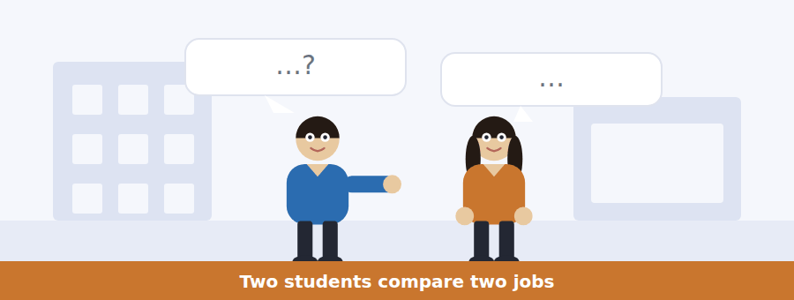
SKILL · Track the trade-off
- When two options are compared, each will have one advantage and one cost. Note all four.
- The speaker who changes their mind is usually the subject of a question.
- Numbers said once are testable; numbers repeated are definitely tested.
- The decision comes in the last two lines.

Exercise B Listen and answer. The audio plays once.
4. What are the speakers mainly discussing?
(A) Which job to take
(B) How to get an interview
(C) Where the job fair was
(D) How many hours students may work
5. How much more per hour does catering pay at the start?
(A) 80p
(B) £2.00
(C) 60p
(D) £1.40
6. What extra does catering offer besides the hourly rate?
(A) Training
(B) Travel costs
(C) A pay rise after six months
(D) Shorter shifts
7. Why does the woman reject the catering job?
(A) The pay is too low
(B) It is too far away
(C) The shifts clash with a lecture
(D) She has no experience
8. What does the woman mean by "the thing nobody puts on the poster"?
(A) The pay is advertised dishonestly
(B) Whether the hours actually fit your life
(C) The travel costs are hidden
(D) Training is not mentioned
9. What does the woman decide?
(A) To take the bookshop job
(B) To take the catering job
(C) To apply to both
(D) To wait until April
Audio script: see the back of the book. Do not read it before you listen.


Exercise A Listen and choose a response. You hear one line. Choose the best reply.
1. Man: What time does it open?
(A) In the Sports Hall.
(B) Twenty-eight employers.
(C) Eleven.
(D) On Thursday.
2. Woman: Do I need to bring my CV?
(A) There’s no printer there.
(B) It’s on Thursday.
(C) Most of them interview on the day.
(D) Yes — ten printed copies.
3. Man: Can I work full time in term?
(A) It depends on the employer.
(B) In the evenings, mostly.
(C) Yes, if you want.
(D) Sixteen hours is the limit.
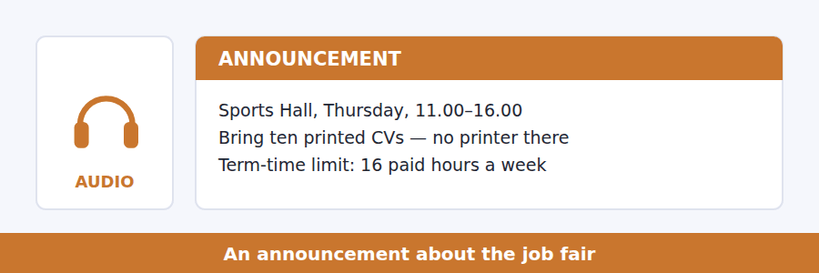
SKILL · Hear the limit
- Announcements about work always carry a limit: hours, age, visa, dates.
- A limit with a reason attached is always tested.
- Advice and rules sound similar. Listen for must, cannot, you are not allowed.
- What the speaker calls the most common mistake is a guaranteed question.

Exercise B Listen and answer. The audio plays once.
4. What is the main purpose of the announcement?
(A) To advertise one employer
(B) To change the date of the fair
(C) To prepare students for the fair
(D) To explain how to write a CV
5. Why must students bring printed CVs?
(A) Employers prefer paper
(B) There is no printer in the building
(C) Phones are not allowed
(D) Ten employers ask for one
6. How should students dress?
(A) As for an interview
(B) Comfortably
(C) In university colours
(D) It does not matter
7. What is the sixteen-hour rule?
(A) A recommendation
(B) A university rule with consequences
(C) A limit set by employers
(D) A legal maximum for all workers
8. Why does the speaker mention four evening shifts?
(A) They pay the most
(B) They are the hardest to get
(C) They add up to the whole weekly limit
(D) They clash with lectures
Audio script: see the back of the book. Do not read it before you listen.


Exercise A Listen and choose a response. You hear one line. Choose the best reply.
1. Woman: Did she say supply or demand?
(A) Supply.
(B) It rises.
(C) On the board.
(D) Yes, she did.
2. Man: What happens to the price?
(A) Because supply has fallen.
(B) Buyers and sellers.
(C) In the long run.
(D) It goes up.
3. Woman: I don’t follow the last bit.
(A) It’s about supply.
(B) Nor do I — shall we ask her?
(C) At the end.
(D) Yes, it was long.
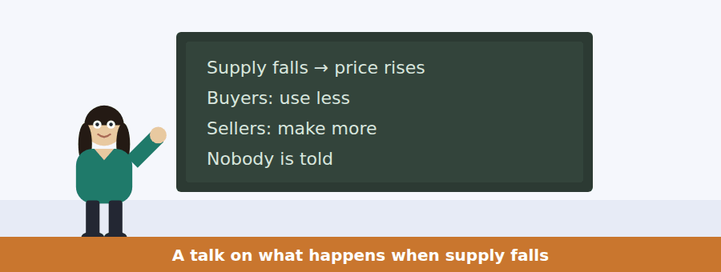
SKILL · Follow a chain of effects
- A talk built on a chain will say each link once. Miss one and the rest will not connect.
- Listen for notice that, the point is, what matters here.
- An objection raised by the speaker (but, of course, the difficulty is) is always tested.
- The final qualification is usually the main idea in disguise.

Exercise B Listen and answer. The audio plays once.
4. What is the main idea of the talk?
(A) Coffee prices are unusually unstable
(B) Governments should control prices
(C) Prices carry information, but only about costs that somebody pays
(D) Buyers and sellers rarely cooperate
5. What happens when supply falls?
(A) The price falls
(B) Demand rises
(C) Nothing changes
(D) The price rises
6. According to the speaker, how do buyers learn about the failed harvest?
(A) They do not — they only see the price
(B) From the news
(C) From the government
(D) From growers
7. Why does the speaker mention a factory and a river?
(A) To give an example of a cost left out of the price
(B) To explain how factories are built
(C) To compare two industries
(D) To describe pollution laws
8. What does the speaker say about a signal that leaves out a cost?
(A) It is slightly inaccurate
(B) It corrects itself over time
(C) It affects only local buyers
(D) It is wrong in the direction that matters
9. What will the rest of the term be about?
(A) Whether prices carry information
(B) Which costs are left out of prices
(C) How coffee is grown
(D) How governments set prices
Audio script: see the back of the book. Do not read it before you listen.


Part 1 · Listen and Repeat
You hear a sentence and repeat it once. There is no preparation time, and the sentences get longer. Focus: contracted auxiliaries
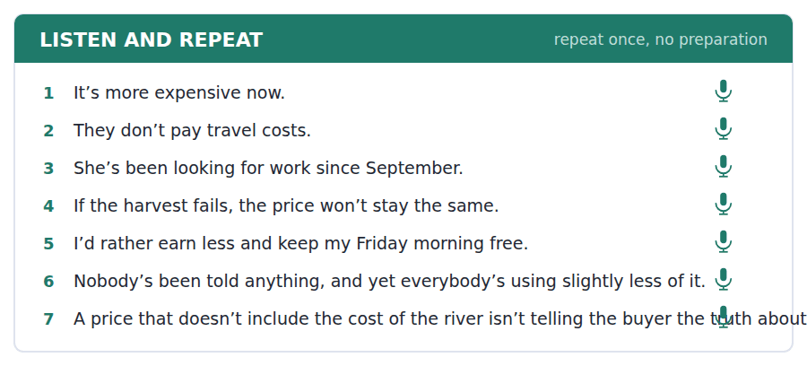
SKILL · Contract, like a speaker
- It’s, they’re, doesn’t, I’d — full forms sound like reading aloud.
- Contract the auxiliary, never the main verb.
- Do not contract at the end of a clause: Yes, I am — not Yes, I’m.
- Say the whole sentence, contractions and all, at a steady speed.

Part 2 · Take an Interview
An interviewer asks you four questions on one theme: a job you have had or want. Answer each one fully. There is no preparation time.
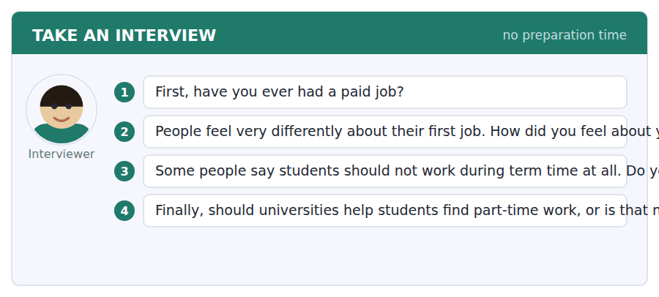
A good answer sounds like this
Question 2 — Mine was in a supermarket and I hated the first month and quite liked the rest, mostly because of the people.
Question 4 — I think they should. A student who has to work will work either way, and a job the university knows about is one that respects the sixteen-hour limit.
I can… | Not yet | Yes
I used contracted forms where a speaker would | □ | □
I did not contract at the end of a clause | □ | □
I gave a reason after every opinion | □ | □


Part 1 · Listen and Repeat
You hear a sentence and repeat it once. There is no preparation time, and the sentences get longer. Focus: talking about money
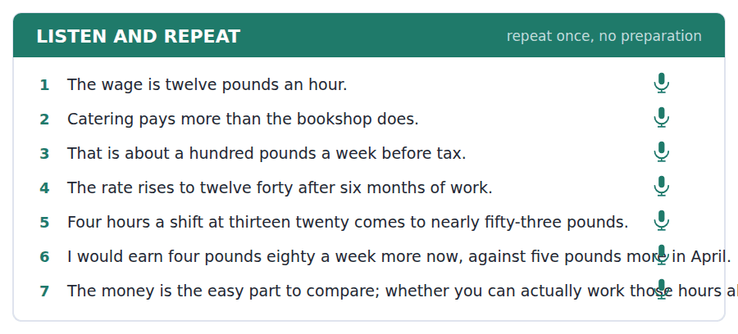
SKILL · Say the amount, then the comparison
- Thirteen twenty an hour, which is a pound forty more than the bookshop.
- Per hour, a week, a month — always say the period.
- Rounding is fine in speech: about a hundred pounds a week.
- One figure, one comparison, one conclusion is a full answer.

Part 2 · Take an Interview
An interviewer asks you four questions on one theme: work and study together. Answer each one fully. There is no preparation time.
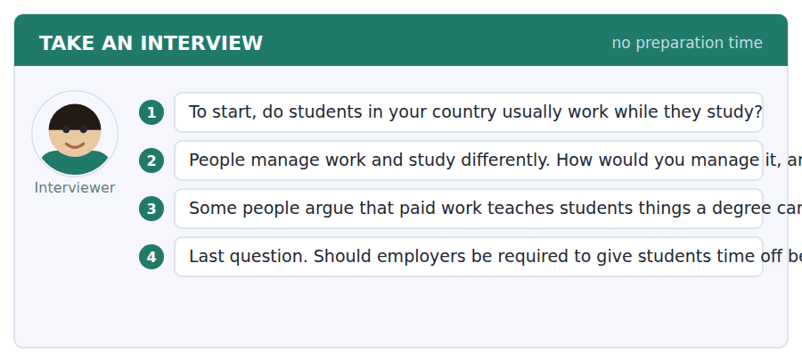
A good answer sounds like this
Question 3 — I agree with that, up to a point. A job taught me how to speak to strangers, which no seminar has ever done.
Question 4 — Yes, but with notice from the student. An employer cannot plan a rota around exams nobody has told them about.
I can… | Not yet | Yes
I said the period after every amount | □ | □
I made one clear comparison | □ | □
I finished every sentence | □ | □


Part 1 · Listen and Repeat
You hear a sentence and repeat it once. There is no preparation time, and the sentences get longer. Focus: academic register
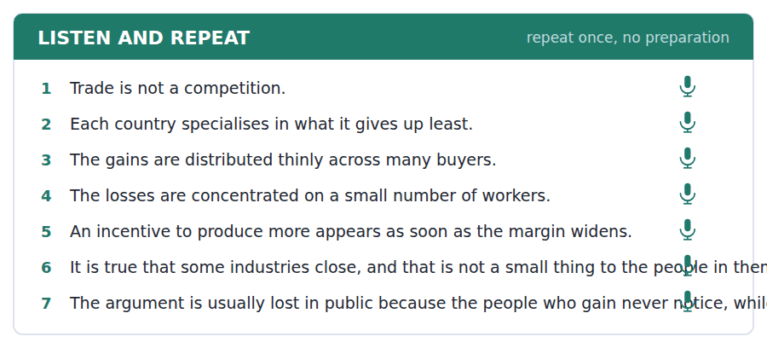
SKILL · Concede, then argue
- Use the unit’s words: incentive, margin, allocate, distribute, equate.
- Admit the strong point on the other side first: it is true that…
- Then say why it does not settle the question: however, that applies to…
- Mark yourself against the three statements below.

Part 2 · Take an Interview
An interviewer asks you four questions on one theme: work, trade and your country. Answer each one fully. There is no preparation time.
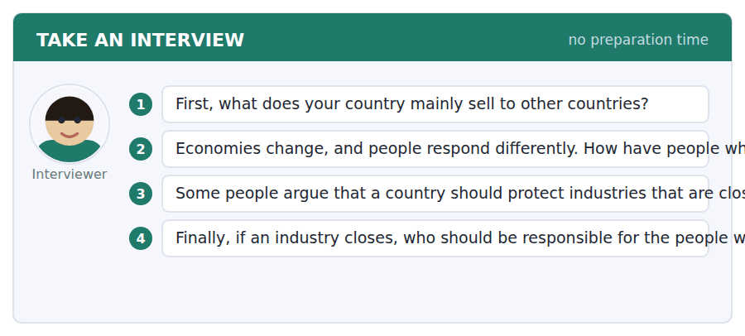
A good answer sounds like this
Question 3 — It is true that closing an industry destroys a town, and that is not a small thing. However, protecting it usually means the same town closes ten years later with less money to move.
Question 4 — Whoever gained from the change. If the gains are spread across everybody, then everybody, through taxation.
I can… | Not yet | Yes
I used at least three academic words from this unit | □ | □
I conceded a point before arguing against it | □ | □
My last answer had an opinion, a reason and an example | □ | □


You see a sentence, then a set of words in boxes. Put the words in order to make one grammatical sentence. Almost every item in the real test makes a question or a question inside another sentence.
SKILL · Articles in the gaps
- A tile that says a or the belongs with a noun. Find the noun first.
- How much + uncountable (money, work); how many + countable (hours, jobs).
- A question about a general truth takes no article: Do prices carry information?
- Use every tile exactly once.

Exercise A Guided practice. The first three are worked through.
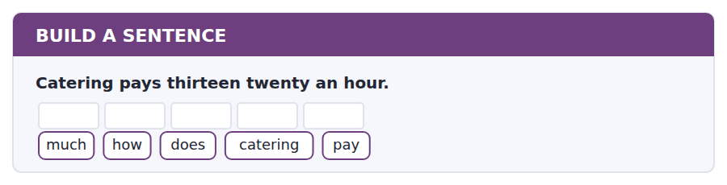
1. How much does catering pay?
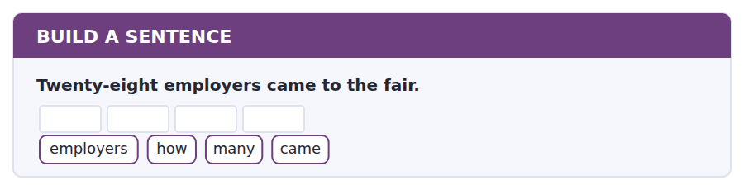
2. How many employers came?
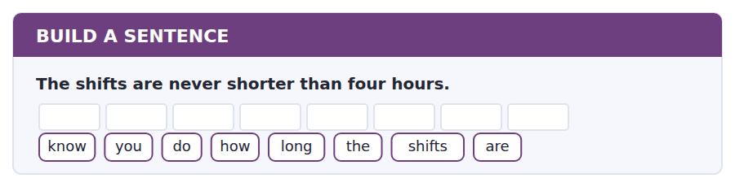
3. Do you know how long the shifts are?
Exercise B Exam practice. Write the sentence.
4. Students may work sixteen hours a week in term time.
hours / how / many / can / I / work
__________________________________________________________
5. The interview is on Dunn Street, not at the university.
tell / can / you / me / where / the / interview / is
__________________________________________________________
6. The bookshop rate rises after six months.
does / when / the / rate / rise
__________________________________________________________
7. Lennox pays travel costs as well as the hourly rate.
know / do / you / whether / they / pay / travel
__________________________________________________________
8. The employer who interviewed me emailed the next day.
the / employer / who / interviewed / me / emailed / the / next / day
__________________________________________________________
9. A background check takes about three weeks.
long / how / does / a / check / take
__________________________________________________________
10. Prices carry information from one country to another.
do / what / prices / carry
__________________________________________________________


You read a short situation and write an email. You have 7 minutes. The three bullet points are the mark scheme: answer all three.
You have been offered an interview with Lennox Catering for evening event work, Thursday to Saturday, minimum four hours a shift. You have a nine o’clock lecture every Friday morning, and you are not sure how late Thursday shifts finish.
Write an email to Ellie Dunn before the interview.
- Confirm the interview.
- Ask the question you need answered before you can commit.
- Say what you can offer if the answer is difficult.
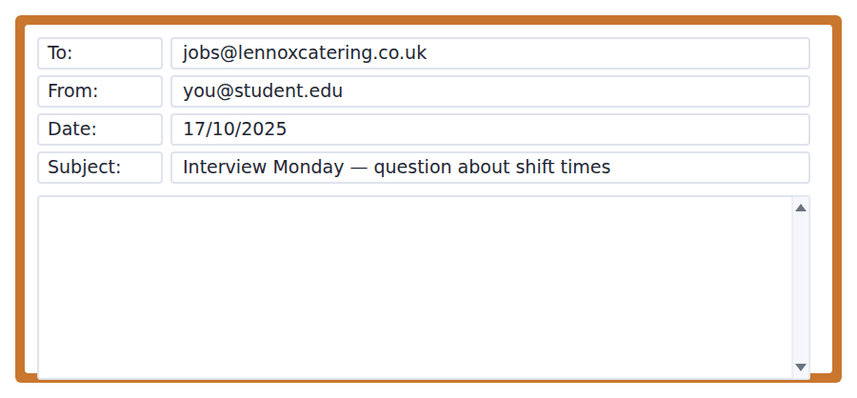
SKILL · Ask before the interview, not during it
- A question asked in advance saves both sides a wasted meeting.
- Give the constraint, then the question: I have a 9.00 lecture on Friday, so…
- Offer an alternative. Two evenings that do work beats three that might not.
- Seven minutes. 110–140 words.

Model email
Dear Ms Dunn,
Thank you for the interview on Monday 20 October at three on Dunn Street. I will be there, with photo identification and my referee’s details.
Before Monday, may I ask one thing? I have a lecture at nine every Friday morning, so I need to know how late Thursday evening shifts usually finish. Could you tell me whether they normally end by about eleven, or whether they can run past midnight?
If Thursdays are late, I could still offer two shifts a week on Friday and Saturday evenings, which would meet the minimum you mentioned. I would rather tell you that now than agree to a rota I cannot keep.
Many thanks,
Kofi Adeyemi
Why it works
- The interview is confirmed in one sentence, with the two things to bring, so nothing has to be chased.
- The constraint comes before the question, and the question offers two concrete possibilities rather than an open one.
- The alternative is specific and meets the employer’s stated minimum of two evenings.
- The last sentence explains why the email exists, which makes the writer look reliable rather than difficult.
Now write your own. 7 minutes.
__________________________________________________________
__________________________________________________________
__________________________________________________________
__________________________________________________________
__________________________________________________________
__________________________________________________________
__________________________________________________________
__________________________________________________________


A professor asks a question and two students answer. You add your own post. You have 10 minutes and an effective answer is at least 100 words.
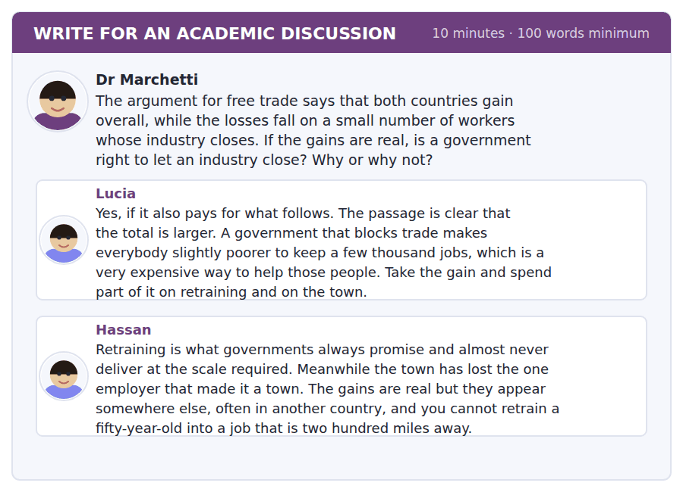
SKILL · Attack the weakest link, not the conclusion
- Both posts may be right about different steps. Find the step that actually fails.
- Here, the weak link is whether compensation is ever delivered.
- Name a classmate and give their argument its strongest form first.
- At least 100 words in ten minutes.

Sentence starters
- Lucia’s argument has one weak link, and Hassan has found it:…
- The disagreement is not about economics but about…
- If Hassan is right about delivery, then Lucia’s conclusion…
- What would change my mind is…
Model post
Lucia’s argument has one weak link and Hassan has found it. The economics is not the disagreement; the delivery is.
Lucia is right that blocking trade is an expensive way to protect a few thousand jobs, and the passage supports her: the total really is larger. But her conclusion depends entirely on the second half of her own sentence — and spend part of it on retraining and on the town. If that part never happens, her policy is simply the losses without the compensation, which is what Hassan has watched.
So I would answer the question conditionally. A government is right to let the industry close only if the compensation is legislated at the same time as the trade agreement, in the same act, with the money committed before the factory shuts. Promised afterwards, it is not a policy. It is a hope.
[160 words]
Now write your own. 10 minutes, at least 100 words.
__________________________________________________________
__________________________________________________________
__________________________________________________________
__________________________________________________________
__________________________________________________________
__________________________________________________________
__________________________________________________________
__________________________________________________________
__________________________________________________________
__________________________________________________________

Grammar focus Articles and generalisation
Form | Example
a / an: one of many, first mention | A price carries information.
the: we both know which one | The price of coffee rose.
No article: plural general | Prices carry information.
No article: uncountable general | Trade is not a competition.
the + singular = the whole class | The consumer is better off.
the + superlative / only / same | the oldest argument, the same question
a + job title | She works as a visitor assistant.

There are three ways to generalise in English and they are not interchangeable in register. Prices carry information is neutral; A price carries information is explanatory; The price carries information is formal or technical.
Use no article with an uncountable noun used generally: trade, labour, information, money.
Use the when the noun has already been introduced, or when the context makes it unique: the harvest, the river, the factory in that example.
Watch out! Never write *the trade is good* or *the information is carried by the prices* when you mean these things in general. General plural and general uncountable nouns take no article at all.
Exercise 1 Complete with a, an, the or – (no article).
1. __________ prices carry information.
2. __________ price of coffee rose last month.
3. She works as __________ visitor assistant at the museum.
4. __________ trade is not a competition with a winner.
5. I read __________ advertisement for a part-time job.
6. __________ advertisement said the pay was twelve pounds an hour.
Exercise 2 One sentence in each pair is correct. Which?
1. a) The students must bring the CV. b) Students must bring a CV.
2. a) The information is free. b) Information is free. (in general)
3. a) He got a interview. b) He got an interview.
Exercise 3 Correct the mistake in each sentence.
1. The trade between two countries makes both richer.
2. She has got the job in a bookshop.
3. A prices carry information from one country to another.
How this is tested in Build a Sentence
Articles rarely appear as the point of a Build a Sentence item, but a wrong article spoils an otherwise correct sentence. When a tile says a or the, decide which noun it belongs to before you decide the order.

Unit review and progress check Unit 8
Exercise A Vocabulary. Write the word.
1. money that you receive regularly
2. money a business receives
3. a raw material that is bought and sold
4. something that encourages you to act
5. the difference between cost and selling price
6. one part of a country’s economy
7. to give out for a particular purpose
8. to treat two things as equal
9. a number showing how something has changed
10. to sell goods to another country
11. hours worked beyond the agreed number
12. a statement about you from someone who knows your work
Exercise B Grammar. Complete the sentence.
1. __________ prices carry information.
2. __________ price of coffee rose last month.
3. She works as __________ visitor assistant.
4. __________ trade is not a competition.
5. He got __________ interview on Monday.
6. __________ advertisement said twelve pounds an hour.
7. Students must bring __________ CV to the fair.
8. __________ information in a price is only as good as the costs included.
Exercise C One timed mini-section. 6 minutes.
1. According to the passage on page 130, each country should concentrate on
(A) what it makes best
(B) what sells for most
(C) what it gives up least to produce
(D) what its neighbours cannot make
2. In the talk, a price fails to carry information when
(A) supply falls
(B) demand rises
(C) a cost is not paid by anyone
(D) the government intervenes
3. Which sentence is correct?
(A) The trade makes both countries richer.
(B) He got a interview.
(C) The students must bring the CV.
(D) Prices carry information.
4. A student in term time may work at most
(A) eight hours a week
(B) sixteen hours a week
(C) twelve hours a week
(D) twenty hours a week
5. In Read in Daily Life, the answer is
(A) always printed in the text
(B) sometimes inferred from outside knowledge
(C) always a number
(D) in the heading
6. In Writing, the email task allows
(A) five minutes
(B) ten minutes
(C) seven minutes
(D) fifteen minutes
Can you do these now?
I can… | Not yet | Yes
complete word endings in a text about prices and value | □ | □
read a job advertisement and an interview email for the conditions | □ | □
follow a passage that explains why two countries both gain from trade | □ | □
understand two people comparing two jobs | □ | □
talk about money and work without preparing | □ | □
write an email asking about conditions, and a post that questions an assumption | □ | □

ADAPTIVE TIP In Read in Daily Life the answer is always printed on the page. If you find yourself reasoning about what is probably true, you have left the text — go back and find the line. This task rewards finding, not thinking.

Unit 9 · Anthropology and Culture
TOEFL iBT® Preparation Course 2026 · Volume 1
CEFR B1 · Grammar: used to and would · Word field: custom, community, identity
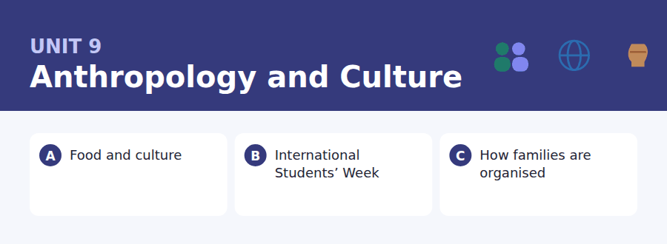
By the end of this unit I can…
- complete word endings in a text about food and custom
- read a programme and a call for volunteers and find what I need to do
- follow a passage that compares how different societies organise something
- understand two people planning a shared event
- describe how things used to be without preparing
- write an email offering to help, and a post about what is worth keeping

Anthropology is written in the past habitual: people used to…, families would… This unit teaches both forms and the difference between them.

Vocabulary 1 · Academic 24 words from the Academic Word List
These twenty-four words come back through the whole unit, and again in the review. Cover the right-hand column and test yourself.
culture the way of life of a group of people | individual one single person
community a group of people living in one place or sharing something | institute an organisation set up for a purpose
tradition a custom passed down over time | network a group of people who are connected
ethnic connected with a group that shares a culture or origin | bond a strong connection between people
gender the social roles connected with being male or female | role the part a person plays in a group
norm what is usual or expected in a group | status a person’s position in a group
reside to live in a place | hierarchy a system in which people are ranked above one another
immigrate to come to live in a new country | accompany to go somewhere with someone
integrate to join and become part of a group | assemble to come together in one place
participate to take part | colleague a person you work with
interact to communicate with other people | context the situation that surrounds something
mutual felt or done by two sides equally | adapt to change in order to fit a new situation

Exercise A Work in pairs. Ask and answer.
1. Describe one tradition in your family. Where do you think it came from?
2. What is the norm about arriving on time where you grew up?
3. How quickly do people in your community integrate newcomers?
4. What role do you usually take when a group of friends plans something?
Vocabulary 2 · Campus and everyday 12 words for the daily-life tasks
The exam does not only test academic English. Notices, emails, conversations and announcements use the everyday words below.
food stall a small open shop selling food at an event | host family a family that a visiting student lives with
recipe instructions for cooking a dish | exchange an arrangement where students swap universities
ingredient one of the things a dish is made from | welcome desk a table where arrivals are greeted
festival a celebration lasting one or more days | marquee a large tent used for events
costume clothes worn for a performance or celebration | raffle a game where numbered tickets can win prizes
performance something done in front of an audience | programme a printed list of what will happen and when

Words you will meet again: culture | significant | vary | identify | contrast | estimate | participate | diverse


SKILL · Watch for the past habitual
- In a text about the past, -ed endings are everywhere. Count the dashes first.
- Used to is never *used too*. The gap after us-- is almost always ed.
- Noun endings common here: -tion, -ment, -ship, -ance.
- If the gap is in a plural noun after a number, it is almost always -s or -es.

Exercise A Guided practice. Five words are not complete. Write the missing letters.
Every country believes its food is ancient, and most of it is not. The tomato did not reach Italy until the sixteenth cent---, and the chilli reached India at about the same t---. People us-- to cook without either, and nobody now thinks of them as new arri----. A tradition only has to be old-- than the people remembering it.

The first one is done for you: 1 cent--- → ury (century)
Exercise B Exam practice. One paragraph, ten gaps — the real task.
A dish travels further than the people who first made it. Noodles, chillies, potatoes and coffee all crossed continents, and each one is now treated as nati---- somewhere it did not come from. The interesting quest--- is not where a food began but what happe--- when it arrived. It was never simply copied. Cooks adapted it to what was avail---- and to what their neighbours would accept, and after two gener------ nobody remembered the adapt-----. Anthropologists call this process localis-----, and it works on more than food: music, clothing and relig--- all do the same thing. Which is why the question are you eating authentic food? is almost meaning----. Authentic to which cent---?

Check your answers in the key at the back of the book.


SKILL · Find the instruction addressed to you
- A programme tells you when. A call for volunteers tells you what to do. Questions mix the two.
- Note what is needed and by when — those two travel together.
- In a social post, the ask is usually in the last three lines.
- If a time appears twice, check whether it is the same event.

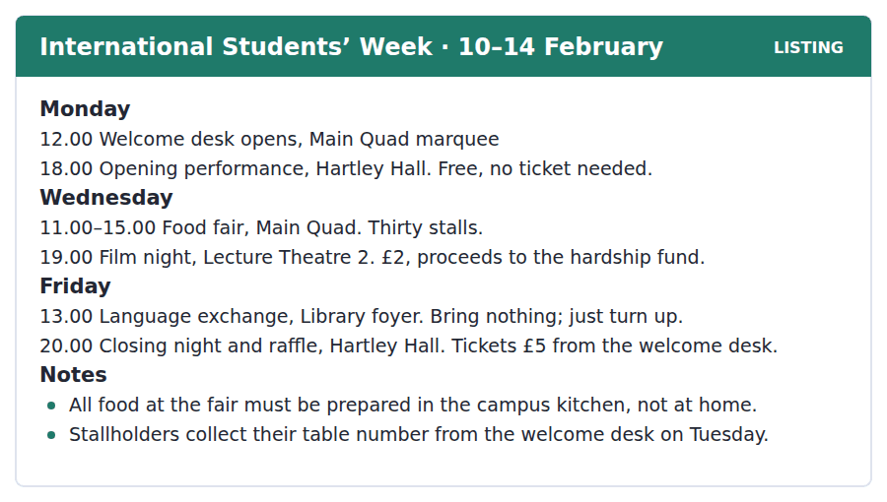
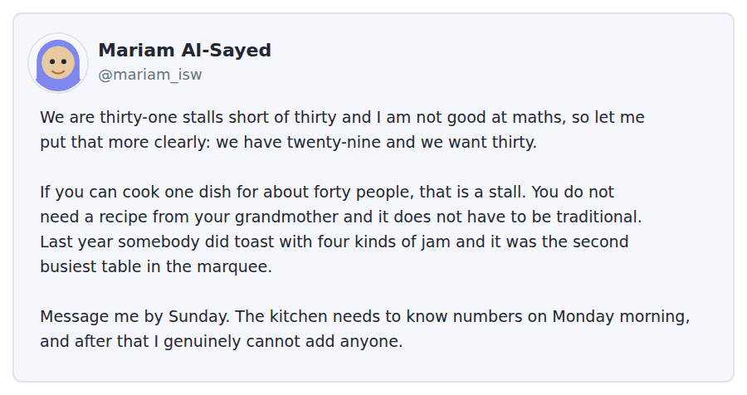
Exercise A Guided practice. The answer is on the page — find it.
1. Which event costs money?
(A) The opening performance
(B) The food fair
(C) The closing night
(D) The language exchange
2. Where does the food fair take place?
(A) Main Quad
(B) Hartley Hall
(C) Library foyer
(D) Lecture Theatre 2
3. What should you bring to the language exchange?
(A) A ticket
(B) Nothing
(C) A dish
(D) A programme
4. Where do stallholders get their table number?
(A) At the marquee on Wednesday
(B) By email
(C) From the kitchen
(D) From the welcome desk on Tuesday
Exercise B Exam practice.
5. How many stalls does Mariam still need?
(A) Two
(B) Twenty-nine
(C) Thirty-one
(D) One
6. What does Mariam say about the dish?
(A) It must be traditional
(B) It does not have to be traditional
(C) It must be from your own country
(D) It must be cooked at home
7. Why does she mention toast with four kinds of jam?
(A) To complain about it
(B) To explain the rules
(C) To show that simple food can work
(D) To describe last year’s winner
8. By when must volunteers contact her?
(A) Sunday
(B) Friday
(C) Monday morning
(D) Tuesday
9. Where must the food be prepared?
(A) At home
(B) At the stall
(C) In the campus kitchen
(D) In the marquee
10. What can be inferred about the food fair?
(A) It is the largest event of the week
(B) It is only for international students
(C) It is organised at short notice
(D) It has fewer stalls than last year


SKILL · Hold a comparison across paragraphs
- A comparative passage moves between two cases. Keep a column for each.
- The reason for a difference is usually economic or practical, not moral. Expect that.
- When a named researcher appears, their claim will be tested.
- A passage that ends on language or vocabulary is making a point about memory.

How Families Are Organised
Ask someone to draw their family and most Europeans will draw two parents and their children. Ask the same question in much of West Africa, South Asia or the Pacific and you will get a larger and differently shaped picture: grandparents, several adult siblings and their children, sometimes all under one roof. Neither drawing is the natural one. Both are answers to questions about work, land and old age.
Where land is farmed by hand, a larger household is a better one: more hands at harvest, and the old looked after by the young who will inherit. Where people move to cities for wages, the same household becomes expensive to keep together, and it breaks into smaller units that can move. The anthropologist Jack Goody argued that the household follows the economy with a delay of roughly one generation, which is why a society often holds the ideal of a family it no longer actually has.
The delay is visible in language. Many languages keep separate words for a father’s brother and a mother’s brother, because the two once had different duties towards a child — one might arrange a marriage, the other might pay for schooling. The duties have usually gone. The words remain, used now for warmth rather than for obligation, which is a reminder that a culture carries its history around in its vocabulary long after the reasons have dissolved.
[275 words]

Exercise A Guided practice.
1. What is the passage mainly about?
(A) Why Europeans have small families
(B) How anthropologists work
(C) How languages change over time
(D) Why family shapes differ, and what explains the difference
2. According to paragraph 1, which family shape is natural?
(A) The small one
(B) Neither
(C) The large one
(D) Both equally
3. Why is a larger household useful where land is farmed by hand?
(A) It is cheaper
(B) Houses are larger
(C) There are more hands at harvest
(D) Children leave school earlier
4. What did Jack Goody argue?
(A) That large families are better
(B) That the household follows the economy with a delay
(C) That language causes family structure
(D) That cities destroy families
Exercise B Exam practice.
5. Why does a society often hold an ideal it no longer has?
(A) People are nostalgic
(B) Governments encourage it
(C) Families are getting smaller everywhere
(D) The household changes more slowly than the economy
6. Why do many languages distinguish a father’s brother from a mother’s brother?
(A) The two once had different duties
(B) The words are easier to say
(C) One lived nearer
(D) It marks respect
7. All of the following are stated about those words EXCEPT:
(A) They are disappearing from most languages
(B) They still exist
(C) The duties behind them have usually gone
(D) They are now used for warmth
8. The word "dissolved" in paragraph 3 is closest in meaning to
(A) returned
(B) strengthened
(C) disappeared
(D) divided
9. What can be inferred about households in a city?
(A) They are always poorer
(B) They are easier to move
(C) They keep more traditions
(D) They are larger than rural ones
10. What does the author suggest about culture in the last sentence?
(A) It changes faster than the economy
(B) It is created by anthropologists
(C) It is the same everywhere
(D) It stores its history in its words
11. Which best states the main idea of paragraph 2?
(A) Farming is harder than city work
(B) Grandparents are valued differently in different places
(C) Household size follows the way people earn a living
(D) Cities are growing everywhere


Exercise A Listen and choose a response. You hear one line. Choose the best reply.
1. Man: Are you doing a stall this year?
(A) I was thinking about it, yes.
(B) Thirty of them.
(C) In the marquee.
(D) It was very good.
2. Woman: How many people do we cook for?
(A) In the campus kitchen.
(B) About forty.
(C) On Wednesday.
(D) Yes, quite a lot.
3. Man: We can’t cook it at home, can we?
(A) My kitchen is quite small.
(B) Yes, forty portions.
(C) On Tuesday morning.
(D) No — it has to be the campus kitchen.
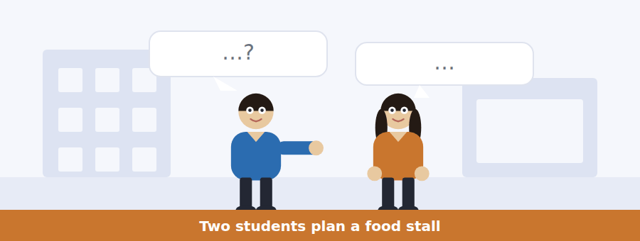
SKILL · Follow a plan being made
- Planning conversations contain a problem, an idea, an objection and a decision. Expect all four.
- Numbers of people, times and quantities are nearly always tested.
- Listen for the objection — it is usually the question with the longest options.
- The last two lines contain the agreed plan.

Exercise B Listen and answer. The audio plays once.
4. What are the speakers deciding?
(A) Whether to go to the food fair
(B) Where to buy ingredients
(C) Whether to run a stall and what to make
(D) Who Mariam should ask next
5. Why does the woman think Mariam messaged her directly?
(A) They are friends
(B) She has run out of other people
(C) She knows her grandmother
(D) She organised a stall last year
6. What was the original recipe designed for?
(A) Twelve people
(B) Forty people
(C) Twenty people
(D) A whole village
7. What is the woman’s main worry?
(A) The cost
(B) Finding the kitchen
(C) Cooking on a Wednesday
(D) Scaling the recipe up
8. Who pays for the ingredients?
(A) The students themselves
(B) The university
(C) The hardship fund
(D) The welcome desk
9. What will the man do?
(A) Cook the soup
(B) Buy the ingredients
(C) Message Mariam
(D) Collect the table number
Audio script: see the back of the book. Do not read it before you listen.


Exercise A Listen and choose a response. You hear one line. Choose the best reply.
1. Woman: Is it still in the Main Quad?
(A) On Wednesday.
(B) Thirty stalls.
(C) Yes, eleven until three.
(D) No, it’s moved into the marquee.
2. Man: Do I have to book a kitchen slot?
(A) There are six of them.
(B) In the campus kitchen.
(C) Yes, by Monday.
(D) It takes two hours.
3. Woman: Where do I get my table number?
(A) On Tuesday.
(B) It’s thirty.
(C) Yes, you need one.
(D) From the welcome desk.
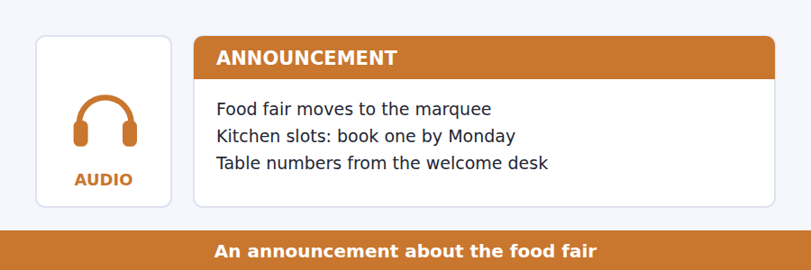
SKILL · Catch the thing that moved
- Events move indoors, change time, or change room. Note the old and the new.
- A booking system introduced at short notice is always tested.
- Listen for who this does not apply to — exceptions carry questions.
- The reason for a change is usually given once, briefly.

Exercise B Listen and answer. The audio plays once.
4. Why has the fair moved into the marquee?
(A) The forecast is poor
(B) There are more stalls
(C) The Quad is being resurfaced
(D) It is warmer
5. What is new this year?
(A) The table numbers
(B) The location
(C) Booking a kitchen slot
(D) The number of stalls
6. Why was the kitchen system changed?
(A) The kitchen was too small
(B) Thirty stalls arriving at once did not work
(C) The slots were too long
(D) Students asked for it
7. What happens if you arrive without a table number?
(A) You are placed in a gap near the entrance
(B) You cannot have a stall
(C) You collect one on the day
(D) You pay a fee
8. Which stalls do not need a kitchen slot?
(A) The three largest
(B) The three serving cold food only
(C) Those arriving at six
(D) None — all must book
Audio script: see the back of the book. Do not read it before you listen.


Exercise A Listen and choose a response. You hear one line. Choose the best reply.
1. Man: Who was Hobsbawm?
(A) In 1983.
(B) It’s on the board.
(C) Yes, he was famous.
(D) A historian who wrote about invented traditions.
2. Woman: Does that mean all traditions are fake?
(A) They are invented.
(B) In 1983.
(C) No — it means age is not what makes them real.
(D) Yes, all of them.
3. Man: Could you give an example?
(A) It’s in the reading.
(B) About two hundred years.
(C) Yes, I could.
(D) Of course — the Scottish tartan.
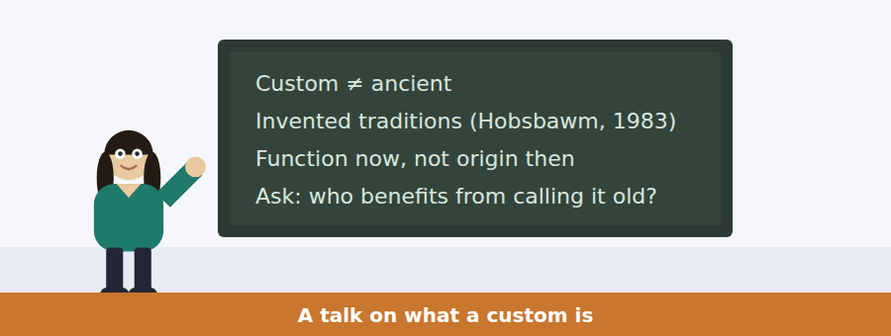
SKILL · Follow a definition being narrowed
- A talk may start with a loose definition and sharpen it. The final version is the one tested.
- A named book or year on the board will be used in an argument.
- Listen for which is why and the question I want you to ask.
- A talk that ends with a question is telling you its main idea.

Exercise B Listen and answer. The audio plays once.
4. What is the main idea of the talk?
(A) Most traditions are fake
(B) What a custom does matters more than how old it is
(C) Hobsbawm was wrong about Scotland
(D) Traditions should be preserved
5. What did Hobsbawm argue?
(A) That many ancient-seeming practices are recent
(B) That traditions should be invented
(C) That Scotland has no real traditions
(D) That nations need anthems
6. Why does the speaker mention tartans and anthems?
(A) To criticise nationalism
(B) To describe Scottish history
(C) To give examples of recent inventions
(D) To compare two countries
7. What does the speaker say Hobsbawm was NOT saying?
(A) That traditions are recent
(B) That traditions are fake
(C) That age matters
(D) That customs have functions
8. What question does the speaker want students to ask?
(A) How old is this?
(B) Who wrote it?
(C) What does it do now?
(D) Where did it begin?
9. What does the speaker suggest about a tradition performed for tourists?
(A) It is more authentic
(B) It should be stopped
(C) It is always older
(D) It may be doing less work than a very recent one
Audio script: see the back of the book. Do not read it before you listen.


Part 1 · Listen and Repeat
You hear a sentence and repeat it once. There is no preparation time, and the sentences get longer. Focus: the reduced form of used to
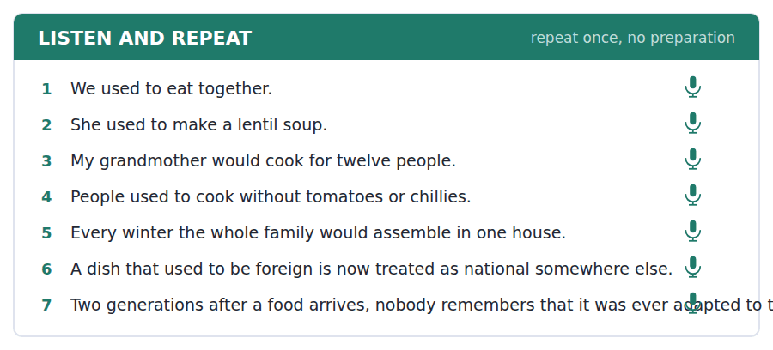
SKILL · Say used to as one word
- It sounds like /juːstə/, not use-ed-to. Say it as a single unit.
- Would for repeated past actions has the same rhythm: we’d always…
- Keep the main verb clear. The weak form is the auxiliary, never the verb.
- Finish every sentence you begin.

Part 2 · Take an Interview
An interviewer asks you four questions on one theme: a custom in your family. Answer each one fully. There is no preparation time.
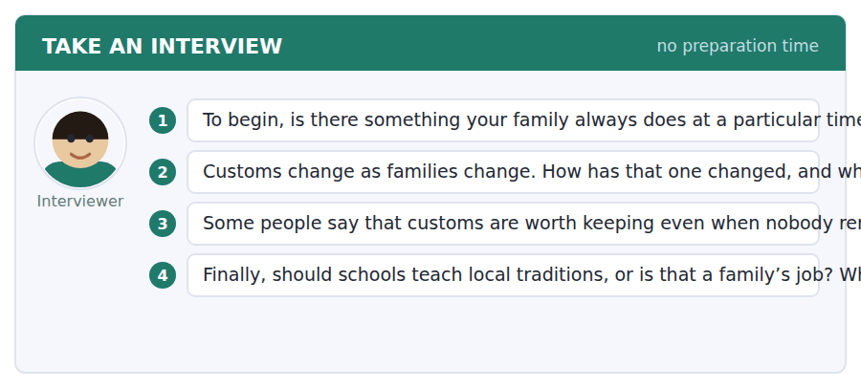
A good answer sounds like this
Question 1 — We always eat together on the last Friday of the month. It started because my aunt lived far away and it is the only day she could come.
Question 3 — I do agree. The reason a custom began is usually gone, but the people it brings into one room are still there.
I can… | Not yet | Yes
I said used to as one reduced unit | □ | □
I used would for repeated past actions | □ | □
I gave a reason after every opinion | □ | □


Part 1 · Listen and Repeat
You hear a sentence and repeat it once. There is no preparation time, and the sentences get longer. Focus: organising and offering
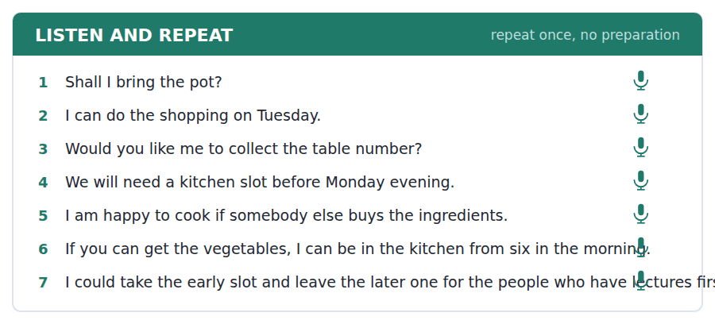
SKILL · Offer something specific
- I can do the shopping beats I can help. Name the task.
- Use shall I and would you like me to for offers.
- Say when as well as what: I can be there from six.
- One offer, one condition, one question is a complete turn.

Part 2 · Take an Interview
An interviewer asks you four questions on one theme: events where you study. Answer each one fully. There is no preparation time.
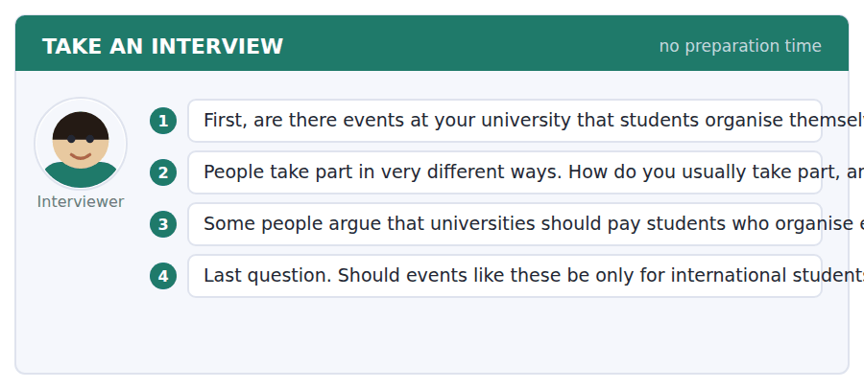
A good answer sounds like this
Question 2 — I am usually the person who turns up and carries things rather than the one who plans. I am better at that and I enjoy it more.
Question 4 — For everybody, definitely. An event for international students that local students never attend has not integrated anybody.
I can… | Not yet | Yes
I named a specific task when I offered | □ | □
I used shall I or would you like me to | □ | □
I said when as well as what | □ | □


Part 1 · Listen and Repeat
You hear a sentence and repeat it once. There is no preparation time, and the sentences get longer. Focus: academic register
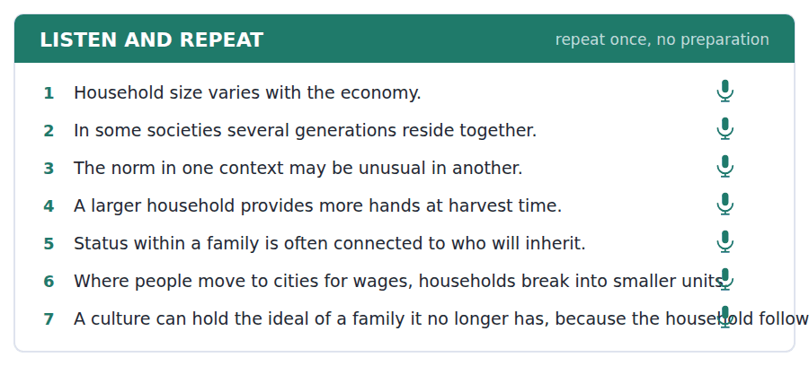
SKILL · Compare two societies fairly
- Use the unit’s words: norm, hierarchy, status, integrate, context.
- Describe both before you judge either. In X…, whereas in Y…
- Give the reason, which in anthropology is usually practical.
- Mark yourself against the three statements below.

Part 2 · Take an Interview
An interviewer asks you four questions on one theme: family and change. Answer each one fully. There is no preparation time.
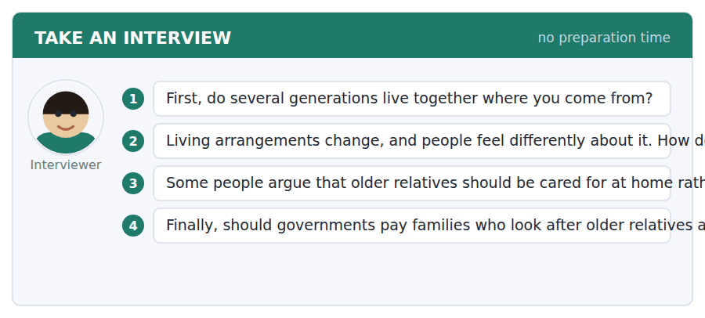
A good answer sounds like this
Question 2 — Older people mind more than younger ones, which makes sense: the norm they grew up with is the one that is disappearing.
Question 4 — Yes, and not out of kindness. The care happens either way, and paying for it at home is cheaper than paying for it in an institution.
I can… | Not yet | Yes
I used at least three academic words from this unit | □ | □
I described both sides before judging | □ | □
I gave a practical reason, not only a moral one | □ | □


You see a sentence, then a set of words in boxes. Put the words in order to make one grammatical sentence. Almost every item in the real test makes a question or a question inside another sentence.
SKILL · Questions about the past habitual
- Did people use to…? — after did, it is use to, with no d.
- Would for repeated past actions: What would she make?
- An embedded past question keeps statement order: do you know what they used to eat.
- Use every tile exactly once.

Exercise A Guided practice. The first three are worked through.
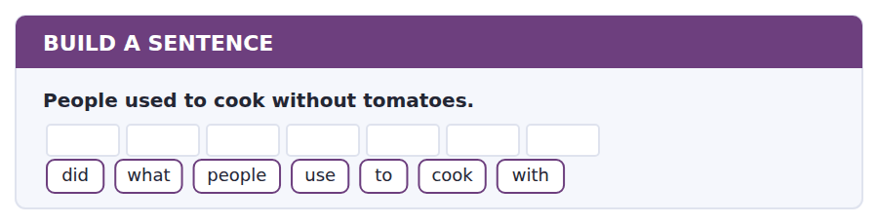
1. What did people use to cook with?
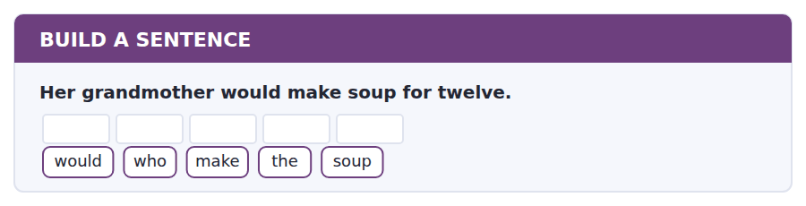
2. Who would make the soup?
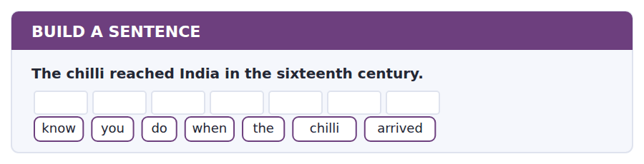
3. Do you know when the chilli arrived?
Exercise B Exam practice. Write the sentence.
4. Families used to live together on the land.
families / did / use / to / live / where
__________________________________________________________
5. Thirty stalls are needed for the fair.
stalls / how / many / are / needed
__________________________________________________________
6. The kitchen must be booked by Monday.
tell / can / you / me / whether / the / kitchen / is / booked
__________________________________________________________
7. The tradition was invented in the nineteenth century.
was / when / the / tradition / invented
__________________________________________________________
8. The student who ran the stall last year is helping again.
the / student / who / ran / the / stall / is / helping / again
__________________________________________________________
9. Ingredients are paid for by the stallholders.
know / do / you / who / pays / for / the / ingredients
__________________________________________________________
10. Her grandmother used to cook for twelve people.
people / how / many / did / she / use / to / cook / for
__________________________________________________________


You read a short situation and write an email. You have 7 minutes. The three bullet points are the mark scheme: answer all three.
Mariam Al-Sayed has posted that she needs one more stall for Wednesday’s food fair. You can cook a lentil soup for about forty people, but you have never cooked for that many, and you have a lecture on Wednesday morning until eleven.
Write an email to Mariam.
- Offer the stall and say what you would make.
- Say honestly what you are not sure about.
- Ask for the one thing you need to know.
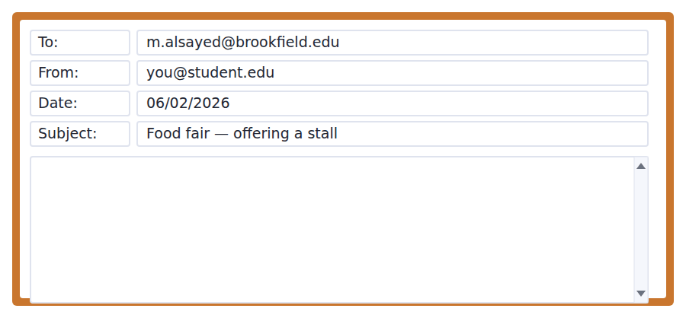
SKILL · Offer with the problem attached
- An offer with a known difficulty in it is more useful than a confident one that collapses on the day.
- Say what you can do, then what you cannot, then what you need.
- Give a number: for forty, from six, until eleven.
- Seven minutes. 110–140 words.

Model email
Dear Mariam,
I saw your post and I would like to take the last stall. I would make a lentil soup — my grandmother’s recipe, which is cheap, vegetarian and easy to serve from a pot.
Two honest things. First, the recipe is designed for twelve people and I have never scaled anything up to forty, so I may need somebody in the kitchen who has. Second, I have a lecture on Wednesday until eleven, so I cannot be at the stall before quarter past.
Could you tell me whether an early kitchen slot is still available — six or eight in the morning? If I can cook before the lecture, the soup only needs reheating and the eleven o’clock problem disappears.
Thank you,
Ines Duarte
Why it works
- The offer is first and concrete: the dish, and three reasons it suits a stall.
- Both difficulties are named with numbers, so Mariam can solve them rather than discover them.
- The question is specific (six or eight) and the writer has already worked out what a yes would fix.
- Nothing is apologised for — the tone is practical, which is what an organiser four days from an event needs.
Now write your own. 7 minutes.
__________________________________________________________
__________________________________________________________
__________________________________________________________
__________________________________________________________
__________________________________________________________
__________________________________________________________
__________________________________________________________
__________________________________________________________


A professor asks a question and two students answer. You add your own post. You have 10 minutes and an effective answer is at least 100 words.
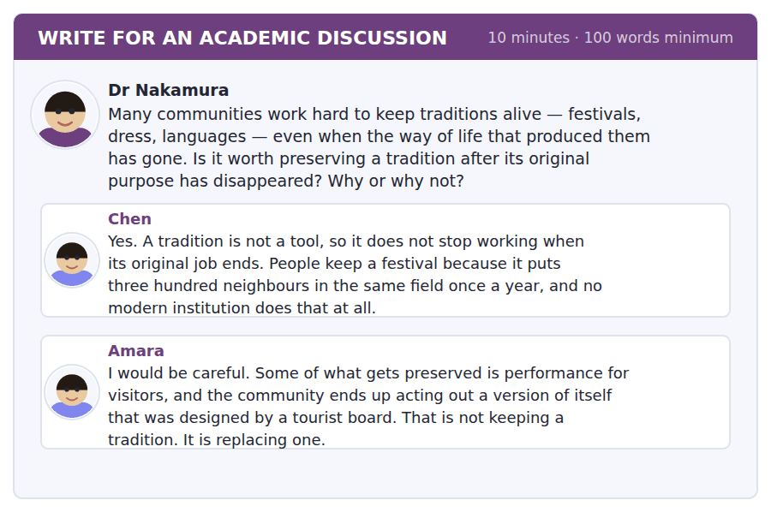
SKILL · Use the lecture’s test
- The talk gave you a question: not how old is it, but what does it do now.
- Apply that test to both posts and you will find the answer almost writes itself.
- Name a classmate and give their point its strongest form.
- At least 100 words in ten minutes.

Sentence starters
- The lecture gave us a test for exactly this:…
- Chen and Amara agree more than they think, because…
- Amara’s worry is right, but it is a worry about…, not about…
- By that test,…
Model post
The lecture gave us a test for exactly this question, and I think it settles the disagreement between Chen and Amara.
Do not ask how old a tradition is. Ask what it does now: who it includes, who it excludes, and who benefits from calling it ancient. By that test Chen is right. A festival that puts three hundred neighbours in one field is doing real work, and it makes no difference whether the reason it began was a harvest nobody now depends on.
But Amara is right too, and about something different. Her worry is not that a tradition has outlived its purpose. It is that it has acquired a new one, and the new one is serving an audience rather than a community. That fails the same test, for the same reason. So the test is the answer: keep what the community is doing, and be suspicious of what it is performing.
[168 words]
Now write your own. 10 minutes, at least 100 words.
__________________________________________________________
__________________________________________________________
__________________________________________________________
__________________________________________________________
__________________________________________________________
__________________________________________________________
__________________________________________________________
__________________________________________________________
__________________________________________________________
__________________________________________________________

Grammar focus used to and would
Form | Example
used to + infinitive (past habit or state) | We used to eat together.
Negative | We did not use to eat together.
Question | Did you use to eat together?
would + infinitive (repeated past action) | She would make soup every winter.
would NOT for past states | She would be a teacher. ✗
Past simple for a single event | The chilli reached India in 1550.
be used to + -ing (a different thing) | I am used to cooking for twelve.

Used to covers both repeated actions and past states. Would covers only repeated actions, so you cannot say *she would be a teacher* or *we would have a house*.
After did, the d disappears: Did you use to…?, We did not use to… The spelling follows the sound.
Be used to + -ing means something quite different: it means accustomed to. I used to cook = I did and I no longer do. I am used to cooking = it is normal for me.
Watch out! Never write *Did you used to…?* The auxiliary did already carries the past, so the main verb goes back to use.
Exercise 1 Complete with used to, would or the past simple.
1. We __________ (eat) together every Friday when I was small.
2. My grandmother __________ (make) soup in an enormous pot each winter.
3. The chilli __________ (reach) India in the sixteenth century.
4. There __________ (be) three generations in that house.
5. Every summer the family __________ (assemble) in one village.
6. __________ you __________ (live) in the city before?
Exercise 2 One sentence in each pair is wrong. Correct it.
1. a) Did you used to cook? b) Did you use to cook?
2. a) She would be a teacher. b) She used to be a teacher.
3. a) I am used to cook for twelve. b) I am used to cooking for twelve.
Exercise 3 Rewrite with used to or would.
1. In the past, families lived on the land. →
2. Each winter they cooked the same dish. →
3. There were separate words for both uncles. →
4. Every year he visited his grandmother. →
How this is tested in Build a Sentence
Build a Sentence tests this as a question: What did people use to cook with? Notice that the auxiliary did takes the past, so use loses its d — a very common slip under time pressure.

Unit review and progress check Unit 9
Exercise A Vocabulary. Write the word.
1. what is usual or expected in a group
2. to join and become part of a group
3. felt or done by two sides equally
4. a person’s position in a group
5. a system in which people are ranked
6. to come together in one place
7. the situation that surrounds something
8. to change in order to fit a new situation
9. to come to live in a new country
10. a strong connection between people
11. a family a visiting student lives with
12. a large tent used for events
Exercise B Grammar. Complete the sentence.
1. We __________ (eat) together every Friday when I was small.
2. Each winter she __________ (make) the same soup.
3. The chilli __________ (reach) India in the sixteenth century.
4. There __________ (be) three generations in that house.
5. __________ you __________ (live) in the city before?
6. I am used to __________ (cook) for twelve, not forty.
7. Every summer the family __________ (assemble) in one village.
8. She __________ (not / use to) enjoy cooking at all.
Exercise C One timed mini-section. 6 minutes.
1. According to the passage on page 146, household size follows
(A) the economy, about a generation behind
(B) religion
(C) the climate
(D) the size of houses
2. In the talk, Hobsbawm argued that many traditions are
(A) fake
(B) older than people think
(C) recent inventions
(D) disappearing
3. Which sentence is correct?
(A) Did you used to cook?
(B) She would be a teacher.
(C) We use to eat together.
(D) I am used to cooking for twelve.
4. Food for the fair must be prepared
(A) at home
(B) in the campus kitchen
(C) at the stall
(D) anywhere
5. A question asking what a speaker means by a phrase is testing
(A) implication
(B) a date
(C) vocabulary from a dictionary
(D) the main idea
6. In Speaking, preparation time is
(A) thirty seconds
(B) not given at all
(C) fifteen seconds
(D) one minute
Can you do these now?
I can… | Not yet | Yes
complete word endings in a text about food and custom | □ | □
read a programme and a call for volunteers and find what I need to do | □ | □
follow a passage that compares how different societies organise something | □ | □
understand two people planning a shared event | □ | □
describe how things used to be without preparing | □ | □
write an email offering to help, and a post about what is worth keeping | □ | □

ADAPTIVE TIP In Take an Interview the four questions get harder on purpose: a fact about you, then a reaction, then an opinion, then an opinion about policy. Knowing the shape is half the preparation, because you can hear which one is coming and answer at the right level instead of being surprised by the fourth.

Unit 10 · Literature and Storytelling
TOEFL iBT® Preparation Course 2026 · Volume 1
CEFR B1 · Grammar: Past continuous and narrative · Word field: plot, character, theme
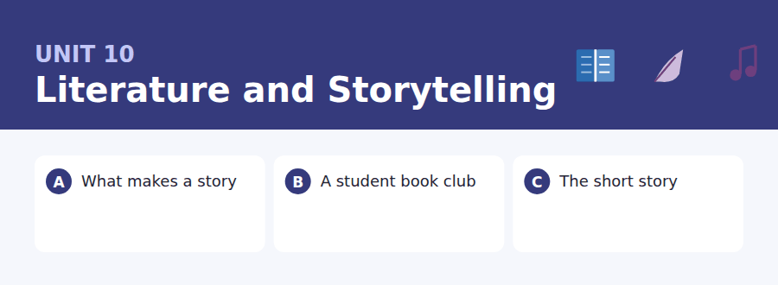
By the end of this unit I can…
- complete word endings in a text about how stories are built
- read a book club notice and a reading-list email for what I have to do
- follow a passage that explains why a form is shaped as it is
- understand two people arguing about the ending of a book
- retell an event out loud, in order, without preparing
- write an email proposing a change, and a post that disagrees carefully

The last unit of Volume 1. Everything from Units 1–10 comes back in Practice Test 1, which follows the glossary at the end of this book.

Vocabulary 1 · Academic 24 words from the Academic Word List
These twenty-four words come back through the whole unit, and again in the review. Cover the right-hand column and test yourself.
theme the main idea running through a work | version one form of something that exists in several
text a piece of writing | brief short
chapter one main part of a book | summary a short account of the main points
author the writer of a book | drama a play, or an exciting series of events
publish to produce a book or article for the public | analogy a comparison that explains something
paragraph a group of sentences on one point | underlie to be the real cause or basis of
quote to repeat someone’s exact words | appreciate to recognise the value of something
comment a written or spoken remark | clarify to make something clearer
imply to suggest without saying directly | contradict to say the opposite of
infer to work out from what is said | coherent holding together logically
ambiguous having more than one possible meaning | abstract about ideas rather than things you can touch
paradigm a typical pattern or model | resolve to settle or bring to an end

Exercise A Work in pairs. Ask and answer.
1. Describe a book or film whose ending you found ambiguous. What did you decide it meant?
2. What theme keeps coming up in the stories you like?
3. Can you summarise a film you saw recently in three sentences?
4. Which do you prefer, a novel or a short story, and why?
Vocabulary 2 · Campus and everyday 12 words for the daily-life tasks
The exam does not only test academic English. Notices, emails, conversations and announcements use the everyday words below.
book club a group that meets to discuss a book | renew to extend a loan for longer
novel a long story in prose | paperback a book with a soft cover
short story a complete story of a few pages | discussion a conversation in which ideas are examined
reading list a list of books to be read for a course | extract a short passage taken from a longer work
library card a card that lets you borrow books | blurb the short description on the back of a book
due date the day a borrowed book must be returned | spine the edge of a book where the pages are joined

Words you will meet again: culture | tradition | interpret | significant | contrast | perceive | context | evident


SKILL · Narrative endings are mostly past tense
- In a story-shaped text, two dashes after a verb stem is usually -ed.
- Three dashes after a verb stem is usually -ing.
- Noun endings common here: -ing, -ion, -ure, -ment.
- Say the sentence aloud in your head. Narrative prose has a strong rhythm.

Exercise A Guided practice. Five words are not complete. Write the missing letters.
Every story needs somebody who wants someth--- and someth--- in the way. Remove either one and the story stops. A character who wants noth--- cannot be interest---, and a character who gets everything immedi----- is not in a story at all. They are in a list.

The first one is done for you: 1 someth--- → ing (something)
Exercise B Exam practice. One paragraph, ten gaps — the real task.
A story is not a sequence of events. A sequence of events is a list. What turns a list into a story is caus-----: this happened, and beca--- it happened, that happened next. The novelist E. M. Forster made the point with two sent-----. The king died and then the queen died is a list. The king died and then the queen died of gr--- is a story, because the second death is explain-- by the first. Notice how little it t---- — two words. Everything else that we admire in fict---, the characters, the sett---, the sentences themselves, sits on top of that one join. Take it away and the most beautiful wri---- in the world is still only a list of things that happ----.

Check your answers in the key at the back of the book.


SKILL · Read the list and the condition together
- A reading list is a set of items with dates. Questions pair an item with its date.
- Note which items are compulsory and which are optional.
- An email that changes a list is more recent than the list itself.
- If something has moved online, the question is often about who that affects.

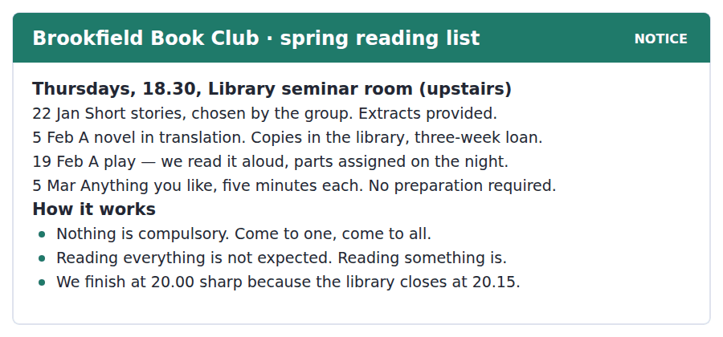
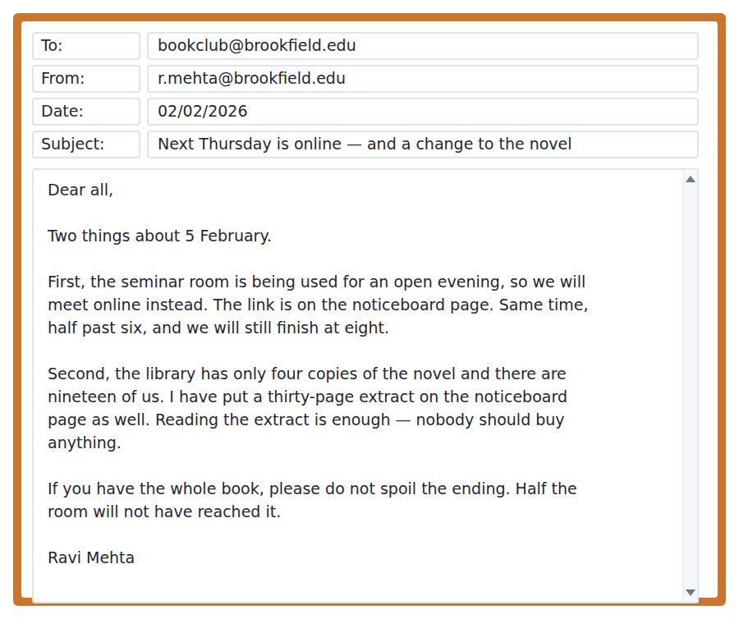
Exercise A Guided practice. The answer is on the page — find it.
1. When does the book club meet?
(A) Thursdays at 18.30
(B) Thursdays at 18.00
(C) Wednesdays at 18.30
(D) Thursdays at 20.00
2. Which session needs no preparation?
(A) 22 January
(B) 5 March
(C) 5 February
(D) 19 February
3. What happens on 19 February?
(A) A novel is discussed
(B) Extracts are provided
(C) Members choose their own book
(D) A play is read aloud
4. Why does the club finish at exactly 20.00?
(A) People have lectures
(B) The room is booked afterwards
(C) The library closes at 20.15
(D) The sessions are ninety minutes
Exercise B Exam practice.
5. Why is the February meeting online?
(A) More people have joined
(B) The library is closed
(C) The novel is only available online
(D) The seminar room is being used for an open evening
6. How many copies of the novel does the library have?
(A) Nineteen
(B) Thirty
(C) Four
(D) Three
7. What does Ravi say members should read?
(A) The whole novel
(B) The thirty-page extract
(C) Any novel in translation
(D) Nothing before the meeting
8. What does Ravi ask members not to do?
(A) Reveal the ending
(B) Buy the book
(C) Arrive late
(D) Bring guests
9. What has NOT changed about the February meeting?
(A) The place
(B) The format
(C) The book
(D) The time
10. What can be inferred about the club?
(A) It tries to keep costs at zero
(B) It is compulsory for literature students
(C) It is open only to members
(D) It has shrunk this year


SKILL · Follow a form explained by its history
- A passage of this type explains a shape by the conditions that produced it. Link the two.
- Rules listed in the middle paragraph will be tested one by one.
- A closing analogy (a room, a bag) is the author’s summary. Expect a question on it.
- What the author denies is as important as what the author claims.

Why the Short Story Is Shaped as It Is
The short story is not a small novel. It is a different instrument, and the reason is partly technological. The form took its modern shape in the nineteenth century, when cheap magazines appeared and needed something that could be read in a single sitting on a train. A novel can afford to wander for forty pages before it becomes interesting. A story in a magazine competed with the window.
That pressure produced the rules that writers still work with. A short story usually begins after the beginning: the situation is already in motion when you arrive, and you work out the background while the story moves. It tends to have one main character rather than several, because there is no room to make you care about a second. And it very often ends a little before you expect it to, leaving the last step to the reader — a technique that would be infuriating across four hundred pages and is the whole pleasure across fifteen.
None of this makes the short story easier than the novel. Writers who do both usually say the opposite, because every sentence has to perform more than one job. A line of dialogue must reveal a character, advance the plot and set the scene at the same time, since it will not get a second chance. The novelist has a room to furnish. The story writer is packing a bag.
[275 words]

Exercise A Guided practice.
1. What is the passage mainly about?
(A) Why short stories are easier to write
(B) The history of magazines
(C) Why the short story has the shape it has
(D) How novels are structured
2. According to paragraph 1, what did cheap magazines need?
(A) Longer stories
(B) Something readable in one sitting
(C) Illustrations
(D) Famous authors
3. What does "competed with the window" mean?
(A) It had to be more interesting than looking outside
(B) It was printed beside advertisements
(C) It was read in daylight
(D) It was sold at stations
4. Why does a short story usually have one main character?
(A) Readers prefer it
(B) Magazines required it
(C) It is easier to write
(D) There is no room to make you care about a second
Exercise B Exam practice.
5. What does the author say about the beginning of a short story?
(A) It explains the background first
(B) It begins after the situation is already moving
(C) It is usually the longest part
(D) It introduces all the characters
6. Why can a story end slightly early?
(A) Magazines limited the length
(B) Readers skip endings
(C) It leaves the last step to the reader
(D) Writers are paid by the page
7. All of the following are given as features of the short story EXCEPT:
(A) one main character
(B) beginning after the beginning
(C) an ending slightly before expected
(D) a slow opening section
8. What do writers who do both forms usually say?
(A) The short story is harder
(B) The novel is harder
(C) They are equally hard
(D) It depends on the subject
9. Why must a line of dialogue do several jobs at once?
(A) Readers are impatient
(B) There will not be a second chance
(C) Editors demand it
(D) Dialogue is expensive to print
10. What does the final analogy mean?
(A) The novelist travels more
(B) Both forms need the same skills
(C) The story writer must choose what to leave out
(D) A bag is cheaper than a room
11. Which best states the main idea of paragraph 1?
(A) Novels were less popular than stories
(B) The form was shaped by where it was read
(C) Nineteenth-century trains were slow
(D) Magazines paid writers badly


Exercise A Listen and choose a response. You hear one line. Choose the best reply.
1. Woman: Did you finish it?
(A) About thirty pages.
(B) It’s on the reading list.
(C) In the library.
(D) Last night, yes — and I’m still annoyed.
2. Man: What did you think of the ending?
(A) Honestly? I’m not sure there was one.
(B) On the last page.
(C) Three weeks.
(D) Yes, I read it.
3. Woman: Don’t tell me what happens.
(A) It happens at the end.
(B) I’ve finished it.
(C) All right — I won’t say anything.
(D) Yes, it’s very good.
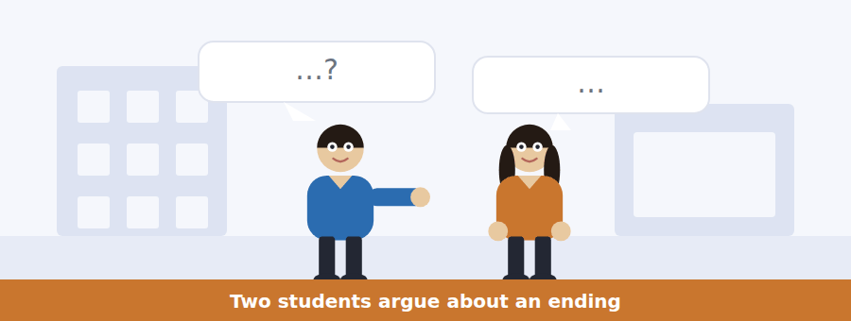
SKILL · Hear an interpretation, not a fact
- When speakers disagree about a text, each will give evidence. Note whose evidence is what.
- Listen for but that is not what it says — it marks a factual correction inside an argument.
- An agreement at the end may be partial. Note exactly what is agreed.
- Attitude questions ask how a speaker feels, which may differ from what they argue.

Exercise B Listen and answer. The audio plays once.
4. What are the speakers disagreeing about?
(A) Whether to read the novel
(B) When the book club meets
(C) Which character is the main one
(D) Whether the ending works
5. What is the man’s objection?
(A) The book is too short
(B) The character is unlikeable
(C) Nothing is resolved and he read four hundred pages
(D) He did not finish it
6. How does the woman describe the ending at first?
(A) As a mistake
(B) As a technique that leaves the last step to the reader
(C) As too long
(D) As the best part
7. What does the woman concede?
(A) That she would have liked it in a shorter work
(B) That the ending is bad
(C) That she did not finish the book
(D) That the man is usually right
8. What does the woman say they actually agree on?
(A) That it is a bad ending
(B) That short stories are better
(C) That it is the wrong length of book for that ending
(D) That nobody should finish it
9. What does the woman suggest the man do?
(A) Read it again
(B) Choose a different novel
(C) Stop reading novels
(D) Say his point at the book club
Audio script: see the back of the book. Do not read it before you listen.


Exercise A Listen and choose a response. You hear one line. Choose the best reply.
1. Man: Is it still in the seminar room?
(A) At half past six.
(B) No, it’s online this week.
(C) Nineteen of us.
(D) Yes, upstairs.
2. Woman: Do I have to read the whole novel?
(A) No — the extract is enough.
(B) There are four copies.
(C) It’s in translation.
(D) By Thursday.
3. Man: Where do I find the link?
(A) On the noticeboard page.
(B) At half past six.
(C) It’s online.
(D) Yes, there is one.
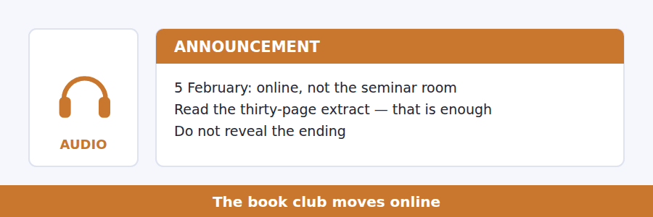
SKILL · Note what is enough, not only what is asked
- Announcements often lower a requirement. That is as testable as raising one.
- A reason given for a change usually explains a number as well.
- A request made politely is still a rule. Listen past the politeness.
- The last instruction is nearly always a question.

Exercise B Listen and answer. The audio plays once.
4. Why is the meeting online?
(A) More people have joined
(B) The library is closed
(C) The weather is poor
(D) The seminar room has been taken
5. Why is the link not in the email?
(A) It is too long
(B) The noticeboard page is safer
(C) The email reaches people who have left the group
(D) It changes every week
6. What should members read?
(A) The whole novel
(B) The thirty-page extract
(C) Nothing
(D) A short story instead
7. Why must nobody reveal the ending?
(A) Over half the group has not reached it
(B) It is a rule of the library
(C) The author asked for it
(D) It is in the extract
8. What is the speaker’s request?
(A) Arrive on time
(B) Buy the novel
(C) Bring a friend
(D) Say one sentence if you usually say nothing
Audio script: see the back of the book. Do not read it before you listen.


Exercise A Listen and choose a response. You hear one line. Choose the best reply.
1. Woman: What are the three things on the board?
(A) In the third chapter.
(B) Three lines.
(C) Want, obstacle, action.
(D) Yes, three of them.
2. Man: Does it work for any character?
(A) It takes three lines.
(B) He says it works for almost any.
(C) In a short story.
(D) Yes, three chapters.
3. Woman: Can we try one in the seminar?
(A) It is on the board.
(B) That is exactly what he suggested.
(C) About five minutes.
(D) Yes, three lines.
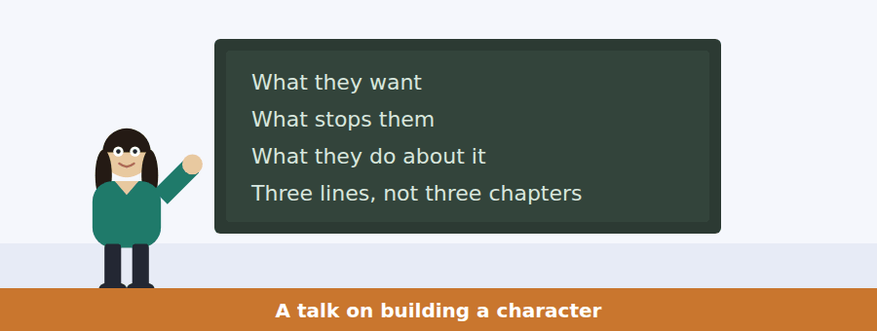
SKILL · Follow a method taught by example
- A talk that teaches a technique will demonstrate it. Watch for the demonstration.
- A short example repeated with one word changed is always tested.
- Listen for and that is all it takes — it marks the point of the example.
- The last sentence usually tells you what to do with the lecture.

Exercise B Listen and answer. The audio plays once.
4. What is the main idea of the talk?
(A) Characters need detailed description
(B) Short stories are harder than novels
(C) Character is built from want, obstacle and action
(D) Writers should plan three chapters
5. Why does the speaker mention a woman at a bus stop?
(A) To describe a scene he once wrote
(B) To compare two characters
(C) To explain how buses work
(D) To demonstrate the method step by step
6. What does the envelope add to the example?
(A) Something she wants and something stopping her
(B) A description of the character
(C) A second character
(D) A setting
7. What does the reader still not know after the three sentences?
(A) What she does
(B) What is in the envelope’s first word
(C) Her age, job or face
(D) Where she is
8. According to the speaker, what is characterisation?
(A) What a person does under pressure
(B) Describing a person carefully
(C) Explaining a person’s history
(D) Giving a person a name
9. What does the speaker say to do if the second question has no answer?
(A) Describe the character more
(B) Recognise that nothing is stopping them, so nothing is happening
(C) Add a second character
(D) Change the setting
Audio script: see the back of the book. Do not read it before you listen.


Part 1 · Listen and Repeat
You hear a sentence and repeat it once. There is no preparation time, and the sentences get longer. Focus: intonation in narrative
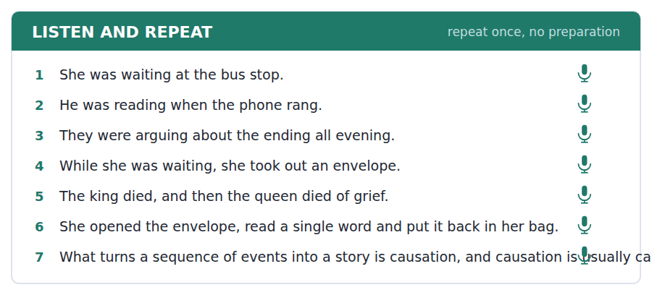
SKILL · Let the voice carry the shape
- A list of events is flat. A story rises at the complication and falls at the end.
- Mark the turning point with a slight pause before it.
- Keep the past continuous smooth: she was waiting, not she-was-waiting.
- Finish every sentence you start.

Part 2 · Take an Interview
An interviewer asks you four questions on one theme: a book or film you remember. Answer each one fully. There is no preparation time.
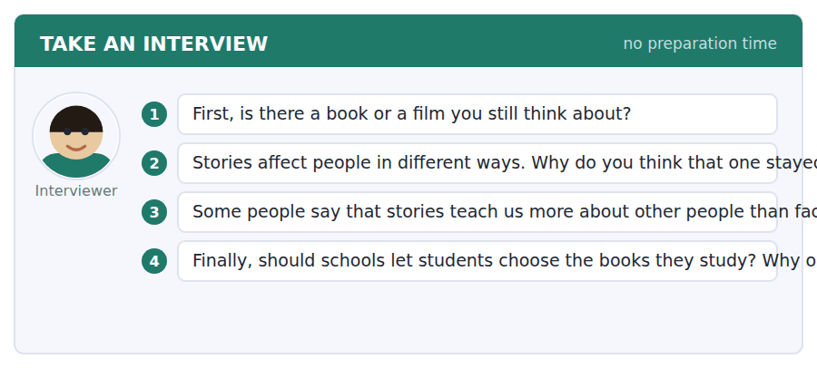
A good answer sounds like this
Question 2 — I think it stayed with me because I read it at the right age. The same book now would probably do nothing at all.
Question 3 — I agree, mostly. A fact tells you what happened. A story makes you spend three hundred pages inside somebody you would never have met.
I can… | Not yet | Yes
I paused slightly before the turning point | □ | □
I kept the past continuous smooth | □ | □
I finished every sentence | □ | □


Part 1 · Listen and Repeat
You hear a sentence and repeat it once. There is no preparation time, and the sentences get longer. Focus: disagreeing politely
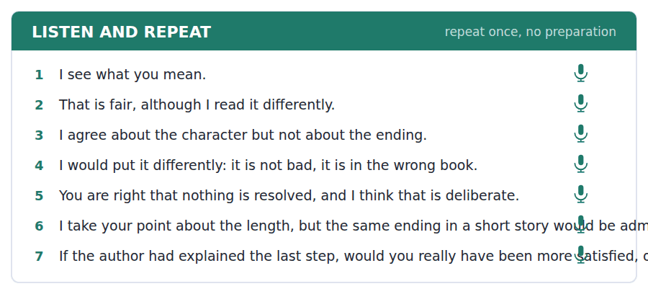
SKILL · Disagree with the point, not the person
- I see what you mean, but… / That is fair, although… / I would put it differently.
- Say what you agree with first. It makes the disagreement land.
- Give one reason. Two weak reasons are worse than one good one.
- A question back is a strong way to finish a turn.

Part 2 · Take an Interview
An interviewer asks you four questions on one theme: reading and how people do it. Answer each one fully. There is no preparation time.
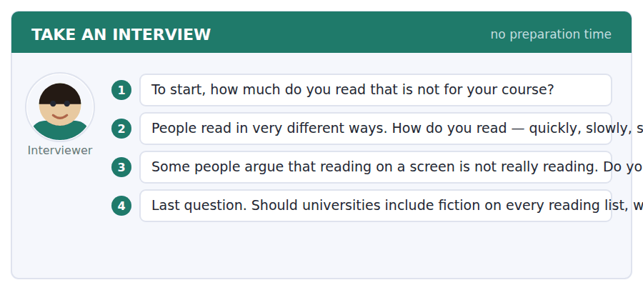
A good answer sounds like this
Question 2 — Slowly and only one at a time. If I start a second book I never finish the first, which I have learned the expensive way.
Question 3 — I disagree, although I understand the feeling. What people really mean is that they are interrupted on a screen, and that is a different complaint.
I can… | Not yet | Yes
I agreed with something before disagreeing | □ | □
I gave one clear reason | □ | □
I was polite without being vague | □ | □


Part 1 · Listen and Repeat
You hear a sentence and repeat it once. There is no preparation time, and the sentences get longer. Focus: academic register
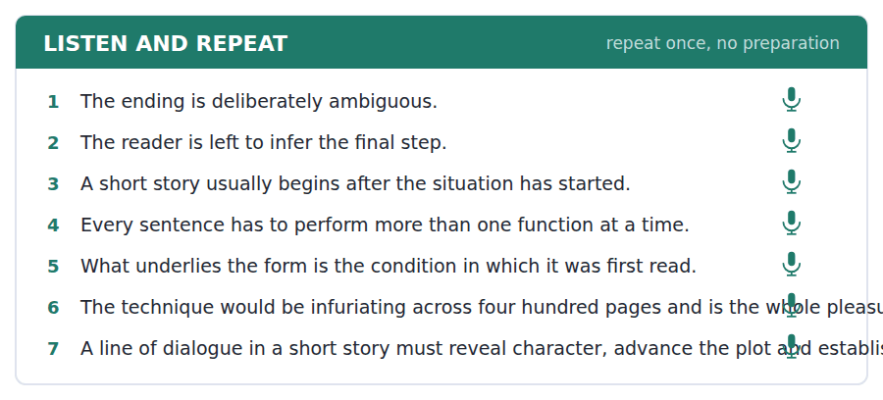
SKILL · Describe a form in its own terms
- Use the unit’s words: imply, infer, ambiguous, coherent, underlie.
- Say what a form does, then why it does it: the story ends early, which leaves…
- Avoid I like. Say the effect: the reader is left to…
- Mark yourself against the three statements below.

Part 2 · Take an Interview
An interviewer asks you four questions on one theme: stories and where they come from. Answer each one fully. There is no preparation time.
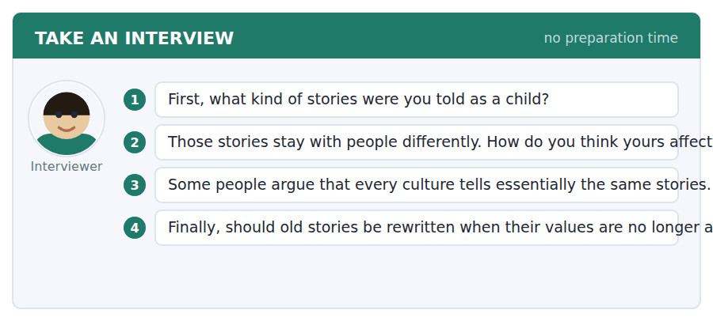
A good answer sounds like this
Question 3 — Partly. The structures repeat, which is what makes them recognisable, but what counts as a happy ending varies enormously and that is the interesting part.
Question 4 — I would publish both, with a note. Rewriting quietly removes the evidence of what people used to believe, and that evidence is useful.
I can… | Not yet | Yes
I used at least three academic words from this unit | □ | □
I described the effect rather than my preference | □ | □
My last answer had an opinion, a reason and an example | □ | □


You see a sentence, then a set of words in boxes. Put the words in order to make one grammatical sentence. Almost every item in the real test makes a question or a question inside another sentence.
SKILL · Past continuous in questions
- What was she doing? — was comes before the subject.
- While and when join two past clauses: while she was waiting, the bus came.
- An embedded past-continuous question keeps statement order: do you know what she was doing.
- Use every tile exactly once.

Exercise A Guided practice. The first three are worked through.
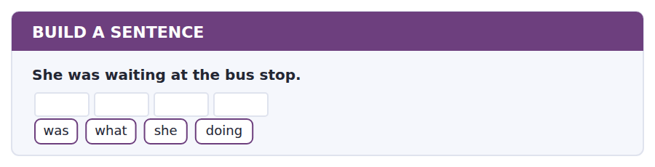
1. What was she doing?
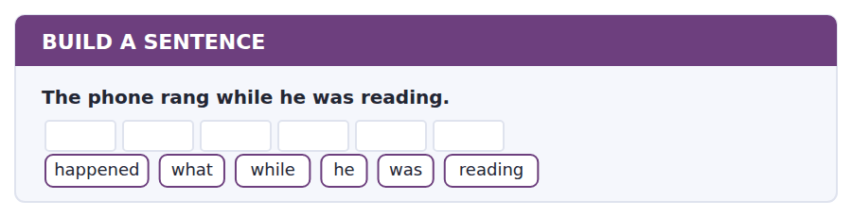
2. What happened while he was reading?
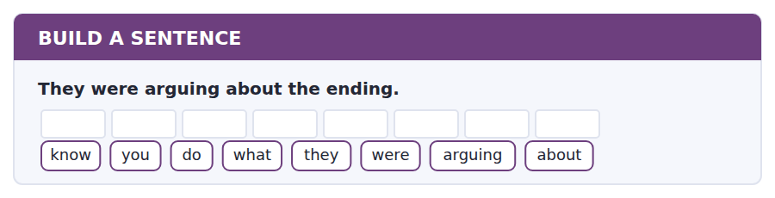
3. Do you know what they were arguing about?
Exercise B Exam practice. Write the sentence.
4. The queen died of grief.
did / why / the / queen / die
__________________________________________________________
5. The club is meeting online on 5 February.
tell / can / you / me / whether / the / club / is / meeting / online
__________________________________________________________
6. There are only four copies in the library.
copies / how / many / are / there
__________________________________________________________
7. She put the envelope back in her bag.
know / do / you / what / she / did / with / it
__________________________________________________________
8. The student who chose the novel is away this week.
the / student / who / chose / the / novel / is / away
__________________________________________________________
9. The short story took its modern shape in the nineteenth century.
did / when / the / form / take / shape
__________________________________________________________
10. Nobody should buy the book.
know / do / you / whether / I / need / to / buy / it
__________________________________________________________


You read a short situation and write an email. You have 7 minutes. The three bullet points are the mark scheme: answer all three.
The book club is meeting online on 5 February and members have been asked to read a thirty-page extract rather than the whole novel. You have read the whole book, and you think the extract stops at a point that will make the discussion of the ending impossible.
Write an email to Ravi Mehta.
- Say what the problem with the extract is.
- Suggest something practical.
- Offer to do part of the work yourself.
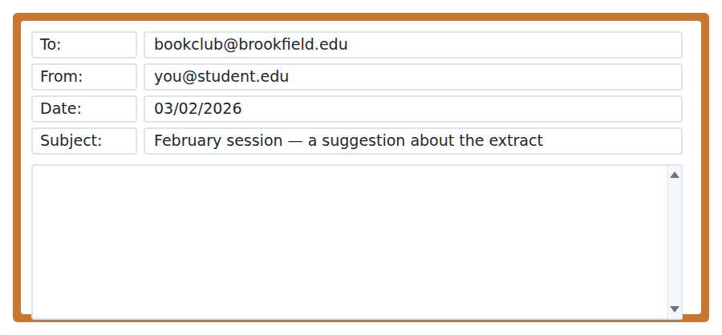
SKILL · Suggest, do not instruct
- Would it be worth…? and Could we perhaps… land better than You should…
- Name the problem in one sentence, with the page number or the detail.
- A suggestion with an offer attached is far more likely to be taken.
- Seven minutes. 110–140 words.

Model email
Dear Ravi,
Thank you for putting the extract up — it solves the copies problem completely. There is one difficulty with where it stops, though. The extract ends on page 212, just before the chapter in which she leaves, so anybody reading only the extract will arrive on Thursday without having met the ending at all.
Would it be worth adding the final chapter, which is only nine pages? That would take the extract to thirty-nine pages, which is still a single evening’s reading.
I have the book, so I am happy to scan those nine pages this afternoon and send them to you, and you could put them on the noticeboard page tonight if you agree.
Either way, I will not mention the ending before Thursday.
Best wishes,
Sara Lindqvist
Why it works
- The praise is genuine and one clause long, and the problem follows immediately with a page number.
- The suggestion is costed: nine pages, thirty-nine in total, still one evening.
- The offer removes the work from the organiser, which is what makes a suggestion actionable.
- The last line answers the request in Ravi’s own email, which shows it was read.
Now write your own. 7 minutes.
__________________________________________________________
__________________________________________________________
__________________________________________________________
__________________________________________________________
__________________________________________________________
__________________________________________________________
__________________________________________________________
__________________________________________________________


A professor asks a question and two students answer. You add your own post. You have 10 minutes and an effective answer is at least 100 words.
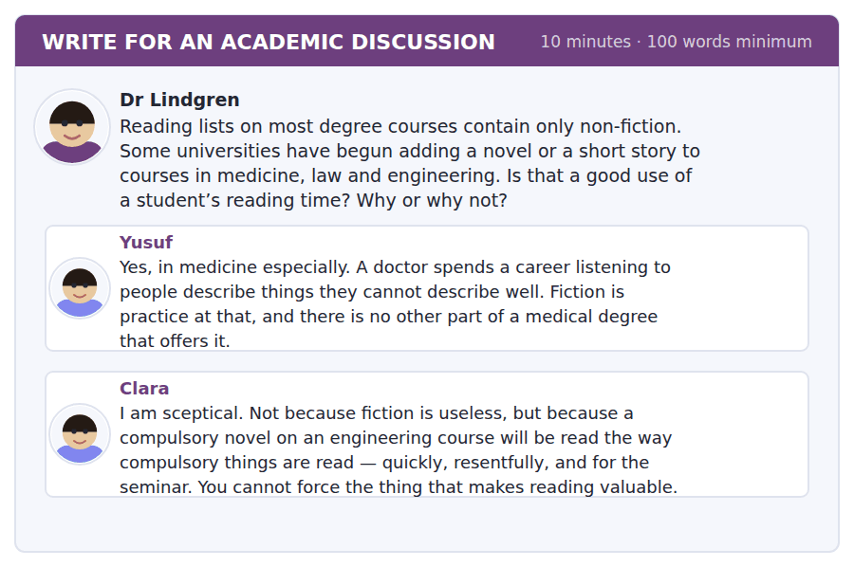
SKILL · Answer the mechanism, not the sentiment
- Both posts here are reasonable. Find the mechanism each depends on.
- Yusuf depends on fiction training attention; Clara on compulsion destroying it.
- Deciding between them means saying which mechanism is stronger, and why.
- At least 100 words in ten minutes.

Sentence starters
- Clara’s objection is about compulsion rather than about fiction, which means…
- Yusuf’s case is strongest where… and weakest where…
- Both are right about different courses:…
- What I would change is not whether but how:…
Model post
Clara’s objection is not about fiction at all. It is about compulsion, and that distinction decides the question.
Yusuf is right that medicine is a listening profession and that nothing else on the degree practises it. But notice that his argument works because the fiction is doing a job the student can see. Clara’s engineering student cannot see the job, so the novel becomes one more thing to get through before Thursday.
So I would not argue about whether, but about how. Put the story on the course at the point where it answers a question the course has already raised — a case the students have just argued about, a patient they could not agree how to treat. Read there, fifteen pages will do more than a whole novel read in week one because the syllabus says so.
[157 words]
Now write your own. 10 minutes, at least 100 words.
__________________________________________________________
__________________________________________________________
__________________________________________________________
__________________________________________________________
__________________________________________________________
__________________________________________________________
__________________________________________________________
__________________________________________________________
__________________________________________________________
__________________________________________________________

Grammar focus Past continuous and narrative
Form | Example
was / were + -ing | She was waiting at the bus stop.
Interrupted action | He was reading when the phone rang.
Two actions at once | While she was waiting, he was parking the car.
Background vs event | It was raining. She opened the envelope.
Question | What was she doing?
Not with state verbs | She was knowing the answer. ✗
Past simple for the sequence | She opened it, read it and put it back.

The past continuous sets the scene; the past simple moves the story. A narrative that uses only one of them feels either static or breathless.
When joins a short event to a longer background: when the phone rang. While joins two long actions: while she was waiting.
State verbs (know, want, believe, own, seem) are not normally used in the continuous, however long the state lasts.
Watch out! Do not put a whole sequence into the past continuous. She was opening it, was reading it and was putting it back is wrong: a sequence of completed actions takes the past simple.
Exercise 1 Put the verb in the past simple or the past continuous.
1. She __________ (wait) at the bus stop when the letter __________ (arrive).
2. While he __________ (read), the phone __________ (ring).
3. They __________ (argue) about the ending all evening.
4. It __________ (rain), so we __________ (stay) inside.
5. She __________ (open) the envelope, __________ (read) one word and __________ (put) it away.
6. I __________ (not / know) the answer at the time.
Exercise 2 Join with when or while.
1. She was waiting. The bus came. →
2. He was reading. She was cooking. →
3. They were arguing. The meeting started. →
4. It was raining. We arrived. →
Exercise 3 Correct the mistake in each sentence.
1. She was knowing the answer.
2. He was opening the envelope, was reading it and was putting it back.
3. While the phone rang, he was reading.
How this is tested in Build a Sentence
Build a Sentence uses the past continuous mainly in questions: What was she doing? What happened while he was reading? Keep was and were in front of the subject in a direct question and behind it in an embedded one.

Unit review and progress check Unit 10
Exercise A Vocabulary. Write the word.
1. to suggest without saying directly
2. to work out from what is said
3. having more than one possible meaning
4. to be the real cause or basis of
5. holding together logically
6. to say the opposite of
7. a comparison that explains something
8. a short account of the main points
9. about ideas rather than things you can touch
10. to settle or bring to an end
11. a short passage taken from a longer work
12. the day a borrowed book must be returned
Exercise B Grammar. Complete the sentence.
1. She __________ (wait) when the letter arrived.
2. While he __________ (read), the phone rang.
3. They __________ (argue) about it all evening.
4. She opened it, __________ (read) one word and put it away.
5. I __________ (not / know) the answer at the time.
6. It __________ (rain) when we arrived.
7. What __________ she __________ (do) at the bus stop?
8. He __________ (finish) the novel last night.
Exercise C One timed mini-section. 6 minutes.
1. According to the passage on page 162, the short story was shaped by
(A) the taste of nineteenth-century readers
(B) the price of paper
(C) competition from the novel
(D) where and how it was read
2. In the talk, characterisation comes from
(A) careful description
(B) a character’s history
(C) dialogue alone
(D) what a person does under pressure
3. Which sentence is correct?
(A) She was knowing the answer.
(B) While the phone rang, he was reading.
(C) He was reading when the phone rang.
(D) He was opening it, was reading it and was putting it back.
4. Book club members have been asked to read
(A) a thirty-page extract
(B) the whole novel
(C) a short story
(D) nothing
5. In Writing, the discussion post should be at least
(A) fifty words
(B) one hundred words
(C) two hundred words
(D) three hundred words
6. Volume 1 ends with
(A) a glossary only
(B) Practice Test 1 and the answer key
(C) Unit 11
(D) the audio scripts only
Can you do these now?
I can… | Not yet | Yes
complete word endings in a text about how stories are built | □ | □
read a book club notice and a reading-list email for what I have to do | □ | □
follow a passage that explains why a form is shaped as it is | □ | □
understand two people arguing about the ending of a book | □ | □
retell an event out loud, in order, without preparing | □ | □
write an email proposing a change, and a post that disagrees carefully | □ | □

ADAPTIVE TIP Before you sit Practice Test 1, read the four adaptive tips in Units 1–4 again. They are about how the test behaves rather than about English, and they are the part most students discover for the first time on the day. **Volume 1 ends here.**

Practice Test 1
The full 2026 shape: 97 items, in the order the real test asks them
Reading 40 · Listening 34 · Writing 12 · Speaking 11
Sit this in one sitting. Do not look anything up. Mark it with the key at the back, then read the explanations — they matter more than the score.

Reading Section, Module 1 In an actual test the clock shows you how long you have
You can use Next and Back to move between questions inside this module.
Fill in the missing letters in the paragraph. (Questions 1–10)
Rivers have always decided where people live. A settlement beside water could move goods che----, drink without digg--- a well, and defend itself on at least one s---. For most of history, carrying a heavy load thirty miles over land cost as much as sh------ it across an ocean, so a town with no water transport could feed itself but could not tr---. The railroad broke that r---. After 1840 a line could be laid almost anyw----, and towns began to app--- in places with no river at all. What had cha---- was not the land. It was the cost of cro----- it.

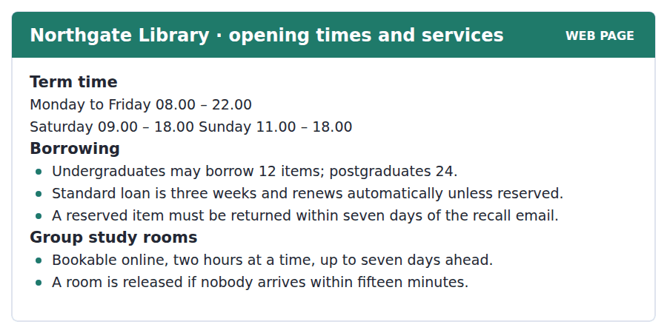
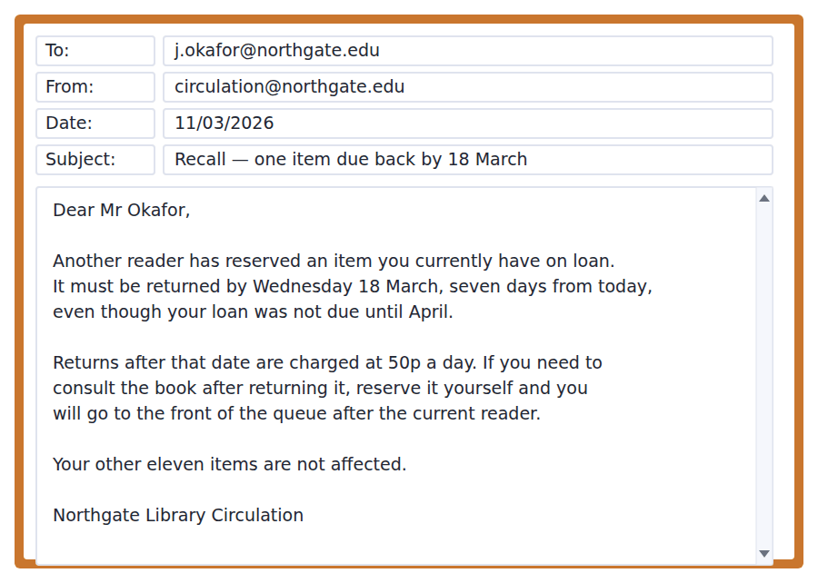
11. How long is a standard loan?
(A) Three weeks
(B) One week
(C) Two weeks
(D) Seven days
12. How many items may an undergraduate borrow?
(A) 7
(B) 12
(C) 24
(D) There is no limit
13. What happens to a booked study room if nobody comes?
(A) It is charged for
(B) It stays booked for two hours
(C) It is released after fifteen minutes
(D) It is given to the next booking
14. Why must Mr Okafor return the item early?
(A) His loan has expired
(B) He has too many items
(C) The library is closing
(D) Somebody else has reserved it
15. How many items does Mr Okafor have on loan in total?
(A) Twelve
(B) Eleven
(C) Twenty-four
(D) Seven
The Mirror and the Mark
Very young children cannot recognise themselves in a mirror. They reach the milestone at around eighteen months, and before that they treat the reflection as another child. The ability is taken to be a component of self-awareness, which raises an obvious question about other species.
The standard method is simple. A coloured mark is placed on an animal’s body where it cannot be seen directly, and the animal is then shown a mirror. If it tries to remove the mark from its own body rather than from the reflection, it has understood what it is looking at. Great apes pass. So, more surprisingly, do elephants and dolphins, which are not closely related to us at all.
In 2019 a far smaller animal passed as well. A cleaner fish, shown a mark on its own body, scraped at the place where the mark was. Some researchers argue that this shows self-awareness is far more widespread than anyone assumed. Others argue that it shows the test measures something narrower than we thought, and that a fish which grooms other animals for a living may simply be very attentive to marks. Both conclusions are uncomfortable, which is usually a sign that an experiment has been worth doing.
[265 words]

16. What is the passage mainly about?
(A) Stages of early childhood development
(B) Differences between apes and dolphins
(C) Why fish behave as they do
(D) Research on self-recognition in animals
17. The word "milestone" in the first paragraph is closest in meaning to
(A) distance
(B) weight
(C) achievement
(D) discovery
18. Why is a coloured mark used?
(A) To track the animal’s movements
(B) To see whether the animal recognises itself
(C) To tell the animals apart
(D) To test colour vision
19. All of the following are true about elephants EXCEPT:
(A) They can recognise themselves in mirrors
(B) They are highly intelligent animals
(C) They pass the same test as apes
(D) They are closely related to humans
20. Why does the author mention the cleaner fish?
(A) To prove that fish are intelligent
(B) To suggest that the result has two possible readings
(C) To criticise the method
(D) To show that the test is now obsolete

Reading Section, Module 2 In an actual test the clock shows you how long you have
You cannot return to Module 1 once Module 2 has begun.
You can use Next and Back to move between questions inside this module.
Fill in the missing letters in the paragraph. (Questions 1–10)
The human brain is a complex organ respon----- for controlling bodily functions and enabling thought, emotion and memory. It is divided into several reg----, each with a specific r---. The cerebrum, the largest pa--, is involved in cognitive functions su-- as reasoning, planning and language. The cerebellum coordi----- movement and balance, while the brainstem controls vital functions l--- breathing and heart rate. These parts dev---- at different speeds, and the regions that handle long term plan---- are among the l--- to finish. Together they enable the brain to perform its various tasks.

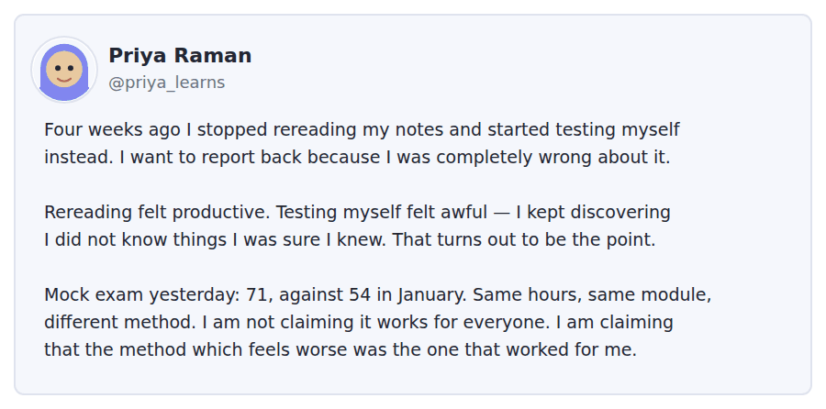
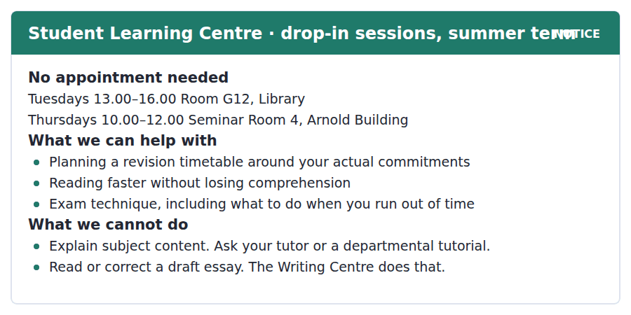
11. What is the main purpose of Priya’s post?
(A) To report the result of changing her method
(B) To ask for study advice
(C) To advertise a workshop
(D) To complain about an exam
12. What does Priya say about rereading?
(A) It is quicker
(B) It works for everyone
(C) It felt productive but was not
(D) It is what the centre recommends
13. What does Priya NOT claim?
(A) That her mark improved
(B) That the method felt worse
(C) That the method works for everyone
(D) That the hours were the same
14. What can a student get help with at a drop-in session?
(A) Understanding difficult subject content
(B) Planning a revision timetable
(C) Having an essay corrected
(D) Choosing a module
15. A student wanting an essay checked should go to
(A) Room G12
(B) Seminar Room 4
(C) their tutor
(D) the Writing Centre
The Paradox of Choice
The freedom to choose is central to consumer culture, and more choice is assumed to be better. Research over the last thirty years suggests the relationship is not that simple. Beyond a certain point, additional options produce anxiety and decision fatigue rather than satisfaction, because every extra possibility is also an extra way of choosing wrongly.
The best-known demonstration is a supermarket experiment by the psychologist Sheena Iyengar. A tasting table offered either six varieties of jam or twenty-four. The larger display attracted more people, which is what any retailer would predict. It also sold far less: shoppers who saw six varieties were roughly ten times more likely to buy than those who saw twenty-four. The smaller selection made the decision easy enough to finish.
The effect is not uniform. It is strongest where the options are similar and the buyer has no established preference, and it weakens where someone knows exactly what they want. It also appears to vary across cultures: in societies that place a high value on individual choice, the burden of deciding falls more heavily on the individual, while in others a narrower range is reported as a relief rather than a restriction. For retailers, the practical conclusion has been to curate rather than to stock everything.
[275 words]

16. Which of the following best states a main idea of the passage?
(A) Limiting consumer choice can lead to higher satisfaction
(B) Effective marketing focuses on increasing product options
(C) Individualism increases consumer contentment
(D) Modern shoppers prefer fewer products overall
17. What is one effect of decision fatigue mentioned in the passage?
(A) Anxiety about choosing wrongly
(B) A desire to copy other consumers
(C) A preference for consumer cultures
(D) Greater freedom of choice
18. Why does the author mention Iyengar’s experiment?
(A) To highlight effective marketing strategies
(B) To explain the methods used in consumer psychology
(C) To criticise the abundance of products in modern markets
(D) To provide evidence supporting the paradox of choice
19. The word "curate" in the passage is closest in meaning to
(A) eliminate
(B) increase
(C) select carefully
(D) advertise
20. What can be inferred about a shopper who knows exactly what they want?
(A) They buy more than other shoppers
(B) They are less affected by a large range
(C) They prefer twenty-four varieties
(D) They take longer to decide

Listening Section, Module 1 You will not be able to return to previous questions
Choose the best response.
1. Woman: Didn’t I just see you in the library an hour ago?
(A) Yes, you can find it in the reference section.
(B) I don’t think I’ll have enough time to do that.
(C) Actually, I think I can get there a little earlier.
(D) As a matter of fact, I was returning a book.
2. Man: Where is the nearest bus stop?
(A) I nearly missed the bus.
(B) I can help you find it.
(C) Every thirty minutes.
(D) I’ll take the subway instead.
3. Woman: How do I contact customer service?
(A) Yes, you’re allowed to do that.
(B) No, I don’t mind.
(C) Use the chat feature on the website.
(D) They provide good service.
4. Woman: I’m afraid I’m not available this evening.
(A) How about tomorrow night then?
(B) Oh, that’s too early.
(C) She arrived this afternoon.
(D) No, that’s not necessary.
5. Man: Isn’t the post office open today?
(A) No, it’s my package.
(B) It’s just around the corner!
(C) I think he’s come home already.
(D) Let’s check the opening times online.
6. Woman: If you need me, just text.
(A) I can help you with that.
(B) You haven’t given me your number yet.
(C) You don’t need any more information.
(D) You have a lot of questions, don’t you?
7. Woman: So the shop is open all weekend?
(A) Yes, there is a major power outage.
(B) Yes, it’s under renovation.
(C) Yes, but it closes early on Sunday.
(D) Yes, they’re having a huge sale.
8. Man: Did you get to the seminar?
(A) I overslept.
(B) No, not very well.
(C) Have you asked your professor?
(D) I forgot to look.
Listen to a conversation.

9. What does the woman imply she was about to do?
(A) See an exhibition
(B) Go shopping
(C) Change her clothes
(D) Cook dinner
10. Why does the man say "I’d forget my head if it wasn’t screwed on"?
(A) He got the day of the exhibition wrong
(B) He forgot what to buy
(C) He forgot what they were eating
(D) He forgot to change
Listen to a conversation.
11. Why did the woman call a technician?
(A) A radiator is leaking
(B) A lift needs maintenance
(C) A room is too cold
(D) A window will not open
12. What does the woman suggest the man do?
(A) Finish an assignment early
(B) Wait for the technician
(C) Open a window
(D) Take his lunch break early
Listen to an announcement.
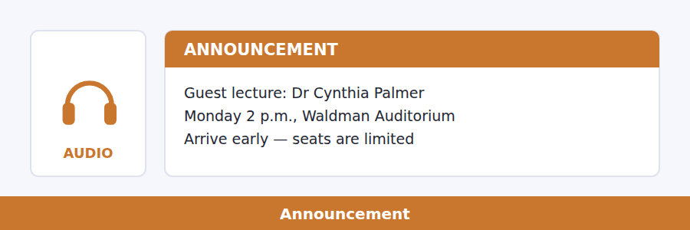
13. What is the announcement mainly about?
(A) A different room for a class
(B) The requirements for a course
(C) A guest lecture
(D) A new science degree
14. Why does the speaker mention Dr Palmer’s popularity?
(A) To encourage students to read her work
(B) To indicate why she was invited
(C) To compare her with other speakers
(D) To explain why students should arrive early
Listen to a talk.
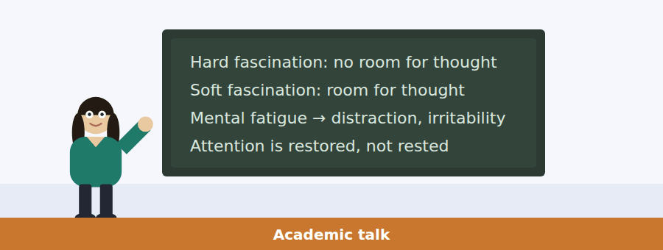
15. What is the topic of the talk?
(A) How psychologists study attention
(B) Two types of fascination
(C) How to keep the mind focused
(D) The benefits of hard fascination
16. Why does the speaker mention a film?
(A) To introduce a concept in psychology
(B) To compare different types of film
(C) To explain how films affect emotions
(D) To encourage listeners to watch more films
17. What does the speaker say about her walk in the park?
(A) It is similar to watching a good film
(B) Her mind has room for thoughts unrelated to nature
(C) She has to make a special effort to stay focused
(D) She gets mental fatigue from it
18. What does the speaker say about the default mode network?
(A) It leads to irritability and stress
(B) It is easily tired by overuse
(C) It is involved in soft fascination
(D) Its effect is unknown to psychologists

Listening Section, Module 2 You will not be able to return to previous questions
Choose the best response.
1. Woman: Who is the new manager?
(A) She started last week.
(B) Let’s welcome the new manager.
(C) The position has been filled.
(D) I’m not sure, but I can find out.
2. Man: When is the due date for the report?
(A) Please wait while I look that up.
(B) Give me some dates.
(C) No, I have another due date.
(D) Yes, that’s correct.
3. Man: I’m going to get some groceries.
(A) Let’s go together.
(B) Every Wednesday.
(C) In aisle four.
(D) The cinema is not open today.
4. Woman: Would you like a copy of my notes?
(A) The research facility.
(B) The break is in an hour.
(C) Two bullet points.
(D) That would be great.
5. Man: Sami and Layla are on their way to the café.
(A) Did you like the concert?
(B) Yesterday evening.
(C) Should we join them?
(D) The best coffee.
6. Woman: I’d like to hear your thoughts on the job candidates.
(A) I’m revising my résumé.
(B) I’ll set up a meeting for us to talk.
(C) She just got a promotion.
(D) Yes, the training is complete.
7. Woman: How much does expedited shipping cost?
(A) We don’t offer that.
(B) It’s one of many.
(C) Twice last week.
(D) I’d like the bill, please.
8. Man: If you need more information, contact Ms Lee.
(A) I can help with that.
(B) You ask a lot of questions.
(C) And whom should I contact?
(D) What is her role in the company?
Listen to a conversation.
9. What is the man trying to decide between?
(A) A laptop and a desktop
(B) A tablet and a phone
(C) A laptop and a tablet
(D) A tablet and a keyboard
10. What reason does the woman give for her suggestion?
(A) It is cheaper
(B) It is easier to use while travelling
(C) It has a larger screen
(D) It has a better keyboard
Listen to an announcement.
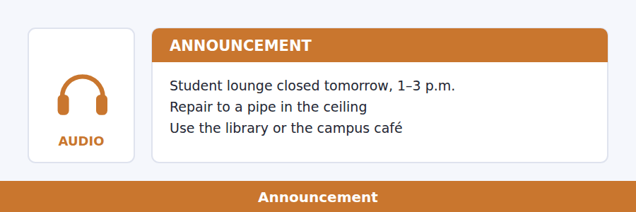
11. What is the main purpose of the announcement?
(A) To inform students about a schedule change
(B) To announce new lounge facilities
(C) To notify students of a temporary closure
(D) To encourage students to use the lounge more
12. What should students do during the closure?
(A) Wait in the lounge
(B) Use other spaces on campus
(C) Help with the maintenance
(D) Visit the library website
Listen to a talk.
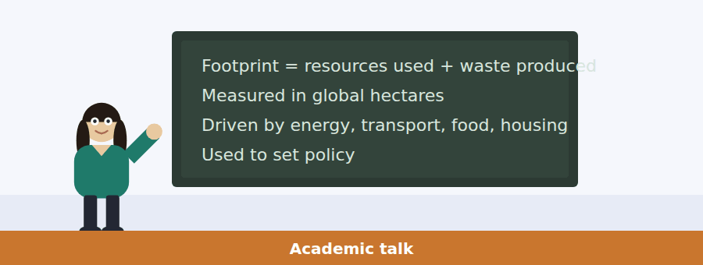
13. What is the main topic of the talk?
(A) Changes in consumption over time
(B) Environmentally damaging activities
(C) The role of governments in sustainability
(D) A measure of environmental impact
14. Why does the speaker mention developed and developing countries?
(A) To illustrate the usefulness of comparing footprints
(B) To contradict a theory about the footprint
(C) To show that resource depletion is similar regardless of lifestyle
(D) To point out that production efficiency reduces the footprint
15. What does the speaker mention as a way to reduce a footprint?
(A) Disposing of waste appropriately
(B) Joining an environmental organisation
(C) Using environmentally friendly transport
(D) Eating locally produced food
16. What will the speaker most likely discuss next?
(A) How data about footprints is collected
(B) Why the idea of a footprint is often misunderstood
(C) How footprint information has been used in creating policies
(D) Why sustainable development is difficult to achieve

Writing Section 12 questions, three types of task
Build a Sentence. Move the words to make grammatical sentences.
1. What was the highlight of your trip?
were / the / was / old city / showed us around / who / tour guides
__________________________________________________________
2. I heard Anna got a promotion.
a different department / if / moving to / know / do / you
__________________________________________________________
3. We’re planning a trip to the mountains next weekend.
the cabins / available / whether / can / will be / you
__________________________________________________________
4. I’m looking forward to the concert this weekend.
does / what / time / it / start
__________________________________________________________
5. The museum exhibition opens next month.
do / you / how / know / tickets / will cost / much
__________________________________________________________
6. I’m planning to go to the beach tomorrow.
is / time of year / what / the water / this / like / temperature
__________________________________________________________
7. I need to buy groceries today.
list / do / a / have / shopping / you
__________________________________________________________
8. I’ll be taking a cooking class this weekend.
learn / what / will / you / recipes
__________________________________________________________
9. What did Maria ask you about the book you’re reading?
she / wanted / a copy / buy / to know / could / where
__________________________________________________________
10. How did you prepare for the exam?
by / the professor / that / the study guide / was provided / it
__________________________________________________________
Write an Email. You have 7 minutes.
A new poetry magazine has asked its readers for submissions, and you decided to submit two of your poems. However, you had a problem using the online submission form, and you are not certain that your submissions were received.
Write an email to the editor of the magazine.
- Tell the editor what you like about the new magazine.
- Describe the problem you experienced.
- Ask about the status of your submissions.
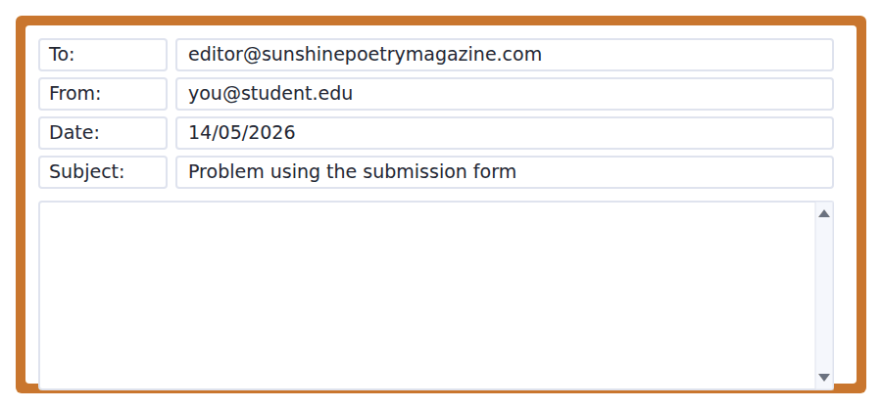
__________________________________________________________
__________________________________________________________
__________________________________________________________
__________________________________________________________
__________________________________________________________
__________________________________________________________
__________________________________________________________
__________________________________________________________
Write for an Academic Discussion. You have 10 minutes.
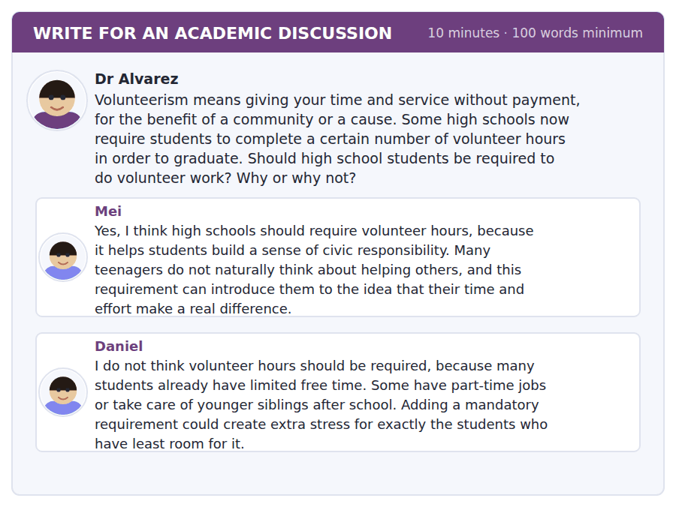
An effective response will contain at least 100 words.
__________________________________________________________
__________________________________________________________
__________________________________________________________
__________________________________________________________
__________________________________________________________
__________________________________________________________
__________________________________________________________
__________________________________________________________
__________________________________________________________
__________________________________________________________

Speaking Section 11 questions, two types of task · no preparation time
Listen and Repeat. Repeat only once.
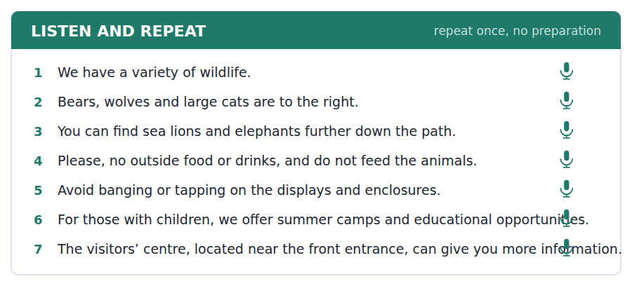
Take an Interview. Answer the questions and say as much as you can.
a research study about urban life
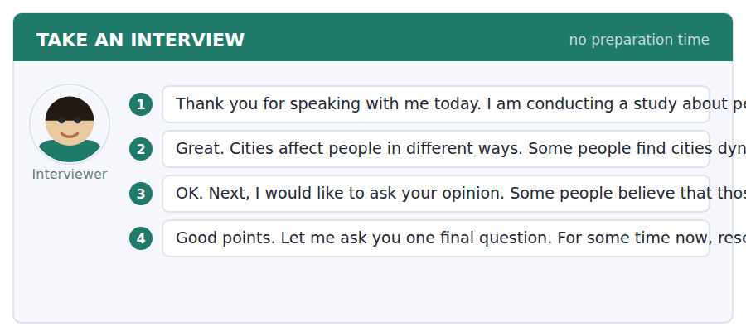

Answer key
Volume 1 · Units 1–10 and Practice Test 1
Every wrong option is explained, because a letter on its own teaches nothing.

Unit 1 · American History
Reading 1 · Complete the Words
1 eks | 3 sand | 5 kly | 7 od | 9 inent
2 roads | 4 ys | 6 all | 8 an | 10 ller

Reading 2 · Read in Daily Life
1 (D) Closed Mondays is printed under Opening hours. The other three days all appear with times.
2 (A) $6 is the student price. $12 is the adult price and under-12s are the ones who pay nothing.
3 (C) Student tickets are only sold with a valid student card. Nothing is said about passports, printing or cash.
4 (B) The notice says from the ticket desk. Gallery 3 is where the exhibition is, not where the tour starts.
5 (D) The subject line and the first sentence both say confirmed. No payment, cancellation or date change is mentioned.
6 (B) Twenty-two students pay the student rate; the two staff come free, so the school is charged for 22.
7 (C) They use the group entrance because the main doors do not open until 10.00. The tour is at 11.00.
8 (A) The email is addressed to a school address and confirms her group booking, so she is the one bringing the group. Nothing says she has been before.
9 (A) Any bag larger than a small rucksack must be left in the cloakroom.
10 (B) The free tour runs on Saturdays at 11.00. Saturday closing is 18.00, not 17.00, and the museum closes only on Mondays.
Reading 3 · Academic Passage
1 (D) All three paragraphs answer the same question: what decides where a city appears. Chicago and transport costs are the evidence, not the subject.
2 (C) Not an accident here means not by chance. The author goes on to give the reason, which rules out crash and mistake.
3 (D) The text says a town without it could feed itself but could not trade. Food is what such a town could still do.
4 (C) Chicago is introduced as the clearest example of the new rule in paragraph 2.
5 (B) A line could be laid almost anywhere — that is the whole point of the paragraph.
6 (A) The eleven companies and the fourth place come thirty years later, and it did have a small harbour.
7 (B) The passage says the opposite: after 1840 a line could be laid almost anywhere. The other three are all stated.
8 (D) The sentence before it says wherever goods stop, people stay. That is the pattern the author calls very old.
9 (C) The pattern is very old and only the reason for stopping changed, so such places existed when the transport was water.
10 (A) Paragraph 3 opens with geography still mattered and then says why: flat ground was cheapest. Chicago did not fail.
11 (D) Everything in the paragraph leads to the break-in-bulk point: the place where goods change transport.
Listening 1 · Conversation
1 (A) The question is about a plan, so only a plan answers it.
2 (C) How long wants a length of time. At eleven answers when.
3 (B) The woman has stated a wrong belief; the natural reply corrects it.
4 (D) He corrects her: it’s the eighteenth, not the twenty-fifth.
5 (B) They moved it when the gallery changed the dates — the man says so directly.
6 (A) Her last line explains it: she had tickets last year and was ill.
7 (C) I’ll ask Sam to cover for me. She is asking, not cancelling.
8 (B) He warns her not to go there because they don’t open till ten.
9 (D) She is working on the eighteenth and talks about swapping a shift and someone covering for her.
Listening 2 · Announcement
1 (C) Where wants a place. At nine fifteen answers when.
2 (A) The only option that names a thing to bring.
3 (C) A yes/no question needs a yes or a no, and this one adds the useful part.
4 (D) The speaker says two things have changed and then gives both.
5 (A) Stated directly, with because built into the sentence.
6 (B) Because of the roadworks on Mill Street.
7 (B) Without it you pay the full adult price — and the refund is specifically ruled out.
8 (D) The last sentence gives the instruction and the reason for it.
Listening 3 · Academic Talk
1 (C) The natural reply to a did-you-understand question is whether you did.
2 (A) What was it? wants a definition, not a date or a yes.
3 (B) The only reply that offers help with a missed point.
4 (C) The last sentence states it, and every example leads there.
5 (A) The point is that it doubled the land but almost nobody moved for twenty years.
6 (D) Suddenly a farmer in Ohio could sell wheat in New York.
7 (B) The speaker says it outright: that is law, not transport.
8 (A) What I want you to notice is the order, followed by the four stages in sequence.
9 (D) The talk ends on expected earnings, which is the one idea introduced and not yet explained.
Writing 1 · Build a Sentence
1 What did you see there?
2 When did the first line open?
3 Have you ever travelled by train?
4 Why did they change the hours?
5 How much track was laid?
6 Which city grew fastest?
7 Have you already booked the tickets?
8 The engineers who built the bridge came from Scotland.
9 What time did you arrive?
10 How long has it been open?
Grammar focus
Exercise 1 opened · have never been · changed · has the exhibition been · grew · have already booked
Exercise 2 When did it open · Why did they change it · Which city grew fastest · How long has it been open
Exercise 3 a is wrong → When did you visit… · b is wrong → Which company built… · a is wrong → I saw the exhibition last week
Unit review
A Vocabulary 1 decade · 2 transform · 3 migrate · 4 significant · 5 establish · 6 route · 7 region · 8 decline · 9 initial · 10 federal · 11 field trip · 12 opening hours
B Grammar 1 reached · 2 Have / been · 3 has / been · 4 designed · 5 have not received · 6 did / leave · 7 has declined · 8 did / move
C Mini-section 1 C · 2 C · 3 D · 4 B · 5 A · 6 C

Unit 2 · Astronomy and Space
Reading 1 · Complete the Words
1 sest | 3 se | 5 ated | 7 st | 9 ally
2 ments | 4 rate | 6 ern | 8 ht | 10 ed

Reading 2 · Read in Daily Life
1 (D) Worlds Beyond is 60 minutes; Night Sky Live is 50 and Our Moon 45.
2 (B) The student price always follows the slash. $14 is the full price for that show.
3 (A) Only Night Sky Live says with an astronomer.
4 (C) Latecomers cannot be admitted once the dome is dark.
5 (D) Fourteen people is ten or more, so the group rate of $4 applies to any show.
6 (A) The doors close at 18.55 for a 19.00 start, which is why latecomers cannot enter.
7 (B) The email gives the reason directly. Nothing is said about price or a ban.
8 (C) Tickets are not refundable but may be moved once — the notice and the email agree.
9 (B) Up to 48 hours beforehand, in the email’s fourth paragraph.
10 (C) The email goes to astro.society@hillcrest.edu and he books for a group of fourteen. Nothing says he studies the subject or has booked before.
Reading 3 · Academic Passage
1 (D) The problem comes in paragraph 1 and two methods follow. The 1995 discovery is one example inside the first method.
2 (A) The author explicitly separates distance from the real problem in the sentence before.
3 (C) It is an image for the brightness problem, not a statement about size.
4 (B) A planet pulls on the star, moving it towards us and away from us.
5 (A) A few metres a second, slower than a person running. It is slow but it is measurable.
6 (D) The colour change belongs to the first method; the dimming belongs to the second.
7 (C) It only works when the planet’s path lies between us and the star — the author says so.
8 (D) The sentence before describes the star getting fainter, so the drop is in brightness.
9 (B) The first planet around an ordinary star was found in 1995, so what was known before was our own system.
10 (A) Neither shows us a planet; both show a star behaving as though something is there.
11 (D) The paragraph gives the method, its difficulty, its one condition, and its success rate.
Listening 1 · Conversation
1 (B) Which wants one of the options, not a time or an opinion.
2 (C) A yes/no question about price. The length and the place answer different questions.
3 (A) A suggestion is answered by agreeing or disagreeing with it.
4 (A) The first line sets the question and the last line answers it.
5 (D) There’s an actual astronomer, and you can ask questions.
6 (B) At four dollars each for any show, the man concludes price isn’t really the question.
7 (C) The length is mentioned afterwards as an extra; the weekend work is the deciding reason.
8 (A) She is telling him that emailing the planetarium will work.
9 (D) She advises him to email them and he does not object.
Listening 2 · Announcement
1 (C) What time wants a clock time; the others answer where, how long and why.
2 (B) The only option that confirms the rate itself.
3 (A) A should-I question wants advice, and this one gives it with a reason.
4 (D) Two details change, and both are times and places.
5 (B) Stated with because, which is where the reason usually sits.
6 (C) Seven fifteen, not quarter to — the old time is given so you can hear the difference.
7 (D) You are all on one list under the society’s name, so the group rate applies.
8 (A) Because the box office charges us for empty seats.
Listening 3 · Academic Talk
1 (B) A did-you-follow question asks whether you understood.
2 (C) How far wants a distance.
3 (C) A request is answered by granting or refusing it.
4 (B) The last three sentences name it: each method is calibrated against the one below.
5 (A) It is a physical demonstration of the apparent shift parallax depends on.
6 (D) It would take years and come back too weak to detect. Accuracy is radar’s strength, not its problem.
7 (D) Stated directly, and it is the reason the third method exists.
8 (B) Objects whose real brightness we already know — the definition is given in the sentence.
9 (C) Radar checks parallax and parallax checks the candles, so radar is the rung the ladder rests on.
Writing 1 · Build a Sentence
1 How far is the Moon?
2 Which is the biggest planet?
3 Which is the longer show?
4 How much does Saturday cost?
5 How far does parallax work?
6 Which method is more accurate?
7 When was the first planet found?
8 The star that moves has a planet.
9 How big is the drop?
10 How many planets are known?
Grammar focus
Exercise 1 farther / the farthest · more accurate / the most accurate · heavier / the heaviest · better / the best · more visible / the most visible · larger / the largest
Exercise 2 fewer · less · Fewer · less
Exercise 3 the most expensive · more accurate than parallax · bigger than that one
Unit review
A Vocabulary 1 estimate · 2 precise · 3 detect · 4 visible · 5 minimum · 6 enormous · 7 confirm · 8 hypothesis · 9 phenomenon · 10 interval · 11 group rate · 12 refund
B Grammar 1 more accurate · 2 the most expensive · 3 fewer · 4 darker · 5 better · 6 the worst · 7 less · 8 the closest
C Mini-section 1 A · 2 A · 3 D · 4 C · 5 B · 6 C

Unit 3 · Cells and Genetics
Reading 1 · Complete the Words
1 pens | 3 ion | 5 bled | 7 ored | 9 able
2 ains | 4 ated | 6 ken | 8 ied | 10 aced

Reading 2 · Read in Daily Life
1 (D) Bags and coats are left on the rack outside; the next sentence rules out under a bench.
2 (C) Both are issued at the door — both refers to the coat and the goggles.
3 (B) Samples are labelled before they are moved, never after. The sentence gives both halves.
4 (A) Only opened by a member of staff, and students do not hold keys.
5 (D) The subject line and the first paragraph both say she has not been inducted and cannot be admitted without it.
6 (A) Students who have not been inducted cannot be admitted, and the practical date is given in the same sentence.
7 (C) Each lasts fifty minutes.
8 (B) You will be sent away if you do not, which matches the notice’s no exceptions rule.
9 (C) Reply to this address by Friday and a make-up session will be arranged.
10 (A) Samples are allowed and must be labelled. Water is named as not allowed, and the other two are forbidden outright.
Reading 3 · Academic Passage
1 (D) A wrong belief, the evidence against it, and its confirmation — all three paragraphs serve that one question.
2 (B) Every generation would be more similar than the one before it — and plainly that does not happen.
3 (D) The paint image in paragraph 1 defines it: two things mixed into one.
4 (B) It did not give a medium plant — the example exists to disprove blending.
5 (A) Short plants reappeared, in a predictable proportion — that is the whole point of the experiment.
6 (C) Paragraph 3 says the opposite: he had only inferred the structures, and microscopes came later.
7 (B) It is contrasted with what biologists could now see, so it means he reached it by reasoning.
8 (A) Thirty-four years, from the 1860s until 1900.
9 (C) Microscopes good enough to see what he had only inferred — so the instruments had improved in the interval.
10 (D) It is a rare case of a theory waiting, fully formed, for the instrument.
11 (C) The paragraph ends on exactly that sentence, and everything before it builds to it.
Listening 1 · Conversation
1 (D) A yes/no question about an action, so the answer both replies and explains.
2 (A) Which wants one of the options. The time alone does not identify a session here.
3 (B) A problem is naturally met with a suggestion.
4 (C) Tuesday clashes with a seminar and she cannot reach Thursday’s on time.
5 (D) The man corrects her: that was the chemistry one.
6 (A) She does not get in until half past, and the session starts at nine.
7 (B) He quotes the email: reply by Friday and one will be arranged.
8 (B) No induction, no practical on the nineteenth — the man states it flatly.
9 (D) Again refers back to the fact that she had already let the first email pass.
Listening 2 · Announcement
1 (C) Where wants a place.
2 (A) A can-I question wants permission, granted or refused.
3 (D) A what-do-I-do question wants an instruction.
4 (C) The speaker says three changes and then numbers them.
5 (A) Because last term several people reached their bench without either.
6 (B) They are free but need a coin, which is returned.
7 (B) The speaker gives exactly that reason, and adds that nobody is in trouble for reporting.
8 (A) The exception is medical, and it must be arranged before the session.
Listening 3 · Academic Talk
1 (C) How long wants a length of time.
2 (D) A yes/no question, and the right reply answers it honestly and usefully.
3 (C) The most helpful reply supplies the missed information.
4 (B) The speaker says the important thing is not the sequence, and then names the checks.
5 (A) This is the slow part — it takes most of the cell’s working life.
6 (D) The whole process stops and waits — the speaker says so directly.
7 (D) It opens the talk and frames the question: how is all that copying done accurately?
8 (B) Roughly one in a billion — the speaker gives the figure just before the end.
9 (C) The last sentence says exactly that.
Writing 1 · Build a Sentence
1 When are samples labelled?
2 Where are the instructions copied?
3 Do you know how energy is generated?
4 Where are goggles issued?
5 Who is the laboratory opened by?
6 How many cells are replaced?
7 Can you tell me whether a session will be arranged?
8 The work that Mendel did was ignored for years.
9 To whom are breakages reported?
10 Do you know why the process stops?
Grammar focus
Exercise 1 is checked · are not held · is labelled · are copied · are issued · is not allowed
Exercise 2 Where are goggles issued · Who is the laboratory opened by · When are samples labelled · How many cells are replaced
Exercise 3 a is wrong → are kept · b is wrong → Where are the goggles issued? · a is wrong → must be reported
Unit review
A Vocabulary 1 function · 2 component · 3 complex · 4 identical · 5 vary · 6 transmit · 7 mechanism · 8 isolate · 9 trace · 10 distinct · 11 induction · 12 make-up session
B Grammar 1 are issued · 2 are not allowed · 3 are / kept · 4 must be reported · 5 are copied · 6 is generated · 7 is only opened · 8 are produced
C Mini-section 1 A · 2 B · 3 D · 4 C · 5 A · 6 D

Unit 4 · Climate and the Environment
Reading 1 · Complete the Words
1 ain | 3 ator | 5 age | 7 ain | 9 ulty
2 ned | 4 dreds | 6 ves | 8 ste | 10 ow

Reading 2 · Read in Daily Life
1 (C) Food waste only, including tea bags — and packaging is specifically excluded.
2 (D) The first rule states exactly this consequence.
3 (A) Large items including furniture go to the drop-off point.
4 (B) Bins are collected on Tuesdays, in the second rule.
5 (C) The last paragraph gives a date, a time and a meeting point, which is what the post is for.
6 (B) About forty other people. Nineteen is the number of sacks.
7 (D) She gives the reason herself: the fountains are in every building and they are free.
8 (A) Bring gloves if you have them — there are never enough.
9 (A) The Why it matters section gives last year’s figure and the target.
10 (D) Jamila calls this one next one and gives a date, which implies a series. The meeting point has changed, and nothing says who organises them.
Reading 3 · Academic Passage
1 (C) Paragraph 1 poses it, paragraph 2 explains it, paragraph 3 gives the consequences.
2 (B) The author rules out the first reading explicitly and gives this one instead.
3 (D) The sentence contrasts absorbing energy with the thermometer barely moving, so it means taking it in.
4 (B) The next sentence makes the point: it keeps turning long after the engine has stopped.
5 (A) Four times is the heat capacity figure; 1,300 is the ratio of masses.
6 (C) More than nine tenths of it has gone into the sea.
7 (A) The passage says the opposite — it has warmed by a much smaller number.
8 (C) The last sentence gives both reasons, and ice is not mentioned anywhere.
9 (D) The sea has been storing heat for decades, and it will go on releasing that heat.
10 (B) Whatever happens to emissions, the stored heat goes on working — so the rise continues for a long time either way.
11 (C) Put those two numbers together is the paragraph’s own summary of itself.
Listening 1 · Conversation
1 (D) A yes/no question; the natural reply answers and adds something.
2 (B) Why wants a reason, and only one option gives one.
3 (A) A stated difficulty is naturally met with help.
4 (A) The man says it is too complicated; the woman disagrees about why it fails.
5 (D) A sandwich box in the green one, and green is food only.
6 (B) She names it as the rule that matters and then explains why.
7 (C) If there’s food in a blue bin the whole bin goes to landfill.
8 (B) Not that it’s complicated, but that nobody explained the consequence — she corrects the man directly.
9 (D) She tells him to write it down because the group meets on Thursday, and he does not object.
Listening 2 · Announcement
1 (A) When wants a day or a time, which only one option supplies.
2 (C) A what-if question wants a consequence.
3 (A) Where wants a place, and the specific one is given in the announcement.
4 (D) The speaker opens with the change and spends the announcement explaining it.
5 (C) Food waste only — that includes tea bags, and packaging is excluded in the same sentence.
6 (B) The speaker gives the consequence and then that exact image.
7 (D) Bags beside a bin will not be taken — if your bin is full, use another one.
8 (C) After the end of term they stop running them until September, so the deadline is the end of term.
Listening 3 · Academic Talk
1 (A) The question offers two figures; the answer picks one.
2 (B) A what-does-it-mean question wants a definition.
3 (B) A request to repeat is met by agreeing and asking which part.
4 (C) An enormous amount of energy wearing a very small number is the talk in one line.
5 (D) She then states the misreading and corrects it, which is what the whole talk is for.
6 (A) Four times for heat capacity and thirteen hundred times for mass.
7 (C) Only a few per cent of the story — she says it as her first of two conclusions.
8 (D) Water expands when it warms, so the heat already stored will go on raising sea level.
9 (A) A flywheel is hard to speed up or slow down and keeps turning after the engine stops — the opposite of being a passenger.
Writing 1 · Build a Sentence
1 What happens if food goes in blue?
2 What will happen when the sun sets?
3 Do you know if the scheme starts Monday?
4 What happens if I leave a bag?
5 How much will landfill fall?
6 Can you tell me whether we can still ask?
7 How long will sea level rise?
8 The bin that contains food goes to landfill.
9 Which day are the bins collected?
10 Do you know why people ignore it?
Grammar focus
Exercise 1 does not blow / will fall · will go / put · reach / will save · rinse / will not be · starts / will be · explains / will ignore
Exercise 2 Unless you rinse it, it will go in grey. · Unless we act now, the target will be missed. · Unless they explain the consequence, nobody will care. · Unless the department emails before Friday, no talk will be arranged.
Exercise 3 If it rains, the clean-up will be cancelled. · Unless you rinse it, it will go to landfill. · When the sun sets, the output will fall.
Unit review
A Vocabulary 1 impact · 2 consume · 3 sustain · 4 alternative · 5 considerable · 6 eliminate · 7 fluctuate · 8 scheme · 9 widespread · 10 regulate · 11 clean-up · 12 drop-off point
B Grammar 1 does not blow · 2 will go · 3 Unless · 4 When · 5 will save · 6 happens · 7 will ignore · 8 might be missed
C Mini-section 1 B · 2 B · 3 D · 4 A · 5 C · 6 C

Unit 5 · Psychology and the Mind
Reading 1 · Complete the Words
1 anged | 3 ding | 5 ked | 7 ated | 9 bered
2 ving | 4 ored | 6 ked | 8 eed | 10 itten

Reading 2 · Read in Daily Life
1 (C) A free 90-minute workshop, in the first line under the title.
2 (B) Monday is in Seminar Room 4, Arnold Building; the other two are in Room G12.
3 (D) Bring a copy of your own timetable — the poster explains why in the same line.
4 (A) Places are limited to 24, under Booking.
5 (A) We start on time and the door is closed once we begin.
6 (C) One subject you are genuinely worried about — and the email explains why in the next sentence.
7 (D) Spent planning that subject, not a general example.
8 (B) The Thursday session has a waiting list of nine people.
9 (C) Why rereading feels effective and is not — the poster puts it in exactly those words.
10 (B) A 90-minute workshop, repeated three times — so the content is identical and only the slot differs.
Reading 3 · Academic Passage
1 (D) The asymmetry is stated in paragraph 1, demonstrated in 2 and applied in 3.
2 (A) Roughly twice as much — the passage gives the figure.
3 (A) Most people take the fifty, even though the average value is the same.
4 (C) Nothing about the amounts has changed — only whether it is described as winning or avoiding a loss.
5 (B) The passage gives exactly that reason, and it is the same mechanism as the coin toss.
6 (D) It names the fact that losses and gains of the same size do not feel the same.
7 (A) Shopping is never mentioned; the other three all appear.
8 (D) To recover time that is already gone — and the next sentence rules out misjudging the danger.
9 (B) Psychologists have shown that we do not — the assumption is presented as having been corrected.
10 (C) The last sentence states it: the risk is taken because the alternative is admitting a loss.
11 (D) This is not a laboratory curiosity — the author then gives two everyday cases.
Listening 1 · Conversation
1 (C) How wants a method; the others answer where and how long.
2 (B) A does-it-work question wants a judgement, with a condition if there is one.
3 (A) A stated difficulty is met with advice.
4 (C) Reading through the lecture notes again. Third time now.
5 (D) Familiar isn’t the same as known — the man repeats the workshop’s point.
6 (B) He describes the method and then admits it feels much worse.
7 (A) The group that tested themselves scored about fifty per cent higher a week later.
8 (D) He is warning her that the feeling and the result point in opposite directions.
9 (C) She asks whether the workshop is running again and he tells her where the sheet is.
Listening 2 · Announcement
1 (A) A yes/no question about the time; only one option answers it.
2 (B) Which building wants a building.
3 (A) A do-I-still question asks whether something has changed, and this answers it.
4 (D) The room has moved is the first thing said and the rest follows from it.
5 (B) Given in a short aside inside the sentence about the move.
6 (C) Same day, same time: ten o’clock, Thursday the sixth.
7 (B) The walk is what catches people out, so the early arrival still matters.
8 (A) Tell us today rather than tomorrow, because nine people are waiting.
Listening 3 · Academic Talk
1 (D) A did-she question wants a yes or no, and this one names the term too.
2 (C) What causes wants a cause; the third option gives an effect instead.
3 (D) A should-I question wants advice, and this one gives it with a limit.
4 (B) The speaker names the two kinds, contrasts them, and the advice follows from the contrast.
5 (A) It frames the whole talk: why an evening of doing nothing is tiring.
6 (C) You do not have to try for one, and it also takes no effort for the other.
7 (B) There is no room left for any other thought in the first; the second leaves room.
8 (A) Soft fascination does the opposite — the opposite of producing mental fatigue.
9 (C) The practical advice is explicitly not to stop watching films, but to walk first.
Writing 1 · Build a Sentence
1 Why did she decide to start again?
2 Do you avoid revising at night?
3 What does he want to do?
4 When did they stop believing that?
5 Do you know whether it is worth going to?
6 What does she need to bring?
7 Why do people avoid testing themselves?
8 The student who tested herself scored higher.
9 Can you tell me which session she wanted?
10 When does he hope to finish?
Grammar focus
Exercise 1 testing · to start · working · to bring · Rereading · going
Exercise 2 at remembering · without saying · about changing · of rereading
Exercise 3 a = he ended the activity; b = he paused in order to read · a = the memory of doing it; b = he did not forget · a = an experiment with a method; b = an attempt that may have failed
Unit review
A Vocabulary 1 perceive · 2 assume · 3 interpret · 4 evaluate · 5 motive · 6 distort · 7 insight · 8 rational · 9 retain · 10 random · 11 distraction · 12 timetable clash
B Grammar 1 testing · 2 to start · 3 working · 4 going · 5 to bring · 6 remembering · 7 Rereading · 8 reading
C Mini-section 1 D · 2 B · 3 D · 4 C · 5 A · 6 D

Unit 6 · Art and Design
Reading 1 · Complete the Words
1 ect | 3 ound | 5 tch | 7 ison | 9 er
2 est | 4 ously | 6 ounds | 8 uries | 10 form

Reading 2 · Read in Daily Life
1 (A) Room 2 has an entry fee of £4, though students go free. The others are marked free or closed.
2 (B) Allowed everywhere except Room 2.
3 (C) Rooms 4 and 5 are upstairs, and Room 5 is closed until 3 December.
4 (D) There is no charge, in the same line as the bag rule.
5 (D) The subject line and the first paragraph both say the hang is open for submissions.
6 (C) Send three photographs of the work, not the work itself — the email rules out the obvious wrong answer.
7 (A) Anything larger than 100 x 80 cm cannot be hung, because of the wall between the windows.
8 (B) The email gives that reason with because.
9 (C) Eighteen places and ninety-one submissions last time — the two numbers are given together for exactly this reason.
10 (D) Bags larger than A4 go in the cloakroom, free of charge. Room 5 is closed until 3 December.
Reading 3 · Academic Passage
1 (B) The three paragraphs are three stages, in sequence, and the passage opens by saying people get the order wrong.
2 (A) It lists how many people, doing what, at which times, and what must never happen — and contains no drawings at all.
3 (D) At that size you cannot draw a detail and are forced to decide what matters.
4 (A) The passage defines it in the same sentence it introduces it.
5 (B) Paragraph 2 ends on exactly that judgement.
6 (C) The last stage reverses the first: the team tests the shape back against the brief.
7 (D) The corridor is quietly added to every meal for fifty years — it is an example of a small plan decision with a large permanent cost.
8 (B) Colour is never mentioned; the other three are the three stages.
9 (A) The reason is in the brief, not in the architect’s taste — stated at the end of paragraph 1.
10 (C) Most of what makes a building pleasant is decided by questions asked before building begins.
11 (C) The paragraph explains why drawing begins small and what that smallness achieves.
Listening 1 · Conversation
1 (B) A yes/no question; the reply answers and asks something useful back.
2 (D) Why wants a reason; the first option gives a date instead.
3 (A) An indirect question about paying; only one option answers the payment question.
4 (C) One is beside a dark panel and one on a white wall, and the man says they are the same grey.
5 (A) They’re the same grey. Identical. The caption says so.
6 (B) He states it directly and adds that the artist is showing you your own eye doing it.
7 (D) She has just said the caption is doing most of the work.
8 (B) All right, that is quite clever — followed immediately by a continuing objection.
9 (C) And he gives a reason: they read it, and quotes appear in the next room.
Listening 2 · Announcement
1 (D) When wants a date, and the others answer how many and where.
2 (A) A can-I question wants permission, and the refusal comes with its reason.
3 (A) What size wants dimensions.
4 (D) Four things, all of them instructions for submitting.
5 (B) There is no second meeting, so it is simply not seen by anybody.
6 (C) Three photographs, with the dimensions and the medium written underneath.
7 (C) Submit anyway, but tell us, because occasionally a piece is moved to Room 4.
8 (B) He says so directly: if you are not selected it means very little.
Listening 3 · Academic Talk
1 (D) Who wants a person; the date answers when.
2 (A) A does-that-mean question wants the meaning clarified.
3 (B) A request to repeat is answered by agreeing and checking which part.
4 (C) The speaker states the usual reading, rejects it, and spends the talk on what the phrase actually means.
5 (D) The shape of a thing should grow out of what it is for.
6 (A) A plain box is not functional if four hundred people cannot leave it in ninety seconds — the figures exist to make that point.
7 (A) It is sized by how many people must come down it in an emergency.
8 (B) Width sets the depth of the hall, which sets the proportion of the facade.
9 (C) The ones we call beautiful are usually the ones where the architect let that happen instead of fighting it.
Writing 1 · Build a Sentence
1 Do you know whether students pay?
2 Can you tell me when the gallery closes?
3 The square that looks lighter is not.
4 Do you know if photography is allowed?
5 Could you tell me whether the deadline has passed?
6 Why is Room 5 closed?
7 How many works are chosen?
8 The architect who designed the hall designed the library.
9 I was wondering if the cloakroom is free.
10 Do you know why the sketches are small?
Grammar focus
Exercise 1 The architect who designed the hall also designed the library. · This is the square that looks lighter. · That is the room where the work is hung. · The students who submitted early were selected. · This is the wall that limits the size. · That is the gallery that I told you about.
Exercise 2 whether the cloakroom is free · when the gallery closes · why Room 5 is closed · whether the deadline has passed
Exercise 3 Do you know where the cloakroom is? · The man who designed it is Spanish. · Could you tell me whether the gallery opens on Monday?
Unit review
A Vocabulary 1 contrast · 2 contemporary · 3 medium · 4 unique · 5 diverse · 6 highlight · 7 intrinsic · 8 uniform · 9 innovate · 10 layer · 11 caption · 12 floor plan
B Grammar 1 who · 2 that · 3 where · 4 where the cloakroom is · 5 whether · 6 why · 7 who · 8 closes
C Mini-section 1 D · 2 B · 3 D · 4 A · 5 C · 6 A

Unit 7 · Geology and the Earth
Reading 1 · Complete the Words
1 ach | 3 omes | 5 iet | 7 orm | 9 ence
2 eded | 4 ages | 6 ply | 8 tten | 10 rst

Reading 2 · Read in Daily Life
1 (B) Trainers are specifically ruled out in the same line.
2 (A) Handed in by Wednesday 11 March, under Essential.
3 (C) A packed lunch for Saturday; Sunday lunch is provided.
4 (D) Headcount at 07.20, ten minutes before departure.
5 (D) One change, and it is the place the minibuses leave from.
6 (A) Given as the reason in the same sentence as the change.
7 (B) Same time: 07.30, with the headcount at 07.20.
8 (C) The form is what the insurance rests on — the reason is given with because.
9 (B) It restates the Essential rule in stronger terms because the forecast is poor.
10 (A) The Arnold Building is eight minutes further, and the time has not changed.
Reading 3 · Academic Passage
1 (D) The pattern is set out in paragraph 1, explained in 2 and divided into two kinds in 3.
2 (C) The pattern was obvious and the explanation was missing.
3 (B) About the speed at which a fingernail grows — the comparison is there to fix the figure.
4 (C) Melted rock is lighter than solid rock, so it rises.
5 (D) And that water lowers the melting point of the rock above, which is what makes the second kind of volcano.
6 (A) Parallel to the edge but a hundred kilometres inland.
7 (D) Trapping gas belongs to the other kind, which is why those erupt violently.
8 (B) The pressure builds until it exceeds the strength of the rock above.
9 (A) The dangerous ones are the ones that have been quiet for a long time — the author puts it as a paradox deliberately.
10 (C) The pressure passes the strength of the rock, which is when the eruption happens.
11 (C) Pulling apart gives one kind; one plate going under another gives the second.
Listening 1 · Conversation
1 (A) A yes/no question about possession; the answer qualifies it usefully.
2 (B) How many wants a number of people.
3 (D) The answer both answers the question and narrows it to the right day.
4 (C) The woman opens with a list and they work through it.
5 (B) Six hammers for twenty-six people — the two numbers are given together.
6 (D) I don’t. I’ll share with you.
7 (A) His Ah and the woman’s reply make it clear, and she reminds him of the email.
8 (D) The woman quotes the reason the lecturer gave.
9 (B) She says the office closes at four and he replies that he is going now.
Listening 2 · Announcement
1 (C) Where wants a place.
2 (A) A what-happens-if question wants a consequence.
3 (A) A yes/no question about signal; only one option answers it directly.
4 (C) Departure, forms, kit and safety — the briefing is the practical information.
5 (D) Eleven minutes of waiting cost the whole group a morning.
6 (B) A student without one is not covered and legally cannot be on the bus.
7 (B) Which is why a waterproof with a hood is compulsory rather than advisable.
8 (C) Do not walk on — stay where you are, and we always find people who stay still.
Listening 3 · Academic Talk
1 (D) A what-is question wants a definition.
2 (A) A can-you question about scope, and the answer gives the limit.
3 (B) Which wants one of the two methods named.
4 (C) The talk defines both questions, gives each method its limitation, and ends on how they work together.
5 (A) Is this layer older or younger than that one — the speaker defines it at once.
6 (D) And this is the limitation people forget.
7 (A) A species that existed for a short time but spread over a wide area.
8 (D) Both reasons are given in the same breath, which is why it leads into the fossil method.
9 (B) The clocks date a sequence once, and the fossils carry that date everywhere else.
Writing 1 · Build a Sentence
1 How thick is the layer?
2 How many hammers are available?
3 Do you know how long it took?
4 How fast do the plates move?
5 Can you tell me how many students are going?
6 What time do the minibuses leave?
7 How much signal is there?
8 The fossil that spread widely is the useful one.
9 Do you know whether I can travel?
10 How old is the rock?
Grammar focus
Exercise 1 few · much · Fewer · many · less · few
Exercise 2 a two-metre layer · a ten-minute walk · a five-year study · an eleven-minute delay
Exercise 3 fewer students · much time · a two-metre layer
Unit review
A Vocabulary 1 erode · 2 accumulate · 3 sequence · 4 duration · 5 exceed · 6 trigger · 7 persist · 8 precede · 9 ongoing · 10 adjacent · 11 risk form · 12 meeting point
B Grammar 1 few · 2 much · 3 Fewer · 4 many · 5 less · 6 two-metre · 7 few · 8 too much
C Mini-section 1 C · 2 A · 3 D · 4 B · 5 C · 6 C

Unit 8 · Economics and Markets
Reading 1 · Complete the Words
1 sts | 3 odity | 5 ing | 7 nces | 9 st
2 nal | 4 ers | 6 cers | 8 ys | 10 ing

Reading 2 · Read in Daily Life
1 (C) Lennox pays £13.20, above the museum’s £12.60 and the bookshop’s £11.80.
2 (B) Only the nursery, and the notice adds that it takes about three weeks.
3 (D) There is no printer in the Sports Hall, which is why the notice says printed.
4 (A) The university limit, in the last line before the email.
5 (B) The email says Dunn Street and adds not at the university in brackets, because that is the mistake people make.
6 (C) And the email explicitly says a written reference is not needed at this stage.
7 (A) The notice and the email agree: never shorter than four hours.
8 (D) If you cannot commit to two evenings a week, it is better to tell us now than in November.
9 (D) Two shifts of at least four hours at £13.20 is about £105.60, and both numbers are given.
10 (B) Most employers interview on the day, and Kofi is offered an interview the following morning.
Reading 3 · Academic Passage
1 (C) Paragraph 2 gives the argument and paragraph 3 explains why it loses in public.
2 (A) The first sentence states it in exactly those words.
3 (D) That is the hinge of the whole argument.
4 (A) Every hour spent on cloth is an hour not spent on wheat — that is what is given up.
5 (C) The distinction between these first two options is the entire point of the argument.
6 (B) Both countries end up with more of everything if each specialises and they exchange.
7 (C) The author insists both effects are real and never minimises the losses.
8 (B) Spread thinly across millions who never notice, concentrated on thousands who notice sharply.
9 (D) The final sentence says exactly that, which is a criticism of the answer rather than of the facts.
10 (A) The argument is defended in paragraph 2 and its human cost conceded in paragraph 3.
11 (D) The paragraph is about the distribution of the effects, not their size.
Listening 1 · Conversation
1 (A) A did-you-get question wants the thing obtained.
2 (C) How much wants an amount.
3 (B) An opinion is naturally met with agreement plus the other side.
4 (A) The first line sets the choice and the last line settles it.
5 (D) Thirteen twenty against eleven eighty, and the man does the arithmetic aloud.
6 (B) Plus travel. The bookshop doesn’t pay travel.
7 (C) Evening shifts Thursday to Saturday against a nine o’clock Friday lecture.
8 (B) She contrasts the money, which is easy to compare, with the hours, which are not.
9 (A) Bookshop. I’ll be poorer and I’ll pass statistics.
Listening 2 · Announcement
1 (C) What time wants a clock time, and only one option gives one.
2 (D) A do-I-need question wants a yes or no plus the detail.
3 (D) A can-I question about permission; the answer gives the rule.
4 (C) Three things, all of them things to do or know before going.
5 (B) Every year people arrive with it on their phone — and the building has no printer.
6 (A) Because most employers interview on the day.
7 (B) That is not advice — exceeding it usually means giving up the job.
8 (C) Four four-hour shifts is sixteen hours, which is already the limit.
Listening 3 · Academic Talk
1 (A) The question offers two terms and the answer picks one.
2 (D) What happens wants the change itself, not its cause.
3 (B) A stated difficulty is met with a practical suggestion.
4 (C) The first half makes the case and the second half states the condition, which is where the talk is going.
5 (D) It is the first link of the chain and it is on the board.
6 (A) Without being told anything about any harvest, they find it more expensive and use less.
7 (A) If the river is free, it is not in the price, so the signal is wrong.
8 (D) Not slightly wrong, but wrong in the one direction that matters.
9 (B) The last sentence says so directly.
Writing 1 · Build a Sentence
1 How much does catering pay?
2 How many employers came?
3 Do you know how long the shifts are?
4 How many hours can I work?
5 Can you tell me where the interview is?
6 When does the rate rise?
7 Do you know whether they pay travel?
8 The employer who interviewed me emailed the next day.
9 How long does a check take?
10 What do prices carry?
Grammar focus
Exercise 1 – · The · a · – · an · The
Exercise 2 b · b · b
Exercise 3 Trade between two countries makes both richer. · She has got a job in a bookshop. · Prices carry information from one country to another.
Unit review
A Vocabulary 1 income · 2 revenue · 3 commodity · 4 incentive · 5 margin · 6 sector · 7 allocate · 8 equate · 9 index · 10 export · 11 overtime · 12 reference
B Grammar 1 – (no article) · 2 The · 3 a · 4 – (no article) · 5 an · 6 The · 7 a · 8 The
C Mini-section 1 C · 2 C · 3 D · 4 B · 5 A · 6 C

Unit 9 · Anthropology and Culture
Reading 1 · Complete the Words
1 onal | 3 ned | 5 ations | 7 ation | 9 less
2 ion | 4 able | 6 ation | 8 ion | 10 ury

Reading 2 · Read in Daily Life
1 (C) Tickets £5 for the closing night. The film night also costs £2, but the opening performance and the language exchange are free.
2 (A) Food fair, Main Quad, on Wednesday from eleven until three.
3 (B) Bring nothing; just turn up.
4 (D) The last note says so, and it is the day before the fair.
5 (D) She has twenty-nine and wants thirty — the joke in her first line is the point.
6 (B) It does not need to be traditional, and the toast-and-jam example proves it.
7 (C) It was the second busiest table, which is her argument against needing a family recipe.
8 (A) Message me by Sunday, because the kitchen needs numbers on Monday morning.
9 (C) The notes are explicit: in the campus kitchen, not at home.
10 (A) Thirty stalls is by far the biggest number in the programme, and Mariam is still recruiting days before.
Reading 3 · Academic Passage
1 (D) Both drawings are answers to questions about work, land and old age — that frames all three paragraphs.
2 (B) Neither drawing is the natural one — the author says so directly.
3 (C) More hands at harvest, and the old cared for by those who will inherit.
4 (B) With a delay of roughly one generation, which is the key claim of the paragraph.
5 (D) That is exactly what a one-generation delay produces.
6 (A) One might arrange a marriage, the other might pay for schooling.
7 (A) The passage says the opposite: the words remain.
8 (C) The reasons have gone while the vocabulary stays, which is the author’s point.
9 (B) The household breaks into smaller units that can move — mobility is the stated advantage.
10 (D) A culture carries its history around in its vocabulary long after the reasons have gone.
11 (C) Hand farming favours large households, wage work favours small ones, with a generation’s delay.
Listening 1 · Conversation
1 (A) A yes/no question about intention; the answer gives one.
2 (B) How many wants a number of people.
3 (D) A negative question checking a rule; the answer confirms and names it.
4 (C) The conversation moves from being asked, to what to make, to who does what.
5 (B) The woman says so in her first line, dryly.
6 (A) She would make it for twelve, and forty is four times that.
7 (D) I’ve never scaled anything up in my life — and the man answers that worry directly.
8 (A) Everything in the pot is yours — which corrects the man’s assumption.
9 (B) He offers the shopping because she has actually seen the dish made.
Listening 2 · Announcement
1 (D) A yes/no question about the place, answered and corrected.
2 (C) A do-I-have-to question wants a yes or no with the deadline.
3 (D) Where wants a place; the day answers when.
4 (A) The reason is given immediately after the change.
5 (C) And this is new this year: the kitchen is now bookable in two-hour slots.
6 (B) Last year the first six cooked and the rest queued.
7 (A) And the speaker adds that the gaps are by the entrance where it is cold.
8 (B) The one exception given at the end, though they still need a table number.
Listening 3 · Academic Talk
1 (D) Who wants a person and what they did.
2 (C) A does-that-mean question wants the claim clarified, and this one corrects a misreading.
3 (D) A request for an example is answered by giving one.
4 (B) Age is not what gives a custom its power — and the speaker turns that into a new question.
5 (A) Designed, deliberately, and recently — that is the claim of the book.
6 (C) They are the two illustrations of Hobsbawm’s claim.
7 (B) The point of this is not to catch anybody out — he was not saying these traditions are fake.
8 (C) Do not ask how old is this; ask what does it do now.
9 (D) A tradition invented last Tuesday and genuinely felt is doing more work than a nine-hundred-year-old one performed for tourists.
Writing 1 · Build a Sentence
1 What did people use to cook with?
2 Who would make the soup?
3 Do you know when the chilli arrived?
4 Where did families use to live?
5 How many stalls are needed?
6 Can you tell me whether the kitchen is booked?
7 When was the tradition invented?
8 The student who ran the stall is helping again.
9 Do you know who pays for the ingredients?
10 How many people did she use to cook for?
Grammar focus
Exercise 1 used to eat · would make · reached · used to be · would assemble · Did / use to live
Exercise 2 a is wrong → Did you use to cook? · a is wrong → She used to be a teacher. · a is wrong → I am used to cooking for twelve.
Exercise 3 Families used to live on the land. · Each winter they would cook the same dish. · There used to be separate words for both uncles. · Every year he would visit his grandmother.
Unit review
A Vocabulary 1 norm · 2 integrate · 3 mutual · 4 status · 5 hierarchy · 6 assemble · 7 context · 8 adapt · 9 immigrate · 10 bond · 11 host family · 12 marquee
B Grammar 1 used to eat · 2 would make · 3 reached · 4 used to be · 5 Did / use to live · 6 cooking · 7 would assemble · 8 did not use to
C Mini-section 1 A · 2 C · 3 D · 4 B · 5 A · 6 B

Unit 10 · Literature and Storytelling
Reading 1 · Complete the Words
1 ation | 3 ences | 5 ed | 7 ion | 9 ting
2 use | 4 ief | 6 akes | 8 ing | 10 ened

Reading 2 · Read in Daily Life
1 (A) Thursdays, 18.30 — 20.00 is the finishing time.
2 (B) Anything you like, five minutes each. No preparation required.
3 (D) Parts are assigned on the night, which is why nothing has to be prepared.
4 (C) The notice gives that reason with because.
5 (D) The first of the two things, given with its reason.
6 (C) Four copies and nineteen members — which is why the extract exists.
7 (B) Reading the extract is enough — nobody should buy anything.
8 (A) Please do not spoil the ending — half the room will not have reached it.
9 (D) Same time, half past six, and we will still finish at eight.
10 (A) Library copies, provided extracts, a free online option and nobody should buy anything all point the same way.
Reading 3 · Academic Passage
1 (C) Technology produced the pressure, the pressure produced the rules, and the last paragraph denies that this makes it easier.
2 (B) Read in a single sitting on a train, which is the whole explanation of the length.
3 (A) The comparison is with a novel that can afford to wander for forty pages.
4 (D) The reason is given in the same sentence as the rule.
5 (B) You work out the background while the story moves.
6 (C) And the author adds that this would be infuriating across four hundred pages.
7 (D) A slow opening belongs to the novel, which can afford forty pages.
8 (A) Writers who do both usually say the opposite — the opposite of the story being easier.
9 (B) Since it will not get a second chance — given as the reason in the same sentence.
10 (C) Packing a bag is a matter of selection; furnishing a room is a matter of filling space.
11 (B) Cheap magazines, a single sitting, a train — the conditions of reading set the length.
Listening 1 · Conversation
1 (D) A yes/no question about completion; the reply answers and opens the topic.
2 (A) What did you think wants an opinion.
3 (C) A request not to do something is answered by agreeing.
4 (D) He calls it stopping, she calls it an ending, and they argue from there.
5 (C) I don’t want to do the last step. I read four hundred pages.
6 (B) She refers back to something the group discussed last term.
7 (A) In fifteen pages I’d have loved it.
8 (C) She corrects his summary in the last line, carefully.
9 (D) Say that on Thursday — because she thinks the reframed complaint is interesting.
Listening 2 · Announcement
1 (B) A yes/no question about place, answered and corrected.
2 (A) A do-I-have-to question wants the requirement, and this one lowers it.
3 (A) Where wants a place, including an online one.
4 (D) Taken for the open evening, which is the reason given.
5 (C) The speaker explains it with because, in the same sentence.
6 (B) Read the extract. That is genuinely enough.
7 (A) And the ending is the entire thing we are going to argue about.
8 (D) And she adds that online is actually easier for that.
Listening 3 · Academic Talk
1 (C) What are they wants the items themselves.
2 (B) A does-it-work question wants a judgement about scope.
3 (B) A can-we question wants agreement or refusal.
4 (C) The three lines on the board are the method, and the demonstration proves it.
5 (D) He builds the example in three stages, adding one element at a time.
6 (A) She wants to know, and something is stopping her — that is the first two of the three lines.
7 (C) The speaker lists exactly those three to make his point about description.
8 (A) Description is not characterisation — what a person does under pressure is.
9 (B) That is your problem — nothing is stopping them, so nothing is happening.
Writing 1 · Build a Sentence
1 What was she doing?
2 What happened while he was reading?
3 Do you know what they were arguing about?
4 Why did the queen die?
5 Can you tell me whether the club is meeting online?
6 How many copies are there?
7 Do you know what she did with it?
8 The student who chose the novel is away.
9 When did the form take shape?
10 Do you know whether I need to buy it?
Grammar focus
Exercise 1 was waiting / arrived · was reading / rang · were arguing · was raining / stayed · opened / read / put · did not know
Exercise 2 She was waiting when the bus came. · He was reading while she was cooking. · They were arguing when the meeting started. · It was raining when we arrived.
Exercise 3 She knew the answer. · He opened the envelope, read it and put it back. · When the phone rang, he was reading.
Unit review
A Vocabulary 1 imply · 2 infer · 3 ambiguous · 4 underlie · 5 coherent · 6 contradict · 7 analogy · 8 summary · 9 abstract · 10 resolve · 11 extract · 12 due date
B Grammar 1 was waiting · 2 was reading · 3 were arguing · 4 read · 5 did not know · 6 was raining · 7 was / doing · 8 finished
C Mini-section 1 D · 2 D · 3 C · 4 A · 5 B · 6 B

Practice Test 1
Reading, Module 1
1 aply | 5 ade | 9 nged | 13 C | 17 C
2 ing | 6 ule | 10 ssing | 14 D | 18 B
3 ide | 7 here | 11 A | 15 A | 19 D
4 ipping | 8 ear | 12 B | 16 D | 20 B

11 (A) Three weeks, renewing automatically unless the item is reserved.
12 (B) Twelve for undergraduates and twenty-four for postgraduates.
13 (C) A room is released if nobody arrives within fifteen minutes.
14 (D) Another reader has reserved it, which triggers the seven-day recall.
15 (A) One recalled item plus eleven others that are not affected.
16 (D) The childhood milestone opens the passage only to set up the animal question, which the other two paragraphs pursue.
17 (C) It is something children reach at a certain age, so it is a stage achieved.
18 (B) The animal must try to remove it from its own body, which only makes sense if it knows the reflection is itself.
19 (D) The passage says the opposite: they are not closely related to us at all.
20 (B) The paragraph gives both interpretations and calls both uncomfortable.
Reading, Module 2
1 sible | 5 ch | 9 ning | 13 C | 17 A
2 ions | 6 nates | 10 ast | 14 B | 18 D
3 ole | 7 ike | 11 A | 15 D | 19 C
4 rt | 8 elop | 12 C | 16 A | 20 B

11 (A) She says she wants to report back, and gives two marks four weeks apart.
12 (C) Rereading felt productive; testing herself felt awful and produced the better mark.
13 (C) I am not claiming it works for everyone — she says so explicitly.
14 (B) The first item under What we can help with; the other two appear under what they cannot do.
15 (D) The last line sends draft essays to the Writing Centre.
16 (A) The whole passage argues that beyond a point, more options reduce satisfaction and sales.
17 (A) Every extra possibility is also an extra way of choosing wrongly.
18 (D) It is introduced as the best-known demonstration of the claim made in paragraph 1.
19 (C) It is contrasted with stocking everything, so it means choosing what to offer.
20 (B) The effect weakens where someone knows exactly what they want.
Listening, Module 1
1 D | 5 D | 9 B | 13 C | 17 B
2 B | 6 B | 10 A | 14 D | 18 C
3 C | 7 C | 11 C | 15 B
4 A | 8 A | 12 D | 16 A

1 (D) A negative question checking what the speaker saw; only one option explains being there.
2 (B) Where wants a place or an offer to locate one; the others answer when and what the speaker will do.
3 (C) How wants a method, and a yes/no answer cannot fit a wh- question.
4 (A) A refusal invites an alternative.
5 (D) The speaker is unsure whether it is open, so the useful reply proposes finding out.
6 (B) The offer cannot be acted on, and only one reply notices why.
7 (C) The question is about the weekend opening, so the answer must address both days.
8 (A) A yes/no question about attendance; oversleeping answers it and explains it.
9 (B) She asks whether he needs anything from the shop, which only makes sense if she was going.
10 (A) He says it immediately after being told the exhibition is tomorrow.
11 (C) The man says it is uncomfortably cold and she agrees she called about it.
12 (D) Why don’t you go to lunch early?
13 (C) The whole announcement concerns one lecture and how to attend it.
14 (D) Because of the level of interest, he recommends arriving early.
15 (B) The speaker names both kinds and spends the talk contrasting them.
16 (A) Her own experience is used to define hard fascination.
17 (B) She might be thinking in the back of her mind about dinner.
18 (C) Soft fascination engages it, and it restores concentration.
Listening, Module 2
1 D | 5 C | 9 C | 13 D
2 A | 6 B | 10 B | 14 A
3 A | 7 A | 11 C | 15 D
4 D | 8 D | 12 B | 16 C

1 (D) Who wants an identity; admitting you do not know and offering to find out answers it.
2 (A) A wh- question cannot take yes or no, and only one option addresses the date.
3 (A) A statement of intention invites a response to the plan.
4 (D) An offer is accepted or declined.
5 (C) News about other people invites a suggestion.
6 (B) A request for an opinion is met by arranging to give it.
7 (A) How much wants a price, and saying the service does not exist answers it.
8 (D) Being given a name invites a question about that person.
9 (C) He names both in his first line.
10 (B) Something light that you can use on the train.
11 (C) The lounge closes for two hours tomorrow, and everything else follows from that.
12 (B) Consider using the library or the campus café.
13 (D) The talk defines the ecological footprint and explains what it is for.
14 (A) The comparison is given as what footprints let us understand.
15 (D) The example given is local food, because less energy is used transporting it.
16 (C) The last sentence promises examples of governments using footprint data for policy.
Writing · Build a Sentence
1 The tour guides who showed us around the old city were fantastic.
2 Do you know if she will be moving to a different department?
3 Can you tell me whether the cabins will be available?
4 What time does it start?
5 Do you know how much tickets will cost?
6 What is the water temperature like this time of year?
7 Do you have a shopping list?
8 What recipes will you learn?
9 She wanted to know where she could buy a copy.
10 I used the study guide that was provided by the professor.
The email, the discussion post and the whole Speaking section are rated, not marked. Use the band descriptors on the next page.

Audio scripts
Volume 1
Read these only after you have listened. At B1 a script is a reading text too, and teachers may use it as one.

Unit 1 · American History
Listening 1 · Conversation
Man: Did you get the email about the museum trip?
Woman: Which one? I’ve had three from the department this week.
Man: The one from the Visits Office. The Railroad Age exhibition.
Woman: Oh — that’s the twenty-fifth, isn’t it? I’ve put it in my calendar.
Man: That’s the thing. It’s the eighteenth. They moved it when the gallery changed the dates.
Woman: Seriously? I’m working on the eighteenth.
Man: Can you swap your shift?
Woman: Maybe. What time do we have to be there?
Man: Quarter to ten, at the group entrance on Mill Street. Not the main doors — they don’t open till ten.
Woman: And the tour?
Man: Fifty minutes, then we’re free in the galleries until lunch.
Woman: Right. I’ll ask Sam to cover for me. I’m not missing it twice.
Man: Twice?
Woman: I had tickets last year and I was ill.
Listen and choose a response, items 1–3:
1. Woman: Are you going to the museum on Saturday?
2. Man: How long does the tour last?
3. Woman: I thought the trip was next week.
Listening 2 · Announcement
Man: Attention everyone. A short announcement about Saturday’s museum trip. Two things have changed. First, the coach now leaves from the library car park, not from the main gate — the main gate is closed for building work. Second, the coach leaves at nine fifteen, not nine thirty, because of the roadworks on Mill Street. Please be there by nine o’clock. Bring your student card; without it you pay the full adult price and the department cannot refund it. Lunch is not included, but there is a café in the museum and several places nearby. If you can no longer come, email the Visits Office today, so that we can offer your place to someone else.
Listen and choose a response, items 1–3:
1. Man: Where does the coach leave from?
2. Woman: Do I need to bring anything?
3. Man: Is lunch included?
Listening 3 · Academic Talk
Professor: Last week we looked at why cities grew where they did. Today I want to take the same question west. Between 1800 and 1900 the population of the United States moved roughly a thousand miles westward, and it did not move evenly. It moved in jumps, and every jump follows a change in transport or a change in law. Look at the dates on the board. The Louisiana Purchase in 1803 doubled the land available, but almost nobody moved for twenty years, because getting there cost more than most families had. The Erie Canal changed that in 1825: suddenly a farmer in Ohio could sell wheat in New York. The Homestead Act of 1862 offered a hundred and sixty acres free to anyone who would farm it for five years — and that is law, not transport. Then in 1869 the first line crossed the whole continent. What I want you to notice is the order: land, then cheap transport, then free land, then fast transport. People did not move because the land was empty. They moved when the cost of moving fell below what they expected to earn.
Listen and choose a response, items 1–3:
1. Woman: Did you understand the part about the canal?
2. Man: What was the Homestead Act?
3. Woman: I missed the last point.
Speaking · Listen and Repeat
Cycle 1: The first line opened in 1830. | Engineers worked quickly and learned fast. | The track reached the river in the spring. | Travellers waited at the station for the morning train. | The company constructed a bridge across the valley last year. | Before the railroad arrived, the journey had taken almost three weeks. | By 1860 more than thirty thousand miles of track had been laid across the country.
Cycle 2: The museum opens at ten. | The guided tour lasts fifty minutes. | We met at the ticket desk on Saturday morning. | The exhibition in Gallery 3 is about the railroad age. | Students pay six dollars if they bring a valid student card. | The coach will leave from the library car park at quarter past nine. | If you can no longer come, please email the Visits Office before Friday afternoon.
Cycle 3: Most early towns were established on rivers. | Transport costs declined significantly after 1840. | The region expanded quickly once the line was constructed. | Historians describe these places as break-in-bulk points. | Geography determined where a railroad could be built cheaply. | Wherever goods had to be moved from one kind of transport to another, a town grew. | The initial reason for the shift was not the land itself but the eventual cost of crossing it.
Speaking · Take an Interview
Cycle 1 · a place you have visited
Interviewer 1: Thanks for talking to me. First, what is a place you have visited that you remember well?
Interviewer 2: Places affect people in different ways. What did you feel when you were there, and why do you think you reacted in that way?
Interviewer 3: Some people say that visiting a place teaches you more than reading about it. Do you agree? Why or why not?
Interviewer 4: One last question. Should schools spend money on trips to museums and historical sites, or is that money better spent in the classroom? Why?
Cycle 2 · the past in your country
Interviewer 1: To start with, is there a museum in the town where you grew up?
Interviewer 2: People feel differently about old buildings. How do you react when an old building in your town is pulled down, and why?
Interviewer 3: Some people argue that a country should spend money protecting its past. Do you agree that this is a good use of public money? Why or why not?
Interviewer 4: Finally, do you think young people in your country know enough about their own history? What makes you say that?
Cycle 3 · what students should learn about history
Interviewer 1: First, which period of history did you study most at school?
Interviewer 2: People remember school history in very different ways. How did you feel about those lessons, and why do you think you felt that way?
Interviewer 3: Some people believe history should be taught through local examples rather than national ones. Do you agree? Why or why not?
Interviewer 4: Last question. Should history be a compulsory subject until the age of eighteen? Why or why not?

Unit 2 · Astronomy and Space
Listening 1 · Conversation
Woman: So, Thursday or Saturday?
Man: Saturday looks better. There’s an actual astronomer, and you can ask questions.
Woman: It’s also the most expensive one. Fourteen dollars.
Man: Eight for us. We’ve got student cards.
Woman: True. But there are twelve of us, so we’d get the group rate anyway — four dollars each, any show.
Man: Four? Then price isn’t really the question.
Woman: No. The question is Saturday evening. Half the group works weekends.
Man: Ah. I hadn’t thought of that.
Woman: Thursday’s show is longer anyway. Sixty minutes instead of fifty.
Man: Fine, Thursday. Although I did want to ask about the new telescope.
Woman: Email them. Honestly, they answer.
Listen and choose a response, items 1–3:
1. Man: Which show did you book?
2. Woman: Is the Saturday show more expensive?
3. Man: We should get there early.
Listening 2 · Announcement
Woman: Quick announcement for everyone coming to the planetarium on Thursday. The show now starts at half past seven, not seven, because the earlier screening ran over last week and they want a proper gap between them. That means we meet at the Mill Street entrance at seven fifteen, not at quarter to. The box office has confirmed the group rate, so it is four dollars each and you do not need your student card — you are all on one list under the society’s name. One more thing: the doors close five minutes before the start and they will not let anyone in afterwards, so please do not be a latecomer. If you can no longer come, tell me by Wednesday lunchtime, because the box office charges us for empty seats.
Listen and choose a response, items 1–3:
1. Woman: What time does it start now?
2. Man: Do we still get the group rate?
3. Woman: Should I bring my student card?
Listening 3 · Academic Talk
Professor: Everything in astronomy depends on one question: how far away is it? And there is no single answer, because no one method works at every distance. Look at the board. For the Moon and the nearer planets we can simply bounce a radar signal off them and time how long it takes to come back. That gives us a distance accurate to a few centimetres. But radar is useless beyond our own system: the signal would take years and come back too weak to detect. So for nearby stars we use parallax. Hold your thumb up and close one eye, then the other — your thumb appears to jump. The Earth does the same thing as it moves around the Sun, and the nearest stars appear to shift against the ones behind them. Measure the shift and geometry gives you the distance. Parallax, though, runs out at a few thousand light years, because the shift becomes too small to measure. Beyond that we use objects whose real brightness we already know — standard candles. If you know how bright something really is, and you can see how bright it looks, you know how far away it is. Now, notice what we have here. Each method is calibrated against the one below it. Radar checks parallax; parallax checks the candles. The whole distance ladder rests on the bottom rung.
Listen and choose a response, items 1–3:
1. Man: Did you follow the part about parallax?
2. Woman: How far away is the nearest star?
3. Man: Can I borrow your notes?
Speaking · Listen and Repeat
Cycle 1: The Moon is visible tonight. | It takes about twenty-nine days. | The distance is roughly three hundred and eighty thousand kilometres. | Greek astronomers estimated it to within ten per cent. | Early observers measured the interval between one full moon and the next. | The telescope arrived in sixteen hundred and nine, long after the first measurements. | Their figures were accurate because the method was careful, not because the instruments were good.
Cycle 2: The Thursday show is longer. | Saturday is the most expensive evening. | The group rate is cheaper than the student price. | We should arrive earlier than the time on the ticket. | The dome is darker and quieter than an ordinary cinema. | The show with the astronomer is more interesting, but it is harder to get to. | Of the three evenings, the one on Thursday suits the largest number of people in our group.
Cycle 3: Astronomers detect planets indirectly. | The star appears to move very slightly. | A planet passing in front of a star reduces its brightness. | This phenomenon can be measured with an accurate instrument. | Scientists confirm a discovery before they announce it publicly. | The method only works when the planet’s path lies between us and the star. | Neither technique shows us a planet directly; both reveal a star behaving as though something is there.
Speaking · Take an Interview
Cycle 1 · the night sky where you live
Interviewer 1: To begin, can you see stars from where you live?
Interviewer 2: People react differently to a clear night sky. How do you feel when you look up at it, and why do you think that is?
Interviewer 3: Some people say that cities should turn off more lights at night so that the sky is visible. Do you agree? Why or why not?
Interviewer 4: Finally, do you think learning about astronomy is useful for an ordinary person? Why or why not?
Cycle 2 · whether space travel interests you
Interviewer 1: First, have you ever been to a planetarium or an observatory?
Interviewer 2: People find space either exciting or distant. Which is it for you, and why?
Interviewer 3: Some people believe that human beings should travel to Mars. Do you agree that this is worth doing? Why or why not?
Interviewer 4: One last question. Should governments pay for space exploration, or should private companies do it? Why?
Cycle 3 · whether governments should fund science
Interviewer 1: To start, did you study any science at school that you enjoyed?
Interviewer 2: People feel differently about spending on research. How do you react when you hear the cost of a space mission, and why?
Interviewer 3: Some people argue that money spent on astronomy would be better spent on problems here on Earth. Do you agree? Why or why not?
Interviewer 4: Finally, should scientific discoveries be shared freely between countries, or kept by the country that paid for them? Why?

Unit 3 · Cells and Genetics
Listening 1 · Conversation
Man: Did you get the email from the lab manager?
Woman: The one about the induction? Yes. I thought I’d done it.
Man: So did I, but apparently that was the chemistry one. This is for Teaching Lab 2.
Woman: Oh, no. So there are two.
Man: There are two. Tuesday at two, or Thursday at nine.
Woman: Tuesday at two is my statistics seminar.
Man: Thursday then.
Woman: Thursday at nine I’m on the train. I don’t get in until half past.
Man: Then you’ll have to email and ask for a make-up session. He says he’ll arrange one if you reply by Friday.
Woman: And if I don’t?
Man: Then nothing. No induction, no practical on the nineteenth.
Woman: Right. I’ll do it now, before I forget again.
Listen and choose a response, items 1–3:
1. Woman: Have you done your lab induction yet?
2. Man: Which session are you going to?
3. Woman: I’ve got a seminar at the same time.
Listening 2 · Announcement
Man: Before your first practical, three changes to the laboratory rules. First, goggles and lab coats are now issued at the door rather than collected from the bench, because last term several people reached their bench without either. Second, the rack outside is gone, so no bags are brought into the building at all — not even a small one. Lockers are available in the corridor and they are free, but you need a coin, which is returned. Third, and this is the important one: any breakage is reported to the technician at once, however small it looks. A piece of glass you cannot see is more dangerous than one you can. Nobody is ever in trouble for reporting a breakage. People are in trouble for not reporting one. The one exception to the no-drink rule is medical: if you need water for medication, speak to the technician before the session, not during it.
Listen and choose a response, items 1–3:
1. Man: Where do we get the goggles now?
2. Woman: Can I take a small bag in?
3. Man: What do I do if I break something?
Listening 3 · Academic Talk
Professor: A human body replaces about two million cells every second, and every one of those replacements is a copy. So the question for today is how a cell makes a copy of itself without making mistakes. Look at the four stages on the board. First, the instructions are copied, so that there are two complete sets instead of one. This is the slow part — it takes most of the cell’s working life. Second, the two sets are lined up along the middle of the cell. Third, they are pulled apart, one set to each end. Fourth, the cell itself divides between them. Now, the important thing is not the sequence. It is that the cell checks between the stages. Before the sets are pulled apart, the cell confirms that every one of them is properly attached, and if a single one is not, the whole process stops and waits. That pause is why the copy is almost always perfect. Almost. Mistakes do get through, at a rate of roughly one in a billion, and next week we will look at what happens when they do.
Listen and choose a response, items 1–3:
1. Woman: How long does the whole process take?
2. Man: Is the copy always perfect?
3. Woman: I didn’t catch the third stage.
Speaking · Listen and Repeat
Cycle 1: Every cell has a structure. | Instructions are stored in the nucleus. | The strongest version is the one that shows. | Proteins are assembled in a separate part of the cell. | Waste products are broken down and transported out. | The complex structures inside a cell each have a distinct function. | Before the sets are pulled apart, the cell confirms that every one of them is properly attached.
Cycle 2: Goggles are issued at the door. | No bags are allowed inside. | Breakages are reported to the technician. | Samples are labelled before they are moved. | The laboratory is only opened by a member of staff. | Students who have not been inducted are not admitted to the practical. | A make-up session will be arranged if you reply before the end of the week.
Cycle 3: Characteristics are transmitted as separate units. | Some traits are hidden in one generation and reappear in the next. | Identical twins derive from a single cell. | The mechanism was inferred long before it could be observed. | Mendel counted thousands of plants and recorded every result. | The proportion of short plants in the second generation was predictable. | It is a rare case of a theory waiting, fully formed, for the instrument that would confirm it.
Speaking · Take an Interview
Cycle 1 · science at your school
Interviewer 1: First, did you study biology at school?
Interviewer 2: People remember science lessons very differently. How did you find them, and why do you think that was?
Interviewer 3: Some people say that practical work is the only part of science teaching that matters. Do you agree? Why or why not?
Interviewer 4: Finally, should every student have to study a science subject until they leave school? Why or why not?
Cycle 2 · rules where you study or work
Interviewer 1: To start, is there a rule where you study that everybody has to follow?
Interviewer 2: Rules affect people differently. How do you react to a rule you think is unnecessary, and why?
Interviewer 3: Some people argue that safety rules are often stricter than they need to be. Do you agree? Why or why not?
Interviewer 4: Last question. Should students help to decide the rules in their own institution? Why or why not?
Cycle 3 · whether science should be compulsory
Interviewer 1: First, which subject at school taught you the most about how to think?
Interviewer 2: Students react differently to difficult subjects. How did you react, and why?
Interviewer 3: Some people believe that schools should teach genetics to everyone, because of the decisions people will face. Do you agree? Why or why not?
Interviewer 4: Finally, who should decide what is taught in schools — teachers, governments or parents? Why?

Unit 4 · Climate and the Environment
Listening 1 · Conversation
Man: Three bins now. Three. I put a sandwich box in the green one this morning and someone actually told me off.
Woman: To be fair, they were right. Green is food only. The box is packaging, so it goes in blue — if you’ve rinsed it.
Man: See, that’s my point. It’s too complicated. People will just give up and put everything in grey.
Woman: Some will. But the leaflet’s quite clear, and the rule that matters is only one: no food in blue.
Man: Why that one?
Woman: Because if there’s food in a blue bin the whole bin goes to landfill. One sandwich can waste an entire bin of clean paper.
Man: Oh. I didn’t know that.
Woman: Nobody does. That’s the problem — not that it’s complicated, but that nobody explained the consequence.
Man: Hm. If they put that on the bin itself, people would read it.
Woman: Write that down. The sustainability group meets on Thursday.
Listen and choose a response, items 1–3:
1. Man: Have you seen the new bins?
2. Woman: Why are there three now?
3. Man: I never know which one to use.
Listening 2 · Announcement
Woman: One announcement before you go. From Monday the campus moves to three bins instead of two. Green is food waste only — that includes tea bags, but no packaging at all. Blue is paper, card, clean plastic, glass and cans. Grey is everything else. There is one rule that matters more than the others: if food waste goes into a blue bin, the entire bin is sent to landfill, so a single sandwich can waste a whole bin of clean paper. Collections stay on Tuesdays, and bags left beside a bin will not be taken — if your bin is full, use another one. Furniture and anything electrical goes to the drop-off point behind Block C, not beside the bins. One last thing. If your department wants a talk on this, email the sustainability group before the end of term; after that they stop running them until September.
Listen and choose a response, items 1–3:
1. Woman: When does it start?
2. Man: What if I put the wrong thing in?
3. Woman: Where do old chairs go?
Listening 3 · Academic Talk
Professor: People get this one wrong constantly, so let us do it properly. You read that the ocean has warmed by a fraction of a degree and you think: a fraction of a degree, that is nothing. It is not nothing. It is an enormous amount of energy wearing a very small number. Look at the board. First, heat capacity. It takes about four times as much energy to warm a kilogram of water by one degree as it does a kilogram of air. Second, mass. The ocean is roughly thirteen hundred times heavier than the whole atmosphere. Multiply those together and you see why the sea can swallow a colossal quantity of heat and move its thermometer almost not at all. And it has. More than ninety per cent of the extra heat trapped since 1970 is now in the ocean, not in the air we measure. Which means two things. One: the air temperature we quote every year is only a few per cent of the story. Two: water expands when it warms, so that stored heat is already committed to raising sea level, and it will go on doing so long after emissions stop. The ocean is not a passenger in this. It is the flywheel.
Listen and choose a response, items 1–3:
1. Man: Did she say nine tenths or nine per cent?
2. Woman: What does heat capacity actually mean?
3. Man: Could you repeat the last point?
Speaking · Listen and Repeat
Cycle 1: The wind does not always blow. | If the sun sets, the output falls. | We will waste less energy if we switch things off. | If the campus reaches its target, landfill will drop to fifteen per cent. | Energy is lost as heat at every stage of the process. | If food waste goes into the blue bin, the whole bin will be sent to landfill. | If people understood the consequence of one small mistake, they would probably take more care about it.
Cycle 2: Green is for food waste. | The leaflet explains the three bins. | If you rinse the box, it can go in blue. | Bags left beside a bin will not be collected on Tuesday. | The sustainability group meets on Thursday afternoon in Block C. | If a department wants a talk, it must ask before the end of this term. | If people are told what happens to a whole bin, they will probably be much more careful about what they put in it.
Cycle 3: The ocean absorbs most of the extra heat. | Water expands considerably as it warms. | Output from wind and solar fluctuates during the day. | The impact is widespread, although it is not evenly distributed. | More than ninety per cent of the heat trapped since 1970 is in the sea. | Sea level will continue to rise for a long period after emissions are reduced. | The evidence suggests that a very small change in temperature can represent an enormous quantity of stored energy.
Speaking · Take an Interview
Cycle 1 · recycling where you live
Interviewer 1: To begin, do you recycle at home?
Interviewer 2: People feel differently about sorting their rubbish. How do you feel about it, and why?
Interviewer 3: Some people say that what one person does makes no difference at all. Do you agree? Why or why not?
Interviewer 4: Finally, should cities fine people who do not recycle, or encourage them in other ways? Why?
Cycle 2 · how your town handles waste
Interviewer 1: First, how is rubbish collected where you live?
Interviewer 2: Systems change, and people react in different ways. How did people react the last time something changed where you live?
Interviewer 3: Some people argue that supermarkets, not shoppers, should be responsible for packaging. Do you agree? Why or why not?
Interviewer 4: Last question. Should a university be allowed to charge departments for the waste they send to landfill? Why or why not?
Cycle 3 · whether individual action matters
Interviewer 1: To start, has the climate where you live changed in your lifetime?
Interviewer 2: People react to climate news in very different ways. How do you react, and why do you think that is?
Interviewer 3: Some people argue that governments, not individuals, should carry the cost of cutting emissions. Do you agree? Why or why not?
Interviewer 4: Finally, should countries that became rich by burning coal pay more than others? Why or why not?

Unit 5 · Psychology and the Mind
Listening 1 · Conversation
Man: How are you revising for the statistics paper?
Woman: Reading through the lecture notes again. Third time now.
Man: Ah. I went to that workshop last week and apparently that is the worst thing you can do.
Woman: Rereading? But it feels like it’s working.
Man: That’s exactly what they said. It feels like it’s working because the words get familiar. Familiar isn’t the same as known.
Woman: So what should I be doing?
Man: Testing yourself. Cover the page and write down what you can remember, then check. It feels much worse and it works much better.
Woman: That does sound horrible.
Man: It is. But they showed us a study — two groups, same material. The group that reread felt more confident. The group that tested themselves scored about fifty per cent higher a week later.
Woman: Fifty? Really? Is the workshop running again?
Man: Monday, I think, in the Arnold Building. There’s a sheet outside G12.
Listen and choose a response, items 1–3:
1. Woman: How do you revise?
2. Man: Do flashcards actually work?
3. Woman: I can never concentrate after an hour.
Listening 2 · Announcement
Woman: A quick change for everyone booked on Thursday’s study-skills workshop. The room has moved. It is no longer Room G12 in the Library — G12 is being used for an exam — so we are in Seminar Room 4 in the Arnold Building instead. Same day, same time: ten o’clock, Thursday the sixth. Please still come five minutes early, because we close the door when we start and the Arnold Building is a four-minute walk from the Library, which catches people out. Bring two things, as before: your own timetable for the next three weeks, and one subject you are worried about. And if you now cannot come because of the change, tell us today rather than tomorrow — there are nine people on the waiting list and it is only fair to give them notice.
Listen and choose a response, items 1–3:
1. Man: Has the time changed as well?
2. Woman: Which building is that in?
3. Man: Do I still need to bring anything?
Listening 3 · Academic Talk
Professor: Last week somebody asked me why they feel exhausted after an evening of doing nothing. It is a good question, and the answer is that doing nothing is not what they were doing. There are two kinds of attention and they have opposite effects. The first is what psychologists call hard fascination. A thriller, a video game, a fast conversation — these hold you completely. You do not have to try, which is why they feel like rest, but there is no room left for any other thought. Hours pass and you notice nothing. The second kind is soft fascination: a walk, a view, running water. It holds your attention too, and it also takes no effort, but it leaves room. Your mind wanders while you look. Now, the crucial finding. Hard fascination produces mental fatigue — after a long evening of it people are measurably more irritable, more distracted and worse at tasks requiring concentration. Soft fascination does the opposite: it restores the ability to concentrate. So the practical advice is not to stop watching films. It is to notice that an evening of hard fascination is not a rest, and that twenty minutes of walking before you study is worth more than twenty minutes of anything on a screen.
Listen and choose a response, items 1–3:
1. Woman: Did she define the second term?
2. Man: What causes mental fatigue?
3. Woman: So should I stop watching films?
Speaking · Listen and Repeat
Cycle 1: I need to concentrate. | She decided to start again. | Most people avoid testing themselves. | He wants to remember what he read last week. | They stopped believing that memory was a recording. | Rereading your notes feels useful, but testing yourself works far better. | Psychologists have shown that remembering something changes it, which is why two people recall the same evening differently.
Cycle 2: I enjoy working early. | She avoids studying at night. | We decided to meet in the library. | He does not mind rereading a chapter twice. | They agreed to test each other before the examination. | Planning a week that includes breaks is better than pretending you will not need any. | I used to spend hours rereading my notes, and I have now stopped doing that because it did not work.
Cycle 3: People perceive losses more strongly than gains. | The study showed that wording changes the decision. | Economists once assumed that we evaluate both sides equally. | A student may continue a failing essay rather than admit a loss. | Nothing about the amounts changes; only the description of them changes. | The insight is not that people misjudge danger but that they refuse to accept a loss. | It would be more rational to stop, and yet most people in that position will take a risk they would normally avoid.
Speaking · Take an Interview
Cycle 1 · how you study
Interviewer 1: First, where do you usually study?
Interviewer 2: People find different things distracting. What distracts you most, and why do you think that is?
Interviewer 3: Some people say that studying with other people is always better than studying alone. Do you agree? Why or why not?
Interviewer 4: Finally, should universities teach students how to study, or is that something people should work out for themselves? Why?
Cycle 2 · time and how you organise it
Interviewer 1: To start, do you make a plan for your week?
Interviewer 2: People organise their time in very different ways. How do you organise yours, and why does that suit you?
Interviewer 3: Some people argue that strict timetables make students less creative. Do you agree? Why or why not?
Interviewer 4: Last question. Should universities set deadlines further apart so that students can plan better? Why or why not?
Cycle 3 · decisions and how people make them
Interviewer 1: First, can you think of a decision you had to make recently?
Interviewer 2: People approach difficult decisions differently. How did you approach that one, and why?
Interviewer 3: Some people argue that we should always ignore what we have already spent when deciding what to do next. Do you agree? Why or why not?
Interviewer 4: Finally, should schools teach students about the mistakes people typically make when they decide things? Why or why not?

Unit 6 · Art and Design
Listening 1 · Conversation
Woman: I don’t get this one. It’s a grey square.
Man: Look at it next to the dark panel, then look at the one on the white wall.
Woman: They’re different greys.
Man: They’re the same grey. Identical. The caption says so.
Woman: That can’t be right. One is clearly lighter.
Man: That’s the point of the piece. Your eye measures brightness by comparison, not absolutely. The artist is showing you your own eye doing it.
Woman: All right, that is quite clever. I still think the caption is doing most of the work.
Man: Maybe. Would you have noticed without it?
Woman: No. But a painting that needs a paragraph to explain it is half a painting.
Man: Write that in the visitors’ book. They read it — there are quotes from it in the next room.
Listen and choose a response, items 1–3:
1. Man: Have you been to Room 3 yet?
2. Woman: Why is Room 5 closed?
3. Man: Do you know if we have to pay?
Listening 2 · Announcement
Man: For anyone thinking of submitting to the February hang in Room 3, four things. First, the deadline is the twelfth of December, and it really is the twelfth — the selection meeting is on the thirteenth and there is no second meeting, so a late submission is simply not seen by anybody. Second, send photographs, not work. Three photographs, with the dimensions and the medium written underneath. We have had people carry paintings across the city and we cannot store them. Third, size. The wall between the windows is the limiting one, so nothing larger than a hundred by eighty centimetres. If yours is bigger, submit anyway, but tell us, because occasionally we move a piece to Room 4. Fourth, and this is the one people ignore: eighteen works are chosen and last time ninety-one were submitted. If you are not selected it means very little. Submit again in six weeks. If you want someone to look at your photographs before you send them, Noor holds an open hour on Wednesdays at two.
Listen and choose a response, items 1–3:
1. Woman: When is the deadline?
2. Man: Can I hand it in late?
3. Woman: What size can they take?
Listening 3 · Academic Talk
Professor: You will all have heard the phrase form follows function. It comes from an American architect, Louis Sullivan, writing in 1896, and it is almost always quoted to mean that a building should be plain. That is not what he said. Sullivan’s argument was that the shape of a thing should grow out of what it is for, and that when it does, the result is beautiful rather than decorated. The difference matters. A plain box is not functional if four hundred people cannot leave it in ninety seconds. Let me give you the example I always use. A staircase in a public building is not sized by how it looks. It is sized by how many people must come down it in an emergency, and that number sets the width, which sets the depth of the stair hall, which sets the proportion of the facade. By the time you have obeyed the fire regulations you have designed a large part of the front of the building. That is form following function, and nobody standing outside it ever knows. The ones we call beautiful are usually the ones where the architect let that happen instead of fighting it.
Listen and choose a response, items 1–3:
1. Woman: Who said form follows function?
2. Man: Does that mean beauty doesn’t matter?
3. Woman: Could you say the last bit again?
Speaking · Listen and Repeat
Cycle 1: The square that looks lighter is not. | The wall that faces north gets no sun. | The students who submitted early were selected. | The colour that you see is made inside your brain. | A room that is painted in one colour looks larger than it is. | The caption that explains the piece is doing most of the work for the visitor. | The artist who made these two squares wanted you to notice your own eye measuring brightness by comparison.
Cycle 2: Could you tell me where Room 3 is? | Do you know whether students pay? | I was wondering if the gallery is open on Mondays. | Could you tell me whether photographs are allowed in Room 2? | Do you know how long the exhibition in Room 4 is staying? | I would like to know whether the deadline for submissions has already passed. | Could you tell me whether there is anywhere in the building where a group of us could leave our bags?
Cycle 3: A brief lists what a building must do. | The first sketches are deliberately very small. | The entrance determines how people move through the building. | Fire regulations set the width of a staircase in a public building. | The width of the stair hall sets the proportion of the front facade. | A design is tested back against the brief before any material is ordered. | Most of what makes a building pleasant to use is settled by questions asked long before anybody begins to build it.
Speaking · Take an Interview
Cycle 1 · art you like
Interviewer 1: To start, is there a picture or an object you particularly like?
Interviewer 2: People react to art in different ways. How do you usually react when you do not understand a piece, and why?
Interviewer 3: Some people say that art needs no explanation and that a caption spoils it. Do you agree? Why or why not?
Interviewer 4: Finally, should public money be spent on buying art for galleries? Why or why not?
Cycle 2 · places you visit
Interviewer 1: First, do you visit galleries or museums?
Interviewer 2: People find some places easy to enter and some intimidating. How do you feel walking into a gallery, and why?
Interviewer 3: Some people argue that museums should always be free. Do you agree? Why or why not?
Interviewer 4: Last question. Should a city spend more on a new gallery or on repairing the one it has? Why?
Cycle 3 · buildings in your town
Interviewer 1: To begin, is there a building in your town that you like?
Interviewer 2: People disagree strongly about new buildings. How did people react to the last new building where you live, and why?
Interviewer 3: Some people argue that old buildings should never be pulled down. Do you agree? Why or why not?
Interviewer 4: Finally, who should decide what a new public building looks like — architects, politicians, or the people who live there? Why?

Unit 7 · Geology and the Earth
Listening 1 · Conversation
Woman: Right. Boots, waterproof, lunch. What else?
Man: Hand lens, sample bag, hammer. Although the list says a few are available to borrow.
Woman: How many is a few?
Man: He said six hammers for twenty-six people, so realistically, bring one if you own one.
Woman: I don’t. I’ll share with you.
Man: Fine. Have you handed in the risk form?
Woman: Last week. You?
Man: Ah.
Woman: Daniel. He sent an email about this. Eleven people hadn’t.
Man: I thought it was the kind of thing you could do on the day.
Woman: It isn’t. He said he can’t make exceptions because the insurance depends on it. The office closes at four.
Man: Then I’m going now.
Listen and choose a response, items 1–3:
1. Man: Have you got boots?
2. Woman: How many of us are going?
3. Man: Do we need to bring lunch?
Listening 2 · Announcement
Man: Hollowdale briefing, three minutes. The minibuses now leave from the Arnold Building, not the Science car park, which is being resurfaced. Headcount at twenty past seven, buses move at half past, and I want to be very clear that we do not wait. Last year we waited eleven minutes for one person and missed our slot at the quarry, which meant the whole group lost a morning. Risk forms. If yours is not in by Wednesday afternoon you cannot travel. That is not me being difficult — the insurance is written against those forms, so a student without one is not covered and legally cannot be on the bus. Kit: boots over the ankle, not trainers, and a waterproof with a hood. The forecast is wet and the ridge has no shelter at all. Last thing, and this is the important one: phone signal in the valley is almost nothing. If you get separated from the group, do not walk on to find us. Stay where you are and we will come back along the path. We always find people who stay still.
Listen and choose a response, items 1–3:
1. Woman: Where do we meet now?
2. Man: What happens if I’m late?
3. Woman: Is there phone signal there?
Listening 3 · Academic Talk
Professor: There are two completely different questions you can ask a rock, and students mix them up constantly. The first is relative: is this layer older or younger than that one? You can answer that with your eyes, because the bottom was there first, and geologists were answering it a century before anyone could answer the second question. The second is absolute: how many years? For that you need a clock that started at zero when the rock formed, and radioactive minerals give you exactly that. But — and this is the limitation people forget — only some rocks contain the right minerals. Sandstone, the rock you will spend all Saturday looking at, generally does not. So how do we date sandstone? With fossils, and with a particular kind: a species that existed for a geologically short time but spread over a very wide area. If you find that species, you know the age of the layer wherever in the world you are standing. We call them index fossils, and the best of them are small, common and frankly rather dull to look at. Notice how the two methods work together. The radiometric clocks date the fossil-bearing sequences once, somewhere the minerals do occur, and then the fossils carry that date everywhere else.
Listen and choose a response, items 1–3:
1. Man: What is an index fossil?
2. Woman: Can you date every rock that way?
3. Man: Which method is older?
Speaking · Listen and Repeat
Cycle 1: The layer is two metres thick. | Plates move a few centimetres a year. | About two thirds of the energy is lost as heat. | The sequence took more than a million years to form. | The minibuses leave at half past seven from the Arnold Building. | Six hammers were available for a group of twenty-six students. | A layer that took a million years to settle can be read in about a minute by somebody who knows what the grains mean.
Cycle 2: There is not much time. | Only a few hammers are available. | We have enough waterproofs for everybody. | Too many people arrived after the headcount had finished. | There is very little phone signal anywhere in the valley. | Several students had not handed in a form, and none of them could travel. | There were six hammers for twenty-six people, which is not nearly enough unless most of us share.
Cycle 3: Plates are rigid and move slowly. | Water lowers the melting point of the rock. | Pressure builds until it exceeds the strength above. | Volcanoes at a spreading join erupt often and quietly. | A descending plate triggers melting a hundred kilometres inland. | Magma that is thick traps gas, and trapped gas is what makes an eruption violent. | The volcanoes that have persisted in silence for the longest period are usually the ones that present the greatest danger.
Speaking · Take an Interview
Cycle 1 · the landscape where you grew up
Interviewer 1: First, what is the landscape like where you grew up?
Interviewer 2: Landscapes affect people differently. How did yours affect you, and why do you think that is?
Interviewer 3: Some people say that everyone should spend time outdoors as part of their education. Do you agree? Why or why not?
Interviewer 4: Finally, should countries protect natural landscapes even when there is valuable rock or oil underneath? Why or why not?
Cycle 2 · trips and how they are organised
Interviewer 1: To start, have you ever been on a school or university trip?
Interviewer 2: Organised trips suit some people and not others. How do you find them, and why?
Interviewer 3: Some people argue that field trips are too expensive to justify. Do you agree? Why or why not?
Interviewer 4: Last question. Should a university pay the full cost of a compulsory trip? Why or why not?
Cycle 3 · living with natural risk
Interviewer 1: First, does your country have earthquakes, floods or storms?
Interviewer 2: People respond to natural risk in different ways. How do people where you live respond, and why?
Interviewer 3: Some people argue that nobody should be allowed to build near an active volcano. Do you agree? Why or why not?
Interviewer 4: Finally, who should pay to rebuild after a natural disaster — the government, insurers, or the people who chose to live there? Why?

Unit 8 · Economics and Markets
Listening 1 · Conversation
Man: So, bookshop or catering?
Woman: Catering pays more. Thirteen twenty against eleven eighty.
Man: That’s a pound forty an hour.
Woman: Plus travel. The bookshop doesn’t pay travel.
Man: But the bookshop goes up to twelve forty after six months.
Woman: In six months. And I’d be there, what, eight hours a week? That’s four pounds eighty a week more now, against five pounds a week more in April.
Man: When you put it like that. So catering.
Woman: Except the shifts are evenings, Thursday to Saturday, minimum four hours. I have a nine o’clock lecture on Fridays.
Man: Ah.
Woman: And that’s the thing nobody puts on the poster. The money is easy to compare. Whether you can actually do the hours isn’t.
Man: So which one?
Woman: Bookshop. I’ll be poorer and I’ll pass statistics.
Listen and choose a response, items 1–3:
1. Woman: Did you get anything from the fair?
2. Man: How much does the bookshop pay?
3. Woman: Four-hour shifts are quite long.
Listening 2 · Announcement
Woman: The autumn job fair is on Thursday, eleven until four, in the Sports Hall. Twenty-eight employers, all of them offering part-time work that fits round a degree. Three things. First, bring ten printed copies of your CV. Every year people arrive with it on their phone and there is no printer in the building. Second, most employers interview on the day, so come dressed as you would for an interview, not as you would for a Thursday. Third, and this is the one that causes real problems later: the university limits you to sixteen paid hours a week during term. That is not advice. If you exceed it and your department finds out, the usual outcome is that you have to give up the job, and by then you have signed a contract. So before you agree to anything, add up the shifts. One four-hour evening shift sounds like nothing; four of them is sixteen hours and you are already at the limit.
Listen and choose a response, items 1–3:
1. Man: What time does it open?
2. Woman: Do I need to bring my CV?
3. Man: Can I work full time in term?
Listening 3 · Academic Talk
Professor: Here is the thing economists find beautiful and almost everyone else finds suspicious. Suppose a harvest fails and the supply of coffee falls. The price rises. Now watch what the rise does. Every buyer in the world, without being told anything about any harvest, finds coffee slightly more expensive and uses slightly less of it. At the same moment every grower in the world finds coffee slightly more profitable and plants slightly more of it. Nobody has issued an instruction. Nobody even knows the whole story. A price has carried a piece of information from a field in one country to a kitchen in another, and the two parties have coordinated without meeting. That is the argument for leaving prices alone. But notice the condition hidden in it. The price only carries the information that somebody pays. If a factory can tip waste into a river for nothing, then the river is not in the price, and the signal that reaches the buyer is simply wrong — not slightly wrong, but wrong in the one direction that matters. The question for the rest of this term is therefore not whether prices carry information. It is which costs we have left out of them.
Listen and choose a response, items 1–3:
1. Woman: Did she say supply or demand?
2. Man: What happens to the price?
3. Woman: I don’t follow the last bit.
Speaking · Listen and Repeat
Cycle 1: It’s more expensive now. | They don’t pay travel costs. | She’s been looking for work since September. | If the harvest fails, the price won’t stay the same. | I’d rather earn less and keep my Friday morning free. | Nobody’s been told anything, and yet everybody’s using slightly less of it. | A price that doesn’t include the cost of the river isn’t telling the buyer the truth about what they’re buying.
Cycle 2: The wage is twelve pounds an hour. | Catering pays more than the bookshop does. | That is about a hundred pounds a week before tax. | The rate rises to twelve forty after six months of work. | Four hours a shift at thirteen twenty comes to nearly fifty-three pounds. | I would earn four pounds eighty a week more now, against five pounds more in April. | The money is the easy part to compare; whether you can actually work those hours alongside your lectures is not.
Cycle 3: Trade is not a competition. | Each country specialises in what it gives up least. | The gains are distributed thinly across many buyers. | The losses are concentrated on a small number of workers. | An incentive to produce more appears as soon as the margin widens. | It is true that some industries close, and that is not a small thing to the people in them. | The argument is usually lost in public because the people who gain never notice, while the people who lose notice very sharply indeed.
Speaking · Take an Interview
Cycle 1 · a job you have had or want
Interviewer 1: First, have you ever had a paid job?
Interviewer 2: People feel very differently about their first job. How did you feel about yours, or how do you imagine feeling, and why?
Interviewer 3: Some people say students should not work during term time at all. Do you agree? Why or why not?
Interviewer 4: Finally, should universities help students find part-time work, or is that not their job? Why?
Cycle 2 · work and study together
Interviewer 1: To start, do students in your country usually work while they study?
Interviewer 2: People manage work and study differently. How would you manage it, and why that way?
Interviewer 3: Some people argue that paid work teaches students things a degree cannot. Do you agree? Why or why not?
Interviewer 4: Last question. Should employers be required to give students time off before examinations? Why or why not?
Cycle 3 · work, trade and your country
Interviewer 1: First, what does your country mainly sell to other countries?
Interviewer 2: Economies change, and people respond differently. How have people where you live responded to that change, and why?
Interviewer 3: Some people argue that a country should protect industries that are closing. Do you agree? Why or why not?
Interviewer 4: Finally, if an industry closes, who should be responsible for the people who worked in it? Why?

Unit 9 · Anthropology and Culture
Listening 1 · Conversation
Woman: Mariam needs one more stall and she messaged me directly, which I think means she has run out of other people.
Man: What would we even make?
Woman: My grandmother used to make a lentil soup. Enormous pot, fed everybody, took about an hour.
Man: For forty people?
Woman: That’s the problem. She would make it for twelve. Forty is four times that and I’ve never scaled anything up in my life.
Man: Soup scales though, doesn’t it? It’s not a cake.
Woman: True. And it’s cheap, which matters, because we pay for the ingredients ourselves.
Man: Do we? I assumed the university did.
Woman: No. They give you the kitchen and the table. Everything in the pot is yours.
Man: All right. Soup. I’ll do the shopping if you do the cooking, because you have actually seen it made.
Woman: Deal. I’ll message her tonight — the kitchen wants numbers on Monday.
Listen and choose a response, items 1–3:
1. Man: Are you doing a stall this year?
2. Woman: How many people do we cook for?
3. Man: We can’t cook it at home, can we?
Listening 2 · Announcement
Man: Three updates about Wednesday’s food fair. First, it has moved. The forecast is poor, so we are using the marquee rather than the open Quad. Same times, eleven until three, same table numbers. Second, and this is new this year: the campus kitchen is now bookable in two-hour slots, and you must book one by Monday. Thirty stalls all arriving at nine on Wednesday morning does not work — we tried it last year and the first six stalls cooked and the rest queued. Slots run from six in the morning. Third, collect your table number from the welcome desk on Tuesday, not on the day. If you turn up on Wednesday without a number you will be put wherever there is a gap, and the gaps are by the entrance where it is cold. One exception: the three stalls serving cold food only do not need a kitchen slot, but you still need a table number like everybody else.
Listen and choose a response, items 1–3:
1. Woman: Is it still in the Main Quad?
2. Man: Do I have to book a kitchen slot?
3. Woman: Where do I get my table number?
Listening 3 · Academic Talk
Professor: Students usually arrive in this subject with the idea that a custom is something very old that has survived. Let me complicate that. In 1983 Eric Hobsbawm published a collection called The Invention of Tradition, and his argument was simple and uncomfortable: a great many of the practices that nations describe as ancient were designed, deliberately, and recently. The clan tartans of Scotland largely date from the early nineteenth century. Several national anthems are younger than the railways. Now, the point of this is not to catch anybody out. Hobsbawm was not saying these traditions are fake. He was saying that age is not what gives a custom its power, which means we have been asking the wrong question. Do not ask how old is this. Ask what does it do now — who it includes, who it excludes, and who benefits from everybody believing it is ancient. A tradition invented last Tuesday and genuinely felt by a community is doing more work than one that is nine hundred years old and performed for tourists. That is the question I want you to take into the reading.
Listen and choose a response, items 1–3:
1. Man: Who was Hobsbawm?
2. Woman: Does that mean all traditions are fake?
3. Man: Could you give an example?
Speaking · Listen and Repeat
Cycle 1: We used to eat together. | She used to make a lentil soup. | My grandmother would cook for twelve people. | People used to cook without tomatoes or chillies. | Every winter the whole family would assemble in one house. | A dish that used to be foreign is now treated as national somewhere else. | Two generations after a food arrives, nobody remembers that it was ever adapted to the ingredients that happened to be available.
Cycle 2: Shall I bring the pot? | I can do the shopping on Tuesday. | Would you like me to collect the table number? | We will need a kitchen slot before Monday evening. | I am happy to cook if somebody else buys the ingredients. | If you can get the vegetables, I can be in the kitchen from six in the morning. | I could take the early slot and leave the later one for the people who have lectures first thing on Wednesday.
Cycle 3: Household size varies with the economy. | In some societies several generations reside together. | The norm in one context may be unusual in another. | A larger household provides more hands at harvest time. | Status within a family is often connected to who will inherit. | Where people move to cities for wages, households break into smaller units. | A culture can hold the ideal of a family it no longer has, because the household follows the economy a generation behind.
Speaking · Take an Interview
Cycle 1 · a custom in your family
Interviewer 1: To begin, is there something your family always does at a particular time of year?
Interviewer 2: Customs change as families change. How has that one changed, and why do you think it changed?
Interviewer 3: Some people say that customs are worth keeping even when nobody remembers why they began. Do you agree? Why or why not?
Interviewer 4: Finally, should schools teach local traditions, or is that a family’s job? Why?
Cycle 2 · events where you study
Interviewer 1: First, are there events at your university that students organise themselves?
Interviewer 2: People take part in very different ways. How do you usually take part, and why?
Interviewer 3: Some people argue that universities should pay students who organise events. Do you agree? Why or why not?
Interviewer 4: Last question. Should events like these be only for international students, or for everybody? Why?
Cycle 3 · family and change
Interviewer 1: First, do several generations live together where you come from?
Interviewer 2: Living arrangements change, and people feel differently about it. How do people where you live feel, and why?
Interviewer 3: Some people argue that older relatives should be cared for at home rather than in institutions. Do you agree? Why or why not?
Interviewer 4: Finally, should governments pay families who look after older relatives at home? Why or why not?

Unit 10 · Literature and Storytelling
Listening 1 · Conversation
Man: So she just walks out and we never find out whether she goes back.
Woman: That’s the ending. She walks out.
Man: It isn’t an ending. It’s stopping.
Woman: Those are not the same thing, and I think you know that. We talked about this last term — the story ends a step before you expect, and you do the last step.
Man: I don’t want to do the last step. I read four hundred pages.
Woman: Ah, but that’s the real objection. It’s a short-story ending stuck on the end of a novel.
Man: Yes. Exactly that.
Woman: All right. I’ll give you that one. In fifteen pages I’d have loved it.
Man: So we agree it is a bad ending.
Woman: No. We agree it is the wrong length of book for that ending. Which is a completely different complaint and a much more interesting one. Say that on Thursday.
Listen and choose a response, items 1–3:
1. Woman: Did you finish it?
2. Man: What did you think of the ending?
3. Woman: Don’t tell me what happens.
Listening 2 · Announcement
Woman: Book club, Thursday the fifth, three changes and one request. The seminar room has been taken for the open evening, so we are meeting online. The link is on the noticeboard page, not in the email, because the email goes to people who left the group last year. Same time, half past six, and we will still stop at eight, even though the library closing time is no longer the reason. Second, the library has four copies of the novel for nineteen of us, so I have put a thirty-page extract on the same page. Read the extract. That is genuinely enough and nobody should be buying anything for a book club. Third, if you do happen to own the whole novel, please do not say how it ends. More than half the group will not have got there, and the ending is the entire thing we are going to argue about. And the request: if you have never said anything at one of these, say one sentence this week. Online is actually easier for that.
Listen and choose a response, items 1–3:
1. Man: Is it still in the seminar room?
2. Woman: Do I have to read the whole novel?
3. Man: Where do I find the link?
Listening 3 · Academic Talk
Professor: People think building a character takes chapters. It does not. It takes three lines, and they are on the board: what the person wants, what stops them, and what they do about it. Let me show you. A woman waits at a bus stop. Nothing. Now: a woman waits at a bus stop, holding an envelope she has not opened. Something has started — she wants to know, and something is stopping her. Add the third line: she opens it, reads one word, and puts it back in her bag. You now have a character, a situation and a question, in three sentences, and you know nothing about her age, her job or her face. That is the lesson. Description is not characterisation. What a person does under pressure is characterisation, and pressure only exists when there is something they want and something in the way. So when you are stuck on a character this week, do not describe them harder. Ask my three questions, and if the second one has no answer, that is your problem: nothing is stopping them, so nothing is happening.
Listen and choose a response, items 1–3:
1. Woman: What are the three things on the board?
2. Man: Does it work for any character?
3. Woman: Can we try one in the seminar?
Speaking · Listen and Repeat
Cycle 1: She was waiting at the bus stop. | He was reading when the phone rang. | They were arguing about the ending all evening. | While she was waiting, she took out an envelope. | The king died, and then the queen died of grief. | She opened the envelope, read a single word and put it back in her bag. | What turns a sequence of events into a story is causation, and causation is usually carried by two or three very ordinary words.
Cycle 2: I see what you mean. | That is fair, although I read it differently. | I agree about the character but not about the ending. | I would put it differently: it is not bad, it is in the wrong book. | You are right that nothing is resolved, and I think that is deliberate. | I take your point about the length, but the same ending in a short story would be admired. | If the author had explained the last step, would you really have been more satisfied, or only less annoyed?
Cycle 3: The ending is deliberately ambiguous. | The reader is left to infer the final step. | A short story usually begins after the situation has started. | Every sentence has to perform more than one function at a time. | What underlies the form is the condition in which it was first read. | The technique would be infuriating across four hundred pages and is the whole pleasure across fifteen. | A line of dialogue in a short story must reveal character, advance the plot and establish the setting, because it will not be given a second chance.
Speaking · Take an Interview
Cycle 1 · a book or film you remember
Interviewer 1: First, is there a book or a film you still think about?
Interviewer 2: Stories affect people in different ways. Why do you think that one stayed with you?
Interviewer 3: Some people say that stories teach us more about other people than facts do. Do you agree? Why or why not?
Interviewer 4: Finally, should schools let students choose the books they study? Why or why not?
Cycle 2 · reading and how people do it
Interviewer 1: To start, how much do you read that is not for your course?
Interviewer 2: People read in very different ways. How do you read — quickly, slowly, several books at once — and why?
Interviewer 3: Some people argue that reading on a screen is not really reading. Do you agree? Why or why not?
Interviewer 4: Last question. Should universities include fiction on every reading list, whatever the subject? Why or why not?
Cycle 3 · stories and where they come from
Interviewer 1: First, what kind of stories were you told as a child?
Interviewer 2: Those stories stay with people differently. How do you think yours affected you, and why?
Interviewer 3: Some people argue that every culture tells essentially the same stories. Do you agree? Why or why not?
Interviewer 4: Finally, should old stories be rewritten when their values are no longer acceptable? Why or why not?

Practice Test 1
Listening, Module 1
1. Woman: Didn’t I just see you in the library an hour ago?
2. Man: Where is the nearest bus stop?
3. Woman: How do I contact customer service?
4. Woman: I’m afraid I’m not available this evening.
5. Man: Isn’t the post office open today?
6. Woman: If you need me, just text.
7. Woman: So the shop is open all weekend?
8. Man: Did you get to the seminar?
Conversation
Woman: Need anything from the shop?
Man: Aren’t we going to the exhibition in half an hour?
Woman: That’s tomorrow.
Man: Oh. I’d forget my head if it wasn’t screwed on. So I don’t need to change after all.
Woman: So you weren’t planning to cook, then?
Man: No, but I can. What do you want?
Woman: Something light. Can you go to the shop instead?
Man: Fine. Fish and a salad?
Woman: Perfect.
Conversation
Man: Did you see the maintenance request about the heating?
Woman: I called the technician this morning. Somebody should be here shortly.
Man: That’s a relief. It’s uncomfortably cold in here.
Woman: I know — I called as soon as I noticed. Hopefully it’s a small problem and they can get it working without too much delay. In the meantime, why don’t you go to lunch early? It may be better when you get back.
Announcement
Man: Good afternoon, everyone. I am pleased to tell you that Dr Cynthia Palmer, a well-known researcher in environmental science, will give a guest lecture next Monday at two in the Waldman Auditorium. Dr Palmer will discuss recent advances in sustainable energy and their effect on global climate. Because of the level of interest in her work I strongly recommend arriving early to get a seat. The lecture is open to all departments, and there is no need to book.
Academic talk
Woman: Did you see that thriller that came out last week? I loved it. The action, the plot twists — I was completely absorbed. Time just went. Not one thought occurred to me that was unrelated to the film. What I experienced is what psychologists call hard fascination. It means intense, effortless focus: you are not trying, and yet nothing else gets in. Television, video games, a fast conversation — hard fascination is very easy to find in a modern evening. There is a second kind, though. Soft fascination is also effortless — no special effort is required to stay with it — but it leaves room for other thoughts. When I walk in the park and look at the trees, I might be thinking in the back of my mind about dinner. Now, one thing to know is that hard fascination causes mental fatigue. The mind is so intensely focused that it tires. What follows mental fatigue? You find yourself easily distracted, irritable and stressed. Soft fascination does the opposite. It engages a different part of the brain, the default mode network, which soothes the mind and restores the ability to concentrate. So next time your mind feels overloaded, turn off the television, put down the phone, take a walk, or simply sit and look at the clouds.
Listening, Module 2
1. Woman: Who is the new manager?
2. Man: When is the due date for the report?
3. Man: I’m going to get some groceries.
4. Woman: Would you like a copy of my notes?
5. Man: Sami and Layla are on their way to the café.
6. Woman: I’d like to hear your thoughts on the job candidates.
7. Woman: How much does expedited shipping cost?
8. Man: If you need more information, contact Ms Lee.
Conversation
Man: I’m trying to decide between a laptop and a tablet. What do you think?
Woman: It depends what you need it for. If you want something light that you can use on the train, a tablet is better.
Man: That’s true. But I like a proper keyboard for writing essays.
Woman: In that case…
Man: I know. I’d better think about it some more.
Announcement
Woman: Attention, everyone. The student lounge will be closed tomorrow from one until three in the afternoon for maintenance. We are repairing a broken pipe in the ceiling, and the area underneath has to be cleared for safety. We apologise for the inconvenience. Please plan accordingly and consider using the library or the campus café during that time. Anything left in the lounge will be moved to the porters’ desk, so please take your belongings with you before one.
Academic talk
Man: An ecological footprint is a measure of the environmental impact of an individual, a community or a country. It calculates the amount of natural resources consumed and the waste generated by human activity, and it is usually expressed in global hectares. Comparing footprints lets us understand how different ways of living contribute to resource depletion. The footprint of someone in a developed country is typically larger than that of someone in a developing country, mainly because of higher levels of consumption and waste. Energy use, transport, food and housing all play significant roles in determining its size. Understanding ecological footprints matters because it identifies where change makes a difference. If you eat locally produced food, for example, you are likely to reduce your footprint, because less energy is used transporting that food. Governments and organisations also use footprint data to develop policies aimed at sustainable development. I will give you some examples of that next.
Speaking
Listen and Repeat: We have a variety of wildlife. | Bears, wolves and large cats are to the right. | You can find sea lions and elephants further down the path. | Please, no outside food or drinks, and do not feed the animals. | Avoid banging or tapping on the displays and enclosures. | For those with children, we offer summer camps and educational opportunities. | The visitors’ centre, located near the front entrance, can give you more information.
Interviewer 1: Thank you for speaking with me today. I am conducting a study about people’s experiences and perceptions of living in a city. Now, do you currently live in a big city, a small town, or a village?
Interviewer 2: Great. Cities affect people in different ways. Some people find cities dynamic and exciting. Others find that cities are overwhelming and drain them of energy. What kind of reaction do you have to cities? Why do you think you react in this way?
Interviewer 3: OK. Next, I would like to ask your opinion. Some people believe that those who live in cities lead more interesting lives. They would argue, for example, that people who live in cities have more access to professional opportunities and interesting leisure activities. Do you agree that people who live in cities lead more interesting lives? Why or why not?
Interviewer 4: Good points. Let me ask you one final question. For some time now, researchers have been interested in whether green spaces, such as parks, make people who live in cities happier. Do you think that city governments should create more parks in urban areas to promote a general sense of happiness and life satisfaction? Why or why not?

Glossary
Volume 1 · 360 entries with B1 definitions
The number after each word is the unit where it is first taught.

A
abstract about ideas rather than things you can touch (10) | analogy a comparison that explains something (10)
accompany to go somewhere with someone (9) | application a formal request for a job or place (8)
accumulate to collect over time (7) | appreciate to recognise the value of something (10)
accurate correct, with no mistakes (2) | approximate almost exact, but not completely (2)
adapt to change in order to fit a new situation (9) | assemble to come together in one place (9)
adjacent next to something (7) | assume to think something is true without checking (5)
aggregate a total formed from many parts (7) | attitude the way you think and feel about something (5)
allocate to give out for a particular purpose (8) | author the writer of a book (10)
alternative another choice that could be used instead (4) | available able to be used or obtained (4)
ambiguous having more than one possible meaning (10) | aware knowing that something exists (5)

B
bench a long work table in a laboratory (3) | booking an arrangement to keep a place for you (2)
bin a container for rubbish (4) | boots strong shoes that cover the ankle (7)
blurb the short description on the back of a book (10) | break a short rest between periods of work (5)
bond a strong connection between people (9) | brief short (10)
book club a group that meets to discuss a book (10)

C
caption the words printed beside a picture (6) | concentration the ability to keep your attention on something (5)
chapter one main part of a book (10) | confirm to show that something is true (2)
chemical connected with substances and how they react (3) | considerable large enough to matter (4)
clarify to make something clearer (10) | consist to be made of (consist of) (3)
classic of lasting quality and widely admired (6) | construct to build (1)
clean-up an organised event to clear rubbish (4) | consume to use up fuel, energy or food (4)
cloakroom a place to leave coats and bags (6) | contemporary belonging to the present time (6)
coach a large bus for a long journey (1) | context the situation that surrounds something (9)
coherent holding together logically (10) | contract a written agreement (8)
collapse to fall down suddenly (7) | contract hours the number of hours you have agreed to work (8)
colleague a person you work with (9) | contradict to say the opposite of (10)
comment a written or spoken remark (10) | contrast a clear difference between two things (6)
commodity a raw material that is bought and sold (8) | convert to change something into another form (4)
community a group of people living in one place or sharing something (9) | core the central part of something (7)
complex made of many connected parts (3) | costume clothes worn for a performance or celebration (9)
component one part of a larger thing (3) | create to make something that did not exist (6)
compost rotted plant waste used on soil (4) | credit an arrangement to pay later (8)
compound a substance made of two or more elements (7) | culture the way of life of a group of people (9)
comprise to be made up of (3) | currency the money used in a country (8)
conceive to form an idea in the mind (5) | CV a short written record of your education and jobs (8)
concentrate to keep your attention on one thing (5) | cycle a set of events that repeat in the same order (4)

D
deadline the last time something can be done (1) | distinct clearly different from other things (3)
decade ten years (1) | distort to change something so it is no longer accurate (5)
decline to become smaller or weaker (1) | distraction something that takes your attention away (5)
derive to come from, or to get from (3) | distribute to share out among many (8)
design to plan how something will look and work (6) | diverse of many different kinds (6)
detect to notice something that is hard to see (2) | document a piece of writing that gives information (1)
deviate to move away from an expected course (7) | domain an area of knowledge or activity (7)
device a tool or machine made for one job (2) | drama a play, or an exciting series of events (10)
dimension a measurement such as length, width or height (2) | drop-off point a place where you leave something (4)
discussion a conversation in which ideas are examined (10) | due date the day a borrowed book must be returned (10)
display to put something where it can be seen (6) | duration the length of time something lasts (7)

E
easel a stand that holds a canvas while you paint (6) | estimate to say about how much or how many (2)
economy the system by which a country makes and uses money (8) | ethnic connected with a group that shares a culture or origin (9)
edit to change a text or image before it is finished (6) | evaluate to judge how good or useful something is (5)
element one of the basic parts of something (3) | eventual happening in the end, after a long time (1)
eliminate to get rid of completely (4) | evident easy to see or understand (1)
emerge to appear for the first time (1) | exceed to be greater than (7)
employer a person or company that pays people to work (8) | exchange an arrangement where students swap universities (9)
enormous extremely large (2) | exhibit to show something publicly (6)
entry fee the money you pay to go in (6) | exhibition a collection of things shown to the public (1)
environment the natural world around us (4) | expand to get bigger (1)
equate to treat two things as equal (8) | export to sell goods to another country (8)
erode to wear away slowly (7) | expose to uncover something (7)
establish to start something that will last (1) | extract a short passage taken from a longer work (10)

F
feature a noticeable part or quality (3) | focus to give all your attention to one thing (5)
federal belonging to the whole country, not one state (1) | food stall a small open shop selling food at an event (9)
festival a celebration lasting one or more days (9) | format the shape and size in which something is presented (6)
field trip a visit away from the school as part of a course (1) | found to start a town, company or school (1)
finance the management of money (8) | frame the border around a picture (6)
flashcard a small card with a question on one side (5) | function the job that something does (3)
floor plan a drawing of a building seen from above (6) | fund to provide money for something (8)
fluctuate to go up and down irregularly (4)

G
gallery a room or building where art is shown (6) | globe the whole world (4)
gender the social roles connected with being male or female (9) | goggles glasses that protect the eyes (3)
generate to produce or make (3) | group rate a lower price for several people together (2)
generation all the people born at about the same time (3) | guided tour a walk round a place with someone who explains it (1)
gift shop a small shop selling presents and souvenirs (1)

H
hammer a tool for breaking rock (7) | hierarchy a system in which people are ranked above one another (9)
hand in to give work to a teacher (3) | highlight to draw attention to something (6)
handout a printed sheet given out in a class (5) | host family a family that a visiting student lives with (9)
headcount a count of how many people are present (7) | hypothesis an idea you test to see if it is true (2)
heating the system that keeps a building warm (4)

I
identical exactly the same (3) | inherent existing as a natural part of something (3)
identify to say what or who something is (2) | initial first (1)
illustrate to show the meaning of something with a picture or example (6) | innovate to introduce something new (6)
image a picture or a mental picture (6) | insight a clear understanding of something (5)
immigrate to come to live in a new country (9) | institute an organisation set up for a purpose (9)
impact a strong effect on something (4) | integrate to join and become part of a group (9)
imply to suggest without saying directly (10) | intense very strong (5)
incentive something that encourages you to act (8) | interact to communicate with other people (9)
income money that you receive regularly (8) | interpret to decide what something means (5)
index a number showing how something has changed (8) | interval the time between two events (2)
individual one single person (9) | interview a formal meeting to decide if someone is suitable (8)
induce to cause something to happen (5) | intrinsic belonging naturally to something (6)
induction a first meeting that teaches you the rules (3) | invest to put money into something to gain more later (8)
infer to work out from what is said (10) | isolate to separate one thing from the rest (3)
ingredient one of the things a dish is made from (9)

J
job fair an event where employers meet possible staff (8)

L
lab coat a white coat worn in a laboratory (3) | lecture hall a large room where a professor teaches (1)
laboratory a room for scientific work (3) | library card a card that lets you borrow books (10)
labour work, especially physical work (8) | light switch the switch that turns a light on and off (4)
latecomer someone who arrives after the start (2) | litter rubbish left in a public place (4)
layer one thickness lying over another (6) | locate to find exactly where something is (2)
leaflet a small printed sheet of information (4)

M
major very large or very important (1) | mental connected with the mind (5)
make-up session a replacement class for one you missed (3) | migrate to move to another place to live (1)
map a drawing of an area (7) | minibus a small bus for about fifteen people (7)
margin the difference between cost and selling price (8) | minimise to make as small as possible (4)
marquee a large tent used for events (9) | minimum the smallest possible amount (2)
maximise to make as large as possible (2) | monitor to watch something over time (5)
mechanism the way a thing works, part by part (3) | motive the reason someone does something (5)
medium the material or method an artist uses (6) | museum a building where old or important things are shown (1)
meeting point the place where a group gathers (7) | mutual felt or done by two sides equally (9)

N
network a group of people who are connected (9) | noticeboard a board where announcements are put up (1)
norm what is usual or expected in a group (9) | novel a long story in prose (10)

O
observatory a building with telescopes for studying the sky (2) | orient to find which way you are facing (2)
offset to balance one thing against another (4) | output the amount a system produces (4)
ongoing still continuing (7) | overlap to cover part of something else (7)
opening hours the times a place is open (1) | overtime hours worked beyond the agreed number (8)

P
packed lunch food you bring with you (7) | planetarium a building where the night sky is shown on a dome (2)
paperback a book with a soft cover (10) | pledge a serious promise to do something (4)
paradigm a typical pattern or model (10) | policy a plan of action agreed by a government or group (4)
paragraph a group of sentences on one point (10) | portfolio a collection of work you show to others (6)
parallel similar and happening at the same time (6) | precede to come before (7)
part-time working fewer than full hours (8) | precise exact and correct in every detail (2)
participate to take part (9) | predict to say what will happen before it happens (2)
past paper an exam paper from an earlier year (5) | previous coming before this one (1)
payslip a paper showing what you were paid (8) | prior before something else (1)
perceive to notice or understand something (5) | private view an opening evening for invited guests (6)
percent one part in a hundred (8) | process a series of actions that produce a result (3)
performance something done in front of an audience (9) | programme a printed list of what will happen and when (9)
period a length of time (1) | proportion a part of a whole (2)
persist to continue for a long time (7) | psychology the study of the mind and behaviour (5)
perspective a particular way of seeing something (5) | publish to produce a book or article for the public (10)
phase one stage in a longer process (7) | purchase to buy (8)
phenomenon something that happens that people notice and study (2)

Q
queue a line of people waiting (2) | quote to repeat someone’s exact words (10)

R
raffle a game where numbered tickets can win prizes (9) | reside to live in a place (9)
random without any pattern or plan (5) | resolve to settle or bring to an end (10)
ratio the relation between two numbers (2) | resource something useful that a country or person has (4)
rational based on reason rather than feeling (5) | respond to react or answer (5)
react to change when mixed with another substance (3) | restrict to keep something within limits (4)
reading list a list of books to be read for a course (10) | retain to keep something (5)
recipe instructions for cooking a dish (9) | reveal to show something that was hidden (2)
recover to get back something lost (5) | revenue money a business receives (8)
recycling treating used things so they can be used again (4) | revision studying again before an exam (5)
reference a statement about you from someone who knows your work (8) | revolution a complete change in the way something is done (1)
refund money given back to you (2) | rigid stiff and not easily bent (7)
region a large area of a country (1) | risk form a form about safety that must be signed (7)
regulate to control something with rules (4) | role the part a person plays in a group (9)
release to let something out (4) | route the way from one place to another (1)
renew to extend a loan for longer (10) | rucksack a bag carried on the back (7)

S
safety rules instructions that keep people from being hurt (3) | specify to say exactly which or what (3)
sample a small amount taken for testing (3) | sphere a perfectly round object, like a ball (2)
sample bag a bag for carrying specimens (7) | spine the edge of a book where the pages are joined (10)
scheme an organised plan to do something (4) | stable not changing or moving (4)
scope how far something reaches (7) | statistic a number that describes a group (8)
screening a showing of a film (2) | status a person’s position in a group (9)
seat a place to sit (2) | structure the way the parts of something are arranged (3)
sector one part of a country’s economy (8) | studio a room where an artist works (6)
sequence a set of things in a particular order (7) | study group a small group that studies together (5)
shelter a place that protects you from weather (7) | style a particular way of doing or making something (6)
shift a period of work (8) | submission work you hand in to be considered (6)
short story a complete story of a few pages (10) | subsequent coming after (1)
show a performance or programme for an audience (2) | sufficient enough (4)
sign-up sheet a list you add your name to (5) | sum a total amount of money (8)
significant important enough to notice (1) | summary a short account of the main points (10)
similar almost the same (3) | survey a careful look at a whole area (2)
site a place where something is or happens (7) | sustain to keep something going over time (4)
sketch a quick rough drawing (6) | swap to exchange one thing for another (3)
slot a short period of time set aside for something (3) | symbol a thing that stands for something else (6)

T
tap water water from a tap, not a bottle (4) | timetable clash two things arranged at the same time (5)
task a piece of work to be done (5) | trace to follow something back to where it began (3)
technician a person who looks after equipment (3) | tradition a custom passed down over time (9)
telescope an instrument for looking at distant things (2) | transfer to move from one place or person to another (8)
text a piece of writing (10) | transform to change something completely (1)
theme the main idea running through a work (10) | transmit to pass something from one place or person to another (3)
ticket desk the place where you buy or collect tickets (1) | transport to carry people or goods from place to place (1)
timetable a list of times when things happen (1) | trigger to make something start (7)

U
undergo to experience a process or change (7) | uniform the same everywhere (6)
underlie to be the real cause or basis of (10) | unique the only one of its kind (6)

V
vary to be different in different cases (3) | visual connected with seeing (6)
version one form of something that exists in several (10) | volume the amount of space something fills (7)
virtual existing on a computer rather than in reality (6) | volunteer someone who works without being paid (4)
visible able to be seen (2) | voucher a paper or code you exchange for something (2)

W
wage money paid for work, usually by the hour (8) | wellbeing the state of being healthy and comfortable (5)
waterproof a coat that keeps rain out (7) | widespread found in many places (4)
welcome desk a table where arrivals are greeted (9) | workshop a short practical class (5)

Grammar reference
Volume 1 · the ten points of this volume, on two pages
Unit 1 · Past simple and present perfect · direct question forms
Form | Example
Past simple — finished time | The line opened in 1830.
Present perfect — no finished time | The museum has changed its hours.
Past simple question | When did the line open?
Present perfect question | How long has it been open?
Ever / never | Have you ever travelled by train?
Wh- + auxiliary + subject + verb | Why did they change the hours?
Subject question (no auxiliary) | Which city grew fastest?

Seven of the ten Build a Sentence items in a real test make a question. Three of them use the shape you have just practised: wh- word, auxiliary, subject, verb. Get that order automatic now and three marks are already safe.
Unit 2 · Comparatives and superlatives
Form | Example
Short adjective + -er / -est | bright → brighter → the brightest
-y → -ier / -iest | heavy → heavier → the heaviest
Long adjective: more / the most | accurate → more accurate → the most accurate
Irregular | good → better → the best; bad → worse → the worst
than after a comparative | Radar is more accurate than parallax.
the before a superlative | Saturday is the most expensive evening.
Comparing amounts | more light · less light · fewer planets

Build a Sentence uses comparison inside questions: Which is the biggest planet? How much does Saturday cost? Notice that a which question about the subject needs no auxiliary at all.
Unit 3 · The present passive
Form | Example
am / is / are + past participle | Goggles are issued at the door.
Negative | Bags are not allowed inside.
Question | Where are goggles issued?
With by (only if it matters) | The lab is opened by a member of staff.
Modal passive | Breakages must be reported at once.
In an indirect question | Do you know how energy is generated?
Common in science writing | Samples are labelled before they are moved.

Build a Sentence often hides a passive inside an indirect question: Do you know how it is done? Keep the normal word order after know — it is done, not is it done.
Unit 4 · The first conditional
Form | Example
If + present simple, will + infinitive | If food goes in blue, the bin will be wasted.
Result first (no comma) | The bin will be wasted if food goes in blue.
Negative in either half | If you do not rinse it, it will not be recycled.
when = it is certain | When the sun sets, the output will fall.
unless = if not | Unless you rinse it, it will go to landfill.
may / might instead of will | If we do nothing, the target might be missed.
Question form | What will happen if I leave a bag?

Build a Sentence uses conditionals inside questions: What happens if food goes in blue? Notice that what happens stays in the present, because the whole thing is a general rule rather than one future event.
Unit 5 · Gerunds and infinitives
Pattern | Example
enjoy / avoid / mind / finish + -ing | I avoid revising late.
want / need / decide / hope / agree + to | She decided to start again.
preposition + -ing | He is good at remembering names.
-ing as a subject | Rereading feels useful.
stop + -ing / stop + to | He stopped reading. / He stopped to read.
worth + -ing | It is worth going.
make / let + bare infinitive | It makes you concentrate.

Build a Sentence hides these patterns inside questions: Why did she decide to start again? Do you avoid revising at night? Get the verb pattern right and the word order follows.
Unit 6 · Defining relative clauses · embedded questions
Form | Example
who for people | The architect who designed the hall.
that / which for things | The square that looks lighter.
where for places | The room where the work is hung.
No second subject | The square that it looks lighter. ✗
Embedded: if / whether | Do you know whether students pay?
Embedded: wh- word | Could you tell me when it closes?
Statement order after the reporting phrase | Do you know where it is? (not *where is it*)

This is the anchor unit for Build a Sentence. In the official practice test, Can you tell me whether the cabins will be available? and The tour guides who showed us around were fantastic are two of the ten items. Both shapes are here.
Unit 7 · Quantifiers and measurement
Form | Example
many / few / fewer (countable) | few hammers, fewer students
much / little / less (uncountable) | little signal, less time
a few = some; few = not many | A few came. Few came.
enough + noun / adjective + enough | enough time; warm enough
too many / too much | too many people; too much rain
How much / How many questions | How much signal is there?
Measurement as an adjective | a two-metre layer; two metres thick

Build a Sentence uses measurement questions constantly: How much track was laid? How many works are chosen? Choose much or many from the noun that follows, not from the size of the answer.
Unit 8 · Articles and generalisation
Form | Example
a / an: one of many, first mention | A price carries information.
the: we both know which one | The price of coffee rose.
No article: plural general | Prices carry information.
No article: uncountable general | Trade is not a competition.
the + singular = the whole class | The consumer is better off.
the + superlative / only / same | the oldest argument, the same question
a + job title | She works as a visitor assistant.

Articles rarely appear as the point of a Build a Sentence item, but a wrong article spoils an otherwise correct sentence. When a tile says a or the, decide which noun it belongs to before you decide the order.
Unit 9 · used to and would
Form | Example
used to + infinitive (past habit or state) | We used to eat together.
Negative | We did not use to eat together.
Question | Did you use to eat together?
would + infinitive (repeated past action) | She would make soup every winter.
would NOT for past states | She would be a teacher. ✗
Past simple for a single event | The chilli reached India in 1550.
be used to + -ing (a different thing) | I am used to cooking for twelve.

Build a Sentence tests this as a question: What did people use to cook with? Notice that the auxiliary did takes the past, so use loses its d — a very common slip under time pressure.
Unit 10 · Past continuous and narrative
Form | Example
was / were + -ing | She was waiting at the bus stop.
Interrupted action | He was reading when the phone rang.
Two actions at once | While she was waiting, he was parking the car.
Background vs event | It was raining. She opened the envelope.
Question | What was she doing?
Not with state verbs | She was knowing the answer. ✗
Past simple for the sequence | She opened it, read it and put it back.

Build a Sentence uses the past continuous mainly in questions: What was she doing? What happened while he was reading? Keep was and were in front of the subject in a direct question and behind it in an embedded one.

Can-do record
Tick a statement when you can do it without help
Unit 1 · American History
I can… | Not yet | Yes
complete missing word endings in a paragraph about the past | □ | □
find one fact quickly in a notice, a web page or an email | □ | □
understand the main idea of a short academic passage about history | □ | □
follow a conversation in which one speaker has got something wrong | □ | □
ask and answer questions about the past without preparing | □ | □
write an email asking for something, and a discussion post with a reason | □ | □

Unit 2 · Astronomy and Space
I can… | Not yet | Yes
complete word endings in a short text about observation and measurement | □ | □
find times, prices and changes in a programme listing and a booking email | □ | □
follow an academic passage that explains a method, not just a fact | □ | □
understand a conversation in which two people compare two options | □ | □
compare two things out loud without preparing what to say | □ | □
write an email asking about a group booking, and a post weighing costs against benefits | □ | □

Unit 3 · Cells and Genetics
I can… | Not yet | Yes
complete word endings in a text that describes how something works | □ | □
read a safety notice and an induction email for the one rule that applies to me | □ | □
follow an academic passage that explains why something happens | □ | □
understand two students sorting out a timetable problem | □ | □
describe a process out loud using the passive | □ | □
write an email asking to rearrange something, and a post that answers an objection | □ | □

Unit 4 · Climate and the Environment
I can… | Not yet | Yes
complete word endings in a text about energy and resources | □ | □
read a notice and a social media post for a rule and a consequence | □ | □
follow an academic passage that explains a delay, not just a change | □ | □
understand two people disagreeing about a practical arrangement | □ | □
talk about causes and consequences without preparing | □ | □
write an email asking for clarification, and a post that proposes something | □ | □

Unit 5 · Psychology and the Mind
I can… | Not yet | Yes
complete word endings in a text about how the mind behaves | □ | □
read a workshop poster and a confirmation email for the detail I need | □ | □
follow a passage that explains an experiment and what it showed | □ | □
understand two students comparing how they work | □ | □
describe a habit and a preference out loud without preparing | □ | □
write an email asking to change an arrangement, and a post that uses evidence | □ | □

Unit 6 · Art and Design
I can… | Not yet | Yes
complete word endings in a text about how we see | □ | □
find one fact in a gallery plan and an email about an exhibition | □ | □
follow a passage that explains how a decision is made before anything is built | □ | □
understand two people disagreeing about something they are looking at | □ | □
describe an object out loud and say what I think of it | □ | □
write a polite enquiry, and a discussion post that makes a distinction | □ | □

Unit 7 · Geology and the Earth
I can… | Not yet | Yes
complete word endings in a text about how rock is formed | □ | □
read a kit list and a practical email and find the one detail I need | □ | □
follow a passage that explains why something happens where it does | □ | □
understand two people working out what to take somewhere | □ | □
talk about amounts and measurements without preparing | □ | □
write an email asking to join something late, and a post about priorities | □ | □

Unit 8 · Economics and Markets
I can… | Not yet | Yes
complete word endings in a text about prices and value | □ | □
read a job advertisement and an interview email for the conditions | □ | □
follow a passage that explains why two countries both gain from trade | □ | □
understand two people comparing two jobs | □ | □
talk about money and work without preparing | □ | □
write an email asking about conditions, and a post that questions an assumption | □ | □

Unit 9 · Anthropology and Culture
I can… | Not yet | Yes
complete word endings in a text about food and custom | □ | □
read a programme and a call for volunteers and find what I need to do | □ | □
follow a passage that compares how different societies organise something | □ | □
understand two people planning a shared event | □ | □
describe how things used to be without preparing | □ | □
write an email offering to help, and a post about what is worth keeping | □ | □

Unit 10 · Literature and Storytelling
I can… | Not yet | Yes
complete word endings in a text about how stories are built | □ | □
read a book club notice and a reading-list email for what I have to do | □ | □
follow a passage that explains why a form is shaped as it is | □ | □
understand two people arguing about the ending of a book | □ | □
retell an event out loud, in order, without preparing | □ | □
write an email proposing a change, and a post that disagrees carefully | □ | □

