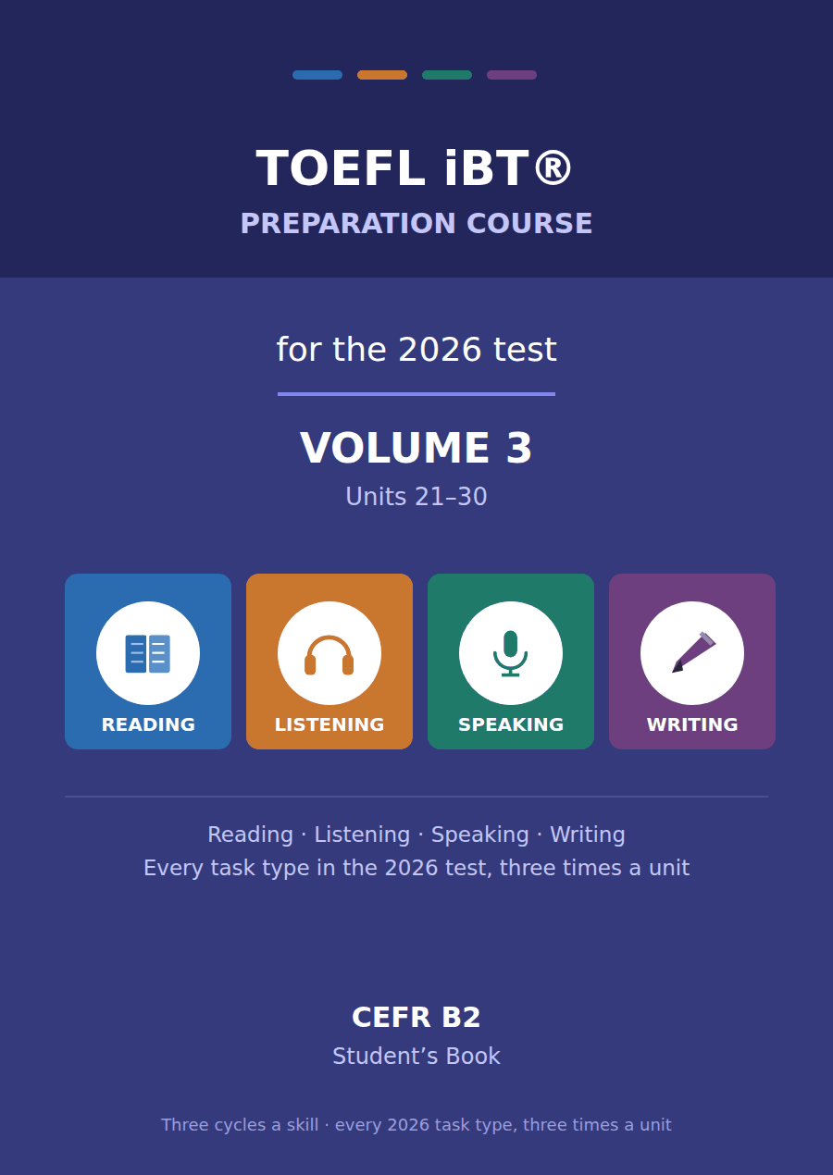

TOEFL iBT® Preparation Course 2026
Volume 3 · Units 21–30 · CEFR B2
Student’s Book with Practice Test 3

This course prepares B2 learners for the TOEFL iBT® test as it has been since 21 January 2026. Every task name, item count and timing in this book follows the official ETS practice test for that form.
Forty units across four volumes. Volumes 1 and 2 take a B1 learner through every task in the test; Volumes 3 and 4, of which this is one, take the same tasks to B2. The passages are not longer here. They are denser, which is what the real test does to you as your score rises.
One thing is assumed rather than taught. Volumes 1 and 2 carried a strand of campus and everyday vocabulary — enrolment, tutorial, reading week — because the Listening conversations turn on it. This volume spends those pages on collocation and stance instead. If you have come straight to Volume 3, read the Volumes 1–2 glossary once before you start.

Series TOEFL iBT® Preparation Course 2026
Level CEFR B2 (targeting a steady 4.5–5.5 band)
Components Student’s Book · Audio · Interview video
This volume Units 21–30, Practice Test 3, answer key, audio scripts, glossary

TOEFL and TOEFL iBT are registered trademarks of ETS. This publication is not endorsed by or affiliated with ETS. Format details are taken from ETS’s own published practice material for the January 2026 form.

Map of the book Volume 3
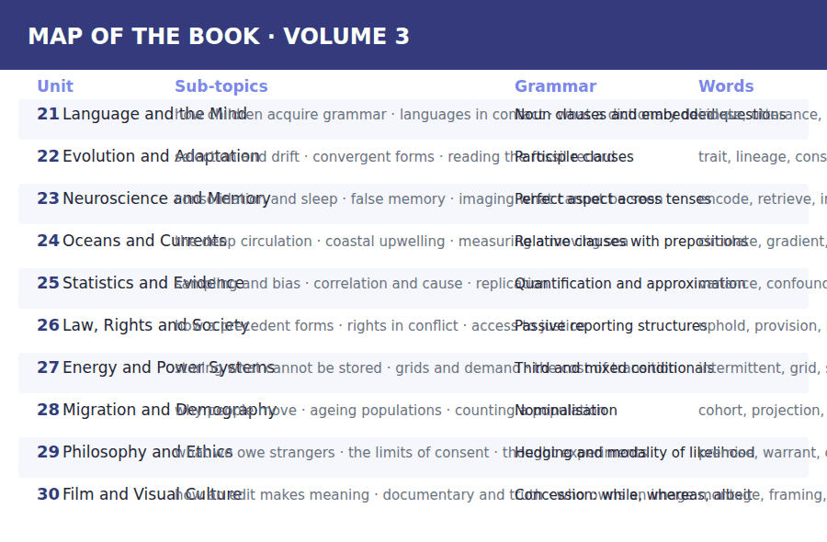

How to use this book Three cycles, four skills
Every unit is sixteen pages and every unit is built the same way, so once you have worked through Unit 21 you know where everything is.
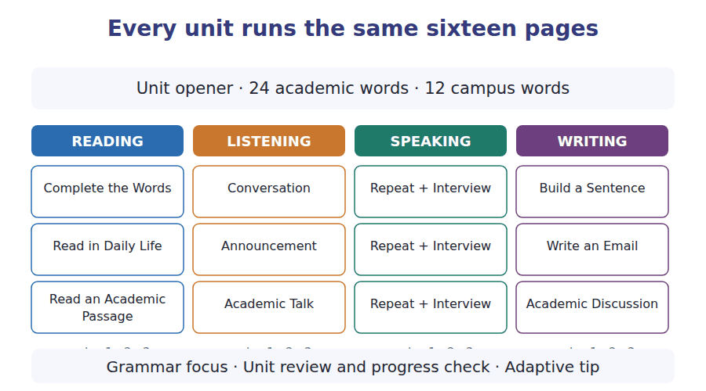
What a cycle is
A cycle is one sub-topic taken through one skill. Cycle 1 of Reading, Listening, Speaking and Writing all deal with sub-topic A; cycle 2 with sub-topic B; cycle 3 with sub-topic C. That is why the email you write in Writing cycle 2 answers the announcement you heard in Listening cycle 2.
Teach, guide, test
Inside every cycle the order is the same. A skill box tells you what to do. A guided exercise does it with help. An exam exercise does it the way the test will.

The 2026 test at a glance What you are preparing for
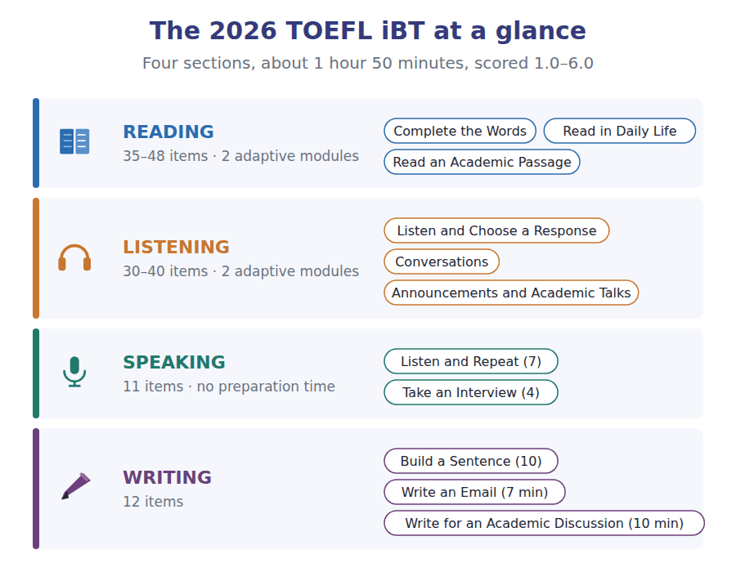
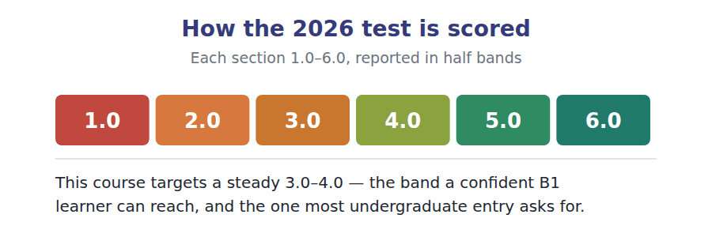

What an adaptive test does to you Modules, and why you cannot go back
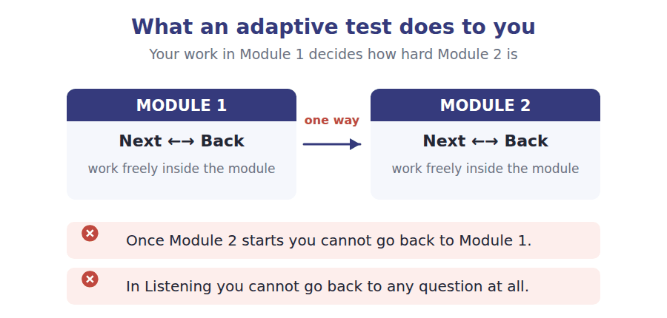
Reading and Listening are adaptive. Each is split into two modules, and how you do in Module 1 decides how hard Module 2 is. Two rules follow, and they are not the same rule.
- In Reading you can move Next and Back freely inside a module. Only the jump to Module 2 is one-way.
- In Listening you cannot go back to a previous question at all. The audio plays once.
- The early questions in a module carry the most weight, because they place you. Never rush them to buy time later.
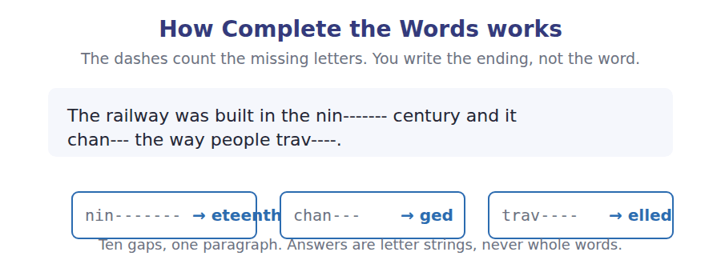

Study planner Twelve weeks, two units a week
When | What | Focus
Week 1 | Unit 21 · Language and the Mind | Vocabulary, Reading, Listening
Week 2 | Unit 22 · Evolution and Adaptation | Speaking, Writing, grammar, review
Week 3 | Unit 23 · Neuroscience and Memory | Vocabulary, Reading, Listening
Week 4 | Unit 24 · Oceans and Currents | Speaking, Writing, grammar, review
Week 5 | Unit 25 · Statistics and Evidence | Vocabulary, Reading, Listening
Week 6 | Unit 26 · Law, Rights and Society | Speaking, Writing, grammar, review
Week 7 | Unit 27 · Energy and Power Systems | Vocabulary, Reading, Listening
Week 8 | Unit 28 · Migration and Demography | Speaking, Writing, grammar, review
Week 9 | Unit 29 · Philosophy and Ethics | Vocabulary, Reading, Listening
Week 10 | Unit 30 · Film and Visual Culture | Speaking, Writing, grammar, review
Week 11 | Review units 21–30 | Glossary and grammar reference
Week 12 | Practice Test 3 | Sit it in one sitting, then mark it

Unit 21 · Language and the Mind
TOEFL iBT® Preparation Course 2026 · Volume 3
CEFR B2 · Grammar: Noun clauses and embedded questions · Word field: innate, utterance, convention
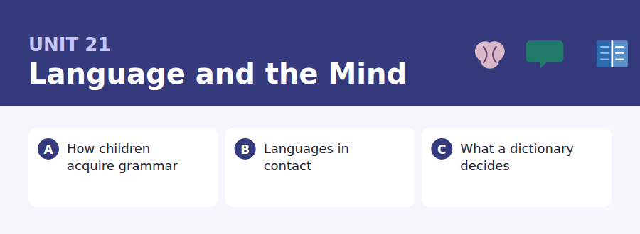
By the end of this unit I can…
- I can follow an academic argument that runs across several paragraphs.
- I can put a whole clause in the subject position without losing the sentence.
- I can form an embedded question with statement word order, every time.
- I can tell a describing claim from a prescribing one in a text.
- I can hedge a claim to the strength the evidence actually supports.
- I can concede a point in a discussion post and still make my own.

You already speak one language without being able to say how. This unit is about what that fact tells us, and about the structures English uses to package a whole idea inside a sentence — which is the single most useful thing a B2 writer can learn to do.

Vocabulary 1 · Academic word families 18 families, not 18 words
At B2 the word on its own is not enough. Each entry below is a family: learn the noun, the verb and the adjective together, because the test will use whichever one the sentence needs.
innate present from birth, not learned | intuition a judgement you can make but not explain
utterance anything a person actually says | competence what a speaker knows, as against what they say
arbitrary decided by agreement, not by reason | universal found in every language examined so far
convention what a community has agreed to do | systematic following a rule, even an unstated one
syntax the rules for putting words in order | plausible believable, though not yet proved
lexicon the whole stock of words a language has | spontaneous produced without planning or prompting
dialect a regional or social variety of a language | prescriptive saying what people ought to say
fluent speaking smoothly and without effort | descriptive recording what people actually say
bilingual using two languages well | threshold the point at which something starts to count

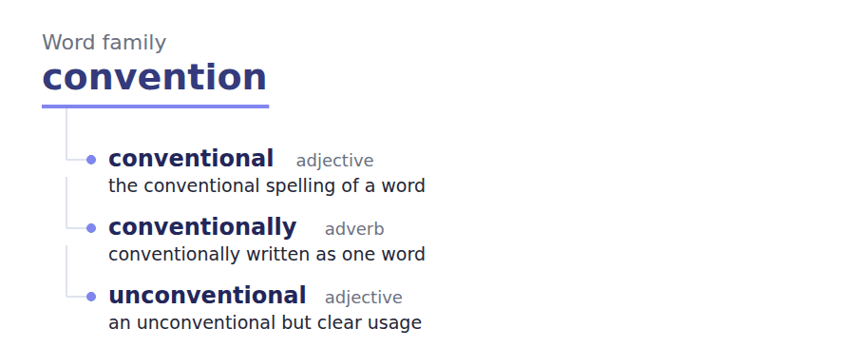
Exercise A Work in pairs. Ask and answer.
1. Which of your languages do you think in? Does it change with the topic?
2. Name one rule of your first language you follow but cannot state.
3. Is a dictionary an authority, or a record? Argue for one.
4. What would be lost if everyone spoke the same dialect?
Vocabulary 2 · Collocation 10 partnerships that actually occur
A word is known when you know what it goes with. These ten are the partners this unit’s texts use; the wrong partner is what marks an answer as translated.
acquire a language children do this without being taught | bear no relation to to have nothing to do with
draw a distinction to say that two things are different | in practice what actually happens, not what the rule says
a body of evidence all the evidence taken together | by and large mostly, with some exceptions
hold true to stay correct across many cases | a matter of convention agreed rather than necessary
a working definition one good enough to go on with | run counter to to go against

Vocabulary 3 · Stance and hedging How far the writer commits
Every one of these says the same thing at a different strength. Reading, you must notice which was chosen. Writing, you must choose.
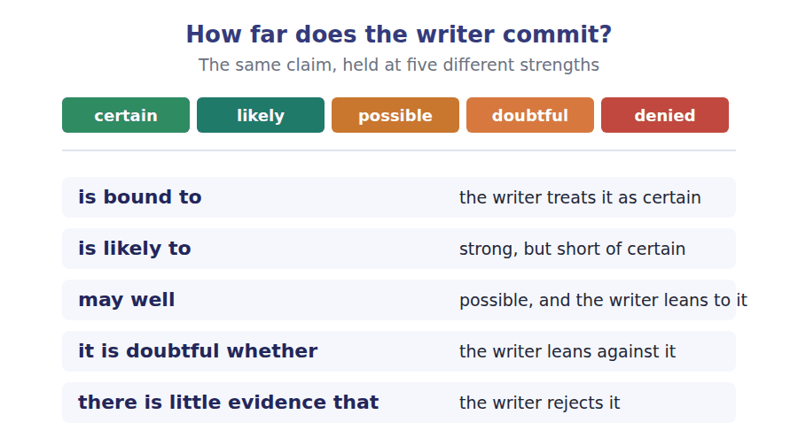
Two words that look alike
imply / infer a speaker implies; a listener infers
prescriptive / descriptive what should be said / what is said
fluent / accurate smooth / correct — not the same thing

Words you will meet again: poverty of the stimulus | word order | usage note | native speaker | language partner | corpus | register | coinage


SKILL · Complete the Words at B2
- The gap is no longer the end of an everyday word. It is usually a suffix that changes the part of speech: system + atic, compet + ence.
- Read the whole sentence first and decide what part of speech the gap needs. Then the letters follow.
- A gap near the end of a long abstract noun is almost always -ion, -ence, -ity or -ings.

Exercise A Guided practice. Five words are not complete. Write the missing letters.
No child is taught the rule for word order, and yet almost every child has it right by the age of four. What they hear is a stream of speech full of false starts and half sentences. What they produce, after a short period of error, is system----. The errors themselves are the clue: a child who says goed has never heard the form, so it cannot be copi--. It has been built from a rule the child extract-- without being told. Linguists call the knowledge that results compet----, and they separate it from what a speaker happens to say on any one occas---.

The first one is done for you: system---- is systematic — the output follows a rule, even when the rule produces a form no adult uses.
Exercise B Exam practice. One paragraph, ten gaps — the real task.
The argument from the poverty of the stimulus runs like this. The speech a child hears is finite, and much of it is ungrammat----. The sentences a child can later produce are infin---. Something must bridge the gap, and the proposal is that part of the structure is inn---, present before any English is heard. The claim is not that grammar is inherited the way eye colour is. It is that the mind arrives with a narrow set of opti---, and that exposure to one language selects among th--. Critics answer that the stimulus is richer than the argument allows, and that general learning can do the work without a dedicated facul--. The debate has run for sixty years because both sides point to real data. What has changed is the evidence: large record---- of what children actually hear, rather than what adults remember saying. On that evidence the input is less degraded than the early argument assum--, which weakens one premise without settling the quest---. Nobody now doubts that children bring something to the task. The argument is about how much of it is specific to langu---.

Check your answers in the key at the back of the book.


SKILL · Reading two documents that do not agree
- At B2 the two documents no longer simply add up. One of them qualifies, limits or contradicts the other.
- When a question could be answered from either document, check both — the later one usually wins.
- Watch for the word that limits a promise: normally, up to, subject to, where places remain.

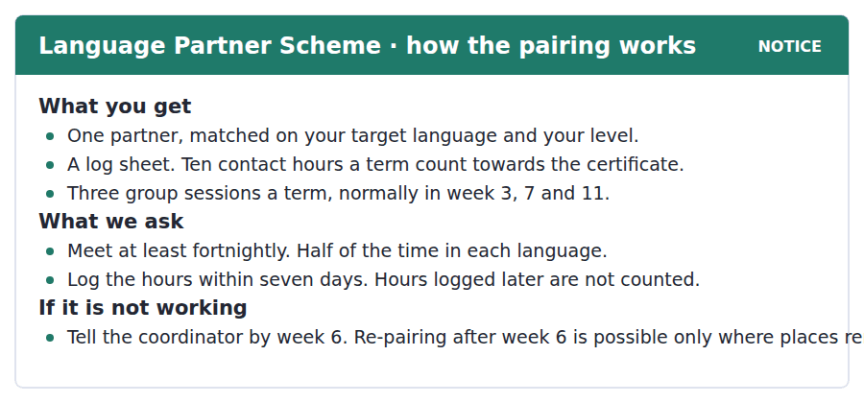
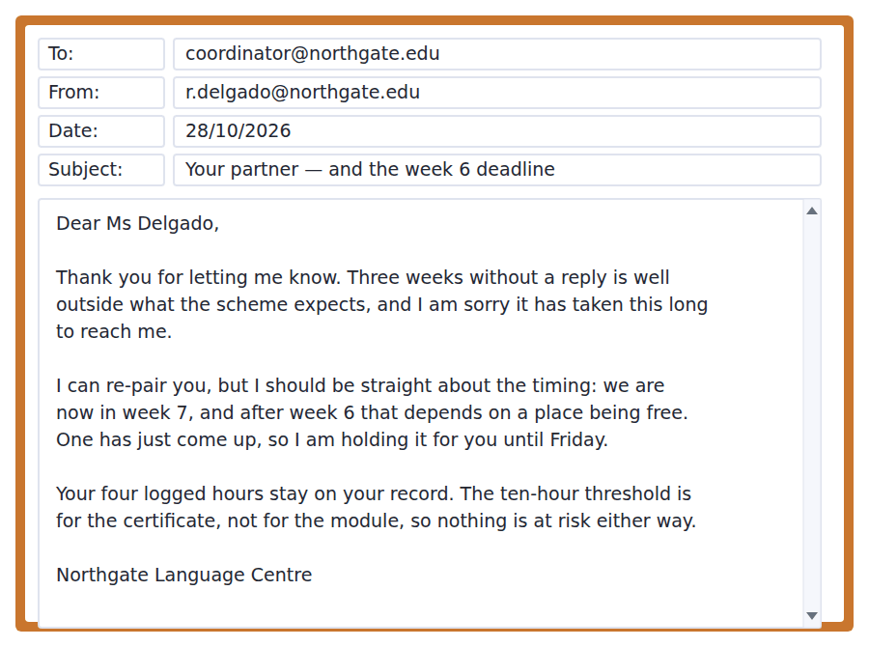
Exercise A Guided practice. The answer is on the page — find it.
1. How many contact hours a term count towards the certificate?
(A) Ten
(B) Four
(C) Seven
(D) Eleven
2. How often are partners asked to meet?
(A) Weekly
(B) Three times a term
(C) Once a month
(D) At least fortnightly
3. What happens to hours logged after seven days?
(A) They count at half
(B) They are not counted
(C) They count towards the module only
(D) They need the coordinator to approve them
4. Why does the coordinator mention week 6?
(A) The scheme closes then
(B) The log sheet is collected then
(C) Re-pairing after it depends on a free place
(D) Group sessions stop then
Exercise B Exam practice.
5. What is the main purpose of the coordinator’s email?
(A) To refuse a request
(B) To remind the student of the log deadline
(C) To explain a rule and offer a way round it
(D) To arrange a group session
6. What is the student at risk of losing?
(A) Her place on the module
(B) Nothing — only the certificate is affected
(C) Her four logged hours
(D) Her partner’s contact details
7. By when must the student reply?
(A) Week 6
(B) Within seven days
(C) The next group session
(D) Friday
8. What does the notice say about which language to use?
(A) Half the time in each
(B) The target language throughout
(C) Whichever the partner prefers
(D) It does not say
9. Which statement is supported by BOTH documents?
(A) Re-pairing is automatic
(B) Group sessions are compulsory
(C) Partners are matched by subject
(D) Ten hours is a threshold for the certificate
10. What does "where places remain" limit?
(A) The number of group sessions
(B) Re-pairing after week 6
(C) The hours that can be logged
(D) Who may join the scheme
11. What can be inferred about the coordinator’s view of the partner?
(A) That the partner has left the university
(B) That the student contacted her too late
(C) That three weeks of silence is not acceptable
(D) That the partner was wrongly matched


SKILL · Reading an argument that concedes
- A B2 passage rarely argues one side. It makes a claim, grants what the other side has right, and then says why the claim survives anyway.
- The concession is usually marked: no dictionary is purely one or the other, but the direction of travel is clear.
- At least one question will ask what the author concedes. Find the but, and the concession is the clause before it.

Who Decides What a Word Means
A dictionary looks like an authority, and most readers treat it as one. Lexicographers describe their work differently. They do not decide that a word means something; they record that a community of speakers uses it that way, and they record it only once the usage is established enough to be worth recording. The authority is borrowed from the speakers, and it is returned to them whenever they change their minds.
The distinction is prescriptive against descriptive, and it is older than any modern dictionary. A prescriptive editor asks what a careful writer should do. A descriptive editor asks what careful writers in practice do, and reports it. No dictionary is purely one or the other: a usage note calling something disputed is doing prescriptive work inside a descriptive frame. But the direction of travel is clear. Entries that once carried a warning now carry a date, and the warning is likely to have been dropped rather than softened.
What makes the question sharp is timing. A new sense may well be current among a million speakers and still be absent from every dictionary, because the editors are waiting to see whether it survives. There is little evidence that early recording changes how a word spreads, but editors are cautious anyway, and the lag can run to a decade. The cost of waiting is that the dictionary describes a slightly older language than the one being spoken. The cost of not waiting is a book full of words nobody kept. Neither cost can be avoided, which is why where the line falls is a matter of convention rather than of principle.
[271 words]

Exercise A Guided practice.
1. What is the passage mainly about?
(A) Whether a dictionary records usage or rules on it
(B) How new words are invented
(C) Why dictionaries take so long to publish
(D) The history of English lexicography
2. According to the passage, where does a dictionary’s authority come from?
(A) Its editors
(B) Its age
(C) The publisher
(D) The speakers whose usage it records
3. What does the author concede about dictionaries?
(A) That none is purely descriptive
(B) That they are often inaccurate
(C) That they are no longer read
(D) That editors disagree with each other
4. The word "lag" in the last paragraph is closest in meaning to
(A) mistake
(B) delay
(C) increase
(D) warning
Exercise B Exam practice.
5. Why does the author mention usage notes?
(A) To explain how entries are ordered
(B) To criticise prescriptive editors
(C) To show that no dictionary is purely descriptive
(D) To date the earliest dictionaries
6. What does the change from a warning to a date suggest?
(A) That practice has moved towards describing rather than ruling
(B) That editors have become stricter
(C) That dictionaries are now shorter
(D) That dates are easier to verify
7. Why do editors wait before recording a new sense?
(A) To avoid legal difficulty
(B) To allow the publisher to approve it
(C) Because speakers object to early recording
(D) To see whether the sense survives
8. What is the author’s view of early recording?
(A) It makes a word spread faster
(B) It should be avoided entirely
(C) It has little demonstrated effect on spread
(D) It is now standard practice
9. All of the following are stated about the lag EXCEPT:
(A) It can run to a decade
(B) It is shrinking as corpora grow
(C) It makes the dictionary slightly out of date
(D) It is caused by editorial caution
10. What does the author mean by "neither cost can be avoided"?
(A) Both waiting and not waiting have a price
(B) Dictionaries are too expensive to produce
(C) Editors are not paid enough
(D) The two costs cancel each other out
11. A "matter of convention" in the last line means that the choice is
(A) determined by evidence
(B) made by the publisher alone
(C) agreed rather than forced by the facts
(D) different in every language
12. Which best describes the structure of the passage?
(A) A problem followed by a solution
(B) Two opposed views left unresolved
(C) A history followed by a prediction
(D) A claim, a concession, and the reason the claim survives
13. What would most weaken the author’s position?
(A) Evidence that dictionaries sell fewer copies than before
(B) Evidence that recording a new sense measurably speeds its spread
(C) Evidence that editors disagree about usage notes
(D) Evidence that the lag varies between languages


Exercise A Listen and choose a response. You hear one line. Choose the best reply.
1. Woman: Did you follow the part about the poverty of the stimulus?
(A) Up to a point — I lost it at the counter-argument.
(B) I sat near the front.
(C) The lecture was at four.
(D) Yes, it was poor.
2. Man: So you think the whole argument falls apart?
(A) Yes, I attended.
(B) No — I think one premise does.
(C) It was about two hours.
(D) The argument is on page four.
3. Woman: Have you ever heard a child say "goed"?
(A) It is not a real word.
(B) Children learn quickly.
(C) No, I have not read it.
(D) My niece said it for about a year.
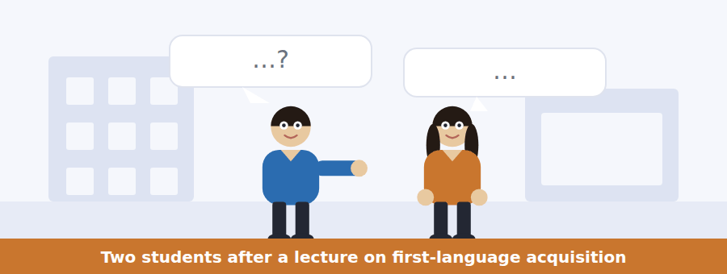
SKILL · Hearing the speaker who is not convinced
- At B2 one speaker usually holds back. Listen for the hedge: I suppose, up to a point, that is one reading.
- The disagreement is rarely stated. It arrives as a question that reframes what the other person just said.
- An item asking what one speaker implies is asking you to hear the hedge, not the words.

Exercise B Listen and answer. The audio plays once.
4. What does the man say he could not get past?
(A) The lecturer’s delivery
(B) The length of the lecture
(C) The evidence for degraded input
(D) The reading list
5. What does the woman imply when she says the lecturer mentioned corpus work?
(A) That the man was not listening
(B) That the point was already addressed
(C) That the corpus work is unreliable
(D) That she disagrees with the lecturer
6. Why does the man mention a footnote?
(A) To cite a source
(B) To recommend further reading
(C) To criticise the slides
(D) To say the problem is too important to pass over quickly
7. What is the man’s actual position?
(A) One premise fails and the rest survives
(B) The whole argument fails
(C) The argument is proved
(D) The question cannot be settled
8. Why do both speakers mention "goed"?
(A) It is on the reading list
(B) It is the lecturer’s example
(C) It is a form no adult supplies
(D) It shows children copy adults
9. What does the man want to know?
(A) When the essay is due
(B) Which corpus to use
(C) Whether the essay should argue or summarise
(D) Whether the woman attended
10. What is the relationship between the two speakers?
(A) Tutor and student
(B) Students on the same course
(C) Researcher and interviewer
(D) Strangers at a public lecture
Audio script: see the back of the book. Do not read it before you listen.


Exercise A Listen and choose a response. You hear one line. Choose the best reply.
1. Man: Is the group session still in the usual room?
(A) It moved to 2.14 this week.
(B) Yes, it was useful.
(C) About fifteen people.
(D) I have not logged my hours.
2. Woman: I have not logged last week’s hours yet.
(A) The room has moved.
(B) There were four of us.
(C) Yes, I enjoyed it.
(D) You have until Tuesday, then they stop counting.
3. Man: Does re-pairing still close on Friday?
(A) Yes, unless the coordinator has already held a place for you.
(B) The scheme started in week 1.
(C) No, I am not re-paired.
(D) It is a good scheme.
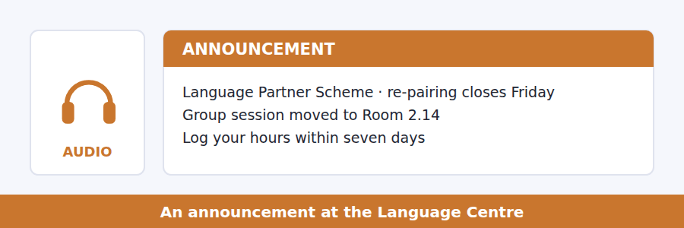
SKILL · Hearing a condition inside an announcement
- A B2 announcement rarely says only what is happening. It attaches a condition: provided that, as long as, unless you have already.
- The condition is the part that gets tested, because it is the part that decides whether the news applies to you.
- Listen for the turn: that said, however, one exception.

Exercise B Listen and answer. The audio plays once.
4. What is the main purpose of the announcement?
(A) To advertise the partner scheme
(B) To report on attendance
(C) To introduce a new coordinator
(D) To give a deadline and the exception to it
5. What has changed about the group session?
(A) Its time
(B) Its room, for one week only
(C) Its room, permanently
(D) It has been cancelled
6. Who is not bound by the Friday deadline?
(A) Anyone who has logged ten hours
(B) Anyone the coordinator has already written to holding a place
(C) Anyone whose partner has left
(D) First-year students
7. What happens to hours from early October?
(A) They count at half
(B) They need the coordinator’s approval
(C) They count towards next term
(D) They cannot be counted
8. Why does the speaker say "the seven days is not a guideline"?
(A) To soften the refusal
(B) To correct an earlier announcement
(C) To make clear the rule will not be bent
(D) To explain how to log hours
9. What must someone holding a place do?
(A) Confirm it by Friday
(B) Take it up within two weeks
(C) Log ten hours first
(D) Attend the group session
Audio script: see the back of the book. Do not read it before you listen.


Exercise A Listen and choose a response. You hear one line. Choose the best reply.
1. Woman: How long does a word wait before it goes in?
(A) Typically five to ten years.
(B) About thirty entries a year.
(C) Yes, quite a long time.
(D) In the online edition.
2. Man: So the editors decide what counts as a word?
(A) No — the evidence does, and they read it.
(B) Yes, there are about twenty.
(C) The dictionary is updated quarterly.
(D) I have a copy at home.
3. Woman: What happens to a word that stops being used?
(A) It was coined in 1critical.
(B) About four a year.
(C) Yes, that happens.
(D) It is marked, not deleted.
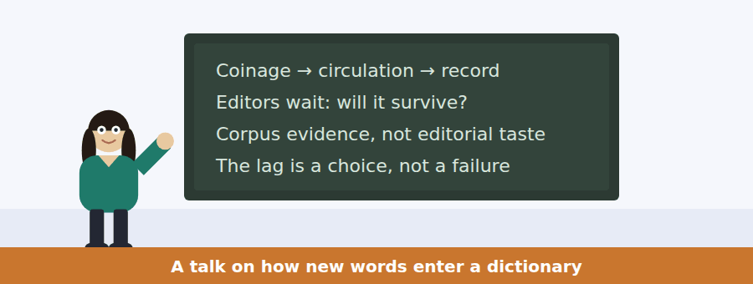
SKILL · Following a talk that answers its own objection
- A B2 academic talk usually raises the obvious objection itself, then answers it. Both halves get tested.
- The signal is a rhetorical question: so why not simply record everything?
- The answer that follows is the speaker’s real position, not the question.

Exercise B Listen and answer. The audio plays once.
4. What is the main point of the talk?
(A) Dictionaries are too slow
(B) Corpora have replaced editors
(C) The waiting period is what makes an entry informative
(D) New words are invented faster than before
5. What objection does the speaker raise?
(A) That corpora are unreliable
(B) That everything could simply be recorded and marked
(C) That editors are too few
(D) That readers do not use dictionaries
6. Why does the speaker say an entry would carry no information?
(A) Because nobody reads usage notes
(B) Because corpora are too large
(C) Because recording everything removes the threshold that made it meaningful
(D) Because rare words change meaning
7. What does the speaker say has changed?
(A) The threshold
(B) The number of editors
(C) The definition of a word
(D) The evidence base, not the threshold
8. What were reading programmes?
(A) Staff and volunteers sending in slips
(B) Courses for lexicographers
(C) Published lists of new words
(D) Automatic corpus searches
9. What does the speaker mean by "the lag is not a failure of the method — it is the method"?
(A) The delay should be made longer
(B) The delay is what the method consists of
(C) The method has failed
(D) The delay is caused by staffing
10. What does the speaker predict about editors who ignore corpus evidence?
(A) They will be more accurate
(B) They will work more slowly
(C) They will be overtaken
(D) They will record fewer words
Audio script: see the back of the book. Do not read it before you listen.


Part 1 · Listen and Repeat
You hear a sentence and repeat it once. There is no preparation time, and the sentences get longer. Focus: keeping a long noun clause intact to the end of the sentence
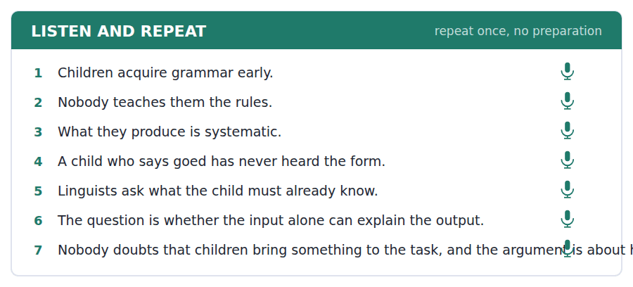
SKILL · Listen and Repeat with an embedded clause
- The sentences now carry a clause inside a clause. If you drop the first half, the second half makes no sense.
- Breathe before the clause, not inside it.
- Keep statement word order after where, what and whether — this is the single most common slip at B2.

Part 2 · Take an Interview
An interviewer asks you four questions on one theme: learning a language as a child and as an adult. Answer each one fully. There is no preparation time.
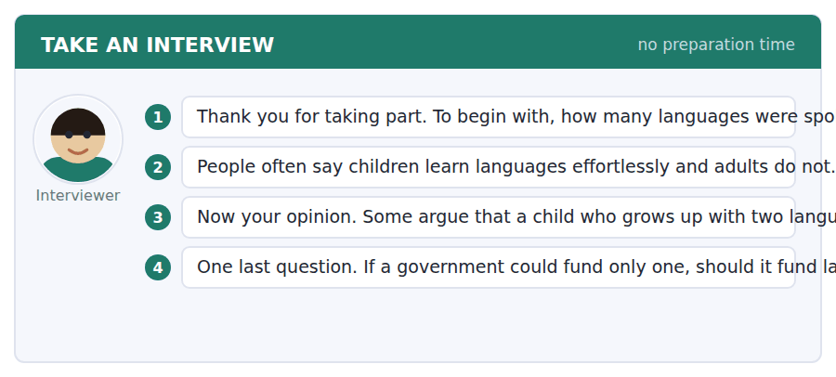
A good answer sounds like this
Question 2 — Up to a point. Children do pick up the sound system in a way adults rarely manage. But adults learn the grammar faster, because they can use a rule once they are told it, and a child cannot.
Question 3 — I do not agree, although I understand where it comes from. The evidence I have seen suggests the vocabulary is split across two languages early on and then catches up. What looks like a deficit at five is usually gone by ten.
I can… | Not yet | Yes
I kept statement word order inside what, where and whether. | □ | □
I conceded a point before disagreeing. | □ | □
I finished the long sentence without restarting it. | □ | □


Part 1 · Listen and Repeat
You hear a sentence and repeat it once. There is no preparation time, and the sentences get longer. Focus: linking across a clause boundary without pausing
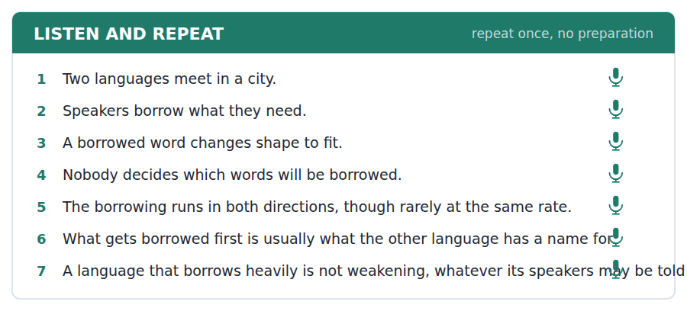
SKILL · Taking an Interview on an unfamiliar angle
- At B2 one of the four questions will be about something you have no experience of. You are not being tested on experience.
- Say so, then reason: I have not come across that myself, but I would expect that…
- An honest hypothesis in good English scores far above a confident invention.

Part 2 · Take an Interview
An interviewer asks you four questions on one theme: living between two languages. Answer each one fully. There is no preparation time.
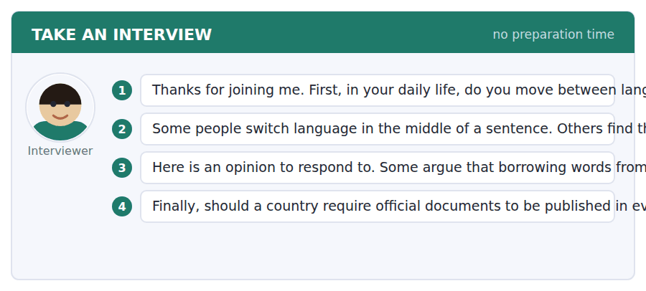
A good answer sounds like this
Question 2 — It does not bother me at all, probably because I grew up hearing it. When people switch, they usually switch for a reason — a word that is sharper in the other language, or a person joining the group.
Question 4 — I would support it up to a threshold — say, any language spoken by more than a small percentage. Below that the cost per reader becomes very hard to defend against, say, interpreting services.
I can… | Not yet | Yes
I answered the question I was asked, not the one I expected. | □ | □
I gave a reason, not only a position. | □ | □
I used at least one hedge where I was not certain. | □ | □


Part 1 · Listen and Repeat
You hear a sentence and repeat it once. There is no preparation time, and the sentences get longer. Focus: stress on the word that carries the contrast
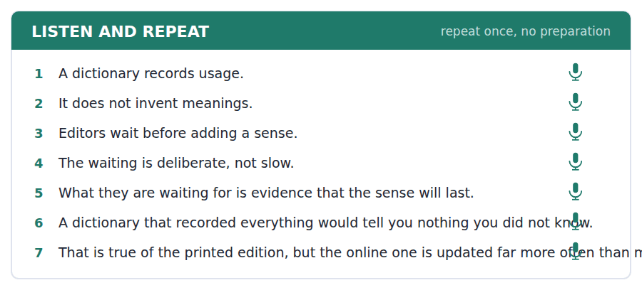
SKILL · Making a concession out loud
- The highest-scoring move in the interview is to grant the other side something real and then say why you still disagree.
- It needs two stresses: that is TRUE of formal writing, but MOST writing is not formal.
- Without the stress the concession sounds like agreement and the examiner hears no argument.

Part 2 · Take an Interview
An interviewer asks you four questions on one theme: authority, correctness and who owns a language. Answer each one fully. There is no preparation time.
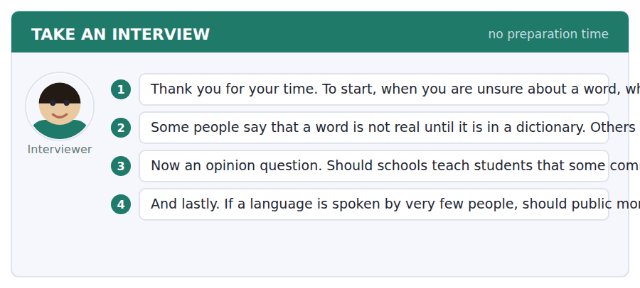
A good answer sounds like this
Question 2 — The second, clearly. A word is real the moment people use it and are understood. The dictionary is useful precisely because it comes afterwards, not because it grants permission.
Question 3 — I would teach the difference rather than the verdict. Students need to know which forms are expected in an examination, and that is not the same as saying the other form is wrong.
I can… | Not yet | Yes
I stressed the contrasting word, not the whole clause. | □ | □
I granted something before disagreeing. | □ | □
I kept going for the full answer without a long pause. | □ | □


You see a sentence, then a set of words in boxes. Put the words in order to make one grammatical sentence. Almost every item in the real test makes a question or a question inside another sentence.
SKILL · Build a Sentence at B2
- The tiles are longer now, and more of them carry a whole phrase rather than one word.
- Almost every item still builds a question or a question inside another sentence. Find the question word first and decide whether it starts the sentence or sits inside it.
- Inside another clause, the word order is a statement: I do not know where it is, never where is it.

Exercise A Guided practice. The first three are worked through.
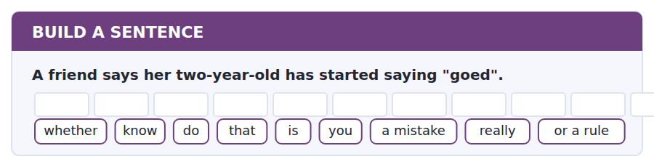
1. Do you know whether that is really a mistake or a rule?
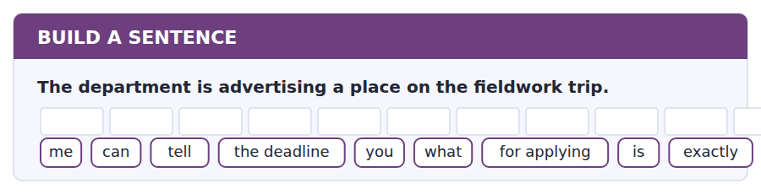
2. Can you tell me exactly what the deadline for applying is?
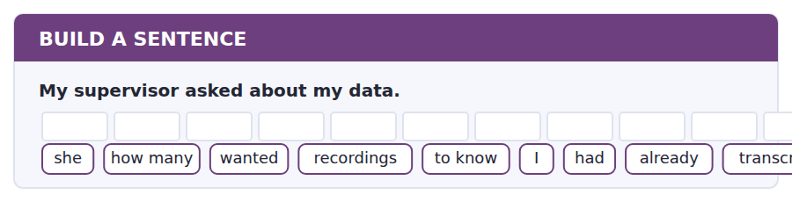
3. She wanted to know how many recordings I had already transcribed.
Exercise B Exam practice. Write the sentence.
4. The lecture on bilingualism is on Thursday.
is / what / the talk / exactly / about / do / you / happen to / know
__________________________________________________________
5. Two of the recordings are missing from the archive.
to know / nobody / where / seems / they / have / gone / in the end / actually
__________________________________________________________
6. The dictionary added forty new senses this year.
decides / what / which / I wonder / ones / go in / and / which / do not
__________________________________________________________
7. I have to choose a dissertation topic by Friday.
whether / know / I / do not / my topic / is / narrow enough / really / yet
__________________________________________________________
8. A speaker from Lagos and a speaker from Leeds understand each other.
exactly / can / anybody / how / explain / that / works / it / at all
__________________________________________________________
9. The seminar room has been changed again.
told / nobody / us / which / we / room / are / in / now
__________________________________________________________
10. I read that no language has more than about fifty sounds.
true / do / whether / know / you / that / is / actually / of every language
__________________________________________________________


You read a short situation and write an email. You have 7 minutes. The three bullet points are the mark scheme: answer all three.
You joined the Language Partner Scheme and were paired in week 2. Your partner replied twice and has not answered since 6 October, three weeks ago. You have four hours logged out of the ten the certificate needs, and the notice says re-pairing after week 6 depends on a free place. It is now week 7.
Write an email to the scheme coordinator.
- Explain what has happened and when the contact stopped.
- Say what you have already tried.
- Ask what can be done about the hours and about a new partner.
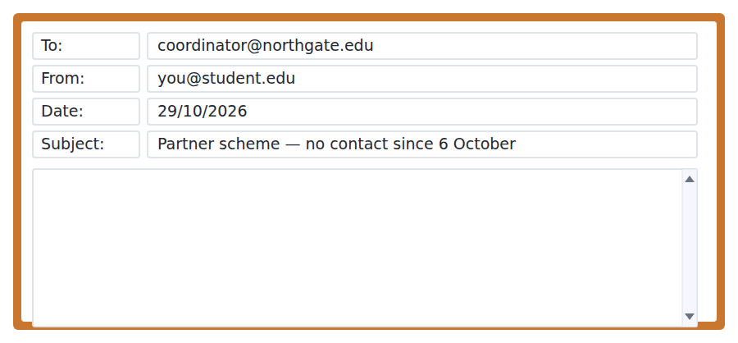
SKILL · Writing a complaint that is easy to say yes to
- A B2 email about a problem does three things a B1 email does not: it dates the facts, it shows what you already tried, and it names the outcome you want.
- Hedge the blame, not the facts. Something may have come up at her end is generous; I have had no reply since 6 October is not negotiable.
- Ask one clear question. A coordinator who can answer in one line usually answers the same day.

Model email
Dear Coordinator,

I am writing about my language partner pairing, which I think may have stalled.

We were paired in week 2 and met twice, on 22 and 29 September. Since my message of 6 October I have had no reply, although I have written twice more, on 13 and 21 October, and left a note at the Centre desk last week. Something may well have come up at her end, and I would not want to assume otherwise.

Two things follow from it, and I would be grateful for a line on each. First, I have four hours logged of the ten the certificate needs, and I am not sure whether those hours stand if the pairing ends. Second, I know re-pairing after week 6 depends on a free place, and we are now in week 7 — is there anything still available?

I am free to meet any afternoon this week if that is easier than writing.

With thanks,
Rafael Delgado
Why it works
- Every fact carries a date, so the coordinator can check it without asking.
- Three attempts are listed before any request is made.
- The blame is hedged — may well have come up — while the facts are not.
- Two numbered questions, each answerable in one line.
Two answers, one band apart
Both answer the three bullet points. One would score in the middle band and one near the top. Read them side by side before you write your own.
A middle-band answer | A top-band answer
Dear Coordinator,  I am writing because my language partner is not replying to me. We were paired at the start of term and met a couple of times, but since the beginning of October I have not heard anything from her at all.  I have sent her several messages and she has not answered any of them. I do not know what has happened. This is a problem because I need ten hours for the certificate and I only have four.  Could you please tell me what I should do? I would like a new partner if that is possible. Thank you for your help with this matter.  Best regards, Rafael Delgado | Dear Coordinator,  I am writing about my language partner pairing, which I think may have stalled. We were paired in week 2 and met twice, on 22 and 29 September. Since my message of 6 October I have had no reply, although I have written twice more and left a note at the Centre desk.  Something may well have come up at her end, and I would not want to assume otherwise. Two things follow, and I would be grateful for a line on each.  First, I have four of the ten hours the certificate needs, and I am not sure whether those stand if the pairing ends. Second, re-pairing after week 6 depends on a free place — is there anything still available?  I am free any afternoon this week. With thanks, Rafael Delgado

What the top answer does that the other does not
- It dates every fact. "Since my message of 6 October" can be checked; "since the beginning of October" cannot.
- It separates the two requests and numbers them, so each can be answered in one line rather than in a paragraph.
- It hedges the blame and not the facts: "may well have come up at her end" beside "I have had no reply".
- It shows the rule has been read — re-pairing after week 6 — which turns a complaint into a question the coordinator can simply answer.
- It offers something: an afternoon this week, rather than only asking.
Now write your own. 7 minutes.
__________________________________________________________
__________________________________________________________
__________________________________________________________
__________________________________________________________
__________________________________________________________
__________________________________________________________
__________________________________________________________
__________________________________________________________


A professor asks a question and two students answer. You add your own post. You have 10 minutes and an effective answer is at least 100 words.
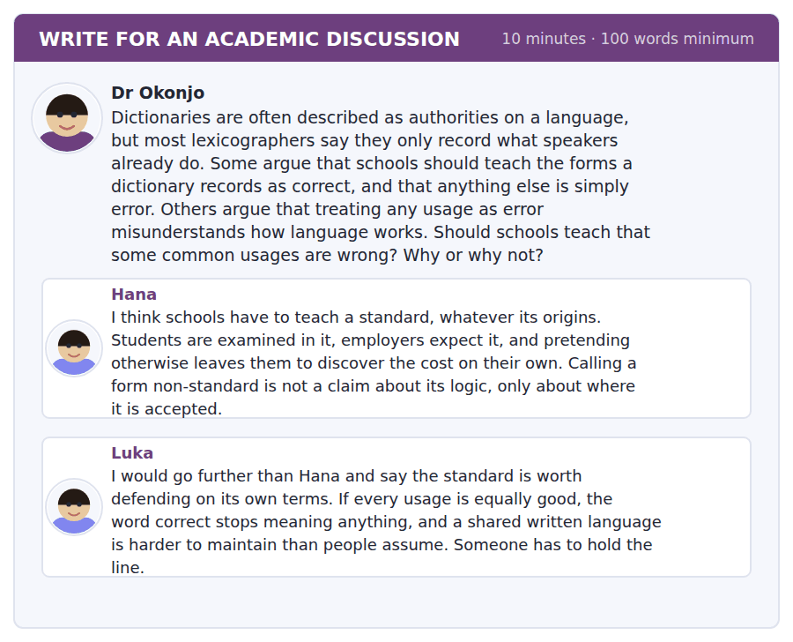
SKILL · Engaging with the other posts, not writing past them
- At B2 a top answer names one of the posts and does something to it: extends it, limits it, or turns it round.
- The move that scores is agree-with-reservation. Hana is right that X, but that argument supports Y rather than Z.
- Do not agree with both posts. If they disagree with each other, agreeing with both means you have not read them.

Sentence starters
- Hana is right that…, although that argument supports… rather than…
- Luka assumes that…, and it is doubtful whether that holds.
- The distinction I would draw is between… and…
- What follows from this is not… but…
Model post
Hana is right that students are examined in a standard and pay a price for not having it. But that argument supports teaching where a form is accepted, not teaching that it is wrong, and the two are easy to confuse in a classroom.
Luka goes further and says the standard is worth defending on its own terms. It is doubtful whether that holds. The forms we now call correct were, by and large, somebody else’s error two hundred years ago, and the ones that survived did so because enough people used them, not because they were better built. A rule that has that history cannot easily be defended as logic.
The distinction I would draw is between accuracy and acceptability. A student who writes a non-standard form has not failed to think; they have used a form that the examiner will not accept. Telling them that plainly is more useful than telling them it is wrong, because it tells them what to do about it.
So I would teach the standard hard, and teach it as a convention. That is not a weaker position than Luka’s. It is the same lesson with an honest reason behind it, and students can tell the difference.
[204 words]
Now write your own. 10 minutes, at least 100 words.
__________________________________________________________
__________________________________________________________
__________________________________________________________
__________________________________________________________
__________________________________________________________
__________________________________________________________
__________________________________________________________
__________________________________________________________
__________________________________________________________
__________________________________________________________

Grammar focus Noun clauses and embedded questions
Structure | Example
that-clause as object | Researchers argue that the input is richer than was assumed.
that-clause as subject | That children invent rules is not in dispute.
the fact that | The fact that she says goed shows she has built a rule.
wh- clause as object | Nobody knows exactly what decides the order.
whether / if clause | Editors are waiting to see whether the sense survives.
embedded question, statement order | Do you know where the recordings are? NOT where are the recordings
a question as the subject | How much of it is innate is still argued over.

A noun clause does the job of a noun. If you can replace the whole clause with the word "something", it is a noun clause.
That can be left out after common verbs (I think he knows) but not when the clause is the subject (That he knows is obvious).
Whether and if are interchangeable after most verbs, but only whether can come before an infinitive or after a preposition: the question of whether, not the question of if.
Watch out! The commonest B2 error in the whole course: keeping question word order inside another clause. "I do not know where is it" is wrong in every register. Once the question is embedded, it is a statement.
Exercise 1 Rewrite as an embedded question beginning with the words given.
1. Where are the recordings kept? → Do you know ______
2. What does the editor decide? → Nobody is sure ______
3. Has the sense survived? → The editors are waiting to see ______
4. How much is innate? → ______ is still argued over.
5. Why did she say goed? → Can you explain ______
6. When will the entry appear? → I have no idea ______
Exercise 2 Join the two sentences using "the fact that".
1. She says goed. This shows she has a rule.
2. The input is rich. This weakens the argument.
3. No adult supplies the form. This is the key point.
4. The lag runs to a decade. Editors accept this.
Exercise 3 Choose that, whether or what.
1. Nobody doubts ______ children bring something to the task.
2. The question is ______ the input alone can explain the output.
3. ______ the child produces is systematic.
4. Editors must decide ______ a sense will last.
5. It is clear ______ the threshold has not moved.
How this is tested in Build a Sentence
Almost every Build a Sentence item in the real test is one of these structures. Eight of the ten in the official paper build a direct or an embedded question; the other two build a relative clause. If you can produce the seven rows above without thinking, you can produce the whole task.
Find the fault 5 errors, drawn from this unit and the two before
Every error below is one a B2 writer makes after learning the rule. Mark what is wrong, then check. Knowing the rule and noticing the breach are two different skills, and only the second one is tested.
In this essay I will discuss that how children learn grammar. The researchers asked that whether the input was rich enough for the task. Many linguists believes that the stimulus is poorer than it looks. The fact of that a child says goed is strong evidence for a rule. Nobody knows exactly where does the boundary lie.
# | As written | As it should be | Why
1 | discuss that how | discuss how | A wh- clause needs no that in front of it; one of the two has to go.
2 | asked that whether | asked whether | Whether already introduces the clause, so that is not added as well.
3 | linguists believes | linguists believe | The subject is plural, so the verb takes no s. Long subjects hide this.
4 | The fact of that | The fact that | The fixed phrase is the fact that; there is no of in it.
5 | where does the boundary lie | where the boundary lies | An embedded question keeps statement word order: no does, and the verb agrees.

Unit review and progress check Unit 21
Exercise A Vocabulary. Write the word.
1. present from birth, not learned
2. anything a person actually says
3. decided by agreement, not by reason
4. the rules for putting words in order
5. the whole stock of words a language has
6. a judgement you can make but not explain
7. what a speaker knows, as against what they say
8. found in every language examined so far
9. believable, though not yet proved
10. produced without planning
11. recording what people actually say
12. the point at which something starts to count
Exercise B Grammar. Complete the sentence.
1. Do you know ______ the recordings are kept?
2. ______ children invent rules is not in dispute.
3. The editors are waiting to see ______ the sense survives.
4. The fact ______ she says goed shows she has a rule.
5. Nobody is sure ______ the editor decides.
6. I have no idea ______ the entry will appear.
7. It is doubtful ______ that argument holds.
8. ______ much of it is innate is still argued over.
Exercise C One timed mini-section. 6 minutes.
1. A dictionary entry is added once a sense has
(A) cleared a threshold of evidence
(B) been approved by an editor
(C) appeared in print
(D) been used by a famous writer
2. "Goed" is evidence of a rule because
(A) children hear it from adults
(B) it appears in dictionaries
(C) it is grammatically correct
(D) no adult supplies the form
3. A prescriptive editor asks
(A) what careful writers do
(B) what a careful writer should do
(C) how often a word appears
(D) when a word was coined
4. Which sentence is correct?
(A) I do not know where the room is.
(B) I do not know where is the room.
(C) I do not know where does the room be.
(D) I do not know where is it the room.
5. "It is doubtful whether that holds" means the writer
(A) is certain it holds
(B) has no view
(C) is certain it does not hold
(D) leans against it holding
6. The lag between coinage and entry exists because
(A) editors work slowly
(B) printing takes time
(C) editors wait to see whether a sense survives
(D) speakers object to new entries
Can you do these now?
I can… | Not yet | Yes
I can follow an academic argument that runs across several paragraphs. | □ | □
I can put a whole clause in the subject position without losing the sentence. | □ | □
I can form an embedded question with statement word order, every time. | □ | □
I can tell a describing claim from a prescribing one in a text. | □ | □
I can hedge a claim to the strength the evidence actually supports. | □ | □
I can concede a point in a discussion post and still make my own. | □ | □

ADAPTIVE TIP The embedded question is the single highest-value structure in this volume. It appears in Build a Sentence, in almost every email you will write, and in the interview whenever you say you are not sure of something. Get the word order automatic now and you stop losing marks for it in three skills at once.

Unit 22 · Evolution and Adaptation
TOEFL iBT® Preparation Course 2026 · Volume 3
CEFR B2 · Grammar: Participle clauses · Word field: trait, lineage, constraint
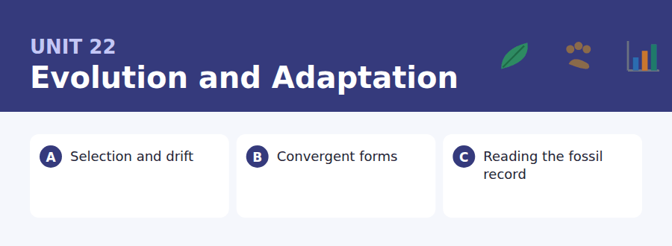
By the end of this unit I can…
- I can follow a text that distinguishes two mechanisms carefully.
- I can compress two clauses into one with a participle.
- I can spot a dangling participle in my own writing.
- I can describe a process without implying that it has a purpose.
- I can read a figure caption and tell what it does not show.
- I can qualify a generalisation instead of abandoning it.

Evolution is the subject most often explained badly, because the everyday words for it — stronger, better, designed — all point the wrong way. This unit gives you the vocabulary that points the right way, and the structure English uses to compress two clauses into one.

Vocabulary 1 · Academic word families 18 families, not 18 words
At B2 the word on its own is not enough. Each entry below is a family: learn the noun, the verb and the adjective together, because the test will use whichever one the sentence needs.
trait one feature of an organism that can be measured | ancestral belonging to the form something descended from
lineage a line of descent from an ancestor | morphology the shape and structure of an organism
constraint something that limits what is possible | fitness how many surviving offspring a form leaves
mutation a change in the genetic material | drift change by chance rather than by advantage
heritable able to be passed to offspring | extinction the permanent loss of a lineage
cumulative building up step by step over time | speciation the splitting of one population into two species
radiation the spread of one lineage into many forms | phenotype what an organism actually looks like and does
convergent arriving at the same form from different starts | gradual happening in small steps, not at once
niche the way of life a species makes a living by | dispersal the movement of a population into new ground

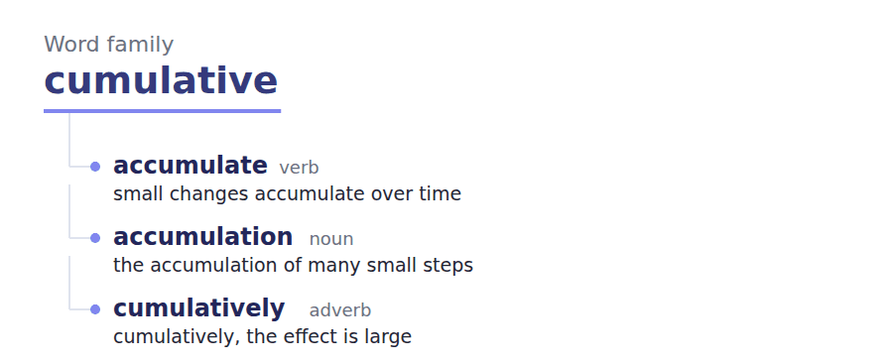
Exercise A Work in pairs. Ask and answer.
1. Name one feature of an animal that looks designed. What is it for?
2. Why does "survival of the fittest" mislead people?
3. Can a species evolve to be worse at something? Give an example.
4. What could a fossil never tell you about a living animal?
Vocabulary 2 · Collocation 10 partnerships that actually occur
A word is known when you know what it goes with. These ten are the partners this unit’s texts use; the wrong partner is what marks an answer as translated.
give rise to to produce or lead to | in the absence of when there is none of
under selection being acted on by selection | subject to affected by, and limited by
at random with no pattern and no direction | a trade-off between a gain in one thing paid for in another
over successive generations across one generation after another | all else being equal if nothing else changes
bear a resemblance to to look like | account for to explain

Vocabulary 3 · Stance and hedging How far the writer commits
Every one of these says the same thing at a different strength. Reading, you must notice which was chosen. Writing, you must choose.
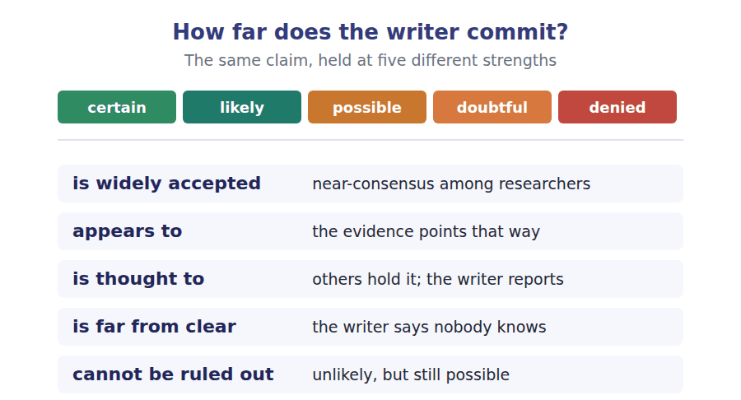
Two words that look alike
adapt / adopt to fit a new condition / to take up
evolve / develop a population evolves; an individual develops
random / arbitrary without pattern / decided by agreement

Words you will meet again: natural selection | common ancestor | bottleneck | founder effect | homology | analogy | strata | transitional form


SKILL · Suffixes that change the part of speech
- Most B2 gaps are a suffix. Decide what the slot needs — noun, adjective, adverb — before you look at the letters.
- A noun after the is almost never a bare verb: select becomes selection.
- If the gap follows a determiner and precedes of, it is a noun.

Exercise A Guided practice. Five words are not complete. Write the missing letters.
Two processes change a population, and only one of them has anything to do with advantage. Selection keeps the variants that leave more offspring. Drift keeps whichever variants happen to be carried forward, and it is strong--- in small populations, where chance has more room. A biologist asked to explain a difference between two island forms will therefore not assume adapt-----. The difference may be the signature of a founder event, in which a handful of individuals carried an unrepresent----- sample of the variation with them. Distinguishing the two matters, because only one of them predicts that the trait is function-- at all. The other predicts noth---.

The first one is done for you: strong--- is strongest — the slot follows is and compares drift across population sizes.
Exercise B Exam practice. One paragraph, ten gaps — the real task.
Convergence is the fact that unrelated lineages, facing the same problem, often arrive at the same sol-----. The eye has evolved independ----- dozens of times. Wings have evolved in insects, in birds, in bats and in one extinct group of rept----. The usual explanation is that physics leaves few options: if an animal is to fly, the available design space is narr--. This is sometimes read as evidence that evolution is predict----, and sometimes as evidence of the opposite, that the same outcome can be reached by many different genetic ro----. Both readings use the same data. The disagreement is about what counts as the same outcome. A bat wing and a bird wing are similar in funct--- and quite different in structure: the bones are the same bones, inherited from a shared ancest--, but they are rearranged in ways that would be hard to predict from the problem alone. Convergence, in other words, is real but partial, and the part that is not convergent carries most of the historical informat---. A palaeontolog--- reading a limb is reading both at once.

Check your answers in the key at the back of the book.


SKILL · Reading a caption against its figure
- A caption says what a figure shows. The question often turns on what it does not show.
- Note every hedge in a caption: approximate, not to scale, redrawn after.
- A redrawn figure is somebody’s interpretation, and the caption usually admits it.

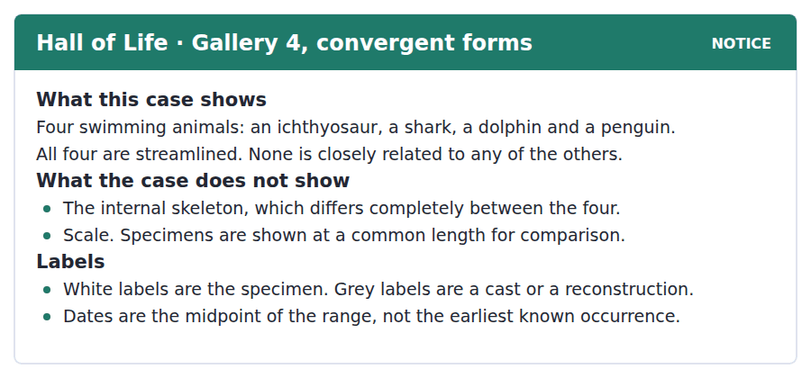
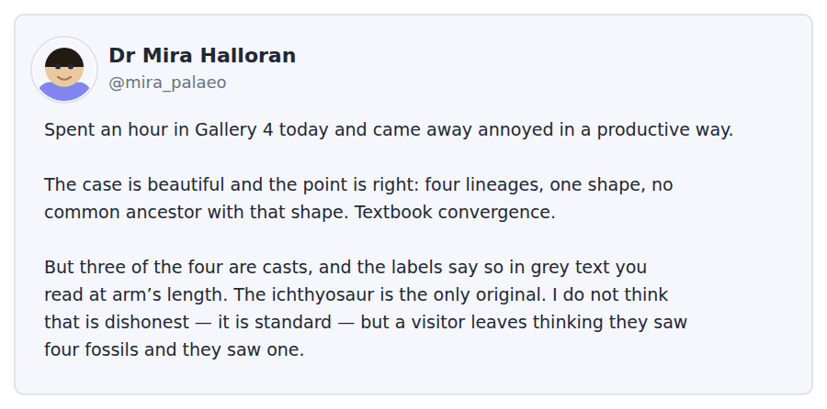
Exercise A Guided practice. The answer is on the page — find it.
1. What do the four animals in the case have in common?
(A) A common ancestor
(B) The same internal skeleton
(C) The same date
(D) A streamlined body
2. What does the case deliberately not show?
(A) The animals’ colour
(B) Their relative size
(C) Where each was found
(D) What each ate
3. What does a grey label mean?
(A) The specimen is a cast or reconstruction
(B) The specimen is on loan
(C) The date is uncertain
(D) The animal is extinct
4. What are the dates on the labels?
(A) The earliest known occurrence
(B) The date of discovery
(C) The midpoint of the range
(D) The date of the cast
Exercise B Exam practice.
5. What is the main point of Dr Halloran’s post?
(A) The science in the case is wrong
(B) Casts should never be exhibited
(C) The gallery should be relabelled in white
(D) The display is honest but easy to misread
6. How many of the four specimens are original?
(A) Two
(B) Three
(C) One
(D) All four
7. What does Dr Halloran say about the grey labels?
(A) They are inaccurate
(B) They are hard to read at a distance
(C) They are in the wrong place
(D) They should be removed
8. What does the notice say about the internal skeleton?
(A) It differs completely between them
(B) It is identical in all four
(C) It is not preserved
(D) It is shown in a separate case
9. Why does the difference in skeletons matter to the case’s argument?
(A) It proves the four are related
(B) It shows the shared shape was arrived at separately
(C) It explains why three are casts
(D) It dates the specimens
10. What is Dr Halloran’s tone?
(A) Dismissive
(B) Enthusiastic
(C) Indifferent
(D) Critical but fair
11. What can be inferred about museum practice from the post?
(A) Displaying casts is normal
(B) Casts are rarely used
(C) Labels are usually white
(D) Reconstructions are forbidden


SKILL · Reading a text that corrects a common framing
- A B2 passage often opens by rejecting the usual way of putting something: is often described as, is commonly thought to be.
- What follows the rejection is the author’s own framing, and the whole passage then works inside it.
- The first question is usually about that move, not about the content.

What the Gaps in the Record Mean
The fossil record is often described as incomplete, as though completeness were the standard it fails to meet. A more useful description is that it is biased in ways that can be listed. Hard parts survive and soft parts do not. Animals that died in water are preserved far more often than animals that died on a hillside. Species that were abundant and widespread leave more fossils than species that were rare, and abundance is thought to explain more of the record than any other single factor.
Once the biases are listed, a gap stops being an absence of information. A lineage that disappears from the record and reappears ten million years later has not necessarily been absent. It may well have been living somewhere that does not preserve, or living at a population size too small to be sampled. This is widely accepted, and it is why palaeontologists distinguish between the last appearance of a fossil and the extinction of a lineage. The two can be separated by a long interval, and the interval is itself evidence of something.
The harder problem is the opposite one. A sudden appearance of many forms in a short stretch of rock appears to show rapid diversification, and sometimes it does. But it can equally reflect a change in the rock: a shift to conditions that preserve well, after a long stretch that preserved almost nothing. Distinguishing a real radiation from a preservation artefact is far from clear in most cases, and the honest answer is often that both contributed. What cannot be ruled out, in a record built from what happened to survive, is that the pattern is partly a pattern in the surviving.
[282 words]

Exercise A Guided practice.
1. What is the author’s main point about the fossil record?
(A) It is too incomplete to use
(B) It is complete for marine animals
(C) Its biases can be listed and worked with
(D) It should be described statistically
2. Why are abundant species better represented?
(A) They were more important
(B) There were simply more of them to fossilise
(C) They lived in water
(D) They had harder parts
3. What is the difference between a last appearance and an extinction?
(A) There is none
(B) Extinction is always earlier
(C) The last fossil may predate the real end of the lineage
(D) Only one can be dated
4. The word "sampled" in the second paragraph is closest in meaning to
(A) captured in the record
(B) counted
(C) measured precisely
(D) identified
Exercise B Exam practice.
5. Why does the author call "incomplete" an unhelpful description?
(A) The record is in fact complete
(B) It is a recent term
(C) It applies only to marine fossils
(D) It implies a standard the record was never going to meet
6. What does the author say a long gap can be evidence of?
(A) Nothing at all
(B) An error in dating
(C) Something — the interval itself carries information
(D) A mass extinction
7. What is "the harder problem"?
(A) Telling a real radiation from a preservation artefact
(B) Dating rocks accurately
(C) Finding soft-bodied fossils
(D) Distinguishing species from varieties
8. How confident is the author that radiations can be told from artefacts?
(A) Very confident
(B) Confident for marine rocks only
(C) It is impossible in principle
(D) It is far from clear in most cases
9. What does "a pattern in the surviving" mean?
(A) A pattern in which animals survived extinction
(B) A pattern in which fossils happened to be preserved
(C) A pattern in modern populations
(D) A pattern in how rocks are dated
10. Which best states the author’s attitude to the record?
(A) Sceptical that it can be used at all
(B) Certain that it is misleading
(C) Confident, provided its biases are stated
(D) Indifferent to the question
11. All of the following are given as biases EXCEPT:
(A) Large species preserve better
(B) Hard parts preserve better
(C) Water burials preserve better
(D) Abundant species preserve better
12. What does "cannot be ruled out" signal about the final claim?
(A) The author is certain of it
(B) The author thinks it unlikely but possible
(C) The author rejects it
(D) The author has no view
13. What would most strengthen the author’s argument?
(A) A new fossil site of exceptional quality
(B) A more precise dating method
(C) More fossils of soft-bodied animals
(D) Evidence that diversification spikes line up with changes in rock type


Exercise A Listen and choose a response. You hear one line. Choose the best reply.
1. Man: So the small beak is an adaptation to the dry years?
(A) Well, that is one reading of it.
(B) Yes, the island is dry.
(C) About four millimetres.
(D) No, it is a large beak.
2. Woman: How many birds were in the founding population?
(A) They arrived by storm.
(B) Yes, quite a few.
(C) In about 1977.
(D) Fewer than twenty, which is the whole point.
3. Man: Have you found the original paper yet?
(A) I think it is a good paper.
(B) About thirty pages.
(C) It is behind a paywall, annoyingly.
(D) Yes, I have read it.
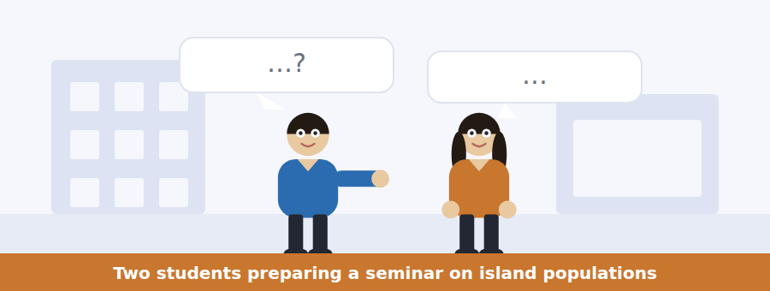
SKILL · Hearing a correction that is not announced
- At B2 a speaker often corrects the other without saying so: Well, that is the selection story.
- The correction is in the hedge and the stress, not in the word no.
- If a speaker restates the other’s point in slightly different words, they are usually about to disagree with it.

Exercise B Listen and answer. The audio plays once.
4. What does the woman mean by "that is one reading of it"?
(A) She agrees completely
(B) She is signalling that she does not fully accept it
(C) She has not read the chapter
(D) She thinks the textbook is wrong about beaks
5. Where does the woman accept the selection explanation?
(A) On their own island
(B) On Daphne Major, where selection was measured
(C) Nowhere
(D) In the textbook only
6. Why does the founding population size matter?
(A) Small populations select faster
(B) Large populations are harder to count
(C) Small populations drift more
(D) It determines the seed supply
7. What test does the woman propose?
(A) Looking at several traits at once
(B) Measuring more birds
(C) Finding the original paper
(D) Comparing two islands
8. What would a shift in many traits at once indicate?
(A) Strong selection
(B) A measurement error
(C) A change in seed hardness
(D) A founder effect
9. What is stopping them reading the original study?
(A) It is not published yet
(B) It is behind a paywall
(C) It is in another language
(D) The library has lost it
10. What is the woman’s overall position?
(A) The textbook explanation does not transfer to their case
(B) The textbook is wrong
(C) Drift explains everything
(D) Selection cannot be measured
Audio script: see the back of the book. Do not read it before you listen.


Exercise A Listen and choose a response. You hear one line. Choose the best reply.
1. Woman: Can we take photographs in the gallery?
(A) The gallery is on the fourth floor.
(B) It opens at ten.
(C) Yes, but without flash.
(D) No, I did not take any.
2. Man: Why a pencil rather than a pen?
(A) They are in the shop.
(B) Yes, bring a pencil.
(C) About two pounds.
(D) Because ink cannot be removed from a specimen case.
3. Woman: Is the worksheet online?
(A) It has eight questions.
(B) It went up last night.
(C) Yes, it is a worksheet.
(D) In Gallery 4.

SKILL · Hearing the reason behind a rule
- A B2 announcement usually gives a reason, and the reason is what gets tested rather than the rule.
- Listen for because, which is why, the reason being.
- A rule with a reason attached is easier to remember and harder to misreport.

Exercise B Listen and answer. The audio plays once.
4. Why does the group meet at the entrance?
(A) The gallery opens late
(B) The worksheet is handed out there
(C) The group ticket is collected as one group
(D) The lift is out of order
5. Why are pencils required?
(A) Pens are expensive
(B) Pencil is easier to erase
(C) The museum sells pencils
(D) Ink cannot be removed from a specimen case
6. Why is flash photography restricted?
(A) It fades the painted reconstructions
(B) It damages the fossils
(C) It disturbs other visitors
(D) It is a copyright issue
7. How are casts distinguished from specimens?
(A) By the wording of the label
(B) By their position in the case
(C) They are not distinguished
(D) By the colour of the label
8. What does the speaker suggest about the assignment?
(A) It is about convergent evolution
(B) It must be handed in on Thursday
(C) It is really testing whether students read the labels
(D) It can be done without visiting
9. What is the speaker’s tone when discussing the pencil rule?
(A) Apologetic
(B) Explanatory rather than apologetic
(C) Impatient
(D) Uncertain
Audio script: see the back of the book. Do not read it before you listen.


Exercise A Listen and choose a response. You hear one line. Choose the best reply.
1. Woman: Does a gap in the record mean the animal was absent?
(A) Not necessarily — it may simply not have preserved.
(B) About ten million years.
(C) Yes, that is what a gap means.
(D) In the Jurassic.
2. Man: What preserves best?
(A) Since the nineteenth century.
(B) Yes, bones do.
(C) In museums.
(D) Hard parts, in water.
3. Woman: So a burst of new forms is always a real radiation?
(A) Yes, usually in the Cambrian.
(B) No — it can be a change in the rock.
(C) About forty species.
(D) It is a good question.
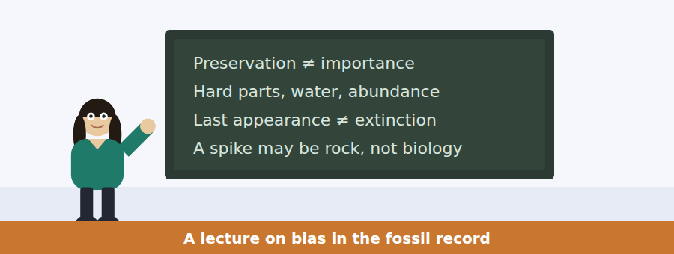
SKILL · Following a talk built on one repeated move
- Some B2 talks make the same move three times with different material. Identify the move and the rest becomes predictable.
- Here the move is: here is a pattern, here is the boring explanation, here is how we tell them apart.
- The test items usually ask for the third part, which is the only one that is the speaker’s own.

Exercise B Listen and answer. The audio plays once.
4. What is the "habit of mind" the speaker recommends?
(A) Always trust the record
(B) Date every specimen twice
(C) Ask first what preservation alone would produce
(D) Prefer marine fossils
5. Why does the record favour marine animals?
(A) Water buries and hillsides do not
(B) More marine species existed
(C) Marine fossils are easier to find
(D) Marine rocks are better dated
6. What is a Lazarus taxon?
(A) A newly discovered species
(B) A fossil found out of place
(C) A lineage with no descendants
(D) A lineage that vanishes and reappears
7. Why is the Lazarus name "a joke at our own expense"?
(A) The animals were never really gone, only unobserved
(B) The term is religious
(C) The fossils were misidentified
(D) The gap was a dating error
8. What does the gap between last appearance and extinction provide?
(A) A dating error
(B) A measurement
(C) A reason to discard the fossil
(D) Evidence of a mass extinction
9. What does a burst of new forms require before it can be called a radiation?
(A) A larger sample
(B) Confirmation from living species
(C) Independent evidence about the rock
(D) A second locality
10. What does the speaker predict about a report without that evidence?
(A) It will be rejected outright
(B) It will take longer to publish
(C) It is bound to be challenged
(D) It will be hard to date
Audio script: see the back of the book. Do not read it before you listen.


Part 1 · Listen and Repeat
You hear a sentence and repeat it once. There is no preparation time, and the sentences get longer. Focus: keeping a participle clause attached to the right subject
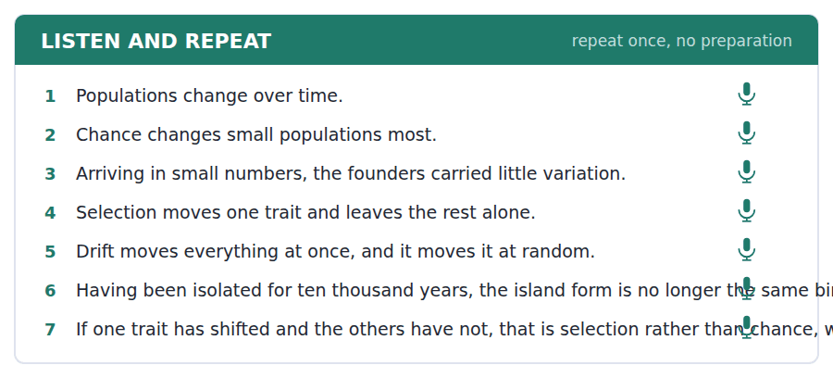
SKILL · Repeating a sentence that front-loads a clause
- A participle clause at the front puts the main subject late. If you lose it, the sentence collapses.
- Hold the opening clause and the subject together in one breath.
- Having arrived in small numbers, THE BIRDS — the stress falls on the subject, not the participle.

Part 2 · Take an Interview
An interviewer asks you four questions on one theme: chance and design in the natural world. Answer each one fully. There is no preparation time.
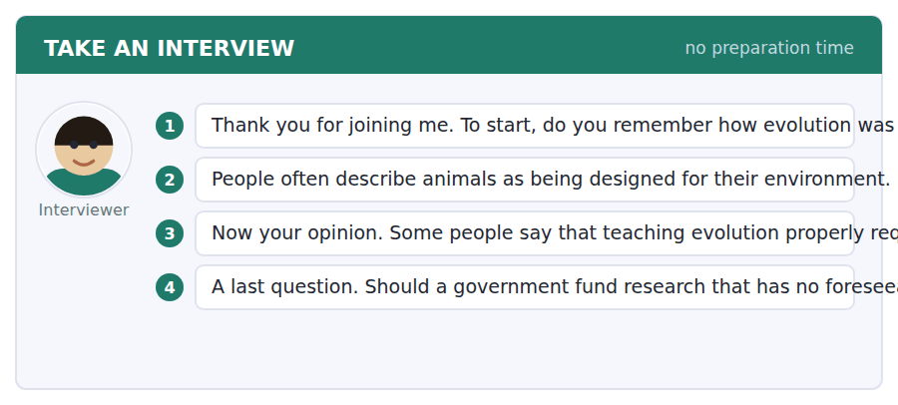
A good answer sounds like this
Question 2 — It is useful as shorthand and misleading if you stop there. Designed implies a designer and a plan, and what actually happened is that the variants that left more offspring became common.
Question 3 — Up to a point. Students do need the idea that something can be common without being better. But I would teach that through examples rather than through probability as a subject.
I can… | Not yet | Yes
I kept the front clause and its subject together. | □ | □
I avoided saying an animal wanted or tried to adapt. | □ | □
I gave one concrete example. | □ | □


Part 1 · Listen and Repeat
You hear a sentence and repeat it once. There is no preparation time, and the sentences get longer. Focus: contrastive stress on the word that carries the difference
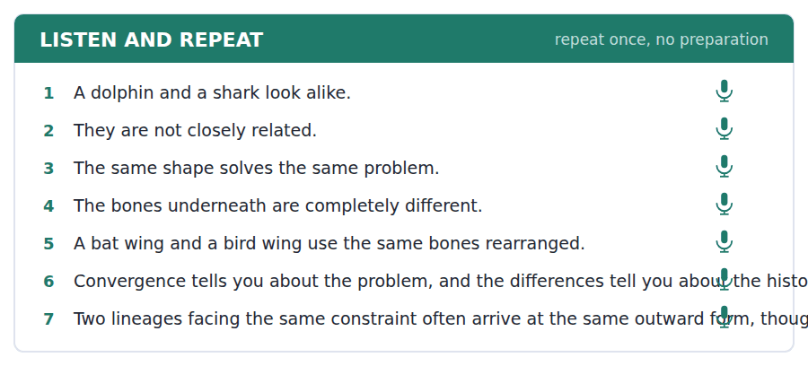
SKILL · Describing a similarity and a difference in one answer
- Comparison questions at B2 want both halves. A list of similarities is half an answer.
- Mark the turn out loud: they look the same from outside; inside they are not.
- Stress the contrasting word, not the whole clause.

Part 2 · Take an Interview
An interviewer asks you four questions on one theme: similarity, difference and what museums choose to show. Answer each one fully. There is no preparation time.
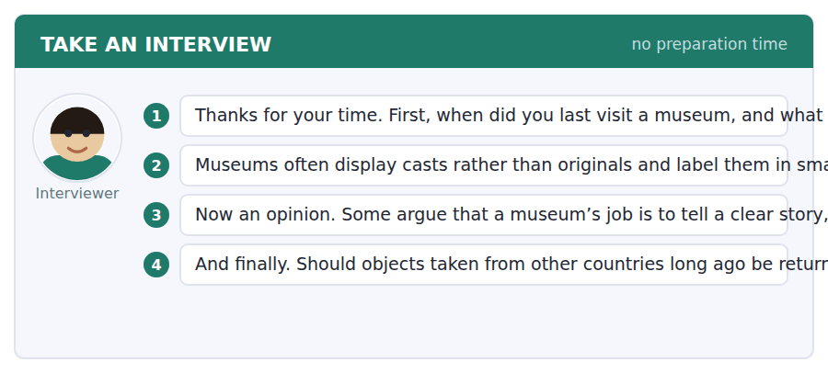
A good answer sounds like this
Question 2 — It matters more than I used to think. I am happy to look at a cast — the shape is the information. But if I leave believing I saw four fossils and I saw one, the label has not done its job.
Question 3 — I lean towards the complications, although I accept that is easy to say as somebody who already wants to be there. A clear story that leaves people curious is better than a complete one that loses them.
I can… | Not yet | Yes
I gave both the similarity and the difference. | □ | □
I stressed the contrasting word. | □ | □
I answered the question asked, not a related one. | □ | □


Part 1 · Listen and Repeat
You hear a sentence and repeat it once. There is no preparation time, and the sentences get longer. Focus: pausing before a qualifying clause instead of inside it
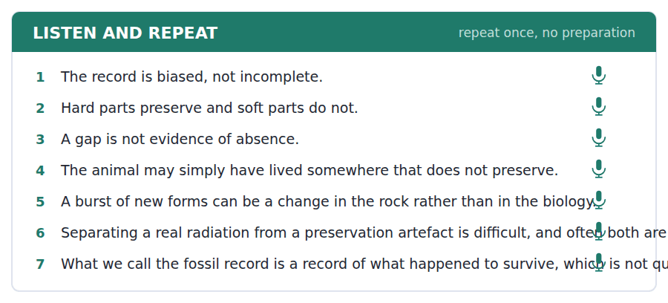
SKILL · Hedging out loud without sounding unsure
- A hedge is a precision instrument, not a retreat. Said firmly, it raises your score; mumbled, it sounds like doubt.
- Say the hedge at normal speed and stress the claim after it: it is PROBABLY an artefact.
- Never stack hedges. Maybe possibly perhaps is one hedge too many three times over.

Part 2 · Take an Interview
An interviewer asks you four questions on one theme: evidence, absence and what we can claim to know. Answer each one fully. There is no preparation time.
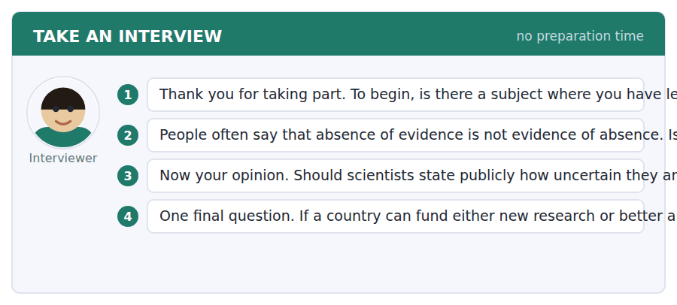
A good answer sounds like this
Question 2 — Not always. If you have looked hard in exactly the place the thing should be, and it is not there, the absence is informative. The slogan protects you from bad inference and can also stop good inference.
Question 3 — Yes, although I understand the fear. A field that hides its uncertainty is one bad result away from losing the public entirely, whereas one that states it can survive being wrong.
I can… | Not yet | Yes
I used one hedge, not three. | □ | □
I said the hedge firmly and stressed the claim. | □ | □
I gave a case where the general rule does not hold. | □ | □


You see a sentence, then a set of words in boxes. Put the words in order to make one grammatical sentence. Almost every item in the real test makes a question or a question inside another sentence.
SKILL · Build a Sentence with a longer embedded clause
- The embedded clause now has its own object and sometimes its own adverb. The word order inside it is still statement order.
- Find the main verb of the whole sentence first. Everything else hangs off it.
- A tile carrying a whole phrase goes in as a block — do not split it.

Exercise A Guided practice. The first three are worked through.
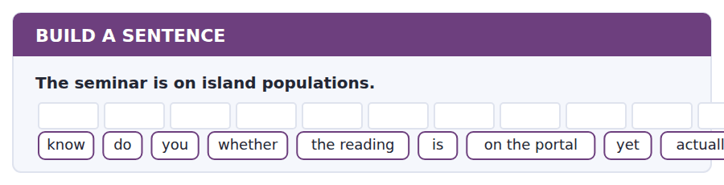
1. Do you know whether the reading is actually on the portal yet?
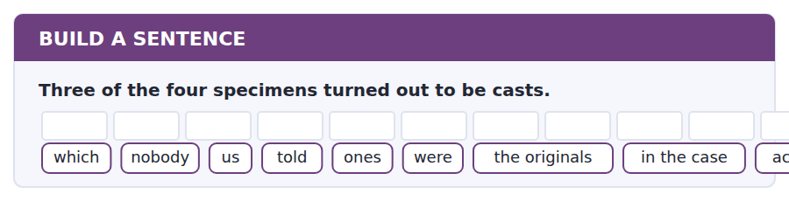
2. Nobody told us which ones in the case were actually the originals.
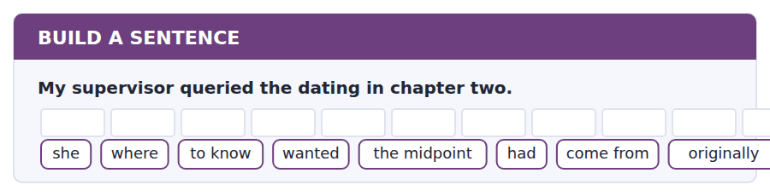
3. She wanted to know where the midpoint figure had originally come from.
Exercise B Exam practice. Write the sentence.
4. The gallery reopens after the refit.
is / what / exactly / in the new case / do / you / going / know / to be
__________________________________________________________
5. The paper is behind a paywall.
whether / has / the library / I wonder / access / to it / at all / actually / still
__________________________________________________________
6. Two lineages arrived at the same body shape.
how / explain / can / anybody / that / twice / happened / exactly / independently
__________________________________________________________
7. The gap in the record runs for ten million years.
know / nobody / seems / to / whether / the lineage / survived / through it / actually
__________________________________________________________
8. The worksheet asks about labels.
told / she / which / us / colour / a cast / meant / was / it
__________________________________________________________
9. The field visit is on Thursday morning.
me / can / remind / we / where / you / are / meeting / exactly
__________________________________________________________
10. The founding population was under twenty birds.
do / whether / you / know / that / is / enough / for drift / really
__________________________________________________________


You read a short situation and write an email. You have 7 minutes. The three bullet points are the mark scheme: answer all three.
You went to Gallery 4 with a university group. The case of four swimming animals is excellent, but three of the four are casts and the labels saying so are in grey print that is hard to read from behind the barrier. Two people in your group left believing they had seen four original fossils.
Write an email to the gallery.
- Say what you liked about the display.
- Explain the problem and give the evidence for it.
- Suggest one change and offer something in return.
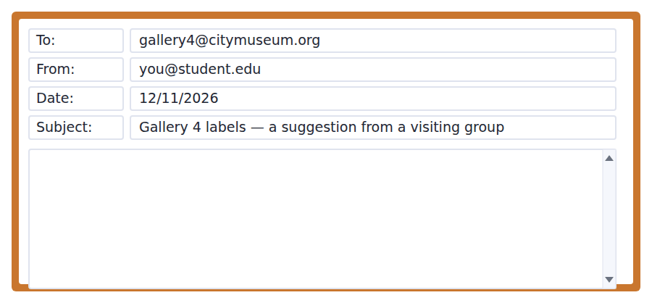
SKILL · Writing a suggestion rather than a complaint
- Open with what works. A reader who feels attacked stops reading before the suggestion.
- Give the evidence as a fact, not an accusation: two of our group left believing X, not your labels are misleading.
- Suggest one change. A list of five reads as a demand; one reads as help.

Model email
Dear Gallery 4 team,

I visited on 10 November with a group of fifteen undergraduates, and the case of four swimming animals did exactly what we needed it to do. Seeing the four shapes side by side made the point about convergence better than an hour of my talking would have.

One thing did not work as intended, and I mention it only because the case is otherwise so good. Three of the four specimens are casts, and the labels do say so, but in grey print read from behind the barrier. Two of our group wrote in their worksheets that they had examined four fossils. They had read the labels; they had simply not seen that part of them.

Would it be possible to move the word cast to the first line of the label, in the same size as the species name? It appears to be the smallest change that would fix it.

If it is useful, I am happy to send the fifteen worksheets so you can see how the current labels are being read. We are back in March and would be glad to test anything you try.

With thanks,
Dr Mira Halloran
Why it works
- It opens with what the display does well, and says why in one specific line.
- The problem is evidenced by what the group wrote, not asserted as a fault.
- One change is proposed, and it is the smallest one that would work.
- It offers the worksheets and a return visit — the reader gains something.
Two answers, one band apart
Both answer the three bullet points. One would score in the middle band and one near the top. Read them side by side before you write your own.
A middle-band answer | A top-band answer
Dear Gallery 4 team,  I came to your gallery last week with some students and I wanted to say that the case with the four swimming animals is very good. It explains convergent evolution much better than a lecture does.  However, I have to say that the labels are a problem. Three of the specimens are casts but you cannot really tell because the writing is grey and small. Some of my students did not realise and thought they were all real fossils, which is not very good.  Please could you make the labels clearer? It would be much better for visitors if people could see what is a cast and what is not. Thank you for reading my email and I hope you can do something about this.  Yours sincerely, Mira Halloran | Dear Gallery 4 team,  I visited on 10 November with fifteen undergraduates, and the case of four swimming animals did exactly what we needed it to do. Seeing the shapes side by side made the point better than an hour of my talking would have.  One thing did not work as intended, and I mention it only because the case is otherwise so good. Three of the four are casts, and the labels do say so, but in grey print read from behind the barrier. Two of our group wrote that they had examined four fossils. They had read the labels; they had not seen that part of them.  Would it be possible to move the word cast to the first line, in the same size as the species name? I am happy to send the worksheets so you can see how the labels are being read.  With thanks, Dr Mira Halloran

What the top answer does that the other does not
- It dates the visit and gives the group size, so the gallery can place the report instead of taking it on trust.
- The evidence is what two visitors wrote, not the writer’s opinion that the labels are unclear — a fact the gallery can check.
- "They had read the labels; they had not seen that part of them" removes blame from both sides and makes the fix obvious.
- It proposes one specific change rather than asking for things to be clearer, which nobody can act on.
- It offers the worksheets, so the email ends by giving the reader something rather than only asking.
Now write your own. 7 minutes.
__________________________________________________________
__________________________________________________________
__________________________________________________________
__________________________________________________________
__________________________________________________________
__________________________________________________________
__________________________________________________________
__________________________________________________________


A professor asks a question and two students answer. You add your own post. You have 10 minutes and an effective answer is at least 100 words.
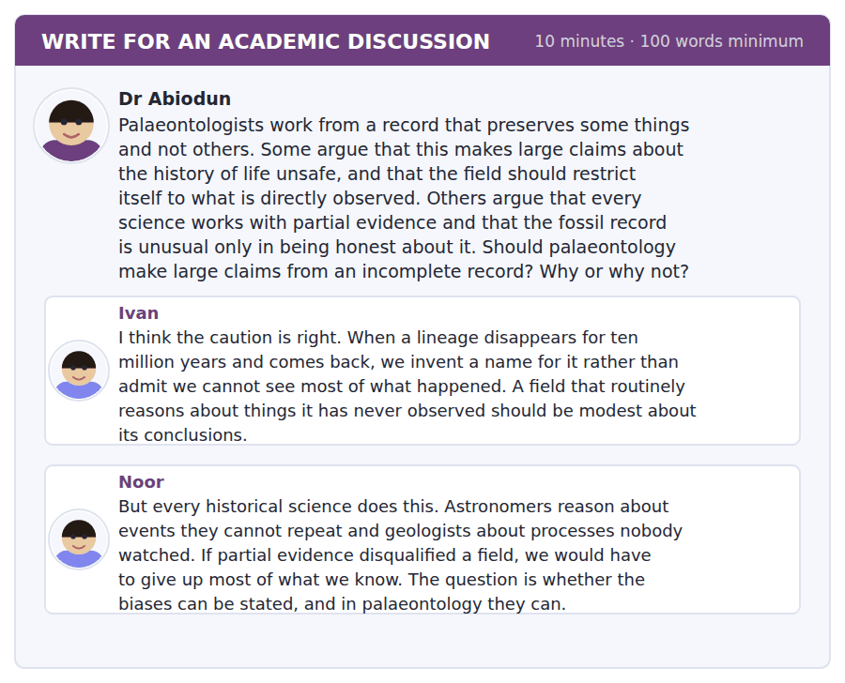
SKILL · Turning an opponent’s example against them
- The strongest B2 move is to take the example the other post used and show it supports your side.
- It requires reading closely enough to see what the example actually demonstrates.
- Signal it: Ivan’s own example makes the opposite point.

Sentence starters
- Ivan’s own example makes the opposite point, because…
- Noor is right that…, but the real distinction is between… and…
- What the Lazarus case shows is not… but…
- I would accept the caution if…, and it does not.
Model post
Ivan’s own example makes the opposite point. The Lazarus taxon is not a case of the field inventing a story to cover a gap. It is a case of the field noticing that a gap had been read as an extinction, naming the error, and building the distinction between last appearance and extinction so that nobody makes it again. That is a discipline correcting itself in public, which is the behaviour he is asking for.
Noor is right that every historical science reasons from partial evidence. But I would put the distinction more narrowly than she does. The question is not whether the evidence is partial — it always is — but whether the way it is partial can be written down. Hard parts preserve, soft parts do not; water buries, hillsides do not. Those are statable biases, and a statable bias can be corrected for.
It is doubtful whether Ivan’s alternative is even available. Restricting the field to what is directly observed would mean describing specimens and declining to say what they were doing, which is not a more modest palaeontology but a different and much smaller subject.
So I would keep the large claims and insist on the apparatus: state the bias, state the confidence, and separate what the record shows from what the lineage did. That is more demanding than caution, not less.
[226 words]
Now write your own. 10 minutes, at least 100 words.
__________________________________________________________
__________________________________________________________
__________________________________________________________
__________________________________________________________
__________________________________________________________
__________________________________________________________
__________________________________________________________
__________________________________________________________
__________________________________________________________
__________________________________________________________

Grammar focus Participle clauses
Form | Example
-ing, same time | Facing the same problem, unrelated lineages arrive at the same form.
-ing, reason | Being small, the population drifted rather than adapted.
-ed, passive | Isolated for ten thousand years, the birds diverged.
Having + -ed, earlier | Having arrived in small numbers, the founders carried little variation.
reduced relative, active | The species living only on one island (= which lives)
reduced relative, passive | The specimens shown in Gallery 4 (= which are shown)
after a conjunction | When reading a caption, check what it does not claim.

A participle clause has no subject of its own. It borrows the subject of the main clause, which is why the subject must be the same for both.
The -ing form is active and the -ed form is passive. Isolated for a long time means somebody or something isolated them.
Having + past participle puts the participle clause earlier in time than the main clause. Use it when the order matters.
Watch out! The dangling participle. "Having studied the labels, three specimens turned out to be casts" says the specimens did the studying. Keep the subject of the main clause the same as the understood subject of the participle.
Exercise 1 Join each pair with a participle clause.
1. The birds arrived in small numbers. They carried little variation.
2. The population was isolated for millennia. It diverged from the mainland form.
3. The lineages face the same problem. They arrive at the same shape.
4. The specimen had been cast in resin. It was displayed beside the original.
5. The rock preserves well. It produces an apparent burst of new forms.
6. She had read the labels carefully. She noticed the grey print.
Exercise 2 Reduce the relative clause to a participle.
1. The species which lives only on one island is flightless.
2. The specimens which are shown in Gallery 4 are mostly casts.
3. A trait which is shaped by drift tells you nothing about the environment.
4. The students who were standing behind the barrier could not read the label.
Exercise 3 Find and correct the dangling participle.
1. Having examined the case, the labels were found to be unclear.
2. Being made of resin, visitors could not tell the difference.
3. Isolated for millennia, researchers studied the island population.
4. Reading the caption, the scale became obvious.
How this is tested in Build a Sentence
Build a Sentence uses participle clauses in the two items that are not questions. A tile reading "having arrived" or "shown in the case" is a participle clause and belongs at one end of the sentence, never in the middle.
Find the fault 5 errors, drawn from this unit and the two before
Every error below is one a B2 writer makes after learning the rule. Mark what is wrong, then check. Knowing the rule and noticing the breach are two different skills, and only the second one is tested.
Having studied the four specimens, three of them turned out to be casts. The labels, which they are printed in grey, are hard to read from the barrier. Being small, the museum could not display the originals. The students was told to bring a pencil. Isolated for millennia, researchers found the population had diverged.
# | As written | As it should be | Why
1 | Having studied the four specimens, three of them | Having studied the four specimens, we found that three | A dangling participle: the specimens did not do the studying.
2 | which they are printed | which are printed | A relative pronoun is already the subject; they repeats it.
3 | Being small, the museum | Being small, the collection | The participle must describe the subject, and the museum was not the small thing.
4 | The students was told | The students were told | A plural subject takes a plural verb, however far the verb sits from it.
5 | Isolated for millennia, researchers | Isolated for millennia, the population | The researchers were not isolated; the population was.

Unit review and progress check Unit 22
Exercise A Vocabulary. Write the word.
1. one measurable feature of an organism
2. a line of descent from an ancestor
3. something that limits what is possible
4. able to be passed to offspring
5. building up step by step
6. arriving at the same form from different starts
7. the way of life a species makes a living by
8. the shape and structure of an organism
9. change by chance rather than advantage
10. the permanent loss of a lineage
11. the splitting of one population into two species
12. the movement of a population into new ground
Exercise B Grammar. Complete the sentence.
1. ______ in small numbers, the founders carried little variation.
2. ______ for millennia, the population diverged.
3. ______ read the labels, she noticed the grey print.
4. The species ______ only on one island is flightless.
5. The specimens ______ in Gallery 4 are mostly casts.
6. ______ the same problem, the lineages arrive at the same shape.
7. A trait ______ by drift tells you nothing about the environment.
8. When ______ a caption, check what it does not claim.
Exercise C One timed mini-section. 6 minutes.
1. Drift is strongest in
(A) large populations
(B) small populations
(C) marine populations
(D) populations under selection
2. Convergence shows that
(A) the same problem can produce the same form twice
(B) two species are related
(C) fossils are unreliable
(D) drift is common
3. A gap in the fossil record means
(A) the lineage was extinct
(B) the rock was misdated
(C) the fossil was lost
(D) the lineage may not have preserved
4. Which sentence has a dangling participle?
(A) Arriving late, we missed the talk.
(B) Arriving late, the talk had already begun.
(C) Having arrived late, we missed the talk.
(D) We arrived late and missed the talk.
5. "Is far from clear" tells you the writer
(A) is certain
(B) disagrees with the evidence
(C) thinks nobody knows
(D) has not read the literature
6. A sudden burst of forms in the record may reflect
(A) a change in preservation
(B) rapid evolution only
(C) a dating error only
(D) a smaller sample
Can you do these now?
I can… | Not yet | Yes
I can follow a text that distinguishes two mechanisms carefully. | □ | □
I can compress two clauses into one with a participle. | □ | □
I can spot a dangling participle in my own writing. | □ | □
I can describe a process without implying that it has a purpose. | □ | □
I can read a figure caption and tell what it does not show. | □ | □
I can qualify a generalisation instead of abandoning it. | □ | □

ADAPTIVE TIP Participle clauses are the fastest way to raise the density of your writing, and the fastest way to write a sentence that says something absurd. Every time you write one, ask who or what is doing the participle. If the answer is not the subject of the main clause, the sentence is wrong, however good it sounds.

Unit 23 · Neuroscience and Memory
TOEFL iBT® Preparation Course 2026 · Volume 3
CEFR B2 · Grammar: Perfect aspect across tenses · Word field: encode, retrieve, impair
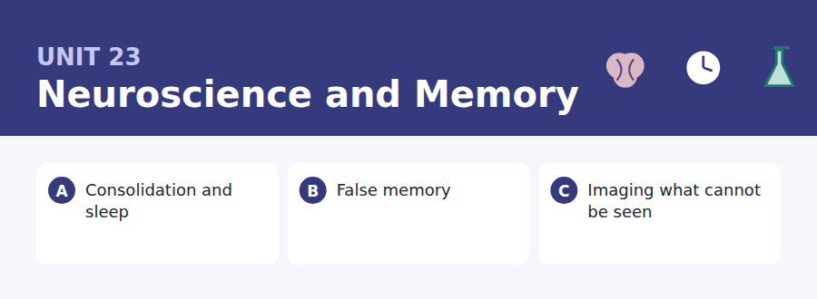
By the end of this unit I can…
- I can follow a text that explains why a system fails by design.
- I can use the three perfect tenses to order events in a narrative.
- I can describe what an experiment shows and what it does not.
- I can report a finding without overstating what it proves.
- I can take an argument from one post and apply it to another.
- I can write a complaint that stays factual under provocation.

Everything you know about your own memory comes from your memory, which is the problem. This unit gives you the language for talking about evidence you cannot inspect directly — and the tense system English uses to place one event relative to another.

Vocabulary 1 · Academic word families 18 families, not 18 words
At B2 the word on its own is not enough. Each entry below is a family: learn the noun, the verb and the adjective together, because the test will use whichever one the sentence needs.
encode to put information into a form memory can hold | decay gradual weakening over time
retrieve to bring a memory back | interference one memory getting in the way of another
impair to make something work less well | vivid felt very clearly and in detail
consolidate to make a new memory stable over time | implant to put a false memory into somebody
recall the act of bringing something back to mind | misattribute to credit something to the wrong source
cue anything that triggers a memory | salient standing out enough to be noticed
priming being influenced by something seen earlier | lesion damage to a region of tissue
episodic about events you personally experienced | resolution how fine a detail an instrument can show
semantic about facts, with no memory of learning them | correlate to vary together, without either causing the other

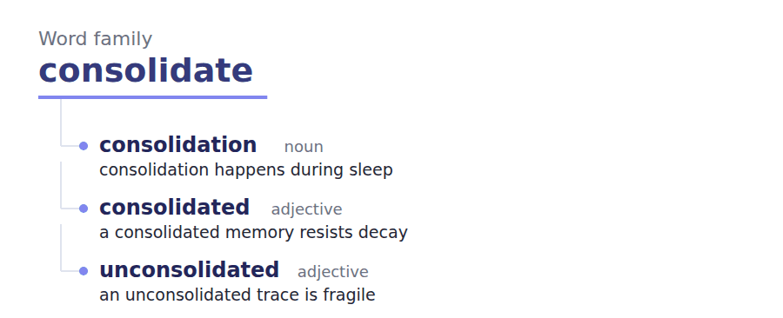
Exercise A Work in pairs. Ask and answer.
1. Describe your earliest memory. How do you know it is yours?
2. What helps you remember a name? Why does it work?
3. Should a jury be told that confident witnesses are often wrong?
4. Is it better to revise late and sleep less, or the opposite?
Vocabulary 2 · Collocation 10 partnerships that actually occur
A word is known when you know what it goes with. These ten are the partners this unit’s texts use; the wrong partner is what marks an answer as translated.
lay down a memory to form one in the first place | a body of work many studies on one question
at the time of encoding when the event happened | rule out to show that something is not the explanation
bear on to be relevant to | in the wake of following, and caused by
to a degree partly, but not completely | stand up to scrutiny to survive close examination
on the face of it judging only by appearances | by definition necessarily, because of what the word means

Vocabulary 3 · Stance and hedging How far the writer commits
Every one of these says the same thing at a different strength. Reading, you must notice which was chosen. Writing, you must choose.
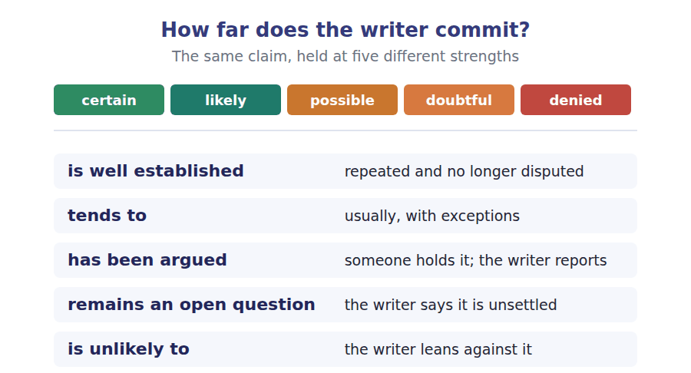
Two words that look alike
remember / remind you remember; something reminds you
recall / recognise produce it / pick it out of a line-up
affect / effect usually verb / usually noun

Words you will meet again: working memory | long-term memory | eyewitness testimony | control group | double-blind | scan | baseline | confound


SKILL · Deciding the part of speech before the letters
- Almost every B2 gap is a suffix. The sentence tells you which part of speech the slot needs before you have read a single letter.
- After a determiner, the slot is a noun. Before a noun, an adjective. After a verb or a whole clause, an adverb.
- Only then does the spelling matter: -tion, -ence, -able, -ly.

Exercise A Guided practice. Five words are not complete. Write the missing letters.
A memory is not filed away whole at the moment it is made. What happens at the moment of an event is encoding, and encoding is partial: a few features are registered and most are not. Over the following hours the trace is strengthened, a process called consolid-----, and much of it happens during sleep. Deprive a volunteer of sleep on the night after learning and the material is measur---- worse the next week, even though they were awake and attentive while learning it. The implication is uncomfort---- for anyone revising late: the hours after study are not dead time. They are part of the learn---, and skipping them costs more than the hours them------.

The first one is done for you: consolidation is consolidation — the slot follows a called and names a process, so it has to be a noun.
Exercise B Exam practice. One paragraph, ten gaps — the real task.
The reconstructive account of memory says that recall is not playback. Each time a memory is retrieved it is rebuilt from fragm----, and the rebuild is influ----- by what the person knows now. This explains a finding that is otherwise inexplic----: confident memories can be comprehens----- wrong. In one line of studies, volunteers were shown a traffic accident and then asked how fast the cars were going when they smashed into each other. A week later those volunteers report-- broken glass that had never been in the film. The verb in the question had become part of the mem---. Nothing about this makes memory useless. A system that rebuilt nothing would need to store everything, which is not biolog------ available, and a system that stored everything would retrieve slow--. The cost of the design is that a memory carries no internal mark of its own accur---. Confidence feels like evidence and is not, which is why eyewitness testimony is now handled with far more caut--- than it once was.

Check your answers in the key at the back of the book.


SKILL · Reading a study description and a press release together
- The press release always claims more than the study. Your job is to find the gap between them.
- Look at the sample: how many people, and who were they?
- A claim about everybody from a study of forty undergraduates is the commonest overreach there is.

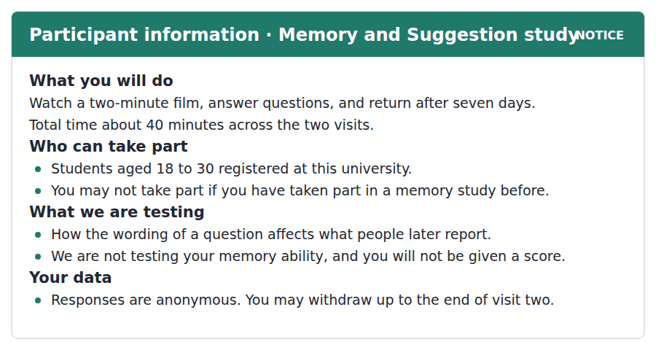
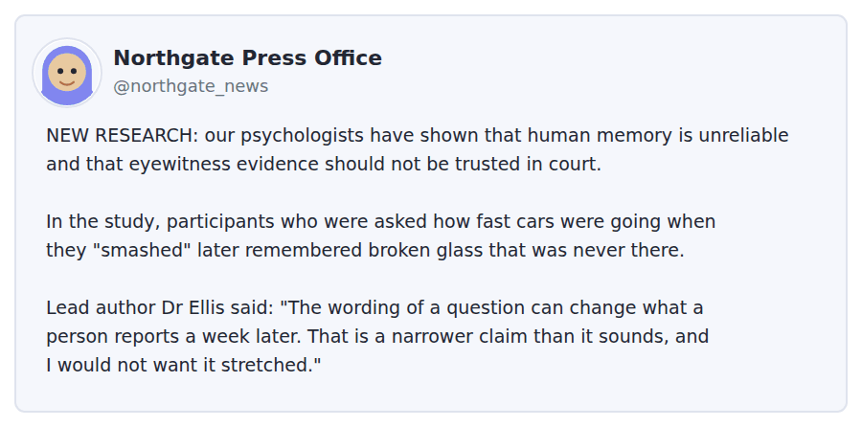
Exercise A Guided practice. The answer is on the page — find it.
1. How many visits does the study require?
(A) One
(B) Three
(C) Two
(D) Seven
2. Who may not take part?
(A) Anyone who has done a memory study before
(B) Anyone over 25
(C) Anyone not studying psychology
(D) Anyone who has seen the film
3. What does the notice say the study is NOT testing?
(A) The wording of questions
(B) Reaction times
(C) The effect of sleep
(D) The participant’s memory ability
4. Until when may a participant withdraw?
(A) At any time
(B) Until the end of visit two
(C) Until seven days after visit one
(D) Only during visit one
Exercise B Exam practice.
5. What is the main difference between the press post and Dr Ellis’s quotation?
(A) They disagree about the result
(B) The quotation is about a different study
(C) The post gives the sample size
(D) The post generalises further than the quotation does
6. What does Dr Ellis mean by "a narrower claim than it sounds"?
(A) The study was small
(B) The result was not significant
(C) The finding is about question wording, not about memory in general
(D) The film was short
7. Which group was studied?
(A) Jurors
(B) University students aged 18 to 30
(C) Police officers
(D) Adults of all ages
8. Why does the sample matter when reading the headline?
(A) A claim about everyone rests on a narrow group
(B) Students have better memories
(C) Students are easier to recruit
(D) The sample was too old
9. What is the stated purpose of the seven-day gap?
(A) To let the memory consolidate
(B) To allow withdrawal
(C) It is not stated
(D) To recruit more participants
10. What does "you will not be given a score" protect against?
(A) Participants comparing results
(B) Participants treating the study as a test of their own ability
(C) Data being traced back to individuals
(D) Participants withdrawing early
11. What would make the press post accurate?
(A) Adding the sample size and limiting the claim to question wording
(B) Removing the quotation
(C) Naming the film used
(D) Describing the seven-day gap


SKILL · Reading a text whose job is to limit a claim
- Some B2 passages exist to say what something does not show. They are built as a list of limits.
- Each paragraph after the first usually adds one limit. Name them as you go: comparison, time, and so on.
- The final paragraph often raises a worry the author does not fully endorse. Watch the hedge on it.

What a Brain Scan Does Not Show
A functional scan produces an image in which some regions are coloured and most are not. The colour is easy to misread. It does not show where thinking is happening; it shows where blood flow changed more than in a comparison condition. Everything in the image is a difference between two states, and the choice of comparison decides what appears. Change the comparison and the coloured regions move.
This is well established among researchers and almost never visible to readers of the resulting news story. A study reporting that a region lights up when people see a familiar face has compared familiar faces with something — unfamiliar faces, perhaps, or a blank screen — and the finding belongs to the pair, not to the region. A region that appears in one comparison and not another has not stopped working. It has stopped differing.
The second limit is time. The signal tracks blood, and blood responds over several seconds, while the activity it stands in for takes milliseconds. A scan tends to show that two regions were both involved, and is unlikely to settle which was involved first. For questions about sequence — did the judgement precede the feeling, or follow it — the method is close to silent, and researchers who need that answer use other tools. It has been argued that the popularity of these images has shaped which questions get asked, with sequence questions quietly dropped because the dominant method cannot reach them. Whether that has actually happened remains an open question, but the worry is not an unreasonable one.
[262 words]

Exercise A Guided practice.
1. What does the colour in a functional scan show?
(A) Where thinking happens
(B) Which regions are largest
(C) Where damage has occurred
(D) Where blood flow changed relative to a comparison
2. What happens if the comparison condition is changed?
(A) The image stays the same
(B) The scan takes longer
(C) The coloured regions move
(D) The resolution improves
3. What does it mean that a region "has stopped differing"?
(A) It is active in both conditions being compared
(B) It is no longer active
(C) It has been damaged
(D) It was never active
4. The word "settle" in the third paragraph is closest in meaning to
(A) calm
(B) decide
(C) pay for
(D) locate
Exercise B Exam practice.
5. What is the main purpose of the passage?
(A) To criticise neuroscience
(B) To explain how scanners are built
(C) To compare two imaging techniques
(D) To set out what the method cannot show
6. Why is the time limit a problem for some questions?
(A) Scans are expensive
(B) Participants move during scanning
(C) Blood responds far more slowly than the activity
(D) The resolution is too low
7. What does the author say about questions of sequence?
(A) The method answers them well
(B) The method is close to silent on them
(C) They are not worth asking
(D) They require larger samples
8. What worry is raised in the last paragraph?
(A) That scans are inaccurate
(B) That the images are edited
(C) That researchers disagree
(D) That the method may be shaping which questions get asked
9. How does the author treat that worry?
(A) Leaves it open while calling it reasonable
(B) Endorses it fully
(C) Rejects it
(D) Attributes it to the press
10. What does "the finding belongs to the pair" mean?
(A) Two researchers share credit
(B) The result is about the two conditions compared
(C) Two regions were involved
(D) The study was replicated twice
11. All of the following are stated as limits EXCEPT:
(A) The small size of typical samples
(B) The dependence on a comparison condition
(C) The slowness of the blood signal
(D) The inability to settle sequence
12. What is implied about news reporting of scans?
(A) It is usually accurate
(B) It exaggerates sample sizes
(C) It ignores the images
(D) It rarely conveys the comparison condition
13. Which finding would most support the worry in the last paragraph?
(A) That scanner resolution has improved
(B) That scans are used in more countries
(C) That published sequence questions have fallen since scanning became common
(D) That blood flow is well understood


Exercise A Listen and choose a response. You hear one line. Choose the best reply.
1. Woman: Are you still here?
(A) Yes, the library is open.
(B) It closes at one.
(C) No, I came at six.
(D) I have about two hours left in me.
2. Man: Does sleeping on it actually help?
(A) I slept badly.
(B) The evidence is surprisingly strong.
(C) About eight hours.
(D) Yes, it is a good bed.
3. Woman: I have not started the second paper yet.
(A) It is a good paper.
(B) Yes, I read it.
(C) Then tonight is not the night to skip sleep.
(D) About forty pages.
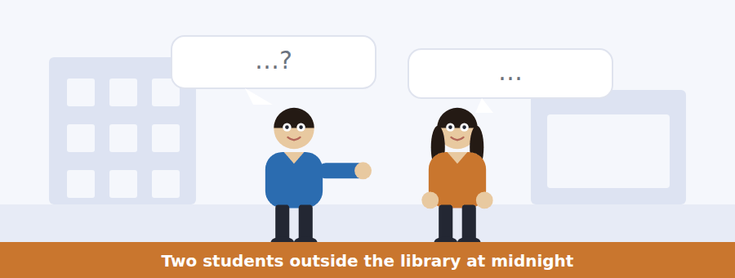
SKILL · Hearing advice that is being resisted
- When one speaker gives advice and the other does not take it, the refusal is usually indirect: I know, but; that is fine for you.
- The item will ask what the second speaker actually intends to do, which is rarely what they say first.
- Listen to the last line. People put the real decision at the end.

Exercise B Listen and answer. The audio plays once.
4. What is the man doing in the library?
(A) Finishing the methods section of a paper
(B) Reading for an exam
(C) Waiting for a friend
(D) Returning books
5. What does the study the man describes compare?
(A) Long study and short study
(B) Morning and evening learners
(C) A group that slept and a group that did not
(D) Students and non-students
6. What does the woman mean by "you have read the research and you are ignoring it"?
(A) He has misunderstood the study
(B) He is acting against what he knows
(C) The research is unreliable
(D) He has not read it carefully
7. How does the man first defend staying?
(A) By doubting the evidence
(B) By saying he is not tired
(C) By blaming his supervisor
(D) By separating the research from the deadline
8. Why does the woman mention her second year?
(A) To give evidence from her own cost
(B) To show she is more experienced
(C) To change the subject
(D) To recommend a module
9. What does the man decide to do?
(A) Stay another three hours
(B) Hand the paper in late
(C) Start again in the morning
(D) Write the outline and leave
10. What does "annoyingly" tell you about the man’s reaction?
(A) He accepts the point and would rather not
(B) He is angry with her
(C) He does not understand
(D) He is joking about the deadline
Audio script: see the back of the book. Do not read it before you listen.


Exercise A Listen and choose a response. You hear one line. Choose the best reply.
1. Man: Will we be told how we did?
(A) Yes, in about a week.
(B) There is no score — that is deliberate.
(C) It takes forty minutes.
(D) The film is two minutes long.
2. Woman: Can I pull out after the second visit?
(A) Yes, at any time.
(B) The study runs for a month.
(C) No — the cut-off is the end of visit two.
(D) You can pull out of visit one.
3. Man: Is this testing how good my memory is?
(A) No — it is testing how questions are worded.
(B) Yes, partly.
(C) About forty people.
(D) It is a psychology study.
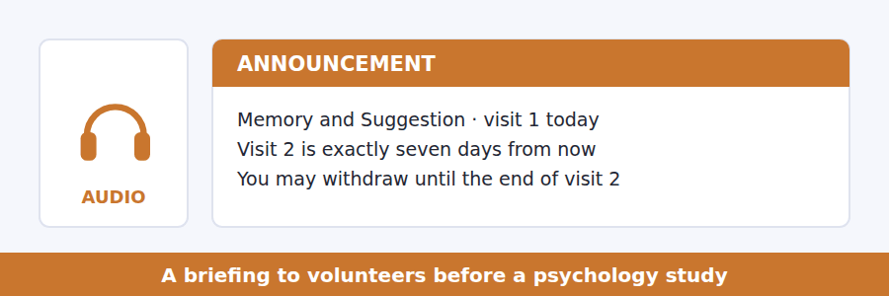
SKILL · Hearing what a speaker rules out
- A careful speaker at B2 spends time saying what they are not claiming. Those sentences are tested.
- Listen for: this is not, we are not testing, that would be a different study.
- The negative statement is usually more precise than the positive one.

Exercise B Listen and answer. The audio plays once.
4. How long does the whole study take?
(A) Two minutes
(B) Forty minutes across two visits
(C) Seven days
(D) It is not stated
5. Why can responses not be removed after visit two?
(A) It is against policy
(B) They have been published
(C) They have been anonymised and cannot be identified
(D) The study has ended
6. What does the speaker say people most often get wrong?
(A) The timing of visit two
(B) The withdrawal rule
(C) The length of the film
(D) That the study tests their memory
7. Why does the speaker mention people apologising?
(A) To ask them not to
(B) To show how easily the purpose is misread
(C) To explain the withdrawal rule
(D) To thank previous volunteers
8. What does the speaker say about people paying the most attention?
(A) They show the effect least
(B) They should not take part
(C) They finish faster
(D) They may show the effect most
9. What is the speaker’s main purpose?
(A) To prevent a specific misunderstanding
(B) To recruit more volunteers
(C) To explain the hypothesis
(D) To obtain written consent
Audio script: see the back of the book. Do not read it before you listen.


Exercise A Listen and choose a response. You hear one line. Choose the best reply.
1. Man: What do the colours actually mean?
(A) They are chosen for clarity.
(B) About four colours.
(C) A difference between two conditions.
(D) Yes, they mean activity.
2. Woman: Can a scan tell us which region acted first?
(A) Yes, to the millisecond.
(B) About two regions.
(C) It can show both.
(D) Not really — the blood signal is too slow.
3. Man: So an uncoloured region is switched off?
(A) No — it just did not differ between conditions.
(B) Yes, entirely.
(C) It is a large region.
(D) The scan took an hour.
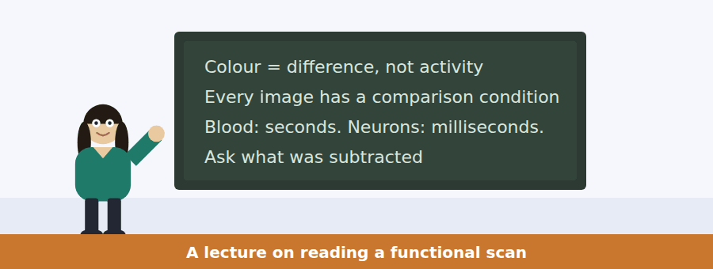
SKILL · Following a talk that teaches one question to ask
- Some B2 talks hand you a single question and apply it repeatedly. The question is the content.
- Here it is: what was this compared with? Everything else follows.
- Expect an item that asks you to apply the question to a new case the speaker has not covered.

Exercise B Listen and answer. The audio plays once.
4. What is the one question the speaker recommends?
(A) How large is the sample?
(B) What was this compared with?
(C) Who funded the study?
(D) How long did the scan take?
5. What does a functional scan actually measure?
(A) Electrical activity
(B) Oxygen levels in one region
(C) Blood flow differences between two conditions
(D) The size of each region
6. In the familiar-faces example, why does the comparison matter?
(A) It changes what the finding actually claims
(B) It changes the colour
(C) It changes the scan duration
(D) It changes the region studied
7. What does the speaker say about an image where the comparison was a blank screen?
(A) It proves face recognition
(B) It is invalid
(C) The region may be responding to anything complex
(D) It has better resolution
8. Why can the method rarely answer questions about order?
(A) Scans are too short
(B) Blood responds in seconds and neurons in milliseconds
(C) Regions overlap
(D) Participants move
9. What does the speaker say about a study claiming to settle sequence?
(A) It is certainly wrong
(B) It must have a large sample
(C) It should be replicated
(D) It is unlikely to be using scanning alone
10. What is the speaker’s overall position on scans?
(A) They are worthless
(B) They answer a narrower question than they appear to
(C) They should be replaced
(D) They are the best available method
Audio script: see the back of the book. Do not read it before you listen.


Part 1 · Listen and Repeat
You hear a sentence and repeat it once. There is no preparation time, and the sentences get longer. Focus: the contracted perfect — I’ve, he’d, they’ve — at speed
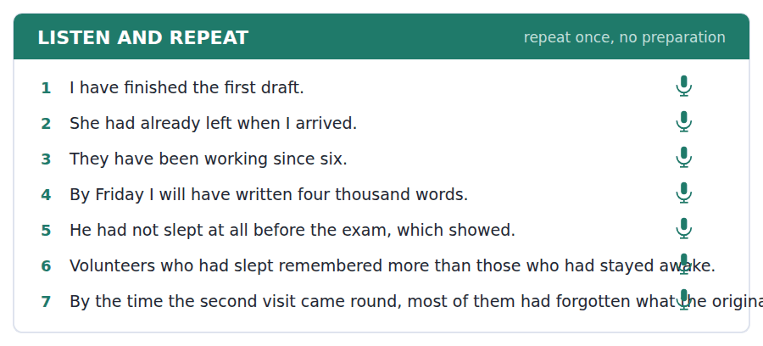
SKILL · Repeating contracted perfect forms
- The perfect contracts in speech and the contraction carries the meaning. Dropping it changes the tense.
- I’d finished and I finished are a different claim. Practise until the contraction is automatic.
- The stress never falls on the auxiliary. It falls on the main verb.

Part 2 · Take an Interview
An interviewer asks you four questions on one theme: sleep, study and how people actually work. Answer each one fully. There is no preparation time.
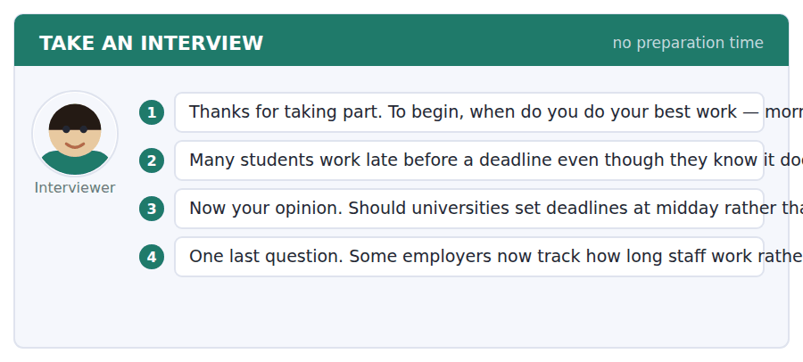
A good answer sounds like this
Question 2 — Partly because the deadline is real and the evidence is abstract. You can see the clock. You cannot see the mark you would have got with six hours of sleep.
Question 3 — I would support it, although I doubt it would work on its own. People would simply start the all-nighter earlier. It would need to come with something about how much work is set.
I can… | Not yet | Yes
I used a contracted perfect form at least twice. | □ | □
I ordered two past events correctly. | □ | □
I gave a reason rather than only a position. | □ | □


Part 1 · Listen and Repeat
You hear a sentence and repeat it once. There is no preparation time, and the sentences get longer. Focus: reporting what somebody else said without agreeing with it
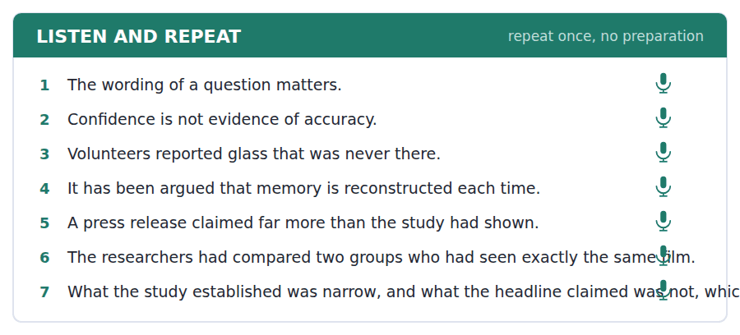
SKILL · Attributing a claim out loud
- At B2 you must be able to report a view without being taken to hold it. That is a tone as much as a structure.
- The research suggests, it has been argued, the press release claimed — each one puts distance in.
- Then mark your own view explicitly: for what it is worth, I think.

Part 2 · Take an Interview
An interviewer asks you four questions on one theme: evidence, confidence and the courtroom. Answer each one fully. There is no preparation time.
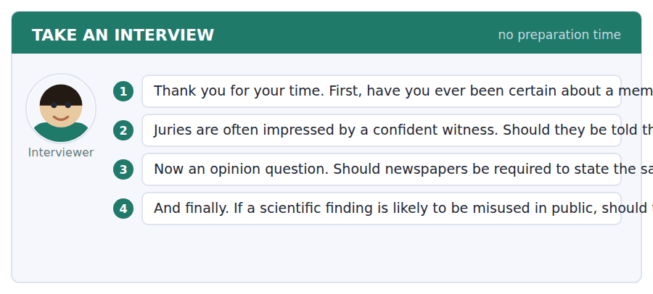
A good answer sounds like this
Question 2 — Yes, they should, and told it carefully. The risk is that a jury swings from trusting every witness to trusting none, and the second error is as bad as the first.
Question 4 — I think they should publish. Withholding a finding assumes the researchers can predict the misuse, and the history of that is not encouraging. The answer is better reporting, not less research.
I can… | Not yet | Yes
I attributed a claim without endorsing it. | □ | □
I then marked my own view clearly. | □ | □
I avoided overstating what a study showed. | □ | □


Part 1 · Listen and Repeat
You hear a sentence and repeat it once. There is no preparation time, and the sentences get longer. Focus: stress on the negative in a limiting statement
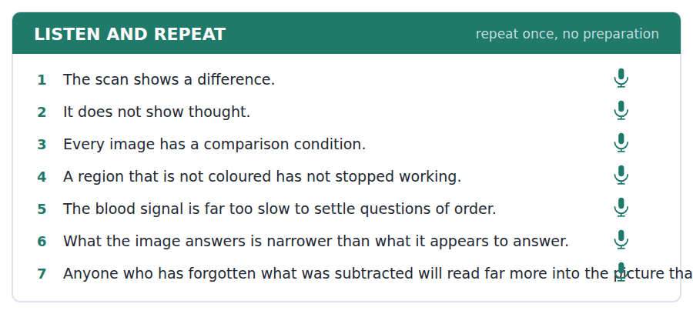
SKILL · Saying what something does not show
- Negative statements are where B2 speakers lose clarity. The listener must hear the not.
- It does NOT show where thinking happens. Stress the auxiliary, not the verb, when the point is the denial.
- Then immediately say what it does show. A denial without a replacement is a dead end.

Part 2 · Take an Interview
An interviewer asks you four questions on one theme: pictures, evidence and public understanding. Answer each one fully. There is no preparation time.
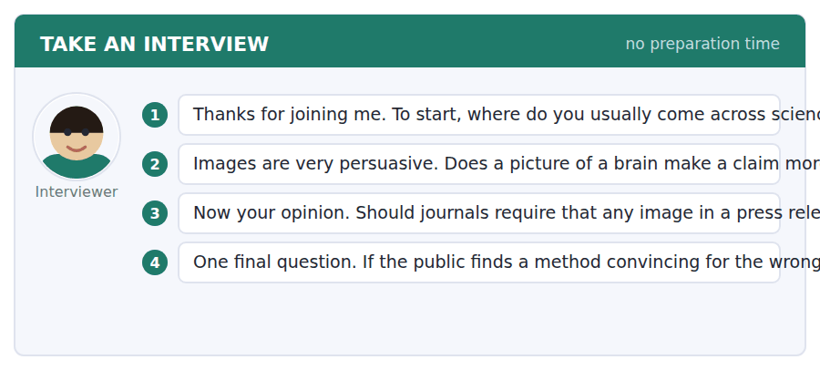
A good answer sounds like this
Question 2 — Honestly, yes, and I know it should not. A picture feels like looking at the thing itself, whereas a table feels like somebody’s summary. Both are summaries.
Question 4 — I would put most of it on the researchers, because they are the only ones who know what was subtracted. Journalists cannot report a limitation nobody has told them about.
I can… | Not yet | Yes
I stressed the negative so the denial was audible. | □ | □
I followed each denial with what is actually shown. | □ | □
I kept going for the whole answer. | □ | □


You see a sentence, then a set of words in boxes. Put the words in order to make one grammatical sentence. Almost every item in the real test makes a question or a question inside another sentence.
SKILL · Build a Sentence with a perfect tense inside
- The embedded clause now often carries a perfect form: had already, has ever, will have.
- The perfect sits inside the clause and keeps statement word order: whether she had finished, not whether had she finished.
- A tile reading had or has goes directly before its participle, wherever the clause sits.

Exercise A Guided practice. The first three are worked through.
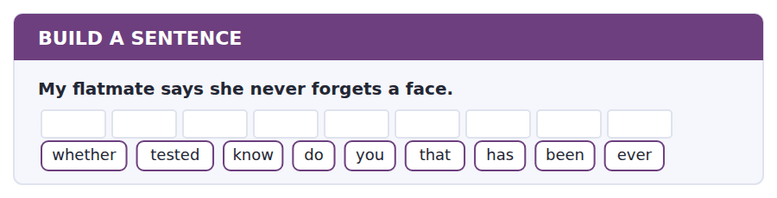
1. Do you know whether that has ever been tested?
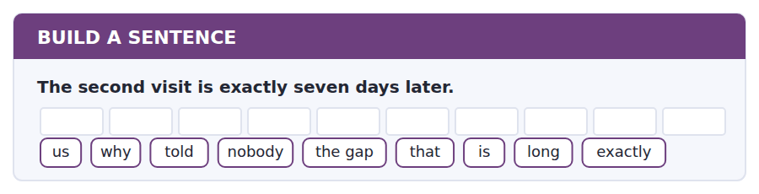
2. Nobody told us exactly why the gap is that long.
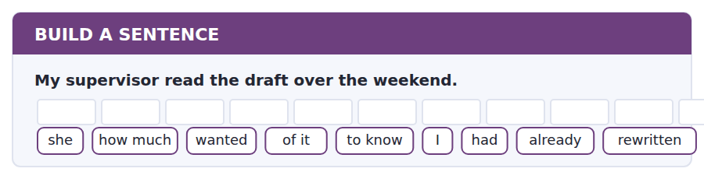
3. She wanted to know how much of it I had already rewritten.
Exercise B Exam practice. Write the sentence.
4. The press office published the story on Tuesday.
do / whether / you / know / the authors / had / seen it / first / actually
__________________________________________________________
5. The region appears in one comparison and not the other.
explain / can / anybody / why / that / happens / at all / exactly / to me
__________________________________________________________
6. The volunteers came back a week later.
to know / nobody / seems / how many / of them / had / the film / forgotten / already
__________________________________________________________
7. I have never taken part in a study before.
whether / tell / can / me / that / you / rules / me out / actually
__________________________________________________________
8. The scan showed two regions lighting up.
which / know / does / anybody / one / responded / first / actually / of them
__________________________________________________________
9. She apologised for having a bad memory.
told / her / the researcher / that / she / had / nothing / wrong / done
__________________________________________________________
10. The deadline is nine in the morning.
whether / I / know / do not / yet / I / will have / by then / finished
__________________________________________________________


You read a short situation and write an email. You have 7 minutes. The three bullet points are the mark scheme: answer all three.
You took part in a psychology study. The university press office has published a post saying the research shows eyewitness evidence should not be trusted in court. The lead researcher is quoted in the same post making a much narrower claim. You are a student journalist and you want the post corrected.
Write an email to the press office.
- Say what the post claims and what the study actually showed.
- Point out that the researcher’s own quotation contradicts the headline.
- Ask for a specific correction.
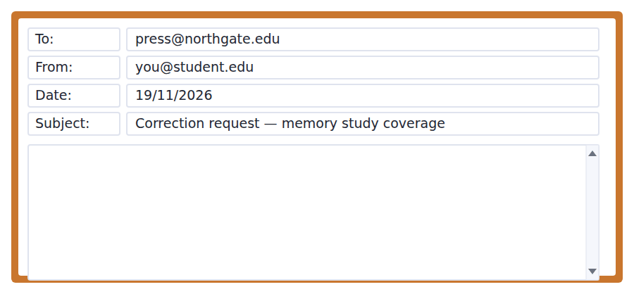
SKILL · Asking for a correction without accusing anybody
- A correction request works when it gives the reader an easy way to say yes, and fails when it makes them defend themselves.
- Quote their own source back to them. The researcher’s words are far more persuasive than your opinion.
- Propose the replacement wording. An editor who has to write it themselves usually does nothing.

Model email
Dear Press Office,

I am writing about Tuesday’s post on the memory and suggestion study, which I took part in as a volunteer.

The post’s opening line says the research has shown that eyewitness evidence should not be trusted in court. The study compared how students described a two-minute film after being asked about it in different words. Those are not the same claim, and the distance between them is large.

I would not normally press the point, except that Dr Ellis is quoted lower down in the same post saying the finding is a narrower claim than it sounds and that she would not want it stretched. The post therefore contradicts its own source in the space of four paragraphs.

Could the opening line be changed to something like: researchers have shown that the wording of a question can change what people report a week later? That is what the study found, and it is still a striking result.

I am happy to be told I have misread it.

With thanks,
Priya Raman
Why it works
- It states both claims side by side so the gap is visible without being argued.
- It uses the researcher’s own quotation, which is far harder to dismiss.
- It supplies replacement wording, so saying yes costs the editor nothing.
- The last line leaves room to be wrong, which keeps the exchange open.
Two answers, one band apart
Both answer the three bullet points. One would score in the middle band and one near the top. Read them side by side before you write your own.
A middle-band answer | A top-band answer
Dear Press Office,  I am writing to complain about your recent post about the memory study. I was a participant in this study and I think the post is very misleading and should be corrected as soon as possible.  The post says that the research proves eyewitness evidence cannot be trusted in court, but this is not what the study was about at all. The study was only about how the wording of questions affects what people remember. It is wrong to say it proves something about courts.  Even Dr Ellis says in your own post that it is a narrow claim. I think you should change the post because it is not accurate and it gives people the wrong idea about the research. Please let me know what you decide to do.  Yours faithfully, Priya Raman | Dear Press Office,  I am writing about Tuesday’s post on the memory and suggestion study, which I took part in as a volunteer.  The post’s opening line says the research has shown that eyewitness evidence should not be trusted in court. The study compared how students described a two-minute film after being asked about it in different words. Those are not the same claim.  I would not normally press the point, except that Dr Ellis is quoted lower down saying the finding is narrower than it sounds. The post contradicts its own source in four paragraphs.  Could the opening line be changed to: researchers have shown that the wording of a question can change what people report a week later? I am happy to be told I have misread it. With thanks, Priya Raman

What the top answer does that the other does not
- It describes the study instead of asserting that the post is wrong, and lets the reader see the gap for themselves.
- It builds the case on the press office’s own quotation rather than on the writer’s judgement, which is much harder to argue with.
- It proposes the exact replacement sentence, so agreeing costs the editor nothing and refusing now needs a reason.
- "I would not normally press the point" signals that this is not habitual complaining, which buys the request a hearing.
- It ends by leaving room to be wrong, which keeps the exchange open rather than demanding a decision.
Now write your own. 7 minutes.
__________________________________________________________
__________________________________________________________
__________________________________________________________
__________________________________________________________
__________________________________________________________
__________________________________________________________
__________________________________________________________
__________________________________________________________


A professor asks a question and two students answer. You add your own post. You have 10 minutes and an effective answer is at least 100 words.
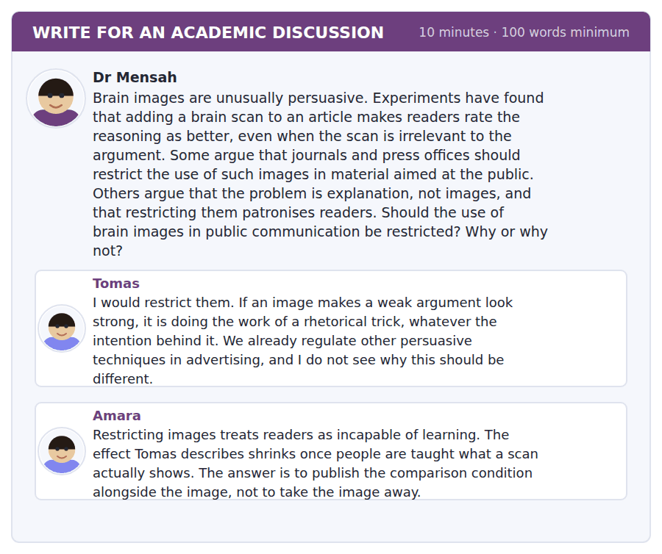
SKILL · Finding the assumption both posts share
- The strongest move at B2 is to notice what the two posts agree on without saying so, and question that.
- Both may assume the same thing about who the reader is, or about what the image is for.
- Signal it: Tomas and Amara disagree about the remedy, but both assume…

Sentence starters
- Tomas and Amara disagree about the remedy, but both assume…
- Amara is right that…, though that holds only where…
- The case Tomas has in mind is…, and it is not the common one.
- What follows is neither restriction nor education but…
Model post
Tomas and Amara disagree about the remedy, but both assume the image is there to inform. Usually it is not. A scan in a news article is almost never the evidence for the claim being made; it is a picture of the research taking place, in the way a photograph of a laboratory is. Once that is clear, the argument changes shape.
Amara is right that the persuasion effect shrinks when readers are taught what a scan shows. But that holds only where the image bears on the claim, so that understanding it does some work. Teaching somebody to read a comparison condition does not help if the image was decorative to begin with, and most of them are.
Tomas’s analogy with advertising is closer than Amara allows, though not for his reason. What is being borrowed is not the persuasive power of the picture but the authority of the instrument. That is a familiar move, and it tends to be handled by disclosure rather than prohibition.
So I would require one line: whether the image shown is from the study being reported. It is doubtful whether anything stronger would survive contact with a press office, and this one change separates the images that are evidence from the images that are scenery, which is the distinction both posts needed and neither made.
[222 words]
Now write your own. 10 minutes, at least 100 words.
__________________________________________________________
__________________________________________________________
__________________________________________________________
__________________________________________________________
__________________________________________________________
__________________________________________________________
__________________________________________________________
__________________________________________________________
__________________________________________________________
__________________________________________________________

Grammar focus Perfect aspect across tenses
Form | What it does
present perfect: has encoded | a past event with a present consequence
present perfect continuous: has been working | an activity still going on, with its duration in view
past perfect: had encoded | an event earlier than another past event
past perfect continuous: had been working | an activity running up to a point in the past
future perfect: will have encoded | an event completed before a future point
perfect infinitive: seems to have forgotten | after a verb, when the event is earlier
perfect participle: having slept | an earlier event in a participle clause

The perfect is not a past tense. It links two times: the time of the event and the time you are looking from.
The past perfect is only needed when the order is not already clear. After she arrived, he left needs no perfect; the sequence is in the conjunction.
With since and for, the present perfect continuous is usually right: they have been working since six, not they work since six.
Watch out! Do not use the past perfect for everything that happened a long time ago. It marks one past event as earlier than another past event. With no second past event in view, use the simple past.
Exercise 1 Put the verb in the right perfect form.
1. By Friday I ______ (write) four thousand words.
2. She ______ (already / leave) when I arrived.
3. They ______ (work) on the data since six this morning.
4. He seems ______ (forget) what the question said.
5. ______ (sleep) badly, she found the test harder than usual.
6. The volunteers ______ (watch) the film a week earlier.
Exercise 2 Decide whether the past perfect is needed. Correct where it is not.
1. After she had arrived, he had left.
2. By the time the second visit came, most had forgotten the wording.
3. I had studied neuroscience for three years before I changed subject.
4. The study had been published in 1974.
Exercise 3 Join the two events, marking which came first.
1. She slept badly. She sat the exam.
2. The press office published the post. The researcher saw it.
3. The volunteers watched the film. They returned a week later.
4. I finished the outline. I went home.
How this is tested in Build a Sentence
Build a Sentence frequently puts a perfect form inside an embedded question: do you know whether she had already left. The auxiliary goes before the participle and the whole clause keeps statement order — no inversion, ever.
Find the fault 5 errors, drawn from this unit and the two before
Every error below is one a B2 writer makes after learning the rule. Mark what is wrong, then check. Knowing the rule and noticing the breach are two different skills, and only the second one is tested.
The study has been published in 1974 and is still cited. After the volunteers had watched the film, they had returned a week later. The press office claim that the research proves something about courts. Having slept badly, the exam was harder than usual. Nobody knows whether had she seen the post before it went out.
# | As written | As it should be | Why
1 | has been published in 1974 | was published in 1974 | A finished time such as 1974 takes the simple past, not the present perfect.
2 | they had returned a week later | they returned a week later | Only the earlier of the two past events takes the past perfect.
3 | The press office claim | The press office claims | A singular body takes a singular verb when it acts as one unit.
4 | Having slept badly, the exam | Having slept badly, she found the exam | The exam did not sleep badly; the participle needs the right subject.
5 | whether had she seen | whether she had seen | An embedded question keeps statement order, so the auxiliary follows the subject.

Unit review and progress check Unit 23
Exercise A Vocabulary. Write the word.
1. to put information into a form memory can hold
2. to bring a memory back
3. to make something work less well
4. to make a new memory stable over time
5. anything that triggers a memory
6. about events you personally experienced
7. about facts, with no memory of learning them
8. one memory getting in the way of another
9. to credit something to the wrong source
10. standing out enough to be noticed
11. how fine a detail an instrument can show
12. to vary together, without either causing the other
Exercise B Grammar. Complete the sentence.
1. By Friday I ______ written four thousand words.
2. She ______ already left when I arrived.
3. They ______ been working since six.
4. He seems ______ have forgotten the question.
5. ______ slept badly, she found the test harder.
6. The study ______ published in 1974.
7. Nobody knows whether she ______ seen it.
8. The volunteers ______ watched the film a week earlier.
Exercise C One timed mini-section. 6 minutes.
1. Consolidation mostly happens
(A) at the moment of the event
(B) during retrieval
(C) during sleep after learning
(D) only with rehearsal
2. A false memory of broken glass shows that
(A) the wording of a question can enter the memory
(B) memory decays quickly
(C) vision is unreliable
(D) volunteers lie
3. Colour in a functional scan indicates
(A) where thinking occurs
(B) regions of damage
(C) the largest regions
(D) a difference in blood flow between two conditions
4. Which sentence is correct?
(A) The study was published in 1974.
(B) The study has been published in 1974.
(C) The study had published in 1974.
(D) The study is published in 1974.
5. "Remains an open question" tells you the writer
(A) has settled it
(B) regards it as unsettled
(C) rejects it
(D) thinks it unimportant
6. A region that is not coloured in a scan
(A) is inactive
(B) is damaged
(C) did not differ between the two conditions
(D) was not measured
Can you do these now?
I can… | Not yet | Yes
I can follow a text that explains why a system fails by design. | □ | □
I can use the three perfect tenses to order events in a narrative. | □ | □
I can describe what an experiment shows and what it does not. | □ | □
I can report a finding without overstating what it proves. | □ | □
I can take an argument from one post and apply it to another. | □ | □
I can write a complaint that stays factual under provocation. | □ | □

ADAPTIVE TIP The past perfect is the tense B2 writers most often overuse. It has exactly one job: marking an event as earlier than another past event already in view. If there is no second past event, you want the simple past, and using the perfect anyway makes the sentence sound translated.

Unit 24 · Oceans and Currents
TOEFL iBT® Preparation Course 2026 · Volume 3
CEFR B2 · Grammar: Relative clauses with prepositions · Word field: circulate, gradient, flux
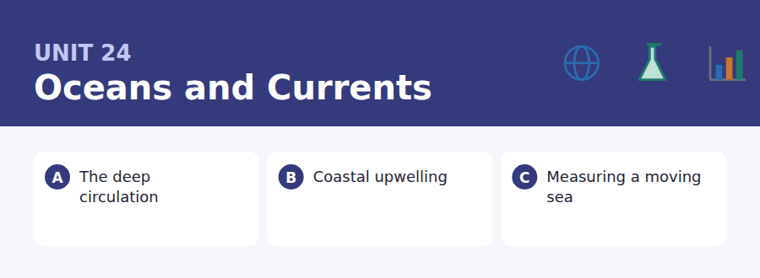
By the end of this unit I can…
- I can follow a description of a process with several linked stages.
- I can use a preposition inside a relative clause correctly.
- I can write "the extent to which" without losing the sentence.
- I can read a dataset description and say what it cannot support.
- I can express approximate quantity precisely.
- I can write an email that reports a problem I did not cause.

The ocean is the largest thing on the planet and the hardest to watch. This unit is about how a science works when it cannot see most of its subject, and about the structure English uses to say exactly which thing you mean: the extent to which, the rate at which, the degree to which.

Vocabulary 1 · Academic word families 18 families, not 18 words
At B2 the word on its own is not enough. Each entry below is a family: learn the noun, the verb and the adjective together, because the test will use whichever one the sentence needs.
circulate to move round a system and return | buoyancy the tendency to float or rise
gradient a steady change in something across space | stratify to settle into separate horizontal layers
saline containing salt | plume a column of water or gas rising through another
density how much mass sits in a given volume | sediment material that settles at the bottom
upwelling deep water rising to the surface | turbulence disordered, mixing motion
nutrient a substance living things need to grow | anomaly a reading that departs from the expected
flux the rate at which something flows through | equilibrium a state in which opposing forces balance
basin a large natural hollow holding water | advection transport of a property by bulk movement
thermal to do with heat | overturning the sinking and rising that drives deep flow

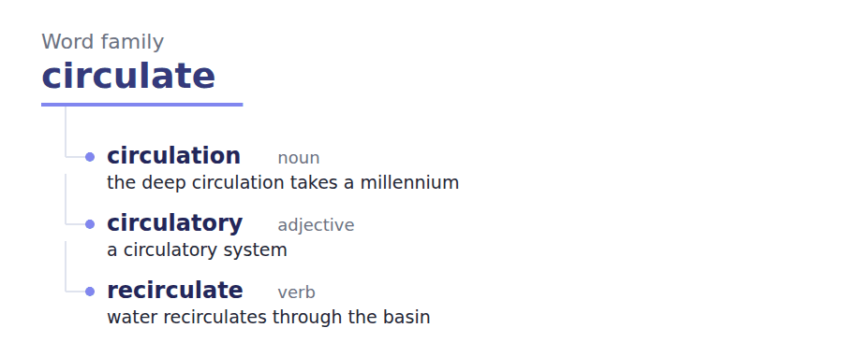
Exercise A Work in pairs. Ask and answer.
1. Describe a journey a drop of water might take over a thousand years.
2. Why is the deep ocean harder to study than space?
3. What would you need to measure to know the ocean is changing?
4. Who should pay for ocean monitoring? Why?
Vocabulary 2 · Collocation 10 partnerships that actually occur
A word is known when you know what it goes with. These ten are the partners this unit’s texts use; the wrong partner is what marks an answer as translated.
the rate at which how fast something happens | draw on to use as a source
the extent to which how far something is true | a proxy for a measurable stand-in for something you cannot measure
give way to to be replaced by | over the long run across a long period
on the order of roughly, to the nearest power of ten | set in motion to start a process that then continues
in the region of approximately | be borne out by to be confirmed by

Vocabulary 3 · Stance and hedging How far the writer commits
Every one of these says the same thing at a different strength. Reading, you must notice which was chosen. Writing, you must choose.
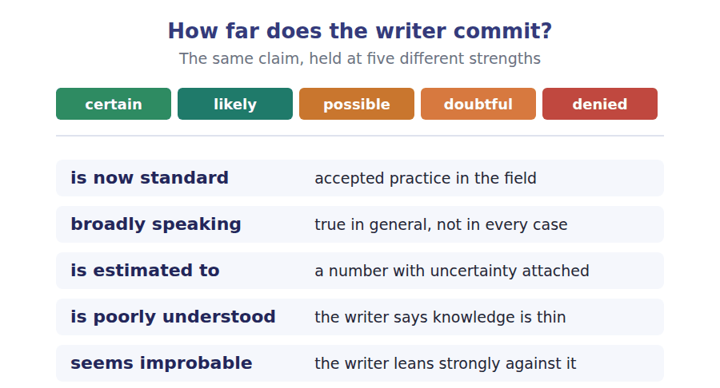
Two words that look alike
affect / effect to change / the change produced
temperature / heat how hot / how much thermal energy
current / tide a flow / a rise and fall

Words you will meet again: salinity | thermocline | El Niño | float array | time series | anomaly map | moorings | research cruise


SKILL · Suffixes on process nouns
- A gap after a or the and before of is a noun. At B2 it is usually a process noun: circulation, stratification, overturning.
- The commonest endings on this page are -tion, -ance, -ity and -ing.
- Read on past the gap. The preposition after it often confirms the part of speech.

Exercise A Guided practice. Five words are not complete. Write the missing letters.
The deep ocean moves, but not in the way the surface does. Surface currents are driven by wind and are relat----- fast. The deep circulation is driven by density, and density depends on two things only: temperature and salt. Water that is cold and salty is dense, and dense water s----. That is the whole engine. In the North Atlantic, water that has travelled north at the surface loses heat to the air, becomes dense enough to sink, and begins a journey of roughly a thous--- years before it surfaces again somewhere in the Pacific. The scale of that journey is what makes the system import--- and what makes it slow to r------.

The first one is done for you: relat--- is relatively — the slot modifies the adjective fast, so it has to be an adverb.
Exercise B Exam practice. One paragraph, ten gaps — the real task.
Upwelling is the process by which deep water is brought to the surface, and it is the reason a few narrow strips of coast produce a dispropor------- share of the world fish catch. The mechanism is indirect. Wind blowing along a coast does not push water ashore; because of the rotation of the planet, it pushes surface water offsh---, and water from below rises to replace it. What rises is cold and rich in the nutri---- that have been accumul----- in the dark for centuries, and a nutrient supply of that kind supports an extraordinary dens--- of life. Four such systems account for a large fraction of the global catch from a tiny fract--- of the ocean surface. The dependence runs the other way as well. In a year when the wind weak---, the upwelling fails, the nutrients stay below, and the fishery coll----- within a season. Communities along these coasts have therefore learned to read the wind, and the econom-- consequences of a quiet spring are felt long before any measurement of the water is publi----.

Check your answers in the key at the back of the book.


SKILL · Reading a dataset description
- A dataset description tells you what was measured, where, and how often. All three limit what can be concluded.
- Gaps in a time series are the most common trap. A series with a two-year hole cannot support a claim about those two years.
- Note the units and the depth. A surface measurement says nothing about what is happening below.

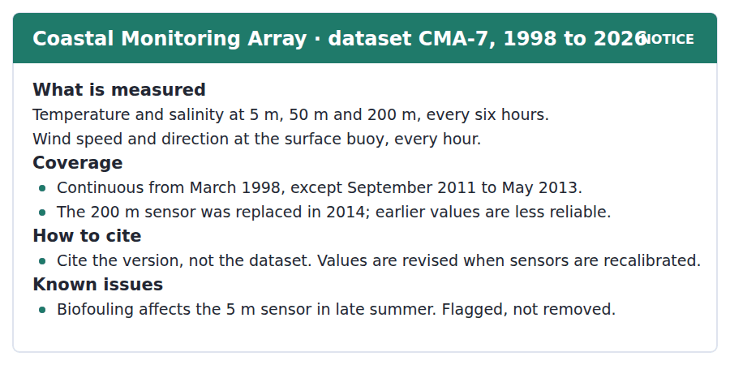
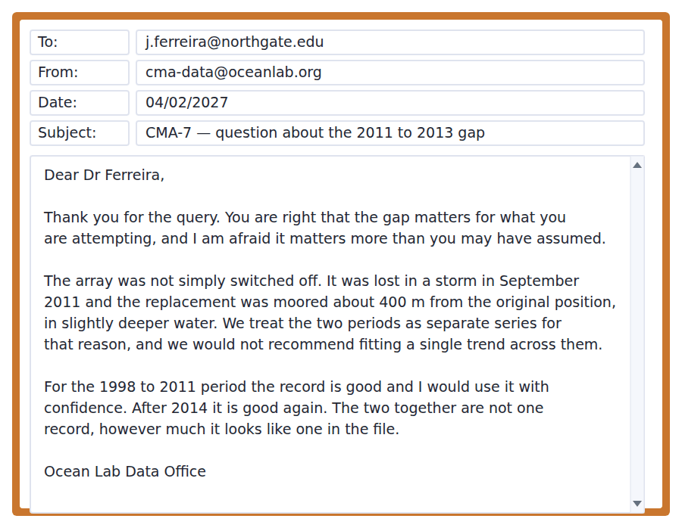
Exercise A Guided practice. The answer is on the page — find it.
1. At how many depths are temperature and salinity measured?
(A) Three
(B) One
(C) Two
(D) Six
2. How often is wind recorded?
(A) Every six hours
(B) Every hour
(C) Daily
(D) Only in summer
3. What should be cited?
(A) The dataset
(B) The sensor
(C) The version
(D) The mooring position
4. What is done about biofouling?
(A) The data are removed
(B) The sensor is cleaned weekly
(C) Nothing is done
(D) The data are flagged
Exercise B Exam practice.
5. What is the main point of the email?
(A) The gap can be interpolated
(B) The two periods are not one record
(C) The dataset should not be used
(D) The sensors were poorly maintained
6. Why were the two periods separated?
(A) The replacement was moored elsewhere, in deeper water
(B) The sensors were different
(C) The funding changed
(D) The storm damaged the earlier data
7. What does Dr Ferreira appear to have wanted to do?
(A) Replace the array
(B) Publish the raw data
(C) Compare two depths
(D) Fit a single trend across the whole record
8. Which period does the data office recommend using with confidence?
(A) 1998 to 2011 only
(B) 2014 onwards only
(C) Both, but separately
(D) Neither
9. What is implied by "however much it looks like one in the file"?
(A) The file is corrupted
(B) The data were falsified
(C) The file is too large
(D) The file format hides the discontinuity
10. Why are values revised?
(A) Users report errors
(B) Sensors are recalibrated
(C) The format changes
(D) New depths are added
11. What does the 200 m note in the notice affect?
(A) Data after 2014
(B) Wind data
(C) Data before 2014
(D) Surface data


SKILL · Reading a before-and-after comparison
- A B2 passage often sets an old method against a new one. Expect a sentence naming what was given up and what was gained.
- The old method is rarely dismissed. Look for a sentence saying it was not wrong, only limited.
- The last paragraph usually says what is still missing.

How to Weigh an Ocean
Until the late 1990s almost everything known about the deep ocean came from ships. A research cruise would stop, lower an instrument, record a column of temperature and salinity, and move on. The result was a set of vertical lines through a moving fluid, taken years apart and mostly in summer, mostly in the north, and mostly where it was convenient to sail. The picture built from them was not wrong. It was thin in exactly the places where the ocean does the most interesting things.
The array that replaced this approach works on a different principle. Several thousand floats drift at depth, rise to the surface every ten days, transmit a profile, and sink again. No float is steered and none is recovered. What the system gives up is control over where the measurements are taken; what it gains is that measurements are taken everywhere, continuously, in all seasons. It is now standard, and the comparison with the ship record is instructive: broadly speaking, the old picture was right about the mean state and wrong about how much the mean varies.
Two limits remain. The floats park at a fixed depth and cannot sample the deepest water, which is estimated to hold a large share of the heat that has entered the ocean in the last century. And the region beneath sea ice is poorly understood, because a float that surfaces under ice cannot transmit. Proposals to extend the array downwards and polewards are technically ready and financially stalled, which is a familiar pattern: the cost of filling the last gaps always seems improbable until the gap turns out to matter.
[272 words]

Exercise A Guided practice.
1. What was the main problem with ship-based measurement?
(A) The coverage was uneven in space and season
(B) The instruments were inaccurate
(C) Ships were too slow
(D) The records were lost
2. How often does a float transmit a profile?
(A) Every day
(B) Every six hours
(C) Every ten days
(D) Once a year
3. What does the float system give up?
(A) Accuracy
(B) Continuous operation
(C) Coverage in winter
(D) Control over where measurements are taken
4. The word "instructive" in the second paragraph is closest in meaning to
(A) confusing
(B) revealing
(C) expensive
(D) routine
Exercise B Exam practice.
5. What does the author say about the old picture of the ocean?
(A) It was right about the mean and wrong about variability
(B) It was wrong throughout
(C) It was never published
(D) It was better than the new one
6. Why can floats not sample the deepest water?
(A) They park at a fixed depth
(B) The pressure destroys them
(C) They are too few
(D) The signal cannot reach the surface
7. Why is the region under sea ice poorly covered?
(A) Ships cannot reach it
(B) Floats cannot transmit from under ice
(C) The water is too cold
(D) There is no funding for it
8. What is described as "technically ready and financially stalled"?
(A) The float array
(B) Ship-based cruises
(C) Sea-ice monitoring
(D) Proposals to extend the array deeper and towards the poles
9. What does "a familiar pattern" refer to?
(A) Floats failing under ice
(B) Ships sampling in summer
(C) Funding arriving only after a gap proves important
(D) Sensors being recalibrated
10. What is the author’s attitude to the float array?
(A) Positive but aware of what it still misses
(B) Sceptical
(C) Indifferent
(D) Opposed on cost grounds
11. All of the following were limits of ship sampling EXCEPT:
(A) Uneven seasonal coverage
(B) Uneven geographic coverage
(C) Poor instrument accuracy
(D) Long gaps between visits
12. "Is estimated to hold" signals that the deep-heat figure is
(A) precisely known
(B) disputed by most researchers
(C) not yet measured at all
(D) a number carrying uncertainty
13. What would most undermine the case for extending the array?
(A) Evidence that float costs are falling
(B) Evidence that the deepest water holds little of the added heat
(C) Evidence that sea ice is shrinking
(D) Evidence that ships are still used


Exercise A Listen and choose a response. You hear one line. Choose the best reply.
1. Man: So the deep water is moving fast?
(A) Yes, very fast.
(B) About four metres.
(C) The opposite — it takes about a thousand years.
(D) It is deep water.
2. Woman: What makes the water sink in the first place?
(A) About two kilometres.
(B) Yes, it sinks.
(C) In the North Atlantic.
(D) It gets cold and salty, so it gets dense.
3. Man: Is this the same thing as the tides?
(A) No, completely different — tides are the moon.
(B) Yes, roughly.
(C) Twice a day.
(D) The tide is coming in.
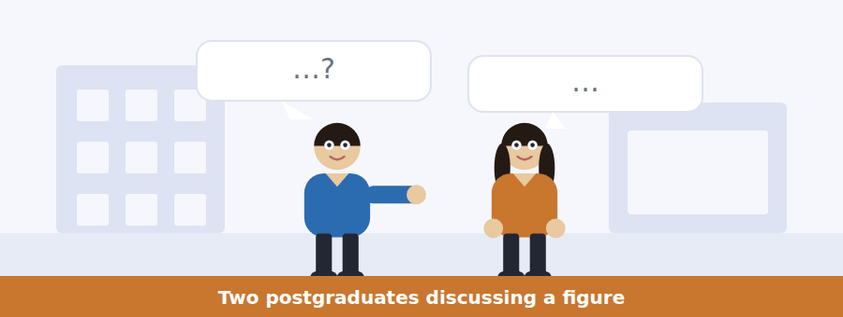
SKILL · Hearing a misunderstanding being unpicked
- One speaker has the wrong model and the other works out why. The items ask what the wrong model was.
- Listen for the moment of diagnosis: oh, I see what you are thinking.
- The correction usually comes with an analogy.

Exercise B Listen and answer. The audio plays once.
4. What did the man initially misunderstand?
(A) The direction of the current
(B) What the arrows on the figure represent
(C) The depth of the ocean
(D) Where the water sinks
5. What does the woman compare the circulation to?
(A) A conveyor belt
(B) A whirlpool
(C) A very wide, very slow river
(D) A pump
6. Why might the sinking stop?
(A) The water gets too warm
(B) The surface water gets fresher and less dense
(C) The wind changes direction
(D) The basin fills with sediment
7. What two sources of fresh water does the woman name?
(A) Rivers and ice melt
(B) Rainfall and rivers
(C) Ice melt and storms
(D) Ice melt and increased rainfall
8. Why does the woman object to the word "slowing"?
(A) It misdescribes what the models show
(B) The system is speeding up
(C) It is too technical
(D) It applies only to surface currents
9. What does the woman find "uncomfortable"?
(A) The cost of monitoring
(B) That the confirming measurement may come too late
(C) That the models disagree
(D) That the public is not interested
10. What is the woman’s role in the conversation?
(A) She is correcting and then extending his picture
(B) She is asking for help
(C) She disagrees with the figure
(D) She is reading from notes
Audio script: see the back of the book. Do not read it before you listen.


Exercise A Listen and choose a response. You hear one line. Choose the best reply.
1. Woman: What time do we actually sail?
(A) From berth nine.
(B) Yes, on Tuesday.
(C) It takes four days.
(D) Six, and the gangway closes at half five.
2. Man: Should I take the tablets now or wait?
(A) They are in the mess.
(B) About two a day.
(C) Before you sail — afterwards is too late.
(D) Yes, they work.
3. Woman: Is there internet on board?
(A) Yes, in the lab.
(B) About eight people.
(C) A satellite link, shared, and slow.
(D) It costs nothing.
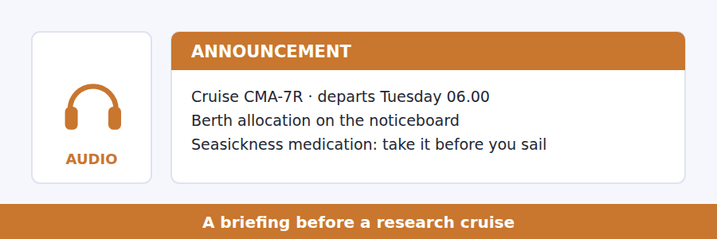
SKILL · Hearing priorities inside a list
- A B2 announcement often lists several items and marks one as the important one.
- Listen for the ranking: the one that matters, above all, if you remember nothing else.
- That item is almost always tested, and the others are distractors.

Exercise B Listen and answer. The audio plays once.
4. What time does the gangway close?
(A) Five
(B) Half past five
(C) Six
(D) Half past six
5. What does the speaker say about the satellite link?
(A) It is unavailable
(B) It costs money
(C) It works only in port
(D) It is shared and slow
6. When should seasickness medication be taken?
(A) Before sailing
(B) When symptoms start
(C) Only if needed
(D) Each morning
7. Which item does the speaker say matters most?
(A) Arriving on time
(B) Logging every instrument before deployment
(C) The berth allocation
(D) The medication
8. Why does the speaker mention a cruise from two years ago?
(A) To praise the crew
(B) To explain the berth system
(C) To describe the route
(D) To give the cost of not logging properly
9. What does the speaker mean by "the log is not administration — it is the measurement"?
(A) The log replaces the instruments
(B) The log is checked by administrators
(C) Without the log the readings cannot be used
(D) The log should be written after each watch
Audio script: see the back of the book. Do not read it before you listen.


Exercise A Listen and choose a response. You hear one line. Choose the best reply.
1. Woman: How many floats are there?
(A) Several thousand, drifting freely.
(B) About ten days.
(C) Yes, quite a few.
(D) In the Atlantic.
2. Man: Can the floats be steered?
(A) Yes, from shore.
(B) About two kilometres down.
(C) They are expensive.
(D) No, and that is deliberate.
3. Woman: What happens to a float under sea ice?
(A) It melts the ice.
(B) It cannot transmit, so the profile is lost.
(C) About every ten days.
(D) Yes, that is a problem.
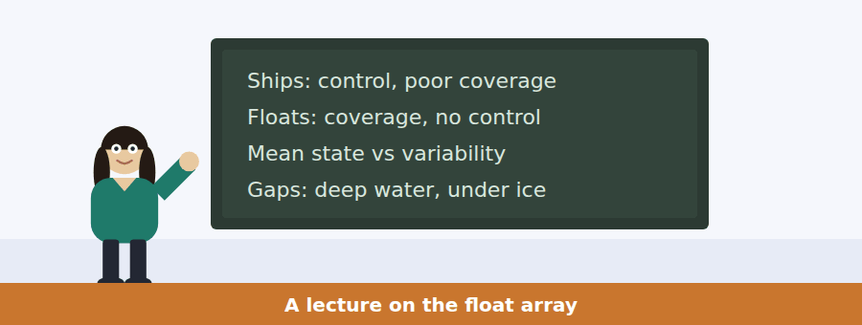
SKILL · Following a talk organised as a trade-off
- Many B2 talks are built on one exchange: what was given up against what was gained.
- Hold both halves. Items frequently ask for the cost rather than the benefit.
- The conclusion is usually that the trade was worth making, with a named exception.

Exercise B Listen and answer. The audio plays once.
4. What did ship-based measurement provide?
(A) Control over where and when
(B) Coverage
(C) Continuous records
(D) Measurements under ice
5. What does the speaker mean by "systematically unrepresentative"?
(A) The measurements were inaccurate
(B) The record was incomplete
(C) The sampling was biased in a consistent way
(D) The instruments differed
6. What is the trade the float array makes?
(A) Control for coverage
(B) Accuracy for cost
(C) Depth for duration
(D) Speed for precision
7. What was the ship record wrong about?
(A) The average state
(B) The depth
(C) The salinity
(D) The variability
8. Why is under-ice sampling the harder problem?
(A) The water is colder
(B) Floats are crushed by ice
(C) A float there cannot transmit its profile
(D) Ships cannot deploy there
9. What does the speaker say about regions that are poorly understood?
(A) They are unimportant
(B) They are where the surprises live
(C) They are too expensive to study
(D) They are being covered now
10. What is the speaker’s overall verdict on the trade?
(A) It was a mistake
(B) Too early to say
(C) Overwhelmingly worth it, with two named limits
(D) Worth it only in the tropics
Audio script: see the back of the book. Do not read it before you listen.


Part 1 · Listen and Repeat
You hear a sentence and repeat it once. There is no preparation time, and the sentences get longer. Focus: keeping the preposition with its relative pronoun
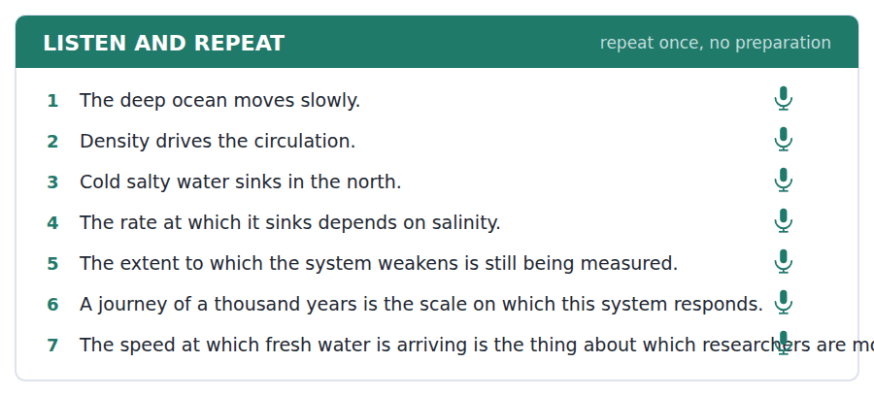
SKILL · Repeating a sentence with a prepositional relative
- The rate at which, the extent to which, the degree to which — these arrive as one block in speech.
- Do not pause between the preposition and which. The pause belongs before the whole phrase.
- Practise until the block comes out whole.

Part 2 · Take an Interview
An interviewer asks you four questions on one theme: slow processes and short attention. Answer each one fully. There is no preparation time.
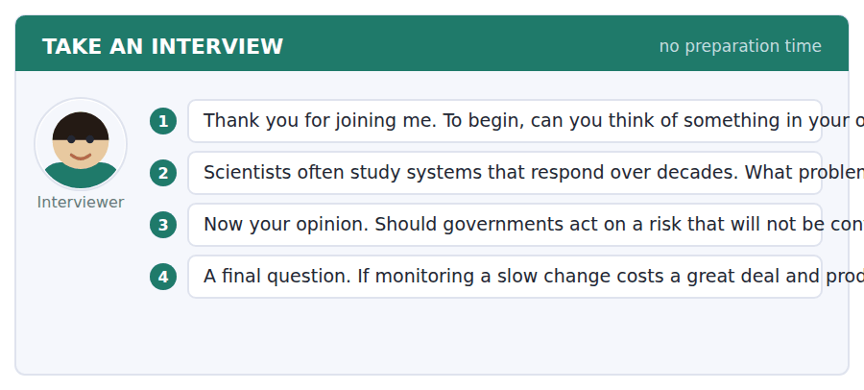
A good answer sounds like this
Question 2 — The main problem is that nothing looks urgent until it is too late to act gradually. By the time a signal is unambiguous, the cheap options have usually gone.
Question 4 — I would justify it the way you justify a smoke alarm. Most of what it produces is silence, and the value is entirely in the one occasion when it is not silent.
I can… | Not yet | Yes
I kept the preposition and which together. | □ | □
I did not pause inside the phrase. | □ | □
I gave an example rather than only a generalisation. | □ | □


Part 1 · Listen and Repeat
You hear a sentence and repeat it once. There is no preparation time, and the sentences get longer. Focus: saying approximate quantities precisely
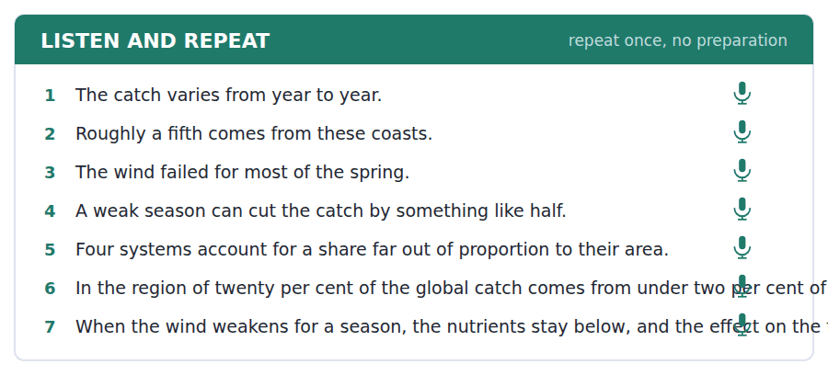
SKILL · Being vague on purpose
- A B2 speaker who does not know a number should still sound precise about how vague they are.
- On the order of, in the region of, roughly, somewhere between — each commits to a different width.
- Never say about and then give three decimal places.

Part 2 · Take an Interview
An interviewer asks you four questions on one theme: fishing, livelihoods and uncertain forecasts. Answer each one fully. There is no preparation time.
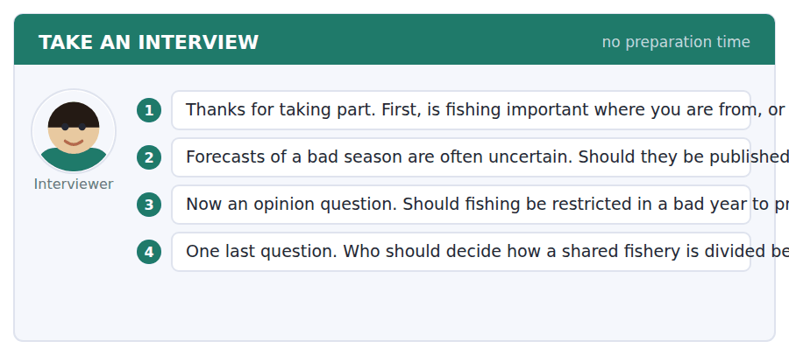
A good answer sounds like this
Question 2 — Yes, with the uncertainty stated plainly. Withholding a forecast protects nobody; people simply make the decision with less to go on.
Question 3 — I would restrict, but I would pay for it. A restriction that takes away this year’s income to protect a stock everybody shares is a public good bought with private money, and that rarely holds.
I can… | Not yet | Yes
I matched the vagueness of the phrase to my actual confidence. | □ | □
I did not give a precise figure I was unsure of. | □ | □
I answered the whole question. | □ | □


Part 1 · Listen and Repeat
You hear a sentence and repeat it once. There is no preparation time, and the sentences get longer. Focus: stating a trade-off out loud in one sentence
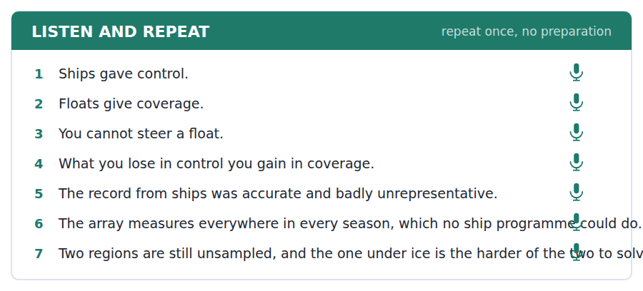
SKILL · Expressing a trade-off
- The pattern is: we give up X and we get Y. Say it in one sentence, with the stress on both nouns.
- What you lose in control you gain in coverage. The symmetry carries the meaning.
- Then say whether it was worth it. A trade-off stated without a verdict sounds like indecision.

Part 2 · Take an Interview
An interviewer asks you four questions on one theme: measurement, money and what we choose not to know. Answer each one fully. There is no preparation time.
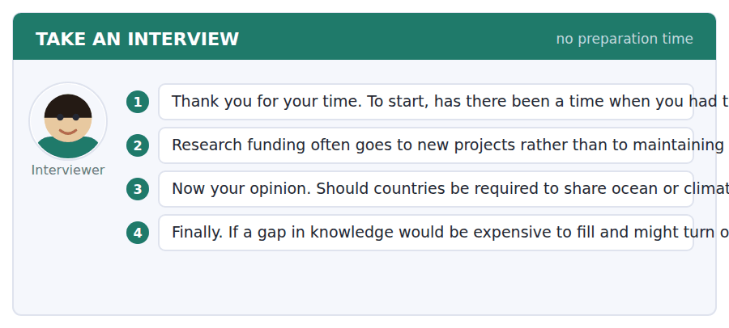
A good answer sounds like this
Question 2 — Partly because a new project has a story and a maintained record does not. Nobody announces that the measurements continued, so the funding for continuing is always the easiest thing to cut.
Question 4 — I would fill it, on the grounds that you cannot tell in advance which gap mattered. That is the whole difficulty: the argument for filling it is only available after you have filled it.
I can… | Not yet | Yes
I stated the trade-off in a single sentence. | □ | □
I then gave a verdict on it. | □ | □
I used a hedge that matched my confidence. | □ | □


You see a sentence, then a set of words in boxes. Put the words in order to make one grammatical sentence. Almost every item in the real test makes a question or a question inside another sentence.
SKILL · Build a Sentence with a prepositional relative
- Two of the ten items will build a relative clause rather than a question. Those are where the prepositions live.
- The preposition goes before which, not at the end, in anything written: the rate at which, not the rate which it happens at.
- A tile reading at which or to which is one block and sits immediately after its noun.

Exercise A Guided practice. The first three are worked through.
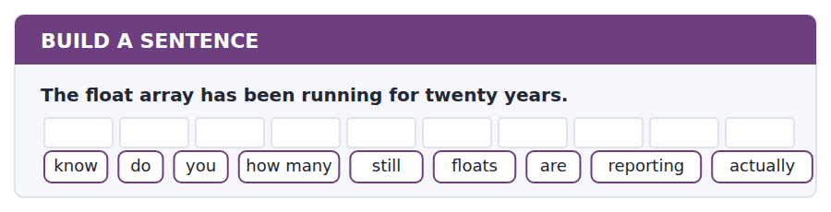
1. Do you know how many floats are actually still reporting?
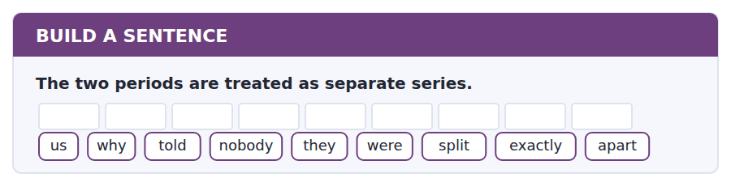
2. Nobody told us exactly why they were split apart.
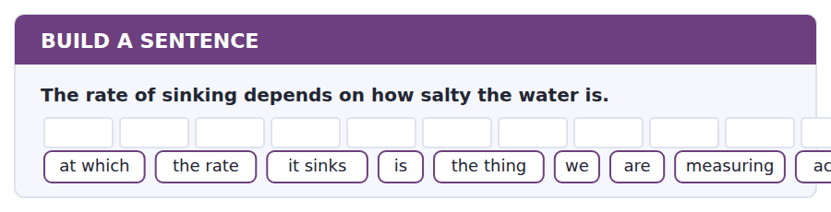
3. The rate at which it sinks is the thing we are actually measuring.
Exercise B Exam practice. Write the sentence.
4. The replacement mooring was 400 metres away.
whether / do / know / you / that / the record / affects / much / very
__________________________________________________________
5. A float under ice cannot transmit.
to which / the extent / do / you / know / this / actually / matters / at all
__________________________________________________________
6. The 200 metre sensor was replaced in 2014.
know / does / anybody / whether / the old / values / were / recalibrated / ever
__________________________________________________________
7. The cruise log must be filled in before deployment.
can / me / remind / you / what / goes / in it / exactly / again
__________________________________________________________
8. The deep water may hold most of the added heat.
to know / nobody / seems / how much / of it / is / down there / actually / still
__________________________________________________________
9. The gangway closes half an hour before we sail.
told / she / us / when / we / had / to be / on board / exactly
__________________________________________________________
10. The array cannot be steered.
at which / the speed / they / drift / is / something / nobody / controls / at all
__________________________________________________________


You read a short situation and write an email. You have 7 minutes. The three bullet points are the mark scheme: answer all three.
You are using dataset CMA-7 for a dissertation. The 5 m temperature values for July and August 2019 are flagged for biofouling but have not been removed. Your supervisor says you must decide whether to use them and justify the decision. You need to know how bad the fouling was before you can decide.
Write an email to the data office.
- Say exactly which values you mean.
- Explain what you need to know and why.
- Ask a question they can answer briefly.
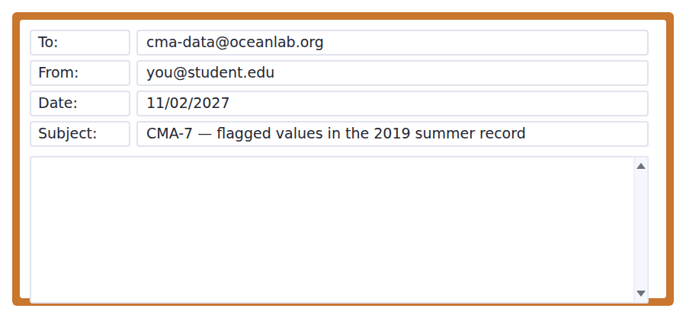
SKILL · Asking a technical question well
- Identify the data precisely — dataset, version, depth, dates. A vague question gets a vague answer or none.
- Say what you intend to do with the answer. It lets the expert tell you something more useful than what you asked for.
- Ask something answerable in two lines, and say that you have looked first.

Model email
Dear Data Office,

I am using CMA-7, version 4.2, for an undergraduate dissertation on summer stratification, and I have a question about the 5 m temperature record for July and August 2019.

Those values carry the biofouling flag but are present in the file. I have read the notes and I understand the policy is to flag rather than remove. What I cannot tell from the documentation is how large the effect was in that particular summer — whether the fouling shifted readings by hundredths of a degree or by something that would change a stratification index.

I am trying to decide whether to use those two months or treat them as missing, and I have to justify the choice in the write-up either way.

Is there a post-recovery comparison for the 2019 deployment that would give me a rough magnitude? Even an order of magnitude would settle it.

With thanks for your time,
Joana Ferreira
Why it works
- The data are identified exactly: dataset, version, depth, months.
- It says what has already been read, so nobody repeats the documentation.
- It explains the decision the answer will feed, which lets the expert answer the real question.
- The request is bounded — even an order of magnitude would settle it.
Two answers, one band apart
Both answer the three bullet points. One would score in the middle band and one near the top. Read them side by side before you write your own.
A middle-band answer | A top-band answer
Dear Data Office,  I am a student using your CMA-7 dataset for my dissertation and I have a question about some of the data. Some of the temperature values in summer 2019 have a flag on them for biofouling but they are still in the file, which is confusing.  I would like to know whether I should use these values or not. My supervisor has asked me to decide and I am not sure what the right thing to do is. It would be very helpful if you could advise me on this.  Could you please let me know what you think? I am working on summer stratification so the surface temperatures are quite important for my analysis. Thank you very much for your time and help.  Best wishes, Joana Ferreira | Dear Data Office,  I am using CMA-7, version 4.2, for a dissertation on summer stratification, and I have a question about the 5 m temperature record for July and August 2019.  Those values carry the biofouling flag but are present in the file. I have read the notes and understand the policy is to flag rather than remove. What I cannot tell is how large the effect was that summer — hundredths of a degree, or enough to change a stratification index.  I am deciding whether to use the two months or treat them as missing, and I must justify the choice either way.  Is there a post-recovery comparison for the 2019 deployment that would give a rough magnitude? Even an order of magnitude would settle it. With thanks, Joana Ferreira

What the top answer does that the other does not
- It names the version, depth and exact months, so the data office can look up the answer instead of writing back to ask which values are meant.
- It states what has already been read, which stops the reply being a link to the documentation.
- It asks a question with a bounded answer — an order of magnitude — rather than asking what somebody thinks.
- It gives the decision the answer feeds, so the expert can volunteer the thing the writer did not know to ask for.
- It never asks to be told what to do, which keeps the judgement with the student where the supervisor put it.
Now write your own. 7 minutes.
__________________________________________________________
__________________________________________________________
__________________________________________________________
__________________________________________________________
__________________________________________________________
__________________________________________________________
__________________________________________________________
__________________________________________________________


A professor asks a question and two students answer. You add your own post. You have 10 minutes and an effective answer is at least 100 words.
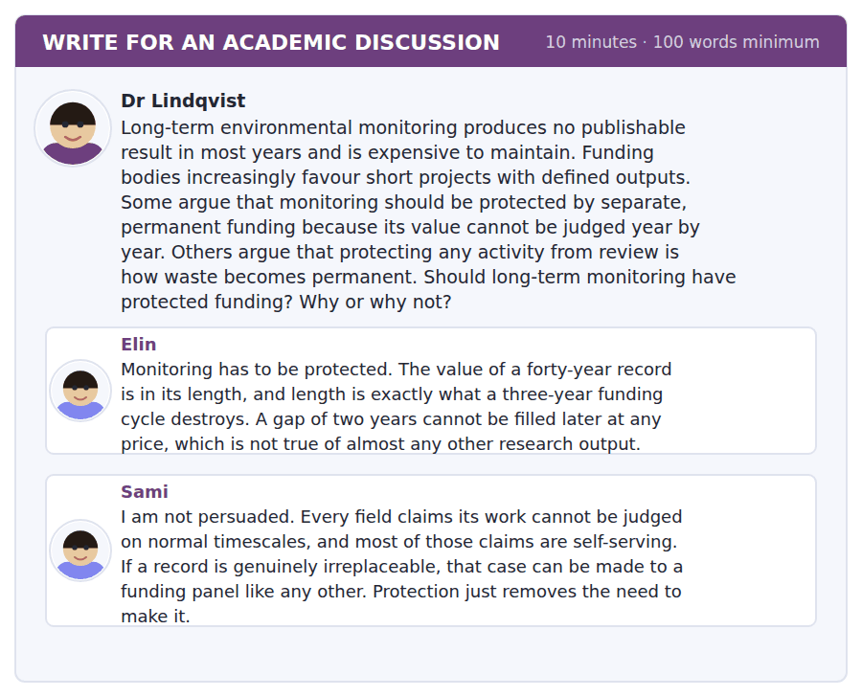
SKILL · Using a technical fact as an argument
- The highest-value move in a discussion post is a specific fact the other posters did not have.
- It must do work. A fact that merely decorates your position does not raise the score.
- Introduce it plainly: there is a technical point neither post mentions.

Sentence starters
- There is a point neither post makes, which is that…
- Elin is right that…, and the reason is stronger than she gives.
- Sami’s test is the right one, but applied properly it gives…
- The distinction that matters is between… and…
Model post
There is a point neither post makes, and it decides the question. A gap in a monitoring record is not merely missing data. It breaks the continuity that makes the rest of the record interpretable. When the coastal array I work with lost two years to a storm, the replacement was moored four hundred metres away, and the data office now treats the two halves as separate series that cannot be joined. Twenty-eight years of measurement became two records of thirteen and twelve, and no amount of later funding can recover the missing link.
Elin is right, then, but the reason is stronger than she gives. It is not only that the gap cannot be filled; it is that the gap devalues the data on both sides of it.
Sami’s test is nonetheless the right one, and applied properly it does the work he wants. If irreplaceability is the criterion, then it is a factual question about each record, and most monitoring would fail it. Broadly speaking, a survey that can be restarted is not in this category at all.
So I would not protect monitoring as a class. I would protect records that meet a stated continuity test, reviewed once a decade rather than every three years. That keeps Sami’s discipline and gives Elin the length she needs.
[219 words]
Now write your own. 10 minutes, at least 100 words.
__________________________________________________________
__________________________________________________________
__________________________________________________________
__________________________________________________________
__________________________________________________________
__________________________________________________________
__________________________________________________________
__________________________________________________________
__________________________________________________________
__________________________________________________________

Grammar focus Relative clauses with prepositions
Pattern | Example
preposition + which | the rate at which the water sinks
preposition + whom | the researcher to whom the sample was sent
preposition + whose | the array on whose data the study depends
quantifier + of which | four systems, three of which lie in the Pacific
the extent / degree to which | the extent to which the system has weakened
end-position preposition (informal) | the rate which it sinks at
no relative pronoun possible | the rate at which it sinks NOT the rate at that it sinks

In academic writing the preposition goes before which or whom. In speech it often goes to the end. Both are correct English; only one is appropriate in an essay.
That can never follow a preposition. If you want to keep that, the preposition must go to the end.
A quantifier takes of which: some of which, most of which, neither of which. This is the neatest way to attach a statistic to a noun.
Watch out! "The extent to which" takes a clause, not a noun. The extent to which the system has weakened, not the extent to which of the weakening. If you cannot finish the clause, you have used the phrase too early.
Exercise 1 Rewrite with the preposition before the relative pronoun.
1. The rate which the water sinks at depends on salt.
2. The researcher who the sample was sent to has replied.
3. The period which the sensor was unreliable during is flagged.
4. The basin which the water returns to is in the Pacific.
5. The scale which this system responds on is a thousand years.
6. The colleague who I wrote to has not answered.
Exercise 2 Join with a quantifier + of which or of whom.
1. There are four upwelling systems. Three lie in the Pacific.
2. Twenty-two people sailed. None had been to sea before.
3. The array has several thousand floats. Most are still reporting.
4. Two periods are flagged. Neither can be joined to the other.
Exercise 3 Complete with the extent to which, the rate at which or the degree to which.
1. ______ the circulation has weakened is still being measured.
2. ______ fresh water is arriving has increased.
3. ______ the two records can be compared is limited.
4. ______ the fishery depends on the wind surprises people.
How this is tested in Build a Sentence
The two non-question items in Build a Sentence are usually relative clauses, and at B2 one of them will carry a preposition. A tile reading at which or of which attaches directly to the noun before it and never floats to the end.
Find the fault 5 errors, drawn from this unit and the two before
Every error below is one a B2 writer makes after learning the rule. Mark what is wrong, then check. Knowing the rule and noticing the breach are two different skills, and only the second one is tested.
The rate at that the water sinks depends on salinity. The extent to which of the weakening is still unclear. There are four systems, three of them lie in the Pacific. The researcher who the sample was sent to have replied. The period which the sensor was unreliable is flagged in the archive.
# | As written | As it should be | Why
1 | at that the water sinks | at which the water sinks | That can never follow a preposition; only which or whom can.
2 | The extent to which of the weakening | The extent to which the system has weakened | The extent to which introduces a clause, not a noun phrase.
3 | three of them lie | three of which lie | Joining two clauses needs of which; of them would start a new sentence.
4 | was sent to have replied | was sent to has replied | The subject is the singular researcher, not the sample next to the verb.
5 | The period which the sensor | The period during which the sensor | The clause needs a preposition: the sensor was unreliable during that period.

Unit review and progress check Unit 24
Exercise A Vocabulary. Write the word.
1. a steady change in something across space
2. containing salt
3. how much mass sits in a given volume
4. deep water rising to the surface
5. a substance living things need to grow
6. the rate at which something flows through
7. the tendency to float or rise
8. to settle into separate horizontal layers
9. material that settles at the bottom
10. a reading that departs from the expected
11. a state in which opposing forces balance
12. the sinking and rising that drives deep flow
Exercise B Grammar. Complete the sentence.
1. The rate ______ which it sinks depends on salt.
2. The researcher ______ whom the sample was sent has replied.
3. Four systems, three ______ which lie in the Pacific.
4. The ______ to which it has weakened is unclear.
5. The period ______ which the sensor failed is flagged.
6. The scale ______ which this responds is a millennium.
7. Twenty-two sailed, none ______ whom had been to sea.
8. The basin ______ which the water returns is in the Pacific.
Exercise C One timed mini-section. 6 minutes.
1. Deep water sinks because it is
(A) cold and salty
(B) warm and fresh
(C) shallow and still
(D) rich in nutrients
2. Upwelling brings deep water up because wind
(A) pushes water ashore
(B) pushes surface water offshore
(C) warms the surface
(D) stops the current
3. The float array gives up
(A) accuracy
(B) seasonal coverage
(C) continuous operation
(D) control over where measurements are taken
4. Which is correct in academic writing?
(A) the rate at that it sinks
(B) the rate which it sinks at that
(C) the rate at which it sinks
(D) the rate what it sinks at
5. "Is estimated to" tells you the number is
(A) exact
(B) carrying uncertainty
(C) disputed
(D) unmeasured
6. The ship record was wrong mainly about
(A) the average state
(B) the salinity
(C) the depth
(D) how much the average varies
Can you do these now?
I can… | Not yet | Yes
I can follow a description of a process with several linked stages. | □ | □
I can use a preposition inside a relative clause correctly. | □ | □
I can write "the extent to which" without losing the sentence. | □ | □
I can read a dataset description and say what it cannot support. | □ | □
I can express approximate quantity precisely. | □ | □
I can write an email that reports a problem I did not cause. | □ | □

ADAPTIVE TIP "The extent to which" is the most useful phrase in academic English and the one B2 writers most often strand. It needs a full clause after it. If you find yourself writing the extent to which of, stop and ask what the system actually did — then write that as a clause.

Unit 25 · Statistics and Evidence
TOEFL iBT® Preparation Course 2026 · Volume 3
CEFR B2 · Grammar: Quantification and approximation · Word field: variance, confound, replicate
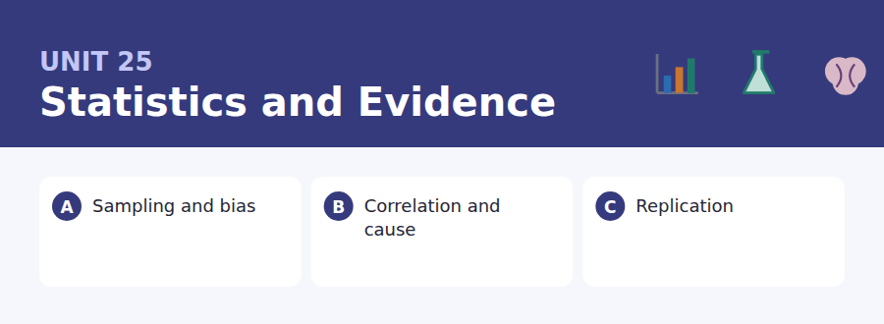
By the end of this unit I can…
- I can identify what a study design can and cannot establish.
- I can express an approximate quantity at the right level of vagueness.
- I can explain why a correlation is not a cause, in one sentence.
- I can read a result and ask the right question about the sample.
- I can qualify a number without sounding evasive.
- I can write a post that supplies a fact the others lacked.

Every argument you will read for the rest of your life rests on evidence, and most of the evidence is quantitative. This unit teaches you to read a claim about numbers without either believing it or dismissing it — and to write about quantity with the precision English expects.

Vocabulary 1 · Academic word families 18 families, not 18 words
At B2 the word on its own is not enough. Each entry below is a family: learn the noun, the verb and the adjective together, because the test will use whichever one the sentence needs.
variance how spread out a set of values is | skew a distribution with a long tail on one side
confound a hidden variable that explains both others | outlier a value far from the rest
replicate to repeat a study and see if it holds | cluster a group of cases close together
assign to put participants into groups | median the middle value when all are ordered
placebo a dummy treatment used for comparison | dispersion the general spread of a distribution
attrition participants dropping out before the end | calibrate to set an instrument against a known standard
spurious looking real but produced by something else | underpowered too small to detect the effect being sought
robust holding up when the method is varied | preregister to publish the plan before collecting data
magnitude how big an effect is, not whether it exists | effect size how much difference the treatment made

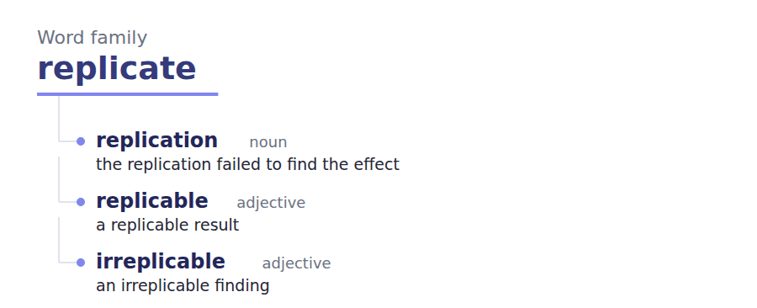
Exercise A Work in pairs. Ask and answer.
1. Describe a statistic you have seen used misleadingly.
2. Why does a bigger sample not fix a biased one?
3. When is an average worse than useless? Give a case.
4. Should journalists be required to state a sample size?
Vocabulary 2 · Collocation 10 partnerships that actually occur
A word is known when you know what it goes with. These ten are the partners this unit’s texts use; the wrong partner is what marks an answer as translated.
control for to remove the influence of | the bulk of most of
account for the variance to explain the spread in the data | fall within to be inside a stated range
at best under the most favourable reading | give or take approximately, in either direction
on average taking all cases together | bear in mind to keep in view while judging
a handful of a very small number of | amount to to add up to, in effect

Vocabulary 3 · Stance and hedging How far the writer commits
Every one of these says the same thing at a different strength. Reading, you must notice which was chosen. Writing, you must choose.
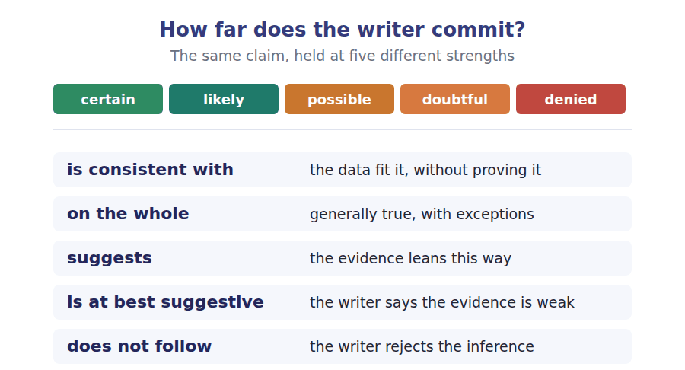
Two words that look alike
average / median the mean / the middle value
significant / large unlikely to be chance / big enough to matter
accuracy / precision close to the truth / consistent with itself

Words you will meet again: selection bias | control group | confidence interval | sample size | statistical significance | publication bias | raw data | meta-analysis


SKILL · Suffixes on abstract nouns and adverbs
- Most gaps here are -ly on an adverb or -tion / -ence on a process noun.
- If the gap follows a verb and ends the clause, it is almost certainly an adverb.
- If it follows the or a and precedes of, it is a noun.

Exercise A Guided practice. Five words are not complete. Write the missing letters.
A sample is useful only if the way it was chosen has no connection to the thing being measured. That sounds obvious and is violated constant--. A survey of reading habits conducted in a library will overstate how much people read, not because the researchers are careless but because the recruitment method and the outcome are relat--. The technical name for this is selection bias, and it cannot be fixed by increasing the sample s---. A larger biased sample is a more confid--- wrong answer. What fixes it is changing how people enter the study, which is usually harder and always more expen----.

The first one is done for you: constantly is constantly — it modifies the verb violated, so it must be an adverb.
Exercise B Exam practice. One paragraph, ten gaps — the real task.
Two variables that rise and fall together are correl----, and correlation is a fact about the numbers rather than about the world. Three explanations are always available and the data alone cannot choose between them. The first is that A causes B. The second is that B causes A, which is more often plaus---- than people expect: hospitals contain sick people, and a careless reading makes hospitals look danger---. The third is that some further variable causes b---, and this is the one that does the real damage, because the further variable is often somet---- nobody thought to record. Ice cream sales and drowning rise together; neither causes the other and both follow the temper-----. The standard way out is to intervene rather than to observe. If the experimenter decides who receives the treatment, by assign--- people at random, then nothing about the person can be correlated with the group they end up in, and the third explanation is removed by construc----. Where intervention is impossible, which covers most questions worth asking about societies, the alternative is to measure the obvious further variables and adjust for th--, while accepting that the variables nobody measured remain a real and unquantifiable risk to the conclu----.

Check your answers in the key at the back of the book.


SKILL · Reading a result and its caveat
- A well-written study report states its own limits. Those sentences are where the questions come from.
- Look for: this design cannot establish, we did not measure, participants were self-selected.
- A report with no limitations section is making a stronger claim than its method supports.

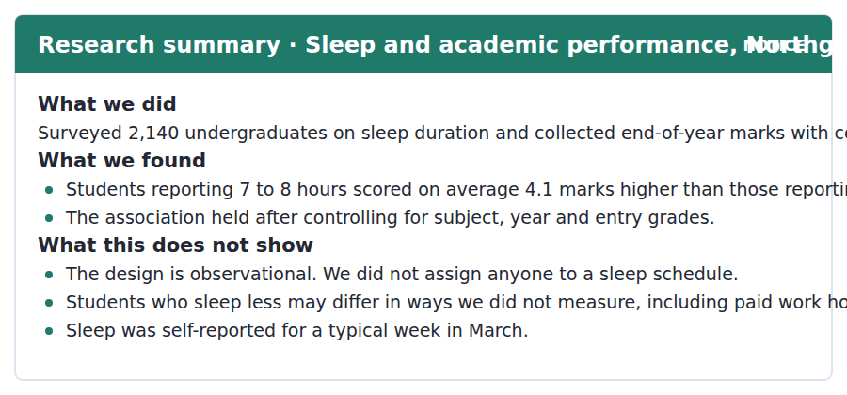
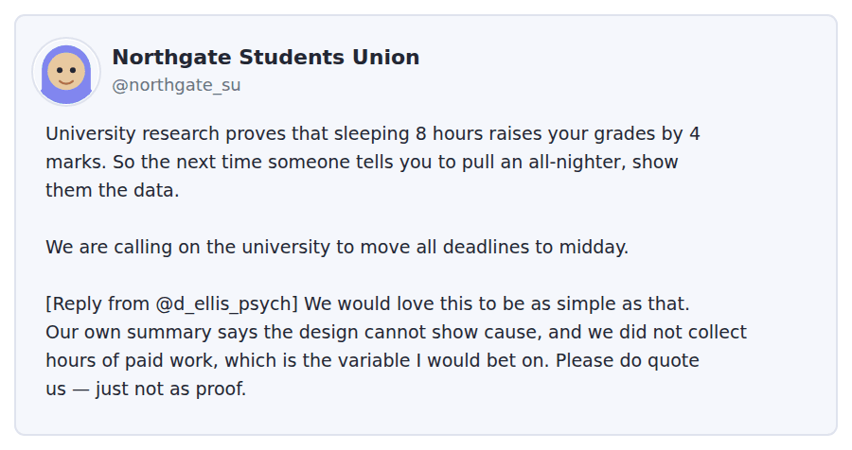
Exercise A Guided practice. The answer is on the page — find it.
1. How many students were surveyed?
(A) 140
(B) 740
(C) 2,140
(D) 4,100
2. What was the difference in average marks?
(A) 6 marks
(B) 7 marks
(C) 8 marks
(D) 4.1 marks
3. What did the researchers control for?
(A) Subject, year and entry grades
(B) Paid work
(C) Sleep quality
(D) Age
4. When was sleep measured?
(A) Across the whole year
(B) For a typical week in March
(C) At the end of the year
(D) Every week
Exercise B Exam practice.
5. What is wrong with the Students Union post?
(A) The figure is incorrect
(B) The sample was too small
(C) It treats an observational finding as proof of cause
(D) It misquotes the researcher
6. Why does Dr Ellis mention paid work?
(A) It was the main finding
(B) It is a variable that could explain both
(C) Students work too much
(D) It was controlled for
7. What does "just not as proof" mean?
(A) Quote it as evidence rather than demonstration
(B) Do not quote the study
(C) The study is unpublished
(D) The figure is provisional
8. What would be needed to show that sleep causes better marks?
(A) A larger survey
(B) Measuring sleep more often
(C) Controlling for subject
(D) Assigning students to sleep schedules
9. Which of the study’s own caveats most undermines the Union’s demand?
(A) Sleep was self-reported
(B) The design cannot establish cause
(C) The survey was in March
(D) Entry grades were controlled
10. What does the phrase "on average" protect the finding from?
(A) The claim that every student improved
(B) The claim that the sample was biased
(C) The claim that sleep was misreported
(D) The claim that marks were inaccurate
11. What is the researcher’s attitude to the Union?
(A) Hostile
(B) Indifferent
(C) Sympathetic but correcting
(D) Supportive of the demand


SKILL · Reading a text that refuses to pick a side
- Some B2 passages set out two readings and decline to choose. Do not look for a winner.
- The author’s own contribution is usually in the last paragraph: what follows whichever reading is right.
- Expect an item asking what the author concludes, with both readings as distractors.

When a Finding Will Not Repeat
In the early 2010s a number of large projects tried to repeat well-known results in psychology, medicine and economics. The headline outcome was that a substantial fraction did not replicate: the second study found a much smaller effect, or none. The reaction divided immediately into two camps, and the division is more interesting than the result.
The first reading is that the original findings were largely false, produced by small samples and by the freedom researchers have when analysing data. On this view the replication projects revealed something that had always been true and was simply not visible. The second reading is that failure to replicate is not the same as falsity. Effects can be real and fragile, depending on conditions the original paper did not record and the replicators could not reproduce. On the whole both readings have cases that fit them, and the difficulty is that the two are hard to tell apart from the outside.
What has changed is not the rate at which findings hold up but the apparatus around them. Preregistration, in which the analysis plan is published before any data exist, removes the freedom that made the first reading plausible. Larger samples remove another. Neither tells you whether a given old result was false or merely fragile, and no procedure can settle that retrospectively. The practical conclusion is uncomfortable and widely resisted: for a result from before this apparatus existed, the honest position is that the evidence is at best suggestive, and that saying so is not an accusation against anybody.
[257 words]

Exercise A Guided practice.
1. What did the replication projects find?
(A) All findings held
(B) Samples were too large
(C) Economics fared worst
(D) A substantial fraction did not replicate
2. What is the first reading of the result?
(A) The effects are real but fragile
(B) The originals were largely false
(C) The replications were poorly done
(D) The field has improved
3. What is the second reading?
(A) Real effects can be fragile and condition-dependent
(B) The originals were fraudulent
(C) Replication is impossible
(D) The projects were too small
4. The word "fragile" in the second paragraph means
(A) false
(B) small
(C) easily broken by changed conditions
(D) recent
Exercise B Exam practice.
5. What does the author find more interesting than the result?
(A) The sample sizes
(B) The choice of fields
(C) The response of journals
(D) The division between the two readings
6. What does preregistration remove?
(A) Small samples
(B) The analytic freedom that makes false positives easy
(C) Publication bias
(D) The need for replication
7. What can the new apparatus NOT do?
(A) Settle whether an old result was false or fragile
(B) Improve future research quality
(C) Increase sample sizes
(D) Make plans public
8. What is the author’s practical conclusion?
(A) Old results should be discarded
(B) Replication projects should stop
(C) Old results are at best suggestive, and saying so blames nobody
(D) Both readings are wrong
9. Why does the author add "and that saying so is not an accusation"?
(A) To protect the replicators
(B) To criticise journals
(C) To introduce a new argument
(D) Because the conclusion is widely resisted as a charge of misconduct
10. What does "on the whole both readings have cases that fit them" imply?
(A) Neither reading is ever right
(B) The first reading is stronger
(C) The two coexist in the literature
(D) The question has been settled
11. All of the following are named as fixes EXCEPT:
(A) Preregistration
(B) Publishing raw data
(C) Larger samples
(D) Nothing else is named
12. What is the author’s tone towards researchers whose work did not replicate?
(A) Accusatory
(B) Dismissive
(C) Admiring
(D) Deliberately non-accusatory
13. Which finding would best support the second reading?
(A) That effects reappear when an unrecorded condition is restored
(B) That replications used smaller samples
(C) That original authors preregistered
(D) That journals reject null results


Exercise A Listen and choose a response. You hear one line. Choose the best reply.
1. Man: I am going to survey people in the library.
(A) The library closes at ten.
(B) Who will you miss by doing that?
(C) Yes, that is a survey.
(D) About two hundred.
2. Woman: How large does the sample need to be?
(A) About the library.
(B) Yes, quite large.
(C) In March.
(D) That depends on the effect you expect.
3. Man: Could I just survey more people instead?
(A) Yes, as many as you like.
(B) It takes about ten minutes.
(C) More of the same people will not help.
(D) The form is online.
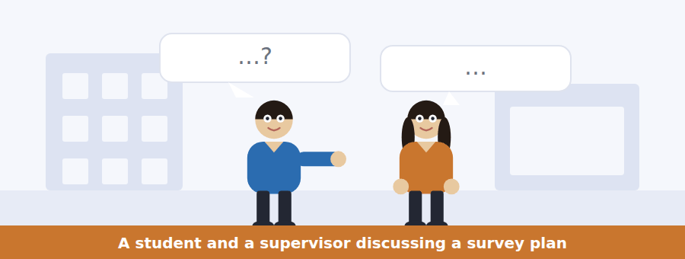
SKILL · Hearing a plan being improved rather than rejected
- A supervisor rarely says no. They ask a question that makes the problem visible.
- Items ask what the problem was, which is usually never named directly.
- The student’s revised plan at the end tells you what they understood.

Exercise B Listen and answer. The audio plays once.
4. What is wrong with surveying in the library?
(A) The place of recruitment relates to the thing measured
(B) The sample is too small
(C) Students are busy there
(D) The library is closed in March
5. What does the man realise about a larger sample?
(A) It takes too long
(B) It is more expensive
(C) It makes him more confident about the wrong number
(D) It would need ethics approval
6. What problem does emailing a course list still have?
(A) People who read are more likely to reply
(B) It is slow
(C) It reaches too few
(D) It needs permission
7. What does the supervisor say a professional does?
(A) Eliminates bias
(B) Avoids surveys
(C) Uses larger samples
(D) Bounds bias and reports it
8. Where should the response rate appear?
(A) In the appendix
(B) In the results
(C) In the method only
(D) It need not be reported
9. What does "you cannot win completely" concede?
(A) The survey should be abandoned
(B) The sample will be too small
(C) Some bias will remain whatever he does
(D) Email is a poor method
10. What is the supervisor’s manner?
(A) Socratic — she asks rather than tells
(B) Dismissive
(C) Impatient
(D) Uninterested in the topic
Audio script: see the back of the book. Do not read it before you listen.


Exercise A Listen and choose a response. You hear one line. Choose the best reply.
1. Woman: Is this session about writing headlines?
(A) Yes, at two o’clock.
(B) About forty people.
(C) In Room B2.
(D) No — it is about what a study can support.
2. Man: Do I need to bring anything?
(A) It lasts an hour.
(B) A story you have already written.
(C) Yes, it is useful.
(D) Room B2.
3. Woman: Is it only for journalism students?
(A) Yes, on Thursday.
(B) About two hours.
(C) Society press officers too.
(D) It is free.
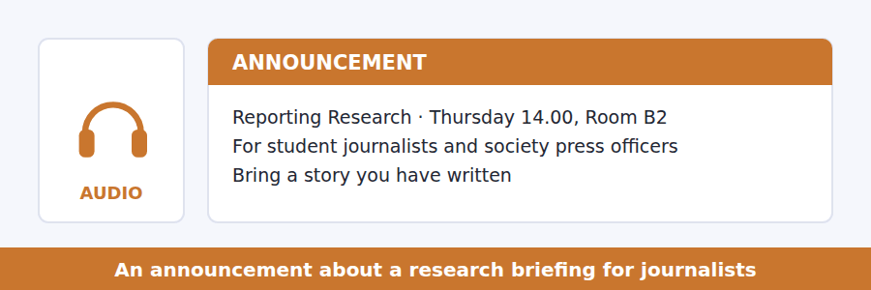
SKILL · Hearing what a session will and will not cover
- A session description that lists exclusions is telling you what the audience usually expects wrongly.
- Listen for: this is not a session about, we will not be covering.
- The exclusion often reveals the real purpose.

Exercise B Listen and answer. The audio plays once.
4. What is the session NOT about?
(A) Study design
(B) Press releases
(C) Real examples
(D) Writing better headlines
5. Why does the speaker reject "be more cautious" as advice?
(A) It is not a skill and produces worse writing
(B) It is too difficult
(C) It is already taught
(D) Editors dislike it
6. What will participants do in the second half?
(A) Write a new story
(B) Apply the method to their own work
(C) Interview a researcher
(D) Read three press releases
7. Who does the speaker particularly encourage?
(A) Journalism students
(B) Researchers
(C) Society press officers
(D) Editors
8. Why does the first version matter most?
(A) It is the longest
(B) Later versions usually follow it
(C) It is the only one researchers see
(D) It is published first
9. What does "went badly wrong in October" refer to?
(A) A session that was cancelled
(B) A complaint from a researcher
(C) A failed study
(D) A real example from this university
Audio script: see the back of the book. Do not read it before you listen.


Exercise A Listen and choose a response. You hear one line. Choose the best reply.
1. Man: So most psychology findings are false?
(A) That is one reading, and it is not the only one.
(B) Yes, about half.
(C) In the 2010s.
(D) Psychology is a science.
2. Woman: What does preregistration actually change?
(A) It is published online.
(B) Yes, it helps.
(C) It fixes the analysis plan before the data exist.
(D) About ten years ago.
3. Man: Can we go back and check the old studies?
(A) Yes, they are archived.
(B) About forty of them.
(C) They were published earlier.
(D) Not in a way that settles it, no.
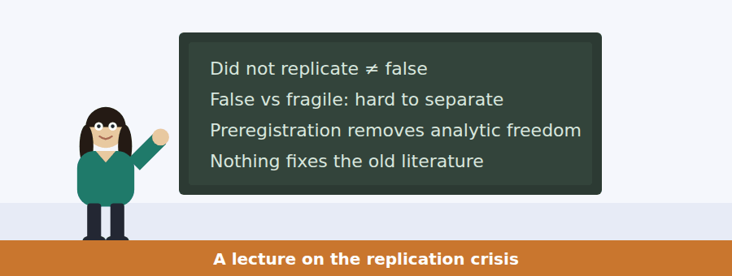
SKILL · Following a talk that resists a popular conclusion
- A B2 lecturer often argues against the version of the story the audience already has.
- Listen for: the way this is usually told; what everybody took from it.
- The correction is the content, and it usually comes with a concession first.

Exercise B Listen and answer. The audio plays once.
4. What does the speaker concede at the start?
(A) That replication is impossible
(B) That analytic freedom produced false effects
(C) That samples were large enough
(D) That the field was dishonest
5. What is the "complication" he introduces?
(A) Failure to replicate fits both falsity and fragility
(B) Replications used different samples
(C) Preregistration is expensive
(D) Journals reject null results
6. What does he say about dishonest intention?
(A) It was common
(B) The effect arises without it
(C) It explains most failures
(D) It cannot be detected
7. What do preregistration and larger samples fix?
(A) The existing literature
(B) Publication bias
(C) The future
(D) Fragile effects
8. What is "the part that people resist"?
(A) That the field improved
(B) That samples were small
(C) That journals are at fault
(D) That nothing can repair the old literature
9. How does the speaker describe old results?
(A) At best suggestive
(B) False
(C) Fully reliable
(D) Fraudulent
10. What does "it does not follow from it that anybody behaved badly" do?
(A) Blocks an inference listeners tend to draw
(B) Introduces a new argument
(C) Concedes the opposite view
(D) Names a specific researcher
Audio script: see the back of the book. Do not read it before you listen.


Part 1 · Listen and Repeat
You hear a sentence and repeat it once. There is no preparation time, and the sentences get longer. Focus: saying numbers and ranges clearly at speed
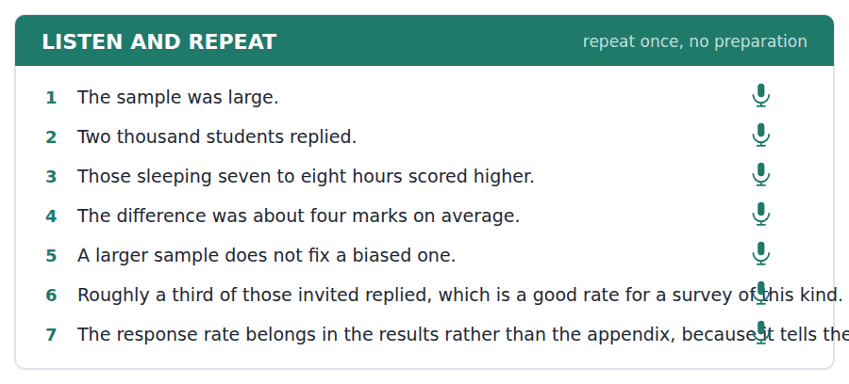
SKILL · Repeating a sentence containing figures
- Numbers are where repetition breaks down. Say the digits at the same pace as the words around them.
- Two thousand one hundred and forty — practise the whole group, not digit by digit.
- A range needs both ends stressed: between SIX and EIGHT hours.

Part 2 · Take an Interview
An interviewer asks you four questions on one theme: surveys, evidence and everyday decisions. Answer each one fully. There is no preparation time.
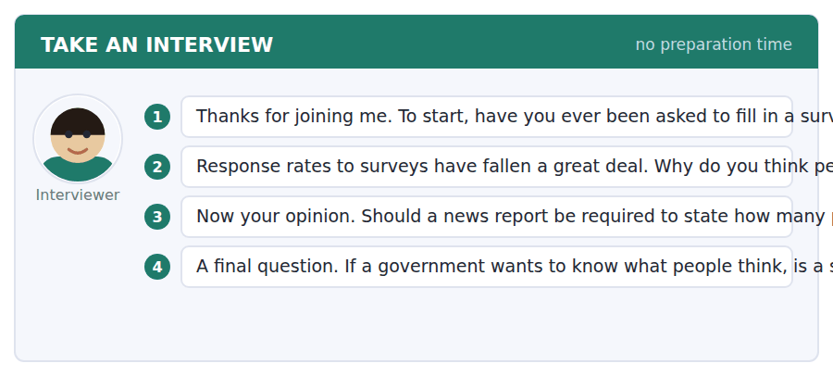
A good answer sounds like this
Question 2 — Partly because we are asked constantly now, and partly because it used to feel like a civic thing and now it feels like marketing. It matters because the people who still answer are not a cross-section.
Question 3 — Yes, and the response rate too. A number without a denominator is not information, and most readers would understand that immediately if it were ever shown to them.
I can… | Not yet | Yes
I said the numbers at the same pace as the rest. | □ | □
I stressed both ends of a range. | □ | □
I gave a reason, not only a position. | □ | □


Part 1 · Listen and Repeat
You hear a sentence and repeat it once. There is no preparation time, and the sentences get longer. Focus: the rising intonation of a hypothetical
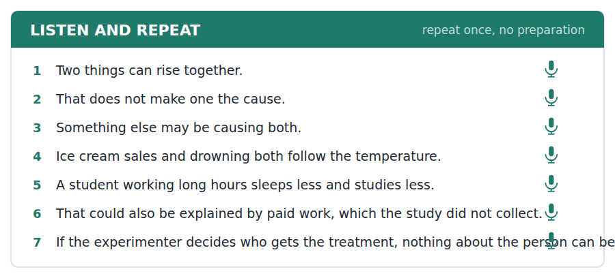
SKILL · Offering an alternative explanation out loud
- The move is: that could also be explained by. Said well it sounds constructive; said badly it sounds like contradiction.
- Keep the intonation open. A falling tone on the alternative makes it a correction rather than a suggestion.
- Always name the variable. A vague other factors adds nothing.

Part 2 · Take an Interview
An interviewer asks you four questions on one theme: evidence in public argument. Answer each one fully. There is no preparation time.
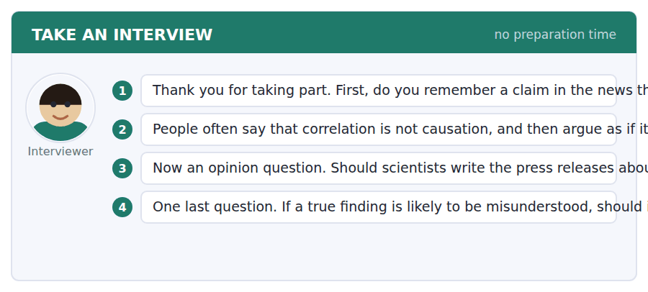
A good answer sounds like this
Question 2 — Because the causal story is usually the interesting one, and the alternative explanations are boring. We remember the story and forget the caveat attached to it.
Question 3 — I would say yes with an editor. Researchers know what the study can support and are frequently terrible at writing a first sentence anybody will read.
I can… | Not yet | Yes
I named a specific alternative variable. | □ | □
I kept the intonation open rather than corrective. | □ | □
I answered the question that was asked. | □ | □


Part 1 · Listen and Repeat
You hear a sentence and repeat it once. There is no preparation time, and the sentences get longer. Focus: pausing to concede, then continuing
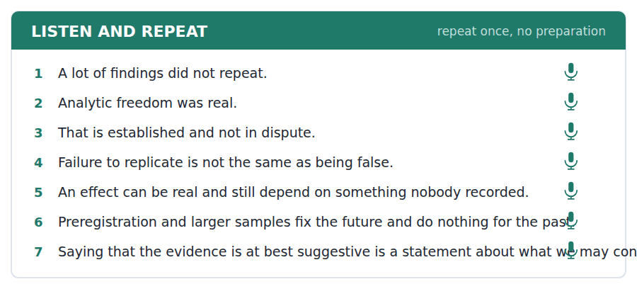
SKILL · Conceding most of an argument and still disagreeing
- The strongest spoken move at B2: grant the bulk of the other case before you narrow it.
- It needs a pause after the concession so the listener registers it.
- Then mark the turn clearly: here is the complication.

Part 2 · Take an Interview
An interviewer asks you four questions on one theme: trust, error and self-correction. Answer each one fully. There is no preparation time.
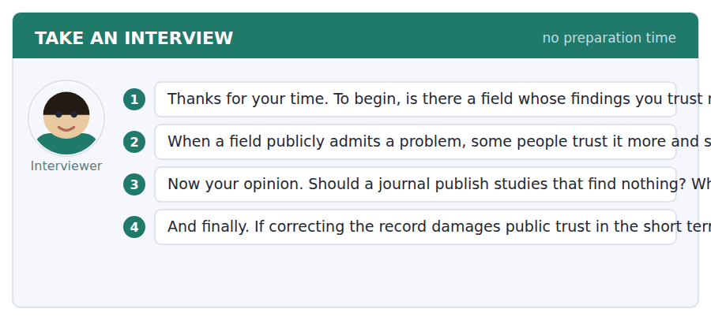
A good answer sounds like this
Question 2 — More, on the whole. A field that can say it got something wrong has a mechanism for finding out, and one that never says it is either perfect or not looking.
Question 3 — Yes, and I would go further: a field that only publishes what worked cannot tell how often things work, which is the number everybody actually needs.
I can… | Not yet | Yes
I conceded clearly before I narrowed. | □ | □
I paused after the concession. | □ | □
I marked the turn so the disagreement was audible. | □ | □

You see a sentence, then a set of words in boxes. Put the words in order to make one grammatical sentence. Almost every item in the real test makes a question or a question inside another sentence.
SKILL · Build a Sentence with a quantity inside
- Several items carry a quantity phrase: how many, how much, what proportion. These behave like any other wh- word.
- The quantity phrase stays together as one block: how much of it, what proportion of them.
- Inside a clause the order is still a statement.

Exercise A Guided practice. The first three are worked through.
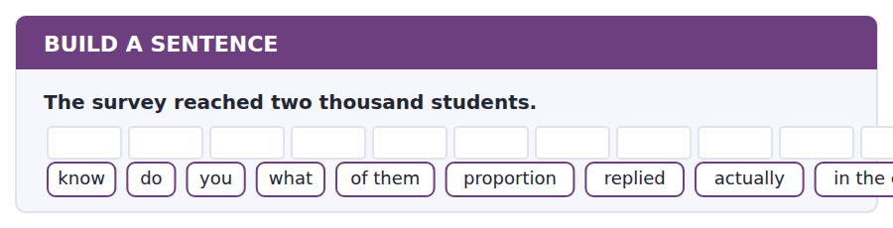
1. Do you know what proportion of them actually replied in the end?
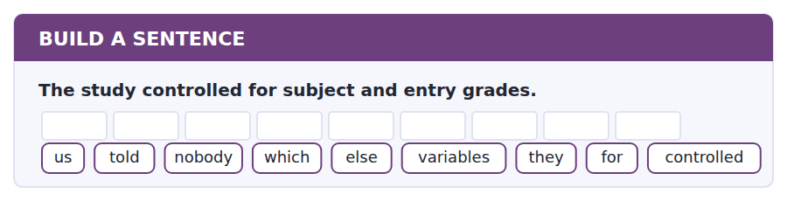
2. Nobody told us which other variables they controlled for.
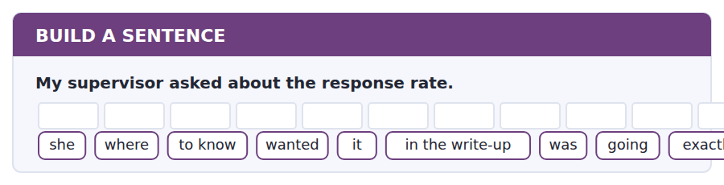
3. She wanted to know exactly where it was going in the write-up.
Exercise B Exam practice. Write the sentence.
4. A substantial fraction of studies did not replicate.
whether / do / know / you / that / means / they / were false / actually
__________________________________________________________
5. The press release said the study proved it.
to know / nobody / seems / who / the first / wrote / version / actually / of it
__________________________________________________________
6. Preregistration fixes the analysis plan in advance.
explain / can / anybody / how / that / helps / exactly / to me / at all
__________________________________________________________
7. The effect was four marks on average.
know / does / anybody / how much / that / varied / between subjects / actually / at all
__________________________________________________________
8. The session is open to press officers too.
told / she / us / why / she / wanted / them / there / particularly
__________________________________________________________
9. Students who sleep less may differ in other ways.
whether / tell / can / me / you / paid work / was / at all / measured
__________________________________________________________
10. The sample came entirely from the library.
the extent / to which / is / that / matters / something / nobody / has / measured
__________________________________________________________


You read a short situation and write an email. You have 7 minutes. The three bullet points are the mark scheme: answer all three.
The Students Union has posted that university research "proves" sleeping eight hours raises grades by four marks, and is using it to campaign for midday deadlines. The research summary says the design cannot show cause. You support the campaign but think the post will be taken apart.
Write an email to the Union communications team.
- Say that you support the campaign.
- Explain precisely what is wrong with the claim.
- Offer wording that keeps the campaign and loses the error.
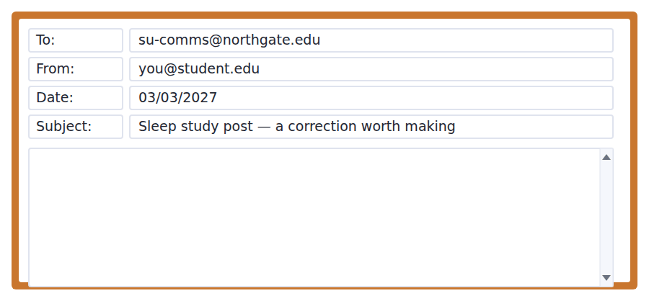
SKILL · Correcting an ally
- Correcting someone on your own side needs the support stated first and meant.
- Frame the problem as a risk to them, not as an error by them: this is what an opponent will say.
- Supply the replacement. An ally who has to rewrite it themselves will usually just defend the original.

Model email
Dear Comms team,

I am writing in support of the deadlines campaign, and about one sentence in Tuesday’s post that I think puts it at risk.

The post says the research proves that sleeping eight hours raises your grades by four marks. The study is a survey: it asked students how long they sleep and looked at their marks. It did not assign anyone to a sleep schedule, and its own summary says the design cannot show cause. The researchers also note that they did not collect hours of paid work, which would explain the pattern on its own.

I am not raising this to be pedantic. The first person who checks the summary will find that paragraph, and the campaign will then be about whether the Union reads its sources rather than about deadlines.

Would this work instead: students who sleep seven to eight hours do measurably better, and the university has never tested whether its own deadline policy is part of the reason. That keeps the figure, keeps the demand, and asks a question the university cannot answer, which is a stronger position than a claim it can refute.

Happy to help with the rewrite if that is useful.

Priya Raman
Why it works
- Support is stated in the first line and is specific, not a formality.
- The problem is framed as a risk to the campaign rather than a fault in the writer.
- The alternative wording is supplied in full and keeps everything the Union wanted.
- It ends with an offer of work, which makes agreement easy.
Two answers, one band apart
Both answer the three bullet points. One would score in the middle band and one near the top. Read them side by side before you write your own.
A middle-band answer | A top-band answer
Dear Comms team,  I am writing about the post you published on Tuesday about the sleep study. I support the campaign for midday deadlines but I think there is a problem with how the research has been described.  The post says the research proves that sleeping eight hours raises grades, but this is not what the study shows. It was only a survey, so it cannot prove that sleep causes better grades. The researchers themselves say this in their summary and they also say they did not measure paid work.  I think you should change the post because people will notice this and it will make the campaign look bad. It is important to be accurate when using research. Please let me know if you would like to discuss this further.  Best wishes, Priya Raman | Dear Comms team,  I am writing in support of the deadlines campaign, and about one sentence in Tuesday’s post that I think puts it at risk.  The post says the research proves that sleeping eight hours raises grades by four marks. The study is a survey. It did not assign anyone to a sleep schedule, and its own summary says the design cannot show cause. The researchers also note they did not collect hours of paid work, which would explain the pattern on its own.  The first person who checks will find that paragraph, and the campaign will then be about whether the Union reads its sources rather than about deadlines.  Would this work instead: students who sleep seven to eight hours do measurably better, and the university has never tested whether its deadline policy is part of the reason. Happy to help with the rewrite. Priya Raman

What the top answer does that the other does not
- The support is specific and comes first, so the reader is an ally being warned rather than an author being corrected.
- It says what the study actually did — a survey, no assignment — instead of asserting that the post is inaccurate.
- It names the concrete risk: the campaign becomes a story about the Union rather than about deadlines.
- It supplies the replacement sentence in full, so agreeing requires no work.
- The new wording is argued to be stronger, not merely safer, which gives the reader a reason to want the change.
Now write your own. 7 minutes.
__________________________________________________________
__________________________________________________________
__________________________________________________________
__________________________________________________________
__________________________________________________________
__________________________________________________________
__________________________________________________________
__________________________________________________________


A professor asks a question and two students answer. You add your own post. You have 10 minutes and an effective answer is at least 100 words.
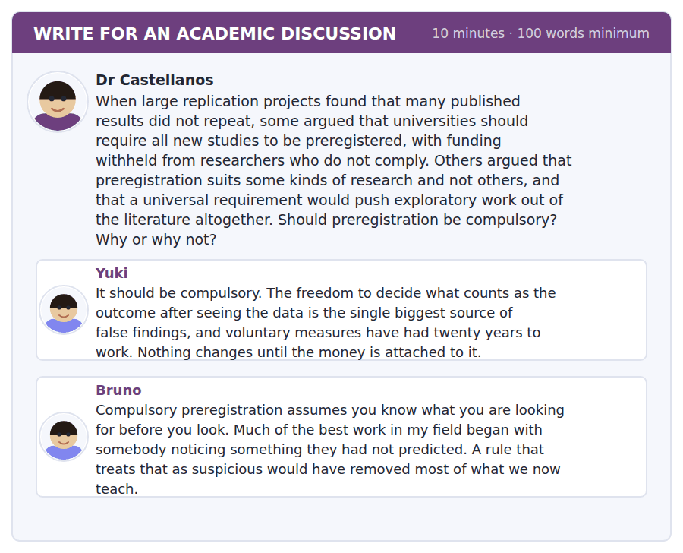
SKILL · Dissolving a disagreement rather than taking a side
- Sometimes the two posts are arguing about different things. Saying so is a stronger move than choosing.
- It requires naming the distinction each one is missing.
- Then show what follows: the rule that satisfies both.

Sentence starters
- Yuki and Bruno are describing different activities, and…
- The distinction that dissolves this is between… and…
- Bruno is right about…, but that is an argument for… rather than against…
- What neither post separates is… from…
Model post
Yuki and Bruno are describing different activities and calling both research. Yuki is talking about testing: you have a hypothesis, you collect data to evaluate it, and the analytic freedom she objects to is straightforwardly a way of getting the wrong answer. Bruno is talking about exploring: you look at something and see what is there, with no hypothesis to protect. The distinction dissolves most of the argument.
What preregistration actually does is fix which of the two you are claiming to have done. That is why Bruno’s objection does not land. A preregistered exploratory study is not a contradiction; it is a study that registers, in advance, that it is exploratory and that its findings are at best suggestive until someone tests them. Nothing is forbidden. What is forbidden is exploring and then reporting it as testing.
Yuki is right that voluntary measures have had their chance, and on the whole I would attach the requirement to funding as she suggests. But the requirement should be to declare the type of study, not to predict the outcome, and that is a much easier rule to comply with than the one Bruno is arguing against.
So: compulsory registration of design, not compulsory hypotheses. Bruno keeps his unpredicted findings, Yuki gets the discipline she wants, and the reader finally learns which kind of claim they are being shown.
[227 words]
Now write your own. 10 minutes, at least 100 words.
__________________________________________________________
__________________________________________________________
__________________________________________________________
__________________________________________________________
__________________________________________________________
__________________________________________________________
__________________________________________________________
__________________________________________________________
__________________________________________________________
__________________________________________________________

Grammar focus Quantification and approximation
Expression | What it commits you to
roughly / about | near the figure, width unstated
on the order of | the right power of ten, no more
in the region of | close to, usually within a few per cent
give or take | the figure plus an explicit margin
up to | a ceiling; the real value may be far lower
at least / no fewer than | a floor; the real value may be far higher
a handful of / the bulk of | very few / most, with no number claimed

Each expression commits you to a different width. Using a narrow one when you mean a wide one is a false claim, not a stylistic choice.
"Up to" is the most abused quantifier in English. Up to 40 per cent is satisfied by two per cent, which is why advertisers like it.
Never combine a vague quantifier with a precise figure. About 37.4 per cent tells the reader you do not know which part to trust.
Watch out! "Significant" in a statistical context means unlikely to be chance, not large. A significant difference can be far too small to matter. If you mean large, write large.
Exercise 1 Choose the expression that fits the certainty stated.
1. The journey takes a thousand years, to the nearest power of ten. → ______
2. The catch fell by half, plus or minus five per cent. → ______
3. Very few of them replied. → ______
4. Most of the variance is explained. → ______
5. The maximum possible is forty per cent. → ______
6. The minimum is two thousand. → ______
Exercise 2 Correct the quantifier.
1. The study found up to a four-mark difference on average.
2. About 37.4 per cent of students replied.
3. The effect was significant and therefore important.
4. On the order of 2,140 students took part.
Exercise 3 Rewrite so the claim matches the evidence described.
1. A survey of library users shows that students read widely.
2. The replication failed, so the original was false.
3. Sleep raises marks by four.
4. Nobody who works a paid job sleeps enough.
How this is tested in Build a Sentence
Build a Sentence often puts a quantity phrase inside an embedded question: do you know what proportion of them replied. The phrase stays together as one unit and the clause keeps statement order.
Find the fault 5 errors, drawn from this unit and the two before
Every error below is one a B2 writer makes after learning the rule. Mark what is wrong, then check. Knowing the rule and noticing the breach are two different skills, and only the second one is tested.
The study proves that sleeping more causes better marks. About 37.4 per cent of the sample replied to the survey. The difference was significant and therefore important. Up to a four-mark difference was found on average. Nobody knows whether did the researchers measure paid work.
# | As written | As it should be | Why
1 | proves that sleeping more causes | suggests that sleeping more is associated with | An observational design cannot establish cause, so proves overstates it.
2 | About 37.4 per cent | About 37 per cent | A vague quantifier with a decimal place claims two different precisions at once.
3 | significant and therefore important | significant, though small | Statistically significant means unlikely to be chance, not large enough to matter.
4 | Up to a four-mark difference was found on average | A four-mark difference was found on average | Up to states a ceiling, which contradicts reporting an average.
5 | whether did the researchers measure | whether the researchers measured | An embedded question keeps statement order, so no auxiliary is inverted.

Unit review and progress check Unit 25
Exercise A Vocabulary. Write the word.
1. how spread out a set of values is
2. a hidden variable explaining both others
3. to repeat a study and see if it holds
4. participants dropping out before the end
5. looking real but produced by something else
6. holding up when the method is varied
7. how big an effect is
8. a value far from the rest
9. the middle value when all are ordered
10. to set an instrument against a known standard
11. too small to detect the effect sought
12. to publish the plan before collecting data
Exercise B Grammar. Complete the sentence.
1. The journey takes ______ the order of a thousand years.
2. The catch fell by half, ______ or take five per cent.
3. ______ a handful of them replied.
4. ______ the bulk of the variance is explained.
5. The maximum is ______ to forty per cent.
6. The minimum is ______ least two thousand.
7. The result was significant ______ small.
8. The figure is ______ the region of two thousand.
Exercise C One timed mini-section. 6 minutes.
1. A larger biased sample gives you
(A) a less biased answer
(B) more confidence in a wrong answer
(C) a smaller variance only
(D) a replicable result
2. Ice cream sales and drowning rise together because
(A) one causes the other
(B) the data are wrong
(C) the sample is biased
(D) both follow the temperature
3. Random assignment works because
(A) it increases the sample
(B) it removes measurement error
(C) nothing about the person can predict the group
(D) it is cheaper
4. "At best suggestive" tells you the writer thinks the evidence is
(A) conclusive
(B) fabricated
(C) weak
(D) irrelevant
5. Which sentence is correct?
(A) About 37.4 per cent replied.
(B) Up to 37 per cent replied on average.
(C) On the order of 37.4 per cent replied.
(D) About 37 per cent replied.
6. Preregistration prevents
(A) choosing the outcome after seeing the data
(B) small samples
(C) publication bias
(D) attrition
Can you do these now?
I can… | Not yet | Yes
I can identify what a study design can and cannot establish. | □ | □
I can express an approximate quantity at the right level of vagueness. | □ | □
I can explain why a correlation is not a cause, in one sentence. | □ | □
I can read a result and ask the right question about the sample. | □ | □
I can qualify a number without sounding evasive. | □ | □
I can write a post that supplies a fact the others lacked. | □ | □

ADAPTIVE TIP Learn the difference between statistically significant and large. It is the single most exploited ambiguity in public argument, and a B2 writer who keeps the two apart will read every news story about research more accurately than the person who wrote it.

Unit 26 · Law, Rights and Society
TOEFL iBT® Preparation Course 2026 · Volume 3
CEFR B2 · Grammar: Passive reporting structures · Word field: uphold, provision, liable
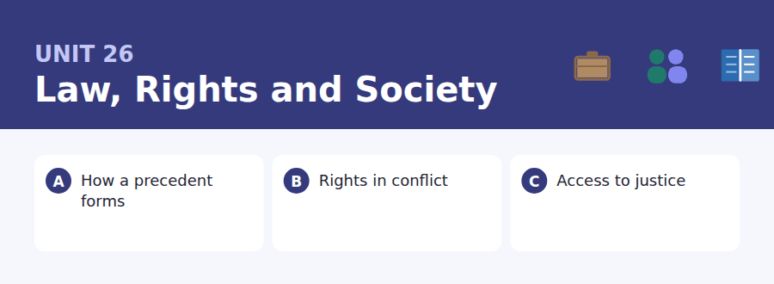
By the end of this unit I can…
- I can report a claim without being taken to endorse it.
- I can use it is said that and X is thought to have correctly.
- I can follow a text that applies one test to several cases.
- I can read a rule and work out what it does not cover.
- I can distinguish a general principle from its application.
- I can build a question on a passive reporting structure.

Legal English is the most careful writing most people ever read, and its care shows mainly in one structure: how to report a claim without owning it. This is the second grammar anchor of the course, and it is the single most useful thing in it for academic writing.

Vocabulary 1 · Academic word families 18 families, not 18 words
At B2 the word on its own is not enough. Each entry below is a family: learn the noun, the verb and the adjective together, because the test will use whichever one the sentence needs.
uphold to confirm a decision on appeal | tribunal a body that decides a particular class of dispute
provision a particular clause of a law or contract | remedy what a court orders to put a wrong right
liable legally responsible for something | discretion freedom to decide within stated limits
precedent an earlier decision later courts must follow | infringe to act against a right or a rule
statute a law passed by a legislature | mandate authority to act, given by someone else
jurisdiction the area or matters a court has power over | testimony evidence given by a witness
binding that must be followed, not merely considered | enshrine to write a principle permanently into law
ruling a decision made by a court | adjudicate to decide formally between two parties
appeal a request that a higher court review a decision | redress the putting right of a wrong

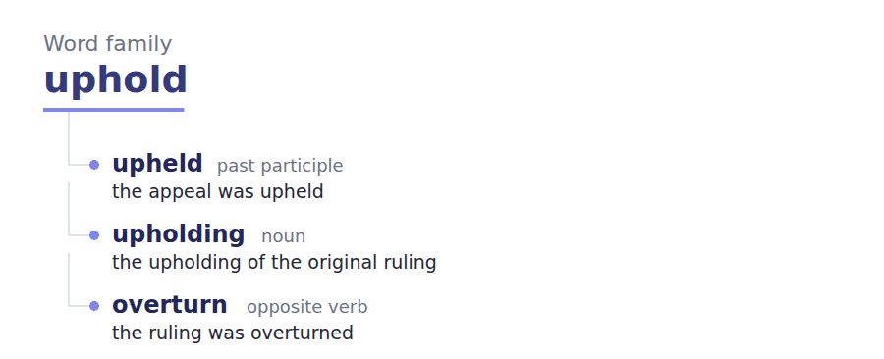
Exercise A Work in pairs. Ask and answer.
1. Should a court follow a decision it thinks was wrong? Why?
2. Name two rights that could come into conflict. How would you decide?
3. Is a law that nobody enforces still a law?
4. Who should pay for a lawyer when somebody cannot?
Vocabulary 2 · Collocation 10 partnerships that actually occur
A word is known when you know what it goes with. These ten are the partners this unit’s texts use; the wrong partner is what marks an answer as translated.
on the grounds that for the stated reason that | set aside to cancel a decision
subject to review able to be reconsidered | bear the burden of proof to be the side that must prove it
in accordance with following, as required by | in the first instance at the first stage, before any appeal
give effect to to put into practice | have regard to to take into account
bring a case to start legal proceedings | strike a balance to find a workable middle position

Vocabulary 3 · Stance and hedging How far the writer commits
Every one of these says the same thing at a different strength. Reading, you must notice which was chosen. Writing, you must choose.
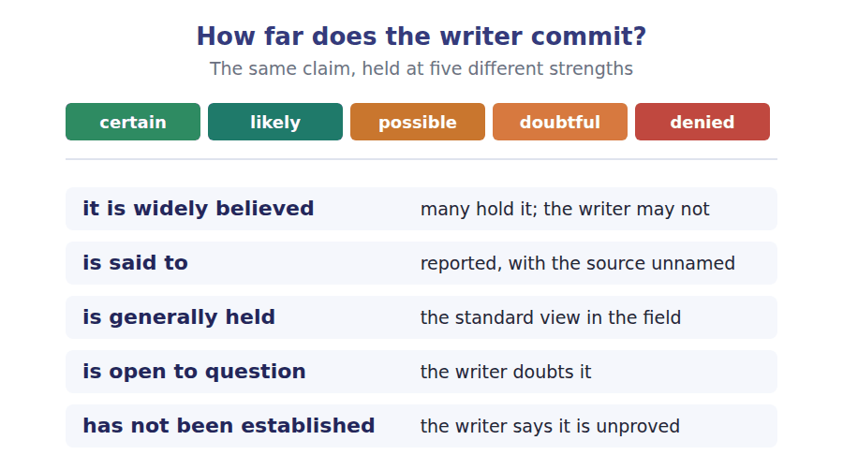
Two words that look alike
legal / lawful to do with law / permitted by law
liable / responsible answerable in law / answerable in general
precedent / principle a decision followed / a rule stated

Words you will meet again: case law | burden of proof | reasonable doubt | judicial review | legal aid | statutory interpretation | dissenting opinion | proportionality


SKILL · Suffixes in formal registers
- Legal and academic English prefers the noun: obligation rather than having to, provision rather than what it says.
- That means more -tion, -ance and -ity gaps than in everyday text.
- If you can replace the gap-word with a whole clause, it is a process noun.

Exercise A Guided practice. Five words are not complete. Write the missing letters.
A precedent is not created by a judge announcing one. It is created by a decision being followed. When a court resolves a dispute it gives reasons, and later courts must decide which part of those reasons was essent--- to the outcome. That part is binding. The rest, however interesting, is treated as a remark made in pass--- and carries no obligat---. Lawyers spend a great deal of their time arguing about which is which, because a case can be followed, distingu----- or, rarely, overrul--, and the whole argument turns on how the earlier reasons are read.

The first one is done for you: essential is essential — it follows was and describes the part of the reasons, so it is an adjective.
Exercise B Exam practice. One paragraph, ten gaps — the real task.
Rights are usually written as though they were absol---, and almost none of them are. A constit----- may state that everyone has the right to express an opinion, and in the same document that everyone has the right to a fair trial. The two are not in tension until a newspaper publishes the name of a juror, at which point a court has to decide which right y-----. This is sometimes described as a conflict between rights, though that phrase is slight-- misleading. What actually happens is that a court asks whether the restriction proposed is necess---, whether it goes no further than it needs to, and whether the benefit is worth the cost to the person restric---. The test is applied the same way whichever right is in question, which is what makes it a legal test rather than a political preference. It is widely believed that judges simply pick the right they prefer and reason back-----. The evidence for that is thin, and where it has been looked for sys----------- the pattern that emerges is less dramatic: judges differ most not on which right matters more but on how much def------ is owed to the body that made the original decis---.

Check your answers in the key at the back of the book.


SKILL · Reading a rule against a case
- A rule is written in general terms and a case is specific. The question is always whether this case falls inside those words.
- Find the operative words of the rule — usually a verb and a condition — and test the facts against each.
- A fact that satisfies some of the conditions and not others is where the argument is.

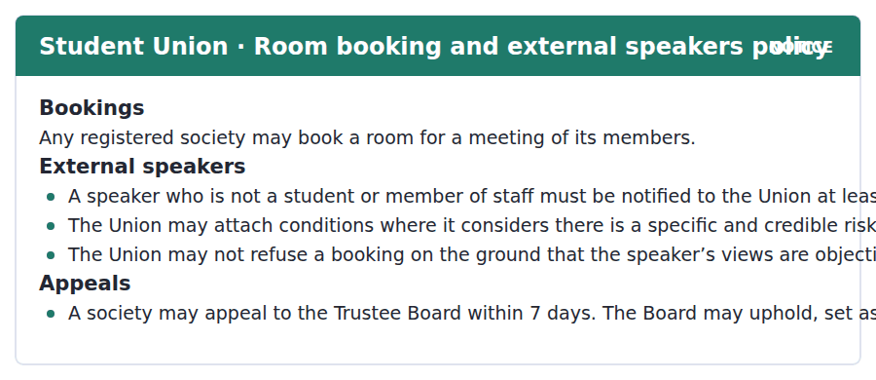
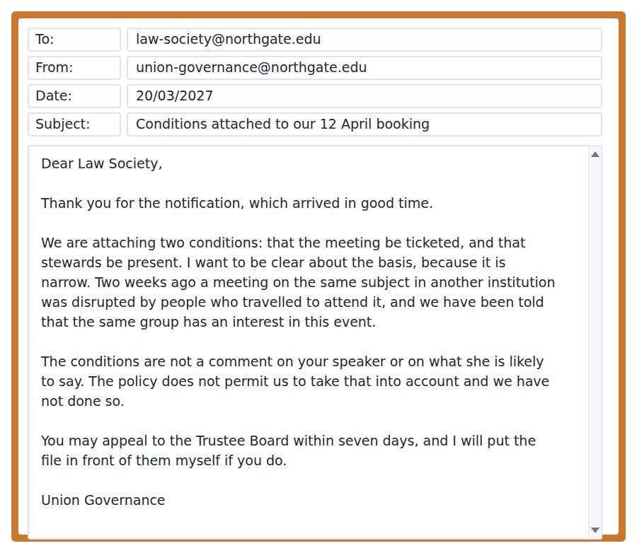
Exercise A Guided practice. The answer is on the page — find it.
1. How much notice is required for an external speaker?
(A) 7 days
(B) 28 days
(C) None
(D) 14 days
2. On what basis may the Union attach conditions?
(A) The speaker’s views
(B) A specific and credible safety risk
(C) The size of the society
(D) The cost of the room
3. What may the Union NOT do?
(A) Refuse a booking because the views are objectionable
(B) Attach conditions
(C) Require stewards
(D) Ask for notice
4. Who hears an appeal?
(A) The Union
(B) The society
(C) The Trustee Board
(D) The university
Exercise B Exam practice.
5. Why does the Union say the basis is "narrow"?
(A) The conditions are minor
(B) The society is small
(C) It is relying on one specific ground only
(D) The notice period was short
6. What evidence does the Union give for a credible risk?
(A) Complaints from students
(B) The speaker’s record
(C) Advice from the police
(D) A disrupted meeting elsewhere and reports about the same group
7. Why does the email say the conditions are not a comment on the speaker?
(A) Because the policy forbids taking her views into account
(B) To be polite
(C) Because the speaker complained
(D) To avoid an appeal
8. What does the Union offer the society?
(A) A different room
(B) To put the file before the Board personally
(C) To waive the conditions
(D) A longer notice period
9. Which of the Union’s actions is NOT authorised by the policy as written?
(A) Requiring tickets
(B) Requiring stewards
(C) Notifying the Board
(D) Nothing — both are within the policy
10. What would make the conditions unlawful under this policy?
(A) If the society appealed
(B) If notice were under 14 days
(C) If they were motivated by the speaker’s views
(D) If stewards were unavailable
11. What is the tone of the email?
(A) Defensive
(B) Precise and procedurally careful
(C) Apologetic
(D) Hostile


SKILL · Reading a text that relocates a problem
- A common B2 structure: the usual diagnosis is X, and X is real, but the bigger factor is Y.
- The author concedes the usual answer before replacing it, so do not mark the concession as the main point.
- The last paragraph normally draws out what follows for policy.

A Right You Cannot Use
A right that cannot be exercised is a curious thing. It is not quite nothing: it can be cited, it shapes what officials expect to be challenged on, and it may be enforced one day. But for the person who holds it and cannot reach a court, the practical difference between a right and its absence can be hard to detect. This gap between a right as written and a right as used is what lawyers mean by access to justice.
It is widely believed that the main barrier is the cost of a lawyer, and cost matters. But the research on why people with good claims do not bring them points at something less obvious. Many never identify their problem as legal at all. An unlawful deduction from wages is experienced as a bad month; an unsafe flat is experienced as a bad landlord. The classification that would turn the experience into a claim is itself specialist knowledge, and it is distributed very unevenly.
This has consequences for how reform is designed. Schemes that reduce the cost of representation help people who have already decided they have a case. They do nothing for the much larger group who never reached that point, and it has not been established that cheaper representation increases the number of claims brought by that group at all. The interventions with the best evidence behind them are unglamorous: advice services in places people already go, and duties on the stronger party to say in plain words what the other side is entitled to. Neither looks like justice. Both appear to produce more of it than a courtroom does.
[273 words]

Exercise A Guided practice.
1. What does the author mean by "access to justice"?
(A) The gap between a right as written and as used
(B) The cost of lawyers
(C) The number of courts
(D) The speed of a trial
2. What is the commonly believed barrier?
(A) Distance from a court
(B) The cost of a lawyer
(C) Fear of officials
(D) Language
3. What does the research point to instead?
(A) People not recognising their problem as legal
(B) Court delays
(C) Lack of evidence
(D) Distrust of lawyers
4. The word "classification" in the second paragraph refers to
(A) a type of court
(B) the cost of advice
(C) a kind of lawyer
(D) recognising an experience as a legal claim
Exercise B Exam practice.
5. Why does the author say a right that cannot be exercised "is not quite nothing"?
(A) It will eventually be removed
(B) It costs nothing to hold
(C) It can still be cited and may shape official behaviour
(D) It applies in other countries
6. Who do cost-reduction schemes help?
(A) People who have already identified a case
(B) Everyone with a claim
(C) Landlords
(D) Advice services
7. What has NOT been established?
(A) That cost matters
(B) That advice services work
(C) That rights can be cited
(D) That cheaper representation increases claims from the unaware group
8. Which interventions does the author say have the best evidence?
(A) Lower court fees
(B) Advice in places people already go, and plain-language duties
(C) More courts
(D) Free legal insurance
9. What does "Neither looks like justice" mean?
(A) Neither is effective
(B) Neither is legal
(C) Neither resembles the courtroom image of justice
(D) Neither has been tried
10. What is the author’s attitude to cost as a barrier?
(A) It is irrelevant
(B) It is the only barrier
(C) It has been exaggerated deliberately
(D) It is real but not the main one
11. All of the following are given as examples EXCEPT:
(A) An unlawful wage deduction
(B) A disputed will
(C) An unsafe flat
(D) Neither of these appears
12. What does the structure of the passage suggest about the author’s purpose?
(A) To defend lawyers
(B) To describe court procedure
(C) To redirect reform towards a different barrier
(D) To compare two countries
13. Which finding would most support the author’s position?
(A) That advice desks in health centres raise the number of valid claims brought
(B) That legal fees have risen
(C) That court waiting times have fallen
(D) That more people know their rights in theory


Exercise A Listen and choose a response. You hear one line. Choose the best reply.
1. Man: Is everything the judge said binding?
(A) Only the part the outcome turned on.
(B) Yes, all of it.
(C) About forty pages.
(D) She is a senior judge.
2. Woman: What happens if a later court disagrees?
(A) It is binding.
(B) Yes, that happens.
(C) It can distinguish the case, or rarely overrule it.
(D) In the Court of Appeal.
3. Man: Did you understand the dissent?
(A) Yes, it was a dissent.
(B) Not the second half of it.
(C) About two pages.
(D) She disagreed.
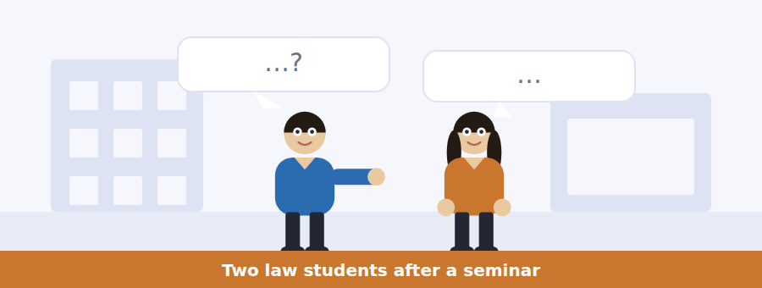
SKILL · Hearing the difference between a rule and an example
- A speaker explaining law moves constantly between the general rule and a particular case.
- Items will test whether you heard which was which.
- Listen for: in that case, as a rule, generally, here specifically.

Exercise B Listen and answer. The audio plays once.
4. What part of a judgment is binding?
(A) All of it
(B) The final paragraph
(C) Anything the judge emphasised
(D) The part the outcome turned on
5. Why was the electronic service discussion not binding?
(A) The case was decided on another ground
(B) It was wrong
(C) It was too short
(D) It was in a dissent
6. Why will later courts still read it carefully?
(A) It is binding after all
(B) It was widely reported
(C) It is the only senior statement on the point in fifteen years
(D) It was in the headnote
7. What is the practical difference between binding and persuasive?
(A) Persuasive is stronger
(B) Binding applies only in the same court
(C) There is no practical difference
(D) Binding needs a reason to depart; persuasive needs none either way
8. What does the man get slightly wrong?
(A) Which part is the ratio
(B) That persuasive requires a reason to follow
(C) The name of the case
(D) The date of the judgment
9. What does the woman say lawyers mostly argue about?
(A) Which court has jurisdiction
(B) Which part of a judgment is binding
(C) How much a case costs
(D) Whether to appeal
10. What is the woman’s role in the conversation?
(A) She is explaining and correcting precisely
(B) She is uncertain and thinking aloud
(C) She disagrees with the judgment
(D) She is revising for an exam
Audio script: see the back of the book. Do not read it before you listen.


Exercise A Listen and choose a response. You hear one line. Choose the best reply.
1. Woman: Can the Union refuse a booking it dislikes?
(A) Yes, at any time.
(B) Within seven days.
(C) Not on the ground that the views are objectionable.
(D) It is a Union policy.
2. Man: How long do we have to appeal?
(A) Fourteen days’ notice.
(B) Yes, you can appeal.
(C) To the Trustee Board.
(D) Seven days from the decision.
3. Woman: What can the Board actually do?
(A) It meets monthly.
(B) Yes, it can help.
(C) About five members.
(D) Uphold, set aside or vary a condition.
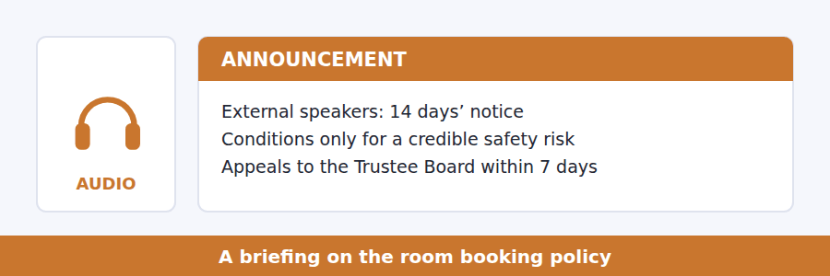
SKILL · Hearing a limit on a power
- When a speaker describes a power, listen for the sentence that limits it. That sentence is the point.
- Phrases to catch: only where, may not, on no account, and nothing else.
- The limit is usually repeated, because the speaker expects to be tested on it.

Exercise B Listen and answer. The audio plays once.
4. What does "specific" mean in the policy?
(A) Something that can be pointed to
(B) Affecting one person
(C) Written down in advance
(D) Relating to one society
5. What does "credible" rule out?
(A) Risks from outside the university
(B) Risks to the speaker
(C) Mere annoyance expressed online
(D) Risks reported anonymously
6. What may the Union NOT do?
(A) Require stewards
(B) Act because views are objectionable
(C) Ask for fourteen days’ notice
(D) Change the room
7. Why is the policy drafted that way?
(A) To protect the Union legally
(B) Because a power to prevent upset has no limits and falls on the unpopular
(C) Because students demanded it
(D) To reduce the Union’s workload
8. What can the Trustee Board do?
(A) Uphold, set aside or vary a decision
(B) Only uphold a decision
(C) Overrule the policy
(D) Extend the notice period
9. Why does the speaker encourage appeals?
(A) To reduce complaints
(B) To delay bookings
(C) Because the Board meets rarely
(D) Because an unappealed policy is unchecked
Audio script: see the back of the book. Do not read it before you listen.


Exercise A Listen and choose a response. You hear one line. Choose the best reply.
1. Woman: Is cost the main barrier?
(A) Yes, entirely.
(B) About two thousand pounds.
(C) It is a barrier, and the evidence says not the main one.
(D) Lawyers are expensive.
2. Man: What stops people before cost does?
(A) The courts are slow.
(B) Yes, several things.
(C) Not seeing the problem as legal at all.
(D) About half of them.
3. Woman: Does cheaper representation help?
(A) Yes, everybody.
(B) It helps people who already know they have a case.
(C) It costs less.
(D) In the first instance.
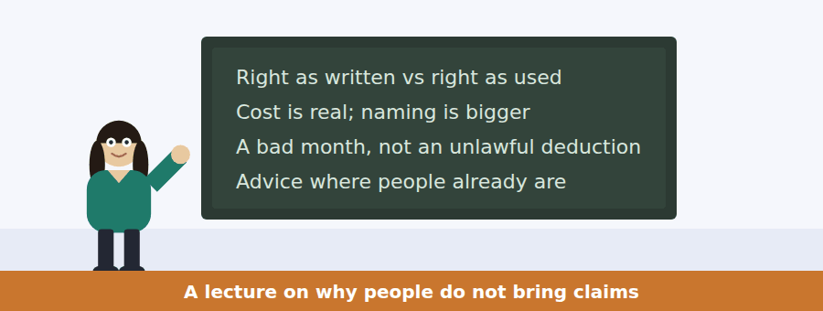
SKILL · Following a talk that reports research without endorsing all of it
- A careful lecturer separates what is established, what is reported, and what they themselves think.
- Listen for the markers: it is widely believed, the evidence shows, my own view is.
- Items frequently ask which category a claim falls into.

Exercise B Listen and answer. The audio plays once.
4. What answer does the speaker say is generally held?
(A) Distrust of lawyers
(B) Court delays
(C) Lack of evidence
(D) Cost
5. What does the research point to?
(A) People not classifying their experience as legal
(B) Court fees
(C) Shortage of lawyers
(D) Fear of employers
6. What examples does she give?
(A) Unpaid fines and parking
(B) Divorce and inheritance
(C) Unlawful wage deductions and substandard housing
(D) Immigration and asylum
7. For whom does cheaper representation work?
(A) Everyone
(B) Landlords
(C) Nobody
(D) Those who have already decided they have a case
8. How does she mark her policy preference?
(A) As established fact
(B) As her own view, flagged explicitly
(C) As the consensus
(D) As the research finding
9. What does she propose instead?
(A) Advice where people already go, and plain-language duties
(B) More courts
(C) Lower court fees
(D) Compulsory insurance
10. What does "Neither of those looks like justice" concede?
(A) That they lack the appearance of justice
(B) That they are ineffective
(C) That they are illegal
(D) That they are untested
Audio script: see the back of the book. Do not read it before you listen.


Part 1 · Listen and Repeat
You hear a sentence and repeat it once. There is no preparation time, and the sentences get longer. Focus: the weak forms in passive reporting chains
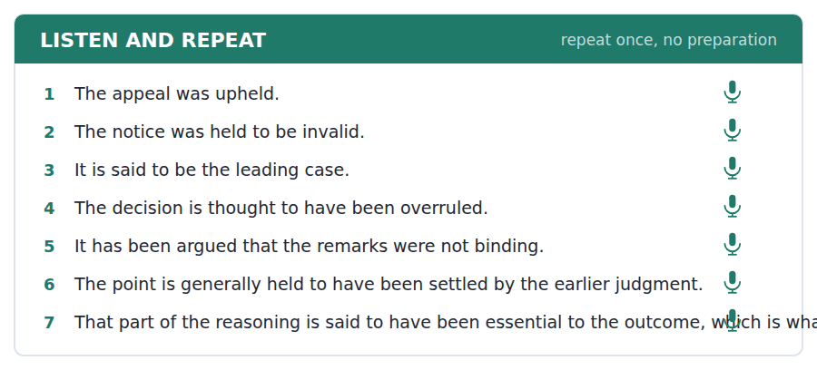
SKILL · Repeating a passive reporting structure
- It is said to have been, is thought to have — these are long strings of weak syllables with one stressed word at the end.
- Do not stress the auxiliaries. Say them fast and lightly.
- The listener is waiting for the main verb.

Part 2 · Take an Interview
An interviewer asks you four questions on one theme: rules, fairness and following decisions you disagree with. Answer each one fully. There is no preparation time.
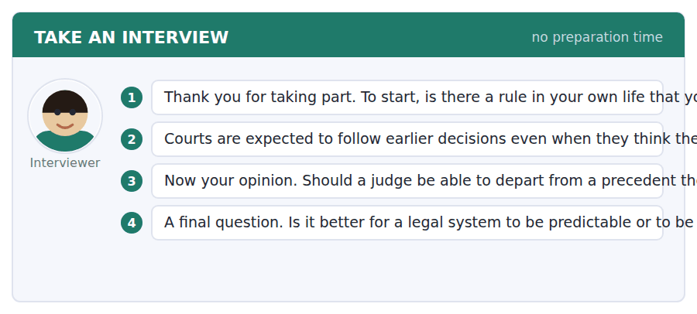
A good answer sounds like this
Question 2 — What is gained is that people can predict what will happen to them, which is most of what law is for. What is lost is that a mistake can be locked in for decades.
Question 4 — Predictable, mostly. A system that is right in each case and unpredictable in general cannot be planned around, and almost everybody deals with law by planning around it rather than by appearing in court.
I can… | Not yet | Yes
I kept the auxiliaries weak and fast. | □ | □
I stressed the main verb. | □ | □
I answered both halves of the question. | □ | □


Part 1 · Listen and Repeat
You hear a sentence and repeat it once. There is no preparation time, and the sentences get longer. Focus: stating a limit clearly and without hedging it away
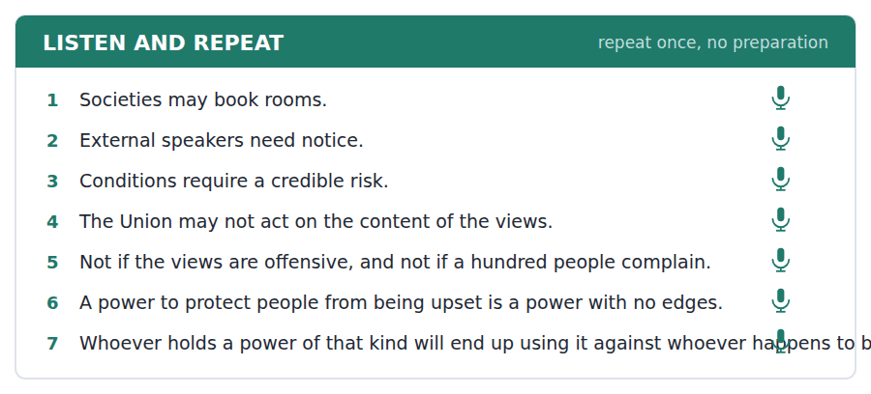
SKILL · Saying what may not be done
- A limit stated hesitantly is not heard as a limit. This is one place where hedging hurts.
- Say the prohibition flatly and then explain. May not, full stop, then the reason.
- Repeat it if it matters. Repetition is how spoken English marks importance.

Part 2 · Take an Interview
An interviewer asks you four questions on one theme: speech, safety and who decides. Answer each one fully. There is no preparation time.
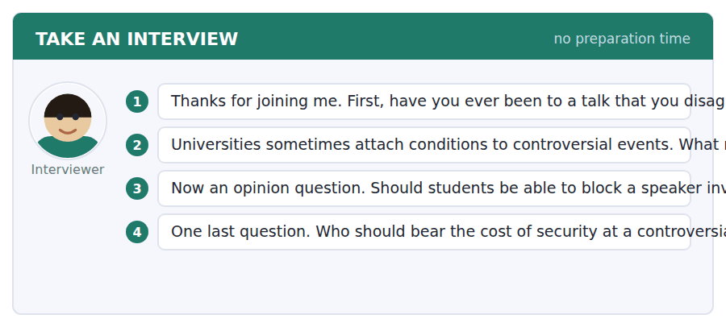
A good answer sounds like this
Question 2 — A reasonable condition is one that would be the same whoever was speaking. Once the condition tracks the content rather than the risk, it is a refusal with extra steps.
Question 4 — The university, mostly. If the cost sits with the society, then the price of speaking rises with how unpopular you are, and that is a refusal operating through a budget.
I can… | Not yet | Yes
I stated the limit without hedging it. | □ | □
I gave the reason after, not instead. | □ | □
I used a concrete example. | □ | □


Part 1 · Listen and Repeat
You hear a sentence and repeat it once. There is no preparation time, and the sentences get longer. Focus: distinguishing what is known from what you think
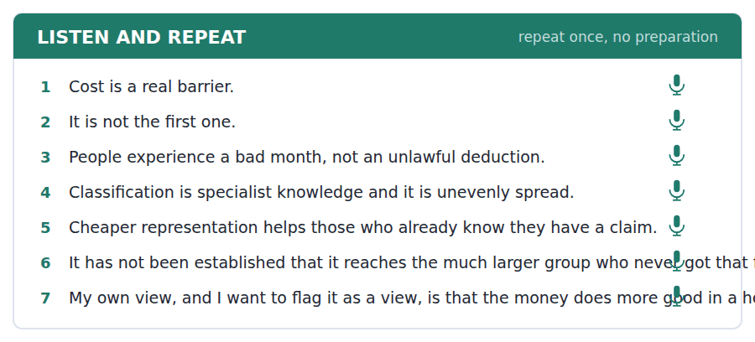
SKILL · Marking your own opinion as an opinion
- At B2 you must be able to report evidence and then separate your view from it, audibly.
- The evidence shows X. My own view, which is a view, is Y.
- Examiners reward the separation itself, not the opinion.

Part 2 · Take an Interview
An interviewer asks you four questions on one theme: fairness, knowledge and who gets help. Answer each one fully. There is no preparation time.
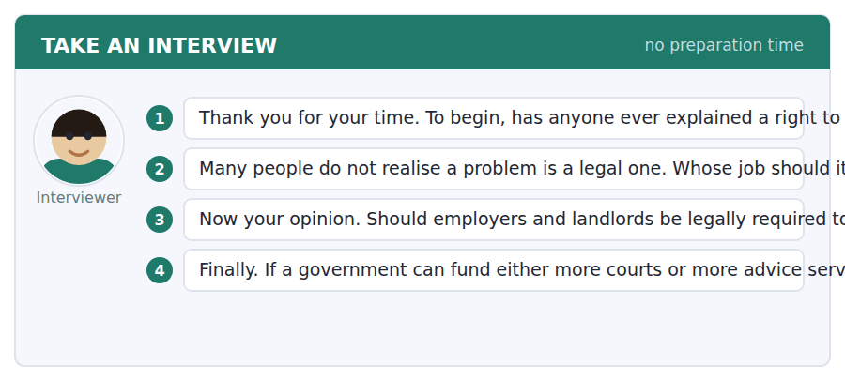
A good answer sounds like this
Question 2 — The stronger party, because they already know. A landlord knows what the standards are; a tenant frequently does not, and the gap is not an accident.
Question 4 — Advice services, on the evidence. Courts help people who have already got that far, and the research suggests most people never do.
I can… | Not yet | Yes
I marked my own opinion as an opinion. | □ | □
I reported the evidence without claiming it as mine. | □ | □
I gave a reason specific to the case. | □ | □


You see a sentence, then a set of words in boxes. Put the words in order to make one grammatical sentence. Almost every item in the real test makes a question or a question inside another sentence.
SKILL · Build a Sentence on a passive reporting frame
- Several items build a question around is said to, is thought to or has been argued.
- The frame holds together: is thought to have been is four tiles that behave as one.
- Inside an embedded question it still keeps statement order.

Exercise A Guided practice. The first three are worked through.
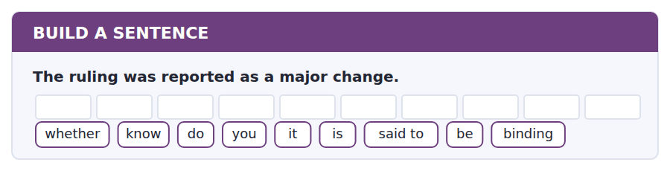
1. Do you know whether it is said to be binding?
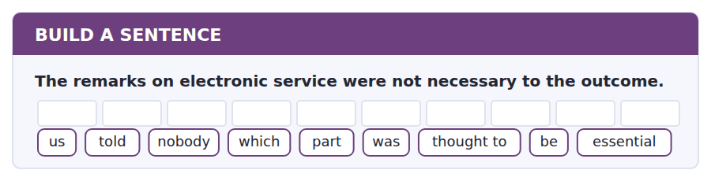
2. Nobody told us which part was thought to be essential.
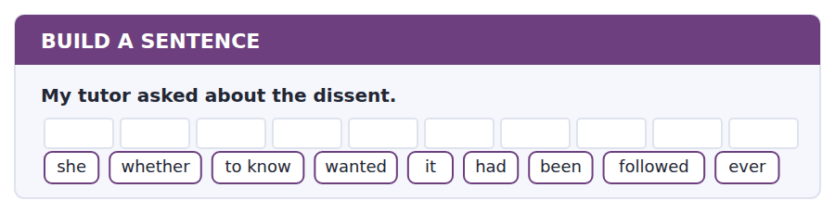
3. She wanted to know whether it had ever been followed.
Exercise B Exam practice. Write the sentence.
4. The policy forbids acting on the content of views.
do / whether / know / you / that / has / been / tested / ever
__________________________________________________________
5. Two conditions were attached to the booking.
to know / nobody / seems / on what / they / were / imposed / grounds / actually
__________________________________________________________
6. The case is cited in every textbook.
explain / can / anybody / why / it / is / said to / matter / so much
__________________________________________________________
7. The claim was never brought.
know / does / anybody / whether / she / had / been / advised / properly
__________________________________________________________
8. The Board can set aside any condition.
told / he / us / how long / we / had / to appeal / exactly / for
__________________________________________________________
9. The decision is generally held to be correct.
the grounds / on which / it / was / decided / are / no longer / in / dispute
__________________________________________________________
10. Advice services are said to work better than courts.
whether / tell / can / me / you / that / has / been / measured
__________________________________________________________


You read a short situation and write an email. You have 7 minutes. The three bullet points are the mark scheme: answer all three.
The Union has attached ticketing and stewarding conditions to your society’s event. The stated basis is a credible safety risk. You believe the real reason is the speaker’s views, partly because two officers said so publicly last week. You want to appeal to the Trustee Board.
Write an email beginning the appeal.
- State what you are appealing against and on what ground.
- Set out the evidence, separating fact from inference.
- Say what outcome you are asking the Board for.
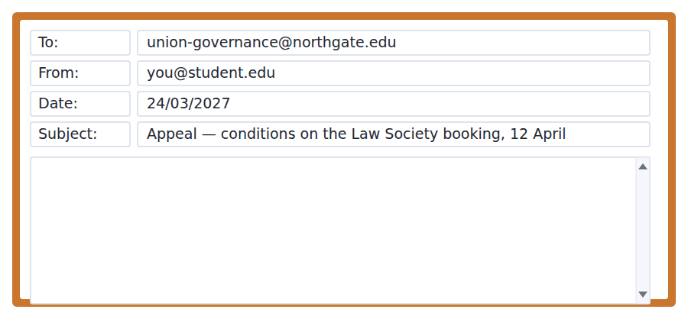
SKILL · Writing an appeal that distinguishes fact from inference
- An appeal fails when it asserts motive. It succeeds when it sets out facts and lets the reader draw the inference.
- Separate the two explicitly: these are the facts; what we infer from them is this.
- Ask for something the body can actually grant. The Board can vary a condition; it cannot discipline an officer.

Model email
Dear Governance,

The Law Society appeals to the Trustee Board against the two conditions attached to our booking of 12 April, on the ground that they were not imposed for the reason stated.

The facts we rely on are these. On 14 March two officers posted publicly that the speaker should not have been invited and that the Union would, in one officer’s words, make sure it is not a comfortable evening. On 20 March the conditions were imposed. The stated basis was a disruption at another institution on 6 March and interest which is said to come from the same group. We have asked what that report consisted of and have not yet had an answer.

What we infer is a matter for the Board rather than for us to assert. We would say only that the policy expressly prohibits acting on the content of a speaker’s views, and that the sequence above is at least consistent with its having been acted on.

We ask the Board to set aside both conditions, or, if it considers a risk is made out, to require that the evidence of that risk be disclosed to us and the conditions varied to what the evidence supports.

We are content for the hearing to be held in public.

For the Law Society
Why it works
- It states the ground of appeal in the first sentence, so the Board knows what it is deciding.
- Facts are dated and separated from the inference, which is explicitly left to the Board.
- "At least consistent with" claims exactly as much as the evidence supports and no more.
- It asks for two outcomes, the second of which the Board can grant even if it finds against the first.
Two answers, one band apart
Both answer the three bullet points. One would score in the middle band and one near the top. Read them side by side before you write your own.
A middle-band answer | A top-band answer
Dear Governance,  We are writing to appeal against the conditions you have put on our event on 12 April. We do not think these conditions are fair and we believe the real reason is that you do not like our speaker.  Two of your officers said publicly last week that the speaker should not have been invited and that they would make sure the evening was not comfortable. Then a few days later you imposed these conditions. It is obvious what has happened here and we think it is a clear breach of your own policy.  We would like the Trustee Board to remove the conditions. We also think the officers involved should be held accountable for what they said, which was completely inappropriate for people in their position.  Yours faithfully, The Law Society | Dear Governance,  The Law Society appeals to the Trustee Board against the two conditions attached to our booking of 12 April, on the ground that they were not imposed for the reason stated.  The facts we rely on are these. On 14 March two officers posted publicly that the speaker should not have been invited and that the Union would make sure it was not a comfortable evening. On 20 March the conditions were imposed. We have asked what the reported risk consisted of and have not had an answer.  What we infer is a matter for the Board. We would say only that the policy prohibits acting on the content of a speaker’s views, and that the sequence is at least consistent with its having been acted on.  We ask the Board to set aside both conditions, or to require the evidence to be disclosed and the conditions varied to what it supports. For the Law Society

What the top answer does that the other does not
- It names the ground of appeal in the first sentence, so the Board knows what question it is being asked.
- The facts are dated and listed separately from the conclusion, instead of being merged into "it is obvious what has happened".
- "At least consistent with" claims only what the evidence carries, which is far harder to rebut than an assertion of motive.
- It asks for a fallback outcome, so the Board can grant something even if it rejects the main ground.
- It drops the demand about disciplining officers, which the Board has no power to grant and which would have weakened the appeal.
Now write your own. 7 minutes.
__________________________________________________________
__________________________________________________________
__________________________________________________________
__________________________________________________________
__________________________________________________________
__________________________________________________________
__________________________________________________________
__________________________________________________________


A professor asks a question and two students answer. You add your own post. You have 10 minutes and an effective answer is at least 100 words.
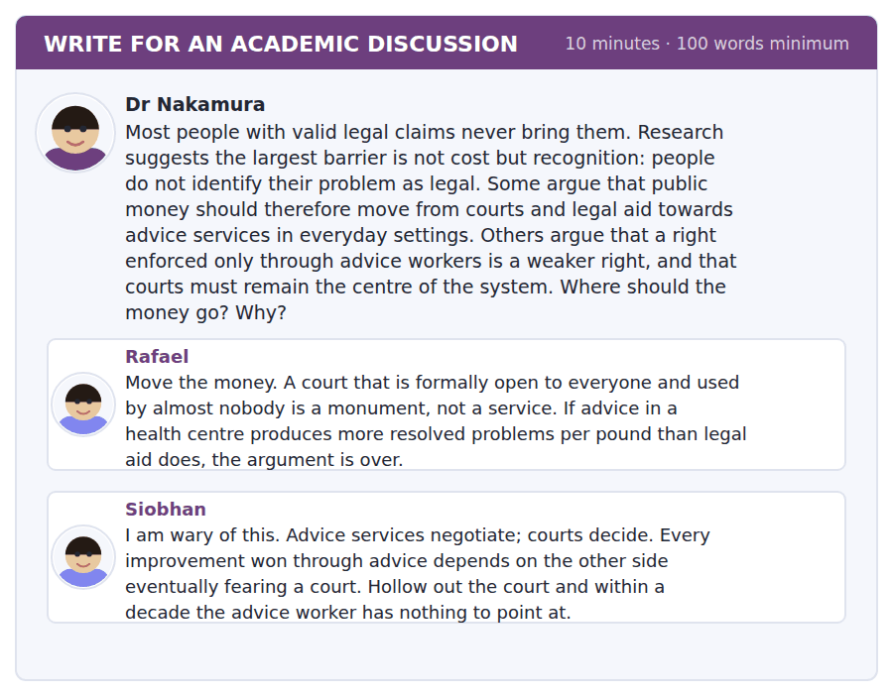
SKILL · Showing that two positions depend on each other
- Sometimes the strongest answer is that the two sides are not alternatives at all but complements.
- It must be argued, not asserted: show the mechanism by which one depends on the other.
- Then say what follows for the actual decision, or the point is academic.

Sentence starters
- Siobhan has identified the mechanism that makes Rafael’s figures work.
- The two are not alternatives, because…
- Rafael’s test is right, and applied properly it gives…
- What this means for the budget is…
Model post
Siobhan has identified the mechanism that makes Rafael’s figures work, which is why they are not really opposed. An advice worker who tells a landlord that a flat breaches the housing standards is making a prediction about what a court would do. If no court would do it, the landlord has no reason to act, and the cheap resolution Rafael is counting simply does not occur. The resolutions achieved outside court are produced by the court existing.
It follows that Rafael’s cost-per-resolution comparison, taken on its own, is misleading. That these are competing budget lines is open to question, and in accounting terms they are. Causally they are not: the cheap intervention is borrowing its authority from the expensive one.
But Siobhan’s conclusion does not follow either. The number of cases a court must actually hear to remain credible is far smaller than the number of problems it resolves, which is the whole logic of a deterrent. A system can shift money towards advice and remain credible, provided the court stays capable of hearing the cases that reach it reasonably quickly.
So the question is not where the money goes but what the court is for. Funded as the place most problems are resolved, it will always look wasteful. Funded as the thing that makes resolution elsewhere possible, it needs to be fast and visible rather than large, and the rest of the money can move.
[236 words]
Now write your own. 10 minutes, at least 100 words.
__________________________________________________________
__________________________________________________________
__________________________________________________________
__________________________________________________________
__________________________________________________________
__________________________________________________________
__________________________________________________________
__________________________________________________________
__________________________________________________________
__________________________________________________________

Grammar focus Passive reporting structures
Structure | Example
It is said / thought / believed that | It is thought that the notice was invalid.
X is said / thought / believed to | The notice is thought to be invalid.
X is said to have + past participle | The case is said to have been overruled.
It has been argued that | It has been argued that the remarks were not binding.
X is generally held to be | The decision is generally held to be correct.
is reported / alleged / claimed to | The group is alleged to have travelled.
in a question | Is it thought to be binding? / whether it is thought to be binding

These structures let you report a claim without saying whose it is and without endorsing it. That is why academic and legal writing uses them so heavily.
There are two forms of the same meaning. It is thought that X is invalid and X is thought to be invalid say the same thing; the second is tighter.
For an earlier event use the perfect infinitive: is thought to have been, not is thought to be, when the event is over.
Watch out! These structures are not a way of avoiding responsibility for a claim you are in fact making. If the view is yours, say so. Using it is widely believed for your own opinion is a recognised bad habit, and examiners notice it.
Exercise 1 Rewrite using X is said / thought / believed to.
1. It is said that the case is the leading authority.
2. It is thought that the notice was invalid.
3. It is believed that the group travelled from another city.
4. It is alleged that the officers acted on the content.
5. It is reported that the meeting was disrupted.
6. It is generally held that the test is the same for every right.
Exercise 2 Choose the present or the perfect infinitive.
1. The ruling is thought ______ (be) binding today.
2. The earlier case is said ______ (be) overruled in 1998.
3. She is believed ______ (bring) the claim last year.
4. The policy is understood ______ (apply) to all societies.
Exercise 3 Make a question from each statement.
1. It is thought to be binding.
2. The case is said to have been overruled.
3. The conditions are alleged to have been imposed for another reason.
4. The test is generally held to be the same.
How this is tested in Build a Sentence
This is anchor 2 of the course. Build a Sentence builds questions on exactly these frames: do you know whether it is said to be binding. The frame holds together as a block and the clause around it keeps statement order.
Find the fault 5 errors, drawn from this unit and the two before
Every error below is one a B2 writer makes after learning the rule. Mark what is wrong, then check. Knowing the rule and noticing the breach are two different skills, and only the second one is tested.
It is thought the notice was invalid at the time. The case is said to be overruled in 1998, which nobody disputes. It is widely believed, in my opinion, that the policy is unfair. Nobody knows whether was the condition imposed properly. The officers is alleged to have acted on the content of the views.
# | As written | As it should be | Why
1 | It is thought the notice | It is thought that the notice | After it is thought the conjunction that is needed before a clause.
2 | is said to be overruled in 1998 | is said to have been overruled in 1998 | A finished past event takes the perfect infinitive, not the present one.
3 | It is widely believed, in my opinion, that | In my opinion | A reporting structure cannot carry your own opinion; pick one or the other.
4 | whether was the condition imposed | whether the condition was imposed | An embedded question keeps statement order, so the subject precedes the verb.
5 | The officers is alleged | The officers are alleged | A plural subject takes a plural verb even inside a reporting frame.

Unit review and progress check Unit 26
Exercise A Vocabulary. Write the word.
1. to confirm a decision on appeal
2. a particular clause of a law
3. legally responsible for something
4. an earlier decision later courts must follow
5. the area or matters a court has power over
6. that must be followed, not merely considered
7. a body deciding a particular class of dispute
8. what a court orders to put a wrong right
9. freedom to decide within stated limits
10. to act against a right or rule
11. to write a principle permanently into law
12. the putting right of a wrong
Exercise B Grammar. Complete the sentence.
1. It is thought ______ the notice was invalid.
2. The notice is thought ______ have been invalid.
3. The case is ______ to be the leading authority.
4. The group is believed ______ have travelled.
5. It has ______ argued that the remarks were obiter.
6. The test is generally ______ to be the same.
7. ______ it thought to be binding?
8. The officers ______ alleged to have acted on content.
Exercise C One timed mini-section. 6 minutes.
1. The binding part of a judgment is
(A) everything the judge said
(B) the final paragraph
(C) the part the outcome turned on
(D) the dissent
2. A persuasive authority
(A) must be followed
(B) can never be cited
(C) binds lower courts only
(D) may be followed with no reason required either way
3. The Union may attach conditions only where
(A) students complain
(B) there is a specific and credible safety risk
(C) the speaker is external
(D) the Board agrees
4. Research suggests the largest barrier to bringing a claim is
(A) the cost of a lawyer
(B) court delays
(C) distance from a court
(D) not recognising the problem as legal
5. Which sentence is correct?
(A) The case is said to be overruled in 1998.
(B) The case is said being overruled in 1998.
(C) The case is said to have been overruled in 1998.
(D) The case said to be overruled in 1998.
6. "It is open to question" tells you the writer
(A) accepts it
(B) doubts it
(C) has proved it false
(D) has no view
Can you do these now?
I can… | Not yet | Yes
I can report a claim without being taken to endorse it. | □ | □
I can use it is said that and X is thought to have correctly. | □ | □
I can follow a text that applies one test to several cases. | □ | □
I can read a rule and work out what it does not cover. | □ | □
I can distinguish a general principle from its application. | □ | □
I can build a question on a passive reporting structure. | □ | □

ADAPTIVE TIP Passive reporting is the structure that makes academic English sound academic, and the one most often misused. Use it to report what others hold. Do not use it to smuggle in your own opinion — an examiner who sees it is widely believed attached to an unsupported claim knows exactly what has happened.

Unit 27 · Energy and Power Systems
TOEFL iBT® Preparation Course 2026 · Volume 3
CEFR B2 · Grammar: Third and mixed conditionals · Word field: intermittent, grid, storage
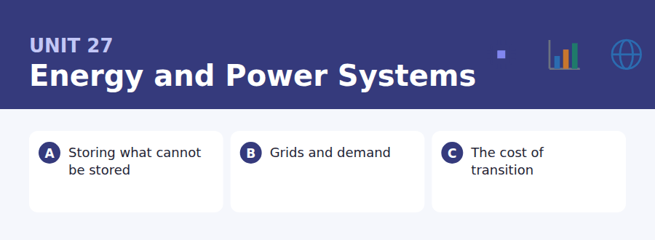
By the end of this unit I can…
- I can follow an argument that compares four options against one problem.
- I can use the third conditional to argue about a decision already taken.
- I can mix time frames in a conditional without losing the sentence.
- I can read a cost claim and ask what it excludes.
- I can concede a point to one side and still reject its conclusion.
- I can write a proposal that anticipates the obvious objection.

Energy is the subject where numbers and politics meet most violently, and where a single unstated assumption can change an answer by a factor of ten. This unit also teaches the structure English uses to argue about what would have happened: the conditional that looks back.

Vocabulary 1 · Academic word families 18 families, not 18 words
At B2 the word on its own is not enough. Each entry below is a family: learn the noun, the verb and the adjective together, because the test will use whichever one the sentence needs.
intermittent available only some of the time | decarbonise to remove carbon from an activity
emissions what is released into the air by burning | retrofit to add new equipment to an existing building
grid the network that carries electricity | tariff the price structure charged to users
baseload the steady demand that never goes away | surplus more than is needed at that moment
dispatch to instruct a plant to produce now | outage a period when supply fails
curtail to shut down output that cannot be used | resilience the ability to keep working under stress
storage holding energy for later use | feedstock the raw material fed into a process
turbine the machine that converts movement into power | interconnector a cable linking two countries’ grids
inertia the resistance of a system to sudden change | peaking generation used only at times of highest demand

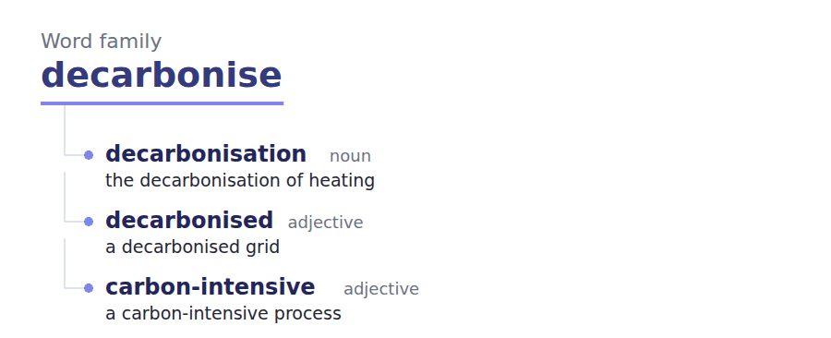
Exercise A Work in pairs. Ask and answer.
1. Why can electricity not simply be stored like oil?
2. Describe what happens on a still, cold evening in winter.
3. Is it fair to charge more for power at peak times? Why?
4. Name one energy decision that is hard to reverse.
Vocabulary 2 · Collocation 10 partnerships that actually occur
A word is known when you know what it goes with. These ten are the partners this unit’s texts use; the wrong partner is what marks an answer as translated.
meet demand to supply what is needed | lock in to make a choice hard to reverse
come online to start operating | the headline figure the number quoted in public
at scale in quantities that matter nationally | all other things being equal if nothing else changed
run the numbers to do the arithmetic properly | at the margin for the next unit, not the average
a step change a sudden large improvement | phase out to withdraw gradually

Vocabulary 3 · Stance and hedging How far the writer commits
Every one of these says the same thing at a different strength. Reading, you must notice which was chosen. Writing, you must choose.
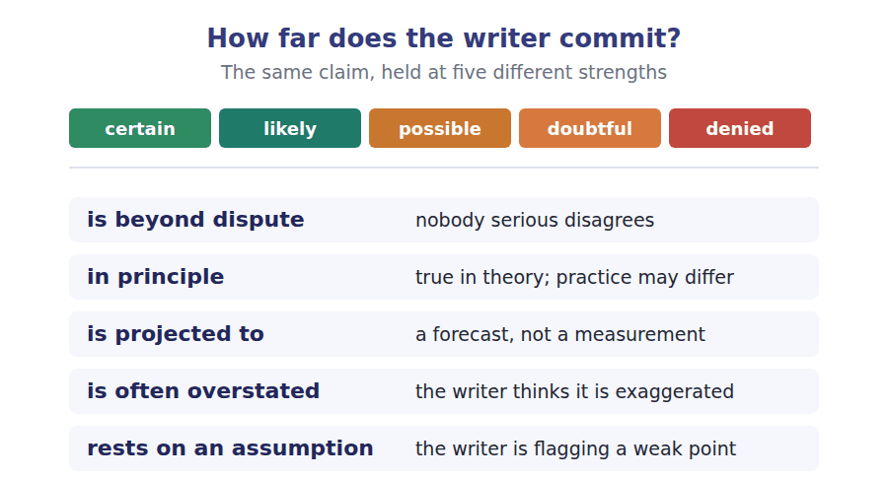
Two words that look alike
power / energy the rate / the total amount
capacity / output what it could make / what it did make
cost / price what it takes to make / what is charged

Words you will meet again: load factor | levelised cost | firm capacity | grid connection | smart meter | demand response | spinning reserve | carbon price


SKILL · Suffixes on technical adjectives and adverbs
- Technical prose is dense in adjectives ending -able, -ive, -ent and adverbs ending -ly.
- If the gap sits between to and a noun, it is almost always an adjective.
- If it ends a clause after a verb, it is an adverb.

Exercise A Guided practice. Five words are not complete. Write the missing letters.
Electricity is unusual among the things we buy because it cannot easily be kept. Almost everything else in an economy is produced, stored and then sold. Electricity is produced and consumed in the same inst---, and the two must match continu-----, second by second, across an entire country. A grid operator is therefore not selling a product so much as managing a balance, and the whole architecture of the system follows from that single constraint. When people say a technology is cheap, they usually mean cheap to gener---. Whether it is cheap to integ---- into a system that must balance every second is a different question, and often the more import--- one.

The first one is done for you: instant is instant — it follows the same and names a moment, so it is a noun.
Exercise B Exam practice. One paragraph, ten gaps — the real task.
Wind and solar are intermittent, which is a pre---- word and not a criticism. It means the output depends on conditions nobody cont----. On a still night a wind farm produces nothing, and the demand does not oblig----- fall to match it. The system has to cover the gap, and how it does so decides the real cost of the technol---. Four options exist and all four are in use. Storage holds energy from a windy afternoon until a still evening, which works well over hours and remains expens--- over weeks. Interconnectors import from somewhere the wind is still blow---, which works until the weather system is large enough to cover both countries. Flexible demand moves consumption to when the power is there, which is cheap and limited by how much consumption can actually be mo---. And peaking plant, usually burning gas, simply fills the gap, which is reliable and defeats part of the purp---. A serious plan uses all four and argues about the propor-----. What it cannot do is pretend the gap does not exist, and a great deal of public argument about energy consists of exactly that preten--, from both directions at once.

Check your answers in the key at the back of the book.


SKILL · Reading two cost claims that use different bases
- Two documents can give different costs for the same thing and both be correct, because they are measuring different quantities.
- Find the basis: per unit generated, per unit delivered, including or excluding the system cost.
- The question is almost never which number is right. It is which number answers the question being asked.

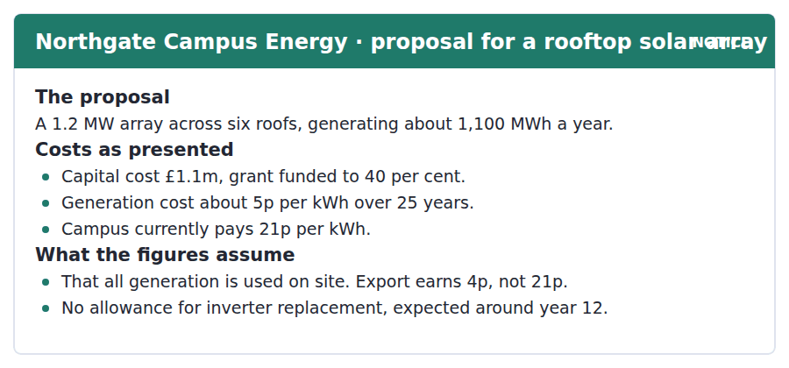
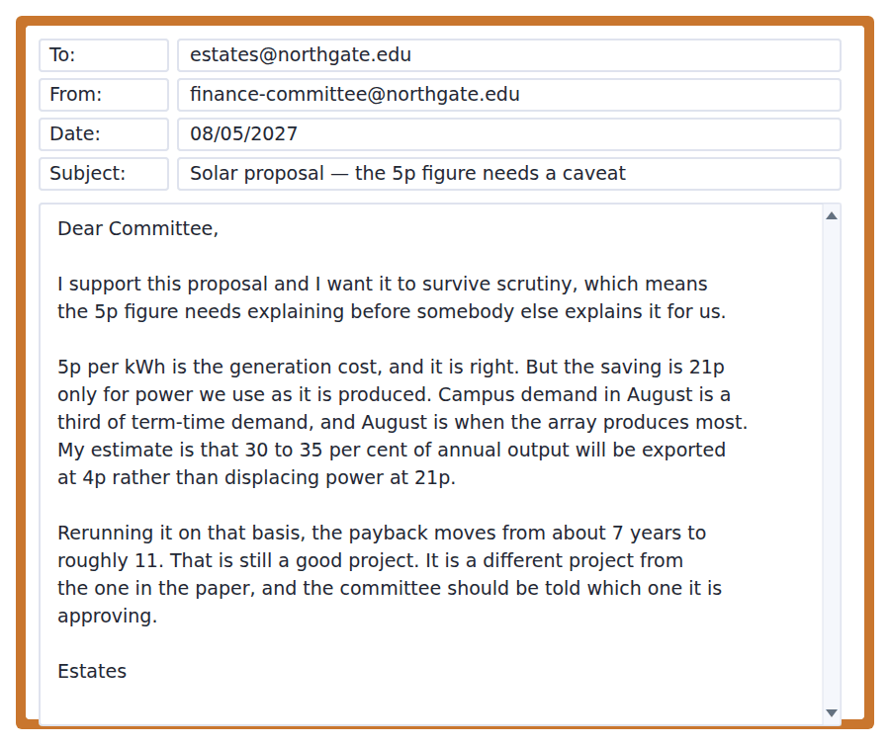
Exercise A Guided practice. The answer is on the page — find it.
1. How much does the campus currently pay per kWh?
(A) 4p
(B) 5p
(C) 21p
(D) 11p
2. What does the array earn for exported power?
(A) 4p
(B) 5p
(C) 21p
(D) Nothing
3. What is not included in the capital cost?
(A) The grant
(B) Inverter replacement
(C) The roofs
(D) Grid connection
4. What proportion of output does Estates expect to be exported?
(A) About 5 per cent
(B) About 20 per cent
(C) All of it
(D) 30 to 35 per cent
Exercise B Exam practice.
5. Why does Estates say the 5p figure "is right"?
(A) It includes export
(B) It correctly states the cost of generating
(C) It was independently audited
(D) It includes the grant
6. What is the mismatch Estates identifies?
(A) Between capital cost and grant
(B) Between two different roofs
(C) Between when power is produced and when it is used
(D) Between export and import tariffs
7. What happens to the payback period on the revised basis?
(A) It falls to 5 years
(B) It stays at 7 years
(C) It cannot be calculated
(D) It rises to about 11 years
8. What is Estates’ overall position on the proposal?
(A) Supportive, but wanting the basis corrected
(B) Opposed
(C) Neutral
(D) Supportive only if the grant increases
9. What does "before somebody else explains it for us" imply?
(A) A critic will find the weakness if they do not
(B) The paper is confidential
(C) Another department is bidding
(D) The grant is at risk
10. Which assumption in the notice does the email challenge?
(A) The 25-year lifetime
(B) The grant percentage
(C) That all generation is used on site
(D) The roof area
11. What does Estates mean by "a different project"?
(A) A different array
(B) A project on different roofs
(C) A project for a different committee
(D) The same array with a materially different return


SKILL · Reading an argument that attacks both sides
- A B2 passage sometimes criticises two opposed positions for the same underlying error.
- Expect a sentence like: this cuts in both directions.
- An item will ask what the two sides have in common, and the answer is the error, not the conclusion.

The Number That Is Always Missing
The cost of generating electricity from wind has fallen by roughly nine tenths in two decades. This is beyond dispute and it is the figure that appears in almost every public discussion. Its weight in that discussion is often overstated, because on its own it is close to useless for deciding what to build, because it prices a unit of electricity at the moment it happens to be produced rather than at the moment somebody wants it.
Two systems can generate the same annual total at the same cost per unit and behave entirely differently. One produces steadily; one produces in bursts determined by weather. The second requires something else — storage, imports, flexible demand, or a gas plant kept warm — and that something else has a cost which belongs to the second system and is conventionally reported separately or not at all. The result is that the cheap option and the cheap system are different things, and public argument routinely moves between them without noticing.
This cuts in both directions, which is why the point is worth making carefully. Those who dislike renewables use the system cost to imply that the headline fall in generating cost was illusory, and it was not. Those who favour them quote the generating cost as though integration were free, and it is not. The honest position is that the fall is real, the extra cost is real, and the second is projected to grow as the share rises, slowly at first and then faster beyond perhaps seventy per cent. Nobody can say exactly where the curve bends, and a confident number from either side rests on an assumption that is doing more work than the data.
[284 words]

Exercise A Guided practice.
1. What has fallen by about nine tenths?
(A) The total cost of electricity
(B) The cost of generating electricity from wind
(C) The price paid by consumers
(D) The cost of storage
2. Why is the generating cost "close to useless" on its own?
(A) It prices power when produced, not when wanted
(B) It is inaccurate
(C) It is out of date
(D) It excludes the grant
3. What does the second system require?
(A) More turbines
(B) A higher tariff
(C) Storage, imports, flexible demand or peaking plant
(D) A longer lifetime
4. The word "illusory" in the third paragraph means
(A) expensive
(B) not real
(C) temporary
(D) disputed
Exercise B Exam practice.
5. What error do both sides make, according to the author?
(A) Using out-of-date figures
(B) Ignoring emissions
(C) Overstating demand
(D) Moving between the cheap option and the cheap system
6. What does the author concede to opponents of renewables?
(A) That the generating cost fall was illusory
(B) That wind is unreliable
(C) That integration is not free
(D) That storage is impossible
7. What does the author concede to supporters of renewables?
(A) That the fall in generating cost is real
(B) That integration is free
(C) That the curve never bends
(D) That seventy per cent is achievable
8. What is "projected to grow"?
(A) The generating cost
(B) Demand
(C) The grant
(D) The extra system cost
9. What does the author say about where the curve bends?
(A) It bends at seventy per cent
(B) Nobody can say exactly
(C) It does not bend
(D) It bends earlier than claimed
10. What does "doing more work than the data" mean?
(A) The calculation is wrong
(B) The data are missing
(C) The assumption carries the conclusion rather than the evidence
(D) The analysis took a long time
11. Why does the author say the point is "worth making carefully"?
(A) It is technically difficult
(B) Because the data are poor
(C) Because it is widely known
(D) Because it could be misused by either side
12. All of the following are named as ways of covering a gap EXCEPT:
(A) Building more turbines
(B) Storage
(C) Interconnectors
(D) Flexible demand
13. Which finding would most strengthen the author’s position?
(A) That generating costs have fallen further
(B) That system costs rise sharply above a measurable share of renewables
(C) That demand is falling
(D) That storage costs are stable


Exercise A Listen and choose a response. You hear one line. Choose the best reply.
1. Woman: Could the battery have covered the whole evening?
(A) Yes, it is a big battery.
(B) About four hours.
(C) Not if the afternoon had been cloudy.
(D) It was installed last year.
2. Man: Why did they curtail the wind farm?
(A) About twenty turbines.
(B) Yes, they did.
(C) In February.
(D) There was nowhere for the power to go.
3. Woman: Would a bigger cable have helped?
(A) Yes, cables help.
(B) It would have, if the neighbours had had spare demand.
(C) About forty kilometres.
(D) It is a new cable.
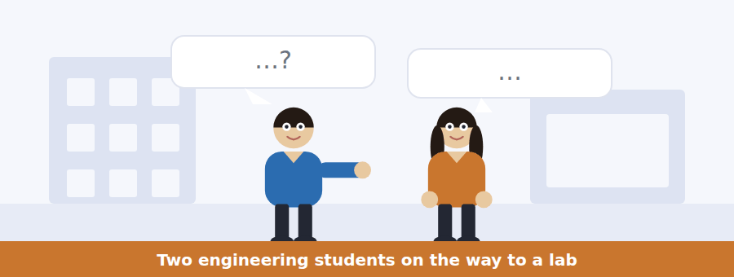
SKILL · Hearing a hypothetical about the past
- Third conditionals are common in technical talk: if we had done X, Y would have happened.
- Listen for the contraction — we’d have, it would’ve — which is where the tense lives.
- Items ask what actually happened, which is always the opposite of the conditional.

Exercise B Listen and answer. The audio plays once.
4. What happened last Tuesday?
(A) About 400 MWh of wind was curtailed
(B) A power cut
(C) A battery failed
(D) An interconnector broke
5. Why does the woman say curtailment is "worse than throwing it away"?
(A) The operators are paid to stop
(B) The power is wasted twice
(C) It damages the turbines
(D) It raises emissions
6. Why was the battery no help?
(A) It had failed
(B) It was already full by the afternoon
(C) It was too far away
(D) It was being serviced
7. What is her objection to simply building a bigger battery?
(A) It is technically impossible
(B) There is no space
(C) It would only earn on a handful of days
(D) The grid cannot take it
8. What does she say about the interconnector?
(A) It was broken
(B) It was too small
(C) It was fully used correctly
(D) It was running the wrong way because the price signal lagged
9. What would have reduced the curtailment at no physical cost?
(A) A larger battery
(B) More turbines
(C) A second interconnector
(D) The market clearing an hour earlier
10. What does the woman find "irritating"?
(A) Attention goes to batteries when half the problem is a scheduling rule
(B) The operators were paid
(C) The battery was too small
(D) Nobody reads the figures
Audio script: see the back of the book. Do not read it before you listen.


Exercise A Listen and choose a response. You hear one line. Choose the best reply.
1. Man: Is the cheaper rate automatic?
(A) Yes, for everyone.
(B) About 11pm.
(C) Only if you opt in before the thirtieth.
(D) It is cheaper at night.
2. Woman: What is the catch?
(A) There is no catch.
(B) Power costs more between five and seven.
(C) About eight pence.
(D) Yes, there is one.
3. Man: Can I leave the trial if it does not suit me?
(A) Yes, it is a trial.
(B) At the end of any month, with a week’s notice.
(C) About two hundred rooms.
(D) It runs for a year.
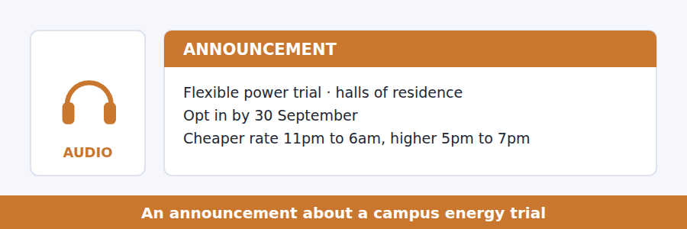
SKILL · Hearing an offer and its catch together
- An announcement offering a benefit nearly always attaches a condition. Both get tested.
- Listen for the turn: in return, the trade-off is, what we ask.
- The catch is usually stated once and quickly.

Exercise B Listen and answer. The audio plays once.
4. How much cheaper is the overnight rate?
(A) About a tenth less
(B) About half as much again
(C) It is free
(D) About a third less
5. When is electricity most expensive on the trial?
(A) 5pm to 7pm
(B) 11pm to 6am
(C) All day
(D) At weekends
6. What is the trial testing?
(A) Whether students save money
(B) Whether heating can be reduced
(C) Whether a price signal moves behaviour
(D) How much power halls use
7. Who is likely to lose money?
(A) Anyone who does laundry at night
(B) Anyone with a dishwasher
(C) Someone out all day who cooks at six every evening
(D) Students in catered halls
8. What is not included in the trial?
(A) Heating
(B) Laundry
(C) Cooking
(D) Lighting
9. Why does the speaker mention being asked eleven times?
(A) To complain
(B) To show the trial is popular
(C) To correct an earlier announcement
(D) To explain why she is answering an unasked question
Audio script: see the back of the book. Do not read it before you listen.


Exercise A Listen and choose a response. You hear one line. Choose the best reply.
1. Woman: Has wind got cheaper?
(A) Yes, slightly.
(B) Dramatically, and that is not in dispute.
(C) About twenty turbines.
(D) In the last decade.
2. Man: So cheaper generation means cheaper electricity?
(A) Yes, obviously.
(B) About five pence.
(C) Not by itself — it depends on the system around it.
(D) Electricity is expensive.
3. Woman: What do you mean by system cost?
(A) Everything you need to cover a still evening.
(B) The cost of the turbines.
(C) About thirty per cent.
(D) It is a technical term.
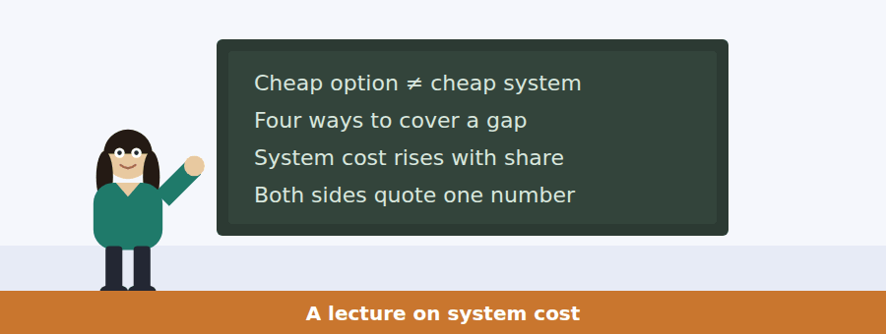
SKILL · Following a talk that refuses both popular answers
- A lecturer taking this line will give each side its strongest point before rejecting its conclusion.
- Expect two concessions, close together, and then the real argument.
- The item about the speaker’s own position usually comes last.

Exercise B Listen and answer. The audio plays once.
4. What does the speaker say about the fall in wind generating cost?
(A) It has been exaggerated
(B) It is real and beyond dispute
(C) It has stopped
(D) It applies only offshore
5. What does the anti-renewables side do with claim two?
(A) Ignores it
(B) Overstates the fall
(C) Applies it only to solar
(D) Uses it to suggest claim one was an accounting trick
6. What does the pro-renewables side do with claim one?
(A) Denies it
(B) Quotes it as though integration were free
(C) Applies it to storage
(D) Understates it
7. What does the speaker call the interesting number?
(A) The average cost of wind
(B) The total system cost today
(C) The price paid by consumers
(D) The cost of the last unit added at a high share
8. Why is that number uncertain?
(A) The data are secret
(B) It varies by country
(C) Nobody has run a grid at that share long enough
(D) It changes every year
9. How does the speaker mark his own view?
(A) As his own position, for what it is worth
(B) As established fact
(C) As the consensus
(D) As a prediction
10. What is the structure of the talk?
(A) A history followed by a forecast
(B) A problem and four solutions
(C) A comparison of two countries
(D) Two true claims, two misuses, then the speaker’s own question
Audio script: see the back of the book. Do not read it before you listen.


Part 1 · Listen and Repeat
You hear a sentence and repeat it once. There is no preparation time, and the sentences get longer. Focus: contracted third conditionals at speed
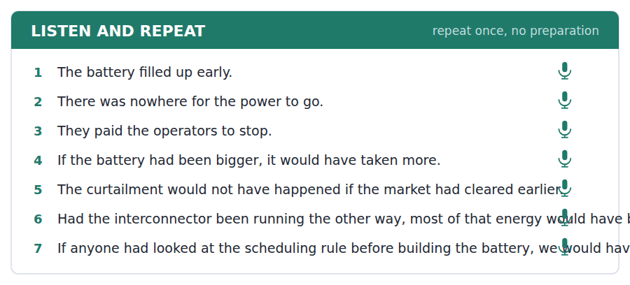
SKILL · Repeating would have and had been
- Would have contracts to would’ve and in fast speech to woulda. You must produce something between the two.
- If it had been contracts to if it’d been. The d is the whole tense.
- Never stress had or have in these. Stress the main verb.

Part 2 · Take an Interview
An interviewer asks you four questions on one theme: decisions, hindsight and infrastructure. Answer each one fully. There is no preparation time.
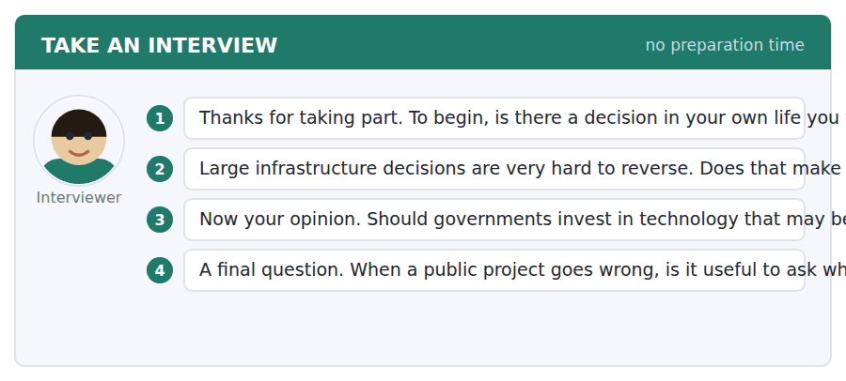
A good answer sounds like this
Question 2 — Not cautious enough, in my experience, but in a particular way. People are careful about the money and careless about whether the thing will still be the right answer in fifteen years.
Question 4 — It is useful if the question is what the process missed, and harmful if it is who to blame. Blame makes the next set of people choose the option that is easiest to defend.
I can… | Not yet | Yes
I contracted would have and had been. | □ | □
I stressed the main verb, not the auxiliary. | □ | □
I kept the whole conditional in one breath. | □ | □


Part 1 · Listen and Repeat
You hear a sentence and repeat it once. There is no preparation time, and the sentences get longer. Focus: stating a condition and its consequence in one breath
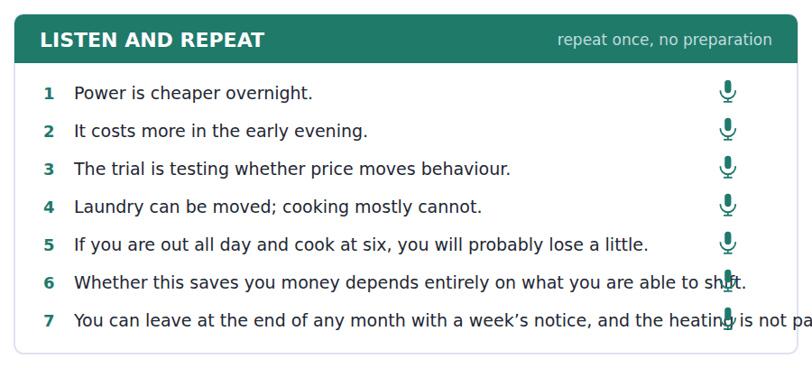
SKILL · Explaining a trade-off to somebody deciding
- When you explain an offer, state the benefit, the cost, and who it suits — in that order.
- The third part is what people actually need and what most speakers leave out.
- Use a concrete case: if you cook at six every evening, you will lose a little.

Part 2 · Take an Interview
An interviewer asks you four questions on one theme: prices, habits and changing behaviour. Answer each one fully. There is no preparation time.
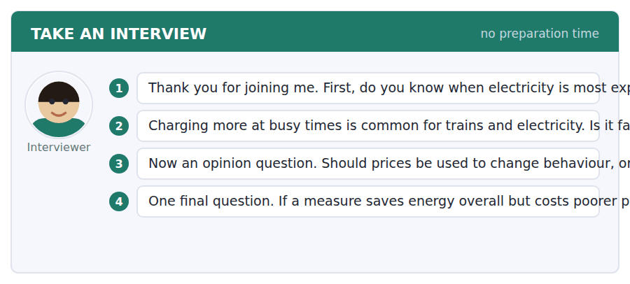
A good answer sounds like this
Question 2 — It is fair only if the alternative exists. If you can move your laundry, a price signal is information. If you work shifts and cannot move anything, it is just a higher bill.
Question 4 — Only with the money recycled. A charge that falls hardest on people with least flexibility is defensible if the revenue comes back to them, and indefensible if it does not.
I can… | Not yet | Yes
I gave benefit, cost and who it suits. | □ | □
I used a concrete case. | □ | □
I kept the condition and consequence together. | □ | □


Part 1 · Listen and Repeat
You hear a sentence and repeat it once. There is no preparation time, and the sentences get longer. Focus: rejecting a conclusion while granting the premise
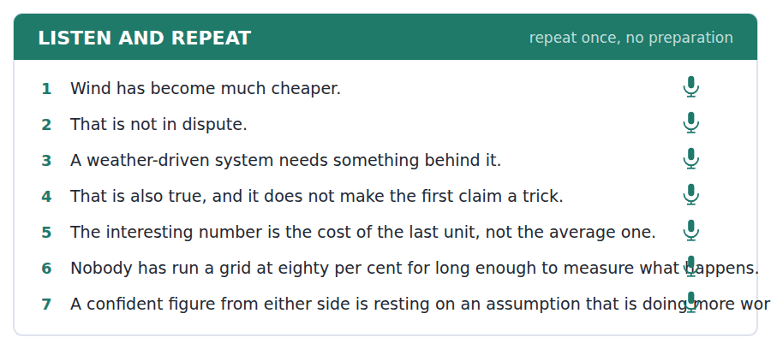
SKILL · Granting a fact and refusing the inference
- The move: that is true, and it does not follow. Both halves need equal weight.
- Stress follow. The listener must hear that you are attacking the step, not the fact.
- Then say what does follow, or the move sounds merely negative.

Part 2 · Take an Interview
An interviewer asks you four questions on one theme: argument, evidence and public debate. Answer each one fully. There is no preparation time.
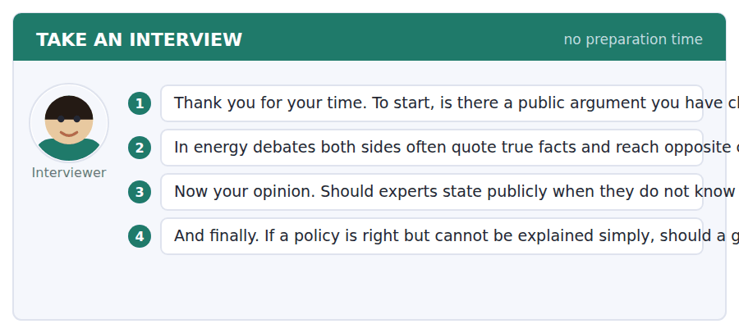
A good answer sounds like this
Question 2 — By asking what each number is a number of. In this case one side quotes the cost of generating and the other the cost of the system, and once you see that the disagreement mostly dissolves.
Question 3 — Yes, and especially then. An expert who only admits uncertainty when it is convenient has told you nothing about the uncertainty and a great deal about themselves.
I can… | Not yet | Yes
I granted the fact clearly before refusing the inference. | □ | □
I stressed the step I was attacking. | □ | □
I said what does follow. | □ | □


You see a sentence, then a set of words in boxes. Put the words in order to make one grammatical sentence. Almost every item in the real test makes a question or a question inside another sentence.
SKILL · Build a Sentence with a conditional inside
- Some items build a question around a third conditional: do you know whether it would have helped.
- Would have stays together and sits after the subject inside the clause.
- The clause keeps statement order however long it gets.

Exercise A Guided practice. The first three are worked through.
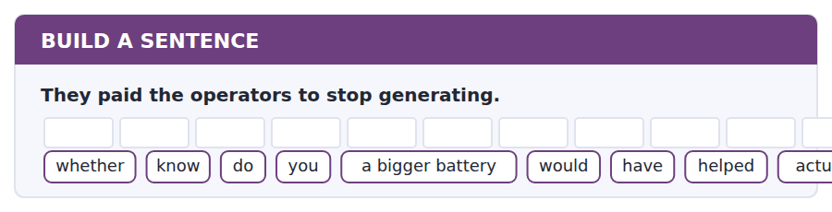
1. Do you know whether a bigger battery would have actually helped?
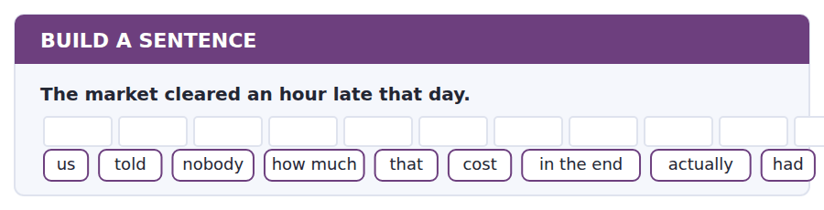
2. Nobody told us how much that had actually cost in the end.
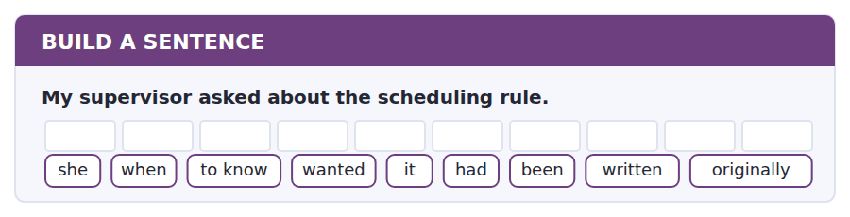
3. She wanted to know when it had originally been written.
Exercise B Exam practice. Write the sentence.
4. The array will export about a third of its output.
do / whether / know / you / that / was / in the paper / at all / mentioned
__________________________________________________________
5. The trial raises the price between five and seven.
to know / nobody / seems / how many / people / have / opted in / actually / so far
__________________________________________________________
6. The curtailment lasted about four hours.
explain / can / anybody / why / nobody / the rule / changed / earlier / to me
__________________________________________________________
7. The payback moves from seven years to eleven.
know / does / anybody / which / figure / the committee / was / shown / actually
__________________________________________________________
8. Heating is not part of the trial.
told / she / us / why / she / was / that / mentioning / at all
__________________________________________________________
9. The last unit added is the expensive one.
at which / the share / the cost / begins / to rise / is / not / known / precisely
__________________________________________________________
10. The interconnector ran the wrong way for part of the day.
whether / tell / can / me / you / that / has / been / fixed
__________________________________________________________


You read a short situation and write an email. You have 7 minutes. The three bullet points are the mark scheme: answer all three.
You live in halls and joined the flexible power trial. The cheap overnight rate works well, but the shared kitchen has one oven for twelve people, so everyone has to cook between five and seven whether they want to or not. Your bill has gone up. You think the trial is a good idea badly implemented.
Write an email to Estates.
- Say what is working and what is not.
- Explain why you cannot shift the activity that costs most.
- Propose something that would let the trial work.
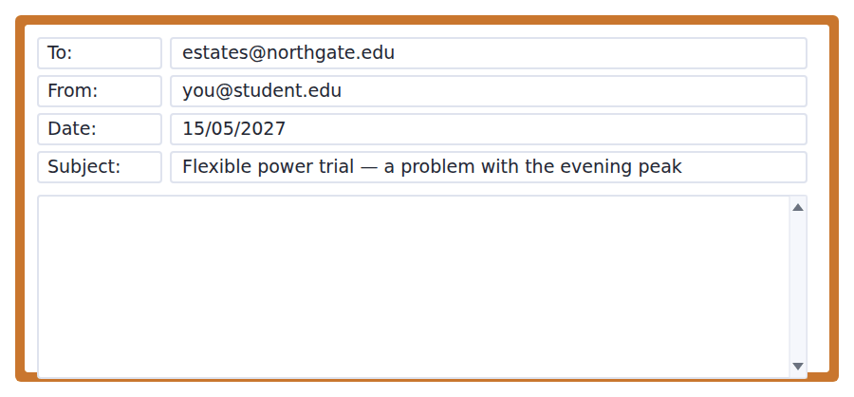
SKILL · Reporting that a scheme does not fit your situation
- The strongest version is not I am worse off but here is the group your design did not anticipate.
- Give the mechanism, not the outcome. One oven for twelve people explains itself; my bill went up does not.
- Propose a fix the organisation can actually implement.

Model email
Dear Estates,

I opted into the flexible power trial in October and I want to report a problem with it, although the overnight part works exactly as described.

The difficulty is the evening peak. Block C has one oven shared between twelve rooms. Between five and seven it is in continuous use, and the people cooking at half past six are not choosing that time — they are third in a queue that started at five. The trial assumes cooking is a fixed habit that a price signal cannot move. In our case it is a fixed queue, which is a different problem and arguably an easier one.

My own bill is up by about four pounds a month, which I mention only as evidence rather than as a complaint. The point is that the design treats twelve people as twelve independent decisions when they are in fact one shared constraint.

Two things would help. A second oven in Block C would spread the load by itself. Failing that, the peak window could start at half past five rather than five, which would let the first sitting fall outside it at no cost to the trial.

I would rather the trial worked than be released from it.

Marta Olsson, Block C
Why it works
- It separates what works from what does not, so the report is credible.
- The mechanism — one oven, twelve rooms, a queue — explains the outcome better than the outcome does.
- The bill increase is offered as evidence, not as the grievance.
- Two fixes are proposed, one cheap, so refusing both requires a reason.
Two answers, one band apart
Both answer the three bullet points. One would score in the middle band and one near the top. Read them side by side before you write your own.
A middle-band answer | A top-band answer
Dear Estates,  I am writing about the flexible power trial which I joined at the start of the year. I have to say that I am quite disappointed with it because my electricity bill has gone up rather than down.  The problem is that the expensive time is between five and seven and this is exactly when I have to cook. I cannot cook at a different time because of my timetable and because the kitchen is always busy. So the trial does not work for me at all and I feel I am being penalised for something I cannot change.  I would like to ask whether I can be taken off the trial, or whether the expensive period could be changed to a different time. I do not think it is fair that students in halls should pay more for cooking a meal.  Yours sincerely, Marta Olsson | Dear Estates,  I opted into the flexible power trial in October and want to report a problem with it, although the overnight part works exactly as described.  The difficulty is the evening peak. Block C has one oven shared between twelve rooms. Between five and seven it is in continuous use, and the people cooking at half past six are third in a queue that started at five. The trial assumes cooking is a habit a price cannot move. Here it is a queue, which is a different problem and an easier one.  My bill is up about four pounds a month, which I mention as evidence rather than as a complaint.  A second oven would spread the load by itself. Failing that, starting the peak at half past five would let the first sitting fall outside it. I would rather the trial worked than be released from it. Marta Olsson, Block C

What the top answer does that the other does not
- It reports rather than complains, and says what is working first, which makes the rest credible.
- It gives the mechanism — one oven, twelve rooms, a queue — so the reader understands the problem without having to take the writer’s word for it.
- It reframes the issue as a design assumption that does not hold, rather than as unfairness to the writer.
- It proposes two fixes, one of which costs nothing, so the reader can act immediately.
- The closing line removes the easy response of simply releasing her from the trial, which would solve her problem and not the real one.
Now write your own. 7 minutes.
__________________________________________________________
__________________________________________________________
__________________________________________________________
__________________________________________________________
__________________________________________________________
__________________________________________________________
__________________________________________________________
__________________________________________________________


A professor asks a question and two students answer. You add your own post. You have 10 minutes and an effective answer is at least 100 words.
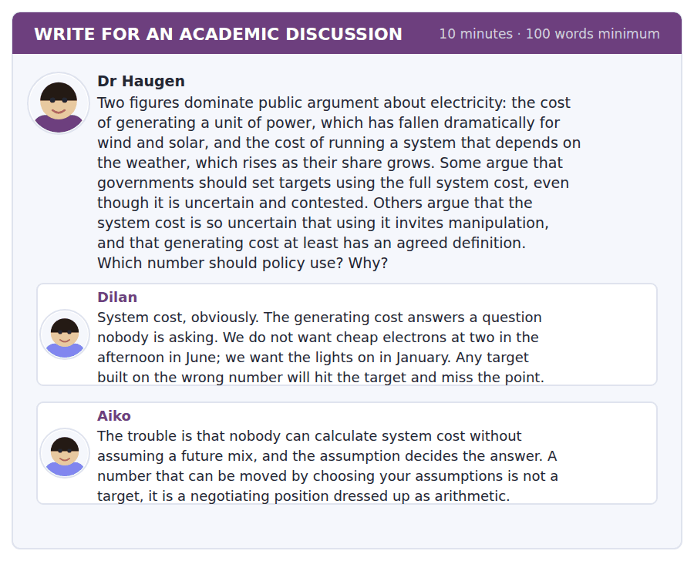
SKILL · Proposing a third option that takes both objections
- When two posts each identify a real problem with the other’s answer, the strong move is a mechanism that avoids both.
- It has to be concrete. A call for balance is not a third option.
- Show which objection each part of your proposal answers.

Sentence starters
- Both objections are right, which rules out both answers.
- Dilan’s point survives if…, and Aiko’s does too, provided…
- The mechanism that takes both is…
- What this gets you is…
Model post
Both objections are right, which is why neither answer works. Dilan is correct that the generating cost answers a question nobody is asking: a target met entirely with summer afternoon solar would be a triumph on paper and a blackout in January. Aiko is equally correct that a system cost rests on an assumption about the future mix, and that whoever chooses the assumption chooses the answer.
The mechanism that takes both objections is to stop targeting a cost at all and target the physical thing the cost is a proxy for. Set the requirement as firm capacity available at a stated winter peak, and let suppliers meet it however they like. A wind farm with no storage contributes little to that number; the same farm with four hours of batteries contributes more; a gas plant contributes fully and carries its emissions cost elsewhere.
This answers Dilan because it is denominated in the thing he actually wants, which is the lights staying on. It answers Aiko because nobody has to assume a future mix: the requirement is a measurement at a moment, not a projection, and it cannot be moved by changing a spreadsheet.
It is not free of difficulty. Deciding what counts as firm is a judgement, and in principle it could be gamed in the same way. But it is a narrower judgement than forecasting an entire system twenty years out, and a narrower judgement is easier to audit, which is all either post is really asking for.
[250 words]
Now write your own. 10 minutes, at least 100 words.
__________________________________________________________
__________________________________________________________
__________________________________________________________
__________________________________________________________
__________________________________________________________
__________________________________________________________
__________________________________________________________
__________________________________________________________
__________________________________________________________
__________________________________________________________

Grammar focus Third and mixed conditionals
Type | Example
third conditional | If the battery had been bigger, it would have taken more.
inverted third (formal) | Had the market cleared earlier, the curtailment would not have happened.
mixed: past condition, present result | If they had built the storage, we would not be curtailing now.
mixed: present condition, past result | If she were not an engineer, she would not have noticed it.
with might / could | A bigger cable might have helped.
negative condition | If the rule had not been written in 2004, this would be a different problem.
unless in a third conditional | Unless the wind had dropped, the farm would have kept running.

The third conditional talks about a past that did not happen. If it had been bigger means it was not bigger.
Mixed conditionals cross the time frames. Use them when the condition and the result belong to different times, which is extremely common in real argument.
The inverted form — had the market cleared — is formal and useful in writing. It drops if and moves had to the front.
Watch out! Never write "if it would have been". The condition clause takes had, and only the result clause takes would have. This is the single most common conditional error at B2 and examiners mark it every time.
Exercise 1 Complete with the third conditional.
1. If the battery ______ (be) bigger, it ______ (take) more.
2. If the market ______ (clear) earlier, the curtailment ______ (not happen).
3. If anyone ______ (read) the rule, we ______ (solve) it for nothing.
4. If the wind ______ (not drop), the farm ______ (keep) running.
Exercise 2 Make a mixed conditional.
1. They did not build the storage. We are curtailing now.
2. She studied engineering. She noticed the error.
3. The rule was written in 2004. The problem exists today.
4. I did not opt in. I am paying the standard rate.
Exercise 3 Rewrite using inversion, without if.
1. If the market had cleared earlier, less would have been wasted.
2. If the committee had been told, it would have asked.
3. If the oven had not been shared, the peak would not have mattered.
4. If the figures had included export, the payback would have been longer.
How this is tested in Build a Sentence
Build a Sentence sometimes embeds a conditional inside a question: do you know whether a bigger battery would have helped. The would have block stays together and the clause keeps statement order.
Find the fault 5 errors, drawn from this unit and the two before
Every error below is one a B2 writer makes after learning the rule. Mark what is wrong, then check. Knowing the rule and noticing the breach are two different skills, and only the second one is tested.
If the battery would have been bigger, it would have taken more power. Had the market cleared earlier, less energy was wasted. If they built the storage last year, we would not be curtailing now. The committee were not told about the export figure. Nobody knows whether would a second oven have helped.
# | As written | As it should be | Why
1 | If the battery would have been bigger | If the battery had been bigger | The condition clause takes had, never would have; only the result takes would.
2 | less energy was wasted | less energy would have been wasted | The result clause of a third conditional needs would have, not a simple past.
3 | If they built the storage last year | If they had built the storage last year | A past condition that did not happen takes the past perfect, not the simple past.
4 | The committee were not told | The committee was not told | A single body acting as one unit takes a singular verb here.
5 | whether would a second oven have helped | whether a second oven would have helped | An embedded question keeps statement order, so would follows the subject.

Unit review and progress check Unit 27
Exercise A Vocabulary. Write the word.
1. available only some of the time
2. the network that carries electricity
3. the steady demand that never goes away
4. to shut down output that cannot be used
5. the resistance of a system to sudden change
6. to remove carbon from an activity
7. to add new equipment to an existing building
8. the price structure charged to users
9. more than is needed at that moment
10. a period when supply fails
11. a cable linking two countries’ grids
12. generation used only at the highest demand
Exercise B Grammar. Complete the sentence.
1. If the battery ______ been bigger, it would have taken more.
2. If the market had cleared earlier, less ______ have been wasted.
3. ______ the committee been told, it would have asked.
4. If they had built storage, we ______ not be curtailing now.
5. If she had not studied engineering, she ______ not have noticed.
6. A bigger cable ______ have helped, though we cannot be sure.
7. ______ the wind had dropped, the farm would have kept running.
8. Nobody knows whether it ______ have helped.
Exercise C One timed mini-section. 6 minutes.
1. Electricity is unusual because it
(A) cannot be transported
(B) cannot be measured
(C) must be produced and used at the same instant
(D) has no market price
2. Curtailment means
(A) a power cut
(B) shutting down generation that cannot be used
(C) importing power
(D) raising the tariff
3. The 5p generation cost overstates the saving because
(A) exported power earns only 4p
(B) it excludes the grant
(C) inverters need replacing
(D) the array is small
4. Which sentence is correct?
(A) If it had been bigger, it would have helped.
(B) If it would have been bigger, it would have helped.
(C) If it had been bigger, it had helped.
(D) If it was bigger, it would have helped.
5. "Rests on an assumption" signals that the writer
(A) accepts the claim
(B) is flagging a weak point
(C) has proved it
(D) is quoting somebody
6. The speaker says the interesting number is
(A) the average cost of wind
(B) the price consumers pay
(C) the cost of the last unit at a high share
(D) the capital cost
Can you do these now?
I can… | Not yet | Yes
I can follow an argument that compares four options against one problem. | □ | □
I can use the third conditional to argue about a decision already taken. | □ | □
I can mix time frames in a conditional without losing the sentence. | □ | □
I can read a cost claim and ask what it excludes. | □ | □
I can concede a point to one side and still reject its conclusion. | □ | □
I can write a proposal that anticipates the obvious objection. | □ | □

ADAPTIVE TIP "If it would have been" is the error examiners are most tired of seeing. The rule is mechanical: had in the if-clause, would have in the other one. Drill it until it is automatic, because a conditional is the natural way to argue about any decision that has already been taken, and you will reach for one constantly.

Unit 28 · Migration and Demography
TOEFL iBT® Preparation Course 2026 · Volume 3
CEFR B2 · Grammar: Nominalisation · Word field: cohort, projection, displacement
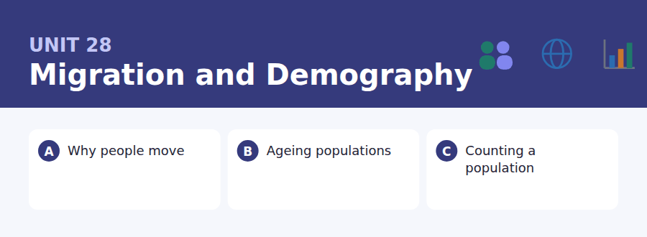
By the end of this unit I can…
- I can turn a verb phrase into a noun phrase and back again.
- I can see when a nominalisation is hiding who did something.
- I can read a statistic and ask what it is a net figure of.
- I can separate categories that a single word has merged.
- I can write about a contested topic without taking a side I did not argue for.
- I can follow a talk that corrects the terms of a public debate.

Demography is the one social science that can tell you about 2060 with confidence, and the one whose findings are most often ignored. This unit also teaches nominalisation — turning a process into a thing — which is how academic English packs a clause into a noun phrase.

Vocabulary 1 · Academic word families 18 families, not 18 words
At B2 the word on its own is not enough. Each entry below is a family: learn the noun, the verb and the adjective together, because the test will use whichever one the sentence needs.
cohort everyone born in the same period | dependency the ratio of non-workers to workers
projection what the numbers give if trends continue | urbanisation the movement of a population into cities
displacement being forced to leave where you live | outflow the number of people leaving
fertility the average number of children per woman | pyramid a chart of population by age and sex
mortality the rate at which people die | replacement the fertility rate that keeps a population level
census an official count of the whole population | influx a large arrival over a short period
diaspora a people settled far from their homeland | settlement staying permanently in a new country
remittance money sent home by somebody working abroad | longevity how long people live
assimilation becoming indistinguishable from the host population | naturalise to become a citizen of a new country

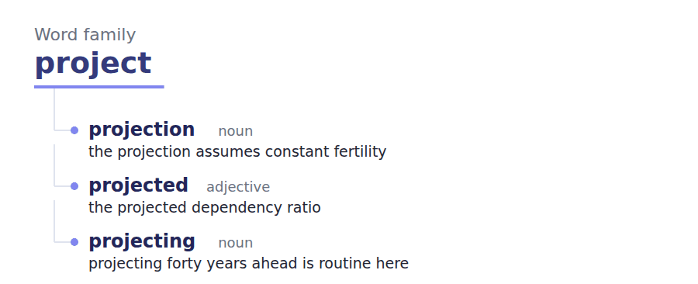
Exercise A Work in pairs. Ask and answer.
1. What would make you leave the place you live?
2. Why does a falling birth rate take so long to matter?
3. What does a net migration figure of zero not tell you?
4. Who should be counted in a census, and who decides?
Vocabulary 2 · Collocation 10 partnerships that actually occur
A word is known when you know what it goes with. These ten are the partners this unit’s texts use; the wrong partner is what marks an answer as translated.
net of after subtracting | break down the figure to separate it into its parts
in absolute terms as a raw number, not a proportion | take account of to include in the reasoning
per head divided by the population | year on year comparing each year with the one before
a drain on a cost to | in the long term over decades rather than years
place demands on to require resources from | at the other end of the scale at the opposite extreme

Vocabulary 3 · Stance and hedging How far the writer commits
Every one of these says the same thing at a different strength. Reading, you must notice which was chosen. Writing, you must choose.
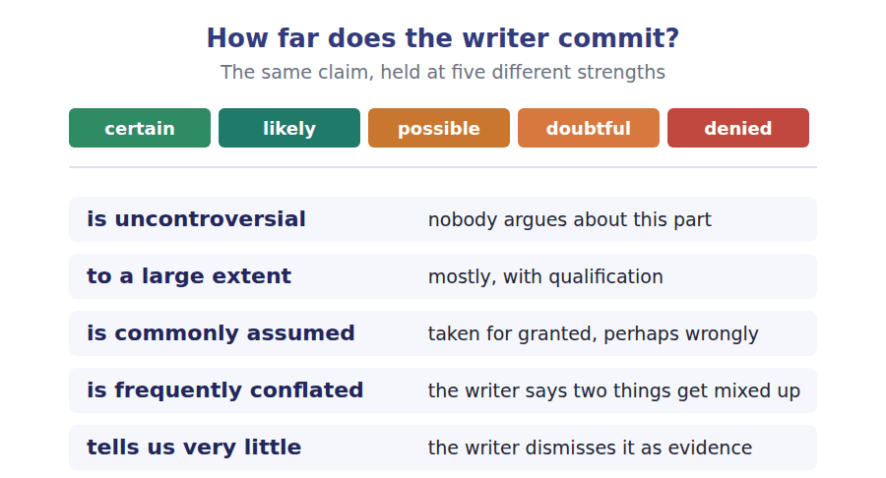
Two words that look alike
emigrate / immigrate to leave a country / to enter one
refugee / migrant a legal status / a description of movement
rate / number per head of population / the raw total

Words you will meet again: net migration | dependency ratio | birth rate | population pyramid | brain drain | push and pull factors | ageing society | labour shortage


SKILL · Nominalising suffixes
- This page is dense in nouns made from verbs: -ation, -ment, -ance, -ence.
- If the gap follows a determiner and the sentence has no other noun, the gap is the noun.
- Reading the sentence as a verb first often gives you the stem: graduate becomes graduation.

Exercise A Guided practice. Five words are not complete. Write the missing letters.
Populations change in only three ways: births, deaths and movement. Everything else is commentary. What makes demography difficult is not the arith----- but the lag. A change in the number of births today shows up in the labour force in twenty years and in pension costs in sixty, which means the consequences of a demographic shift arrive long after the shift itself has stopped being n---. Governments are therefore routinely managing the effects of decisions nobody took, in response to a change that happened before most of the officials involved were b---. This is one of the few areas of policy where the forecast is genuinely relia--- for thirty years ahead, and one of the fewest where anybody acts on it that far in adv----.

The first one is done for you: arithmetic is arithmetic — it follows the and names the easy part, so it is a noun.
Exercise B Exam practice. One paragraph, ten gaps — the real task.
The word migrant does a great deal of work and conceals most of it. It covers a software engineer moving between offices, a nurse recruited deliber----- by a health service, a student who stays after graduat---, and somebody who has walked out of a war. These have almost nothing in com--- except the crossing of a border, and treating them as one category produces statistics that are technically correct and practically meaning----. Public debate compounds the problem by moving between the categories without announ---- it: an argument about pressure on housing, which is about numbers, is answered with an argument about obliga----, which is about protection, and neither side notices that they are discussing different peo---. A further difficulty is that the figure most often quoted is net migration, which is arriv--- minus departures. A net figure of zero is compatible with a million people arriving and a million leaving, and those two situations place complete-- different demands on a country. Anybody who wants to understand the subject has to begin by refusing the single number and asking which of the underlying flows has actually chan---.

Check your answers in the key at the back of the book.


SKILL · Reading a projection and its assumptions
- A projection is not a prediction. It says what follows if stated assumptions hold.
- The assumptions are always listed, usually in smaller type, and they are where the questions come from.
- Changing one assumption can change the headline by a factor of two.

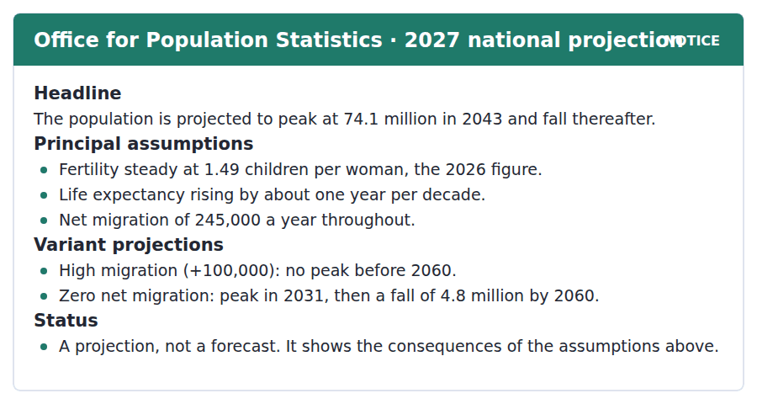
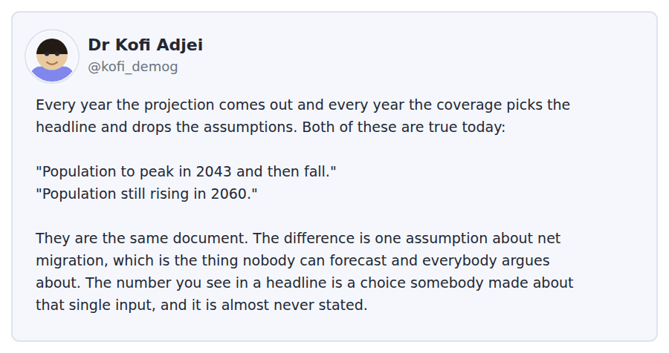
Exercise A Guided practice. The answer is on the page — find it.
1. When is the population projected to peak on the principal assumptions?
(A) 2043
(B) 2031
(C) 2060
(D) It does not peak
2. What fertility rate is assumed?
(A) 1.80
(B) 2.10
(C) 1.49
(D) 2.45
3. What does the zero net migration variant show?
(A) A peak in 2043
(B) No peak before 2060
(C) No change
(D) A peak in 2031 and a fall of 4.8 million by 2060
4. What does the notice say about the status of the figures?
(A) They are a forecast
(B) They are a projection showing the consequences of assumptions
(C) They are provisional
(D) They are a government target
Exercise B Exam practice.
5. What is Dr Adjei’s main complaint?
(A) The projection is wrong
(B) The assumptions are unrealistic
(C) Coverage takes a headline and drops the assumptions
(D) The variants are not published
6. How can both quoted headlines be true?
(A) They cover different years
(B) One is a forecast and one a projection
(C) One is out of date
(D) They rest on different migration assumptions
7. What does Dr Adjei say about forecasting net migration?
(A) Nobody can do it and everybody argues about it
(B) It is straightforward
(C) It is done annually
(D) It depends on fertility
8. What is "almost never stated" in coverage?
(A) The year of the peak
(B) The choice of migration assumption
(C) The fertility rate
(D) The source of the data
9. Which assumption would most change the 2043 peak?
(A) Fertility
(B) Life expectancy
(C) Net migration
(D) The base year
10. What does "a projection, not a forecast" mean?
(A) It is less accurate
(B) It covers a shorter period
(C) It is unofficial
(D) It states consequences of assumptions rather than predicting
11. What can be inferred about Dr Adjei’s view of the statisticians?
(A) He blames them for the headlines
(B) He does not blame them
(C) He thinks the method is flawed
(D) He wants fewer variants


SKILL · Reading a text about a self-reinforcing problem
- Watch for a loop: X causes Y, and Y makes X worse. The loop is usually the point of the passage.
- The author will normally state it in one sentence and then draw out the consequence.
- An item often asks what breaks or sustains the loop.

The Census and the People It Misses
A census aims at something no other survey attempts: counting everybody. The ambition is what makes it valuable and what makes its failures interesting. No census has ever succeeded, and the people it misses are not missed at random. They are disproportionately young, mobile, poor, and living in households that do not match the form.
That last point is commonly assumed to be minor, and is frequently conflated with a simple shortage of effort. A census form is built around a household with a recognisable head, at a fixed address, on one night. People in temporary accommodation, people moving between two homes, people whose landlord would rather they were not recorded, and people sharing a flat with four others on short tenancies are all harder to count, and all of them are concentrated in the same places. The undercount is therefore geographically clustered, which matters enormously, because census figures determine funding allocations per head.
An area that is undercounted by five per cent receives five per cent less for a decade, and the effect is self-reinforcing: the services that would reach the uncounted are the services the undercount defunds. Statistical agencies know this and adjust for it, using follow-up surveys to estimate the miss. The adjustment is uncontroversial among statisticians and ferociously contested in public, because adjusting a count feels like changing an answer, and because the direction of the adjustment is always the same. To a large extent the argument is not about statistics at all. It is about whether a number that has been corrected is still a count, and that question has no technical answer.
[268 words]

Exercise A Guided practice.
1. What is unusual about a census?
(A) It aims to count everybody
(B) It is voluntary
(C) It is run every year
(D) It uses a sample
2. Who does a census tend to miss?
(A) The elderly
(B) Homeowners
(C) The young, mobile and poor
(D) Civil servants
3. Why is the undercount geographically clustered?
(A) The hardest-to-count groups live in the same places
(B) Forms are delivered unevenly
(C) Rural areas are remote
(D) Cities have more people
4. The word "self-reinforcing" in the third paragraph means
(A) easy to correct
(B) making itself worse over time
(C) officially approved
(D) repeated every decade
Exercise B Exam practice.
5. Why does the undercount matter so much?
(A) It affects the headline total
(B) It delays publication
(C) It affects fertility estimates
(D) Funding is allocated per head on census figures
6. How do statistical agencies respond?
(A) They repeat the census
(B) They adjust using follow-up surveys
(C) They publish a range
(D) They do nothing
7. Why is the adjustment contested in public?
(A) It is statistically doubtful
(B) It is expensive
(C) Adjusting a count feels like changing an answer, and always moves one way
(D) It delays funding decisions
8. What does the author say about the statisticians’ view?
(A) It is divided
(B) They oppose adjustment
(C) They have not studied it
(D) The adjustment is uncontroversial among them
9. What is the question the author says has no technical answer?
(A) Whether a corrected number is still a count
(B) How many people were missed
(C) How to design the form
(D) Which areas are undercounted
10. What is "commonly assumed to be minor"?
(A) The mismatch between households and the form
(B) The undercount of the elderly
(C) The cost of a census
(D) The length of the form
11. All of the following are named as hard to count EXCEPT:
(A) People in temporary accommodation
(B) People moving between two homes
(C) People sharing on short tenancies
(D) People living alone
12. What does the structure of the argument suggest about the author’s purpose?
(A) To defend the census
(B) To show that a technical problem has political consequences
(C) To criticise statisticians
(D) To propose a new method
13. Which change would most reduce the problem described?
(A) A longer form
(B) More frequent censuses
(C) A design that does not assume a fixed household at one address
(D) Publishing the adjustment


Exercise A Listen and choose a response. You hear one line. Choose the best reply.
1. Man: Our topic is migration. Where do we start?
(A) Yes, it is a big topic.
(B) About fifteen minutes.
(C) On Thursday.
(D) By deciding which kind we mean.
2. Woman: Is net migration the right figure to use?
(A) Yes, it is official.
(B) Only if you also give the two flows.
(C) About 245,000.
(D) It is published annually.
3. Man: Should we mention remittances?
(A) Yes, we should.
(B) About forty slides.
(C) It would surprise people how large they are.
(D) They are sent home.
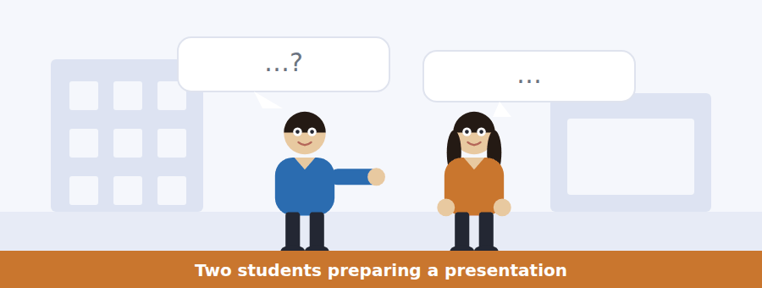
SKILL · Hearing a category being split
- One speaker will often show that a single word covers several different things.
- Listen for: that is three different groups; which of those do you mean.
- The item asks what the distinction is, not what the word means.

Exercise B Listen and answer. The audio plays once.
4. Why does the woman want to narrow the topic?
(A) Otherwise they will be discussing four different things
(B) There is not enough time
(C) The data are poor
(D) The tutor asked them to
5. What four groups does she name?
(A) Students, tourists, workers, refugees
(B) Refugees, citizens, visitors, residents
(C) Men, women, children, families
(D) A consultant, a recruited nurse, a student who stays, somebody leaving a war
6. Why can two people both be right in the housing argument?
(A) They are talking about different people
(B) The data are unreliable
(C) Both are using net figures
(D) Neither has evidence
7. Why does she choose labour migration?
(A) It is easier
(B) The data are good and the argument is economic rather than moral
(C) It is what the tutor wants
(D) It has fewer categories
8. What is wrong with using net migration alone?
(A) It is out of date
(B) It excludes students
(C) Net zero is compatible with very different situations
(D) It is not published
9. What does the woman mean by "the whole presentation in one slide"?
(A) That point carries the entire argument
(B) The slide is too full
(C) They need only one slide
(D) The slide should be last
10. What is the relationship between the speakers?
(A) Tutor and student
(B) Strangers
(C) Two students, one leading the analysis
(D) Researcher and interviewee
Audio script: see the back of the book. Do not read it before you listen.


Exercise A Listen and choose a response. You hear one line. Choose the best reply.
1. Woman: Which projection is the main one?
(A) Yes, there is a main one.
(B) The principal, but it is one of five.
(C) About 74 million.
(D) On Thursday.
2. Man: Is this a forecast of what will happen?
(A) Yes, essentially.
(B) Until 2060.
(C) It is official.
(D) No — it is what follows if the assumptions hold.
3. Woman: Which assumption matters most?
(A) They all matter.
(B) About 245,000.
(C) Fertility is assumed steady.
(D) Net migration, by a long way.
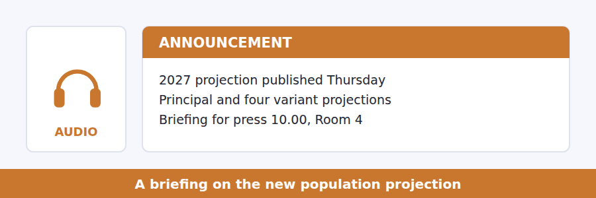
SKILL · Hearing a warning about how figures will be used
- A speaker releasing figures often predicts the misuse before it happens.
- Listen for: what will be reported is, the line you will see tomorrow.
- The prediction and the correction are both tested.

Exercise B Listen and answer. The audio plays once.
4. How many projections are being published?
(A) One
(B) Three
(C) Five
(D) Fifty
5. What does the principal projection assume about migration?
(A) Zero
(B) 245,000 a year
(C) 100,000 a year
(D) It varies
6. What happens to the peak under zero net migration?
(A) It moves to 2031
(B) It disappears
(C) It moves to 2060
(D) It stays at 2043
7. What is the speaker’s request?
(A) That journalists use the principal projection
(B) That the figures be embargoed
(C) That any piece state which variant it uses, once
(D) That headlines include the assumptions
8. What does he suggest readers ask?
(A) How many people were surveyed
(B) What was assumed about migration
(C) Who published the figures
(D) When the census was taken
9. What is the speaker’s attitude to journalists?
(A) Critical
(B) Indifferent
(C) Hostile
(D) Explicitly not complaining about them
Audio script: see the back of the book. Do not read it before you listen.


Exercise A Listen and choose a response. You hear one line. Choose the best reply.
1. Woman: Does a census count everybody?
(A) No census ever has.
(B) Yes, that is the point of it.
(C) Every ten years.
(D) About 74 million.
2. Man: Is the undercount spread evenly?
(A) Yes, roughly.
(B) No, and that is what makes it serious.
(C) About five per cent.
(D) It is measured afterwards.
3. Woman: Do statisticians disagree about adjusting?
(A) Yes, strongly.
(B) About follow-up surveys.
(C) Not really — the public argument is elsewhere.
(D) It is adjusted every time.
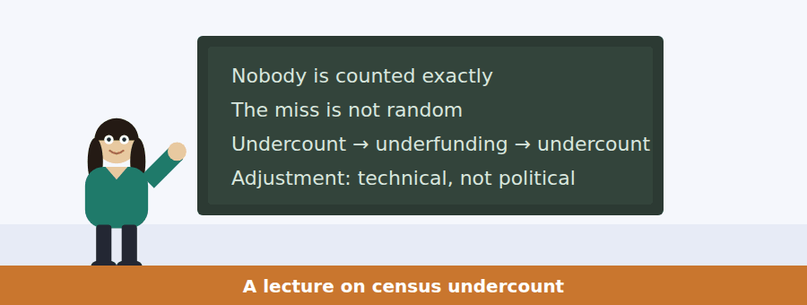
SKILL · Following a talk that separates a technical and a political question
- A careful lecturer will say which parts of a dispute are settled and which are not.
- Listen for: that part is uncontroversial; this part is not a statistical question at all.
- The division is usually the examinable content.

Exercise B Listen and answer. The audio plays once.
4. What are the two questions the speaker separates?
(A) Who was missed, and whether to publish an adjusted figure
(B) Who to count and when to count
(C) How much a census costs and who pays
(D) Technical and historical
5. Who does the census miss?
(A) Older homeowners
(B) People in rural areas
(C) Recent arrivals only
(D) The young, mobile, poor and those outside standard households
6. Why does the clustering matter?
(A) Funding per head follows the count, so undercounted areas lose money
(B) It makes the total wrong
(C) It affects the next census
(D) It delays publication
7. What is the "loop" she describes?
(A) Each census misses more people than the last
(B) Funding rises as population falls
(C) Undercount reduces funding for the services that would reach the missed
(D) Adjustment increases the count each time
8. What do statisticians think about adjustment?
(A) They are divided
(B) It is uncontroversial and the methods are public
(C) They oppose it
(D) They have not studied it
9. What is the public argument actually about?
(A) Whether the methods work
(B) Who pays for the census
(C) How often to count
(D) Whether a corrected number is still a count, and one-directional adjustment
10. What does the speaker call unreasonable?
(A) Asking about adjustment
(B) Publishing a raw count
(C) Conflating the two sets of questions
(D) Running a census at all
Audio script: see the back of the book. Do not read it before you listen.


Part 1 · Listen and Repeat
You hear a sentence and repeat it once. There is no preparation time, and the sentences get longer. Focus: stressing the noun in a long noun phrase
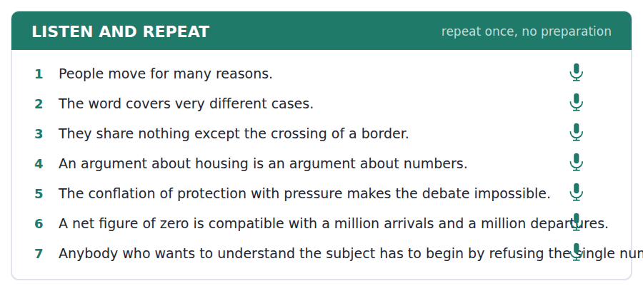
SKILL · Repeating a nominalised sentence
- Nominalisation produces long noun phrases with one head noun. The stress goes on the head.
- The crossing of a border — stress crossing, not border.
- If you stress the wrong word the listener loses the structure.

Part 2 · Take an Interview
An interviewer asks you four questions on one theme: moving, staying and what makes somewhere home. Answer each one fully. There is no preparation time.
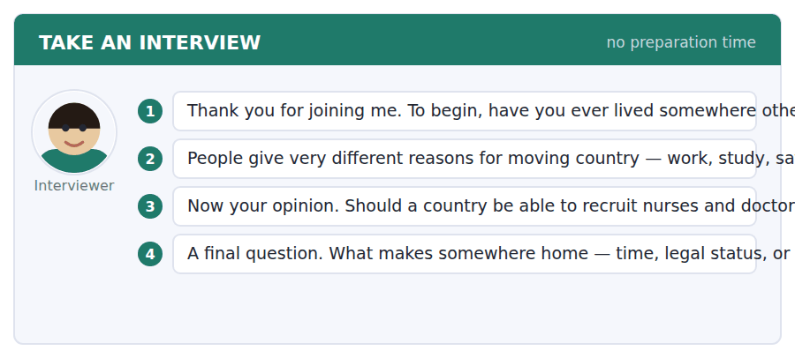
A good answer sounds like this
Question 2 — In law it clearly does, and I think it should. But in daily life it makes less difference than people expect. Somebody arriving for work and somebody arriving from a war both have to find a flat.
Question 3 — Not without compensation of some kind. Training a doctor is a large public investment, and recruiting one is taking that investment without paying for it.
I can… | Not yet | Yes
I stressed the head noun in each phrase. | □ | □
I kept the long noun phrase together. | □ | □
I distinguished two categories explicitly. | □ | □


Part 1 · Listen and Repeat
You hear a sentence and repeat it once. There is no preparation time, and the sentences get longer. Focus: saying large numbers and dates fluently
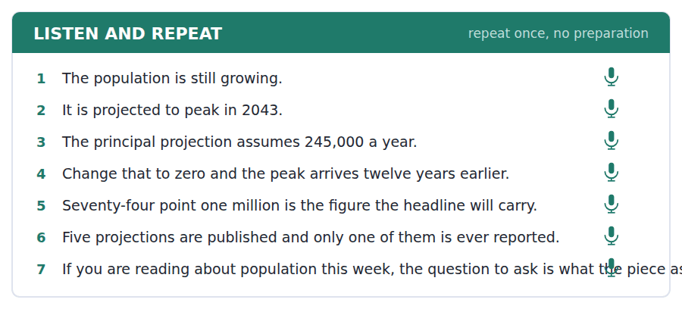
SKILL · Handling figures in a spoken answer
- Big numbers derail fluency. Practise the shapes: seventy-four point one million, two hundred and forty-five thousand.
- Say a date as a unit: twenty forty-three, not two zero four three.
- If you are unsure of a figure, round it and say you are rounding.

Part 2 · Take an Interview
An interviewer asks you four questions on one theme: ageing, work and who supports whom. Answer each one fully. There is no preparation time.
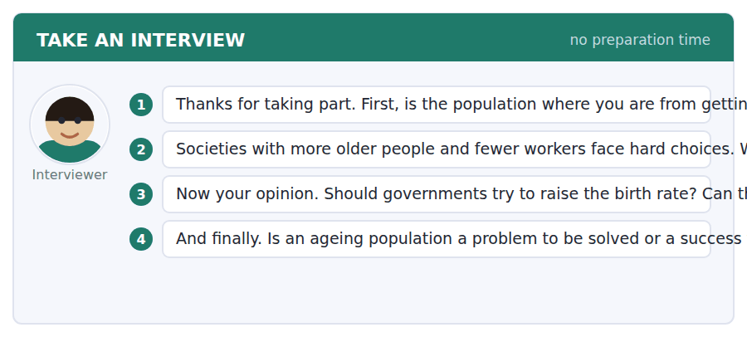
A good answer sounds like this
Question 2 — Later retirement, if the work is survivable. The difficulty is that it is easy for me to say and much harder for somebody who has been doing physical work since they were sixteen.
Question 4 — A success, mostly. People living thirty years longer than their grandparents is the outcome everybody wanted, and complaining about the cost of it is a strange way to describe winning.
I can… | Not yet | Yes
I said the large numbers without hesitating. | □ | □
I said dates as units. | □ | □
I rounded openly where I was unsure. | □ | □


Part 1 · Listen and Repeat
You hear a sentence and repeat it once. There is no preparation time, and the sentences get longer. Focus: marking a distinction audibly
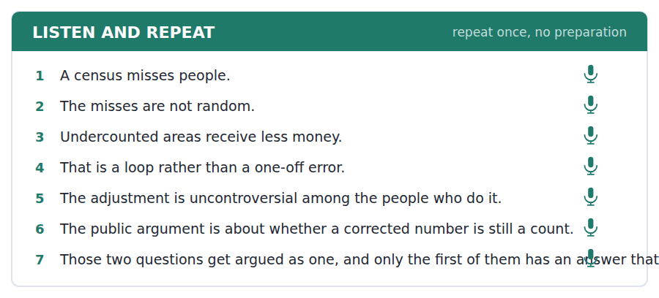
SKILL · Separating two questions out loud
- When two issues are being confused, say so and number them. One is technical. Two is not.
- Pause between them. The pause does the work the paragraph break does in writing.
- Then say which one you are answering.

Part 2 · Take an Interview
An interviewer asks you four questions on one theme: counting, funding and trust in numbers. Answer each one fully. There is no preparation time.
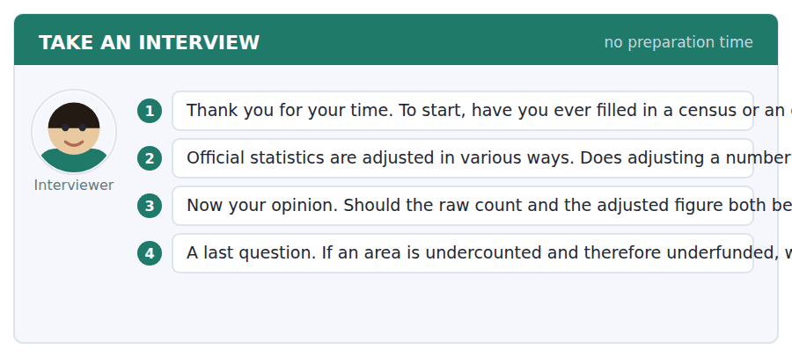
A good answer sounds like this
Question 2 — More accurate and less trusted at the same time, which is the real difficulty. People can follow the method if it is explained, but the explanation never travels as far as the number does.
Question 3 — Both, with the method attached. Publishing only the adjusted figure invites exactly the suspicion that makes adjustment controversial in the first place.
I can… | Not yet | Yes
I numbered the two questions. | □ | □
I paused between them. | □ | □
I said which one I was answering. | □ | □


You see a sentence, then a set of words in boxes. Put the words in order to make one grammatical sentence. Almost every item in the real test makes a question or a question inside another sentence.
SKILL · Build a Sentence with a nominalised subject
- Some items put a long noun phrase in the subject: the crossing of a border, the conflation of two arguments.
- The whole phrase is the subject and the verb follows it, however long it gets.
- Inside an embedded question it still keeps statement order.

Exercise A Guided practice. The first three are worked through.
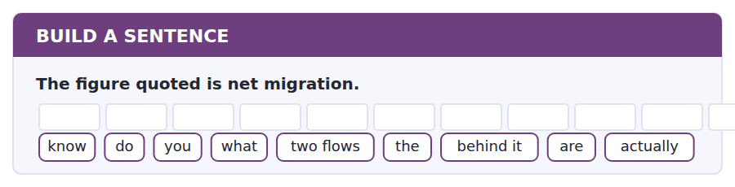
1. Do you know what the two flows behind it actually are?
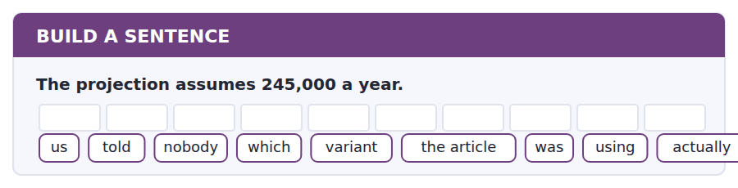
2. Nobody told us which variant the article was actually using.
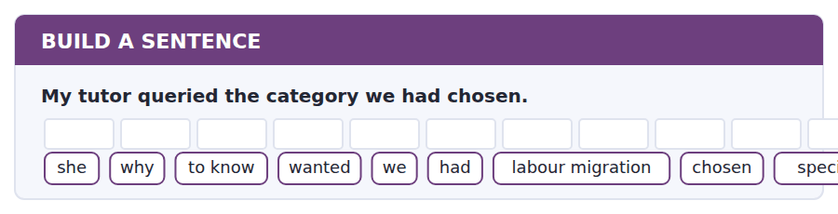
3. She wanted to know why we had specifically chosen labour migration.
Exercise B Exam practice. Write the sentence.
4. The undercount is geographically clustered.
do / whether / know / you / that / is / in the report / at all / mentioned
__________________________________________________________
5. Five projections were published on Thursday.
to know / nobody / seems / how many / of them / were / reported / actually / anywhere
__________________________________________________________
6. Net zero can mean nobody moved or a million each way.
explain / can / anybody / why / that / matters / so much / to me / exactly
__________________________________________________________
7. Funding follows the census figure.
know / does / anybody / how long / an undercount / an area / affects / actually / for
__________________________________________________________
8. The adjustment always moves in one direction.
told / she / us / why / that / makes / people / suspicious / exactly
__________________________________________________________
9. The form assumes a household with a head at one address.
the conflation / of two questions / is / what / makes / the argument / impossible / to / settle
__________________________________________________________
10. A projection is not a forecast.
whether / tell / can / me / you / the piece / says / which / anywhere
__________________________________________________________


You read a short situation and write an email. You have 7 minutes. The three bullet points are the mark scheme: answer all three.
A local paper ran the headline "Population to shrink from 2031" above a story about the national projection. That date comes from the zero net migration variant, not the principal projection, which gives 2043. The article does not say which variant it used. You are a geography student.
Write a letter to the paper.
- Say what the article got right.
- Explain the error precisely, without accusing anyone of bias.
- Say what one sentence would have fixed it.
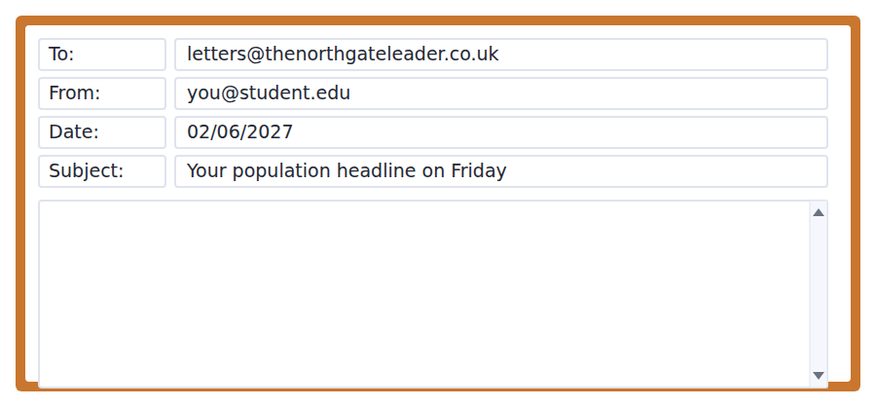
SKILL · Correcting a publication briefly
- A letter that will be printed is short, specific and does not impute motive.
- Give the two figures and where each comes from. The reader can then see the error without being told it is one.
- Name the fix in one sentence so the paper knows the cost of agreeing is small.

Model email
Sir,

Your report on the national population projection (Friday) was right that the population is expected to fall, and right that this is a significant change.

The date is the difficulty. Your headline gives 2031. The projection published on Thursday contains five variants, and 2031 is the peak under the variant that assumes net migration of zero every year until 2060. The principal projection, which assumes 245,000 a year, gives 2043. Both numbers are in the same document and the article does not say which one it used.

I am not suggesting anyone chose the dramatic figure deliberately; the variants are easy to mix up and the document is long. But a reader who takes 2031 from your headline has been given somebody’s assumption about migration, not a finding about population.

One clause would have fixed it: "on the assumption of zero net migration". That is the whole correction I am asking for.

Marta Olsson
Second-year Geography, Northgate
Why it works
- It opens by granting what the article got right, which earns the rest a reading.
- Both figures are given with their sources, so the error is visible rather than asserted.
- Motive is explicitly disclaimed, which removes the paper’s easiest defence.
- The fix is one clause, quoted, so agreeing costs nothing.
Two answers, one band apart
Both answer the three bullet points. One would score in the middle band and one near the top. Read them side by side before you write your own.
A middle-band answer | A top-band answer
Sir,  I am writing about your article on Friday about the population projection. As a geography student I was very surprised to see the headline saying the population will shrink from 2031, because this is not what the projection actually says.  The real figure is 2043. The number you have used, 2031, only applies if you assume there is no net migration at all, which is not what the main projection assumes. I think you should have checked this before publishing such a dramatic headline, as many readers will now believe something that is not true.  Please could you print a correction? It is important that newspapers report statistics accurately, especially on a subject as sensitive as this one.  Marta Olsson | Sir,  Your report on the national population projection (Friday) was right that the population is expected to fall, and right that this is a significant change.  The date is the difficulty. Your headline gives 2031. The projection contains five variants, and 2031 is the peak under the variant assuming net migration of zero until 2060. The principal projection, assuming 245,000 a year, gives 2043. Both are in the same document and the article does not say which it used.  I am not suggesting anyone chose the dramatic figure deliberately; the variants are easy to mix up. But a reader taking 2031 from your headline has been given an assumption about migration, not a finding about population.  One clause would have fixed it: "on the assumption of zero net migration". Marta Olsson, Second-year Geography

What the top answer does that the other does not
- It opens with what the article got right, so the paper is not reading a letter that attacks it from the first line.
- It gives both figures with the assumption attached to each, which lets the reader see the error instead of being told about it.
- It disclaims motive explicitly, removing the defence that the writer is alleging bias.
- It distinguishes an assumption from a finding, which is the actual intellectual point and is worth printing.
- It asks for one quoted clause rather than a correction in general, so the editor knows exactly what agreeing involves.
Now write your own. 7 minutes.
__________________________________________________________
__________________________________________________________
__________________________________________________________
__________________________________________________________
__________________________________________________________
__________________________________________________________
__________________________________________________________
__________________________________________________________


A professor asks a question and two students answer. You add your own post. You have 10 minutes and an effective answer is at least 100 words.
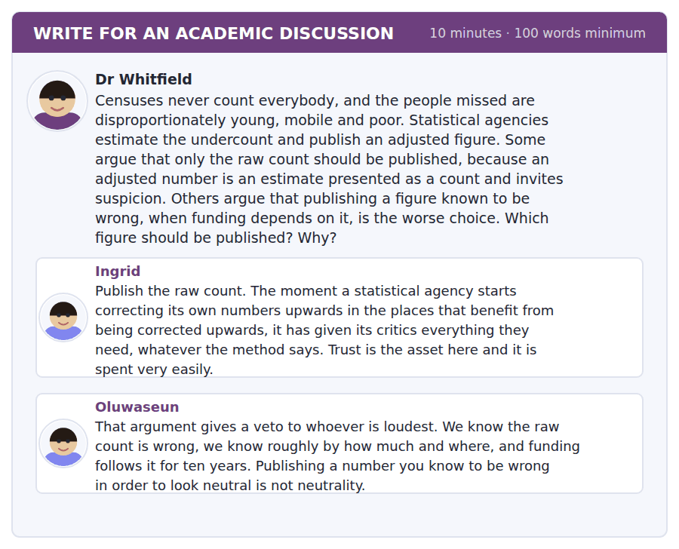
SKILL · Separating a technical claim from a political one
- Where a dispute mixes a settled technical question with an unsettled political one, say so and treat them separately.
- It changes what evidence is relevant to each half.
- Then propose something that respects both.

Sentence starters
- These are two questions and only one of them is statistical.
- Ingrid is describing a real risk, but it is a risk about…
- Oluwaseun is right that…, which does not settle…
- What follows is that the choice is not between… but between…
Model post
These are two questions and only one of them is statistical. Whether the raw count is wrong, and roughly by how much and where, is uncontroversial among people who do this work: follow-up surveys answer it and the methods are public. Whether a corrected figure should carry the name of a count is not a statistical question at all, and no amount of methodological rigour will settle it.
Ingrid is therefore describing a real risk, but it is a risk about institutional trust rather than about accuracy. Oluwaseun is right that publishing a known error to appear neutral is not neutrality, which disposes of the simplest version of her argument but not of the version she is actually making.
The choice is not between two numbers. It is between two things a published figure can be for. A count is a record of what was observed. An allocation base is an estimate of what is there. We have been asking one number to be both, and the entire dispute lives in that overloading.
So publish both, labelled as what they are: the enumerated count, and the estimated population with its interval. Funding attaches to the second, and Ingrid’s suspicion has somewhere to go, because the raw figure is still on the page to be checked against. This is commonly assumed to be a fudge. It is the opposite: it is refusing to let one number do two jobs it cannot do at once.
[243 words]
Now write your own. 10 minutes, at least 100 words.
__________________________________________________________
__________________________________________________________
__________________________________________________________
__________________________________________________________
__________________________________________________________
__________________________________________________________
__________________________________________________________
__________________________________________________________
__________________________________________________________
__________________________________________________________

Grammar focus Nominalisation
Verb phrase | Nominalised
people cross a border | the crossing of a border
two arguments are confused | the conflation of two arguments
the population is counted | the enumeration of the population
funding is allocated | the allocation of funding
the figure was adjusted | the adjustment of the figure
people move to cities | urbanisation
she assumed net migration of zero | her assumption of zero net migration

Nominalisation packs a clause into a noun phrase, which is why academic writing uses it constantly: you can then make the whole idea the subject of a new sentence.
It also removes the agent. The adjustment of the figure does not say who adjusted it, and sometimes that is exactly the problem.
Good academic prose alternates. A paragraph entirely in nominalisations is unreadable; one with none is shapeless.
Watch out! Do not nominalise to sound serious. "The implementation of a reduction in the allocation" means "they cut the funding". If the verb version is clearer, use the verb — examiners reward clarity, not weight.
Exercise 1 Nominalise the underlined idea.
1. People cross a border. → the ______ of a border
2. Two arguments are confused. → the ______ of two arguments
3. The population is counted. → the ______ of the population
4. The figure was adjusted. → the ______ of the figure
5. People move into cities. → ______
6. She assumed zero migration. → her ______ of zero migration
Exercise 2 Turn each nominalisation back into a clause, supplying an agent.
1. the allocation of funding
2. the adjustment of the count
3. the publication of five variants
4. the clustering of the undercount
Exercise 3 Rewrite more clearly, using verbs.
1. The implementation of a reduction in the allocation took place in 2024.
2. There was a conflation of the two questions by the reporting.
3. The provision of an explanation was not undertaken.
4. An increase in the utilisation of adjusted figures has occurred.
How this is tested in Build a Sentence
Build a Sentence sometimes gives you a long nominalised subject in tiles: the conflation of two arguments. It goes at the front as one block and the verb follows the whole phrase.
Find the fault 5 errors, drawn from this unit and the two before
Every error below is one a B2 writer makes after learning the rule. Mark what is wrong, then check. Knowing the rule and noticing the breach are two different skills, and only the second one is tested.
The conflation of the two questions by the reporting were unhelpful. The implementation of a reduction in the allocation took place in 2024. Nobody knows whether did the article state its assumption. The data shows that the undercount clusters in particular areas. Having adjusted the figure, the criticism became louder.
# | As written | As it should be | Why
1 | two questions by the reporting were unhelpful | two questions by the reporting was unhelpful | The head of the subject is conflation, which is singular; questions is not the subject.
2 | The implementation of a reduction in the allocation took place in 2024 | They cut the funding in 2024 | Three stacked nominalisations hide a simple sentence and add nothing.
3 | whether did the article state | whether the article stated | An embedded question keeps statement order and takes no auxiliary.
4 | The data shows | The data show | Data is plural in formal academic writing, which is the register here.
5 | Having adjusted the figure, the criticism | Having adjusted the figure, the agency | The criticism did not adjust anything; the participle needs the right subject.

Unit review and progress check Unit 28
Exercise A Vocabulary. Write the word.
1. everyone born in the same period
2. what the numbers give if trends continue
3. being forced to leave where you live
4. the average number of children per woman
5. an official count of the whole population
6. money sent home by somebody working abroad
7. the ratio of non-workers to workers
8. the movement of a population into cities
9. a chart of population by age and sex
10. a large arrival over a short period
11. how long people live
12. to become a citizen of a new country
Exercise B Grammar. Complete the sentence.
1. People cross a border. → the ______ of a border
2. Two arguments are confused. → the ______ of two arguments
3. The population is counted. → the ______ of the population
4. The figure was adjusted. → the ______ of the figure
5. People move into cities. → ______
6. She assumed zero migration. → her ______
7. Funding is allocated. → the ______ of funding
8. The office published five variants. → the ______ of five variants
Exercise C One timed mini-section. 6 minutes.
1. A net migration figure of zero means
(A) nobody moved
(B) arrivals and departures were equal
(C) migration was banned
(D) the data are missing
2. A projection differs from a forecast because it
(A) is less accurate
(B) covers fewer years
(C) is unofficial
(D) states the consequences of stated assumptions
3. Census undercount matters for funding because
(A) money is allocated per head on census figures
(B) the total is wrong
(C) it delays publication
(D) it affects fertility estimates
4. Which is clearer?
(A) The implementation of a reduction in the allocation took place.
(B) A reduction was undertaken in respect of the allocation.
(C) There was an occurrence of allocation reduction.
(D) They cut the funding.
5. "Is frequently conflated" tells you the writer thinks
(A) two things are the same
(B) the evidence is strong
(C) two different things get wrongly merged
(D) nobody has studied it
6. Among statisticians, adjusting the census count is
(A) uncontroversial
(B) highly controversial
(C) forbidden
(D) rarely attempted
Can you do these now?
I can… | Not yet | Yes
I can turn a verb phrase into a noun phrase and back again. | □ | □
I can see when a nominalisation is hiding who did something. | □ | □
I can read a statistic and ask what it is a net figure of. | □ | □
I can separate categories that a single word has merged. | □ | □
I can write about a contested topic without taking a side I did not argue for. | □ | □
I can follow a talk that corrects the terms of a public debate. | □ | □

ADAPTIVE TIP Nominalisation is the gear that lets academic English move. Use it to make a whole idea the subject of your next sentence — but check every one you write by asking who did it. If the answer matters and the noun has hidden it, go back to the verb.

Unit 29 · Philosophy and Ethics
TOEFL iBT® Preparation Course 2026 · Volume 3
CEFR B2 · Grammar: Hedging and modality of likelihood · Word field: premise, warrant, obligation
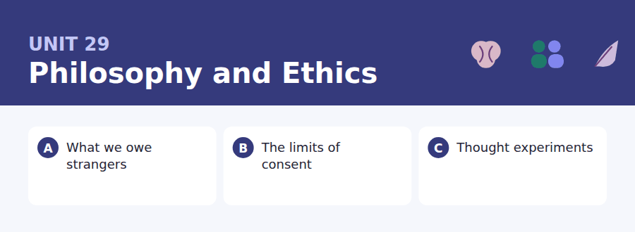
By the end of this unit I can…
- I can tell a false premise from an invalid inference.
- I can commit to a claim at the strength the evidence supports.
- I can state an objection to my own position fairly.
- I can follow an argument that uses an artificial example on purpose.
- I can use may well, is likely to and it is doubtful whether accurately.
- I can write a discussion post that strengthens the other side first.

Philosophy is where you learn that an argument can be wrong in two entirely different ways, and that most people only ever check for one of them. This unit also teaches hedging: committing to a claim by degree, which is the skill that separates a 4 from a 5 in Writing.

Vocabulary 1 · Academic word families 18 families, not 18 words
At B2 the word on its own is not enough. Each entry below is a family: learn the noun, the verb and the adjective together, because the test will use whichever one the sentence needs.
premise a claim offered in support of a conclusion | virtue a settled trait of good character
warrant what entitles you to move from evidence to claim | harm a setback to somebody’s interests
obligation something you are required to do | autonomy the right to decide about your own life
entail to follow necessarily from | paternalism overriding a choice for the chooser’s own good
refute to show that a claim is false | permissible allowed, though not required
counterexample a single case that defeats a general claim | culpable deserving blame
impartial not favouring any particular person | dilemma a choice between two options both of which cost
consequentialist judging an act by its results | scrupulous very careful about doing right
duty what you must do regardless of the results | defensible able to be argued for, though not obviously true

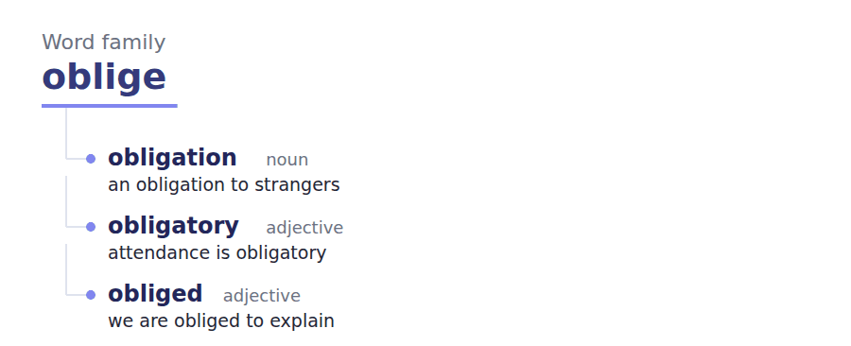
Exercise A Work in pairs. Ask and answer.
1. Do you owe more to a neighbour than to a stranger? Why?
2. Name a choice somebody should be allowed to make even if it harms them.
3. When is an artificial example useful? When is it a trick?
4. Can you be blamed for something you did not know?
Vocabulary 2 · Collocation 10 partnerships that actually occur
A word is known when you know what it goes with. These ten are the partners this unit’s texts use; the wrong partner is what marks an answer as translated.
beg the question to assume what you are trying to prove | all things considered taking everything into account
draw a line to decide where a limit falls | as a matter of principle because of the rule, not the outcome
on reflection after thinking it through | grant for the sake of argument to accept temporarily
bite the bullet to accept an unwelcome consequence of your view | carry weight to be a serious consideration
cut both ways to support each side equally | set aside to leave out of consideration for now

Vocabulary 3 · Stance and hedging How far the writer commits
Every one of these says the same thing at a different strength. Reading, you must notice which was chosen. Writing, you must choose.
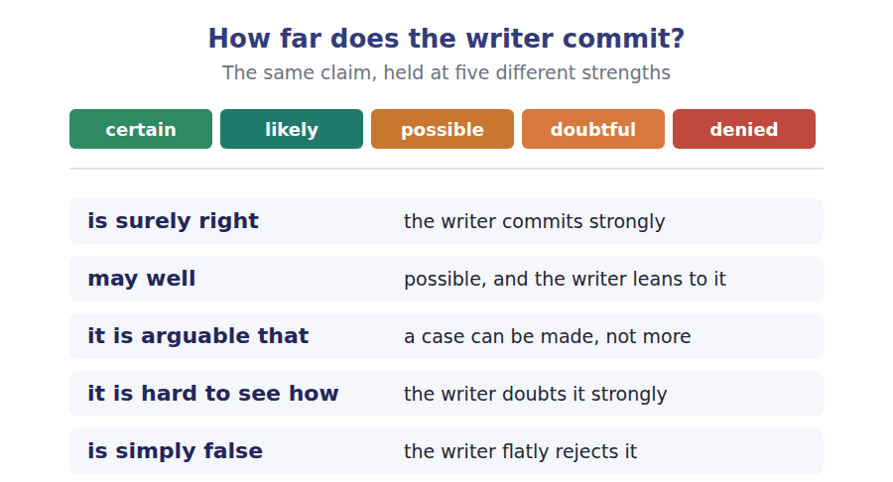
Two words that look alike
refute / deny to disprove / merely to reject
imply / entail to suggest / to follow necessarily
permissible / obligatory allowed / required

Words you will meet again: valid argument | sound argument | the trolley problem | moral luck | informed consent | the harm principle | slippery slope | burden of proof


SKILL · Suffixes in abstract argument
- Philosophical prose is unusually dense in -tion, -ity and -ence nouns and in -ible / -able adjectives.
- Decide the part of speech first. The abstraction is usually a noun doing the work of a clause.
- A gap after is or seems is almost always an adjective.

Exercise A Guided practice. Five words are not complete. Write the missing letters.
An argument is not a disagreement. An argument is a set of claims offered in support of another claim, and it can be assessed without anybody raising their vo---. Two things can go wrong and they are quite separ---. The premises may be false, in which case the argument tells you noth--- even if the reasoning is perfect. Or the premises may be true and simply fail to support the conclusion, in which case the argument is inval--. Most public disputes are conducted as though only the first kind of error exi----, which is why so many of them consist of two people correcting each other on facts that neither conclusion actually depends on.

The first one is done for you: voice is voice — it follows raising their, so the slot is a noun.
Exercise B Exam practice. One paragraph, ten gaps — the real task.
A thought experiment is a device for isolating one variable, and it works the way a laboratory does: by removing everything that is not under examin-----. The famous cases are deliberately unreal-----. Nobody is ever standing beside a lever with full knowledge of the consequences and no time pres----, and that is the point rather than an objec----. The scenario strips away the uncertainty, the personal stake and the social cost so that one question can be asked clear--: does it matter whether a death is caused or merely allo---? Critics answer that the stripping away is exactly what makes the exercise worth----, because real decisions are made under uncertainty and by people who will have to live with their neigh----- afterwards. That objection has force, and it proves less than it appears to. If an intuition survives in the artificial case, something is generating it that is not explained by the messy features that have been remo---. If it does not survive, the intuition was about the mess, which is also worth kno----. Either way the experiment has told you where the work is being done, which is more than most real cases manage.

Check your answers in the key at the back of the book.


SKILL · Reading a policy against the principle behind it
- Policies state rules; the reasoning behind them is usually in a separate document or a covering note.
- The interesting question is whether the rule actually serves the stated principle.
- Look for a case the rule covers that the principle does not, or the reverse.

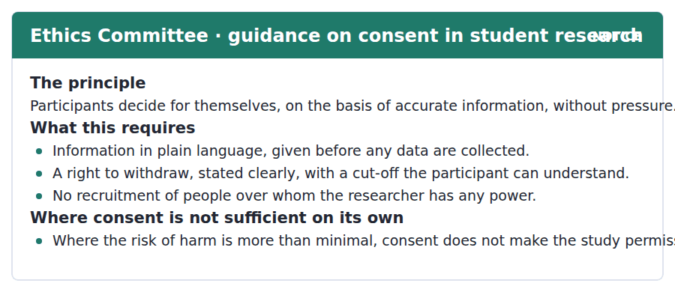
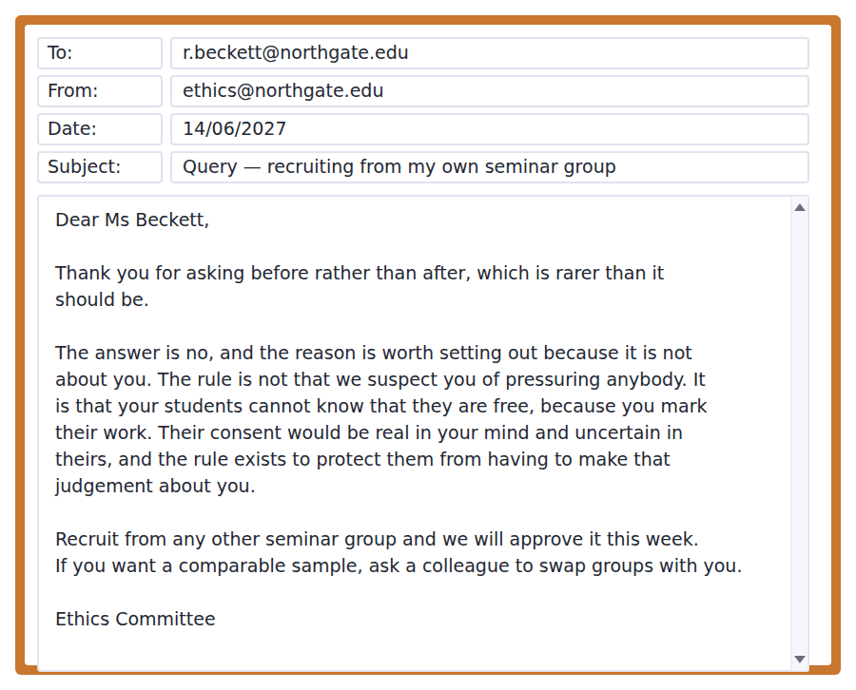
Exercise A Guided practice. The answer is on the page — find it.
1. What three things does the principle require?
(A) Deciding for oneself, accurate information, no pressure
(B) Accuracy, speed, consent
(C) Approval, funding, supervision
(D) Anonymity, consent, withdrawal
2. When must information be given?
(A) After the study
(B) Before any data are collected
(C) At the halfway point
(D) Only on request
3. Who may not be recruited?
(A) Anyone under 18
(B) People in other departments
(C) People over whom the researcher has power
(D) Previous participants
4. When is consent not sufficient on its own?
(A) Where the sample is small
(B) Where the study is long
(C) Where funding is external
(D) Where the risk of harm is more than minimal
Exercise B Exam practice.
5. Why is the request refused?
(A) The researcher has power over the potential participants
(B) The study is risky
(C) The sample is too small
(D) The information is unclear
6. What does the committee explicitly say the rule is NOT about?
(A) The design of the study
(B) The size of the sample
(C) Suspicion of this particular researcher
(D) The timing of the request
7. What is the committee’s actual concern?
(A) That she would apply pressure
(B) That students cannot know they are free when she marks their work
(C) That the data would be poor
(D) That she has not read the guidance
8. What does the committee offer?
(A) A waiver
(B) A longer deadline
(C) An appeal
(D) Approval if she recruits from another group
9. What does "rarer than it should be" refer to?
(A) Good study designs
(B) Students volunteering
(C) Asking before acting rather than after
(D) Committees replying quickly
10. Which part of the policy does the refusal rest on?
(A) The plain language requirement
(B) The recruitment restriction
(C) The withdrawal right
(D) The harm threshold
11. What does this exchange suggest about the committee’s approach?
(A) It explains the principle behind the rule
(B) It applies rules without explanation
(C) It discourages student research
(D) It prefers large samples


SKILL · Reading an extended analogy
- A B2 passage often carries one analogy across two paragraphs. Track what maps onto what.
- The author will usually state the limit of the analogy, or use it to close the argument.
- An item will ask what the analogy is doing, not what it describes.

Why Philosophers Use Impossible Cases
The standard objection to a thought experiment is that it could not happen. Nobody stands beside a lever knowing exactly who will die, with no time pressure and nothing at stake for themselves. The objection is correct and it is not the criticism it is taken to be, because the impossibility is deliberate. The case is built to remove everything except the one feature under examination.
The reasoning is the same as a physicist’s frictionless surface. Nobody claims such a surface exists. It is introduced so that the behaviour attributable to friction can be subtracted and what remains can be seen. A moral thought experiment subtracts uncertainty, self-interest and social consequence for the same reason, and what it is looking for is whether an intuition survives the subtraction.
That is where the real argument begins. If the intuition survives — if people still feel the difference between killing and letting die when every other factor has been equalised — then something is generating it that the removed factors do not explain, and it is arguable that this something deserves a place in the theory. If it does not survive, the intuition was tracking the mess, which is also worth knowing and is not a failure. The one conclusion the method cannot support is the popular one: that because the case is artificial, whatever people say about it may be disregarded. That inference is simply false, and it is hard to see how anybody reached it. A frictionless surface is artificial too, and nobody takes that as a reason to ignore what happens on it.
[264 words]

Exercise A Guided practice.
1. What is the standard objection to a thought experiment?
(A) It is too long
(B) It is not original
(C) It assumes too much knowledge
(D) The situation could not happen
2. Why is the impossibility deliberate?
(A) To make it memorable
(B) To remove everything except the feature under examination
(C) To simplify teaching
(D) To avoid offence
3. What does a frictionless surface allow a physicist to do?
(A) Measure friction directly
(B) Build better machines
(C) Subtract friction and see what remains
(D) Avoid calculation
4. The word "subtraction" in the second paragraph refers to
(A) removing factors to isolate one
(B) an arithmetic operation
(C) reducing the number of cases
(D) shortening the argument
Exercise B Exam practice.
5. What does the author say the method is looking for?
(A) A correct answer
(B) Agreement among readers
(C) A counterexample
(D) Whether an intuition survives the subtraction
6. What follows if the intuition survives?
(A) The theory is proved
(B) The experiment failed
(C) Something unexplained by the removed factors is generating it
(D) The case was badly designed
7. What follows if the intuition does not survive?
(A) The method is useless
(B) The intuition was tracking the removed factors
(C) The theory is false
(D) The case must be repeated
8. What is "the popular conclusion" the author rejects?
(A) That intuitions are unreliable
(B) That philosophers use too many examples
(C) That physics and ethics are alike
(D) That artificiality licenses disregarding the responses
9. How does the author use the frictionless surface at the end?
(A) To show that artificiality alone is not a reason to dismiss
(B) To introduce a new argument
(C) To criticise physicists
(D) To define friction
10. What does "it is arguable that" signal about the author’s commitment?
(A) That a case can be made, no more
(B) Certainty
(C) Rejection
(D) Agreement with critics
11. All of the following are subtracted in a moral thought experiment EXCEPT:
(A) Uncertainty
(B) Self-interest
(C) Social consequence
(D) The intuition itself
12. What is the author’s overall view of the standard objection?
(A) It is mistaken
(B) It is irrelevant
(C) It is correct but does not show what people think it shows
(D) It is the strongest objection available
13. Which argument would most damage the author’s position?
(A) That friction cannot be measured
(B) That moral intuitions are produced only by the features the method removes
(C) That thought experiments are old
(D) That physicists disagree about surfaces


Exercise A Listen and choose a response. You hear one line. Choose the best reply.
1. Woman: So distance makes no moral difference at all?
(A) Yes, about a thousand miles.
(B) That is what the argument commits you to.
(C) It is a good seminar.
(D) No, distance is important.
2. Man: Would you jump in to save a drowning child?
(A) It depends on the water.
(B) About two metres.
(C) Yes, it happened once.
(D) Obviously — which is the point of the example.
3. Woman: Is that not just guilt-tripping?
(A) It might be, and the argument would still be valid.
(B) Yes, probably.
(C) About forty pounds.
(D) No, it is philosophy.
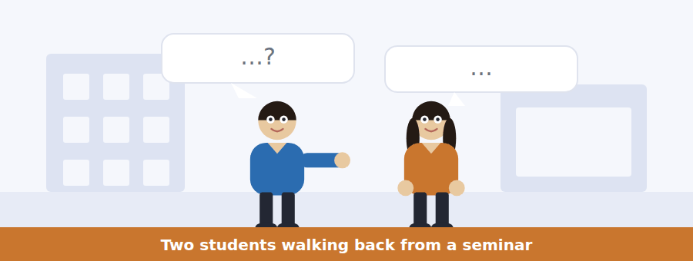
SKILL · Hearing an argument being tested rather than asserted
- Philosophical conversation proceeds by trying a position and then attacking it.
- Listen for: suppose, what if, then you would have to say.
- The item often asks what somebody would be committed to, which is not what they said.

Exercise B Listen and answer. The audio plays once.
4. What does the argument commit you to, according to the man?
(A) Saving children nearby
(B) Distrusting charities
(C) Giving away most of your money
(D) Travelling to help
5. What does the woman say about the conclusion?
(A) She rejects it
(B) She thinks it is probably right and is not acting on it
(C) She has not understood it
(D) She finds it obvious
6. What is her objection to the premise?
(A) Distance does matter
(B) The example is unrealistic
(C) Certainty and whether your contribution is decisive also differ
(D) Children are a special case
7. How does the man rate that objection?
(A) The best objection there is
(B) Weak
(C) Irrelevant
(D) Already refuted
8. Does the objection defeat the argument?
(A) Yes, entirely
(B) No, it is irrelevant
(C) It strengthens it
(D) It weakens the conclusion without removing it
9. What is his point about ten per cent confidence?
(A) The argument fails below certainty
(B) Confidence cannot be measured
(C) Most people are more confident than that
(D) Even a small probability leaves an extraordinary rate of return
10. What does the man say about the person who wrote the argument?
(A) They have refuted it
(B) They have changed their mind
(C) They do not fully act on it either
(D) They are no longer cited
Audio script: see the back of the book. Do not read it before you listen.


Exercise A Listen and choose a response. You hear one line. Choose the best reply.
1. Man: Can I recruit from my own seminar group?
(A) Yes, if they agree.
(B) No, because you mark their work.
(C) About twelve people.
(D) On Friday.
2. Woman: Does consent make a risky study acceptable?
(A) Not on its own, above minimal risk.
(B) Yes, that is what consent is for.
(C) About four forms.
(D) It is on the website.
3. Man: When should I apply?
(A) Yes, you should.
(B) About two weeks.
(C) Before you collect anything, not after.
(D) To the committee.
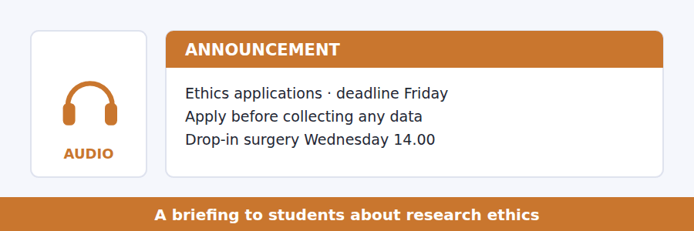
SKILL · Hearing a rule explained by its purpose
- A good briefing gives the reason, because a rule understood is a rule followed.
- Listen for: the reason is, this exists because, what we are protecting against.
- Items often ask for the purpose rather than the rule.

Exercise B Listen and answer. The audio plays once.
4. Why must applications come before data collection?
(A) It is a legal requirement
(B) Consent given afterwards is not really consent
(C) The committee meets weekly
(D) The data would be lost
5. Which rule causes the most complaints?
(A) The restriction on recruiting people you have power over
(B) The deadline
(C) The risk threshold
(D) The plain language requirement
6. What is the rule actually protecting?
(A) The researcher’s reputation
(B) The quality of the data
(C) The committee’s time
(D) Participants from having to judge the researcher’s character
7. What surprises people about consent?
(A) It must be written
(B) It can be withdrawn
(C) It is not always sufficient
(D) It must be in plain language
8. What does "you cannot consent your way into a study that should not be run" mean?
(A) Agreement does not make an unacceptable design acceptable
(B) Consent forms must be approved
(C) Participants cannot withdraw
(D) Consent must be repeated
9. Why does the speaker give a reason for each rule?
(A) To fill the time
(B) Because a rule that is understood is remembered
(C) Because the rules are disputed
(D) To avoid appeals
Audio script: see the back of the book. Do not read it before you listen.


Exercise A Listen and choose a response. You hear one line. Choose the best reply.
1. Man: Is it not a problem that the case is unrealistic?
(A) Yes, a serious one.
(B) About five examples.
(C) It is a famous case.
(D) It would be, if realism were what it was for.
2. Woman: What is the physics comparison?
(A) About forces.
(B) Yes, it is similar.
(C) A frictionless surface — nobody thinks it exists.
(D) In the first lecture.
3. Man: So the intuition is the data?
(A) No, the case is the data.
(B) Exactly, and the case is the apparatus.
(C) About half of them.
(D) Intuitions vary.
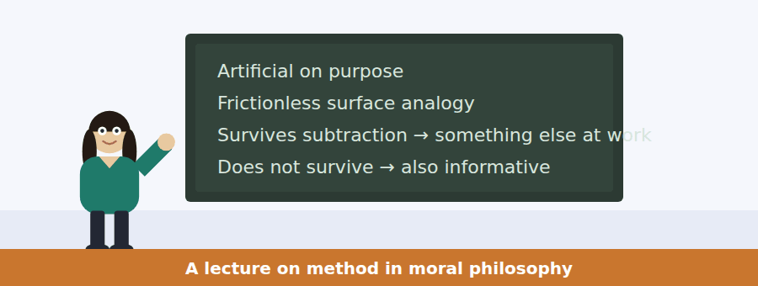
SKILL · Following a defence of a method
- A lecture defending a method states the objection first, in its strongest form, then answers it.
- Listen for the strengthening: and the objection is right, as far as it goes.
- The answer usually turns on what the method is for.

Exercise B Listen and answer. The audio plays once.
4. Why does the speaker state the objection at length first?
(A) To agree with it
(B) Because it cannot be answered
(C) To save time
(D) To put it in its strongest form before answering
5. What does he concede?
(A) That every statement in the objection is true
(B) That the method is flawed
(C) That the cases should be changed
(D) That intuitions vary
6. What is the frictionless surface for?
(A) Making calculations easier
(B) Modelling real surfaces
(C) Seeing what is left when friction is removed
(D) Teaching beginners
7. What follows if the intuition survives the removal?
(A) The theory is confirmed
(B) The case was badly designed
(C) The intuition is unreliable
(D) Something unexplained by the removed factors is producing it
8. What follows if the intuition vanishes?
(A) The experiment failed
(B) The intuition was about the removed factors
(C) The method is discredited
(D) The case must be rebuilt
9. What is the move the method cannot support?
(A) Dismissing responses because the case is artificial
(B) Comparing ethics to physics
(C) Using more than one case
(D) Testing intuitions at all
10. How is the lecture structured?
(A) Chronologically
(B) Two competing theories
(C) A list of famous cases
(D) Objection, concession, analogy, two outcomes, rejection of one inference
Audio script: see the back of the book. Do not read it before you listen.


Part 1 · Listen and Repeat
You hear a sentence and repeat it once. There is no preparation time, and the sentences get longer. Focus: keeping a conditional chain intact
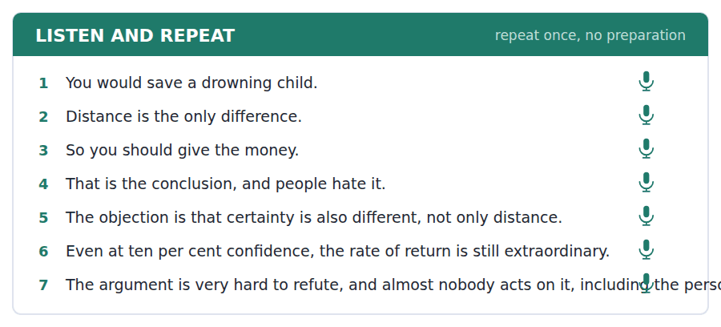
SKILL · Repeating an argument, not a sentence
- These sentences are steps in a chain. Lose one and the rest means nothing.
- Mark the joints with a small pause: if X, and if Y, then Z.
- Do not speed up at the end. The conclusion needs the same weight as the premises.

Part 2 · Take an Interview
An interviewer asks you four questions on one theme: obligation, distance and what we actually do. Answer each one fully. There is no preparation time.
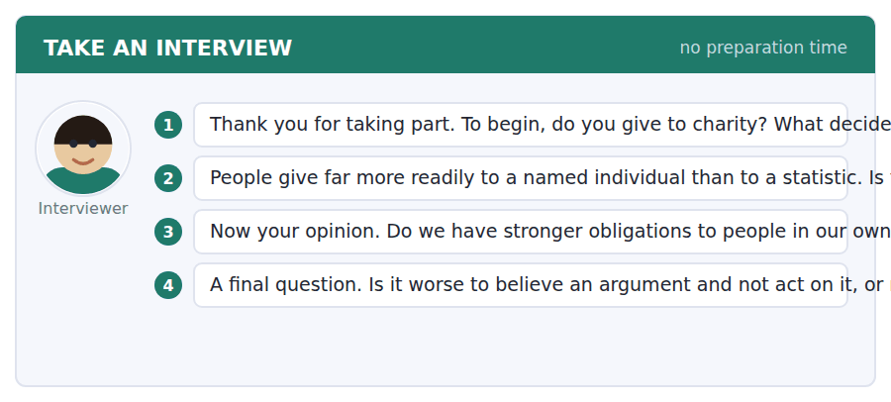
A good answer sounds like this
Question 2 — Both. It is a flaw if it means we help one person while ignoring a thousand. But the response to an individual is also what the response to the thousand is made of, so removing it would not obviously help.
Question 4 — Believing and not acting is worse in one sense and better in another. You are more culpable, and you are also one step from doing something, which the other person is not.
I can… | Not yet | Yes
I kept the steps of the argument in order. | □ | □
I paused at the joints rather than inside them. | □ | □
I gave the conclusion full weight. | □ | □


Part 1 · Listen and Repeat
You hear a sentence and repeat it once. There is no preparation time, and the sentences get longer. Focus: explaining a rule by its purpose
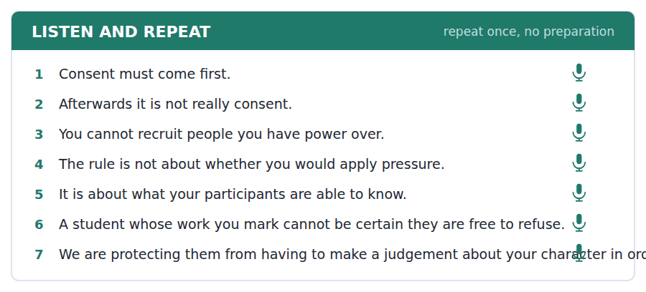
SKILL · Giving the reason before the rule
- A rule explained is remembered; a rule asserted is resented. Lead with the purpose.
- The structure is: what we are protecting, then what follows from that.
- It is also the structure of a good exam answer about policy.

Part 2 · Take an Interview
An interviewer asks you four questions on one theme: consent, power and research on people. Answer each one fully. There is no preparation time.
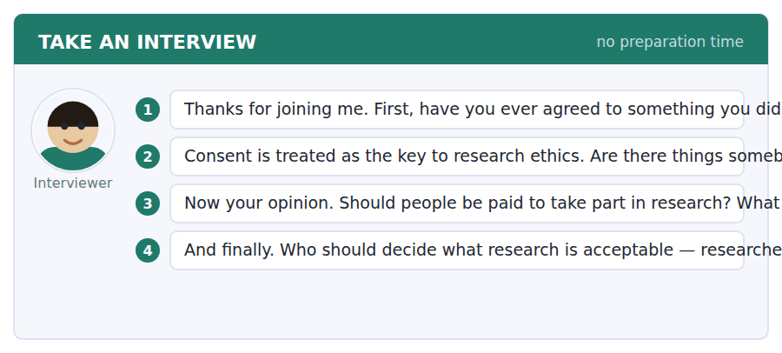
A good answer sounds like this
Question 2 — Yes, where the risk is serious enough that agreement starts to look like a transfer of responsibility rather than a real decision. That is roughly where the rules draw it, and I think they are right.
Question 3 — Payment is fine and changes who volunteers. If the sum is large enough to matter to somebody poor and not to anybody else, you have quietly selected your sample by income.
I can… | Not yet | Yes
I gave the purpose before the rule. | □ | □
I used a concrete example. | □ | □
I answered the question that was asked. | □ | □


Part 1 · Listen and Repeat
You hear a sentence and repeat it once. There is no preparation time, and the sentences get longer. Focus: stating an objection fairly before answering it
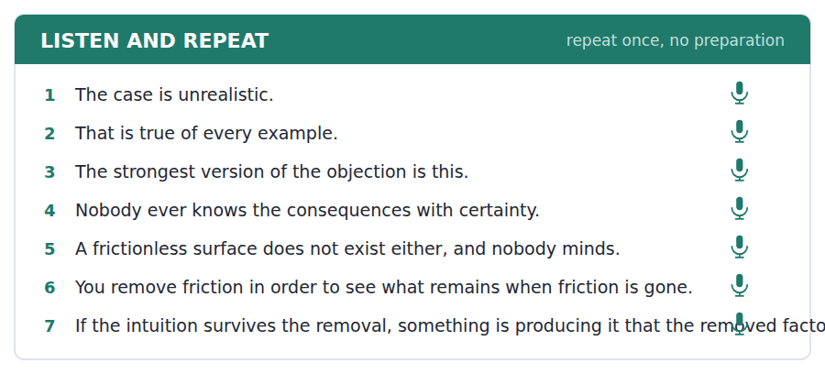
SKILL · Steelmanning out loud
- Putting the other side at its strongest costs you nothing and buys you everything.
- Mark it clearly: the strongest version of the objection is this.
- Then answer the strong version, not the weak one.

Part 2 · Take an Interview
An interviewer asks you four questions on one theme: argument, examples and changing minds. Answer each one fully. There is no preparation time.
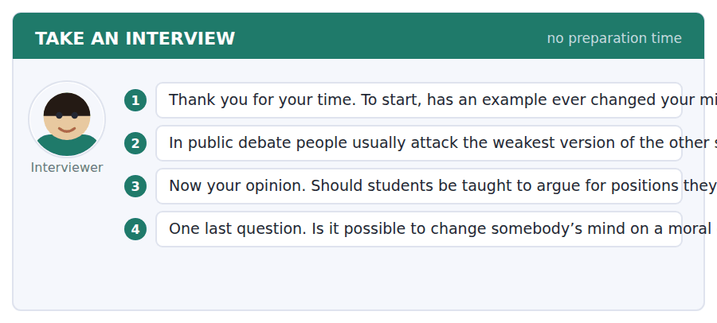
A good answer sounds like this
Question 2 — Because the weak version is easier and because an audience usually cannot tell. What it costs is that you never find out whether you were right, which eventually shows.
Question 3 — Yes, and not mainly for the skill. You cannot tell whether you believe something until you have had to build the case against it properly.
I can… | Not yet | Yes
I stated the objection at its strongest. | □ | □
I answered the strong version. | □ | □
I did not concede more than I meant to. | □ | □


You see a sentence, then a set of words in boxes. Put the words in order to make one grammatical sentence. Almost every item in the real test makes a question or a question inside another sentence.
SKILL · Build a Sentence with a hedge inside
- Several items place a hedge inside the embedded clause: whether it is arguable that, whether it may well be.
- The hedge sits with the verb and does not disturb the word order.
- A tile reading may well or is likely to is one block.

Exercise A Guided practice. The first three are worked through.
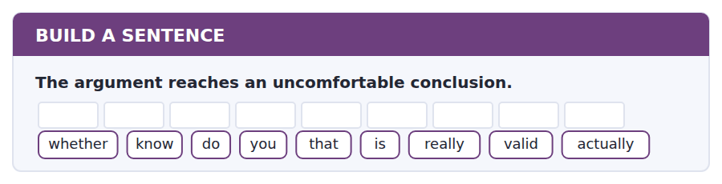
1. Do you know whether that is actually really valid?
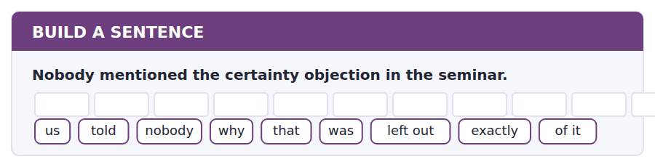
2. Nobody told us exactly why that was left out of it.
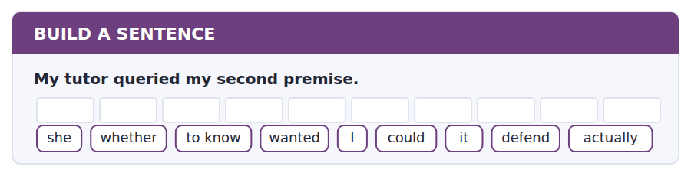
3. She wanted to know whether I could actually defend it.
Exercise B Exam practice. Write the sentence.
4. The case removes uncertainty on purpose.
do / whether / know / you / that / may well / be / the point / actually
__________________________________________________________
5. The committee refused the application.
to know / nobody / seems / on what / the refusal / was / based / actually / grounds
__________________________________________________________
6. Consent is not sufficient above minimal risk.
explain / can / anybody / why / that / is / to me / exactly / so
__________________________________________________________
7. The intuition survived the subtraction.
know / does / anybody / what / it / is / that / producing / actually
__________________________________________________________
8. She refused to recruit from her own group.
told / she / us / whether / the committee / had / that / asked / for
__________________________________________________________
9. The objection has real force.
the extent / to which / it / damages / the argument / is / still / in / dispute
__________________________________________________________
10. Ten per cent confidence is still a high rate of return.
whether / tell / can / me / you / that / is / likely to / hold
__________________________________________________________


You read a short situation and write an email. You have 7 minutes. The three bullet points are the mark scheme: answer all three.
Your ethics application was refused because you planned to recruit from your own seminar group. The committee explained why and suggested swapping groups with a colleague. You have done that, and you have also realised a second problem with your original design that the committee did not raise.
Write an email resubmitting the application.
- Say what you have changed in response to their point.
- Raise the second problem yourself and say how you have dealt with it.
- Ask one clear question about what remains.
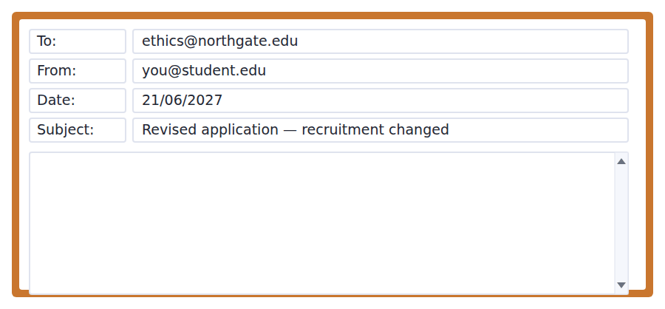
SKILL · Volunteering a problem nobody has found
- Raising a weakness yourself is the strongest thing you can do in an application of any kind.
- It must come with the fix, or it is simply a confession.
- It buys credibility for the parts you have not changed.

Model email
Dear Committee,

Thank you for the explanation, which was more useful than the decision. I have swapped seminar groups with a colleague, so I will recruit from a group I do not teach or mark, and she will recruit from mine. The revised recruitment section is attached.

Working through your reasoning made me notice a second problem you did not raise. My original withdrawal clause said participants could withdraw "at any time". For an anonymous survey that is not true after submission, because I cannot identify which response is theirs in order to remove it. Promising something I cannot deliver is worse than a shorter promise, so I have changed it to a cut-off at the point of submission, with that limitation stated in the information sheet in plain words.

One question remains and I would rather ask than assume. My study carries no more than minimal risk by any reading I can give the guidance, but it asks about experiences of academic failure, which some participants may well find uncomfortable even though nothing in it is harmful. Does that count as minimal risk for your purposes, or should I treat it as above the threshold and submit the fuller design justification?

With thanks,
Rosa Beckett
Why it works
- The change made in response is stated first and concretely, so compliance is visible.
- The second problem is volunteered with its fix attached, not merely confessed.
- The reasoning behind the fix is given, which shows the principle was understood rather than the rule obeyed.
- One question is asked, with both possible answers named so either is easy to give.
Two answers, one band apart
Both answer the three bullet points. One would score in the middle band and one near the top. Read them side by side before you write your own.
A middle-band answer | A top-band answer
Dear Committee,  Thank you for your email about my application. I have now made the changes you asked for and I am resubmitting it for your consideration.  As you suggested, I have arranged to swap seminar groups with a colleague so that I will not be recruiting any students whose work I mark. I hope this resolves the issue you identified.  I would also like to ask a question about risk. My study is about experiences of academic failure. I do not think this is risky but some students might find it a bit upsetting to talk about. Could you let me know whether this counts as minimal risk or not? I want to make sure I have done everything correctly this time.  Thank you for your help. Rosa Beckett | Dear Committee,  Thank you for the explanation, which was more useful than the decision. I have swapped seminar groups with a colleague, so I will recruit from a group I do not teach or mark.  Working through your reasoning made me notice a second problem you did not raise. My withdrawal clause said participants could withdraw at any time. For an anonymous survey that is untrue after submission, because I cannot identify which response to remove. I have changed it to a cut-off at submission, stated plainly in the information sheet.  One question remains. My study carries no more than minimal risk by any reading I can give the guidance, but it asks about academic failure, which some participants may well find uncomfortable. Does that count as minimal risk, or should I submit the fuller design justification?  With thanks, Rosa Beckett

What the top answer does that the other does not
- It volunteers a second problem the committee did not find, with the fix already made — which is the single most credibility-earning move available.
- It gives the reasoning behind the fix, showing the principle was understood rather than the instruction obeyed.
- The question names both possible answers, so the committee can reply in one line instead of explaining.
- It distinguishes uncomfortable from harmful, which is the actual distinction the guidance turns on.
- It avoids "I want to make sure I have done everything correctly", which frames the writer as a rule-follower rather than as someone exercising judgement.
Now write your own. 7 minutes.
__________________________________________________________
__________________________________________________________
__________________________________________________________
__________________________________________________________
__________________________________________________________
__________________________________________________________
__________________________________________________________
__________________________________________________________


A professor asks a question and two students answer. You add your own post. You have 10 minutes and an effective answer is at least 100 words.
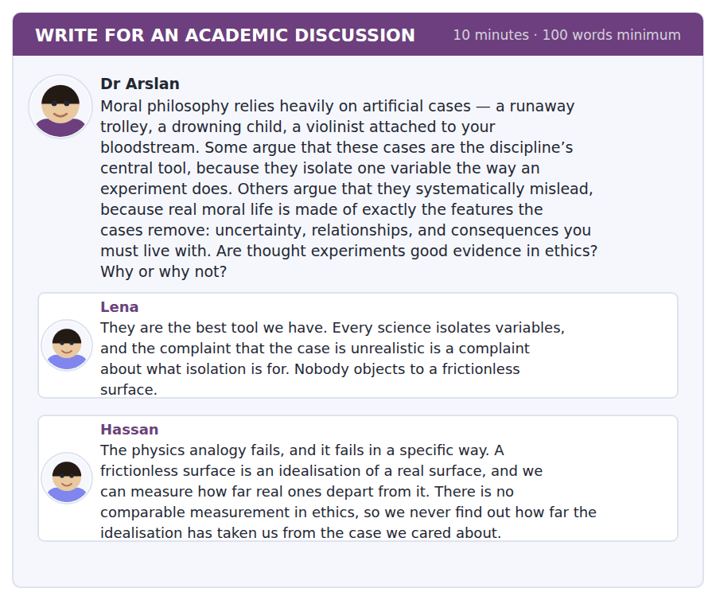
SKILL · Attacking an analogy precisely
- An analogy fails at a specific point. Naming the point is an argument; saying it is a bad analogy is not.
- Then say whether the failure matters for the conclusion drawn from it.
- Sometimes an analogy fails and the conclusion survives on other grounds.

Sentence starters
- Hassan has found the real weakness in the analogy, which is that…
- Lena is right that…, though the physics case differs in…
- The question this leaves is whether…
- What survives of the method is…
Model post
Hassan has found the real weakness in the analogy, and it is worth stating even more sharply than he does. A physicist does not merely idealise; she can run the experiment on a real surface, measure the discrepancy, and attribute it to friction. The idealisation is checkable against the thing it idealises. In ethics there is nothing corresponding to that measurement, so the subtraction is performed and never audited.
Lena is surely right about what isolation is for, and her objection does not reach as far as Hassan needs it to. The absence of a check means we cannot quantify how far the artificial case has drifted. It does not mean we learn nothing from it. If an intuition survives when uncertainty and self-interest are removed, that is a fact about the intuition regardless of whether we can measure the drift, and it is hard to see how it could be explained by factors that are no longer present.
What this leaves is a narrower claim than either post makes. Thought experiments are good evidence about the structure of our moral responses and poor evidence about what to do on Tuesday. That is not a small result; most of the famous cases were offered as the first and have been read as the second.
So I would keep them and change what we take them to show. Used to ask what a theory must explain, they are indispensable. Used to decide a case under uncertainty, with people one has to live beside afterwards, they are simply the wrong instrument, and Hassan’s objection is exactly why.
[265 words]
Now write your own. 10 minutes, at least 100 words.
__________________________________________________________
__________________________________________________________
__________________________________________________________
__________________________________________________________
__________________________________________________________
__________________________________________________________
__________________________________________________________
__________________________________________________________
__________________________________________________________
__________________________________________________________

Grammar focus Hedging and modality of likelihood
Expression | Strength
is bound to / is certain to | the writer treats it as settled
is likely to / will probably | strong, short of certain
may well | possible, and the writer leans towards it
may / might / could | possible, with no lean either way
it is arguable that | a case can be made, no more
it is doubtful whether | the writer leans against
it is hard to see how | the writer doubts it strongly

These form a scale. Choosing the wrong point on it is a factual error, not a matter of style: may well and might say different things.
May well is stronger than may. The well is not decoration; it marks a lean towards the possibility.
Hedges do not stack. Possibly might perhaps is one hedge used three times and reads as evasion rather than precision.
Watch out! A hedge protects a claim; it does not excuse one you have no basis for. Writing it is arguable that in front of something you have not argued for is the commonest way B2 writers lose credit for a paragraph.
Exercise 1 Put these in order from strongest to weakest commitment.
1. may well
2. is bound to
3. it is doubtful whether
4. is likely to
5. it is hard to see how
6. could
Exercise 2 Choose the expression that matches the evidence described.
1. Every study so far has found it. → It ______ be real.
2. One study found it; nobody has repeated it. → It ______ be real.
3. Three studies looked and none found it. → ______ it is real.
4. The mechanism is unknown but the effect is consistent. → It ______ be real.
Exercise 3 Remove the stacked hedges, keeping the intended strength.
1. It is possibly maybe the case that the effect might be real.
2. It could perhaps arguably be said to be true.
3. There may possibly be some slight suggestion of an effect.
4. It is quite likely that it might well be correct.
How this is tested in Build a Sentence
Build a Sentence often puts a hedge inside the embedded clause: do you know whether that is likely to hold. The hedge travels with the verb and the clause keeps statement order.
Find the fault 5 errors, drawn from this unit and the two before
Every error below is one a B2 writer makes after learning the rule. Mark what is wrong, then check. Knowing the rule and noticing the breach are two different skills, and only the second one is tested.
It is possibly maybe the case that the argument might be valid. It is arguable that distance makes no difference, although I have given no reason for this. The evidence refute the second premise completely. Nobody knows whether can the intuition survive the subtraction. Having removed self-interest, the intuition was still present in the case.
# | As written | As it should be | Why
1 | It is possibly maybe the case that the argument might be valid | The argument may be valid | Three hedges stacked on one claim read as evasion rather than precision.
2 | although I have given no reason for this | because of the drowning-child case | A hedge does not excuse a claim with no argument behind it.
3 | The evidence refute | The evidence refutes | Evidence is singular here, so the verb takes an s.
4 | whether can the intuition survive | whether the intuition can survive | An embedded question keeps statement order, so the modal follows the subject.
5 | Having removed self-interest, the intuition was still present | Having removed self-interest, we found the intuition still present | The intuition did not remove self-interest; the participle needs a subject that did.

Unit review and progress check Unit 29
Exercise A Vocabulary. Write the word.
1. a claim offered in support of a conclusion
2. what entitles you to move from evidence to claim
3. to follow necessarily from
4. to show that a claim is false
5. a single case that defeats a general claim
6. not favouring any particular person
7. judging an act by its results
8. the right to decide about your own life
9. overriding a choice for the chooser’s own good
10. allowed, though not required
11. deserving blame
12. able to be argued for, though not obviously true
Exercise B Grammar. Complete the sentence.
1. Every study found it, so it ______ almost certainly be real.
2. One study found it, so it ______ be real.
3. It is ______ whether that holds in every case.
4. It is ______ to see how that follows.
5. It is ______ that distance makes no difference.
6. It ______ well be the point of the example.
7. The effect is ______ to be small.
8. That conclusion is ______ to follow, given the premises.
Exercise C One timed mini-section. 6 minutes.
1. An argument can fail because
(A) the speaker is wrong
(B) it is too long
(C) a premise is false or the inference is invalid
(D) nobody agrees
2. A thought experiment removes uncertainty in order to
(A) see whether an intuition survives without it
(B) simplify teaching
(C) make the case memorable
(D) avoid offence
3. Consent is not sufficient when
(A) the sample is small
(B) the risk is more than minimal
(C) the study is long
(D) the researcher is a student
4. Which is the strongest commitment?
(A) is bound to
(B) may well
(C) could
(D) it is arguable that
5. "It is hard to see how" signals that the writer
(A) is uncertain
(B) doubts it strongly
(C) accepts it
(D) is quoting
6. The rule against recruiting your own students protects
(A) the researcher
(B) the data
(C) participants from judging the researcher’s character
(D) the committee
Can you do these now?
I can… | Not yet | Yes
I can tell a false premise from an invalid inference. | □ | □
I can commit to a claim at the strength the evidence supports. | □ | □
I can state an objection to my own position fairly. | □ | □
I can follow an argument that uses an artificial example on purpose. | □ | □
I can use may well, is likely to and it is doubtful whether accurately. | □ | □
I can write a discussion post that strengthens the other side first. | □ | □

ADAPTIVE TIP Hedging is where B2 writers gain or lose a band. The rule is simple and strict: pick the point on the scale your evidence actually reaches, use one hedge, and never put a hedge in front of a claim you have not argued for. An unsupported claim is not made safer by it is arguable that — it is made conspicuous.

Unit 30 · Film and Visual Culture
TOEFL iBT® Preparation Course 2026 · Volume 3
CEFR B2 · Grammar: Concession: while, whereas, albeit · Word field: montage, framing, spectator
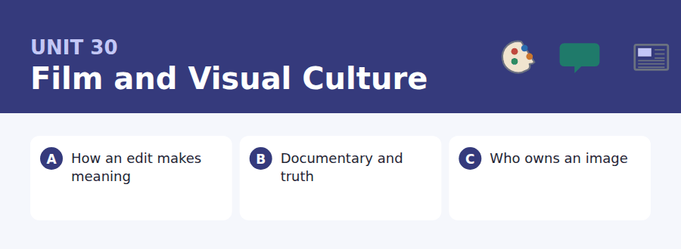
By the end of this unit I can…
- I can describe how meaning is produced by arrangement rather than content.
- I can use while, whereas and albeit accurately and in the right register.
- I can concede a point in the middle of a sentence without losing the thread.
- I can read an image as a claim and ask what it is evidence for.
- I can discuss a contested practice without taking sides prematurely.
- I can write an argument whose structure the reader can follow at a glance.

Film is the medium everyone consumes and almost nobody has been taught to read. This closing unit of Volume 3 teaches the vocabulary for describing how an image makes its argument — and the structures English uses to grant a point and keep going.

Vocabulary 1 · Academic word families 18 families, not 18 words
At B2 the word on its own is not enough. Each entry below is a family: learn the noun, the verb and the adjective together, because the test will use whichever one the sentence needs.
montage meaning made by the order of shots | authorship who is held to have made the work
framing what is included in the shot and what is left out | realism the convention of appearing not to be a convention
spectator the viewer, considered as part of the system | staging arranging what happens in front of the camera
continuity keeping the fictional world consistent across cuts | pacing how fast information is given to the viewer
genre a category with expectations attached | subtext what a scene is about underneath what it shows
narrative the ordering of events into a story | archival drawn from existing recorded material
protagonist the character whose perspective organises the film | reenactment a staged version of something that happened
juxtapose to place two things side by side | voiceover narration heard over the image
aesthetic to do with how something looks and why | footage recorded material, before it is edited

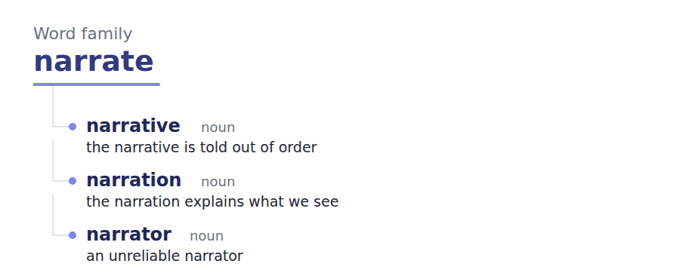
Exercise A Work in pairs. Ask and answer.
1. Describe a scene where the music changed what you thought you saw.
2. Should a documentary label every reconstruction? Why?
3. Who is the author of a film? Defend your answer.
4. What can an image never tell you on its own?
Vocabulary 2 · Collocation 10 partnerships that actually occur
A word is known when you know what it goes with. These ten are the partners this unit’s texts use; the wrong partner is what marks an answer as translated.
cut between to alternate two shots | bear out to confirm
read as to be interpreted as | lend itself to to be well suited to
stand in for to represent something else | call into question to make doubtful
take at face value to accept without questioning | on screen visible to the audience
in the first place before anything else happened | a case in point an example that proves the general claim

Vocabulary 3 · Stance and hedging How far the writer commits
Every one of these says the same thing at a different strength. Reading, you must notice which was chosen. Writing, you must choose.
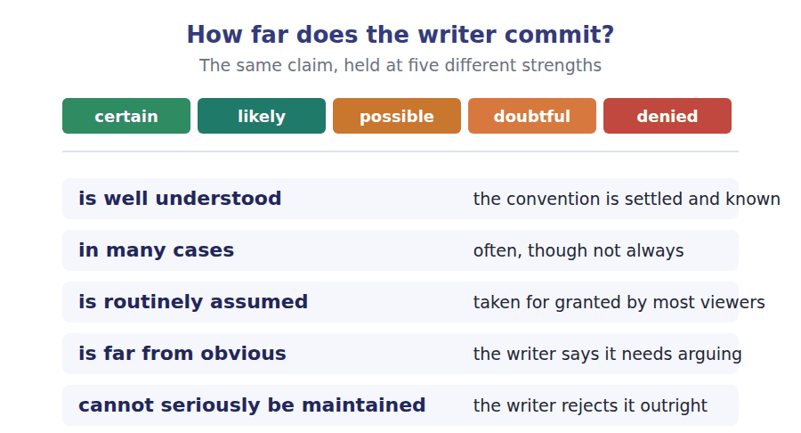
Two words that look alike
scene / shot a unit of action / a single run of camera
film / footage the finished work / the raw material
fiction / fabrication an agreed convention / a deception

Words you will meet again: cut | shot length | close-up | establishing shot | talking head | B-roll | dramatic irony | point of view


SKILL · Suffixes in critical writing
- Criticism uses abstract nouns heavily: connection, inference, convention, authorship.
- The -ship and -ure endings are more common here than elsewhere.
- Decide what the sentence needs grammatically before guessing at the spelling.

Exercise A Guided practice. Five words are not complete. Write the missing letters.
Two shots placed side by side are read as connected, whether or not the filmmaker intended any connect---. A face, then a bowl of soup: the audience sees hun---. The same face, then a coffin: the audience sees gr---. The face has not changed. What has changed is what sits next to it, and the meaning is manufac----- entirely in the viewer. This is the oldest finding in film theory and it remains the most useful, because it means an editor is not arranging pictures but direct--- an inference that the audience will make without noticing that they have made it.

The first one is done for you: connection is connection — it follows any and names a thing, so the slot is a noun.
Exercise B Exam practice. One paragraph, ten gaps — the real task.
Documentary carries an implicit promise that what you are watching happ----, and almost every technique available to a filmmaker puts pressure on that prom---. Two interviews recorded on different days can be cut so that one person appears to answer the other. Archival footage can be laid under a narration describing an event it does not actually show, and the viewer will assume the picture is evi----- for the words. A reconstruction, shot with actors and graded to look older than it is, can be indistinguish---- from the real thing at the speed a television audience wat----. None of this is necessarily dishonest. A filmmaker who reconstructs a conversation nobody filmed is doing something a historian does in prose every day, and the convention that lets a historian do it is well under-----. The difficulty is that film has no equival--- of the footnote. Prose can signal its own status in the middle of a sentence, and an image cann--, which is why the question of what a documentary owes its audience keeps returning in a form that the written disciplines settled a century a--. Some directors label every reconstruction on screen. Others regard the label as a failure of n----. The argument is not about honesty but about whether an audience that has not been told is nevertheless being deceived.

Check your answers in the key at the back of the book.


SKILL · Reading a code of practice against a case
- A code states what practitioners agree to do. A case tests whether the wording covers a situation its authors did not foresee.
- Look for the word doing the work — materially, significantly, reasonably — and ask who decides.
- A rule with an undefined threshold is a rule that will be argued about.

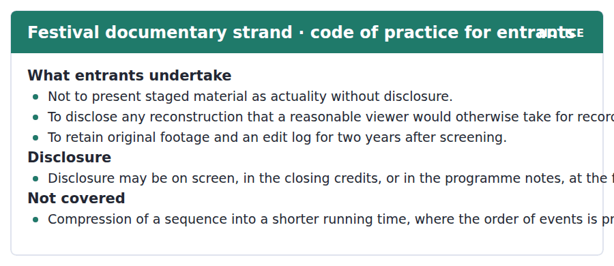
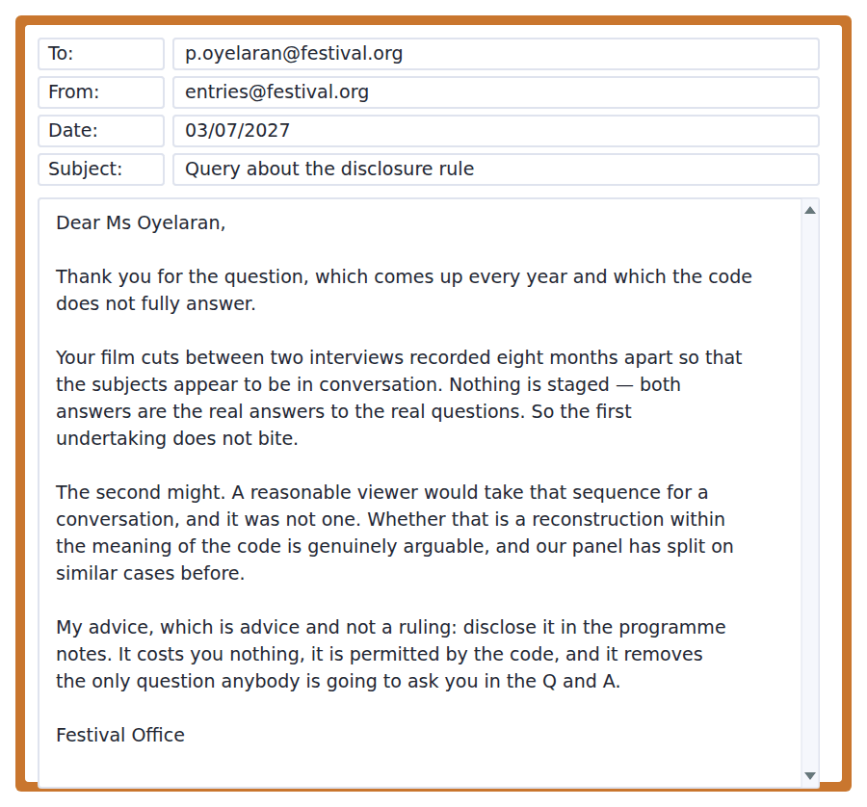
Exercise A Guided practice. The answer is on the page — find it.
1. For how long must original footage be kept?
(A) One year
(B) Five years
(C) Indefinitely
(D) Two years after screening
2. Where may disclosure be made?
(A) On screen, in the credits or in the programme notes
(B) On screen only
(C) In the credits only
(D) Nowhere
3. What is explicitly not covered by the code?
(A) Reconstruction
(B) Compressing a sequence while preserving the order
(C) Archival footage
(D) Voiceover
4. What triggers the second undertaking?
(A) Any editing
(B) The use of actors
(C) Material a reasonable viewer would take for recorded events
(D) A running time over an hour
Exercise B Exam practice.
5. Why does the first undertaking not apply to the film?
(A) Nothing was staged
(B) The film is too short
(C) The interviews were disclosed
(D) It is an archival film
6. Why might the second undertaking apply?
(A) Actors were used
(B) A reasonable viewer would take the sequence for a conversation
(C) The footage was not retained
(D) The film was compressed
7. What does the officer say about the panel?
(A) It always refuses such films
(B) It has never seen one
(C) It will rule in advance
(D) It has split on similar cases
8. Why does the officer distinguish advice from a ruling?
(A) To avoid responsibility
(B) Because the code forbids advice
(C) Because a ruling would bind the panel
(D) To delay the decision
9. What is the practical argument for disclosing?
(A) It is required
(B) It improves the film
(C) The panel prefers it
(D) It is free, permitted, and removes the obvious question
10. What does the exchange reveal about the code?
(A) It is unusually precise
(B) It is rarely enforced
(C) It leaves a genuine gap at the edges
(D) It is new this year
11. What does "the only question anybody is going to ask you in the Q and A" suggest?
(A) The film is uninteresting
(B) The issue is obvious to an audience
(C) Audiences do not ask questions
(D) The panel will not notice


SKILL · Reading a passage that refuses an easy verdict
- When an author says the arguments cut across the usual lines, expect no clean answer.
- The structure is usually: cost of option A, cost of option B, and then something both have in common.
- The final move is often to point out that the question was framed for different conditions.

The Photograph and the Person In It
A photograph has at least three parties with a claim on it: the person who took it, the person in it, and whoever is paying. Copyright, in most jurisdictions, goes to the first of these and takes almost no account of the second. The rule is well understood by practitioners and is routinely assumed to be an oversight. It is not; it follows from treating a photograph as an authored work rather than as a record of somebody, and the choice was deliberate.
The consequences are visible wherever the two claims diverge. A photograph taken of a stranger in a public place belongs to the photographer, who may sell it, and the subject has in many cases no say at all. Where the law has intervened it has done so sideways, through privacy or data protection rather than through copyright, producing a patchwork in which the same image may be freely publishable in one country and actionable in the next.
Whether this is the right arrangement is far from obvious, and the arguments cut across the usual lines. Giving subjects a veto would end street photography as a form, and most of the twentieth century’s record of ordinary life would have been impossible under it. Giving photographers an unqualified right produces the situation in which somebody’s worst moment is a saleable asset belonging to a stranger. Both of those are real costs, and the claim that one of them is obviously smaller cannot seriously be maintained by anybody who has looked at the cases. What can be said is that the current arrangement was designed for a world in which taking a photograph was difficult and publishing one was expensive, and neither of those is now true.
[287 words]

Exercise A Guided practice.
1. Who does copyright in a photograph normally go to?
(A) The photographer
(B) The subject
(C) The publisher
(D) Nobody
2. What does the author say about calling this an oversight?
(A) It is accurate
(B) It is wrong — the choice was deliberate
(C) It is a recent view
(D) It applies only in some countries
3. How has the law intervened where it has?
(A) Through copyright
(B) Through contract
(C) Through privacy or data protection
(D) Not at all
4. The word "actionable" in the second paragraph means
(A) able to be sued over
(B) newsworthy
(C) easily published
(D) well composed
Exercise B Exam practice.
5. What would giving subjects a veto cost?
(A) Nothing significant
(B) Only commercial photography
(C) The privacy laws
(D) Street photography as a form
6. What does an unqualified photographer’s right produce?
(A) Better photographs
(B) Lower publishing costs
(C) Somebody’s worst moment as a stranger’s saleable asset
(D) More privacy claims
7. What does the author say about claiming one cost is obviously smaller?
(A) It is correct
(B) It depends on the country
(C) It is the consensus
(D) It cannot seriously be maintained by anyone who knows the cases
8. What is the author’s closing observation?
(A) The arrangement was designed for conditions that no longer hold
(B) The law should be unified
(C) Photographers should be licensed
(D) Subjects should be paid
9. Why does the author mention the patchwork?
(A) To praise variation
(B) To show the consequence of intervening sideways
(C) To criticise one country
(D) To explain copyright
10. What does "the arguments cut across the usual lines" mean?
(A) Everyone agrees
(B) The positions do not line up with the usual groupings
(C) The arguments are weak
(D) The law is unclear
11. All of the following are named as parties with a claim EXCEPT:
(A) The photographer
(B) The subject
(C) The publisher’s lawyer
(D) Whoever is paying
12. What is the author’s attitude to the current arrangement?
(A) Neither endorsing nor condemning, but questioning its basis
(B) Strongly supportive
(C) Strongly opposed
(D) Indifferent
13. Which development would most support the author’s closing point?
(A) A new privacy statute
(B) A ruling favouring photographers
(C) A fall in camera prices
(D) Evidence that the number of photographs taken has risen by orders of magnitude


Exercise A Listen and choose a response. You hear one line. Choose the best reply.
1. Man: Can I see that again with the other shot?
(A) Yes, it is the same shot.
(B) Watch the face — it has not changed at all.
(C) About four seconds.
(D) It was filmed last week.
2. Woman: Did you reshoot anything?
(A) Nothing. Only the order changed.
(B) Yes, twice.
(C) About two hours.
(D) It is a short film.
3. Man: Is this a famous experiment?
(A) Yes, it is good.
(B) About five shots.
(C) It is about a century old now.
(D) In an editing suite.
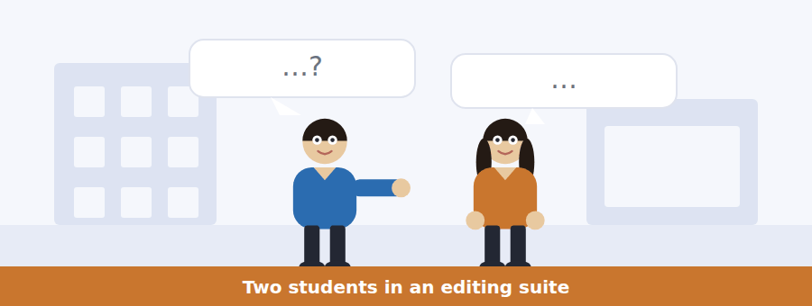
SKILL · Hearing a demonstration described in speech
- When somebody demonstrates something, the items test what the demonstration showed, not what was said about it.
- Listen for the two versions: first I will show you this, now watch the same shot with.
- The difference between the two versions is the finding.

Exercise B Listen and answer. The audio plays once.
4. What did the woman change between the two versions?
(A) The lighting
(B) The length of the shot
(C) The actor’s expression
(D) Only what comes after the face
5. What does the man conclude at first?
(A) The actor was skilled
(B) The edit was obvious
(C) He was reading the face
(D) The shots were different
6. How does the woman correct him?
(A) The face did change
(B) The soup was the key
(C) He saw it too quickly
(D) He was reading his own inference
7. What conclusion does she reject?
(A) That the edit matters
(B) That the actor does not have to do much
(C) That the finding is old
(D) That the face was neutral
8. Why must the face be neutral?
(A) So it can carry both readings
(B) To save time
(C) Because of the lighting
(D) To match the soup
9. What does she say about the best screen performances?
(A) They are the most expressive
(B) They often look like nothing on set
(C) They require reshooting
(D) They need no editing
10. What is the woman doing in the conversation?
(A) Asking for help
(B) Disagreeing with the theory
(C) Demonstrating and then refining the lesson
(D) Preparing an essay
Audio script: see the back of the book. Do not read it before you listen.


Exercise A Listen and choose a response. You hear one line. Choose the best reply.
1. Woman: Does compressing a sequence count as reconstruction?
(A) Yes, always.
(B) About ninety minutes.
(C) It is in the code.
(D) Not if the order is preserved.
2. Man: Where do I have to disclose?
(A) Anywhere — screen, credits or notes.
(B) Yes, you must.
(C) Before Friday.
(D) To the panel.
3. Woman: What if the code does not cover my case?
(A) Then you may do as you like.
(B) Then it is undecided, not allowed.
(C) About four cases a year.
(D) The code covers everything.
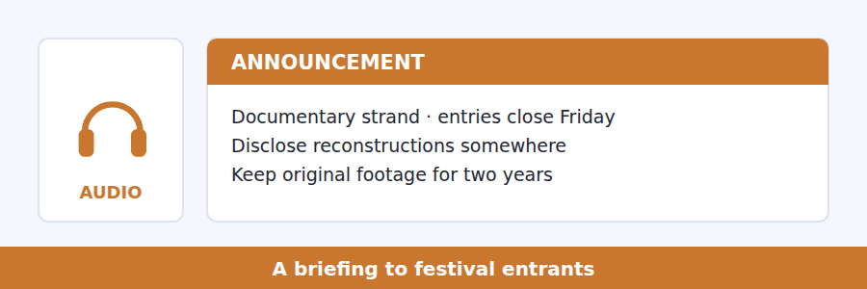
SKILL · Hearing where a rule stops
- A briefing on a code will usually say what the code does not cover. That is where the questions come from.
- Listen for: the code is silent on, that is not covered, you are on your own there.
- An uncovered case is not a permitted one; it is an undecided one.

Exercise B Listen and answer. The audio plays once.
4. What is the code clear about?
(A) Compression and pacing
(B) Programme notes
(C) Disclosing staged material and retaining footage
(D) Panel procedure
5. What is the carve-out for compression conditional on?
(A) The running time
(B) Panel approval
(C) Disclosure in the credits
(D) The order of events being preserved
6. What happens if an exchange is moved for effect?
(A) The case leaves the carve-out and the code is silent
(B) It is permitted
(C) It must be disclosed on screen
(D) The entry is refused
7. What does the speaker say silence in the code means?
(A) The practice is allowed
(B) The code will be amended
(C) The panel cannot rule
(D) The case is undecided
8. Why does he recommend the programme notes?
(A) The code requires it
(B) The panel prefers it
(C) It is permitted, free, and removes the question
(D) It is the only option
9. Why does the speaker focus on what the code does not say?
(A) Every dispute has come from there
(B) The code is badly written
(C) There is little else to cover
(D) The panel asked him to
Audio script: see the back of the book. Do not read it before you listen.


Exercise A Listen and choose a response. You hear one line. Choose the best reply.
1. Man: Who owns a photograph of me?
(A) You do, obviously.
(B) In most places, the person who took it.
(C) About fifty years.
(D) It depends on the camera.
2. Woman: Why does the subject have no say?
(A) Because nobody asked.
(B) Because the law treats it as an authored work.
(C) About three parties.
(D) Yes, that is unfair.
3. Man: Has anything changed recently?
(A) Yes, the law changed.
(B) About twenty years.
(C) Cameras are better.
(D) Taking and publishing both became almost free.
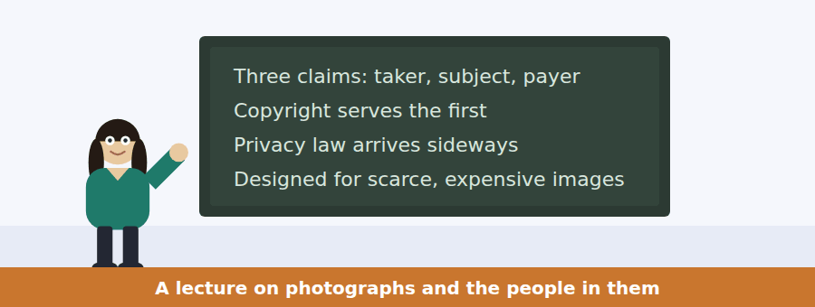
SKILL · Following a talk that criticises a framing rather than an answer
- The strongest academic move is to show that the question was badly put.
- Listen for: the real problem is that we are asking; both answers inherit the same assumption.
- The item about the speaker’s own view will be about the framing, not the verdict.

Exercise B Listen and answer. The audio plays once.
4. How many parties does the speaker say have a claim?
(A) Three
(B) Two
(C) Four
(D) It varies
5. Why does the subject get almost nothing?
(A) Nobody has fixed it
(B) Subjects rarely complain
(C) The law treats a photograph as an authored work
(D) Privacy law covers it
6. What does she say students usually assume?
(A) That the law is correct
(B) That subjects are paid
(C) That copyright is recent
(D) That it is an unfixed oversight
7. How has legal change arrived?
(A) Through copyright reform
(B) Through the courts only
(C) Sideways, through privacy and data protection
(D) It has not
8. Why does she decline to say which arrangement is right?
(A) She does not know and thinks the question is badly framed
(B) She has no view
(C) It depends on the country
(D) The law is about to change
9. What assumption do both usual answers share?
(A) That photographs are accurate
(B) That a photograph is a scarce, costly object
(C) That subjects object
(D) That photographers are professionals
10. What does she mean by "arguments that were both correct in 1960"?
(A) The arguments are historically important
(B) Both sides have won before
(C) The law has not changed since 1960
(D) The arguments are outdated in their premises
Audio script: see the back of the book. Do not read it before you listen.


Part 1 · Listen and Repeat
You hear a sentence and repeat it once. There is no preparation time, and the sentences get longer. Focus: describing a sequence in the present tense
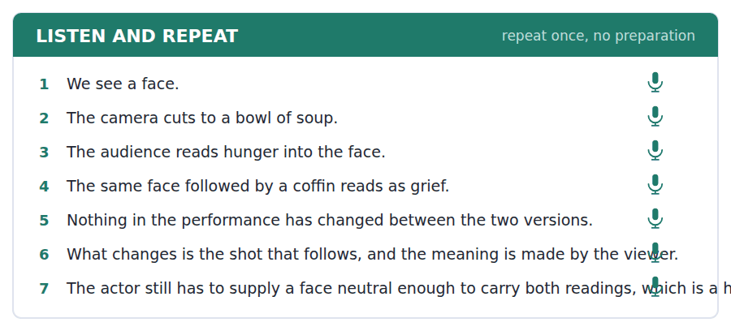
SKILL · Narrating what a viewer sees
- Film description uses the present: we see, the camera cuts, the face holds.
- Keep the tense consistent. Switching to the past makes it a story about filming rather than about watching.
- Stress the verb of perception: we SEE hunger — because the point is what the viewer does.

Part 2 · Take an Interview
An interviewer asks you four questions on one theme: watching, noticing and being manipulated. Answer each one fully. There is no preparation time.
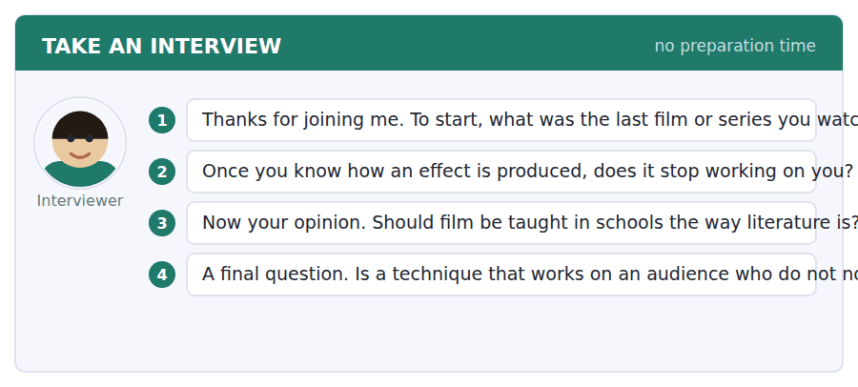
A good answer sounds like this
Question 2 — Mostly it keeps working, which is the interesting part. I can identify the music cue that is telling me to feel something and feel it anyway.
Question 4 — Craft, as long as the audience has agreed to be moved. We buy a ticket precisely so that somebody will do this to us. It becomes manipulation when the form promises that it is not doing it.
I can… | Not yet | Yes
I kept the present tense throughout. | □ | □
I stressed the verb of perception. | □ | □
I described the sequence before interpreting it. | □ | □


Part 1 · Listen and Repeat
You hear a sentence and repeat it once. There is no preparation time, and the sentences get longer. Focus: concessive clauses said in one breath
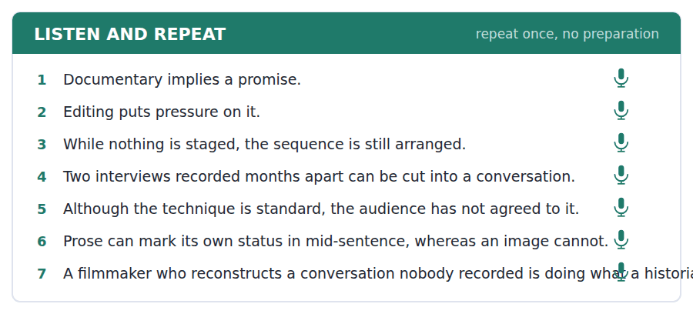
SKILL · Conceding in the middle of a sentence
- While the technique is standard, the promise is still implied — the whole thing is one sentence and needs one breath.
- The pause goes at the comma, not inside either clause.
- Drop your pitch slightly on the concession and raise it on the main clause. That is how a listener knows which is which.

Part 2 · Take an Interview
An interviewer asks you four questions on one theme: truth, convention and what audiences are owed. Answer each one fully. There is no preparation time.
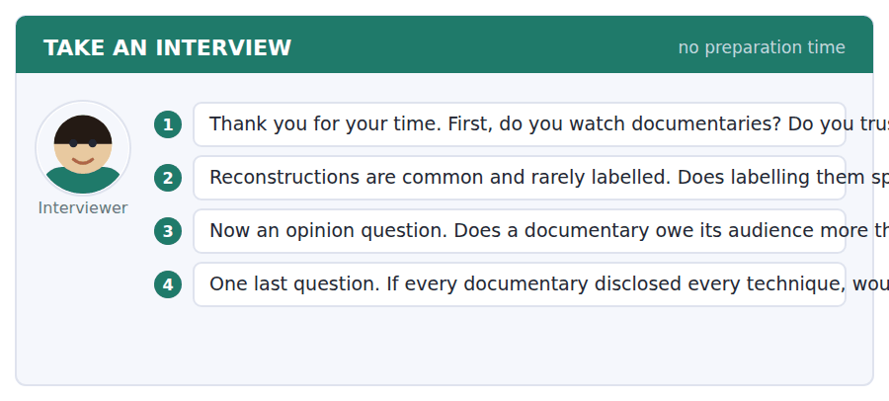
A good answer sounds like this
Question 2 — It is a weak objection, though not an empty one. A caption does break the spell. But a form that depends on the audience not knowing how it works has a problem that a caption did not create.
Question 3 — Yes, because it has made a claim a drama has not. The claim is implicit, but an implicit claim is still a claim, and the audience has relied on it.
I can… | Not yet | Yes
I said the concession and the main clause in one breath. | □ | □
I paused at the comma, not inside a clause. | □ | □
I used while, whereas or albeit correctly. | □ | □


Part 1 · Listen and Repeat
You hear a sentence and repeat it once. There is no preparation time, and the sentences get longer. Focus: summarising a position you do not hold
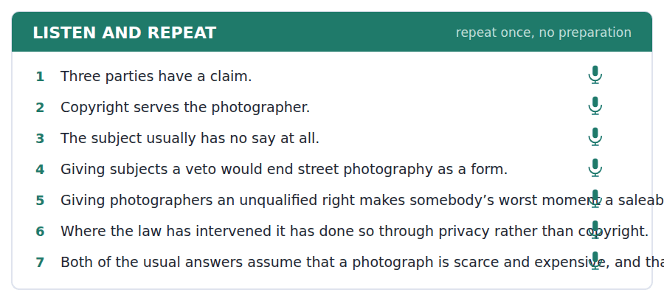
SKILL · Representing both sides before judging
- At B2 you are often asked about a contested question. Give both positions before your own.
- Each should be given its best reason, in one sentence.
- Then say what you think and why, marked as your view.

Part 2 · Take an Interview
An interviewer asks you four questions on one theme: images, consent and the people in the frame. Answer each one fully. There is no preparation time.
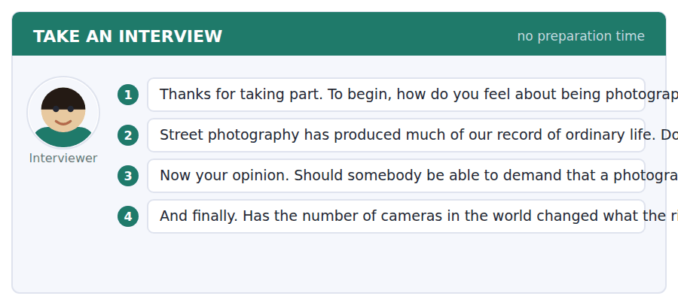
A good answer sounds like this
Question 2 — It justifies some of it. The record exists because nobody had to ask, and I would not want to lose it. That is a reason, not a permission slip for every case.
Question 4 — I think it has. A rule written when a photograph was rare and expensive is answering a different question from one written for a world where everyone is photographed constantly.
I can… | Not yet | Yes
I gave both positions their best reason. | □ | □
I marked my own view as mine. | □ | □
I did not pretend the question was easy. | □ | □


You see a sentence, then a set of words in boxes. Put the words in order to make one grammatical sentence. Almost every item in the real test makes a question or a question inside another sentence.
SKILL · Build a Sentence with a concessive clause
- The two non-question items in this unit build concessive clauses with while, whereas or although.
- The concessive clause can go first or second; the tiles will tell you which by where the comma falls.
- Albeit is followed by a phrase, never a full clause with its own subject and verb.

Exercise A Guided practice. The first three are worked through.
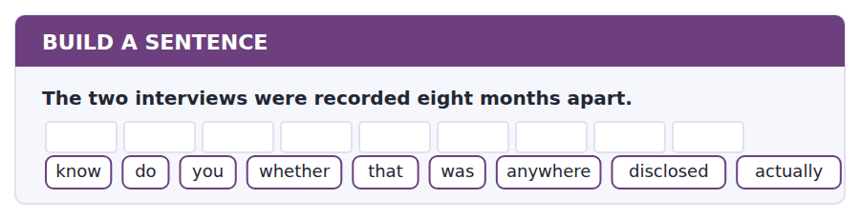
1. Do you know whether that was actually disclosed anywhere?
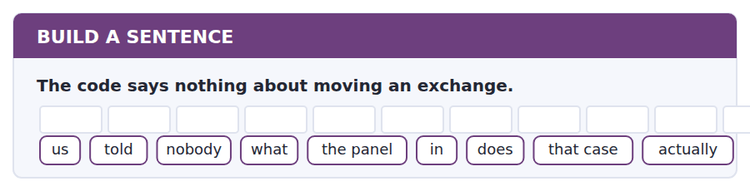
2. Nobody told us what the panel actually does in that case.
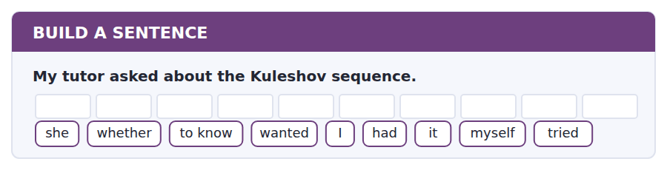
3. She wanted to know whether I had tried it myself.
Exercise B Exam practice. Write the sentence.
4. The subject of a photograph usually has no say.
do / whether / know / you / that / is / everywhere / true / actually
__________________________________________________________
5. The panel has split on similar cases before.
to know / nobody / seems / how / it / the last one / decided / actually / in the end
__________________________________________________________
6. Nothing in the performance changed between the versions.
explain / can / anybody / why / the face / different / looks / to me / then
__________________________________________________________
7. Disclosure is permitted in the programme notes.
know / does / anybody / whether / anybody / the notes / reads / actually / at all
__________________________________________________________
8. The rules were written for a different world.
told / he / us / when / they / had / been / drafted / originally
__________________________________________________________
9. Nothing was staged in the film.
while / nothing / was / staged / the sequence / was / still / carefully / arranged
__________________________________________________________
10. Prose can mark its own status in mid-sentence.
whereas / prose / can / do that / an image / has / no / equivalent / device
__________________________________________________________


You read a short situation and write an email. You have 7 minutes. The three bullet points are the mark scheme: answer all three.
The festival office advised you to disclose your cut-between-interviews sequence in the programme notes, while saying the code does not clearly require it. You have decided to disclose on screen instead. You also think the code’s gap should be fixed, and you have a specific suggestion.
Write an email to the festival office.
- Say what you have decided and why you went further than advised.
- Identify the gap in the code precisely.
- Propose specific wording and acknowledge its cost.
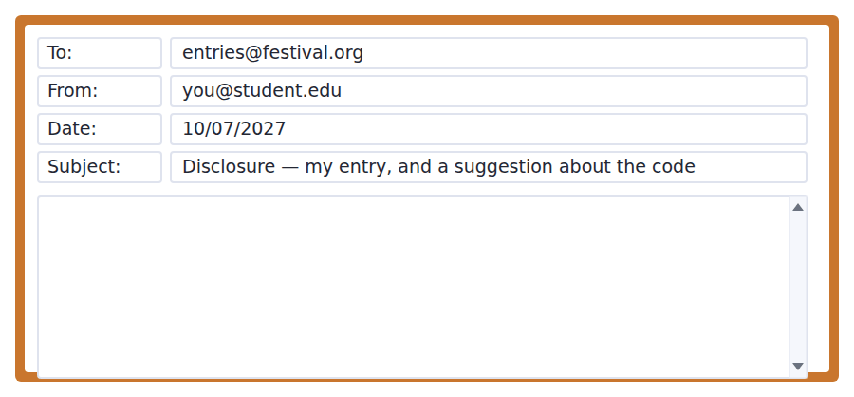
SKILL · Proposing a rule change
- A proposal that names only the problem gets filed. One that supplies wording gets discussed.
- Acknowledge what your proposal would cost somebody. A proposal with no costs is one you have not thought through.
- Keep it to one change. A redraft of the whole code will not be read.

Model email
Dear Festival Office,

Thank you for the advice, which I have taken and then gone slightly beyond. The sequence is now captioned on screen — "interviews recorded eight months apart" — rather than disclosed only in the programme notes. It cost me four seconds and, to my surprise, it makes the sequence stronger: the audience now watches the cut rather than being caught by it.

On the code itself, I think the gap is narrower than it looks and worth closing. The compression carve-out turns entirely on "where the order of events is preserved". That phrase does the work of a whole clause, and it is silent about the case your panel keeps splitting on, which is not compression at all but juxtaposition: two true things placed together so that a relationship the viewer infers was never there.

Would something like this work? "Where separately recorded material is edited so as to imply an exchange or a sequence that did not occur, this shall be disclosed." It is one sentence and it uses the code’s existing vocabulary.

It would have a cost. It catches some entirely innocent editing, and a few filmmakers would have to caption things they currently do not think twice about. I am not sure that is a bad outcome, but it is a real one and the panel should weigh it rather than discover it.

With thanks,
Priscilla Oyelaran
Why it works
- It reports what was decided and why, including a result the writer did not expect, which is more persuasive than agreement.
- The gap is located in one phrase, quoted, rather than described in general terms.
- Draft wording is supplied in the code’s own vocabulary, so adopting it is a small step.
- The cost of the proposal is volunteered, which is what distinguishes a proposal from a demand.
Two answers, one band apart
Both answer the three bullet points. One would score in the middle band and one near the top. Read them side by side before you write your own.
A middle-band answer | A top-band answer
Dear Festival Office,  Thank you for your advice about my entry. I decided to disclose the sequence on screen rather than just in the programme notes, because I thought it was the right thing to do and I did not want anyone to feel misled.  I also wanted to say that I think there is a problem with the code. It does not really say anything about cases like mine, where two separate interviews are edited together. This is clearly something that should be covered, especially as you said the panel has split on it before.  I think the code should be updated to make this clearer so that filmmakers know where they stand. It would be better for everyone if the rules were more specific about this kind of editing. Thank you for considering my suggestion.  Best wishes, Priscilla Oyelaran | Dear Festival Office,  Thank you for the advice, which I have taken and then gone slightly beyond. The sequence is now captioned on screen rather than disclosed only in the notes. It cost four seconds and makes the sequence stronger: the audience watches the cut rather than being caught by it.  On the code, the gap is narrower than it looks. The carve-out turns entirely on "where the order of events is preserved". That phrase is silent about the case your panel keeps splitting on, which is not compression but juxtaposition.  Would this work? "Where separately recorded material is edited so as to imply an exchange that did not occur, this shall be disclosed."  It has a cost: it catches innocent editing, and some filmmakers would have to caption things they do not think twice about. The panel should weigh that rather than discover it. Priscilla Oyelaran

What the top answer does that the other does not
- It reports an unexpected result — the caption improved the film — which is far more persuasive than stating that disclosure was the right thing to do.
- It quotes the exact phrase carrying the weight, so the reader can see the gap instead of being told one exists.
- It names the distinction the code lacks: compression against juxtaposition.
- It supplies draft wording, turning a complaint into something a committee can put on an agenda.
- It volunteers the cost of its own proposal, which is what separates a proposal from a demand and makes the writer credible.
Now write your own. 7 minutes.
__________________________________________________________
__________________________________________________________
__________________________________________________________
__________________________________________________________
__________________________________________________________
__________________________________________________________
__________________________________________________________
__________________________________________________________


A professor asks a question and two students answer. You add your own post. You have 10 minutes and an effective answer is at least 100 words.
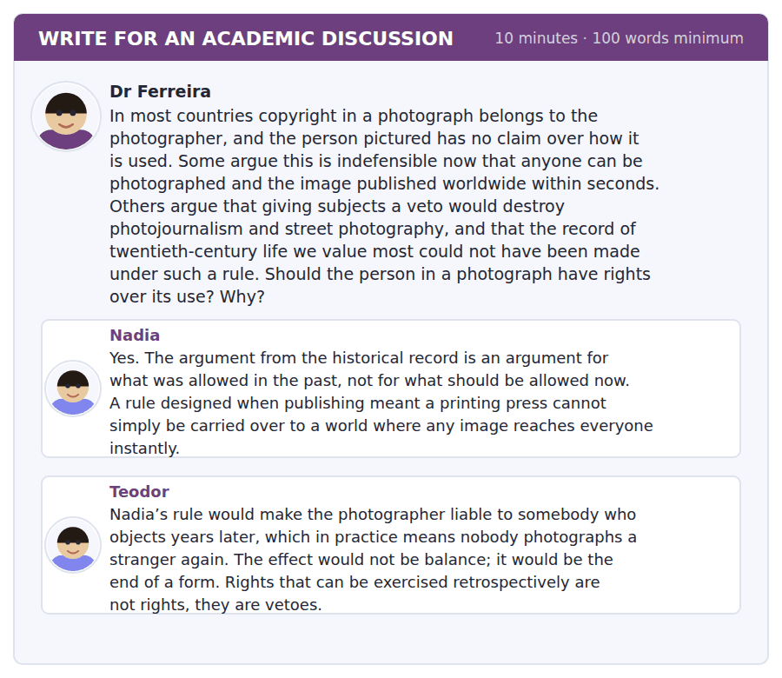
SKILL · Separating a right from its remedy
- Many disputes about rights are really disputes about enforcement. Distinguishing them often dissolves the problem.
- A right with a different remedy can have entirely different effects.
- Show the mechanism: here is what changes if the remedy changes.

Sentence starters
- Teodor’s objection is about the remedy, not the right.
- Nadia is right that…, though her conclusion needs…
- The distinction that does the work here is between… and…
- With that separated, what follows is…
Model post
Teodor’s objection is about the remedy, not the right, and separating the two dissolves most of the disagreement. What would end street photography is not a subject having an interest in their image; it is a subject being able to compel removal years afterwards, which makes every photograph a contingent liability. Those are different arrangements and only the second has the effect he describes.
Nadia is surely right that an argument from what the past permitted is not an argument for the present, and her historical point is stronger than she makes it. The record we value was made under a rule that also produced a great many images the people in them would have stopped, and we do not have those to weigh against it. The surviving record is the evidence of a selection we cannot see.
What follows is that the question is which remedy, not whether there is a right. A right to be informed, exercisable at the point of publication, costs a photographer almost nothing and gives a subject the one thing they mostly want, which is not suppression but notice. A right to compel removal is the veto Teodor describes, and in many cases it would be used against exactly the images that matter most.
So I would give the subject a right and deliberately give it a weak remedy. That will satisfy neither post entirely, which is a reasonable sign that it is located where the actual trade-off is.
[245 words]
Now write your own. 10 minutes, at least 100 words.
__________________________________________________________
__________________________________________________________
__________________________________________________________
__________________________________________________________
__________________________________________________________
__________________________________________________________
__________________________________________________________
__________________________________________________________
__________________________________________________________
__________________________________________________________

Grammar focus Concession: while, whereas, albeit
Word | How it is used
although / though | grants a point: Although nothing was staged, the sequence was arranged.
while | grants a point, or marks simultaneous contrast: While the technique is standard, the promise remains.
whereas | marks a straight contrast between two facts: Prose can signal its status, whereas an image cannot.
albeit | followed by a phrase, not a clause: effective, albeit expensive
even if / even though | if = hypothetical; though = actual
for all that / notwithstanding | formal, placed before a noun phrase
nevertheless / even so | sentence adverbs, after a full stop or semicolon

Whereas contrasts two things that are both true. Although concedes one thing before asserting another. They are not interchangeable, and the misuse is conspicuous.
Albeit is followed by an adjective, an adverb or a noun phrase — never by a subject and a verb. Albeit it was expensive is wrong; albeit expensive is right.
Even if introduces something that may not be true; even though introduces something that is. Getting this wrong changes the meaning of the sentence.
Watch out! Do not pair although with but. "Although it was late, but we continued" is a single concession marked twice, and it is one of the most common errors at B2. Use one or the other.
Exercise 1 Choose while, whereas or albeit.
1. ______ nothing was staged, the sequence was arranged.
2. Prose can mark its status, ______ an image cannot.
3. The caption was effective, ______ brief.
4. ______ the technique is standard, the audience has not agreed to it.
5. Copyright serves the photographer, ______ privacy law serves the subject.
6. The change was useful, ______ expensive to implement.
Exercise 2 Correct the doubled concession.
1. Although it was late, but we continued.
2. Even though the code is silent, however the panel still decides.
3. While nothing was staged, but the sequence was arranged.
4. Despite the cost, nevertheless they went ahead.
Exercise 3 Rewrite with the concessive clause second.
1. Although the record is valuable, it was made without consent.
2. While the caption costs four seconds, it strengthens the sequence.
3. Whereas prose has footnotes, film has none.
4. Even though the panel split, the entry was accepted.
How this is tested in Build a Sentence
Two of the ten Build a Sentence items are not questions, and at B2 they are often concessive clauses. A tile reading while, whereas or albeit begins its clause, and the comma in the prompt tells you which half comes first.
Find the fault 5 errors, drawn from this unit and the two before
Every error below is one a B2 writer makes after learning the rule. Mark what is wrong, then check. Knowing the rule and noticing the breach are two different skills, and only the second one is tested.
Although the technique is standard, but the audience has not agreed to it. Prose can signal its status, while an image cannot, which is a straight contrast. The caption was effective, albeit it was brief. Nobody knows whether did the panel disclose its reasoning. Having captioned the sequence, the audience understood the cut.
# | As written | As it should be | Why
1 | Although the technique is standard, but the audience | Although the technique is standard, the audience | Although already concedes; adding but marks the same concession twice.
2 | while an image cannot, which is a straight contrast | whereas an image cannot, which is a straight contrast | A straight contrast between two facts takes whereas rather than while.
3 | albeit it was brief | albeit brief | Albeit is followed by a phrase, never by a subject and a verb.
4 | whether did the panel disclose | whether the panel disclosed | An embedded question keeps statement order and takes no auxiliary.
5 | Having captioned the sequence, the audience | Having captioned the sequence, the director found that the audience | The audience did not caption anything; the participle needs the right subject.

Unit review and progress check Unit 30
Exercise A Vocabulary. Write the word.
1. meaning made by the order of shots
2. what is included in the shot and what is left out
3. the viewer, considered as part of the system
4. keeping the fictional world consistent across cuts
5. to place two things side by side
6. who is held to have made the work
7. the convention of appearing not to be a convention
8. how fast information is given to the viewer
9. what a scene is about underneath what it shows
10. drawn from existing recorded material
11. a staged version of something that happened
12. recorded material, before it is edited
Exercise B Grammar. Complete the sentence.
1. ______ nothing was staged, the sequence was arranged.
2. Prose can mark its status, ______ an image cannot.
3. The caption was effective, ______ brief.
4. ______ the code is silent, the panel still decides.
5. The entry was accepted, even ______ the panel split.
6. ______ the cost, they went ahead.
7. The change was useful, ______ expensive.
8. Copyright serves the taker, ______ privacy serves the subject.
Exercise C One timed mini-section. 6 minutes.
1. The Kuleshov effect shows that
(A) actors need training
(B) close-ups are best
(C) meaning is produced by what a shot is placed next to
(D) editing should be invisible
2. A case the festival code does not cover is
(A) undecided
(B) permitted
(C) automatically refused
(D) referred to the courts
3. Copyright in a photograph normally belongs to
(A) the subject
(B) the photographer
(C) the publisher
(D) nobody
4. Which sentence is correct?
(A) Although it was late, we continued.
(B) Although it was late, but we continued.
(C) Although it was late, however we continued.
(D) Although it was late, nevertheless but we continued.
5. "Is far from obvious" tells you the writer thinks the claim
(A) is clearly true
(B) needs arguing for
(C) is false
(D) is widely held
6. Albeit is followed by
(A) a full clause
(B) a question
(C) a semicolon
(D) a phrase
Can you do these now?
I can… | Not yet | Yes
I can describe how meaning is produced by arrangement rather than content. | □ | □
I can use while, whereas and albeit accurately and in the right register. | □ | □
I can concede a point in the middle of a sentence without losing the thread. | □ | □
I can read an image as a claim and ask what it is evidence for. | □ | □
I can discuss a contested practice without taking sides prematurely. | □ | □
I can write an argument whose structure the reader can follow at a glance. | □ | □

ADAPTIVE TIP Volume 3 ends here. The three things to carry into Volume 4 are the embedded question, the passive reporting frame and the hedging scale — Units 21, 26 and 29. Everything in the next ten units assumes you can produce all three without thinking about them.

Practice Test 3
The full 2026 shape: 97 items, in the order the real test asks them
Reading 40 · Listening 34 · Writing 12 · Speaking 11
Sit this in one sitting. Do not look anything up. Mark it with the key at the back, then read the explanations — they matter more than the score.

Reading Section, Module 1 In an actual test the clock shows you how long you have
You can use Next and Back to move between questions inside this module.
Fill in the missing letters in the paragraph. (Questions 1–10)
Nobody learns a first language from a list of rules, and almost nobody learns a second one that way either. What a rule gives you is a descript--- of a pattern you have already noticed, which is useful for checking and useless for produ----. This is why a learner who can recite the condit----- still hesit---- in conversation: the knowledge is in the wrong f---. What converts it is quant--- of exposure under mild pres---- — enough input to build the pattern, and enough demand to force retriev--. Neither on its own is suffic----, which is why both silent reading and untutored conversation prod--- slower progress than people expect.

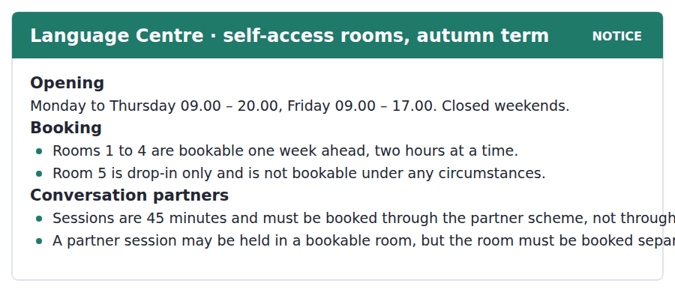
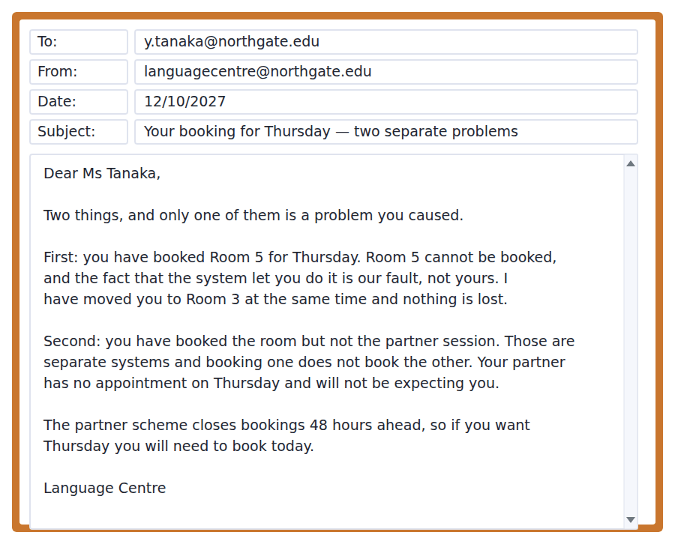
11. Which room cannot be booked in advance?
(A) Room 1
(B) Room 5
(C) Room 3
(D) All rooms can be booked
12. How long is a conversation partner session?
(A) 45 minutes
(B) 30 minutes
(C) Two hours
(D) It varies
13. Which of Ms Tanaka’s two problems does the Centre accept responsibility for?
(A) Neither
(B) The missing partner booking
(C) The Room 5 booking
(D) Both
14. What has the Centre already done?
(A) Cancelled the booking
(B) Booked the partner session
(C) Extended the deadline
(D) Moved her to Room 3 at the same time
15. Why must she act today?
(A) The room booking expires
(B) The Centre closes Friday
(C) Partner bookings close 48 hours ahead
(D) Room 3 is in demand
Why Rules Do Not Produce Fluency
Explicit grammatical knowledge and fluent production are stored differently and recruited differently, which is why a learner can score highly on a grammar paper and then hesitate over the same structure in conversation. The rule is available, but retrieving it takes a second or two, and a conversation does not wait.
This has been taken by some teachers to show that explicit teaching is useless, and that conclusion does not follow. A rule does something a pattern cannot: it lets a learner notice an error in their own output and correct it afterwards, which is the mechanism by which a plateau is broken. What the evidence shows is narrower. Explicit knowledge rarely converts into fluent production on its own, and conversion appears to require repeated retrieval under time pressure — the condition a grammar exercise is specifically designed to remove.
The practical conclusion is unglamorous and well supported. Teach the rule, then force retrieval of the structure under conditions that make deliberation impossible, then return to the rule when the learner has produced something wrong and can see why. Each stage does something the others cannot, and courses that drop any one of them produce a predictable failure: rule without retrieval gives accurate slow speech, retrieval without rule gives fluent fossilised error, and neither gives what the learner came for.
[272 words]

16. What is the main point of the passage?
(A) Rules and fluency are different systems and each needs the other
(B) Explicit teaching is useless
(C) Grammar papers should be abolished
(D) Fluency comes only from conversation
17. Why can a learner hesitate over a structure they know?
(A) They have forgotten the rule
(B) They are not confident
(C) The structure is rare
(D) Retrieving the rule takes longer than a conversation allows
18. What does a rule do that a pattern cannot?
(A) Make speech faster
(B) Let a learner notice and correct their own error afterwards
(C) Increase vocabulary
(D) Improve pronunciation
19. What does conversion appear to require?
(A) Repeated retrieval under time pressure
(B) More rules
(C) Silent reading
(D) Longer courses
20. What does "fluent fossilised error" describe?
(A) A learner who knows the rule but speaks slowly
(B) A learner who has stopped studying
(C) A learner who speaks fluently with mistakes that no longer change
(D) A teacher who ignores grammar

Reading Section, Module 2 In an actual test the clock shows you how long you have
You cannot return to Module 1 once Module 2 has begun.
You can use Next and Back to move between questions inside this module.
Fill in the missing letters in the paragraph. (Questions 1–10)
A model is a set of assumptions with arithmetic attached, and its output can never be stronger than the weak--- of those assumptions. This is widely agreed and routinely forgotten, because a number produced by a model arrives looking like a measure----. The distinction matters most where it is least vis----. A projection of energy demand in 2050 depends on assumptions about population, about effic----- and about how people behave when a price ch-----, and the third of those is the one for which the evidence is thin----. Change it within the range the literature supp---- and the answer moves by more than the difference between the policies being compa---. A model that is honest about this will publish the range rather than the central figure, and almost none of the models quoted in public do, because a range is harder to report and easier to ign---. The result is a debate conducted in single numbers that were never meant to be read al---.

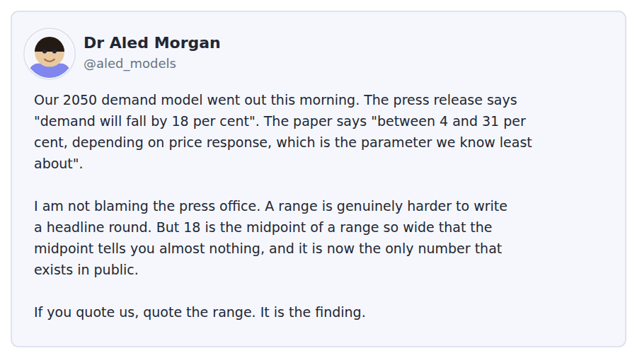
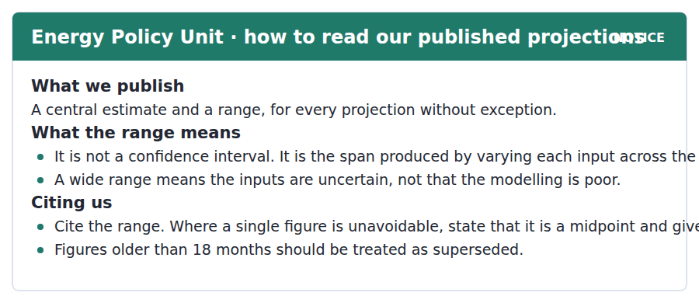
11. What does the Policy Unit publish for every projection?
(A) A central estimate only
(B) A central estimate and a range
(C) A range only
(D) Three scenarios
12. What does a wide range indicate?
(A) Poor modelling
(B) A long time horizon
(C) Disagreement among authors
(D) Uncertain inputs
13. What is the range NOT?
(A) A span of input values
(B) A confidence interval
(C) A published figure
(D) Part of the citation
14. How should figures over 18 months old be treated?
(A) As provisional
(B) As confidential
(C) As superseded
(D) As central estimates
15. What does Dr Morgan say about the press office?
(A) They misquoted the paper
(B) They refused to publish the range
(C) They chose the wrong parameter
(D) He is not blaming them
What a Model Cannot Tell You
A model is an argument in arithmetic. Its conclusion follows from its assumptions with complete reliability, which is both the source of its usefulness and the reason it can mislead so thoroughly. The arithmetic is never the weak point. The assumptions are, and they are rarely visible in the number that comes out.
Consider a projection of energy demand thirty years ahead. It rests on assumptions about population, about how efficient appliances become, and about how much consumption falls when a price rises. The first is well constrained by demography. The second has a reasonable literature. The third is the weakest, because behaviour under a price change varies by country, by income and by how the change is communicated, and the published estimates differ by a factor of several. Vary that parameter alone across the range the evidence supports and the projection moves further than the gap between the policies the model was built to compare.
The honest response is to publish the span rather than the midpoint, and many modelling groups do. It is routinely undone downstream. A range cannot carry a headline, so a midpoint is extracted, and the midpoint of a wide range is a number with no particular claim on anybody’s attention. Within a week it is being cited without the range, and within a year it is being cited against a policy it was never precise enough to assess. The failure is not in the modelling and it is not quite in the reporting either. It is in asking a single number to carry a finding that was never shaped like one.
[278 words]

16. What does the author identify as the weak point of a model?
(A) The assumptions
(B) The arithmetic
(C) The software
(D) The time horizon
17. Which assumption is described as weakest?
(A) Behaviour under a price change
(B) Population
(C) Appliance efficiency
(D) The discount rate
18. What happens when that parameter alone is varied?
(A) The projection barely changes
(B) The projection moves further than the gap between the policies compared
(C) The arithmetic fails
(D) The range narrows
19. Why is publishing the range "routinely undone downstream"?
(A) Modelling groups withdraw it
(B) Journals forbid ranges
(C) A range cannot carry a headline, so a midpoint is extracted
(D) The range is confidential
20. Where does the author locate the failure?
(A) In the modelling
(B) In the reporting
(C) In the policies being compared
(D) In asking one number to carry a finding not shaped like one

Listening Section, Module 1 You will not be able to return to previous questions
Choose the best response.
1. Woman: Have you booked the room or the partner session?
(A) Yes, on Thursday.
(B) Forty-five minutes.
(C) In Room 3.
(D) The room. I did not realise they were separate.
2. Man: Does knowing the rule actually help you speak?
(A) Afterwards, when you can see what went wrong.
(B) Yes, a great deal.
(C) I know most of them.
(D) About two seconds.
3. Woman: I keep hesitating on the conditional.
(A) It is a hard tense.
(B) That is normal — it needs retrieval, not revision.
(C) Yes, I hesitate too.
(D) About three forms.
4. Man: Would more reading fix it?
(A) Yes, definitely.
(B) About an hour a day.
(C) It would help the input and not the retrieval.
(D) I read quite a lot.
5. Woman: Is Room 5 free this afternoon?
(A) Yes, I booked it.
(B) About two hours.
(C) It is drop-in, so you can simply go.
(D) It closes at eight.
6. Man: My partner did not turn up last week.
(A) That is annoying.
(B) Had the session actually been booked?
(C) About forty-five minutes.
(D) Yes, mine did.
7. Woman: Can I book two rooms at once?
(A) Yes, as many as you like.
(B) Rooms 1 to 4.
(C) It is a booking system.
(D) One at a time, up to a week ahead.
8. Man: The Centre is closed at weekends, is it not?
(A) Completely, which catches people out.
(B) Yes, it opens at nine.
(C) On Friday it closes at five.
(D) No, it is open.
Listen to a conversation.

9. What was the man’s problem in the test?
(A) He did not know the structures
(B) He could not retrieve them quickly enough
(C) He misunderstood the questions
(D) He ran out of time
10. Why does the woman say grammar exercises would make it worse?
(A) They are too difficult
(B) They cover the wrong structures
(C) They allow unlimited time, which trains the wrong thing
(D) They are not assessed
Listen to a conversation.
11. What is the woman’s objection to the figure of 18 per cent?
(A) It is too low
(B) It is out of date
(C) It contradicts the paper
(D) It is the midpoint of a range so wide it means little
12. What does she suggest the press office should have done?
(A) Led with why the range is wide
(B) Published nothing
(C) Quoted the lower figure
(D) Waited for better data
Listen to an announcement.
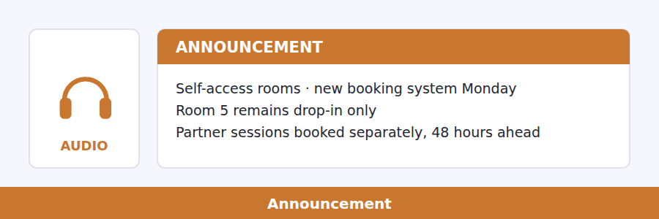
13. What was wrong with the old booking system?
(A) It was slow
(B) It closed at weekends
(C) It allowed invalid bookings for Room 5
(D) It did not show partner sessions
14. What does the speaker ask listeners to remember?
(A) Room 5 is drop-in
(B) The system changes Monday
(C) Sessions last 45 minutes
(D) Room and partner bookings are separate
Listen to a talk.
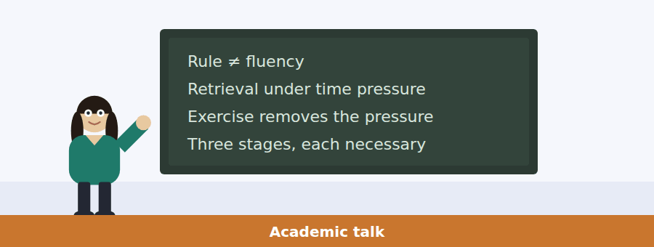
15. What is the speaker’s view of the old argument?
(A) Both sides have each noticed half the evidence
(B) One side is clearly right
(C) The question cannot be settled
(D) It is no longer relevant
16. What does a rule allow a learner to do?
(A) Speak more quickly
(B) See why something they said was wrong
(C) Remember vocabulary
(D) Avoid conversation
17. What happens without that capacity?
(A) Errors stabilise and become hard to treat
(B) Progress stops entirely
(C) Vocabulary shrinks
(D) Learners lose confidence
18. Why is a grammar exercise poor at building fluency?
(A) It is too short
(B) It removes the time pressure fluency is built under
(C) It uses the wrong structures
(D) It is not marked

Listening Section, Module 2 You will not be able to return to previous questions
Choose the best response.
1. Woman: Is this figure from the paper or the press release?
(A) Yes, it is official.
(B) Eighteen per cent.
(C) The release. The paper gives a range.
(D) Last Tuesday.
2. Man: Why is the range so wide?
(A) The model is new.
(B) About thirty per cent.
(C) Yes, it is wide.
(D) One parameter is very poorly measured.
3. Woman: Should I cite the midpoint?
(A) Yes, it is simpler.
(B) In the references.
(C) About 2050.
(D) Only with the span beside it.
4. Man: These figures are two years old.
(A) Yes, they are.
(B) Then treat them as superseded.
(C) About eighteen months.
(D) They were published in 2025.
5. Woman: Does a wide range mean the model is bad?
(A) No — it means the inputs are uncertain.
(B) Yes, usually.
(C) About four to thirty-one.
(D) It is a good model.
6. Man: Can I get the underlying data?
(A) Yes, probably.
(B) About six files.
(C) It is published with every projection.
(D) From the Policy Unit.
7. Woman: Nobody reports the range, though.
(A) Yes, that is true.
(B) About half of them.
(C) Journalists are busy.
(D) Which is the problem the guidance exists for.
8. Man: Is the central estimate meaningless, then?
(A) Yes, completely.
(B) Not meaningless, but weaker than it looks.
(C) It is the midpoint.
(D) No, it is reliable.
Listen to a conversation.
9. Why does the man want to use the older projection?
(A) It has a breakdown the newer one lacks
(B) It is more accurate
(C) It is easier to find
(D) His supervisor recommended it
10. What does the woman recommend?
(A) Use the older figures
(B) Use both equally
(C) Use the newer figures and footnote the limitation
(D) Change the topic
Listen to an announcement.
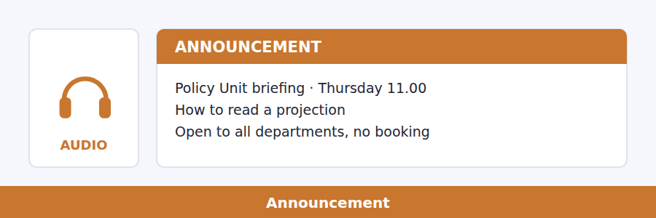
11. What is the briefing NOT about?
(A) Energy policy itself
(B) How to read a projection
(C) Dissertation writing
(D) Statistical methods
12. What should attendees bring?
(A) A dissertation draft
(B) A laptop
(C) Nothing
(D) A projection they are using
Listen to a talk.
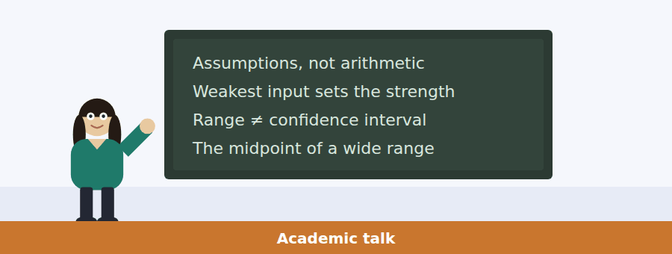
13. What is the "one habit" the speaker recommends?
(A) Checking the arithmetic
(B) Asking which assumption the result is most sensitive to
(C) Reading the whole paper
(D) Comparing two models
14. Which assumption does he say is weakest in the energy example?
(A) Population
(B) Efficiency improvement
(C) Price elasticity
(D) The time horizon
15. What follows from moving that parameter alone?
(A) The projection moves more than the policy difference
(B) The arithmetic breaks
(C) The range narrows
(D) The model must be rebuilt
16. What does the speaker say the remedy is?
(A) Better models
(B) Quoting the range every time, as a habit
(C) Fewer projections
(D) Independent review

Writing Section 12 questions, three types of task
Build a Sentence. Move the words to make grammatical sentences.
1. My partner did not come to the session on Thursday.
whether / know / do / you / the session / had / been / booked / actually
__________________________________________________________
2. The press release gives a single figure.
said / has / anybody / where / that / came / number / from / actually
__________________________________________________________
3. I scored well on the grammar paper and froze in the test.
explain / can / anybody / why / that / happens / to me / exactly / at all
__________________________________________________________
4. The projection is twenty months old.
whether / tell / can / me / you / that / counts / superseded / as
__________________________________________________________
5. Room 5 cannot be booked in advance.
us / told / nobody / why / the system / it / allowed / anyway / exactly
__________________________________________________________
6. The range runs from four to thirty-one per cent.
know / does / anybody / which / parameter / is / that / driving / actually
__________________________________________________________
7. She asked about my dissertation sources.
she / whether / to know / wanted / I / had / the newer / checked / edition
__________________________________________________________
8. The briefing is open to all departments.
do / whether / know / you / we / have / to book / at all / actually
__________________________________________________________
9. Fluency requires retrieving a structure quickly.
at which / the speed / you / retrieve / it / is / what / actually / matters
__________________________________________________________
10. A grammar exercise gives you unlimited time.
whereas / an exercise / gives / you / time / a conversation / does / not / wait
__________________________________________________________
Write an Email. You have 7 minutes.
You are writing a dissertation and need the regional breakdown of an energy demand projection. The breakdown appears only in the 2026 edition, which the Unit’s own guidance says should be treated as superseded after 18 months. The current edition has the headline figures but no breakdown.
Write an email to the Policy Unit.
- Explain exactly which figures you need and why.
- Show that you have read the guidance on superseded figures.
- Ask a question they can answer briefly.
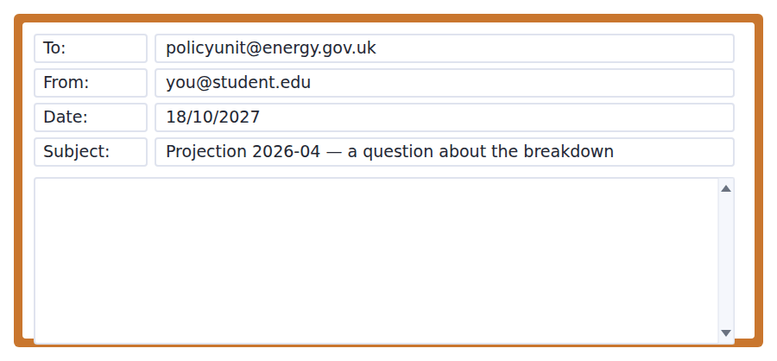
__________________________________________________________
__________________________________________________________
__________________________________________________________
__________________________________________________________
__________________________________________________________
__________________________________________________________
__________________________________________________________
__________________________________________________________
Write for an Academic Discussion. You have 10 minutes.
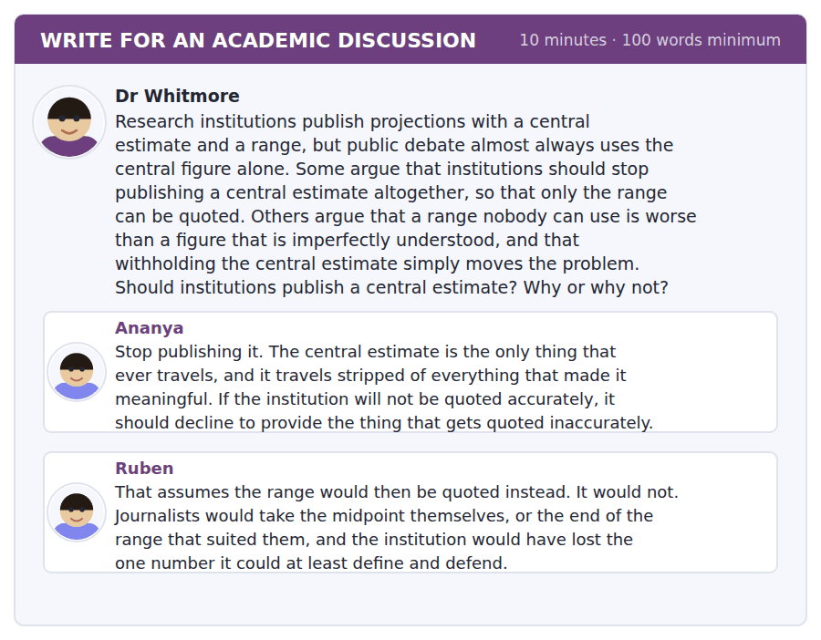
An effective response will contain at least 100 words.
__________________________________________________________
__________________________________________________________
__________________________________________________________
__________________________________________________________
__________________________________________________________
__________________________________________________________
__________________________________________________________
__________________________________________________________
__________________________________________________________
__________________________________________________________

Speaking Section 11 questions, two types of task · no preparation time
Listen and Repeat. Repeat only once.
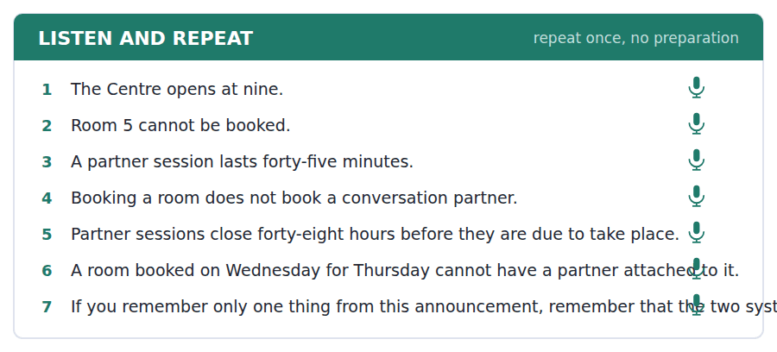
Take an Interview. Answer the questions and say as much as you can.
a research study about how people learn to speak a language
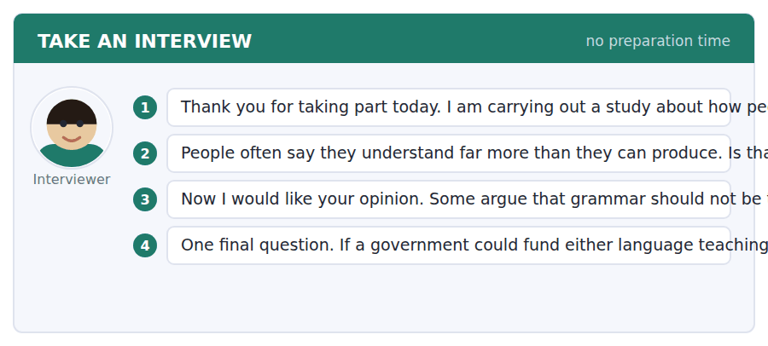

Answer key
Volume 3 · Units 21–30 and Practice Test 3
Every wrong option is explained, because a letter on its own teaches nothing.

Unit 21 · Language and the Mind
Reading 1 · Complete the Words
1 ical | 3 ate | 5 em | 7 ings | 9 ion
2 ite | 4 ons | 6 ty | 8 ed | 10 age

Reading 2 · Read in Daily Life
1 (A) The notice sets the threshold at ten; four is what this student has logged so far.
2 (D) At least fortnightly, with the three group sessions as a separate commitment.
3 (B) The notice is flat about it: hours logged later are not counted at all.
4 (C) After week 6 re-pairing is possible only where places remain, which is the limit the email then works around.
5 (C) It states the week 6 limit and then says a place has come up, which is the offer the rest of the message depends on.
6 (B) The last paragraph separates the two: the threshold is for the certificate, and the module is not affected either way.
7 (D) The coordinator says the free place is being held until Friday, which is the only deadline the email itself sets.
8 (A) Half of the time in each language, which is the point of pairing rather than simply providing a tutor.
9 (D) The notice sets the ten hours and the email calls it the threshold for the certificate; nothing else appears in both.
10 (B) It is the qualifier attached to re-pairing after week 6, and it is why the coordinator has to hold a place rather than simply allocate one.
11 (C) Well outside what the scheme expects is a judgement on the partner, not on the student, and it is followed by an apology rather than a reproach.
Reading 3 · Academic Passage
1 (A) All three paragraphs turn on the same question: whether the editor describes what speakers do or prescribes what they should do.
2 (D) The authority is borrowed from the speakers and returned to them when usage changes, which is the opposite of the editors holding it.
3 (A) No dictionary is purely one or the other is granted before the author goes on to insist that the direction of travel is still clear.
4 (B) It is the gap between a sense becoming current and the editors recording it, so it is a delay.
5 (C) The usage note is offered as prescriptive work inside a descriptive frame, which is the evidence for the concession.
6 (A) A warning tells the reader what to do; a date simply records. Replacing one with the other is the direction of travel the author names.
7 (D) Waiting to see whether it survives is given as the reason, and the risk of not waiting is a book full of words nobody kept.
8 (C) There is little evidence that early recording changes how a word spreads is a rejection, not a doubt, and it is the author’s own position.
9 (B) The passage never claims the lag is shrinking; the other three are all stated in the last paragraph.
10 (A) The two costs named are describing an older language and recording words that did not last, and the sentence says there is no option without one of them.
11 (C) Convention is contrasted with principle, so the point is that the line is settled by agreement rather than derived from anything necessary.
12 (D) The first two paragraphs make and qualify the claim, and the third explains why the difficulty does not overturn it.
13 (B) The author rests on there being little evidence that recording changes spread, so a demonstrated effect would remove the support for editorial caution.
Listening 1 · Conversation
1 (A) A yes/no question about understanding, answered with a qualified yes and the place where understanding stopped.
2 (B) A checking question that overstates the other speaker, so the useful reply corrects the scope rather than agreeing or refusing.
3 (D) A question about personal experience wants an instance, not a judgement on whether the form is correct.
4 (C) He names the slide showing recordings that looked well formed as the thing that stopped him accepting the premise.
5 (B) She offers it as a defence of the lecturer, which the man then rejects on the grounds that one sentence is not enough.
6 (D) Calling something not a footnote is a way of saying it deserved more than the single sentence it got.
7 (A) He corrects the woman explicitly: one premise does, and the other half is not touched by the objection.
8 (C) Nobody says goed to a child, so producing it is evidence the child built a rule rather than copied a form.
9 (C) His last line says he cannot tell whether the lecturer wants an argument or a summary, which is the question he puts to her.
10 (B) They attended the same lecture and are writing the same essay, which places them on the same course rather than in any teaching relationship.
Listening 2 · Announcement
1 (A) A yes/no question about a room is answered with the change, which is more useful than a bare no.
2 (D) An admission of something undone invites the deadline that applies to it.
3 (A) A checking question about a deadline is answered by confirming it and naming the one exception that matters.
4 (D) Most of the announcement sets the Friday deadline and then names the one case in which it does not bite.
5 (C) The speaker is explicit: from this week onwards, not just for one week.
6 (B) That is the stated exception, and it comes with its own two-week limit instead.
7 (D) The speaker apologises but is flat about it, and adds that the seven days is not a guideline.
8 (C) It follows an apology, which would otherwise read as an invitation to ask for an exception, and closes that off.
9 (B) The place is theirs whether or not they confirm by Friday, but it has to be taken up within two weeks.
Listening 3 · Academic Talk
1 (A) How long wants a span of time; a count of entries and a yes answer a different question entirely.
2 (A) A checking question that misstates the position, so the reply corrects it and says where the authority actually sits.
3 (D) A what-happens question wants the procedure, and the answer draws the distinction between marking and removing.
4 (C) The speaker argues that the threshold is what gives an entry its meaning, so the lag is the method rather than a fault in it.
5 (B) He puts it as a rhetorical question — why not record everything and mark what is rare — before answering it.
6 (C) Without a threshold the entry only shows that someone once used the word, which the reader knew by looking it up.
7 (D) He is explicit: the threshold has not moved, only how fast we can see it being crossed.
8 (A) That is the definition given, and it is contrasted with the corpus that now answers the same question in seconds.
9 (B) He is restating that waiting to clear a threshold is the procedure itself, not an unwanted side effect of it.
10 (C) Is bound to be overtaken is the strongest commitment in the talk, and he uses it for exactly this claim.
Writing 1 · Build a Sentence
1 Do you know whether that is really a mistake or a rule?
2 Can you tell me exactly what the deadline for applying is?
3 She wanted to know how many recordings I had already transcribed.
4 Do you happen to know exactly what the talk is about?
5 Nobody seems to know where they have actually gone in the end.
6 I wonder what decides which ones go in and which do not.
7 I do not know yet whether my topic is really narrow enough.
8 Can anybody explain exactly how it works at all?
9 Nobody told us which room we are in now.
10 Do you know whether that is actually true of every language?
Grammar focus
Exercise 1 where the recordings are kept · what the editor decides · whether the sense has survived · How much is innate · why she said goed · when the entry will appear
Exercise 2 The fact that she says goed shows she has a rule. · The fact that the input is rich weakens the argument. · The fact that no adult supplies the form is the key point. · Editors accept the fact that the lag runs to a decade.
Exercise 3 that · whether · What · whether · that
Unit review
A Vocabulary 1 innate · 2 utterance · 3 arbitrary · 4 syntax · 5 lexicon · 6 intuition · 7 competence · 8 universal · 9 plausible · 10 spontaneous · 11 descriptive · 12 threshold
B Grammar 1 where · 2 That · 3 whether · 4 that · 5 what · 6 when · 7 whether · 8 How
C Mini-section 1 A · 2 D · 3 B · 4 A · 5 D · 6 C

Unit 22 · Evolution and Adaptation
Reading 1 · Complete the Words
1 ution | 3 iles | 5 able | 7 ion | 9 ion
2 ently | 4 ow | 6 utes | 8 or | 10 ist

Reading 2 · Read in Daily Life
1 (D) All four are streamlined, and the notice is explicit that none is closely related to the others, which is the point of the case.
2 (B) Specimens are shown at a common length for comparison, so the real scale is exactly what the display removes.
3 (A) The notice sets white for the specimen and grey for a cast, which is what Dr Halloran then objects to.
4 (C) The notice says the midpoint, and explicitly not the earliest known occurrence.
5 (D) She says plainly that it is not dishonest and that it is standard, while insisting a visitor still leaves with a false impression.
6 (C) Three of the four are casts and the ichthyosaur is the only original, which is the fact her objection rests on.
7 (B) Her complaint is about legibility, not accuracy: grey text you read at arm’s length is technically present and practically invisible.
8 (A) The notice lists it under what the case does not show, and says the skeletons differ completely.
9 (B) Convergence means reaching the same outward form from different starting points, and the differing skeletons are the evidence that the starts differ.
10 (D) She calls the case beautiful and the point right before raising one specific objection, and grants that the practice is standard.
11 (A) I do not think that is dishonest — it is standard tells you the practice is widespread rather than exceptional.
Reading 3 · Academic Passage
1 (C) The opening replaces incomplete with biased in ways that can be listed, and everything after it works from that framing.
2 (B) The passage says more fossils follow from being abundant and widespread, and adds that this is not the same as mattering more.
3 (C) The lineage may have continued somewhere that does not preserve, so the last fossil marks the end of the evidence, not the end of the animal.
4 (A) A population too small to be sampled is one that left too few fossils to appear in what we have recovered.
5 (D) As though completeness were the standard it fails to meet is the objection: the word measures the record against something irrelevant.
6 (C) The last line of the second paragraph says the interval is itself evidence of something, which is the opposite of treating it as missing data.
7 (A) The third paragraph opens by naming the opposite problem and then defines it as exactly this distinction.
8 (D) Far from clear is the author’s own hedge, and it is immediately softened further by saying both often contributed.
9 (B) The phrase closes a paragraph about preservation, so the surviving is the fossils that made it into the record rather than the organisms.
10 (C) The argument throughout is that naming the biases converts a weakness into something you can reason with.
11 (A) Size is never mentioned; the other three are each stated in the first paragraph.
12 (B) Cannot be ruled out is the weakest positive commitment available, so the claim is kept open rather than asserted.
13 (D) If the spikes track the rock rather than the biology, the preservation artefact the author raises is shown to be doing real work.
Listening 1 · Conversation
1 (A) A checking question met with a hedge rather than a yes, which marks the start of a disagreement about how to read the data.
2 (D) A how-many question wants a number, and this one adds why the number matters.
3 (C) A yes/no about finding something is answered with the obstacle, which is more informative than a bare no.
4 (B) The hedge marks a disagreement she then explains, and the man hears it immediately — he asks whether she buys it.
5 (B) She calls the Daphne Major case about as clean as field biology gets, and that is the one place she grants it.
6 (C) With fewer than twenty founders, chance can move a trait regardless of what any advantage would favour.
7 (A) Drift moves everything at random and selection moves one thing, so the number of traits that shifted is the discriminating evidence.
8 (D) She says so directly: then it is a founder effect and the beak tells us nothing about seeds.
9 (B) She names the paywall and says she has asked the library, which is the current state of the problem.
10 (A) She accepts the explanation where it was measured and refuses to carry it to an island with a very different history.
Listening 2 · Announcement
1 (C) A yes/no about permission is answered with the permission and the condition attached to it.
2 (D) A why question wants the reason, and the other options give a place, an agreement and a price instead.
3 (B) A yes/no about availability is answered with when it appeared, which confirms and locates it at once.
4 (C) The speaker gives the ticket as the reason and contrasts it with meeting in the gallery.
5 (D) He calls it not fussiness and backs it with two cases the museum has lost.
6 (A) He says explicitly that the fossils do not care and names the paintings behind them as the reason.
7 (D) The distinction is in the colour, not the wording, which is why it is easy to miss.
8 (C) His last sentence says that is the question the assignment is really asking, after warning what a careless worksheet will show.
9 (B) That is not fussiness heads off the obvious reaction and replaces it with a reason, which is explanation rather than apology.
Listening 3 · Academic Talk
1 (A) A yes/no question about inference is answered by rejecting the inference and naming the alternative.
2 (D) A what question wants the categories, and the answer gives both conditions the lecture keeps returning to.
3 (B) A checking question that overstates the case, answered by naming the competing explanation.
4 (C) She states the order explicitly: the artefact question first, the real-pattern question only after it.
5 (A) She calls the asymmetry enough on its own, which is the point of the first use of the habit.
6 (D) The name is given to the gap-and-return pattern, and she says the joke is at palaeontologists’ own expense.
7 (A) Nothing rose from the dead — the lineage persisted somewhere nobody was looking, so the drama is in the record, not the biology.
8 (B) She calls it itself a measurement, which turns the apparent absence into data.
9 (C) Because a well-preserving stretch after a poor one produces the same picture, only evidence about the rock separates them.
10 (C) Is bound to be asked for it is her strongest commitment in the talk, and she uses it for exactly this case.
Writing 1 · Build a Sentence
1 Do you know whether the reading is actually on the portal yet?
2 Nobody told us which ones in the case were actually the originals.
3 She wanted to know where the midpoint figure had originally come from.
4 Do you know exactly what is going to be in the new case?
5 I wonder whether the library actually still has access to it at all.
6 Can anybody explain exactly how that happened independently twice?
7 Nobody seems to know whether the lineage actually survived through it.
8 She told us which colour it was that meant a cast.
9 Can you remind me exactly where we are meeting?
10 Do you know whether that is really enough for drift?
Grammar focus
Exercise 1 Arriving in small numbers, the birds carried little variation. · Isolated for millennia, the population diverged from the mainland form. · Facing the same problem, the lineages arrive at the same shape. · Cast in resin, the specimen was displayed beside the original. · Preserving well, the rock produces an apparent burst of new forms. · Having read the labels carefully, she noticed the grey print.
Exercise 2 The species living only on one island is flightless. · The specimens shown in Gallery 4 are mostly casts. · A trait shaped by drift tells you nothing about the environment. · The students standing behind the barrier could not read the label.
Exercise 3 Having examined the case, we found the labels unclear. · Being made of resin, the specimen was hard to distinguish. · Isolated for millennia, the island population was studied by researchers. · Reading the caption, I realised the scale had been standardised.
Unit review
A Vocabulary 1 trait · 2 lineage · 3 constraint · 4 heritable · 5 cumulative · 6 convergent · 7 niche · 8 morphology · 9 drift · 10 extinction · 11 speciation · 12 dispersal
B Grammar 1 Arriving · 2 Isolated · 3 Having · 4 living · 5 shown · 6 Facing · 7 shaped · 8 reading
C Mini-section 1 B · 2 A · 3 D · 4 B · 5 C · 6 A

Unit 23 · Neuroscience and Memory
Reading 1 · Complete the Words
1 ents | 3 able | 5 ed | 7 ically | 9 acy
2 enced | 4 ively | 6 ory | 8 ly | 10 ion

Reading 2 · Read in Daily Life
1 (C) Participants watch the film and then return after seven days, which the notice calls visit two.
2 (A) Previous participation is the one exclusion the notice lists, alongside the age and registration requirements.
3 (D) It says so explicitly, and adds that no score will be given, which is there to stop people treating it as a test of themselves.
4 (B) The data section sets the limit at the end of visit two, after which the responses are anonymous and cannot be traced back.
5 (D) The post concludes that eyewitness evidence should not be trusted; the researcher claims only that wording changes what is reported.
6 (C) She is marking the boundary of her own result, which is exactly the boundary the headline crosses.
7 (B) The participant information restricts the sample to registered students in that age band.
8 (A) The headline is about human memory and courts; the evidence is forty undergraduates watching a film.
9 (C) The notice gives the timing but never explains it, so any reason the reader supplies is their own.
10 (B) It sits directly after we are not testing your memory ability, and removes the reason somebody might worry about performing.
11 (A) The two faults are the missing sample and the leap from wording effects to courtroom evidence, and both are fixed by the same change.
Reading 3 · Academic Passage
1 (D) The passage corrects the common reading directly: everything in the image is a difference between two states.
2 (C) Change the comparison and the coloured regions move is stated as the direct consequence of the method.
3 (A) Not appearing means the two states did not differ there, which is compatible with the region working hard in both.
4 (B) The scan cannot settle which region was involved first, meaning it cannot decide the question.
5 (D) Each paragraph adds a limit — the comparison, then time — and the title names the purpose directly.
6 (C) Seconds against milliseconds is the mismatch, and it is why sequence questions cannot be answered this way.
7 (B) Close to silent is the author’s own phrase, followed by the note that researchers needing the answer use other tools.
8 (D) The concern is about the field’s agenda rather than the technique, and it is the only claim in the passage the author hedges twice.
9 (A) Remains an open question is followed by but the worry is not an unreasonable one, which withholds agreement without dismissing it.
10 (B) The pair is the pair of conditions, and the sentence is saying the result cannot be detached from the comparison that produced it.
11 (A) Sample size is never mentioned; the other three are each developed at length.
12 (D) Almost never visible to readers of the resulting news story is the author’s only remark about reporting, and it is about the comparison.
13 (C) The worry is that a method is shaping the agenda, so evidence that the unanswerable questions stopped being asked is exactly what would bear on it.
Listening 1 · Conversation
1 (D) A question that is really about why someone is still working invites a plan rather than a yes or no.
2 (B) A does-it-work question is answered with the state of the evidence, not with the speaker’s own night.
3 (C) An admission of being behind invites a judgement about the plan, which is what the conversation then turns on.
4 (A) He names the methods section and the nine o’clock deadline as the reason he is still there at midnight.
5 (C) Same study time, different sleep, measured a week later — that is the design he reports.
6 (B) It is an accusation of inconsistency, and his reply — those are different problems — concedes that he knows.
7 (D) I have read it and I have a deadline draws a line between knowing something and being free to act on it.
8 (A) She says explicitly that she is not trying to win, and then supplies the worst mark she has ever had as the reason.
9 (D) His last line splits the task: the outline now, the writing at seven, which takes the advice without abandoning the deadline.
10 (A) It concedes the argument and registers irritation at having to, which is why the next line is a change of plan.
Listening 2 · Announcement
1 (B) A yes/no about feedback is answered with the fact and the reason behind it.
2 (C) A question about a limit is answered by stating the limit precisely rather than vaguely reassuring.
3 (A) A misunderstanding about the purpose is corrected and replaced with the actual object of study.
4 (B) Forty minutes in total across the two visits is given in the practicalities.
5 (C) The speaker is careful to say that is not a policy, it is a limitation, which distinguishes a rule from an impossibility.
6 (D) She numbers it third and flags it as the one, then spends the rest of the briefing on it.
7 (B) The apologies are offered as evidence that the misunderstanding is common and has a cost for the participants.
8 (D) If anything, the effect is strongest in them — which removes any reading of the result as a failure of attention.
9 (A) Two short practical points are followed by a long third one, and the third is entirely about what the study is not.
Listening 3 · Academic Talk
1 (C) A what-do-they-mean question wants the referent, and the answer names the comparison rather than the region.
2 (D) A can-it question about sequence is answered with the limitation and the reason for it.
3 (A) A checking question built on a misunderstanding, corrected by restating what absence of colour actually means.
4 (B) He states it at the start and uses it as the organising device for the rest of the talk.
5 (C) He corrects the natural assumption immediately: it does not measure thought, it reports a difference in blood flow.
6 (A) Blank screen and unfamiliar faces give very different findings from an identical-looking image.
7 (C) That is the weaker reading he offers, and it is why he calls the unfamiliar-face comparison stronger and narrower.
8 (B) The timescale mismatch is the whole of the second limitation, and he calls it harder to fix than the first.
9 (D) He hedges rather than rejecting it, which leaves room for studies combining scanning with a faster method.
10 (B) He says explicitly that none of this means the images are worthless, and then states the narrower claim.
Writing 1 · Build a Sentence
1 Do you know whether that has ever been tested?
2 Nobody told us exactly why the gap is that long.
3 She wanted to know how much of it I had already rewritten.
4 Do you know whether the authors had actually seen it first?
5 Can anybody explain to me exactly why that happens at all?
6 Nobody seems to know how many of them had already forgotten the film.
7 Can you tell me whether that actually rules me out?
8 Does anybody know which one of them actually responded first?
9 The researcher told her that she had done nothing wrong.
10 I do not know yet whether I will have finished by then.
Grammar focus
Exercise 1 will have written · had already left · have been working · to have forgotten · Having slept · had watched
Exercise 2 After she arrived, he left. · correct as written · correct as written · The study was published in 1974.
Exercise 3 Having slept badly, she sat the exam. · The press office had published the post before the researcher saw it. · The volunteers returned a week after they had watched the film. · Having finished the outline, I went home.
Unit review
A Vocabulary 1 encode · 2 retrieve · 3 impair · 4 consolidate · 5 cue · 6 episodic · 7 semantic · 8 interference · 9 misattribute · 10 salient · 11 resolution · 12 correlate
B Grammar 1 will have · 2 had · 3 have · 4 to · 5 Having · 6 was · 7 had · 8 had
C Mini-section 1 C · 2 A · 3 D · 4 A · 5 B · 6 C

Unit 24 · Oceans and Currents
Reading 1 · Complete the Words
1 tionate | 3 ents | 5 ity | 7 ens | 9 ic
2 ore | 4 ating | 6 ion | 8 apses | 10 shed

Reading 2 · Read in Daily Life
1 (A) The notice lists 5 m, 50 m and 200 m, which is what makes the array useful for questions about layering.
2 (B) Wind is hourly while the water sensors are six-hourly, which is a difference worth noticing when comparing the two.
3 (C) Values are revised when sensors are recalibrated, so only a version number identifies what was actually used.
4 (D) Flagged, not removed — which leaves the decision to the user rather than making it for them.
5 (B) The closing line states it directly, and the mooring move is the reason given for treating them separately.
6 (A) About 400 m away and slightly deeper is the stated reason, and it is a reason about place rather than equipment.
7 (D) The data office advises against exactly that, which tells you it was what was proposed.
8 (C) Both are described as good, and the warning is only against combining them into one series.
9 (D) The numbers run on without a visible break, so the structure of the file invites exactly the mistake being warned against.
10 (B) The citation section gives recalibration as the reason, which is why the version matters more than the dataset name.
11 (C) The sensor was replaced in 2014 and earlier values are described as less reliable, so the caution applies backwards.
Reading 3 · Academic Passage
1 (A) Years apart, mostly in summer, mostly in the north describes a sampling problem rather than a measurement problem.
2 (C) The cycle described is drift, rise every ten days, transmit, sink again.
3 (D) No float is steered, which is stated as the cost of getting coverage everywhere.
4 (B) The comparison teaches something — that the old picture was right about the mean and wrong about its variability.
5 (A) The comparison sentence gives exactly this split, which is why the author refuses to call the old picture wrong.
6 (A) The limit is the parking depth, not the instrument, which is why extending the array downwards is described as technically ready.
7 (B) A float that surfaces under ice cannot transmit, which is a communications limit rather than a sampling one.
8 (D) That phrase attaches to the extension proposals, and the author then calls the pattern familiar.
9 (C) The sentence that follows spells it out: the cost seems improbable until the gap turns out to matter.
10 (A) It is called now standard and credited with real gains, and the final paragraph is about completing it rather than replacing it.
11 (C) Accuracy is never questioned; the complaint throughout is about where and when the measurements were taken.
12 (D) An estimate is a quantity with error attached, which is weaker than a measurement and stronger than a guess.
13 (B) The argument for going deeper rests on the deep water holding a large share of the heat, so removing that removes the reason.
Listening 1 · Conversation
1 (C) A checking question with the wrong assumption, corrected with the figure that makes the scale clear.
2 (D) A what-makes question wants a mechanism, and the answer gives both conditions and the consequence.
3 (A) A question conflating two phenomena is answered by separating them and naming the cause of the other one.
4 (B) He read the arrow size as speed, and the woman diagnoses it: the arrows are volume.
5 (C) The man offers the river image and she endorses it as exactly right, then extends it.
6 (B) Fresher water is less dense, and density is what makes it sink in the first place.
7 (D) She corrects the man’s single source by adding rainfall, and notes both act in the same place.
8 (A) She calls it the wrong word for what the models actually show and then describes weakening from the top instead.
9 (B) The system responds over decades, so the measurement that settles the question may arrive after the change it would have warned about.
10 (A) Each of her turns either diagnoses a misreading or adds the next piece, which is explanation rather than disagreement.
Listening 2 · Announcement
1 (D) A what-time question is answered with the time and the earlier deadline that really governs it.
2 (C) A now-or-later question wants the timing and the reason it matters.
3 (C) A yes/no about a facility is answered with what exists and its real limitations.
4 (B) The sailing time is six but the gangway closes half an hour earlier, which is the deadline that actually binds.
5 (D) Shared between twenty-two people and slow, with the practical instruction not to plan on uploading.
6 (A) He gives the reason too: it does almost nothing once you are already unwell.
7 (B) He flags the fifth item explicitly with if you remember nothing else and spends the most time on it.
8 (D) Three days lost and data still flagged as uncertain is the evidence for the rule he has just given.
9 (C) A reading with no reliable time and position attached cannot be placed, which is exactly what left the earlier data flagged.
Listening 3 · Academic Talk
1 (A) A how-many question wants the number, and the answer adds the fact that makes the number meaningful.
2 (D) A can-it question answered with the limitation and a signal that it is a design choice rather than a failure.
3 (B) A what-happens question wants the consequence, which the other options either dodge or merely agree with.
4 (A) The talk opens with complete control over position, depth, instrument and moment, and contrasts it with coverage.
5 (C) Convenient places, pleasant seasons — the bias has a direction, which is what systematically adds to unrepresentative.
6 (A) She names it in three words and then evidences it from the comparison with the ship record.
7 (D) The average was right and the variability badly wrong, which she calls exactly the predictable error.
8 (C) The profile never arrives, so the measurement is taken and then lost rather than never attempted.
9 (B) That is her closing line, and it is the reason she gives for not treating the gaps as acceptable.
10 (C) She answers her own question with overwhelmingly yes and then spends the rest of the talk being honest about where it falls short.
Writing 1 · Build a Sentence
1 Do you know how many floats are actually still reporting?
2 Nobody told us exactly why they were split apart.
3 The rate at which it sinks is the thing we are actually measuring.
4 Do you know whether that affects the record very much?
5 Do you know the extent to which this actually matters at all?
6 Does anybody know whether the old values were ever recalibrated?
7 Can you remind me exactly what goes in it again?
8 Nobody seems to know how much of it is actually still down there.
9 She told us exactly when we had to be on board.
10 The speed at which they drift is something nobody controls at all.
Grammar focus
Exercise 1 The rate at which the water sinks depends on salt. · The researcher to whom the sample was sent has replied. · The period during which the sensor was unreliable is flagged. · The basin to which the water returns is in the Pacific. · The scale on which this system responds is a thousand years. · The colleague to whom I wrote has not answered.
Exercise 2 There are four upwelling systems, three of which lie in the Pacific. · Twenty-two people sailed, none of whom had been to sea before. · The array has several thousand floats, most of which are still reporting. · Two periods are flagged, neither of which can be joined to the other.
Exercise 3 The extent to which · The rate at which · The degree to which · The extent to which
Unit review
A Vocabulary 1 gradient · 2 saline · 3 density · 4 upwelling · 5 nutrient · 6 flux · 7 buoyancy · 8 stratify · 9 sediment · 10 anomaly · 11 equilibrium · 12 overturning
B Grammar 1 at · 2 to · 3 of · 4 extent · 5 during · 6 on · 7 of · 8 to
C Mini-section 1 A · 2 B · 3 D · 4 C · 5 B · 6 D

Unit 25 · Statistics and Evidence
Reading 1 · Complete the Words
1 ated | 3 ous | 5 hing | 7 ing | 9 em
2 ible | 4 oth | 6 ature | 8 tion | 10 sion

Reading 2 · Read in Daily Life
1 (C) The method section gives 2,140 undergraduates, which is a large sample and still an observational one.
2 (D) Those reporting 7 to 8 hours scored 4.1 marks higher than those reporting under 6.
3 (A) Those three are listed; paid work is named separately as something they did not collect.
4 (B) Self-reported for a typical week in March, which is both a recall measure and a single snapshot.
5 (C) Proves and raises are causal claims, and the summary says explicitly that the design cannot show cause.
6 (B) A student working long hours sleeps less and has less study time, which would produce the association with no causal link between sleep and marks.
7 (A) She explicitly invites quotation and objects only to the word that overstates what the design can deliver.
8 (D) Intervention removes the confound by construction, which is what the summary means by saying they did not assign anyone.
9 (B) The demand rests on moving deadlines changing marks, which requires exactly the causal link the design cannot supply.
10 (A) An average difference is compatible with many individual students showing no difference or the opposite, which the Union’s wording loses.
11 (C) We would love this to be as simple as that opens with agreement about the goal before the correction about the evidence.
Reading 3 · Academic Passage
1 (D) The second study found a much smaller effect or none, across a substantial fraction of the attempts.
2 (B) Small samples and analytic freedom producing false positives is the first camp the passage describes.
3 (A) Failure to replicate is not the same as falsity, with unrecorded conditions as the explanation.
4 (C) The sentence explains it: depending on conditions the original paper did not record.
5 (D) The first paragraph ends by saying so directly, and the passage then spends a paragraph on each camp.
6 (B) Publishing the plan before the data exist means the analysis cannot be chosen after seeing the results.
7 (A) No procedure can settle that retrospectively is stated plainly, and it is the limit the conclusion rests on.
8 (C) The last sentence gives both halves: the weak evidential status and the explicit refusal to treat it as an accusation.
9 (D) Widely resisted immediately precedes it, and the resistance being addressed is the reading of weak evidence as blame.
10 (C) It grants real examples to each camp, which is why the author then says they are hard to tell apart from outside.
11 (B) Raw data publication is never mentioned; only preregistration and sample size appear as parts of the new apparatus.
12 (D) The final clause exists to forestall the accusatory reading, which is a deliberate choice rather than a neutral one.
13 (A) Fragility means the effect is real under conditions the replication did not reproduce, so restoring the condition and recovering the effect is the test.
Listening 1 · Conversation
1 (B) A supervisor’s question that exposes the sampling problem without stating it.
2 (D) A how-large question has no answer in the abstract, and the reply names what it depends on.
3 (C) A proposal to fix bias with size, corrected by pointing at what size does not change.
4 (A) People not in the library read least, so where you recruit is correlated with the outcome.
5 (C) He says it in his own words, which is why the supervisor tells him to hold on to it.
6 (A) The supervisor asks who replies to emails about reading, and the man supplies the answer himself.
7 (D) Not eliminating bias, but bounding it is her formulation, and it is the lesson of the whole conversation.
8 (B) She corrects his guess firmly and calls the response rate a finding in its own right.
9 (C) She grants that no recruitment method is neutral, and then distinguishes that from doing nothing about it.
10 (A) Almost every one of her turns is a question, and the man reaches each conclusion himself.
Listening 2 · Announcement
1 (D) A yes/no about content is corrected and replaced with the actual subject.
2 (B) A do-I-need question wants the item, which the poster also names.
3 (C) A question about eligibility is answered by naming the other group included.
4 (D) She names headlines and media training as the two things the session is not, before saying what it is.
5 (A) She gives both reasons in one clause, which is why the session teaches a distinction instead.
6 (B) You doing it to your own work is how she describes it, and she calls it uncomfortable and more useful.
7 (C) She singles them out and gives a reason: they write the first version of the claim.
8 (B) If the first version is right, the rest usually follows is her stated reason for the priority.
9 (D) It is one of the three real examples she says the session will take apart.
Listening 3 · Academic Talk
1 (A) An overstated version of the finding, met with a hedge that opens the distinction the talk is about.
2 (C) A what-does-it-do question wants the mechanism, which the other options avoid.
3 (D) A can-we question answered with the limit, which is the talk’s uncomfortable conclusion.
4 (B) He grants it explicitly and calls it established and not in dispute before introducing the complication.
5 (A) Both are consistent with the same observation, and he adds that from outside they look identical.
6 (B) You will do it without any dishonest intention whatever is the point of the concession, and it sets up the later refusal to accuse.
7 (C) He is explicit that they do nothing at all for work already done, because the plan cannot be registered retrospectively.
8 (D) He flags the resistance immediately before the claim that the new apparatus cannot reach back.
9 (A) That is his chosen formulation, and he then spends the closing lines defending it against being heard as blame.
10 (A) He has just said people hear it as an accusation, and this sentence rejects that inference directly.
Writing 1 · Build a Sentence
1 Do you know what proportion of them actually replied in the end?
2 Nobody told us which other variables they controlled for.
3 She wanted to know exactly where it was going in the write-up.
4 Do you know whether that actually means they were false?
5 Nobody seems to know who actually wrote the first version of it.
6 Can anybody explain to me exactly how that helps at all?
7 Does anybody know how much that actually varied between subjects at all?
8 She told us why she particularly wanted them there.
9 Can you tell me whether paid work was measured at all?
10 The extent to which that matters is something nobody has measured.
Grammar focus
Exercise 1 on the order of a thousand years · by half, give or take five per cent · a handful of them replied · the bulk of the variance · up to forty per cent · at least two thousand
Exercise 2 The study found a four-mark difference on average. · About 37 per cent of students replied. · The effect was significant, though small. · 2,140 students took part.
Exercise 3 A survey of library users suggests that library users read widely. · The replication failed, which is consistent with the original being false or fragile. · Students reporting more sleep scored about four marks higher on average. · Students in paid work reported less sleep on average.
Unit review
A Vocabulary 1 variance · 2 confound · 3 replicate · 4 attrition · 5 spurious · 6 robust · 7 magnitude · 8 outlier · 9 median · 10 calibrate · 11 underpowered · 12 preregister
B Grammar 1 on · 2 give · 3 Only · 4 Roughly · 5 up · 6 at · 7 though · 8 in
C Mini-section 1 B · 2 D · 3 C · 4 C · 5 D · 6 A

Unit 26 · Law, Rights and Society
Reading 1 · Complete the Words
1 ute | 3 ields | 5 ary | 7 wards | 9 erence
2 ution | 4 ly | 6 ted | 8 tematically | 10 ion

Reading 2 · Read in Daily Life
1 (D) The policy sets 14 days, and the email confirms the notification arrived in good time.
2 (B) That is the only ground the policy provides, and it is the one the email is careful to rely on.
3 (A) The policy states that prohibition explicitly, which is why the email denies having considered the speaker’s views.
4 (C) The Board may uphold, set aside or vary any condition, within seven days of the decision.
5 (C) It then gives that single ground — a disruption elsewhere and intelligence about the same group — and nothing else.
6 (D) Those two facts together are the whole of the case, and the email supplies no other material.
7 (A) The policy may not refuse on the ground that views are objectionable, so the denial is a statement of compliance.
8 (B) The final paragraph names the appeal route and adds an offer that goes beyond the policy’s requirements.
9 (D) Both conditions fall under the power to attach conditions where there is a credible safety risk, which the email has established.
10 (C) That is the single prohibition, and the email’s careful denial shows the Union knows it is the vulnerable point.
11 (B) Each paragraph names a power, its basis, or a route of challenge, which is the register of someone expecting to be reviewed.
Reading 3 · Academic Passage
1 (A) The first paragraph closes by naming exactly that gap, having spent the rest of the paragraph describing it.
2 (B) It is widely believed that the main barrier is the cost of a lawyer, which the author then concedes matters before moving past it.
3 (A) Many never identify their problem as legal at all is the finding the second paragraph is built on.
4 (D) It is the step that turns a bad month into an unlawful deduction, which is what the paragraph says is specialist knowledge.
5 (C) Three functions are listed before the concession that the practical difference may be undetectable.
6 (A) The third paragraph draws that line precisely and then says what such schemes do not do.
7 (D) The author uses has not been established for exactly this claim, which marks it as unproved rather than false.
8 (B) Those two are named together and described as unglamorous, which is part of the author’s point.
9 (C) It is contrasted immediately with producing more of it than a courtroom does, so the objection is to appearance rather than effect.
10 (D) And cost matters is a concession, placed before the evidence that something else explains more.
11 (B) Wages and housing are the two illustrations; inheritance is never mentioned.
12 (C) Each paragraph moves the diagnosis further from cost and the last one says what should be funded instead.
13 (A) The claim is that reaching people before they classify the problem works better, and a desk where people already are tests exactly that.
Listening 1 · Conversation
1 (A) A yes/no question about scope, answered by naming the test rather than agreeing or refusing.
2 (C) A what-happens question wants the options, and the answer gives both with their relative frequency.
3 (B) A yes/no about understanding, answered with the precise part that was not understood.
4 (D) She gives the test at the start and then demonstrates it with the notice point: remove it and the result changes.
5 (A) The notice was invalid anyway, so the two paragraphs could not have changed the outcome.
6 (C) Scarcity of authority is the reason she gives, and it explains why non-binding remarks can still be decisive.
7 (D) She corrects the man’s nearly-right formulation precisely on this point.
8 (B) He says persuasive means you need a reason to follow, and she corrects it to needing no reason either way.
9 (B) She calls it most of what practising lawyers argue about, immediately after conceding the line is fine.
10 (A) Every turn either states a rule, illustrates it, or corrects a near-miss, which is sustained explanation.
Listening 2 · Announcement
1 (C) A can-it question about power, answered by naming the prohibited ground.
2 (D) A how-long question wants the period, and the other options give the notice rule, an agreement and a destination.
3 (D) A what-can-it-do question wants the powers, which the policy lists as three.
4 (A) He defines both operative words, and specific is the one requiring an identifiable thing rather than a general fear.
5 (C) More than somebody being annoyed on the internet is his own gloss on the word.
6 (B) He states the prohibition three times with three different intensifiers, which marks it as the central point.
7 (B) That is his stated reason, and it is an argument about the shape of the power rather than about any particular speaker.
8 (A) Those three verbs are the Board’s powers, and he urges societies to use the route.
9 (D) A policy nobody appeals against is not a policy anybody is checking is his closing line and his reason.
Listening 3 · Academic Talk
1 (C) A question assuming the standard answer, met with a partial concession and a correction.
2 (C) A what-stops question wants the earlier barrier, which is the lecture’s whole subject.
3 (B) A does-it-help question answered by naming precisely who is helped, which implies who is not.
4 (D) She names it immediately and then takes care to say she is not dismissing it.
5 (A) A large proportion never classified the experience as legal, which she calls a step earlier in the chain.
6 (C) Those are the two she names as things a lawyer would recognise immediately as actionable.
7 (D) She grants that it works for that population before saying the larger group is unreached.
8 (B) My own view, and I want to flag it as a view is a deliberate change of register from the reporting that precedes it.
9 (A) Those are her two proposals, and she lists health centres, job centres and schools as the places she means.
10 (A) The next sentence says both appear to produce more of it, so the concession is about how they look and not about what they do.
Writing 1 · Build a Sentence
1 Do you know whether it is said to be binding?
2 Nobody told us which part was thought to be essential.
3 She wanted to know whether it had ever been followed.
4 Do you know whether that has ever been tested?
5 Nobody seems to know on what grounds they were actually imposed.
6 Can anybody explain why it is said to matter so much?
7 Does anybody know whether she had been properly advised?
8 He told us exactly how long we had to appeal for.
9 The grounds on which it was decided are no longer in dispute.
10 Can you tell me whether that has been measured?
Grammar focus
Exercise 1 The case is said to be the leading authority. · The notice is thought to have been invalid. · The group is believed to have travelled from another city. · The officers are alleged to have acted on the content. · The meeting is reported to have been disrupted. · The test is generally held to be the same for every right.
Exercise 2 to be · to have been · to have brought · to apply
Exercise 3 Is it thought to be binding? · Is the case said to have been overruled? · Are the conditions alleged to have been imposed for another reason? · Is the test generally held to be the same?
Unit review
A Vocabulary 1 uphold · 2 provision · 3 liable · 4 precedent · 5 jurisdiction · 6 binding · 7 tribunal · 8 remedy · 9 discretion · 10 infringe · 11 enshrine · 12 redress
B Grammar 1 that · 2 to · 3 said · 4 to · 5 been · 6 held · 7 Is · 8 are
C Mini-section 1 C · 2 D · 3 B · 4 D · 5 C · 6 B

Unit 27 · Energy and Power Systems
Reading 1 · Complete the Words
1 cise | 3 ingly | 5 ive | 7 ved | 9 tions
2 rols | 4 ogy | 6 ing | 8 ose | 10 ce

Reading 2 · Read in Daily Life
1 (C) The notice gives 21p as the current purchase price, against a 5p generation cost for the array.
2 (A) Export earns 4p, which is the figure the whole of the Estates objection turns on.
3 (B) The notice lists it under assumptions: no allowance for inverter replacement around year 12.
4 (D) That is the estimate given, and it is what moves the payback from seven years to about eleven.
5 (B) The objection is not that the number is wrong but that it answers a different question from the one the committee is asking.
6 (C) August output is highest and August demand is lowest, so a third of the generation cannot displace purchased power.
7 (D) Estates gives both figures explicitly and still describes the result as a good project.
8 (A) I support this proposal and I want it to survive scrutiny is the opening line and governs everything after it.
9 (A) It is an argument about who gets to frame the caveat, not about whether the caveat is real.
10 (C) That assumption is listed in the notice itself, and the email supplies the figure that shows it does not hold.
11 (D) Nothing physical changes; the financial case the committee would be approving is not the one on the page.
Reading 3 · Academic Passage
1 (B) The first sentence is specific about which cost, and the rest of the passage depends on that precision.
2 (A) That mismatch between production and demand is the whole basis of the system cost the author goes on to describe.
3 (C) Those four are listed as the ways of covering a gap that the steady system does not create.
4 (B) The critics imply the fall was not genuine, and the author replies that it was.
5 (D) That confusion is named at the end of the second paragraph and then applied to each side in turn.
6 (C) The author grants the extra cost is real while rejecting the claim that the headline fall was not.
7 (A) And it was not is addressed to the critics, granting the supporters their central fact.
8 (D) The projection applies to the integration cost as the renewable share rises, which is the asymmetry the author is pointing at.
9 (B) Perhaps seventy per cent is offered with a hedge and then explicitly disclaimed as unknowable.
10 (C) A confident number from either side rests on an assumption, and the phrase says the assumption is bearing the weight.
11 (D) It cuts in both directions immediately precedes it, and the paragraph then takes care to deny each side its preferred misreading.
12 (A) Four options are listed and more generation is not among them, because it does not help on a still night.
13 (B) The author claims the second cost grows with share and that nobody knows where it accelerates, so measuring that point supports the whole argument.
Listening 1 · Conversation
1 (C) A could-have question about a past possibility, answered with the condition that would have defeated it.
2 (D) A why question wants the reason, and the answer gives the grid constraint rather than a fact about the farm.
3 (B) A would-have question invites a third conditional, and the answer supplies the condition it depends on.
4 (A) She opens with the figure and then explains that operators were paid to stop generating.
5 (A) Money leaves the system as well as the energy, which is the distinction she draws.
6 (B) Full by two in the afternoon, which is why she then moves to the hypothetical about doubling its size.
7 (C) A battery earns by cycling, and one sized for rare surpluses does not pay for itself.
8 (D) Full capacity in the wrong direction for part of the day, caused by the timing of the market.
9 (D) She says a good chunk would not have happened and that the fix costs nothing physical.
10 (A) Her closing line contrasts what everybody wants to talk about with a rule written in 2004.
Listening 2 · Announcement
1 (C) A yes/no about eligibility is answered with the condition and its deadline.
2 (B) A direct question about the downside deserves the downside, stated plainly.
3 (B) A can-I-leave question wants the exit terms rather than reassurance.
4 (D) A third less between eleven and six is the benefit, against half as much again in the evening peak.
5 (A) That is the peak window, and the speaker calls it the hour everybody cooks.
6 (C) She states the purpose directly after naming the catch, which is why the catch is the whole point.
7 (C) She gives that case as the explicit example of when the trial does not pay.
8 (A) Heating is not on the trial at all, and she volunteers it because of how often she has been asked.
9 (D) It justifies raising the heating point without anyone in this audience having raised it.
Listening 3 · Academic Talk
1 (B) A yes/no question answered with the strength of the claim and a signal that no argument follows about it.
2 (C) A checking question that assumes the inference, corrected by naming what else it depends on.
3 (A) A definition question answered with the thing itself rather than a label.
4 (B) He calls it one of the fastest cost reductions in industrial history and says anyone denying it is not reading the data.
5 (D) That is the misuse he names, and he rejects it immediately.
6 (B) He says integration never has been free and increasingly is not at high shares.
7 (D) That is where the system cost stops being a rounding error, which is his stated reason.
8 (C) He ends on exactly that: projected rather than measured, for lack of experience at the relevant share.
9 (A) He changes register explicitly before giving it, having spent the first half reporting other people’s claims.
10 (D) He states both claims, shows what each side does with them, and then names the number he thinks actually matters.
Writing 1 · Build a Sentence
1 Do you know whether a bigger battery would have actually helped?
2 Nobody told us how much that had actually cost in the end.
3 She wanted to know when it had originally been written.
4 Do you know whether that was mentioned in the paper at all?
5 Nobody seems to know how many people have actually opted in so far.
6 Can anybody explain to me why nobody changed the rule earlier?
7 Does anybody know which figure the committee was actually shown?
8 She told us why she was mentioning that at all.
9 The share at which the cost begins to rise is not precisely known.
10 Can you tell me whether that has been fixed?
Grammar focus
Exercise 1 had been / would have taken · had cleared / would not have happened · had read / would have solved · had not dropped / would have kept
Exercise 2 If they had built the storage, we would not be curtailing now. · If she had not studied engineering, she would not have noticed the error. · If the rule had not been written in 2004, the problem would not exist today. · If I had opted in, I would not be paying the standard rate.
Exercise 3 Had the market cleared earlier, less would have been wasted. · Had the committee been told, it would have asked. · Had the oven not been shared, the peak would not have mattered. · Had the figures included export, the payback would have been longer.
Unit review
A Vocabulary 1 intermittent · 2 grid · 3 baseload · 4 curtail · 5 inertia · 6 decarbonise · 7 retrofit · 8 tariff · 9 surplus · 10 outage · 11 interconnector · 12 peaking
B Grammar 1 had · 2 would · 3 Had · 4 would · 5 would · 6 might · 7 Unless · 8 would
C Mini-section 1 C · 2 B · 3 A · 4 A · 5 B · 6 C

Unit 28 · Migration and Demography
Reading 1 · Complete the Words
1 ately | 3 mon | 5 cing | 7 ple | 9 ly
2 ion | 4 less | 6 tion | 8 als | 10 ged

Reading 2 · Read in Daily Life
1 (A) The headline gives 2043 at 74.1 million, on the principal assumptions listed beneath it.
2 (C) The 2026 figure of 1.49 is held steady throughout, which is itself a strong assumption.
3 (D) That variant is listed explicitly and is the largest departure from the headline.
4 (B) The status section draws that distinction deliberately, which is the point Dr Adjei then says the coverage loses.
5 (C) He says both statements are true of the same document, which is only possible because the assumption is never reported.
6 (D) The difference is one assumption about net migration, which he names as the single input that moves the answer.
7 (A) That combination — unforecastable and contested — is why it is the lever that moves the headline.
8 (B) The number you see is a choice about that single input, and the choice goes unreported.
9 (C) The two variants both vary migration and move the peak by decades or remove it, which the other assumptions do not.
10 (D) The notice defines it that way, and it is why the variants exist alongside the principal projection.
11 (B) His complaint is entirely about coverage, and he notes the document itself contains both answers openly.
Reading 3 · Academic Passage
1 (A) The first sentence names the ambition that distinguishes it from every other survey.
2 (C) The first paragraph lists them and stresses that the misses are not random.
3 (A) Each of the groups named is concentrated in the same areas, which turns a statistical problem into a funding one.
4 (B) The services that would reach the uncounted are the ones the undercount defunds, which is the loop.
5 (D) An area undercounted by five per cent receives five per cent less for a decade, which is the mechanism.
6 (B) Follow-up surveys estimate the miss and the count is adjusted, which is standard practice.
7 (C) Both reasons are given together, and the author treats the second as the one that generates the heat.
8 (D) Uncontroversial among statisticians is set directly against ferociously contested in public.
9 (A) The final sentence names it and says explicitly that statistics cannot settle it.
10 (A) The second paragraph opens by flagging that assumption and then spends the rest of itself refuting it.
11 (D) Living alone is never mentioned; the other three appear in the same list.
12 (B) The passage moves from who is missed to how funding follows to why the fix is resisted, which is a path from method to politics.
13 (C) The second paragraph locates the cause in the form’s assumptions about households, so changing those addresses the cause rather than the symptom.
Listening 1 · Conversation
1 (D) An open question about starting, answered with the first analytical step rather than a logistic detail.
2 (B) A question about a measure, answered with the condition under which it is informative.
3 (C) A should-we question invites a reason, which is what makes the answer useful.
4 (A) She names four groups with nothing in common except a border, which is the reason she gives.
5 (D) Those are her four, chosen because they are all captured by the same statistic.
6 (A) One argument is about numbers and the other about protection, and the single word hides the switch.
7 (B) She gives both reasons together, which is also an argument about what a presentation can handle.
8 (C) Nobody moving and a million each way produce the same net figure and completely different countries.
9 (A) She follows it by saying that is usually a sign you should open with it, which treats it as the central claim.
10 (C) They are preparing a presentation together and she is doing the structuring, which he accepts.
Listening 2 · Announcement
1 (B) A which question answered with the name and the context that makes it meaningful.
2 (D) A yes/no about status, corrected with the definition that the whole briefing turns on.
3 (D) A which-matters-most question wants a ranking, and the answer gives one decisively.
4 (C) He opens with five, not one, and the rest of the briefing is about why that matters.
5 (B) He calls it a working assumption rather than a prediction, held for thirty-three years.
6 (A) That is the variant he quotes, and it is twelve years earlier than the headline.
7 (C) He is explicit that a headline cannot carry an assumption and asks only for one clause in the body.
8 (B) That is the question he gives the audience for anything they read this week.
9 (D) I am not complaining about journalists is followed by an acknowledgement that a headline genuinely cannot carry the caveat.
Listening 3 · Academic Talk
1 (A) A yes/no question about the ideal, answered with the historical fact that undercuts it.
2 (B) A question about distribution, answered with the fact and why it matters.
3 (C) A question about professional disagreement, answered by locating the real dispute.
4 (A) She labels the first technical and the second explicitly not technical at all.
5 (D) That list is given with the form’s household assumption as the unifying cause.
6 (A) She traces the chain from clustering to allocation to a decade of reduced funding.
7 (C) She states it directly and calls it the reason the problem is not academic.
8 (B) She contrasts that professional consensus with the public argument that follows.
9 (D) Those are the two she names, and she calls them reasonable questions.
10 (C) She grants the second questions are reasonable and objects only to merging them with the first, which does have answers.
Writing 1 · Build a Sentence
1 Do you know what the two flows behind it actually are?
2 Nobody told us which variant the article was actually using.
3 She wanted to know why we had specifically chosen labour migration.
4 Do you know whether that is mentioned in the report at all?
5 Nobody seems to know how many of them were actually reported anywhere.
6 Can anybody explain to me exactly why that matters so much?
7 Does anybody know how long an undercount actually affects an area for?
8 She told us exactly why that makes people suspicious.
9 The conflation of two questions is what makes the argument impossible to settle.
10 Can you tell me whether the piece says which anywhere?
Grammar focus
Exercise 1 crossing · conflation · enumeration · adjustment · urbanisation · assumption
Exercise 2 the government allocates funding · the agency adjusts the count · the office publishes five variants · the undercount clusters in particular areas
Exercise 3 They cut the funding in 2024. · The reporting confused the two questions. · Nobody explained it. · Adjusted figures are used more than they were.
Unit review
A Vocabulary 1 cohort · 2 projection · 3 displacement · 4 fertility · 5 census · 6 remittance · 7 dependency · 8 urbanisation · 9 pyramid · 10 influx · 11 longevity · 12 naturalise
B Grammar 1 crossing · 2 conflation · 3 enumeration · 4 adjustment · 5 urbanisation · 6 assumption · 7 allocation · 8 publication
C Mini-section 1 B · 2 D · 3 A · 4 D · 5 C · 6 A

Unit 29 · Philosophy and Ethics
Reading 1 · Complete the Words
1 ation | 3 sure | 5 ly | 7 less | 9 ved
2 istic | 4 tion | 6 wed | 8 bours | 10 wing

Reading 2 · Read in Daily Life
1 (A) Those are the three elements named in the statement of principle, and the rules beneath it serve them.
2 (B) The requirement is explicit about timing, because information given afterwards cannot inform a decision.
3 (C) That is the recruitment restriction, and it is the one the email applies to Ms Beckett’s seminar group.
4 (D) Above that threshold the committee must still judge the design, whatever the participants agree to.
5 (A) Marking their work is the power relationship the rule is written to exclude.
6 (C) It is not about you is stated directly, which separates the rule from any judgement about her conduct.
7 (B) Their consent would be real in your mind and uncertain in theirs is the exact formulation of the problem.
8 (D) Recruit from any other seminar group and we will approve it this week, with a practical suggestion attached.
9 (C) It is the opening line and praises the timing of the query rather than its content.
10 (B) No recruitment of people over whom the researcher has power is the operative provision.
11 (A) Most of the email is reasoning rather than ruling, and it ends with a way to proceed.
Reading 3 · Academic Passage
1 (D) The first sentence states it, and the rest of the passage is a reply to it.
2 (B) That is the stated purpose, and it is what the frictionless surface analogy then illustrates.
3 (C) The analogy turns on subtraction, which is exactly the move the moral case makes.
4 (A) It names the removal of uncertainty, self-interest and social consequence.
5 (D) That is stated at the end of the second paragraph and is the hinge of the whole argument.
6 (C) The author then says it is arguable that this something deserves a place in the theory.
7 (B) Which is also worth knowing and is not a failure — both outcomes are informative.
8 (D) It is named as the one conclusion the method cannot support, and the frictionless surface is used against it.
9 (A) Nobody takes a frictionless surface as a reason to ignore what happens on it, which closes the parallel.
10 (A) It is the weakest positive commitment in the passage and is used for the theoretical claim rather than for the method.
11 (D) The intuition is what the experiment is testing, so it is precisely what is left in.
12 (C) The objection is correct and it is not the criticism it is taken to be is stated in the first paragraph.
13 (B) The whole method assumes an intuition can survive subtraction; if nothing survives in principle, the subtraction can tell you nothing.
Listening 1 · Conversation
1 (B) A checking question about a consequence, answered by naming it as a commitment rather than a belief.
2 (D) A question whose obvious answer is the premise of the argument, acknowledged as such.
3 (A) An objection about motive, answered by separating the psychology from the logic.
4 (C) The woman draws the conclusion herself and he confirms it is the conclusion people hate.
5 (B) She distinguishes disagreeing with a conclusion from failing to act on it, which the man calls honest.
6 (C) She lists three things that hold for the drowning child and not for the money.
7 (A) He names it as the strongest available and restates it more precisely than she did.
8 (D) He says it does not get you back to zero and gives the expected-value calculation that remains.
9 (D) Ten per cent of a life for forty pounds is the figure he uses to show the weakened conclusion still bites.
10 (C) Including the person who wrote it closes the conversation and generalises the gap between accepting and acting.
Listening 2 · Announcement
1 (B) A can-I question answered with the refusal and the reason behind it.
2 (A) A question about the scope of consent, answered with the threshold where it stops being sufficient.
3 (C) A when question answered with the rule and the error it is guarding against.
4 (B) She explains that approving something already done is a different and harder question to refuse.
5 (A) She says so directly and notes the complainants are usually right about their own conduct.
6 (D) She reframes the rule from the researcher’s integrity to the participant’s position.
7 (C) She flags the surprise before stating that above minimal risk the design is still judged.
8 (A) It is the plain statement of the limit she has just described.
9 (B) She states that purpose in her opening sentence and follows it consistently.
Listening 3 · Academic Talk
1 (D) An objection answered by questioning what the method is supposed to deliver.
2 (C) A what-is question wants the analogy itself, which the answer supplies with its key feature.
3 (B) A checking question that gets the structure right, confirmed and completed.
4 (D) He says explicitly that he wants to put it as strongly as he can, which is a deliberate rhetorical choice.
5 (A) The objection is right, as far as it goes, with each factual claim granted.
6 (C) The analogy turns entirely on subtraction, which is what he then maps onto the moral case.
7 (D) He adds that it is arguable the theory owes that something an explanation.
8 (B) He calls that a genuine finding rather than a failed experiment.
9 (A) He names it as the move people make most often and says it does not follow from anything.
10 (D) Each stage is signalled, and the structure is what carries the defence.
Writing 1 · Build a Sentence
1 Do you know whether that is actually really valid?
2 Nobody told us exactly why that was left out of it.
3 She wanted to know whether I could actually defend it.
4 Do you know whether that may well actually be the point?
5 Nobody seems to know on what grounds the refusal was actually based.
6 Can anybody explain to me exactly why that is so?
7 Does anybody know what it is that is actually producing it?
8 She told us whether the committee had asked for that.
9 The extent to which it damages the argument is still in dispute.
10 Can you tell me whether that is likely to hold?
Grammar focus
Exercise 1 is bound to · is likely to · may well · could · it is doubtful whether · it is hard to see how
Exercise 2 is almost certainly · may · It is doubtful whether · is likely to
Exercise 3 The effect may be real. · It is arguable that it is true. · There may be a small effect. · It is likely to be correct.
Unit review
A Vocabulary 1 premise · 2 warrant · 3 entail · 4 refute · 5 counterexample · 6 impartial · 7 consequentialist · 8 autonomy · 9 paternalism · 10 permissible · 11 culpable · 12 defensible
B Grammar 1 is · 2 may · 3 doubtful · 4 hard · 5 arguable · 6 may · 7 likely · 8 bound
C Mini-section 1 C · 2 A · 3 B · 4 A · 5 B · 6 C

Unit 30 · Film and Visual Culture
Reading 1 · Complete the Words
1 ened | 3 dence | 5 ches | 7 ent | 9 go
2 ise | 4 able | 6 stood | 8 ot | 10 erve

Reading 2 · Read in Daily Life
1 (D) The code sets two years after screening, together with the edit log.
2 (A) All three are permitted at the filmmaker’s discretion, which is what makes the office’s advice costless.
3 (B) That exclusion is listed separately, which tells you the authors thought about it and decided to allow it.
4 (C) The test is the reasonable viewer, which is why the office says the case is arguable.
5 (A) Both answers are real answers to real questions, so no material was staged for the camera.
6 (B) The sequence looks like something that did not happen, which is what the reasonable-viewer test is aimed at.
7 (D) That split is the evidence that the code’s wording does not settle the question.
8 (C) Calling it advice keeps the panel free, which is why the email is careful to mark the difference.
9 (D) Those three reasons are given together, and none of them is that the code compels it.
10 (C) The office says the code does not fully answer the question and that the panel has split, which is a gap rather than a strictness.
11 (B) If a reasonable viewer notices, so will an audience, which is the same test arriving from a different direction.
Reading 3 · Academic Passage
1 (A) The first paragraph says it goes to the person who took it and takes almost no account of the subject.
2 (B) It follows from treating a photograph as an authored work, which was a decision rather than an omission.
3 (C) The author calls this sideways intervention and says it produces a patchwork.
4 (A) It is contrasted with freely publishable, so it describes an image that could give rise to a legal claim.
5 (D) Most of the twentieth century’s record of ordinary life would have been impossible, which the author treats as a real loss.
6 (C) That is the cost the author sets against the other, in deliberately concrete terms.
7 (D) That is the strongest rejection in the passage, and it is aimed at both sides equally.
8 (A) Taking a photograph was difficult and publishing one was expensive, and neither is now true.
9 (B) Privacy and data protection vary by jurisdiction in a way copyright does not, so the same image has different status.
10 (B) It signals that the normal political sides do not predict who holds which view here.
11 (C) Three parties are listed at the start and a lawyer is not among them.
12 (A) Both options are given real costs, the easy verdict is rejected, and only the premise is questioned at the end.
13 (D) The closing point is that the rules were built for difficulty and expense, so evidence that both have collapsed is exactly what bears on it.
Listening 1 · Conversation
1 (B) A request to repeat, answered with the instruction that makes the point of the repetition.
2 (A) A yes/no about production, answered with the fact that the point depends on.
3 (C) A yes/no about status, answered with the age, which is more informative than agreement.
4 (D) She is explicit: identical frames and length, with only the following shot changed.
5 (C) He says he was reading his face, which she then corrects.
6 (D) You were reading your own inference and attributing it to his face is the correction and the finding.
7 (B) She calls it one conclusion people draw and the wrong one, then explains why.
8 (A) If he is obviously crying, the soup version fails, which sets the requirement on the performance.
9 (B) It follows from the neutral performance being the skilled one, which she calls backwards from how people talk about acting.
10 (C) She shows the effect, states the finding, and then rejects the wrong inference from it.
Listening 2 · Announcement
1 (D) A does-it-count question answered with the condition that decides it.
2 (A) A where question wants the permitted locations, which the code leaves to the filmmaker.
3 (B) A what-if question about a gap, answered with the distinction that matters most.
4 (C) He names those two as settled before moving to the edges where disputes arise.
5 (D) He then points out how much weight that condition is carrying.
6 (A) He uses exactly that example to show where the carve-out ends.
7 (D) He flags that people get this wrong every year and draws the distinction explicitly.
8 (C) Those three reasons are given together, and none of them is compulsion.
9 (A) That is his opening justification for how he is spending the briefing.
Listening 3 · Academic Talk
1 (B) A who-owns question answered with the general rule and a hedge about jurisdiction.
2 (B) A why question wants the reason in the law rather than a judgement about it.
3 (D) A has-anything-changed question answered with the change the lecture turns on.
4 (A) The taker, the subject and whoever paid are named at the start.
5 (C) She says it follows directly from that decision rather than from neglect.
6 (D) She names the assumption and then rejects it with the reason the rule is consistent.
7 (C) Almost never through copyright itself, which is why the result is a patchwork.
8 (A) She gives both reasons together and the second is the substantive one.
9 (B) That was true when the rules were written and has not been for about twenty years.
10 (D) The point is that each side reasons well from a condition that no longer obtains.
Writing 1 · Build a Sentence
1 Do you know whether that was actually disclosed anywhere?
2 Nobody told us what the panel actually does in that case.
3 She wanted to know whether I had tried it myself.
4 Do you know whether that is actually true everywhere?
5 Nobody seems to know how it actually decided the last one in the end.
6 Can anybody explain to me why the face looks different then?
7 Does anybody know whether anybody actually reads the notes at all?
8 He told us when they had originally been drafted.
9 While nothing was staged, the sequence was still carefully arranged.
10 Prose can do that, whereas an image has no equivalent device.
Grammar focus
Exercise 1 While · whereas · albeit · While · whereas · albeit
Exercise 2 Although it was late, we continued. · Even though the code is silent, the panel still decides. · While nothing was staged, the sequence was arranged. · Despite the cost, they went ahead.
Exercise 3 The record was made without consent, although it is valuable. · The caption strengthens the sequence, while costing four seconds. · Film has no footnotes, whereas prose does. · The entry was accepted, even though the panel split.
Unit review
A Vocabulary 1 montage · 2 framing · 3 spectator · 4 continuity · 5 juxtapose · 6 authorship · 7 realism · 8 pacing · 9 subtext · 10 archival · 11 reenactment · 12 footage
B Grammar 1 While · 2 whereas · 3 albeit · 4 Although · 5 though · 6 Despite · 7 albeit · 8 whereas
C Mini-section 1 C · 2 A · 3 B · 4 A · 5 B · 6 D

Practice Test 3
Reading, Module 1
1 ion | 5 orm | 9 ient | 13 C | 17 D
2 cing | 6 ity | 10 uce | 14 D | 18 B
3 ional | 7 sure | 11 B | 15 C | 19 A
4 ates | 8 al | 12 A | 16 A | 20 C

11 (B) The notice says Room 5 is drop-in only and not bookable under any circumstances, which is the rule the email then applies.
12 (A) Forty-five minutes, which is different from the two-hour room booking and is part of why the two systems are separate.
13 (C) The system should not have allowed a Room 5 booking, and the email says explicitly that this is their fault and not hers.
14 (D) The move is presented as complete, with nothing lost, which is why only the second problem needs action from her.
15 (C) Thursday is less than 48 hours from the partner scheme’s cut-off once today passes, which is the deadline the email sets.
16 (A) The passage rejects both extremes and argues that the three stages each do something the others cannot.
17 (D) A second or two is the stated cost, and the passage adds that conversation does not wait.
18 (B) That is named as the mechanism by which a plateau is broken, and it is the passage’s defence of explicit teaching.
19 (A) And the passage notes the irony that a grammar exercise is designed to remove exactly that pressure.
20 (C) It is the predicted outcome of retrieval without the rule, since nothing lets the learner notice what is wrong.
Reading, Module 2
1 est | 5 anges | 9 ore | 13 B | 17 A
2 ment | 6 nest | 10 one | 14 C | 18 B
3 ible | 7 orts | 11 B | 15 D | 19 C
4 iency | 8 red | 12 D | 16 A | 20 D

11 (B) Both, without exception, which is the practice Dr Morgan is appealing to.
12 (D) The notice draws that distinction explicitly, because the opposite reading is the natural one.
13 (B) It is produced by varying inputs across supported values, which is a different construction from a statistical interval.
14 (C) The citation section is explicit, which matters because old central figures circulate long after the range has moved.
15 (D) He grants that a range is genuinely harder to write a headline around before making his request.
16 (A) The arithmetic is called never the weak point, and the assumptions are said to be invisible in the output.
17 (A) Published estimates differ by a factor of several, and the author says it varies by country, income and communication.
18 (B) That comparison is the whole point: the uncertainty exceeds the effect the model was built to measure.
19 (C) The extraction happens after publication, which is why the author says the failure is not in the modelling.
20 (D) The last sentence explicitly declines to blame either the modellers or the reporters and names the demand itself.
Listening, Module 1
1 D | 5 C | 9 B | 13 C | 17 A
2 A | 6 B | 10 C | 14 D | 18 B
3 B | 7 D | 11 D | 15 A
4 C | 8 A | 12 A | 16 B

1 (D) A question offering two options, answered by naming which one and admitting the misunderstanding behind it.
2 (A) A does-it-help question answered by naming when the help arrives, which is the whole point at issue.
3 (B) A report of a difficulty met with a diagnosis rather than sympathy, which is what makes it useful.
4 (C) A would-it question answered with a split judgement, which is more accurate than either yes or no.
5 (C) A question about availability answered with the fact that makes booking unnecessary.
6 (B) A complaint met with the question that most often explains it, which is more useful than agreement.
7 (D) A can-I question answered with the limit and the booking window together.
8 (A) A checking question confirmed and extended with the practical consequence.
9 (B) He says he knew every structure and could not get to them fast enough, which the woman then names as a retrieval problem.
10 (C) The exercise removes the time pressure that is the thing he needs to practise under.
11 (D) She says it is not an estimate of anything in particular, because the span around it is four to thirty-one.
12 (A) She argues the uncertainty itself is the newsworthy finding, which is what a headline could carry.
13 (C) Students arrived with bookings that were never valid, which the speaker says has now been fixed on the Centre’s side.
14 (D) If you remember one thing from this, make it that one is attached directly to the separate-systems point.
15 (A) He closes by saying the argument comes from people who have noticed one fact and not the other.
16 (B) That is the thing exposure alone cannot provide, and the reason the speaker says rules earn their place.
17 (A) Fluent and permanently wrong is how he describes the result, and he calls such a learner extremely hard to help.
18 (B) He points out the design irony directly: the exercise removes exactly the condition the second job requires.
Listening, Module 2
1 C | 5 A | 9 A | 13 B
2 D | 6 C | 10 C | 14 C
3 D | 7 D | 11 A | 15 A
4 B | 8 B | 12 D | 16 B

1 (C) A which-source question answered by naming the source and the difference that makes it matter.
2 (D) A why question wants the cause, and the answer locates it in a single input rather than in the method.
3 (D) A should-I question answered with the condition, which is what the guidance actually requires.
4 (B) A statement of a fact that triggers a rule, answered with the rule.
5 (A) A yes/no question built on a misunderstanding, corrected by naming what the width actually reports.
6 (C) A can-I question answered with the fact that makes the request unnecessary.
7 (D) An observation answered by connecting it to the rule that was written because of it.
8 (B) A question pushing to an extreme, answered with the more accurate middle position.
9 (A) He says the newer one does not have the breakdown he wants, which is the whole reason for the dilemma.
10 (C) She proposes exactly that split and argues that stating the limitation is respectable rather than weak.
11 (A) She corrects the expectation immediately and explains that half the room got it wrong last year.
12 (D) The second half works on what people have brought, which she says is the more useful half.
13 (B) He distinguishes it carefully from listing the assumptions, which he says there are always dozens of.
14 (C) Published estimates vary by a factor of several, depending on country, income and communication.
15 (A) That comparison is the point: the uncertainty exceeds the effect being measured.
16 (B) He says explicitly that it is not more modelling and calls the fix a habit rather than a technique.
Writing · Build a Sentence
1 Do you know whether the session had actually been booked?
2 Has anybody said where that number actually came from?
3 Can anybody explain to me exactly why that happens at all?
4 Can you tell me whether that counts as superseded?
5 Nobody told us exactly why the system allowed it anyway.
6 Does anybody know which parameter is actually driving that?
7 She wanted to know whether I had checked the newer edition.
8 Do you know whether we actually have to book at all?
9 The speed at which you retrieve it is what actually matters.
10 An exercise gives you time, whereas a conversation does not wait.
The email, the discussion post and the whole Speaking section are rated, not marked. Use the band descriptors on the next page.

Audio scripts
Volume 3
Read these only after you have listened. At B1 a script is a reading text too, and teachers may use it as one.

Unit 21 · Language and the Mind
Listening 1 · Conversation
Woman: Did you follow the part about the poverty of the stimulus?
Man: I think so. The input is too thin to explain the output, so something must already be there.
Woman: That is the claim. Did you find it convincing?
Man: Up to a point. The bit I could not get past was the evidence. He said the input is degraded, and then the slide showed recordings that looked perfectly well formed to me.
Woman: He did say the corpus work had changed the picture.
Man: He said it in one sentence and moved on. If the input turns out to be rich, the argument loses a premise, and that is not a footnote.
Woman: So you think the whole argument falls apart?
Man: No — I think one premise does. The other half, that children produce forms they have never heard, is not touched by any of it.
Woman: That is fair. Goed, and so on.
Man: Exactly. Nobody says goed to a child. The child builds it.
Woman: Are you going to put that in the essay?
Man: I was going to ask you the same thing. It feels like the interesting question, but I cannot tell whether he wants an argument or a summary.
Listen and choose a response, items 1–3:
1. Woman: Did you follow the part about the poverty of the stimulus?
2. Man: So you think the whole argument falls apart?
3. Woman: Have you ever heard a child say "goed"?
Listening 2 · Announcement
Woman: Two things from the Language Centre before you go. First, the group session has moved from the seminar room to Room 2.14, from this week onwards, not just for one week. Second, and more importantly: re-pairing for the partner scheme closes on Friday at five. If your partner has stopped replying, tell the coordinator before then, because after Friday nothing can be done until next term. That said, there is one exception. If the coordinator has already written to you holding a place, that place is yours whether or not you confirm it by Friday — you simply need to take it up within two weeks. Finally, a reminder that hours are logged within seven days of the meeting. We have had a run of claims for hours from early October, and I am sorry, but those cannot be counted. The seven days is not a guideline.
Listen and choose a response, items 1–3:
1. Man: Is the group session still in the usual room?
2. Woman: I have not logged last week’s hours yet.
3. Man: Does re-pairing still close on Friday?
Listening 3 · Academic Talk
Man: A word does not enter a dictionary when it is invented. It enters when enough people have used it, in enough different places, for long enough that an editor is confident it will still be there in ten years. That confidence is the whole job. Now, the obvious objection: so why not simply record everything, and mark what is rare? Storage costs nothing online, and the lag frustrates everybody. It is a fair question, and the answer is not sentimental. A dictionary that records everything stops being evidence of anything. The reason a lexicographer can tell you that a sense is established is precisely that it cleared a threshold. Remove the threshold and the entry carries no information: it tells you somebody once used the word, which you already knew, because you are looking it up. So the lag is not a failure of the method. It is the method. What has genuinely changed is the evidence base. Editors used to rely on reading programmes — staff and volunteers sending in slips. Now a corpus of billions of words answers in seconds the question that used to take a decade of slips. The threshold has not moved. What has moved is how fast we can see it being crossed, and any editor who ignores that evidence is bound to be overtaken by one who does not.
Listen and choose a response, items 1–3:
1. Woman: How long does a word wait before it goes in?
2. Man: So the editors decide what counts as a word?
3. Woman: What happens to a word that stops being used?
Speaking · Listen and Repeat
Cycle 1: Children acquire grammar early. | Nobody teaches them the rules. | What they produce is systematic. | A child who says goed has never heard the form. | Linguists ask what the child must already know. | The question is whether the input alone can explain the output. | Nobody doubts that children bring something to the task, and the argument is about how much.
Cycle 2: Two languages meet in a city. | Speakers borrow what they need. | A borrowed word changes shape to fit. | Nobody decides which words will be borrowed. | The borrowing runs in both directions, though rarely at the same rate. | What gets borrowed first is usually what the other language has a name for. | A language that borrows heavily is not weakening, whatever its speakers may be told about it.
Cycle 3: A dictionary records usage. | It does not invent meanings. | Editors wait before adding a sense. | The waiting is deliberate, not slow. | What they are waiting for is evidence that the sense will last. | A dictionary that recorded everything would tell you nothing you did not know. | That is true of the printed edition, but the online one is updated far more often than most readers realise.
Speaking · Take an Interview
Cycle 1 · learning a language as a child and as an adult
Interviewer 1: Thank you for taking part. To begin with, how many languages were spoken around you when you were small?
Interviewer 2: People often say children learn languages effortlessly and adults do not. From what you have seen, is that fair? What do adults find hardest?
Interviewer 3: Now your opinion. Some argue that a child who grows up with two languages ends up weaker in both. Do you agree? Why or why not?
Interviewer 4: One last question. If a government could fund only one, should it fund language teaching for young children or for adults arriving in the country? Why?
Cycle 2 · living between two languages
Interviewer 1: Thanks for joining me. First, in your daily life, do you move between languages? When does that happen most?
Interviewer 2: Some people switch language in the middle of a sentence. Others find that uncomfortable. How do you react to it, and why do you think that is?
Interviewer 3: Here is an opinion to respond to. Some argue that borrowing words from English damages a language. Do you agree? Why or why not?
Interviewer 4: Finally, should a country require official documents to be published in every language widely spoken there, whatever the cost? Why?
Cycle 3 · authority, correctness and who owns a language
Interviewer 1: Thank you for your time. To start, when you are unsure about a word, where do you look it up, and do you trust what you find?
Interviewer 2: Some people say that a word is not real until it is in a dictionary. Others say the dictionary is simply a record. Which is closer to your view, and why?
Interviewer 3: Now an opinion question. Should schools teach students that some common usages are simply wrong, even when millions of people use them? Why or why not?
Interviewer 4: And lastly. If a language is spoken by very few people, should public money be spent recording and teaching it? Why?

Unit 22 · Evolution and Adaptation
Listening 1 · Conversation
Man: So the small beak is an adaptation to the dry years?
Woman: Well, that is one reading of it. It is the one in the textbook.
Man: You do not buy it?
Woman: I buy it for the Daphne Major birds, where they measured the selection directly — the drought, the hard seeds, the survivors. That is about as clean as field biology gets.
Man: But not for our island.
Woman: Our island was colonised by fewer than twenty birds after a storm. With a founding population that small, you would expect the beak to drift somewhere odd whatever the seeds were doing.
Man: So we cannot tell.
Woman: We can tell if we look at several traits. Drift pushes everything around at random. Selection pushes one trait and leaves the rest alone. If the beak moved and nothing else did, that is selection.
Man: And if everything moved?
Woman: Then it is a founder effect and the beak is not telling us anything about seeds.
Man: Have you found the original paper yet?
Woman: It is behind a paywall, annoyingly. I have asked the library.
Listen and choose a response, items 1–3:
1. Man: So the small beak is an adaptation to the dry years?
2. Woman: How many birds were in the founding population?
3. Man: Have you found the original paper yet?
Listening 2 · Announcement
Man: A few things before Thursday. We meet at the main entrance at ten, not in the gallery, because the group ticket has to be collected as one group. Bring the worksheet — it went up last night — and bring a pencil rather than a pen. That is not fussiness: ink cannot be removed from a specimen case, and the museum has lost two cases that way. Photography is fine without flash. Flash is restricted not for the fossils, which do not care, but for the painted reconstructions behind them, which fade. One last thing, and it is the one that matters for your assignment. The labels distinguish specimens from casts, and the distinction is in the colour of the label, not in the wording. Three of the four animals in the main case are casts. If your worksheet says you examined four fossils, you have not read the labels, and that is the question the assignment is really asking.
Listen and choose a response, items 1–3:
1. Woman: Can we take photographs in the gallery?
2. Man: Why a pencil rather than a pen?
3. Woman: Is the worksheet online?
Listening 3 · Academic Talk
Woman: I want to give you one habit of mind, and then use it three times. The habit is this: when you see a pattern in the fossil record, ask what the record would look like if the pattern were entirely an artefact of preservation. Only then ask what it would look like if the pattern were real. First use. Marine animals dominate the record. Does that mean life was mostly marine? It is widely accepted that it does not — water buries things, hillsides do not, and that asymmetry is enough on its own. Second use. A lineage vanishes and comes back ten million years later. Palaeontologists call that a Lazarus taxon, and the name is a joke at our own expense: nothing rose from the dead, the animal was somewhere we were not looking. Which is why we separate the last appearance of a fossil from the extinction of a lineage, and why the gap between them is itself a measurement. Third use, and this one is harder. A sudden burst of forms in a short stretch of rock. It appears to show rapid diversification. But a stretch of rock that preserves well, following a stretch that preserved almost nothing, produces exactly the same picture. Telling those apart needs independent evidence about the rock itself, and anyone who reports a radiation without that evidence is bound to be asked for it.
Listen and choose a response, items 1–3:
1. Woman: Does a gap in the record mean the animal was absent?
2. Man: What preserves best?
3. Woman: So a burst of new forms is always a real radiation?
Speaking · Listen and Repeat
Cycle 1: Populations change over time. | Chance changes small populations most. | Arriving in small numbers, the founders carried little variation. | Selection moves one trait and leaves the rest alone. | Drift moves everything at once, and it moves it at random. | Having been isolated for ten thousand years, the island form is no longer the same bird. | If one trait has shifted and the others have not, that is selection rather than chance, whatever the textbook says.
Cycle 2: A dolphin and a shark look alike. | They are not closely related. | The same shape solves the same problem. | The bones underneath are completely different. | A bat wing and a bird wing use the same bones rearranged. | Convergence tells you about the problem, and the differences tell you about the history. | Two lineages facing the same constraint often arrive at the same outward form, though almost never by the same route.
Cycle 3: The record is biased, not incomplete. | Hard parts preserve and soft parts do not. | A gap is not evidence of absence. | The animal may simply have lived somewhere that does not preserve. | A burst of new forms can be a change in the rock rather than in the biology. | Separating a real radiation from a preservation artefact is difficult, and often both are involved. | What we call the fossil record is a record of what happened to survive, which is not quite the same as a record of what lived.
Speaking · Take an Interview
Cycle 1 · chance and design in the natural world
Interviewer 1: Thank you for joining me. To start, do you remember how evolution was first explained to you at school?
Interviewer 2: People often describe animals as being designed for their environment. Is that a useful way of talking, or a misleading one? Why?
Interviewer 3: Now your opinion. Some people say that teaching evolution properly requires teaching probability first. Do you agree? Why or why not?
Interviewer 4: A last question. Should a government fund research that has no foreseeable application, such as work on fossil lineages? Why?
Cycle 2 · similarity, difference and what museums choose to show
Interviewer 1: Thanks for your time. First, when did you last visit a museum, and what did you go to see?
Interviewer 2: Museums often display casts rather than originals and label them in small print. Does that matter to you as a visitor? Why?
Interviewer 3: Now an opinion. Some argue that a museum’s job is to tell a clear story, even if that means simplifying. Others say the complications are the interesting part. Which is closer to your view?
Interviewer 4: And finally. Should objects taken from other countries long ago be returned, whatever the cost to the collection? Why or why not?
Cycle 3 · evidence, absence and what we can claim to know
Interviewer 1: Thank you for taking part. To begin, is there a subject where you have learned to be careful about what the evidence actually shows?
Interviewer 2: People often say that absence of evidence is not evidence of absence. Is that always true? When might an absence tell you something real?
Interviewer 3: Now your opinion. Should scientists state publicly how uncertain they are, even when that makes their work easier to dismiss? Why or why not?
Interviewer 4: One final question. If a country can fund either new research or better archives of research already done, which should it choose? Why?

Unit 23 · Neuroscience and Memory
Listening 1 · Conversation
Woman: Are you still here?
Man: I have about two hours left in me. Maybe three.
Woman: It is already midnight.
Man: I know. But I have not finished the methods section and it is due at nine.
Woman: Does sleeping on it actually help, or is that something people say?
Man: The evidence is surprisingly strong, apparently. They did a study where one group slept and one group did not, and a week later the sleepers remembered more. Same amount of study time.
Woman: So you have read the research and you are ignoring it.
Man: I have read it and I have a deadline. Those are different problems.
Woman: They are the same problem. If you write it at three and it is bad, you rewrite it tomorrow when you are worse.
Man: That is a fair point, annoyingly.
Woman: I am not trying to win. I did exactly this in second year and the essay I wrote at four in the morning is the lowest mark I have ever had.
Man: Right. I will do the outline and go. The writing can happen at seven.
Listen and choose a response, items 1–3:
1. Woman: Are you still here?
2. Man: Does sleeping on it actually help?
3. Woman: I have not started the second paper yet.
Listening 2 · Announcement
Woman: Thank you all for coming. Before we start, three things, and the third is the one people get wrong. First, the practicalities: you will watch a short film, answer some questions, and come back in exactly seven days. Forty minutes in total across the two visits. Second, withdrawal. You can stop at any point up to the end of visit two. After that the responses have been anonymised and we genuinely cannot find yours to remove it — that is not a policy, it is a limitation. Third, and this is the one. This study is not a test of your memory. You will not be given a score, and there is no good or bad performance here. What we are measuring is something about the questions, not something about you. I say that because in the last round several people apologised to me afterwards for having a bad memory, and they had done nothing of the kind. If anything, the effect we are looking for is strongest in people paying the most attention.
Listen and choose a response, items 1–3:
1. Man: Will we be told how we did?
2. Woman: Can I pull out after the second visit?
3. Man: Is this testing how good my memory is?
Listening 3 · Academic Talk
Man: I am going to give you one question today, and I want you to ask it every time you see a brain image for the rest of your life. The question is: what was this compared with? Here is why it matters. A functional scan does not measure thought. It measures blood flow, and it reports the difference in blood flow between two conditions. So every coloured region in every image you have ever seen is the answer to a subtraction. Take a real example. A paper reports that a region responds to familiar faces. Compared with what? If the comparison was a blank screen, the region may simply be responding to faces, or to anything complex. If the comparison was unfamiliar faces, the claim is much stronger and much narrower. Same region, same colour, entirely different finding, and the image looks identical. Now the second limitation, which is harder to fix. The blood response takes several seconds. The neural activity takes milliseconds. So if you want to know whether region A acted before region B, this method tends to be unable to tell you, and a study that claims otherwise is unlikely to be using scanning alone. None of this means the images are worthless. It means they answer a narrower question than they appear to, and anyone who forgets the subtraction is bound to overread them.
Listen and choose a response, items 1–3:
1. Man: What do the colours actually mean?
2. Woman: Can a scan tell us which region acted first?
3. Man: So an uncoloured region is switched off?
Speaking · Listen and Repeat
Cycle 1: I have finished the first draft. | She had already left when I arrived. | They have been working since six. | By Friday I will have written four thousand words. | He had not slept at all before the exam, which showed. | Volunteers who had slept remembered more than those who had stayed awake. | By the time the second visit came round, most of them had forgotten what the original question had said.
Cycle 2: The wording of a question matters. | Confidence is not evidence of accuracy. | Volunteers reported glass that was never there. | It has been argued that memory is reconstructed each time. | A press release claimed far more than the study had shown. | The researchers had compared two groups who had seen exactly the same film. | What the study established was narrow, and what the headline claimed was not, which is a difference worth insisting on.
Cycle 3: The scan shows a difference. | It does not show thought. | Every image has a comparison condition. | A region that is not coloured has not stopped working. | The blood signal is far too slow to settle questions of order. | What the image answers is narrower than what it appears to answer. | Anyone who has forgotten what was subtracted will read far more into the picture than the method can support.
Speaking · Take an Interview
Cycle 1 · sleep, study and how people actually work
Interviewer 1: Thanks for taking part. To begin, when do you do your best work — morning, afternoon or late at night?
Interviewer 2: Many students work late before a deadline even though they know it does not help. Why do you think people do that?
Interviewer 3: Now your opinion. Should universities set deadlines at midday rather than midnight, to discourage working through the night? Why or why not?
Interviewer 4: One last question. Some employers now track how long staff work rather than what they produce. Is that reasonable? Why?
Cycle 2 · evidence, confidence and the courtroom
Interviewer 1: Thank you for your time. First, have you ever been certain about a memory and later found out you were wrong?
Interviewer 2: Juries are often impressed by a confident witness. Should they be told that confidence and accuracy are only weakly related? Why?
Interviewer 3: Now an opinion question. Should newspapers be required to state the sample size of any study they report? Why or why not?
Interviewer 4: And finally. If a scientific finding is likely to be misused in public, should the researchers publish it anyway? Why?
Cycle 3 · pictures, evidence and public understanding
Interviewer 1: Thanks for joining me. To start, where do you usually come across science news — and do you follow it up?
Interviewer 2: Images are very persuasive. Does a picture of a brain make a claim more convincing to you than a table of numbers would? Why?
Interviewer 3: Now your opinion. Should journals require that any image in a press release be published with its comparison condition stated? Why or why not?
Interviewer 4: One final question. If the public finds a method convincing for the wrong reasons, whose problem is that — the researchers’, the journalists’, or the readers’?

Unit 24 · Oceans and Currents
Listening 1 · Conversation
Man: So the deep water is moving fast?
Woman: The opposite — it takes about a thousand years to get round.
Man: A thousand? The arrows on this figure are enormous.
Woman: Oh, I see what you are thinking. The arrows are not speed. They are volume. That one is huge because an enormous amount of water is moving, not because it is moving quickly.
Man: Right. So it is like a very wide, very slow river.
Woman: That is exactly it. Wide enough to carry more water than every river on land put together, and slow enough that a drop takes a human lifetime to cross one ocean.
Man: And that is the thing people worry about slowing down?
Woman: Yes, although slowing is the wrong word for what the models actually show. The concern is about the sinking at the north end. If the surface water there gets fresher, it stops being dense enough to sink, and the whole thing weakens from the top.
Man: Fresher from the ice melting.
Woman: Fresher from ice melt and from more rainfall. Both add fresh water in the same place.
Man: And we would know if that was happening?
Woman: We would eventually. That is the uncomfortable part — the system we are watching responds over decades, so the measurement that settles it may arrive after the thing it was measuring.
Listen and choose a response, items 1–3:
1. Man: So the deep water is moving fast?
2. Woman: What makes the water sink in the first place?
3. Man: Is this the same thing as the tides?
Listening 2 · Announcement
Man: Five things before Tuesday, and I will tell you which one matters. One: we sail at six, and the gangway closes at half past five, so arrive before that or you will watch us leave. Two: berths are on the noticeboard and are not negotiable. Three: there is a satellite link, it is shared between twenty-two people, and it is slow — do not plan to upload anything. Four: if you take seasickness medication, take it before you sail. It does almost nothing once you are already unwell. Now, the fifth, and if you remember nothing else from this briefing, remember this one. Every instrument you lower goes into the log before it goes into the water, with the time and the position. Not afterwards, not from memory at the end of the watch. We lost three days of a cruise two years ago reconstructing which cast was which, and the data from those three days is still flagged as uncertain in the archive. The log is not administration. It is the measurement.
Listen and choose a response, items 1–3:
1. Woman: What time do we actually sail?
2. Man: Should I take the tablets now or wait?
3. Woman: Is there internet on board?
Listening 3 · Academic Talk
Woman: For most of the twentieth century, ocean measurement meant a ship. That gave you complete control: you chose the position, the depth, the instrument and the moment. What it did not give you was coverage. Cruises happened where it was convenient to sail, in the seasons when sailing was pleasant, and years apart. So the record we inherited is detailed, accurate, and systematically unrepresentative. Now consider the trade the float array makes. Several thousand instruments drift wherever the water takes them. You cannot steer one. You cannot recover one. You cannot ask for a profile at a particular place on a particular day. In exchange, you get measurements from everywhere, in every season, continuously, for twenty years and counting. Control for coverage. Was it worth it? Overwhelmingly yes, and the evidence is in the comparison: broadly speaking the ship record had the average right and the variability badly wrong, which is exactly the error you would predict from sampling the same convenient places in the same pleasant months. But the trade has a limit, and I want to be honest about it. Two regions are still effectively unsampled: the water below the parking depth, and anywhere under ice. The second is the harder one. A float that surfaces beneath an ice sheet cannot transmit, so the profile simply never arrives, and a region that is poorly understood is precisely the region where the surprises live.
Listen and choose a response, items 1–3:
1. Woman: How many floats are there?
2. Man: Can the floats be steered?
3. Woman: What happens to a float under sea ice?
Speaking · Listen and Repeat
Cycle 1: The deep ocean moves slowly. | Density drives the circulation. | Cold salty water sinks in the north. | The rate at which it sinks depends on salinity. | The extent to which the system weakens is still being measured. | A journey of a thousand years is the scale on which this system responds. | The speed at which fresh water is arriving is the thing about which researchers are most uncertain.
Cycle 2: The catch varies from year to year. | Roughly a fifth comes from these coasts. | The wind failed for most of the spring. | A weak season can cut the catch by something like half. | Four systems account for a share far out of proportion to their area. | In the region of twenty per cent of the global catch comes from under two per cent of the ocean. | When the wind weakens for a season, the nutrients stay below, and the effect on the fishery is felt within months rather than years.
Cycle 3: Ships gave control. | Floats give coverage. | You cannot steer a float. | What you lose in control you gain in coverage. | The record from ships was accurate and badly unrepresentative. | The array measures everywhere in every season, which no ship programme could do. | Two regions are still unsampled, and the one under ice is the harder of the two to solve, for reasons that have nothing to do with the instruments.
Speaking · Take an Interview
Cycle 1 · slow processes and short attention
Interviewer 1: Thank you for joining me. To begin, can you think of something in your own life that changes too slowly to notice?
Interviewer 2: Scientists often study systems that respond over decades. What problems does that create for them, and for the public?
Interviewer 3: Now your opinion. Should governments act on a risk that will not be confirmed for thirty years? Why or why not?
Interviewer 4: A final question. If monitoring a slow change costs a great deal and produces no news for decades, how would you justify funding it?
Cycle 2 · fishing, livelihoods and uncertain forecasts
Interviewer 1: Thanks for taking part. First, is fishing important where you are from, or anywhere you have lived?
Interviewer 2: Forecasts of a bad season are often uncertain. Should they be published anyway, knowing people may act on them? Why?
Interviewer 3: Now an opinion question. Should fishing be restricted in a bad year to protect future catches, even when families depend on it? Why or why not?
Interviewer 4: One last question. Who should decide how a shared fishery is divided between countries, and on what basis?
Cycle 3 · measurement, money and what we choose not to know
Interviewer 1: Thank you for your time. To start, has there been a time when you had to choose between doing something thoroughly and doing it at all?
Interviewer 2: Research funding often goes to new projects rather than to maintaining old measurements. Why do you think that is, and is it a problem?
Interviewer 3: Now your opinion. Should countries be required to share ocean or climate data they collect? Why or why not?
Interviewer 4: Finally. If a gap in knowledge would be expensive to fill and might turn out not to matter, should it be filled anyway? Why?

Unit 25 · Statistics and Evidence
Listening 1 · Conversation
Man: I am going to survey people in the library about how much they read.
Woman: Who will you miss by doing that?
Man: People who are not in the library. But I will get a few hundred, so —
Woman: Finish the sentence.
Man: So the numbers will be... Ah. The people who are not in the library are the people who read least.
Woman: And what does a larger sample do about that?
Man: Nothing. It makes me more confident about the wrong number.
Woman: Right. This is the thing people find hardest and you have just got it in thirty seconds, so hold on to it. What could you do instead?
Man: Email everyone on a course list?
Woman: Better. Who replies to emails about reading?
Man: People who read. I cannot win.
Woman: You cannot win completely. You can do much better than a library. Email everyone, report your response rate honestly, and say in the write-up which direction the remaining bias probably runs in. That is what a professional does — not eliminating bias, but bounding it.
Man: So the response rate goes in the results, not in the appendix.
Woman: In the results. It is a finding.
Listen and choose a response, items 1–3:
1. Man: I am going to survey people in the library.
2. Woman: How large does the sample need to be?
3. Man: Could I just survey more people instead?
Listening 2 · Announcement
Woman: A note about Thursday’s session on reporting research. First, what it is not. It is not a session about writing better headlines, and it is not media training. We will not be telling you to be more cautious, because being more cautious is not a skill and usually produces worse copy. What it is: one afternoon on the difference between what a study design can support and what a press release says it supports. We will take three real examples, including one from this university that went badly wrong in October, and work out exactly where the claim slipped. Bring a story you have written — your own, not somebody else’s — because the second half is you doing it to your own work, which is uncomfortable and much more useful. It is open to student journalists and to society press officers, and I would particularly encourage the press officers, because in practice you are the ones writing the first version of the claim. If the first version is right, the rest usually follows.
Listen and choose a response, items 1–3:
1. Woman: Is this session about writing headlines?
2. Man: Do I need to bring anything?
3. Woman: Is it only for journalism students?
Listening 3 · Academic Talk
Man: The way this is usually told is that a lot of published findings turned out to be false, and that the field had been fooling itself. I want to complicate that, and I want to start by conceding most of it. The analytic freedom was real. If you can choose which outcome to report after you have seen the data, you will find effects that are not there, and you will do it without any dishonest intention whatever. That is established and it is not in dispute. Here is the complication. Failure to replicate is consistent with the original being false, and it is also consistent with the original being real but fragile — dependent on some condition that nobody wrote down because nobody knew it mattered. Both happen. And from outside, in a particular case, they look identical. Now the part that people resist. Preregistration and bigger samples fix the future. They do nothing at all for the existing literature, because you cannot preregister a study that has already been run. So for a result from before all this, the honest description is that the evidence is at best suggestive. People hear that as an accusation and it is not one. It is a statement about what we are entitled to conclude, and it does not follow from it that anybody behaved badly.
Listen and choose a response, items 1–3:
1. Man: So most psychology findings are false?
2. Woman: What does preregistration actually change?
3. Man: Can we go back and check the old studies?
Speaking · Listen and Repeat
Cycle 1: The sample was large. | Two thousand students replied. | Those sleeping seven to eight hours scored higher. | The difference was about four marks on average. | A larger sample does not fix a biased one. | Roughly a third of those invited replied, which is a good rate for a survey of this kind. | The response rate belongs in the results rather than the appendix, because it tells the reader which direction the remaining bias runs in.
Cycle 2: Two things can rise together. | That does not make one the cause. | Something else may be causing both. | Ice cream sales and drowning both follow the temperature. | A student working long hours sleeps less and studies less. | That could also be explained by paid work, which the study did not collect. | If the experimenter decides who gets the treatment, nothing about the person can be correlated with the group they end up in.
Cycle 3: A lot of findings did not repeat. | Analytic freedom was real. | That is established and not in dispute. | Failure to replicate is not the same as being false. | An effect can be real and still depend on something nobody recorded. | Preregistration and larger samples fix the future and do nothing for the past. | Saying that the evidence is at best suggestive is a statement about what we may conclude, not an accusation against anybody.
Speaking · Take an Interview
Cycle 1 · surveys, evidence and everyday decisions
Interviewer 1: Thanks for joining me. To start, have you ever been asked to fill in a survey? Did you complete it?
Interviewer 2: Response rates to surveys have fallen a great deal. Why do you think people stopped answering, and does it matter?
Interviewer 3: Now your opinion. Should a news report be required to state how many people a survey asked? Why or why not?
Interviewer 4: A final question. If a government wants to know what people think, is a survey the best way to find out? What else could it do?
Cycle 2 · evidence in public argument
Interviewer 1: Thank you for taking part. First, do you remember a claim in the news that you later found out was wrong?
Interviewer 2: People often say that correlation is not causation, and then argue as if it were. Why is the mistake so hard to avoid?
Interviewer 3: Now an opinion question. Should scientists write the press releases about their own work? Why or why not?
Interviewer 4: One last question. If a true finding is likely to be misunderstood, should it still be publicised? Why?
Cycle 3 · trust, error and self-correction
Interviewer 1: Thanks for your time. To begin, is there a field whose findings you trust more than others? Why that one?
Interviewer 2: When a field publicly admits a problem, some people trust it more and some less. Which reaction do you have, and why?
Interviewer 3: Now your opinion. Should a journal publish studies that find nothing? Why or why not?
Interviewer 4: And finally. If correcting the record damages public trust in the short term, is it still the right thing to do? Why?

Unit 26 · Law, Rights and Society
Listening 1 · Conversation
Man: Is everything the judge said binding?
Woman: Only the part the outcome turned on. The rest is a remark in passing.
Man: That seems like a very fine line.
Woman: It is, and that is most of what practising lawyers argue about. Take the case from this morning. The court held that the notice was invalid because it did not state the reason. That is the ratio — remove it and the result changes.
Man: And the bit about electronic service?
Woman: That is the interesting one. She spent two paragraphs on whether emailing a notice counts as serving it, and then said it did not matter here because the notice was invalid anyway.
Man: So it is not binding.
Woman: Not binding. But it is the only thing a senior judge has said on electronic service in fifteen years, so the next court to face the question will read it very carefully and probably follow it.
Man: Follow something that is not binding?
Woman: Persuasive rather than binding. Courts do it constantly. The distinction matters for whether they have to explain themselves if they do not.
Man: Right — binding means you need a reason to depart, persuasive means you need a reason to follow.
Woman: Almost. Persuasive means you need no reason either way, which is exactly why people argue about it.
Listen and choose a response, items 1–3:
1. Man: Is everything the judge said binding?
2. Woman: What happens if a later court disagrees?
3. Man: Did you understand the dissent?
Listening 2 · Announcement
Man: I want to go through the speaker policy, because it is misunderstood in both directions. First, what the Union can do. If a society invites someone from outside, we need fourteen days. With that notice we may attach conditions — ticketing, stewarding, a change of room — where we consider there is a specific and credible risk to the safety of people attending. Note both words. Specific means we can point to something. Credible means it is more than somebody being annoyed on the internet. Now the limit, and this is the part that matters. We may not refuse a booking, and we may not attach conditions, because the speaker’s views are objectionable to other students. Not if the views are offensive. Not if a hundred people complain. Not if the officers personally find them repellent. The policy is drafted that way deliberately, because a power to protect people from being upset is a power with no edges, and whoever holds it ends up using it against whoever is least popular that year. Finally, appeals. Seven days, to the Trustee Board, which can uphold, set aside or vary anything we have done. Use it. A policy nobody appeals against is not a policy anybody is checking.
Listen and choose a response, items 1–3:
1. Woman: Can the Union refuse a booking it dislikes?
2. Man: How long do we have to appeal?
3. Woman: What can the Board actually do?
Listening 3 · Academic Talk
Woman: The question I want to ask is why people with good legal claims do not bring them. The answer that is generally held is cost, and I want to be careful here, because cost is a real barrier and I am not about to tell you it is imaginary. But the research points somewhere earlier in the chain. When you interview people who have been through something a lawyer would immediately recognise as actionable — wages unlawfully deducted, a flat that breaches every housing standard there is — a large proportion of them never classified the experience as legal at all. They experienced a bad month and a bad landlord. The step that turns that into a claim is an act of classification, and classification is specialist knowledge. Now, what follows from that is awkward for policy. It is widely believed that reducing the cost of representation is the main lever, and for the population who have already decided they have a case, it is. For the much larger group who have not reached that point, it has not been established that cheaper lawyers change anything at all, because the barrier bites before any lawyer enters the picture. My own view, and I want to flag it as a view, is that the money is better spent on advice in places people already go — health centres, job centres, schools — and on requiring the stronger party to state plainly what the other side is owed. Neither of those looks like justice. Both appear to produce more of it.
Listen and choose a response, items 1–3:
1. Woman: Is cost the main barrier?
2. Man: What stops people before cost does?
3. Woman: Does cheaper representation help?
Speaking · Listen and Repeat
Cycle 1: The appeal was upheld. | The notice was held to be invalid. | It is said to be the leading case. | The decision is thought to have been overruled. | It has been argued that the remarks were not binding. | The point is generally held to have been settled by the earlier judgment. | That part of the reasoning is said to have been essential to the outcome, which is what makes it binding on later courts.
Cycle 2: Societies may book rooms. | External speakers need notice. | Conditions require a credible risk. | The Union may not act on the content of the views. | Not if the views are offensive, and not if a hundred people complain. | A power to protect people from being upset is a power with no edges. | Whoever holds a power of that kind will end up using it against whoever happens to be least popular that year.
Cycle 3: Cost is a real barrier. | It is not the first one. | People experience a bad month, not an unlawful deduction. | Classification is specialist knowledge and it is unevenly spread. | Cheaper representation helps those who already know they have a claim. | It has not been established that it reaches the much larger group who never got that far. | My own view, and I want to flag it as a view, is that the money does more good in a health centre than in a courtroom.
Speaking · Take an Interview
Cycle 1 · rules, fairness and following decisions you disagree with
Interviewer 1: Thank you for taking part. To start, is there a rule in your own life that you follow even though you think it is wrong?
Interviewer 2: Courts are expected to follow earlier decisions even when they think they were mistaken. What is gained by that, and what is lost?
Interviewer 3: Now your opinion. Should a judge be able to depart from a precedent they believe is unjust? Why or why not?
Interviewer 4: A final question. Is it better for a legal system to be predictable or to be right in each individual case? Why?
Cycle 2 · speech, safety and who decides
Interviewer 1: Thanks for joining me. First, have you ever been to a talk that you disagreed with strongly? Did you go deliberately?
Interviewer 2: Universities sometimes attach conditions to controversial events. What makes a condition reasonable rather than a refusal in disguise?
Interviewer 3: Now an opinion question. Should students be able to block a speaker invited by another society? Why or why not?
Interviewer 4: One last question. Who should bear the cost of security at a controversial event — the society, the university, or the public? Why?
Cycle 3 · fairness, knowledge and who gets help
Interviewer 1: Thank you for your time. To begin, has anyone ever explained a right to you that you did not know you had?
Interviewer 2: Many people do not realise a problem is a legal one. Whose job should it be to tell them, and why?
Interviewer 3: Now your opinion. Should employers and landlords be legally required to state plainly what the other side is entitled to? Why or why not?
Interviewer 4: Finally. If a government can fund either more courts or more advice services, which should it choose? Why?

Unit 27 · Energy and Power Systems
Listening 1 · Conversation
Woman: Did you see the figures from last Tuesday? They curtailed about four hundred megawatt hours.
Man: Just threw it away?
Woman: Paid the operators to stop generating, which is worse than throwing it away. There was nowhere for it to go.
Man: Why not store it?
Woman: The battery was already full by two in the afternoon. If it had been twice the size, it would have taken maybe half of the rest.
Man: So build a bigger battery.
Woman: For four hours a year? The economics are brutal. A battery earns money by cycling — charging and discharging, day in, day out. One that only earns on the handful of days when there is a surplus this large does not pay for itself.
Man: What about the interconnector?
Woman: Better question. It was running at full capacity in the wrong direction for part of the day, because the price signal lagged. If the market had cleared an hour earlier, a good chunk of that curtailment would not have happened at all, and that fix costs nothing physical.
Man: So it is a software problem.
Woman: Partly. Which is the irritating thing — everybody wants to talk about batteries and half of this was a scheduling rule written in 2004.
Listen and choose a response, items 1–3:
1. Woman: Could the battery have covered the whole evening?
2. Man: Why did they curtail the wind farm?
3. Woman: Would a bigger cable have helped?
Listening 2 · Announcement
Woman: A note about the flexible power trial in halls, because the deadline is Friday and I would rather you decided than drifted. Here is the offer. If you opt in, electricity costs you about a third less between eleven at night and six in the morning. Over a year that is real money for most people. Here is the catch, and I am going to state it plainly rather than in a footnote: between five and seven in the evening, it costs about half as much again. That is the whole point of the trial. The grid is under most strain at exactly the hour everybody cooks, and we are testing whether a price signal moves behaviour. Now, whether this saves you money depends entirely on what you can actually shift. Laundry and dishwashers, yes. Cooking dinner, mostly no. If you are out all day and cook at six every evening, you will probably lose a little. Two more things. You can leave at the end of any month with a week’s notice, and your room will not be colder — heating is not on the trial at all. I mention that because it is the question I have been asked eleven times.
Listen and choose a response, items 1–3:
1. Man: Is the cheaper rate automatic?
2. Woman: What is the catch?
3. Man: Can I leave the trial if it does not suit me?
Listening 3 · Academic Talk
Man: Two claims are made constantly in public about energy, and they are both true and neither answers the question. Claim one: the cost of generating electricity from wind has collapsed. That is beyond dispute. It has fallen by something like ninety per cent in twenty years and anybody telling you otherwise is not reading the data. Claim two: a system that runs on weather needs something else behind it, and that something else is not free. Also true. Now watch what each side does with these. The side that dislikes renewables takes claim two and uses it to suggest that claim one was some kind of accounting trick. It was not. The fall is real and it is one of the fastest cost reductions in industrial history. The other side takes claim one and quotes it as though integration were free, which in principle it never has been and at high shares increasingly is not. Here is my own position, for what it is worth. The interesting number is not the cost of a unit of wind. It is the cost of the last unit you add at a seventy or eighty per cent share, because that is where the system cost stops being a rounding error. And the honest answer about that number is that it is projected rather than measured, because nobody has run a grid at that share for long enough to find out.
Listen and choose a response, items 1–3:
1. Woman: Has wind got cheaper?
2. Man: So cheaper generation means cheaper electricity?
3. Woman: What do you mean by system cost?
Speaking · Listen and Repeat
Cycle 1: The battery filled up early. | There was nowhere for the power to go. | They paid the operators to stop. | If the battery had been bigger, it would have taken more. | The curtailment would not have happened if the market had cleared earlier. | Had the interconnector been running the other way, most of that energy would have been exported. | If anyone had looked at the scheduling rule before building the battery, we would have solved half the problem for nothing.
Cycle 2: Power is cheaper overnight. | It costs more in the early evening. | The trial is testing whether price moves behaviour. | Laundry can be moved; cooking mostly cannot. | If you are out all day and cook at six, you will probably lose a little. | Whether this saves you money depends entirely on what you are able to shift. | You can leave at the end of any month with a week’s notice, and the heating is not part of the trial at all.
Cycle 3: Wind has become much cheaper. | That is not in dispute. | A weather-driven system needs something behind it. | That is also true, and it does not make the first claim a trick. | The interesting number is the cost of the last unit, not the average one. | Nobody has run a grid at eighty per cent for long enough to measure what happens. | A confident figure from either side is resting on an assumption that is doing more work than the evidence behind it.
Speaking · Take an Interview
Cycle 1 · decisions, hindsight and infrastructure
Interviewer 1: Thanks for taking part. To begin, is there a decision in your own life you would make differently with hindsight?
Interviewer 2: Large infrastructure decisions are very hard to reverse. Does that make people too cautious, or not cautious enough? Why?
Interviewer 3: Now your opinion. Should governments invest in technology that may be obsolete before it is finished? Why or why not?
Interviewer 4: A final question. When a public project goes wrong, is it useful to ask who was responsible, or does that make the next decision worse?
Cycle 2 · prices, habits and changing behaviour
Interviewer 1: Thank you for joining me. First, do you know when electricity is most expensive where you live? Has it ever changed what you do?
Interviewer 2: Charging more at busy times is common for trains and electricity. Is it fair to people who cannot change when they travel or cook? Why?
Interviewer 3: Now an opinion question. Should prices be used to change behaviour, or should governments simply make rules? Why?
Interviewer 4: One final question. If a measure saves energy overall but costs poorer people more, should it still be introduced? Why or why not?
Cycle 3 · argument, evidence and public debate
Interviewer 1: Thank you for your time. To start, is there a public argument you have changed your mind about?
Interviewer 2: In energy debates both sides often quote true facts and reach opposite conclusions. How should a reader deal with that?
Interviewer 3: Now your opinion. Should experts state publicly when they do not know something, even if it helps the side they disagree with? Why?
Interviewer 4: And finally. If a policy is right but cannot be explained simply, should a government pursue it anyway? Why or why not?

Unit 28 · Migration and Demography
Listening 1 · Conversation
Man: Our topic is migration. Where do we start?
Woman: By deciding which kind we mean, otherwise the presentation will be about four things at once.
Man: It is one word.
Woman: It is one word covering a consultant moving between offices, a nurse actively recruited by a hospital, a student who stays on after finishing, and somebody who has left a war. Those four have nothing in common except a border.
Man: They are all in the same statistic, though.
Woman: They are, and that is exactly the problem. If you argue about housing pressure you are talking about numbers. If somebody answers with obligations to refugees, they are talking about protection. Both can be right because they are about different people.
Man: So we pick one.
Woman: We pick one and say so in the first thirty seconds. I would take labour migration, because the data are decent and the argument is actually about economics rather than about values.
Man: Is net migration the right figure to use?
Woman: Only if you also give the two flows. Net zero can mean nobody moved or a million people each way, and those are completely different countries.
Man: That is a good slide, actually.
Woman: It is the whole presentation in one slide, which is usually a sign you should open with it.
Listen and choose a response, items 1–3:
1. Man: Our topic is migration. Where do we start?
2. Woman: Is net migration the right figure to use?
3. Man: Should we mention remittances?
Listening 2 · Announcement
Man: Thursday’s publication contains five projections, not one, and I want to say in advance what I expect to see reported, because it happens every time. The principal projection shows a peak at 74.1 million in 2043 and a decline after that. That will be the headline. What will not be in the headline is that the principal projection assumes net migration of 245,000 a year for thirty-three years, which is not a prediction, it is a working assumption. Change it to zero and the peak arrives in 2031. Add a hundred thousand and there is no peak at all before 2060. All three of those sentences describe the same document. Now, I am not complaining about journalists; a headline cannot carry an assumption. What I would ask is that anyone writing about this says which variant they are using, in the piece, once. That is the whole request. One clause. And if you are reading rather than writing, the question to ask of any population figure you see this week is: what did they assume about migration? If the piece does not say, you are not being told the number, you are being told somebody’s choice of input.
Listen and choose a response, items 1–3:
1. Woman: Which projection is the main one?
2. Man: Is this a forecast of what will happen?
3. Woman: Which assumption matters most?
Listening 3 · Academic Talk
Woman: I want to separate two questions that always get argued as one. Question one is technical: how many people did the census miss, and who were they? That question has an answer, we have good methods for getting at it, and the answer is always the same in shape. We miss young people, mobile people, poor people, and anybody whose living arrangement does not fit the form. A raw total on its own tells us very little about any of that. The form is built around a household with a head at a fixed address. Crucially, those groups are not spread evenly across the country. They cluster. So the undercount clusters, and since funding is allocated per head on census figures, the areas with the biggest undercount receive the least money, for a decade, for services that would have reached the people who were missed. That is a loop, and it is the reason this is not an academic problem. Now question two, which is not technical at all. Should the published figure be the raw count or the adjusted one? Among statisticians the adjustment itself is uncontroversial — it is standard practice and the methods are public. The public argument is about something else entirely: whether a corrected number is still a count, and whether an adjustment that always moves in one direction can be trusted. Those are reasonable questions and they are frequently conflated with the first set, which is not reasonable, because the first set has answers and the second does not.
Listen and choose a response, items 1–3:
1. Woman: Does a census count everybody?
2. Man: Is the undercount spread evenly?
3. Woman: Do statisticians disagree about adjusting?
Speaking · Listen and Repeat
Cycle 1: People move for many reasons. | The word covers very different cases. | They share nothing except the crossing of a border. | An argument about housing is an argument about numbers. | The conflation of protection with pressure makes the debate impossible. | A net figure of zero is compatible with a million arrivals and a million departures. | Anybody who wants to understand the subject has to begin by refusing the single number and asking which flow has actually changed.
Cycle 2: The population is still growing. | It is projected to peak in 2043. | The principal projection assumes 245,000 a year. | Change that to zero and the peak arrives twelve years earlier. | Seventy-four point one million is the figure the headline will carry. | Five projections are published and only one of them is ever reported. | If you are reading about population this week, the question to ask is what the piece assumed about migration, because that single input decides the answer.
Cycle 3: A census misses people. | The misses are not random. | Undercounted areas receive less money. | That is a loop rather than a one-off error. | The adjustment is uncontroversial among the people who do it. | The public argument is about whether a corrected number is still a count. | Those two questions get argued as one, and only the first of them has an answer that statistics can supply.
Speaking · Take an Interview
Cycle 1 · moving, staying and what makes somewhere home
Interviewer 1: Thank you for joining me. To begin, have you ever lived somewhere other than where you grew up? What was hardest?
Interviewer 2: People give very different reasons for moving country — work, study, safety, family. Does the reason change how they should be treated? Why?
Interviewer 3: Now your opinion. Should a country be able to recruit nurses and doctors from places that have too few of their own? Why or why not?
Interviewer 4: A final question. What makes somewhere home — time, legal status, or something else?
Cycle 2 · ageing, work and who supports whom
Interviewer 1: Thanks for taking part. First, is the population where you are from getting older? How do people talk about it?
Interviewer 2: Societies with more older people and fewer workers face hard choices. Which do you think is fairest: later retirement, higher taxes, or more migration?
Interviewer 3: Now your opinion. Should governments try to raise the birth rate? Can they? Why or why not?
Interviewer 4: And finally. Is an ageing population a problem to be solved or a success to be managed? Why?
Cycle 3 · counting, funding and trust in numbers
Interviewer 1: Thank you for your time. To start, have you ever filled in a census or an official form that did not fit your situation?
Interviewer 2: Official statistics are adjusted in various ways. Does adjusting a number make it more accurate or less trustworthy, in your view?
Interviewer 3: Now your opinion. Should the raw count and the adjusted figure both be published, even if that confuses people? Why?
Interviewer 4: A last question. If an area is undercounted and therefore underfunded, whose responsibility is it to fix that?

Unit 29 · Philosophy and Ethics
Listening 1 · Conversation
Woman: So distance makes no moral difference at all?
Man: That is what the argument commits you to, yes. If you would wade in to save a drowning child in front of you, and the only difference with a child a thousand miles away is the distance, then —
Woman: Then I should be giving away most of my money.
Man: That is the conclusion, and people hate it.
Woman: I do not hate it. I think it is probably right and I am not doing it, which is a different thing.
Man: That is more honest than most responses.
Woman: But I want to push on the premise. Is distance really the only difference? With the drowning child I know exactly what to do, I know it will work, and nobody else is going to do it. None of those hold for the money.
Man: That is the best objection there is. It is not about distance, it is about certainty and about whether your particular contribution makes the difference.
Woman: Does it defeat the argument?
Man: It weakens the conclusion. It does not get you back to zero. Even if you are only ten per cent confident that your money saves a life, ten per cent of a life for forty pounds is still an extraordinary rate.
Woman: That is annoying.
Man: It is meant to be. The argument is very hard to refute and almost nobody acts on it, including the person who wrote it.
Listen and choose a response, items 1–3:
1. Woman: So distance makes no moral difference at all?
2. Man: Would you jump in to save a drowning child?
3. Woman: Is that not just guilt-tripping?
Listening 2 · Announcement
Woman: Three things about ethics applications, and I am going to give you the reason for each, because a rule you understand is a rule you remember. First: apply before you collect any data. Not because we are bureaucratic, but because consent given after the fact is not consent — the person is being asked to approve something that has already happened to them, which is a different question and a much harder one to say no to. Second: you may not recruit people you have power over. This is the one that causes complaints, usually from people who are quite right that they personally would never apply pressure. The rule is not about you. It is about what your participants can know. A student whose work you mark cannot be certain they are free to refuse, however certain you are that they are. We are protecting them from having to make a judgement about your character in order to decline. Third, and this surprises people: consent is not always enough. Above minimal risk, the committee still has to judge the design. You cannot consent your way into a study that should not be run, and we would not approve it if you tried.
Listen and choose a response, items 1–3:
1. Man: Can I recruit from my own seminar group?
2. Woman: Does consent make a risky study acceptable?
3. Man: When should I apply?
Listening 3 · Academic Talk
Man: I want to defend a method that most of you will have been told is ridiculous, and I want to start by putting the objection as strongly as I can. Here it is. The famous cases in moral philosophy describe situations that never occur. You never know with certainty who will die. You are never free of self-interest. You always have to live with the people afterwards. Therefore, the objection runs, whatever people say about these cases tells you about an imaginary world and nothing about this one. And the objection is right, as far as it goes — every one of those statements is true. Here is why it misses. Consider the frictionless surface in a physics problem. It does not exist either. Nobody has ever been troubled by that, because everyone understands what it is for: you remove friction in order to see what is left when friction is gone. The moral case removes uncertainty, self-interest and social consequence for exactly the same reason. And now the interesting part. Suppose the intuition survives the removal — people still think there is a difference between killing and letting die when everything else has been equalised. Then something is producing that response which the removed factors do not account for, and it is arguable that your theory owes it an explanation. Suppose instead it vanishes. Then the intuition was about the mess all along, which is a genuine finding and not a failed experiment. Either result teaches you something. The only move the method cannot support is the one people make most often, which is to say that because the case is artificial, the responses can be ignored. It is hard to see how that follows from anything.
Listen and choose a response, items 1–3:
1. Man: Is it not a problem that the case is unrealistic?
2. Woman: What is the physics comparison?
3. Man: So the intuition is the data?
Speaking · Listen and Repeat
Cycle 1: You would save a drowning child. | Distance is the only difference. | So you should give the money. | That is the conclusion, and people hate it. | The objection is that certainty is also different, not only distance. | Even at ten per cent confidence, the rate of return is still extraordinary. | The argument is very hard to refute, and almost nobody acts on it, including the person who first set it out.
Cycle 2: Consent must come first. | Afterwards it is not really consent. | You cannot recruit people you have power over. | The rule is not about whether you would apply pressure. | It is about what your participants are able to know. | A student whose work you mark cannot be certain they are free to refuse. | We are protecting them from having to make a judgement about your character in order to say no.
Cycle 3: The case is unrealistic. | That is true of every example. | The strongest version of the objection is this. | Nobody ever knows the consequences with certainty. | A frictionless surface does not exist either, and nobody minds. | You remove friction in order to see what remains when friction is gone. | If the intuition survives the removal, something is producing it that the removed factors do not account for.
Speaking · Take an Interview
Cycle 1 · obligation, distance and what we actually do
Interviewer 1: Thank you for taking part. To begin, do you give to charity? What decides where it goes?
Interviewer 2: People give far more readily to a named individual than to a statistic. Is that a flaw in us, or is there something right about it?
Interviewer 3: Now your opinion. Do we have stronger obligations to people in our own country than to people elsewhere? Why or why not?
Interviewer 4: A final question. Is it worse to believe an argument and not act on it, or never to have considered it?
Cycle 2 · consent, power and research on people
Interviewer 1: Thanks for joining me. First, have you ever agreed to something you did not really want to, because of who was asking?
Interviewer 2: Consent is treated as the key to research ethics. Are there things somebody should not be able to agree to? Why?
Interviewer 3: Now your opinion. Should people be paid to take part in research? What difference does payment make? Why?
Interviewer 4: And finally. Who should decide what research is acceptable — researchers, participants, or someone else?
Cycle 3 · argument, examples and changing minds
Interviewer 1: Thank you for your time. To start, has an example ever changed your mind about something, rather than an argument?
Interviewer 2: In public debate people usually attack the weakest version of the other side. Why, and what does it cost them?
Interviewer 3: Now your opinion. Should students be taught to argue for positions they disagree with? Why or why not?
Interviewer 4: One last question. Is it possible to change somebody’s mind on a moral question? What works, if anything?

Unit 30 · Film and Visual Culture
Listening 1 · Conversation
Woman: Right, watch this. Face, then soup.
Man: He looks hungry.
Woman: Now the same face, then a coffin.
Man: He looks... sad. Grieving.
Woman: Did you reshoot anything?
Man: You said it is the same shot.
Woman: Identical. Same frames, same length. The only thing I changed is what comes after it.
Man: That is genuinely unsettling. I was reading his face.
Woman: You were reading your own inference and attributing it to his face. That is the whole finding and it is about a century old now.
Man: So an actor does not have to do very much.
Woman: That is one conclusion people draw and I think it is the wrong one. The actor still has to give you a face that will carry both readings. A face doing something specific will not work — if he is obviously crying, the soup version fails.
Man: So the neutral performance is the skilled one.
Woman: Which is exactly backwards from how people talk about acting, and it is why the best screen performances often look like nothing at all on set.
Listen and choose a response, items 1–3:
1. Man: Can I see that again with the other shot?
2. Woman: Did you reshoot anything?
3. Man: Is this a famous experiment?
Listening 2 · Announcement
Man: I want to spend the time on what the code does not say, because that is where every dispute we have had has come from. The code is clear on two things. Do not present staged material as actuality without disclosing it. Keep your original footage and edit log for two years. Fine. Now the edges. Compressing three hours of a meeting into four minutes is explicitly not covered, provided the order of events is preserved. That is a deliberate carve-out; without it nobody could make a documentary at all. But notice how much weight the order of events is carrying. If you move an exchange from the end of the meeting to the beginning because it works better there, you have left the carve-out, and the code does not tell you what happens next. It is silent. And I want to be precise about what silence means, because people get this wrong every year: a case the code does not cover is an undecided case, not a permitted one. Our panel will decide it, and the panel has split on cases like this before. So if you are near an edge, the sensible move is to disclose in the programme notes. It is permitted, it costs you nothing, and it converts a question you might lose into a question nobody asks.
Listen and choose a response, items 1–3:
1. Woman: Does compressing a sequence count as reconstruction?
2. Man: Where do I have to disclose?
3. Woman: What if the code does not cover my case?
Listening 3 · Academic Talk
Woman: A photograph of a person has at least three parties with a claim on it: whoever pressed the button, whoever is in the frame, and whoever paid for the commission. Copyright law, in most places, hands the whole thing to the first of those and gives the second almost nothing. Students usually assume this is an oversight that nobody has got round to fixing. It is not. It follows directly from a decision to treat a photograph as an authored work — something somebody made — rather than as a record of a person. Once you make that decision, everything else is consistent, and the subject drops out because the subject did not make anything. Now, where the discomfort with that has produced legal change, it has arrived sideways: through privacy, through data protection, almost never through copyright itself. Which gives you a patchwork where the same image is publishable here and actionable two hundred miles away. I am not going to tell you which arrangement is right, partly because I do not know and partly because I think the question is badly framed. Both of the usual answers inherit the same assumption: that a photograph is a scarce object, difficult to make and expensive to distribute. That was true when these rules were written and it has not been true for about twenty years. Until somebody rewrites the question for a world of unlimited images, the two sides will keep producing arguments that were both correct in 1960.
Listen and choose a response, items 1–3:
1. Man: Who owns a photograph of me?
2. Woman: Why does the subject have no say?
3. Man: Has anything changed recently?
Speaking · Listen and Repeat
Cycle 1: We see a face. | The camera cuts to a bowl of soup. | The audience reads hunger into the face. | The same face followed by a coffin reads as grief. | Nothing in the performance has changed between the two versions. | What changes is the shot that follows, and the meaning is made by the viewer. | The actor still has to supply a face neutral enough to carry both readings, which is a harder thing to do than it looks.
Cycle 2: Documentary implies a promise. | Editing puts pressure on it. | While nothing is staged, the sequence is still arranged. | Two interviews recorded months apart can be cut into a conversation. | Although the technique is standard, the audience has not agreed to it. | Prose can mark its own status in mid-sentence, whereas an image cannot. | A filmmaker who reconstructs a conversation nobody recorded is doing what a historian does in prose, albeit without the footnote that makes it visible.
Cycle 3: Three parties have a claim. | Copyright serves the photographer. | The subject usually has no say at all. | Giving subjects a veto would end street photography as a form. | Giving photographers an unqualified right makes somebody’s worst moment a saleable asset. | Where the law has intervened it has done so through privacy rather than copyright. | Both of the usual answers assume that a photograph is scarce and expensive, and that has not been true for about twenty years.
Speaking · Take an Interview
Cycle 1 · watching, noticing and being manipulated
Interviewer 1: Thanks for joining me. To start, what was the last film or series you watched, and did anything about how it was made stand out?
Interviewer 2: Once you know how an effect is produced, does it stop working on you? What does that suggest?
Interviewer 3: Now your opinion. Should film be taught in schools the way literature is? Why or why not?
Interviewer 4: A final question. Is a technique that works on an audience who do not notice it manipulation, or simply craft?
Cycle 2 · truth, convention and what audiences are owed
Interviewer 1: Thank you for your time. First, do you watch documentaries? Do you trust what they show you?
Interviewer 2: Reconstructions are common and rarely labelled. Does labelling them spoil the film, or is that a weak objection?
Interviewer 3: Now an opinion question. Does a documentary owe its audience more than a drama does? Why or why not?
Interviewer 4: One last question. If every documentary disclosed every technique, would audiences read the disclosures? Does that matter?
Cycle 3 · images, consent and the people in the frame
Interviewer 1: Thanks for taking part. To begin, how do you feel about being photographed by a stranger in public?
Interviewer 2: Street photography has produced much of our record of ordinary life. Does that justify taking pictures of people who have not agreed? Why?
Interviewer 3: Now your opinion. Should somebody be able to demand that a photograph of them be taken down? Always, sometimes, or never?
Interviewer 4: And finally. Has the number of cameras in the world changed what the right answer is? Why or why not?

Practice Test 3
Listening, Module 1
1. Woman: Have you booked the room or the partner session?
2. Man: Does knowing the rule actually help you speak?
3. Woman: I keep hesitating on the conditional.
4. Man: Would more reading fix it?
5. Woman: Is Room 5 free this afternoon?
6. Man: My partner did not turn up last week.
7. Woman: Can I book two rooms at once?
8. Man: The Centre is closed at weekends, is it not?
Conversation
Woman: How did the speaking test go?
Man: Badly, and not in the way I expected. I knew every structure they asked for.
Woman: But?
Man: But I could not get to them fast enough. I would start a sentence, realise I needed a conditional, and by the time I had assembled it the examiner had moved on.
Woman: That is a retrieval problem, not a knowledge problem.
Man: Which means more grammar exercises will not help.
Woman: They will make it worse, if anything. An exercise gives you as long as you like, which trains exactly the wrong thing.
Man: So what does help?
Woman: Anything that forces you to produce the structure before you have time to think. Our partner sessions are good for it if you ask your partner to interrupt you.
Conversation
Man: Did you see the press release about the 2050 model?
Woman: Eighteen per cent.
Man: The paper says four to thirty-one.
Woman: I know. And eighteen is just the middle of that, which means it is not an estimate of anything in particular.
Man: Is the press office at fault?
Woman: Partly, but I have some sympathy. Try writing a headline that says between four and thirty-one. Nobody would read it.
Man: So what should they have done?
Woman: Led with why the range is wide. The uncertainty is the interesting finding — we do not know how people respond to prices, and that is more newsworthy than a number nobody should trust.
Announcement
Woman: A short notice about the Language Centre. From Monday the room booking system changes, and there are two things worth knowing. The first is that Room 5 will still be drop-in only. It has always been drop-in only, but the old system let people book it anyway, which produced a steady stream of students arriving with a booking that was never valid. That is now fixed and the fix is on our side, not yours. The second thing is the one that still catches people. Booking a room does not book a conversation partner. They are separate systems, they always have been, and the new system does not change that. Partner sessions close forty-eight hours ahead, so a room booked on Wednesday for Thursday cannot have a partner attached to it. If you remember one thing from this, make it that one.
Academic talk
Man: There is an old argument in language teaching about whether explicit grammar is worth teaching at all, and I think both sides have been arguing past each other for about forty years. Here is what the evidence actually supports. Explicit knowledge of a rule and fluent production of the structure are stored differently and retrieved differently. A learner can have the first in full and the second not at all, which is the familiar case of somebody who scores highly on a grammar paper and then hesitates in conversation. From this, one camp concludes that teaching rules is a waste of time. That does not follow, and the reason it does not follow is interesting. A rule does one thing that exposure alone cannot: it lets a learner look at something they have just said, see that it was wrong, and understand why. Without that, errors stabilise, and a learner who is fluent and permanently wrong is extremely hard to help. So the rule earns its place. What it cannot do is produce fluency on its own, because fluency requires retrieving the structure faster than you can think about it, and that capacity is built only by retrieving it repeatedly under pressure. Notice that a grammar exercise is designed to remove pressure. It is a good tool for the first job and close to useless for the second, and most of the argument I mentioned comes from people who have noticed one of those facts and not the other.
Listening, Module 2
1. Woman: Is this figure from the paper or the press release?
2. Man: Why is the range so wide?
3. Woman: Should I cite the midpoint?
4. Man: These figures are two years old.
5. Woman: Does a wide range mean the model is bad?
6. Man: Can I get the underlying data?
7. Woman: Nobody reports the range, though.
8. Man: Is the central estimate meaningless, then?
Conversation
Woman: Have you decided which projection to use in the dissertation?
Man: The 2026 one. It has the number I need.
Woman: How old is it?
Man: Published in early 2026, so about twenty months.
Woman: Their guidance says anything over eighteen months is superseded.
Man: The newer one does not have the breakdown I want, though.
Woman: Then say that. Use the newer figures and explain in a footnote that the breakdown is only available in the superseded version. That is a perfectly respectable thing to write.
Man: It feels like admitting a weakness.
Woman: It is admitting a weakness, and the examiner will like it. The alternative is using a superseded figure and hoping nobody checks, which they will.
Announcement
Woman: A note about Thursday’s briefing from the Energy Policy Unit, which is open to everybody and needs no booking. It is not a talk about energy policy. I say that because last year half the room had come expecting one and were visibly disappointed by the first slide. It is a session on how to read a projection: what a central estimate is, what a range is, why the two are not a measurement and an error bar, and what you are entitled to conclude from either. If you are writing a dissertation that cites any projection of anything — energy, population, climate, demand — this is the hour that will stop you making the mistake every external examiner looks for. Bring a projection you are actually using. The second half works on what people have brought, and it is considerably more useful than the first.
Academic talk
Man: I want to give you one habit for reading any projection, and it will serve you in every field that produces them. When you see a number from a model, ask which assumption it is most sensitive to. Not which assumptions it makes — there are always dozens — but which single one, if you moved it within the range the evidence allows, would move the answer most. That assumption is the finding. Everything else is arithmetic. Take an energy demand projection for 2050. It assumes a population path, which demography constrains quite tightly. It assumes an efficiency improvement rate, which has a decent literature behind it. And it assumes a price elasticity — how much consumption falls when prices rise — for which the published estimates vary by a factor of several, because the answer depends on the country, the income level and how the price change is communicated. Move that one parameter alone and the projection moves by more than the difference between the policies the model was built to compare. Which means that a debate conducted using the central figure is not really a debate about the policies at all. It is a debate about an assumption nobody has stated. And the remedy is not more modelling. It is that whoever quotes the number has to quote the range with it, every time, and that is a habit rather than a technique.
Speaking
Listen and Repeat: The Centre opens at nine. | Room 5 cannot be booked. | A partner session lasts forty-five minutes. | Booking a room does not book a conversation partner. | Partner sessions close forty-eight hours before they are due to take place. | A room booked on Wednesday for Thursday cannot have a partner attached to it. | If you remember only one thing from this announcement, remember that the two systems are separate and have always been separate.
Interviewer 1: Thank you for taking part today. I am carrying out a study about how people develop confidence speaking a language they have learned. To begin, how many languages do you use in an ordinary week?
Interviewer 2: People often say they understand far more than they can produce. Is that true for you? Why do you think that gap exists?
Interviewer 3: Now I would like your opinion. Some argue that grammar should not be taught explicitly at all, and that learners should simply be exposed to the language. Do you agree? Why or why not?
Interviewer 4: One final question. If a government could fund either language teaching in primary schools or free classes for adults who have just arrived in the country, which should it choose, and why?

Glossary
Volume 3 · 280 entries with B2 definitions
The number after each word is the unit where it is first taught.

A
a body of evidence all the evidence taken together (21) | amount to to add up to, in effect (25)
a body of work many studies on one question (23) | ancestral belonging to the form something descended from (22)
a case in point an example that proves the general claim (30) | anomaly a reading that departs from the expected (24)
a drain on a cost to (28) | appeal a request that a higher court review a decision (26)
a handful of a very small number of (25) | arbitrary decided by agreement, not by reason (21)
a matter of convention agreed rather than necessary (21) | archival drawn from existing recorded material (30)
a proxy for a measurable stand-in for something you cannot measure (24) | as a matter of principle because of the rule, not the outcome (29)
a step change a sudden large improvement (27) | assign to put participants into groups (25)
a trade-off between a gain in one thing paid for in another (22) | assimilation becoming indistinguishable from the host population (28)
a working definition one good enough to go on with (21) | at best under the most favourable reading (25)
account for to explain (22) | at random with no pattern and no direction (22)
account for the variance to explain the spread in the data (25) | at scale in quantities that matter nationally (27)
acquire a language children do this without being taught (21) | at the margin for the next unit, not the average (27)
adjudicate to decide formally between two parties (26) | at the other end of the scale at the opposite extreme (28)
advection transport of a property by bulk movement (24) | at the time of encoding when the event happened (23)
aesthetic to do with how something looks and why (30) | attrition participants dropping out before the end (25)
all else being equal if nothing else changes (22) | authorship who is held to have made the work (30)
all other things being equal if nothing else changed (27) | autonomy the right to decide about your own life (29)
all things considered taking everything into account (29)

B
baseload the steady demand that never goes away (27) | beg the question to assume what you are trying to prove (29)
basin a large natural hollow holding water (24) | bilingual using two languages well (21)
be borne out by to be confirmed by (24) | binding that must be followed, not merely considered (26)
bear a resemblance to to look like (22) | bite the bullet to accept an unwelcome consequence of your view (29)
bear in mind to keep in view while judging (25) | break down the figure to separate it into its parts (28)
bear no relation to to have nothing to do with (21) | bring a case to start legal proceedings (26)
bear on to be relevant to (23) | buoyancy the tendency to float or rise (24)
bear out to confirm (30) | by and large mostly, with some exceptions (21)
bear the burden of proof to be the side that must prove it (26) | by definition necessarily, because of what the word means (23)

C
calibrate to set an instrument against a known standard (25) | continuity keeping the fictional world consistent across cuts (30)
call into question to make doubtful (30) | control for to remove the influence of (25)
carry weight to be a serious consideration (29) | convention what a community has agreed to do (21)
census an official count of the whole population (28) | convergent arriving at the same form from different starts (22)
circulate to move round a system and return (24) | correlate to vary together, without either causing the other (23)
cluster a group of cases close together (25) | counterexample a single case that defeats a general claim (29)
cohort everyone born in the same period (28) | cue anything that triggers a memory (23)
come online to start operating (27) | culpable deserving blame (29)
competence what a speaker knows, as against what they say (21) | cumulative building up step by step over time (22)
confound a hidden variable that explains both others (25) | curtail to shut down output that cannot be used (27)
consequentialist judging an act by its results (29) | cut between to alternate two shots (30)
consolidate to make a new memory stable over time (23) | cut both ways to support each side equally (29)
constraint something that limits what is possible (22)

D
decarbonise to remove carbon from an activity (27) | dispatch to instruct a plant to produce now (27)
decay gradual weakening over time (23) | dispersal the movement of a population into new ground (22)
defensible able to be argued for, though not obviously true (29) | dispersion the general spread of a distribution (25)
density how much mass sits in a given volume (24) | displacement being forced to leave where you live (28)
dependency the ratio of non-workers to workers (28) | draw a distinction to say that two things are different (21)
descriptive recording what people actually say (21) | draw a line to decide where a limit falls (29)
dialect a regional or social variety of a language (21) | draw on to use as a source (24)
diaspora a people settled far from their homeland (28) | drift change by chance rather than by advantage (22)
dilemma a choice between two options both of which cost (29) | duty what you must do regardless of the results (29)
discretion freedom to decide within stated limits (26)

E
effect size how much difference the treatment made (25) | entail to follow necessarily from (29)
emissions what is released into the air by burning (27) | episodic about events you personally experienced (23)
encode to put information into a form memory can hold (23) | equilibrium a state in which opposing forces balance (24)
enshrine to write a principle permanently into law (26) | extinction the permanent loss of a lineage (22)

F
fall within to be inside a stated range (25) | fluent speaking smoothly and without effort (21)
feedstock the raw material fed into a process (27) | flux the rate at which something flows through (24)
fertility the average number of children per woman (28) | footage recorded material, before it is edited (30)
fitness how many surviving offspring a form leaves (22) | framing what is included in the shot and what is left out (30)

G
genre a category with expectations attached (30) | gradient a steady change in something across space (24)
give effect to to put into practice (26) | gradual happening in small steps, not at once (22)
give or take approximately, in either direction (25) | grant for the sake of argument to accept temporarily (29)
give rise to to produce or lead to (22) | grid the network that carries electricity (27)
give way to to be replaced by (24)

H
harm a setback to somebody’s interests (29) | heritable able to be passed to offspring (22)
have regard to to take into account (26) | hold true to stay correct across many cases (21)

I
impair to make something work less well (23) | in the region of approximately (24)
impartial not favouring any particular person (29) | in the wake of following, and caused by (23)
implant to put a false memory into somebody (23) | inertia the resistance of a system to sudden change (27)
in absolute terms as a raw number, not a proportion (28) | influx a large arrival over a short period (28)
in accordance with following, as required by (26) | infringe to act against a right or a rule (26)
in practice what actually happens, not what the rule says (21) | innate present from birth, not learned (21)
in the absence of when there is none of (22) | interconnector a cable linking two countries’ grids (27)
in the first instance at the first stage, before any appeal (26) | interference one memory getting in the way of another (23)
in the first place before anything else happened (30) | intermittent available only some of the time (27)
in the long term over decades rather than years (28) | intuition a judgement you can make but not explain (21)

J
jurisdiction the area or matters a court has power over (26) | juxtapose to place two things side by side (30)

L
lay down a memory to form one in the first place (23) | liable legally responsible for something (26)
lend itself to to be well suited to (30) | lineage a line of descent from an ancestor (22)
lesion damage to a region of tissue (23) | lock in to make a choice hard to reverse (27)
lexicon the whole stock of words a language has (21) | longevity how long people live (28)

M
magnitude how big an effect is, not whether it exists (25) | montage meaning made by the order of shots (30)
mandate authority to act, given by someone else (26) | morphology the shape and structure of an organism (22)
median the middle value when all are ordered (25) | mortality the rate at which people die (28)
meet demand to supply what is needed (27) | mutation a change in the genetic material (22)
misattribute to credit something to the wrong source (23)

N
narrative the ordering of events into a story (30) | niche the way of life a species makes a living by (22)
naturalise to become a citizen of a new country (28) | nutrient a substance living things need to grow (24)
net of after subtracting (28)

O
obligation something you are required to do (29) | outage a period when supply fails (27)
on average taking all cases together (25) | outflow the number of people leaving (28)
on reflection after thinking it through (29) | outlier a value far from the rest (25)
on screen visible to the audience (30) | over successive generations across one generation after another (22)
on the face of it judging only by appearances (23) | over the long run across a long period (24)
on the grounds that for the stated reason that (26) | overturning the sinking and rising that drives deep flow (24)
on the order of roughly, to the nearest power of ten (24)

P
pacing how fast information is given to the viewer (30) | plume a column of water or gas rising through another (24)
paternalism overriding a choice for the chooser’s own good (29) | precedent an earlier decision later courts must follow (26)
peaking generation used only at times of highest demand (27) | premise a claim offered in support of a conclusion (29)
per head divided by the population (28) | preregister to publish the plan before collecting data (25)
permissible allowed, though not required (29) | prescriptive saying what people ought to say (21)
phase out to withdraw gradually (27) | priming being influenced by something seen earlier (23)
phenotype what an organism actually looks like and does (22) | projection what the numbers give if trends continue (28)
place demands on to require resources from (28) | protagonist the character whose perspective organises the film (30)
placebo a dummy treatment used for comparison (25) | provision a particular clause of a law or contract (26)
plausible believable, though not yet proved (21) | pyramid a chart of population by age and sex (28)

R
radiation the spread of one lineage into many forms (22) | replicate to repeat a study and see if it holds (25)
read as to be interpreted as (30) | resilience the ability to keep working under stress (27)
realism the convention of appearing not to be a convention (30) | resolution how fine a detail an instrument can show (23)
recall the act of bringing something back to mind (23) | retrieve to bring a memory back (23)
redress the putting right of a wrong (26) | retrofit to add new equipment to an existing building (27)
reenactment a staged version of something that happened (30) | robust holding up when the method is varied (25)
refute to show that a claim is false (29) | rule out to show that something is not the explanation (23)
remedy what a court orders to put a wrong right (26) | ruling a decision made by a court (26)
remittance money sent home by somebody working abroad (28) | run counter to to go against (21)
replacement the fertility rate that keeps a population level (28) | run the numbers to do the arithmetic properly (27)

S
salient standing out enough to be noticed (23) | staging arranging what happens in front of the camera (30)
saline containing salt (24) | stand in for to represent something else (30)
scrupulous very careful about doing right (29) | stand up to scrutiny to survive close examination (23)
sediment material that settles at the bottom (24) | statute a law passed by a legislature (26)
semantic about facts, with no memory of learning them (23) | storage holding energy for later use (27)
set aside to cancel a decision (26) | stratify to settle into separate horizontal layers (24)
set aside to leave out of consideration for now (29) | strike a balance to find a workable middle position (26)
set in motion to start a process that then continues (24) | subject to affected by, and limited by (22)
settlement staying permanently in a new country (28) | subject to review able to be reconsidered (26)
skew a distribution with a long tail on one side (25) | subtext what a scene is about underneath what it shows (30)
speciation the splitting of one population into two species (22) | surplus more than is needed at that moment (27)
spectator the viewer, considered as part of the system (30) | syntax the rules for putting words in order (21)
spontaneous produced without planning or prompting (21) | systematic following a rule, even an unstated one (21)
spurious looking real but produced by something else (25)

T
take account of to include in the reasoning (28) | thermal to do with heat (24)
take at face value to accept without questioning (30) | threshold the point at which something starts to count (21)
tariff the price structure charged to users (27) | to a degree partly, but not completely (23)
testimony evidence given by a witness (26) | trait one feature of an organism that can be measured (22)
the bulk of most of (25) | tribunal a body that decides a particular class of dispute (26)
the extent to which how far something is true (24) | turbine the machine that converts movement into power (27)
the headline figure the number quoted in public (27) | turbulence disordered, mixing motion (24)
the rate at which how fast something happens (24)

U
under selection being acted on by selection (22) | upwelling deep water rising to the surface (24)
underpowered too small to detect the effect being sought (25) | urbanisation the movement of a population into cities (28)
universal found in every language examined so far (21) | utterance anything a person actually says (21)
uphold to confirm a decision on appeal (26)

V
variance how spread out a set of values is (25) | vivid felt very clearly and in detail (23)
virtue a settled trait of good character (29) | voiceover narration heard over the image (30)

W
warrant what entitles you to move from evidence to claim (29)

Y
year on year comparing each year with the one before (28)

Grammar reference
Volume 3 · the ten points of this volume, on two pages
Unit 21 · Noun clauses and embedded questions
Structure | Example
that-clause as object | Researchers argue that the input is richer than was assumed.
that-clause as subject | That children invent rules is not in dispute.
the fact that | The fact that she says goed shows she has built a rule.
wh- clause as object | Nobody knows exactly what decides the order.
whether / if clause | Editors are waiting to see whether the sense survives.
embedded question, statement order | Do you know where the recordings are? NOT where are the recordings
a question as the subject | How much of it is innate is still argued over.

Almost every Build a Sentence item in the real test is one of these structures. Eight of the ten in the official paper build a direct or an embedded question; the other two build a relative clause. If you can produce the seven rows above without thinking, you can produce the whole task.
Unit 22 · Participle clauses
Form | Example
-ing, same time | Facing the same problem, unrelated lineages arrive at the same form.
-ing, reason | Being small, the population drifted rather than adapted.
-ed, passive | Isolated for ten thousand years, the birds diverged.
Having + -ed, earlier | Having arrived in small numbers, the founders carried little variation.
reduced relative, active | The species living only on one island (= which lives)
reduced relative, passive | The specimens shown in Gallery 4 (= which are shown)
after a conjunction | When reading a caption, check what it does not claim.

Build a Sentence uses participle clauses in the two items that are not questions. A tile reading "having arrived" or "shown in the case" is a participle clause and belongs at one end of the sentence, never in the middle.
Unit 23 · Perfect aspect across tenses
Form | What it does
present perfect: has encoded | a past event with a present consequence
present perfect continuous: has been working | an activity still going on, with its duration in view
past perfect: had encoded | an event earlier than another past event
past perfect continuous: had been working | an activity running up to a point in the past
future perfect: will have encoded | an event completed before a future point
perfect infinitive: seems to have forgotten | after a verb, when the event is earlier
perfect participle: having slept | an earlier event in a participle clause

Build a Sentence frequently puts a perfect form inside an embedded question: do you know whether she had already left. The auxiliary goes before the participle and the whole clause keeps statement order — no inversion, ever.
Unit 24 · Relative clauses with prepositions
Pattern | Example
preposition + which | the rate at which the water sinks
preposition + whom | the researcher to whom the sample was sent
preposition + whose | the array on whose data the study depends
quantifier + of which | four systems, three of which lie in the Pacific
the extent / degree to which | the extent to which the system has weakened
end-position preposition (informal) | the rate which it sinks at
no relative pronoun possible | the rate at which it sinks NOT the rate at that it sinks

The two non-question items in Build a Sentence are usually relative clauses, and at B2 one of them will carry a preposition. A tile reading at which or of which attaches directly to the noun before it and never floats to the end.
Unit 25 · Quantification and approximation
Expression | What it commits you to
roughly / about | near the figure, width unstated
on the order of | the right power of ten, no more
in the region of | close to, usually within a few per cent
give or take | the figure plus an explicit margin
up to | a ceiling; the real value may be far lower
at least / no fewer than | a floor; the real value may be far higher
a handful of / the bulk of | very few / most, with no number claimed

Build a Sentence often puts a quantity phrase inside an embedded question: do you know what proportion of them replied. The phrase stays together as one unit and the clause keeps statement order.
Unit 26 · Passive reporting structures
Structure | Example
It is said / thought / believed that | It is thought that the notice was invalid.
X is said / thought / believed to | The notice is thought to be invalid.
X is said to have + past participle | The case is said to have been overruled.
It has been argued that | It has been argued that the remarks were not binding.
X is generally held to be | The decision is generally held to be correct.
is reported / alleged / claimed to | The group is alleged to have travelled.
in a question | Is it thought to be binding? / whether it is thought to be binding

This is anchor 2 of the course. Build a Sentence builds questions on exactly these frames: do you know whether it is said to be binding. The frame holds together as a block and the clause around it keeps statement order.
Unit 27 · Third and mixed conditionals
Type | Example
third conditional | If the battery had been bigger, it would have taken more.
inverted third (formal) | Had the market cleared earlier, the curtailment would not have happened.
mixed: past condition, present result | If they had built the storage, we would not be curtailing now.
mixed: present condition, past result | If she were not an engineer, she would not have noticed it.
with might / could | A bigger cable might have helped.
negative condition | If the rule had not been written in 2004, this would be a different problem.
unless in a third conditional | Unless the wind had dropped, the farm would have kept running.

Build a Sentence sometimes embeds a conditional inside a question: do you know whether a bigger battery would have helped. The would have block stays together and the clause keeps statement order.
Unit 28 · Nominalisation
Verb phrase | Nominalised
people cross a border | the crossing of a border
two arguments are confused | the conflation of two arguments
the population is counted | the enumeration of the population
funding is allocated | the allocation of funding
the figure was adjusted | the adjustment of the figure
people move to cities | urbanisation
she assumed net migration of zero | her assumption of zero net migration

Build a Sentence sometimes gives you a long nominalised subject in tiles: the conflation of two arguments. It goes at the front as one block and the verb follows the whole phrase.
Unit 29 · Hedging and modality of likelihood
Expression | Strength
is bound to / is certain to | the writer treats it as settled
is likely to / will probably | strong, short of certain
may well | possible, and the writer leans towards it
may / might / could | possible, with no lean either way
it is arguable that | a case can be made, no more
it is doubtful whether | the writer leans against
it is hard to see how | the writer doubts it strongly

Build a Sentence often puts a hedge inside the embedded clause: do you know whether that is likely to hold. The hedge travels with the verb and the clause keeps statement order.
Unit 30 · Concession: while, whereas, albeit
Word | How it is used
although / though | grants a point: Although nothing was staged, the sequence was arranged.
while | grants a point, or marks simultaneous contrast: While the technique is standard, the promise remains.
whereas | marks a straight contrast between two facts: Prose can signal its status, whereas an image cannot.
albeit | followed by a phrase, not a clause: effective, albeit expensive
even if / even though | if = hypothetical; though = actual
for all that / notwithstanding | formal, placed before a noun phrase
nevertheless / even so | sentence adverbs, after a full stop or semicolon

Two of the ten Build a Sentence items are not questions, and at B2 they are often concessive clauses. A tile reading while, whereas or albeit begins its clause, and the comma in the prompt tells you which half comes first.

Can-do record
Tick a statement when you can do it without help
Unit 21 · Language and the Mind
I can… | Not yet | Yes
I can follow an academic argument that runs across several paragraphs. | □ | □
I can put a whole clause in the subject position without losing the sentence. | □ | □
I can form an embedded question with statement word order, every time. | □ | □
I can tell a describing claim from a prescribing one in a text. | □ | □
I can hedge a claim to the strength the evidence actually supports. | □ | □
I can concede a point in a discussion post and still make my own. | □ | □

Unit 22 · Evolution and Adaptation
I can… | Not yet | Yes
I can follow a text that distinguishes two mechanisms carefully. | □ | □
I can compress two clauses into one with a participle. | □ | □
I can spot a dangling participle in my own writing. | □ | □
I can describe a process without implying that it has a purpose. | □ | □
I can read a figure caption and tell what it does not show. | □ | □
I can qualify a generalisation instead of abandoning it. | □ | □

Unit 23 · Neuroscience and Memory
I can… | Not yet | Yes
I can follow a text that explains why a system fails by design. | □ | □
I can use the three perfect tenses to order events in a narrative. | □ | □
I can describe what an experiment shows and what it does not. | □ | □
I can report a finding without overstating what it proves. | □ | □
I can take an argument from one post and apply it to another. | □ | □
I can write a complaint that stays factual under provocation. | □ | □

Unit 24 · Oceans and Currents
I can… | Not yet | Yes
I can follow a description of a process with several linked stages. | □ | □
I can use a preposition inside a relative clause correctly. | □ | □
I can write "the extent to which" without losing the sentence. | □ | □
I can read a dataset description and say what it cannot support. | □ | □
I can express approximate quantity precisely. | □ | □
I can write an email that reports a problem I did not cause. | □ | □

Unit 25 · Statistics and Evidence
I can… | Not yet | Yes
I can identify what a study design can and cannot establish. | □ | □
I can express an approximate quantity at the right level of vagueness. | □ | □
I can explain why a correlation is not a cause, in one sentence. | □ | □
I can read a result and ask the right question about the sample. | □ | □
I can qualify a number without sounding evasive. | □ | □
I can write a post that supplies a fact the others lacked. | □ | □

Unit 26 · Law, Rights and Society
I can… | Not yet | Yes
I can report a claim without being taken to endorse it. | □ | □
I can use it is said that and X is thought to have correctly. | □ | □
I can follow a text that applies one test to several cases. | □ | □
I can read a rule and work out what it does not cover. | □ | □
I can distinguish a general principle from its application. | □ | □
I can build a question on a passive reporting structure. | □ | □

Unit 27 · Energy and Power Systems
I can… | Not yet | Yes
I can follow an argument that compares four options against one problem. | □ | □
I can use the third conditional to argue about a decision already taken. | □ | □
I can mix time frames in a conditional without losing the sentence. | □ | □
I can read a cost claim and ask what it excludes. | □ | □
I can concede a point to one side and still reject its conclusion. | □ | □
I can write a proposal that anticipates the obvious objection. | □ | □

Unit 28 · Migration and Demography
I can… | Not yet | Yes
I can turn a verb phrase into a noun phrase and back again. | □ | □
I can see when a nominalisation is hiding who did something. | □ | □
I can read a statistic and ask what it is a net figure of. | □ | □
I can separate categories that a single word has merged. | □ | □
I can write about a contested topic without taking a side I did not argue for. | □ | □
I can follow a talk that corrects the terms of a public debate. | □ | □

Unit 29 · Philosophy and Ethics
I can… | Not yet | Yes
I can tell a false premise from an invalid inference. | □ | □
I can commit to a claim at the strength the evidence supports. | □ | □
I can state an objection to my own position fairly. | □ | □
I can follow an argument that uses an artificial example on purpose. | □ | □
I can use may well, is likely to and it is doubtful whether accurately. | □ | □
I can write a discussion post that strengthens the other side first. | □ | □

Unit 30 · Film and Visual Culture
I can… | Not yet | Yes
I can describe how meaning is produced by arrangement rather than content. | □ | □
I can use while, whereas and albeit accurately and in the right register. | □ | □
I can concede a point in the middle of a sentence without losing the thread. | □ | □
I can read an image as a claim and ask what it is evidence for. | □ | □
I can discuss a contested practice without taking sides prematurely. | □ | □
I can write an argument whose structure the reader can follow at a glance. | □ | □

