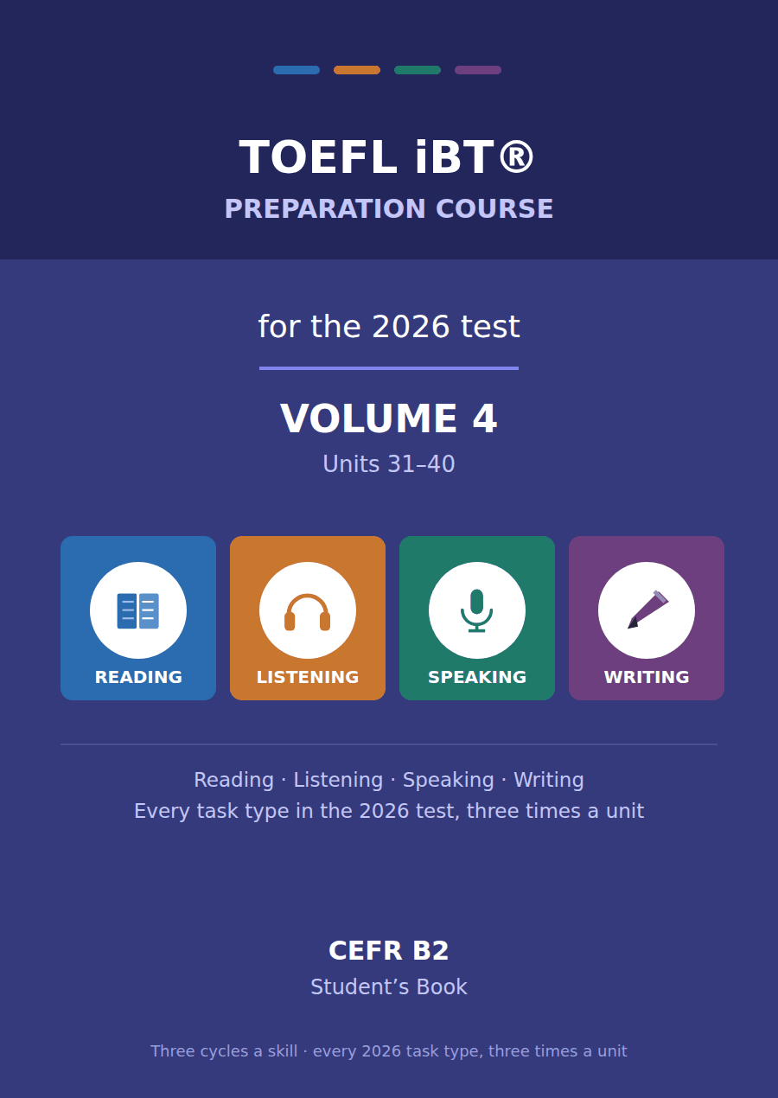

TOEFL iBT® Preparation Course 2026
Volume 4 · Units 31–40 · CEFR B2
Student’s Book with Practice Test 4

This course prepares B2 learners for the TOEFL iBT® test as it has been since 21 January 2026. Every task name, item count and timing in this book follows the official ETS practice test for that form.
Forty units across four volumes. Volumes 1 and 2 take a B1 learner through every task in the test; Volumes 3 and 4, of which this is one, take the same tasks to B2. The passages are not longer here. They are denser, which is what the real test does to you as your score rises.
One thing is assumed rather than taught. Volumes 1 and 2 carried a strand of campus and everyday vocabulary — enrolment, tutorial, reading week — because the Listening conversations turn on it. This volume spends those pages on collocation and stance instead. If you have come straight to Volume 3, read the Volumes 1–2 glossary once before you start.

Series TOEFL iBT® Preparation Course 2026
Level CEFR B2 (targeting a steady 4.5–5.5 band)
Components Student’s Book · Audio · Interview video
This volume Units 31–40, Practice Test 4, answer key, audio scripts, glossary

TOEFL and TOEFL iBT are registered trademarks of ETS. This publication is not endorsed by or affiliated with ETS. Format details are taken from ETS’s own published practice material for the January 2026 form.

Map of the book Volume 4
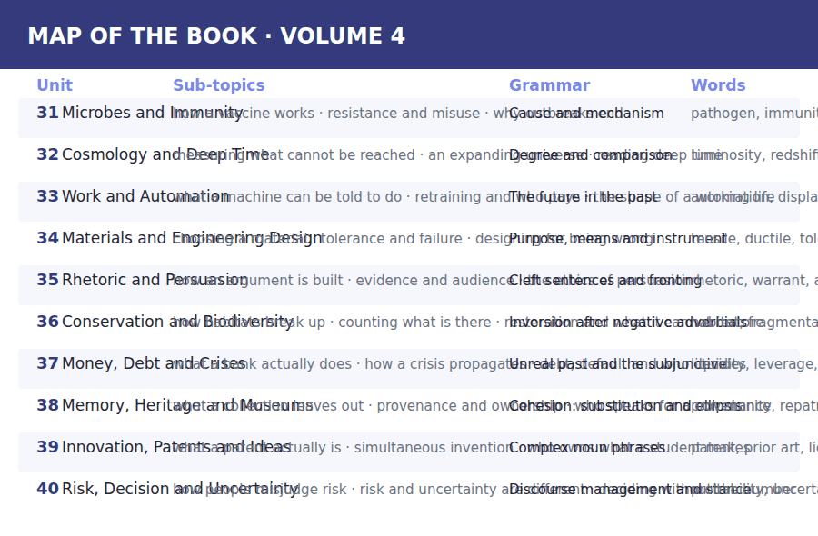

How to use this book Three cycles, four skills
Every unit is sixteen pages and every unit is built the same way, so once you have worked through Unit 31 you know where everything is.
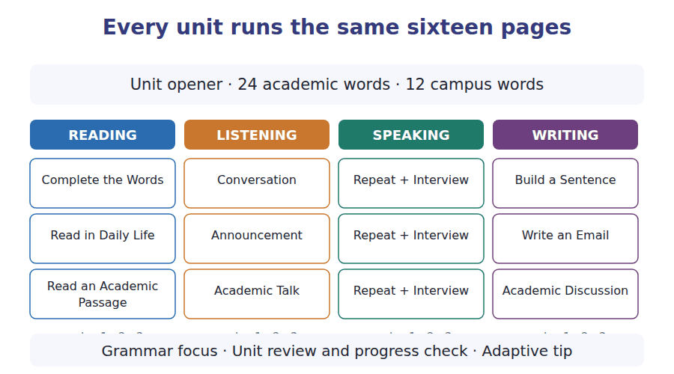
What a cycle is
A cycle is one sub-topic taken through one skill. Cycle 1 of Reading, Listening, Speaking and Writing all deal with sub-topic A; cycle 2 with sub-topic B; cycle 3 with sub-topic C. That is why the email you write in Writing cycle 2 answers the announcement you heard in Listening cycle 2.
Teach, guide, test
Inside every cycle the order is the same. A skill box tells you what to do. A guided exercise does it with help. An exam exercise does it the way the test will.

The 2026 test at a glance What you are preparing for
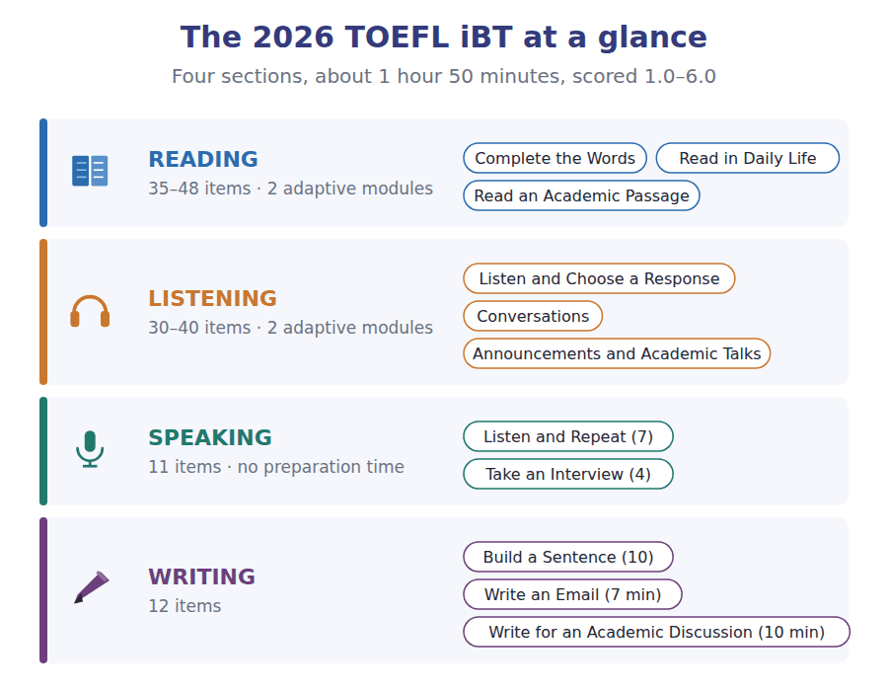
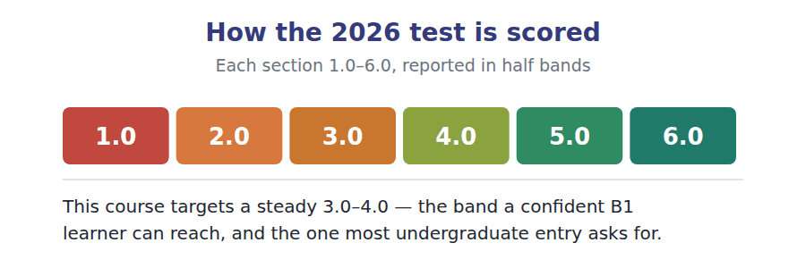

What an adaptive test does to you Modules, and why you cannot go back
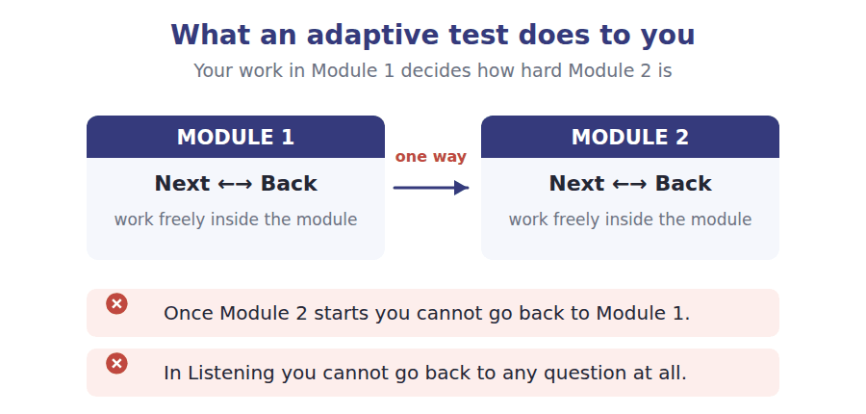
Reading and Listening are adaptive. Each is split into two modules, and how you do in Module 1 decides how hard Module 2 is. Two rules follow, and they are not the same rule.
- In Reading you can move Next and Back freely inside a module. Only the jump to Module 2 is one-way.
- In Listening you cannot go back to a previous question at all. The audio plays once.
- The early questions in a module carry the most weight, because they place you. Never rush them to buy time later.
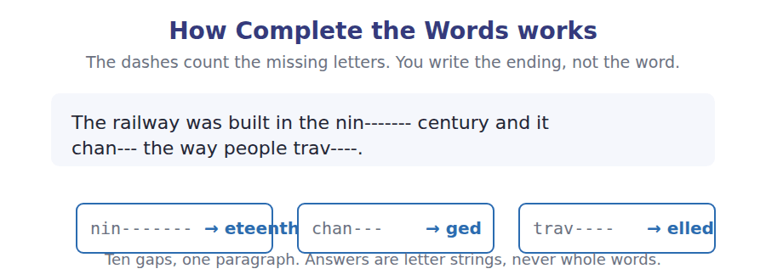

Study planner Twelve weeks, two units a week
When | What | Focus
Week 1 | Unit 31 · Microbes and Immunity | Vocabulary, Reading, Listening
Week 2 | Unit 32 · Cosmology and Deep Time | Speaking, Writing, grammar, review
Week 3 | Unit 33 · Work and Automation | Vocabulary, Reading, Listening
Week 4 | Unit 34 · Materials and Engineering Design | Speaking, Writing, grammar, review
Week 5 | Unit 35 · Rhetoric and Persuasion | Vocabulary, Reading, Listening
Week 6 | Unit 36 · Conservation and Biodiversity | Speaking, Writing, grammar, review
Week 7 | Unit 37 · Money, Debt and Crises | Vocabulary, Reading, Listening
Week 8 | Unit 38 · Memory, Heritage and Museums | Speaking, Writing, grammar, review
Week 9 | Unit 39 · Innovation, Patents and Ideas | Vocabulary, Reading, Listening
Week 10 | Unit 40 · Risk, Decision and Uncertainty | Speaking, Writing, grammar, review
Week 11 | Review units 31–40 | Glossary and grammar reference
Week 12 | Practice Test 4 | Sit it in one sitting, then mark it

Unit 31 · Microbes and Immunity
TOEFL iBT® Preparation Course 2026 · Volume 4
CEFR B2 · Grammar: Cause and mechanism · Word field: pathogen, immunity, resistance
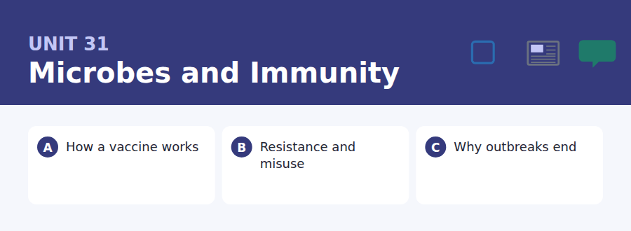
By the end of this unit I can…
- I can describe a biological mechanism step by step without losing the thread.
- I can distinguish a cause from a correlation in my own writing.
- I can use owing to, as a result of, gives rise to and accounts for accurately.
- I can explain why a popular explanation is wrong without being dismissive.
- I can follow a talk that corrects a common misunderstanding.
- I can write an explanation a non-specialist can follow and a specialist would accept.

Volume 4 opens with the field where everyday language is least adequate. Immune, infectious, resistant and contagious are used loosely in conversation and precisely in science, and the gap between the two is where most public misunderstanding lives.

Vocabulary 1 · Academic word families 18 families, not 18 words
At B2 the word on its own is not enough. Each entry below is a family: learn the noun, the verb and the adjective together, because the test will use whichever one the sentence needs.
pathogen an organism that causes disease | incubation the delay between infection and symptoms
immunity the ability to resist a particular infection | reservoir a population in which an organism persists
antibody a protein made to match one invader | inoculate to introduce material in order to produce immunity
antigen the part of an invader that is recognised | attenuate to weaken deliberately
vaccine a preparation that rehearses an immune response | microbiome the community of organisms living in or on a body
strain one variant of an organism within a species | commensal living alongside without causing harm
virulence how much harm an organism does | outbreak a sudden local rise in cases
resistance the ability to survive something meant to kill you | epidemiology the study of how disease moves through populations
susceptible able to be affected | asymptomatic infected without showing symptoms

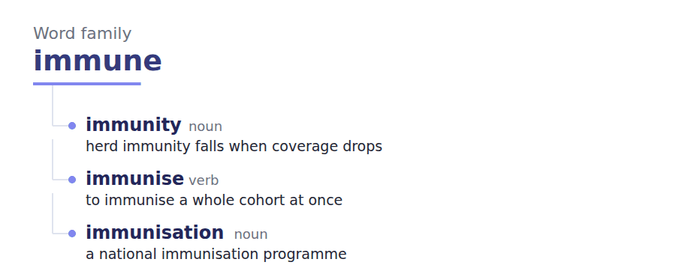
Exercise A Work in pairs. Ask and answer.
1. Explain how a vaccine works to somebody who has never been told.
2. Why does finishing a course of antibiotics matter?
3. What is the difference between being infected and being ill?
4. Why might an outbreak stop before everyone has been infected?
Vocabulary 2 · Collocation 10 partnerships that actually occur
A word is known when you know what it goes with. These ten are the partners this unit’s texts use; the wrong partner is what marks an answer as translated.
mount a response to begin to react to an invader | at risk of likely to suffer
build up immunity to acquire it gradually | account for to explain, or to make up a proportion of
break out to begin suddenly, of a disease | give rise to to cause
die out to disappear completely | in the wake of following, as a consequence of
confer protection to give protection to somebody | run its course to continue until it finishes naturally

Vocabulary 3 · Stance and hedging How far the writer commits
Every one of these says the same thing at a different strength. Reading, you must notice which was chosen. Writing, you must choose.
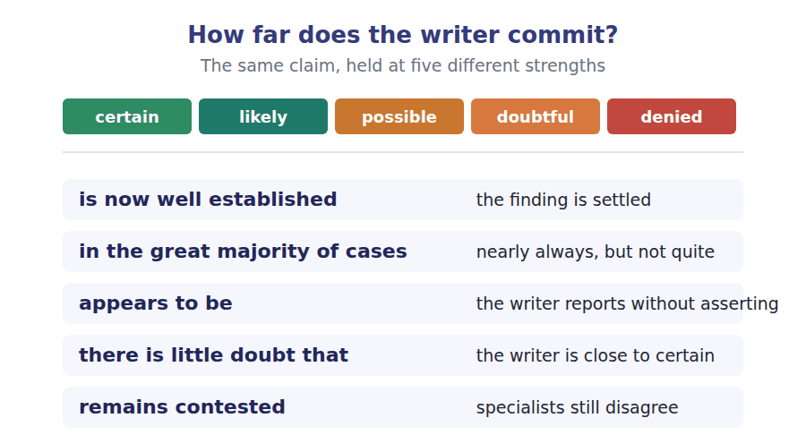
Two words that look alike
infection / disease the organism arrives / the person is ill
immune / immunised able to resist / made able by a vaccine
outbreak / epidemic local and short / wide and sustained

Words you will meet again: host | carrier | herd immunity | booster | quarantine | case fatality rate | contact tracing | surveillance


SKILL · Suffixes that mark a process or a state
- Science writing turns verbs into processes: demonstrate becomes demonstration, select becomes selection.
- The -ible and -able endings mark capacity: susceptible, available.
- Decide whether the slot needs a process, a state or a capacity before you spell anything.

Exercise A Guided practice. Five words are not complete. Write the missing letters.
A vaccine does not fight an infection. It rehearses one. The material injected is recognis-- as foreign, the immune system mounts a response to it, and a record of that response is ret-----. When the real pathogen arrives the response is already availab--, which is why the illness is shorter or does not happ-- at all. Nothing about the mechanism is myster----; the difficulty has always been manufacture, storage and delivery rather than theory.

The first one is done for you: recognis-- is recognised — the slot is a passive verb after is, so it takes the past participle.
Exercise B Exam practice. One paragraph, ten gaps — the real task.
Antibiotic resistance is not caused by a body becoming used to a drug; it is caused by the bacteria changing. A population of bacteria is var---, and if a drug kills almost all of it, the survivors are the ones that happened to be less suscept----. They then reprod---. This is selection operating in days rather than millennia, and it is the clearest demonstr----- of evolution available to anybody with a laboratory and a week. The practical consequences follow directly from the mechanism. A course of treatment stopped early leaves exactly the population most likely to be resist---, which is why the instruction to finish the course is not bureaucr---- caution. Prescribing an antibiotic for a viral infection gives rise to resistance without any corresponding bene---, because the virus is unaffec--- and only the bystanding bacteria are selected. Worse, resistance travels between species: a gene conferring it can be transferred horizont---- between organisms that are not closely rel---- at all.

Check your answers in the key at the back of the book.


SKILL · Reading a clinical policy against a request
- A policy sets out when something may be done. A request tests whether the conditions are met.
- Find the operative word — may, must, only where, except — and ask what it rules out.
- A policy that allows an exception usually says who may authorise it.

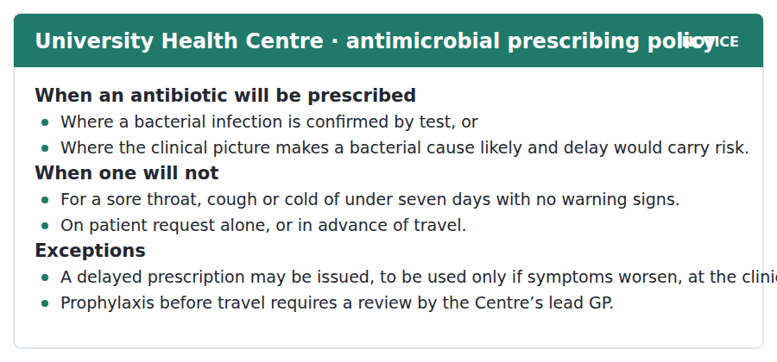
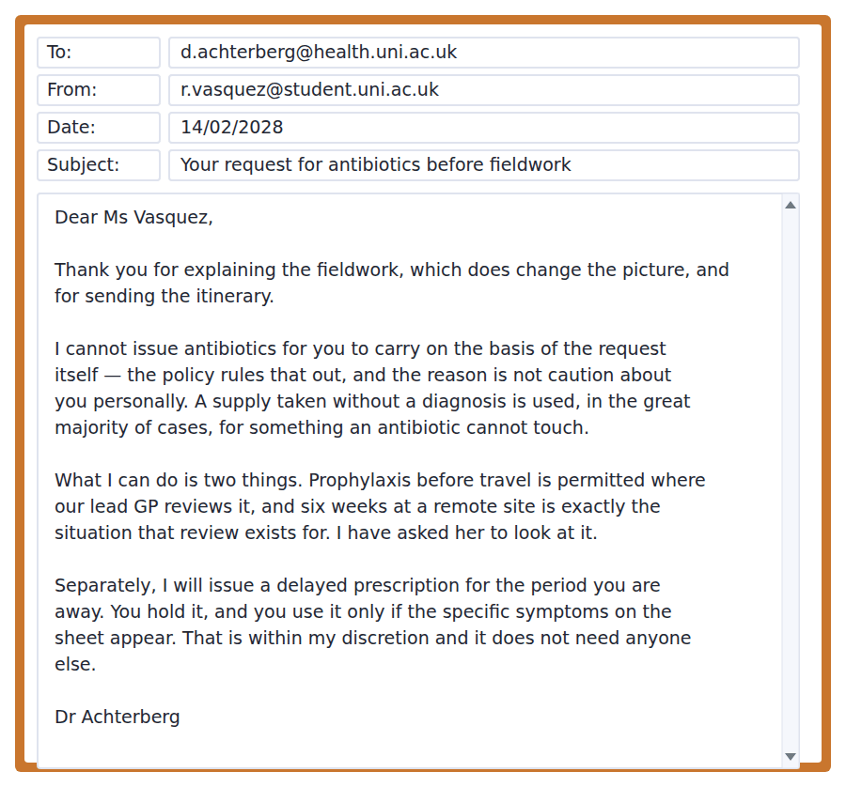
Exercise A Guided practice. The answer is on the page — find it.
1. When will the Centre prescribe an antibiotic?
(A) On request
(B) Before any travel
(C) Where a bacterial infection is confirmed or likely with risk in delay
(D) For any cough
2. What is a delayed prescription?
(A) One issued late
(B) One held and used only if symptoms worsen
(C) One issued by the lead GP
(D) One for travel only
3. Who must review prophylaxis before travel?
(A) Any clinician
(B) The patient
(C) Nobody
(D) The Centre’s lead GP
4. What will the policy not accept on its own?
(A) A patient request
(B) A positive test
(C) A clinical judgement
(D) A travel plan
Exercise B Exam practice.
5. Why does the doctor refuse the original request?
(A) He doubts the itinerary
(B) The policy excludes prescribing on request alone
(C) He has no supply
(D) The fieldwork is too short
6. What reason does he give for the rule?
(A) A supply held without a diagnosis is usually used for the wrong thing
(B) Cost
(C) Storage conditions
(D) Legal liability
7. What does the fieldwork change?
(A) Nothing
(B) It removes the need for review
(C) It makes a test unnecessary
(D) It brings the request within the prophylaxis exception
8. What can the doctor do without consulting anybody?
(A) Issue prophylaxis
(B) Overrule the policy
(C) Issue a delayed prescription
(D) Order a test abroad
9. What condition attaches to the delayed prescription?
(A) It expires in a week
(B) It needs the lead GP
(C) It must be collected abroad
(D) It is used only if the listed symptoms appear
10. What is the doctor’s overall approach?
(A) A flat refusal
(B) Granting the request
(C) Refusing the route requested and opening two permitted ones
(D) Delaying a decision
11. What does "it does not need anyone else" tell you?
(A) The GP is unavailable
(B) The delayed prescription is within his own authority
(C) The policy is being waived
(D) The patient must decide


SKILL · Reading a passage that corrects an intuition
- These passages open with the wrong model, stated fairly, and then dismantle it.
- The correction is usually mechanical: here is what actually has to be true for the thing to grow.
- The last paragraph often concedes that a quantity is unknown. That concession is the point, not a weakness.

Why an Outbreak Stops Before Everyone Has Had It
The intuitive model of an epidemic is a fire that burns until it runs out of fuel, and it predicts that an outbreak ends when everybody has been infected. Almost no outbreak behaves this way. It is now well established that transmission falls away long before the susceptible population is exhausted, and the reason is arithmetic rather than biological: each case has to produce more than one further case for the outbreak to grow, and as the immune proportion rises, that average falls below one while most of the population has never been infected at all.
That threshold appears to be reached earlier than the simplest calculation suggests, because people are not interchangeable. Transmission is concentrated in a minority who have many contacts, and they are infected first precisely because they have many contacts. By the time a tenth of a population has been infected, that tenth is not a random tenth; it is the part of the network doing most of the work. Removing it damages the network out of proportion to its size, and in the great majority of cases that is what produces the early turn which puzzles people watching the daily figures.
There is little doubt that the effect is real, and its size remains contested, which matters more than it sounds. If the threshold is low, an outbreak subsides early and waiting is defensible. If it is high, waiting means an enormous number of infections before anything slows down, and the difference is not one of opinion about values but a quantity nobody can measure until afterwards. This is the position epidemiology is routinely in: the mechanism is understood, the direction is agreed, and the number that would settle the argument arrives too late to be useful.
[292 words]

Exercise A Guided practice.
1. What does the intuitive model predict?
(A) That an outbreak ends when everybody is infected
(B) That outbreaks never end
(C) That immunity is permanent
(D) That transmission is random
2. Why does transmission fall away early?
(A) The pathogen weakens
(B) People recover faster
(C) Testing improves
(D) Each case stops producing more than one further case
3. Why are the first people infected not a random sample?
(A) They are younger
(B) They are tested more
(C) They have many contacts, which is why they were infected first
(D) They live closer together
4. The word "susceptible" in the first paragraph means
(A) already immune
(B) able to be infected
(C) symptomatic
(D) infectious
Exercise B Exam practice.
5. What is the effect of removing the highly connected minority?
(A) The network is damaged out of proportion to the number removed
(B) Nothing measurable
(C) Transmission becomes random
(D) Immunity is lost
6. What does the author say remains contested?
(A) Whether the effect exists
(B) The size of the effect
(C) Whether immunity works
(D) The definition of an outbreak
7. Why does the size of the effect matter so much?
(A) It changes the biology
(B) It affects vaccine design
(C) It changes the definition of immunity
(D) It decides whether a policy of waiting is defensible
8. What does the author mean by "not a difference of opinion about values"?
(A) The disagreement is about a measurable quantity
(B) The disagreement is political
(C) Values do not matter here
(D) Nobody disagrees
9. What is the "uncomfortable position" described at the end?
(A) The mechanism is unknown
(B) The data are falsified
(C) The mechanism is understood but the decisive number arrives too late
(D) Policy ignores science
10. Which would most weaken the second paragraph?
(A) Evidence that vaccines work
(B) Evidence that immunity fades
(C) Evidence that contacts are distributed evenly across a population
(D) Evidence that outbreaks recur
11. All of the following are stated EXCEPT:
(A) Transmission falls before the susceptible population is exhausted
(B) The threshold can be measured in advance
(C) Highly connected people are infected early
(D) The threshold is reached earlier than the simplest calculation suggests
12. What is the author’s attitude to epidemiology?
(A) Sympathetic about a real limit rather than a failing
(B) Dismissive
(C) Uncritical
(D) Hostile to modelling
13. Why does the author open with the wrong model?
(A) To pad the passage
(B) Because it is still believed by scientists
(C) To criticise the public
(D) Because the correction only makes sense against it


Exercise A Listen and choose a response. You hear one line. Choose the best reply.
1. Woman: So the vaccine contains the actual pathogen?
(A) Yes, it does.
(B) About two doses.
(C) Sometimes, but weakened.
(D) In the fridge.
2. Man: Why do I need a second dose?
(A) Yes, you do.
(B) The first one rarely builds enough.
(C) About three weeks later.
(D) At the health centre.
3. Woman: Does being immune mean I cannot pass it on?
(A) Not necessarily — those are different things.
(B) Yes, it does.
(C) About a week.
(D) Only after two doses.
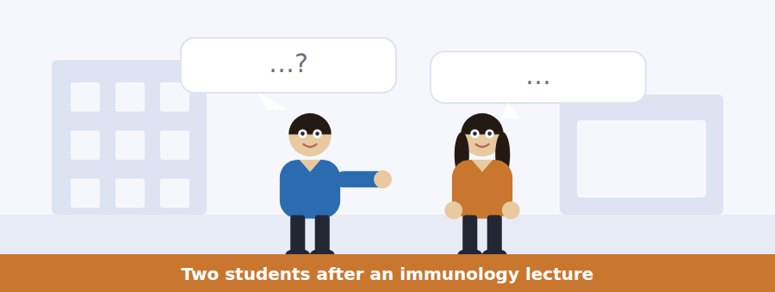
SKILL · Hearing an explanation checked by a question
- One speaker explains and the other tests the explanation with a case.
- The items usually come from the answer to that case, not from the original explanation.
- Listen for: but what about, so does that mean, then why does.

Exercise B Listen and answer. The audio plays once.
4. What does an attenuated pathogen mean?
(A) A dead one
(B) A fragment
(C) A set of instructions
(D) A weakened one that cannot establish an infection
5. What does the body respond to?
(A) The organism
(B) The dose
(C) The antigen
(D) The injection site
6. Why is a second dose needed?
(A) The first wears off
(B) The dose is too small
(C) To cover new strains
(D) The first rarely leaves a durable record
7. What does immunity reliably protect against?
(A) Transmission
(B) Disease in the immune person
(C) All strains
(D) Reinfection permanently
8. What does she say varies between vaccines?
(A) Whether transmission is blocked
(B) The antigen
(C) The number of doses
(D) The storage temperature
9. Why does she think the point never lands?
(A) It is rarely said
(B) The everyday meaning of immune is stronger than the technical one
(C) People do not listen
(D) The evidence is weak
10. What is the man doing in the conversation?
(A) Explaining
(B) Disagreeing
(C) Testing the explanation with the next obvious case
(D) Revising for an exam
Audio script: see the back of the book. Do not read it before you listen.


Exercise A Listen and choose a response. You hear one line. Choose the best reply.
1. Man: Does my body get used to antibiotics?
(A) No — the bacteria change, not you.
(B) Yes, over time.
(C) About five days.
(D) At the pharmacy.
2. Woman: What if I feel better after three days?
(A) Then stop.
(B) About seven days.
(C) Yes, you will.
(D) Finish the course anyway.
3. Man: Can resistance spread between different bacteria?
(A) Yes, the gene can transfer directly.
(B) No, never.
(C) About two species.
(D) In hospitals.
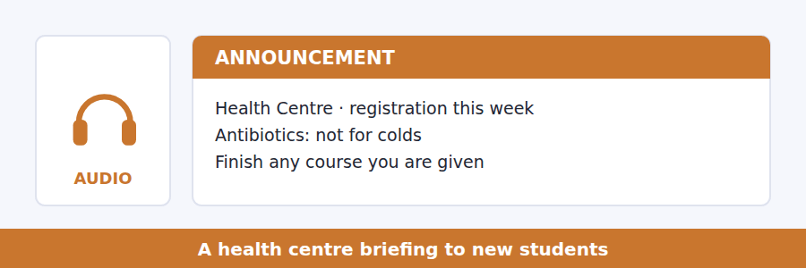
SKILL · Hearing a correction of a popular belief
- A speaker correcting a belief states it first, fairly, then says why it is wrong.
- Listen for: the usual explanation is, people think, that is not what happens.
- The item will test the correct mechanism, not the belief.

Exercise B Listen and answer. The audio plays once.
4. What is the belief the speaker corrects?
(A) That antibiotics are harmful
(B) That colds are bacterial
(C) That courses are too long
(D) That the body gets used to the drug
5. What actually produces resistance?
(A) Tolerance in the patient
(B) Weak drugs
(C) Selection within a varying bacterial population
(D) Short courses only
6. What happens if a course is stopped early?
(A) Nothing
(B) The susceptible bacteria are gone and the resistant ones have a clear field
(C) The drug becomes toxic
(D) The infection returns unchanged
7. Why is an antibiotic useless for a cold?
(A) The dose is wrong
(B) Colds are too short
(C) It would be too expensive
(D) The virus is untouched, so there is no benefit
8. What makes resistance a collective problem?
(A) Hospitals
(B) Travel
(C) A resistance gene can transfer between unrelated organisms
(D) Prescribing rates
9. Why does she say the wrong explanation matters?
(A) It changes behaviour
(B) It is unscientific
(C) It is old
(D) It confuses doctors
Audio script: see the back of the book. Do not read it before you listen.


Exercise A Listen and choose a response. You hear one line. Choose the best reply.
1. Man: Does an epidemic stop when everyone has had it?
(A) Yes, eventually.
(B) No — well before that, in fact.
(C) About six months.
(D) It depends on the vaccine.
2. Woman: What has to be true for an outbreak to grow?
(A) Yes, it must grow.
(B) About two weeks.
(C) A new strain.
(D) Each case must cause more than one more.
3. Man: Can we measure the threshold in advance?
(A) Unfortunately not, only afterwards.
(B) Yes, routinely.
(C) About twenty per cent.
(D) With better data.
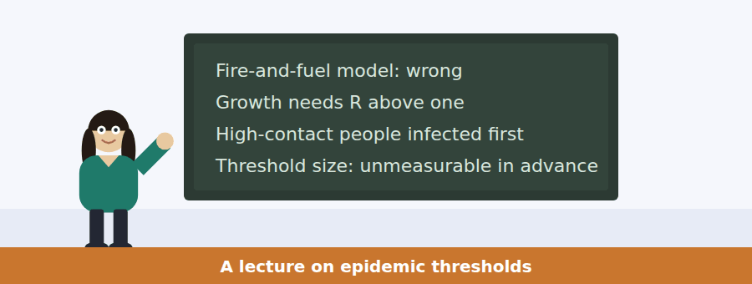
SKILL · Following a talk built on one number
- When a lecture turns on a single quantity, every item will be about what happens above and below it.
- Listen for the two scenarios the speaker lays out.
- The speaker’s own view is usually about what we cannot know, not about which scenario is true.

Exercise B Listen and answer. The audio plays once.
4. What is wrong with the fire model?
(A) It is too complicated
(B) It ignores vaccines
(C) It predicts an end only when everyone is infected
(D) It assumes immunity fades
5. What has to be true for an outbreak to grow?
(A) Immunity must fall
(B) Each case must produce more than one further case
(C) The pathogen must mutate
(D) Contact must be random
6. Why is the first tenth infected not a random tenth?
(A) High-contact people are infected early
(B) Testing is uneven
(C) Younger people are infected first
(D) Cities are infected first
7. What does removing that group do?
(A) Little
(B) Ends the outbreak entirely
(C) Raises the threshold
(D) Damages transmission more than its size suggests
8. What does the speaker say about the disagreement?
(A) It is ideological
(B) It is about a number, and both camps want the same outcome
(C) It has been settled
(D) It is about definitions
9. What is the "permanent predicament" of his field?
(A) Poor funding
(B) Public mistrust
(C) The decisive number is only available after the event
(D) Weak models
10. What does "with most of the fuel untouched" mean?
(A) The outbreak restarts
(B) Immunity was widespread
(C) The fire model is correct
(D) Most people were never infected
Audio script: see the back of the book. Do not read it before you listen.


Part 1 · Listen and Repeat
You hear a sentence and repeat it once. There is no preparation time, and the sentences get longer. Focus: explaining a mechanism in order
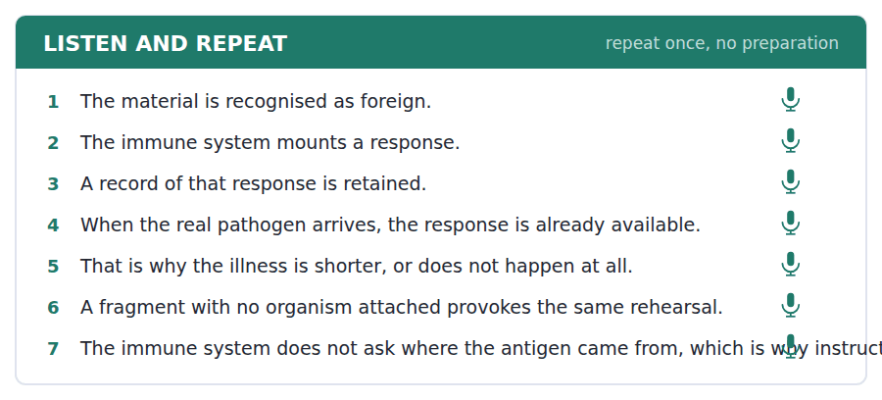
SKILL · Sequencing an explanation out loud
- A mechanism is a sequence. Say the steps in order and mark them: first, then, which means that.
- Do not start with the conclusion. The listener cannot hold it until the steps arrive.
- Stress the verb in each step, because the verb is the step.

Part 2 · Take an Interview
An interviewer asks you four questions on one theme: health, prevention and what people believe. Answer each one fully. There is no preparation time.
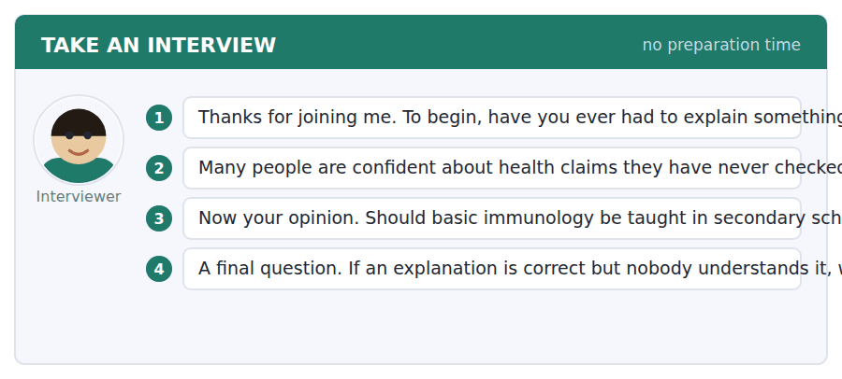
A good answer sounds like this
Question 2 — Health is one of the few technical subjects everybody has personal experience of, and experience feels like evidence. Nobody is confident about metallurgy because nobody has a metallurgy anecdote.
Question 4 — The explainer’s, mostly. If the words you are using mean something else in ordinary speech, the failure is predictable and therefore yours to fix.
I can… | Not yet | Yes
I gave the steps in order. | □ | □
I marked the sequence out loud. | □ | □
I stressed the verb in each step. | □ | □


Part 1 · Listen and Repeat
You hear a sentence and repeat it once. There is no preparation time, and the sentences get longer. Focus: stating a cause without overstating it
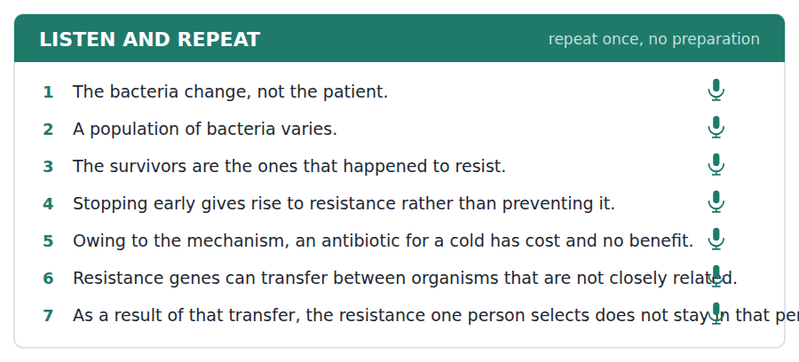
SKILL · Saying what causes what
- Owing to and as a result of are followed by a noun phrase; because is followed by a clause.
- Gives rise to is a cause; accounts for can be a cause or a proportion. Keep them apart.
- Slow down on the causal phrase. It is the load-bearing part of the sentence.

Part 2 · Take an Interview
An interviewer asks you four questions on one theme: medicine, instructions and collective consequences. Answer each one fully. There is no preparation time.
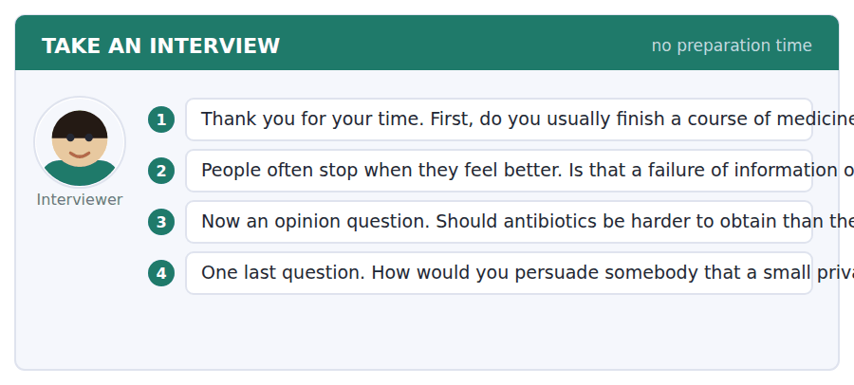
A good answer sounds like this
Question 2 — It is not information. Everyone has been told. It is that feeling better is vivid and the future population of bacteria is abstract, and the vivid thing wins.
Question 4 — Not with statistics. I would use the one case where the collective cost came back to the person who caused it, because that converts an abstraction into a story.
I can… | Not yet | Yes
I used owing to and as a result of with noun phrases. | □ | □
I did not confuse gives rise to with accounts for. | □ | □
I slowed down on the causal phrase. | □ | □


Part 1 · Listen and Repeat
You hear a sentence and repeat it once. There is no preparation time, and the sentences get longer. Focus: presenting two scenarios neutrally
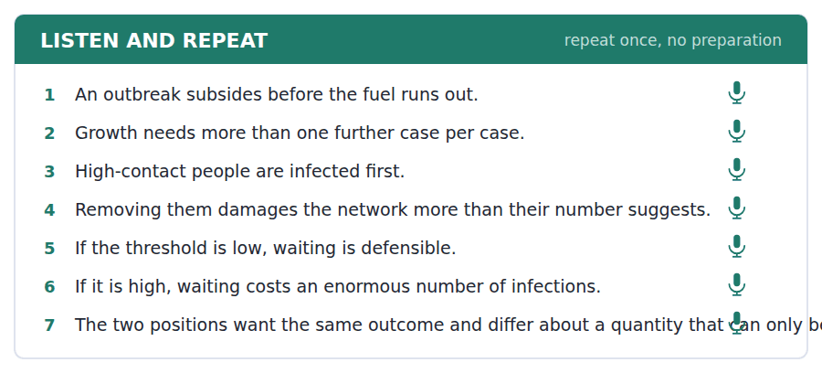
SKILL · Laying out a fork in the evidence
- When the answer depends on an unknown quantity, say so and give both branches.
- Give each branch the same shape: if it is low, then; if it is high, then.
- Say which you believe only after both branches are on the table.

Part 2 · Take an Interview
An interviewer asks you four questions on one theme: uncertainty, policy and acting without the number. Answer each one fully. There is no preparation time.
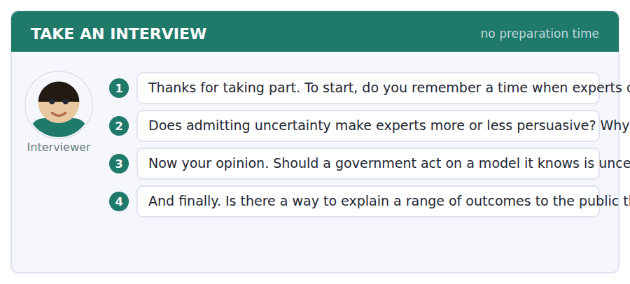
A good answer sounds like this
Question 2 — Less persuasive in the short run and more trustworthy in the long run, and institutions keep choosing the short run because that is where the criticism arrives.
Question 3 — It has to act, because waiting is also a decision and it is not a neutral one. What it owes people is a clear statement of what would change its mind.
I can… | Not yet | Yes
I gave both branches the same shape. | □ | □
I stated the unknown quantity clearly. | □ | □
I gave my own view last. | □ | □


You see a sentence, then a set of words in boxes. Put the words in order to make one grammatical sentence. Almost every item in the real test makes a question or a question inside another sentence.
SKILL · Build a Sentence with a causal link
- The two non-question items in this unit build causal sentences with owing to, as a result of or which is why.
- A tile reading owing to or as a result of is followed by a noun phrase, never by a subject and a verb.
- Which is why joins two clauses and cannot begin the sentence.

Exercise A Guided practice. The first three are worked through.
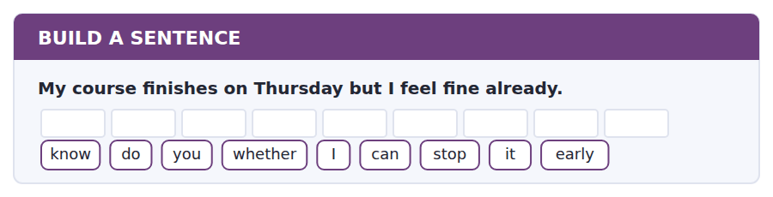
1. Do you know whether I can stop it early?
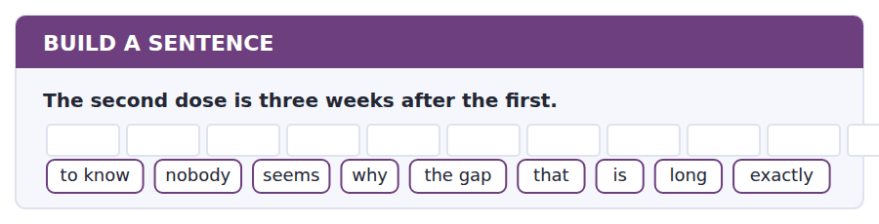
2. Nobody seems to know exactly why the gap is that long.
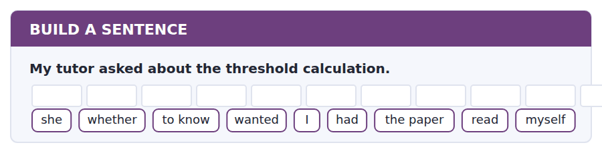
3. She wanted to know whether I had read the paper myself.
Exercise B Exam practice. Write the sentence.
4. Immunity does not always stop transmission.
do / whether / know / you / that / is / every vaccine / of / true
__________________________________________________________
5. The health centre refused the request.
explain / can / anybody / why / the policy / that / rules / to me / out
__________________________________________________________
6. Resistance genes move between species.
know / does / anybody / how / a transfer / like / that / happens / actually
__________________________________________________________
7. The threshold cannot be measured in advance.
us / told / nobody / when / the number / does / available / become / actually
__________________________________________________________
8. The delayed prescription is held in reserve.
told / she / me / what / symptoms / would / justify / it / using
__________________________________________________________
9. Stopping a course early leaves the resistant bacteria.
owing to / that / selection / the course / has / to / be / finished / properly
__________________________________________________________
10. High-contact people are infected first.
which / is / why / the first / cases / are / a random / not / sample
__________________________________________________________


You read a short situation and write an email. You have 7 minutes. The three bullet points are the mark scheme: answer all three.
The health centre has refused to give you antibiotics to carry, offered to refer you for travel prophylaxis, and issued a delayed prescription instead. You are satisfied with that, but the fieldwork site is nine hours from a clinic and you want to know what the sheet of symptoms does not cover.
Write an email to the health centre.
- Accept what has been offered and show you understood the reasoning.
- Describe the constraint the policy was not written for.
- Ask one answerable question rather than several.
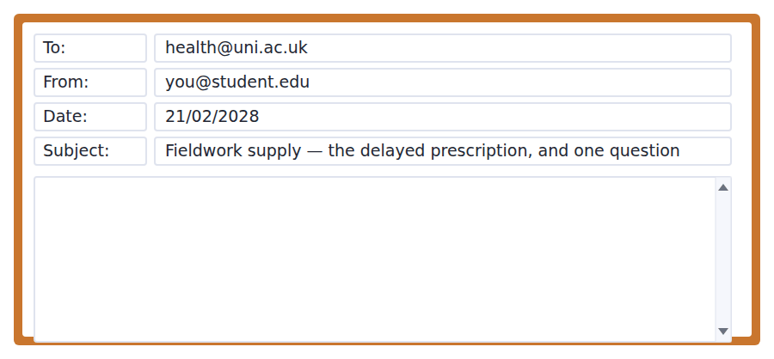
SKILL · Asking about the gap in an arrangement
- Accept the arrangement first. A question that arrives with a complaint is read as a complaint.
- Describe your constraint in facts, not in adjectives: nine hours, not "very remote".
- Ask one question. Three questions get one answer, usually to the easiest.

Model email
Dear Dr Achterberg,

Thank you — the delayed prescription is exactly what I needed, and I understand now why carrying a supply without a diagnosis is a different thing from carrying one with a trigger attached. I have also had the review appointment with your lead GP and the prophylaxis is sorted.

One constraint I did not explain properly. The site is nine hours from the nearest clinic, and for two of the six weeks there is no vehicle on site at all. So the question of whether something has crossed a threshold has to be answered by me, at the time, with no possibility of being wrong twice.

The symptom sheet is clear about the cases it lists. My question is about the case it does not: if I have two of the listed symptoms but neither has reached the severity described, should I treat that as a yes or wait?

That is the only thing I am unsure about, and a one-line answer would do. I will write up whatever happens, if it is of any use to the Centre for the next student in this position.

With thanks,
Rosalía Vasquez
Why it works
- It accepts the arrangement and restates the reasoning in its own words, which shows the explanation landed.
- The constraint is given as facts — nine hours, two weeks, no vehicle — rather than as adjectives.
- One question is asked, and it is the question the sheet genuinely does not answer.
- The offer to write it up is small, costless and makes the writer easy to help again.
Two answers, one band apart
Both answer the three bullet points. One would score in the middle band and one near the top. Read them side by side before you write your own.
A middle-band answer | A top-band answer
Dear Dr Achterberg,  Thank you very much for the delayed prescription and for arranging the appointment with the lead GP. I really appreciate it and I understand the policy much better now.  I should have explained before that the fieldwork site is extremely remote and it is very difficult to get to a clinic from there, especially as we do not always have a vehicle available. This makes the situation quite difficult for me and I am a bit worried about making the wrong decision while I am away.  Could you tell me more about how I should use the symptom sheet? I would also like to know whether I should contact you if I am unsure, and what the best way to do that would be from the site. Any advice would be very helpful.  Thank you again for all your help. Best wishes, Rosalía Vasquez | Dear Dr Achterberg,  Thank you — the delayed prescription is exactly what I needed, and I understand now why carrying a supply without a diagnosis differs from carrying one with a trigger attached. The review with your lead GP is done and the prophylaxis is sorted.  One constraint I did not explain properly. The site is nine hours from the nearest clinic and for two of the six weeks there is no vehicle on site. So whether something has crossed a threshold has to be answered by me, at the time, with no possibility of being wrong twice.  The sheet is clear about the cases it lists. My question is about the one it does not: if I have two listed symptoms but neither has reached the severity described, is that a yes or a wait?  A one-line answer would do. I will write up whatever happens if it is of use to the Centre. Rosalía Vasquez

What the top answer does that the other does not
- It restates the reasoning behind the refusal in its own words, which proves comprehension instead of merely claiming it.
- It replaces adjectives with measurements: nine hours and two weeks without a vehicle, rather than extremely remote and quite difficult.
- It names the precise gap in the symptom sheet, so the reader can answer without asking what is meant.
- It asks one question instead of three, which is why it will get an answer to the one that matters.
- It offers something back and marks the cost of answering as one line, making the request easy to grant.
Now write your own. 7 minutes.
__________________________________________________________
__________________________________________________________
__________________________________________________________
__________________________________________________________
__________________________________________________________
__________________________________________________________
__________________________________________________________
__________________________________________________________


A professor asks a question and two students answer. You add your own post. You have 10 minutes and an effective answer is at least 100 words.
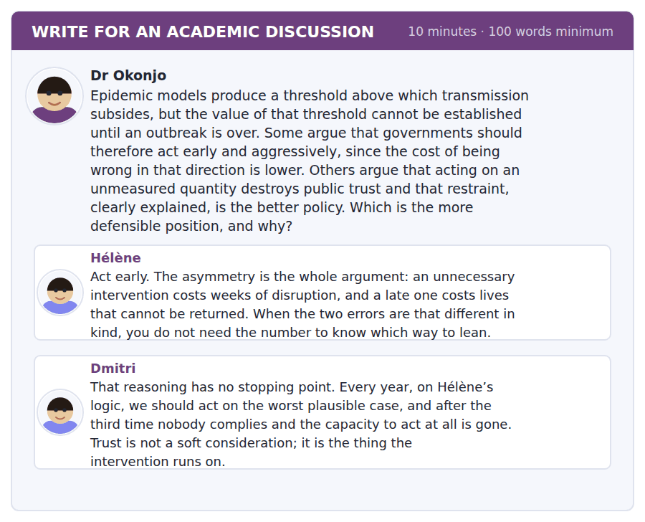
SKILL · Answering an asymmetry argument
- An argument from asymmetric costs is strong and usually incomplete, because it ignores what repetition does.
- The reply is not to deny the asymmetry but to show what else changes when you act on it repeatedly.
- Then propose the condition that keeps the asymmetry argument and limits it.

Sentence starters
- Hélène’s asymmetry is real and it is not the whole calculation.
- Dmitri is right that…, though his conclusion…
- What is missing from both is…
- The condition that holds both together is…
Model post
Hélène’s asymmetry is real and it is not the whole calculation. An unnecessary intervention and a late one are indeed different in kind, and she is right that this is knowable without the threshold. What the argument leaves out is that the cost of the unnecessary intervention is not paid once. It is paid in the willingness of people to comply next time, which means the second-order cost lands precisely when the asymmetry argument next needs to be used.
Dmitri is right about that mechanism and wrong about what follows from it. Trust is a resource and acting early spends it, but restraint also spends it, and more abruptly, if the outbreak then does what the models said it might. An institution that waited and was wrong does not retain its authority by having been cautious.
What is missing from both posts is any account of what would be said in advance. The asymmetry argument is defensible when the institution states, before acting, what it expects, what it would accept as evidence that it over-reacted, and what it will do if that evidence arrives. An intervention announced with those three things spends far less trust than the same intervention announced as a certainty, because when it turns out to have been unnecessary the institution has already said so.
So I would side with Hélène on the direction and with Dmitri on the constraint. Act early, and make the prediction falsifiable at the moment you act. That is the only version of her position that survives being used more than twice.
[260 words]
Now write your own. 10 minutes, at least 100 words.
__________________________________________________________
__________________________________________________________
__________________________________________________________
__________________________________________________________
__________________________________________________________
__________________________________________________________
__________________________________________________________
__________________________________________________________
__________________________________________________________
__________________________________________________________

Grammar focus Cause and mechanism
Form | How it is used
because + clause | because the virus is unaffected, there is no benefit
owing to / due to + noun phrase | owing to that selection, the course must be finished
as a result of + noun phrase | as a result of horizontal transfer, resistance spreads
gives rise to | a transitive cause: early stopping gives rise to resistance
accounts for | explains, or makes up a proportion of — two different meanings
is attributable to | formal and cautious: the fall is attributable to coverage
so that / such that | result rather than purpose when it follows a fact

Owing to, due to and as a result of are followed by a noun phrase. Owing to the virus is unaffected is wrong; because the virus is unaffected, or owing to the virus being unaffected, is right.
Accounts for carries two meanings and English readers disambiguate by context: selection accounts for resistance is causal, while resistant strains account for a fifth of cases is proportional. Do not use it where either reading is possible.
Is attributable to concedes that the attribution is a judgement. Causes does not. At B2 the difference is the difference between a claim you can defend and one you cannot.
Watch out! Do not write "the reason is because". The reason already states a cause, so because repeats it. Write the reason is that, or simply because.
Exercise 1 Choose because, owing to or as a result of.
1. ______ the virus is unaffected, there is no benefit.
2. ______ that selection, the resistant bacteria dominate.
3. ______ horizontal transfer, resistance crosses species.
4. ______ the first dose is weak, a second is needed.
5. ______ the patient’s travel plans, a review was required.
6. ______ nobody can measure the threshold, policy is contested.
Exercise 2 Correct the causal error.
1. The reason is because the bacteria vary.
2. Owing to the course was stopped early, resistance developed.
3. Due to he felt better, he stopped taking it.
4. The fall in cases causes to higher coverage.
Exercise 3 Rewrite using gives rise to or is attributable to.
1. Stopping early causes resistance.
2. The drop in cases was probably caused by immunity.
3. Horizontal transfer causes resistance to spread between species.
4. The early peak was probably caused by high-contact people being infected first.
How this is tested in Build a Sentence
Two of the ten Build a Sentence items in this unit are causal rather than interrogative. A tile reading owing to or as a result of must be followed by a noun phrase, and which is why can never begin the sentence.
Find the fault 5 errors, drawn from this unit and the two before
Every error below is one a B2 writer makes after learning the rule. Mark what is wrong, then check. Knowing the rule and noticing the breach are two different skills, and only the second one is tested.
The reason resistance develops is because the bacteria vary. Owing to the course was stopped early, the resistant strain survived. Nobody knows whether did the patient finish it. The drop in cases causes to higher coverage. Being asymptomatic, the test was still positive.
# | As written | As it should be | Why
1 | The reason resistance develops is because | The reason resistance develops is that | The reason already names a cause, so because states the same thing twice.
2 | Owing to the course was stopped early | Owing to the course being stopped early | Owing to takes a noun phrase, not a subject and a finite verb.
3 | whether did the patient finish it | whether the patient finished it | An embedded question keeps statement order and takes no auxiliary.
4 | The drop in cases causes to higher coverage | The drop in cases is attributable to higher coverage | Causes takes a direct object with no preposition, and the direction of cause here is backwards.
5 | Being asymptomatic, the test was still positive | Being asymptomatic, the patient still tested positive | The test was not asymptomatic; the participle needs the subject it describes.

Unit review and progress check Unit 31
Exercise A Vocabulary. Write the word.
1. an organism that causes disease
2. the part of an invader that is recognised
3. how much harm an organism does
4. able to be affected
5. the delay between infection and symptoms
6. a population in which an organism persists
7. to weaken deliberately
8. living alongside without causing harm
9. a sudden local rise in cases
10. the study of how disease moves through populations
11. infected without showing symptoms
12. the community of organisms living in or on a body
Exercise B Grammar. Complete the sentence.
1. ______ the virus is unaffected, there is no benefit.
2. ______ that selection, the course must be finished.
3. ______ horizontal transfer, resistance crosses species.
4. The reason is ______ the bacteria vary.
5. Stopping early ______ rise to resistance.
6. The fall is ______ to higher coverage.
7. Selection ______ for the rise in resistant strains.
8. ______ to the remoteness of the site, a review was needed.
Exercise C One timed mini-section. 6 minutes.
1. Antibiotic resistance develops because
(A) the body adapts to the drug
(B) the bacterial population is selected
(C) doses are too small
(D) drugs lose potency
2. An outbreak usually subsides when
(A) everyone has been infected
(B) the pathogen weakens
(C) each case produces fewer than one further case
(D) testing increases
3. Being immune reliably means
(A) you are protected from the disease
(B) you cannot transmit it
(C) you have been vaccinated
(D) you have had the infection
4. Which sentence is correct?
(A) Owing to the course being stopped, resistance developed.
(B) Owing to the course was stopped, resistance developed.
(C) Owing to that the course was stopped, resistance developed.
(D) Owing to stopped the course, resistance developed.
5. "Is attributable to" rather than "is caused by" signals that the writer
(A) is certain
(B) is quoting
(C) treats the attribution as a judgement
(D) disagrees
6. The first people infected in an outbreak tend to be
(A) a random sample
(B) those with many contacts
(C) the youngest
(D) the least healthy
Can you do these now?
I can… | Not yet | Yes
I can describe a biological mechanism step by step without losing the thread. | □ | □
I can distinguish a cause from a correlation in my own writing. | □ | □
I can use owing to, as a result of, gives rise to and accounts for accurately. | □ | □
I can explain why a popular explanation is wrong without being dismissive. | □ | □
I can follow a talk that corrects a common misunderstanding. | □ | □
I can write an explanation a non-specialist can follow and a specialist would accept. | □ | □

ADAPTIVE TIP Volume 4 starts here, and it assumes the three anchors from Volume 3: the embedded question, the passive reporting frame and the hedging scale. If any of them still needs thought, go back to Units 21, 26 and 29 before Unit 32. Everything from now on uses all three at once.

Unit 32 · Cosmology and Deep Time
TOEFL iBT® Preparation Course 2026 · Volume 4
CEFR B2 · Grammar: Degree and comparison · Word field: luminosity, redshift, magnitude
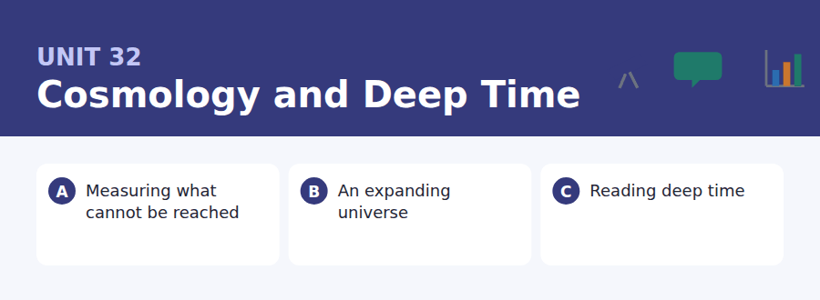
By the end of this unit I can…
- I can compare two quantities precisely, including by a factor or an order of magnitude.
- I can use the more … the more, by far, nowhere near and twice as … as accurately.
- I can explain why a popular analogy breaks down, and where.
- I can report a very large or very small number without losing the reader.
- I can follow a lecture that is built on a chain of comparisons.
- I can write about an unresolved question without pretending it is resolved.

Astronomy is the discipline with no absolute measurements and no experiments, which makes it the best possible training in comparison. This unit teaches the structures English uses to say how much, how far and how much more — and how to be precise about an approximation.

Vocabulary 1 · Academic word families 18 families, not 18 words
At B2 the word on its own is not enough. Each entry below is a family: learn the noun, the verb and the adjective together, because the test will use whichever one the sentence needs.
luminosity how much light a body actually emits | orbit a closed path around a more massive body
photometry the measurement of how bright a source appears | eclipse one body passing in front of another
redshift the stretching of light from a receding source | celestial to do with the sky
parallax apparent shift of a near object against a far background | terrestrial to do with the Earth
spectrum light separated into its component wavelengths | stellar to do with stars
wavelength the distance between one wave crest and the next | cosmic to do with the universe as a whole
nebula a cloud of gas and dust in space | isotope a form of an element with a different atomic mass
constellation a named pattern of stars as seen from Earth | calibration setting an instrument against a known standard
trajectory the path a body follows | extrapolate to extend a pattern beyond the measured range

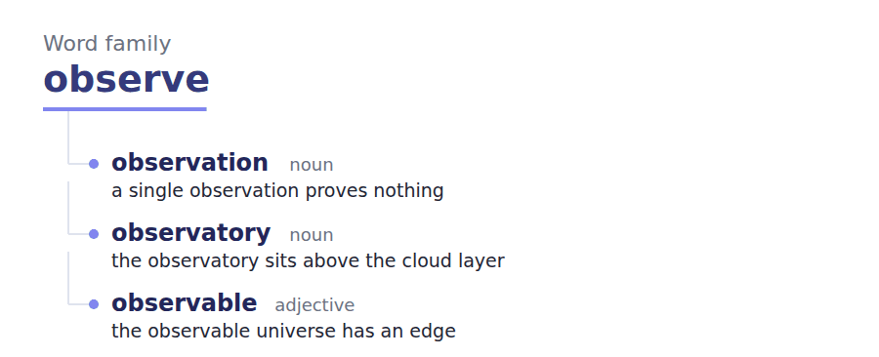
Exercise A Work in pairs. Ask and answer.
1. Describe the size of something using a comparison, not a number.
2. Why is an analogy useful even when it is wrong?
3. What is the difference between accuracy and precision?
4. Name something science still does not know. Why does that not worry you?
Vocabulary 2 · Collocation 10 partnerships that actually occur
A word is known when you know what it goes with. These ten are the partners this unit’s texts use; the wrong partner is what marks an answer as translated.
by a factor of multiplied or divided by that number | bear in mind to keep something in consideration
an order of magnitude ten times, roughly | break down to stop working, of an explanation
nowhere near not remotely close to | hold up to remain true under testing
on the order of approximately, to within a factor of ten | fall short of to be less than needed
within a margin of accurate to this amount either way | to a first approximation roughly, ignoring the refinements

Vocabulary 3 · Stance and hedging How far the writer commits
Every one of these says the same thing at a different strength. Reading, you must notice which was chosen. Writing, you must choose.
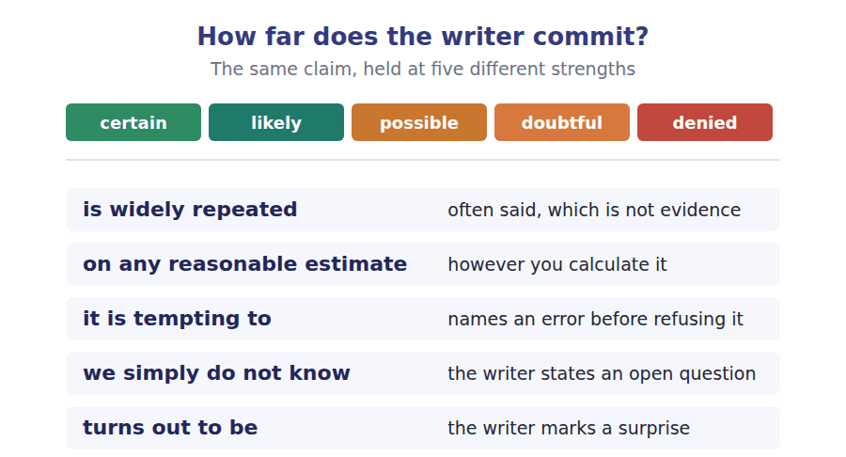
Two words that look alike
luminosity / magnitude what is emitted / what we receive
accuracy / precision close to the truth / finely specified
estimate / guess calculated with a method / not

Words you will meet again: light year | parsec | standard candle | cosmic microwave background | half-life | strata | radiometric dating | uniformitarianism


SKILL · Completing comparative and abstract forms
- Comparison words are often the missing piece: relative, comparable, proportional.
- The -less and -ful endings turn a noun into an adjective of absence or presence: meaningless, purposeful.
- Check what the sentence is doing grammatically before you fill a gap: a comparison needs a comparative.

Exercise A Guided practice. Five words are not complete. Write the missing letters.
Every number in astronomy is a comparison. A star is not bright; it is brighter than another star by a factor you can st---. A galaxy is not far; it is far enough that the light reaching us was emi---- before the Earth exis---. Working in this field means giving up the habit of absolute description entirely, because nothing in it has a scale a human body can supp--, and the only honest way to report a quantity is relat--- to something the reader already knows.

The first one is done for you: st-- is state — the slot follows can, so it needs a bare infinitive.
Exercise B Exam practice. One paragraph, ten gaps — the real task.
The expansion of the universe is the most widely repeated finding in modern science and one of the most consistently misunder-----. The usual picture is of galaxies flying apart through space, like fragments of an explo----, which gets the geometry exactly wrong. Space itself is what is expanding, and the galaxies are not moving through it so much as being car---- by it, the way two marks on a stretching sheet of rubber grow further ap--- without either of them travelling across the sheet. The distinction is not pedan---. On the explosion picture there is a centre, and every student who holds it asks where the centre was; on the correct picture the question is meaning----, because every observer anywhere sees the same recession in every dire-----. The explosion picture also predicts that distant galaxies must be receding more slowly than light, which is false, and the fact that it is false is far less sur------- once you notice that nothing is actually trave-----. What the rubber sheet cannot give you is the reason for the stretching, and on that the honest answer is still that nobody kn---.

Check your answers in the key at the back of the book.


SKILL · Reading a specification against a proposal
- A specification lists what an instrument or a facility can do. A proposal asks for something that may be outside it.
- Match each request against a line of the specification before reading the reply.
- A refusal on technical grounds usually offers a second-best option, and that option is where the items come from.

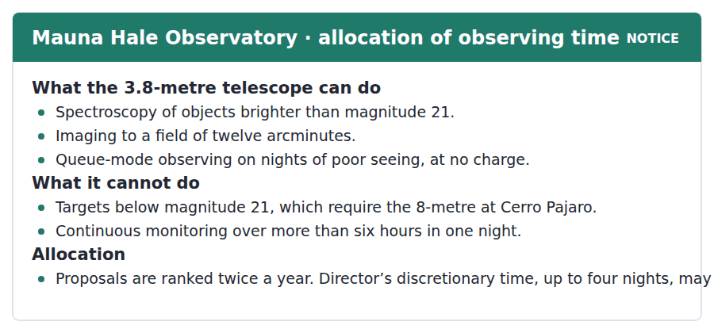
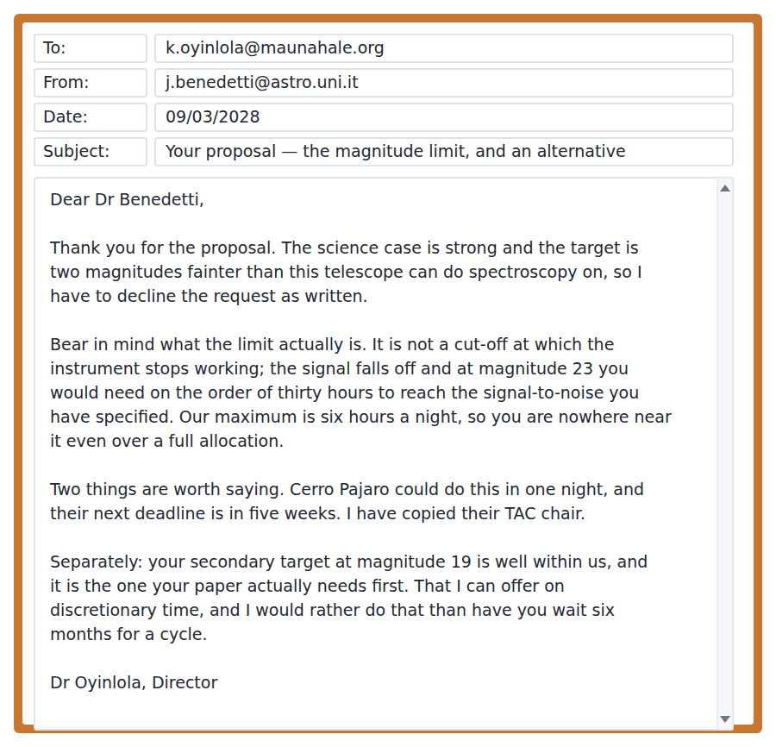
Exercise A Guided practice. The answer is on the page — find it.
1. What is the magnitude limit for spectroscopy?
(A) Magnitude 19
(B) Magnitude 23
(C) There is none
(D) Magnitude 21
2. What is the maximum continuous monitoring in one night?
(A) Three hours
(B) Six hours
(C) Twelve hours
(D) Unlimited
3. What is discretionary time for?
(A) Time-critical targets outside the cycle
(B) Poor weather
(C) Students
(D) Calibration
4. Which facility handles targets fainter than magnitude 21?
(A) Mauna Hale
(B) Neither
(C) Cerro Pajaro
(D) Both equally
Exercise B Exam practice.
5. Why is the proposal declined as written?
(A) The target is two magnitudes beyond the instrument
(B) The science is weak
(C) The deadline passed
(D) No time is available
6. What does the director say the magnitude limit really is?
(A) A hard cut-off
(B) A safety rule
(C) A point where the required exposure becomes impractical
(D) An administrative convention
7. How long would the target need on this telescope?
(A) Six hours
(B) One night
(C) Four nights
(D) On the order of thirty hours
8. What does "you are nowhere near it" refer to?
(A) The deadline
(B) The required signal-to-noise
(C) The magnitude limit
(D) The field of view
9. What does the director do about Cerro Pajaro?
(A) Names the deadline and copies in their TAC chair
(B) Advises against it
(C) Says it is full
(D) Offers to apply jointly
10. What is offered on discretionary time?
(A) The original target
(B) Queue-mode observing
(C) Four nights of imaging
(D) The secondary target at magnitude 19
11. What does the director prefer to avoid?
(A) A joint proposal
(B) Using discretionary time
(C) The applicant waiting six months for a cycle
(D) Contacting another observatory


SKILL · Reading a passage about how a method is justified
- The strength of a method is rarely one measurement. Look for the word independent.
- A good passage will name the assumption the method rests on, not hide it.
- When the last paragraph shifts from accuracy to understanding, the author is changing the subject deliberately.

How We Know the Age of Things We Cannot Watch
That the Earth is four and a half billion years old is widely repeated and rarely explained, leaving most people with a number they could not defend. The method behind it is simpler than its reputation. Certain isotopes decay at a rate that does not depend on temperature, pressure or anything else we can do to them, so the proportion of parent to daughter isotope in a mineral records how long the mineral has existed. What makes the technique strong is not one measurement but that several independent decay systems, with half-lives differing by orders of magnitude, agree.
It is tempting to treat that agreement as the end of the argument, and it is nearly but not quite. Every method rests on an assumption about the starting composition, and where that assumption fails the method fails with it. Geologists know this better than their critics, which is why the literature contains far more discussion of discordant dates than of concordant ones: a sample that disagrees with itself is interesting, and one that agrees is merely filed. Where the starting composition cannot be reconstructed, we simply do not know the age, and the convention is to say so.
The deeper difficulty is not accuracy but comprehension. On any reasonable estimate our species has existed for about a ten-thousandth of the Earth’s span, and no amount of restating that ratio makes it available to intuition. Compressing the whole of it into one year, which turns out to be the only device that reliably works, puts the first animals in late November and recorded history in the last thirty seconds. The analogy is crude and nobody has improved on it, because the problem it solves is not ignorance of the number but the absence of anything in ordinary experience to compare it with.
[300 words]

Exercise A Guided practice.
1. What does the proportion of parent to daughter isotope record?
(A) The temperature
(B) How long the mineral has existed
(C) The depth of burial
(D) The original composition
2. What makes the technique strong?
(A) One very precise measurement
(B) Several independent systems with very different half-lives agreeing
(C) International agreement
(D) Repeated sampling
3. What does every method rest on?
(A) A constant decay rate only
(B) Laboratory conditions
(C) A calibration against the Sun
(D) An assumption about the starting composition
4. Why does the literature discuss discordant dates more?
(A) They are more common
(B) They are easier to publish
(C) A disagreement is informative and an agreement is not
(D) Critics demand it
Exercise B Exam practice.
5. What does the author say about the agreement between methods?
(A) It is nearly but not quite the end of the argument
(B) It settles the question completely
(C) It is coincidental
(D) It is disputed
6. What does the author say about geologists and their critics?
(A) They disagree about decay rates
(B) Critics are usually right
(C) Neither understands the assumption
(D) Geologists understand the weakness better than critics do
7. What is the ratio of human to Earth history, on the author’s estimate?
(A) About a hundredth
(B) About a millionth
(C) About a ten-thousandth
(D) About a tenth
8. What does the one-year analogy achieve?
(A) Greater accuracy
(B) Making the ratio available to intuition
(C) A simpler calculation
(D) A better estimate of the age
9. Why has nobody improved on the analogy?
(A) The problem it solves is the absence of a comparison in ordinary experience
(B) It is traditional
(C) It is accurate
(D) Teachers prefer it
10. What does the author mean by "a number they could not defend"?
(A) People know the figure but not the reasoning
(B) The number is wrong
(C) The number is disputed
(D) The number keeps changing
11. Which would most weaken the first paragraph?
(A) A new estimate of the Earth’s age
(B) A disagreement about half-lives
(C) Evidence that decay rates vary with conditions
(D) A discordant sample
12. All of the following are stated EXCEPT:
(A) Decay rates are independent of conditions
(B) The one-year analogy is accurate as well as useful
(C) Several systems with different half-lives agree
(D) Discordant dates receive more discussion
13. What is the shift between the second and third paragraphs?
(A) From method to history
(B) From geology to astronomy
(C) From evidence to speculation
(D) From whether the number is right to whether it can be grasped


Exercise A Listen and choose a response. You hear one line. Choose the best reply.
1. Man: How do you measure the distance to a star?
(A) Yes, we can.
(B) For the near ones, by parallax.
(C) About four light years.
(D) With the big telescope.
2. Woman: Is magnitude the same as brightness?
(A) Yes, exactly the same.
(B) About magnitude six.
(C) As seen from here, yes — not as emitted.
(D) In the spectrum.
3. Man: Can you see the expansion through the telescope?
(A) Only in the spectra, not the image.
(B) Yes, clearly.
(C) About thirteen billion years.
(D) On a clear night.
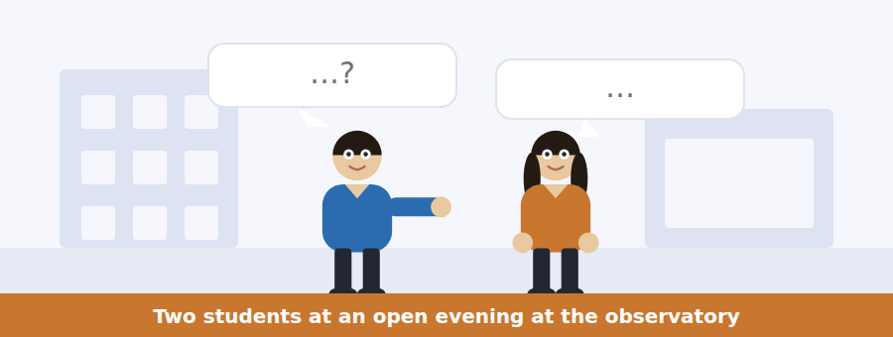
SKILL · Hearing a chain of comparisons
- When a speaker explains a distance or a size, they will build a chain: this is to that as that is to the other.
- Hold the chain, not the numbers. The items test the relationship.
- Listen for by a factor of, an order of magnitude, nowhere near.

Exercise B Listen and answer. The audio plays once.
4. What does magnitude depend on?
(A) Emission only
(B) Distance only
(C) The telescope used
(D) What the star emits and how far away it is
5. What is the problem the woman identifies?
(A) Telescopes are too small
(B) A dim near star and a bright far one look the same
(C) Parallax is unreliable
(D) Spectra are hard to read
6. How is parallax used?
(A) By comparing spectra
(B) By measuring brightness
(C) The star shifts against the background as the Earth moves
(D) By timing an eclipse
7. What is a standard candle?
(A) An object whose true luminosity is already known
(B) A very bright star
(C) A calibration lamp
(D) A nearby galaxy
8. What is the order of the chain he describes?
(A) Candles, then parallax, then near distances
(B) Spectra, then parallax, then candles
(C) Candles only
(D) Parallax, then near distances, then candles
9. How does he answer the "tower of assumptions" worry?
(A) He dismisses it
(B) He says the tower is short
(C) He changes the subject
(D) He accepts it and explains how the rungs are checked
10. What happened with the nine per cent discrepancy?
(A) It was ignored
(B) It was never resolved
(C) It took two generations and a space telescope to resolve
(D) It was a calculation error
Audio script: see the back of the book. Do not read it before you listen.


Exercise A Listen and choose a response. You hear one line. Choose the best reply.
1. Woman: Where was the centre of the Big Bang?
(A) There was no centre — that is the misunderstanding.
(B) Yes, there was one.
(C) About fourteen billion years ago.
(D) In the spectra.
2. Man: Are galaxies flying apart through space?
(A) Yes, very fast.
(B) Space is expanding between them.
(C) About two million light years.
(D) With the big telescope.
3. Woman: Does the rubber sheet explain why it expands?
(A) Yes, completely.
(B) No — that is exactly what it leaves out.
(C) About a metre across.
(D) It is a good analogy.
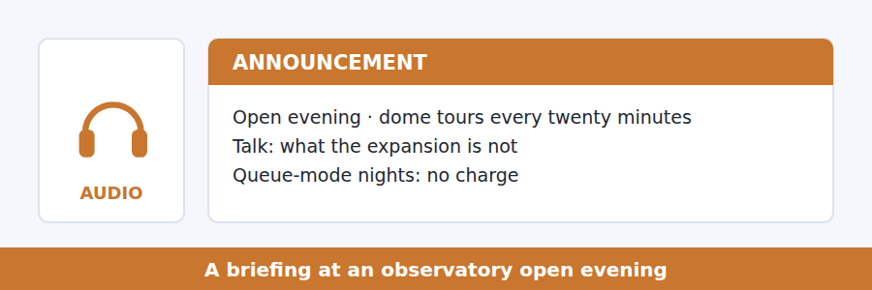
SKILL · Hearing an analogy dismantled
- A speaker who uses an analogy will usually say where it fails. That boundary is the examinable part.
- Listen for: the analogy breaks down when, what this does not give you, do not push it further than.
- An item about the analogy will test its limit, not its content.

Exercise B Listen and answer. The audio plays once.
4. What does the explosion picture require that is wrong?
(A) A centre
(B) A very high speed
(C) An edge
(D) A fixed age
5. What is actually expanding?
(A) The galaxies
(B) The light
(C) Space itself
(D) The observable region only
6. Why does he want the analogy punctured?
(A) It is unpopular
(B) It is out of date
(C) Students prefer numbers
(D) An analogy you cannot puncture is a liability
7. Which feature does the sheet have that the universe does not?
(A) Two dimensions only
(B) A measurable size
(C) A fixed shape
(D) An edge and a centre
8. What does the analogy fail to supply?
(A) The rate of expansion
(B) The direction of motion
(C) A reason for the stretching
(D) The age of the universe
9. What is his warning about using the analogy there?
(A) It is too simple
(B) It gives a feeling of explanation and no explanation
(C) It is mathematically wrong
(D) Students find it confusing
Audio script: see the back of the book. Do not read it before you listen.


Exercise A Listen and choose a response. You hear one line. Choose the best reply.
1. Man: How do we know the Earth is that old?
(A) Several independent clocks agree.
(B) Yes, it is very old.
(C) About four billion years.
(D) From the rocks.
2. Woman: Could the decay rate have changed?
(A) Yes, possibly.
(B) About a billion years.
(C) Nothing we can do to a sample changes it.
(D) In the laboratory.
3. Man: What is the weakest part of the method?
(A) The assumption about the starting mixture.
(B) There is no weak part.
(C) About two systems.
(D) The laboratory equipment.
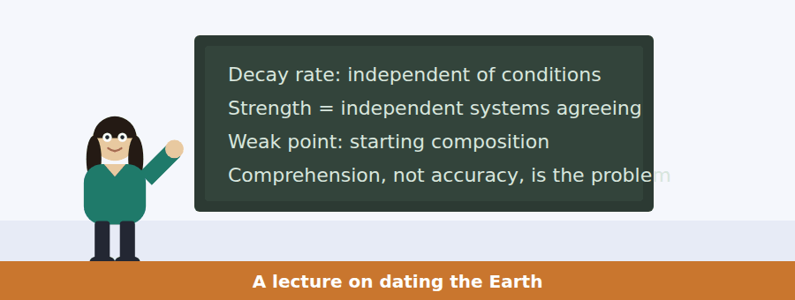
SKILL · Following a talk that defends a method
- A defence of a method states the strongest objection to it before answering.
- Listen for the word independent and for the phrase that names the assumption.
- The final section often changes the question from is it right to can it be understood.

Exercise B Listen and answer. The audio plays once.
4. What is she setting out to do?
(A) State a number
(B) Defend a number
(C) Correct a number
(D) Compare two numbers
5. What is the decay rate indifferent to?
(A) Time
(B) The element involved
(C) The size of the sample
(D) Temperature, pressure and chemistry
6. Why does she say one clock proves very little?
(A) It is imprecise
(B) The strength comes from several independent ones agreeing
(C) Clocks are expensive
(D) Half-lives are uncertain
7. What does every clock assume?
(A) A constant rate only
(B) A closed system forever
(C) A known age
(D) Something about the starting composition
8. What happens to a concordant date?
(A) It gets filed
(B) It gets a paper
(C) It is rechecked
(D) It is published widely
9. What does she call the ten-thousandth problem?
(A) A scientific problem
(B) A measurement error
(C) Not a scientific problem at all
(D) A dating difficulty
10. What is her view of the one-year compression?
(A) It is elegant
(B) It is crude and the only device that works
(C) It should be replaced
(D) It is misleading
Audio script: see the back of the book. Do not read it before you listen.


Part 1 · Listen and Repeat
You hear a sentence and repeat it once. There is no preparation time, and the sentences get longer. Focus: comparing quantities out loud
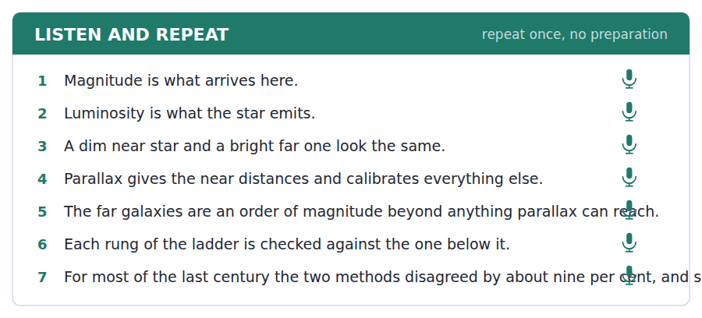
SKILL · Saying how much more
- Comparison needs a stress pattern: twice as BRIGHT as, an order of magnitude FURTHER.
- By a factor of ten and ten times are the same thing; the first is more formal.
- Nowhere near takes the stress on near, and it is stronger than not close.

Part 2 · Take an Interview
An interviewer asks you four questions on one theme: scale, instruments and what can be measured. Answer each one fully. There is no preparation time.
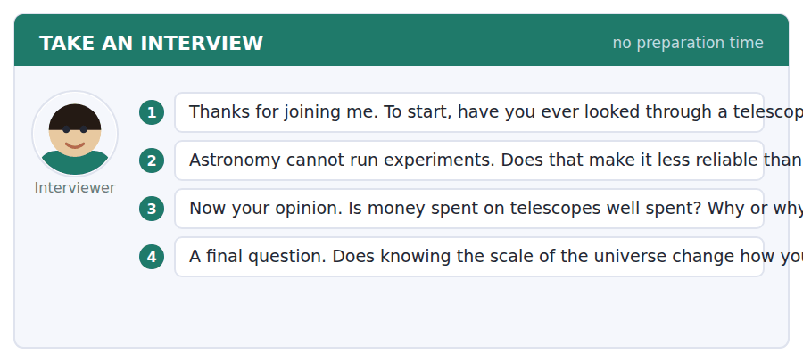
A good answer sounds like this
Question 2 — Differently reliable rather than less. It cannot intervene, so it compensates with independent methods that have to agree, and that is a real constraint, not a weaker one.
Question 4 — Honestly, no, and I think the people who say it does are performing. What it changes is which questions feel worth asking.
I can… | Not yet | Yes
I stressed the adjective in each comparison. | □ | □
I used by a factor of or an order of magnitude correctly. | □ | □
I did not say nowhere near when I meant not quite. | □ | □


Part 1 · Listen and Repeat
You hear a sentence and repeat it once. There is no preparation time, and the sentences get longer. Focus: correcting a misunderstanding politely
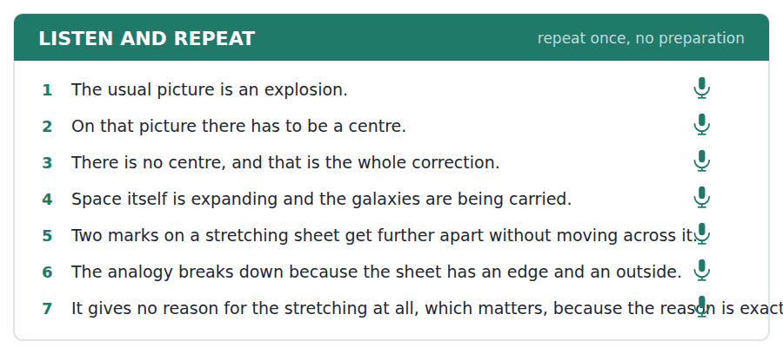
SKILL · Saying that something is not the case
- Correcting a belief needs the belief stated first: the usual picture is, and it gets the geometry wrong.
- Keep the correction short and the reason long. The reverse sounds dismissive.
- Drop your pitch on the belief and raise it on the correction.

Part 2 · Take an Interview
An interviewer asks you four questions on one theme: explanations, analogies and what they hide. Answer each one fully. There is no preparation time.
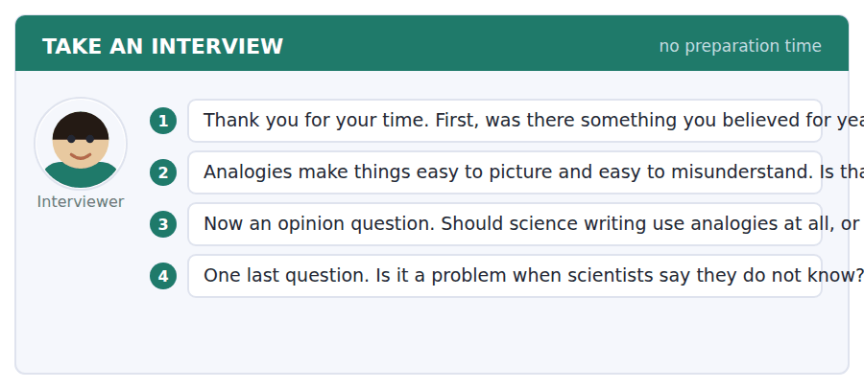
A good answer sounds like this
Question 2 — Worth making, as long as the limit comes with it. An analogy without its boundary is not a simplification, it is a different claim.
Question 4 — It is only a problem for people who wanted an oracle. Saying we do not know why the expansion is accelerating is the most informative sentence in the field.
I can… | Not yet | Yes
I stated the belief before correcting it. | □ | □
I kept the correction short and the reason long. | □ | □
I did not sound dismissive. | □ | □


Part 1 · Listen and Repeat
You hear a sentence and repeat it once. There is no preparation time, and the sentences get longer. Focus: defending a figure rather than asserting it
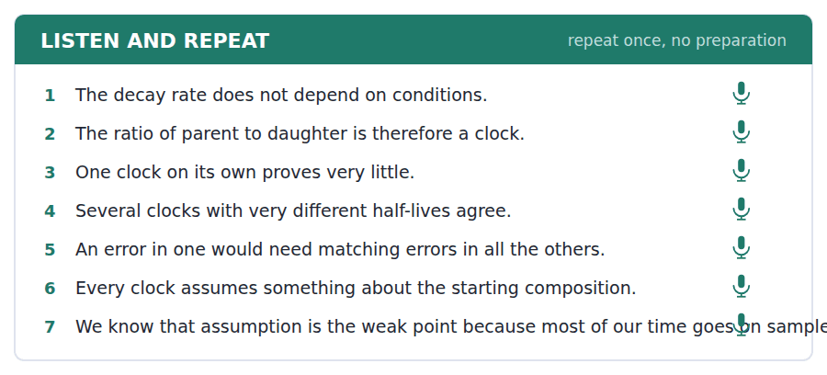
SKILL · Giving the structure of your evidence
- Say how many independent sources agree before you say what they say.
- Name the weakest assumption yourself. A listener who finds it after you have hidden it stops believing the rest.
- Mark the move from evidence to interpretation out loud.

Part 2 · Take an Interview
An interviewer asks you four questions on one theme: evidence, deep time and the limits of intuition. Answer each one fully. There is no preparation time.
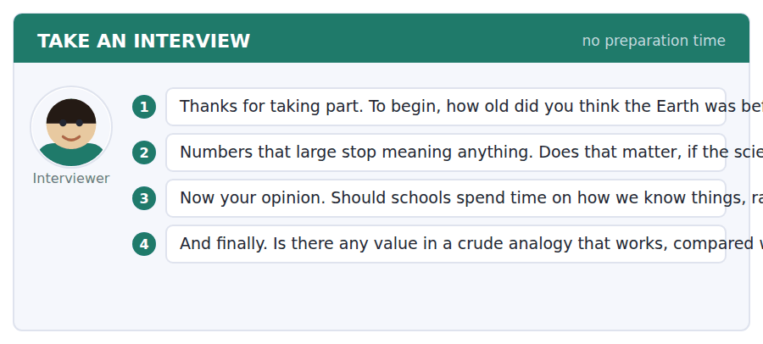
A good answer sounds like this
Question 2 — It matters for anything that needs public support, because a number nobody can feel is a number nobody will act on. For the science itself it changes nothing.
Question 4 — The crude one wins every time. A precise explanation that leaves the listener with nothing has transmitted no information, however correct it was.
I can… | Not yet | Yes
I gave the structure of the evidence before the conclusion. | □ | □
I named the weakest assumption myself. | □ | □
I marked where interpretation began. | □ | □


You see a sentence, then a set of words in boxes. Put the words in order to make one grammatical sentence. Almost every item in the real test makes a question or a question inside another sentence.
SKILL · Build a Sentence with a comparison
- The two non-question items in this unit build comparisons: twice as … as, the more … the more, by far the.
- The more … the more needs both halves and no commas inside either.
- By far goes immediately before the superlative, never after it.

Exercise A Guided practice. The first three are worked through.
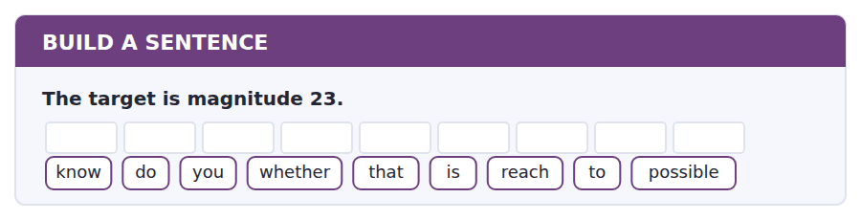
1. Do you know whether that is possible to reach?
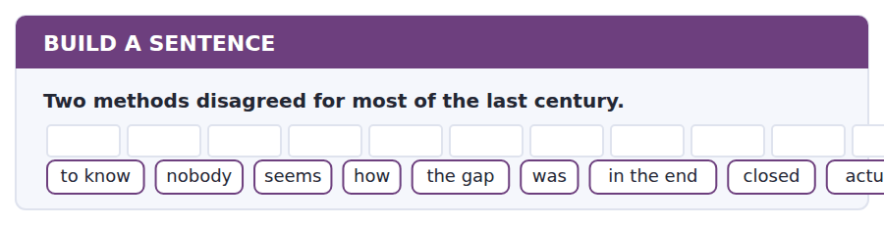
2. Nobody seems to know how the gap was actually closed in the end.
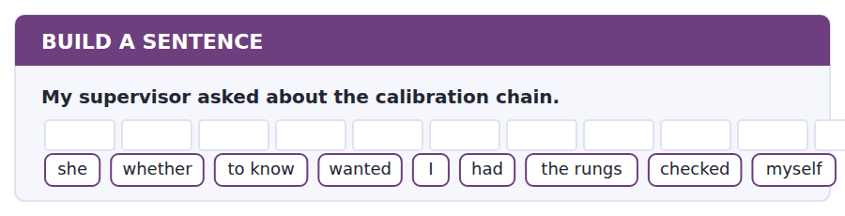
3. She wanted to know whether I had checked the rungs myself.
Exercise B Exam practice. Write the sentence.
4. The expansion is accelerating.
do / whether / know / you / anybody / knows / why / that / happening / is
__________________________________________________________
5. There is no centre to the expansion.
explain / can / anybody / why / the question / to me / is / meaningless / then
__________________________________________________________
6. Discretionary time is limited to four nights.
know / does / anybody / how / those / nights / allocated / are / actually
__________________________________________________________
7. The secondary target is within reach of this telescope.
us / told / nobody / which / target / the paper / needs / first / actually
__________________________________________________________
8. The samples disagreed with each other.
told / he / me / what / a discordant / date / usually / about / means
__________________________________________________________
9. A standard candle is further away than any parallax target.
by far / a standard / candle / is / the / reliable / most / distance / marker
__________________________________________________________
10. Each extra independent method strengthens the result.
the more / methods / agree / the harder / the result / is / to / away / explain
__________________________________________________________


You read a short situation and write an email. You have 7 minutes. The three bullet points are the mark scheme: answer all three.
The director has declined your main target as beyond the telescope, offered your secondary target on discretionary time, and pointed you to a larger facility whose deadline is in five weeks. You want to accept the discretionary offer, but you need the observation in April rather than whenever it is convenient, because the object is only above the horizon until early May.
Write an email to the allocations office.
- Accept clearly and say what you are accepting.
- Explain the timing constraint as a fact about the object, not a preference.
- Say what you will do if the constraint cannot be met.
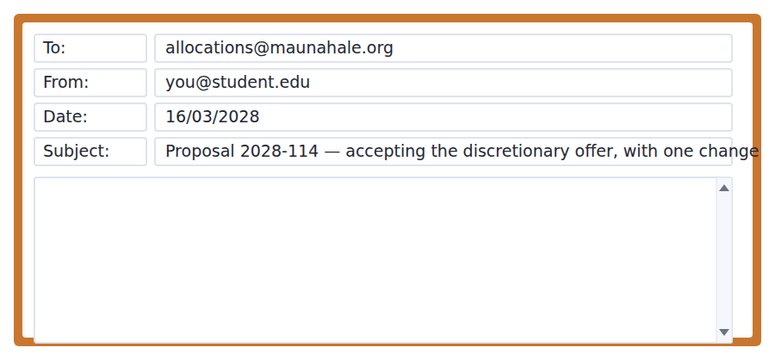
SKILL · Accepting an offer while changing one term
- Accept first and unambiguously. An acceptance with a condition buried in it reads as a refusal.
- Make the constraint belong to the world, not to you: the object sets the window, you do not.
- Name your fallback. It shows the request is not an ultimatum.

Model email
Dear Dr Oyinlola,

Thank you — I accept the discretionary offer on the secondary target, and you were right that it is the one the paper needs first. I have also written to Cerro Pajaro for the faint target and their deadline is manageable.

One thing I should have put in the proposal. The object sets its own window: it is above thirty degrees at this site until roughly the fifth of May and then not again for eleven months. So April is not a preference, and a date in June would be the same as no date.

I realise discretionary time is awkward to schedule and that this narrows it. If April is not possible, I would rather take a queue-mode slot on a poor-seeing night in April than a guaranteed night later — the measurement tolerates bad seeing far better than it tolerates the wrong month.

Either way I am grateful, and I will send you the reduced spectra whether or not they end up in the paper.

With thanks,
Jacopo Benedetti
Why it works
- The acceptance comes first and names what is being accepted, so nothing has to be inferred.
- The constraint is attributed to the object and quantified, which makes it a fact rather than a request.
- The writer volunteers a worse but acceptable alternative, which converts a condition into a choice for the reader.
- The closing offer is small and unconditional, so it does not read as leverage.
Two answers, one band apart
Both answer the three bullet points. One would score in the middle band and one near the top. Read them side by side before you write your own.
A middle-band answer | A top-band answer
Dear Dr Oyinlola,  Thank you very much for your email and for the offer of discretionary time on the secondary target. I am very happy to accept this and I appreciate you taking the time to look at the proposal in such detail.  There is one issue I need to mention. Unfortunately the object is only visible for a limited period and after that it will not be visible again for a long time. This means that it would be much better for me if the observation could take place in April if that is at all possible.  I understand that discretionary time is difficult to schedule and I do not want to cause problems. Please let me know whether April would be feasible, and if not, what the options might be. I am happy to be flexible.  Thank you again for all your help with this. Best wishes, Jacopo Benedetti | Dear Dr Oyinlola,  Thank you — I accept the discretionary offer on the secondary target, and you were right that it is the one the paper needs first. I have written to Cerro Pajaro for the faint target.  One thing I should have put in the proposal. The object sets its own window: it is above thirty degrees here until roughly the fifth of May and then not again for eleven months. April is not a preference, and a date in June would be the same as no date.  I realise this narrows an already awkward schedule. If April is not possible, I would rather take a queue-mode slot on a poor-seeing night in April than a guaranteed night later: the measurement tolerates bad seeing far better than the wrong month.  Either way I am grateful, and I will send the reduced spectra whether or not they reach the paper. Jacopo Benedetti

What the top answer does that the other does not
- It quantifies the window — thirty degrees, the fifth of May, eleven months — instead of calling it a limited period.
- It attributes the constraint to the object, so the reader is not being asked to accommodate a preference.
- It names a specific worse alternative rather than saying it is happy to be flexible, which gives the scheduler something to act on.
- It states the trade-off underlying that alternative in one clause: bad seeing costs less than the wrong month.
- It closes with an unconditional offer, so the goodwill is not contingent on getting April.
Now write your own. 7 minutes.
__________________________________________________________
__________________________________________________________
__________________________________________________________
__________________________________________________________
__________________________________________________________
__________________________________________________________
__________________________________________________________
__________________________________________________________


A professor asks a question and two students answer. You add your own post. You have 10 minutes and an effective answer is at least 100 words.
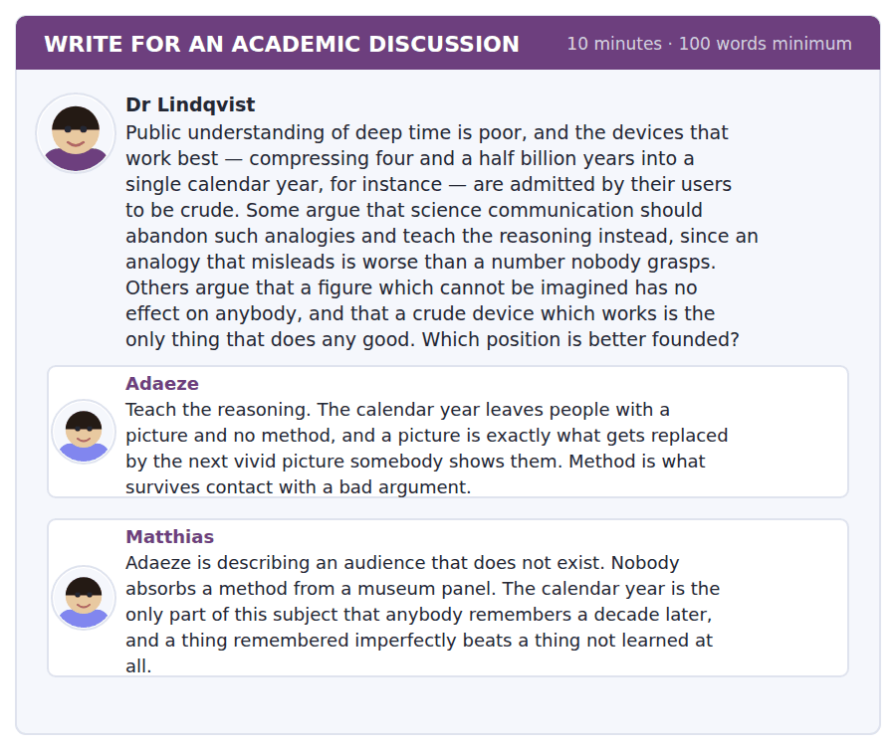
SKILL · Answering a false alternative
- When two positions assume you must choose, check whether the choice is real.
- Show what each is actually right about, then name the thing neither has addressed.
- A good answer ends with the condition under which both are satisfied.

Sentence starters
- Both posts assume a choice that the evidence does not force.
- Adaeze is right about…, though her claim about…
- Matthias is right that…, and that concedes more than he notices.
- What neither addresses is…
Model post
Both posts assume a choice that the evidence does not force, and the assumption is doing more work than either argument. Adaeze is right that a picture gets displaced by the next picture, and this is a real failure mode rather than a hypothetical one. But her alternative is not method against image; it is method against nothing, because the audience that would absorb the reasoning from a panel is not the audience the panel has.
Matthias is right that the calendar year is what people retain, and that concedes more than he notices. If retention is the test, it is a test the analogy passes and the reasoning has never been given a fair chance to sit, because nobody has tried presenting the reasoning in a form with the same retention properties. His argument is evidence about one delivery format, not about method as such.
What neither addresses is that the two things fail differently. An analogy fails by being replaced, and a method fails by being forgotten wholesale, which means the right combination is not a compromise between them but a division of labour: the analogy carries the scale, and one line of method — several independent clocks, built on different elements, agreeing — carries the authority. That line is short enough for a panel and it is the part that defends the number when somebody vivid turns up to dispute it.
So the defensible position is Matthias on the device and Adaeze on what has to travel with it. The analogy without the independence claim is a story; the independence claim without the analogy is unread.
[269 words]
Now write your own. 10 minutes, at least 100 words.
__________________________________________________________
__________________________________________________________
__________________________________________________________
__________________________________________________________
__________________________________________________________
__________________________________________________________
__________________________________________________________
__________________________________________________________
__________________________________________________________
__________________________________________________________

Grammar focus Degree and comparison
Form | How it is used
twice / three times as … as | twice as bright as the companion star
by a factor of | the exposure is longer by a factor of five
an order of magnitude | ten times, roughly: an order of magnitude further
by far the + superlative | by far the most reliable marker
the more … the more | the more methods agree, the harder it is to dismiss
nowhere near / not nearly | nowhere near the required signal
on the order of / roughly / some | on the order of thirty hours

The more … the more needs both halves, and neither half takes a that: the more methods agree, the harder it becomes. The more that methods agree is wrong.
By far modifies a superlative and goes in front of it: by far the most reliable. The most reliable by far is possible at the end of a clause, but never in the middle.
Twice as … as takes the positive form, not the comparative: twice as bright as, never twice as brighter as. This is one of the most frequent B2 errors in writing about data.
Watch out! Do not write "more brighter" or "twice as brighter". A comparative is marked once — either with -er or with more, and never with both, and never after twice as.
Exercise 1 Choose the correct degree expression.
1. The star is twice as ______ as its companion.
2. The exposure is longer ______ a factor of five.
3. Parallax is ______ near far enough for this target.
4. The galaxy is an ______ of magnitude further away.
5. That is ______ far the most reliable method.
6. The exposure would be ______ the order of thirty hours.
Exercise 2 Correct the comparison.
1. The star is twice as brighter as the other.
2. This method is more reliabler than that one.
3. The more that methods agree, the better.
4. It is the most accurate by far method.
Exercise 3 Rewrite using the more … the more.
1. If you add methods, the result becomes harder to dismiss.
2. If the half-lives differ more, the agreement means more.
3. If an analogy is more vivid, it is more easily replaced.
4. If the exposure is longer, the signal-to-noise is better.
How this is tested in Build a Sentence
Two of the ten Build a Sentence items in this unit are comparisons rather than questions. A tile reading by far sits in front of the superlative, and a tile reading the more opens one half of a two-part structure that needs both halves.
Find the fault 5 errors, drawn from this unit and the two before
Every error below is one a B2 writer makes after learning the rule. Mark what is wrong, then check. Knowing the rule and noticing the breach are two different skills, and only the second one is tested.
The target is twice as brighter as the companion. The more that methods agree, the stronger the result. It is the most reliable by far method we have. Nobody knows whether was the exposure long enough. Having calibrated the ladder, the distances were finally reliable.
# | As written | As it should be | Why
1 | twice as brighter as | twice as bright as | Twice as takes the positive form, so the comparative ending is one marker too many.
2 | The more that methods agree | The more methods agree | Neither half of the more … the more takes a that after it.
3 | the most reliable by far method | by far the most reliable method | By far goes in front of the superlative when the phrase sits inside a clause.
4 | whether was the exposure long enough | whether the exposure was long enough | An embedded question keeps statement order and does not invert the verb.
5 | Having calibrated the ladder, the distances were finally reliable | Having calibrated the ladder, the team could finally rely on the distances | The distances did not calibrate anything; the participle needs a subject that performed the action.

Unit review and progress check Unit 32
Exercise A Vocabulary. Write the word.
1. how much light a body actually emits
2. the measurement of how bright a source appears
3. the stretching of light from a receding source
4. apparent shift of a near object against a far background
5. light separated into its component wavelengths
6. a cloud of gas and dust in space
7. the path a body follows
8. to do with the Earth
9. to do with the universe as a whole
10. a form of an element with a different atomic mass
11. setting an instrument against a known standard
12. to extend a pattern beyond the measured range
Exercise B Grammar. Complete the sentence.
1. The star is twice as ______ as its companion.
2. The exposure is longer ______ a factor of five.
3. Parallax is ______ near far enough for this target.
4. That is ______ far the most reliable method.
5. The ______ methods agree, the stronger the result.
6. The exposure would be ______ the order of thirty hours.
7. The galaxy is an order of ______ further away.
8. To a first ______, the two agree.
Exercise C One timed mini-section. 6 minutes.
1. Magnitude describes
(A) how bright a star appears from here
(B) what a star emits
(C) the distance to a star
(D) the age of a star
2. The expansion of the universe means that
(A) galaxies travel outward from a centre
(B) light slows down
(C) the universe has an edge
(D) space itself is expanding
3. Radiometric dating is strong mainly because
(A) one measurement is very precise
(B) decay is fast
(C) several independent systems with different half-lives agree
(D) samples are plentiful
4. Which sentence is correct?
(A) The more methods agree, the better.
(B) The more that methods agree, the better.
(C) More methods agree, more better.
(D) The more methods agree, the more better.
5. "We simply do not know" in academic writing signals that the writer
(A) is being modest
(B) is marking a genuinely open question
(C) disagrees with the field
(D) has not read the literature
6. An analogy should be taught together with
(A) a diagram
(B) its history
(C) the point at which it breaks down
(D) a precise number
Can you do these now?
I can… | Not yet | Yes
I can compare two quantities precisely, including by a factor or an order of magnitude. | □ | □
I can use the more … the more, by far, nowhere near and twice as … as accurately. | □ | □
I can explain why a popular analogy breaks down, and where. | □ | □
I can report a very large or very small number without losing the reader. | □ | □
I can follow a lecture that is built on a chain of comparisons. | □ | □
I can write about an unresolved question without pretending it is resolved. | □ | □

ADAPTIVE TIP The comparison structures in this unit are the ones examiners notice. Twice as bright as, by far the most, the more … the more: each is marked once and marked in one place. If you can produce all three without hesitating, your writing has crossed a visible line.

Unit 33 · Work and Automation
TOEFL iBT® Preparation Course 2026 · Volume 4
CEFR B2 · Grammar: The future in the past · Word field: automation, displacement, retraining
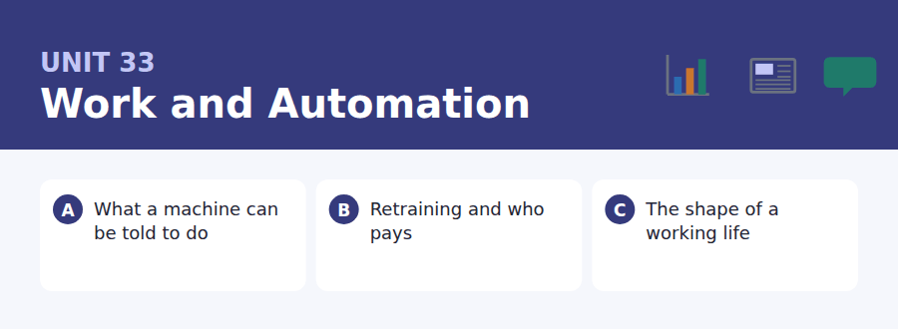
By the end of this unit I can…
- I can describe an expectation that was not met, without confusing the time frames.
- I can use was going to, would have, was to have and was due to accurately.
- I can explain why a confident prediction turned out wrong.
- I can argue about a policy whose costs and benefits fall on different people.
- I can follow a talk that reinterprets a familiar story.
- I can write about a trend without claiming to know where it ends.

This unit is about predictions that failed, which makes it the right place to learn the structures English uses for a future seen from the past. Was going to, would have been, was due to: every one of them carries a claim about what did not happen.

Vocabulary 1 · Academic word families 18 families, not 18 words
At B2 the word on its own is not enough. Each entry below is a family: learn the noun, the verb and the adjective together, because the test will use whichever one the sentence needs.
automation doing by machine what was done by people | manual done with the hands
churn the rate at which workers leave and are replaced | wage payment for time worked
redundancy loss of a job because the job has gone | severance a payment on losing a job
productivity output per hour of work | reskill to learn a different trade
occupation the kind of work somebody does | transition the move from one state to another
obsolete no longer of use | polarise to split into two extremes
specification a complete statement of what is required | subsidise to pay part of the cost of something
routine repeated in the same way each time | entitlement something a person has a right to
cognitive to do with thinking | lifelong lasting a whole life

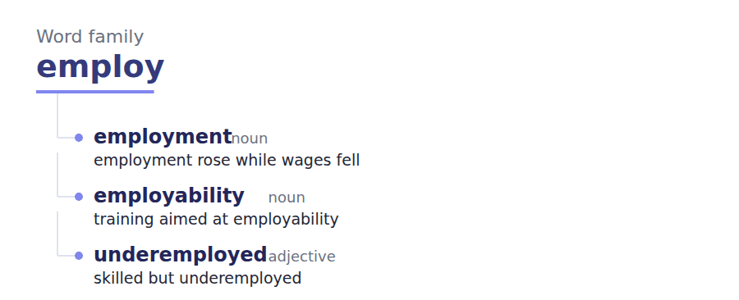
Exercise A Work in pairs. Ask and answer.
1. Name a job that existed in your parents’ time and does not now.
2. Why did predictions about automation keep getting the order wrong?
3. Who should pay when a job is automated away?
4. Is a working life still one occupation? Should it be?
Vocabulary 2 · Collocation 10 partnerships that actually occur
A word is known when you know what it goes with. These ten are the partners this unit’s texts use; the wrong partner is what marks an answer as translated.
phase out to remove gradually | bear the cost to pay for something
take over to assume control of something | in the long run eventually, over many years
fall through to fail to happen | as things stand given the present situation
bring forward to move to an earlier date | across the board affecting everyone equally
lay off to dismiss for lack of work | come to nothing to produce no result

Vocabulary 3 · Stance and hedging How far the writer commits
Every one of these says the same thing at a different strength. Reading, you must notice which was chosen. Writing, you must choose.
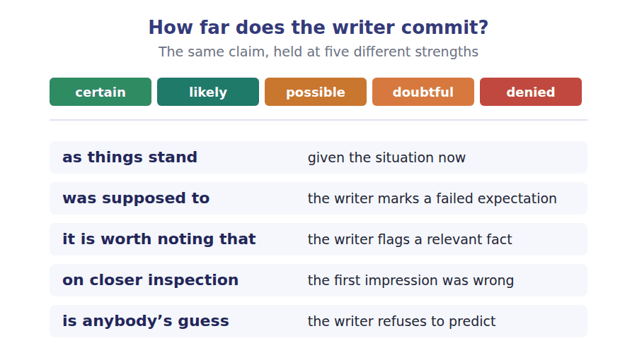
Two words that look alike
redundant / unemployed the job has gone / the person has none
productivity / output per hour of work / in total
retrain / reskill for the same trade / for a different one

Words you will meet again: assembly line | gig work | zero-hours contract | collective bargaining | sector | labour market | structural change | safety net


SKILL · Completing nouns of process and adjectives of capacity
- Economics writing is full of -ment and -tion nouns: displacement, specification, transition.
- The -ive and -ible endings mark capacity or tendency: instructive, specifiable.
- Read to the end of the sentence first. The grammar tells you the ending before the meaning does.

Exercise A Guided practice. Five words are not complete. Write the missing letters.
Every generation since the first mechanical loom has been told that machines were about to abol--- work, and every generation has instead watched the composition of work ch----. The jobs that disappeared were real jobs and the people who lost them were not compens---- by the jobs that appeared somewhere else twenty years la---. Both halves of that sentence are true, and arguments about automation usually go wrong by insist--- on only one of them.

The first one is done for you: abol-- is abolish — the slot follows about to, so it needs a bare infinitive.
Exercise B Exam practice. One paragraph, ten gaps — the real task.
A task is automated when it can be specified completely, and this turns out to be a much narrower condition than it so----. Driving a vehicle along a motorway is specifiable. Persuading a reluctant patient to accept a diagnosis is not, and the distinction has very little to do with how difficult either task feels to a human be---. For most of the last century the assumption was that machines would take the physically demanding work and leave the cogni---- work to people, and the actual pattern has been close to the rev----: arithmetic went first, pattern recognition went second, and the occupations that have proved most stubbor--- resistant are the ones involving unpredictable physical environments and other people’s emot----. Nobody predicted this, and the reason nobody predicted it is instruct---. We judged difficulty by how long a human takes to learn something, which measures the scarcity of the skill in our own species rather than the complex--- of the task. A warehouse picker learns the job in a week and a radiologist trains for a dec---, and it is the radiologist’s work that decomposes into specifiable steps. The lesson is not that expertise is worth l--- than we thought, but that our intuitions about what is hard were never about the tasks at all.

Check your answers in the key at the back of the book.


SKILL · Reading a scheme against an individual case
- A scheme sets eligibility. A case asks whether a particular person falls inside it.
- Eligibility rules usually turn on a date, a duration or a category. Find which one.
- Where a rule produces an unintended result, the reply will often say so rather than defend it.

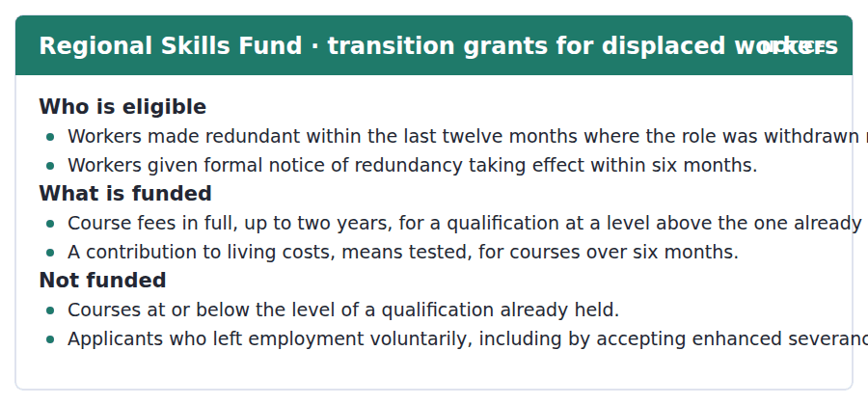
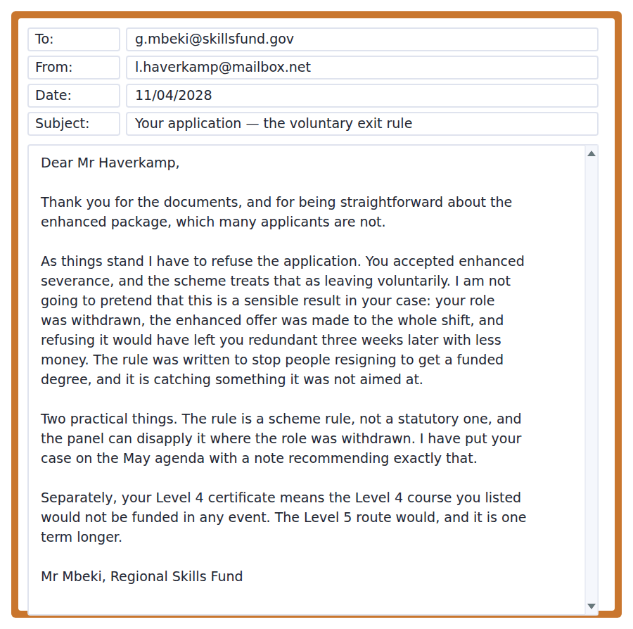
Exercise A Guided practice. The answer is on the page — find it.
1. Who is eligible under the scheme?
(A) Workers whose role was withdrawn, within set time limits
(B) Anyone unemployed
(C) Anyone retraining
(D) Workers over fifty
2. What level of course is funded?
(A) Any level
(B) The same level
(C) Only degree level
(D) A level above the one already held
3. When is a living-costs contribution available?
(A) Always
(B) Never
(C) For courses over six months, means tested
(D) For the first year only
4. Why is the applicant initially refused?
(A) He applied late
(B) He accepted enhanced severance, which counts as leaving voluntarily
(C) His role was filled
(D) He holds no qualification
Exercise B Exam practice.
5. What does the officer say about the result in this case?
(A) It is correct
(B) It is not a sensible result and he will not pretend otherwise
(C) It is unavoidable
(D) It is the applicant’s fault
6. What was the voluntary exit rule aimed at?
(A) Reducing costs
(B) Older workers
(C) People resigning in order to get a funded degree
(D) Short courses
7. What would have happened if the applicant had refused the package?
(A) He would have been made redundant weeks later with less money
(B) He would have kept his job
(C) He would have been eligible immediately
(D) Nothing would have changed
8. What is the significance of the rule being a scheme rule?
(A) It cannot be changed
(B) It applies to everyone
(C) It expires annually
(D) The panel has power to disapply it
9. What has the officer already done?
(A) Approved the grant
(B) Referred it to a court
(C) Put the case on the May agenda with a recommendation
(D) Closed the file
10. Why would the Level 4 course not be funded?
(A) It is too short
(B) The applicant already holds a Level 4 qualification
(C) It is not on the list
(D) The panel has refused it
11. What is the overall structure of the officer’s reply?
(A) A refusal with an apology
(B) An approval with conditions
(C) A request for more documents
(D) A refusal, a criticism of the rule, and two routes forward


SKILL · Reading a passage that re-dates a familiar thing
- A common move is to show that what looks permanent is recent and local.
- Expect a sentence giving the real span: about two generations, in about a dozen countries.
- The last paragraph usually separates what cannot be changed from what could.

The Career That Was Supposed to Last Forty Years
The single-occupation working life is treated as the natural state of affairs that recent decades have disrupted, and on closer inspection it was a local arrangement lasting about two generations in about a dozen countries. Before industrial employment most people did several kinds of work in a year, seasonally and by necessity. The pattern in which a person entered one firm at sixteen and left it at sixty was supposed to be the beginning of something and turned out to be the exception.
It is worth noting that the arrangement did not end because workers wanted variety. It ended because the firms that offered it stopped existing at the rate they once did, and because the skills a firm needed began turning over faster than a career. Neither of those is a preference and neither can be reversed by exhortation. Where the single-employer pattern survives it is usually in sectors with regulated entry and slow technical change, which is a description of a structural condition rather than of a culture. As things stand, those sectors employ a shrinking minority.
What replaces it is anybody’s guess, and the honest observation is that no institution has yet been built for the pattern that actually exists. Pensions, mortgages, professional licensing and most training subsidies all assume continuous employment in one field, and each of them imposes a penalty on the person who changes direction at forty. The penalty is not a judgement about career changes; it is an artefact of institutions designed around an arrangement that lasted two generations. That is a solvable problem, which is what distinguishes it from the underlying change, and almost nobody is working on it.
[277 words]

Exercise A Guided practice.
1. What does the author say about the single-occupation working life?
(A) It lasted about two generations in about a dozen countries
(B) It is the natural state
(C) It never existed
(D) It is returning
2. What did people do before industrial employment?
(A) One job for life
(B) Mostly agriculture only
(C) Nothing systematic
(D) Several kinds of work in a year
3. Why did the arrangement end, according to the author?
(A) Firms stopped lasting and skills turned over faster than careers
(B) Workers wanted variety
(C) Governments withdrew support
(D) Unions declined
4. Where does the single-employer pattern survive?
(A) In large firms
(B) In the public sector only
(C) In sectors with regulated entry and slow technical change
(D) Nowhere
Exercise B Exam practice.
5. What does "neither can be reversed by exhortation" mean?
(A) Nobody has tried
(B) Urging people to behave differently cannot change either cause
(C) Both are preferences
(D) Policy has failed
6. What do pensions, mortgages and licensing have in common, in the author’s account?
(A) They are too expensive
(B) They are recent
(C) They are unregulated
(D) They assume continuous employment in one field
7. How does the author characterise the penalty on changing direction?
(A) A deserved consequence
(B) An artefact of institutional design
(C) A legal requirement
(D) An economic necessity
8. What distinguishes the penalty from the underlying change?
(A) It is solvable
(B) Its size
(C) Its history
(D) Who it affects
9. What is the author’s closing complaint?
(A) Institutions are too slow
(B) Workers are unwilling to retrain
(C) Almost nobody is working on the solvable part
(D) The data are poor
10. What does "turned out to be the exception" refer to?
(A) Seasonal work
(B) Industrial employment
(C) Regulated sectors
(D) The one-firm career
11. Which would most weaken the second paragraph?
(A) Evidence that workers value variety
(B) Evidence that firm lifespans and skill turnover have been stable
(C) Evidence that pensions are underfunded
(D) Evidence that licensing has expanded
12. All of the following are stated EXCEPT:
(A) Workers changing direction at forty usually succeed
(B) The pattern lasted about two generations
(C) Skills now turn over faster than a career
(D) Institutions assume continuous employment
13. What is the author’s attitude to the end of the one-firm career?
(A) Nostalgic
(B) Celebratory
(C) Analytical about the cause and critical of the institutional response
(D) Indifferent


Exercise A Listen and choose a response. You hear one line. Choose the best reply.
1. Man: So machines take the physical jobs first?
(A) Yes, always.
(B) About twenty years.
(C) That is what everyone expected, and no.
(D) In the warehouse.
2. Woman: Why did everyone get the order wrong?
(A) Yes, we did.
(B) About a decade.
(C) In the seminar.
(D) We measured difficulty by how long people take to learn.
3. Man: Does that mean expertise is worthless?
(A) Yes, apparently.
(B) No — it means our intuitions were off.
(C) About ten years of training.
(D) For radiologists.
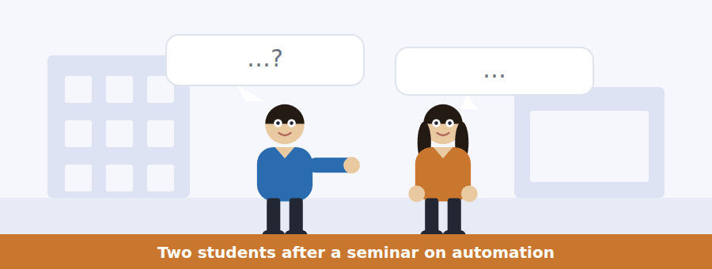
SKILL · Hearing an argument reversed
- One speaker will state the common view and the other will reverse it with a counterexample.
- The counterexample is the examinable part. Hold the two cases being compared.
- Listen for: you would think, in fact it is the other way round, which is the opposite of.

Exercise B Listen and answer. The audio plays once.
4. What was the expected order of automation?
(A) Physical work first, thinking last
(B) Cognitive work first
(C) Emotional work first
(D) There was no expectation
5. What has actually been automated first?
(A) Manual work
(B) Arithmetic, then pattern recognition
(C) Nursing
(D) Teaching
6. Which jobs have proved most resistant?
(A) Highly paid ones
(B) Ones requiring long training
(C) Ones in manufacturing
(D) Ones with unpredictable spaces and other people’s emotions
7. Why did predictions get the order wrong?
(A) Poor data
(B) Technology moved too fast
(C) Difficulty was judged by how long a human takes to learn
(D) Economists ignored engineers
8. What is the contrast between the picker and the radiologist?
(A) The long-trained work is the one that decomposes into specifiable steps
(B) Pay
(C) Job security
(D) Working hours
9. What inference does the man reject?
(A) That the order was reversed
(B) That expertise is worthless
(C) That radiology is difficult
(D) That predictions failed
10. What does he say the radiologist is still doing?
(A) Something difficult, just not what we thought
(B) Nothing difficult
(C) Work a machine cannot specify
(D) Work that will not change
Audio script: see the back of the book. Do not read it before you listen.


Exercise A Listen and choose a response. You hear one line. Choose the best reply.
1. Woman: Does accepting a severance package affect eligibility?
(A) No, not at all.
(B) About three weeks.
(C) Yes — the scheme counts it as leaving voluntarily.
(D) At the clinic.
2. Man: Can the panel waive that rule?
(A) No, never.
(B) About four cases.
(C) In May.
(D) It can, where the role was withdrawn.
3. Woman: Will a course at my current level be funded?
(A) Yes, any course.
(B) About two years.
(C) No — it has to be a level above.
(D) Course fees in full.

SKILL · Hearing a rule criticised by the person applying it
- An official may apply a rule and disagree with it in the same breath. Both are examinable.
- Listen for: the rule says, and I think it is catching the wrong people.
- The route round the rule is usually named immediately afterwards.

Exercise B Listen and answer. The audio plays once.
4. What does the speaker say he will do?
(A) Explain the scheme fully
(B) Be useful rather than diplomatic
(C) Defend the rules
(D) Describe the panel
5. What was the voluntary exit rule designed to stop?
(A) People resigning from a secure job to get a funded degree
(B) Early retirement
(C) Short courses
(D) Repeat applications
6. Who does the rule actually catch, in his account?
(A) Dishonest applicants
(B) Older workers
(C) People changing sector
(D) People offered enhanced terms because the whole shift was going
7. What does he advise applicants to do?
(A) Appeal to a court
(B) Reapply next year
(C) Accept the refusal
(D) Ask in writing for the rule to be disapplied, with the date and the offer
8. What is the second rule he names?
(A) A time limit
(B) A course at or below a level already held is not funded
(C) A means test
(D) A residence requirement
9. What mistake does he say people make?
(A) Applying too late
(B) Omitting documents
(C) Choosing a course on content and finding the level is wrong
(D) Asking for too much
Audio script: see the back of the book. Do not read it before you listen.


Exercise A Listen and choose a response. You hear one line. Choose the best reply.
1. Man: Was a job for life ever normal?
(A) For about two generations, in a few countries.
(B) Yes, everywhere.
(C) About forty years.
(D) In manufacturing.
2. Woman: Did it end because people wanted variety?
(A) No — the firms stopped lasting.
(B) Yes, mostly.
(C) About two generations.
(D) In the 1980s.
3. Man: What assumes continuous employment?
(A) Yes, it does.
(B) About forty years.
(C) Pensions, mortgages, licensing — nearly everything.
(D) The careers service.
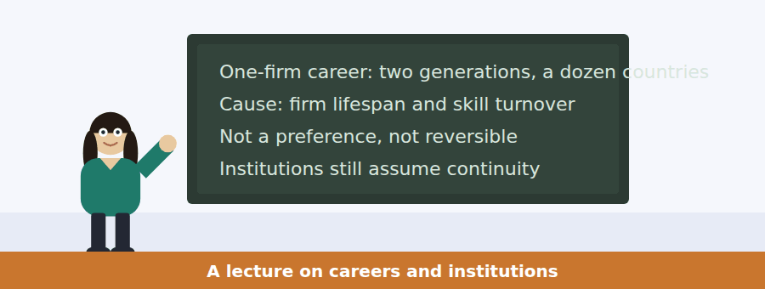
SKILL · Following a talk that separates the fixable from the fixed
- A good policy lecture will divide a problem into what cannot be changed and what could.
- Listen for: that part is not going back, and this part is simply a design choice.
- The speaker’s complaint is usually about effort going to the wrong half.

Exercise B Listen and answer. The audio plays once.
4. Why does the speaker begin by dating the arrangement?
(A) To give context
(B) Because the dating does most of the argument
(C) To be accurate
(D) To introduce the data
5. What did people do before industrial employment?
(A) One trade for life
(B) Mostly nothing recorded
(C) Work for the state
(D) Several kinds of work in a year, as the seasons required
6. Which explanation does she reject firmly?
(A) That firms stopped lasting
(B) That skills turn over
(C) That workers wanted variety
(D) That institutions are badly designed
7. What does she say about urging loyalty?
(A) Neither cause responds to it
(B) It would help
(C) Firms should try it
(D) It worked once
8. What annoys her?
(A) Workers changing jobs
(B) Institutions that fine the person who changes direction
(C) The lack of data
(D) Employers
9. What does she say about that penalty?
(A) It is a law of economics
(B) It is necessary
(C) It is small
(D) It is a design choice that could be undone
10. What is her closing complaint?
(A) Almost nobody is working on the fixable part
(B) Nobody agrees with her
(C) The data are missing
(D) Firms will not cooperate
Audio script: see the back of the book. Do not read it before you listen.


Part 1 · Listen and Repeat
You hear a sentence and repeat it once. There is no preparation time, and the sentences get longer. Focus: describing an expectation that failed
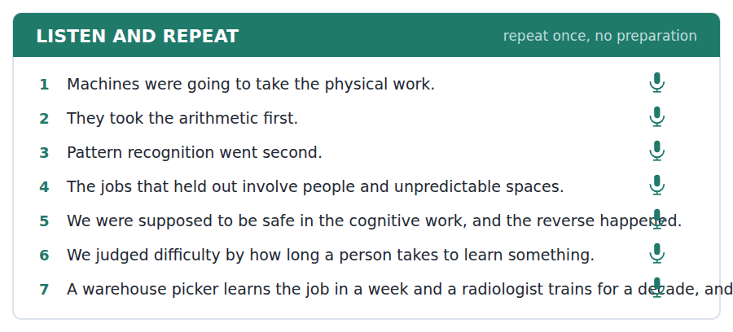
SKILL · Saying what was going to happen
- Was going to and was supposed to both describe a future seen from the past, and both imply it did not happen.
- Stress the auxiliary: it WAS going to, which is what signals the contrast.
- Follow it with what happened instead, in the same breath.

Part 2 · Take an Interview
An interviewer asks you four questions on one theme: work, machines and predictions. Answer each one fully. There is no preparation time.
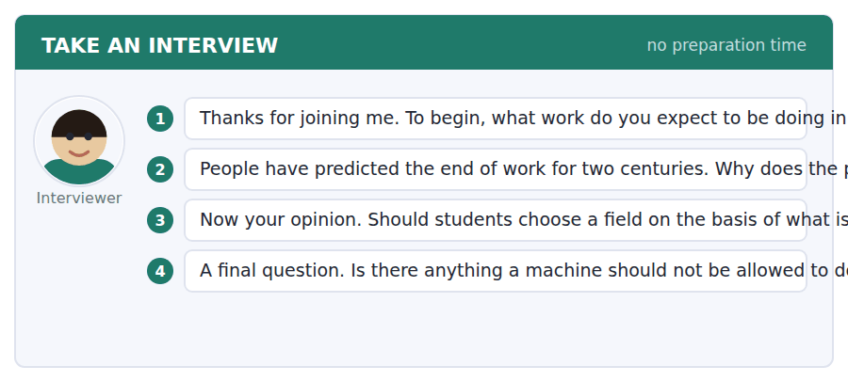
A good answer sounds like this
Question 2 — Because the visible half is always true. Jobs really do disappear, and the replacement jobs arrive later and somewhere else, so at any moment the prediction looks correct.
Question 4 — Deciding things about a person where somebody has to be answerable. Not because the machine is worse, but because an unanswerable decision is a different kind of thing.
I can… | Not yet | Yes
I stressed the auxiliary in was going to. | □ | □
I said what happened instead immediately. | □ | □
I did not mix up the time frames. | □ | □


Part 1 · Listen and Repeat
You hear a sentence and repeat it once. There is no preparation time, and the sentences get longer. Focus: stating an unintended consequence
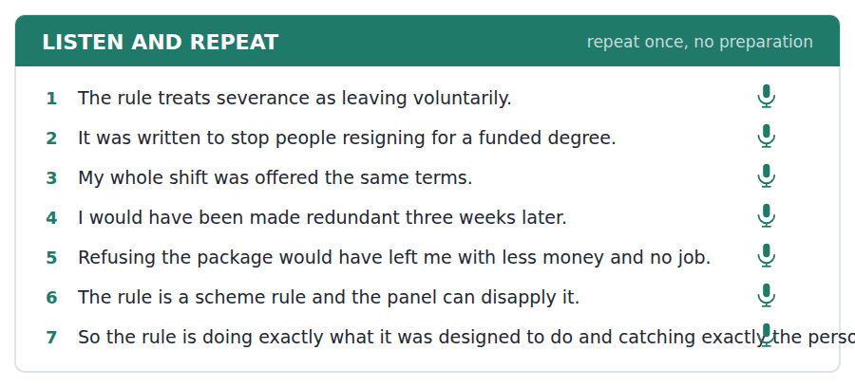
SKILL · Saying that a rule catches the wrong case
- Name the purpose of the rule first, generously. Then show the case it catches.
- Would have is the key form: I would have been made redundant three weeks later.
- Keep the tone flat. An unintended consequence stated calmly is harder to dismiss.

Part 2 · Take an Interview
An interviewer asks you four questions on one theme: rules, fairness and who bears a cost. Answer each one fully. There is no preparation time.
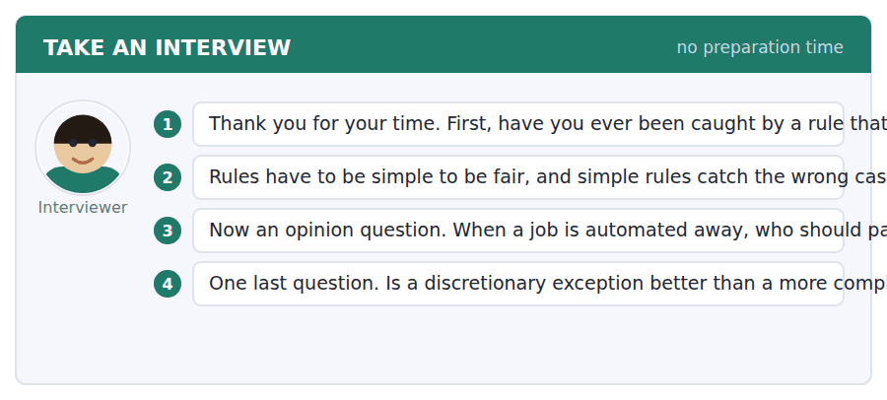
A good answer sounds like this
Question 2 — With a named power to disapply and somebody willing to use it. The alternative is a rule so detailed that nobody can apply it and everybody appeals.
Question 3 — Mostly the employer and the state together, because the gain from automating goes to one and the tax base goes to the other. The worker is the only party who did not make the decision.
I can… | Not yet | Yes
I gave the rule its purpose before criticising it. | □ | □
I used would have correctly. | □ | □
I kept the tone flat. | □ | □


Part 1 · Listen and Repeat
You hear a sentence and repeat it once. There is no preparation time, and the sentences get longer. Focus: separating what can change from what cannot
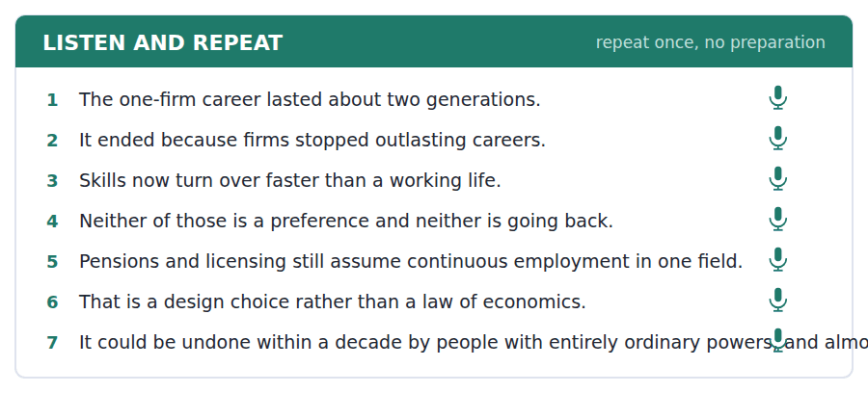
SKILL · Dividing a problem out loud
- Say the division before the detail: one part of this is not going back, and one part is a design choice.
- Put the irreversible part first. It makes the second half sound practical rather than naive.
- Use is not going to and could be undone to mark the two halves.

Part 2 · Take an Interview
An interviewer asks you four questions on one theme: careers, institutions and what could be redesigned. Answer each one fully. There is no preparation time.
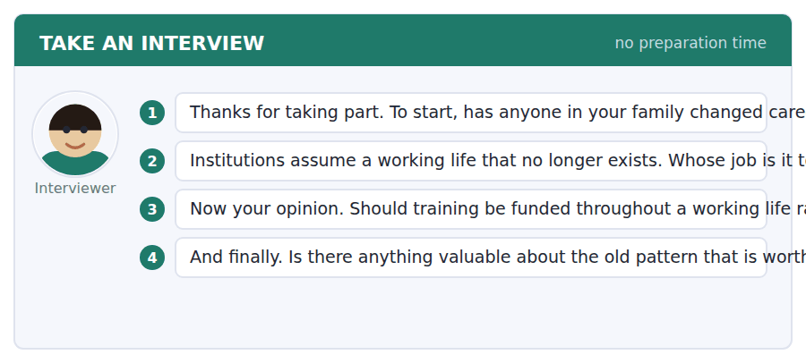
A good answer sounds like this
Question 2 — Whoever is embarrassed by the gap. In practice that means it waits for a cohort large enough to vote on it, which is why it takes a generation rather than a decade.
Question 4 — The accumulation. Forty years in one place built a kind of judgement that five jobs do not, and nothing in the new pattern has replaced it.
I can… | Not yet | Yes
I stated the division before the detail. | □ | □
I put the irreversible part first. | □ | □
I marked the two halves with different forms. | □ | □


You see a sentence, then a set of words in boxes. Put the words in order to make one grammatical sentence. Almost every item in the real test makes a question or a question inside another sentence.
SKILL · Build a Sentence with a future in the past
- The two non-question items in this unit build a future seen from the past: was going to, was supposed to, would have been.
- Was going to and was supposed to are followed by a bare infinitive; would have takes a past participle.
- The tile order will tell you which: a tile reading have signals would have.

Exercise A Guided practice. The first three are worked through.
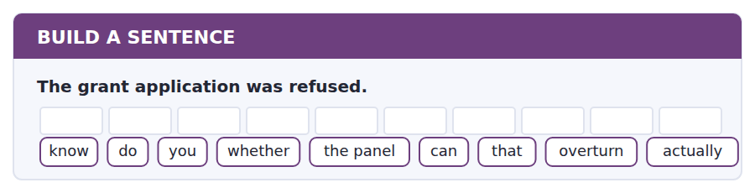
1. Do you know whether the panel can actually overturn that?
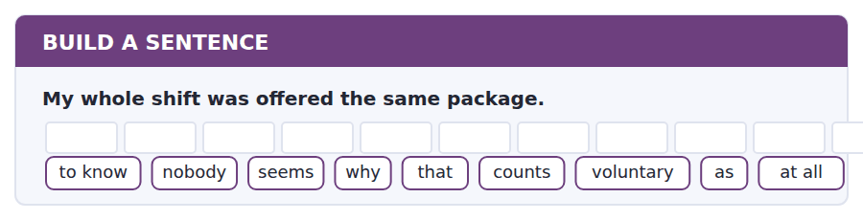
2. Nobody seems to know why that counts as voluntary at all.
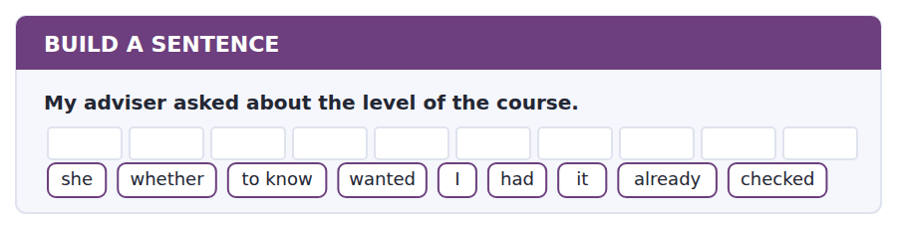
3. She wanted to know whether I had already checked it.
Exercise B Exam practice. Write the sentence.
4. Arithmetic was automated before manual work.
do / whether / know / you / anybody / that / predicted / order / at all
__________________________________________________________
5. The Level 4 course would not be funded.
explain / can / anybody / why / the level / to me / the content / than / matters more
__________________________________________________________
6. Firms stopped lasting as long as careers.
know / does / anybody / when / that / change / began / actually / happening
__________________________________________________________
7. The panel meets in May.
us / told / nobody / how / long / a decision / normally / takes / afterwards
__________________________________________________________
8. Pensions assume continuous employment.
told / he / me / which / institutions / had / that / built / assumption in
__________________________________________________________
9. Machines did not take the physical work first.
were / machines / going / to / take / the physical / work / and / did not
__________________________________________________________
10. Refusing the package would have cost him money.
would / he / have / been / made / redundant / three weeks / anyway / later
__________________________________________________________


You read a short situation and write an email. You have 7 minutes. The three bullet points are the mark scheme: answer all three.
The Skills Fund has refused your application because you accepted enhanced severance, while saying the result is wrong in your case and that the panel can disapply the rule. You are writing the formal request for the May panel. You also need to change your course choice from Level 4 to Level 5.
Write an email to the Skills Fund.
- Make the request formally and give the facts the panel needs.
- Show that your case falls outside what the rule was aimed at.
- Deal with the course change in the same email.
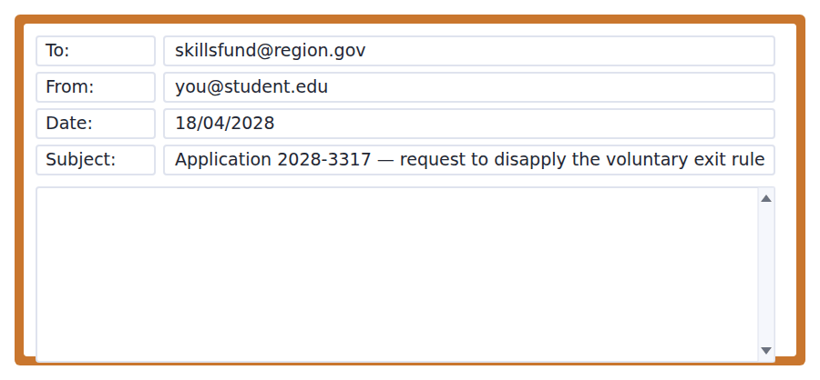
SKILL · Writing for a decision-making body
- A panel reads dozens of these. Put the facts it needs in the order it needs them, early.
- Dates and documents, not feelings. The panel cannot act on how unfair something was.
- Handle every outstanding matter in one email. A second email arrives after the agenda closes.

Model email
Dear Mr Mbeki,

Thank you for putting the case on the May agenda. This is the formal request, with the facts in the order the panel will want them.

My role was withdrawn on 2 February 2028 and has not been filled. The enhanced package was offered on 5 February to all eleven people on the shift, with a reply required within four working days. The redundancy notices for those who declined took effect on 28 February. I have attached the shift-wide offer letter, the notice schedule and the confirmation that the role was not readvertised.

On the rule itself: it is aimed at a person leaving a secure post in order to obtain funded study. My post was not secure, the alternative to accepting was redundancy three weeks later on worse terms, and I applied for study only after the shift closed. None of the three features the rule targets is present.

Separately, please change my course choice to the Level 5 Advanced Technician route, which is one term longer. I hold a Level 4 certificate, so the Level 4 course I originally listed would not have been fundable in any event, and I would rather correct that now than have the panel refuse on two grounds.

I am happy to attend if that is useful.

With thanks,
Lennart Haverkamp
Why it works
- The facts arrive as dates and documents, in the order a panel needs them, with nothing to look up.
- The rule is restated as three features, and each is then shown to be absent — which is an argument rather than a complaint.
- The course change is handled in the same email, before the agenda closes.
- The writer corrects his own error openly, which costs nothing and makes the rest more credible.
Two answers, one band apart
Both answer the three bullet points. One would score in the middle band and one near the top. Read them side by side before you write your own.
A middle-band answer | A top-band answer
Dear Mr Mbeki,  Thank you so much for your email and for agreeing to take my case to the panel in May. I am very grateful for your help and for your understanding of my situation.  As you said yourself, I did not really leave my job voluntarily. The whole shift was offered the package and I would have lost my job anyway very soon afterwards, with less money. I hope the panel will see that this is not what the rule was meant for, because it feels very unfair to be treated as if I had resigned.  I would also like to change my course to the Level 5 one that you mentioned, since you said the Level 4 one would not be funded. Please let me know if you need anything else from me and I will send it straight away.  Thank you again for everything. Best wishes, Lennart Haverkamp | Dear Mr Mbeki,  Thank you for putting the case on the May agenda. This is the formal request, with the facts in the order the panel will want them.  My role was withdrawn on 2 February and has not been filled. The enhanced package went to all eleven people on the shift on 5 February, with four working days to reply. Notices for those who declined took effect on 28 February. I attach the offer letter, the notice schedule and confirmation that the role was not readvertised.  On the rule: it is aimed at somebody leaving a secure post to obtain funded study. My post was not secure, the alternative was redundancy three weeks later on worse terms, and I applied only after the shift closed. None of the three features is present.  Please also change my course to the Level 5 route. I hold a Level 4 certificate, so my original choice was never fundable and I would rather correct that than be refused on two grounds. Lennart Haverkamp

What the top answer does that the other does not
- It gives dates, numbers and named attachments, so the panel can verify every claim without asking.
- It decomposes the rule into three features and shows each to be absent, turning a sense of unfairness into an argument.
- It drops the appeal to feeling entirely, because a panel cannot act on how something felt.
- It volunteers its own error about the course level rather than leaving the reader to raise it a second time.
- It closes the whole matter in one email, which is what keeps it inside the agenda deadline.
Now write your own. 7 minutes.
__________________________________________________________
__________________________________________________________
__________________________________________________________
__________________________________________________________
__________________________________________________________
__________________________________________________________
__________________________________________________________
__________________________________________________________


A professor asks a question and two students answer. You add your own post. You have 10 minutes and an effective answer is at least 100 words.
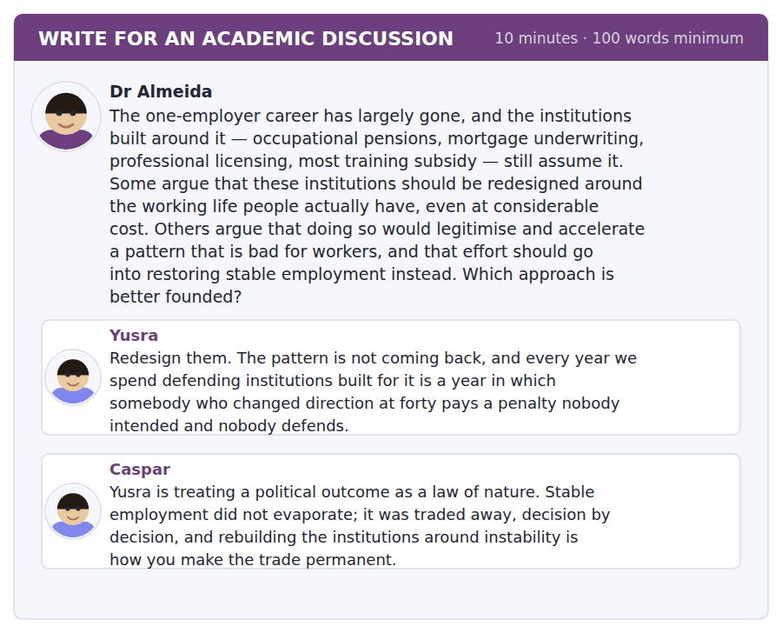
SKILL · Answering an argument about legitimisation
- The claim that fixing a harm legitimises its cause is serious and often unfalsifiable. Test it against a case.
- Ask whether the remedy and the restoration actually compete for the same resource.
- Then say what evidence would settle it.

Sentence starters
- Caspar’s objection is the serious one and it needs a test.
- Yusra is right that…, though her framing concedes…
- Whether these two compete depends on…
- What would settle it is…
Model post
Caspar’s objection is the serious one and it needs a test, because as stated it can absorb any evidence. The claim is that repairing a harm legitimises whatever produced it. Sometimes that is true, and the way to tell is to ask whether the repair and the restoration draw on the same resource. Portable pensions and licensing that survives a career change are administrative work done by regulators and actuaries. Restoring stable employment is a bargaining question between employers, workers and the state. These are not the same people, the same budgets or even the same decade, so the trade-off he describes has to be argued for rather than assumed.
Yusra is right that the penalty is real and undefended, and her framing concedes more than it needs to. Saying the pattern is not coming back invites exactly Caspar’s reply. The stronger version is narrower: whatever happens to employment stability over the next thirty years, the people who changed direction in the last ten are being fined now, and nothing in a restoration programme reaches them.
What would settle it is whether portability has in practice preceded further casualisation. That is answerable: several countries made pensions portable decades ago, and if legitimisation works the way Caspar says, their employment tenure should have fallen faster afterwards than in comparable countries that did not. I do not know the answer, and neither post has looked.
So I would do the administrative repair now and treat the bargaining question as a separate argument with separate opponents. Refusing to reduce an undefended penalty, in order to preserve the political salience of a harm, asks the people currently paying it to wait for a settlement nobody has scheduled.
[283 words]
Now write your own. 10 minutes, at least 100 words.
__________________________________________________________
__________________________________________________________
__________________________________________________________
__________________________________________________________
__________________________________________________________
__________________________________________________________
__________________________________________________________
__________________________________________________________
__________________________________________________________
__________________________________________________________

Grammar focus The future in the past
Form | What it says
was / were going to + infinitive | an intention or expectation, usually unfulfilled
was / were supposed to + infinitive | an expectation imposed by somebody else
was / were to + infinitive | formal: arranged in advance — the talks were to begin in May
was / were due to + infinitive | scheduled: the notice was due to take effect in March
would + infinitive | a future seen from a past viewpoint, in narrative
would have + past participle | what would have happened under a different condition
was on the point of + -ing | about to happen, very close

Was going to and was supposed to both normally imply that the thing did not happen. If it did happen, English prefers the simple past: the notice took effect in March.
Was to have + past participle makes the non-fulfilment explicit: the talks were to have begun in May. Without have, the sentence is neutral about whether they did.
Would is the narrative future in the past and does not imply failure: he joined the firm at sixteen and would stay for forty years. Students often avoid this would, which makes their narrative writing flat.
Watch out! Do not write "I would have been made redundant anyway, so I was forced to accept" and then use was going to in the same sentence for the same event. Pick the frame — a counterfactual or an unfulfilled expectation — and stay in it.
Exercise 1 Choose was going to, was supposed to or was due to.
1. The notice ______ take effect in March.
2. Machines ______ take the physical work first.
3. I ______ receive a reply within four working days.
4. The panel ______ meet in May and was postponed.
5. We ______ be safe in the cognitive work.
6. The course ______ start in September.
Exercise 2 Correct the time frame.
1. I would be made redundant anyway, so I accepted.
2. The talks were to have begin in May.
3. He was going to stay for forty years, and he did.
4. She was on the point of to resign.
Exercise 3 Rewrite using would + infinitive as a narrative future.
1. He joined the firm at sixteen and stayed for forty years.
2. She took the Level 5 course and later ran the department.
3. The scheme opened in 2019 and funded nine thousand people.
4. The rule was written in 2011 and caught the wrong applicants for a decade.
How this is tested in Build a Sentence
Two of the ten Build a Sentence items in this unit use a future in the past. A tile reading going or supposed is followed by to and a bare infinitive; a tile reading have signals would have and a past participle.
Find the fault 5 errors, drawn from this unit and the two before
Every error below is one a B2 writer makes after learning the rule. Mark what is wrong, then check. Knowing the rule and noticing the breach are two different skills, and only the second one is tested.
The talks were to have begin in May. I would be made redundant anyway, so I accepted the package. He was going to stay for forty years, and he did. Nobody knows whether was the role readvertised. Having withdrawn the role, the package was offered to the whole shift.
# | As written | As it should be | Why
1 | were to have begin | were to have begun | Was to have is followed by a past participle, not by a bare infinitive.
2 | I would be made redundant anyway, so I accepted | I would have been made redundant anyway, so I accepted | A counterfactual about the past needs would have been rather than would be.
3 | He was going to stay for forty years, and he did | He stayed for forty years | Was going to implies the thing did not happen, so it contradicts the clause that follows it.
4 | whether was the role readvertised | whether the role was readvertised | An embedded question keeps statement order and does not invert the verb.
5 | Having withdrawn the role, the package was offered | Having withdrawn the role, the employer offered the package | The package did not withdraw anything; the participle needs the subject that acted.

Unit review and progress check Unit 33
Exercise A Vocabulary. Write the word.
1. the rate at which workers leave and are replaced
2. loss of a job because the job has gone
3. output per hour of work
4. no longer of use
5. a complete statement of what is required
6. to do with thinking
7. a payment on losing a job
8. to learn a different trade
9. to split into two extremes
10. to pay part of the cost of something
11. something a person has a right to
12. the move from one state to another
Exercise B Grammar. Complete the sentence.
1. The notice ______ due to take effect in March.
2. Machines were ______ to take the physical work first.
3. The talks were to ______ begun in May.
4. I would ______ been made redundant anyway.
5. He joined at sixteen and ______ stay for forty years.
6. She was on the point of ______ when the offer came.
7. We were ______ to be safe in the cognitive work.
8. The course was ______ to start in September.
Exercise C One timed mini-section. 6 minutes.
1. A task can be automated when
(A) it is physically easy
(B) it is poorly paid
(C) it is repetitive in appearance
(D) it can be specified completely
2. Predictions about automation got the order wrong because
(A) technology moved faster than expected
(B) difficulty was judged by how long humans take to learn a task
(C) economists ignored data
(D) firms concealed their plans
3. The one-employer career ended mainly because
(A) workers wanted variety
(B) governments withdrew support
(C) firms stopped outlasting careers and skills turned over faster
(D) wages fell
4. Which sentence is correct?
(A) The talks were to have begun in May.
(B) The talks were to have begin in May.
(C) The talks were to having begun in May.
(D) The talks were to begin have in May.
5. "On closer inspection" tells you that the writer
(A) agrees with the first impression
(B) found the first impression wrong
(C) is uncertain
(D) is quoting somebody
6. The penalty on changing career at forty is, in the passage,
(A) an economic necessity
(B) a deserved cost
(C) an artefact of institutional design
(D) a legal rule
Can you do these now?
I can… | Not yet | Yes
I can describe an expectation that was not met, without confusing the time frames. | □ | □
I can use was going to, would have, was to have and was due to accurately. | □ | □
I can explain why a confident prediction turned out wrong. | □ | □
I can argue about a policy whose costs and benefits fall on different people. | □ | □
I can follow a talk that reinterprets a familiar story. | □ | □
I can write about a trend without claiming to know where it ends. | □ | □

ADAPTIVE TIP The future in the past is the structure that separates a competent narrative from a confused one. If you can say was going to, was to have and would have in the right places, you can write about a plan that failed — which is most of history, most of policy and a large share of TOEFL discussion prompts.

Unit 34 · Materials and Engineering Design
TOEFL iBT® Preparation Course 2026 · Volume 4
CEFR B2 · Grammar: Purpose, means and instrument · Word field: tensile, ductile, tolerance
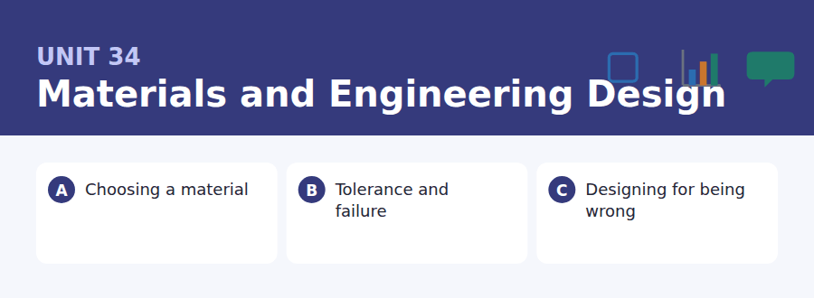
By the end of this unit I can…
- I can state what something is for without confusing purpose with result.
- I can use so as to, in order that, by means of and with a view to accurately.
- I can compare two options on several criteria at once.
- I can explain why the obvious choice is wrong for a particular job.
- I can follow a talk about a design decision and its trade-offs.
- I can write a recommendation that names what it gives up.

Engineering is the discipline of deliberate compromise, and the language it needs is the language of purpose: what is this for, how is it done, what with. This unit teaches the structures that answer those three questions and keeps them apart.

Vocabulary 1 · Academic word families 18 families, not 18 words
At B2 the word on its own is not enough. Each entry below is a family: learn the noun, the verb and the adjective together, because the test will use whichever one the sentence needs.
tensile to do with being pulled apart | yield the load at which permanent deformation begins
compressive to do with being pushed together | fracture a break in a material
ductile able to deform a long way before breaking | load the force a structure has to carry
brittle breaking suddenly with no deformation | stress force per unit area inside a material
fatigue weakening caused by repeated loading | polymer a material made of long repeating molecules
tolerance the permitted range of variation | composite two materials combined to get both sets of properties
alloy a metal mixed with another element | thermal expansion change of size with temperature
corrosion gradual chemical destruction of a surface | buckling sudden sideways collapse of a slender member under load
stiffness resistance to being bent | elasticity the ability to return to the original shape

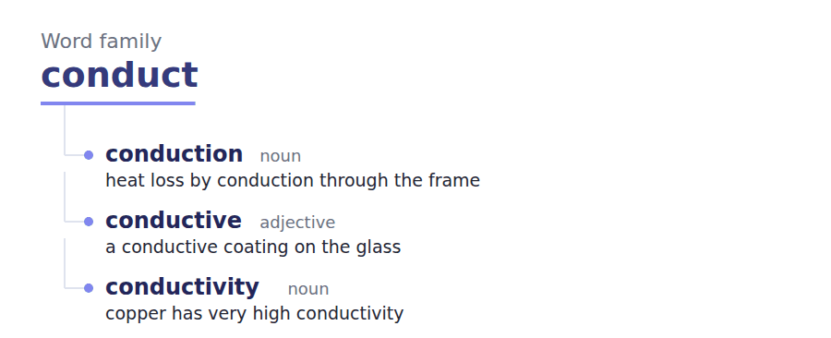
Exercise A Work in pairs. Ask and answer.
1. Name something badly designed. What was it optimised for instead?
2. Why is a material never simply better than another?
3. Describe a failure that gave warning, and one that did not.
4. Is over-engineering a virtue or a waste? Defend your answer.
Vocabulary 2 · Collocation 10 partnerships that actually occur
A word is known when you know what it goes with. These ten are the partners this unit’s texts use; the wrong partner is what marks an answer as translated.
rule out to eliminate as a possibility | at the expense of by sacrificing
allow for to leave room for in a calculation | over-engineer to build with far more capacity than needed
trade off to accept less of one thing for more of another | fit for purpose adequate for the job it has to do
give way to collapse under load | by design deliberately, not by accident
stand up to to withstand | in practice as things actually turn out

Vocabulary 3 · Stance and hedging How far the writer commits
Every one of these says the same thing at a different strength. Reading, you must notice which was chosen. Writing, you must choose.
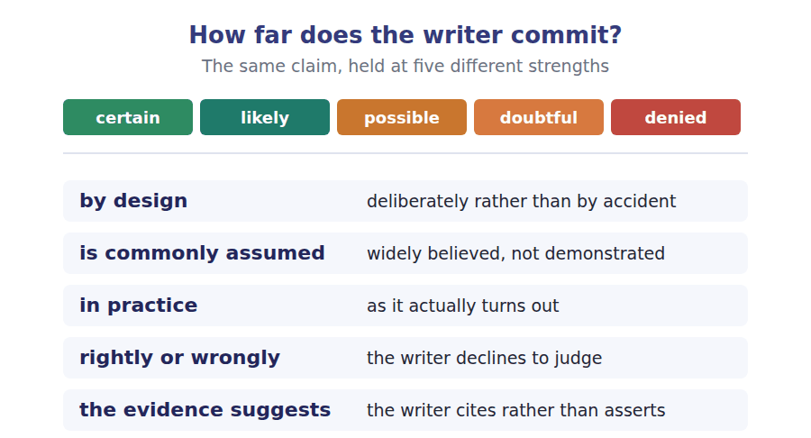
Two words that look alike
strength / stiffness what it survives / how much it bends
ductile / brittle warns before failing / does not
tolerance / accuracy permitted variation / closeness to target

Words you will meet again: beam | column | strain | safety factor | prototype | stress test | failure mode | maintenance interval


SKILL · Completing technical nouns and negative adjectives
- Engineering prose is dense with -ity and -ion nouns: quantity, property, deformation, provision.
- The -less ending marks absence: faultless, flawless. The -ible and -able endings mark possibility.
- A gap after the or a needs a noun, whatever the root looks like.

Exercise A Guided practice. Five words are not complete. Write the missing letters.
A material is chosen, not found. Steel is not simply strong; it is strong in tension, predictable in failure, and cheap enough to use in quant---, and an engineer selects it for whichever of those properties the job act----- needs. The commonest mistake a student makes is to rank materials on a single axis, as though one could be better than another in gen----. Nothing is better in general. Everything is better for some purp--- and worse for the next, and learning to say which is most of the train---.

The first one is done for you: quant--- is quantity — it follows in and names an amount, so the slot is a noun.
Exercise B Exam practice. One paragraph, ten gaps — the real task.
Failure is the subject engineering is organised around, and students arrive expecting it to be about avoiding breakage. It is not. A structure that cannot fail at any load is either impossib-- or absurdly expensive, so the real design question is how a thing fails and whether anybody is warned before----. A steel beam loaded beyond its limit bends visibly for a long time before it gives way, which is why it is spec----- in buildings people occupy. A ceramic of the same strength shatters without any prior deform----- at all, and the absence of warning is the proper-- that rules it out, not any deficiency in strength. This way of thinking generalises far beyond mater----. A system designed so that its faults appear early and conspicuously is safer than one designed to be fault----, because the second design is a claim about the future and the first is a provi---- for being wrong about it. Engineers learned this through a century of collapses and the lesson is still resisted by almost everybody who commis----- a building, because a structure advertised as incapable of failing is easier to sell than one adver----- as failing politely.

Check your answers in the key at the back of the book.


SKILL · Reading a specification against a substitution request
- A specification states required properties. A substitution asks to meet them another way.
- Check each required property separately. A substitute can pass four tests and fail the fifth.
- The decisive property is often the one that is not about strength.

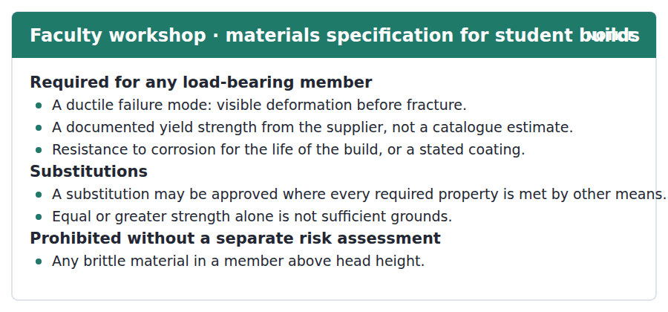
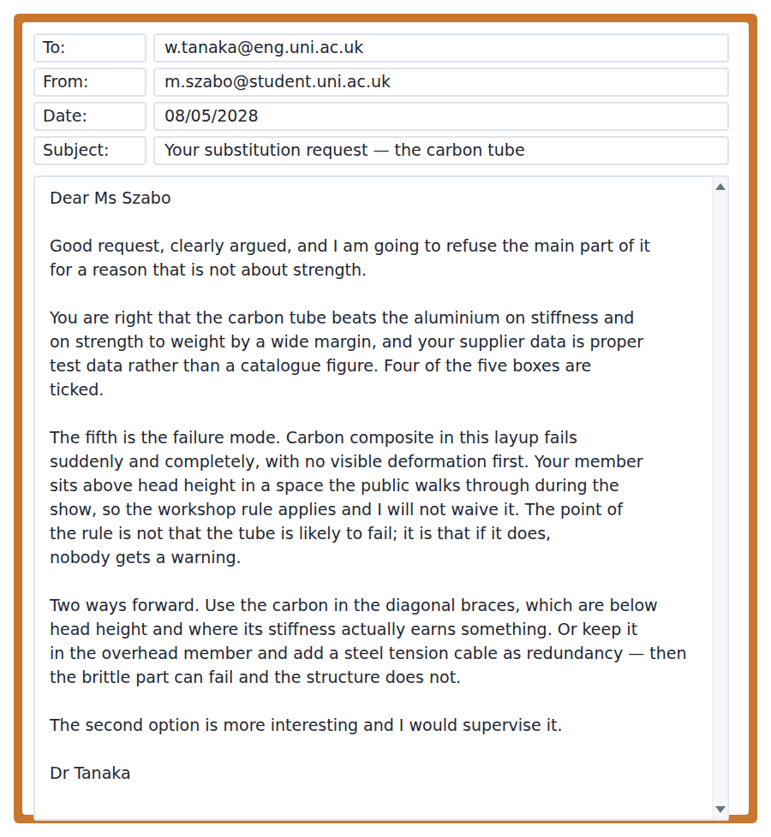
Exercise A Guided practice. The answer is on the page — find it.
1. What failure mode is required for a load-bearing member?
(A) Any
(B) A brittle one
(C) A ductile one, with visible deformation before fracture
(D) None is specified
2. What kind of yield strength figure is acceptable?
(A) Documented supplier test data
(B) A catalogue estimate
(C) A calculated value
(D) Any published figure
3. On what grounds may a substitution be approved?
(A) Greater strength
(B) Lower cost
(C) Supervisor approval alone
(D) Every required property being met by other means
4. What is prohibited without a separate risk assessment?
(A) Any substitution
(B) A brittle material above head height
(C) Composite materials
(D) Uncoated steel
Exercise B Exam practice.
5. Why is the request refused?
(A) The failure mode gives no warning
(B) The strength is inadequate
(C) The data is unreliable
(D) The cost is too high
6. What does the supervisor concede about the carbon tube?
(A) Nothing
(B) It is cheaper
(C) It is easier to work
(D) It beats the aluminium on stiffness and strength to weight
7. What does he say the point of the rule is?
(A) That the tube will probably fail
(B) That composites are untested
(C) That nobody would be warned if it did
(D) That the public dislikes them
8. Why does the location matter?
(A) It is hard to reach
(B) It is above head height in a public space
(C) It is exposed to weather
(D) It carries the heaviest load
9. What is the first alternative offered?
(A) A thicker tube
(B) Using the carbon in the diagonal braces
(C) A different composite
(D) Dropping the member
10. How does the second alternative solve the problem?
(A) By strengthening the tube
(B) By lowering the member
(C) By adding a coating
(D) A steel cable means the brittle part can fail without the structure failing
11. What does the supervisor’s closing line tell you?
(A) He prefers the simpler option
(B) He doubts the project
(C) He favours the redundancy solution and will support it
(D) He wants a risk assessment


SKILL · Reading a passage that reframes a goal
- The move is to show that the obvious objective is the wrong one, then supply a better one.
- Look for the sentence that converts a question of probability into a question of consequence.
- The last paragraph often explains why the better idea is not adopted, and the reason is usually not technical.

Designing So That Mistakes Are Visible
It is commonly assumed that the best engineering is the engineering that does not fail, and the profession has spent a century learning why this is the wrong target. Nothing can be made incapable of failure at any load, and a design that claims to be is making a prediction about conditions nobody has seen. The more useful question is what happens at the moment the prediction turns out to be wrong, and the answer is a property of the design rather than an accident.
Two systems with the same probability of failure can therefore be very differently safe. A steel beam deflects conspicuously for a long time before it yields, and the deflection is a message to anybody in the building. A brittle member of equal strength sends no message at all. By design, good structures distribute the consequence of a wrong assumption: a redundant load path means the failing part can fail without the structure doing so, which converts a collapse into a repair.
The evidence suggests this way of thinking transfers well beyond structures, and that it transfers badly in one specific respect. Software, aviation procedure and clinical protocol all now build in visible failure and spare capacity. What does not transfer is the willingness to pay for it, because the cost of graceful failure is visible and the benefit is a collapse that did not happen. Rightly or wrongly, the person authorising the expenditure is rarely the person who would have been standing underneath, and in practice that asymmetry does more to shape what gets built than any disagreement about engineering.
[265 words]

Exercise A Guided practice.
1. What does the author say is the wrong target?
(A) Engineering that does not fail
(B) Low cost
(C) Rapid construction
(D) Maximum strength
2. What is a design that claims never to fail actually doing?
(A) Making a prediction about unseen conditions
(B) Meeting the specification
(C) Wasting material
(D) Following regulation
3. Why can two systems with equal failure probability differ in safety?
(A) One is cheaper
(B) They differ in what happens when failure occurs
(C) One is newer
(D) One is better maintained
4. What does a redundant load path achieve?
(A) Greater strength
(B) Lower cost
(C) Faster construction
(D) The failing part can fail without the structure failing
Exercise B Exam practice.
5. What does the author say the deflection of a steel beam is?
(A) A defect
(B) A sign of poor material
(C) A message to anybody in the building
(D) A calculation error
6. Which fields does the author say have adopted this thinking?
(A) Software, aviation procedure and clinical protocol
(B) Only structural engineering
(C) Architecture and law
(D) None of them
7. What does the author say does not transfer?
(A) The engineering itself
(B) The willingness to pay for it
(C) The terminology
(D) The regulation
8. Why is graceful failure hard to fund?
(A) It is technically difficult
(B) It is rarely effective
(C) Its cost is visible and its benefit is invisible
(D) Regulators forbid it
9. What asymmetry does the author identify?
(A) Between materials
(B) Between disciplines
(C) Between regulators and builders
(D) Between the person paying and the person at risk
10. What does "rightly or wrongly" signal here?
(A) The author declines to judge the asymmetry
(B) The author approves
(C) The author is uncertain of the facts
(D) The author is quoting
11. Which would most strengthen the final paragraph?
(A) Evidence that composites are improving
(B) Evidence that projects with the decision-maker exposed to the risk specify more redundancy
(C) Evidence that collapses are rare
(D) Evidence that regulation has tightened
12. All of the following are stated EXCEPT:
(A) Nothing can be made incapable of failure
(B) Redundancy converts a collapse into a repair
(C) The cost of graceful failure is usually small
(D) Several other fields have adopted this thinking
13. What is the structure of the passage as a whole?
(A) A history of failures
(B) A comparison of materials
(C) An argument for regulation
(D) A reframing, its mechanism, and why it is not funded


Exercise A Listen and choose a response. You hear one line. Choose the best reply.
1. Man: Is aluminium not weaker than steel?
(A) Yes, much weaker.
(B) Per kilogram it is not, which is the point.
(C) About three millimetres.
(D) In the workshop.
2. Woman: Why not just use the strongest thing available?
(A) Yes, we should.
(B) About two hundred megapascals.
(C) From the supplier.
(D) Because strength is rarely what decides.
3. Man: Does the tube have test data?
(A) Proper test data, not a catalogue figure.
(B) Yes, it is strong.
(C) About six metres.
(D) Last Tuesday.
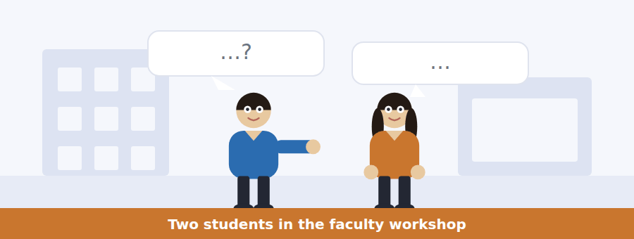
SKILL · Hearing a choice justified on several criteria
- When a speaker chooses between options, they will name the criteria and say which one decides.
- The deciding criterion is the examinable part, not the list.
- Listen for: it wins on, it loses on, and the one that matters here is.

Exercise B Listen and answer. The audio plays once.
4. What does the man question in her first statement?
(A) Her measurements
(B) Her supplier
(C) Whether her list of criteria is complete
(D) Her calculation
5. On how many criteria does the carbon tube win?
(A) Three
(B) Five
(C) All of them
(D) Four
6. What is the fifth criterion?
(A) The failure mode
(B) Cost
(C) Corrosion
(D) Availability
7. Why does the man say the other four are decoration?
(A) They were measured badly
(B) They are irrelevant generally
(C) The fifth criterion decides this case
(D) The supplier data is weak
8. What does the location contribute to the decision?
(A) Nothing
(B) Above head height over a public walkway makes the warning essential
(C) It affects the load
(D) It affects corrosion
9. What does the cable solution achieve?
(A) It strengthens the tube
(B) It lets the tube fail without the structure dropping
(C) It reduces the load
(D) It replaces the tube
10. Why does the man think the supervisor will prefer it?
(A) It answers the actual question
(B) It is cheaper
(C) It uses less material
(D) It is quicker to build
Audio script: see the back of the book. Do not read it before you listen.


Exercise A Listen and choose a response. You hear one line. Choose the best reply.
1. Woman: Why must failure be ductile?
(A) Because it is stronger.
(B) About five millimetres.
(C) So that somebody gets a warning.
(D) In every member.
2. Man: Is greater strength enough for a substitution?
(A) Yes, always.
(B) About twice as strong.
(C) Ask the workshop.
(D) No — every property has to be met.
3. Woman: What if I have already bought the material?
(A) Then it is approved.
(B) About forty pounds.
(C) Last week.
(D) Then you have bought it and we still say no.
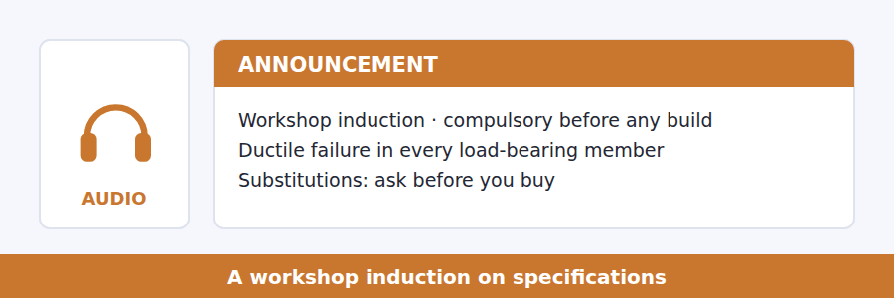
SKILL · Hearing a rule explained by its purpose
- A good induction gives the reason, not just the rule. The reason is what the items test.
- Listen for: the rule exists because, what we are actually protecting against.
- A rule with a stated purpose can be argued with. That is deliberate.

Exercise B Listen and answer. The audio plays once.
4. Why does he give the reason for each rule?
(A) Because an understood rule is applied when nobody is watching
(B) To fill time
(C) Because the rules are optional
(D) Because students complain
5. What does ductile failure mean?
(A) It fails at a higher load
(B) It deforms visibly for a long time before breaking
(C) It does not fail
(D) It fails quietly
6. Why can a stronger brittle tube be refused?
(A) It is more expensive
(B) It cannot be tested
(C) It gives no warning when overloaded
(D) It corrodes
7. What is wrong with a catalogue figure?
(A) It is usually too low
(B) It is out of date
(C) It is a typical value for a family, not this piece
(D) It cannot be verified
8. What does he say about material already bought?
(A) It will be approved
(B) It needs a risk assessment
(C) It can be returned
(D) It changes nothing
9. What is his closing advice?
(A) Read the specification
(B) Ask first, because the conversation is short and free
(C) Buy from approved suppliers
(D) Keep receipts
Audio script: see the back of the book. Do not read it before you listen.


Exercise A Listen and choose a response. You hear one line. Choose the best reply.
1. Man: Should a bridge be designed never to fail?
(A) Nothing can be, so that is the wrong target.
(B) Yes, obviously.
(C) About a century.
(D) By the engineers.
2. Woman: What does redundancy actually buy you?
(A) Yes, it helps.
(B) About ten per cent more cost.
(C) A repair instead of a collapse.
(D) In the load path.
3. Man: Why is graceful failure hard to fund?
(A) Because it is expensive.
(B) About fifteen per cent.
(C) From the client.
(D) The cost shows and the benefit never does.
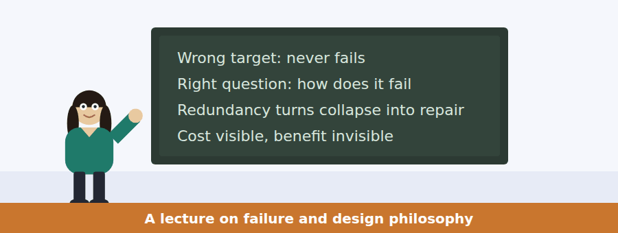
SKILL · Following a talk that names a non-technical obstacle
- Many engineering lectures end on an economic or institutional problem rather than a technical one.
- Listen for the switch: the engineering here is settled, and what is not settled is who pays.
- The final item will usually be about that obstacle.

Exercise B Listen and answer. The audio plays once.
4. What assumption does she set out to unsettle?
(A) That the best engineering never fails
(B) That engineering is expensive
(C) That materials matter most
(D) That regulation works
5. What is a design that claims never to fail doing?
(A) Meeting the code
(B) Predicting conditions nobody has observed
(C) Wasting material
(D) Following tradition
6. What does she say about the sag of a steel beam?
(A) It is a defect
(B) It is unavoidable
(C) It is a message
(D) It is a sign of overload only
7. What does a redundant load path permit?
(A) A stronger structure
(B) The failing component to fail without a collapse
(C) A cheaper build
(D) A longer life
8. What has not travelled to other fields with the idea?
(A) The willingness to pay for it
(B) The terminology
(C) The regulation
(D) The evidence
9. Why can the benefit not be shown?
(A) It is too small
(B) It is disputed
(C) It arrives too late
(D) It is a collapse that did not occur
10. What does she say shapes the built environment most?
(A) Material science
(B) Regulation
(C) Client taste
(D) The gap between who pays and who is at risk
Audio script: see the back of the book. Do not read it before you listen.


Part 1 · Listen and Repeat
You hear a sentence and repeat it once. There is no preparation time, and the sentences get longer. Focus: stating what something is for
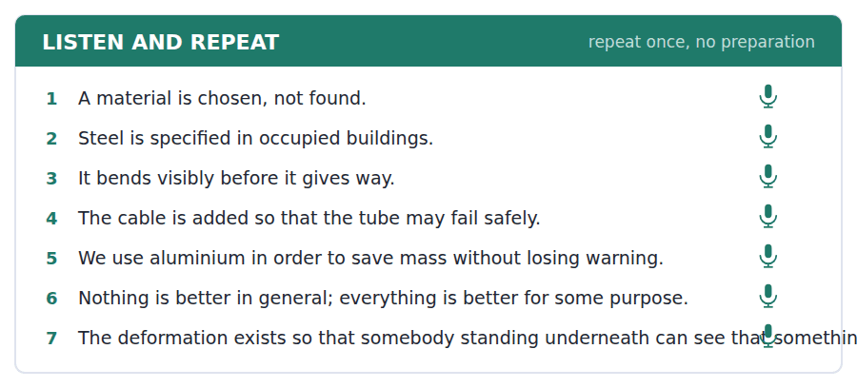
SKILL · Saying purpose out loud
- So as to and in order to state purpose; so that states purpose with a new subject.
- Do not use for plus -ing to state the purpose of an action: use it for the function of a thing.
- Stress the purpose clause. It is the reason the sentence exists.

Part 2 · Take an Interview
An interviewer asks you four questions on one theme: design, choices and trade-offs. Answer each one fully. There is no preparation time.
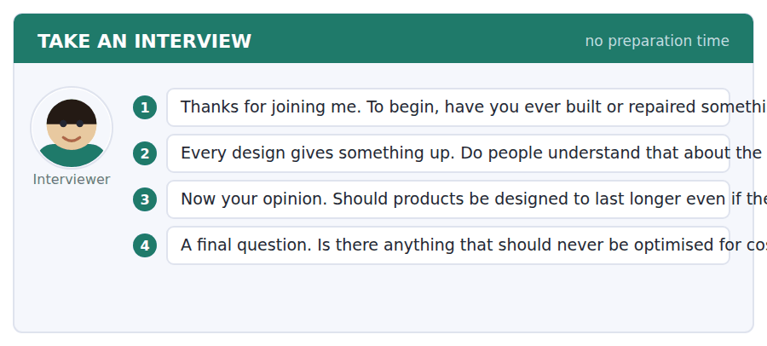
A good answer sounds like this
Question 2 — Not really, because the thing given up is usually invisible. Nobody sees the repairability that was traded for thinness.
Question 4 — Anything where the person bearing the risk did not choose the product. A ladder I buy is my problem; a handrail in a station is not.
I can… | Not yet | Yes
I used so as to and in order to correctly. | □ | □
I stressed the purpose clause. | □ | □
I did not use for plus -ing for a purpose. | □ | □


Part 1 · Listen and Repeat
You hear a sentence and repeat it once. There is no preparation time, and the sentences get longer. Focus: explaining a rule by its purpose
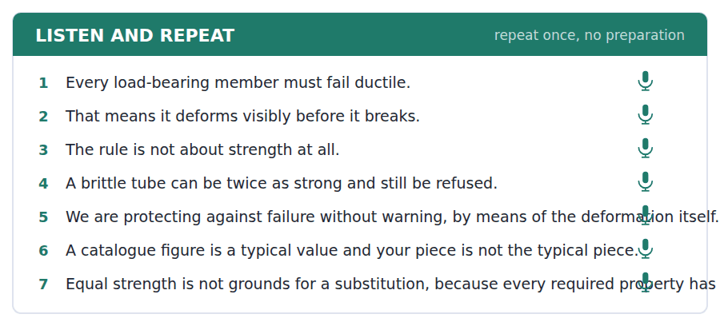
SKILL · Giving a reason rather than an instruction
- A rule stated with its purpose is easier to say and harder to argue with.
- The pattern is: the rule is X, and the reason is Y, which is why Z does not count.
- Keep the reason in one clause. A long reason sounds like an excuse.

Part 2 · Take an Interview
An interviewer asks you four questions on one theme: rules, reasons and sunk costs. Answer each one fully. There is no preparation time.
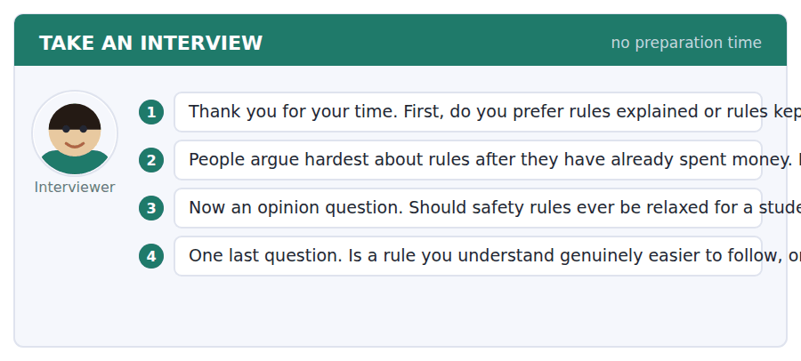
A good answer sounds like this
Question 2 — By refusing anyway and saying so in advance. The moment sunk cost buys an exception, everybody buys first and asks afterwards.
Question 4 — It is genuinely easier, but not for the reason people give. You do not follow it more faithfully; you apply it correctly in the case nobody wrote down.
I can… | Not yet | Yes
I gave the purpose in one clause. | □ | □
I kept the reason short. | □ | □
I used by means of or so that accurately. | □ | □


Part 1 · Listen and Repeat
You hear a sentence and repeat it once. There is no preparation time, and the sentences get longer. Focus: naming a non-technical obstacle
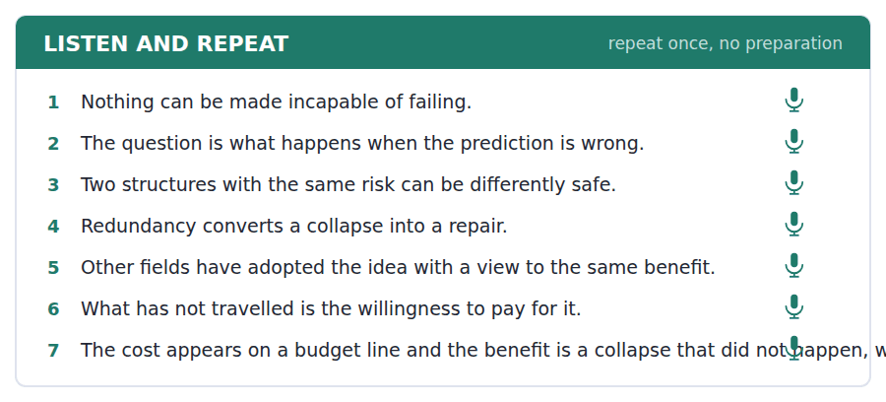
SKILL · Saying that the problem is not the thing it looks like
- Signal the switch clearly: the engineering here is settled, and the problem is elsewhere.
- Describe the obstacle as a structure, not as a villain.
- End on what would have to change, not on blame.

Part 2 · Take an Interview
An interviewer asks you four questions on one theme: risk, cost and who decides. Answer each one fully. There is no preparation time.
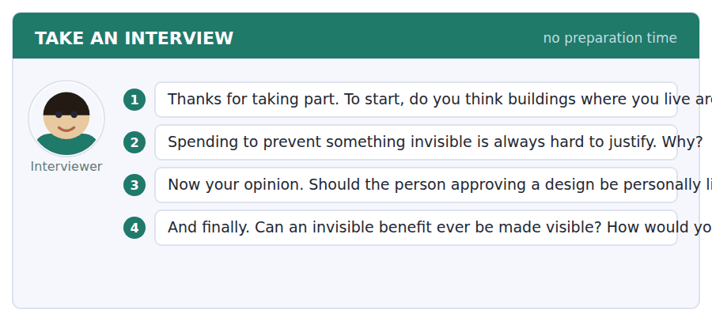
A good answer sounds like this
Question 2 — Because success looks identical to never having had the problem. The budget line is the only evidence that anything happened.
Question 4 — You can make the near-misses public. Aviation did exactly that, and it is the only field where the invisible benefit has a paper trail.
I can… | Not yet | Yes
I signalled the switch away from the technical question. | □ | □
I described the obstacle as a structure. | □ | □
I ended on what would have to change. | □ | □


You see a sentence, then a set of words in boxes. Put the words in order to make one grammatical sentence. Almost every item in the real test makes a question or a question inside another sentence.
SKILL · Build a Sentence with a purpose clause
- The two non-question items in this unit build purpose or means: so as to, in order that, by means of.
- So as to and in order to take a bare infinitive; so that takes a clause with its own subject.
- By means of is followed by a noun phrase and never by a verb.

Exercise A Guided practice. The first three are worked through.
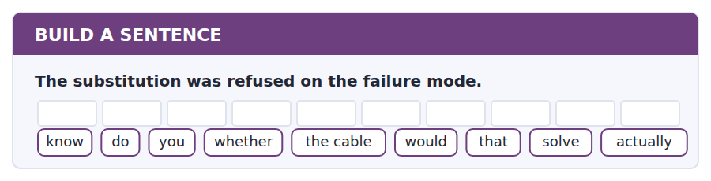
1. Do you know whether the cable would actually solve that?
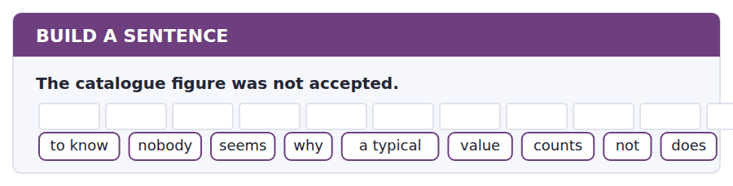
2. Nobody seems to know why a typical value does not count.
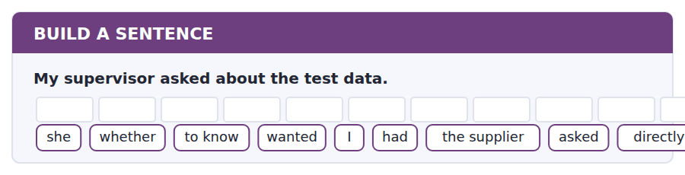
3. She wanted to know whether I had asked the supplier directly.
Exercise B Exam practice. Write the sentence.
4. Brittle members are prohibited above head height.
do / whether / know / you / that / applies / the braces / to / as well
__________________________________________________________
5. The benefit of redundancy cannot be demonstrated.
explain / can / anybody / why / a prevented / collapse / to me / count / does not
__________________________________________________________
6. The workshop refuses material that has already been bought.
know / does / anybody / how / often / that / happens / actually / here
__________________________________________________________
7. Aviation publishes its near-misses.
us / told / nobody / which / other / fields / that / do / routinely
__________________________________________________________
8. The cable catches the load if the tube fails.
told / he / me / what / the structure / would / do / that case / in
__________________________________________________________
9. The beam is allowed to deform before it yields.
so as to / the beam / deforms / visibly / give / everybody / underneath / a / warning
__________________________________________________________
10. A redundant path takes the load when a part fails.
by means of / a redundant / path / a collapse / is / converted / into / a / repair
__________________________________________________________


You read a short situation and write an email. You have 7 minutes. The three bullet points are the mark scheme: answer all three.
Your substitution was refused because the carbon tube fails without warning in a member above head height. Your supervisor offered two routes and said he would supervise the second. You have designed it: carbon tube plus a steel tension cable. You need workshop approval and you have one problem — the cable anchors need a bolt pattern the workshop does not stock.
Write an email to the workshop.
- Describe the revised design and what it does about the original objection.
- State the one thing you still need, precisely.
- Say what you will do if it cannot be supplied.
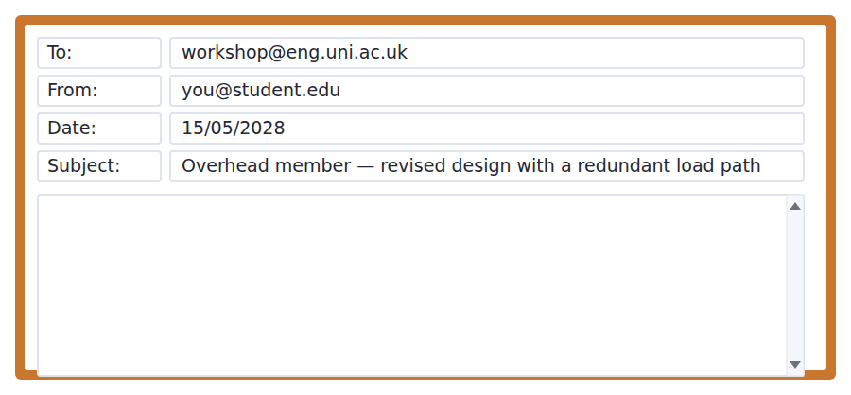
SKILL · Submitting a revision
- Name the objection and answer it in the first paragraph. Do not make the reader reconstruct the history.
- Separate what is decided from what you are asking for. Mixing them makes both look provisional.
- A fallback that is slightly worse and clearly workable gets approved faster than a perfect design with a dependency.

Model email
Dear Workshop,

This is the revised overhead member, with Dr Tanaka supervising. The original objection was the failure mode: the carbon tube fails suddenly and the member sits above head height over the public walkway. The revision keeps the tube and adds a steel tension cable along the full span, sized to carry the whole design load on its own.

So the failure sequence is now: the tube fails, the cable takes the load, the member deflects by about sixty millimetres and stays up. The deflection is visible from the floor and the walkway can be closed. That converts the member from brittle to a system that fails with warning, by means of the cable rather than by changing the tube.

One thing I need. The cable anchors take an M12 four-bolt pattern at 60 millimetre centres, which the workshop does not stock. The drawing is attached with the pattern dimensioned.

If that cannot be supplied in time, I will move to the aluminium member and put the carbon in the diagonal braces, which was Dr Tanaka’s first suggestion. That loses about a third of the stiffness and it is a design I can build with stock parts, so the show is not at risk either way.

With thanks,
Márta Szabó
Why it works
- The objection is named and answered in the first paragraph, so the reader needs no history.
- The failure sequence is given step by step with a number attached, which is what makes the claim checkable.
- The single outstanding need is stated with the exact specification and an attached drawing.
- The fallback is named, costed in one clause, and buildable from stock, which removes the schedule risk from the reader’s decision.
Two answers, one band apart
Both answer the three bullet points. One would score in the middle band and one near the top. Read them side by side before you write your own.
A middle-band answer | A top-band answer
Dear Workshop,  I am writing about my overhead member, which was refused last week because of the failure mode of the carbon tube. I have now revised the design as Dr Tanaka suggested and I hope it will be acceptable.  The new design uses the carbon tube together with a steel cable, so that if the tube fails the cable will hold the load and the structure will not come down. This should deal with the safety concern that was raised, as there will now be a clear warning if anything goes wrong.  There is one difficulty, which is that the anchors need a bolt pattern that I do not think the workshop has in stock. Could you let me know whether this would be possible? If it is a problem then I will have to think about alternatives, as I am quite short of time before the show.  Thank you very much for your help. Best wishes, Márta Szabó | Dear Workshop,  This is the revised overhead member, with Dr Tanaka supervising. The objection was the failure mode: the tube fails suddenly and the member sits above head height over the public walkway. The revision keeps the tube and adds a steel cable along the span, sized to carry the whole design load alone.  The failure sequence is now: tube fails, cable takes the load, the member deflects about sixty millimetres and stays up. The deflection is visible from the floor and the walkway can be closed.  One thing I need: the anchors take an M12 four-bolt pattern at 60 millimetre centres, which is not stock. Drawing attached, pattern dimensioned.  If it cannot be supplied in time I will move to the aluminium member and put the carbon in the diagonal braces. That loses about a third of the stiffness and builds from stock, so the show is not at risk either way. Márta Szabó

What the top answer does that the other does not
- It states the failure sequence as ordered steps with a measured deflection, so the safety claim can be checked rather than believed.
- It specifies the part exactly — M12, four bolts, 60 millimetre centres, drawing attached — instead of saying the workshop may not have it.
- It commits to a named fallback rather than saying it will think about alternatives, which removes the decision from the reader.
- It costs the fallback in one clause, a third of the stiffness, so the reader can see what is being given up.
- It closes the schedule risk explicitly, which is the thing a workshop actually worries about before a public show.
Now write your own. 7 minutes.
__________________________________________________________
__________________________________________________________
__________________________________________________________
__________________________________________________________
__________________________________________________________
__________________________________________________________
__________________________________________________________
__________________________________________________________


A professor asks a question and two students answer. You add your own post. You have 10 minutes and an effective answer is at least 100 words.
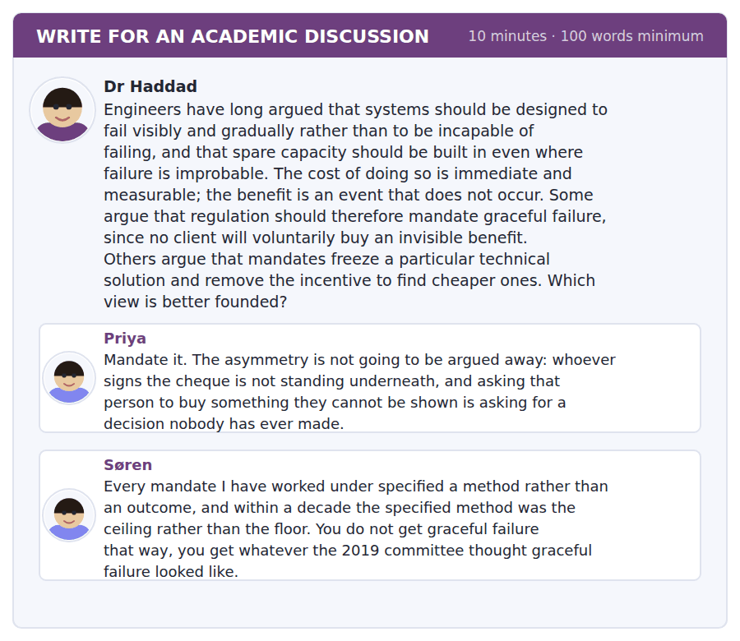
SKILL · Answering an argument about regulatory form
- When one side wants a mandate and the other fears it, the disagreement is usually about the form of the rule rather than its existence.
- Distinguish a rule that specifies a method from one that specifies an outcome and who must demonstrate it.
- Then say which failure mode you would rather have.

Sentence starters
- Søren is describing a specific kind of mandate, not mandates as such.
- Priya is right about the asymmetry, and her remedy does not follow from it.
- The distinction that resolves this is…
- Which leaves one real question…
Model post
Søren is describing a specific kind of mandate, not mandates as such, and the distinction does most of the work here. A rule that says use a steel tension cable does become a ceiling, exactly as he says, and the mechanism is well documented across several industries. A rule that says demonstrate, before approval, what your structure does at one and a half times the design load, and publish it, specifies no method at all. It makes the behaviour the requirement and leaves the means open, which is the form Priya needs and the form Søren is not objecting to.
Priya is right about the asymmetry, and her remedy does not follow from it. Whoever signs is not underneath, and that is a structural fact rather than a failure of character. But the conclusion she draws is that the state must buy the benefit on everybody’s behalf, and there is a weaker intervention that exploits the same asymmetry: require the demonstration to be public. A client who cannot be shown an invisible benefit can still be shown a published number alongside a competitor’s, and that converts the thing into something a buyer will pay for.
Which leaves one real question, and neither post addresses it: who performs the demonstration. An outcome mandate with self-certification is a method mandate with extra paperwork, because the cheapest way to pass is to interpret the outcome loosely. Independent verification is what makes the difference, and it is also the expensive part nobody campaigns for.
So: an outcome requirement, published, independently verified, and silent about method. That satisfies Søren’s objection in full and Priya’s concern in substance, and it fails in the one way I would accept, which is slowly and visibly.
[287 words]
Now write your own. 10 minutes, at least 100 words.
__________________________________________________________
__________________________________________________________
__________________________________________________________
__________________________________________________________
__________________________________________________________
__________________________________________________________
__________________________________________________________
__________________________________________________________
__________________________________________________________
__________________________________________________________

Grammar focus Purpose, means and instrument
Form | What it says
in order to / so as to + infinitive | purpose, same subject: deforms so as to give warning
so that / in order that + clause | purpose, new subject: so that somebody notices
for + noun | the function of a thing: a cable for the overhead member
by + -ing | the means: by adding a cable
by means of + noun phrase | formal means: by means of a redundant path
with + noun | the instrument: tightened with a torque wrench
with a view to + -ing | a longer-term purpose: with a view to reducing mass

So as to and in order to need the same subject in both halves. If the subject changes, you need so that: the cable was added so that the tube could fail safely.
By plus -ing gives the means and never the purpose. By adding a cable answers how, not why. Students who write by adding a cable to make it safe have answered two questions with one structure and blurred both.
With a view to is followed by a gerund, not an infinitive: with a view to reducing mass. With a view to reduce mass is a common and conspicuous error.
Watch out! Do not use for plus -ing to state the purpose of an action. "He added a cable for making it safer" is wrong; for plus -ing states the function of a thing (a tool for cutting steel), while an action takes in order to or so as to.
Exercise 1 Choose so as to, so that, by or with a view to.
1. The beam deforms ______ give a warning.
2. The cable was added ______ the tube could fail safely.
3. The load is carried ______ adding a redundant path.
4. The alloy was chosen ______ reducing mass.
5. The anchors are tightened ______ a torque wrench.
6. Test data is required ______ the figure applies to this piece.
Exercise 2 Correct the purpose or means.
1. He added a cable for making it safer.
2. The alloy was chosen with a view to reduce mass.
3. By adding a cable to make the member safe, the problem was solved.
4. The beam deforms so as the occupants notice.
Exercise 3 Rewrite using by means of.
1. A collapse is converted into a repair by adding a redundant path.
2. The warning is produced by the visible deformation.
3. Mass was reduced by substituting an aluminium alloy.
4. The load is shared by using two independent members.
How this is tested in Build a Sentence
Two of the ten Build a Sentence items in this unit state purpose or means. A tile reading so as to takes a bare infinitive with the same subject; a tile reading by means of takes a noun phrase and usually opens the sentence.
Find the fault 5 errors, drawn from this unit and the two before
Every error below is one a B2 writer makes after learning the rule. Mark what is wrong, then check. Knowing the rule and noticing the breach are two different skills, and only the second one is tested.
He added a cable for making the member safer. The alloy was chosen with a view to reduce mass. The beam deforms so as the occupants notice in time. Nobody knows whether was the figure taken from a catalogue. Having failed suddenly, the walkway had to be closed.
# | As written | As it should be | Why
1 | for making the member safer | in order to make the member safer | For plus -ing gives the function of a thing, while the purpose of an action takes in order to.
2 | with a view to reduce mass | with a view to reducing mass | With a view to is followed by a gerund rather than by an infinitive.
3 | so as the occupants notice | so that the occupants notice | So as to needs the same subject in both halves, so a new subject requires so that.
4 | whether was the figure taken | whether the figure was taken | An embedded question keeps statement order and does not invert the verb.
5 | Having failed suddenly, the walkway had to be closed | Having failed suddenly, the member forced the closure of the walkway | The walkway did not fail; the participle needs the subject that performed the action.

Unit review and progress check Unit 34
Exercise A Vocabulary. Write the word.
1. to do with being pulled apart
2. able to deform a long way before breaking
3. breaking suddenly with no deformation
4. weakening caused by repeated loading
5. the permitted range of variation
6. a metal mixed with another element
7. gradual chemical destruction of a surface
8. the load at which permanent deformation begins
9. force per unit area inside a material
10. two materials combined to get both sets of properties
11. sudden sideways collapse of a slender member under load
12. resistance to being bent
Exercise B Grammar. Complete the sentence.
1. The beam deforms ______ as to give a warning.
2. The cable was added ______ that the tube could fail safely.
3. The load is carried ______ adding a redundant path.
4. The alloy was chosen with a view to ______ mass.
5. The anchors are tightened ______ a torque wrench.
6. ______ means of a redundant path, a collapse becomes a repair.
7. A tool ______ cutting steel is kept in the rack.
8. ______ order to make it safer, he added a cable.
Exercise C One timed mini-section. 6 minutes.
1. A material is ruled out for an overhead member mainly because
(A) it is not strong enough
(B) it corrodes
(C) it fails without warning
(D) it is expensive
2. A redundant load path changes
(A) the consequence of failure
(B) the probability of failure
(C) the strength of the member
(D) the cost only
3. Graceful failure is hard to fund because
(A) it is technically difficult
(B) its cost is visible and its benefit is a non-event
(C) regulators forbid it
(D) clients prefer speed
4. Which sentence is correct?
(A) The alloy was chosen with a view to reducing mass.
(B) The alloy was chosen with a view to reduce mass.
(C) The alloy was chosen with a view of reduce mass.
(D) The alloy was chosen for reduce mass.
5. "By design" tells you that something is
(A) accidental
(B) unproven
(C) deliberate
(D) regulated
6. Equal or greater strength is not grounds for a substitution because
(A) strength cannot be measured
(B) suppliers are unreliable
(C) cost matters more
(D) every required property has to be met
Can you do these now?
I can… | Not yet | Yes
I can state what something is for without confusing purpose with result. | □ | □
I can use so as to, in order that, by means of and with a view to accurately. | □ | □
I can compare two options on several criteria at once. | □ | □
I can explain why the obvious choice is wrong for a particular job. | □ | □
I can follow a talk about a design decision and its trade-offs. | □ | □
I can write a recommendation that names what it gives up. | □ | □

ADAPTIVE TIP Purpose, means and instrument are three different questions — why, how and with what — and English answers them with three different structures. Most B2 writing errors in technical subjects come from answering two of them with one phrase. Keep them apart and your explanations stop being ambiguous.

Unit 35 · Rhetoric and Persuasion
TOEFL iBT® Preparation Course 2026 · Volume 4
CEFR B2 · Grammar: Cleft sentences and fronting · Word field: rhetoric, warrant, audience
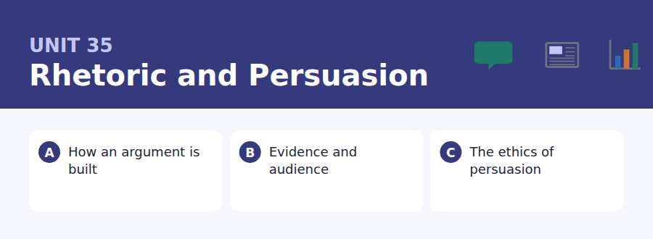
By the end of this unit I can…
- I can emphasise any part of a sentence without changing its content.
- I can use it-clefts, what-clefts and fronting accurately and sparingly.
- I can distinguish the validity of an argument from its persuasiveness.
- I can identify the unstated assumption that an argument needs.
- I can follow a talk that analyses the structure of a persuasive text.
- I can write an argument whose emphasis a reader cannot mistake.

This is the third anchor unit of the course, and the most immediately useful. Cleft sentences and fronting are how English writers put emphasis where they want it. Every high-scoring writing answer uses them; almost no B1 answer does.

Vocabulary 1 · Academic word families 18 families, not 18 words
At B2 the word on its own is not enough. Each entry below is a family: learn the noun, the verb and the adjective together, because the test will use whichever one the sentence needs.
rhetoric the study of how language persuades | connotation the associations a word carries
caveat a warning that limits what has just been said | audience the people an argument is aimed at
rebuttal an answer to an objection | credibility the degree to which a speaker is believed
concede to grant a point to the other side | overstate to claim more than the evidence allows
equivocate to use language that can be read two ways | qualifier a word that limits the strength of a claim
fallacy a form of reasoning that does not work | syllogism an argument in two premises and a conclusion
analogy an argument from similarity | assertion a claim made without support
anecdote a single story used as evidence | inference the step from evidence to conclusion
emphasis the weight given to one part of a message | persuasion bringing somebody to accept a position

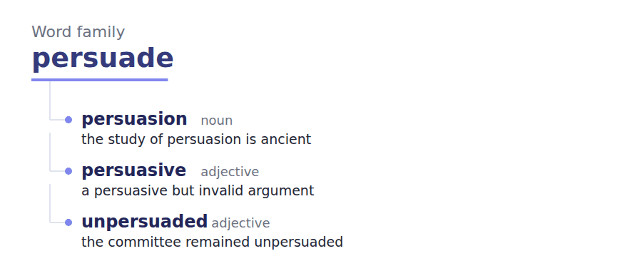
Exercise A Work in pairs. Ask and answer.
1. Describe an argument that convinced you and should not have.
2. What is the unstated assumption in "it worked for me, so it works"?
3. Is studying persuasion a way of learning to manipulate people?
4. Name a word whose connotation does more work than its meaning.
Vocabulary 2 · Collocation 10 partnerships that actually occur
A word is known when you know what it goes with. These ten are the partners this unit’s texts use; the wrong partner is what marks an answer as translated.
make a case to argue for something | beg the question to assume what you are trying to prove
carry weight to be influential | on the face of it judging by appearance alone
win over to persuade somebody who was opposed | cut both ways to support each side equally
talk past to argue without addressing the other person | stand or fall on to depend entirely on
bear the weight to be strong enough to support something | give ground to concede part of a position

Vocabulary 3 · Stance and hedging How far the writer commits
Every one of these says the same thing at a different strength. Reading, you must notice which was chosen. Writing, you must choose.
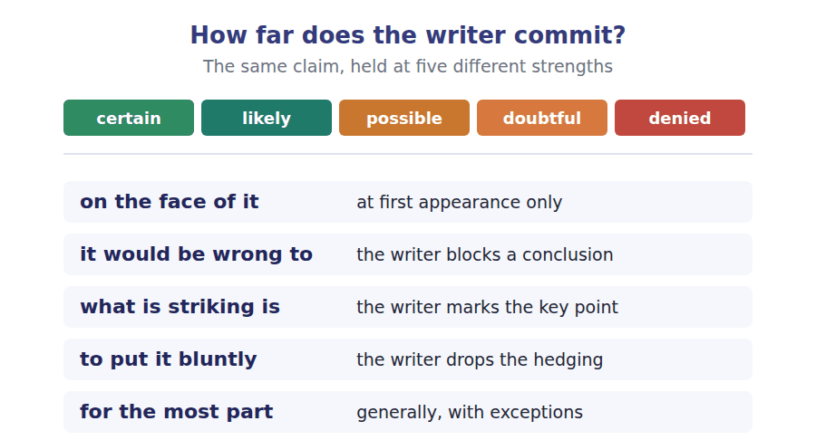
Two words that look alike
valid / persuasive the reasoning works / the audience agrees
refute / deny to disprove / merely to reject
premise / warrant a stated start / the unstated link

Words you will meet again: thesis statement | topic sentence | counterargument | hedge | signpost | straw man | burden of proof | rhetorical question


SKILL · Completing nouns and adverbs in argumentative prose
- Argument writing is built on -ment, -ion and -ity nouns: argument, concession, credibility.
- The -ly adverbs carry the writer’s attitude: quietly, separately, conspicuously.
- If the gap follows a verb and ends the clause, suspect an adverb rather than a noun.

Exercise A Guided practice. Five words are not complete. Write the missing letters.
What persuades people is almost never the strongest argument, and anybody who has watched an audience knows it. It is the ord----- that does the work: a claim placed first is judged by different standards from the same claim placed th---. It is also the concess--- — an argument that grants nothing is heard as an advertis-----, while one that gives something away is heard as an attempt at the tr---. Neither of these is a trick. They are facts about listeners, and ignoring them is not integrity but incompetence.

The first one is done for you: ord---- is ordering — it follows the and does the work, so the slot is a noun acting as a subject.
Exercise B Exam practice. One paragraph, ten gaps — the real task.
What makes an argument persuasive and what makes it sound are different questions, and treating them as one has produced two opposite kinds of fail---. The first is the writer who believes that if a case is valid it needs no presenta----, and whose correct papers are read by nob---. The second is the writer who has learned the devices and uses them on a case that will not bear the we----, which works once and then destroys the writer’s credibil--- permanently. What the rhetorical tradition actually taught was that the two questions have to be answered separ----- and in order: establish that the claim is true, then decide how a particular audience can be brought to see it. It is the second step that modern education has qui---- dropped, on the assumption that it is either unnecessary or slightly dishonest. The result is not a more honest public argu----. It is a public argument in which the only people who have studied persuasion are the ones selling something, and the people with the better case keep losing and concl----- that audiences are stupid. Never has that conclusion been less useful than it is n--.

Check your answers in the key at the back of the book.


SKILL · Reading a submission rule against a draft
- A competition or journal rule sets limits on form. A draft tests whether a particular device is inside them.
- Where a rule bans a technique, ask what it is actually protecting.
- An adjudicator who explains the purpose is telling you how to comply without obeying literally.

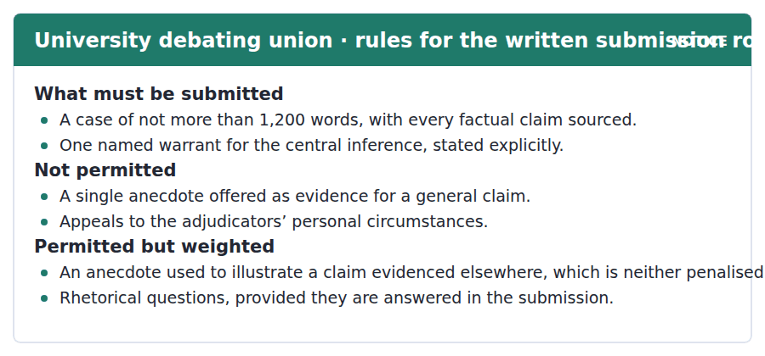
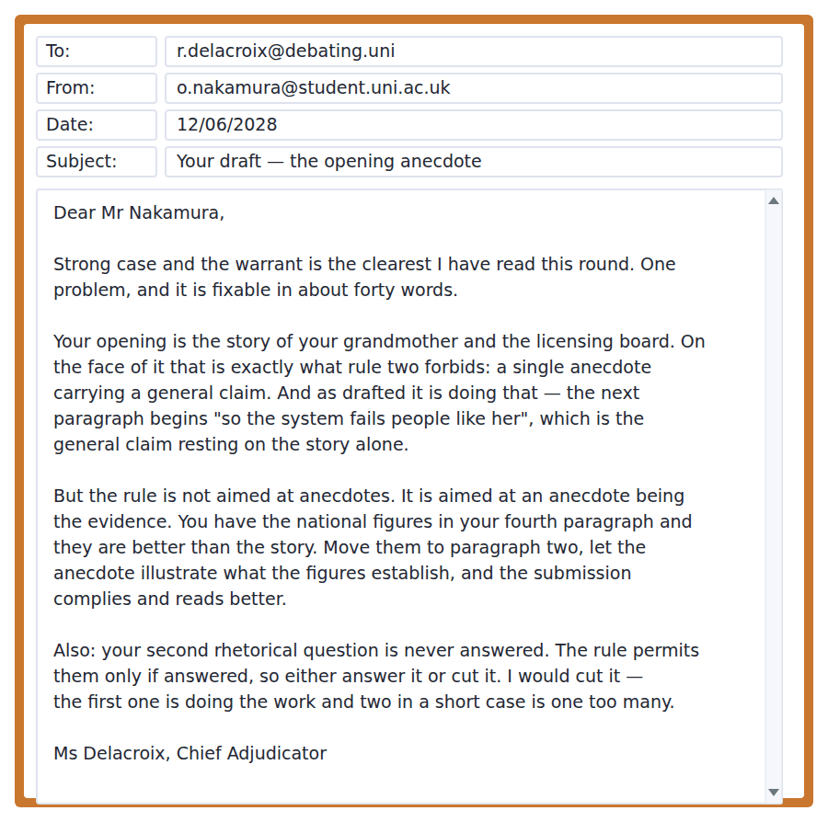
Exercise A Guided practice. The answer is on the page — find it.
1. What must be stated explicitly in a submission?
(A) One named warrant for the central inference
(B) Every source
(C) The word count
(D) The opposing case
2. What is not permitted?
(A) Any anecdote
(B) Rhetorical questions
(C) A single anecdote offered as evidence for a general claim
(D) Statistics
3. How is an illustrative anecdote treated?
(A) Penalised
(B) Neither penalised nor credited
(C) Credited
(D) Forbidden
4. When is a rhetorical question permitted?
(A) Always
(B) Never
(C) Once only
(D) If it is answered in the submission
Exercise B Exam practice.
5. What does the adjudicator praise?
(A) The clarity of the warrant
(B) The word count
(C) The opening anecdote
(D) The sources
6. Why is the opening a problem as drafted?
(A) It is too long
(B) It is unsourced
(C) It appeals to the adjudicators
(D) The following paragraph rests a general claim on the story alone
7. What does she say the rule is actually aimed at?
(A) Anecdotes
(B) An anecdote being the evidence
(C) Personal stories
(D) Weak sources
8. What is her suggested fix?
(A) Cut the anecdote
(B) Add more sources
(C) Move the national figures earlier and let the anecdote illustrate them
(D) Rewrite the warrant
9. Why does she say the figures are better than the story?
(A) They are shorter
(B) They are more recent
(C) They can carry the general claim
(D) They are easier to source
10. What is wrong with the second rhetorical question?
(A) It is unclear
(B) It repeats the first
(C) It is too long
(D) It is never answered
11. Why does she recommend cutting rather than answering it?
(A) The first question already does the work
(B) The rule prefers it
(C) There is no space
(D) It weakens the warrant


SKILL · Reading a passage that concedes most of an objection
- The strongest defences grant the objection in general and then narrow it.
- Look for the sentence that says where the defence fails: here the defence largely collapses.
- The conclusion is usually about conditions rather than about the thing itself.

Is Learning to Persuade Learning to Manipulate?
Suspicion of rhetoric is as old as the subject and has never been adequately answered, partly because the people best placed to answer it have an obvious interest in doing so. The objection is simple: if a device makes a weak case sound strong, then teaching the technique is teaching deception, whatever the intentions of the teacher. On the face of it this is unanswerable, and it would be wrong to pretend that the standard reply — that rhetoric is merely a tool, like a knife — does any work, since the question is precisely what the tool is for.
What is striking is how little the objection accounts for. The techniques are not in practice neutral between cases, because most of them require something a weak case cannot supply. Conceding a real point weakens a bad argument and strengthens a good one. Naming your warrant exposes a bad inference and reinforces a sound one. For the most part, the devices that actually persuade an attentive audience are devices that a weak case fails at, which is not an accident but a consequence of audiences having encountered persuasion before.
That leaves a narrower and harder version of the objection, which is about inattentive audiences, and here the defence largely collapses. To put it bluntly, against a hurried reader the cheap devices work and the expensive ones do not, and anybody who has written for a newspaper knows which they are. The honest position is therefore not that rhetoric is innocent but that its abuse depends on conditions — haste, volume, the absence of any reply — and that those conditions are themselves things societies can change. Refusing to teach persuasion alters none of them. It ensures only that the fluent speakers are those who had a commercial reason to learn.
[300 words]

Exercise A Guided practice.
1. What does the author say about the standard reply to the objection?
(A) It is decisive
(B) It does no real work
(C) It is widely accepted
(D) It is new
2. What is the objection to rhetoric, as stated?
(A) Teaching a technique that makes a weak case sound strong is teaching deception
(B) It is difficult
(C) It is outdated
(D) It serves only the powerful
3. Why are the techniques not neutral between cases?
(A) They are hard to learn
(B) Most require something a weak case cannot supply
(C) They are regulated
(D) They work only in writing
4. What does naming your warrant do to a bad inference?
(A) Hides it
(B) Strengthens it
(C) Exposes it
(D) Has no effect
Exercise B Exam practice.
5. Why does the author say audiences are not neutral ground?
(A) They are poorly educated
(B) They prefer anecdotes
(C) They are inattentive
(D) They have encountered persuasion before
6. Where does the author say the defence largely collapses?
(A) With inattentive audiences
(B) With expert audiences
(C) In writing
(D) In formal debate
7. What does "to put it bluntly" signal?
(A) A change of topic
(B) A quotation
(C) Uncertainty
(D) That the hedging is being dropped
8. What is the author’s honest position?
(A) Rhetoric is innocent
(B) Its abuse depends on changeable conditions
(C) Rhetoric should not be taught
(D) The objection fails entirely
9. What does the author say refusing to teach persuasion achieves?
(A) A more honest public argument
(B) Better education
(C) Fluency confined to those with a commercial reason to learn
(D) Nothing at all
10. Why does the author mention the interests of rhetoric’s defenders?
(A) To explain why the objection has not been well answered
(B) To discredit them
(C) To praise their honesty
(D) To introduce a source
11. Which would most weaken the second paragraph?
(A) Evidence that audiences dislike concession
(B) Evidence that warrants are rarely stated
(C) Evidence that conceding a point strengthens weak arguments as much as strong ones
(D) Evidence that rhetoric is widely taught
12. All of the following are stated EXCEPT:
(A) The standard reply does no real work
(B) Teaching rhetoric reliably improves public argument
(C) Conceding a real point strengthens a good argument
(D) Against hurried readers the cheap devices work
13. What is the overall movement of the passage?
(A) Rejecting the objection
(B) Defending rhetoric unconditionally
(C) Comparing two traditions
(D) Granting it, narrowing it, and relocating it to conditions


Exercise A Listen and choose a response. You hear one line. Choose the best reply.
1. Man: Is my evidence not strong enough?
(A) Yes, it is weak.
(B) About four sources.
(C) The evidence is fine — it is in the wrong place.
(D) In paragraph four.
2. Woman: Should I cut the story about my grandmother?
(A) No — move the figures in front of it.
(B) Yes, cut it.
(C) About eighty words.
(D) It is a good story.
3. Man: Do I have to state the warrant?
(A) No, nobody does.
(B) About one sentence.
(C) In the introduction.
(D) The rules require it, and it helps you.
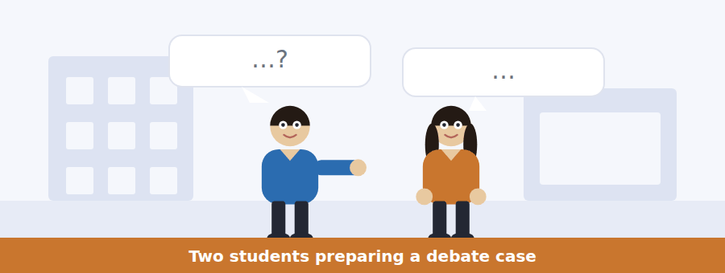
SKILL · Hearing a structural criticism
- A criticism of structure is not a criticism of content. The items will keep them apart.
- Listen for: the claim is fine, it is where you have put it.
- The fix is usually a move rather than a cut.

Exercise B Listen and answer. The audio plays once.
4. What does she say the problem is not?
(A) The length
(B) The content
(C) The sources
(D) The warrant
5. Where is the strong evidence?
(A) Paragraph four
(B) Paragraph one
(C) The conclusion
(D) A footnote
6. What is wrong with paragraph two as drafted?
(A) It is too short
(B) It rests a general claim on one story
(C) It repeats paragraph one
(D) It has no source
7. Why does she say an adjudicator will not believe it?
(A) The story is implausible
(B) The rules are strict
(C) A general claim resting on one story is not evidence
(D) The figures contradict it
8. What does she recommend?
(A) Cutting the anecdote
(B) Adding sources
(C) Rewriting the claim
(D) Moving the figures earlier so the anecdote illustrates them
9. What does she say the anecdote then does?
(A) The job stories are good at
(B) Nothing
(C) Carries the claim
(D) Replaces the figures
10. What is her closing point about ordering?
(A) It is presentation
(B) It matters only in competitions
(C) It is argument
(D) It should come last
Audio script: see the back of the book. Do not read it before you listen.


Exercise A Listen and choose a response. You hear one line. Choose the best reply.
1. Woman: Are anecdotes banned?
(A) Yes, completely.
(B) Only as evidence, not as illustration.
(C) About one per case.
(D) In the rules.
2. Man: Why must I state the warrant?
(A) Because the rules say so.
(B) About one sentence.
(C) In the introduction.
(D) Because a bad inference shows once you do.
3. Woman: Can I use a rhetorical question?
(A) No, never.
(B) About two of them.
(C) At the start.
(D) If you answer it, yes.
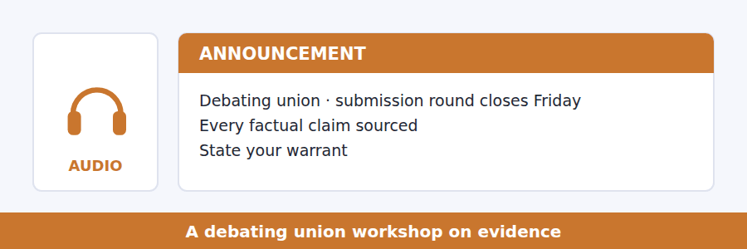
SKILL · Hearing a rule distinguished from its purpose
- When a speaker separates what a rule says from what it is for, both are examinable.
- Listen for: the rule says X, the rule is aimed at Y, so Z is fine.
- Compliance and purpose can come apart, and the speaker will say so.

Exercise B Listen and answer. The audio plays once.
4. What does the warrant rule require?
(A) A source for every claim
(B) Naming the unstated principle linking evidence to claim
(C) A counterargument
(D) A word limit
5. What is the first effect of stating a warrant?
(A) You find out whether you believe it
(B) It shortens the case
(C) It satisfies the adjudicator
(D) It weakens the opponent
6. What does it force an opponent to do?
(A) Find better figures
(B) Concede
(C) Attack the principle rather than the figures
(D) Change the subject
7. What does he call the third effect?
(A) Honesty rather than rhetoric
(B) A rhetorical advantage
(C) A formality
(D) A risk
8. What has the union actually banned?
(A) Anecdotes
(B) Personal stories
(C) An anecdote being the evidence for a general claim
(D) Rhetorical questions
9. What is a story for, in his account?
(A) Proving an average
(B) Showing what a figure looks like to one person
(C) Opening a case
(D) Winning sympathy
Audio script: see the back of the book. Do not read it before you listen.


Exercise A Listen and choose a response. You hear one line. Choose the best reply.
1. Man: Is teaching persuasion teaching manipulation?
(A) No, not at all.
(B) About two thousand years.
(C) In the lecture.
(D) That is the objection and it is a good one.
2. Woman: Does the tool argument work?
(A) No — it assumes what it has to prove.
(B) Yes, it settles it.
(C) About one paragraph.
(D) Like a knife.
3. Man: When does the defence break down?
(A) It never does.
(B) With a hurried audience.
(C) About half the time.
(D) In newspapers.
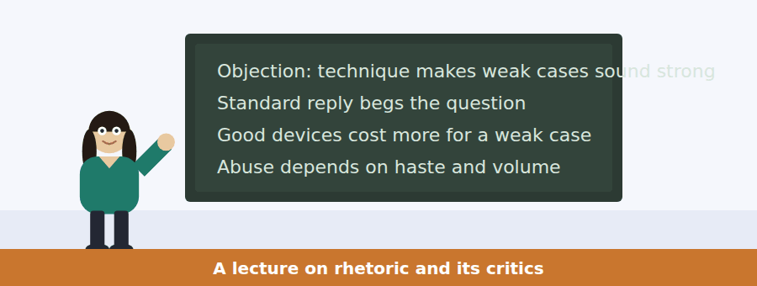
SKILL · Following a talk that concedes then narrows
- A lecturer who grants an objection at the start is going to narrow it, not reject it.
- Listen for where the defence is admitted to fail. That admission is the most examinable sentence.
- The conclusion will usually be about circumstances rather than about the thing itself.

Exercise B Listen and answer. The audio plays once.
4. Why does she begin by agreeing with critics?
(A) To be polite
(B) To introduce her sources
(C) Because the objection is good and the usual answer is not
(D) Because she shares their view entirely
5. What is wrong with the tool argument?
(A) It is unpopular
(B) It is too abstract
(C) It is recent
(D) It assumes what is at issue
6. What does she say about the devices that persuade attentive audiences?
(A) They are neutral
(B) They are easy to learn
(C) They demand something a weak case has not got
(D) They are rarely taught
7. Why does she say that is not a coincidence?
(A) The devices were designed that way
(B) Audiences have been persuaded before and remember it
(C) Critics chose the examples
(D) Weak cases are rare
8. Where does her defence fail?
(A) With a hurried reader
(B) In writing
(C) In formal debate
(D) With experts
9. What is her honest conclusion?
(A) Rhetoric is innocent
(B) Rhetoric should not be taught
(C) The objection is decisive
(D) Its abuse depends on conditions a society can change
10. What does she say refusing to teach it guarantees?
(A) A fairer debate
(B) That the fluent people are the ones who were paid to learn
(C) Nothing
(D) Better education
Audio script: see the back of the book. Do not read it before you listen.


Part 1 · Listen and Repeat
You hear a sentence and repeat it once. There is no preparation time, and the sentences get longer. Focus: putting the emphasis where you want it
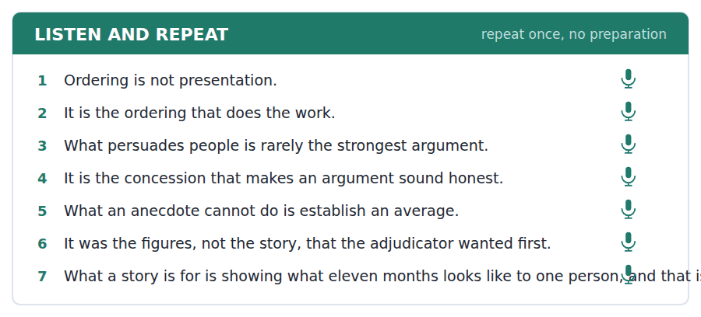
SKILL · Saying a cleft sentence out loud
- An it-cleft puts the stress on the element after it is: it is the ordering that does the work.
- A what-cleft puts it at the end: what does the work is the ordering.
- Stress the clefted element and keep the rest flat. A cleft said evenly is wasted.

Part 2 · Take an Interview
An interviewer asks you four questions on one theme: argument, emphasis and being understood. Answer each one fully. There is no preparation time.
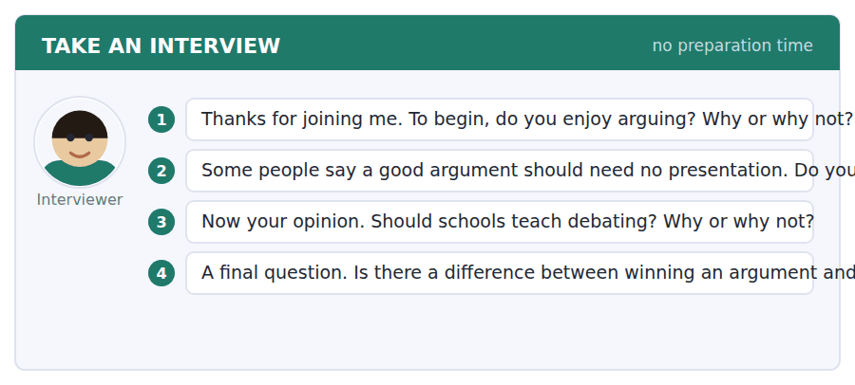
A good answer sounds like this
Question 2 — No, and the people who say it have usually never had to be read by a stranger. An argument nobody finishes has not been made.
Question 4 — Obviously, and the interesting case is the other way round: being right and losing, which happens constantly and teaches you more.
I can… | Not yet | Yes
I stressed the clefted element. | □ | □
I kept the rest of the sentence flat. | □ | □
I used both it-clefts and what-clefts. | □ | □


Part 1 · Listen and Repeat
You hear a sentence and repeat it once. There is no preparation time, and the sentences get longer. Focus: stating a warrant aloud
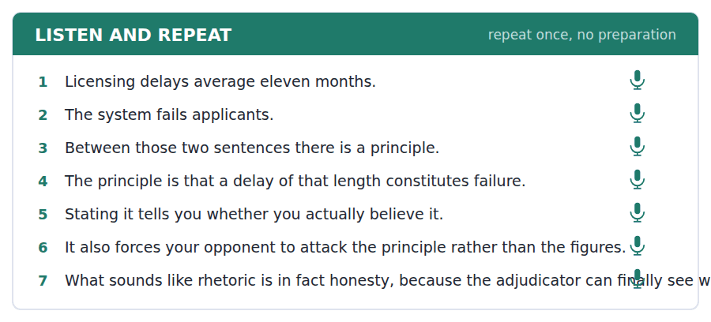
SKILL · Saying the step between evidence and claim
- A warrant is one sentence and it begins with a principle: that a delay of that length constitutes failure.
- Say the evidence, pause, say the warrant, pause, say the claim. Three beats.
- If you cannot say the warrant in one sentence, you do not yet have the argument.

Part 2 · Take an Interview
An interviewer asks you four questions on one theme: evidence, reasoning and what gets left unsaid. Answer each one fully. There is no preparation time.
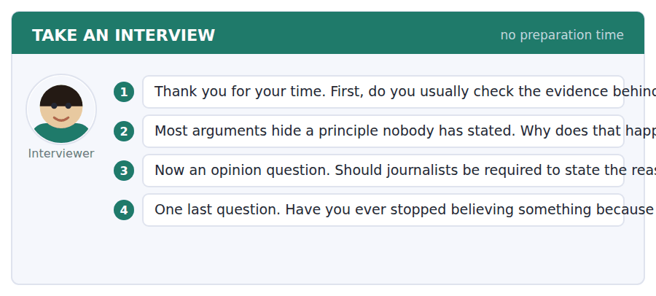
A good answer sounds like this
Question 2 — Because the principle usually feels too obvious to say, and the ones that feel obvious are the ones that turn out to be doing all the work.
Question 4 — Once, about a policy I had defended for years. Written out as a syllogism it had a premise I would not have signed.
I can… | Not yet | Yes
I said the warrant as one sentence. | □ | □
I used three beats: evidence, warrant, claim. | □ | □
I did not skip the principle. | □ | □


Part 1 · Listen and Repeat
You hear a sentence and repeat it once. There is no preparation time, and the sentences get longer. Focus: conceding before narrowing
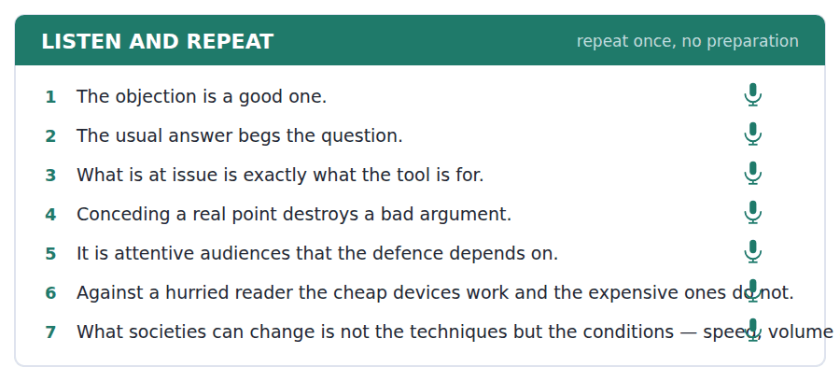
SKILL · Granting an objection out loud
- Say the objection in its strongest form, not a weak version. A weakened objection is heard immediately.
- Then narrow: that holds where, and it does not hold where.
- Mark your own concession with stress: that is TRUE of a hurried reader.

Part 2 · Take an Interview
An interviewer asks you four questions on one theme: honesty, influence and public argument. Answer each one fully. There is no preparation time.
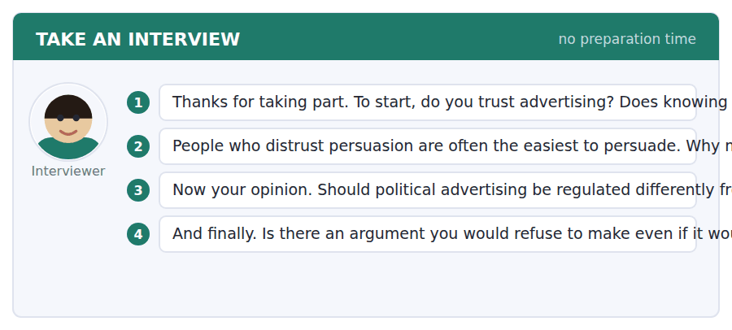
A good answer sounds like this
Question 2 — Because distrust is aimed at a style rather than a method. Anything that does not look like advertising gets through unexamined.
Question 4 — Yes — anything that depends on the audience not having time. If my case only works on somebody in a hurry, it is not my case that is working.
I can… | Not yet | Yes
I stated the objection in its strongest form. | □ | □
I narrowed rather than rejected it. | □ | □
I stressed my own concession. | □ | □


You see a sentence, then a set of words in boxes. Put the words in order to make one grammatical sentence. Almost every item in the real test makes a question or a question inside another sentence.
SKILL · Build a Sentence with a cleft or a fronted element
- The two non-question items in this unit build an it-cleft, a what-cleft or a fronted phrase.
- An it-cleft is it + be + the emphasised element + that: it is the ordering that matters.
- A fronted negative adverbial inverts the verb: never has that conclusion been less useful.

Exercise A Guided practice. The first three are worked through.
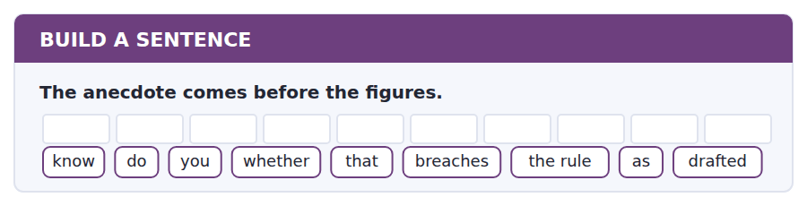
1. Do you know whether that breaches the rule as drafted?
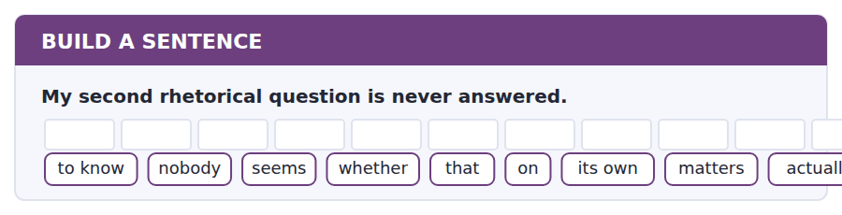
2. Nobody seems to know whether that actually matters on its own.
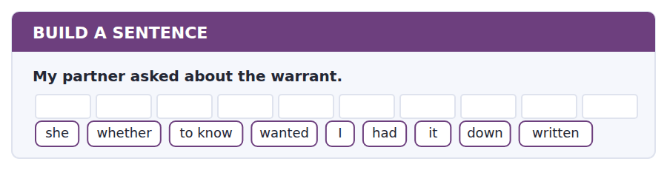
3. She wanted to know whether I had written it down.
Exercise B Exam practice. Write the sentence.
4. Anecdotes are permitted as illustration.
do / whether / know / you / that / the opening / covers / as well / actually
__________________________________________________________
5. The standard reply to the objection begs the question.
explain / can / anybody / why / the knife / to me / not / does / analogy work
__________________________________________________________
6. The defence fails with hurried readers.
know / does / anybody / which / devices / on / work / actually / them
__________________________________________________________
7. The figures are in paragraph four.
us / told / nobody / where / the evidence / to / was / supposed / go
__________________________________________________________
8. Stating the warrant changed his mind.
told / he / me / which / premise / he / no longer / believed / actually
__________________________________________________________
9. Ordering does the work, not evidence.
it / is / the ordering / that / does / the work / and / the evidence / not
__________________________________________________________
10. An anecdote cannot establish an average.
what / an anecdote / cannot / do / is / establish / an average / at / all
__________________________________________________________


You read a short situation and write an email. You have 7 minutes. The three bullet points are the mark scheme: answer all three.
The chief adjudicator told you to move your national figures ahead of the anecdote and to cut your second rhetorical question. You have done the first and you think she is wrong about the second: your second question is answered, but three paragraphs later. You are resubmitting.
Write an email to the adjudication office.
- Confirm the change you made and what it did to the case.
- Disagree about the second point, with the evidence from your own text.
- Say what you will do if the adjudicator still disagrees.
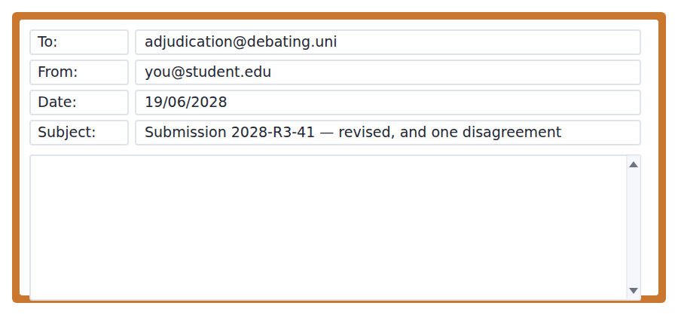
SKILL · Disagreeing with somebody who has authority over you
- Accept the part you accept, fully and first. A disagreement that arrives before any agreement reads as resistance.
- Quote your own text. A disagreement about what a document says is settled by the document.
- Say in advance what you will do if you lose the point. That makes the disagreement safe to have.

Model email
Dear Ms Delacroix,

Thank you — the reordering works and it was about forty words, as you said. The national figures are now paragraph two and the licensing story follows them as illustration. What it changed was not the compliance but the reading: the story is doing something it is actually good at.

On the second rhetorical question I think you may have missed the answer rather than that it is absent. The question is at the end of paragraph three — "so what would an acceptable delay look like?" — and it is answered at the start of paragraph six: "an acceptable delay is one shorter than the applicant’s own planning horizon, which in this sector is about four months." Three paragraphs is a long gap and I take the point that it reads as unanswered.

So rather than argue about whether it complies, I have moved the answer to paragraph four, immediately after the evidence it depends on. The question is now answered two sentences later and nobody has to hold it in mind.

If you still think two rhetorical questions is one too many in a case this short, say so and I will cut it before Friday. That is a judgement about effect and it is yours to make, not mine.

With thanks,
Osamu Nakamura
Why it works
- The accepted point is dealt with first and in full, including what the change achieved.
- The disagreement is settled by quotation from the writer’s own text, so nobody has to go and check.
- The writer concedes the reasonable version of the criticism — three paragraphs is too far — and fixes that instead of winning the argument.
- The last paragraph hands the remaining judgement back to the person whose judgement it is, with a deadline attached.
Two answers, one band apart
Both answer the three bullet points. One would score in the middle band and one near the top. Read them side by side before you write your own.
A middle-band answer | A top-band answer
Dear Ms Delacroix,  Thank you very much for your feedback on my submission. I have made the change you suggested and moved the national figures before the anecdote, and I agree that it reads much better now.  About the second rhetorical question, I am afraid I do not quite agree with you. I did actually answer it, although I can see that it comes rather later in the case, so perhaps it was easy to miss. I have now moved the answer closer to the question so that it should be much clearer.  I hope this is acceptable. If you still feel that the question should be cut then of course I will do that, as I understand that you have more experience of judging these submissions than I do. Please let me know what you think before Friday.  Thank you again for taking the time to read it. Best wishes, Osamu Nakamura | Dear Ms Delacroix,  Thank you — the reordering works and it was about forty words. The figures are paragraph two and the story follows as illustration. What it changed was not the compliance but the reading.  On the second rhetorical question I think the answer was missed rather than absent. The question ends paragraph three — "so what would an acceptable delay look like?" — and paragraph six answers it: "one shorter than the applicant’s planning horizon, about four months in this sector." Three paragraphs is too far, and I take the point that it reads as unanswered.  So rather than argue about compliance I have moved the answer to paragraph four, immediately after the evidence it rests on.  If you still think two rhetorical questions is one too many in a case this short, say so and I will cut it before Friday. That is a judgement about effect and it is yours. Osamu Nakamura

What the top answer does that the other does not
- It quotes both the question and the answer, so the factual disagreement is settled on the page rather than asserted.
- It concedes the defensible version of the criticism — three paragraphs is too far — instead of defending the draft as it stood.
- It acts rather than asks: the answer has already been moved, so the reader has nothing to arbitrate.
- It separates the factual point from the judgement point and hands only the judgement back, which is the one that genuinely belongs to the adjudicator.
- It drops the appeal to the reader’s greater experience, which in the middle answer quietly withdraws the disagreement it has just made.
Now write your own. 7 minutes.
__________________________________________________________
__________________________________________________________
__________________________________________________________
__________________________________________________________
__________________________________________________________
__________________________________________________________
__________________________________________________________
__________________________________________________________


A professor asks a question and two students answer. You add your own post. You have 10 minutes and an effective answer is at least 100 words.
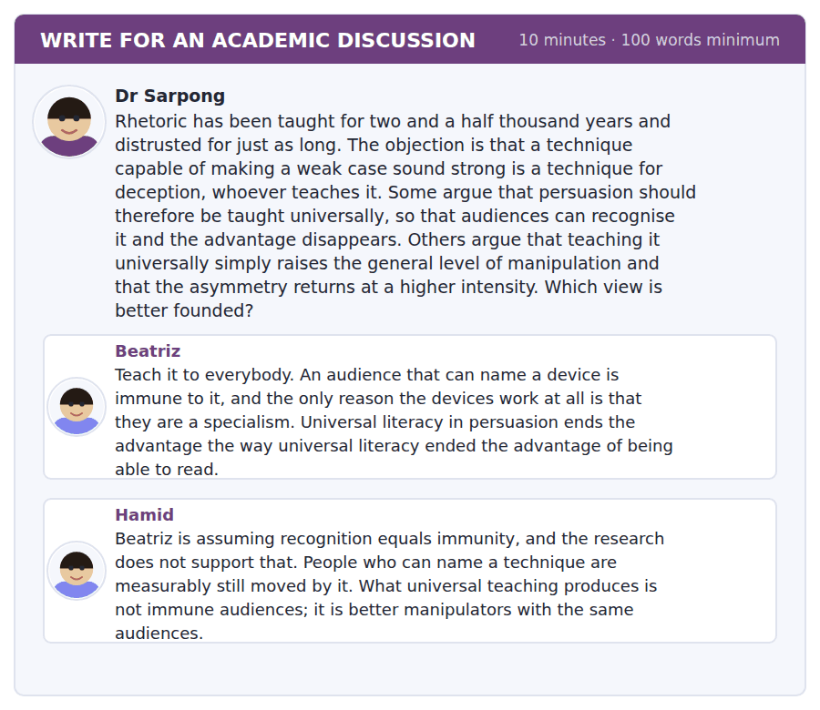
SKILL · Answering a claim about what education achieves
- An argument that teaching X removes the advantage of X needs an account of the mechanism.
- Distinguish recognition from resistance. They are different capacities and they are taught differently.
- Then say what would have to be taught for the claim to hold.

Sentence starters
- Hamid is right about the evidence and wrong about what follows.
- Beatriz’s analogy with literacy is doing more work than it can bear.
- The distinction that matters here is between…
- What would actually have to be taught is…
Model post
Hamid is right about the evidence and wrong about what follows from it. Recognition does not confer immunity; people who can name a device are still moved by it, and this is one of the better established findings in the area. But his conclusion treats that as settling the question, when what it settles is only that recognition is the wrong thing to teach. It is resistance that would have to be taught, and resistance is a different capacity: not knowing that a concession is a device, but having the habit of asking what the concession cost the person making it.
Beatriz’s analogy with literacy is doing more work than it can bear. Reading is a capacity you either have or lack, and persuasion is a contest in which both sides improve. If everyone learns, the advantage does not vanish; it moves to whoever has more time, which is Hamid’s point and it is a good one. What is striking is that she has the better instinct and the worse argument. The reason to teach it universally is not symmetry but that the alternative is a population with no defences at all facing people who are paid to practise.
What would actually have to be taught is the slow part: demanding the warrant, checking whether an anecdote is carrying a general claim, noticing that a question was never answered. Those are habits rather than knowledge, they survive being named, and they are expensive to teach because they take time rather than a lecture.
So neither post has the remedy. The defensible position is that recognition is worthless, resistance is teachable, and the thing standing in the way is not the ethics of rhetoric but the number of hours in a curriculum.
[291 words]
Now write your own. 10 minutes, at least 100 words.
__________________________________________________________
__________________________________________________________
__________________________________________________________
__________________________________________________________
__________________________________________________________
__________________________________________________________
__________________________________________________________
__________________________________________________________
__________________________________________________________
__________________________________________________________

Grammar focus Cleft sentences and fronting
Structure | What it emphasises
it + be + X + that/who | X: it is the ordering that does the work
what + clause + be + X | X, placed last: what persuades people is the ordering
all + clause + be + X | X, with a sense of only: all I did was move a paragraph
the reason … is that | the explanation: the reason it fails is that readers hurry
fronted object | that argument I can answer
fronted negative adverbial + inversion | never has the conclusion been less useful
fronted prepositional phrase + inversion | in paragraph four lay the evidence

A what-cleft puts the emphasised element at the end, and an it-cleft puts it in the middle. Choose by where you want the reader to arrive: end position is heavier.
A fronted negative adverbial forces inversion: never has, rarely do, not once did. Never the conclusion has been is wrong, and the error is conspicuous.
Clefts are for emphasis and emphasis is a scarce resource. Two clefts in a paragraph cancel each other out. One per paragraph is plenty, and most paragraphs need none.
Watch out! A cleft does not take an extra that: "It is the ordering that it does the work" is wrong. And after a fronted negative adverbial you must invert: "Never has that conclusion been less useful", not "Never that conclusion has been".
Exercise 1 Rewrite as an it-cleft, emphasising the underlined idea in brackets.
1. The ordering does the work. (the ordering)
2. The concession makes it sound honest. (the concession)
3. The figures persuaded the adjudicator. (the figures)
4. A hurried reader is the problem. (a hurried reader)
5. The warrant decides the case. (the warrant)
6. The second question was never answered. (the second question)
Exercise 2 Correct the cleft or the inversion.
1. It is the ordering that it does the work.
2. Never that conclusion has been less useful.
3. What persuades people are the ordering.
4. Rarely a cleft is needed twice in a paragraph.
Exercise 3 Rewrite as a what-cleft.
1. An anecdote cannot establish an average.
2. I moved one paragraph.
3. The rule protects against the anecdote being the evidence.
4. A story shows what a figure looks like to one person.
How this is tested in Build a Sentence
Two of the ten Build a Sentence items in this unit build a cleft. A tile reading it opening the sentence with is and that later signals an it-cleft; a tile reading what opening the sentence signals a what-cleft, whose verb is is and comes late.
Find the fault 5 errors, drawn from this unit and the two before
Every error below is one a B2 writer makes after learning the rule. Mark what is wrong, then check. Knowing the rule and noticing the breach are two different skills, and only the second one is tested.
It is the ordering that it does the work. Never that conclusion has been less useful. What persuades people are the ordering and the concession. Nobody knows whether was the question answered. Having stated the warrant, the argument became uncomfortable for the author.
# | As written | As it should be | Why
1 | It is the ordering that it does the work | It is the ordering that does the work | The that-clause of a cleft already has its subject, so the extra pronoun is one subject too many.
2 | Never that conclusion has been less useful | Never has that conclusion been less useful | A fronted negative adverbial forces inversion of the auxiliary and the subject.
3 | What persuades people are the ordering | What persuades people is the ordering | A what-clause as subject is singular, whatever follows the verb.
4 | whether was the question answered | whether the question was answered | An embedded question keeps statement order and does not invert the verb.
5 | Having stated the warrant, the argument became uncomfortable for the author | Having stated the warrant, the author found the argument uncomfortable | The argument did not state anything; the participle needs the subject that acted.

Unit review and progress check Unit 35
Exercise A Vocabulary. Write the word.
1. a warning that limits what has just been said
2. an answer to an objection
3. to grant a point to the other side
4. a form of reasoning that does not work
5. a single story used as evidence
6. the associations a word carries
7. the degree to which a speaker is believed
8. a word that limits the strength of a claim
9. a claim made without support
10. the step from evidence to conclusion
11. the study of how language persuades
12. to use language that can be read two ways
Exercise B Grammar. Complete the sentence.
1. ______ is the ordering that does the work.
2. ______ persuades people is rarely the strongest argument.
3. Never ______ that conclusion been less useful.
4. ______ I did was move one paragraph.
5. The reason it fails ______ that readers hurry.
6. Rarely ______ a cleft needed twice in a paragraph.
7. ______ an anecdote cannot do is establish an average.
8. ______ was the second question that went unanswered.
Exercise C One timed mini-section. 6 minutes.
1. A warrant is
(A) the unstated principle linking evidence to a claim
(B) a source
(C) a counterargument
(D) a qualifier
2. The debating rule forbids
(A) all anecdotes
(B) rhetorical questions
(C) personal stories
(D) an anecdote being the evidence for a general claim
3. The passage says the devices that persuade attentive audiences
(A) work equally for any case
(B) are easy to learn
(C) demand something a weak case has not got
(D) are rarely effective
4. Which sentence is correct?
(A) Never has that conclusion been less useful.
(B) Never that conclusion has been less useful.
(C) Never that conclusion had been less useful.
(D) Never been has that conclusion less useful.
5. "On the face of it" tells you the writer
(A) agrees
(B) is quoting
(C) is about to qualify or reverse the appearance
(D) is uncertain of the facts
6. A what-cleft places the emphasised element
(A) in the middle
(B) at the start
(C) nowhere in particular
(D) at the end
Can you do these now?
I can… | Not yet | Yes
I can emphasise any part of a sentence without changing its content. | □ | □
I can use it-clefts, what-clefts and fronting accurately and sparingly. | □ | □
I can distinguish the validity of an argument from its persuasiveness. | □ | □
I can identify the unstated assumption that an argument needs. | □ | □
I can follow a talk that analyses the structure of a persuasive text. | □ | □
I can write an argument whose emphasis a reader cannot mistake. | □ | □

ADAPTIVE TIP This is the structure that most visibly separates a B2 writer from a B1 one. Use one cleft where you most want the reader to stop, and none anywhere else. Emphasis applied everywhere is emphasis nowhere, and an examiner can tell the difference between a writer who chose and a writer who sprinkled.

Unit 36 · Conservation and Biodiversity
TOEFL iBT® Preparation Course 2026 · Volume 4
CEFR B2 · Grammar: Inversion after negative adverbials · Word field: habitat, fragmentation, baseline
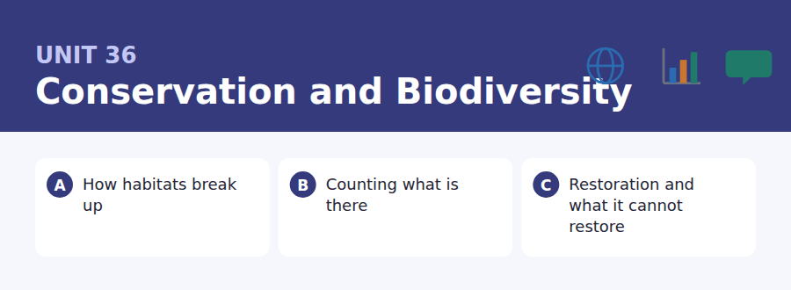
By the end of this unit I can…
- I can front a negative adverbial and invert the verb correctly.
- I can use rarely, seldom, not until, no sooner and under no circumstances.
- I can explain a process that happens gradually and is noticed suddenly.
- I can read a monitoring report and say what it does not establish.
- I can follow a talk that criticises how success is measured.
- I can write about a trade-off where one side is easier to count.

Conservation writing uses inversion more than almost any other field: rarely does a species vanish, not until the habitat is measured, under no circumstances should. This unit teaches that structure and the vocabulary of a discipline that has to argue in public.

Vocabulary 1 · Academic word families 18 families, not 18 words
At B2 the word on its own is not enough. Each entry below is a family: learn the noun, the verb and the adjective together, because the test will use whichever one the sentence needs.
habitat the place a species lives in | understorey the vegetation below the canopy
fragmentation the breaking of a habitat into separate pieces | pollinator an animal that carries pollen between plants
corridor a strip of habitat connecting two larger areas | keystone a species whose removal changes the whole system
endemic found only in one place | trophic to do with feeding levels in a food web
invasive spreading where it did not previously occur | succession the orderly change of a community over time
baseline the reference state a change is measured against | restoration returning a degraded place towards an earlier state
abundance how many individuals there are | degradation loss of quality or function
biomass the total mass of living material | viable able to survive and reproduce
canopy the upper layer of a forest | quadrat a marked square in which organisms are counted

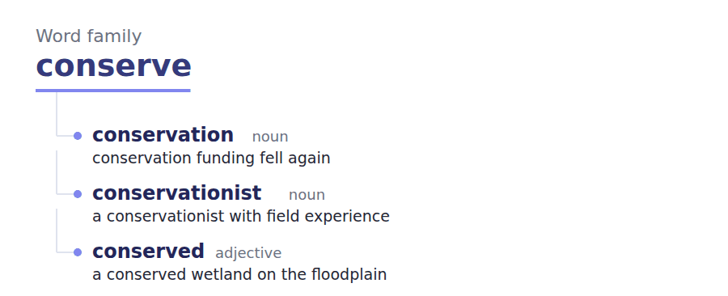
Exercise A Work in pairs. Ask and answer.
1. Describe a place near you that has changed. What was the baseline?
2. Why is a charismatic animal easier to fund than an ecosystem?
3. What does replanting a wood not restore?
4. Is a species protected on paper actually protected? Give an example.
Vocabulary 2 · Collocation 10 partnerships that actually occur
A word is known when you know what it goes with. These ten are the partners this unit’s texts use; the wrong partner is what marks an answer as translated.
die back to decline without disappearing | tip over to pass a point of no return
wipe out to destroy completely | in the round considered as a whole
set aside to reserve for a purpose | on paper in theory but perhaps not in fact
bounce back to recover quickly | at a stroke in one single action
hold on to survive marginally | with hindsight knowing how it turned out

Vocabulary 3 · Stance and hedging How far the writer commits
Every one of these says the same thing at a different strength. Reading, you must notice which was chosen. Writing, you must choose.
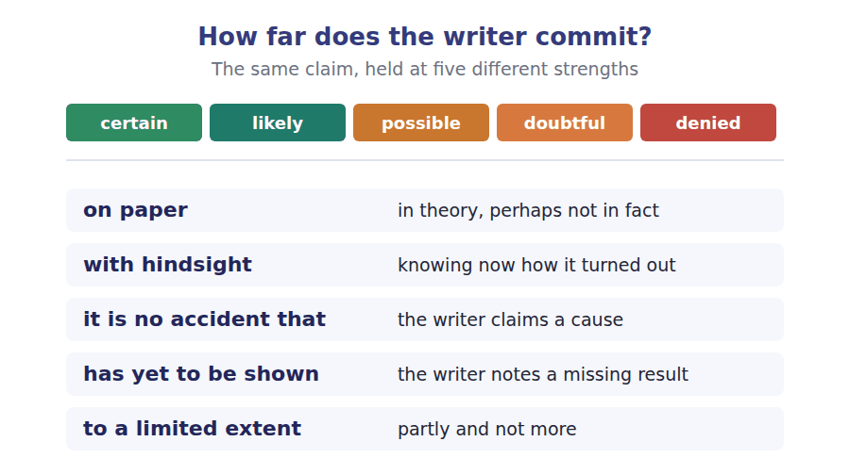
Two words that look alike
extinct / extirpated gone everywhere / gone locally
abundance / diversity how many / how many kinds
restoration / replacement returning a system / building a new one

Words you will meet again: metapopulation | edge effect | gene flow | rewilding | red list | offsetting | shifting baseline | ecosystem service


SKILL · Completing nouns of quality and of process
- Ecology writing is full of -ation and -ity nouns: fragmentation, degradation, viability.
- The -able and -ible endings mark possibility: solvable, reversible.
- A gap after too or so usually needs an adjective, not a noun.

Exercise A Guided practice. Five words are not complete. Write the missing letters.
Rarely does a species disappear because the last individuals were killed. What happens first is that the habitat is broken into pie--- too small to support a breeding populat---, and the animals that remain are a collection of isolated groups rather than one. Each group is then vulnerable to an ordinary bad year, and extinction arr---- as a series of small local losses that nobody records as remar----- until the total is counted and found to be ze--.

The first one is done for you: pie--- is pieces — it follows broken into and names things, so the slot is a plural noun.
Exercise B Exam practice. One paragraph, ten gaps — the real task.
Conservation has spent forty years arguing about whether to protect species or habitats, and the argument has outlived its usefulness. Protecting a species means, in practice, protecting whatever it depends on, so the two policies converge almost immedia----. Where they genuinely diverge is in what gets measu--- and therefore funded: a programme aimed at a single charismatic animal produces a number that a minister can repeat, and a programme aimed at an ecosystem produces a report nobody can summar---. Not until this is treated as a problem about institutions rather than about ecology will it be solv----. There is a further difficulty that conservation biology has been reluc---- to state plainly. Restoration is not reve------ in the way the word suggests. A woodland replanted on cleared ground reaches something resembling the original in perhaps a cent---, and the soil community it lost may take very much lon--- or may not return at all, because the species that built it are no longer in the neighbourhood to recoloni--. Replanting is therefore worth doing and is not a licence for clearance elsewhere, and the distinction matters because the second claim is routinely made in the language of the fi---.

Check your answers in the key at the back of the book.


SKILL · Reading a survey protocol against a result
- A protocol says how a count must be made. A result is only as good as the protocol it followed.
- Look for the conditions: time of day, season, minimum number of visits.
- A result obtained outside the protocol is not wrong; it is unusable for the purpose the protocol serves.

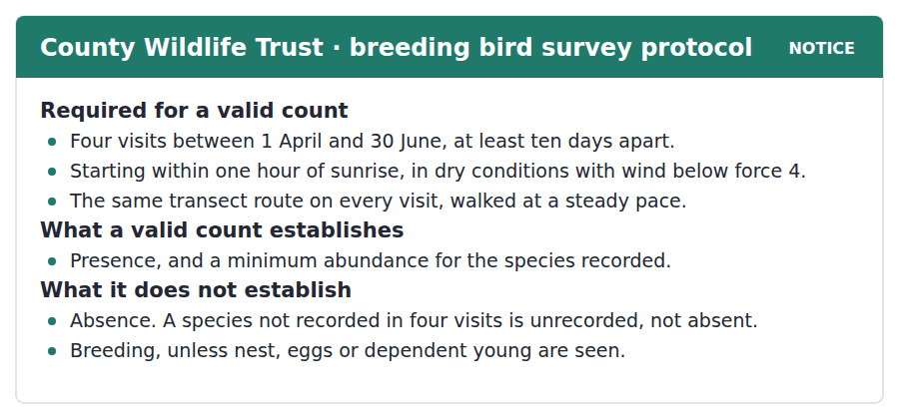
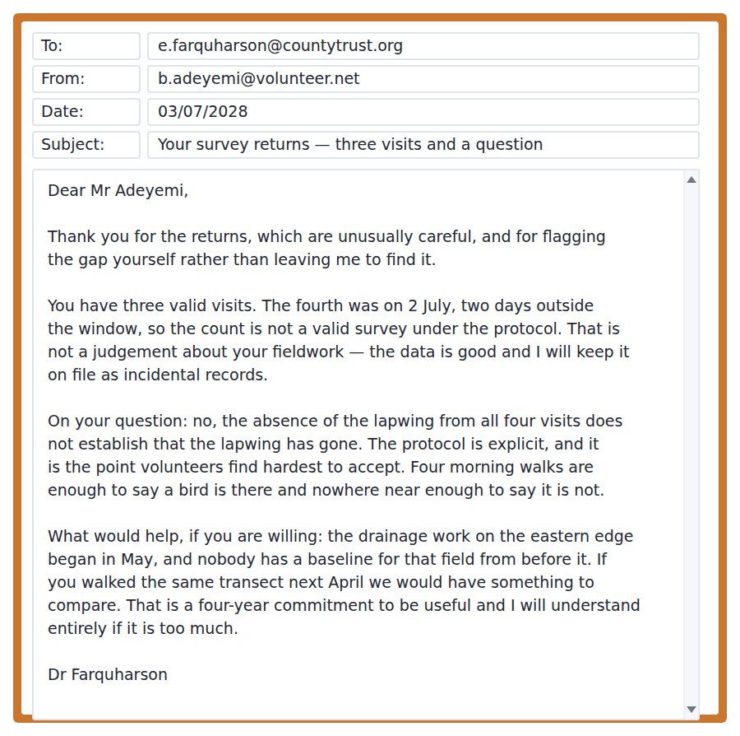
Exercise A Guided practice. The answer is on the page — find it.
1. How many visits does a valid count require?
(A) Four
(B) Two
(C) Six
(D) As many as possible
2. When must a visit start?
(A) Any time
(B) At midday
(C) Before the window opens
(D) Within one hour of sunrise
3. What does a valid count establish?
(A) Absence
(B) Breeding
(C) Presence and a minimum abundance
(D) Population trend
4. What does a count not establish?
(A) Presence
(B) Absence
(C) Minimum abundance
(D) The route walked
Exercise B Exam practice.
5. Why is the survey not valid?
(A) The route changed
(B) The weather was wrong
(C) Too few visits were made
(D) The fourth visit fell outside the window
6. What does the officer say about the fieldwork itself?
(A) The data is good and will be kept as incidental records
(B) It was careless
(C) It must be repeated
(D) It cannot be used at all
7. What does she say about the missing lapwing?
(A) It confirms a local extinction
(B) It requires a fifth visit
(C) It does not establish that the bird has gone
(D) It is a recording error
8. Why does she mention what volunteers find hardest?
(A) To criticise them
(B) To acknowledge that the rule is counter-intuitive
(C) To explain the protocol’s origin
(D) To ask for more visits
9. What is the problem with the eastern field?
(A) There is no baseline from before the drainage work
(B) It is inaccessible
(C) It is outside the transect
(D) It has been surveyed too often
10. What is she asking for?
(A) A fifth visit this year
(B) A new protocol
(C) A report on the drainage
(D) The same transect walked next April
11. What does "a four-year commitment to be useful" tell you?
(A) The work is easy
(B) A single repeat year would not be enough
(C) The Trust pays for four years
(D) The protocol lasts four years


SKILL · Reading a passage that defends a practice against its own defenders
- An author can support an activity and attack the argument used for it.
- Look for the sentence beginning none of which is an argument against.
- The real conclusion is usually narrower than either side wants.

What a Replanted Wood Is Not
Replanting is the most popular conservation activity in the world and the least well understood by the people who fund it. A plantation of native species on cleared ground is, on paper, a restored woodland, and in the respects most easily photographed it is one. Canopy closes within twenty years, birds arrive, and the carbon figures are real. It is no accident that this is the activity politicians attend: the before and after are visible within a term of office.
What does not return on that timescale is everything below the surface. The soil community of an old woodland — the fungi, the invertebrates, the particular chemistry built by centuries of the same litter falling in the same place — is not planted and cannot be. It arrives, if it arrives, by colonisation from nearby, which requires somewhere nearby for it to come from. Where the clearance was extensive there is no source population within reach, and the replanted wood develops a soil community resembling a young one indefinitely. That this converges on the original within a human lifetime has yet to be shown anywhere.
None of which is an argument against replanting, and it is routinely used as one. The conclusion that actually follows is narrower and more awkward: replanting is worth doing on its own terms and is not an exchange rate. A scheme that clears mature woodland and plants twice the area elsewhere is, to a limited extent, replacing what it destroyed, and under no circumstances should the arithmetic of area be allowed to stand in for the comparison. With hindsight, the discipline’s mistake was accepting a vocabulary of restoration and offset that had equivalence built into it, and then trying to argue against the equivalence in words that assumed it.
[294 words]

Exercise A Guided practice.
1. What does the author say a replanted wood is in the most photographable respects?
(A) A failure
(B) An ordinary plantation
(C) A restored woodland
(D) An offset
2. Why does the author say politicians attend replanting?
(A) It is cheap
(B) It is popular with scientists
(C) The before and after are visible within a term of office
(D) It requires no permits
3. What cannot be planted?
(A) The soil community
(B) Native trees
(C) The canopy
(D) The understorey
4. What does colonisation require?
(A) Time only
(B) Replanting
(C) Protection from grazing
(D) A source population within reach
Exercise B Exam practice.
5. What does "has yet to be shown anywhere" refer to?
(A) That replanting works
(B) That the soil community converges on the original within a human lifetime
(C) That carbon figures are real
(D) That birds return
6. What conclusion does the author say does not follow?
(A) That replanting is worth doing
(B) That replanting should not be done
(C) That soil matters
(D) That offsets are regulated
7. What is the conclusion the author says does follow?
(A) Replanting should be expanded
(B) Clearance should be banned
(C) Offsets should be doubled
(D) Replanting is worth doing but is not an exchange rate
8. What does the author say about a scheme that plants twice the area cleared?
(A) It replaces what it destroyed only to a limited extent
(B) It fully compensates
(C) It is fraudulent
(D) It is unmeasurable
9. What should not be allowed to stand in for the comparison?
(A) Carbon accounting
(B) Species counts
(C) The arithmetic of area
(D) Photographic evidence
10. What does the author identify as the discipline’s mistake?
(A) Opposing replanting
(B) Ignoring soil
(C) Accepting a vocabulary with equivalence built into it
(D) Trusting politicians
11. Which would most strengthen the second paragraph?
(A) Evidence that canopy closes faster than thought
(B) Evidence that birds return quickly
(C) Evidence that carbon uptake is high
(D) Evidence that soil fungi are absent from replanted woods far from old woodland
12. All of the following are stated EXCEPT:
(A) Replanting restores an old woodland within a century
(B) Canopy closes within twenty years
(C) The soil community arrives by colonisation
(D) Replanting is worth doing on its own terms
13. What is the author’s position overall?
(A) Opposed to replanting
(B) In favour of replanting and opposed to the argument used for it
(C) Neutral
(D) Opposed to conservation funding


Exercise A Listen and choose a response. You hear one line. Choose the best reply.
1. Man: Does a species go extinct all at once?
(A) Yes, usually.
(B) About forty years.
(C) In the seminar.
(D) Rarely — it goes in small local losses.
2. Woman: Why does fragment size matter so much?
(A) A small fragment cannot hold a breeding group.
(B) Yes, it does matter.
(C) About ten hectares.
(D) On the eastern edge.
3. Man: Would a corridor actually help?
(A) Yes, probably.
(B) It turns several groups back into one.
(C) About two kilometres.
(D) Along the river.
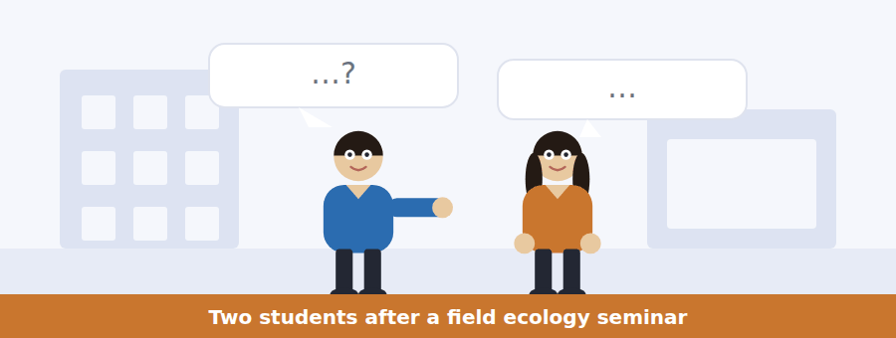
SKILL · Hearing a gradual process described
- A gradual process is usually explained in stages. The items test the order of the stages.
- Listen for: first, then, and by the time.
- The point is often that nothing dramatic happens at any single stage.

Exercise B Listen and answer. The audio plays once.
4. What did the woman have wrong?
(A) The size of fragments
(B) The role of corridors
(C) That extinction is an event
(D) The timescale
5. What happens to each fragment?
(A) It falls below the size that can hold a breeding population
(B) It is recolonised
(C) It grows back
(D) It becomes a corridor
6. What does the man say people miss?
(A) The cost
(B) The role of predators
(C) The speed of change
(D) That every fragment eventually gets a bad winter
7. Why can the fragments not be recolonised?
(A) No animals remain
(B) They are not connected to each other
(C) The habitat is unsuitable
(D) The winters are too severe
8. What does a corridor do, in his account?
(A) Adds habitat
(B) Protects against predators
(C) Turns several small populations into one large one
(D) Improves the soil
9. Why are corridors opposed?
(A) The ecology is disputed
(B) They are expensive
(C) They cross whoever is in the way
(D) They do not work
10. What does he say the hard part has always been?
(A) The map
(B) The ecology
(C) The funding
(D) The monitoring
Audio script: see the back of the book. Do not read it before you listen.


Exercise A Listen and choose a response. You hear one line. Choose the best reply.
1. Woman: Can I do two visits in one week?
(A) Yes, if you like.
(B) About four visits.
(C) In April.
(D) No — they have to be ten days apart.
2. Man: If I never see it, is it gone?
(A) Yes, probably gone.
(B) It is unrecorded, which is not the same.
(C) About four visits.
(D) On the transect.
3. Woman: Does hearing a bird count?
(A) Yes, but it does not prove breeding.
(B) No, only seeing it.
(C) About twenty species.
(D) At sunrise.
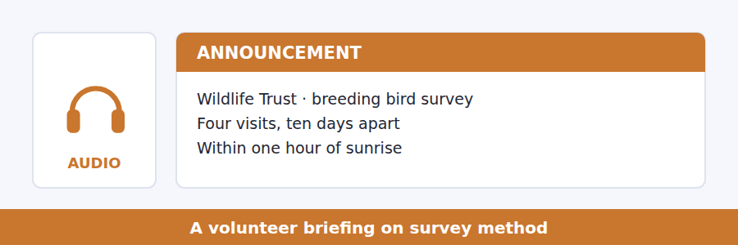
SKILL · Hearing what a method cannot show
- A briefing on method will spend most of its time on what the result does not prove.
- Listen for: this tells you, this does not tell you.
- The hardest item is usually the one about absence.

Exercise B Listen and answer. The audio plays once.
4. Why does he say the conditions are not bureaucracy?
(A) They are legally required
(B) Without them the counts are not comparable
(C) They protect the birds
(D) They save time
5. What does a valid count establish?
(A) An exact population
(B) Absence
(C) Breeding
(D) Presence and a minimum number
6. What does he say about overcounting?
(A) It is common
(B) It happens in bad weather
(C) Not once has a well-run transect overcounted
(D) It is corrected later
7. What is the consequence of treating absence as established?
(A) Better data
(B) Reported extinctions that have not happened
(C) More funding
(D) Shorter surveys
8. Why does he say he understands the difficulty?
(A) The rule is poorly written
(B) The protocol changed recently
(C) Four visits is too few
(D) The volunteer was there and looking and saw nothing
9. What does hearing a bird establish?
(A) Presence only
(B) Breeding
(C) Abundance
(D) Nothing
Audio script: see the back of the book. Do not read it before you listen.


Exercise A Listen and choose a response. You hear one line. Choose the best reply.
1. Man: Does replanting restore a woodland?
(A) Yes, within twenty years.
(B) About two hundred hectares.
(C) Above ground, largely. Below ground, no.
(D) With native species.
2. Woman: Why can the soil community not be planted?
(A) It has to arrive from somewhere nearby.
(B) Because it is too small.
(C) About a century.
(D) In the understorey.
3. Man: Is planting twice the area a fair exchange?
(A) Yes, that is the rule.
(B) About twice as much.
(C) On the eastern edge.
(D) Only if area is what was lost.
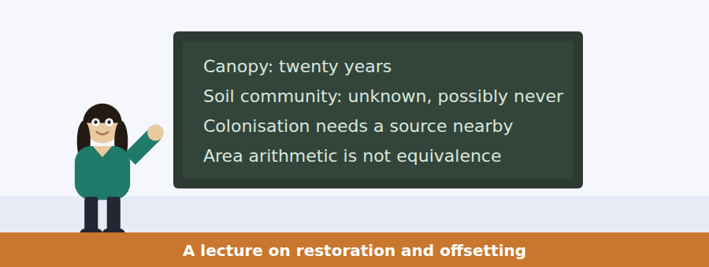
SKILL · Following a talk that attacks a vocabulary
- A speaker may argue that the words available for a debate have the answer built into them.
- Listen for: the moment we accepted the word, we had conceded the argument.
- The final item will usually be about the language rather than the science.

Exercise B Listen and answer. The audio plays once.
4. What does she say she is attacking?
(A) Replanting
(B) Carbon accounting
(C) The argument people make for replanting
(D) Conservation funding
5. What does she concede about replanting?
(A) Nothing
(B) Canopy, birds and carbon are all genuine
(C) It is cheap
(D) It is popular
6. Why can the soil community not be planted?
(A) It is too fragile
(B) It takes a century
(C) It is unknown
(D) It has to arrive from somewhere within reach
7. What has yet to be shown?
(A) That canopy closes
(B) That birds return
(C) That the soil community ever converges
(D) That carbon is captured
8. What conclusion does she say follows?
(A) Replanting should stop
(B) Replanting is worth doing and is not an exchange rate
(C) Offsetting should double
(D) Clearance should be banned
9. What does she say about area arithmetic?
(A) It should under no circumstances settle the account
(B) It is a reasonable approximation
(C) It is the only measure available
(D) It favours conservation
10. What does she identify as her own field’s mistake?
(A) Accepting a vocabulary with equivalence built in
(B) Ignoring soil
(C) Trusting politicians
(D) Overstating carbon
Audio script: see the back of the book. Do not read it before you listen.


Part 1 · Listen and Repeat
You hear a sentence and repeat it once. There is no preparation time, and the sentences get longer. Focus: fronting a negative adverbial
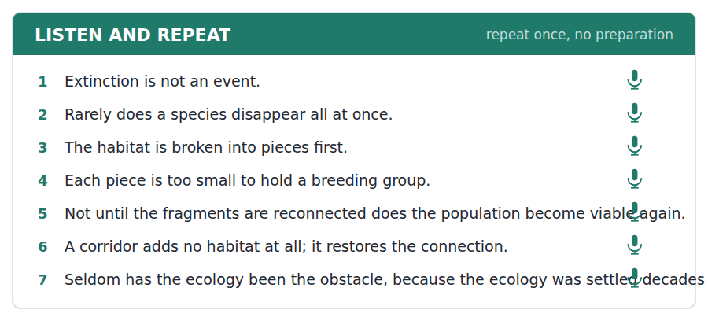
SKILL · Saying rarely does and not until out loud
- A fronted negative adverbial inverts the verb: rarely does a species disappear.
- Stress the adverbial, then drop slightly into the inversion. The pattern is heavy-light.
- Do not use two in a row. The structure is emphatic and emphasis repeated is emphasis lost.

Part 2 · Take an Interview
An interviewer asks you four questions on one theme: land, wildlife and competing uses. Answer each one fully. There is no preparation time.
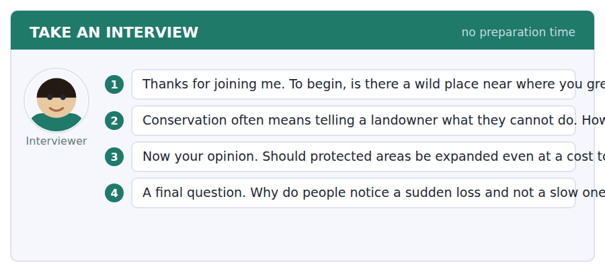
A good answer sounds like this
Question 2 — By paying for it, and by being honest that it is a purchase rather than a duty. A duty nobody volunteered for gets resisted on principle.
Question 4 — Because a slow loss never has a day on which it happened, and without a day there is nothing to be angry about.
I can… | Not yet | Yes
I inverted the verb after the fronted adverbial. | □ | □
I stressed the adverbial and dropped into the inversion. | □ | □
I did not use two inversions in a row. | □ | □


Part 1 · Listen and Repeat
You hear a sentence and repeat it once. There is no preparation time, and the sentences get longer. Focus: stating what a result does not show
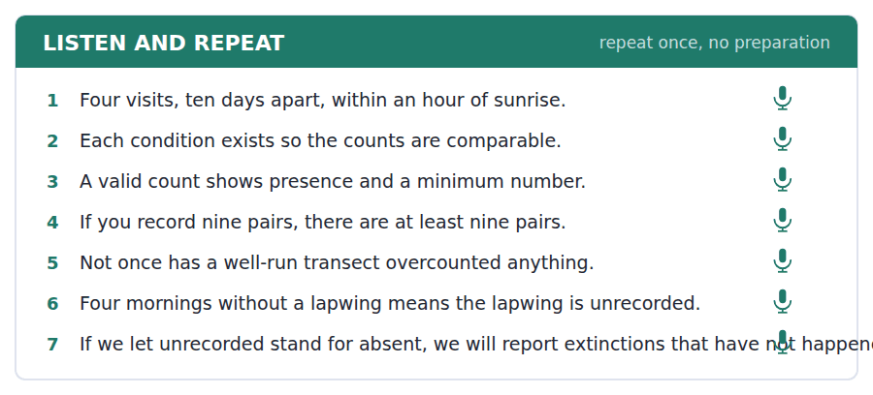
SKILL · Saying the limit of your evidence
- Separate the two claims out loud: this shows presence; it does not show absence.
- Give the number as a floor: at least nine pairs, not nine pairs.
- Concede the experience before refusing the inference: you were there, and still.

Part 2 · Take an Interview
An interviewer asks you four questions on one theme: evidence, fieldwork and what counts as proof. Answer each one fully. There is no preparation time.
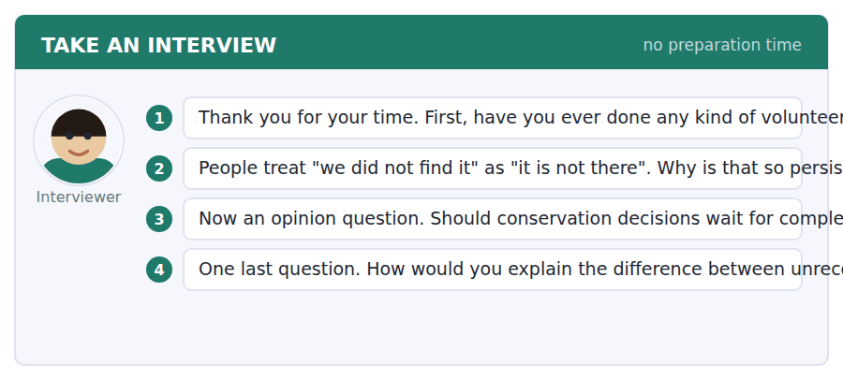
A good answer sounds like this
Question 2 — Because looking feels like a complete action. You searched, you finished, and the absence of a result feels like a result.
Question 3 — No, because complete data never arrives and waiting is itself a decision with consequences. What you owe people is a clear statement of how confident you are.
I can… | Not yet | Yes
I kept presence and absence apart. | □ | □
I gave the number as a minimum. | □ | □
I conceded the experience before refusing the inference. | □ | □


Part 1 · Listen and Repeat
You hear a sentence and repeat it once. There is no preparation time, and the sentences get longer. Focus: supporting something while attacking its defence
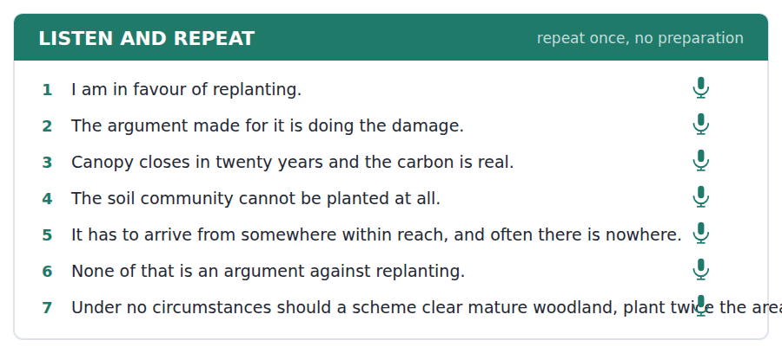
SKILL · Separating a practice from its justification
- Say which you support and which you are attacking, in the first sentence.
- Concede the real benefits in detail. A grudging concession is heard as opposition.
- End with the narrower conclusion, not the popular one.

Part 2 · Take an Interview
An interviewer asks you four questions on one theme: trade-offs, offsetting and honest accounting. Answer each one fully. There is no preparation time.
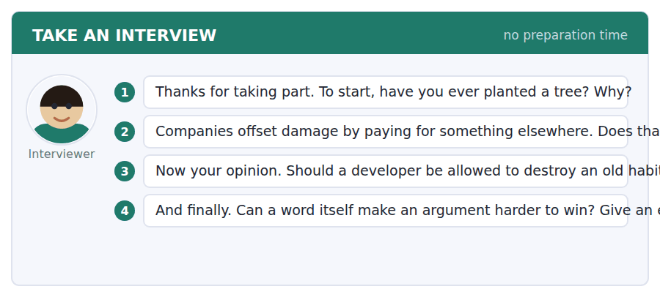
A good answer sounds like this
Question 2 — Where the two things are genuinely the same kind of thing, which is rarer than the schemes assume. Carbon offsets against carbon, perhaps. Habitat against habitat, almost never.
Question 4 — Offsetting does it. The word contains the claim that the two sides balance, so anybody arguing they do not has to argue against the vocabulary first.
I can… | Not yet | Yes
I said what I support and what I am attacking first. | □ | □
I conceded the benefits in detail. | □ | □
I ended on the narrower conclusion. | □ | □


You see a sentence, then a set of words in boxes. Put the words in order to make one grammatical sentence. Almost every item in the real test makes a question or a question inside another sentence.
SKILL · Build a Sentence with a fronted negative adverbial
- The two non-question items in this unit front a negative adverbial and invert: rarely does, not until, under no circumstances should.
- The inversion takes the auxiliary: rarely does a species disappear, never has it been shown.
- Not until needs a clause before the inversion: not until the fragments are joined does the population recover.

Exercise A Guided practice. The first three are worked through.
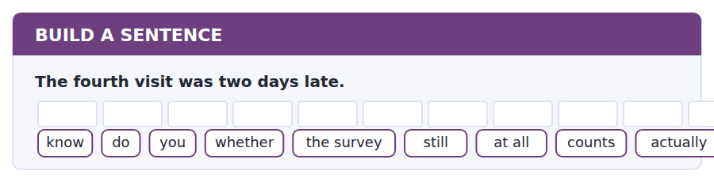
1. Do you know whether the survey still actually counts at all?
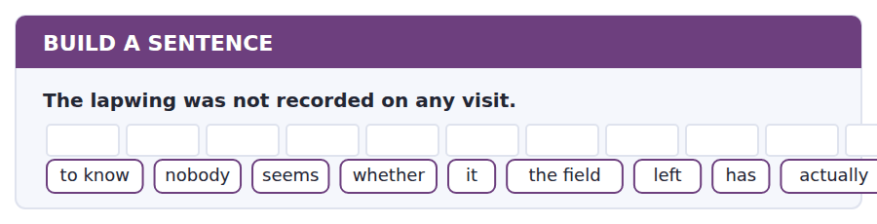
2. Nobody seems to know whether it has actually left the field.
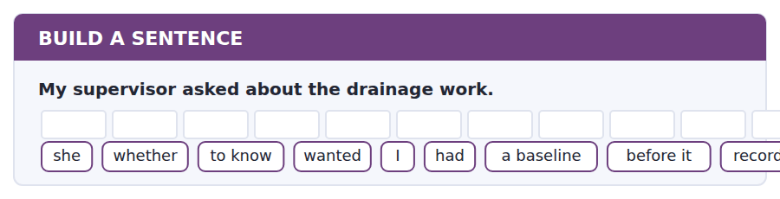
3. She wanted to know whether I had recorded a baseline before it.
Exercise B Exam practice. Write the sentence.
4. A corridor does not add habitat.
do / whether / know / you / that / is / everyone / to / obvious
__________________________________________________________
5. Replanting does not restore the soil community.
explain / can / anybody / why / that / to me / planted / be / cannot
__________________________________________________________
6. The scheme planted twice the area it cleared.
know / does / anybody / whether / the regulator / that / accepted / actually / in the end
__________________________________________________________
7. Four visits cannot establish absence.
us / told / nobody / how / many / visits / would / needed / be
__________________________________________________________
8. The ecology of corridors was settled decades ago.
told / he / me / what / the real / obstacle / had / been / always
__________________________________________________________
9. A species does not usually disappear all at once.
rarely / does / a species / disappear / at once / all / and / nobody / notices
__________________________________________________________
10. The population recovers only when the fragments are joined.
not until / the fragments / are / joined / does / the population / become / again / viable
__________________________________________________________


You read a short situation and write an email. You have 7 minutes. The three bullet points are the mark scheme: answer all three.
The Trust has told you your fourth visit fell outside the window, so this year’s survey is invalid but the data will be kept as incidental records. They have asked you to walk the same transect each April for four years to build a baseline for a field where drainage work began in May. You want to do it, but you are away every April for two weeks and need to know whether the window allows you to work around that.
Write an email to the Trust.
- Agree to the commitment and say what you are agreeing to.
- Set out the scheduling problem as a constraint, with dates.
- Propose a solution and say what you will do if it is not acceptable.
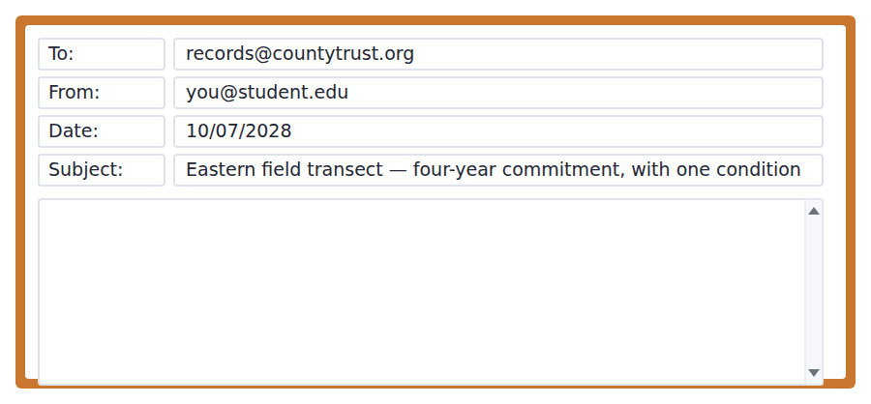
SKILL · Committing to something long with a condition attached
- Say yes first and unambiguously. A conditional yes read as a maybe gets offered to somebody else.
- Give the constraint as dates, and show you have checked the rule yourself.
- Propose the solution rather than asking for one. The other person has less information about your diary than you do.

Model email
Dear Dr Farquharson,

Yes — I will walk the eastern transect every year from April 2029 to April 2032, four visits a season under the protocol. I would rather commit to the four years now than do one year and leave you with something unusable.

One scheduling constraint, which I think the protocol already solves. I am away from roughly the 8th to the 22nd of April every year for work. That removes two weeks from the middle of the month.

As I read it, that does not matter. The window runs from 1 April to 30 June and the only spacing requirement is ten days between visits, so visits on about 3 April, 25 April, 10 May and 25 May are all inside the rules and inside the breeding season. If you would rather the four visits were spread evenly across the window I can do early April, early May, late May and mid-June instead.

If my reading is wrong and the Trust needs a visit in mid-April specifically, say so and I will find somebody to cover that one week — but I would want to train them on the route with me first, because a different walker on a different line is not the same transect.

The drainage baseline is the reason I am saying yes, so tell me if there is anything else worth recording in the same walk.

With thanks,
Babatunde Adeyemi
Why it works
- The commitment is unambiguous and quantified — four seasons, named years — in the first line.
- The constraint is given as dates and the writer has already checked it against the protocol rather than asking.
- A specific schedule is proposed, with an alternative, so the reader can approve rather than design.
- The fallback names its own risk: a substitute walker is not the same transect, which is a point the Trust would otherwise have to make.
Two answers, one band apart
Both answer the three bullet points. One would score in the middle band and one near the top. Read them side by side before you write your own.
A middle-band answer | A top-band answer
Dear Dr Farquharson,  Thank you for your email and for explaining why the fourth visit could not be counted. I would be very happy to help with the eastern field and to walk the transect for the next few years if that would be useful to you.  There is one difficulty I should mention. Unfortunately I am away for work in the middle of April every year, which might make it hard to fit in all the visits. I am not sure whether this would be a problem or not, so I thought it was better to ask before committing to anything.  Could you let me know whether the dates are flexible, and how exactly you would like the visits to be arranged? I am very keen to be involved and I will do whatever fits best with what the Trust needs.  Thank you again for all your help. Best wishes, Babatunde Adeyemi | Dear Dr Farquharson,  Yes — I will walk the eastern transect every year from April 2029 to April 2032, four visits a season under the protocol. Better to commit to four years now than leave you with one unusable season.  One constraint, which I think the protocol already solves. I am away from about the 8th to the 22nd of April each year. As I read it that does not matter: the window runs to 30 June and the only spacing rule is ten days, so 3 April, 25 April, 10 May and 25 May are all compliant.  If you would rather they were spread across the whole window, I can do early April, early May, late May and mid-June.  If the Trust needs a mid-April visit specifically, say so and I will find cover — though I would train them on the route first, because a different walker on a different line is not the same transect. Babatunde Adeyemi

What the top answer does that the other does not
- It commits in the first line with named years and a visit count, so nothing has to be inferred from willingness.
- It checks the constraint against the protocol itself and proposes four dates, leaving the reader to approve rather than solve.
- It offers a second schedule, so a preference can be expressed without reopening the question.
- It names the risk in its own fallback — a substitute is not the same transect — which is the objection the Trust would otherwise raise.
- It drops the offer to do whatever fits best, which sounds cooperative and hands the whole problem back.
Now write your own. 7 minutes.
__________________________________________________________
__________________________________________________________
__________________________________________________________
__________________________________________________________
__________________________________________________________
__________________________________________________________
__________________________________________________________
__________________________________________________________


A professor asks a question and two students answer. You add your own post. You have 10 minutes and an effective answer is at least 100 words.
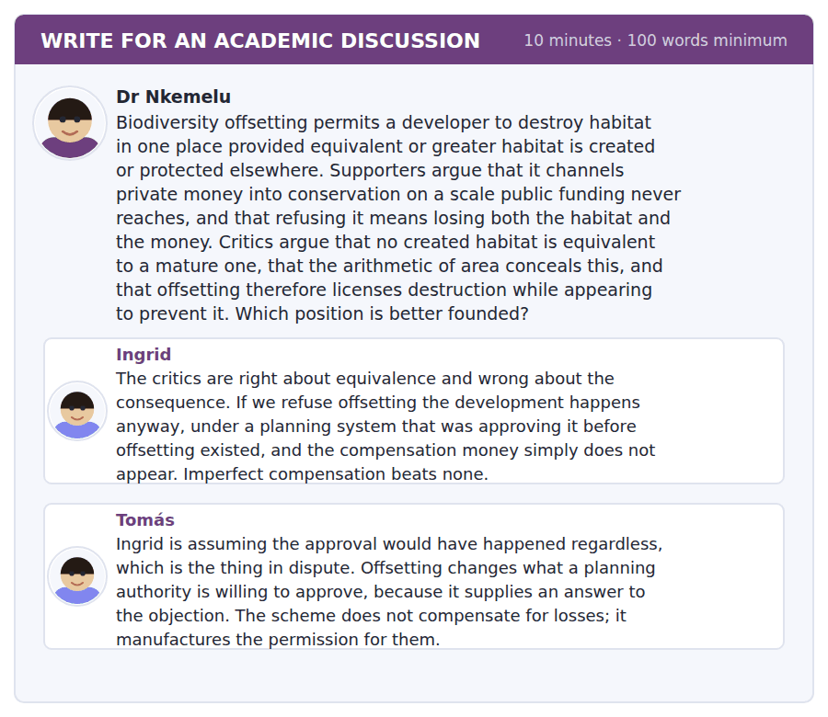
SKILL · Answering a counterfactual disagreement
- When two sides disagree about what would have happened otherwise, name the counterfactual explicitly.
- Say what evidence would distinguish the two, even if nobody has it.
- Then say what to do under uncertainty, which is a different question from who is right.

Sentence starters
- The disagreement here is entirely about a counterfactual.
- Ingrid is right that…, and her argument needs…
- Tomás has identified the mechanism, and not the evidence for it.
- Under that uncertainty, what follows is…
Model post
The disagreement here is entirely about a counterfactual, and once that is said the two positions stop being symmetrical. Ingrid holds that the development proceeds either way, so offsetting adds money without adding losses. Tomás holds that offsetting changes approval rates, so some losses exist only because the scheme does. Both are empirical claims about the same quantity and only one of them can be true of any particular planning regime.
Ingrid is right that refusing an imperfect remedy on purity grounds usually leaves the harm and loses the remedy, and her argument needs something she has not supplied: evidence that approval rates did not move. Tomás has identified the mechanism and not the evidence for it. The mechanism is entirely plausible — an authority with an answer to an objection approves more — and plausibility is not a rate.
What would distinguish them is comparatively simple and has been done in only a few jurisdictions: approval rates for development on designated habitat, before and after an offsetting regime, against a control. Where this has been looked at the answer appears to be that approvals rose, which is Tomás’s prediction, and the samples are small enough that I would not build a policy on them.
Under that uncertainty what follows is not a verdict but a design rule. Offsetting should be permitted only where the receiving site is secured before the clearance, only for habitat types that demonstrably reassemble, and never on an area ratio alone. Those three conditions cost supporters almost nothing if Ingrid is right, and they remove most of what Tomás fears if he is. That is what a policy should look like when the decisive number is missing.
[282 words]
Now write your own. 10 minutes, at least 100 words.
__________________________________________________________
__________________________________________________________
__________________________________________________________
__________________________________________________________
__________________________________________________________
__________________________________________________________
__________________________________________________________
__________________________________________________________
__________________________________________________________
__________________________________________________________

Grammar focus Inversion after negative adverbials
Fronted element | What happens to the verb
rarely / seldom | rarely does a species disappear all at once
never / not once | never has it been shown anywhere
not until + clause | not until the fragments are joined does it recover
no sooner … than | no sooner had the drainage begun than the field dried
under no circumstances | under no circumstances should area settle the account
little / nowhere | little did anybody realise; nowhere is this clearer
only after / only when | only when the corridor opened did the groups mix

The inversion uses the auxiliary, exactly as a question does: rarely does a species disappear, never has it been shown. If there is no auxiliary, do is supplied.
Not until and only when invert the main clause, not the fronted one: not until the fragments are joined does the population recover. Writing not until are the fragments joined is a common error.
No sooner takes than, never when: no sooner had the work begun than the field dried. No sooner had the work begun when is wrong.
Watch out! Inversion is emphatic, and emphasis repeated stops working. One inverted sentence per paragraph at most, and never two in succession — a paragraph of inversions reads as parody rather than as force.
Exercise 1 Rewrite with the negative adverbial fronted.
1. A species rarely disappears all at once.
2. It has never been shown anywhere.
3. The population only becomes viable when the fragments are joined.
4. A well-run transect has not once overcounted.
5. Area arithmetic should under no circumstances settle the account.
6. The groups only mixed after the corridor opened.
Exercise 2 Correct the inversion.
1. Rarely a species disappears all at once.
2. Not until are the fragments joined does it recover.
3. No sooner had the work begun when the field dried.
4. Never it has been shown anywhere.
Exercise 3 Join with no sooner … than.
1. The drainage began. The field dried out.
2. The corridor opened. The two groups mixed.
3. The scheme was approved. The clearance started.
4. The canopy closed. The birds arrived.
How this is tested in Build a Sentence
Two of the ten Build a Sentence items in this unit front a negative adverbial. A tile reading rarely or not until begins the sentence, and the tile reading does or has belongs immediately after the fronted element, not after the subject.
Find the fault 5 errors, drawn from this unit and the two before
Every error below is one a B2 writer makes after learning the rule. Mark what is wrong, then check. Knowing the rule and noticing the breach are two different skills, and only the second one is tested.
Rarely a species disappears all at once. Not until are the fragments joined does the population recover. No sooner had the drainage begun when the field dried out. Nobody knows whether was the lapwing recorded. Having been cleared, the developer replanted twice the area.
# | As written | As it should be | Why
1 | Rarely a species disappears all at once | Rarely does a species disappear all at once | A fronted negative adverbial requires the auxiliary before the subject.
2 | Not until are the fragments joined | Not until the fragments are joined | Not until inverts the main clause and leaves its own clause in statement order.
3 | No sooner had the drainage begun when | No sooner had the drainage begun than | No sooner is completed by than, in the same way as a comparative.
4 | whether was the lapwing recorded | whether the lapwing was recorded | An embedded question keeps statement order and does not invert the verb.
5 | Having been cleared, the developer replanted twice the area | Having cleared the site, the developer replanted twice the area | The developer was not cleared; the participle must describe the subject it attaches to.

Unit review and progress check Unit 36
Exercise A Vocabulary. Write the word.
1. the breaking of a habitat into separate pieces
2. a strip of habitat connecting two larger areas
3. found only in one place
4. spreading where it did not previously occur
5. the reference state a change is measured against
6. how many individuals there are
7. the upper layer of a forest
8. a species whose removal changes the whole system
9. the orderly change of a community over time
10. loss of quality or function
11. able to survive and reproduce
12. a marked square in which organisms are counted
Exercise B Grammar. Complete the sentence.
1. Rarely ______ a species disappear all at once.
2. Never ______ it been shown anywhere.
3. Not ______ the fragments are joined does it recover.
4. No sooner had the work begun ______ the field dried.
5. Under no circumstances ______ area settle the account.
6. Only ______ the corridor opened did the groups mix.
7. Not ______ has a well-run transect overcounted.
8. ______ is this clearer than on the eastern edge.
Exercise C One timed mini-section. 6 minutes.
1. A species usually goes extinct through
(A) a single catastrophic event
(B) a series of small local losses
(C) hunting alone
(D) climate change alone
2. Four valid survey visits can establish
(A) absence
(B) breeding
(C) population trend
(D) presence and a minimum abundance
3. What a replanted wood does not recover quickly is
(A) canopy
(B) bird species
(C) the soil community
(D) biomass
4. Which sentence is correct?
(A) Rarely does a species disappear all at once.
(B) Rarely a species disappears all at once.
(C) Rarely a species does disappear all at once.
(D) Rarely disappears a species all at once.
5. "On paper" tells you the writer thinks something is
(A) proven
(B) true in theory and perhaps not in fact
(C) written down
(D) disputed
6. A corridor helps mainly because it
(A) adds habitat area
(B) excludes predators
(C) reconnects small populations into one
(D) improves soil quality
Can you do these now?
I can… | Not yet | Yes
I can front a negative adverbial and invert the verb correctly. | □ | □
I can use rarely, seldom, not until, no sooner and under no circumstances. | □ | □
I can explain a process that happens gradually and is noticed suddenly. | □ | □
I can read a monitoring report and say what it does not establish. | □ | □
I can follow a talk that criticises how success is measured. | □ | □
I can write about a trade-off where one side is easier to count. | □ | □

ADAPTIVE TIP Inversion is the most conspicuous structure in this volume and the easiest to overuse. One per paragraph, placed where you most want the reader to slow down. Examiners notice the first one as range and the third one as a tic.

Unit 37 · Money, Debt and Crises
TOEFL iBT® Preparation Course 2026 · Volume 4
CEFR B2 · Grammar: Unreal past and the subjunctive · Word field: liquidity, leverage, default
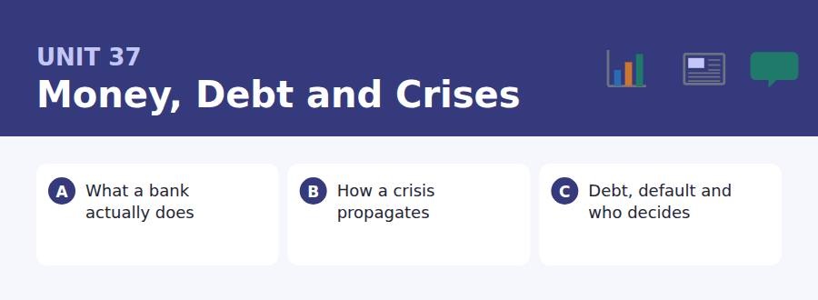
By the end of this unit I can…
- I can write a third conditional and a mixed conditional accurately.
- I can use inverted conditionals: had it been, were it not for, should you need.
- I can use the mandative subjunctive: it is essential that the position be reported.
- I can explain a mechanism in which each step is reasonable and the whole is not.
- I can follow a talk that distinguishes a moral explanation from a structural one.
- I can write about a failure without reaching for blame.

Finance is the subject where counterfactuals do the most work: if the regulator had asked, had the position been visible, were the system sound. This unit teaches the structures English uses for things that did not happen but nearly did.

Vocabulary 1 · Academic word families 18 families, not 18 words
At B2 the word on its own is not enough. Each entry below is a family: learn the noun, the verb and the adjective together, because the test will use whichever one the sentence needs.
liquidity how easily an asset becomes cash | arbitrage profiting from a price difference between markets
solvency having more assets than liabilities | contagion the spread of trouble from one institution to others
leverage the use of borrowed money to increase a position | exposure the amount that could be lost
collateral an asset pledged against a loan | insolvent unable to pay what is owed
default failure to make a payment that is due | underwrite to accept a risk in return for a fee
creditor somebody who is owed money | securitise to turn loans into tradable instruments
debtor somebody who owes money | counterparty the other side of a contract
maturity the date a debt falls due | audit an independent examination of accounts
amortise to pay off a debt in instalments over time | bailout public money used to rescue an institution

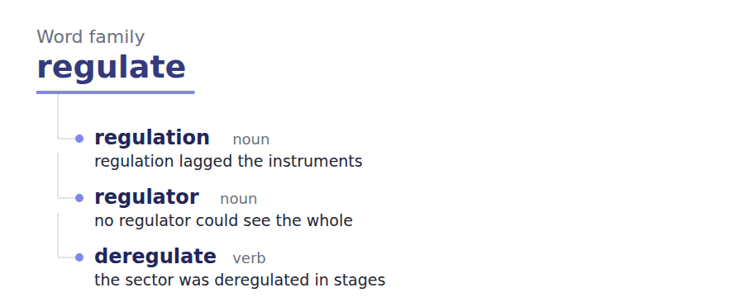
Exercise A Work in pairs. Ask and answer.
1. Explain why a bank cannot repay every depositor at once.
2. Why is joining a bank run rational for one saver?
3. What is the difference between being illiquid and being insolvent?
4. Should a country ever be allowed to default? Why?
Vocabulary 2 · Collocation 10 partnerships that actually occur
A word is known when you know what it goes with. These ten are the partners this unit’s texts use; the wrong partner is what marks an answer as translated.
call in a loan to demand repayment | in the red owing money, in deficit
write off to accept that a debt will not be paid | to the tune of to the amount of
run on a bank a rush of savers withdrawing | across the system everywhere in it at once
bail out to rescue with money | in good faith honestly, without intent to deceive
go under to fail completely | after the fact once it has already happened

Vocabulary 3 · Stance and hedging How far the writer commits
Every one of these says the same thing at a different strength. Reading, you must notice which was chosen. Writing, you must choose.
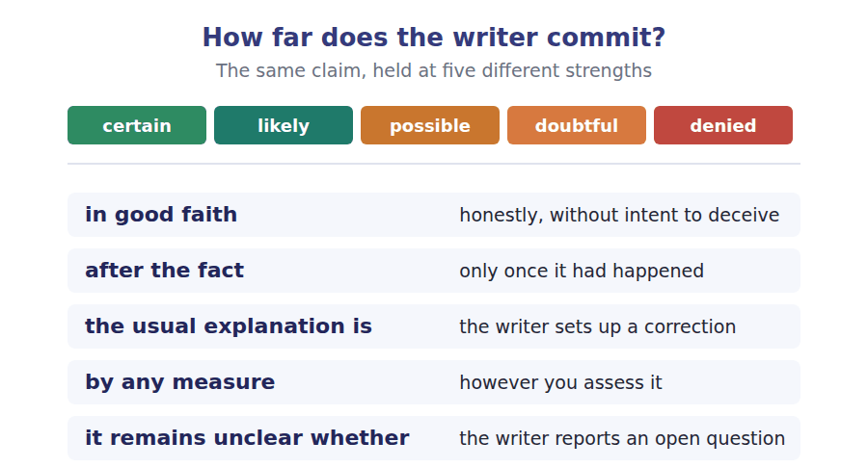
Two words that look alike
liquidity / solvency can pay today / can pay at all
debt / deficit what is owed / what is overspent this year
default / bankruptcy a missed payment / a legal process

Words you will meet again: central bank | interest rate | bond | credit rating | stress test | moral hazard | lender of last resort | capital requirement


SKILL · Completing abstract nouns and adjectives of judgement
- Finance writing runs on -ity, -ure and -ence nouns: liquidity, exposure, incompetence.
- The -ible and -able endings mark judgement: defensible, sensible.
- A gap after the only usually needs an adjective, not a noun.

Exercise A Guided practice. Five words are not complete. Write the missing letters.
A bank does not keep your money in a drawer, and if everybody asked for it at once no bank could pay. This is not a scandal; it is the mechan---. Deposits are lent out, the loans become somebody else’s deposits, and the system works because withdraw--- are normally uncorrel----. What makes a bank run dangerous is not that savers are irrati---- but the opposite: once a run begins, joining it is the only sens---- thing an individual saver can do.

The first one is done for you: mechan--- is mechanism — it follows it is the and names a thing, so the slot is a noun.
Exercise B Exam practice. One paragraph, ten gaps — the real task.
If regulators had understood in 2006 what they understood by 2010, the crisis would have been smaller, and the reason they did not is more interesting than incompetence. The risk had not disappeared; it had been moved somewhere nobody was requ---- to look. Mortgages were bundled into securities, the securities were rated by agencies paid by the issu---, and the resulting instruments were held by entities that did not appear on any bank’s balance sh---. Each step was individually defens---- and legal, and the combination produced a system in which no single institution could see its own expos---. Had any supervisor been able to add the positions together, the picture would have been obvious by 2005. Nobody could, because the information sat in different jurisdict---- under different reporting requirem----, and the one authority with the legal power to demand it had no stat----- duty to do so. The lesson usually drawn is that bankers were greedy, which is true, unhelpful and constant. The lesson worth drawing is that a system can be compliant at every point and unsound as a wh---, and that detecting this requires somebody whose job is to look at the whole and who has the authority to ins---.

Check your answers in the key at the back of the book.


SKILL · Reading a reporting requirement against a position
- A reporting rule says what must be disclosed, to whom, and when. A position tests whether it is caught.
- Look for the threshold and the definition. Most disclosure gaps are definitional, not numerical.
- An answer that says the rule does not catch something is usually followed by a rule that does.

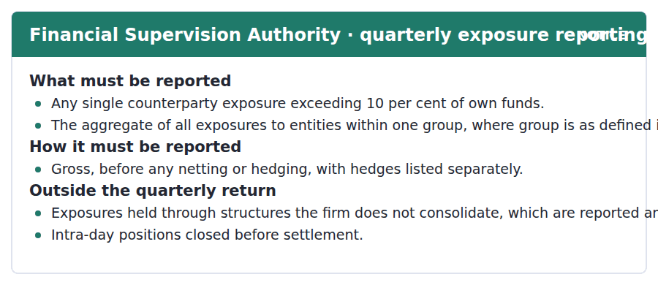
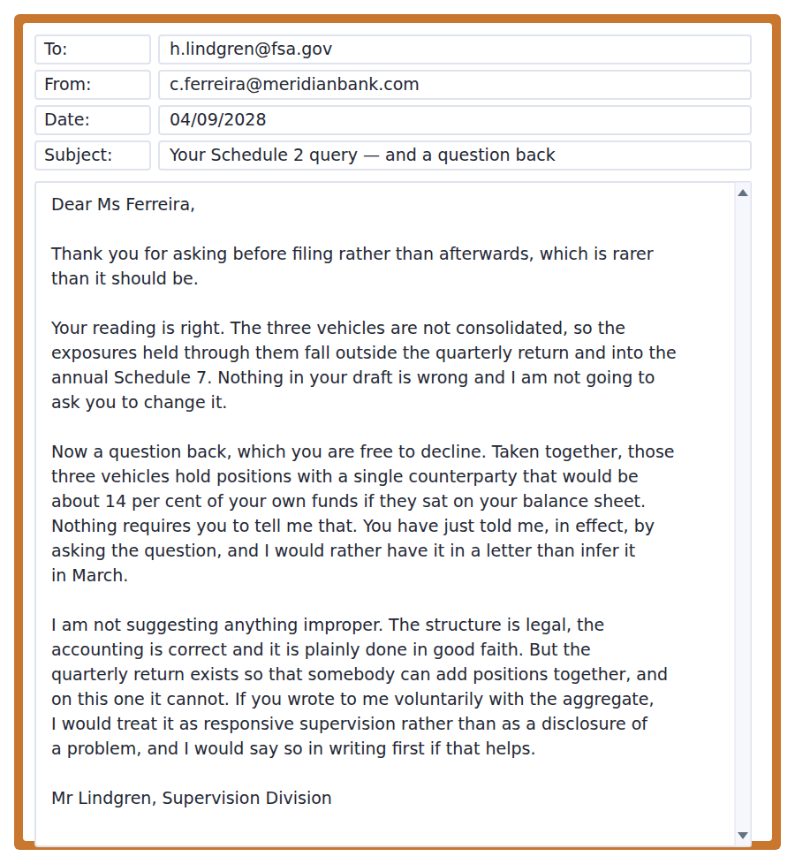
Exercise A Guided practice. The answer is on the page — find it.
1. What single-counterparty exposure must be reported?
(A) Any exposure
(B) Any over 14 per cent
(C) Any exceeding 10 per cent of own funds
(D) Only group exposures
2. How must exposures be reported?
(A) Net of hedging
(B) After netting
(C) As a single total
(D) Gross, with hedges listed separately
3. Where do non-consolidated exposures go?
(A) The annual Schedule 7 return
(B) The quarterly return
(C) Nowhere
(D) The audit report
4. What is outside the quarterly return?
(A) All hedges
(B) Intra-day positions closed before settlement
(C) Group exposures
(D) Collateral
Exercise B Exam practice.
5. What does the supervisor say about the bank’s reading of the rules?
(A) It is wrong
(B) It needs legal advice
(C) It is arguable
(D) It is right and nothing needs changing
6. What is the aggregate exposure through the three vehicles?
(A) About 10 per cent of own funds
(B) Below the threshold
(C) About 14 per cent of own funds
(D) Not calculable
7. Why does the supervisor say he now knows?
(A) The question itself told him
(B) The bank filed it
(C) An audit found it
(D) A counterparty reported it
8. What does he explicitly not suggest?
(A) That the structure is legal
(B) That anything improper has occurred
(C) That the return is adequate
(D) That the bank should restructure
9. What does he say the quarterly return exists for?
(A) Tax purposes
(B) So that somebody can add positions together
(C) To check hedging
(D) To record defaults
10. What does he offer in return for a voluntary letter?
(A) To treat it as responsive supervision and to say so in writing
(B) A lighter audit
(C) An extension
(D) A change to Schedule 7
11. What is the structure of his email?
(A) A refusal and an instruction
(B) A warning
(C) A confirmation, a question he cannot compel, and an assurance
(D) A request for an audit


SKILL · Reading a passage that takes the opposing argument seriously
- A strong author will restate the opposing case in a form its holders would accept.
- Look for the sentence that says what the argument is really about, as against how it is characterised.
- The criticism at the end may fall on the author’s own side.

The Country That Cannot Pay
A country that cannot service its debts has no bankruptcy court to go to, and the absence of one shapes everything that follows. A company in that position enters a process with a judge, a queue and a statutory outcome. A state enters a negotiation, and the usual explanation is that it borrowed irresponsibly and must now accept the consequences. Sometimes it is accurate, and much of the borrowing was done in good faith by governments two administrations ago. It is also the explanation that requires no reform, which may be why it survives.
The economics are not seriously disputed. A debt that cannot be paid will not be paid, and the only question is how long the pretence lasts and what it costs. By any measure the costs of delay fall mainly on people who did not borrow anything: a decade of contracted spending, emigration of the young and skilled, a tax base shrinking faster than the debt. Creditors who refuse to write down a claim they will never collect are not protecting their money; they are protecting the accounting treatment of an asset they will admit is impaired only after the fact.
It remains unclear whether an orderly process would be better; it would help some countries and harm others. A statutory mechanism would reduce the cost of default, which is the point, and would therefore raise the cost of borrowing for every government that might one day use it — a real cost, falling now, on countries that have done nothing wrong. The argument against reform is thus not a defence of creditors but a claim about who pays for the insurance, and it has never been answered by the reform camp, which has preferred to treat the opposition as venal.
[294 words]

Exercise A Guided practice.
1. What does a state in default lack that a company has?
(A) Creditors
(B) Assets
(C) Legal advice
(D) A bankruptcy court with a statutory outcome
2. What does the author say about the usual explanation?
(A) It is always wrong
(B) It is sometimes accurate and requires no institutional reform
(C) It is new
(D) It is unpopular
3. What does the author say is not seriously disputed?
(A) Who is to blame
(B) The size of the debt
(C) That a debt which cannot be paid will not be paid
(D) The legal position
4. On whom do the costs of delay mainly fall?
(A) People who did not borrow anything
(B) Creditors
(C) Future governments
(D) Rating agencies
Exercise B Exam practice.
5. What does the author say refusing creditors are protecting?
(A) Their money
(B) Their legal rights
(C) Future lending
(D) The accounting treatment of an impaired asset
6. What would a statutory mechanism do to the cost of default?
(A) Reduce it
(B) Raise it
(C) Leave it unchanged
(D) Make it unmeasurable
7. What is the consequence of reducing the cost of default?
(A) Fewer defaults
(B) A higher cost of borrowing for governments that might use it
(C) Stronger creditors
(D) Larger debts
8. What does the author say the argument against reform really is?
(A) A defence of creditors
(B) A legal objection
(C) A moral argument
(D) A claim about who pays for the insurance
9. What criticism does the author make of the reformers?
(A) They are naive
(B) They lack evidence
(C) They have treated the opposition as venal instead of answering it
(D) They are too cautious
10. What does "the pretence" refer to?
(A) Maintaining that a debt which cannot be paid will be
(B) The debt figures
(C) The creditors’ accounts
(D) The negotiation
11. Which would most weaken the third paragraph?
(A) Evidence that defaults are rare
(B) Evidence that borrowing costs did not rise where such mechanisms exist
(C) Evidence that creditors oppose reform
(D) Evidence that delay is costly
12. All of the following are stated EXCEPT:
(A) A state has no bankruptcy court
(B) The costs of delay fall mainly on non-borrowers
(C) An orderly process would be better for every country
(D) A statutory mechanism would reduce the cost of default
13. What is the author’s overall approach?
(A) Advocacy for reform
(B) Opposition to reform
(C) Neutral reporting
(D) Sympathetic to reform and critical of its advocates’ argument


Exercise A Listen and choose a response. You hear one line. Choose the best reply.
1. Man: So the bank does not have my money?
(A) Yes, in a vault.
(B) Not as cash, no. It has been lent out.
(C) About two per cent.
(D) At the branch.
2. Woman: Is joining a bank run irrational?
(A) Yes, completely.
(B) About three days.
(C) No — that is exactly the problem.
(D) In a crisis.
3. Man: Would a regulator have seen it in 2005?
(A) Only if somebody could have added it up.
(B) Yes, easily.
(C) About four years.
(D) In the lecture.
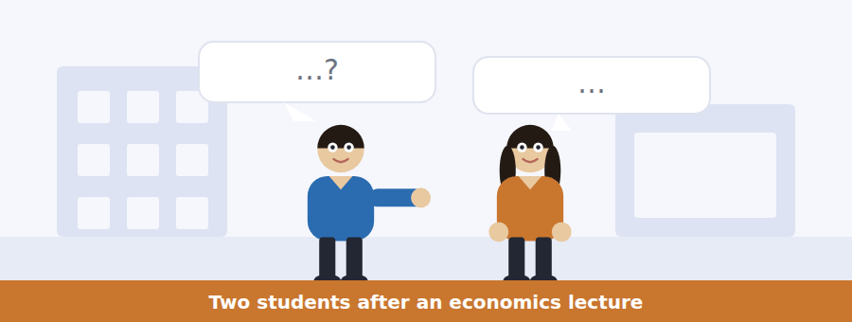
SKILL · Hearing a counterfactual argument
- Counterfactual reasoning is common in economics. The items test the condition, not the outcome.
- Listen for: if they had, the result would have been, had anybody been able to.
- A speaker may use a counterfactual to show that a cause was not the obvious one.

Exercise B Listen and answer. The audio plays once.
4. What does the woman find most striking?
(A) The size of the losses
(B) The role of ratings
(C) The speed of the collapse
(D) That nobody had to break a rule
5. What does the man say about each individual step?
(A) Each was illegal
(B) Each was unprecedented
(C) Each was concealed
(D) Each taken alone is defensible
6. Where does he say it goes wrong?
(A) In the addition
(B) In the ratings
(C) In the lending
(D) In the law
7. When would the picture have been obvious?
(A) 2010
(B) Never
(C) About 2005
(D) 2008
8. Why could nobody add the positions?
(A) The data did not exist
(B) Different jurisdictions and reporting rules, and no duty to demand them
(C) The instruments were secret
(D) Nobody thought of it
9. What does he say about the greed explanation?
(A) It is false
(B) It is true, unhelpful and constant
(C) It is the main cause
(D) It is unfashionable
10. What does he say changed?
(A) The visibility
(B) The level of greed
(C) The regulations
(D) The interest rate
Audio script: see the back of the book. Do not read it before you listen.


Exercise A Listen and choose a response. You hear one line. Choose the best reply.
1. Woman: Must I report the unconsolidated positions quarterly?
(A) Yes, every quarter.
(B) About fourteen per cent.
(C) On Friday.
(D) No — those go in the annual return.
2. Man: Should I net the hedges off?
(A) Yes, always net.
(B) About ten per cent.
(C) No — gross, with hedges listed separately.
(D) In Schedule 2.
3. Woman: Can you require the aggregate figure?
(A) No, which is why I am asking for it.
(B) Yes, I can demand it.
(C) About four vehicles.
(D) By March.
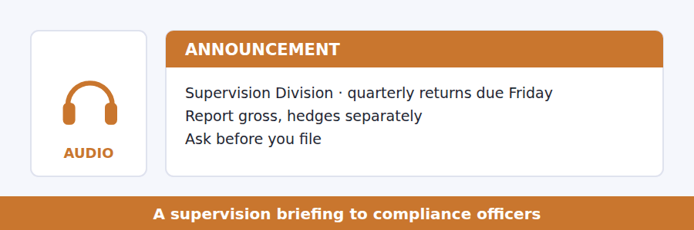
SKILL · Hearing a request that cannot be compelled
- A speaker may ask for something they have no power to require. The distinction will be stated.
- Listen for: nothing obliges you to, I am asking rather than requiring.
- The reason it is worth doing anyway is the examinable part.

Exercise B Listen and answer. The audio plays once.
4. How must single-counterparty exposures be reported?
(A) Net of hedges
(B) Annually
(C) Gross, with hedges listed separately
(D) Only above 14 per cent
5. Why does the Authority want gross figures?
(A) They are simpler
(B) A netted figure shows what the firm thinks its risk is, not its position
(C) They are legally required
(D) They are easier to audit
6. Where do unconsolidated exposures go?
(A) The quarterly return
(B) Nowhere
(C) An audit report
(D) The annual Schedule 7
7. What does he say about his authority on the second point?
(A) It is discretionary
(B) It applies annually
(C) He has none at all
(D) It is under review
8. What is he asking firms to do?
(A) File early
(B) Consolidate the vehicles
(C) Change their hedging
(D) Write to him if the aggregate would cross the threshold on balance sheet
9. What assurance does he offer?
(A) Written confirmation in advance that such a letter is responsive supervision
(B) A lighter inspection
(C) Anonymity
(D) An extended deadline
Audio script: see the back of the book. Do not read it before you listen.


Exercise A Listen and choose a response. You hear one line. Choose the best reply.
1. Man: Can a country go bankrupt?
(A) Yes, like a company.
(B) There is no court for it to go to.
(C) About a decade.
(D) In the lecture.
2. Woman: Why delay a default that must happen?
(A) Because it might not happen.
(B) Because somebody still has it as an asset.
(C) About ten years.
(D) The creditors decide.
3. Man: Would a legal process be better?
(A) For some countries. Worse for others.
(B) Yes, obviously.
(C) About thirty years.
(D) Under the treaty.
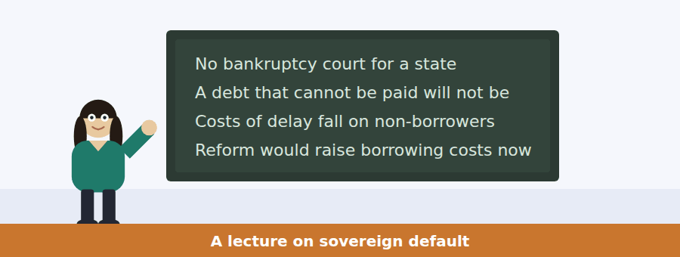
SKILL · Following a talk that criticises its own side
- A lecturer who favours one position may spend the strongest section attacking its advocates.
- Listen for: the argument against this is serious and we have not answered it.
- The final item is usually about the quality of the argument, not the policy.

Exercise B Listen and answer. The audio plays once.
4. What is the difference she builds the lecture on?
(A) Between debt and deficit
(B) Between banks and states
(C) Between a court process and a negotiation
(D) Between default and bankruptcy
5. What does she say is not in dispute?
(A) Who is at fault
(B) The size of the debt
(C) The legal framework
(D) That a debt which cannot be paid will not be paid
6. On whom does the cost of delay fall?
(A) Creditors
(B) Rating agencies
(C) People who borrowed nothing
(D) Future lenders
7. What does she say refusing creditors are defending?
(A) The accounting treatment of an impaired asset
(B) Their money
(C) Their legal rights
(D) The negotiation
8. What effect would a statutory mechanism have?
(A) No effect on borrowing costs
(B) Lower default costs and higher borrowing costs now
(C) Higher default costs
(D) Fewer negotiations
9. Who would bear that cost?
(A) Bondholders
(B) The institutions
(C) Future governments only
(D) Countries that have done nothing wrong
10. What is her criticism of her own side?
(A) They are wrong
(B) They have called the other side greedy instead of answering the argument
(C) They lack evidence
(D) They are too cautious
Audio script: see the back of the book. Do not read it before you listen.


Part 1 · Listen and Repeat
You hear a sentence and repeat it once. There is no preparation time, and the sentences get longer. Focus: saying a third conditional cleanly
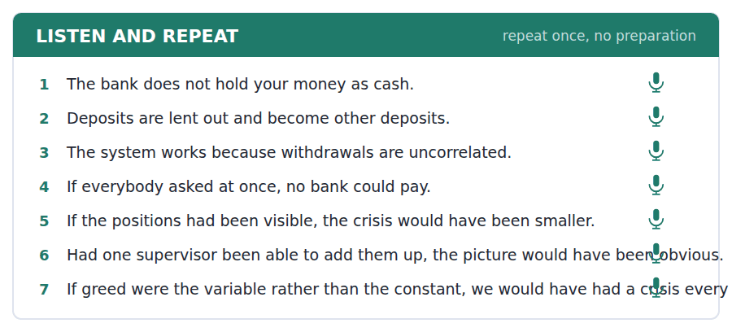
SKILL · Saying what would have happened
- The third conditional has two halves and both are past: if they had seen it, the crisis would have been smaller.
- Contract the auxiliaries in speech: if they’d seen it, it would’ve been. Full forms sound like dictation.
- Stress the condition, not the result. The condition is the claim.

Part 2 · Take an Interview
An interviewer asks you four questions on one theme: money, trust and institutions. Answer each one fully. There is no preparation time.
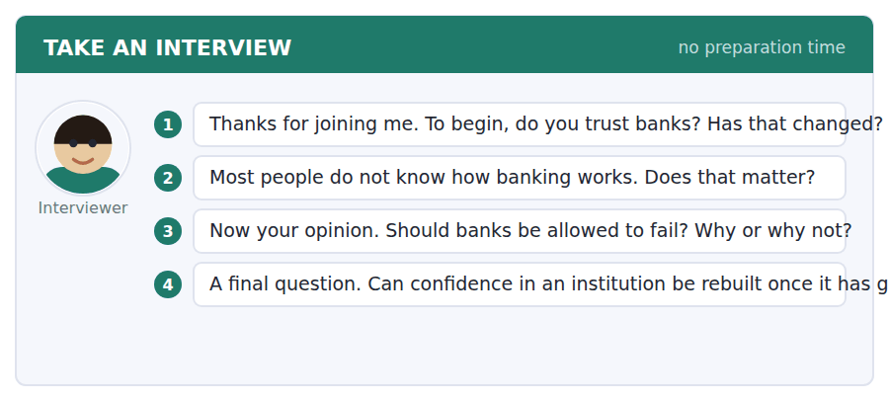
A good answer sounds like this
Question 2 — It matters less than people think for ordinary decisions and more than they think for voting, because the policy arguments are conducted in terms nobody has been given.
Question 4 — Slowly, and only by the institution being boring for a long time. Anything faster is marketing.
I can… | Not yet | Yes
I kept both halves of the third conditional in the past. | □ | □
I contracted the auxiliaries. | □ | □
I stressed the condition rather than the result. | □ | □


Part 1 · Listen and Repeat
You hear a sentence and repeat it once. There is no preparation time, and the sentences get longer. Focus: inverted conditionals and the subjunctive
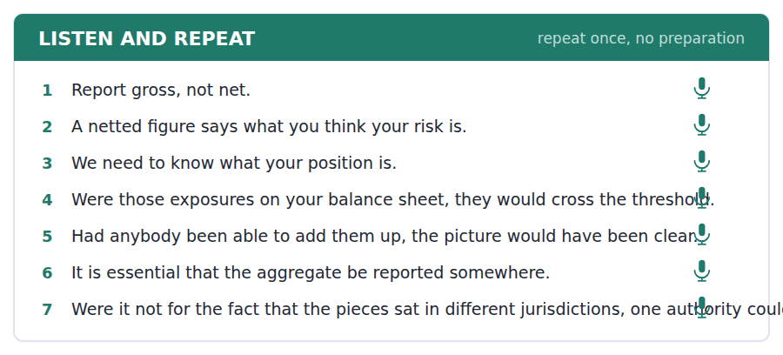
SKILL · Saying had it been and were it not for
- An inverted conditional drops if and inverts: had the position been visible, were it not for the structure.
- The mandative subjunctive uses the bare verb: it is essential that the position be reported.
- Both are formal. In speech, use one and then return to ordinary forms.

Part 2 · Take an Interview
An interviewer asks you four questions on one theme: rules, disclosure and what nobody is required to say. Answer each one fully. There is no preparation time.
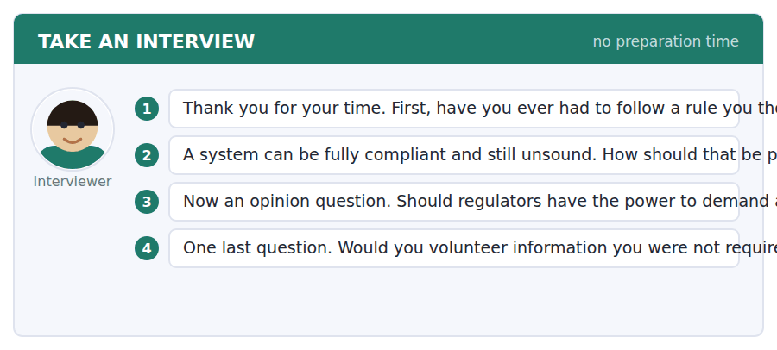
A good answer sounds like this
Question 2 — By giving somebody the job of looking at the whole and the authority to insist. Compliance at every point is not a substitute for anybody adding it up.
Question 4 — If the person asking said in advance, in writing, how they would treat the answer. Without that, volunteering is just taking a risk nobody will thank you for.
I can… | Not yet | Yes
I inverted the conditional without using if. | □ | □
I used the bare verb after it is essential that. | □ | □
I did not stack formal structures. | □ | □


Part 1 · Listen and Repeat
You hear a sentence and repeat it once. There is no preparation time, and the sentences get longer. Focus: criticising your own position
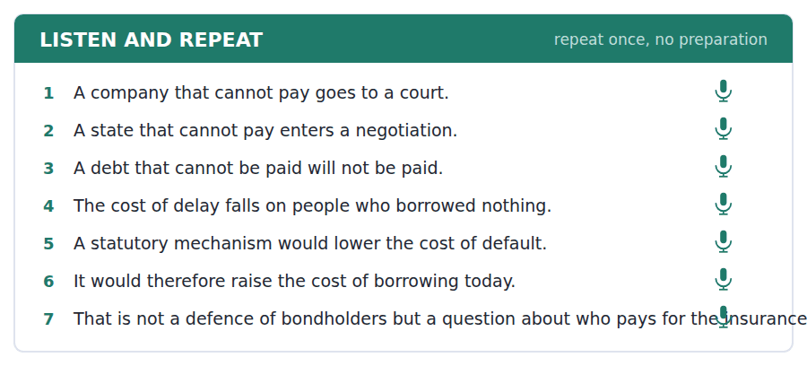
SKILL · Granting the strongest objection
- State the objection as its holders would: not a caricature, a version they would sign.
- Say plainly that it has not been answered, if it has not.
- Separate whether you are right from whether you have argued well.

Part 2 · Take an Interview
An interviewer asks you four questions on one theme: debt, fairness and institutional design. Answer each one fully. There is no preparation time.
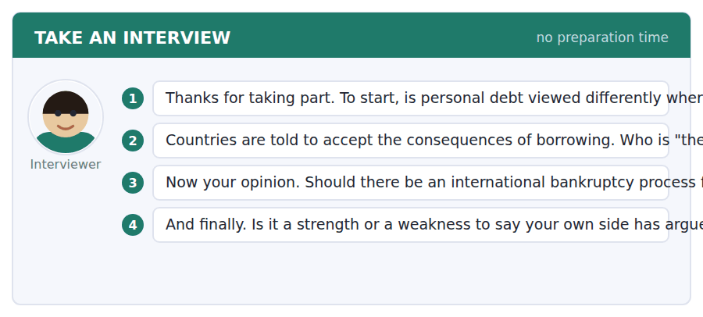
A good answer sounds like this
Question 2 — Not the people who borrowed, usually. The government changed twice, and the consequences are accepted by whoever is still in the country in ten years.
Question 4 — A strength, and only if you then answer the objection. Saying it and stopping is a way of looking honest without doing the work.
I can… | Not yet | Yes
I stated the objection in a form its holders would accept. | □ | □
I said whether it had been answered. | □ | □
I kept being right and arguing well apart. | □ | □


You see a sentence, then a set of words in boxes. Put the words in order to make one grammatical sentence. Almost every item in the real test makes a question or a question inside another sentence.
SKILL · Build a Sentence with an unreal condition
- The two non-question items in this unit build an unreal condition, often inverted: had it been, were it not for.
- An inverted conditional has no if: had the position been visible, not if had the position.
- Were it not for is followed by a noun phrase, never by a clause.

Exercise A Guided practice. The first three are worked through.
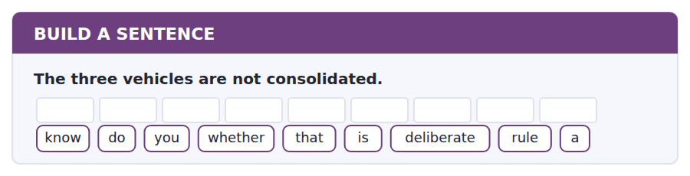
1. Do you know whether that is a deliberate rule?
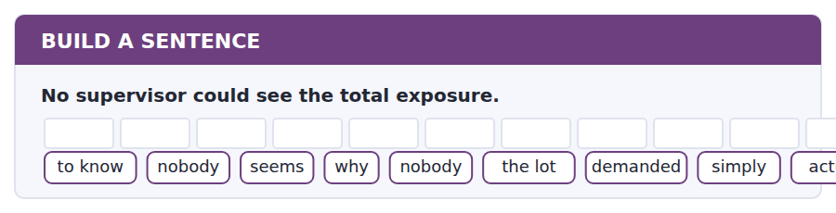
2. Nobody seems to know why nobody actually simply demanded the lot.
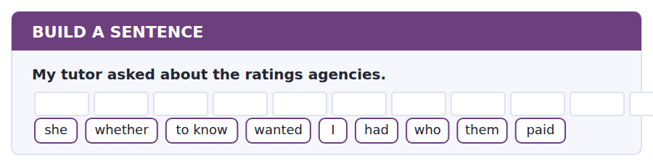
3. She wanted to know whether I had asked who paid them.
Exercise B Exam practice. Write the sentence.
4. A netted figure hides the underlying position.
do / whether / know / you / the rule / that / allows / all / at
__________________________________________________________
5. The quarterly return cannot capture those exposures.
explain / can / anybody / why / the gap / to me / was / there / left
__________________________________________________________
6. A state has no bankruptcy court.
know / does / anybody / why / one / has / been / never / created
__________________________________________________________
7. The costs of delay fall on non-borrowers.
us / told / nobody / who / the costs / was / supposed / bear / to
__________________________________________________________
8. Two firms wrote in voluntarily last year.
told / he / me / what / had / happened / to / in the end / them
__________________________________________________________
9. The positions were never added together.
had / anybody / added / them / up / the picture / would / have / been obvious
__________________________________________________________
10. The pieces sat in different jurisdictions.
were / it / not / for / that / one authority / could / the lot / have demanded
__________________________________________________________


You read a short situation and write an email. You have 7 minutes. The three bullet points are the mark scheme: answer all three.
The supervisor has confirmed your reading of the rules, pointed out that your aggregate exposure through three unconsolidated vehicles would breach the quarterly threshold if it sat on your balance sheet, and offered to treat a voluntary letter as responsive supervision. Your board has agreed to write. You also want to propose something about the rule itself.
Write an email to the Supervision Division.
- Give the figure and the basis on which it is calculated.
- Say what you have done about it internally.
- Make one proposal about the reporting rule, and name its cost.
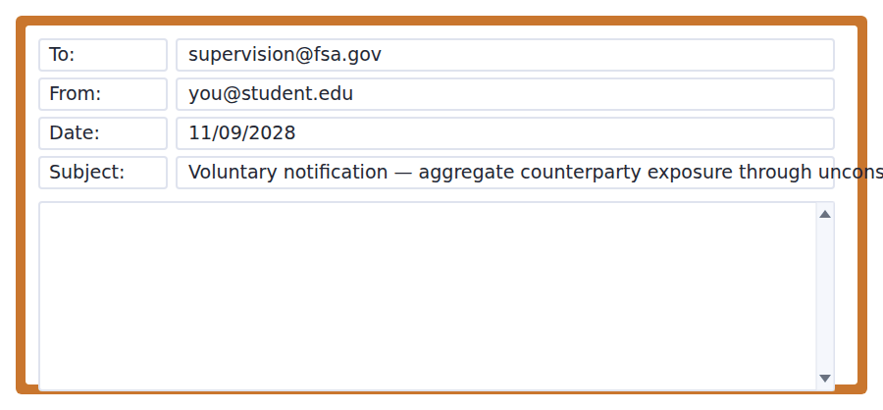
SKILL · Volunteering information that was not required
- Lead with the number. A voluntary disclosure that buries the figure reads as reluctance.
- State the basis of calculation, because a figure without a basis cannot be compared with anything.
- Say what you have already done. It converts the letter from a confession into a report.

Model email
Dear Mr Lindgren,

Thank you for confirming in writing how this letter will be treated. The board met on Tuesday and agreed to write.

The figure is 13.8 per cent of own funds as at 31 August, gross, aggregated across the three unconsolidated vehicles, against a single counterparty. The basis is the same as the quarterly return: gross, before netting, with hedges excluded from the numerator. On the same basis the equivalent figure at 31 May was 11.2 per cent, so the direction matters as much as the level.

Three things have changed internally. The aggregate is now calculated monthly rather than annually and goes to the Risk Committee. We have set an internal limit of 12 per cent, which we are currently above and expect to be inside by December. And the Committee has asked for the same aggregation across the four next largest counterparties, which we did not previously produce at all.

One proposal, with its cost stated. Schedule 7 could require the aggregate through unconsolidated structures to be reported quarterly rather than annually, as a single line, without the full Schedule 7 detail. For us that is about two days of work a quarter. For the Authority it closes the gap you described without asking anybody to consolidate anything. It would catch firms who are doing nothing wrong and who will nonetheless find the line uncomfortable, and that is a real cost rather than an imaginary one.

With thanks,
Constança Ferreira
Why it works
- The figure comes first, with a date, and the basis of calculation is stated so it can be compared.
- The previous quarter is given unprompted, which supplies the trend the supervisor would have asked for next.
- Three internal changes are reported, including an admission that the firm is currently above its own new limit.
- The proposal is specific, costed in days, and names who it would inconvenience — which is what makes it a proposal rather than a gesture.
Two answers, one band apart
Both answer the three bullet points. One would score in the middle band and one near the top. Read them side by side before you write your own.
A middle-band answer | A top-band answer
Dear Mr Lindgren,  Thank you very much for your email and for your reassurance about how a letter of this kind would be handled. Our board has now discussed the matter and has agreed that I should write to you about it.  You are right that our aggregate exposure through the three vehicles would be above the quarterly threshold if the vehicles were consolidated. The figure is just under 14 per cent at the moment. We have been looking at this carefully and we are taking steps internally to monitor it more closely than we did before.  We would also like to suggest that the reporting rules might be looked at, as it does seem that there is a gap here which could cause problems in future. We would be happy to discuss this further with you if that would be helpful at any point.  Thank you again for your understanding. Best wishes, Constança Ferreira | Dear Mr Lindgren,  Thank you for confirming in writing how this letter will be treated. The board met on Tuesday and agreed to write.  The figure is 13.8 per cent of own funds at 31 August, gross, aggregated across the three vehicles against one counterparty, on the same basis as the quarterly return. At 31 May it was 11.2 per cent, so the direction matters as much as the level.  Internally: the aggregate is now monthly rather than annual and goes to the Risk Committee; we have set an internal limit of 12 per cent, which we are above and expect to be inside by December; and the Committee has asked for the same aggregation across the next four counterparties.  One proposal, costed. Schedule 7 could require this aggregate quarterly as a single line, without the full detail. For us, about two days a quarter. It would catch firms doing nothing wrong who will find the line uncomfortable, and that is a real cost. Constança Ferreira

What the top answer does that the other does not
- It gives the exact figure and date rather than just under 14 per cent, and states the basis so the number can be compared with the return.
- It supplies the previous quarter unprompted, which turns a level into a trend.
- It lists three specific internal changes, including the admission that the firm is above its own new limit — which a regulator trusts far more than monitoring more closely.
- It makes a concrete drafting proposal instead of suggesting the rules be looked at.
- It costs the proposal in days and names whom it would inconvenience, so the supervisor can weigh it rather than investigate it.
Now write your own. 7 minutes.
__________________________________________________________
__________________________________________________________
__________________________________________________________
__________________________________________________________
__________________________________________________________
__________________________________________________________
__________________________________________________________
__________________________________________________________


A professor asks a question and two students answer. You add your own post. You have 10 minutes and an effective answer is at least 100 words.
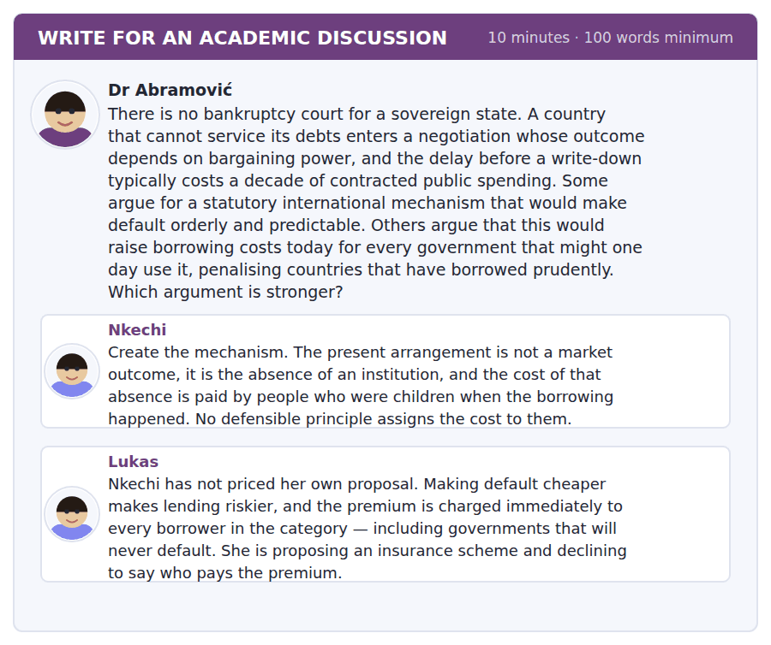
SKILL · Answering an argument about who bears a cost
- When the dispute is about incidence, say who pays under each arrangement, now and later.
- Check whether the costs are of the same kind. A certain small cost and an uncertain large one are not comparable by size alone.
- Then propose the design feature that changes the incidence.

Sentence starters
- Lukas is right that the proposal has a price and wrong about its shape.
- Nkechi’s principle is the strongest thing in either post.
- What neither has separated is…
- The design feature that changes this is…
Model post
Lukas is right that the proposal has a price and wrong about its shape. Making default orderly does raise the risk premium, and it raises it for a defined category of borrowers, which is a real and immediate cost. But he describes it as a penalty on the prudent, and that comparison only works if the current arrangement is costless to those same countries. It is not. The absence of a mechanism makes every default chaotic and contagious, and contagion is charged to neighbours and trading partners who did not borrow either. The choice is between a small certain premium and a large uncertain one, not between a premium and nothing.
Nkechi’s principle is the strongest thing in either post and she states it too broadly. No defensible principle assigns the cost to people who were children at the time — agreed, and that argument also condemns a mechanism that lowered default costs so far that governments borrowed more freely against it. Her principle supports an orderly process and constrains its generosity, and she has used only the first half.
What neither has separated is the two things a mechanism does. It fixes the procedure, and it fixes the depth of the write-down. The procedural part — a queue, a timetable, a stay on enforcement — is close to costless and is where the decade of delay actually comes from. The distributional part, how much creditors lose, is where Lukas’s premium lives.
So the design feature that changes this is to legislate the procedure and leave the quantum to negotiation inside it. That removes most of the cost of delay without announcing in advance how much a creditor forfeits, which is the thing the premium is priced against. It satisfies Nkechi’s principle and gives Lukas very little left to charge for.
[301 words]
Now write your own. 10 minutes, at least 100 words.
__________________________________________________________
__________________________________________________________
__________________________________________________________
__________________________________________________________
__________________________________________________________
__________________________________________________________
__________________________________________________________
__________________________________________________________
__________________________________________________________
__________________________________________________________

Grammar focus Unreal past and the subjunctive
Form | What it says
if + past perfect, would have + participle | third conditional: if they had seen it, it would have been smaller
had + subject + participle | inverted third conditional: had they seen it
were + subject + to | formal future unreal: were the firm to consolidate
were it not for + noun phrase | but for this: were it not for the jurisdictions
mixed conditional | past condition, present result: if they had reported it, we would now know
mandative subjunctive | it is essential that the position be reported
should + subject + verb | formal open condition: should you need the figure

An inverted conditional never keeps if: had they seen it, not if had they seen it. The inversion replaces the conjunction and is one of the most reliable markers of formal written English.
Were it not for is followed by a noun phrase. Were it not for the pieces sat in different jurisdictions is wrong; were it not for the fact that they sat in different jurisdictions is right.
The mandative subjunctive uses the bare verb after essential, vital, recommended, required: it is essential that the aggregate be reported, not is reported. British English also allows should: that the aggregate should be reported.
Watch out! Do not write "if I would have known". The condition half of a third conditional takes the past perfect and never would: if I had known. The error is common in speech and fatal in writing.
Exercise 1 Complete with the correct form.
1. If the positions ______ (be) visible, the crisis would have been smaller.
2. ______ anybody been able to add them up, the picture would have been clear.
3. Were it not for the ______ (fact) that they sat in different jurisdictions, one authority could have acted.
4. It is essential that the aggregate ______ (report) somewhere.
5. If they had reported it, we ______ now know the total.
6. ______ you need the figure, I can supply it.
Exercise 2 Correct the conditional.
1. If I would have known, I would have written.
2. If had the position been visible, it would have been obvious.
3. Were it not for the pieces sat in different jurisdictions, one authority could have acted.
4. It is essential that the aggregate is reported.
Exercise 3 Rewrite as an inverted conditional.
1. If anybody had added the positions up, the picture would have been obvious.
2. If the vehicles were consolidated, the exposure would breach the threshold.
3. If the firm had written in March, nothing would have followed.
4. If the mechanism had existed, the delay would have been shorter.
How this is tested in Build a Sentence
Two of the ten Build a Sentence items in this unit build an unreal condition, usually inverted. A tile reading had or were opening the sentence signals the inversion, and there will be no if tile anywhere in the set.
Find the fault 5 errors, drawn from this unit and the two before
Every error below is one a B2 writer makes after learning the rule. Mark what is wrong, then check. Knowing the rule and noticing the breach are two different skills, and only the second one is tested.
If I would have known the aggregate, I would have written in March. If had the position been visible, the picture would have been obvious. Were it not for the pieces sat in different jurisdictions, one authority could have acted. It is essential that the aggregate is reported somewhere. Nobody knows whether did the board agree.
# | As written | As it should be | Why
1 | If I would have known | If I had known | The condition half of a third conditional takes the past perfect and never would.
2 | If had the position been visible | Had the position been visible | An inverted conditional replaces if, so keeping both marks the condition twice.
3 | Were it not for the pieces sat in different jurisdictions | Were it not for the fact that the pieces sat in different jurisdictions | Were it not for takes a noun phrase rather than a clause with its own finite verb.
4 | It is essential that the aggregate is reported | It is essential that the aggregate be reported | Essential, vital and required take the bare verb in the subordinate clause.
5 | whether did the board agree | whether the board agreed | An embedded question keeps statement order and takes no auxiliary.

Unit review and progress check Unit 37
Exercise A Vocabulary. Write the word.
1. to pay off a debt in instalments over time
2. having more assets than liabilities
3. the use of borrowed money to increase a position
4. an asset pledged against a loan
5. failure to make a payment that is due
6. the date a debt falls due
7. the spread of trouble from one institution to others
8. the amount that could be lost
9. to turn loans into tradable instruments
10. the other side of a contract
11. public money used to rescue an institution
12. somebody who is owed money
Exercise B Grammar. Complete the sentence.
1. If the positions ______ been visible, it would have been obvious.
2. ______ anybody added them up, the picture would have been clear.
3. ______ the vehicles consolidated, the limit would be breached.
4. It is essential that the aggregate ______ reported.
5. ______ you need the figure, I can supply it.
6. Were it not ______ that fact, one authority could have acted.
7. If they had reported it, we ______ now know the total.
8. ______ the firm to consolidate, the exposure would appear.
Exercise C One timed mini-section. 6 minutes.
1. A bank cannot repay every depositor at once because
(A) it is insolvent
(B) the law forbids it
(C) cash is limited by regulation
(D) deposits have been lent out
2. The crisis spread largely because
(A) bankers broke the law
(B) interest rates rose
(C) no institution could see its own total exposure
(D) ratings were secret
3. A state that cannot pay differs from a company in that
(A) there is no court and no statutory outcome
(B) it has no creditors
(C) its debts are smaller
(D) it cannot default
4. Which sentence is correct?
(A) If I had known, I would have written.
(B) If I would have known, I would have written.
(C) If I had have known, I would have written.
(D) Had I would have known, I would have written.
5. "In good faith" tells you that the writer regards the conduct as
(A) unlawful
(B) honest, whatever its effect
(C) careless
(D) concealed
6. Refusing to write down an uncollectable claim protects
(A) the creditor’s money
(B) the debtor
(C) future lending
(D) the accounting treatment of the asset
Can you do these now?
I can… | Not yet | Yes
I can write a third conditional and a mixed conditional accurately. | □ | □
I can use inverted conditionals: had it been, were it not for, should you need. | □ | □
I can use the mandative subjunctive: it is essential that the position be reported. | □ | □
I can explain a mechanism in which each step is reasonable and the whole is not. | □ | □
I can follow a talk that distinguishes a moral explanation from a structural one. | □ | □
I can write about a failure without reaching for blame. | □ | □

ADAPTIVE TIP The unreal past is where careful writers are separated from fluent ones. If I would have known is the single most common error at B2 and it is entirely avoidable: the condition half never takes would. Learn the inverted forms too — had it been, were it not for — because they are what an examiner reads as range.

Unit 38 · Memory, Heritage and Museums
TOEFL iBT® Preparation Course 2026 · Volume 4
CEFR B2 · Grammar: Cohesion: substitution and ellipsis · Word field: provenance, repatriation, curation
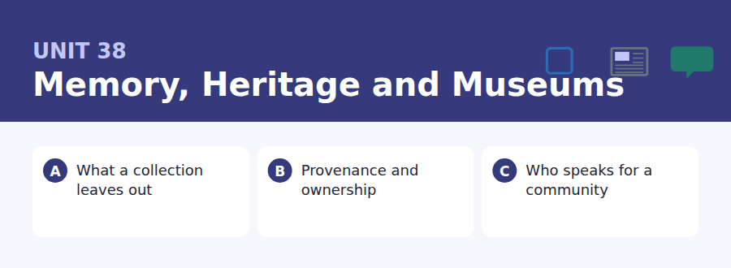
By the end of this unit I can…
- I can avoid repetition using one, ones, so, do so and the former.
- I can leave out what the reader can supply, and know when I cannot.
- I can keep a reference clear across several sentences.
- I can distinguish a legal question from a question about authority.
- I can follow a talk about a dispute in which both sides are partly right.
- I can write about a contested history without flattening it.

This unit is about what makes a text hang together. Substitution and ellipsis are the structures that let English avoid repeating itself, and they are the difference between writing that flows and writing that restates its own nouns every sentence.

Vocabulary 1 · Academic word families 18 families, not 18 words
At B2 the word on its own is not enough. Each entry below is a family: learn the noun, the verb and the adjective together, because the test will use whichever one the sentence needs.
provenance the documented history of an object’s ownership | custodian somebody who holds something on another’s behalf
repatriation returning an object to its place of origin | title legal ownership of property
curation the selection and arrangement of a collection | restitution giving back what was wrongly taken
artefact an object made by a person | inventory a complete list of holdings
acquisition the act of obtaining something for a collection | commemorate to mark publicly in memory of something
bequest something left to an institution in a will | vernacular ordinary, local and everyday
deaccession formally removing an object from a collection | canonical treated as standard and authoritative
conservator a specialist who preserves objects | archive a store of records kept for the long term
interpretation the explanation offered to a visitor | ephemera items not made to be kept

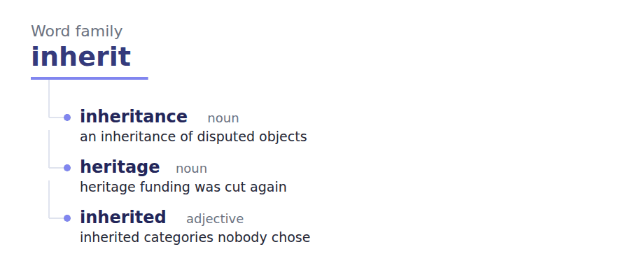
Exercise A Work in pairs. Ask and answer.
1. Describe a museum you have visited. What did it choose not to show?
2. Who should decide how an object is displayed?
3. Is returning an object the same as admitting it was stolen?
4. What would you keep from this decade for a museum in 2200?
Vocabulary 2 · Collocation 10 partnerships that actually occur
A word is known when you know what it goes with. These ten are the partners this unit’s texts use; the wrong partner is what marks an answer as translated.
hand down to pass to a later generation | lay claim to to assert a right over
come to light to become known | in trust held on behalf of somebody else
bring to the surface to make visible | on loan lent temporarily
put on display to exhibit | as a rule usually, as a general principle
stand in for to represent something absent | in its own right considered independently

Vocabulary 3 · Stance and hedging How far the writer commits
Every one of these says the same thing at a different strength. Reading, you must notice which was chosen. Writing, you must choose.
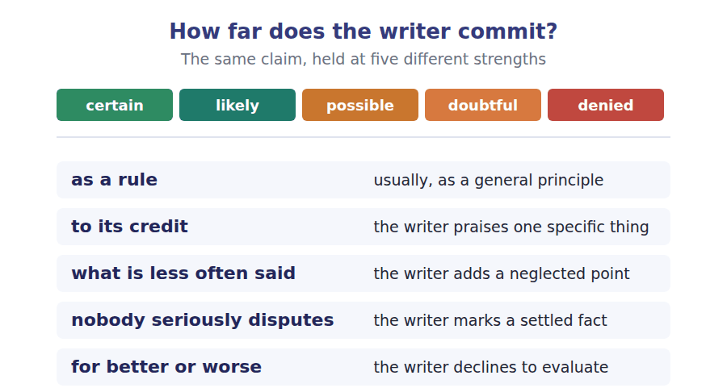
Two words that look alike
provenance / title the documented history / the legal ownership
restitution / repatriation giving back a wrong / returning to a place
archive / collection records kept / objects shown

Words you will meet again: storeroom | accession number | catalogue entry | wall label | loan agreement | due diligence | source community | oral history


SKILL · Completing nouns, and short words you nearly skip
- Museum writing is dense with -tion and -ity nouns: selection, authority, documentation.
- Short gaps matter too: were, no, so. A two-letter gap is still a word with a job.
- Read the whole sentence before filling a short gap. Its identity comes from the grammar, not the letters.

Exercise A Guided practice. Five words are not complete. Write the missing letters.
A museum does not display the past. It displays a selection, made by people with budgets, and the things not shown outnumber the things shown by a factor few visitors would gu---. This is not a criticism. No building could hold everything, and a collection with no principle of select--- would be a warehouse rather than a muse--. What deserves scrutiny is not that choices are made but whether anybody can find out what they w---, and in most institutions the answer is still n-.

The first one is done for you: gu-- is guess — the slot follows would, so it needs a bare infinitive.
Exercise B Exam practice. One paragraph, ten gaps — the real task.
Whose object is it, and who decides? Those two questions have dominated museum debate for thirty years, and they are often run together when they ought to be kept sep-----. A claim of ownership is a legal matter with documents, dates and, in some cases, a clear answer. A claim about who should decide the display of an object is about author---, and no document settles it. Institutions that treat the second as though it were the first produce the reply that infuriates everyone: we have examined the title and it is so---. That may be true and it answers a question nobody a----. The more honest institutions have begun publishing their acquisition records in f---, which is harder than it sounds and has had one consequence nobody expec---. The disputes have not multiplied. What has happened instead is that the arguments have become specific: this object, this date, this gap of eleven years in the documen------. Vagueness favours whoever is in possess---, because a general accusation is answered by a general den---, and both sides can repeat themselves indefinitely. Detail is uncomfortable for everybody and it is the only thing that has ever moved a single ca--.

Check your answers in the key at the back of the book.


SKILL · Reading an acquisitions policy against an offer
- A policy sets the conditions under which something may be accepted. An offer tests them.
- Provenance rules usually turn on a date and on the completeness of the record.
- A refusal to acquire is not an accusation, and a careful institution will say so explicitly.

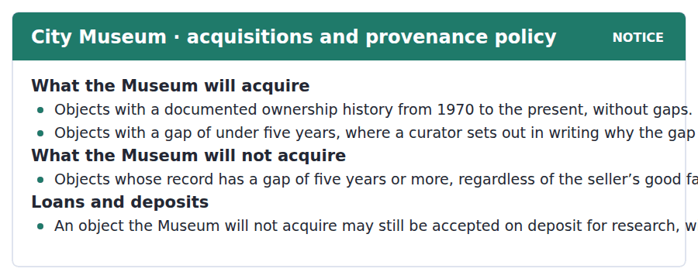
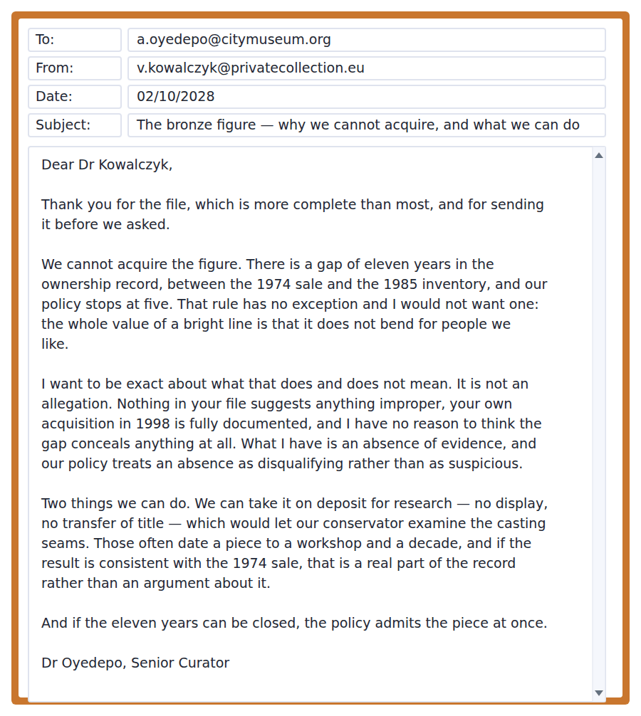
Exercise A Guided practice. The answer is on the page — find it.
1. What ownership history does the Museum require?
(A) From 1970 to the present without gaps
(B) From 1900
(C) From the date of manufacture
(D) None
2. When may a gap be accepted?
(A) Any gap, with curatorial support
(B) A gap under five years, explained in writing
(C) A gap under eleven years
(D) Never
3. What is the Museum’s position on a gap of five years or more?
(A) It depends on the seller
(B) It requires a legal opinion
(C) It requires a deposit first
(D) It will not acquire, regardless of good faith
4. What may happen to an object the Museum will not acquire?
(A) Nothing
(B) It may be displayed on loan
(C) It may be accepted on deposit for research, without display
(D) Title may transfer
Exercise B Exam practice.
5. Why can the Museum not acquire the figure?
(A) The seller’s title is defective
(B) There is an eleven-year gap in the record
(C) The object is a forgery
(D) The price is too high
6. What does the curator say about having no exception?
(A) It is regrettable
(B) It may change
(C) It applies only to bronzes
(D) The value of a bright line is that it does not bend for people we like
7. What does she say the refusal is not?
(A) Final
(B) A matter of policy
(C) An allegation
(D) A legal judgement
8. How does the policy treat an absence of evidence?
(A) As disqualifying rather than suspicious
(B) As suspicious
(C) As irrelevant
(D) As a matter for the courts
9. What could the casting seams establish?
(A) Legal title
(B) A workshop and a decade
(C) The 1974 price
(D) The owner in 1980
10. What are the two conditions of the deposit offer?
(A) No display and no transfer of title
(B) No research and no display
(C) No conservation and no publication
(D) No insurance and no loan
11. What does the curator’s last line tell you?
(A) The decision is final
(B) The policy is under review
(C) A legal opinion is needed
(D) Closing the gap would make the piece acquirable immediately


SKILL · Reading a passage that separates two questions
- A common academic move is to show that a debate confuses two different questions.
- Look for the sentence naming each and saying which has evidence available to it.
- The last paragraph often identifies who benefits from the confusion.

Who Is Entitled to Decide
Nobody seriously disputes that some museum objects were taken in circumstances that would now be criminal, and the argument has long since moved on from whether to what follows. What follows is harder than either side admits, because ownership and authority are different questions and only the first has documents. A title can be traced. The right to decide how an object is displayed, named and explained cannot be, and as a rule the institutions that have handled this worst are the ones that answered a question about authority with an answer about title.
The practical difficulty is that a community is not a committee. An object may be claimed by a national government, by a regional authority, by a descendant family and by a religious institution, and these four may want incompatible things: display, return, reburial, or destruction. To its credit, the field has stopped pretending that identifying the correct claimant is usually easy, and has started treating the plurality as a fact to be worked with rather than a problem to be resolved before anything can happen.
What is less often said is that this has produced a quiet transfer of power to whoever is best organised. A ministry with a legal department will out-argue a descendant family every time, and the museum that deals with the ministry can say truthfully that it consulted the recognised authority. For better or worse, the institutions getting this right are doing something slower and harder than consultation: publishing the full record, including the gaps, and accepting that the first consequence is a more specific argument rather than a resolved one. That is an unattractive offer to make to a board, and it is the only approach that has moved a single case in thirty years.
[294 words]

Exercise A Guided practice.
1. What does the author say the argument has moved on from?
(A) Who owns objects
(B) How to display objects
(C) Whether some objects were wrongly taken
(D) Whether museums should exist
2. Which of the two questions has documents?
(A) Ownership
(B) Authority
(C) Both
(D) Neither
3. What mistake have the worst-handling institutions made?
(A) Returning objects too quickly
(B) Refusing to publish records
(C) Consulting too widely
(D) Answering a question about authority with an answer about title
4. Why is "a community is not a committee"?
(A) Communities are large
(B) Communities change
(C) Several bodies may claim and want incompatible things
(D) Committees are formal
Exercise B Exam practice.
5. What does the author credit the field with?
(A) Returning more objects
(B) Stopping the pretence that identifying the correct claimant is easy
(C) Publishing more research
(D) Reducing acquisitions
6. What has the field started doing instead?
(A) Waiting for legal rulings
(B) Consulting ministries only
(C) Deaccessioning routinely
(D) Treating the plurality of claims as a fact to work with
7. What does the author say has quietly happened?
(A) Power has transferred to whoever is best organised
(B) Objects have been returned
(C) Museums have closed collections
(D) Records have been destroyed
8. Why can a museum dealing with a ministry say it consulted properly?
(A) The ministry owns the object
(B) No other claimant exists
(C) The ministry is the recognised authority
(D) The law requires it
9. What are the institutions getting it right doing?
(A) Returning everything
(B) Publishing the full record including the gaps
(C) Refusing all claims
(D) Consulting more widely
10. What is the first consequence of that approach?
(A) Fewer disputes
(B) Faster returns
(C) Legal challenges
(D) A more specific argument rather than a resolved one
11. Which would most strengthen the final paragraph?
(A) Evidence that cases involving published records have been resolved more often
(B) Evidence that museums are underfunded
(C) Evidence that ministries are well staffed
(D) Evidence that claims are increasing
12. All of the following are stated EXCEPT:
(A) Ownership and authority are different questions
(B) Publication reduces the number of disputes
(C) A community may contain incompatible claims
(D) Publication produces more specific arguments
13. What is the author’s attitude to the field?
(A) Hostile
(B) Uncritical
(C) Critical of its failures and specific about its one real improvement
(D) Indifferent


Exercise A Listen and choose a response. You hear one line. Choose the best reply.
1. Man: How much of the collection is on display?
(A) Yes, most of it.
(B) Under two per cent, as a rule.
(C) About four galleries.
(D) In the storeroom.
2. Woman: Is that a scandal?
(A) No — no building could hold it all.
(B) Yes, it is terrible.
(C) About ninety thousand objects.
(D) The curators decide.
3. Man: Can I find out why something is not shown?
(A) Yes, it is published.
(B) About eleven years.
(C) In most museums, no. That is the real problem.
(D) Ask a conservator.
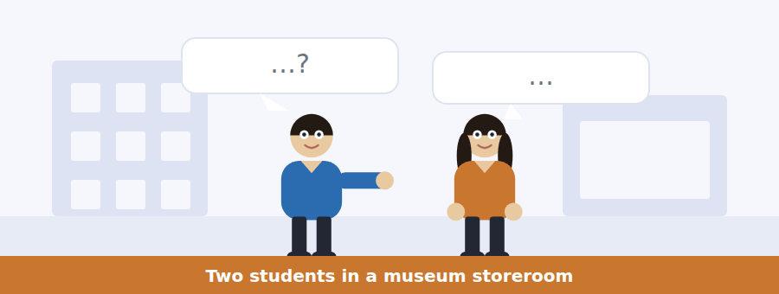
SKILL · Hearing a proportion that surprises
- When a speaker gives a ratio, the item is usually about the ratio rather than the subject.
- Listen for: of those, only, the rest.
- A speaker correcting a visitor’s assumption will state the assumption first.

Exercise B Listen and answer. The audio plays once.
4. What proportion of the collection is on display?
(A) A third
(B) About ten per cent
(C) Half
(D) Under two per cent
5. Why does she say the storeroom is not a failure?
(A) A collection showing everything would have no principle of selection
(B) It is well managed
(C) The objects are fragile
(D) Visitors prefer fewer objects
6. Where does she locate the real problem?
(A) In the proportion displayed
(B) In the storeroom conditions
(C) In whether the reasoning behind the selection can be read
(D) In the budget
7. What does she say is worth being angry about?
(A) The two per cent
(B) The funding
(C) The curators
(D) The invisibility of the decision
8. What have three European institutions done?
(A) Displayed more objects
(B) Published their selection criteria and the minutes
(C) Returned objects
(D) Closed their storerooms
9. What changed as a result?
(A) Fewer complaints
(B) More visitors
(C) Nothing
(D) The complaints got much better
10. Why does a specific complaint matter more?
(A) It can be answered, whereas a vague one gets a press statement
(B) It is shorter
(C) It is more polite
(D) It reaches more people
Audio script: see the back of the book. Do not read it before you listen.


Exercise A Listen and choose a response. You hear one line. Choose the best reply.
1. Woman: Why does the record have to start in 1970?
(A) Because it is recent.
(B) About five years.
(C) It is the date of the convention.
(D) In the policy.
2. Man: Can a curator make an exception?
(A) Yes, any exception.
(B) For under five years, with reasons in writing.
(C) About eleven years.
(D) The director decides.
3. Woman: Does refusing mean the object is stolen?
(A) No — it means the record is incomplete.
(B) Yes, usually.
(C) About two per cent.
(D) Ask the seller.
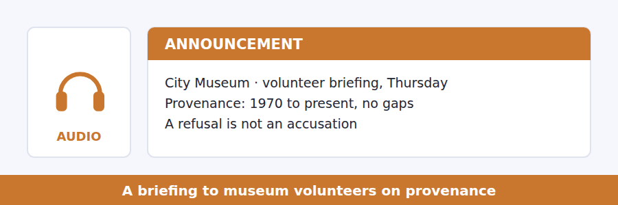
SKILL · Hearing a rule defended for an unexpected reason
- A speaker may defend a strict rule on grounds you would not predict.
- Listen for: the reason we have no exception is not what you would think.
- The unexpected reason is the examinable part.

Exercise B Listen and answer. The audio plays once.
4. What does he want volunteers to remember?
(A) The rule
(B) The 1970 date
(C) The deposit option
(D) Why the rule is not bent
5. Why is 1970 the threshold?
(A) It is recent enough
(B) It is the date of the international convention
(C) Records improve after it
(D) The Museum was founded then
6. What does he say about most sellers?
(A) They conceal things
(B) They are dealers
(C) They are entirely honest
(D) They dispute the rule
7. What is the real reason for having no exception?
(A) To catch wrongdoers
(B) A rule with an exception is applied generously to people we like
(C) To save curators time
(D) To satisfy the convention
8. What does he say a bright line protects the Museum from?
(A) Litigation
(B) Public criticism
(C) Dishonest sellers
(D) Its own judgement
9. What sentence does he want volunteers to be able to say?
(A) Refusing to acquire is not an allegation
(B) The object may be stolen
(C) The policy may change
(D) A deposit is always possible
Audio script: see the back of the book. Do not read it before you listen.


Exercise A Listen and choose a response. You hear one line. Choose the best reply.
1. Man: Is this an argument about ownership?
(A) Yes, entirely.
(B) About thirty years.
(C) Partly. The harder part is about authority.
(D) In the lecture.
2. Woman: Who speaks for a community?
(A) The government does.
(B) About four claimants.
(C) Nobody knows.
(D) Often several bodies, wanting different things.
3. Man: Why does vagueness help the museum?
(A) A general claim gets a general denial.
(B) It does not help anybody.
(C) About eleven years.
(D) In the press statement.
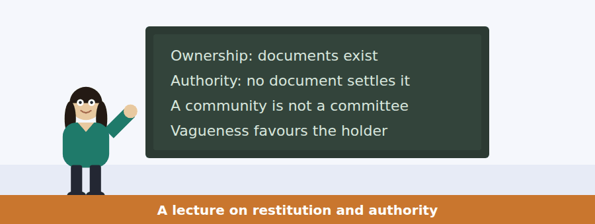
SKILL · Following a talk that identifies who benefits
- When a lecturer separates two questions, ask who gains from them being confused.
- Listen for: and the effect of that, which nobody intended, is.
- The last item usually concerns that beneficiary.

Exercise B Listen and answer. The audio plays once.
4. What does she say is settled?
(A) Who owns the objects
(B) That some objects were wrongly taken
(C) How to display them
(D) Who should decide
5. Which question has documents?
(A) Who decides display
(B) Both
(C) Who owns the object
(D) Neither
6. What reply does she say infuriates people?
(A) We are reviewing the case
(B) We will consult
(C) We have examined the title and it is sound
(D) We cannot comment
7. What does "a community is not a committee" mean?
(A) Communities are informal
(B) Communities are large
(C) Committees are slow
(D) Several bodies may claim and want incompatible outcomes
8. What unintended effect does she identify?
(A) Power transferring to whoever is best organised
(B) More returns
(C) Fewer claims
(D) Slower decisions
9. What are the institutions getting somewhere doing?
(A) Returning objects quickly
(B) Publishing the whole record including the gaps
(C) Consulting ministries
(D) Refusing to comment
10. Why does vagueness favour the holder?
(A) Holders have lawyers
(B) A general claim can be met with a general denial
(C) Vagueness delays courts
(D) The public loses interest
Audio script: see the back of the book. Do not read it before you listen.


Part 1 · Listen and Repeat
You hear a sentence and repeat it once. There is no preparation time, and the sentences get longer. Focus: avoiding repetition out loud
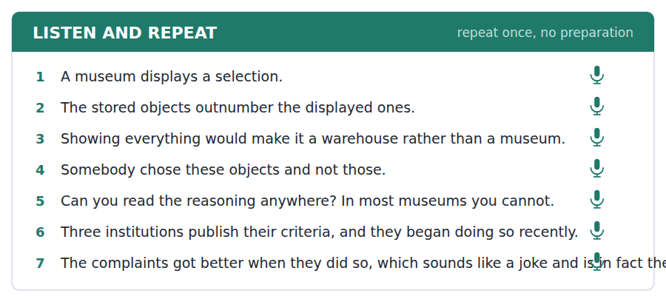
SKILL · Substituting instead of repeating
- One and ones replace a countable noun: the shown ones and the stored ones.
- So replaces a whole clause after think, hope, say: I think so, and the minutes say so too.
- Do so replaces a verb phrase: three museums publish the minutes, and they began doing so in 2019.

Part 2 · Take an Interview
An interviewer asks you four questions on one theme: museums, choices and what gets kept. Answer each one fully. There is no preparation time.
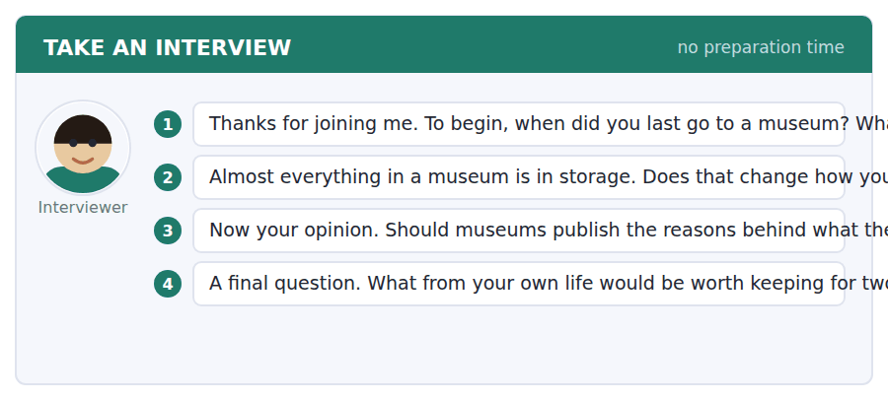
A good answer sounds like this
Question 2 — It does, because it turns the gallery from a summary of the past into somebody’s argument about it, and an argument is a thing you can disagree with.
Question 4 — The ordinary things nobody is saving. Receipts, timetables, the notices in a shop window. The important objects will survive without my help.
I can… | Not yet | Yes
I used one and ones instead of repeating the noun. | □ | □
I used so after think, say or hope. | □ | □
I used do so for a repeated verb phrase. | □ | □


Part 1 · Listen and Repeat
You hear a sentence and repeat it once. There is no preparation time, and the sentences get longer. Focus: saying no without accusing
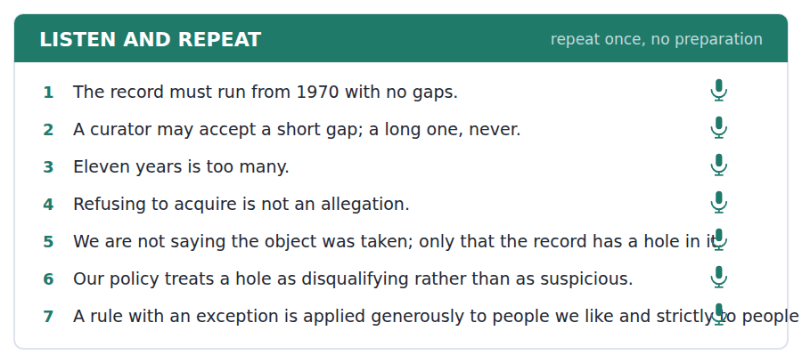
SKILL · Refusing on the record rather than the person
- Put the reason in the document, not in the person: the record has a gap, rather than you cannot prove it.
- Ellipsis helps here: we cannot acquire it, though we can hold it. The second verb phrase is left out.
- Say what the refusal is not. That sentence does most of the work.

Part 2 · Take an Interview
An interviewer asks you four questions on one theme: rules, trust and saying no. Answer each one fully. There is no preparation time.
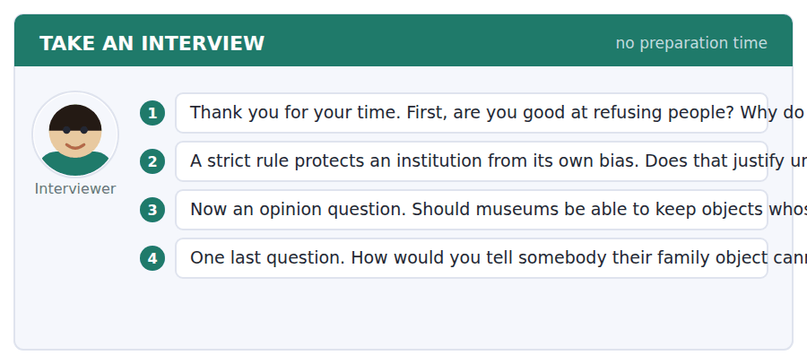
A good answer sounds like this
Question 2 — Sometimes, and only if the institution says that is what it is doing. An unfair outcome defended as a correct one is much worse than an unfair outcome admitted.
Question 4 — By putting it on the paperwork. The sentence has to be about the record, because anything about the family is heard as an accusation.
I can… | Not yet | Yes
I located the reason in the record, not the person. | □ | □
I used ellipsis to avoid repeating a verb phrase. | □ | □
I said what the refusal was not. | □ | □


Part 1 · Listen and Repeat
You hear a sentence and repeat it once. There is no preparation time, and the sentences get longer. Focus: keeping a long reference clear
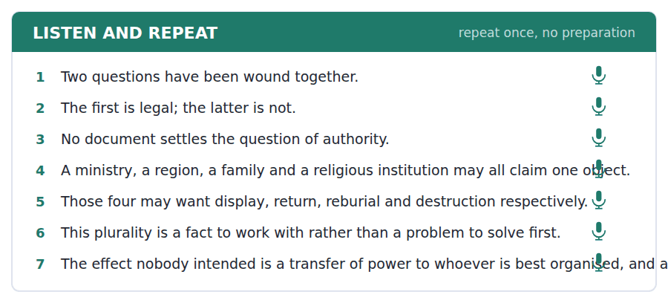
SKILL · Referring back across several sentences
- The former and the latter are precise and formal, and only work with exactly two things.
- This plus a noun is safer than this alone: this distinction, this claim.
- If you have four claimants, name them. Substitution fails when there are too many candidates.

Part 2 · Take an Interview
An interviewer asks you four questions on one theme: heritage, authority and competing claims. Answer each one fully. There is no preparation time.
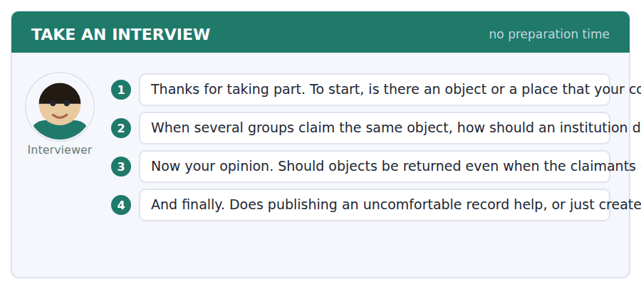
A good answer sounds like this
Question 2 — By publishing everything it knows and declining to pick a representative. The moment it chooses one claimant it has taken a side in somebody else’s dispute.
Question 4 — Both, and the more argument is the help. A vague grievance can be managed indefinitely; a specific one has to be answered.
I can… | Not yet | Yes
I used the former and the latter only with two items. | □ | □
I added a noun after this. | □ | □
I named the claimants when there were several. | □ | □


You see a sentence, then a set of words in boxes. Put the words in order to make one grammatical sentence. Almost every item in the real test makes a question or a question inside another sentence.
SKILL · Build a Sentence with substitution or ellipsis
- The two non-question items in this unit use substitution or ellipsis: one, ones, do so, the former.
- Do so replaces a whole verb phrase and must follow an auxiliary or a subject: they began doing so.
- Ellipsis leaves out what the first half already supplied: we cannot acquire it, though we can hold it.

Exercise A Guided practice. The first three are worked through.
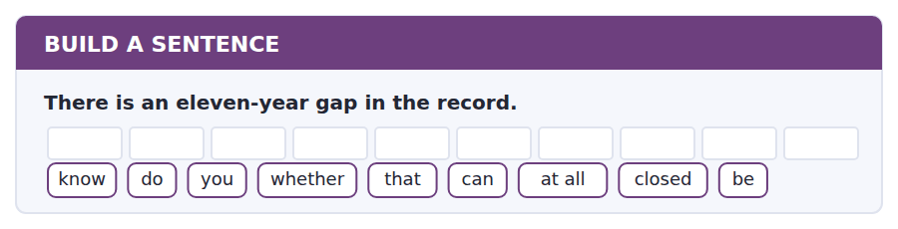
1. Do you know whether that can be closed at all?
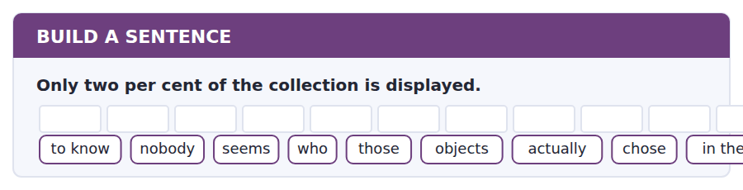
2. Nobody seems to know who actually chose those objects in the end.
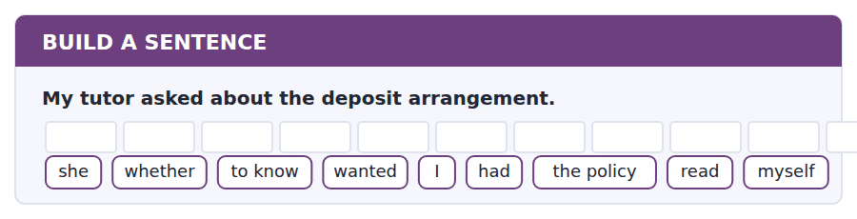
3. She wanted to know whether I had read the policy myself.
Exercise B Exam practice. Write the sentence.
4. A refusal to acquire is not an allegation.
do / whether / know / you / donors / that / understand / actually / distinction
__________________________________________________________
5. No document settles the question of authority.
explain / can / anybody / why / the title / to me / is / then / irrelevant
__________________________________________________________
6. Three institutions publish their selection minutes.
know / does / anybody / when / they / doing / began / so / actually
__________________________________________________________
7. Four bodies claim the same object.
us / told / nobody / which / of / them / museum / the / consulted
__________________________________________________________
8. The casting seams can date the piece.
told / he / me / what / a result / like / that / prove / would
__________________________________________________________
9. The stored objects far outnumber the displayed objects.
the / stored / objects / far / outnumber / the / displayed / in / ones
__________________________________________________________
10. We cannot acquire the figure but we can hold it.
we / cannot / acquire / it / though / we / hold / can / it
__________________________________________________________


You read a short situation and write an email. You have 7 minutes. The three bullet points are the mark scheme: answer all three.
The Museum has refused to acquire your bronze because of an eleven-year gap, offered to take it on deposit for research, and said the policy would admit it at once if the gap could be closed. You have found a 1979 auction catalogue that covers four of the eleven years. You want the deposit, and you want to know whether partial evidence is worth submitting.
Write an email to the acquisitions office.
- Accept the deposit and set out what you want examined.
- Describe the new evidence precisely and say what it does not cover.
- Ask whether partial closure is worth pursuing before you spend more.
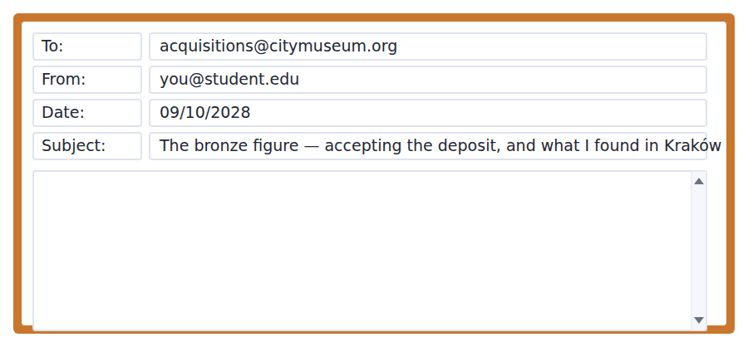
SKILL · Reporting partial evidence honestly
- State what the evidence covers and, in the same sentence, what it does not. A reader who finds the limit themselves discounts the whole.
- Give the document, not your conclusion from it. The curator will draw a better one.
- Ask whether to continue before you continue. It is cheaper for both of you.

Model email
Dear Dr Oyedepo,

Thank you for a refusal I would rather have than most acceptances. I accept the deposit for research on the terms you set out — no display, no transfer of title — and the casting seams are exactly what I would want examined. I can deliver it any week from the 20th.

Since your letter I have found something, and I want to be precise about how much it is worth. The Habsburger auction catalogue for March 1979 lists the figure as lot 211, with a photograph that matches ours including the repair to the left foot. The consignor is named as the Weiss estate. That places the piece in Vienna in 1979 and, with the 1985 inventory, closes four of the eleven years.

It does not touch 1974 to 1979. Those five years are the ones that matter and I have nothing on them. The Weiss estate papers are in a private archive in Kraków which requires a written application and, I am told, about four months.

So my question before I spend the four months: does partial closure help at all? If the policy needs the whole eleven years, I would rather know now and simply leave the piece on deposit. If seven years with a named consignor at each end is materially different from eleven with nothing, I will apply.

With thanks,
Weronika Kowalczyk
Why it works
- The acceptance restates the terms, so the deposit is agreed on the record rather than in principle.
- The evidence is given as a document with a lot number, a photograph and a named consignor, not as a conclusion.
- The limit of the evidence is stated in its own short paragraph, which is more convincing than any amount of assurance.
- The question is asked before the cost is incurred and offers the reader an easy answer either way.
Two answers, one band apart
Both answer the three bullet points. One would score in the middle band and one near the top. Read them side by side before you write your own.
A middle-band answer | A top-band answer
Dear Dr Oyedepo,  Thank you very much for your email, which I thought was extremely fair even though the news was not what I had hoped for. I am very happy to accept your offer of a research deposit and I think examining the casting seams is an excellent idea.  I also have some good news. I have managed to find an old auction catalogue from 1979 which seems to show the same figure, and this would help to fill in part of the missing period. Unfortunately it does not cover the whole of the gap, but I think it is definitely a step forward.  There are some further papers in an archive in Poland which might help, although apparently it takes a long time to get access. Before I go to all that trouble, I wondered whether you thought it would be worthwhile? I would be grateful for your advice.  Thank you again for your help. Best wishes, Weronika Kowalczyk | Dear Dr Oyedepo,  Thank you for a refusal I would rather have than most acceptances. I accept the deposit on the terms you set out — no display, no transfer of title — and the casting seams are what I would want examined. Available from the 20th.  I have found something and want to be precise about its worth. The Habsburger catalogue for March 1979 lists the figure as lot 211, photographed, including the repair to the left foot, consignor named as the Weiss estate. With the 1985 inventory that closes four of the eleven years.  It does not touch 1974 to 1979. Those five are the ones that matter and I have nothing on them. The Weiss papers are in a private archive in Kraków: written application, about four months.  So, before I spend the four months: does partial closure help? If the policy needs all eleven years I would rather know now and leave the piece on deposit. Weronika Kowalczyk

What the top answer does that the other does not
- It identifies the evidence by catalogue, date, lot number and a matching repair, so the curator can verify it rather than take it on trust.
- It names the consignor, which is the detail that makes the catalogue useful at all.
- It states the limit in a paragraph of its own and names the exact years still missing, instead of saying it does not cover the whole gap.
- It quantifies the cost of the next step — written application, four months — so the question being asked has a price attached.
- It offers the reader the easy answer explicitly, which is what makes a request for advice answerable in one line.
Now write your own. 7 minutes.
__________________________________________________________
__________________________________________________________
__________________________________________________________
__________________________________________________________
__________________________________________________________
__________________________________________________________
__________________________________________________________
__________________________________________________________


A professor asks a question and two students answer. You add your own post. You have 10 minutes and an effective answer is at least 100 words.
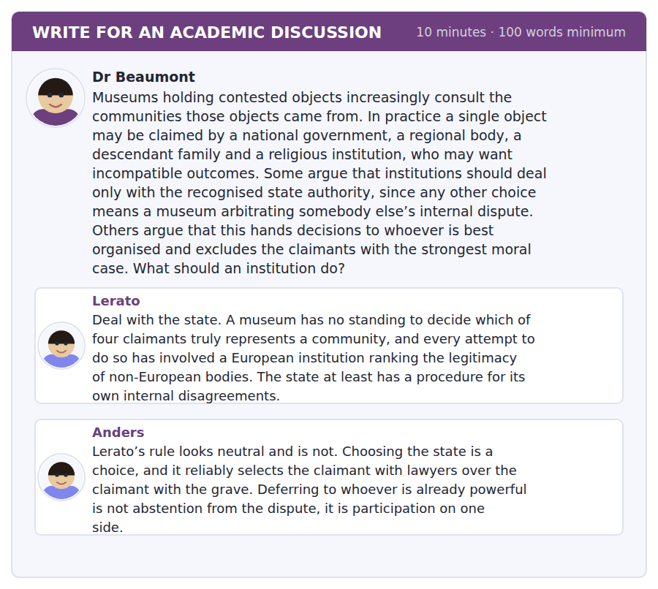
SKILL · Answering an argument from institutional modesty
- Claims that an institution should not decide often conceal a decision already made.
- Ask what the default rule does, and who it favours in practice.
- Then look for a procedure that avoids the choice rather than making it differently.

Sentence starters
- Anders has identified the flaw in Lerato’s rule and has no rule of his own.
- Lerato’s worry is the right one and her remedy inherits the problem.
- What neither considers is…
- The procedure that avoids the choice is…
Model post
Anders has identified the flaw in Lerato’s rule and has no rule of his own, which leaves the argument half finished. He is right that deferring to the state is a choice rather than an abstention, and right that it selects the claimant with a legal department. But the objection does not generate an alternative, and the alternative he implies — the museum weighing which claimant has the stronger moral case — is exactly what Lerato warns against, for reasons he never addresses.
Lerato’s worry is the right one and her remedy inherits the problem she is trying to avoid. A European institution ranking the legitimacy of non-European bodies is a genuinely bad position to be in. Yet recognising the state as the sole interlocutor is itself such a ranking, made once, in advance, and then treated as neutral because it was made by somebody else. The decision has not been avoided; its authorship has been outsourced.
What neither considers is that the museum does not have to be the body that chooses. Its position gives it one thing nobody else has, which is the record, and the record can be handed to every claimant simultaneously. An institution that publishes the full provenance, writes to all four claimants with the same document, and states publicly that it will transfer the object to whichever body the claimants jointly nominate has not arbitrated anything. It has made the internal dispute visible and put the cost of not resolving it where it belongs.
That is slower than dealing with a ministry and it will sometimes produce no answer for years, which is the real objection to it and not the one either post raises. I would still prefer it, because a museum holding an object while four claimants argue is at least honest about what it is doing, and a museum that handed the object to a ministry can no longer be asked.
[320 words]
Now write your own. 10 minutes, at least 100 words.
__________________________________________________________
__________________________________________________________
__________________________________________________________
__________________________________________________________
__________________________________________________________
__________________________________________________________
__________________________________________________________
__________________________________________________________
__________________________________________________________
__________________________________________________________

Grammar focus Cohesion: substitution and ellipsis
Device | How it works
one / ones | replaces a countable noun: the displayed ones
so | replaces a clause after think, hope, say, do: I think so
do so / did so | replaces a verb phrase: they began doing so in 2019
do / does / did | replaces a verb phrase in short answers and comparisons
the former / the latter | refers back to two things, in order
ellipsis after and, but, though | we cannot acquire it, though we can hold it
this / that + noun | this distinction, that claim — safer than this alone

One and ones replace countable nouns only. For an uncountable noun English uses nothing at all: I need information and she has some, not she has one.
The former and the latter work only with exactly two items, and in that order. With three or more claimants they are wrong, and naming is the only option.
Ellipsis is only available where the reader can reconstruct the missing words exactly. We cannot acquire it, though we can hold it works because hold shares the object. If the second half needs a different object, nothing may be left out.
Watch out! Do not write "this is the main problem" when two problems have just been mentioned. A bare this with more than one possible referent is the commonest cohesion failure at B2. Add the noun: this second problem.
Exercise 1 Replace the repeated words with one, ones, so or do so.
1. The displayed objects are fewer than the stored objects.
2. Three museums publish their minutes and they began to publish their minutes in 2019.
3. I think the record is incomplete. — I think the record is incomplete too.
4. She wanted the older catalogue, not the newer catalogue.
5. They promised to publish the gaps and they published the gaps.
6. He hoped the seams would date it, and the seams did date it.
Exercise 2 Correct the cohesion error.
1. The record has a gap and the title is disputed. This is the main problem.
2. I need information and she has one.
3. Four bodies claimed it: the former wanted display.
4. We cannot acquire it, though we can the figure hold.
Exercise 3 Rewrite using the former and the latter.
1. Ownership is a legal question. Authority is not. Ownership has documents.
2. A ministry and a family both claimed it. The ministry had lawyers.
3. The 1974 sale and the 1985 inventory are both documented. The 1974 sale is earlier.
4. Display and reburial were both proposed. Reburial was accepted.
How this is tested in Build a Sentence
Two of the ten Build a Sentence items in this unit use substitution or ellipsis. A tile reading ones replaces a noun already in the prompt, and a tile reading so after doing or did replaces a whole verb phrase.
Find the fault 5 errors, drawn from this unit and the two before
Every error below is one a B2 writer makes after learning the rule. Mark what is wrong, then check. Knowing the rule and noticing the breach are two different skills, and only the second one is tested.
The record has a gap and the title is disputed. This is the main problem. The displayed objects are fewer than the stored objects. I need information and she has one. Nobody knows whether was the catalogue consulted. Having examined the seams, the date became clear to the conservator.
# | As written | As it should be | Why
1 | This is the main problem | This second problem is the more serious | Two problems have just been named, so a bare this has no single referent.
2 | fewer than the stored objects | fewer than the stored ones | A countable noun already mentioned is replaced by ones rather than repeated.
3 | she has one | she has some | One replaces countable nouns only, and information is uncountable.
4 | whether was the catalogue consulted | whether the catalogue was consulted | An embedded question keeps statement order and does not invert the verb.
5 | Having examined the seams, the date became clear to the conservator | Having examined the seams, the conservator saw the date clearly | The date did not examine anything; the participle needs the subject that acted.

Unit review and progress check Unit 38
Exercise A Vocabulary. Write the word.
1. the documented history of an object’s ownership
2. returning an object to its place of origin
3. the selection and arrangement of a collection
4. the act of obtaining something for a collection
5. something left to an institution in a will
6. formally removing an object from a collection
7. somebody who holds something on another’s behalf
8. giving back what was wrongly taken
9. a complete list of holdings
10. ordinary, local and everyday
11. treated as standard and authoritative
12. items not made to be kept
Exercise B Grammar. Complete the sentence.
1. The displayed objects are fewer than the stored ______.
2. They began doing ______ in 2019.
3. I think ______ too.
4. Ownership and authority differ; the ______ has documents.
5. Display and reburial were proposed; the ______ was accepted.
6. We cannot acquire it, though we can ______ it.
7. I need information and she has ______.
8. This ______ problem is the more serious.
Exercise C One timed mini-section. 6 minutes.
1. Most of a museum collection is
(A) in storage
(B) on display
(C) on loan
(D) deaccessioned
2. The City Museum will not acquire an object whose record has
(A) any gap
(B) an unnamed seller
(C) no photograph
(D) a gap of five years or more
3. The two questions the lecture separates are
(A) price and provenance
(B) display and storage
(C) ownership and authority
(D) law and ethics
4. Which sentence is correct?
(A) I need information and she has some.
(B) I need information and she has one.
(C) I need information and she has ones.
(D) I need information and she has it one.
5. "As a rule" tells you the writer means
(A) always
(B) never
(C) usually, with exceptions
(D) by law
6. Publishing a full provenance record first produces
(A) fewer disputes
(B) faster returns
(C) legal immunity
(D) more specific disputes
Can you do these now?
I can… | Not yet | Yes
I can avoid repetition using one, ones, so, do so and the former. | □ | □
I can leave out what the reader can supply, and know when I cannot. | □ | □
I can keep a reference clear across several sentences. | □ | □
I can distinguish a legal question from a question about authority. | □ | □
I can follow a talk about a dispute in which both sides are partly right. | □ | □
I can write about a contested history without flattening it. | □ | □

ADAPTIVE TIP Cohesion is invisible when it works and glaring when it fails. The single most common fault at B2 is a bare this with two possible referents. Add the noun. It costs one word and it is the difference between a reader following you and a reader going back a sentence.

Unit 39 · Innovation, Patents and Ideas
TOEFL iBT® Preparation Course 2026 · Volume 4
CEFR B2 · Grammar: Complex noun phrases · Word field: patent, prior art, licence
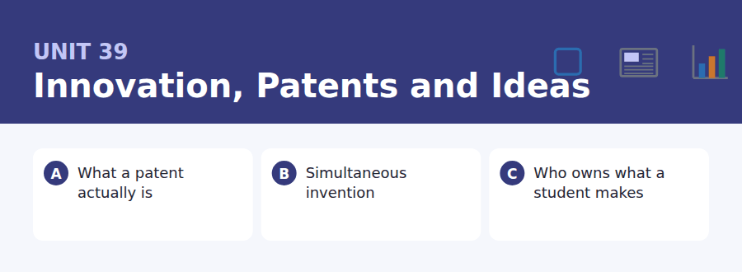
By the end of this unit I can…
- I can build a complex noun phrase with modifiers before and after the noun.
- I can use a compound modifier with hyphens correctly.
- I can compress a clause into a noun phrase without losing the agent.
- I can recognise when a noun phrase has become unreadable.
- I can follow a talk that separates a legal argument from a moral one.
- I can write about a rule whose justification is administrative.

B2 writing is compressed writing, and the main engine of compression in English is the noun phrase: a filing date, the first-to-file rule, a twenty-year exclusivity period. This unit teaches how to build them and how to stop before they collapse.

Vocabulary 1 · Academic word families 18 families, not 18 words
At B2 the word on its own is not enough. Each entry below is a family: learn the noun, the verb and the adjective together, because the test will use whichever one the sentence needs.
patent a time-limited monopoly granted for a disclosed invention | assignee the person or body to whom a right is transferred
prior art everything already known before a filing | proprietary owned and not freely available
licence permission to use something somebody else owns | open source released with permission to use and modify
royalty a payment per use or per sale | incremental advancing in small steps
infringement use of a protected right without permission | trade secret valuable information kept undisclosed
disclosure making an invention public in the application | exclusivity the right to exclude others
novelty the requirement of being genuinely new | portfolio a set of rights held together
obviousness the test that an invention must not be an easy step | cross-licence a mutual exchange of permissions
claim the part of a patent defining what is protected | monopoly exclusive control of a market

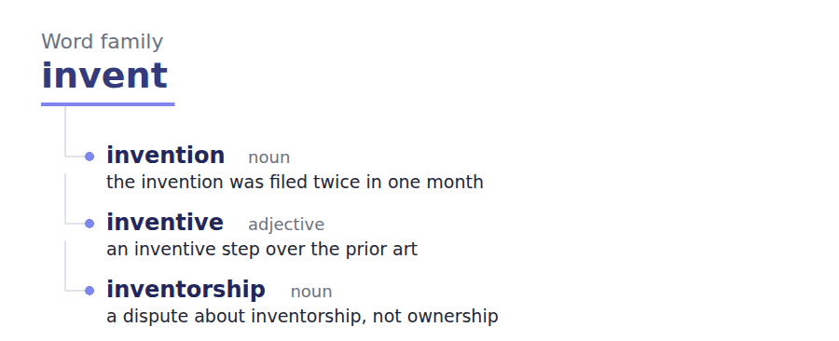
Exercise A Work in pairs. Ask and answer.
1. Describe something invented twice. Why did that happen?
2. Is a patent a reward or a bargain? Explain the difference.
3. Should a university own what a student invents? Why?
4. What is the strongest argument for a simple rule you think is unfair?
Vocabulary 2 · Collocation 10 partnerships that actually occur
A word is known when you know what it goes with. These ten are the partners this unit’s texts use; the wrong partner is what marks an answer as translated.
file for to make a formal application | tie up to make unavailable
build on to develop further from | in the public domain free for anybody to use
come up with to produce an idea | ahead of the field further advanced than competitors
sit on to hold without using | by a matter of weeks with only weeks between them
see off to defeat a challenge | on the face of the record judging only by the documents

Vocabulary 3 · Stance and hedging How far the writer commits
Every one of these says the same thing at a different strength. Reading, you must notice which was chosen. Writing, you must choose.
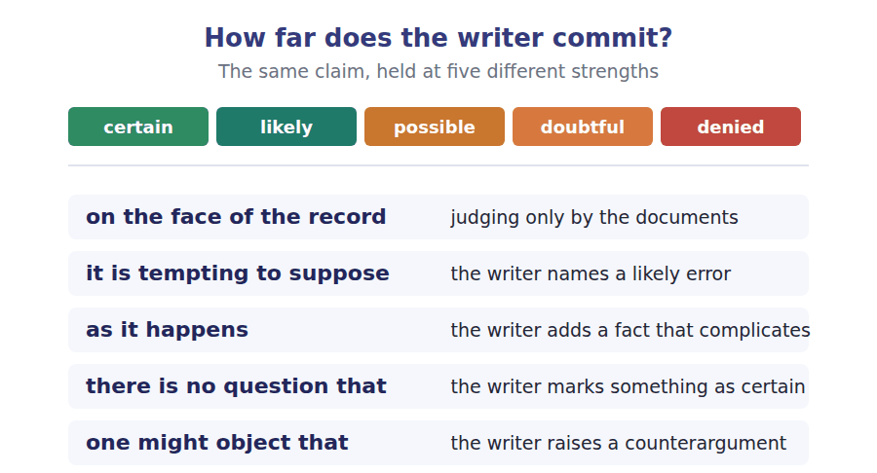
Two words that look alike
invention / innovation the idea / getting it used
patent / trade secret disclose and own / conceal and hope
inventorship / ownership who made it / who holds the right

Words you will meet again: filing date | grace period | examiner | opposition | standard-essential patent | patent pool | evergreening | compulsory licence


SKILL · Completing nouns, adjectives and the verbs between them
- Legal and technical writing stacks nouns: disclosure, exclusivity, administration.
- Watch for -ous and -ed adjectives: generous, supported, solved.
- Where a gap follows a modal, it needs a bare infinitive whatever the surrounding nouns look like.

Exercise A Guided practice. Five words are not complete. Write the missing letters.
A patent is not a reward for having an idea. It is a deal: twenty years of exclusive use in exchange for publishing how the thing w----, so that anybody can build on it once the term exp----. Understood that way, most arguments about patents become arguments about whether the deal is well pri---. Twenty years for a new kind of bearing may be gener--- and twenty years for a drug that took fourteen years to test may be nothing like en----.

The first one is done for you: w---- is works — the slot follows how the thing, so it needs a present-tense verb.
Exercise B Exam practice. One paragraph, ten gaps — the real task.
The lone inventor is the most durable myth in the history of technology and one of the least support-- by the record. Almost every significant invention of the last two centuries was arrived at independently by two or more people within a few years, and frequently within a few mon---, which tells you that the determining factor was not individual genius but the state of everything else. A device becomes thinkable when its component problems have already been sol--- elsewhere, and at that point it occurs to everybody competent who is looking in the right direc----. The patent system is built on the opposite assumption. It awards the whole of a monopoly lasting two decades to whoever filed fi---, which in a race between simultaneous inventors is often decided by we---. Defenders of the system usually concede the point about simultan---- and argue that a sharp rule is still better than a vague one, because any attempt to apportion credit would produce litigation without end. That argument is strong and it is an argument about administr-----, not about desert. It is worth being clear which one is being made, because the system is routinely defended as though it rewarded contribut---, and the people it rewards know perfectly well that it rewards spe--.

Check your answers in the key at the back of the book.


SKILL · Reading a regulation against a timeline
- Where a rule turns on dates, build the timeline before you read the argument.
- A grace period, a priority date and a publication date are three different things.
- The decisive fact is usually which event came first, not which was more important.

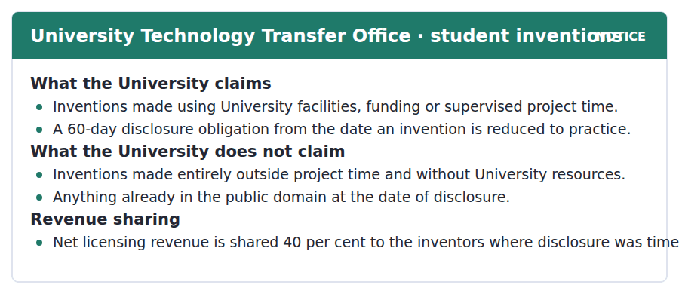
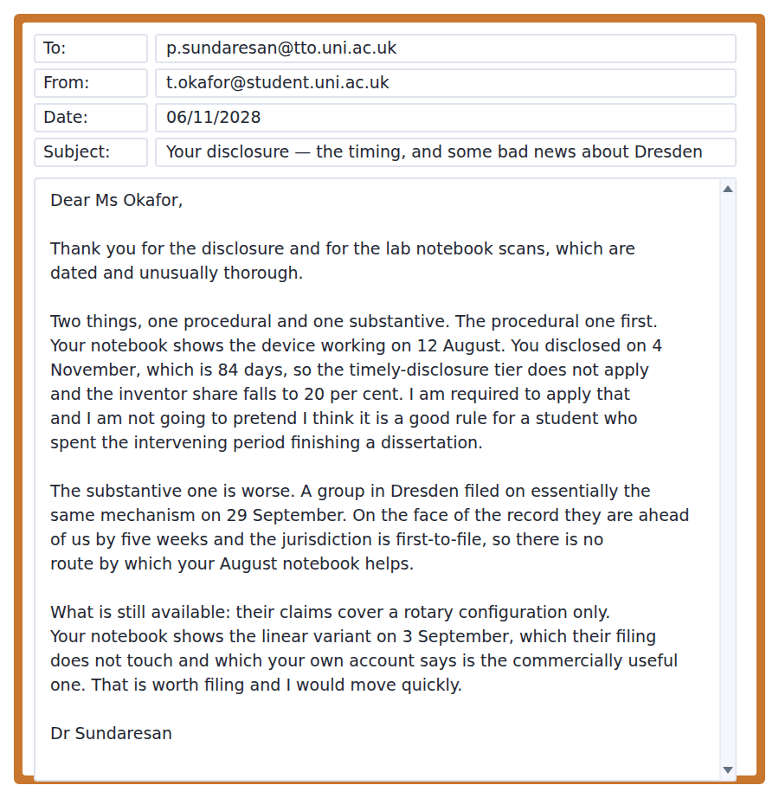
Exercise A Guided practice. The answer is on the page — find it.
1. What does the University claim?
(A) All student inventions
(B) Only funded research
(C) Nothing from students
(D) Inventions using its facilities, funding or project time
2. What is the disclosure obligation?
(A) 30 days
(B) 60 days from reduction to practice
(C) 90 days
(D) There is none
3. What is the inventor share where disclosure is late?
(A) 40 per cent
(B) Nothing
(C) 20 per cent
(D) Unchanged
4. What does the University not claim?
(A) Inventions made outside project time without its resources
(B) Supervised project work
(C) Anything disclosed late
(D) Rotary mechanisms
Exercise B Exam practice.
5. Why does the inventor share fall to 20 per cent?
(A) The disclosure was 84 days after reduction to practice
(B) The invention was unfunded
(C) Dresden filed first
(D) The device was not novel
6. What does the officer say about applying the rule?
(A) It is clearly correct
(B) It may be waived
(C) He is required to apply it and does not think it a good rule here
(D) It is under appeal
7. What happened in Dresden?
(A) A paper was published
(B) A filing was made on the same mechanism on 29 September
(C) A licence was granted
(D) A patent was refused
8. Why does the August notebook not help?
(A) It is undated
(B) It shows the wrong device
(C) It was not witnessed
(D) The jurisdiction is first-to-file
9. What do the Dresden claims cover?
(A) Both configurations
(B) The linear configuration only
(C) The rotary configuration only
(D) Neither
10. What does the student’s notebook show on 3 September?
(A) The linear variant
(B) The rotary variant
(C) A failed test
(D) The first working device
11. What is the officer’s advice?
(A) Challenge the Dresden filing
(B) Appeal the revenue share
(C) Publish immediately
(D) File on the linear variant quickly


SKILL · Reading a passage that defends a rule and refuses its justification
- An author may accept a rule as necessary and reject the reason officially given for it.
- Look for the sentence distinguishing a workable rule from a fair one.
- The final criticism is usually about language rather than policy.

The Invention That Belongs to Nobody in Particular
University invention policies are written as though the central difficulty were dishonesty, and it is actually attribution. It is tempting to suppose that a research group can say who invented what, and in a group of four working two years on one apparatus it usually cannot. The supervisor framed the problem, a postdoctoral researcher ruled out the obvious approach, a technician suggested the configuration that worked and a student built it and found out why it worked. There is no question that all four contributed, and no principled way to convert those contributions into percentages.
Institutions have responded by writing rules that are administratively clean and substantively arbitrary: the named inventors are those listed on the filing, the filing is prepared by an office, and the office relies on whoever came to see it. On the face of the record this is a neutral procedure. As it happens this produces a mild and consistent bias towards senior staff, not because anybody intends it but because senior staff know the office exists, know the deadline, and are not finishing a dissertation during the sixty days in which the disclosure has to be made.
One might object that the alternative is unworkable, and the objection is correct. A tribunal apportioning inventive contribution inside a research group would be slow, intrusive and probably worse than what we have. But what follows is not that the current rule is fair; it is that we have chosen a workable rule over a fair one, and that is a respectable choice which ought to be defended in its own terms. The institutions that describe their revenue-sharing formula as recognising contribution are not defending the choice. They are concealing it, and the people whose contribution goes unrecognised are the ones least able to say so.
[298 words]

Exercise A Guided practice.
1. What does the author say the central difficulty is?
(A) Dishonesty
(B) Attribution
(C) Funding
(D) Delay
2. What is the author’s example meant to show?
(A) That students are exploited
(B) That supervisors do the work
(C) That four people genuinely contributed and cannot be ranked
(D) That technicians are overlooked
3. How do institutions decide who the inventors are?
(A) By tribunal
(B) By who is listed on the filing prepared by an office
(C) By seniority
(D) By contribution
4. What bias does the author say this produces?
(A) A mild and consistent bias towards senior staff
(B) Against students
(C) Towards technicians
(D) None
Exercise B Exam practice.
5. What objection does the author raise and accept?
(A) That attribution does not matter
(B) That students rarely invent
(C) That filings are rare
(D) That the alternative would be unworkable
6. What conclusion does the author say follows?
(A) The current rule is fair
(B) A workable rule has been chosen over a fair one
(C) The rule should be abolished
(D) Tribunals should be created
7. What does the author object to in institutional language?
(A) Its complexity
(B) Its vagueness
(C) Describing the formula as recognising contribution
(D) Its legal style
8. Who does the author say is least able to object?
(A) Those whose contribution goes unrecognised
(B) Supervisors
(C) Technology transfer offices
(D) External examiners
9. What does "as it happens" signal?
(A) A coincidence
(B) A quotation
(C) An uncertainty
(D) A complicating fact the author is adding
10. Why does the author say nobody intends the bias?
(A) It follows from who knows the deadline and who is busy
(B) It is illegal
(C) It is denied
(D) It is recent
11. Which would most weaken the second paragraph?
(A) Evidence that offices are well funded
(B) Evidence that filings are increasing
(C) Evidence that students and junior staff disclose at the same rate as senior staff
(D) Evidence that revenue shares are generous
12. All of the following are stated EXCEPT:
(A) Four people may all genuinely contribute
(B) The current rule recognises contribution accurately
(C) A tribunal would probably be worse
(D) The current rule favours senior staff mildly
13. What is the author’s position on the current rule?
(A) It should be abolished
(B) It is fair
(C) It is unimportant
(D) It is defensible as workable and indefensible as fair


Exercise A Listen and choose a response. You hear one line. Choose the best reply.
1. Man: So a patent rewards you for having an idea?
(A) Yes, exactly.
(B) It is a trade, not a reward.
(C) About twenty years.
(D) At the patent office.
2. Woman: What does the inventor give up?
(A) Nothing at all.
(B) About twenty years.
(C) To the office.
(D) Secrecy — you have to publish how it works.
3. Man: Is twenty years the right length?
(A) It depends entirely on the field.
(B) Yes, for everything.
(C) About fourteen years.
(D) In this jurisdiction.
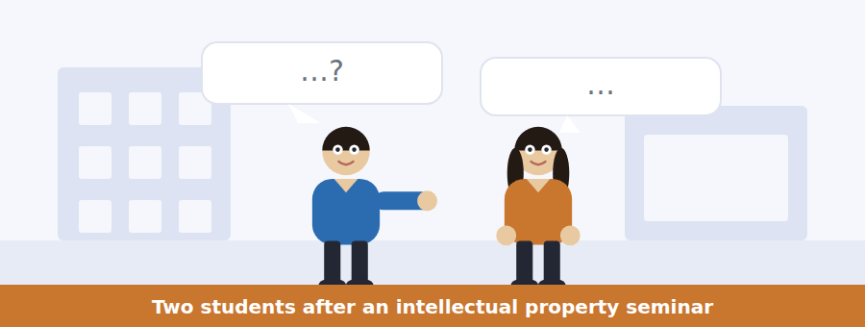
SKILL · Hearing a definition corrected
- A speaker correcting a definition will give the common one, then the accurate one.
- Listen for: it is not a reward, it is a deal.
- The items usually test what the accurate definition implies, not the words of it.

Exercise B Listen and answer. The audio plays once.
4. What does she say a patent actually is?
(A) A prize
(B) A licence
(C) A contract
(D) A monopoly only
5. What does the inventor provide in return?
(A) A fee
(B) A licence
(C) A share of revenue
(D) A document explaining exactly how it works
6. What is the alternative to patenting?
(A) Publishing freely
(B) Licensing
(C) Keeping it secret
(D) Applying abroad
7. What determines the choice between the two?
(A) The cost of filing
(B) How easy the thing is to reverse-engineer
(C) The length of the term
(D) The field of invention
8. Why is twenty years generous for a bearing?
(A) The engineering is cheap and the term is long
(B) Bearings are valuable
(C) Bearings are rarely patented
(D) Competition is weak
9. Why does she say the term is not varied?
(A) Nobody has proposed it
(B) Somebody would have to classify every application
(C) The law forbids it
(D) Inventors object
10. What does she say most defences of the system are?
(A) Arguments that the rule is right
(B) Arguments from history
(C) Arguments about incentives
(D) Arguments that the alternatives are worse to administer
Audio script: see the back of the book. Do not read it before you listen.


Exercise A Listen and choose a response. You hear one line. Choose the best reply.
1. Woman: When does the sixty days start?
(A) When you file.
(B) About eighty-four days.
(C) When the device first works, not when you think of it.
(D) In August.
2. Man: Does my dated notebook protect me?
(A) Not here — the jurisdiction is first to file.
(B) Yes, completely.
(C) About five weeks.
(D) With the scans.
3. Woman: What happens if I disclose late?
(A) Your share halves, from forty to twenty.
(B) Nothing happens.
(C) About sixty days.
(D) The office decides.

SKILL · Hearing a deadline explained by its consequence
- A briefing on a deadline will usually give the cost of missing it rather than the rule alone.
- Listen for: the figure, then what changes if you are outside it.
- A speaker may criticise the rule they are enforcing, and both are examinable.

Exercise B Listen and answer. The audio plays once.
4. When does the sixty-day period begin?
(A) When the idea occurs
(B) When the device first works
(C) When the application is filed
(D) When the supervisor is told
5. What are the two revenue percentages?
(A) Fifty and twenty-five
(B) Sixty and thirty
(C) Forty and twenty
(D) Thirty and fifteen
6. Why does he apply the rule mechanically?
(A) The law requires it
(B) He has no discretion
(C) Students expect it
(D) An office applying it sympathetically would apply it unevenly
7. What is his criticism of the sixty days?
(A) It is too long
(B) It is unclear
(C) It is rarely enforced
(D) It is measured so as to catch research students
8. What does a dated notebook establish?
(A) What you knew and when
(B) Priority over any filing
(C) Ownership
(D) Novelty
9. What has the mistaken belief cost?
(A) A revenue share
(B) Several disclosures
(C) At least two groups in the building a patent
(D) Nothing yet
Audio script: see the back of the book. Do not read it before you listen.


Exercise A Listen and choose a response. You hear one line. Choose the best reply.
1. Man: Can a research group say who invented what?
(A) Yes, easily.
(B) After two years on one apparatus, usually not.
(C) About four people.
(D) In the policy.
2. Woman: Who gets named as inventor?
(A) The supervisor always.
(B) About forty per cent.
(C) On the filing.
(D) Whoever came to the office before the deadline.
3. Man: Should there be a tribunal instead?
(A) Yes, certainly.
(B) About sixty days.
(C) It would probably be worse than this.
(D) The office decides.
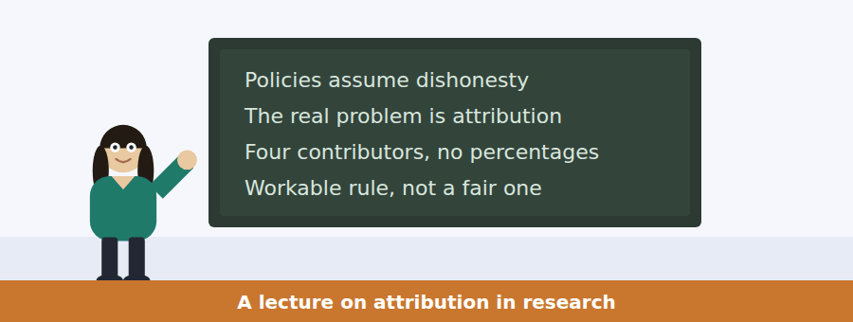
SKILL · Following a talk that accepts a rule and rejects its justification
- A speaker may say that a rule should stay and that the reason given for it is false.
- Listen for: the objection is correct, and the conclusion does not follow.
- The last item is usually about how the rule is described rather than what it does.

Exercise B Listen and answer. The audio plays once.
4. What do invention policies assume the problem is?
(A) Attribution
(B) People cheating
(C) Delay
(D) Funding
5. What did the postdoctoral researcher contribute?
(A) Ruling out the approach everybody would have tried first
(B) The apparatus
(C) The configuration
(D) The explanation
6. Who are the named inventors, in practice?
(A) The most senior
(B) All contributors
(C) Whoever is named on the filing prepared by the office
(D) Whoever built the device
7. Why does the bias arise?
(A) Deliberate favouritism
(B) Students do not invent
(C) Offices prefer staff
(D) Senior people know the office and the deadline and are not writing up
8. What does she concede about a tribunal?
(A) It would be slow, intrusive and probably worse
(B) It would be fairer
(C) It is already used
(D) It would be cheap
9. What conclusion does she say follows?
(A) The rule is fair
(B) A workable rule was chosen over a fair one
(C) The rule should go
(D) Students should be excluded
10. What does she object to?
(A) The sixty-day rule
(B) Describing the revenue formula as recognising contribution
(C) The tribunal proposal
(D) The filing process
Audio script: see the back of the book. Do not read it before you listen.


Part 1 · Listen and Repeat
You hear a sentence and repeat it once. There is no preparation time, and the sentences get longer. Focus: saying a long noun phrase cleanly
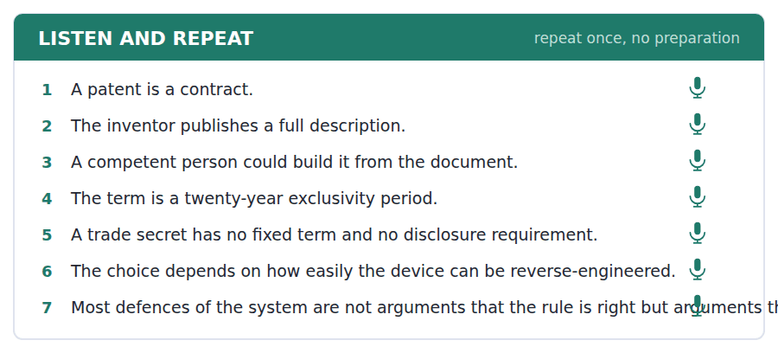
SKILL · Keeping a noun phrase intelligible
- A long noun phrase needs one stress, on the head noun: a twenty-year exclusivity PERIOD.
- Do not pause inside the phrase. A pause suggests the phrase has ended.
- If you cannot say it in one breath, it is too long. Break it into two.

Part 2 · Take an Interview
An interviewer asks you four questions on one theme: invention, ownership and incentives. Answer each one fully. There is no preparation time.
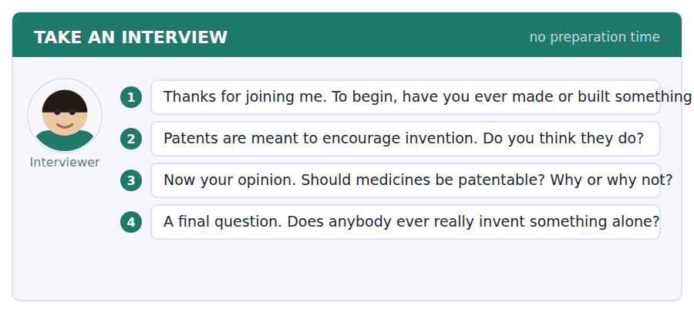
A good answer sounds like this
Question 2 — In some fields clearly yes, in others they mainly protect what already exists. The problem is that the same twenty years applies to both.
Question 4 — Almost never, and the record is quite clear about it. Everything significant has been invented twice within a few years.
I can… | Not yet | Yes
I put one stress on the head noun. | □ | □
I did not pause inside the noun phrase. | □ | □
I broke up anything I could not say in one breath. | □ | □


Part 1 · Listen and Repeat
You hear a sentence and repeat it once. There is no preparation time, and the sentences get longer. Focus: stating a deadline and its cost
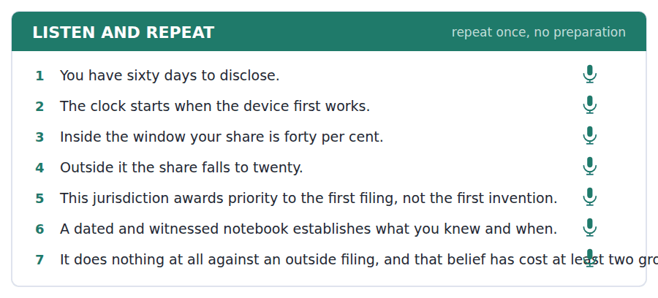
SKILL · Giving a rule and its consequence together
- Say the number, then what changes: sixty days, and after that your share halves.
- Stress the number. It is the only part the listener will retain.
- If you criticise the rule, mark the switch clearly: that is the rule; here is what I think of it.

Part 2 · Take an Interview
An interviewer asks you four questions on one theme: deadlines, rules and the people they catch. Answer each one fully. There is no preparation time.
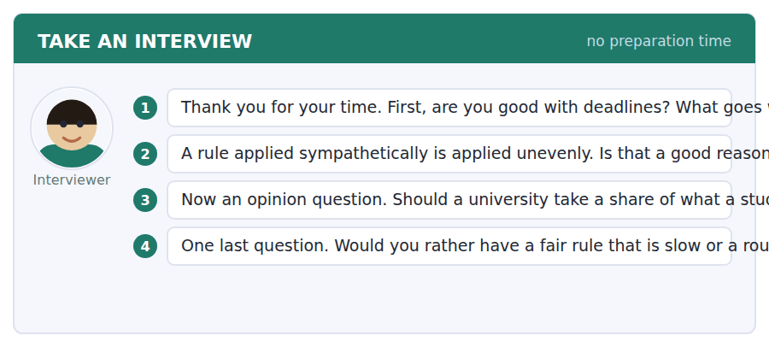
A good answer sounds like this
Question 2 — It is a good reason, and it does not make the rigid outcome right. Both things are true and institutions usually only say the first.
Question 4 — A rough fast rule, provided it is described honestly. Most of the damage comes from rough rules presented as fair ones.
I can… | Not yet | Yes
I stressed the numbers. | □ | □
I gave the consequence with the rule. | □ | □
I marked the switch to my own opinion. | □ | □


Part 1 · Listen and Repeat
You hear a sentence and repeat it once. There is no preparation time, and the sentences get longer. Focus: compressing a clause into a noun phrase
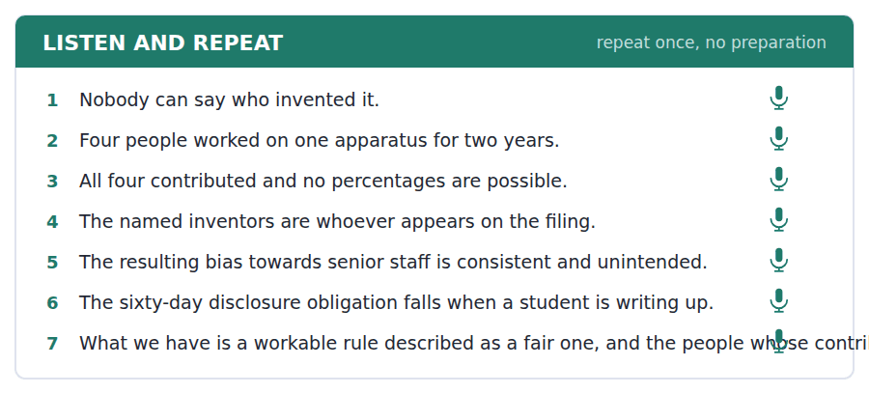
SKILL · Turning a sentence into a phrase
- Compression is a B2 skill: the office relies on whoever came to see it becomes a reliance on self-reporting.
- Compression hides the agent, so put it back where it matters: a reliance by the office on self-reporting.
- Say the compressed phrase and then unpack it once, so the listener gets both.

Part 2 · Take an Interview
An interviewer asks you four questions on one theme: credit, hierarchy and institutional language. Answer each one fully. There is no preparation time.
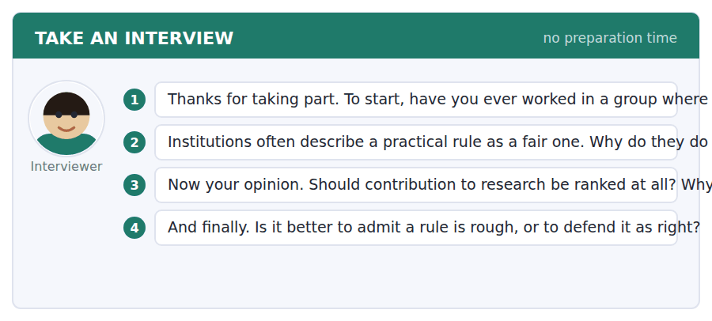
A good answer sounds like this
Question 2 — Because defending a rule as merely workable invites somebody to look for a better one, and nobody in an institution wants that review on their desk.
Question 4 — Admit it. A rough rule honestly described can be improved. A rough rule defended as right has to be overthrown first.
I can… | Not yet | Yes
I compressed at least one clause into a noun phrase. | □ | □
I restored the agent where it mattered. | □ | □
I unpacked the compressed phrase once. | □ | □


You see a sentence, then a set of words in boxes. Put the words in order to make one grammatical sentence. Almost every item in the real test makes a question or a question inside another sentence.
SKILL · Build a Sentence with a complex noun phrase
- The two non-question items in this unit build a long noun phrase as subject or object.
- Modifiers before the noun are adjectives and compounds; modifiers after it are phrases and clauses.
- A compound modifier before a noun is hyphenated: a sixty-day obligation, a twenty-year term.

Exercise A Guided practice. The first three are worked through.
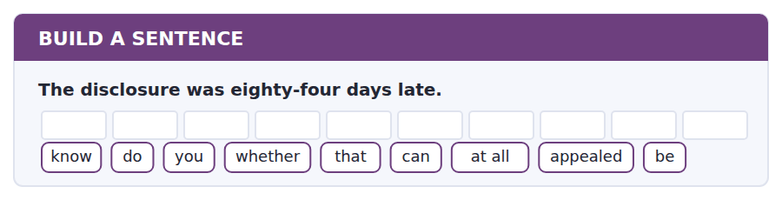
1. Do you know whether that can be appealed at all?
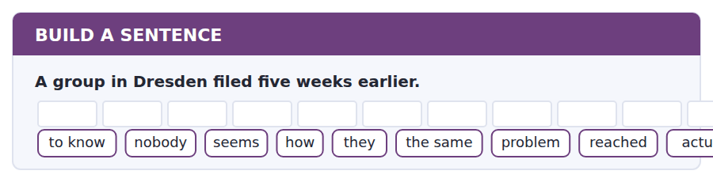
2. Nobody seems to know how they actually reached the same problem.
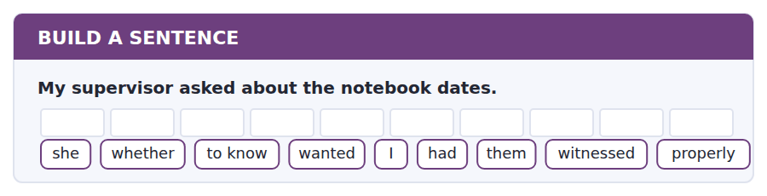
3. She wanted to know whether I had them properly witnessed.
Exercise B Exam practice. Write the sentence.
4. The jurisdiction awards priority to the first filing.
do / whether / know / you / every / country / rule / that / uses
__________________________________________________________
5. The notebook does not establish priority.
explain / can / anybody / why / a dated / record / to me / count / does not
__________________________________________________________
6. The Dresden claims cover the rotary configuration only.
know / does / anybody / whether / the linear / one / free / is / still
__________________________________________________________
7. The inventor share depends on the disclosure date.
us / told / nobody / when / the sixty / days / were / supposed / to start
__________________________________________________________
8. Two groups in the building lost a patent this way.
told / he / me / which / mistake / they / both / made / had
__________________________________________________________
9. A patent gives twenty years of exclusive use.
a / twenty-year / exclusivity / period / is / the / standard / in / term
__________________________________________________________
10. Students must disclose within sixty days of the device working.
the / sixty-day / disclosure / obligation / runs / from / the first / working / device
__________________________________________________________


You read a short situation and write an email. You have 7 minutes. The three bullet points are the mark scheme: answer all three.
The office has told you the Dresden filing blocks the rotary mechanism, that your late disclosure drops your share to 20 per cent, and that the linear variant in your 3 September notebook entry is still available and worth filing quickly. You want to file. You also want to ask whether the 20 per cent tier applies to the linear variant, which you disclosed within sixty days of building it.
Write an email to the technology transfer office.
- Confirm you want to file and what on.
- Set out the argument about which invention the clock applies to.
- Say what you will do whatever the answer is.
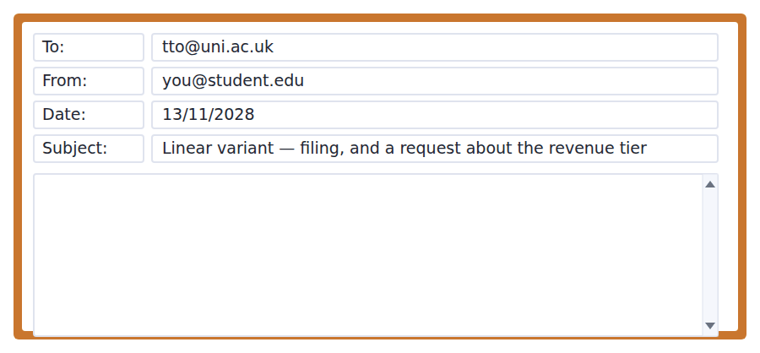
SKILL · Making a technical argument about a rule
- Identify which fact the rule actually turns on, then show your case against that fact alone.
- Dates in a list are more persuasive than dates in a sentence.
- Separate the argument from the request. One paragraph each.

Model email
Dear Dr Sundaresan,

Yes — please file on the linear variant, and I can be in the office any morning this week to sign whatever is needed.

A question about the revenue tier, which I think turns on a fact rather than on discretion. The dates are:

12 August — rotary configuration first works (notebook pp. 41–44)
3 September — linear variant first works (pp. 58–61)
4 November — disclosure to the office

The policy counts sixty days from the date an invention is reduced to practice. For the rotary configuration that is 12 August and I was 84 days late, which I accept. For the linear variant it is 3 September, and 4 November is 62 days. Two days over, not twenty-four.

I am not asking you to overlook the two days. I am asking whether the policy treats these as one invention or two, because the Dresden filing has already treated them as two and the configurations work on different principles. If they are two inventions, the linear one has its own sixty-day clock and I am close to it rather than far outside.

If the answer is that it is one invention, that is the end of it and I would rather know than argue. Either way I want the filing to go in this week, and the tier can be settled afterwards.

With thanks,
Tochukwu Okafor
Why it works
- The instruction to file comes first and unconditionally, so the argument cannot delay the filing.
- The dates are set out as a list with page references, which makes them checkable in seconds.
- The argument identifies the fact the rule turns on — one invention or two — and borrows the Dresden filing as independent support.
- The writer concedes the late rotary disclosure outright, which makes the narrower claim credible.
Two answers, one band apart
Both answer the three bullet points. One would score in the middle band and one near the top. Read them side by side before you write your own.
A middle-band answer | A top-band answer
Dear Dr Sundaresan,  Thank you very much for your email, and for looking into the Dresden filing so quickly. I would definitely like to go ahead with filing on the linear variant and I am available whenever suits you this week.  I did want to raise one thing about the revenue share. I understand that my disclosure was late for the rotary version and I accept that. However, I only built the linear version in September, so I was not nearly as late with that one, and I wondered whether the twenty per cent tier really ought to apply to it as well.  I realise this may not be possible and I do not want to seem as though I am complaining about the rules, especially as you have been so helpful. But it did seem worth asking whether the two versions are treated separately or not.  Thank you again for everything. Best wishes, Tochukwu Okafor | Dear Dr Sundaresan,  Yes — please file on the linear variant. I can sign anything needed any morning this week.  A question about the tier, which I think turns on a fact rather than on discretion. 12 August: rotary first works (pp. 41–44). 3 September: linear first works (pp. 58–61). 4 November: disclosure.  The policy counts sixty days from reduction to practice. For the rotary that is 12 August and I was 84 days late, which I accept. For the linear it is 3 September, and 4 November is 62 days — two days over, not twenty-four.  I am not asking you to overlook two days. I am asking whether the policy treats these as one invention or two. The Dresden filing has already treated them as two and the configurations work on different principles. If it is one invention, that is the end of it and I would rather know than argue. The filing should go in this week either way. Tochukwu Okafor

What the top answer does that the other does not
- It lays the three dates out with page references, so the reader can verify the claim instead of taking it on trust.
- It does the arithmetic — 62 days, not 84 — which is the entire argument and is absent from the middle answer.
- It names the fact the rule turns on, one invention or two, rather than appealing to how late the writer was.
- It cites the Dresden filing as independent support for treating the variants separately.
- It drops the apology for asking, which in the middle answer undercuts the request it is attached to.
Now write your own. 7 minutes.
__________________________________________________________
__________________________________________________________
__________________________________________________________
__________________________________________________________
__________________________________________________________
__________________________________________________________
__________________________________________________________
__________________________________________________________


A professor asks a question and two students answer. You add your own post. You have 10 minutes and an effective answer is at least 100 words.
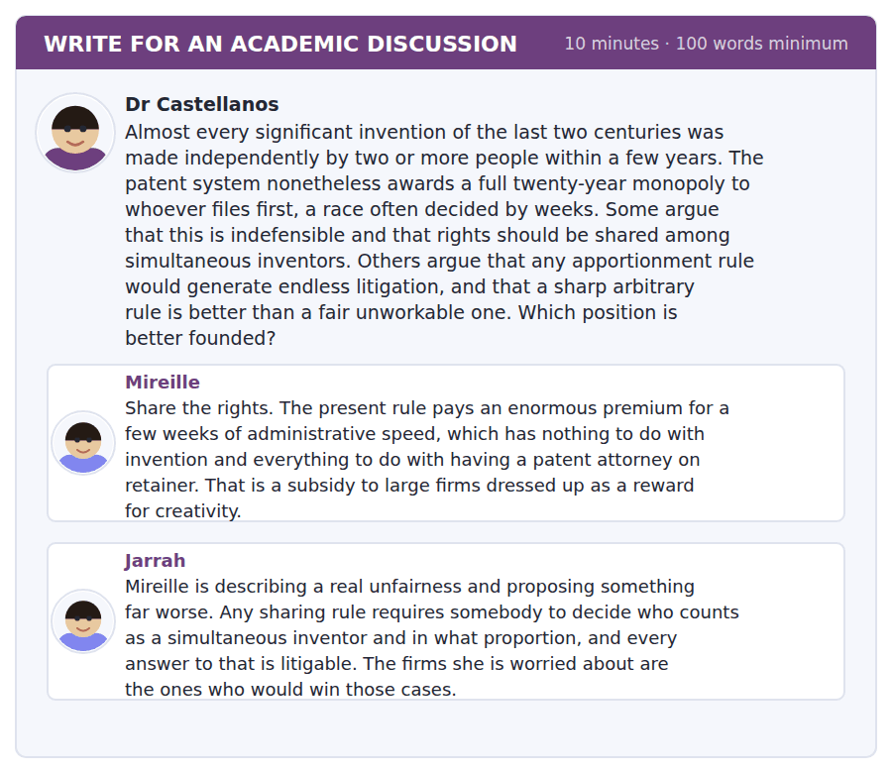
SKILL · Answering an argument about workability
- A workability objection is usually right about the proposal and silent about the status quo.
- Ask whether the current rule also generates the cost the objection names.
- Then look for a change that is cheap to administer.

Sentence starters
- Jarrah is right about the proposal and has not costed the alternative.
- Mireille has diagnosed the problem and prescribed the wrong remedy.
- What both leave out is…
- The cheap change nobody has proposed is…
Model post
Jarrah is right about the proposal and has not costed the alternative, which is the standard shape of a workability argument. Any apportionment of inventive contribution is litigable, and the parties best placed to litigate are the ones Mireille wants to constrain. That is a serious objection and it is not a defence of the present rule; it is a reason to prefer it, which is a different and much weaker claim than the one usually made for first-to-file.
Mireille has diagnosed the problem and prescribed the wrong remedy. The premium paid for administrative speed is real and large, and her remedy relocates the whole question into a tribunal where the advantage of having lawyers is greater rather than smaller. What she should be attacking is not who gets the right but how much the right is worth, because the unfairness scales with the size of the prize and not with the rule for awarding it.
What both leave out is that the term and the remedy are adjustable without any new finding of fact. Shortening exclusivity in fields where development is cheap reduces the premium on filing first by exactly the amount it reduces the monopoly, and requires nobody to decide who invented anything. A compulsory licence available to a demonstrably independent inventor who filed within, say, six months does the same thing: it needs only two dates and a document, both of which already exist.
So the cheap change nobody has proposed is to keep first-to-file for the grant and attach a late-filer licence to it. Jarrah keeps his sharp rule and his empty courtroom, Mireille loses most of the premium she objects to, and nothing turns on anybody weighing one contribution against another.
[286 words]
Now write your own. 10 minutes, at least 100 words.
__________________________________________________________
__________________________________________________________
__________________________________________________________
__________________________________________________________
__________________________________________________________
__________________________________________________________
__________________________________________________________
__________________________________________________________
__________________________________________________________
__________________________________________________________

Grammar focus Complex noun phrases
Position | What goes there
determiner | a, the, this, every, no
before the noun: adjective | a mild consistent bias
before the noun: compound | a sixty-day obligation, a twenty-year term
before the noun: noun modifier | a patent attorney, a disclosure deadline
the head noun | the word everything else describes
after the noun: phrase | a bias towards senior staff
after the noun: clause | the configuration that worked

A compound modifier before a noun is hyphenated and singular: a sixty-day obligation, a twenty-year term. After the noun it is neither: an obligation of sixty days, a term of twenty years.
Noun modifiers stack, and three is usually the limit of comfort: a student invention disclosure deadline is readable; a student invention disclosure deadline extension request is not. Break it with of.
Compression removes the agent. A reliance on self-reporting does not say who relies. At B2 this is sometimes what you want and more often an accident; decide which, every time.
Watch out! Do not write "a sixty-days obligation" or "a twenty-years term". A compound modifier before a noun is always singular, however many days or years it names.
Exercise 1 Compress the clause into a noun phrase before the noun.
1. an obligation lasting sixty days
2. a term of twenty years
3. a bias that is mild and consistent
4. a deadline for disclosing an invention
5. a rule that gives priority to the first filing
6. a period of exclusivity lasting twenty years
Exercise 2 Correct the noun phrase.
1. a sixty-days disclosure obligation
2. a twenty-years exclusivity period
3. a student invention disclosure deadline extension request
4. a bias towards of senior staff
Exercise 3 Unpack the noun phrase into a clause, naming the agent.
1. a reliance on self-reporting
2. the apportionment of inventive contribution
3. a consistent bias towards senior staff
4. the recognition of contribution
How this is tested in Build a Sentence
Two of the ten Build a Sentence items in this unit build a long noun phrase. A hyphenated tile such as sixty-day or twenty-year sits immediately before its head noun, and nothing comes between them.
Find the fault 5 errors, drawn from this unit and the two before
Every error below is one a B2 writer makes after learning the rule. Mark what is wrong, then check. Knowing the rule and noticing the breach are two different skills, and only the second one is tested.
The policy sets a sixty-days disclosure obligation and a twenty-years exclusivity period. The office relies on self-reporting, which produces a bias towards of senior staff. Nobody knows whether did the student disclose in time. Having filed in September, the rotary claims were already blocked.
# | As written | As it should be | Why
1 | a sixty-days disclosure obligation | a sixty-day disclosure obligation | A compound modifier before a noun is singular however many days it names.
2 | a twenty-years exclusivity period | a twenty-year exclusivity period | The same rule applies to years, and the plural before the noun is a conspicuous error.
3 | a bias towards of senior staff | a bias towards senior staff | Towards already governs the noun phrase, so the second preposition has nothing to do.
4 | whether did the student disclose | whether the student disclosed | An embedded question keeps statement order and takes no auxiliary.
5 | Having filed in September, the rotary claims were already blocked | Having filed in September, the Dresden group had already blocked the rotary claims | The claims did not file anything; the participle needs the subject that acted.

Unit review and progress check Unit 39
Exercise A Vocabulary. Write the word.
1. everything already known before a filing
2. a payment per use or per sale
3. use of a protected right without permission
4. making an invention public in the application
5. the requirement of being genuinely new
6. the part of a patent defining what is protected
7. the person or body to whom a right is transferred
8. owned and not freely available
9. advancing in small steps
10. valuable information kept undisclosed
11. the right to exclude others
12. a mutual exchange of permissions
Exercise B Grammar. Complete the sentence.
1. The policy sets a sixty-______ disclosure obligation.
2. A twenty-______ exclusivity period is standard.
3. The office relies on self-______.
4. There is a mild bias ______ senior staff.
5. It is a first-to-______ jurisdiction.
6. The configuration ______ worked was the technician’s.
7. An obligation ______ sixty days is the same thing.
8. A patent ______ is not the same as an inventor.
Exercise C One timed mini-section. 6 minutes.
1. A patent is best described as
(A) a reward for invention
(B) a form of ownership
(C) a licence to sell
(D) a trade of disclosure for exclusivity
2. Simultaneous invention is common because
(A) inventors copy each other
(B) patents are published
(C) a device becomes thinkable once its component problems are solved
(D) funding is concentrated
3. In a first-to-file jurisdiction a dated notebook establishes
(A) what you knew and when
(B) priority over any filing
(C) ownership
(D) novelty
4. Which noun phrase is correct?
(A) a sixty-day obligation
(B) a sixty-days obligation
(C) a sixty day’s obligation
(D) a sixty-days’ obligation
5. "One might object that" signals that the writer
(A) agrees
(B) is quoting
(C) is uncertain
(D) is raising a counterargument in order to address it
6. The passage says institutions describing their formula as recognising contribution are
(A) defending a choice
(B) concealing a choice
(C) measuring contribution
(D) following the law
Can you do these now?
I can… | Not yet | Yes
I can build a complex noun phrase with modifiers before and after the noun. | □ | □
I can use a compound modifier with hyphens correctly. | □ | □
I can compress a clause into a noun phrase without losing the agent. | □ | □
I can recognise when a noun phrase has become unreadable. | □ | □
I can follow a talk that separates a legal argument from a moral one. | □ | □
I can write about a rule whose justification is administrative. | □ | □

ADAPTIVE TIP The noun phrase is where B2 writing gets its density, and it is also where it most often collapses. Three modifiers before the head noun is the practical limit. Beyond that, break the phrase with of — and check whether compressing the clause has quietly removed the person who did the thing.

Unit 40 · Risk, Decision and Uncertainty
TOEFL iBT® Preparation Course 2026 · Volume 4
CEFR B2 · Grammar: Discourse management and stance · Word field: probability, uncertainty, robustness
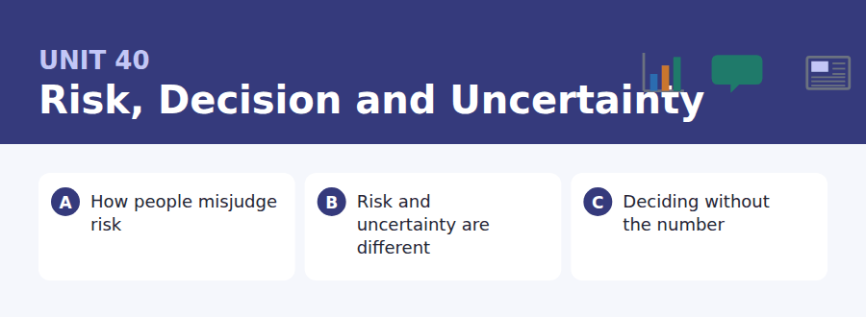
By the end of this unit I can…
- I can manage a long argument with signposts a reader can follow.
- I can mark my own position at the right strength and keep it consistent.
- I can distinguish risk from uncertainty and write about each correctly.
- I can concede, qualify and conclude in a single coherent paragraph.
- I can follow an extended talk and identify the speaker’s own view.
- I can write a full discussion answer under time pressure.

The last unit of the course is about the thing every other unit has been practising: managing a long argument so a reader can follow it, and marking your own position in it. Everything you have learned about hedging, emphasis and cohesion comes together here.

Vocabulary 1 · Academic word families 18 families, not 18 words
At B2 the word on its own is not enough. Each entry below is a family: learn the noun, the verb and the adjective together, because the test will use whichever one the sentence needs.
probability the chance of an outcome, as a number | contingency a possible event planned for in advance
uncertainty not knowing the probabilities at all | mitigation reducing the severity of a harm
robustness performing acceptably across many possible futures | buffer spare capacity held against a shock
volatility how much a quantity moves up and down | aversion a settled dislike of something
expectation the average outcome, weighted by probability | illusory seeming real without being so
heuristic a rule of thumb | tractable able to be handled or solved
salience how readily something comes to mind | conjecture a guess offered for testing
overconfidence stating more certainty than the evidence supports | deliberation careful collective consideration
precaution acting to avoid a harm that is not yet proven | accountable required to answer for a decision

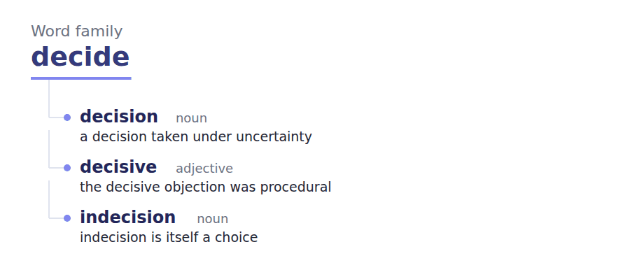
Exercise A Work in pairs. Ask and answer.
1. Name a risk you overestimate and one you ignore. Why those?
2. Give an example of risk and one of uncertainty. What is the difference?
3. When is a rough answer better than a precise one?
4. Should a decision-maker be judged on the decision or the outcome?
Vocabulary 2 · Collocation 10 partnerships that actually occur
A word is known when you know what it goes with. These ten are the partners this unit’s texts use; the wrong partner is what marks an answer as translated.
weigh up to consider the balance of | on balance taking everything into account
rule of thumb a rough practical method | in the final analysis when everything has been considered
err on the side of to choose the safer mistake | all things considered weighing everything
hedge your bets to avoid committing fully to one outcome | stack the odds to make an outcome more likely
worst case the least favourable outcome considered | come what may whatever happens

Vocabulary 3 · Stance and hedging How far the writer commits
Every one of these says the same thing at a different strength. Reading, you must notice which was chosen. Writing, you must choose.
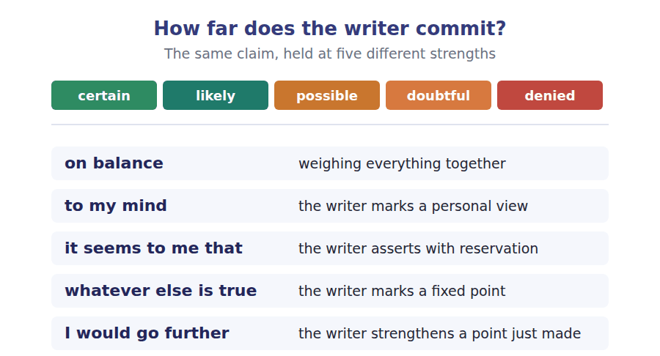
Two words that look alike
risk / uncertainty probabilities known / not available
robust / optimal good across many futures / best in one
precaution / prohibition acting cautiously / forbidding

Words you will meet again: base rate | expected value | tail risk | scenario planning | stress test | confidence interval | hindsight bias | option value


SKILL · Completing the full range of endings
- This closing unit mixes everything: -ity and -ion nouns, -ible and -able adjectives, -ly adverbs, and bare verbs after modals.
- Decide the part of speech from the grammar first, every time.
- If a gap could be two parts of speech, read the next three words.

Exercise A Guided practice. Five words are not complete. Write the missing letters.
People are not bad at risk. They are bad at the particular kind of risk that has no story attac---. A one in ten thousand chance of something vivid will be overestim---- by almost everybody, and a one in ten chance of something tedious will be ign----, and both errors come from the same place: we judge likelihood by how easily we can imag--- the event. This is not stupidity. It is a rule of thumb that works very well in an environment where the things you can picture are the things that have actually happ---- to somebody you know.

The first one is done for you: attac--- is attached — the slot follows has no story, so it needs a past participle acting as an adjective.
Exercise B Exam practice. One paragraph, ten gaps — the real task.
There are two kinds of not knowing and most public argument conflates them. The first is risk: the possible outcomes are known and so are their probabil-----, as with an insurance table or a dice game. The second is uncertainty: the outcomes may be known and the probabilities are not avail---- at all, because the event has never happened often enough to produce a frequency. Decisions under risk can be optim----, which is why insurance works and why casinos are profit----. Decisions under uncertainty cannot be, and the appropriate response to them is complet--- different: not a calculation of the best outcome but an arrangement that survives being wrong. Institutions get into difficulty when they apply the first set of tools to the second kind of problem, which they do constantly, because a number is defens---- at a meeting and a judgement is not. The pressure is not intellect---. Anybody competent knows the difference. The pressure is that a decision supported by a figure can be justified afterwards by producing the fig---, and a decision supported by judgement can only be justified by having been ri---. Given that asymmetry, the invention of spurious precision is not a failure of training but an entirely rat----- response to how the people making decisions are judged.

Check your answers in the key at the back of the book.


SKILL · Reading a decision framework against a case
- A framework tells you which method to use when. A case tests which category it falls into.
- The categories usually turn on whether a frequency exists.
- A framework that says do not produce a number is unusual, and the reason will be stated.

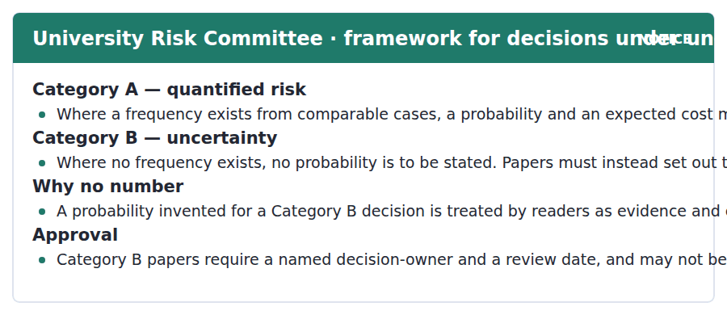
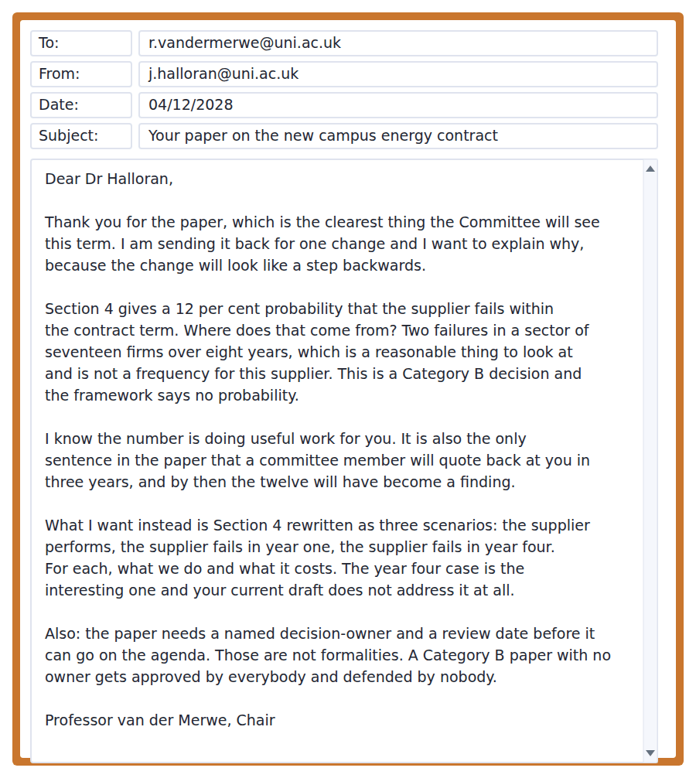
Exercise A Guided practice. The answer is on the page — find it.
1. When must a probability be stated?
(A) Where a frequency exists from comparable cases
(B) Always
(C) Never
(D) Where the Committee requests it
2. What must a Category B paper contain instead of a probability?
(A) An expected cost
(B) A legal opinion
(C) Three scenarios and the response to each
(D) A confidence interval
3. Why is no number permitted in Category B?
(A) It would be inaccurate
(B) It takes too long
(C) The Committee cannot interpret it
(D) Readers treat it as evidence and it cannot be withdrawn
4. What do Category B papers require for approval?
(A) A unanimous vote
(B) A named decision-owner and a review date
(C) An external review
(D) A legal sign-off
Exercise B Exam practice.
5. Why is the paper sent back?
(A) It is unclear
(B) It lacks costings
(C) It is too long
(D) Section 4 states a probability in a Category B decision
6. Where did the 12 per cent come from?
(A) The supplier’s accounts
(B) An external consultant
(C) Two failures among seventeen firms over eight years
(D) A sector average
7. What does the Chair predict about the number?
(A) It will be forgotten
(B) It will be quoted back in three years as a finding
(C) It will be revised
(D) It will be challenged immediately
8. What does the Chair acknowledge about the number?
(A) It is doing useful work in the paper
(B) It is accurate
(C) It is required
(D) It is conventional
9. Which scenario does the Chair call interesting?
(A) The supplier performs
(B) Failure in year one
(C) Contract renegotiation
(D) Failure in year four
10. Why does the Chair say the owner and review date are not formalities?
(A) The rules require them
(B) A paper with no owner is approved by everybody and defended by nobody
(C) They speed up approval
(D) Auditors check them
11. What is the structure of the Chair’s email?
(A) Praise, one required change with two reasons, and two procedural requirements
(B) A refusal
(C) A request for data
(D) An approval with conditions


SKILL · Reading a passage with a sustained first-person position
- Some academic writing marks the author’s view openly: to my mind, it seems to me, I would go further.
- Track the strength of each marker. They are usually ordered from weaker to stronger.
- The conclusion relocates the problem into a different field, and the final sentence names it.

Deciding When Nobody Can Give You a Probability
The standard account of good decision-making assumes you can put a number on each outcome, and most of the decisions that matter are not like that. A frequency requires repetition, and the events institutions worry about — a supplier failing, a technology arriving, a political arrangement collapsing — happen rarely and never twice under the same conditions. To my mind the useful response is not better estimation but a different objective: instead of looking for the course of action with the best expected outcome, look for the one that performs acceptably across the widest range of futures.
That is a real change rather than a rhetorical one, because the two objectives often recommend different things. Optimising assumes you know which future you are in. A robust choice deliberately gives up some performance in the most likely case in exchange for not failing in the others, and on balance it will look worse in retrospect roughly whenever the likely case happens to arrive, which is most of the time. Whatever else is true about institutional incentives, this one is decisive: the robust choice is the one that is hardest to defend afterwards.
It seems to me that this, rather than any deficit of numeracy, explains the persistence of spurious precision. A decision backed by a figure can be defended by producing the figure, whoever turned out to be right. A decision backed by judgement can be defended only by the outcome. I would go further: anybody who has sat on a committee knows this, which means the invention of unjustified probabilities is not an error to be trained out of people but a rational response to how they are judged. Fixing it requires changing what counts as a defensible paper, and that is a question about accountability rather than about statistics.
[300 words]

Exercise A Guided practice.
1. Why do most important decisions lack probabilities?
(A) Nobody collects data
(B) Statistics are unreliable
(C) The events are rare and never recur under the same conditions
(D) Institutions are careless
2. What does the author recommend instead of better estimation?
(A) Avoiding decisions
(B) A different objective: performing acceptably across many futures
(C) Hiring statisticians
(D) Delaying until data exists
3. What does optimising assume?
(A) That outcomes are equal
(B) That probabilities are low
(C) That you know which future you are in
(D) That costs are known
4. What does a robust choice give up?
(A) Nothing
(B) All performance
(C) Its defensibility only
(D) Some performance in the most likely case
Exercise B Exam practice.
5. Why will a robust choice usually look worse in retrospect?
(A) The likely case arrives most of the time
(B) It is badly explained
(C) It costs more
(D) It is slower
6. What does the author call decisive?
(A) The quality of the data
(B) That the robust choice is hardest to defend afterwards
(C) The cost of failure
(D) The speed of the decision
7. What does the author say explains spurious precision?
(A) Poor numeracy
(B) Pressure of time
(C) Weak frameworks
(D) How decision-makers are judged
8. How can a decision backed by judgement be defended?
(A) By producing the reasoning
(B) By citing a framework
(C) Only by the outcome
(D) By naming an owner
9. What does "I would go further" introduce?
(A) A stronger version of the point just made
(B) A qualification
(C) A counterargument
(D) A concession
10. What does the author say fixing the problem requires?
(A) Better statistical training
(B) More data
(C) Fewer committees
(D) Changing what counts as a defensible paper
11. Which would most weaken the third paragraph?
(A) Evidence that decision-makers are in fact judged on their reasoning rather than their outcomes
(B) Evidence that committees are numerate
(C) Evidence that probabilities are often accurate
(D) Evidence that robust choices are rare
12. All of the following are stated EXCEPT:
(A) A frequency requires repetition
(B) Better statistical training would solve the problem
(C) Robust and optimal choices often differ
(D) The robust choice is hard to defend afterwards
13. What is the function of the first-person markers in the passage?
(A) To soften weak claims
(B) To avoid citation
(C) To mark which claims are the author’s own judgement, at increasing strength
(D) To address the reader directly


Exercise A Listen and choose a response. You hear one line. Choose the best reply.
1. Man: Are people just bad at probability?
(A) Yes, hopeless.
(B) About one in ten thousand.
(C) Only where there is no story attached.
(D) In the lecture.
2. Woman: Why do vivid risks feel larger?
(A) Yes, they do.
(B) About ten per cent.
(C) From the news.
(D) Because we judge by how easily we picture them.
3. Man: Is the rule of thumb useless then?
(A) It works well where your experience is representative.
(B) Yes, entirely.
(C) About two errors.
(D) In the seminar.
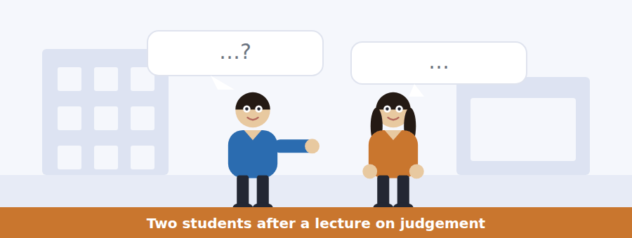
SKILL · Hearing two errors with one cause
- When a speaker names two opposite mistakes, expect a single explanation covering both.
- Listen for: both of those come from the same thing.
- The item about the cause is the hardest and the most likely to appear.

Exercise B Listen and answer. The audio plays once.
4. What does the woman say about the two mistakes?
(A) They have different causes
(B) They are the same mistake
(C) One is worse
(D) Neither is avoidable
5. What happens to a one in ten chance of something tedious?
(A) It is overestimated
(B) It gets no attention
(C) It is calculated correctly
(D) It is insured against
6. What is the common cause?
(A) Poor education
(B) Media bias
(C) Judging likelihood by how easily the event can be pictured
(D) Innumeracy
7. When does the rule of thumb work well?
(A) When your images come from what has happened to people you know
(B) Always
(C) With small numbers
(D) Never
8. When does it break?
(A) When numbers are large
(B) When events are rare
(C) When people are tired
(D) When images are selected for being memorable rather than frequent
9. What did the lecturer say the fix is not?
(A) Comparisons
(B) Education
(C) Regulation
(D) Telling people the numbers
10. What is the intervention she recommends?
(A) Repeating the statistics
(B) Giving a comparison people can picture
(C) Avoiding vivid examples
(D) Training in probability
Audio script: see the back of the book. Do not read it before you listen.


Exercise A Listen and choose a response. You hear one line. Choose the best reply.
1. Woman: Why can I not give a probability?
(A) Because it would be wrong.
(B) About twelve per cent.
(C) Because no frequency exists for this case.
(D) In Section 4.
2. Man: What goes in its place?
(A) Three scenarios and what you do in each.
(B) Nothing at all.
(C) About four years.
(D) The Committee decides.
3. Woman: Does a paper need a named owner?
(A) No, never.
(B) In Category B, yes, and a review date.
(C) About two names.
(D) Before December.
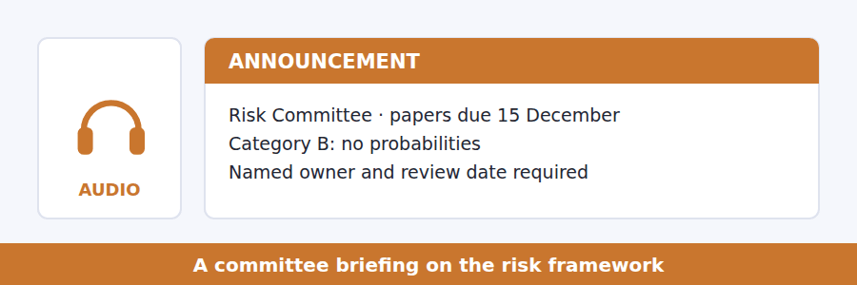
SKILL · Hearing a prohibition explained
- A rule that forbids something useful will always come with a reason. The reason is examinable.
- Listen for: I know this looks like a step backwards.
- The replacement for the forbidden thing is usually specified in detail.

Exercise B Listen and answer. The audio plays once.
4. What is the one distinction the framework makes?
(A) Whether a frequency exists
(B) Cost against benefit
(C) Short term against long term
(D) Internal against external risk
5. What may a Category B paper not contain?
(A) A cost estimate
(B) Scenarios
(C) A review date
(D) A probability
6. What does he say happens to a number in a paper?
(A) It is checked
(B) It is forgotten
(C) It gets quoted and cannot be withdrawn
(D) It is revised annually
7. What will people remember in three years?
(A) The two failures in seventeen firms
(B) A twelve per cent risk
(C) The scenarios
(D) The decision-owner
8. Which scenario does he say is usually missing?
(A) The fails-late case
(B) The success case
(C) The fails-early case
(D) The renegotiation case
9. What happens to a Category B paper with no owner?
(A) It is rejected
(B) It is deferred
(C) It is approved by everybody and defended by nobody
(D) It is sent for review
Audio script: see the back of the book. Do not read it before you listen.


Exercise A Listen and choose a response. You hear one line. Choose the best reply.
1. Man: Can we not just estimate the probability?
(A) Yes, roughly.
(B) About twelve per cent.
(C) In the paper.
(D) Not without a frequency, and there is none.
2. Woman: What does a robust choice give up?
(A) Nothing much.
(B) About ten per cent.
(C) Across many futures.
(D) Performance in the likely case.
3. Man: So why does nobody choose it?
(A) Because it costs more.
(B) Because it is the hardest to defend afterwards.
(C) About three years.
(D) The committee decides.
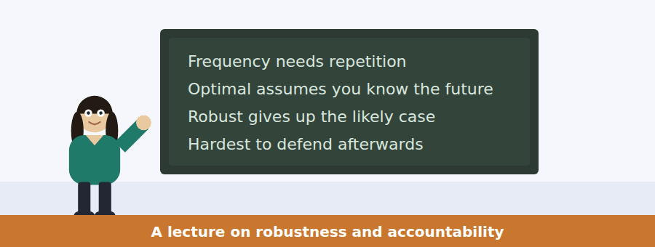
SKILL · Following a talk that ends by changing the subject
- A lecturer may conclude that the problem belongs to a different field entirely.
- Listen for: this is not a question about statistics, it is a question about.
- The speaker’s own view is usually marked explicitly in the last third.

Exercise B Listen and answer. The audio plays once.
4. Why is a probability unavailable for these events?
(A) A frequency needs repetition and these events do not repeat
(B) Data is withheld
(C) Models are poor
(D) Committees refuse to produce one
5. What does she say the response should be?
(A) Estimate better
(B) Delay the decision
(C) Change the objective
(D) Consult more widely
6. What does optimising assume?
(A) That costs are known
(B) That outcomes are rare
(C) That you know which future you are in
(D) That probabilities are accurate
7. Why will a robust choice look worse in hindsight?
(A) It sacrifices the likely case, and the likely case usually arrives
(B) It is expensive
(C) It is poorly documented
(D) It takes longer
8. What does she call decisive?
(A) The accuracy of estimates
(B) The cost of failure
(C) The quality of committees
(D) That the robust option is hardest to defend at review
9. What does she say invented probabilities are not caused by?
(A) Incentives
(B) A shortage of numeracy
(C) Committee procedure
(D) Time pressure
10. What does she conclude the problem is about?
(A) Accountability
(B) Probability
(C) Statistics
(D) Training
Audio script: see the back of the book. Do not read it before you listen.


Part 1 · Listen and Repeat
You hear a sentence and repeat it once. There is no preparation time, and the sentences get longer. Focus: managing a short argument out loud
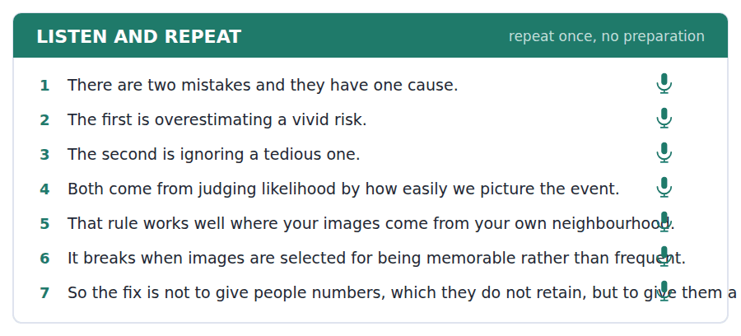
SKILL · Signposting as you speak
- Say how many points you have before you make them: there are two things here.
- Mark each one: the first is, the second is, and both come from.
- A listener who knows how many points are coming can follow all of them.

Part 2 · Take an Interview
An interviewer asks you four questions on one theme: risk, fear and what we pay attention to. Answer each one fully. There is no preparation time.
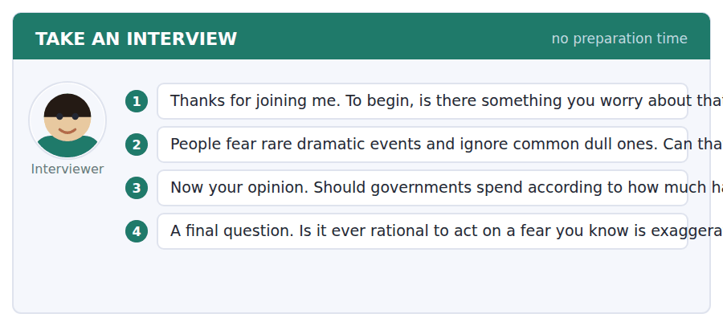
A good answer sounds like this
Question 2 — Only by working with it. Telling somebody the number does nothing; giving them a comparison they can see does quite a lot.
Question 4 — Yes, where the fear itself is costly. If I cannot sleep, that is a real harm even if the thing I fear is not.
I can… | Not yet | Yes
I said how many points I had. | □ | □
I marked each one. | □ | □
I gave the shared cause at the end. | □ | □


Part 1 · Listen and Repeat
You hear a sentence and repeat it once. There is no preparation time, and the sentences get longer. Focus: defending a rule that looks unhelpful
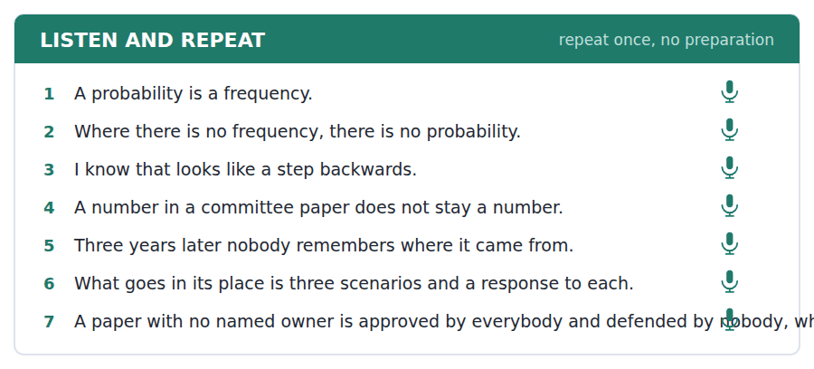
SKILL · Saying why a restriction helps
- Anticipate the objection out loud: I know this looks like a step backwards.
- Give the mechanism, not the principle: the number gets quoted and cannot be withdrawn.
- Specify the replacement in detail, so the restriction does not sound like a refusal.

Part 2 · Take an Interview
An interviewer asks you four questions on one theme: rules, numbers and institutional memory. Answer each one fully. There is no preparation time.
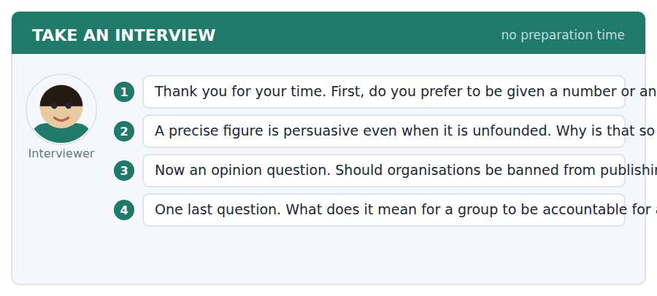
A good answer sounds like this
Question 2 — Because precision looks like work. A figure to one decimal place implies somebody did something, and we read the implication rather than checking it.
Question 4 — That somebody can be asked. A group is accountable when there is a name on the paper, and not otherwise, whatever the minutes say.
I can… | Not yet | Yes
I anticipated the objection out loud. | □ | □
I gave the mechanism rather than the principle. | □ | □
I specified the replacement. | □ | □


Part 1 · Listen and Repeat
You hear a sentence and repeat it once. There is no preparation time, and the sentences get longer. Focus: marking your own position at the right strength
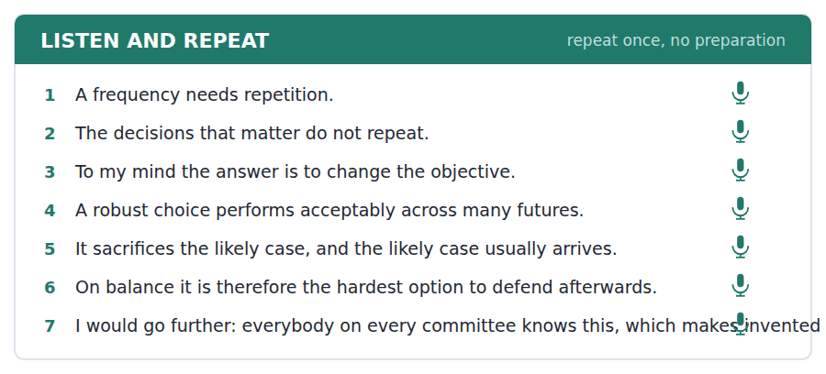
SKILL · Grading your own claims
- It seems to me is weaker than to my mind, which is weaker than I would go further.
- Use the weak ones early and the strong one once, at the point you most want believed.
- Never mark a claim stronger than your evidence. An examiner hears the mismatch immediately.

Part 2 · Take an Interview
An interviewer asks you four questions on one theme: judgement, accountability and being wrong. Answer each one fully. There is no preparation time.
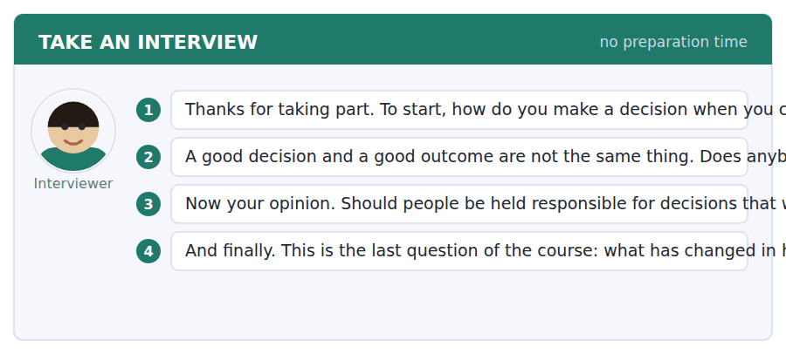
A good answer sounds like this
Question 2 — Almost nobody, because the outcome is observable and the reasoning is not. Which is exactly why reasoning has to be written down before the outcome arrives.
Question 4 — I concede more than I used to, and I have stopped treating that as a loss. The arguments that survive are the ones that have already given something away.
I can… | Not yet | Yes
I graded my markers from weaker to stronger. | □ | □
I used the strongest one only once. | □ | □
I did not mark a claim stronger than my evidence. | □ | □


You see a sentence, then a set of words in boxes. Put the words in order to make one grammatical sentence. Almost every item in the real test makes a question or a question inside another sentence.
SKILL · Build a Sentence: everything from the course
- The two non-question items in this closing unit may use any structure from Volumes 3 and 4.
- Read the tiles for the marker first: a cleft, a fronted adverbial, a concession, a conditional.
- The comma in the prompt is still the best clue to which half comes first.

Exercise A Guided practice. The first three are worked through.
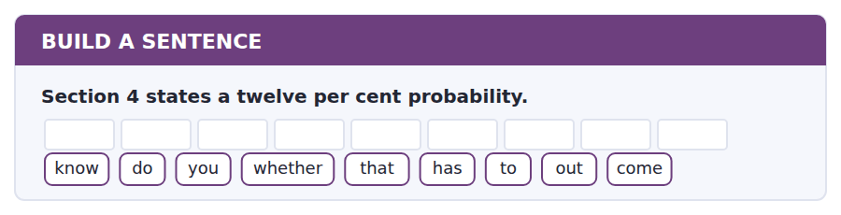
1. Do you know whether that has to come out?
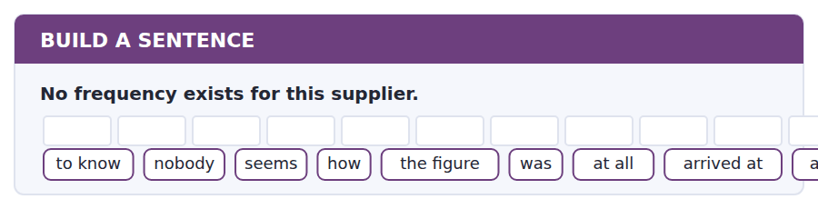
2. Nobody seems to know how the figure was actually arrived at at all.
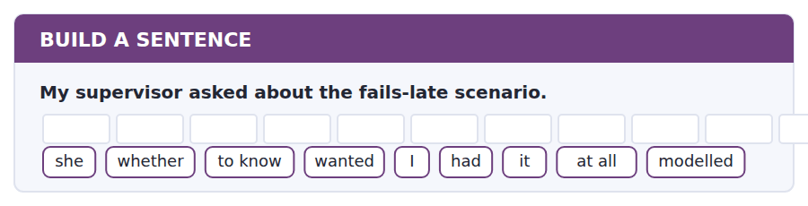
3. She wanted to know whether I had modelled it at all.
Exercise B Exam practice. Write the sentence.
4. A robust choice looks worse in hindsight.
do / whether / know / you / anybody / for / that / allows / at review
__________________________________________________________
5. Category B papers may not state a probability.
explain / can / anybody / why / a number / to me / is / worse / than nothing
__________________________________________________________
6. The paper has no named decision-owner.
know / does / anybody / who / is / supposed / to / sign / actually
__________________________________________________________
7. The committee cannot withdraw a published figure.
us / told / nobody / what / happens / when / a number / wrong / goes
__________________________________________________________
8. Invented probabilities are a rational response to incentives.
told / he / me / which / incentive / the / work / was / doing
__________________________________________________________
9. The hardest option to defend is the robust one.
it / is / the robust / option / that / is / to / defend / hardest
__________________________________________________________
10. A committee rarely accepts a paper without a figure.
rarely / does / a committee / accept / a paper / with / no / in / figure it
__________________________________________________________


You read a short situation and write an email. You have 7 minutes. The three bullet points are the mark scheme: answer all three.
The Chair has sent your paper back, told you to remove the 12 per cent probability because the decision is Category B, and asked for three scenarios including a late-failure case. You have done that. You also think one part of the paper — the price volatility estimate in Section 6 — genuinely is Category A, and the Chair’s email implied the whole paper was Category B.
Write an email to the Risk Committee.
- Confirm what you have changed, briefly.
- Make the Category A argument for Section 6, with the frequency you are relying on.
- Say what you will do if the Chair disagrees.
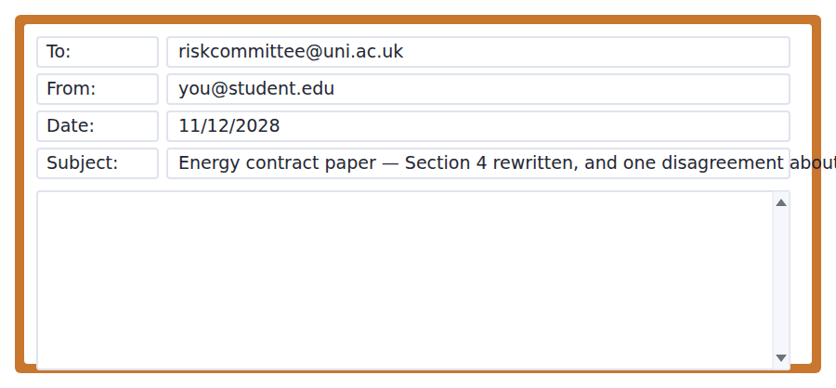
SKILL · Closing a paper out for a committee
- Report the changes in one short paragraph. The Chair wants to know it is done, not how.
- Where you disagree, show the test being met rather than asserting the conclusion.
- Say what you will do if you lose, so the Chair can decide in one line.

Model email
Dear Professor van der Merwe,

Section 4 is rewritten. The probability is gone, and there are now three scenarios — supplier performs, fails in year one, fails in year four — each with the response and the cost. You were right that the year four case was the one missing; it is also the only one in which we are still inside the fixed-price period, which changes the answer substantially.

One disagreement, and I think it is about which category Section 6 falls into rather than about the framework. Section 6 estimates wholesale price volatility over the contract term. That is not a judgement about this supplier. It is a frequency: eleven years of half-hourly settlement prices for this market, published, with the two regulatory interventions identifiable and separable. On the framework’s own test — does a frequency exist from comparable cases — that is Category A, and stating a distribution there is required rather than forbidden.

I may be reading your email too broadly. If the Committee’s view is that a paper is Category A or B as a whole rather than section by section, then Section 6 comes out too and I will restate it as a scenario range with no probabilities attached. That is a worse paper and it is not a worse decision, so I would rather have the ruling than the argument.

Either way the paper can be on the agenda by Friday. The decision-owner is named in the revised cover sheet and the review date is March 2030, twelve months before the first break clause.

With thanks,
Jonathan Halloran
Why it works
- The changes are reported in four lines, with one substantive finding the Chair did not know.
- The disagreement is argued by applying the framework’s own test rather than by objecting to it.
- The frequency is described precisely enough to be checked: eleven years, half-hourly, published, interventions separable.
- The writer states the fallback and calls it a worse paper but not a worse decision, which lets the Chair rule in one line.
Two answers, one band apart
Both answer the three bullet points. One would score in the middle band and one near the top. Read them side by side before you write your own.
A middle-band answer | A top-band answer
Dear Professor van der Merwe,  Thank you very much for your comments on my paper, which were extremely helpful. I have now rewritten Section 4 as you asked, removing the probability and adding the three scenarios including the late failure case, which I agree was an important omission.  There is one point I wanted to raise with you. I am not sure that Section 6 should really be treated in the same way, because the price volatility figures are based on a lot of historical market data rather than on a judgement about the supplier. It seemed to me that this might count as Category A under the framework.  Of course I may well be wrong about this, and if you think the whole paper should be Category B then I am happy to take that section out as well. Please let me know what you would prefer and I will make the changes straight away.  Thank you again for your help with this. Best wishes, Jonathan Halloran | Dear Professor van der Merwe,  Section 4 is rewritten: the probability is gone and there are three scenarios — performs, fails in year one, fails in year four — each with response and cost. You were right that year four was missing; it is also the only case still inside the fixed-price period, which changes the answer.  One disagreement, about which category Section 6 falls into. Section 6 estimates wholesale price volatility. That is a frequency: eleven years of half-hourly settlement prices for this market, published, with the two regulatory interventions separable. On the framework’s own test that is Category A, and a distribution there is required rather than forbidden.  If the Committee’s view is that a paper is Category A or B as a whole, Section 6 comes out and I will restate it as a scenario range. That is a worse paper and not a worse decision, so I would rather have the ruling than the argument.  Either way it can be on the agenda by Friday. Owner named, review date March 2030. Jonathan Halloran

What the top answer does that the other does not
- It reports the rewrite in one line and adds a finding the Chair did not have — the fixed-price overlap — which is the only new information worth his time.
- It argues by applying the framework’s stated test instead of saying the section might count as Category A.
- It describes the frequency precisely enough to be verified, rather than calling it a lot of historical market data.
- It names the fallback and evaluates it in one clause — a worse paper, not a worse decision — so the Chair can rule without weighing anything.
- It closes the procedural requirements in six words, because a Chair reading twenty papers needs them confirmed and not explained.
Now write your own. 7 minutes.
__________________________________________________________
__________________________________________________________
__________________________________________________________
__________________________________________________________
__________________________________________________________
__________________________________________________________
__________________________________________________________
__________________________________________________________


A professor asks a question and two students answer. You add your own post. You have 10 minutes and an effective answer is at least 100 words.
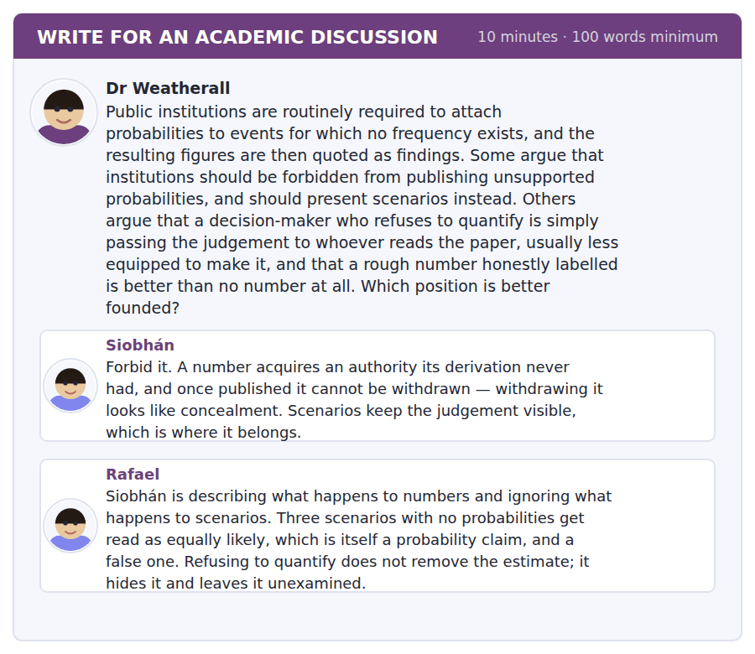
SKILL · Answering an argument you largely agree with
- When both sides identify a real failure mode, the question is which failure is worse and which is fixable.
- Look for a design that avoids both rather than choosing between them.
- This is the last discussion of the course: mark your own position clearly and grade it.

Sentence starters
- Rafael has found the strongest objection to the scenario approach.
- Siobhán is right about what happens to a number, and that is not the whole case.
- What separates them is which failure is fixable…
- To my mind what follows is…
Model post
Rafael has found the strongest objection to the scenario approach and it is stronger than Siobhán’s reply would be. Three scenarios presented without weights are read as roughly equally likely; that is an implicit probability claim, it is almost always false, and nobody can be held to it because nobody stated it. Refusing to quantify does not remove the estimate from the paper. It removes it from the part of the paper that can be criticised.
Siobhán is right about what happens to a number, and that is not the whole case. Her mechanism is real and well documented: the derivation is forgotten, the figure survives, and withdrawal reads as concealment. But she treats that as a property of numbers when it is a property of unlabelled numbers. A figure published with its derivation attached in the same sentence — two failures among seventeen firms over eight years — does not acquire that authority, because the thinness is visible every time it is quoted.
What separates them is which failure is fixable, and on that Siobhán loses. The implicit equal weighting of scenarios cannot be corrected without adding weights, at which point you are quantifying again. The over-reading of a number can be corrected by requiring the derivation to travel with it, which is a drafting rule rather than a change of method.
To my mind what follows is a weaker prohibition than Siobhán wants and a stronger discipline than Rafael implies: no bare probability anywhere, but a requirement that every scenario carry an explicit statement of how likely its author thinks it is and on what basis, even where that basis is only judgement. I would go further, since this is the point both posts avoid: whatever else is true, the author of the estimate should be named. The reason unsupported figures persist is not that institutions cannot tell risk from uncertainty. It is that nobody has ever been asked, three years later, to account for one.
[328 words]
Now write your own. 10 minutes, at least 100 words.
__________________________________________________________
__________________________________________________________
__________________________________________________________
__________________________________________________________
__________________________________________________________
__________________________________________________________
__________________________________________________________
__________________________________________________________
__________________________________________________________
__________________________________________________________

Grammar focus Discourse management and stance
Function | Expressions
announcing structure | there are two things here; I want to do three things
ordering | the first is; the second; and finally
conceding | granted; I accept that; there is something in that
qualifying | on balance; to a limited extent; for the most part
marking your own view | to my mind; it seems to me; in my view
strengthening | I would go further; more than that; indeed
fixing a point | whatever else is true; the one thing that is certain is

Stance markers have strengths and should be ordered. It seems to me is weaker than to my mind; I would go further is the strongest and should appear once. Three strong markers in a paragraph cancel each other out.
A concession needs a following clause that does something with it. Granted, the data is thin, and I accept the objection is not an argument — the reader is waiting for the but.
Announcing structure is only useful if you keep to it. If you say there are two things and then give three, the reader trusts nothing else you signpost.
Watch out! Do not hedge a claim and then assert it. "It seems to me that this is certainly decisive" marks the claim twice at two different strengths, and the reader believes the weaker one.
Exercise 1 Choose the appropriate marker.
1. ______ there are two mistakes here, and they share a cause.
2. ______, the data is thin — but the direction is clear.
3. ______ the answer is to change the objective, not the estimate.
4. ______ else is true, the robust option is hardest to defend.
5. I accept the objection, and ______ I would go further.
6. ______ balance the restriction does more good than harm.
Exercise 2 Correct the stance error.
1. It seems to me that this is certainly decisive.
2. Granted, the data is thin.
3. In my view, I think the answer is clear.
4. There are two things here. First, the frequency. Second, the incentive. Third, the drafting.
Exercise 3 Rewrite with the marker shown, keeping the meaning.
1. This is the most important objection. (I would go further)
2. The estimate is not reliable. (it seems to me)
3. The restriction helps more than it costs. (on balance)
4. The robust option is hardest to defend. (whatever else is true)
How this is tested in Build a Sentence
The last Build a Sentence of the course draws on everything: clefts, fronted adverbials, concessions and conditionals. Find the marker in the tiles before you decide the word order, exactly as you have been doing since Unit 21.
Find the fault 5 errors, drawn from this unit and the two before
Every error below is one a B2 writer makes after learning the rule. Mark what is wrong, then check. Knowing the rule and noticing the breach are two different skills, and only the second one is tested.
It seems to me that this is certainly decisive. Granted, the data is thin. In my view, I think the answer is clear. There are two things here: the frequency, the incentive and the drafting. Nobody knows whether was the figure supported.
# | As written | As it should be | Why
1 | It seems to me that this is certainly decisive | To my mind this is decisive | The claim is marked twice at two different strengths, and a reader believes the weaker one.
2 | Granted, the data is thin. | Granted, the data is thin, but the direction is clear. | A concession needs a following clause that uses it, or the reader is left waiting.
3 | In my view, I think the answer is clear | In my view the answer is clear | In my view and I think do the same job, so using both marks the view twice.
4 | There are two things here: the frequency, the incentive and the drafting | There are three things here: the frequency, the incentive and the drafting | An announced structure that does not match what follows destroys the reader’s trust in every later signpost.
5 | whether was the figure supported | whether the figure was supported | An embedded question keeps statement order and does not invert the verb.

Unit review and progress check Unit 40
Exercise A Vocabulary. Write the word.
1. not knowing the probabilities at all
2. performing acceptably across many possible futures
3. how much a quantity moves up and down
4. a rule of thumb
5. how readily something comes to mind
6. stating more certainty than the evidence supports
7. acting to avoid a harm that is not yet proven
8. reducing the severity of a harm
9. spare capacity held against a shock
10. seeming real without being so
11. able to be handled or solved
12. required to answer for a decision
Exercise B Grammar. Complete the sentence.
1. ______ my mind the answer is to change the objective.
2. It ______ to me that the estimate is unreliable.
3. ______ else is true, the robust option is hardest to defend.
4. I would go ______: everybody on the committee knows this.
5. ______ balance the restriction does more good than harm.
6. ______, the data is thin, but the direction is clear.
7. For the most ______, the devices that persuade are the expensive ones.
8. In the final ______, the question is about accountability.
Exercise C One timed mini-section. 6 minutes.
1. Risk differs from uncertainty in that
(A) risk is larger
(B) under risk the probabilities are known
(C) uncertainty is rarer
(D) risk can be insured only by governments
2. People overestimate vivid risks because
(A) the media exaggerate
(B) the numbers are wrong
(C) likelihood is judged by how easily the event is pictured
(D) they are innumerate
3. A robust choice is hard to defend afterwards because
(A) it costs more
(B) it is poorly documented
(C) it is slower
(D) it sacrifices performance in the case that usually arrives
4. Which sentence is correct?
(A) To my mind this is decisive.
(B) It seems to me that this is certainly decisive.
(C) In my view, I think this is decisive.
(D) It seems to me that in my view this is decisive.
5. "Whatever else is true" signals that the writer is
(A) uncertain
(B) conceding
(C) fixing one point as settled before continuing
(D) quoting
6. Unsupported probabilities persist mainly because
(A) decision-makers are innumerate
(B) frameworks are weak
(C) data is expensive
(D) a figure can be defended afterwards and a judgement cannot
Can you do these now?
I can… | Not yet | Yes
I can manage a long argument with signposts a reader can follow. | □ | □
I can mark my own position at the right strength and keep it consistent. | □ | □
I can distinguish risk from uncertainty and write about each correctly. | □ | □
I can concede, qualify and conclude in a single coherent paragraph. | □ | □
I can follow an extended talk and identify the speaker’s own view. | □ | □
I can write a full discussion answer under time pressure. | □ | □

ADAPTIVE TIP This is the end of the course. The four volumes have taught twenty grammar systems, 1,620 words and every 2026 task type three times over, and the thing that will actually move your score now is none of those. It is doing a complete timed test, marking it honestly against the keys, and going back to the three units whose structures you avoided. You know which three.

Practice Test 4
The full 2026 shape: 97 items, in the order the real test asks them
Reading 40 · Listening 34 · Writing 12 · Speaking 11
Sit this in one sitting. Do not look anything up. Mark it with the key at the back, then read the explanations — they matter more than the score.

Reading Section, Module 1 In an actual test the clock shows you how long you have
You can use Next and Back to move between questions inside this module.
Fill in the missing letters in the paragraph. (Questions 1–10)
Revision works by retrieval, not by exposure, and almost every student discovers this too l---. Reading a page again feels productive because it feels eas--- the second time, and that sensation of ease is exactly what you should be suspic---- of: it measures familiarity rather than recall. Closing the book and writing down what you can remember feels much wo--- and produces far more learning, which is a thoroughly inconven---- finding. The effect is largest where the material is hard---, and it survives every attempt to explain it a---. Students told about it still prefer rereading, because the method that works offers no reass------ while you are doing it, and the method that does not offer- nothing el--.

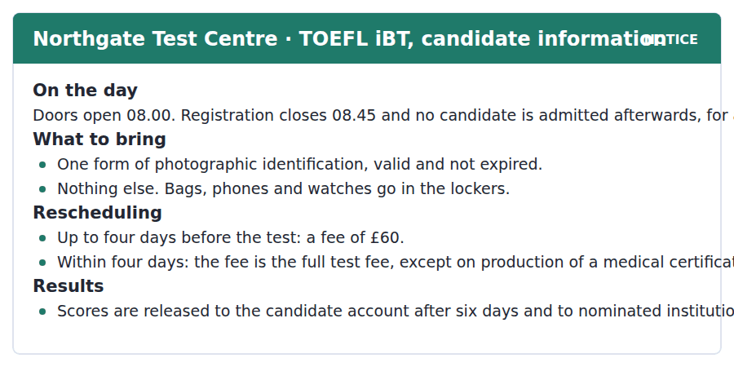
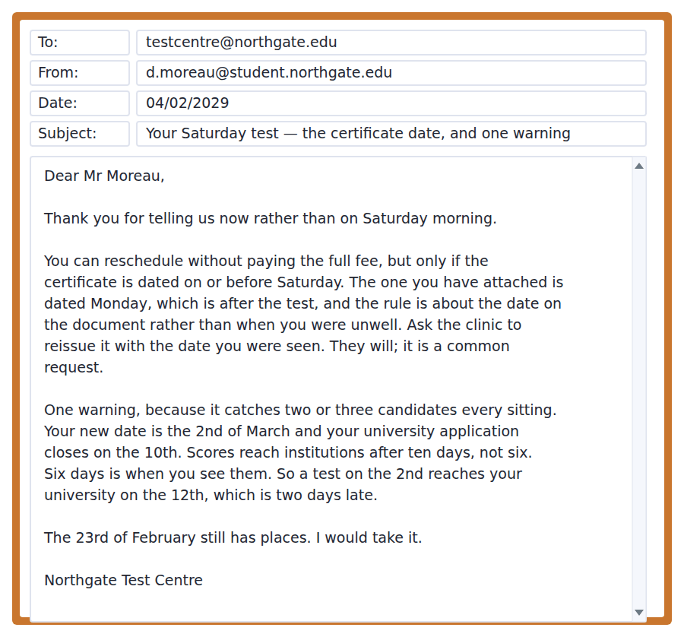
11. What is the latest a candidate may register?
(A) 08.00
(B) 08.45
(C) 09.00
(D) Any time before the test begins
12. What may a candidate bring into the test room?
(A) A phone on silent
(B) A watch
(C) One valid photographic identification
(D) A bag
13. Why is Mr Moreau’s certificate not accepted?
(A) It is dated after the test day
(B) It is unsigned
(C) It is from the wrong clinic
(D) It arrived too late
14. When do nominated institutions receive scores?
(A) After six days
(B) On the test day
(C) After four days
(D) After ten days
15. Why does the Centre recommend the 23rd of February?
(A) It is cheaper
(B) A test on the 2nd of March would reach the university two days late
(C) The 2nd is full
(D) The certificate would then be unnecessary
Why the Same Thing Gets Invented Twice
The lone inventor is the most durable story in the history of technology and one of the least supported by the record. Almost every significant invention of the last two centuries was arrived at independently by two or more people within a few years, and often within a few months. That pattern is too consistent to be coincidence, and it tells you that the determining factor was not individual brilliance but the state of everything else.
A device becomes thinkable when the problems it depends on have already been solved somewhere else. Before that point no amount of talent produces it; after that point it occurs to everybody competent who is looking in the right direction. On this account the inventor supplies the last step rather than the whole staircase, and the last step is the one that gets the name attached to it because it is the one that can be dated.
Nobody seriously disputes the pattern, and the institutions built around invention assume the opposite of it. A patent awards twenty years of exclusivity to whoever filed first, a race frequently decided by weeks and by whether a firm keeps a patent attorney on retainer. Defenders of the system usually concede the point about simultaneity and argue that a sharp rule is better than a vague one, because any attempt to apportion credit would produce litigation without end. That is a strong argument and it is an argument about administration rather than about desert. It is worth keeping the two apart, because the system is routinely defended as though it rewarded contribution, and the people it rewards know quite well that it rewards speed.
[276 words]

16. What is the main claim of the passage?
(A) Invention is determined by the state of surrounding knowledge rather than individual genius
(B) Patents should be abolished
(C) Inventors are rarely credited correctly
(D) Simultaneous invention is a coincidence
17. Why does the author say the pattern cannot be coincidence?
(A) It has been proved mathematically
(B) Inventors have admitted it
(C) Patents record it
(D) It is too consistent across two centuries
18. What does "the last step rather than the whole staircase" mean?
(A) The inventor does very little work
(B) Invention happens in stages of equal size
(C) The inventor supplies the final piece of a structure others built
(D) The staircase is a metaphor for the patent system
19. Why does the last step get the name attached to it?
(A) It is the hardest
(B) It is the one that can be dated
(C) It is the most valuable
(D) It is usually patented
20. What distinction does the author insist on at the end?
(A) Between an argument about administration and one about desert
(B) Between invention and innovation
(C) Between patents and trade secrets
(D) Between filing first and inventing first

Reading Section, Module 2 In an actual test the clock shows you how long you have
You cannot return to Module 1 once Module 2 has begun.
You can use Next and Back to move between questions inside this module.
Fill in the missing letters in the paragraph. (Questions 1–10)
Almost nobody is bad at risk in general. People are bad at the particular risks that arrive without a story, and the mechanism is now reasonably well underst---. We judge how likely something is by how readily we can picture it, which is an excellent rule in a world where the things you can picture are the things that have actually happ---- nearby. It fails in a world where your supply of images has been selected for being memor----. So a vanishingly unlikely disaster is treated as a live possibil--- and a common dull hazard is ign----, and both errors come from the same place. What follows is not that people should be given more numbers. They do not ret--- numbers, and telling them the figure has been tried for forty years with results that are consistently disappoin----. What works, as far as anything does, is a compar---- they can see: this risk is about the same size as that one. The intervention does not fight the rule of thumb. It fe--- it better material, which is the only approach in this literature that has survived replica----.

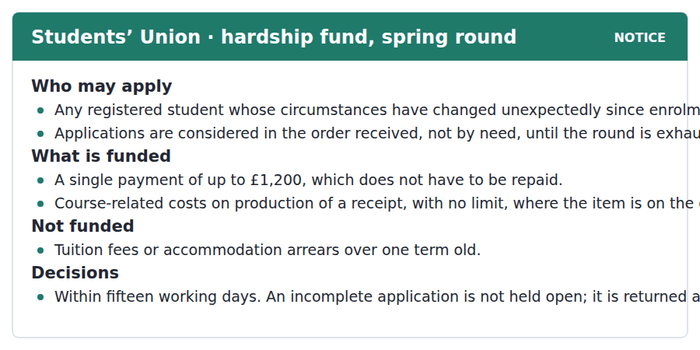
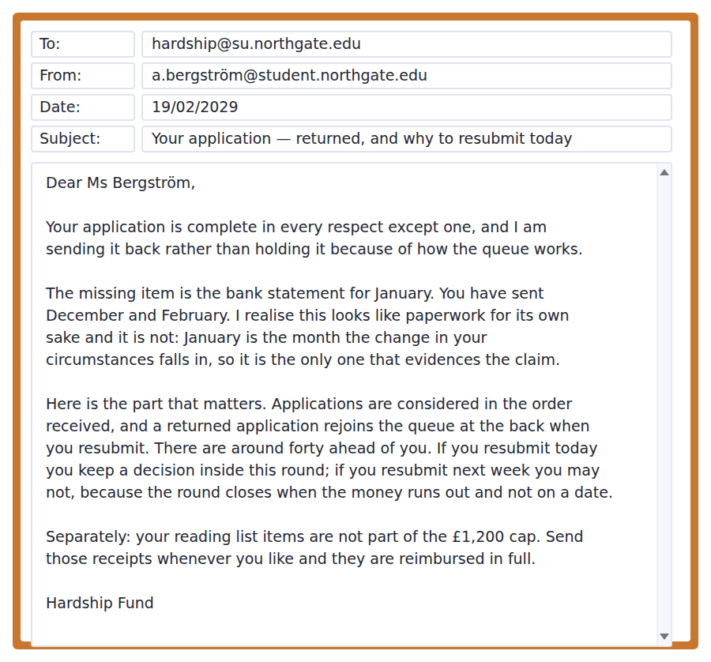
11. How are applications considered?
(A) By level of need
(B) By year of study
(C) By a panel vote
(D) In the order received
12. What is the limit on course-related costs?
(A) £1,200
(B) £600
(C) There is no limit for items on the required list
(D) They are not funded
13. What is not funded?
(A) Accommodation arrears over one term old
(B) Reading list items
(C) Travel costs
(D) Equipment
14. Why is the January statement needed?
(A) It is a standard requirement
(B) January is the month the change of circumstances falls in
(C) December was illegible
(D) Three months are always required
15. Why should Ms Bergström resubmit today?
(A) The round closes on Friday
(B) The fee increases
(C) The officer is away next week
(D) A returned application rejoins the queue at the back
The Baseline Nobody Thought to Record
Almost every environmental argument turns on a comparison with an earlier state, and in a surprising number of cases nobody measured the earlier state. Monitoring tends to begin when a place is already in trouble, which means the first careful survey records a degraded system and then becomes the standard against which everything later is judged. The effect is that each generation of specialists inherits a baseline set by the damage done before they arrived, and defends it in good faith as the natural condition.
The consequence is not that recovery targets are too ambitious. It is that they are quietly too modest, and the modesty is invisible because the evidence for anything richer sits in sources nobody treats as data: fishermen’s landing records, estate ledgers, the species lists in nineteenth-century parish accounts. Where somebody has gone back to those documents the revision has usually been large and in one direction.
What is less often said is that the problem repeats at every level of detail. A replanted woodland is compared with a mature one for canopy and bird species and almost never for its soil community, because the soil community of the original was never recorded either. Rarely does this reflect carelessness; it reflects the fact that monitoring is funded after a loss has become visible, and a soil community disappears without becoming visible to anybody. The honest position is that we do not know what most of these places were like, and that the number we are working towards is a guess with a long history rather than a measurement.
[262 words]

16. What is the central problem the passage describes?
(A) Monitoring is too expensive
(B) Recovery targets are too ambitious
(C) The reference state used for comparison is itself already degraded
(D) Specialists disagree about methods
17. Why does the author say specialists defend the baseline in good faith?
(A) They inherit it and have no record of anything earlier
(B) They benefit from it
(C) They have been instructed to
(D) They distrust historical sources
18. What does the author say about recovery targets?
(A) They are too ambitious
(B) They are about right
(C) They are quietly too modest
(D) They cannot be set
19. What kind of sources does the author point to?
(A) Satellite imagery
(B) Government surveys
(C) Museum collections
(D) Landing records, estate ledgers and parish accounts
20. Why is a replanted woodland rarely compared for its soil community?
(A) Soil is hard to sample
(B) The original soil community was never recorded either
(C) It is not considered important
(D) It recovers quickly

Listening Section, Module 1 You will not be able to return to previous questions
Choose the best response.
1. Woman: Have you booked your test date yet?
(A) Yes, I have booked.
(B) About six days.
(C) At the test centre.
(D) The 23rd, in the end.
2. Man: Does the certificate have to be dated before the test?
(A) Yes, it does.
(B) About four days.
(C) On or before — that is the whole rule.
(D) From the clinic.
3. Woman: Why is rereading so popular?
(A) Yes, it is popular.
(B) Because it feels easier the second time.
(C) About three hours.
(D) In the library.
4. Man: Can I take my watch in?
(A) Nothing at all except your identification.
(B) Yes, you can.
(C) About twenty minutes.
(D) In the lockers.
5. Woman: Did the Centre charge you the full fee?
(A) No, once the date was corrected.
(B) Yes, they did.
(C) About sixty pounds.
(D) On Saturday.
6. Man: How many applications are ahead of yours?
(A) Yes, quite a lot.
(B) About fifteen days.
(C) Around forty, apparently.
(D) At the Union.
7. Woman: Are my reading list books inside the cap?
(A) Yes, they are.
(B) About twelve hundred pounds.
(C) With a receipt.
(D) No — those are reimbursed separately.
8. Man: Should I resubmit today or wait until I have everything?
(A) Yes, you should.
(B) Today. The queue is the thing that matters.
(C) About a week.
(D) To the Hardship Fund.
Listen to a conversation.

9. What does the man take as a good sign?
(A) Finishing the chapters
(B) Remembering the chapter titles
(C) Reading faster
(D) Rereading feeling easier each time
10. Why does she say almost nobody switches method?
(A) The better method takes longer
(B) The better method feels like failing while you do it
(C) Nobody is told about it
(D) It only works for easy material
Listen to a conversation.
11. Why was the certificate refused?
(A) It was unsigned
(B) It came from the wrong clinic
(C) It was dated after the test day
(D) It arrived too late
12. What had she confused?
(A) The six days to the candidate with the ten days to institutions
(B) The test date and the closing date
(C) The fee and the rescheduling fee
(D) The clinic date and the test date
Listen to an announcement.
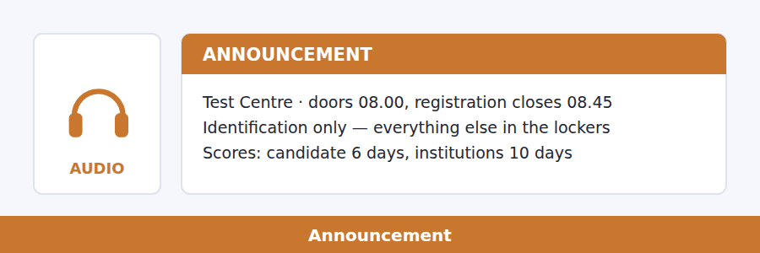
13. What does the speaker say about the registration deadline?
(A) It can be extended briefly
(B) It applies only to first-time candidates
(C) The desk staff have no discretion over it
(D) It is eight o’clock
14. Which number does he tell candidates to count from?
(A) Six
(B) Ten
(C) Four
(D) Fifteen
Listen to a talk.
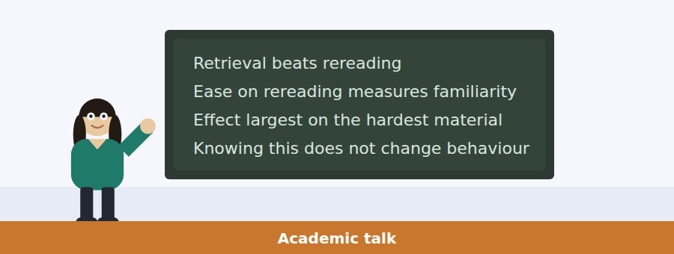
15. What is the finding she describes?
(A) Rereading is useless
(B) Learning depends on material
(C) Students are poorly informed
(D) Retrieval produces learning and exposure does not
16. What does increasing ease on rereading actually measure?
(A) Familiarity with the page
(B) Learning
(C) Reading speed
(D) Confidence
17. Why does she say retrieval is unpleasant and informative in inverse proportion?
(A) It takes longer
(B) The worse the experience feels, the more it tells you
(C) It is harder to schedule
(D) It requires a teacher
18. What does she say should worry teachers?
(A) Students cannot state the finding
(B) The effect is small
(C) The research is recent
(D) Students who know the finding still choose to reread

Listening Section, Module 2 You will not be able to return to previous questions
Choose the best response.
1. Woman: Is the hardship payment a loan?
(A) Yes, it is.
(B) About twelve hundred pounds.
(C) No, it does not have to be repaid.
(D) From the Union.
2. Man: Why can a patent go to the wrong person?
(A) Because it goes to whoever filed first.
(B) Yes, it happens.
(C) About twenty years.
(D) At the patent office.
3. Woman: Did anybody measure the river before the drainage?
(A) Nobody did, which is the whole difficulty.
(B) Yes, in detail.
(C) About eleven years.
(D) On the eastern edge.
4. Man: Are landing records really evidence?
(A) No, not really.
(B) About two centuries.
(C) In the archive.
(D) They are the only evidence there is.
5. Woman: Should I apply before I have every document?
(A) Yes, apply now.
(B) About forty ahead.
(C) No — an incomplete one goes to the back.
(D) To the Fund.
6. Man: Does the twenty-year term suit every field?
(A) Yes, it does.
(B) Nothing like it, and that is the obvious objection.
(C) About fourteen years.
(D) In this jurisdiction.
7. Woman: How long do decisions take?
(A) Yes, quite a while.
(B) About forty applications.
(C) Fifteen working days, if nothing is missing.
(D) At the Union office.
8. Man: Is the soil community really unrecoverable?
(A) Yes, it is gone.
(B) About a century.
(C) Under the canopy.
(D) Unknown, which is not the same as no.
Listen to a conversation.
9. What does the man object to initially?
(A) The date of the survey
(B) A merchant’s ledger counting as data
(C) The size of the estuary
(D) The recovery target
10. Why does she say recovery targets are too modest?
(A) They are defined by a survey of an already damaged system
(B) They were set politically
(C) Funding is insufficient
(D) The estuary cannot recover
Listen to an announcement.
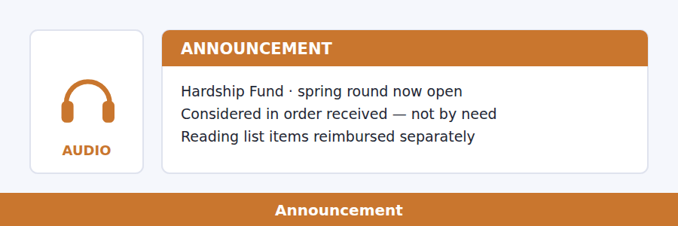
11. How are applications sorted?
(A) By need
(B) By order of arrival
(C) By year of study
(D) By amount requested
12. What happens to an incomplete application?
(A) It is held open
(B) It is rejected permanently
(C) It is returned and goes to the back on resubmission
(D) It is decided on what was sent
Listen to a talk.
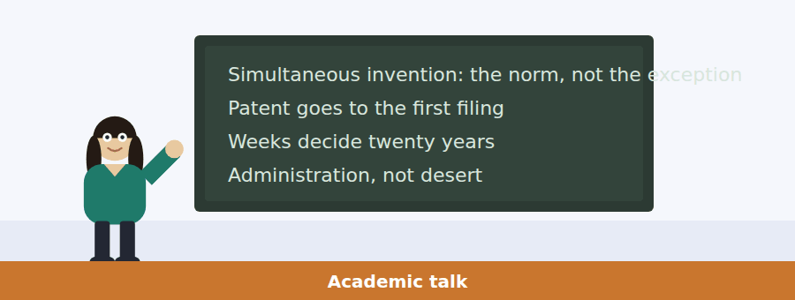
13. What pattern does the speaker describe?
(A) Inventions are rarely patented
(B) Patents are usually disputed
(C) Invention has slowed
(D) Significant inventions are typically arrived at independently by several people
14. What is her explanation for the pattern?
(A) A device becomes possible once its component problems are solved
(B) Inventors communicate
(C) Patents are published
(D) Funding is concentrated
15. Why does the last step get the inventor’s name?
(A) It is the step with a date on it
(B) It is the hardest part
(C) It is the most valuable
(D) It is the one patented
16. What does she want students to notice about the defence of the system?
(A) It denies simultaneity
(B) It is rarely made
(C) It is purely legal
(D) It is an argument about administration presented as one about desert

Writing Section 12 questions, three types of task
Build a Sentence. Move the words to make grammatical sentences.
1. My certificate is dated the day after the test.
know / do / you / whether / the clinic / can / it / reissue / actually
__________________________________________________________
2. Scores reach institutions four days after I see them.
said / has / anybody / why / that / gap / exists / at all / actually
__________________________________________________________
3. I rebooked for the 2nd of March.
explain / can / anybody / why / that / date / to me / work / does not
__________________________________________________________
4. My application was returned for one missing statement.
know / does / anybody / whether / it / the queue / keeps / place / its
__________________________________________________________
5. Reading list items are reimbursed in full.
us / told / nobody / which / items / the list / on / actually / are
__________________________________________________________
6. Two groups invented the same mechanism in one year.
do / whether / know / you / either / of / them / the other / knew about
__________________________________________________________
7. The estuary was first surveyed in 1974.
told / she / me / what / the fishery / had / done / by then / already
__________________________________________________________
8. Rereading feels easier every time.
know / do / you / whether / that / feeling / anything / means / at all
__________________________________________________________
9. A patent goes to whoever files first.
it / is / speed / that / the system / rewards / and / contribution / not
__________________________________________________________
10. Nobody measured the estuary before the fishery collapsed.
rarely / does / monitoring / begin / before / the damage / has / visible / become
__________________________________________________________
Write an Email. You have 7 minutes.
The Hardship Fund has returned your application because the January bank statement is missing, explained that a returned application rejoins the queue at the back, and told you that reading list items fall outside the £1,200 cap. Your bank cannot produce the January statement until Thursday, but it can give you a stamped transaction list today.
Write an email to the Hardship Fund.
- Say what you are sending today and what is still coming.
- Ask whether the stamped list is enough to keep your place in the queue.
- Deal with the receipts in the same email.
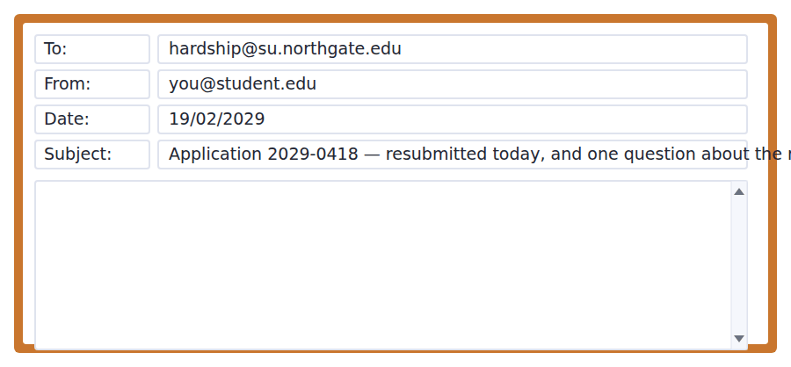
__________________________________________________________
__________________________________________________________
__________________________________________________________
__________________________________________________________
__________________________________________________________
__________________________________________________________
__________________________________________________________
__________________________________________________________
Write for an Academic Discussion. You have 10 minutes.
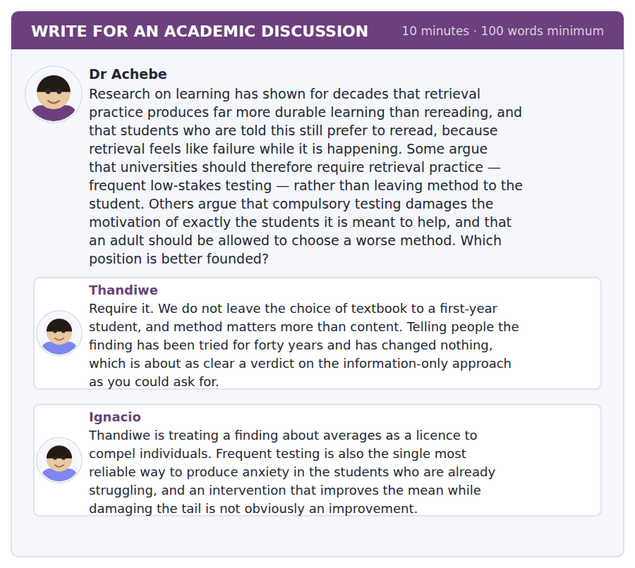
An effective response will contain at least 100 words.
__________________________________________________________
__________________________________________________________
__________________________________________________________
__________________________________________________________
__________________________________________________________
__________________________________________________________
__________________________________________________________
__________________________________________________________
__________________________________________________________
__________________________________________________________

Speaking Section 11 questions, two types of task · no preparation time
Listen and Repeat. Repeat only once.
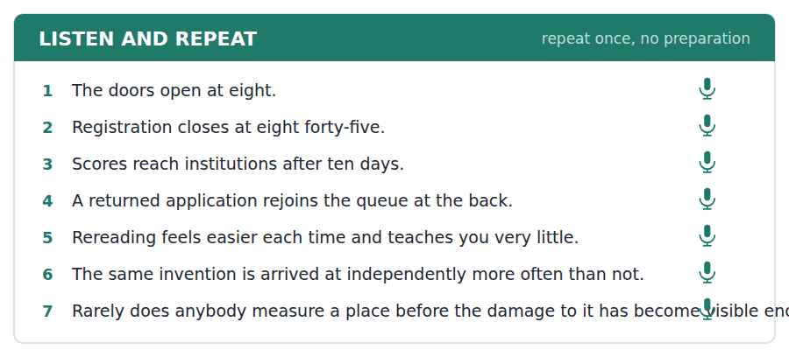
Take an Interview. Answer the questions and say as much as you can.
a research study about how people study, decide and remember
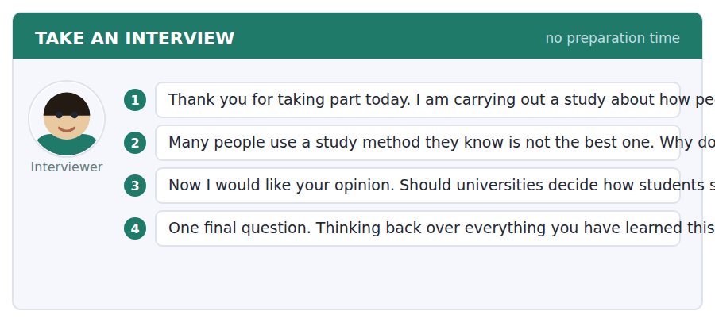

Answer key
Volume 4 · Units 31–40 and Practice Test 4
Every wrong option is explained, because a letter on its own teaches nothing.

Unit 31 · Microbes and Immunity
Reading 1 · Complete the Words
1 ied | 3 uce | 5 ant | 7 fit | 9 ally
2 ible | 4 ation | 6 atic | 8 ted | 10 ated

Reading 2 · Read in Daily Life
1 (C) The two conditions are listed together and both concern a bacterial cause rather than the patient’s wishes.
2 (B) The notice defines it as held in reserve, and the email applies that definition to six weeks away.
3 (D) The policy names the lead GP, which is why the doctor can refer rather than simply refuse.
4 (A) On patient request alone is listed under when an antibiotic will not be prescribed.
5 (B) He says the policy rules it out and is careful to add that the reason is not personal caution.
6 (A) He generalises about how carried supplies are actually used rather than about this patient.
7 (D) Six weeks at a remote site is the situation the exception exists for, which is why he refers it.
8 (C) The notice puts the delayed prescription within the clinician’s discretion, and he says so explicitly.
9 (D) The point of the arrangement is that the supply exists but the decision to use it is tied to evidence.
10 (C) He explains why one door is closed and then uses the exception and his own discretion instead.
11 (B) It contrasts with the prophylaxis route, which the policy says requires a review by somebody more senior.
Reading 3 · Academic Passage
1 (A) The fire-and-fuel image is stated first precisely so that the passage can show it is wrong.
2 (D) The author calls the reason arithmetic: the average falls below one while most people are still uninfected.
3 (C) Being highly connected both causes early infection and makes that person important to transmission.
4 (B) It is contrasted with those already immune, so it describes people the infection can still reach.
5 (A) That disproportion is the whole argument of the second paragraph.
6 (B) The existence is given as near-certain and the magnitude as unsettled, and the distinction is deliberate.
7 (D) A low threshold makes waiting reasonable and a high one makes it very costly, which is a policy difference, not a value difference.
8 (A) The point is that the two sides want the same thing and differ about a number.
9 (C) Understood mechanism, agreed direction, and a number that is only available afterwards is the position named.
10 (C) The argument depends entirely on transmission being concentrated in a minority.
11 (B) The final paragraph says the opposite: the number arrives too late to be useful.
12 (A) The limit is presented as structural — the number exists but arrives late — not as carelessness.
13 (D) The arithmetic argument in the first paragraph is a direct reply to the fire image, so the image has to come first.
Listening 1 · Conversation
1 (C) A yes/no question about content, answered with the qualification that makes the answer accurate.
2 (B) A why question wants the reason rather than confirmation or a time.
3 (A) A does-it-mean question answered by separating two ideas the questioner has joined.
4 (D) She defines it directly as weakened so that it cannot establish an infection.
5 (C) She says the immune system does not ask where the antigen came from, which is why a fragment works.
6 (D) The second dose meets a system that already recognises the antigen, so the response is faster and larger.
7 (B) She separates protection from disease from the question of passing it on.
8 (A) She calls it a separate question with a separate answer for every vaccine.
9 (B) She says it is said constantly, so the obstacle is the word rather than the communication.
10 (C) Each of his turns pushes the explanation into a case it has not yet covered.
Listening 2 · Announcement
1 (A) A does-my-body question answered by relocating the change to where it actually happens.
2 (D) A what-if question wants the instruction and the reason behind it.
3 (A) A can-it question answered with the mechanism that makes the answer yes.
4 (D) She states it with the caffeine comparison and then says the body is not involved.
5 (C) The survivors reproduce, which is selection rather than habituation.
6 (B) She calls it the exact opposite of what the patient intended.
7 (D) All cost, no benefit is her summary, because only bystanding bacteria are selected.
8 (C) She says the resistance you select does not stay in your body or your species.
9 (A) That is her stated reason for spending five minutes on it at all.
Listening 3 · Academic Talk
1 (B) A does-it question answered with a correction and an intensifier rather than agreement.
2 (D) A what-has-to-be-true question wants the condition stated as a condition.
3 (A) A can-we question answered with the limit and when the number does arrive.
4 (C) He says almost no epidemic has behaved like that and gives the arithmetic reason.
5 (B) That average crossing one is the mechanism the whole talk rests on.
6 (A) Having many contacts both causes early infection and makes the person important to transmission.
7 (D) He calls it taking the part of the network doing most of the work out of circulation.
8 (B) He is explicit that it is not ideological, which is why he calls it a predicament rather than a dispute.
9 (C) The mechanism is clear and the quantity that would settle policy arrives too late.
10 (D) It restates the arithmetic conclusion in the terms of the image he has just rejected.
Writing 1 · Build a Sentence
1 Do you know whether I can stop it early?
2 Nobody seems to know exactly why the gap is that long.
3 She wanted to know whether I had read the paper myself.
4 Do you know whether that is true of every vaccine?
5 Can anybody explain to me why the policy rules that out?
6 Does anybody know how a transfer like that actually happens?
7 Nobody told us when the number does actually become available.
8 She told me what symptoms would justify using it.
9 Owing to that selection, the course has to be finished properly.
10 High-contact people are infected first, which is why the first cases are not a random sample.
Grammar focus
Exercise 1 Because · Owing to · As a result of · Because · Owing to · Because
Exercise 2 The reason is that the bacteria vary. · Owing to the course being stopped early, resistance developed. · Because he felt better, he stopped taking it. · The fall in cases is attributable to higher coverage.
Exercise 3 Stopping early gives rise to resistance. · The drop in cases is attributable to immunity. · Horizontal transfer gives rise to the spread of resistance between species. · The early peak is attributable to high-contact people being infected first.
Unit review
A Vocabulary 1 pathogen · 2 antigen · 3 virulence · 4 susceptible · 5 incubation · 6 reservoir · 7 attenuate · 8 commensal · 9 outbreak · 10 epidemiology · 11 asymptomatic · 12 microbiome
B Grammar 1 Because · 2 Owing to · 3 As a result of · 4 that · 5 gives · 6 attributable · 7 accounts · 8 Owing
C Mini-section 1 B · 2 C · 3 A · 4 A · 5 C · 6 B

Unit 32 · Cosmology and Deep Time
Reading 1 · Complete the Words
1 stood | 3 ried | 5 tic | 7 ction | 9 lling
2 sion | 4 art | 6 less | 8 prising | 10 ows

Reading 2 · Read in Daily Life
1 (D) The specification sets brighter than magnitude 21, which is the line the proposal falls outside.
2 (B) Over six hours in one night is listed under what the telescope cannot do.
3 (A) Up to four nights may be granted outside the twice-yearly ranking for targets that cannot wait.
4 (C) The notice names the 8-metre at Cerro Pajaro for exactly those targets.
5 (A) The director separates the quality of the case from the capability of the telescope.
6 (C) The signal falls off gradually, and thirty hours against a six-hour maximum is what makes it impossible.
7 (D) That figure set against the six-hour nightly maximum is the whole argument for declining.
8 (B) It follows the comparison between thirty hours needed and six hours available per night.
9 (A) Five weeks and a copied chair is a practical handover rather than a suggestion.
10 (D) It is well within the instrument and the director says the paper needs it first.
11 (C) That preference is his stated reason for using discretionary time rather than the normal route.
Reading 3 · Academic Passage
1 (B) Decay proceeds at a fixed rate, so the ratio is a clock rather than a thermometer.
2 (B) The author is explicit that it is not any single measurement but the agreement of independent ones.
3 (D) The second paragraph names it and says the method fails wherever the assumption does.
4 (C) A sample that disagrees across two systems is interesting; one that agrees is merely filed.
5 (A) The qualification is deliberate and introduces the assumption that could fail.
6 (D) The volume of discussion of discordant dates is offered as the evidence for that claim.
7 (C) That figure is given to set up the point about intuition rather than to be precise.
8 (B) The author says the problem is not ignorance of the number but having nothing to compare it with.
9 (A) The author calls it crude and still unimproved, and gives the reason in the final clause.
10 (A) It sets up the whole passage, which supplies the reasoning rather than the figure.
11 (C) Independence from temperature and pressure is what makes the ratio a clock at all.
12 (B) The author calls the analogy crude and defends it only as pedagogy.
13 (D) The author names it as the deeper difficulty and calls it comprehension rather than accuracy.
Listening 1 · Conversation
1 (B) A how question answered with the method and a qualification about which cases it covers.
2 (C) An is-it-the-same question answered by separating what we receive from what is emitted.
3 (A) A can-you-see question answered with where the evidence actually appears.
4 (D) He is explicit that it is what arrives here, which combines both quantities.
5 (B) He confirms it happens constantly and calls separating the two most of the subject.
6 (C) The size of that apparent shift is what yields the distance for nearby stars.
7 (A) Knowing the true output lets you turn the observed brightness into a distance.
8 (D) Each rung is calibrated by the one below it, which is why he gives it as a sequence.
9 (D) He calls it the right worry and then describes the overlap where errors would appear.
10 (C) He offers it as evidence that the checking works rather than as an embarrassment.
Listening 2 · Announcement
1 (A) A where question answered by rejecting the premise that makes it askable.
2 (B) An are-they question answered by correcting the geometry rather than the speed.
3 (B) A does-it-explain question answered with the boundary of the analogy.
4 (A) He says the first question everybody then asks is where the centre was, and there is none.
5 (C) The galaxies are carried rather than travelling, which is the correction he is making.
6 (D) He treats naming the limits as part of teaching the analogy at all.
7 (D) He lists both, along with being stretched by something outside it.
8 (C) He says that is the part we actually do not know, which is why the gap matters.
9 (B) That is his closing line and the point of the whole briefing.
Listening 3 · Academic Talk
1 (A) A how-do-we-know question wants the structure of the evidence, not the figure.
2 (C) A could-it question answered with the experimental fact that constrains the answer.
3 (A) A what-is-weakest question answered with the assumption rather than a reassurance.
4 (B) She opens by saying defending a number is more interesting than stating one.
5 (D) That independence is what makes the parent-to-daughter ratio a clock.
6 (B) An error in one would need matching errors of exactly the right size in the others.
7 (D) She calls this the honest part and says the date is wrong wherever the assumption is.
8 (A) A discordant one gets a paper, which is her evidence that the field concentrates on its own weak points.
9 (C) She shifts deliberately from whether the number is right to whether it can be held in mind.
10 (B) She says nobody has improved on it in a century, while still calling it crude.
Writing 1 · Build a Sentence
1 Do you know whether that is possible to reach?
2 Nobody seems to know how the gap was actually closed in the end.
3 She wanted to know whether I had checked the rungs myself.
4 Do you know whether anybody knows why that is happening?
5 Can anybody explain to me why the question is meaningless then?
6 Does anybody know how those nights are actually allocated?
7 Nobody told us which target the paper actually needs first.
8 He told me what a discordant date usually means.
9 By far the most reliable distance marker is a standard candle.
10 The more methods agree, the harder the result is to explain away.
Grammar focus
Exercise 1 bright · by · nowhere · order · by · on
Exercise 2 The star is twice as bright as the other. · This method is more reliable than that one. · The more methods agree, the better. · It is by far the most accurate method.
Exercise 3 The more methods you add, the harder the result is to dismiss. · The more the half-lives differ, the more the agreement means. · The more vivid an analogy is, the more easily it is replaced. · The longer the exposure, the better the signal-to-noise.
Unit review
A Vocabulary 1 luminosity · 2 photometry · 3 redshift · 4 parallax · 5 spectrum · 6 nebula · 7 trajectory · 8 terrestrial · 9 cosmic · 10 isotope · 11 calibration · 12 extrapolate
B Grammar 1 bright · 2 by · 3 nowhere · 4 by · 5 more · 6 on · 7 magnitude · 8 approximation
C Mini-section 1 A · 2 D · 3 C · 4 A · 5 B · 6 C

Unit 33 · Work and Automation
Reading 1 · Complete the Words
1 unds | 3 tive | 5 nly | 7 ive | 9 ade
2 ing | 4 erse | 6 ions | 8 ity | 10 ess

Reading 2 · Read in Daily Life
1 (A) The notice ties eligibility to the role being withdrawn rather than filled by somebody else.
2 (D) Courses at or below the level already held are listed under what is not funded.
3 (C) Both conditions are attached, which is why the length of the course matters to the applicant.
4 (B) The scheme classifies the enhanced package as a voluntary exit regardless of what prompted it.
5 (B) He states the rule, applies it, and then says plainly that it is catching the wrong case.
6 (C) He names the purpose in order to show that this applicant falls outside it.
7 (A) That counterfactual is what makes the refusal look unreasonable to the officer himself.
8 (D) He distinguishes it from a statutory rule precisely because that difference creates a route.
9 (C) He has acted before being asked, which is why the email is more than a refusal.
10 (B) Courses at or below the level already held fall outside the scheme regardless of eligibility.
11 (D) He applies the rule, says it is wrong here, opens the panel route and corrects the course choice.
Reading 3 · Academic Passage
1 (A) The whole first paragraph is built to replace the assumption of permanence with a span.
2 (D) Seasonally and by necessity is how the author describes it, which is the opposite of the modern assumption.
3 (A) The author explicitly rules out preference as the cause and names two structural reasons.
4 (C) The author calls this a structural condition rather than a cultural one.
5 (B) It follows directly from the claim that neither cause is a preference.
6 (D) That shared assumption is what produces the penalty on changing direction.
7 (B) The author is explicit that it is not a judgement about career changes.
8 (A) The closing paragraph separates what institutions could fix from what they cannot.
9 (C) It lands harder because the author has just conceded that the larger change is not reversible.
10 (D) It closes the first paragraph by reversing the status of the thing assumed to be normal.
11 (B) Those two trends are the entire causal account the paragraph offers.
12 (A) The passage says the opposite: each institution imposes a penalty on them.
13 (C) The causes are treated as irreversible and the institutional failure as a separate, fixable thing.
Listening 1 · Conversation
1 (C) A so-is-it question answered by naming the expectation and then rejecting it.
2 (D) A why question wants the underlying mistake rather than confirmation.
3 (B) A does-that-mean question answered by rejecting an overstated inference.
4 (A) She states it as what you would think, and he immediately reverses it.
5 (B) He gives the sequence and then names the occupations that have held out.
6 (D) Nursing, plumbing and teaching a class of thirty are his examples.
7 (C) That measure tracks the scarcity of a skill in our species rather than the complexity of the task.
8 (A) A week against a decade, with the decade being the more automatable, is the whole point.
9 (B) He says what is worthless is our confidence about which things are hard.
10 (A) He separates the difficulty of the work from our account of where the difficulty lay.
Listening 2 · Announcement
1 (C) A does-it-affect question answered with the classification the scheme applies.
2 (D) A can-it question answered with the power and the condition attached to it.
3 (C) A will-it-be-funded question answered with the rule that decides it.
4 (B) That framing is his announcement that he will criticise the scheme he administers.
5 (A) He grants that this is a real problem before showing who the rule actually catches.
6 (D) They would have been made redundant weeks later with less money, which he says is not voluntary in any sense that matters.
7 (D) He gives three specific things to include, which is the practical core of the briefing.
8 (B) He says it catches people who have done nothing wrong, however relevant the course is.
9 (C) Check the level before you fall in love with the syllabus is his closing instruction.
Listening 3 · Academic Talk
1 (A) A was-it-normal question answered with the actual span rather than a yes.
2 (A) A did-it-end-because question answered by replacing the proposed cause.
3 (C) A what-assumes question wants the list, and the list is the lecture’s argument.
4 (B) Showing it was brief and local is what removes its status as the normal condition.
5 (D) That pattern is offered as the longer-standing one against which the one-firm career is unusual.
6 (C) She calls it the explanation that flatters everybody and says it is wrong.
7 (A) Because neither cause is a preference, exhortation has nothing to act on.
8 (B) Pensions, mortgages, licensing and training subsidies all assume continuity and penalise departure from it.
9 (D) She contrasts it directly with the part that is not going back.
10 (A) It lands because she has just conceded that the larger change cannot be reversed.
Writing 1 · Build a Sentence
1 Do you know whether the panel can actually overturn that?
2 Nobody seems to know why that counts as voluntary at all.
3 She wanted to know whether I had already checked it.
4 Do you know whether anybody predicted that order at all?
5 Can anybody explain to me why the level matters more than the content?
6 Does anybody know when that change actually began happening?
7 Nobody told us how long a decision normally takes afterwards.
8 He told me which institutions had that assumption built in.
9 Machines were going to take the physical work and did not.
10 He would have been made redundant three weeks later anyway.
Grammar focus
Exercise 1 was due to · were going to · was supposed to · was due to · were supposed to · was due to
Exercise 2 I would have been made redundant anyway, so I accepted. · The talks were to have begun in May. · He stayed for forty years. · She was on the point of resigning.
Exercise 3 He joined the firm at sixteen and would stay for forty years. · She took the Level 5 course and would later run the department. · The scheme opened in 2019 and would fund nine thousand people. · The rule was written in 2011 and would catch the wrong applicants for a decade.
Unit review
A Vocabulary 1 churn · 2 redundancy · 3 productivity · 4 obsolete · 5 specification · 6 cognitive · 7 severance · 8 reskill · 9 polarise · 10 subsidise · 11 entitlement · 12 transition
B Grammar 1 was · 2 going · 3 have · 4 have · 5 would · 6 resigning · 7 supposed · 8 due
C Mini-section 1 D · 2 B · 3 C · 4 A · 5 B · 6 C

Unit 34 · Materials and Engineering Design
Reading 1 · Complete the Words
1 le | 3 ified | 5 ty | 7 less | 9 sions
2 hand | 4 ation | 6 ials | 8 sion | 10 tised

Reading 2 · Read in Daily Life
1 (C) The specification puts it first precisely because it is the property students overlook.
2 (A) The notice rules out catalogue estimates explicitly, which is why the student’s data is accepted.
3 (D) Equal or greater strength alone is stated not to be sufficient grounds.
4 (B) That rule is what the carbon tube runs into, rather than anything about its strength.
5 (A) The supervisor says explicitly that the reason is not about strength.
6 (D) He grants four of the five requirements before refusing on the fifth.
7 (C) He separates the probability of failure from the consequence of an unannounced one.
8 (B) The prohibition is tied to height and occupancy rather than to load.
9 (B) Those braces sit below head height and are where the stiffness earns something.
10 (D) Redundancy changes the consequence of failure rather than its likelihood.
11 (C) Calling it more interesting and offering supervision is an endorsement rather than a permission.
Reading 3 · Academic Passage
1 (A) The first sentence names the common assumption so that the paragraph can replace it.
2 (A) That reframing is the author’s central objection to the goal.
3 (B) The steel beam sends a message and the brittle member does not.
4 (D) The author calls this converting a collapse into a repair.
5 (C) The contrast with a brittle member that sends no message is the point of the paragraph.
6 (A) All three are named as building in visible failure and spare capacity.
7 (B) The cost is visible and the benefit is an event that did not occur.
8 (C) A collapse that did not happen cannot be shown to whoever authorised the spending.
9 (D) The author says this does more to shape what gets built than any engineering disagreement.
10 (A) It marks a deliberate refusal to evaluate while still reporting the effect.
11 (B) The claim is specifically about who bears the risk relative to who authorises the spending.
12 (C) The passage says the cost is visible, and never says it is small.
13 (D) Each paragraph does one of those three jobs in that order.
Listening 1 · Conversation
1 (B) A negative question answered by changing the basis of comparison rather than agreeing.
2 (D) A why-not question answered with the principle rather than a specific material.
3 (A) A does-it-have question answered with the distinction the workshop rule turns on.
4 (C) Everything you can measure, or everything on your list, is a challenge to the criteria rather than the data.
5 (D) She names stiffness, strength to weight, mass and real test data.
6 (A) She admits it is the one she keeps not wanting to look at.
7 (C) He calls it a warning problem rather than a strength problem.
8 (B) The absence of warning only matters because people are underneath it.
9 (B) The structure sags instead of dropping, which is a change of consequence rather than of probability.
10 (A) The actual question was about warning, and the cable addresses that rather than the strength figures.
Listening 2 · Announcement
1 (C) A why-must question answered with the purpose rather than a property.
2 (D) An is-it-enough question answered with the rule that makes the answer no.
3 (D) A what-if question answered plainly, because the point of the rule is that it does not bend to sunk cost.
4 (A) That is his stated justification for the whole structure of the induction.
5 (B) The visible deformation is what makes the warning possible.
6 (C) He says they are protecting against failure without warning rather than against failure.
7 (C) The specification needs the property of the actual member being used.
8 (D) He says he has refused delivered material before and will again.
9 (B) He contrasts ten free minutes with the cost of a refused purchase.
Listening 3 · Academic Talk
1 (A) A should-it question answered by rejecting the target rather than the ambition.
2 (C) A what-does-it-buy question answered with the change in outcome.
3 (D) A why-is-it-hard question answered with the asymmetry rather than the price.
4 (A) She says nothing can be made incapable of failing at any load.
5 (B) She ties this to a history of such predictions being wrong unexpectedly.
6 (C) The brittle member of the same strength sends no message, which is the contrast.
7 (B) She calls the result converting a collapse into a repair.
8 (A) She names this as the part that is not engineering.
9 (D) The cost appears on a budget line and the benefit is a non-event.
10 (D) She says that single fact does more than anything in her own field.
Writing 1 · Build a Sentence
1 Do you know whether the cable would actually solve that?
2 Nobody seems to know why a typical value does not count.
3 She wanted to know whether I had asked the supplier directly.
4 Do you know whether that applies to the braces as well?
5 Can anybody explain to me why a prevented collapse does not count?
6 Does anybody know how often that actually happens here?
7 Nobody told us which other fields do that routinely.
8 He told me what the structure would do in that case.
9 The beam deforms visibly so as to give everybody underneath a warning.
10 By means of a redundant path, a collapse is converted into a repair.
Grammar focus
Exercise 1 so as to · so that · by · with a view to · with · so that
Exercise 2 He added a cable in order to make it safer. · The alloy was chosen with a view to reducing mass. · The problem was solved by adding a cable, so that the member fails safely. · The beam deforms so that the occupants notice.
Exercise 3 By means of a redundant path, a collapse is converted into a repair. · The warning is produced by means of the visible deformation. · Mass was reduced by means of an aluminium alloy substitution. · The load is shared by means of two independent members.
Unit review
A Vocabulary 1 tensile · 2 ductile · 3 brittle · 4 fatigue · 5 tolerance · 6 alloy · 7 corrosion · 8 yield · 9 stress · 10 composite · 11 buckling · 12 stiffness
B Grammar 1 so · 2 so · 3 by · 4 reducing · 5 with · 6 By · 7 for · 8 In
C Mini-section 1 C · 2 A · 3 B · 4 A · 5 C · 6 D

Unit 35 · Rhetoric and Persuasion
Reading 1 · Complete the Words
1 ure | 3 ody | 5 ity | 7 etly | 9 uding
2 tion | 4 ight | 6 ately | 8 ment | 10 ow

Reading 2 · Read in Daily Life
1 (A) The rule requires the unstated link to be made explicit, which is unusual and deliberate.
2 (C) The prohibition turns on the anecdote carrying the claim rather than on anecdotes as such.
3 (B) It is listed under permitted but weighted, with no effect either way.
4 (D) That condition is what the adjudicator applies to the second question in the draft.
5 (A) She calls it the clearest she has read this round, which is why the rest is framed as a small fix.
6 (D) She quotes the sentence that makes the anecdote carry the claim.
7 (B) That distinction is what allows the anecdote to stay once the figures do the evidential work.
8 (C) She says the submission then complies and reads better, which is the point of the suggestion.
9 (C) The whole problem is that the general claim needs evidence the anecdote cannot supply.
10 (D) The rule permits them only if answered, so an unanswered one breaches it.
11 (A) She says two in a short case is one too many, which is advice about effect rather than compliance.
Reading 3 · Academic Passage
1 (B) The tool-like-a-knife answer begs the question, since what the tool is for is exactly what is at issue.
2 (A) The author states it in its strongest form before beginning to answer it.
3 (B) Conceding a real point and naming a warrant both expose a bad argument.
4 (C) It is given as a parallel to conceding, which also cuts against the weaker case.
5 (D) That prior experience is what makes the expensive devices work and the cheap ones fail.
6 (A) Against a hurried reader the cheap devices work and the expensive ones do not.
7 (D) It introduces the least comfortable sentence in the passage.
8 (B) Haste, volume and the absence of a reply are named as the conditions.
9 (C) That consequence is the closing argument against the position the passage has taken seriously.
10 (A) It appears as part of the reason the question has stayed open, not as an attack.
11 (C) The paragraph depends entirely on the devices not being neutral between cases.
12 (B) The passage argues only that refusing to teach it makes things worse, which is a weaker claim.
13 (D) Each paragraph performs one of those three moves in sequence.
Listening 1 · Conversation
1 (C) A question about strength answered by relocating the problem to structure.
2 (A) A should-I-cut question answered with a move rather than a deletion.
3 (D) A do-I-have-to question answered with the requirement and a reason.
4 (B) She opens by separating a structural problem from a content problem.
5 (A) That misplacement is the entire criticism she is making.
6 (B) She quotes the sentence and names the general claim resting on the anecdote.
7 (C) She adds this as the substantive reason, beyond the rule.
8 (D) Same words in a different order is how she describes the change.
9 (A) She contrasts that with the job they are bad at, which is supplying evidence.
10 (C) The whole conversation is an illustration of a reordering that changes what the case proves.
Listening 2 · Announcement
1 (B) An are-they-banned question answered with the distinction that decides it.
2 (D) A why-must question answered with the purpose rather than the authority.
3 (D) A can-I question answered with the condition the rule attaches.
4 (B) He gives the licensing example precisely to show where that principle hides.
5 (A) He says a surprising number of people do not, once it is on the page.
6 (C) He adds that this is a harder target if the principle is sound.
7 (A) The adjudicator can see what is being claimed, which he distinguishes from presentation.
8 (C) He says people think anecdotes are banned and they are not.
9 (B) He contrasts that directly with what it cannot do, which is establish the average.
Listening 3 · Academic Talk
1 (D) An is-it question answered by conceding the force of the objection first.
2 (A) A does-it-work question answered with the reason the reply fails.
3 (B) A when question answered with the condition the lecture turns on.
4 (C) She says both halves explicitly and builds the whole lecture on the second.
5 (D) What the tool is for is precisely the question, so the reply begs it.
6 (C) Conceding and naming a warrant are both given as examples that cut against the weaker case.
7 (B) The explanation is about the audience rather than about the techniques.
8 (A) She says the cheap devices work there and the expensive ones do not.
9 (D) Speed, volume and nobody answering back are the conditions she names.
10 (B) It is her closing line and the practical argument for the subject.
Writing 1 · Build a Sentence
1 Do you know whether that breaches the rule as drafted?
2 Nobody seems to know whether that actually matters on its own.
3 She wanted to know whether I had written it down.
4 Do you know whether that actually covers the opening as well?
5 Can anybody explain to me why the knife analogy does not work?
6 Does anybody know which devices actually work on them?
7 Nobody told us where the evidence was supposed to go.
8 He told me which premise he no longer actually believed.
9 It is the ordering that does the work, and not the evidence.
10 What an anecdote cannot do is establish an average at all.
Grammar focus
Exercise 1 It is the ordering that does the work. · It is the concession that makes it sound honest. · It was the figures that persuaded the adjudicator. · It is a hurried reader that is the problem. · It is the warrant that decides the case. · It was the second question that was never answered.
Exercise 2 It is the ordering that does the work. · Never has that conclusion been less useful. · What persuades people is the ordering. · Rarely is a cleft needed twice in a paragraph.
Exercise 3 What an anecdote cannot do is establish an average. · What I did was move one paragraph. · What the rule protects against is the anecdote being the evidence. · What a story does is show what a figure looks like to one person.
Unit review
A Vocabulary 1 caveat · 2 rebuttal · 3 concede · 4 fallacy · 5 anecdote · 6 connotation · 7 credibility · 8 qualifier · 9 assertion · 10 inference · 11 rhetoric · 12 equivocate
B Grammar 1 It · 2 What · 3 has · 4 All · 5 is · 6 is · 7 What · 8 It
C Mini-section 1 A · 2 D · 3 C · 4 A · 5 C · 6 D

Unit 36 · Conservation and Biodiversity
Reading 1 · Complete the Words
1 tely | 3 ise | 5 tant | 7 ury | 9 se
2 red | 4 able | 6 rsible | 8 ger | 10 rst

Reading 2 · Read in Daily Life
1 (A) The protocol sets four, at least ten days apart, inside a fixed window.
2 (D) The timing condition sits alongside the weather conditions as part of validity.
3 (C) Those two things are listed together, and everything else is excluded.
4 (B) A species not recorded in four visits is unrecorded rather than absent.
5 (D) Two days past 30 June puts the fourth visit outside the protocol.
6 (A) She separates the validity of the survey from the quality of the observation.
7 (C) Four morning walks can establish presence and not absence.
8 (B) She says it is the point they find hardest to accept, which frames the rule sympathetically.
9 (A) Without a before-state the drainage effect cannot be measured.
10 (D) Repeating the route is what would create something to compare against.
11 (B) She is stating the real cost of the request before he agrees to it.
Reading 3 · Academic Passage
1 (C) The concession is genuine: canopy, birds and carbon figures are all real.
2 (C) It is no accident that marks the claim as causal rather than coincidental.
3 (A) The fungi, invertebrates and chemistry arrive by colonisation or not at all.
4 (D) Where the clearance was extensive there is nowhere nearby for it to come from.
5 (B) It marks a specific missing result rather than a general doubt.
6 (B) None of which is an argument against replanting, and it is routinely used as one.
7 (D) The author calls it narrower and more awkward than either side wants.
8 (A) The qualification is deliberate and sets up the objection to the arithmetic.
9 (C) Under no circumstances should marks this as the strongest claim in the passage.
10 (C) Arguing against equivalence in words that assume it is the trap the author describes.
11 (D) Distance from a source population is the mechanism the paragraph proposes.
12 (A) The passage says the opposite: convergence within a human lifetime has yet to be shown.
13 (B) The passage concedes the benefits in detail and attacks only the equivalence claim.
Listening 1 · Conversation
1 (D) A does-it question answered with a frequency adverb and the actual pattern.
2 (A) A why question wants the mechanism rather than confirmation.
3 (B) A would-it-help question answered with what the corridor changes.
4 (C) His reply, rarely is it an event, confirms the correction she is making.
5 (A) That threshold is what makes the later losses inevitable.
6 (D) Nothing dramatic happens at any one moment, which is why the process is not noticed.
7 (B) That isolation is what the corridor argument is designed to address.
8 (C) He is explicit that it does not add habitat, and one large population survives a bad year.
9 (C) Nobody is against them in principle, only on their own land.
10 (A) He contrasts it with the ecology, which he says was settled decades ago.
Listening 2 · Announcement
1 (D) A can-I question answered with the spacing rule that makes the answer no.
2 (B) An if-then question answered by replacing one category with another.
3 (A) A does-it-count question answered with a yes and the limit on what it establishes.
4 (B) Comparability with other surveys is the purpose each condition serves.
5 (D) If nine pairs are recorded there are at least nine, which is a floor rather than a figure.
6 (C) That is why the result is treated as a minimum rather than an estimate.
7 (B) He adds the practical consequence: somebody stops protecting a field that still has the birds.
8 (D) He concedes the experience before refusing the inference drawn from it.
9 (A) Breeding requires a nest, eggs or dependent young, and nothing else will do.
Listening 3 · Academic Talk
1 (C) A does-it question answered by splitting the thing being asked about.
2 (A) A why-not question answered with the mechanism it depends on.
3 (D) An is-it-fair question answered by exposing the assumption in the question.
4 (C) She says that argument is doing more damage than its opponents.
5 (B) She calls all of it genuine before turning to what it does not do.
6 (D) Where the clearance was large there is no such somewhere.
7 (C) She repeats anywhere for emphasis, marking it as a wholly missing result.
8 (B) She calls the conclusion narrower than the one people draw from the same facts.
9 (A) The inverted construction marks it as the strongest claim in the lecture.
10 (A) Twenty years of arguing against equivalence in language that assumes it is the consequence she names.
Writing 1 · Build a Sentence
1 Do you know whether the survey still actually counts at all?
2 Nobody seems to know whether it has actually left the field.
3 She wanted to know whether I had recorded a baseline before it.
4 Do you know whether that is obvious to everyone?
5 Can anybody explain to me why that cannot be planted?
6 Does anybody know whether the regulator actually accepted that in the end?
7 Nobody told us how many visits would be needed.
8 He told me what the real obstacle had always been.
9 Rarely does a species disappear all at once, and nobody notices.
10 Not until the fragments are joined does the population become viable again.
Grammar focus
Exercise 1 Rarely does a species disappear all at once. · Never has it been shown anywhere. · Not until the fragments are joined does the population become viable. · Not once has a well-run transect overcounted. · Under no circumstances should area arithmetic settle the account. · Only after the corridor opened did the groups mix.
Exercise 2 Rarely does a species disappear all at once. · Not until the fragments are joined does it recover. · No sooner had the work begun than the field dried. · Never has it been shown anywhere.
Exercise 3 No sooner had the drainage begun than the field dried out. · No sooner had the corridor opened than the two groups mixed. · No sooner had the scheme been approved than the clearance started. · No sooner had the canopy closed than the birds arrived.
Unit review
A Vocabulary 1 fragmentation · 2 corridor · 3 endemic · 4 invasive · 5 baseline · 6 abundance · 7 canopy · 8 keystone · 9 succession · 10 degradation · 11 viable · 12 quadrat
B Grammar 1 does · 2 has · 3 until · 4 than · 5 should · 6 after · 7 once · 8 Nowhere
C Mini-section 1 B · 2 D · 3 C · 4 A · 5 B · 6 C

Unit 37 · Money, Debt and Crises
Reading 1 · Complete the Words
1 ired | 3 eet | 5 ure | 7 ents | 9 ole
2 ers | 4 ible | 6 ions | 8 utory | 10 ist

Reading 2 · Read in Daily Life
1 (C) The threshold is set against own funds rather than against a fixed sum.
2 (D) Reporting gross is what allows a supervisor to see the underlying position.
3 (A) That annual route is exactly the gap the supervisor is writing about.
4 (B) It is listed alongside non-consolidated structures as a stated exclusion.
5 (D) He confirms the position before raising anything else, which is what makes the request a request.
6 (C) That figure would breach the quarterly threshold if the vehicles were consolidated.
7 (A) He says he would rather have it in a letter than infer it in March.
8 (B) He calls the accounting correct and the arrangement plainly done in good faith.
9 (B) His whole point is that on this exposure it cannot do that job.
10 (A) Saying so in writing first is what removes the risk of volunteering the information.
11 (C) He settles the compliance point, asks for something outside the rules, and makes it safe to answer.
Reading 3 · Academic Passage
1 (D) The absence of that process is what the first paragraph says shapes everything else.
2 (B) The second observation is offered as a possible reason the explanation survives.
3 (C) That leaves only the duration of the pretence and its cost as live questions.
4 (A) Contracted spending, emigration and a shrinking tax base are the examples given.
5 (D) The distinction is between the claim’s value and how it is carried on the books.
6 (A) The author adds that this is the point of such a mechanism.
7 (B) The author calls it a real cost falling now on countries that have done nothing wrong.
8 (D) The author explicitly contrasts this with how the argument is usually characterised.
9 (C) The criticism falls on the side the passage otherwise appears to favour.
10 (A) It follows directly from the claim that such a debt will not be paid.
11 (B) The whole argument against reform rests on that predicted rise in borrowing costs.
12 (C) The author says it would be better for some and worse for others.
13 (D) The passage grants the economics, states the strongest objection fairly and faults the reformers for ignoring it.
Listening 1 · Conversation
1 (B) A so-does-it question answered by correcting the form the money takes.
2 (C) An is-it-irrational question answered by rejecting the premise and naming the difficulty.
3 (A) A would-it question answered with the condition the counterfactual depends on.
4 (D) He agrees and says that is what makes the episode worth studying.
5 (D) He gives an ordinary justification for bundling, ratings and off-balance-sheet vehicles.
6 (A) No institution could see its own total and no supervisor could see anybody’s.
7 (C) He attaches that date to the counterfactual about adding the positions together.
8 (B) He names both the fragmentation and the absence of a duty on the one authority with the power.
9 (B) He adds that if greed were the variable there would be a crisis every year.
10 (A) That contrast with the constant is the conclusion of the whole conversation.
Listening 2 · Announcement
1 (D) A must-I question answered with the route the rule actually sends it down.
2 (C) A should-I question answered with the reporting basis the rule requires.
3 (A) A can-you question answered with the limit on the power and the reason for the request.
4 (C) He repeats gross, not net, and explains the reason immediately afterwards.
5 (B) He says those are different questions and that the difference was the whole story in 2008.
6 (D) He calls this a perfectly deliberate rule rather than an oversight.
7 (C) Nothing obliges any of them to tell him in between, which is why he asks.
8 (D) The condition is counterfactual: were it on the balance sheet.
9 (A) He also notes that two firms did it last year and nothing came of it.
Listening 3 · Academic Talk
1 (B) A can-it question answered by naming the institution that does not exist.
2 (B) A why-delay question answered with the interest that is actually being protected.
3 (A) A would-it-be-better question answered by splitting the answer rather than giving one.
4 (C) A company has a judge, a statute and an outcome; a state has none of them.
5 (D) She says no economist of any school disagrees with it.
6 (C) Contracted spending, emigration and a shrinking tax base are her examples.
7 (A) She distinguishes the value of the claim from how it is carried on the books.
8 (B) She says the first is the point and the second is the price.
9 (D) That is why she calls it a question about who pays for the insurance.
10 (B) Her closing line separates whether they are right from how they have argued.
Writing 1 · Build a Sentence
1 Do you know whether that is a deliberate rule?
2 Nobody seems to know why nobody actually simply demanded the lot.
3 She wanted to know whether I had asked who paid them.
4 Do you know whether the rule allows that at all?
5 Can anybody explain to me why the gap was left there?
6 Does anybody know why one has never been created?
7 Nobody told us who was supposed to bear the costs.
8 He told me what had happened to them in the end.
9 Had anybody added them up, the picture would have been obvious.
10 Were it not for that, one authority could have demanded the lot.
Grammar focus
Exercise 1 had been · Had · fact · be · would · Should
Exercise 2 If I had known, I would have written. · Had the position been visible, it would have been obvious. · Were it not for the fact that the pieces sat in different jurisdictions, one authority could have acted. · It is essential that the aggregate be reported.
Exercise 3 Had anybody added the positions up, the picture would have been obvious. · Were the vehicles consolidated, the exposure would breach the threshold. · Had the firm written in March, nothing would have followed. · Had the mechanism existed, the delay would have been shorter.
Unit review
A Vocabulary 1 amortise · 2 solvency · 3 leverage · 4 collateral · 5 default · 6 maturity · 7 contagion · 8 exposure · 9 securitise · 10 counterparty · 11 bailout · 12 creditor
B Grammar 1 had · 2 Had · 3 Were · 4 be · 5 Should · 6 for · 7 would · 8 Were
C Mini-section 1 D · 2 C · 3 A · 4 A · 5 B · 6 D

Unit 38 · Memory, Heritage and Museums
Reading 1 · Complete the Words
1 arate | 3 und | 5 ull | 7 tation | 9 ial
2 ity | 4 sked | 6 ted | 8 ion | 10 se

Reading 2 · Read in Daily Life
1 (A) The 1970 threshold with no gaps is the general rule, and everything else is an exception to it.
2 (B) Both conditions apply: the length and a written curatorial explanation.
3 (D) The policy says regardless of the seller’s good faith, which is why the curator can refuse without accusing.
4 (C) That route is what the curator then offers, with the two exclusions restated.
5 (B) Eleven years against a five-year limit is the whole reason given.
6 (D) She treats the absence of discretion as the point of the rule rather than a defect in it.
7 (C) She says nothing in the file suggests anything improper and the 1998 acquisition is documented.
8 (A) That distinction is what lets her refuse the object without impugning the owner.
9 (B) She says a result consistent with the 1974 sale would be part of the record rather than an argument about it.
10 (A) She repeats both from the policy, which keeps the offer clearly inside it.
11 (D) The refusal is tied to the record rather than to the object or the owner.
Reading 3 · Academic Passage
1 (C) Nobody seriously disputes it, so the live question is what follows.
2 (A) A title can be traced; the right to decide display cannot.
3 (D) The author gives this as the characteristic failure rather than as one example.
4 (C) Government, region, family and religious institution may want display, return, reburial or destruction.
5 (B) To its credit marks a specific and limited piece of praise.
6 (D) The contrast is with resolving the question before anything can happen.
7 (A) What is less often said introduces it as a neglected consequence.
8 (C) The statement is truthful, which is precisely the author’s complaint about it.
9 (B) The author calls this slower and harder than consultation.
10 (D) The author concedes that this makes it an unattractive offer to a board.
11 (A) The claim is specifically that publication is the only thing that has moved cases.
12 (B) The passage says the first consequence is specificity, not fewer disputes.
13 (C) To its credit praises one change while the rest of the passage criticises the handling.
Listening 1 · Conversation
1 (B) A how-much question answered with the proportion and a hedge about generality.
2 (A) An is-it question answered by rejecting the framing and giving the reason.
3 (C) A can-I question answered with a frank no and a redirection of the criticism.
4 (D) One and a half thousand out of ninety-one thousand is the figure she gives.
5 (A) She calls such a collection a warehouse rather than a museum.
6 (C) Somebody chose, with a view and a budget and a deadline, and that reasoning is usually unavailable.
7 (D) She explicitly contrasts the two, which is the structure of her whole argument.
8 (B) That publication is what she offers as the practical alternative.
9 (D) She says it sounds like a joke and is the whole point.
10 (A) That contrast is the reason she gives for publishing the reasoning at all.
Listening 2 · Announcement
1 (C) A why-that-date question answered with the reason behind the threshold.
2 (B) A can-they question answered with the limit and the condition on it.
3 (A) A does-it-mean question answered by separating absence of evidence from wrongdoing.
4 (D) He says so in his first sentence and builds the whole briefing on it.
5 (B) He adds that this is why the date is not arbitrary.
6 (C) Most gaps are somebody’s grandmother not keeping receipts, which is his illustration.
7 (B) He adds that nobody involved can tell from the inside which is happening.
8 (D) That is the conclusion of the argument about generosity and strictness.
9 (A) He distinguishes saying the record has a hole from saying the object was taken.
Listening 3 · Academic Talk
1 (C) An is-it question answered by splitting the question rather than answering it.
2 (D) A who question answered with the plurality that makes it hard.
3 (A) A why question answered with the mechanism rather than a judgement.
4 (B) She says nobody seriously disputes it and that the argument has moved on.
5 (C) The second question, about authority, is settled by no document at all.
6 (C) She calls it possibly true and an answer to a question nobody asked.
7 (D) Ministry, region, family and religious institution may want four different things.
8 (A) A ministry with a legal department out-argues a descendant family every time.
9 (B) She calls it the slow thing and says the first result is a more specific argument.
10 (B) Detail is uncomfortable for everybody, which is why she says it is the only thing that moves a case.
Writing 1 · Build a Sentence
1 Do you know whether that can be closed at all?
2 Nobody seems to know who actually chose those objects in the end.
3 She wanted to know whether I had read the policy myself.
4 Do you know whether donors actually understand that distinction?
5 Can anybody explain to me why the title is irrelevant then?
6 Does anybody know when they actually began doing so?
7 Nobody told us which of them the museum consulted.
8 He told me what a result like that would prove.
9 The stored objects far outnumber the displayed ones in here.
10 We cannot acquire it, though we can hold it.
Grammar focus
Exercise 1 The displayed objects are fewer than the stored ones. · Three museums publish their minutes and they began doing so in 2019. · I think so too. · She wanted the older catalogue, not the newer one. · They promised to publish the gaps and they did so. · He hoped the seams would date it, and they did.
Exercise 2 The record has a gap and the title is disputed. This second problem is the more serious. · I need information and she has some. · Four bodies claimed it: the ministry wanted display. · We cannot acquire it, though we can hold it.
Exercise 3 Ownership and authority are different questions; the former has documents and the latter has none. · A ministry and a family both claimed it, and the former had lawyers. · The 1974 sale and the 1985 inventory are both documented, the former being the earlier. · Display and reburial were both proposed, and the latter was accepted.
Unit review
A Vocabulary 1 provenance · 2 repatriation · 3 curation · 4 acquisition · 5 bequest · 6 deaccession · 7 custodian · 8 restitution · 9 inventory · 10 vernacular · 11 canonical · 12 ephemera
B Grammar 1 ones · 2 so · 3 so · 4 former · 5 latter · 6 hold · 7 some · 8 second
C Mini-section 1 A · 2 D · 3 C · 4 A · 5 C · 6 D

Unit 39 · Innovation, Patents and Ideas
Reading 1 · Complete the Words
1 ed | 3 ved | 5 rst | 7 eity | 9 ion
2 ths | 4 tion | 6 eks | 8 ation | 10 ed

Reading 2 · Read in Daily Life
1 (D) The three triggers are listed together and any one of them is enough.
2 (B) The clock runs from the date the invention is reduced to practice, not from the idea.
3 (C) The policy halves the share rather than removing it, which is why the officer applies it rather than refusing the case.
4 (A) That exclusion and the public-domain exclusion are listed together.
5 (A) Eighty-four days against a sixty-day obligation is the whole procedural point.
6 (C) He names the dissertation as the reason the rule fits badly in this case.
7 (B) Five weeks ahead of the University in a first-to-file jurisdiction is what makes it decisive.
8 (D) Priority goes to the filing date rather than to the date of invention.
9 (C) That limitation is what leaves the student something to file.
10 (A) The officer adds that her own account calls this the commercially useful one.
11 (D) It is the one route the Dresden claims leave open, which is why he says move quickly.
Reading 3 · Academic Passage
1 (B) Policies are written for the first and the real problem is the second.
2 (C) There is no question that all four contributed, and no principled way to convert that into percentages.
3 (B) The office relies on whoever came to see it, which is the mechanism the paragraph exposes.
4 (A) Knowing the office exists and not writing a dissertation during the sixty days is the explanation given.
5 (D) A tribunal apportioning contribution would be slow, intrusive and probably worse.
6 (B) The author calls that a respectable choice that ought to be defended in its own terms.
7 (C) The author says this conceals the choice rather than defending it.
8 (A) That is the closing sentence and the point the whole passage builds to.
9 (D) It introduces the bias as a consequence nobody intended rather than as an accusation.
10 (A) The mechanism is informational and circumstantial rather than deliberate.
11 (C) The claimed bias depends entirely on differential rates of coming to the office.
12 (B) The author says institutions claiming this are concealing a choice rather than describing one.
13 (D) The whole third paragraph separates those two defences and accepts only the first.
Listening 1 · Conversation
1 (B) A so-is-it question answered by replacing the category rather than confirming.
2 (D) A what-do-you-give question answered with the consideration on the other side.
3 (A) An is-it-right question answered by making the answer conditional.
4 (C) She replaces the category in her first sentence and the rest follows from it.
5 (D) The detail requirement is that a competent person could build it.
6 (C) She gives the Coca-Cola formula as the example of a secret that has never been patented.
7 (B) A secret lasts as long as it can be kept and a patent lasts twenty years.
8 (A) She contrasts it directly with a drug that took fourteen years to test.
9 (B) She calls that a worse problem than the one it would solve.
10 (D) She adds that these are respectable arguments nobody makes out loud.
Listening 2 · Announcement
1 (C) A when question answered with the trigger and a contrast that prevents a mistake.
2 (A) A does-it-protect question answered with the rule that decides priority.
3 (A) A what-happens question answered with the specific consequence.
4 (B) He draws the contrast explicitly: not from the idea, from the working device.
5 (C) Forty inside the window and twenty outside it, which is the cost of being late.
6 (D) That is his stated reason, and it sits alongside his criticism of the rule.
7 (D) The period after a device first works is when a student is writing up.
8 (A) He says it matters for disputes inside a team and does nothing against an outside filing.
9 (C) He offers that as evidence that people find the rule hard to believe.
Listening 3 · Academic Talk
1 (B) A can-they question answered with the condition under which the answer is no.
2 (D) A who question answered with the mechanism rather than the principle.
3 (C) A should-there-be question answered by conceding the objection to the alternative.
4 (B) She immediately replaces that assumption with the attribution problem.
5 (A) She adds that this saved a year, which is why it counts as a contribution.
6 (C) The office works with whoever came to see it, which is the operative step.
7 (D) She is explicit that nobody intends it.
8 (A) She calls the objection correct before refusing the conclusion drawn from it.
9 (B) She calls that a respectable choice that should be defended as such.
10 (B) She calls it a concealment of the choice rather than a defence of it.
Writing 1 · Build a Sentence
1 Do you know whether that can be appealed at all?
2 Nobody seems to know how they actually reached the same problem.
3 She wanted to know whether I had them properly witnessed.
4 Do you know whether every country uses that rule?
5 Can anybody explain to me why a dated record does not count?
6 Does anybody know whether the linear one is still free?
7 Nobody told us when the sixty days were supposed to start.
8 He told me which mistake they had both made.
9 A twenty-year exclusivity period is the standard term in it.
10 The sixty-day disclosure obligation runs from the first working device.
Grammar focus
Exercise 1 a sixty-day obligation · a twenty-year term · a mild consistent bias · an invention disclosure deadline · a first-to-file rule · a twenty-year exclusivity period
Exercise 2 a sixty-day disclosure obligation · a twenty-year exclusivity period · a request to extend the student invention disclosure deadline · a bias towards senior staff
Exercise 3 the office relies on people reporting their own inventions · somebody has to decide how much each person contributed · the process consistently favours senior staff · the formula claims to recognise what each person contributed
Unit review
A Vocabulary 1 prior art · 2 royalty · 3 infringement · 4 disclosure · 5 novelty · 6 claim · 7 assignee · 8 proprietary · 9 incremental · 10 trade secret · 11 exclusivity · 12 cross-licence
B Grammar 1 day · 2 year · 3 reporting · 4 towards · 5 file · 6 that · 7 of · 8 attorney
C Mini-section 1 D · 2 C · 3 A · 4 A · 5 D · 6 B

Unit 40 · Risk, Decision and Uncertainty
Reading 1 · Complete the Words
1 ities | 3 ised | 5 ely | 7 ual | 9 ght
2 able | 4 able | 6 ible | 8 ure | 10 ional

Reading 2 · Read in Daily Life
1 (A) That is the definition of Category A, and Category B is defined by its absence.
2 (C) The framework replaces the number with a structure rather than leaving the question open.
3 (D) The stated reason is about how a figure behaves once published, not about its accuracy.
4 (B) The framework adds that they may not be approved on the nod.
5 (D) The Chair calls the paper the clearest of the term before identifying the one problem.
6 (C) The Chair calls that a reasonable thing to look at and not a frequency for this supplier.
7 (B) That is his practical reason for removing it, over and above the framework.
8 (A) He concedes its usefulness before explaining why it still has to go.
9 (D) He adds that the current draft does not address it at all.
10 (B) The point is about accountability after the decision rather than before it.
11 (A) He also warns in advance that the change will look like a step backwards.
Reading 3 · Academic Passage
1 (C) A frequency requires repetition, which is exactly what these events do not offer.
2 (B) The author calls this a change of objective rather than of technique.
3 (C) That assumption is what makes the two objectives recommend different things.
4 (D) In exchange it avoids failing in the other futures.
5 (A) The robust choice sacrifices performance precisely in the case that usually happens.
6 (B) Whatever else is true marks this as the fixed point of the argument.
7 (D) The author explicitly rejects a deficit of numeracy as the explanation.
8 (C) The contrast is with a figure, which can be produced whoever turned out to be right.
9 (A) The stronger claim is that the behaviour is rational rather than mistaken.
10 (D) The final sentence relocates the problem into accountability rather than statistics.
11 (A) The whole argument depends on the asymmetry in how the two kinds of defence are received.
12 (B) The author says the opposite: it is not an error to be trained out of people.
13 (C) To my mind, it seems to me and I would go further run from weaker to stronger across the three paragraphs.
Listening 1 · Conversation
1 (C) An are-they question answered by narrowing the claim rather than agreeing.
2 (D) A why question answered with the mechanism behind both errors.
3 (A) An is-it-useless question answered with the condition under which it succeeds.
4 (B) She opens with that and the man supplies the two examples.
5 (B) That is set against the vivid one in ten thousand chance.
6 (C) Both errors follow from the same rule of thumb.
7 (A) She is explicit that it is not stupidity but a rule suited to a different environment.
8 (D) She adds that this describes roughly all of modern information.
9 (D) Her reason is that people do not retain numbers.
10 (B) It works by supplying the heuristic with better inputs rather than by overriding it.
Listening 2 · Announcement
1 (C) A why-not question answered with the condition that puts the decision in Category B.
2 (A) A what-instead question answered with the required structure.
3 (B) A does-it-need question answered with the requirement and its companion.
4 (A) Everything else in the framework follows from that division.
5 (D) The prohibition is absolute, which is why he spends the briefing justifying it.
6 (C) Withdrawing it looks like concealing something, which is why the damage is permanent.
7 (B) The derivation is lost and the figure survives, which is his central argument.
8 (A) He calls it almost always the interesting one as well.
9 (C) He adds that the committee then has no collective memory of having decided anything.
Listening 3 · Academic Talk
1 (D) A can-we question answered with the requirement that is missing.
2 (D) A what-does-it-give-up question answered with the specific sacrifice.
3 (B) A so-why question answered with the incentive rather than the merits.
4 (A) Rare and never twice under the same conditions is the condition she names.
5 (C) She replaces best expected outcome with acceptable across many futures.
6 (C) That assumption is why the two objectives recommend different things.
7 (A) She calls this the whole problem.
8 (D) Whatever else is true marks it as the fixed point of her argument.
9 (B) She says everybody on every committee knows the difference.
10 (A) Her final sentence relocates it deliberately into a different field.
Writing 1 · Build a Sentence
1 Do you know whether that has to come out?
2 Nobody seems to know how the figure was actually arrived at at all.
3 She wanted to know whether I had modelled it at all.
4 Do you know whether anybody allows for that at review?
5 Can anybody explain to me why a number is worse than nothing?
6 Does anybody know who is actually supposed to sign?
7 Nobody told us what happens when a number goes wrong.
8 He told me which incentive was doing the work.
9 It is the robust option that is hardest to defend.
10 Rarely does a committee accept a paper with no figure in it.
Grammar focus
Exercise 1 First · Granted · To my mind · Whatever · indeed · On
Exercise 2 To my mind this is decisive. · Granted, the data is thin, but the direction is clear. · In my view the answer is clear. · There are three things here. First, the frequency. Second, the incentive. Third, the drafting.
Exercise 3 I would go further: this is the objection the whole case rests on. · It seems to me that the estimate is not reliable. · On balance the restriction helps more than it costs. · Whatever else is true, the robust option is hardest to defend.
Unit review
A Vocabulary 1 uncertainty · 2 robustness · 3 volatility · 4 heuristic · 5 salience · 6 overconfidence · 7 precaution · 8 mitigation · 9 buffer · 10 illusory · 11 tractable · 12 accountable
B Grammar 1 To · 2 seems · 3 Whatever · 4 further · 5 On · 6 Granted · 7 part · 8 analysis
C Mini-section 1 B · 2 C · 3 D · 4 A · 5 C · 6 D

Practice Test 4
Reading, Module 1
1 ate | 5 ient | 9 s | 13 A | 17 D
2 ier | 6 est | 10 se | 14 D | 18 C
3 ious | 7 way | 11 B | 15 B | 19 B
4 rse | 8 urance | 12 C | 16 A | 20 A

11 (B) Registration closes at 08.45 and the notice says no candidate is admitted afterwards for any reason, which is why the email treats the deadline as absolute.
12 (C) The notice says one form of valid photographic identification and nothing else, with everything else going in the lockers.
13 (A) The rule turns on the date on the document, and his is dated Monday while the test is on Saturday.
14 (D) Six days is when the candidate sees them, and the email is written to correct exactly that confusion.
15 (B) The 2nd plus ten days is the 12th, and the application closes on the 10th, so the earlier sitting is the only one that arrives in time.
16 (A) The first two paragraphs establish the pattern and its explanation, and the third applies it to the patent system.
17 (D) Independent arrival within a few years or months, repeated across almost every significant invention, is the evidence offered.
18 (C) The surrounding problems have already been solved, so the inventor completes rather than originates.
19 (B) The author offers datability rather than difficulty or value as the reason.
20 (A) The author grants that the administrative argument is strong and objects only to the system being defended as though it rewarded contribution.
Reading, Module 2
1 ood | 5 ored | 9 eds | 13 A | 17 A
2 ened | 6 ain | 10 tion | 14 B | 18 C
3 able | 7 ting | 11 D | 15 D | 19 D
4 ity | 8 ison | 12 C | 16 C | 20 B

11 (D) The notice says in the order received and not by need, which is why the email treats resubmitting today as urgent.
12 (C) They sit outside the single-payment cap provided the item is on the department’s required list.
13 (A) Tuition fees and arrears older than one term are the two stated exclusions.
14 (B) The officer says it is the only month that evidences the claim, which is why December and February do not substitute for it.
15 (D) With forty applications ahead of her and a round that closes when the money runs out, the position in the queue decides whether she is reached.
16 (C) The first survey records a damaged system and then becomes the standard everything later is judged against.
17 (A) Each generation receives a baseline set by damage done before it arrived, with nothing to compare it against.
18 (C) The modesty is invisible because the evidence for a richer earlier state sits in unconventional sources.
19 (D) The author notes that where somebody has used them the revision has usually been large and in one direction.
20 (B) The same absence of a baseline repeats at a finer level of detail, which is the author’s closing point.
Listening, Module 1
1 D | 5 A | 9 D | 13 C | 17 B
2 C | 6 C | 10 B | 14 B | 18 D
3 B | 7 D | 11 C | 15 D
4 A | 8 B | 12 A | 16 A

1 (D) A have-you question is answered with the date, which is the information actually requested.
2 (C) A does-it-have-to question is answered with the precise form of the rule rather than with agreement.
3 (B) A why question wants the reason, and the sensation of ease is the mechanism the whole topic turns on.
4 (A) A can-I question about one item is answered with the general rule, which covers it.
5 (A) A did-they question takes a no, with the condition that produced it.
6 (C) A how-many question is answered with a number and a hedge about the source.
7 (D) An are-they question is answered with a no and the treatment that applies instead.
8 (B) An either-or question takes one of the two options, with the reason attached.
9 (D) She immediately reinterprets that ease as a measure of familiarity rather than of learning.
10 (B) Rereading feels like progress and retrieval feels like failure, which is the asymmetry she identifies.
11 (C) The rule turns on the date written on the document rather than on when she was unwell.
12 (A) She says she had the six in her head, and the ten-day figure is the one that decides whether the score arrives in time.
13 (C) He says nobody is admitted afterwards and that it is unkind to ask the desk for discretion they do not have.
14 (B) Ten days is when institutions receive the score, and booking against the six-day figure is the error he is trying to prevent.
15 (D) She contrasts four readings with one reading plus three attempts at recall, which is the comparison the finding rests on.
16 (A) She is explicit that familiarity with a page is not the same capacity as production without it.
17 (B) Remembering four things out of twelve is both the discomfort and the information.
18 (D) Forty years of informing students has not changed the behaviour, which is why she says the feeling rather than the information has to change.
Listening, Module 2
1 C | 5 C | 9 B | 13 D
2 A | 6 B | 10 A | 14 A
3 A | 7 C | 11 B | 15 A
4 D | 8 D | 12 C | 16 D

1 (C) An is-it question is answered with a no and the fact that settles it.
2 (A) A why question wants the rule that produces the outcome.
3 (A) A did-anybody question takes a no, with the consequence that makes it matter.
4 (D) An are-they question is answered by raising the status of the source rather than defending it.
5 (C) A should-I question takes a no, with the mechanism that justifies it.
6 (B) A does-it question is answered with a strong negative and an acknowledgement that the point is well known.
7 (C) A how-long question is answered with the figure and the condition on it.
8 (D) An is-it question is answered by replacing a claim of fact with a statement about the state of the evidence.
9 (B) She reframes the objection by pointing out that it is the only evidence available.
10 (A) The 1974 survey came after two collapses and has served as the reference state ever since.
11 (B) He repeats that need is not how the queue is sorted, which is the reason he gives for applying early.
12 (C) He calls this the mistake that costs people real money, because the round closes when the fund empties.
13 (D) She says almost every significant invention of two centuries shows two or more independent arrivals within a few years.
14 (A) Before that point ability is not enough, and after it the idea occurs to everybody looking in the right direction.
15 (A) She distinguishes datability from difficulty, which is the point of the staircase image.
16 (D) Defenders concede simultaneity and then argue workability, while the system is publicly defended as rewarding contribution.
Writing · Build a Sentence
1 Do you know whether the clinic can actually reissue it?
2 Has anybody said why that gap actually exists at all?
3 Can anybody explain to me why that date does not work?
4 Does anybody know whether it keeps its place in the queue?
5 Nobody told us which items are actually on the list.
6 Do you know whether either of them knew about the other?
7 She told me what the fishery had already done by then.
8 Do you know whether that feeling means anything at all?
9 It is speed that the system rewards, and not contribution.
10 Rarely does monitoring begin before the damage has become visible.
The email, the discussion post and the whole Speaking section are rated, not marked. Use the band descriptors on the next page.

Audio scripts
Volume 4
Read these only after you have listened. At B1 a script is a reading text too, and teachers may use it as one.

Unit 31 · Microbes and Immunity
Listening 1 · Conversation
Man: So the vaccine contains the actual pathogen?
Woman: Sometimes, but attenuated — weakened so that it cannot establish an infection. Sometimes it is only a fragment. Sometimes it is just the instructions for making the fragment.
Man: And the body treats all three the same way?
Woman: The body treats the antigen the same way. That is the whole trick. The immune system does not ask where the antigen came from, so a fragment with no organism attached provokes the same rehearsal.
Man: Then why do I need a second dose?
Woman: Because the first response is usually not strong enough to leave a durable record. The second dose meets a system that already recognises the antigen, and the response is both faster and larger.
Man: Does being immune mean I cannot pass it on?
Woman: No, and that is the one people get wrong most often. Immunity protects you from disease. Whether it stops transmission is a separate question with a separate answer for every vaccine.
Man: That seems like something worth saying publicly.
Woman: It is said constantly and it never lands, because the everyday word immune means untouchable and the technical word does not.
Listen and choose a response, items 1–3:
1. Woman: So the vaccine contains the actual pathogen?
2. Man: Why do I need a second dose?
3. Woman: Does being immune mean I cannot pass it on?
Listening 2 · Announcement
Woman: I want to spend five minutes on antibiotics, because the explanation most of you are carrying is wrong in a way that changes behaviour. The usual explanation is that your body gets used to a drug, the way it gets used to caffeine. That is not what happens. Your body is not involved. The bacteria are a population, they vary, and when you take a drug that kills most of them the ones left are the ones that happened to survive it. They then reproduce, and you have selected for resistance. That is why we are tedious about finishing a course. Stop on day three because you feel better and you have killed the susceptible bacteria and left the resistant ones a clear field — the exact opposite of what you intended. It also explains why we will not give you an antibiotic for a cold. The virus is untouched, so there is no benefit at all, and the bacteria you are carrying harmlessly get selected anyway. All cost, no benefit. And one last thing, because it is the part that makes this a collective problem rather than a personal one: a resistance gene can transfer directly between organisms that are not even closely related. The resistance you select does not stay in your body or in your species.
Listen and choose a response, items 1–3:
1. Man: Does my body get used to antibiotics?
2. Woman: What if I feel better after three days?
3. Man: Can resistance spread between different bacteria?
Listening 3 · Academic Talk
Man: The model most people carry is a fire. It burns until it runs out of fuel, and on that model an epidemic ends when everybody has had it. Almost no epidemic has ever behaved like that, and the reason is arithmetic. For an outbreak to grow, each case has to produce more than one further case on average. As the immune proportion rises, that average falls, and it crosses one while the large majority of people have never been infected. So the outbreak subsides with most of the fuel untouched. Now, the interesting part. The simple version of that calculation treats everybody as interchangeable, and they are not. A minority of people have very many contacts and they do most of the transmitting — and they are infected early, precisely because they have many contacts. So the first ten per cent to be infected is not a random ten per cent. It is the part of the network doing most of the work, and taking it out of circulation damages transmission far more than its size suggests. There is little doubt that this is real. How large it is remains contested, and I want to be honest that the disagreement is not ideological. If the threshold is low, an outbreak subsides early and patience is defensible. If it is high, patience costs an enormous number of infections. The two camps want the same outcome and differ about a number — and it is a number we can only establish after the event, which is the permanent predicament of my field.
Listen and choose a response, items 1–3:
1. Man: Does an epidemic stop when everyone has had it?
2. Woman: What has to be true for an outbreak to grow?
3. Man: Can we measure the threshold in advance?
Speaking · Listen and Repeat
Cycle 1: The material is recognised as foreign. | The immune system mounts a response. | A record of that response is retained. | When the real pathogen arrives, the response is already available. | That is why the illness is shorter, or does not happen at all. | A fragment with no organism attached provokes the same rehearsal. | The immune system does not ask where the antigen came from, which is why instructions for making a fragment work as well as the fragment itself.
Cycle 2: The bacteria change, not the patient. | A population of bacteria varies. | The survivors are the ones that happened to resist. | Stopping early gives rise to resistance rather than preventing it. | Owing to the mechanism, an antibiotic for a cold has cost and no benefit. | Resistance genes can transfer between organisms that are not closely related. | As a result of that transfer, the resistance one person selects does not stay in that person, or even in the species.
Cycle 3: An outbreak subsides before the fuel runs out. | Growth needs more than one further case per case. | High-contact people are infected first. | Removing them damages the network more than their number suggests. | If the threshold is low, waiting is defensible. | If it is high, waiting costs an enormous number of infections. | The two positions want the same outcome and differ about a quantity that can only be established after the event.
Speaking · Take an Interview
Cycle 1 · health, prevention and what people believe
Interviewer 1: Thanks for joining me. To begin, have you ever had to explain something medical to a member of your family?
Interviewer 2: Many people are confident about health claims they have never checked. Why do you think that is?
Interviewer 3: Now your opinion. Should basic immunology be taught in secondary school? Why or why not?
Interviewer 4: A final question. If an explanation is correct but nobody understands it, whose problem is that?
Cycle 2 · medicine, instructions and collective consequences
Interviewer 1: Thank you for your time. First, do you usually finish a course of medicine you have been given?
Interviewer 2: People often stop when they feel better. Is that a failure of information or of something else?
Interviewer 3: Now an opinion question. Should antibiotics be harder to obtain than they currently are? Why?
Interviewer 4: One last question. How would you persuade somebody that a small private choice has a collective cost?
Cycle 3 · uncertainty, policy and acting without the number
Interviewer 1: Thanks for taking part. To start, do you remember a time when experts disagreed about something that affected you?
Interviewer 2: Does admitting uncertainty make experts more or less persuasive? Why?
Interviewer 3: Now your opinion. Should a government act on a model it knows is uncertain, or wait for better evidence?
Interviewer 4: And finally. Is there a way to explain a range of outcomes to the public that actually works?

Unit 32 · Cosmology and Deep Time
Listening 1 · Conversation
Woman: Hold on — you said the star is brighter. Brighter than what?
Man: Fair. Brighter as we see it. Magnitude is what arrives here, and it depends on two things: what the star emits and how far away it is.
Woman: So a dim nearby star and a brilliant distant one could look the same.
Man: They do, constantly, and separating the two is most of the subject. For the near ones you use parallax — the star shifts against the background as the Earth moves, and the shift tells you the distance.
Woman: And the far ones?
Man: You find something whose true luminosity you already know, and compare. That is what a standard candle is. The chain goes: parallax gives you the near distances, the near distances calibrate the candles, and the candles reach everything else.
Woman: That sounds alarmingly like a tower of assumptions.
Man: It is a tower, and that is the right worry to have. But each rung is checked against the one below it over a range where both work, and the overlap is where the errors would show up.
Woman: And they do not?
Man: They did, by about nine per cent, for most of the last century, and sorting it out took two generations and a space telescope.
Listen and choose a response, items 1–3:
1. Man: How do you measure the distance to a star?
2. Woman: Is magnitude the same as brightness?
3. Man: Can you see the expansion through the telescope?
Listening 2 · Announcement
Man: The expansion of the universe is the finding everybody has heard and almost nobody has been given correctly, so let me spend the time on what it is not. It is not an explosion with galaxies flying outward through space. On that picture there has to be a centre, and the first question every one of you wants to ask is where the centre was. There is no centre. Space itself is expanding, and the galaxies are being carried rather than travelling. The standard analogy is two marks on a sheet of rubber that is being stretched: the marks get further apart and neither has moved across the sheet. That is a good analogy and I want to tell you precisely where it breaks down, because an analogy you cannot puncture is a liability. The sheet has an edge and a centre. The universe, as far as we can tell, has neither. The sheet is being stretched by something outside it, and there is no outside here. And the sheet gives you no reason at all for the stretching — which matters, because that is the part we actually do not know. The expansion is accelerating, we have known that for thirty years, and the honest position on why is that we simply do not know. Pushing the rubber sheet into that gap gives you a feeling of explanation and no explanation.
Listen and choose a response, items 1–3:
1. Woman: Where was the centre of the Big Bang?
2. Man: Are galaxies flying apart through space?
3. Woman: Does the rubber sheet explain why it expands?
Listening 3 · Academic Talk
Woman: I am going to defend a number, and defending a number is more interesting than stating one. The Earth is about four and a half billion years old. Here is why that is not a guess. Certain isotopes decay at a rate that is, as far as any experiment has been able to establish, completely indifferent to temperature, pressure, chemistry and anything else we can do to a sample. So the ratio of parent to daughter isotope in a mineral is a clock. Now, one clock proves very little. What makes this strong is that there are several of them, using different elements, with half-lives differing by orders of magnitude, and they agree. An error in one would have to be matched by an error of exactly the right size in the others, which is not how errors behave. Then the honest part. Every one of these clocks assumes something about the starting composition of the sample, and where that assumption is wrong, the date is wrong. We know this because we spend most of our time on samples that disagree with themselves. A concordant date gets filed. A discordant one gets a paper. And finally the thing that is not a scientific problem at all. On any reasonable estimate our species has been here for about a ten-thousandth of that span, and I have never met anybody, myself included, who can hold the ratio in mind. Compress the whole thing into a year and recorded history is the last thirty seconds. That device is crude, it turns out to be the only one that works, and nobody has improved on it in a century.
Listen and choose a response, items 1–3:
1. Man: How do we know the Earth is that old?
2. Woman: Could the decay rate have changed?
3. Man: What is the weakest part of the method?
Speaking · Listen and Repeat
Cycle 1: Magnitude is what arrives here. | Luminosity is what the star emits. | A dim near star and a bright far one look the same. | Parallax gives the near distances and calibrates everything else. | The far galaxies are an order of magnitude beyond anything parallax can reach. | Each rung of the ladder is checked against the one below it. | For most of the last century the two methods disagreed by about nine per cent, and sorting that out took two generations and a space telescope.
Cycle 2: The usual picture is an explosion. | On that picture there has to be a centre. | There is no centre, and that is the whole correction. | Space itself is expanding and the galaxies are being carried. | Two marks on a stretching sheet get further apart without moving across it. | The analogy breaks down because the sheet has an edge and an outside. | It gives no reason for the stretching at all, which matters, because the reason is exactly the part nobody knows.
Cycle 3: The decay rate does not depend on conditions. | The ratio of parent to daughter is therefore a clock. | One clock on its own proves very little. | Several clocks with very different half-lives agree. | An error in one would need matching errors in all the others. | Every clock assumes something about the starting composition. | We know that assumption is the weak point because most of our time goes on samples that disagree with themselves.
Speaking · Take an Interview
Cycle 1 · scale, instruments and what can be measured
Interviewer 1: Thanks for joining me. To start, have you ever looked through a telescope? What did you expect to see?
Interviewer 2: Astronomy cannot run experiments. Does that make it less reliable than chemistry?
Interviewer 3: Now your opinion. Is money spent on telescopes well spent? Why or why not?
Interviewer 4: A final question. Does knowing the scale of the universe change how you think about anything on it?
Cycle 2 · explanations, analogies and what they hide
Interviewer 1: Thank you for your time. First, was there something you believed for years and then found out was wrong?
Interviewer 2: Analogies make things easy to picture and easy to misunderstand. Is that trade worth making?
Interviewer 3: Now an opinion question. Should science writing use analogies at all, or insist on the real thing?
Interviewer 4: One last question. Is it a problem when scientists say they do not know?
Cycle 3 · evidence, deep time and the limits of intuition
Interviewer 1: Thanks for taking part. To begin, how old did you think the Earth was before you were taught it?
Interviewer 2: Numbers that large stop meaning anything. Does that matter, if the science is right?
Interviewer 3: Now your opinion. Should schools spend time on how we know things, rather than on what we know? Why?
Interviewer 4: And finally. Is there any value in a crude analogy that works, compared with a precise one that does not?

Unit 33 · Work and Automation
Listening 1 · Conversation
Woman: The bit that stayed with me was the ordering. You would think machines take the heavy physical work first and leave thinking to people.
Man: And it has been almost exactly the other way round.
Woman: Arithmetic went first.
Man: Arithmetic, then pattern recognition, and the jobs that have held out are the ones with unpredictable physical spaces and other people’s emotions in them. Nursing. Plumbing. Teaching a class of thirty.
Woman: So why did everybody get the order wrong?
Man: Because we judged how hard a task is by how long a human takes to learn it. Which measures how rare the skill is in our species, not how complex the task is.
Woman: A warehouse picker learns the job in a week.
Man: And a radiologist trains for a decade, and it is the radiologist’s work that breaks down into specifiable steps. That is the whole finding and it is genuinely uncomfortable.
Woman: It sounds like it makes expertise worthless.
Man: That is the inference people jump to and it does not follow. What it makes worthless is our confidence about which things are hard. The radiologist is still doing something difficult — we were just wrong about what the difficulty consisted of.
Listen and choose a response, items 1–3:
1. Man: So machines take the physical jobs first?
2. Woman: Why did everyone get the order wrong?
3. Man: Does that mean expertise is worthless?
Listening 2 · Announcement
Man: I want to be useful rather than diplomatic, so I am going to tell you where this scheme goes wrong. Two rules catch almost everybody who comes to this clinic. The first is the voluntary exit rule. If you accepted an enhanced severance package, the scheme treats you as having left voluntarily and you are not eligible. Now, that rule was written to stop somebody resigning from a secure job to get a funded degree, which is a real problem. But what it actually catches is people who were offered enhanced terms because the whole shift was going, and who would have been made redundant three weeks later with less money. That is not leaving voluntarily in any sense that matters, and the panel knows it. The rule is a scheme rule, not a statutory one, and the panel can disapply it where the role was withdrawn. Ask for that in writing, name the date the role was withdrawn, and attach the shift-wide offer. The second rule is simpler and it catches people who have done nothing wrong: a course at or below a level you already hold is not funded, however relevant it is. People arrive having chosen a course on the strength of the content and find it is the wrong level. Check the level before you fall in love with the syllabus.
Listen and choose a response, items 1–3:
1. Woman: Does accepting a severance package affect eligibility?
2. Man: Can the panel waive that rule?
3. Woman: Will a course at my current level be funded?
Listening 3 · Academic Talk
Woman: I want to start by dating something, because the dating does most of the work. The career in which a person joins one firm at sixteen and leaves it at sixty is treated as the normal condition that recent decades disrupted. It lasted about two generations, in about a dozen countries. Before industrial employment, most people did several kinds of work in a year, because that is what the seasons required. So the thing we are mourning was an unusual local arrangement, and it was supposed to be the beginning of a trend rather than a short exception. Now, why did it end? Not because workers wanted variety — I want to be firm about that, because it is the explanation that flatters everybody and it is wrong. It ended because firms stopped lasting as long as careers, and because the skills a firm needs now turn over faster than a working life. Neither of those is a preference, and neither responds to anybody being urged to be more loyal. That part is not going back. Here is the part that annoys me. Pensions, mortgages, professional licensing, most training subsidies: every one of them assumes continuous employment in a single field, and every one of them therefore fines the person who changes direction at forty. That is not a law of economics. It is a design choice made when the arrangement looked permanent, and it could be undone in a decade by people with ordinary powers. What happens instead is anybody’s guess, because almost nobody is working on it.
Listen and choose a response, items 1–3:
1. Man: Was a job for life ever normal?
2. Woman: Did it end because people wanted variety?
3. Man: What assumes continuous employment?
Speaking · Listen and Repeat
Cycle 1: Machines were going to take the physical work. | They took the arithmetic first. | Pattern recognition went second. | The jobs that held out involve people and unpredictable spaces. | We were supposed to be safe in the cognitive work, and the reverse happened. | We judged difficulty by how long a person takes to learn something. | A warehouse picker learns the job in a week and a radiologist trains for a decade, and it is the decade of training that decomposes into steps.
Cycle 2: The rule treats severance as leaving voluntarily. | It was written to stop people resigning for a funded degree. | My whole shift was offered the same terms. | I would have been made redundant three weeks later. | Refusing the package would have left me with less money and no job. | The rule is a scheme rule and the panel can disapply it. | So the rule is doing exactly what it was designed to do and catching exactly the person it was not aimed at.
Cycle 3: The one-firm career lasted about two generations. | It ended because firms stopped outlasting careers. | Skills now turn over faster than a working life. | Neither of those is a preference and neither is going back. | Pensions and licensing still assume continuous employment in one field. | That is a design choice rather than a law of economics. | It could be undone within a decade by people with entirely ordinary powers, and almost nobody is working on it.
Speaking · Take an Interview
Cycle 1 · work, machines and predictions
Interviewer 1: Thanks for joining me. To begin, what work do you expect to be doing in ten years?
Interviewer 2: People have predicted the end of work for two centuries. Why does the prediction keep returning?
Interviewer 3: Now your opinion. Should students choose a field on the basis of what is hard to automate? Why or why not?
Interviewer 4: A final question. Is there anything a machine should not be allowed to do, even if it can?
Cycle 2 · rules, fairness and who bears a cost
Interviewer 1: Thank you for your time. First, have you ever been caught by a rule that was not meant for you?
Interviewer 2: Rules have to be simple to be fair, and simple rules catch the wrong cases. How should that be handled?
Interviewer 3: Now an opinion question. When a job is automated away, who should pay for retraining — the employer, the state, or the worker?
Interviewer 4: One last question. Is a discretionary exception better than a more complicated rule?
Cycle 3 · careers, institutions and what could be redesigned
Interviewer 1: Thanks for taking part. To start, has anyone in your family changed career completely?
Interviewer 2: Institutions assume a working life that no longer exists. Whose job is it to change them?
Interviewer 3: Now your opinion. Should training be funded throughout a working life rather than at the start? Why?
Interviewer 4: And finally. Is there anything valuable about the old pattern that is worth trying to keep?

Unit 34 · Materials and Engineering Design
Listening 1 · Conversation
Woman: I have been going round in circles on the overhead member. The carbon tube is better than the aluminium on everything I can measure.
Man: Everything you can measure, or everything on your list?
Woman: Fair. Stiffness, strength to weight, mass, and the supplier sent real test data rather than a catalogue number.
Man: So four criteria and it wins on four. What is the fifth?
Woman: That is the bit I keep not wanting to look at. It fails suddenly. No deformation, no noise, nothing.
Man: And the member is where?
Woman: Above head height, over the walkway, during the public show.
Man: Then the fifth criterion is the only one that matters and the other four are decoration. That is not a strength problem, it is a warning problem.
Woman: So I go back to aluminium and lose the stiffness.
Man: Or you keep the tube and put a steel cable behind it. Then the tube is allowed to fail, because the cable catches the load and the structure sags instead of dropping. That is the answer Tanaka will like, because it is the answer to the actual question.
Listen and choose a response, items 1–3:
1. Man: Is aluminium not weaker than steel?
2. Woman: Why not just use the strongest thing available?
3. Man: Does the tube have test data?
Listening 2 · Announcement
Man: Three rules, and I am going to give you the reason for each, because a rule you understand is a rule you will apply when I am not watching. First: every load-bearing member must fail ductile. That means it deforms visibly, for a long time, before it breaks. The rule is not about strength. A brittle tube can be twice as strong as a steel bar and still be refused, because when the steel bar is overloaded it bends and everybody underneath it can see that something is wrong. The brittle tube gives you nothing. We are not protecting against failure; we are protecting against failure without warning. Second: supplier test data, not catalogue figures. A catalogue number is a typical value for a family of products and your piece is not the typical piece. Third, and this is the one that causes arguments: equal or greater strength is not grounds for a substitution on its own. Every required property has to be met, by some means. If you have already bought something, that is unfortunate and it changes nothing — I have refused things that were already delivered and I will do it again. Come and ask first. The conversation takes ten minutes and it is free.
Listen and choose a response, items 1–3:
1. Woman: Why must failure be ductile?
2. Man: Is greater strength enough for a substitution?
3. Woman: What if I have already bought the material?
Listening 3 · Academic Talk
Woman: I want to unsettle something you probably arrived with, which is that the best engineering is the engineering that does not fail. Nothing can be made incapable of failing at any load. A design that claims otherwise is making a prediction about conditions nobody has observed, and the history of this profession is a history of such predictions being wrong in ways nobody had thought of. So the better question, and the one we actually design around, is: when the prediction is wrong, what happens? And that is not luck. It is a property you choose. Two structures with identical probability of failure can be very differently safe. A steel beam sags for a long time before it yields, and the sag is a message. A brittle member of the same strength sends no message. Add a redundant load path and the failing component is permitted to fail: the structure sags, somebody notices, and you have converted a collapse into a repair. Now, the part that is not engineering. Software, aviation and medicine have all adopted this, and what has not travelled with it is the willingness to pay. The cost of graceful failure appears on a budget line. The benefit is a collapse that did not occur, and you cannot show anybody that. Rightly or wrongly, the person signing the cheque is almost never the person who would have been standing underneath, and in practice that single fact shapes the built environment more than anything in my field.
Listen and choose a response, items 1–3:
1. Man: Should a bridge be designed never to fail?
2. Woman: What does redundancy actually buy you?
3. Man: Why is graceful failure hard to fund?
Speaking · Listen and Repeat
Cycle 1: A material is chosen, not found. | Steel is specified in occupied buildings. | It bends visibly before it gives way. | The cable is added so that the tube may fail safely. | We use aluminium in order to save mass without losing warning. | Nothing is better in general; everything is better for some purpose. | The deformation exists so that somebody standing underneath can see that something has gone wrong in time to move.
Cycle 2: Every load-bearing member must fail ductile. | That means it deforms visibly before it breaks. | The rule is not about strength at all. | A brittle tube can be twice as strong and still be refused. | We are protecting against failure without warning, by means of the deformation itself. | A catalogue figure is a typical value and your piece is not the typical piece. | Equal strength is not grounds for a substitution, because every required property has to be met by some means or other.
Cycle 3: Nothing can be made incapable of failing. | The question is what happens when the prediction is wrong. | Two structures with the same risk can be differently safe. | Redundancy converts a collapse into a repair. | Other fields have adopted the idea with a view to the same benefit. | What has not travelled is the willingness to pay for it. | The cost appears on a budget line and the benefit is a collapse that did not happen, which nobody can be shown.
Speaking · Take an Interview
Cycle 1 · design, choices and trade-offs
Interviewer 1: Thanks for joining me. To begin, have you ever built or repaired something yourself?
Interviewer 2: Every design gives something up. Do people understand that about the objects they buy?
Interviewer 3: Now your opinion. Should products be designed to last longer even if they cost more? Why?
Interviewer 4: A final question. Is there anything that should never be optimised for cost?
Cycle 2 · rules, reasons and sunk costs
Interviewer 1: Thank you for your time. First, do you prefer rules explained or rules kept short?
Interviewer 2: People argue hardest about rules after they have already spent money. How should that be handled?
Interviewer 3: Now an opinion question. Should safety rules ever be relaxed for a student project? Why or why not?
Interviewer 4: One last question. Is a rule you understand genuinely easier to follow, or does that just sound true?
Cycle 3 · risk, cost and who decides
Interviewer 1: Thanks for taking part. To start, do you think buildings where you live are well built?
Interviewer 2: Spending to prevent something invisible is always hard to justify. Why?
Interviewer 3: Now your opinion. Should the person approving a design be personally liable if it fails? Why or why not?
Interviewer 4: And finally. Can an invisible benefit ever be made visible? How would you try?

Unit 35 · Rhetoric and Persuasion
Listening 1 · Conversation
Woman: The case is good. The problem is the first two paragraphs and it is not a problem with the content.
Man: Is my evidence not strong enough?
Woman: The evidence is excellent. It is in paragraph four. What you have in paragraph one is your grandmother and the licensing board, and in paragraph two you write "so the system fails people like her".
Man: Which is the general claim.
Woman: Resting on one story. That is the thing the rules forbid, and more to the point it is the thing an adjudicator will not believe.
Man: So I cut the grandmother.
Woman: No. Move the national figures to paragraph two and let the grandmother illustrate them. Same words, different order, and suddenly the story is doing the job stories are good at instead of the job they are bad at.
Man: That is a forty-word change.
Woman: It is a forty-word change that moves you from non-compliant to the strongest submission in the round. And it is why I keep telling you that ordering is not presentation. Ordering is argument.
Listen and choose a response, items 1–3:
1. Man: Is my evidence not strong enough?
2. Woman: Should I cut the story about my grandmother?
3. Man: Do I have to state the warrant?
Listening 2 · Announcement
Man: I want to talk about the warrant rule, because it is the one nobody likes and it is the most useful thing this union does. The rule is: name the unstated principle that gets you from your evidence to your claim. Most people have never written one down. You have figures showing that licensing delays average eleven months, and you conclude that the system fails applicants. Between those two sentences there is a principle: that a delay of that length constitutes failure. State it and three things happen. First, you find out whether you believe it. A surprising number of people do not, once it is on the page. Second, your opponent has to attack the principle rather than your figures, which is a much harder target if the principle is sound. Third — and this is the part that sounds like rhetoric and is actually honesty — the adjudicator can see what you are claiming. Now the anecdote rule. People think we have banned anecdotes. We have not. We have banned an anecdote being the evidence for a general claim. Use your grandmother all you like, after the figures, to show what eleven months looks like to one person. That is what a story is for. What it is not for is proving that the average is eleven months.
Listen and choose a response, items 1–3:
1. Woman: Are anecdotes banned?
2. Man: Why must I state the warrant?
3. Woman: Can I use a rhetorical question?
Listening 3 · Academic Talk
Woman: I am going to start by agreeing with the people who distrust my subject, because the objection is good and the usual answer to it is not. The objection is that if a technique can make a weak case sound strong, then teaching it is teaching deception, whatever anyone intends. The usual answer is that rhetoric is a tool, like a knife. That answer begs the question, because what is at issue is exactly what the tool is for. So let me give you a better one, and then tell you where it fails. Here it is: the devices that actually persuade an attentive audience are not neutral between cases, because most of them demand something a weak case has not got. Conceding a real point strengthens a sound argument and destroys a bad one. Stating your warrant exposes a bad inference and fortifies a good one. That is not a coincidence. It is what you would expect from audiences who have been persuaded before and remember it. Now the failure. All of that assumes an audience that is paying attention. Against a hurried reader, the cheap devices work and the expensive ones do not, and anybody who has written for a newspaper knows precisely which is which. So the honest conclusion is not that rhetoric is innocent. It is that its abuse depends on conditions — speed, volume, nobody answering back — and those are conditions a society can do something about. Refusing to teach the subject changes none of them. It only guarantees that the fluent people are the ones who were paid to learn.
Listen and choose a response, items 1–3:
1. Man: Is teaching persuasion teaching manipulation?
2. Woman: Does the tool argument work?
3. Man: When does the defence break down?
Speaking · Listen and Repeat
Cycle 1: Ordering is not presentation. | It is the ordering that does the work. | What persuades people is rarely the strongest argument. | It is the concession that makes an argument sound honest. | What an anecdote cannot do is establish an average. | It was the figures, not the story, that the adjudicator wanted first. | What a story is for is showing what eleven months looks like to one person, and that is a job no table of figures can do.
Cycle 2: Licensing delays average eleven months. | The system fails applicants. | Between those two sentences there is a principle. | The principle is that a delay of that length constitutes failure. | Stating it tells you whether you actually believe it. | It also forces your opponent to attack the principle rather than the figures. | What sounds like rhetoric is in fact honesty, because the adjudicator can finally see what is being claimed.
Cycle 3: The objection is a good one. | The usual answer begs the question. | What is at issue is exactly what the tool is for. | Conceding a real point destroys a bad argument. | It is attentive audiences that the defence depends on. | Against a hurried reader the cheap devices work and the expensive ones do not. | What societies can change is not the techniques but the conditions — speed, volume and nobody answering back.
Speaking · Take an Interview
Cycle 1 · argument, emphasis and being understood
Interviewer 1: Thanks for joining me. To begin, do you enjoy arguing? Why or why not?
Interviewer 2: Some people say a good argument should need no presentation. Do you agree?
Interviewer 3: Now your opinion. Should schools teach debating? Why or why not?
Interviewer 4: A final question. Is there a difference between winning an argument and being right?
Cycle 2 · evidence, reasoning and what gets left unsaid
Interviewer 1: Thank you for your time. First, do you usually check the evidence behind a claim you agree with?
Interviewer 2: Most arguments hide a principle nobody has stated. Why does that happen?
Interviewer 3: Now an opinion question. Should journalists be required to state the reasoning behind a conclusion? Why?
Interviewer 4: One last question. Have you ever stopped believing something because you wrote it down?
Cycle 3 · honesty, influence and public argument
Interviewer 1: Thanks for taking part. To start, do you trust advertising? Does knowing how it works help?
Interviewer 2: People who distrust persuasion are often the easiest to persuade. Why might that be?
Interviewer 3: Now your opinion. Should political advertising be regulated differently from commercial advertising? Why?
Interviewer 4: And finally. Is there an argument you would refuse to make even if it would work?

Unit 36 · Conservation and Biodiversity
Listening 1 · Conversation
Woman: The thing I had wrong was thinking extinction is an event.
Man: Rarely is it an event. Go on.
Woman: So the habitat gets cut into pieces. Each piece is below the size that can hold a breeding population. And then nothing dramatic happens for thirty years.
Man: That is the bit people miss. Every fragment is now one bad winter away from losing its group, and over thirty years every fragment gets a bad winter.
Woman: And they cannot be recolonised from each other because they are not connected.
Man: Which is the whole argument for corridors. A corridor does not add habitat. It turns six small populations back into one large one, and one large one survives a bad winter.
Woman: So why is anybody against them?
Man: Nobody is against them in principle. They are against them on their land, and a corridor by definition crosses whoever happens to be in the way. The ecology was settled decades ago. The hard part has always been the map.
Woman: That is a depressing sentence.
Man: It is also the only sentence in this subject that tells you where to put your effort.
Listen and choose a response, items 1–3:
1. Man: Does a species go extinct all at once?
2. Woman: Why does fragment size matter so much?
3. Man: Would a corridor actually help?
Listening 2 · Announcement
Man: Four visits, between the first of April and the thirtieth of June, at least ten days apart, starting within an hour of sunrise, dry, wind below force four, same route every time. Those conditions are not bureaucracy — each one is there because without it the counts are not comparable with anybody else’s. Now the important part, which is what your four visits will and will not tell us. They will tell us that a species is present, and they will give us a minimum number. If you record nine pairs, there are at least nine pairs. Not once has a well-run transect overcounted. What they will not tell us is that anything is absent. If you walk four mornings and never hear a lapwing, the lapwing is unrecorded. It is not gone. Volunteers find this the hardest thing to accept, and I understand why — you were there, you were looking, and nothing was there. But four mornings out of ninety days is not evidence of absence, and if we let it be, we will report local extinctions that have not happened, and somebody will stop protecting a field that still has lapwings on it. And one more: hearing a bird counts as presence. It does not count as breeding. Breeding needs a nest, eggs or dependent young, and nothing else will do.
Listen and choose a response, items 1–3:
1. Woman: Can I do two visits in one week?
2. Man: If I never see it, is it gone?
3. Woman: Does hearing a bird count?
Listening 3 · Academic Talk
Woman: I am in favour of replanting and I want to spend this hour attacking the argument people make for it, because that argument is doing more damage than its opponents. Here is what replanting does. Canopy closes in about twenty years. Birds arrive. The carbon is real and measurable. All of that is genuine and none of it is what I want to talk about. Here is what it does not do. An old woodland has a soil community — fungi, invertebrates, a chemistry built by centuries of the same leaves falling in the same place — and you cannot plant that. It has to walk in from somewhere, which means there has to be a somewhere within reach. Where the clearance was large, there is not, and the new wood keeps a young soil indefinitely. Whether it ever converges has yet to be shown anywhere, and I mean anywhere. Now: none of that is an argument against replanting, and I keep hearing it used as one. The conclusion is narrower. Replanting is worth doing for its own sake and it is not an exchange rate. Under no circumstances should a scheme be allowed to clear mature woodland and plant twice the area somewhere else and call the account settled. And with hindsight I think our own mistake was accepting the words. The moment this field agreed to talk about restoration and offsetting, equivalence was built into the vocabulary, and we have spent twenty years arguing against equivalence in language that assumes it.
Listen and choose a response, items 1–3:
1. Man: Does replanting restore a woodland?
2. Woman: Why can the soil community not be planted?
3. Man: Is planting twice the area a fair exchange?
Speaking · Listen and Repeat
Cycle 1: Extinction is not an event. | Rarely does a species disappear all at once. | The habitat is broken into pieces first. | Each piece is too small to hold a breeding group. | Not until the fragments are reconnected does the population become viable again. | A corridor adds no habitat at all; it restores the connection. | Seldom has the ecology been the obstacle, because the ecology was settled decades ago and the difficulty has always been the map.
Cycle 2: Four visits, ten days apart, within an hour of sunrise. | Each condition exists so the counts are comparable. | A valid count shows presence and a minimum number. | If you record nine pairs, there are at least nine pairs. | Not once has a well-run transect overcounted anything. | Four mornings without a lapwing means the lapwing is unrecorded. | If we let unrecorded stand for absent, we will report extinctions that have not happened and somebody will stop protecting a field that still has birds on it.
Cycle 3: I am in favour of replanting. | The argument made for it is doing the damage. | Canopy closes in twenty years and the carbon is real. | The soil community cannot be planted at all. | It has to arrive from somewhere within reach, and often there is nowhere. | None of that is an argument against replanting. | Under no circumstances should a scheme clear mature woodland, plant twice the area elsewhere and call the account settled.
Speaking · Take an Interview
Cycle 1 · land, wildlife and competing uses
Interviewer 1: Thanks for joining me. To begin, is there a wild place near where you grew up? Has it changed?
Interviewer 2: Conservation often means telling a landowner what they cannot do. How should that be handled?
Interviewer 3: Now your opinion. Should protected areas be expanded even at a cost to farming? Why?
Interviewer 4: A final question. Why do people notice a sudden loss and not a slow one?
Cycle 2 · evidence, fieldwork and what counts as proof
Interviewer 1: Thank you for your time. First, have you ever done any kind of volunteer fieldwork or counting?
Interviewer 2: People treat "we did not find it" as "it is not there". Why is that so persistent?
Interviewer 3: Now an opinion question. Should conservation decisions wait for complete data? Why or why not?
Interviewer 4: One last question. How would you explain the difference between unrecorded and absent to somebody impatient?
Cycle 3 · trade-offs, offsetting and honest accounting
Interviewer 1: Thanks for taking part. To start, have you ever planted a tree? Why?
Interviewer 2: Companies offset damage by paying for something elsewhere. Does that ever work?
Interviewer 3: Now your opinion. Should a developer be allowed to destroy an old habitat if they create a larger new one? Why?
Interviewer 4: And finally. Can a word itself make an argument harder to win? Give an example.

Unit 37 · Money, Debt and Crises
Listening 1 · Conversation
Woman: The part I keep turning over is that nobody had to break a rule.
Man: Every step was legal. That is what makes it worth studying.
Woman: Mortgages bundled into securities, securities rated by agencies the issuers paid, instruments parked in entities nobody consolidated.
Man: And each of those, taken alone, is defensible. Bundling spreads risk. Ratings are a service somebody has to pay for. Off-balance-sheet vehicles have perfectly ordinary uses.
Woman: So where does it go wrong?
Man: In the addition. No institution could see its own total exposure, and no supervisor could see anybody’s. Had one person been able to add the positions together, the picture would have been obvious by about 2005.
Woman: Why could nobody?
Man: Because the pieces sat in different jurisdictions with different reporting rules, and the one authority with the legal power to demand the lot had no duty to.
Woman: The lecture said the greed explanation is useless.
Man: It said it was true, unhelpful and constant. Greed is always there. If it were the variable, we would have a crisis every year. What changed was the visibility.
Listen and choose a response, items 1–3:
1. Man: So the bank does not have my money?
2. Woman: Is joining a bank run irrational?
3. Man: Would a regulator have seen it in 2005?
Listening 2 · Announcement
Man: Two things, and the second is a request rather than an instruction. First, the mechanics. Single counterparty exposures above ten per cent of own funds, reported gross — gross, not net — with your hedges listed separately underneath. We ask for gross because a netted figure tells us what you think your risk is, and we need to know what your position is. Those are different questions and in 2008 the difference was the whole story. Second, and here I have no authority at all. Exposures you hold through structures you do not consolidate are outside the quarterly return. They go in the annual Schedule 7. That is the rule, it is a perfectly deliberate rule, and nothing obliges any of you to tell me about them in between. But the quarterly return exists so that somebody can add positions together across the system, and for anything held that way, it cannot. So I am asking. If your aggregate through those structures would cross the threshold were it on your balance sheet, write to me. I will confirm in advance and in writing that I treat such a letter as responsive supervision and not as the disclosure of a problem. Two of you did this last year and in both cases it ended in nothing at all, which is the outcome I am hoping for.
Listen and choose a response, items 1–3:
1. Woman: Must I report the unconsolidated positions quarterly?
2. Man: Should I net the hedges off?
3. Woman: Can you require the aggregate figure?
Listening 3 · Academic Talk
Woman: A company that cannot pay goes to a court. There is a judge, a queue of creditors, a statute and an outcome. A state that cannot pay goes into a negotiation, and the difference between those two sentences is the subject of this lecture. Start with what is not in dispute. A debt that cannot be paid will not be paid. No economist of any school disagrees. The only live questions are how long the pretence lasts and what it costs, and by any measure the cost falls on people who borrowed nothing: a decade of contracted public spending, the young and skilled emigrating, a tax base shrinking faster than the debt. And creditors who will not write down a claim they are never going to collect are not defending their money. They are defending the accounting treatment of an asset they have not yet called impaired. Now the part where I am going to criticise my own side, because it needs doing. People like me have argued for thirty years for a statutory mechanism. There is a serious argument against it and we have never answered it. A mechanism would lower the cost of default — that is the point — and it would therefore raise the cost of borrowing today for every government that might one day use it. That cost falls now, on countries that have done nothing wrong. That is not a defence of bondholders. It is a question about who pays for the insurance, and the reform camp has mostly preferred to call the other side greedy rather than engage with it. It remains unclear whether we are right. It is entirely clear that we have argued badly.
Listen and choose a response, items 1–3:
1. Man: Can a country go bankrupt?
2. Woman: Why delay a default that must happen?
3. Man: Would a legal process be better?
Speaking · Listen and Repeat
Cycle 1: The bank does not hold your money as cash. | Deposits are lent out and become other deposits. | The system works because withdrawals are uncorrelated. | If everybody asked at once, no bank could pay. | If the positions had been visible, the crisis would have been smaller. | Had one supervisor been able to add them up, the picture would have been obvious. | If greed were the variable rather than the constant, we would have had a crisis every year instead of once a generation.
Cycle 2: Report gross, not net. | A netted figure says what you think your risk is. | We need to know what your position is. | Were those exposures on your balance sheet, they would cross the threshold. | Had anybody been able to add them up, the picture would have been clear. | It is essential that the aggregate be reported somewhere. | Were it not for the fact that the pieces sat in different jurisdictions, one authority could have demanded the lot and nobody did.
Cycle 3: A company that cannot pay goes to a court. | A state that cannot pay enters a negotiation. | A debt that cannot be paid will not be paid. | The cost of delay falls on people who borrowed nothing. | A statutory mechanism would lower the cost of default. | It would therefore raise the cost of borrowing today. | That is not a defence of bondholders but a question about who pays for the insurance, and my own side has preferred to call it greed.
Speaking · Take an Interview
Cycle 1 · money, trust and institutions
Interviewer 1: Thanks for joining me. To begin, do you trust banks? Has that changed?
Interviewer 2: Most people do not know how banking works. Does that matter?
Interviewer 3: Now your opinion. Should banks be allowed to fail? Why or why not?
Interviewer 4: A final question. Can confidence in an institution be rebuilt once it has gone?
Cycle 2 · rules, disclosure and what nobody is required to say
Interviewer 1: Thank you for your time. First, have you ever had to follow a rule you thought was pointless?
Interviewer 2: A system can be fully compliant and still unsound. How should that be policed?
Interviewer 3: Now an opinion question. Should regulators have the power to demand any information they want? Why?
Interviewer 4: One last question. Would you volunteer information you were not required to give? Under what conditions?
Cycle 3 · debt, fairness and institutional design
Interviewer 1: Thanks for taking part. To start, is personal debt viewed differently where you are from?
Interviewer 2: Countries are told to accept the consequences of borrowing. Who is "the country" in that sentence?
Interviewer 3: Now your opinion. Should there be an international bankruptcy process for states? Why?
Interviewer 4: And finally. Is it a strength or a weakness to say your own side has argued badly?

Unit 38 · Memory, Heritage and Museums
Listening 1 · Conversation
Woman: Ninety-one thousand objects in this building. How many do you think are on display?
Man: A third?
Woman: One and a half thousand. Under two per cent.
Man: That feels like a scandal.
Woman: It is the first thing everybody says and it is wrong. No building could show ninety thousand objects, and a collection that showed everything would have no principle of selection, which would make it a warehouse. The storeroom is not a failure. It is what a collection is.
Man: So where is the real problem?
Woman: In whether you can find out why these one and a half thousand. Somebody chose. They had a view about what mattered, and a budget, and a deadline. Can you read that reasoning anywhere?
Man: I assume not.
Woman: In most museums you cannot, and that is the thing worth being angry about. Not the two per cent — the invisibility of the decision. Three institutions in Europe now publish their selection criteria and the minutes behind them.
Man: Did anything change when they did?
Woman: The complaints got much better. Which sounds like a joke and is actually the whole point: a specific complaint can be answered, and a vague one just gets a press statement.
Listen and choose a response, items 1–3:
1. Man: How much of the collection is on display?
2. Woman: Is that a scandal?
3. Man: Can I find out why something is not shown?
Listening 2 · Announcement
Man: Provenance, in twenty minutes, and the part I want you to remember is not the rule but why we refuse to bend it. The rule: a documented ownership history from 1970 to the present, with no gaps. 1970 is the date of the international convention, so it is not arbitrary. A curator may accept a gap of under five years if they write down why it is explicable. Five years or more: we do not acquire, full stop, whatever the seller’s good faith. Now, you would expect the reason for that rigidity to be about catching wrongdoers. It is not. Most sellers who come to us are entirely honest and most gaps are somebody’s grandmother not keeping receipts. The reason we have no exception is that a rule with an exception is a rule that gets applied generously to people we like and strictly to people we do not, and nobody involved can tell from the inside which is happening. A bright line protects us from our own judgement. One more thing, and it is the sentence I would like you to be able to say to a donor: refusing to acquire is not an allegation. We are not saying the object was taken. We are saying the record has a hole in it, and our policy treats a hole as disqualifying rather than as suspicious. Those are different sentences and the difference matters enormously to somebody who has just been told no.
Listen and choose a response, items 1–3:
1. Woman: Why does the record have to start in 1970?
2. Man: Can a curator make an exception?
3. Woman: Does refusing mean the object is stolen?
Listening 3 · Academic Talk
Woman: Thirty years ago this argument was about whether some objects were wrongly taken. That is settled; nobody seriously disputes it. The argument now is about what follows, and it is harder, because two different questions have been wound together. Question one: who owns this? That is a legal question. There are documents, dates, sometimes a clear answer. Question two: who is entitled to decide how it is displayed, named and explained? No document settles that, and the institutions that have handled this worst are the ones that answered the second question with an answer to the first. We have examined the title and it is sound. Possibly true, and nobody asked. Now the part that gets least attention. A community is not a committee. One object may be claimed by a national ministry, a regional authority, a descendant family and a religious institution, and those four may want display, return, reburial and destruction respectively. To its credit the field has stopped pretending that this is usually easy. But the effect, which nobody intended, is a quiet transfer of power to whoever is best organised. A ministry with a legal department will out-argue a descendant family every single time, and the museum that deals with the ministry can say truthfully that it consulted the recognised authority. For better or worse, the institutions actually getting somewhere are doing the slow thing: publishing the whole record, gaps included, and accepting that what they get first is a more specific argument rather than a resolved one. Vagueness favours whoever is holding the object. Detail is uncomfortable for everybody, and it is the only thing that has ever moved a case.
Listen and choose a response, items 1–3:
1. Man: Is this an argument about ownership?
2. Woman: Who speaks for a community?
3. Man: Why does vagueness help the museum?
Speaking · Listen and Repeat
Cycle 1: A museum displays a selection. | The stored objects outnumber the displayed ones. | Showing everything would make it a warehouse rather than a museum. | Somebody chose these objects and not those. | Can you read the reasoning anywhere? In most museums you cannot. | Three institutions publish their criteria, and they began doing so recently. | The complaints got better when they did so, which sounds like a joke and is in fact the entire argument for publishing.
Cycle 2: The record must run from 1970 with no gaps. | A curator may accept a short gap; a long one, never. | Eleven years is too many. | Refusing to acquire is not an allegation. | We are not saying the object was taken; only that the record has a hole in it. | Our policy treats a hole as disqualifying rather than as suspicious. | A rule with an exception is applied generously to people we like and strictly to people we do not, and nobody can tell from the inside which they are doing.
Cycle 3: Two questions have been wound together. | The first is legal; the latter is not. | No document settles the question of authority. | A ministry, a region, a family and a religious institution may all claim one object. | Those four may want display, return, reburial and destruction respectively. | This plurality is a fact to work with rather than a problem to solve first. | The effect nobody intended is a transfer of power to whoever is best organised, and a museum dealing with that body can say truthfully that it consulted.
Speaking · Take an Interview
Cycle 1 · museums, choices and what gets kept
Interviewer 1: Thanks for joining me. To begin, when did you last go to a museum? What do you remember?
Interviewer 2: Almost everything in a museum is in storage. Does that change how you think about what you saw?
Interviewer 3: Now your opinion. Should museums publish the reasons behind what they display? Why?
Interviewer 4: A final question. What from your own life would be worth keeping for two hundred years?
Cycle 2 · rules, trust and saying no
Interviewer 1: Thank you for your time. First, are you good at refusing people? Why do you think that is?
Interviewer 2: A strict rule protects an institution from its own bias. Does that justify unfair individual outcomes?
Interviewer 3: Now an opinion question. Should museums be able to keep objects whose history is unclear? Why?
Interviewer 4: One last question. How would you tell somebody their family object cannot be accepted?
Cycle 3 · heritage, authority and competing claims
Interviewer 1: Thanks for taking part. To start, is there an object or a place that your community would say belongs to it?
Interviewer 2: When several groups claim the same object, how should an institution decide?
Interviewer 3: Now your opinion. Should objects be returned even when the claimants disagree among themselves? Why?
Interviewer 4: And finally. Does publishing an uncomfortable record help, or just create more argument?

Unit 39 · Innovation, Patents and Ideas
Listening 1 · Conversation
Woman: Everybody arrives thinking a patent is a prize for inventing something. It is a contract.
Man: Between the inventor and whom?
Woman: The public, effectively. You get twenty years in which nobody else may use it. In return you publish a document explaining exactly how it works, in enough detail that a competent person could build it.
Man: So the alternative is not patenting it.
Woman: The alternative is keeping it secret, which sometimes works better. Nobody has ever patented the Coca-Cola formula. A trade secret lasts as long as you can keep it and a patent lasts twenty years, so the choice depends on how easy the thing is to reverse-engineer.
Man: And twenty years is the same for everything?
Woman: Which is the obvious objection. Twenty years for a bearing is very generous — the engineering is cheap and the term is long. Twenty years for a drug that took fourteen years of trials leaves you six, which may be nothing like enough.
Man: So why not vary it?
Woman: Because somebody would then have to decide which field each invention belongs to, for every application, and that is a worse problem than the one it solves. Most defences of the patent system are like this. They are not arguments that the rule is right. They are arguments that the alternatives are worse to administer, and those are respectable arguments that nobody makes out loud.
Listen and choose a response, items 1–3:
1. Man: So a patent rewards you for having an idea?
2. Woman: What does the inventor give up?
3. Man: Is twenty years the right length?
Listening 2 · Announcement
Man: Three numbers and then an opinion you did not ask for. Sixty: the days you have to disclose an invention to this office, counted from the date the thing first works — not from the idea, from the working device. Forty: the percentage of net licensing revenue that goes to you if you disclose inside that window. Twenty: the percentage if you do not. The rule is mechanical and I apply it mechanically, because an office that applied it sympathetically would be applying it unevenly. Now the opinion. The sixty days is measured in a way that is almost perfectly designed to catch research students, because the period after a device first works is exactly when you are writing it up, and writing up is not an excuse the policy recognises. I have raised it twice. Second thing, and this one is not about us. This jurisdiction is first to file. Your notebook, dated, witnessed, signed by three people, does not establish priority over somebody who filed a fortnight before you. It establishes what you knew and when, which matters for inventorship disputes inside a team and does nothing at all against an outside filing. People find this very hard to believe and the belief has cost at least two groups in this building a patent.
Listen and choose a response, items 1–3:
1. Woman: When does the sixty days start?
2. Man: Does my dated notebook protect me?
3. Woman: What happens if I disclose late?
Listening 3 · Academic Talk
Woman: Invention policies are written as though the problem were people cheating. The problem is that nobody can say who invented it. Take an ordinary case. Four people, two years, one apparatus. The supervisor framed the question. A postdoc ruled out the approach everybody would have tried first, which saved a year. A technician suggested the configuration that worked. A student built it and worked out why it worked. There is no question that all four contributed and there is no principled way to turn that into percentages. So institutions do something administratively clean instead. The inventors are whoever is named on the filing; the filing is prepared by an office; the office works with whoever came to see it. And as it happens that produces a consistent mild bias towards senior people. Not because anyone intends it. Because senior people know the office exists, know the deadline, and are not writing a dissertation during the sixty days. Now, one might object that the alternative is unworkable, and that objection is correct. A tribunal apportioning inventive contribution inside a lab would be slow, intrusive and probably worse than what we have. Fine. But the conclusion is not that the rule is fair. It is that we picked a workable rule over a fair one, which is a respectable choice and should be defended as that. What I object to is the universities that describe their revenue formula as recognising contribution. That is not a defence of the choice. It is a concealment of it, and the people whose contribution is not recognised are precisely the people with no standing to say so.
Listen and choose a response, items 1–3:
1. Man: Can a research group say who invented what?
2. Woman: Who gets named as inventor?
3. Man: Should there be a tribunal instead?
Speaking · Listen and Repeat
Cycle 1: A patent is a contract. | The inventor publishes a full description. | A competent person could build it from the document. | The term is a twenty-year exclusivity period. | A trade secret has no fixed term and no disclosure requirement. | The choice depends on how easily the device can be reverse-engineered. | Most defences of the system are not arguments that the rule is right but arguments that every alternative is worse to administer.
Cycle 2: You have sixty days to disclose. | The clock starts when the device first works. | Inside the window your share is forty per cent. | Outside it the share falls to twenty. | This jurisdiction awards priority to the first filing, not the first invention. | A dated and witnessed notebook establishes what you knew and when. | It does nothing at all against an outside filing, and that belief has cost at least two groups in this building a patent.
Cycle 3: Nobody can say who invented it. | Four people worked on one apparatus for two years. | All four contributed and no percentages are possible. | The named inventors are whoever appears on the filing. | The resulting bias towards senior staff is consistent and unintended. | The sixty-day disclosure obligation falls when a student is writing up. | What we have is a workable rule described as a fair one, and the people whose contribution goes unrecognised have no standing to say so.
Speaking · Take an Interview
Cycle 1 · invention, ownership and incentives
Interviewer 1: Thanks for joining me. To begin, have you ever made or built something yourself?
Interviewer 2: Patents are meant to encourage invention. Do you think they do?
Interviewer 3: Now your opinion. Should medicines be patentable? Why or why not?
Interviewer 4: A final question. Does anybody ever really invent something alone?
Cycle 2 · deadlines, rules and the people they catch
Interviewer 1: Thank you for your time. First, are you good with deadlines? What goes wrong when you are not?
Interviewer 2: A rule applied sympathetically is applied unevenly. Is that a good reason to be rigid?
Interviewer 3: Now an opinion question. Should a university take a share of what a student invents? Why?
Interviewer 4: One last question. Would you rather have a fair rule that is slow or a rough rule that is fast?
Cycle 3 · credit, hierarchy and institutional language
Interviewer 1: Thanks for taking part. To start, have you ever worked in a group where credit was shared unevenly?
Interviewer 2: Institutions often describe a practical rule as a fair one. Why do they do that?
Interviewer 3: Now your opinion. Should contribution to research be ranked at all? Why or why not?
Interviewer 4: And finally. Is it better to admit a rule is rough, or to defend it as right?

Unit 40 · Risk, Decision and Uncertainty
Listening 1 · Conversation
Woman: The bit I liked was that the two mistakes are the same mistake.
Man: Overestimating the dramatic thing and ignoring the boring one.
Woman: Right. A one in ten thousand chance of something horrifying gets treated as a live possibility, and a one in ten chance of something tedious gets no attention at all.
Man: And both come from judging likelihood by how easily you can picture it.
Woman: Which is not stupidity. That rule is excellent in an environment where the things you can picture are the things that have happened to people you know.
Man: So it breaks when the pictures come from somewhere else.
Woman: It breaks when your supply of images is selected for being memorable rather than for being frequent. Which describes roughly all of modern information.
Man: That is a bleaker conclusion than she drew.
Woman: She drew it in the last five minutes. She said the fix is not telling people the numbers, because they do not retain numbers. It is giving them a comparison they can picture — this risk is about the same as that one — and letting the heuristic work on better inputs.
Man: Using the bias rather than fighting it.
Woman: She called it the only intervention in the literature that has ever survived replication, which I thought was a slightly bitter way to put it.
Listen and choose a response, items 1–3:
1. Man: Are people just bad at probability?
2. Woman: Why do vivid risks feel larger?
3. Man: Is the rule of thumb useless then?
Listening 2 · Announcement
Man: The framework makes one distinction and everything else follows from it. Category A: a frequency exists. We have comparable cases, we can state a probability and an expected cost, and you should. Category B: no frequency exists. The event is rare, or it has never happened under conditions like ours, and in Category B you may not state a probability at all. I know that looks like a step backwards and I want to tell you exactly why it is not. A number in a committee paper does not stay a number. It gets quoted. Three years later nobody remembers that the twelve per cent was two failures in a sector of seventeen firms; they remember a twelve per cent risk, and you cannot withdraw it, because withdrawing it looks like concealing something. What goes in its place is not a shrug. Three scenarios: the thing works, the thing fails early, the thing fails late. For each one, what we do and what it costs. The fails-late scenario is almost always the interesting one and almost always the one that is missing. And two procedural requirements that are not procedural at all: a named decision-owner and a review date. A Category B paper with no owner is approved by everybody and defended by nobody, and when it goes wrong the committee discovers it has no collective memory of having decided anything.
Listen and choose a response, items 1–3:
1. Woman: Why can I not give a probability?
2. Man: What goes in its place?
3. Woman: Does a paper need a named owner?
Listening 3 · Academic Talk
Woman: The textbook account of a good decision assumes a number for every outcome, and almost nothing that matters is like that. A probability is a frequency, and a frequency needs repetition. The things institutions actually worry about — a supplier collapsing, a technology arriving early, a political arrangement coming apart — happen rarely and never twice under the same conditions. To my mind the response is not to estimate better. It is to change the objective. Stop looking for the option with the best expected outcome and start looking for the one that performs acceptably across the widest range of futures. And I want to be clear that this is a real change, not a slogan, because the two objectives recommend different things. Optimising assumes you know which future you are in. A robust choice deliberately sacrifices performance in the most likely case so that it does not fail in the others. Which means — and here is the whole problem — on balance it will look worse in hindsight whenever the likely case turns up, and the likely case turns up most of the time. Whatever else is true about how institutions work, that is decisive. The robust option is the hardest one to defend at the review. It seems to me that this, and not any shortage of numeracy, is why invented probabilities are everywhere. A decision with a figure attached can be defended by producing the figure. A decision with judgement behind it can only be defended by having been right. I would go further: everybody on every committee knows this. So the fix is not statistical training. It is changing what a committee accepts as a defensible paper, which makes this a problem about accountability and not a problem about probability at all.
Listen and choose a response, items 1–3:
1. Man: Can we not just estimate the probability?
2. Woman: What does a robust choice give up?
3. Man: So why does nobody choose it?
Speaking · Listen and Repeat
Cycle 1: There are two mistakes and they have one cause. | The first is overestimating a vivid risk. | The second is ignoring a tedious one. | Both come from judging likelihood by how easily we picture the event. | That rule works well where your images come from your own neighbourhood. | It breaks when images are selected for being memorable rather than frequent. | So the fix is not to give people numbers, which they do not retain, but to give them a comparison they can picture.
Cycle 2: A probability is a frequency. | Where there is no frequency, there is no probability. | I know that looks like a step backwards. | A number in a committee paper does not stay a number. | Three years later nobody remembers where it came from. | What goes in its place is three scenarios and a response to each. | A paper with no named owner is approved by everybody and defended by nobody, which is how a committee ends up with no memory of deciding anything.
Cycle 3: A frequency needs repetition. | The decisions that matter do not repeat. | To my mind the answer is to change the objective. | A robust choice performs acceptably across many futures. | It sacrifices the likely case, and the likely case usually arrives. | On balance it is therefore the hardest option to defend afterwards. | I would go further: everybody on every committee knows this, which makes invented precision a rational response rather than a mistake.
Speaking · Take an Interview
Cycle 1 · risk, fear and what we pay attention to
Interviewer 1: Thanks for joining me. To begin, is there something you worry about that you know is unlikely?
Interviewer 2: People fear rare dramatic events and ignore common dull ones. Can that be changed?
Interviewer 3: Now your opinion. Should governments spend according to how much harm something does, or how much people fear it?
Interviewer 4: A final question. Is it ever rational to act on a fear you know is exaggerated?
Cycle 2 · rules, numbers and institutional memory
Interviewer 1: Thank you for your time. First, do you prefer to be given a number or an explanation?
Interviewer 2: A precise figure is persuasive even when it is unfounded. Why is that so hard to resist?
Interviewer 3: Now an opinion question. Should organisations be banned from publishing estimates they cannot support? Why?
Interviewer 4: One last question. What does it mean for a group to be accountable for a decision?
Cycle 3 · judgement, accountability and being wrong
Interviewer 1: Thanks for taking part. To start, how do you make a decision when you cannot get the information you want?
Interviewer 2: A good decision and a good outcome are not the same thing. Does anybody judge the first?
Interviewer 3: Now your opinion. Should people be held responsible for decisions that were reasonable and turned out badly? Why?
Interviewer 4: And finally. This is the last question of the course: what has changed in how you argue?

Practice Test 4
Listening, Module 1
1. Woman: Have you booked your test date yet?
2. Man: Does the certificate have to be dated before the test?
3. Woman: Why is rereading so popular?
4. Man: Can I take my watch in?
5. Woman: Did the Centre charge you the full fee?
6. Man: How many applications are ahead of yours?
7. Woman: Are my reading list books inside the cap?
8. Man: Should I resubmit today or wait until I have everything?
Conversation
Man: Can I ask you something about revision? I have read the same four chapters three times and I am not sure anything is happening.
Woman: Does it feel easier each time?
Man: Much easier. Which I took as a good sign.
Woman: It is the opposite of a good sign, or rather it is a sign of something other than learning. Ease on rereading measures familiarity. You recognise the page. That is not the same as being able to produce the content when the page is not there.
Man: So what should I be doing?
Woman: Shut the book and write down everything you can remember from chapter one. Then open it and see what you missed.
Man: That sounds awful.
Woman: It is awful, and that is the problem with the method. It feels like failing the whole time you are doing it, and rereading feels like progress. Everybody knows which one works and almost nobody switches.
Man: Is the difference big enough to be worth the misery?
Woman: It is largest on the material you find hardest, which is the material you are rereading. So yes.
Conversation
Woman: The clinic dated it Monday. The test was Saturday.
Man: And the Centre refused it?
Woman: They refused it and then told me how to fix it, which I was not expecting. The rule is about the date on the document, not about when I was actually ill, so the clinic just has to reissue it with the date they saw me.
Man: Will they do that?
Woman: Apparently it is a common request. The part that genuinely helped was something I had not asked about at all. I had rebooked for the 2nd of March, and my application closes on the 10th.
Man: That is eight days. Plenty.
Woman: Scores go to institutions after ten days. Six is when I see them. I had the six in my head.
Man: So the 2nd would have arrived two days late.
Woman: Two days late, with the fee paid and nothing to show for it. They offered me the 23rd of February instead, which nobody had to do.
Announcement
Man: A short notice from the Test Centre, and it is the same notice every sitting because the same two things go wrong. The first is registration. Doors open at eight, registration closes at eight forty-five, and nobody is admitted afterwards. Not with a good reason, not with a train ticket, not at eight forty-seven. The staff on the desk have no discretion and it is unkind to ask them for some. The second is the gap between two numbers that look similar. Your scores appear in your own account six days after the test. They reach the institutions you nominated after ten. Every sitting, two or three candidates book a date that works for the six and does not work for the ten, and discover it after they have paid. Count from ten. And if you are rescheduling on medical grounds, the certificate has to be dated on or before the test day. Not the day you went to the clinic — the day on the document. If your clinic has dated it later, ask them to reissue it. They will.
Academic talk
Woman: I want to spend this session on the single most robust finding in the study of learning, and on why knowing it changes almost nobody’s behaviour. The finding is that retrieval produces learning and exposure does not. If you read a chapter four times you will learn considerably less than if you read it once and then try three times to write down what was in it. This has been replicated in every population anybody has tested, across every kind of material, and the size of the effect is large. Now, why does nobody do it? Because of how the two activities feel. Rereading gets easier each time, and that increasing ease is interpreted as learning. It is not. It is familiarity with the page, and familiarity with a page is not the same capacity as production without the page. Retrieval, by contrast, feels like failing. You sit with a blank sheet, you remember four things out of twelve, and the experience is unpleasant and informative in exactly inverse proportion. And here is the part that should worry anybody who teaches. We have tried simply telling students. It has been tried for forty years. Students informed of the finding, who can state it back to you accurately, still choose to reread, because the method that works offers no reassurance while you are using it. That is not irrationality. It is a preference for a reliable feeling over an unreliable one, and if we want the behaviour to change we have to change the feeling rather than supply the information.
Listening, Module 2
1. Woman: Is the hardship payment a loan?
2. Man: Why can a patent go to the wrong person?
3. Woman: Did anybody measure the river before the drainage?
4. Man: Are landing records really evidence?
5. Woman: Should I apply before I have every document?
6. Man: Does the twenty-year term suit every field?
7. Woman: How long do decisions take?
8. Man: Is the soil community really unrecoverable?
Conversation
Woman: You know the figure for what this estuary used to support? It comes from a nineteenth-century fish merchant’s ledger.
Man: That is not data.
Woman: It is the only data there is, which is a different objection. Nobody surveyed this estuary until 1974, by which point the commercial fishery had already collapsed twice.
Man: So the 1974 survey is the baseline.
Woman: The 1974 survey is the baseline, and it is a measurement of a system that was already in trouble. Everything since has been compared against it, and all our recovery targets are defined by it.
Man: Which means the targets are...
Woman: Too modest, almost certainly, and invisibly so. Nobody is being dishonest. They inherited a number and there was nothing earlier to compare it with.
Man: Until somebody reads a fish merchant’s accounts.
Woman: And every time somebody has gone back to a source like that, the revision has been large and it has been in the same direction. That consistency is what makes a ledger worth taking seriously.
Announcement
Man: Two minutes on the hardship fund, because the most common way to lose money from it is procedural rather than substantive. Applications are considered in the order they arrive. Not by need, not by year, not by how serious your situation is — in order of arrival, until the money for the round is gone. The round does not close on a date. It closes when the fund is empty. Which means two things. First, apply early, even if your circumstances are not the worst in the queue, because need is not how the queue is sorted. Second, and this is the one that costs people real money: an incomplete application is not held open while you find the missing document. It is returned, and when you resubmit it goes to the back. So check the list twice before you send it. One more thing that is good news for a change: items on your department’s required reading or equipment list are not inside the twelve-hundred-pound cap. Send those receipts separately, any time, and they come back in full.
Academic talk
Woman: I am going to describe a pattern, and then a system that assumes the pattern does not exist. The pattern first. Take any significant invention of the last two hundred years and look at who else was working on it. In almost every case you find two or more people arriving independently within a few years, and frequently within months. This is so consistent that it cannot be coincidence, and the explanation is not mysterious. A device becomes possible when the problems it rests on have been solved elsewhere. Before that, no amount of ability gets you there. After that, it occurs to everybody competent looking in that direction. The inventor supplies the last step, and the last step gets the name because it is the one with a date on it. Now the system. A patent gives twenty years of exclusivity to whoever filed first. In a race between simultaneous inventors that is often decided by a fortnight, and a fortnight usually means which of them had a patent attorney already on retainer. Here is what I want you to notice about how this is defended. Defenders of the system almost always concede the simultaneity point immediately. They then argue that a sharp arbitrary rule beats a fair unworkable one, because apportioning credit between co-inventors would generate litigation without end. That is a strong argument. It is also an argument about administration and not about who deserves what, and the two keep getting swapped. The system is defended in public as a reward for contribution, and everybody inside it knows that what it rewards is speed.
Speaking
Listen and Repeat: The doors open at eight. | Registration closes at eight forty-five. | Scores reach institutions after ten days. | A returned application rejoins the queue at the back. | Rereading feels easier each time and teaches you very little. | The same invention is arrived at independently more often than not. | Rarely does anybody measure a place before the damage to it has become visible enough to pay for.
Interviewer 1: Thank you for taking part today. I am carrying out a study about how people learn and make decisions. To begin, how do you usually prepare for something important?
Interviewer 2: Many people use a study method they know is not the best one. Why do you think that happens?
Interviewer 3: Now I would like your opinion. Should universities decide how students study, or should that be left to the student? Why?
Interviewer 4: One final question. Thinking back over everything you have learned this year, what would you tell somebody starting now that nobody told you?

Glossary
Volume 4 · 280 entries with B2 definitions
The number after each word is the unit where it is first taught.

A
abundance how many individuals there are (36) | arbitrage profiting from a price difference between markets (37)
account for to explain, or to make up a proportion of (31) | archive a store of records kept for the long term (38)
accountable required to answer for a decision (40) | artefact an object made by a person (38)
acquisition the act of obtaining something for a collection (38) | as a rule usually, as a general principle (38)
across the board affecting everyone equally (33) | as things stand given the present situation (33)
across the system everywhere in it at once (37) | assertion a claim made without support (35)
after the fact once it has already happened (37) | assignee the person or body to whom a right is transferred (39)
ahead of the field further advanced than competitors (39) | asymptomatic infected without showing symptoms (31)
all things considered weighing everything (40) | at a stroke in one single action (36)
allow for to leave room for in a calculation (34) | at risk of likely to suffer (31)
alloy a metal mixed with another element (34) | at the expense of by sacrificing (34)
amortise to pay off a debt in instalments over time (37) | attenuate to weaken deliberately (31)
an order of magnitude ten times, roughly (32) | audience the people an argument is aimed at (35)
analogy an argument from similarity (35) | audit an independent examination of accounts (37)
anecdote a single story used as evidence (35) | automation doing by machine what was done by people (33)
antibody a protein made to match one invader (31) | aversion a settled dislike of something (40)
antigen the part of an invader that is recognised (31)

B
bail out to rescue with money (37) | break out to begin suddenly, of a disease (31)
bailout public money used to rescue an institution (37) | bring forward to move to an earlier date (33)
baseline the reference state a change is measured against (36) | bring to the surface to make visible (38)
bear in mind to keep something in consideration (32) | brittle breaking suddenly with no deformation (34)
bear the cost to pay for something (33) | buckling sudden sideways collapse of a slender member under load (34)
bear the weight to be strong enough to support something (35) | buffer spare capacity held against a shock (40)
beg the question to assume what you are trying to prove (35) | build on to develop further from (39)
bequest something left to an institution in a will (38) | build up immunity to acquire it gradually (31)
biomass the total mass of living material (36) | by a factor of multiplied or divided by that number (32)
bounce back to recover quickly (36) | by a matter of weeks with only weeks between them (39)
break down to stop working, of an explanation (32) | by design deliberately, not by accident (34)

C
calibration setting an instrument against a known standard (32) | concede to grant a point to the other side (35)
call in a loan to demand repayment (37) | confer protection to give protection to somebody (31)
canonical treated as standard and authoritative (38) | conjecture a guess offered for testing (40)
canopy the upper layer of a forest (36) | connotation the associations a word carries (35)
carry weight to be influential (35) | conservator a specialist who preserves objects (38)
caveat a warning that limits what has just been said (35) | constellation a named pattern of stars as seen from Earth (32)
celestial to do with the sky (32) | contagion the spread of trouble from one institution to others (37)
churn the rate at which workers leave and are replaced (33) | contingency a possible event planned for in advance (40)
claim the part of a patent defining what is protected (39) | corridor a strip of habitat connecting two larger areas (36)
cognitive to do with thinking (33) | corrosion gradual chemical destruction of a surface (34)
collateral an asset pledged against a loan (37) | cosmic to do with the universe as a whole (32)
come to light to become known (38) | counterparty the other side of a contract (37)
come to nothing to produce no result (33) | credibility the degree to which a speaker is believed (35)
come up with to produce an idea (39) | creditor somebody who is owed money (37)
come what may whatever happens (40) | cross-licence a mutual exchange of permissions (39)
commemorate to mark publicly in memory of something (38) | curation the selection and arrangement of a collection (38)
commensal living alongside without causing harm (31) | custodian somebody who holds something on another’s behalf (38)
composite two materials combined to get both sets of properties (34) | cut both ways to support each side equally (35)
compressive to do with being pushed together (34)

D
deaccession formally removing an object from a collection (38) | die back to decline without disappearing (36)
debtor somebody who owes money (37) | die out to disappear completely (31)
default failure to make a payment that is due (37) | disclosure making an invention public in the application (39)
degradation loss of quality or function (36) | ductile able to deform a long way before breaking (34)
deliberation careful collective consideration (40)

E
eclipse one body passing in front of another (32) | equivocate to use language that can be read two ways (35)
elasticity the ability to return to the original shape (34) | err on the side of to choose the safer mistake (40)
emphasis the weight given to one part of a message (35) | exclusivity the right to exclude others (39)
endemic found only in one place (36) | expectation the average outcome, weighted by probability (40)
entitlement something a person has a right to (33) | exposure the amount that could be lost (37)
ephemera items not made to be kept (38) | extrapolate to extend a pattern beyond the measured range (32)
epidemiology the study of how disease moves through populations (31)

F
fall short of to be less than needed (32) | file for to make a formal application (39)
fall through to fail to happen (33) | fit for purpose adequate for the job it has to do (34)
fallacy a form of reasoning that does not work (35) | fracture a break in a material (34)
fatigue weakening caused by repeated loading (34) | fragmentation the breaking of a habitat into separate pieces (36)

G
give ground to concede part of a position (35) | give way to collapse under load (34)
give rise to to cause (31) | go under to fail completely (37)

H
habitat the place a species lives in (36) | heuristic a rule of thumb (40)
hand down to pass to a later generation (38) | hold on to survive marginally (36)
hedge your bets to avoid committing fully to one outcome (40) | hold up to remain true under testing (32)

I
illusory seeming real without being so (40) | in trust held on behalf of somebody else (38)
immunity the ability to resist a particular infection (31) | incremental advancing in small steps (39)
in good faith honestly, without intent to deceive (37) | incubation the delay between infection and symptoms (31)
in its own right considered independently (38) | inference the step from evidence to conclusion (35)
in practice as things actually turn out (34) | infringement use of a protected right without permission (39)
in the final analysis when everything has been considered (40) | inoculate to introduce material in order to produce immunity (31)
in the long run eventually, over many years (33) | insolvent unable to pay what is owed (37)
in the public domain free for anybody to use (39) | interpretation the explanation offered to a visitor (38)
in the red owing money, in deficit (37) | invasive spreading where it did not previously occur (36)
in the round considered as a whole (36) | inventory a complete list of holdings (38)
in the wake of following, as a consequence of (31) | isotope a form of an element with a different atomic mass (32)

K
keystone a species whose removal changes the whole system (36)

L
lay claim to to assert a right over (38) | lifelong lasting a whole life (33)
lay off to dismiss for lack of work (33) | liquidity how easily an asset becomes cash (37)
leverage the use of borrowed money to increase a position (37) | load the force a structure has to carry (34)
licence permission to use something somebody else owns (39) | luminosity how much light a body actually emits (32)

M
make a case to argue for something (35) | mitigation reducing the severity of a harm (40)
manual done with the hands (33) | monopoly exclusive control of a market (39)
maturity the date a debt falls due (37) | mount a response to begin to react to an invader (31)
microbiome the community of organisms living in or on a body (31)

N
nebula a cloud of gas and dust in space (32) | nowhere near not remotely close to (32)
novelty the requirement of being genuinely new (39)

O
obsolete no longer of use (33) | on the order of approximately, to within a factor of ten (32)
obviousness the test that an invention must not be an easy step (39) | open source released with permission to use and modify (39)
occupation the kind of work somebody does (33) | orbit a closed path around a more massive body (32)
on balance taking everything into account (40) | outbreak a sudden local rise in cases (31)
on loan lent temporarily (38) | over-engineer to build with far more capacity than needed (34)
on paper in theory but perhaps not in fact (36) | overconfidence stating more certainty than the evidence supports (40)
on the face of it judging by appearance alone (35) | overstate to claim more than the evidence allows (35)
on the face of the record judging only by the documents (39)

P
parallax apparent shift of a near object against a far background (32) | portfolio a set of rights held together (39)
patent a time-limited monopoly granted for a disclosed invention (39) | precaution acting to avoid a harm that is not yet proven (40)
pathogen an organism that causes disease (31) | prior art everything already known before a filing (39)
persuasion bringing somebody to accept a position (35) | probability the chance of an outcome, as a number (40)
phase out to remove gradually (33) | productivity output per hour of work (33)
photometry the measurement of how bright a source appears (32) | proprietary owned and not freely available (39)
polarise to split into two extremes (33) | provenance the documented history of an object’s ownership (38)
pollinator an animal that carries pollen between plants (36) | put on display to exhibit (38)
polymer a material made of long repeating molecules (34)

Q
quadrat a marked square in which organisms are counted (36) | qualifier a word that limits the strength of a claim (35)

R
rebuttal an answer to an objection (35) | rhetoric the study of how language persuades (35)
redshift the stretching of light from a receding source (32) | robustness performing acceptably across many possible futures (40)
redundancy loss of a job because the job has gone (33) | routine repeated in the same way each time (33)
repatriation returning an object to its place of origin (38) | royalty a payment per use or per sale (39)
reservoir a population in which an organism persists (31) | rule of thumb a rough practical method (40)
resistance the ability to survive something meant to kill you (31) | rule out to eliminate as a possibility (34)
reskill to learn a different trade (33) | run its course to continue until it finishes naturally (31)
restitution giving back what was wrongly taken (38) | run on a bank a rush of savers withdrawing (37)
restoration returning a degraded place towards an earlier state (36)

S
salience how readily something comes to mind (40) | stand or fall on to depend entirely on (35)
securitise to turn loans into tradable instruments (37) | stand up to to withstand (34)
see off to defeat a challenge (39) | stellar to do with stars (32)
set aside to reserve for a purpose (36) | stiffness resistance to being bent (34)
severance a payment on losing a job (33) | strain one variant of an organism within a species (31)
sit on to hold without using (39) | stress force per unit area inside a material (34)
solvency having more assets than liabilities (37) | subsidise to pay part of the cost of something (33)
specification a complete statement of what is required (33) | succession the orderly change of a community over time (36)
spectrum light separated into its component wavelengths (32) | susceptible able to be affected (31)
stack the odds to make an outcome more likely (40) | syllogism an argument in two premises and a conclusion (35)
stand in for to represent something absent (38)

T
take over to assume control of something (33) | to the tune of to the amount of (37)
talk past to argue without addressing the other person (35) | tolerance the permitted range of variation (34)
tensile to do with being pulled apart (34) | tractable able to be handled or solved (40)
terrestrial to do with the Earth (32) | trade off to accept less of one thing for more of another (34)
thermal expansion change of size with temperature (34) | trade secret valuable information kept undisclosed (39)
tie up to make unavailable (39) | trajectory the path a body follows (32)
tip over to pass a point of no return (36) | transition the move from one state to another (33)
title legal ownership of property (38) | trophic to do with feeding levels in a food web (36)
to a first approximation roughly, ignoring the refinements (32)

U
uncertainty not knowing the probabilities at all (40) | underwrite to accept a risk in return for a fee (37)
understorey the vegetation below the canopy (36)

V
vaccine a preparation that rehearses an immune response (31) | virulence how much harm an organism does (31)
vernacular ordinary, local and everyday (38) | volatility how much a quantity moves up and down (40)
viable able to survive and reproduce (36)

W
wage payment for time worked (33) | with hindsight knowing how it turned out (36)
wavelength the distance between one wave crest and the next (32) | within a margin of accurate to this amount either way (32)
weigh up to consider the balance of (40) | worst case the least favourable outcome considered (40)
win over to persuade somebody who was opposed (35) | write off to accept that a debt will not be paid (37)
wipe out to destroy completely (36)

Y
yield the load at which permanent deformation begins (34)

Grammar reference
Volume 4 · the ten points of this volume, on two pages
Unit 31 · Cause and mechanism
Form | How it is used
because + clause | because the virus is unaffected, there is no benefit
owing to / due to + noun phrase | owing to that selection, the course must be finished
as a result of + noun phrase | as a result of horizontal transfer, resistance spreads
gives rise to | a transitive cause: early stopping gives rise to resistance
accounts for | explains, or makes up a proportion of — two different meanings
is attributable to | formal and cautious: the fall is attributable to coverage
so that / such that | result rather than purpose when it follows a fact

Two of the ten Build a Sentence items in this unit are causal rather than interrogative. A tile reading owing to or as a result of must be followed by a noun phrase, and which is why can never begin the sentence.
Unit 32 · Degree and comparison
Form | How it is used
twice / three times as … as | twice as bright as the companion star
by a factor of | the exposure is longer by a factor of five
an order of magnitude | ten times, roughly: an order of magnitude further
by far the + superlative | by far the most reliable marker
the more … the more | the more methods agree, the harder it is to dismiss
nowhere near / not nearly | nowhere near the required signal
on the order of / roughly / some | on the order of thirty hours

Two of the ten Build a Sentence items in this unit are comparisons rather than questions. A tile reading by far sits in front of the superlative, and a tile reading the more opens one half of a two-part structure that needs both halves.
Unit 33 · The future in the past
Form | What it says
was / were going to + infinitive | an intention or expectation, usually unfulfilled
was / were supposed to + infinitive | an expectation imposed by somebody else
was / were to + infinitive | formal: arranged in advance — the talks were to begin in May
was / were due to + infinitive | scheduled: the notice was due to take effect in March
would + infinitive | a future seen from a past viewpoint, in narrative
would have + past participle | what would have happened under a different condition
was on the point of + -ing | about to happen, very close

Two of the ten Build a Sentence items in this unit use a future in the past. A tile reading going or supposed is followed by to and a bare infinitive; a tile reading have signals would have and a past participle.
Unit 34 · Purpose, means and instrument
Form | What it says
in order to / so as to + infinitive | purpose, same subject: deforms so as to give warning
so that / in order that + clause | purpose, new subject: so that somebody notices
for + noun | the function of a thing: a cable for the overhead member
by + -ing | the means: by adding a cable
by means of + noun phrase | formal means: by means of a redundant path
with + noun | the instrument: tightened with a torque wrench
with a view to + -ing | a longer-term purpose: with a view to reducing mass

Two of the ten Build a Sentence items in this unit state purpose or means. A tile reading so as to takes a bare infinitive with the same subject; a tile reading by means of takes a noun phrase and usually opens the sentence.
Unit 35 · Cleft sentences and fronting
Structure | What it emphasises
it + be + X + that/who | X: it is the ordering that does the work
what + clause + be + X | X, placed last: what persuades people is the ordering
all + clause + be + X | X, with a sense of only: all I did was move a paragraph
the reason … is that | the explanation: the reason it fails is that readers hurry
fronted object | that argument I can answer
fronted negative adverbial + inversion | never has the conclusion been less useful
fronted prepositional phrase + inversion | in paragraph four lay the evidence

Two of the ten Build a Sentence items in this unit build a cleft. A tile reading it opening the sentence with is and that later signals an it-cleft; a tile reading what opening the sentence signals a what-cleft, whose verb is is and comes late.
Unit 36 · Inversion after negative adverbials
Fronted element | What happens to the verb
rarely / seldom | rarely does a species disappear all at once
never / not once | never has it been shown anywhere
not until + clause | not until the fragments are joined does it recover
no sooner … than | no sooner had the drainage begun than the field dried
under no circumstances | under no circumstances should area settle the account
little / nowhere | little did anybody realise; nowhere is this clearer
only after / only when | only when the corridor opened did the groups mix

Two of the ten Build a Sentence items in this unit front a negative adverbial. A tile reading rarely or not until begins the sentence, and the tile reading does or has belongs immediately after the fronted element, not after the subject.
Unit 37 · Unreal past and the subjunctive
Form | What it says
if + past perfect, would have + participle | third conditional: if they had seen it, it would have been smaller
had + subject + participle | inverted third conditional: had they seen it
were + subject + to | formal future unreal: were the firm to consolidate
were it not for + noun phrase | but for this: were it not for the jurisdictions
mixed conditional | past condition, present result: if they had reported it, we would now know
mandative subjunctive | it is essential that the position be reported
should + subject + verb | formal open condition: should you need the figure

Two of the ten Build a Sentence items in this unit build an unreal condition, usually inverted. A tile reading had or were opening the sentence signals the inversion, and there will be no if tile anywhere in the set.
Unit 38 · Cohesion: substitution and ellipsis
Device | How it works
one / ones | replaces a countable noun: the displayed ones
so | replaces a clause after think, hope, say, do: I think so
do so / did so | replaces a verb phrase: they began doing so in 2019
do / does / did | replaces a verb phrase in short answers and comparisons
the former / the latter | refers back to two things, in order
ellipsis after and, but, though | we cannot acquire it, though we can hold it
this / that + noun | this distinction, that claim — safer than this alone

Two of the ten Build a Sentence items in this unit use substitution or ellipsis. A tile reading ones replaces a noun already in the prompt, and a tile reading so after doing or did replaces a whole verb phrase.
Unit 39 · Complex noun phrases
Position | What goes there
determiner | a, the, this, every, no
before the noun: adjective | a mild consistent bias
before the noun: compound | a sixty-day obligation, a twenty-year term
before the noun: noun modifier | a patent attorney, a disclosure deadline
the head noun | the word everything else describes
after the noun: phrase | a bias towards senior staff
after the noun: clause | the configuration that worked

Two of the ten Build a Sentence items in this unit build a long noun phrase. A hyphenated tile such as sixty-day or twenty-year sits immediately before its head noun, and nothing comes between them.
Unit 40 · Discourse management and stance
Function | Expressions
announcing structure | there are two things here; I want to do three things
ordering | the first is; the second; and finally
conceding | granted; I accept that; there is something in that
qualifying | on balance; to a limited extent; for the most part
marking your own view | to my mind; it seems to me; in my view
strengthening | I would go further; more than that; indeed
fixing a point | whatever else is true; the one thing that is certain is

The last Build a Sentence of the course draws on everything: clefts, fronted adverbials, concessions and conditionals. Find the marker in the tiles before you decide the word order, exactly as you have been doing since Unit 21.

Can-do record
Tick a statement when you can do it without help
Unit 31 · Microbes and Immunity
I can… | Not yet | Yes
I can describe a biological mechanism step by step without losing the thread. | □ | □
I can distinguish a cause from a correlation in my own writing. | □ | □
I can use owing to, as a result of, gives rise to and accounts for accurately. | □ | □
I can explain why a popular explanation is wrong without being dismissive. | □ | □
I can follow a talk that corrects a common misunderstanding. | □ | □
I can write an explanation a non-specialist can follow and a specialist would accept. | □ | □

Unit 32 · Cosmology and Deep Time
I can… | Not yet | Yes
I can compare two quantities precisely, including by a factor or an order of magnitude. | □ | □
I can use the more … the more, by far, nowhere near and twice as … as accurately. | □ | □
I can explain why a popular analogy breaks down, and where. | □ | □
I can report a very large or very small number without losing the reader. | □ | □
I can follow a lecture that is built on a chain of comparisons. | □ | □
I can write about an unresolved question without pretending it is resolved. | □ | □

Unit 33 · Work and Automation
I can… | Not yet | Yes
I can describe an expectation that was not met, without confusing the time frames. | □ | □
I can use was going to, would have, was to have and was due to accurately. | □ | □
I can explain why a confident prediction turned out wrong. | □ | □
I can argue about a policy whose costs and benefits fall on different people. | □ | □
I can follow a talk that reinterprets a familiar story. | □ | □
I can write about a trend without claiming to know where it ends. | □ | □

Unit 34 · Materials and Engineering Design
I can… | Not yet | Yes
I can state what something is for without confusing purpose with result. | □ | □
I can use so as to, in order that, by means of and with a view to accurately. | □ | □
I can compare two options on several criteria at once. | □ | □
I can explain why the obvious choice is wrong for a particular job. | □ | □
I can follow a talk about a design decision and its trade-offs. | □ | □
I can write a recommendation that names what it gives up. | □ | □

Unit 35 · Rhetoric and Persuasion
I can… | Not yet | Yes
I can emphasise any part of a sentence without changing its content. | □ | □
I can use it-clefts, what-clefts and fronting accurately and sparingly. | □ | □
I can distinguish the validity of an argument from its persuasiveness. | □ | □
I can identify the unstated assumption that an argument needs. | □ | □
I can follow a talk that analyses the structure of a persuasive text. | □ | □
I can write an argument whose emphasis a reader cannot mistake. | □ | □

Unit 36 · Conservation and Biodiversity
I can… | Not yet | Yes
I can front a negative adverbial and invert the verb correctly. | □ | □
I can use rarely, seldom, not until, no sooner and under no circumstances. | □ | □
I can explain a process that happens gradually and is noticed suddenly. | □ | □
I can read a monitoring report and say what it does not establish. | □ | □
I can follow a talk that criticises how success is measured. | □ | □
I can write about a trade-off where one side is easier to count. | □ | □

Unit 37 · Money, Debt and Crises
I can… | Not yet | Yes
I can write a third conditional and a mixed conditional accurately. | □ | □
I can use inverted conditionals: had it been, were it not for, should you need. | □ | □
I can use the mandative subjunctive: it is essential that the position be reported. | □ | □
I can explain a mechanism in which each step is reasonable and the whole is not. | □ | □
I can follow a talk that distinguishes a moral explanation from a structural one. | □ | □
I can write about a failure without reaching for blame. | □ | □

Unit 38 · Memory, Heritage and Museums
I can… | Not yet | Yes
I can avoid repetition using one, ones, so, do so and the former. | □ | □
I can leave out what the reader can supply, and know when I cannot. | □ | □
I can keep a reference clear across several sentences. | □ | □
I can distinguish a legal question from a question about authority. | □ | □
I can follow a talk about a dispute in which both sides are partly right. | □ | □
I can write about a contested history without flattening it. | □ | □

Unit 39 · Innovation, Patents and Ideas
I can… | Not yet | Yes
I can build a complex noun phrase with modifiers before and after the noun. | □ | □
I can use a compound modifier with hyphens correctly. | □ | □
I can compress a clause into a noun phrase without losing the agent. | □ | □
I can recognise when a noun phrase has become unreadable. | □ | □
I can follow a talk that separates a legal argument from a moral one. | □ | □
I can write about a rule whose justification is administrative. | □ | □

Unit 40 · Risk, Decision and Uncertainty
I can… | Not yet | Yes
I can manage a long argument with signposts a reader can follow. | □ | □
I can mark my own position at the right strength and keep it consistent. | □ | □
I can distinguish risk from uncertainty and write about each correctly. | □ | □
I can concede, qualify and conclude in a single coherent paragraph. | □ | □
I can follow an extended talk and identify the speaker’s own view. | □ | □
I can write a full discussion answer under time pressure. | □ | □

