import pandas as pd
import numpy as np
import seaborn as sns
import matplotlib.pyplot as plt
import statsmodels.api as sm
from statsmodels.stats.outliers_influence import variance_inflation_factor
df = pd.read_csv("marketing_sales_data.csv")
df.head()
TV Radio Social Media Influencer Sales
0 Low 3.518070 2.293790 Micro 55.261284
1 Low 7.756876 2.572287 Mega 67.574904
2 High 20.348988 1.227180 Micro 272.250108
3 Medium 20.108487 2.728374 Mega 195.102176
4 High 31.653200 7.776978 Nano 273.960377
print(df.shape)
df.info()
df.describe()
(572, 5)
<class 'pandas.core.frame.DataFrame'>
RangeIndex: 572 entries, 0 to 571
Data columns (total 5 columns):
# Column Non-Null Count Dtype
--- ------ -------------- -----
0 TV 572 non-null object
1 Radio 572 non-null float64
2 Social Media 572 non-null float64
3 Influencer 572 non-null object
4 Sales 572 non-null float64
dtypes: float64(3), object(2)
memory usage: 22.5+ KB
Radio Social Media Sales
count 572.000000 572.000000 572.000000
mean 17.520616 3.333803 189.296908
std 9.290933 2.238378 89.871581
min 0.109106 0.000031 33.509810
25% 10.699556 1.585549 118.718722
50% 17.149517 3.150111 184.005362
75% 24.606396 4.730408 264.500118
max 42.271579 11.403625 357.788195
df.isnull().sum()
TV 0
Radio 0
Social Media 0
Influencer 0
Sales 0
dtype: int64
print("Total Missing Values:", df.isnull().sum().sum())
Total Missing Values: 0
df_encoded = pd.get_dummies(
df,
columns=["TV", "Influencer"],
drop_first=True
)
df_encoded = df_encoded.astype(float)
df_encoded.head()
Radio Social Media Sales TV_Low TV_Medium Influencer_Mega \
0 3.518070 2.293790 55.261284 1.0 0.0 0.0
1 7.756876 2.572287 67.574904 1.0 0.0 1.0
2 20.348988 1.227180 272.250108 0.0 0.0 0.0
3 20.108487 2.728374 195.102176 0.0 1.0 1.0
4 31.653200 7.776978 273.960377 0.0 0.0 0.0
Influencer_Micro Influencer_Nano
0 1.0 0.0
1 0.0 0.0
2 1.0 0.0
3 0.0 0.0
4 0.0 1.0
corr_matrix = df_encoded.corr()
plt.figure(figsize=(10,8))
sns.heatmap(
corr_matrix,
annot=True,
cmap="coolwarm"
)
plt.title("Correlation Matrix")
plt.show()
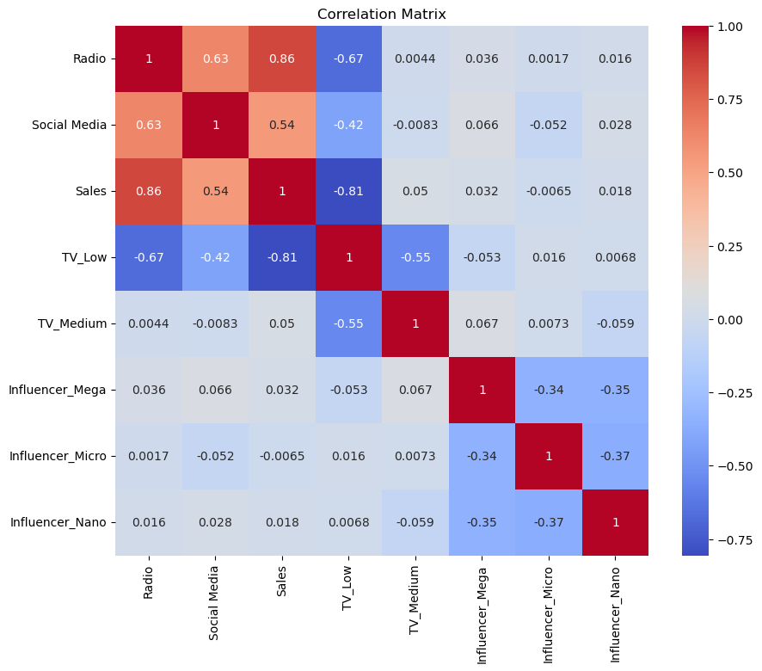
X_vif = df_encoded.drop("Sales", axis=1)
X_vif = sm.add_constant(X_vif)
vif = pd.DataFrame()
vif["Feature"] = X_vif.columns
vif["VIF"] = [
variance_inflation_factor(
X_vif.values,
i
)
for i in range(X_vif.shape[1])
]
print(vif)
Feature VIF
0 const 31.649565
1 Radio 3.479641
2 Social Media 1.669098
3 TV_Low 4.076384
4 TV_Medium 2.233350
5 Influencer_Mega 1.593889
6 Influencer_Micro 1.618434
7 Influencer_Nano 1.627430
X = df_encoded.drop("Sales", axis=1)
y = df_encoded["Sales"]
X = sm.add_constant(X)
model = sm.OLS(y, X).fit()
print(model.summary())
OLS Regression Results
==============================================================================
Dep. Variable: Sales R-squared: 0.904
Model: OLS Adj. R-squared: 0.903
Method: Least Squares F-statistic: 760.4
Date: Fri, 19 Jun 2026 Prob (F-statistic): 1.82e-282
Time: 09:35:42 Log-Likelihood: -2713.4
No. Observations: 572 AIC: 5443.
Df Residuals: 564 BIC: 5478.
Df Model: 7
Covariance Type: nonrobust
====================================================================================
coef std err t P>|t| [0.025 0.975]
------------------------------------------------------------------------------------
const 217.4784 6.584 33.031 0.000 204.546 230.411
Radio 2.9735 0.235 12.644 0.000 2.512 3.435
Social Media -0.1391 0.676 -0.206 0.837 -1.467 1.189
TV_Low -154.5736 4.949 -31.231 0.000 -164.295 -144.852
TV_Medium -75.5947 3.647 -20.726 0.000 -82.759 -68.431
Influencer_Mega 2.4948 3.462 0.721 0.471 -4.305 9.295
Influencer_Micro 2.9391 3.378 0.870 0.385 -3.695 9.574
Influencer_Nano 0.8015 3.346 0.240 0.811 -5.770 7.373
==============================================================================
Omnibus: 58.711 Durbin-Watson: 1.874
Prob(Omnibus): 0.000 Jarque-Bera (JB): 17.802
Skew: 0.057 Prob(JB): 0.000136
Kurtosis: 2.143 Cond. No. 147.
==============================================================================
Notes:
[1] Standard Errors assume that the covariance matrix of the errors is correctly specified.
print("Adjusted R-Squared:", model.rsquared_adj)
Adjusted R-Squared: 0.9030011006551627
predictions = model.predict(X)
residuals = y - predictions
plt.figure(figsize=(8,5))
plt.scatter(
predictions,
residuals
)
plt.axhline(
y=0,
color="red"
)
plt.xlabel("Predicted Sales")
plt.ylabel("Residuals")
plt.title("Residual Plot")
plt.show()
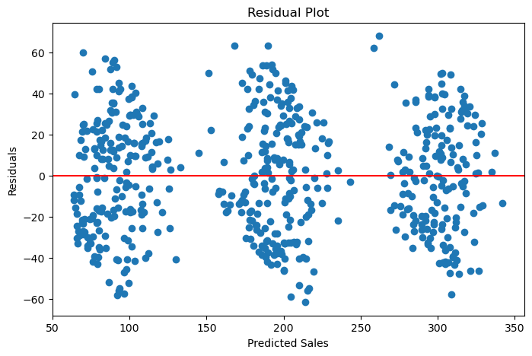
sm.qqplot(
residuals,
line="45"
)
plt.title("QQ Plot of Residuals")
plt.show()
