Index

1. Component
2. Jsx
3. Styling
4. Props
5. State
6. EventHandling
7. LifeCyle Hooks
8. APi Calls
9. Forms
10. Component: Component are core building block and reusable web component.
11. Virtual Dom:

1. Component Hierarchy

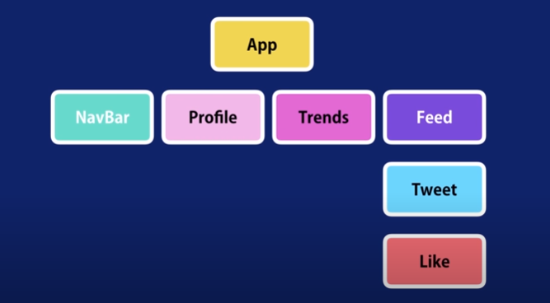

2) Basic component syntax

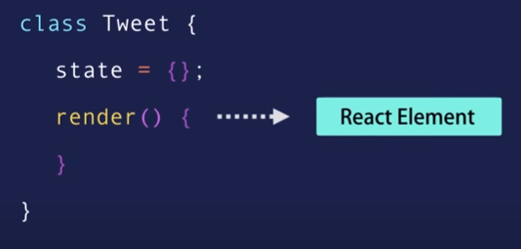

3) Virtual Dom

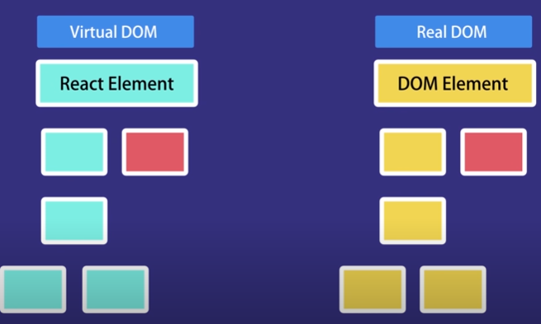

4) Install react library

C:\Users\kelz>npm i -g create-react-app@4.0.0

5) In Vs code install

Install extensions

1. Simple react snippets
2. Prettier

6) Create new react app

>create-react-app react-app

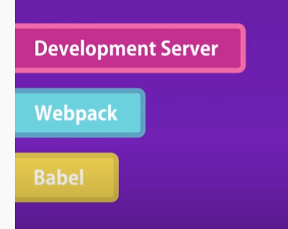

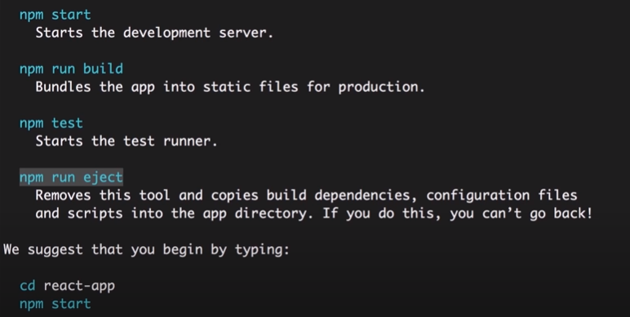

7) install bootstrap

>npm i [bootstrap@4.5.3](mailto:bootstrap@4.5.3)

8) props vs state

Props - passing data between components. It’s read only

State – data private to that component

9) Raising and handling events

Thumb Rule:

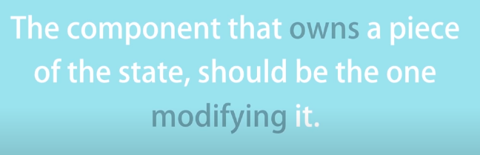

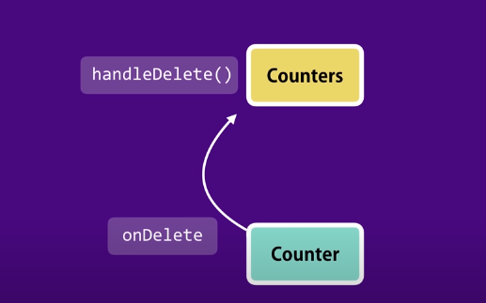

10. SinglesourceofTruth

11. Removing local state (controlled component): The Child component is been controlled by parent component

12. Component Sync

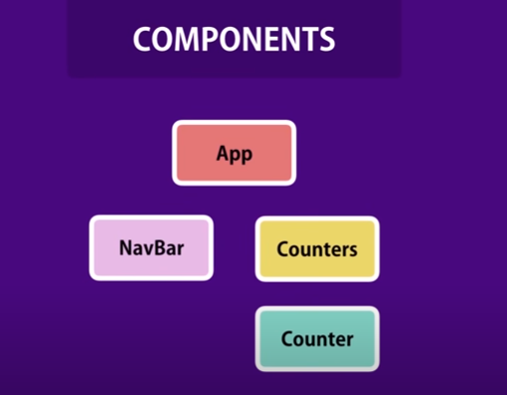

13. LifeCycle hooks

Mounting phase Updating phase Unmount phase

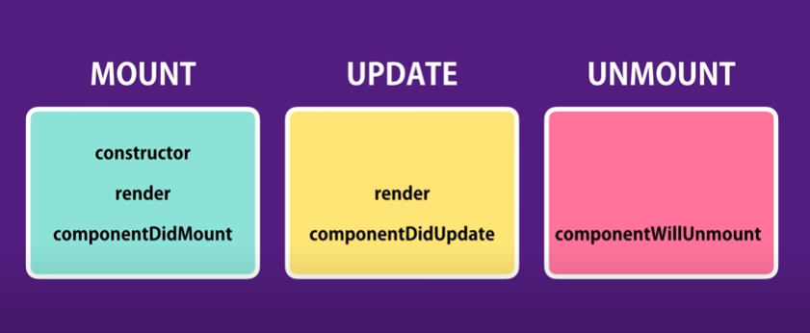

Constructor – called only once, perfect place of initialize the state

componentDidMount - ajax call to fetch data from backend when component render

componentDidUpdate – ajax call to get new data from server basing on condition

componentWillUnmount – called before the component removed, perfect place for clean up code