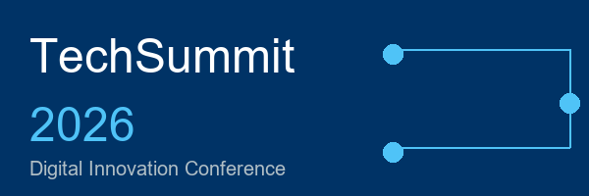
Table of Contents
Table of Contents 1
Welcome to TechSummit 2026 2
Conference Agenda - Day 1 3

Welcome to TechSummit 2026
We are delighted to welcome you to the TechSummit 2026 Digital Innovation Conference, hosted at the Edinburgh International Conference Centre (EICC). This year's conference brings together over 500 technology professionals, industry leaders, and innovators from across the United Kingdom and beyond.

Dr Sarah Chen, Chief Technology Officer at InnovateTech Solutions, will discuss the future of artificial intelligence in healthcare. Professor James MacLeod from the University of Edinburgh will present his groundbreaking research on quantum computing applications. Fiona Stewart, Managing Director of Digital Scotland, will share insights on Scotland's digital transformation strategy. Raj Patel, Head of Innovation at GlobalTech Partners, will explore sustainable technology and green computing initiatives.

Conference Agenda - Day 1
Time | Session
08:00 | Registration and Welcome Coffee
09:00 | Opening Ceremony and Welcome Address
09:30 | Keynote: Dr Sarah Chen - AI in Healthcare
10:30 | Coffee Break and Networking
11:00 | Keynote: Prof James MacLeod - Quantum Computing
12:00 | Panel Discussion: Future of Scottish Tech
13:00 | Lunch and Exhibition Tour
14:00 | Breakout Sessions (Choice of 4 tracks)
16:00 | Keynote: Fiona Stewart - Digital Scotland Strategy

Registration opens at 08:00 each morning in the main foyer. Please ensure you wear your delegate badge at all times for security purposes. Free Wi-Fi is available throughout the venue using the network name TECHSUMMIT2026 with the password Innovation2026. Emergency exits are clearly marked throughout the building. First aid stations are located at the reception desk on each floor.

We hope you enjoy TechSummit 2026 and find the conference both informative and inspiring.

The TechSummit Organising Committee

