

Name/id: abdelkareem yousef mamdoh soubar/19110022
Assignment Title: X-Power
Course Tutor: Eng. Moath Sulaiman
Submission Date: 26/1/2022

Introduction
I have been assigned by by the three year old start up company X-Power to check their new design and report back my feedback and provide them with the security report.

When it comes to security I have to say that it’s not that easy to achieve and that's for have so many things that can interfere with security magerments where we have take human error and thing that come from the nature.

IT security risks
to start talking about the it security risks first we need to understand how big risks are that would lead us to catograize them, risks include every thing that can enterfere with my server, software, hardware or any thing that can relate to them risks are split into.

- NATURAL CAUSES
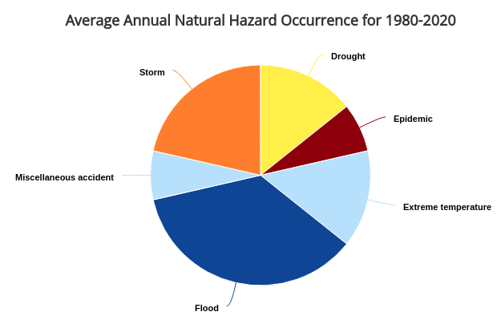
natural risk are the risks that might happen becouse of the environment fo example in some areas in china can flood and there flooding is a natural risk but here in jojrdan the risks are difrenet because here we have a defeninet environment.
• droughts
• extreme temperature
• storms
• landslides
• flash floods
- HUMAN CAUSES
humans can do mistakes and for security we have to take that into consideration but not all of them do them as mistake so we have to take intentional and unintentional behavior for humans.
Intentional behavior
its when somebody tries to harm the X-Power company by destroying there equipment or trying to attack there servers to harm there data or computers this type humans is very random because they can be paid or sent by someone.
- Social Engineering
it’s basicly getting your data(information or any sensitive info like the client )stolen and threating you to unleash them to public if don’t do as he says which usually is money and on the devices that been infected it would be like a malware that is harmful being planted in
your file and it can lock up your files.
- Man-in-the-Middle
man in the middle attack is simply standing in the middle of the user connection and server connection but it has more to that because it can check everything you send and if it not encrypted it will show your data if it was it would become the mater of time form it to get cracked in addition to that it can fake it self as if it become the server which means it can talk to you as if it were the original server and for example it can tell you windows that it has updates and when you do them you will install a program from him which can inject your pc with anything it likes.
- Viruses
its mostly a small file that had the ability to copy it self into other programs or files and it can only be received to the PC ether by user or downloaded some of them change them self a bit so it can adapt and spread and make it self harder to remove, a lot of those viruses are annoying but some of them are very destructive.
- D Dos
it’s an attempt to disturb the traffic on a specific IP/server by flooding it with requests which leads the server to fill the memory with data that will lead it to crash and restart or lag make the security stop working and making the server unavailable or get temp free access to the server without any security check for lagging in the memory by quickly feeding it data and the server receiving it with out having it looked over by the security protocol in that service.
- TCP/IP Hijacking
it’s one of the forms of man in the middle attack were the attacker gets the IP addresses for the 2 sessions then forces one of them to be inadvisable by using a Dos attack and the other one gets attacked by using a spoof attack on the former and get the network ID For the session
- Trojan Horses
its a virus that come hidden in side installable files can be activated when the program runs and usually it come on the form of a thread remover or something to repair you computer but in reality it dose the complete opposite from what it says, in the old days it wouldn’t copy it self to other places and stay active which means it goes off when the application/program goes off but now days it can copy it self and become a background process.
- Worms
its the most common virus these days and its specialty that it can copy it self and send it self plus usually it would be one of the most destructive viruses.
- Logic Bombs
its a string of code that is inserted into a program to harm a network when specific conditions are meet when when that happens the it explodes and execute the specific code that was written, usually this type of injection is hard to detect until the executes then it detectable and found and using this attack in the past it used to be deleting files and corrupting files but these days it can be used to take in a virus to the system.
unintentional
- unintentional risks come usually from employees who do things and forget about them like forgetting to lock the server room door behind them or while testing the backup battery for server and leave unplugged from the wall or forget to lock there computers or shut them down, and there are the software part were they do mistakes like forgetting to save or placing weak passwords and for employees who work on database they can forget to backup or delete things by mistake, in addition to all of the employees get mails some times those mail can be infected and they would be in spam but some of them still do open them or when they send files/data through 3ed party services and the data gets taken or spied on through some social-engineering tools that can listen to the wifi or have the man in the middle connection to him self.
- assessing risks
CBA :A cost-benefit analysis is a process used by businesses to evaluate the potential rewards and costs associated with a given decision. The analyst sums up the expected returns and then subtracts the total costs.
I will have to start by saying that x-power company is a start up company and it haven’t been long on the market only 3 years, so we will need to use cost benefit analysis(CBA) to check wither its worth it or not because it doesn't make sense to place 5000 jds security/fire system on 1500 jds power generator or on a 2000 jds ups, so we are going to use CBA to check and what to do regarding security and safety systems.

- treating risks
treating risks in our case it based on to factors physical, networks risks
physical risks are like natural causes are not that bad in Jordan by that I mean that we don't have much earthquakes in Jordan and if it happens its not strong as for high temperature we have to install Air conditioning units for the building and servers as for sand/rain storms, in Jordan the building structure is strong and can hold up very well in front of storms as for floods, its very rare to happen in aqaba pandemic and other stuff are on the government to cover.
As for human mistakes we can install CCTV systems (camera) to monitor who enters and exits the building plus we need keep an eye on the server room and the important components inside the company.
We can install security system associated with the CCTV system to insure that only authorized people can enter the important rooms such as the server room and its doable through using RF-ID or finger print scanners on each room and with the CCTV and security system we will have a control room for live monitoring screens and in case anything wrong or anyone unauthorized got in through some one the security team would interfere and kick them out to restore order.
As for human error we can put on each door a mechanism to shut the door automatically and we can ban 3ed party network to make sure our employees stay on a secured network as for password we can put a restriction on how long and special characters they must use and every 3 month they must change the password.
For the network and the infected files we can add a firewall to the network to fuilter and make sure that data coming in is clean plus it prevents Ddos attacks and cheeck how clean the connection to network is and it can prevent viruses from coming in and it can detect social-engineering attacks from happening which over all it would result in a secured network with low variability options.

- What could happen if we configured the network/security incorrectly
network in this compny is a base bone for how? Will the entier system is based on data colloction from defrent locairon from the IOT devices that being said if we had missid something in the coinfurraion the data might get corrapted or not saved maybe not even secured or others can minipulate it and we dont want to be place in the risk were the data didnt arrive or anything happened to it as for the main building where data is being saved, it must be secued and backed up were it geets cold and hot backups because as far as I understand all of the data is being saved in one locaion and thats good but not perfect, so the main building would get most out of this security system and will be most foucuised on
  - physical securty from natual cuses is mostly sovled by the bulding structure and there isnt much room do anything other than install air conditioning units
  - as for normal bulding saecurty we will have control room that have full connection with human security force(securty gurdes) that can interacte accordingly wo the sechuashen.
  - Control room will have access to CCTV/security system to make sure only people who need to be there are there.
  - As for employees each one of them would get a PC that is secured and have everying pre installes by the IT deprartment includeing VPC(virtual private connection) in case of working from home the IT department can provide secured laptops that get full secured connection to the server through using SSH keys (hashed keys ) and VPN for the companby and it comes with encrypted connection to be sure that no 3ed party programs are used or in case that some was trying to listen to the network, they wont be able to get any useful data from you.
  - Firawall is one of the most imporant security components in ther system
firewall it prevents unauthorized connection plus fuilter the network connection and stops social-engineering, DDOS attacks from happeing and can use sandbox method to mnake sure all of the files are not infected that go in to the company, if the firewall was missconfgured it can drop and refuse connection whichu means it can getread of the data that is being sent from the other locaions or let other pepopl (hackers) get a connection to the main server.
  - VPN are the programs that allow you get a secured connection to server and it would allow you to connect to the server if the configuration wasnt placed correctly we would have anon secured connection which would mean hacker would be able to listien to what you are send and they might be able to get password and keys and setupo there own connection and start minupulating the main server.
  - VPC are the virual networks that are place in the company so in case the hacker goes throughe firewall and security, the hacker would take him mor time to figure out the system which means it will give the sicurty taeam more time to take action not configuring the VPC corrctly would not ewffect the day to day work but it woulkd make the road for the hacker easrer in case the sucsseded and hacked security.
- ISO risk management
it is required to protect our assets such as users, hardware and software, so we need understand and asses the risks that would face us and can effect them.
Risk assesment is the method thats used to see what can result in damge or harm to the X-Power company and then do some analysis to understand those risks so we can create a way/methode to protect our equipment and assets from being harmed or damaged.
Risk management has some steps:
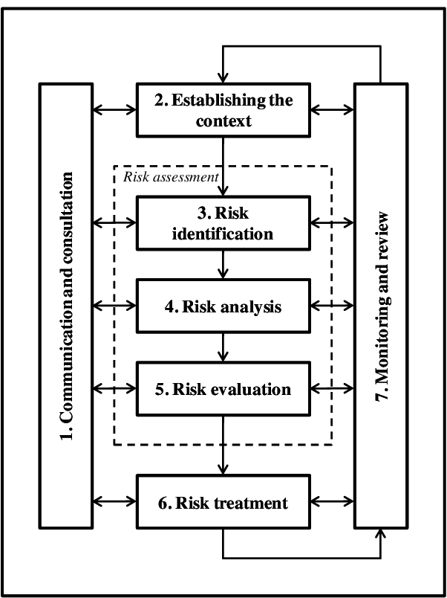
1 Identify
2 Analyze
3 Evaluate
4 Treat
5 Monitor
I have been assigned by my manager to this task as a junior IT security Analyst, and its my responsibility to take care of the risks that can harm / damage our security/ CCTV/network systems and it my job to find them and find a way to minimize/ eliminate them.
- hy
- hy
- hy
- hy

