! Review the systems development life cycle
(SDLC).

! Examine the problems and alternatives
with SDLC.

! Know the key issues in ERP
implementation strategy.

! Understand ERP implementation life cycle.

! Examine the rapid implementation
methodologies.

! Compare and contrast SDLC and ERP life
cycles.

! Examine the role of people like top
management, consultants, and subject
matter experts (SMEs) in the ERP
life cycle.

! Understand the importance of the project
management office and the project
organization to a successful ERP
implementation.

! Know the components of a project
organization and the roles and
responsibilities of each.

Stage 1: Planning and Requirement Analysis
Requirement analysis is the most important and fundamental stage in SDLC. It is performed by the senior members of the team with inputs from the customer, the sales department, market surveys and domain experts in the industry. This information is then used to plan the basic project approach and to conduct product feasibility study in the economical, operational and technical areas.

Planning for the quality assurance requirements and identification of the risks associated with the project is also done in the planning stage. The outcome of the technical feasibility study is to define the various technical approaches that can be followed to implement the project successfully with minimum risks.

Stage 2: Defining Requirements
Once the requirement analysis is done the next step is to clearly define and document the product requirements and get them approved from the customer or the market analysts. This is done through an SRS (Software Requirement Specification) document which consists of all the product requirements to be designed and developed during the project life cycle.

Stage 3: Designing the Product Architecture
SRS is the reference for product architects to come out with the best architecture for the product to be developed. Based on the requirements specified in SRS, usually more than one design approach for the product architecture is proposed and documented in a DDS - Design Document Specification.

This DDS is reviewed by all the important stakeholders and based on various parameters as risk assessment, product robustness, design modularity, budget and time constraints, the best design approach is selected for the product.

A design approach clearly defines all the architectural modules of the product along with its communication and data flow representation with the external and third party modules (if any). The internal design of all the modules of the proposed architecture should be clearly defined with the minutest of the details in DDS.

Stage 4: Building or Developing the Product
In this stage of SDLC the actual development starts and the product is built. The programming code is generated as per DDS during this stage. If the design is performed in a detailed and organized manner, code generation can be accomplished without much hassle.

Developers must follow the coding guidelines defined by their organization and programming tools like compilers, interpreters, debuggers, etc. are used to generate the code. Different high level programming languages such as C, C++, Pascal, Java and PHP are used for coding. The programming language is chosen with respect to the type of software being developed.

Stage 5: Testing the Product
This stage is usually a subset of all the stages as in the modern SDLC models, the testing activities are mostly involved in all the stages of SDLC. However, this stage refers to the testing only stage of the product where product defects are reported, tracked, fixed and retested, until the product reaches the quality standards defined in the SRS.

Stage 6: Deployment in the Market and Maintenance
Once the product is tested and ready to be deployed it is released formally in the appropriate market. Sometimes product deployment happens in stages as per the business strategy of that organization. The product may first be released in a limited segment and tested in the real business environment (UAT- User acceptance testing).

Then based on the feedback, the product may be released as it is or with suggested enhancements in the targeting market segment. After the product is released in the market, its maintenance is done for the existing customer base.

SDLC Models
There are various software development life cycle models defined and designed which are followed during the software development process. These models are also referred as Software Development Process Models". Each process model follows a Series of steps unique to its type to ensure success in the process of software development.

Following are the most important and popular SDLC models followed in the industry −

Waterfall Model

Waterfall Model - Design
Waterfall approach was first SDLC Model to be used widely in Software Engineering to ensure success of the project. In "The Waterfall" approach, the whole process of software development is divided into separate phases. In this Waterfall model, typically, the outcome of one phase acts as the input for the next phase sequentially.
The following illustration is a representation of the different phases of the Waterfall Model.
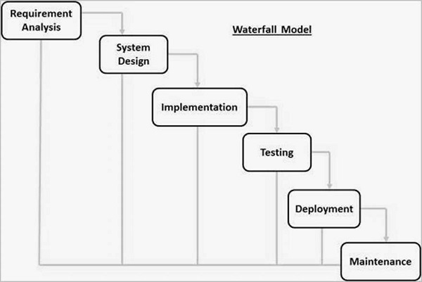
The sequential phases in Waterfall model are −
- Requirement Gathering and analysis − All possible requirements of the system to be developed are captured in this phase and documented in a requirement specification document.
- System Design − The requirement specifications from first phase are studied in this phase and the system design is prepared. This system design helps in specifying hardware and system requirements and helps in defining the overall system architecture.
- Implementation − With inputs from the system design, the system is first developed in small programs called units, which are integrated in the next phase. Each unit is developed and tested for its functionality, which is referred to as Unit Testing.
- Integration and Testing − All the units developed in the implementation phase are integrated into a system after testing of each unit. Post integration the entire system is tested for any faults and failures.
- Deployment of system − Once the functional and non-functional testing is done; the product is deployed in the customer environment or released into the market.
- Maintenance − There are some issues which come up in the client environment. To fix those issues, patches are released. Also to enhance the product some better versions are released. Maintenance is done to deliver these changes in the customer environment.
All these phases are cascaded to each other in which progress is seen as flowing steadily downwards (like a waterfall) through the phases. The next phase is started only after the defined set of goals are achieved for previous phase and it is signed off, so the name "Waterfall Model". In this model, phases do not overlap.

Waterfall Model - Application
Every software developed is different and requires a suitable SDLC approach to be followed based on the internal and external factors. Some situations where the use of Waterfall model is most appropriate are −
- Requirements are very well documented, clear and fixed.
- Product definition is stable.
- Technology is understood and is not dynamic.
- There are no ambiguous requirements.
- Ample resources with required expertise are available to support the product.
- The project is short.

Waterfall Model - Advantages
The advantages of waterfall development are that it allows for departmentalization and control. A schedule can be set with deadlines for each stage of development and a product can proceed through the development process model phases one by one.
Development moves from concept, through design, implementation, testing, installation, troubleshooting, and ends up at operation and maintenance. Each phase of development proceeds in strict order.
Some of the major advantages of the Waterfall Model are as follows −
- Simple and easy to understand and use
- Easy to manage due to the rigidity of the model. Each phase has specific deliverables and a review process.
- Phases are processed and completed one at a time.
- Works well for smaller projects where requirements are very well understood.
- Clearly defined stages.
- Well understood milestones.
- Easy to arrange tasks.
- Process and results are well documented.

Waterfall Model - Disadvantages
The disadvantage of waterfall development is that it does not allow much reflection or revision. Once an application is in the testing stage, it is very difficult to go back and change something that was not well-documented or thought upon in the concept stage.
The major disadvantages of the Waterfall Model are as follows −
- No working software is produced until late during the life cycle.
- High amounts of risk and uncertainty.
- Not a good model for complex and object-oriented projects.
- Poor model for long and ongoing projects.
- Not suitable for the projects where requirements are at a moderate to high risk of changing. So, risk and uncertainty is high with this process model.
- It is difficult to measure progress within stages.
- Cannot accommodate changing requirements.
- Adjusting scope during the life cycle can end a project.
- Integration is done as a "big-bang. at the very end, which doesn't allow identifying any technological or business bottleneck or challenges early.

Iterative Model - Design
Iterative process starts with a simple implementation of a subset of the software requirements and iteratively enhances the evolving versions until the full system is implemented. At each iteration, design modifications are made and new functional capabilities are added. The basic idea behind this method is to develop a system through repeated cycles (iterative) and in smaller portions at a time (incremental).
The following illustration is a representation of the Iterative and Incremental model −
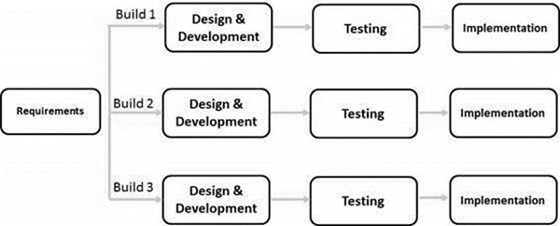
Iterative and Incremental development is a combination of both iterative design or iterative method and incremental build model for development. "During software development, more than one iteration of the software development cycle may be in progress at the same time." This process may be described as an "evolutionary acquisition" or "incremental build" approach."
In this incremental model, the whole requirement is divided into various builds. During each iteration, the development module goes through the requirements, design, implementation and testing phases. Each subsequent release of the module adds function to the previous release. The process continues till the complete system is ready as per the requirement.
The key to a successful use of an iterative software development lifecycle is rigorous validation of requirements, and verification & testing of each version of the software against those requirements within each cycle of the model. As the software evolves through successive cycles, tests must be repeated and extended to verify each version of the software.

Iterative Model - Application
Like other SDLC models, Iterative and incremental development has some specific applications in the software industry. This model is most often used in the following scenarios −
- Requirements of the complete system are clearly defined and understood.
- Major requirements must be defined; however, some functionalities or requested enhancements may evolve with time.
- There is a time to the market constraint.
- A new technology is being used and is being learnt by the development team while working on the project.
- Resources with needed skill sets are not available and are planned to be used on contract basis for specific iterations.
- There are some high-risk features and goals which may change in the future.

Iterative Model - Pros and Cons
The advantage of this model is that there is a working model of the system at a very early stage of development, which makes it easier to find functional or design flaws. Finding issues at an early stage of development enables to take corrective measures in a limited budget.
The disadvantage with this SDLC model is that it is applicable only to large and bulky software development projects. This is because it is hard to break a small software system into further small serviceable increments/modules.
The advantages of the Iterative and Incremental SDLC Model are as follows −
- Some working functionality can be developed quickly and early in the life cycle.
- Results are obtained early and periodically.
- Parallel development can be planned.
- Progress can be measured.
- Less costly to change the scope/requirements.
- Testing and debugging during smaller iteration is easy.
- Risks are identified and resolved during iteration; and each iteration is an easily managed milestone.
- Easier to manage risk - High risk part is done first.
- With every increment, operational product is delivered.
- Issues, challenges and risks identified from each increment can be utilized/applied to the next increment.
- Risk analysis is better.
- It supports changing requirements.
- Initial Operating time is less.
- Better suited for large and mission-critical projects.
- During the life cycle, software is produced early which facilitates customer evaluation and feedback.
The disadvantages of the Iterative and Incremental SDLC Model are as follows −
- More resources may be required.
- Although cost of change is lesser, but it is not very suitable for changing requirements.
- More management attention is required.
- System architecture or design issues may arise because not all requirements are gathered in the beginning of the entire life cycle.
- Defining increments may require definition of the complete system.
- Not suitable for smaller projects.
- Management complexity is more.
- End of project may not be known which is a risk.
- Highly skilled resources are required for risk analysis.
- Projects progress is highly dependent upon the risk analysis phase.

Spiral Model

Spiral Model - Design
The spiral model has four phases. A software project repeatedly passes through these phases in iterations called Spirals.

Identification
This phase starts with gathering the business requirements in the baseline spiral. In the subsequent spirals as the product matures, identification of system requirements, subsystem requirements and unit requirements are all done in this phase.
This phase also includes understanding the system requirements by continuous communication between the customer and the system analyst. At the end of the spiral, the product is deployed in the identified market.

Design
The Design phase starts with the conceptual design in the baseline spiral and involves architectural design, logical design of modules, physical product design and the final design in the subsequent spirals.

Construct or Build
The Construct phase refers to production of the actual software product at every spiral. In the baseline spiral, when the product is just thought of and the design is being developed a POC (Proof of Concept) is developed in this phase to get customer feedback.
Then in the subsequent spirals with higher clarity on requirements and design details a working model of the software called build is produced with a version number. These builds are sent to the customer for feedback.

Evaluation and Risk Analysis
Risk Analysis includes identifying, estimating and monitoring the technical feasibility and management risks, such as schedule slippage and cost overrun. After testing the build, at the end of first iteration, the customer evaluates the software and provides feedback.
The following illustration is a representation of the Spiral Model, listing the activities in each phase.
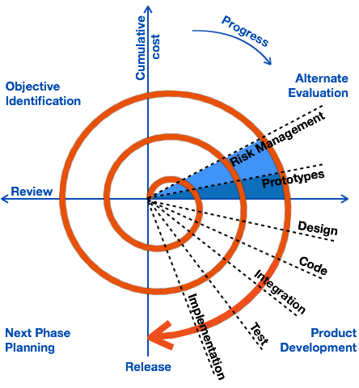
Based on the customer evaluation, the software development process enters the next iteration and subsequently follows the linear approach to implement the feedback suggested by the customer. The process of iterations along the spiral continues throughout the life of the software.

Spiral Model Application
The Spiral Model is widely used in the software industry as it is in sync with the natural development process of any product, i.e. learning with maturity which involves minimum risk for the customer as well as the development firms.
The following pointers explain the typical uses of a Spiral Model −
- When there is a budget constraint and risk evaluation is important.
- For medium to high-risk projects.
- Long-term project commitment because of potential changes to economic priorities as the requirements change with time.
- Customer is not sure of their requirements which is usually the case.
- Requirements are complex and need evaluation to get clarity.
- New product line which should be released in phases to get enough customer feedback.
- Significant changes are expected in the product during the development cycle.

Spiral Model - Pros and Cons
The advantage of spiral lifecycle model is that it allows elements of the product to be added in, when they become available or known. This assures that there is no conflict with previous requirements and design.
This method is consistent with approaches that have multiple software builds and releases which allows making an orderly transition to a maintenance activity. Another positive aspect of this method is that the spiral model forces an early user involvement in the system development effort.
On the other side, it takes a very strict management to complete such products and there is a risk of running the spiral in an indefinite loop. So, the discipline of change and the extent of taking change requests is very important to develop and deploy the product successfully.
The advantages of the Spiral SDLC Model are as follows −
- Changing requirements can be accommodated.
- Allows extensive use of prototypes.
- Requirements can be captured more accurately.
- Users see the system early.
- Development can be divided into smaller parts and the risky parts can be developed earlier which helps in better risk management.
The disadvantages of the Spiral SDLC Model are as follows −
- Management is more complex.
- End of the project may not be known early.
- Not suitable for small or low risk projects and could be expensive for small projects.
- Process is complex
- Spiral may go on indefinitely.
- Large number of intermediate stages requires excessive documentation.

V-Model

V-Model - Design
Under the V-Model, the corresponding testing phase of the development phase is planned in parallel. So, there are Verification phases on one side of the ‘V’ and Validation phases on the other side. The Coding Phase joins the two sides of the V-Model.
The following illustration depicts the different phases in a V-Model of the SDLC.
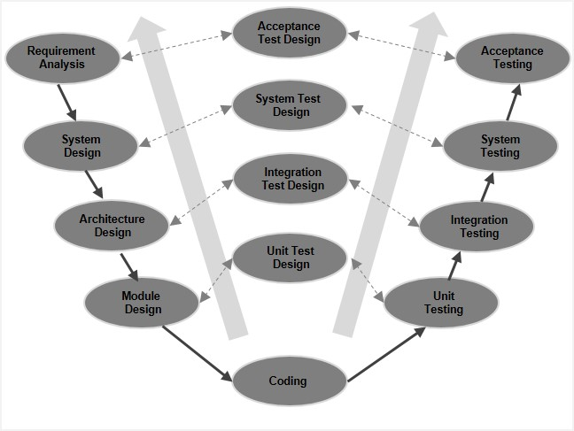

V-Model - Verification Phases
There are several Verification phases in the V-Model, each of these are explained in detail below.

Business Requirement Analysis
This is the first phase in the development cycle where the product requirements are understood from the customer’s perspective. This phase involves detailed communication with the customer to understand his expectations and exact requirement. This is a very important activity and needs to be managed well, as most of the customers are not sure about what exactly they need. The acceptance test design planning is done at this stage as business requirements can be used as an input for acceptance testing.

System Design
Once you have the clear and detailed product requirements, it is time to design the complete system. The system design will have the understanding and detailing the complete hardware and communication setup for the product under development. The system test plan is developed based on the system design. Doing this at an earlier stage leaves more time for the actual test execution later.

Architectural Design
Architectural specifications are understood and designed in this phase. Usually more than one technical approach is proposed and based on the technical and financial feasibility the final decision is taken. The system design is broken down further into modules taking up different functionality. This is also referred to as High Level Design (HLD).
The data transfer and communication between the internal modules and with the outside world (other systems) is clearly understood and defined in this stage. With this information, integration tests can be designed and documented during this stage.

Module Design
In this phase, the detailed internal design for all the system modules is specified, referred to as Low Level Design (LLD). It is important that the design is compatible with the other modules in the system architecture and the other external systems. The unit tests are an essential part of any development process and helps eliminate the maximum faults and errors at a very early stage. These unit tests can be designed at this stage based on the internal module designs.

Coding Phase
The actual coding of the system modules designed in the design phase is taken up in the Coding phase. The best suitable programming language is decided based on the system and architectural requirements.
The coding is performed based on the coding guidelines and standards. The code goes through numerous code reviews and is optimized for best performance before the final build is checked into the repository.

Validation Phases
The different Validation Phases in a V-Model are explained in detail below.

Unit Testing
Unit tests designed in the module design phase are executed on the code during this validation phase. Unit testing is the testing at code level and helps eliminate bugs at an early stage, though all defects cannot be uncovered by unit testing.

Integration Testing
Integration testing is associated with the architectural design phase. Integration tests are performed to test the coexistence and communication of the internal modules within the system.

System Testing
System testing is directly associated with the system design phase. System tests check the entire system functionality and the communication of the system under development with external systems. Most of the software and hardware compatibility issues can be uncovered during this system test execution.

Acceptance Testing
Acceptance testing is associated with the business requirement analysis phase and involves testing the product in user environment. Acceptance tests uncover the compatibility issues with the other systems available in the user environment. It also discovers the non-functional issues such as load and performance defects in the actual user environment.

V- Model ─ Application
V- Model application is almost the same as the waterfall model, as both the models are of sequential type. Requirements have to be very clear before the project starts, because it is usually expensive to go back and make changes. This model is used in the medical development field, as it is strictly a disciplined domain.
The following pointers are some of the most suitable scenarios to use the V-Model application.
- Requirements are well defined, clearly documented and fixed.
- Product definition is stable.
- Technology is not dynamic and is well understood by the project team.
- There are no ambiguous or undefined requirements.
- The project is short.

V-Model - Pros and Cons
The advantage of the V-Model method is that it is very easy to understand and apply. The simplicity of this model also makes it easier to manage. The disadvantage is that the model is not flexible to changes and just in case there is a requirement change, which is very common in today’s dynamic world, it becomes very expensive to make the change.
The advantages of the V-Model method are as follows −
- This is a highly-disciplined model and Phases are completed one at a time.
- Works well for smaller projects where requirements are very well understood.
- Simple and easy to understand and use.
- Easy to manage due to the rigidity of the model. Each phase has specific deliverables and a review process.
The disadvantages of the V-Model method are as follows −
- High risk and uncertainty.
- Not a good model for complex and object-oriented projects.
- Poor model for long and ongoing projects.
- Not suitable for the projects where requirements are at a moderate to high risk of changing.
- Once an application is in the testing stage, it is difficult to go back and change a functionality.
- No working software is produced until late during the life cycle.

Big Bang Model

Big Bang Model ─ Design and Application
The Big Bang Model comprises of focusing all the possible resources in the software development and coding, with very little or no planning. The requirements are understood and implemented as they come. Any changes required may or may not need to revamp the complete software.
This model is ideal for small projects with one or two developers working together and is also useful for academic or practice projects. It is an ideal model for the product where requirements are not well understood and the final release date is not given.

Big Bang Model - Pros and Cons
The advantage of this Big Bang Model is that it is very simple and requires very little or no planning. Easy to manage and no formal procedure are required.
However, the Big Bang Model is a very high risk model and changes in the requirements or misunderstood requirements may even lead to complete reversal or scraping of the project. It is ideal for repetitive or small projects with minimum risks.
The advantages of the Big Bang Model are as follows −
- This is a very simple model
- Little or no planning required
- Easy to manage
- Very few resources required
- Gives flexibility to developers
- It is a good learning aid for new comers or students.
The disadvantages of the Big Bang Model are as follows −
- Very High risk and uncertainty.
- Not a good model for complex and object-oriented projects.
- Poor model for long and ongoing projects.
- Can turn out to be very expensive if requirements are misunderstood.

Steps in Rapid Application Development
Here are the four basic steps of RAD:

1. Define the Requirements
At the very beginning, rapid application development sets itself apart from traditional software development models. It doesn’t require you to sit with end users and get a detailed list of specifications; instead, it asks for a broad requirement. The broad nature of the requirements helps you take the time to segment specific requirements at different points of the development cycle.

2. Prototype
This is where the actual development takes place. Instead of following a rigid set of requirements, developers create prototypes with different features and functions as fast as they can. These prototypes are then shown to the clients who decide what they like and what they don’t.
More often than not, these prototypes are quickly made to work to showcase just the key features. This is normal, and the final product is only created during the finalization stage where the client and developer are in alignment with the final product.

3. Construction
The construction stage is a crucial stage of development. Engineers and developers work tirelessly to flesh out a working system from a working model. Feedback and reviews are crucial at this stage and most bugs, issues, and alterations are addressed during this stage. This stage can be particularly long, especially in cases where clients change directions or feedback is intensive.

4. Deployment
The final stage of RAD involves deploying the built system into a live production environment. The deployment phase involves intensive scale testing, technical documentation, issue tracking, final customizations, and system simulation. Teams also spend time debugging the app and running final updates and maintenance tasks before going live.

