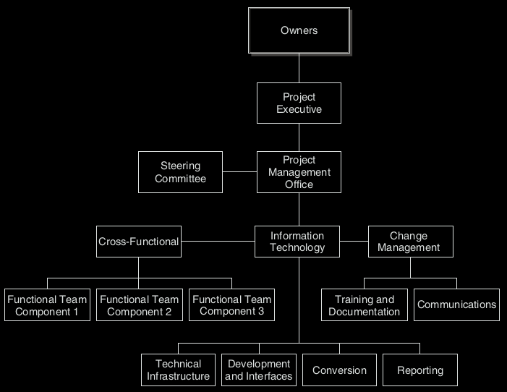
PROJECT ROLES AND RESPONSIBILITIES
IMPLICATIONS FOR MANAGEMENT

- Management Support
Top management advocacy, provision of adequate resources,
and commitment to project
- Release of Full-Time Subject
Release full time on to the project of relevant business experts

- Matter Experts (SME)
who provide assistance to the project

- Empowered Decision Makers
The members of the project team(s) must be empowered to make quick decisions
- Deliverable Dates Champion
At planning stage, set realistic milestones and end date
Advocate for system who is unswerving in promoting the
benefits of the new system
- Vanilla ERP
Minimal customization and uncomplicated option selection
- Smaller Scope
Fewer modules and less functionality implemented, smaller user group, and fewer site(s)
- Definition of Scope and Goals
The steering committee determines the scope and objectives
of the project in advance and then adheres to it

- Balanced Team
Right mix of business analysts, technical experts, and users
from within the implementation company and consultants
from external companies
- Commitment to Change
Perseverance and determination in the face of inevitable
problems with implementation

Hardware

Servers. ERP systems are very hardware intensive

Clients. People accessing ERP systems (e.g., end users, IT support staff, and developers)
use personal computers (PCs) to access the ERP system.

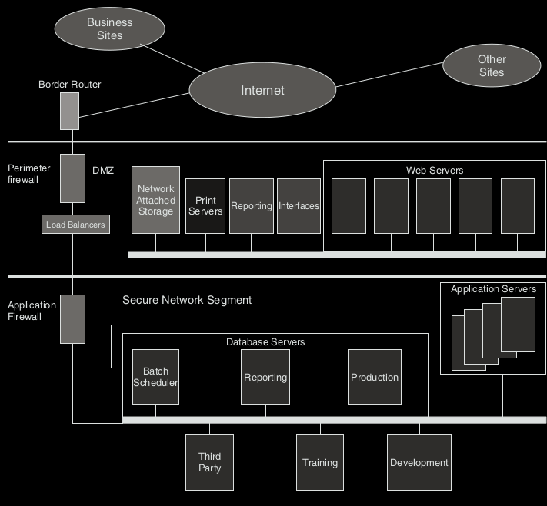

Peripherals. ERP systems also require media for long-term archiving of all business
transactions, backup and recovery RAID and/or network-attached storage devices, and the
like. In addition, they will require e-mail servers, printers, backup power supply equipment,
and networking hardware to support a multiuser access over the Internet.

Software
- System software.
This is the operating system (OS) platform that is essential for any application software to work efficiently with the hardware and IT personnel.
- Database management system (DBMS).
- Application software.
These are programs or software utilities that help in the develop-ment, monitoring, and integration of ERP software.

People Resources
- For the implementation and operation of ERP systems to be successful, a knowledgeable staff is
necessary. This includes end users, IT specialists, and project manager(s).

- IT specialists are staff members of the ERP implementation team.
They consist of database administrators, IT operations support, developers, change managers, trainers, and others in the

- The ERP implementation team

ERP AND VIRTUALIZATION

Benefits:
1. A main benefit of virtualization is enhanced hardware utilization.
2. Virtualization makes provisioning and deploying more agile.
3. Through consolidation, virtualization can lower total cost of operations TCO at the data
center.
4. Virtualization technology also enhances business continuity and availability.

Drawbacks:
1. Although virtualization technology is beneficial, it can create some challenges.
2. Another concern with virtualization is security.

