

Name/ID : ABDELKAREEM YOUSEF MAMDOH SOUBAR/19110022
Subject : 30202451 Human Computer Interaction
Assignment Title :HCI Assignment
Submission Date : Sep 11, 2022

Part 1:
1.1 Define the field of User Experience and explain it’s important for consumers and businesses and outline
the process in building a UX design

User Experience(UX)
user experience design is basically what will the user face from the begging to the end, and usually, in companies, there is a UX team that test, tries and reports what could go wrong or what could be annoying to a point that they would use other platforms instead of yours, and using user design experience is to enhance the application in a way that would let users love it instead of having to deal with it.

explain it’s important for consumers and businesses

It's really important to think about your client more, why??

because in this case, I am trying to add a feature to the CAREEM application, and what we need to think about is how would the customer interact with the application and why would they switch to it, and that is what UX design is all about, that's why it's really important to use UX again and again, which also means that you will have user inviting user.

In addition, business is all about making more money, and to do that you would need to take a huge consideration in UX/UI, why ??
so you would start getting more clients over time, especially in this where careem is not the only food Delivery service on the market, and you wouldn't want your client to start switching because of not finding a button or the application is too hard to use, that's why you need check UX/UI, so you would eliminate a factor that could take effect on your application and income.

outline the process of building a UX design

UX design process is a step-by-step methodology where you get the UX teams to test the project in ways that can find bugs and figure out what the interface needs so it would stay simple and this process really depends on what is the purpose behind the program and what it used for and a lot of the companies use the design thinking process in case of this is the first (before the application comes or be implemented)

Empathize – Discover what your users are looking for and need
Define – Determine the problem you want to solve
Ideate – Develop possible solutions to users’ problems
Prototype – Create prototypes
Test – Test your prototypes with users & stakeholders

as for the UX design process

8 Stages of UX Design Process

Stage 1 – Project Definition & Scope

here we need to define the project and its goals alongside the scope so we know what to work on and what are our limitations and it usually takes multiple departments to have a meeting and make the final decision.

Stage 2 – Understanding the Problem

here we may use some tools such as User personas, User journey maps and Empathy maps, to understand our users and how they feel about our project.

Stage 3 – UX Research

here we will need to use User research, Market research, Competitive research and Product research to be able to find the solution for the problems that we found in the stage before.

Stage 4 – Ideation – Sketching & Low-Fidelity Prototyping

here after we got a clear idea of what to do here /what to be done we would start creating simplified versions of what will happen by using.

Sketching
Paper prototyping:
Wireframing
Low-fidelity prototypes

Stage 5 – High-Fidelity Mockups & Prototypes

here we convert the ideation ideas to reality by creating prototypes that will function as real products.

Stage 6 – Usability Testing

here we start getting real users to test the application and see what they come up with to fix it or change it plus report it.

Validate ideas
Identify usability issues
Test accessibility
Identify business opportunities

Stage 7 – Design Handoff

here we are near the end where everything is handed down to the technical team so they would make sure that everything done in the design meets the functionality of the applications itself.

Stage 8 – Quality Assurance or UX Audit

here we have the final step that is based on making sure that the application meets the goals and UX and that it's been applied correctly.

1.3 Analyze the impact of common User Experience and Interface Design methodology in the software
development life cycle generally and in your software specifically using the principles and components of
User Experience design.

I have to start here by talking about how important UX/UI design is to the growth of the application and ease of use where we need to put more effort into the design that's going to introduce the application in front of people and depending on that people may keep on using it or not even if the technical part of the application works perfect, the interface is what people deal with, so as a start I would like to talk about software development life cycle which consists of.

Planning

this is where the Business requirements are compiled and analyzed by a business analyst and shared with other teams to gather ideas to be implemented and make sure that everybody is at the same table

Designing

here we create the design in a high-level design method and the plans of creating it and making sure from the design that it's compatible with the system and hardware requirements plus at this point, I would like to talk about the UX/UI design, this was it gets handy, and it's based on few public rules we need check them just to make sure that they are compatible with most people and easy to use.

Let's start with don norman's principles

Visibility

in the feature that I am trying to add visibility is the one for sure that is added and that's by having all of the options in front of the user from start to beginning to simplify it I made some options on different screens

Feedback

the advanced search feature indirectly gives feedback and that's by taking you step by step to work out your search options I considered moving to the next screen is the feedback to the user

Affordance

At the beginning of adding this feature the affordance inside the feature is great but getting to the feature may not agree with this principle because when we talk about the search we usually find it in the search bar but in this case, we are not, I placed it between other options in the middle

Mapping

this feature is made of multiple screens so the mapping would be simpler for the user, and by that, I mean that the first screen that contains the main type of food is on a single screen and the layers are on the 3ed one and the 4th one has all the results all of this could have been in one screen for the ease of use and mapping I made multiple screens plus each button and list in the application are labelled.

Constraints

I don’t have many constraints in this feature other than the hardware change such as changing the screen ratio from phone to phone or having some elder people not knowing how to use or read a phone.

Consistency

the advanced search may not have Consistency when it comes to finding the feature but it applies this principle side the feature by having the user use the screen from top to bottom and at the bottom is the next/search button.

As for Nielsen's ten heuristics

1. Visibility of system status

as I said in don norman when moving from screen to screen by pressing the next/search button.

2. Match between system and the real world

this feature came to mind from having the people not knowing the restaurants and being not sure which restaurant to order from, this feature applies to having the right known language from the real world and showing more options about returans they didn’t know about.

3. User control and freedom

in this advanced search, you always have the back button active and useable in case the user forgot to add or edit something

4. Consistency and standards

advanced search is the same and as any other advanced search even by the steps some websites/applications may implement it on different screens or have all of the options on the same screen plus what I talked about in don norman principles

5. Error prevention

my error prevention method is by showing the user the available options only and that makes sure that the user cant enter the wrong information, to begin with.

6. Recognition rather than recall

in the advanced search feature, each screen has its information and each screen depends on the screen before it, so the user would have to remember anything from before.

7. Flexibility and efficiency of use

instead of numbering the layers, we made them movable above each other it would be more simple for the user and the human eye so it would be more simple to imagine the food

8. Aesthetic and minimalist design

the design is very straight forward there is no extra information added other than the requirement for the user to choose all screens

9. Help users recognize, diagnose, and recover from errors

there is no error message other than an item not found in case of the customer searching for an item that does not exist

10. Help and documentation

here we will use gestures and first time walk the user through the process.

Developing

this is where the application is being built and the developers need to keep in mind that changes may occur later on and be ready to change in a short time, not just build the application.

Testing

this is where we start testing the application on people from the company and outside the company and this had been explained in 1.1.

Maintenance

having a routine maintenance schedule and keeping the application up to date is very important plus fixing bugs constantly and making the users feel that the company cares about their suggestions.

1.4 Evaluate the User Experience and Interface Design of a specific forms and justify your modifications to
the User Experience and Interface Design and their uses.

Everything in question had already been covered in the past answers but I have to say that this Idea came from me and my friends having deficulty searching for our meals on careems application I am answering this question in a way that everything after this would make sense, me, my friends and family usually have the problem of not knowing many restaurants and not memorising where we eat, so to solve this problem I had 2 schedules that create a feature that compares restaurants or create a search method that would make restaurants easier to understand in careems application.

Part 2:
2.1 Assess standard tools available for use in User Experience and Interface Design.

Paper and pencil
features
your limit is in yours hands
can be saved for long times
not editable

Maze
features

Run in-depth tests with or without prototypes
Test and validate ideas, concepts, copy
Remote, rapid user testing and research

Sketch

features

Create prototypes
Visual design for web-based products
Collaboration tools

Adobe XD

features
Create product prototypes, mobile apps and websites
Create workflows, element creation, animated transitions, dynamic elements

Figma

features

Cloud-based design
Design and build prototypes
Create wireframes, mind maps, mood boards
Collaboration tools

Wireframe.cc

features
Low-fidelity tool focused on minimalism
Create wireframes easily
Ideal for beginners

2.2 Build a P.A.C.T Analysis for the system and assess your user journey maps to understand user needs.

The people who are going to be users of the feature:

people who are 18+
people who can use smartphones
people who are comfortable ordering online food
people who want specific food in their way

Given that they are aware of the trend and with technology in general, my target audience would have the abilities needed to use that program. People who follow and are interested in food and trends in the food world make up my target audience since they are confident in what they wear. I think of my target market as driven, active individuals who lead busy lives and lead healthy lifestyles. They may not have time to cook because of their hectic schedules. Expert users would be my ideal target group because they tend to be older and more knowledgeable about their trends or technology.

Activities

People can use my app to search the catalogue of food goods and order from new restaurants. In a subsequent version, users might be able to specify minimal defaults, so it will be used pretty frequently for brief periods of time. Since it would be accessible to everyone, more people could use it to browse restaurants and see which ones serve the foods they prefer. The user will want to view their findings or be able to browse easily and without being delayed, therefore the app should load and respond rather rapidly.

Context

Context:
this app can be used according to your location and what restaurants can deliver the food to you, from those restaurants you may make your choice from the menu (without using the advanced search feature) or you can start using the new feature and order from it if you had anything in mind and the process of delivery is the same as any other order, careems application will track the food and the driver until it gets to your pointed location.

Technologies

Since the program only accesses data while it is being used, it will be easy on the battery. When the app is closed, neither power nor data are needed. The interface and overall feel of the software are straightforward and efficient. The user will have a wonderful experience because the software is quick and dependable. To access or utilize the app, all you'll need is a smartphone that you can get from the app store.

2.3 Review different end user categorizations, classifications and behavior modelling techniques for building your end user model.

categorizations | different
Novice | - The memory is very limited to a point that the progress.  - Chunking is essentially nonexistent.  - The users of this system are beginners and for them, we need to get more feedback and closure chances.
Knowledgeable / intermittent user | - All they need is good documentation, and continuous same structure
Expert / frequent user | - They need minimal feedback and they have a very fast response time  - they would start using shortcuts and build sequences to use it faster  - Experts group their information based on a more advanced framework.  - Constant confirmation screens may irritate experts; only use them when necessary.

2.4 Review advantages and disadvantages of end user testing requirements for building forms of User
Experience and Interface Design.

pros | cons
It may increase your money (revenue) | Confidentiality issues
It may save you some money | It may have a heavy cost
Save time | It may not apply to most users
Unbiased perspective From multiple different people | You may need to use special equipment
Make sure that the product meets the goals | It may not be true
Prioritize improvements | Testing may be limited due to low number of people
User-centred design improves user satisfaction | Need a lot of time to accomplish

Part 3:

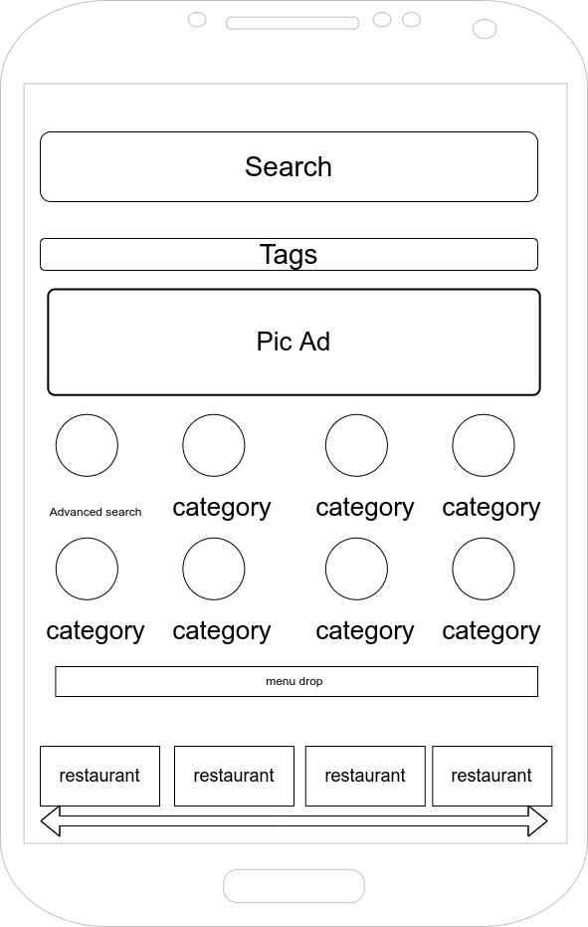
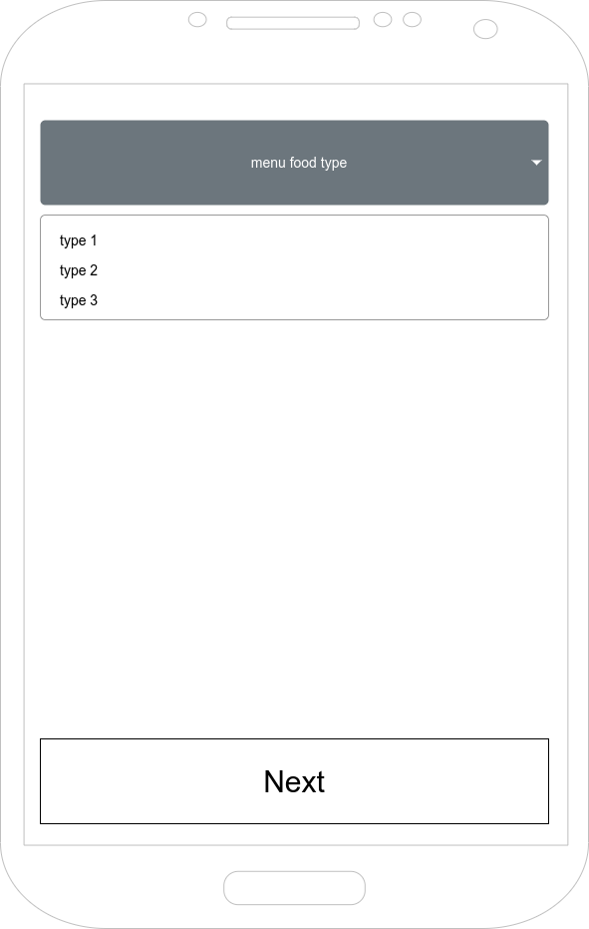
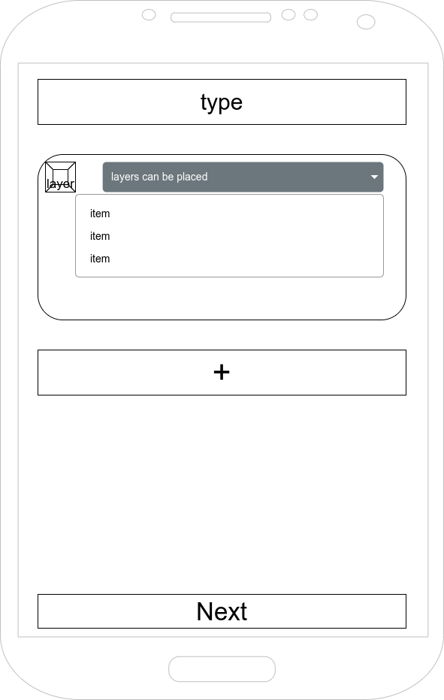
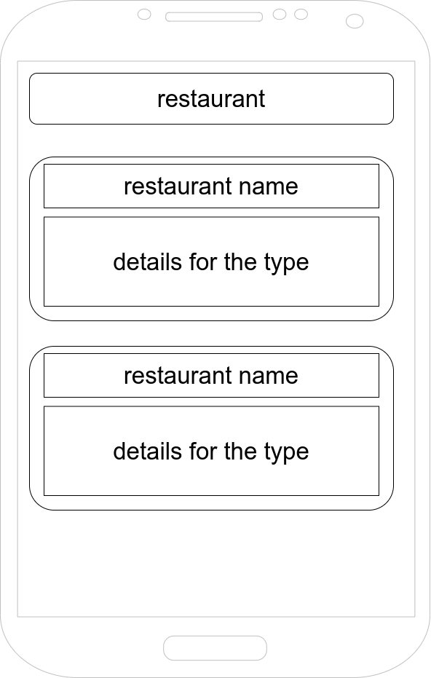

I used Drwa.io to implement this prototype and I used it because it has all of the freedom in free drawing everything with having prebuilt models.

In the first picture, I showed how the application's main menu for food look

in the second picture, I showed what type of food to be chosen such as burgers

in the third picture, I showed the menu for building the layers of the sandwich built by the user

in the fourth picture I showed the results of searching for the restaurant that contains the type with the options of the desired food

Part 4:
4.1 Run end user experiments and examine feedback.

Do you like the way that you found the advanced searching feature?
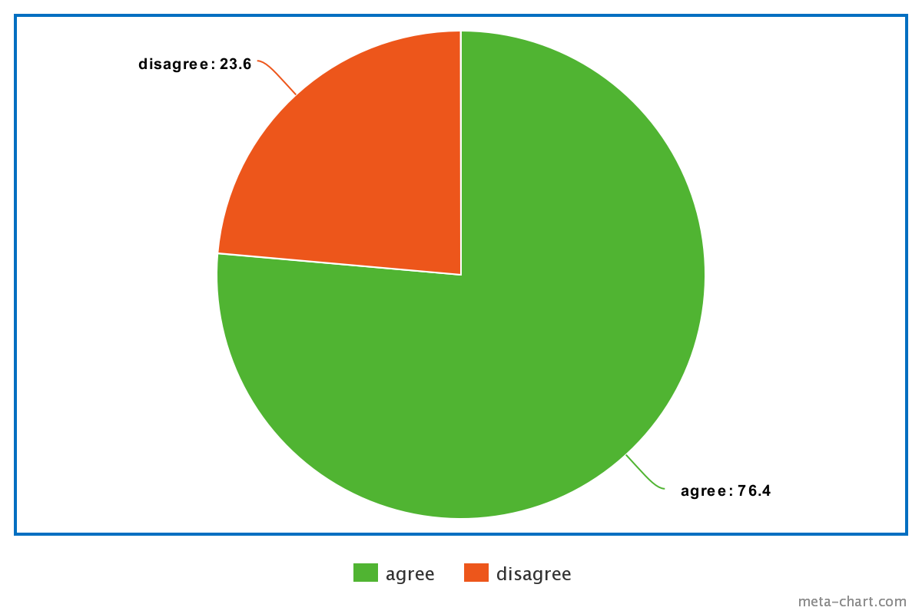
do you like the 2nd screen?
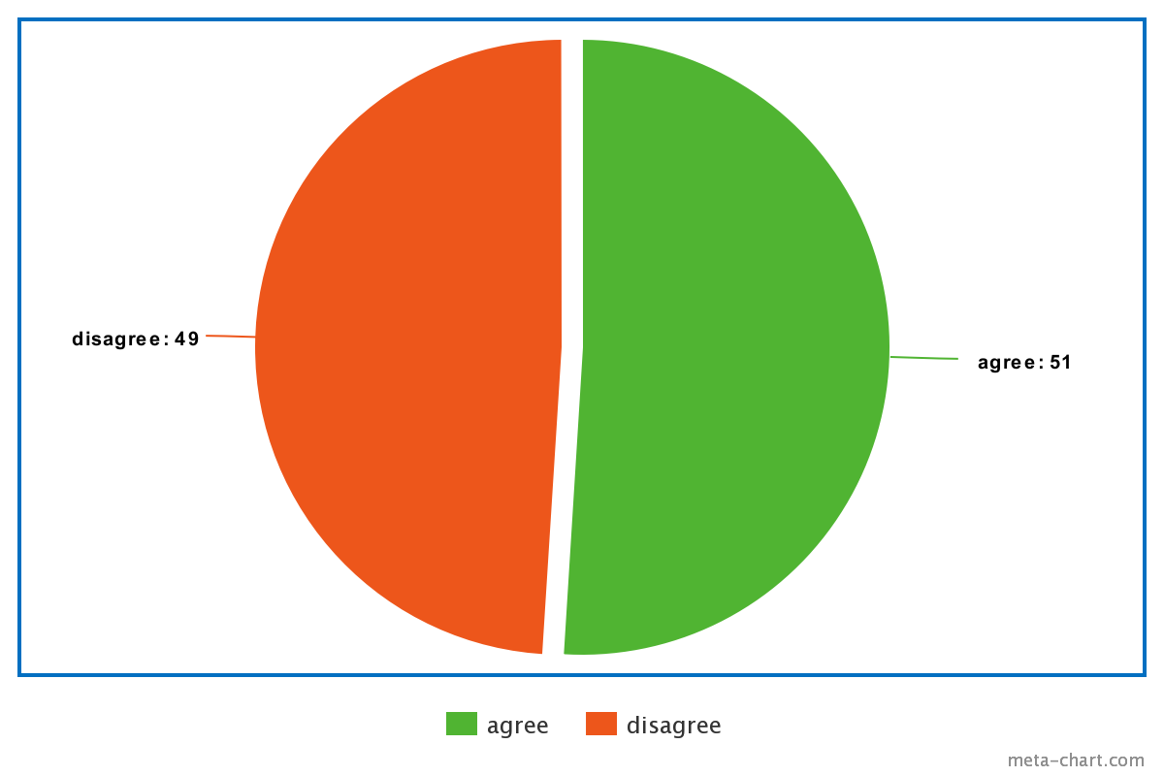
should I combine screen 2 and 3?

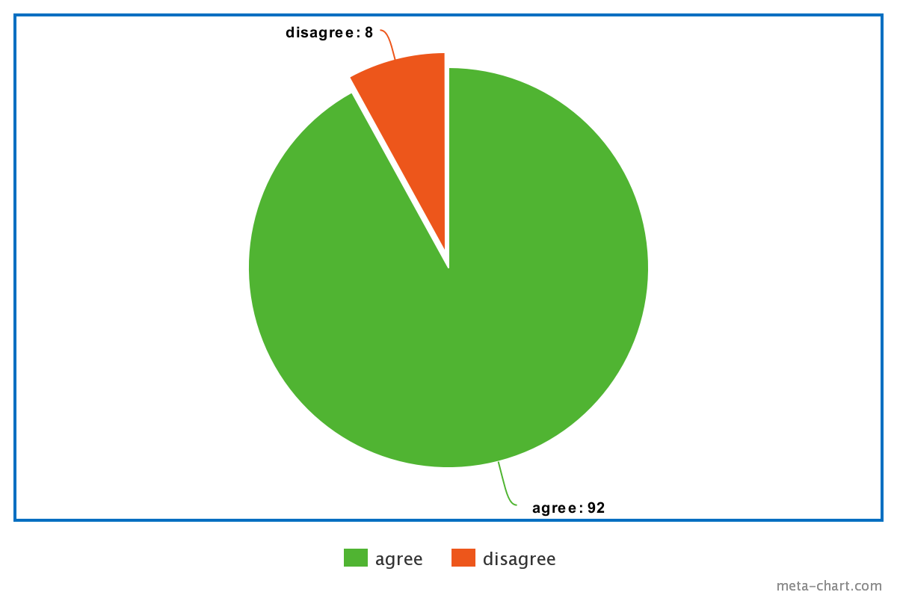
is the 3ed screen missing something?
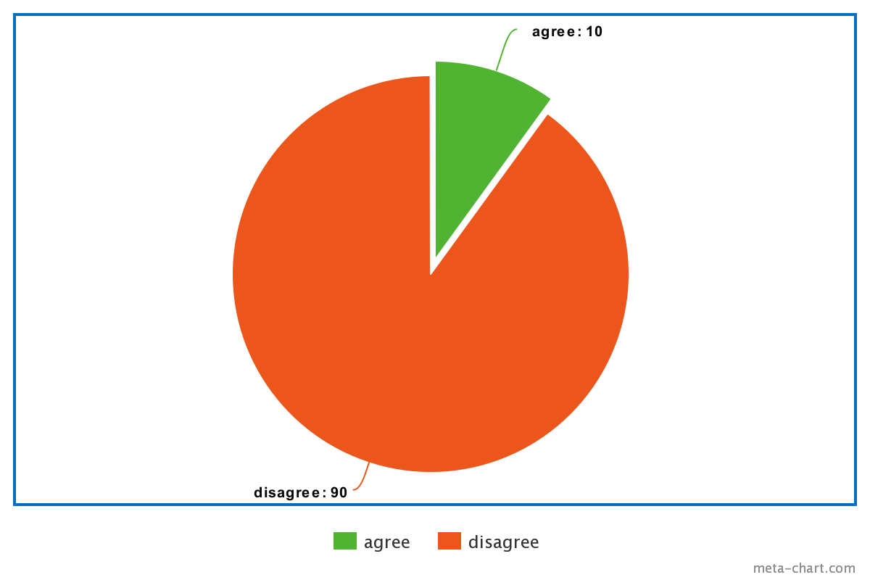

4.2 Evaluate end user feedback and build a new iteration of your user interface modified with the most
important feedback and enhancements.

Will what I understood from the servay / feedback is that I need to combine the 2nd and the 3ed screens although from don norman and Nielsen ten terms having the screen split to 2 makes more sense but in this case, shows that there are no exact rules for what makes humans more comfortable.

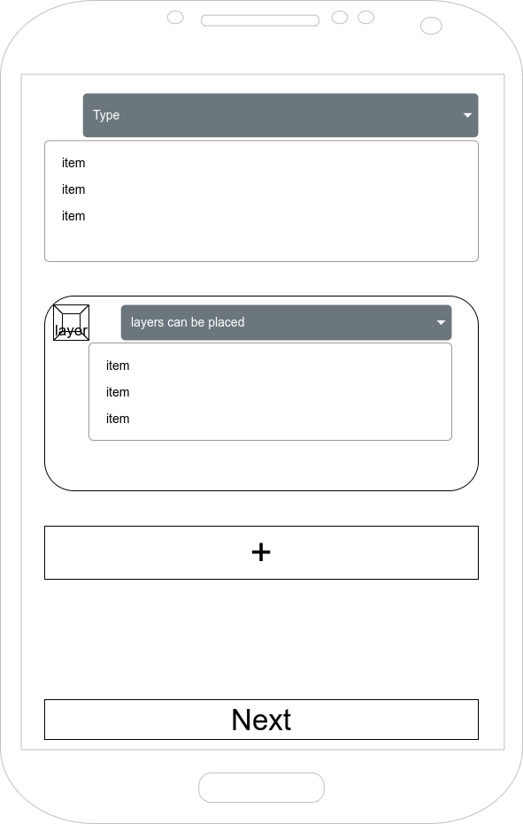

4.3 Suggest steps to improve in future versions of your UI.

For the future what can be done is that change the way you get to the feature because at the moment reaching the advanced search is the lasting thing missing from the feature having a full implementation on the consistency part, plus I have to say that there must be a way to implement this feature with a better and faster method and I would imagine by making the feature embedded in the search bar itself and access it from there.

4.4 Undertake a critical review and compare your final user interface and your test results with the original plan.

Originally I had in mind the advanced search feature and to implement it, I placed the entry point in front of the user so in the beings they would see it and wonder about it plus use it for testing and data collection but at the same time, it was placed in front of the user so they would learn about it in addition to that inside the feature I had placed 3 screens to walk the user through the process from start to finish.

What happened is that I made a servay and asked people about what they thought and I was kind of shocked by what they liked that is against the don norman and Nielsen ten and they asked to get screens 2 and 3 combined and have all of the information in front of the user but in a labelled list, and they didn’t like the place the feature was placed in as I talk about before.

4.5 Critically evaluate the overall success of your User Interface concept and discusses your insight.

Ordering food is no longer just ordering food, now food delivery applications exist on more than one platform and you have multiple different applications that serve the same purpose, which means you would need to make your application shine in front of the competitors and make sure that people would invite others to use it, and the feature that I have been talking may be able to do that, How?

Will as a start there is no other application that had implemented this feature before, which means we need to consider that this is the first time introduction to advanced search in food applications and it needs to be very simple to use and make sure that it stays up to date because other competes will try to implement it, and may succeed with a better design, that's why we need to stay updated.

The base place where this idea came from is that we order on daily bases from Talabat and Careem and most of the time we keep seeing new restaurants that opened but are afraid to try because we don’t know how well are they built plus we keep seeing restaurants that are old but never heard off and there are so many choices, and this feature may help people like us to check out new restaurants, to restaurants that's been in the shade.

I also have to talk about the growth and the new variety of options that this feature will unlock, and by that, I mean that many people know what they want to order, and its a thing to randomized among people especially people with dites, those are the people who would start looking at advanced search options.

Finally, now I can say that this design applies most of don norman’s principles and the heuristics from nelson and made sure that people will like it from the feedback and UX/UI design is implemented in the correct way that would attract people and make sure that they are satisfied.

References

“13 Useful Tools for UX/UI Designers in 2022.” Maze, maze.co/collections/ux-ui-design/tools/.
Charter Global. “What Are the 5 Phases in the Software Development Life Cycle (SDLC)?” Software Development & IT Staffing Company, 13 Jan. 2020, www.charterglobal.com/what-are-the-5-phases-in-the-software-development-life-cycle-sdlc/.
Enginess. “StackPath.” Www.enginess.io, 3 Nov. 2014, www.enginess.io/insights/6-principles-design-la-donald-norman.
“Expert Reviews, Usability Testing, and User Research – What’s the Difference? | Infragistics Blog.” Www.infragistics.com, www.infragistics.com/community/blogs/b/ux/posts/expert-reviews-usability-testing-and-user-research-what-s-the-difference.
Grozny, Maxim. “10 Pros and Cons of User Testing for UX/UI Designers.” Medium, 3 Feb. 2020, uxdesign.cc/10-pros-and-cons-of-user-testing-for-ux-ui-designers-571e56836778.
Interaction Design Foundation. “What Is User Experience (UX) Design?” The Interaction Design Foundation, UX courses, 2019, www.interaction-design.org/literature/topics/ux-design.
---. “What Is User Interface (UI) Design?” The Interaction Design Foundation, UX courses, 2018, www.interaction-design.org/literature/topics/ui-design.
Jevtic, Goran. “What Is SDLC? How the Software Development Life Cycle Works.” PhoenixNAP Global IT Services, 15 May 2019, phoenixnap.com/blog/software-development-life-cycle.
Meta-chart. “Create a Pie Chart, Free . Customize, Download and Easily Share. Just Enter the Amounts, Pick Some Colors/Fonts, and We’ll Take It from There!” Meta-Chart.com, 2019, www.meta-chart.com/pie#/display.
msatdesigns. “PACT Analysis.” App Design., 18 Mar. 2015, appdesignunit.wordpress.com/2015/03/18/pact-analysis/. Accessed 11 Sept. 2022.
“Nielsen’s 10 Usability Heuristics - Heurio.” Www.heurio.co, www.heurio.co/nielsens-10-usability-heuristics.
PACT ANALYSIS.
“PACT Analysis Example 1.” Hci.ilikecake.ie, hci.ilikecake.ie/req_pactexample1.htm.
“Stages of the Design Thinking Process.” Studio by UXPin, 28 Sept. 2021, www.uxpin.com/studio/blog/stages-design-thinking-process/.
Unit 40: User Experience and Interface Design.
“User Classification.” Hci.ilikecake.ie, hci.ilikecake.ie/des_userclassification.htm.
UXPin. “The Stages of UX Design Process.” Studio by UXPin, 25 May 2022, www.uxpin.com/studio/blog/design-process-ux/#h-what-is-a-ux-design-process. Accessed 11 Sept. 2022.

