1)

Which of the following equations are dimensionally correct?

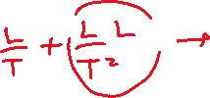

2)

(a) Assume the equation $x=At^{3}+Bt$ describes the motion of a particular object, with x having the dimension of length and t having the dimension of time. Determine the dimensions of the constants A and B.



1. Determine the dimensions of the derivative .



3) (H.W)

Newton’s law of universal gravitation is represented by $F=\frac{GMm}{r^{2}}$, where F is the magnitude of the gravitational force exerted by one small object on another, M and m are the masses of the objects, and r is a distance. Force has the SI units $kg.m/s^{2}$. What are the SI units of the proportionality constant G?

4)

An ore loader moves 1200 tons/h from a mine to the surface. Convert this rate to pounds per second, using 1 ton = 2000 lb.

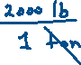

5)

A rectangular building lot has a width of 75.0 ft and a length of 125 ft. Determine the area of this lot in square meters. (1m = 3.281 ft)

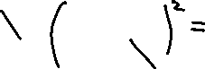

6) (H.W)

One gallon of paint ($volume=3.78 ×{10}^{-3} m^{3}$) covers an area of 25.0 m2. What is the thickness of the fresh paint on the wall? (Ans: 1.51 x 10-4)