1)



A particle moves according to the equation , where x is in meters and t is in seconds. Find:

1. the average velocity for the time interval from 2.00 s to 3.00 s.
2. the velocity when t= 5.00 seconds
3. the average acceleration for the time interval from 2.00 s to 3.00 s
4. the acceleration of the particle at any time.

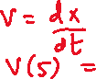

2) (H.W)

A particle moves along the x axis according to the equation, where x is in meters and t is in seconds. At t = 3 seconds, find:

(a) the position of the particle,

(b) its velocity, and

(c) its acceleration.

3)



The minimum distance required to stop a car moving at 35.0 mi/h is 40.0 ft. What is the minimum stopping distance for the same car moving at 70.0 mi/h, assuming the same rate of acceleration? (Ans: 160 ft)

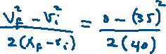

4)



A truck covers 40.0 m in 8.50 s while smoothly slowing down to a final speed of 2.80 m/s.



Find its original speed? (Ans: 6.61 m/s).



Find its acceleration (Ans: -0.448 m/s2).



5)



The driver of a car slams on the brakes when he sees a tree blocking the road. The car slows uniformly with an acceleration of -5.60 m/s2 for 4.20 s, making straight skid marks 62.4 m long, all the way to the tree. With what speed does the car then strike the tree? (Ans: 3.10 m/s)

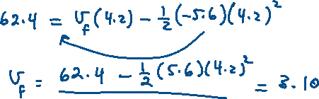

6)

A particle moves along the x axis. Its position is given by the equation , with x in meters and t in seconds. Determine its position when it changes direction. (Ans: 2.56 m)



7)



A ball is thrown directly downward with an initial speed of 8.00 m/s from a height of 30.0 m. After what time interval does it strike the ground? (Ans: 1.79 sec)



8)

A baseball is hit so that it travels straight upward after being struck by the bat. A fan observes that it takes 3.00 s for the ball to reach its maximum height. Find:



(a) the ball’s initial velocity. (Ans: 29.4 m/s2)



(b) the height it reaches. (Ans: 44.1 m)



9)



A student throws a set of keys vertically upward to her sorority sister, who is in a window 4.00 m above. The second student catches the keys 1.50 s later.



(a) With what initial velocity were the keys thrown? (Ans: 10m/s)



(b) What was the velocity of the keys just before they were caught? (Ans: -4.68m/s)



10) (H.W)

A ball is thrown upward from the ground with an initial speed of 25 m/s; at the same instant, another ball is dropped from a building 15 m high. After how long will the balls be at the same height above the ground? (Ans: 0.6 sec)