Install djano in virtual env

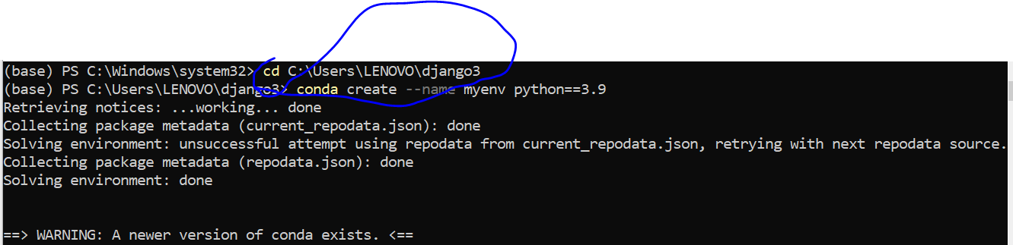

Activate environment and install django

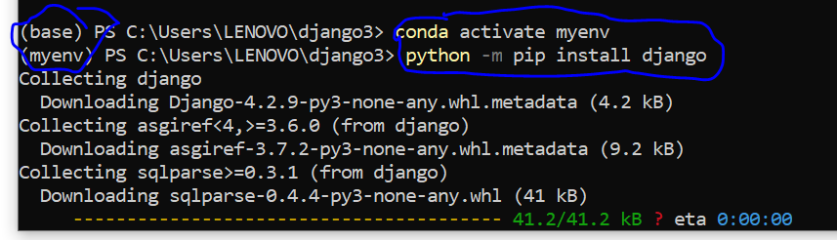

Djproject created

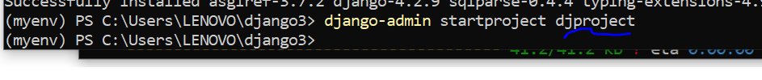

Using dir check project

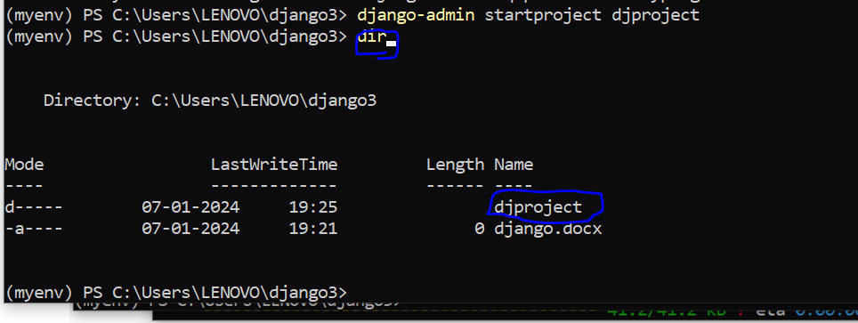

**Inside djproject manage.py folder is there**

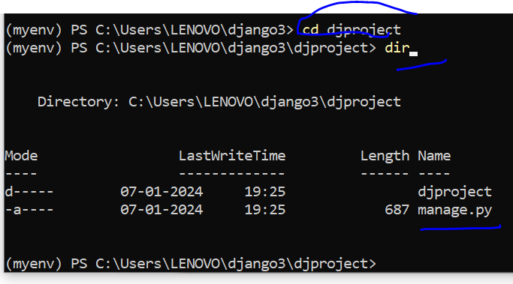

**Run server**

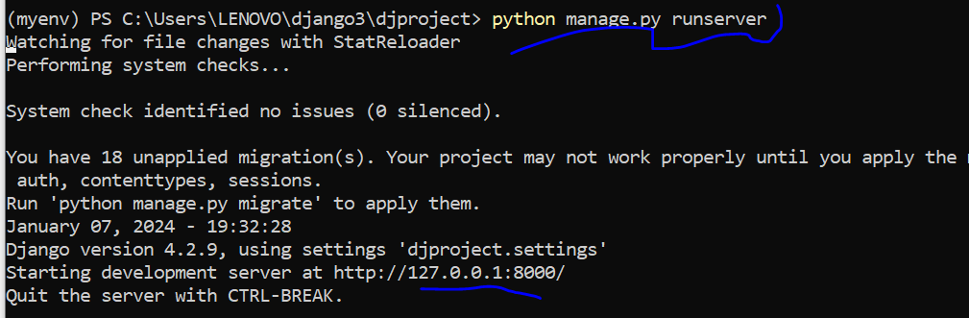

**Create a user app**

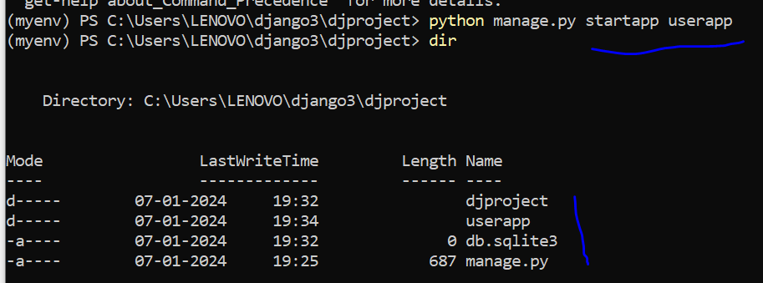

Lets create super user

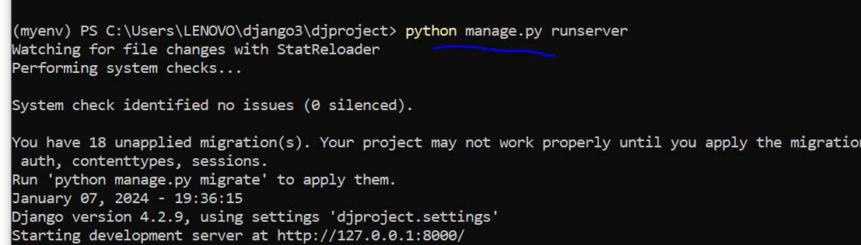

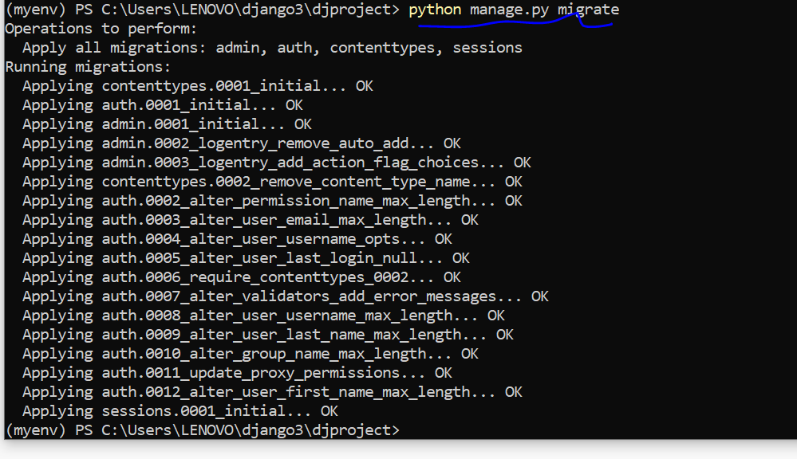

Create password and username and email

