How to use REHOS system for dorm payment

All dorms at Charles University use REHOS system for payments and payment history. However, it's all in Czech with no way to switch to English, which is absolutely idiotic.

I am making this for all the foreign students to know where to click and what to do.

You need to go first to

https://rehos.cuni.cz

Then click here (it means "login")
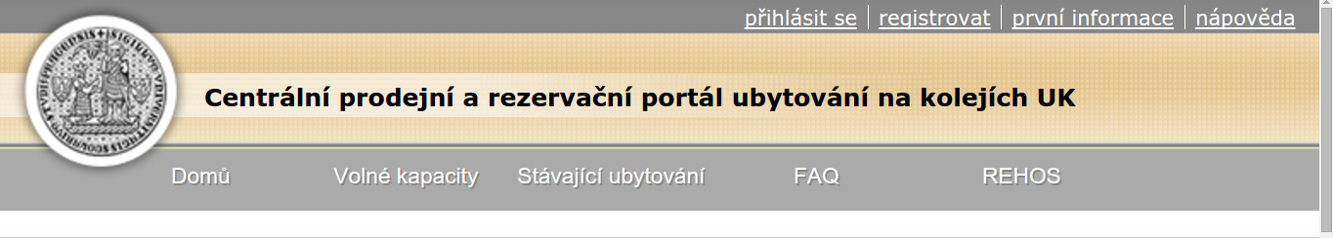
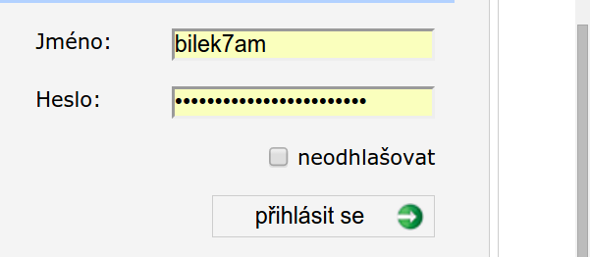
log-in with name/password that you should have to other school systems

You should now see your username on top right.
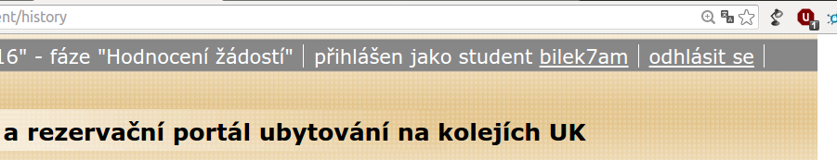

(continued on next page)
(this document is also at http://karelbilek.com/rehos.pdf and http://karelbilek.com/rehos.odt )

How to see your current room type/price
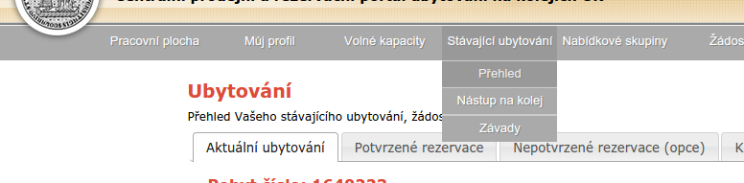
Click on Stávající ubytování → Přehled

Here, you can see basic information about your room and price
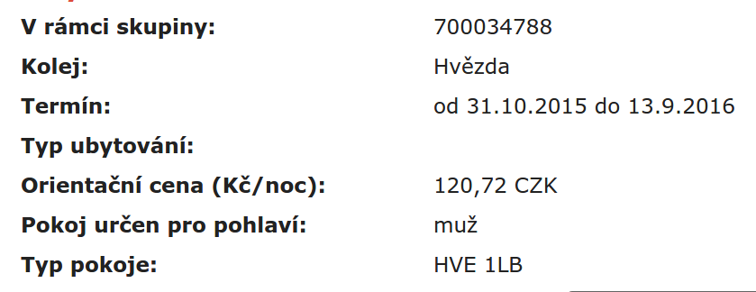

The most important information:
- Termín – at which day your living here starts and terminates
- Orientační cena – price per 1 night
- Pokoj určen pro pohlaví – sex (muž=male, žena=female)
- Typ pokoje – type of room – “1L” means “1 bed in room”, “2L” means “two beds in room”

How to see your payment history
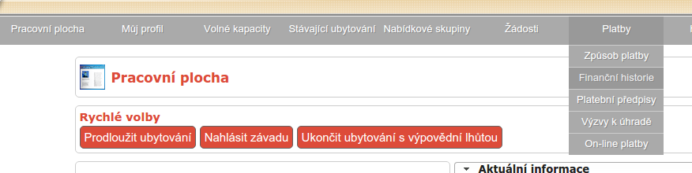
Click on Platby → finanční historie

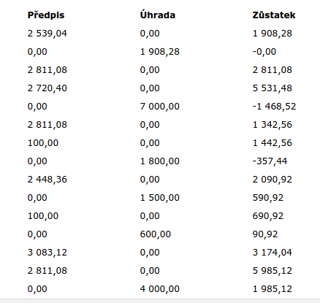
This is slightly chaotic even for Czech people – go figure!
In the left column (“předpis”), you see how much you should have paid.
In the middle column (“úhrada”), you see how much you paid.
On the right column, you can see how much money you have left. However – positive means how much you owe, negative means how much money you have left, if you overpaid for example.

If you want to see in more detail how did were the numbers counted, go to
Platby → Platební předpisy

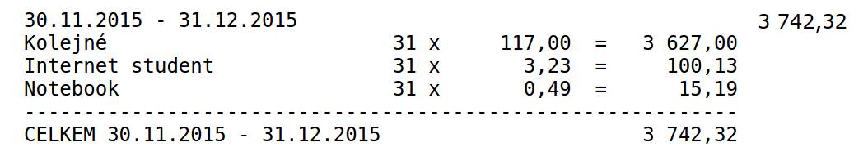
Here you can see detailed information about the recent months

The first row is the date + total for that date.
“Kolejné” means just general housing, and you can see the number of the nights X price for 1 night
Then you have to pay for internet + notebook separately, but it's really small money.
Then you see the total again.
(continued)

(this document is also at http://karelbilek.com/rehos.pdf and http://karelbilek.com/rehos.odt )
How to pay
You do not need Czech bank account to pay! All you need is an international payment card, like MasterCard or VISA (American Express does't work in Czech Republic). It's very easy.
You need to go to Stávající ubytování → Přehled.

If you see big red number like this, it means you owe some money to dorm and you should pay it. If you don't see it, it means you are OK and don't need to pay anything.
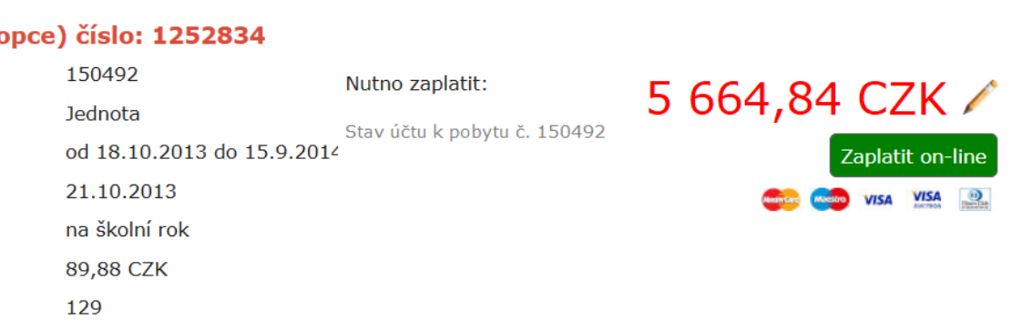
“Nutno zaplatit” means “you need to pay:”
“Zaplatit” means “to pay”
If you see this big number, you should
- click on the pencil and edit, how much you want to pay
  - (you can pay less than you owe, but that will leave you with debt, so if you have money, don't edit it)
- click on “Zaplatit on-line”
- that will redirect you to a general payment gate, which should be in English
- you fill in your MasterCard/VISA details, confirm, and that's it

(this document is also at http://karelbilek.com/rehos.pdf and http://karelbilek.com/rehos.odt )

