# User Guide

## Introduction

Welcome to the user guide for the **MRI Viewer**. Please review the following **table of contents** and refer to the appropriate section in order **to resolve your issue as quickly as possible**. If you did not find what you were looking for, proceed to **the last chapter** and contact us **directly via email**. We are still developing this user guide, and your feedback is **very valuable to us**. Thank you, and happy visualizing!

## Table of Contents

1. MRI Viewer 2

2. Features 2

2.1 Load Files 2

2.1.1 Limitations 2

2.1.2 Error Codes 3

2.1.3 Recommendations 4

2.2 File 4

2.2.1 Groups 4

2.2.2 Memorization 4

2.3 Data Array 5

2.4 Representation 5

2.5 Interaction 6

2.5.1 Slice 6

2.5.2 Zoom 7

2.5.3 Translation 7

2.5.4 Rotation 8

2.6 Main Icon and Title 9

2.7 Player 10

2.7.1 Recommendations 10

2.8 Point and Cell Information 10

2.9 Axes Information 11

2.9.1 Axes Widget 12

2.10 Scalar Bar 13

2.11 Reset View 14

2.12 Dark and Light Themes 14

2.13 Languages 14

2.14 Progress Bar 15

3. Contact 15

## 1. MRI Viewer

MRI Viewer is a web application **for visualizing VTI files**. The purpose of the application is **to simplify scientific work with data coming from MRI machines**. It is **a replacement for the ParaView tool** in terms of specific workflows and aims **to reduce its complexity and enhance its accessibility**. The original client is **the Institute for Clinical and Experimental Medicine in Prague, Czech Republic**.

## 2. Features

MRI Viewer offers several features, as follows:

### 2.1 Load Files

This feature enables you **to upload VTI files to the application**. You can use this functionality **on startup** or **by clicking the LOAD FILES button**.

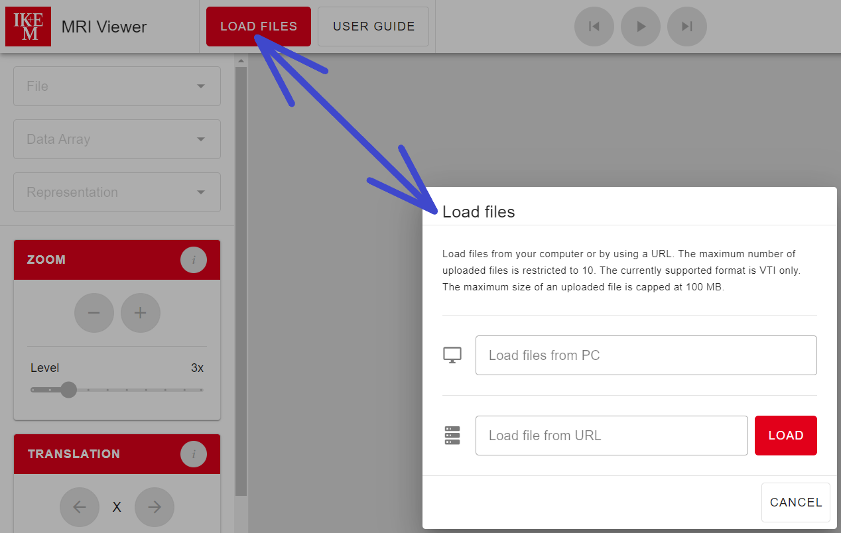  
*A dialog for uploading files and a button to open it*

#### 2.1.1 Limitations

* You can either upload files **from your computer** or **provide a URL**.
* You can upload **only VTI files** (extension *.vti*).
* Each of the uploaded files **must not exceed 100 MB**.
* If you want to upload data **from your computer**, you can upload **one or more** files, but **no more than 10**.
* If you want to upload data **using the URL**, you can upload **only one file**.

#### 2.1.2 Error Codes

There is a list of the most common error codes that can occur while uploading files:

* **WRONG-FILE-EXTENSION** → You are trying to upload **a file with an extension other than *.vti***, which violates the limitation. Please upload VTI files only.
* **FILE-IS-TOO-LARGE** → You are trying to upload **a file larger than 100 MB**, which violates the limitation. Please compress your data or use smaller files.
* **TOO-MANY-FILES-TO-UPLOAD** → You are trying to upload **more than 10 files**, which violates the limitation. Please load your data in small batches (e.g., groups of three files).
* **INVALID-URL** → You provided **an incorrect URL**. Please check the URL and make sure there is a VTI file on the other side.
* **MISSING-... →** Error codes starting with *MISSING-* indicates that there are **some troubles with reading uploaded VTI files**, and some parts may be missing. It may also happen that **there is no VTI file to be uploaded** (while uploading via URL). Please check the VTI file you are trying to upload, or use another VTI file.

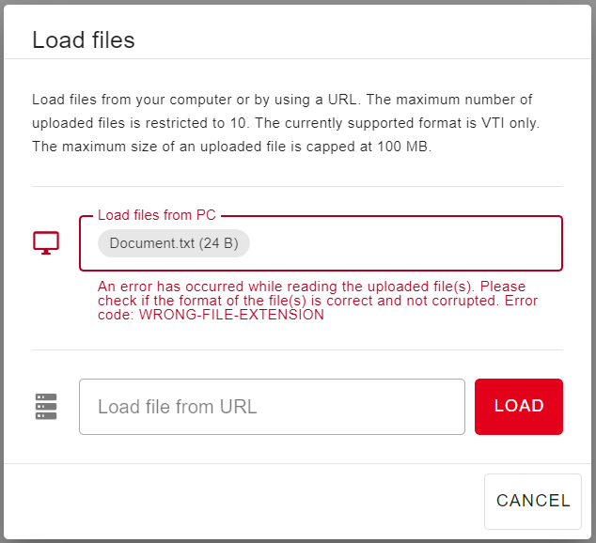  
*An example of an error while uploading files*

If you encounter **an error code that is different from those mentioned above**, please contact us and let us know.

#### 2.1.3 Recommendations

Please **be patient** while uploading VTI files. This action **may take some time** (up to one minute or even more), as the data **must be properly loaded and processed**. It depends **not only** on the size of your files. Do not upload a large group of files at once. Try to upload data in small groups of files instead.

### 2.2 File

This feature enables you **to select one of the uploaded VTI files to show**. You can use this functionality **by clicking the *File* select and choosing the file to visualize**. If you upload a group of files, then **the first file in this group** is automatically selected and visualized. The visualized file is **temperature-colored** only.

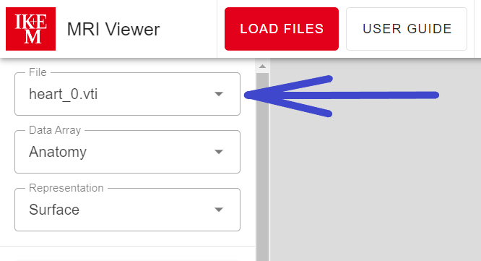

*The list of files to visualize is located in the left column*

#### 2.2.1 Groups

A file group is automatically created while uploading a file. It always contains **at least one file**. If you upload 10 different files, then there are implicitly 10 different file groups (each of them contains one file). The main advantage of the file group is that it remembers your work.

If there is already a file group with a very similar file(s) (in terms of data), then the newly uploaded file is added to this group. Groups with **more than one file** can be played using the player.

#### 2.2.2 Memorization

File groups are able to remember the following things: current **slice** (in all orientations), **zoom**, **translation**, **rotation**, selected **data array**, and **representation**. If you switch to another group, then the work in **the old group is remembered** and the work in progress in **the new group is loaded**.

### 2.3 Data Array

This feature enables you **to select one of the data arrays** defined in the selected file. You can use this functionality **by clicking the *Data Array* select and choosing the data array to apply**. The list contains only **point OR cell arrays**. If there are **point and cell arrays** defined in a single file, then only **cell arrays are listed**.

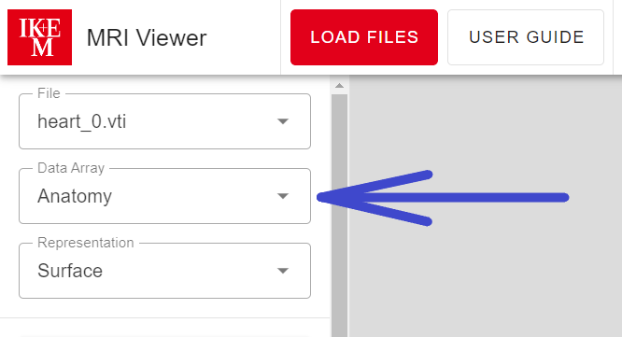

*The list of data arrays to apply is located in the left column*

### 2.4 Representation

This feature enables you **to select one of the representations** of the visualized file. You can use this functionality **by clicking the *Representation* select and choosing the representation to apply**. You can represent the visualized file as **points**, **slice**, **surface**, **surface with edges**, or **wireframe**.

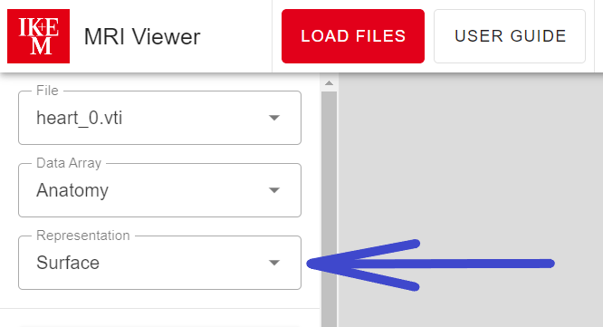

*The list of representations is located in the left column*

### 2.5 Interaction

You can use several available tools to interact with the data, as follows:

#### 2.5.1 Slice

This particular tool creates a slice of the data in the pre-selected **orientation** and **position**. The list of available orientations contains **XY**, **YZ**, and **XZ**. These are **the axes along which the final slice is inserted**.

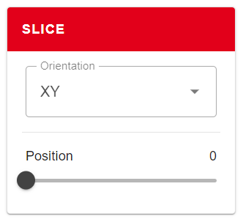

*The slice tool*

You can also set **the position of the slice in the direction of the remaining axis** (e.g., for the XY orientation, you set the position within the Z-axis). This position is limited by the data boundaries in that particular direction.

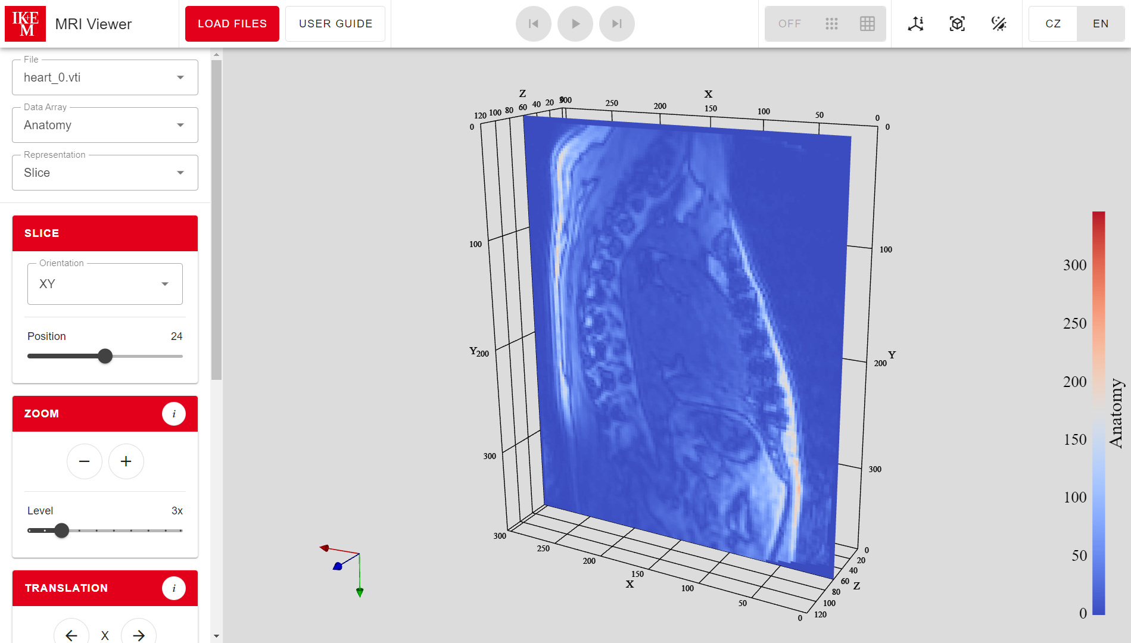

*There is a slice inserted along the X and Y axes and positioned within the data boundaries in the direction of the Z-axis*

#### 2.5.2 Zoom

This particular tool enables you **to zoom the data in or out**. The **minus** icon is for **zooming out**, and the **plus** icon is for **zooming in**. The level determines **the depth** of zooming. We recommend using **the right mouse button** for zooming in or out smoothly and quickly rather than using the zoom tool.

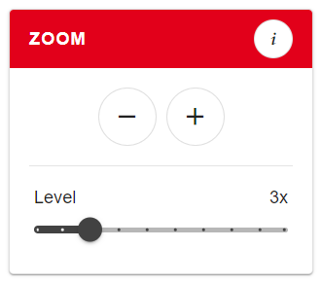

*The zoom tool*

#### 2.5.3 Translation

This particular tool enables you **to pan the data in the direction of any axis**. The **left arrow** icon is for shifting to the **negative** values of the particular axis. The **right arrow** icon is for shifting to the **positive** values of the particular axis. The distance determines **the length** of the shift. We recommend using **the middle mouse button** for panning smoothly and quickly rather than using the translation tool.

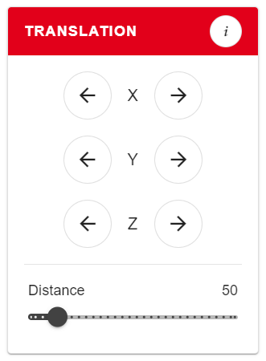

*The translation tool*

#### 2.5.4 Rotation

This particular tool enables you **to rotate the data around any axis**. The **left-rounded arrow** icon is for rotating **counterclockwise** around a particular axis. The **right-rounded arrow** icon is for rotating **clockwise** around a particular axis. You can set **the angle** of the rotation. We recommend using **the left mouse button** for rotating smoothly and quickly rather than using the rotation tool.

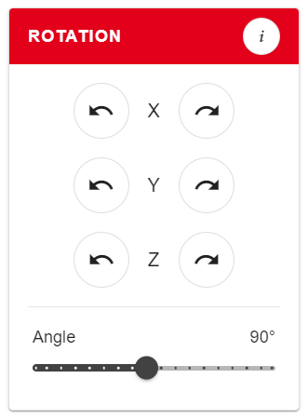

*The rotation tool*

### 2.6 Main Icon and Title

By clicking the main icon, **you will be redirected to the website of a client** (in this case, **the Institute for Clinical and Experimental Medicine in Prague, Czech Republic**).

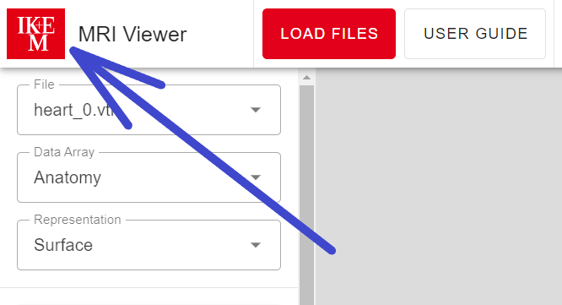

*The main icon and title are located in the top-left corner*

### 2.7 Player

A player is available only for **groups of files with more than one file**. If you choose the file that is included in such a group, then you can **start** this player by clicking **the play icon**. The player goes through these files one after another. You can **skip** to the previous or next file by clicking **the side icons** (this action also stops the player). You can **stop** the player by clicking **the stop icon** that will appear instead of the play icon while playing.

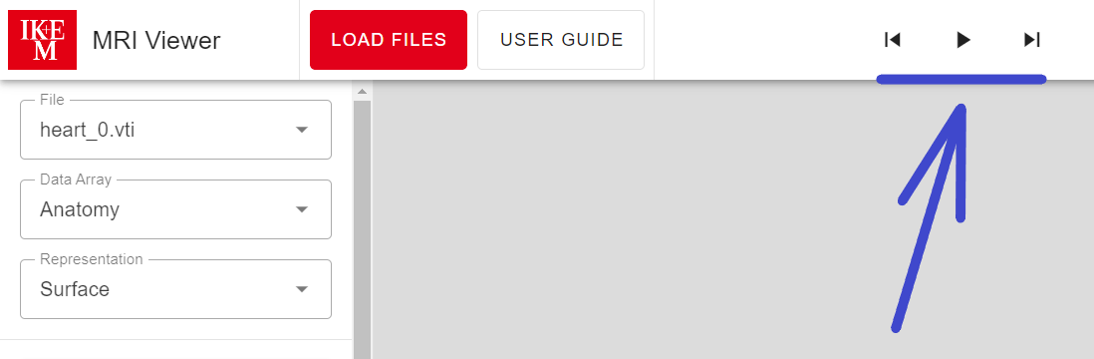

*The player is located in the middle of the upper bar*

#### 2.7.1 Recommendations

Be patient while playing the first round. The animation **might be slow** because of the data loading and rendering. The next rounds **should be faster**.

### 2.8 Point and Cell Information

You can see **the values of point or cell data arrays** stored in the visualized file by clicking on the particular buttons in the toolbar (*OFF*, *points*, *cells*).

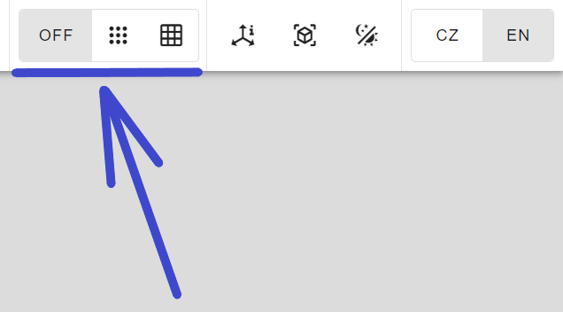

*Point and cell information can be turned on or off in the upper bar*

When you **click on** some point or cell in your data afterwards, the dialog with the values of the particular data arrays will appear. Additionally, there is an **identifier and location** (for **points**) and an **identifier** (for **cells**). Point or cell information is automatically **disabled** while playing the animation or using the slice tool.

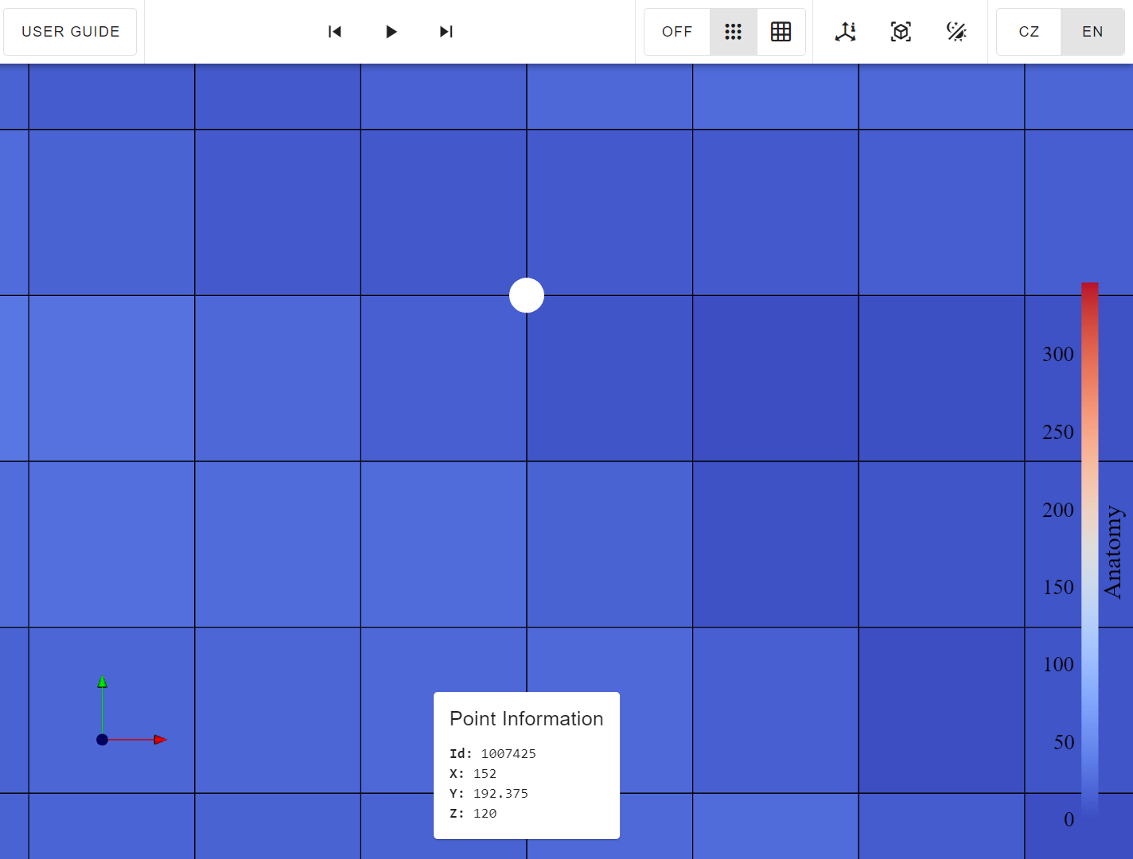

*Point information (i.e., identifier, location, and point data array values, if available) can be found in the bottom part of the screen*

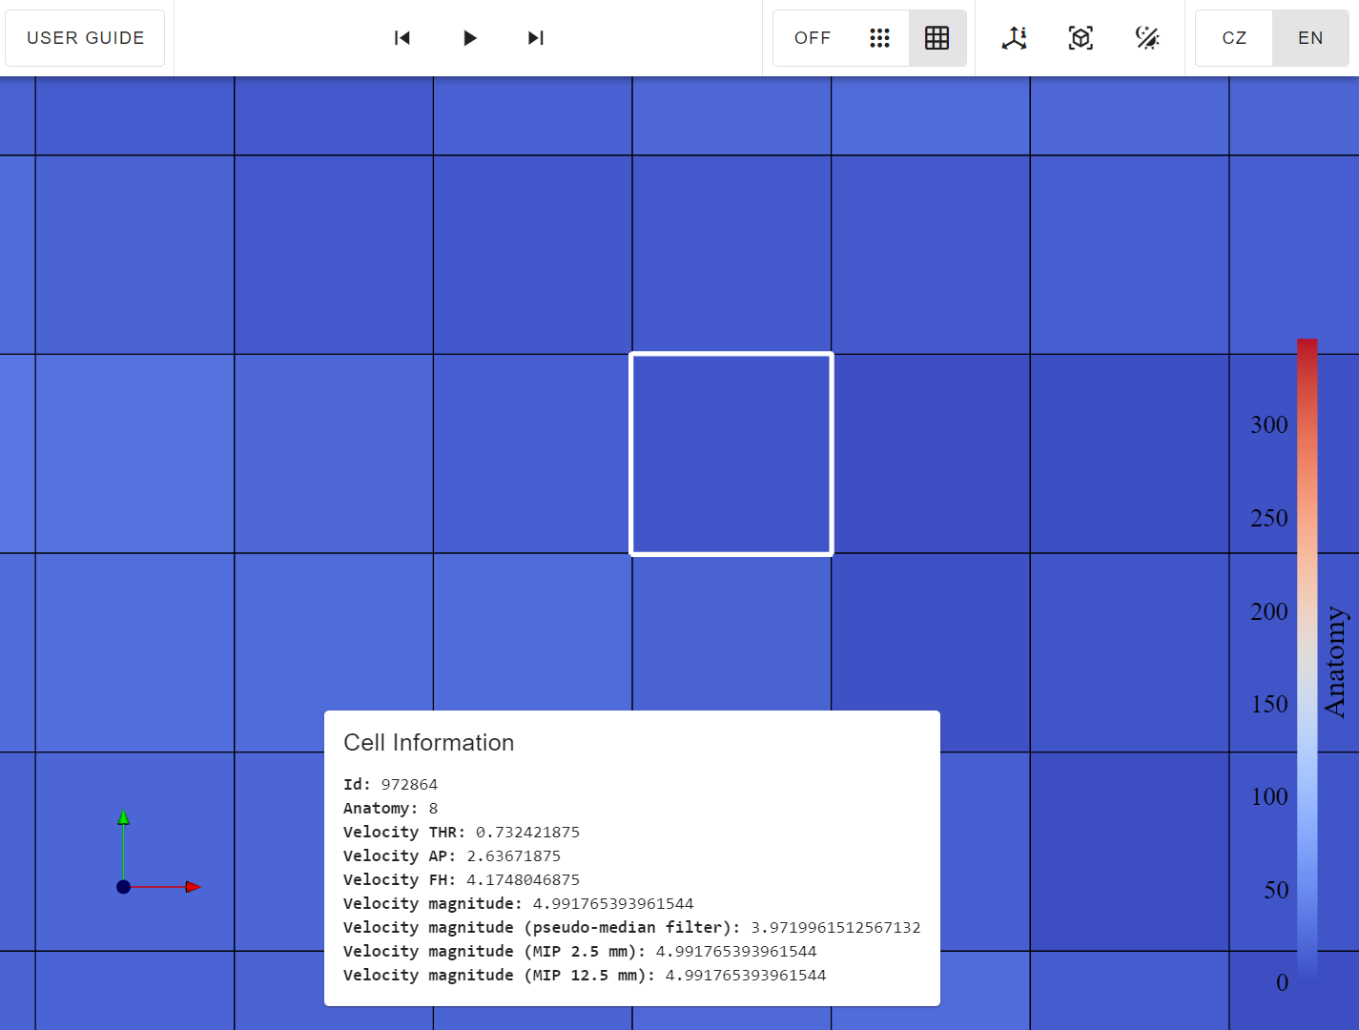

*Cell information (i.e., identifier and cell data array values, if available) can also be found in the bottom part of the screen*

### 2.9 Axes Information

You can turn on or off **the axes information** by clicking on the particular icon in the toolbar.

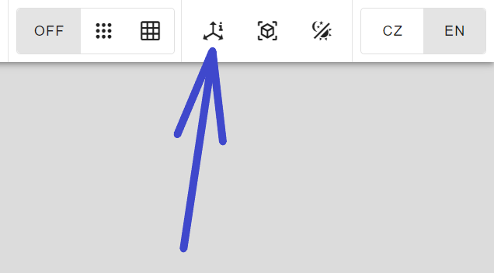

*Axes information can be turned on or off in the upper bar*

This will show **the axes labels**, **a grid**,and **the bounds of your data**.

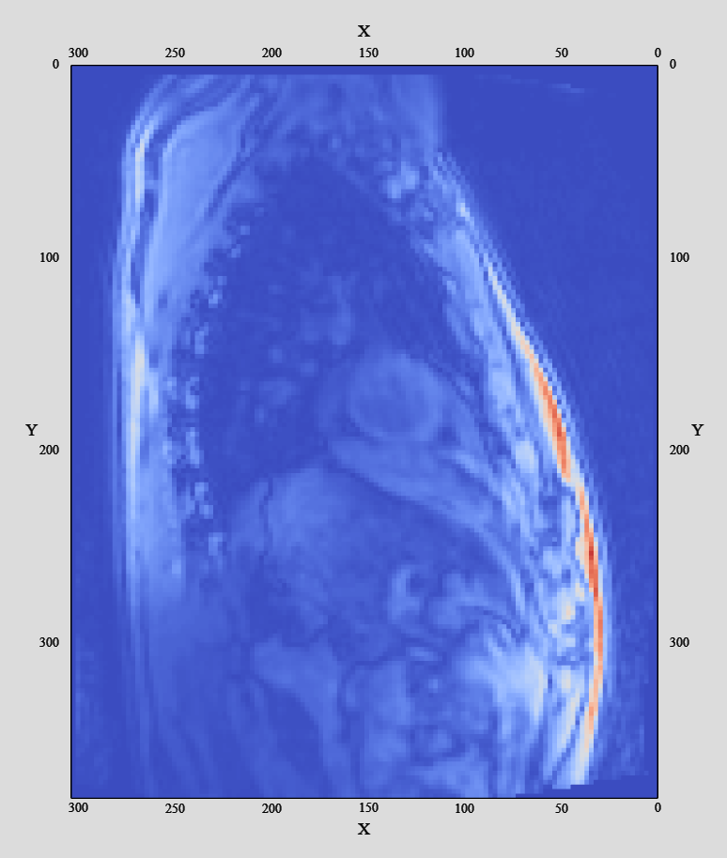

*You have more insight by activating the axes information*

#### 2.9.1 Axes Widget

For even better orientation in data and space, there is a **small axes widget** composed of three basic axes perpendicular to each other. The **x-axis** is **red**, the **y-axis** is **green**, and the **z-axis** is **blue**. The axes widget **copies the orientation of the data**. If you rotate your data, the widget is rotated accordingly.

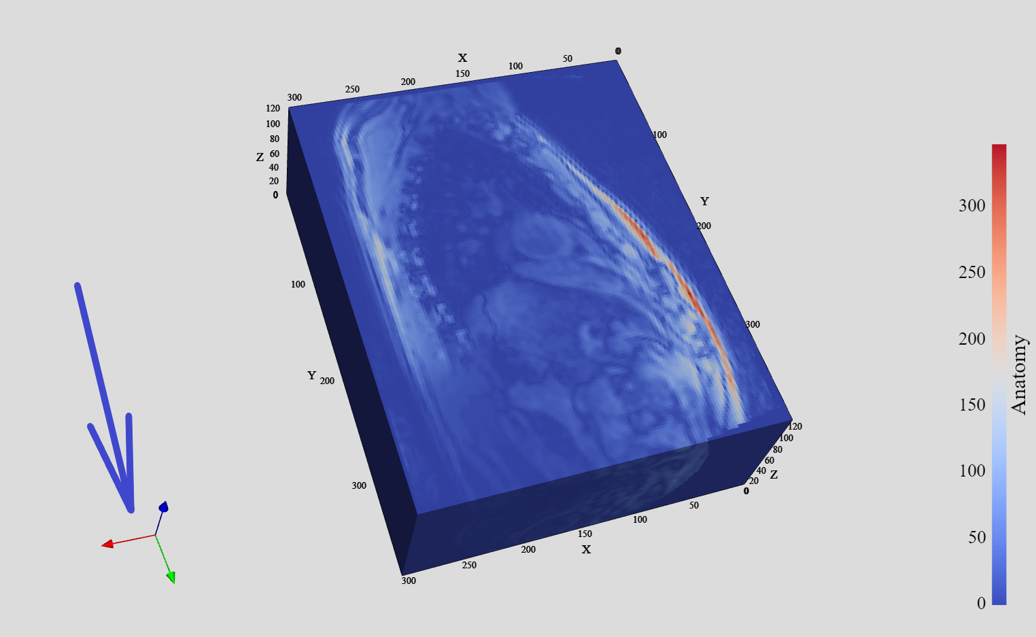

*The axes widget is located in the bottom-left corner*

### 2.10 Scalar Bar

There is also **another helper** on the other side of the screen. The scalar bar maps **the data array values** to **temperature colors**. Therefore, you can better determine values in the interesting parts of the visualized data.

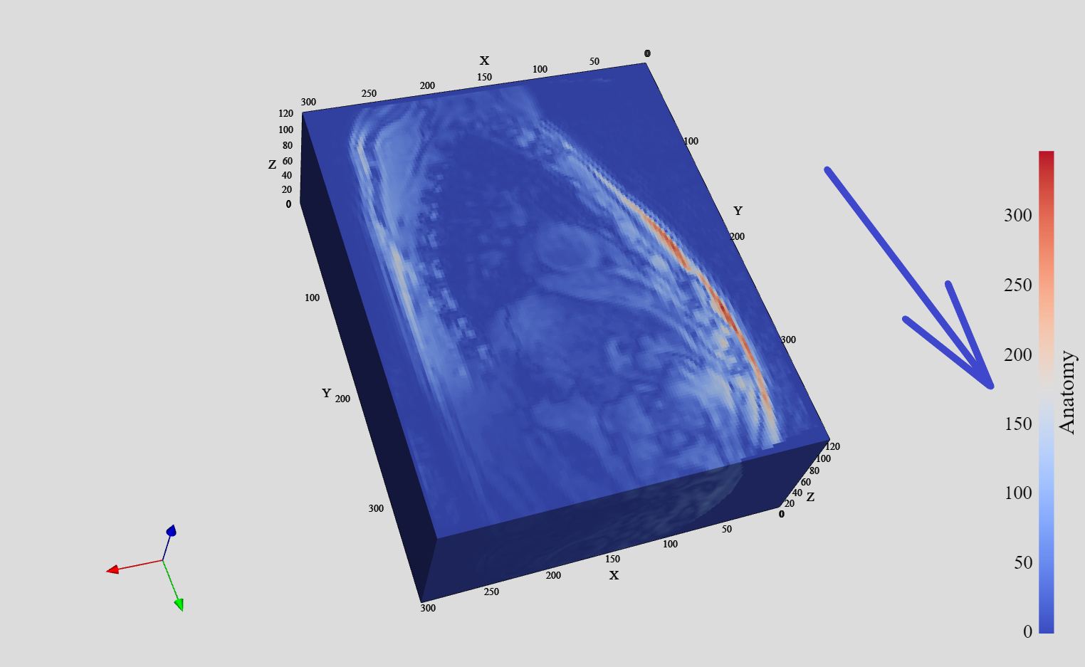

*The scalar bar is on the right side*

### 2.11 Reset View

By clicking **the reset view icon**, you reset all the **zoom**, **translation**,and **rotation** interactions you have made in history.

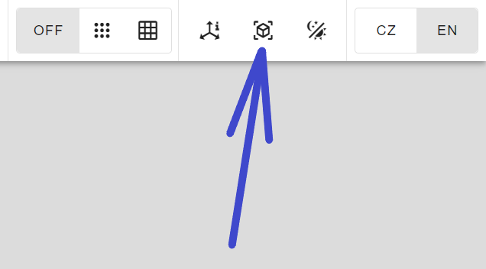

*The reset view can be found in the upper bar*

### 2.12 Dark and Light Themes

You can switch between the light and dark themes by clicking **the mode icon**.

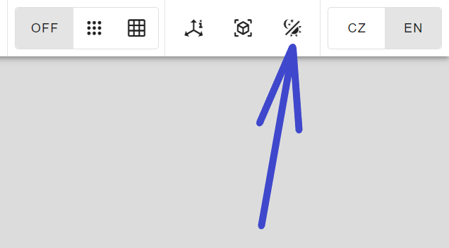

*Mode can be switched in the upper bar*

### 2.13 Languages

You can switch between **the Czech and English languages** by clicking the particular button in the top-right corner.

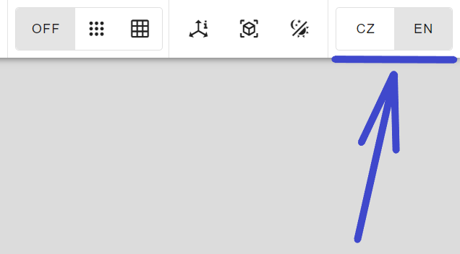

*Languages can be switched in the upper bar*

### 2.14 Progress Bar

When you see a progress bar under the toolbar, then **the application is busy working**. The progress bar appears while **file uploading**, **data processing**, **rendering**, **picking** points or cells, **switching** files, data arrays or representations, and so on. Please be patient and let it disappear. The style of the progress bar indicates the blood flow, as the application is primarily determined for medical purposes.

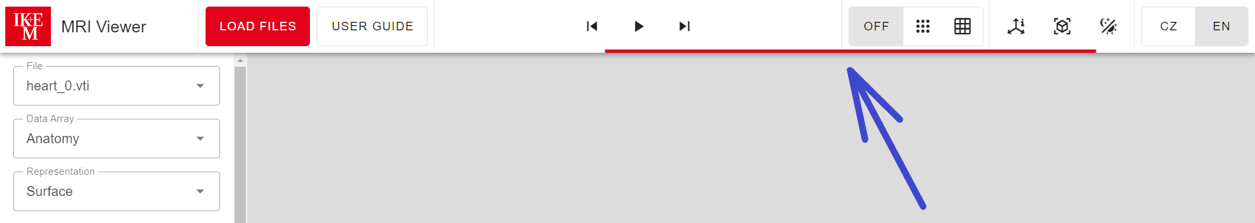

*The progress bar appears under the upper bar*

## 3. Contact

In case of trouble, **please contact us** at [karelvrabeckv@gmail.com](mailto:karelvrabeckv@gmail.com). Your questions and ideas **will make this user guide better** for future users. Thank you very much!