RealTime-App
Real-Time Chat Between Users — Complete Project Guide
ASP.NET Core Web API (.NET 10) • Angular 21 • SignalR • EF Core + SQLite
Trainee project documentation
Repository: github.com/karem27012000/RealTime-App
October 2026

Table of Contents

(If the table of contents is empty, right-click it in Word and choose "Update Field".)

1. Project Overview
RealTime-App is a chat web application where people talk to each other in real time. A user picks a nickname, then chats one-to-one with another user or in group rooms. Messages appear instantly on every member's screen, without refreshing the page, and everything is saved in a database.
It was built as a trainee project, so the goal is not only that it works, but that it shows a clean, professional structure that is easy to read, test and extend.

1.1 Main features
- Nickname login – no password; the same nickname brings you back to your account and history.
- Private chats – one-to-one conversations. Only one private chat exists per pair of users.
- Group rooms – anyone can create a group; others can browse, join and leave it.
- Instant delivery – messages are pushed over SignalR (WebSockets) to every open tab of every member.
- Online / last seen – a green dot shows who is online; offline users show when they were last seen.
- Typing indicator – "bob is typing…" while someone writes in the open chat.
- Unread badges – a counter on chats that received messages while you were elsewhere.
- Message history with "Load older messages" (paging, 50 at a time).
- Responsive UI – desktop and phone layouts, light and dark mode.
- Interactive API docs (Scalar), consistent JSON errors, and unit tests for backend and frontend.

1.2 How it looks
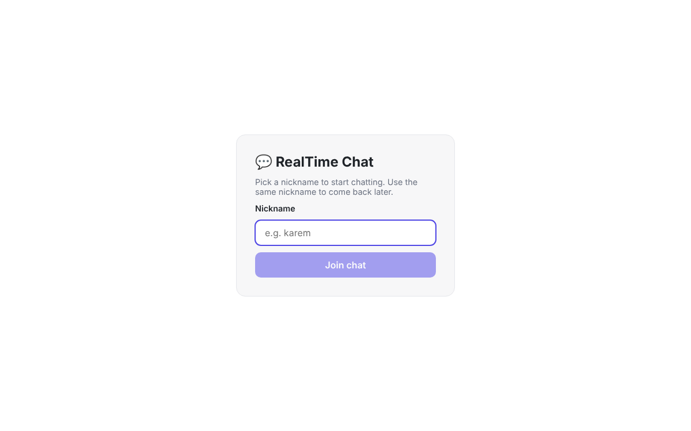
Figure 1 – Login: pick a nickname
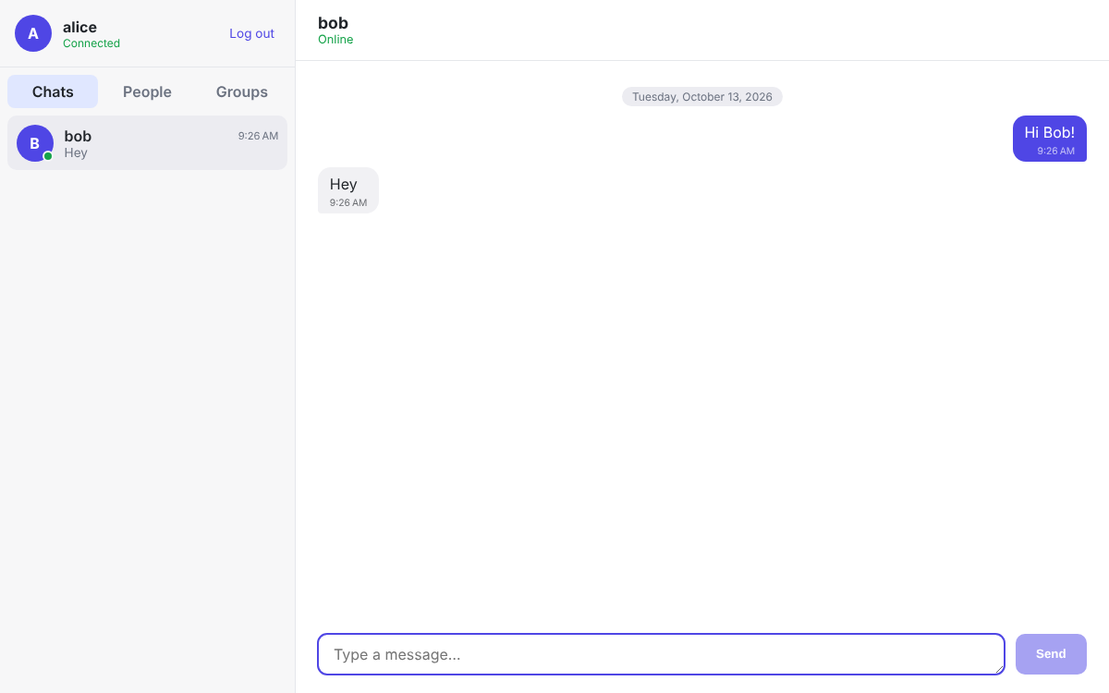
Figure 2 – Private chat (alice ↔ bob). Green dot = online
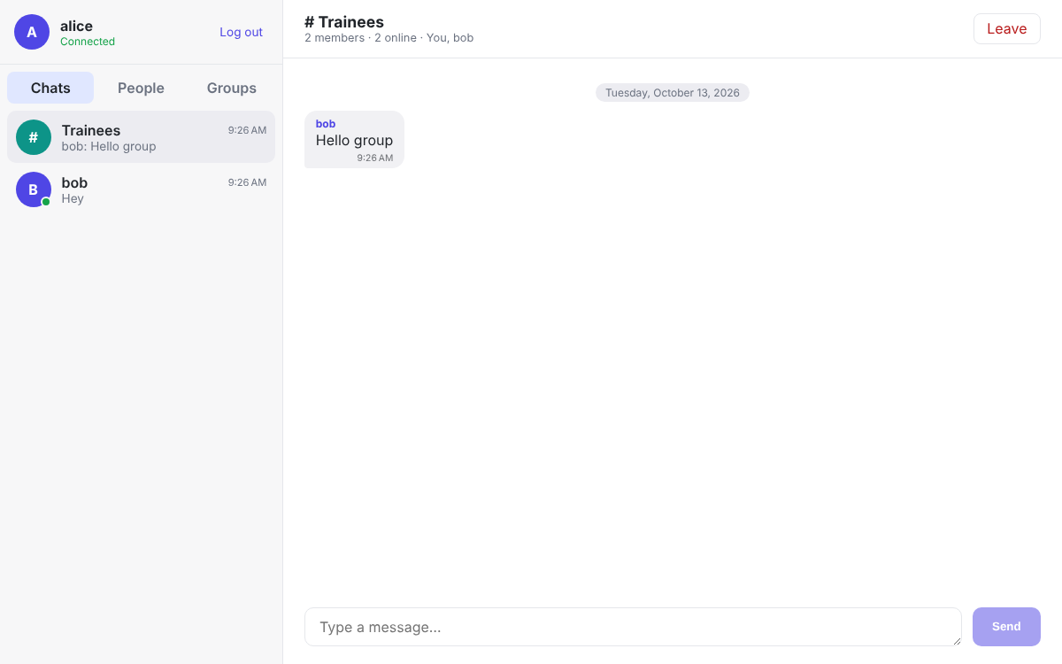
Figure 3 – Group room "Trainees": sender names, member count, Leave button
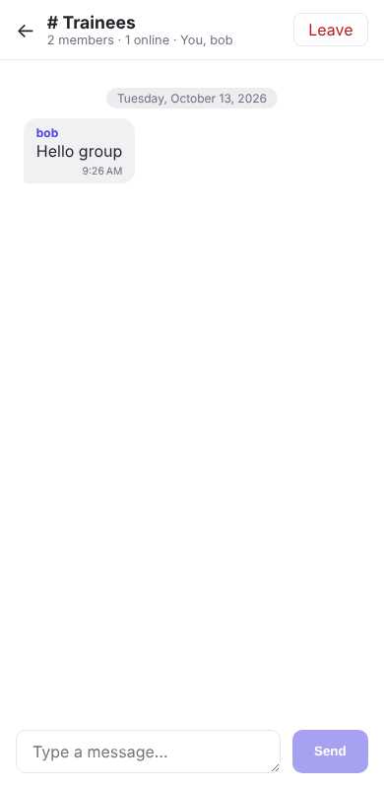
Figure 4 – Phone view of a group

1.3 The big picture
Part | Technology | Address (development) | Job
Frontend | Angular 21 | http://localhost:4200 | The user interface that runs in the browser.
Backend | ASP.NET Core Web API (.NET 10) | http://localhost:5000 | Business rules, database, real-time hub.
Real-time | SignalR hub | /hubs/chat | Pushes messages, typing and presence to browsers.
Database | SQLite (file chatapp.db) | Next to the API | Stores users, rooms, members and messages.

Browser A (alice) Browser B (bob)
│ REST: login, rooms, history ▲
│ SignalR: SendMessage(room, txt) │ SignalR: ReceiveMessage(msg)
▼ │
ASP.NET Core Web API ── saves ──► SQLite database
└── ChatHub / SignalRChatNotifier pushes the message to every member

2. Technologies and Tools

2.1 Backend
Technology / package | Version | What it is used for
.NET SDK / C# | 10 (LTS) | Platform and language of the backend.
ASP.NET Core Web API | 10 | HTTP API: controllers, routing, middleware, dependency injection.
ASP.NET Core SignalR | 10 (built in) | Real-time, two-way communication with the browsers.
Entity Framework Core | 10.0.12 | ORM: maps C# classes to tables, LINQ queries, migrations.
Microsoft.EntityFrameworkCore.Sqlite | 10.0.12 | EF Core provider for SQLite (a single-file database).
Microsoft.EntityFrameworkCore.Design | 10.0.12 | Needed by the dotnet ef tool to create migrations.
Microsoft.AspNetCore.OpenApi | 10.0.12 | Generates the OpenAPI description at /openapi/v1.json.
Scalar.AspNetCore | 2.18.0 | Interactive API documentation page at /scalar.
Microsoft.Extensions.DependencyInjection.Abstractions | 10.0.12 | Lets the Application library register its services.
xUnit + Microsoft.NET.Test.Sdk | 2.9.3 / 17.14.1 | Unit-testing framework and test runner.
dotnet-ef (global tool) | 10.0.12 | Command-line tool to add and apply migrations.

2.2 Frontend
Technology / package | Version | What it is used for
Angular | 21.2 | Standalone components, signals, router, guards, interceptors, forms, HttpClient.
TypeScript | 5.9 | Typed JavaScript; the language of the frontend.
Angular CLI / @angular/build | 21.2 | ng serve, ng build, ng test (esbuild + Vite).
@microsoft/signalr | 10.0 | SignalR client: connects to the hub, sends and receives events.
RxJS | 7.8 | Observables for HTTP calls and hub events.
SCSS | — | Styles with nesting; theme colours as CSS variables.
Vitest + jsdom | 4.1 / 28 | Unit tests for components (default runner in Angular 21).
Prettier | 3.8 | Automatic code formatting.

2.3 Development tools
Tool | Why you need it
Visual Studio 2026 / VS Code / Rider | Edit and debug the code. Note: Visual Studio 2022 does not support .NET 10.
Node.js 22.12+ or 24 (and npm) | Run the Angular CLI. Older Node versions fail with "require() of ES Module … not supported".
Git + GitHub | Version control; the project lives in the RealTime-App repository.
Two browsers (or a private window) | Log in as two different users to test the chat.
Browser DevTools | Network tab → "WS" shows the SignalR WebSocket frames.
DB Browser for SQLite (optional) | Open chatapp.db to look at the tables.

3. Architecture

3.1 Clean Architecture in the backend
The backend is split into four projects (layers). Each has one responsibility, and dependencies always point inwards: outer layers know inner layers, never the reverse.
ChatApp.Api (entry point: controllers, SignalR hub, Program.cs)
│ uses
▼
ChatApp.Infrastructure (EF Core + SQLite, online-presence tracker)
│ implements interfaces of
▼
ChatApp.Application (use cases: UserService, RoomService, MessageService)
│ uses
▼
ChatApp.Domain (entities + rules: User, ChatRoom, RoomMember, Message)
Layer | Responsibility | Depends on | Examples
Domain | Business objects and their rules. Pure C#. | Nothing | ChatRoom.PostMessage(), ChatRoom.Join()
Application | Use cases. Defines interfaces for what it needs (database, real-time push, presence). | Domain | MessageService, IChatNotifier, IPresenceTracker
Infrastructure | Technical details: database, in-memory presence. | Application | AppDbContext, ChatRoomRepository, InMemoryPresenceTracker
Api | HTTP + SignalR entry point; wires everything together. | Application + Infrastructure | RoomsController, ChatHub, SignalRChatNotifier

The key idea: the business logic doesn't know SignalR
MessageService saves a message and then calls IChatNotifier.MessageReceivedAsync(...). It only knows the interface. The Api layer provides SignalRChatNotifier, which uses SignalR to push the message. This is Dependency Inversion: you could replace SignalR with something else, and in unit tests a simple RecordingChatNotifier checks what would have been sent.

Why is this good?
- Testable – 27 unit tests run in milliseconds with fakes, no database or browser.
- Replaceable – SQLite → SQL Server, or in-memory presence → Redis, only touches Infrastructure.
- Readable – every file has an obvious place.

3.2 Frontend structure
- core/ – things used everywhere: models, API services, the SignalR service, the interceptor and guards.
- features/ – one folder per screen: login and chat.
- Container vs presentational – ChatPage talks to the ChatStore; Sidebar, RoomHeader, MessageList, MessageInput only use inputs and outputs.
- One store – ChatStore keeps all chat state in signals and reacts to SignalR events.

4. Folder Structure
RealTime-App/
├── README.md
├── docs/RealTime-App-Project-Guide.docx ← this document
├── backend/
│ ├── ChatApp.slnx ← solution file (new XML format)
│ ├── src/
│ │ ├── ChatApp.Domain/
│ │ │ ├── Common/BaseEntity.cs
│ │ │ ├── Entities/User.cs, ChatRoom.cs, RoomMember.cs, Message.cs
│ │ │ ├── Enums/RoomType.cs
│ │ │ └── Exceptions/DomainException.cs
│ │ ├── ChatApp.Application/
│ │ │ ├── Abstractions/IUserRepository.cs, IChatRoomRepository.cs,
│ │ │ │ IChatNotifier.cs, IPresenceTracker.cs
│ │ │ ├── DTOs/UserDtos.cs, RoomDtos.cs, MessageDtos.cs
│ │ │ ├── Exceptions/NotFound-, Forbidden-, UnauthorizedException.cs
│ │ │ ├── Mappings/ChatMappings.cs
│ │ │ ├── Services/UserService.cs, RoomService.cs, MessageService.cs
│ │ │ └── DependencyInjection.cs
│ │ ├── ChatApp.Infrastructure/
│ │ │ ├── Persistence/AppDbContext.cs
│ │ │ │ ├── Configurations/ (User, ChatRoom, RoomMember, Message)
│ │ │ │ ├── Repositories/UserRepository.cs, ChatRoomRepository.cs
│ │ │ │ └── Migrations/ (generated by dotnet ef)
│ │ │ ├── Presence/InMemoryPresenceTracker.cs
│ │ │ └── DependencyInjection.cs
│ │ └── ChatApp.Api/
│ │ ├── Controllers/ApiControllerBase.cs, UsersController.cs, RoomsController.cs
│ │ ├── Hubs/ChatHub.cs, IChatClient.cs, SignalRChatNotifier.cs,
│ │ │ QueryStringUserIdProvider.cs, HubExceptionFilter.cs
│ │ ├── Middleware/GlobalExceptionHandler.cs
│ │ ├── Extensions/WebApplicationExtensions.cs
│ │ ├── appsettings.json, Properties/launchSettings.json
│ │ └── Program.cs
│ └── tests/ChatApp.Application.Tests/
│ ├── Domain/UserTests.cs, ChatRoomTests.cs
│ ├── Services/UserServiceTests.cs, RoomServiceTests.cs, MessageServiceTests.cs
│ └── Fakes/ (in-memory repositories, presence tracker, recording notifier)
└── frontend/chat-ui/src/
├── index.html, main.ts, styles.scss, environments/
└── app/
├── app.ts, app.config.ts, app.routes.ts
├── core/
│ ├── models/user.model.ts, room.model.ts, message.model.ts
│ ├── services/auth.service.ts, users-api.service.ts,
│ │ rooms-api.service.ts, chat-hub.service.ts
│ ├── interceptors/user-id.interceptor.ts
│ └── guards/auth.guard.ts
└── features/
├── login/login-page/
└── chat/
├── chat.store.ts
├── chat-page/ (container)
├── sidebar/ (Chats / People / Groups tabs)
├── room-header/ (name, status, members, Leave)
├── message-list/ (bubbles, dates, load older)
└── message-input/ (text box, typing)

5. Backend in Detail

5.1 Domain layer (ChatApp.Domain)
File | What it does
Common/BaseEntity.cs | Base class: Guid Id (created in code) and CreatedAt (UTC).
Entities/User.cs | Nickname (2–30 chars; letters, digits, space, _ - .) and LastSeenAt. NormalizeNickname() validates and trims.
Entities/ChatRoom.cs | The heart of the rules. CreateGroup(name, creator), CreatePrivate(a, b) (not with yourself), Join()/Leave() (groups only), IsMember(), and PostMessage(sender, text) which checks membership, rejects empty or >2000-char messages and updates UpdatedAt. PrivateKey = both user ids in fixed order so a pair has only one private chat.
Entities/RoomMember.cs | Join table between users and rooms (many-to-many) with JoinedAt.
Entities/Message.cs | RoomId, SenderId, Content. Only ChatRoom.PostMessage can create one (internal constructor).
Enums/RoomType.cs | Private or Group.
Exceptions/DomainException.cs | Thrown when a rule is broken; the API turns it into HTTP 400.

Concept: Properties have private setters and collections are read-only. Nobody outside can put a room in an invalid state – for example adding a third person to a private chat is impossible. This is a "rich domain model".

5.2 Application layer (ChatApp.Application)
File | What it does
Abstractions/IUserRepository.cs, IChatRoomRepository.cs | Data access interfaces. IChatRoomRepository also returns RoomSummary (room + last message) for the chat list and pages messages with a before date.
Abstractions/IChatNotifier.cs | Push real-time events: MessageReceived, RoomAdded, MembersChanged, PresenceChanged.
Abstractions/IPresenceTracker.cs | Who is online. Counts connections per user, so several tabs count as one online user.
DTOs/*.cs | Records sent over the API: UserDto, RoomDto (a room as one user sees it), RoomDetailsDto (with members), MessageDto, TypingDto and request records.
Exceptions/*.cs | NotFoundException → 404, ForbiddenException → 403 (not a member), UnauthorizedException → 401 (unknown user).
Mappings/ChatMappings.cs | Entity → DTO. A private room is named after the other user, so the same room is "bob" for alice and "alice" for bob.
Services/UserService.cs | Login (find or create by nickname, case-insensitive), list users with online status, and Connect/Disconnect called by the hub (announces online/offline, updates LastSeenAt).
Services/RoomService.cs | My rooms, joinable groups, details, create group, start private chat (reuses the existing one), join, leave. Notifies the affected users in real time.
Services/MessageService.cs | Message history (checks membership, max 100 per page, oldest first) and Send: validate → save → push to all members.

5.3 Infrastructure layer (ChatApp.Infrastructure)
File | What it does
Persistence/AppDbContext.cs | DbSets for Users, Rooms, RoomMembers, Messages. Applies all configurations; treats every DateTime as UTC.
Persistence/Configurations/*.cs | Fluent API: table names, keys (RoomMember has a composite key), unique case-insensitive nickname (NOCASE), unique PrivateKey, enums stored as text, cascade deletes, indexes for fast queries.
Persistence/Repositories/UserRepository.cs | EF Core queries for users.
Persistence/Repositories/ChatRoomRepository.cs | Loads rooms with members (Include/ThenInclude), the latest message of each room in one extra query, and message pages ordered by date.
Persistence/Migrations/ | Generated code that creates the database schema (InitialCreate).
Presence/InMemoryPresenceTracker.cs | Thread-safe dictionary userId → set of connection ids. Singleton; resets when the server restarts.
DependencyInjection.cs | AddInfrastructure() registers the DbContext (SQLite), repositories and the presence tracker.

5.4 Api layer (ChatApp.Api)
File | What it does
Program.cs | Registers services, SignalR (with the exception filter and user-id provider), the notifier, ProblemDetails, CORS; maps controllers and /hubs/chat; applies migrations; runs.
Controllers/ApiControllerBase.cs | Base class with CurrentUserId, read from the X-User-Id header (401 if missing).
Controllers/UsersController.cs | POST /api/users/login, GET /api/users/me, GET /api/users.
Controllers/RoomsController.cs | All room and message endpoints (see section 7).
Hubs/ChatHub.cs | The SignalR hub. On connect: checks the user and marks them online. On disconnect: offline. Methods: SendMessage(roomId, content) and StartTyping(roomId).
Hubs/IChatClient.cs | Strongly-typed list of events the server can call on the browser (ReceiveMessage, RoomAdded, MembersChanged, PresenceChanged, UserTyping).
Hubs/QueryStringUserIdProvider.cs | Tells SignalR which user owns a connection (from ?userId=), which makes Clients.User(id) / Clients.Users(ids) work for every tab.
Hubs/SignalRChatNotifier.cs | Implements IChatNotifier with IHubContext<ChatHub, IChatClient> – so REST controllers can push events too.
Hubs/HubExceptionFilter.cs | Sends readable errors to the client for expected problems; hides details of unexpected ones.
Middleware/GlobalExceptionHandler.cs | Maps exceptions to 400/401/403/404/500 Problem Details JSON.

6. Database
SQLite stores everything in one file, chatapp.db, created next to the API on start-up (ignored by Git). EF Core migrations create the tables.
Users 1 ──── * RoomMembers * ──── 1 Rooms 1 ──── * Messages
└───────────────────── 1 ──── * Messages (SenderId)

6.1 Tables
Table | Columns | Notes
Users | Id, Nickname, CreatedAt, LastSeenAt | Nickname unique and case-insensitive (NOCASE): "Karem" = "karem".
Rooms | Id, Type, Name, CreatedById, PrivateKey, CreatedAt, UpdatedAt | Type is "Private" or "Group". PrivateKey unique (one private chat per pair). UpdatedAt indexed to sort the chat list.
RoomMembers | RoomId, UserId, JoinedAt | Composite primary key (RoomId, UserId) – a user is in a room only once. Cascade delete.
Messages | Id, RoomId, SenderId, Content (max 2000), CreatedAt | Index (RoomId, CreatedAt) for fast history loading. Cascade delete with the room.

6.2 Migrations
cd backend
dotnet tool install --global dotnet-ef # once
dotnet ef migrations add <Name> -p src/ChatApp.Infrastructure -s src/ChatApp.Api -o Persistence/Migrations
Pending migrations are applied automatically the next time the API starts.

7. API Reference

7.1 Who is calling? (identity)
After login, the Angular app sends the user id in the `X-User-Id` header on every REST call (added by userIdInterceptor), and as `?userId=` when connecting to the hub.
Security: This is simple on purpose. The server trusts the id it receives, so a user could pretend to be someone else. A real app uses passwords and signed tokens (JWT). That is the first "next step" in section 14.

7.2 REST endpoints
Method | URL | Body / query | Result
POST | /api/users/login | { "nickname": "karem" } | UserDto (created first time)
GET | /api/users/me | — | Current user; 401 if unknown
GET | /api/users | — | All users, online first
GET | /api/rooms | — | My chats, newest activity first
GET | /api/rooms/groups | — | Groups I can join
GET | /api/rooms/{id} | — | RoomDetailsDto with members; 403/404
POST | /api/rooms/private | { "userId": "…" } | Private RoomDto (existing or new)
POST | /api/rooms/groups | { "name": "Trainees" } | 201 + RoomDto
POST | /api/rooms/{id}/join | — | RoomDto
POST | /api/rooms/{id}/leave | — | 204 (400 for private chats)
GET | /api/rooms/{id}/messages | ?before=<date>&take=50 | Messages oldest first
POST | /api/rooms/{id}/messages | { "content": "Hi" } | MessageDto (also pushed live)

7.3 SignalR hub (/hubs/chat)
Direction | Name | Data
Browser → server | SendMessage | roomId, content → returns the saved MessageDto
Browser → server | StartTyping | roomId (sent at most every 2 seconds while typing)
Server → browser | ReceiveMessage | MessageDto – to every member, including the sender
Server → browser | RoomAdded | RoomDto – new private chat, created or joined group
Server → browser | MembersChanged | roomId, memberCount – someone joined/left
Server → browser | PresenceChanged | UserDto – someone came online / went offline (to everyone)
Server → browser | UserTyping | { roomId, userId, nickname } – to the other members

7.4 Errors
Errors use the Problem Details format (RFC 9457): 400 invalid input (e.g. empty message, bad nickname), 401 unknown user, 403 not a member of the room, 404 not found. Try everything at http://localhost:5000/scalar.

8. How It Works (Step by Step)

8.1 Logging in and connecting
- LoginPage calls AuthService.login(nickname) → POST /api/users/login.
- The API finds the user (case-insensitive) or creates a new one, and returns the UserDto.
- AuthService saves the user in a signal and in localStorage (so a refresh keeps you logged in) and the router opens /chat.
- ChatStore.init() checks the saved user still exists (GET /me), loads rooms and users, then ChatHubService.connect(userId).
- ChatHub.OnConnectedAsync → UserService.ConnectAsync → presence tracker. If this is the user's first tab, everyone receives PresenceChanged (green dot appears).

8.2 Sending a message
- MessageInput emits send; ChatPage calls store.sendMessage(text).
- ChatHubService.sendMessage() invokes the hub method SendMessage(roomId, text) over the WebSocket.
- MessageService.SendAsync loads the room, room.PostMessage() checks the rules, the message is saved.
- IChatNotifier.MessageReceivedAsync → SignalRChatNotifier → Clients.Users(memberIds).ReceiveMessage(dto).
- Every member's ChatStore handles the event: the room moves to the top with the new preview; if the room is open, the bubble is added; otherwise the unread badge increases.
Detail: The sender receives the message twice (as the hub reply and as the ReceiveMessage event). The store ignores duplicates by message id.

8.3 Starting a private chat
- In People, alice clicks bob → POST /api/rooms/private { userId: bob }.
- RoomService looks for an existing room with the same PrivateKey; if none, ChatRoom.CreatePrivate makes one.
- Both users receive RoomAdded – each with the room named after the other person – so bob sees the chat appear instantly.

8.4 Typing indicator and presence
- While typing, MessageInput emits typing at most every 2 s → hub StartTyping → the other members get UserTyping → "alice is typing…" for 3 s (cleared early when her message arrives).
- When a user's last tab closes, OnDisconnectedAsync marks them offline, saves LastSeenAt and broadcasts PresenceChanged.
- If the connection drops, SignalR reconnects automatically; the store then reloads rooms, users and the open chat to catch up on anything missed.

9. Frontend in Detail

9.1 App setup, routing and security
File | What it does
app.config.ts | provideHttpClient(withInterceptors([userIdInterceptor])), router with withComponentInputBinding(). Zoneless – signals drive change detection.
app.routes.ts | /login (guestGuard), /chat and /chat/:roomId (authGuard). Pages are lazy-loaded.
core/guards/auth.guard.ts | authGuard sends logged-out users to /login; guestGuard sends logged-in users to /chat.
core/interceptors/user-id.interceptor.ts | Adds the X-User-Id header to every request to our API.
environments/*.ts | apiUrl of the backend (http://localhost:5000).

9.2 Core services
Service | What it does
AuthService | currentUser signal, login(), logout(), persisted in localStorage.
UsersApiService / RoomsApiService | Typed wrappers around HttpClient for every REST endpoint.
ChatHubService | Creates the HubConnection with automatic reconnect, registers the server events and exposes them as RxJS Subjects; state signal (connecting / connected / reconnecting / disconnected); sendMessage() and startTyping().

9.3 ChatStore (state)
A root service built with signals. State: rooms, users, joinableGroups, activeRoomId, activeRoom, messages, hasOlderMessages, unread (per room), typing, error. Computed: otherUsers (online first), onlineUserIds, totalUnread, typingText. Actions: init, logout, openRoom, loadOlderMessages, sendMessage, notifyTyping, startPrivateChat, createGroup, joinGroup, leaveGroup. It subscribes to every hub event and updates the signals, so all components refresh automatically.

9.4 Components
Component | Type | What it does
LoginPage | Page | Nickname form, shows server validation errors.
ChatPage | Container | Reads the :roomId route input, opens that room, connects the store to the children. On phones shows either the list or the chat.
Sidebar | Presentational | Your name + connection status + Log out; tabs Chats (previews, times, unread badges, online dots), People (start private chat), Groups (create, join).
RoomHeader | Presentational | Room name; online / last seen for private chats; members and online count for groups; Leave button; back arrow on phones.
MessageList | Presentational | Bubbles (mine on the right), sender name in groups, date separators, "Load older messages", auto-scroll on new messages.
MessageInput | Presentational | Textarea (max 2000), Enter sends, Shift+Enter new line, throttled typing output, disabled while disconnected.

9.5 Modern Angular features used
- Standalone components, inject(), and the new control flow @if, @for, @switch.
- Signals: signal(), computed(), effect() + untracked(), input(), output(), viewChild().
- Functional guards and interceptors, lazy-loaded routes, route params as component inputs.
- Zoneless change detection (default in Angular 21) and takeUntilDestroyed() for subscriptions.

10. Configuration, Running and Testing

10.1 Configuration (appsettings.json)
{
"ConnectionStrings": { "Default": "Data Source=chatapp.db" },
"Cors": { "AllowedOrigins": [ "http://localhost:4200" ] }
}
CORS must allow the Angular address with credentials, because SignalR needs them.

10.2 Run the project
- Install the .NET 10 SDK and Node.js 22.12+ or 24.
- API: cd backend/src/ChatApp.Api then dotnet run --launch-profile http → http://localhost:5000 (docs at /scalar).
- Frontend (second terminal): cd frontend/chat-ui, npm install, npm start → http://localhost:4200.
- Open the app in two different browsers (or one private window), log in with two nicknames and chat.

10.3 Tests
Command | What is tested | Count
cd backend && dotnet test | Nickname rules; room rules (private/group, join/leave, membership, message validation); login find-or-create; presence with several tabs; private chat reuse and naming; groups; permissions; sending pushes to all members; history order. | 27 tests
cd frontend/chat-ui && npm test | App creation; MessageInput (Enter, empty, disconnected, typing throttle); MessageList (my bubbles on the right, sender names). | 7 tests

The project was also tested end-to-end with two real browsers (Playwright): live delivery, unread badges, typing indicator, groups, member count, reload, and online/offline status all passed.

10.4 Common problems
Problem | Solution
require() of ES Module … not supported when running ng serve | Node.js is too old. Install Node 22.12+ or 24 LTS, delete node_modules, npm install again.
Visual Studio 2022 errors / project won't load | VS 2022 doesn't support .NET 10. Use Visual Studio 2026, VS Code or Rider, or run dotnet run from a terminal.
"Could not connect to the chat server" | Start the API first and check it runs on http://localhost:5000.
Logged in as the same user in two tabs | Tabs share localStorage. Use a different browser or a private window for the second user.

11. Error Handling, Validation and Security
Where | How errors are handled
Domain | Broken rules throw DomainException (e.g. empty message, joining a private chat).
REST API | GlobalExceptionHandler → Problem Details with 400/401/403/404; 500 hides details and is logged.
SignalR | HubExceptionFilter turns expected errors into HubException with a readable message.
Angular | The store catches errors and shows a dismissible red banner; the login form shows validation messages.

11.1 Validation rules
- Nickname: 2–30 characters, letters/digits/space/_ - . only, unique (case-insensitive).
- Group name: 2–50 characters. Message: 1–2000 characters, trimmed.
- Only members can read a room, see its details, send messages or get typing events.
- Private chats can't be joined or left, and you can't start one with yourself.

11.2 Security notes
- Identity is not verified (nickname login) – fine for learning, not for production.
- CORS limits which websites can call the API.
- Angular escapes text in templates, so a message like <script> is shown as text, not run.
- Internal error details are never sent to the browser.

12. Key Concepts (Glossary)
Concept | Simple explanation | Where in the project
Web API / REST | A server exposing data and actions over HTTP using URLs and verbs (GET, POST…). | UsersController, RoomsController
SignalR | Library for real-time, two-way communication between server and browsers. | ChatHub, ChatHubService
WebSocket | A connection that stays open so the server can push data at any time. | Used by SignalR
Hub | A SignalR class whose methods the browser can call; it can also call the browser. | ChatHub
Strongly-typed hub | Hub<IChatClient> – compile-time checked names for client events. | IChatClient
IHubContext | Send SignalR messages from outside the hub (services, controllers). | SignalRChatNotifier
IUserIdProvider | Decides which user owns a connection so you can send to "user X" on all tabs. | QueryStringUserIdProvider
Presence | Knowing who is online; tracked by counting open connections. | InMemoryPresenceTracker
Dependency Injection | Classes receive what they need in the constructor; the framework creates it. | DependencyInjection.cs, Program.cs
Service lifetimes | Singleton (one for the app), Scoped (one per request), Transient (new each time). | Presence = Singleton; services = Scoped
Dependency Inversion | High-level code depends on interfaces; low-level code implements them. | IChatNotifier, IPresenceTracker
Entity / Aggregate | Object with identity that protects its own rules. | ChatRoom
DTO | Simple object to move data in/out of the API. | DTOs folder
Repository | Hides how data is stored. | ChatRoomRepository
EF Core / Migration | ORM mapping classes to tables / versioned schema changes. | AppDbContext, Migrations
Many-to-many | Users ↔ rooms through a join table. | RoomMember
Composite key | Primary key made of two columns. | RoomMember (RoomId, UserId)
Cursor paging | Load the next page with "older than this date" instead of page numbers. | GET messages ?before=
Problem Details | Standard JSON format for HTTP errors (RFC 9457). | GlobalExceptionHandler
CORS | Browser rule; the server must allow requests from another origin. | Program.cs
Signal / computed / effect | Reactive value / derived value / code that re-runs when values change. | ChatStore, components
Observable / Subject | Stream of values you subscribe to / one you can push values into. | ChatHubService events
Interceptor | Code that changes every HTTP request (adds a header). | userIdInterceptor
Route guard | Decides if a route may open. | authGuard, guestGuard
Optimistic UI / dedupe | Show results immediately; ignore the same message arriving twice. | ChatStore.onMessageReceived
Throttling | Do something at most once per time window. | Typing every 2 s
Unit test / Fake | Test one piece alone; a fake is a simple stand-in. | tests/ folder, *.spec.ts

13. Lessons Learned While Building

1. SQLite can't do "latest message per room" inside an Include
Problem: Include(r => r.Messages.OrderByDescending(...).Take(1)) threw "requires the SQL APPLY operation, which is not supported on SQLite". Fix: load the rooms first, then the newest message of each room with one extra query, and combine them into RoomSummary records.

2. The sender receives their own message twice
SignalR returns the saved message to the sender and broadcasts it to every member, including the sender (so their other tabs update). The store keeps one copy by checking the message id.

3. One user, many tabs
Online status counts connections per user. You become "offline" only when your last tab closes, otherwise closing one tab would wrongly show you offline.

4. Angular effect() tracks every signal it reads
The page effect that opens a room must only react to the route id. Without untracked(...), it also reacted to store signals read inside openRoom and reset the chat.

5. Component hosts are inline by default
Elements like <app-message-list> need :host { display: flex; flex: 1; min-height: 0 } so the message area fills the screen and scrolls.

6. Tooling versions matter
Angular 21 needs Node 22.12+ (or 24); .NET 10 needs Visual Studio 2026 (or VS Code / Rider). Check versions first when a fresh clone fails to start.

14. Ideas for Next Steps
Idea | What you will learn
Real accounts (ASP.NET Core Identity + JWT) | Authentication, protecting REST and the hub with [Authorize], access tokens in SignalR.
Read receipts ("seen") | Extra table, new hub event, per-user state.
Edit / delete messages, emoji reactions | Updating real-time state on all clients.
Send images and files | File upload, storage, content types.
Browser notifications | Notification API, page visibility.
Redis for presence + SignalR backplane | Running several API servers behind a load balancer.
Integration and end-to-end tests | WebApplicationFactory, Playwright with two users.
Docker + GitHub Actions | Containers and CI (build + tests on every push).

Summary: RealTime-App is a complete real-time chat: a layered .NET 10 Web API with EF Core and SignalR, an Angular 21 app built on signals, private and group rooms, presence, typing indicators and unread counts – with tests and a clear separation of responsibilities.

