The Best Python Libraries for Machine Learning and AI: Features & Applications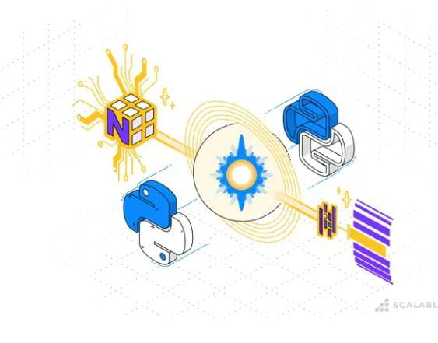
Python is one of the most powerful and widely used languages in AI and ML development. Its rising popularity in artificial intelligence and machine learning projects is the result of its user-friendly syntax, flexibility, and most importantly, its rich library ecosystem.
Python’s comprehensive libraries streamline tasks from data wrangling to algorithm development. Because ML requires continuous data processing, Python’s library ecosystem enables developers to access, manipulate, and transform data.

In this article, we’ll explore essential Python libraries for AI and ML development, including Pandas, NumPy, and Matplotlib. We’ll also dive into ML tools like Sklearn, TensorFlow, and Keras. By the end, you’ll understand these tools and their specific applications in AI projects. Let’s start with an in-depth look at data manipulation libraries.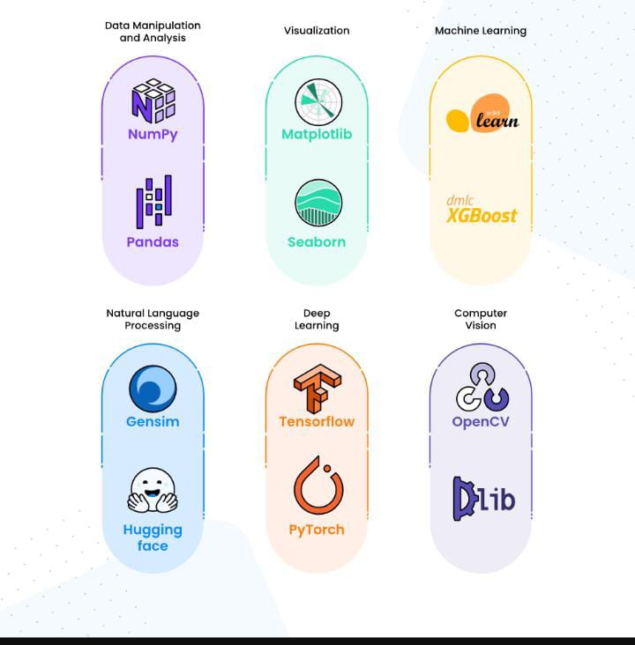

Python Libraries for Data Manipulation and Analysis

Pandas
Imagine you’re working with an e-commerce business that has massive databases containing user interactions, purchases, and a plethora of product details. They ask you to help extract monthly insights, such as identifying the top-selling products, pinpointing the highest-spending users, and calculating average sales per category. But there’s a problem; the dataset is messy, filled with typos, duplicated records, missing values, and inconsistent formats.
Your first challenge in understanding this data isn’t just in the size, but in making sense of it all. The solution? Enter Pandas.
Pandas isn’t just another tool; it’s a powerhouse for data manipulation in Python, turning daunting tasks into manageable ones. It empowers you to delve into data with ease, offering robust functionalities for sorting, filtering, transforming, and grouping. Whether it’s performing aggregations like averages and sums or preparing comprehensive reports, Pandas streamlines these processes with minimal coding.
Here are some of the key features of Pandas:
- DataFrames: Think of these as sophisticated tables where manipulating data becomes a breeze. You can sort, filter, group, and aggregate data efficiently, thanks to vectorized operations and intuitive built-in methods.
- Data Cleaning: This feature is a lifesaver for tidying up cluttered datasets. It addresses missing values and irregularities, ensuring your AI models are fed quality data.
- Data Filtering: Applying conditions and narrowing down data sets is effortless with Pandas’ filtering capabilities.
- Merging and Joining: For a holistic view, Pandas enables the seamless combination of diverse datasets, enriching your analytical scope.
Pandas is a great tool for preparing and refining data for AI endeavors, but it’s not the only option available. You can also explore Dask and Koalas. All of these options make the management of table-like structures incredibly straightforward in Python.

Now that you’ve got a good glimpse of Pandas, let’s learn about another helpful tool in data analysis: NumPy.NumPy: Empowering Numerical Computations in AI
Venturing beyond words and tables, we delve into working with extensive numerical data where precision and efficiency are paramount. Here, NumPy emerges as a critical tool, adept at handling large arrays (or, more simply put, lists of numbers) and performing mathematical operations with remarkable efficiency.
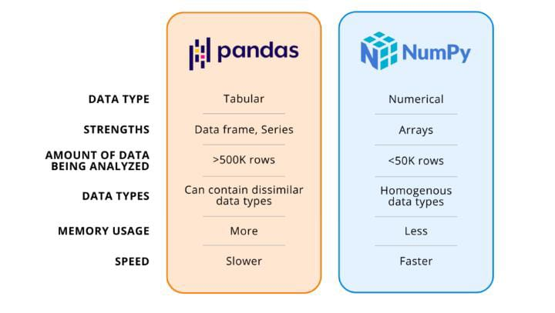Consider, for example, the complexities of an image recognition project. You’re inundated with pixel values, each representing a color or intensity, typically organized in arrays or matrices. NumPy steps in to handle these vast arrays, enabling operations on entire collections of pixel values simultaneously. This approach is far more efficient than traditional for-loop methods. Whether it’s normalizing, resizing, or augmenting data, NumPy prepares and processes your datasets for model feeding with unparalleled proficiency.
The world of AI is deeply intertwined with mathematics, and NumPy is the powerhouse that introduces advanced mathematical functions and operations into Python’s environment. It’s designed to handle intricate mathematical tasks, significantly boosting the efficiency and performance of your work without overly complicating your code.
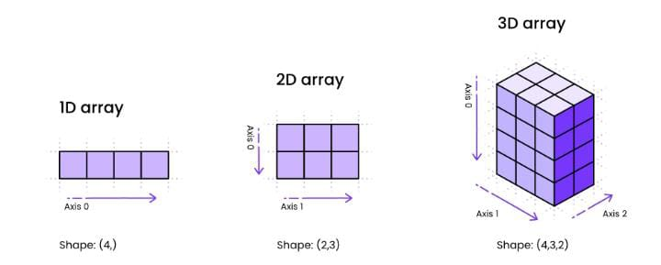Key Features of NumPy:
- Arrays: NumPy excels in efficient array operations, outperforming traditional Python lists in speed and functionality.
- Vectorization: This feature allows you to apply operations to entire arrays simultaneously, eliminating the need for explicit loops and thereby enhancing computational efficiency.
- Linear Algebra: NumPy comes equipped with built-in functions to smoothly execute complex linear algebra tasks.
With NumPy, data manipulation and analysis in Python are not just about transforming raw data into insights; it’s about doing it with speed, accuracy, and efficiency. As we continue our exploration, we’ll next dive into the exciting world of data visualization libraries.

Visualization Libraries

Matplotlib and Seaborn: Crafting Stories with Data Visualization
When you need to translate results from code into engaging presentations and explain the insights you’ve gained from data to your stakeholders, Matplotlib and Seaborn will be your partners. Both libraries help you tell stories through data, turning these into visual representations of your discoveries through charts, heatmaps, histograms, and much more.
Matplotlib stands as a pillar in the Python data visualization landscape. Its versatility spans from crafting simple line charts to designing intricate heatmaps, catering to a wide spectrum of visualization needs. On the other hand, Seaborn is often seen as the sophisticated counterpart to Matplotlib, infusing your charts with an aesthetic flair. It excels in statistical visualization and comes pre-equipped with elegant styles and color palettes, making your data not just understandable but visually striking.
While Seaborn simplifies and beautifies statistical representations, Matplotlib offers extensive customization. It allows for meticulous control over every plot element. Whether it’s embedding annotations, orchestrating subplots across varied grids, fine-tuning the minutiae of tick marks, or customizing legends, Matplotlib empowers you with the tools to tailor every aspect of your data story.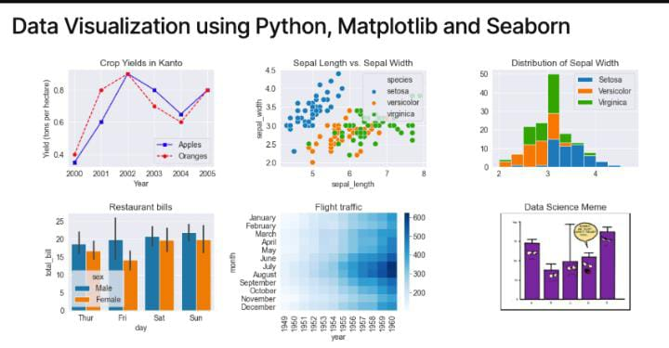
Key Features of Seaborn and Matplotlib:
- Diverse Plotting Options: From the basic to the complex, these libraries offer a broad array of plotting choices to fit your specific visualization needs.
- Stylish Aesthetics: Seaborn enhances data presentation with its range of built-in themes and color palettes, elevating the visual appeal of your data.
- Figures and Subplots Management: Handle multiple plots with ease, exploring intricate data relationships. Seaborn’s facet grids are particularly adept at illuminating complex data interactions.
Armed with Matplotlib and Seaborn, you’re now equipped to weave insightful narratives from your data. As we progress, the journey takes us next into the realm of traditional Machine Learning tools.

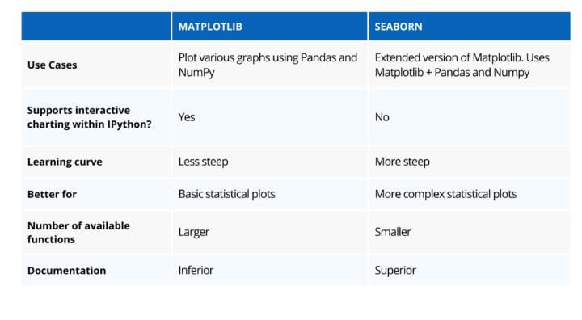

Traditional Machine Learning Tools

Scikit-Learn (Sklearn): Simplifying the Art of Machine Learning
Imagine being tasked with discerning spam from genuine emails. The challenge lies not just in sifting through historical data to identify patterns, but in crafting a system that can adeptly classify new emails. Here, Scikit-Learn (or Sklearn) shines as a beacon, simplifying the complexity of building and deploying machine learning models. Whether it’s categorizing flower species or forecasting real estate prices, Sklearn is an invaluable companion in the journey of machine learning.
Sklearn excels in streamlining the entire machine learning process, from the initial stages of data preprocessing to the critical phase of model evaluation. Its plethora of algorithms provides a versatile toolkit, adaptable to a wide range of scenarios.
Now, you may wonder how Sklearn relates to Pandas, which we learned about earlier. While Pandas lays the groundwork in exploratory data analysis and preliminary data processing, Sklearn takes the baton with its advanced methods, such as the KNN imputer for handling missing values, and sprints towards the finish line of model deployment.
Key Features of Sklearn:
- Data Preprocessing: Sklearn is equipped with an array of preprocessing techniques, ensuring your data is in prime condition for model training.
- Diverse Algorithm Portfolio: Housing everything from straightforward decision trees to complex ensemble models, Sklearn offers a suitable algorithm for almost every conceivable machine learning challenge.
- Model Evaluation Tools: Sklearn’s built-in functions allow for a streamlined and effective evaluation of model performance, enabling easy comparison and fine-tuning.
As we deepen our exploration of machine learning tools, let’s gear up to delve into another powerhouse in this realm: XGBoost.

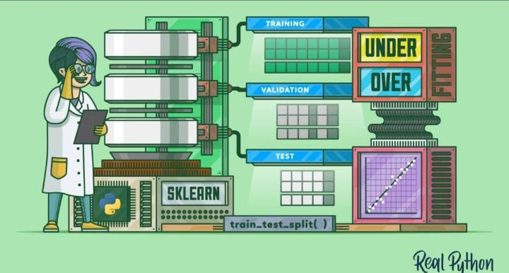

XGBoost: Elevating Model Performance to New Heights
In the nuanced world of machine learning where even a fractional improvement in metrics can be pivotal, XGBoost stands out as a game-changer. Ideal for applications ranging from predicting credit card fraud to competing in ML contests, eXtreme Gradient Boosting (XGBoost) is renowned for taking model performance to the next level.
XGBoost operates on the principle of gradient boosting, amalgamating multiple ‘weak learners’ to forge a robust, highly effective model. In an arena like AI, where precision is paramount, XGBoost distinguishes itself with its impressive speed and performance capabilities. It’s a go-to choice among AI competitors seeking an edge in model accuracy.
But is XGBoost the panacea for all modeling challenges? The answer lies in the specific requirements of your project. While XGBoost excels in metric optimization, it might not always be the ideal pick, especially when interpretability is a key factor. The adage ‘not using a cannon to kill an ant’ aptly applies here; simpler models may be more appropriate for less complex problems.
Key Features of XGBoost:
- Performance: XGBoost is engineered for speed and efficiency, often surpassing traditional gradient boosting methods in performance.
- Regularization: It incorporates regularization techniques to mitigate the risk of overfitting, a common pitfall in machine learning models.
- Handling Missing Values: XGBoost uniquely learns how to approach missing values during training, reducing the necessity for extensive data preprocessing.
The fun part of exploring ML models is just beginning, so let’s get prepared to learn about other cool libraries in the ML world, specifically in the Natural Language Processing (NLP) domain.

Natural Language Processing (NLP) Libraries

NLTK: Deciphering the Human Language in AI
Imagine you’ve been asked to analyze customer reviews and understand their sentiments. The NLTK tool becomes your best friend in processing and understanding the emotional nuances in the text. It’s the library that transforms your text data into something meaningful.
NLTK has played a crucial role in the ML and AI field, being the go-to library for those working on projects involving human language. With a variety of tools for text processing and analysis, you will be in good hands for applying anything you need like tokenization, stemming, part-of-speech tagging, and much more.
Here’s a look at some key features of this library:
- Tokenization and Parsing: NLTK excels in segmenting texts into manageable units, laying the groundwork for deeper analysis.
- Corpus Resources: Offering an extensive collection of text resources, it provides a rich training ground for your NLP models.
- Part-of-Speech Tagging: This feature allows for detailed grammatical analysis, identifying the role of each word within the textual context.
For those looking to deepen their journey into NLP, the next step involves exploring an equally powerful tool: Gensim. Get ready to unlock new dimensions in understanding and leveraging human language through AI.
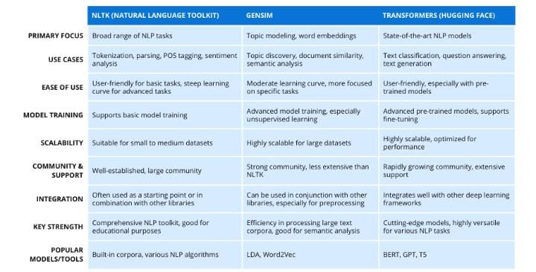

Gensim: Navigating the Maze of Textual Data
Picture this: your desk is piled high with articles on varied topics like sports, politics, and entertainment, and your task is to organize them into distinct categories. This is where Gensim, a powerhouse in the world of NLP, steps in. Renowned for its efficient handling of text categorization, Gensim arms you with an array of models, including Latent Dirichlet Allocation (LDA) and Word2Vec, making it an indispensable tool for semantic analysis.
Gensim stands out as a specialized library for NLP tasks, particularly excelling in areas such as topic modeling, word embedding, and document similarity analysis. Its user-friendly nature and impressive scalability make it a favorite among AI enthusiasts who deal with large volumes of textual data.
Key Features of Gensim:
- Diverse Algorithm Suite: Gensim boasts a comprehensive range of algorithms, adept at uncovering topics in document collections, facilitating document clustering, and capturing semantic nuances.
- Scalability: It is built to handle vast text corpora with efficiency, making it ideal for large-scale NLP projects.
- Ready-to-Use Resources: Gensim provides an array of pre-trained models and datasets, offering a head start in your NLP endeavors.
As we continue our exploration of NLP tools, prepare to be amazed by the next library in our journey: Transformers. While NLP tools like Gensim provide effective solutions with better interpretability, Transformers take it a step further. They unravel complex patterns and relationships in language data through their advanced attention mechanisms, considering the entire contextual spectrum for more accurate predictions. Let’s dive deeper into the transformative world of Transformers.

Transformers (Hugging Face): Revolutionizing Conversational AI
Imagine interacting with a virtual assistant so intuitive that it feels like conversing with a human. This level of sophistication in natural language understanding is largely attributed to a type of model known as Transformers. The Transformers library, particularly from Hugging Face, marks a significant milestone in the NLP arena. It provides a suite of state-of-the-art (SOTA) pre-trained models, paving the way for a myriad of advanced NLP applications.
The Transformers library is a treasure trove for anyone delving into tasks like text classification, question-answering, summarization, translation, and beyond. It doesn’t just supply the tools; it offers the means to innovate and push the boundaries of what’s possible in NLP.
Key Features of Transformers:
- State-of-the-Art Models: Tap into an extensive collection of powerful pre-trained models, including the likes of BERT and GPT, each tailored for specific NLP tasks.
- Fine-Tuning Capabilities: The library enables customization of models to better align with your unique project requirements, optimizing performance.
- Multilingual Support: Breaking down language barriers, Transformers excel in multilingual applications, making them indispensable in global NLP projects.
With this high-level overview of NLP libraries under our belt, we’re ready to transition into another exciting realm of AI: the deep learning libraries that are shaping the future of this ever-evolving field.

Deep Learning Libraries: Unveiling the Powerhouses of Advanced AI
Deep Learning (DL), a sophisticated branch of neural networks, stands at the forefront of AI’s most groundbreaking advancements. Imagine it as an incredibly astute system, adept at recognizing patterns and details. While traditional neural networks are structured around an input layer, a hidden layer, and an output layer, deep learning introduces multiple hidden layers, each performing intricate operations on substantial data volumes.

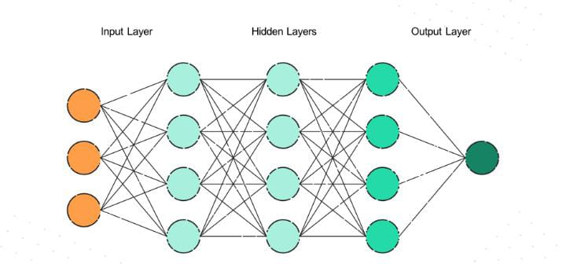

Recall our earlier discussion on image recognition? Deep learning is the driving force behind such capabilities, enabling models to discern features like edges, shapes, and colors through extensive analysis of diverse images.
Let’s embark on a journey through the pivotal libraries that power deep learning.

TensorFlow: A Cornerstone in Deep Learning Innovation
Envision a scenario where you’re tasked with developing an image recognition system for medical diagnoses. TensorFlow emerges as the ideal ally. It’s a comprehensive platform for crafting and honing complex neural networks, well-suited for handling hefty datasets and ensuring scalability in deployment.

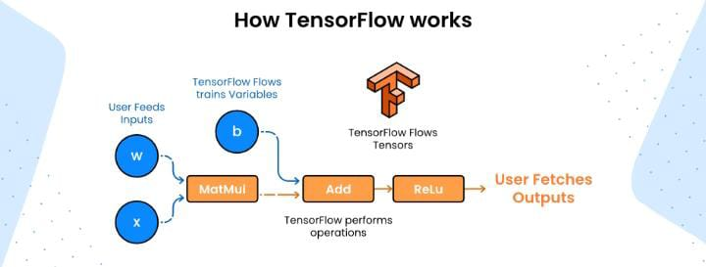
TensorFlow’s versatility spans multiple domains, from healthcare to finance, and from image and speech recognition to NLP tasks. This adaptability is a testament to its power and utility.
Key Features of TensorFlow:
- Scalability: Excelling in scalability, it operates seamlessly across multiple CPUs and GPUs, fitting both modest and extensive ML applications.
- Flexibility: TensorFlow’s architecture supports various neural network designs, enabling the creation of tailor-made models for diverse tasks.
- Observability: With tools like Tensorboard, it offers insightful visualization and monitoring of the training process, crucial for understanding, debugging, and optimizing models.
Next on our exploration is PyTorch, another formidable tool in the deep learning arsenal, sharing several similarities with TensorFlow.

PyTorch: Simplifying the Journey into AI
In the realm of deep learning libraries, PyTorch stands out for its simplicity, intuitive design, and dynamic computational capabilities. Sharing the stage with TensorFlow in image recognition and language processing, PyTorch distinguishes itself with features that resonate particularly well with the research community. For those taking their first steps in AI, PyTorch offers a welcoming environment, thanks to its user-friendly approach.
Let’s delve into the defining characteristics of PyTorch:
- Dynamic Computational Graph: PyTorch sets itself apart with its dynamic graphing capabilities, offering unprecedented flexibility in constructing and adjusting neural networks on-the-fly. This feature is especially beneficial for experimentation and debugging during model development.
- Ease of Use: PyTorch is celebrated for its ‘pythonic’ nature. Its syntax and structure feel like a natural extension of Python, making it intuitive and straightforward for Python enthusiasts to adopt.
- Tensor Operations: Employing data structures akin to NumPy arrays and matrices, PyTorch facilitates the efficient manipulation of tensors (data formats used for input/output in models), streamlining data handling processes.
While TensorFlow is often hailed for its robustness in handling large datasets and suitability for production environments, PyTorch is frequently preferred for research and experimental purposes due to its flexibility and simplicity.
As we progress, we’ll introduce another library that serves as an ideal entry point for those venturing into neural networks. If the complexity of TensorFlow and PyTorch seems daunting, this next library might be the perfect starting point for your neural network journey.

Keras: Demystifying Neural Network Complexity
The world of neural networks, with its intricate architectures and complex algorithms, can be daunting. Keras steps in as a beacon of simplicity in this sophisticated landscape. Renowned as a high-level neural networks API, Keras serves as an intuitive abstraction layer atop more granular deep learning frameworks like TensorFlow. It’s the go-to choice for beginners and those who prioritize ease-of-use and rapid prototyping, without getting bogged down in the minutiae of neural architecture.
Keras is particularly adept at managing small datasets, streamlining the journey from concept to functional prototype through its high-level API. This approach allows developers to concentrate more on the creative aspects of model design, rather than the often-tedious implementation specifics.
Key Features of Keras:
- User-Friendly API: Keras shines with its straightforward, high-level interface, making the design and training of neural network algorithms more accessible, especially for newcomers.
- Modularity: The library encourages experimentation, allowing users to assemble models with ease, akin to stacking building blocks, offering flexibility in architecture design.
- Multiple Backend Support: Keras isn’t restricted to a single framework; it seamlessly integrates with TensorFlow, Theano, and Microsoft Cognitive Toolkit (CNTK), broadening its application scope.
But there’s more to Python’s AI capabilities. Let’s explore libraries related to the computer vision domain.

Computer Vision (CV) Tools: Empowering Machines to Visualize the World
Understanding the nuances of Computer Vision (CV) is essential before diving into its dedicated libraries. CV is akin to teaching computers to interpret and understand visual information, mirroring human vision capabilities. In contrast, Deep Learning (DL) is a broader field, encompassing not just visual data but also text and speech, tackling a wider array of tasks beyond mere vision.
As we explore CV libraries, we’re essentially equipping computers with the tools to ‘see’ and analyze visual data. These libraries are tailored with functions and methods to simplify the development of applications for image recognition, object detection, and more.
Before jumping to Computer Vision libraries, let’s understand the difference of Computer Vision tasks, compared to DL tasks. CV is like teaching computers to see and understand visual information, replicating aspects of human vision. On the other hand, DL is more versatile, it works not only with images but also with text and speech, handling a wide range of tasks beyond just vision.
So, when we delve into CL libraries, we’re essentially diving into tools designed specifically for helping computers “see” and interpret visual data. These libraries come with functions and methods that make it easier for developers to build applications for tasks like image recognition, object detection and more.

OpenCV: Pioneering Image and Video Analysis
Have you ever noticed how certain videos have squares drawn around objects to identify them? This fascinating capability is made possible by libraries like OpenCV. As a cornerstone in the CV domain, OpenCV offers an extensive toolkit for processing, manipulating, and understanding images and videos.
Key Features of OpenCV:
- Image Processing: OpenCV excels in providing a wide range of image processing algorithms for enhancing and transforming visual data.
- Object Detection: It’s adept at detecting and recognizing objects within images and videos, a key aspect of many modern CV applications.
- Feature Matching: This functionality is vital for identifying and aligning image features, playing a critical role in image recognition tasks.
While OpenCV focuses on CV-specific tasks, it’s worth noting that it complements other libraries like NumPy, which is more centered on mathematical operations on arrays and matrices. In the realm of CV, OpenCV and NumPy often work hand in hand, each enhancing the other’s capabilities.
Next, we’ll take a look at another significant player in the CV landscape: Dlib, a tool that further expands our ability to implement advanced computer vision solutions.

Dlib: Specializing in Facial Recognition and Shape Analysis
In the dynamic field of computer vision, Dlib stands out as a versatile library, akin to OpenCV, but with its unique strengths in image processing and machine learning tasks. Dlib particularly shines in areas like detecting facial expressions, face recognition, and sentiment analysis. Its proficiency in accurately predicting shapes within images makes it invaluable for applications involving face and hand gesture recognition.
Key Features of Dlib:
- Face Recognition: Dlib offers sophisticated face detection and recognition capabilities, allowing for precise identification and analysis of facial features.
- Expression Analysis: This library excels in interpreting facial expressions, a critical component in the realm of computer vision, providing insights into emotional states.
- Shape Prediction: One of Dlib’s standout features is its ability to predict shapes in images. It can discern key elements in various objects, especially in faces and hands, aiding in detailed shape analysis.
When deciding between computer vision libraries, consider OpenCV as your comprehensive toolkit for a broad range of CV tasks. It’s an all-encompassing solution for diverse computer vision needs. On the other hand, if your project has a specific focus, such as face recognition or shape prediction, Dlib emerges as the specialized tool for those tasks. It’s akin to having an expert by your side for specific computer vision challenges.

Conclusion: Embarking on Your AI Journey with Python
Our expedition through the diverse landscape of AI and Machine Learning tools in Python has been enlightening and extensive. We’ve journeyed from the foundational steps of navigating and understanding data with Pandas, NumPy, Matplotlib, and Seaborn, to delving into the intricate realms of Neural Networks, NLP, Sklearn, and Computer Vision libraries.
This comprehensive exploration of key players in the field of Artificial Intelligence has armed you with the knowledge to select the appropriate tool for your AI project. Whether it’s deciphering data patterns, delving into the complexities of text, or unveiling the mysteries hidden in images, you now possess the resources and insights to transform your innovative ideas into tangible solutions.
In summing up, Python’s rich and varied ecosystem of AI libraries not only serves as an invaluable resource but also acts as a beacon, inviting individuals from diverse backgrounds to participate in the AI revolution. Here’s to hoping that your future endeavors in AI are as thrilling and fulfilling as the journey we’ve embarked on in composing this article. May your path in AI be as innovative and impactful as the technologies you employ.

