CADD -- JOB ASSIGNMENT

**Experiential Learning: Level 1- Banana Problem statement**

1. **Problem Statement: 8-bit BCD Adder**

Design hardware to add two 8-bit unsigned BCD numbers. Sketch a schematic for your design, and

write an HDL module for the BCD adder. The inputs are A, B, and Cin, and the outputs are S and

Cout. Cin and Cout are 1-bit carries, and A, B, and S are 8-bit BCD numbers.

CODE

module BCD_Adder (

input logic [7:0] A,B,

input Cin,

output [7:0]S,

output c

);

wire [3:0]sum0,sum1;

wire x0,x1;

wire [3:0]y,z;

wire cc0,cc1;

assign {x0,sum0}=A[3:0]+B[3:0]+Cin;

assign cc0=(sum0>4'd9)?1'b1:1'b0;

assign y=cc0?sum0+4'd6:sum0;

assign {x1,sum1}=A[7:4]+B[7:4]+cc0;

assign cc1=(sum1 > 4'd9)?1'b1:1'b0;

assign z=cc1?sum1+4'd6:sum1;

assign S={y,z};

assign c=x1|cc1;

endmodule

TESTBENCH

Test bench:

module BCD_Adder_tb;

reg [7:0] A, B;

reg Cin;

wire [7:0] S;

wire c;

BCD_Adder uut (A,B,Cin,S,c);

initial

begin

A = 8'b00000010;B = 8'b00000011;Cin = 0;#10;

A = 8'b00001001;B = 8'b00000010;Cin = 0;#10;

A = 8'b01011000;B = 8'b01001001;Cin = 0;#10;

A = 8'b00000101;B = 8'b00000101;Cin = 1;#10;

A = 8'b10011001;B = 8'b10011001; Cin = 0;#10;

A = 8'b00000000;B = 8'b00000000;Cin = 0;#10;

A = 8'b00100110;B = 8'b00010101;Cin = 1;#10;

end

endmodule

RTL

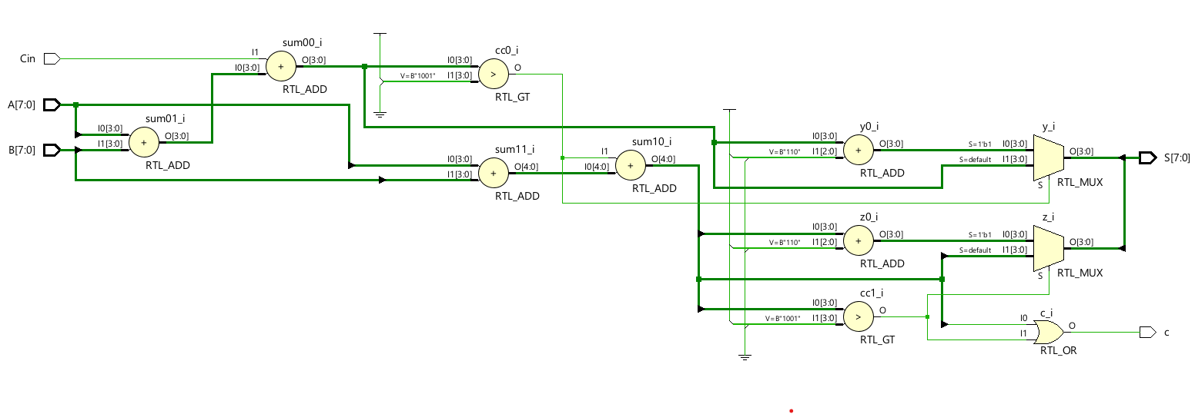

*Technology schematic*

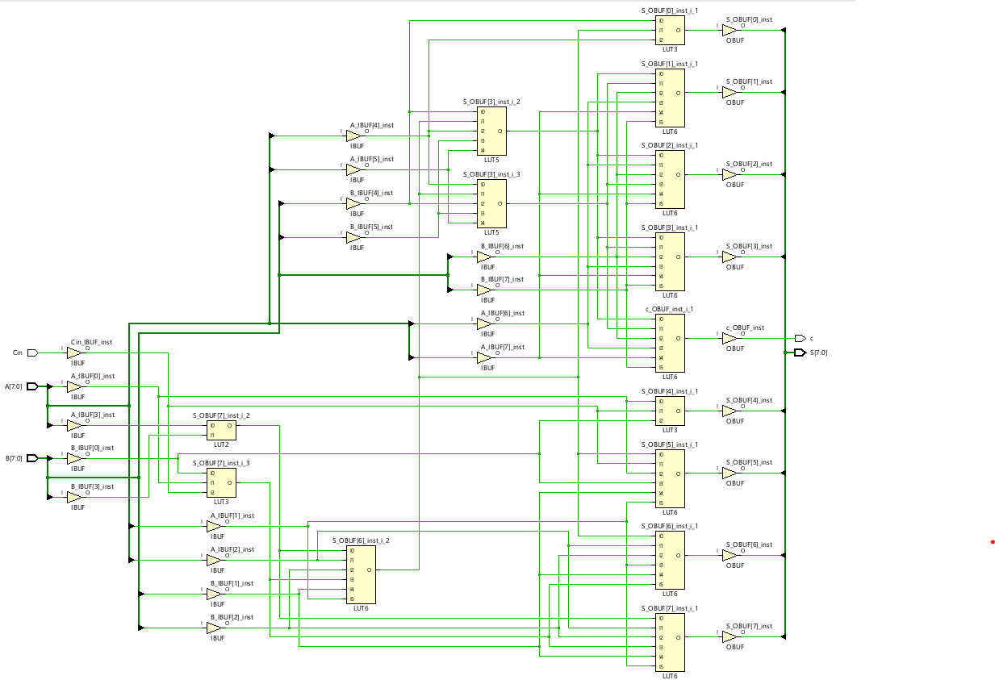

WAVEFORM

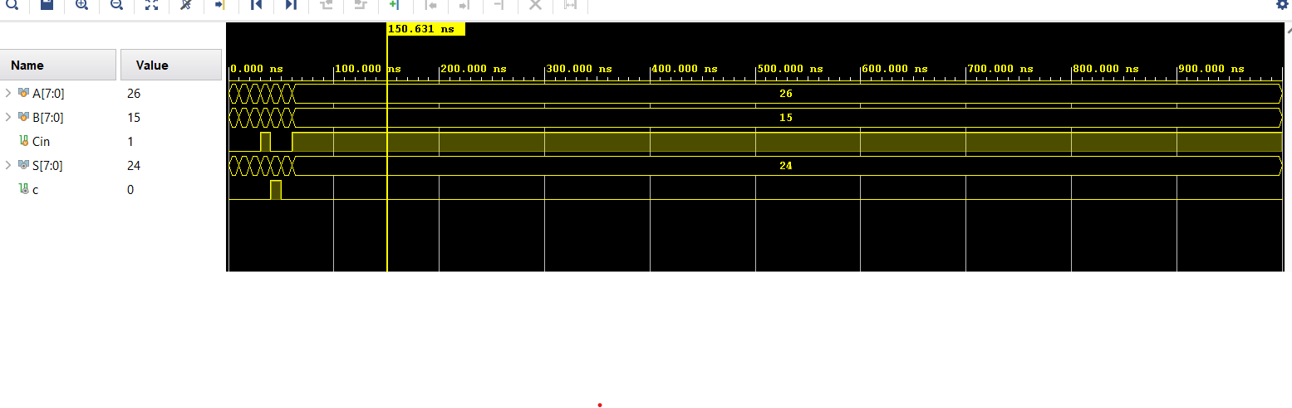

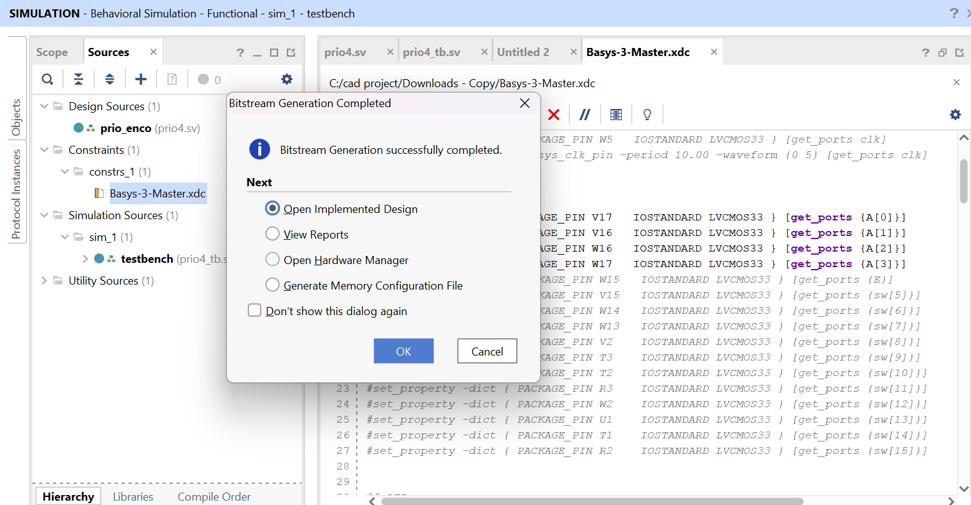

**2. Problem Statement: FPGA Flow – Combinational & Sequential circuits**

How many ARTY 100T FPGA CLBs/recourses are required to perform each of the following

functions? Show how to configure one or more CLBs to perform the function.

(i) You should be able to do this by inspection, without performing logic synthesis.

(ii) Write HDL module, perform synthesis, and tabulate the synthesis results

(a) The combinational function

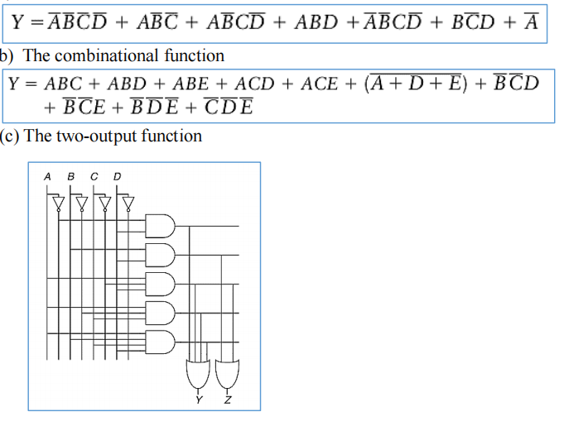

CODE

module logic1 (

input logic A, B, C, D,

output logic Y);

assign Y = ~A | (A&B&D) | (A&C&(~D)) | (A&(~B)&(~C));

endmodule

TESTBENCH

module logic1_tb;

reg A,B,C,D;

wire Y;

logic1 dut(A,B,C,D,Y);

initial

begin

#20;A=0;B=0;C=0;D=0;

#10;A=0;B=0;C=0;D=1;

#10;A=0;B=0;C=1;D=0;

#10;A=0;B=0;C=1;D=1;

#10;A=0;B=1;C=0;D=0;

#10;A=0;B=1;C=0;D=1;

#10;A=0;B=1;C=1;D=0;

#10;A=0;B=1;C=1;D=1;

#10;A=1;B=0;C=0;D=0;

#10;A=1;B=0;C=0;D=1;

#10;A=1;B=0;C=1;D=0;

#10;A=1;B=0;C=1;D=1;

#10;A=1;B=1;C=0;D=0;

#10;A=1;B=1;C=0;D=1;

#10;A=1;B=1;C=1;D=0;

#10;A=1;B=1;C=1;D=1;

end

endmodule

WAVEFORM

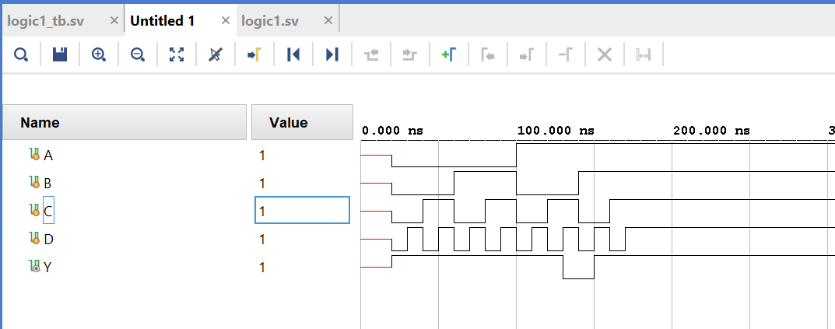

RTL

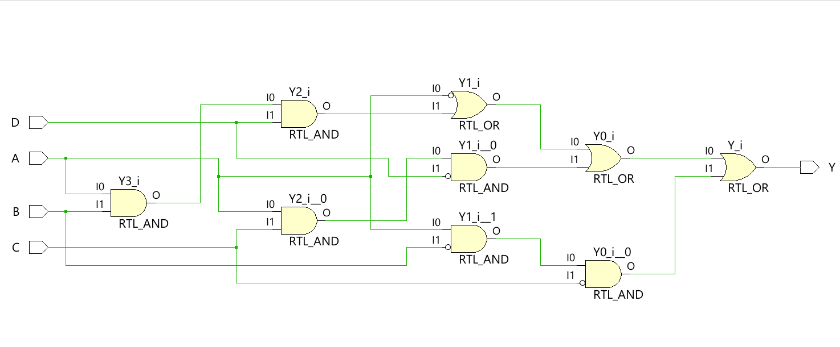

*Technology schematic*

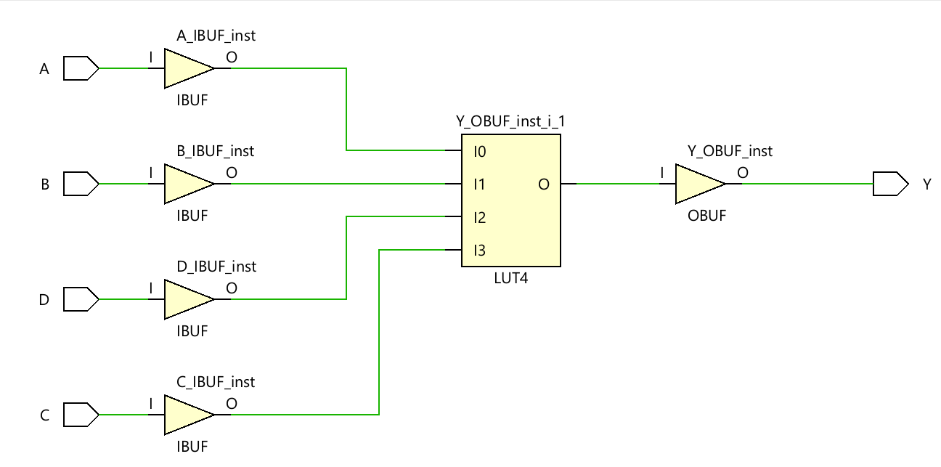

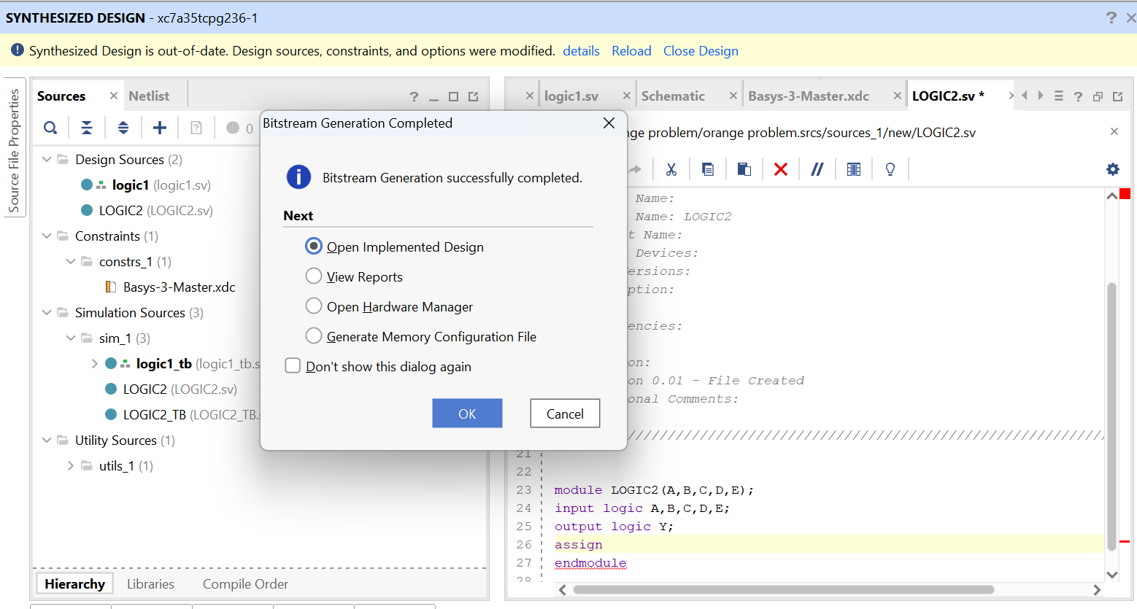

(b) The combinational function



CODE

module LOGIC2(A,B,C,D,E,Y);

input logic A,B,C,D,E;

output logic Y;

assign Y=( A&B&C | A&B&D | A&B&E | A&C&D | A&C&E | ~(A|B|E) | ~B&~C&D | ~B&~C&E | ~B&~D&~E | ~C&~D&~E );

endmodule

TESTBENCH

module LOGIC2_tb;

reg A,B,C,D,E;

wire Y;

LOGIC2 dut(A,B,C,D,E,Y);

initial

begin

#10;A=0;B=0;C=0;D=0;E=0;

#10;A=0;B=0;C=0;D=0;E=1;

#10;A=0;B=0;C=0;D=1;E=0;

#10;A=0;B=0;C=0;D=1;E=1;

end

endmodule

WAVEFORM

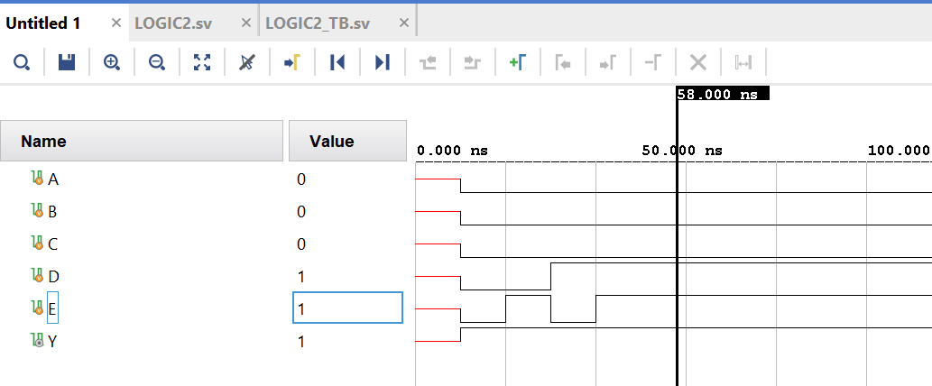

RTL

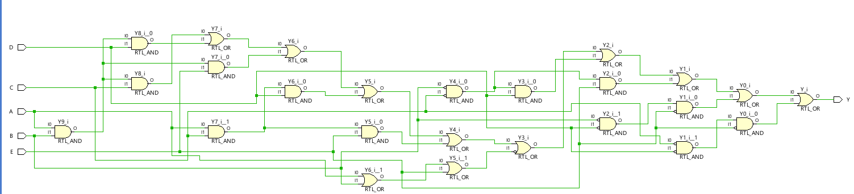

*Technology schematic*

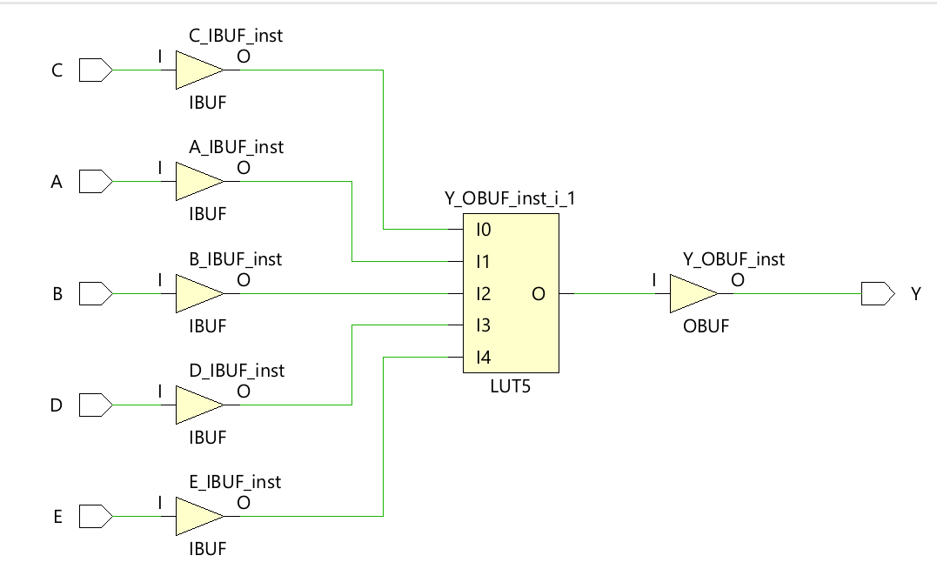

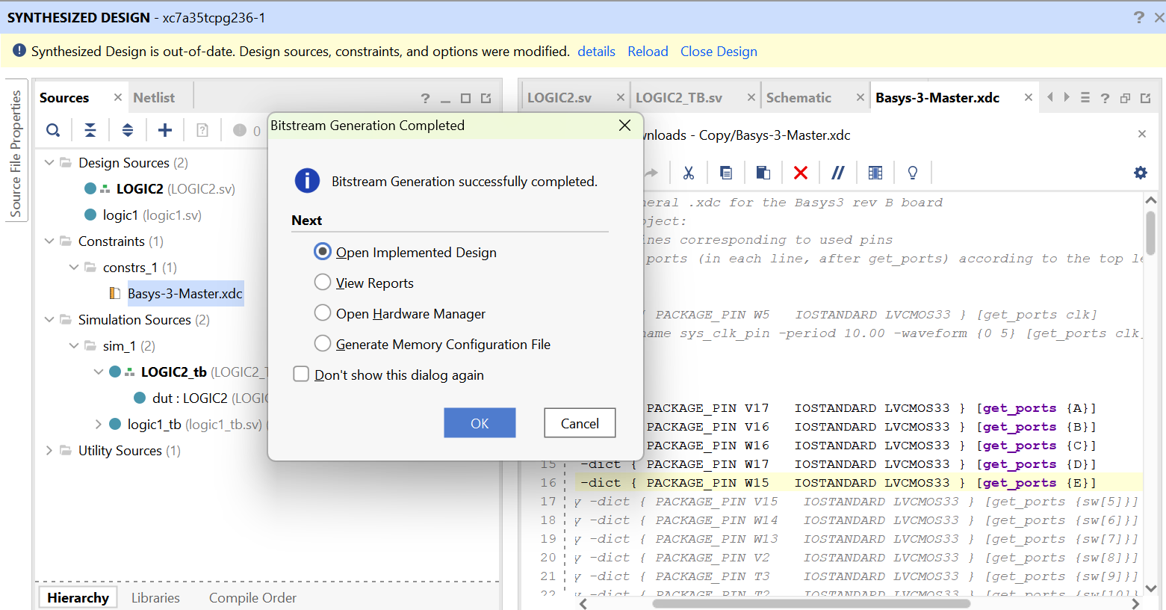

(c) The two-output function

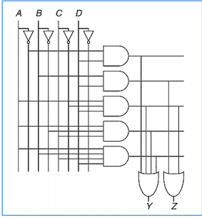

CODE

module logic3(A,B,C,D,Y,Z);

input logic A,B,C,D;

output logic Y,Z;

assign Y= ( ~A&D | A&~C&D | A&~B&C | A&B&C&D );

assign Z= ( B&D | A&~C&D );

endmodule

TESTBENCH

module logic3_tb;

reg A,B,C,D;

wire Y,Z;

logic3 dut(A,B,C,D,Y,Z);

initial

begin

#20;A=0;B=0;C=0;D=0;

#10;A=0;B=0;C=0;D=1;

#10;A=0;B=0;C=1;D=0;

#10;A=0;B=0;C=1;D=1;

#10;A=0;B=1;C=0;D=0;

#10;A=0;B=1;C=0;D=1;

#10;A=0;B=1;C=1;D=0;

#10;A=0;B=1;C=1;D=1;

#10;A=1;B=0;C=0;D=0;

#10;A=1;B=0;C=0;D=1;

#10;A=1;B=0;C=1;D=0;

#10;A=1;B=0;C=1;D=1;

#10;A=1;B=1;C=0;D=0;

#10;A=1;B=1;C=0;D=1;

#10;A=1;B=1;C=1;D=0;

#10;A=1;B=1;C=1;D=1;

end

endmodule

WAVEFORM

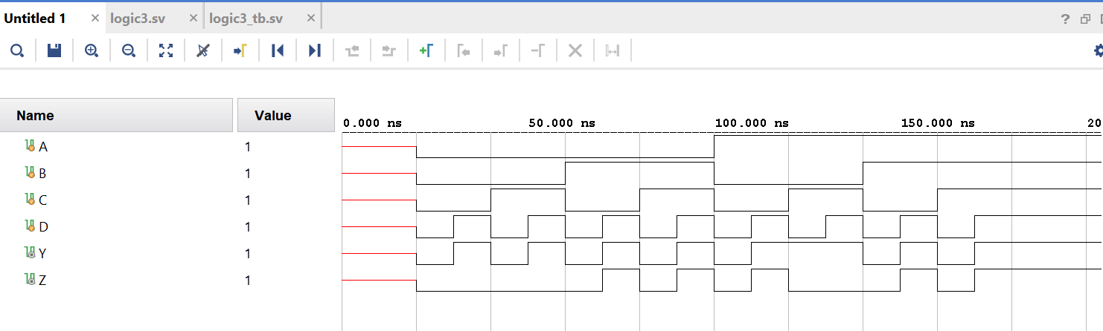

RTL

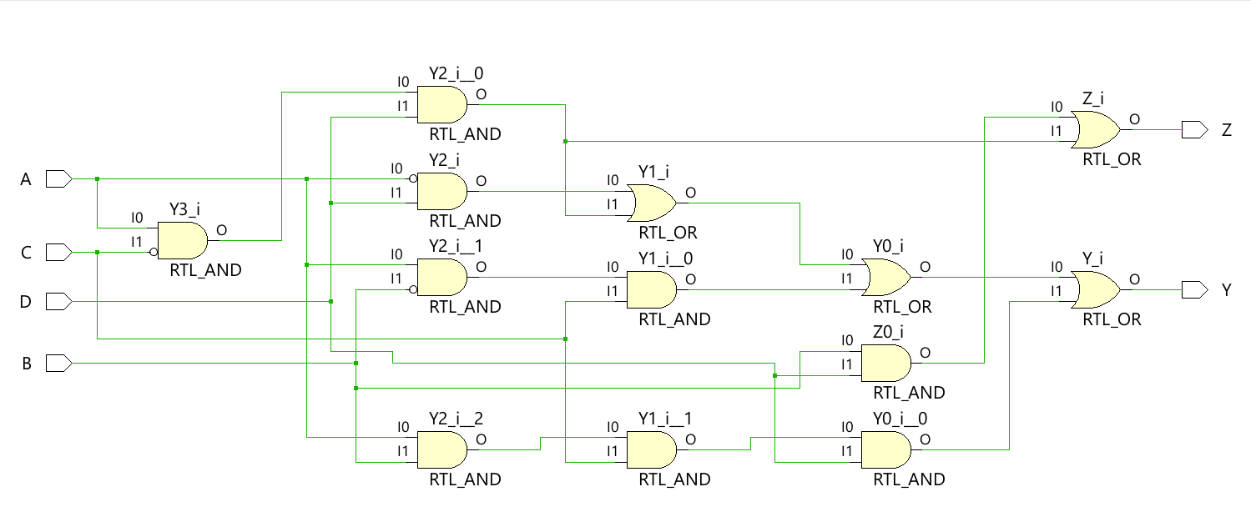

Technology schematic

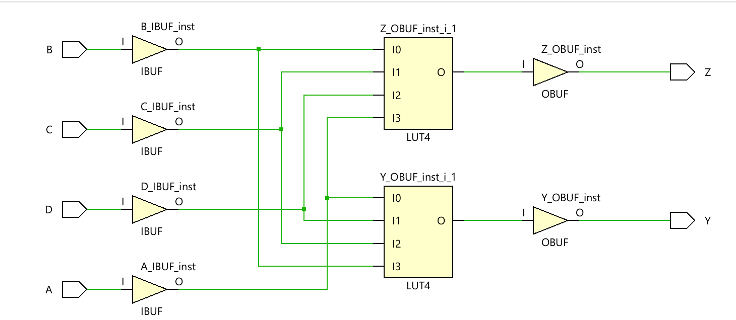

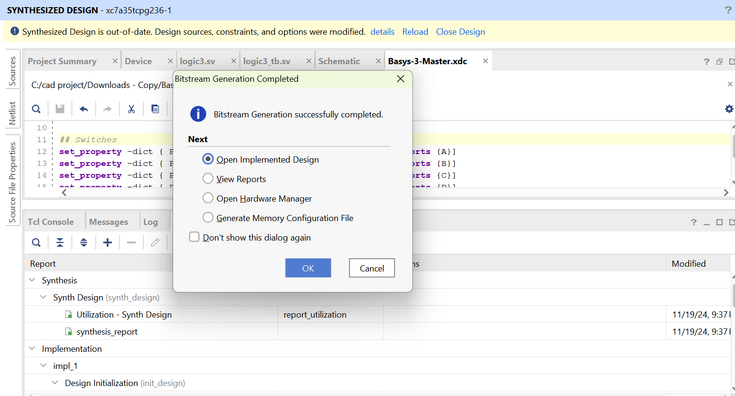

(d) The function from –

A circuit has four inputs and two outputs. The inputs, A3:0, represent a number from 0 to 15. Output

P should be TRUE if the number is prime (0 and 1 are not prime, but 2, 3, 5, and so on, are prime). Output

D should be TRUE if the number is divisible by 3. Give simplified Boolean equations for each output and

sketch a circuit.

CODE

module PIME(

input logic [3:0] A,

output logic P,D

);

assign P = ((!A[3])&(!A[2])&A[1]&(!A[0]))|((!A[3])&(!A[2])&A[1]&A[0])|((!A[3])&A[2]&(!A[1])&A[0])|((!A[3])&A[2]&A[1]&A[0])|(A[3]&(!A[2])&A[1]&A[0])|(A[3]&A[2]&(!A[1])&A[0]);

assign D=((!A[3])&(!A[2])&(!A[1])&(!A[0]))|((!A[3])&(!A[2])&A[1]&A[0])|((!A[3])&A[2]&A[1]&(!A[0]))|(A[3]&(!A[2])&(!A[1])&A[0])|(A[3]&A[2]&(!A[1])&(!A[0]))|(A[3]&A[2]&A[1]&A[0]);

endmodule

*TESTBENCH*

*module PIME_tb;*

*reg [3:0] A;*

*wire P, D;*

*PIME dut (A,P,D);*

*initial*

*begin*

*A = 4'd0; #10;*

*A = 4'd1; #10;*

*A = 4'd2; #10;*

*A = 4'd3; #10;*

*A = 4'd4; #10;*

*A = 4'd5; #10;*

*A = 4'd6; #10;*

*A = 4'd7; #10;*

*A = 4'd8; #10;*

*A = 4'd9; #10;*

*A = 4'd10; #10;*

*A = 4'd11; #10;*

*A = 4'd12; #10;*

*A = 4'd13; #10;*

*A = 4'd14; #10;*

*A = 4'd15; #10;*

*end*

*endmodule*

*WAVEFORM*

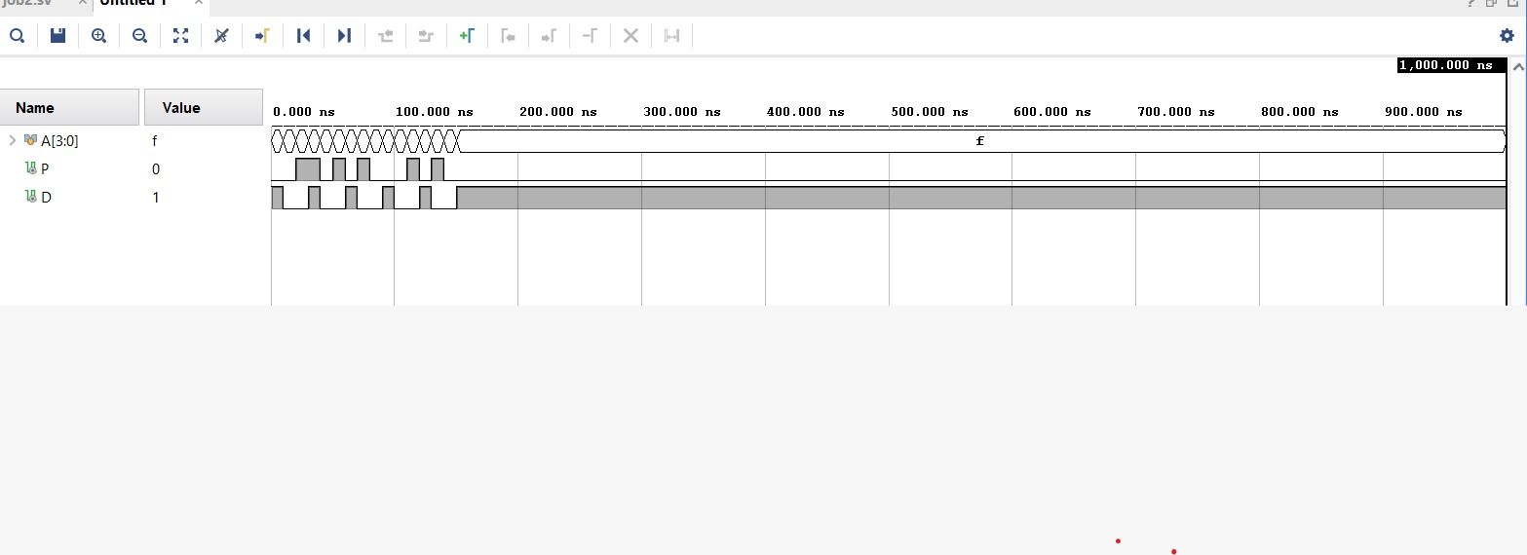

*RTL*

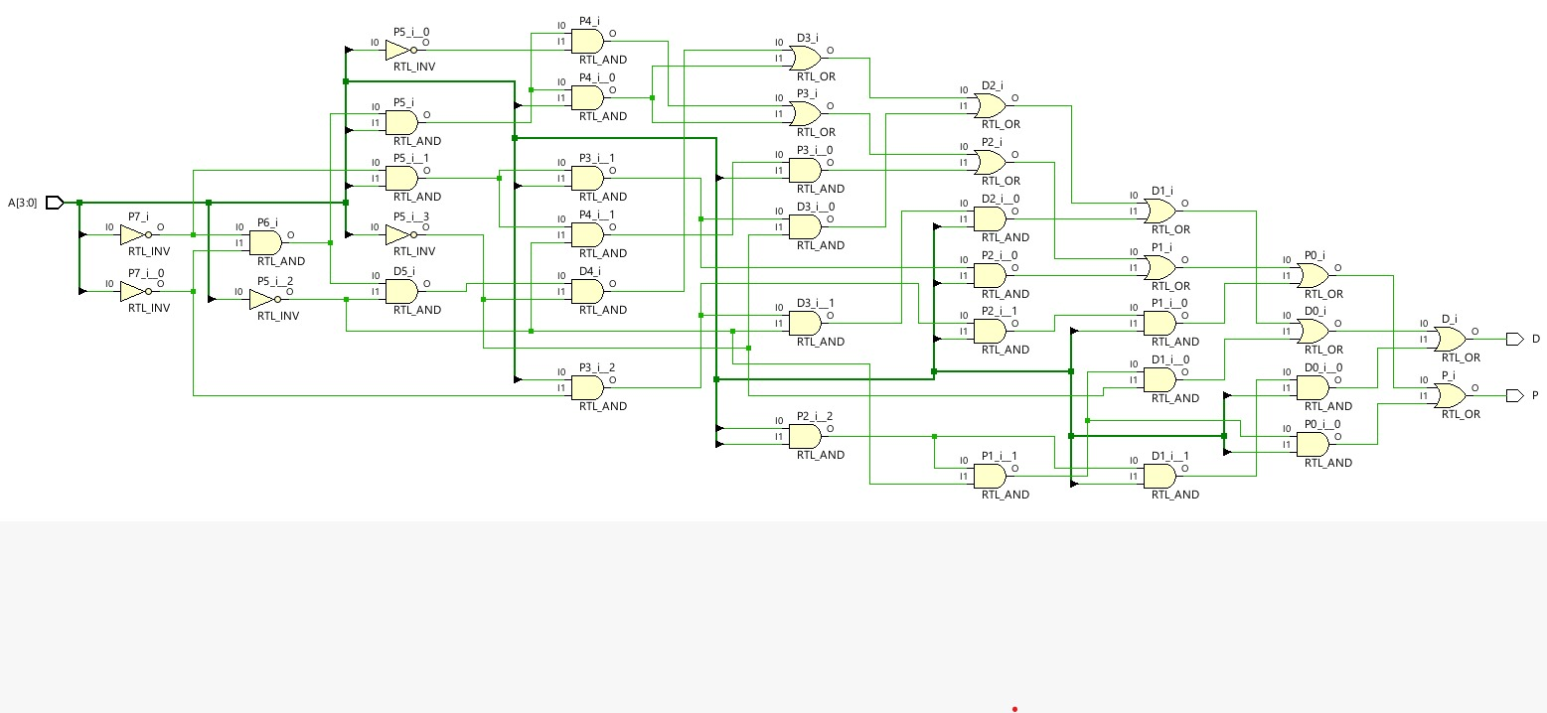

Technology schematic

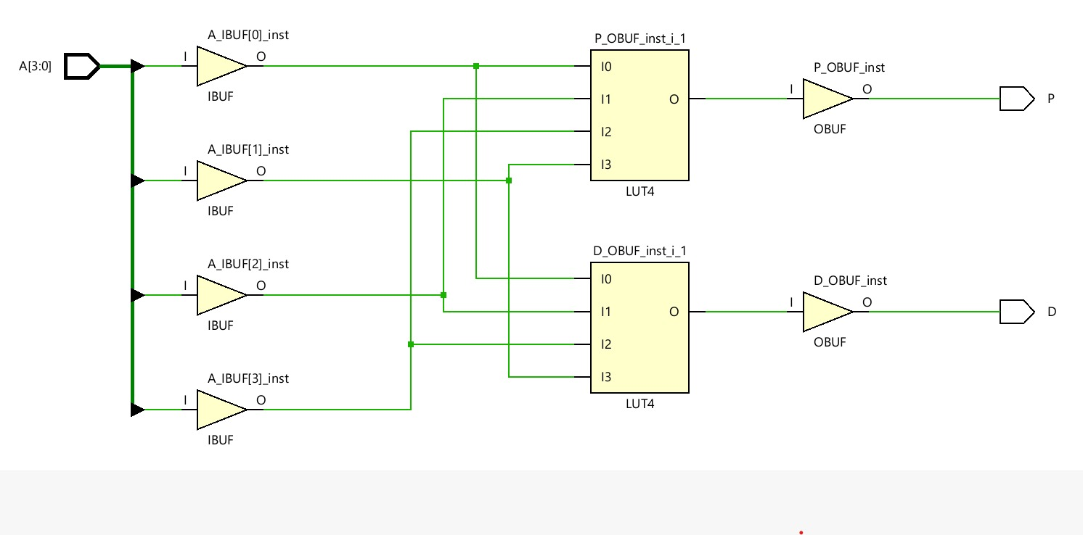



(e) A four-input priority encoder

CODE

*module prio_enco(input logic [3:0] A, output logic [1:0] Y, output logic valid);*

*always_comb*

*casez(A)*

*4'b0001, 4'b001x, 4'b01xx, 4'b1xxx : Y = 2'b00;*

*4'b0010, 4'b0011, 4'b01xx, 4'b1xxx : Y = 2'b01;*

*4'b0100, 4'b0101, 4'b011x, 4'b1xxx : Y = 2'b10;*

*4'b1000, 4'b1001, 4'b101x, 4'b11xx : Y = 2'b11;*

*default : Y = 2'b00;*

*endcase*

*assign valid = (A != 4'b0000);*

*Endmodule*

*TESTBENCH*

*module testbench;*

*reg [3:0] A;*

*wire [1:0] Y;*

*wire valid;*

*prio_enco DUT (A, Y, valid);*

*initial begin*

*A = 4'b0000; #10;*

*A = 4'b0001; #10;*

*A = 4'b0010; #10;*

*A = 4'b0100; #10;*

*A = 4'b1000; #10;*

*A = 4'b1100; #10;*

*A = 4'b1110; #10;*

*A = 4'b1111; #10;*

*end*

*endmodule*

*WAVEFORM*

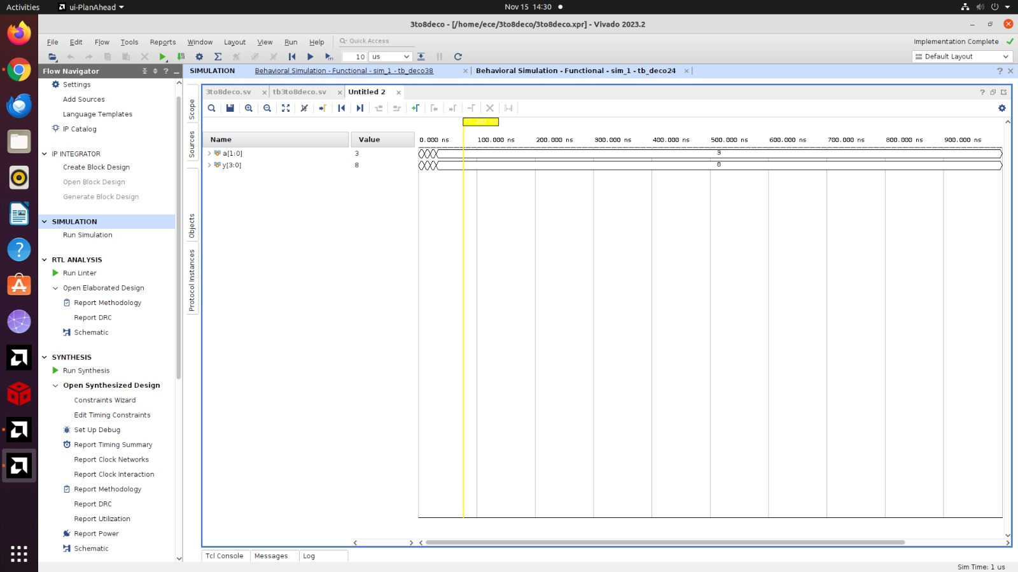

*RTL*

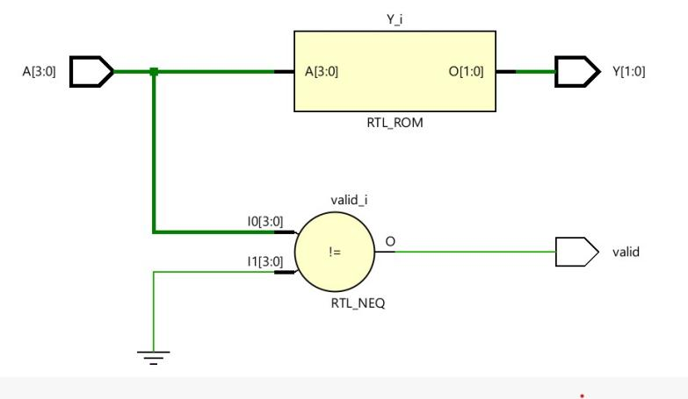

Technology schematic

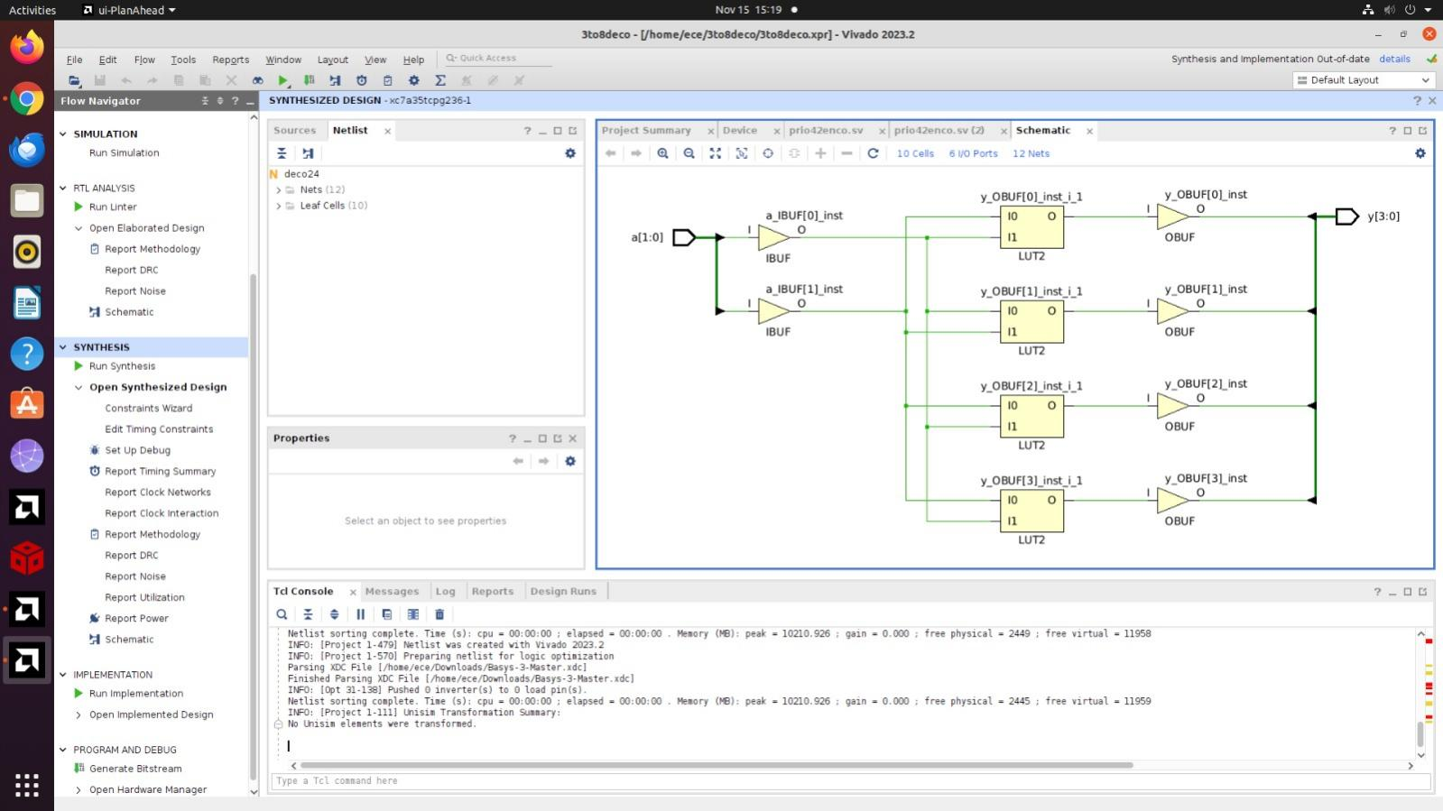



(f) An eight-input priority encoder

CODE

module prio_enco(

input logic [7:0] A,

output logic [2:0] Y

);

always_comb begin

casez (A)

8'b00000001, 8'b0000001x, 8'b000001xx, 8'b00001xxx, 8'b0001xxxx, 8'b001xxxxx, 8'b01xxxxxx, 8'b1xxxxxxx: Y = 3'b000;

8'b00000010, 8'b0000011x, 8'b00001xxx, 8'b0001xxxx, 8'b001xxxxx, 8'b01xxxxxx, 8'b1xxxxxxx: Y = 3'b001;

8'b00000100, 8'b000011xx, 8'b0001xxxx, 8'b001xxxxx, 8'b01xxxxxx, 8'b1xxxxxxx: Y = 3'b010;

8'b00001000, 8'b00011xxx, 8'b001xxxxx, 8'b01xxxxxx, 8'b1xxxxxxx: Y = 3'b011;

8'b00010000, 8'b001xxxxx, 8'b01xxxxxx, 8'b1xxxxxxx: Y = 3'b100;

8'b00100000, 8'b01xxxxxx, 8'b1xxxxxxx: Y = 3'b101;

8'b01000000, 8'b1xxxxxxx: Y = 3'b110;

8'b10000000: Y = 3'b111;

default: Y = 3'b000; // Default case for no valid input

endcase

end

endmodule

TESTBENCH

*module testbench;*

*reg [7:0] A;*

*wire [2:0] Y;*

*wire valid;*

*prio_enco DUT (A, Y, valid);*

*initial begin*

*// Apply test cases*

*A = 8'b00000000; #10;*

*A = 8'b00000001; #10;*

*A = 8'b00000010; #10;*

*A = 8'b00000100; #10;*

*A = 8'b00001000; #10;*

*A = 8'b00010000; #10;*

*A = 8'b00100000; #10;*

*A = 8'b01000000; #10;*

*A = 8'b10000000; #10;*

*A = 8'b11111111; #10;*

*$stop;*

*end*

*Endmodule*

*WAVEFORM*

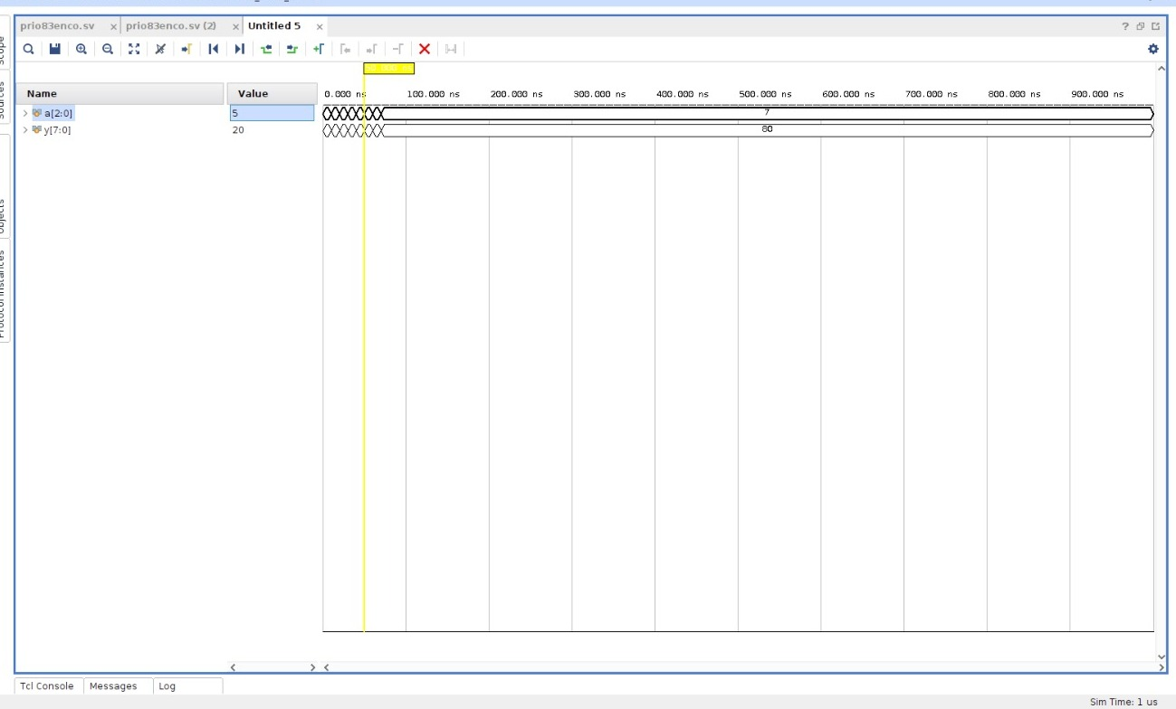

*RTL*

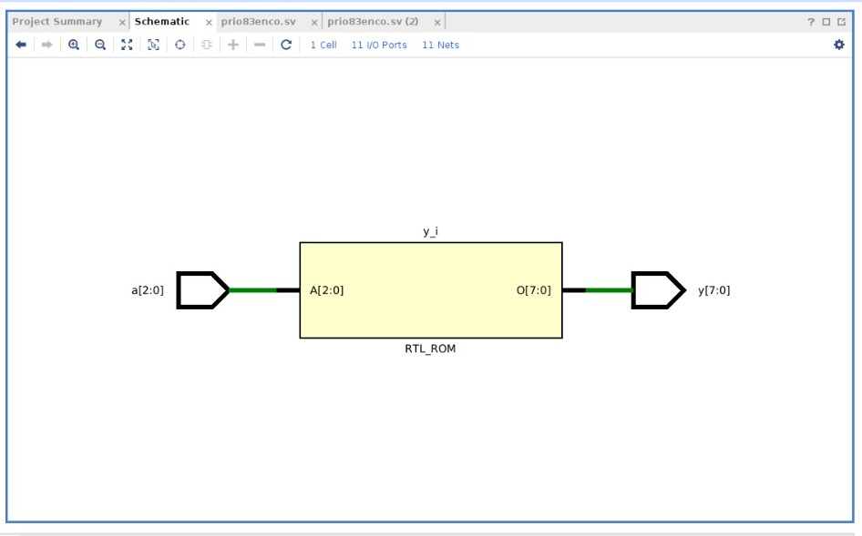

*Technology schematic*

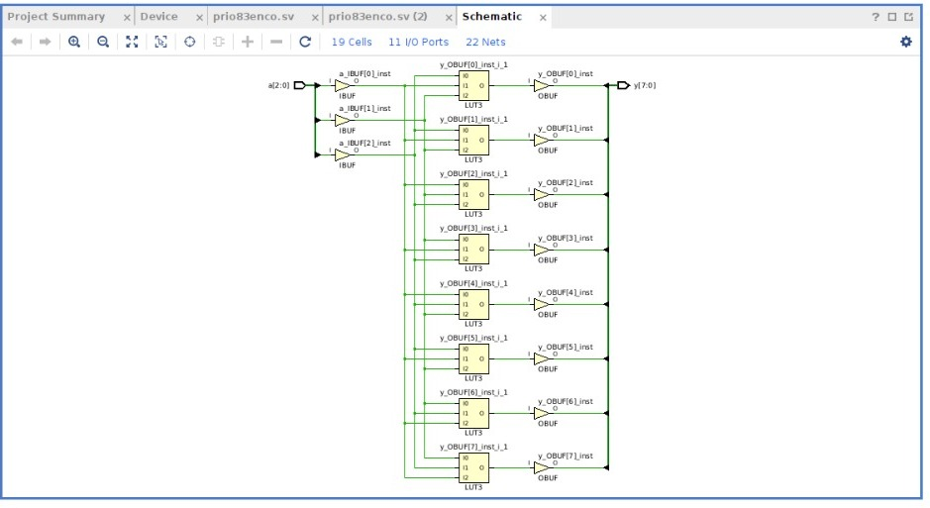



(g) A 3:8 decoder.

CODE

*module deco38(input logic [2:0] a, output logic [7:0] y);*

*always_comb*

*case(a)*

*3'b000 : y = 8'b00000001;*

*3'b001 : y = 8'b00000010;*

*3'b010 : y = 8'b00000100;*

*3'b011 : y = 8'b00001000;*

*3'b100 : y = 8'b00010000;*

*3'b101 : y = 8'b00100000;*

*3'b110 : y = 8'b01000000;*

*3'b111 : y = 8'b10000000;*

*default: y = 8'bxxxxxxxx;*

*endcase*

*endmodule*

TESTBENCH

*module tb_deco38;*

*logic [2:0] a;*

*logic [7:0] y;*

*deco38 dut (a, y);*

*initial begin*

*a = 3'b000; #10;*

*a = 3'b001; #10;*

*a = 3'b010; #10;*

*a = 3'b011; #10;*

*a = 3'b100; #10;*

*a = 3'b101; #10;*

*a = 3'b110; #10;*

*a = 3'b111; #10;*

*end*

*endmodule*

WAVEFORM

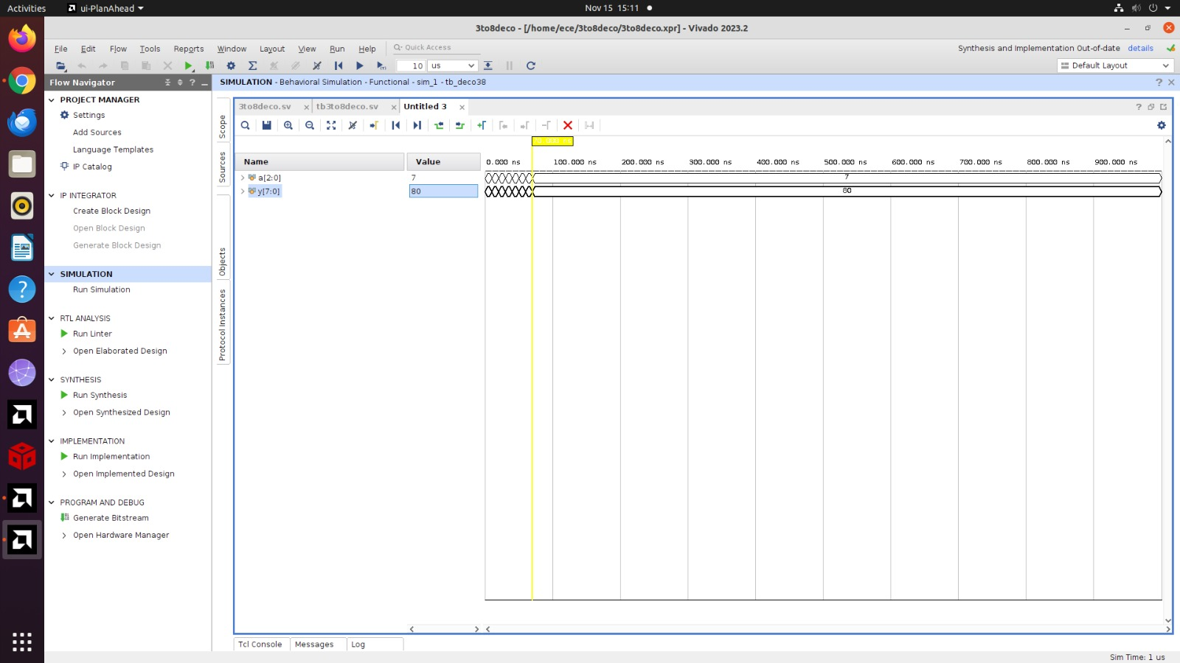

*RTL*

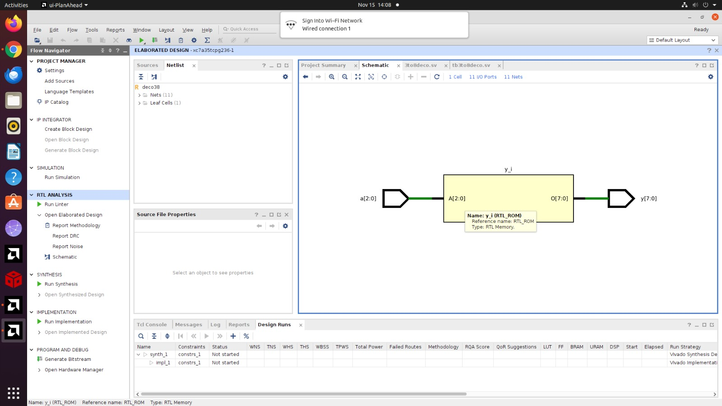

*Technology schematic*

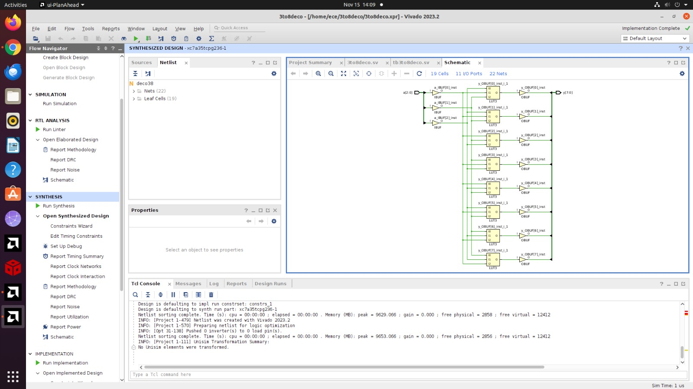



(h) A 4-bit carry propagate adder (with no carry in or out).

CODE

module carry_propagate_adder(

input [3:0] A,

input [3:0] B,

output [3:0] Sum

);

assign Sum = A + B;

endmodule

TESTBENCH

module carry_propagate_adder_tb;

reg [3:0] A, B;

wire [3:0] Sum;

carry_propagate_adder uut (

.A(A),

.B(B),

.Sum(Sum)

);

initial begin

A = 4'b0000; B = 4'b0000; #10;

A = 4'b0001; B = 4'b0001; #10;

A = 4'b0010; B = 4'b0010; #10;

A = 4'b0100; B = 4'b0100; #10;

A = 4'b1000; B = 4'b1000; #10;

A = 4'b1111; B = 4'b1111; #10;

A = 4'b1101; B = 4'b1011; #10;

A = 4'b0110; B = 4'b0111; #10;

$finish;

end

Endmodule

WAVEFORM

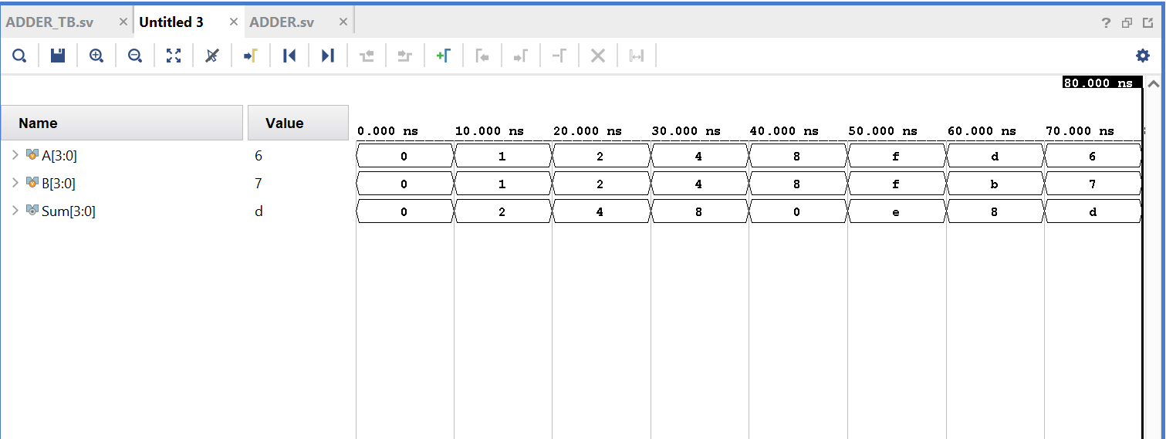

RTL

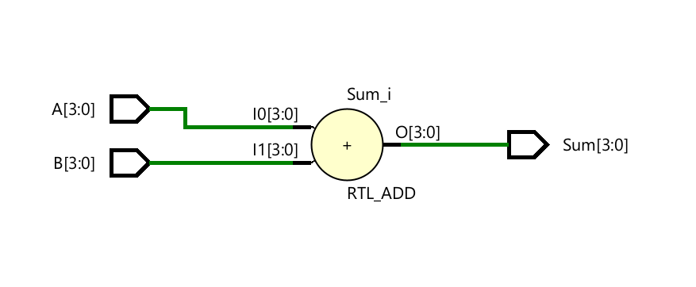

*Technology schematic*

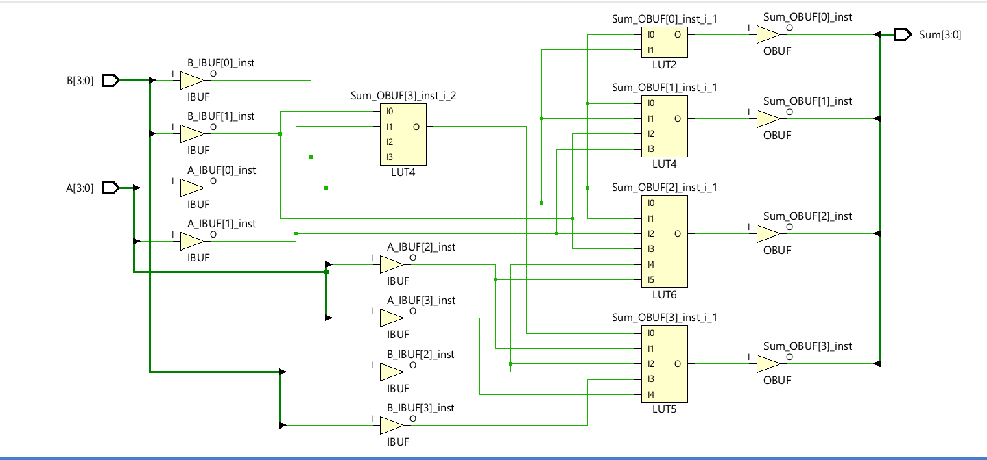



1. The FSM

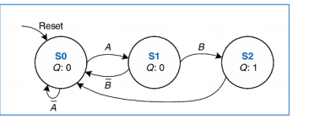

CODE

module fsm(

input logic clk,

input logic reset,

input logic A,

input logic B,

output logic Q

);

typedef enum logic [1:0] {S0 = 2'b00, S1 = 2'b01, S2 = 2'b10} state_t;

state_t state, next_state;

always_ff @(posedge clk or posedge reset) begin

if (reset)

state <= S0;

else

state <= next_state;

end

always_ff @(state or A or B) begin

case (state)

S0:

if (~A) next_state = S0;

else next_state = S1;

S1:

if (~B) next_state = S1;

else next_state = S2;

S2:

if (~A) next_state = S2;

else next_state = S0;

default: next_state = S0;

endcase

end

assign Q = (state == S2);

endmodule

TESTBENCH

module fsm_tb;

reg clk,reset,A,B;

wire Q;

fsm uut(.clk(clk),.reset(reset),.A(A),.B(B),.Q(Q));

always #5 clk=~clk;

initial begin

clk=0;reset=0;A=0;B=0;

#10 reset=1;#10 reset=0;

#10 A=1;B=0;#10 A=0;B=0;

#10 A=0;B=1;#10 A=0;B=0;

#10 A=1;B=0;#10 A=0;B=0;

#10 reset=1;#10 reset=0;

#10 $finish;

end

endmodule

WAVEFORM

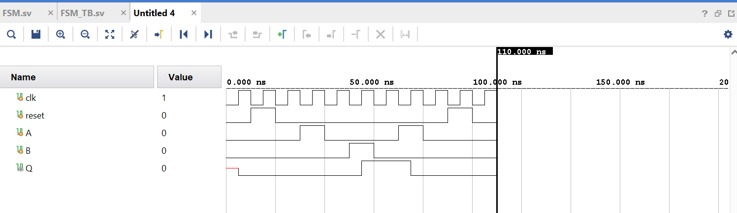

RTL

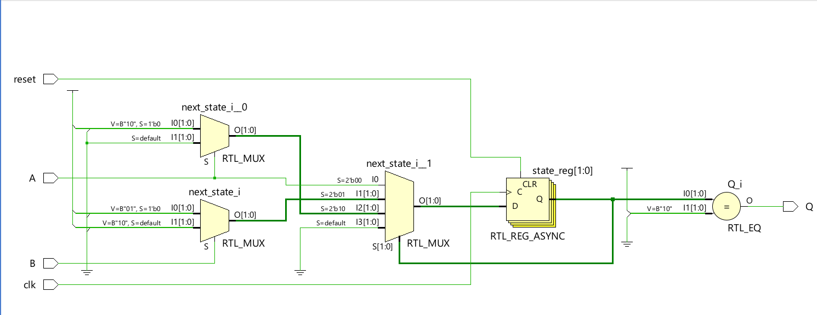

*Technology schematic*

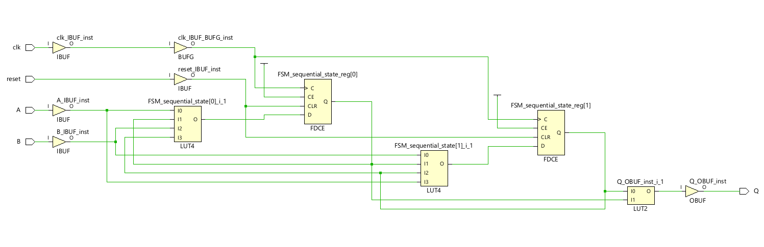



(j) The Gray code counter

CODE

module binary_to_gray (

input logic [3:0] B,

output logic [3:0] G

);

assign G[3] = B[3];

assign G[2] = B[3] ^ B[2];

assign G[1] = B[2] ^ B[1];

assign G[0] = B[1] ^ B[0];

endmodule

TESTBENCH

module tb_binary_to_gray();

logic [3:0] B;

logic [3:0] G;

binary_to_gray uut (

.B(B),

.G(G)

);

initial begin

B = 4'b0000; #10;

B = 4'b0001; #10;

B = 4'b0010; #10;

B = 4'b0011; #10;

B = 4'b0100; #10;

B = 4'b0101; #10;

B = 4'b0110; #10;

B = 4'b0111; #10;

B = 4'b1000; #10;

B = 4'b1001; #10;

$finish;

end

endmodule

WAVEFORM

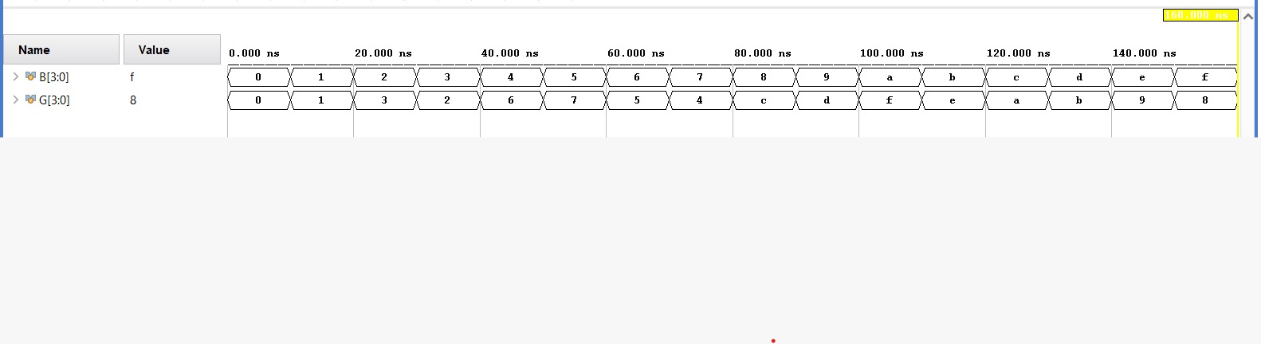

*RTL*

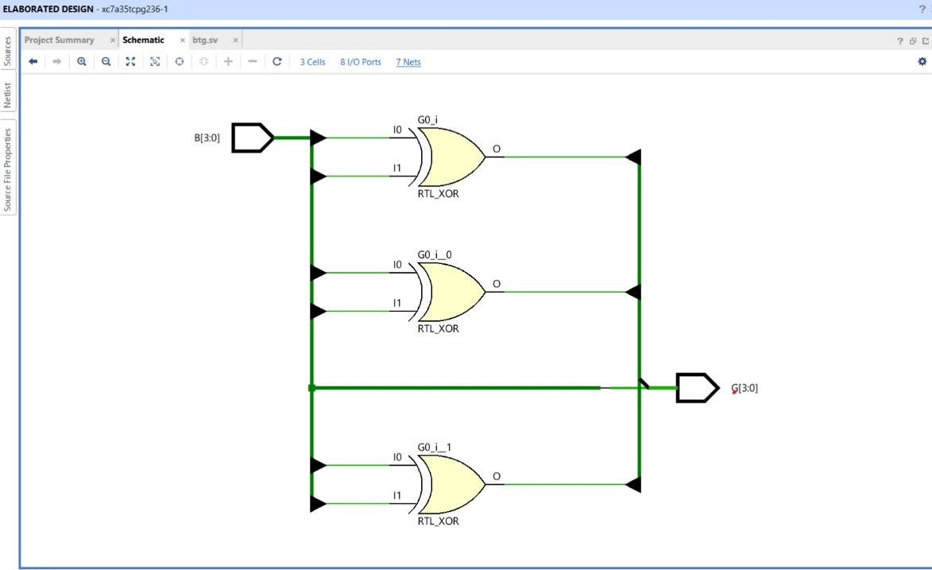

*Technology schematic*

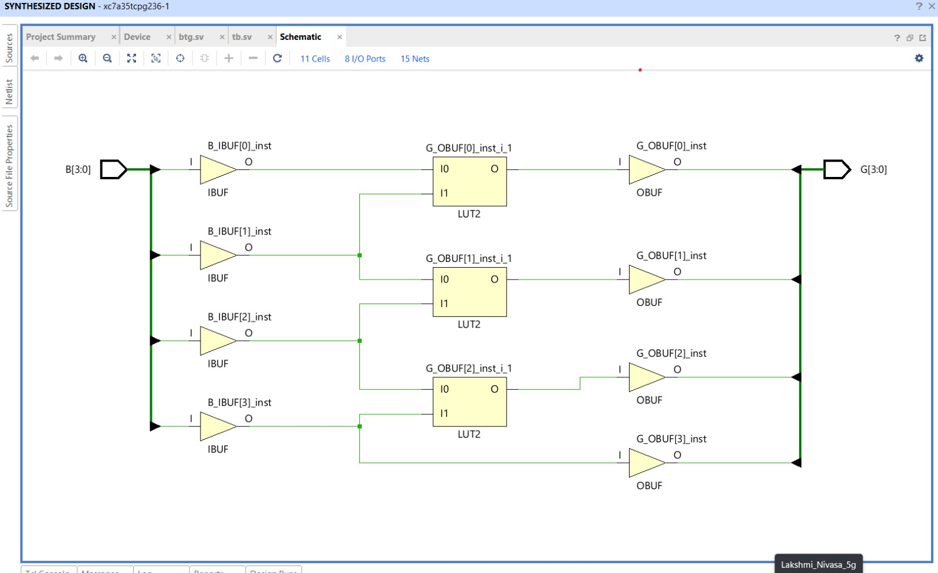



**1. Problem Statement: FPGA Flow – Floating Point Multiplier**

In this problem, you will explore the design of a 32-bit floating point multiplier. The multiplier has

two 32-bit floating-point inputs and produces a 32-bit floating-point output. You may consider

positive numbers only and use round toward zero (truncate).

1. Write the steps necessary to perform 32-bit floating-point multiplication.

CODE