**Overview**

This is a program which provides the user the opportunity to read and input bills. It also provides various reports for these bills based off of the users input.

**Welcome Menu**

When you open the program, you will be greeted with the welcome menu:

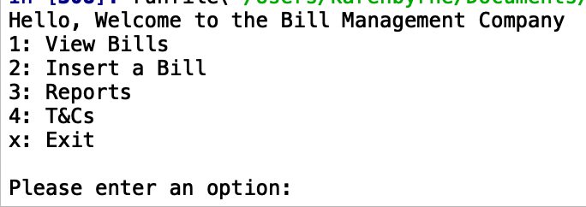

**Instructions for use**

Here you are provided with the options.

**Viewing the dataset:** If you wish to view the bills you should insert 1, this provides the following output. A panda’s data frame of all bills inside the csv file with the column’s names added. Along with this there is also an additional column added – ‘Period’. This column is a concatenation of year-month-day:

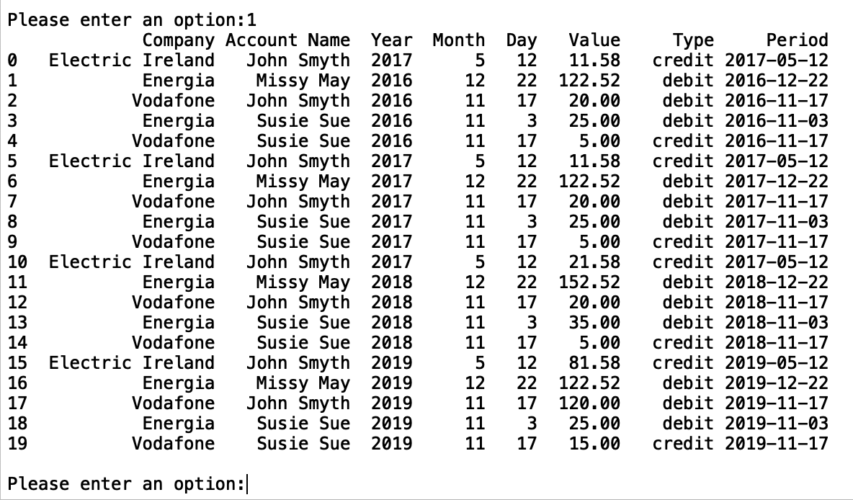

You are then prompted to add another option. If you wish to discover more inside the app you can press 3 or 4. If you wish to add a bill, you should input 2.

**Adding a new bill:** If you enter the value 2 you will be given the option to add a new bill to the dataset.

**Reports:** If you input 3 to the main menu view you will be given the option to view the reports for the dataset.