Class 05: Data Visualization

Karen Li

January 22, 2019

#Section 2A  
read.table("bimm143_05_rstats/weight_chart.txt", header = TRUE)

## Age Weight  
## 1 0 3.6  
## 2 1 4.4  
## 3 2 5.2  
## 4 3 6.0  
## 5 4 6.6  
## 6 5 7.2  
## 7 6 7.8  
## 8 7 8.4  
## 9 8 8.8  
## 10 9 9.2

weight <- read.table("bimm143_05_rstats/weight_chart.txt", header = TRUE)  
plot(weight, typ="o", pch=15, cex=1.5, lwd=2,   
 col="red", ylim=c(2,10), xlab="Age (months)",  
 ylab="Weight (kg)", main="Weight vs. Age")

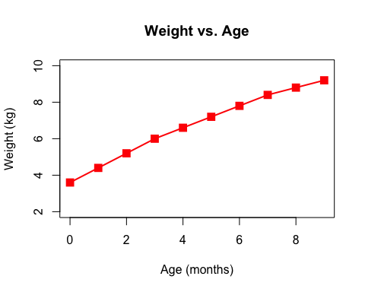

# Section 2B  
feat <- read.table("bimm143_05_rstats/feature_counts.txt", header = TRUE,   
 sep="\t")  
par(mar=c(5,11,4,2))  
barplot(feat$Count, horiz=TRUE, names.arg=feat$Feature,  
 main="Number of Features in the Mouse GRCm38 Genome", las=1,   
 col=heat.colors(12))

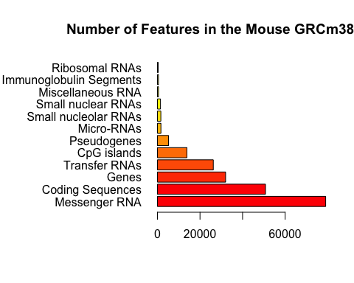

#Section 2C  
  
  
# Section 3A  
gender <- read.table("bimm143_05_rstats/male_female_counts.txt",   
 header=TRUE, sep="\t")  
par(mar=c(7,4,4,4))  
barplot(gender$Count, names.arg=gender$Sample, las=2,   
 col=rainbow(nrow(gender)))

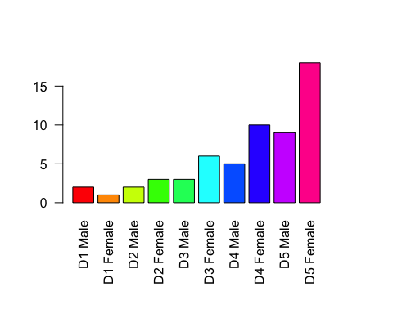

# Section 3B  
genes <- read.table("bimm143_05_rstats/up_down_expression.txt", header=TRUE)  
table(genes$State)

##   
## down unchanging up   
## 72 4997 127

palette(c("red", "gray", "blue"))  
plot(genes$Condition1, genes$Condition2, col=genes$State)

